Title: Decline of Community and Tenancy Integrity in a Council Estate
Who’s the girl illegally attacking me in 115 and should she legally be in the flat also her Motive “MO” behind what she does?

Girl Known as: Rebbeca O`Hare

The Illegal Subletting of Council Stock Homes!
The illegal subletting of flats by council secure tenants constitutes a breach of their tenancy agreements. In my block, there are six flats arranged over three levels, with two flats on each level. Each front door faces the next, and the bottom-floor flats have back gardens. I have lived in one of these bottom-floor flats since 2006.
This estate is designated for individuals over 40 years old; however, I've noticed an increasing trend of younger individuals moving in alongside the adult tenants. While their presence has contributed to some changes, my negative experiences in the community primarily stem from the actions of the original adults I once considered friends. Unfortunately, I have faced racial hatred, unfounded rumors, and a toxic atmosphere fueled by individuals seeking to emulate violent behavior. These actions have severely damaged our community spirit without justification.
Between 2006 and 2014, this place thrived with a strong sense of community, and I cherished my time here. Sadly, that sense of belonging has faded, and my overall experience has significantly declined. Despite this, I continue to keep an eye on the activities around me, taking notes of who lives whereas I have also been forced to maintain a diary of the wrongs I have endured, by some of those neighbors as requested by the council and police, when they asked me to document incidents involving members of the estate in my block and sent me a diary form to fulfill.
The two ground-floor flats are council-owned, while the second-floor flats are numbered 113 and 115, with 113 being directly above my flat. When I first moved in, 115 was occupied by a young couple, both white British, with whom I had no issues. However, in 2014, I began experiencing harassment from the residents of flats 111, 113, and 117 (the latter address of 117 being directly above 113). The situation escalated, as the council and police sided with them, due to initiating the problems of cause and this wrongful behaviour further exacerbating the problem.
With that being explained I can get closer to the point and that being about the legal occupation and inhabitance of 115 Burncroft Avenue based from my understanding

It is worth noting that the tenants of 115, who disapproved of their neighbors' behavior, eventually moved out.

2006, 2007, 2008, 2009, 2010, 2011

 | - Responsible Doctors & Enfield Council for Debra Andrews  - The reason that we have adduced this exhibit into these proceedings is because | 00/00/2006  Till  2011 | Evidence: Exhibit BB5 – 1 / 00/00/2006:  - We contain the Evidence in the Now Claimants Diary!  Evidence: Exhibit BB5 – 2 / 00/00/2006:  - This is a picture of the front layout of Burncroft Avenue  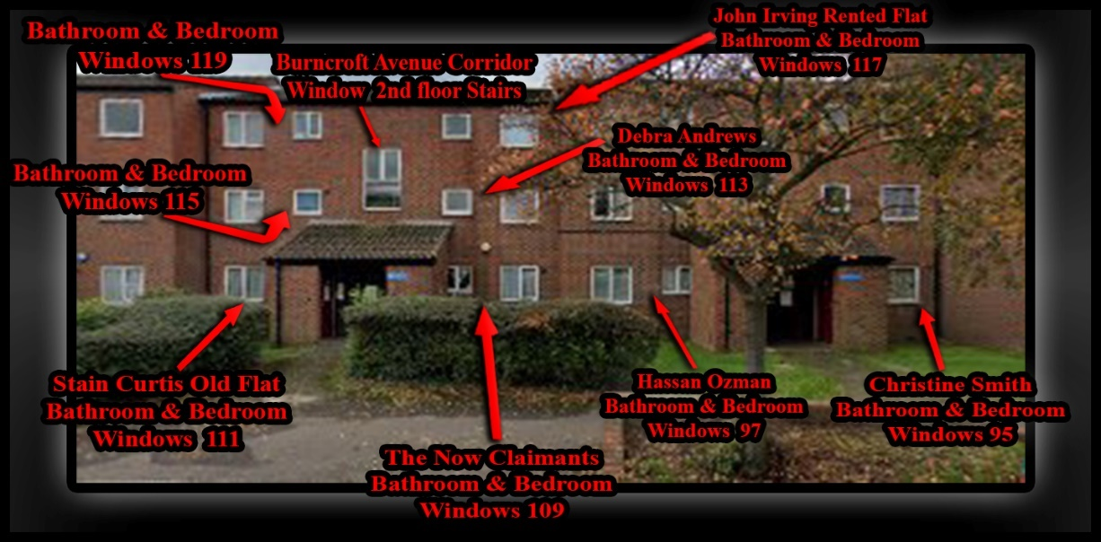  Evidence: Exhibit BB5 – 3 / 00/00/2006:  - This is a picture of the front layout of Burncroft Avenue  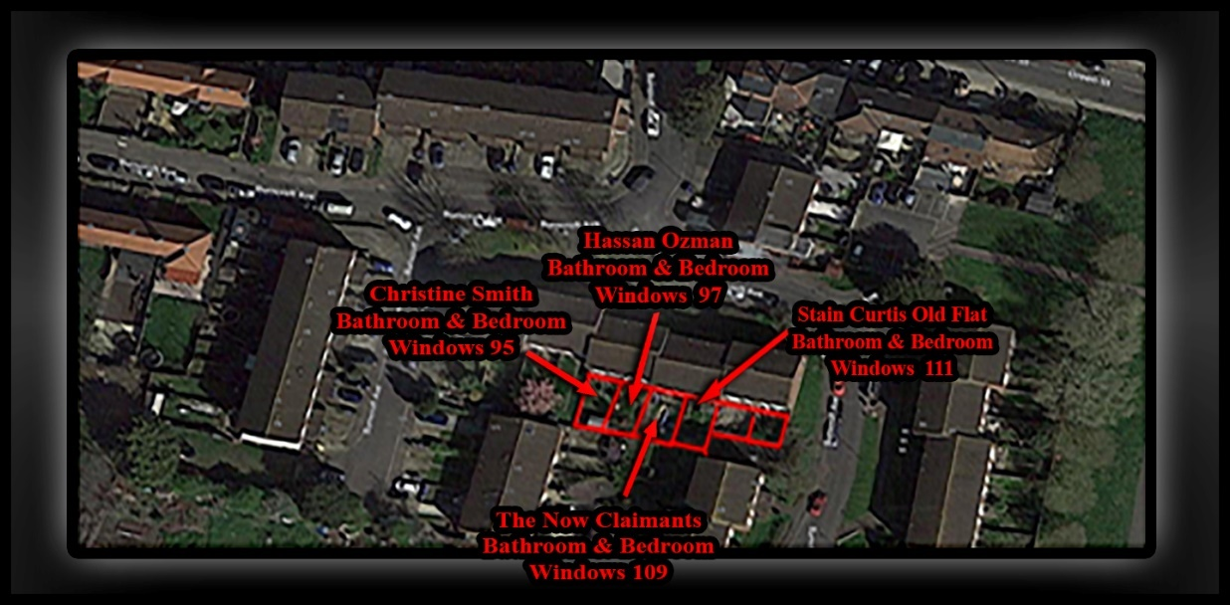  Evidence: Exhibit BB5 – 2 / 00/00/2006:  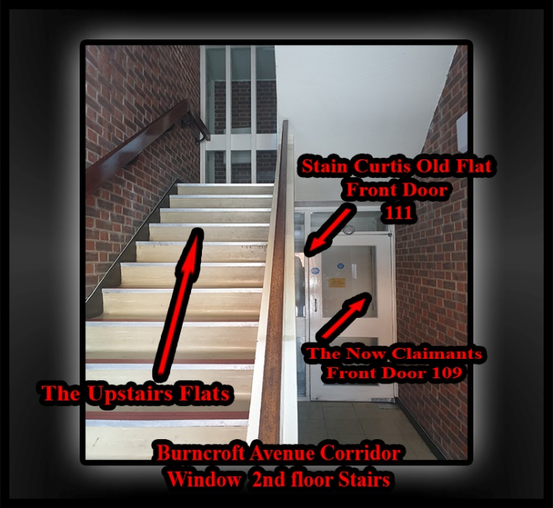  Evidence: Exhibit BB5 – 2 / 00/00/2006:  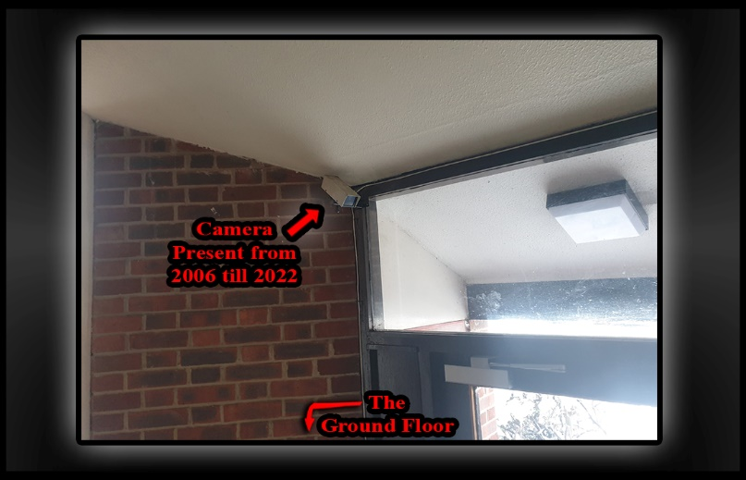  Evidence: Exhibit BB5 – 2 / 00/00/2006:  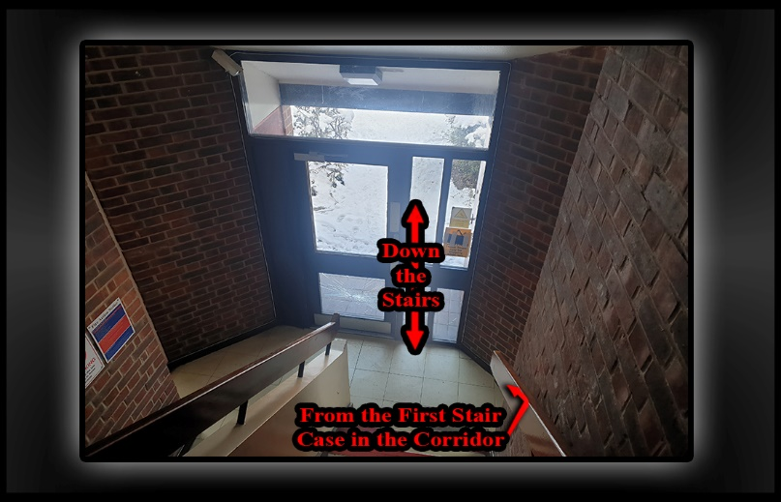  Evidence: Exhibit BB5 – 2 / 00/00/2006:  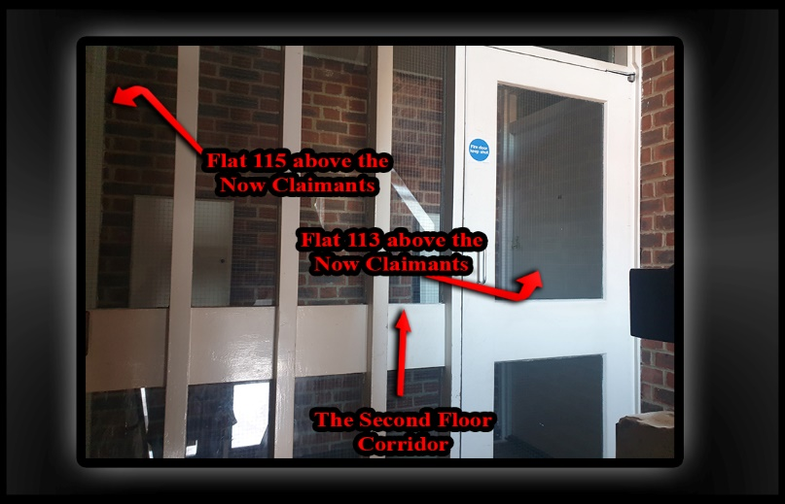  Evidence: Exhibit BB5 – 2 / 00/00/2006:  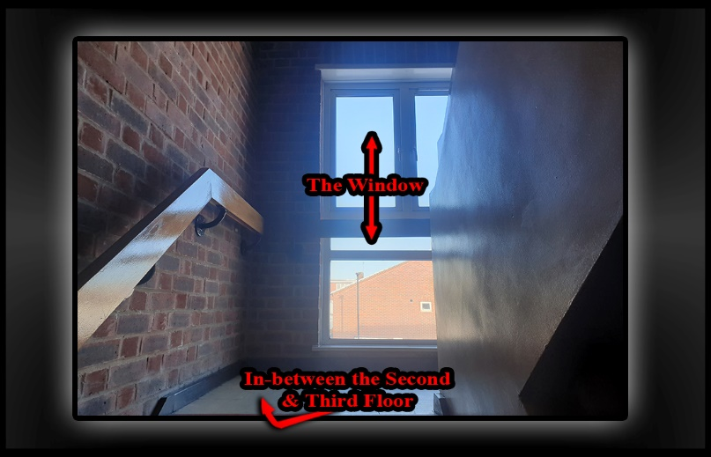  Evidence: Exhibit BB5 – 2 / 00/00/2006:  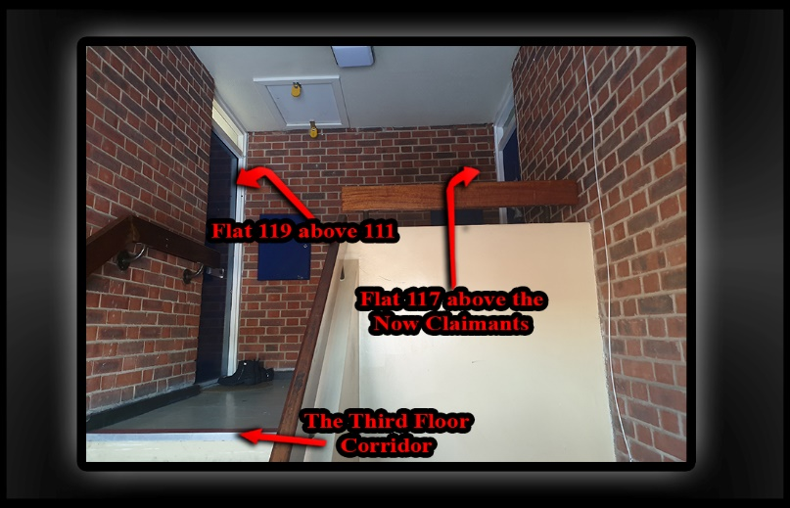

INFO | Statement Exhibit BB0 – 1 / 00/00/2014:  - O
 | - Responsible Doctors  - The reason that we have adduced this exhibit into these proceedings is because | 00/00/2014 | Evidence: Exhibit BB5 – 1 / 00/00/2014:  Evidence: Exhibit BB5 – 2 / 00/00/2014:  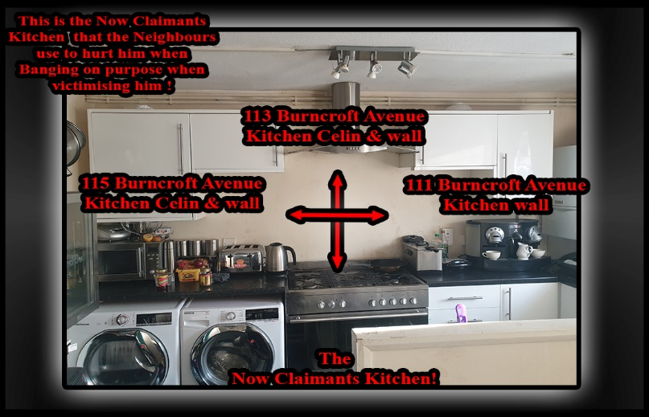

- First time I met White Couple
A

- First time I met 2nd Turkish looking woman
- 18/03/2017
- CRIS 5210999/17 - Subject's female neighbour at number 115, reports that Subject has knocking at her door, following her to her car and asks her why she has been making noises. Neighbour thinks Subject has mental health problem s. 1st instance harassment warning has been issued to Subject.

Lemmy
- 20/03/2017
I visited 109 Burncroft Avenue on 17/03/2017 to hand deliver to post a letter through Mr. Cordell’s door and as I got into my car to drive off after posting the letter, Mr Cordell ran after me shouting and screaming abuse. I did not stop to speak to him and he ran after me until I turned left into Green Street, as he was running after my car, he was shouting at people passing by to stop the car.
By the time I returned to the office, Mr Cordell had telephoned me several times. I telephoned him back and he wanted to know whether I was the person that posted a letter through his letterbox and I said yes. He asked why
did not stop when he ran after me and I told him that I had another visit and did not have the time to stop and talk to him. He stated that he will not attend the meeting at the Civic Centre or any of the council and that I should come to his flat. I offered to have the meeting at a neutral venue like the local library or even at his mother's house, but he refused and shouted to shout abuse and accuse me of taking sides with his neighbours. He denied doing the things that he is accused of doing and stated that he is the victim and that the council have refused to deal with his complaints against his neighbours. He stated that he has been suffering noise disturbances from his neighbours since he moved into his flat and that the council have refused to deal with it, He alleged that the council is conniving with the police to victimise him and threatened to put in a complaint. against me. He continued shouting abuse and will not Set me say a word. I then advised him that I will have to terminate the conversation as we were getting nowhere,

- First time I met 3rd Light skin Girl and Light skin Bloke

21/05/2021
The girl in 117 moved out.
R. lynch is her name I am not too sure of her first name.
This led me to doing some searches on the internet and I decided to look for the other people’s names that live on my estate that have been hurting me for the first time as well I spent the next couple of days doing this right up a till todays date of the 06/06/2021 when I started writing down what had taken place on the 08/09/10 of the 05/2021

