DEFENCE STATEMENT

(Criminal Procedure and Investigations Act 1996, section 5 & 6; Criminal Procedure and Investigations Act 1996 (Defence Disclosure Time Limits) Regulations 2011; Criminal Procedure Rules, rule 15.4)

This is my 3rd defence statement
WITNESS STATEMENT
Criminal Procedure Rules, r27. 2; Criminal Justice Act 1967, s. 9; Magistrates’ Courts Act 1930, s.5B
URN

Statement of: Mr. Simon Paul Cordell
Age if under 18: Over (if over 18 insert ‘over 18') Occupation: News Reporter!
This statement (Consisting of 21 Page{s) each signed by me) is true to the best of my knowledge and belief and I make it knowing that, if it is tendered in evidence, I shall be liable to prosecution if I have wilfully stated in it anything which I know to be false, or do not believe to be true.
Dated: 18/11/2025
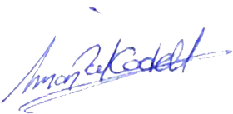

(Signed)

(On behalf of Mr. Simon Paul CORDELL) (Date Signed) 03/12/2025

- Unlawful Actions Taken Against Me by Rebbeca O’ Hare and Co!
- The unlawful actions taken against me by the occupier Rebbeca O’ Hare of 115 Burncroft Avenue, and her collaborators. These persons illegal actions were achieved through coordinated setups, false allegations, and procedural manipulation, all of which are documented and exhibited through the following evidence:

- Exhibits 1, 2, 3, 4, 5: Evidence Covering the Years 2006 to 2011
- We hereby submit the Claimant’s “Exhibits 1, 2, 3, 4, 5” in support of these court proceedings. These Exhibits all contain contemporaneous entries spanning the years “2006 till 2025” and are presented as evidence for the following reasons:
- Exhibits 1: -- These are the Emails: that my mother sent on my behalf due to me going to her and explaining what my neighbors were doing to me illegally rather than going to their front doors.
- Exhibits 2: -- Contains two Enfield Council Report Forms that both initiated Mr. Simon Paul Cordells Diary to be developed.
- The First Form given to him to fill in was: “The Enfield-Council-Incident Diary-Received.pdf”
- The Second Form given to him was: “The Enfield Insurance Incident report form 2013 - 2020.pdf”

- The First Form: The official incident diary form provided by the Enfield Council to us was too restrictive in its layout. The small boxes limited me to “Brief legal Notes,” which prevented me from recording the full details of each incident so, to ensure accuracy, context, and a complete record of events, I was forced to create my own diary alongside the council’s form, but they refused to accept it after I put them in receipt of it allowing Rebbeca O ‘ Hare and Co to continue till date.
- The Second Form: this is what the wood green Police Skipper / custody Officer keeps using to say I got mental health issues behind my back, in his fabricated notes. The Police Skipper I am referring to is the officer who has lost all the past cases against me when helping The Enfield Council label me as the perpetrator and them as the victims when it’s the other way around as Exhibit 1, emails prove as we reported them for months prior to the swap.
- Exhibits 3: -- The Diary: these files document the Claimant’s lived experiences, interactions, and events relevant to the case during the complete period.
- Exhibits 4: -- Housing Transfer and Decorating Files
- Exhibits 5: -- All Case Original Court Application Case Files
- Exhibits 6: -- 2014-Extracts-from-Diary

- Exhibits 1: --
- Weblink 1 To Digital Copy: <Dir> 06. 06-03-2019 Emails Attachments
- Weblink 2 To Digital Copy: <Dir> https://everyoneloginto.me/03.%20R-2014-and-Onwards/06.%2006-03-2019%20Emails%20Attachments/

- Exhibits 2: --
- Weblink 1 To Digital Copy: <Dir> 11. Enfield Insurance and the Incident report forms
- Weblink 2 To Digital Copy: <Dir> https://everyoneloginto.me/03.%20R-2014-and-Onwards/11.%20Enfield%20Insurance%20Incident%20report%20form/

- Exhibits 3: --
- Weblink 1 To Digital Copy: <Dir> 08. Diary 19-10-25
- Weblink 2 To Digital Copy: <Dir> https://everyoneloginto.me/08.%20Diary%2019-10-25/

- Exhibits 4: --
- Weblink 1 To Digital Copy: <Dir> 05. Housing Transfer and Decorating Files
- Weblink 2 To Digital Copy: <Dir> https://everyoneloginto.me/03.%20R-2014-and-Onwards/05.%20HousingTransfer%20and%20DecoratingFiles/

- Exhibits 5: --
- Weblink 1 To Digital Copy: <Dir> 07. All Case Original Court Application Case Files
- Weblink 2 To Digital Copy: <Dir> https://everyoneloginto.me/03.%20R-2014-and-Onwards/07.%20All%20Case%20Original%20Court%20Application%20Case%20Files/

- Exhibits 6: --
- Weblink 1 To Digital Copy: <Dir> 01. 2014-Extracts-from-Diary
- Weblink 2 To Digital Copy: <Dir> https://everyoneloginto.me/03.%20R-2014-and-Onwards/01.%202014-Extracts-from-Diary/

- It provides a chronological account that supports the Claimant’s assertions and timeline.
- It reflects the Claimant’s state of mind, observations, and responses to key incidents under dispute.
- It serves as a primary source of factual reference, unaltered and maintained by the Claimant throughout the years in question.

01 | - Accused as liable  - Doctors!  - Enfield Council!  - Met Police Force!  - The listed occupants apart from 119  - The reason that we have adduced this exhibit into these proceedings is as listed below! |  |  | Evidence: Exhibit 7 /  - This is a picture of the front layout of Burncroft Avenue  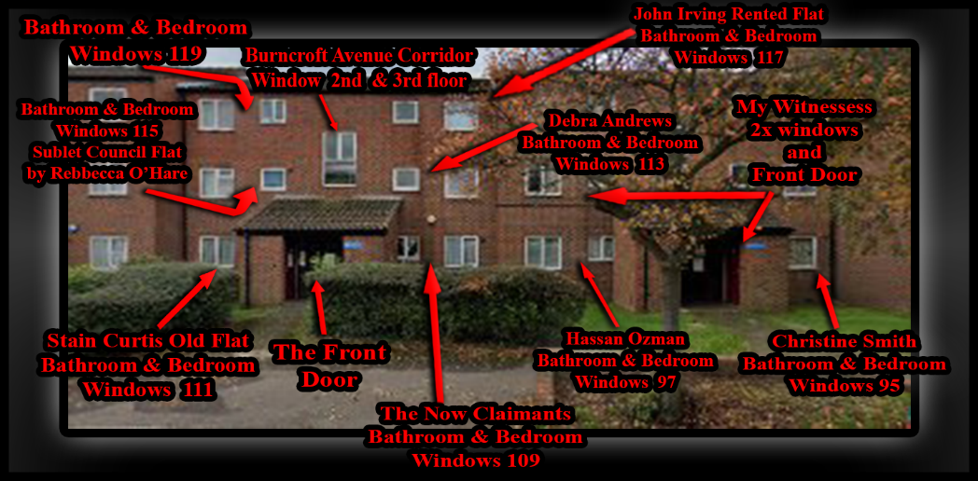  Purpose of the Image:  - This diagram supports my case by:  - Documenting who lives where in relation to “Flat 115 Rebecca O’Hare’s flat.”  - Clarifying visibility and access points, especially relevant to her claims about seeing or being seen.  - Establishing physical layout for forensic contradiction of her timeline.

Breakdown of Labels and Their Significance:
Annotation | Description | Relevance
BATHROOM & BEDROOM WINDOWS 115 | Rebecca O’Hare’s flat | - Rebecca O’Hare (Flat 115,) illegally sublets the council flat, breaching tenancy agreements.  - Her flat’s windows (bathroom & bedroom) are central to her false claims about visibility and movement.  - This map disproves her disapprove ability to see or interact safely as stated, while, exposing her harassment and intimidation against me.  - The image supports the pattern of her illegal occupation and targeted victimization, towards me, undermining her credibility and demonstrating systemic failure to address her misconduct.

Annotation | Description | Relevance
BURNCROFT AVENUE CORRIDOR WINDOW 2ND FLOOR STAIRS | Communal stairwell window | - This is in between the second and third floor but easily accessible for assessing whether she could have seen me or vice versa.

Annotation | Description | Relevance
JOHN IRVING RENTED FLAT BATHROOM & BEDROOM WINDOWS 117 | Another resident’s flat | - Statement: Flat 117 Burncroft Avenue – Council-Enabled Harassment, Fabricated Legal Process, and Evidentiary Breakdown  - Flat 117 Burncroft Avenue, originally rented by John Irving, has been sublet to Enfield Council through a private intermediary, “Ashdale Services Limited,” a residential accommodation management company. Ashdale, in collaboration with the council, places temporary occupants in this flat under statutory frameworks such as the Housing Act. These placements have consistently involved individuals who have participated in sustained harassment, intimidation, and coordinated attacks against me.  - The flat itself has been deliberately neglected and weaponized. Its creaking floors and structural damage are not incidental, they are used by occupants to create psychological disruption. Despite repeated reports, the council has failed to intervene, allowing the flat to operate as a “Torture Room,” with its occupants acting as tools to destabilize my life and dismiss my right to live peacefully.  - This abuse is not isolated. “Ashdale Services Limited,” another property enforcement company, issued notices permitting random inspections and threatening eviction for damages but yet they have ignored the deliberate misuse of the property by council-placed individuals, as I reported them or as they should have been inspected. This dual failure by both Ashdale and Enfield Council has enabled a system of abuse, surveillance, and environmental harm that violates my rights and safety.  - In one particularly egregious incident, “John Irving Attempted To Break Into My Home,” falsely claiming to be a plumber. I immediately reported this to a council officer named “Lemmy” and recorded the interaction. Instead of investigating or protecting me, Lemmy met with John Irving and together they produced a “Fabricated Statement” designed to cover up the break-in attempt. This false statement was later used in a possession order against me.  - However, due to the strength of my evidence, including recordings, surveillance logs, and witness accounts they could not bring the cases to trial and the Housing possession order cases, and two injunction order cases were all lost. Yet the authorities continued to trap me in an “Illegal And Abusive Legal Process,” imposing conditions based on “Fraudulent And Fabricated Claims.” These actions were designed to set me up, to keep me confined within a system that ignored due process and enabled ongoing harm.  - The council’s failure to act on tenancy violations, their complicity in enabling harassment, and their reliance on falsified documentation all point to a coordinated effort to undermine my existence. The misuse of Flat 117 and surrounding properties has had a direct and measurable impact on my health, safety, and legal standing.  Evidence: Exhibit 8 /  - Weblink 1: <Dir> This just come out of 117 3rd set of ten in 2 years  - Weblink 2: https://everyoneloginto.me/03.%20R-2014-and-Onwards/This%20just%20come%20out%20of%20117%203rd%20set%20of%20ten%20in%202%20years/

Annotation | Description | Relevance
DEBRA ANDREWS BATHROOM & BEDROOM WINDOWS 113 | Flat directly above Mine! | Timeline of Occupants and Actions from Flat 113 Burncroft Avenue  1. Debra Andrews – Initial Disruption Phase:  - Role: First known hostile occupant of Flat 113.  - Actions:  - She initiated noise-based harassment, deliberately targeting my rest and work hours to disrupt my daily life.  She colluded with other residents to create a hostile and intimidating living environment.  Her behavior set the foundation for a continuing pattern of provocation and harassment originating from this flat.  Furthermore, government officials exploited her vulnerabilities, including her cholesterol and mental health history, the loss of custody of her three children, and her struggle with alcoholism, to fabricate false records against me. They used this to produce misleading reports and misrepresentations of my conduct to themselves, the authorities as part of an illegal campaign to attack me and discredit me.  - Initiated “Noise-Based Harassment,” particularly targeting my rest and work hours.  - She “Colluded with Other Residents” to create a hostile living environment.  - Her behaviour laid the groundwork for what would become a “Pattern of Provocation” from this flat.  - She was involved and used by Government Officials illegally to attack me they used her cholesterol mental health history and prior 3 children taken away from her as well as alcoholism dependency in creating “False History Against Me Were They Developed a Fake Record of False Reporting and Misrepresentation of My Conduct” to authorities.  Followed Then Afterwards By: --  2. George Quinton – Escalation and Surveillance:  - Role: Successor to Debra Andrews.  - Actions:  - Introduced “Surveillance-Like Behaviour,” including monitoring my movements and interactions while mentally and physically attacking me.  - He deliberately victimised me and copycatted the prior occupant.  - George Quinton – Escalation and Deliberate Neglect: While Debra Andrews was still residing in the flat, my mother and I repeatedly wrote to the council about the poor and unsafe condition of the floors. When Debra moved out, the council placed builders into the flat and then assigned George Quinton as the new occupant. The council claimed that all repair work had been completed, but this was false, they had only been pretending to replace the floor. When George allowed my mother and me into the flat, we discovered that the floor had been cut into numerous uneven pieces, resembling the piano keys in the movie Big that Tom Hanks famously jumps on. The nails were improperly fixed, especially at the corners, creating multiple trip hazards on each section of the floor. This dangerous flooring was deliberately left in this hazardous state, seemingly to enable George to continue copying Debra’s pattern of harassment and victimisation. The council’s failure to properly repair the flat not only ignored safety standards but actively facilitated ongoing abuse against me.  - His tenure marked a shift from passive disruption to “Active Targeting.”  Followed Then Afterwards By: --  3. Ambrose – Tactical Provocation:  - Role: Occupant following George Quinton.  - Actions: Pattern of Council-Enabled Harassment: Debra Andrews, George Quinton, and Ambrose Atoro!  - Debra Andrews – Foundation of Provocation:  - Debra Andrews was the initial occupant whose behavior laid the groundwork for sustained harassment.  - She initiated “Noise-Based Attacks,” deliberately targeting my rest and work hours.  - She “Colluded With Other Residents” to create a hostile living environment.  - Her conduct established a “Template Of Provocation” that subsequent occupants replicated.  - Critically, Debra was “Used Illegally By Government Officials” to attack me. They exploited her vulnerabilities, including her mental health history, cholesterol issues, alcoholism, and the loss of custody of her three children, to fabricate a false narrative against me.  - This manipulation led to “False Reporting And Misrepresentation Of My Conduct,” forming the basis of a fraudulent record used to justify further legal action.  Followed Then Afterwards By: --  George Quinton – Escalation, Surveillance, and Council Negligence  - George Quinton succeeded Debra and escalated the harassment.  - George Quinton was placed in the flat following Debra Andrews, continuing and escalating the pattern of harassment against me. His behavior included:  - Surveillance-Like Monitoring: tracking my movements and interactions.  - Mental And Physical Intimidation: including deliberate noise-based disruption during legal preparation.  - False Reporting And Misrepresentation Of My Conduct: submitted to authorities to reinforce a hostile narrative.  - Exploitation Of Unsafe Housing Conditions: including a deliberately fragmented floor left unrepaired by the council. When my mother and I were later allowed into the flat, we documented the flooring, cut into uneven sections with improperly fixed nails, creating trip hazards and psychological stress.  - George’s conduct was not isolated, it was shaped by a vulnerable personal history. He suffers from Mental Health Issues, stemming in part from the Loss Of His Mother At A Young Age, which left him emotionally destabilized. This trauma contributed to his susceptibility to manipulation and erratic behavior. There are also serious allegations concerning Sexuality Exploitation During His Youth, which may have further impacted on his psychological state.  - Despite his known vulnerabilities, Enfield Council Placed George In A Flat Already Associated With Harassment And Provocation, without safeguards or supervision. Rather than offering support, the council enabled a situation where George’s instability was weaponized allowing him to replicate and escalate the tactics used by Debra Andrews.  - This placement must be viewed as part of a broader pattern of Council-Enabled Provocation, where vulnerable individuals with known histories were strategically positioned to destabilize me and obstruct my legal defence.  Ambrose Atoro – Strategic Placement Despite Violent History:  - Ambrose was placed in the flat after George, despite a Documented History Of Extreme Violence.  - At age 20, Ambrose committed a Brutal Armed Robbery at Brick Lane Post Office, assaulting the postmaster with a fake handgun and causing grievous bodily harm.  - He had Escaped From Chase Farm Hospital the day before, where he was being held for schizophrenia.  - He was sentenced and transferred under “Section 47 Of The Mental Health Act 1983,” with a “Section 49 Restriction,” meaning he could not be released without approval from the Secretary of State.  - According to housing transfer records dated “12 August 2021,” Ambrose was “Explicitly Barred From Returning To The Area Of His Previous Victim.”  - Despite this, “Enfield Council And Police Placed Him At Burncroft Avenue,” near my residence, already destabilized by Debra and George.  - Ambrose was reportedly offered “Early Release” on the condition of accepting psychiatric treatment, and his placement appears to have been “Strategically Designed To Provoke Further Escalation.”  - Since arrival, he has engaged in “Floor Banging, Verbal Baiting, And Timed Disturbances,” especially during legal preparation, mirroring the tactics of his predecessors.  Legal Implications  - The council’s decision to place three successive occupants, each with escalating patterns of harassment and known vulnerabilities, constitutes “Gross Negligence And Institutional Abuse.”  - They Ignored Safeguarding Protocols.  - They Enabled Coordinated Harassment.  - They Manipulated Vulnerable Individuals To Provoke And Destabilize Me.  - This pattern must be formally addressed in court as part of a broader abuse of process and denial of my right to live safely and prepare my legal defence without obstruction.  - Evidence: Exhibit 9 /  - Weblink 1: <Dir> Ambrose Upstairs  - Weblink 2: <Dir> People - Neighbours Ambrose Newspaper File Master 12-08-21  - Weblink 3: <Dir> 13. Some-MP4-Flat-Attack-Bits  4. Richard Edward Skinner – Current and Most Aggressive Phase:  - Role: Present occupant of Flat 113.  - Actions:  - Engages in persistent and direct provocation, including loud stomping and heavy footsteps directly above my front room during critical times when I am working or preparing legal documentation.  - His actions are deliberately timed and coordinated with council activities to disrupt and interfere with my ability to compile legal evidence, demonstrating a calculated psychological harassment campaign.  - The intensity and nature of his conduct pose a serious threat to my physical and mental well-being, amounting to a life-endangering pattern of harassment through an ongoing spree of illegal actions targeted against.  Evidentiary Pattern:  - Each occupant has “Built Upon the Tactics of The Previous,” escalating from noise and passive disruption to “Active Setups, False Allegations, And Coordinated Interference.”  - The flat itself has become a “Central Node of Harassment,” with each resident contributing to a sustained campaign against me.  - My documentation, including spatial maps, video evidence, and contradiction tracking—clearly shows that Flat 113 has been used as a “Strategic Platform for Destabilization.”

Annotation | Description | Relevance
CHRISTINE SMITH BATHROOM & BEDROOM WINDOWS 95 | Ground-floor flat | Exhibit: Christine Smith – Foundational Role in Coordinated Legal Targeting:  - Subject: Christine Smith, Secure Council Tenant of Burncroft Avenue  - Status: Still the Current Occupier as of 06/10/2025  - Reference: “Secure Council Tenants” registry and Now Claimant’s evidence archive  Summary:  - Christine Smith has remained a “Secure Council Tenant” at Burncroft Avenue, with confirmed occupancy as of “2006.” Over the years, the Now Claimant has amassed a “Large Magnitude of Evidence” showing that Christine Smith played a “Central and Initiating Role” in the illegal activities and administrative targeting that followed.  - Her involvement is not incidental, it is “Foundational.” Without her actions and coordination, “None of The Court Order Applications or Government System Entries” but mostly any “Mental Health History” that allows illegal targeting of the Now Claimant would even exist. She positioned herself as the “Root Cause and Enabler,” working alongside “Co-Defendants and Unnamed Collaborators” to embed false narratives and procedural traps.  Key Points of Involvement:  - Christine Smith’s name appears across “Multiple Government Systems,” linked to applications and entries that “Triggered Legal Actions” against the Now Claimant.  - Her status as a “Secure Tenant” gave her “Institutional Access and Credibility,” which she used to “Seed False Claims” and support fabricated allegations.  - She operated in tandem with “At Least Two Named Individual and Others,”  - Stain Curtis,  - Carron Dunno,  - forming a “Network of Complicity” that spans housing, legal, and administrative channels.  - Her actions laid the groundwork for “Subsequent Setups,” including those involving:  - Flat 113 (Debra Andrews, George Quinton, Ambrose, Richard Edward Skinner) and Flat 115 (Rebecca O’Hare).  Evidentiary Importance:  - Christine Smith’s “Role” is “Not Reactive, It Is Generative.” She is the “Origin Point” for the systemic targeting.  - Her continued occupancy as a secure tenant suggests “Institutional Protection or Oversight Failure,” despite the volume of evidence against her.  - This exhibit supports the claim that the harassment and legal targeting were “Not Isolated Incidents,” but part of a “Coordinated Campaign Rooted in Tenancy Privilege and Administrative Manipulation.”

Annotation | Description | Relevance
HASSAN OZMAN BATHROOM & BEDROOM WINDOWS 97 | Adjacent flat | Exhibit: Hassan Ozman (“Ozzie”) – Criminal Activity and Council Negligence:  - Subject: Hassan Ozman – Secure Council Tenant  - Address: 97 Burncroft Avenue (Next Block of Flats)  - Status: Occupant from “2004” to at least “06/10/2025”  - Alias: “Ozzie” – One person + sub-renters  Summary:  - Hassan Ozman, known locally as “Ozzie,” has been a “secure council tenant” at “97 Burncroft Avenue” since approximately 2004, with confirmed occupancy up to “06/10/2025.” His flat is located in the “Next Block,” but his “Front Room and Bedroom Walls Are Directly Side-By-Side with The Now Claimant’s,” allowing for physical and auditory interference.  - Ozzie has routinely “Rented His Council Flat Out to Loggers,” and this also includes the bedroom alone of whom such illegal loggers have remained a “Persistent and Disruptive Problem.” These sub-renters have contributed to a pattern of illegal activity and environmental destabilization, leading to a complete loss of usage of my bedroom.  Criminal Conduct and Documentation:  - Hassan Ozman has committed “Multiple Crimes Against the Now Claimant,” including acts of aggression and disruption.  - These incidents have been “Documented in The Now Claimant’s Diary,” and supported by “Audio Recordings, Video Footage,” and “Witness Testimony” from third parties.  - One such event is described as an “Illegal Frenzied Escapade,” in which Ozzie was caught in the act.  - Despite the volume and clarity of evidence, both “Enfield Council and The Police Have Refused to Fairly Investigate” or act on the documented crimes.  Spatial Impact:  - Ozzie’s flat shares “Wall-To-Wall Proximity” with the Now Claimant’s front room and bedroom.  - This positioning allows him to “Create Noise, Vibration, And Psychological Pressure,” even from a separate block.  - His use of sub-renters further “Amplifies the Disruption,” creating a rotating cast of hostile occupants with no accountability.  Evidentiary Importance:  - Establishes Hassan Ozman as a “Long-Term, Institutionally Protected Tenant,” despite repeated criminal behaviour.  - Highlights the “Failure of Enfield Council and Police” to act on clear evidence, recordings, and witness accounts.  - Demonstrates how “Spatial Adjacency and Sub-Letting Practices” have been weaponized to destabilize the Now Claimant’s living environment.  - Supports the broader claim that harassment and criminal setups are “Not Isolated,” but part of a “Multi-Flat, Multi-Tenant campaign” rooted in council negligence.

Annotation | Description | Relevance
THE NOW CLAIMANTS BATHROOM & BEDROOM WINDOWS 109 | My flat | Crucial for establishing my location and line-of-sight during the incidents.

Annotation | Description | Relevance
STAIN CURTIS OLD FLAT BATHROOM & BEDROOM WINDOWS 111 | Historical resident | Flat 111 Burncroft Avenue — Tenancy History, Timeline, and Impact on Me  - Tenants Documented:  - Stain Curtis and his wife: Secure tenants until wife’s passing in 2010 and Stain until 2020.  - Janice Burton: Transitional occupant after Stain’s death.  - New Secure Tenant: Assigned “30/09/2022.”  - Timeline and Actions:  - Before 03/09/2010:  Stain Curtis and his wife lived together in Flat 111 as secure tenants. During this time, their presence was stable, and no significant issues were noted affecting me directly.  - 03/09/2010:  Stain’s wife passed away, marking the start of a negative change in the flat’s environment.  - 2010 to ~2013:  After his wife’s death, Stain Curtis began living alone and started drinking heavily and once the tenancy was officially transferred in just Stains name, he soon allowed Debra Andrews to become his drinking partner and lover as they became an intimate relationship. The Enfield Council transferred the flat of 111 into Stain Curtis’ name in “Late 2013” and this is when the harassment escalated.  - 2013 to 14/02/2020:  During this period, I experienced increasing harassment from noises, aggressive behavior, and intimidation originating from Flat 111. Stain’s drinking contributed to a volatile atmosphere and several incidents where he was verbally and physically aggressive towards me, while using his flat as a weapon to hurt and torcher me while no person would protect my life from harm by them. I thought they was going to kill me, and I would become a murder investigation that the police and councils would cover up.  Stain, sometimes together with other occupants or alone, would engaged in targeted actions designed to disturb my peace and wellbeing. This included:  - Loud noises and floor banging directly to my kitchen wall and Rebecca O’Hare would copy the him and the last tenants of 115.  - Aggressive confrontations and threats, some of which I recorded.  - Ongoing intimidation that affected my ability to live and work peacefully or defend myself fairly in the courts of law.  - The environment created by Stain and others volatile and contributed heavily to my distress during these years.  - February 2020 – October 2021: The Shiftwork of Harassment  Stain Curtis’s death in mid-February 2020 didn’t mark the end of the campaign—it marked its evolution. Flat 111 may have gone quiet for a moment, but the silence was tactical. The surrounding flats, 113, 115, 117. activated like a relay team. The harassment didn’t pause. It rotated.  “They worked in shifts. Rebbeca O’Hare, Richard Edward Skinner, the occupants of 117, Ozzie, and the loggers—each took turns.” Whether it was stomping, baiting, or timed disruptions, the tactics were coordinated. The goal was clear: destabilize me, obstruct my legal work, and provoke reactions that could be weaponized.  Stain’s absence didn’t deter them, it emboldened them. His legacy wasn’t buried; it was inherited. They weren’t just neighbours. They were successors to a blueprint of psychological warfare. Each one tried to outdo the last, chasing notoriety like it was currency. They weren’t just copycats. They were auditioning to be the next headline the next “Hot Killer” in a campaign that the council refused to dismantle.  And through it all, I documented every shift, every sound, every betrayal. Because truth doesn’t sleep, even when they work in shifts.  - Between 2021 and 2022:  Janice Burton briefly occupied the flat as a transitional tenant. Her time in Flat 111 was short-lived, as she gave up her tenancy after incidents that involved her indirectly contributing to the hostile atmosphere and me recording them.  - 30/09/2022:  A new secure tenant was assigned to Flat 111. Since then, the flat’s impact on my situation has shifted just slightly but the history of disruption from this address remains a significant part of the wider pattern of harassment I have endured.  - Summary:  - Flat 111, particularly during Stain Curtis’s tenancy after his wife’s passing, was a major source of harassment, intimidation, and distress for me. The aggressive behavior, noise disturbances, and threatening actions from this flat formed a core part of the hostile environment I experienced at Burncroft Avenue. The transitional occupancy by Janice Burton briefly extended this disruption, and while the new tenant’s impact is currently limited, the legacy of Flat 111’s role in my challenges remains clear, and that being that the police and council officers are the ones that allowed these crimes to flourish.

Annotation | Description | Relevance
BATHROOM & BEDROOM WINDOWS 119 | Upper-level flat | Did not get involved in attacking me!

Strategic Use in Mr S. P. Cordell’s Defence Case:
- This annotated image helps you:
- Disprove Rebecca’s claim: of seeing me in the corridor or being threatened from a specific vantage point.
- Establish your own visibility: e.g., if I were outside or inside during key moments.
- Support witness statements: e.g., neighbours who could or couldn’t have seen the interaction.
- Challenge tenancy legitimacy: e.g., if Rebecca’s flat was sublet or occupied unlawfully.

 | - Accused as liable  - Doctors!  - Enfield Council!  - Met Police Force!  - The listed occupants apart from 119  - The reason that we have adduced this exhibit into these proceedings is as listed below! |  |  |  | Evidence: Exhibit 10 /  - This is a picture of the front layout of Burncroft Avenue  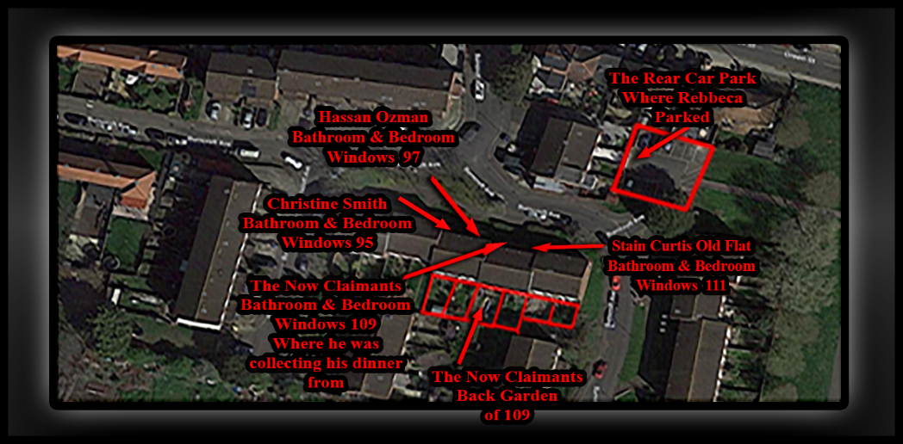
- Exhibit: Christine Smith (Flat 95) – Strategic Surveillance, False Allegations, and Coordinated Access
- Christine Smith, occupant of Flat 95, has played a deliberate and sustained role in the harassment campaign against me.
- Her flat’s “Bathroom And Bedroom Windows Directly Overlook The Front Entrance Of My Property,” giving her a clear and uninterrupted line-of-sight into my daily movements. While such visibility is not inherently illegal, it was “Exploited As A Tactical Vantage Point,” used to monitor, provoke, and ultimately fabricate criminal allegations against me.
- In addition to this visual access, “Christine’s Back Garden And Front Room Provide Indirect Physical Access To My Garden,” separated only by “Ozzie’s Garden,” which served as a narrow buffer. This layout was strategically manipulated. Christine, in coordination with “Stain Curtis” and “Carron Duno,” allowed Carron to use two “Light-Skinned Children” placed under her welfare—children who were not biologically hers, but had been left in her care following the death of their mother, who had been in a relationship with Carron’s male associate.
- Christine Smith then falsely alleged that I had entered my garden and “Threatened The Children,” despite the fact that I had “Not Stepped Into The Garden At All.” The police arrived, refused to disclose the identities of the alleged victims, and proceeded to “Section Me Under False Pretenses.” I was later released on bail and able to “Prove The Truth,” leading to the “Charges Being Dropped In Court.”
- This incident was not a misunderstanding, it was a “Coordinated Setup,” designed to:
- Weaponize Christine’s line-of-sight and garden access.
- Fabricate a criminal narrative to justify police intervention.
- Shield Stain Curtis from exposure for his illegal tapping and harassment, particularly the “Kitchen Wall Tapping” now replicated by Rebbeca O’Hare and others.
- Reinforce a council-backed campaign of obstruction and psychological destabilization.

- Christine Smith’s involvement must be formally addressed in court as part of the “Systemic Abuse Of Process,” the “Normalization Of Surveillance-Based Harassment,” and the “Denial Of My Right To A Safe And Fair Living Environment.”

- Exhibit Hassan Ozman: (Flat 97)
- Hassan Ozman has been involved in coordinated harassment alongside other neighbours. His bedroom and bathroom windows face key communal areas and my flat, enabling him to observe and falsely report my movements or the tenants he sublets the bedroom to. His actions have supported the council’s fabricated narrative and helped sustain the campaign of abuse against me and all while he and his tenants use drill and other objects to bang on my bedroom and front room walls or just simply tap with their fingers.

- Exhibit the Now Claimants: (Flat 109)
- This is my residence. The image marks my bathroom and bedroom windows, as well as the back garden. It also shows where I was collecting my dinner during the incident. This location is central to disproving Rebecca O’Hare’s timeline and supports my documented movements and innocence.

- Exhibit Stain Curtis: (Flat 111, Old Occupant)
- Previously occupied by Stain Curtis, this flat has historical relevance to the decline in community safety, as well as my wellbeing and expectancy of life. It was part of the block where harassment escalated, and its occupants contributed to the toxic environment that the council failed to address.

- Exhibit Rear Car Park: (Where Rebecca O’Hare Parked)
- This is the exact location where Rebecca O’Hare parked on 02/08/2025. The image disproves her claim of entry and interaction, with myself, while showing were she states she remained in the car park while I was outside resolving a delivery issue. Her timeline is physically impossible based on this layout as demonstrated even more so, below!

- Exhibit BB5 – 3: (Front Layout of Burncroft Avenue)
- This image shows the front layout of Burncroft Avenue. It establishes the physical structure of the block, entrance points, and flat positions. It is essential for understanding movement patterns and disproving claims made by neighbours and council officers.

- Exhibit John Irving’s Flat: (117)
- Flat 117 is sublet by John Irving to Enfield Council and Co, who have placed individuals there that have attacked and harassed me. The flat was deliberately left in poor condition, with damaged floors used to provoke and monitor me as I have Exhibited as Mp4 and Jpgs as well as in written statements. Despite reports, the council enabled this abuse, making it part of their coordinated campaign.

 | - Accused as liable  - Doctors!  - Enfield Council!  - Met Police Force!  - The listed occupants apart from 119  - The reason that we have adduced this exhibit into these proceedings is as listed below! |  |  |  |  |  |  | Evidence: Exhibit 11 /  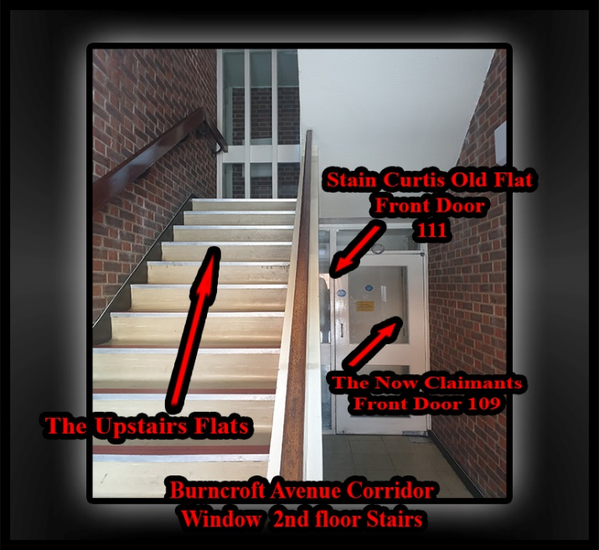
- Exhibit Burncroft Avenue Corridor – 2nd Floor Stairs:
- This image shows the internal corridor layout of Burncroft Avenue, specifically the second-floor stairs. It marks the front doors of Flat 109 (my residence) and Flat 111 (formerly occupied by Stain Curtis), as well as the communal staircase leading to the upper flats. This layout is critical for disproving claims made by neighbours and council officers about my movements and visibility. It shows the physical separation between flats and the sightlines available, directly undermining fabricated allegations about corridor encounters and disturbances.

 | - Accused as liable  - Doctors!  - Enfield Council!  - Met Police Force!  - The listed occupants apart from 119  - The reason that we have adduced this exhibit into these proceedings is as listed below! |  |  |  |  |  |  | Evidence: Exhibit 12/  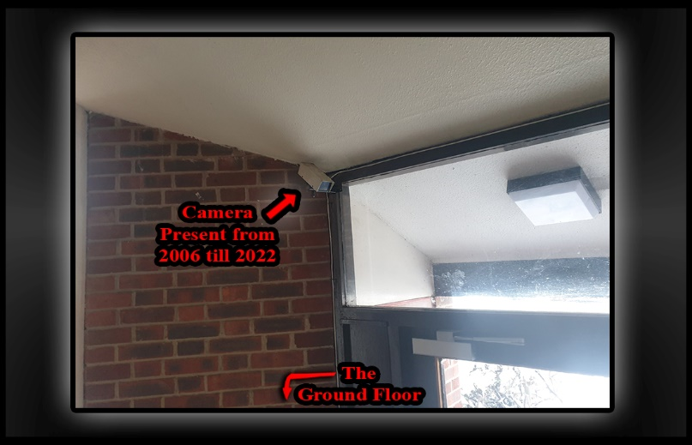
- Exhibit Surveillance Camera Above Communal Entrance
- Location: Ground Floor Entrance, Burncroft Avenue
- Label: Camera Present from 2006 till 2025
- Subject: Long-Term Presence of Resident-Installed Surveillance and Selective Enforcement.

- Summary:
- This exhibit shows a surveillance camera mounted above the communal entrance of Burncroft Avenue, labelled as present continuously from 2006 through 2025. The camera was “Installed by A Resident, Not the Council,” and has remained in place throughout this period.
- In contrast, my prior personal safety camera, installed outside my flat’s front door for protection and to document harassment, was forcibly disabled by police on 14 August 2016. Later that year, Council Officer Sarah Fletcher issued a formal notice demanding its removal by 25 November 2016, with threats of financial penalty, despite no damage being caused or regulation or laws being broken.

- Key Context and Implications:
- The resident-installed communal camera remained untouched, while my safety camera was singled out and removed.
- This selective suppression stripped me of the critical ability to gather real-time evidence, which would have “Undermined the False Council and Mental Health Records Being Constructed Against Me.”
- Those false records never diagnosed as genuine or leading to a conviction were illegally used to justify “Unlawful Orders and Legal Harassment,” manipulated and deliberately fabricated by police and council alongside with true offenders.
- Had my safety camera “Not Been Taken Down,” Rebecca O’Hare would have lacked the means to orchestrate her setup against me with such impunity.
- The council and associated officials’ failure to protect my right to record enabled a “Coordinated Campaign of Harassment and Defamation.”

- Legal and Evidentiary Importance:
- Demonstrates “Deliberate Suppression of Tenant Safety and Evidence-Gathering Tools” while allowing other surveillance to remain.
- Establishes a direct link between the “Removal of My Camera and The Fabrication of False Legal and Medical Histories.”
- Supports claims of “Discriminatory Enforcement and Collusion Between Council, Police, And Certain Neighbours.”
- Highlights how these actions facilitated Rebecca O’Hare’s ongoing ability to harass and set me up without accountability.

- Outcome:
- My camera was disabled and removed starting 14th August–November 2016, leaving me vulnerable and unable to prove my innocence.
- The resident-installed communal camera remained operational through 2025, underscoring the unequal application of surveillance policies.
- This exhibit is central to exposing the systematic denial of my rights and the unlawful campaign against me.

 | - Accused as liable  - Doctors!  - Enfield Council!  - Met Police Force!  - The listed occupants apart from 119  - The reason that we have adduced this exhibit into these proceedings is as listed below! |  |  |  |  |  |  | Evidence: Exhibit 13 /  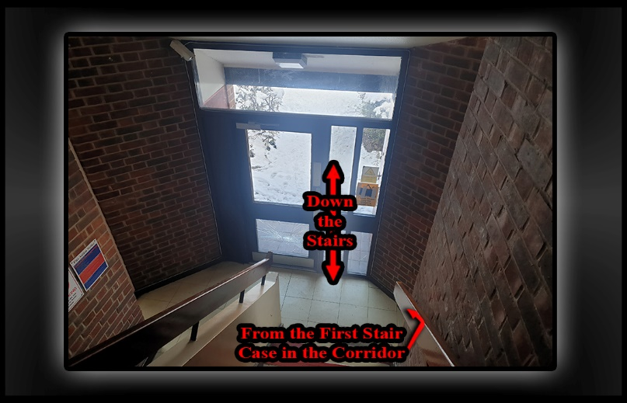
- Forensic Breakdown, Why Rebecca O’Hare’s Stairwell Account Is Implausible
- Rebecca claims she went back downstairs to retrieve a nappy bag, implying a hurried return to the ground floor. However, given the “Close Proximity of The Stairwell to The Front Door,” logic dictates that she would have simply exited directly and “Not Paused or Lingered” in the corridor unless she had a reason to stop.
- If my back was turned at the time, I would not have seen her descending. But as she exited her flat, she would have “Immediately Realised I Was Already in The Corridor and At the Front Door,” based on the timing of my movements. The layout makes this unavoidable.
- Had I heard her footsteps or movement on the stairs, I would have “Naturally Turned Around and Spotted Her.” The stairwell is open, with clear sightlines over the banister. Any person descending would be visible, and any person already in the corridor would instinctively look up or toward the sound.
- For her version to be true, she must have “Deliberately Stopped at The Bottom of The Stairs,” “Rather” than making a direct exit. Her statement does not acknowledge this pause or explain why she would linger, especially if she felt threatened or was in a hurry. This omission is critical.
- Moreover:
- She could have seen me from halfway down the stairs or spoken to me over the banister.
- Her failure to mention this natural visibility suggests “Intentional Narrative Shaping,” not a spontaneous or truthful account.
- Her timeline requires me to be both unaware and present yet not engaged, “A Contradiction” given the confined space and human instinct to respond to nearby movement.

- Conclusion:
- Rebecca’s account is “Logically and Physically Implausible.” It relies on a compressed and contradictory timeline, ignores natural human behaviour, and fails to account for the spatial realities of the stairwell. Her version of events is “Constructed to Support a False Allegation,” not to reflect what actually occurred.

 | - Accused as liable  - Doctors!  - Enfield Council!  - Met Police Force!  - The listed occupants apart from 119  - The reason that we have adduced this exhibit into these proceedings is as listed below! |  |  |  |  |  |  | Evidence: Exhibit 14 /  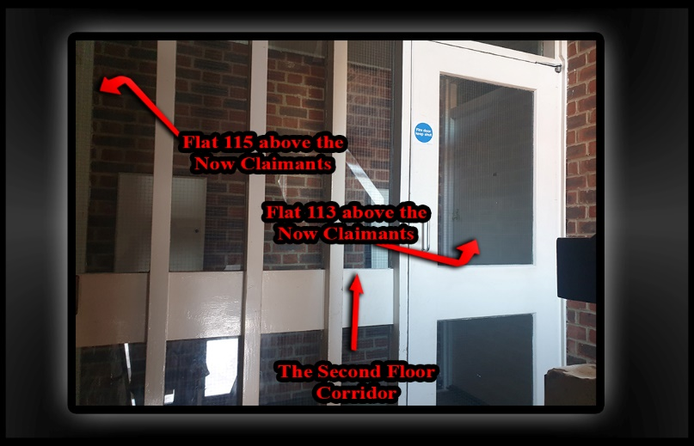
- Forensic Rebuttal: Corridor Layout and False Allegation by Rebecca O’Hare
- Location: Second Floor Corridor, Burncroft Avenue
- Flats Involved: 113 (Richard Edward Skinner), 115 (Rebecca O’Hare)
- Date of Statement: 02 August 2025
- Subject: Misrepresentation of Door Interaction, Builder Engagement, and Threat Claims

- Spatial Reality:
- The “Second-Floor Corridor Is Extremely Narrow,” with only a few feet between each door.
- “Richard’s Door (Flat 113)” is closest to the stairwell entrance and is the first door you reach.
- “Rebecca’s Door (Flat 115)” is directly behind where I stood. Simply “Turning Around Places Me Face-To-Face with Her Door,” if it were present!
- Therefore, “Any Interaction That Occurred Was Incidental and Proximity-Based,” Not targeted or intentional.

- Logical Breakdown:
- Rebecca “Admits I Knocked at Richard’s Door,” not hers. That confirms my intent and direction.
- For her to engage with me, she had to “Come to Her Flat Door Voluntarily,” I did not knock or call for her.
- The “Builder Present at Her Door Spoke to Me First.” Rebecca had “No Authority to Decide Whether He Should Speak to Me.”
- Her claim that I approached her is “Disproven by Her Own Admission and The Corridor’s Layout.”
- The interaction only occurred because “She Inserted Herself into The Situation,” not because I sought her out.
- In contrast, “Rebecca O’Hare Resides in Flat 115,” which is positioned “Above My Hallway but To the Side of My Hallway and Kitchen.” Our bedrooms have an “Open Gap Between Them Consisting of the Hallway and Stairs,” meaning that her bedroom is adjacent but not directly above mine and to the side of mine.
- Rebecca has used this positioning to cause targeted disruption in the following ways:
- From her “Hallway,” she squawks and creaks the floorboards, using these sounds to make me unwell by monitoring movement and creating tension through her presence, while deliberately attacking me with pre-meditated intent.
- From her “kitchen”, she has repeatedly banged on floors and walls, sending vibrations directly into my kitchen and front room, and into my body and ears and this effects where I cook, work, and rest.

- Evidentiary Significance:
- Her statement contains another clear contradiction: acknowledging I knocked at Richard’s door, then claiming I was “Banging on Her Door,” which was “Removed by The Contractor,” as she herself states.
- The “Tight Layout of The Corridor Makes It Impossible to Be Near One Door Without Being Near the Other, But My Proximity Was Not Intended.”
- Her version of events is “Structurally and Spatially Implausible” and designed to support another “False Allegation.”
- The “Video She Submitted Does Not Contain the Threats She Claims to Have” and disprove her serious accusations.

- Conclusion:
- Rebecca’s claim that I approached her or threatened her is “Factually Incorrect and Contradicted by Her Own Words, The Corridor Layout, And Her Video Evidence“. I knocked at Richard’s door in response to harassment. She chose to engage, and the builder-initiated contact. The layout of the corridor means any interaction was incidental. Her narrative is not supported by the “physical environment, the timeline, of her events or in collaboration with the factual evidence” and must be treated as a “Fabricated Account Designed to Criminalize Proximity and Silence My Self-Defence.”

 | - Accused as liable  - Doctors!  - Enfield Council!  - Met Police Force!  - The listed occupants apart from 119  - The reason that we have adduced this exhibit into these proceedings is as listed below! |  |  |  |  |  |  | Evidence: Exhibit 15 /  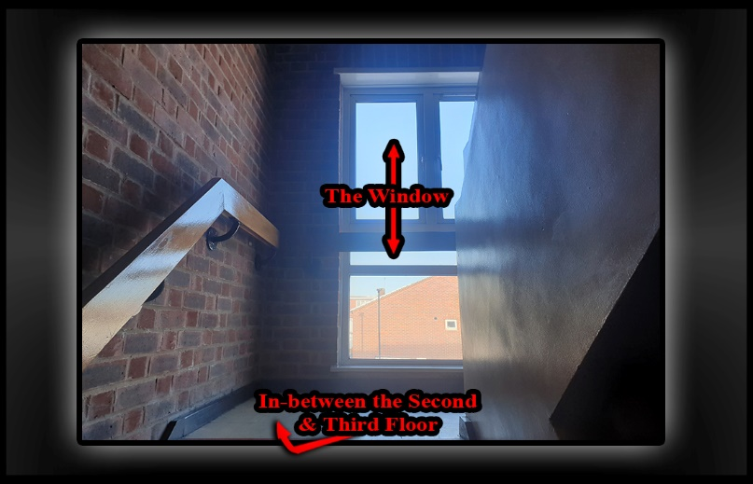
- Stairwell Access and Observation Point
- The stairwell between the second and third floors provides “Easy and Direct Access” to the last two flats in the block. Its location and design make it a convenient route for residents moving between floors without having to use the main corridor extensively.
- Additionally, this stairwell area serves as a natural “Observation Point,” which Rebecca could use to monitor activity at the building’s front entrance, much like how her bathroom and bedroom windows offer views to keep an eye on the surroundings.
- This positioning allows for discreet observation and could contribute to her awareness of who is coming and going, reinforcing her ability to watch the communal spaces without needing to be at the front door constantly.

 | - Accused as liable  - Doctors!  - Enfield Council!  - Met Police Force!  - The listed occupants apart from 119  - The reason that we have adduced this exhibit into these proceedings is as listed below! |  |  |  |  | Evidence: Exhibit 16 /  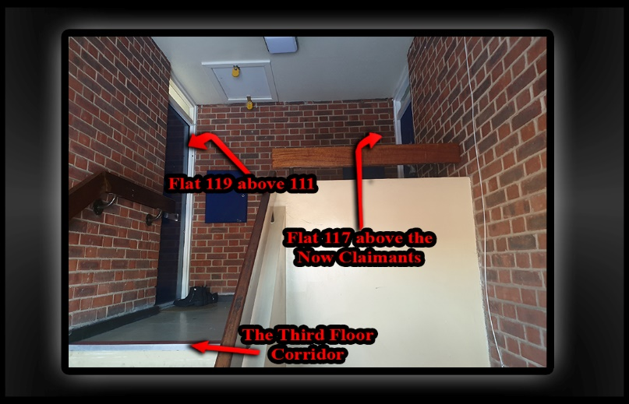
- Statement: Comparative Impact of Flats 117 and 119 on My Home
- Location: Burncroft Avenue.
- Flats Involved:
- Flat 117 (Mathiylagans) – Full-room impact.
- Flat 119 – No involvement

- The harassment I’ve faced began with the occupants of “Flat 117,” the Mathiylagans family, as documented in my “2014 and Onwards” file starting at Section 2014. Due to the structural layout of the building, “Flat 117 Sits Directly Above My Flat” but with 115 in between allowing them to affect “Every Room in My Home and Bedroom, Kitchen, Hallway, Bathroom, And Front Room and All Through Deliberate Noise, Floor Banging, And Coordinated Disruptions.” This was a 24-hour 7 days a week attack against me a human being and British citizen.

- Evidentiary Importance:
- Establishes the “Full-Spectrum Harassment from Flat 117,” beginning years prior and affecting all rooms.
- Clarifies that “Rebecca’s Influence Is Spatially Limited but Strategically Disruptive,” focused on the most sensitive areas of my home.
- Supports the claim that the flat of “117 Occupants Flat Has Contributed to A Sustained Campaign of Psychological Pressure,” exploiting their spatial advantage with other neighbours such as Rebbeca O’Hare!

INFO |  | Statement Exhibit BB0 – 1 /
 |  | - Accused as liable  - Doctors!  - Enfield Council!  - Met Police Force!  - The listed occupants apart from 119  - The reason that we have adduced this exhibit into these proceedings is as listed below! |  |  |  |  | Evidence: Exhibit 17 /  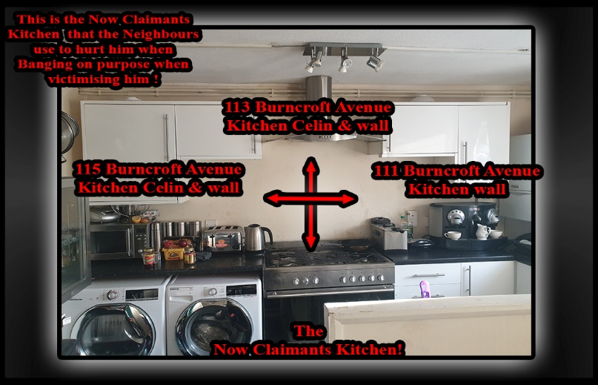
- Picture-111-115-117-Attack-Point – Coordinated Harassment via Kitchen Adjacency and Weaponized Flooring
- This image shows the reality of my living conditions and the coordinated harassment I continue to endure. My kitchen—labelled as “The Now Claimant’s Kitchen” is surrounded by “Flats 111, 113, 115, and 117.” These aren’t just neighboring units. They are tactical positions used to target me.
- “Flat 111,” previously occupied by “Stain Curtis,” was the origin point of the harassment. He lived on the ground floor, on the same block, next side to me. He initiated the wall tapping, especially through the kitchen wall, timed to provoke and destabilize me. His tactics were deliberate, rhythmic, and psychologically invasive.
- Directly above him in “Flat 115, Rebbeca O’Hare” moved in and continued the harassment seamlessly. She didn’t just replicate Stain’s tactics—she escalated them. Her flat gives her access to both the vertical floors and shared walls, which she uses to mirror the tapping, stomping, and baiting techniques. She lives in the same block next side to me, and her actions are rehearsed and deliberate. She operates as if inheriting a role, using the same timings, same pressure points, and same psychological triggers.
- “Flat 119,” which sits above both 111 and 115, has not been involved.
- On “My Side Of The Block,” the harassment is just as coordinated. “Flat 113,” currently occupied by “Richard Edward Skinner,” continues to use the floors to attack me. His flat was previously occupied by “Ambrose Atoro,” and after Ambrose moved out, the council attempted a superficial fix to the flooring. I was present when the work was carried out. They sprayed foam under the main beams on one side of the room—not a proper structural repair, but a cosmetic patch job.
- Richard has deliberately re-damaged the temporary fix. He replicates the tactics of previous occupants, using the same beam-based mechanics to generate impact. By standing on one end of the long beam near his front door, he lifts the entire floor section—then drops it with force, creating targeted bangs directly above my kitchen. He does this in “Every Room,” not just the kitchen. The attacks extend above my “Bedroom And Toilet,” areas I’ve been unable to safely access since “2014 And Even Before.” If I enter those rooms, I am “Visibly Attacked,” the harassment intensifies, and the banging becomes violent and targeted.
- Above 113 is “Flat 117,” originally occupied by “Mathiylagans and Co.” “Co” refers to a cousin named “Kanthren,” who was hiding inside the front room. He pretended to live in “Flat 119” but was actually operating from 117, where he initiated the early tapping attacks. Mathiylagans allowed and supported him, giving him cover and access. When the tapping began above my head while I was working, I went directly to Mathiylagans to ask who was responsible. They blamed “Debra Andrews,” a deflection I didn’t understand at the time, because I didn’t yet know about Kanthren’s presence.
- I then knocked at Debra’s flat to ask her directly. She blamed Mathiylagans in return. No one took responsibility. No one stopped. The harassment escalated. At that time, “Stain Curtis was in a Relationship With Debra,” and together they joined the pattern, using their positions to contribute to the noise setups and psychological pressure.
- This isn’t incidental. It’s structured. Each flat plays a role. The floors have been altered, the walls exploited, and the council continues to allow it. My kitchen, my workspace, my home—turned into a battleground by design.
- The harassment is rotational, coordinated, and council enabled. And I continue to document every moment of it.

(Signed)

(On behalf of Mr. Simon Paul CORDELL) (Dated Signed) 03/12/2025

Signature witnessed by:

