DEFENCE STATEMENT

(Criminal Procedure and Investigations Act 1996, section 5 & 6; Criminal Procedure and Investigations Act 1996 (Defence Disclosure Time Limits) Regulations 2011; Criminal Procedure Rules, rule 15.4)

This is my 7th statement
Key-Screenshot– Just-Eat-Timining-and-115-Rebbeca -Statement!

WITNESS STATEMENT
Criminal Procedure Rules, r27. 2; Criminal Justice Act 1967, s. 9; Magistrates’ Courts Act 1930, s.5B
URN
Statement of: Mr. Simon Paul Cordell
Age if under 18: Over (if over 18 insert ‘over 18') Occupation: Newspaper Developer
This statement (consisting of 8 page{s) each signed by me) is true to the best of my knowledge and belief and I make it knowing that, if it is tendered in evidence, I shall be liable to prosecution if I have wilfully stated in it anything which I know to be false, or do not believe to be true.
Date: 07/08/2025
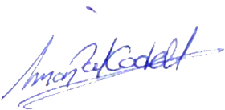

(Signed)

(On behalf of Mr. Simon Paul CORDELL) (Date Signed) 04/12/2025

- The reason that we have adduced this exhibit into these proceedings is as listed below!

- Exhibit Bundle: Just Eat Delivery, Timeline Contradictions & Procedural Breakdown
- Exhibit A: Just Eat Order Confirmation – Timestamped Alibi
- Order Number: 654529129
- Delivery Date & Time: Saturday, 02 August 2025 at 20:15
- Delivery Address: 109 Burncroft Avenue, Enfield, EN2 7AE
- Clarification: This address is “Equivalent To 109 Burncroft Avenue,” my legal residence.
- Payment Method: Credit/Debit Card ending in **

- Evidence: Exhibit A1 /
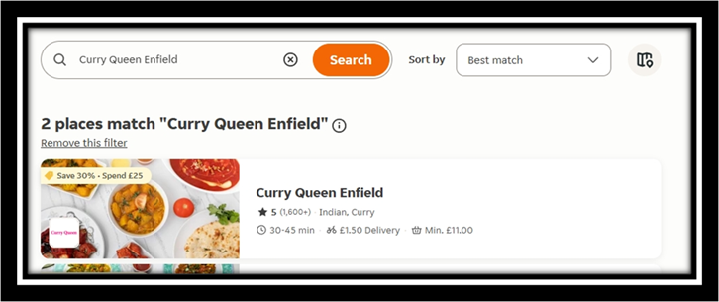
- 30 to 45 mins wait time for delivery.

- Delivery Wait Time: Exhibit A1 /
- The listing states a “30–45-Minute Average Delivery Window,” which helps estimate the time it took for the driver to return with missing items.
- This time marker is crucial for establishing my “Location And Activity Window,” especially when cross-referenced with my “Telephone Records” (attached in the next exhibit).

- Evidence: Exhibit A2 /

- Delivered Say 02 Aug 2025 20:15Pm

- Exhibit A2 /: Timeline Contradiction – Rebbeca O’Hare’s Allegation vs. Proven Activity

Events | Time | Important notes proved & File Sources
I order food. Exhibit A1 Proves 45-Minute Wait Time. | 19:40 | Exhibit A1
The food company marks “Order Delivered” 5 minutes before the delivery driver had arrived and delivered the food to me. | 20:15 | Exhibit A2 (screenshot evidence)
Once the 45‑minute wait time was complete, I received Exhibit A4 which proves the exact time the delivery driver called me upon his arrival outside with the food I ordered. | 20:20 | Exhibit A4 (call log)
I am outside collecting the food. The exchange took less than 1 minute as I live on the ground floor and was waiting since I ordered the food. If Rebecca O’Hare had seen me, it could only have been when she drove past. | 20:21 | Exhibits A1 + A4
Rebecca states she never went past me other than when she drove past. The Delivery Driver was not present at any time according to her recollections.  From this point, it took Rebecca 31 minutes to call the police. | 20:21  Till  20:52 | Rebecca MG11
I headed back towards my front door but turned around instead of entering it because I noticed the food was short. I shouted to the delivery driver as he was about to start his car and drive off, meaning that I had then managed to stop him, he quickly returned to the communal front door; all happened between me and the delivery driver momentary as our exchange happened at first within seconds! | 20:22 | Exhibit A4 (driver presence confirmed)
The delivery driver spent “Around 5 Minutes” attempting to resolve the missing‑food issue before agreeing to hurry off and return with the remainder of the missing order. | 20:27 | Exhibit A4 (driver call log confirms ongoing contact and re‑return arrangement)
Rebecca states she at no point in time went past me and the delivery driver. | — | Rebecca MG11 statements (all three)
I re-enter my front door awaiting for the missing food after the confirmation about the return of the delivery driver to replace the missing ordered food. | 20:28 | Exhibits A1 + A4
Rebecca must have gone inside of the block of flats at this time according to her own admissions in her statement. | 20:28 | Rebecca MG11
She states that she hurried her children inside of the Flat 115 Burncroft Avenue and closed the door.  She claims she immediately re-left her flat but if we allow her 5 minutes grace for her to realise that she still needed to collect her missing nappy bag, the alleged threat time becomes from : 20:34 till 20:29! | 20:29 | Rebecca MG11
Alleged Threat About a Car that Rebbecca O ‘ Hare Parked in the Burncroft Carpark for The First Time that I Ever Knew Of:  No Time Grace Work Out:  This is when she says she would have seen me 20:29 till 20:34. But we gave grace for this time as she is likely to say she was in her flat working out the nappy bag was missing or had already headed down the stairs. But we prove this would be to no person being there.  With 5-minute Grace Worked Out:  Alternative, if she had waited the 5 minutes and left this would have happened from 20:34 till 20:41 But I was still not outside as the delivery driver would had been present with me and this would have not happen until the delivery driver was outside and not driving so, he could telephone call me as he did at 20:40.  Additional Notes:  At that time the delivery driver and food bag were both present with me on each occasion but neither of these rememberable items are mentioned in Rebecca O’Hare’s statements.  I am said to have turned around from my back facing her but Rebecca O’Hare’ states before I turned around to face her that she heard me speaking to her, but she could not hear what I was saying to her, how is she sure of any of these facts then?  Rebecca then states she called me and I turned around but as the exhibits prove I am still not present and therefore not this person or she is lying!  From 20:29 till 20:41 when at 20:41 I am back in the corridor with another person there is 12 minutes but due to the 5-minute grace we grant for her to discover her missing nappy bag and for her to then leave her front door she is in the corridor alone for another 7 minutes.  12 or 7 minutes after claiming to see me as a person when the exhibits prove I was not there, Rebecca O’Hare next chooses to make a 999-telephone call about me as an “Invisible Person” she must have thought she see or maybe someone she thought resembled me but I as a person was not present and because it was not me this really happened with or I would remember it and the time logs of events would fit her explanation also as another fact I was inside of my flat eating my food while awaiting a further call about the missing items so I could eat even more and this was until I was disturbed at 20:40.  Rebecca O’Hare has most likely heard my voice in the corridor talking to the delivery driver or / and looked out of her window then fabricated the alleged offence to the police met ccc that I kept harassing her and elaborated on her false claim another additional part that now I have also threatened to damage her car and in knowing this never really happened.  Rebecca O’Hare car is a car that no one could have known, especially me to be her own, as I don’t know her like that  In person nor had she told me she could legally drive and had lawfully acquired it and had she personally told me then I would have known. In other words, she is asking the court to believe I somehow recognised and threatened a mystery vehicle I had no way of knowing existed of hers or even if it was even hers and what would be a feat closer to clairvoyance than reality. Rebecca O’Hare’s statements does not prove that I knew she “Owned” or “Could Drive a Car,” neither does she prove that I had any intent to commit such an offence and therefore the allegation of Threats to Cause Criminal Damage collapses under Rebecca O’Hare’s own impossibility. | 20:34 | Rebecca MG11
The 7-Minute Corridor Gap Of Me Not Present: From 20:34 until 20:41  Or the 12 -minute corridor gap of me not present: From 20:29 until 20:41 Rebecca O’Hare is supposedly outside but exhibits prove I was not present.  Also, Rebecca has provided no evidence she herself descended down the stairs and this is because of their is no signature from her signed in her own statement. Therefore, she has no legally admissible defence. | 20:34–20:40 | Exhibits A1–A4
The delivery driver returned with the missing food for the second time, as Exhibit A4 the call logs and their time records prove. | 20:40 | Exhibit A4 (call log)
At this point of time, I was walking out my front door and towards the bottom of the staircase, while the driver was waiting at the communal front door. If Rebecca O’Hare had exited her flat then, she would have noticed me and the delivery Driver together and the food bag. Rebecca’s MG11 statements proves she did not see us. | 20:40  Till  20:41 | Exhibit A4
Rebecca states she never passed me or the driver. As for the truth, she could not have seen me at all. | — | Rebecca MG11
12-Minute Missing Window: From 20:41 (driver present) until 20:52 when any (Logical CAD Suggested Created Call Time). Would have occurred based upon the police arrival time of 21:00 Hours, meaning Rebecca provides no evidence possible timeline of evidence where we could have been together outside or inside without third person being present. | 20:41–20:52 | Exhibit A4 + CAD log
18-minute CAD delay: Alleged sighting 20:29 till 20:34, but the Logical CAD Suggested Created Call Time was not until 20:52. So, “Rebecca’s Delay In Response With Her ‘Mobile Phone’ Undermines Her Own Credibility.” | 20:34–20:52 | CAD log + Rebecca MG11
CAD call is said to have been created by Rebbeca O ‘ Hare:  A logical duration for this call on the average till a response team was dispatched would be operational police dispatch within (3-Minute While The Call May Continue). | 20:52 | CAD log would prove!
Due to the police officers’ statements stating that they arrived at 21:00 Hours we can therefore calculate from the “Police Attendance Response Time” a fair timeline of the “Police Cad Intel” as the record itself would more than likely demonstrate. | 20:55 | CAD log would prove!
Police arrival time. | 21:00 | Police statements prove this!
PC Chan’s BWF logs show officers had already been upstairs, then went back outside to start recording. | 21:08 | - CKC_01_Witnessing_arrestofSimon Cordell.mp4
Police give caution through closed front door. | 20:16 | PCs Obsiye, Williams, Wilson-Wallis

The Exhibited Table Above Workouts
- 7 minutes (20:34–20:40): corridor gap where she claims to be outside, but I was not present.
- 12 minutes (20:41–20:52): missing window between driver return and CAD call where I when I was not present.
- 18 minutes (20:34–20:52): delay between alleged sighting and possible CAD call time.
- Some of Rebecca O’Hare contradictions are embedded directly in the table above, so the table content proves her account is impossible.

Extracts and Contradictions from Official Police Statements

Officer | Statement Date | Claimed Time | Role | Contradiction
PC Wilson-Wallis | 02/08/2025 | 21:16 | Witness to arrest | Misidentifies suspect; Also, Pc is not present upstairs, BWV not reviewed!
PC Obsiye | 01/08/2025 | 0700–1600 | Arresting officer | Date/time impossible; backdated statement, BWV not reviewed!
PC Chan | 02/08/2025 | 1300 | Passive witness | Time mismatch: did not receive allegation, BWV Partly reviewed!
PC Williams | 30/08/2022: | 2100 | Late arrival | Wrong year: BWV not reviewed!

- Evidence: Exhibit A3 /
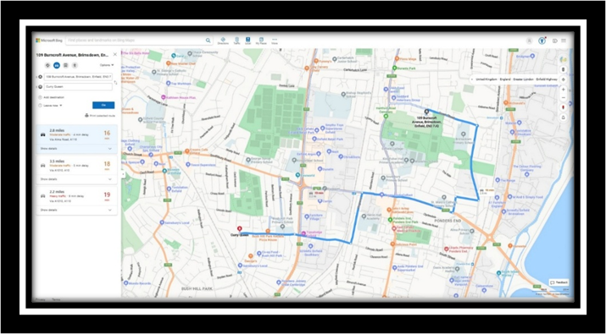
- 2.8 miles there and 2.8 miles back approximately 16 mins

- Evidence: Exhibit A4 /
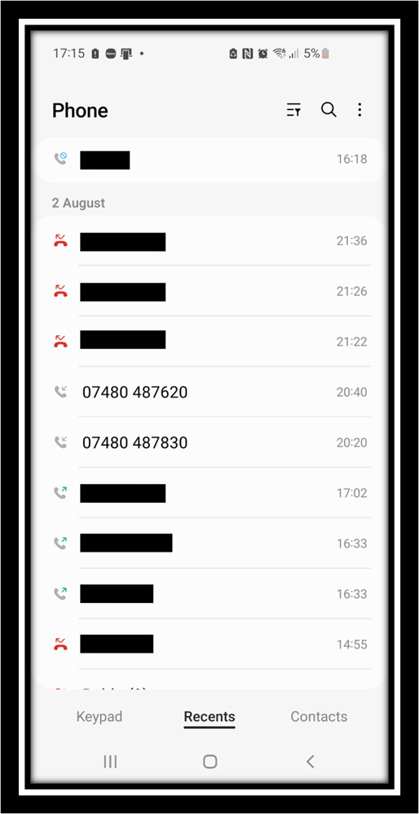

- Both telephone numbers have the same phone number starting digits = 07480 487 *** and this proves that they are from the same company that I ordered food from in Exhibit A1 /.
- The time of first call is as follows: 20:20Pm this is when the food was first delivered to Mr. Simon Paul Cordell.
- Time of second call is time logged as: 20:40Pm and is the time of when the delivery driver re returned back with the missing food Exhibit A1 and Exhibit A3 prove this 16 minutes

- Exhibits A5:
- Statement of Pc Calvin Chan States the Time to Be: CAD 6844/02082025 1300 hours.
- Statement of PC Obsiye 1543NA States the Time to Be: On Friday 01st August 2025 between the hours of 0700 and 1600
- Statement of Constable Reece Williams States the Time to Be: At approx. 2100hrs NA 22L PC CHAN 2464NA and PC OBSIYE 1543NA called for a van not on the hurry up
- Statement of: PC George WILSON-WALLIS States the Time to Be: Once arriving at the scene, I brought PC 2464NA the enforcer to help break the door in whilst this was going on at 21 :16 PC 1
- Pc Chans BWF Time Logs: 03. CKC_01_Witnessing_arrestofSimon Cordell.mp4 21 :08 and they had been upstairs already and decided to go back outside and start recording

Now What We Can Prove If We Put All The Exhibits Together Disclosed Exhibits A1, A2, A3, A4 & Exhibits A5+1, A5+2, A5+3, A5+4, A5+5 Contradiction Summary:
- Rebbeca claims I was outside Burncroft Avenue threatening her at a time when the food was delivered to my flat and I would have not been alone, but Rebbeca O’Hare failed to mention this fact.
- My receipt, payment trail, and Just Eat invoice confirms that I was inside my residence and only received food to eat on the 02/08/2025 as evidenced by our Exhibits.
- My Official diary and telephone logs documents Rebbeca O’Hare’s illegal activities against me and reinforce my non-presence at the alleged scene.

(Signed)

(On behalf of Mr. Simon Paul CORDELL) (Date Signed) 03/12/2025

Signature Witnessed by Signature:
Page 8 of 8

