DEFENCE STATEMENT

(Criminal Procedure and Investigations Act 1996, section 5 & 6; Criminal Procedure and Investigations Act 1996 (Defence Disclosure Time Limits) Regulations 2011; Criminal Procedure Rules, rule 15.4)

This Is My Tenth Statement
WITNESS STATEMENT
Criminal Procedure Rules, r27. 2; Criminal Justice Act 1967, s. 9; Magistrates’ Courts Act 1930, s.5B
URN

Statement of: Mr. Simon Paul Cordell
Age if under 18: Over (if over 18 insert ‘over 18') Occupation: News Reporter!
This statement (Consisting 8 Of 8 Page{s) all signed by me) is true to the best of my knowledge and belief and I make it knowing that, if it is tendered in evidence, I shall be liable to prosecution if I have wilfully stated in it anything which I know to be false, or do not believe to be true.
Dated: 07/08/2025
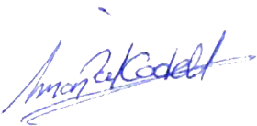

(Signed)

(On behalf of Mr. Simon Paul CORDELL) (Dated) 19/12/2025

I, Mr Simon Paul Cordell, of 109 Burncroft Avenue PO BOX EN3 7JQ.
- WILL SAY AS FOLLOWS
- Date of Incident: 02/08/2025
- Location: Allegedly the Communal area of my flat and about a car that was not present with us!

- Defence Statement – GPS Tag and Exclusion From Home (Short, Strong Introduction)
- This section explains why the GPS tag and exclusion zone imposed on me were unlawful and disproportionate. The allegation in this case concerns a movable object — a car — not a person. GPS tags and exclusion zones exist to protect individuals where there is a proven risk of harm, not to protect property or objects. Because of this, excluding me from my own home on the basis of an allegation involving a car, falls outside the lawful purpose of electronic monitoring and breaches the principles of necessity, proportionality, and least-restrictive measures.
- Bail conditions that remove a person from their home can only be imposed where there is a real and evidenced risk to another person, and only where no lesser measure would suffice. None of those conditions were met here. A car is not a protected person under bail law, it can be moved, and it does not justify a residence ban. The decision to impose a GPS tag and exclude me from my home therefore raises serious procedural concerns and undermines the lawfulness of the bail process.
- This section sets out the legal principles governing GPS tags, explains why the exclusion zone was not justified, and demonstrates how the restriction breached proportionality and fairness.

Exhibit: Tenth Statement 01
Received by the defendant by post on 19/12/2025
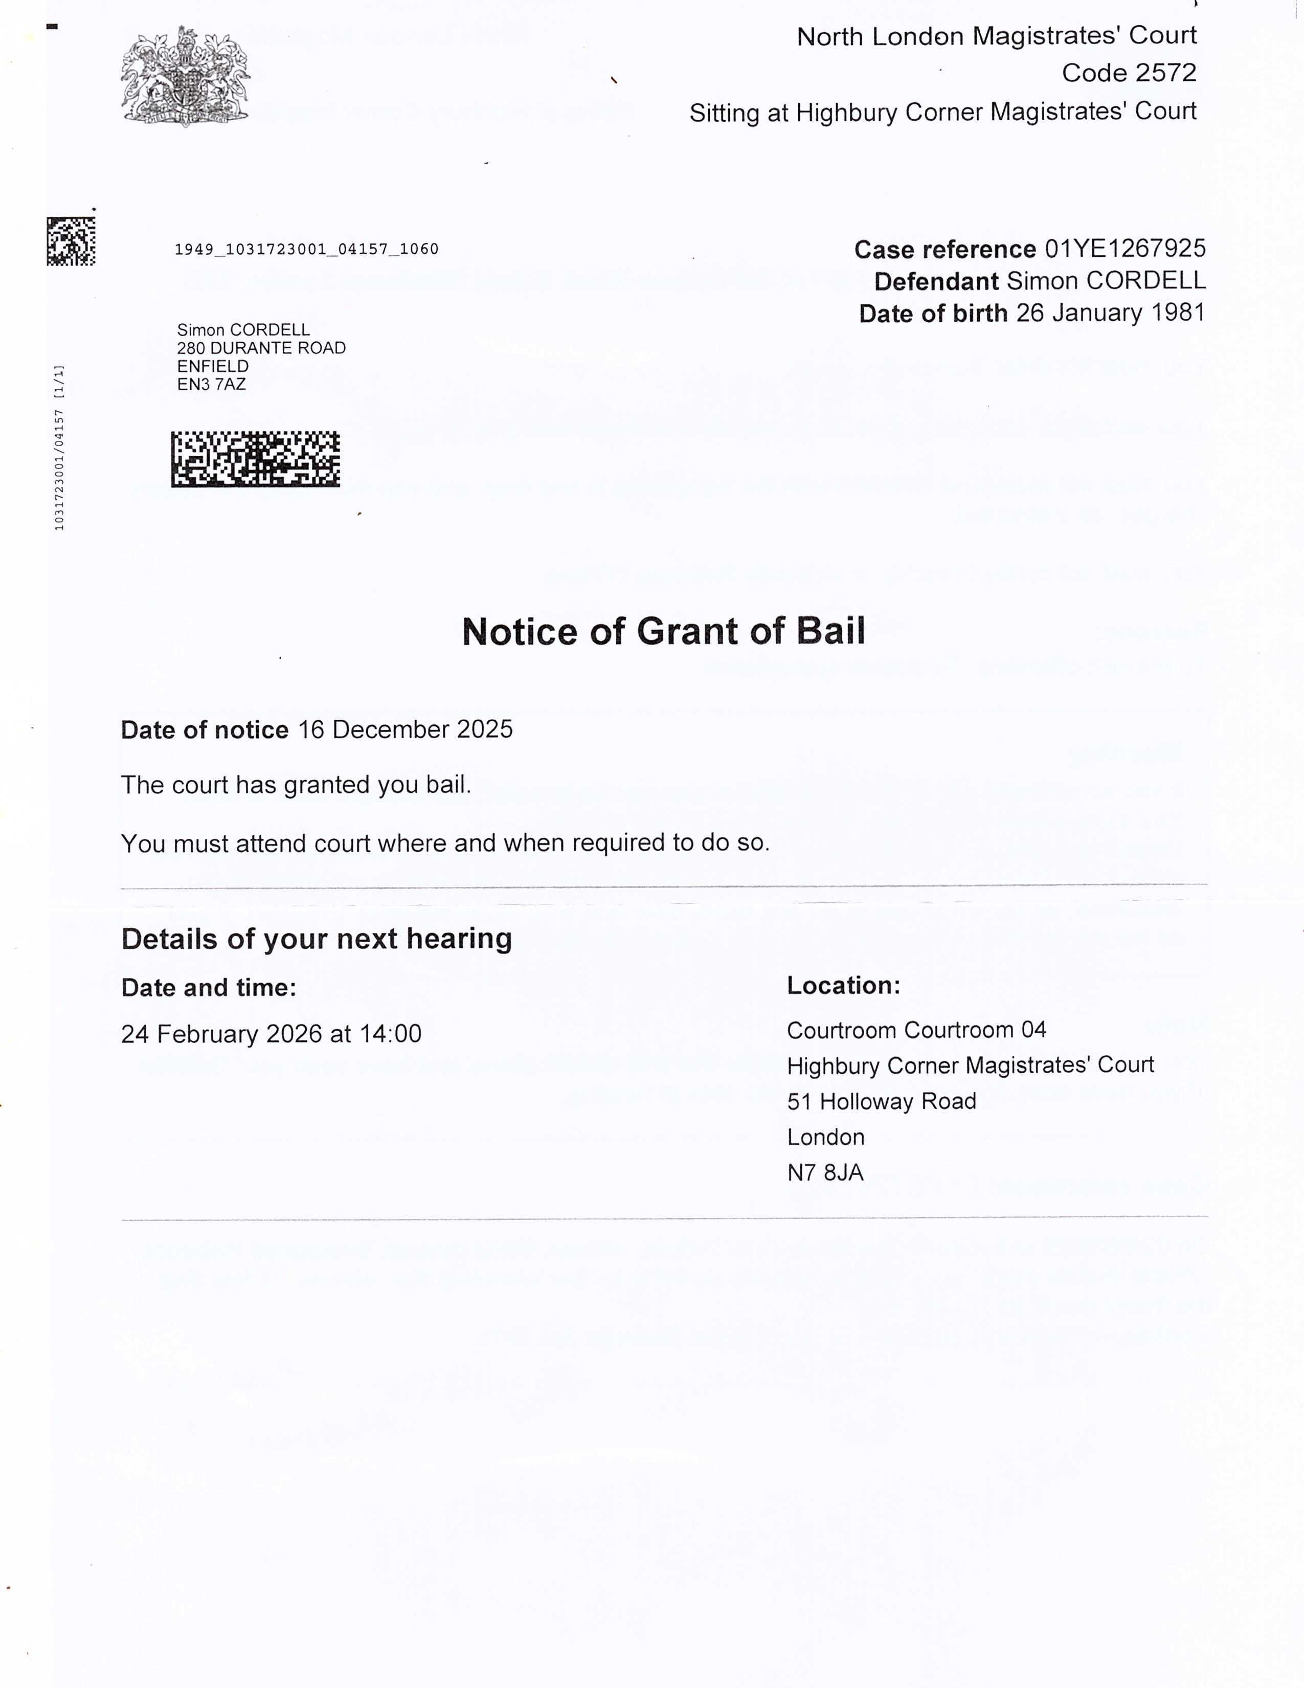

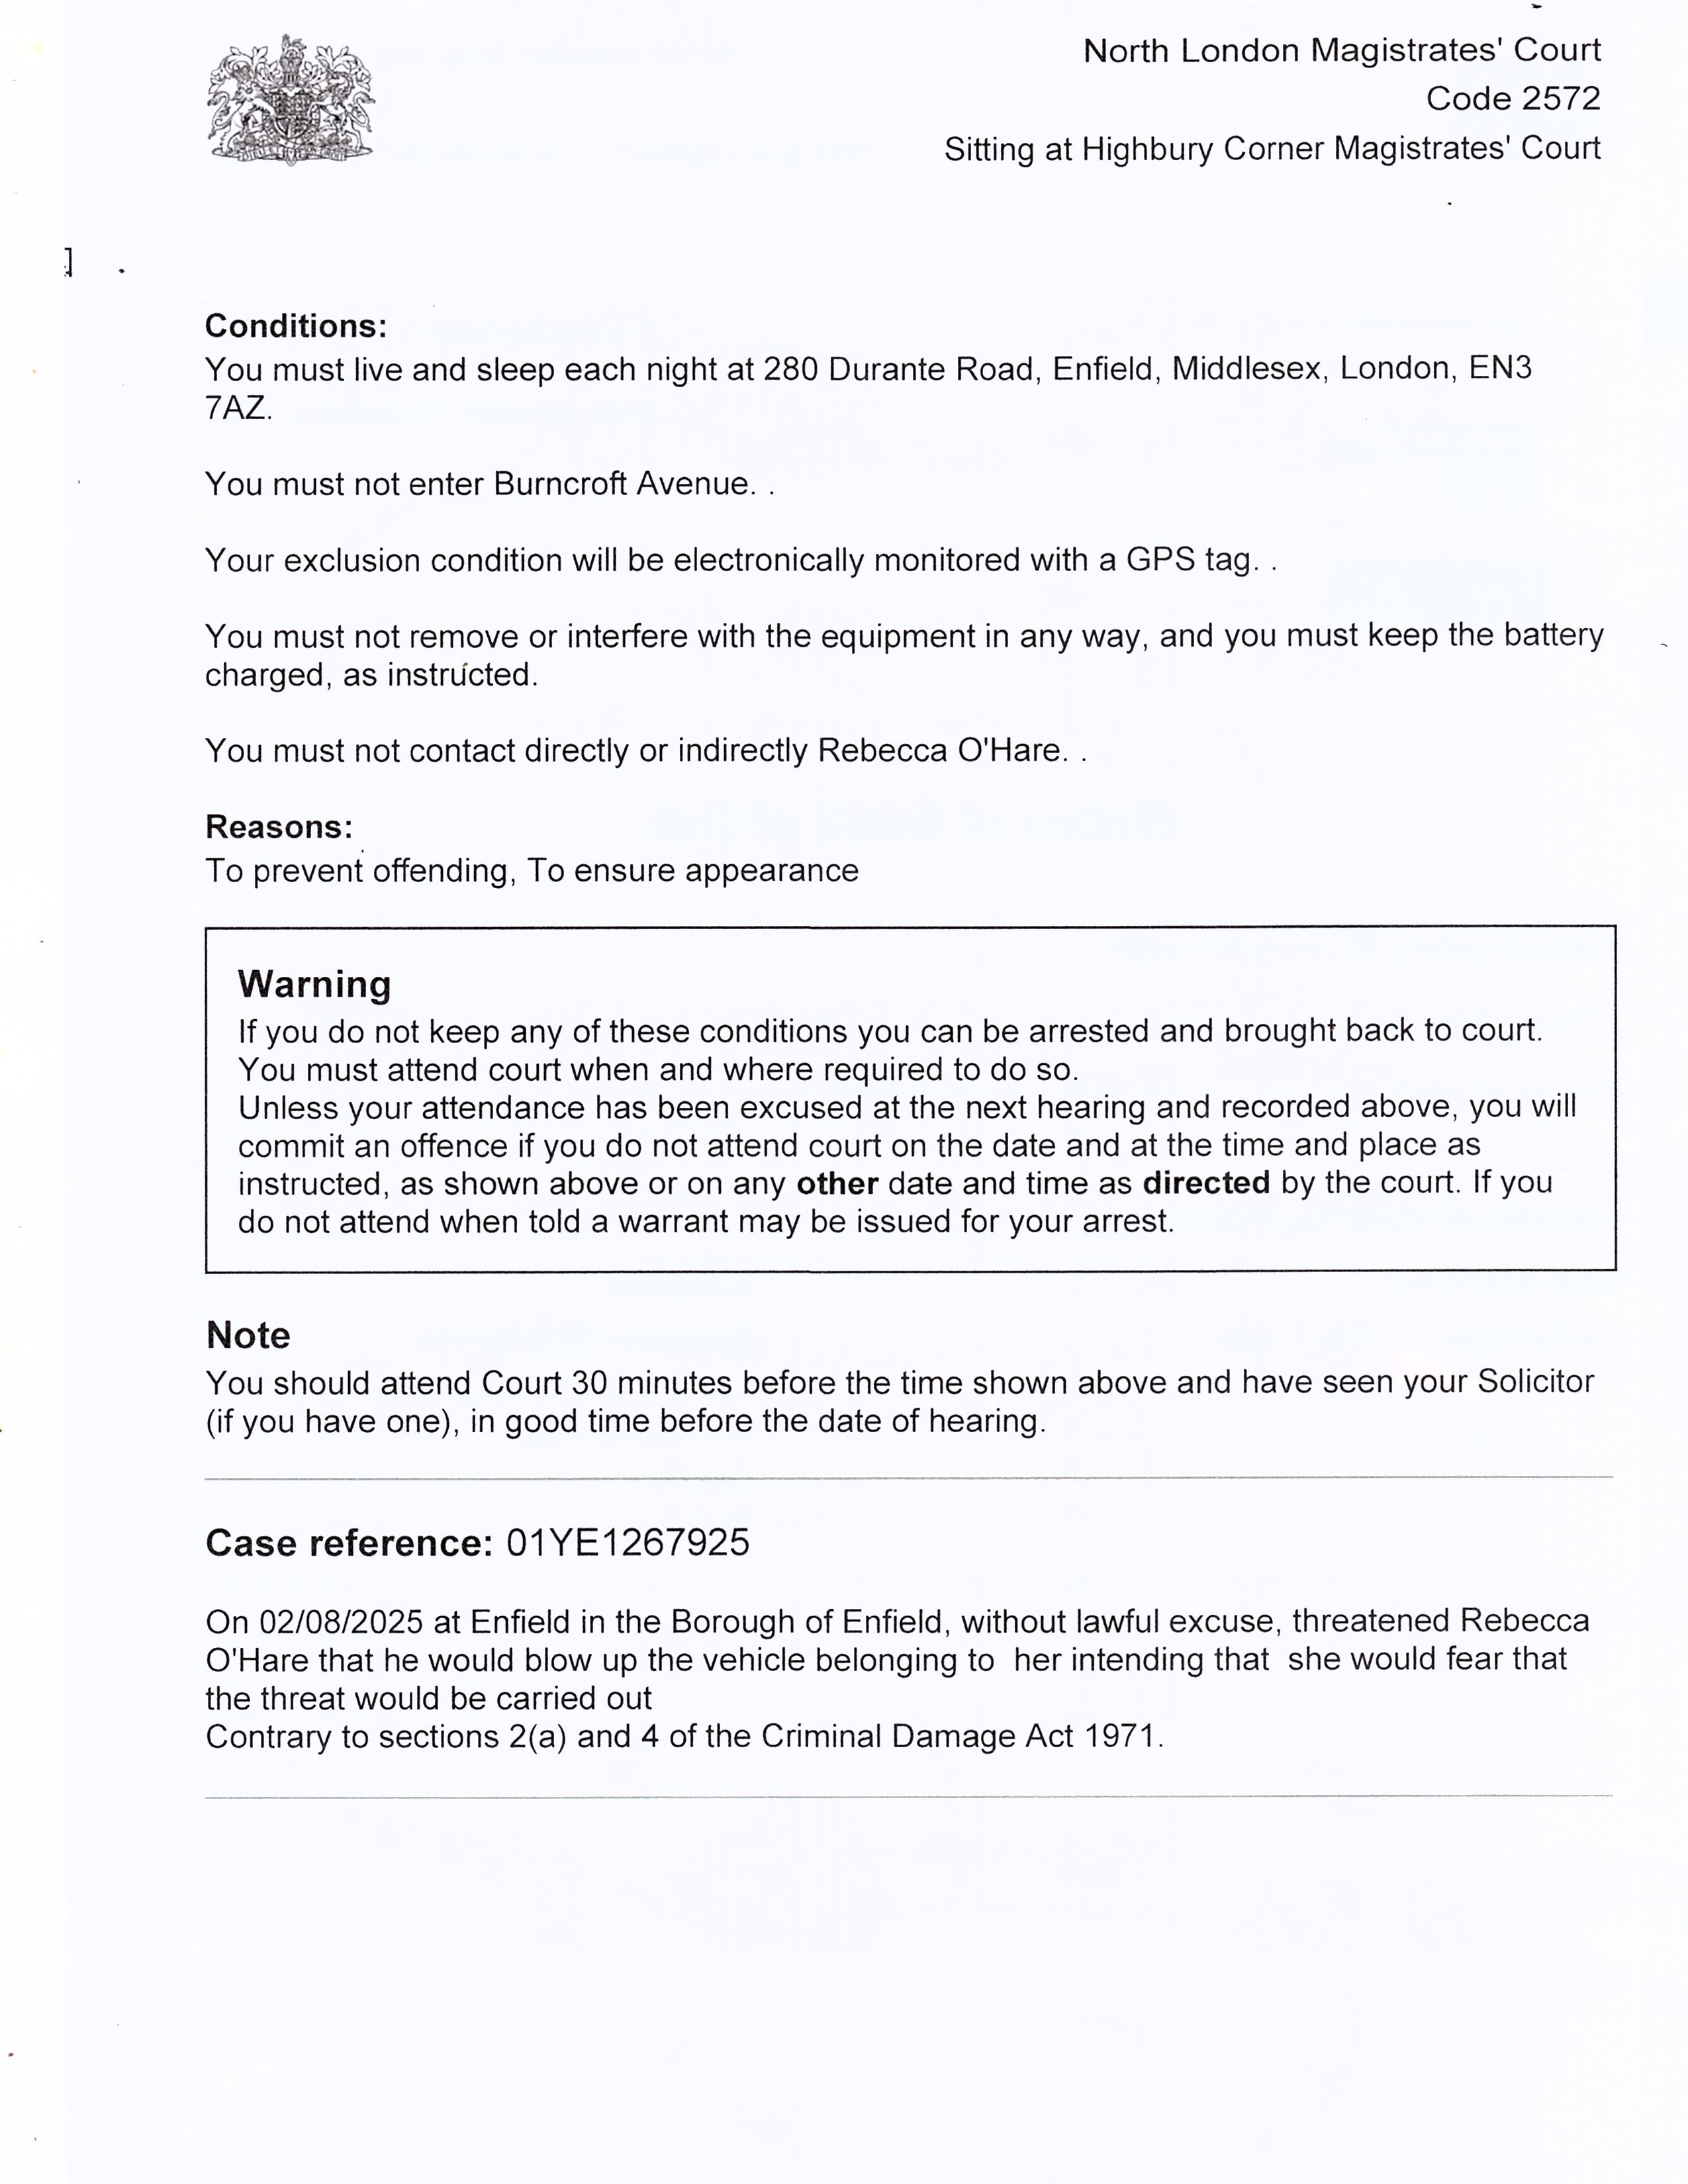

- This exhibit requires clear explanation because Exhibit: Tenth Statement 01 demonstrates a misuse of legal restrictions, specifically the bail conditions and the application of GPS tagging placed upon me. The exhibit shows that I am being excluded from my own home on the basis of an allegation involving a movable object “A Car, And Not A Person.” This section sets out how GPS tags are lawfully intended to be used, as is not the case for the GPS Tag forced to be on my Leg and also explains why the conditions imposed on me are disproportionate and procedurally flawed, and how these issues support my defence of a miscarriage of Justice. I’ll keep it factual and grounded so all the readers can use this understanding as I do in my defence as follows bellow: --

- Is This Legal For It To Be Done To Me The Short Answer:
- No — a person cannot normally be banned from their own home by a GPS tag simply because of an allegation involving a movable object like a car.
- GPS tags are used to enforce location-based restrictions, but those restrictions must be:
- Necessary
- Proportionate
- Linked to a real risk involving a person
- Justified by evidence

- A car is not a “protected person” under bail law.

- Let’s break it down properly

- GPS tags are designed to protect people, not objects
- Courts Use GPS Tags To Enforce:
- Exclusion zones around a person
- Curfews
- Residence requirements
- Risk-based restrictions

- They Are Not Designed To Protect:
- Cars
- Property
- Moveable objects
- Parking spaces
- Driveways

- So, banning any person in the United Kingdom including me from their own home because of a car is legally questionable as it is a breach of the guidelines to be followed.

- A Person Cannot Be Excluded from Their Home Unless:
- The court must show:
- A real risk of harm to a person
- That no lesser measure would work
- That the exclusion is proportionate
- That the person has somewhere else safe to live
- If the allegation is about a car, none of these conditions are met.

- If The Allegation Is Not About Threatening a Person, A GPS Exclusion Zone Is Usually Unlawful
- If the allegation is:
- “Threatening a car”
- “Damaging a car”
- “Criminal damage to property”

- Then A GPS Tag Cannot Legally Be Used To Exclude You From Your Home, Because:
- The object can be moved
- The risk is not tied to a fixed location
- The risk is not tied to a person
- The restriction would be disproportionate

- Courts must always choose the least restrictive option but that has failed to happen in my case.

- If They Banned You from Your Home Because Of a Car, That Is a Major Procedural Issue
- This Must Raise Serious Questions:
- Why was a GPS tag used at all?
- Why was your home included in the exclusion zone?
- Why was the “victim” defined as a car?
- Why was no alternative considered?
- Why was proportionality ignored?

- This is something I absolutely challenge.

- How You Can Safely Frame This in Your Defence
- The allegation concerns a movable object, not a person. GPS tags and exclusion zones are designed to protect individuals, not property. Excluding me from my own home on the basis of a car is disproportionate, unnecessary, and inconsistent with the purpose of electronic monitoring. The restriction was neither justified nor lawful.

- DEFENCE STATEMENT – PROPORTIONALITY OF BAIL CONDITIONS AND GPS TAG
- The bail conditions imposed on 02/08/2025 were disproportionate, unnecessary, and far exceeded what the Sentencing Council guidelines would ever justify for this type of allegation. The restrictions placed on me — including exclusion from my own home and continuous GPS monitoring — amount to a level of punishment that is significantly greater than the sentence that would realistically be imposed even if I were convicted.

- Duration of GPS Tagging and Exclusion
- From 02 August 2025 to 24 February 2026, I was subject to:
- GPS electronic monitoring
- A full exclusion from my own home
- Strict lifestyle restrictions

- This, Totals: 207 Days On A GPS Tag (Over 6 Months And 3 Weeks.) During This Period, I Was Prevented From:
- Spending Christmas with family
- Spending New Year’s Eve with family
- Maintaining a normal private life
- Maintaining any intimate relationship, because the bail address did not allow for it
- Living in my own home
- Exercising normal autonomy or freedom of movement

- This level of restriction is equivalent to — and in many ways harsher than — a medium-level community order or a curfew requirement, which is the upper limit of what the Sentencing Council recommends for this offence.

- 2. What the Actual Punishment Would Be (Sentencing Council Guidelines)
- For the offence charged (Criminal Damage Act 1971, s.2 – threats to damage property), the Sentencing Council sets the following realistic sentencing range:

- Likely sentence if convicted:
- Absolute discharge, or
- Conditional discharge, or
- Low-level community order

- Custody is NOT appropriate unless:
- Weapons were used
- There was repeated behaviour
- There was serious harm
- There was high culpability

- None of these apply in this case.
- Therefore: The realistic punishment for this offence — even on conviction — would be:
- ➡ 0 days in custody
- ➡ 0 days on a GPS tag
- ➡ 0 days excluded from home
- ➡ 0 days of lifestyle restrictions

- Yet I Have Already Spent:
- 207 days on a GPS tag
- 207 days excluded from my home
- 207 days under restrictions harsher than the likely sentence

- This means the bail conditions have already exceeded the maximum realistic punishment.

- Legal Tests for Bail Conditions
- Under the Bail Act 1976, any condition must be:
- Necessary
- Proportionate
- The least restrictive measure
- Linked to preventing a real risk involving a person

- In this case:
- The allegation concerns a movable object (a car)
- No person was harmed
- No property was damaged
- No violence occurred
- No risk assessment justified exclusion from my home

- A car is not a protected person under bail law. Therefore, the exclusion zone and GPS tag were not proportionate to the alleged risk.

- 4. Article 8 ECHR – Right to Private and Family Life
- Article 8 protects:
- The Right To A Home
- The Right To Family Life
- The Right To Private Life
- The Right To Form Intimate Relationships

- The Bail Conditions Prevented:
- Living in my own home
- Spending Christmas with family
- Maintaining a relationship or sex life
- Normal social life
- Freedom of movement

- Any Interference With Article 8 Must Be:
- Lawful
- Necessary
- Proportionate

- The restrictions imposed on me were far beyond what was necessary for an allegation involving a car.

- 5. Impact on Daily Life and Liberty
- The GPS tag and exclusion zone resulted in:
- Loss of home
- Loss of privacy
- Loss of intimate relationships
- Loss of normal social life
- Constant surveillance
- Restricted movement
- Psychological distress
- Stigma and reputational harm

- These Are Consequences Normally Associated With:
- community orders
- curfews
- restraining orders
- or custodial sentences

- Yet they were imposed before trial, without conviction, and without meeting the legal tests for necessity.

- Defence Position
- The restrictions imposed on me between 02/08/2025 and 24/02/2026 were disproportionate, unnecessary, and exceeded the level of punishment that would be imposed even if I were convicted.

- The court is invited to consider:
- The 207 Days Of GPS Monitoring
- The Loss Of Home
- The Loss Of Private And Family Life
- The Absence Of Any Risk To A Person
- The Sentencing Council Guidelines
- The Article 8 Implications
- The Principle Of Proportionality
- The Requirement For The Least Restrictive Measure

- These factors demonstrate that the bail conditions were excessive and that the impact on my liberty has already outweighed any realistic sentence for the offence charged.

- P.S.
- Tuckers Solicitor Firms Staff till date of this defence statement has refused to reply to any correspondence.

Kind Regards
Mr. Simon Paul Cordell.

(Signed)

(On behalf of Mr. Simon Paul CORDELL) (Dated Signed) 18/12/2025

Signature witnessed by:

