LAA TIMELINE

02. LEGAL AID 2025 DECLARATION V7 (4)

57. LEGAL AID 2025 DECLARATION V7
56. New Solicitor - Sent-14-10-25.pdf
57. Application to Transfer Legal Aid.doc
57. LEGAL AID 2025 DECLARATION V7 (1).pdf
57. LEGAL AID 2025 DECLARATION V7.pdf

02-02-26

OFFICIAL-SENSITIVE
From: Legal Aid (Shared) <legalaid@tuckerssolicitors.com>
Sent: 02 February 2026 13:32
To: re_wired@Ymail.com; Birmingham CAT <birminghamCAT@Justice.gov.uk>
Subject: File 1 - Simon Cordell - MAAT 900900 URN 01YE1267925 ld:COR10388/00001
Good afternoon
- Mr. Cordell has contacted the LAA in respect of legal aid for this matter and I am writing to clear up any misunderstanding as Mr. Cordell has suggested that Tuckers have fraudulently issued ourselves a rep order - Refer to the attached, however I have tried to explain to him that legal aid was self-granted during the period of the LAA contingency and that is a template of what the LAA issued to all providers to use and that his legal aid on this file had all been carried out exactly as per the LAA protocol at that time.
- We represented Mr. Cordell at Highbury Magistrates court on 4th August 2025 as the duty solicitor. There is NO record that we represented Mr. Cordell at the police station in these proceedings prior to the 4th of August 2025.
- It appears that we have withdrawn from representation with the courts in this matter and the file closed.
- I understand that Mr. Cordell has instructed another firm to represent him, however they appear to be having issues with legal aid Its unclear why.
- Please can the LAA kindly respond to Mr. Cordell with the procedure that his new firm should follow under the circumstances as stated above as this would not be a usual transfer given the legal aid was granted under the contingency.
Kind Regards
Rosie Yates

This e-mail and any attachments is intended only for the attention of the addressee(s). Its unauthorised use, disclosure, storage or copying is not permitted. If you are not the intended recipient, please destroy all copies and inform the sender by return e-mail. Internet e-mail is not a secure medium. Any reply to this message could be intercepted and read by someone else. Please bear that in mind when deciding whether to send material in response to this message by e-mail. This e-mail (whether you are the sender or the recipient) may be monitored, recorded and retained by the Ministry of Justice. Monitoring / blocking software may be used, and e-mail content may be read at any time. You have a responsibility to ensure laws are not broken when composing or forwarding e-mails and their contents.

114. Received-LAA-04-02-26
114. Received-LAA-04-02-26.pdf
RE: File 1 - Simon Cordell - MAAT 900900 URN 01YE1267925
Id:COR10388/00001
From: Birmingham CAT (birminghamcat@justice.gov.uk)
To: legalaid@tuckerssolicitors.com;
re_wired@ymail.Com
Date: Wednesday, 4 February 2026 at 15:17 GMT
OFFICIAL-SENSITIVE
Good afternoon

- The new solicitor would simply produce their own rep order from transferred dated as it’s delegated functions case.

Regards
Legal Aid Agency
Luke Atkins
Caseworker
National Criminal Applications Team
Office Base 23 Stephenson Street Birmingham B2 4BH. Tel: 0300 200 2020 |
All correspondence postal address - Legal Aid Agency Birmingham, Berkley Way, Unit 8B, Jarrow, NE31 1SF, DX 742 350 Jarrow

115. Sent - to LAA - 07-02-26
115. Sent - to LAA - 07-02-26.pdf
Re: File 1 - Simon Cordell - MAAT 900900 URN 01YE1267925 Id:COR10388/00001
From: Rewired (re_wired@ymail.com)
To: birminghamcat@justice.gov.uk
Date: Saturday, 7 February 2026 at 09:17 GMT

Email to the Legal Aid Agency (No vague points, fully focused)

Subject: Request for Procedural Clarification on Representation Orders and CRM Forms
Dear Legal Aid Agency,
- I am requesting clarification on several procedural points relating to representation orders, delegated functions, and the correct use of CRM forms. I would be grateful if you could confirm the LAA’s position on each point below.
- I was provided with a “representation order” document by Tuckers Solicitors for a matter dated 04/08/25. The document uses the LAA Birmingham Crime Applications Team address and appears in the format of an official LAA certificate, but it contains no LAA reference number and does not appear on your system. When I contacted the LAA, I was informed that no representation order exists for this matter and that the document supplied to me is not recognised as a valid certificate or contingency form. Your latest response also stated: “The new solicitor would simply produce their own rep order from transferred dated as it’s delegated functions case.”
- I must now understand how this situation should have been handled under LAA rules, I request clarification on the following specific points:

Representation order documents
- Are solicitor firms permitted to create their own representation order Certificates / documents using the LAA’s address or formatting?
- Are firms permitted to develop and produce to clients documents resembling LAA certificates where no corresponding records exists on the LAA system?

CRM14 and CRM15 - application and means test
During the contingency period:
- Were firms required to complete CRM 14 and CRM 15 for every client, including those on passported benefits, where they intended to rely on legal aid?
- Were firms permitted to retain completed CRM14/CRM15 forms without submitting them, or were they required to submit them as soon as practicable after attendance?
- Does LAA guidance require solicitors to record the correct offence and URN before creating or submitting any CRM14/CRM15 documentation?

CRM16-hardship
- Where a client would fail the means test but cannot realistically fund representation privately, are firms required to submit a CRM16 hardship application if they wish to rely on legal aid?
- Are firms permitted to proceed as if legal aid is in place without submitting CRM 16 where hardship applies?

CRM18 - Crown Court legal aid
- Where a case is, or maybe, sent to the Crown Court, is a CRM 18 required in addition to the original CRM14/CRM15?
- Must the offence and URN recorded on any CRM18 match the Police Custody Log Records offence and URN recorded on the original CRM14/CRM15 and on the LAA system?

CRM7 - solicitor’s claim for payment
- Can a firm lawfully submit a CRM7 claim for payment where:
- No Representation Order Exists on the LAA System.
- No CRM14/CRM15 Are Recorded by the Solicitor Firm Staff for The Matter.
- The Offence Recorded by The Firm Does Not Match the Offence Recorded in the Wood Green Police Station Custody Loo Records: And
- The URN Is Linked to An Incorrect Offence?

- Does LAA guidance allow any payment to be made in the absence of a valid representation order on your system for the relevant offence and URN?

Consistency with LAA procedure
- Based on LAA rules, would the following sequence of events be consistent with standard LAA procedure:
- The Custody Record at Wood Green Police Station Shows the Firm Attended to Act on my behalf Only for A Section 4A Offence: That is the offence they were called for, the offence they discussed with me, and the offence recorded in the police system.
- After That Attendance. The Firm Later Entered a Completely Different Offence on Their Own System (“Threats to Cause Criminal Damage”) For the Same URN: even though no solicitor ever attended for me for that substituted offence and no fair legal process took place after the no further actioned offence was discontinued!
- No CRM14. CRM15. CRM16 Or CRM18 Exist on the LAA System for This Matter: meaning no legal aid application, no means test, no hardship application, and no Crown Court application were ever submitted for either offence.
- There Is No Valid Representation Order on the LAA Portal For This URN: for either the original Section 4A allegation or the later substituted offence.
- Despite This. A “Representation Order”-Style Certificate Was Created and Given to Me: using the LAA’s address and formatting, for the substituted Criminal offence Charge and without any fair legal process even though:
- I had already signed CRM14/CRM15 for the original Section 4A matter AND SAME URN Number: 01YE1267925 on the 03/08/2025.
- And that original matter was later marked “no further action”.
- and now Tucker Solicitor Firms Staff claims that no CRM14/CRM15 were even ever completed or required.

- This discrepancy appears to be preventing my new solicitors from progressing a legal aid transfer, as the URN is linked to an offence that does not match the Wood Green Police Station Custody Log Records or the solicitors Reasons attendance

- I AM REQUESTING THE ANSWERS TO ALL “EIGHTEEN QUESTIONS” OF MINE: to be able to understand the correct “LAA” legal process because the URN in my case is linked to the wrong offence. The custody logs show that Tuckers attended for a Section 4A allegation, and I have a recording of a two-hour meeting with their legal representative, Nichole Widser, which confirms the same. However, the offence later recorded on their system is now wrongly “Threats to Cause Criminal Damage.” which is not the offence they attended for. This mismatch appears to be the reason why my new solicitors have been unable to progress a legal aid transfer legally, as all Urn Numbers are to only be useable once and for the correct Criminal Offence charge.

- I am not asking the LAA to comment on the conduct of any solicitor. I am asking for clarification of the LAA’s own procedures so I can understand what should have occurred and what steps are available now.

- Thank you for your assistance. I look forward to your clarification.

Kind regards,
Simon Cordell

119. Sent - to LAA - 10-02-26
119. Sent - to LAA - 10-02-26.pdf
Re: File 1 - Simon Cordell - MAAT 900900 URN 01YE1267925 Id:COR10388/00001
From: Rewired (re_wired@ymail.com)
To: birminghamcat@justice.gov.uk
Date: Tuesday, 10 February 2026 at 15:12 GMT

Email Chaser to the Legal Aid Agency (Birmingham CAT / National CAT)

Subject: Follow-up: Outstanding Procedural Clarification Required

Dear Sir/Madam,
- I am following up on my previous email, which remains unanswered. The delay is now directly preventing me from instructing a new solicitor, as the issues I raised concern the validity, status, and procedural handling of the representation order and URN linked to my case.
- For clarity, the Legal Aid Agency responded immediately when the provider contacted you, yet my own request for written clarification has not received the same urgency. Given the circumstances, and the fact that the questions I raised relate to procedural compliance, delegated functions, and the accuracy of LAA records, I require a written response without further delay.
- A reasonable timeframe for matters affecting active criminal proceedings is five working days. That period has now passed.
- Please confirm when I will receive full written answers to the questions previously submitted, as my ability to obtain representation cannot progress until the LAA clarifies the position.
- I look forward to your prompt response.

Yours faithfully,
Simon Cordell

120. Received-LAA-11-02-26
120. Received-LAA-11-02-26.pdf
RE: File 1 - Simon Cordell - MAAT 900900 URN 01YE1267925 Id:COR10388/00001
From: Birmingham CAT (birminghamcat@justice.gov.uk)
To: re_wired@ymail.com
Date: Wednesday, 11 February 2026 at 08:10 GMT

Dear Simon Cordell,
- Thank you for your email. I can confirm receipt of your previous email on the 7 February 2026 and can advise that a response is currently being put together by our Senior colleagues. As some of the applications you have requested information of span a couple of different teams we are also having to wait for their response before we can compile the full response to you.
- Please note that we advise that we respond to all emails within 10 working days. This does not include weekends. We therefore aim to have issued a response to you by, at the latest, the 23 February 2026. We are looking into this urgently for you though and will get a response out as soon as we can.
Yours sincerely,
Martina Aston
Senior Technical Caseworker
National Criminal Applications Team
Office Base 23 Stephenson Street Birmingham B2 4BH
DX post to DX 13041 Birmingham
Tel: 0300 200 2020
All other correspondence send to postal address -
Legal Aid Agency Birmingham, Berkley Way, Unit 8B, Jarrow, NE31
1SF.

121. Recording (65) LAA 11-02-2026 0946
121. Recording (65) LAA 11-02-2026 0946.docx
121. Recording (65) LAA 11-02-2026 0946.pdf
121. Recording (65) LAA 11-02-2026_0946.m4a

Legal Aid Agency (Criminal Legal Aid) – Phone Number
0300 200 2020
apply-for-criminal-legal-aid.service.justice.gov.uk
When you call, choose Option 2 for criminal legal aid case enquiries.
Opening Hours
9:00am – 5:00pm, Monday to Friday
(Closed on public holidays)
apply-for-criminal-legal-aid.service.justice.gov.uk

121. RECORDING (65) LAA 11-02-2026 0946
[Speaker 1]
00:00
9.21 in the morning, the 11/02/2026. I'm calling Legal Aid. Because they are saying that it's going to take 10 days to be able to make me aware of the legal process for "RO" Orders and self-referral Orders as to what Tuckers solicitors have made happen and by that time I will be on trial for the case
[Speaker 2]
00:33
This is the legal aid agency!
Please be aware that we are facing a huge pressure situation, storing CCMS, limiting the number of concurrent users. If you're given access to CCMS but can't access it because there are no more streaming resources available, CCMS is at its current limit so please wait to try again later. If your caseload cannot wait, please stay on the line.
Welcome to the Legal Aid Agency. All calls are recorded. Training is monitored. If you're calling about civil case, please press one, and if you're calling about criminal case , please press two!
02:01
Good morning criminal legal aid staff speaking how can I help?
[Speaker 1]
02:05
Hey, how are you doing? I'm trying to get some advice of you.
02:08
Ok
02:08
In regard to an issue, I'm having ongoing.
02:11
Ok
02:11
I have a URN number, and that URN number is.
02:12
Ok
02:12
I'm basically a litigant on my own behalf at the moment because I'm being forced to. I'm supposed to be able to obtain legal aid, but I can't obtain legal aid to my understanding.
I just want you to confirm this, because I have wrote an email over to yourself, but you're saying you're going to take 10 days to respond to me.
02:33
Okay
02:35
In those 10 days, the trial will already have taken place, so the information will be rendered useless, and it can prove my innocence, that I'm right, so this matter being resolved is of the most of importance.
02:45
Basically, I had a case and this case I was arrested for it and basically: I was arrested at my front door for something to do with harassment, what is a criminal offence.
02:56
okay
02:56
Do you have the URN for it?
02:58
The URN number is quite confusing to give to yourself.
I will give it to you in a second, but is it okay if I explain myself to you first
03:06
Yes, go ahead
03:06
So, you can understand what's actually happening.
Basically, I was arrested at my front door for harassment 1997 Act, which is a criminal offence. I have body warn footage to prove that.
03:16
I was taken to a hospital for two days. While I was in the hospital, different staff took over and police officers took over, hum police officers took over! Eventually, they brought me to the police station, and they booked me in for the wrong offence, they have booked me in for a Section 4A, which the police custody logs prove!
That had its own URN number made for it and I was interviewed for that case on, say, the 03/08/25, Then, the CPS, Hmm, in the custody logs, the information was sent over for review to the CPS and they have "No Further Actioned it" and then, basically, the police never re-further arrested me and they've swapped the charge with another criminal charge, which is for "Threats to Cause Criminal Damage," so, that is Three different things.
Basically, I was never arrested or never legally processed for this third charge.
So, I know that basically the first case, the URN number, should be submitted by Tucker's solicitors to yourselves. I believe that they should fill in a CRM 14 and a CRM 15 and that will complete my details and the rest of it. I actually signed those and they're self-referral forms.
But, basically, somehow, Tucker's solicitors have provided me an RO certificate with your address on it. I've sent that RO certificate over to yourselves and you've said it's not registered on your computer. And, due to the LAA Hack, I believe that solicitors are allowed to fill in CRM 14s and CRM 15s.
But they're not allowed to create their own representation orders with your address.
Is that correct to believe that?
[Speaker 2]
04:54
Hmm, So, when did they process this? Was it a month ago or was it recently?
[Speaker 1]
05:03
On the 08/08/25 is when I was actually arrested.
No, sorry. On the 02/08/2025, is when I was arrested.
I was brought to the police station on the 3rd, and I was brought into the police station for the Section 4A. And then, the case was no further acted on the 4th and the solicitor went home. He came and represented me, made me sign CRM 14 or 15, I believe, in the interview room.
He acted for me, he done a prepared statement for Section 4A. He went home and then the police come and no further actioned the case. Then, all of a sudden, they just swapped it for another charge.
But they've used the same URN from the no further actioned case, which is illegal. Tucker's hasn't put a receipt in for it.
But they've actually gave me, they've not shown me the CRM 14 or 15 that I have signed.
They've said to me, they don't have to sign CRM 14s or 15s, because I'm on benefits, this does not have to be completed.
06:04
Yes, it does!
06:04
So, I don't understand how, I thought it was something that was mandatory to yourselves.
That's what I'm trying to understand. And can they create an RO certificate? because they've given me an RO certificate and it's got your address on it, but it's not registered on the computer systems.
[Speaker 2]
06:19
Ok so it would be helpful to see the URN number to see what information is on record or if we have any!
06:25
Just give me two seconds and I'll get it up. The URN number. The URN number is 01-Yankee Echo-1267925.
06:46
Okay. just give me one moment!
06:53
And, what's your name?
06:54
My name is Mr. Simon Paul Cordell.
06:57
Okay. And, what's your date of birth?

[Speaker 1]
06:59
********
[Speaker 2]
07:04
Okay. Just a security, I'll ask you a couple more questions. So, your first hearing, what magistrate court was it at?
07:14
It might be Highbury & Islington.
07:18
Okay. That's fine.
07:30
What was the name of your provider for the solicitor?
07:32
Pardon?
07:34
At the bail application, the bail from the 8th of the 8th.
Do you remember the name of that person?
What's the name?
[Speaker 1]
07:47
Her name, she wasn't, what's confusing? She wasn't my solicitor for this case.
What's actually her...
07:57
Mumble
[Speaker 2]
07:57
Yeah, go on, sorry. Anita or something? And, what's her name?
[Speaker 1]
What's her name? Give me one second, because I've got it stored in my phone, so I'll just go through it for one second. Deena, Deena or something?
08:17
Deena, Deena the solicitor, D-E-E-N-A, Deena the solicitor.
08:23
No, that's not what I have here, but that's okay.
08:24
Or Kevin, or Kevin, Kevin was in charge of the CPS part.
[Speaker 2]
08:33
I'll ask you the next question. So, what was the first Court hearing, at Highbury do you remember the date that that was?
[Speaker 1]
08:37
The date of the, it was on the 4th, I arrived at the court, on the 4th. The 4/8/2025.
[Speaker 2]
08:45
Okay. So, the issue is your arrest, but can we just, because I have it here, the first thing that you're arrested for, that's Section 4a
[Speaker 1]
09:00
Yeah, at my front door, I was, on the body-worn footage, they say, oh, you're under arrest, and give me a caution for harassment 1997, which is one criminal offence. If they're supposed to, if they're going to package me for, like, threats to cause criminal damage, they should give me a caution for both of them at the same time. But they never done that in the body-worn footage.
I got taken to the hospital. Two different police officers changed shifts throughout a period of time, and then they brought me to the police station on the 3rd, early hours in the morning on the 3rd. And basically, when they brought me in, they put me in for Section 4A, which is another criminal offence, to the one that I was arrested for.
The Cps, I've got the custody log, and the custody log clearly shows he's booked in at the police station for Section 4A, reason for detention at Wood Green police station. Then when you read through it, you can see they said, I have an interview with a solicitor, a solicitor's called out, Tuckers, that I signed, I believe I signed a CRM 14/15 IN the interview for that case. Then Tuckers leaves the police station and leaves me in.
The police officer comes, and he "No Further Actions,|" that URN number, which is the number that I've gave you. But I go to ask to be released, and he goes, and he throws me back in the cell, because I'm making an insurance claim against him for another case. And it's the same sergeant that's done this to me.
And he's thrown me back in the cell, and I've been brought straight to court. There's no case paperwork at the court, the first hearing or the second hearing, for the newly swapped charge. They put "Threats to Cause Criminal Damage" and put damage into it after the "no further action case!"
Bu now, that no further actions case is using the same URN number for the case that was no further action. And that shouldn't be allowed to happen. I've contacted Tucker's solicitors, and Tucker's solicitors said to me, I've got a recording of it, they said, I don't have to fill in CRM, CRM 14s or 15s, they can just issue out an RO order certificate with your address on it, and then that's it.
11:05
And I'm saying, well, that is not the procedure, I believe you have to fill in a CRM 14 or 15, that has to be sent, you're allowed to stockpile those when the LAA Hack id ongoing. But the second that the system's up and going, you're supposed to submit them CRM, then Legal Aid will issue the RO orders with their address on it. So, this is, like...
[Speaker 2]
11:25
So, the correct, OK, and then the correct offence now, then, what would you say that is?
[Speaker 1]
11:32
Basically, what it should have been is harassment, but instead they've nicked me for Section 4A, then both of them have been no further action, because if I actually look at the MG4 charge sheet, the Section 4A that I'm booked into the police station disappeared. So basically, you can see it's been no further action by the CPS because I've not been charged for it. Where has it disappeared to?
But then what someone's done is they've actually put threats towards criminal damage in there, now under the same URN, and I've not been further arrested, I've not been processed, I've not had notice, I was refused access to solicitors, and now all of a sudden everyone's trying to do this. I've not even been... Technically, I've not been arrested for threats towards criminal damage.
[Speaker 2]
12:15
Ok
12:20
And the disclosed information proves that.
12:23
OK.
[Speaker 1]
12:23
So, are you saying that the threats towards criminal damage was one of the things that didn't happened, and it was caused by harassment?
12:31
No, I'm saying that the offence of harassment was put forward, and it was no further action because I was innocent in those proceedings, and police officers caused misconduct, negligence, gross misconduct in public office, and what is actually done is caused under the 2006 Act, and they have actually illegally swapped the charge and put in a new criminal charge after no further action, and used the same URN to do that, and the disclosed information proves this. I believe that if Tucker's put the receipt in for no further action that they should have done, I've got a recording, and Tucker's is saying to me that the day that I attended the police state, they attended the police station for me on the 3rd, and acted for the section 4A under, they've lost all of the paperwork, so there's no audit trial for me before them attending the police station.
But if we actually look in the custody logs, you can see all the police calling Tucker back, you can see Tucker's solicitors arriving, you can see them acting for me under this URN number, and then you can see that it's not in the "MG4 Charge Sheet," and that I've been completely set up, and that this is illegal.
Tucker's has failed to disclose to you, lot, that they won this case under that URN number. Now this is an active slot, and now I'm being told to submit this other threat case, and they're trying to mislead me into putting this into place, and because they've not put their receipts in, your system's going to accept it. But if Tucker's have really put their receipts in, for the paperwork that they've lost, then basically when I went to use threats, because your system would refuse it, and say no, that this number's already been used.
And now...
[Speaker 2]
14:09
Okay, so I'm just going to rush off and speak to another solicitor because I don't have the answers to all the questions you ask, so I'll put you on hold and get straight back to you to you in a moment .
14:29
Ok, I appreciate that Thank you
16:58
Hello
16:58
Hello
16:58
Hello
16:58
Oh, thank you for holding.
So, I can't see any evidence of pervious Legal Aid in place for this case. So, you don't have to worry about that.
But with this current case you said that the court hearing is on what date for that.
[Speaker 1]
17:18
The hearing is on the 24th of February, it's a trial on the 24th of February which is in two weeks’ time and I can't get legal aid at the moment because they're all trying to abuse their powers and mislead me into reusing this URN number for a substituted Criminal Charge that I have never been arrested for and technically your systems are saying yes this is okay to happen because you have no evidence of well technically I forwarded legal aid LAA evidence of the custody log and the proof that I really was arrested for section 4A and that's what the URN number belongs to and they can review it themselves but no one's they're saying they don't want to take a they don't want to be legally involved in the dispute in a sense like that I think so but what I'm trying to understand is it is what I'm trying to ask is it mandatory for a solicitor's firm to fill in a CRN 14-15 and then to send them over to yourself or are Tucker's solicitors allowed to create the RO order themselves and never send you a CRN 14-15 which is what they're saying?
[Speaker 2]
18:28
Um, so, I'm just trying to check if there was a time in the summer when there was like a data issue where,
18:38
yeah, the LAA Hack
18:38
Yeah, where the solicitors were allowed to self-referral
18:45
Yeah, stockpile them
18:45
depending on the type of defence, first, obviously they can't do that now, so I'm just trying to check the date.
[Speaker 1]
18:50
But it's not so much the date, it's what is the procedure?
18:57
Oh, for now
18:57
If I know I'm a solicitor and forever, yeah, no matter what, it didn't change, when the system was hacked, it didn't change that much, the procedure. If I'm a solicitor and I want you to sign a client to find legal aid, do they have to sign a CRN 14 and a CRN 15?
And then are those the forms that I'm, as a solicitor, I'm allowed to stockpile until you lot are operational again? And then, or am I allowed to never fill in a CRN 14 and 15 and make you sign that? And am I allowed to just create an RO order, put your address on it and put your company's logo on it and I can, how do I get paid for it afterwards?
Should a CRN 18 should be filled in, which is for payment, 14 and 15 and I believe that's what's allowed to be stockpiled and they're self-referral orders and not the Ro Order, I'm not allowed to, as a solicitor, for them to create an RO order, an actual certificate, is that correct in believing? That's all that I've needed to confirm.
[Speaker 2]
19:58
They can't do that, just create an RO Order because it don't work like that. it to do with a CRN 14 is a legal aid application and CRM15 is for employed persons, was you employed.
[Speaker 1]
20:13
So, I'm guessing you're employed.
20:14
Yeah, well, if I wasn't employed!
I was self-employed for a long time, but I am not at the present time, and I wasn't through these proceedings.
[Speaker 2]
20:24
So, if you were employed now then, you would have crm15 ******* as you work
so, how that would be workout? so You're on 14 or 15, so how you would work it out is by the t means test, right?
[Speaker 1]
20:31
Yeah, the means test.
20:30
Do you have universal credit?
20:32
Yes, I'm on PIP at the moment, disability allowance.
20:35
So, what you're explaining to me, madam, if I understand this, if I'm a solicitor, it is mandatory if I have a client to come to me, if a client's on benefits, they have to fill in CRN 14, and if the client's working, I'd make them fill in CRN 15. But no matter what, my clients would have to fill one of these two forms in. And then after that process, is that correct in saying that, madam?
21:02
It's not mandatory, it's only if you're wanting Legal Aid.
So, there's people that could go private with it.
21:08
Yeah. But
21:08
there are people that do that but if you're wanting legal aid and it going to court, then yes, it is mandatory.
[Speaker 1]
21:19
So, okay. And then what I'm asking is, the other question that I'm asking, which finalises everything, is if now that I have not, say I didn't fill in a CRN 14 or 15 and I wasn't going private personals on benefits, and I wasn't doing a pro bono for them, so it weren't pro bono, it weren't private, they're on benefits, I want to claim money. I should fill in the CRN 18, which allows me to set my receipts as well, I believe.
And also, I can't just make a certificate. Can I make a certificate myself with LAA's address?
21:51
No, you can't do that with them yourself, then you don't have LAA's to say.
[Speaker 2]
If you're representing yourself then you don't have legal aid in place

[Speaker 1]
21:58
But can the solicitor firm, is it okay for any solicitor firm just to create a RO order?
22:04
No
[Speaker 2]
22:06
No, if they don't have a contract and the LAA's application, then they don't have LAA's application.
[Speaker 1]
22:14
So, if they've not filled the means test in. If they've not filled the CRN 14 or 15 or the means test,
22:18
yes
22:18
Then they haven't filled in an application,
22:20
yes
22:20
And then there would be no way for them, it not right for them to create their own RO.
22:23
yes exactly
[Speaker 2]
22:23
In that case, yes, there would be no representation order, because an application hasn't been made.
[Speaker 1]
22:34
I appreciate your time today, madam. You're representative of Legal Aid, and that's correct, yes? Yes,
22:40
Legal Aid Agency, yes.
22:42
Yes, that's perfect. I appreciate your time today, and I hope you have a really good day.
[Speaker 2]
22:48
Have a good day. Thank you. Bye-bye.

127. Received-LAA -13-02-26
127. Rebuilt Received-LAA -13-02-26.docx
127. Received-LAA -13-02-26.pdf
RE: File 1 - Simon Cordell - MAAT 900900 URN 01YE1267925 Id:COR10388/00001 From: Birmingham CAT (birminghamcat@justice.gov.uk)
To: re_wired@ymail.com
Date: Friday, 13 February 2026 at 13:21 GMT
OFFICIAL - SENSITIVE

Dear Simon Cordell,

Thank you for your email to the Legal Aid Agency. We have investigated this for you and have spoken to all relevant teams in order to answer all points. I have entered those answers under each relevant question.

1. Representation order documents

1+ ARE SOLICITOR FIRMS PERMITTED TO CREATE THEIR OWN REPRESENTATION ORDER CERTIFICATES/DOCUMENTS USING THE LAA’S ADDRESS OR FORMATTING?

LAA Response
Generally, no, however, due to the recent Cyber Security Incident, the legislation was amended so that for certain specified case types (these included Summary, Either way matters remaining in the Magistrates Court, and Committals for Sentence where the defendant was on Passported benefits or unemployed with no income) Solicitors were given Delegated Powers to grant their own Representation orders. This contingency period of Delegated Powers started on the 7 May 2025 and came to an end on the 30 September 2025.
See also Legal Aid Agency cyber security incident - GOV.UK. They were also permitted to self-grant for cases up to the point they were sent to the Crown Court for trial, at which point their representation order would stop, and they would need to submit an application to the Legal Aid Agency to cover Crown court trials.

2+ ARE FIRMS PERMITTED TO DEVELOP AND PRODUCE TO CLIENTS DOCUMENTS RESEMBLING LAA CERTIFICATES WHERE NO CORRESPONDING RECORDS EXISTS ON THE LAA SYSTEM?

LAA Response
As above - yes,
for certain specified case types and only during the period when Delegated Powers were in force. The Legal Aid Agency provided Firms with templates to use under these circumstances to ensure that they would be following the same format as the ones we create.

2. CRM14 and CRM15 – application and means test

DURING THE CONTINGENCY PERIOD:
3+ WERE FIRMS REQUIRED TO COMPLETE CRM14 AND CRM15 FOR EVERY CLIENT, INCLUDING THOSE ON PASSPORTED BENEFITS, WHERE THEY INTENDED TO RELY ON LEGAL AID?

LAA Response
No.
We only recommended that they complete and had the forms kept on file for those that they were able to self-grant. They did however have to keep IOJ reasoning and full details of means / relevant evidence on file. Specific requirements mentioned in the FAQ document available to Providers (Legal Aid Agency cyber security incident - GOV.UK), were as follows:
WHAT EVIDENCE SHOULD PROVIDERS RETAIN ON FILE TO EVIDENCE THAT THE INTERESTS OF JUSTICE (IOJ) TEST HAS BEEN SATISFIED WITH SELF-GRANTED APPLICATIONS? [ADDED 21 JULY 2025, ARCHIVED 30 SEPTEMBER 2025?

LAA Response
Providers should keep a note of IOJ reasoning on file along with full details of the client’s means (including all relevant evidence). For all applications as part of the contingency, IOJ justification should be provided in line with the Widgery criteria, whether that is on file or part of an application to LAA.

It is also recommended that providers complete a copy of the CRM14/15 and keep this on file for this purpose, although this is not mandatory.
They were only required to complete CM14/15S for clients that still had to be processed by the Legal Aid Agency.

4+ WERE FIRMS PERMITTED TO RETAIN COMPLETED CRM14/CRM15 FORMS WITHOUT SUBMITTING THEM, OR WERE THEY REQUIRED TO SUBMIT THEM AS SOON AS PRACTICABLE AFTER ATTENDANCE?

LAA Response
As per our answer above to Q3 - Firms should keep documents on file. Firms were only required to submit CRM14/15 forms to LAA for certain case types (e.g. for employed and self-employed applicants; for crown court trials and indictable cases; for appeals to Crown Court – N.B. this isn’t an exhaustive list).

5+ DOES LAA GUIDANCE REQUIRE SOLICITORS TO RECORD THE CORRECT OFFENCE AND URN BEFORE CREATING OR SUBMITTING ANY CRM14/CRM15 DOCUMENTATION?

LAA Response
On application forms submitted to us we ask that the firm provides the correct Offences as we are unable to grant for any that aren’t on the Court system and each offence needs to be considered for the Interest of Justice (IOJ) Test. If we are given a different offence, it may be that the IOJ needs to be relooked at to ensure legal aid is put in place correctly.

We ask that firms provide the URN where possible as it helps us quickly match the offences on the court however this isn’t currently mandatory.

3. CRM16 – hardship

6+ WHERE A CLIENT WOULD FAIL THE MEANS TEST BUT CANNOT REALISTICALLY FUND REPRESENTATION PRIVATELY, ARE FIRMS REQUIRED TO SUBMIT A CRM16 HARDSHIP APPLICATION IF THEY WISH TO RELY ON LEGAL AID?

LAA Response
There is no mandatory requirement for firms to submit a CRM16 hardship at any point of the case as if the means test is passed to the extent we are able to grant legal aid, with or without an income contribution order (ICO), then the Legal Aid is granted and firms can act. We do strongly advise firms to submit a hardship application if the client has any debts or other outgoings that would help make the ICO more manageable or remove it completely. This can either be submitted with the CRM14/15 at the start or submitted separately later.

7+ ARE FIRMS PERMITTED TO PROCEED AS IF LEGAL AID IS IN PLACE WITHOUT SUBMITTING CRM16 WHERE HARDSHIP APPLIES?

LAA Response
As mentioned above, once granted then the legal aid and the ICO work separately so the firm can continue to work even if the ICO is higher than expected or based on an incorrect means assessment. We would be expecting the firms to assist their client in making sure the assessment is correct though.

4. CRM18 – Crown Court legal aid

8+ WHERE A CASE IS, OR MAY BE, SENT TO THE CROWN COURT, IS A CRM18 REQUIRED IN ADDITION TO THE ORIGINAL CRM14/CRM15?

LAA Response
CRM18 is a Police station exceptional cases claim form that is used for billing police station cases that have gone above the Escape threshold. It doesn’t appear to be applicable in this case.

9+ MUST THE OFFENCE AND URN RECORDED ON ANY CRM18 MATCH THE POLICE CUSTODY LOG RECORDS OFFENCE AND URN RECORDED ON THE ORIGINAL CRM14/CRM15 AND ON THE LAA SYSTEM?

LAA Response
Please see our answer to question 8

5. CRM7 – solicitor’s claim for payment
a) Can a firm lawfully submit a CRM7 claim for payment where:
10+ No Representation Order Exists on The LAA System.

LAA Response
Yes, for self-granted orders during the period of Delegated Powers.

11+ No CRM14/CRM15 Are Recorded by the Solicitor Firm Staff for The Matter.

LAA Response
See answer for #10

12+ The Offence Recorded by the Firm Does Not Match the Offence Recorded in the Wood Green Police Station Custody Log Records; And

LAA Response
Grants made by the Legal Aid Agency are determined by the offences showing on court computer systems, rather than on police records.

13+ The URN Is Linked to An Incorrect Offence?
b) Does LAA guidance allow any payment to be made in the absence of a valid representation order on your system for the relevant offence and URN?

LAA Response
Yes - providers are guided to use the ‘dummy’ MAAT reference 900900 when submitting their bills for self-granted cases. This ensures that it is clear that the claim rerates to a case from during the contingency phase.

6. Consistency with LAA procedure
a) Based on LAA rules, would the following sequence of events be consistent with standard LAA procedure:
14+ The Custody Record at Wood Green Police Station Shows the Firm Attended to Act on my behalf Only for A Section 4A Offence: That is the offence they were called for, the offence they discussed with me, and the offence recorded in the police system.

LAA Response
Yes, and this would be covered by Police Station assistance under Legal aid without any application.

15+ After That Attendance, The Firm Later Entered a Completely Different Offence on Their Own System (“Threats to Cause Criminal Damage”) For the Same URN: even though no solicitor ever attended for me for that substituted offence and no fair legal process took place after the no further actioned offence was discontinued!

16+ No CRM14, CRM15, CRM16 Or CRM18 Exist on The LAA System for This Matter: meaning no legal aid application, no means test, no hardship application, and no Crown Court application were ever submitted for either offence.

17+ There Is No Valid Representation Order on The LAA Portal For This URN: for either the original Section 4A allegation or the later substituted offence.

LAA Response
As per our answer above in question 1, during the contingency we did not require firms to submit CRM14s or 15s for specific cases to the LAA. These would have been cases which would have automatically passed the means test so no CRM16 would have been needed and would not progress to the Crown Court for trial so the CRM18 would not have been required either. This would mean that we would not have any record, but this does not make them any less valid.
Checking on the court system we can only find two URNs for you, both of which remained in the Magistrates court. Only charges in the courts can be covered by Legal Aid Representation order. Matters in the police station are covered under Police Station Assistance which doesn’t require a CRM14/15 application to us. If the S4A Offence is the threat to property under URN 01YE1267925 then the rep order has been created correctly. Attendance by the solicitors would have to be questioned through them though as the Legal Aid Agency cannot help on that matter.

18+ Despite This, A “Representation Order”-Style Certificate Was Created and Given to Me: using the LAA’s address and formatting, for the substituted Criminal offence Charge and without any fair legal process even though:

I had already signed CRM14/CRM15 for the original Section 4A matter AND SAME URN Number: 01YE1267925 on the 03/08/2025.

And that original matter was later marked “no further action” and now Tucker Solicitor Firms Staff claims that no CRM14/CRM15 were even ever completed or required.

LAA Response
As above, please note that the Legal Aid Agency can only grant Criminal Legal Aid for each case according to the offences showing on court computer systems. Any discrepancies between court and police records would need to be taken up with the relevant court.
Concerns about criminal Legal Aid providers can be raised here: SRA | Problems with law firms and individuals | Solicitors Regulation Authority

b) This discrepancy appears to be preventing my new solicitors from progressing a legal aid transfer, as the URN is linked to an offence that does not match the Wood Green Police Station Custody Log Records or the solicitors Reasons attendance

LAA Response
As above, steps taken by the Legal Aid Agency are determined by the offences as they appear on the court systems.

c) I AM REQUESTING THE ANSWERS TO ALL “EIGHTEEN QUESTIONS” OF MINE: to be able to understand the correct “LAA” legal process because the URN in my case is linked to the wrong offence. The custody logs show that Tuckers attended for a Section 4A allegation, and I have a recording of a two-hour meeting with their legal representative, Nichole Widser, which confirms the same. However, the offence later recorded on their system is now wrongly “Threats to Cause Criminal Damage,” which is not the offence they attended for. This mismatch appears to be the reason why my new solicitors have been unable to progress a legal aid transfer legally, as all Urn Numbers are to only be useable once and for the correct Criminal Offence charge.
d) I am not asking the LAA to comment on the conduct of any solicitor. I am asking for clarification of the LAA’s own procedures so I can understand what should have occurred and what steps are available now.

LAA Response
The offences that appear on the URN are handled by the Police, CPS and HMCTS. In order to seek clarification on how / what information is being presented on the URN, we suggest contacting HMCTS for further clarification.

- Thank you for your assistance. I look forward to your clarification.

- I hope this helps clarify the LAA position for your questions.

Extra Parts Associated
127.1. Sent Email 17-02-26 to CPS - Court - Mc Lartys.docx
127.1.Sent Email 17-02-26 to CPS - Court - Mc Lartys.pdf
127.1.Sent Email 17-02-26 to CPS - Court - Mc Lartys_.pdf
127.2. Received 17-02-26 - SRA.pdf
I respectfully request that the email I have sent, together with all associated attachments and disclosure links, be “Uploaded To The Common Platform Without Delay!”

129. Email To the Legal Aid Agency 18-02-25 + CPS and Courthouse
129. Email To The Legal Aid Agency 18-02-25.docx
129. Email To The Legal Aid Agency 18-02-25.pdf
File Dir
129. Sent 18-02-26 to LLA and CPS and Courthouse
129. Sent Email To The Legal Aid Agency 18-02-25.pdf
129. Sent 18-02-26 to LLA and CPS and Courthouse/

[To Parent Directory]
2/18/2026 1:09 PM <Dir> 01. Request For Court and CPS
2/18/2026 1:09 PM <Dir> 02. Cabinet LAA Response

[To Parent Directory]
<Dir> 01. Exhibits
3. LAA Response needed pending further enquiries into investigation.docx
3. LAA Response needed pending further enquiries into investigation.pdf
3.1. Original 128. Received-LAA -13-02-26.pdf
3.2. Mod 128. Rebuilt Eighteen Received-LAA -13-02-26.docx
3.2. Mod 128. Rebuilt Eighteen Received-LAA -13-02-26.pdf
<Dir> 3.3. Exhibits
[To Parent Directory]
3.3. Screenshot_18-2-2026_LAA App Forms.jpeg
CRM14_Screen_V18.pdf
CRM15_Screen_V17.pdf
Guidance_CRM14_and_CRM15.pdf
legal-aid-crm15c.pdf
Screenshot_18-2-2026_CRM14 criminal legal aid.jpeg
Screenshot_18-2-2026_LAA Cyber Security Incident.jpeg

3.3. Proof solicitors had to fill in CRM 14 or 15_ New.docx
3.3. Proof solicitors had to fill in CRM 14 or 15_ New.pdf
3.3. Screenshot_18-2-2026_LAA App Forms.jpeg

Re: File 1 - Simon Cordell - MAAT 900900 URN 01YE1267925 Id:COR10388/00001
From: Rewired (re_wired@ymail.com)
To: birminghamcat@justice.gov.uk
Date: Wednesday, 18 February 2026 at 14:29 GMT

URGENT EMAIL TO THE LEGAL AID AGENCY

EMAIL TO THE LEGAL AID AGENCY

Subject: URGENT: Representation Order Investigation – False RO Entries, CRM14/CRM15 Failure to Submit & Deliberate Procedural Obstructions (Case 1: 02/08/25 → URN Wrongfully Swapped Without Any Fair Law 04/08/25)

Dear Legal Aid Agency Investigations Team,

I write to provide a full and formal response to your ongoing investigation into the Representation Order irregularities affecting Case 1, arising from an arrest on 02 August 2025, and subsequently subjected to an “Unlawful URN Substitution On 04 August 2025.”

The Attached Evidence Exhibit Is Drawn Directly from The Défense’s Case Directory: --
Weblink 1: <Dir> 129. Sent 16-02-26 to LLA and CPS and Courthouse
Mirror Weblink 2: https://everyoneloginto.me/01.%2002-08-2025-Another-Case/02.%20All-Docs/129.%20Sent%2016-02-26%20to%20LLA%20and%20CPS%20and%20CourtHouse/129.%20Sent%2016-02-26%20to%20LLA%20and%20CPS%20and%20CourtHouse/

And Its Sub-Folders: --
Weblink 1: <Dir> 1. Request For Case Review 02-08-25 LAA
Mirror Weblink 2: https://everyoneloginto.me/01.%2002-08-2025-Another-Case/02.%20All-Docs/129.%20Sent%2016-02-26%20to%20LLA%20and%20CPS%20and%20CourtHouse/129.%20Sent%2016-02-26%20to%20LLA%20and%20CPS%20and%20CourtHouse/1.%20Request%20For%20Case%20Review%2002-08-25%20LAA/

As Well As: --
Weblink 1: <Dir> 02. Cabinet LAA Response
Mirror Weblink 2: https://everyoneloginto.me/01.%2002-08-2025-Another-Case/02.%20All-Docs/129.%20Sent%2016-02-26%20to%20LLA%20and%20CPS%20and%20CourtHouse/129.%20Sent%2016-02-26%20to%20LLA%20and%20CPS%20and%20CourtHouse/1.%20Request%20For%20Case%20Review%2002-08-25%20LAA/02.%20Cabinet%20LAA%20Response/
all the defence folders demonstrate a “Complete Procedural Collapse,” including:
- False Representation Order Entries,
- The Total Failure to Submit Any CRM14/CRM15,
- Unlawful Charge Substitution,
- Unlawful URN Reuse,
- And Deliberate Obstruction of My Ability to Obtain Lawful Representation.
Below is the full chronology and evidential basis for your investigation.

1.
Chronological Timeline of Events – Case 1 (02/08/25 → URN swapped 04/08/25)
02 August 2025 – Arrest for Harassment (1997 Act)
I was arrested solely for “Harassment, Under the Protection from Harassment Act 1997.”
This is confirmed by the “Body-Worn Video,” which records the arresting officer stating Harassment and nothing else.

Hospital Transfer & Officer Changes
Following arrest, I was taken to hospital.
Two separate officer teams took over due to shift changes.
At no point was any offence other than Harassment raised, cautioned, or alleged.

03 August 2025 – Wrongful Custody Booking
Upon arrival at the police station, “I Was Wrongly Booked in Under URN 01/YE/12679/25 For Section 4A Public Order Act 1986” what is an offence for which I was:
- Never Arrested,
- Never Cautioned,
- Never Informed,
- And Never Lawfully Processed.

03 August 2025 – Interview for the Wrong Offence
- I was interviewed “Only for Section 4A.”
- I was “Never Interviewed” for Harassment.
- I was “Never Interviewed” for “Threats to Cause Criminal Damage.”
This breaches “PACE Code C, Criminal Procedure Rules Part 22, And Article 6 Rights.”

04 August 2025 – 04:00 Am – Section 4a NFA’D
The Section 4A allegation — the only offence the police processed — “Was No Further Actioned at Approximately 04:00 AM Under URN 01/YE/12679/25.”

Despite this, police:
- Refused To Release Me,
- Refused To Re-Arrest Me,
- Refused To Caution Me,
- Refused Solicitor Contact,
- Refused Appropriate Adult Contact.
This constitutes “Unlawful Detention.”

04 August 2025 – Taken to Court Without Any Lawful Charge
I was taken to court “Without Any Lawful Charge in Place.”
There was:
- No CPS Paperwork,
- No MG4,
- No MG5,
- No Case Summary,
- No Disclosure,
- No Police Attendance.
This Occurred at Three Consecutive Hearings: each time leaving the court unable to proceed and placing me unlawfully before the court.

2.
URN Swap & Unlawful Substitution of a New Offence
After the Section 4A NFA, officers “Re-Used the Same URN (01/YE/12679/25)” and inserted
“Threats To Cause Criminal Damage.”
This substituted allegation was created “Without Any Lawful Basis,” because I was:
- Never Arrested for This Offence,
- Never Cautioned for This Offence,
- Never Interviewed for This Offence,
- Never Processed for This Offence,
- Never Informed of This Offence at Any Stage.
There is “No BWV, No MG11, and “No Charging Decisions in the Police Custody Record,” supporting this substituted allegation of “Threats to Cause Criminal Damage.” The offence was entered into “MG4, MG5, And the Police Custody Record After the Section 4a” and technically original “Harassment Charge” that I was “never booked into the police station for” was “No Further Actioned by The CPS And the Police and Without Any Lawful Process.”

Legal Consequence
The police effectively:
- Arrested Me for Harassment,
- Processed Me for Section 4A,
- NFA’d Section 4A,
- Re-Used the Same URN,
- Inserted A New Offence (Threats to Cause Criminal Damage),
- Without Any Lawful Arrest, Caution, Interview, Or Charge.
This Is a Textbook Unlawful URN Swap: and contaminates the entire case.

3.
False Representation Order Entries & CRM14/CRM15 Failure
The attached LAA Response (13/02/26) confirms:
- No CRM14 or CRM15 was ever submitted by Tuckers.
- No Representation Order was ever issued by the LAA.
- The RO entries recorded against my name were not created by the LAA.

These False Entries:
- Prevented Mc Lartys from Taking Over the Case,
- Blocked All Attempts to Obtain Lawful Representation,
- And Left Me Represented Only Under “Section 36/38,” Which Prohibits Defence Preparation.
This obstruction was not caused by me.
It was caused by “False RO Entries and The Failure to Submit the Required CRM14/CRM15.”

4.
Evidence Provided:
The following documents are attached and form the evidential basis of this response:
- Request For Case Review
- LAA Response (13/02/26)
- Proof Solicitors Were Required to Submit CRM14/CRM15
- LAA Call Recording (11/02/2026)
- Recording Confirming Elliot Stern’s Attendance
- Recording Of Tuckers Providing Contradictory Information
- Defence Statements 1–14
- URN Swap Files 1–5
- Procedural Breach Documents
- Disclosure Requests
- Witness Statements (Saheed MG11, Aunt MG11)
- BWV-Related Documents
- Section 78 Application
- Notice To Defendant Documents

These Materials Demonstrate That the Legal Aid Obstruction Was “Not Caused by Me,” But By:
- False RO Entries,
- The Absence of Any CRM14/CRM15,
- And The Unlawful URN Substitution.

5.
Request for Immediate Action
To assist the Legal Aid Agency in completing its investigation and to ensure that the procedural failures affecting Case 1 are formally acknowledged and corrected. I respectfully request written answers to the following two core issues. These issues arise directly from the “Exhibited Documents” attached to this email, including:
- <Dir> 01. Exhibits
- Link 1: 3. LAA Response needed pending further enquiries into investigation.pdf
Mirror Link 1: https://everyoneloginto.me/01.%2002-08-2025-Another-Case/02.%20All-Docs/129.%20Sent%2016-02-26%20to%20LLA%20and%20CPS%20and%20CourtHouse/129.%20Sent%2016-02-26%20to%20LLA%20and%20CPS%20and%20CourtHouse/1.%20Request%20For%20Case%20Review%2002-08-25%20LAA/02.%20Cabinet%20LAA%20Response/3.%20LAA%20Response%20needed%20pending%20further%20enquiries%20into%20investigation.pdf

- Link 2: 3.1. Original 128. Received-LAA -13-02-26.pdf
Mirror Link 2: https://everyoneloginto.me/01.%2002-08-2025-Another-Case/02.%20All-Docs/129.%20Sent%2016-02-26%20to%20LLA%20and%20CPS%20and%20CourtHouse/129.%20Sent%2016-02-26%20to%20LLA%20and%20CPS%20and%20CourtHouse/1.%20Request%20For%20Case%20Review%2002-08-25%20LAA/02.%20Cabinet%20LAA%20Response/3.1.%20Original%20128.%20Received-LAA%20-13-02-26.pdf

- Link 3: 3.2. Mod 128. Rebuilt Eighteen Received-LAA -13-02-26.pdf
Mirror Link 3: https://everyoneloginto.me/01.%2002-08-2025-Another-Case/02.%20All-Docs/129.%20Sent%2016-02-26%20to%20LLA%20and%20CPS%20and%20CourtHouse/129.%20Sent%2016-02-26%20to%20LLA%20and%20CPS%20and%20CourtHouse/1.%20Request%20For%20Case%20Review%2002-08-25%20LAA/02.%20Cabinet%20LAA%20Response/3.2.%20Mod%20128.%20Rebuilt%20Eighteen%20Received-LAA%20-13-02-26.pdf

- Link 4: 3.3. Proof solicitors had to fill in CRM 14 or 15_ New.pdf
Mirror Link 4: https://everyoneloginto.me/01.%2002-08-2025-Another-Case/02.%20All-Docs/129.%20Sent%2016-02-26%20to%20LLA%20and%20CPS%20and%20CourtHouse/129.%20Sent%2016-02-26%20to%20LLA%20and%20CPS%20and%20CourtHouse/1.%20Request%20For%20Case%20Review%2002-08-25%20LAA/02.%20Cabinet%20LAA%20Response/3.3.%20Proof%20solicitors%20had%20to%20fill%20in%20Crm%2014%20or%2015_%20New.pdf

- Link 5: 3. Tuckers Recording 02-02-26 1207 pt2.pdf
Mirror Link 5: https://everyoneloginto.me/01.%2002-08-2025-Another-Case/02.%20All-Docs/129.%20Sent%2016-02-26%20to%20LLA%20and%20CPS%20and%20CourtHouse/129.%20Sent%2016-02-26%20to%20LLA%20and%20CPS%20and%20CourtHouse/1.%20Request%20For%20Case%20Review%2002-08-25%20LAA/02.%20Cabinet%20LAA%20Response/01.%20Exhibits/3.%20Tuckers%20Recording%2002-02-26%201207%20pt2.pdf

- Link 6: 121. Recording (65) LAA 11-02-2026 0946.pdf
Mirror Link 6: https://everyoneloginto.me/01.%2002-08-2025-Another-Case/02.%20All-Docs/129.%20Sent%2016-02-26%20to%20LLA%20and%20CPS%20and%20CourtHouse/129.%20Sent%2016-02-26%20to%20LLA%20and%20CPS%20and%20CourtHouse/1.%20Request%20For%20Case%20Review%2002-08-25%20LAA/02.%20Cabinet%20LAA%20Response/01.%20Exhibits/121.%20Recording%20(65)%20LAA%2011-02-2026%200946.pdf

- Link 7: 126. Recording 11-02-25 Elliot Stern.pdf
Mirror Link 7: https://everyoneloginto.me/01.%2002-08-2025-Another-Case/02.%20All-Docs/129.%20Sent%2016-02-26%20to%20LLA%20and%20CPS%20and%20CourtHouse/129.%20Sent%2016-02-26%20to%20LLA%20and%20CPS%20and%20CourtHouse/1.%20Request%20For%20Case%20Review%2002-08-25%20LAA/02.%20Cabinet%20LAA%20Response/01.%20Exhibits/126.%20Recording%2011-02-25%20Elliot%20Stern.pdf
These exhibits have been provided specifically for your review.

5.1.
REPRESENTATION ORDER CERTIFICATE — ORIGIN, AUTHORITY & MISCONDUCT
“All key exhibits referenced below are attached directly to this email for ease of access.”

The Exhibits Show That:
- No CRM14/CRM15 Was Ever Submitted,
- No Representation Order Was Ever Issued by the LAA,
- Yet A Completed “Representation Order Certificate” Exists in My Court File,
- And Tuckers Stated That I “Did Not Need A CRM14/CRM15 As I Was on Benefit” And That They Were “Advised to Complete the Certificate of Credit.”

I Therefore Request Formal Confirmation of The Following:
- That solicitors Cannot Create Their Own Representation Order Certificates: of credit as I was provided and have Exhibited in this file: “As Above in link 4” 3.3. Proof solicitors had to fill in CRM 14 or 15_ New.pdf
- That the LAA “Did Not Issue Any Template of The Same Kind as Exhibited Above in Their Own Online Weblinks That They Provided for Solicitors to Complete,”
- That the RO certificate exhibited was “Not Issued or Authorised by the LAA,”
- That the RO certificate is therefore “Invalid, Misleading, And Cannot Be Relied Upon.”

Purpose:
This confirmation is required to establish that the RO certificate in my file is “Not Genuine,” that I was “Never Granted Legal Aid,” and that the obstruction to representation was caused by “Solicitor Misconduct,” not by me.
It also requires the LAA to answer the original eighteen questions fairly and without contradiction, as the current responses conflict with the evidence and with the LAA’s own published guidance.

5.2.
URN CONTAMINATION — LEGAL AID VALIDITY & REQUIRED CORRECTION
The exhibits show that URN 01/YE/12679/25 was:
- Used For “Harassment 1997,”
- Then Wrongly Used For “Section 4A, 1986”
- Then NFA’d,
- Then Unlawfully Reused For “Threats to Cause Criminal Damage, 1971”
- Without Any Lawful Arrest, Caution, Interview, Or Charge.

I Therefore Request Formal Confirmation of The Following:
- That a URN that has been reused in this manner is “Procedurally Contaminated,”
- That Such A URN Cannot Lawfully Be Used: for a Representation Order or legal aid application, unless reviewed by the Courts and CPS or issuing police force!
- That no solicitor could lawfully act on this case while the URN irregularities remain unresolved,
- That the inability to obtain representation was caused by “Procedural Failures, Not by Me,” in these circumstances.
- And that the LAA will now take steps to ensure that Mc Lartys can be authorised to act once the URN issue is corrected.
Purpose:
This confirmation is required to demonstrate that the legal aid failure was caused by “Police Procedural Abuse”, not by me, and that the case could not lawfully progress.
It also ensures that the LAA formally acknowledges the contamination and corrects the record so that the correct offence is recorded.

5.3.
(INCLUDING SYSTEMIC MISCONDUCT BY TUCKERS)
I REQUEST: Written clarification of the LAA’s findings regarding the false Representation Order entries linked to Tuckers, including confirmation that:
- Solicitors Cannot Create or Issue Their Own Representation Order Certificates,
- The LAA Does Not Provide Any Template or Authority for Solicitors to Complete RO Certificates Themselves,
- The RO Certificate Exhibited in This Case Was Not Issued, Authorised, Or Recognised by the LAA,
- The Absence of A CRM14/CRM15 Means No Valid Representation Order Could Ever Have Existed,
- And That the Practice Admitted by Tuckers — Namely, Completing RO Certificates Themselves for Clients on Benefits and Not Submitting CRM14/CRM15 — Is Not Compliant with LAA Rules.

In Addition, I Request Confirmation Of:
- What Action the LAA Intends to Take in Response to A Solicitor Admitting on Record That This Practice Is Carried Out for All Clients on Benefits,
- Whether The LAA Will Issue a Compliance Notice, Warning, Or Regulatory Investigation,
- And What Steps the LAA Will Take to Ensure This Is Not a Wider Systemic Issue Affecting Other Defendants Who May Also Have Been Denied Lawful Representation by Tuckers Solicitor Firms Staff!
Purpose:
This clarification is required so that the LAA can formally confirm that the RO certificate placed on my file was “Not Genuine and That I Was Never Granted Legal Aid,” and that the obstruction to representation arose from “Non-Compliance with LAA Rules,” not from any action or omission on my part!
It is also necessary that the LAA addresses the contradictions within its own responses, particularly in light of the eighteen questions originally submitted after Tuckers’ Legal Aid Manager first raised these issues with your department. Her statements about what she “can and cannot do” when applying for legal aid on behalf of clients directly conflict with the requirements set out in the LAA’s published guidance, online resources, and official manuals. I therefore request that the LAA provides clear, consistent, and accurate answers to the original eighteen questions, ensuring that the information supplied is not misleading and reflects the actual legal aid application requirements that solicitors must follow?
Finally, it also requires the LAA to explain how they intend to handle a solicitor who has admitted that this practice is used “For All Tuckers Solicitors Firms Clients,” which raises a “Serious Concern of Systemic Procedural Risk Beyond My Individual Case?”

6.
Urgency
Case 1 has been irreparably compromised by:
- The Unlawful URN Swap,
- The Absence of Lawful Representation,
- The Failure to Submit CRM14/CRM15,
- And The Creation of False RO Entries.

I Request to have Written Confirmation As Soon As Possible Before the Trial Date Is to Commence: so that the Court and CPS can be informed of the current position.
Thank you for your urgent attention.

P.S.
For ease of reference, I have also provided secure access to my defence archive. These links contain the full evidential history of Case 1, including the defence files, CPS files, and all materials referenced in this email. The Legal Aid Agency may review these folders to verify the exhibits, timelines, and procedural issues raised above.

Main Evidence Portals:
- https://horrificcorruption.com/
- https://everyoneloginto.me/
- https://everyoneloginto.me/01.%2002-08-2025-Another-Case/

Other Relevant Folders Within the Archive Include:
- Link 1: <Dir> 2. Sent Defence Files – All defence submissions, statements, and evidential exhibits.
Mirror Link 1: https://everyoneloginto.me/01.%2002-08-2025-Another-Case/02.%20All-Docs/129.%20Sent%2016-02-26%20to%20LLA%20and%20CPS%20and%20CourtHouse/129.%20Sent%2016-02-26%20to%20LLA%20and%20CPS%20and%20CourtHouse/2.%20Sent%20Defence%20Files/

- Link 2: <Dir> 04. Original-CPS-Case-Archive (1) 01-09-25 – The CPS disclosure bundle as originally served.
Mirror Link 2: https://everyoneloginto.me/01.%2002-08-2025-Another-Case/04.%20Original-CPS-Case-Archive%20(1)%2001-09-25/

- Link 3: <Dir> 05. CPS-caseratio-10-10-25-Case-Files-02-08-25- – CPS case files, chronology, and ratio documents relating to the 02/08/25 incident.
Mirror Link 3: https://everyoneloginto.me/01.%2002-08-2025-Another-Case/05.%20CPS-caseratio-10-10-25-Case-Files-02-08-25-/

Also, as disclosed is a copy of our defence files that we intend to rely on in court proceedings as dated this email:
This link is permanent, does not expire, and is already part of the defence disclosure structure previously served.
Please confirm receipt.
Link 1: 129. Sent 16-02-26 to LLA and CPS and Courthouse .rar
Mirror Link 1: https://everyoneloginto.me/01.%2002-08-2025-Another-Case/05.%20CPS-caseratio-10-10-25-Case-Files-02-08-25-/

These folders contain the same documents referenced in the exhibits attached to this email, including the LAA correspondence, the CRM14/CRM15 evidence, the Tuckers recording, and the URN-related materials. They are provided to ensure full transparency and to assist the LAA in verifying the procedural failures that prevented me from obtaining lawful representation.

Kind regards,
Mr. Simon Paul Cordell
Case 1 – 02/08/2025 (URN swapped 04/08/2025)

142. Received-LAA -19-02-26
142. Received-LAA -19-02-26.pdf
RE: File 1 - Simon Cordell - MAAT 900900 URN 01YE1267925

Id:COR10388/00001 From: Birmingham CAT (birminghamcat@justice.gov.uk)
To: re_wired@ymail.com; legalaid@tuckerssolicitors.com
Date: Thursday, 19 February 2026 at 16:14 GMT

OFFICIAL-SENSITIVE
Good afternoon
I’ve just reviewed initial email and can see that Tuckers withdrew their delegated functions.
If legal aid was withdrawn, then the process for new solicitor would be to obtain confirmation that it would be reasonable costs upon funding for us to consider a new application from the court. Ideally, we would need to see the new solicitors application to work out what issues there is.

All The Information Regarding the Whole Contingency Period Can Be Found Here:
Legal Aid Agency cyber security incident - GOV.UK
In respect of hardship applications this wouldn’t be applicable as only unemployed and passported applications that weren’t indictable/crown court trial were considered as ‘delegated functions’.
For the sequence of events prior to application process that’s not something we can comment upon as it’s something separate to Legal Aid Agency involvement. The only thing we can advise about is regarding the CRM 14 application for legal aid. Issues with the police, solicitors, HMCTS will have to be resolved directly with them.

Regards
Legal Aid Agency
Luke Atkins
Caseworker
National Criminal Applications Team
Office Base 23 Stephenson Street Birmingham B2 4BH.
Tel: 0300 200 2020 |

All correspondence postal address - Legal Aid Agency Birmingham, Berkley Way, Unit 8B, Jarrow, NE31 1SF, DX 742 350 Jarrow

143. Sent-LAA -19-02-26
143. Sent-LAA -19-02-26.pdf
Re: File 1 - Simon Cordell - MAAT 900900 URN 01YE1267925 Id:COR103 88/00001
From: Rewired (re_wired@ymail.com)
To: birminghamcat@justice.gov.uk
Date: Thursday, 19 February 2026 at 19:09 GMT

EMAIL TO THE LEGAL AID AGENCY (Corrected and Complete)

Subject: Follow-Up: Outstanding Investigation Questions Requiring Direct and Specific Answers (Tuckers Solicitors / URN Irregularities)

Dear Legal Aid Agency,
Thank you for your previous correspondence. However, several critical questions raised during your investigation remain unanswered. These matters concern the conduct of “Tuckers Solicitors.” specifically “Ms. Rosie Yates Legal Aid Manager & Cot." and relate directly to the lawfulness of the legal aid application submitted on my behalf. I respectfully request clear, direct answers to each of the following points.

- Re-Use of an NFA’d Police URN f01YE12679251
Please confirm whether it is lawful for a police URN that has already been recorded as “No Further Actioned NFA to be:
- Reused once No Further Action (NFA1)
- Reactivated. After Being No Further Action (NFA1 For Another Criminal Offence Other Than the One You Was Arrested For!
- Used As the Basis for A New or Substituted Criminal Offence Allegation once the Custody loo was stopped and the Original Reason for Arrest Was Disposed of as discontinued.
These questions were raised explicitly during this investigation with yourselves but has not been answered.

- Legal Aid Application Submitted Under a URN Used for Multiple and Substituted Allegations
The sequence of events in my case is as follows:
- I Was Originally Arrested for Harassment Under URN 01YE1267925.
- When Booked into Custody. The Allegation Was Changed to Section 4A Fear of Violence!
- During The Interview. I Was Instructed Not to Sneak About the Harassment Allegation and To Answer Only in Relation to Section 4A.
- An Attempt Was Made to Introduce an Allegation Against Police. Which Mv Then Solicitor (Elliot Stem! Stopped. After Which He Left.
- The Section 4A Allegation Was Later Recorded As NFA.
- The MG4/MG5 Documentation Did Not Appear in The First Disclosure Bundle. Which Was Already Compromised by The Fake Representation Order Dated 01-09-2025.
- The First Time the MG4 Ever Appeared Was in The CPS Case Ratio Folder Created On 10-10-2025.
- That MG4 Shows Both the Harassment Allegation and A New Allegation Of “Threats to Cause Criminal Damage” Under the Same URN f01YE1267925L
- I Was Never Re-Arrested. Never Re-Interviewed. And Never Cautioned for The Substituted “Threats to Cause Criminal Damage” Allegation.

Despite this, under the responsibility of “Tuckers Solicitors Someone Has” submitted and relied upon a legal aid position based on this URN, even though the URN had been used for multiple and substituted allegations and did not reflect a clear, lawfully progressed charge sequence.

Therefore, Require the Legal Aid Agency to Confirm:
- Whether A Solicitor Is Permitted to Apply for Or Rely on Legal Aid Where A URN Has Been Used for Multiple and Substituted Allegations Without a Fresh Arrest. Interview. Or Caution.
- Whether A Solicitor Is Permitted to Proceed Where the URN History Includes an Allegation That Has Been NFA’d And Then Followed by A Different Allegation Under the Same URN.
- Whether The LAA Considers This Use of The URN To Be Compliant with Legal Aid Regulations and Professional Standards.

This question has not been answered in your previous correspondence and requires a direct, unambiguous response.

- Representation Order Provided by Tuckers Solicitors
Tuckers Solicitors provided me with a document they described as an “Official Representation Order Template.” Please confirm:
- Whether The RO Certificate of Legal Aid approval Document Provided by Ms. Rosie Yates and Exhibited by me Matches Any Official LAA Template, or Form Issued by the LAA Though the LAA Hack as a replacement to Crm14 and/or crm15 to be completed by acting Solicitor Firms and Not the LAA to obtain Legal Aid for their Clients?
- Whether The LAA allows solicitor Firms to Issue this Template as an official document supported by them and without Contacting them?
- And Whether the LAA Has Any Record of This Representation Order Being Created Within Your System.
This point has been avoided in previous responses and requires clarification.

Exhibit 1: Is this template really issued out by LAA to Solicitor firm as Ms. Rosie Yates states it was given to her firm to complete by the LAA on their own to obtain legal Aid in compliance to law and LAA Standards for client like me though the LA Hack or not?
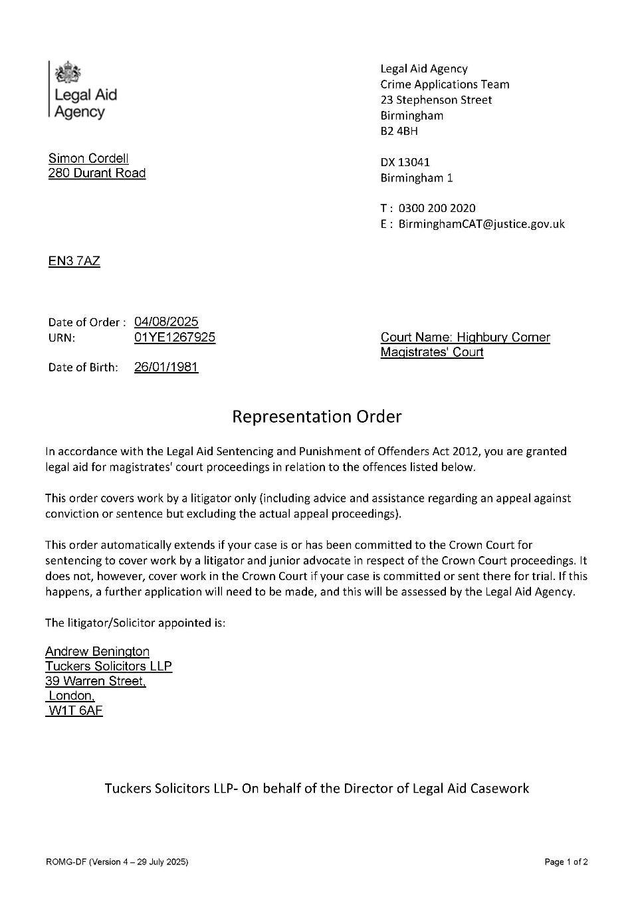



Exhibit 2:
Is from another case but of the same kind and issued by the same Solicitor firm!
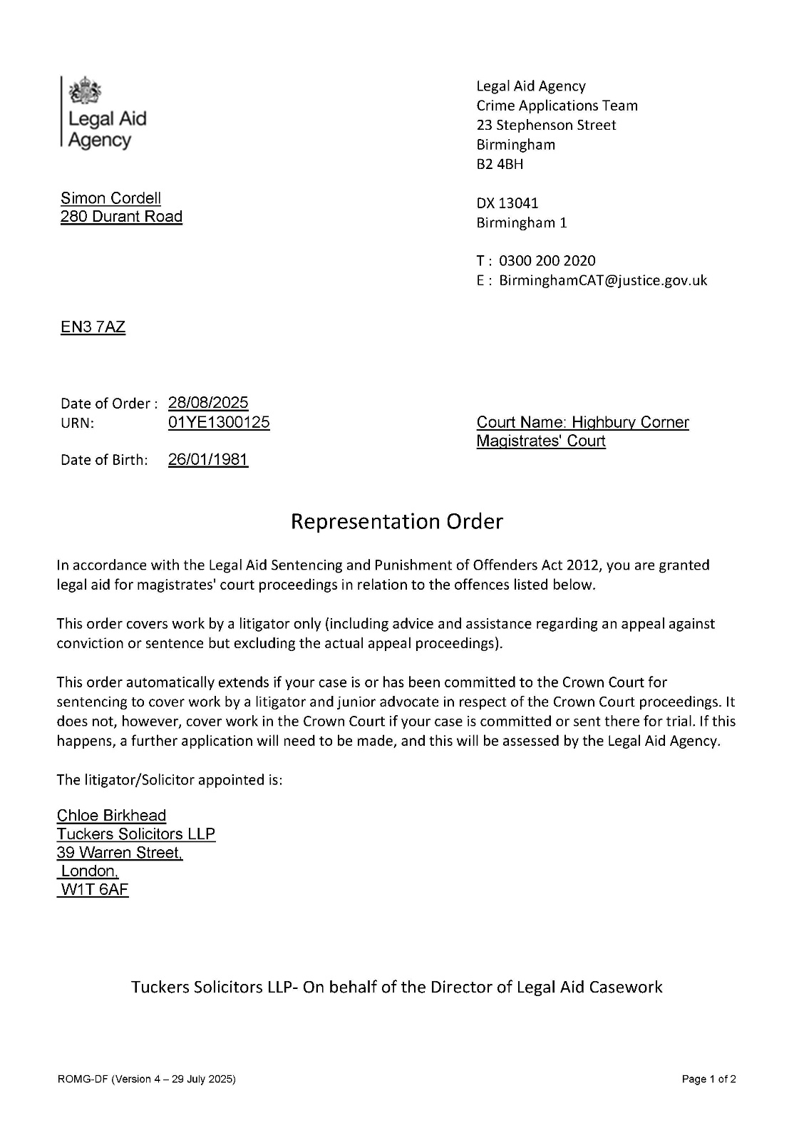



- Clarification of What Is Legally Permitted When Applying for Legal Aid
During the investigation, I requested clarification on what a solicitor “Is Legally Permitted to Do When Applying for Legal Aid. Specifically:
- Can A Solicitor Self-Issue or Generate Their Own Representation Order Certificates as I have been provided with?
- Can A Solicitor Apply for Legal Aid Without Submitting CRM14/CRM15 Forms?
- Can A Solicitor Apply Using A URN That Has Been Used for Changing or Substituted Allegations in The Wav Described Above?
- Can A Solicitor Proceed with A Legal Aid Application Where the URN Has Been Prior NFA’d And Then Reused without fair legal process? These questions remain unanswered and require direct clarification.

- Procedural Impact on Mv Ability to Obtain Representation
Your previous response did not address how these irregularities have:
- Prevented Me from Obtaining Lawful Representation.
- Restricted Me Lartys Solicitors to Section 36/38 Only.
- And Obstructed Mv Ability to Prepare a Defence.

Please confirm whether the LAA acknowledges the procedural impact caused by the irregularities identified above.
I would be grateful if you could provide “Direct. Specific Answers” to each of the points listed. These matters are central to the integrity of the legal aid process and the fairness of the ongoing criminal proceedings.

P.S.
For clarity, I expect the Legal Aid Agency to act with full impartiality and in accordance with its public-law duties. Any administrative decision that contributes to procedural unfairness, or that enables a solicitor to rely on irregular or misleading documentation, risks undermining the integrity of the criminal justice process. I trust that the Agency will ensure its actions remain fully compliant with its statutory obligations, including the duty to act fairly, transparently, and without favour to any party involved.
I have also attached the "Two LAA RO Orders" supposedly issued to Tuckers by the LAA to complete on mine and other clients behalf’s that are in question as attachments for your review!

Kind regards,
Mr. Simon Paul Cordell
The Illegal Swapped URN is: 01YE1267925



78. Received-Cordell ROl.pdf 128.4 kB


78. Received-Cordell R02.pdf 128.6 kB

174. Sent-LAA -03-03-26
174. Sent-LAA -03-03-26.pdf
174..zip
Re: File 1 - Simon Cordell - MAAT 900900
URN 01YE1267925 Id:COR103 88/00001
From: Rewired (re_wired@ymail.com)
To :birminghamcat@justice.gov.uk
Date: Tuesday, 3 March 2026 at 15:27 GMT

Please can you respond towards my questions as I have not received a fair response from yourselves that all members of the public can understand without a degree in how the LAA System works, as now is required by us! We want to understand the following:

- Is the template of form used by Tuckers solicitor firm that we Exhibited to you a form you issued to them to fill in to obtain legal aid on clients behalf’s or not!
- Also, did they have to complete a CRM 14 /15 to obtain legal aid on my behalf while I was on benefits.
- Did they have to complete a legal aid transfer form with the prior solicitors mindless of the LAA Hack.

Please can you respond as a matter of urgency and not protect any persons by refusing to explain how the LAA system is complied with in these circumstances by avoiding what you know to be fake or real such as the attached RO Certificates that are addressed from the LAA.

On Thursday, 19 February 2026 at 19:09:03 GMT,
Rewired <re_wired@ymail.com> wrote:
EMAIL TO THE LEGAL AID AGENCY (Corrected and Complete)
Subject: Follow-Up: Outstanding Investigation Questions Requiring Direct and Specific Answers (Tuckers Solicitors / URN Irregularities)

Dear Legal Aid Agency,
Thank you for your previous correspondence. However, several critical questions raised during your investigation remain unanswered. These matters concern the conduct of “Tuckers Solicitors.” specifically “Ms. Rosie Yates Leaal Aid Manager & Col.” and relate directly to the lawfulness of the legal aid application submitted on my behalf. I respectfully request clear, direct answers to each of the following points.

Re-Use of an NFA’d Police URN L01YE12679251

185. Received 10-03-26 LAA From 03_02-03-26 And

RE: File 1 - Simon Cordell - MAAT 900900 URN 01YE1267925 Id:COR10388/00001 From: Birmingham CAT (birminghamcat@justice.gov.uk)
To: re_wired@ymail.com
Date: Tuesday, 10 March 2026 at 11:36 GMT

Dear Simon Cordell,
Thank you for your emails. I have copied all of your questions, and our answers are in blue italics underneath each question or subsection.

Questions From the Email on the 3/03/2026:
- Is The Template Of Form Used By Tuckers Solicitor Firm That We Exhibited To You A Form You Issued To Them To Fill In To Obtain Legal Aid On Clients Behalf’s Or Not!
LAA Response 10-03-26:
The Rep order you have attached is perfectly valid. As per our email response on the 13/02/2026 we gave providers these templates to use for any client they granted their own legal aid for.

- Also, did they have to complete a CRM 14 /15 to obtain legal aid on my behalf while I was on benefits.
LAA Response 10-03-26:
Again, as per our email response on the 13/02/2026 they did not have to complete a CRM14/15 for your case because you were on benefits.

- Did they have to complete a legal aid transfer form with the prior solicitors mindless of the LAA Hack.
LAA Response 10-03-26:
If there was legal aid in place then regardless of the LAA Hack, a transfer would have had to be applied for and sent to the Court hearing the matter. Neither the LAA nor the solicitors have the power to move legal aid to another firm. This is solely and always has been a Court decision.

Questions from the 19/02/2026

- Re-Use of an NFA’d Police URN f01YE12679251 Please confirm whether it is lawful for a police URN that has already been recorded as “No Further Action (NFA) to be:
- Reused once No Further Action (NFA)
- Reactivated. After Being No Further Action (NFA) For Another Criminal Offence Other Than The One You Was Arrested For!
- Used As The Basis For A New Or Substituted Criminal Offence Allegation once the Custody log was stopped and the Original Reason For Arrest Was Disposed of As discontinued.
These questions were raised explicitly during this investigation with yourselves but has not been answered.
LAA Response 10-03-26:
We do not have the authority to answer Q1(1)-(3) as we are not involved with Police actions or what references they record cases under. This is an area where the LAA has no authority.

- Legal Aid Application Submitted Under a URN Used for Multiple and Substituted Allegations
The sequence of events in my case is as follows:
- I Was Originally Arrested For Harassment Under URN 01YE1267925.

- When Booked Into Custody. The Allegation Was Changed To Section 4A (Fear Of Violence).

- Purina The Interview. I Was Instructed Not To Speak About The Harassment Allegation And To Answer Only In Relation To Section 4A.

- An Attempt Was Made To Introduce An Allegation Against Police. Which Mv Then Solicitor /Elliot Stern 1 Stopped. After Which He Left.

- The Section 4A Allegation Was Later Recorded As NFA.

- The MG4/MG5 Documentation Did Not Appear In The First Disclosure Bundle. Which Was Already Compromised By The Fake Representation Order Dated 01092025.

- The First Time The MG4 Ever Appeared Was In The CPS Case Ratio Folder Created On 10102025.

- That MG4 Shows Both The Harassment Allegation And A New Allegation Of “Threats To Cause Criminal Damage” Under The Same URN f01YE1267925T

- I Was Never Re Arrested. Never Reinterviewed. And Never Cautioned For The Substituted “Threats To Cause Criminal Damage” Allegation.

- Despite this, under the responsibility of “Tuckers Solicitors Someone Has” submitted and relied upon a legal aid position based on this URN, even though the URN had been used for multiple and substituted allegations and did not reflect a clear, lawfully progressed charge sequence.
LAA Response 10-03-26:
Q2 (1+-9+): Again, the use of the URN again is not something the LAA can assist with. However, any offence under the URN can be entered onto the same Representation order.

I Therefore Require the Legal Aid Agency to Confirm:
- Whether A Solicitor Is Permitted To Apply For Or Rely On Legal Aid Where A URN Has Been Used For Multiple And Substituted Allegations Without A Fresh Arrest. Interview. Or Caution.
- Whether A Solicitor Is Permitted To Proceed Where The URN History Includes An Allegation That Has Been NFA’d And Then Followed By A Different Allegation Under The Same URN.
- Whether The LAA Considers This Use Of The URN To Be Compliant With Legal Aid Regulations And Professional Standards.
This question has not been answered in your previous correspondence and requires a direct, unambiguous response.
LAA Response 10-03-26:
1+ - 3+: Where the police or the Courts enter offences under URNs, regardless of whether they have been previously used for other matters is not an area that the Legal Aid Agency can get involved with or have any authority over. Where multiple offences are entered under the same URN then any of those offences can be granted on the same representation order.

- Representation Order Provided by Tuckers Solicitors
Tuckers Solicitors provided me with a document they described as an “Official Representation Order Template.” Please confirm:

- 1+ Whether The RO Certificate of Legal Aid approval Document Provided By Ms. Rosie Yates and Exhibited by me Matches Any Official LAA Template, or Form Issued by the LAA Though the LAA Hack as a replacement to Crm14 and/or crm15 to be completed by acting Solicitor Firms and Not the LAA to obtain Legal Aid for their Clients?
LAA Response 10-03-26:
Yes, it does match our template

- Whether The LAA allows solicitor Firms to Issue this Template as an official document supported by them and without Contacting them?
LAA Response 10-03-26:
Yes, we do

- And Whether The LAA Has Any Record Of This Representation Order Being Created Within Your System.
LAA Response 10-03-26:
No, we don’t as it was not created within our system.

This Point Has Been Avoided in Previous Responses and Requires Clarification.
LAA Response 10-03-26:
Q3 (1+-3+) was answered in the email from the 13/02/2026 where we stated that the LAA created the template for solicitors to use, and it is a valid Rep order. We don’t have any record of it being created within our system as it wasn’t created within our system being a word document that they could amend and save on their own systems. The LAA would only see these orders if they were submitted with the bill or the file was audited.

Exhibit 1: Is this template really issued out by LAA to Solicitor firm as Ms. Rosie Yates states it was given to her firm to complete by the LAA on their own to obtain legal Aid in compliance to law and LAA Standards for client like me though the LA Hack or not?
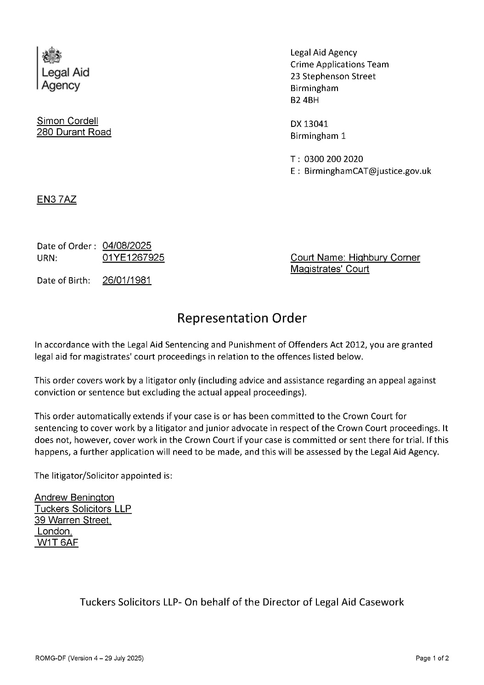



Exhibit 2:
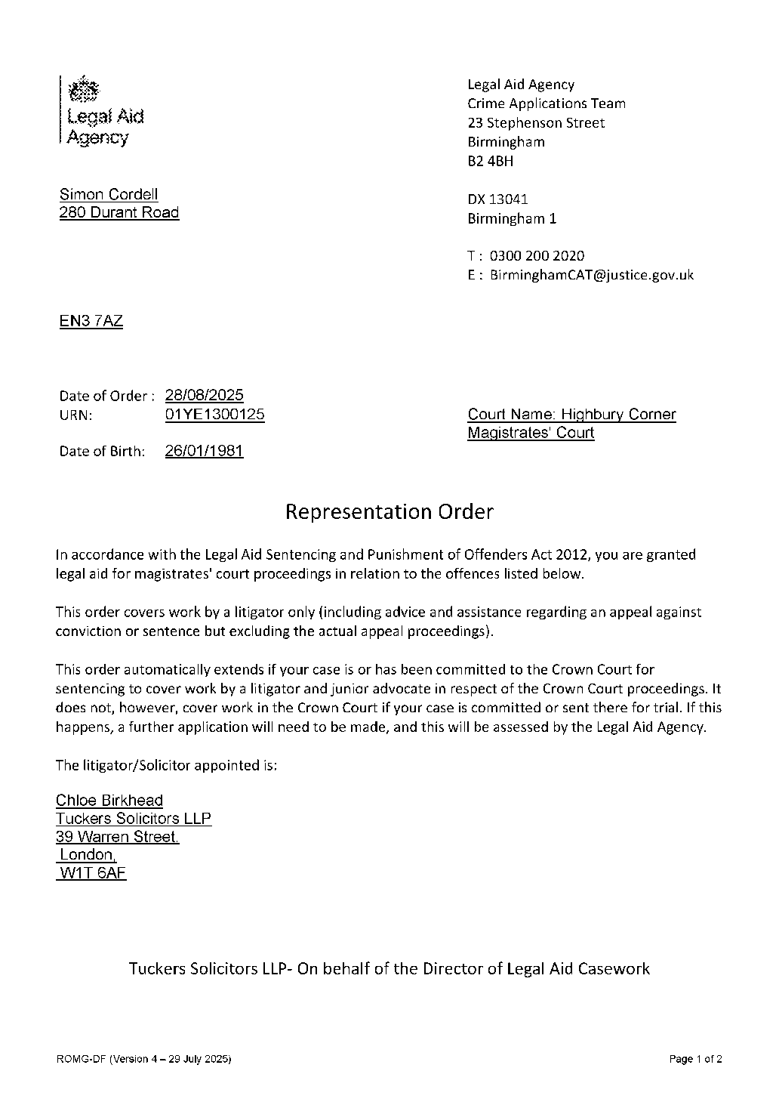

Is from another case but of the same kind and issued by the same Solicitor firm!
LAA Response 10-03-26:
yes. The two Rep orders you have attached are using the template issued to Solicitors for this purpose

- Clarification Of What Is Legally Permitted When Applying For Legal Aid During The Investigation, I Requested Clarification On What A Solicitor “Is Legally Permitted To Do When Applying For Legal Aid. Specifically:
- Can A Solicitor Self issue Or Generate Their Own Representation Order Certificates as I have been provided with?
LAA Response 10-03-26:
yes. And firms were given specific guidance as to when they could do so. This is available here: Crime Contingency- Legal Aid
Learning which is designed for Solicitors and Advocates but is freely open to the public.

- Can A Solicitor Apply For Legal Aid Without Submitting CRM14/CRM15 Forms?
LAA Response 10-03-26:
yes. I refer to our answer to Q2.3+ in the email from the 19/02:
2. CRM14 and CRM15 - application and means test
During the contingency period:
3+ Were firms required to complete CRM14 and CRM15 for every client, including those on passported benefits, where they intended to rely on legal aid?
No. We only recommended that they complete and had the forms kept on file for those that they were able to self-grant. They did however have to keep IOJ reasoning and full details of means / relevant evidence on file. Specific requirements mentioned in the FAQ document available to Providers (Legal Aid Agency cyber security incident - GOV.UK). were as follows:

- Can A Solicitor Apply Using A URN That Has Been Used For Changing Or Substituted Allegations In The Way Described Above?
LAA Response 10-03-26:
yes, they can. If the offences applied for are under the URN, then they can apply for them. As above - we do not have control over what the police or courts enter under each URN.

- Can A Solicitor Proceed With A Legal Aid Application Where The URN Has Been Prior NFA’d And Then Reused Without Fair Legal Process?
LAA Response 10-03-26:
If the offences are showing under the URN, regardless of if they were added later, then the solicitors can apply for those offences.

These Questions Remain Unanswered and Require Direct Clarification.
LAA Response 10-03-26:
Each has now been given its own response to help with clarification.

- Procedural Impact on My Ability to Obtain Representation
Your previous response did not address how these irregularities have:
1+ Prevented Me from Obtaining Lawful Representation.
2+ Restricted Me Lartys Solicitors to Section 36/38 Only.
3+ And Obstructed My Ability to Prepare a Defence.
Please confirm whether the LAA acknowledges the procedural impact caused by the irregularities identified above.
LAA Response 10-03-26:
The URN 01YE1267925 you have provided only shows the following offences:
- Threat to damage / destroy property; and
- Arrest by a constable for breaking / likely to break bail conditions - duty to surrender into the custody of a court.
The orders you have provided are correct and valid based on the matters remaining in the magistrates' court, and you being on benefits. You would have therefore had lawful representation through Tuckers. Once they had put legal aid in place then any transfer would have been down to the Court. They would have been able to confirm the correct URN, as that is not an LAA area.
If the court granted a transfer of legal aid, then any new firm would use the same template as Tuckers did to continue your representation.
After carefully considering everything, you have provided, we cannot see any irregularities’ in how the Legal Aid was granted by Tuckers, or how it has made any contribution to the points you have raised in Q5 (1+ to 3+)
I hope this fully answers all of your questions.
Yours sincerely,
Martina Aston
Senior Technical Caseworker National Criminal Applications Team

Office Base: 23 Stephenson Street Birmingham B2 4BH
DX Post To: DX 13041 Birmingham
Tel: 0300 200 2020
All other correspondence send to postal address - Legal Aid Agency Birmingham, Berkley Way, Unit 8B, Jarrow, NE31 1SF.

If you would like to provide feedback based on your experience in this transaction, please click the link: httDs://forms.office.com/e/99dnPxDs9K
Crime Apply - All new applications for criminal legal aid should be made through the Apply for criminal legal aid service. You can request historic e-Forms via Online-Support@justice.gov.uk. The team aim to respond to all requests within 5 working days.
Find out more on People Finder Follow us on Twitter @LegalAidAgency
Progress of Your Application:
We aim to process the majority of applications within 2 working days following the date of receipt.
Before calling to check the progress of an application please check our oldest dates by following this link https://www.aov.uk/auidance/crime- processing-dates. Reducing call volumes will allow us to process more applications.
Contacting Us:
- Birmingham CAT: BirminahamCAT@iustice.gov.uk
- Liverpool CAT: LiverpoolCAT@iustice.gov.uk
- Nottingham CAT: NottinahamCAT@iustice.gov.uk
- National Crime Team (NCT): nationalcrimeteam@iustice.aov.uk
- Interests of Justice appeals: ioiappeals@iustice.gov.uk
- Customer Services Team: 0300 200 2020
- Provider Guidance/forms and Webchat: Ministry of Justice (telephone and webchat helpline hours are 9am to 5pm Monday to Friday)

For frequently asked questions and standard pro forma's follow this link
httDs://www.aov.uk/aovernment/Dublications/simDlifvina-criminal-leaal-aid-
processing
Application to transfer legal Aid: httD://www.iustice.aov.uk/courts/Drocedure- rules/criminal/forms-2015 Part 46
PLEASE NOTE: "I am not authorised to bind the Ministry of Justice contractually, nor make representations, or statements which bind the Ministry of Justice in any way via electronic means.

Re: File 1 - Simon Cordell - MAAT 900900
URN 01YE1267925 Id:COR103 88/00001
From: Rewired (re_wired@ymail.com)
To :birminghamcat@justice.gov.uk
Date: Tuesday, 3 March 2026 at 15:27 GMT

Please can you respond towards my questions as I have not received a fair response from yourselves that all members of the public can understand without a degree in how the LAA System works, as now is required by us! We want to understand the following:

- Is the template of form used by Tuckers solicitor firm that we Exhibited to you a form you issued to them to fill in to obtain legal aid on clients behalf’s or not!
- Also, did they have to complete a CRM 14 /15 to obtain legal aid on my behalf while I was on benefits.
- Did they have to complete a legal aid transfer form with the prior solicitors mindless of the LAA Hack.

Please can you respond as a matter of urgency and not protect any persons by refusing to explain how the LAA system is complied with in these circumstances by avoiding what you know to be fake or real such as the attached RO Certificates that are addressed from the LAA.

On Thursday, 19 February 2026 at 19:09:03 GMT,
Rewired <re_wired@ymail.com> wrote:

EMAIL TO THE LEGAL AID AGENCY (Corrected and Complete)
Subject: Follow-Up: Outstanding Investigation Questions Requiring Direct and Specific Answers (Tuckers Solicitors / URN Irregularities)

Dear Legal Aid Agency,
Thank you for your previous correspondence. However, several critical questions raised during your investigation remain unanswered. These matters concern the conduct of “Tuckers Solicitors.” specifically “Ms. Rosie Yates Leaal Aid Manager & Col.” and relate directly to the lawfulness of the legal aid application submitted on my behalf. I respectfully request clear, direct answers to each of the following points.

Re-Use of an NFA’d Police URN L01YE12679251

Please confirm whether it is lawful for a police URN that has already been recorded as “No Further Action NFA to be:
- 1+ Reused once No Further Action (NFA1
- 2+ Reactivated. After Being No Further Action (NFA1 For Another Criminal Offence Other Than The One You Was Arrested For!
- 3+ Used As The Basis For A New Or Substituted Criminal Offence Allegation once the Custody loo was stopped and the Original Reason For Arrest Was Disposed of As discontinued.
These questions were raised explicitly during this investigation with yourselves but has not been answered.

Legal Aid Application Submitted Under a URN Used for Multiple and Substituted Allegations

The sequence of events in my case is as follows:

- I Was Originally Arrested For Harassment Under URN 01YE1267925.
- When Booked Into Custody. The Allegation Was Changed To Section 4A Fear Of Violence!.
- Purina The Interview. I Was Instructed Not To Sneak About The Harassment Allegation And To Answer Only In Relation To Section 4A.
- An Attempt Was Made To Introduce An Allegation Against Police. Which Mv Then Solicitor (Elliot Stern1 Stopped. After Which He Left.
- The Section 4A Allegation Was Later Recorded As NFA.
- The MG4/MG5 Documentation Did Not Appear In The First Disclosure Bundle. Which Was Already Compromised By The Fake Representation Order Dated 01-09-2025.
- The First Time The MG4 Ever Appeared Was In The CPS Case Ratio Folder Created On 10-10-2025.
- That MG4 Shows Both The Harassment Allegation And A New Allegation Of “Threats To Cause Criminal Damage” Under The Same URN f01YE1267925L
- I Was Never Re-Arrested. Never Re-Interviewed. And Never Cautioned For The Substituted “Threats To Cause Criminal Damage” Allegation.

Despite this, under the responsibility of “Tuckers Solicitors Someone Has” submitted and relied upon a legal aid position based on this URN, even though the URN had been used for multiple and substituted allegations and did not reflect a clear, lawfully progressed charge sequence.

I Therefore Require the Legal Aid Agency to Confirm:
- Whether A Solicitor Is Permitted To Apply For Or Rely On Legal Aid Where A URN Has Been Used For Multiple And Substituted Allegations Without A Fresh Arrest. Interview. Or Caution.
- Whether A Solicitor Is Permitted To Proceed Where The URN History Includes An Allegation That Has Been NFA’d And Then Followed By A Different Allegation Under The Same URN.
- Whether The LAA Considers This Use Of The URN To Be Compliant With Legal Aid Regulations And Professional Standards.
This question has not been answered in your previous correspondence and requires a direct, unambiguous response.

Representation Order Provided by Tuckers Solicitors
Tuckers Solicitors provided me with a document they described as an “Official Representation Order Template.” Please confirm:

- Whether The RO Certificate of Legal Aid approval Document Provided By Ms. Rosie Yates and Exhibited by me Matches Any Official LAA Template, or Form Issued by the LAA Though the LAA Hack as a replacement to Crm14 and/or crm15 to be completed by acting Solicitor Firms and Not the LAA to obtain Legal Aid for their Clients?
- Whether The LAA allows solicitor Firms to Issue this Template as an official document supported by them and without Contacting them?
- And Whether The LAA Has Any Record Of This Representation Order Being Created Within Your System.
This point has been avoided in previous responses and requires clarification.
Exhibit 1: Is this template really issued out by LAA to Solicitor firm as Ms. Rosie Yates states it was given to her firm to complete by the LAA on their own to obtain legal Aid in compliance to law and LAA Standards for client like me though the LA Hack or not?

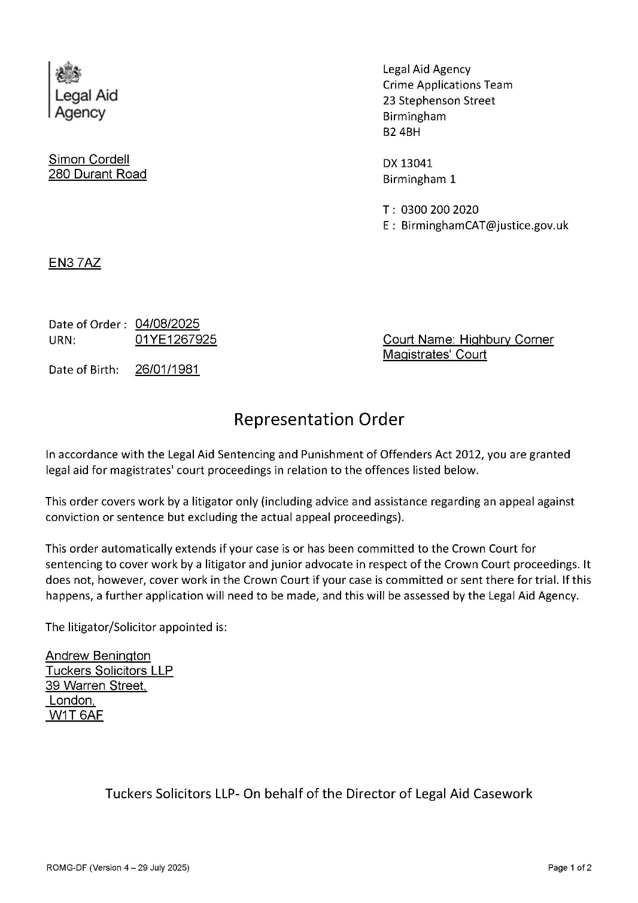



Exhibit 2:
Is from another case but of the same kind and issued by the same Solicitor firm!

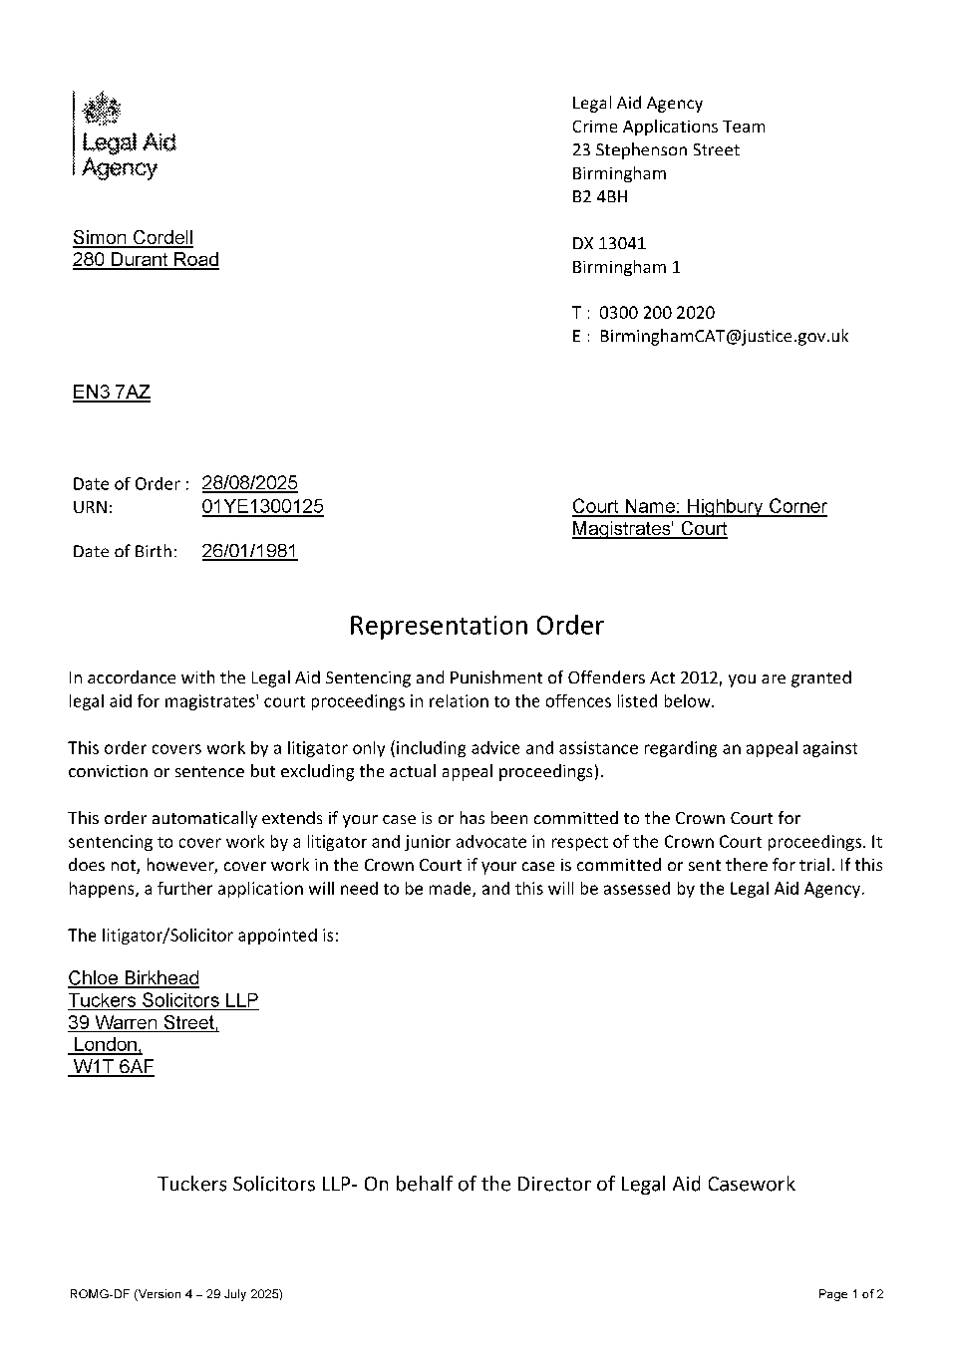



Clarification of What Is Legally Permitted When Applying for Legal Aid
During the investigation, I requested clarification on what a solicitor “Is Legally Permitted to Do When Applying for Legal Aid. Specifically:
- Can A Solicitor Self-Issue Or Generate Their Own Representation Order Certificates as I have been provided with?
- Can A Solicitor Apply For Legal Aid Without Submitting CRM14/CRM15 Forms?
- Can A Solicitor Apply Using A URN That Has Been Used For Changing Or Substituted Allegations In The Wav Described Above?
- Can A Solicitor Proceed With A Legal Aid Application Where The URN Has Been Prior NFA’d And Then Reused without fair legal process? These questions remain unanswered and require direct clarification.

Procedural Impact on Mv Ability to Obtain Representation
Your previous response did not address how these irregularities have:
- Prevented Me From Obtaining Lawful Representation.
- Restricted Me Lartys Solicitors To Section 36/38 Only.
- And Obstructed Mv Ability To Prepare A Defence.
Please confirm whether the LAA acknowledges the procedural impact caused by the irregularities identified above.

- I would be grateful if you could provide “Direct. Specific Answers” to each of the points listed. These matters are central to the integrity of the legal aid process and the fairness of the ongoing criminal proceedings.

P.S.
- For clarity, I expect the Legal Aid Agency to act with full impartiality and in accordance with its public-law duties. Any administrative decision that contributes to procedural unfairness, or that enables a solicitor to rely on irregular or misleading documentation, risks undermining the integrity of the criminal justice process. I trust that the Agency will ensure its actions remain fully compliant with its statutory obligations, including the duty to act fairly, transparently, and without favour to any party involved.
- I have also attached the "Two LAA RO Orders" supposedly issued to Tuckers by the LAA to complete on mine and other clients behalf’s that are in question as attachments for your review!
Kind regards,
Mr. Simon Paul Cordell

The Illegal Swapped URN is: 01YE1267925
On Thursday, 19 February 2026 at 16:14:37 GMT, Birmingham CAT <birminghamcat@justice.gov.uk> wrote:

OFFICIAL-SENSITIVE
Good afternoon
I’ve just reviewed initial email and can see that Tuckers withdrew their delegated functions.
If legal aid was withdrawn, then the process for new solicitor would be to obtain confirmation that it would be reasonable costs upon funding for us to consider a new application from the court. Ideally, we would need to see the new solicitors application to work out what issues there is.
All the information regarding the whole contingency period can be found here:
Legal Aid Agency cyber security incident - GOV.UK
In respect of hardship applications this wouldn’t be applicable as only unemployed and passported applications that weren’t indictable/crown court trial were considered as ‘delegated functions’.
For the sequence of events prior to application process that’s not something we can comment upon as it’s something separate to Legal Aid Agency involvement. The only thing we can advise about is regarding the CRM 14 application for legal aid. Issues with the police, solicitors, HMCTS will have to be resolved directly with them.
Regards
Luke Atkins
Caseworker

Agency ^{d} National Criminal Applications Team
Office Base 23 Stephenson Street Birmingham B2 4BH.
Tel: 0300 200 2020 |

All correspondence postal address - Legal Aid Agency Birmingham,
Berkley Way, Unit 8B, Jarrow, NE31 1SF, DX 742 350 Jarrow
Find out more on People Finder Follow us on Twitter @LeaalAidAaencv
Progress of Your Application:
We aim to process the majority of applications within 2 working days following the date of receipt.
Before calling to check the progress of an application please use the tracking function within the e-Form system and check our oldest dates by following this link
httDs://www.aov.uk/auidance/crime-Drocessina-dates. Reducing call volumes will allow us to process more applications.
Contacting Us:
- Birmingham CAT: BirminqhamCAT@justice.qov.uk
- Liverpool CAT: LiverpoolCAT@justice.qov.uk
- Nottingham CAT: NottinqhamCAT@justice.qov.uk
- Interests of Justice appeals: jojappeals@justice.qov.uk

Guidance_CRM14_and_CRM15 = C:\Users\Si_Al\OneDrive\Desktop\21-10-25\01. 02-08-2025-Another-Case\02. All-Docs\129. Sent 16-02-26 to LLA and CPS and Courthouse\1. Request For Case Review 02-08-25 LAA\Admin\02. Exhibits Cabinet LAA Response - Sent Pt1

Screenshot_18-2-2026_LAA Cyber Security Incident

02. Cabinet LAA Response

02. Exhibits Cabinet LAA Response - Sent Pt1 = C:\Users\Si_Al\OneDrive\Desktop\21-10-25\01. 02-08-2025-Another-Case\02. All-Docs\129. Sent 16-02-26 to LLA and CPS and Courthouse\1. Request For Case Review 02-08-25 LAA\Admin

02. Cabinet LAA Response – Sent

1. Request For Case Review 02-08-25 LAA

