Custody Sergeants (“Skippers”)

Who Is The Main Corporate?

“What time did I arrive at the police station, as I saw the main corporate at 08:00 and again at 04:00 the next morning — even though these are two different work shifts?”
Police custody sergeants normally work “12-hour shifts,” typically:
- 07:00 to 19:00 (day shift)
- 19:00 to 07:00 (night shift)
Because of this structure, the supervising sergeant at 08:00 and the supervising sergeant at 04:00 should be “Two Different Individuals.”
This timing is central to identifying “Which Sergeant Was Actually Present” at the moments I remember.

Why I Am Trying To Identify The Main Corporate
I have a clear and consistent memory of a particular officer’s face — a face that has appeared during “Multiple Stressful Events” over several years.
This includes:
- Two Housing Possession Orders,
- Two Injunction Orders,
- An Asbo-Related Matter,
- And Interactions Connected To “Mental-Health-Related Entries And Pnc/Acro Issues.”
Because these events were significant and emotionally charged, the same officer’s face became strongly imprinted in my memory.
This officer has also been present at key moments in custody.
When I arrived at the station, he was visible in the background.
After I raised concerns about him, I noticed a pattern:
- Other Officers Began Handling The Booking-In Process.
- He Remained Behind Them, Positioned Slightly Out Of Direct Involvement.
- He Appeared To Oversee Or Supervise Indirectly.
- His Presence Was Consistent Even When He Was Not The One Speaking.
Because of this repeated pattern, I am trying to determine “Which Custody Sergeant Matches The Face I Recognise.”

Why I Am Using The Custody Logs
Police forces do not release the identities of active officers due to “Data-Protection Rules.”
When I attempted to obtain information by telephone, I was told that such details cannot be shared.
This means the “Custody Logs” are the only available source that:
- List Supervising Sergeants,
- Show Who Was On Duty At Each Time,
- Allow Me To Compare My Memory With The Documented Shift Pattern.
I am using these logs to determine:
- Who Was Present At 08:00,
- Who Was Present At 04:00,
- And Whether Either Sergeant Matches The Officer I Recognise.

Complications That Make Identification Difficult

1. No Member Of The Defence Team Has Ever Met “PC Quick”
Because no one from the defence side has met or spoken to this officer, it is unclear:
- Whether He Was Involved In The Case,
- Whether His Details Were Recorded Correctly,
- Or Whether The Name Refers To An Administrative Placeholder.
This uncertainty makes it harder to match my memory to the paperwork.

2. Procedural Irregularities In The Case History
There have been issues such as:
- A Charge Being Swapped,
- A URN Being Reused,
- General Case-Handling Inconsistencies.
Because of these irregularities, it is difficult to rely fully on the paperwork without cross-checking it against:
- The Custody Logs,
- The Shift Patterns,
- And My Own Recollection.

Purpose of This Section
This section is designed to:
- Identify “Which Sergeant Was On Duty” At The Times I Remember,
- Compare My Memory With The Official Custody Timeline,
- Determine Whether The Officer I Recognise Appears In The Records,
- Clarify Whether The Same Sergeant Could Realistically Have Been Present At Both 08:00 And 04:00.

This Is Not An Accusation.
It Is A Factual Attempt To:
- Understand The Timeline,
- Match Memory To Documentation,
- And Resolve Inconsistencies In A Structured, Evidence-Based Way to prove who is responsible for all the frauded and fabricated applications as well as arrests to support them or otherwise!
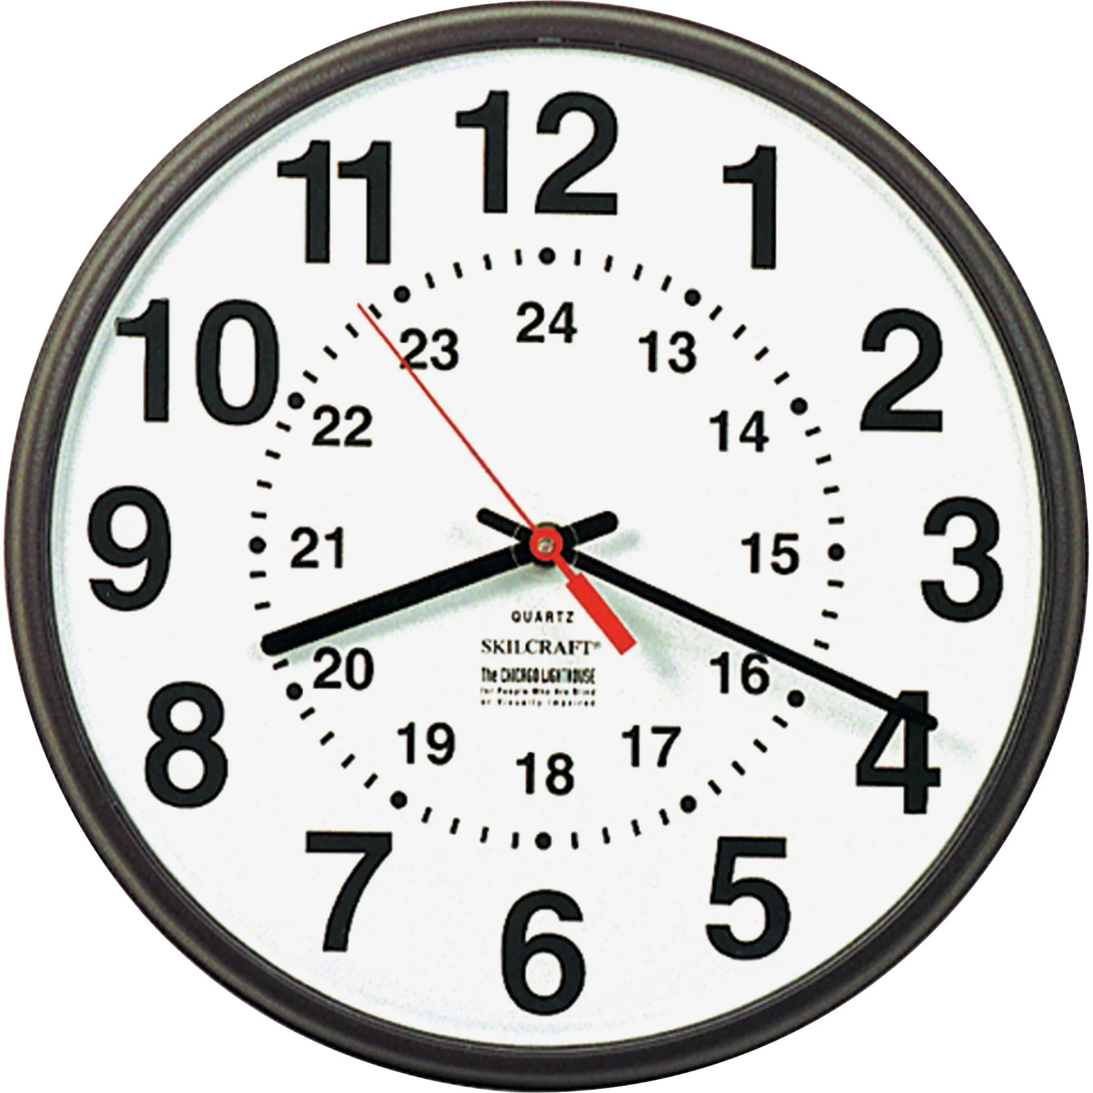

- SGT OZCAN (P240417) – CUSTODY SERGEANT — FULL SHIFT TIMELINE TABLE

Date | Time | Event | Description | Shift Type
03/08/2025 | 07:43 | Arrival | You arrive at custody; Ozcan is the supervising sergeant | DAY SHIFT (start)
03/08/2025 | 07:58 | Detention Authorised | Ozcan formally authorises your detention | DAY SHIFT
03/08/2025 | 08:08 | Detention Entry | Staff member logs detention; still authorised by Ozcan | DAY SHIFT
03/08/2025 | 08:21 | Initial Search | Search authorised by Ozcan | DAY SHIFT
03/08/2025 | 08:24–08:25 | Observation Level | Observation level and visit diary set by Ozcan | DAY SHIFT
03/08/2025 | 08:25 | Cell Allocation | Cell 11C allocated under Ozcan’s authority | DAY SHIFT
03/08/2025 | 09:38 | Op Herald | Logged by Ozcan | DAY SHIFT
03/08/2025 | 09:39 | Supervision | Ozcan still supervising custody | DAY SHIFT
03/08/2025 | 18:57 | Handover | Ozcan hands over to Sgt Willans (P236764) | END OF DAY SHIFT
- Authorised “Detention At 07:58” before any officer in case was assigned.
- “Approved Search By PC Obsiye That Could Not Have Occurred.”
- Must explain lawfulness of detention, fabricated search entry, and why detention grounds were repeated despite contradictions.

- Sgt Hales (P235743) – Custody Sergeant — FULL SHIFT TIMELINE TABLE
Date | Time | Event | Description | Shift Type
03/08/2025 | 09:19 | Arrest / Booking Oversight | Sgt Hales is supervising the arrest entry | DAY SHIFT
03/08/2025 | 15:34 | Solicitor Contact | Hales confirms solicitor Shafiq Suleman was contacted | DAY SHIFT
03/08/2025 | 15:49 | Interview Start | Hales authorises and logs the interview start | DAY
- Logged arrest “Details At 09:19,” noted “Officer in case was NA VCT.”
- Must explain Why No OIC Was Assigned During Detention, how charges were processed without oversight, and why custody record shows gaps in officer assignment.

- Sgt Bloomfield (P232415) – SHIFT TYPE FOR EACH TIMESTAMP
Date | Time | Event | Shift Type
03/08/2025 | 13:30 | Mental Health Entry | DAY SHIFT
03/08/2025 | 14:28 | Image Capture | DAY SHIFT
03/08/2025 | 16:17 | Risk Assessment | DAY SHIFT
03/08/2025 | 16:17 | Interview Finish / Return | DAY SHIFT
04/08/2025 | 07:14 | Review | DAY SHIFT Overtime
04/08/2025 | 07:21 | Handover | DAY SHIFT Overtime
- 03/08/2025 16:17
- Interview Finish
- Sgt 01 P232415 Bloomfield
- The Detainee Was Returned From Interview At 16:16 On 03/08/2025:
a. The cell visit clock was reset as a result of the detainee being returned directly to cell from interview.
b. PACE and the Codes of Practice were complied with and PC 01 P264294 Uddin signed to this effect at 03/08/2025 16:16
• The following persons were present at the interview:
a. Appropriate Adult,
b. Solicitor
• The detainee was returned to custody on 03/08/2025 at 16:17.
a. The officer returned to was SFLT 01 P232415 Bloomfield

- SGT 01 SMITH (P201985) — FULL SHIFT TIMELINE TABLE
Date | Time | Event | Description | Shift Type
04/08/2025 | 03:33 | Disposal / Decision Entry | Sgt Smith records the early-morning disposal entry | NIGHT SHIFT
04/08/2025 | 03:33 | Custody Supervision | Smith is the supervising sergeant at this time | NIGHT SHIFT

- SGT WILLANS (P236764) – CUSTODY SERGEANT — SHIFT TIMELINE TABLE
Date | Time | Event | Description | Shift Type
03/08/2025 | 18:57 | Handover | Sgt Willans takes over custody responsibility | DAY SHIFT  to →  NIGHT SHIFT HANDOVER
- Took over custody at 18:57 handover.
- Must explain continuity of detention, whether irregularities were communicated during handover, and why custody record shows fabricated welfare notes.
- “I participated in a handover between the incoming and outgoing custody teams,
- which was conducted within the sight and sound of CCTV. I accept responsibility for the detainee.”

Inspector
- Insp Sewell (P240595) – Inspector
  - Conducted detention review at 13:33.
  - Must explain why continued detention was authorised despite disputed medical entries, absence of OIC, and contradictions in custody logs.

6. INSP SEWELL (P240595) — DETENTION REVIEWING OFFICER — SHIFT TIMELINE TABLE
Date | Time | Event | Description | Shift Type
03/08/2025 | 10:32 | Common Law / Police Disclosure Entry | Inspector Sewell appears in the custody record in connection with a disclosure-related entry | DAY SHIFT
03/08/2025 | 13:34 | Detention Review | Inspector Sewell conducts the statutory detention review | DAY SHIFT
03/08/2025 | 18:57 | Handover Context | Review falls within the same operational period leading into the Willans handover  His name | DAY SHIFT → NIGHT SHIFT HANDOVER

Key Issues Requiring Clarification
- 10:32 “Common Law / Police Disclosure” Entry
- Inspector Sewell appears in the custody record at 10:32, connected to a “Common Law / Police Disclosure” entry.

- He Must Clarify:
- what disclosure was being considered or actioned at this time,
- whether this related to the allegation, unused material, or internal communication,
- whether this entry influenced later decisions,
- and what information he reviewed or authorised.
This entry appears before the formal detention review, making it relevant to the chain of decision-making.

b) 13:34 Detention Review
Inspector Sewell authorised continued detention at 13:34.
At this time, the custody record contained:
- disputed medical entries,
- inconsistent mental-health notes,
- no assigned Officer in Case (OIC),
- contradictions in search entries,
- and repeated detention-ground entries.
He must explain:
- what information he relied upon,
- whether he reviewed the disputed entries,
- and how he determined that continued detention was lawful.

c) Oversight of Custody-Record Irregularities
By the time of his review, the custody record already showed:
- a search attributed to an officer who was not present,
- repeated detention-ground entries,
- missing OIC assignment,
- contradictory welfare notes,
- and timeline inconsistencies.
As the senior officer, he must clarify:
- whether he identified these issues,
- whether he queried them,
- and whether he raised concerns with the supervising sergeant.

d) Continuity Between Day and Night Shift
His review sits within the operational period leading into the 18:57 handover to Sgt Willans.
He must explain:
- what information he passed to the incoming sergeant,
- whether he flagged any irregularities,
- and whether he verified the accuracy of the custody record before authorising continued detention.

e) Senior Responsibility for PACE Compliance
As an Inspector, he is the highest-ranking officer involved in the custody process.
He is responsible for ensuring:
- PACE Code C compliance,
- lawful detention,
- accurate record-keeping,
- and proper oversight of sergeants and DDOs.
His attendance is required to clarify:
- whether PACE was followed,
- whether the custody record was complete and accurate,
- and whether any concerns were raised or overlooked.

Reason Attendance Is Required
Inspector Sewell must attend in person to:
- explain the 10:32 “Common Law / Police Disclosure” entry,
- clarify the basis for authorising continued detention at 13:34,
- address contradictions in the custody record,
- confirm what information he reviewed and relied upon,
- and explain continuity between the day and night shifts.
His evidence is essential because he is the only senior officer who reviewed the detention during the period where multiple irregularities appear in the custody record.

“Inspector Sewell does not appear in the 18:57 handover entry, meaning he did not supervise or verify the transition between day and night shifts. His absence from the handover record raises questions about continuity of oversight and whether irregularities were carried forward without senior review.

Outcome:

- I believe is the Wood custody sergeant who has been setting me up after Jane Johnson left Edmonton as borough commander for north London. I am happy to ID him out at any arranged identification parade!
Jane Johnson & Co forged the asbo and signed it against me.
I believe it is Sgt Bloomfield (P232415 who is the head Skipper) and in control of himself and the other police officers under him some of who attempted to build even more confusion with setup cases that I have one time and time again since he came into force. My PNC record shows the NFA Cases with him and his other officers that are all of a similar nature to this case. He and his officers tried to help the Enfield council build fake Court Order applications like 2x possession orders and 2x injunction orders and ALSO helped Rebbeca Attack me with others.
  - “Inserted Disputed Mental Health Entry At 13:30, Claiming Psychosis Without Clinical Basis.”
  - He has done the same to me before as explained in my diary.
- Here dated the 11/05/2021 before and after:

- https://everyoneloginto.me/Webpage%20
Content%20Index%20and%20Summery%20Draft.pdf

- https://everyoneloginto.me/08.%20Diary%2019-10-25/01.%20New-Diary-V1-V2-V3/8.%20New-Diary-V1-V2-V3/0.%20HTML-Si-Diry-09-05-24/New%20parts%2030-06-21%20need%20to%20put%20in%20diary%20(AutoRecovered).htm

- https://everyoneloginto.me/01.%2002-08-2025-Another-Case/02.%20All-Docs/59.1.%20Arrested-Again-17-10-25-1325Hours/

  - Certified Interview Compliance At 16:17 despite incomplete disclosure.

I State That: “the Officer Accepting Charge was Sgt 01 P201985 Smith.”

Arrived Date Time 03/08/2025 07:43 Detention Authorised Yes Detention Authorised by Sgt 01 P240417 Ozcan Detention Authorised 03/08/2025 Date/Time 07:58

When I got to the police station on the 03/08/2025. He sat behind a detention officer who I believe is Staff 01 C749973 Novo Rodriguez because I was complaining about him.

Extracted Exhibit:
What This Entry Means • Date/Time: 03/08/2025 at 08:08 • Officer: Staff 01 C749973 Novo Rodriguez • Action: “Main Offence set to: Public Order Act - Sec 4a - Intentional Harassment/Alarm/Distress”
This means that at the time of custody processing, the primary offence recorded was Section 4A Public Order Act and definitely Not Threats To Cause Criminal Damage Act.

Then: Sgt Bloomfield (P232415) took over as custody logs prove

Then next:

The Officer Accepting Charge was Sgt 01 P201985 Smith. e. The Officer in the Case was PC 01 P257543 Quick. This is the first time pc Quick appears in the documents and he was never seen in the police station

03/08/2025 16:17

Interview Finish

Sgt 01 P232415 Bloomfield

The detainee was returned from interview at 16:16 on 03/08/2025. a. The cell visit clock was reset as a result of the detainee being returned directly to cell from interview. b. PACE and the Codes of Practice were complied with and PC 01 P264294 Uddin signed to this effect at 03/08/2025 16:16 • The following persons were present at the interview: a. Appropriate Adult, b. Solicitor • The detainee was returned to custody on 03/08/2025 at 16:17. a. The officer returned to was SFLT 01 P232415 Bloomfield

04/08/2025 at 03:33
The detainee was given a Charge for the following. a. on 04/08/2025 at 03:09 b. Offence: Threat to damage / destroy property c. The Charging Officer was PC 01 P255681 White. d. The Officer Accepting Charge was Sgt 01 P201985 Smith. e. The Officer in the Case was PC 01 P257543 Quick. f. The Appropriate Adult was present. g. A signature was not provided by the Appropriate Adult because Paper Signature. h. A signature was not provided by the detainee because Paper Signature. i. Detention clock was stopped. j. The expected departure time recorded is 04/08/2025, 07:43. k. Review after charge scheduled on 04/08/2025 at 07:33.

https://everyoneloginto.me/01.%2002-08-2025-Another-Case/55.1.%20CPS-caseratio-10-10-25-Case-Files-02-08-25-/02.%20ReturnCORDELL%20Simon%2001YE1267925Unused%20Material%20Disclosure22-09-2025.pdf

  - Must explain source of psychosis label, contradictions in medical notes, and why incomplete interview disclosure was certified.

