DEFENCE STATEMENT

(Criminal Procedure and Investigations Act 1996, section 5 & 6; Criminal Procedure and Investigations Act 1996 (Defence Disclosure Time Limits) Regulations 2011; Criminal Procedure Rules, rule 15.4)

This Is My Tenth Statement
WITNESS STATEMENT
Criminal Procedure Rules, r27. 2; Criminal Justice Act 1967, s. 9; Magistrates’ Courts Act 1930, s.5B
URN

Statement of: Mr. Simon Paul Cordell
Age if under 18: Over (if over 18 insert ‘over 18') Occupation: News Reporter!
This statement (Consisting Of 8 Page{s) all signed by me) is true to the best of my knowledge and belief and I make it knowing that, if it is tendered in evidence, I shall be liable to prosecution if I have wilfully stated in it anything which I know to be false, or do not believe to be true.
Dated: 07/08/2025
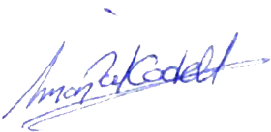

(Signed)

(On behalf of Mr. Simon Paul CORDELL) (Dated) 19/12/2025

I, Mr Simon Paul Cordell, of 109 Burncroft Avenue PO BOX EN3 7JQ.
- WILL SAY AS FOLLOWS
- Date of Incident: 02/08/2025
- Location: Allegedly the Communal area of my flat and wrongly accused of a threat to a car that was not present with us!

- DEFENCE CHAPTER 1 of 3 – – THE FIRST SET OF FILES DISCLOSED TO ME.

- I am going to exhibit the CPS case files that were disclosed to me on two separate dates, namely 01 September 2025 and 10 October 2025. These documents demonstrate the true reasons for my arrest and the procedural breaches of my legal rights committed by both the police and the CPS. In particular, they show the unlawful re-use of a previously “No Further Action” URN number in order to implement a different criminal offence, amounting to an illegal substitution of the original allegation.
- Below this, I will also exhibit the Police Detention/ Custody Logs, which appear in the unused material disclosed as part of the second set of files dated 10 October 2025. These records further evidence the unlawful re-reuse of the URN number and the improper substitution of the criminal charge, Threats To Cause Criminal Damage.

- This is the first set of files disclosed to me by CPS and through Tuckers Solicitor Firm dated the 01/09/2025.
- Exhibit 1: <Dir> 04. Original-CPS-Case-Archive (1) 01-09-25

- Within the disclosed Folders files are the prosecuting teams first served thirteen files as follows and the following files prove the true ongoings for case 02-08-25 that are being refused to be acknowledged as they prove my case and with that being that these court proceedings have become a place where I am intentionally being set up in the prosecution team knowing that I am innocent and they are acting recklessly in refusing to

- Exhibits 2: [To Parent Directory]
- Case_Summary_pdf.pdf
The CPS Case Summary (MG5), states that it was created on 04/08/25 and is in question as to what criminal offence it was developed for and as to its own date being backdated as well as its official context being modified to cover up the true legal process and deliberate failures within.
The CPS Case Summary (MG5) was also not disclosed to me until 01/09/25, while it also did not exist in the first and second court proceedings.
The CPS Case Summary (MG5) shows that my arrest was based solely on an uncorroborated allegation made by the complainant. No independent evidence existed at the time of arrest and still to date.
The CPS Case Summary (MG5) also proves that the charge of a Section 4A Public Order offence relies entirely on her verbal account.
The MG5 also reveals that the case reference/ was latter wrongly introduced during the booking in stage at the Wood Green Police Station and created by mistake of the police who transported me from the hospital due to being assaulted by police within my home at the time of arrest for the Harassment Act 1997 and being brought there.

The Cps

or added after the arrest, raising serious concerns about the lawful basis of the investigation and the possibility of an unlawful re-use or substitution of a previously NFA’d URN.

The CPS Case Summary (MG5) claims it was created on 04/08/2025, yet the document itself raises serious concerns about what offence it was actually produced for, i.e. Harassment Act 1997, Public Order Act – Sec 4A – Intentional Harassment/Alarm/Distress, Threats To Cause Criminal Damage 19 When the real reason as the evidence proves is for Harassment Act 1997, alone!
The CPS Case Summary (MG5) creation date also appears to have been backdated.
and whether its text has been altered or reconstructed to conceal the true legal process and the deliberate procedural failures that occurred. The MG5 was not disclosed to me until 01/09/2025, and it was absent from both the first and second court hearings, meaning the prosecution proceeded without the very document that is supposed to outline the basis of the case.
The MG5 confirms that my arrest was based solely on an uncorroborated allegation made by the complainant. There was no independent evidence at the time of arrest, and none exists even now. The charge under Section 4A of the Public Order Act relies entirely on the complainant’s verbal account, with no supporting material, no witnesses, and no objective evidence.
The MG5 also exposes a major procedural defect: the case reference number was not generated at the time of arrest but was instead incorrectly introduced later during the booking-in process at Wood Green Police Station. This error was made by the officers who transported me from the hospital after I had been assaulted inside my home during the arrest for an alleged offence under the Protection from Harassment Act 1997. As a result, the case reference was effectively created after the arrest, not before, which is incompatible with lawful case creation and raises the possibility that the reference was misapplied, substituted, or reused to justify a charge that did not lawfully exist at the time.

01. Case_Summary_pdf.pdf

https://everyoneloginto.me/01.%2002-08-2025-Another-Case/04.%20Original-CPS-Case-Archive%20(1)%2001-09-25/01.%20Case_Summary_pdf.pdf
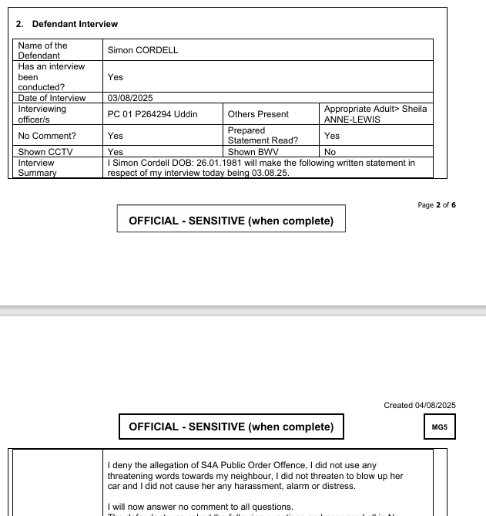

The defence statement created by my solicitor for me proves his own understand after his review of the police custody detention records as to the reason for attendance for my arrest and that being a Criminal Offence of Section 4a Public Order Offence and not any other Criminal Offence.

- CORDELL_Simon_01YE1267925_Section_9_pdf.pdf
‘

- Defendant_Notice_of_Grant_of_Bail_pdf.pdf
By this stage the illegal charge swap had already took place and the courts had proceeded with bail conditions such as GPS Tag with an exclusion Zone from my own home and even when there was no case files to review!

- Let_to_Client_Magistrates_Court_Trial_Advice.docx
This is a letter I received from Tuckers Solicitors following the successful conclusion of the case closure under the original URN at Wood Green Police Station.
The letter was issued after the point at which the police Skipper had lawfully No further actioned the reasons for arrest and detention but soon afterwards unlawfully altered the records to legally create and force another criminal offence as charge in order to bring the matter before the Magistrates’ Court. By the time this correspondence was sent, the Skipper’s amendments had already taken an illegal effect on my life, as evidenced and proven within the Police Custody Record and this letter was produced as a consequence after I was wrongly forced to court for an offence that I was not legal processed for.
They prosecuting team were not acting on the basis of the original charge, as that matter had already been recorded as “no further action.” Instead, Tuckers solicitors firms staff concealed the true reason for their attendance in the interview room at the Wood Green Police Station and involved themselves in crimes to aid in police officers avoidance of punishment by misrepresented the purpose of their visit and creating fake Representation Orders with the use of the original no further actioned Urn.

- PC_Chan_pdf.pdf

States An offence only of Harassment Act 1997.

- PC_obsiye_pdf.pdf
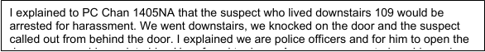

States An offence only of Harassment Act 1997.

- PC_Williams_pdf.pdf

States An offence through the door

- PC_Wilson_Wallis_pdf.pdf
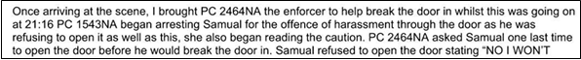

States An offence only of Harassment Act 1997.

- Rebecca_O_HARE_2nd_pdf.pdf
The second statement is dated 02/08/2025

There was no third statement of Rebecca O ‘ Hare served in this disclosure dated the 07/08/25.

- Rebecca_O_hare_pdf.pdf
The first statement is dated 03/08/2025

- ROH_01_mp4.mp4
Used for the section 4a Criminal Offence in the interview due to being booked in for the wrong criminal offence!

- Simon_CORDELL_Charges_pdf.pdf
Shows only two offences and proves the police officer involved awareness of me being arrested and booked into the police station for two separate offences by mistake after their case review.

- Simon_CORDELL_Pre_Cons_pdf.pdf
“The police and CPS have continued to use my criminal record against me even after being repeatedly informed of the factual inaccuracies it contains. Their refusal to correct these errors under GDPR not only breaches their statutory obligations but also perpetuates the defamation of my character, causing ongoing prejudice in every subsequent interaction.”

- After Careful review of the “Exhibit 1 & Exhibited 2” disclosed files to myself it becomes apparent that The Correct Reason For My Arrest while at my home Address 109 Burncroft Avenue on the 02/08/2025 was for: Harassment 1997 alone.

- It is Proved by the attending police officers own MG11 Statements recoded due to being in attendance at the alleged scene of the offence on the same day. Which also proves that Police URN number 01YE1267925 was supposed to be for that harassment 1997 police arrest and police caution and not for a “Public Order Act – Sec 4A – Intentional Harassment/Alarm/Distress,” nor was Police URN number 01YE1267925 supposed to be for the criminal offence of “Threats To Cause Criminal Damage.”

- The CPS own files disclosed to the defending team have proven all along that all four attending police officers official MG11 statements state that I was arrested just for the harassment Act 1997. This case was later dismissed of as a no further actioned case, as I will continue to prove below!

- It is Proved by police body worn footage but inside of the second set of disclosed files dated the 10/10/2025, and due to this must therefore be shown early in this document here: 03. CKC_01_Witnessing_arrestofSimon Cordell.mp4

- The only police body cam footage that has been disclosed does not show me being taken out of my flat and is disclosed on its own to give that wrongful impression. Moreover, to the point the Police BWF is 24:32 minutes long in footage time and at 08:12 Minutes Pc Obsiye can clearly be hard giving her reason for arrest through a closed front door that she was not sure any person was behind. The reason for arrest at the time of police caution was for the Harassment 1997 Act Alone.

- Brought To The Hospital

- DEFENCE CHAPTER 2 OF 3 – THE SECOND SET OF FILES DISCLOSED TO ME.

- Exhibit 3:
12. Simon_CORDELL_Charges_pdf.pdf
<Dir> 05. CPS-caseratio-10-10-25-Case-Files-02-08-25-

[To Parent Directory]
- CORDELL Simon 01YE1267925 Initial Details Pros Case 22-09-2025.pdf

- Rebecca O’HARE Third Statement Added No-DisclosureRequest.pdf

- Original-CORDELL Simon 01YE1267925 Unused Material Disclosure 22-09-2025-.pdf
- Return CORDELL Simon 01YE1267925Unused Material Disclosure22-09-2025.pdf

- CKC 01 Witness arrest of Simon Cordell.mp4.mp4
- CKC_01_Witnessing_arrestofSimon Cordell.mp4

- Rebbeca O-Hare's-Video-11. ROH 01 mp4.pdf
- Rebbeca O-Hare's-Video-11. ROH_01_mp4.mp4

- Axon_Interview_Interview_Room_7_Camera_1_mp4.mp4

- CORDELL Simon 01YE1267925 Section 9 05-08-2025.pdf

- DEFENCE CHAPTER 3 of 3 – POLICE CUSTODY LOG ANALYSIS, CPS NFA, AND UNLAWFUL CHARGE SWAP

THE POLICE DETENTION CUSTODY LOGS

- Wrongfully Booked Into the Wood Green Police Station for a – Section 4A Arrest: On 03/08/2025 at 07:43, I was booked into “Wood Green Police Station” following an arrest for an alleged offence under “Section 4A of the Public Order Act 1986” (Intentional Harassment, Alarm or Distress). The custody record confirms that the “Main Offence” at the point of booking-in was recorded as:
- “Public Order Act – Sec 4A – Intentional Harassment/Alarm/Distress.”

- Exhibit 4:
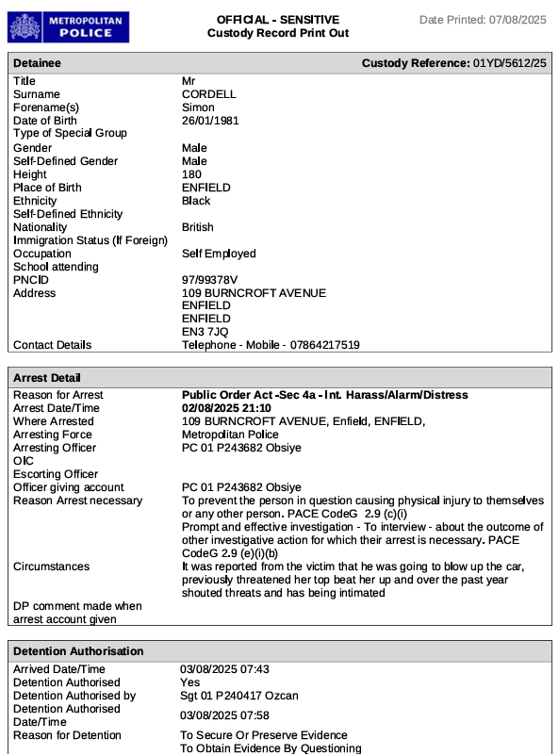

The above exhibit 4 is an extracted snippet from the Wood Green police station and is the “custody record printout” and is dated printed 07/08/2025

If you were arrested and held in the police station on 02_03/08/2025 and taken to court on 04/08/2025, then:

The custody record printout must be printed on or before 04/08/2025
— and normally it is printed on the SAME DAY you are taken to court.
That is the only way the police can show:
- the detention was lawful
- the timings were lawful
- the release to court was lawful
- the charge was lawful
- the handover to CPS was lawful
If the printout is dated after 04/08/2025, it indicates the record was altered, reconstructed, or created after the event, which is a procedural breach.

Arrest Details Section

Reason For Arrest
Arrest Date/Time

Detention Authorisation

Arrived Date/Time

Custody Reference Number: 01YD/5612/25

reason given for my continued detention in the Wood Green police station was Section 4A of the Public Order Act 1986.

he reason given for my continued detention in the Wood Green police station was Section 4A of the Public Order Act 1986.

- Arrest Date and Time was 02/08/2025 – 21:10Pm.
- The time and date that I was brought to the police station due to going to the hospital first on the 02/08/2025 was 03/08/2025 – 07:43Am.
- The police urn was for the Harassment Act 1997 as Cautioned and arrested but due to police officers own errors was wrongful not used for police detention reasons as mandatory must be as the police officers booking me into the Police station used the wrong offence of threats to cause criminal damage.

- Proof of No Further Action of Urn Case reference number 01/YE/12679/25
- Proof of illegal Swap and reuse of No Further Action of Urn afterwards to create these illegal Court proceedings

- During The Booking-In Process:
- It is said that The arresting officer was PC 01 P243682 Obsiye on the 02/08/2025 which is not denied as truth, but it is also said that PC 01 P243682 Obsiye was present at the Wood Green Police Station and commenced with a search, but she was not present on the 03/08/2025 - 08:21 the Initial Search and she is a female officer and therefore this would not be prohibited.

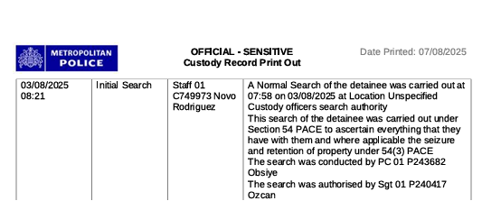

- “The Search Was Conducted By PC 01 P243682 Obsiye”

- All early custody entries relate Only to the Section 4A allegation in the police detention custody log records!
- No allegation of “Threat To Damage/Destroy Property” existed at this stage under PC 01 P243682 Obsiye name and does not afterwards!
- No other officers were assigned to the original case until it was disposed of the following morning.
- No MG4 or charge paperwork was created, as would be if charged for the section 4a offence or harassment offence!

- This Establishes The Starting Point of the Police Detention Custody Logged Record.: I was detained “Solely” for a Section 4A Public Order allegation.

- Exhibit 5:

- 2. CPS Review – Section 4A Discontinued (NFA)
- At 22:38 On 03/08/2025, The Custody Record States: “To allow sufficient time for an ERO/CPS prosecutor to review the case file and evidence to come to an informed decision on suitable case disposal.” This is the formal CPS charging review.

- Exhibit 6:

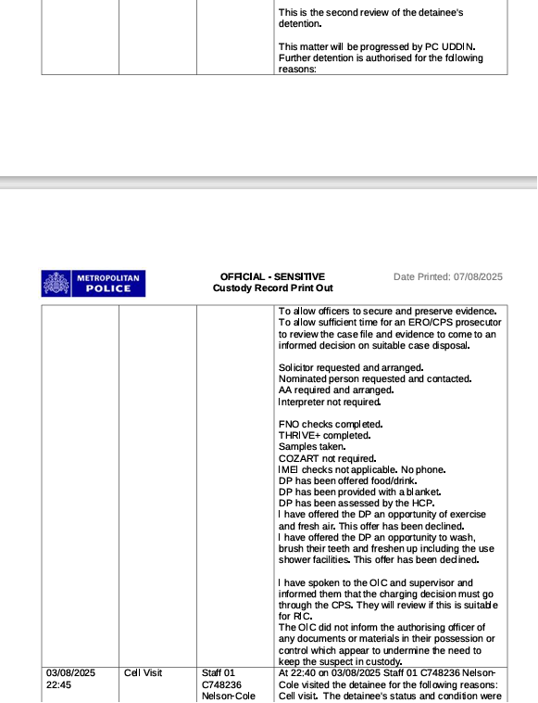

- After This Review:
- No charge was authorised!
- No MG4 was completed!
- No “detainee charged with Section 4A” entry exists.
- No “charge authorised” entry exists.
- No continuation of Section 4A appears in the log.

- Under CPS Charging Rules: if CPS authorises a charge, the detainee “Must” be charged before release.
- I Was Not. Therefore: CPS Reviewed Section 4A And Issued No Further Action (NFA).
- This is the only lawful interpretation of the custody record.

- 3. No Officer in Case – 09:19 Entry Proves No Charge Was Being Prepared
- At 09:19 on 03/08/2025, the custody log states: “Officer in case was NA VCT.”

- Exhibit 7:
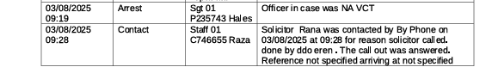

- This Means:
- No officer was assigned
- No one was managing the case.
- No one could authorise a charge
- No one could lawfully swap the offence
- But a solicitor was still called for the Section 4A Public Order allegation.

- This is incompatible with any lawful charging process.

- 4. No Lawful PACE Process for Any New Offence
- Between booking-in and release, the custody record contains “No Entries Showing:
- A further arrest
- A caution for a new offence
- Grounds for further arrest
- A new detention authorisation
- A lawful handover between officers
- CPS authorisation for a new charge
- MG4 completion inside custody

- This proves that “No New Offence Was Created During Lawful Detention.”

- 5. New Offence Appears for the First Time at 03:09 on 04/08/2025

- Exhibit 8:
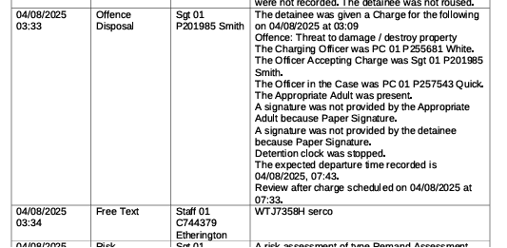

- The custody log shows: 04/08/2025 – 03:09 “Offence: Threat To Damage/Destroy Property.” This is the “First Time” this offence appears anywhere in the custody record.
- This is:
- Over 4 Hours After: the CPS review
- After: Section 4A was discontinued
- After: the point where any lawful charging process should have occurred
- Without: any PACE-required entries

- This proves the new offence was “Not Part Of The Original Arrest.”

- 6. Two New Police Officers Appear Only for the Newly Swapped Offence
- At 03:09 on 04/08/2025, the custody log lists:
- Charging Officer: PC 01 P255681 White
- Officer Accepting Charge: Sgt 01 P201985 Smith
- Officer in the Case: PC 01 P257543 Quick. The 04/08/2025 at 03:33 is the first and only entry in the police custody detention log record that PC 01 P257543 Quick name appears.

- These Officers:
- Never appear in the “Section 4A Entries Other Than Sgt 01 P201985 Smith.”
- We’re not present during arrest!
- We’re not present during booking-in!
- We’re not involved in the CPS review!
- Only appear “After” the new illegally swapped offence of threats to cause criminal damage is inserted into the official Police Custody Record and is also the only time “PC 01 P255681 White And PC 01 P257543 Quick” are both mentioned in the custody record as the case handlers!

- This proves that a “Separate Process” was used for the third criminal offence used by police and that no person from the defending team ever met “PC 01 P255681 White And PC 01 P257543 Quick” for the wrongly alleged offence of “Threats To Cause Criminal Damage,” also wrongly Charged Allegation!

- 7. No Lawful Handover Between Officers
- PACE requires:
- A handover entry
- A new grounds entry
- A new caution
- A new detention authorisation
- None exist. Therefore: “The New Offence Was Not Created Inside Custody.”

- 8. MG4 Charge Sheet Contains Offences Not in the Custody Log
- The MG4 Later Contains:
- Harassment fear of violence
- Threat to blow up a car

- But The Custody Log Contains:
- No charge authorisation
- No MG4 entry
- No lawful process for either charge
- This proves the “MG4” was created “After Custody,” not during it.

- 9. Final Defence Position
- The custody record proves that I was booked in for a Section 4A Public Order allegation only. The CPS reviewed this allegation at 22:38 on 03/08/2025 and did not authorise a charge, which is the CPS definition of No Further Action. The new offence (“Threat To Damage/Destroy Property”) appears for the first time at 03:09 on 04/08/2025, after the CPS review, with three completely different officers (PC White, Sgt Smith, and PC Quick) handling it. There is no record of a further arrest, caution, grounds, charge authorisation, MG4 completion, or lawful handover. This proves that the new offence was introduced through a separate process after the Section 4A allegation had already been discontinued, and not during lawful custody.

- What the CPS Charging Guidance actually says (relevant to this case)

- Exhibited Weblink: https://www.cps.gov.uk/prosecution-guidance/directors-guidance-charging-sixth-edition-december-2020-incorporating-national

- The Exhibited Web linked page explains “How Charging Decisions MUST Be Made,” and it proves several things that directly support my argument about the police detention custody record and the illegal charge swap.
- Here are those key points.

- Police Can Only Charge Certain Offences

- Annex 1 Of The Guidance States That Police May Only Charge:
- summary-only offences.
- retail theft.
- either-way offences “ONLY If A Guilty Plea Is Anticipated!”
- and “NOT” offences requiring CPS authority.

- Police Cannot Charge:
- Public Order Act s4A: (if not anticipated guilty plea.)
- Criminal Damage (depending on value and circumstances.)
- ANY offence requiring CPS review.

- This Is Important Because the police Custody Record Shows:
- No CPS authorisation
- No MG3
- No “Charge Authorised” entry
- No Police Officer further arresting me or putting me through a legal process before charging me, I clearly requested for the return of my solicitor and due to none compliance by them was not replaced with one by the police, considering all the legal requirements for this to be implemented.

- Exhibited Timeline Extracted From Police Custody Logs Of Solicitors Attendance.
- Exhibit 9:
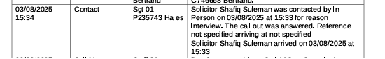

- Exhibit 10:
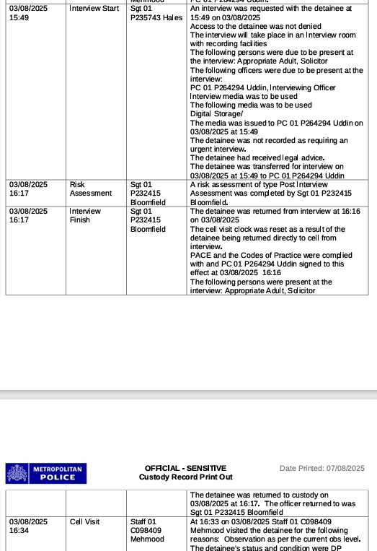

- I was interviewed at the time of:
- Time of only Interview video disclosed 16:13 Pm 03/08/2025 and ends at 16:14.53
- The Video of the interview is the second half and does not show the charge or complete interview.
- The Solicitor left with the appropriate adult as I was placed back into a cell and never returned.

- No More Solicitor for Harassment 1997
- 03/08/2025 - 16:17 the Interview was Finish

- Exhibit 11:

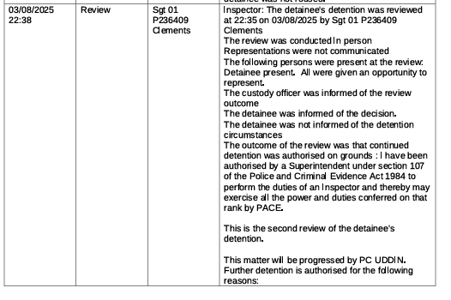
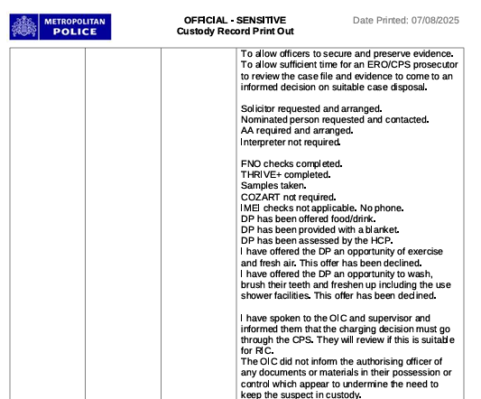

03/08/2025 - 22:38 - a. Solicitor requested and arranged.
- The detainee's detention was reviewed at 22:35 on 03/08/2025 by Sgt 01 P236409 Cleme

- Exhibit 12:

03/08/2025 - 23:23 - HCP Exam Staff 01 C748428 Aguilar - The detainee was fit to be interviewed.

- Exhibit 13:
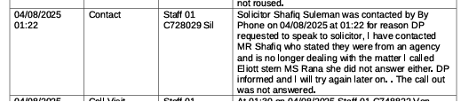

04/08/2025
01:22 Contact Staff 01 C728029 Sil • Solicitor Shafiq Suleman was contacted by Phone on 04/08/2025 at 01:22 for reason:
a. DP requested to speak to solicitor,
b. I have contacted MR Shafiq who stated they were from an agency and is no longer dealing with the matter.
c. I called Eliott stern MS Rana she did not answer either.
d. DP informed and I will try again later on.
e. The call out was not answered.

- Exhibit 14:

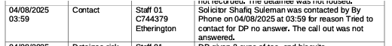

04/08/2025
03:59 Contact Staff 01
C744379
Etherington • Solicitor Shafiq Suleman was contacted by Phone on 04/08/2025 at 03:59 for reason.
a. Tried to contact for DP no answer.
b. The call out was not answered.

- Exhibit 15:

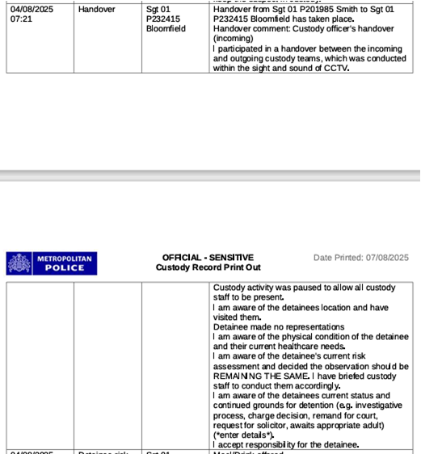

04/08/2025
07:21
- Handover from: Sgt 01 P201985 Smith to Sgt 01 P232415 Bloomfield has taken place.
- Handover comment: Custody officer's handover (incoming)
- I participated in a handover between the incoming and outgoing custody teams, which was conducted within the sight and sound of CCTV.
- Custody activity was paused to allow all custody staff to be present.
- I am aware of the detainees location and have visited them.
- Detainee made no representations I am aware of the physical condition of the detainee and their current healthcare needs.
- I am aware of the detainee's current risk assessment and decided the observation should be REMAINING THE SAME.
- I have briefed custody staff to conduct them accordingly.
- I am aware of the detainees current status and continued grounds for detention (e.g.
- Investigative Process: Did not happen as Pc Quick and White did not follow standard Protocols.
- Charge Decision: missing as it is not present in the custody log.
- Remand For Court Decision from CPS: missing as it is not present in the custody log.
- Request For Solicitor: Not Completed, after case Section 4a was disposed of by way of no Further Actioned. Urn 01YE1267925!
- Awaits Appropriate Adult) (*Enter Details*): show none was called and stared as it still awaits details to be entered as (*Enter Details*).
- I accept responsibility for the detainee.

- Yet a new offence appeared.

- 2. If CPS is required, police MUST NOT charge: “The Law I’m Referring To is: The Director’s Guidance on Charging (DG6) issued under section 37A of PACE 1984
- Section 4.4 Says:
- “Where A Case Is Required To Be Referred To The CPS… The Police Are Not Authorised To Take No Further Action On Public Interest Grounds.”

- Meaning:
- If CPS must decide, police cannot “Decide” anything themselves.
- They cannot charge.
- They cannot play the NFA.
- They cannot swap offences.

- The polices custody record shows “No CPS Decision Recorded,” which is a Breach, Under Section 37A Of PACE 1984!

- 3. CPS decisions “MUST” be recorded
- Section 4.26:
- “Prosecutors will record their charging decision and share it with the police.”
- The polices custody record in my name contains “No CPS Decision Entry At All.”
- Thes findings are all major procedural failures.

- 4. Police Must Record The Rationale For Charging
- Section 4.8:
- Police must record the rationale for charging, including:
- evidential basis
- public interest basis
- assessment of any defence
- assurance about disclosure

- Your record contains none of this.

- 5. If Police Charge Incorrectly, CPS Must Review And Discontinue
- Section 4.10–4.12:
- If police charge when they shouldn’t:
- CPS must review
- If the Full Code Test is not met, the case must be discontinued
- Police may face civil liability

- This Supports Your Argument That:
- The new offence was not lawfully charged
- CPS never authorised it
- The record was manipulated before closure

- 6. Emergency Charging Is Extremely Limited
- Section 4.35:
- Emergency charging can only be used if:
- suspect will remain in custody
- CPS cannot be reached
- offence is serious
- rationale is recorded
- CPS must ratify immediately

- The Police Custody Log Record In My Name Shows:
- No emergency charging
- No rationale
- No CPS ratification
- You were released, not detained

- So emergency charging cannot apply.

- 7. The Custody Officer Must Give Written Notice If CPS Says NFA
- Section 4.30:
- If CPS says there is insufficient evidence:
- “The custody officer will provide the person with a notice in writing.”
- You received no such notice, even though CPS clearly did not authorise a charge for the original s4A.

- What This Means For Your Nova Submission
- The CPS Guidance Proves:
- ✔ Police cannot lawfully add a new offence without CPS
- ✔ Police cannot charge an offence requiring CPS authority
- ✔ CPS decisions MUST be recorded — yours is missing
- ✔ Police must record rationale — yours is missing
- ✔ Emergency charging does not apply
- ✔ The custody record does not meet PACE or CPS standards
- ✔ The new offence was inserted without lawful authority

- What These Entries Mean (Plain English)
- “Custody Delete Offence by Ref Request – NOMINAL UPDATE completed successfully”

- Exhibit 16:

- This Means:
- An offence already recorded on your custody record was Deleted
- The deletion was done After The Original Entry
- It required a Manual Override
- It was applied to your Nominal Record (your PNC identity)

- This is not something that happens during normal custody flow.
- This Is Exactly What Happens When:→ The Original Offence (Section 4A) Is Removed From The System.

- 2. “Custody Create Disposal by Ref Request – NOMINAL UPDATE completed successfully”
- This Means:
- A new disposal (outcome) was created
- It was added After Custody
- It required a manual override
- It was applied to your PNC nominal record

- A “Disposal” Is:
- Charge
- NFA
- Caution
- Community resolution
- Any outcome

- This Proves: → A new outcome was created for a different offence than the one you were arrested for. This Is Exactly What Happens When:
- Section 4A is discontinued
- A new offence is inserted
- A new “disposal” is created for the new offence

- 3. “Custody Amend Arrest Request – NOMINAL UPDATE completed successfully”
- This is the most important one.

- Exhibit 17:

- It means:
- The arrest record itself was amended
- The amendment was done after the original arrest
- It required a manual override
- It was applied to your PNC nominal record

- This Is Only Used When: → The original arrest offence is being replaced with a different offence. This is the technical footprint of a Charge Swap.

- What These Three Entries Prove Together: When you put them together, they show:
- The Original Offence Was Deleted: (“Custody Delete Offence by Ref Request”)

- A New Offence Disposal Was Created: (“Custody Create Disposal by Ref Request”)

- The Arrest Record Was Amended To Match The New Offence: (“Custody Amend Arrest Request”)

- These three actions Cannot occur during normal custody.
- They Only Occur When:
- CPS or police change the offence after custody
- The system must be manually updated to reflect the new charge
- The original offence is removed
- A new offence is inserted
- The arrest record is rewritten to match the new charge

- This is exactly what happened in your case.

- Why This Is So Important Legally
- These entries prove:

✔ Section 4A was removed (deleted)

✔ A new offence was created (threat to damage/destroy property)

✔ The arrest record was amended to match the new offence

✔ All of this happened AFTER custody, not during it

✔ None of this appears in the lawful custody timeline

✔ The charge swap was done administratively, not procedurally

- This is Not allowed under PACE.

- A Charge Cannot Be:
- Added
- Swapped
- Amended
- Created
- Or Disposed Of

- Without A Lawful Custody Entry, Including:
- Further Arrest
- Caution
- Grounds
- Authorisation
- Mg4
- Officer In Case
- Cps Approval

- None of these exist in my custody record.
- But the Backend System Logs show the swap happened.
- That is our proof.

- Defence Sentence (ready to paste)
- The custody system logs contain three administrative override entries — “Custody Delete Offence By Ref Request”, “Custody Create Disposal by Ref Request”, and “Custody Amend Arrest Request”, each marked as “NOMINAL UPDATE Completed Successfully”.
- These entries prove that the original Section 4A offence was deleted, a new disposal was created, and the arrest record was amended after custody. None of these actions appear in the lawful custody timeline, meaning the new offence was inserted through a separate administrative process after the CPS had already discontinued the Section 4A allegation. This is direct evidence of an unlawful charge swap.

- FULL CHRONOLOGICAL TIMELINE — STARTING AT 08:08 (03/08/2025)
- All entries are rewritten into clean English, with explanations of what they mean and what they prove.

- 03/08/2025 — 08:08: Booking-In Begins (This is the TRUE start of custody)
- I arrive at Wood Green Police Station at 07:43, Sgt 01 P240417 Ozcan.
- Booking-in is logged by police officer at 08:08.
- Arresting Officer: PC 01 P243682 Obsiye but was no present as I went to the hospital after arrest.
- Arrest Reason: Harassment Act 997 was the alleged reason for arrest at the scene, but I was also wrongly booked into the police station for “Public Order Act – Section 4A – Intentional Harassment/Alarm/Distress,” instead of Harassment Act 997.
- Circumstances Recorded: neighbour alleged you “Threatened Her On More Than One Occasion” and with the first occasion being at her front door and the second occasion being that you threatened to “blow up her car,” causing her harassment under the 1997 Act of law. This is proved in the disclosed Police Body Worn Footage, but the police officers at “The Wood Green Police Station Wrongly Logged Another Criminal Offence In Its Place Under Section 4A” and it’s important to note that the Criminal Offence of “Threats To Cause Criminal Damage,” did not exist at this time.
- Detention authorised at 07:58.
- Main Offence Set To: Section 4A.
- No other offences existed at this time proved by the police Detention Custody Log as Section 4A. was the only Criminal Offence marked in the official Record.
- No mention of “Threat To Cause Damage/Destroy Property”.

- What This Proves:
- This is the Only Lawful Arrest.
- I was never detained legally from the start Solely for Section 4A or Harassment Act 1997 under URN 01YE1267925 and that: --
- No Threats to Cause Criminal Damage Offence under URN 01YE1267925, existed at this point

- 03/08/2025 — 08:18 To 08:21
- Risk Assessment, Demeanour, Search
- Risk assessment completed.
- Demeanour recorded as “aggressive”. If my Demeanor was aggressive then I would have had more police transport me from the hospital and my handcuffs would not have been taken of straight away. Nor would I have been willing to supply answers to the question or compliance in protocols as I was.
- Search conducted by PC Obsiye (contradiction: I only see her on the 02-08-25 at my home when she assaulted me and broke into my home unfairly. I was in the hospital with two different sets of male police officers as each det of two had to change work shifts due to the hours that passed.).
- No male officer listed for the search (as PC Obsiye is: PC Obsiye is female, and I am a male and Under PACE Code C and D, a strip or intimate search must be conducted by an officer of the same sex, unless in exceptional circumstances and with explicit authorisation. There is no record of a male officer conducting or witnessing the search, nor any exceptional authorisation logged. There is also no BWV footage disclosed, no witness, and no audit trail confirming Pc Obsiye’s presence at the Wood Green Police Custody Suite on the morning of the 03/08/2025, Nor do I have any recollection of her as in fact I did not see her!

“Observations questions were not asked at

this time because not required to complete

the risk assessment of type Child Related

Questions were not asked at this time

because not required to complete.”

- What this proves: The custody record is already showing “Fabrication,” and “Case Profiling Intentional Manipulation” but still only refers to Section 4A.

- 03/08/2025 — 08:19 to 08:26
- Rights, Legal Advice, Duty Solicitor
- Rights given at 08:19.
- Offered to inform someone — It states that I declined when I never would have!
- Offered legal advice — I accepted.
- Duty solicitor requested at 08:26.

- What This Proves:
- I followed procedure.
- No new offences were introduced.
- Still Section 4A only.

- 03/08/2025 — 09:19
- Critical Entry: “Officer In Case was NA VCT”
- This Means:
- No officer was assigned to your case.
- No one was managing the investigation.
- No One Could Authorise A Charge.
- No one could lawfully introduce a new offence.

- What This Proves:
- This is impossible if a charge was being prepared.
- It proves No Charge Was Being Worked On at this time.

- 03/08/2025 — 22:38
- CPS Review Entry: The custody log states: “To Allow Sufficient Time For An ERO/CPS Prosecutor To Review The Case File And Evidence To Come To An Informed Decision On Suitable Case Disposal.” This is the formal CPS charging review.
- What This Proves:
- CPS reviewed the Section 4A allegation.
- CPS Did Not Authorise A Charge.
- No MG4 was completed.
- No “charge authorised” entry exists.
- You were not charged before release.

- This is the CPS definition of NFA (No Further Action).

- 04/08/2025 — 03:09
- THE FIRST APPEARANCE OF THE NEW OFFENCE: The custody log suddenly shows: “Offence: Threat To Damage/Destroy Property.”
- This Is:
- The first time this offence appears.
- Hours after the CPS review.
- Not linked to any lawful arrest.
- Not linked to any caution.
- Not linked to any grounds.
- Not linked to any officer who arrested you.

- What This Proves:
- This is the charge swap.
- The new offence was inserted “After Custody,” not during it.

- 04/08/2025 — 03:09 (same entry)
- Three New Officers Appear Out of Nowhere
- Charging Officer: PC 01 P255681 White
- Officer Accepting Charge: Sgt 01 P201985 Smith
- Officer in the Case: PC 01 P257543 Quick

- These Officers:
- Never appear in the Section 4A entries.
- We’re not present at arrest.
- We’re not present at booking-in.
- We’re not present during CPS review.
- Only appear “After The New Offence Is Inserted.”

- What This Proves:
- This is a separate process, not part of your lawful detention.
- The new offence was created Administratively, not procedurally.

- 04/08/2025 — 03:33 (same entry)

Listed As: Entry Name = Offence Disposal

- 04/08/2025 — 08:15 to 09:00
- Detention Record Closed + PNC Upload
- Detention record closed at 08:15.
- System auto-generates:
“Arrest outcome: Charge” for Section 4A.
- At 09:00, custody record submitted to PNC.

- What This Proves:
- This is not a real charge.
- It is an automatic system close-out.

- The Real Disposal Was Applied Later Via:
- Custody Delete Offence by Ref Request
- Custody Create Disposal by Ref Request
- Custody Amend Arrest Request

- These Prove:
- Section 4A was deleted.
- A new offence was created.
- The arrest record was amended.
- All of this happened after custody, not during it.

- Backend System Entries (NOMINAL UPDATE)
- These entries prove the administrative manipulation:
- Custody Delete Offence by Ref Request
- Custody Create Disposal by Ref Request
- Custody Amend Arrest Request

- All marked “NOMINAL UPDATE Completed Successfully.”

- What This Proves: These Commands Are Used To:
- Delete the original offence
- Insert a new offence
- Rewrite the arrest record
- Create a new disposal
- Push the altered record to PNC

- This is the “Technical Footprint Of The Charge Swap.”

- SUMMARY
- You were arrested and booked in for Section 4A at 08:08 on 03/08/2025.
CPS reviewed the case at 22:38 and did not authorise a charge (NFA).
At 03:09 on 04/08/2025, a completely new offence (“Threat To Damage/Destroy Property”) appears for the first time, handled by three different officers who were not involved in your arrest.
No lawful entries exist showing a further arrest, caution, grounds, charge authorisation, or MG4.
Backend system logs show the original offence was deleted, a new disposal was created, and the arrest record was amended after custody.
- This is conclusive evidence of an unlawful charge swap.

7TH North Room 19

