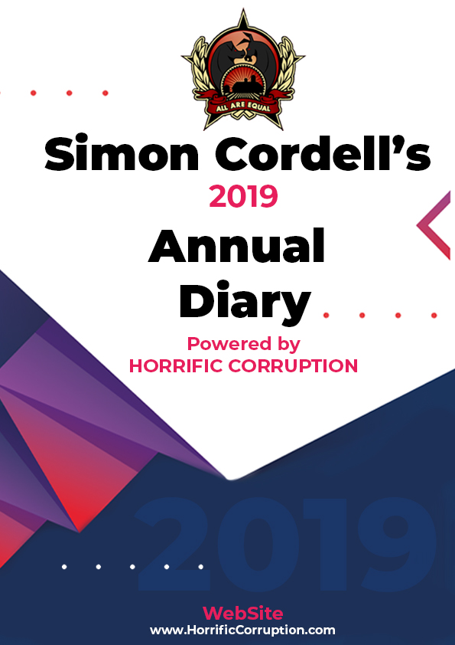
This document is still not complete.
2019

Tuesday!
01/01/2019

Stain and the Mathiyalagan and Co!
Issues with My Neighbours and Housing Disrepair!
Working on the Court Case Defence!
The Anti-Social Behaviour Order Case and the Verdict got made Guilty against me in error and the conditions got imposed against me till late 2020!
The Banging Continued: -
Building the catalogue for printers
George Quinton Moved Out and Ambrose Tariq Moved in!
01/01/2019

- Disrepair!
- The Asbo Order got granted in Error with Full Conditions against me and Fraudulently!
- The banging Continued at me!
- Working at home!

- 117 Burncroft Avenue
The Mathiyalagan family

- 113 Burncroft Avenue
Ambrose!
--
17/12/2018 -- I see Ambrose and his mate Alley in the corridor!
--
28/02/2019 -- Ambrose started again
--
04/03/2019 -- Just Alley staying inside of the flat of 113 Burncroft Avenue
--
25/05/2019 -- Alley & Co, Opening my front door in safety!
--
26/05/2019 -- Getting Arrested Partly for Trusting Alley!

- 115 Burncroft Avenue
Young Light skin girl and boy! “Responsible.”

- 111 Burncroft Avenue
Stain Curtis Fisher! “Responsible.”

1
- Mother Gave me the extra emails around this date?

--

The banging Started!

Summary!

Disrepair!

Time Spent Building.

Working at Home doing Court Case Defense Work!

Wednesday!
02/01/2019

Stain and the Mathiyalagan and Co!
Issues with My Neighbours and Housing Disrepair!
Working on the Court Case Defence!
The Anti-Social Behaviour Order Case and the Verdict got made Guilty against me in error and the conditions got imposed against me till late 2020!
The Banging Continued: -
Building the catalogue for printers
George Quinton Moved Out and Ambrose Tariq Moved in!
02/01/2019

- Disrepair!
- The Asbo Order got granted in Error with Full Conditions against me and Fraudulently!
- The banging Continued at me!
- Working at home!

- 117 Burncroft Avenue
The Mathiyalagan family

- 113 Burncroft Avenue
Ambrose!
--
17/12/2018 -- I see Ambrose and his mate Alley in the corridor!
--
28/02/2019 -- Ambrose started again
--
04/03/2019 -- Just Alley staying inside of the flat of 113 Burncroft Avenue
--
25/05/2019 -- Alley & Co, Opening my front door in safety!
--
26/05/2019 -- Getting Arrested Partly for Trusting Alley!

- 115 Burncroft Avenue
Young Light skin girl and boy! “Responsible.”

- 111 Burncroft Avenue
Stain Curtis Fisher! “Responsible.”

1
- Mother Gave me the extra emails around this date?

2
- Working at home!

--

1
Mother Gave me the extra emails around this date?

2
Working at home!
Working at home still on the computer been stuck in all Christmas and the new year’s alone because of what they have all done to me.

The banging Started!

Si Note:
1

Summary!

Disrepair!

Time Spent Building.

Working at Home doing Court Case Defense Work!

Thursday!
03/01/2019

Stain and the Mathiyalagan and Co!
Issues with My Neighbours and Housing Disrepair!
Working on the Court Case Defence!
The Anti-Social Behaviour Order Case and the Verdict got made Guilty against me in error and the conditions got imposed against me till late 2020!
The Banging Continued: -
Building the catalogue for printers
George Quinton Moved Out and Ambrose Tariq Moved in!
03/01/2019

- Disrepair!
- The Asbo Order got granted in Error with Full Conditions against me and Fraudulently!
- The banging Continued at me!
- Working at home!

- 117 Burncroft Avenue
The Mathiyalagan family

- 113 Burncroft Avenue
Ambrose!
--
17/12/2018 -- I see Ambrose and his mate Alley in the corridor!
--
28/02/2019 -- Ambrose started again
--
04/03/2019 -- Just Alley staying inside of the flat of 113 Burncroft Avenue
--
25/05/2019 -- Alley & Co, Opening my front door in safety!
--
26/05/2019 -- Getting Arrested Partly for Trusting Alley!

- 115 Burncroft Avenue
Young Light skin girl and boy! “Responsible.”

- 111 Burncroft Avenue
Stain Curtis Fisher! “Responsible.”

1
- The Enfield Gov / Email’s Issue:
1130. Alev_ (6) /
Page Numbers: 4454,

2
- The Doctor’s Folder / pub Book Issue: 1!
Stage 3
Folder: 3
Page Numbers: 93,94,95
94
Sent: 03 January 2019 11:18
To: APPADOO, Soobah
(BARNET, ENFIELD AND HARINGEY MENTAL HEALTH NHS TRUST);
BENYURE, George
(BARNET, ENFIELD AND HARINGEY MENTAL HEALTH NHS TRUST);
GREENSIDES, Jonathan
(BARNET, ENFIELD AND HARINGEY MENTAL HEALTH NHS TRUST);
HUSSAIN, Basit
(BARNET, ENFIELD AND HARINGEY MENTAL HEALTH NHS TRUST)
Cc: DINALA, Allan
(BARNET, ENFIELD AND HARINGEY MENTAL HEALTH NHS TRUST);
MURPHY, Lucy
(BARNET, ENFIELD AND HARINGEY MENTAL HEALTH NHS TRUST); Forensic. Referrals (BARNET, ENFIELD AND HARINGEY MENTAL HEALTH NHS TRUST)
Subject: Re: Simon Cordell
Dear all,
Happy New Year.
I wonder if I could email about Simon Cordell.

3
- Alev, on behalf of Joan Ryan MP Labour Member of Parliament for Enfield North
Dear Lorraine
Please see the latest response from Enfield Council in relation to your complaint. We will contact you as soon as we receive any further responses.
Kind regards,
--

1
The Enfield Gov / Email’s Issue:
1130. Alev_ (6)
/ Page Numbers: 4454,
From: alev.cazimoglu@parliament.uk
Sent: 03 January 2019 09:59
To: lorraine32@blueyonder.co.uk
Subject: FW: CRM MEQ 13856 - Mr Simon Cordell of 109 Burncroft Ave, Enfield, EN3 7JQ (Case Ref: JR5802) [SEC=OFFICIAL]
Attachments: ~WRD106.jpg; image002.png; On behalf of Mr Simon Cordell of 109 Burncroft Ave, Enfield, EN3 7JQ.pdf; image001.png
Dear Lorraine
Please see the latest response from Enfield Council in relation to your complaint. We will contact you as soon as we receive any further responses.
Kind regards,
Alev, on behalf of Joan Ryan MP
Labour Member of Parliament for Enfield North
t: 0208 804 4543 (Enfield North)
t: 0207 219 2442 (Westminster)
e: joan.ryan.mp@parliament.uk
w: www.joanryan.org.uk
Westminster Office:
House of Commons, London, SW1A OAA
T: 0207 219 2442
Constituency Office:
542 Hertford Road, Enfield, EN3 5ST
T: 0208 804 4543
Sent: 21 December 2018 16:00
To: RYAN, Joan
Subject: FW: CRM MEQ 13856 - Mr Simon Cordell of 109 Burncroft Ave, Enfield, EN3 7JQ (Case Ref: JR5802) [SEC=OFFICIAL]
Classification: OFFICIAL
Dear Joan Ryan MP,
I am writing in response to the letter of complaint that has been submitted by Lorraine Cordell concerning the handling of her son’s case (letter attached) We have received a number of communications from Ms Cordell about various matters relating to the court proceedings that were taken against Simon Cordell and issues to do with his mental health. We have therefore sought legal clarification on some of those points and we intend to respond to all these matters (including the attached letter) once we have received the appropriate advice. Please be advised we will provide you will a full response in the new year.
Yours Sincerely
Kaunchita Maudhub
Anti-Social Behaviour - Team Leader
Community Safety Unit
Enfield Council
Civic Centre, Silver St
Enfield EN1 3XA

2
The Doctor’s Folder / pub Book Issue: 1!
Stage 3
Folder: 3
Page Numbers: 93,94,95
“Not Relevant to Day!”
94,
From: ROGERS, Tim
(BARNET, ENFIELD AND HARINGEY MENTAL HEALTH NHS TRUST)
Sent: 03 January 2019 11:18
To: APPADOO, Soobah
(BARNET, ENFIELD AND HARINGEY MENTAL HEALTH NHS TRUST);
BENYURE, George
(BARNET, ENFIELD AND HARINGEY MENTAL HEALTH NHS TRUST)
GREENSIDES, Jonathan
(BARNET, ENFIELD AND HARINGEY MENTAL HEALTH NHS TRUST)
HUSSAIN, Basit
(BARNET, ENFIELD AND HARINGEY MENTAL HEALTH NHS TRUST)
Cc: DINALA, Allan
(BARNET, ENFIELD AND HARINGEY MENTAL HEALTH NHS TRUST)
MURPHY, Lucy
(BARNET, ENFIELD AND HARINGEY MENTAL HEALTH NHS TRUST)
Forensic. Referrals
(BARNET, ENFIELD AND HARINGEY MENTAL HEALTH NHS TRUST)
Subject: Re: Simon Cordell
Dear all,
Happy New Year.
I wonder if I could email about Simon Cordell.
He has remained administratively open to the forensic outreach team for consultation if needed, in case it was possible to contribute to a professionals meeting about him if needed. Where are things up to? Are we able to close his referral to us if there is no current contact with services?
Kind regards
Dr Tim Rogers
Consultant Forensic Psychiatrist - FICS Enfield
Camlet Three
Chase Farm Hospital
The Ridgeway
Enfield EN2 8JL
Tel: 020 8702 5953 (mobile and landline)
Email: tim.rogersl@nhs.net
Line Manager: Dr Mehdi Veisi, Clinical Director
Line Manager:
Contact: 020 8702 6040
Web: www.beh-mht.nhs.uk
Twitter: @BEHMHTNHS / Facebook: www.fb.com/behmht
95
“Not Relevant to Day!”

3
Alev, on behalf of Joan Ryan MP Labour Member of Parliament for Enfield North
Dear Lorraine
Please see the latest response from Enfield Council in relation to your complaint. We will contact you as soon as we receive any further responses.
Kind regards,

The banging Started!

Si Note:
1

2

Summary!

Disrepair!

Time Spent Building.

Working at Home doing Court Case Defense Work!
Friday!
04/01/2019

Stain and the
Issues with Housing Disrepair!
Working on the Court Case Defence!
The Anti-Social Behaviour Order Case and the Verdict got made Guilty against me in error and the conditions got imposed against me till late 2020!
The Banging Continued: -
04/01/2019

- Disrepair!
- The Asbo Order got granted in Error with Full Conditions against me and Fraudulently!
- The banging Continued at me!
- Working at home!

- 117 Burncroft Avenue
The Mathiyalagan family

- 113 Burncroft Avenue
Ambrose!
--
17/12/2018 -- I see Ambrose and his mate Alley in the corridor!
--
28/02/2019 -- Ambrose started again
--
04/03/2019 -- Just Alley staying inside of the flat of 113 Burncroft Avenue
--
25/05/2019 -- Alley & Co, Opening my front door in safety!
--
26/05/2019 -- Getting Arrested Partly for Trusting Alley!

- 115 Burncroft Avenue
Young Light skin girl and boy! “Responsible.”

- 111 Burncroft Avenue
Stain Curtis Fisher! “Responsible.”

1
- The Doctor’s Folder / pub Book Issue: 1!
Stage 3
Folder: 3
Page Numbers: 93,94,95
93
From: ROGERS, Tim
(BARNET, ENFIELD AND HARINGEY MENTAL HEALTH NHS TRUST)
Sent: 04 January 2019 15:08
Cc: DINALA, Allan
(BARNET, ENFIELD AND HARINGEY MENTAL HEALTH NHS TRUST);
MURPHY, Lucy
(BARNET, ENFIELD AND HARINGEY MENTAL HEALTH NHS TRUST); Forensic. Referrals (BARNET, ENFIELD AND HARINGEY MENTAL HEALTH NHS TRUST)
Subject: Re: Simon +++
From: APPADOO, Soobah
(BARNET, ENFIELD AND HARINGEY MENTAL HEALTH NHS TRUST)
Sent: 04 January 2019 12:19
To: ROGERS, Tim
(BARNET, ENFIELD AND HARINGEY MENTAL HEALTH NHS TRUST);
BENYURE, George
(BARNET, ENFIELD AND HARINGEY MENTAL HEALTH NHS TRUST);
GREENSIDES, Jonathan
(BARNET, ENFIELD AND HARINGEY MENTAL HEALTH NHS TRUST);
HUSSAIN, Basit
(BARNET, ENFIELD AND HARINGEY MENTAL HEALTH NHS TRUST)
Cc: DINALA, Allan
(BARNET, ENFIELD AND HARINGEY MENTAL HEALTH NHS TRUST);
MURPHY, Lucy
(BARNET, ENFIELD AND HARINGEY MENTAL HEALTH NHS TRUST); Forensic. Referrals (BARNET, ENFIELD AND HARINGEY MENTAL HEALTH NHS TRUST)
Subject: RE: Simon Cordell
Dear Dr Rogers,
He has not engaged with us; we have not been able to review him
94
Perhaps we could have a Professionals Meeting after the Unmanaged Risk Forum and make joint decisions in that meeting. We will

--

1
The Doctor’s Folder / pub Book Issue: 1!
Stage 3
Folder: 3
Page Numbers: 93,94,95
“Not Relevant to Day!”
94,
From: ROGERS, Tim
(BARNET, ENFIELD AND HARINGEY MENTAL HEALTH NHS TRUST)
Sent: 04 January 2019 15:08
Cc: DINALA, Allan
(BARNET, ENFIELD AND HARINGEY MENTAL HEALTH NHS TRUST)
MURPHY, Lucy
(BARNET, ENFIELD AND HARINGEY MENTAL HEALTH NHS TRUST)
Forensic. Referrals
(BARNET, ENFIELD AND HARINGEY MENTAL HEALTH NHS TRUST)
Subject: Re: Simon Cordell
Lucy
Please close the referral - it would appear that we are delaying doing the work otherwise. We can always re-open a referral if a professionals meeting is requested
Dr Tim Rogers
Consultant Forensic Psychiatrist - FICS Enfield
Camlet Three
Chase Farm Hospital
The Ridgeway
Enfield EN2 8JL
Tel: 020 8702 5953 (mobile and landline)
E-Mail: tim.roeersl@nhs.net
Line Manager: Dr Mehdi Veisi,
Clinical Director Line Manager
Contact: 0208702 6040
Web: www.beh-mht.nhs.uk
Twitter: @BEHMHTNHS / Facebook: www.fb.com/behmht
From: APPADOO, Soobah
(BARNET, ENFIELD AND HARINGEY MENTAL HEALTH NHS TRUST)
Sent: 04 January 2019 12:19
To: ROGERS, Tim
(BARNET, ENFIELD AND HARINGEY MENTAL HEALTH NHS TRUST)
BENYURE, George
(BARNET, ENFIELD AND HARINGEY MENTAL HEALTH NHS TRUST)
GREENSIDES, Jonathan
(BARNET, ENFIELD AND HARINGEY MENTAL HEALTH NHS TRUST)
HUSSAIN, Basit
(BARNET, ENFIELD AND HARINGEY MENTAL HEALTH NHS TRUST)
Cc: DINALA, Allan
(BARNET, ENFIELD AND HARINGEY MENTAL HEALTH NHS TRUST)
MURPHY, Lucy
(BARNET, ENFIELD AND HARINGEY MENTAL HEALTH NHS TRUST)
Forensic. Referrals
(BARNET, ENFIELD AND HARINGEY MENTAL HEALTH NHS TRUST)
Subject: RE: Simon Cordell
Dear Dr Rogers,
He has not engaged with us; we have not been able to review him since his discharge from hospital. We are in the process of referring SC to the Unmanaged Risk Forum and will be guided by them.
95
Perhaps we could have a Professionals Meeting after the Unmanaged Risk Forum and make joint decisions in that meeting. We will keep you posted.
BW
Soobah

The banging Started!

Si Note:
1

Summary!

Disrepair!

Time Spent Building.

Working at Home doing Court Case Defense Work!

Saturday!
05/01/2019

Stain and the
Issues with Housing Disrepair!
Working on the Court Case Defence!
The Anti-Social Behaviour Order Case and the Verdict got made Guilty against me in error and the conditions got imposed against me till late 2020!
The Banging Continued: -
05/01/2019

- Disrepair!
- The Asbo Order got granted in Error with Full Conditions against me and Fraudulently!
- The banging Continued at me!
- Working at home!

- 117 Burncroft Avenue
The Mathiyalagan family

- 113 Burncroft Avenue
Ambrose!
--
17/12/2018 -- I see Ambrose and his mate Alley in the corridor!
--
28/02/2019 -- Ambrose started again
--
04/03/2019 -- Just Alley staying inside of the flat of 113 Burncroft Avenue
--
25/05/2019 -- Alley & Co, Opening my front door in safety!
--
26/05/2019 -- Getting Arrested Partly for Trusting Alley!

- 115 Burncroft Avenue
Young Light skin girl and boy! “Responsible.”

- 111 Burncroft Avenue
Stain Curtis Fisher! “Responsible.”

--

The banging Started!

Summary!

Disrepair!

Time Spent Building.

Working at Home doing Court Case Defense Work!

Sunday!
06/01/2019

Stain and the
Issues with Housing Disrepair!
Working on the Court Case Defence!
The Anti-Social Behaviour Order Case and the Verdict got made Guilty against me in error and the conditions got imposed against me till late 2020!
The Banging Continued: -
06/01/2019

- Disrepair!
- The Asbo Order got granted in Error with Full Conditions against me and Fraudulently!
- The banging Continued at me!
- Working at home!

- 117 Burncroft Avenue
The Mathiyalagan family

- 113 Burncroft Avenue
Ambrose!
--
17/12/2018 -- I see Ambrose and his mate Alley in the corridor!
--
28/02/2019 -- Ambrose started again
--
04/03/2019 -- Just Alley staying inside of the flat of 113 Burncroft Avenue
--
25/05/2019 -- Alley & Co, Opening my front door in safety!
--
26/05/2019 -- Getting Arrested Partly for Trusting Alley!

- 115 Burncroft Avenue
Young Light skin girl and boy! “Responsible.”

- 111 Burncroft Avenue
Stain Curtis Fisher! “Responsible.”

1
- 117 Burncroft Avenue
14:42 stated banging the you killed my baby beat on the floor at me!

--

1
117 Burncroft Avenue
14:42 stated banging the you killed my baby beat on the floor at me!

The banging Started!

Summary!

Disrepair!

Time Spent Building.

Working at Home doing Court Case Defense Work!

Monday!
07/01/2019

Stain and the
Issues with Housing Disrepair!
Working on the Court Case Defence!
The Anti-Social Behaviour Order Case and the Verdict got made Guilty against me in error and the conditions got imposed against me till late 2020!
The Banging Continued: -
07/01/2019

- Disrepair!
- The Asbo Order got granted in Error with Full Conditions against me and Fraudulently!
- The banging Continued at me!
- Working at home!

- 117 Burncroft Avenue
The Mathiyalagan family

- 113 Burncroft Avenue
Ambrose!
--
17/12/2018 -- I see Ambrose and his mate Alley in the corridor!
--
28/02/2019 -- Ambrose started again
--
04/03/2019 -- Just Alley staying inside of the flat of 113 Burncroft Avenue
--
25/05/2019 -- Alley & Co, Opening my front door in safety!
--
26/05/2019 -- Getting Arrested Partly for Trusting Alley!

- 115 Burncroft Avenue
Young Light skin girl and boy! “Responsible.”

- 111 Burncroft Avenue
Stain Curtis Fisher! “Responsible.”

1
- The Enfield Gov / Email’s Issue:
1131. Trishna Kerai _RE_ Simon Cordell-E00ED049 /
Page Numbers: 4455,4456,

2
- The Enfield Gov / Email’s Issue:
1132. Lorraine Cordell _Re_ Simon Cordell-E00ED049_ (1) /
Page Numbers: 4457,4458,4459,

3
- The Enfield Gov / Email’s Issue:
1133. Lorraine Cordell _Re_ Health Records Subject Access Request S /
Page Numbers: 4460,

1.
- Additional Email Attachments & Emails / Issue:
1. 1. 1
Trishna@stuartmillersolicitors.co.uk_01.07.2019_RE Simon Cordell-E00ED049 11:13:00
07/01/2019
/ Page Numbers: 1,2,3,4,5,6,7,8,9,10,11,12,13

--

1
The Enfield Gov / Email’s Issue:
1131. Trishna Kerai _RE_ Simon Cordell-E00ED049
/ Page Numbers: 4455,4456,
From: Trishna Kerai [Trishna@stuartmillersolicitors.co.uk]
Sent: 07 January 2019 11:13
To: 'Lorraine Cordell'
Subject: RE: Simon CordellE00ED049
Attachments: LBE v Simon CordellE00ED049
Order 09082018 (686 KB) ; LBE v Simon CordellE00ED049
Order 09082018 (680 KB) ; LBE v Simon CordellE00ED049
amended Order 09082018 (667 KB)
Hi Lorraine,
Thank you for your emails. Please see emails attached sent to Ludmilla in relation to the below. Emails had been sent to her and she did not respond confirming whether the amendments were accepted or not. The only time we were waiting for your instructions were when we were waiting for an amendment in the Order.
Kind regards,
Trishna Kerai | Caseworker | Magistrates Court Department
T: 0208 888 5225
M: 07790 993 860
E: trishna@stuartmillersolicitors.co.uk
W: www.stuartmillersolicitors.co.uk
4456,
Dear Trishna Kerai
I have sent some emails to you and I have had no replies regarding issues I am having regarding the court order that was made on the
09/08/2018.
Today I got a letter from Enfield Council which stated that you agreed with Enfield Council draft order on the
13/08/2018,
but was waiting instructions from me.
Please see below: --
"In relation to the allegations made in regard to the draft Order submitted to the Court. Ms lyavoo explains that she contacted Ms Trishna Kerai, of Stuart Miller Solicitors; the caseworker instructed on behalf of Simon Cordell on 10th August 2018 and emailed her a draft order. Ms lyavoo did not hear from Ms Kerai, so she emailed her again on
13th August 2018
and asked that she provides her agreement as soon as possible and if no response was made by 4pm on the same day she will have to email the draft to the Judge. Ms lyavoo states that she received a response from Ms Kerai on the same day stating that she was in agreement with the order, but she was waiting for your instructions. As no response was forthcoming, Ms lyavoo had to email the order to the Court on
15th. August 2018
and she also copied Simon's caseworker to the email. Ms. Kerai has never indicated that she was on annual leave during the time of the correspondence but confirmed that the delay was due to the receipt of your instructions." I am very upset as you were well aware when you sent me the draft order on the
13th August 2018
to me, I did not agree to it and you said you was going to try and rewrite it that day, which was not done until after you came back from leave. So how is Enfield Council blaming that on me saying you stated the delay was due to me not getting back to you with instructions?
I am having a great deal of issues with Enfield Council they are not moving Simon and are going to take him back to court to try and get his flat. They have not put the management transfer application in front of the panel and are saying they will not do this. It seems due to the way the court order was worded this is being put down to me, due to this section in the order please see below. AND UPON the Defendants mother agreeing to engage with the Enfield Mental Health Unit team so the Defendant could receive assistance with his mental health conditions and housing. I know you feel that this was dealt with and you should not need to do any other work regarding this, but this is a mess and I need some help as my son is suffering due to the on goings of Enfield Council. I await your reply
Regards
Lorraine Cordell

2
The Enfield Gov / Email’s Issue:
1132. Lorraine Cordell _Re_ Simon Cordell-E00ED049_ (1)
/ Page Numbers: 4457,4458,4459,
From: Lorraine Cordell [lorraine32@blueyonder.co.uk]
Sent: 07 January 2019 12:19
To: Trishna Kerai
Subject: Re: Simon CordellE00ED049
Dear Trishna
Thank you for the updated email and getting back to me. You sent me Ludmilla updated order on the 13/08/2018 and I replied saying I did not agree with their order on the 14/08/2018 I sent an attachment with that email showing what I did not agree to, and you said you would rewrite it. But I never heard anything if this had been done, I emailed you a few times after that you was on leave so I rewrote the order and sent to you, you amended that order and it was sent to Ludmilla. And you did not hear back from her. But this is not how they are saying it happened and it seems I am being blamed for not dealing with it. Also, it was funny as when you sent the order to Ludmilla and she never got back to you Her order was sealed at the court a few days after you sent it. Also Enfield Council is saying a lot to other bodies which in fact are not even in the order, and are misleading everyone they can, they have also never put the application to the panel for the move and are misleading other bodies as to the reasons this has not been done, by way of saying that the order stated Simon had to work with the mental health team and this was agreed in the court order when it clearly was not as the judge would not allow that, this is just some of the issues I am trying to deal with and Simon is suffering each day that goes by.
Regards
Lorraine
Sent from my iPhone
On 7 Jan 2019, at 11:13, Trishna Kerai <Trishna@stuartmillersolicitors.co.uk> wrote:
Hi Lorraine,
Thank you for your emails.
Please see emails attached sent to Ludmilla in relation to the below. Emails had been sent to her and she did not respond confirming whether the amendments were accepted or not. The only time we were waiting for your instructions were when we were waiting for an amendment in the Order.
Kind regards,
Trishna Kerai | Caseworker | Magistrates Court Department
T: 0208 888 5225
M: 07790
E: trishna@stuartmillersolicitors.co.uk
W: www.stuartmillersolicitors.co.uk
4458,
From: Lorraine Cordell [Mail To:lorraine32@blueyonder.co.uk]
Sent: 28 December 2018 14:14
To: Trishna Kerai
Subject: RE: Simon CordellE00ED049
Dear Trishna Kerai
I have sent some emails to you and I have had no replies regarding issues I am having regarding the court order that was made on the
09/08/2018.
Today I got a letter from Enfield Council which stated that you agreed with Enfield Council draft order on the
13/08/2018
but was waiting instructions from me.
Please see below
"In relation to the allegations made in regard to the draft Order submitted to the Court. Ms lyavoo explains that she contacted Ms Trishna Kerai, of Stuart Miller Solicitors; the caseworker instructed on behalf of Simon Cordell on 10th August 2018 and emailed her a draft order. Ms lyavoo did not hear from Ms Kerai, so she emailed her again on 13th August 2018 and asked that she provides her agreement as soon as possible and if no response was made by 4pm on the same day she will have to email the draft to the Judge. Ms lyavoo states that she received a response from Ms Kerai on the same day stating that she was in agreement with the order, but she was waiting for your instructions. As no response was forthcoming, Ms lyavoo had to email the order to the Court on 15th. August 2018 and she also copied Simon's caseworker to the email. Ms∙ Kerai has never indicated that she was on annual leave during the time of the correspondence but confirmed that the delay was due to the receipt of your instructions." I am very upset as you was well aware when you sent me the draft order on the 13th August 2018 to me, I did not agree to it and you said you was going to try and rewrite it that day, which was not done until after you came back from leave. So how is Enfield Council blaming that on me saying you stated the delay was due to me not getting back to you with instructions?
I am having a great deal of issues with Enfield Council they are not moving Simon and are going to take him back to court to try and get his flat. They have not put the management transfer application in front of the panel and are saying they will not do this. It seems due to the way the court order was worded this is being put down to me, due to this section in the order please see below. AND UPON the Defendants mother agreeing to engage with the Enfield Mental Health Unit team so the Defendant could receive assistance with his mental health conditions and housing. I know you feel that this was dealt with and you should not need to do any other work regarding this, but this is a mess and I need some help as my son is suffering due to the on goings of Enfield Council. I await your reply
Regards
Lorraine Cordell
<mime attachment>
<mime attachment>
4459,
<mime attachment>

3
The Enfield Gov / Email’s Issue:
1133. Lorraine Cordell _Re_ Health Records Subject Access Request S
/ Page Numbers: 4460,
From: Lorraine Cordell [lorraine32@blueyonder.co.uk]
Sent: 07 January 2019 15:22
To: 'Records
(BARNET, ENFIELD AND HARINGEY MENTAL HEALTH NHS TRUST)
Subject: RE: Health Records Subject Access Request S.C.
Dear Christine Devaney
I am writing this email as I have had no update regarding the request the SAR, I put in via email on the 13/11/2018, under law I should have had this by now or at least an update that you needed longer to process the information. Could you please get back to me as soon as possible regarding this with an update when my mother can come and collect the information I have requested, which I hope at this stage is nearly ready and is up to today's date the information covers seeing as it been so long, I have been waiting.
Regards
From: Records (BARNET, ENFIELD AND HARINGEY MENTAL HEALTH NHS TRUST)
[Mail To: behtr.records@nhs.net]
Sent: 13 November 2018 15:20
To: Lorraine Cordell; records@behmht.nhs.uk; Information Governance
(BARNET, ENFIELD AND HARINGEY MENTAL HEALTH NHS TRUST) ; Records
(BARNET, ENFIELD AND HARINGEY MENTAL HEALTH NHS TRUST)
Subject: RE: Health Records Subject Access Request S.C.
Importance: High
Good afternoon
Thanks for your email request received with five attachments. We shall keep you updated regarding progress.
Kind regards
Christine Devaney
Medical Records Manager
Barnet, Enfield & Haringey Mental Health NHS Trust
Edgware Community Hospital | Ground Floor | Dennis Scott Unit | Burnt Oak Broadway | Edgware | HA8 0AD
Mobile: 020 8702 4371
Email: cdevaney@nhs.net
Facebook: www.fb.com/behmht
Please note that my old email address
christine.devaney@behmht.nhs.uk
will no longer work from 1st September 2018. Please use
cdevaney@nhs.net
Manager: Doreen Todd
Information Governance Manager
Ground Floor, Dennis Scott Unit
Edgware Community Hospital
mobile 020 8702 4134
doreentodd@nhs.net
From: Lorraine Cordell
Mail To:lorraine32@blueyonder.co.uk]
Sent: 13 November 2018 14:23
To: records@behmht.nhs.uk
Information Governance (BARNET, ENFIELD AND HARINGEY MENTAL HEALTH NHS TRUST) ; Records (BARNET, ENFIELD AND HARINGEY MENTAL HEALTH NHS TRUST)
Subject: RE: Health Records Subject Access Request Simon Cordell
To whom it may concern:
Please see attached documents regarding the subject access request I am requesting for my health records. If I have sent this to the wrong email can it be passed to the correct person who is able to deal with this? Could you also please confirm you have got this email with 5 attached files and it is being dealt with?
Regards
***************************************************************************
This message may contain confidential information. If you are not the intended recipient please inform the sender that you have received the message in error before deleting it. Please do not disclose, copy or distribute information in this email or take any action in relation to its contents. To do so is strictly prohibited and may be unlawful. Thank you for your cooperation. NHS mail is the secure email and directory service available for all NHS staff in England and Scotland. NHS mail is approved for exchanging patient data and other sensitive information with NHS mail and other accredited email
services.

1.
Additional Email Attachments & Emails / Issue:
1. 1. 1
Trishna@stuartmillersolicitors.co.uk_01.07.2019_RE Simon Cordell-E00ED049 11:13:00
07/01/2019
/ Page Numbers: 1,2,3,4,5,6,7,8,9,10,11,12,13
--
1,
From: Trishna Kerai <Trishna@stuartmillersolidtors.co.uk>
Sent: 07 January 2019 11:13
To: 'Lorraine Cordell'
Subject: RE: Simon Cordell-E00ED049
Attachments: LBE v Simon Cordell-E00ED049
Order 09082018 (686 KB)
LBE v Simon Cordell-E00ED049
Order 09082018 (680 KB)
LBE v Simon Cordell-E00ED049 amended Order 09082018 (667 KB)
Hi Lorraine,
Thank you for your emails.
Please see emails attached sent to Ludmilla in relation to the below.
Emails had been sent to her and she did not respond confirming whether the amendments were accepted or not.
The only time we were waiting for your instructions were when we were waiting for an amendment in the Order.
Kind regards,
Trishna Kerai | Caseworker | Magistrates Court Department
T: 0208 888 5225
M: 07790 993 860
E: trishna@stuartminersolicitors.co.uk
W: www.stuartmillersolicitors.co.uk
The information in this email is confidential and may be legally privileged. It is intended solely for the addressee and access to this email by anyone else is unauthorised. Any views or opinions presented are those of the author only and do not necessarily represent those of Stuart Miller Solicitors. If you are not the intended recipient; any disclosure, copying, distribution or any action taken in reliance of this email or attachments, is prohibited and may be unlawful. To avoid incurring legal liabilities, you must not distribute or copy the information in this email without the express permission of the sender. When addressed to our clients, any opinions or advice contained in this email or attachments are subject to the terms and conditions expressed in the governing client engagement letter or contract and terms of business. If you have received this email in error please notify Stuart Miller Solicitors by telephone on 020 8888 5225, by fax on 020 8889 5871 or by email at info@stuartmillersolicitors.co.uk Stuart Miller Solicitors do not accept service of documents by email. The security of this email and any attachments cannot be guaranteed. It is your responsibility to take all necessary steps to ensure this email and any attachments or transmissions are free from viruses. Stuart Miller Solicitors do not accept any responsibility for damage incurred as a result of internet transmissions and viruses. Only the Directors are authorised to conclude binding agreements on behalf of Stuart Miller Solicitors by email.
Stuart Miller Solicitors do not accept responsibility for unauthorised agreements reached with other employees or agents. Stuart Miller Solicitors may use your personal data for marketing purposes. If you do not want us to use your personal data and contact you by electronic means and / or by post, please opt-out by emailing us at info@stuartmillersolicitors.co.uk Stuart Miller Solicitors Limited is authorised and regulated by the Solicitors Regulation Authority (ID No. 533277). Stuart Miller Solicitors is a trading name for Stuart Miller Solicitors Limited. Incorporated in England & Wales (Company No.
07161343). Stuart Miller Solicitors is a
VAT registered company (VAT No. 990 0197 14).
From: Lorraine Cordell mailto: lorraine32@blueyonder.co.uk
Sent: 28 December 2018 14:14
To: Trishna Kerai
Subject: RE: Simon Cordell-E00ED049
Dear Trishna Kerai
2,
I have sent some emails to you and I have had no replies regarding issues I am having regarding the court order that was made on the 09/08/2018.
Today I got a letter from Enfield Council which stated that you agreed with Enfield Council draft order on the 13/08/2018 but was waiting instructions from me.
Please see below
- "In relation to the allegations made in regard to the draft Order submitted to the Court. Ms lyavoo explains that she contacted Ms Trishna Kerai, of Stuart Miller Solicitors; the caseworker instructed on behalf of Simon Cordell on 10th August 2018 and emailed her a draft order. Ms lyavoo did not hear from Ms Kerai, so she emailed her again on 13th August 2018 and asked that she provides her agreement as soon as possible and if no response was made by 4pm on the same day she will have to email the draft to the Judge. Ms lyavoo states that she received a response from Ms Kerai on the same day stating that she agreed with the order, but she was waiting for your instructions. As no response was forthcoming, Ms lyavoo had to email the order to the Court on 15th. August 2018 and she also copied Simon's caseworker to the email. Ms Kerai has never indicated that she was on annual leave during the time of the correspondence but confirmed that the delay was due to the receipt of your instructions."
I am very upset as you was well aware when you sent me the draft order on the 13th August 2018 to me, I did not agree to it and you said you was going to try and rewrite it that day, which was not done until after you came back from leave. So how is Enfield Council blaming that on me saying you stated the delay was due to me not getting back to you with instructions?
I am having a great deal of issues with Enfield Council they are not moving Simon and are going to take him back to court to try and get his flat. They have not put the management transfer application in front of the panel and are saying they will not do this.
It seems due to the way the court order was worded this is being put down to me, due to this section in the order please see below.
- AND UPON the Defendants mother agreeing to engage with the Enfield Mental Health Unit team so the Defendant could receive assistance with his mental health conditions and housing.
know you feel that this was dealt with and you should not need to do any other work regarding this, but this is a mess and I need some help as my son is suffering due to the on goings of Enfield Council.
I await your reply
Regards
Lorraine Cordell
3,
RE: Simon Cordell-E00ED049-> LBE v Simon Cordell-E00ED049 Order 09082018 (686 KB).msg
From: Trishna Kerai [Trishna@stuartmiUersolicitors.co.uk]
To: 'Ludmilla Iyavoo¹
Sent: 04 September 2018 15:58:42
Subject: RE: LBE v Simon Cordell-E00ED049 Order 09082018
Attachments: image001.jpg (570 KB)
image002.jpg (1 KB)
image003.jpg (1 KB)
image004.jpg (1 KB)
image005.jpg (2 KB)
image006.png (0 KB)
image007.png (48 KB)
LBE v Simon Cordell-E00ED049 Amended Order.docx (17 KB)
Dear Ludmilla,
Please find our final draft of the Order. You will see the amendments we have made.
Please provide us with your views.
Kind regards,
Trishna Kerai | Caseworker | Magistrates Court Department
T: 0208 888 5225
M: 07790 993 860
E: trishna@stuartmillersolicitors.co.uk
W: www.stuartmillersolicitors.co.uk
Stuart Miller Solicitors
The information in this email is confidential and may be legally privileged. It is intended solely for the addressee and access to this email by anyone else is unauthorised. Any views or opinions presented are those of the author only and do not necessarily represent those of Stuart Miller Solicitors. If you are not the intended recipient; any disclosure, copying, distribution or any action taken in reliance of this email or attachments, is prohibited and may be unlawful. To avoid incurring legal liabilities, you must not distribute or copy the information in this email without the express permission of the sender. When addressed to our clients, any opinions or advice contained in this email or attachments are subject to the terms and conditions expressed in the governing client engagement letter or contract and terms of business. If you have received this email in error please notify Stuart Miller Solicitors by telephone on 020 8888 5225, by fax on 020 8889 5871 or by email at info@stuartmillersolicitors.co.uk Stuart Miller Solicitors do not accept service of documents by email. The security of this email and any attachments cannot be guaranteed. It is your responsibility to take all necessary steps to ensure this email and any attachments or transmissions are free from viruses. Stuart Miller Solicitors do not accept any responsibility for damage incurred as a result of internet transmissions and viruses. Only the Directors are authorised to conclude binding agreements on behalf of Stuart Miller Solicitors by email. Stuart Miller Solicitors do not accept responsibility for unauthorised agreements reached with other employees or agents. Stuart Miller Solicitors may use your personal data for marketing purposes. If you do not want us to use your personal data and contact you by electronic means and / or by post, please opt-out by emailing us at info@stuartmillersolicitors.co.uk Stuart Miller Solicitors Limited is authorised and regulated by the Solicitors Regulation Authority (ID No. 533277). Stuart Miller Solicitors is a trading name for Stuart Miller Solicitors Limited. Incorporated in England & Wales (Company No. 07161343). Stuart Miller Solicitors is a VAT registered company (VAT No. 990 0197 14).
From: Ludmilla Iyavoo
mailto: Ludmilla.Iyavoo@enfield.gov.uk
Sent: 15 August 2018 15:49
To: Dias, DJ Allison
Cc: Trishna Kerai
Subject: LBE v Simon Cordell-E00ED049 Order 09082018
Importance: High
Dear Judge,
Further to the hearing which took place on 9th
August 2018, I attach a draft order for the Court's approval. I apologise for the
4,
RE: Simon Cordell-E00ED049-> LBE v Simon Cordell-E00ED049 Order 09082018 (686 KB).msg
delay in sending this draft order to you, I have been waiting for the Defendant's solicitor’s approval which has not been received as yet.
Kind regards,
Ludmilla Iyavoo Solicitor Corporate Team Legal Services Enfield Council Silver Street Enfield EN1 3XY
DX 90615 Enfield 1
Telephone: 020 8379 8323
Fax: 020 8379 6492
Enfield Council is committed to serving the whole borough fairly, delivering excellent services and building strong communities.
From: Ludmilla Iyavoo
Sent: 10 August 2018 14:42
To: 'Trishna Kerai'
Subject: LBE v Simon Cordell-E00ED049 amended Order 09082018
Importance: High
Dear Trishna,
I write further to my email to you and Mrs Lorraine Cordell. Our allocation manager has advised us that as Mr Cordell is an existing council tenant, he is entitled to apply for a transfer of tenancy and cannot make a rehousing application.
am advised that the application needs to be done via Mr Cordell's neighbourhood officer. I have emailed the officer and asked him to contact Mrs Cordell as soon as possible. Mrs Cordell is also encouraged to contact the Mental Health Team so they can support him with his MH issues and rehousing. I have amended the order to reflect the above and look forward to hearing from you.
Kind regards,
Ludmilla Iyavoo Solicitor Corporate Team Legal Services Enfield Council Silver Street Enfield EN1 3XY
DX 90615 Enfield 1
Telephone: 020 8379 8323
Fax: 020 8379 6492
Enfield Council is committed to serving the whole borough fairly, delivering excellent services and building strong communities.
5,
RE: Simon Cordell-E00ED049-> LBE v Simon Cordell-E00ED049 Order 09082018 (686 KB).msg
Be the first to receive the latest Council news straight to your inbox
SIGN UP ONLINE NOW
www.enfield.gov.uk/enewsletters
Enfield Council is committed to serving the whole borough fairly, delivering excellent services and building strong communities. Opinions expressed in this email are those of the individual and not necessarily those of the London Borough of Enfield. This email and any attachments or files transmitted with it are strictly confidential and intended solely for the named addressee. It may contain privileged and confidential information and if you are not the intended recipient and receive it in error you must not copy, distribute, or use the communication in any other way. All traffic handled by the Government Connect Secure Extranet may be subject to recording/and or monitoring in accordance with relevant legislation.
This email has been scanned for viruses, but we cannot guarantee that it will be free of viruses or malware. The recipient should perform their own virus checks.
6,
RE: Simon Cordell-E00ED049-> LBE v Simon Cordell-E00ED049 Order 09082018 (686 KB). mgs->LBE v Simon Cordell-E00ED049 Amended Order.doc
IN THE COUNTY COURT AT EDMONTON Claim No: E00ED049
Before District Judge Dias
BETWEEN
THE LONDON BOROUGH OF ENFTELD
Claimant
and
MR STMON CORDELL
Defendant
ORDER
UPON hearing Solicitor for the Claimant and Defendant, the Defendant’s mother, the Defendant’s uncle, and the Defendant not attending.
UPON the Court reviewing the psychiatrist report of Dr Dhinakaran dated 08 July 2018 confirming that the Defendant lacks capacity to litigate and/or capacity to understand the terms of the injunction order made on 09 January 2018.
UPON Mr Cordell’s mother, Miss Lorraine Cordell, confirming that she will engage with the Claimant and assist Mr Cordell neighbourhood officer in making a housing management transfer application on or before 16 August 2018.
UPON the Claimant agreeing that it will deal with the housing management transfer application as quickly as possible after being made.
7,
And UPON the Claimant taking into account when dealing with the housing management transfer the need for a suitable two-bedroom property so Mr Cordell can have a spare room for carers and for his family so he can get the support that he requires.
IT IS ORDERED:
- The interim injunction order dated 09 January 2018 is dismissed forthwith.
- The Claimant’s claim and application for an injunction dated 09 January 2018, the Claimant’s applications for the Defendant’s committal dated 05 February 2018 and 20 April 2018 and the Claimant’s application notice dated 07 August 2018 do stand dismissed.
- The Claimant should serve a copy of this order upon the police to confirm the injection orders dated 9 August 2017 and the 09 January 2018 has been dismissed.
- There be no order as to costs save for detailed assessment of the Defendant’s publicly funded costs.
- Dated 09 August 2018
8,
RE: Simon Cordell-E00ED049-> LBE v Simon Cordell-E00ED049 Order 09082018 (680 KB).msg
From: Trishna Kerai [Trishna@stuartmiUersolicitors.co.uk]
To: 'Ludmilla Iyavoo¹
Sent: 17 September 2018 09:58:36
Subject: RE: LBE v Simon Cordell-E00ED049 Order 09082018
Attachments: image001.jpg (570 KB)
image002.jpg (1 KB)
image003.jpg (1 KB)
image004.jpg (1 KB)
image005.jpg (2 KB); image006.png (0 KB)
image007.png (48 KB)
Hi Ludmilla,
Further to my email below, could I please have a response with your views in relation to our proposed amended Order. Many thanks.
Kind regards,
Trishna Kerai | Caseworker | Magistrates Court Department
T: 0208 888 5225
M: 07790 993 860
E: trishna@stuartmillersolicitors.co.uk
W: www.stuartmillersolicitors.co.uk
Stuart Miller Solicitors
The information in this email is confidential and may be legally privileged. It is intended solely for the addressee and access to this email by anyone else is unauthorised. Any views or opinions presented are those of the author only and do not necessarily represent those of Stuart Miller Solicitors. If you are not the intended recipient; any disclosure, copying, distribution or any action taken in reliance of this email or attachments, is prohibited and may be unlawful. To avoid incurring legal liabilities, you must not distribute or copy the information in this email without the express permission of the sender. When addressed to our clients, any opinions or advice contained in this email or attachments are subject to the terms and conditions expressed in the governing client engagement letter or contract and terms of business. If you have received this email in error please notify Stuart Miller Solicitors by telephone on 020 8888 5225, by fax on 020 8889 5871 or by email at info@stuartmillersolicitors.co.uk Stuart Miller Solicitors do not accept service of documents by email. The security of this email and any attachments cannot be guaranteed. It is your responsibility to take all necessary steps to ensure this email and any attachments or transmissions are free from viruses. Stuart Miller Solicitors do not accept any responsibility for damage incurred as a result of internet transmissions and viruses. Only the Directors are authorised to conclude binding agreements on behalf of Stuart Miller Solicitors by email. Stuart Miller Solicitors do not accept responsibility for unauthorised agreements reached with other employees or agents. Stuart Miller Solicitors may use your personal data for marketing purposes. If you do not want us to use your personal data and contact you by electronic means and / or by post, please opt-out by emailing us at info@stuartmillersolicitors.co.uk Stuart Miller Solicitors Limited is authorised and regulated by the Solicitors Regulation Authority (ID No. 533277). Stuart Miller Solicitors is a trading name for Stuart Miller Solicitors Limited. Incorporated in England & Wales (Company No. 07161343). Stuart Miller Solicitors is a VAT registered company (VAT No. 990 0197 14).
From: Trishna Kerai
Sent: 04 September 2018 15:59
To: 'Ludmilla Iyavoo'
Cc: 'Lorraine Cordell'
Subject: RE: LBE v Simon Cordell-E00ED049 Order 09082018
Importance: High Dear Ludmilla,
Please find our final draft of the Order. You will see the amendments we have made.
Please provide us with your views.
Kind regards,
Trishna Kerai | Caseworker | Magistrates Court Department
T: 0208 888 5225
M: 07790 993 860
E: trishna@stuartmillersolicitors.co.uk
W: www.stuartmillersolicitors.co.uk
9,
RE: Simon Cordell-E00ED049-> LBE v Simon Cordell-E00ED049 Order 09082018 (680 KB).msg
Stuart Miller Solicitors
The information in this email is confidential and may be legally privileged. It is intended solely for the addressee and access to this email by anyone else is unauthorised. Any views or opinions presented are those of the author only and do not necessarily represent those of Stuart Miller Solicitors. If you are not the intended recipient; any disclosure, copying, distribution or any action taken in reliance of this email or attachments, is prohibited and may be unlawful. To avoid incurring legal liabilities, you must not distribute or copy the information in this email without the express permission of the sender. When addressed to our clients, any opinions or advice contained in this email or attachments are subject to the terms and conditions expressed in the governing client engagement letter or contract and terms of business. If you have received this email in error please notify Stuart Miller Solicitors by telephone on 020 8888 5225, by fax on 020 8889 5871 or by email at info@stuartmillersolicitors.co.uk Stuart Miller Solicitors do not accept service of documents by email. The security of this email and any attachments cannot be guaranteed. It is your responsibility to take all necessary steps to ensure this email and any attachments or transmissions are free from viruses. Stuart Miller Solicitors do not accept any responsibility for damage incurred as a result of internet transmissions and viruses. Only the Directors are authorised to conclude binding agreements on behalf of Stuart Miller Solicitors by email.
Stuart Miller Solicitors do not accept responsibility for unauthorised agreements reached with other employees or agents. Stuart Miller Solicitors may use your personal data for marketing purposes. If you do not want us to use your personal data and contact you by electronic means and / or by post, please opt-out by emailing us at info@stuartmillersolicitors.co.uk Stuart Miller Solicitors Limited is authorised and regulated by the Solicitors Regulation Authority (ID No. 533277). Stuart Miller Solicitors is a trading name for Stuart Miller Solicitors Limited. Incorporated in England & Wales (Company No.
07161343). Stuart Miller Solicitors is a VAT registered company (VAT No. 990 0197 14).
From: Ludmilla Iyavoo [mailto: Ludmilla.Iyavoo@enfield.gov.uk
Sent: 15 August 2018 15:49
To: Dias, DJ Allison
Cc: Trishna Kerai
Subject: LBE v Simon Cordell-E00ED049 Order 09082018
Importance: High
Dear Judge,
Further to the hearing which took place on 9th August 2018, I attach a draft order for the Court's approval. I apologise for the delay in sending this draft order to you, I have been waiting for the Defendant's solicitor’s approval which has not been received as yet.
Kind regards,
Ludmilla Iyavoo
Solicitor
Corporate Team
Legal Services
Enfield Council
Silver Street
Enfield EN1 3XY
DX 90615 Enfield 1
Telephone: 020 8379 8323
Fax: 020 8379 6492
Enfield Council is committed to serving the whole borough fairly, delivering excellent services and building strong communities.
From: Ludmilla Iyavoo
Sent: 10 August 2018 14:42
To: 'Trishna Kerai'
Subject: LBE v Simon Cordell-E00ED049 amended Order 09082018
Importance: High Dear Trishna,
write further to my email to you and Mrs Lorraine Cordell. Our allocation manager has advised us that as Mr Cordell is an existing council tenant, he is entitled to apply for a transfer of tenancy and cannot make a rehousing application.
I am advised that the application needs to be done via Mr Cordell's neighbourhood officer. I have emailed the officer and asked him to contact Mrs Cordell as soon as possible. Mrs Cordell is also encouraged to contact the Mental Health Team so they
10,
RE: Simon Cordell-E00ED049-> LBE v Simon Cordell-E00ED049 Order 09082018 (680 KB).msg
can support him with his MH issues and rehousing. I have amended the order to reflect the above and look forward to hearing from you.
Kind regards,
Ludmilla Iyavoo
Solicitor
Corporate Team
Legal Services
Enfield Council
Silver Street
Enfield EN1 3XY
DX 90615 Enfield 1
Telephone: 020 8379 8323
Fax: 020 8379 6492
Enfield Council is committed to serving the whole borough fairly, delivering excellent services and building strong communities.
Be the first to receive the latest
Council news straight to your inbox
SIGN UP ONLINE NOW
www.enfield.gov.uk/enewsletters
Enfield Council is committed to serving the whole borough fairly, delivering excellent services and building strong communities. Opinions expressed in this email are those of the individual and not necessarily those of the London Borough of Enfield. This email and any attachments or files transmitted with it are strictly confidential and intended solely for the named addressee. It may contain privileged and confidential information and if you are not the intended recipient and receive it in error you must not copy, distribute, or use the communication in any other way. All traffic handled by the Government Connect Secure Extranet may be subject to recording/and or monitoring in accordance with relevant legislation.
This email has been scanned for viruses, but we cannot guarantee that it will be free of viruses or malware. The recipient should perform their own virus checks.
11,
RE: Simon Cordell-E00ED049-> LBE v Simon Cordell-E00ED049 amended Order 09082018 (667 KB).msg
From: Trishna Kerai [Trishna@stuartmiUersolicitors.co.uk]
To: 'Ludmilla Iyavoo¹
Sent: 13 August 2018 14:52:12
Subject: RE: LBE v Simon Cordell-E00ED049 amended Order 09082018
Attachments: image001.jpg (570 KB)
image002.jpg (1 KB).
image003.jpg (1 KB)
image004.jpg (1 KB)
image005.jpg (2 KB)
image006.png (0 KB)
image007.png (48 KB
Dear Ludmilla,
Please note that we have no issues with the Order, but I have been waiting for a response from my client's mum in relation to the Order. I have just text her and will let you know once she gets back to me.
Please also note that we will not be dealing with the Housing Management Transfer Application as we are only instructed to deal with the breach of Injunction Order.
Thanks.
Kind regards,
Trishna Kerai | Caseworker | Magistrates Court Department
T: 0208 888 5225
M: 07790 993 860
E: trishna@stuartminersolicitors.co.uk
W: www.stuartmillersolicitors.co.uk
Stuart Miller Solicitors
The information in this email is confidential and may be legally privileged. It is intended solely for the addressee and access to this email by anyone else is unauthorised. Any views or opinions presented are those of the author only and do not necessarily represent those of Stuart Miller Solicitors. If you are not the intended recipient; any disclosure, copying, distribution or any action taken in reliance of this email or attachments, is prohibited and may be unlawful. To avoid incurring legal liabilities, you must not distribute or copy the information in this email without the express permission of the sender. When addressed to our clients, any opinions or advice contained in this email or attachments are subject to the terms and conditions expressed in the governing client engagement letter or contract and terms of business. If you have received this email in error please notify Stuart Miller Solicitors by telephone on 020 8888 5225, by fax on 020 8889 5871 or by email at info@stuartmillersolicitors.co.uk Stuart Miller Solicitors do not accept service of documents by email. The security of this email and any attachments cannot be guaranteed. It is your responsibility to take all necessary steps to ensure this email and any attachments or transmissions are free from viruses. Stuart Miller Solicitors do not accept any responsibility for damage incurred as a result of internet transmissions and viruses. Only the Directors are authorised to conclude binding agreements on behalf of Stuart Miller Solicitors by email. Stuart Miller Solicitors do not accept responsibility for unauthorised agreements reached with other employees or agents. Stuart Miller Solicitors may use your personal data for marketing purposes. If you do not want us to use your personal data and contact you by electronic means and / or by post, please opt-out by emailing us at info@stuartmillersolicitors.co.uk Stuart Miller Solicitors Limited is authorised and regulated by the Solicitors Regulation Authority (ID No. 533277). Stuart Miller Solicitors is a trading name for Stuart Miller Solicitors Limited. Incorporated in England & Wales (Company No. 07161343). Stuart Miller Solicitors is a VAT registered company (VAT No. 990 0197 14).
From: Ludmilla Iyavoo [mailto:Ludmilla.Iyavoo@enfield.gov.uk]
Sent: 13 August 2018 14:48
To: Trishna Kerai
Subject: RE: LBE v Simon Cordell-E00ED049 amended Order 09082018
Dear Trishna,
12,
RE: Simon Cordell-E00ED049-> LBE v Simon Cordell-E00ED049 amended Order 09082018 (667 KB).msg
I refer to my email sent to you on Friday 10/08 with a draft order and I am concerned that no response has been made since. Can you please advise me whether your client is in agreement? If I do not hear from you by 4pm today, I will have to email the Court and advise them that your lack of response is delaying the approval of the order.
I look forward to hearing from you.
Kind regards,
Ludmilla Iyavoo Solicitor Corporate Team Legal Services Enfield Council Silver Street Enfield EN1 3XY
DX 90615 Enfield 1
Telephone: 020 8379 8323
Fax: 020 8379 6492
Enfield Council is committed to serving the whole borough fairly, delivering excellent services and building strong communities.
From: Ludmilla Iyavoo
Sent: 10 August 2018 14:42
To: 'Trishna Kerai'
Subject: LBE v Simon Cordell-E00ED049 amended Order 09082018
Importance: High
Dear Trishna,
I write further to my email to you and Mrs Lorraine Cordell. Our allocation manager has advised us that as Mr Cordell is an existing council tenant, he is entitled to apply for a transfer of tenancy and cannot make a rehousing application.
am advised that the application needs to be done via Mr Cordell's neighbourhood officer. I have emailed the officer and asked him to contact Mrs Cordell as soon as possible. Mrs Cordell is also encouraged to contact the Mental Health Team so they can support him with his MH issues and rehousing. I have amended the order to reflect the above and look forward to hearing from you.
Kind regards,
Ludmilla Iyavoo Solicitor Corporate Team Legal Services Enfield Council Silver Street Enfield EN1 3XY
DX 90615 Enfield 1
Telephone: 020 8379 8323
Fax: 020 8379 6492
Enfield Council is committed to serving the whole borough fairly, delivering excellent services and building strong communities.
13,
RE: Simon Cordell-E00ED049-> LBE v Simon Cordell-E00ED049 amended Order 09082018 (667 KB).msg
Be the first to receive the latest Council news straight to your inbox
SIGN UPONL NENOW
www.enfield.gov.uk/enewsletters
Enfield Council is committed to serving the whole borough fairly, delivering excellent services and building strong communities. Opinions expressed in this email are those of the individual and not necessarily those of the London Borough of Enfield. This email and any attachments or files transmitted with it are strictly confidential and intended solely for the named addressee. It may contain privileged and confidential information and if you are not the intended recipient and receive it in error you must not copy, distribute, or use the communication in any other way. All traffic handled by the Government Connect Secure Extranet may be subject to recording/and or monitoring in accordance with relevant legislation.
This email has been scanned for viruses, but we cannot guarantee that it will be free of viruses or malware. The recipient should perform their own virus checks.

The banging Started!

Si Note:
1

2

3

Summary!

Disrepair!

Time Spent Building.

Working at Home doing Court Case Defense Work!

Tuesday!
08/01/2019

Stain and the
Issues with Housing Disrepair!
Working on the Court Case Defence!
The Anti-Social Behaviour Order Case and the Verdict got made Guilty against me in error and the conditions got imposed against me till late 2020!
The Banging Continued: -
08/01/2019

- Disrepair!
- The Asbo Order got granted in Error with Full Conditions against me and Fraudulently!
- The banging Continued at me!
- Working at home!

- 117 Burncroft Avenue
The Mathiyalagan family

- 113 Burncroft Avenue
Ambrose!
--
17/12/2018 -- I see Ambrose and his mate Alley in the corridor!
--
28/02/2019 -- Ambrose started again
--
04/03/2019 -- Just Alley staying inside of the flat of 113 Burncroft Avenue
--
25/05/2019 -- Alley & Co, Opening my front door in safety!
--
26/05/2019 -- Getting Arrested Partly for Trusting Alley!

- 115 Burncroft Avenue
Young Light skin girl and boy! “Responsible.”

- 111 Burncroft Avenue
Stain Curtis Fisher! “Responsible.”

1
- The Enfield Gov / Email’s Issue:
1134. Lorraine Cordell _Re_ Your request for information (Our ref_ CRM SAR 1085) /
Page Numbers: 4461,4462,

2
- Police Came to My Home
TO RE ARREST ME!
--

1
The Enfield Gov / Email’s Issue:
1134. Lorraine Cordell _Re_ Your request for information (Our ref_ CRM SAR 1085)
/ Page Numbers: 4461,4462,
From: Lorraine Cordell [lorraine32@blueyonder.co.uk]
Sent: 08 January 2019 13:55
To: 'Kailey Plahar'
Subject: RE: Your request for information (Our ref: CRM SAR 1085)
Dear Kailey Plahar
I am writing regarding the below email case number CRM SAR 1085; I am sorry about the time that it has taken me to reply but I have been very busy. You state you do not have a authority Letter on your systems for me to act on behalf of my son Simon Cordell, But there is in place letters of authority across Enfield Council for me to dealt with everything for my son. So, I cannot understand why you cannot find them as many have been sent over can you please look into this and see why you feel I do not already have authority as it has never been removed.
Regards
Lorraine Cordell
From: Kailey Plahar [Mail To: Kailey.Plahar@enfield.gov.uk]
Sent: 04 December 2018 12:55
To: lorraine32@blueyonder.co.uk
Subject: Your request for information (Our ref: CRM SAR 1085)
Dear Ms Cordell
We note that you have raised a request for information which relates to another person. In line with the Data Protection Act 2018, we are unable to correspond with you on these matters. Where a request for information is made on behalf of somebody else, we need to confirm that they are happy for you to access their personal information. Should Simon Cordell want you to act on their behalf and access their personal information, he will need to provide us with their signed written agreement to the complaint issues raised and for you to proceed with these on their behalf. We note that your request is for ‘all data that is held about me on Enfield Council systems all departments’. As your request does not provide us with much detail, we need you to clarify the specific information you are looking for. In order for us to retrieve relevant records, we would need to know where your personal information could be located and it would greatly help our search if you are able to give us more details regarding:
- Clarifying the type of information that you think the Council may hold about Mr. Cordell
- Clarifying the likely dates or time period when you think the information may have been created
- Clarifying if you only want information relating to a particular issue or specific time period
We have registered your request under case number CRM SAR 1085 and you may quote this when you get back in touch with us. We look forward to your response. Once we receive the clarification from you, we will contact you with a further update.
Yours sincerely,
Kailey Plahar
Statutory Complaints and Access to Information Officer Complaints and Access to Information Team
Chief Executive
Enfield Council
Civic Centre
4462,
EN1 3XA
From: Lorraine Cordell <lorraine32@blueyonder.co.uk>
Sent: 25 November 2018 12:07
To: Enfield Data Protection Officer (Corporate) <enfield.data.protection.officer@enfield.gov.uk>
Subject: RE: Subject access Request Simon Cordell
To Whom It May Concern:
Please see attached 4 documents regarding the request for all data that his held about me on Enfield Council systems all departments. If you need a fee or any other information please reply to this Email as soon as possible.
Regards

2
Police Came to My Home
TO RE ARREST ME!
I had already been arrested for what the police were then at my front door for; Re - trying to re arrest me for in the past.
Getting arrested while wanting to sue the police with the police aware of my motive and the displinary actions that will follow regarding the 1st Abo and much more than just that then meant that I never got interviewed at the police understood that I had done nothing wrong and if interviewed and charged there would have been no likelihood of a realistic prospect of a guilty conviction in fact I would have one the case and this would have meant to the police another loss against me Mr. Simon Paul Cordell + Benjamin.
The police on this day became abusive and violent while trying to force a wrongful entry into my premises, so to help their colleges evade justice from their own corrupt doings.
I made a phone call to my mother while the police were outside of my front door shouting at me that they are going to break the front door down so that they could take me away. While the police were stepping outside of the bounders of the law by not following the correct so-called regulated police procedures in a multitude of different incidents when at my front door, they became unmoral as human beings let alone representing government official’s. I decided to test their integrity by explain the current ongoing leading towards their arrival to my humble fixed abode.
I explored for a reason to why the police were treating me in such a horrid way.
After executing my line of questioning I received some replies to my questions from the police officers.
The police explained that they wanted to re arrest me for the alleged incident that took place on the 10/11/2018 = 25/10/2018
taken from the police station straight to a Chase Farm Mental Health department and keep against y free will in an abuse of malicious process to cover up what my official complaint covers.
The time was 22:40 Hours when the police first came to my home on this day.

Spitting at police case: “incident”
The police came to my home front door again to arrest me I would not let them into my home and therefore did not open my front door. I asked the police officers what they wanted but they would not tell me the only thing that they would explain to me is that I had to go to the police station with them to be interviewed and for this to happen I had to get arrested
I made a phone call to my mother and she soon after arrived at my home with my uncial Andrew
Booked for me to attend Edmonton Police Station on Sunday the;
13/01/2019
On Video!

The banging Started!

Si Note:
1

2

Summary!

Disrepair!

Time Spent Building.

Working at Home doing Court Case Defense Work!

Wednesday!
09/01/2019

Stain and the
Issues with Housing Disrepair!
Working on the Court Case Defence!
The Anti-Social Behaviour Order Case and the Verdict got made Guilty against me in error and the conditions got imposed against me till late 2020!
The Banging Continued: -
09/01/2019

- Disrepair!
- The Asbo Order got granted in Error with Full Conditions against me and Fraudulently!
- The banging Continued at me!
- Working at home!

- 117 Burncroft Avenue
The Mathiyalagan family

- 113 Burncroft Avenue
Ambrose!
--
17/12/2018 -- I see Ambrose and his mate Alley in the corridor!
--
28/02/2019 -- Ambrose started again
--
04/03/2019 -- Just Alley staying inside of the flat of 113 Burncroft Avenue
--
25/05/2019 -- Alley & Co, Opening my front door in safety!
--
26/05/2019 -- Getting Arrested Partly for Trusting Alley!

- 115 Burncroft Avenue
Young Light skin girl and boy! “Responsible.”

- 111 Burncroft Avenue
Stain Curtis Fisher! “Responsible.”

2.
- Additional Email Attachments & Emails / Issue:
2. 1. 2.
Wix 09-01-2019 -03-13
09/01/2019
/ Page Numbers: 14,15

--

2.
Additional Email Attachments & Emails / Issue:
2. 1. 2.
Wix 09-01-2019 -03-13
09/01/2019
/ Page Numbers: 14,15
--
14,
From: Sent time: To:
Subject:
Wix.com <wix-team@emails.wix.com> 09/01/2019 03:13:51 PM re_wired@ymail.com
Here are the trends you need to know in 2019
WlX.com
Stay Ahead of the Trends in 2019
Get the latest on web design, SEO and online marketing sent directly to your inbox.
Web Design: What to Know for 2019
SEO: The Definitive List to Get Found on Google
Social Media: Tips You Can’t Afford to Miss
Marketing: The Top 10 Trends of 2019
15,
Stay up to date with our latest news & features.
Please do not reply to this email.
If you wish to unsubscribe
500 Terry A Francois Blvd San Francisco, CA 94158 Wix.com Ltd., Wix.com Inc. www.wix.com View our privacy policy.

The banging Started!

Summary!

Disrepair!

Time Spent Building.

Working at Home doing Court Case Defense Work!

Thursday!
10/01/2019

Stain and the
Issues with Housing Disrepair!
Working on the Court Case Defence!
The Anti-Social Behaviour Order Case and the Verdict got made Guilty against me in error and the conditions got imposed against me till late 2020!
The Banging Continued: -
10/01/2019

- Disrepair!
- The Asbo Order got granted in Error with Full Conditions against me and Fraudulently!
- The banging Continued at me!
- Working at home!

- 117 Burncroft Avenue
The Mathiyalagan family

- 113 Burncroft Avenue
Ambrose!
--
17/12/2018 -- I see Ambrose and his mate Alley in the corridor!
--
28/02/2019 -- Ambrose started again
--
04/03/2019 -- Just Alley staying inside of the flat of 113 Burncroft Avenue
--
25/05/2019 -- Alley & Co, Opening my front door in safety!
--
26/05/2019 -- Getting Arrested Partly for Trusting Alley!

- 115 Burncroft Avenue
Young Light skin girl and boy! “Responsible.”

- 111 Burncroft Avenue
Stain Curtis Fisher! “Responsible.”

--

The banging Started!

Summary!

Disrepair!

Time Spent Building.

Working at Home doing Court Case Defense Work!

Friday!
11/01/2019

Stain and the
Issues with Housing Disrepair!
Working on the Court Case Defence!
The Anti-Social Behaviour Order Case and the Verdict got made Guilty against me in error and the conditions got imposed against me till late 2020!
The Banging Continued: -
11/01/2019

- Disrepair!
- The Asbo Order got granted in Error with Full Conditions against me and Fraudulently!
- The banging Continued at me!
- Working at home!

- 117 Burncroft Avenue
The Mathiyalagan family

- 113 Burncroft Avenue
Ambrose!
--
17/12/2018 -- I see Ambrose and his mate Alley in the corridor!
--
28/02/2019 -- Ambrose started again
--
04/03/2019 -- Just Alley staying inside of the flat of 113 Burncroft Avenue
--
25/05/2019 -- Alley & Co, Opening my front door in safety!
--
26/05/2019 -- Getting Arrested Partly for Trusting Alley!

- 115 Burncroft Avenue
Young Light skin girl and boy! “Responsible.”

- 111 Burncroft Avenue
Stain Curtis Fisher! “Responsible.”

--

The banging Started!

Summary!

Disrepair!

Time Spent Building.

Working at Home doing Court Case Defense Work!

Saturday!
12/01/2019

Stain and the
Issues with Housing Disrepair!
Working on the Court Case Defence!
The Anti-Social Behaviour Order Case and the Verdict got made Guilty against me in error and the conditions got imposed against me till late 2020!
The Banging Continued: -
12/01/2019

- Disrepair!
- The Asbo Order got granted in Error with Full Conditions against me and Fraudulently!
- The banging Continued at me!
- Working at home!

- 117 Burncroft Avenue
The Mathiyalagan family

- 113 Burncroft Avenue
Ambrose!
--
17/12/2018 -- I see Ambrose and his mate Alley in the corridor!
--
28/02/2019 -- Ambrose started again
--
04/03/2019 -- Just Alley staying inside of the flat of 113 Burncroft Avenue
--
25/05/2019 -- Alley & Co, Opening my front door in safety!
--
26/05/2019 -- Getting Arrested Partly for Trusting Alley!

- 115 Burncroft Avenue
Young Light skin girl and boy! “Responsible.”

- 111 Burncroft Avenue
Stain Curtis Fisher! “Responsible.”

1
- No Ambrose
Today

2
- Ozzie started
On the wall again with a drills and other objects.

3
- Letter of my GP

--

1
No Ambrose
Today

2
Ozzie started
On the wall again with a drills and other objects.

3
Letter of my GP
DR D ABIDOYE
DR Y CHONG
DR C AKA
NIGHTINGALE HOUSE SURGERY
1-3 NIGHTINGALE ROAD
EDMONTON
LONDON N9 8AJ
Tel: 0208 805 9997
Fax: 0208 805 9994
www.nightingalehousesurgery.nhs.uk
25 January 2018
PRIVATE & CONFIDENTIAL
Mr. Simon Cordell
109 Burncroft Avenue
Enfield
Middlesex
EN3 7JQ
Dear Mr. Cordell
We are writing as we have been unable to reach you by telephone today.
Dr Chong has asked for you to make an appointment with him for an annual review.
Please contact us on 0208 805 9997.
Please also provide us with your correct home and mobile telephone numbers. Regards
Reception Team Nightingale House Surgery

The banging Started!

Si Note:
1

2

3

Summary!

Disrepair!

Time Spent Building.

Working at Home doing Court Case Defense Work!

Sunday!
13/01/2019

Stain and the
Issues with Housing Disrepair!
Working on the Court Case Defence!
The Anti-Social Behaviour Order Case and the Verdict got made Guilty against me in error and the conditions got imposed against me till late 2020!
The Banging Continued: -
13/01/2019

- Disrepair!
- The Asbo Order got granted in Error with Full Conditions against me and Fraudulently!
- The banging Continued at me!
- Working at home!

- 117 Burncroft Avenue
The Mathiyalagan family

- 113 Burncroft Avenue
Ambrose!
--
17/12/2018 -- I see Ambrose and his mate Alley in the corridor!
--
28/02/2019 -- Ambrose started again
--
04/03/2019 -- Just Alley staying inside of the flat of 113 Burncroft Avenue
--
25/05/2019 -- Alley & Co, Opening my front door in safety!
--
26/05/2019 -- Getting Arrested Partly for Trusting Alley!

- 115 Burncroft Avenue
Young Light skin girl and boy! “Responsible.”

- 111 Burncroft Avenue
Stain Curtis Fisher! “Responsible.”

1
- The Police Station: --

--

1
The Police Station: --
I was to attended the police station but had not been feeling to well and therefore asked my mother if she would make a phone call to the police officer who had come to my front door on the 08/01/2019

The banging Started!

Si Note:
1

Summary!

Disrepair!

Time Spent Building.

Working at Home doing Court Case Defense Work!

Monday!
14/01/2019

Stain and the
Issues with Housing Disrepair!
Working on the Court Case Defence!
The Anti-Social Behaviour Order Case and the Verdict got made Guilty against me in error and the conditions got imposed against me till late 2020!
The Banging Continued: -
14/01/2019

- Disrepair!
- The Asbo Order got granted in Error with Full Conditions against me and Fraudulently!
- The banging Continued at me!
- Working at home!

- 117 Burncroft Avenue
The Mathiyalagan family

- 113 Burncroft Avenue
Ambrose!
--
17/12/2018 -- I see Ambrose and his mate Alley in the corridor!
--
28/02/2019 -- Ambrose started again
--
04/03/2019 -- Just Alley staying inside of the flat of 113 Burncroft Avenue
--
25/05/2019 -- Alley & Co, Opening my front door in safety!
--
26/05/2019 -- Getting Arrested Partly for Trusting Alley!

- 115 Burncroft Avenue
Young Light skin girl and boy! “Responsible.”

- 111 Burncroft Avenue
Stain Curtis Fisher! “Responsible.”

--

The banging Started!

Summary!

Disrepair!

Time Spent Building.

Working at Home doing Court Case Defense Work!

Tuesday!
15/01/2019

Stain and the
Issues with Housing Disrepair!
Working on the Court Case Defence!
The Anti-Social Behaviour Order Case and the Verdict got made Guilty against me in error and the conditions got imposed against me till late 2020!
The Banging Continued: -
15/01/2019

- Disrepair!
- The Asbo Order got granted in Error with Full Conditions against me and Fraudulently!
- The banging Continued at me!
- Working at home!

- 117 Burncroft Avenue
The Mathiyalagan family

- 113 Burncroft Avenue
Ambrose!
--
17/12/2018 -- I see Ambrose and his mate Alley in the corridor!
--
28/02/2019 -- Ambrose started again
--
04/03/2019 -- Just Alley staying inside of the flat of 113 Burncroft Avenue
--
25/05/2019 -- Alley & Co, Opening my front door in safety!
--
26/05/2019 -- Getting Arrested Partly for Trusting Alley!

- 115 Burncroft Avenue
Young Light skin girl and boy! “Responsible.”

- 111 Burncroft Avenue
Stain Curtis Fisher! “Responsible.”

1
- The Enfield Gov / Email’s Issue:
1135. Kailey Plahar_ Your request for information (Our ref_ CRM SAR 1085) _ (3) /
Page Numbers: 4463,4464,4465,

2
- The Enfield Gov / Email’s Issue:
1136. Kailey Planar _RE_ Your request for information (Our ref_ CRM SAR 1085) /
Page Numbers: 4466,4467,4468,4469,

3
- Revathy from 117 Burncroft Avenue was
Banging: --

--

1
The Enfield Gov / Email’s Issue:
1135. Kailey Plahar_ Your request for information (Our ref_ CRM SAR 1085) _ (3)
/ Page Numbers: 4463,4464,4465,
From: Kailey Plahar [Kailey.Plahar@enfield.gov.uk]
Sent: 15 January 2019 10:02
To: Lorraine Cordell
Subject: Your request for information (Our ref: CRM SAR 1085)
Dear Ms Cordell
Thank you for your email. To clarify, the process for dealing with subject access requests is independent of any other interactions you have had with any other Council service. We will need express permission from your son that he is happy for us to share his personal data from you. Once this is provided, we will also require two forms of identification from your son to confirm his own identity. As per my email below, we are still unclear of what information you/your son requires. Please could you clarify what information is required and in which departments it is likely to be held. When we receive your reply, we shall provide you with a further update. Should you have any queries in the meantime
Kind regards
Kailey Plahar
Statutory Complaints and Access to Information Officer
Complaints and Access to Information Team
Chief Executive
Enfield Council
Civic Centre
Silver Street, Enfield
EN1 3XA
From: Lorraine Cordell <lorraine32@blueyonder.co.uk>
Sent: 08 January 2019 13:55
To: Kailey Plahar <Kailey.Plahar@enfield.gov.uk>
Subject: RE: Your request for information (Our ref: CRM SAR 1085)
Dear Kailey Plahar
I am writing regarding the below email case number CRM SAR 1085; I am sorry about the time that it has taken me to reply but I have been very busy. You state you do not have an authority Letter on your systems for me to act on behalf of my son Simon Cordell, but there is in place letters of authority across Enfield Council for me to dealt with everything for my son. So, I cannot understand why you cannot find them as many have been sent over can you please look into this and see why you feel I do not already have authority as it has never been removed.
Regards
Lorraine Cordell
From: Kailey Plahar [Mail To: Kailey.Plahar@enfield.gov.uk]
Sent: 04 December 2018 12:55
To: lorraine32@blueyonder.co.uk
Subject: Your request for information (Our ref: CRM SAR 1085)
4464,
We note that you have raised a request for information which relates to another person. In line with the Data Protection Act 2018, we are unable to correspond with you on these matters. Where a request for information is made on behalf of somebody else, we need to confirm that they are happy for you to access their personal information. Should Simon Cordell want you to act on their behalf and access their personal information, he will need to provide us with their signed written agreement to the complaint issues raised and for you to proceed with these on their behalf. We note that your request is for ‘all data that is held about me on Enfield Council systems all departments’. As your request does not provide us with much detail, we need you to clarify the specific information you are looking for. In order for us to retrieve relevant records, we would need to know where your personal information could be located and it would greatly help our search if you are able to give us more details regarding: Clarifying the type of information that you think the Council may hold about Mr Cordell Clarifying the likely dates or time period when you think the information may have been created Clarifying if you only want information relating to a particular issue or specific time period We have registered your request under case number CRM SAR 1085 and you may quote this when you get back in touch with us. We look forward to your response. Once we receive the clarification from you, we will contact you with a further update.
Yours sincerely,
Kailey Plahar
Statutory Complaints and Access to Information Officer
Complaints and Access to Information Team
Chief Executive
Enfield Council
Civic Centre
Silver Street, Enfield
EN1 3XA
From: Lorraine Cordell <lorraine32@blueyonder.co.uk>
Sent: 25 November 2018 12:07
To: Enfield Data Protection Officer (Corporate) <enfield.data.protection.officer@enfield.gov.uk>
Subject: RE: Subject access Request Simon Cordell
To Whom It May Concern:
Please see attached 4 documents regarding the request for all data that his held about me on Enfield Council systems all departments. If you need a fee or any other information please reply to this Email as soon as possible.
Regards
4465,
“forward Info”

2
The Enfield Gov / Email’s Issue:
1136. Kailey Planar _RE_ Your request for information (Our ref_ CRM SAR 1085)
/ Page Numbers: 4466,4467,4468,4469,
From: Kailey Plahar [Kailey.Plahar@enfield.gov.uk]
Sent: 15 January 2019 10:04
To: Lorraine Cordell
Subject: RE: Your request for information (Our ref: CRM SAR 1085)
Dear Ms Cordell
I have noted an error in my email below. We already identification for your son, so we just require clarification of the request and your son’s express permission to share his personal data with you. I apologise for any inconvenience.
Kind regards
Kailey Plahar
Statutory Complaints and Access to Information Officer
Complaints and Access to Information Team
Chief Executive
Enfield Council
Civic Centre
Silver Street, Enfield
EN1 3XA
From: Kailey Plahar
Sent: 15 January 2019 10:02
To: 'Lorraine Cordell' <lorraine32@blueyonder.co.uk>
Subject: Your request for information (Our ref: CRM SAR 1085)
Dear Ms Cordell
Thank you for your email.
To clarify, the process for dealing with subject access requests is independent of any other interactions you have had with any other Council service. We will need express permission from your son that he is happy for us to share his personal data from you. Once this is provided, we will also require two forms of identification from your son to confirm his own identity. As per my email below, we are still unclear of what information you/your son requires. Please could you clarify what information is required and in which departments it is likely to be held. When we receive your reply, we shall provide you with a further update. Should you have any queries in the meantime
Kind regards
Kailey Plahar
Statutory Complaints and Access to Information Officer Complaints and Access to Information Team
Chief Executive
Enfield Council
Civic Centre
Silver Street, Enfield
EN1 3XA
4467,4468,4469,

3
Revathy from 117 Burncroft Avenue was
Banging: --
Revathy was banging upstairs on the floorboards I knew this was her because when she was leaving the building, I see her, for the last time.
And another reason that I also knew this was because I spoke to the removal man who I had caught with his friend leaving the building after winding me up by betrending to be them and hitting the floor
I went out to the communal front door as I heard them slam the door in believing it was still the Mathiyalagan family

The banging Started!

Si Note:
1

2

3

Summary!

Disrepair!

Time Spent Building.

Working at Home doing Court Case Defense Work!

Wednesday!
16/01/2019

Stain and the
Issues with Housing Disrepair!
Working on the Court Case Defence!
The Anti-Social Behaviour Order Case and the Verdict got made Guilty against me in error and the conditions got imposed against me till late 2020!
The Banging Continued: -
16/01/2019

- Disrepair!
- The Asbo Order got granted in Error with Full Conditions against me and Fraudulently!
- The banging Continued at me!
- Working at home!

- 117 Burncroft Avenue was
The Mathiyalagan family had moved out for ever!
“Empty / vacated!”

- 113 Burncroft Avenue
Ambrose!
--
17/12/2018 -- I see Ambrose and his mate Alley in the corridor!
--
28/02/2019 -- Ambrose started again
--
04/03/2019 -- Just Alley staying inside of the flat of 113 Burncroft Avenue
--
25/05/2019 -- Alley & Co, Opening my front door in safety!
--
26/05/2019 -- Getting Arrested Partly for Trusting Alley!

- 115 Burncroft Avenue
Young Light skin girl and boy! “Responsible.”

- 111 Burncroft Avenue
Stain Curtis Fisher! “Responsible.”

1
- Wood Green
Police Station!

2
- Sim Text

--

1
Wood Green
Police Station: --
It had been arranged for me to attended the Wood Green police station due to allegations of assault were an incident happened with Met police on the 25/10/2016
It was agreed that I would attend the police station at 04:00 pm but on stead I asked my mother if she would contact my solicitor and ask if I still need to attend. This request did get achieved by my mother and my solicitor and the reply from the police officer was no not on this date but maybe further in the following week I still might have to go to get interviewed.

2
Sim Text

The banging Started!

Si Note:
1

2

Summary!

Disrepair!

Time Spent Building.

Working at Home doing Court Case Defense Work!

Thursday!
17/01/2019

Stain and the
Issues with Housing Disrepair!
Working on the Court Case Defence!
The Anti-Social Behaviour Order Case and the Verdict got made Guilty against me in error and the conditions got imposed against me till late 2020!
The Banging Continued: -
17/01/2019

- Disrepair!
- The Asbo Order got granted in Error with Full Conditions against me and Fraudulently!
- The banging Continued at me!
- Working at home!

- 117 Burncroft Avenue was
The Mathiyalagan family had moved out for ever!
“Empty / vacated!”

- 113 Burncroft Avenue
Ambrose!
--
17/12/2018 -- I see Ambrose and his mate Alley in the corridor!
--
28/02/2019 -- Ambrose started again
--
04/03/2019 -- Just Alley staying inside of the flat of 113 Burncroft Avenue
--
25/05/2019 -- Alley & Co, Opening my front door in safety!
--
26/05/2019 -- Getting Arrested Partly for Trusting Alley!

- 115 Burncroft Avenue
Young Light skin girl and boy! “Responsible.”

- 111 Burncroft Avenue
Stain Curtis Fisher! “Responsible.”

1
- No Ambrose
Today

2
- Simon Cordell’s A Second Housing Possession Order
Served & Dated: 06/02/2019 Till 10/06/2019
INDEX / Page Numbers: 16

--

1
No Ambrose
Today
1:00am I got awoke by Ambrose Tariq and his guest due to the jumping up and down on the floor above my head in the front room to where I had fell to sleep, this was getting done to me on purpose and happening so, to have a negative effect on my life and cause a reaction from me that would lead towards me getting arrested and or put into a hospital if I try to defend myself in any form or manner, and even worse to the facts is that it was getting done to me so that I would end up with a mental illness or even dead.

The banging stopped at 3:00 Am and awoke the other neighbours who live on the housing estate and stopped till 4:00am when it started again till 6:00am

2
Simon Cordell’s A Second Housing Possession Order
Served & Dated: 06/02/2019 Till 10/06/2019
INDEX
Number | Information | Date | Time | Report  ID | Page
16 | again, using the same private number, but he terminated the call as soon as he heard his voice. The Defendant called repeatedly after that.  12/09/2018  45. On 24th September 2018 at about 11.30am, one of the Defendant neighbours returned home from dropping her daughter at school and as she entered their block of flat, she noticed that the middle door on the ground floor was open as well as the Defendant front door. As she went up the stairs to their second floor flat, the Defendant dog came out of the Defendant flat and started barking at her. The neighbour had to run up the stairs to her flat to escape from the dog. It was reported that the Defendant dog is always barking whenever they go out or return to the block and the neighbour and 4 years old daughter are terrified.  24/09/2018  46. On 30th September 2018, it is alleged that the Defendant attempted to break down one of his neighbour’s front door by kicking it several times and accused him flushing his toilet.  30/09/2018  47. On 2nd October 2018 at about 12:45pm, it is alleged that the Defendant attacked one of his neighbour’s cousins as he was leaving the block. It is alleged that as he exited the block, the Defendant followed him and suddenly grabbed his jacket from behind and tried to pull him to the ground. The cousin started shouting to attract neighbours and managed to push the Defendant off.  02/09/2018  48. On 18th October 2018, the Defendant telephoned one of the Enfield Council solicitors, Miss Ludmilla lyavoo almost ten times, making threats and intimidating her. The Defendant suggested that she stops working on the case or you will try to get her struck off from the 'register'.  18/10/2018  49. On 19th October 2018, the Defendant telephoned Miss Ludmilla lyavoo at least five times and left two voice messages making threats and trying to intimidate the solicitor working on the case.  19/10/2018  50. On 22nd October 2018, the Defendant telephoned Miss Ludmilla lyavoo from a private number and left one threatening and intimidating voice message.  22/10/2018  51. On 23rd October 2018, the Defendant telephoned Miss Ludmilla lyavoo from a private number and left an intimidating voice message.  23/10/2018  52. On 24th October 2018, the Defendant telephoned Ludmilla lyavoo twice but did not leave any messages.  24/10/2018  53. On 16th December 2018 at around 6pm, it is alleged that the Defendant repeatedly banged on one of his neighbour’s door and peeped through his letterbox.  16/12/2018  54. On 17th January2019, the Defendant was videotaped when he confronted one of his neighbours outside his block of flats (109-119 Burncroft Avenue) as he was taking his three-year-old daughter to school and started shouting  17/01/2019  12 | 12/09/2018  - 24/09/2018  - 30/09/2018  - 02/09/2018  - 18/10/2018  - 19/10/2018  - 22/10/2018  - 23/10/2018  - 24/10/2018  - 16/12/2018  - 17/01/2019 |  |  | 16

The banging Started!

Si Note:
1

Summary!

Disrepair!

Time Spent Building.

Working at Home doing Court Case Defense Work!
Friday!
18/01/2019

Stain and the
Issues with Housing Disrepair!
Working on the Court Case Defence!
The Anti-Social Behaviour Order Case and the Verdict got made Guilty against me in error and the conditions got imposed against me till late 2020!
The Banging Continued: -
18/01/2019

- Disrepair!
- The Asbo Order got granted in Error with Full Conditions against me and Fraudulently!
- The banging Continued at me!
- Working at home!

- 117 Burncroft Avenue was
The Mathiyalagan family had moved out for ever!
“Empty / vacated!”

- 113 Burncroft Avenue
Ambrose!
--
17/12/2018 -- I see Ambrose and his mate Alley in the corridor!
--
28/02/2019 -- Ambrose started again
--
04/03/2019 -- Just Alley staying inside of the flat of 113 Burncroft Avenue
--
25/05/2019 -- Alley & Co, Opening my front door in safety!
--
26/05/2019 -- Getting Arrested Partly for Trusting Alley!

- 115 Burncroft Avenue
Young Light skin girl and boy! “Responsible.”

- 111 Burncroft Avenue
Stain Curtis Fisher! “Responsible.”

1
- FOI / Doctors 18_01_2019
Received at 1:00

2
- Simon Cordell’s A Second Housing Possession Order
Served & Dated: 06/02/2019 Till 10/06/2019
INDEX / Page Numbers: 17

--

1
FOI / Doctors 18_01_2019
Received at 1:00 by the post man I had to sign for the docs

2
Simon Cordell’s A Second Housing Possession Order
Served & Dated: 06/02/2019 Till 10/06/2019
INDEX
Number | Information | Date | Time | Report  ID | Page
17 | abuse and threats at him thereby preventing him from taking his daughter to school. The Defendant then followed him and his daughter up the stairs to their second floor flat and was videotaped by a member of the neighbour's family as he attempted to attack them causing them to run into their flat for safety with the Defendant forcing the door to try and gain entry. The neighbour and his family have since fled their property as a result of the Defendant constant threats and intimidation.  17/01/2019  55. On 18th January 2019, the Defendant telephoned Miss Ludmilla lyavoo from a private number and started making threats and the solicitor ended the call. The Defendant called again three times and left a voice message making threats and intimidation.  18/01/2019  56. On 23rd January 2019, the Defendant telephoned Miss Ludmilla lyavoo eight times within a ten-minute period.  23/01/2019  57. On 25th January 2019, the Defendant telephoned Miss Ludmilla lyavoo on two occasions acknowledged receipt of the Notice of Seeking Possession, threaten to have her struck off the register and accused her of falsifying evidence against him.  25/01/2019  13 | 17/01/2019  - 18/01/2019  - 23/01/2019  - 25/01/2019 |  |  | 17

The banging Started!

Si Note:
1

Summary!

Disrepair!

Time Spent Building.

Working at Home doing Court Case Defense Work!

Saturday!
19/01/2019

Stain and the
Issues with Housing Disrepair!
Working on the Court Case Defence!
The Anti-Social Behaviour Order Case and the Verdict got made Guilty against me in error and the conditions got imposed against me till late 2020!
The Banging Continued: -
19/01/2019

- Disrepair!
- The Asbo Order got granted in Error with Full Conditions against me and Fraudulently!
- The banging Continued at me!
- Working at home!

- 117 Burncroft Avenue was
The Mathiyalagan family had moved out for ever!
“Empty / vacated!”

- 113 Burncroft Avenue
Ambrose!
--
17/12/2018 -- I see Ambrose and his mate Alley in the corridor!
--
28/02/2019 -- Ambrose started again
--
04/03/2019 -- Just Alley staying inside of the flat of 113 Burncroft Avenue
--
25/05/2019 -- Alley & Co, Opening my front door in safety!
--
26/05/2019 -- Getting Arrested Partly for Trusting Alley!

- 115 Burncroft Avenue
Young Light skin girl and boy! “Responsible.”

- 111 Burncroft Avenue
Stain Curtis Fisher! “Responsible.”

--
The banging Started!

Summary!

Disrepair!

Time Spent Building.

Working at Home doing Court Case Defense Work!

Sunday!
20/01/2019

Stain and the
Issues with Housing Disrepair!
Working on the Court Case Defence!
The Anti-Social Behaviour Order Case and the Verdict got made Guilty against me in error and the conditions got imposed against me till late 2020!
The Banging Continued: -
20/01/2019

- Disrepair!
- The Asbo Order got granted in Error with Full Conditions against me and Fraudulently!
- The banging Continued at me!
- Working at home!

- 117 Burncroft Avenue was
The Mathiyalagan family had moved out for ever!
“Empty / vacated!”

- 113 Burncroft Avenue
Ambrose!
--
17/12/2018 -- I see Ambrose and his mate Alley in the corridor!
--
28/02/2019 -- Ambrose started again
--
04/03/2019 -- Just Alley staying inside of the flat of 113 Burncroft Avenue
--
25/05/2019 -- Alley & Co, Opening my front door in safety!
--
26/05/2019 -- Getting Arrested Partly for Trusting Alley!

- 115 Burncroft Avenue
Young Light skin girl and boy! “Responsible.”

- 111 Burncroft Avenue
Stain Curtis Fisher! “Responsible.”

--

The banging Started!

Summary!

Disrepair!

Time Spent Building.

Working at Home doing Court Case Defense Work!

Monday!
21/01/2019

Stain and the
Issues with Housing Disrepair!
Working on the Court Case Defence!
The Anti-Social Behaviour Order Case and the Verdict got made Guilty against me in error and the conditions got imposed against me till late 2020!
The Banging Continued: -
21/01/2019

- Disrepair!
- The Asbo Order got granted in Error with Full Conditions against me and Fraudulently!
- The banging Continued at me!
- Working at home!

- 117 Burncroft Avenue was
The Mathiyalagan family had moved out for ever!
“Empty / vacated!”

- 113 Burncroft Avenue
Ambrose!
--
17/12/2018 -- I see Ambrose and his mate Alley in the corridor!
--
28/02/2019 -- Ambrose started again
--
04/03/2019 -- Just Alley staying inside of the flat of 113 Burncroft Avenue
--
25/05/2019 -- Alley & Co, Opening my front door in safety!
--
26/05/2019 -- Getting Arrested Partly for Trusting Alley!

- 115 Burncroft Avenue
Young Light skin girl and boy! “Responsible.”

- 111 Burncroft Avenue
Stain Curtis Fisher! “Responsible.”

1
- The Enfield Gov / Email’s Issue:
1137. Lorraine Cordell _Re_ Your request for information (Our ref_ CRM SAR 1085) _ (1) /
Page Numbers: 4470,4471,4472,4473,

2
- The Enfield Gov / Email’s Issue:
1138. Lorraine Cordell _Re_ Health Records Subject Access Request S_ (1) /
Page Numbers: 4474,

3.
- Additional Email Attachments & Emails / Issue:
3. 1. 1
lorraine32@blueyonder.co.uk_01.21.2019_RE Your request for information (Our ref CRM SAR 13:54:00
21/01/2019
Page Numbers: 16,17,18,19,20

--

1
The Enfield Gov / Email’s Issue:
1137. Lorraine Cordell _Re_ Your request for information (Our ref_ CRM SAR 1085) _ (1)
/ Page Numbers: 4470,4471,4472,4473,
From: Lorraine Cordell [lorraine32@blueyonder.co.uk]
Sent: 21 January 2019 13:54
To: 'Kailey Plahar'
Subject: RE: Your request for information (Our ref: CRM SAR 1085)
Attachments: Simon_Cordell_authority_Letter_21012019.
pdf
Dear Kailey Plahar
Please see attached document of authority for ref: CRM SAR 1085 regarding request for data for Mr Simon
Cordell.
Regards
Lorraine Cordell
From: Kailey Plahar
Mail To: Kailey.Plahar@enfield.gov.uk
Sent: 15 January 2019 10:04
To: Lorraine Cordell
Subject: RE: Your request for information (Our ref: CRM SAR 1085)
Dear Ms Cordell
I have noted an error in my email below. We already identification for your son, so we just require clarification of the request and your son’s express permission to share his personal data with you. I apologise for any inconvenience.
Kind regards
Kailey Plahar
Statutory Complaints and Access to Information Officer Complaints and Access to Information Team
Chief Executive
Enfield Council
Civic Centre
Silver Street, Enfield
EN1 3XA
From: Kailey Plahar
Sent: 15 January 2019 10:02
To: 'Lorraine Cordell' <lorraine32@blueyonder.co.uk>
Subject: Your request for information (Our ref: CRM SAR 1085)
Dear Ms Cordell
Thank you for your email. To clarify, the process for dealing with subject access requests is independent of any other interactions you have had with any other Council service. We will need express permission from your son that he is happy for us to share his personal data from you. Once this is provided, we will also require two forms of identification from your son to confirm his own identity. As per my email below, we are still unclear of what information you/your son requires. Please could you
4471,
clarify what information is required and in which departments it is likely to be held. When we receive your reply, we shall provide you with a further update. Should you have any queries in the meantime
Kind regards
Kailey Plahar
Statutory Complaints and Access to Information Officer
Complaints and Access to Information Team
Chief Executive
Enfield Council
Civic Centre
Silver Street, Enfield
EN1 3XA
From: Lorraine Cordell <lorraine32@blueyonder.co.uk>
Sent: 08 January 2019 13:55
To: Kailey Plahar <Kailey.Plahar@enfield.gov.uk>
Subject: RE: Your request for information (Our ref: CRM SAR 1085)
Dear Kailey Plahar
I am writing regarding the below email case number CRM SAR 1085; I am sorry about the time that it has taken me to reply but I have been very busy. You state you do not have an authority Letter on your systems for me to act on behalf of my son Simon Cordell, but there is in place letters of authority across Enfield Council for me to dealt with everything for my son. So, I cannot understand why you cannot find them as many have been sent over can you please look into this and see why you feel I do not already have authority as it has never been removed.
Regards
Lorraine Cordell
From: Kailey Plahar [Mail To: Kailey.Plahar@enfield.gov.uk]
Sent: 04 December 2018 12:55
To: lorraine32@blueyonder.co.uk
Subject: Your request for information (Our ref: CRM SAR 1085)
Dear Ms Cordell
We note that you have raised a request for information which relates to another person. In line with the Data Protection Act 2018, we are unable to correspond with you on these matters. Where a request for information is made on behalf of somebody else, we need to confirm that they are happy for you to access their personal information. Should Simon Cordell want you to act on their behalf and access their personal information, he will need to provide us with their signed written agreement to the complaint issues raised and for you to proceed with these on their behalf. We note that your request is for ‘all data that is held about me on Enfield Council systems all departments’. As your request does not provide us with much detail, we need you to clarify the specific information you are looking for. In order for us to retrieve relevant records, we would need to know where your personal information could be located and it would greatly help our search if you are able to give us more details regarding:
4472,4473,

2
The Enfield Gov / Email’s Issue:
1138. Lorraine Cordell _Re_ Health Records Subject Access Request S_ (1)
/ Page Numbers: 4474,
From: Lorraine Cordell [lorraine32@blueyonder.co.uk]
Sent: 21 January 2019 15:19
To: 'Records (BARNET, ENFIELD AND HARINGEY MENTAL HEALTH NHS TRUST)'
Subject: RE: Health Records Subject Access Request S.C.
Dear Christine Devaney
I am writing in regards the SAR that was requested and received on the
25/01/2019
it seems there is a lot of information that was requested that is missing, It also seems you have been limited with the data that has been supplied which is held on the RIO system as there has been limited data and dates inputted, Date Range Criteria = Care provision time,
Start Date =
12 October 2018
13: 50, End Date =
04 December 2018
May I ask why so much data is missing which was requested from the RIO system, the request that was submitted asked for all data?
May I also ask why so much data is missing from the main file bundle and why so many emails and attachments are missing?
When the request for my data was submitted, we asked for all data from all systems and this does not seem to have been done and there is limited data that has been sent. Could you please get back to me regarding this, and supply all data that you hole on me?
Regards
Simon Cordell
Lorraine Cordell

3.
Additional Email Attachments & Emails / Issue:
3. 1. 1
lorraine32@blueyonder.co.uk_01.21.2019_RE Your request for information (Our ref CRM SAR 13:54:00
21/01/2019
/ Page Numbers: 16,17,18,19,20
--
16,
From: Lorraine Cordell <lorraine32@blueyonder.co.uk>
Sent: 21 January 2019 13:54
To: 'Kailey Plahar'
Subject: RE: Your request for information (Our ref: CRM SAR 1085)
Attachments: Simon-Cordell-authority-Letter-21-01-2019.pdf
Dear Kailey Plahar
Please see attached document of authority for ref: CRM SAR 1085 regarding request for data for Mr Simon Cordell.
Regards
Lorraine Cordell
From: Kailey Plahar
mailto: Kailey.Plahar@enfield.gov.uk
Sent: 15 January 2019 10:04
To: Lorraine Cordell
Subject: RE: Your request for information (Our ref: CRM SAR 1085)
Dear Ms Cordell
I have noted an error in my email below. We already identification for your son, so we just require clarification of the request and your son's express permission to share his personal data with you. I apologise for any inconvenience.
Kind regards
Kailey Plahar
Statutory Complaints and Access to Information Officer
Complaints and Access to Information Team
Chief Executive
Enfield Council
Civic Centre
Silver Street, Enfield
EN13XA
From: Kailey Plahar
Sent: 15 January 2019 10:02
To: 'Lorraine Cordell' <lorraine32@blueyonder.co.uk>
Subject: Your request for information (Our ref: CRM SAR 1085)
Dear Ms Cordell Thank you for your email.
To clarify, the process for dealing with subject access requests is independent of any other interactions you have had with any other Council service. We will need express permission from your son that he is happy for us to share his personal data from you. Once this is provided, we will also require two forms of identification from your son to confirm his own identity.
As per my email below, we are still unclear of what information you/your son requires. Please could you clarify what information is required and in which departments it is likely to be held.
17,
When we receive your reply, we shall provide you with a further update. Should you have any queries in the meantime Kind regards
Kailey Plahar
Statutory Complaints and Access to Information Officer
Complaints and Access to Information Team
Chief Executive
Enfield Council
Civic Centre
Silver Street, Enfield
EN13XA
From: Lorraine Cordell <lorraine32@blueyonder.co.uk>
Sent: 08 January 2019 13:55
To: Kailey Plahar <Kailey.Plahar@enfield.gov.uk>
Subject: RE: Your request for information (Our ref: CRM SAR 1085)
Dear Kailey Plahar
I am writing regarding the below email case number CRM SAR 1085; I am sorry about the time that it has taken me to reply but I have been very busy. You state you do not have an authority Letter on your systems for me to act on behalf of my son Simon Cordell, but there is in place letters of authority across Enfield Council for me to dealt with everything for my son. So I cannot understand why you cannot find them as many have been sent over can you please look into this and see why you feel I do not already have authority as it has never been removed.
Regards
Lorraine Cordell
From: Kailey Plahar mailto: Kailey.Plahar@enfield.gov.uk
Sent: 04 December 2018 12:55
To: lorraine32@blueyonder.co.uk
Subject: Your request for information (Our ref: CRM SAR 1085)
Dear Ms Cordell
We note that you have raised a request for information which relates to another person. In line with the Data Protection Act 2018, we are unable to correspond with you on these matters. Where a request for information is made on behalf of somebody else, we need to confirm that they are happy for you to access their personal information. Should Simon Cordell want you to act on their behalf and access their personal information, he will need to provide us with their signed written agreement to the complaint issues raised and for you to proceed with these on their behalf.
We note that your request is for ‘all data that is held about me on Enfield Council systems all departments’. As your request does not provide us with much detail, we need you to clarify the specific information you are looking for.
In order for us to retrieve relevant records, we would need to know where your personal information could be located, and it would greatly help our search if you are able to give us more details regarding:
- Clarifying the type of information that you think the Council may hold about Mr Cordell
- Clarifying the likely dates or time period when you think the information may have been created
- Clarifying if you only want information relating to a particular issue or specific time period
18,
We have registered your request under case number CRM SAR 1085, and you may quote this when you get back in touch with us.
We look forward to your response. Once we receive the clarification from you, we will contact you with a further update. Yours sincerely,
Kailey Plahar
Statutory Complaints and Access to Information Officer
Complaints and Access to Information Team
Chief Executive
Enfield Council
Civic Centre
Silver Street, Enfield
EN13XA
From: Lorraine Cordell <lorraine32@blueyonder.co.uk>
Sent: 25 November 2018 12:07
To: Enfield Data Protection Officer (Corporate) <enfield.data.protection.officer@enfield.gov.uk>
Subject: RE: Subject access Request Simon Cordell
To Whom It May Concern:
Please see attached 4 documents regarding the request for all data that his held about me on Enfield Council systems all departments. If you need a fee or any other information, please reply to this Email as soon as possible.
Regards
Be the first to receive the latest Council news straight to your inbox
SIGN UP ONLINE NOW
www.enfield.gov.uk/enewsletters
Enfield Council is committed to serving the whole borough fairly, delivering excellent services and building strong communities. Opinions expressed in this email are those of the individual and not necessarily those of the London Borough of Enfield. This email and any attachments or files transmitted with it are strictly confidential and intended solely for the named addressee. It may contain privileged and confidential information and if you are not the intended recipient and receive it in error you must not copy, distribute, or use the communication in any other way. All traffic handled by the Government Connect Secure Extranet may be subject to recording/and or monitoring in accordance with relevant legislation.
This email has been scanned for viruses, but we cannot guarantee that it will be free of viruses or malware. The recipient should perform their own virus checks.
19,
Be the first to receive the latest Council news straight to your inbox
SIGN UP ONLINE NOW
www.enfield.gov.uk/enewsletters
Enfield Council is committed to serving the whole borough fairly, delivering excellent services and building strong communities. Opinions expressed in this email are those of the individual and not necessarily those of the London Borough of Enfield. This email and any attachments or files transmitted with it are strictly confidential and intended solely for the named addressee. It may contain privileged and confidential information and if you are not the intended recipient and receive it in error you must not copy, distribute, or use the communication in any other way. All traffic handled by the Government Connect Secure Extranet may be subject to recording/and or monitoring in accordance with relevant legislation.
This email has been scanned for viruses, but we cannot guarantee that it will be free of viruses or malware. The recipient should perform their own virus checks.
20,
RE: Your request for information (Our ref: CRM SAR 1085)->Simon_Cordell_authority_Letter_21-01-2019.pdf
Mr Simon Cordell 109 Burncroft Ave Enfield Middlesex EN3 7JQ 21/01/2019
• Subject Access Requests for my data authority Letter: 21/01/2019
To whom it may concern:
I am writing this letter to confirm I do give my mother Miss Lorraine Cordell my authority to obtain my data under the SAR that was submitted to Enfield Council on the 25 November 2018.
I agree and give authority that my mother Miss Lorraine Cordell may receive replies to any emails that is written from her email address lorraine32@blueyonder.co.uk to Enfield Council regarding the SAR on my behalf.
My mother Miss Lorraine Cordell can also speak to anyone that is needed at Enfield Council to deal with the SAR request that has been submitted on my behalf.
And I allow Enfield Council to send any data gathered to my mother Miss Lorraine Cordell regarding the SAR.
Full details of my mother Miss Lorraine Cordell are below.
lorraine32@blueyonder.co.uk
23 Byron Terrace Edmonton London N9 7DG
07807 333545
Regards
Simon Cordell

The banging Started!

Si Note:
1

2

Summary!

Disrepair!

Time Spent Building.

Working at Home doing Court Case Defense Work!

Tuesday!
22/01/2019

Stain and the
Issues with Housing Disrepair!
Working on the Court Case Defence!
The Anti-Social Behaviour Order Case and the Verdict got made Guilty against me in error and the conditions got imposed against me till late 2020!
The Banging Continued: -
22/01/2019

- Disrepair!
- The Asbo Order got granted in Error with Full Conditions against me and Fraudulently!
- The banging Continued at me!
- Working at home!

- 117 Burncroft Avenue was
The Mathiyalagan family had moved out for ever!
“Empty / vacated!”

- 113 Burncroft Avenue
Ambrose!
--
17/12/2018 -- I see Ambrose and his mate Alley in the corridor!
--
28/02/2019 -- Ambrose started again
--
04/03/2019 -- Just Alley staying inside of the flat of 113 Burncroft Avenue
--
25/05/2019 -- Alley & Co, Opening my front door in safety!
--
26/05/2019 -- Getting Arrested Partly for Trusting Alley!

- 115 Burncroft Avenue
Young Light skin girl and boy! “Responsible.”

- 111 Burncroft Avenue
Stain Curtis Fisher! “Responsible.”

1
- The Enfield Gov / Email’s Issue:
1139. Records (BARNET, ENFIELD AND HARINGEY MENTAL HEALTH NHS TRUST) _RE_ Health Records Subject Access 2 /
Page Numbers: 4475,4476,

--

1
The Enfield Gov / Email’s Issue:
1139. Records (BARNET, ENFIELD AND HARINGEY MENTAL HEALTH NHS TRUST) _RE_ Health Records Subject Access 2
/ Page Numbers: 4475,4476,
From: Records
(BARNET, ENFIELD AND HARINGEY MENTAL HEALTH NHS TRUST)
beh-tr.records@nhs.net
Sent: 22 January 2019 16:26
To: Lorraine Cordell; Records
(BARNET, ENFIELD AND HARINGEY MENTAL HEALTH NHS TRUST)
Subject: RE: Health Records Subject Access Request S.C.
Importance: High
Dear Lorraine and Simon
Thanks for your email below which I just initially wanted to acknowledge receipt of and I will forward your concerns to the appropriate team so they can respond.
Kind regards
Christine Devaney Medical Records Manager
Barnet, Enfield & Haringey Mental Health NHS Trust
Edgware Community Hospital | Ground Floor | Dennis Scott Unit | Burnt Oak Broadway | Edgware | HA8 0AD
Mobile: 020 8702 4371
Email: cdevanev@nhs.net
Facebook: www.fb.com/behmht
Please note that my old email address
christine.devaney@beh-mht.nhs.uk
will no longer work from 1st September 2018. Please use
cdevaney@nhs.net
Manager: Doreen Todd Information Governance Manager Ground Floor, Dennis Scott Unit Edgware Community Hospital mobile 020 8702 4134
doreentodd@nhs.net
From: Lorraine Cordell
mailto: lorraine32@blueyonder.co.uk
Sent: 21 January 2019 15:19
To: Records (BARNET, ENFIELD AND HARINGEY MENTAL HEALTH NHS TRUST)
Subject: RE: Health Records Subject Access Request S.C.
Dear Christine Devaney
I am writing in regards the SAR that was requested and received on the 25/01/2019, it seems there is a lot of information that was requested that is missing, It also seems you have been limited with the data that has been supplied which is held on the RIO system as there has been limited data and dates inputted,
Date Range Criteria = Care provision time,
Start Date = 12 October 2018 13: 50
End Date = 4 December 2018,
May I ask why so much data is missing which was requested from the RIO system, the request that was submitted asked for all data?
May I also ask why so much data is missing from the main file bundle and why so many emails and attachments are missing?
When the request for my data was submitted, we asked for all data from all systems and this does not seem to have been done and there is limited data that has been sent. Could you please get back to me regarding this, and supply all data that you hole on me?
Regards
Simon Cordell
Lorraine Cordell
This message may contain confidential information. If you are not the intended recipient please inform the sender that you have received the message in error before deleting it. Please do not disclose, copy or distribute information in this e-mail or take any action in relation to its contents. To do so is strictly prohibited and may be unlawful. Thank you for your co-operation. NHS mail is the secure email and directory service available for all NHS staff in England and Scotland. NHS mail is
4476,
approved for exchanging patient data and other sensitive information with NHS mail and other accredited email services. For more information and to find out how you can switch, https://portal.nhs.net/help/joiningnhsmail

The banging Started!

Si Note:
1

Summary!

Disrepair!

Time Spent Building.

Working at Home doing Court Case Defense Work!

Wednesday!
23/01/2019

Stain and the
Issues with Housing Disrepair!
Working on the Court Case Defence!
The Anti-Social Behaviour Order Case and the Verdict got made Guilty against me in error and the conditions got imposed against me till late 2020!
The Banging Continued: -
23/01/2019

- Disrepair!
- The Asbo Order got granted in Error with Full Conditions against me and Fraudulently!
- The banging Continued at me!
- Working at home!

- 117 Burncroft Avenue was
The Mathiyalagan family had moved out for ever!
“Empty / vacated!”

- 113 Burncroft Avenue
Ambrose!
--
17/12/2018 -- I see Ambrose and his mate Alley in the corridor!
--
28/02/2019 -- Ambrose started again
--
04/03/2019 -- Just Alley staying inside of the flat of 113 Burncroft Avenue
--
25/05/2019 -- Alley & Co, Opening my front door in safety!
--
26/05/2019 -- Getting Arrested Partly for Trusting Alley!

- 115 Burncroft Avenue
Young Light skin girl and boy! “Responsible.”

- 111 Burncroft Avenue
Stain Curtis Fisher! “Responsible.”

1
- Simon Cordell’s A Second Housing Possession Order
Served & Dated: 06/02/2019 Till 10/06/2019
INDEX / Page Numbers: 17

--

1
Simon Cordell’s A Second Housing Possession Order
Served & Dated: 06/02/2019 Till 10/06/2019
INDEX
Number | Information | Date | Time | Report  ID | Page
17 | abuse and threats at him thereby preventing him from taking his daughter to school. The Defendant then followed him and his daughter up the stairs to their second floor flat and was videotaped by a member of the neighbour's family as he attempted to attack them causing them to run into their flat for safety with the Defendant forcing the door to try and gain entry. The neighbour and his family have since fled their property as a result of the Defendant constant threats and intimidation.  17/01/2019  55. On 18th January 2019, the Defendant telephoned Miss Ludmilla lyavoo from a private number and started making threats and the solicitor ended the call. The Defendant called again three times and left a voice message making threats and intimidation.  18/01/2019  56. On 23rd January 2019, the Defendant telephoned Miss Ludmilla lyavoo eight times within a ten-minute period.  23/01/2019  57. On 25th January 2019, the Defendant telephoned Miss Ludmilla lyavoo on two occasions acknowledged receipt of the Notice of Seeking Possession, threaten to have her struck off the register and accused her of falsifying evidence against him.  25/01/2019  13 | 17/01/2019  - 18/01/2019  - 23/01/2019  - 25/01/2019 |  |  | 17

The banging Started!

Summary!

Disrepair!

Time Spent Building.

Working at Home doing Court Case Defense Work!

Thursday!
24/01/2019

Stain and the
Issues with Housing Disrepair!
Working on the Court Case Defence!
The Anti-Social Behaviour Order Case and the Verdict got made Guilty against me in error and the conditions got imposed against me till late 2020!
The Banging Continued: -
24/01/2019

- Disrepair!
- The Asbo Order got granted in Error with Full Conditions against me and Fraudulently!
- The banging Continued at me!
- Working at home!

- 117 Burncroft Avenue was
The Mathiyalagan family had moved out for ever!
“Empty / vacated!”

- 113 Burncroft Avenue
Ambrose!
--
17/12/2018 -- I see Ambrose and his mate Alley in the corridor!
--
28/02/2019 -- Ambrose started again
--
04/03/2019 -- Just Alley staying inside of the flat of 113 Burncroft Avenue
--
25/05/2019 -- Alley & Co, Opening my front door in safety!
--
26/05/2019 -- Getting Arrested Partly for Trusting Alley!

- 115 Burncroft Avenue
Young Light skin girl and boy! “Responsible.”

- 111 Burncroft Avenue
Stain Curtis Fisher! “Responsible.”

1
- The Enfield Gov / Email’s Issue:
1140. Records (BARNET, ENFIELD AND HARINGEY MENTAL HEALTH NHS TRUST) _RE_ Health Records Subject Access 3 /
Page Numbers: 4477,4478,

2
- The Enfield Gov / Email’s Issue:
1141. Lorraine Cordell _Re_ Health Records Subject Access Request S_ (2) /
Page Numbers: 4479,4480,

--

1
The Enfield Gov / Email’s Issue:
1140. Records (BARNET, ENFIELD AND HARINGEY MENTAL HEALTH NHS TRUST) _RE_ Health Records Subject Access 3
/ Page Numbers: 4477,4478,
From: Records (BARNET, ENFIELD AND HARINGEY MENTAL HEALTH NHS TRUST)
beh-tr.records@nhs.net
Sent: 24 January 2019 11:11
To: Records (BARNET, ENFIELD AND HARINGEY MENTAL HEALTH NHS TRUST)
Lorraine Cordell
Subject: RE: Health Records Subject Access Request S.C.
Importance: High
Dear Lorraine and Simon
Further to my email below I just wanted to inform you that the appropriate team are investigating your concerns and will update you as soon as they possibly can.
Kind regards
Christine Devaney Medical Records Manager
Barnet, Enfield & Haringey Mental Health NHS Trust
Edgware Community Hospital | Ground Floor | Dennis Scott Unit | Burnt Oak Broadway | Edgware | HA8 0AD
Mobile: 020 8702 4371
Email: cdevanev@nhs.net
Facebook: www.fb.com/behmht
Please note that my old email address
christine.devaney@beh-mht.nhs.uk
will no longer work from 1st September 2018. Please use
cdevaney@nhs.net
Manager: Doreen Todd Information Governance Manager Ground Floor, Dennis Scott Unit Edgware Community Hospital mobile 020 8702 4134 doreentodd@nhs.net
From: Records
(BARNET, ENFIELD AND HARINGEY MENTAL HEALTH NHS TRUST)
Sent: 22 January 2019 16:26
To: Lorraine Cordell; Records
(BARNET, ENFIELD AND HARINGEY MENTAL HEALTH NHS TRUST)
Subject: RE: Health Records Subject Access Request S.C.
Importance: High
Dear Lorraine and Simon
Thanks for your email below which I just initially wanted to acknowledge receipt of and I will forward your concerns to the appropriate team so they can respond.
Kind regards
Christine Devaney Medical Records Manager
Barnet, Enfield & Haringey Mental Health NHS Trust
Edgware Community Hospital | Ground Floor | Dennis Scott Unit | Burnt Oak Broadway | Edgware | HA8 0AD
Mobile: 020 8702 4371
Email: cdevaney@nhs.net
Facebook: www.fb.com/behmht
Please note that my old email address
christine.devaney@beh-mht.nhs.uk
will no longer work from 1st September 2018. Please use
cdevaney@nhs.net
Manager: Doreen Todd Information Governance Manager Ground Floor, Dennis Scott Unit Edgware Community Hospital mobile 020 8702 4134
doreentodd@nhs.net
From: Lorraine Cordell
mailto: lorraine32@blueyonder.co.uk
Sent: 21 January 2019 15:19
To: Records (BARNET, ENFIELD AND HARINGEY MENTAL HEALTH NHS TRUST)
Subject: RE: Health Records Subject Access Request S.C.
Dear Christine Devaney
I am writing in regards the SAR that was requested and received on the 25/01/2019, it seems there is a lot of information that was requested that is missing,
4478,
It also seems you have been limited with the data that has been supplied which is held on the RIO system as there has been limited data and dates inputted,
- Date Range Criteria = Care provision time,
- Start Date = 12 October 2018 13: 50, End Date = 4 December 2018,
May I ask why so much data is missing which was requested from the RIO system, the request that was submitted asked for all data?
May I also ask why so much data is missing from the main file bundle and why so many emails and attachments are missing?
When the request for my data was submitted, we asked for all data from all systems and this does not seem to have been done and there is limited data that has been sent. Could you please get back to me regarding this, and supply all data that you hole on me?
Regards
Simon Cordell
Lorraine Cordell
This message may contain confidential information. If you are not the intended recipient please inform the sender that you have received the message in error before deleting it. Please do not disclose, copy or distribute information in this e-mail or take any action in relation to its contents. To do so is strictly prohibited and may be unlawful. Thank you for your co-operation. NHS mail is the secure email and directory service available for all NHS staff in England and Scotland. NHS mail is approved for exchanging patient data and other sensitive information with NHS mail and other accredited email services. For more information and to find out how you can switch, https://portal.nhs.net/help/joiningnhsmail

2
The Enfield Gov / Email’s Issue:
1141. Lorraine Cordell _Re_ Health Records Subject Access Request S_ (2)
/ Page Numbers: 4479,4480,
From: Lorraine Cordell lorraine32@blueyonder.co.uk
Sent: 24 January 2019 11:16
To: 'Records (BARNET, ENFIELD AND HARINGEY MENTAL HEALTH NHS TRUST)'
Subject: RE: Health Records Subject Access Request S.C.
Dear Christine Devaney
Thank you for the update email I will wait a reply regarding the data that is missing as it seems to be a great deal of data.
Regards
Lorraine
From: Records
(BARNET, ENFIELD AND HARINGEY MENTAL HEALTH NHS TRUST)
mailto: beh-tr.records@nhs.net
Sent: 24 January 2019 11:11
To: Records
(BARNET, ENFIELD AND HARINGEY MENTAL HEALTH NHS TRUST)
Lorraine Cordell
Subject: RE: Health Records Subject Access Request S.C.
Importance: High
Dear Lorraine and Simon
Further to my email below I just wanted to inform you that the appropriate team are investigating your concerns and will update you as soon as they possibly can.
Kind regards
Christine Devaney Medical Records Manager
Barnet, Enfield & Haringey Mental Health NHS Trust
Edgware Community Hospital | Ground Floor | Dennis Scott Unit | Burnt Oak Broadway | Edgware | HA8 0AD
Mobile: 020 8702 4371
Email: cdevanev@nhs.net
Facebook: www.fb.com/behmht
Please note that my old email address
christine.devaney@beh-mht.nhs.uk
will no longer work from 1st September 2018. Please use cdevaney@nhs.net
Manager: Doreen Todd Information Governance Manager Ground Floor, Dennis Scott Unit Edgware Community Hospital mobile 020 8702 4134
doreentodd@nhs.net
From: Records (BARNET, ENFIELD AND HARINGEY MENTAL HEALTH NHS TRUST)
Sent: 22 January 2019 16:26
To: Lorraine Cordell; Records
(BARNET, ENFIELD AND HARINGEY MENTAL HEALTH NHS TRUST)
Subject: RE: Health Records Subject Access Request S.C.
Importance: High
Dear Lorraine and Simon
Thanks for your email below which I just initially wanted to acknowledge receipt of and I will forward your concerns to the appropriate team so they can respond.
Kind regards
Christine Devaney Medical Records Manager
Barnet, Enfield & Haringey Mental Health NHS Trust
Edgware Community Hospital | Ground Floor | Dennis Scott Unit | Burnt Oak Broadway | Edgware | HA8 0AD
Mobile: 020 8702 4371
Email: cdevaney@nhs.net
Facebook: www.fb.com/behmht
Please note that my old email address
christine.devaney@beh-mht.nhs.uk
will no longer work from 1st September 2018. Please use
cdevaney@nhs.net
Manager: Doreen Todd Information Governance Manager Ground Floor, Dennis Scott Unit Edgware Community Hospital mobile 020 8702 4134 doreentodd@nhs.net
4480,
From: Lorraine Cordell mailto: lorraine32@bluevonder.co.uk
Sent: 21 January 2019 15:19
To: Records (BARNET, ENFIELD AND HARINGEY MENTAL HEALTH NHS TRUST)
Subject: RE: Health Records Subject Access Request S.C.
Dear Christine Devaney
I am writing in regards the SAR that was requested and received on the 25/01/2019, it seems there is a lot of information that was requested that is missing,
It also seems you have been limited with the data that has been supplied which is held on the RIO system as there has been limited data and dates inputted,
- Date Range Criteria = Care provision time,
- Start Date = 12 October 2018 13: 50, End Date = 4 December 2018,
May I ask why so much data is missing which was requested from the RIO system, the request that was submitted asked for all data?
May I also ask why so much data is missing from the main file bundle and why so many emails and attachments are missing?
When the request for my data was submitted, we asked for all data from all systems and this does not seem to have been done and there is limited data that has been sent. Could you please get back to me regarding this, and supply all data that you hole on me?
Regards
Simon Cordell Lorraine Cordell
This message may contain confidential information. If you are not the intended recipient please inform the sender that you have received the message in error before deleting it. Please do not disclose, copy or distribute information in this e-mail or take any action in relation to its contents. To do so is strictly prohibited and may be unlawful. Thank you for your co-operation. NHS mail is the secure email and directory service available for all NHS staff in England and Scotland. NHS mail is approved for exchanging patient data and other sensitive information with NHS mail and other accredited email services. For more information and to find out how you can switch, https://portal.nhs.net/help/joiningnhsmail

The banging Started!

Si Note:
1

2

Summary!

Disrepair!

Time Spent Building.

Working at Home doing Court Case Defense Work!

Friday!
25/01/2019

Stain and the
Issues with Housing Disrepair!
Working on the Court Case Defence!
The Anti-Social Behaviour Order Case and the Verdict got made Guilty against me in error and the conditions got imposed against me till late 2020!
The Banging Continued: -
25/01/2019

- Disrepair!
- The Asbo Order got granted in Error with Full Conditions against me and Fraudulently!
- The banging Continued at me!
- Working at home!

- 117 Burncroft Avenue was
The Mathiyalagan family had moved out for ever!
“Empty / vacated!”

- 113 Burncroft Avenue
Ambrose!
--
17/12/2018 -- I see Ambrose and his mate Alley in the corridor!
--
28/02/2019 -- Ambrose started again
--
04/03/2019 -- Just Alley staying inside of the flat of 113 Burncroft Avenue
--
25/05/2019 -- Alley & Co, Opening my front door in safety!
--
26/05/2019 -- Getting Arrested Partly for Trusting Alley!

- 115 Burncroft Avenue
Young Light skin girl and boy! “Responsible.”

- 111 Burncroft Avenue
Stain Curtis Fisher! “Responsible.”

1
- The Enfield Gov / Email’s Issue:
1142. A PHILIPPOU_SIMON CORDELL RE NOTICE OF SEEKING POSSESSION /
Page Numbers: 4481,4482,

2
- The Enfield Gov / Email’s Issue:
1143. A PHILIPPOU _Re_ SIMON CORDELL RE NOTICE OF SEEKING POSSESSION /
Page Numbers: 4483,4484,4485,

3
- The Enfield Gov / Email’s Issue:
1144. A PHILIPPOU _Re_ SIMON CORDELL RE NOTICE OF SEEKING POSSESSION_ (1) /
Page Numbers: 4486,4487,4488,

4
- The Enfield Gov / Email’s Issue:
1145. Lorraine Cordell_RE_ /
Page Numbers: 4489,

5
- The Enfield Gov / Email’s Issue:
1146. Lorraine Cordell_ RE_ Simon Cordell Update /
Page Numbers: 4490,

6
- Simon Cordell’s MP3’S Indexed
Stage 1
1x Recording
01m. 10. 999 like to go out tonight p1 25_01_2019m
Page Number: Update Page Number 1,
01m. 10. 999 like to go out tonight p1 25_01_2019.docx
01m. 10. 999 like to go out tonight p1 25_01_2019.htm
01m. 10. 999 like to go out tonight p1 25_01_2019.mp3

7
- Simon Cordell’s MP3’S Indexed
Stage 1
1x Recording
01m. 10. 999 like to go out tonight p2 25_01_2019m
Page Number: Update Page Number 1,
01m. 10. 999 like to go out tonight p2 25_01_2019.docx
01m. 10. 999 like to go out tonight p2 25_01_2019.htm
01m. 10. 999 like to go out tonight p2 25_01_2019.mp3

8
- Simon Cordell’s MP3’S Indexed
Stage 1
1x Recording
01m. 10. 999 like to go out tonight p3 25_01_2019m
Page Number: Update Page Number 1,
01m. 10. 999 like to go out tonight p3 25_01_2019.docx
01m. 10. 999 like to go out tonight p3 25_01_2019.htm
01m. 10. 999 like to go out tonight p3 25_01_2019.mp3

9
- Simon Cordell’s MP3’S Indexed
Stage 1
Simon MP3’S Indexed
1x Recording
01m. doctors 2 looking for docs alabaz + Andrew 25_01_2019
Page Number: Update Page Number 1,
01m. doctors 2 looking for docs Alabaz + Andrew 25_01_2019.mp3

10
- Simon Cordell’s A Second Housing Possession Order
Served & Dated: 06/02/2019 Till 10/06/2019
INDEX / Page Numbers: 08

11
- Simon Cordell’s A Second Housing Possession Order
Served & Dated: 06/02/2019 Till 10/06/2019
INDEX / Page Numbers: 08

12
- Simon Cordell’s A Second Housing Possession Order
Served & Dated: 06/02/2019 Till 10/06/2019
INDEX / Page Numbers: 17

4.
- Additional Email Attachments & Emails / Issue:
4. 1. 1
Gis.group@btinternet.com_01.25.2019_SIMON CORDELL RE NOTICE OF SEEKING POSSESSION
25/01/2019
10:43:00
/ Page Numbers: 21,22,23,24
25,26,27,28,29,30
31,32,33,34,35

--

1
The Enfield Gov / Email’s Issue:
1142. A PHILIPPOU_SIMON CORDELL RE NOTICE OF SEEKING POSSESSION
/ Page Numbers: 4481,4482,
From: A PHILIPPOU
gis.group@btintemet.com
Sent: 25 January 2019 10:43
To: lorraine32@blueyonder.co.uk
Subject: SIMON CORDELL RE NOTICE OF SEEKING POSSESSION
Attachments: LONDON BOROUGH OF ENFIELD RE LBE V SIMON CORDELL NOTICE OF SEEKING POSSESSION 25JAN19 AP.pdf
Hi Lorraine
I have been instructed by the London Borough of Enfield to effect service of the attached Notice of Seeking Possession relating to your son Simon Cordell for the address supplied of 106 Burncroft Avenue, Enfield, Middlesex EN3 7JH. Please be mindful of its content copies of which have been posted through the letterbox of your son's address as well as attaching two further copies on and adjacent to the front door of said property.
Many thanks
Andy
Global Investigation Services Incorporating the G.I.S. Group
(UK)
Earnscliff House London N9 9AB
Tel: 020 8884 6299
Mobile: 07918 104488
Email: gis.group@btinternet.com
4482,
(Cyprus)
No 6, Ground Floor Offices
6, Freedom Road Drousheia Village Paphos District Cyprus 8700
Tel: (00357) 99136710
Email: gis.group@btinternet.com
Andy Philippou
Full/Member/Association/of/British/Investigators 1508 (p)
Full/Member/Institute/of/Professional/Investigators
Full/Member/World/Association/of/Professional/Investigators

2
The Enfield Gov / Email’s Issue:
1143. A PHILIPPOU _Re_ SIMON CORDELL RE NOTICE OF SEEKING POSSESSION
/ Page Numbers: 4483,4484,4485,
From: A PHILIPPOU [gis.group@btintemet.com]
Sent: 25 January 2019 10:51
To: lorraine32@blueyonder.co.uk
Subject: Re: SIMON CORDELL RE NOTICE OF SEEKING POSSESSION
Hi Lorraine
my apologies this should have read 109 of Burncroft
Many thanks
Andy
Global Investigation Services Incorporating the G.I.S. Group
(UK)
Earnscliff House London N9 9AB
Tel: 020 8884 6299
Mobile: 07918 104488 Email: gis.group@btinternet.com
(Cyprus)
No 6, Ground Floor Offices
4484,
6, Freedom Road Drousheia Village Paphos District Cyprus 8700
Tel:(00357) 99136710
Email: gis.group@btinternet.com
Andy Philippou
Full/Member/Association/of/British/Investigators 1508 (p)
Full/Member/Institute/of/Professional/Investigators
Full/Member/World/Association/of/Professional/Investigators
On Friday, 25 January 2019 10:42:49 GMT, A PHILIPPOU <gis.group@btinternet.com> wrote:
Hi Lorraine
I have been instructed by the London Borough of Enfield to effect service of the attached Notice of Seeking Possession relating to your son Simon Cordell for the address supplied of 106 Burncroft Avenue, Enfield, Middlesex EN3 7JH. Please be mindful of its content copies of which have been posted through the letterbox of your son's address as well as attaching two further copies on and adjacent to the front door of said property.
Many thanks
Andy
Global Investigation Services Incorporating the G.I.S. Group
(UK)
Earnscliff House
4485,
London
N9 9AB
Tel: 020 8884 6299
Mobile: 07918 104488 Email: gis.group@btinternet.com
(Cyprus)
No 6, Ground Floor Offices
6, Freedom Road Drousheia Village Paphos District Cyprus 8700
Tel:(00357) 99136710
Email: gis.group@btinternet.com
Andy Philippou
Full/Member/Association/of/British/Investigators 1508 (p)
Full/Member/Institute/of/Professional/Investigators
Full/Member/World/Association/of/Professional/Investigators

3
The Enfield Gov / Email’s Issue:
1144. A PHILIPPOU _Re_ SIMON CORDELL RE NOTICE OF SEEKING POSSESSION_ (1)
/ Page Numbers: 4486,4487,4488,
From: A PHILIPPOU [gis.group@btintemet.com]
Sent: 25 January 2019 10:51
To: lorraine32@blueyonder.co.uk
Subject: Re: SIMON CORDELL RE NOTICE OF SEEKING POSSESSION
Hi Lorraine
my apologies this should have read 109 of Burncroft
Many thanks
Andy
Global Investigation Services Incorporating the G.I.S. Group
(UK)
Earnscliff House London N9 9AB
Tel: 020 8884 6299
Mobile: 07918 104488 Email: gis.group@btinternet.com
(Cyprus)
No 6, Ground Floor Offices
4487,
6, Freedom Road Drousheia Village Paphos District Cyprus 8700
Tel:(00357) 99136710
Email: gis.group@btinternet.com
Andy Philippou
Full/Member/Association/of/British/Investigators 1508 (p)
Full/Member/Institute/of/Professional/Investigators
Full/Member/World/Association/of/Professional/Investigators
On Friday, 25 January 2019 10:42:49 GMT, A PHILIPPOU <gis.group@btinternet.com> wrote:
Hi Lorraine
I have been instructed by the London Borough of Enfield to effect service of the attached Notice of Seeking Possession relating to your son Simon Cordell for the address supplied of 106 Burncroft Avenue, Enfield, Middlesex EN3 7JH. Please be mindful of its content copies of which have been posted through the letterbox of your son's address as well as attaching two further copies on and adjacent to the front door of said property.
Many thanks
Andy
Global Investigation Services Incorporating the G.I.S. Group (UK)
Earnscliff House
4488,
London
N9 9AB
Tel: 020 8884 6299
Mobile: 07918 104488 Email: gis.group@btinternet.com
(Cyprus)
No 6, Ground Floor Offices
6, Freedom Road Drousheia Village Paphos District Cyprus 8700
Tel:(00357) 99136710
Email: gis.group@btinternet.com
Andy Philippou
Full/Member/Association/of/British/Investigators 1508 (p)
Full/Member/Institute/of/Professional/Investigators
Full/Member/World/Association/of/Professional/Investigators

4
The Enfield Gov / Email’s Issue:
1145. Lorraine Cordell_ RE_
/ Page Numbers: 4489,
From: Lorraine Cordell
lorraine32@blueyonder.co.uk
Sent: 25 January 2019 17:27
To: Andrea Clemons
Kaunchita Maudhub
Mr. Ian Davis
Subject: RE:
To Whom It May Concern:
I am writing this email to get an update regarding my complaint dated the 05/12/2018 as I have not heard anything regarding it, and you are now out of the time limited for replying to a complaint and have not asked for more time.
Could I please have the name of the person who is dealing with the complaint so that I can have contact with them?
Also, I have not yet had a reply to my last letters written to you. Could you also please tell me if Lemmy Nwabuisi is still dealing with my son's case, if not what is the name of the person who has taken over please from the Anti-Social Behaviour Team, could you please say if it is Kaunchita Maudhub as if it is I do not believe it is correct that she is dealing with my son's case as she was part of the reason my son was arrested on the 09/01/2018. Also, could you please state what stage level my complaints are at, is it stage 1,2 or 3. Also, could you please state under what jurisdiction within law, Enfield Council and Enfield Council legal services and the Anti-Social Behaviour Team is using to share data to the mental health team and also other bodies without the consent of my son?
Also, on what jurisdiction within law, Enfield Council and Enfield Council legal services and the Anti-Social Behaviour Team is using to ask for information relating to my son from the mental health team and other bodies without 1st getting consent or even asking for consent from my son?
Also, what security is being taken by Enfield Council and Enfield Council legal services and the Anti-Social Behaviour Team when passing information over to other bodies within?
Also, when Enfield Council has been told no data can be shared with the mental health and other bodies why it is still being shared?
Could someone please get back to me regarding this issue within 3 working days?
Regards
Lorraine Cordell

5
The Enfield Gov / Email’s Issue:
1146. Lorraine Cordell_ RE_ Simon Cordell Update
/ Page Numbers: 4490,
From: Lorraine Cordell [lorraine32@blueyonder.co.uk]
Sent: 25 January 2019 17:29
To: 'Mr Ian Davis
Andrea Clemons
Kaunchita Maudhub
Subject: RE: Simon Cordell Update
To Whom It May Concern:
I am writing this email to get an update regarding my complaint dated the 05/12/2018 as I have not heard anything regarding it, and you are now out of the time limited for replying to a complaint and have not asked for more time.
Could I please have the name of the person who is dealing with the complaint so that I can have contact with them?
Also, I have not yet had a reply to my last letters written to you. Could you also please tell me if Lemmy Nwabuisi is still dealing with my son's case, if not what is the name of the person who has taken over please from the Anti-Social Behaviour Team, could you please say if it is Kaunchita Maudhub as if it is I do not believe it is correct that she is dealing with my son's case as she was part of the reason my son was arrested on the 09/01/2018. Also, could you please state what stage level my complaints are at, is it stage 1,2 or 3. Also, could you please state under what jurisdiction within law, Enfield Council and Enfield Council legal services and the Anti-Social Behaviour Team is using to share data to the mental health team and also other bodies without the consent of my son?
Also, on what jurisdiction within law, Enfield Council and Enfield Council legal services and the Anti-Social Behaviour Team is using to ask for information relating to my son from the mental health team and other bodies without 1 st getting consent or even asking for consent from my son?
Also, what security is being taken by Enfield Council and Enfield Council legal services and the Anti-Social Behaviour Team when passing information over to other bodies within?
Also, when Enfield Council has been told no data can be shared with the mental health and other bodies why it is still being shared?
Could someone please get back to me regarding this issue within 3 working days?
Regards
Lorraine Cordell

6
Simon Cordell’s MP3’S Indexed
Stage 1
1x Recording
01m. 10. 999 like to go out tonight p1 25_01_2019m
Page Number: Update Page Number 1,
01m. 10. 999 like to go out tonight p1 25_01_2019.docx
01m. 10. 999 like to go out tonight p1 25_01_2019.htm
01m. 10. 999 like to go out tonight p1 25_01_2019.mp3
6.
Speaker 1: 00:00 Thank you.
Speaker 2: 00:04 To report a crime that is happening now or someone is injured and in need of urgent medical attention or in immediate danger, please hang up and dial nine, nine, nine now you can report a non-emergency crime throw or website at www.met.police.co.uk that's met.police.uk for custody related inquiries. Please press one please report all non-emergency crimes.
Speaker 1: 00:39 Laughing in the background.
New Speaker: 00:39 Okay.
Speaker 2: 00:40 Hello Met police what is your reason for calling.
Speaker 3: 00:43 Hello. I'd like to go out tonight and I've gotten, there is supposed to be some bail conditions that a police officer fraudulently put on me. You can go to a website and see that they're fraudulently put on me. I'm not even the right colour skin. I want to go to wear ass nightclub tonight after 10 o'clock you've put warnings out on Crime Watch saying that you're going to send me to prison if I do that, Is that true? Am I not to go to, warehouse night club tonight, the only nightclub?
New Speaker: 01:07 Laughing in the background.
New Speaker: 01:07 in my area?
Speaker 2: 01:08 What was the name for?
Speaker 3: 01:09 My name is Mr. Simon. Paul Cordell.
Speaker 2: 01:12 Okay and why do you believe that the officers put the bail conditions on you fraudulently
Speaker 3: 01:17 because they, each one of them signed an MGA 11 form. They done four witness statements each and none of them have victim statements on the bottom of them. So, there's no firsthand evidence, which is you've got to have first-hand evidence in a court. 15 police officers went to court all the highest-ranking officers and I was requesting MG6e I was requesting MG2 under the Crown Prosecution for I asking for witnesses to turn up. No witnesses turned up to court. I've got the transcripts here. Every police officer was hearsay not none of them first-hand evidence. The legal executive when she was index in the folder, she's done all the witness statements, which are the victim. She said signed by PC McMillen, resident statement, one resident statement two signed by PC McMillen, resident statement three, signed by PC max millennium.
Speaker 3: 02:05 So, she knew when she was indexing and that there was no, no victims statements and Now, I can't even go to wear House nightclub tonight. I'm on the curfew until 2020 the 11th yeah. And, and I've got all the court paperwork and that here and all the court numbers that say it's against the law for this to happen. When I've called your call centre and explained this to you in previous occasions, you've telling me down the phone that I have been robbed now. I've had to put all that up on the crime up on, up on the website and everything. Yeah. I'll keep putting it down because I won't use it to lose your jobs, but I want you to act efficiently and get this thing off me. That shouldn't be on me. Yeah. They fraudulently put it on, it says that white people commit the crime. I'm not the right colour.
Speaker 3: 02:43 I want to go out. I'm not being allowed to go out forever. You've labelled me like I've got a disease when there's nothing wrong with me and spread that out in public I mean every time I walk down the High Street, I've got people spitting at me and everything thinking that I've been danger at some woman that I was with for eight months and I've never ever done nothing bad to her. Me and now argued, I'm going to go and pick Shannon up in a minute. I'm going to drag her by her hair and I'm going to put her online and we're going, I will get her to tell all of you lot as well when everyone on the line, I never gave her a no disease and I never done nothing to nobody. Yeah, so if you don't want me to go down to Shannon and Heidi's house, right? Yeah. You know that's what's going to end up happening.
Speaker 2: 03:19 Okay. Well I have let local officers know in regard to your call.
Speaker 3: 03:21 Yeah, use told me that you're going to get an officer to call me yesterday in regards to the website. Got 20 million emails here now and I'm going to start blasting this website out to everybody. Yeah. Show you how corrupt that office is on your call centres and the rest of it I'll be, I had or I had in 2014 in the recordings I had nine. Doctors come in my front room, three police officers come in my front room and four / two council offices. I recorded the whole conversation that I'm trying to take me away. They went through to first Asbo with me and they, you even said that there's no signatures there. Hang on, you're not the right colour skin to fit these crimes Simon. They went through the whole lot, went through my medical notes from me in 2014 in the front room on them recordings. They knew there was nothing wrong with me. Then they spread all these rumours up to 2018 that I have gave someone a sexual disease and the rest of it. Yeah. What the heck is going on with you lot in them offices.
Speaker 2: 04:12 Okay. like I said it has been added, I'm not sure why someone didn't call you yesterday because I should have and it was marked up on your previous call for them to call you, but have you already made a complaint for the IPPC in regards to what we are talking about now
Speaker 3: 04:23 I spoke to the IPO. IPO, I have got loads of recordings of them as well when they're telling me that use what need to deal with this internally.
Speaker 2: 04:30 Okay. Well it has been referred to them so I'm not sure why they've said that. We will look into it ourselves because you might complain to them.
Speaker 3: 04:36 The reason is the, I put a complaint into the IOPC.
Speaker 2: 04:39 Simon, Simon let me let me speak now. You put a complaint in to then. So, legally they have to respond to you.
Speaker 3: 04:45 Yeah, I remember if he responded to me and I've won the case. Yeah. The police officers being suspended yeah. One of them have, yeah. They are doing a second inquiry right now into this case as well. Yeah. The first one was the traffic copper. who on roadside? When I was working outside Brixton nightclub, he pulled me over. Yeah. Strip searched my van, there was no thinking In side of van and then what he done is I put him on the phone to my insurance company and he said to my insurance company down the phone, we're going to rob Simon and we're going to take everything of him. Yeah. Now I went to court. I lost my driving license because of it. Yeah. I remember I've had nine drive in bands. Why use lot have done all this to me. Yeah. I won.
Speaker 3: 05:21 I, I went to appeal state I won the court case. I've got a copy of all the recording tapes of the, of the police officer saying this or I've got the recording tapes and the copper down the phone at roadside that you use are going to rob me as well. Then I also went to the car compound. Yeah. And Perryville put the manager on the phone to the insurance. My insurance company, he went out, took pictures of the van and said that there's no tools inside it that the other copper had tried to set me up. All the pink seizure notice said that I had no tools in it. Yeah. And then so I've got both recordings of roadside and how this all started with that traffic copper and then he got suspended. The IPOCI. The police held a fake tribunal. Yeah. They didn't contact the IOPC.
Speaker 3: 06:00 See and tell the IOP, see that they were going to hold a tribunal in this coppers name. Yeah. They held, a tribunal sent me the paperwork, told me they're going to give me 90 pounds for it all yeah. And then I contacted the IOPC, seeks, showed them all the evidence and then they done their nut and then they phoned up some other company, the Omni Omniscient and the rest of em professional standards. And then they've gone chasing this police officer. The police officers left the company. Now he's somehow working as an MP in the Ministry of Justice. Yeah, I'll all, we keep messaging him, the IOPC, do. And I keep messaging him myself and he won't reply to none of us. Yeah. And now the IOPC have found him guilty on 20 accounts of conduct and we're just finished with the traffic copper. Now we're ready to come. I saw all the used or I'm sending a report off to Christopher Jedit that's the Queen Secretary.
Speaker 3: 06:48 I'm going to the EU. I don't trust this government here in this country. So, I'm going into the Universal Declaration of acts. I'm going to send it to the European committees, all this paperwork, what you're doing to me. And I hope that every person that touched me gets done for targeted malice, which is a 12-year sentence and the rest of it that comes on top. Yeah, you have a left people to attack me continuously. I phoned you over 220 times, told you I've got video evidence of what my neighbours are doing to me and what could the use of spread this sexual assault in mine and Shannon's name to cover up these missing signatures and protect these coppers that set me up in the beginning yeah, the maximum sentences is six months if you get found guilty and arrested for the organization of illegally. They never even arrested me.
Speaker 3: 07:30 I never even got arrested. Yeah, I know. I'm riding a nine-year sentence curfew, eight-year curfew and it don't even have enough for criminal conviction. They gave me a standalone Asbo which means you get see CBO Asbo’s and standalone Asbo, Yeah. a standalone Asbo means, it's not a criminal conviction. So, if you check my record now and see if the organization of illegal raves is on my criminal record, it's not on my criminal record yeah. A standalone Asbo should be anything but a form of punishment. It's just a deterrent. So why the heck have I got a curfew inside of my Asbo? Inside of it because a curfew. People get released from prison as an early release. It's a form of punishment. So why? Why? I've got a curfew inside of a standalone Asbo, but when I never even got arrested and you do and I'm riding a bigger bird than you could give even if you had enough for criminal conviction. I'm not the right colour skin to fit the crimes. All your timestamps are wrong.
New Speaker: 08:18 Simon, Simon.
New Speaker: 08:18 Your missing all of your signatures and none of you, we'll deal with it.
Speaker 2: 08:22 Simon, I'm goanna stop you there because you are repeating yourself now ok. I've let you know that the information has been passed on to officer and It will be for them to call you back. Also, it's the ICPC for them to advise you of any updates. Okay? bout I have got everything down that you've already said.
Speaker 3: 08:35 And I have. I'm recording this as well.
Speaker 2: 08:37 Ok, that is fine Simon. but at the moments. You have said things a few couple of times now, so I've already got that written down, so it will be passed on
Speaker 3: 08:44 you’ve not done nothing in five years about it. In five years, I'll be telling you about your whistle blowing policies about your co; there is an act of law,
New Speaker: 08:51 Simon.
New Speaker: 08:51 which is called the efficiency Act 1999 and 2003.
New Speaker: 08:54 Alright Simon, do you want a reference number for your call, I am going to clear the line
New Speaker: 08:54 when I tell you what another police officers doing that is corrupt you're supposed.
New Speaker: 08:59 Right Simon.
New Speaker: 08:59 His ruined
New Speaker: 08:59 to act on it. You’re as bad as a criminal as them because you don't act on what Steve Elesmore and that has done.
New Speaker: 09:04 Simon.
New Speaker: 09:04 You're all criminals. You signed the Alliance of oath in there.
New Speaker: 09:07 I am going to hang up the phone because you are not listening to me, Bye.
New Speaker: 09:07 Well, you have a good day, madam.

7
Simon Cordell’s MP3’S Indexed
Stage 1
1x Recording
01m. 10. 999 like to go out tonight p2 25_01_2019m
Page Number: Update Page Number 1,
01m. 10. 999 like to go out tonight p2 25_01_2019.docx
01m. 10. 999 like to go out tonight p2 25_01_2019.htm
01m. 10. 999 like to go out tonight p2 25_01_2019.mp3
7.
Speaker 1: 00:00 The metropolitan police 101 service. If you wish to report a crime that is happening now or someone is injured and indeed urgent medical attention or in immediate danger, please hang up and dial nine, nine, nine now you can report a non-emergency crime throw our website at www.met.police.co.UK that's www.met.police.co.UK for custody related inquiries. Please press one to report a new crime. Press two to provide or receive an update or please report or non-emergency crimes.
New Speaker: 00:44 Metropolitan Police what is your reason for calling.
Speaker 2: 00:46 Hello? I believe I just spoke to you a second ago. Is that correct?
Speaker 1: 00:50 No, No that would not have been me.
Speaker 2: 00:52 I'm trying to find a question I want to go out tonight. There's supposed to be bail conditioners that are on me, I want to know if them bail conditions. If somebody else phones you like they would like the companies has advised them to like on crime watch. If they see me out. Um, I want to know if I'm going to get arrested. Can I go to warehouse nightclub? And also, can you tell me if I give you the badge numbers of the coppers, I'm saying that copper is a fraudulently made paperwork and holding me illegally and most of the people that I speak to on the phone, public servants have said that they don't believe in that. I don't think it's fair for them to make that decision. I think a fair investigation should happen and someone should take a statement of me, but just in case I am correct and some of these coppers have done this to me.
Speaker 2: 01:39 I want to know if they're on duty today. If I go out now, if they're on duty now in my area, if I go out tonight, are they on duty because I don't feel safe before 10 o'clock let alone going out after 10 o'clock just to go clubbing. I want to go out and have a life. I mean I've been locked up for seven years ago. I'm now 37 and I'm being told I've got to stay in until I'm 40 years old in fear of reapersols of the copper still working in the area cause no one wants to see that there's no signatures or that the timestamp to your call centres go backwards or on the right colour and that I don't think it's fair. I think that if they did see me or their friends did see me while they are on duty in the area that they're going, it's like they're going to take advantage of what you use or are doing and that they're going to set me up even further to what they've continued to set me up throughout the years. All right.
Speaker 1: 02:26 All right. What's your name?
Speaker 2: 02:29 Simon Paul Cordell.
Speaker 1: 02:31 Simon Paul Cornell.
Speaker 2: 02:32 Cordell, C. O. R. D. E. double L.
Speaker 1: 02:36 okay.
Speaker 2: 02:37 I've been locked up for 1.5 million hours. Yeah, that's over seven years year. If you have, you took 500,000,000 half a million of them hours away. Yeah. And said, okay, I'm asleep for them. Half a million. Say I'm awake for the other million doing my defence work writing all of this. That means over the seven years, for every hour I get a pound, I should get a million-pound compensation. And I am, I've proved from the beginning in recordings that I'm correct and I'm right and I've worked harder than a computer expert on a level five who should be getting 50 pounds an hour. So, if I'm getting 50 pound an hour over the seven hours for over the seven years and I take away the five or half a million from there, you do the sums, that's one pound an hour. And I, I at one point at one pound an hour, that's a million pounds, 50 million pounds somewhere I've lost because of what these coppers have done to me and I've had to sit and write it out in defence work a defence solicitor would get it and I've got damages to my health, I've got damages to my reputation the definition of my character, I have been completely slandered here.
Speaker 2: 03:37 And I have done nothing wrong. Apart from going through the correct channels and ask for respect and courtesy towards my human rights and for the person that I am and nobody has been efficient in doing so.
Speaker 1: 03:47 Okay. Can you just give me a date of birth?
Speaker 2: 03:50 26 of the first 1981
Speaker 1: 03:53 1981. Alright. Um, and what's your address?
Speaker 2: 03:58 109 Burncroft Avenue.
Speaker 3: 04:00 Okay.
Speaker 1: 04:02 Burncroft Avenue and what is the post code
Speaker 2: 04:04 echo November three seven Juliet Cubex.
Speaker 3: 04:10 Right.
Speaker 1: 04:16 Okay. So, in an answer to your original question about if you can go out, I can't advise you on, do you have a solicitor?
Speaker 2: 04:23 I've spoken to solicitor. I am acting litigant on my own behalf, which I'm legally allowed to do. And I'm phoning you spread a message in movement and put photos of me in the newspaper saying that I've been, found guilty for the organization of an illegal raves. I've got the transcripts up online and you can see the judge couldn't, she even says it, I can't prove a legality. So, she says that I went there to fight the organization with legal. She says in the transcripts, she couldn't prove a legality because trespass wasn't present. So how am I, so how have you lot published this in the newspapers and asking everyone to phone you if they see me out on any industrial Estates or seeing me out or doing business personal or otherwise. Yeah. Personal is just, if I give you an amp as a friend or a bouncy castle otherwise is if I do business with you.
Speaker 2: 05:07 If anyone sees me doing business or sees me doing anything in the entertainment industry, I am liable for five years. For five years in prison. I'm liable even if. I believe I give my friend, a friend an amp to borrow as a friend or I or higher it and that's not fair. The conditions are a breach of my human rights, I can't even get out to, I can't even go out to a night club. Like I believe I should, I want to go out tonight. You're the only night club in the whole of my area that is on is, uh, is warehouse nightclub. If I go to warehouse nightclub club tonight, am I going to get put into prison? Can I get put in prison for five years?
Speaker 1: 05:41 Cause I, I can’t advise you on that. The only people that can advise you on are your solicitors with the courts they are the people that are in charge of your bail conditions.
New Speaker: 05:48 Yes. Yeah, but
Speaker 2: 05:48 you're the ones that's going to have authorise it all use lot no ones. You've put your phone numbers up to contact this phone number if anyone sees me out. So, when someone tests, if I do go out tonight and someone does see me there, are they going to phone use lot? Then w what you're going to say to them but we don't know. Again, you need to speak to Simon solicitor now you're not going to say that. You're going to send coppers there to arrest me. So please can you
Speaker 1: 06:09 You’re asking, you’re asking if your allowed to go out tonight. You need to speak to you solicitor
Speaker 2: 06:14 Now, I'm asking you've got bail conditions on that computer and I've got a copy of what you've got on that computer.
New Speaker: 06:20 No I do not.
New Speaker: 06:20 right now on that computer there. I've, I've requested a freedom of information and I've stripped the computers that are in front of you. Yeah, I can tell you right now from the top
Speaker 1: 06:28 Ok, and I am telling you now I don't have that information on my computer.
New Speaker: 06:30 So
New Speaker: 06:30 That is why I'm telling you, you speak to your solicitor about your bail conditions. I don't know what they are. I can't advise you on that.
Speaker 2: 06:37 But you are the nine, nine, nine call centre. You're at Bow Lambert.
Speaker 1: 06:41 Yep, and that's all it is.
Speaker 2: 06:44 I put a freedom of information request in already a subject.
New Speaker: 06:47 Yeah, and that doesn't come from here that doesn't come from here.
Speaker 2: 06:50 I've got the, I've got the complete Crimits that use lot see so when someone phones use up and use it, look on the, on the computer here on met CC. I've got met CC schematics here so I can tell when use it can check when the next closest location house. I've got the full schematics for Met CC here and I understand the NIC or I understand what you are capable of doing in that centre and what you are not capable of doing yeah. Now I'm, I tell you, I've got a copy of what you've got on your computers right now in front of you and it tells you my bail conditions and it tells you all my previous name.
Speaker 1: 07:23 Well I am telling you now that it does not Do you know that it does.
New Speaker: 07:25 So
New Speaker: 07:25 I am the one sitting here in front of it and I am telling you that I cannot see that information. I have advised you correctly.
Speaker 2: 07:32 So if someone phones use lot up and says that they see Simon.
New Speaker: 07:34 I accept what you're saying. Someone phones you up tonight and says, okay, I've seen Simon in a night club. How do you know if he's breached his conditions or not? Who do you phone?
New Speaker: 07:44 I would not know.
New Speaker: 07:46 But someone in that call centre would no
Speaker 1: 07:48 that is different people?
Speaker 2: 07:49 So what, so who is it? Who is it? Where is it? Who is it in bow what section? So ok, you might be in a lower section or a lower tier or a lower phase in bow. So, you might not be able to get access to that information. But somebody in Bow their right now can log into that computer and they can see all my previous, they can see all my things, they can see all my alias names, they can see, what, what, all of my addresses, every address that I've lived that you have access on that computer or someone in that department does cause I have got it all here and all the blueprints of what you can do and it shows and I've got copies of it right now and it shows me use a lot more than what you're telling me.
Speaker 1: 08:28 Okay. Well I've advised you correctly,
Speaker 2: 08:31 yeah, you may not, but who does in your department, I don't want to go out of your department,
Speaker 1: 08:35 I would not no, I would not know.
Speaker 2: 08:37 can I speak to her superior or somebody else? or a line manager of yours please and it’s not about you, not about you.
New Speaker: 08:42 Yeah, sure
New Speaker: 08:42 It's not about you but just about.
New Speaker: 08:44 no, no, that is fine.
New Speaker: 08:45 About the company in general,
New Speaker: 08:47 That's fine I will go and speak to one.
New Speaker: 08:47 you've been more than courteous talking to me. Thank you.
Speaker 2: 09:56 I have got a copy of it here now police, national computer, nominal report and then what it says is straight away saying nominal details. Acro and I got it from a subject, access request, criminal record office. And then it says the name please, national computer ID, the last name and it goes with the whole of the history personal descriptions and it says the aliases and everything like that. Yeah. And this is what these lot have available to them and a lot more, Met CC is a very powerful tool.
Speaker 5: 10:37 Hello Boss you Plaza. How can I help you?
New Speaker: 10:40 Hello may I ask who I'm speaking to please.
New Speaker: 10:41 Yeah, you're speaking Sergeant Sing how can I help you?
New Speaker: 10:42 Sergeant King.
New Speaker: 10:44 Sing, S.I.G.H.
New Speaker: 10:44 how are you doing sir.
New Speaker: 10:48 I Am doing very well how can I help?
Speaker 2: 10:48 My name is Mr Cordell and I've been trying to contact yourselves in regards to your policies that the police force actually represent. Um, and my rights to equality, equality, equality 2010 not to be treated different from any other or, and to be treated fair and for my human rights to be taken into account when addressing the issues of concern, I raise of yourself that are of the utmost of importance. Is that okay if I go through a few of these issues with yourself and explain to you a few of the policies that should come into play. And I'm concerned that people are overseen.
Speaker 5: 11:23 Sir you have actually come through to the nine, nine, nine and one zero one control room. If you've got any issues,
Speaker 2: 11:28 you are a company still though you still have an abused to have a salary and you are still set under a constitution . So, I'm wanting to talk to, I'm talking to you. You are higher person than the person I was just speaking to.
New Speaker: 11:39 How can I help you sir.
New Speaker: 11:39 I would like to, I meet I've, I would like to, I'd like you to understand that I would like you to act on regards to in the efficiency Act 1999 and 2003 which States if I put you or any member of the public as CFS Call for services puts you in receipt of any information in regards to corruption misconduct that would be or negligence in regards to the police force. Yeah. You must act efficient with it and you must not disregard it and be scared to be a whistleblowing. Or some people might say, you know,
New Speaker: 12:13 OK, CAN YOU LISTEN TO M.
New Speaker: 12:13 I would like to put you in receipt of information.
New Speaker: 12:16 Okay, sir. I am going to start again
New Speaker: 12:16 Of what offices have done.
Speaker 5: 12:18 rather than quoting policy. You need to just tell me what you are calling for that. We've got numerous 999 and 101 calls
Speaker 2: 12:25 your call centre can handle 1,500 calls with ease per day. You, and this is not a serious bank holiday on new year’s, your call centre is more than able to be able to deal with this conversation and you are paid a salary.
New Speaker: 12:37 All you are doing sir is quoting policy.
New Speaker: 12:37 I am not what I am explaining to you? I'm explaining to you that I would like to explain to you ok, a Steve Elesmore. And a Jane Johnson, who was your borough commander for North London, she's now been transferred to Westminster leave me in large and at concern. They created an Asbo application and they forged the information within side of that Asbo application to prove my innocence, I've had to build a website which I can turn on and off when I choose to. And in that website holds all of the recordings to the call centres that I've been phoning through before, and I've not uploaded all of them yet but it holds a few and explains that when I'm speaking to your call centres, they're telling me I've been robbed and I'm a black boy on the phone and I've transcribed all of this up now the people that are working inside of your call centres touching DPA personal data.
Speaker 2: 13:24 I would like them.
New Speaker: 13:25 Sir are you going to tell me why you're calling.
New Speaker: 13:26 I am, I'm telling you right now, I am telling you that I've been calling your call centre, I'm telling you the, I've been calling your call centre and.
New Speaker: 13:34 Your dead
New Speaker: 13:34 And people have been telling me that I've been robbed down the phone and I'm a black Bastard and there's nothing I could do about my issues,
Speaker 5: 13:38 Your making no sense at all or whatsoever.
Speaker 2: 13:40 Well, I'm going to put this record of you alongside with the rest of the recordings.
New Speaker: 13:44 No problem.
New Speaker: 13:44 Do you want me to, do you want me to turn the website on for you to show you the evidence that I have so, that I can make a bit more sense.
New Speaker: 13:49 You can do whatever you want to do.
New Speaker: 13:49 So can I, so do you have access to Google, do you have access to Google right now?
Speaker 2: 13:57 Hello?
New Speaker: 13:59 Are you feeling alright.
New Speaker: 13:59 Do you have access to Google.
New Speaker: 14:00 Seriously that has got nothing to do with you.
New Speaker: 14:00 What. What hasn't got nothing to do with me. Google.
New Speaker: 14:07 So, Ok, I am going to ask you.
New Speaker: 14:07 I have a website right now. We've evidence of corruption. It's got over a hundred. He's got over a hundred copies names in it, and I'm going to put your name in it, Mr. Sing. And you're going to get reprimanded and your goanna end up facing what's called targeted malice when you tried to help a person evade justice. Yeah. When what that is a 12-year sentence is a breach of public office,
New Speaker: 14:25 there dead,
New Speaker: 14:25 malfeasance of public Office.
New Speaker: 14:27 Ok, Simon ok, thank you.
New Speaker: 14:27 Yeah. I swear to God you should act efficiently. And what I'm telling you, and he puts the phone down.

8
Simon Cordell’s MP3’S Indexed
Stage 1
1x Recording
01m. 10. 999 like to go out tonight p3 25_01_2019m
Page Number: Update Page Number 1,
01m. 10. 999 like to go out tonight p3 25_01_2019.docx
01m. 10. 999 like to go out tonight p3 25_01_2019.htm
01m. 10. 999 like to go out tonight p3 25_01_2019.mp3
8.

Speaker 1: 00:00 Thank you for calling the metropolitan police when 101 service. If you wish to report a crime that is happening now or someone is injured and in need of urgent medical attention or an immediate danger, please hang up and dial nine, nine, nine now you can report a non-emergency crime through or website at www.met.police.co.uk That's www.met.police.co.uk for custody related inquiries. Please press one to report a new crime press two to provide or to receive an update. Please report all non-emergency crimes.
New Speaker: 00:50 Hello police what is your reason for calling?
Speaker 2: 00:52 Hello? I am just trying to find out is this Bow that I'm through too.
Speaker 1: 00:56 Is it what, sorry,
Speaker 2: 00:57 Bow Met CC.
Speaker 1: 01:01 Yes. How can I help you?
Speaker 2: 01:02 Is Mr Sing still on line? Um, On duty.
New Speaker: 01:06 Mr. who sorry.
New Speaker: 01:06 is it Mr Sing, the line manager?
New Speaker: 01:09 I got no idea, Um I started at 3 O'clock. What was it regarding?
Speaker 2: 01:14 a conversation that we just had a little while ago in regards to his advice and him, him saying, that I'm not going to have Google no more. I would like when I was explaining to him about my website with my evidence, that I've got in it and obviously from playing the tape back to myself, I'm quite concerned that he, the way that he's talking that he's going to be putting pressure onto my hosting server to get the website turned off.
New Speaker: 01:39 What’s your name please.
New Speaker: 01:39 Simon Cordell,
Speaker 1: 01:41 right, and what is it that you was calling to discuss Simon.
Speaker 2: 01:44 I was calling the discuss an Asbo that is holding me in my house illegally.
New Speaker: 01:48 Right.
New Speaker: 01:48 and there was misconduct in that being created. There's no signatures on it. The timestamps are wrong to your call centres and all of the Cads, what initially happened.
New Speaker: 01:57 Right.
New Speaker: 01:57 and so forth. I've been sentenced to an eight-year curfew, well two years for the injunction, five years for the Asbo, so that is seven years plus I already rid a year curfew before that and that is eight years of my life. I've got found guilty for the first case, which should have been a found not guilty for the first case for the first year. Then I've got to ride the seven till 2020 November. I'm supposed to be on curfew till I am 40 I never got arrested. The case says it's less loads of things that are wrong with the case.
New Speaker: 02:26 Right.
New Speaker: 02:26 and I wanted the police. I've been asking the police throughout all the years rather than me call misconduct or negligence and go out of body and go through a solicitor like they keep telling me go to a solicitor, go to a solicitor.
Speaker 2: 02:39 It'd be better if they go in a body and they just go through the Asbo folder and notice that trespass wasn't present, which was just an error under the law and if they called an emergency application back to the courts, they could have had this Asbo dropped I could have been released in 2014 when they realized they was fraudulently made in my front room on the, when I was going through it, we've done and I could have been released and no person would have been in trouble. No one person would have followed a misconduct or negligence, but every person keeps being rude, putting the phone down on to me and saying, go to a solicitor. So, now I've built a report and before I decided to hand that report over to her solicitor firms and to everybody else, I decided.
New Speaker: 03:19 Hmm.
New Speaker: 03:19 to phone yourselves again and try and see if we can resolve the problem.
Speaker 2: 03:22 I still got treated with no courtesy and the line manager that I spoke to, he told me basically on the phone that I'm not going to have Google no longer when I said to him well, I've got a website you can go to. He goes you're not going to have Google no more. So now I'm concerned that they're going to be attacking my website to cover up the truth and to cover up these missing signatures and the rest of it that is holding me in my house and I don't think fair, and it's another infringement, It’s a company. I started the limited company. It's protected under the freedom of press and it's protected under my rights. It's a report, it's an official report. And I'm asking for other people of the public to join in, in that report and help me build it before I send it to yourselves or to the companies that you represent and who I've got recordings of me chatting to, people in your call centres asking for help and they're telling me down the phone that I have been robbed and there's nothing I can do. So, I've transcribed all of these up and putting them all in this website and I want somebody to call me back and to go through it. No one's took a statement of me in the last five years in regard to everything they're making me live next to people that I've got video evidence of them attacking me in my home. And I don't want to live next to these people. I shouldn't have to. I shouldn't.
Speaker 1: 04:32 So w what is it you want me to do for you with this call then? Cause I've never spoken to before this
Speaker 2: 04:36 I just wanted to speak to the [inaudible], I wanted to speak to the line, manage, um, well I just wanted to understand what he was saying to me. Whether he's going to attack my website to cover everything up because that is targeted malice. If my website does get touched, it's been okay. It's been up for the last. I have not showing a lot of people it but. I've had it for the last nine months. I spoke to Wix legal departments.
Speaker 1: 04:56 What's your, what's your contact number Simon?
Speaker 2: 04:59 You can contact me on Oh two on the contact number that your I'm phoning in on right now.
Speaker 1: 05:03 ending in six, Zero, three.
Speaker 2: 05:08 Yes that is correct.
New Speaker: 05:08 Ok.
New Speaker: 05:08 Nobody wants to clear them. Mess up. And I'm at a stage where I am going to go public now because I'm not going to write a number two
Speaker 1: 05:13 Right well just bear with me and I will see if the person that you spoke to is available alright,
New Speaker: 05:15 Ok, Thank you.
New Speaker: 05:15
Speaker 2: 06:41 Hello, Simon, Hello, right Um Mr. Sing who you've spoke earlier on he is still on duty but his away from the office at the moment, what I would do is get him to give you a call back.
New Speaker: 06:41 Or any person to give me a call, I just want somebody maybe not even if it is him himself, even if he just pass it on to the correct people and someone does do the investigations. That's supposed to be going on. I have a lot of evidence here that I want to go through with people and I'm not having him
Speaker 1: 06:54 would it, not be easier just to go into the police station. If you,
Speaker 2: 06:57 I have, I've, I went to the police station the police officers that actually done all of this. Fraud to me are still working in the local area. I've had the friends continuously knocking on my front door trying to Put applications possession orders, trying to do all sorts of things to me so I'm not allowed to be homeless. I'm not allowed to be homeless. Plus, I'm allowed to have a home anymore. So where am I supposed to live there? Put a possession order on me and number two in junctional and I won all of these cases because I proved another officer fraudulently made all of the paperwork as well, so I can prove that I am continuously being attacked and all of these are official servants have fraudulently done all of this to me. I just want something to be done about it. I don't feel safe in my own town area anymore. I want to know who's on duty and who's not on duty and if weather I can walk out or whether they're going to try and cover their over, when I walk out my front door and grab me. My life was bad enough before getting grabbed by the police before all of this started, if that makes any sense.
Speaker 3: 07:59 Hello.
Speaker 1: 08:03 Yeah, I am still here Simon.
Speaker 2: 08:08 Well, I'm going to leave it with you lot with yourselves and I will expect a phone call back off. Somebody who may be able to handle my complaint fairly
Speaker 1: 08:14 I will make sure that it is all logged onto our systems alright.
Speaker 2: 08:15 I appreciate that. You have a good day, sir.
New Speaker: 08:17 Alright, Good bye

9
Simon Cordell’s A Second Housing Possession Order
Served & Dated: 06/02/2019 Till 10/06/2019
INDEX
Number | Information | Date | Time | Report  ID | Page
08 | 8. The Claimant is seeking to rely on Grounds 1 and 2 of Schedule 2 to the Housing Act 195 in the claim for possession of the premises.  Ground 1 of Schedule 2 states " Rent lawfully due from the tenant has not been paid or an obligation of the tenancy has not been broken or not performed  Ground 2 Schedule 2 states” the tenant or a person residing in or visiting the dwelling-house:  (a) Has been guilty of conduct causing or likely to cause harassment, alarm or distress to a person residing, visiting or otherwise engaging in unlawful activity in the locality, or  (aa) has been guilty of conduct causing or likely to cause a nuisance or annoyance to the landlord of the dwelling-house, or a person employed (whether or not by the landlord) in connection with the landlord’s housing management functions, and that is directly or indirectly related to or affects those functions, or  (b) has been convicted of—  (i) using the dwelling-house or allowing it to be used for immoral or illegal purposes, or  (ii) an indictable offence committed in, or in the locality of, the dwelling-house.  9. In accordance with the requirements of Section 83 of the Housing Act 1985, a Notice of Seeking Possession was served on the Defendant on 25 January 2019.  25/01/2019  10. The Claimant claims that it is reasonable to grant possession of the premises on account of the Defendant’s conduct.  4 | 9.  25/01/2019 |  |  | 8

10
Simon Cordell’s A Second Housing Possession Order
Served & Dated: 06/02/2019 Till 10/06/2019
INDEX
Number | Information | Date | Time | Report  ID | Page
08 | 8. The Claimant is seeking to rely on Grounds 1 and 2 of Schedule 2 to the Housing Act 195 in the claim for possession of the premises.  Ground 1 of Schedule 2 states " Rent lawfully due from the tenant has not been paid or an obligation of the tenancy has not been broken or not performed  Ground 2 Schedule 2 states” the tenant or a person residing in or visiting the dwelling-house:  (a) Has been guilty of conduct causing or likely to cause harassment, alarm or distress to a person residing, visiting or otherwise engaging in unlawful activity in the locality, or  (aa) has been guilty of conduct causing or likely to cause a nuisance or annoyance to the landlord of the dwelling-house, or a person employed (whether or not by the landlord) in connection with the landlord’s housing management functions, and that is directly or indirectly related to or affects those functions, or  (b) has been convicted of—  (i) using the dwelling-house or allowing it to be used for immoral or illegal purposes, or  (ii) an indictable offence committed in, or in the locality of, the dwelling-house.  9. In accordance with the requirements of Section 83 of the Housing Act 1985, a Notice of Seeking Possession was served on the Defendant on 25 January 2019.  25/01/2019  10. The Claimant claims that it is reasonable to grant possession of the premises on account of the Defendant’s conduct.  4 | 9.  25/01/2019 |  |  | 8

11
Simon Cordell’s A Second Housing Possession Order
Served & Dated: 06/02/2019 Till 10/06/2019
INDEX
Number | Information | Date | Time | Report  ID | Page
17 | abuse and threats at him thereby preventing him from taking his daughter to school. The Defendant then followed him and his daughter up the stairs to their second floor flat and was videotaped by a member of the neighbour's family as he attempted to attack them causing them to run into their flat for safety with the Defendant forcing the door to try and gain entry. The neighbour and his family have since fled their property as a result of the Defendant constant threats and intimidation.  17/01/2019  55. On 18th January 2019, the Defendant telephoned Miss Ludmilla lyavoo from a private number and started making threats and the solicitor ended the call. The Defendant called again three times and left a voice message making threats and intimidation.  18/01/2019  56. On 23rd January 2019, the Defendant telephoned Miss Ludmilla lyavoo eight times within a ten-minute period.  23/01/2019  57. On 25th January 2019, the Defendant telephoned Miss Ludmilla lyavoo on two occasions acknowledged receipt of the Notice of Seeking Possession, threaten to have her struck off the register and accused her of falsifying evidence against him.  25/01/2019  13 | 17/01/2019  - 18/01/2019  - 23/01/2019  - 25/01/2019 |  |  | 17

4.
Additional Email Attachments & Emails / Issue:
4. 1. 1
Gis.group@btinternet.com_01.25.2019_SIMON CORDELL RE NOTICE OF SEEKING POSSESSION
25/01/2019 10:43:00
/ Page Numbers: 21,22,23,24
25,26,27,28,29,30
31,32,33,34,35
--
21,
From: A PHILIPPOU <gis.group@btinternet.com>
Sent: 25 January 2019 10:43
To: lorraine32@blueyonder.co.uk
Subject: SIMON CORDELL RE NOTICE OF SEEKING POSSESSION
Attachments: LONDON BOROUGH OF ENFIELD RE LBE V SIMON CORDELL NOTICE OF SEEKING POSSESSION 25JAN19.AP.pdf
Hi Lorraine
I have been instructed by the London Borough of Enfield to effect service of the attached Notice of Seeking Possession relating to your son Simon Cordell for the address supplied of 106 Burncroft Avenue, Enfield, Middlesex EN3 7JH. Please be mindful of its content copies of which have been posted through the letterbox of your son's address as well as attaching two further copies on and adjacent to the front door of said property.
Many thanks
Andy
Global Investigation Services Incorporating the G.I.S. Group
(UK)
Earnscliff House London N9 9AB
Tel: 020 8884 6299 Mobile: 07918 104488
22,
Email: gis.group@btinternet.com
(Cyprus)
No 6, Ground Floor Offices
6, Freedom Road Drousheia Village Paphos District Cyprus 8700
Tel:(00357) 99136710 Email: gis.group@btinternet.com
Andy Philippou
- Full Member/Association of British Investigators 1508 (p)
- Full Member Institute of Professional Investigators
- Full Member/World Association of Professional Investigators
23,
SIMON CORDELL RE NOTICE OF SEEKING POSSESSION->LONDON BOROUGH OF ENFIELD RE LBE V SIMON CORDELL NOTICE OF SEEKING POSSESSION 25JAN19 AP.pdf
LONDON BOROUGH OF ENFIELD
Housing Department P.O. Box No. 60, Civic Centre, Enfield
NOTICE OF SEEKING POSSESSION
HOUSING ACT 1985 - SECTION 83
THIS NOTICE IS THE FIRST STEP TOWARDS REQUIRING YOU TO GIVE UP POSSESSION OF YOUR DWELLING. YOU SHOULD READ IT AND ALL THE NOTES VERY CAREFULLY.
- To: Mr Simon Cordell
NOTES TO PARAGRAPH 1
If you need advice about this Notice, and what you should do about it, take it as quickly as possible to a Citizens’ Advice Bureau, a Housing Aid Centre, or a Law Centre, or to a Solicitor. You may be able to receive Legal Aid, but this will depend on your personal circumstances.
- The Landlord, the Mayor and Burgesses of the London Borough of Enfield intends to apply to the Court for an order requiring you to give up possession of:
109 Burncroft Avenue, Enfield, Middlesex, EN3 7JQ
NOTES TO PARAGRAPH 2
If you are a secure tenant under the Housing Act 1985, you can only be required to leave your dwelling if your landlord obtains an order for possession from the Court. The order must be based on one of the Grounds, which are set out in the 1985 Act (see paragraphs 3 and 4 below).
If you are willing to give up possession without a Court order, you should notify the person who signed this Notice as soon as possible and say when you would leave.
- Possession will be sought on Grounds 1 & 2 of Schedule 2 to the Housing Act 1985, which read:
Ground 1
l
24,
Rent lawfully due from the tenant has not been paid or an obligation of the tenancy has been broken or not performed.
Ground 2
- The tenant or a person residing in or visiting the dwelling-house -
has been guilty of conduct causing or likely to cause harassment, alarm or distress to a person residing, visiting, or otherwise engaging in a lawful activity in the locality, or
(aa) has been guilty of conduct causing or likely to cause a nuisance or annoyance to the landlord of the dwelling-house, or a person employed (whether or not by the landlord) in connection with the landlord’s housing management functions, and that is directly or indirectly related to or affects those functions, or
- has been convicted of—
- using the dwelling-house or allowing it to be used for immoral or illegal purposes, or
- an indictable offence committed in, or in the locality of, the dwelling-house.
NOTES TO PARAGRAPH 3
Whatever Grounds for possession are set out in paragraph 3 of this Notice, the Court may allow any of the other Grounds to be added at a later stage. If this is done, you will be told about it so you can argue at the hearing in Court about the new Ground, as well as the Grounds set out in paragraph 3 if you want to.
- The reasons for taking this action are>
You have failed to comply with the following obligations of your tenancy agreement which commenced on 14th August 2006.
The relevant conditions of the tenancy agreement are as follows:
As to Ground 2
Condition 9
2
25,
“You, the tenant, are responsible for the behaviour of anyone, including your children, living in, or visiting your home. This means that you must ensure that they do not act in breach of any of these conditions. Also, you must not encourage them to act in such a way. This applies in the property, in communal and surrounding areas, any property belonging to the council and or anywhere within Enfield borough.”
Condition 10
“You must not act in any way which causes, or is likely to cause, a nuisance or annoyance or is anti-social.”
Condition 21
“You must not abuse, harass, make offensive comments and/or malicious allegations, use or threaten to use violence against any of our officers or agents, or against a councillor. This applies at any time and in any place. We may report the matter to the Police.”
As to Ground 1
Condition 31
“You must take care not to cause damage to your property or the property of your neighbours.”
Condition 33
“You must keep the inside of your property clean and in reasonable decorative order.”
Condition 34
“You must not use the property in any way that may cause a health or safety hazard or encourage vermin and/or pests (for example, by hoarding items inappropriately).”
Condition 44
“You must obtain our prior written permission before carrying out any alterations, improvements or structural work to the property. You may need to obtain other permissions such as planning permission or building regulations approval.”
Condition 53
“You must keep the inside of the property, the fixtures and fittings and all glass in the property in good repair during the tenancy.”
3
26,
Condition 57
“You must allow our employees, representatives and contractors to come into your property to service any electrical and gas supplies and appliances that we are responsible for maintaining.”
Condition 69
“You must not interfere with the electric or gas supply.”
Condition 76
“You have the right to keep one pet, or animal such as a cat, a dog, small bird, fish, non-poisonous insect, spider, small snake or lizard, rabbit hamster, guinea pig, mouse, gerbil or domestic rat as long as they do not cause damage to the property, or nuisance or annoyance to anyone in your locality.”
Condition 79
“You must always keep your dog(s) on a lead in communal areas and on our land.”
Particulars of Breaches
- On 6th July 2016, it is alleged that you approached an elderly neighbour as he came out of his flat and started to shout abuse and swear at him and threatened to burn down his flat.
- Sometime in July 2016 it is alleged that you damaged the lock of a neighbour’s electric cupboard and removed his fuse box, resulting in no electricity to his flat. ,
- On 6th August 2016, it is alleged that you threatened one of your neighbours and his wife and aggressively demanded money from him. It is also alleged that you repeatedly swore and shouted abuse at him and his wife and called his wife a ‘bitch’ and tried to stop him from going up the stairs to his flat by standing in front of him.
- Sometime in September 2016 it is alleged that you confronted an elderly neighbour outside your block of flats, 109-119 Burncroft Avenue as he was going to the local park with another resident and started to shout abuse and threats at him and said to him ‘I can get you over at the park, I know you go for a walk’.
4
27,
- On 27th September 2016, it is alleged that you confronted one of your neighbours as he returned to his flat with his family, threatened, swore at him, and demanded money from him. It is also alleged that you later banged on his door, shouted further abuse, and swear words at him and accused him of making noise inside his flat.
- On 28th September 2016, it is alleged that you aggressively banged on a neighbour’s door and threatened and shouted verbal abuse and swear words at them. It is also alleged that you aggressively demanded money from him.
- On 4th October 2016, it is alleged that you aggressively banged on your ceiling and accused one of your neighbours of making noise, you then went to your neighbour’s flat and started kicking and banging on his front door aggressively, accused him of banging on the floor and was swearing and shouting abuse at him. It is also alleged that you later went downstairs, dragged your neighbour’s motorbike from where it was parked and started to hit it with a piece of wood.
- On 22nd November 2016 during a telephone conversation between you, Mrs Cordell your mother and Ms Sarah Fletcher, neighbourhood officer, Ms Fletcher reported that she overheard you threaten her by saying ‘I’m goanna do her over’ and then ‘I’m goanna take her job just for fun’.
- On 8th December 2016, it is alleged that you aggressively banged on one of your neighbour’s front door, shouted abuse and threats and accused him of making noise. .
- On 11th December 2016, it is alleged that you aggressively banged on your neighbour’s door several times and accused them of banging on pipes. It is also alleged that you shouted abuse and threats at them.
- On 14th December 2016, it is alleged that you were verbally abusive towards a woman who was visiting one of your neighbours as she knocked on your neighbour’s door. ,
- On 23rd December 2016, it is alleged that you banged on a neighbour’s front door, shouted abuse at them and asked them to turn their tap off. You then removed their electricity fuse thereby cutting off their power supply.
5
28,
- On 26th December 2016, it is alleged that you ran up the communal stairs to the first floor and confronted one of your neighbours as he was going out with his family and started to shout abuse and threats at him, his wife and accused him of tampering with your water supply. You also attempted to stop him from leaving the block.
- On 3rd January 2017, it is alleged that you confronted one of your neighbours as he returned to the block with his wife and two-year-old daughter and started shouting abuse and threats at them.
- On 21st January 2017, it is alleged that you aggressively banged on your neighbour’s door, swore, and shouted abuse and threats at them and accused them of making noise.
- On 31st January 2017, it is alleged that you aggressively banged on your neighbour’s door, shouted abuse, and threats at them and accused them of banging on the floor.
- We received a report that on 7th February 2017 you approached the leaseholder of 117 Burncroft Avenue and his plumber outside the block as they were attempting to resolve the problem causing low water pressure in the flat. You said to the leaseholder that there were problems between you and his tenants but did not give any specific details. The leaseholder explained to you that his tenants were experiencing low water pressure in the flat and you said to him ‘you will not solve the problem as I am restricting their water supply’. The leaseholder later knocked on your door and asked whether you would increase the water pressure and you stated, ‘I cannot do anything at the moment, I will sort it out later’.
- On 24th February 2017 Sarah Fletcher (Neighbourhood Officer) and Steve Stirk (Maintenance Surveyor) attended your property at flat 109 Burncroft Avenue to inspect the property following reports of low water pressure from flats 113 and 117 Burncroft Avenue. While inside your flat, they observed that you had installed an iron security gate inside your front door. It also appeared to them that the wall between your kitchen and living room seemed to have been removed thereby creating an open plan effect. Much of the property was taken up by industrial type printers, boxes and folders and there were dog faeces in your back garden.
- On 17th March 2017 Lemmy Nwabuisi, ASB Coordinator visited 109 Burncroft Avenue to post a letter through your door and as he got into his car to drive off after posting the letter, you ran after him shouting and screaming abuse. The letter requested that you attend our offices to
6
29,
discuss the nuisance reports being received from your neighbours. By the time he returned to the office, you had telephoned him several times. He telephoned you back and you asked whether he was the person that posted a letter through your letterbox and he said yes. You asked why he did not stop when you ran after him and he stated that he had another visit and did not have the time to stop and talk to you. You stated that you will not attend the meeting at the Civic Centre or any of the council offices as you are unable to leave your flat and that the meeting should take place in your flat. Mr Nwabuisi offered to have the meeting at a neutral venue and suggested the local library or at your mother's house, but you refused saying that you have done nothing wrong and accused him of taking sides with your neighbours.
- On 5th May 2017, it is alleged that you threatened one of your neighbours by saying that you will ruin his life and that you were going to the police to present evidence about his illegal activities.
- On 14th May 2017, it is alleged that you aggressively banged on one of your neighbour’s door, shouted abuse, and threats at her and falsely accused her of making noise and coming into your flat to attack you. You later followed her to her car shouting abuse and wanting to know where she was going.
- On 14th May 2017 it is alleged that you allowed your dog to run freely in the communal area of your block without a lead.
- On 28th May 2017, the police issued you with a first instance Harassment letter following reports of harassment and threatening behaviour made to the police by one of your neighbours.
- On 9th June 2017, it is alleged that you attacked one of your neighbours in the communal hallway of your block as he returned from work late at night by grabbing him on the arm and neck thereby causing bruising to his arm and neck. You also snatched his phone from him as he tried to videorecord the incident.
- On 16th June 2017 at 11:55hrs it is alleged that you confronted one of your neighbours as she was exiting the main entrance to your building and said to her that you had her bank details and personal details such as date of birth and said to her that you wanted her and her husband to pay you some money.
7
30,
- On 18th June 2017 at 11:55hrs it is alleged that you confronted one of your neighbours as she was exiting the main entrance to your building and said to her that you knew what time she went out and what time she returned and to tell her husband that you would like to speak to him.
- On 23rd June 2017 at 23:35hrs it is alleged that you came out of your flat with your dog without a lead and attacked one of your neighbours as he returned from work by punching him twice on the chest. You tried to push him out of the block and snatched his phone as he took it out of his pocket to record the incident.
- On 28th June 2017 at 11:45hrs it is alleged that you confronted your neighbour as she was leaving the block. You swore and shouted abuse at her and accused her of making noise inside her flat. You told her that you know all her personal details and that of her husband including their full names, phone numbers, date of birth and banking details. You demanded that they pay you some money and asked her to tell her husband to come and see you.
- On 30th June 2017 at 11:45hrs it is alleged that you confronted your neighbour as she was leaving the block and accused her of slamming the door. She denied slamming the door and called her a liar and proceeded to swear and shout abuse at her.
- On 2nd July 2017 at 17:18hrs it is alleged that you confronted your neighbour as he was going out with his family with your dog barking and without a lead and asked him when he was going to hand over the money. It is also alleged that as they left the block, you ran after them swearing and shouting abuse at your neighbour and demanding that he must pay you some money if he wants you to leave him alone. You also said to him that you have all their personal details including their dates of birth and bank details.
- On 12th July 2017 an Enfield Council Surveyor attended your flat to investigate reports of low water pressure to flats above yours, but you refused him access. The Surveyor attended your flat again in the evening of the same day following further reports that the water supply to the affected flats had completely ceased and you refused him access. You then followed him to his car swearing and shouting abuse at him and prevented him from entering his car. He then called the police.
8
31,
- On 11th November 2017 at 11.30am, it is alleged by one of your neighbours that you came to their front door, opened the letterbox, and peeped through it to see who was inside the flat. You then started swearing and shouting abuse and banging on their front door as soon as you saw the neighbour’s wife.
- On 2nd January 2018 at 6.30pm, it is alleged that you stood outside your neighbour’s property for more than twenty minutes swearing and shouting abuse. You went away and returned half an hour later, you lifted their letterbox, stuck your mobile phone through the letterbox and started to record his family while swearing and shouting abuse. This went on for about fifteen minutes.
- On 9th January 2018 at about 12.18pm, you telephone Lemmy Nwabuisi (ASB Behaviour officer) and accused him of forging documents to get an Anti-Social Behaviour order against you and you told him that he had made you a prisoner within your home. You also stated that you knew where he lives in Enfield and that he and his family were not safe from you. You also told him that you would watch him leave the office and you would have followed him home and he needed to watch his back. You called the ASB officer again 30 minutes later and told him that you knew he has a flat in Edmonton and also knew that one of his colleagues lives in Edmonton. You also stated that you knew where they live, and they were not safe.
- On 9th January 2018 you called Kaunchita Maudhub (ASB Behaviour officer) and left a long voicemail on her work telephone number and made threats.
- On 26th February 2018, at around 11.45pm it is alleged that you came to one of your neighbour’s front door and started making loud banging noises and rattling with their letter box. You ran away after the neighbour opened her front door.
- On 1st March 2018 it is alleged that you knocked on one of your neighbours’ door loudly, you started rattling with their letter box and started shouting. This went on for 5 to 10 minutes, but you left after you’ve heard that the neighbour was calling the police.
- On 15th March 2018 it is alleged that you swore, shouted, and assaulted one of you neighbours in front of his wife and his 3 years old child.
9
32,
- On 1st May 2018, you attended the Edmonton County Court as there was a hearing listed in relation to an injunction. It is alleged that you started shouting abuse, swore and make threats to two of the Claimant’s employees (Lemmy Nwabuisi, ASB officer and Balbinder Kaur Geddes, lawyer) and to one of your neighbours who attended Court to give evidence. You also swore at a judge. These incidents were witnessed by members of staff working at the Court.
- On 29th May 2018, it is alleged that you attended one of your neighbours’ property; you took your dog with you and waited by their front door. It is alleged that you tried to intimidate as they were due to attend a hearing in the Edmonton County Court to give evidence in support of a claim for an injunction issued against you.
- On 30th May 2018, it is alleged that you made threats to kill to one of your neighbours. The matter was reported to the police. You were arrested and released on bail.
- On 29th August 2018, it is alleged that you assaulted one of your neighbours for flushing his toilet.
- You telephoned two council officers (Lemmy Nwabuisi and Ludmilla lyavoo) on 12th September 2018 and made threats to them over the telephone. You also accused them of fraud and of fabricating evidence to support the Council’s claim for an injunction
- On 12th September 2018 at about 3.50pm, you called one of your neighbours on his mobile phone using a private number. It is not known how you obtained his number, but he terminated the call. You called again using the same private number, but he terminated the call as soon as he heard your voice. You called repeatedly after that.
- On 24th September 2018 at about 11.30am, one of your neighbours returned home from dropping her daughter at school and as she entered their block of flat, she noticed that the middle door on the ground floor was open as well as your front door. As she went up the stairs to their second floor flat, your dog came out of your flat and started barking at her. The neighbour had to run up the stairs to her flat to escape from the dog. It was reported that your dog is always barking whenever they go out or return to the block and the neighbour and 4 years old daughter are terrified.
10
33,
- On 30th September 2018, it is alleged that you attempted to break down one of your neighbour’s front door by kicking it several times and accused him flushing his toilet.
- On 2nd October 2018 at about 12:45pm, it is alleged that you attacked one of your neighbour’s cousins as he was leaving the block. It is alleged that as he exited the block, you followed him and suddenly grabbed his jacket from behind and tried to pull him to the ground. The cousin started shouting to attract neighbours and managed to push you off.
- On 18th October 2018, you telephoned one of the Enfield Council solicitors, Miss Ludmilla lyavoo almost ten times, making threats and intimidating her. You suggested that she stops working on the case or you will try to get her struck off from the ‘register’.
- On 19th October 2018, you telephoned Miss Ludmilla lyavoo at least five times and left two voice messages making threats and trying to intimidate the solicitor working on the case.
- On 22nd October 2018, you telephoned Miss Ludmilla lyavoo from a private number and left one threatening and intimidating voice message.
- 51.On 23rd October 2018, you telephoned Miss Ludmilla lyavoo from a private number and left an intimidating voice message.
- On 24th October 2018, you telephoned Ludmilla lyavoo twice but did not leave any messages.
- On 16th December 2018 at around 6pm, it is alleged that you repeatedly banged on one of your neighbour’s door and peeped through his letterbox.
- On 17th January 2019, you were videotaped when you confronted one of your neighbours outside your block of flats (109-119 Burncroft Avenue) as he was taking his three-year-old daughter to school and started shouting abuse and threats at him thereby preventing him from taking his daughter to school. You then followed him and his daughter up the stairs to their second floor flat and was videotaped by a member of the neighbour’s family as you attempted to attack them causing them to run into their flat for safety with you forcing the door to try and gain entry. Your neighbour and his family have since fled their property as a result of your constant threats and intimidation.
11
34,
- On 18th January 2019, you telephoned Miss Ludmilla lyavoo from a private number and started making threats and the solicitor ended the call. You called again three times and left a voice message making threats and intimidation.
- On 23rd January 2019, you telephoned Miss Ludmilla lyavoo eight times within a ten-minute period.
- It is reported that you continue to harass and intimidate other residents on a regular basis.
NOTES TO PARAGRAPH 4.
Before the Court will grant an order on any of the Grounds 1 to 8 or 12 to 16, it must be satisfied that it is reasonable to require you to leave. This means that, if one of these Grounds is set out in paragraph 3 to this Notice, you will be able to argue at the hearing in Court that it is not reasonable that you should have to leave, even if you accept that the Ground applies.
Before the court grants an order on any of the Grounds 9 to 16, it must be satisfied that there will be suitable alternative accommodation for you when you have to leave. This means that the Court will have to decide that, in its opinion, there will be other accommodation which is reasonably suitable for the needs of you and your family, taking into particular account various factors such as the nearness of your place of work, and the sort of housing that other people with similar needs are offered. Your new home will have to be let to you on another secure tenancy or a private tenancy under the Rent Act of a kind that will give you similar security.
There is no requirement for suitable alternative accommodation where Grounds 1 to 8 apply.
If your landlord is not a local authority, and the local authority gives a certificate that it will provide you with suitable accommodation, the Court has to accept the certificate.
One of the requirements of Ground 10A is that the landlord must have approval for the redevelopment scheme from the Secretary of State (or, in the case of a housing association landlord, the Housing Corporation). The landlord must have consulted all secure tenants affected by the proposed redevelopment scheme.
12
35,
5. Court proceedings for possession of the dwelling-house can be begun immediately. The date by which the tenant is to give up possession of the dwelling-house is Monday the 25 February 2019.
NOTES TO PARAGRAPH 5
Court proceedings may be begun at once or at any time during the following twelve months. Once the twelve months are up this Notice will lapse, and a new Notice must be served before possession can be sought.
Possession of your dwelling-house cannot be obtained until after this date, which cannot be earlier than the date when your tenancy or license could have been brought to an end. This means that if you have a weekly or fortnightly tenancy, there should be at least 4 weeks between the date this Notice is given, and the date possession is ordered.
Signed
Anti-Social Behaviour Team Leader
On behalf of Enfield Council Housing
Address: The Edmonton Centre,
36-44 South Mall London N9 OTN
13

The banging Started!

Si Note:
1

2

3

4

5

6

7

8

9

Summary!

Disrepair!

Time Spent Building.

Working at Home doing Court Case Defense Work!

Saturday!
26/01/2019

Stain and the
Issues with Housing Disrepair!
Working on the Court Case Defence!
The Anti-Social Behaviour Order Case and the Verdict got made Guilty against me in error and the conditions got imposed against me till late 2020!
The Banging Continued: -
26/01/2019

- Disrepair!
- The Asbo Order got granted in Error with Full Conditions against me and Fraudulently!
- The banging Continued at me!
- Working at home!

- 117 Burncroft Avenue was
The Mathiyalagan family had moved out for ever!
“Empty / vacated!”

- 113 Burncroft Avenue
Ambrose!
--
17/12/2018 -- I see Ambrose and his mate Alley in the corridor!
--
28/02/2019 -- Ambrose started again
--
04/03/2019 -- Just Alley staying inside of the flat of 113 Burncroft Avenue
--
25/05/2019 -- Alley & Co, Opening my front door in safety!
--
26/05/2019 -- Getting Arrested Partly for Trusting Alley!

- 115 Burncroft Avenue
Young Light skin girl and boy! “Responsible.”

- 111 Burncroft Avenue
Stain Curtis Fisher! “Responsible.”

1
- My Birthday: --
My Birthday again stuck indoors on curfew and scared of repositions from government officials or persons that have been miss informed about me.

--

1
My Birthday: --
My Birthday again stuck indoors on curfew and scared of repositions from government officials or persons that have been miss informed about

The banging Started!

Si Note:
1

Summary!

Disrepair!

Time Spent Building.

Working at Home doing Court Case Defense Work!

Sunday!
27/01/2019

Stain and the
Issues with Housing Disrepair!
Working on the Court Case Defence!
The Anti-Social Behaviour Order Case and the Verdict got made Guilty against me in error and the conditions got imposed against me till late 2020!
The Banging Continued: -
27/01/2019

- Disrepair!
- The Asbo Order got granted in Error with Full Conditions against me and Fraudulently!
- The banging Continued at me!
- Working at home!

- 117 Burncroft Avenue was
The Mathiyalagan family had moved out for ever!
“Empty / vacated!”

- 113 Burncroft Avenue
Ambrose!
--
17/12/2018 -- I see Ambrose and his mate Alley in the corridor!
--
28/02/2019 -- Ambrose started again
--
04/03/2019 -- Just Alley staying inside of the flat of 113 Burncroft Avenue
--
25/05/2019 -- Alley & Co, Opening my front door in safety!
--
26/05/2019 -- Getting Arrested Partly for Trusting Alley!

- 115 Burncroft Avenue
Young Light skin girl and boy! “Responsible.”

- 111 Burncroft Avenue
Stain Curtis Fisher! “Responsible.”

--

The banging Started!

Summary!

Disrepair!

Time Spent Building.

Working at Home doing Court Case Defense Work!

Monday!
28/01/2019

Stain and the
Issues with Housing Disrepair!
Working on the Court Case Defence!
The Anti-Social Behaviour Order Case and the Verdict got made Guilty against me in error and the conditions got imposed against me till late 2020!
The Banging Continued: -
28/01/2019

- Disrepair!
- The Asbo Order got granted in Error with Full Conditions against me and Fraudulently!
- The banging Continued at me!
- Working at home!

- 117 Burncroft Avenue was
The Mathiyalagan family had moved out for ever!
“Empty / vacated!”

- 113 Burncroft Avenue
Ambrose!
--
17/12/2018 -- I see Ambrose and his mate Alley in the corridor!
--
28/02/2019 -- Ambrose started again
--
04/03/2019 -- Just Alley staying inside of the flat of 113 Burncroft Avenue
--
25/05/2019 -- Alley & Co, Opening my front door in safety!
--
26/05/2019 -- Getting Arrested Partly for Trusting Alley!

- 115 Burncroft Avenue
Young Light skin girl and boy! “Responsible.”

- 111 Burncroft Avenue
Stain Curtis Fisher! “Responsible.”

1
- The Enfield Gov / Email’s Issue:
1147. Kailey Planar _RE_ Your request for information (Our ref_ CRM SAR 1085) _ (1) /
Page Numbers: 4491,4492,4493,4494,4495,

--

1
The Enfield Gov / Email’s Issue:
1147. Kailey Planar _RE_ Your request for information (Our ref_ CRM SAR 1085) _ (1)
/ Page Numbers: 4491,4492,4493,4494,4495,
From: Kailey Plahar
Kailey.Plahar@enfield.gov.uk
Sent: 28 January 2019 15:56
To: Lorraine Cordell
Subject: RE: Your request for information (Our ref: CRM SAR 1085)
Dear Ms Cordell
Thank you for providing Simon Cordell’s letter of authority, which we received on 21 January 2019. I confirm we are now processing your Subject Access Request in accordance with the Data Protection Act 2018 and in line with the statutory timescale of 1 month, we aim to complete your response by 20 February 2019. The Council promotes using online services to access information quicker and easier therefore our team works efficiently and effectively through electronic methods wherever possible. Our usual practice and often the method preferred by requestors, particularly when a vast amount of records is involved, would be to send records out via secure email. Do let us know if you have any queries regarding receiving your records in this way. We have registered your request under case number CRM SAR 1085. Please do not hesitate to contact us if you have any questions during the interim period.
Regards
Kailey Plahar
Statutory Complaints and Access to Information Officer
Complaints and Access to Information Team
Chief Executive
Enfield Council
Civic Centre
Silver Street, Enfield
EN13XA
From: Lorraine Cordell <lorraine32@blueyonder.co.uk>
Sent: 21 January 2019 13:54
To: Kailey Plahar <Kailey.Plahar@enfield.gov.uk>
Subject: RE: Your request for information (Our ref: CRM SAR 1085)
Dear Kailey Plahar
Please see attached document of authority for ref: CRM SAR 1085 regarding request for data for Mr Simon Cordell.
Regards
Lorraine Cordell
From: Kailey Plahar
mailto: Kailey.Plahar@enfield.gov.uk
Sent: 15 January 2019 10:04
To: Lorraine Cordell
Subject: RE: Your request for information (Our ref: CRM SAR 1085)
Dear Ms Cordell
I have noted an error in my email below. We already identification for your son, so we just require
4492,
clarification of the request and your son's express permission to share his personal data with you. I apologise for any inconvenience.
Kind regards
Kailey Plahar
Statutory Complaints and Access to Information Officer
Complaints and Access to Information Team
Chief Executive
Enfield Council
Civic Centre
Silver Street, Enfield
EN13XA
From: Kailey Plahar
Sent: 15 January 2019 10:02
To: 'Lorraine Cordell
lorraine32@bluevonder.co.uk
Subject: Your request for information (Our ref: CRM SAR 1085)
Dear Ms. Cordell
Thank you for your email. To clarify, the process for dealing with subject access requests is independent of any other interactions you have had with any other Council service. We will need express permission from your son that he is happy for us to share his personal data from you. Once this is provided, we will also require two forms of identification from your son to confirm his own identity. As per my email below, we are still unclear of what information you/your son requires. Please could you clarify what information is required and in which departments it is likely to be held. When we receive your reply, we shall provide you with a further update. Should you have any queries in the meantime
Kind regards
Kailey Plahar
Statutory Complaints and Access to Information Officer
Complaints and Access to Information Team
Chief Executive
Enfield Council
Civic Centre
Silver Street, Enfield
EN13XA
From: Lorraine Cordell
lorraine32@blueyonder.co.uk
Sent: 08 January 2019 13:55
To: Kailey Plahar
Kailey.Plahar@enfield.gov.uk
Subject: RE: Your request for information (Our ref: CRM SAR 1085)
4493,
Dear Kailey Plahar
I am writing regarding the below email case number CRM SAR 1085; I am sorry about the time that it has taken me to reply but I have been very busy. You state you do not have a authority Letter on your systems for me to act on behalf of my son Simon Cordell, But there is in place letters of authority across Enfield Council for me to dealt with everything for my son. So, I cannot understand why you cannot find them as many have been sent over can you please look into this and see why you feel I do not already have authority as it has never been removed.
Regards
Lorraine Cordell
From: Kailey Plahar
mailto: Kailey.Plahar@enfield.gov.uk
Sent: 04 December 2018 12:55
To: lorraine32@blueyonder.co.uk
Subject: Your request for information (Our ref: CRM SAR 1085)
Dear Ms. Cordell
We note that you have raised a request for information which relates to another person. In line with the Data Protection Act 2018, we are unable to correspond with you on these matters. Where a request for information is made on behalf of somebody else, we need to confirm that they are happy for you to access their personal information. Should Simon Cordell want you to act on their behalf and access their personal information, he will need to provide us with their signed written agreement to the complaint issues raised and for you to proceed with these on their behalf. We note that your request is for ‘all data that is held about me on Enfield Council systems all departments’. As your request does not provide us with much detail, we need you to clarify the specific information you are looking for.
In order for us to retrieve relevant records, we would need to know where your personal information could be located and it would greatly help our search if you are able to give us more details regarding:
- Clarifying the type of information that you think the Council may hold about Mr. Cordell
- Clarifying the likely dates or time period when you think the information may have been created
- Clarifying if you only want information relating to a particular issue or specific time period
We have registered your request under case number CRM SAR 1085 and you may quote this when you get back in touch with us. We look forward to your response. Once we receive the clarification from you, we will contact you with a further update.
Yours sincerely,
Kailey Plahar
Statutory Complaints and Access to Information Officer
Complaints and Access to Information Team
Chief Executive
Enfield Council
Civic Centre
Silver Street, Enfield
EN13XA
From: Lorraine Cordell <lorraine32@bluevonder.co.uk>
4494,
Sent: 25 November 2018 12:07
To: Enfield Data Protection Officer (Corporate)
enfield.data.protection.officer@enfield.gov.uk
Subject: RE: Subject access Request Simon Cordell
To Whom It May Concern:
Please see attached 4 documents regarding the request for all data that his held about me on Enfield Council systems all departments. If you need a fee or any other information, please reply to this Email as soon as possible.
Regards
Be the first to receive the latest Council news straight to your inbox
SIGN UP ONLINE NOW
www.enfield.gov.uk/enewsletters
Follow us on Facebook * Twitter * http://www.enfield.gov.uk
Enfield Council is committed to serving the whole borough fairly, delivering excellent services and building strong communities. Opinions expressed in this email are those of the individual and not necessarily those of the London Borough of Enfield. This email and any attachments or files transmitted with it are strictly confidential and intended solely for the named addressee. It may contain privileged and confidential information and if you are not the intended recipient and receive it in error you must not copy, distribute, or use the communication in any other way. All traffic handled by the Government Connect Secure Extranet may be subject to recording/and or monitoring in accordance with relevant legislation. This email has been scanned for viruses, but we cannot guarantee that it will be free of viruses or malware. The recipient should perform their own virus checks. Be the first to receive the latest Council news straight to your Inbox
SIGN UP ONLINE NOW
www.enfield.gov.uk/enewsletters
Follow us on Facebook * Twitter * http://www.enfield.gov.uk
Enfield Council is committed to serving the whole borough fairly, delivering excellent services and building strong communities. Opinions expressed in this email are those of the individual and not necessarily those of the London Borough of Enfield. This email and any attachments or files transmitted with it are strictly confidential and intended solely for the named addressee. It may contain privileged and confidential information and if you are not the intended recipient and receive
4495,
it in error you must not copy, distribute or use the communication in any other way. All traffic handled by the Government Connect Secure Extranet may be subject to recording/and or monitoring in accordance with relevant legislation.
This email has been scanned for viruses but we cannot guarantee that it will be free of viruses or malware. The recipient should perform their own virus checks.
Be the first to receive the latest Council news straight to your inbox
SIGN UP ONLINE NOW
www.enfield.gov.uk/enewsletters
Follow us on Facebook * Twitter * http://www.enfield.gov.uk
Enfield Council is committed to serving the whole borough fairly, delivering excellent services and building strong communities. Opinions expressed in this email are those of the individual and not necessarily those of the London Borough of Enfield. This email and any attachments or files transmitted with it are strictly confidential and intended solely for the named addressee. It may contain privileged and confidential information and if you are not the intended recipient and receive it in error you must not copy, distribute or use the communication in any other way. All traffic handled by the Government Connect Secure Extranet may be subject to recording/and or monitoring in accordance with relevant legislation. This email has been scanned for viruses but we cannot guarantee that it will be free of viruses or malware. The recipient should perform their own virus checks.

The banging Started!

Si Note:
1

Summary!

Disrepair!

Time Spent Building.

Working at Home doing Court Case Defense Work!

Tuesday!
29/01/2019

Stain and the
Issues with Housing Disrepair!
Working on the Court Case Defence!
The Anti-Social Behaviour Order Case and the Verdict got made Guilty against me in error and the conditions got imposed against me till late 2020!
The Banging Continued: -
29/01/2019

- Disrepair!
- The Asbo Order got granted in Error with Full Conditions against me and Fraudulently!
- The banging Continued at me!
- Working at home!

- 117 Burncroft Avenue was
The Mathiyalagan family had moved out for ever!
“Empty / vacated!”

- 113 Burncroft Avenue
Ambrose!
--
17/12/2018 -- I see Ambrose and his mate Alley in the corridor!
--
28/02/2019 -- Ambrose started again
--
04/03/2019 -- Just Alley staying inside of the flat of 113 Burncroft Avenue
--
25/05/2019 -- Alley & Co, Opening my front door in safety!
--
26/05/2019 -- Getting Arrested Partly for Trusting Alley!

- 115 Burncroft Avenue
Young Light skin girl and boy! “Responsible.”

- 111 Burncroft Avenue
Stain Curtis Fisher! “Responsible.”

1
- Simon Cordell’s A Second Housing Possession Order
Served & Dated: 06/02/2019 Till 10/06/2019
INDEX /
Page Numbers: 04

2
- Simon Cordell’s A Second Housing Possession Order
Served & Dated: 06/02/2019 Till 10/06/2019
INDEX /
Page Numbers: 09

--

Simon Cordell’s A Second Housing Possession Order
Served & Dated: 06/02/2019 Till 10/06/2019
INDEX
Number | Information | Date | Time | Report  ID | Page
04 | Grounds for possession  Anti-social Behaviour  The claimant is alleging:  [ /] actual or threatened anti-social Behaviour  [ /] actual or threatened use of the property for unlawful purposes  The claim for possession is made on the following ground(s):  Statement of Truth  (I believe) (The claimant believes) that the facts stated in this claim form are true.  I am duly authorised by the claimant to sign this statement.  Signed:  Date; 29th January 2019  (Claimant) (Litigation friend (where the claimant is a child or a patient)) (Claimant's legal representative) 'delete as appropriate  Full name: Paul Buckridge | 29th January 2019  29/01/2019 |  |  | 4

2
Simon Cordell’s A Second Housing Possession Order
Served & Dated: 06/02/2019 Till 10/06/2019
INDEX
Number | Information | Date | Time | Report  ID | Page
09 | 11. The Claimant has informed the Defendant of the impact of his conduct and behaviour on other residents and sent him warning letters.  The Notice of Seeking Possession clearly sets out the details of the complaints,  12. The Claimant was assessed by a consultant psychiatrist on 6th July 2018 and she confirmed that the Defendant lacks capacity to litigate.  06/07/2018  AND THE CLAIMANT CLAIMS  1. Possession of the premises known as 109 Burncroft Avenue, Enfield, EN3 7JQ.  2. Mesne profit at the rate of £13.99 per day from the day possession is granted.  3. Costs  Statement of Truth  I believe that the facts stated in this Particulars of Claim are true.  I am duly authorised by the Claimant to sign this statement.  (Claimant’s Solicitor)  Dated: 29 January 2019  29/01/2019  5 | 29/01/2019  06/07/2018 |  |  | 9

The banging Started!

Summary!

Disrepair!

Time Spent Building.

Working at Home doing Court Case Defense Work!

Wednesday!
30/01/2019

Stain and the
Issues with Housing Disrepair!
Working on the Court Case Defence!
The Anti-Social Behaviour Order Case and the Verdict got made Guilty against me in error and the conditions got imposed against me till late 2020!
The Banging Continued: -
30/01/2019

- Disrepair!
- The Asbo Order got granted in Error with Full Conditions against me and Fraudulently!
- The banging Continued at me!
- Working at home!

- 117 Burncroft Avenue was
The Mathiyalagan family had moved out for ever!
“Empty / vacated!”

- 113 Burncroft Avenue
Ambrose!
--
17/12/2018 -- I see Ambrose and his mate Alley in the corridor!
--
28/02/2019 -- Ambrose started again
--
04/03/2019 -- Just Alley staying inside of the flat of 113 Burncroft Avenue
--
25/05/2019 -- Alley & Co, Opening my front door in safety!
--
26/05/2019 -- Getting Arrested Partly for Trusting Alley!

- 115 Burncroft Avenue
Young Light skin girl and boy! “Responsible.”

- 111 Burncroft Avenue
Stain Curtis Fisher! “Responsible.”

--

The banging Started!

Summary!

Disrepair!

Time Spent Building.

Working at Home doing Court Case Defense Work!

Thursday!
31/01/2019

Stain and the
Issues with Housing Disrepair!
Working on the Court Case Defence!
The Anti-Social Behaviour Order Case and the Verdict got made Guilty against me in error and the conditions got imposed against me till late 2020!
The Banging Continued: -
31/01/2019

- Disrepair!
- The Asbo Order got granted in Error with Full Conditions against me and Fraudulently!
- The banging Continued at me!
- Working at home!

- 117 Burncroft Avenue was
The Mathiyalagan family had moved out for ever!
“Empty / vacated!”

- 113 Burncroft Avenue
Ambrose!
--
17/12/2018 -- I see Ambrose and his mate Alley in the corridor!
--
28/02/2019 -- Ambrose started again
--
04/03/2019 -- Just Alley staying inside of the flat of 113 Burncroft Avenue
--
25/05/2019 -- Alley & Co, Opening my front door in safety!
--
26/05/2019 -- Getting Arrested Partly for Trusting Alley!

- 115 Burncroft Avenue
Young Light skin girl and boy! “Responsible.”

- 111 Burncroft Avenue
Stain Curtis Fisher! “Responsible.”

1
- Letter of my GP

2
- Simon Cordell’s A Second Housing Possession Order
Served & Dated: 06/02/2019 Till 10/06/2019
INDEX /
Page Numbers: 03

--

1
Letter of my GP
DR D ABIDOYE
DRYCHONG
DR C AKA
NIGHTINGALE HOUSE SURGERY
1-3 NIGHTINGALE ROAD
EDMONTON
LONDON N9 8AJ
Tel: 0208 805 9997
Fax: 0208 805 9994
www.nightingalehousesurgery.nhs.uk
31 January 2019
PRIVATE & CONFIDENTIAL
Mr. Simon Cordell
109 Burncroft Avenue
Enfield
Middlesex
EN3 7JQ
Dear Mr. Cordell
We are writing as we have been unable to reach you by telephone today.
Your GP would like to see you on the 11/02/2019 at 11 am for a review of a health care plan.
Please contact us on 0208 805 9997.
Please also provide us with your correct home and mobile telephone numbers. Regards
Reception Team Nightingale House Surgery

2
Simon Cordell’s A Second Housing Possession Order
Served & Dated: 06/02/2019 Till 10/06/2019
INDEX
Number | Information | Date | Time | Report  ID | Page
03 | Claim form for In the County Court at Edmonton  possession of property  Claim no: F00ED222  Fee Account no. PBA0079006  Issue date 31 JAN 2019 | 31/01/2019 |  |  | 3

The banging Started!

Si Note:
1

Summary!

Disrepair!

Time Spent Building.

Working at Home doing Court Case Defense Work!

Friday!
01/02/2019

Stain and the
Issues with Housing Disrepair!
Working on the Court Case Defence!
The Anti-Social Behaviour Order Case and the Verdict got made Guilty against me in error and the conditions got imposed against me till late 2020!
The Banging Continued: -
01/02/2019

- Disrepair!
- The Asbo Order got granted in Error with Full Conditions against me and Fraudulently!
- The banging Continued at me!
- Working at home!

- 117 Burncroft Avenue was
The Mathiyalagan family had moved out for ever!
“Empty / vacated!”

- 113 Burncroft Avenue
Ambrose!
--
17/12/2018 -- I see Ambrose and his mate Alley in the corridor!
--
28/02/2019 -- Ambrose started again
--
04/03/2019 -- Just Alley staying inside of the flat of 113 Burncroft Avenue
--
25/05/2019 -- Alley & Co, Opening my front door in safety!
--
26/05/2019 -- Getting Arrested Partly for Trusting Alley!

- 115 Burncroft Avenue
Young Light skin girl and boy! “Responsible.”

- 111 Burncroft Avenue
Stain Curtis Fisher! “Responsible.”

--

The banging Started!

Summary!

Disrepair!

Time Spent Building.

Working at Home doing Court Case Defense Work!

Saturday!
02/02/2019

Stain and the
Issues with Housing Disrepair!
Working on the Court Case Defence!
The Anti-Social Behaviour Order Case and the Verdict got made Guilty against me in error and the conditions got imposed against me till late 2020!
The Banging Continued: -
02/02/2019

- Disrepair!
- The Asbo Order got granted in Error with Full Conditions against me and Fraudulently!
- The banging Continued at me!
- Working at home!

- 117 Burncroft Avenue was
The Mathiyalagan family had moved out for ever!
“Empty / vacated!”

- 113 Burncroft Avenue
Ambrose!
--
17/12/2018 -- I see Ambrose and his mate Alley in the corridor!
--
28/02/2019 -- Ambrose started again
--
04/03/2019 -- Just Alley staying inside of the flat of 113 Burncroft Avenue
--
25/05/2019 -- Alley & Co, Opening my front door in safety!
--
26/05/2019 -- Getting Arrested Partly for Trusting Alley!

- 115 Burncroft Avenue
Young Light skin girl and boy! “Responsible.”

- 111 Burncroft Avenue
Stain Curtis Fisher! “Responsible.”

--

The banging Started!

Summary!

Disrepair!

Time Spent Building.

Working at Home doing Court Case Defense Work!
Sunday!
03/02/2019

Stain and the
Issues with Housing Disrepair!
Working on the Court Case Defence!
The Anti-Social Behaviour Order Case and the Verdict got made Guilty against me in error and the conditions got imposed against me till late 2020!
The Banging Continued: -
03/02/2019

- Disrepair!
- The Asbo Order got granted in Error with Full Conditions against me and Fraudulently!
- The banging Continued at me!
- Working at home!

- 117 Burncroft Avenue was
The Mathiyalagan family had moved out for ever!
“Empty / vacated!”

- 113 Burncroft Avenue
Ambrose!
--
17/12/2018 -- I see Ambrose and his mate Alley in the corridor!
--
28/02/2019 -- Ambrose started again
--
04/03/2019 -- Just Alley staying inside of the flat of 113 Burncroft Avenue
--
25/05/2019 -- Alley & Co, Opening my front door in safety!
--
26/05/2019 -- Getting Arrested Partly for Trusting Alley!

- 115 Burncroft Avenue
Young Light skin girl and boy! “Responsible.”

- 111 Burncroft Avenue
Stain Curtis Fisher! “Responsible.”

--

Three days now in a row I have been awoke by Richard of 113 Burncroft Avenue on purpose he keeps doing the same wired thigs that the previous tenants have done to me and still allows the tenants of 117 Burncroft Avenue to continue also.
Today I listened to him attack me then stamp his feet and slam his front door so I went outside and had a word with him what did happen is that

The banging Started!

Summary!

Disrepair!

Time Spent Building.

Working at Home doing Court Case Defense Work!

Monday!
04/02/2019

Stain and the
Issues with Housing Disrepair!
Working on the Court Case Defence!
The Anti-Social Behaviour Order Case and the Verdict got made Guilty against me in error and the conditions got imposed against me till late 2020!
The Banging Continued: -
04/02/2019

- Disrepair!
- The Asbo Order got granted in Error with Full Conditions against me and Fraudulently!
- The banging Continued at me!
- Working at home!

- 117 Burncroft Avenue was
The Mathiyalagan family had moved out for ever!
“Empty / vacated!”

- 113 Burncroft Avenue
Ambrose!
--
17/12/2018 -- I see Ambrose and his mate Alley in the corridor!
--
28/02/2019 -- Ambrose started again
--
04/03/2019 -- Just Alley staying inside of the flat of 113 Burncroft Avenue
--
25/05/2019 -- Alley & Co, Opening my front door in safety!
--
26/05/2019 -- Getting Arrested Partly for Trusting Alley!

- 115 Burncroft Avenue
Young Light skin girl and boy! “Responsible.”

- 111 Burncroft Avenue
Stain Curtis Fisher! “Responsible.”

1
- Simon Cordell’s A Second Housing Possession Order
Served & Dated: 06/02/2019 Till 10/06/2019
INDEX /
Page Numbers: 02

--

2
Simon Cordell’s A Second Housing Possession Order
Served & Dated: 06/02/2019 Till 10/06/2019
INDEX
Number | Information | Date | Time | Report  ID | Page
02 | Notice of Hearing  1st Claimant  Ref LS/C/PB/159272 | 04/02/2019 |  |  | 2

The banging Started!

Summary!

Disrepair!

Time Spent Building.

Working at Home doing Court Case Defense Work!

Tuesday!
05/02/2019

Stain and the
Issues with Housing Disrepair!
Working on the Court Case Defence!
The Anti-Social Behaviour Order Case and the Verdict got made Guilty against me in error and the conditions got imposed against me till late 2020!
The Banging Continued: -
05/02/2019

- Disrepair!
- The Asbo Order got granted in Error with Full Conditions against me and Fraudulently!
- The banging Continued at me!
- Working at home!

- 117 Burncroft Avenue was
The Mathiyalagan family had moved out for ever!
“Empty / vacated!”

- 113 Burncroft Avenue
Ambrose!
--
17/12/2018 -- I see Ambrose and his mate Alley in the corridor!
--
28/02/2019 -- Ambrose started again
--
04/03/2019 -- Just Alley staying inside of the flat of 113 Burncroft Avenue
--
25/05/2019 -- Alley & Co, Opening my front door in safety!
--
26/05/2019 -- Getting Arrested Partly for Trusting Alley!

- 115 Burncroft Avenue
Young Light skin girl and boy! “Responsible.”

- 111 Burncroft Avenue
Stain Curtis Fisher! “Responsible.”

1
- Working on Com
Quite

--

1
Working on Com
Quit, is a simple way to explain the day and night, I continued to work hard on the computer

The banging Started!

Si Note:
1

Summary!

Disrepair!

Time Spent Building.

Working at Home doing Court Case Defense Work!

Wednesday!
06/02/2019

Stain and the
Issues with Housing Disrepair!
Working on the Court Case Defence!
The Anti-Social Behaviour Order Case and the Verdict got made Guilty against me in error and the conditions got imposed against me till late 2020!
The Banging Continued: -
06/02/2019

- Disrepair!
- The Asbo Order got granted in Error with Full Conditions against me and Fraudulently!
- The banging Continued at me!
- Working at home!

- 117 Burncroft Avenue was
The Mathiyalagan family had moved out for ever!
“Empty / vacated!”

- 113 Burncroft Avenue
Ambrose!
--
17/12/2018 -- I see Ambrose and his mate Alley in the corridor!
--
28/02/2019 -- Ambrose started again
--
04/03/2019 -- Just Alley staying inside of the flat of 113 Burncroft Avenue
--
25/05/2019 -- Alley & Co, Opening my front door in safety!
--
26/05/2019 -- Getting Arrested Partly for Trusting Alley!

- 115 Burncroft Avenue
Young Light skin girl and boy! “Responsible.”

- 111 Burncroft Avenue
Stain Curtis Fisher! “Responsible.”

1
- Working at home!

2
- The Start of the Official Documentation for a 2nd Possession Order,
The Enfield Council!

3
- Simon Cordell’s A Second Housing Possession Order
Served & Dated: 06/02/2019 Till 10/06/2019
INDEX /
Page Numbers: 01

4
- Simon Cordell’s A Second Housing Possession Order
Served & Dated: 06/02/2019 Till 10/06/2019
INDEX /
Page Numbers: 05

5
- Simon Cordell’s A Second Housing Possession Order
Served & Dated: 06/02/2019 Till 10/06/2019
INDEX /
Page Numbers: 06

6
- Simon Cordell’s MP3’S Indexed
Stage 1
Simon MP3’S Indexed
1x Recording
01m. Mental Health Kevin 06_02_2019
Page Number: Update Page Number 1,
01m. Mental Health Kevin 06_02_2019m.WMA
Update

6.
- Additional Email Attachments & Emails / Issue:
6. 1. 2.
2nd Possession Order 06-02-2019-04-49
06/02/2019
/ Page Numbers: 36
37,38,39,40,41,42
43,44,45,46,47,48
49,50,51

7.
- Additional Email Attachments & Emails / Issue:
7. 1. 2.
2nd Possession Order 06-02-2019-05-00 1
06/02/2019
/ Page Numbers: 52

8.
- Additional Email Attachments & Emails / Issue:
8. 5. 1. 2.
2nd Possession Order
06-02-2019 -04-59
/ Page Numbers: 53,54
55,56,57,58,59,60
61,62,63,64,65,66
67,68,69

--

1
Working on Com
Quite until: --
While working on my computer I also listen to music at a reasonable sound level, not to cause any unwanted disturbances or discrepancy between me and the already horrid people who have and do still abuse me thought my life and just for living my life as it seems.
Being on my computer working of course meant that I was working on my defence against what is getting done to my person against my free will,

2
The Start of the Official Documentation for a 2nd Possession Order,
The Enfield Council!
When working quietly, I received a letter through my now open mail box at 109 Burncroft Avenue, Open as the malicious abuse of process of the mentioned government officials has cessed for a few weeks, until again now.
The mentioned government officials who do keep on using the company credit or debit card to account for forged official paperwork that does accuse me of fabricated offence had become somewhat tiering due to the malicious Possess caused by Gross Misconduct and Criminal intentions.
In a campaign to a fixate a forged guilty conviction against me while trashing my health to help themselves gain an advantage by overrunning me with documentation that does eventually get sent through my letter box had calmed down, allowing for me to unblock the mail box to receive mail once again. When inspecting my new mail, I noticed it was another position order to take my flat away from me and without any fair reason or cause of my own fault. I scanned the document while filing it within my filing cabinets that I have had to now create to address such abuse of position and power.
Time of mail 2:00 Pm

3
Simon Cordell’s A Second Housing Possession Order
Served & Dated: 06/02/2019 Till 10/06/2019
INDEX
Number | Information | Date | Time | Report  ID | Page
01 | Notice of Issue  (possession claim)  The Mayor and Burgesses of The London Borough of Enfield  Legal Services - Po Box 50  Civic Centre  Silver Street  Enfield  ENl 3XA  90615 ENFIELD  V  S. Cordell  Issue Fee  £355.00  The claim will be heard on 8 March 2019 at 10:00 AM. | 06/02/2019 |  |  | 1

4
Simon Cordell’s A Second Housing Possession Order
Served & Dated: 06/02/2019 Till 10/06/2019
INDEX
Number | Information | Date | Time | Report  ID | Page
05 | IN THE COUNTY COURT AT EDMONTON  CLAIM NO  BETWEEN  LONDON BOROUGH OF ENFIELD  Claimant  and  MR SIMON CORDELL  Defendant  PARTICULARS OF CLAIM  1. The Claimant is the Landlord and the freehold owner of the premises known as 109 Burncroft Avenue, Enfield, EN3 7JQ (hereinafter referred to as the premises).  2. The premises are a one-bedroom flat located in a block of flats, granted to the Defendant, Simon Cordell on 14 August 2006. The current weekly gross rent is £98.24. The Defendant lives in the Property alone and is in receipt of Employment and Support Allowance as well as Housing Benefits.  3. The Claimant is seeking possession of the premises from the Defendant because on numerous occasions and times since the commencement of the tenancy, the Defendant has failed to comply with the terms and conditions of her tenancy agreement.  PARTICULARS OF TENANCY CONDITIONS  Condition 9  "You, the tenant, are responsible for the behaviour of anyone, including your children, living in or visiting your home. This means that you must ensure that they do not act in breach of any of these conditions. Also, you must not encourage them to act in such a way. This applies in -the property, in  1 | 06/02/2019 |  |  | 5

5
Simon Cordell’s A Second Housing Possession Order
Served & Dated: 06/02/2019 Till 10/06/2019
INDEX
Number | Information | Date | Time | Report  ID | Page
06 | communal and surrounding areas, any property belonging to the council and or anywhere within Enfield borough.”  Condition 10  "You must not act in any way which causes, or is likely to cause, a nuisance or annoyance or is anti-social."  Condition 21  “You must not abuse, harass, make offensive comments and/or malicious allegations, use or threaten to use violence against any of ours. officers or agents, or against a councilor. This applies at any time and in any place. We may report the matter to the Police.”  Condition 31  “You must take care not to cause damage to your property or the property of your neighbours.”  Condition 33  "You must keep the inside of your property clean and in reasonable decorative order.” Condition 34  “You. Must not use the property in any way that may cause a health or safety hazard or encourage vermin and/or pests (for example, by hoarding items inappropriately).”  Condition 44  “You must obtain our prior written permission before carrying out any alterations, improvements or structural work to the property. You may need to obtain other permissions such as planning permission or building regulations approval."  Condition 53  “You must keep the inside of the property, the fixtures and fittings and all glass in the property in good repair during the tenancy.”  Condition 57  “You must allow our employees, representatives and contractors to come into your property to service any electrical and gas supplies and appliances that we are responsible for maintaining.”  Condition 69  “You must not interfere with the electric or gas supply.”  Condition 76  “You have the right to keep one pet, or animal such as a cat, a dog, small bird, fish, non-poisonous insect, spider, small snake or lizard, rabbit hamster, guinea pig, mouse, gerbil or domestic rat as long as they do not cause damage to the property, or nuisance or annoyance to anyone in your locality.”  2 | 06/02/2019 |  |  | 6

6
Simon Cordell’s MP3’S Indexed
Stage 1
Simon MP3’S Indexed
1x Recording
01m. Mental Health Kevin 06_02_2019
Page Number: Update Page Number 1,
01m. Mental Health Kevin 06_02_2019m.WMA
Update

6.
Additional Email Attachments & Emails / Issue:
6. 1. 2.
2nd Possession Order 06-02-2019-04-49
06/02/2019
/ Page Numbers: 36
37,38,39,40,41,42
43,44,45,46,47,48
49,50,51
--
36,
From: Rewired <re_wired@ymail.com>
Sent time: 06/02/2019 04:49:19 PM
To: Lorraine Cordell <lorraine32@blueyonder.co.uk>
Subject: New Docs
Attachments: Untitled(1).pdf
37,
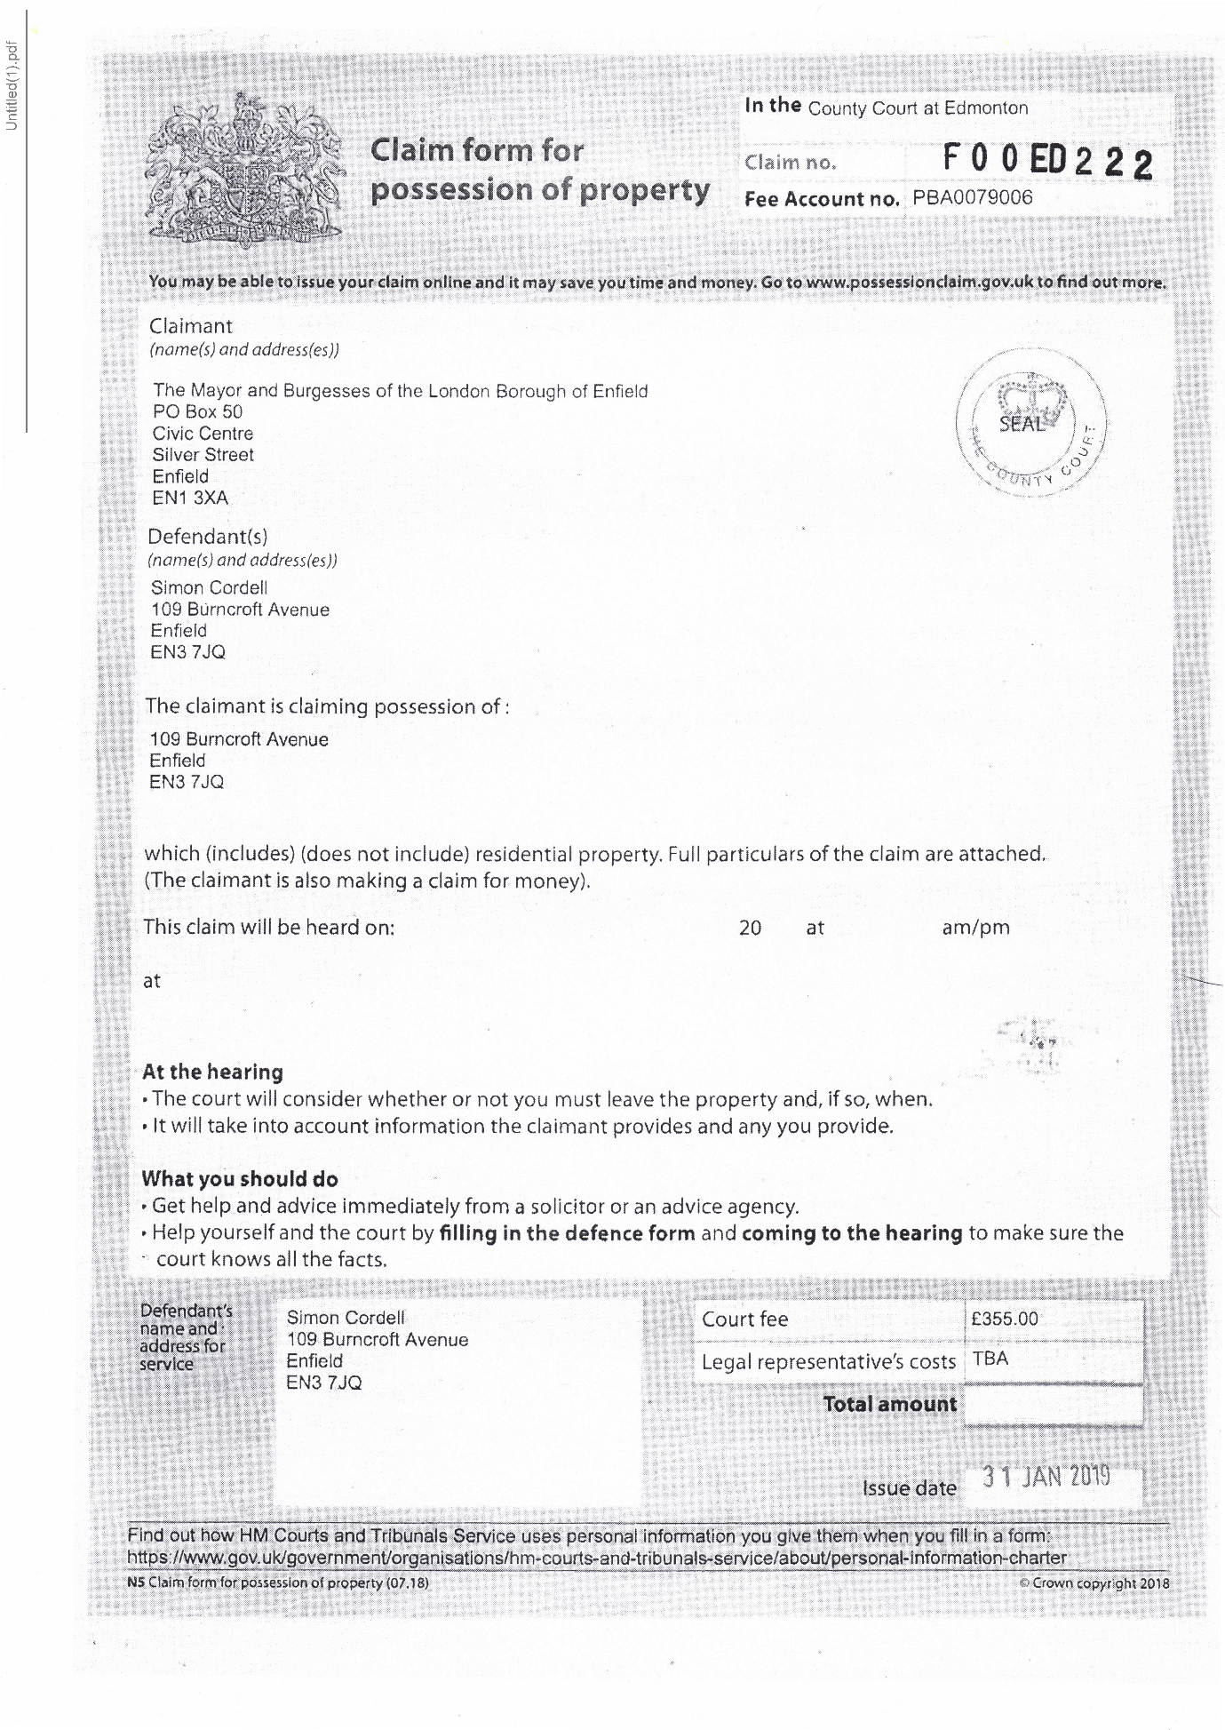
38,
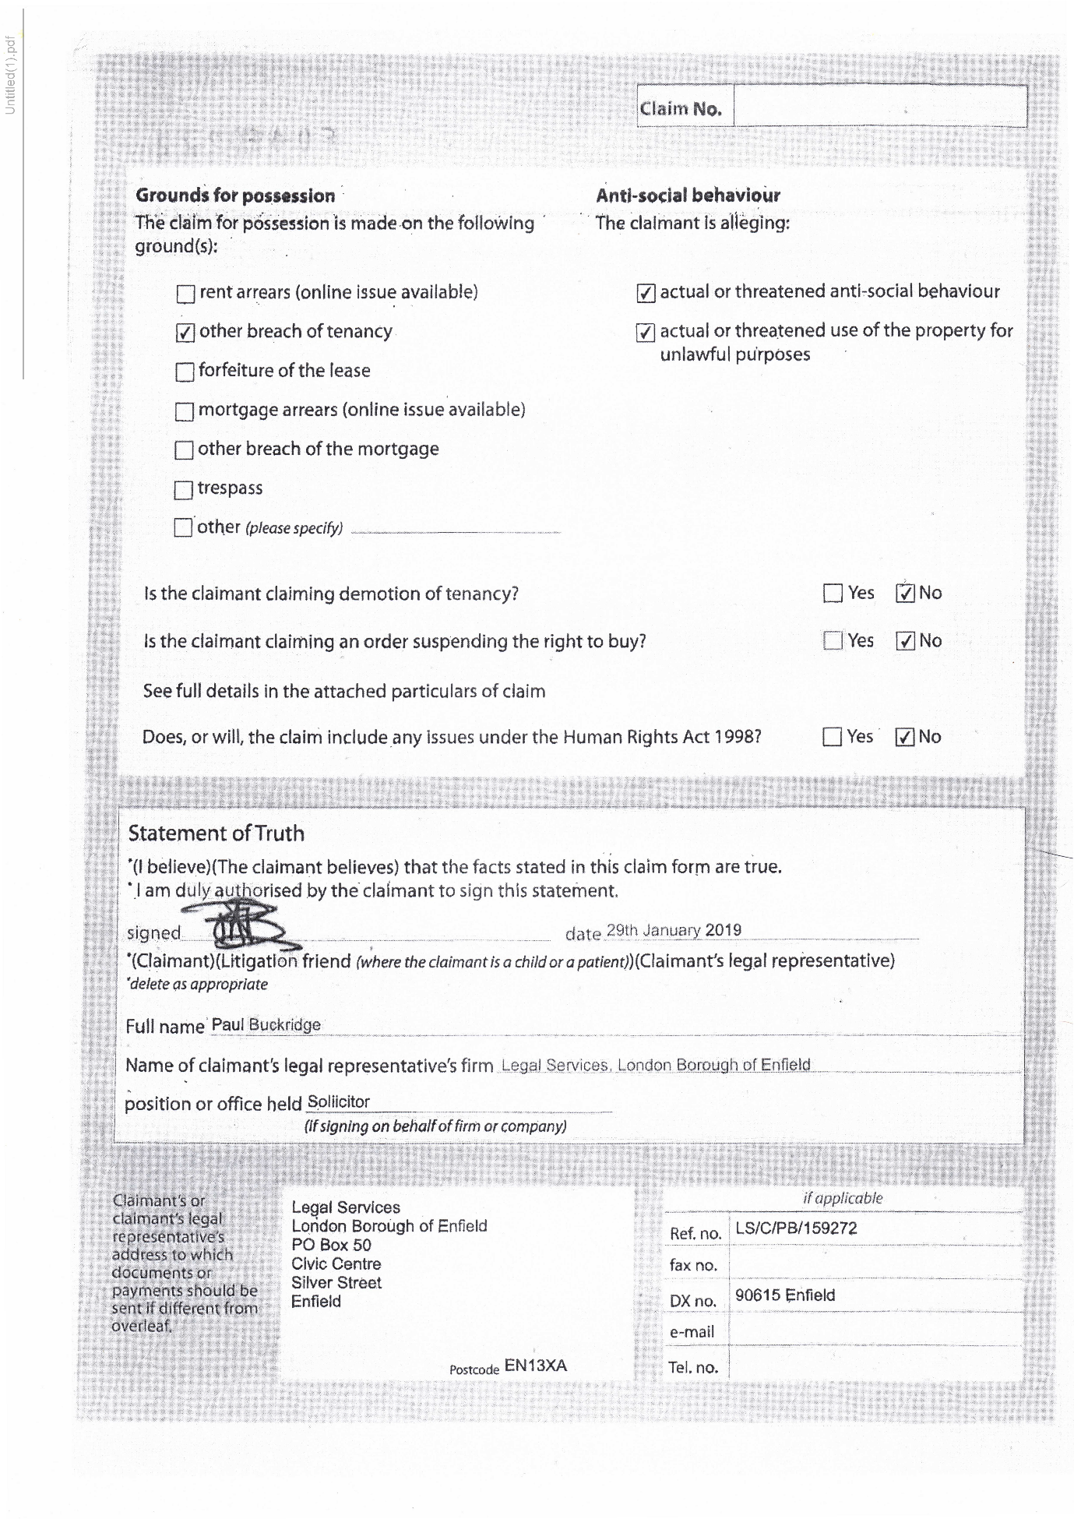
39,
Blank Page!
40,
IN THE COUNTY COURT AT EDMONTON
CLAIM NO
BETWEEN
LONDON BOROUGH OF ENFIELD
and
Claimant
MR SIMON CORDELL
Defendant
PARTICULARS OF CLAIM
- The Claimant is the Landlord and the freehold owner of the premises known as 109 Burncroft Avenue, Enfield, EN3 7JQ (hereinafter referred to as the premises).
- The premises are a one-bedroom flat located in a block of flats, granted to the Defendant, Simon Cordell on 14 August 2006. The current weekly gross rent is £98.24. The Defendant lives in the Property alone and is in receipt of Employment and Support Allowance as well as Housing Benefits.
- The Claimant is seeking possession of the premises from the Defendant because on numerous occasions and times since the commencement of the tenancy, the Defendant has failed to comply with the terms and conditions of her tenancy agreement.
PARTICULARS OF TENANCY CONDITIONS
Condition 9
“You, the tenant, are responsible for the behaviour of anyone, including your children, living in, or visiting your home. This means that you must ensure that they do not act in breach of any of these conditions. Also, you must not encourage them to act in such a way. This applies in. the property, in
41,
communal and surrounding areas, any property belonging to the council and or anywhere within Enfield borough.”
Condition 10
"You must not act in any way which causes, or is likely to cause, a nuisance or annoyance or is anti-social.”
Condition 21
“You must not abuse, harass, make offensive comments and/or malicious allegations, use or threaten to use violence against any of ours. Officers or agents, or against a councillor. This applies at any time and in any place. We may report the matter to the Police.”
Condition 31
“You must take care not to cause damage to your property or the property of your neighbours.”
Condition 33
“You must keep the inside of your property clean and in reasonable decorative order.”
Condition 34
"You. Must not use the property in any way that may cause a health or safety hazard or encourage vermin and/or pests (for example, by hoarding items inappropriately).”
Condition 44
“You must obtain our prior written permission before carrying out any alterations, improvements or structural work to the property. You may need to obtain other permissions such as planning permission or building regulations approval.”
Condition 53
“You must keep the inside of the property, the fixtures and fittings and all glass in the property in good repair during the tenancy.”
Condition 57
“You must allow our employees, representatives and contractors to come into your property to service any electrical and gas supplies and appliances that we are responsible for maintaining.”
Condition 69
“You must not interfere with the electric or gas supply."
Condition 76
“You have the right to keep one pet, or animal such as a cat, a dog, small bird, fish, non-poisonous insect, spider, small snake or lizard, rabbit hamster, guinea pig, mouse, gerbil or domestic rat as long as they do not cause damage to the property, or nuisance or annoyance to anyone in your locality.”
2
42,
Condition 79
“You must always keep your dog(s) on a lead in communal areas and on our land.”
- The Claimant claims that the Defendant has acted in contravention of the above tenancy conditions.
- Detail of the nuisance acts that the Defendant has engaged in which constitute a breach of these conditions are particularised in the attached Schedule of Nuisance.
- The Claimant alleges that there have been reports of nuisance and anti-social behaviour from the Defendant since July 2016.
- The Defendant has been given verbal and written warnings of the anti-social behaviour and has been invited to attend meetings with his mother to see the Claimant's officers to discuss his conduct and behaviour, but he declined to attend.
PARTICULARS OF WARNING LETTERS AND REQUEST FOR MEETINGS
- On 29 December 2016 a letter was sent to the Defendant to attend a meeting on 6 December 2016, but the Defendant cancelled the meeting.
- On 31 January 2017 to attend a meeting for 9 February 2017 that was cancelled by the Defendant.
- On 16 February 2017 for a meeting on 22 February 2017 that again was cancelled by the Defendant
- On 16 March 2017 for a meeting on 23 March 2017 that was cancelled by the Defendant.
- On 15 October 2018 a pre-action letter was sent to the Defendant informing of legal action as a consequence of his antisocial behaviour conduct.
3
43,
- The Claimant is seeking to rely on Grounds 1 and 2 of Schedule 2 to the Housing Act 195 in the claim for possession of the premises.
Ground 1 of Schedule 2 states " Rent lawfully due from the tenant has not been paid or an obligation of the tenancy has not been broken or not performed”.
Ground 2 Schedule 2 states” the tenant or a person residing in or visiting the dwelling-house:
Has been guilty of conduct causing or likely to cause harassment, alarm or distress to a person residing, visiting, or otherwise engaging in unlawful activity in the locality, or
(aa) has been guilty of conduct causing or likely to cause a nuisance or annoyance to the landlord of the dwelling-house, or a person employed (whether or not by the landlord) in connection with the landlord’s housing management functions, and that is directly or indirectly related to or affects those functions, or
- has been convicted of—
- using the dwelling-house or allowing it to be used for immoral or illegal purposes, or
- an indictable offence committed in, or in the locality of, the dwelling-house.
- In accordance with the requirements of Section 83 of the Housing Act 1985, a Notice of Seeking Possession was served on the Defendant on 25 January 2019.
The Claimant claims that it is reasonable to grant possession of the premises on account of the Defendant’s conduct.
4
44,
- The Claimant has informed the Defendant of the impact of his conduct and behaviour on other residents and sent him warning letters. The Notice of Seeking Possession clearly sets out the details of the complaints.
- The Claimant was assessed by a consultant psychiatrist on 6th July 2018 and she confirmed that the Defendant lacks capacity to litigate.
AND THE CLAIMANT CLAIMS
- Possession of the premises known as 109 Burncroft Avenue, Enfield, EN3 7JQ.
- Mesne profit at the rate of £13.99 per day from the day possession is granted.
- Costs
Statement of Truth
I believe that the facts stated in this Particulars of Claim are true.
I am duly authorised by the Claimant to sign this statement.
Signed
Dated: 29th January 2019
(Claimant’s Solicitor)
5
45,
IN THIE COUNTY COURT AT EDMONTON CLAIM NO
BETWEEN
LONDON BOROUGH OF ENFIELD
and
Claimant
MR SIMON CORDELL
Defendant
SCHEDULE OF NUISANCE ACTIVITIES
- On 6th July 2016, it is alleged that the Defendant approached an elderly neighbour as he came out of his flat and started to shout abuse and swear at him and threatened to burn down his flat.
- Sometime in July 2016 it is alleged that the Defendant damaged the lock of a neighbour’s electric cupboard and removed his fuse box resulting in no electricity to his flat.
- On 6th August 2016, it is alleged that the Defendant threatened one of his neighbours and his wife and aggressively demanded money from him. It is also alleged that the Defendant repeatedly swore and shouted abuse at him and his wife and called his wife a ‘bitch’ and tried to stop him from going up the stairs to his flat by standing in front of him.
- Sometime in September 2016 it is alleged that the Defendant confronted an elderly neighbour outside his block of flats, 109 - 119 Burncroft Avenue as he was going to the local park with another resident and started to shout abuse and threats at him and said to him ‘I can get you over at the park, I know you go for a walk’. .
- On 27th September 2016, it is alleged that the Defendant confronted one of his neighbours as he returned to his flat with his family, threatened, swore at him, and demanded money from him. It is also alleged that the Defendant later banged on his door, shouted further abuse, and swear words at him and accused him of making noise inside his flat.
- On 28th September 2016, it is alleged that the Defendant aggressively banged on a neighbour’s door and threatened and shouted verbal abuse and swear words at them. It is also alleged that the Defendant aggressively demanded money from him.
- On 4th October 2016, it is alleged that the Defendant aggressively banged on his ceiling and accused one of his neighbours of making noise, then went to his neighbour's flat and started kicking and banging on his front door
6
46,
aggressively, accused him of banging on the floor, swore and shouted abuse at him. It is also alleged that the Defendant later went downstairs, dragged his neighbour’s motorbike from where it was parked and started to hit it with a piece of wood.
- On 22nd November 2016 during a telephone conversation between the Defendant, Mrs Cordell the Defendant mother and Ms Sarah Fletcher, neighbourhood officer, Ms Fletcher reported that she overheard the Defendant threaten her by saying 'I’m goanna do her over’ and then Tm goanna take her job just for fun'.
- On 8th December 2016, it is alleged that the Defendant aggressively banged on one of his neighbour’s front door, shouted abuse and threats and accused him of making noise.
- 10.On 11th December 2016, it is alleged that the Defendant aggressively banged on his neighbour’s door several times and accused them of banging on pipes. It is also alleged that the Defendant shouted abuse and threats at them.
- 11.On 14th December 2016, it is alleged that the Defendant was verbally abusive towards a woman who was visiting one of his neighbours as she knocked on his neighbour's door.
- On 23rd December 2016, it is alleged that the Defendant banged on a neighbour’s front door, shouted abuse at them and asked them to turn their tap off. The Defendant then removed their electricity fuse thereby cutting off their power supply.
- On 26th December 2016, it is alleged that the Defendant ran up the communal stairs to the first floor and confronted one of his neighbours as he was going out with his family and started to shout abuse and threats at him and his wife and accused him of tampering with his water supply. The Defendant also attempted to stop him from leaving the block.
- On 3rd January 2017, it is alleged that the Defendant confronted one of his neighbours as he returned to the block with his wife and two-year-old daughter and started shouting abuse and threats at them.
- On 21st January 2017, it is alleged that the Defendant aggressively banged on his neighbour's door, swore, and shouted abuse and threats at them and accused them of making noise.
- On 31st January 2017, it is alleged that the Defendant aggressively banged on his neighbour’s door, shouted abuse, and threats at them and accused them of banging on the floor.
7
47,
- We received a report that on 7th February 2017 that the Defendant approached the leaseholder of 117 Burncroft Avenue and his plumber outside the block as they were attempting to resolve the problem causing low water pressure in the flat. The Defendant said to the leaseholder that there were problems between him and his tenants but did not give any specific details. The leaseholder explained to the Defendant that his tenants were experiencing low water pressure in the flat and the Defendant said to him ’you will not solve the problem as I am restricting their water supply’. The leaseholder later knocked on the Defendant door and asked whether he would increase the water pressure and the Defendant stated, ‘I cannot do anything at the moment, I will sort it out later’.
- On 24th February 2017 Sarah Fletcher (Neighbourhood Officer) and Steve Stirk (Maintenance Surveyor) attended the Defendant property at flat 109 Burncroft Avenue to inspect the property following reports of low water pressure from fiats 113 and 117 Burncroft Avenue. While inside the Defendant flat, they observed that the Defendant had installed an iron security gate inside his front door. It also appeared to them that the wall between the Defendant kitchen and living room seemed to have been removed thereby creating an open plan effect. Much of the property was taken up with industrial type printers, boxes and folders and there were dog faeces in the Defendant’s back garden.
- 19.On 17th March 2017 Lemmy Nwabuisi, ASB Coordinator visited 109 Burncroft Avenue to post a letter through the Defendant door and as he got into his car to drive off after posting the letter, the Defendant ran after him shouting and screaming abuse. The letter requested that the Defendant attend the Council office to discuss the nuisance reports being received from his neighbours. By the time he returned to the office, the Defendant had telephoned him several times. Lemmy Nwabuisi telephoned the Defendant back and the Defendant asked whether he was the person that posted a letter through his letterbox and Lemmy Nwabuisi said yes. The Defendant asked why he did not stop when he ran after him and Lemmy Nwabuisi stated that he had another visit and did not have the time to stop and talk to him. The Defendant stated that he will not attend the meeting at the Civic Centre or any of the council offices as he is unable to leave his flat and that the meeting should take place in his flat. Mr Nwabuisi offered to have the meeting at a neutral venue and suggested the local library or at his mother's house, but the Defendant refused saying that he have done nothing wrong and accused Lemmy Nwabuisi of taking sides with his neighbours.
- On 5th May 2017, it is alleged that the Defendant threatened one of his neighbours by saying that he will ruin his life and that the Defendant was going to the police to present evidence about his illegal activities.
8
48,
- On 14th May 2017, it is alleged that the Defendant aggressively banged on one of his neighbour’s door, shouted abuse, and threats at her and falsely accused her of making noise and coming into his flat to attack him. The Defendant later followed her to her car shouting abuse and wanting to know where she was going.
- On 14th. May 2017 it is alleged that the Defendant allowed his dog to run freely in the communal area of his block without a lead.
- On 28th May 2017, the police issued the Defendant with a first instance Harassment letter following reports of harassment and threatening behaviour made to the police by one of the Defendant neighbours.
- On 9th June 2017, it is alleged that the Defendant attacked one of his neighbours in the communal hallway of his block as he returned from work late at night by grabbing him on the arm and neck thereby causing bruising to his arm and neck. The Defendant also snatched his phone from him as he tried to video-record the incident.
- 25.On 16th June 2017 at 11:55hrs it is alleged that the Defendant confronted one of his neighbours as she was exiting the main entrance to his building and said to her that he had her bank details and personal details such as date of birth and said to her that he wanted her and her husband to pay the Defendant some money.
- On 18th June 2017 at 11:55hrs it is alleged that the Defendant confronted one of his neighbours as she was exiting the main entrance to his building and said to her that he knew what time she went out and what time she returned and to tell her husband that the Defendant would like to speak to him.
- On 23rd June 2017 at 23:35hrs it is alleged that the Defendant came out of his flat with his dog without a lead and attacked one of his neighbours as he returned from work by punching him twice on the chest. The Defendant tried to push him out of the block and snatched his phone as he took it out of his pocket to record the incident.
- On 28th June 2017 at 11:45hrs it is alleged that the Defendant confronted his neighbour as she was leaving the block. The Defendant swore and shouted abuse at her and accused her of making noise inside her flat. The Defendant told her that he knows all her personal details and that of her husband including their full names, phone numbers, date of birth and banking details. The Defendant demanded that they pay him some money and asked her to tell her husband to come and see him.
- On 30th June 2017 at 11:45hrs it is alleged that the Defendant confronted his neighbour as she was leaving the block and accused her of slamming
9
49,
the door. She denied slamming the door and the Defendant called her a liar and proceeded to swear and shout abuse at her.
- On 2nd July 2017 at 17:18hrs it is alleged that the Defendant confronted his neighbour as he was going out with his family with his dog barking and without a lead. The Defendant asked him when he was going to hand over the money. It is also alleged that as they left the block, the Defendant ran after them swearing and shouting abuse at his neighbour and demanding that he must pay him some money if he wants the Defendant to leave him alone. The Defendant also said to him that he has all their personal details including their dates of birth and bank details.
- On 12th July 2017 an Enfield Council Surveyor attended the Defendant flat to investigate reports of low water pressure to flats above his, but he refused him access. The Surveyor attended the Defendant flat again in the evening of the same day following further reports that the water supply to the affected flats had completely ceased and the Defendant refused him access. The Defendant then followed him to his car swearing and shouting abuse at him and prevented him from entering his car. The Surveyor then called the police.
- On 11th November 2017 at 11.30am, it is alleged by one of his neighbours that the Defendant came to their front door, opened the letterbox, and peeped through it to see who was inside the flat. The Defendant then started swearing and shouting abuse and banging on their front door as soon as he saw the neighbour’s wife.
- On 2nd January 2018 at 6.30pm, it is alleged that the Defendant stood outside his neighbour’s property for more than twenty minutes swearing and shouting abuse. The Defendant went away and returned half an hour later, lifted their letterbox, stuck his mobile phone through the letterbox and started to record his neighbour’s family while swearing and shouting abuse. This went on for about fifteen minutes.
- On 9th January 2018 at about 12.18pm, the Defendant telephoned Lemmy Nwabuisi (ASB Behaviour officer) and accused him of forging documents to get an anti-social behaviour order against him. The Defendant further told him that he had made him a prisoner within his home. The Defendant stated that he knows where he lives in Enfield and that he and his family were not safe from him. The Defendant told Lemmy Nwabuisi that he would watch him leave the office and he would have followed him home and he needed to watch his back. The Defendant called the ASB officer again 30 minutes later and told him that he knows he has a flat in Edmonton and also know that one of his colleagues lives in Edmonton. The Defendant also stated that he knows where they live and they were not safe.
10
50,
- On 9th January 2018 the Defendant called Kaunchita Maudhub (ASB Behaviour officer) and left a long voicemail on her work telephone number and made threats.
- On 26th February 2018, at around 11.45pm it is alleged that the Defendant came to one of his neighbour’s front door and started making loud banging noises and rattling with their letter box. The Defendant ran away after the neighbour opened her front door.
- On 1st March 2018 it is alleged that the Defendant knocked on one of his neighbours’ door loudly, he started rattling with their letter box and shouting. This went on for 5 to 10 minutes, but the Defendant left after he heard that the neighbour was calling the police.
- On 15th March 2018 it is alleged that the Defendant swore, shouted, and assaulted one of his neighbours in front of his wife and his 3 years old child.
- On 1st May 2018, the Defendant attended the Edmonton County Court as there was a hearing listed in relation to an injunction. It is alleged that the Defendant started shouting abuse, swore and make threats to two of the Claimant’s employees (Lemmy Nwabuisi, ASB officer and Balbinder Kaur Geddes, lawyer) and to one of his neighbours who attended Court to give evidence. The Defendant also swore at a judge. These incidents were witnessed by members of staff working at the Court.
- On 29th May 2018, it is alleged that the Defendant attended one of his neighbours’ property; he took his dog with him and waited by their front door. It is alleged that the Defendant tried to intimidate as they were due to attend a hearing in the Edmonton County Court to give evidence in support of a claim for an injunction issued against the Defendant.
- On 30th May 2018, it is alleged that the Defendant made threats to kill to one of his neighbours. The matter was reported to the police. The Defendant was arrested and released on bail.
- On 29th August 2018, it is alleged that the Defendant assaulted one of his neighbours for flushing his toilet.
- The Defendant telephoned two council officers (Lemmy Nwabuisi and Ludmilla Lyavoo) on 12th September 2018 and made threats to them over the telephone. The Defendant also accused them of fraud and of fabricating evidence to support the Council’s claim for an injunction
- On 12th September 2018 at about 3.50pm, the Defendant called one of his neighbours on his mobile phone using a private number. It is not known how you obtained his number, but he terminated the call. The Defendant called
11
51,
again using the same private number, but he terminated the call as soon as he heard his voice. The Defendant called repeatedly after that.
- On 24th September 2018 at about 11.30am, one of the Defendant neighbours returned home from dropping her daughter at school and as she entered their block of flat, she noticed that the middle door on the ground floor was open as well as the Defendant front door. As she went up the stairs to their second floor flat, the Defendant dog came out of the Defendant flat and started barking at her. The neighbour had to run up the stairs to her flat to escape from the dog. It was reported that the Defendant dog is always barking whenever they go out or return to the block and the neighbour and 4 years old daughter are terrified.
- On 30th September 2018, it is alleged that the Defendant attempted to break down one of his neighbour’s front door by kicking it several times and accused him flushing his toilet.
- On 2nd October 2018 at about 12:45pm, it is alleged that the Defendant attacked one of his neighbour’s cousins as he was leaving the block. It is alleged that as he exited the block, the Defendant followed him and suddenly grabbed his jacket from behind and tried to pull him to the ground. The cousin started shouting to attract neighbours and managed to push the Defendant off.
- On 18th October 2018, the Defendant telephoned one of the Enfield Council solicitors, Miss Ludmilla lyavoo almost ten times, making threats and intimidating her. The Defendant suggested that she stops working on the case or you will try to get her struck off from the 'register'.
- On 19th October 2018, the Defendant telephoned Miss Ludmilla lyavoo at least five times and left two voice messages making threats and trying to intimidate the solicitor working on the case.
- On 22nd October 2018, the Defendant telephoned Miss Ludmilla lyavoo from a private number and left one threatening and intimidating voice message.
- On 23rd October 2018, the Defendant telephoned Miss Ludmilla lyavoo from a private number and left an intimidating voice message.
- On 24th October 2018, the Defendant telephoned Ludmilla lyavoo twice but did not leave any messages.
- On 16th December 2018 at around 6pm, it is alleged that the Defendant repeatedly banged on one of his neighbour’s door and peeped through his letterbox.
- On 17th January2019, the Defendant was videotaped when he confronted one of his neighbours outside his block of flats (109-119 Burncroft Avenue) as he was taking his three-year-old daughter to school and started shouting
12
Extra Page
abuse and threats at him thereby preventing him from taking his daughter to school. The Defendant then followed him and his daughter up the stairs to their second floor flat and was videotaped by a member of the neighbour's family as he attempted to attack them causing them to run into their flat for safety with the Defendant forcing the door to try and gain entry. The neighbour and his family have since fled their property as a result of the Defendant constant threats and intimidation.
- On 18th January 2019, the Defendant telephoned Miss Ludmilla Lyavoo from a private number and started making threats and the solicitor ended the call. The Defendant called again three times and left a voice message making threats and intimidation.
- On 23rd January 2019, the Defendant telephoned Miss Ludmilla lyavoo eight times within a ten-minute period.
- On 25th January 2019, the Defendant telephoned Miss Ludmilla lyavoo on two occasions acknowledged receipt of the Notice of Seeking Possession, threaten to have her struck off the register and accused her of falsifying evidence against him.
13

7.
Additional Email Attachments & Emails / Issue:
7. 1. 2.
2nd Possession Order 06-02-2019-05-00 1
06/02/2019
/ Page Numbers: 52
--
52
From: Rewired <re_wired@ymail.com>
Sent time: 06/02/2019 05:00:16 PM
To: Lorraine Cordell <lorraine32@blueyonder.co.uk>
Attachments: UTF-8bVW50aXRsZWQoMSkgRnJlc2ggUG9zc2Vzc3Rpb24gT3J

8.
Additional Email Attachments & Emails / Issue:
8. 5. 1. 2.
2nd Possession Order
06-02-2019 -04-59
/ Page Numbers: 53,54
55,56,57,58,59,60
61,62,63,64,65,66
67,68,69
--
53,
From: Rewired <re_wired@ymail.com>
Sent time:06/02/2019 04:59:13 PM
To: Lorraine Cordell <lorraine32@blueyonder.co.uk>
Subject: Fwd.: New Docs
Attachments: Untitled(1).pdf
— Forwarded message —
From: Rewired <re_wired@ymail.com>
To: Lorraine Cordell <lorraine32@blueyonder.co.uk>
Sent: Wednesday, 6 February 2019, 16:49:23 GMT
Subject: New Docs
54,
55,
56,
Blank Page!
57,
IN THE COUNTY COURT AT EDMONTON
CLAIM NO
BETWEEN
LONDON BOROUGH OF ENFIELD
and
Claimant
MR SIMON CORDELL
Defendant
PARTICULARS OF CLAIM
- The Claimant is the Landlord and the freehold owner of the premises known as 109 Burncroft Avenue, Enfield, EN3 7JQ (hereinafter referred to as the premises).
- The premises are a one-bedroom flat located in a block of flats, granted to the Defendant, Simon Cordell on 14 August 2006. The current weekly gross rent is £98.24. The Defendant lives in the Property alone and is in receipt of Employment and Support Allowance as well as Housing Benefits.
- The Claimant is seeking possession of the premises from the Defendant because on numerous occasions and times since the commencement of the tenancy, the Defendant has failed to comply with the terms and conditions of her tenancy agreement.
PARTICULARS OF TENANCY CONDITIONS
Condition 9
“You, the tenant, are responsible for the behaviour of anyone, including your children, living in, or visiting your home. This means that you must ensure that they do not act in breach of any of these conditions. Also, you must not encourage them to act in such a way. This applies in. the property, in
58,
communal and surrounding areas, any property belonging to the council and or anywhere within Enfield borough.”
Condition 10
"You must not act in any way which causes, or is likely to cause, a nuisance or annoyance or is anti-social.”
Condition 21
“You must not abuse, harass, make offensive comments and/or malicious allegations, use or threaten to use violence against any of ours. Officers or agents, or against a councillor. This applies at any time and in any place. We may report the matter to the Police.”
Condition 31
“You must take care not to cause damage to your property or the property of your neighbours.”
Condition 33
“You must keep the inside of your property clean and in reasonable decorative order.”
Condition 34
"You. Must not use the property in any way that may cause a health or safety hazard or encourage vermin and/or pests (for example, by hoarding items inappropriately).”
Condition 44
“You must obtain our prior written permission before carrying out any alterations, improvements or structural work to the property. You may need to obtain other permissions such as planning permission or building regulations approval.”
Condition 53
“You must keep the inside of the property, the fixtures and fittings and all glass in the property in good repair during the tenancy.”
Condition 57
“You must allow our employees, representatives and contractors to come into your property to service any electrical and gas supplies and appliances that we are responsible for maintaining.”
Condition 69
“You must not interfere with the electric or gas supply."
Condition 76
“You have the right to keep one pet, or animal such as a cat, a dog, small bird, fish, non-poisonous insect, spider, small snake or lizard, rabbit hamster, guinea pig, mouse, gerbil or domestic rat as long as they do not cause damage to the property, or nuisance or annoyance to anyone in your locality.”
2
59,
Condition 79
“You must always keep your dog(s) on a lead in communal areas and on our land.”
- The Claimant claims that the Defendant has acted in contravention of the above tenancy conditions.
- Detail of the nuisance acts that the Defendant has engaged in which constitute a breach of these conditions are particularised in the attached Schedule of Nuisance.
- The Claimant alleges that there have been reports of nuisance and anti-social behaviour from the Defendant since July 2016.
- The Defendant has been given verbal and written warnings of the anti-social behaviour and has been invited to attend meetings with his mother to see the Claimant's officers to discuss his conduct and behaviour, but he declined to attend.
PARTICULARS OF WARNING LETTERS AND REQUEST FOR MEETINGS
- On 29 December 2016 a letter was sent to the Defendant to attend a meeting on 6 December 2016, but the Defendant cancelled the meeting.
- On 31 January 2017 to attend a meeting for 9 February 2017 that was cancelled by the Defendant.
- On 16 February 2017 for a meeting on 22 February 2017 that again was cancelled by the Defendant
- On 16 March 2017 for a meeting on 23 March 2017 that was cancelled by the Defendant.
- On 15 October 2018 a pre-action letter was sent to the Defendant informing of legal action as a consequence of his antisocial behaviour conduct.
3
60,
- The Claimant is seeking to rely on Grounds 1 and 2 of Schedule 2 to the Housing Act 195 in the claim for possession of the premises.
Ground 1 of Schedule 2 states " Rent lawfully due from the tenant has not been paid or an obligation of the tenancy has not been broken or not performed”.
Ground 2 Schedule 2 states” the tenant or a person residing in or visiting the dwelling-house:
Has been guilty of conduct causing or likely to cause harassment, alarm or distress to a person residing, visiting, or otherwise engaging in unlawful activity in the locality, or
(aa) has been guilty of conduct causing or likely to cause a nuisance or annoyance to the landlord of the dwelling-house, or a person employed (whether or not by the landlord) in connection with the landlord’s housing management functions, and that is directly or indirectly related to or affects those functions, or
- has been convicted of—
- using the dwelling-house or allowing it to be used for immoral or illegal purposes, or
- an indictable offence committed in, or in the locality of, the dwelling-house.
- In accordance with the requirements of Section 83 of the Housing Act 1985, a Notice of Seeking Possession was served on the Defendant on 25 January 2019.
The Claimant claims that it is reasonable to grant possession of the premises on account of the Defendant’s conduct.
4
61,
- The Claimant has informed the Defendant of the impact of his conduct and behaviour on other residents and sent him warning letters. The Notice of Seeking Possession clearly sets out the details of the complaints.
- The Claimant was assessed by a consultant psychiatrist on 6th July 2018 and she confirmed that the Defendant lacks capacity to litigate.
AND THE CLAIMANT CLAIMS
- Possession of the premises known as 109 Burncroft Avenue, Enfield, EN3 7JQ.
- Mesne profit at the rate of £13.99 per day from the day possession is granted.
- Costs
Statement of Truth
I believe that the facts stated in this Particulars of Claim are true.
I am duly authorised by the Claimant to sign this statement.
Signed
Dated: 29th January 2019
(Claimant’s Solicitor)
5
62,
IN THIE COUNTY COURT AT EDMONTON CLAIM NO
BETWEEN
LONDON BOROUGH OF ENFIELD
and
Claimant
MR SIMON CORDELL
Defendant
SCHEDULE OF NUISANCE ACTIVITIES
- On 6th July 2016, it is alleged that the Defendant approached an elderly neighbour as he came out of his flat and started to shout abuse and swear at him and threatened to burn down his flat.
- Sometime in July 2016 it is alleged that the Defendant damaged the lock of a neighbour’s electric cupboard and removed his fuse box resulting in no electricity to his flat.
- On 6th August 2016, it is alleged that the Defendant threatened one of his neighbours and his wife and aggressively demanded money from him. It is also alleged that the Defendant repeatedly swore and shouted abuse at him and his wife and called his wife a ‘bitch’ and tried to stop him from going up the stairs to his flat by standing in front of him.
- Sometime in September 2016 it is alleged that the Defendant confronted an elderly neighbour outside his block of flats, 109 - 119 Burncroft Avenue as he was going to the local park with another resident and started to shout abuse and threats at him and said to him ‘I can get you over at the park, I know you go for a walk’. .
- On 27th September 2016, it is alleged that the Defendant confronted one of his neighbours as he returned to his flat with his family, threatened, swore at him, and demanded money from him. It is also alleged that the Defendant later banged on his door, shouted further abuse, and swear words at him and accused him of making noise inside his flat.
- On 28th September 2016, it is alleged that the Defendant aggressively banged on a neighbour’s door and threatened and shouted verbal abuse and swear words at them. It is also alleged that the Defendant aggressively demanded money from him.
- On 4th October 2016, it is alleged that the Defendant aggressively banged on his ceiling and accused one of his neighbours of making noise, then went to his neighbour's flat and started kicking and banging on his front door
6
63,
aggressively, accused him of banging on the floor, swore and shouted abuse at him. It is also alleged that the Defendant later went downstairs, dragged his neighbour’s motorbike from where it was parked and started to hit it with a piece of wood.
- On 22nd November 2016 during a telephone conversation between the Defendant, Mrs Cordell the Defendant mother and Ms Sarah Fletcher, neighbourhood officer, Ms Fletcher reported that she overheard the Defendant threaten her by saying 'I’m goanna do her over’ and then Tm goanna take her job just for fun'.
- On 8th December 2016, it is alleged that the Defendant aggressively banged on one of his neighbour’s front door, shouted abuse and threats and accused him of making noise.
- 10.On 11th December 2016, it is alleged that the Defendant aggressively banged on his neighbour’s door several times and accused them of banging on pipes. It is also alleged that the Defendant shouted abuse and threats at them.
- 11.On 14th December 2016, it is alleged that the Defendant was verbally abusive towards a woman who was visiting one of his neighbours as she knocked on his neighbour's door.
- On 23rd December 2016, it is alleged that the Defendant banged on a neighbour’s front door, shouted abuse at them and asked them to turn their tap off. The Defendant then removed their electricity fuse thereby cutting off their power supply.
- On 26th December 2016, it is alleged that the Defendant ran up the communal stairs to the first floor and confronted one of his neighbours as he was going out with his family and started to shout abuse and threats at him and his wife and accused him of tampering with his water supply. The Defendant also attempted to stop him from leaving the block.
- On 3rd January 2017, it is alleged that the Defendant confronted one of his neighbours as he returned to the block with his wife and two-year-old daughter and started shouting abuse and threats at them.
- On 21st January 2017, it is alleged that the Defendant aggressively banged on his neighbour's door, swore, and shouted abuse and threats at them and accused them of making noise.
- On 31st January 2017, it is alleged that the Defendant aggressively banged on his neighbour’s door, shouted abuse, and threats at them and accused them of banging on the floor.
7
64,
- We received a report that on 7th February 2017 that the Defendant approached the leaseholder of 117 Burncroft Avenue and his plumber outside the block as they were attempting to resolve the problem causing low water pressure in the flat. The Defendant said to the leaseholder that there were problems between him and his tenants but did not give any specific details. The leaseholder explained to the Defendant that his tenants were experiencing low water pressure in the flat and the Defendant said to him ’you will not solve the problem as I am restricting their water supply’. The leaseholder later knocked on the Defendant door and asked whether he would increase the water pressure and the Defendant stated, ‘I cannot do anything at the moment, I will sort it out later’.
- On 24th February 2017 Sarah Fletcher (Neighbourhood Officer) and Steve Stirk (Maintenance Surveyor) attended the Defendant property at flat 109 Burncroft Avenue to inspect the property following reports of low water pressure from fiats 113 and 117 Burncroft Avenue. While inside the Defendant flat, they observed that the Defendant had installed an iron security gate inside his front door. It also appeared to them that the wall between the Defendant kitchen and living room seemed to have been removed thereby creating an open plan effect. Much of the property was taken up with industrial type printers, boxes and folders and there were dog faeces in the Defendant’s back garden.
- 19.On 17th March 2017 Lemmy Nwabuisi, ASB Coordinator visited 109 Burncroft Avenue to post a letter through the Defendant door and as he got into his car to drive off after posting the letter, the Defendant ran after him shouting and screaming abuse. The letter requested that the Defendant attend the Council office to discuss the nuisance reports being received from his neighbours. By the time he returned to the office, the Defendant had telephoned him several times. Lemmy Nwabuisi telephoned the Defendant back and the Defendant asked whether he was the person that posted a letter through his letterbox and Lemmy Nwabuisi said yes. The Defendant asked why he did not stop when he ran after him and Lemmy Nwabuisi stated that he had another visit and did not have the time to stop and talk to him. The Defendant stated that he will not attend the meeting at the Civic Centre or any of the council offices as he is unable to leave his flat and that the meeting should take place in his flat. Mr Nwabuisi offered to have the meeting at a neutral venue and suggested the local library or at his mother's house, but the Defendant refused saying that he have done nothing wrong and accused Lemmy Nwabuisi of taking sides with his neighbours.
- On 5th May 2017, it is alleged that the Defendant threatened one of his neighbours by saying that he will ruin his life and that the Defendant was going to the police to present evidence about his illegal activities.
8
65,
- On 14th May 2017, it is alleged that the Defendant aggressively banged on one of his neighbour’s door, shouted abuse, and threats at her and falsely accused her of making noise and coming into his flat to attack him. The Defendant later followed her to her car shouting abuse and wanting to know where she was going.
- On 14th. May 2017 it is alleged that the Defendant allowed his dog to run freely in the communal area of his block without a lead.
- On 28th May 2017, the police issued the Defendant with a first instance Harassment letter following reports of harassment and threatening behaviour made to the police by one of the Defendant neighbours.
- On 9th June 2017, it is alleged that the Defendant attacked one of his neighbours in the communal hallway of his block as he returned from work late at night by grabbing him on the arm and neck thereby causing bruising to his arm and neck. The Defendant also snatched his phone from him as he tried to video-record the incident.
- 25.On 16th June 2017 at 11:55hrs it is alleged that the Defendant confronted one of his neighbours as she was exiting the main entrance to his building and said to her that he had her bank details and personal details such as date of birth and said to her that he wanted her and her husband to pay the Defendant some money.
- On 18th June 2017 at 11:55hrs it is alleged that the Defendant confronted one of his neighbours as she was exiting the main entrance to his building and said to her that he knew what time she went out and what time she returned and to tell her husband that the Defendant would like to speak to him.
- On 23rd June 2017 at 23:35hrs it is alleged that the Defendant came out of his flat with his dog without a lead and attacked one of his neighbours as he returned from work by punching him twice on the chest. The Defendant tried to push him out of the block and snatched his phone as he took it out of his pocket to record the incident.
- On 28th June 2017 at 11:45hrs it is alleged that the Defendant confronted his neighbour as she was leaving the block. The Defendant swore and shouted abuse at her and accused her of making noise inside her flat. The Defendant told her that he knows all her personal details and that of her husband including their full names, phone numbers, date of birth and banking details. The Defendant demanded that they pay him some money and asked her to tell her husband to come and see him.
- On 30th June 2017 at 11:45hrs it is alleged that the Defendant confronted his neighbour as she was leaving the block and accused her of slamming
9
66,
the door. She denied slamming the door and the Defendant called her a liar and proceeded to swear and shout abuse at her.
- On 2nd July 2017 at 17:18hrs it is alleged that the Defendant confronted his neighbour as he was going out with his family with his dog barking and without a lead. The Defendant asked him when he was going to hand over the money. It is also alleged that as they left the block, the Defendant ran after them swearing and shouting abuse at his neighbour and demanding that he must pay him some money if he wants the Defendant to leave him alone. The Defendant also said to him that he has all their personal details including their dates of birth and bank details.
- On 12th July 2017 an Enfield Council Surveyor attended the Defendant flat to investigate reports of low water pressure to flats above his, but he refused him access. The Surveyor attended the Defendant flat again in the evening of the same day following further reports that the water supply to the affected flats had completely ceased and the Defendant refused him access. The Defendant then followed him to his car swearing and shouting abuse at him and prevented him from entering his car. The Surveyor then called the police.
- On 11th November 2017 at 11.30am, it is alleged by one of his neighbours that the Defendant came to their front door, opened the letterbox, and peeped through it to see who was inside the flat. The Defendant then started swearing and shouting abuse and banging on their front door as soon as he saw the neighbour’s wife.
- On 2nd January 2018 at 6.30pm, it is alleged that the Defendant stood outside his neighbour’s property for more than twenty minutes swearing and shouting abuse. The Defendant went away and returned half an hour later, lifted their letterbox, stuck his mobile phone through the letterbox and started to record his neighbour’s family while swearing and shouting abuse. This went on for about fifteen minutes.
- On 9th January 2018 at about 12.18pm, the Defendant telephoned Lemmy Nwabuisi (ASB Behaviour officer) and accused him of forging documents to get an anti-social behaviour order against him. The Defendant further told him that he had made him a prisoner within his home. The Defendant stated that he knows where he lives in Enfield and that he and his family were not safe from him. The Defendant told Lemmy Nwabuisi that he would watch him leave the office and he would have followed him home and he needed to watch his back. The Defendant called the ASB officer again 30 minutes later and told him that he knows he has a flat in Edmonton and also know that one of his colleagues lives in Edmonton. The Defendant also stated that he knows where they live and they were not safe.
10
67,
- On 9th January 2018 the Defendant called Kaunchita Maudhub (ASB Behaviour officer) and left a long voicemail on her work telephone number and made threats.
- On 26th February 2018, at around 11.45pm it is alleged that the Defendant came to one of his neighbour’s front door and started making loud banging noises and rattling with their letter box. The Defendant ran away after the neighbour opened her front door.
- On 1st March 2018 it is alleged that the Defendant knocked on one of his neighbours’ door loudly, he started rattling with their letter box and shouting. This went on for 5 to 10 minutes, but the Defendant left after he heard that the neighbour was calling the police.
- On 15th March 2018 it is alleged that the Defendant swore, shouted, and assaulted one of his neighbours in front of his wife and his 3 years old child.
- On 1st May 2018, the Defendant attended the Edmonton County Court as there was a hearing listed in relation to an injunction. It is alleged that the Defendant started shouting abuse, swore and make threats to two of the Claimant’s employees (Lemmy Nwabuisi, ASB officer and Balbinder Kaur Geddes, lawyer) and to one of his neighbours who attended Court to give evidence. The Defendant also swore at a judge. These incidents were witnessed by members of staff working at the Court.
- On 29th May 2018, it is alleged that the Defendant attended one of his neighbours’ property; he took his dog with him and waited by their front door. It is alleged that the Defendant tried to intimidate as they were due to attend a hearing in the Edmonton County Court to give evidence in support of a claim for an injunction issued against the Defendant.
- On 30th May 2018, it is alleged that the Defendant made threats to kill to one of his neighbours. The matter was reported to the police. The Defendant was arrested and released on bail.
- On 29th August 2018, it is alleged that the Defendant assaulted one of his neighbours for flushing his toilet.
- The Defendant telephoned two council officers (Lemmy Nwabuisi and Ludmilla Lyavoo) on 12th September 2018 and made threats to them over the telephone. The Defendant also accused them of fraud and of fabricating evidence to support the Council’s claim for an injunction
- On 12th September 2018 at about 3.50pm, the Defendant called one of his neighbours on his mobile phone using a private number. It is not known how you obtained his number, but he terminated the call. The Defendant called
11
68,
again using the same private number, but he terminated the call as soon as he heard his voice. The Defendant called repeatedly after that.
- On 24th September 2018 at about 11.30am, one of the Defendant neighbours returned home from dropping her daughter at school and as she entered their block of flat, she noticed that the middle door on the ground floor was open as well as the Defendant front door. As she went up the stairs to their second floor flat, the Defendant dog came out of the Defendant flat and started barking at her. The neighbour had to run up the stairs to her flat to escape from the dog. It was reported that the Defendant dog is always barking whenever they go out or return to the block and the neighbour and 4 years old daughter are terrified.
- On 30th September 2018, it is alleged that the Defendant attempted to break down one of his neighbour’s front door by kicking it several times and accused him flushing his toilet.
- On 2nd October 2018 at about 12:45pm, it is alleged that the Defendant attacked one of his neighbour’s cousins as he was leaving the block. It is alleged that as he exited the block, the Defendant followed him and suddenly grabbed his jacket from behind and tried to pull him to the ground. The cousin started shouting to attract neighbours and managed to push the Defendant off.
- On 18th October 2018, the Defendant telephoned one of the Enfield Council solicitors, Miss Ludmilla lyavoo almost ten times, making threats and intimidating her. The Defendant suggested that she stops working on the case or you will try to get her struck off from the 'register'.
- On 19th October 2018, the Defendant telephoned Miss Ludmilla lyavoo at least five times and left two voice messages making threats and trying to intimidate the solicitor working on the case.
- On 22nd October 2018, the Defendant telephoned Miss Ludmilla lyavoo from a private number and left one threatening and intimidating voice message.
- On 23rd October 2018, the Defendant telephoned Miss Ludmilla lyavoo from a private number and left an intimidating voice message.
- On 24th October 2018, the Defendant telephoned Ludmilla lyavoo twice but did not leave any messages.
- On 16th December 2018 at around 6pm, it is alleged that the Defendant repeatedly banged on one of his neighbour’s door and peeped through his letterbox.
- On 17th January2019, the Defendant was videotaped when he confronted one of his neighbours outside his block of flats (109-119 Burncroft Avenue) as he was taking his three-year-old daughter to school and started shouting
12
69.
abuse and threats at him thereby preventing him from taking his daughter to school. The Defendant then followed him and his daughter up the stairs to their second floor flat and was videotaped by a member of the neighbour's family as he attempted to attack them causing them to run into their flat for safety with the Defendant forcing the door to try and gain entry. The neighbour and his family have since fled their property as a result of the Defendant constant threats and intimidation.
- On 18th January 2019, the Defendant telephoned Miss Ludmilla Lyavoo from a private number and started making threats and the solicitor ended the call. The Defendant called again three times and left a voice message making threats and intimidation.
- On 23rd January 2019, the Defendant telephoned Miss Ludmilla lyavoo eight times within a ten-minute period.
- On 25th January 2019, the Defendant telephoned Miss Ludmilla lyavoo on two occasions acknowledged receipt of the Notice of Seeking Possession, threaten to have her struck off the register and accused her of falsifying evidence against him.
13

The banging Started!

Si Note:
1

2

3

Summary!

Disrepair!

Time Spent Building.

Working at Home doing Court Case Defense Work!

Thursday!
07/02/2019

Stain and the
Issues with Housing Disrepair!
Working on the Court Case Defence!
The Anti-Social Behaviour Order Case and the Verdict got made Guilty against me in error and the conditions got imposed against me till late 2020!
The Banging Continued: -
07/02/2019

- Disrepair!
- The Asbo Order got granted in Error with Full Conditions against me and Fraudulently!
- The banging Continued at me!
- Working at home!

- 117 Burncroft Avenue was
The Mathiyalagan family had moved out for ever!
“Empty / vacated!”

- 113 Burncroft Avenue
Ambrose!
--
17/12/2018 -- I see Ambrose and his mate Alley in the corridor!
--
28/02/2019 -- Ambrose started again
--
04/03/2019 -- Just Alley staying inside of the flat of 113 Burncroft Avenue
--
25/05/2019 -- Alley & Co, Opening my front door in safety!
--
26/05/2019 -- Getting Arrested Partly for Trusting Alley!

- 115 Burncroft Avenue
Young Light skin girl and boy! “Responsible.”

- 111 Burncroft Avenue
Stain Curtis Fisher! “Responsible.”

1
- 2nd Possession Order! 06/02/2019
I have good news in that the Council have decided to not pursue the case further due to a lack of recent incidents. Please see attached their letter received recently and our letter dated 22 October 2019 sent to your son.

2
- The Enfield Gov / Email’s Issue:
1148. Lorraine Cordell _RE_CRM COM 9005-07-02-2019 /
Page Numbers: 4496,

3
- The Enfield Gov / Email’s Issue:
1149. Lizelle Archer _Legal Aid Agency Requirements /
Page Numbers: 4497,4498,

4
- Woke Up
Late: --

5
- Simon Cordell’s MP3’S Indexed
Stage 1
1x Recording
01m. Mental Health Kevin (2) 07_02_2019m
Page Number: Update Page Number 1,
Update
01m. Mental Health Kevin (2) 07_02_2019m.WMA

--

1
2nd Possession Order! 06/02/2019
I have good news in that the Council have decided to not pursue the case further due to a lack of recent incidents. Please see attached their letter received recently and our letter dated 22 October 2019 sent to your son.

2
The Enfield Gov / Email’s Issue:
1148. Lorraine Cordell _RE_CRM COM 9005-07-02-2019
/ Page Numbers: 4496,
Lorraine Cordell
From: Lorraine Cordell
lorraine32@blueyonder.co.uk
Sent: 07 February 2019 11:17
To: complaints and information
Subject: Re: CRM COM 9005
To Whom it may concern
I am writing this email to see if there is any update regarding the complaint submitted on the 05/12/2018, I am yet to get a reply or an update asking for more time to deal with the complaint I last wrote in January asking for an update and have yet had a reply. At this stage I would say the 20 days you have to reply have ended and I have heard nothing. Could you also please confirm the stage of the complaint is it stage 1,2 or 3.
Regards
Lorraine Cordell Sent from my iPhone
On 7 Dec 2018, at 11:33, complaints and information
complaintsandinformation@enfield.gov.uk
wrote:
CRM COM 9005

3
The Enfield Gov / Email’s Issue:
1149. Lizelle Archer _Legal Aid Agency Requirements
/ Page Numbers: 4497,4498,
From: Liselle Archer [liselle@tyrerroxburgh.co.uk]
Sent: 07 February 2019 15:51
To: lorraine32@blueyonder.co.uk
Subject: Legal Aid Agency Requirements Dear Madam
Following our telephone conversation today, please see below the requirements for the application for public funding (Legal Aid).
Please bring the following documents in order for us to open a case:
1. Most recent award letter confirming that your son receives ESA
2. Bank statements of all adults over the age 18 living in the household.
(Please note that the bank statements must be:
- Covering the last 3 months with no gaps, this includes 07 February 2019 -07 November 2018)
- For all bank statements including savings accounts and dormant accounts)
3. Passport or Driving Licence (proof of ID)
4. Tenancy Agreement and letters from your landlord
5. Anything else you consider relevant.
Please note we are unable to open a case until we have received all of the above documents.
Kind Regards
Liselle Archer
Tyrer Roxburgh Solicitors LLP
Tel +44 (0)20 8889 3319
Direct Dial +44 (0)20 8829 2950
Email liselle@tvrerroxburgh.co.uk
Head Office:
1 St Michaels Terrace
London N22 7SJ DX 34704 WOOD GREEN 2
Tel +44 (0)20 8889 3319
fax +44 (0)20 8881 6089
Luton Office:
Trend House Dallow Road Luton LU1 1LY
Tel +44 (0)1582 726579
Please reply to our Head Office www.tvrerroxburgh.co.uk
Authorised by the Solicitors Regulation Authority. Tyrer Roxburgh Solicitors LLP is a limited liability partnership under the no.560748. A list of the members' names is open to inspection at the registered office.
VAT REG No: 221 8088 78 SRA No: 560748
4498,
cid: image006.jpg@01D15
Contracted with the Legal Aid Agency
We do not accept service of documents or other process by e-mail
Email us at lawmakers@tvrerroxburgh.co.uk
This message may contain privileged information and is only intended to be received by the person to whom it is addressed. If you are not the intended recipient please contact us as soon as possible.
Partners • Mukesh Badhan • D Shanmuganathan

4
I Woke Up Late: --
At home woke up late at about 10Am but went to sleep late as I was working on my defence as always.
On the computer working. There were not any issues of concern today in reference towards my next-door neighbours.

5
Simon Cordell’s MP3’S Indexed
Stage 1
1x Recording
01m. Mental Health Kevin (2) 07_02_2019m
Page Number: Update Page Number 1,
01m. Mental Health Kevin (2) 07_02_2019m.WMA
Update

The banging Started!

Si Note:
1

2

3

4

5

Summary!

Disrepair!

Time Spent Building.

Working at Home doing Court Case Defense Work!

Friday!
08/02/2019

Stain and the
Issues with Housing Disrepair!
Working on the Court Case Defence!
The Anti-Social Behaviour Order Case and the Verdict got made Guilty against me in error and the conditions got imposed against me till late 2020!
The Banging Continued: -
08/02/2019

- Disrepair!
- The Asbo Order got granted in Error with Full Conditions against me and Fraudulently!
- The banging Continued at me!
- Working at home!

- 117 Burncroft Avenue was
The Mathiyalagan family had moved out for ever!
“Empty / vacated!”

- 113 Burncroft Avenue
Ambrose!
--
17/12/2018 -- I see Ambrose and his mate Alley in the corridor!
--
28/02/2019 -- Ambrose started again
--
04/03/2019 -- Just Alley staying inside of the flat of 113 Burncroft Avenue
--
25/05/2019 -- Alley & Co, Opening my front door in safety!
--
26/05/2019 -- Getting Arrested Partly for Trusting Alley!

- 115 Burncroft Avenue
Young Light skin girl and boy! “Responsible.”

- 111 Burncroft Avenue
Stain Curtis Fisher! “Responsible.”

1
- 2nd Possession Order! 06/02/2019
I have good news in that the Council have decided to not pursue the case further due to a lack of recent incidents. Please see attached their letter received recently and our letter dated 22 October 2019 sent to your son.

--

1
The 2nd Possession Order,
The Enfield Council!

2
Enfield Health
Barnet, Enfield, and Haringey
Mental Health NHS Trust
Supporting Physical and Mental Health in Enfield
A University Teaching Trust
Enfield Directorate Barnet, Enfield, and Haringey Mental Health Trust Enfield North Locality Team
58-60 Silver Street Enfield EN1 3EP
Tel: 020 8379 4142
Mr. Simon Cordell 109 Burncroft Avenue Enfield EN3 7JQ
08/02/2019
Dear Simon,
I hope this letter will find you well.
It is unfortunate that you could not attend your appointment on the 4th December at Silver Street.
I understand that you have recently been served with a possession order of eviction and I was wondering how we could assist you. I can assure you that we are not advocating for you to be evicted from your flat; we are not supporting this.
I appreciate that it could be difficult for you to seek help from mental health professionals but we could try to help you if you meet with us to discuss the current issues.
I am therefore offering you an appointment to see me and your new Consultant Psychiatrist, Dr. Antonio Albanese. This appointment will be at Silver Street at the above address on Monday the 4th March 2019 at 3.00pm.
You may ask a family member, perhaps your mother to come with you if this is helpful for you.
I trust that this date/time is convenient for you and we look forward to seeing you. Please do not hesitate to contact me if you need to.
Sincerely
Soobah Appa Care Coordinator
Enfield Health is the combined name for Community Services (ECS) and Barnet, Enfield, and Haringey Mental Health NHS Trust in Enfield
BEH Chair: Michael Fox
BEH Chief Executive: Maria Kane

The banging Started!

Si Note:
1

Summary!

Disrepair!

Time Spent Building.

Working at Home doing Court Case Defense Work!

Saturday!
09/02/2019

Stain and the
Issues with Housing Disrepair!
Working on the Court Case Defence!
The Anti-Social Behaviour Order Case and the Verdict got made Guilty against me in error and the conditions got imposed against me till late 2020!
The Banging Continued: -
09/02/2019

- Disrepair!
- The Asbo Order got granted in Error with Full Conditions against me and Fraudulently!
- The banging Continued at me!
- Working at home!

- 117 Burncroft Avenue was
The Mathiyalagan family had moved out for ever!
“Empty / vacated!”

- 113 Burncroft Avenue
Ambrose!
--
17/12/2018 -- I see Ambrose and his mate Alley in the corridor!
--
28/02/2019 -- Ambrose started again
--
04/03/2019 -- Just Alley staying inside of the flat of 113 Burncroft Avenue
--
25/05/2019 -- Alley & Co, Opening my front door in safety!
--
26/05/2019 -- Getting Arrested Partly for Trusting Alley!

- 115 Burncroft Avenue
Young Light skin girl and boy! “Responsible.”

- 111 Burncroft Avenue
Stain Curtis Fisher! “Responsible.”

1
- 2nd Possession Order! 06/02/2019
I have good news in that the Council have decided to not pursue the case further due to a lack of recent incidents. Please see attached their letter received recently and our letter dated 22 October 2019 sent to your son.

--

The banging Started!

Summary!

Disrepair!

Time Spent Building.

Working at Home doing Court Case Defense Work!
Sunday!
10/02/2019

Stain and the
Issues with Housing Disrepair!
Working on the Court Case Defence!
The Anti-Social Behaviour Order Case and the Verdict got made Guilty against me in error and the conditions got imposed against me till late 2020!
The Banging Continued: -
10/02/2019

- Disrepair!
- The Asbo Order got granted in Error with Full Conditions against me and Fraudulently!
- The banging Continued at me!
- Working at home!

- 117 Burncroft Avenue was
The Mathiyalagan family had moved out for ever!
“Empty / vacated!”

- 113 Burncroft Avenue
Ambrose!
--
17/12/2018 -- I see Ambrose and his mate Alley in the corridor!
--
28/02/2019 -- Ambrose started again
--
04/03/2019 -- Just Alley staying inside of the flat of 113 Burncroft Avenue
--
25/05/2019 -- Alley & Co, Opening my front door in safety!
--
26/05/2019 -- Getting Arrested Partly for Trusting Alley!

- 115 Burncroft Avenue
Young Light skin girl and boy! “Responsible.”

- 111 Burncroft Avenue
Stain Curtis Fisher! “Responsible.”

1
- 2nd Possession Order! 06/02/2019
I have good news in that the Council have decided to not pursue the case further due to a lack of recent incidents. Please see attached their letter received recently and our letter dated 22 October 2019 sent to your son.

--

The banging Started!

Summary!

Disrepair!

Time Spent Building.

Working at Home doing Court Case Defense Work!
Monday!
11/02/2019

Stain and the
Issues with Housing Disrepair!
Working on the Court Case Defence!
The Anti-Social Behaviour Order Case and the Verdict got made Guilty against me in error and the conditions got imposed against me till late 2020!
The Banging Continued: -
11/02/2019

- Disrepair!
- The Asbo Order got granted in Error with Full Conditions against me and Fraudulently!
- The banging Continued at me!
- Working at home!

- 117 Burncroft Avenue was
The Mathiyalagan family had moved out for ever!
“Empty / vacated!”

- 113 Burncroft Avenue
Ambrose!
--
17/12/2018 -- I see Ambrose and his mate Alley in the corridor!
--
28/02/2019 -- Ambrose started again
--
04/03/2019 -- Just Alley staying inside of the flat of 113 Burncroft Avenue
--
25/05/2019 -- Alley & Co, Opening my front door in safety!
--
26/05/2019 -- Getting Arrested Partly for Trusting Alley!

- 115 Burncroft Avenue
Young Light skin girl and boy! “Responsible.”

- 111 Burncroft Avenue
Stain Curtis Fisher! “Responsible.”

1
- 2nd Possession Order! 06/02/2019
I have good news in that the Council have decided to not pursue the case further due to a lack of recent incidents. Please see attached their letter received recently and our letter dated 22 October 2019 sent to your son.

1
- The Enfield Gov / Email’s Issue:
1150. Lorraine Cordell _Re_ Legal Aid Agency Requirements /
Page Numbers: 4499,4500,4501,

9.
- Additional Email Attachments & Emails / Issue:
9. 1. 1
lorraine32@blueyonder.co.uk_02.11.2019_RE Legal Aid Agency Requirements
11/02/2019
/ Page Numbers: 70,71,72
73,74,75,76,77,78
79,80,81,82,83,84
85,86,87,88,89,90
91,92,93,94,95,96
97,98,99,100,101,102
103,104,105,106,107,108
109,110,111,112,113,114
115,116,117,118,119,120
121,122,123,124,125,126
127,128,129,130,131,132
133,134,135,136,137,138
139,140,141,142,143,144
145,146,147,148,149,150
151,152,153,154,155,156
157,158,159,160,161,162
163,164,165,166,167,168
169,170,171,172,173,174
175,176

--

1
The Enfield Gov / Email’s Issue:
1150. Lorraine Cordell _Re_ Legal Aid Agency Requirements
/ Page Numbers: 4499,4500,4501,
From: Lorraine Cordell
lorraine32@blueyonder.co.uk
Sent: 11 February 2019 18:17
To: 'Liselle Archer'
Subject: RE: Legal Aid Agency Requirements
Attachments:
- ESA-Comfirmed-Letter-08-03-2018.pdf
- Fresh Possession Order 06_02_2019-Full.pdf
- Simon-Licence-Front-Back.pdf
- Seal-Court-Order-09-08-2018-got-on-the-06-12-2018.pdf
- VLS_20171215_103522.pdf.
- VLS_20171215_103441.pdf.
- Citizencard.pdf; Seal-Court-Order-09-08-2018-got-on-the-06-12-2018-001 (2).pdf.
- 2018 11 28 Signed response.pdf;
- A PHILIPPOU _Re _ SIMON CORDELL RE NOTICE OF SEEKING P0SSESSI0N-25-01-2019-001.pdf.
- A PHILIPPOU_SIMON CORDELL RE NOTICE OF SEEKING POSSESSION-25--01-2019.pdf.
- alev.cazimoglu@parliament.pdf.
- alev.cazimoglu@parliament-03-01-2019.pdf.
- alev.cazimoglu@parliament-17-12-2018.pdf.
- alev.cazimoglu@parliament-21-12-2018.pdf.
- alev.cazimoglu@parliament-23-11-2018.pdf.
- Chief _Executive _ FW _ Mr Simon_Cordell_of_109_Burncroft_Ave_Enfield_EN3_7JQ_[SEC=OFFICIAL] -06-12-2018.pdf.
- Enfield-Counci-Reply-28-12-2018.pdf.
- Joan Ryan _Re _ Simon Cordell (Case Ref_ JR14051) -10-12-2018.pdf.
- Kaunchita Maudhub _Re _ Mr Simon Cordell. 109 Burncroft Avenue.pdf.
- Letter to ECC attaching Dr Dhinakaran's assessment report 10 7 2018.pdf.
- Letter to Lorraine Cordell 28.12.18 (2).pdf; Letter to Lorraine Cordell 28.12.18.pdf.
- LONDON BOROUGH OF ENFIELD RE LBE V SIMON CORDELL NOTICE OF SEEKING POSSESSION 25JAN19 AP (2).pdf.
- Lorraine Cordell_ RE_ Mr Simon Cordell. 109 Burncroft Avenue.pdf; Ludmilla Lyavoo _RE_ Simon Cordell Move [SEC=OFFICIAL] -27-11-2018.pdf.
- Ludmilla Lyavoo _RE_ Simon Cordell Move [SEC=Official]-27-1 1 -2018-001.pdf.
- MEQ 13653 (4).pdf.
- MEQ 13653-001.pdf.
- On behalf of Mr Simon Cordell of 109 Burncroft Ave Enfield EN3 7JQ (2).pdf.
- On behalf of Mr Simon Cordell of 109 Burncroft Ave Enfield EN3 7JQ-05-12-2018.pdf.
- Paul Buckridge _RE _ Simon Cordell-30-11-2018.pdf.
- Paul Buckridge _RE _ Simon Cordell-30-11-2018-001.pdf
Dear Liselle Archer
I am writing this letter regarding the case that Enfield Council has laid before the court for a Possession Order for my son’s flat. The court hearing is for the 08/03/2019 at 10:00 hours. I have tried to attach the most up to date information as there is a long history to this with Enfield Council and my son. I have ordered my son's bank statements but am waiting for them to come in the post so have included the other documents asked for in the email, and if a date can be set for him to see someone maybe by the time we see someone we will have the bank statement, but my son has had legal aid in the below cases, Please see attached documents.
I am writing this to give you some form of information relating to this case as it has in some ways been ongoing for some time.
Enfield Council has had 2 other court cases regarding these matters which were for injunction orders please see below information they were for the same cases as in this new Possession Order.
E00ED049: Edmonton Country Court
1. Interim Injunction order started by Enfield Council on the 09th January 2018 at Edmonton Country Court, to replace the one that was struck out by the court on the 06/11/2017 as the Judge would not put it back in place.
2. This case went on until the 09/08/2018, please see attached court order which was made, which Enfield Council was meant to have moved my son, which has never happened I have been trying to get this done since this date and Enfield Council have not done anything.
4500,
D02ED073: Edmonton Country Court
1. Interim Injunction order started by Enfield Council on the 9th August 2017 at Edmonton Country Court.
2. This case ended up being struck out on the 06/11/2017, the reason for this was due to Enfield Council not doing what the court asked them to do.
Even through there is a court order in place for Enfield Council to move my son, Enfield Council has done nothing only kept my son in a flat that is causing his health to be impacted and lied to multiple bodies regarding the order that was made on the 09/08/2018. The judge warned Enfield Council regarding a Possession Order on my son on the 09/08/2018, there is a lot of paperwork regarding all of this which will need to be gone over. There are so many Emails and Documents regarding everything that has gone on it will be too much to send via email. So, I have only put a few of the last emails and Letters including the new order, the other information will need to be done at a meeting as there is just so much information.
Regards
Lorraine Cordell
From: Liselle Archer [mailto: liseNe@tyrerroxburgh.co.uk]
Sent: 07 February 2019 15:51
To: lorraine32@blueyonder.co.uk
Subject: Legal Aid Agency Requirements
Dear Madam
Following our telephone conversation today, please see below the requirements for the application for public funding (Legal Aid).
Please bring the following documents in order for us to open a case:
1. Most recent award letter confirming that your son receives ESA
2. Bank statements of all adults over the age 18 living in the household.
(Please note that the bank statements must be:
- Covering the last 3 months with no gaps, this includes 07 February 2019 -07 November 2018)
- For all bank statements including savings accounts and dormant accounts)
3. Passport or Driving License (proof of ID)
4. Tenancy Agreement and letters from your landlord
5. Anything else you consider relevant.
Please note we are unable to open a case until we have received all of the above documents.
4501,
Kind Regards
Liselle Archer
Tyrer Roxburgh Solicitors LLP
Tel +44 (0)20 8889 3319
Direct Dial +44 (0)20 8829 2950
Email liselle@tyrerroxburgh.co.uk
Head Office:
1 St Michaels Terrace London N22 7SJ
DX 34704 WOOD GREEN 2
Tel +44 (0)20 8889 3319
fax +44 (0)20 8881 6089
Luton Office:
Trend House Dallow Road Luton
LU1 1LY
Tel +44 (0)1582 726579
Please reply to our Head Office
www.tyrerroxburgh.co.uk
Authorised by the Solicitors Regulation Authority. Tyrer Roxburgh Solicitors LLP is a limited liability partnership under the no.560748. A list of the members' names is open to inspection at the registered office.
VAT REG No: 221 8088 78 SRA No: 560748
cid: image006.jpg@01D15
Contracted with the Legal Aid Agency
We do not accept service of documents or other process by e-mail
Email us at lawmakers@tvrerroxburgh.co.uk
This message may contain privileged information and is only intended to be received by the person to whom it is addressed. If you are not the intended recipient please contact us as soon as possible.
Partners • Mukesh Badhan • D Shanmuganathan

9.
Additional Email Attachments & Emails / Issue:
9. 1. 1
lorraine32@blueyonder.co.uk_02.11.2019_RE Legal Aid Agency Requirements
11/02/2019
/ Page Numbers: 70,71,72
73,74,75,76,77,78
79,80,81,82,83,84
85,86,87,88,89,90
91,92,93,94,95,96
97,98,99,100,101,102
103,104,105,106,107,108
109,110,111,112,113,114
115,116,117,118,119,120
121,122,123,124,125,126
127,128,129,130,131,132
133,134,135,136,137,138
139,140,141,142,143,144
145,146,147,148,149,150
151,152,153,154,155,156
157,158,159,160,161,162
163,164,165,166,167,168
169,170,171,172,173,174
175,176
--
70,
From: Lorraine Cordell <lorraine32@blueyonder.co.uk>
Sent: 11 February 2019 18:17
To: 'Liselle Archer'
Subject: RE: Legal Aid Agency Requirements
Attachments:
- ESA-Comfirmed-Letter-08-03-2018.pdf.
- Fresh Possession Order-06-02-2019-Full.pdf; Simon-Licence-
- Front-Back.pdf.
- Seal-Court-Order-09-08-2018-got-on-the-06-12-2018.pdf.
- VLS-20171215-103522.pdf.
- VLS-20171215-103441.pdf.
- Citizencard.pdf.
- Seal-Court-Order-09-08-2018-got-on-the-06-12-2018-001 (2).pdf.
- 2018 11 28 Signed response.pdf.
- A PHILIPPOU-Re-SIMON CORDELL RE NOTICE OF SEEKING POSSESSION-25-01-2019-001.pdf.
- A PHILIPPOU-SIMON CORDELL RE NOTICE OF SEEKING POSSESSION- 25--01-2019.pdf.
- alev.cazimoglu@parliament.pdf;
- alev.cazimoglu@parliament-03-01-2019.pdf;
- alev.cazimoglu@parliament-17-12-2018.pdf;
- alev.cazimoglu@parliament-21-12-2018.pdf;
- alev.cazimoglu@parliament-23-11-2018.pdf;
- Chief Executive- Mr Simon Cordell of 109 Burncroft Ave, Enfield, EN3 7JQ [SEC=OFFICIAL] -06-12-2018.pdf.
- Enfield-Counci-Reply-28-12-2018.pdf.
- Joan Ryan-Re- Simon Cordell (Case Ref_ JR14051) -10-12-2018.pdf.
- Kaunchita Maudhub-Re-Mr Simon Cordell. 109 Burncroft Avenue.pdf.
- Letter to ECC attaching Dr Dhinakaran's assessment report 10 7 2018.pdf.
- Letter to Lorraine Cordell 28.12.18 (2).pdf; Letter to Lorraine Cordell 28.12.18.pdf.
- LONDON BOROUGH OF ENFIELD RE LBE V SIMON CORDELL NOTICE OF SEEKING POSSESSION 25JAN19 AP (2).pdf.
- Lorraine Cordell-RE-Mr Simon Cordell. 109 Burncroft Avenue.pdf.
- Ludmilla Iyavoo-RE-Simon Cordell Move [SEC=OFFICIAL] -27-11-2018.pdf.
- Ludmilla Iyavoo- RE-Simon Cordell Move [SEC=OFFICIAL] -27-11-2018-001.pdf.
- MEQ 13653 (4).pdf; MEQ 13653-001.pdf.
- On behalf of Mr Simon Cordell of 109 Burncroft Ave Enfield EN3 7JQ (2).pdf.
- On behalf of Mr Simon Cordell of 109 Burncroft Ave Enfield EN3 7JQ-05-12-2018.pdf.
- Paul Buckridge-RE-Simon Cordell-30-11-2018.pdf.
- Paul Buckridge-RE-Simon Cordell-30-11-2018-001.pdf
Dear Liselle Archer
I am writing this letter regarding the case that Enfield Council has laid before the court for a Possession Order for my son’s flat.
The court hearing is for the 08/03/2019 at 10:00 hours. I have tried to attach the most up to date information as there is a long history to this with Enfield Council and my son. I have ordered my son's bank statements but am waiting for them to come in the post so have included the other documents asked for in the email, and if a date can be set for him to see someone maybe by the time we see someone we will have the bank statement, but my son has had legal aid in the below cases, Please see attached documents.
I am writing this to give you some form of information relating to this case as it has in some ways been ongoing for some time.
Enfield Council has had 2 other court cases regarding these matters which were for injunction orders please see below information they were for the same cases as in this new Possession Order.
E00ED049: Edmonton Country Court
- Interim Injunction order started by Enfield Council on the 09th January 2018 at Edmonton Country Court, to replace the one that was struck out by the court on the 06/11/2017 as the Judge would not put it back in place.
- This case went on until the 09/08/2018, please see attached court order which was made, which Enfield Council was meant to have moved my son, which has never happened I have been trying to get this done since this date and Enfield Council have not done anything.
D02ED073: Edmonton Country Court
- Interim Injunction order started by Enfield Council on the 9th August 2017 at Edmonton Country Court.
71,
- This case ended up being struck out on the 06/11/2017, the reason for this was due to Enfield Council not doing what the court asked them to do.
Even through there is a court order in place for Enfield Council to move my son, Enfield Council has done nothing only kept my son in a flat that is causing his health to be impacted and lied to multiple bodies regarding the order that was made on the 09/08/2018. The judge warned Enfield Council regarding a Possession Order on my son on the 09/08/2018, there is a lot of paperwork regarding all of this which will need to be gone over.
There are so many Emails and Documents regarding everything that has gone on it will be too much to send via email. So I have only put a few of the last emails and Letters including the new order, the other information will need to be done at a meeting as there is just so much information.
Regards
Lorraine Cordell
From: Liselle Archer [mailto: liselle@tyrerroxburgh.co.uk
Sent: 07 February 2019 15:51
To: lorraine32@blueyonder.co.uk
Subject: Legal Aid Agency Requirements
Dear Madam
Following our telephone conversation today, please see below the requirements for the application for public funding (Legal Aid).
Please bring the following documents in order for us to open a case:
- Most recent award letter confirming that your son receives ESA
- Bank statements of all adults over the age 18 living in the household.
(Please note that the bank statements must be:
Covering the last 3 months with no gaps, this includes 07 February 2019 -07 November 2018)
For all bank statements including savings accounts and dormant accounts)
- Passport or Driving Licence (proof of ID)
- Tenancy Agreement and letters from your landlord
- Anything else you consider relevant.
Please note we are unable to open a case until we have received all of the above documents.
Kind Regards
Liselle Archer
Tyrer Roxburgh Solicitors LLP
Tel +44 (0)20 8889 3319
Direct Dial +44 (0)20 8829 2950
72,
Email liselle@tyrerroxburgh.co.uk
TR TYRER ROXBURGH
Head Office:
1 St Michaels Terrace London N22 7SJ DX 34704 WOOD GREEN 2
Tel +44 (0)20 8889 3319 fax +44 (0)20 8881 6089
Luton Office:
Trend House Dallow Road Luton LU1 1LY
Tel +44 (0)1582 726579
Please reply to our Head Office www.tvrerroxburgh.co.uk
Authorised by the Solicitors Regulation Authority. Tyrer Roxburgh Solicitors LLP is a limited liability partnership under the no.560748. A list of the members' names is open to inspection at the registered office.
VAT REG No: 221 8088 78 SRA No: 560748
Contracted with the Legal Aid Agency
We do not accept service of documents or other process by e-mail
Email us at lawmakers@tyrerroxburgh.co.uk
This message may contain privileged information and is only intended to be received by the person to whom it is addressed.
If you are not the intended recipient, please contact us as soon as possible.
Partners • Mukesh Badhan • D Shanmuganathan
73,
RE: Legal Aid Agency Requirements '->ESA-Camfirmed~Letter-08-03-2018.pdf
MR SIMON PAUL CORDELL 109 BURNCROFTAVENUE ENFIELD EN3 7JQ
ESA Merthyr Tydfil Post Handling Site B Wolverhampton WV99 2FN
www.gov.uk
Telephone: 0800 169 0310
Text phone: 0800 169 0314
Date: 08/03/2018
If you get in touch with us, tell us this reference number: JH65
Dear MR SIMON PAUL CORDELL,
Thank you for your request for information.
The details are as follows: -
You were awarded Employment Support Allowance Contributory; Employment Support Allowance Income Related .
Claim start date 19/09/17
Claim termination date LIVE CLAIM • -
At a weekly rate of £125.55
Paid up to:
Any other information: IN SUPPORT GROUP ON ESA
For any further enquiries please contact us on the above number.
Benefit Centre Manager
Part of the Department for Work and Pensions
http://dbs02app/BDCentres.nsf/Proof%20of%20Benef!t%20Letter?OpenForm&Seq=4 08/03/2018
74,
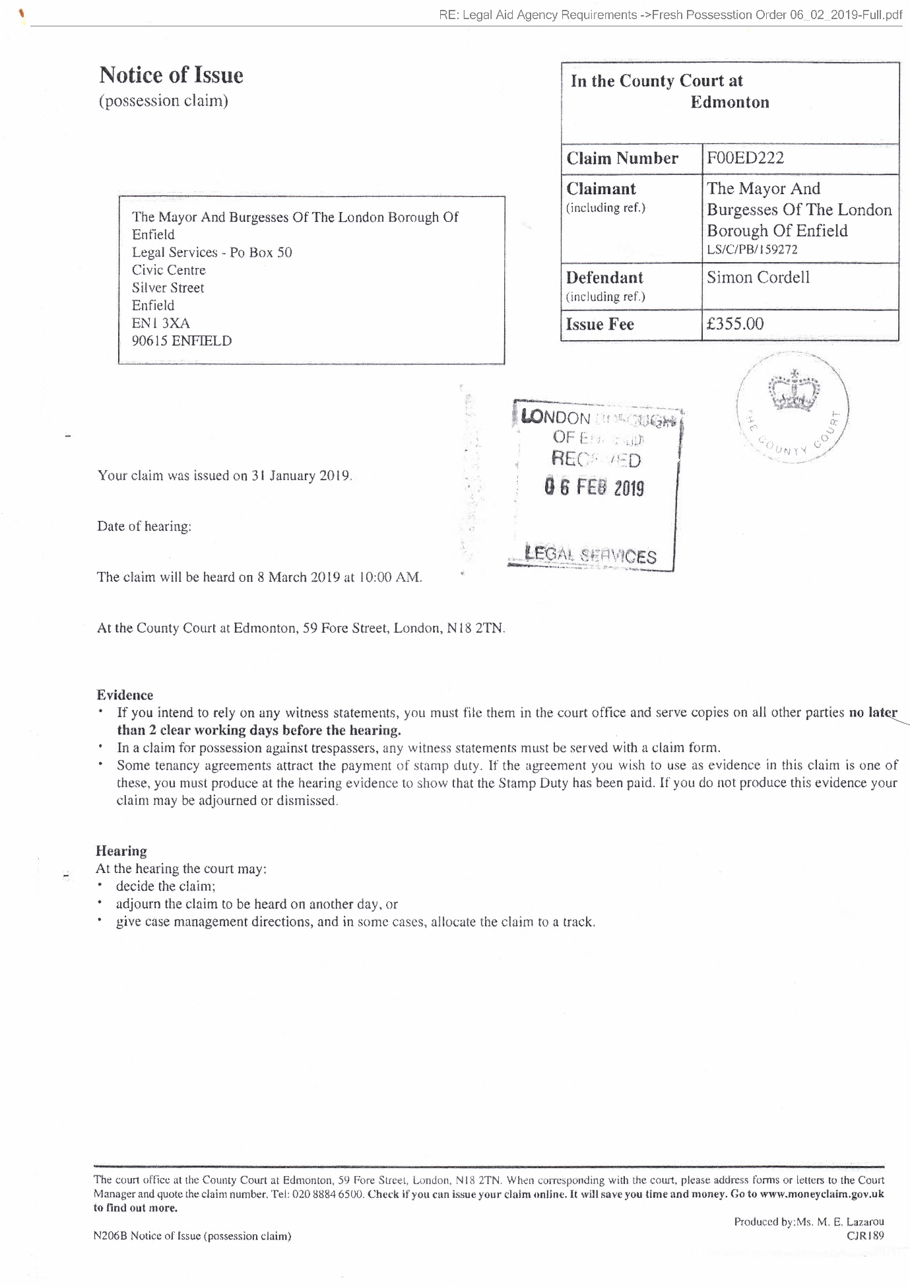
75,
*
Notice of Hearing
In the County Court at Edmonton
Claim Number: f00ED222
Date: 4 February 2019
Ref: LS/C/PB/159272
Ref:
THE MAYOR AND BURGESSES OF THE LONDON BOROUGH OF ENFIELD
Claimant
SIMON CORDELL
Defendant
TAKE NOTICE that the Hearing will take place on 8 March 2019 at 10:00 AM
at the County Court at Edmonton, 59 Fore Street, London, N18 2TN
When you should attend
30 minutes has been allowed for the Hearing
Please Note: This case may be released to another Judge, possibly at a different Court
Cases are listed in accordance with local hearing arrangements determined by the Judiciary and implemented by court staff. Every effort is made to ensure that hearings start either at the time specified or as soon as possible thereafter. However, listing practices or other factors may mean that delays are unavoidable. Furthermore, in some instances a case may be released to another judge, possibly at a different court or adjourned to another date. Please contact the court for further information on the listing arrangements that may apply to your hearing.
Your case has been listed at the same time as several other cases, but you are required to attend Court at the time - given in your notice, or earlier if you need to speak to your legal representative. When you arrive at Court you should report to an Usher who will tell you if the other party are in attendance. You may wish to consult with them before going into Court to attempt to clarify/resolve any outstanding issues.
The Judge will decide the order in which cases are called based on who is in attendance, the time estimate and other factors. Please ensure that the Usher is aware of your whereabouts at all times. If you are not in the court at the required time and your case is called it will be heard in your absence.
If your case does settle prior to the hearing date, please notify the court in writing.
The court office at the County Court at Edmonton, 59 Fore Street, London, NIB 2TN. When corresponding with the court, please address forms or letters to the Court Manager and quote the claim number.
Tel: 020 8884 6500.
Check if you can issue your claim online. It will save you time and money.
Go to www.moneydaim.gov.uk to find out more.
Produced by: Ms. M. E. Lazarou
N24 Notice of PTR/Added/Restored/Hrg/Management Conference CJR024
76,
Claim form for: F00ed222
In the County Court at Edmonton
possession of property Claim no,
Fee Account no. PBA0079006
You may be able to Issue your claim online and it may save you time and money. Go to www.possessiondaim.gov.uk to find out more. Claimant
(name(s) and address(es))
The Mayor and Burgesses of the London Borough of Enfield PO Box 50 Civic Centre Silver Street Enfield EN13XA
Defendant(s)
(name(s) and address(es))
Simon Cordell 109 Burncroft Avenue Enfield EN37JQ
The claimant is claiming possession of:
109 Burncroft Avenue Enfield EN3 7JQ
which (includes) (does not include) residential property. Full particulars of the claim are attached. (The claimant is also making a claim for money).
This claim will be heard on at 20 at am/pm
At the hearing
The court will consider whether or not you must leave the property and, if so, when.
It will take into account information the claimant provides and any you provide.
What you should do
Get help and advice immediately from a solicitor or an advice agency.
Help yourself and the court by filling in the defence form and coming to the hearing to make sure the court knows all the facts.
Name: Simon Cordell
Address: 109 Burncroft Avenue
Enfield Council Service
EN37JQ
Court fee: £355.00
Legal representative's costs TBA
Total amount:
Issue date 31 JAN 2019
Find out how HM Courts and Tribunals Service uses personal information you give them when you fill in a form: https://www.gov.uk/government/organisations/hm-courts-and-tribunals-service/aboutypersonal-informatiQn-charter
NS Claim form for possession of property (07.18) © Crown copyright 2018
77,
78,
IN THE COUNTY COURT AT EDMONTON
CLAIM NO
BETWEEN
LONDON BOROUGH OF ENFIELD
Claimant
and
MR SIMON CORDELL
Defendant
PARTICULARS OF CLAIM
- The Claimant is the Landlord and the freehold owner of the premises known as 109 Burncroft Avenue, Enfield, EN3 7JQ (hereinafter referred to as the premises).
- The premises are a one-bedroom flat located in a block of flats, granted to the Defendant, Simon Cordell on 14 August 2006. The current weekly gross rent is £98.24. The Defendant lives in the Property alone and is in receipt of Employment and Support Allowance as well as Housing Benefits.
- The Claimant is seeking possession of the premises from the Defendant because on numerous occasions and times since the commencement of the tenancy, the Defendant has failed to comply with the terms and conditions of her tenancy agreement.
PARTICULARS OF TENANCY CONDITIONS
Condition 9
"You, the tenant, are responsible for the behaviour of anyone, including your children, living in, or visiting your home. This means that you must ensure that they do not act in breach of any of these conditions. Also, you must not encourage them to act in such a way. This applies in -the property, in
79,
communal and surrounding areas, any property belonging to the council and or anywhere within Enfield borough.”
Condition 10
"You must not act in any way which causes, or is likely to cause, a nuisance or annoyance or is anti-social."
Condition 21
“You must not abuse, harass, make offensive comments and/or malicious allegations, use or threaten to use violence against any of ours. officers or agents, or against a councillor. This applies at any time and in any place. We may report the matter to the Police.”
Condition 31
“You must take care not to cause damage to your property or the property of your neighbours.”
Condition 33
"You must keep the inside of your property clean and in reasonable decorative order.”
Condition 34
“You. Must not use the property in any way that may cause a health or safety hazard or encourage vermin and/or pests (for example, by hoarding items inappropriately).”
Condition 44
“You must obtain our prior written permission before carrying out any alterations, improvements or structural work to the property. You may need to obtain other permissions such as planning permission or building regulations approval."
Condition 53
“You must keep the inside of the property, the fixtures and fittings and all glass in the property in good repair during the tenancy.”
Condition 57
“You must allow our employees, representatives and contractors to come into your property to service any electrical and gas supplies and appliances that we are responsible for maintaining.”
Condition 69
“You must not interfere with the electric or gas supply.”
Condition 76
“You have the right to keep one pet, or animal such as a cat, a dog, small bird, fish, non-poisonous insect, spider, small snake or lizard, rabbit hamster, guinea pig, mouse, gerbil or domestic rat as long as they do not cause damage to the property, or nuisance or annoyance to anyone in your locality.”
2
80,
Condition 79
"You must always keep your dog(s) on a lead in communal areas and on our land.”
- The Claimant claims that the Defendant has acted in contravention of the above tenancy conditions.
- Detail of the nuisance acts that the Defendant has engaged in which constitute a breach of these conditions are particularised in the attached Schedule of Nuisance.
- The Claimant alleges that there have been reports of nuisance and anti-social behaviour from the Defendant since July 2016.
- The Defendant has been given verbal and written warnings of the anti-social behaviour and has been invited to attend meetings with his mother to see the Claimant’s officers to discuss his conduct and behaviour, but he declined to attend.
PARTICULARS OF WARNING LETTERS AND REQUEST FOR MEETINGS
- On 29 December 2016 a letter was sent to the Defendant to attend a meeting on 6 December 2016, but the Defendant cancelled the meeting.
- On 31 January 2017 to attend a meeting for 9 February 2017 that was cancelled by the Defendant.
- On 16 February 2017 for a meeting on 22 February 2017 that again was cancelled by the Defendant
- On 16 March 2017 for a meeting on 23 March 2017 that was cancelled by the Defendant.
- On 15 October 2018 a pre-action letter was sent to the Defendant informing of legal action as a consequence of his antisocial behaviour conduct.
3
81,
- The Claimant is seeking to rely on Grounds 1 and 2 of Schedule 2 to the Housing Act 195 in the claim for possession of the premises.
Ground 1 of Schedule 2 states " Rent lawfully due from the tenant has not been paid or an obligation of the tenancy has not been broken or not performed
Ground 2 Schedule 2 states” the tenant or a person residing in or visiting the dwelling-house:
- Has been guilty of conduct causing or likely to cause harassment, alarm or distress to a person residing, visiting, or otherwise engaging in unlawful activity in the locality, or
(aa) has been guilty of conduct causing or likely to cause a nuisance or annoyance to the landlord of the dwelling-house, or a person employed (whether or not by the landlord) in connection with the landlord’s housing management functions, and that is directly or indirectly related to or affects those functions, or
- has been convicted of—
- using the dwelling-house or allowing it to be used for immoral or illegal purposes, or
- an indictable offence committed in, or in the locality of, the dwelling-house.
- In accordance with the requirements of Section 83 of the Housing Act 1985, a Notice of Seeking Possession was served on the Defendant on 25 January 2019.
- The Claimant claims that it is reasonable to grant possession of the premises on account of the Defendant’s conduct.
4
82,
- The Claimant has informed the Defendant of the impact of his conduct and behaviour on other residents and sent him warning letters. The Notice of Seeking Possession clearly sets out the details of the complaints,
- The Claimant was assessed by a consultant psychiatrist on 6th July 2018 and she confirmed that the Defendant lacks capacity to litigate.
AND THE CLAIMANT CLAIMS
- Possession of the premises known as 109 Burncroft Avenue, Enfield, EN3 7JQ.
- Mesne profit at the rate of £13.99 per day from the day possession is granted.
- Costs
Statement of T ruth
I believe that the facts stated in this Particulars of Claim are true.
I am duly authorised by the Claimant to sign this statement.
(Claimant’s Solicitor)
Dated: 29 January 2019
5
83,
IN THIE COUNTY COURT AT EDMONTON
CLAIM NO
BETWEEN
LONDON BOROUGH OF ENFIELD
and Claimant
MR SIMON CORDELL
Defendant
SCHEDULE OF NUISANCE ACTIVITIES
- On 6th July 2016, it is alleged that the Defendant approached an elderly neighbour as he came out of his flat and started to shout abuse and swear at him and threatened to burn down his flat.
- Sometime in July 2016 it is alleged that the Defendant damaged the lock of a neighbour’s electric cupboard and removed his fuse box resulting in no electricity to his flat.
- On 6th August 2016, it is alleged that the Defendant threatened one of his neighbours and his wife and aggressively demanded money from him. It is also alleged that the Defendant repeatedly swore and shouted abuse at him and his wife and called his wife a ‘bitch’ and tried to stop him from going up the stairs to his flat by standing in front of him.
- Sometime in September 2016 it is alleged that the Defendant confronted an elderly neighbour outside his block of flats, 109-119 Burncroft Avenue as he was going to the local park with another resident and started to shout abuse and threats at him and said to him ‘I can get you over at the park, I know you go for a walk’.
- ,5. On 27th September 2016, it is alleged that the Defendant confronted one of his neighbours as he returned to his flat with his family, threatened, swore at him, and demanded money from him. It is also alleged that the Defendant later banged on his door, shouted further abuse, and swear words at him and accused him of making noise inside his flat.
- On 28th September 2016, it is alleged that the Defendant aggressively banged on a neighbour's door and threatened and shouted verbal abuse and swear words at them. It is also alleged that the Defendant aggressively demanded money from him.
- On 4th October 2016, it is alleged that the Defendant aggressively banged on his ceiling and accused one of his neighbours of making noise, then went to his neighbour’s flat and started kicking and banging on his front door
6
84,
aggressively, accused him of banging on the floor, swore and shouted abuse at him. It is also alleged that the Defendant later went downstairs, dragged his neighbour’s motorbike from where it was parked and started to hit it with a piece of wood.
- On 22nd November 2016 during a telephone conversation between the Defendant, Mrs Cordell the Defendant mother and Ms Sarah Fletcher, neighbourhood officer, Ms Fletcher reported that she overheard the Defendant threaten her by saying 'I’m goanna do her over’ and then ‘I’m goanna take her job just for fun’.
- On 8th December 2016, it is alleged that the Defendant aggressively banged on one of his neighbour’s front door, shouted abuse and threats and accused him of making noise.
- 10.On 11th December 2016, it is alleged that the Defendant aggressively banged on his neighbour’s door several times and accused them of banging on pipes. It is also alleged that the Defendant shouted abuse and threats at them.
- On 14th December 2016, it is alleged that the Defendant was verbally abusive towards a woman who was visiting one of his neighbours as she knocked on his neighbour’s door.
- On 23rd December 2016, it is alleged that the Defendant banged on a neighbour’s front door, shouted abuse at them and asked them to turn their tap off. The Defendant then removed their electricity fuse thereby cutting off their power supply.
- On 26th December 2016, it is alleged that the Defendant ran up the communal stairs to the first floor and confronted one of his neighbours as he was going out with his family and started to shout abuse and threats at him and his wife and accused him of tampering with his water supply. The Defendant also attempted to stop him from leaving the block.
- On 3rd January 2017, it is alleged that the Defendant confronted one of his neighbours as he returned to the block with his wife and two-year-old daughter and started shouting abuse and threats at them.
- On 21st January 2017, it is alleged that the Defendant aggressively banged on his neighbour’s door, swore, and shouted abuse and threats at them and accused them of making noise.
- On 31st January 2017, it is alleged that the Defendant aggressively banged on his neighbour's door, shouted abuse, and threats at them and accused them of banging on the floor.
7
85,
- We received a report that on 7th February 2017 that the Defendant approached the leaseholder of 117 Burncroft Avenue and his plumber outside the block as they were attempting to resolve the problem causing low water pressure in the flat. The Defendant said to the leaseholder that there were problems between him and his tenants but did not give any specific details. The leaseholder explained to the Defendant that his tenants were experiencing low water pressure in the flat and the Defendant said to him ‘you will not solve the problem as I am restricting their water supply’. The leaseholder later knocked on the Defendant door and asked whether he would increase the water pressure and the Defendant stated '! cannot do anything at the moment, I will sort it out later’.
- On 24th February 2017 Sarah Fletcher (Neighbourhood Officer) and Steve Stirk (Maintenance Surveyor) attended the Defendant property at fiat 109 Burncroft Avenue to inspect the property following reports of low water pressure from flats 113 and 117 Burncroft Avenue. While inside the Defendant flat, they observed that the Defendant had installed an iron security gate inside his front door. It also appeared to them that the wall between the Defendant kitchen and living room seemed to have been removed thereby creating an open plan effect. Much of the property was taken up with industrial type printers, boxes and folders and there were dog faeces in the Defendant’s back garden.
- On 17th March 2017 Lemmy Nwabuisi, ASB Coordinator visited 109 Burncroft Avenue to post a letter through the Defendant door and as he got into his car to drive off after posting the letter, the Defendant ran after him shouting and screaming abuse. The letter requested that the Defendant attend the Council office to discuss the nuisance reports being received from his neighbours. By the time he returned to the office, the Defendant had telephoned him several times. Lemmy Nwabuisi telephoned the Defendant back and the Defendant asked whether he was the person that posted a letter through his letterbox and Lemmy Nwabuisi said yes. The Defendant asked why he did not stop when he ran after him and Lemmy Nwabuisi stated that he had another visit and did not have the time to stop and talk to him. The Defendant stated that he will not attend the meeting at the Civic Centre or any of the council offices as he is unable to leave his flat and that the meeting should take place in his flat. Mr Nwabuisi offered to have the meeting at a neutral venue and suggested the local library or at his mother's house, but the Defendant refused saying that he have done nothing wrong and accused Lemmy Nwabuisi of taking sides with his neighbours.
- On 5th May 2017, it is alleged that the Defendant threatened one of his neighbours by saying that he will ruin his life and that the Defendant was going to the police to present evidence about his illegal activities.
8
86,
- On 14th May 2017, it is alleged that the Defendant aggressively banged on one of his neighbour’s door, shouted abuse, and threats at her and falsely accused her of making noise and coming into his flat to attack him. The Defendant later followed her to her car shouting abuse and wanting to know where she was going.
- On 14th May 2017 it is alleged that the Defendant allowed his dog to run freely in the communal area of his block without a lead.
- On 28th May 2017, the police issued the Defendant with a first instance Harassment letter following reports of harassment and threatening behaviour made to the police by one of the Defendant neighbours.
- On 9th June 2017, it is alleged that the Defendant attacked one of his neighbours in the communal hallway of his block as he returned from work late at night by grabbing him on the arm and neck thereby causing bruising to his arm and neck. The Defendant also snatched his phone from him as he tried to video-record the incident.
- On 16th June 2017 at 11:55hrs it is alleged that the Defendant confronted one of his neighbours as she was exiting the main entrance to his building and said to her that he had her bank details and personal details such as date of birth and said to her that he wanted her and her husband to pay the Defendant some money.
- On 18th June 2017 at 11:55hrs it is alleged that the Defendant confronted one of his neighbours as she was exiting the main entrance to his building and said to her that he knew what time she went out and what time she returned and to tell her husband that the Defendant would like to speak to him.
- On 23rd June 2017 at 23:35hrs it is alleged that the Defendant came out of his flat with his dog without a lead and attacked one of his neighbours as he returned from work by punching him twice on the chest. The Defendant tried to push him out of the block and snatched his phone as he took it out of his pocket to record the incident.
- On 28th June 2017 at 11:45hrs it is alleged that the Defendant confronted his neighbour as she was leaving the block. The Defendant swore and shouted abuse at her and accused her of making noise inside her flat. The Defendant told her that he knows all her personal details and that of her husband including their full names, phone numbers, date of birth and banking details. The Defendant demanded that they pay him some money and asked her to tell her husband to come and see him.
- On 30th June 2017 at 11:45hrs it is alleged that the Defendant confronted his neighbour as she was leaving the block and accused her of slamming
9
87,
the door. She denied slamming the door and the Defendant called her a liar and proceeded to swear and shout abuse at her.
- On 2nd July 2017 at 17:18hrs it is alleged that the Defendant confronted his neighbour as he was going out with his family with his dog barking and without a lead. The Defendant asked him when he was going to hand over the money. It is also alleged that as they left the block, the Defendant ran after them swearing and shouting abuse at his neighbour and demanding that he must pay him some money if he wants the Defendant to leave him alone. The Defendant also said to him that he has all their personal details including their dates of birth and bank details.
- On 12th July 2017 an Enfield Council Surveyor attended the Defendant flat to investigate reports of low water pressure to flats above his, but he refused him access. The Surveyor attended the Defendant flat again in the evening of the same day following further reports that the water supply to the affected flats had completely ceased and the Defendant refused him access. The Defendant then followed him to his car swearing and shouting abuse at him and prevented him from entering his car. The Surveyor then called the police.
- On 11th November 2017 at 11.30am, it is alleged by one of his neighbours that the Defendant came to their front door, opened the letterbox, and peeped through it to see who was inside the flat. The Defendant then started swearing and shouting abuse and banging on their front door as soon as he saw the neighbour’s wife.
- On 2nd January 2018 at 6.30pm, it is alleged that the Defendant stood outside his neighbour’s property for more than twenty minutes swearing and shouting abuse. The Defendant went away and returned half an hour later, lifted their letterbox, stuck his mobile phone through the letterbox and started to record his neighbour’s family while swearing and shouting abuse. This went on for about fifteen minutes.
- On 9th January 2018 at about 12.18pm, the Defendant telephoned Lemmy Nwabuisi (ASB Behaviour officer) and accused him of forging documents to get an anti-social behaviour order against him. The Defendant further told him that he had made him a prisoner within his home. The Defendant stated that he knows where he lives in Enfield and that he and his family were not safe from him. The Defendant told Lemmy Nwabuisi that he would watch him leave the office and he would have followed him home and he needed to watch his back. The Defendant called the ASB officer again 30 minutes later and told him that he knows he has a flat in Edmonton and also know that one of his colleagues lives in Edmonton. The Defendant also stated that he knows where they live, and they were not safe.
10
88,
- On 9th January 2018 the Defendant called Kaunchita Maudhub (ASB Behaviour officer) and left a long voicemail on her work telephone number and made threats.
- On 26th February 2018, at around 11.45pm it is alleged that the Defendant came to one of his neighbour’s front door and started making loud banging noises and rattling with their letter box. The Defendant ran away after the neighbour opened her front door.
- On 1st March 2018 it is alleged that the Defendant knocked on one of his neighbours’ door loudly, he started rattling with their letter box and shouting. This went on for 5 to 10 minutes, but the Defendant left after he heard that the neighbour was calling the police.
- On 15th March 2018 it is alleged that the Defendant swore, shouted, and assaulted one of his neighbours in front of his wife and his 3 years old child.
- On 1sl May 2018, the Defendant attended the Edmonton County Court as there was a hearing listed in relation to an injunction. It is alleged that the Defendant started shouting abuse, swore and make threats to two of the Claimant’s employees (Lemmy Nwabuisi, ASB officer and Balbinder Kaur Geddes, lawyer) and to one of his neighbours who attended Court to give evidence. The Defendant also swore at a judge. These incidents were witnessed by members of staff working at the Court.
- On 29th May 2018, it is alleged that the Defendant attended one of his neighbours’ property; he took his dog with him and waited by their front door. It is alleged that the Defendant tried to intimidate as they were due to attend a hearing in the Edmonton County Court to give evidence in support of a claim for an injunction issued against the Defendant.
- On 30th May 2018, it is alleged that the Defendant made threats to kill to one of his neighbours. The matter was reported to the police. The Defendant was arrested and released on bail.
- On 29th August 2018, it is alleged that the Defendant assaulted one of his neighbours for flushing his toilet.
- The Defendant telephoned two council officers (Lemmy Nwabuisi and Ludmilla lyavoo) on 12th September 2018 and made threats to them over the telephone. The Defendant also accused them of fraud and of fabricating evidence to support the Council’s claim for an injunction
- On 12th September 2018 at about 3.50pm, the Defendant called one of his neighbours on his mobile phone using a private number. It is not known how you obtained his number, but he terminated the call. The Defendant called
11
89,
again using the same private number, but he terminated the call as soon as he heard his voice. The Defendant called repeatedly after that.
- On 24th September 2018 at about 11.30am, one of the Defendant neighbours returned home from dropping her daughter at school and as she entered their block of flat, she noticed that the middle door on the ground floor was open as well as the Defendant front door. As she went up the stairs to their second floor flat, the Defendant dog came out of the Defendant flat and started barking at her. The neighbour had to run up the stairs to her flat to escape from the dog. It was reported that the Defendant dog is always barking whenever they go out or return to the block and the neighbour and 4 years old daughter are terrified.
- On 30th September 2018, it is alleged that the Defendant attempted to break down one of his neighbour’s front door by kicking it several times and accused him flushing his toilet.
- On 2nd October 2018 at about 12:45pm, it is alleged that the Defendant attacked one of his neighbour’s cousins as he was leaving the block. It is alleged that as he exited the block, the Defendant followed him and suddenly grabbed his jacket from behind and tried to pull him to the ground. The cousin started shouting to attract neighbours and managed to push the Defendant off.
- On 18th October 2018, the Defendant telephoned one of the Enfield Council solicitors, Miss Ludmilla lyavoo almost ten times, making threats and intimidating her. The Defendant suggested that she stops working on the case or you will try to get her struck off from the 'register'.
- On 19th October 2018, the Defendant telephoned Miss Ludmilla lyavoo at least five times and left two voice messages making threats and trying to intimidate the solicitor working on the case.
- On 22nd October 2018, the Defendant telephoned Miss Ludmilla lyavoo from a private number and left one threatening and intimidating voice message.
- On 23rd October 2018, the Defendant telephoned Miss Ludmilla lyavoo from a private number and left an intimidating voice message.
- On 24th October 2018, the Defendant telephoned Ludmilla lyavoo twice but did not leave any messages.
- On 16th December 2018 at around 6pm, it is alleged that the Defendant repeatedly banged on one of his neighbour’s door and peeped through his letterbox.
- On 17th January2019, the Defendant was videotaped when he confronted one of his neighbours outside his block of flats (109-119 Burncroft Avenue) as he was taking his three-year-old daughter to school and started shouting
12
90,
abuse and threats at him thereby preventing him from taking his daughter to school. The Defendant then followed him and his daughter up the stairs to their second floor flat and was videotaped by a member of the neighbour's family as he attempted to attack them causing them to run into their flat for safety with the Defendant forcing the door to try and gain entry. The neighbour and his family have since fled their property as a result of the Defendant constant threats and intimidation.
- 55.On 18th January 2019, the Defendant telephoned Miss Ludmilla lyavoo from a private number and started making threats and the solicitor ended the call. The Defendant called again three times and left a voice message making threats and intimidation.
- 56.On 23rd January 2019, the Defendant telephoned Miss Ludmilla lyavoo eight times within a ten-minute period.
- On 25th January 2019, the Defendant telephoned Miss Ludmilla lyavoo on two occasions acknowledged receipt of the Notice of Seeking Possession, threaten to have her struck off the register and accused her of falsifying evidence against him.
13
91,
Copy of my Driving Licence!
92,
RE: Legal Aid Agency Requirements ->Seal-Court-Order-09-08-2018-got-on-the-06-12-2018.pdf
General Form of Judgment or Order
In the County Court at Edmonton
Claim Number: E00ED049
Date: 6 September 2018
Ref: LS/C/Ll/155584
Ref: TKK/TKK/ [SIM041/002
THE LONDON BOROUGH OF ENFIELD
1st Claimant
MR SIMON CORDELL
1st Defendant
Before District Judge Dias sitting at the County Court at Edmonton, 59 Fore Street, London, N18 2TN.
UPON hearing Solicitor for the Claimant and Defendant, the Defendant's mother, the Defendant's uncle, and the Defendant not attending.
UPON the Court reviewing the psychiatrist report of Dr Dhinakaran dated 8th July 2018, confirming that the Defendant lacks capacity to litigate and/or capacity to understand the terms of the injunction order made on 9th January 2018.
UPON the Defendant's mother Mrs Lorraine Cordell, confirming that she will engage with the Claimant and assist the Defendant's neighbourhood officer in making a housing management transfer application on or before 16 August 2018.
UPON the Claimant agreeing that it will deal with the housing management transfer application as quickly as possible after being made.
AND UPON the Defendants mother agreeing to engage with the Enfield Mental Health Unit team so the Defendant could receive assistance with his mental health conditions and housing.
IT IS ORDERED THAT
- The interim injunction order dated 9th January 2018 be discharged forthwith.
- The Claimants claim and application for an injunction dated 9th January 2018, the Claimants applications for the Defendant's committal dated 5th February and 20 April 2018 and the Claimant's application notice dated 7th August 2018 do stand dismissed.
The court office at the County Court at Edmonton, 59 Fore Street, London, NIB 2TN. When corresponding with the court, please address forms or letters to the Court Manager and quote the claim number.
Tel: 020 8884 6500. Check if you can issue your claim online. It will save you time and money.
Go to www.moneyelaim.gov.uk to find out more.
Produced by: D. Humphreys
N24 General Form of Judgment or Order CJR0h5C
93,
- The Claimant should serve a copy of this order upon the Wood Green Police station.
- There be no order as to costs save for detailed assessment of the Defendant's publicly funded costs.
Dated: 09 August 2018
94,
RE: Legal Aid Agency Requirements ->VLS_20171215_103522.pdf
HM Courts & Tribunals Service
Vis Solicitors
Gibson House
800 High Road
Tottenham
London
N17 0DH
36209 EDMONTON EXCHANGE
HM Courts & Tribunals Service the County Court at Edmonton
59 Fore Street London N18 2TN
DX 136686 EDMONTON
T 020 8884 6500
www.gov.uk
Your ref: VLS/EO/H/CORDELL/17
Dear Sir
13 December 2017
Re: Case Number: D02ED073 London Borough of Enfield v Mr Simon Cordell
Enclosed please find copy of courts letter to the claimant's as directed by the District Judge.
Yours faithfully,
Ourvasse Cundapen Back Office Section Ext
95,
HM Courts & Tribunals Service
London Borough of Enfield
P O Box 50
Civic Centre
Silver Street
Enfield
EN1 3XA
90615 ENFIELD 1
HM Courts & Tribunals Service the County Court at Edmonton
59 Fore Street London N18 2TN
DX 136686 EDMONTON 3
T 020 8884 6500
www.gov.uk
Your ref: LS/C/LI/157255
Dear Sir/Madam
13 December 2017
Re: Case Number: D02ED073 London Borough of Enfield v Mr Simon Cordell
The file was referred to the District Judge and his comments are:
"Your Directions Questionnaire was received by the court on 20/11/17. Therefore the sanction on the order of 6/11/17 applies."
Yours sincerely,
Ourvasse Cundapen Back Office Section Ext
cc: defendants
96,

97
My ID Card!
98,
RE: Legal Aid Agency Requirements ->Seal-Court-Order-09-08-2018-got-on-the-06-12-2018.pdf
General Form of Judgment or Order
In the County Court at Edmonton
Claim Number: E00ED049
Date: 6 September 2018
Ref: LS/C/Ll/155584
Ref: TKK/TKK/ [SIM041/002
THE LONDON BOROUGH OF ENFIELD
1st Claimant
MR SIMON CORDELL
1st Defendant
Before District Judge Dias sitting at the County Court at Edmonton, 59 Fore Street, London, N18 2TN.
UPON hearing Solicitor for the Claimant and Defendant, the Defendant's mother, the Defendant's uncle, and the Defendant not attending.
UPON the Court reviewing the psychiatrist report of Dr Dhinakaran dated 8th July 2018, confirming that the Defendant lacks capacity to litigate and/or capacity to understand the terms of the injunction order made on 9th January 2018.
UPON the Defendant's mother Mrs Lorraine Cordell, confirming that she will engage with the Claimant and assist the Defendant's neighbourhood officer in making a housing management transfer application on or before 16 August 2018.
UPON the Claimant agreeing that it will deal with the housing management transfer application as quickly as possible after being made.
AND UPON the Defendants mother agreeing to engage with the Enfield Mental Health Unit team so the Defendant could receive assistance with his mental health conditions and housing.
IT IS ORDERED THAT
- The interim injunction order dated 9th January 2018 be discharged forthwith.
- The Claimants claim and application for an injunction dated 9th January 2018, the Claimants applications for the Defendant's committal dated 5th February and 20 April 2018 and the Claimant's application notice dated 7th August 2018 do stand dismissed.
The court office at the County Court at Edmonton, 59 Fore Street, London, NIB 2TN. When corresponding with the court, please address forms or letters to the Court Manager and quote the claim number.
Tel: 020 8884 6500. Check if you can issue your claim online. It will save you time and money.
Go to www.moneyelaim.gov.uk to find out more.
Produced by: D. Humphreys
N24 General Form of Judgment or Order CJR0h5C
99,
- The Claimant should serve a copy of this order upon the Wood Green Police station.
- There be no order as to costs save for detailed assessment of the Defendant's publicly funded costs.
Dated: 09 August 2018
100,
RE: Legal Aid Agency Requirements ->2018 11 28 Signed response.pdf
Barnet, Enfield, and Haringey
Mental Health NHS Trust
A University Teaching Trust
Private & Confidential
Barnet, Enfield, and Haringey Mental Health Trust
Ms Lorraine Cordell
Lorraine32@blueyonder.co.uk VIA EMAIL ONLY
Trust Headquarters Orchard House St Ann’s Hospital
St Ann’s Road London N15 3TH
Tel: 020 8702 3559
Email: beh-tr.chiefexecutive@nhs.net
27th November 2018
Our Ref: ENF/18/Q2/SC/6273
Dear Mrs Cordell
Re: Your complaint regarding the sharing of your son’s information
Thank you for passing on your concerns in your conversation and initial email with Angela Hague on 30th July 2018, and subsequently with Rachel Yona on 10th August 2018. You raised some key questions relating to information governance and the sharing of information regarding your son. Please accept our sincere apologies for the delay in our response to your queries, which was due to there being a separate ongoing investigation within the Trust regarding the matters you have raised.
Your concerns have been investigated and I am now in a position to respond to your complaint. Your concerns were investigated by Rachel Yona (Enfield Adult Mental Health Community Services Manager) and involved interviews with staff and a review of your son’s clinical records.
You stated that a report written by Angela Hague regarding your son, dated 15th June 2018 and 19th June 2018, had been presented in court on 26th June 2018. You stated you had not had prior access to these reports and explained that you had considered the court case and the assessments by Angela Hague were separate processes.
Please be assured that we have looked into this matter and I can confirm the report used in court was not a formal report, but rather a response by Angela to a request for information. The Trust had communicated to the Council Legal Services that we would not be providing a report for the Court and it was recommended they commission an independent report if this were required. However as part of the investigation, it has been highlighted that this communication was only shared verbally with the Council Legal Services, and the position of the Trust was not clarified in writing.
During our communications with the Council Legal Services it was asked whether your son had engaged in his recent assessment, and it was for this reason the information presented in court was given. Our investigation found that the information which was sent was not a limited, direct response to the question posed to the Trust; I sincerely regret therefore that information was overshared and as such this aspect of your complaint is upheld.
This is a matter we have taken very seriously; I would like to offer you our sincere apologies that your son’s information was used for anything other than it’s intended use whilst in the hands of the
Chairman: Mark Lam
Chief Executive: Jinjer Kandola
101,
Trust, and assure you that we fully understand our role in ensuring the security and safekeeping of records relating to all of those in our care. We have completed a full internal incident investigation into this matter, and I would like to assure you that all due processes and actions have been taken in relation to this breach.
I understand that you also were concerned about the processing of your son’s information by the Court and the Local Authority. We are aware your son did not give consent for his records to be used in Court, and I can confirm the Trust also did not give consent for the sharing of information by the Local Authority with the Court. Our investigation found that the London Borough of Enfield requested to know if your son had engaged in treatment. As part of the legal proceedings the Court had asked for an assessment of your son’s capacity to litigate and capacity to understand the meaning of the interim injunction from January 2018. Whilst we cannot speak on behalf of the Courts, we believe that this was why they passed on the information.
I am very sorry to learn that you feel the trust between yourself, your son, and the Mental Health Services has been broken. I understand that your son is now being seen by the Enfield North Locality Team, and I sincerely hope that they will be able to help rebuild the trust and develop a good working relationship with yourself and your son.
I understand that when you discussed your concerns with Rachel Yona (Enfield Community Services Manager) you raised your view that you feel there were inaccuracies within your son’s report. Please be advised that whilst we are unable to retrospectively amend records, we are able to add additional entries to reflect your views and comments, and we would be very happy to add any information as you see fit.
Please be assured that the recommendations from this complaint will be shared with the London Borough of Enfield Legal Services and across our Enfield Adult Community Mental Health Teams, to ensure all agencies involved in this situation can learn from this regrettable incident.
We appreciate all feedback from service users’ experience of our service as this helps us to assess, reflect on our actions and improve the care we provide. Staff members are committed to providing and delivering a high standard of care to all our service users. We try to ensure that through good support and training opportunities, staff are enabled to deal effectively and sensitively with the needs of all service users and their relatives. When members of our staff fall below the expected levels of performance, we ensure that issues are addressed and dealt with quickly. Our aim is to learn from these experiences and give assurances that any actions as a result of our investigation will be delivered.
If you remain unhappy after this further contact, you have the right to take your complaint to the Parliamentary and Health Service Ombudsman. The contact details are as follows:
The Parliamentary and Health Service Ombudsman
Millbank Tower
Millbank
London SW1P4QP Helpline: 0345 015 4033
Thank you for bringing these matters to our attention.
Yours sincerely
Jinjer Kandola Chief Executive
Chairman: Mark Lam
Chief Executive: Jinjer Kandola
102,
RE: Legal Aid Agency Requirements ->A PHILIPPOU_ Re_ SIMON CORDELL RE NOTICE OF SEEKING POSSESSION-25-01-2019-001.pdf
From: A PHILIPPOU [gis.group@btmtemet.com]
Sent: 25 January 2019 10:51
To: lorraine32@blueyonder.co.uk
Subject: Re: SIMON CORDELL RE NOTICE OF SEEKING POSSESSION
Hi Lorraine
my apologies this should have read 109 of Burncroft
Many thanks
Andy
Global Investigation Services Incorporating the G.I.S. Group
(UK)
Earnscliff House London N9 9AB
Tel: 020 8884 6299
Mobile: 07918 104488
Email: gis.group@btinternet.com
(Cyprus)
No 6, Ground Floor Offices
103,
- Freedom Road Drousheia Village Paphos District Cyprus 8700
Tel:(00357) 99136710
Email: gis.group@btinternet.com
Andy Philippou
Full Member/Association of British Investigators 1508 (p)
Full Member Institute of Professional Investigators
Full Member/World Association of Professional Investigators
On Friday, 25 January 2019 10:42:49 GMT, A PHILIPPOU <gis.group@btinternet.com> wrote:
Hi Lorraine
I have been instructed by the London Borough of Enfield to effect service of the attached Notice of Seeking Possession relating to your son Simon Cordell for the address supplied of 106 Burncroft Avenue, Enfield, Middlesex EN3 7JH. Please be mindful of its content copies of which have been posted through the letterbox of your son's address as well as attaching two further copies on and adjacent to the front door of said property.
Many thanks
Andy
Global Investigation Services Incorporating the G.I.S. Group
(UK)
Earnscliff House
104,
London
N9 9AB
Tel: 020 8884 6299
Mobile: 07918 104488
Email: gis.group@btinternet.com
(Cyprus)
No 6, Ground Floor Offices
6, Freedom Road Drousheia Village Paphos District Cyprus 8700
Tel:(00357) 99136710
Email: gis.group@btinternet.com
Andy Philippou
Full Member/Association of British Investigators 1508 (p)
Full Member Institute of Professional Investigators
Full Member/World Association of Professional Investigators
105,
RE: Legal Aid Agency Requirements ->A PHILIPPOU_SIMON CORDELL RE NOTICE OF SEEKING POSSESSION-25--01-2019.pdf
From: A PHILIPPOU [gis.group@btmtemet.com]
Sent: 25 January 2019 10:43
To: lorraine32@blueyonder.co.uk
Subject: SIMON CORDELL RE NOTICE OF SEEKING POSSESSION
Attachments: LONDON BOROUGH OF ENFIELD RE LBE V SIMON CORDELL NOTICE OF SEEKING POSSESSION 25JAN19 AP.pdf
Hi Lorraine
I have been instructed by the London Borough of Enfield to effect service of the attached Notice of Seeking Possession relating to your son Simon Cordell for the address supplied of 106 Burncroft Avenue, Enfield, Middlesex EN3 7JH. Please be mindful of its content copies of which have been posted through the letterbox of your son's address as well as attaching two further copies on and adjacent to the front door of said property.
Many thanks
Andy
Global Investigation Services Incorporating the G.I.S. Group
(UK)
Earnscliff House London N9 9AB
Tel: 020 8884 6299
Mobile: 07918 104488
Email: gis.group@btinternet.com
106,
(Cyprus)
No 6, Ground Floor Offices
6, Freedom Road Drousheia Village Paphos District Cyprus 8700
Tel:(00357) 99136710 Email: gis.group@btinternet.com
Andy Philippou
Full Member/Association of British Investigators 1508 (p)
Full Member Institute of Professional Investigators
Full Member/World Association of Professional Investigators
107,
RE: Legal Aid Agency Requirements ->alev.cazimoglu@parliament.pdf
From: alev.cazimoglu@parliament.uk
Sent: 03 January 2019 09:59
To: lorraine32@blueyonder.co.uk
Subject: FW: CRM MEQ 13856 - Mr Simon Cordell of 109 Burncroft Ave, Enfield, EN3 7JQ (Case Ref: JR5802) [SEC=OFFICIAL]
Attachments: ~WRD106.jpg
image002.png
On behalf of Mr Simon Cordell of 109 Burncroft Ave, Enfield, EN3 7JQ.pdf
image001.png
Dear Lorraine
Please see the latest response from Enfield Council in relation to your complaint. We will contact you as soon as we receive any further responses.
Kind regards,
Alev, on behalf of Joan Ryan MP
Labour Member of Parliament for Enfield North
t: 0208 804 4543 (Enfield North)
t: 0207 219 2442 (Westminster)
e: joan.ryan.mp@parliament.uk
w: www.joanryan.org.uk
Westminster Office:
House of Commons, London, SW1A OAA
T: 0207 219 2442
Constituency Office:
542 Hertford Road, Enfield, EN3 5ST
T: 0208 804 4543
Sent: 21 December 2018 16:00
To: RYAN, Joan
Subject: FW: CRM MEQ 13856 - Mr Simon Cordell of 109 Burncroft Ave, Enfield, EN3 7JQ (Case Ref: JR5802) [SEC=OFFICIAL]
Classification: OFFICIAL
Dear Joan Ryan MP,
I am writing in response to the letter of complaint that has been submitted by Lorraine Cordell concerning the handling of her son’s case (letter attached) We have received a number of communications from Ms Cordell about various matters relating to the court proceedings that were taken against Simon Cordell and issues to do with his mental health. We have therefore sought legal clarification on some of those points and we intend to respond to all these matters (including the attached letter) once we have received the appropriate advice.
Please be advised we will provide you will a full response in the new year.
Yours Sincerely
Kaunchita Maudhub
Anti-Social Behaviour - Team Leader
Community Safety Unit
Enfield Council
Civic Centre, Silver St
Enfield EN1 3XA
108,
RE: Legal Aid Agency Requirements ->alev.cazimoglu@parliament-03-01-2019.pdf
From: alev.cazimoglu@parliament.uk
Sent: 03 January 2019 09:59
To: lorraine32@blueyonder.co.uk
Subject: FW: CRM MEQ 13856 - Mr Simon Cordell of 109 Burncroft Ave, Enfield, EN3 7JQ (Case Ref: JR5802) [SEC=OFFICIAL]
Attachments: ~WRD106.jpg
image002.png
On behalf of Mr Simon Cordell of 109 Burncroft Ave, Enfield, EN3 7JQ.pdf
image001.png
Dear Lorraine
Please see the latest response from Enfield Council in relation to your complaint. We will contact you as soon as we receive any further responses.
Kind regards,
Alev, on behalf of Joan Ryan MP
Labour Member of Parliament for Enfield North
t: 0208 804 4543 (Enfield North)
t: 0207 219 2442 (Westminster)
e: joan.ryan.mp@parliament.uk
w: www.joanryan.org.uk
Westminster Office:
House of Commons, London, SW1A OAA
T: 0207 219 2442
Constituency Office:
542 Hertford Road, Enfield, EN3 5ST
T: 0208 804 4543
Sent: 21 December 2018 16:00
To: RYAN, Joan
Subject: FW: CRM MEQ 13856 - Mr Simon Cordell of 109 Burncroft Ave, Enfield, EN3 7JQ (Case Ref: JR5802) [SEC=OFFICIAL]
Classification: OFFICIAL
Dear Joan Ryan MP,
I am writing in response to the letter of complaint that has been submitted by Lorraine Cordell concerning the handling of her son’s case (letter attached) We have received a number of communications from Ms Cordell about various matters relating to the court proceedings that were taken against Simon Cordell and issues to do with his mental health. We have therefore sought legal clarification on some of those points and we intend to respond to all these matters (including the attached letter) once we have received the appropriate advice.
Please be advised we will provide you will a full response in the new year.
Yours Sincerely
Kaunchita Maudhub
Anti-Social Behaviour - Team Leader
Community Safety Unit
Enfield Council
Civic Centre, Silver St
Enfield EN1 3XA
109,
RE: Legal Aid Agency Requirements ->alev.cazimoglu@parliament-17-12-2018.pdf
From: alev.cazimoglu@parliament.uk
Sent: 17 December 2018 11:16
To: lorraine32@blueyonder.co.uk
Subject: FW: MEQ 13653 - Simon Cordell (Case Ref: JR5802) - Due Date 12/12/18 [SEC=OFFICIAL]
Attachments: MEQ 13653.pdf
WRD000.jpg
Dear Lorraine
Please see the response in relation to your complaint. I know you will be upset with the contents of the letter, but I think Simon needs to cooperate with the Mental Health Teams.
Joan is happy to write to the Mental Health Trust if Simon needs support from them.
Kind regards,
Alev, on behalf of Joan Ryan MP
Labour Member of Parliament for Enfield North
t: 0208 804 4543 (Enfield North)
t: 0207 219 2442 (Westminster)
e: joan.ryan.mp@parliament.uk
w: www.joanryan.org.uk
Westminster Office:
House of Commons, London, SW1A OAA
T: 0207 219 2442
Constituency Office:
542 Hertford Road, Enfield, EN3 5ST
T: 0208 804 4543
Sent: 14 December 2018 14:51 To: RYAN, Joan
Subject: Re: MEQ 13653 - Simon Cordell (Case Ref: JR5802) - Due Date 12/12/18 [SEC=OFFICIAL]
Classification: OFFICIAL
Dear Joan Ryan MP,
Please find attached a response to your enquiry from Lorraine Cordell on behalf of her son Simon Cordell of Burncroft Avenue.
Yours Sincerely
Kaunchita Maudhub
Anti-Social Behaviour - Team Leader
Community Safety Unit
Enfield Council
Civic Centre, Silver St
Enfield EN1 3XA
110,
RE: Legal Aid Agency Requirements ->alev.cazimoglu@parliament-21-12-2018.pdf
From: alev.cazimoglu@parliament.uk
Sent: 21 December 2018 11:41 To: lorraine32@blueyonder.co.uk
Subject: FW: (Case Ref: JR5802)
Attachments: image003.jpg
image002.jpg
image001.png
Dear Lorraine
Please see latest response from the Mental Health Trust following Joan's request for an appointment for Simon.
Kind regards,
Alev, on behalf of Joan Ryan MP
Labour Member of Parliament for Enfield North
t: 0208 804 4543 (Enfield North)
t: 0207 219 2442 (Westminster)
e: joan.ryan.mp@parliament.uk
w: www.joanryan.org.uk
Westminster Office:
House of Commons, London, SW1A OAA
T: 0207 219 2442
Constituency Office:
542 Hertford Road, Enfield, EN3 5ST
T: 0208 804 4543
Sent: 18 December 2018 16:56
To: CAZIMOGLU, Alev
Subject: RE: (Case Ref: JR5802)
Dear Alev,
Thank you for your email.
I can confirm that the team is trying to work with Mr Cordell, and that appointments have been offered. Best Wishes Rachel Yona
Enfield Adult Mental Health Community Services Manager Barnet, Enfield & Haringey Mental Health Trust
111,
RE: Legal Aid Agency Requirements ->alev.cazimoglu@parliament-23-11-2018.pdf
From: alev.cazimoglu@parliament.uk
Sent: 23 November 2018 16:20
To: lorraine32@blueyonder.co.uk
Subject: FW: Fwd.: SC [SEC=OFFICIAL] (Case Ref: JR5802)
Attachments: image002.png
WRD000.jpg.
image001.jpg.
image003.png.
image004.jpg
Dear Lorraine
Please see the latest response below.
Kind regards,
Alev, on behalf of Joan Ryan MP
Labour Member of Parliament for Enfield North
t: 0208 804 4543 (Enfield North)
t: 0207 219 2442 (Westminster)
e: joan.ryan.mp@parliament.uk
w: www.joanryan.org.uk
Westminster Office:
House of Commons, London, SW1A OAA
T: 0207 219 2442
Constituency Office:
542 Hertford Road, Enfield, EN3 5ST
T: 0208 804 4543
From: Cllr Alev Cazimoglu
Sent: 19 November 2018 15:34
To: CAZIMOGLU, Alev
Subject: Fwd.: SC [SEC=OFFICIAL]
Sent from my iPad
Begin forwarded message:
From: Denise Cook-Smith
Date: 19 November 2018 at 15:32:12 GMT
To: Cllr Alev Cazimoglu
Subject: FW: SC [SEC=OFFICIAL]
Classification: OFFICIAL
Hi Alev
Further to your enquiry regarding Simon Cordell. Please see the update below from Debbie Morgan.
SC was discharged from hospital on 15/11/18 having been detained under the Mental Health Act for the purpose of assessment of his mental health. SC did not believe he required to be in hospital or wish to accept the proposed treatment that was offered. As there is insufficient grounds or risk for further detention or to take any further intrusive measures against his will, he has been discharged.
SC does not believe he has a mental illness that requires him to take treatment or to maintain on-going engagement with mental health services. He appears disappointed with services in which he perceives to have received from both housing and metropolitan police believing he is being targeted for things he has not done. His assessment has not elicited he has care needs warranting supported accommodation or a package of care to sustain independent living as he can be adequately supported through universal services. He presents with adequate daily living skills and can live in general needs housing. He appears to be young man who has particular beliefs, which may lead to him having differences in opinion with others, which may impact on relationships with others; particularly those in positions of authority. His mental health/psychological state therefore remains fragile; however the risk is not such that he can be forced to engage with services.
112,
He was offered follow-up by mental health services in the community to which he declined, although agreed the he can be contacted by nurses from the ward to check on progress following discharge. He has been allocated a care coordinator (Soohah Appadoo, North Locality Team - 0208 379 4142) who will continue to try to engage him to build a relationship. SC describes his main presenting need to be that of his relationship with particular neighbours within his block, whom he believes to be intentionally causing him a nuisance by way of making noise, and reports feeling disbelieved and unfairly treated by the housing department and police. He therefore wants to be moved from his current accommodation.
His mother approached the ward Consultant for a supporting letter to provide to housing for a 2-bedroom property citing she is his main carer. As there is no evidence to suggest SC requires to be looked after due to having care needs requiring a live-in carer her request was declined, she was advised to suggest housing put their request in writing should this be housing’s request. Mental Health would support relocation to alternative accommodation to reduce further tensions between the residents within the block.
Hi mother advised that SC has/or is in the possess of eviction, and that he was discharged from hospital with no support which does not seem to be the case. Support has been offered which has been declined and will continue to be offered to assist in managing the current situation or avoid and/or mitigation a situation of eviction.
113,
RE: Legal Aid Agency Requirements ->Chief Executive_ FW_ Mr Simon Cordell of 109 Burncroft Ave, Enfield, EN3 7JQ [SEC=OFFICIAL] -06-12-2018.pdf
From: Chief Executive [Chief.Executive@enfield.gov.uk]
Sent: 06 December 2018 11:53
To: lorraine32@blueyonder.co.uk
complaints and information
Subject: FW: Mr Simon Cordell of 109 Burncroft Ave, Enfield, EN3 7JQ [SEC=OFFICIAL]
Attachments: On behalf of Mr Simon Cordell of 109 Burncroft Ave, Enfield, EN3 7JQ.pdf
Classification: OFFICIAL
Dear Ms Cordell
Thank you for your email address to the Chief Executive. I am writing in acknowledgement and to advise you that a copy of your correspondence has been passed to the Complaints and Access to Information Team. A response will be sent to you direct on the issues raised.
Regards
Heather Littler
Senior Admin Officer
Chief Executive's Unit
London Borough of Enfield
Civic Centre, Silver Street, Enfield, EN1 3XY
Tel: 020 8379 4037
Email: heather.littler@enfield.gov.uk
"Enfield Council is committed to serving the whole borough fairly, delivering excellent services and building strong communities"
From: Lorraine Cordell <lorraine32@blueyonder.co.uk>
Sent: 05 December 2018 14:09
To: Chief Executive
Chief.Executive@enfield.gov.uk
Sarah Cary
Sarah.Cary@enfield.gov.uk
Jeremy Chambers
Jeremy.Chambers@enfield.gov.uk
James Rolfe
James.Rolfe@enfield.gov.uk
Tony Theodoulou
Tony.Theodoulou@enfield.gov.uk
Alev Cazimoglu
alev.cazimoglu@parliament.uk
Subject: RE: Mr Simon Cordell of 109 Burncroft Ave, Enfield, EN3 7JQ
To Whom It May Concern:
Please see attached letter regarding issues I have.
Regards
Classification: OFFICIAL
Be the first to receive the latest Council news straight to your inbox
SIGN UPONL NENOW
www.enfield.gov.uk/enewsletters
114,
Enfield Council is committed to serving the whole borough fairly, delivering excellent services and building strong communities. Opinions expressed in this email are those of the individual and not necessarily those of the London Borough of Enfield. This email and any attachments or files transmitted with it are strictly confidential and intended solely for the named addressee. It may contain privileged and confidential information and if you are not the intended recipient and receive it in error you must not copy, distribute, or use the communication in any other way. All traffic handled by the Government Connect Secure Extranet may be subject to recording/and or monitoring in accordance with relevant legislation.
This email has been scanned for viruses, but we cannot guarantee that it will be free of viruses or malware. The recipient should perform their own virus checks.
115,
RE: Legal Aid Agency Requirements ->Enfield-Counci-Reply-28-12-2018.pdf
- Simon Cordell - 109 Burncroft Ave, Enfield, EN3 7JQ - 28/12/2018
Dear Kaunchita Maudhub and Andrea Clemons
Thank you for the reply letter to my emails dated the 28/12/18, I have today contracted by email Mr Cordell's solicitors who were acting for my son Trishna Kerai, but she is away until the 2nd January 2019, Trishna Kerai was well aware I did not agree with Enfield Council's draft order, which was sent to me by her on the 13th August 2018 at 15:14, I made a reply to her with the points I did not agree to right away, and she was due to rewrite them points I did not agree with. Then she went on leave and did not do the rewrite until she came back of leave. This was when her amended order was sent back to Ludmilla Iyavoo and she got no reply and a few days after this Enfield Council draft order was sealed by the court.
I did not agree to submit a housing management transfer to be considered by the exceptions panel on 17/08/2018, As Ms lyavoo is well aware it is Enfield Council neighbourhood officer that has to complete this application, In fact I have nothing to do with the making of this application I was not even allowed to see it after it was completed by the neighbourhood officer even when I asked to see it I was not allowed to be sent it as it is only used internally.
I did not only email Ludmilla Iyavoo I had calls with her and we spoke, I also left voice messages for her, when the management transfer application was deferred on the 16/08/2018 it was only due to be deferred until the next panel meeting on 29/09/2018 when it should have gone before the panel even if it was a like to like move but this did not happen. When I emailed Ms Ludmilla Iyavoo on the 28/09/2018 I asked for an update as I had not heard anything, I did not know I was meant to have given her an update regarding the appointment; and I am sure I said to her on a phone call when the management transfer application was deferred if I got any medical information I would email it to her as soon as I got it, so by not sending anything to her I sure she would have known I had not got anything, in fact the mental health team was not replying to me at all, looking back now I believe that was due to them looking into the complaint I had sent. But the medical evidence was not necessary for it to have gone to the housing panel.
1
116,
I did not get any updates from Ludmilla Iyavoo at this stage or any reasons it was not put forward to the panel on that date. I again emailed Ms Ludmilla Iyavoo on the 01/10/2018 and after talking to Lemmy Nwabuisi on the 02/10/2018 via a phone call I sent a next email to Ms Ludmilla Iyavoo asking for an update on the 02/10/2018, I did get a reply on the 02/10/2018 from Ms Ludmilla Iyavoo stating she had been in meetings and was unable to attend to my voice messages calls or emails, and that she was taking instructions from her office and would get back to me in due cause. I again emailed Ms Ludmilla Iyavoo on the 07/10/2018 as I still had not had any updates, I did not get a reply so again sent an email on the 09/10/2018 to Ms Ludmilla Iyavoo, on the 12/10/2018 I did get a reply to that email, but from my emailed it would have been very clear I wanted it to go to the panel, at that point I was very busy and did not have time to reply to that email, I then got an next email on the 15/10/2018 from Ms Ludmilla Iyavoo stating court action was going to start. At this point I knew in my heart Enfield Council was never going to put this to the panel and only wanted one thing and this was the real reason it took Ms Ludmilla Iyavoo so long to reply to my emails and calls, so it was around this time I made arrangements to see my son’s MP as I felt I was not getting anywhere and through maybe it was better coming from the MP.
The issue with appointments being made they are for my son to go to the clinic; I have told them many times my son does not leave the flat and a home appointment should be made which they are still falling to do. I spoke to Soohah Appadoo, North Locality Team more than once saying this is an issue and been told he will get back to me regarding it after he has a meeting with his team about it but he has not done this yet.
If you are now agreeing that the court did not actually record that my son submits a housing transfer application on the condition that he engages with mental health team, why has Enfield Council been stating this to everyone as this is incorrect is it not? I believe this should be corrected should it not?
Yes, I agreed to talk with the mental health team which I have done, and it is clear I have done this as it stated in your letters and replies to the MP, so I am doing what I
2
117,
was asked to do by Enfield Council at court, so why is Enfield Council not doing what they were meant to do?
This section in the court order “AND UPON the Defendants mother agreeing to engage with the Enfield Mental Health Unit team so the Defendant could receive assistance with his mental health conditions and housing.” is also something I did not agree to, and it was this point I asked to be rewritten or removed along with other sections. The reason I did not agree to it being written in the court order was due to the fact I knew I was limited in what I could do with the mental health team, and really the way the draft court order is worded by Enfield Council was not said in court that way and was I believe only written this way for Enfield Council to get out of moving my son.
There is only so much I can do as my son has rights even under the mental health act, so when I agreed I knew I would be limited in what I could do. It seems Enfield Council are just passing the buck over to anyone they can and not doing anything to help my son and passing incorrect information over all the time to people.
There is a duty of care and so far, Enfield Council has beached that in every way possible regarding my son, also the beaches in data protection is beyond anything I have ever seen when is this going to stop? By now you would have the complaint outcome letter that was submitted to the mental health team which was upheld, which should have been learned from, but it seems the sharing of information regarding my son is even worse now than when it was when I submitted the complaint to the mental health team. There has never been no consent from my son for Enfield Council to share data the way they have with the mental health team the way it has been shared.
When is Enfield Council going to help my son? not leave him to suffer the way Enfield Council has done since the end of 2014 when I started making calls about what was going on with the neighbours, from the start of 2015 I had to start sending emails to Enfield Council regarding what was going on with the neighbours because Enfield Council was just not getting back to me regarding the phone calls and still no one got back to me until 21/09/2015, it seems Enfield Council only acts when it is against my son, as I was putting in reports and complaints regarding what the
3
118,
neighbours were doing well before any report or complaint went in regarding my son,
I was told so many times by Lemmy Nwabuisi to forget all about the emails I sent, and it seems Enfield Council don’t seem to have many of the emails I sent begging for help with what was ongoing.
To me this is one sided only and not once has Lemmy Nwabuisi ever asked to see anything this is a beach and discrimination against my son, not even the police take one side to everything at least they do an investigation, which I believe the council also have a duty to do.
Why is Enfield Council also allowed to try and pressure neighbours into doing statements against their will, against my son and don’t think I don’t know about this as I do, why am I being told by neighbours Enfield Council is out to get my son really badly and are not going to stop until they do get him out, why are neighbours even being talked to about my son? It seems Enfield Council will stop at nothing regarding my son.
Why has Lemmy Nwabuisi or any other Enfield Council worker ever taken any report from my son regarding anything when they have been told time and time again, we have proof my son has not done the things that is being said he has done? Why does Enfield Council see fit to wait months and months and months to tell us about any reports? The list can go on and on, but we know already Enfield Council will do nothing for my son but disregard him.
Please could you clarify for me whether or not you are seeking possession order for my son flat? Because you have now admitted in your letter to me dated the 28/12/2018 that the information used in your letter dated the 12/12/2018 was incorrect as it was not stated in the court order my son had to engage with mental health team to be able to get a housing management transfer, and that my son did not need to provide medical evidence to support the housing management transfer application, and you did in fact have enough information to put this to the panel as the application was completed by the 16/08/2018. As it really seems to me that Enfield Council has not done what was within the court order or taken anything the Judge said in court on the 09/08/2018 into account, and the basic for the seeking possession order on my son's
4
119,
flat was based on facts that was clearly not in the court order, if Enfield Council had put this before the panel then this would not even be an issue and we would not need to address this now.
Also I would like to say at this point Trishna Kerai from Stuart miller solicitors is no longer acting solicitors for my son, so there is no need for the legal team or any other team within Enfield Council to forward any documents to her regarding my son.
I apologise for the sternness of this letter, but it seems where my son and I are concerned we seem to take one step forward then two back and I am sure you can sympathise with how frustrating this must be.
I look forward to hearing from you soon.
Regards
Lorraine Cordell
5
120,
RE: Legal Aid Agency Requirements ->Joan Ryan_ Re_ Simon Cordell (Case Ref_ JR14051) -10-12-2018.pdf
From: Joan Ryan [alev.cazimoglu@parliament.uk]
Sent: 10 December 2018 14:35
To: lorraine32@blueyonder.co.uk
Subject: Re: Simon Cordell (Case Ref: JR14051)
Hi Lorraine
We have sent your most recent letter to the council in addition to all the other information you have provided. We will contact you as soon as we receive a reply.
Kind regards,
Alev, on behalf of Joan Ryan MP
Labour Member of Parliament for Enfield North
t: 0208 804 4543 (Enfield North)
t: 0207 219 2442 (Westminster)
e: joan.ryan.mp@parliament.uk
w: www.joanryan.org.uk
Westminster Office:
House of Commons, London, SW1A OAA
T: 0207 219 2442
Constituency Office:
542 Hertford Road, Enfield, EN3 5ST
T: 0208 804 4543
From: Lorraine Cordell
Sent: 7 December 2018 13:39
To: CAZIMOGLU, Alev
Subject: RE: Simon Cordell
Dear Alev Cazimoglu
I know you said to me today on the phone that you would get back to me if you heard anything from Enfield Council.
But this cannot be allowed to carry on, this is making my son's health worse with what is going on and him being in that flat, the banging does not stop even people I am I getting to stay with my son don't want to be there due to how bad it is it does not stop.
Enfield Council is now making my son stay in a flat living in hell, they know the issues why have they not just moved him out of there?
How long is it going to take with letters going backwards and forwards with no end to it? All awhile my son is suffering badly, and it is impacting on his health how far is Enfield Council going to let this go?
Enfield Council has not once asked my son's side to this they only go with what is being said about my son is this right? This are always 2 sides to anything so why is Enfield Council only taking one side to all of this and not once hearing our side?
Enfield Council has had long enough to move my son why have they not.
I need help to deal with this and I can’t wait months for anything to be done, and that is not saying you are not doing your best as I know you are it seems Enfield Council are the ones holding this up and really for what reason, is it so they can make my son suffer more?
Regards
Lorraine
UK Parliament Disclaimer: this e-mail is confidential to the intended recipient. If you have received it in error, please notify the sender and delete it from your system. Any unauthorised use, disclosure, or copying is not permitted. This e-mail has been checked for viruses, but no liability is accepted for any damage caused by any
121,
virus transmitted by this e-mail. This e-mail address is not secure, is not encrypted and should not be used for sensitive data.
122,
RE: Legal Aid Agency Requirements ->Kaunchita Maudhub_ Re_ Mr Simon Cordell. 109 Burncroft Avenue.pdf
From: Kaunchita Maudhub [Kaunchita.Maudhub@enfield.gov.uk]
Sent: 28 December 2018 13:14
To: lorraine32@blueyonder.co.uk
Subject: Re: Mr Simon Cordell. 109 Burncroft Avenue. EN3 7JQ [SEC=OFFICIAL]
Importance: High
Attachments: Letter to Lorraine Cordell 28.12.18.pdf
Classification: OFFICIAL
Dear Ms Cordell,
Please find attached a letter in response to your emails dated 12th and 20th December 18 sent to Ms Andrea Clemons.
Yours Sincerely
Kaunchita Maudhub
Anti-Social Behaviour - Team Leader
Community Safety Unit
Enfield Council
Civic Centre, Silver St
Enfield EN1 3XA
Tel: 020 8379-4182 kaunchita.maudhub@enfield.gov.uk
Enfield Council is committed to serving the whole borough fairly, delivering excellent services and building strong communities.
From: Lorraine Cordell <lorraine32@blueyonder.co.uk>
Sent: 20 December 2018 13:55
To:
Andrea Clemons
Andrea.Clemons@enfield.gov.uk
Chief Executive
Chief.Executive@enfield.gov.uk
Jeremy Chambers
Jeremy.Chambers@enfield.gov.uk
Alev Cazimoglu
alev.cazimoglu@parliament.uk
Subject: RE: Mr Simon Cordell. 109 Burncroft Avenue. EN3 7JQ
Dear Andrea Clemons
I was wondering if you was going to reply to the below email as it has been a few days since I sent it and I feel this is very important due to the action going to be taken from Enfield Council, and I did not have a reply to my last email to you.
I would like the incorrect information corrected that is being used, and without a reply I cannot do this, I have attached a copy of your letter sent to the MP dated 12/12/2018.
Regards
Lorraine Cordell
From: Lorraine Cordell
mailto: lorraine32@bluevonder.co.uk
Sent: 17 December 2018 17:12
To: 'Andrea Clemons
alev.cazimoglu@parliament.uk
123,
Subject: RE: Mr Simon Cordell. 109 Burncroft Avenue. EN3 7JQ
Dear Andrea Clemons
Today the MP's aid for Joan Ryan, Alev Cazimoglu sent me a copy of your letter dated the 12/12/2018, I am shocked to see what is written within it and the misleading information being passed over to the MP Joan Ryan.
It was not agreed on the condition that Mr Cordell should engage with mental health services and provide medical evidence to support the housing management transfer application. The court did not state this, so I do not know where this is coming from.
I also do not understand where it is coming from that Mr Cordell had to provided supporting letter from the mental health services to support his management transfer application, and he has not done this, he was never meant to have done this and the management transfer application was completed by Enfield Council to go to the panel on the 17/08/2018 and it was ready to go to the panel on this date, but this was deferred to be considered at the next panel meeting which would have taken place on 28/09/2018, which never happened.
The reason for it being deferred was so that I Miss Lorraine Cordell could try and get a letter from the mental health team, which I could not so it therefore should have gone ahead to the panel on the 28/09/2018, which I do have the emails to prove this. I also do not understand why Enfield Council is stating supported accommodation was being asked for as this was never asked for. I did however state in court that a 2 bedroom would be better as my son could have family live with him so he could get support from his family; I have never said I am his carer I have never said a lot of things that Enfield Council is stating I have said.
It was stated in the court order.
- UPON the Defendant's mother Mrs Lorraine Cordell, confirming that she will engage with the Claimant and assist the Defendant's neighbourhood officer in making a housing management transfer application on or before 16 August 2018.
- UPON the Claimant agreeing that it will deal with the housing management transfer application as quickly as possible after being made.
- AND UPON the Defendants mother agreeing to engage with the Enfield Mental Health Unit team so the Defendant could receive assistance with his mental health conditions and housing.
The order was to be agreed with my son’s solicitor upon being drafted by Enfield Council, but my son’s solicitor was on annual leave and therefore did not reply to Enfield Council order until she came back of leave, But when you emailed her it came back that she was on annual leave so Enfield Council was well aware of this.
Upon her return from annual leave her amended order was sent over to Ludmilla Iyavoo, which my son’s solicitor never had a reply back from Ludmilla Iyavoo regarding her amended order, but some days after the amended order was sent over to Ludmilla Iyavoo, it seems an order was sealed at Edmonton Country Court which was not agreed on which was Enfield Council drafted order, which we never agreed to and feel it is misleading as to what was said in court.
I believe a lot of what was said in court is not being told and misleading information is being said, maybe someone should ask Ludmilla Iyavoo what the judge said when Ludmilla Iyavoo said she would go for a possession order to the judge because she did not get what she wanted.
124,
There is also the fact that my son was willing to stay in Hospital when he was sectioned on the 25/10/2018, it was the hospital that discharged him on the 15/11/2018 due to not getting the section 3 on my son they wanted, that was heard on the 14/11/2018, my son said as soon as he knew they was not allowing the section 3 on the 14/11/2018 that they would kick him out of the hospital, as this is what they did in 2016, and the next day the 15/11/2018 that is what the doctors did kicked him out the hospital, yet my son was willing to stay and build trust up with the doctors and the mental health team, which had broken down due to what has been ongoing for some time.
Which in fact would have been a lot better as if he had been allowed to stay in hospital like he wanted maybe by now they would have been trust built up with the doctors and teams, this is what Soohah Appadoo wanted to do as he saw that there was a real problem with trust and stated this at the appeal on the section 2 at the hearing. On the 16/11/2018 I myself spoke to Soohah Appadoo on the phone, but since that we have heard nothing from him is this what is being called support put in place when my son was discharged from hospital?
This misleading information needs to stop as it is a beach of the data protection act.
I look forward to hearing from you regarding this, please can you reply as I did not get a reply from you to my last email, I sent to you.
Regards
Lorraine Cordell
Classification: OFFICIAL
Classification: OFFICIAL
Be the first to receive the latest Council news straight to your inbox
SIGN UPONL NENOW
www.enfieldgov.uk/enewsletters
Enfield Council is committed to serving the whole borough fairly, delivering excellent services and building strong communities. Opinions expressed in this email are those of the individual and not necessarily those of the London Borough of Enfield. This email and any attachments or files transmitted with it are strictly confidential and intended solely for the named addressee. It may contain privileged and confidential information and if you are not the intended recipient and receive it in error you must not copy, distribute, or use the communication in any other way. All traffic handled by the Government Connect Secure Extranet may be subject to recording/and or monitoring in accordance with relevant legislation.
This email has been scanned for viruses, but we cannot guarantee that it will be free of viruses or malware. The recipient should perform their own virus checks.
125,
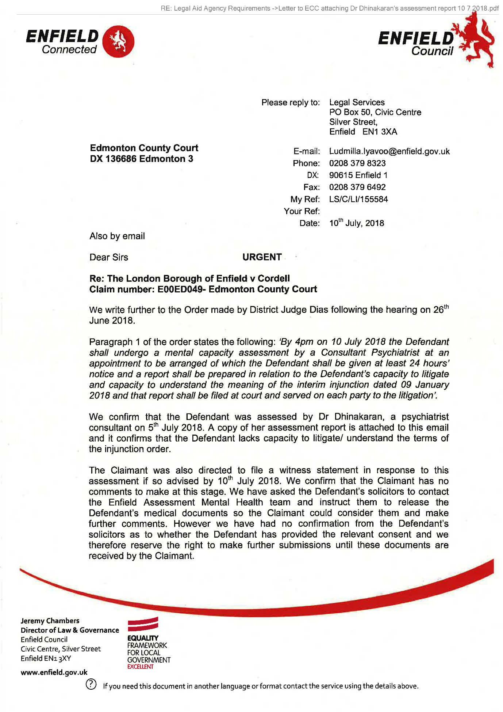
126,

127,
Psychiatric Report on Mr Simon Cordell 109 Burncroft Avenue Enfield EN3 7JQ
- Introduction
This report is prepared at the request of London Borough of Enfield, Antisocial Behaviour Team following directions from the Edmonton County Court to undertake an assessment on Mr Cordell. My instructions were received in a letter dated 5 July 2018 and outlined as below:
- Whether the defendant has the mental capacity to litigate and give instructions in his defence.
- Whether the defendant understands the terms of the injunction order dated 9 January 2018.
- Details of current proceedings
The current proceedings relate to an interim injunction order issued against Mr Cordell, at the Edmonton County Court on 9 January 2018. This followed numerous complaints from neighbours about Mr Cordell’s acts of harassment and antisocial behaviour. However it has been reported that Mr Cordell has continued to breach the order. It has been reported that a neighbour has been assaulted, harassed, and has received threats from Mr Cordell. He has also made threats towards certain council employees. The local authority issued applications for committal due to Mr Cordell’s breach of the injunction, however the applications could not be considered due to concerns about his mental capacity.
- Sources of information
  - I was provided with the following information to aid in the assessment:
  - Claim form for an injunction with supporting documents
  - Order for an injunction dated 9.1.2018
  - Report of Angela Hague from the Enfield Assessment Team
  - Court order made by DJ Dias, Edmonton County Court at the hearing on 30.05.2018 and 26.6.2018.
1
128,
  - I assessed Mr Cordell on 6 July 2018, at his flat 109 Burncroft Avenue, Enfield EN3 7JQ, accompanied by two officers from the Enfield Housing Team. I can confirm that prior to my assessment; I explained to Mr Cordell my role and the purpose of my visit. I also explained to him that I was acting on the instructions of the Enfield Council at the directions of the Court.
- Assessment of Mr Cordell
  - Mr Cordell spoke to us for a few minutes outside his flat and upon explaining the purpose of the visit, he allowed us into his flat. He agreed to tie the dog outside in the garden. The flat although disorganised with papers and folders scattered around, did not appear overly cluttered. Mr Cordell presented as a young, slim built, mixed race male with reasonable hygiene. We explained our roles and the purpose of our visit. Mr Cordell informed us that he was recording our conversation.
  - Mr Cordell seemed very keen and enthusiastic to talk and we had to explain the reason of our visit several times to maintain some structure and focus. He maintained appropriate eye contact and we managed to establish a rapport after a while. His demeanour was polite and appropriate. There was evidence of psychomotor agitation as he appeared generally restless and overactive. Mr Cordell described his appetite and sleep pattern as fine. Objectively I would regard his mood as labile, rapidly fluctuating between euthymia (normal mood) and irritability.
  - Mr Cordell’s comprehension of information presented to him appeared adequate. He was able to understand the queries presented to him. His responses however were very elaborate and circumstantial. His speech was very pressured, difficult to interrupt and at times frankly rambling. There was clear evidence of thought disorder with flight of ideas (rapid shift of ideas with some superficial apparent connection). Mr Cordell struggled to sustain his goal of thinking as he often derailed to themes of relevance to him, digressing away from the topic of discussion. It was very difficult to obtain a direct response to the queries posed to him and follow his thread of conversation.
  - Mr Cordell’s thought content was replete with various delusional beliefs of persecutory and grandiose nature. He spoke of an elaborate conspiracy which involves the Enfield local authority and the metropolitan police, dating back since 2013, when he claimed that he was arrested for putting up a gazebo in his garden which led to him being barred from visiting
2
129,
places in central London and placed on a curfew from 10 pm. Mr Cordell informed that he followed these restrictions imposed on him for about a year and returned to Court and won the case. Mr Cordell then went on to talk about Sally Gilcrest, the legal executive for the metropolitan police who he alleged set him up for a million pounds and brought on an ASBO against him, which ended with him being imposed on a nine-year curfew. Mr Cordell stated that Sally Gilcrest in conjunction with the borough commander Jane Johnson and the community officer started spreading rumours that he was “suffering from herpes and has hurt a woman” which the neighbours in his block became aware of and started sending him messages addressing him as “you black boy”. Mr Cordell implied that Sally Gilcrest colluded with the neighbours as she had a vested interest in getting him out of this country. He stated that the neighbours above him deliberately bang on his ceiling and have also subject him to other forms of harassment since 2014. Mr Cordell implied that the neighbours were responsible for the miscarriage suffered by his then girlfriend and also held them responsible for the separation from his previous girlfriends. He further stated that between 2014 and 2016, his mother has made numerous complaints to the council regarding the harassment he has been subject to and he has won a criminal case against his neighbours
  - Mr Cordell then went on to elaborate his grievance against Lemmy, the officer who works for the Enfield local authority. He claimed that he received an email from Lemmy threatening that he would obtain a possession order against him and asking him to attend a meeting. He then stated that the ASBO that was served against him was not valid due to lack of signature. Therefore Lemmy built a false case against him by using “lower grade cases" to pursue a possession order and subsequently an injunction order, by falsifying statements and using “statements from dead cases”. According to Mr Cordell this was declared as invalid by a Judge, however Lemmy has continued to produce false orders against him in the way of a second injunction, which he claimed has never been served on him. Mr Cordell described this as “targeted malice" by Lemmy as he has used the injunction as a smoke screen to cover up the ASBO by providing false statements and witnesses.
  - In addition, Mr Cordell also described a number of grandiose beliefs, stating that he was building a constitution on CIC, which he explained to be Community Interest Company. He also spoke of a number of other businesses. He was keen to show us the various documents, emails, and recordings he has accrued as evidence to support his case.
3
130,
- Opinion and Recommendations
Mr Cordell is a resident at the Enfield borough, who was served an injunction on 9 January 2018, following numerous complaints by his neighbours of antisocial behaviour and harassment. Despite this, Mr Cordell has continued to breach the order with further incidents of harassment, threats, and assault against the neighbours. In addition, it has been reported that some council employees have also received threats from Mr Cordell. According to available information, Mr Cordell has had sporadic contact with the mental health services and has been recently assessed by the Enfield Mental Health Assessment Service. During my assessment, Mr Cordell was preoccupied with a number of persecutory and grandiose delusional beliefs. In addition, he also presented with other symptoms such as labile mood, pressured speech, overactivity, and flight of ideas. In my view, Mr Cordell’s current presentation is consistent with Schizoaffective Disorder, which is recognised as an enduring mental illness.
I have received specific instructions to address the following issues:
- Whether Mr Cordell has the mental capacity to litigate and give instructions to his defence?
As highlighted above, Mr Cordell’s mental state is replete with complex persecutory delusional belief system. During my assessment, Mr Cordell was convinced that the local authority and the police have been colluding alongside his neighbours to pursue false claims and allegations against him. In his view, the possession order and the injunction order were based on false statements, created against him and this did not stand up in Court and therefore an injunction was not issued against him. In my view, although there are no significant deficits in Mr Cordell’s comprehension or retention of information, his ability to process information relevant to the current proceedings is likely to be influenced by his underlying delusional beliefs. During my interaction, it was evident that his interpretation of events and actions of others are influenced by his abnormal beliefs. Mr Cordell perceives himself as a victim and is aggrieved by the injustice carried out against him. In my view,
Mr Cordell’s ability to weigh the information relevant to the current proceedings is impaired due to his tendency to misinterpret any information presented to him to fit into his entrenched persecutory delusional beliefs. Moreover Mr Cordell presents with significant thought disorder and it is unlikely that he will be able to give coherent instructions to the defence.
It is therefore my opinion that Mr Cordell lacks capacity to litigate and give appropriate instructions to the defence.
4
131,
- Whether Mr Cordell understands the terms of the injunction order dated 9 January 2018?
Mr Cordell is currently suffering from symptoms of Schizoaffective Disorder and presents with florid psychotic symptoms. His thinking and behaviour are influenced by his underlying persecutory beliefs. Mr Cordell is convinced that the injunction order is a cover up by the local authority for the errors and mistakes of the ASBO and therefore did not stand up in Court. Mr Cordell is convinced that the injunction order has been falsified by certain individuals (particularly Lemmy possibly in conjunction with others). He therefore does not value the order, or the contents contained within it. In my opinion Mr Cordell’s capacity to process the information relevant to the order is again impacted by his delusional beliefs.
Dr Dhara Dinakaran, MBBS,
MSc, MR C Psych
Consultant Psychiatrist
Approved under Section 12 (2) of MHA
08/07/2018
5
132,
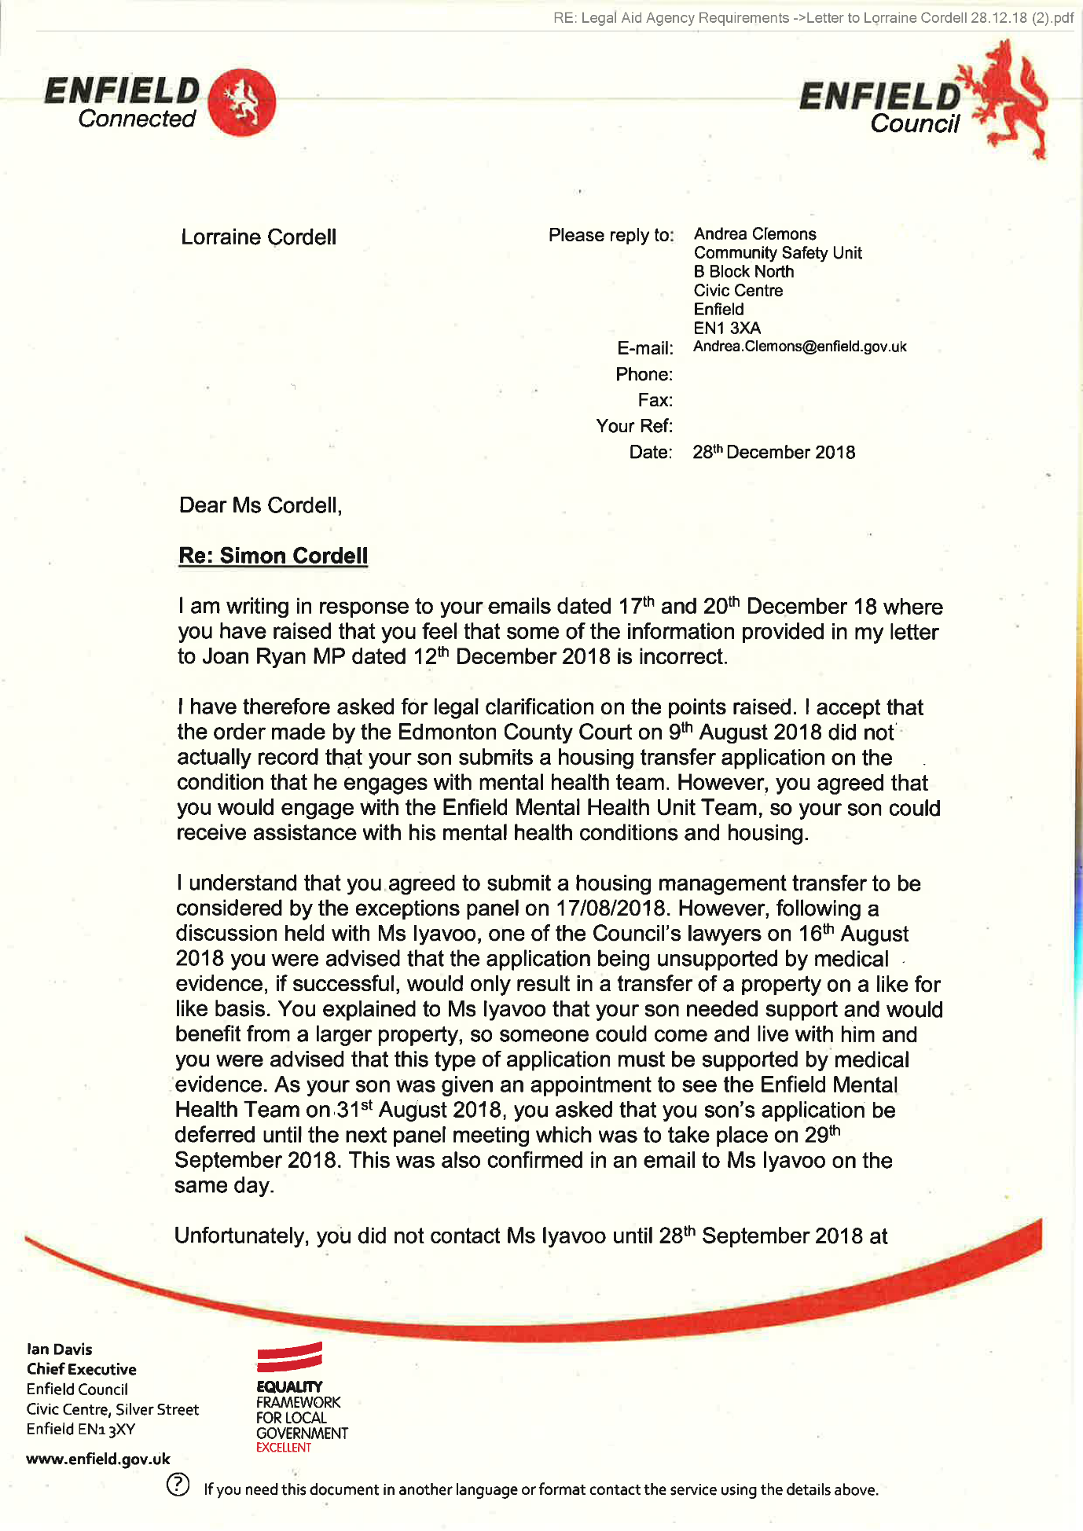
133,
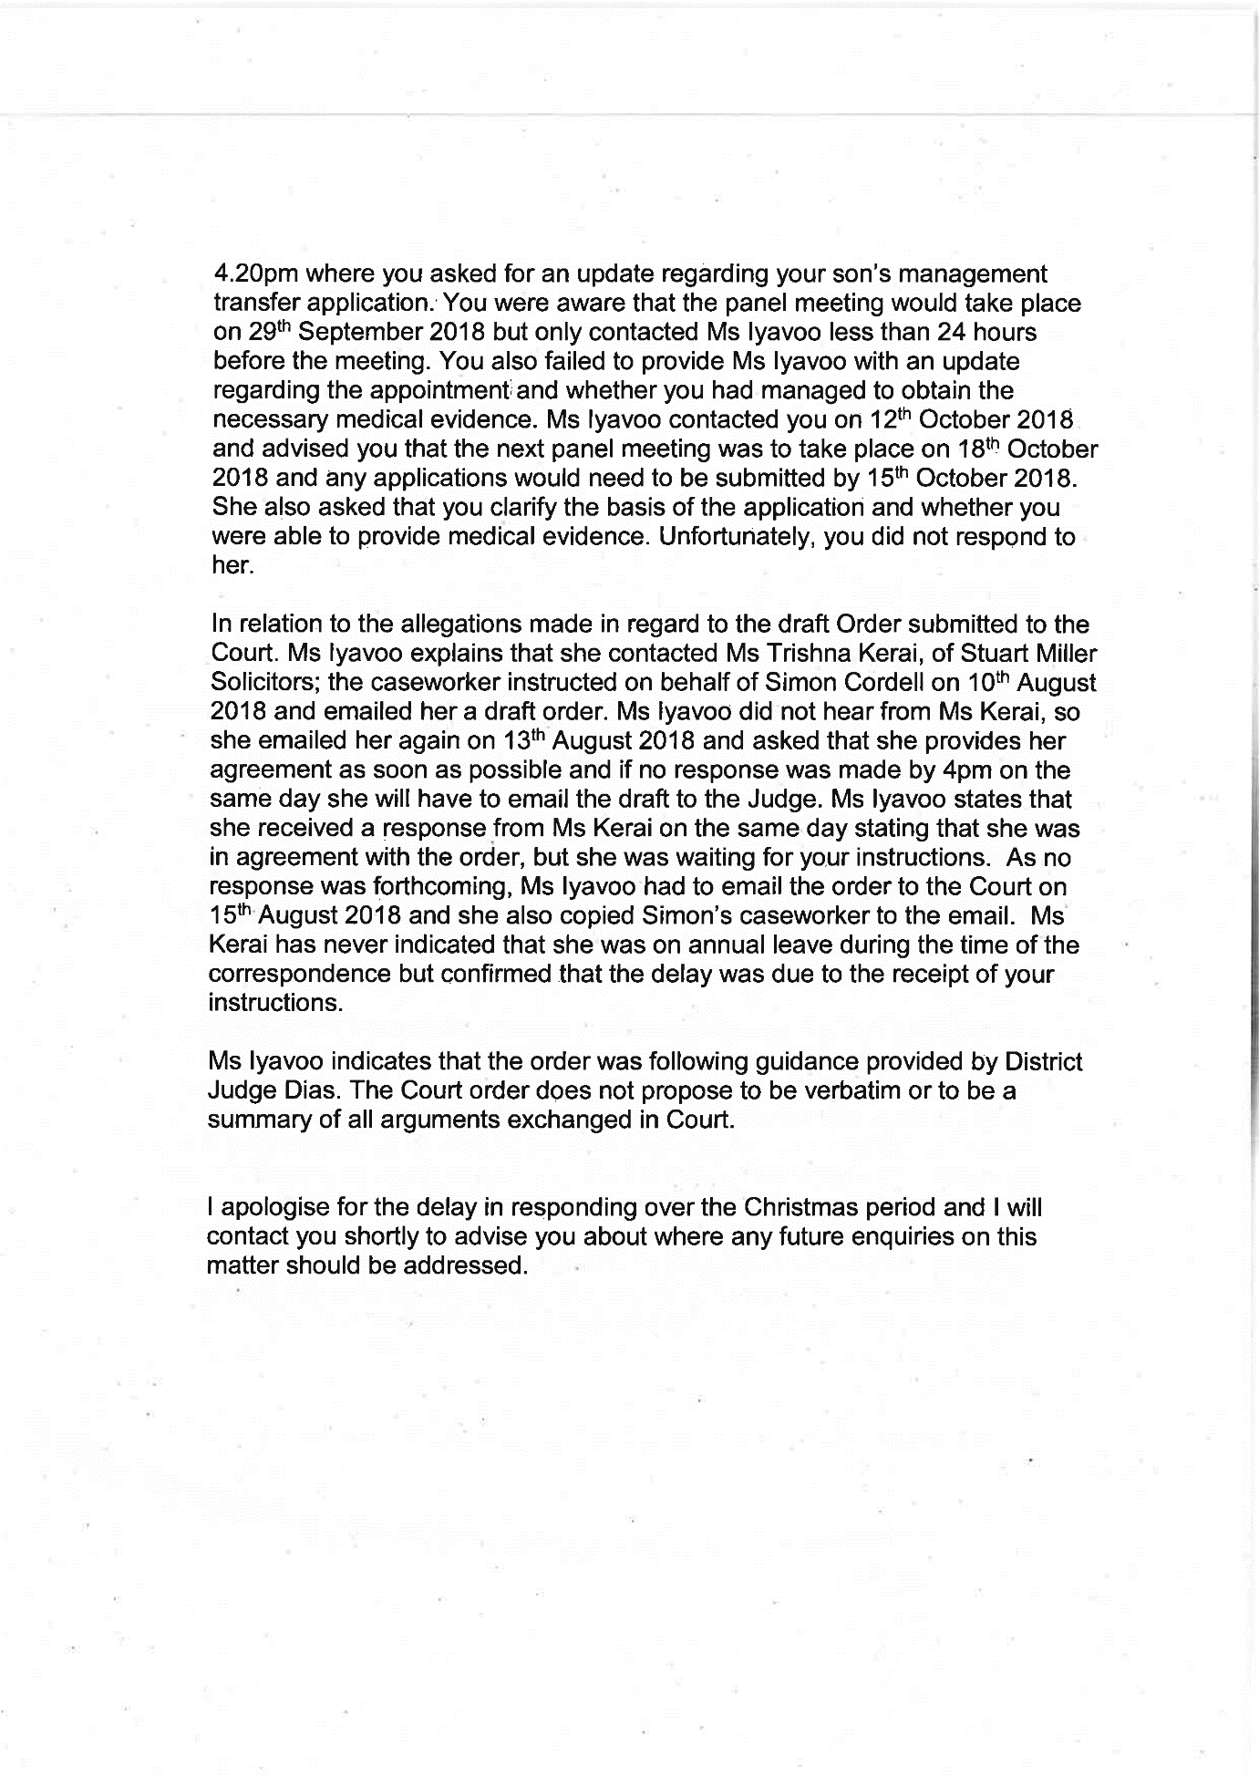
134,
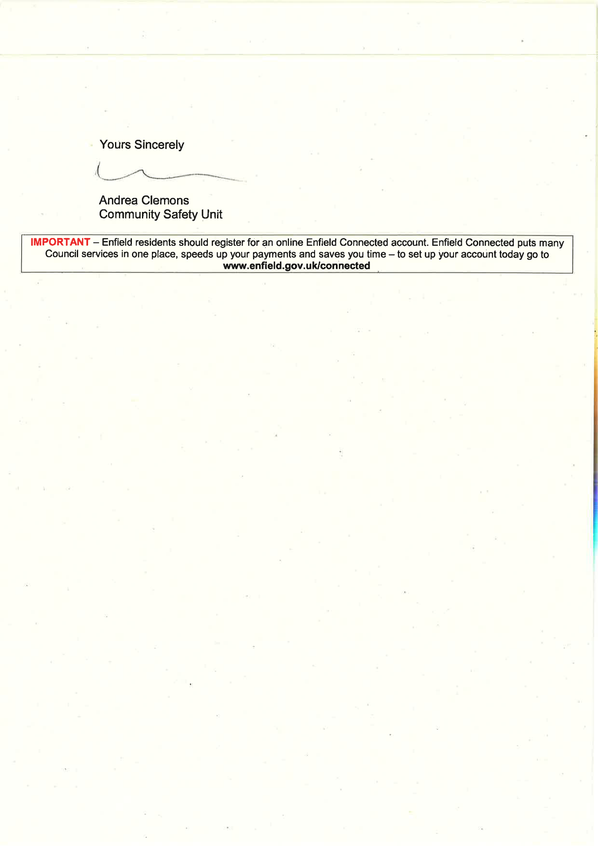
135,
Blank Page!
136,
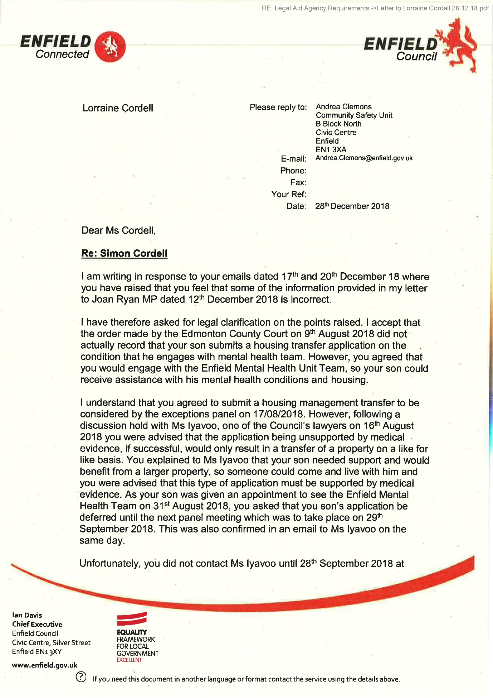
137,
138,
139,
RE: Legal Aid Agency Requirements ->LONDON BOROUGH OF ENFIELD RE LBE V SIMON CORDELL NOTICE OF SEEKING POSSESSION 25JAN19 AP (2).pdf
LONDON BOROUGH OF ENFIELD
Housing Department P.O. Box No. 60, Civic Centre, Enfield
NOTICE OF SEEKING POSSESSION HOUSING ACT 1985 - SECTION 83
THIS NOTICE IS THE FIRST STEP TOWARDS REQUIRING YOU TO GIVE UP POSSESSION OF YOUR DWELLING. YOU SHOULD READ IT AND ALL THE NOTES VERY CAREFULLY.
- To: Mr Simon Cordell
NOTES TO PARAGRAPH 1
If you need advice about this Notice, and what you should do about it, take it as quickly as possible to a Citizens’ Advice Bureau, a Housing Aid Centre, or a Law Centre, or to a Solicitor. You may be able to receive Legal Aid, but this will depend on your personal circumstances.
- The Landlord, the Mayor and Burgesses of the London Borough of Enfield intends to apply to the Court for an order requiring you to give up possession of:
109 Burncroft Avenue, Enfield, Middlesex, EN3 7JQ
NOTES TO PARAGRAPH 2
If you are a secure tenant under the Housing Act 1985, you can only be required to leave your dwelling if your landlord obtains an order for possession from the Court. The order must be based on one of the Grounds, which are set out in the 1985 Act (see paragraphs 3 and 4 below).
If you are willing to give up possession without a Court order, you should notify the person who signed this Notice as soon as possible and say when you would leave.
- Possession will be sought on Grounds 1 & 2 of Schedule 2 to the Housing Act 1985, which read:
Ground 1
l
140,
Rent lawfully due from the tenant has not been paid or an obligation of the tenancy has been broken or not performed.
Ground 2
- The tenant or a person residing in or visiting the dwelling-house –
has been guilty of conduct causing or likely to cause harassment, alarm or distress to a person residing, visiting, or otherwise engaging in a lawful activity in the locality, or
(aa) has been guilty of conduct causing or likely to cause a nuisance or annoyance to the landlord of the dwelling-house, or a person employed (whether or not by the landlord) in connection with the landlord’s housing management functions, and that is directly or indirectly related to or affects those functions, or
- has been convicted of—
- using the dwelling-house or allowing it to be used for immoral or illegal purposes, or
- an indictable offence committed in, or in the locality of, the dwelling-house.
NOTES TO PARAGRAPH 3
Whatever Grounds for possession are set out in paragraph 3 of this Notice, the Court may allow any of the other Grounds to be added at a later stage. If this is done, you will be told about it so you can argue at the hearing in Court about the new Ground, as well as the Grounds set out in paragraph 3 if you want to.
- The reasons for taking this action are>
You have failed to comply with the following obligations of your tenancy agreement which commenced on 14th August 2006.
The relevant conditions of the tenancy agreement are as follows:
As to Ground 2
Condition 9
2
141,
“You, the tenant, are responsible for the behaviour of anyone, including your children, living in, or visiting your home. This means that you must ensure that they do not act in breach of any of these conditions. Also, you must not encourage them to act in such a way. This applies in the property, in communal and surrounding areas, any property belonging to the council and or anywhere within Enfield borough.”
Condition 10
“You must not act in any way which causes, or is likely to cause, a nuisance or annoyance or is anti-social.”
Condition 21
“You must not abuse, harass, make offensive comments and/or malicious allegations, use or threaten to use violence against any of our officers or agents, or against a councillor. This applies at any time and in any place. We may report the matter to the Police.”
As to Ground 1
Condition 31
“You must take care not to cause damage to your property or the property of your neighbours.”
Condition 33
“You must keep the inside of your property clean and in reasonable decorative order.”
Condition 34
“You must not use the property in any way that may cause a health or safety hazard or encourage vermin and/or pests (for example, by hoarding items inappropriately).”
Condition 44
“You must obtain our prior written permission before carrying out any alterations, improvements or structural work to the property. You may need to obtain other permissions such as planning permission or building regulations approval.”
Condition 53
“You must keep the inside of the property, the fixtures and fittings and all glass in the property in good repair during the tenancy.”
3
142,
Condition 57
“You must allow our employees, representatives and contractors to come into your property to service any electrical and gas supplies and appliances that we are responsible for maintaining.”
Condition 69
“You must not interfere with the electric or gas supply.”
Condition 76
“You have the right to keep one pet, or animal such as a cat, a dog, small bird, fish, non-poisonous insect, spider, small snake or lizard, rabbit hamster, guinea pig, mouse, gerbil or domestic rat as long as they do not cause damage to the property, or nuisance or annoyance to anyone in your locality.”
Condition 79
“You must always keep your dog(s) on a lead in communal areas and on our land.”
Particulars of Breaches
- On 6th July 2016, it is alleged that you approached an elderly neighbour as he came out of his flat and started to shout abuse and swear at him and threatened to burn down his flat.
- Sometime in July 2016 it is alleged that you damaged the lock of a neighbour’s electric cupboard and removed his fuse box, resulting in no electricity to his flat. ,
- On 6th August 2016, it is alleged that you threatened one of your neighbours and his wife and aggressively demanded money from him. It is also alleged that you repeatedly swore and shouted abuse at him and his wife and called his wife a ‘bitch’ and tried to stop him from going up the stairs to his flat by standing in front of him.
- Sometime in September 2016 it is alleged that you confronted an elderly neighbour outside your block of flats, 109-119 Burncroft Avenue as he was going to the local park with another resident and started to shout abuse and threats at him and said to him ‘I can get you over at the park, I know you go for a walk’.
4
143,
- On 27th September 2016, it is alleged that you confronted one of your neighbours as he returned to his flat with his family, threatened, swore at him, and demanded money from him. It is also alleged that you later banged on his door, shouted further abuse, and swear words at him and accused him of making noise inside his flat.
- On 28th September 2016, it is alleged that you aggressively banged on a neighbour’s door and threatened and shouted verbal abuse and swear words at them. It is also alleged that you aggressively demanded money from him.
- On 4th October 2016, it is alleged that you aggressively banged on your ceiling and accused one of your neighbours of making noise, you then went to your neighbour’s flat and started kicking and banging on his front door aggressively, accused him of banging on the floor and was swearing and shouting abuse at him. It is also alleged that you later went downstairs, dragged your neighbour’s motorbike from where it was parked and started to hit it with a piece of wood.
- On 22nd November 2016 during a telephone conversation between you, Mrs Cordell your mother and Ms Sarah Fletcher, neighbourhood officer, Ms Fletcher reported that she overheard you threaten her by saying ‘I’m goanna do her over’ and then ‘I’m goanna take her job just for fun’.
- On 8th December 2016, it is alleged that you aggressively banged on one of your neighbour’s front door, shouted abuse and threats and accused him of making noise. .
- On 11th December 2016, it is alleged that you aggressively banged on your neighbour’s door several times and accused them of banging on pipes. It is also alleged that you shouted abuse and threats at them.
- On 14th December 2016, it is alleged that you were verbally abusive towards a woman who was visiting one of your neighbours as she knocked on your neighbour’s door. ,
- On 23rd December 2016, it is alleged that you banged on a neighbour’s front door, shouted abuse at them and asked them to turn their tap off. You then removed their electricity fuse thereby cutting off their power supply.
5
144,
- On 26th December 2016, it is alleged that you ran up the communal stairs to the first floor and confronted one of your neighbours as he was going out with his family and started to shout abuse and threats at him, his wife and accused him of tampering with your water supply. You also attempted to stop him from leaving the block.
- On 3rd January 2017, it is alleged that you confronted one of your neighbours as he returned to the block with his wife and two-year-old daughter and started shouting abuse and threats at them.
- On 21st January 2017, it is alleged that you aggressively banged on your neighbour’s door, swore, and shouted abuse and threats at them and accused them of making noise.
- On 31st January 2017, it is alleged that you aggressively banged on your neighbour’s door, shouted abuse, and threats at them and accused them of banging on the floor.
- We received a report that on 7th February 2017 you approached the leaseholder of 117 Burncroft Avenue and his plumber outside the block as they were attempting to resolve the problem causing low water pressure in the flat. You said to the leaseholder that there were problems between you and his tenants but did not give any specific details. The leaseholder explained to you that his tenants were experiencing low water pressure in the flat and you said to him ‘you will not solve the problem as I am restricting their water supply’. The leaseholder later knocked on your door and asked whether you would increase the water pressure and you stated, ‘I cannot do anything at the moment, I will sort it out later’.
- On 24th February 2017 Sarah Fletcher (Neighbourhood Officer) and Steve Stirk (Maintenance Surveyor) attended your property at flat 109 Burncroft Avenue to inspect the property following reports of low water pressure from flats 113 and 117 Burncroft Avenue. While inside your flat, they observed that you had installed an iron security gate inside your front door. It also appeared to them that the wall between your kitchen and living room seemed to have been removed thereby creating an open plan effect. Much of the property was taken up by industrial type printers, boxes and folders and there were dog faeces in your back garden.
- On 17th March 2017 Lemmy Nwabuisi, ASB Coordinator visited 109 Burncroft Avenue to post a letter through your door and as he got into his car to drive off after posting the letter, you ran after him shouting and screaming abuse. The letter requested that you attend our offices to
6
145,
discuss the nuisance reports being received from your neighbours. By the time he returned to the office, you had telephoned him several times. He telephoned you back and you asked whether he was the person that posted a letter through your letterbox and he said yes. You asked why he did not stop when you ran after him and he stated that he had another visit and did not have the time to stop and talk to you. You stated that you will not attend the meeting at the Civic Centre or any of the council offices as you are unable to leave your flat and that the meeting should take place in your flat. Mr Nwabuisi offered to have the meeting at a neutral venue and suggested the local library or at your mother's house, but you refused saying that you have done nothing wrong and accused him of taking sides with your neighbours.
- On 5th May 2017, it is alleged that you threatened one of your neighbours by saying that you will ruin his life and that you were going to the police to present evidence about his illegal activities.
- On 14th May 2017, it is alleged that you aggressively banged on one of your neighbour’s door, shouted abuse, and threats at her and falsely accused her of making noise and coming into your flat to attack you. You later followed her to her car shouting abuse and wanting to know where she was going.
- On 14th May 2017 it is alleged that you allowed your dog to run freely in the communal area of your block without a lead.
- On 28th May 2017, the police issued you with a first instance Harassment letter following reports of harassment and threatening behaviour made to the police by one of your neighbours.
- On 9th June 2017, it is alleged that you attacked one of your neighbours in the communal hallway of your block as he returned from work late at night by grabbing him on the arm and neck thereby causing bruising to his arm and neck. You also snatched his phone from him as he tried to videorecord the incident.
- On 16th June 2017 at 11:55hrs it is alleged that you confronted one of your neighbours as she was exiting the main entrance to your building and said to her that you had her bank details and personal details such as date of birth and said to her that you wanted her and her husband to pay you some money.
7
146,
- On 18th June 2017 at 11:55hrs it is alleged that you confronted one of your neighbours as she was exiting the main entrance to your building and said to her that you knew what time she went out and what time she returned and to tell her husband that you would like to speak to him.
- On 23rd June 2017 at 23:35hrs it is alleged that you came out of your flat with your dog without a lead and attacked one of your neighbours as he returned from work by punching him twice on the chest. You tried to push him out of the block and snatched his phone as he took it out of his pocket to record the incident.
- On 28th June 2017 at 11:45hrs it is alleged that you confronted your neighbour as she was leaving the block. You swore and shouted abuse at her and accused her of making noise inside her flat. You told her that you know all her personal details and that of her husband including their full names, phone numbers, date of birth and banking details. You demanded that they pay you some money and asked her to tell her husband to come and see you.
- On 30th June 2017 at 11:45hrs it is alleged that you confronted your neighbour as she was leaving the block and accused her of slamming the door. She denied slamming the door and called her a liar and proceeded to swear and shout abuse at her.
- On 2nd July 2017 at 17:18hrs it is alleged that you confronted your neighbour as he was going out with his family with your dog barking and without a lead and asked him when he was going to hand over the money. It is also alleged that as they left the block, you ran after them swearing and shouting abuse at your neighbour and demanding that he must pay you some money if he wants you to leave him alone. You also said to him that you have all their personal details including their dates of birth and bank details.
- On 12th July 2017 an Enfield Council Surveyor attended your flat to investigate reports of low water pressure to flats above yours, but you refused him access. The Surveyor attended your flat again in the evening of the same day following further reports that the water supply to the affected flats had completely ceased and you refused him access. You then followed him to his car swearing and shouting abuse at him and prevented him from entering his car. He then called the police.
8
147,
- On 11th November 2017 at 11.30am, it is alleged by one of your neighbours that you came to their front door, opened the letterbox, and peeped through it to see who was inside the flat. You then started swearing and shouting abuse and banging on their front door as soon as you saw the neighbour’s wife.
- On 2nd January 2018 at 6.30pm, it is alleged that you stood outside your neighbour’s property for more than twenty minutes swearing and shouting abuse. You went away and returned half an hour later, you lifted their letterbox, stuck your mobile phone through the letterbox and started to record his family while swearing and shouting abuse. This went on for about fifteen minutes.
- On 9th January 2018 at about 12.18pm, you telephone Lemmy Nwabuisi (ASB Behaviour officer) and accused him of forging documents to get an Anti-Social Behaviour order against you and you told him that he had made you a prisoner within your home. You also stated that you knew where he lives in Enfield and that he and his family were not safe from you. You also told him that you would watch him leave the office and you would have followed him home and he needed to watch his back. You called the ASB officer again 30 minutes later and told him that you knew he has a flat in Edmonton and also knew that one of his colleagues lives in Edmonton. You also stated that you knew where they live, and they were not safe.
- On 9th January 2018 you called Kaunchita Maudhub (ASB Behaviour officer) and left a long voicemail on her work telephone number and made threats.
- On 26th February 2018, at around 11.45pm it is alleged that you came to one of your neighbour’s front door and started making loud banging noises and rattling with their letter box. You ran away after the neighbour opened her front door.
- On 1st March 2018 it is alleged that you knocked on one of your neighbours’ door loudly, you started rattling with their letter box and started shouting. This went on for 5 to 10 minutes, but you left after you’ve heard that the neighbour was calling the police.
- On 15th March 2018 it is alleged that you swore, shouted, and assaulted one of you neighbours in front of his wife and his 3 years old child.
9
148,
- On 1st May 2018, you attended the Edmonton County Court as there was a hearing listed in relation to an injunction. It is alleged that you started shouting abuse, swore and make threats to two of the Claimant’s employees (Lemmy Nwabuisi, ASB officer and Balbinder Kaur Geddes, lawyer) and to one of your neighbours who attended Court to give evidence. You also swore at a judge. These incidents were witnessed by members of staff working at the Court.
- On 29th May 2018, it is alleged that you attended one of your neighbours’ property; you took your dog with you and waited by their front door. It is alleged that you tried to intimidate as they were due to attend a hearing in the Edmonton County Court to give evidence in support of a claim for an injunction issued against you.
- On 30th May 2018, it is alleged that you made threats to kill to one of your neighbours. The matter was reported to the police. You were arrested and released on bail.
- On 29th August 2018, it is alleged that you assaulted one of your neighbours for flushing his toilet.
- You telephoned two council officers (Lemmy Nwabuisi and Ludmilla lyavoo) on 12th September 2018 and made threats to them over the telephone. You also accused them of fraud and of fabricating evidence to support the Council’s claim for an injunction
- On 12th September 2018 at about 3.50pm, you called one of your neighbours on his mobile phone using a private number. It is not known how you obtained his number, but he terminated the call. You called again using the same private number, but he terminated the call as soon as he heard your voice. You called repeatedly after that.
- On 24th September 2018 at about 11.30am, one of your neighbours returned home from dropping her daughter at school and as she entered their block of flat, she noticed that the middle door on the ground floor was open as well as your front door. As she went up the stairs to their second floor flat, your dog came out of your flat and started barking at her. The neighbour had to run up the stairs to her flat to escape from the dog. It was reported that your dog is always barking whenever they go out or return to the block and the neighbour and 4 years old daughter are terrified.
10
149,
- On 30th September 2018, it is alleged that you attempted to break down one of your neighbour’s front door by kicking it several times and accused him flushing his toilet.
- On 2nd October 2018 at about 12:45pm, it is alleged that you attacked one of your neighbour’s cousins as he was leaving the block. It is alleged that as he exited the block, you followed him and suddenly grabbed his jacket from behind and tried to pull him to the ground. The cousin started shouting to attract neighbours and managed to push you off.
- On 18th October 2018, you telephoned one of the Enfield Council solicitors, Miss Ludmilla lyavoo almost ten times, making threats and intimidating her. You suggested that she stops working on the case or you will try to get her struck off from the ‘register’.
- On 19th October 2018, you telephoned Miss Ludmilla lyavoo at least five times and left two voice messages making threats and trying to intimidate the solicitor working on the case.
- On 22nd October 2018, you telephoned Miss Ludmilla lyavoo from a private number and left one threatening and intimidating voice message.
- On 23rd October 2018, you telephoned Miss Ludmilla lyavoo from a private number and left an intimidating voice message.
- On 24th October 2018, you telephoned Ludmilla lyavoo twice but did not leave any messages.
- On 16th December 2018 at around 6pm, it is alleged that you repeatedly banged on one of your neighbour’s door and peeped through his letterbox.
- On 17th January 2019, you were videotaped when you confronted one of your neighbours outside your block of flats (109-119 Burncroft Avenue) as he was taking his three-year-old daughter to school and started shouting abuse and threats at him thereby preventing him from taking his daughter to school. You then followed him and his daughter up the stairs to their second floor flat and was videotaped by a member of the neighbour’s family as you attempted to attack them causing them to run into their flat for safety with you forcing the door to try and gain entry. Your neighbour and his family have since fled their property as a result of your constant threats and intimidation.
11
150,
- On 18th January 2019, you telephoned Miss Ludmilla lyavoo from a private number and started making threats and the solicitor ended the call. You called again three times and left a voice message making threats and intimidation.
- On 23rd January 2019, you telephoned Miss Ludmilla lyavoo eight times within a ten-minute period.
- It is reported that you continue to harass and intimidate other residents on a regular basis.
NOTES TO PARAGRAPH 4.
Before the Court will grant an order on any of the Grounds 1 to 8 or 12 to 16, it must be satisfied that it is reasonable to require you to leave. This means that, if one of these Grounds is set out in paragraph 3 to this Notice, you will be able to argue at the hearing in Court that it is not reasonable that you should have to leave, even if you accept that the Ground applies.
Before the court grants an order on any of the Grounds 9 to 16, it must be satisfied that there will be suitable alternative accommodation for you when you have to leave. This means that the Court will have to decide that, in its opinion, there will be other accommodation which is reasonably suitable for the needs of you and your family, taking into particular account various factors such as the nearness of your place of work, and the sort of housing that other people with similar needs are offered. Your new home will have to be let to you on another secure tenancy or a private tenancy under the Rent Act of a kind that will give you similar security.
There is no requirement for suitable alternative accommodation where Grounds 1 to 8 apply.
If your landlord is not a local authority, and the local authority gives a certificate that it will provide you with suitable accommodation, the Court has to accept the certificate.
One of the requirements of Ground 10A is that the landlord must have approval for the redevelopment scheme from the Secretary of State (or, in the case of a housing association landlord, the Housing Corporation). The landlord must have consulted all secure tenants affected by the proposed redevelopment scheme.
12
152,
- Court proceedings for possession of the dwelling-house can be begun immediately. The date by which the tenant is to give up possession of the dwelling-house is Monday the 25 February 2019.
NOTES TO PARAGRAPH 5
Court proceedings may be begun at once or at any time during the following twelve months. Once the twelve months are up this Notice will lapse, and a new Notice must be served before possession can be sought.
Possession of your dwelling-house cannot be obtained until after this date, which cannot be earlier than the date when your tenancy or license could have been brought to an end. This means that if you have a weekly or fortnightly tenancy, there should be at least 4 weeks between the date this Notice is given, and the date possession is ordered.
Signed
Anti-Social Behaviour Team Leader
On behalf of Enfield Council Housing Address: The Edmonton Centre,
36-44 South Mall London N9 OTN
Dated: 24/01/2019
13
151,
RE: Legal Aid Agency Requirements ->Lorraine Cordell_ RE_ Mr Simon Cordell. 109 Burncroft Avenue.pdf
From: Lorraine Cordell [lorraine32@blueyonder.co.uk]
Sent: 28 December 2018 22:16
To: 'Kaunchita Maudhub
Andrea Clemons
Alev Cazimoglu
chief.executive@enfield.gov.uk
Subject: RE: Mr Simon Cordell. 109 Burncroft Avenue. EN3 7JQ [SEC=OFFICIAL]
Attachments: Enfield-Counci-Reply-28-12-2018.pdf
Dear Kaunchita Maudhub and Andrea Clemons
Please see attached reply to your letter dated the 28/12/2018.
Regards
Lorraine Cordell
From: Kaunchita Maudhub
mailto: Kaunchita.Maudhub@enfield.gov.uk
Sent: 28 December 2018 13:14
To: lorraine32@blueyonder.co.uk
Subject: Re: Mr Simon Cordell. 109 Burncroft Avenue. EN3 7JQ [SEC=OFFICIAL] Importance: High
Classification: OFFICIAL
Dear Ms Cordell,
Please find attached a letter in response to your emails dated 12th and 20th December 18 sent to Ms Andrea Clemons.
Yours Sincerely
Kaunchita Maudhub
Anti-Social Behaviour - Team Leader
Community Safety Unit
Enfield Council
Civic Centre, Silver St
Enfield EN1 3XA
Tel: 020 8379-4182 kaunchita.maudhub@enfield.gov.uk
Enfield Council is committed to serving the whole borough fairly, delivering excellent services and building strong communities.
From: Lorraine Cordell <lorraine32@blueyonder.co.uk>
Sent: 20 December 2018 13:55
To:
Andrea Clemons
Andrea.Clemons@enfield.gov.uk
Chief Executive
Chief.Executive@enfield.gov.uk
Jeremy Chambers
Jeremy.Chambers@enfield.gov.uk
Alev Cazimoglu
alev.cazimoglu@parliament.uk
Subject: RE: Mr Simon Cordell. 109 Burncroft Avenue. EN3 7JQ
Dear Andrea Clemons
I was wondering if you was going to reply to the below email as it has been a few days since I sent it and I feel this is very important due to the action going to be taken from Enfield Council, and I did not
153,
have a reply to my last email to you.
I would like the incorrect information corrected that is being used, and without a reply I cannot do this, I have attached a copy of your letter sent to the MP dated 12/12/2018.
Regards
Lorraine Cordell
From: Lorraine Cordell mailto: lorraine32@bluevonder.co.uk
Sent: 17 December 2018 17:12
To: 'Andrea Clemons’.
alev.cazimoglu@parliament.uk
Subject: RE: Mr Simon Cordell. 109 Burncroft Avenue. EN3 7JQ
Dear Andrea Clemons
Today the MP's aid for Joan Ryan, Alev Cazimoglu sent me a copy of your letter dated the 12/12/2018, I am shocked to see what is written within it and the misleading information being passed over to the MP Joan Ryan.
It was not agreed on the condition that Mr Cordell should engage with mental health services and provide medical evidence to support the housing management transfer application. The court did not state this, so I do not know where this is coming from.
I also do not understand where it is coming from that Mr Cordell had to provided supporting letter from the mental health services to support his management transfer application, and he has not done this, he was never meant to have done this and the management transfer application was completed by Enfield Council to go to the panel on the 17/08/2018 and it was ready to go to the panel on this date, but this was deferred to be considered at the next panel meeting which would have taken place on 28/09/2018, which never happened.
The reason for it being deferred was so that I Miss Lorraine Cordell could try and get a letter from the mental health team, which I could not so it therefore should have gone ahead to the panel on the 28/09/2018, which I do have the emails to prove this. I also do not understand why Enfield Council is stating supported accommodation was being asked for as this was never asked for. I did however state in court that a 2 bedroom would be better as my son could have family live with him so he could get support from his family; I have never said I am his carer I have never said a lot of things that Enfield Council is stating I have said.
It was stated in the court order.
- UPON the Defendant's mother Mrs Lorraine Cordell, confirming that she will engage with the Claimant and assist the Defendant's neighbourhood officer in making a housing management transfer application on or before 16 August 2018.
- UPON the Claimant agreeing that it will deal with the housing management transfer application as quickly as possible after being made.
- AND UPON the Defendants mother agreeing to engage with the Enfield Mental Health Unit team so the Defendant could receive assistance with his mental health conditions and housing.
154,
The order was to be agreed with my son’s solicitor upon being drafted by Enfield Council, but my son’s solicitor was on annual leave and therefore did not reply to Enfield Council order until she came back of leave, But when you emailed her it came back that she was on annual leave so Enfield Council was well aware of this.
Upon her return from annual leave her amended order was sent over to Ludmilla Iyavoo, which my son’s solicitor never had a reply back from Ludmilla Iyavoo regarding her amended order, but some days after the amended order was sent over to Ludmilla Iyavoo, it seems an order was sealed at Edmonton Country Court which was not agreed on which was Enfield Council drafted order, which we never agreed to and feel it is misleading as to what was said in court.
I believe a lot of what was said in court is not being told and misleading information is being said, maybe someone should ask Ludmilla Iyavoo what the judge said when Ludmilla Iyavoo said she would go for a possession order to the judge because she did not get what she wanted.
There is also the fact that my son was willing to stay in Hospital when he was sectioned on the 25/10/2018, it was the hospital that discharged him on the 15/11/2018 due to not getting the section 3 on my son they wanted, that was heard on the 14/11/2018, my son said as soon as he knew they was not allowing the section 3 on the 14/11/2018 that they would kick him out of the hospital, as this is what they did in 2016, and the next day the 15/11/2018 that is what the doctors did kicked him out the hospital, yet my son was willing to stay and build trust up with the doctors and the mental health team, which had broken down due to what has been ongoing for some time.
Which in fact would have been a lot better as if he had been allowed to stay in hospital like he wanted maybe by now they would have been trust built up with the doctors and teams, this is what Soohah Appadoo wanted to do as he saw that there was a real problem with trust and stated this at the appeal on the section 2 at the hearing. On the 16/11/2018 I myself spoke to Soohah Appadoo on the phone, but since that we have heard nothing from him is this what is being called support put in place when my son was discharged from hospital?
This misleading information needs to stop as it is a beach of the data protection act.
I look forward to hearing from you regarding this, please can you reply as I did not get a reply from you to my last email, I sent to you.
Regards
Lorraine Cordell
Classification: OFFICIAL
Classification: OFFICIAL
Be the first to receive the latest Council news straight to your inbox
SIGN UP ONLNE NOW
www.enfield.gov
UK/newsletters
http://www.enfield. gov.uk
155,
Enfield Council is committed to serving the whole borough fairly, delivering excellent services and building strong communities. Opinions expressed in this email are those of the individual and not necessarily those of the London Borough of Enfield. This email and any attachments or files transmitted with it are strictly confidential and intended solely for the named addressee. It may contain privileged and confidential information and if you are not the intended recipient and receive it in error you must not copy, distribute, or use the communication in any other way. All traffic handled by the Government Connect Secure Extranet may be subject to recording/and or monitoring in accordance with relevant legislation.
This email has been scanned for viruses, but we cannot guarantee that it will be free of viruses or malware. The recipient should perform their own virus checks.
156,
RE: Legal Aid Agency Requirements ->Ludmilla Iyavoo_ RE_ Simon Cordell Move [SEC=OFFICIAL] -27-11-2018.pdf
From: Ludmilla Iyavoo
Ludmilla.Iyavoo@enfield.gov.uk
Sent: 27 November 2018 12:45
To: Lorraine Cordell
Subject: RE: Simon Cordell Move [SEC=OFFICIAL]
Classification: OFFICIAL
Dear Ms Cordell,
I am not longer dealing with Simon's case. This matter has been re-allocated to my colleague Paul Buckridge who would be in touch.
Kind regards,
Ludmilla lyavoo Solicitor Corporate Team Legal Services Enfield Council Silver Street Enfield EN1 3XA
DX 90615 Enfield 1
Telephone: 020 8379 8323
Fax: 020 8379 6492
Enfield Council is committed to serving the whole borough fairly, delivering excellent services and building strong communities.
From: Lorraine Cordell <lorraine32@blueyonder.co.uk>
Sent: 27 November 2018 12:17
To: Ludmilla lyavoo <Ludmilla.Iyavoo@enfield.gov.uk>
Subject: RE: Simon Cordell Move
Dear Ludmilla
Can you tell me when the next panel meeting is and if Simon paperwork will be put forward for the move at this meeting please.
Regards
Lorraine Cordell
Classification: OFFICIAL
157,
Be the first to receive the latest Council news straight to your Inbox
SIGN UPONL NENOW
www.enfieldgov.uk/enewsletters
Enfield Council is committed to serving the whole borough fairly, delivering excellent services and building strong communities. Opinions expressed in this email are those of the individual and not necessarily those of the London Borough of Enfield. This email and any attachments or files transmitted with it are strictly confidential and intended solely for the named addressee. It may contain privileged and confidential information and if you are not the intended recipient and receive it in error you must not copy, distribute, or use the communication in any other way. All traffic handled by the Government Connect Secure Extranet may be subject to recording/and or monitoring in accordance with relevant legislation.
This email has been scanned for viruses, but we cannot guarantee that it will be free of viruses or malware. The recipient should perform their own virus checks.
158,
RE: Legal Aid Agency Requirements ->Ludmilla Iyavoo_ RE_ Simon Cordell Move [SEC=OFFICIAL] -27-11-2018-001.pdf
From: Ludmilla Iyavoo [Ludmilla.Iyavoo@enfield.gov.uk]
Sent: 27 November 2018 12:53
To: Lorraine Cordell
Cc: Paul Buckridge
Subject: RE: Simon Cordell Move [SEC=OFFICIAL]
Classification: OFFICIAL Dear Ms Cordell,
Paul Buckridge is a lawyer working in the legal team. I have copied him to this email and have asked him to contact you once he has received instructions from the relevant officer.
Kind regards,
Ludmilla Iyavoo Solicitor Corporate Team Legal Services Enfield Council Silver Street Enfield EN1 3XA
DX 90615 Enfield 1
Telephone: 020 8379 8323
Fax: 020 8379 6492
Enfield Council is committed to serving the whole borough fairly, delivering excellent services and building strong communities.
From: Lorraine Cordell <lorraine32@blueyonder.co.uk>
Sent: 27 November 2018 12:50
To: Ludmilla Iyavoo <Ludmilla.Iyavoo@enfield.gov.uk>
Subject: RE: Simon Cordell Move [SEC=OFFICIAL]
Dear Ludmilla
Who is Paul Buckridge what department does he work for can you tell me this please and if you have a contract for him could this be passed on please.
Regards
Lorraine Cordell
From: Ludmilla Iyavoo
mailto: Ludmilla.Iyavoo@enfield.gov.uk
Sent: 27 November 2018 12:45
To: Lorraine Cordell
Subject: RE: Simon Cordell Move [SEC=OFFICIAL]
Classification: OFFICIAL
Dear Ms Cordell,
159,
I am not longer dealing with Simon's case. This matter has been re-allocated to my colleague Paul Buckridge who would be in touch.
Kind regards,
Ludmilla lyavoo Solicitor Corporate Team Legal Services Enfield Council Silver Street Enfield EN1 3XA
DX 90615 Enfield 1
Telephone: 020 8379 8323
Fax: 020 8379 6492
Enfield Council is committed to serving the whole borough fairly, delivering excellent services and building strong communities.
From: Lorraine Cordell <lorraine32@blueyonder.co.uk>
Sent: 27 November 2018 12:17
To: Ludmilla lyavoo <Ludmilla.Iyavoo@enfield.gov.uk>
Subject: RE: Simon Cordell Move
Dear Ludmilla
Can you tell me when the next panel meeting is and if Simon paperwork will be put forward for the move at this meeting please.
Regards
Lorraine Cordell
Classification: OFFICIAL
Enfield Council is committed to serving the whole borough fairly, delivering excellent services and building strong communities. Opinions expressed in this email are those of the individual and not necessarily those of the London Borough of Enfield. This email and any attachments or files transmitted with it are strictly confidential and intended solely for the named addressee. It may
160,
contain privileged and confidential information and if you are not the intended recipient and receive it in error you must not copy, distribute, or use the communication in any other way. All traffic handled by the Government Connect Secure Extranet may be subject to recording/and or monitoring in accordance with relevant legislation.
This email has been scanned for viruses, but we cannot guarantee that it will be free of viruses or malware. The recipient should perform their own virus checks.
Classification: OFFICIAL
Be the first to receive the latest Council news straight to your inbox
SIGN UP ONLINE NOW
www.enfield.gov.uk/enewsletters
Enfield Council is committed to serving the whole borough fairly, delivering excellent services and building strong communities. Opinions expressed in this email are those of the individual and not necessarily those of the London Borough of Enfield. This email and any attachments or files transmitted with it are strictly confidential and intended solely for the named addressee. It may contain privileged and confidential information and if you are not the intended recipient and receive it in error you must not copy, distribute, or use the communication in any other way. All traffic handled by the Government Connect Secure Extranet may be subject to recording/and or monitoring in accordance with relevant legislation.
This email has been scanned for viruses, but we cannot guarantee that it will be free of viruses or malware. The recipient should perform their own virus checks.
161,
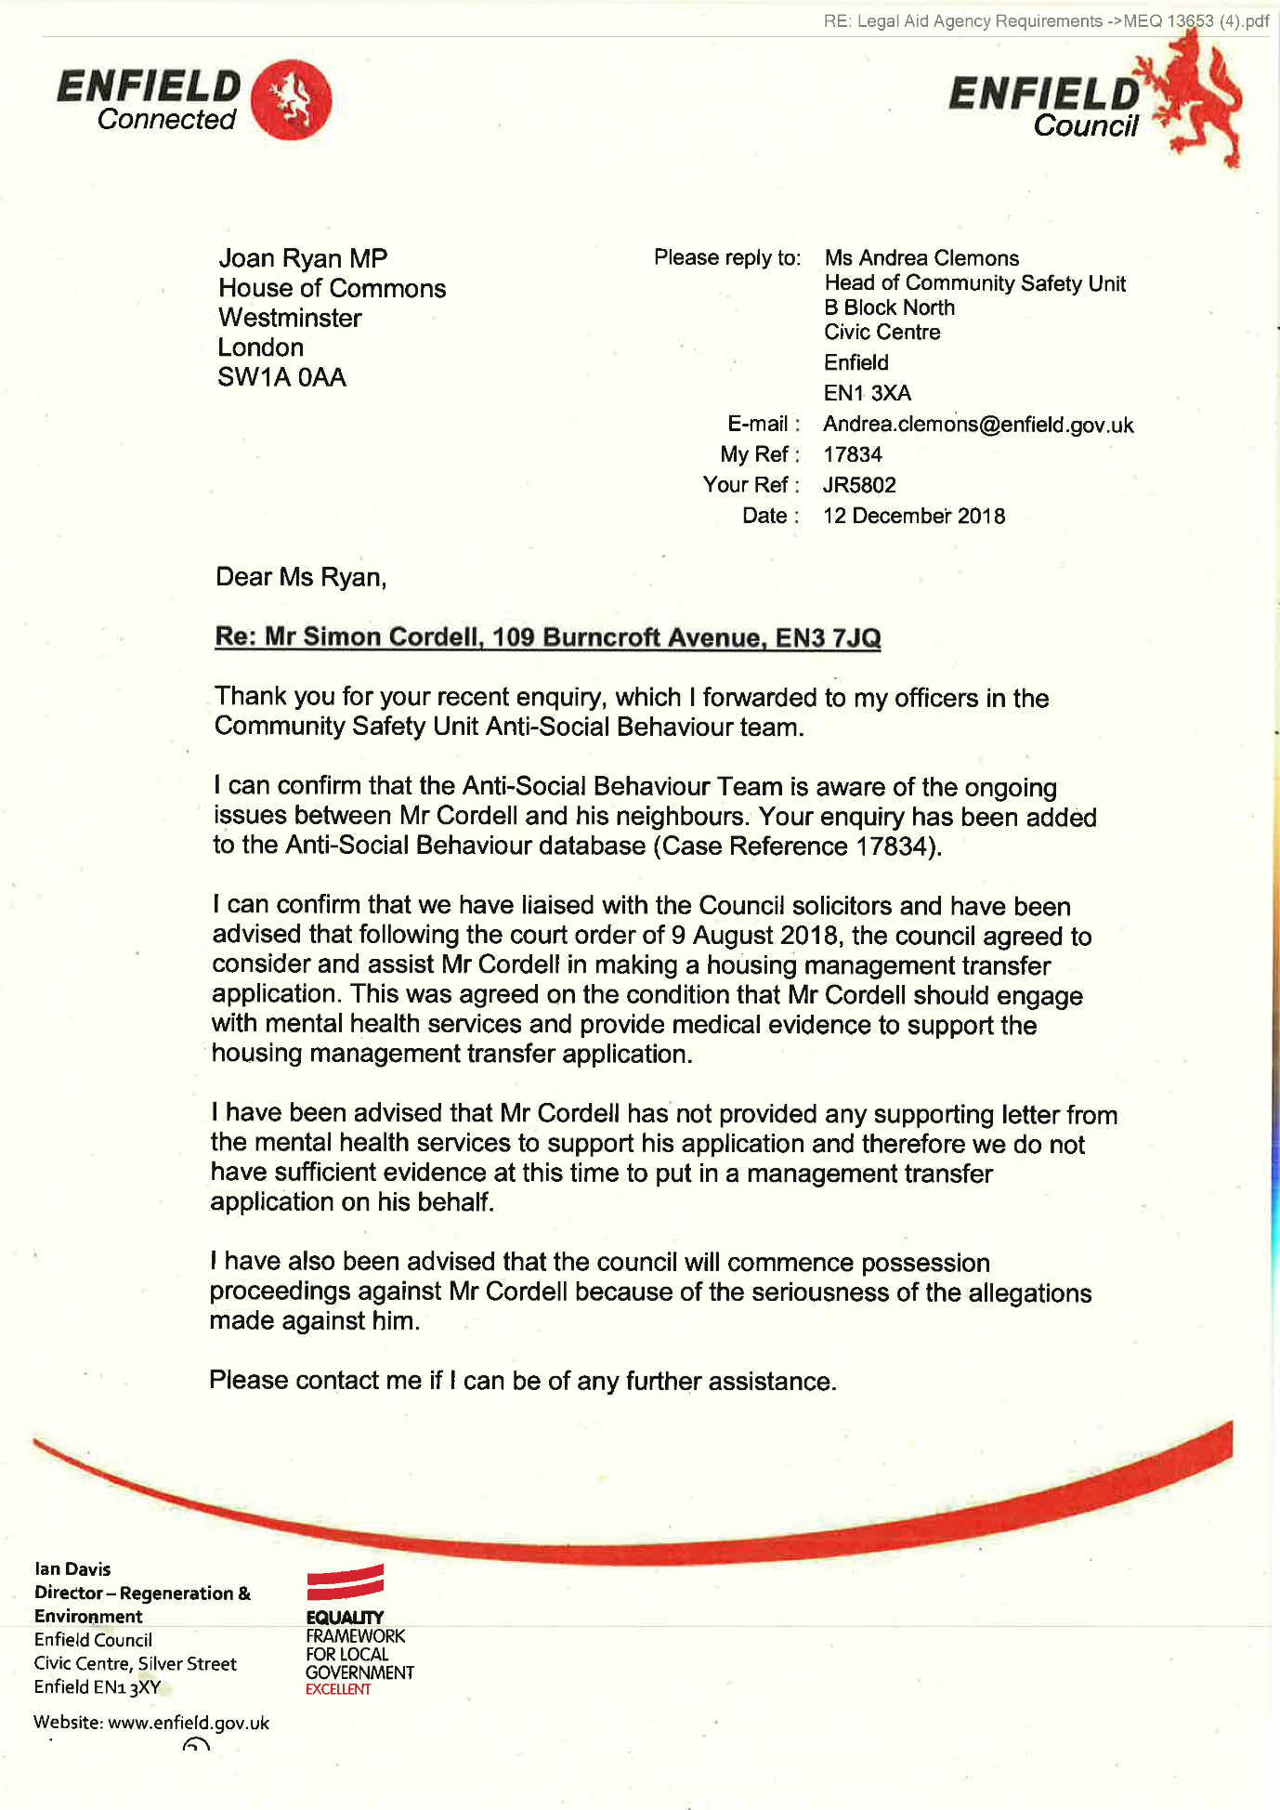
162,
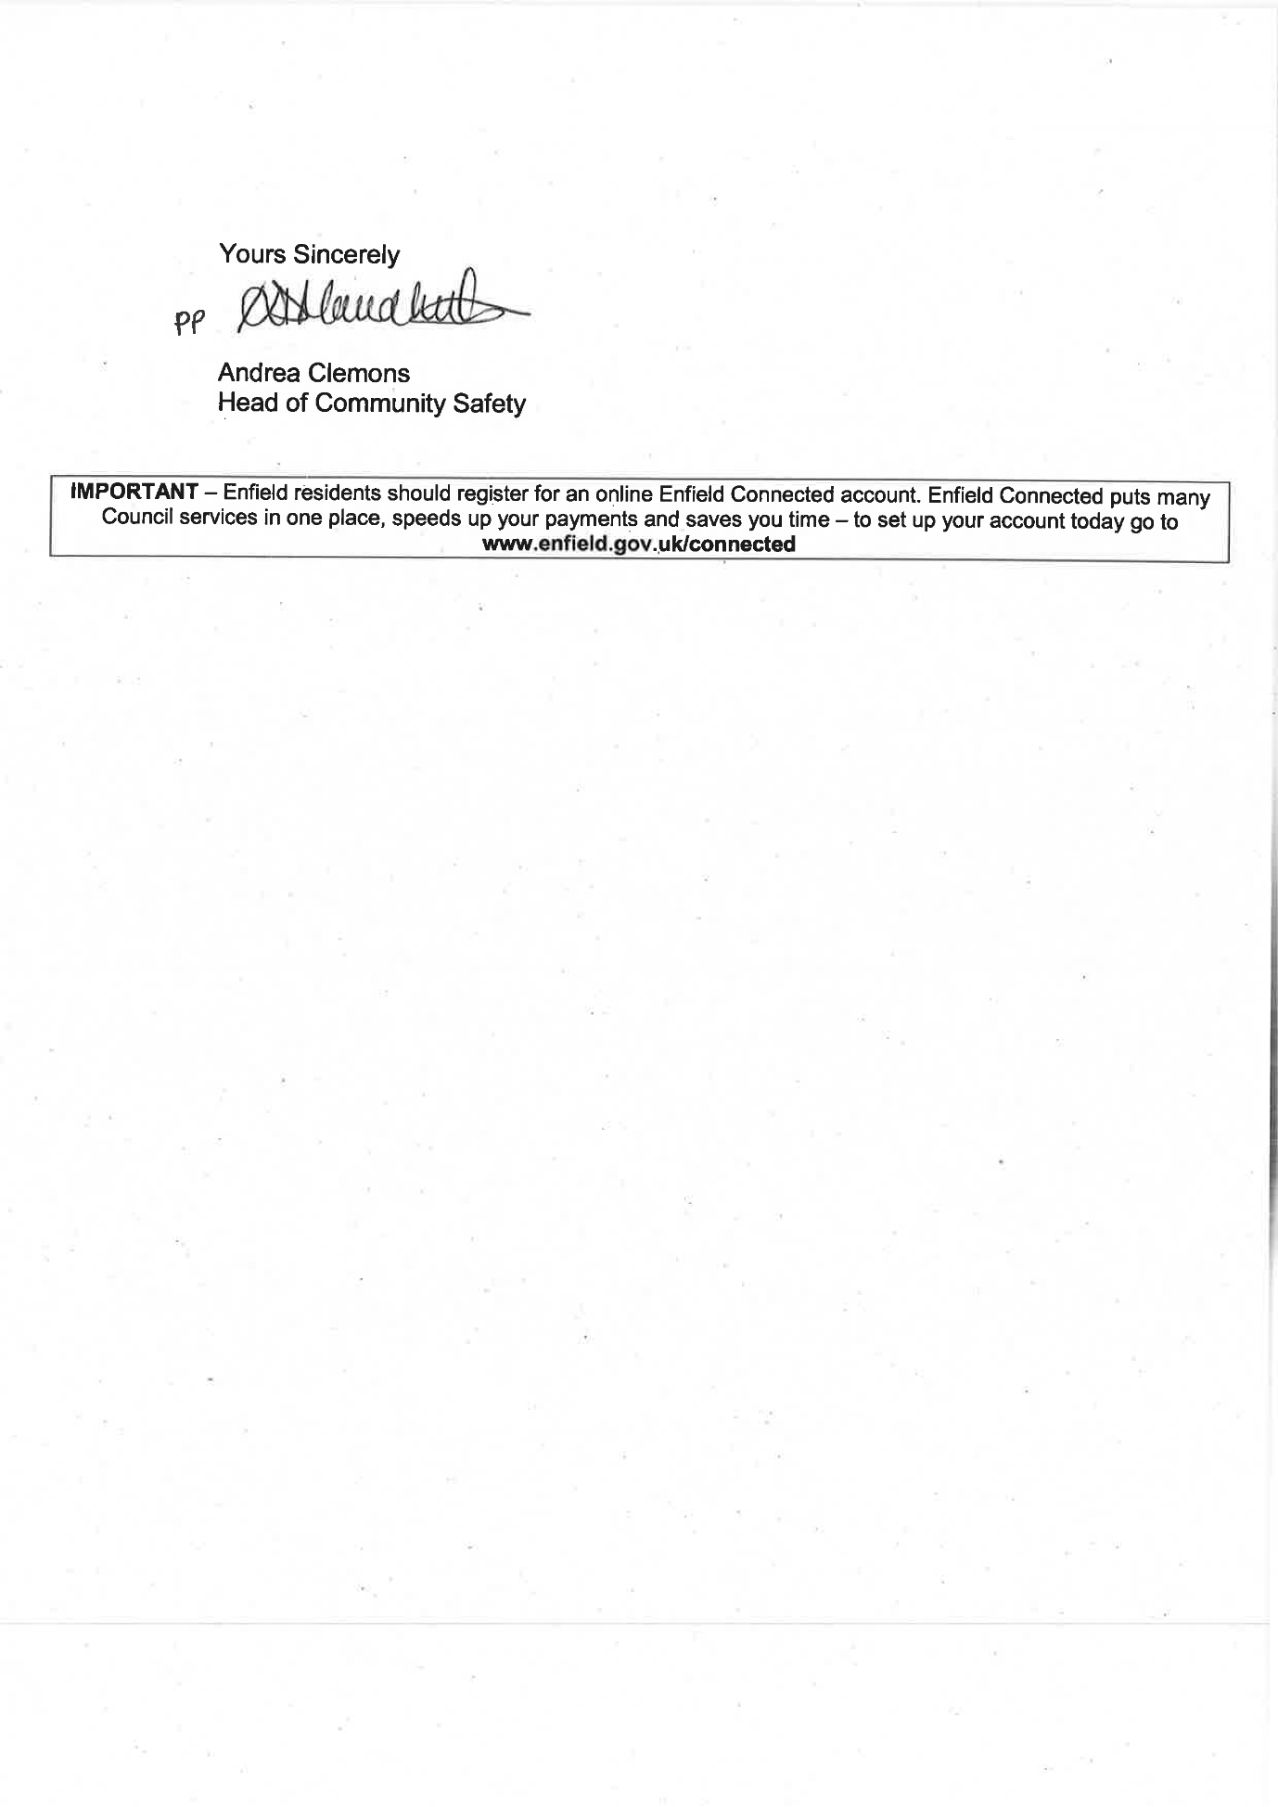
163,
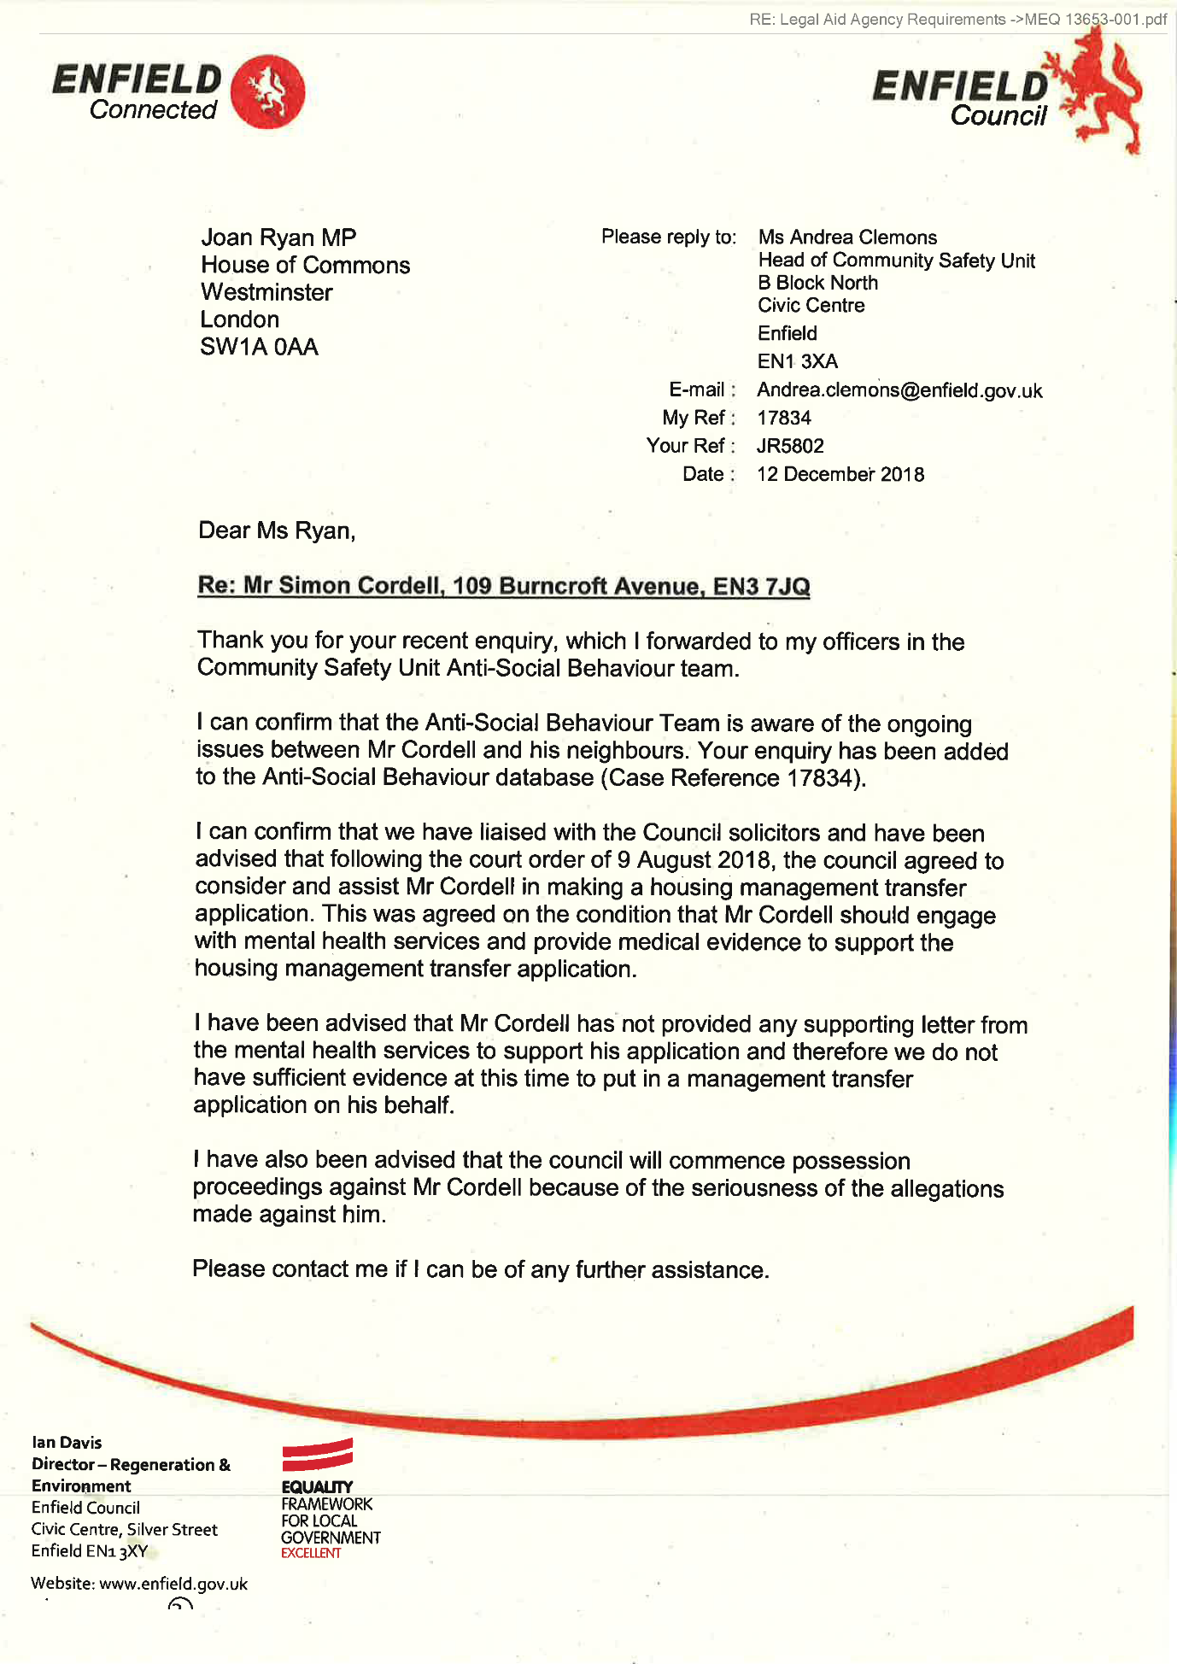
164,
165,
RE: Legal Aid Agency Requirements ->On behalf of Mr Simon Cordell of 109 Burncroft Ave Enfield EN3 7JQ (2).pdf
- Complaint 05/12/2018
On behalf of Mr Simon Cordell of 109 Burncroft Ave, Enfield, EN3 7JQ
I am writing this email due to issues I have regarding a member of staff who works for Enfield Council by the name off Mr Lemmy Nwabuisi the Anti-Social Behaviour Coordinator,
Since 2016 when Mr Lemmy Nwabuisi the Anti-Social Behaviour Coordinator started working for Enfield Council he has been working on investigations relating to my son Mr. Simon Cordell.
In this time not once has Mr Lemmy Nwabuisi the Anti-Social Behaviour Coordinator, come to see my son’s side to the alleged allegations regarding what the neighbours have put in about my son.
Mr Lemmy Nwabuisi the Anti-Social Behaviour Coordinator has taken one side to these said alleged allegations without no investigations,’ Mr Lemmy Nwabuisi it seem has taken one side to everything that has been said and that is the side of the neighbours, Mr Lemmy Nwabuisi has been told many times we have information which would proof my son had not done things which have been stated by the neighbours
Mr Lemmy Nwabuisi the Anti-Social Behaviour Coordinator knows my son does not leave the flat he was told this, and also told that if he wanted to attend a meeting with my son he could do so with police there to have a meeting to hear my son’s side, he has never got back to me regarding having a meeting at my son’s home because he never wanted to, which I am sure if someone is a vulnerable person where was the duty of care where has it ever been for my son?
I believe Mr Lemmy Nwabuisi the Anti-Social Behaviour Coordinator just through to himself that my son is in the wrong he is a vulnerable person I will put pressure on him and get him out without even thinking there is 2 side to anything. And just blamed my son without even talking to him this is how it has been since Mr Lemmy
1
166,
Nwabuisi the Anti-Social Behaviour Coordinator starting working for Enfield
Council.
I also feel Mr Lemmy Nwabuisi has taken information and not relayed it back correctly many times regarding my son’s health even to the courts. Information is being passed and obtained relating to my son which should never have been passed to 3 parties or used, how can this be allowed. There are many other points and failings which have been allowed to happen and this needs to stop. I will be drafting up a full complaint of failings and submitting it, but this will take a while to draft up as I have got to go back some years.
Mr Lemmy Nwabuisi also had my son arrested on the 09/01/2018 and even though we asked many times, even my own son’s solicitors could not understand why he was the person still investigating my son. When his case was part of the court actions being taken against my son by Enfield Council this is against the law that someone is investigating something within their own case, and it beaches many other things.
At this point in time I want Mr Lemmy Nwabuisi taken off dealing with anything to do with my son or related to him, I feel he has not done acted correctly and feel he has not investigated anything which would prove my son has done nothing wrong and only wanted to blame him for everything, I have asked this before and heard nothing back regarding this. But it has got to the point in time that this needs to happen.
Could someone please get back to me as soon as possible regarding this?
Regards
Lorraine Cordell
2
167,
RE: Legal Aid Agency Requirements ->On behalf of Mr Simon Cordell of 109 Burncroft Ave Enfield EN3 7JQ-05-12-2018.pdf
• Complaint 05/12/2018
On behalf of Mr Simon Cordell of 109 Burncroft Ave, Enfield, EN3 7JQ
I am writing this email due to issues I have regarding a member of staff who works for Enfield Council by the name off Mr Lemmy Nwabuisi the Anti-Social Behaviour Coordinator,
Since 2016 when Mr Lemmy Nwabuisi the Anti-Social Behaviour Coordinator started working for Enfield Council he has been working on investigations relating to my son Mr. Simon Cordell.
In this time not once has Mr Lemmy Nwabuisi the Anti-Social Behaviour Coordinator, come to see my son’s side to the alleged allegations regarding what the neighbours have put in about my son.
Mr Lemmy Nwabuisi the Anti-Social Behaviour Coordinator has taken one side to these said alleged allegations without no investigations,’ Mr Lemmy Nwabuisi it seem has taken one side to everything that has been said and that is the side of the neighbours, Mr Lemmy Nwabuisi has been told many times we have information which would proof my son had not done things which have been stated by the neighbours
Mr Lemmy Nwabuisi the Anti-Social Behaviour Coordinator knows my son does not leave the flat he was told this, and also told that if he wanted to attend a meeting with my son he could do so with police there to have a meeting to hear my son’s side, he has never got back to me regarding having a meeting at my son’s home because he never wanted to, which I am sure if someone is a vulnerable person where was the duty of care where has it ever been for my son?
I believe Mr Lemmy Nwabuisi the Anti-Social Behaviour Coordinator just through to himself that my son is in the wrong he is a vulnerable person I will put pressure on him and get him out without even thinking there is 2 side to anything. And just blamed my son without even talking to him this is how it has been since Mr Lemmy
1
168,
Nwabuisi the Anti-Social Behaviour Coordinator starting working for Enfield
Council.
I also feel Mr Lemmy Nwabuisi has taken information and not relayed it back correctly many times regarding my son’s health even to the courts. Information is being passed and obtained relating to my son which should never have been passed to 3 parties or used, how can this be allowed. There are many other points and failings which have been allowed to happen and this needs to stop. I will be drafting up a full complaint of failings and submitting it, but this will take a while to draft up as I have got to go back some years.
Mr Lemmy Nwabuisi also had my son arrested on the 09/01/2018 and even though we asked many times, even my own son’s solicitors could not understand why he was the person still investigating my son. When his case was part of the court actions being taken against my son by Enfield Council this is against the law that someone is investigating something within their own case, and it beaches many other things.
At this point in time I want Mr Lemmy Nwabuisi taken off dealing with anything to do with my son or related to him, I feel he has not done acted correctly and feel he has not investigated anything which would prove my son has done nothing wrong and only wanted to blame him for everything, I have asked this before and heard nothing back regarding this. But it has got to the point in time that this needs to happen.
Could someone please get back to me as soon as possible regarding this?
Regards
Lorraine Cordell
2
169,
Blank Page!
170,
RE: Legal Aid Agency Requirements ->Paul Buckridge_ RE_ Simon Cordell-30-11-2018.pdf
From: Paul Buckridge [Paul.Buckridge@enfield.gov.uk]
Sent: 30 November 2018 15:43
To: Lorraine Cordell
Subject: RE: Simon Cordell
Dear Ms Cordell
My instructing client is the Council Housing and Anti-Social Behaviour section.
Regards,
Paul Buckridge
From: Lorraine Cordell <lorraine32@blueyonder.co.uk>
Sent: 30 November 2018 14:54
To: Paul Buckridge Paul.Buckridge@enfield.gov.uk
Alev Cazimoglu
alev.cazimoglu@parliament.uk
Subject: RE: Simon Cordell
Paul Buckridge
Regarding point 1, I have not demanded a 2 bedroom flat for my son I only said it would be better as someone could be there with my son, but Enfield council was told to re-house my son by the court even if it was a like to like as Enfield Council stated this should have been done.
Regarding point 2, I will deal with this when the paperwork is received due to what the judge stated in court on the 09/08/2018 regarding this.
But could you please give me the name of the person who has instructed you to start the proceedings against Simon Cordell for possession.
Regards
Lorraine Cordell
From: Paul Buckridge
mailto: Paul.Buckridge@enfield.gov.uk
Sent: 30 November 2018 14:17
To: Lorraine Cordell
Subject: RE: Simon Cordell
Dear Ms Cordell
Thank you for your email. I apologise for not responding earlier I was waiting instructions.
In respect to point 1 of your email, I am advised by my client that they will not be submitting any paperwork to the exception panel. Our client informs that the court order of 9/8/18 does not mandate the council to offer a two-bed property to Mr Cordell.
I am now instructed by my client to issue proceedings against Simon Cordell for possession.
Regards,
Paul Buckridge
From: Lorraine Cordell <lorraine32@bluevonder.co.uk
171,
Sent: 30 November 2018 11:12
To: Paul Buckridge Paul.Buckridge@enfield.gov.uk
Alev Cazimoglu
alev.cazimoglu@parliament.uk
Subject: RE: Simon Cordell
Dear Paul Buckridge
I have not had a reply from you in regard to the emails I sent to Ludmilla.
- Could you please tell me if my son paperwork will be put in front the next panel regarding moving him as was meant to be done via the court order of the 09/08/2018, if so, what date is the next panel meeting.
- Or are you going to commence possession proceedings as was stated by Ludmilla emails dated the 18/10/2018
Could you please tell me if you have had instructions in regards as to what is the next steps to be taken. As I myself need to know so I can address this matter as soon as possible for my son.
Regards
Lorraine Cordell
From: Paul Buckridge
mailto: Paul.Buckridge@enfield.gov.uk
Sent: 27 November 2018 16:51
To: lorraine32@bluevonder.co.uk
Subject: Simon Cordell
Importance: High
Dear Ms Cordell
I am in receipt of the email exchange between my colleague and yourself. I have recently taken over the matter and will on receipt of instructions from our client revert to you on the points that you have raised. I will endeavour to get instructions tomorrow and provide a full response.
Regards,
Paul Buckridge
Locum Solicitor | Corporate Team | Legal Services On behalf of the Director of Law and Governance
020 8379 5492
PO Box 50, Civic Centre, Silver Street, Enfield EN1 3XA
DX: 90615
Enfield 1
Enfield Council is committed to serving the whole borough fairly, delivering excellent services and building strong communities.
Legal advice in this email is given on behalf of the Assistant Director of Legal Services; it is subject to legal professional privilege and should not be disclosed without expressed prior authorisation.
172,
Be the first to receive the latest Council news straight to your Inbox
SIGN UP ONLINE NOW
www.enfieldgov.uk/enewsletters
Enfield Council is committed to serving the whole borough fairly, delivering excellent services and building strong communities. Opinions expressed in this email are those of the individual and not necessarily those of the London Borough of Enfield. This email and any attachments or files transmitted with it are strictly confidential and intended solely for the named addressee. It may contain privileged and confidential information and if you are not the intended recipient and receive it in error you must not copy, distribute, or use the communication in any other way. All traffic handled by the Government Connect Secure Extranet may be subject to recording/and or monitoring in accordance with relevant legislation.
This email has been scanned for viruses, but we cannot guarantee that it will be free of viruses or malware. The recipient should perform their own virus checks.
Enfield Council is committed to serving the whole borough fairly, delivering excellent services and building strong communities. Opinions expressed in this email are those of the individual and not necessarily those of the London Borough of Enfield. This email and any attachments or files transmitted with it are strictly confidential and intended solely for the named addressee. It may contain privileged and confidential information and if you are not the intended recipient and receive it in error you must not copy, distribute, or use the communication in any other way. All traffic handled by the Government Connect Secure Extranet may be subject to recording/and or monitoring in accordance with relevant legislation.
This email has been scanned for viruses, but we cannot guarantee that it will be free of viruses or malware. The recipient should perform their own virus checks.
173,
Be the first to receive the latest Council news straight to your Inbox
SIGN UP ONLINE NOW
www.enfieldgov.uk/enewsletters
Enfield Council is committed to serving the whole borough fairly, delivering excellent services and building strong communities. Opinions expressed in this email are those of the individual and not necessarily those of the London Borough of Enfield. This email and any attachments or files transmitted with it are strictly confidential and intended solely for the named addressee. It may contain privileged and confidential information and if you are not the intended recipient and receive it in error you must not copy, distribute, or use the communication in any other way. All traffic handled by the Government Connect Secure Extranet may be subject to recording/and or monitoring in accordance with relevant legislation.
This email has been scanned for viruses, but we cannot guarantee that it will be free of viruses or malware. The recipient should perform their own virus checks.
174,
RE: Legal Aid Agency Requirements ->Paul Buckridge_ RE_ Simon Cordell-30-11-2018-001.pdf
From: Paul Buckridge [Paul.Buckridge@enfield.gov.uk]
Sent: 30 November 2018 14:17
To: Lorraine Cordell
Subject: RE: Simon Cordell
Dear Ms Cordell
Thank you for your email. I apologise for not responding earlier I was waiting instructions.
In respect to point 1 of your email, I am advised by my client that they will not be submitting any paperwork to the exception panel. Our client informs that the court order of 9/8/18 does not mandate the council to offer a two-bed property to Mr Cordell.
I am now instructed by my client to issue proceedings against Simon Cordell for possession.
Regards,
Paul Buckridge
From: Lorraine Cordell <lorraine32@blueyonder.co.uk>
Sent: 30 November 2018 11:12
To: Paul Buckridge <Paul.Buckridge@enfield.gov.uk
Alev Cazimoglu
alev.cazimoglu@parliament.uk
Subject: RE: Simon Cordell
Dear Paul Buckridge
I have not had a reply from you in regard to the emails I sent to Ludmilla.
- Could you please tell me if my son paperwork will be put in front of the next panel regarding moving him as was meant to be done via the court order of the 09/08/2018, if so, what date is the next panel meeting.
- Or are you going to commence possession proceedings as was stated by Ludmilla emails dated the 18/10/2018
Could you please tell me if you have had instructions in regards as to what is the next steps to be taken. As I myself need to know so I can address this matter as soon as possible for my son.
Regards
Lorraine Cordell
From: Paul Buckridge
mailto: Paul.Buckridge@enfield.gov.uk
Sent: 27 November 2018 16:51
To: lorraine32@bluevonder.co.uk
Subject: Simon Cordell
Importance: High
Dear Ms Cordell
I am in receipt of the email exchange between my colleague and yourself. I have recently taken over the matter and will on receipt of instructions from our client revert to you on the points that you have raised. I will endeavour to get instructions tomorrow and provide a full response.
Regards,
Paul Buckridge
175,
Locum Solicitor | Corporate Team | Legal Services On behalf of the Director of Law and Governance
m 020 8379 5492
PO Box 50, Civic Centre, Silver Street, Enfield EN1 3XA DX: 90615 Enfield 1
Enfield Council is committed to serving the whole borough fairly, delivering excellent services and building strong communities.
Legal advice in this email is given on behalf of the Assistant Director of Legal Services; it is subject to legal professional privilege and should not be disclosed without expressed prior authorisation.
Be the first to receive the latest Council news straight to your inbox
SIGN UP ONLINE NOW
www.enfield.gov.uk/enewsletters
Enfield Council is committed to serving the whole borough fairly, delivering excellent services and building strong communities. Opinions expressed in this email are those of the individual and not necessarily those of the London Borough of Enfield. This email and any attachments or files transmitted with it are strictly confidential and intended solely for the named addressee. It may contain privileged and confidential information and if you are not the intended recipient and receive it in error you must not copy, distribute, or use the communication in any other way. All traffic handled by the Government Connect Secure Extranet may be subject to recording/and or monitoring in accordance with relevant legislation.
This email has been scanned for viruses, but we cannot guarantee that it will be free of viruses or malware. The recipient should perform their own virus checks.
Be the first to receive the latest Council news straight to your inbox
SIGN UP ONLINE NOW
www.enfield.gov.uk/enewsletters
Enfield Council is committed to serving the whole borough fairly, delivering excellent services and building strong communities. Opinions expressed in this email are those of the individual and not necessarily those of the London Borough of Enfield. This email and any attachments or files transmitted with it are strictly confidential and intended solely for the named addressee. It may contain privileged and confidential information and if you are not the intended recipient and receive
176,
it in error you must not copy, distribute, or use the communication in any other way. All traffic handled by the Government Connect Secure Extranet may be subject to recording/and or monitoring in accordance with relevant legislation.
This email has been scanned for viruses, but we cannot guarantee that it will be free of viruses or malware. The recipient should perform their own virus checks.

The banging Started!

Si Note:
1

Summary!

Disrepair!

Time Spent Building.

Working at Home doing Court Case Defense Work!

Tuesday!
12/02/2019

Stain and the
Issues with Housing Disrepair!
Working on the Court Case Defence!
The Anti-Social Behaviour Order Case and the Verdict got made Guilty against me in error and the conditions got imposed against me till late 2020!
The Banging Continued: -
12/02/2019

- Disrepair!
- The Asbo Order got granted in Error with Full Conditions against me and Fraudulently!
- The banging Continued at me!
- Working at home!

- 117 Burncroft Avenue was
The Mathiyalagan family had moved out for ever!
“Empty / vacated!”

- 113 Burncroft Avenue
Ambrose!
--
17/12/2018 -- I see Ambrose and his mate Alley in the corridor!
--
28/02/2019 -- Ambrose started again
--
04/03/2019 -- Just Alley staying inside of the flat of 113 Burncroft Avenue
--
25/05/2019 -- Alley & Co, Opening my front door in safety!
--
26/05/2019 -- Getting Arrested Partly for Trusting Alley!

- 115 Burncroft Avenue
Young Light skin girl and boy! “Responsible.”

- 111 Burncroft Avenue
Stain Curtis Fisher! “Responsible.”

1
- 2nd Possession Order! 06/02/2019
I have good news in that the Council have decided to not pursue the case further due to a lack of recent incidents. Please see attached their letter received recently and our letter dated 22 October 2019 sent to your son.

1
- The Enfield Gov / Email’s Issue:
1151. Lorraine Cordell _Fwd._ Legal Aid Agency Requirements Simon Cordell /
Page Numbers: 4502,4503,4504,4505,

10.
- Additional Email Attachments & Emails / Issue:
10. 1. 1
lorraine32@blueyonder.co.uk_02.12.2019_FW Legal Aid Agency Requirements Simon Cordell
12/02/2019
/ Page Numbers: 177,178,179,180
181,182,183,184,185,186
187,188,189,190,191,192
193,194,195,196,197,198
199,200,201,202,203,204
205,206,207,208,209,210
211,212,213,214,215,216
217,218,219,220,221,222
223,224,225,226,227,228
229,230,231,232,233,234
235,236,237,238,239,240
241,242,243,244,245,246
247,248,249,250,251,252
253,254,255,256,257,258
259,260,261,262,263,264
265,266,267,268,269,270
271,272,273,274,275,276
277,278,279,280,281,282
283,284,285,286,287,288
289

--

1
The Enfield Gov / Email’s Issue:
1151. Lorraine Cordell _Fwd._ Legal Aid Agency Requirements Simon Cordell
/ Page Numbers: 4502,4503,4504,4505,
From: Lorraine Cordell [lorraine32@blueyonder.co.uk]
Sent: 12 February 2019 18:14
To: 'Liselle Archer'
Subject: FW: Legal Aid Agency Requirements Simon Cordell
Attachments:
- ESA-Comfirmed-Letter-08-03-2018.pdf.
- FreshPossesstionOrder06_02_2019-Full.pdf.
- Simon-Licence-Front-Back.pdf
- Seal-Court-Order-09-08-2018-got-on-the-06-12-2018.pdf
- VLS_20171215_103522.pdf.
- VLS_20171215_103441.pdf
- Citizencard.pdf.
- Seal-Court-Order-09-08-2018-got-on-the-06-12-2018-001 (2).pdf.
- 2018 11 28 Signedresponse.pdf.
- APHILIPPOU_Re_SIMONCORDELLRENOTICEOFSEEKINGP0SSESSI0N-25-01-2019-001.pdf.
- APHILIPPOU_SIMONCORDELLRENOTICEOFSEEKINGPOSSESSION-25--01-2019.pdf.
- alev.cazimoglu@parliament.pdf;
- alev.cazimoglu@parliament-03-01-2019.pdf;
- alev.cazimoglu@parliament-17-12-2018.pdf.
- alev.cazimoglu@parliament-21-12-2018.pdf;
- alev.cazimoglu@parliament-23-11-2018.pdf;
- ChiefExecutive_FW_MrSimonCordellof109BurncroftAve_Enfield_EN37JQ_SEC=OFFICIAL-06-12-2018.pdf.
- Enfield-Counci-Reply-28-12-2018.pdf.
- JoanRyan_Re_SimonCordell_CaseRef_JR14051-10-12-2018.pdf.
- Kaunchita_Maudhub_Re_Mr_Simon_Cordell.109 Burncroft Avenue.pdf.
- Letter to ECC attaching Dr Dhinakaran's_assessment_report_10_7_2018.pdf.
- Letter to Lorraine Cordell 28.12.18 (2).pdf; Letter to Lorraine Cordell 28.12.18.pdf.
- LONDON BOROUGH OF ENFIELD RE LBE V SIMON CORDELL NOTICE OF SEEKING POSSESSION 25JAN19 AP (2).pdf.
- Lorraine Cordell_ RE_ Mr Simon Cordell. 109 Burncroft Avenue.pdf
- Ludmilla_Iyavoo_RE_Simon_Cordell_Move_SEC=OFFICIAL_-27-11-2018.pdf
- Ludmilla_Iyavoo_RE_Simon_Cordell_Move_sEC=OFFICIAl-27-11-2018-001.pdf.
- MEQ 13653 (4).pdf.
- MEQ 13653-001.pdf.
- On behalf of Mr Simon Cordell of 109 Burncroft Ave Enfield EN3 7JQ (2).pdf.
- On behalf of Mr Simon Cordell of 109 Burncroft Ave Enfield EN3 7JQ-05-12-2018.pdf.
- PaulBuckridge_RE_SimonCordell-30-11-2018.pdf.
- PaulBuckridge_RE_SimonCordell-30-11-2018-001.pdf.
- Simon-Bank-Statements-12-02-2019.pdf
Dear Liselle Archer
Please see attached documents including his bank statements which was missing from the below email. But can the solicitor please read below email as that says some bits about the case.
Regards
Lorraine Cordell
From: Lorraine Cordell [mailto:lorraine32@blueyonder.co.uk]
Sent: 11 February 2019 18:17
To: 'Liselle Archer'
Subject: RE: Legal Aid Agency Requirements
Dear Liselle Archer
I am writing this letter regarding the case that Enfield Council has laid before the court for a Possession Order for my son’s flat. The court hearing is for the 08/03/2019 at 10:00 hours. I have tried to attach the most up to date information as there is a long history to this with Enfield Council and my son. I have ordered my son's bank statements but am waiting for them to come in the post so have included the other documents asked for in the email, and if a date can be set for him to see someone maybe by the time we see someone we will have the bank statement, but my son has had legal aid in the below cases, Please see attached documents.
4503,
I am writing this to give you some form of information relating to this case as it has in some ways been ongoing for some time.
Enfield Council has had 2 other court cases regarding these matters which were for injunction orders please see below information they were for the same cases as in this new Possession Order.
E00ED049: Edmonton Country Court
1. Interim Injunction order started by Enfield Council on the 09th January 2018 at Edmonton Country Court, to replace the one that was struck out by the court on the 06/11/2017 as the Judge would not put it back in place.
2. This case went on until the 09/08/2018, please see attached court order which was made, which Enfield Council was meant to have moved my son, which has never happened I have been trying to get this done since this date and Enfield Council have not done anything.
D02ED073: Edmonton Country Court
1. Interim Injunction order started by Enfield Council on the 9th August 2017 at Edmonton Country Court.
2. This case ended up being struck out on the 06/11/2017, the reason for this was due to Enfield Council not doing what the court asked them to do.
Even through there is a court order in place for Enfield Council to move my son, Enfield Council has done nothing only kept my son in a flat that is causing his health to be impacted and lied to multiple bodies regarding the order that was made on the 09/08/2018. The judge warned Enfield Council regarding a Possession Order on my son on the 09/08/2018, there is a lot of paperwork regarding all of this which will need to be gone over. There are so many Emails and Documents regarding everything that has gone on it will be too much to send via email. So, I have only put a few of the last emails and Letters including the new order, the other information will need to be done at a meeting as there is just so much information.
Regards
Lorraine Cordell
From: Liselle Archer
mailto: liseNe@tyrerroxburgh.co.uk
Sent: 07 February 2019 15:51
To: lorraine32@blueyonder.co.uk
Subject: Legal Aid Agency Requirements
Dear Madam
Following our telephone conversation today, please see below the requirements for the application for public funding (Legal Aid).
Please bring the following documents in order for us to open a case:
4504,
1. Most recent award letter confirming that your son receives ESA
2. Bank statements of all adults over the age 18 living in the household.
(Please note that the bank statements must be:
- Covering the last 3 months with no gaps, this includes 07 February 2019 -07 November 2018)
- For all bank statements including savings accounts and dormant accounts)
3. Passport or Driving License (proof of ID)
4. Tenancy Agreement and letters from your landlord
5. Anything else you consider relevant.
Please note we are unable to open a case until we have received all of the above documents.
Kind Regards
Liselle Archer
Tyrer Roxburgh Solicitors LLP
Tel +44 (0)20 8889 3319
Direct Dial +44 (0)20 8829 2950
Email liselle@tyrerroxburgh.co.uk
Head Office:
1 St Michaels Terrace London N22 7SJ
DX 34704 WOOD GREEN 2
Tel +44 (0)20 8889 3319
fax +44 (0)20 8881 6089
Luton Office:
Trend House Dallow Road Luton LU1 1LY
Tel +44 (0)1582 726579
Please reply to our Head Office www.tvrerroxburgh.co.uk
Authorised by the Solicitors Regulation Authority. Tyrer Roxburgh Solicitors LLP is a limited liability partnership under the no.560748. A list of the members' names is open to inspection at the registered office.
VAT REG No: 221 8088 78 SRA No: 560748
cid: image006.jpg@01D15
Contracted with the Legal Aid Agency
We do not accept service of documents or other process by e-mail
Email us at lawmakers@tvrerroxburgh.co.uk
This message may contain privileged information and is only intended to be received by the person to whom it is addressed. If you are not the intended recipient, please contact us as soon as possible.
4505,
Partners •
Mukesh Badhan • D Shanmuganathan

10.
Additional Email Attachments & Emails / Issue:
10. 1. 1
lorraine32@blueyonder.co.uk_02.12.2019_FW Legal Aid Agency Requirements Simon Cordell
12/02/2019
/ Page Numbers: 177,178,179,180
181,182,183,184,185,186
187,188,189,190,191,192
193,194,195,196,197,198
199,200,201,202,203,204
205,206,207,208,209,210
211,212,213,214,215,216
217,218,219,220,221,222
223,224,225,226,227,228
229,230,231,232,233,234
235,236,237,238,239,240
241,242,243,244,245,246
247,248,249,250,251,252
253,254,255,256,257,258
259,260,261,262,263,264
265,266,267,268,269,270
271,272,273,274,275,276
277,278,279,280,281,282
283,284,285,286,287,288
289
--
177,
From: Lorraine Cordell <lorraine32@blueyonder.co.uk>
Sent: 12 February 2019 18:14
To: 'Liselle Archer'
Subject: FW: Legal Aid Agency Requirements Simon Cordell
Attachments:
ESA-Comfirmed-Letter-08-03-2018.pdf.
Fresh Possession Order 06_02_2019-Full.pdf
Simon-Licence-Front-Back.pdf
Seal-Court-Order-09-08-2018-got-on-the-06-12-2018.pdf
VLS_20171215_103522.pdf; VLS_20171215_103441.pdf
Citizencard.pdf; Seal-Court-Order-09-08-2018-got-on-the-06-12-2018-001 (2).pdf
2018 11 28 Signed response.pdf
A PHILIPPOU_ Re_ SIMON CORDELL RE NOTICE OF SEEKING POSSESSION-25-01-2019-001.pdf
A PHILIPPOU_SIMON CORDELL RE NOTICE OF SEEKING POSSESSION- 25--01-2019.pdf
alev.cazimoglu@parliament.pdf
alev.cazimoglu@parliament-03-01-2019.pdf
alev.cazimoglu@parliament-17-12-2018.pdf
alev.cazimoglu@parliament-21-12-2018.pdf
alev.cazimoglu@parliament-23-11-2018.pdf
Chief Executive-FW-Mr Simon Cordell of 109 Burncroft Ave, Enfield, EN3 7JQ [SEC=OFFICIAL] -06-12-2018.pdf
Enfield-Counci-Reply-28-12-2018.pdf
Joan Ryan-Re-Simon-Cordell (Case Ref_ JR14051) -10-12-2018.pdf
Kaunchita Maudhub-Re-Mr Simon Cordell. 109 Burncroft Avenue.pdf
Letter to ECC attaching Dr Dhinakaran's assessment report 10 7 2018.pdf
Letter to Lorraine Cordell 28.12.18 (2).pdf
Letter to Lorraine Cordell 28.12.18.pdf
LONDON BOROUGH OF ENFIELD RE LBE V SIMON CORDELL NOTICE OF SEEKING POSSESSION 25JAN19 AP (2).pdf
Lorraine Cordell-RE-Mr Simon Cordell. 109 Burncroft Avenue.pdf
Ludmilla Iyavoo-RE- Simon Cordell Move [SEC=OFFICIAL] -27-11-2018.pdf
Ludmilla Iyavoo-RE-Simon Cordell Move [SEC=OFFICIAL] -27-11-2018-001.pdf
MEQ 13653 (4).pdf
MEQ 13653-001.pdf
On behalf of Mr Simon Cordell of 109 Burncroft Ave Enfield EN3 7JQ (2).pdf
On behalf of Mr Simon Cordell of 109 Burncroft Ave Enfield EN3 7JQ-05-12-2018.pdf
Paul Buckridge-RE-Simon Cordell-30-11-2018.pdf
Paul Buckridge-RE-Simon Cordell-30-11-2018-001.pdf
Simon-Bank-Statements-12-02-2019.pdf
Dear Liselle Archer
Please see attached documents including his bank statements which was missing from the below email. But can the solicitor please read below email as that says some bits about the case.
Regards
Lorraine Cordell
From: Lorraine Cordell
mailto: lorraine32@blueyonder.co.uk
Sent: 11 February 2019 18:17
To: 'Liselle Archer'
Subject: RE: Legal Aid Agency Requirements
Dear Liselle Archer
I am writing this letter regarding the case that Enfield Council has laid before the court for a Possession Order for my son’s flat. The court hearing is for the 08/03/2019 at 10:00 hours. I have tried to attach the most up to date information as there is a long history to this with Enfield Council and my son. I have ordered my son's bank statements but am waiting for them to come in the post so have included the other documents asked for in the email, and if a date can be set for him to see someone maybe by the time we see someone we will have the bank statement, but my son has had legal aid in the below cases, Please see attached documents.
I am writing this to give you some form of information relating to this case as it has in some ways been ongoing for some time. Enfield Council has had 2 other court cases regarding these matters which were for injunction orders please see below information
178,
they were for the same cases as in this new Possession Order.
E00ED049: Edmonton Country Court
- Interim Injunction order started by Enfield Council on the 09th January 2018 at Edmonton Country Court, to replace the one that was struck out by the court on the 06/11/2017 as the Judge would not put it back in place.
- This case went on until the 09/08/2018, please see attached court order which was made, which Enfield Council was meant to have moved my son, which has never happened I have been trying to get this done since this date and Enfield Council have not done anything.
D02ED073: Edmonton Country Court
- Interim Injunction order started by Enfield Council on the 9th August 2017 at Edmonton Country Court.
- This case ended up being struck out on the 06/11/2017, the reason for this was due to Enfield Council not doing what the court asked them to do.
Even through there is a court order in place for Enfield Council to move my son, Enfield Council has done nothing only kept my son in a flat that is causing his health to be impacted and lied to multiple bodies regarding the order that was made on the 09/08/2018. The judge warned Enfield Council regarding a Possession Order on my son on the 09/08/2018, there is a lot of paperwork regarding all of this which will need to be gone over.
There are so many Emails and Documents regarding everything that has gone on it will be too much to send via email. So I have only put a few of the last emails and Letters including the new order, the other information will need to be done at a meeting as there is just so much information.
Regards
Lorraine Cordell
From: Liselle Archer
mailto: liselle@tyrerroxburgh.co.uk
Sent: 07 February 2019 15:51
To: lorraine32@blueyonder.co.uk
Subject: Legal Aid Agency Requirements
Dear Madam
Following our telephone conversation today, please see below the requirements for the application for public funding (Legal Aid).
Please bring the following documents in order for us to open a case:
- Most recent award letter confirming that your son receives ESA
- Bank statements of all adults over the age 18 living in the household.
Please note that the bank statements must be:
Covering the last 3 months with no gaps, this includes 07 February 2019 -07 November 2018)
For all bank statements including savings accounts and dormant accounts)
179,
- Passport or Driving Licence (proof of ID)
- Tenancy Agreement and letters from your landlord
- Anything else you consider relevant.
Please note we are unable to open a case until we have received all of the above documents.
Kind Regards
Liselle Archer
Tyrer Roxburgh Solicitors LLP
Tel +44 (0)20 8889 3319
Direct Dial +44 (0)20 8829 2950
Email liselle@tvrerroxburgh.co.uk
TR TYRER ROXBURGH
Head Office:
1 St Michaels Terrace London N22 7SJ
DX 34704 WOOD GREEN 2
Tel +44 (0)20 8889 3319
fax +44 (0)20 8881 6089
Luton Office:
Trend House Dallow Road Luton LU1 1LY
Tel +44 (0)1582 726579
Please reply to our Head Office www.tyrerroxburgh.co.uk
Authorised by the Solicitors Regulation Authority. Tyrer Roxburgh Solicitors LLP is a limited liability partnership under the no.560748. A list of the members' names is open to inspection at the registered office.
VAT REG No: 221 8088 78
SRA No: 560748
First for family law
Contracted with the Legal Aid Agency
We do not accept service of documents or other process by e-mail
Email us at lawmakers@tyrerroxburgh.co.uk
This message may contain privileged information and is only intended to be received by the person to whom it is addressed. If you are not the intended recipient, please contact us as soon as possible.
Partners • Mukesh Badhan • D Shanmuganathan
180,
Same as Above!
181,
Same as Above!
182,
Same as Above!
183,
Same as Above!
184,
Same as Above!
185,
Same as Above!
186,
Same as Above!
187,188,189,190,191,192
193,194,195,196,197,198
199,200,201,202,203,204
205,206,207,208,209,210
211,212,213,214,215,216
217,218,219,220,221,222
223,224,225,226,227,228
229,230,231,232,233,234
235,236,237,238,239,240
241,242,243,244,245,246
247,248,249,250,251,252
253,254,255,256,257,258
259,260,261,262,263,264
265,266,267,268,269,270
271,272,273,274,275,276
277,278,279,280,281,282
283,284,285,286,287,288
289

The banging Started!

Si Note:
1

Summary!

Disrepair!

Time Spent Building.

Working at Home doing Court Case Defense Work!

Wednesday!
13/02/2019

Stain and the
Issues with Housing Disrepair!
Working on the Court Case Defence!
The Anti-Social Behaviour Order Case and the Verdict got made Guilty against me in error and the conditions got imposed against me till late 2020!
The Banging Continued: -
13/02/2019

- Disrepair!
- The Asbo Order got granted in Error with Full Conditions against me and Fraudulently!
- The banging Continued at me!
- Working at home!

- 117 Burncroft Avenue was
The Mathiyalagan family had moved out for ever!
“Empty / vacated!”

- 113 Burncroft Avenue
Ambrose!
--
17/12/2018 -- I see Ambrose and his mate Alley in the corridor!
--
28/02/2019 -- Ambrose started again
--
04/03/2019 -- Just Alley staying inside of the flat of 113 Burncroft Avenue
--
25/05/2019 -- Alley & Co, Opening my front door in safety!
--
26/05/2019 -- Getting Arrested Partly for Trusting Alley!

- 115 Burncroft Avenue
Young Light skin girl and boy! “Responsible.”

- 111 Burncroft Avenue
Stain Curtis Fisher! “Responsible.”

1
- 2nd Possession Order! 06/02/2019
I have good news in that the Council have decided to not pursue the case further due to a lack of recent incidents. Please see attached their letter received recently and our letter dated 22 October 2019 sent to your son.

1
- The Enfield Gov / Email’s Issue:
1152. Liselle Archer _Booked Appointments /
Page Numbers: 4506,4507,4508,4509,

--

1
The Enfield Gov / Email’s Issue:
1152. Liselle Archer _Booked Appointments
/ Page Numbers: 4506,4507,4508,4509,
From: Liselle Archer [liselle@tyrerroxburgh.co.uk]
Sent: 13 February 2019 12:36
To: Lorraine Cordell
Subject: Booked Appointments
Dear Lorraine
Following our telephone conversation today, these appointments have been booked for you in relation to your son’s case:
Friday 15 February 2019 @ 12pm: Telephone Legal Aid Application Appointment
Monday 18 February 2019 @ 3pm: Office Face to Face Appointment
Please note: if the legal aid application is not submitted on Friday, the appointment booked for Monday will have to be rescheduled.
Kind Regards
Liselle Archer
Tyrer Roxburgh Solicitors LLP
Tel +44 (0)20 8889 3319
Direct Dial +44 (0)20 8829 2950
Email liselle@tvrerroxburgh.co.uk
witter-Full (002)
Head Office:
1 St Michaels Terrace London N22 7SJ
DX 34704 WOOD GREEN 2
Tel +44 (0)20 8889 3319
fax +44 (0)20 8881 6089
Luton Office:
Trend House Dallow Road Luton LU1 1LY
Tel +44 (0)1582 726579
Please reply to our Head Office www.tyrerroxburgh.co.uk
Authorised by the Solicitors Regulation Authority. Tyrer Roxburgh Solicitors LLP is a limited liability partnership under the no.560748. A list of the members' names is open to inspection at the registered office.
VAT REG No: 221 8088 78 SRA No: 560748
cid: image006.jpg@01D15
Contracted with the Legal Aid Agency
We do not accept service of documents or other process by e-mail
Email us at lawmakers@tvrerroxburgh.co.uk
This message may contain privileged information and is only intended to be received by the person to whom it is addressed. If you are not the intended recipient please contact us as soon as possible.
Partners • Mukesh Badhan • D Shanmuganathan
4507,
From: Lorraine Cordell mailto: lorraine32@blueyonder.co.uk
Sent: 12 February 2019 18:14
To: Liselle Archer <liselle@tyrerroxburgh.co.uk>
Subject: FW: Legal Aid Agency Requirements Simon Cordell
Dear Liselle Archer
Please see attached documents including his bank statements which was missing from the below email. But can the solicitor please read below email as that says some bits about the case.
Regards
Lorraine Cordell
From: Lorraine Cordell
mailto: lorraine32@bluevonder.co.uk
Sent: 11 February 2019 18:17
To: 'Liselle Archer'
Subject: RE: Legal Aid Agency Requirements
Dear Liselle Archer
I am writing this letter regarding the case that Enfield Council has laid before the court for a Possession Order for my son’s flat. The court hearing is for the 08/03/2019 at 10:00 hours. I have tried to attach the most up to date information as there is a long history to this with Enfield Council and my son. I have ordered my son's bank statements but am waiting for them to come in the post so have included the other documents asked for in the email, and if a date can be set for him to see someone maybe by the time we see someone we will have the bank statement, but my son has had legal aid in the below cases, Please see attached documents. I am writing this to give you some form of information relating to this case as it has in some ways been ongoing for some time. Enfield Council has had 2 other court cases regarding these matters which were for injunction orders please see below information they were for the same cases as in this new Possession Order. E00ED049: Edmonton Country Court Interim Injunction order started by Enfield Council on the 09th January 2018 at Edmonton Country Court, to replace the one that was struck out by the court on the 06/11/2017 as the Judge would not put it back in place. This case went on until the 09/08/2018, please see attached court order which was made, which Enfield Council was meant to have moved my son, which has never happened I have been trying to get this done since this date and Enfield Council have not done anything.
D02ED073: Edmonton Country Court
- Interim Injunction order started by Enfield Council on the 9th August 2017 at Edmonton
4508,
Country Court.
- This case ended up being struck out on the 06/11/2017, the reason for this was due to Enfield Council not doing what the court asked them to do.
Even through there is a court order in place for Enfield Council to move my son, Enfield Council has done nothing only kept my son in a flat that is causing his health to be impacted and lied to multiple bodies regarding the order that was made on the 09/08/2018. The judge warned Enfield Council regarding a Possession Order on my son on the 09/08/2018, there is a lot of paperwork regarding all of this which will need to be gone over. There are so many Emails and Documents regarding everything that has gone on it will be too much to send via email. So, I have only put a few of the last emails and Letters including the new order, the other information will need to be done at a meeting as there is just so much information.
Regards
Lorraine Cordell
From: Liselle Archer
mail to: liselle@tvrerroxburgh.co.uk
Sent: 07 February 2019 15:51 To: lorraine32@bluevonder.co.uk
Subject: Legal Aid Agency Requirements
Dear Madam
Following our telephone conversation today, please see below the requirements for the application for public funding (Legal Aid).
Please bring the following documents in order for us to open a case:
1. Most recent award letter confirming that your son receives ESA
2. Bank statements of all adults over the age 18 living in the household.
(Please note that the bank statements must be:
- Covering the last 3 months with no gaps, this includes 07 February 2019 -07 November 2018)
- For all bank statements including savings accounts and dormant accounts)
3. Passport or Driving License (proof of ID)
4. Tenancy Agreement and letters from your landlord
5. Anything else you consider relevant.
Please note we are unable to open a case until we have received all of the above documents.
Kind Regards
Liselle Archer
4509,
Partners •
Mukesh Badhan • D Shanmuganathan

The banging Started!

Si Note:
1

Summary!

Disrepair!

Time Spent Building.

Working at Home doing Court Case Defense Work!

Thursday!
14/02/2019

Stain and the
Issues with Housing Disrepair!
Working on the Court Case Defence!
The Anti-Social Behaviour Order Case and the Verdict got made Guilty against me in error and the conditions got imposed against me till late 2020!
The Banging Continued: -
14/02/2019

- Disrepair!
- The Asbo Order got granted in Error with Full Conditions against me and Fraudulently!
- The banging Continued at me!
- Working at home!

- 117 Burncroft Avenue was
The Mathiyalagan family had moved out for ever!
“Empty / vacated!”

- 113 Burncroft Avenue
Ambrose!
--
17/12/2018 -- I see Ambrose and his mate Alley in the corridor!
--
28/02/2019 -- Ambrose started again
--
04/03/2019 -- Just Alley staying inside of the flat of 113 Burncroft Avenue
--
25/05/2019 -- Alley & Co, Opening my front door in safety!
--
26/05/2019 -- Getting Arrested Partly for Trusting Alley!

- 115 Burncroft Avenue
Young Light skin girl and boy! “Responsible.”

- 111 Burncroft Avenue
Stain Curtis Fisher! “Responsible.”

1
- 2nd Possession Order! 06/02/2019
I have good news in that the Council have decided to not pursue the case further due to a lack of recent incidents. Please see attached their letter received recently and our letter dated 22 October 2019 sent to your son.

--

The banging Started!

Summary!

Disrepair!

Time Spent Building.

Working at Home doing Court Case Defense Work!

Friday!
15/02/2019

Stain and the
Issues with Housing Disrepair!
Working on the Court Case Defence!
The Anti-Social Behaviour Order Case and the Verdict got made Guilty against me in error and the conditions got imposed against me till late 2020!
The Banging Continued: -
15/02/2019

- Disrepair!
- The Asbo Order got granted in Error with Full Conditions against me and Fraudulently!
- The banging Continued at me!
- Working at home!

- 117 Burncroft Avenue was
The Mathiyalagan family had moved out for ever!
“Empty / vacated!”

- 113 Burncroft Avenue
Ambrose!
--
17/12/2018 -- I see Ambrose and his mate Alley in the corridor!
--
28/02/2019 -- Ambrose started again
--
04/03/2019 -- Just Alley staying inside of the flat of 113 Burncroft Avenue
--
25/05/2019 -- Alley & Co, Opening my front door in safety!
--
26/05/2019 -- Getting Arrested Partly for Trusting Alley!

- 115 Burncroft Avenue
Young Light skin girl and boy! “Responsible.”

- 111 Burncroft Avenue
Stain Curtis Fisher! “Responsible.”

1
- 2nd Possession Order! 06/02/2019
I have good news in that the Council have decided to not pursue the case further due to a lack of recent incidents. Please see attached their letter received recently and our letter dated 22 October 2019 sent to your son.

--

The banging Started!

Summary!

Disrepair!

Time Spent Building.

Working at Home doing Court Case Defense Work!

Saturday!
16/02/2019

Stain and the
Issues with Housing Disrepair!
Working on the Court Case Defence!
The Anti-Social Behaviour Order Case and the Verdict got made Guilty against me in error and the conditions got imposed against me till late 2020!
The Banging Continued: -
16/02/2019

- Disrepair!
- The Asbo Order got granted in Error with Full Conditions against me and Fraudulently!
- The banging Continued at me!
- Working at home!

- 117 Burncroft Avenue was
The Mathiyalagan family had moved out for ever!
“Empty / vacated!”

- 113 Burncroft Avenue
Ambrose!
--
17/12/2018 -- I see Ambrose and his mate Alley in the corridor!
--
28/02/2019 -- Ambrose started again
--
04/03/2019 -- Just Alley staying inside of the flat of 113 Burncroft Avenue
--
25/05/2019 -- Alley & Co, Opening my front door in safety!
--
26/05/2019 -- Getting Arrested Partly for Trusting Alley!

- 115 Burncroft Avenue
Young Light skin girl and boy! “Responsible.”

- 111 Burncroft Avenue
Stain Curtis Fisher! “Responsible.”

1
- 2nd Possession Order! 06/02/2019
I have good news in that the Council have decided to not pursue the case further due to a lack of recent incidents. Please see attached their letter received recently and our letter dated 22 October 2019 sent to your son.

1
- The Enfield Gov / Email’s Issue:
1153. Eboni Ward _SAR CRM 1085 [SEC=OFFICIAL - SENSITIVE] /
Page Numbers: 4510,4511,

2
- The Enfield Gov / Email’s Issue:
1154. Eboni Ward _SAR CRM 1085 email 2 of 3 [SEC=OFFICIAL - SENSITIVE] /
Page Numbers: 4512,4513,

3
- The Enfield Gov / Email’s Issue:
1155. Eboni Ward _SAR CRM 1085 email 3 of 3 [SEC=OFFICIAL - SENSITIVE] /
Page Numbers: 4514,4515,

4
- The Enfield Gov / Email’s Issue:
1156. Eboni Ward _SAR CRM 1085 [SEC=OFFICIAL - SENSITIVE] _ (1) /
Page Numbers: 4516,

--

1
The Enfield Gov / Email’s Issue:
1153. Eboni Ward _SAR CRM 1085 [SEC=OFFICIAL - SENSITIVE]
/ Page Numbers: 4510,4511,
From: Eboni Ward
Eboni.Ward@enfield.gov.uk
Sent: 16 February 2019 20:30
To: lorraine32@blueyonder.co.uk
Subject: SAR CRM 1085 [SEC=OFFICIAL - SENSITIVE]
Attachments: Email-EW-190216-203114.switch
This email has been sent to you securely using Egress.
Click to read this secure email online.
This free service is provided by Enfield Council and enables you to communicate securely.
If you have Egress installed, simply open the attachment.
Regular user? Download the free Egress desktop or mobile apps. Having problems accessing the email? Click Here
Confidentiality Notice: This email and any files transmitted with it are confidential and intended solely for the use of the individual or entity to whom they are addressed. If you have received this email in error please notify the sender.
© Copyright 2007-2018 Egress Software Technologies Ltd.
Be the first to receive the latest Council news straight to your inbox
SIGN UP ONLINE NOW
www.enfield.gov.uk/enewsletters
Follow us on Facebook * Twitter http://www.enfield. gov.uk
Enfield Council is committed to serving the whole borough fairly, delivering excellent services and building strong communities. Opinions expressed in this email are those of the individual and not necessarily those of the London Borough of Enfield. This email and any attachments or files transmitted with it are strictly confidential and intended solely for the named addressee. It may contain privileged and confidential information and if you are not the intended recipient and receive it in error you must not copy, distribute, or use the communication in any other way. All traffic handled by the Government Connect Secure Extranet may be subject to recording/and or monitoring in accordance with relevant legislation.
4511,
This email has been scanned for viruses, but we cannot guarantee that it will be free of viruses or malware. The recipient should perform their own virus checks.

2
The Enfield Gov / Email’s Issue:
1154. Eboni Ward _SAR CRM 1085 email 2 of 3 [SEC=OFFICIAL - SENSITIVE]
/ Page Numbers: 4512,4513,
From: Eboni Ward
Eboni.Ward@enfield.gov.uk
Sent: 16 February 2019 20:31
To: lorraine32@blueyonder.co.uk
Subject: SAR CRM 1085 email 2 of 3 [SEC=OFFICIAL - SENSITIVE]
Attachments: Email-EW -190216-203135. switch
This email has been sent to you securely using Egress.
Click to read this secure email online.
This free service is provided by Enfield Council and enables you to communicate securely.
If you have Egress installed, simply open the attachment.
Regular user? Download the free Egress desktop or mobile apps. Having problems accessing the email? Click Here
Confidentiality Notice: This email and any files transmitted with it are confidential and intended solely for the use of the individual or entity to whom they are addressed. If you have received this email in error please notify the sender.
© Copyright 2007-2018 Egress Software Technologies Ltd.
Be the first to receive the latest Council news straight to your inbox
SIGN UP ONLINE NOW
www.enfield.gov.uk/enewsletters
Follow us on Facebook * Twitter http://www.enfield.gov.uk
Enfield Council is committed to serving the whole borough fairly, delivering excellent services and building strong communities. Opinions expressed in this email are those of the individual and not necessarily those of the London Borough of Enfield. This email and any attachments or files transmitted with it are strictly confidential and intended solely for the named addressee. It may contain privileged and confidential information and if you are not the intended recipient and receive it in error you must not copy, distribute or use the communication in any other way. All traffic handled by the Government Connect Secure Extranet may be subject to recording/and or monitoring in accordance with relevant legislation.
4513,
This email has been scanned for viruses, but we cannot guarantee that it will be free of viruses or malware. The recipient should perform their own virus checks.

3
The Enfield Gov / Email’s Issue:
1155. Eboni Ward _SAR CRM 1085 email 3 of 3 [SEC=OFFICIAL - SENSITIVE]
/ Page Numbers: 4514,4515,
From: Eboni Ward
Eboni.Ward@enfield.gov.uk
Sent: 16 February 2019 20:33
To: lorraine32@blueyonder.co.uk
Subject: SAR CRM 1085 email 3 of 3 [SEC=OFFICIAL - SENSITIVE]
Attachments: Email-EW -190216-203322. switch
This email has been sent to you securely using Egress.
Click to read this secure email online.
This free service is provided by Enfield Council and enables you to communicate securely.
If you have Egress installed, simply open the attachment. Regular user?
Download the free Egress desktop or mobile apps. Having problems accessing the email? Click Here Confidentiality Notice: This email and any files transmitted with it are confidential and intended solely for the use of the individual or entity to whom they are addressed. If you have received this email in error please notify the sender.
© Copyright 2007-2018 Egress Software Technologies Ltd.
Be the first to receive the latest Council news straight to your inbox
SIGN UPONL NENOW
www.enfield.gov.uk/enewsletters
Follow us on Facebook * Twitter http://www.enfield.gov.uk
Enfield Council is committed to serving the whole borough fairly, delivering excellent services and building strong communities. Opinions expressed in this email are those of the individual and not necessarily those of the London Borough of Enfield. This email and any attachments or files transmitted with it are strictly confidential and intended solely for the named addressee. It may contain privileged and confidential information and if you are not the intended recipient and receive it in error you must not copy, distribute or use the communication in any other way. All traffic handled by the Government Connect Secure Extranet may be subject to recording/and or monitoring in accordance with relevant legislation.
4515,
This email has been scanned for viruses, but we cannot guarantee that it will be free of viruses or malware. The recipient should perform their own virus checks.

4
The Enfield Gov / Email’s Issue:
1156. Eboni Ward _SAR CRM 1085 [SEC=OFFICIAL - SENSITIVE] _ (1)
/ Page Numbers: 4516,
From: Eboni Ward
Eboni.Ward@enfield.gov.uk
Sent: 16 February 2019 20:35
To: lorraine32@blueyonder.co.uk
Subject: SAR CRM 1085 [SEC=OFFICIAL - SENSITIVE]
Classification: OFFICIAL - SENSITIVE
Dear Mrs. Cordell,
I have sent the requested files via egress switch today (16/02/2019) Please confirm receipt Kind regards Eboni Ward
Access to Records Officer - Gateway Services Enfield Council
E: Eboni.ward@enfield.gov.uk
Classification: OFFICIAL - SENSITIVE
Be the first to receive the latest Council news straight to your inbox
SIGN UP ONLINE NOW
www.enfieldgov.uk/enewsletters
Enfield Council is committed to serving the whole borough fairly, delivering excellent services and building strong communities. Opinions expressed in this email are those of the individual and not necessarily those of the London Borough of Enfield. This email and any attachments or files transmitted with it are strictly confidential and intended solely for the named addressee. It may contain privileged and confidential information and if you are not the intended recipient and receive it in error you must not copy, distribute or use the communication in any other way. All traffic handled by the Government Connect Secure Extranet may be subject to recording/and or monitoring in accordance with relevant legislation. This email has been scanned for viruses but we cannot guarantee that it will be free of viruses or malware. The recipient should perform their own virus checks.

The banging Started!

Si Note:
1

2

3

4

Summary!

Disrepair!

Time Spent Building.

Working at Home doing Court Case Defense Work!

Sunday!
17/02/2019

Stain and the
Issues with Housing Disrepair!
Working on the Court Case Defence!
The Anti-Social Behaviour Order Case and the Verdict got made Guilty against me in error and the conditions got imposed against me till late 2020!
The Banging Continued: -
17/02/2019

- Disrepair!
- The Asbo Order got granted in Error with Full Conditions against me and Fraudulently!
- The banging Continued at me!
- Working at home!

- 117 Burncroft Avenue was
The Mathiyalagan family had moved out for ever!
“Builders!”

- 113 Burncroft Avenue
Ambrose!
--
17/12/2018 -- I see Ambrose and his mate Alley in the corridor!
--
28/02/2019 -- Ambrose started again
--
04/03/2019 -- Just Alley staying inside of the flat of 113 Burncroft Avenue
--
25/05/2019 -- Alley & Co, Opening my front door in safety!
--
26/05/2019 -- Getting Arrested Partly for Trusting Alley!

- 115 Burncroft Avenue
Young Light skin girl and boy! “Responsible.”

- 111 Burncroft Avenue
Stain Curtis Fisher! “Responsible.”

1
- 2nd Possession Order! 06/02/2019
I have good news in that the Council have decided to not pursue the case further due to a lack of recent incidents. Please see attached their letter received recently and our letter dated 22 October 2019 sent to your son.

1
- The Enfield Gov / Email’s Issue:
1157. Lorraine Cordell _Re_ SAR CRM 1085 [SEC=OFFICIAL - SENSITIVE] /
Page Numbers: 4517,4518,

--

17/02/2019
117 Burncroft Avenue was Empty / vacated! 117 Painters and decorators, started works, no Problems
Mother see some new people in the flat of 117 she told me when she came into my flat!
After she left, I went up the stairs to see if this was true and to say hello to the new tenants.
When I got to the top floor I noticed that the front door was open and I could smell paint I noticed two decorators in the flat and said hello to them both, they were both polite, had my mother not told me about seeing people in the flat I would have not even known that they were even there. I asked them both if they were contracted to also repair the floorboards and they replied no.
I asked them if they council speak to John Iron about getting the floor fixed before any other persons got moved int the premises the both agreed to do so. We all said goodbye to each other and I left them to finish their work.

1
The Enfield Gov / Email’s Issue:
1157. Lorraine Cordell _Re_ SAR CRM 1085 [SEC=OFFICIAL - SENSITIVE]
/ Page Numbers: 4517,
From: Lorraine Cordell
lorraine32@blueyonder.co.uk
Sent: 17 February 2019 11:24
To: Eboni Ward
Subject: RE: SAR CRM 1085 [SEC=OFFICIAL - SENSITIVE]
Dear Eboni Ward
Thank you for the files but part 3 of 3 did not have any attachments could you please resend if possible.
Regards
Lorraine Cordell
From: Eboni Ward
mailto:Eboni.Ward@enfield.gov.uk
Sent: 16 February 2019 20:35
To: lorraine32@blueyonder.co.uk
Subject: SAR CRM 1085 [SEC=OFFICIAL - SENSITIVE]
Classification: OFFICIAL - SENSITIVE
Dear Mrs. Cordell,
I have sent the requested files via egress switch today (16/02/2019) Please confirm receipt Kind regards Eboni Ward
Access to Records Officer - Gateway Services Enfield Council
E: Eboni.ward@enfield.gov.uk
Classification: OFFICIAL - SENSITIVE
Be the first to receive the latest Council news straight to your inbox
SIGN UPONL NENOW
www.enfield.gov.uk/enewsletters
Follow us on Facebook
Twitter
http://www.enfield.gov.uk
Enfield Council is committed to serving the whole borough fairly, delivering excellent services and building strong communities. Opinions expressed in this email are those of the individual and not necessarily those of the London Borough of Enfield. This email and any attachments or files transmitted with it are strictly confidential and intended solely for the named addressee. It may contain privileged and confidential information and if you are not the intended recipient and receive
4518,
it in error you must not copy, distribute or use the communication in any other way. All traffic handled by the Government Connect Secure Extranet may be subject to recording/and or monitoring in accordance with relevant legislation. This email has been scanned for viruses but we cannot guarantee that it will be free of viruses or malware. The recipient should perform their own virus checks.

The banging Started!

Si Note:
1

Summary!

Disrepair!

Time Spent Building.

Working at Home doing Court Case Defense Work!

Monday!
18/02/2019

Stain and the
Issues with Housing Disrepair!
Working on the Court Case Defence!
The Anti-Social Behaviour Order Case and the Verdict got made Guilty against me in error and the conditions got imposed against me till late 2020!
The Banging Continued: -
18/02/2019

- Disrepair!
- The Asbo Order got granted in Error with Full Conditions against me and Fraudulently!
- The banging Continued at me!
- Working at home!

- 117 Burncroft Avenue was
The Mathiyalagan family had moved out for ever!
“Builders!”
24/02/2019
117 Painters and decorators, no Problems - Left the building for good!

- 113 Burncroft Avenue
Ambrose!
--
17/12/2018 -- I see Ambrose and his mate Alley in the corridor!
--
28/02/2019 -- Ambrose started again
--
04/03/2019 -- Just Alley staying inside of the flat of 113 Burncroft Avenue
--
25/05/2019 -- Alley & Co, Opening my front door in safety!
--
26/05/2019 -- Getting Arrested Partly for Trusting Alley!

- 115 Burncroft Avenue
Young Light skin girl and boy! “Responsible.”

- 111 Burncroft Avenue
Stain Curtis Fisher! “Responsible.”

1
- 2nd Possession Order! 06/02/2019
I have good news in that the Council have decided to not pursue the case further due to a lack of recent incidents. Please see attached their letter received recently and our letter dated 22 October 2019 sent to your son.

1
- The Enfield Gov / Email’s Issue:
1158. Lorraine Cordell _Re_ SAR CRM 1085 [SEC=OFFICIAL - SENSITIVE] _ (1) /
Page Numbers: 4519,4520,

2
- The Enfield Gov / Email’s Issue:
1159. Eboni Ward _SAR CRM 1085 email 3 of 3 (resent) [SEC=OFFICIAL - SENSITIVE] /
Page Numbers: 4521,4522,

3
- The Enfield Gov / Email’s Issue:
1160. Eboni Ward _RE_ SAR CRM 1085 [SEC=OFFICIAL - SENSITIVE] /
Page Numbers: 4523,4524,4525,

4
- The Enfield Gov / Email’s Issue:
1161. Lorraine Cordell _Re_ SAR CRM 1085 [SEC=OFFICIAL - SENSITIVE] _ (2) /
Page Numbers: 4526,4527,4528,

11.
- Additional Email Attachments & Emails / Issue:
11. 1. 2.
Mother
18-02-2019 -09-26
/ Page Numbers: 290,291,292,293,294
295,296,297,298,299,300
301,302,303,304,305,306
307,308,309,310

12.
- Additional Email Attachments & Emails / Issue:
11. 1. 2.
Mother 18-02-2019 -09-26
18/02/2019
/ Page Numbers: 311,312
313,314,315,316,317,318
319,320,321,322

--

1
The Enfield Gov / Email’s Issue:
1158. Lorraine Cordell _Re_ SAR CRM 1085 [SEC=OFFICIAL - SENSITIVE] _ (1)
/ Page Numbers: 4519,4520,
From: Lorraine Cordell
lorraine32@blueyonder.co.uk
Sent: 18 February 2019 11:39
To: Eboni Ward
Subject: RE: SAR CRM 1085 [SEC=OFFICIAL - SENSITIVE]
Dear Eboni Ward
Thank you for the files but when I checked there is no attachment to 3 of 3 could you re-upload it please and let me know when it has been done thank you.
Regards
Lorraine Cordell
From: Eboni Ward
mailto:Eboni.Ward@enfield.gov.uk
Sent: 16 February 2019 20:35
To: lorraine32@blueyonder.co.uk
Subject: SAR CRM 1085 [SEC=OFFICIAL - SENSITIVE]
Classification: OFFICIAL - SENSITIVE
Dear Mrs. Cordell,
I have sent the requested files via egress switch today (16/02/2019) Please confirm receipt Kind regards Eboni Ward
Access to Records Officer - Gateway Services Enfield Council
E: Eboni.ward@enfield.gov.uk
Classification: OFFICIAL - SENSITIVE
Be the first to receive the latest Council news straight to your inbox
SIGN UP ONLINE NOW
www.enfield.gov.uk/enewsletters
Follow us on Facebook * Twitter
http://www.enfield. gov.uk
Enfield Council is committed to serving the whole borough fairly, delivering excellent services and building strong communities. Opinions expressed in this email are those of the individual and not necessarily those of the London Borough of Enfield. This email and any attachments or files
,4520,
transmitted with it are strictly confidential and intended solely for the named addressee. It may contain privileged and confidential information and if you are not the intended recipient and receive it in error you must not copy, distribute or use the communication in any other way. All traffic handled by the Government Connect Secure Extranet may be subject to recording/and or monitoring in accordance with relevant legislation. This email has been scanned for viruses, but we cannot guarantee that it will be free of viruses or malware. The recipient should perform their own virus checks.

2
The Enfield Gov / Email’s Issue:
1159. Eboni Ward _SAR CRM 1085 email 3 of 3 (resent) [SEC=OFFICIAL - SENSITIVE]
/ Page Numbers: 4521,4522,
From: Eboni Ward
Eboni.Ward@enfield.gov.uk
Sent: 18 February 2019 17:11
To: lorraine32@blueyonder.co.uk
Subject: SAR CRM 1085 email 3 of 3 (resent) [SEC=OFFICIAL - SENSITIVE]
Attachments: Email-EW -190218-171039. switch
This email has been sent to you securely using Egress.
Click to read this secure email online.
This free service is provided by Enfield Council and enables you to communicate securely. If you have Egress installed, simply open the attachment. Regular user?
Download the free Egress desktop or mobile apps. Having problems accessing the email? Click Here Confidentiality Notice: This email and any files transmitted with it are confidential and intended solely for the use of the individual or entity to whom they are addressed. If you have received this email in error please notify the sender. © Copyright 2007-2018 Egress Software Technologies Ltd. Be the first to receive the latest Council news straight to your inbox
SIGN UPONL NENOW
www.enfield.gov.uk/enewsletters
Follow us on Facebook * Twitter http://www.enfield. gov.uk
Enfield Council is committed to serving the whole borough fairly, delivering excellent services and building strong communities. Opinions expressed in this email are those of the individual and not necessarily those of the London Borough of Enfield. This email and any attachments or files transmitted with it are strictly confidential and intended solely for the named addressee. It may contain privileged and confidential information and if you are not the intended recipient and receive it in error you must not copy, distribute, or use the communication in any other way. All traffic handled by the Government Connect Secure Extranet may be subject to recording/and or monitoring in accordance with relevant legislation.
4522,
This email has been scanned for viruses, but we cannot guarantee that it will be free of viruses or malware. The recipient should perform their own virus checks.

3
The Enfield Gov / Email’s Issue:
1160. Eboni Ward _RE_ SAR CRM 1085 [SEC=OFFICIAL - SENSITIVE]
/ Page Numbers: 4523,4524,4525,
From: Eboni Ward
Eboni.Ward@enfield.gov.uk
Sent: 18 February 2019 17:12
To: Lorraine Cordell
Subject: RE: SAR CRM 1085 [SEC=OFFICIAL - SENSITIVE]
Classification: OFFICIAL – SENSITIVE
Dear Mrs. Cordell,
Apologies, I have resent the files today.
Please confirm receipt.
Kind regards
Eboni Ward
Access to Records Officer - Gateway Services Enfield Council
E: Eboni.ward@enfield.gov.uk
From: Lorraine Cordell
lorraine32@blueyonder.co.uk
Sent: 18 February 2019 11:39
To: Eboni Ward
Eboni.Ward@enfield.gov.uk
Subject: RE: SAR CRM 1085 [SEC=OFFICIAL - SENSITIVE]
Dear Eboni Ward
Thank you for the files but when I checked there is no attachment to 3 of 3 could you re-upload it please and let me know when it has been done thank you.
Regards
Lorraine Cordell
From: Eboni Ward
mailto:Eboni.Ward@enfield.gov.uk
Sent: 16 February 2019 20:35
To: lorraine32@blueyonder.co.uk
Subject: SAR CRM 1085 [SEC=OFFICIAL - SENSITIVE]
Classification: OFFICIAL - SENSITIVE
Dear Mrs. Cordell,
I have sent the requested files via egress switch today (16/02/2019) Please confirm receipt
Kind regards
4524,
Eboni Ward
Access to Records Officer - Gateway Services Enfield Council
E: Eboni.ward@enfield.gov.uk
Classification: OFFICIAL - SENSITIVE
Image removed by sender. Campaign
Follow us on Facebook
Twitter
http://www.enfield.gov.uk
Enfield Council is committed to serving the whole borough fairly, delivering excellent services and building strong communities. Opinions expressed in this email are those of the individual and not necessarily those of the London Borough of Enfield. This email and any attachments or files transmitted with it are strictly confidential and intended solely for the named addressee. It may contain privileged and confidential information and if you are not the intended recipient and receive it in error you must not copy, distribute, or use the communication in any other way. All traffic handled by the Government Connect Secure Extranet may be subject to recording/and or monitoring in accordance with relevant legislation. This email has been scanned for viruses, but we cannot guarantee that it will be free of viruses or malware. The recipient should perform their own virus checks.
Classification: OFFICIAL - SENSITIVE
Be the first to receive the latest Council news straight to your inbox
SIGN UPONINE NOW
www.enfield.gov.uk/enewsletters
Follow us on Facebook * Twitter http://www.enfield. gov.uk
Enfield Council is committed to serving the whole borough fairly, delivering excellent services and building strong communities. Opinions expressed in this email are those of the individual and not necessarily those of the London Borough of Enfield. This email and any attachments or files transmitted with it are strictly confidential and intended solely for the named addressee. It may contain privileged and confidential information and if you are not the intended recipient and receive it in error you must not copy, distribute, or use the communication in any other way. All traffic
4525,
handled by the Government Connect Secure Extranet may be subject to recording/and or monitoring in accordance with relevant legislation. This email has been scanned for viruses, but we cannot guarantee that it will be free of viruses or malware. The recipient should perform their own virus checks.

4
The Enfield Gov / Email’s Issue:
1161. Lorraine Cordell _Re_ SAR CRM 1085 [SEC=OFFICIAL - SENSITIVE] _ (2)
/ Page Numbers: 4526,4527,4528,
From: Lorraine Cordell
lorraine32@blueyonder.co.uk
Sent: 18 February 2019 18:17
To: Eboni Ward
Subject: RE: SAR CRM 1085 [SEC=OFFICIAL - SENSITIVE]
Dear Eboni Ward
Thank you for the email and re-sending the last document again to me. But I have a very big issue there is hardly any data I have asked for in the 3 documents that you have sent, there is nothing from ASB Team, Legal services, no complaint details, no emails from anyone, no information regarding meeting that have been held about my son yet we know meetings have been held, nothing really from the mental health teams where data has been requested from Enfield Council. the list can go on and on, yet I know that the information is being held on Enfield councils’ systems, in fact there should be a great deal of data that all seems to me missing from the documents you have sent me. If you look at our request you will see if does cover what I have asked for yet none of the data has been sent. If Enfield Council is withholding data for some reason could we please be told the reason and why it is being withheld?
Can this please be addressed as soon as possible as we need all information that is being held on Enfield Councils systems across all departments relating to my son.
Regards
Lorraine Cordell
From: Eboni Ward
mailto: Eboni.Ward@enfield.gov.uk
Sent: 18 February 2019 17:12
To: Lorraine Cordell
Subject: RE: SAR CRM 1085 [SEC=OFFICIAL - SENSITIVE]
Classification: OFFICIAL – SENSITIVE
Dear Mrs. Cordell,
Apologies, I have resent the files today. Please confirm receipt.
Kind regards
Eboni Ward
Access to Records Officer - Gateway Services Enfield Council
E: Eboni.ward@enfield.gov.uk
From: Lorraine Cordell
lorraine32@blueyonder.co.uk
Sent: 18 February 2019 11:39
To: Eboni Ward
Eboni.Ward@enfield.gov.uk
Subject: RE: SAR CRM 1085 [SEC=OFFICIAL - SENSITIVE]
4527,
Dear Eboni Ward
Thank you for the files but when I checked there is no attachment to 3 of 3 could you re-upload it please and let me know when it has been done thank you.
Regards
Lorraine Cordell
From: Eboni Ward [mailto: Eboni.Ward@enfield.gov.uk]
Sent: 16 February 2019 20:35
To: lorraine32@blueyonder.co.uk
Subject: SAR CRM 1085 [SEC=OFFICIAL - SENSITIVE]
Classification: OFFICIAL - SENSITIVE
Dear Mrs. Cordell,
I have sent the requested files via egress switch today (16/02/2019)
Please confirm receipt
Kind regards Eboni Ward
Access to Records Officer - Gateway Services Enfield Council
E: Eboni.ward@enfield.gov.uk
Classification: OFFICIAL - SENSITIVE ^Image removed by sender. Campaign
Follow us on Facebook
Twitter
Http://www.enfield.gov.uk
Enfield Council is committed to serving the whole borough fairly, delivering excellent services and building strong communities. Opinions expressed in this email are those of the individual and not necessarily those of the London Borough of Enfield. This email and any attachments or files transmitted with it are strictly confidential and intended solely for the named addressee. It may contain privileged and confidential information and if you are not the intended recipient and receive it in error you must not copy, distribute or use the communication in any other way. All traffic handled by the Government Connect Secure Extranet may be subject to recording/and or monitoring
4528,
in accordance with relevant legislation. This email has been scanned for viruses but we cannot guarantee that it will be free of viruses or malware. The recipient should perform their own virus checks.
Classification: OFFICIAL - SENSITIVE
Be the first to receive the latest Council news straight to your Inbox
SIGN UP ONLINE NOW
www.enfield.gov.uk/enewsletters
Follow us on Facebook
Twitter
http://www.enfield. gov.uk
Enfield Council is committed to serving the whole borough fairly, delivering excellent services and building strong communities. Opinions expressed in this email are those of the individual and not necessarily those of the London Borough of Enfield. This email and any attachments or files transmitted with it are strictly confidential and intended solely for the named addressee. It may contain privileged and confidential information and if you are not the intended recipient and receive it in error you must not copy, distribute or use the communication in any other way. All traffic handled by the Government Connect Secure Extranet may be subject to recording/and or monitoring in accordance with relevant legislation. This email has been scanned for viruses but we cannot guarantee that it will be free of viruses or malware. The recipient should perform their own virus checks.

11.
Additional Email Attachments & Emails / Issue:
11. 1. 2.
Mother
18-02-2019 -09-26
/ Page Numbers: 290,291,292,293,294
295,296,297,298,299,300
301,302,303,304,305,306
307,308,309,310
--
290,
From: Lorraine Cordell <lorraine32@blueyonder.co.uk>
Sent time: 18/02/2019 09:26:54 PM
To: re_wired@ymail.com
Subject: RE: RE: Enfield Council files Part 002
Attachments: Sar 1085 records 16022019-part 2.pdf
Part 2 of 3
From: Lorraine Cordell [mailto: lorraine32@blueyonder.co.uk
Sent: 18 February 2019 21:26
To: re_wired@ymail.com
Subject: RE: RE: Enfield Council files Part 001
please see attached please del this email once you have downloaded files 1 of 3
291,
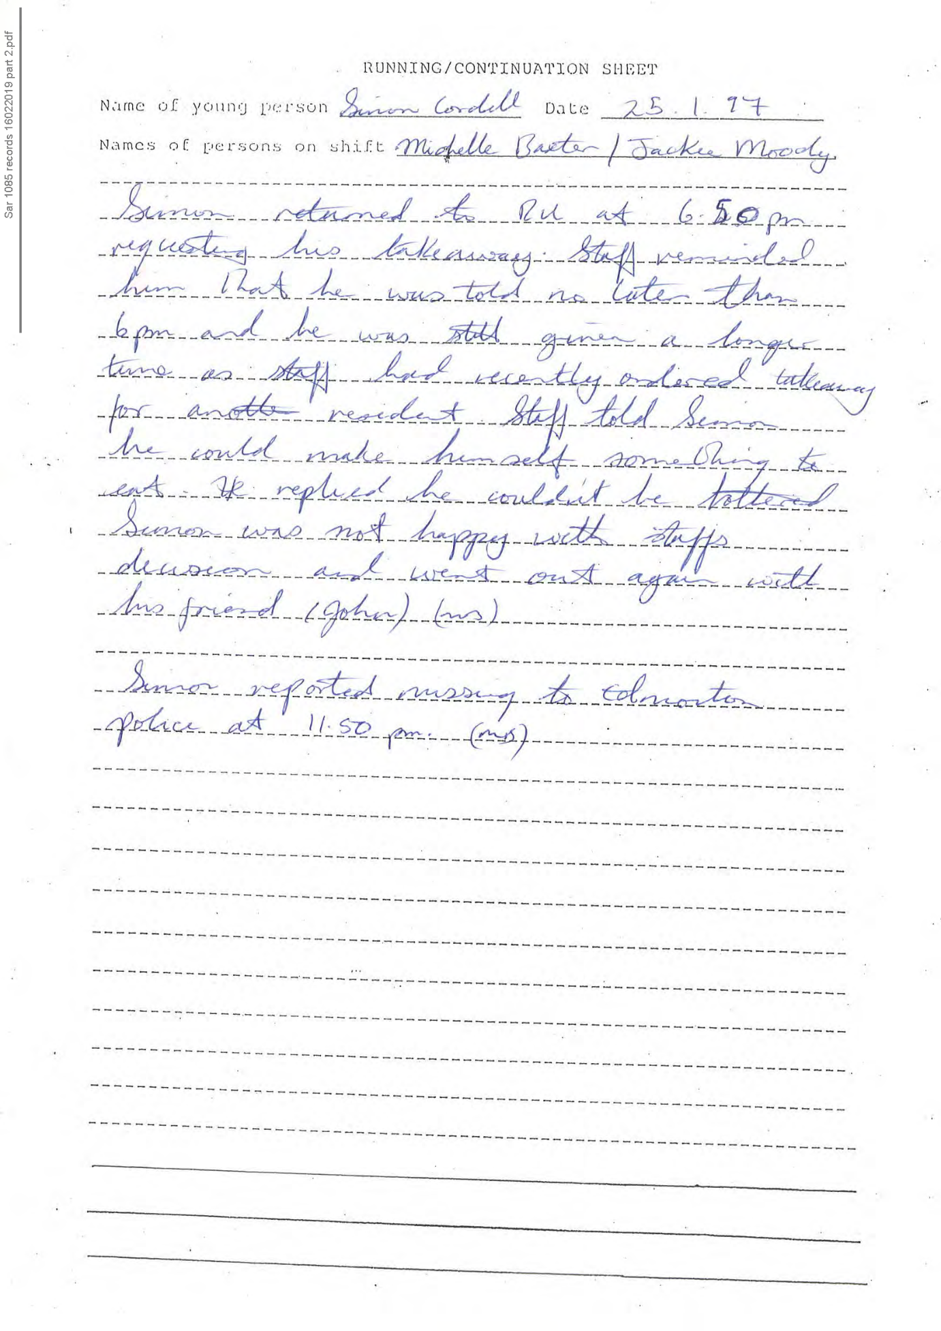
292,
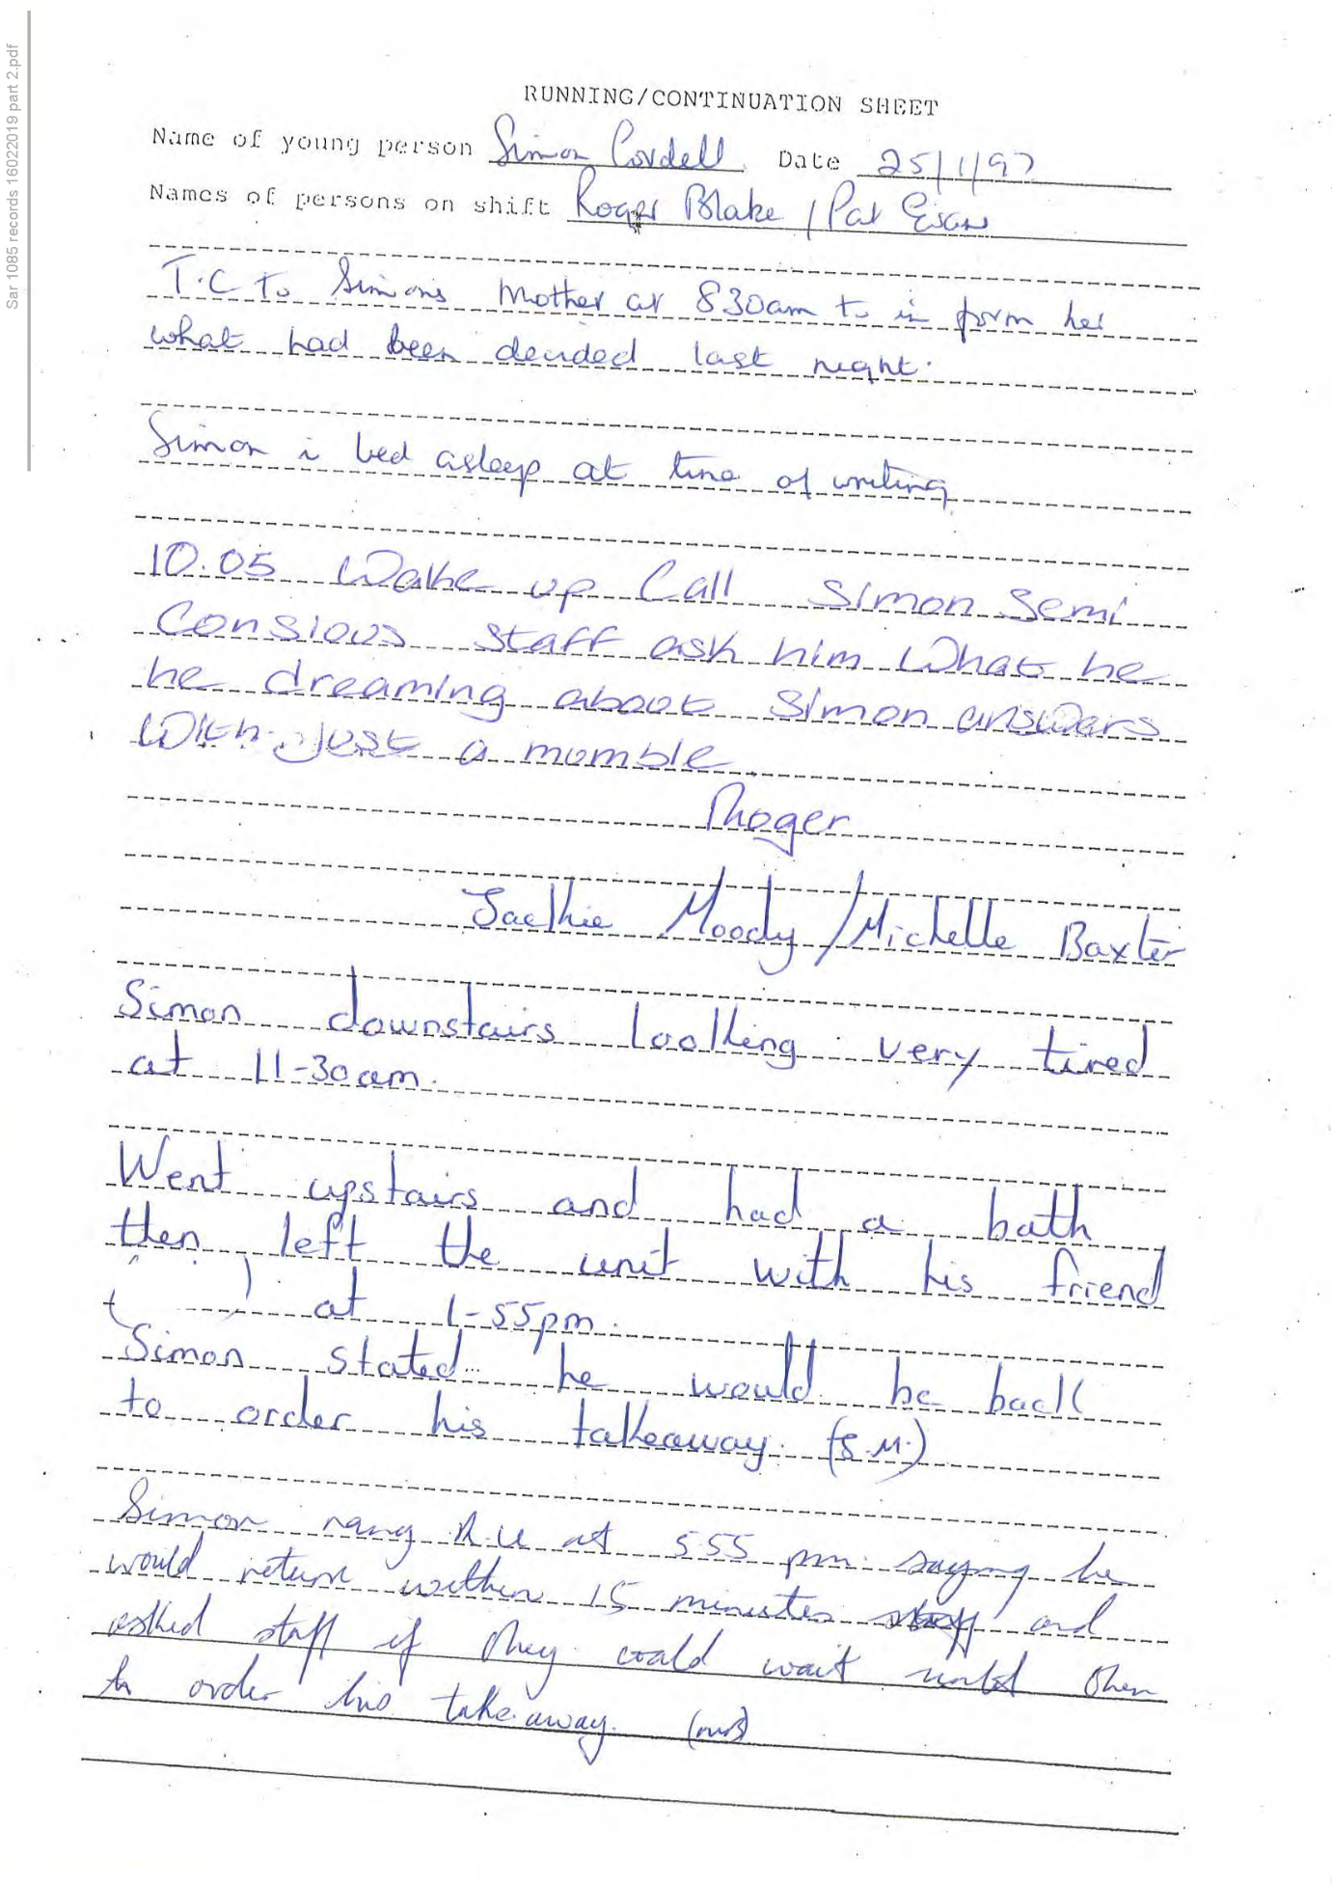
293,
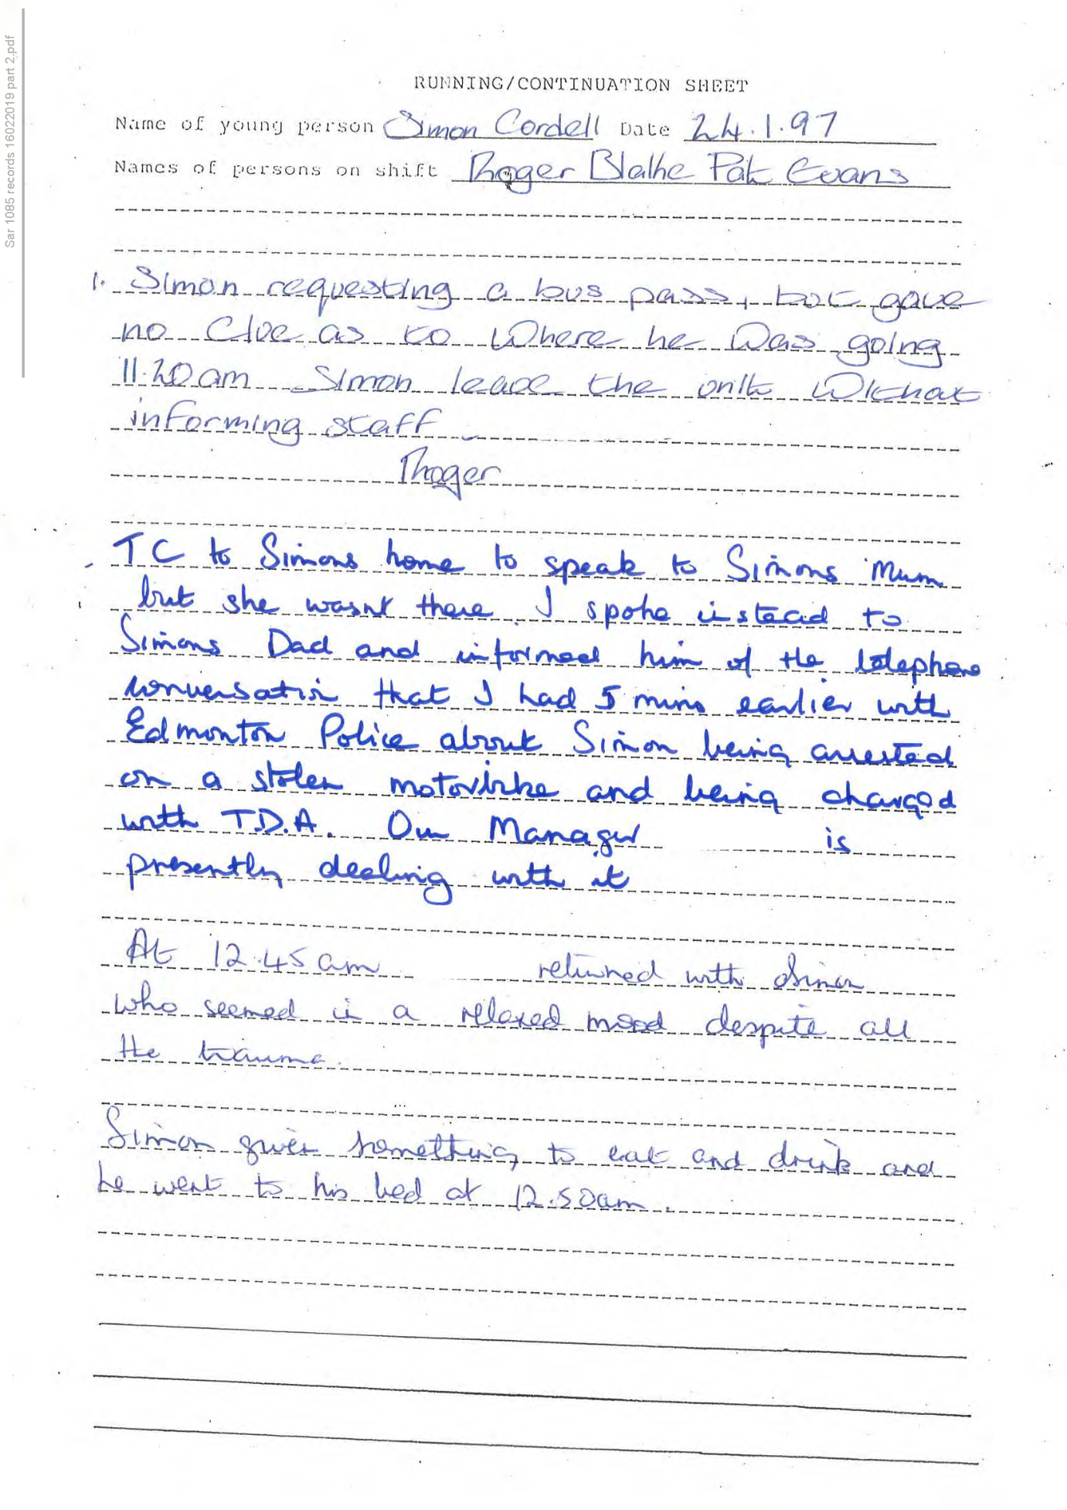
294,
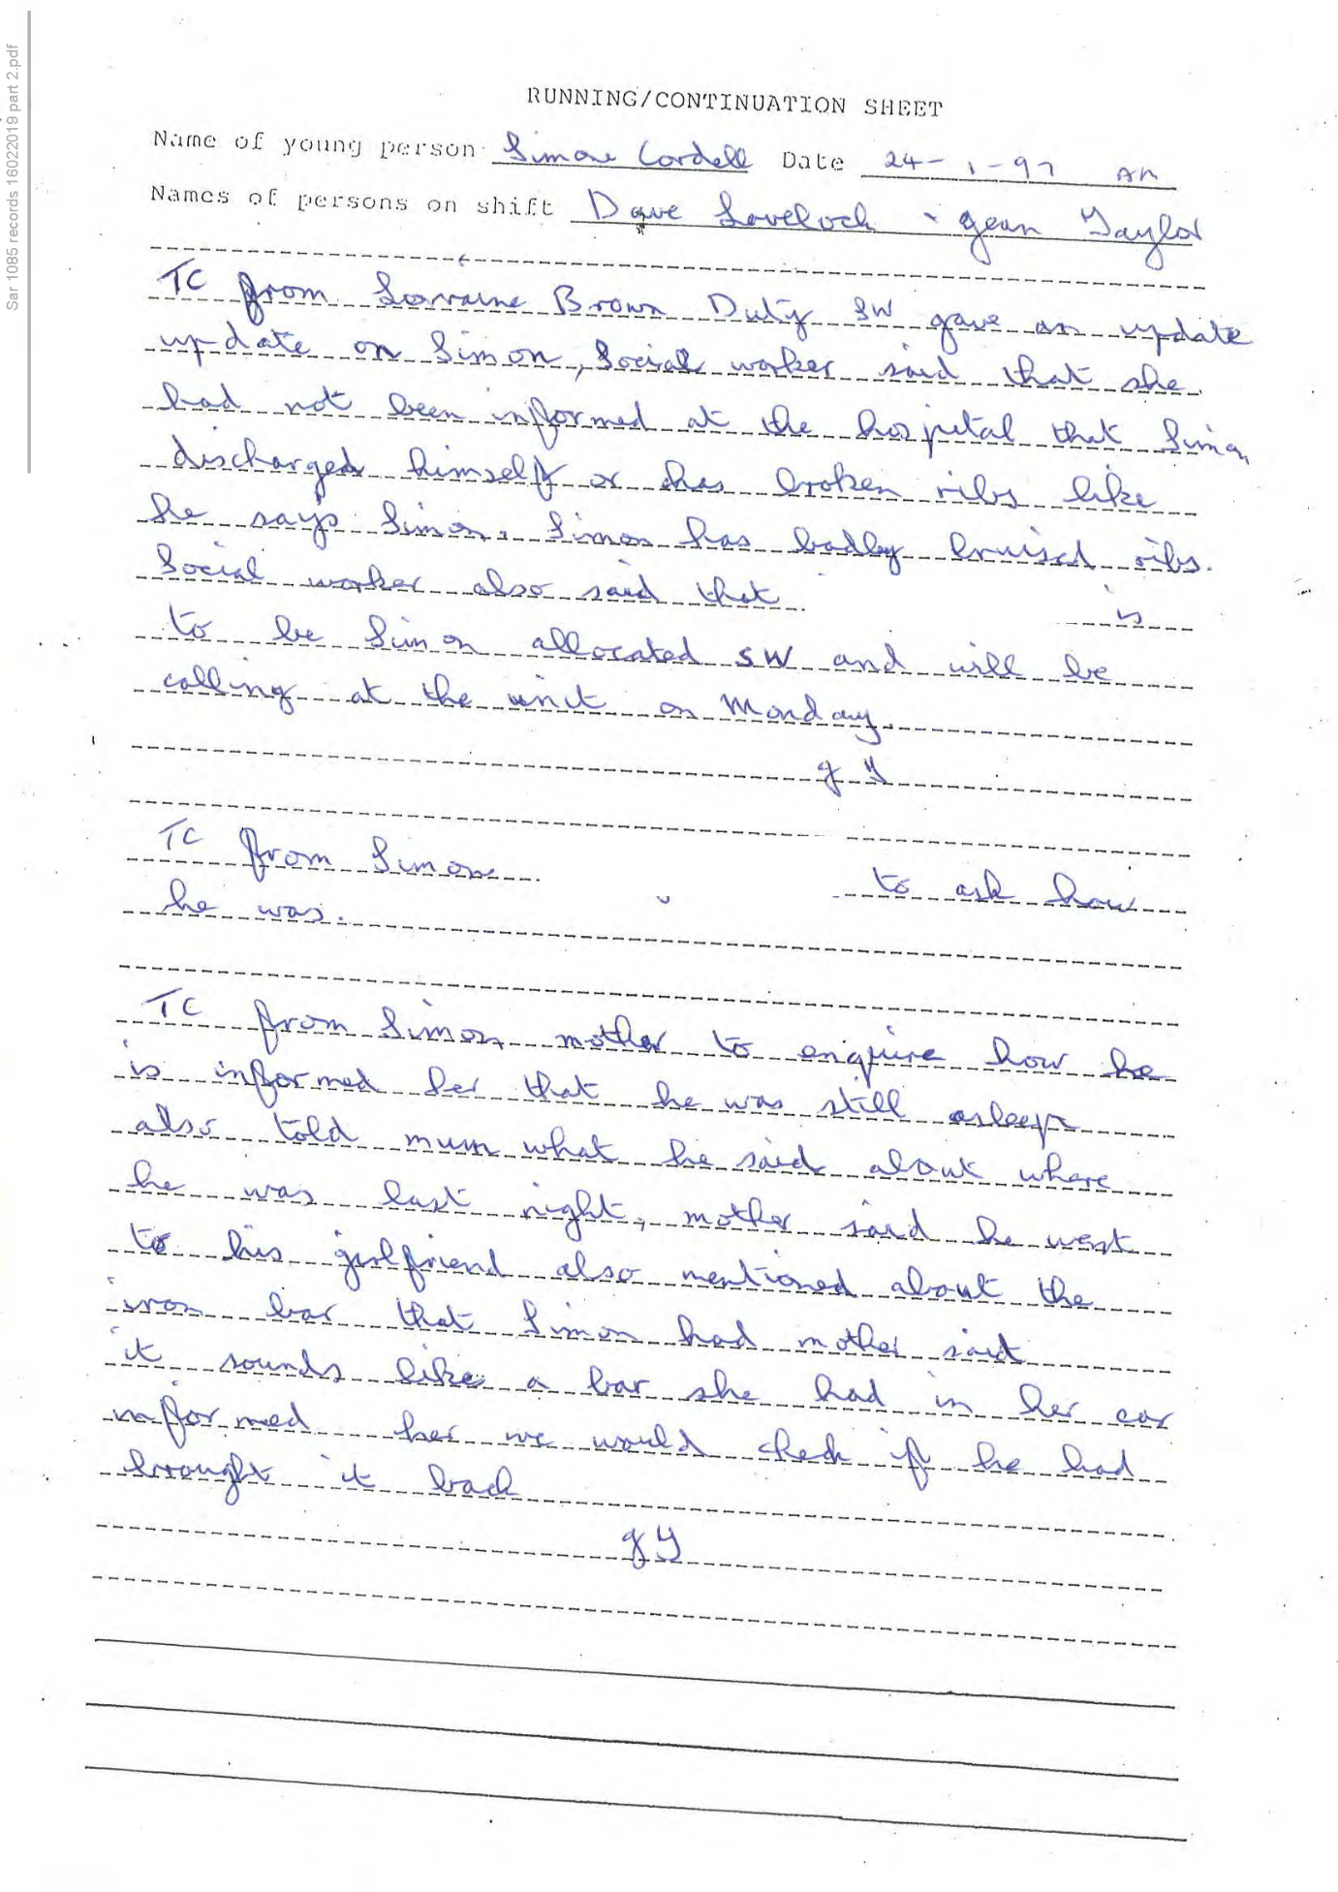
295,
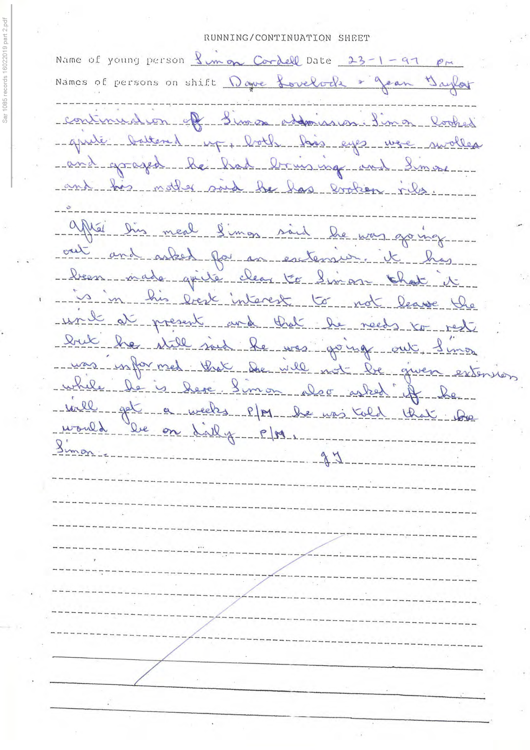
296,
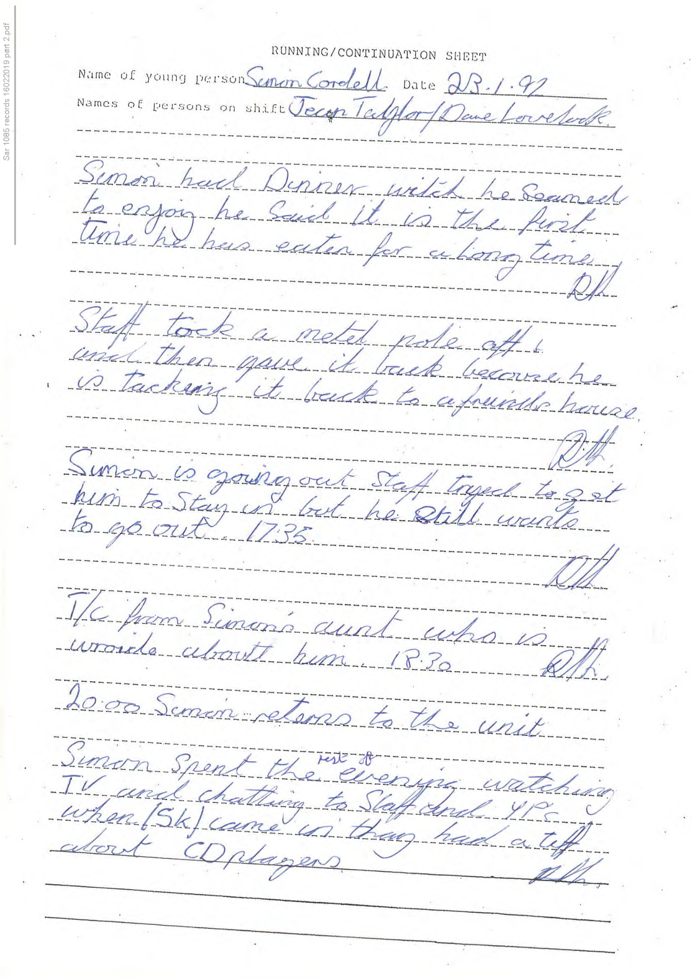
297,
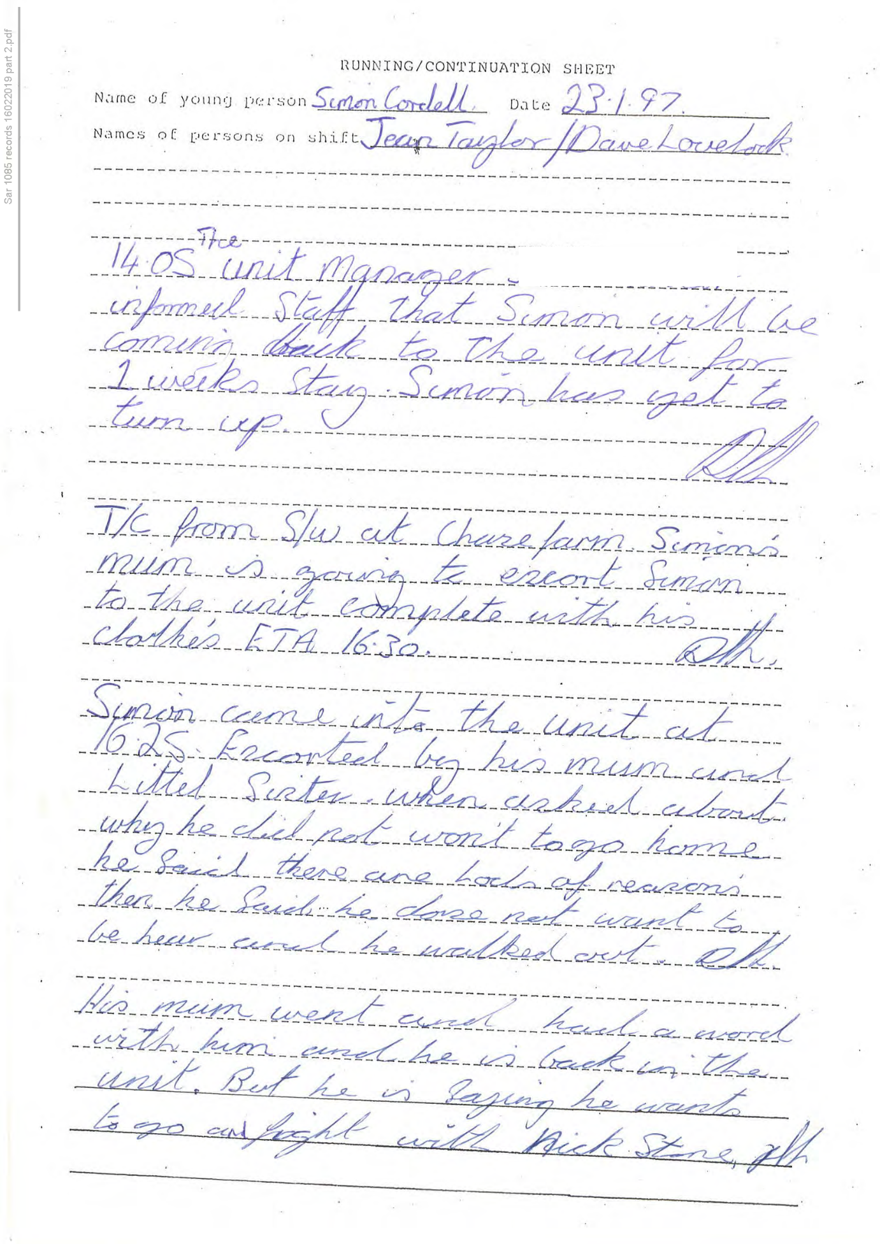
298,
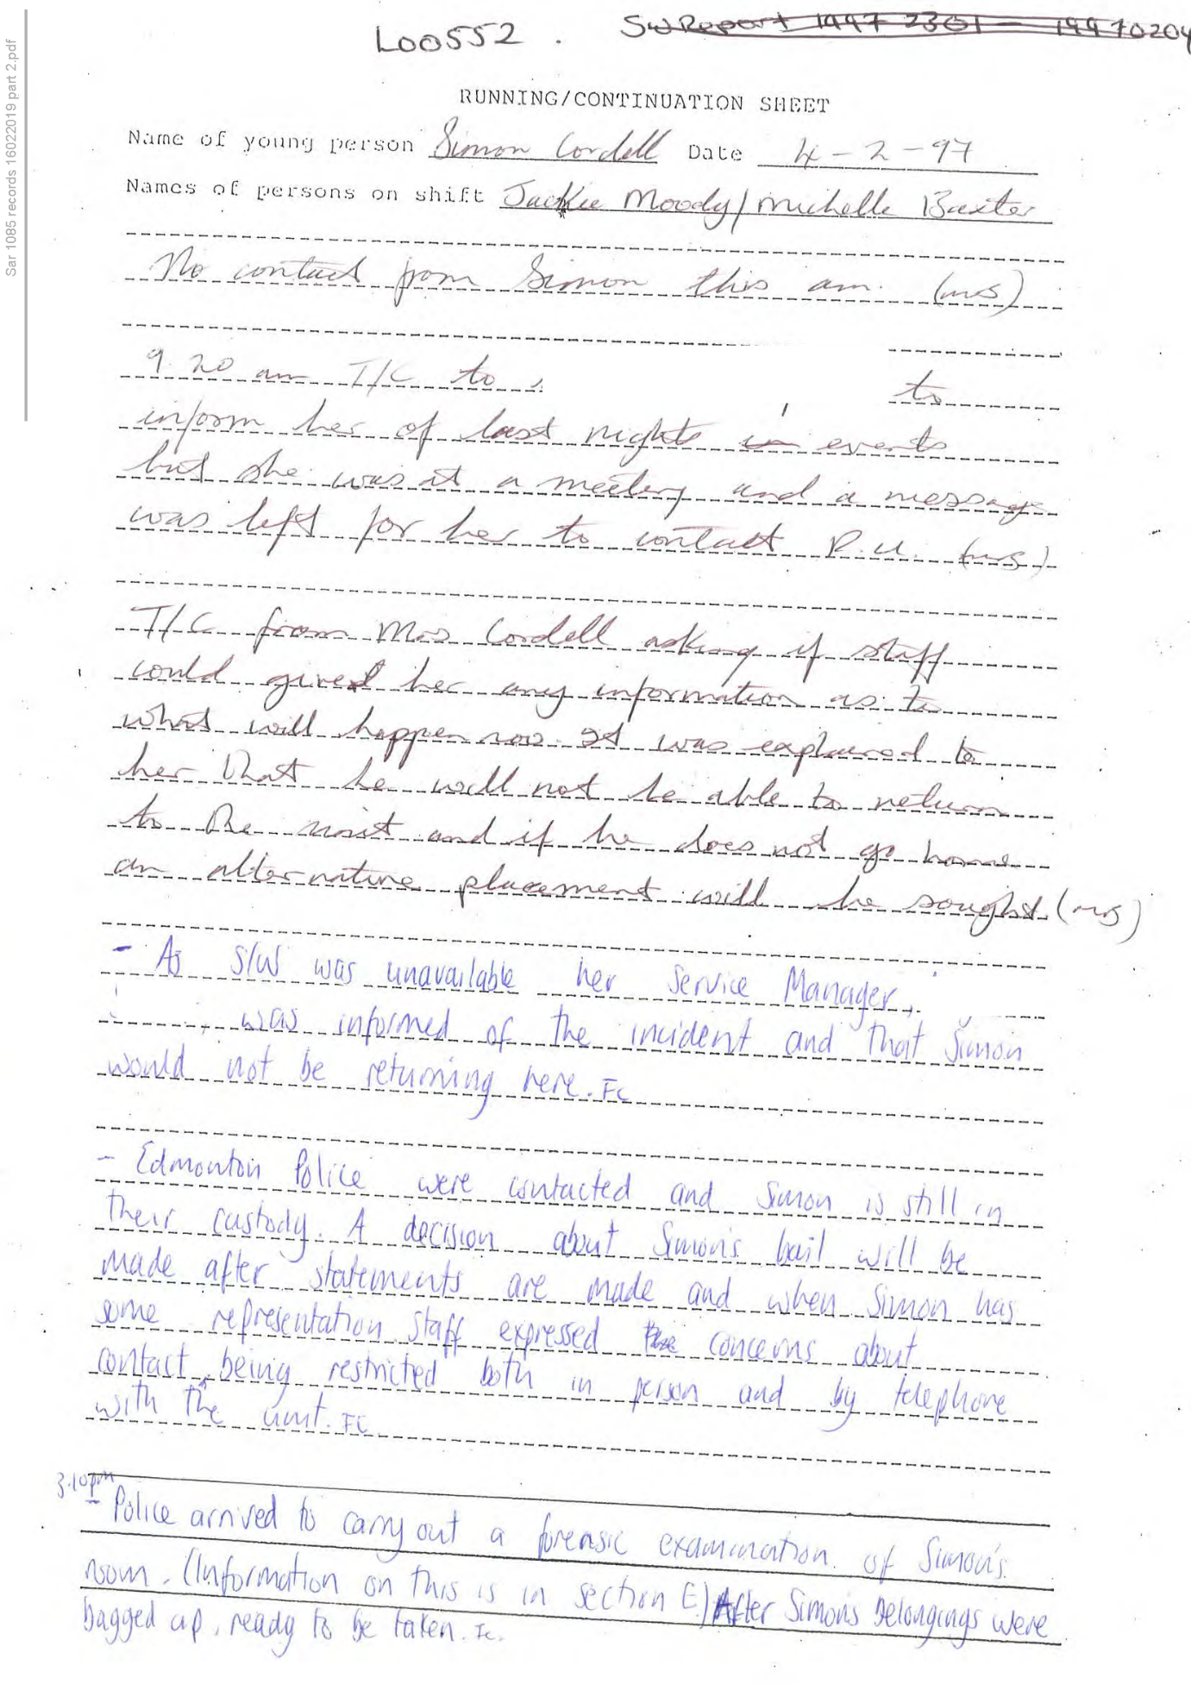
299,
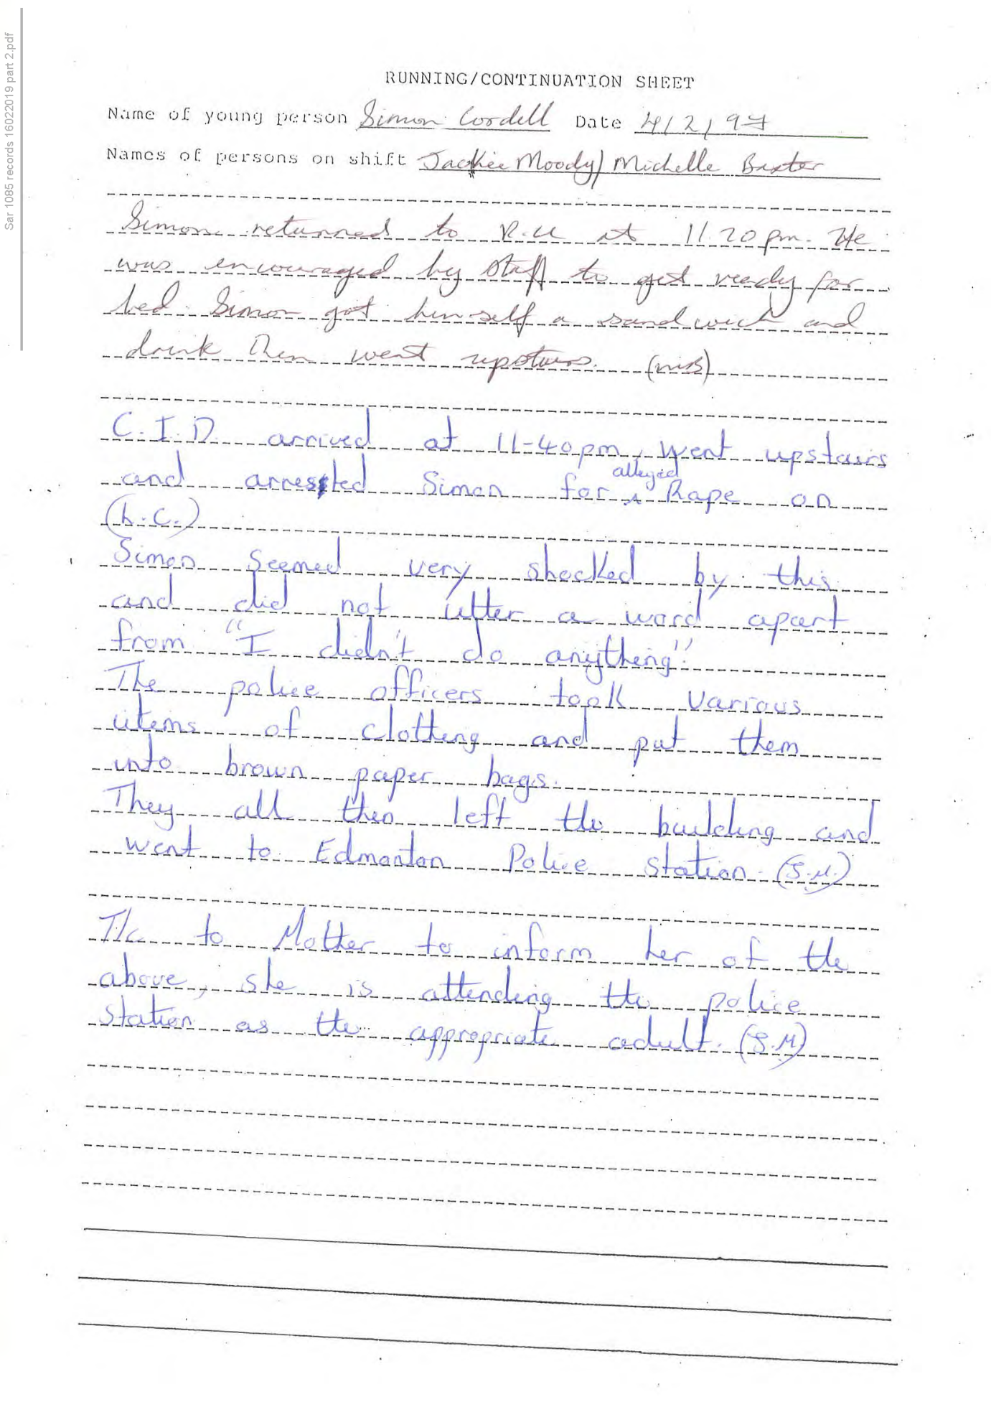
300,
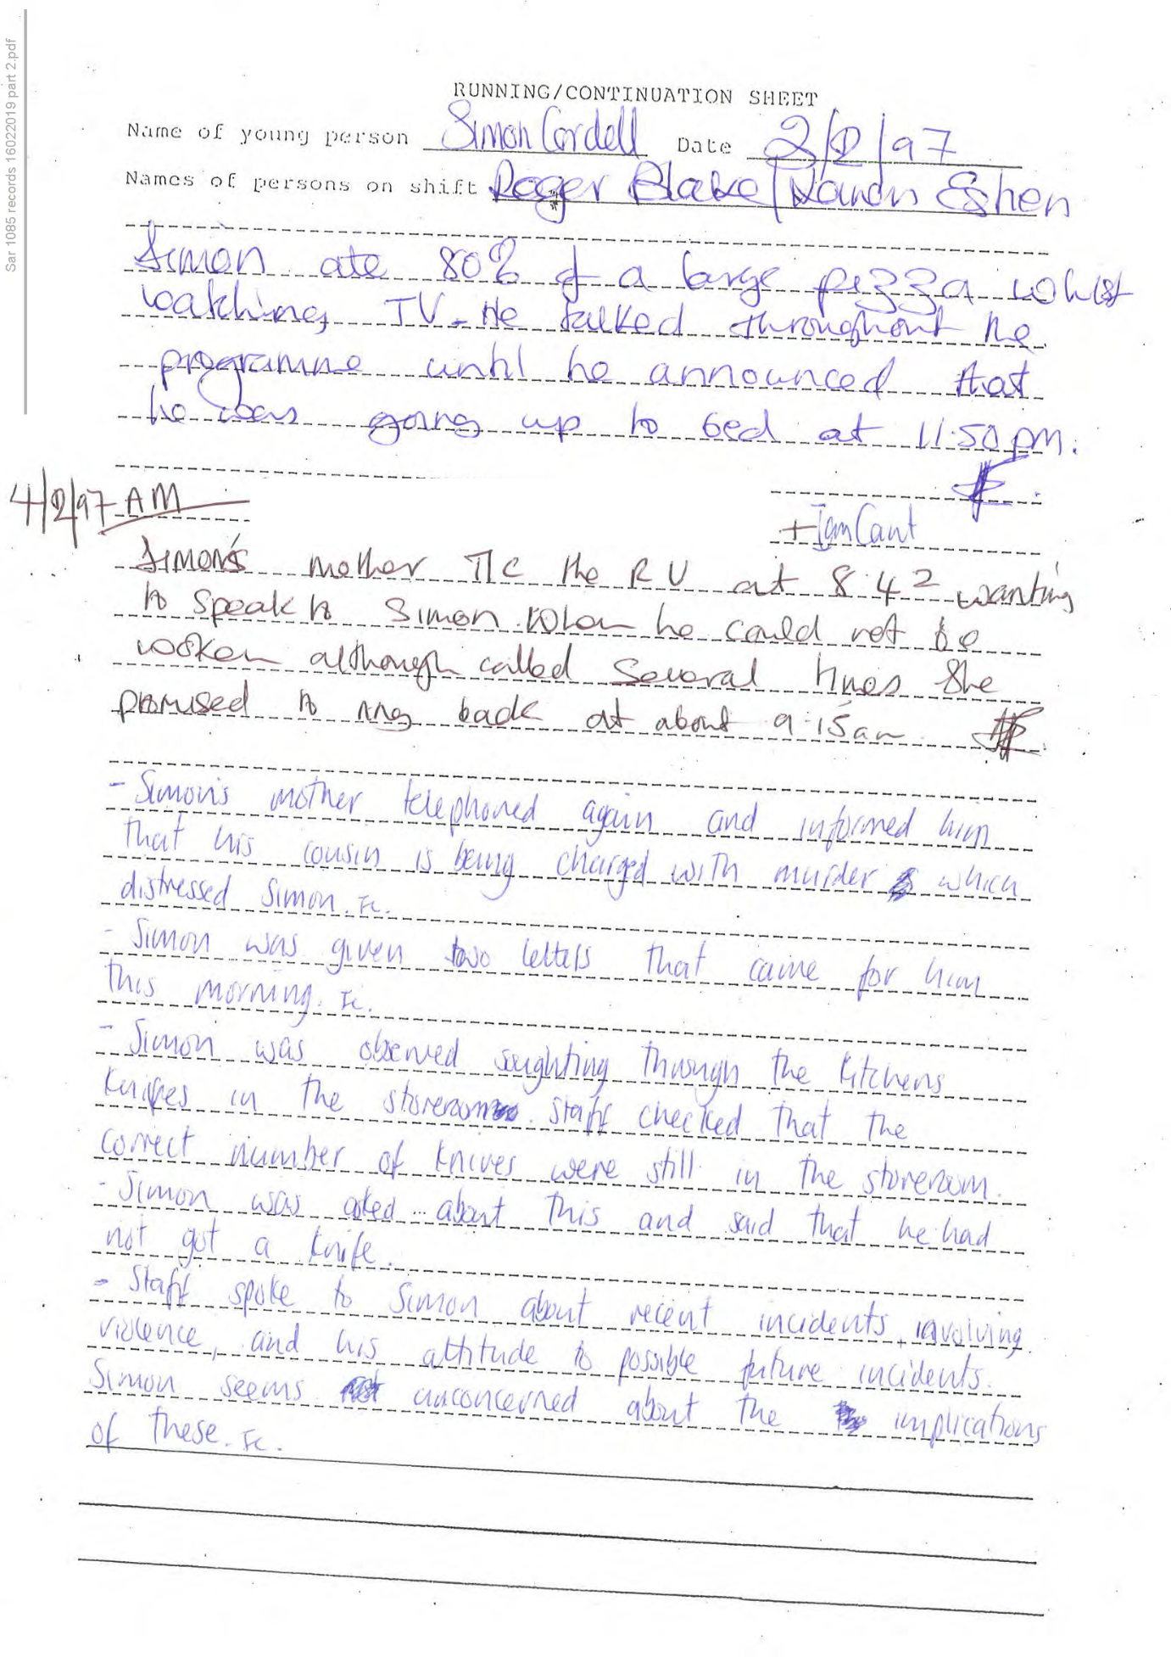
301,
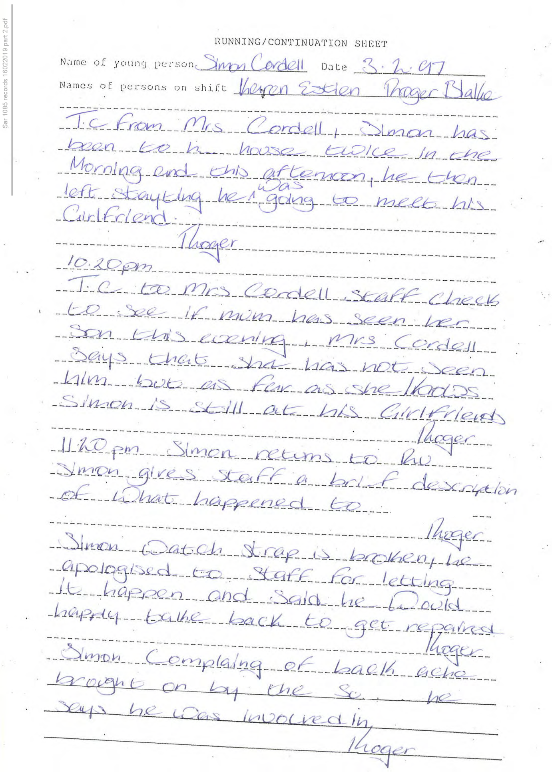
302,
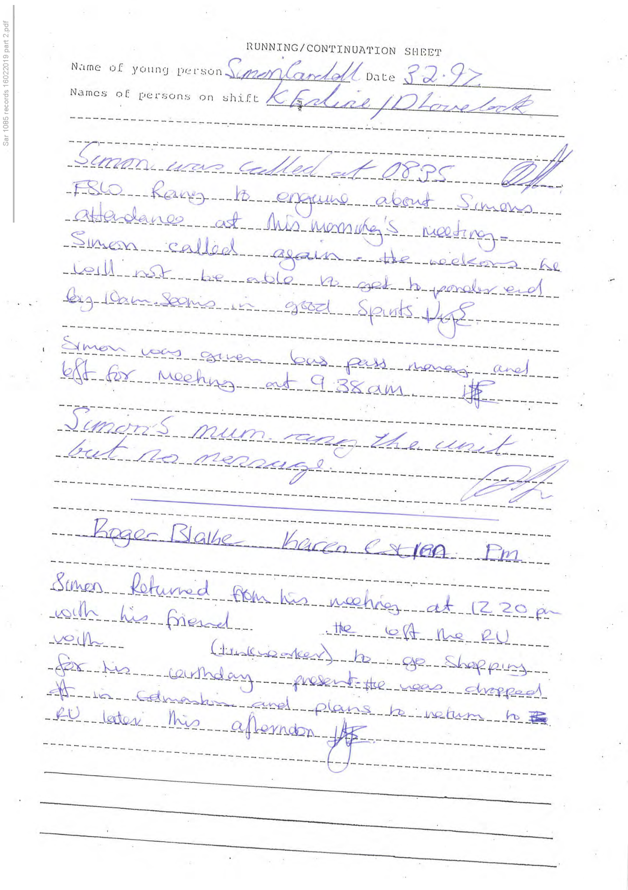
303,
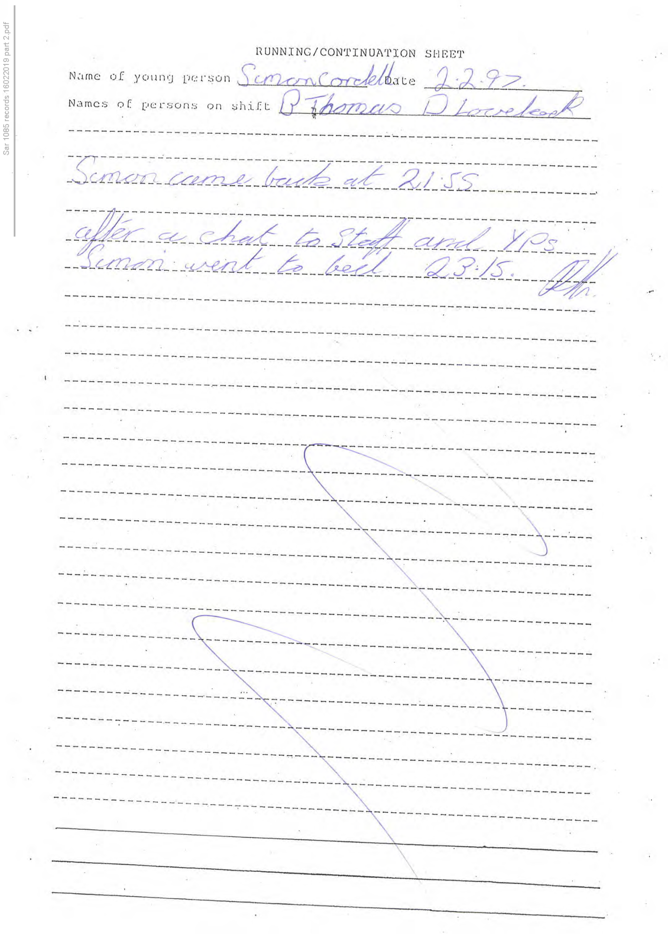
304,
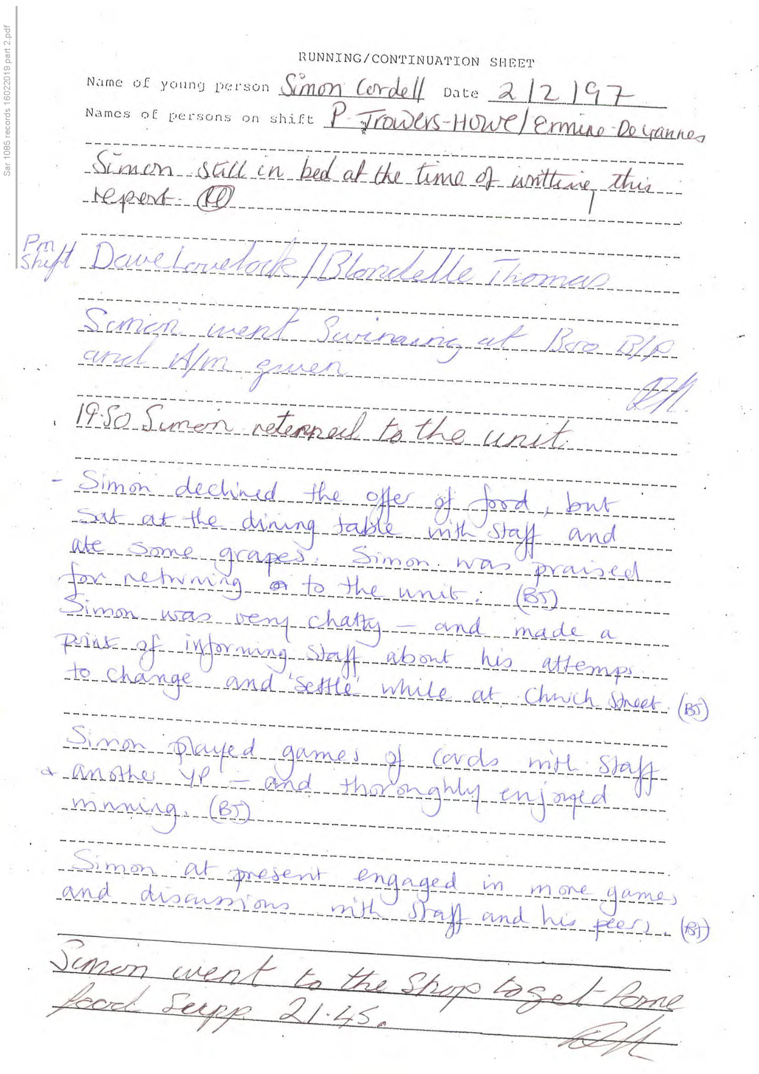
305,
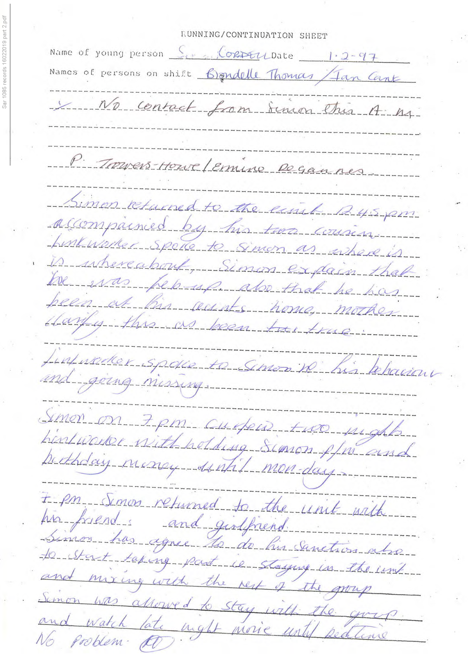
306,
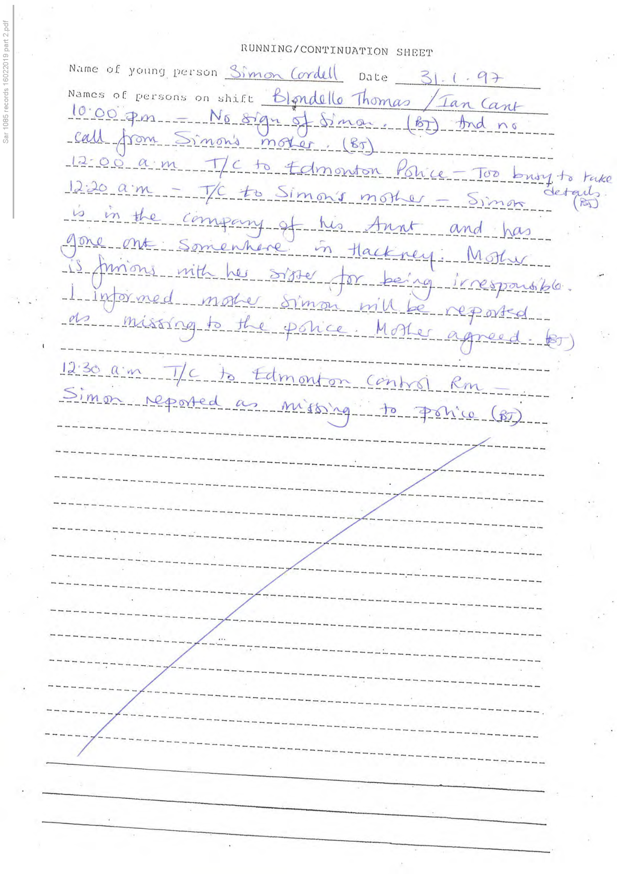
307,
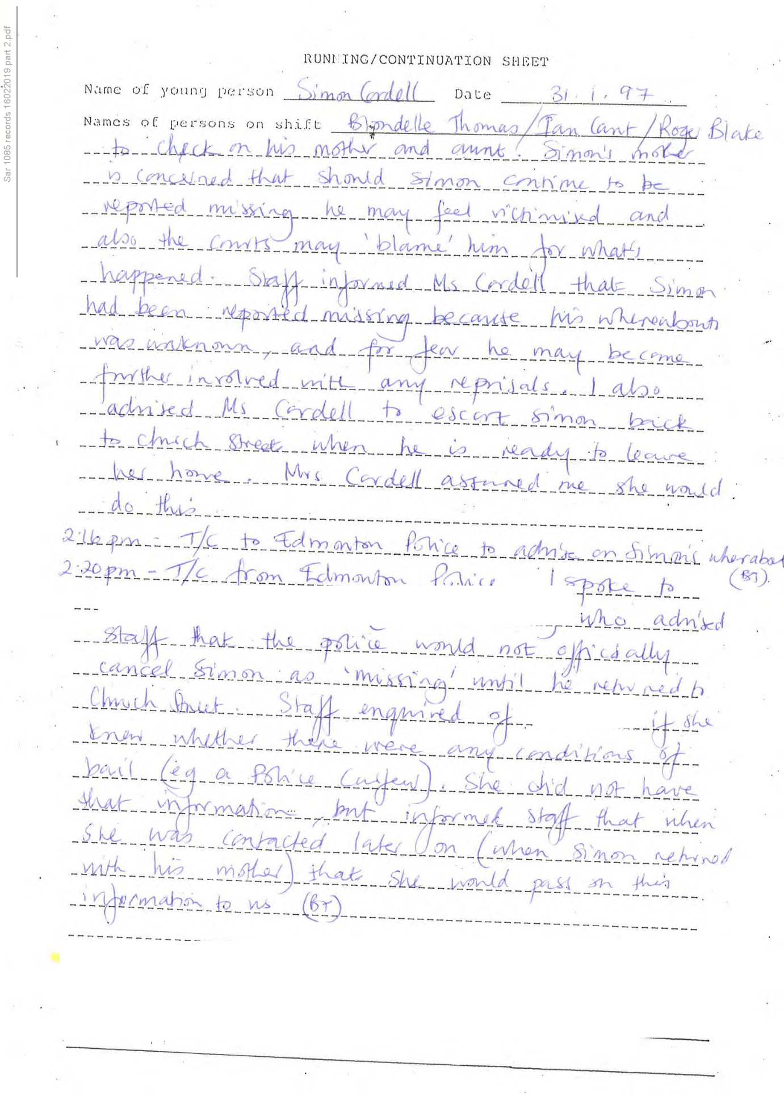
308,
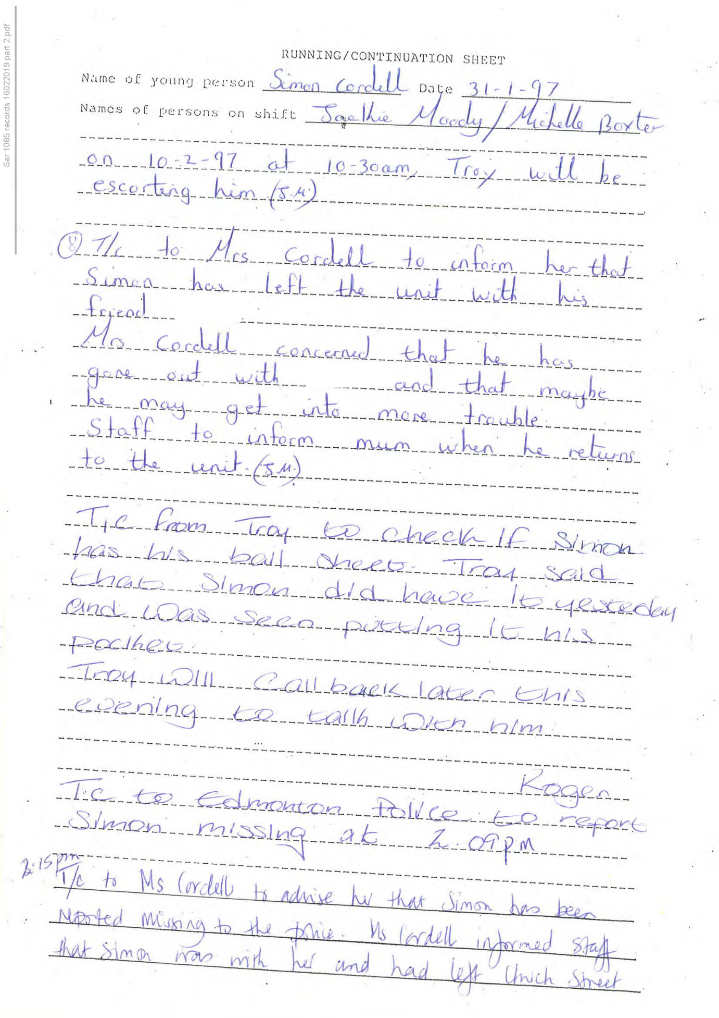
309,
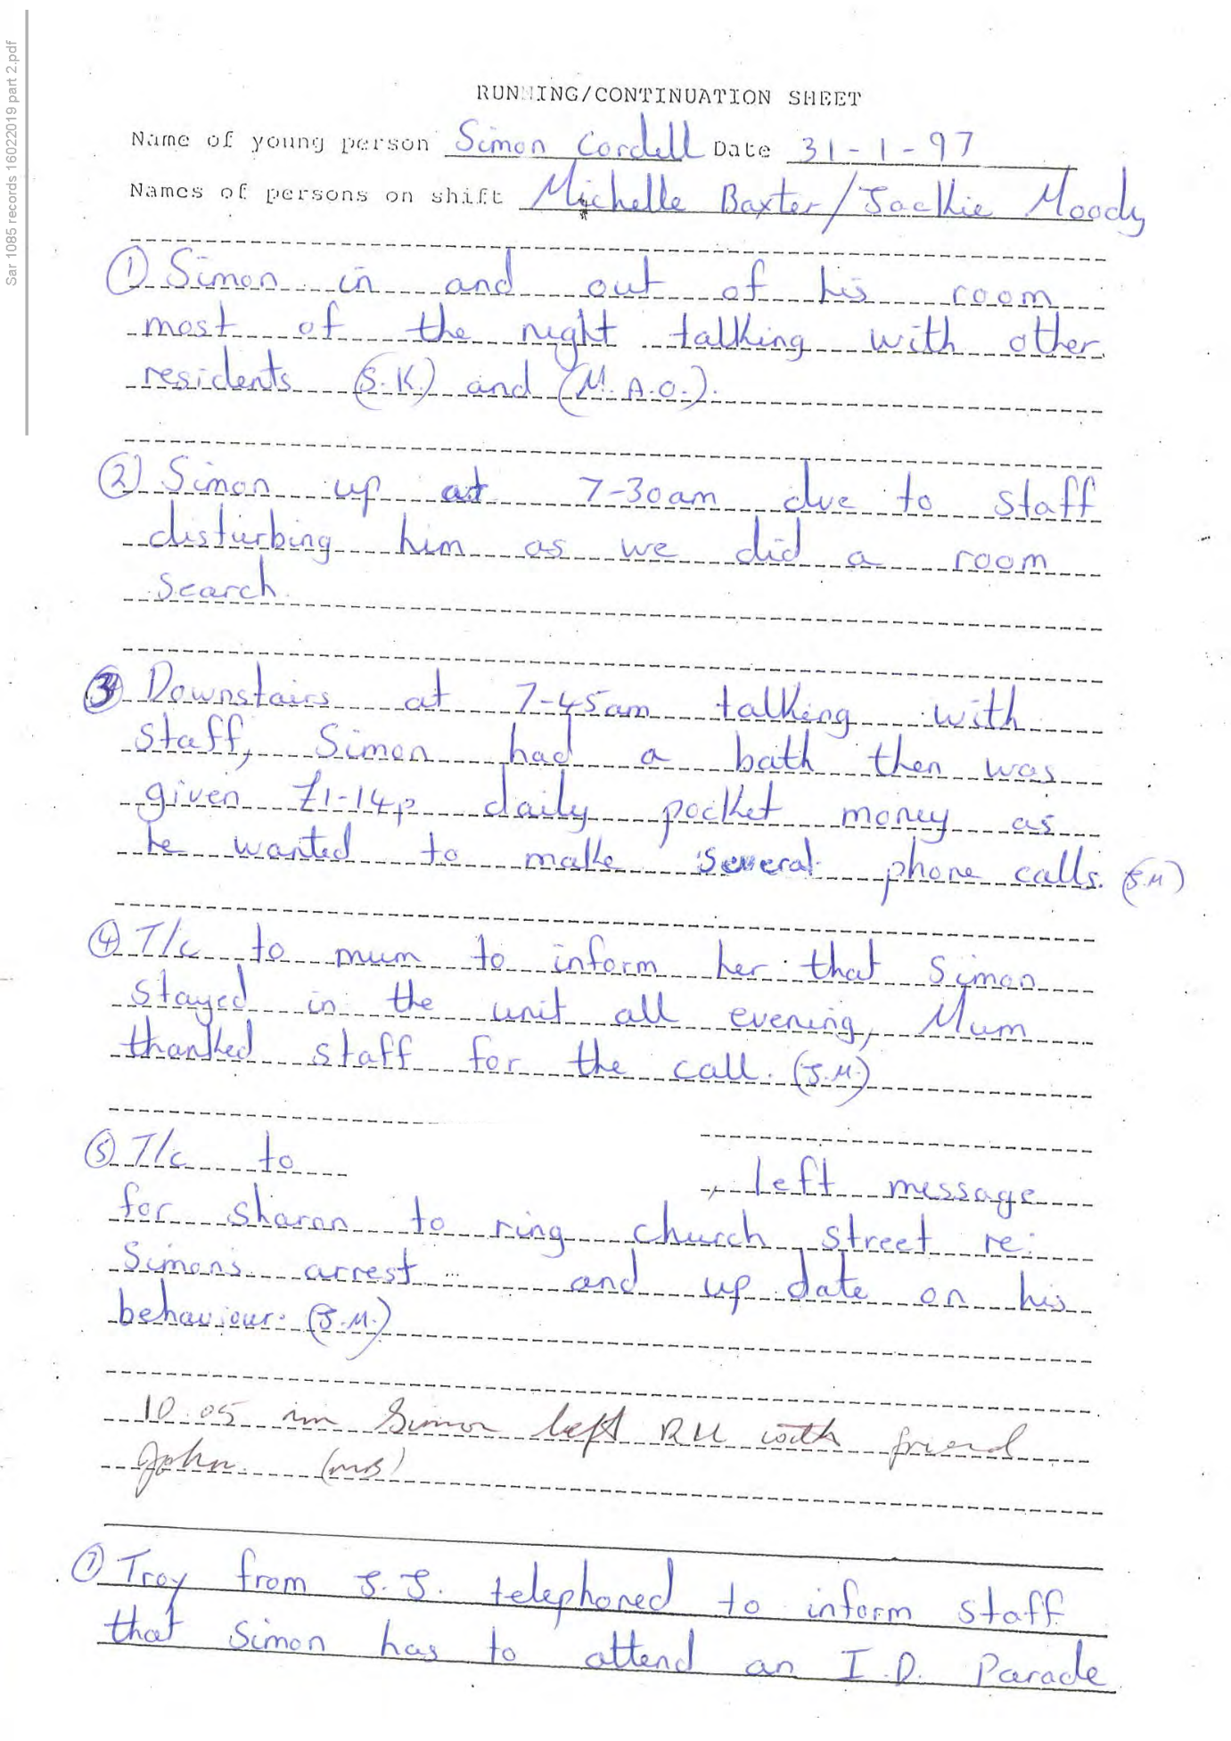
310,
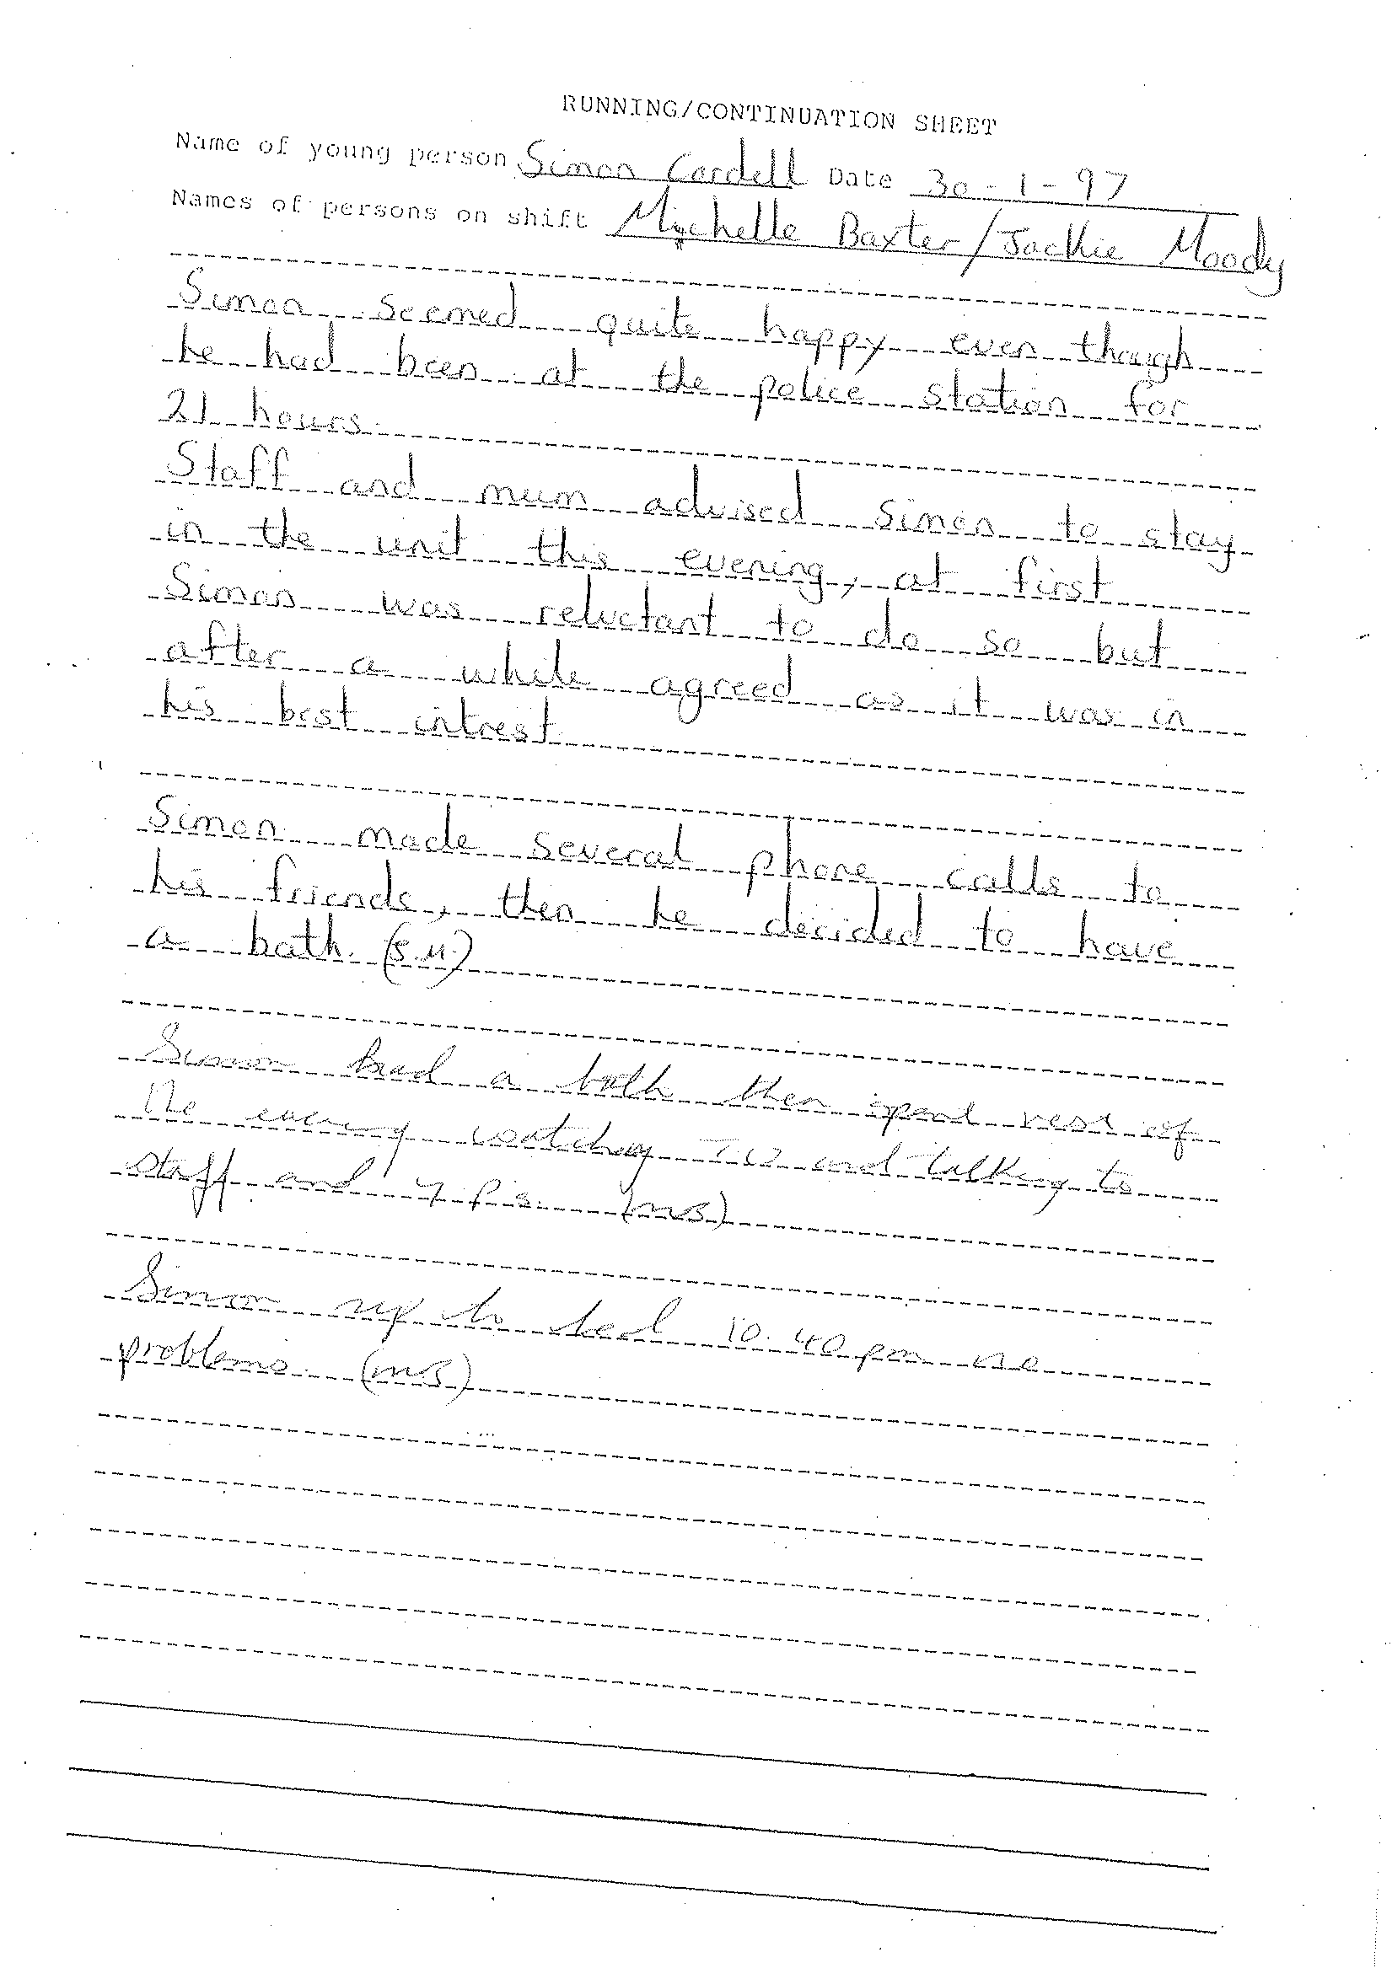
End of Picture!

12.
- Additional Email Attachments & Emails / Issue:
11. 1. 2.
Mother 18-02-2019 -09-26
18/02/2019
/ Page Numbers: 311,312,313,314,
315,316,317,318, 319,320,321,322
--
311,
From: Lorraine Cordell <lorraine32@blueyonder.co.uk>
Sent time: 18/02/2019 09:29:02 PM
To: re_wired@ymail.com
Subject: RE: RE: Enfield Council files Part 003
Attachments: Sar 1085 records 16022019.part 3.pdf
Part 3 of 3
From: Lorraine Cordell
mailto: lorraine32@blueyonder.co.uk
Sent: 18 February 2019 21:27
To: re_wired@ymail.com
Subject: RE: RE: Enfield Council files Part 002
Part 2 of 3
From: Lorraine Cordell
mailto: lorraine32@blueyonder.co.uk
Sent: 18 February 2019 21:26
To: re_wired@ymail.com
Subject: RE: RE: Enfield Council files Part 001
please see attached please del this email once you have downloaded files 1 of 3
312,
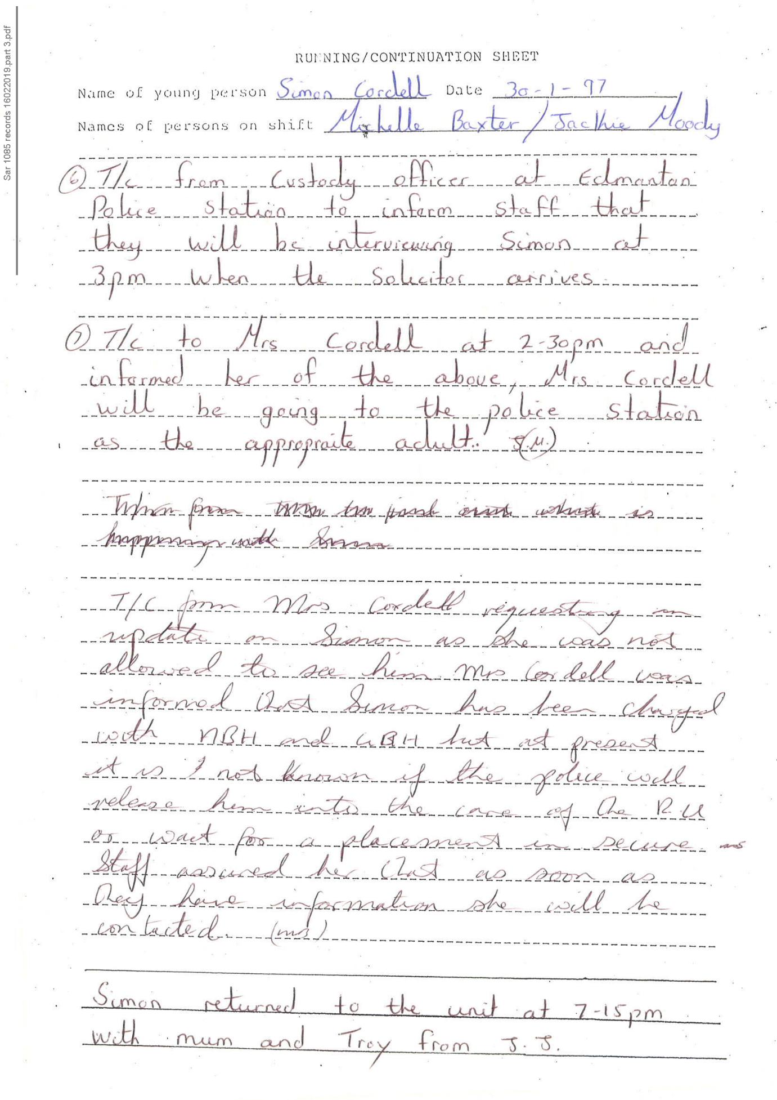
313,
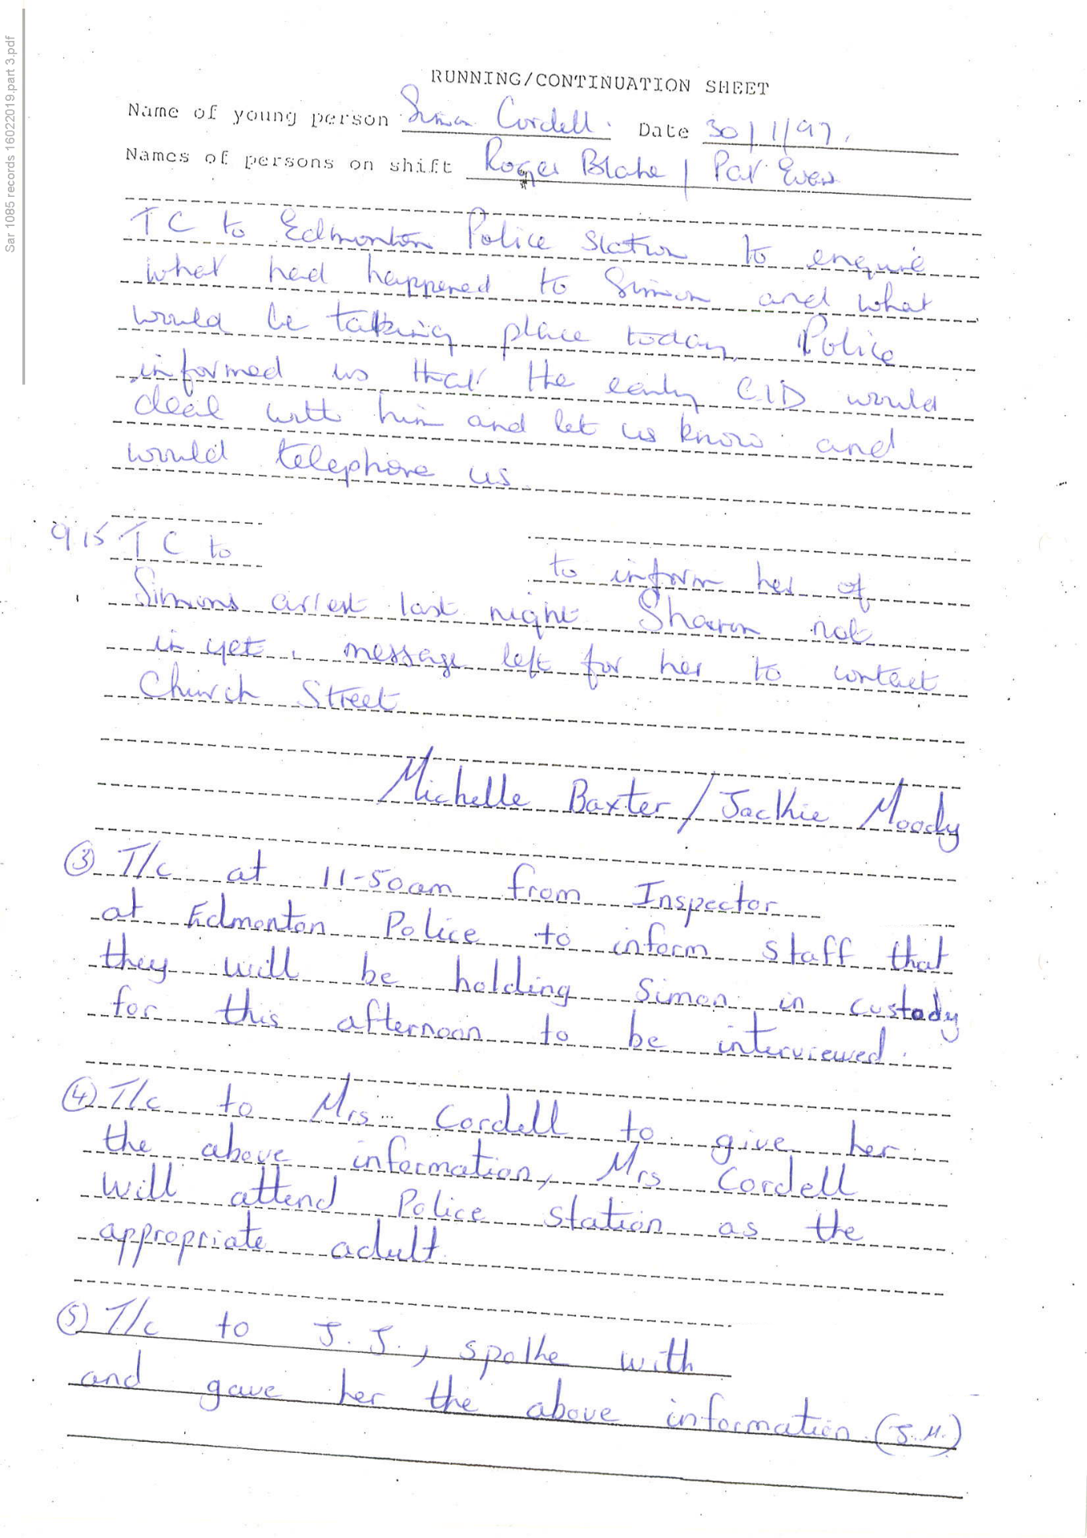
314,
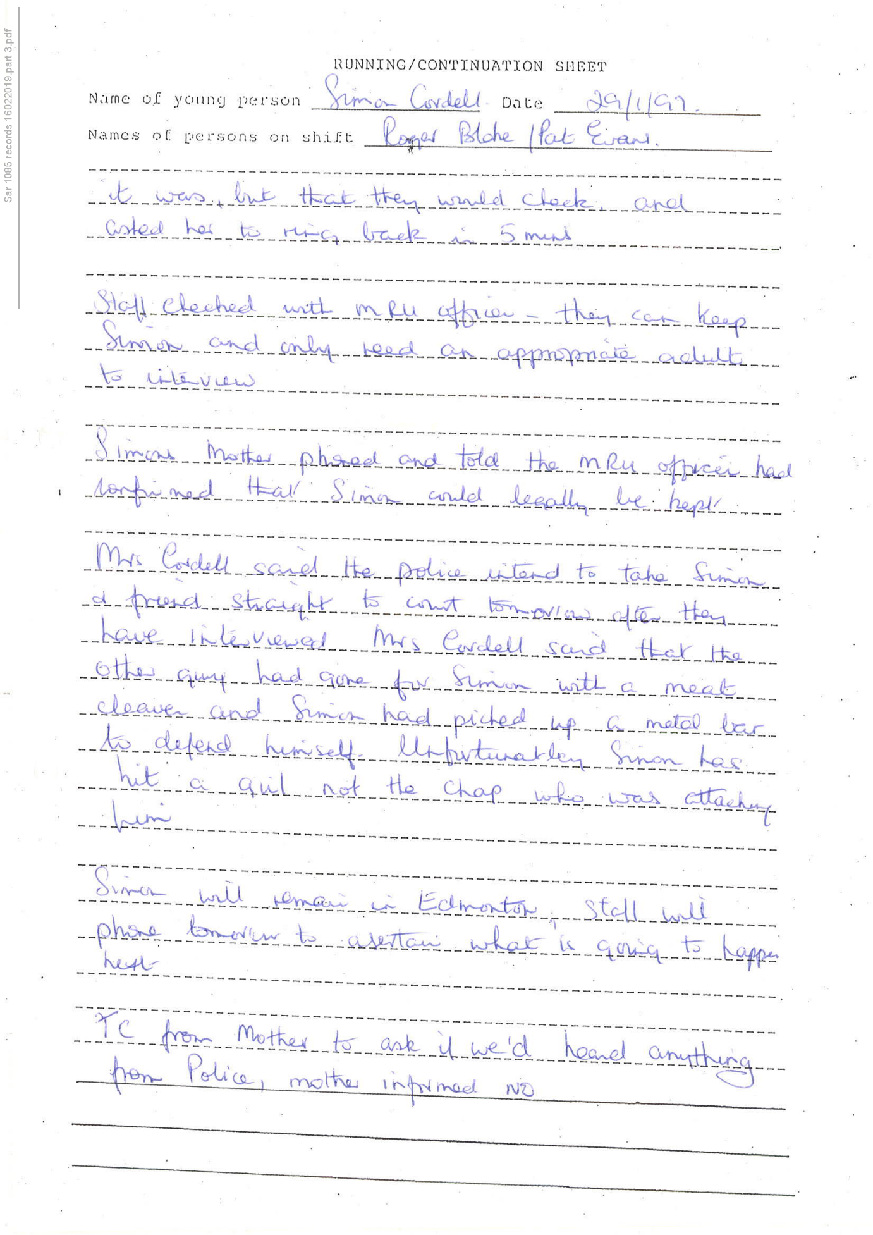
315,
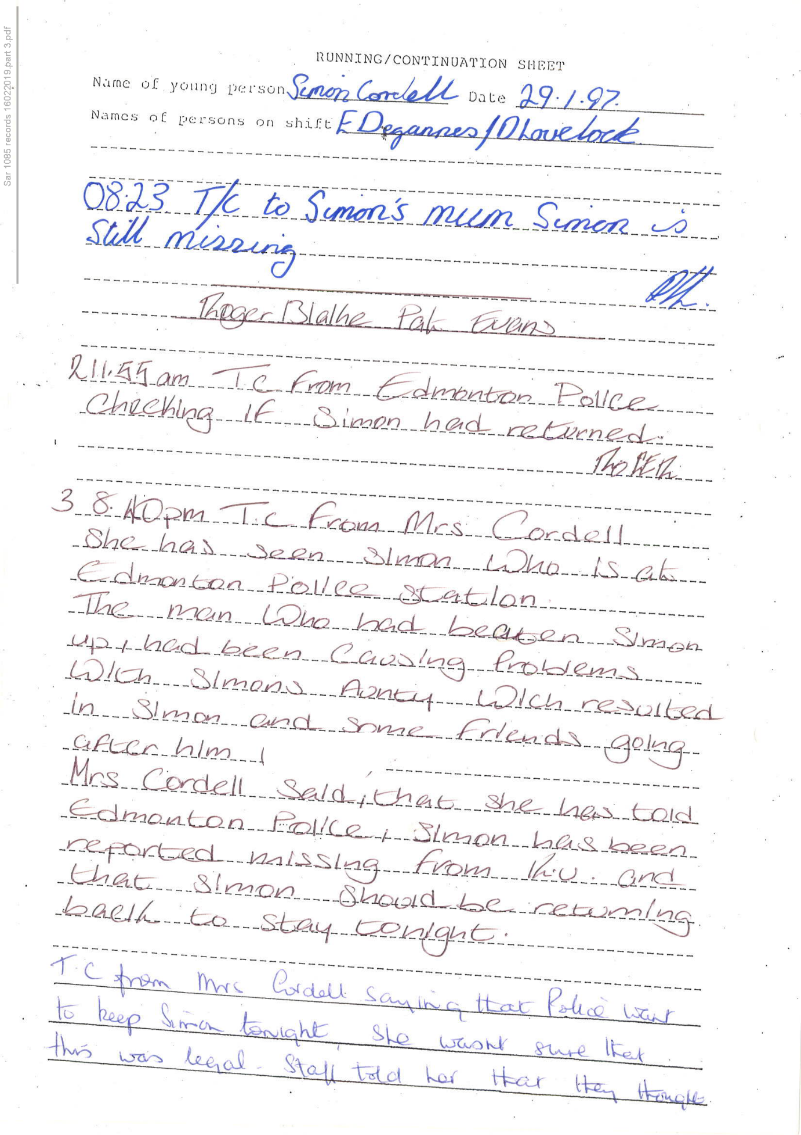
316,
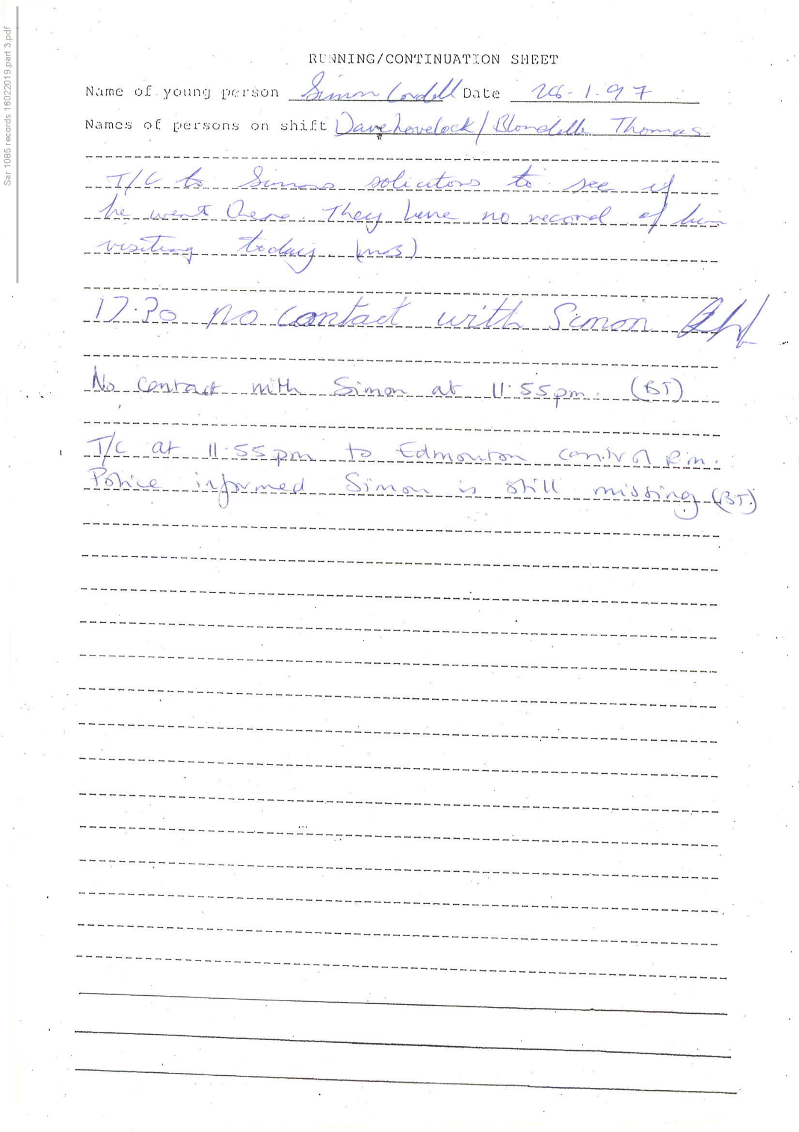
317,
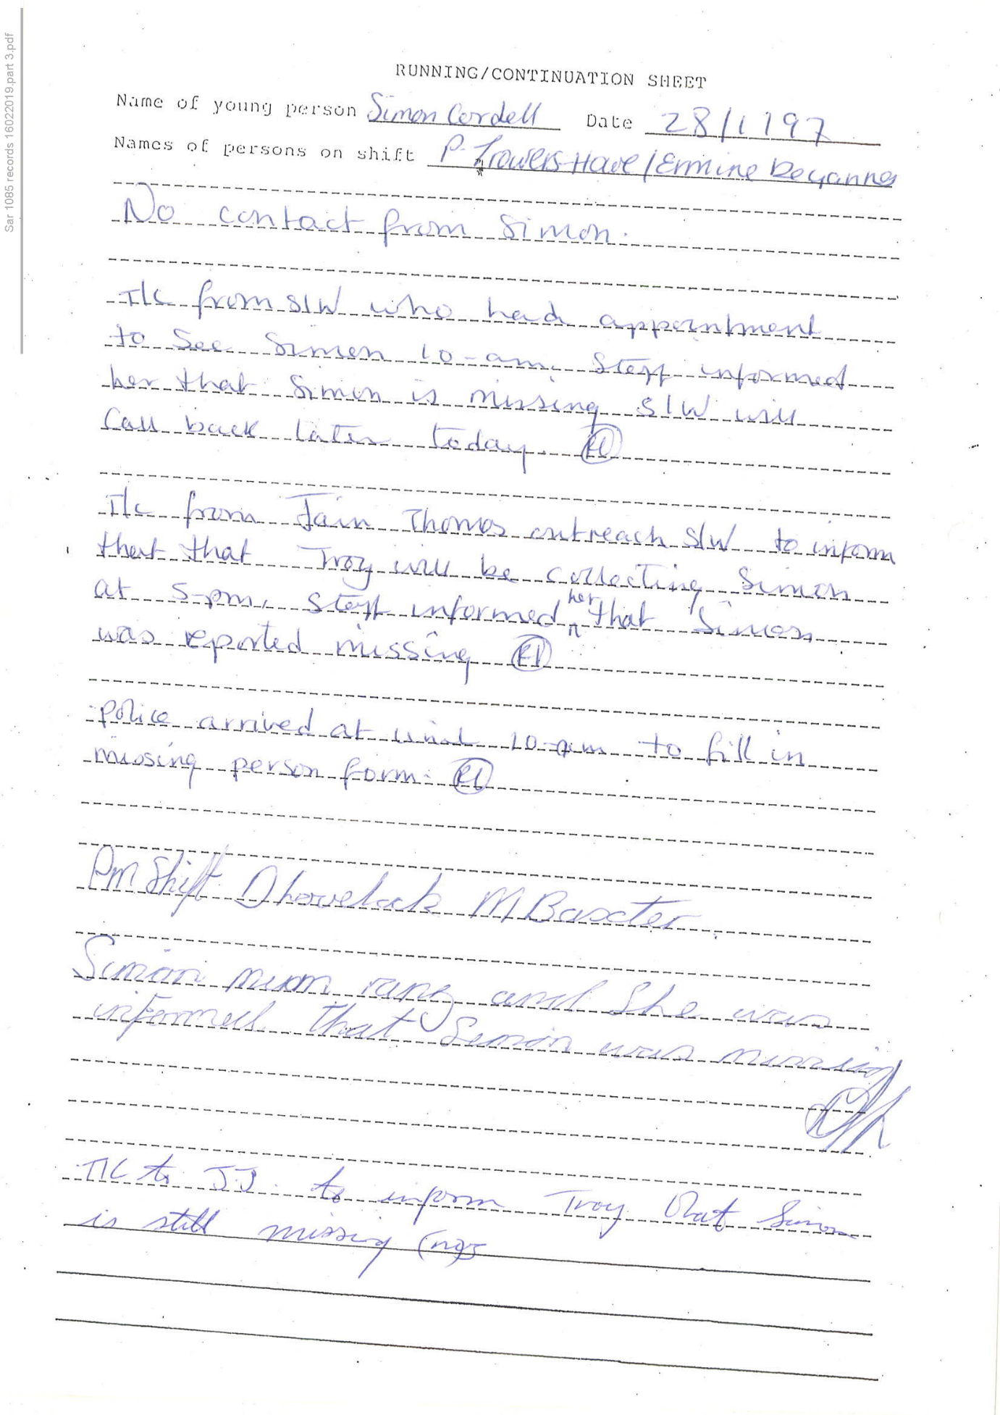
318,
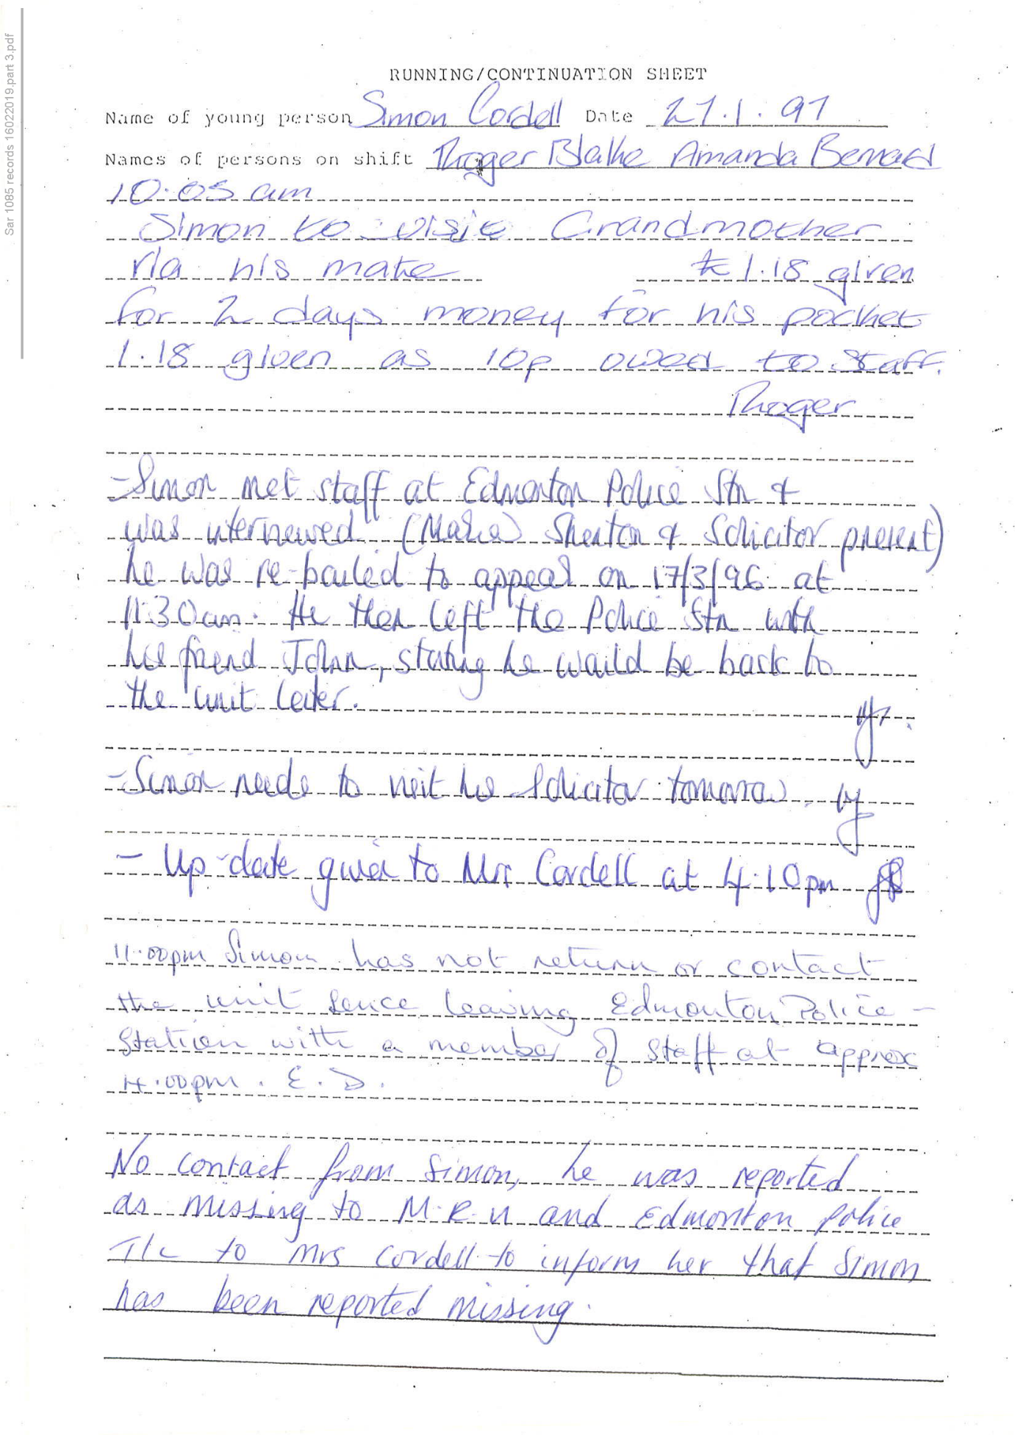
319,
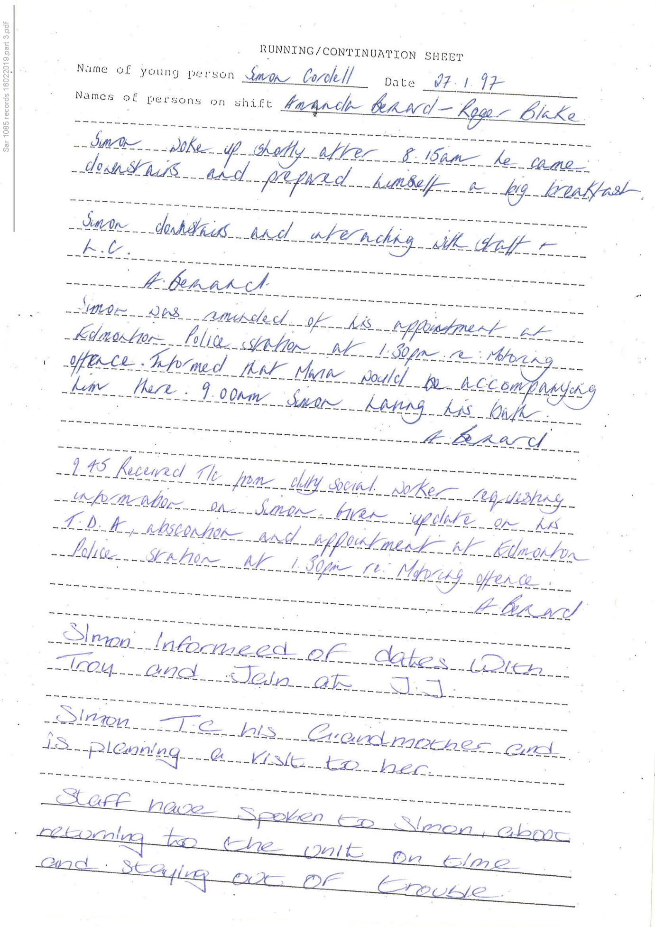
320,
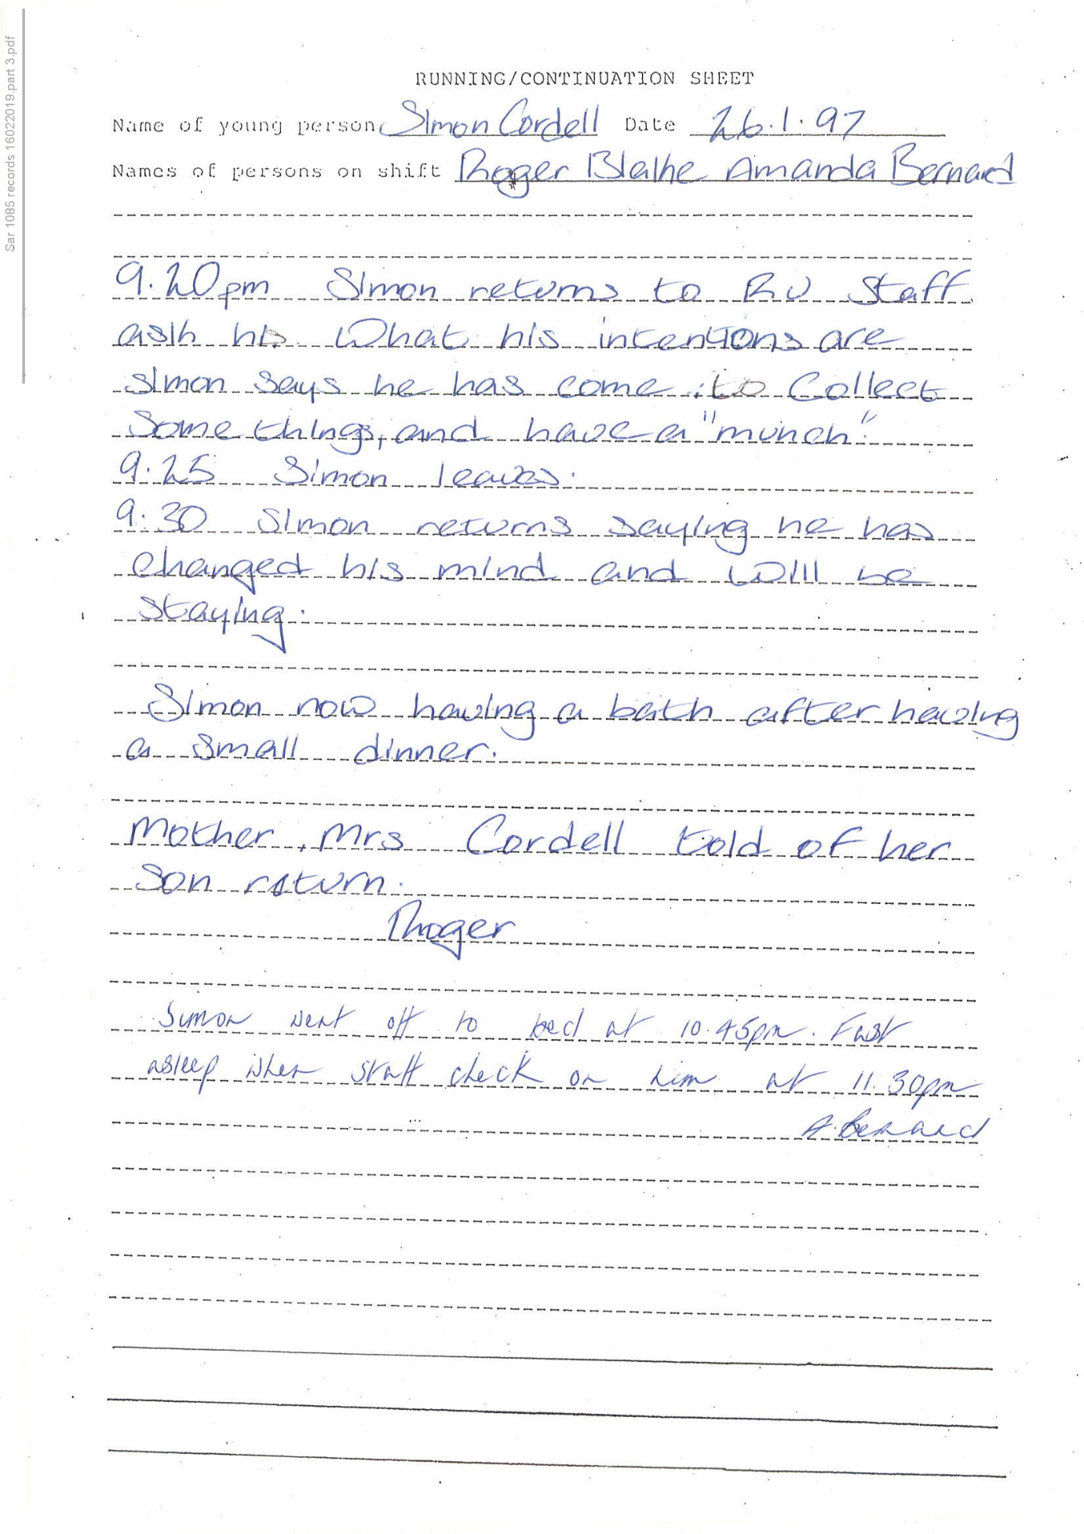
321,
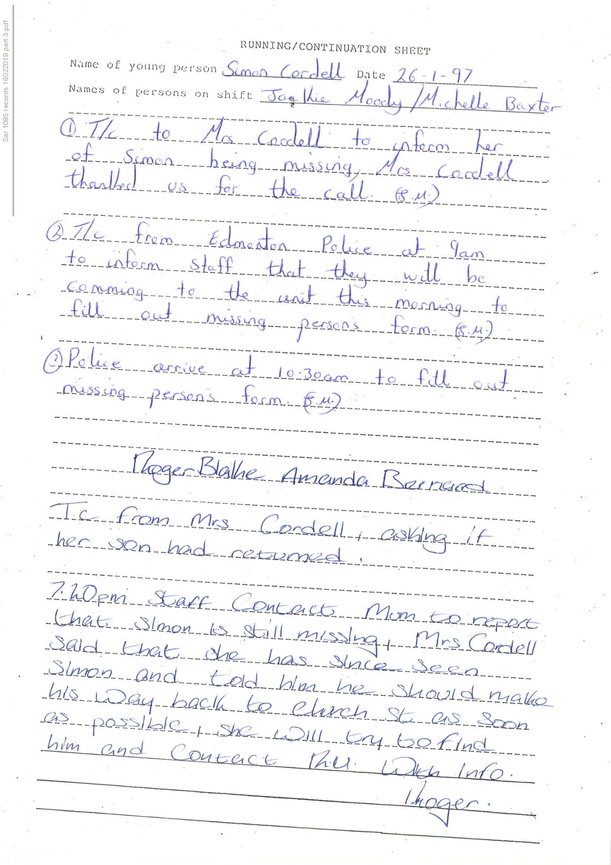
322,
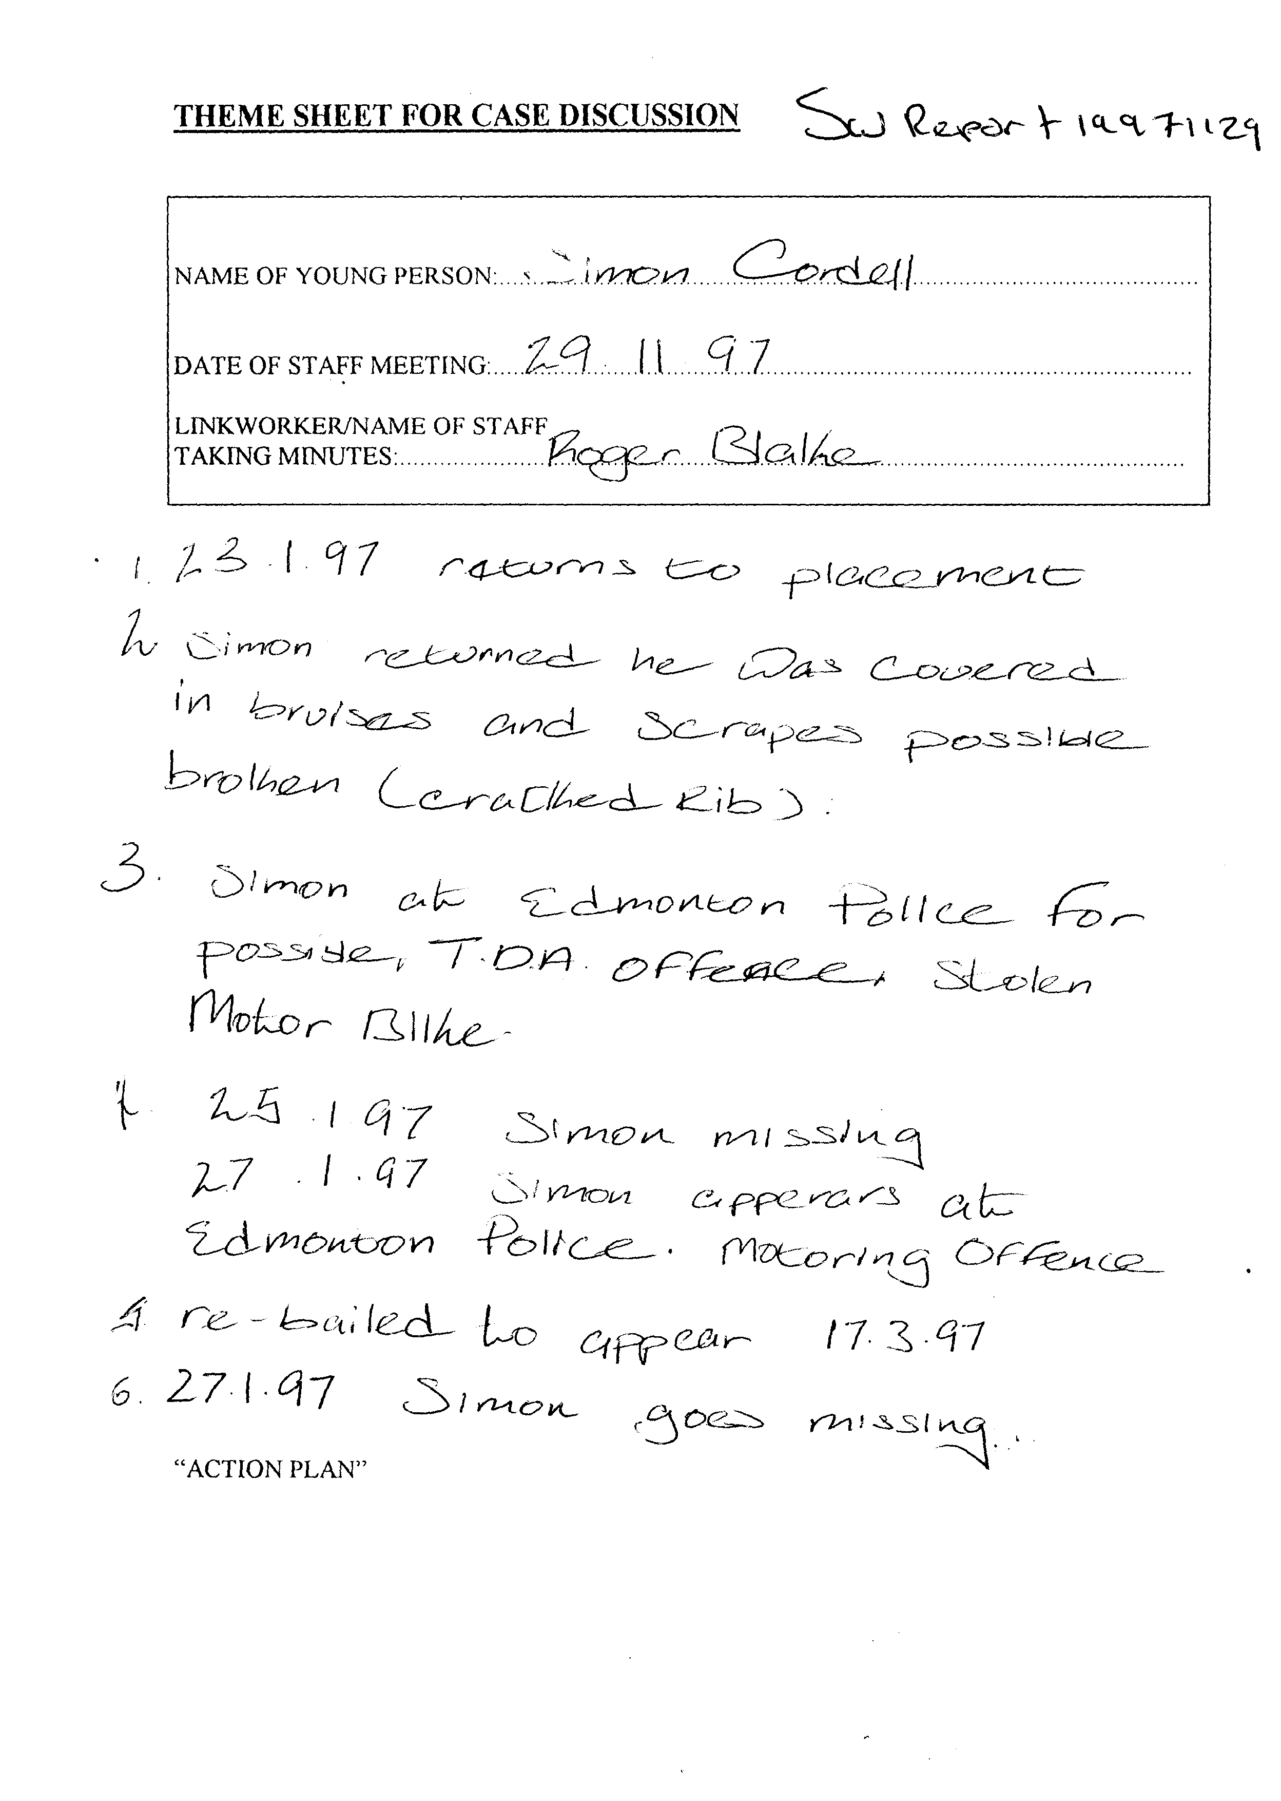
End of Picture!

The banging Started!

Si Note:
1

2

3

4

Summary!

Disrepair!

Time Spent Building.

Working at Home doing Court Case Defense Work!

Tuesday!
19/02/2019

Stain and the
Issues with Housing Disrepair!
Working on the Court Case Defence!
The Anti-Social Behaviour Order Case and the Verdict got made Guilty against me in error and the conditions got imposed against me till late 2020!
The Banging Continued: -
19/02/2019

- Disrepair!
- The Asbo Order got granted in Error with Full Conditions against me and Fraudulently!
- The banging Continued at me!
- Working at home!

- 117 Burncroft Avenue was
The Mathiyalagan family had moved out for ever!
“Builders!”
24/02/2019
117 Painters and decorators, no Problems - Left the building for good!

- 113 Burncroft Avenue
Ambrose!
--
17/12/2018 -- I see Ambrose and his mate Alley in the corridor!
--
28/02/2019 -- Ambrose started again
--
04/03/2019 -- Just Alley staying inside of the flat of 113 Burncroft Avenue
--
25/05/2019 -- Alley & Co, Opening my front door in safety!
--
26/05/2019 -- Getting Arrested Partly for Trusting Alley!

- 115 Burncroft Avenue
Young Light skin girl and boy! “Responsible.”

- 111 Burncroft Avenue
Stain Curtis Fisher! “Responsible.”

1
- 2nd Possession Order! 06/02/2019
I have good news in that the Council have decided to not pursue the case further due to a lack of recent incidents. Please see attached their letter received recently and our letter dated 22 October 2019 sent to your son.

--

1
Disrepair!

2
The Asbo Order got granted in Error with Full Conditions against me and Fraudulently!

3
The banging Continued at me!

4
Working at home!

4
117 Burncroft Avenue was
The Mathiyalagan family had moved out for ever!
“Empty / vacated!”

5
113 Burncroft Avenue
Ambrose!
--
- 17/12/2018 -- I see Ambrose and his mate Alley in the corridor!
- 28/02/2019 -- Ambrose started again
- 04/03/2019 -- Just Alley staying inside of the flat of 113 Burncroft Avenue
- 25/05/2019 -- Alley & Co, Opening my front door in safety!
- 26/05/2019 -- Getting Arrested Partly for Trusting Alley!

6
115 Burncroft Avenue
Young Light skin girl and boy! “Responsible.”

7
111 Burncroft Avenue
Stain Curtis Fisher! “Responsible.”

8
2nd Possession Order! 06/02/2019
I have good news in that the Council have decided to not pursue the case further due to a lack of recent incidents. Please see attached their letter received recently and our letter dated 22 October 2019 sent to your son.

The banging Started!

Si Note:
1

2

3

4

5

6

7

8

Summary!

Disrepair!

Time Spent Building.

Working at Home doing Court Case Defense Work!

Wednesday!
20/02/2019

Stain and the
Issues with Housing Disrepair!
Working on the Court Case Defence!
The Anti-Social Behaviour Order Case and the Verdict got made Guilty against me in error and the conditions got imposed against me till late 2020!
The Banging Continued: -
20/02/2019

- Disrepair!
- The Asbo Order got granted in Error with Full Conditions against me and Fraudulently!
- The banging Continued at me!
- Working at home!

- 117 Burncroft Avenue was
The Mathiyalagan family had moved out for ever!
“Builders!”
24/02/2019
117 Painters and decorators, no Problems - Left the building for good!

- 113 Burncroft Avenue
Ambrose!
--
17/12/2018 -- I see Ambrose and his mate Alley in the corridor!
--
28/02/2019 -- Ambrose started again
--
04/03/2019 -- Just Alley staying inside of the flat of 113 Burncroft Avenue
--
25/05/2019 -- Alley & Co, Opening my front door in safety!
--
26/05/2019 -- Getting Arrested Partly for Trusting Alley!

- 115 Burncroft Avenue
Young Light skin girl and boy! “Responsible.”

- 111 Burncroft Avenue
Stain Curtis Fisher! “Responsible.”

1
- 2nd Possession Order! 06/02/2019
I have good news in that the Council have decided to not pursue the case further due to a lack of recent incidents. Please see attached their letter received recently and our letter dated 22 October 2019 sent to your son.

1
- The Enfield Gov / Email’s Issue:
1162. Lorraine Cordell _Re_ SAR CRM 1085 [SEC=OFFICIAL - SENSITIVE] _ (3) /
Page Numbers: 4529,4530,4531,

2
- The Enfield Gov / Email’s Issue:
1163. Lorraine Cordell _Re_ Booked Appointments /
Page Numbers: 4532,4533,4534,

13.
- Additional Email Attachments & Emails / Issue:
13. 1. 1
Prob. lorraine32@blueyonder.co.uk_02.20.2019_Re Booked Appointments _001
20/02/2019 20:03:00
Page Numbers: 323,324,325,326

14.
- Additional Email Attachments & Emails / Issue:
14. 1. 1
Prob. lorraine32@blueyonder.co.uk_02.20.2019_Re Booked Appointments
20/02/2019 20:03:00
Double of 13
Page Numbers: 327,328,329,330

--

1
The Enfield Gov / Email’s Issue:
1162. Lorraine Cordell _Re_ SAR CRM 1085 [SEC=OFFICIAL - SENSITIVE] _ (3)
/ Page Numbers: 4529,4530,4531,
From: Lorraine Cordell [lorraine32@blueyonder.co.uk]
Sent: 20 February 2019 12:24
To: 'Eboni Ward'
Subject: RE: SAR CRM 1085 [SEC=OFFICIAL SENSITIVE]
Dear Eboni Ward
Can you please tell me if anything is being done regarding my below email as of yet I have not had a reply back from you regarding the issue I have with the SAR I put in regarding the data that has been asked for and we have not got.
Regards
Lorraine Cordell
From: Lorraine Cordell [Mail To:lorraine32@blueyonder.co.uk]
Sent: 18 February 2019 18:17
To: 'Eboni Ward'
Subject: RE: SAR CRM 1085 [SEC=OFFICIAL SENSITIVE]
Dear Eboni Ward
Thank you for the email and resending the last document again to me. But I have a very big issue there is hardly any data I have asked for in the 3 documents that you have sent, there is nothing from ASB Team, Legal services, no complaint details, no emails from anyone, no information regarding meeting that have been held about my son yet we know meetings have been held, nothing really from the mental health teams where data has been requested from Enfield Council. the list can go on and on, yet I know that the information is being held on Enfield councils’ systems, in fact there should be a great deal of data that all seems to me missing from the documents you have sent me. If you look at our request you will see if does cover what I have asked for yet none of the data has been sent. If Enfield Council is withholding data for some reason could we please be told the reason and why it is being withheld?
Can this please be addressed as soon as possible as we need all information that is being held on Enfield Councils systems across all departments relating to my son.
Regards
Lorraine Cordell
From: Eboni Ward [Mail To:Eboni.Ward@enfield.gov.uk]
Sent: 18 February 2019 17:12
To: Lorraine Cordell
Subject: RE: SAR CRM 1085 [SEC=OFFICIAL SENSITIVE]
Classification: OFFICIAL SENSITIVE
Dear Mrs. Cordell,
Apologies, I have resent the files today.
,4530,
Please confirm receipt.
Kind regards
Eboni Ward
Access to Records Officer – Gateway Services
Enfield Council
E: Eboni.ward@enfield.gov.uk
From: Lorraine Cordell <lorraine32@blueyonder.co.uk>
Sent: 18 February 2019 11:39
To: Eboni Ward <Eboni.Ward@enfield.gov.uk>
Subject: RE: SAR CRM 1085 [SEC=OFFICIAL ‐ SENSITIVE]
Dear Eboni Ward
Thank you for the files but when I checked there is no attachment to 3 of 3 could you reupload it please and let me know when it has been done thank you.
Regards
Lorraine Cordell
From: Eboni Ward [Mail To:Eboni.Ward@enfield.gov.uk]
Sent: 16 February 2019 20:35
To: lorraine32@blueyonder.co.uk
Subject: SAR CRM 1085 [SEC=OFFICIAL SENSITIVE]
Classification: OFFICIAL SENSITIVE
Dear Mrs. Cordell,
I have sent the requested files via egress switch today (16/02/2019) Please confirm receipt
Kind regards
Eboni Ward
Access to Records Officer – Gateway Services
Enfield Council
E: Eboni.ward@enfield.gov.uk
Classification: OFFICIAL SENSITIVE
4531,
N/a

2
The Enfield Gov / Email’s Issue:
1163. Lorraine Cordell _Re_ Booked Appointments
/ Page Numbers: 4532,4533,4534,
From: Lorraine Cordell [lorraine32@blueyonder.co.uk]
Sent: 20 February 2019 20:03
To: Liselle Archer
Subject: Re: Booked Appointments
Dear Liselle Archer
Would it please be possible to set a meeting up for Simon Cordell for Monday afternoon, it has taken me longer to get a laptop then I was hoping. If you can get back to me, I would be most grateful
Regards
Lorraine Cordell
Sent from my iPhone
On 13 Feb 2019, at 12:36, Liselle Archer <liselle@tyrerroxburgh.co.uk> wrote:
Dear Lorraine
Following our telephone conversation today, these appointments have been booked for you in relation to your son’s case:
Friday 15 February 2019 @ 12pm: Telephone Legal Aid Application Appointment
Monday 18 February 2019 @ 3pm: Office Face to Face Appointment
Please note: if the legal aid application is not submitted on Friday, the appointment booked for Monday will have to be rescheduled.
Kind Regards
Liselle Archer
Tyrer Roxburgh Solicitors LLP
Tel +44 (0)20 8889 3319
Direct Dial +44 (0)20 8829 2950
Email liselle@tyrerroxburgh.co.uk
<image001.jpg><image002.jpg>
Head Office:
1 St Michaels Terrace
London N22 7SJ
DX 34704 WOOD GREEN 2
Tel +44 (0)20 8889 3319
fax +44 (0)20 8881 6089
Luton Office:
Trend House
Dallow Road
Luton LU1 1LY
Tel +44 (0)1582 726579
Please reply to our Head Office
www.tyrerroxburgh.co.uk
Authorised by the Solicitors Regulation Authority. Tyrer Roxburgh Solicitors LLP is a limited liability partnership under the no.560748. A list of the members' names is open to inspection at the registered office. VAT REG No: 221 8088 78 SRA No: 560748
<image007.png><image008.png> <image009.png> <image010.jpg>
Contracted with the Legal Aid Agency We do not accept service of documents or other process by email us at lawmakers@tyrerroxburgh.co.uk
This message may contain privileged information and is only intended to be received by the person to whom it is addressed. If you are not the intended recipient please contact us as soon as possible.
4533
Partners Mukesh Badhan D Shanmuganathan
From: Lorraine Cordell [Mail To: lorraine32@blueyonder.co.uk]
Sent: 12 February 2019 18:14
To: Liselle Archer <liselle@tyrerroxburgh.co.uk>
Subject: FW: Legal Aid Agency Requirements Simon Cordell
Dear Liselle Archer
Please see attached documents including his bank statements which was missing from the below email. But can the solicitor please read below email as that says some bits about the case.
Regards
Lorraine Cordell
From: Lorraine Cordell [Mail To: lorraine32@blueyonder.co.uk]
Sent: 11 February 2019 18:17
To: 'Liselle Archer'
Subject: RE: Legal Aid Agency Requirements
Dear Liselle Archer
I am writing this letter regarding the case that Enfield Council has laid before the court for a Possession Order for my son’s flat. The court hearing is for the 08/03/2019 at 10:00 hours. I have tried to attach the most up to date information as there is a long history to this with Enfield Council and my son. I have ordered my son’s bank statements but am waiting for them to come in the post so have included the other documents asked for in the email, and if a date can be set for him to see someone maybe by the time we see someone we will have the bank statement, but my son has had legal aid in the below cases, Please see attached documents. I am writing this to give you some form of information relating to this case as it has in some ways been ongoing for some time. Enfield Council has had 2 other court cases regarding these matters which were for injunction orders please see below information they were for the same cases as in this new Possession Order.
E00ED049: Edmonton Country Court
1. Interim Injunction order started by Enfield Council on the 09th January 2018 at Edmonton Country Court, to replace the one that was struck out by the court on the 06/11/2017 as the Judge would not put it back in place.
2. This case went on until the 09/08/2018, please see attached court order which was made, which Enfield Council was meant to have moved my son, which has never happened I have been trying to get this done since this date and Enfield Council have not done anything.
D02ED073: Edmonton Country Court
1. Interim Injunction order started by Enfield Council on the 9th August 2017 at Edmonton Country Court.
2. This case ended up being struck out on the 06/11/2017, the reason for this was due to Enfield Council not doing what the court asked them to do.
Even through there is a court order in place for Enfield Council to move my son, Enfield Council has done nothing only kept my son in a flat that is causing his health to be impacted and lied to multiple bodies regarding the order that was made on the 09/08/2018. The judge warned Enfield Council regarding a Possession Order on my son on the 09/08/2018, there is a lot of paperwork regarding all of this which will need to be gone over. There are so many Emails and Documents regarding everything that has gone on it will be too much to send via email. So, I have only put a few of the last emails and Letters including the new order, the other information will need to be done at a meeting as there is just so much information.
Regards
Lorraine Cordell
,4534
From: Liselle Archer [Mail To: liselle@tyrerroxburgh.co.uk]
Sent: 07 February 2019 15:51
To: lorraine32@blueyonder.co.uk
Subject: Legal Aid Agency Requirements
Dear Madam
Following our telephone conversation today, please see below the requirements for the application for public funding (Legal Aid). Please bring the following documents in order for us to open a case:
Most recent award letter confirming that your son receives ESA Bank statements of all adults over the age 18 living in the household.
(Please note that the bank statements must be:
Covering the last 3 months with no gaps, this includes 07 February 2019 –07 November 2018) For all bank statements including savings accounts and dormant accounts) or Driving Licence (proof of ID) Tenancy Agreement and letters from your landlord Anything else you consider relevant.
Please note we are unable to open a case until we have received all of the above documents.
Kind Regards
Liselle Archer
Tyrer Roxburgh Solicitors LLP
Tel +44 (0)20 8889 3319
Direct Dial +44 (0)20 8829 2950
Email liselle@tyrerroxburgh.co.uk
<image001.jpg><image002.jpg>
Head Office:
1 St Michaels Terrace
London N22 7SJ
DX 34704 WOOD GREEN 2
Tel +44 (0)20 8889 3319
fax +44 (0)20 8881 6089
Luton Office:
Trend House
Dallow Road
Luton LU1 1LY
Tel +44 (0)1582 726579
Please reply to our Head Office
www.tyrerroxburgh.co.uk
Authorised by the Solicitors Regulation Authority. Tyrer Roxburgh Solicitors LLP is a limited liability partnership under the no.560748. A list of the members' names is open to inspection at the registered office.
VAT REG No: 221 8088 78 SRA No: 560748
<image011.gif><image012.gif> <image013.gif> <image010.jpg>
Contracted with the Legal Aid Agency
We do not accept service of documents or other process by Email us at lawmakers@tyrerroxburgh.co.uk This message may contain privileged information, and is only intended to be received by the person to whom it is addressed. If you are not the intended recipient please contact us as soon as possible.
Partners Mukesh Badhan D Shanmuganathan

13.
Additional Email Attachments & Emails / Issue:
13. 1. 1
Prob. lorraine32@blueyonder.co.uk_02.20.2019_Re Booked Appointments _001
20/02/2019 20:03:00
/ Page Numbers: 323,324,325,326
323,
From: Lorraine Cordell <lorraine32@blueyonder.co.uk>
Sent: 20 February 2019 20:03
To: Liselle Archer
Subject: Re: Booked Appointments
Dear Liselle Archer
Would it please be possible to set a meeting up for Simon Cordell for Monday afternoon, it has taken me longer to get a laptop then I was hoping.
If you can get back to me, I would be most grateful Regards
Lorraine Cordell
Sent from my iPhone
On 13 Feb 2019, at 12:36, Liselle Archer <liselle@tvrerroxburgh.co.uk> wrote:
Dear Lorraine
Following our telephone conversation today, these appointments have been booked for you in relation to your son’s case:
Friday 15 February 2019 @ 12pm: Telephone Legal Aid Application Appointment
Monday 18 February 2019 @ 3pm: Office Face to Face Appointment
Please note: if the legal aid application is not submitting on Friday, the appointment booked for Monday will have to be rescheduled.
Kind Regards
Liselle Archer
Tyrer Roxburgh Solicitors LLP
Tel +44 (0)20 8889 3319
Direct Dial +44 (0)20 8829 2950
Email liselle@tvrerroxburgh.co.uk
Head Office:
1 St Michaels Terrace London N22 7SJ
DX 34704 WOOD GREEN 2
Tel +44 (0)20 8889 3319
fax +44 (0)20 8881 6089
Luton Office:
Trend House Dallow Road Luton LU1 1LY
Tel +44 (0)1582 726579
Please reply to our Head Office
324,
www.tyrerroxburgh.co.uk
Authorised by the Solicitors Regulation Authority. Tyrer Roxburgh Solicitors LLP is a limited liability partnership under the no.560748. A list of the members' names is open to inspection at the registered office.
VAT REG No: 221 8088 78 SRA No: 560748
Contracted with the Legal Aid Agency
We do not accept service of documents or other process by e-mail
Email us at lawmakers@tyrerroxburgh.co.uk
This message may contain privileged information and is only intended to be received by the person to whom it is addressed.
If you are not the intended recipient, please contact us as soon as possible.
Partners • Mukesh Badhan • D Shanmuganathan
From: Lorraine Cordell mailto: lorraine32@blueyonder.co.uk
Sent: 12 February 2019 18:14
To: Liselle Archer <liselle@tvrerroxburgh.co.uk>
Subject: FW: Legal Aid Agency Requirements Simon Cordell
Dear Liselle Archer
Please see attached documents including his bank statements which was missing from the below email. But can the solicitor please read below email as that says some bits about the case.
Regards
Lorraine Cordell
From: Lorraine Cordell
mailto: lorraine32@bluevonder.co.uk
Sent: 11 February 2019 18:17
To: 'Liselle Archer'
Subject: RE: Legal Aid Agency Requirements
Dear Liselle Archer
I am writing this letter regarding the case that Enfield Council has laid before the court for a Possession Order for my son’s flat. The court hearing is for the 08/03/2019 at 10:00 hours. I have tried to attach the most up to date information as there is a long history to this with Enfield Council and my son. I have ordered my son's bank statements but am waiting for them to come in the post so have included the other documents asked for in the email, and if a date can be set for him to see someone maybe by the time we see someone we will have the bank statement, but my son has had legal aid in the below cases, Please see attached documents.
I am writing this to give you some form of information relating to this case as it has in some ways been ongoing for some time.
Enfield Council has had 2 other court cases regarding these matters which were for injunction orders please see below information they were for the same cases as in this new Possession Order.
325,
E00ED049: Edmonton Country Court
- Interim Injunction order started by Enfield Council on the 09th January 2018 at Edmonton Country Court, to replace the one that was struck out by the court on the 06/11/2017 as the Judge would not put it back in place.
- This case went on until the 09/08/2018, please see attached court order which was made, which Enfield Council was meant to have moved my son, which has never happened I have been trying to get this done since this date and Enfield Council have not done anything.
D02ED073: Edmonton Country Court
- Interim Injunction order started by Enfield Council on the 9th August 2017 at Edmonton Country Court.
- This case ended up being struck out on the 06/11/2017, the reason for this was due to Enfield Council not doing what the court asked them to do.
Even through there is a court order in place for Enfield Council to move my son, Enfield Council has done nothing only kept my son in a flat that is causing his health to be impacted and lied to multiple bodies regarding the order that was made on the 09/08/2018. The judge warned Enfield Council regarding a Possession Order on my son on the 09/08/2018, there is a lot of paperwork regarding all of this which will need to be gone over.
There are so many Emails and Documents regarding everything that has gone on it will be too much to send via email. So I have only put a few of the last emails and Letters including the new order, the other information will need to be done at a meeting as there is just so much information.
Regards
Lorraine Cordell
From: Liselle Archer
mailto: liselle@tvrerroxburgh.co.uk
Sent: 07 February 2019 15:51
To: lorraine32@blueyonder.co.uk
Subject: Legal Aid Agency Requirements
Dear Madam
Following our telephone conversation today, please see below the requirements for the application for public funding (Legal Aid).
Please bring the following documents in order for us to open a case:
- Most recent award letter confirming that your son receives ESA
- Bank statements of all adults over the age 18 living in the household.
(Please note that the bank statements must be:
Covering the last 3 months with no gaps, this includes 07 February 2019 -07 November 2018)
• For all bank statements including savings accounts and dormant accounts)
326,
- Passport or Driving Licence (proof of ID)
- Tenancy Agreement and letters from your landlord
- Anything else you consider relevant.
Please note we are unable to open a case until we have received all of the above documents.
Kind Regards
Liselle Archer
Tyrer Roxburgh Solicitors LLP
Tel +44 (0)20 8889 3319
Direct Dial +44 (0)20 8829 2950
Email liselle@tyrerroxburgh.co.uk
Head Office:
1 St Michaels Terrace London N22 7SJ
DX 34704 WOOD GREEN 2
Tel +44 (0)20 8889 3319
Fax +44 (0)20 8881 6089
Luton Office:
Trend House Dallow Road Luton LU1 1LY
Tel +44 (0)1582 726579
Please reply to our Head Office www.tyrerroxburgh.co.uk
Authorised by the Solicitors Regulation Authority. Tyrer Roxburgh Solicitors LLP is a limited liability partnership under the no.560748. A list of the members' names is open to inspection at the registered office.
VAT REG No: 221 8088 78
SRA No: 560748
Contracted with the Legal Aid Agency
We do not accept service of documents or other process by e-mail
Email us at lawmakers@tyrerroxburgh.co.uk
This message may contain privileged information and is only intended to be received by the person to whom it is addressed.
If you are not the intended recipient, please contact us as soon as possible.
Partners • Mukesh Badhan • D Shanmuganathan

14.
- Additional Email Attachments & Emails / Issue:
14. 1. 1
Prob. lorraine32@blueyonder.co.uk_02.20.2019_Re Booked Appointments
20/02/2019 20:03:00
Double of 13
/ Page Numbers: 327,328,329,330
327,
From: Lorraine Cordell <lorraine32@blueyonder.co.uk>
Sent: 20 February 2019 20:03
To: Liselle Archer
Subject: Re: Booked Appointments
Dear Liselle Archer
Would it please be possible to set a meeting up for Simon Cordell for Monday afternoon, it has taken me longer to get a laptop then I was hoping.
If you can get back to me, I would be most grateful Regards
Lorraine Cordell
Sent from my iPhone
On 13 Feb 2019, at 12:36, Liselle Archer <liselle@tvrerroxburgh.co.uk> wrote:
Dear Lorraine
Following our telephone conversation today, these appointments have been booked for you in relation to your son’s case:
- Friday 15 February 2019 @ 12pm: Telephone Legal Aid Application Appointment
- Monday 18 February 2019 @ 3pm: Office Face to Face Appointment
Please note: if the legal aid application is not submitting on Friday, the appointment booked for Monday will have to be rescheduled.
Kind Regards
Liselle Archer
Tyrer Roxburgh Solicitors LLP
Tel +44 (0)20 8889 3319
Direct Dial +44 (0)20 8829 2950
Email liselle@tvrerroxburgh.co.uk
Head Office:
1 St Michaels Terrace London N22 7SJ
DX 34704 WOOD GREEN 2
Tel +44 (0)20 8889 3319
Fax +44 (0)20 8881 6089
Luton Office:
Trend House Dallow Road Luton LU1 1LY
Tel +44 (0)1582 726579
Please reply to our Head Office
328,
www.tyrerroxburgh.co.uk
Authorised by the Solicitors Regulation Authority. Tyrer Roxburgh Solicitors LLP is a limited liability partnership under the no.560748. A list of the members' names is open to inspection at the registered office.
VAT REG No: 221 8088 78
SRA No: 560748
Contracted with the Legal Aid Agency
We do not accept service of documents or other process by e-mail
Email us at lawmakers@tyrerroxburgh.co.uk
This message may contain privileged information and is only intended to be received by the person to whom it is addressed.
If you are not the intended recipient, please contact us as soon as possible.
Partners • Mukesh Badhan • D Shanmuganathan
From: Lorraine Cordell [mailto: lorraine32@blueyonder.co.uk
Sent: 12 February 2019 18:14
To: Liselle Archer <liselle@tvrerroxburgh.co.uk>
Subject: FW: Legal Aid Agency Requirements Simon Cordell
Dear Liselle Archer
Please see attached documents including his bank statements which was missing from the below email. But can the solicitor please read below email as that says some bits about the case.
Regards
Lorraine Cordell
From: Lorraine Cordell
mailto: lorraine32@bluevonder.co.uk
Sent: 11 February 2019 18:17
To: 'Liselle Archer'
Subject: RE: Legal Aid Agency Requirements
Dear Liselle Archer
I am writing this letter regarding the case that Enfield Council has laid before the court for a Possession Order for my son’s flat. The court hearing is for the 08/03/2019 at 10:00 hours. I have tried to attach the most up to date information as there is a long history to this with Enfield Council and my son. I have ordered my son's bank statements but am waiting for them to come in the post so have included the other documents asked for in the email, and if a date can be set for him to see someone maybe by the time we see someone we will have the bank statement, but my son has had legal aid in the below cases, Please see attached documents.
I am writing this to give you some form of information relating to this case as it has in some ways been ongoing for some time.
Enfield Council has had 2 other court cases regarding these matters which were for injunction orders please see below information they were for the same cases as in this new Possession Order.
329,
E00ED049: Edmonton Country Court
- Interim Injunction order started by Enfield Council on the 09th January 2018 at Edmonton Country Court, to replace the one that was struck out by the court on the 06/11/2017 as the Judge would not put it back in place.
- This case went on until the 09/08/2018, please see attached court order which was made, which Enfield Council was meant to have moved my son, which has never happened I have been trying to get this done since this date and Enfield Council have not done anything.
D02ED073: Edmonton Country Court
- Interim Injunction order started by Enfield Council on the 9th August 2017 at Edmonton Country Court.
- This case ended up being struck out on the 06/11/2017, the reason for this was due to Enfield Council not doing what the court asked them to do.
- Even through there is a court order in place for Enfield Council to move my son, Enfield Council has done nothing only kept my son in a flat that is causing his health to be impacted and lied to multiple bodies regarding the order that was made on the 09/08/2018. The judge warned Enfield Council regarding a Possession Order on my son on the 09/08/2018, there is a lot of paperwork regarding all of this which will need to be gone over.
- There are so many Emails and Documents regarding everything that has gone on it will be too much to send via email. So I have only put a few of the last emails and Letters including the new order, the other information will need to be done at a meeting as there is just so much information.
Regards
Lorraine Cordell
From: Liselle Archer
mailto: liselle@tvrerroxburgh.co.uk
Sent: 07 February 2019 15:51
To: lorraine32@blueyonder.co.uk
Subject: Legal Aid Agency Requirements
Dear Madam
Following our telephone conversation today, please see below the requirements for the application for public funding (Legal Aid).
Please bring the following documents in order for us to open a case:
- Most recent award letter confirming that your son receives ESA
- Bank statements of all adults over the age 18 living in the household.
(Please note that the bank statements must be:
Covering the last 3 months with no gaps, this includes 07 February 2019 -07 November 2018)
• For all bank statements including savings accounts and dormant accounts)
330,
- Passport or Driving Licence (proof of ID)
- Tenancy Agreement and letters from your landlord
- Anything else you consider relevant.
Please note we are unable to open a case until we have received all of the above documents.
Kind Regards
Liselle Archer
Tyrer Roxburgh Solicitors LLP
Tel +44 (0)20 8889 3319
Direct Dial +44 (0)20 8829 2950
Email liselle@tyrerroxburgh.co.uk
Head Office:
1 St Michaels Terrace London N22 7SJ
DX 34704 WOOD GREEN 2
Tel +44 (0)20 8889 3319
Fax +44 (0)20 8881 6089
Luton Office:
Trend House Dallow Road Luton LU1 1LY
Tel +44 (0)1582 726579
Please reply to our Head Office www.tyrerroxburgh.co.uk
Authorised by the Solicitors Regulation Authority. Tyrer Roxburgh Solicitors LLP is a limited liability partnership under the no.560748. A list of the members' names is open to inspection at the registered office.
VAT REG No: 221 8088 78
SRA No: 560748
Contracted with the Legal Aid Agency
We do not accept service of documents or other process by e-mail
Email us at lawmakers@tyrerroxburgh.co.uk
This message may contain privileged information and is only intended to be received by the person to whom it is addressed.
If you are not the intended recipient, please contact us as soon as possible.
Partners • Mukesh Badhan • D Shanmuganathan

The banging Started!

Si Note:
1

2

Summary!

Disrepair!

Time Spent Building.

Working at Home doing Court Case Defense Work!

Thursday!
21/02/2019

Stain and the
Issues with Housing Disrepair!
Working on the Court Case Defence!
The Anti-Social Behaviour Order Case and the Verdict got made Guilty against me in error and the conditions got imposed against me till late 2020!
The Banging Continued: -
21/02/2019

- Disrepair!
- The Asbo Order got granted in Error with Full Conditions against me and Fraudulently!
- The banging Continued at me!
- Working at home!

- 117 Burncroft Avenue was
The Mathiyalagan family had moved out for ever!
“Builders!”
24/02/2019
117 Painters and decorators, no Problems - Left the building for good!

- 113 Burncroft Avenue
Ambrose!
--
17/12/2018 -- I see Ambrose and his mate Alley in the corridor!
--
28/02/2019 -- Ambrose started again
--
04/03/2019 -- Just Alley staying inside of the flat of 113 Burncroft Avenue
--
25/05/2019 -- Alley & Co, Opening my front door in safety!
--
26/05/2019 -- Getting Arrested Partly for Trusting Alley!

- 115 Burncroft Avenue
Young Light skin girl and boy! “Responsible.”

- 111 Burncroft Avenue
Stain Curtis Fisher! “Responsible.”

1
- 2nd Possession Order! 06/02/2019
I have good news in that the Council have decided to not pursue the case further due to a lack of recent incidents. Please see attached their letter received recently and our letter dated 22 October 2019 sent to your son.

--

The banging Started!

Summary!

Disrepair!

Time Spent Building.

Working at Home doing Court Case Defense Work!

Friday!
22/02/2019

Stain and the
Issues with Housing Disrepair!
Working on the Court Case Defence!
The Anti-Social Behaviour Order Case and the Verdict got made Guilty against me in error and the conditions got imposed against me till late 2020!
The Banging Continued: -
22/02/2019

- Disrepair!
- The Asbo Order got granted in Error with Full Conditions against me and Fraudulently!
- The banging Continued at me!
- Working at home!

- 117 Burncroft Avenue was
The Mathiyalagan family had moved out for ever!
“Builders!”
24/02/2019
117 Painters and decorators, no Problems - Left the building for good!

- 113 Burncroft Avenue
Ambrose!
--
17/12/2018 -- I see Ambrose and his mate Alley in the corridor!
--
28/02/2019 -- Ambrose started again
--
04/03/2019 -- Just Alley staying inside of the flat of 113 Burncroft Avenue
--
25/05/2019 -- Alley & Co, Opening my front door in safety!
--
26/05/2019 -- Getting Arrested Partly for Trusting Alley!

- 115 Burncroft Avenue
Young Light skin girl and boy! “Responsible.”

- 111 Burncroft Avenue
Stain Curtis Fisher! “Responsible.”

1
- 2nd Possession Order! 06/02/2019
I have good news in that the Council have decided to not pursue the case further due to a lack of recent incidents. Please see attached their letter received recently and our letter dated 22 October 2019 sent to your son.

1
- The Enfield Gov / Email’s Issue:
1164. Ronak Ahmed _RE_ Simon Cordell /
Page Numbers: 4535,

15.
- Additional Email Attachments & Emails / Issue:
15. 1. 1
lorraine32@blueyonder.co.uk_02.22.2019_Re Simon Cordell
22/02/2019
Page Numbers: 331,332

--

1
The Enfield Gov / Email’s Issue:
1164. Ronak Ahmed _RE_ Simon Cordell
/ Page Numbers: 4535,
From: Ronak Ahmed [ronak@tyrerroxburgh.co.uk]
Sent: 22 February 2019 15:34
To: lorraine32@blueyonder.co.uk
Cc: Liselle Archer
Subject: RE: Simon Cordell
Dear Ms Cordell
I have been forwarded your email below and can confirm that I am unfortunately not able to meet with you on Monday. Additionally, I am on holiday next week so if you need to speak to someone at the Office then please ask for Sean. My colleague Liselle Archer will also not be in the office from Monday so please do not send her any emails going forward. The hearing on 8 March 2019 will be a brief 5-minute hearing and we will be requesting directions from the court on that occasion. This means that there will be opportunity to present further documents to trial (which will be sometime winter 2019 or spring 2020. Therefore, I propose that we meet after I return from holiday. I will arrange for my colleague Sean or an external lawyer to represent Simon Cordell at the first hearing. Best wishes
Ronak Ahmed
Consultant Solicitor
Tel (01582) 726579
Email ronak@tyrerroxburgh.co.uk
From: Lorraine Cordell [Mail To: lorraine32@blueyonder.co.uk]
Sent: 20 February 2019 20:03
To: Liselle Archer <liselle@tyrerroxburgh.co.uk>
Subject: Re: Booked Appointments
Dear Liselle Archer
Would it please be possible to set a meeting up for Simon Cordell for Monday afternoon, it has taken me longer to get a laptop then I was hoping. If you can get back to me, I would be most grateful
Regards
Lorraine Cordell
Sent from my iPhone

15.
Additional Email Attachments & Emails / Issue:
15. 1. 1
lorraine32@blueyonder.co.uk_02.22.2019_Re Simon Cordell
22/02/2019
/ Page Numbers: 331,332
331,
From: Lorraine Cordell <lorraine32@blueyonder.co.uk>
Sent: 22 February 2019 16:34
To: Ronak Ahmed
Subject: Re: Simon Cordell
Dear Ronak Ahmed
Thank you for the below email would it please be possible for you to call me on 07807 333545. I don't think it's going to be that easy on the 08/03/2019 as the last 2 court cases Enfield Council has tried to railroad my son with the court totally misleading the courts with everything including my son's health. My son did not even attend the last 3 hearings due to what was going on and the court assessment was ordered by the court. There have also been major data beaches between Enfield Council staying to the MH team there was a court order for information to be given to them regarding my son which there was not. I know on the 08/03/2019 that Enfield Council is going to try and get the possession order on that date. Even though they have not complied with the court order dated the 09/08/2018 where they were meant to have moved my son. They have never put anything in front of the housing management panel to even start this, they have lied to the MP and also the MH teams.
This case really does need to be heard by judge dais who heard the last 3 hearings from the last case.
Simon is very worried, and this is not helping him, Enfield Council knows he does not cope with court hearings also, the impact this is having on my son is very bad.
If you can call me, I would be most grateful.
Regards
Lorraine Cordell Sent from my iPhone
On 22 Feb 2019, at 15:33, Ronak Ahmed <ronak@tyrerroxburgh.co.uk> wrote:
Dear Ms Cordell
I have been forwarded your email below and can confirm that I am unfortunately not able to meet with you on Monday. Additionally, I am on holiday next week so if you need to speak to someone at the Office then please ask for Sean. My colleague Liselle Archer will also not be in the office from Monday so please do not send her any emails going forward.
The hearing on 8 March 2019 will be a brief 5-minute hearing and we will be requesting directions from the court on that occasion. This means that there will be opportunity to present further documents to trial (which will be sometime winter 2019 or spring 2020. Therefore I propose that we meet after I return from holiday. I will arrange for my colleague Sean or an external lawyer to represent Simon Cordell at the first hearing.
Best wishes
Ronak Ahmed
Consultant Solicitor
Tel (01582)726579
Email ronak@tvrerroxburah.co.uk
From: Lorraine Cordell
mailto: lorraine32@blueyonder.co.uk
Sent: 20 February 2019 20:03
To: Liselle Archer <liselle@tyrerroxburgh.co.uk>
332,
Subject: Re: Booked Appointments
Dear Liselle Archer
Would it please be possible to set a meeting up for Simon Cordell for Monday afternoon, it has taken me longer to get a laptop then I was hoping.
If you can get back to me, I would be most grateful
Regards
Lorraine Cordell Sent from my iPhone

The banging Started!

Si Note:
1

Summary!

Disrepair!

Time Spent Building.

Working at Home doing Court Case Defense Work!

Saturday!
23/02/2019

Stain and the
Issues with Housing Disrepair!
Working on the Court Case Defence!
The Anti-Social Behaviour Order Case and the Verdict got made Guilty against me in error and the conditions got imposed against me till late 2020!
The Banging Continued: -
23/02/2019

- Disrepair!
- The Asbo Order got granted in Error with Full Conditions against me and Fraudulently!
- The banging Continued at me!
- Working at home!

- 117 Burncroft Avenue was
The Mathiyalagan family had moved out for ever!
“Builders!”
24/02/2019
117 Painters and decorators, no Problems - Left the building for good!

- 113 Burncroft Avenue
Ambrose!
--
17/12/2018 -- I see Ambrose and his mate Alley in the corridor!
--
28/02/2019 -- Ambrose started again
--
04/03/2019 -- Just Alley staying inside of the flat of 113 Burncroft Avenue
--
25/05/2019 -- Alley & Co, Opening my front door in safety!
--
26/05/2019 -- Getting Arrested Partly for Trusting Alley!

- 115 Burncroft Avenue
Young Light skin girl and boy! “Responsible.”

- 111 Burncroft Avenue
Stain Curtis Fisher! “Responsible.”

1
- 2nd Possession Order! 06/02/2019
I have good news in that the Council have decided to not pursue the case further due to a lack of recent incidents. Please see attached their letter received recently and our letter dated 22 October 2019 sent to your son.

--

The banging Started!

Summary!

Disrepair!

Time Spent Building.

Working at Home doing Court Case Defense Work!

Sunday!
24/02/2019

Stain and the
Issues with Housing Disrepair!
Working on the Court Case Defence!
The Anti-Social Behaviour Order Case and the Verdict got made Guilty against me in error and the conditions got imposed against me till late 2020!
The Banging Continued: -
24/02/2019

- Disrepair!
- The Asbo Order got granted in Error with Full Conditions against me and Fraudulently!
- The banging Continued at me!
- Working at home!

- 117 Burncroft Avenue was
The Mathiyalagan family had moved out for ever!
“Builders!”
24/02/2019
117 Painters and decorators, no Problems - Left the building for good!

- 113 Burncroft Avenue
Ambrose!
--
17/12/2018 -- I see Ambrose and his mate Alley in the corridor!
--
28/02/2019 -- Ambrose started again
--
04/03/2019 -- Just Alley staying inside of the flat of 113 Burncroft Avenue
--
25/05/2019 -- Alley & Co, Opening my front door in safety!
--
26/05/2019 -- Getting Arrested Partly for Trusting Alley!

- 115 Burncroft Avenue
Young Light skin girl and boy! “Responsible.”

- 111 Burncroft Avenue
Stain Curtis Fisher! “Responsible.”

1
- 2nd Possession Order! 06/02/2019
I have good news in that the Council have decided to not pursue the case further due to a lack of recent incidents. Please see attached their letter received recently and our letter dated 22 October 2019 sent to your son.

1
- Shattered Glass: --

--

1
Shattered Glass: --
Shattered Glass outside all on the floor had gotten left sticking out of the grassland that is placed directly outside of the front of the building and what is upsetting about this the most is that little birds eat food outside as people put bread out for them to eat and Ambrose’s window is directly above

had to clean Ambrose window

The banging Started!

Si Note:
1

Summary!

Disrepair!

Time Spent Building.

Working at Home doing Court Case Defense Work!

Monday!
25/02/2019

Stain and the
Issues with Housing Disrepair!
Working on the Court Case Defence!
The Anti-Social Behaviour Order Case and the Verdict got made Guilty against me in error and the conditions got imposed against me till late 2020!
The Banging Continued: -
25/02/2019

- Disrepair!
- The Asbo Order got granted in Error with Full Conditions against me and Fraudulently!
- The banging Continued at me!
- Working at home!

- 117 Burncroft Avenue was
The Mathiyalagan family had moved out for ever!
“Empty / vacated!”

- 113 Burncroft Avenue
Ambrose!
--
17/12/2018 -- I see Ambrose and his mate Alley in the corridor!
--
28/02/2019 -- Ambrose started again
--
04/03/2019 -- Just Alley staying inside of the flat of 113 Burncroft Avenue
--
25/05/2019 -- Alley & Co, Opening my front door in safety!
--
26/05/2019 -- Getting Arrested Partly for Trusting Alley!

- 115 Burncroft Avenue
Young Light skin girl and boy! “Responsible.”

- 111 Burncroft Avenue
Stain Curtis Fisher! “Responsible.”

1
- 2nd Possession Order! 06/02/2019
I have good news in that the Council have decided to not pursue the case further due to a lack of recent incidents. Please see attached their letter received recently and our letter dated 22 October 2019 sent to your son.

--

The banging Started!

Summary!

Disrepair!

Time Spent Building.

Working at Home doing Court Case Defense Work!

Tuesday!
26/02/2019

Stain and the
Issues with Housing Disrepair!
Working on the Court Case Defence!
The Anti-Social Behaviour Order Case and the Verdict got made Guilty against me in error and the conditions got imposed against me till late 2020!
The Banging Continued: -
26/02/2019

- Disrepair!
- The Asbo Order got granted in Error with Full Conditions against me and Fraudulently!
- The banging Continued at me!
- Working at home!

- 117 Burncroft Avenue was
The Mathiyalagan family had moved out for ever!
“Empty / vacated!”

- 113 Burncroft Avenue
Ambrose!
--
17/12/2018 -- I see Ambrose and his mate Alley in the corridor!
--
28/02/2019 -- Ambrose started again
--
04/03/2019 -- Just Alley staying inside of the flat of 113 Burncroft Avenue
--
25/05/2019 -- Alley & Co, Opening my front door in safety!
--
26/05/2019 -- Getting Arrested Partly for Trusting Alley!

- 115 Burncroft Avenue
Young Light skin girl and boy! “Responsible.”

- 111 Burncroft Avenue
Stain Curtis Fisher! “Responsible.”

1
- 2nd Possession Order! 06/02/2019
I have good news in that the Council have decided to not pursue the case further due to a lack of recent incidents. Please see attached their letter received recently and our letter dated 22 October 2019 sent to your son.

1
- Solicitor
Letter received

--

1
Solicitor
Letter received

The banging Started!

Si Note:
1

Summary!

Disrepair!

Time Spent Building.

Working at Home doing Court Case Defense Work!

Wednesday!
27/02/2019

Stain and the
Issues with Housing Disrepair!
Working on the Court Case Defence!
The Anti-Social Behaviour Order Case and the Verdict got made Guilty against me in error and the conditions got imposed against me till late 2020!
The Banging Continued: -
27/02/2019

- Disrepair!
- The Asbo Order got granted in Error with Full Conditions against me and Fraudulently!
- The banging Continued at me!
- Working at home!

- 117 Burncroft Avenue was
The Mathiyalagan family had moved out for ever!
“Empty / vacated!”

- 113 Burncroft Avenue
Ambrose!
--
17/12/2018 -- I see Ambrose and his mate Alley in the corridor!
--
28/02/2019 -- Ambrose started again
--
04/03/2019 -- Just Alley staying inside of the flat of 113 Burncroft Avenue
--
25/05/2019 -- Alley & Co, Opening my front door in safety!
--
26/05/2019 -- Getting Arrested Partly for Trusting Alley!

- 115 Burncroft Avenue
Young Light skin girl and boy! “Responsible.”

- 111 Burncroft Avenue
Stain Curtis Fisher! “Responsible.”

1
- 2nd Possession Order! 06/02/2019
I have good news in that the Council have decided to not pursue the case further due to a lack of recent incidents. Please see attached their letter received recently and our letter dated 22 October 2019 sent to your son.

--

The banging Started!

Summary!

Disrepair!

Time Spent Building.

Working at Home doing Court Case Defense Work!

Thursday!
28/02/2019

Stain and the
Issues with Housing Disrepair!
Working on the Court Case Defence!
The Anti-Social Behaviour Order Case and the Verdict got made Guilty against me in error and the conditions got imposed against me till late 2020!
The Banging Continued: -
28/02/2019

- Disrepair!
- The Asbo Order got granted in Error with Full Conditions against me and Fraudulently!
- The banging Continued at me!
- Working at home!

- 117 Burncroft Avenue was
The Mathiyalagan family had moved out for ever!
“Empty / vacated!”

- 113 Burncroft Avenue
Ambrose!
--
17/12/2018 -- I see Ambrose and his mate Alley in the corridor!
--
28/02/2019 -- Ambrose started again
--
04/03/2019 -- Just Alley staying inside of the flat of 113 Burncroft Avenue
--
25/05/2019 -- Alley & Co, Opening my front door in safety!
--
26/05/2019 -- Getting Arrested Partly for Trusting Alley!

- 115 Burncroft Avenue
Young Light skin girl and boy! “Responsible.”

- 111 Burncroft Avenue
Stain Curtis Fisher! “Responsible.”

1
- 2nd Possession Order! 06/02/2019
I have good news in that the Council have decided to not pursue the case further due to a lack of recent incidents. Please see attached their letter received recently and our letter dated 22 October 2019 sent to your son.

1
- Ambrose started again
and this was the last time that I see him living in the same block of flats as myself

--

1
Ambrose started again
Ambrose started again when I was going to the toilet when I was taking a number two!

The banging Started!

Si Note:
1

Summary!

Disrepair!

Time Spent Building.

Working at Home doing Court Case Defense Work!

Friday!
01/03/2019

Stain and the
Issues with Housing Disrepair!
Working on the Court Case Defence!
The Anti-Social Behaviour Order Case and the Verdict got made Guilty against me in error and the conditions got imposed against me till late 2020!
The Banging Continued: -
01/03/2019

- Disrepair!
- The Asbo Order got granted in Error with Full Conditions against me and Fraudulently!
- The banging Continued at me!
- Working at home!

- 117 Burncroft Avenue
The 2ND set of Tenant’s since the Problems Started with the Flat being used as an Offensives Weapons against my Person and against my free will.
has been “Re-Vacated” again by John Iron

- 113 Burncroft Avenue
Ambrose!
--
17/12/2018 -- I see Ambrose and his mate Alley in the corridor!
--
28/02/2019 -- Ambrose started again
--
04/03/2019 -- Just Alley staying inside of the flat of 113 Burncroft Avenue
--
25/05/2019 -- Alley & Co, Opening my front door in safety!
--
26/05/2019 -- Getting Arrested Partly for Trusting Alley!

- 115 Burncroft Avenue
Young Light skin girl and boy! “Responsible.”

- 111 Burncroft Avenue
Stain Curtis Fisher! “Responsible.”

1
- 2nd Possession Order! 06/02/2019
I have good news in that the Council have decided to not pursue the case further due to a lack of recent incidents. Please see attached their letter received recently and our letter dated 22 October 2019 sent to your son.

--

117 Burncroft Avenue
The 2ND set of Tenant’s since the Problems Started with the Flat being used as an Offensives Weapons against my Person and against my free will.
has been “Re-Vacated” again by John Iron
117 Burncroft Avenue has been rented out again by John Iron and the Enfield Council pretty soon after what the Mathiyalagan Family have been doing to me and without any fair follow up, by any official persons.
The reason that I understand that there is new tenant’s that live within side of the premises of 117 is that when on my computer writing my report, I noticed a person directly above my head jumping on the floor.
I was not too sure if it was the builders whom I had met just the other day on the date of 00/00/20019
Who were maybe still re-decorating the flat? The Jumping above my head was directly above my work desk to where I was sitting in my managers chair and was not the average noise that the builders had been making while in the flat
after it getting done up by the decorators straight after the Mathiyalagan Family moved out just after The
31st February 2019.
I do not think that it is right or fair that he has been allowed to get away with what he has done to me by allowing the Mathiyalagan Family to live in his property and attack me the way they have with him knowing what they are doing to me and joining in while this breach of my human right gets accomplished

The banging Started!

Si Note:
1

Summary!

Disrepair!

Time Spent Building.

Working at Home doing Court Case Defense Work!

Saturday!
02/03/2019

Stain and the
Issues with Housing Disrepair!
Working on the Court Case Defence!
The Anti-Social Behaviour Order Case and the Verdict got made Guilty against me in error and the conditions got imposed against me till late 2020!
The Banging Continued: -
02/03/2019

- Disrepair!
- The Asbo Order got granted in Error with Full Conditions against me and Fraudulently!
- The banging Continued at me!
- Working at home!

- 117 Burncroft Avenue
The 2ND set of Tenant’s since the Problems Started with the Flat being used as an Offensives Weapons against my Person and against my free will.
has been “Re-Vacated” again by John Iron

- 113 Burncroft Avenue
Ambrose!
--
17/12/2018 -- I see Ambrose and his mate Alley in the corridor!
--
28/02/2019 -- Ambrose started again
--
04/03/2019 -- Just Alley staying inside of the flat of 113 Burncroft Avenue
--
25/05/2019 -- Alley & Co, Opening my front door in safety!
--
26/05/2019 -- Getting Arrested Partly for Trusting Alley!

- 115 Burncroft Avenue
Young Light skin girl and boy! “Responsible.”

- 111 Burncroft Avenue
Stain Curtis Fisher! “Responsible.”

1
- 2nd Possession Order! 06/02/2019
I have good news in that the Council have decided to not pursue the case further due to a lack of recent incidents. Please see attached their letter received recently and our letter dated 22 October 2019 sent to your son.

--

The banging Started!

Summary!

Disrepair!

Time Spent Building.

Working at Home doing Court Case Defense Work!

Sunday!
03/03/2019

Stain and the
Issues with Housing Disrepair!
Working on the Court Case Defence!
The Anti-Social Behaviour Order Case and the Verdict got made Guilty against me in error and the conditions got imposed against me till late 2020!
The Banging Continued: -
03/03/2019

- Disrepair!
- The Asbo Order got granted in Error with Full Conditions against me and Fraudulently!
- The banging Continued at me!
- Working at home!

- 117 Burncroft Avenue
The 2ND set of Tenant’s since the Problems Started with the Flat being used as an Offensives Weapons against my Person and against my free will.
has been “Re-Vacated” again by John Iron

- 113 Burncroft Avenue
Ambrose!
--
17/12/2018 -- I see Ambrose and his mate Alley in the corridor!
--
28/02/2019 -- Ambrose started again
--
04/03/2019 -- Just Alley staying inside of the flat of 113 Burncroft Avenue
--
25/05/2019 -- Alley & Co, Opening my front door in safety!
--
26/05/2019 -- Getting Arrested Partly for Trusting Alley!

- 115 Burncroft Avenue
Young Light skin girl and boy! “Responsible.”

- 111 Burncroft Avenue
Stain Curtis Fisher! “Responsible.”

1
- 2nd Possession Order! 06/02/2019
I have good news in that the Council have decided to not pursue the case further due to a lack of recent incidents. Please see attached their letter received recently and our letter dated 22 October 2019 sent to your son.

1
- The Enfield Gov / Email’s Issue:
1165. Lorraine Cordell _Re_ SAR CRM 1085 [SEC=OFFICIAL - SENSITIVE] _ (4) /
Page Numbers: 4536,4537,4538,4539,
2
- The Enfield Gov / Email’s Issue:
1166. Lorraine Cordell _Re_ Complaint_ (1) /
Page Numbers: 4540,
3
- Just Alley staying inside of the flat of 113 Burncroft Avenue
I got awoke this morning by a friend of Ambrose 113

4
- At the time of 12:05
Ozzie started to get a drill out to hurt me again

--

1
The Enfield Gov / Email’s Issue:
1165. Lorraine Cordell _Re_ SAR CRM 1085 [SEC=OFFICIAL - SENSITIVE] _ (4)
/ Page Numbers: 4536,4537,4538,4539,
From: Lorraine Cordell [lorraine32@blueyonder.co.uk]
Sent: 03 March 2019 15:07
To: chief.executive@enfield.gov.uk
Eboni Ward
jeremy.chambers@enfield.gov.uk
enfield.data.protection.officer@enfield.gov.uk
Subject: RE: SAR CRM 1085 [SEC=OFFICIAL SENSITIVE]
To Whom It May Concern:
I am writing this email as I have had no reply to my below emails, Eboni Ward sent me what was meant to be the full information I asked for on the
16/02/2019
yet there is really only 1997 data within the files she sent, I have emailed her back and yet have had not reply to my below emails. I do know there is a lot of data I asked for missing too much for it to have been a mistake. I am asking for this to be corrected and all the data I asked for in my SAR sent to me. This is not the only time I submitted a SAR request to not be given all my data, could this please be addressed ASAP as I would like full data you hold about me, I do not feel it is right that I have to include in my email the chief executive and other to be able to get a reply to anything I write to anyone within Enfield Council. Could someone please get back to me regarding this as soon as possible?
Regards
Lorraine Cordell
From: Lorraine Cordell [Mail To:lorraine32@blueyonder.co.uk]
Sent: 20 February 2019 12:24
To: 'Eboni Ward'
Subject: RE: SAR CRM 1085 [SEC=OFFICIAL SENSITIVE]
Dear Eboni Ward
Can you please tell me if anything is being done regarding my below email as of yet I have not had a reply back from you regarding the issue I have with the SAR I put in regarding the data that has been asked for and we have not got.
Regards
Lorraine Cordell
From: Lorraine Cordell [Mail To:lorraine32@blueyonder.co.uk]
Sent: 18 February 2019 18:17
To: 'Eboni Ward'
Subject: RE: SAR CRM 1085 [SEC=OFFICIAL SENSITIVE]
Dear Eboni Ward
Thank you for the email and resending the last document again to me. But I have a very big issue there is hardly any data I have asked for in the 3 documents that you have sent, there is nothing from ASB Team, Legal services, no complaint details, no emails from anyone, no information regarding meeting that have been held about my son yet we know meetings have been held, nothing really from the mental health teams where data has been requested from Enfield Council. the list can go on and on, yet I know that the information is being held on Enfield councils’ systems, in fact there should be a great deal of data that all seems to me missing from the documents you have sent me. If you look at our request you will see if does cover what I have asked for yet none of the data has been sent.
4537
If Enfield Council is withholding data for some reason could we please be told the reason and why it is being withheld?
Can this please be addressed as soon as possible as we need all information that is being held on Enfield Councils systems across all departments relating to my son.
Regards
Lorraine Cordell
From: Eboni Ward [Mail To:Eboni.Ward@enfield.gov.uk]
Sent: 18 February 2019 17:12
To: Lorraine Cordell
Subject: RE: SAR CRM 1085 [SEC=OFFICIAL SENSITIVE]
Classification: OFFICIAL SENSITIVE
Dear Mrs. Cordell,
Apologies, I have resent the files today. Please confirm receipt.
Kind regards
Eboni Ward
Access to Records Officer – Gateway Services
Enfield Council
E: Eboni.ward@enfield.gov.uk
From: Lorraine Cordell <lorraine32@blueyonder.co.uk>
Sent: 18 February 2019 11:39
To: Eboni Ward <Eboni.Ward@enfield.gov.uk>
Subject: RE: SAR CRM 1085 [SEC=OFFICIAL ‐ SENSITIVE]
Dear Eboni Ward
Thank you for the files but when I checked there is no attachment to 3 of 3 could you reupload it please and let me know when it has been done thank you.
Regards
Lorraine Cordell
From: Eboni Ward [Mail To: Eboni.Ward@enfield.gov.uk]
Sent: 16 February 2019 20:35
To: lorraine32@blueyonder.co.uk
Subject: SAR CRM 1085 [SEC=OFFICIAL SENSITIVE]
,4538
Classification: OFFICIAL SENSITIVE
Dear Mrs. Cordell,
I have sent the requested files via egress switch today
(16/02/2019)
Please confirm receipt
Kind regards
Eboni Ward
Access to Records Officer – Gateway Services
Enfield Council
E: Eboni.ward@enfield.gov.uk
4539,
N/a

2
The Enfield Gov / Email’s Issue:
1166. Lorraine Cordell _Re_ Complaint_ (1)
/ Page Numbers: 4540,
From: Lorraine Cordell [lorraine32@blueyonder.co.uk]
Sent: 03 March 2019 15:29
To: 'Ian Davis'
Subject: RE: Complaint
To Whom It May Concern:
I am writing this email as I feel it is the only option I have left, I have written emails and complaints and I just do not get a reply to them, I have had to CC you into some of them in order to try and get a reply some I do get a reply when I CC you into emails but most of the time I get nothing. I do not feel it is correct have to do this and as far as I know when you are CC into emails I am sure you should over see it and make sure things are getting addressed but it seems like this is failing now and I would like to know the reason why it is failing so badly. I do know there is a pending court case for my son which Enfield Council has submitted to the court, but I do not feel that is a reason why emails / letters / complaints are not followed up, from my understanding when a complaint is submitted you are on a time limited in order to make a reply yet even complaints are failing to deal or address complaint in a timely manner, I do not just write emails and letters for the fun of things I write them in order to get answer to what I am asking. I am sorry for the way in which I have had to word this email but this is not just one letter / complaint / email which has gone a nonreply to this has been ongoing now for years. the way in which my son has been treated is a disgrace by Enfield Council, not once in all these years has anyone from Enfield Council come t see my son and as his side to anything or look at all the data my son has got which will prove he has not done all the things that is being said. It seems all Enfield Council wants to do is court case after court case, and mislead the courts as that has been done many times regarding my son, and when the court orders something Enfield Council fails to do that as well. This is becoming more and more serious regarding the failing towards my son and I feel it has gone far enough and therefore I would like you to address these failing.
Regards
Lorraine Cordell

3
Just Alley staying inside of the flat of 113 Burncroft Avenue
I got awoke this morning by a friend of Ambrose 113
Stamping the floorboards above my head in the front room deliberately.

4
At the time of 12:05
Ozzie started to get a drill out to hurt me again and start on the front room wall with deliberate intent to upset me a d have a negative way on my life, he also was banging on the wall with objects the same as he does normally when he is attacking me in my home.
This continued till the time of 13:30
When he finally stopped

The banging Started!

Si Note:
1

2

3

4

Summary!

Disrepair!

Time Spent Building.

Working at Home doing Court Case Defense Work!

Monday!
04/03/2019

Stain and the
Issues with Housing Disrepair!
Working on the Court Case Defence!
The Anti-Social Behaviour Order Case and the Verdict got made Guilty against me in error and the conditions got imposed against me till late 2020!
The Banging Continued: -
04/03/2019

- Disrepair!
- The Asbo Order got granted in Error with Full Conditions against me and Fraudulently!
- The banging Continued at me!
- Working at home!

- 117 Burncroft Avenue
The 2ND set of Tenant’s since the Problems Started with the Flat being used as an Offensives Weapons against my Person and against my free will.
has been “Re-Vacated” again by John Iron

- 113 Burncroft Avenue
Ambrose!
--
17/12/2018 -- I see Ambrose and his mate Alley in the corridor!
--
28/02/2019 -- Ambrose started again
--
04/03/2019 -- Just Alley staying inside of the flat of 113 Burncroft Avenue
--
25/05/2019 -- Alley & Co, Opening my front door in safety!
--
26/05/2019 -- Getting Arrested Partly for Trusting Alley!

- 115 Burncroft Avenue
Young Light skin girl and boy! “Responsible.”

- 111 Burncroft Avenue
Stain Curtis Fisher! “Responsible.”

1
- 2nd Possession Order! 06/02/2019
I have good news in that the Council have decided to not pursue the case further due to a lack of recent incidents. Please see attached their letter received recently and our letter dated 22 October 2019 sent to your son.

1
- The Enfield Gov / Email’s Issue:
1167. Chief Executive _RE_ Complaint [SEC=OFFICIAL]
/ Page Numbers: 4541,4542,

16.
- Additional Email Attachments & Emails / Issue:
16. 1. 1
lorraine32@blueyonder.co.uk_03.04.2019_RE Complaint [SEC=OFFICIAL]
ALL NEW STUFF
04/03/2019
/ Page Numbers: 333,334,335

--

1
The Enfield Gov / Email’s Issue:
1167. Chief Executive _RE_ Complaint [SEC=OFFICIAL]
/ Page Numbers: 4541,4542,
From: Chief Executive [Chief.Executive@enfield.gov.uk]
Sent: 04 March 2019 12:11
To: Lorraine Cordell
Cc: complaints and information; Andrea Clemons
Subject: RE: Complaint [SEC=OFFICIAL]
Classification: OFFICIAL
Dear Ms Cordell
Thank you for your email addressed to the Chief Executive. I am writing in acknowledgement and to you that a copy of your correspondence has been passed to the Complaints and Access to Information Team. A response will be sent to you direct on the issues raised.
Regards
Heather Littler
Senior Admin Officer
Chief Executive's Unit
London Borough of Enfield
Civic Centre, Silver Street, Enfield, EN1 3XY
Tel: 020 8379 4037
Email: heather.littler@enfield.gov.uk
"Enfield Council is committed to serving the whole borough fairly, delivering excellent services and building strong communities"
From: Lorraine Cordell <lorraine32@blueyonder.co.uk>
Sent: 03 March 2019 15:29
To: Chief Executive <Chief.Executive@enfield.gov.uk>
Subject: RE: Complaint
To Whom It May Concern:
I am writing this email as I feel it is the only option I have left, I have written emails and complaints and I just do not get a reply to them, I have had to CC you into some of them in order to try and get a reply some I do get a reply when I CC you into emails but most of the time I get nothing. I do not feel it is correct have to do this and as far as I know when you are CC into emails I am sure you should over see it and make sure things are getting addressed but it seems like this is failing now and I would like to know the reason why it is failing so badly. I do know there is a pending court case for my son which Enfield Council has submitted to the court, but I do not feel that is a reason why emails / letters / complaints are not followed up, from my understanding when a complaint is submitted you are on a time limited in order to make a reply yet even complaints are failing to deal or address complaint in a timely manner, I do not just write emails and letters for the fun of things I write them in order to get answer to what I am asking. I am sorry for the way in which I have had to word this email but this is not just one letter / complaint / email which has gone a none replied to this has been ongoing now for years. the way in which my son has been treated is a disgrace by Enfield Council, not once in all these years has anyone from Enfield Council come t see my son and as his side to anything or look at all the data my son has got which will prove he has not done all the things that is being said. It seems all Enfield Council wants to do is court case after court case and mislead the courts as that has been done many times regarding my son, and when the court orders something Enfield Council fails to do that as well.
4542
This is becoming more and more serious regarding the failing towards my son and I feel it has gone far enough and therefore I would like you to address these failing.
Regards
Lorraine Cordell

16.
Additional Email Attachments & Emails / Issue:
16. 1. 1
lorraine32@blueyonder.co.uk_03.04.2019_RE Complaint [SEC=OFFICIAL]
ALL NEW STUFF
04/03/2019
/ Page Numbers: 333,334,335
333,
From: Lorraine Cordell <lorraine32@blueyonder.co.uk>
Sent: 04 March 2019 13:21
To: 'Chief Executive'
Subject: RE: Complaint [SEC=OFFICIAL]
Dear Heather, Littler
Thank you for the below reply, but I fear just passing a copy of my correspondence will do very little, as I have been waiting for a reply just from one complaint since I believe the 05/12/2019, and there are multiple emails and letters going back to 2018 and the start of 2019 I have yet to have a reply from, also the SAR I put in on 25/11/2018 is still on going with really only data from 1997 included within a few documents I did get which I am writing emails for updates and getting no replies.
So you can see things are for some reason things are not being dealt with, Also I get no correspondence asking for more time, I write more emails to ask for an update but yet no replies so I think you can see that issues are not being dealt with in the correct way, and this has been like this for years not a few months, it is like I am wasting my time sitting and writing anything as it seem Enfield Council are not addressing anything I have asked.
This is why I have asked the Chief Executive's Unit to get involved as I feel I am getting nowhere, and that should not be the case I should at least get a reply. There are multiple issues and it seems where my son is involved Enfield Council just pushes it under the table.
As it seems you have just pushed this to the same teams that are not doing their job and have not done their job for some time, is there anyone else in Enfield Council I can take this to that is higher as it seems no one wants to do anything within Enfield Council,
I also do feel that departments within Enfield Council have deleted multiple of my correspondence from Enfield Council systems so it looks like I am doing nothing, when in fact I am. Multiple beaches in data can also be proven regarding the sharing of my son's data, and multiple other beaches. I have been told to ask under what jurisdiction within law; Enfield Council is using to share data, and what security is being taken by Enfield Council when passing information over to other bodies within, yet I have had no reply to this also along with multiple other questions I have asked.
I would like to know if anyone at Enfield Council is going to take anything serious?
Regards
Lorraine Cordell
From: Chief Executive
mailto: Chief.Executive@enfield.gov.uk
Sent: 04 March 2019 12:11
To: Lorraine Cordell
Cc: complaints and information; Andrea Clemons
Subject: RE: Complaint [SEC=OFFICIAL]
334,
Classification: OFFICIAL
Dear Ms Cordell
Thank you for your email addressed to the Chief Executive. I am writing in acknowledgement and to advise you that a copy of your correspondence has been passed to the Complaints and Access to Information Team. A response will be sent to you direct on the issues raised.
Regards
Heather Littler
Senior Admin Officer
Chief Executive's Unit
London Borough of Enfield
Civic Centre, Silver Street, Enfield, EN1 3XY
Tel: 020 8379 4037
Email: heather.littler@enfield.gov.uk
"Enfield Council is committed to serving the whole borough fairly, delivering excellent services and building strong communities"
From: Lorraine Cordell <lorraine32@bluevonder.co.uk>
Sent: 03 March 2019 15:29
To: Chief Executive <Chief.Executive@enfield.gov.uk>
Subject: RE: Complaint
To Whom It May Concern:
I am writing this email as I feel it is the only option I have left, I have written emails and complaints and I just do not get a reply to them,
I have had to CC you into some of them in order to try and get a reply some I do get a reply when I CC you into emails but most of the time I get nothing.
I do not feel it is correct have to do this and as far as I know when you are CC into emails I am sure you should over see it and make sure things are getting addressed but it seems like this is failing now and I would like to know the reason why it is failing so badly.
I do know there is a pending court case for my son which Enfield Council has submitted to the court, but I do not feel that is a reason why emails / letters / complaints are not followed up,
from my understanding when a complaint is submitted you are on a time limited in order to make a reply yet even complaints are failing to deal or address complaint in a timely manner, I do not just write emails and letters for the fun of things I write them in order to get answer to what I am asking.
I am sorry for the way in which I have had to word this email, but this is not just one letter / complaint / email which has gone un-replied to this has been ongoing now for years.
the way in which my son has been treated is a disgrace by Enfield Council, not once in all these years has anyone from Enfield Council come to see my son and as his side to anything or look at all the data my son has got which will prove he has not done all the things that is being said.
It seems all Enfield Council wants to do is court case after court case and mislead the courts as that has been done many times regarding my son, and when the court orders something Enfield Council fails to do that as well.
This is becoming more and more serious regarding the failing towards my son and I feel it has gone far enough and therefore I would like you to address these failing.
Regards
335,
Lorraine Cordell
Classification: OFFICIAL
Be the first to receive the latest Council news straight to your inbox
SIGN UP ONLINE NOW
www.enfield.gov.uk/enewsletters
Enfield Council is committed to serving the whole borough fairly, delivering excellent services and building strong communities. Opinions expressed in this email are those of the individual and not necessarily those of the London Borough of Enfield. This email and any attachments or files transmitted with it are strictly confidential and intended solely for the named addressee. It may contain privileged and confidential information and if you are not the intended recipient and receive it in error you must not copy, distribute, or use the communication in any other way. All traffic handled by the Government Connect Secure Extranet may be subject to recording/and or monitoring in accordance with relevant legislation.
This email has been scanned for viruses, but we cannot guarantee that it will be free of viruses or malware. The recipient should perform their own virus checks.

The banging Started!

Si Note:
1

Summary!

Disrepair!

Time Spent Building.

Working at Home doing Court Case Defense Work!

Tuesday!
05/03/2019

Stain and the
Issues with Housing Disrepair!
Working on the Court Case Defence!
The Anti-Social Behaviour Order Case and the Verdict got made Guilty against me in error and the conditions got imposed against me till late 2020!
The Banging Continued: -
05/03/2019

- Disrepair!
- The Asbo Order got granted in Error with Full Conditions against me and Fraudulently!
- The banging Continued at me!
- Working at home!

- 117 Burncroft Avenue
The 2ND set of Tenant’s since the Problems Started with the Flat being used as an Offensives Weapons against my Person and against my free will.
has been “Re-Vacated” again by John Iron

- 113 Burncroft Avenue
Ambrose!
--
04/03/2019 -- Just Alley staying inside of the flat of 113 Burncroft Avenue
--
25/05/2019 -- Alley & Co, Opening my front door in safety!
--
26/05/2019 -- Getting Arrested Partly for Trusting Alley!

- 115 Burncroft Avenue
Young Light skin girl and boy! “Responsible.”

- 111 Burncroft Avenue
Stain Curtis Fisher! “Responsible.”

1
- 2nd Possession Order! 06/02/2019
I have good news in that the Council have decided to not pursue the case further due to a lack of recent incidents. Please see attached their letter received recently and our letter dated 22 October 2019 sent to your son.

17.
- Additional Email Attachments & Emails / Issue:
17. 1. 2.
Diary to mother version 05_03_2019
05/03/2019 - 1-08-03
/ Page Numbers: 336

--

17.
Additional Email Attachments & Emails / Issue:
17. 1. 2.
Diary to mother version 05_03_2019 - 05-03-2019-1-08-03
/ Page Numbers: 336
--
336,
From: Rewired <re_wired@ymail.com>
Sent time: 05/03/2019 08:03:29 PM
To: Lorraine Cordell <lorraine32@blueyonder.co.uk>
Subject: This is updated version 05_03_2019
Attachments: 9b2fde35-b16e-a32d-2036-0151df77810a@yahoo.com

The banging Started!

Summary!

Disrepair!

Time Spent Building.

Working at Home doing Court Case Defense Work!

Wednesday!
06/03/2019

Stain and the
Issues with Housing Disrepair!
Working on the Court Case Defence!
The Anti-Social Behaviour Order Case and the Verdict got made Guilty against me in error and the conditions got imposed against me till late 2020!
The Banging Continued: -
06/03/2019

- Disrepair!
- The Asbo Order got granted in Error with Full Conditions against me and Fraudulently!
- The banging Continued at me!
- Working at home!

- 117 Burncroft Avenue
The 2ND set of Tenant’s since the Problems Started with the Flat being used as an Offensives Weapons against my Person and against my free will.
has been “Re-Vacated” again by John Iron

- 113 Burncroft Avenue
Ambrose!
--
04/03/2019 -- Just Alley staying inside of the flat of 113 Burncroft Avenue
--
25/05/2019 -- Alley & Co, Opening my front door in safety!
--
26/05/2019 -- Getting Arrested Partly for Trusting Alley!

- 115 Burncroft Avenue
Young Light skin girl and boy! “Responsible.”

- 111 Burncroft Avenue
Stain Curtis Fisher! “Responsible.”

1
- 2nd Possession Order! 06/02/2019
I have good news in that the Council have decided to not pursue the case further due to a lack of recent incidents. Please see attached their letter received recently and our letter dated 22 October 2019 sent to your son.

--

The banging Started!

Summary!

Disrepair!

Time Spent Building.

Working at Home doing Court Case Defense Work!

Thursday!
07/03/2019

Stain and the
Issues with Housing Disrepair!
Working on the Court Case Defence!
The Anti-Social Behaviour Order Case and the Verdict got made Guilty against me in error and the conditions got imposed against me till late 2020!
The Banging Continued: -
07/03/2019

- Disrepair!
- The Asbo Order got granted in Error with Full Conditions against me and Fraudulently!
- The banging Continued at me!
- Working at home!

- 117 Burncroft Avenue
The 2ND set of Tenant’s since the Problems Started with the Flat being used as an Offensives Weapons against my Person and against my free will.
has been “Re-Vacated” again by John Iron

- 113 Burncroft Avenue
Ambrose!
--
04/03/2019 -- Just Alley staying inside of the flat of 113 Burncroft Avenue
--
25/05/2019 -- Alley & Co, Opening my front door in safety!
--
26/05/2019 -- Getting Arrested Partly for Trusting Alley!

- 115 Burncroft Avenue
Young Light skin girl and boy! “Responsible.”

- 111 Burncroft Avenue
Stain Curtis Fisher! “Responsible.”

1
- 2nd Possession Order! 06/02/2019
I have good news in that the Council have decided to not pursue the case further due to a lack of recent incidents. Please see attached their letter received recently and our letter dated 22 October 2019 sent to your son.

--

The banging Started!

Summary!

Disrepair!

Time Spent Building.

Working at Home doing Court Case Defense Work!

Friday!
08/03/2019

Stain and the
Issues with Housing Disrepair!
Working on the Court Case Defence!
The Anti-Social Behaviour Order Case and the Verdict got made Guilty against me in error and the conditions got imposed against me till late 2020!
The Banging Continued: -
08/03/2019

- Disrepair!
- The Asbo Order got granted in Error with Full Conditions against me and Fraudulently!
- The banging Continued at me!
- Working at home!

- 117 Burncroft Avenue
The 2ND set of Tenant’s since the Problems Started with the Flat being used as an Offensives Weapons against my Person and against my free will.
has been “Re-Vacated” again by John Iron

- 113 Burncroft Avenue
Ambrose!
--
04/03/2019 -- Just Alley staying inside of the flat of 113 Burncroft Avenue
--
25/05/2019 -- Alley & Co, Opening my front door in safety!
--
26/05/2019 -- Getting Arrested Partly for Trusting Alley!

- 115 Burncroft Avenue
Young Light skin girl and boy! “Responsible.”

- 111 Burncroft Avenue
Stain Curtis Fisher! “Responsible.”

1
- 2nd Possession Order! 06/02/2019
I have good news in that the Council have decided to not pursue the case further due to a lack of recent incidents. Please see attached their letter received recently and our letter dated 22 October 2019 sent to your son.

--

The banging Started!

Summary!

Disrepair!

Time Spent Building.

Working at Home doing Court Case Defense Work!

Saturday!
09/03/2019

Stain and the
Issues with Housing Disrepair!
Working on the Court Case Defence!
The Anti-Social Behaviour Order Case and the Verdict got made Guilty against me in error and the conditions got imposed against me till late 2020!
The Banging Continued: -
09/03/2019

- Disrepair!
- The Asbo Order got granted in Error with Full Conditions against me and Fraudulently!
- The banging Continued at me!
- Working at home!

- 117 Burncroft Avenue
The 2ND set of Tenant’s since the Problems Started with the Flat being used as an Offensives Weapons against my Person and against my free will.
has been “Re-Vacated” again by John Iron

- 113 Burncroft Avenue
Ambrose!
--
04/03/2019 -- Just Alley staying inside of the flat of 113 Burncroft Avenue
--
25/05/2019 -- Alley & Co, Opening my front door in safety!
--
26/05/2019 -- Getting Arrested Partly for Trusting Alley!

- 115 Burncroft Avenue
Young Light skin girl and boy! “Responsible.”

- 111 Burncroft Avenue
Stain Curtis Fisher! “Responsible.”

1
- 2nd Possession Order! 06/02/2019
I have good news in that the Council have decided to not pursue the case further due to a lack of recent incidents. Please see attached their letter received recently and our letter dated 22 October 2019 sent to your son.

--

The banging Started!

Summary!

Disrepair!

Time Spent Building.

Working at Home doing Court Case Defense Work!

Sunday!
10/03/2019

Stain and the
Issues with Housing Disrepair!
Working on the Court Case Defence!
The Anti-Social Behaviour Order Case and the Verdict got made Guilty against me in error and the conditions got imposed against me till late 2020!
The Banging Continued: -
10/03/2019

- Disrepair!
- The Asbo Order got granted in Error with Full Conditions against me and Fraudulently!
- The banging Continued at me!
- Working at home!

- 117 Burncroft Avenue
The 2ND set of Tenant’s since the Problems Started with the Flat being used as an Offensives Weapons against my Person and against my free will.
has been “Re-Vacated” again by John Iron

- 113 Burncroft Avenue
Ambrose!
--
04/03/2019 -- Just Alley staying inside of the flat of 113 Burncroft Avenue
--
25/05/2019 -- Alley & Co, Opening my front door in safety!
--
26/05/2019 -- Getting Arrested Partly for Trusting Alley!

- 115 Burncroft Avenue
Young Light skin girl and boy! “Responsible.”

- 111 Burncroft Avenue
Stain Curtis Fisher! “Responsible.”

1
- 2nd Possession Order! 06/02/2019
I have good news in that the Council have decided to not pursue the case further due to a lack of recent incidents. Please see attached their letter received recently and our letter dated 22 October 2019 sent to your son.

--

The banging Started!

Summary!

Disrepair!

Time Spent Building.

Working at Home doing Court Case Defense Work!

Monday!
11/03/2019

Stain and the
Issues with Housing Disrepair!
Working on the Court Case Defence!
The Anti-Social Behaviour Order Case and the Verdict got made Guilty against me in error and the conditions got imposed against me till late 2020!
The Banging Continued: -
11/03/2019

- Disrepair!
- The Asbo Order got granted in Error with Full Conditions against me and Fraudulently!
- The banging Continued at me!
- Working at home!

- 117 Burncroft Avenue
The 2ND set of Tenant’s since the Problems Started with the Flat being used as an Offensives Weapons against my Person and against my free will.
has been “Re-Vacated” again by John Iron

- 113 Burncroft Avenue
Ambrose!
--
04/03/2019 -- Just Alley staying inside of the flat of 113 Burncroft Avenue
--
25/05/2019 -- Alley & Co, Opening my front door in safety!
--
26/05/2019 -- Getting Arrested Partly for Trusting Alley!

- 115 Burncroft Avenue
Young Light skin girl and boy! “Responsible.”

- 111 Burncroft Avenue
Stain Curtis Fisher! “Responsible.”

1
- 2nd Possession Order! 06/02/2019
I have good news in that the Council have decided to not pursue the case further due to a lack of recent incidents. Please see attached their letter received recently and our letter dated 22 October 2019 sent to your son.

--

1
The 2nd Possession Order,
The Enfield Council!
P1
General Form of Judgment or Order
In the County Court at Edmonton
Claim Number: F00ED222
Date: 11 March 2019
THE MAYOR AND BURGESSES OF THE LONDON BOROUGH OF ENFIELD
1st Claimant Ref: LS/C/PB/159272
SIMON CORDELL
1st Defendant Ref
Before District Judge Davies sitting at the County Court at Edmonton, 59 Fore Street, London, N18 2TN.
Upon hearing the Solicitor for the Claimant and the Solicitor for the Defendant
Upon the Particulars of Claim setting out (at paragraph 12 that the Defendant was assessed by a Consultant Psychiatrist on 06/07/2018 as lacking capacity to litigate
IT IS ORDERED THAT
1. These proceedings are adjourned generally with permission to restore in order for the parties to apply to the Official Solicitor to consider whether he is prepared to act as Litigation Friend for the Defendant. If no request to restore is made by 4pm on 08/06/2019, the claim will stand struck out without further order.
2. Costs reserved. Dated 8 March 2019
The court office at the County Court at Edmonton, 59 Fore Street, London, N18 2TN. When corresponding with the court, please address forms or letters to the Court Manager and quote the claim number. Tel: 020 8884 6500. Check if you can issue your claim online. It will save you time and money. Go to www.moneyclaim.gov.uk to find out more.
Produced by: A. ABIODUN
N24 General Form of Judgment or Order
CJR065C
P2
Simon Cordell
109 Burncroft Avenue
Enfield
EN3 7JQ

The banging Started!

Si Note:
1

Summary!

Disrepair!

Time Spent Building.

Working at Home doing Court Case Defense Work!

Tuesday!
12/03/2019

Stain and the
Issues with Housing Disrepair!
Working on the Court Case Defence!
The Anti-Social Behaviour Order Case and the Verdict got made Guilty against me in error and the conditions got imposed against me till late 2020!
The Banging Continued: -
12/03/2019

- Disrepair!
- The Asbo Order got granted in Error with Full Conditions against me and Fraudulently!
- The banging Continued at me!
- Working at home!

- 117 Burncroft Avenue
The 2ND set of Tenant’s since the Problems Started with the Flat being used as an Offensives Weapons against my Person and against my free will.
has been “Re-Vacated” again by John Iron

- 113 Burncroft Avenue
Ambrose!
--
04/03/2019 -- Just Alley staying inside of the flat of 113 Burncroft Avenue
--
25/05/2019 -- Alley & Co, Opening my front door in safety!
--
26/05/2019 -- Getting Arrested Partly for Trusting Alley!

- 115 Burncroft Avenue
Young Light skin girl and boy! “Responsible.”

- 111 Burncroft Avenue
Stain Curtis Fisher! “Responsible.”

1
- 2nd Possession Order! 06/02/2019
I have good news in that the Council have decided to not pursue the case further due to a lack of recent incidents. Please see attached their letter received recently and our letter dated 22 October 2019 sent to your son.

- 1
Letter of my GP

20.
- Additional Email Attachments & Emails / Issue:
20.1. 1
sean@tyrerroxburgh.co.uk_03.12.2019_
12/03/2019
/ Page Numbers: 341

21.
- Additional Email Attachments & Emails / Issue:
21. 1. 1
lorraine32@blueyonder_03.12.2019_RE urgent FOOED222
12/03/2019
/ Page Numbers: 342

--

1
Letter of my GP
DR D ABIDOYE
DR Y CHONG
DR C AKA
NIGHTINGALE HOUSE SURGERY
1-3 NIGHTINGALE ROAD
EDMONTON
LONDON N9 8AJ
Tel: 0208 805 9997
Fax: 0208 805 9994
www.nightingalehousesurgery.nhs.uk
12 March 2019
PRIVATE & CONFIDENTIAL
Mr. Simon Cordell
109 Burncroft Avenue
Enfield
Middlesex
EN3 7JQ
Dear Mr. Cordell
We are writing as we have been unable to reach you by telephone today.
Your GP has asked that you to book a Double routine appointment with the doctor you normally see for a Mental Health Review many thanks.
Please contact us on 0208 805 9997.
Please also provide us with your correct home and mobile telephone numbers. Regards
Reception Team Nightingale House Surgery

20.
Additional Email Attachments & Emails / Issue:
20.1. 1
sean@tyrerroxburgh.co.uk_03.12.2019_
12/03/2019
/ Page Numbers: 341
--
341,
From: Sean Shanmuganathan <sean@tyrerroxburgh.co.uk>
Sent: 12 March 2019 16:35
To: lorraine32@blueyonder.co.uk
Kind Regards
D Shanmuganathan Partner
Tyrer Roxburgh Solicitors LLP
Tel +44 (0)20 8889 3319
Direct Dial +44 (0)20 8829 2937
Email sean@tyrerroxburgh.co.uk
TR TYRER ROXBURGH
Head Office:
1 St Michaels Terrace London N22 7SJ
DX 34704 WOOD GREEN 2
Tel +44 (0)20 8889 3319
Fax +44 (0)20 8881 6089
Luton Office:
Trend House Dallow Road Luton LU1 1LY
Tel +44 (0)1582 726579
Please reply to our Head Office
www.tyrerroxburgh.co.uk
Authorised by the Solicitors Regulation Authority. Tyrer Roxburgh Solicitors LLP is a limited liability partnership under the no.560748. A list of the members ‘names is open to inspection at the registered office.
VAT REG No: 221 8088 78
SRA No: 560748
first for family Law
Contracted with the Legal Aid Agency
We do not accept service of documents or other process by e-mail
Email us at lawmakers@tyrerroxburgh.co.uk
This message may contain privileged information and is only intended to be received by the person to whom it is addressed.
If you are not the intended recipient, please contact us as soon as possible.
Partners • Mukesh Badhan • D Shanmuganathan

21.
Additional Email Attachments & Emails / Issue:
21. 1. 1
lorraine32@blueyonder_03.12.2019_RE urgent FOOED222
12/03/2019
/ Page Numbers: 342
--
342,
From: Lorraine Cordell <lorraine32@blueyonder.co.uk>
Sent: 12 March 2019 17:03
To: 'Edmonton County, Enquiries'
Subject: RE: urgent FOOED222
Importance: High
To Whom It May Concern:
I am writing this email as I believe a mistake has been made with the above court case number FOOED222
We attended court on the 08/03/2019 where Mr S Cordell had an acting solicitor acting for him, but the court order has been sent to Mr S Cordell home address and not the acting solicitors.
Could you please amend the court case number to show the acting solicitors please so documents can be sent to them as they have not had the court order of the 08/03/2019 it has been sent to Mr S Cordell address.
The acting solicitor's information is:
Tyrer Roxburgh Solicitors LLP D Shanmuganathan Partner 1 St Michaels Terrace London N22 7SJ
DX 34704 WOOD GREEN 2
Tel +44 (0)20 8889 3319
Fax +44 (0)20 8881 6089
Email sean@tvrerroxburgh.co.uk
Kind Regards

The banging Started!

Si Note:
1

Summary!

Disrepair!

Time Spent Building.

Working at Home doing Court Case Defense Work!

Wednesday!
13/03/2019

Stain and the
Issues with Housing Disrepair!
Working on the Court Case Defence!
The Anti-Social Behaviour Order Case and the Verdict got made Guilty against me in error and the conditions got imposed against me till late 2020!
The Banging Continued: -
13/03/2019

- Disrepair!
- The Asbo Order got granted in Error with Full Conditions against me and Fraudulently!
- The banging Continued at me!
- Working at home!

- 117 Burncroft Avenue
The 2ND set of Tenant’s since the Problems Started with the Flat being used as an Offensives Weapons against my Person and against my free will.
has been “Re-Vacated” again by John Iron

- 113 Burncroft Avenue
Ambrose!
--
04/03/2019 -- Just Alley staying inside of the flat of 113 Burncroft Avenue
--
25/05/2019 -- Alley & Co, Opening my front door in safety!
--
26/05/2019 -- Getting Arrested Partly for Trusting Alley!

- 115 Burncroft Avenue
Young Light skin girl and boy! “Responsible.”

- 111 Burncroft Avenue
Stain Curtis Fisher! “Responsible.”

1
- 2nd Possession Order! 06/02/2019
I have good news in that the Council have decided to not pursue the case further due to a lack of recent incidents. Please see attached their letter received recently and our letter dated 22 October 2019 sent to your son.

22.
- Additional Email Attachments & Emails / Issue:
22. 1. 1
Enquiries.edmonton.co3.13.2019_Read urgent FOOED222
13/03/2019
/ Page Numbers: 343, 344

--

22.
Additional Email Attachments & Emails / Issue:
22. 1. 1
Enquiries.edmonton.co3.13.2019_Read urgent FOOED222
13/03/2019
/ Page Numbers: 343, 344
--
343,
From: Edmonton County, Enquiries <enquiries.edmonton.countycourt@justice.gov.uk>
Sent: 13 March 2019 10:08
To: Lorraine Cordell
Subject: Read: urgent FOOED222
Attachments: urgent FOOED222 (11.0 KB)
Importance: High
This e-mail and any attachments are intended only for the attention of the addressee(s). Its unauthorised use, disclosure, storage, or copying is not permitted. If you are not the intended recipient, please destroy all copies and inform the sender by return e-mail. Internet e-mail is not a secure medium. Any reply to this message could be intercepted and read by someone else. Please bear that in mind when deciding whether to send material in response to this message by e-mail. This e-mail (whether you are the sender or the recipient) may be monitored, recorded, and retained by the Ministry of Justice. Monitoring / blocking software may be used, and e-mail content may be read at any time. You have a responsibility to ensure laws are not broken when composing or forwarding e-mails and their contents.
344,
Read: urgent FOOED222 -> urgent FOOED222 (11.0 KB).msg
From: Edmonton County, Enquiries [enquiries.edmonton.countycourt@justice.gov.uk]
To: Lorraine Cordell
Sent: 13 March 2019 10:08:10
Subject: Read: urgent FOOED222
Your message
To: Edmonton County, Enquiries
Subject: RE: urgent FOOED222
Sent: 12/03/2019 17:02
was read on 13/03/2019 10:07

22.
Additional Email Attachments & Emails / Issue:
22. 1. 1
Enquiries.edmonton.co3.13.2019_Read urgent FOOED222
13/03/2019
/ Page Numbers: 343, 344
--
343,
From: Edmonton County, Enquiries <enquiries.edmonton.countycourt@justice.gov.uk>
Sent: 13 March 2019 10:08
To: Lorraine Cordell
Subject: Read: urgent FOOED222
Attachments: urgent FOOED222 (11.0 KB)
Importance: High
This e-mail and any attachments are intended only for the attention of the addressee(s). Its unauthorised use, disclosure, storage, or copying is not permitted. If you are not the intended recipient, please destroy all copies and inform the sender by return e-mail. Internet e-mail is not a secure medium. Any reply to this message could be intercepted and read by someone else. Please bear that in mind when deciding whether to send material in response to this message by e-mail. This e-mail (whether you are the sender or the recipient) may be monitored, recorded, and retained by the Ministry of Justice. Monitoring / blocking software may be used, and e-mail content may be read at any time. You have a responsibility to ensure laws are not broken when composing or forwarding e-mails and their contents.
344,
Read: urgent FOOED222 -> urgent FOOED222 (11.0 KB).msg
From: Edmonton County, Enquiries [enquiries.edmonton.countycourt@justice.gov.uk]
To: Lorraine Cordell
Sent: 13 March 2019 10:08:10
Subject: Read: urgent FOOED222
Your message
To: Edmonton County, Enquiries
Subject: RE: urgent FOOED222
Sent: 12/03/2019 17:02
was read on 13/03/2019 10:07

The banging Started!

Summary!

Disrepair!

Time Spent Building.

Working at Home doing Court Case Defense Work!

Thursday!
14/03/2019

Stain and the
Issues with Housing Disrepair!
Working on the Court Case Defence!
The Anti-Social Behaviour Order Case and the Verdict got made Guilty against me in error and the conditions got imposed against me till late 2020!
The Banging Continued: -
14/03/2019

- Disrepair!
- The Asbo Order got granted in Error with Full Conditions against me and Fraudulently!
- The banging Continued at me!
- Working at home!

- 2nd Possession Order! 06/02/2019
I have good news in that the Council have decided to not pursue the case further due to a lack of recent incidents. Please see attached their letter received recently and our letter dated 22 October 2019 sent to your son.

- 113 Burncroft Avenue
Ambrose had moved for ever!
“Legally Empty Just Alley Ambrose’s friend staying inside of the flat illegally. ”

- 117 Burncroft Avenue
The 2ND set of Tenant’s since the Problems Started with the Flat being used as an Offensives Weapons against my Person and against my free will.
has been “Re-Vacated” again by John Iron

- 115 Burncroft Avenue
Young Light skin girl and boy! “Responsible.”

- 111 Burncroft Avenue
Stain Curtis Fisher! “Responsible.”

--

1
Just Alley staying inside of.
The flat of 113 Burncroft Avenue!

The banging Started!

Si Note:

Summary!

Disrepair!

Time Spent Building.

Working at Home doing Court Case Defense Work!

Friday!
15/03/2019

Stain and the
Issues with Housing Disrepair!
Working on the Court Case Defence!
The Anti-Social Behaviour Order Case and the Verdict got made Guilty against me in error and the conditions got imposed against me till late 2020!
The Banging Continued: -
15/03/2019

- Disrepair!
- The Asbo Order got granted in Error with Full Conditions against me and Fraudulently!
- The banging Continued at me!
- Working at home!

- 2nd Possession Order! 06/02/2019
I have good news in that the Council have decided to not pursue the case further due to a lack of recent incidents. Please see attached their letter received recently and our letter dated 22 October 2019 sent to your son.

- 113 Burncroft Avenue
Ambrose had moved for ever!
“Legally Empty Just Alley Ambrose’s friend staying inside of the flat illegally. ”

- 117 Burncroft Avenue
The 2ND set of Tenant’s since the Problems Started with the Flat being used as an Offensives Weapons against my Person and against my free will.
has been “Re-Vacated” again by John Iron

- 115 Burncroft Avenue
Young Light skin girl and boy! “Responsible.”

- 111 Burncroft Avenue
Stain Curtis Fisher! “Responsible.”

23.
- Additional Email Attachments & Emails / Issue:
23. 1. 2.
Mother 15-03-2019 -09-13
15/03/2019
/ Page Numbers: 345,346,347

--

23.
Additional Email Attachments & Emails / Issue:
23. 1. 2.
Mother 15-03-2019 -09-13
15/03/2019
/ Page Numbers: 345,346,347
--
345,
From: Lorraine Cordell <lorraine32@blueyonder.co.uk>
Sent time: 15/03/2019 09:13:56 PM
To: re_wired@ymail.com
Subject: re: document
Attachments: Court-Order=F00ED222-08-03-2019.pdf
here
346,
General Form of Judgment or Order in the County Court at Edmonton
Claim Number: F00ED222
Date: 11 March 2019
Ref LS/C/PB/159272
Ref
THE MAYOR AND BURGESSES OF THE LONDON BOROUGH OF ENFIELD h* Claimant
SIMON CORDELL
1st Defendant
Before District Judge Davies sitting at the County Court at Edmonton, 59 Fore Street, London, N18 2TN.
Upon hearing the Solicitor for the Claimant and the Solicitor for the Defendant
Upon the Particulars of Claim setting out (at paragraph 12 that the Defendant was assessed by a Consultant Psychiatrist on 06/07/2018 as lacking capacity to litigate
IT IS ORDERED THAT
These proceedings are adjourned generally with permission to restore in order for the parties to apply to the Official Solicitor to consider whether he is prepared to act as Litigation Friend for the Defendant. If no request to restore is made by 4pm on 08/06/2019, the claim will stand struck out without further order.
Costs reserved.
Dated 8 March 2019
The court office at the County Court at Edmonton, 59 Fore Street, London, N18 2TN. When corresponding with the court, please address forms or letters to the Court Manager and quote the claim number.
Tel: 020 8884 6500. Check if you can issue your claim online. It will save you time and money. Go to www.moneyclaim.gov.uk to find out more.
Produced by: A. ABIODUN
N24 General Form of Judgment or Order
CJR065C
347,
Simon Cordell 109 Burncroft Avenue Enfield EN3 7JQ

1
Just Alley staying inside of the flat of 113 Burncroft Avenue
I got awoke this morning by a friend of Ambrose 113
Stamping the floorboards above my head in the front room deliberately.

The banging Started!

Si Note:
1

Summary!

Disrepair!

Time Spent Building.

Working at Home doing Court Case Defense Work!

Saturday!
16/03/2019

Stain and the
Issues with Housing Disrepair!
Working on the Court Case Defence!
The Anti-Social Behaviour Order Case and the Verdict got made Guilty against me in error and the conditions got imposed against me till late 2020!
The Banging Continued: -
16/03/2019

- Disrepair!
- The Asbo Order got granted in Error with Full Conditions against me and Fraudulently!
- The banging Continued at me!
- Working at home!

- 2nd Possession Order! 06/02/2019
I have good news in that the Council have decided to not pursue the case further due to a lack of recent incidents. Please see attached their letter received recently and our letter dated 22 October 2019 sent to your son.

- 113 Burncroft Avenue
Ambrose had moved for ever!
“Legally Empty Just Alley Ambrose’s friend staying inside of the flat illegally. ”

- 117 Burncroft Avenue
The 2ND set of Tenant’s since the Problems Started with the Flat being used as an Offensives Weapons against my Person and against my free will.
has been “Re-Vacated” again by John Iron

- 115 Burncroft Avenue
Young Light skin girl and boy! “Responsible.”

- 111 Burncroft Avenue
Stain Curtis Fisher! “Responsible.”

--

1
Just Alley staying inside of.
The flat of 113 Burncroft Avenue!
Date?

Alley came to my front door and knocked on it to talk to me and when I realised who was present outside, I keep our conversation maintained with the front door shut.
He explained to me that Ambrose had gone to the Mental Hospital trying to get some money and they asked him to do a urine test and unlucky for Ambrose he came back positive for smoking Crack and because of this reason alongside with his Mental Health they admitted him into hospital for detention.
Alley continued by explain that Ambrose had also lost possession of the premises that is named 113 Burncroft Avenue and that this meant that he would be staying in the premises for a short period of time longer until the Enfield Council reclaimed the keys back and sealed the flat as vacated.
I asked him if Ambrose is going to be ok and if he went to the hospital to see him yet
Alley explained to me that he had not managed to go and visit him yet.

The banging Started!

Si Note:
1

Summary!

Disrepair!

Time Spent Building.

Working at Home doing Court Case Defense Work!

Sunday!
17/03/2019

Stain and the
Issues with Housing Disrepair!
Working on the Court Case Defence!
The Anti-Social Behaviour Order Case and the Verdict got made Guilty against me in error and the conditions got imposed against me till late 2020!
The Banging Continued: -
17/03/2019

- Disrepair!
- The Asbo Order got granted in Error with Full Conditions against me and Fraudulently!
- The banging Continued at me!
- Working at home!

- 2nd Possession Order! 06/02/2019
I have good news in that the Council have decided to not pursue the case further due to a lack of recent incidents. Please see attached their letter received recently and our letter dated 22 October 2019 sent to your son.

- 113 Burncroft Avenue
Ambrose had moved for ever!
“Legally Empty Just Alley Ambrose’s friend staying inside of the flat illegally. ”

- 117 Burncroft Avenue
The 2ND set of Tenant’s since the Problems Started with the Flat being used as an Offensives Weapons against my Person and against my free will.
has been “Re-Vacated” again by John Iron

- 115 Burncroft Avenue
Young Light skin girl and boy! “Responsible.”

- 111 Burncroft Avenue
Stain Curtis Fisher! “Responsible.”

--

The banging Started!

Summary!

Disrepair!

Time Spent Building.

Working at Home doing Court Case Defense Work!

Monday!
18/03/2019

Stain and the
Issues with Housing Disrepair!
Working on the Court Case Defence!
The Anti-Social Behaviour Order Case and the Verdict got made Guilty against me in error and the conditions got imposed against me till late 2020!
The Banging Continued: -
18/03/2019

- Disrepair!
- The Asbo Order got granted in Error with Full Conditions against me and Fraudulently!
- The banging Continued at me!
- Working at home!

- 2nd Possession Order! 06/02/2019
I have good news in that the Council have decided to not pursue the case further due to a lack of recent incidents. Please see attached their letter received recently and our letter dated 22 October 2019 sent to your son.

- 113 Burncroft Avenue
Ambrose had moved for ever!
“Legally Empty Just Alley Ambrose’s friend staying inside of the flat illegally. ”

- 117 Burncroft Avenue
The 2ND set of Tenant’s since the Problems Started with the Flat being used as an Offensives Weapons against my Person and against my free will.
has been “Re-Vacated” again by John Iron

- 115 Burncroft Avenue
Young Light skin girl and boy! “Responsible.”

- 111 Burncroft Avenue
Stain Curtis Fisher! “Responsible.”

--

The banging Started!

Summary!

Disrepair!

Time Spent Building.

Working at Home doing Court Case Defense Work!

Tuesday!
19/03/2019

Stain and the
Issues with Housing Disrepair!
Working on the Court Case Defence!
The Anti-Social Behaviour Order Case and the Verdict got made Guilty against me in error and the conditions got imposed against me till late 2020!
The Banging Continued: -
19/03/2019

- Disrepair!
- The Asbo Order got granted in Error with Full Conditions against me and Fraudulently!
- The banging Continued at me!
- Working at home!

- 2nd Possession Order! 06/02/2019
I have good news in that the Council have decided to not pursue the case further due to a lack of recent incidents. Please see attached their letter received recently and our letter dated 22 October 2019 sent to your son.

1
- 113 Burncroft Avenue
Ambrose had moved for ever!
“Empty”

- 117 Burncroft Avenue
The 2ND set of Tenant’s since the Problems Started with the Flat being used as an Offensives Weapons against my Person and against my free will.
has been “Re-Vacated” again by John Iron

--

The banging Started!

Summary!

Disrepair!

Time Spent Building.

Working at Home doing Court Case Defense Work!

Wednesday!
20/03/2019

Stain and the
Issues with Housing Disrepair!
Working on the Court Case Defence!
The Anti-Social Behaviour Order Case and the Verdict got made Guilty against me in error and the conditions got imposed against me till late 2020!
The Banging Continued: -
20/03/2019

- Disrepair!
- The Asbo Order got granted in Error with Full Conditions against me and Fraudulently!
- The banging Continued at me!
- Working at home!

- 2nd Possession Order! 06/02/2019
I have good news in that the Council have decided to not pursue the case further due to a lack of recent incidents. Please see attached their letter received recently and our letter dated 22 October 2019 sent to your son.

- 113 Burncroft Avenue
Ambrose had moved for ever!
“Legally Empty Just Alley Ambrose’s friend staying inside of the flat illegally. ”

- 117 Burncroft Avenue
The 2ND set of Tenant’s since the Problems Started with the Flat being used as an Offensives Weapons against my Person and against my free will.
has been “Re-Vacated” again by John Iron

- 115 Burncroft Avenue
Young Light skin girl and boy! “Responsible.”

- 111 Burncroft Avenue
Stain Curtis Fisher! “Responsible.”

--

The banging Started!

Summary!

Disrepair!

Time Spent Building.

Working at Home doing Court Case Defense Work!

Thursday!
21/03/2019

Stain and the
Issues with Housing Disrepair!
Working on the Court Case Defence!
The Anti-Social Behaviour Order Case and the Verdict got made Guilty against me in error and the conditions got imposed against me till late 2020!
The Banging Continued: -
21/03/2019

- Disrepair!
- The Asbo Order got granted in Error with Full Conditions against me and Fraudulently!
- The banging Continued at me!
- Working at home!

- 2nd Possession Order! 06/02/2019
I have good news in that the Council have decided to not pursue the case further due to a lack of recent incidents. Please see attached their letter received recently and our letter dated 22 October 2019 sent to your son.

- 113 Burncroft Avenue
Ambrose had moved for ever!
“Legally Empty Just Alley Ambrose’s friend staying inside of the flat illegally. ”

- 117 Burncroft Avenue
The 2ND set of Tenant’s since the Problems Started with the Flat being used as an Offensives Weapons against my Person and against my free will.
has been “Re-Vacated” again by John Iron

- 115 Burncroft Avenue
Young Light skin girl and boy! “Responsible.”

- 111 Burncroft Avenue
Stain Curtis Fisher! “Responsible.”

--

The banging Started!

Summary!

Disrepair!

Time Spent Building.

Working at Home doing Court Case Defense Work!

Friday!
22/03/2019

Stain and the
Issues with Housing Disrepair!
Working on the Court Case Defence!
The Anti-Social Behaviour Order Case and the Verdict got made Guilty against me in error and the conditions got imposed against me till late 2020!
The Banging Continued: -
22/03/2019

- Disrepair!
- The Asbo Order got granted in Error with Full Conditions against me and Fraudulently!
- The banging Continued at me!
- Working at home!

- 2nd Possession Order! 06/02/2019
I have good news in that the Council have decided to not pursue the case further due to a lack of recent incidents. Please see attached their letter received recently and our letter dated 22 October 2019 sent to your son.

- 113 Burncroft Avenue
Ambrose had moved for ever!
“Legally Empty Just Alley Ambrose’s friend staying inside of the flat illegally. ”

- 117 Burncroft Avenue
The 2ND set of Tenant’s since the Problems Started with the Flat being used as an Offensives Weapons against my Person and against my free will.
has been “Re-Vacated” again by John Iron

- 115 Burncroft Avenue
Young Light skin girl and boy! “Responsible.”

- 111 Burncroft Avenue
Stain Curtis Fisher! “Responsible.”

--

The banging Started!

Summary!

Disrepair!

Time Spent Building.

Working at Home doing Court Case Defense Work!

Saturday!
23/03/2019

Stain and the
Issues with Housing Disrepair!
Working on the Court Case Defence!
The Anti-Social Behaviour Order Case and the Verdict got made Guilty against me in error and the conditions got imposed against me till late 2020!
The Banging Continued: -
23/03/2019

- Disrepair!
- The Asbo Order got granted in Error with Full Conditions against me and Fraudulently!
- The banging Continued at me!
- Working at home!

- 2nd Possession Order! 06/02/2019
I have good news in that the Council have decided to not pursue the case further due to a lack of recent incidents. Please see attached their letter received recently and our letter dated 22 October 2019 sent to your son.

- 113 Burncroft Avenue
Ambrose had moved for ever!
“Legally Empty Just Alley Ambrose’s friend staying inside of the flat illegally. ”

- 117 Burncroft Avenue
The 2ND set of Tenant’s since the Problems Started with the Flat being used as an Offensives Weapons against my Person and against my free will.
has been “Re-Vacated” again by John Iron

- 115 Burncroft Avenue
Young Light skin girl and boy! “Responsible.”

- 111 Burncroft Avenue
Stain Curtis Fisher! “Responsible.”

--

The banging Started!

Summary!

Disrepair!

Time Spent Building.

Working at Home doing Court Case Defense Work!

Sunday!
24/03/2019

Stain and the
Issues with Housing Disrepair!
Working on the Court Case Defence!
The Anti-Social Behaviour Order Case and the Verdict got made Guilty against me in error and the conditions got imposed against me till late 2020!
The Banging Continued: -
24/03/2019

- Disrepair!
- The Asbo Order got granted in Error with Full Conditions against me and Fraudulently!
- The banging Continued at me!
- Working at home!

- 2nd Possession Order! 06/02/2019
I have good news in that the Council have decided to not pursue the case further due to a lack of recent incidents. Please see attached their letter received recently and our letter dated 22 October 2019 sent to your son.

1
- 113 Burncroft Avenue
Ambrose had moved for ever!
“Empty”

- 117 Burncroft Avenue
The 2ND set of Tenant’s since the Problems Started with the Flat being used as an Offensives Weapons against my Person and against my free will.
has been “Re-Vacated” again by John Iron

--

The banging Started!

Summary!

Disrepair!

Time Spent Building.

Working at Home doing Court Case Defense Work!

Monday!
25/03/2019

Stain and the
Issues with Housing Disrepair!
Working on the Court Case Defence!
The Anti-Social Behaviour Order Case and the Verdict got made Guilty against me in error and the conditions got imposed against me till late 2020!
The Banging Continued: -
25/03/2019

- Disrepair!
- The Asbo Order got granted in Error with Full Conditions against me and Fraudulently!
- The banging Continued at me!
- Working at home!

- 2nd Possession Order! 06/02/2019
I have good news in that the Council have decided to not pursue the case further due to a lack of recent incidents. Please see attached their letter received recently and our letter dated 22 October 2019 sent to your son.

1
- 113 Burncroft Avenue
Ambrose had moved for ever!
“Empty”

- 117 Burncroft Avenue
The 2ND set of Tenant’s since the Problems Started with the Flat being used as an Offensives Weapons against my Person and against my free will.
has been “Re-Vacated” again by John Iron

--

The banging Started!

Summary!

Disrepair!

Time Spent Building.

Working at Home doing Court Case Defense Work!

Tuesday!
26/03/2019

Stain and the
Issues with Housing Disrepair!
Working on the Court Case Defence!
The Anti-Social Behaviour Order Case and the Verdict got made Guilty against me in error and the conditions got imposed against me till late 2020!
The Banging Continued: -
26/03/2019

- Disrepair!
- The Asbo Order got granted in Error with Full Conditions against me and Fraudulently!
- The banging Continued at me!
- Working at home!

- 2nd Possession Order! 06/02/2019
I have good news in that the Council have decided to not pursue the case further due to a lack of recent incidents. Please see attached their letter received recently and our letter dated 22 October 2019 sent to your son.

1
- 113 Burncroft Avenue
Ambrose had moved for ever!
“Empty”

- 117 Burncroft Avenue
The 2ND set of Tenant’s since the Problems Started with the Flat being used as an Offensives Weapons against my Person and against my free will.
has been “Re-Vacated” again by John Iron

--

1
I laid down most of the day away from the computer as I am fed up of what has been going on to myself
Still getting toyed with by the neighbours

The banging Started!

Si Note:
1

Summary!

Disrepair!

Time Spent Building.

Working at Home doing Court Case Defense Work!

Wednesday!
27/03/2019

Stain and the
Issues with Housing Disrepair!
Working on the Court Case Defence!
The Anti-Social Behaviour Order Case and the Verdict got made Guilty against me in error and the conditions got imposed against me till late 2020!
The Banging Continued: -
27/03/2019

- Disrepair!
- The Asbo Order got granted in Error with Full Conditions against me and Fraudulently!
- The banging Continued at me!
- Working at home!

- 2nd Possession Order! 06/02/2019
I have good news in that the Council have decided to not pursue the case further due to a lack of recent incidents. Please see attached their letter received recently and our letter dated 22 October 2019 sent to your son.

1
- 113 Burncroft Avenue
Ambrose had moved for ever!
“Empty”

- 117 Burncroft Avenue
The 2ND set of Tenant’s since the Problems Started with the Flat being used as an Offensives Weapons against my Person and against my free will.
has been “Re-Vacated” again by John Iron

--

1
I Laid down most of the day away from the computer as I am fed up of what has been going on to myself

The banging Started!

Si Note:
1

Summary!

Disrepair!

Time Spent Building.

Working at Home doing Court Case Defense Work!

Thursday!
28/03/2019

Stain and the
Issues with Housing Disrepair!
Working on the Court Case Defence!
The Anti-Social Behaviour Order Case and the Verdict got made Guilty against me in error and the conditions got imposed against me till late 2020!
The Banging Continued: -
28/03/2019

- Disrepair!
- The Asbo Order got granted in Error with Full Conditions against me and Fraudulently!
- The banging Continued at me!
- Working at home!

- 2nd Possession Order! 06/02/2019
I have good news in that the Council have decided to not pursue the case further due to a lack of recent incidents. Please see attached their letter received recently and our letter dated 22 October 2019 sent to your son.

1
- 113 Burncroft Avenue
Ambrose had moved for ever!
“Empty”

- 117 Burncroft Avenue
The 2ND set of Tenant’s since the Problems Started with the Flat being used as an Offensives Weapons against my Person and against my free will.
has been “Re-Vacated” again by John Iron

--

1
I had to go upstairs at the time of 17:00hours due to the new neighbours squeaking the floorboard above my head I caught her doing this to me by

The banging Started!

Si Note:
1

Summary!

Disrepair!

Time Spent Building.

Working at Home doing Court Case Defense Work!

Friday!
29/03/2019

Stain and the
Issues with Housing Disrepair!
Working on the Court Case Defence!
The Anti-Social Behaviour Order Case and the Verdict got made Guilty against me in error and the conditions got imposed against me till late 2020!
The Banging Continued: -
29/03/2019

- Disrepair!
- The Asbo Order got granted in Error with Full Conditions against me and Fraudulently!
- The banging Continued at me!
- Working at home!

- 2nd Possession Order! 06/02/2019
I have good news in that the Council have decided to not pursue the case further due to a lack of recent incidents. Please see attached their letter received recently and our letter dated 22 October 2019 sent to your son.

1
- 113 Burncroft Avenue
Ambrose had moved for ever!
“Empty”

- 117 Burncroft Avenue
The 2ND set of Tenant’s since the Problems Started with the Flat being used as an Offensives Weapons against my Person and against my free will.
has been “Re-Vacated” again by John Iron

18.
- Additional Email Attachments & Emails / Issue:
18. 1. 1
Ronak@tyrerroxburgh.c_03.29.2019_RE Your Son's Case 1
29/03/2019
/ Page Numbers: 337

--

1
The new tenants off 17 keep on dropping things above my head
Ozzie gets involved still
The police kicked of the door to my brother’s house 06:00
I spoke to mother at the time of 21:00 about what had happened on the phone.

18.
Additional Email Attachments & Emails / Issue:
18. 1. 1
Ronak@tyrerroxburgh.c_03.29.2019_RE Your Son's Case 1
29/03/2019
/ Page Numbers: 337
--
337,
From: Ronak Ahmed <ronak@tyrerroxburgh.co.uk>
Sent: 29 March 2019 11:11
To: Lorraine Cordell
Subject: RE: Your Son's Case
Good morning
Given the outcome of the last hearing, there is no further action to be taken at this stage. If the Council make further applications to the Court, then we will need to respond as appropriate.
I need to send some standard letters to your son which I will complete next week.
Kind Regards
Ron Ahmed
Consultant Solicitor
Tel (01582) 726579
Email ronak@tyrerroxburgh.co.uk
From: Lorraine Cordell
mailto: lorraine32@blueyonder.co.uk
Sent: 25 March 2019 11:21
To: Sean Shanmuganathan
sean@tyrerroxburgh.co.uk
Ronak Ahmed
ronak@tyrerroxburgh.co.uk
Subject: RE:
Dear Sean and Ron
I was wondering if you could give me an update regarding my son Mr Simon Cordell case, I just wanted to know what way we are going with this.
Regards
Lorraine Cordell

The banging Started!

Si Note:
1

Summary!

Disrepair!

Time Spent Building.

Working at Home doing Court Case Defense Work!

Saturday!
30/03/2019

Stain and the
Issues with Housing Disrepair!
Working on the Court Case Defence!
The Anti-Social Behaviour Order Case and the Verdict got made Guilty against me in error and the conditions got imposed against me till late 2020!
The Banging Continued: -
30/03/2019

- Disrepair!
- The Asbo Order got granted in Error with Full Conditions against me and Fraudulently!
- The banging Continued at me!
- Working at home!

- 2nd Possession Order! 06/02/2019
I have good news in that the Council have decided to not pursue the case further due to a lack of recent incidents. Please see attached their letter received recently and our letter dated 22 October 2019 sent to your son.

1
- 113 Burncroft Avenue
Ambrose had moved for ever!
“Empty”

- 117 Burncroft Avenue
The 2ND set of Tenant’s since the Problems Started with the Flat being used as an Offensives Weapons against my Person and against my free will.
has been “Re-Vacated” again by John Iron

--

The banging Started!

Summary!

Disrepair!

Time Spent Building.

Working at Home doing Court Case Defense Work!

Sunday!
31/03/2019

Stain and the
Issues with Housing Disrepair!
Working on the Court Case Defence!
The Anti-Social Behaviour Order Case and the Verdict got made Guilty against me in error and the conditions got imposed against me till late 2020!
The Banging Continued: -
31/03/2019

- Disrepair!
- The Asbo Order got granted in Error with Full Conditions against me and Fraudulently!
- The banging Continued at me!
- Working at home!

- 2nd Possession Order! 06/02/2019
I have good news in that the Council have decided to not pursue the case further due to a lack of recent incidents. Please see attached their letter received recently and our letter dated 22 October 2019 sent to your son.

1
- 113 Burncroft Avenue
Ambrose had moved for ever!
“Empty”

- 117 Burncroft Avenue
The 2ND set of Tenant’s since the Problems Started with the Flat being used as an Offensives Weapons against my Person and against my free will.
has been “Re-Vacated” again by John Iron

--

The banging Started!

Summary!

Disrepair!

Time Spent Building.

Working at Home doing Court Case Defense Work!

Monday!
01/04/2019

Stain and the
Issues with Housing Disrepair!
Working on the Court Case Defence!
The Anti-Social Behaviour Order Case and the Verdict got made Guilty against me in error and the conditions got imposed against me till late 2020!
The Banging Continued: -
01/04/2019

- Disrepair!
- The Asbo Order got granted in Error with Full Conditions against me and Fraudulently!
- The banging Continued at me!
- Working at home!

- 2nd Possession Order! 06/02/2019
I have good news in that the Council have decided to not pursue the case further due to a lack of recent incidents. Please see attached their letter received recently and our letter dated 22 October 2019 sent to your son.

1
- 113 Burncroft Avenue
Ambrose had moved for ever!
“Empty”

- 117 Burncroft Avenue
The 2ND set of Tenant’s since the Problems Started with the Flat being used as an Offensives Weapons against my Person and against my free will.
has been “Re-Vacated” again by John Iron

--

The banging Started!

Summary!

Disrepair!

Time Spent Building.

Working at Home doing Court Case Defense Work!

Tuesday!
02/04/2019

Stain and the
Issues with Housing Disrepair!
Working on the Court Case Defence!
The Anti-Social Behaviour Order Case and the Verdict got made Guilty against me in error and the conditions got imposed against me till late 2020!
The Banging Continued: -
02/04/2019

- Disrepair!
- The Asbo Order got granted in Error with Full Conditions against me and Fraudulently!
- The banging Continued at me!
- Working at home!

- 2nd Possession Order! 06/02/2019
I have good news in that the Council have decided to not pursue the case further due to a lack of recent incidents. Please see attached their letter received recently and our letter dated 22 October 2019 sent to your son.

1
- 113 Burncroft Avenue
Ambrose had moved for ever!
“Empty”

- 117 Burncroft Avenue
The 2ND set of Tenant’s since the Problems Started with the Flat being used as an Offensives Weapons against my Person and against my free will.
has been “Re-Vacated” again by John Iron

--

The banging Started!

Summary!

Disrepair!

Time Spent Building.

Working at Home doing Court Case Defense Work!

Wednesday!
03/04/2019

Stain and the
Issues with Housing Disrepair!
Working on the Court Case Defence!
The Anti-Social Behaviour Order Case and the Verdict got made Guilty against me in error and the conditions got imposed against me till late 2020!
The Banging Continued: -
03/04/2019

- Disrepair!
- The Asbo Order got granted in Error with Full Conditions against me and Fraudulently!
- The banging Continued at me!
- Working at home!

- 2nd Possession Order! 06/02/2019
I have good news in that the Council have decided to not pursue the case further due to a lack of recent incidents. Please see attached their letter received recently and our letter dated 22 October 2019 sent to your son.

1
- 113 Burncroft Avenue
Ambrose had moved for ever!
“Empty”

- 117 Burncroft Avenue
The 2ND set of Tenant’s since the Problems Started with the Flat being used as an Offensives Weapons against my Person and against my free will.
has been “Re-Vacated” again by John Iron

--

The banging Started!

Summary!

Disrepair!

Time Spent Building.

Working at Home doing Court Case Defense Work!

Thursday!
04/04/2019

Stain and the
Issues with Housing Disrepair!
Working on the Court Case Defence!
The Anti-Social Behaviour Order Case and the Verdict got made Guilty against me in error and the conditions got imposed against me till late 2020!
The Banging Continued: -
04/04/2019

- Disrepair!
- The Asbo Order got granted in Error with Full Conditions against me and Fraudulently!
- The banging Continued at me!
- Working at home!

- 2nd Possession Order! 06/02/2019
I have good news in that the Council have decided to not pursue the case further due to a lack of recent incidents. Please see attached their letter received recently and our letter dated 22 October 2019 sent to your son.

1
- 113 Burncroft Avenue
Ambrose had moved for ever!
“Empty”

- 117 Burncroft Avenue
The 2ND set of Tenant’s since the Problems Started with the Flat being used as an Offensives Weapons against my Person and against my free will.
has been “Re-Vacated” again by John Iron

1
- Soobah
Came to my Front Door!

2
- Stain tumble dryer

3
- 117 Just won’t stop attacking me
while I am in my home.

--

1
Soobah
Came to my Front Door!
Soobah came to my front door he never told me that he was with doctors
Time: 11:44
I then received a letter from his mental Health department on the 30/04/2019
Of a doctor named as
Antonio
Saying he was outside of the front door also.

2
Stain tumble dryer
In the morning time
It was 7:00Am and I had been up from 6:00Am tidying up and having a wash so to get ready to be able to finish my work on my report.
I could remember that the night before I had been going over the evidence that I have in regard to all of my bad treatments when I heard Stain leaving to go and get his newspaper. I felt upset about all the things that I had been going throw because of him and other people involved. So I decided to open my front door and ask him why he has done the things to me that he has and why they are still continuing with a possession order made up from his and Christine’s while also Carron’s fake claims after assaulting me from the beginning by attacking me when I was in my home by banging on the walls and slamming the taps on and off.
Stains reply to me was shocking as he lent into my front door and took a quick look around at what my flat looked like. He said to me don’t worry about it all anymore as he has worked it all out.
I said to him to carry on with what he was explaining.
The reply was it was my tumble dryer, but I fixed it now.
Words just flew out of my mouth “and you expect me to explain that as the truth to Shannon and all of my family and friends that have suffered because of all of this hatred” I continued by saying that he can come into my home and take a look at all of the videos I have and the illegal applications that have been frauded and the rest of the official paperwork that has been put into my name.
With this Stain just walked back into his house and said you need to speak to the Council about it all. I then walked of back into my home and continued to work on the report.

3
117 Just won’t stop attacking me
while I am in my home. floorboards above my head.

The banging Started!

Si Note:
1

Summary!

Disrepair!

Time Spent Building.

Working at Home doing Court Case Defense Work!

Friday!
05/04/2019

Stain and the
Issues with Housing Disrepair!
Working on the Court Case Defence!
The Anti-Social Behaviour Order Case and the Verdict got made Guilty against me in error and the conditions got imposed against me till late 2020!
The Banging Continued: -
05/04/2019

- Disrepair!
- The Asbo Order got granted in Error with Full Conditions against me and Fraudulently!
- The banging Continued at me!
- Working at home!

- 2nd Possession Order! 06/02/2019
I have good news in that the Council have decided to not pursue the case further due to a lack of recent incidents. Please see attached their letter received recently and our letter dated 22 October 2019 sent to your son.

1
- 113 Burncroft Avenue
Ambrose had moved for ever!
“Empty”

- 117 Burncroft Avenue
The 2ND set of Tenant’s since the Problems Started with the Flat being used as an Offensives Weapons against my Person and against my free will.
has been “Re-Vacated” again by John Iron

1
- 117 Burncroft Avenue Tenants started again

--

1
117 Burncroft Avenue Tenants started again
15:45 117 started to bang above my head again on purpose to hurt me at the Time of 15:45
I then went outside to speak to them, and she called the police on me again

The banging Started!

Summary!

Disrepair!

Time Spent Building.

Working at Home doing Court Case Defense Work!

Saturday!
06/04/2019

Stain and the
Issues with Housing Disrepair!
Working on the Court Case Defence!
The Anti-Social Behaviour Order Case and the Verdict got made Guilty against me in error and the conditions got imposed against me till late 2020!
The Banging Continued: -
06/04/2019

- Disrepair!
- The Asbo Order got granted in Error with Full Conditions against me and Fraudulently!
- The banging Continued at me!
- Working at home!

- 2nd Possession Order! 06/02/2019
I have good news in that the Council have decided to not pursue the case further due to a lack of recent incidents. Please see attached their letter received recently and our letter dated 22 October 2019 sent to your son.

1
- 113 Burncroft Avenue
Ambrose had moved for ever!
“Empty”

- 117 Burncroft Avenue
The 2ND set of Tenant’s since the Problems Started with the Flat being used as an Offensives Weapons against my Person and against my free will.
has been “Re-Vacated” again by John Iron

--

The banging Started!

Summary!

Disrepair!

Time Spent Building.

Working at Home doing Court Case Defense Work!

Sunday!
07/04/2019

Stain and the
Issues with Housing Disrepair!
Working on the Court Case Defence!
The Anti-Social Behaviour Order Case and the Verdict got made Guilty against me in error and the conditions got imposed against me till late 2020!
The Banging Continued: -
07/04/2019

- Disrepair!
- The Asbo Order got granted in Error with Full Conditions against me and Fraudulently!
- The banging Continued at me!
- Working at home!

- 2nd Possession Order! 06/02/2019
I have good news in that the Council have decided to not pursue the case further due to a lack of recent incidents. Please see attached their letter received recently and our letter dated 22 October 2019 sent to your son.

1
- 113 Burncroft Avenue
Ambrose had moved for ever!
“Empty”

- 117 Burncroft Avenue
The 2ND set of Tenant’s since the Problems Started with the Flat being used as an Offensives Weapons against my Person and against my free will.
has been “Re-Vacated” again by John Iron

--

The banging Started!

Summary!

Disrepair!

Time Spent Building.

Working at Home doing Court Case Defense Work!

Monday!
08/04/2019

Stain and the
Issues with Housing Disrepair!
Working on the Court Case Defence!
The Anti-Social Behaviour Order Case and the Verdict got made Guilty against me in error and the conditions got imposed against me till late 2020!
The Banging Continued: -
08/04/2019

- Disrepair!
- The Asbo Order got granted in Error with Full Conditions against me and Fraudulently!
- The banging Continued at me!
- Working at home!

- 2nd Possession Order! 06/02/2019
I have good news in that the Council have decided to not pursue the case further due to a lack of recent incidents. Please see attached their letter received recently and our letter dated 22 October 2019 sent to your son.

1
- 113 Burncroft Avenue
Ambrose had moved for ever!
“Empty”

- 117 Burncroft Avenue
The 2ND set of Tenant’s since the Problems Started with the Flat being used as an Offensives Weapons against my Person and against my free will.
has been “Re-Vacated” again by John Iron

1
- Letter of my GP

--

1
Letter of my GP
NHS Number: 434 096 1671
Hospital Number:11214451
08 Apr 2019
Private and Confidential to be opened by addressee
Mr Simon P CORDELL
109 Burncroft Avenue
Enfield
Middlesex
EN3 7JQ
Dear Cordell,
Barnet, Enfield and Haringey
Mental Health NHS Tryst A (University Teaching Trust
East Enfield Support and Recovery Team
58-60 Silver Street Enfield
EN13EP Tel: 0208 379 4142 Email:
We would like to offer you a follow-up appointment:
Appointment
Review
Clinic: Enfield Adults North MH Locality
Date/Time: 21 May 2019 15:00:00
Intended Duration 30 mins
Clinician: Antonio Albanese
Address: 58-60 Silver Street, Enfield, Middlesex, EN1 3EP
To make sure that access to our services is fair, please:
Contact us to confirm you can attend, or to arrange another appointment.
We may not be able to offer you another appointment if you don't attend this one, or don't tell us that you can't come.
Please note that if you are more than 10 minutes late for your appointment, you won’t be seen as the clinics are very busy.
Arrive on time for your appointment as we may not be able to see you if you are late.
Please contact us on the above number if English is not your first language and you need help or an interpreter. Please also contact us if you have a disability and have additional requirements which you need to discuss before your appointment, e.g. transport.
Yours sincerely,
Augustina Barnum
Team Administrator
On Behalf of Barnet, Enfield and Haringey Mental Health Trust

The banging Started!

Si Note:
1

Summary!

Disrepair!

Time Spent Building.

Working at Home doing Court Case Defense Work!

Tuesday!
09/04/2019

Stain and the
Issues with Housing Disrepair!
Working on the Court Case Defence!
The Anti-Social Behaviour Order Case and the Verdict got made Guilty against me in error and the conditions got imposed against me till late 2020!
The Banging Continued: -
09/04/2019

- Disrepair!
- The Asbo Order got granted in Error with Full Conditions against me and Fraudulently!
- The banging Continued at me!
- Working at home!

- 2nd Possession Order! 06/02/2019
I have good news in that the Council have decided to not pursue the case further due to a lack of recent incidents. Please see attached their letter received recently and our letter dated 22 October 2019 sent to your son.

1
- 113 Burncroft Avenue
Ambrose had moved for ever!
“Empty”

- 117 Burncroft Avenue
The 2ND set of Tenant’s since the Problems Started with the Flat being used as an Offensives Weapons against my Person and against my free will.
has been “Re-Vacated” again by John Iron

--

The banging Started!

Summary!

Disrepair!

Time Spent Building.

Working at Home doing Court Case Defense Work!

Wednesday!
10/04/2019

Stain and the
Issues with Housing Disrepair!
Working on the Court Case Defence!
The Anti-Social Behaviour Order Case and the Verdict got made Guilty against me in error and the conditions got imposed against me till late 2020!
The Banging Continued: -
10/04/2019

- Disrepair!
- The Asbo Order got granted in Error with Full Conditions against me and Fraudulently!
- The banging Continued at me!
- Working at home!

- 2nd Possession Order! 06/02/2019
I have good news in that the Council have decided to not pursue the case further due to a lack of recent incidents. Please see attached their letter received recently and our letter dated 22 October 2019 sent to your son.

1
- 113 Burncroft Avenue
Ambrose had moved for ever!
“Empty”

- 117 Burncroft Avenue
The 2ND set of Tenant’s since the Problems Started with the Flat being used as an Offensives Weapons against my Person and against my free will.
has been “Re-Vacated” again by John Iron

--

1
A community Cop
A community police office came to my front door about the recent problems that I have been having with 117 Burncroft Avenue
They asked me if I wanted them arrested I explained that I am not happy with the way that the police have dealt with the investigation as of so far and continued to explain why will they only arrest a black boy and not Stain Christin Carron Ozzie or any of their own colleagues that have hurt me with criminal intentions I also expressed that I have these incidents well documented and covered by supported evidence.
The police officer walked off from my front door. Time: 12:00hours Mid-Day

2
When on my way back home from going to the local shops for some living essentials I Notice A dark coloured Ford in make car it was a People Carrier as it had lots of seats in the back of it for people to when being precise. As I went to walk past the People Carrier about to park, I noticed that Christine was sitting in the passage sit and Carron was in the driver sit, they both looked at me and then turned and looked at each other and started to Laugh.
I took this as I had caught them to gather again since Carron has moved out and they did not expect for me to catch them together as I do not come out of my house any more due to what they have all done to me. I just continued to walk into my so-called home and that is what I done.
Time: 07:00
I then after keep an eye on what was going on from my bedroom window and not much seemed to take place so I went back into my front room and started to do a little bit of work on my report on my computer and at the time of 07:46 I heard Stain shutting his front door a s he went out to go and get his dinner from Christine’s House.

The banging Started!

Summary!

Disrepair!

Time Spent Building.

Working at Home doing Court Case Defense Work!

Thursday!
11/04/2019

Stain and the
Issues with Housing Disrepair!
Working on the Court Case Defence!
The Anti-Social Behaviour Order Case and the Verdict got made Guilty against me in error and the conditions got imposed against me till late 2020!
The Banging Continued: -
11/04/2019

- Disrepair!
- The Asbo Order got granted in Error with Full Conditions against me and Fraudulently!
- The banging Continued at me!
- Working at home!

- 2nd Possession Order! 06/02/2019
I have good news in that the Council have decided to not pursue the case further due to a lack of recent incidents. Please see attached their letter received recently and our letter dated 22 October 2019 sent to your son.

1
- 113 Burncroft Avenue
Ambrose had moved for ever!
“Empty”

- 117 Burncroft Avenue
The 2ND set of Tenant’s since the Problems Started with the Flat being used as an Offensives Weapons against my Person and against my free will.
has been “Re-Vacated” again by John Iron

--

The banging Started!

Summary!

Disrepair!

Time Spent Building.

Working at Home doing Court Case Defense Work!

Friday!
12/04/2019

Stain and the
Issues with Housing Disrepair!
Working on the Court Case Defence!
The Anti-Social Behaviour Order Case and the Verdict got made Guilty against me in error and the conditions got imposed against me till late 2020!
The Banging Continued: -
12/04/2019

- Disrepair!
- The Asbo Order got granted in Error with Full Conditions against me and Fraudulently!
- The banging Continued at me!
- Working at home!

- 2nd Possession Order! 06/02/2019
I have good news in that the Council have decided to not pursue the case further due to a lack of recent incidents. Please see attached their letter received recently and our letter dated 22 October 2019 sent to your son.

1
- 113 Burncroft Avenue
Ambrose had moved for ever!
“Empty”

- 117 Burncroft Avenue
The 2ND set of Tenant’s since the Problems Started with the Flat being used as an Offensives Weapons against my Person and against my free will.
has been “Re-Vacated” again by John Iron

--

The banging Started!

Summary!

Disrepair!

Time Spent Building.

Working at Home doing Court Case Defense Work!

Saturday!
13/04/2019

Stain and the
Issues with Housing Disrepair!
Working on the Court Case Defence!
The Anti-Social Behaviour Order Case and the Verdict got made Guilty against me in error and the conditions got imposed against me till late 2020!
The Banging Continued: -
13/04/2019

- Disrepair!
- The Asbo Order got granted in Error with Full Conditions against me and Fraudulently!
- The banging Continued at me!
- Working at home!

- 2nd Possession Order! 06/02/2019
I have good news in that the Council have decided to not pursue the case further due to a lack of recent incidents. Please see attached their letter received recently and our letter dated 22 October 2019 sent to your son.

1
- 113 Burncroft Avenue
Ambrose had moved for ever!
“Empty”

- 117 Burncroft Avenue
The 2ND set of Tenant’s since the Problems Started with the Flat being used as an Offensives Weapons against my Person and against my free will.
has been “Re-Vacated” again by John Iron

--

The banging Started!

Summary!

Disrepair!

Time Spent Building.

Working at Home doing Court Case Defense Work!

Sunday!
14/04/2019

Stain and the
Issues with Housing Disrepair!
Working on the Court Case Defence!
The Anti-Social Behaviour Order Case and the Verdict got made Guilty against me in error and the conditions got imposed against me till late 2020!
The Banging Continued: -
14/04/2019

- Disrepair!
- The Asbo Order got granted in Error with Full Conditions against me and Fraudulently!
- The banging Continued at me!
- Working at home!

- 2nd Possession Order! 06/02/2019
I have good news in that the Council have decided to not pursue the case further due to a lack of recent incidents. Please see attached their letter received recently and our letter dated 22 October 2019 sent to your son.

1
- 113 Burncroft Avenue
Ambrose had moved for ever!
“Empty”

- 117 Burncroft Avenue
The 2ND set of Tenant’s since the Problems Started with the Flat being used as an Offensives Weapons against my Person and against my free will.
has been “Re-Vacated” again by John Iron

--

1
Ozzie

The banging Started!

Si Note:
1

Summary!

Disrepair!

Time Spent Building.

Working at Home doing Court Case Defense Work!

Monday!
15/04/2019

Stain and the
Issues with Housing Disrepair!
Working on the Court Case Defence!
The Anti-Social Behaviour Order Case and the Verdict got made Guilty against me in error and the conditions got imposed against me till late 2020!
The Banging Continued: -
15/04/2019

- Disrepair!
- The Asbo Order got granted in Error with Full Conditions against me and Fraudulently!
- The banging Continued at me!
- Working at home!

- 2nd Possession Order! 06/02/2019
I have good news in that the Council have decided to not pursue the case further due to a lack of recent incidents. Please see attached their letter received recently and our letter dated 22 October 2019 sent to your son.

1
- 113 Burncroft Avenue
Ambrose had moved for ever!
“Empty”

- 117 Burncroft Avenue
The 2ND set of Tenant’s since the Problems Started with the Flat being used as an Offensives Weapons against my Person and against my free will.
has been “Re-Vacated” again by John Iron

--

The banging Started!

Summary!

Disrepair!

Time Spent Building.

Working at Home doing Court Case Defense Work!

Tuesday!
16/04/2019

Stain and the
Issues with Housing Disrepair!
Working on the Court Case Defence!
The Anti-Social Behaviour Order Case and the Verdict got made Guilty against me in error and the conditions got imposed against me till late 2020!
The Banging Continued: -
16/04/2019

- Disrepair!
- The Asbo Order got granted in Error with Full Conditions against me and Fraudulently!
- The banging Continued at me!
- Working at home!

- 2nd Possession Order! 06/02/2019
I have good news in that the Council have decided to not pursue the case further due to a lack of recent incidents. Please see attached their letter received recently and our letter dated 22 October 2019 sent to your son.

1
- 113 Burncroft Avenue
Ambrose had moved for ever!
“Empty”

- 117 Burncroft Avenue
The 2ND set of Tenant’s since the Problems Started with the Flat being used as an Offensives Weapons against my Person and against my free will.
has been “Re-Vacated” again by John Iron

--

The banging Started!

Summary!

Disrepair!

Time Spent Building.

Working at Home doing Court Case Defense Work!

Wednesday!
17/04/2019

Stain and the
Issues with Housing Disrepair!
Working on the Court Case Defence!
The Anti-Social Behaviour Order Case and the Verdict got made Guilty against me in error and the conditions got imposed against me till late 2020!
The Banging Continued: -
17/04/2019

- Disrepair!
- The Asbo Order got granted in Error with Full Conditions against me and Fraudulently!
- The banging Continued at me!
- Working at home!

- 2nd Possession Order! 06/02/2019
I have good news in that the Council have decided to not pursue the case further due to a lack of recent incidents. Please see attached their letter received recently and our letter dated 22 October 2019 sent to your son.

1
- 113 Burncroft Avenue
Ambrose had moved for ever!
“Empty”

- 117 Burncroft Avenue
The 2ND set of Tenant’s since the Problems Started with the Flat being used as an Offensives Weapons against my Person and against my free will.
has been “Re-Vacated” again by John Iron

--

The banging Started!

Summary!

Disrepair!

Time Spent Building.

Working at Home doing Court Case Defense Work!

Thursday!
18/04/2019

Stain and the
Issues with Housing Disrepair!
Working on the Court Case Defence!
The Anti-Social Behaviour Order Case and the Verdict got made Guilty against me in error and the conditions got imposed against me till late 2020!
The Banging Continued: -
18/04/2019

- Disrepair!
- The Asbo Order got granted in Error with Full Conditions against me and Fraudulently!
- The banging Continued at me!
- Working at home!

- 2nd Possession Order! 06/02/2019
I have good news in that the Council have decided to not pursue the case further due to a lack of recent incidents. Please see attached their letter received recently and our letter dated 22 October 2019 sent to your son.

1
- 113 Burncroft Avenue
Ambrose had moved for ever!
“Empty”

- 117 Burncroft Avenue
The 2ND set of Tenant’s since the Problems Started with the Flat being used as an Offensives Weapons against my Person and against my free will.
has been “Re-Vacated” again by John Iron

--

The banging Started!

Summary!

Disrepair!

Time Spent Building.

Working at Home doing Court Case Defense Work!

Friday!
19/04/2019

Stain and the
Issues with Housing Disrepair!
Working on the Court Case Defence!
The Anti-Social Behaviour Order Case and the Verdict got made Guilty against me in error and the conditions got imposed against me till late 2020!
The Banging Continued: -
19/04/2019

- Disrepair!
- The Asbo Order got granted in Error with Full Conditions against me and Fraudulently!
- The banging Continued at me!
- Working at home!

- 2nd Possession Order! 06/02/2019
I have good news in that the Council have decided to not pursue the case further due to a lack of recent incidents. Please see attached their letter received recently and our letter dated 22 October 2019 sent to your son.

1
- 113 Burncroft Avenue
Ambrose had moved for ever!
“Empty”

- 117 Burncroft Avenue
The 2ND set of Tenant’s since the Problems Started with the Flat being used as an Offensives Weapons against my Person and against my free will.
has been “Re-Vacated” again by John Iron

--

The banging Started!

Summary!

Disrepair!

Time Spent Building.

Working at Home doing Court Case Defense Work!

Saturday!
20/04/2019

Stain and the
Issues with Housing Disrepair!
Working on the Court Case Defence!
The Anti-Social Behaviour Order Case and the Verdict got made Guilty against me in error and the conditions got imposed against me till late 2020!
The Banging Continued: -
20/04/2019

- Disrepair!
- The Asbo Order got granted in Error with Full Conditions against me and Fraudulently!
- The banging Continued at me!
- Working at home!

- 2nd Possession Order! 06/02/2019
I have good news in that the Council have decided to not pursue the case further due to a lack of recent incidents. Please see attached their letter received recently and our letter dated 22 October 2019 sent to your son.

1
- 113 Burncroft Avenue
Ambrose had moved for ever!
“Empty”

- 117 Burncroft Avenue
The 2ND set of Tenant’s since the Problems Started with the Flat being used as an Offensives Weapons against my Person and against my free will.
has been “Re-Vacated” again by John Iron

--

The banging Started!

Summary!

Disrepair!

Time Spent Building.

Working at Home doing Court Case Defense Work!

Sunday!
21/04/2019

Stain and the
Issues with Housing Disrepair!
Working on the Court Case Defence!
The Anti-Social Behaviour Order Case and the Verdict got made Guilty against me in error and the conditions got imposed against me till late 2020!
The Banging Continued: -
21/04/2019

- Disrepair!
- The Asbo Order got granted in Error with Full Conditions against me and Fraudulently!
- The banging Continued at me!
- Working at home!

- 2nd Possession Order! 06/02/2019
I have good news in that the Council have decided to not pursue the case further due to a lack of recent incidents. Please see attached their letter received recently and our letter dated 22 October 2019 sent to your son.

1
- 113 Burncroft Avenue
Ambrose had moved for ever!
“Empty”

- 117 Burncroft Avenue
The 2ND set of Tenant’s since the Problems Started with the Flat being used as an Offensives Weapons against my Person and against my free will.
has been “Re-Vacated” again by John Iron

--

The banging Started!

Summary!

Disrepair!

Time Spent Building.

Working at Home doing Court Case Defense Work!

Monday!
22/04/2019

Stain and the
Issues with Housing Disrepair!
Working on the Court Case Defence!
The Anti-Social Behaviour Order Case and the Verdict got made Guilty against me in error and the conditions got imposed against me till late 2020!
The Banging Continued: -
22/04/2019

- Disrepair!
- The Asbo Order got granted in Error with Full Conditions against me and Fraudulently!
- The banging Continued at me!
- Working at home!

- 2nd Possession Order! 06/02/2019
I have good news in that the Council have decided to not pursue the case further due to a lack of recent incidents. Please see attached their letter received recently and our letter dated 22 October 2019 sent to your son.

1
- 113 Burncroft Avenue
Ambrose had moved for ever!
“Empty”

- 117 Burncroft Avenue
The 2ND set of Tenant’s since the Problems Started with the Flat being used as an Offensives Weapons against my Person and against my free will.
has been “Re-Vacated” again by John Iron

--

The banging Started!

Summary!

Disrepair!

Time Spent Building.

Working at Home doing Court Case Defense Work!

Tuesday!
23/04/2019

Stain and the
Issues with Housing Disrepair!
Working on the Court Case Defence!
The Anti-Social Behaviour Order Case and the Verdict got made Guilty against me in error and the conditions got imposed against me till late 2020!
The Banging Continued: -
23/04/2019

- Disrepair!
- The Asbo Order got granted in Error with Full Conditions against me and Fraudulently!
- The banging Continued at me!
- Working at home!

- 2nd Possession Order! 06/02/2019
I have good news in that the Council have decided to not pursue the case further due to a lack of recent incidents. Please see attached their letter received recently and our letter dated 22 October 2019 sent to your son.

1
- 113 Burncroft Avenue
Ambrose had moved for ever!
“Empty”

- 117 Burncroft Avenue
The 2ND set of Tenant’s since the Problems Started with the Flat being used as an Offensives Weapons against my Person and against my free will.
has been “Re-Vacated” again by John Iron

--

The banging Started!

Summary!

Disrepair!

Time Spent Building.

Working at Home doing Court Case Defense Work!

Wednesday!
24/04/2019

Stain and the
Issues with Housing Disrepair!
Working on the Court Case Defence!
The Anti-Social Behaviour Order Case and the Verdict got made Guilty against me in error and the conditions got imposed against me till late 2020!
The Banging Continued: -
24/04/2019

- Disrepair!
- The Asbo Order got granted in Error with Full Conditions against me and Fraudulently!
- The banging Continued at me!
- Working at home!

- 2nd Possession Order! 06/02/2019
I have good news in that the Council have decided to not pursue the case further due to a lack of recent incidents. Please see attached their letter received recently and our letter dated 22 October 2019 sent to your son.

1
- 113 Burncroft Avenue
Ambrose had moved for ever!
“Empty”

- 117 Burncroft Avenue
The 2ND set of Tenant’s since the Problems Started with the Flat being used as an Offensives Weapons against my Person and against my free will.
has been “Re-Vacated” again by John Iron

--

The banging Started!

Summary!

Disrepair!

Time Spent Building.

Working at Home doing Court Case Defense Work!

Thursday!
25/04/2019

Stain and the
Issues with Housing Disrepair!
Working on the Court Case Defence!
The Anti-Social Behaviour Order Case and the Verdict got made Guilty against me in error and the conditions got imposed against me till late 2020!
The Banging Continued: -
25/04/2019

- Disrepair!
- The Asbo Order got granted in Error with Full Conditions against me and Fraudulently!
- The banging Continued at me!
- Working at home!

- 2nd Possession Order! 06/02/2019
I have good news in that the Council have decided to not pursue the case further due to a lack of recent incidents. Please see attached their letter received recently and our letter dated 22 October 2019 sent to your son.

1
- 113 Burncroft Avenue
Ambrose had moved for ever!
“Empty”

- 117 Burncroft Avenue
The 2ND set of Tenant’s since the Problems Started with the Flat being used as an Offensives Weapons against my Person and against my free will.
has been “Re-Vacated” again by John Iron

--

The banging Started!

Summary!

Disrepair!

Time Spent Building.

Working at Home doing Court Case Defense Work!

Friday!
26/04/2019

Stain and the
Issues with Housing Disrepair!
Working on the Court Case Defence!
The Anti-Social Behaviour Order Case and the Verdict got made Guilty against me in error and the conditions got imposed against me till late 2020!
The Banging Continued: -
26/04/2019

- Disrepair!
- The Asbo Order got granted in Error with Full Conditions against me and Fraudulently!
- The banging Continued at me!
- Working at home!

- 2nd Possession Order! 06/02/2019
I have good news in that the Council have decided to not pursue the case further due to a lack of recent incidents. Please see attached their letter received recently and our letter dated 22 October 2019 sent to your son.

1
- 113 Burncroft Avenue
Ambrose had moved for ever!
“Empty”

- 117 Burncroft Avenue
The 2ND set of Tenant’s since the Problems Started with the Flat being used as an Offensives Weapons against my Person and against my free will.
has been “Re-Vacated” again by John Iron

--

The banging Started!

Summary!

Disrepair!

Time Spent Building.

Working at Home doing Court Case Defense Work!

Saturday!
27/04/2019

Stain and the
Issues with Housing Disrepair!
Working on the Court Case Defence!
The Anti-Social Behaviour Order Case and the Verdict got made Guilty against me in error and the conditions got imposed against me till late 2020!
The Banging Continued: -
27/04/2019

- Disrepair!
- The Asbo Order got granted in Error with Full Conditions against me and Fraudulently!
- The banging Continued at me!
- Working at home!

- 2nd Possession Order! 06/02/2019
I have good news in that the Council have decided to not pursue the case further due to a lack of recent incidents. Please see attached their letter received recently and our letter dated 22 October 2019 sent to your son.

1
- 113 Burncroft Avenue
Ambrose had moved for ever!
“Empty”

- 117 Burncroft Avenue
The 2ND set of Tenant’s since the Problems Started with the Flat being used as an Offensives Weapons against my Person and against my free will.
has been “Re-Vacated” again by John Iron

24.
- Additional Email Attachments & Emails / Issue:
24. 1. 2.
Wix 27-04-2019-01-06
27/04/2019
/ Page Numbers: 348

--

24.
Additional Email Attachments & Emails / Issue:
24. 1. 2.
Wix 27-04-2019-01-06
27/04/2019
/ Page Numbers: 348
--
348,
From: Wix.com <wix-team@notifications.wix.com>
Sent time: 27/04/2019 01:06:08 AM
To: re_wired@ymail.com
Subject: Your Domain horrificcorruption.com Will Renew Soon
Can't see this email
WlX.com
Your Domain Will Renew Soon
Your domain, horrificcorruption.com, will automatically renew for another year on Jun 6, 2019 for GBP20.72.
To ensure uninterrupted service, your payment method may be charged up to two weeks before the renewal date.
Simply check that your payment information is correct so your domain will renew on time:
- Access your Billing & Payments
- Click on horrificcorruption.com
- Click Update Payment Method to check your payment info and make any changes
- Click Update and you're ready to go for another year
To learn more about the way Wix processes your payments,
You may disable auto-renewal or cancel your subscription at any time through your account.

The banging Started!

Summary!

Disrepair!

Time Spent Building.

Working at Home doing Court Case Defense Work!

Sunday!
28/04/2019

Stain and the
Issues with Housing Disrepair!
Working on the Court Case Defence!
The Anti-Social Behaviour Order Case and the Verdict got made Guilty against me in error and the conditions got imposed against me till late 2020!
The Banging Continued: -
28/04/2019

- Disrepair!
- The Asbo Order got granted in Error with Full Conditions against me and Fraudulently!
- The banging Continued at me!
- Working at home!

- 2nd Possession Order! 06/02/2019
I have good news in that the Council have decided to not pursue the case further due to a lack of recent incidents. Please see attached their letter received recently and our letter dated 22 October 2019 sent to your son.

1
- 113 Burncroft Avenue
Ambrose had moved for ever!
“Empty”

- 117 Burncroft Avenue
The 2ND set of Tenant’s since the Problems Started with the Flat being used as an Offensives Weapons against my Person and against my free will.
has been “Re-Vacated” again by John Iron

--

The banging Started!

Summary!

Disrepair!

Time Spent Building.

Working at Home doing Court Case Defense Work!

Monday!
29/04/2019

Stain and the
Issues with Housing Disrepair!
Working on the Court Case Defence!
The Anti-Social Behaviour Order Case and the Verdict got made Guilty against me in error and the conditions got imposed against me till late 2020!
The Banging Continued: -
29/04/2019

- Disrepair!
- The Asbo Order got granted in Error with Full Conditions against me and Fraudulently!
- The banging Continued at me!
- Working at home!

- 2nd Possession Order! 06/02/2019
I have good news in that the Council have decided to not pursue the case further due to a lack of recent incidents. Please see attached their letter received recently and our letter dated 22 October 2019 sent to your son.

1
- 113 Burncroft Avenue
Ambrose had moved for ever!
“Empty”

- 117 Burncroft Avenue
The 2ND set of Tenant’s since the Problems Started with the Flat being used as an Offensives Weapons against my Person and against my free will.
has been “Re-Vacated” again by John Iron

--

The banging Started!

Summary!

Disrepair!

Time Spent Building.

Working at Home doing Court Case Defense Work!

Tuesday!
30/04/2019

Stain and the
Issues with Housing Disrepair!
Working on the Court Case Defence!
The Anti-Social Behaviour Order Case and the Verdict got made Guilty against me in error and the conditions got imposed against me till late 2020!
The Banging Continued: -
30/04/2019

- Disrepair!
- The Asbo Order got granted in Error with Full Conditions against me and Fraudulently!
- The banging Continued at me!
- Working at home!

- 2nd Possession Order! 06/02/2019
I have good news in that the Council have decided to not pursue the case further due to a lack of recent incidents. Please see attached their letter received recently and our letter dated 22 October 2019 sent to your son.

1
- 113 Burncroft Avenue
Ambrose had moved for ever!
“Empty”

- 117 Burncroft Avenue
The 2ND set of Tenant’s since the Problems Started with the Flat being used as an Offensives Weapons against my Person and against my free will.
has been “Re-Vacated” again by John Iron

1
- Letter of my GP

25.
- Additional Email Attachments & Emails / Issue:
25. 1. 1
Ronak@tyrerroxburgh.c_04.30.2019_RE Your Son's Case 1
30/04/2019
/ Page Numbers: 349

--

1
Letter of my GP
Enfield Health
Barnet, Enfield and Haringey
Mental Health NHS Trust
Supporting Physical and Mental Health in Enfield
A University Teaching Trust
PRIVATE AND CONFIDENTIAL
Simon Cordell
109 Burncroft Avenue
Enfield
Middlesex
EN3 7JQ
Enfield Directorate Barnet, Enfield and Haringey Mental Health Trust Enfield North Adult Locality Mental Health Team
58-60 Silver Street Enfield EN1 3EP
Tel: 020 8379 4142
Fax: 020 8363 9170
Date: 30/04/2019
Ref: AA/sm/11214451
Re: Mr Simon Cordell
Dear Simon,
I am sorry it has not been possible for me to meet you in person. You did not attend appointments with me at Silver Street, nor did you allow me and your Care Coordinator Soobah to enter your property when we recently came to visit you.
Soobah and I would like to see you with a view to ascertain whether there is anything that our team could offer to support you. I therefore encourage you to make contact with us at the number above to book such appointment at you earliest convenience. Should you choose not to do so, we will assume you don’t require our support and we will consider a discharge from our team back to the care of your GP.
In the meantime, should you feel you need it, please contact the Duty staff on the above telephone number between 9am and 5pm and the CRHTT on 0208 702 3800 between 5pm and 9am if there is a crisis.
Yours Sincerely,
Dr. Antonio Albanese Consultant Psychiatrist
Enfield North Adult Locality Mental Health Team
Cc Soobah Appadoo, Care Coordinator
Enfield Health is the combined name for Community Services (ECS) and Barnet, Enfield and Haringey Mental Health NHS Trust in Enfield
BEH Chair: Michael Fox
BEH Chief Executive: Maria Kane

25.
Additional Email Attachments & Emails / Issue:
25. 1. 1
Ronak@tyrerroxburgh.c_04.30.2019_RE Your Son's Case 1
30/04/2019
/ Page Numbers: 349
--
349,
From: Ronak Ahmed <ronak@tyrerroxburgh.co.uk>
Sent: 30 April 2019 16:57
To: Lorraine Cordell
Subject: RE: Your Son's Case
Good afternoon
Thank you or your email.
We have not heard anything yet and I am hoping that the Claimants do not take any action so that the claim is stuck out. If contact is made, then we shall of course be in touch.
In relation to opening up the old court order, I am not confident that such a step would be covered by Legal Aid.
Kind Regards
Ronak Ahmed
Consultant Solicitor
Tel (01582) 726579
Email ronak@tyrerroxburgh.co.uk
From: Lorraine Cordell [mailto: lorraine32@blueyonder.co.uk
Sent: 23 April 2019 11:40
To: Ronak Ahmed <ronak@tyrerroxburgh.co.uk>
Subject: RE: Your Son's Case
Dear Ronak Ahmed
I was wondering if there was any update and if Enfield Council has made any contract with you regarding my son. Sean also said when we saw him at court maybe the old court order should be reopened due to Enfield Council not doing what the court ordered I was wondering your input in this.
Regards
Lorraine Cordell

The banging Started!

Si Note:
1

Summary!

Disrepair!

Time Spent Building.

Working at Home doing Court Case Defense Work!

Wednesday!
01/05/2019

Stain and the
Issues with Housing Disrepair!
Working on the Court Case Defence!
The Anti-Social Behaviour Order Case and the Verdict got made Guilty against me in error and the conditions got imposed against me till late 2020!
The Banging Continued: -
01/05/2019

- Disrepair!
- The Asbo Order got granted in Error with Full Conditions against me and Fraudulently!
- The banging Continued at me!
- Working at home!

- 2nd Possession Order! 06/02/2019
I have good news in that the Council have decided to not pursue the case further due to a lack of recent incidents. Please see attached their letter received recently and our letter dated 22 October 2019 sent to your son.

1
- 113 Burncroft Avenue
Ambrose had moved for ever!
“Empty”

- 117 Burncroft Avenue
The 2ND set of Tenant’s since the Problems Started with the Flat being used as an Offensives Weapons against my Person and against my free will.
has been “Re-Vacated” again by John Iron

--

The banging Started!

Summary!

Disrepair!

Time Spent Building.

Working at Home doing Court Case Defense Work!

Thursday!
02/05/2019

Stain and the
Issues with Housing Disrepair!
Working on the Court Case Defence!
The Anti-Social Behaviour Order Case and the Verdict got made Guilty against me in error and the conditions got imposed against me till late 2020!
The Banging Continued: -
02/05/2019

- Disrepair!
- The Asbo Order got granted in Error with Full Conditions against me and Fraudulently!
- The banging Continued at me!
- Working at home!

- 2nd Possession Order! 06/02/2019
I have good news in that the Council have decided to not pursue the case further due to a lack of recent incidents. Please see attached their letter received recently and our letter dated 22 October 2019 sent to your son.

1
- 113 Burncroft Avenue
Ambrose had moved for ever!
“Empty”

- 117 Burncroft Avenue
The 2ND set of Tenant’s since the Problems Started with the Flat being used as an Offensives Weapons against my Person and against my free will.
has been “Re-Vacated” again by John Iron

--

The banging Started!

Summary!

Disrepair!

Time Spent Building.

Working at Home doing Court Case Defense Work!

Friday!
03/05/2019

Stain and the
Issues with Housing Disrepair!
Working on the Court Case Defence!
The Anti-Social Behaviour Order Case and the Verdict got made Guilty against me in error and the conditions got imposed against me till late 2020!
The Banging Continued: -
03/05/2019

- Disrepair!
- The Asbo Order got granted in Error with Full Conditions against me and Fraudulently!
- The banging Continued at me!
- Working at home!

- 2nd Possession Order! 06/02/2019
I have good news in that the Council have decided to not pursue the case further due to a lack of recent incidents. Please see attached their letter received recently and our letter dated 22 October 2019 sent to your son.

1
- 113 Burncroft Avenue
Ambrose had moved for ever!
“Empty”

- 117 Burncroft Avenue
The 2ND set of Tenant’s since the Problems Started with the Flat being used as an Offensives Weapons against my Person and against my free will.
has been “Re-Vacated” again by John Iron

1
- Simon Cordell’s MP3’S Indexed
Stage 1
1x Recording
01m. 48. doctors 2 03/05/2019
Page Number: Update Page Number 1,
01m. 48. doctors 2 03_05_2019.docx
01m. 48. doctors 2 03_05_2019.htm
01m. 48. doctors 2 03_05_2019.wma

--

1
Simon Cordell’s MP3’S Indexed
Stage 1
1x Recording
01m. 48. doctors 2 03/05/2019
Page Number: Update Page Number 1,
1.
Speaker 1: 00:01 Hello?
New Speaker: 00:01 Hello, I believe I'm speaking to you a little while ago, Mr Cordell and someone has just contacted my mother in regards to asking for my personal details.
New Speaker: 00:11 That was me. I called just to double check what your date of birth was so I can get you up. so, I can send it to Ollie so he knows who you are.
New Speaker: 00:20 Okay.
New Speaker: 00:20 Yes. Okay.
New Speaker: 00:23 Pardon.
New Speaker: 00:23 Um, do you still want to querying are you still querying.
New Speaker: 00:26 Sorry I cannot hear you Simon it sounds, Hello it sounds like a hyena.
New Speaker: 00:26 Hello, do you still have a query in regards to my date of birth.
New Speaker: 00:31 No, no, I'm your uncle gave it to me and then I uh, I look it up and I saw you. So, um, I just sent those details over to Olli Maggie, so, he should contact you yeah.
New Speaker: 00:42 Can you see my information on the computer? My personal data?
New Speaker: 00:45 Yeah.
New Speaker: 00:45 Am I allowed to, can you not see the last case files to who has actually been sent to my addresses? to my personal home house address.
New Speaker: 00:52 Um, No, not that I can see no.
New Speaker: 00:57 Or the doctor's notes?
New Speaker: 00:59 No, there's only so much that I can see cause I'm administration.
New Speaker: 01:01 Ok.
New Speaker: 01:01 so there's only so much access. I have, I did see that you made a telephone call two days ago and spoke to a night team.
New Speaker: 01:09 Yes, that's correct.
New Speaker: 01:11 Yeah. So that is all that I saw but I did pass that information on as well, to Ollie to let him know that you called the night team two days ago before to let him know that you have,
New Speaker: 01:21 Do you have a list of available doctors that use lot have? So let's say now that you wanted to call somebody out of the team, like obviously if I said Simon to you, Simon Clark that would be the ex-director of the company and most people would, and I know that like you might not understand cause he, he wasn't there at your time, but then you'd still have access to knowing what, what like personnel is available, like Goodie
New Speaker: 01:46 Sir if you called and ask to speak to a certain person I will try and transfer you to that person I will try and transfer you to that person
Speaker 1: 01:47 So if I would like to see, I'm trying to get hold of um, Dr. Albaz, A.L.
New Speaker: 01:56 Dr. Albaz.
New Speaker: 01:56 Sir Dr. Alabaz from what I can see on our list. I don't think works here anymore. So, I don't, I don't actually know who that is or Dr. Amin A. M I. N.
New Speaker: 02:07 I do not know who that is, eva but I have passed this on to Ollie and he is aware.
New Speaker: 02:11 Okay.
New Speaker: 02:12 He is actually very smart.
New Speaker: 02:12 Do you know who did this gentleman Sam or Elan is that I referred to.
New Speaker: 02:16 I don't know who Elaine is that's why I have passed this onto Ollie because he is the manager only cause he will, he's the manager. So, he will know.
New Speaker: 02:22 ok.
New Speaker: 02:22 many of the people.
New Speaker: 02:22 Well, I appreciate that.
New Speaker: 02:24 That’s ok Simon
New Speaker: 02:24 Thank you for, for your time. Anyway.
New Speaker: 02:27 That's alright have a good day yeah.
New Speaker: 02:28 Thank you.
New Speaker: 02:29 Thank you to have a good day

117 Burncroft Avenue
13:54 Started Again

The banging Started!

Si Note:
1

Summary!

Disrepair!

Time Spent Building.

Working at Home doing Court Case Defense Work!

Saturday!
04/05/2019

Stain and the
Issues with Housing Disrepair!
Working on the Court Case Defence!
The Anti-Social Behaviour Order Case and the Verdict got made Guilty against me in error and the conditions got imposed against me till late 2020!
The Banging Continued: -
04/05/2019

- Disrepair!
- The Asbo Order got granted in Error with Full Conditions against me and Fraudulently!
- The banging Continued at me!
- Working at home!

- 2nd Possession Order! 06/02/2019
I have good news in that the Council have decided to not pursue the case further due to a lack of recent incidents. Please see attached their letter received recently and our letter dated 22 October 2019 sent to your son.

1
- 113 Burncroft Avenue
Ambrose had moved for ever!
“Empty”

- 117 Burncroft Avenue
The 2ND set of Tenant’s since the Problems Started with the Flat being used as an Offensives Weapons against my Person and against my free will.
has been “Re-Vacated” again by John Iron

--

The banging Started!

Summary!

Disrepair!

Time Spent Building.

Working at Home doing Court Case Defense Work!

Sunday!
05/05/2019

Stain and the
Issues with Housing Disrepair!
Working on the Court Case Defence!
The Anti-Social Behaviour Order Case and the Verdict got made Guilty against me in error and the conditions got imposed against me till late 2020!
The Banging Continued: -
05/05/2019

- Disrepair!
- The Asbo Order got granted in Error with Full Conditions against me and Fraudulently!
- The banging Continued at me!
- Working at home!

- 2nd Possession Order! 06/02/2019
I have good news in that the Council have decided to not pursue the case further due to a lack of recent incidents. Please see attached their letter received recently and our letter dated 22 October 2019 sent to your son.

1
- 113 Burncroft Avenue
Ambrose had moved for ever!
“Empty”

- 117 Burncroft Avenue
The 2ND set of Tenant’s since the Problems Started with the Flat being used as an Offensives Weapons against my Person and against my free will.
has been “Re-Vacated” again by John Iron

26.
- Additional Email Attachments & Emails / Issue:
26. 1. 2.
Wix 07-05-2019 -03-17
05/05/2019
/ Page Numbers: 350

--

1
Mother got me Chinese
Stuck indoors and everything has been quiet.
The council and the police continue to hold me in my house.

26.
Additional Email Attachments & Emails / Issue:
26. 1. 2.
Wix 07-05-2019 -03-17
05/05/2019
/ Page Numbers: 350
--
350,
From: Wix.com <wix-team@notifications.wix.com>
Sent time: 07/05/2019 03:17:46 AM
To: re_wired@ymail.com
Subject: Your Domain horrificcorruption.com Will Renew Soon
Can't see this email?
WlX.com
Your Domain Will Renew Soon
Your domain, horrificcorruption.com, will automatically renew for another year on Jun 6, 2019 for GBP20.72.
To ensure uninterrupted service, your payment method may be charged up to two weeks before the renewal date.
Simply check that your payment information is correct so your domain will renew on time:
- Access your Billing & Payments
- Click on horrificcorruption.com
- Click Update Payment Method to check your payment info and make any changes
- Click Update and you're ready to go for another year
To learn more about the way Wix processes your payments,
You may disable auto-renewal or cancel your subscription at any time through your account.

The banging Started!

Si Note:
1

Summary!

Disrepair!

Time Spent Building.

Working at Home doing Court Case Defense Work!

Monday!
06/05/2019

Stain and the
Issues with Housing Disrepair!
Working on the Court Case Defence!
The Anti-Social Behaviour Order Case and the Verdict got made Guilty against me in error and the conditions got imposed against me till late 2020!
The Banging Continued: -
06/05/2019

- Disrepair!
- The Asbo Order got granted in Error with Full Conditions against me and Fraudulently!
- The banging Continued at me!
- Working at home!

- 2nd Possession Order! 06/02/2019
I have good news in that the Council have decided to not pursue the case further due to a lack of recent incidents. Please see attached their letter received recently and our letter dated 22 October 2019 sent to your son.

1
- 113 Burncroft Avenue
Ambrose had moved for ever!
“Empty”

- 117 Burncroft Avenue
The 2ND set of Tenant’s since the Problems Started with the Flat being used as an Offensives Weapons against my Person and against my free will.
has been “Re-Vacated” again by John Iron

--

The banging Started!

Summary!

Disrepair!

Time Spent Building.

Working at Home doing Court Case Defense Work!

Tuesday!
07/05/2019

Stain and the
Issues with Housing Disrepair!
Working on the Court Case Defence!
The Anti-Social Behaviour Order Case and the Verdict got made Guilty against me in error and the conditions got imposed against me till late 2020!
The Banging Continued: -
07/05/2019

- Disrepair!
- The Asbo Order got granted in Error with Full Conditions against me and Fraudulently!
- The banging Continued at me!
- Working at home!

- 2nd Possession Order! 06/02/2019
I have good news in that the Council have decided to not pursue the case further due to a lack of recent incidents. Please see attached their letter received recently and our letter dated 22 October 2019 sent to your son.

1
- 113 Burncroft Avenue
Ambrose had moved for ever!
“Empty”

- 117 Burncroft Avenue
The 2ND set of Tenant’s since the Problems Started with the Flat being used as an Offensives Weapons against my Person and against my free will.
has been “Re-Vacated” again by John Iron

1
- Simon Cordell’s MP3’S Indexed
Stage 1
1x Recording
01m. 20. Council Music in background 07_05_2019
Page Number: Update Page Number 1,
01m. 20. Council Music in background 07_05_2019.mp3
Update

2
- Simon Cordell’s MP3’S Indexed
Stage 1
1x Recording
01m. Enfield Council (1) LOOKING FOR MIHCLE NEIGHBIOURHOOD 07_05_2019
Page Number: Update Page Number 1,
01m. Enfield Council (1) LOOKING FOR MIHCLE NEIGHBIOURHOOD 07_05_2019.WMA
Update

--

1
Simon Cordell’s MP3’S Indexed
Stage 1
1x Recording
01m. 20. Council Music in background 07_05_2019
Page Number: Update Page Number 1,
01m. 20. Council Music in background 07_05_2019.mp3
Update

2
Simon Cordell’s MP3’S Indexed
Stage 1
1x Recording
01m. Enfield Council (1) LOOKING FOR MIHCLE NEIGHBIOURHOOD 07_05_2019
Page Number: Update Page Number 1,
01m. Enfield Council (1) LOOKING FOR MIHCLE NEIGHBIOURHOOD 07_05_2019.WMA
Update

The banging Started!

Si Note:
1

2

Summary!

Disrepair!

Time Spent Building.

Working at Home doing Court Case Defense Work!

Wednesday!
08/05/2019

Stain and the
Issues with Housing Disrepair!
Working on the Court Case Defence!
The Anti-Social Behaviour Order Case and the Verdict got made Guilty against me in error and the conditions got imposed against me till late 2020!
The Banging Continued: -
08/05/2019

- Disrepair!
- The Asbo Order got granted in Error with Full Conditions against me and Fraudulently!
- The banging Continued at me!
- Working at home!

- 2nd Possession Order! 06/02/2019
I have good news in that the Council have decided to not pursue the case further due to a lack of recent incidents. Please see attached their letter received recently and our letter dated 22 October 2019 sent to your son.

- 113 Burncroft Avenue
Ambrose had moved for ever!
“Empty”

- 117 Burncroft Avenue
The 2ND set of Tenant’s since the Problems Started with the Flat being used as an Offensives Weapons against my Person and against my free will.
has been “Re-Vacated” again by John Iron

2
- Simon Cordell’s MP3’S Indexed
Stage 1
1x Recording
01m. Enfield Council (4) 08_05_2019
Page Number: Update Page Number 1,
01m. Enfield Council (4) 08_05_2019.WMA
Update

--

1
The new 117 came back and started on me while I was on my new commuter table.
13:43
Someone was in Ozie’s house with a drill on the wall again at the same time

2
Simon Cordell’s MP3’S Indexed
Stage 1
1x Recording
01m. Enfield Council (4) 08_05_2019
Page Number: Update Page Number 1,
01m. Enfield Council (4) 08_05_2019.WMA
Update

The banging Started!

Si Note:
1

2

Summary!

Disrepair!

Time Spent Building.

Working at Home doing Court Case Defense Work!

Thursday!
09/05/2019

Stain and the
Issues with Housing Disrepair!
Working on the Court Case Defence!
The Anti-Social Behaviour Order Case and the Verdict got made Guilty against me in error and the conditions got imposed against me till late 2020!
The Banging Continued: -
09/05/2019

- Disrepair!
- The Asbo Order got granted in Error with Full Conditions against me and Fraudulently!
- The banging Continued at me!
- Working at home!

- 2nd Possession Order! 06/02/2019
I have good news in that the Council have decided to not pursue the case further due to a lack of recent incidents. Please see attached their letter received recently and our letter dated 22 October 2019 sent to your son.

- 113 Burncroft Avenue
Ambrose had moved for ever!
“Empty”

- 117 Burncroft Avenue
The 2ND set of Tenant’s since the Problems Started with the Flat being used as an Offensives Weapons against my Person and against my free will.
has been “Re-Vacated” again by John Iron

--

The banging Started!

Summary!

Disrepair!

Time Spent Building.

Working at Home doing Court Case Defense Work!

Friday!
10/05/2019

Stain and the
Issues with Housing Disrepair!
Working on the Court Case Defence!
The Anti-Social Behaviour Order Case and the Verdict got made Guilty against me in error and the conditions got imposed against me till late 2020!
The Banging Continued: -
10/05/2019

- Disrepair!
- The Asbo Order got granted in Error with Full Conditions against me and Fraudulently!
- The banging Continued at me!
- Working at home!

- 2nd Possession Order! 06/02/2019
I have good news in that the Council have decided to not pursue the case further due to a lack of recent incidents. Please see attached their letter received recently and our letter dated 22 October 2019 sent to your son.

- 113 Burncroft Avenue
Ambrose had moved for ever!
“Empty”

- 117 Burncroft Avenue
The 2ND set of Tenant’s since the Problems Started with the Flat being used as an Offensives Weapons against my Person and against my free will.
has been “Re-Vacated” again by John Iron

--

The banging Started!

Summary!

Disrepair!

Time Spent Building.

Working at Home doing Court Case Defense Work!

Saturday!
11/05/2019

Stain and the
Issues with Housing Disrepair!
Working on the Court Case Defence!
The Anti-Social Behaviour Order Case and the Verdict got made Guilty against me in error and the conditions got imposed against me till late 2020!
The Banging Continued: -
11/05/2019

- Disrepair!
- The Asbo Order got granted in Error with Full Conditions against me and Fraudulently!
- The banging Continued at me!
- Working at home!

- 2nd Possession Order! 06/02/2019
I have good news in that the Council have decided to not pursue the case further due to a lack of recent incidents. Please see attached their letter received recently and our letter dated 22 October 2019 sent to your son.

- 113 Burncroft Avenue
Ambrose had moved for ever!
“Empty”

- 117 Burncroft Avenue
The 2ND set of Tenant’s since the Problems Started with the Flat being used as an Offensives Weapons against my Person and against my free will.
has been “Re-Vacated” again by John Iron

--

The banging Started!

Summary!

Disrepair!

Time Spent Building.

Working at Home doing Court Case Defense Work!

Sunday!
12/05/2019

Stain and the
Issues with Housing Disrepair!
Working on the Court Case Defence!
The Anti-Social Behaviour Order Case and the Verdict got made Guilty against me in error and the conditions got imposed against me till late 2020!
The Banging Continued: -
12/05/2019

- Disrepair!
- The Asbo Order got granted in Error with Full Conditions against me and Fraudulently!
- The banging Continued at me!
- Working at home!

- 2nd Possession Order! 06/02/2019
I have good news in that the Council have decided to not pursue the case further due to a lack of recent incidents. Please see attached their letter received recently and our letter dated 22 October 2019 sent to your son.

- 113 Burncroft Avenue
Ambrose had moved for ever!
“Empty”

- 117 Burncroft Avenue
The 2ND set of Tenant’s since the Problems Started with the Flat being used as an Offensives Weapons against my Person and against my free will.
has been “Re-Vacated” again by John Iron

--

The banging Started!

Summary!

Disrepair!

Time Spent Building.

Working at Home doing Court Case Defense Work!

Monday!
13/05/2019

Stain and the
Issues with Housing Disrepair!
Working on the Court Case Defence!
The Anti-Social Behaviour Order Case and the Verdict got made Guilty against me in error and the conditions got imposed against me till late 2020!
The Banging Continued: -
13/05/2019

- Disrepair!
- The Asbo Order got granted in Error with Full Conditions against me and Fraudulently!
- The banging Continued at me!
- Working at home!

- 2nd Possession Order! 06/02/2019
I have good news in that the Council have decided to not pursue the case further due to a lack of recent incidents. Please see attached their letter received recently and our letter dated 22 October 2019 sent to your son.

- 113 Burncroft Avenue
Ambrose had moved for ever!
“Empty”

- 117 Burncroft Avenue
The 2ND set of Tenant’s since the Problems Started with the Flat being used as an Offensives Weapons against my Person and against my free will.
has been “Re-Vacated” again by John Iron

1
- Ozzie Shops
How are you doing Brother:

--

1
Ozzie Shops
How are you doing Brother:
The cheek of him I do not no who this elder is try to mug I off of after all the respect I had for him.
Today I went across to the local shop the same shop that I had seen Debra inside buying acholic beverages to come back and drink with stain while attacking me while I was inside of my home in the past but
still unforgivable, as an added memory of mine towards all, I can recollect the date to have been 00/00/2016.
Anyway, while I the shop for no longer than 2 minutes I came across Da, Da, Da; Ozzie

The banging Started!

Si Note:
1

Summary!

Disrepair!

Time Spent Building.

Working at Home doing Court Case Defense Work!

Tuesday!
14/05/2019

Stain and the
Issues with Housing Disrepair!
Working on the Court Case Defence!
The Anti-Social Behaviour Order Case and the Verdict got made Guilty against me in error and the conditions got imposed against me till late 2020!
The Banging Continued: -
14/05/2019

- Disrepair!
- The Asbo Order got granted in Error with Full Conditions against me and Fraudulently!
- The banging Continued at me!
- Working at home!

- 2nd Possession Order! 06/02/2019
I have good news in that the Council have decided to not pursue the case further due to a lack of recent incidents. Please see attached their letter received recently and our letter dated 22 October 2019 sent to your son.

- 113 Burncroft Avenue
Ambrose had moved for ever!
“Empty”

- 117 Burncroft Avenue
The 2ND set of Tenant’s since the Problems Started with the Flat being used as an Offensives Weapons against my Person and against my free will.
has been “Re-Vacated” again by John Iron

--

The banging Started!

Summary!

Disrepair!

Time Spent Building.

Working at Home doing Court Case Defense Work!

Wednesday!
15/05/2019

Stain and the
Issues with Housing Disrepair!
Working on the Court Case Defence!
The Anti-Social Behaviour Order Case and the Verdict got made Guilty against me in error and the conditions got imposed against me till late 2020!
The Banging Continued: -
15/05/2019

- Disrepair!
- The Asbo Order got granted in Error with Full Conditions against me and Fraudulently!
- The banging Continued at me!
- Working at home!

- 2nd Possession Order! 06/02/2019
I have good news in that the Council have decided to not pursue the case further due to a lack of recent incidents. Please see attached their letter received recently and our letter dated 22 October 2019 sent to your son.

- 113 Burncroft Avenue
Ambrose had moved for ever!
“Empty”

- 117 Burncroft Avenue
The 2ND set of Tenant’s since the Problems Started with the Flat being used as an Offensives Weapons against my Person and against my free will.
has been “Re-Vacated” again by John Iron

--

The banging Started!

Summary!

Disrepair!

Time Spent Building.

Working at Home doing Court Case Defense Work!

Thursday!
16/05/2019

Stain and the
Issues with Housing Disrepair!
Working on the Court Case Defence!
The Anti-Social Behaviour Order Case and the Verdict got made Guilty against me in error and the conditions got imposed against me till late 2020!
The Banging Continued: -
16/05/2019

- Disrepair!
- The Asbo Order got granted in Error with Full Conditions against me and Fraudulently!
- The banging Continued at me!
- Working at home!

- 2nd Possession Order! 06/02/2019
I have good news in that the Council have decided to not pursue the case further due to a lack of recent incidents. Please see attached their letter received recently and our letter dated 22 October 2019 sent to your son.

- 113 Burncroft Avenue
Ambrose had moved for ever!
“Empty”

- 117 Burncroft Avenue
The 2ND set of Tenant’s since the Problems Started with the Flat being used as an Offensives Weapons against my Person and against my free will.
has been “Re-Vacated” again by John Iron

--

The banging Started!

Summary!

Disrepair!

Time Spent Building.

Working at Home doing Court Case Defense Work!

Friday!
17/05/2019

Stain and the
Issues with Housing Disrepair!
Working on the Court Case Defence!
The Anti-Social Behaviour Order Case and the Verdict got made Guilty against me in error and the conditions got imposed against me till late 2020!
The Banging Continued: -
17/05/2019

- Disrepair!
- The Asbo Order got granted in Error with Full Conditions against me and Fraudulently!
- The banging Continued at me!
- Working at home!

- 2nd Possession Order! 06/02/2019
I have good news in that the Council have decided to not pursue the case further due to a lack of recent incidents. Please see attached their letter received recently and our letter dated 22 October 2019 sent to your son.

- 113 Burncroft Avenue
Ambrose had moved for ever!
“Empty”

- 117 Burncroft Avenue
The 2ND set of Tenant’s since the Problems Started with the Flat being used as an Offensives Weapons against my Person and against my free will.
has been “Re-Vacated” again by John Iron

--

The banging Started!

Summary!

Disrepair!

Time Spent Building.

Working at Home doing Court Case Defense Work!

Saturday!
18/05/2019

Stain and the
Issues with Housing Disrepair!
Working on the Court Case Defence!
The Anti-Social Behaviour Order Case and the Verdict got made Guilty against me in error and the conditions got imposed against me till late 2020!
The Banging Continued: -
18/05/2019

- Disrepair!
- The Asbo Order got granted in Error with Full Conditions against me and Fraudulently!
- The banging Continued at me!
- Working at home!

- 2nd Possession Order! 06/02/2019
I have good news in that the Council have decided to not pursue the case further due to a lack of recent incidents. Please see attached their letter received recently and our letter dated 22 October 2019 sent to your son.

- 113 Burncroft Avenue
Ambrose had moved for ever!
“Empty”

- 117 Burncroft Avenue
The 2ND set of Tenant’s since the Problems Started with the Flat being used as an Offensives Weapons against my Person and against my free will.
has been “Re-Vacated” again by John Iron

--

The banging Started!

Summary!

Disrepair!

Time Spent Building.

Working at Home doing Court Case Defense Work!

Sunday!
19/05/2019

Stain and the
Issues with Housing Disrepair!
Working on the Court Case Defence!
The Anti-Social Behaviour Order Case and the Verdict got made Guilty against me in error and the conditions got imposed against me till late 2020!
The Banging Continued: -
19/05/2019

- Disrepair!
- The Asbo Order got granted in Error with Full Conditions against me and Fraudulently!
- The banging Continued at me!
- Working at home!

- 2nd Possession Order! 06/02/2019
I have good news in that the Council have decided to not pursue the case further due to a lack of recent incidents. Please see attached their letter received recently and our letter dated 22 October 2019 sent to your son.

- 113 Burncroft Avenue
Ambrose had moved for ever!
“Empty”

- 117 Burncroft Avenue
The 2ND set of Tenant’s since the Problems Started with the Flat being used as an Offensives Weapons against my Person and against my free will.
has been “Re-Vacated” again by John Iron

1
- Working at home!

--

1
Working on com

The banging Started!

Si Note:
1

Summary!

Disrepair!

Time Spent Building.

Working at Home doing Court Case Defense Work!

Monday!
20/05/2019

Stain and the
Issues with Housing Disrepair!
Working on the Court Case Defence!
The Anti-Social Behaviour Order Case and the Verdict got made Guilty against me in error and the conditions got imposed against me till late 2020!
The Banging Continued: -
20/05/2019

- Disrepair!
- The Asbo Order got granted in Error with Full Conditions against me and Fraudulently!
- The banging Continued at me!
- Working at home!

- 2nd Possession Order! 06/02/2019
I have good news in that the Council have decided to not pursue the case further due to a lack of recent incidents. Please see attached their letter received recently and our letter dated 22 October 2019 sent to your son.

- 113 Burncroft Avenue
Ambrose had moved for ever!
“Empty”

- 117 Burncroft Avenue
The 2ND set of Tenant’s since the Problems Started with the Flat being used as an Offensives Weapons against my Person and against my free will.
has been “Re-Vacated” again by John Iron

--

The banging Started!

Summary!

Disrepair!

Time Spent Building.

Working at Home doing Court Case Defense Work!

Tuesday!
21/05/2019

Stain and the
Issues with Housing Disrepair!
Working on the Court Case Defence!
The Anti-Social Behaviour Order Case and the Verdict got made Guilty against me in error and the conditions got imposed against me till late 2020!
The Banging Continued: -
21/05/2019

- Disrepair!
- The Asbo Order got granted in Error with Full Conditions against me and Fraudulently!
- The banging Continued at me!
- Working at home!

- 2nd Possession Order! 06/02/2019
I have good news in that the Council have decided to not pursue the case further due to a lack of recent incidents. Please see attached their letter received recently and our letter dated 22 October 2019 sent to your son.

- 113 Burncroft Avenue
Ambrose had moved for ever!
“Empty”

- 117 Burncroft Avenue
The 2ND set of Tenant’s since the Problems Started with the Flat being used as an Offensives Weapons against my Person and against my free will.
has been “Re-Vacated” again by John Iron

- The 2nd Possession Order,
The Enfield Council!

1
- Ozzie Brook / a Conchos’ Person
Washing Line Day: --

--

1
Ozzie Brook / a Conchos’ Person
Washing Line Day: --

The banging Started!

Si Note:
1

Summary!

Disrepair!

Time Spent Building.

Working at Home doing Court Case Defense Work!

Wednesday!
22/05/2019

Stain and the
Issues with Housing Disrepair!
Working on the Court Case Defence!
The Anti-Social Behaviour Order Case and the Verdict got made Guilty against me in error and the conditions got imposed against me till late 2020!
The Banging Continued: -
22/05/2019

- Disrepair!
- The Asbo Order got granted in Error with Full Conditions against me and Fraudulently!
- The banging Continued at me!
- Working at home!

- 2nd Possession Order! 06/02/2019
I have good news in that the Council have decided to not pursue the case further due to a lack of recent incidents. Please see attached their letter received recently and our letter dated 22 October 2019 sent to your son.

- 113 Burncroft Avenue
Ambrose had moved for ever!
“Empty”

- 117 Burncroft Avenue
The 2ND set of Tenant’s since the Problems Started with the Flat being used as an Offensives Weapons against my Person and against my free will.
has been “Re-Vacated” again by John Iron

1
- Simon Cordell’s MP3’S Indexed
Stage 1
1x Recording
01m. 14. 999 on the new message 22_05_2019
Page Number: Update Page Number 1,
01m. 14. 999 on the new message 22_05_2019.docx
01m. 14. 999 on the new message 22_05_2019.htm
01m. 14. 999 on the new message 22_05_2019.mp3

--

1
Simon Cordell’s MP3’S Indexed
Stage 1
1x Recording
01m. 14. 999 on the new message 22_05_2019m
Page Number: Update Page Number 1,
1.
Speaker 1: 00:01 In police 101 services . If you wish to report a crime that is happening now or someone is injured and in need of urgent medical attention or in immediate danger, please hang up and dial nine, nine, nine now you can report a non-emergency crimes through our website at www.met.police.co.uk that's www.met.police.co.uk for custody related inquiries. Please press one to report.
New Speaker: 00:38 the will be a significant weight to speak to an operator as we are busy dealing with emergencies. If you are reporting antisocial behavior, please stay on the line if you are calling to report a crime or a road traffic instance, you may find it quicker and more convenient to use our website, simply go to www.met.police.co.uk
Speaker 2: 01:17 [inaudible].
Speaker 3: 01:44 Hello Met police.
New Speaker: 01:44 Hello, how are you doing?
New Speaker: 01:47 Hello
sSpeaker 4: 01:48 I spoke to a few agents earlier in regards to official servants in regards to my on goings at present and I just wanted to go through a few things. On your new message. When I, first of all, when I phoned up this phone line, now here on the new message, that's an audio recorded message. It says, if this is in regard to any social behaviour, please stay on the line. If it's in regard to a traffic report, then contact the traffic officer. So, my first issue I'm having here is I have phoned this line so many times in regards to any social Behaviour where the claimants are attacking me and every time, I phoned it and asked use lot to take a statement of me, you refuse to let that happen. But you've taken statements of other people that call you. So, I want to understand, I've been told that this line has nothing to do with antisocial Behaviour or with people banging or attacking me in my home that I can't phone use, not in regard to none of these issues.
Speaker 4: 02:44 People trying to take my life, flushing the toilet above my head every day. Why can’t? Why won't you deal with me? But you would deal with other members of the public. I'm quite concerned about it. You've got 220 phone calls off me when I've been getting attacked at worst of times when you could have stopped the suffering I was going through on your, on them, on the computers. Um, because a police officer admitted that to my mother on recording the other day. He went through and said, there's over 220 phone calls here to us. And he said, this is out of order. What's happening? So, I want to understand why am I so different? Why won't you deal with my own Anti-social Behaviour claims against my neighbours and not arrest any of these people? Is that a fair question to ask? Would you say?
Speaker 1: 03:27 Well, w I can't comment on that. I don't know. I don't know what the current history is. I wishing to make a complaint.
Speaker 4: 03:35 Um, I've already made complaints. I've been waiting for a supervisor to phone me back today. I've had to make a website. The website is live now I'm about to start to go to go public with it and start to send it out to mass amounts of people. It's got lots of police officers names in it. I've spoken to all the highest departments and legal departments in Wix and the rest of it and they've all advised me that what I'm doing is not against the law. I'm going to build an online report in regard to all of the call centres cause I'm recording all of these and I'm putting them online and I want and the people upstairs above me. I've got loads of evidence in the website of what they've done and previously done in fraud that they've actually committed that they are in over 50 houses in fraudulent names.
Speaker 4: 04:16 She got married in a fake name which she uses with you now and for and signs all affidavit's. of service, which is a fraudulently under the 1911 Act. Yeah. When she signing all of this, knowing that she falsified her first name in her marriage certificate and she falsified the [inaudible], she never used her real surname yogajah because she's got lots of houses storied in it because her dad is an accountant they used her other surname to add, to nick a council flat, their temporary accommodation. I'm a secure tenant and you've left them upstairs, attacking me and basically telling me I'm not allowed to live in my own hometown. And when they're finished, there not even goanna live in this area cause they're from Walthamstow and they're goanna move back to Walthamstow, so why am I, why won't you support me in my own hometown that my mother gave me birth and I was given birth at chase farm hospital.
Speaker 4: 05:04 Yeah. And I was born in 1981. I've got my British UK passport, I've got my birth certificate, I'm a secure tenant. And you've got these temporary accommodation people upstairs, two flats above me attacking me. They've lied when a Lemmy Nwabusi who's is a council officer in 2016 has come along and he has picked up. He, he, he on the phone call recording, he had two three previous claims against me, which are in the council's history. And in what he'd done is he, um, he, he tried to entrap me into a meeting. Saying, if I don't go for a meeting about these free claims that he's going to take my home off of me. I said to him, I've already been arrested for these claims by the police and I've got found not guilty at court. So, they're all NFS and if you've got no right in questioning me, you're not a police officer.
Speaker 4: 05:54 I asked him the last time on the time in the recording what the, um, what, when we last complaint was he says our in January, this was on the seventh of 2017 so it was prior six months. So, I said, Tim, you're at, at the time limitation act. Anyway, even if he did pass the information to the police, he got upset and he copied and pasted all of the information. Yeah, that's the three claims thirty-one times. So now my next-door neighbour, Stan's had seven meeting's this one's had eight and he went for possession order to steal my flat then because I've, I've told him I know what he's done. He then called the Mathiyalagan’s down for a meeting with the first time with him and he had a prepared statement. We've all done the stuff that you'd put in the procession order and got the Mathiyalagan’s to comes to forgurly sign it, so they have signed it.
Speaker 4: 06:43 knowing that I never done none of these things to them and that can be proved from the councils history that I have and the timestamps. If anyone just went to, for instance, I've turned my website on horrific corruption and if you just went into horrific corruption and forgot the first Asbo and the missing signatures and I've left all the evidence in the first Asbo on Horrific corruption to prove that I wasn't found guilty in the court. You can see it. Yeah, I've just turned it on. But if you go to the, the instructions are, cause you, someone told me you don't have Google, but I don't believe that if you go into the horrific corruption, you go to the second injunction folder at the bottom and it says the 25th of the sixth 2018 if you click on that, you'll see three PDF books come up, which is all of Lemmy's injunction orders and that is put against me and now if you scroll to the very bottom of the bottom book.
Speaker 4: 07:31 If you, if you click along. You see I'm on page two four on the second book just up. You see, Lemmy’s first claims against me. And if you click on the bottom index, yeah, at the very bottom of it and press control F, what you can do is you can see all of the claims that Lemmy accuse me of and you can put them into the control F into the index of the bottom and you see the claimant's histories. And then you see all of the ones that never really got made that he falsified. And if it's very easy to do and very easy to see what Lemmy done when he tried to steal my home to cover up the Asbo that the metropolitan police and the council made against me with new victims. I've been abused for the last four or five years of my life.
Speaker 4: 08:16 I've not done nothing wrong. I don't think this is fair. If you go to the first Asbo someone can actually go into the thing, because I've got no problem with the police. I got on with grand force so well before they touched my woman to get to me. I've been arrested so many times as a, as a child and I've never ever, ever gone to a police officer's wife and gave them a problem. I wouldn't do that. If anyone has a problem with me, they should come to me and then no one should have touch Shannon ever on you for eight months. And I cared for her. Yeah. And no one should scare me out of the country because I'm supposed to have a sexually. The gave them something, but I never done that. I've never done nothing bad to nobody. Yeah, that was
Speaker 4: 08:56 a smoke screen to scare me out of the country to cover up the first Asbo and you can see the transcripts in the first. If you click on the first Asbo in the website, you can see. Are you still there, madam, if you go to the first Asbo and you click in there, you can click on the first Asbo, and you can see I was requesting MG6e which is a copy of all the criminal convictions of all the P official people dealing with my case. You can see that these people had done this to somebody else. They cause a sex scandal. Robert Taylor, who dealt with my whole case. The evidence is there. You can see that not one first-hand witness attended court all inspector Skinner, inspector miles and all the rest of them attended court and are all hearsay, I've got the right to question the firsthand evidence.
Speaker 4: 09:42 Yeah, and you can see the transcripts and you can see them all saying, Oh were, sorry. We copied the evidence out of the crimits, we weren’t. None of the police officers were even there. They have all copied it out of the crimits and made them all up. Yeah,
New Speaker: 09:56 Ok.
New Speaker: 09:56 The timestamps are wrong. You can see all of these things that are wrong and I don't see why I shouldn't have to ride another two years in my house because of what these police officers have done when I'm informing everybody of what they've done. This isn't fair. It's not fair on my neighbourhood. It's not fair on myself. It was advertised that in the newspapers that I was, found guilty for the organization of illegal raves if you just scroll down in the bottom of the Asbo you can read my barristers submissions, they couldn't prove illegality in the court it’s in red part 11 and it says that they couldn't prove that the raves were illegal.
Speaker 4: 10:31 Yeah, and they could cause they couldn't prove trespass. So, he found it very out of all that this has happened to me and it's very confusing and he said that this is the law, this is wrong. What's happened. You can even check; there's a copy of the licensing Act a snip-lit in there and it says that house parties and squat are not licensable you can charge money to make money. Yeah. As long as you don't have a few of making profit. I never throw these parties. The Facebook of the person actually through party is there and there's a letter of a police officer called inspector, um, Adrian Combs, an Adrian Combs he owns, he owns big boss limited so I didn't really want to cause any problems for Adrian Combs cause big boss limits in charge of all the festivals, Glastonbury and the rest of it.
Speaker 4: 11:19 But what he says in his paperwork and the rest of his release notes, which I have here and I've just put a letter up, what he gave me is that he, when he was phoning a gentleman called Chris Lurcher Lewis telling him not to throw a party, well to speak to Chris. Chris kept putting the phone down on him and being rude. He mostly would have let Chris have the party if Chris has spoken to him with courtesy and respect. Chris throw the party and this police officer got in a helicopter, got loads of the reporters and landed in a field in Essex. He told all of them and them a noise abatement notice in Chriss name. Chris even tried to forge his name in the beginning and told them that this party is not that that happened. Chriss. He sent the paperwork to the metropolitan police and the metropolitan police had Chris lurchers name in it, knew that it was Chris's party and somehow took Chris's picture of it and sent me up for it.
Speaker 4: 12:15 Yeah, I don't think that's fair. Yeah. I never throw this party. Chris, Facebook is there and there's the rest of it. Yeah. I, I'm entitled to question any evidence that you have and nobody went on know that you're listening to a lot here about, no one's taking me serious here that I'm, I'm not gonna be the next Steven Lawrence on the next Jay ball that gets found in a river because of use lot, I can tell I've got hundreds of videos and all audio recordings of use lot i.
New Speaker: 12:41 What happened is Andrew Rio died while I was on curfew in Croydon, the public order team, which is a, if you, I don't know, you might know who they are because of your job. Yeah, but if I was to explain it to a member of the public, yeah. I'd say the public order team is a special operation.
Speaker 4: 12:59 They're special police officers that att under a limited company and they're based in Scotland yard. They normally they can take drugs with people and trick people and, and do the rest of it. Yeah. And the main order is to set out to stop public offenses like riots and protests and stuff like that. They took on the inquiry of Andrew Rio's death while I was on curfew knowing that I had nothing to do with Andrew Rio's Death They put a regulations 2000 Act into Theresa May because she was secretary of state for the right to invade their privacy and they invaded lots of different peoples. While I was on curfew, I got put on that and they had no right to put me on that. Invading inside of my house. They knew I never went to the party and that it has nothing to do with me.
Speaker 4: 13:46 And I was built in charities and working hard in my flat somehow. Now the police officers, a load of, police, dealt with a load of them. But Chris who lives in Essex got, he got, um, Adrian Combs, but all the rest of the Londoners got the public or the team Valerie Tanner going to their houses now. I never knew that they were from in parties. Yeah. I've not contacted none of them for over a year. I've been in my house working hard. I didn't go to Andrew Rio's party I didn't have nothing to do with none of it Yeah.
New Speaker: 14:19 Ok.
New Speaker: 14:19 Now what actually happened in that building? I don't know if how well-informed use lot are. But while I was on curfew in my house at gentleman phoned my phone and told me the a gentleman no um, er, another person Tucker I believe his name is that is not his real name inaudible] but nickname is he, he, he must've been attending the party for whatever purpose and he's advised people to spray my name on the wall in the toilet while I'm on curfew in my house and there's a sex scandal being spread in my name that I've sexually assaulted my partner when I have not and no one's letting me out of my house.
Speaker 4: 14:56 Now I phone up my bread - rens and I say to them, well, when they, when they tell me that has happened, I tell them to go and sort this out speak on for me, now they're all grafters. They're all sprayers anyway. And now Tucker has gone upstairs on top of the building and got a microphone and shouted through that megaphone and infringed a riot yeah, breaking police front line telling everyone to come in the building. He's pissed out of his nut and gone downstairs and gone to sleep in the van. Andrew Rio must be passing out on the floor dying and no one's looking after Andrew Rio. This isn’t my fault. I'm not there. The lads have gone to Tuckers van and sprayed Tucker's van, completely while his asleep in side of it, he's brand new van because of this so-called spray thing. Whatever's happened, year when I'm on curfew, Tucker has woken up, left the building and collected or whatever and left at four o'clock.
Speaker 4: 15:49 Use have watched his van leave sprayed up at four o'clock but you also had the big bird on top of the building recording him with the megaphone, so you arrest, you put the six pictures up of all the people that you want it in relation to the possibility of Andrew Rio's death and they will over the news and Tuckers picture was one of them. He got arrested but no one told Andrew Rio's mother that Tucker got arrested for this organizing this party or that he got the police had him on camera in sighting the megaphone. They charged Tucker. with breaking front line and never told Andrew Rio's mother the truth. Yeah. That Andrew Rio had died and they let Tucker get 18 months custodial do half. So, he'd done his half and got released. He kept throwing more, whatever, and then he's been done again.
Speaker 4: 16:42 now he's riding a little bird again because he's breach of license and six months we're throwing a party,
New Speaker: 16:49 Alright.
New Speaker: 16:49 not throw all of that now somehow these police, Steven Elesmore has gone and took Andrew Rios deaf and put in the third page on my Asbo. And I've seemed to be riding a curfew because somehow it says I, I'm involved in these parties that caused Andrew Rio's Death. Yeah. Now, I don't think that's fair. Yeah. Now what makes it worse than its Inspector Skinner knows that another one of these people that was up with Tucker's picture, it's called Antony Harvey. This young kid, I don't even know this young kid get, goes to the police station, hands himself in use or do an investigation and put him on bail conditions. Do not throw no more parties anywhere. now, I'm on curfew in my house working hard.
Speaker 4: 17:28 I'm building Bliss Charity and working with Ponders End festival also kids with cela palsy. I've got the keys to my community hall. I've got, I'm a manager down at white sands night club on Brixton high street. I'm working hard. I'm building a model constitution. I've got charity bar up on my charity I'm, I'm in lock to lock festival, so I'm committing myself to working hard and to where I said I was going to be, year and I never done nothing wrong year, now, next thing I know Steve Elesmore has put that inside about the first Asbo, Yeah, and he's, he's gone along and he has created the application. Each police officer has done four statements saying that I that I, I kept, I had done this party when they all knew and there because Adrian Combs has given them the true paperwork. All of this has happened to me and I've done nothing wrong.
Speaker 4: 18:17 They've gone and, they knew that there was two parties going on the same day, progress way and one at the old man building in them transcripts. You can see Steve ELsmore was asked, are you sure? that every party that was on on the sixth and the seventh of the eighth is only, what is that you put in that folder is only progress way. He swears under oath. Yes. I'm 100% sure. Yeah, and if you check, he got so bored making that folder. He left all crown road in all of the cards. He lied under oath to get me found guilty, when he knew all of the 999 calls, no one went to progress way because progress way, if you work it out them lot them lot have left Essex. So only the cars that were with them, not in Essex. After Adrian Combs served them an abatement notice followed Chris.
Speaker 4: 19:03 Chris has gone down to progress way to meet other friends where they're living and they have had a little party there maybe. Yeah, but the adults are in the old man building and they'd been in there for months prior and use lot knew that. Yeah. I didn't know I'm on curfew. I haven't even visited them. They're all, my family and friends I have not even visited my own friends. Yeah. Now. Everyone, all of the foot soldiers that have left after Adrian Combs had come, they've gone straight to Southbury train station, the closest train station and walk straight out and seen the old man building and gone straight into the old man building. So, no one's gone to this progress way. Yeah. Other than a few of the cars from the beginning. So, no noise complaints went to progress way? Now. What? That's what the police officers went and done is they falsified all of they, they took all of the Cads and started blocking out all the, blocking out all of the Cads names.
Speaker 4: 19:51 The things, but they forgot to take the X to Y locations out. so, when you check them all, all of the nine, nine, nine calls, the true ones that don't, the time stamps don't go wrong to belong to crown roads. Then to make up progress way they've made up frauded paperwork out off the computers and they've got the timestamps wrong, making them and put them in for progress way. None of the police officers have got 101 note Books. Year, none of them, I've got a note here of Sally Gilchrist, the legal executive director, and she says, no, no members of the public wanted to give evidence in court or wanted to sign, a statement, but you can tell by the magnitude of the Cads that there was a problem on this day. So now I've been without no first-hand evidence, not been allowed to question the victims.
Speaker 4: 20:38 I have been found guilty and without, no true witnesses, no true victims, no signatures to the bottoms. All the timestamps wrong. No one really went to progress where they all went to the old man building. All the paperwork in that folder really belongs to the old man building and not progress way. Steven Elesmore has lied under his statement saying that that's the complete opposite. And I've got, I've got a ride nine eight years in one of my life in my house here. I'm not allowed to have a festival. I've wrote to every other, every other borough and they've said because of this says the organization of illegal raves. I'm not allowed. Licensing. Yeah. They've said that. They said because it says illegal. That's the problem. Yeah, and they said it never said that. I've got all of the emails from all of the other Boroughs and they've said the only Borough I can work with is Enfield Council, but how can I go and give Enfield Council all of my work when they forged all of this paperwork to do that to me in the beginning and then allow this to happen to my wifey and the baby that I cared about.
Speaker 4: 21:35 Yeah. I don't think it's all fair. I appreciate that you've listened to me and you're not finding my, understandably, I'm not done. Nothing wrong here. Yeah. Have the recordings. I've got all of all the police officers, you, you go to the audio recordings just in that website. If you click on it, I've not uploaded all of them. I've got so many more here and I've transcribed quite a lot. Then if you click on audios, yeah, and then you just on the website you can see, you can click on the little buttons beside it and you can see the transcripts in them. If you click on the little music button on it, yeah, you can see them all and you can see where you are telling me down the phone. I've been robbed of. You look at the German bloke doing the Morse code, typing it all up.
Speaker 4: 22:18 If you just click on the little play button, sign there, you see what the transcripts and they keep telling me down the phone, I'm dead. You're dead. You're dead. You've been robbed. You dead. How is that professional behavior? How am I supposed to walk out of my house now know and use that saying that down the phone? You've all forged this paperwork in the beginning. It's a sentence that not even a terrorist should get. Yeah. If you check the video footage here, of the Supreme courts, the Supreme courts say that you can't even give a terrorist. This sort of sentence. Yeah. A curfew is a punishment it is a criminal is a punishable offense. Yeah. Curfew, electronic tag being released from prison early. I've got a standalone Asbo. It's not supposed to be a criminal offense. It's not on my criminal record. Have you checked my criminal record? There isn’t no organization of illegal raves on it and the reason for that is because I've got a standalone. Asbo and I went to court to defend myself and I won the case of the organization of illegal raves and they set me up otherwise it'd be on my criminal record. Yeah. I shouldn't be getting punished for this.
Speaker 4: 23:25 I shouldn't be getting punished. No way. It'd be on my criminal record. No. Am I correct in saying that if the organization of illegal raves if I have been found guilty It should be on my criminal record. The max. I should have been six months custodial then a CBO Asbo should have started and I should have then got the Asbo to start after that. Why have I got to wait till 2020 now, the 11th of 2020 when I walk out of my house in 2020 say I walk out a month earlier. Yeah. You lot most times you lot try and set people up at the end of their Asbo’s not all the way through it because you want to reactivate the Asbo at the end of it and make the person do extra bird. So how bad is my life? Gonna be in 2020 when you use, really need to get this back onto me. To hold me even longer to stop me getting out and showing people the truth of for or talking to Shannon about this because use lot have made it out that Shannon's told use lot that it is alright to kill me and the general public should all believe in this, but me and Shannon haven't argued, has Shannon told you lot that you were allowed to kill me in public or Bar me from my own country.
Speaker 1: 24:31 [inaudible].
New Speaker: 24:33 Hello.
New Speaker: 24:33 I cannot comment on that because I do not no I can’t comment on that.
Speaker 4: 24:33 I appreciate you listening. Anyway, I'm going to go madam. Thank you. Have a good day madam.
New Speaker: 24:37 Ok, bye.
New Speaker: 24:37 I have not got much else to say.

The banging Started!

Si Note:
1

Summary!

Disrepair!

Time Spent Building.

Working at Home doing Court Case Defense Work!

Thursday!
23/05/2019

Stain and the
Issues with Housing Disrepair!
Working on the Court Case Defence!
The Anti-Social Behaviour Order Case and the Verdict got made Guilty against me in error and the conditions got imposed against me till late 2020!
The Banging Continued: -
23/05/2019

- Disrepair!
- The Asbo Order got granted in Error with Full Conditions against me and Fraudulently!
- The banging Continued at me!
- Working at home!

- 2nd Possession Order! 06/02/2019
I have good news in that the Council have decided to not pursue the case further due to a lack of recent incidents. Please see attached their letter received recently and our letter dated 22 October 2019 sent to your son.

- 113 Burncroft Avenue
Ambrose had moved for ever!
“Empty”

- 117 Burncroft Avenue
The 2ND set of Tenant’s since the Problems Started with the Flat being used as an Offensives Weapons against my Person and against my free will.
has been “Re-Vacated” again by John Iron

1
- What I Know to Be Fact
so far!

--

1
What I Know to Be Fact
so far: --

The banging Started!

Si Note:
1

Summary!

Disrepair!

Time Spent Building.

Working at Home doing Court Case Defense Work!

Friday!
24/05/2019

Stain and the
Issues with Housing Disrepair!
Working on the Court Case Defence!
The Anti-Social Behaviour Order Case and the Verdict got made Guilty against me in error and the conditions got imposed against me till late 2020!
The Banging Continued: -
24/05/2019

- Disrepair!
- The Asbo Order got granted in Error with Full Conditions against me and Fraudulently!
- The banging Continued at me!
- Working at home!

- 2nd Possession Order! 06/02/2019
I have good news in that the Council have decided to not pursue the case further due to a lack of recent incidents. Please see attached their letter received recently and our letter dated 22 October 2019 sent to your son.

- 113 Burncroft Avenue
Ambrose had moved for ever!
“Empty”

- 117 Burncroft Avenue
The 2ND set of Tenant’s since the Problems Started with the Flat being used as an Offensives Weapons against my Person and against my free will.
has been “Re-Vacated” again by John Iron

1
- What I Can Prove to Be True
So Far

--

1
What I Can Prove to Be True
So Far!

The banging Started!

Si Note:
1

Summary!

Disrepair!

Time Spent Building.

Working at Home doing Court Case Defense Work!

Saturday!
25/05/2019

Stain and the
Issues with Housing Disrepair!
Working on the Court Case Defence!
The Anti-Social Behaviour Order Case and the Verdict got made Guilty against me in error and the conditions got imposed against me till late 2020!
The Banging Continued: -
25/05/2019

- Disrepair!
- The Asbo Order got granted in Error with Full Conditions against me and Fraudulently!
- The banging Continued at me!
- Working at home!

- 2nd Possession Order! 06/02/2019
I have good news in that the Council have decided to not pursue the case further due to a lack of recent incidents. Please see attached their letter received recently and our letter dated 22 October 2019 sent to your son.

- 113 Burncroft Avenue
Ambrose had moved for ever!
“Empty”

- 117 Burncroft Avenue
The 2ND set of Tenant’s since the Problems Started with the Flat being used as an Offensives Weapons against my Person and against my free will.
has been “Re-Vacated” again by John Iron

1
- No front door
On my flat due to what the police have done to my home and me / Dated:25/05/2019.

2
- Morning: --
I Woke up this morning

--

Morning: --
I Woke up this morning and I felt fed up of all the work that I am now faced with in creating my defence paperwork so to be able to receive the correct gratitude my life deserves. This is now apparent and due to the other people involved who have taken apart in destroying my life as of so far, meaning as of this far in age of mine. These people have now been highlighted as such, to which led to evidence getting contained within side of this document of mine. The day progressed without any bother from my neighbours as a whole group, which for me is a gift from above because it has become far from the normal day to day’s events that I get induced to thought. I studied hard at work, right up until 04:00Pm.

When trouble starts: --
As per normal I received a knock at my front door while I was at my computer writing my report and Avoiding the officials to which my report reflects upon.

Reason; Safety: --
As I maintain the goal and causes of my work at the present, I have to keep safety as a number one concern of mine because of the foul play I have been in receipt of and this means that simple daily practices that a British citizen just take to be a part of a life’s routine have been changed for me, to set an example tasks such as the following three situation have been effected and in route compile a large list of breaches to my human rights.
1.
Safety to me means staying indoors safe until the problem of my cause(s) are rectified so that no person can abused their position to undermined me like has pressed to circulate as of so far, or manage to achieve going even further in their disrespect for law by dispensing of me and the truth therefore at the present time causing safety for myself to be a key part of my stringent process of mine to oversee my goals, in short, I stay indoors a lot more so, that do not get victimised and then labelled as the perpetrator.
The negative effects this causes me even to allow I use my time wisely transpire to be some of the listed
1.1
I do not go out and socialize or cause myself more havoc in my daily life’s routine for safety reasons. in-turn putting myself in harm’s way if a routine were to be scheduled for myself to go outside of my premises more than I do at the present time.
Causing a lack of socialism between me and others. I chose not to put other people life’s at risk due to the death defences attitudes of official behaviour towards our well-beings, Portraying Gross Misconduct towards our lives for their own out of bounds focuses of causes.
to socialise with others that much anymore due to my security and safety being comprised because of official persons continue to illegally victimise myself or sometime just simply causing negligence towards me.
1.2
1.3
2.
3.
Opening my front door in safety: --
When I went to my front door to see who was knocking, I looked through my keyhole to see who was present.
I noticed one person that I had meet about 2 times before had of this day.
I could remember his name well and this was because his chosen choice of action’s in the past dates leading up to this date that had accumulated over about a half a year period of time prior.
What he had done to me in the past has and still does caused me a large negative effect and therefore caused damage to my way of life.
Together himself who is named as Alley from North London Southgate Area and his friend who I introduce as
Alleys friend 1 Ambrose the correct past tenancy holder of 113 Burncroft Avenue, Between the date of
00/00/0000.
00/00/0000.
Had both continued to attack me against my free will, as already explained in this document.
After asking him what he wanted I heard Alleys voice it never took me too long to recognise who it was after seeing him and hearing him.
Alleys voice is very recognisable because when he speaks his voice and attitude towards himself and others are as if he can deceive any person in the world, an example, I know he has attacked me even low he does not know me,
But yet he still came to my front door chatting as if we had been best friends for twenty years or more of our life’s and without any acceptance or acknowledgment of the position him and Ambrose have left me in by taking apart in the evil and cruel treatment that they subjected me towards.
Alleys voice on this day and the past six other actions that he has come down to my front door without myself ever answering the door in total to him, sounds like he has never done any of the evil thighs that he has to me in layman terms he sounds fake and unsympathetic towards the issues, but yet still sounds like he is trying to be your best friend when his actions speak different.
When asking Alley why he was at my front door he explained to me that he just wanted to say hello to me alongside with this following comment, Ally explained that he still had a key for the flat upstairs referring to 113 Burncroft Avenue
And that he intended to enter the premises and sleep over the night.
I found this wired as I have never really got along with him as I have explained and I also understood that the flat had gotten vacated about 2 months prior.
I explained that this was not my decision to take apart of and that I personal did not have a problem with his decision personally, when I said this to him I hoped that he had the brain cells available to possess the whole citation, for himself to then on after in a respectful manner, if he did chose to go ahead with his decision.
While Alley was present still outside of my front door I asked Alley what was going on with Ambrose , because it was Alley who had come down to my front door and told me that he was going to be staying upstairs for a little while until the Enfield Council took the keys back of them both due to Ambrose losing the Flat and getting placed into a Mental Hospital again for the reason of testing positive on a drug test alongside other problems of his. I was shocked before when told what had happened to Ambrose, even allow, he had been the one attacking me without any fair cause not that any person should be issuing punishment without law anyway.
I knew that I was right also on this day by not opening the door to Ally from the start and then on afterwards by deciding that I was defiantly not going to open it to him.
I had heard a part of what Ally had to say.
A few bangs on the floor but nothing major or abnormal to standard living.

Later the same day:
“Ally and Friend 2 Unnamed at this time”
All of a sudden, a loud intrusive mad banging started above my head and did not stop I moved around my flat and the people / person in 1113 were following me around again banging objects above my head

No front door
On my flat due to what the police have done to my home and me / Dated:25/05/2019.
While I was in the police station maliciously getting detained in process

The banging Started!

Si Note:
1

Summary!

Disrepair!

Time Spent Building.

Working at Home doing Court Case Defense Work!

Sunday!
26/05/2019

Stain and the
Issues with Housing Disrepair!
Working on the Court Case Defence!
The Anti-Social Behaviour Order Case and the Verdict got made Guilty against me in error and the conditions got imposed against me till late 2020!
The Banging Continued: -
26/05/2019

- Disrepair!
- The Asbo Order got granted in Error with Full Conditions against me and Fraudulently!
- The banging Continued at me!
- Working at home!

- 2nd Possession Order! 06/02/2019
I have good news in that the Council have decided to not pursue the case further due to a lack of recent incidents. Please see attached their letter received recently and our letter dated 22 October 2019 sent to your son.

- 113 Burncroft Avenue
Ambrose had moved for ever!
“Empty”

- 117 Burncroft Avenue
The 2ND set of Tenant’s since the Problems Started with the Flat being used as an Offensives Weapons against my Person and against my free will.
has been “Re-Vacated” again by John Iron

--

While indoors I started to tidy up, straight after awaking at 07:00am. I soon afterwards found myself sitting back at my commuter table working hard and of no bother to any other person by the time of 7;30Am.
When working I noticed that I was again getting attacked by other people or a person’s, adding more my upset to my problems.
To further my understanding of what was happening to myself.
I noticed someone or more were inside of the flat above mine hitting the floor with objects. Door number 113 Burncroft Avenue
I decided to move to another location within side of my flat and see if I got followed to where I stood for the same action of others to re occur.
Doing this made me sure that the banging above my head was not just Alley Squatting in a residential flat doing a so-called normal living routing
hitting the floor with objects.
Because of the current day prior, I thought that this person would be Ally’s and his Friend 2 a female with an unknown name as this time.
2:00Pm Soon after staring work stuck the clock.
3:00Pm

The banging Started!

Si Note:
1

Summary!

Disrepair!

Time Spent Building.

Working at Home doing Court Case Defense Work!

Monday!
27/05/2019

Stain and the
Issues with Housing Disrepair!
Working on the Court Case Defence!
The Anti-Social Behaviour Order Case and the Verdict got made Guilty against me in error and the conditions got imposed against me till late 2020!
The Banging Continued: -
27/05/2019

- Disrepair!
- The Asbo Order got granted in Error with Full Conditions against me and Fraudulently!
- The banging Continued at me!
- Working at home!

- 2nd Possession Order! 06/02/2019
I have good news in that the Council have decided to not pursue the case further due to a lack of recent incidents. Please see attached their letter received recently and our letter dated 22 October 2019 sent to your son.

- 113 Burncroft Avenue
Ambrose had moved for ever!
“Empty”

- 117 Burncroft Avenue
The 2ND set of Tenant’s since the Problems Started with the Flat being used as an Offensives Weapons against my Person and against my free will.
has been “Re-Vacated” again by John Iron

--

I got back home at the time of:
When back at home I took a look at my front door and realised that there weren’t much left I had to take a look at my self

The banging Started!

Si Note:
1

Summary!

Disrepair!

Time Spent Building.

Working at Home doing Court Case Defense Work!

Tuesday!
28/05/2019

Stain and the
Issues with Housing Disrepair!
Working on the Court Case Defence!
The Anti-Social Behaviour Order Case and the Verdict got made Guilty against me in error and the conditions got imposed against me till late 2020!
The Banging Continued: -
28/05/2019

- Disrepair!
- The Asbo Order got granted in Error with Full Conditions against me and Fraudulently!
- The banging Continued at me!
- Working at home!

- 2nd Possession Order! 06/02/2019
I have good news in that the Council have decided to not pursue the case further due to a lack of recent incidents. Please see attached their letter received recently and our letter dated 22 October 2019 sent to your son.

- 113 Burncroft Avenue
Ambrose had moved for ever!
“Empty”

- 117 Burncroft Avenue
The 2ND set of Tenant’s since the Problems Started with the Flat being used as an Offensives Weapons against my Person and against my free will.
has been “Re-Vacated” again by John Iron

--

At home after having to go to the police station in regard to the prior days.
2x times new police cases / 113 and 117 Burncroft Avenue.

The banging Started!

Si Note:
1

Summary!

Disrepair!

Time Spent Building.

Working at Home doing Court Case Defense Work!

Wednesday!
29/05/2019

Stain and the
Issues with Housing Disrepair!
Working on the Court Case Defence!
The Anti-Social Behaviour Order Case and the Verdict got made Guilty against me in error and the conditions got imposed against me till late 2020!
The Banging Continued: -
29/05/2019

- Disrepair!
- The Asbo Order got granted in Error with Full Conditions against me and Fraudulently!
- The banging Continued at me!
- Working at home!

- 2nd Possession Order! 06/02/2019
I have good news in that the Council have decided to not pursue the case further due to a lack of recent incidents. Please see attached their letter received recently and our letter dated 22 October 2019 sent to your son.

- 113 Burncroft Avenue
Ambrose had moved for ever!
“Empty”

- 117 Burncroft Avenue
The 2ND set of Tenant’s since the Problems Started with the Flat being used as an Offensives Weapons against my Person and against my free will.
has been “Re-Vacated” again by John Iron

--

Still up on the computer 02:26 working on I bet you can guess what.

The banging Started!

Si Note:
1

Summary!

Disrepair!

Time Spent Building.

Working at Home doing Court Case Defense Work!

Thursday!
30/05/2019

Stain and the
Issues with Housing Disrepair!
Working on the Court Case Defence!
The Anti-Social Behaviour Order Case and the Verdict got made Guilty against me in error and the conditions got imposed against me till late 2020!
The Banging Continued: -
30/05/2019

- Disrepair!
- The Asbo Order got granted in Error with Full Conditions against me and Fraudulently!
- The banging Continued at me!
- Working at home!

- 2nd Possession Order! 06/02/2019
I have good news in that the Council have decided to not pursue the case further due to a lack of recent incidents. Please see attached their letter received recently and our letter dated 22 October 2019 sent to your son.

- 113 Burncroft Avenue
Ambrose had moved for ever!
“Empty”

- 117 Burncroft Avenue
The 2ND set of Tenant’s since the Problems Started with the Flat being used as an Offensives Weapons against my Person and against my free will.
has been “Re-Vacated” again by John Iron

--

Mother came around and brought lady a few bits she then came back and brought me some food because her and uncle and that went out to get something to eat together.
I gave lady med 5mg poo stuff

The banging Started!

Si Note:
1

Summary!

Disrepair!

Time Spent Building.

Working at Home doing Court Case Defense Work!

Friday!
31/05/2019

Stain and the
Issues with Housing Disrepair!
Working on the Court Case Defence!
The Anti-Social Behaviour Order Case and the Verdict got made Guilty against me in error and the conditions got imposed against me till late 2020!
The Banging Continued: -
31/05/2019

- Disrepair!
- The Asbo Order got granted in Error with Full Conditions against me and Fraudulently!
- The banging Continued at me!
- Working at home!

- 2nd Possession Order! 06/02/2019
I have good news in that the Council have decided to not pursue the case further due to a lack of recent incidents. Please see attached their letter received recently and our letter dated 22 October 2019 sent to your son.

- 113 Burncroft Avenue
Ambrose had moved for ever!
“Empty”

- 117 Burncroft Avenue
The 2ND set of Tenant’s since the Problems Started with the Flat being used as an Offensives Weapons against my Person and against my free will.
has been “Re-Vacated” again by John Iron

- Waiting for the second possession order
From the Enfield Council to get dropped!

1
- I got up early but decided to
take a lay down for a bit longer due to working so hard through getting tortured.

2
- Making a phone call to the 999 Met Police call Centre
Time: 12::55
Cressida Dick
Oxford

3
- Deciding to wait till: --

4
- Simon Cordell’s MP3’S Indexed
Stage 1
1x Recording
01m. 16. 999 finally pick up 31_05_2019
Page Number: Update Page Number 1,
01m. 16. 999 finally pick up 31_05_2019.docx
01m. 16. 999 finally pick up 31_05_2019.htm
01m. 16. 999 finally pick up 31_05_2019.mp3

5
- Simon Cordell’s MP3’S Indexed
Stage 1
1x Recording
01m. oxford ty (1) 31_05_2019
Page Number: Update Page Number 1,
01m. oxford ty (1) 31_05_2019.WMA
Update

6
- Simon Cordell’s MP3’S Indexed
Stage 1
1x Recording
01m. 15. 999 won’t pick up 31_05_2019
Page Number: Update Page Number 1,
01m. 15. 999 won’t pick up 31_05_2019.mp3
Update

7
- Simon Cordell’s MP3’S Indexed
Stage 1
1x Recording
01m. 17. 999 won’t pick up 31_05_2019
Page Number: Update Page Number 1,
01m. 17. 999 won’t pick up 31_05_2019.mp3
Update

--

1
I got up early but decided to
take a lay down for a bit longer due to working so hard through getting tortured.

2
Making a phone call to the 999 Met Police call Centre
Time: 12::55
Cressida Dick
Oxford

3
Deciding to wait till: --
I had decided to wait till I update my new website Horrific Corruption from its current status / “Draft Mode” until I and my family and loved ones had received a reply about my brother and his ongoing court case with the Met Police. Getting Anxious for my brothers release to freedom, had caused me to make many phone calls to my mother so that she can keep me upon dated in regard to his Court matters.
Making another phone call to mother took place at 12:45.
I knew not to start the conversation by jumping straight into the deep end of what I wanted then to understand from her. A simple hello seduced the moment of time and I was of trying to make factful placement of all the key elements to which she realised to me of the tip of her tongue.
After the usual l conversation interval, I asked the question of and what is going on with my Brother I heard a moments silence in her voice I was straight onto her give away clue, by saying you have already received a reply haven’t you. again, I heard another pause of silence., At this point I noticed my voice become more Manley “As I had to still stay aware that I was on the phone to my Mother.”
Mother Replied with the comment of yes, I have and the answer is no, he will not be getting his legal right to an Appeal.
I knew the conversation could turn for the worst from that point of time as I also believe mother did, so we both terminated or call.

4
Simon Cordell’s MP3’S Indexed
Stage 1
1x Recording
01m. 16. 999 finally pick up 31_05_2019
Page Number: Update Page Number 1,
01m. 16. 999 finally pick up 31_05_2019.docx
01m. 16. 999 finally pick up 31_05_2019.htm
01m. 16. 999 finally pick up 31_05_2019.mp3
4.
Speaker 1: 00:00 The metropolitan police when 101 service. If you wish to report a crime that is happening now or someone is injured and in need of urgent medical attention or an immediate danger, please hang up and dial nine, nine, nine now you can report a non-emergency crime through or website at www.met.police.co.uk That's www.met.police.co.uk for custody related inquiries. Please press one to report a new crime press two to provide or to receive an update. Please report all non-emergency crimes.
Speaker 2: 00:33 [inaudible]
Speaker 1: 00:37 there will be a significant weight to speak to an operator as we are busy dealing with emergencies. If you are reporting antisocial behaviour, please stay on the line. If you are calling to report a crime or a road traffic incident, you may find it quicker and more convenient. To use our website, simply go to www.met.police.co.uk.
Speaker 2: 01:01 Eh, eh, eh, eh, eh, eh, eh, eh, eh, eh, eh, eh, eh, eh, eh, eh, eh, eh, eh, eh, eh, eh, eh,
Speaker 1: 02:02 there will be a significant weight to speak to an operator as we are busy dealing with emergencies. If you are reporting antisocial behavior, please stay on the line. If you are calling to report a crime or a road traffic incident, you may find it quicker and more convenient. To use our website, simply go to www.met.police.co.uk.
Speaker 2: 02:27 eh, eh, eh, eh, eh, eh, eh, eh, [inaudible], eh, eh, eh, eh. [inaudible].
Speaker 3: 03:15 Oxford Creesa Road, Oxford, Oxford, Oxfordshire 0X two with Rosemary J prints 2002 to 2003
Speaker 1: 03:27 there will be significant wait to speak to an operator.
New Speaker: 03:29 She might have moved since then.
New Speaker: 03:29 Because we're probably dealing with emergencies.
New Speaker: 03:32 That is why my brother has been sent to Oxford because of Cresa.
New Speaker: 03:34 Antisocial social behaviour. Please stay on the line. If you are calling to report a crime or a road traffic incident, you may find it quicker and more convenient to use our website.
New Speaker: 03:44 She's has kidnaped my brother. Www.met.police.co.uk.
New Speaker: 03:49 She has done exactly the same thing to my brother.
Speaker 2: 03:52 eh, eh, eh, eh,
Speaker 3: 03:59 With Rosemary J Prentice,
Speaker 2: 04:02 eh, eh, eh, eh, eh, eh, eh, eh, eh, eh, eh, eh, eh, eh, eh, [inaudible]. [inaudible] [inaudible]
Speaker 1: 04:53 there will be a significant weight to speak to an operator as we are busy dealing with emergencies. If you are reporting as social behavior, please stay on the line. If you are calling to report a crime or a road traffic incident you may find it quicker and more convenient. To use our website, simply go to www.met.police.co.Uk.
Speaker 2: 05:22 Hmm [inaudible].
Speaker 3: 05:38 She lived in Oxford, Rose, Rosemary J printess and Rothbroker and now [inaudible] and that's where they have kidnaped my brother to oxford.
Speaker 2: 05:55 [inaudible] [inaudible] [inaudible] [inaudible]
Speaker 3: 06:07 well were back to six minutes already and they won't pick up the phone
Speaker 2: 06:14 [inaudible]
Speaker 1: 06:18 there will be a significant weight to speak to an operator as we are busy dealing with emergencies. If you are reporting antisocial behavior, please stay on the line. If you are calling to report a crime or a road traffic incident, you may find it quicker and more convenient. To use our website, simply go to www.met.police.co.uk.
Speaker 2: 07:26 [inaudible]
Speaker 3: 07:37 It was eighteen minutes last time. So, Okay. Its 7:40 Now
Speaker 1: 07:44 there will be a significant weight to speak to an operator as we are busy dealing with emergencies. If you are reporting antisocial behaviour, please stay on the line. If you are calling to report a crime or a road traffic incident, you may find it quicker and more convenient. To use our website, simply go to www.met.police.co.uk.
New Speaker: 08:05 [inaudible]
Speaker 3: 08:06 the same 10 minute system. They aren’t going to pick up the phone because they know what they are doing to me and to me and my brother.
Speaker 2: 08:19 [inaudible]
Speaker 3: 08:21 stop Banging at me why do you want to keep on banging at me. Get away from my life.
Speaker 2: 08:26 Eh, eh, eh, eh, eh, eh, eh, eh, eh, eh, eh, eh, eh, eh, [inaudible] [inaudible] [inaudible] [inaudible] [inaudible]
Speaker 1: 09:09 there will be a significant weight to speak to an operator as we are busy dealing with emergencies. If you are reporting antisocial behaviour, please stay on the line. If you are calling to report a crime or a road traffic incident, you may find it quicker and more convenient. To use our website, simply go to www.met.police.co.uk. Please stop. Okay.
Speaker 2: 09:36 [inaudible] [inaudible] [inaudible] [inaudible] [inaudible] [inaudible] [inaudible] [inaudible] [inaudible] [inaudible]
Speaker 3: 10:09 when you write Cressida Rose dick at 192 and you bring up her address and you find the company that she's invested in her Area to protect herself with the 1.2 net million to keep the people around her sort of happy. I am telling you i knew straight away
New Speaker: 10:21 She took my brother to the court there to kidnap him because she's they all think that
Speaker 1: 10:34 they are above the law and can get away with it.
New Speaker: 10:34 There will be a significant weight to speak to an operator as we are busy dealing with emergencies. If you are reporting antisocial behavior, please stay on the line. If you are calling to report a crime or a road traffic incident, you may find it quicker and more convenient. To use our website, simply go to www.met.police.co.uk.
Speaker 3: 10:57 They won't pick up the phone again. We're at 10 or 11 minutes now. 18 minutes it cut off, last time so, they got another seven minutes and we will see if that is the end of time limit for that call centre, we will see how many of these that we can get eighteen minutes if that stops at eighteen minutes
Speaker 2: 11:31 [inaudible]
Speaker 3: 11:35 It's logic is it not this call centre handles over 15,000 calls a day its a tuesday and there's is nothing major going on. The news is dead. Everything is quiet. Yeah. Yeah. The only thing is that I've turned my website on live and now they're concerned for what they've done. That's the only thing that has changed lately, it is that i have turnt the website on now
Speaker 1: 11:59 therewill be a significant weight to speak to an operator as we are busy dealing with emergencies. If you are reporting actually social behavior, please stay on the line. If you are calling to report a crime.
New Speaker: 12:12 21:56. Note: x 2 recordings
New Speaker: 12:12 you may find it quicker and more convenient to use or website, simply go to www.met.police.uk
Speaker 2: 13:06 [inaudible].
Speaker 1: 13:25 there will be a significant weight to speak to an operator as we are busy dealing with emergencies. If you are reporting antisocial behavior, please stay on the line. If you are calling to report a crime or a road traffic incident, you may find it quicker and more convenient. To use our website, simply go to www.met.police.uk.
Speaker 2: 13:49 [inaudible]
Speaker 3: 13:50 What is Crissidas company she has got in that area called again
Speaker 2: 13:57 [inaudible]
Speaker 3: 13:58 What is the company called i just had it up a second ago [inaudible]
Speaker 2: 14:03 eh, eh,
Speaker 3: 14:05 It's Oxford Homes [inaudible] says its three companies companies int there, over there
Speaker 2: 14:13 eh, eh, eh.
Speaker 3: 14:20 [inaudible] Homeless, Oxfordshire Limited [inaudible]
Speaker 2: 14:24 [inaudible]
Speaker 3: 14:25 Homeless, Oxfordshire Limited and. That's one of the little investments she's got going in the area. She's got loads of directions. Underneath it One, two, three, four, five, six. seven, eight, nine, ten, So, she has most probably picked these from the local area, different people, she, their all just networking it and it's like a i Circle on the map.
Speaker 2: 14:46 She is just trying to hold authority and power in the area that is my personal opinion
Speaker 1: 14:50 There will be in a significant wait as we are dealing with emergencies. If you are reporting as social behavior, please stay on the line. If you are calling to report a crime or road traffic,
New Speaker: 15:03 Tying to look good.
New Speaker: 15:03 you may find it quicker and more convenient to use our website, www.Met.police.uk
Speaker 3: 15:12 To provide safe and emergency accommodation for homeless people to move onto more appropriate accommodation. I'm more independent, and stable lifestyle to fight homelessness, raise awareness and promote social inclusion and reflect and she's got like how much she got sitting in the bank account and boy, how many homeless people are out there going hungry to night. There company is not working hard anoth the right ways. Well they must have solved homelessness,
Speaker 2: 15:37 eh, eh, eh, eh, eh, eh, eh, eh,
Speaker 3: 15:48 she got all this and then she's gone and done that. This happened to me because I was helping real homeless people and living life with them experiencing their way of life.
New Speaker: 16:01 She's is having a bubble bath ist she.
Speaker 2: 16:05 [inaudible]
Speaker 3: 16:08 how many minutes we at now? I want my brother back, were at 16:12
Speaker 1: 16:15 there will be a significant weight to speak to an operator as we are busy dealing with emergencies. If you are reporting antisocial behaviour, please stay on the line. If you are calling to report a crime or a road traffic incident, you may find it quicker and more convenient. To use our website, simply go to www.met.police.co.uk.
Speaker 2: 16:41 [inaudible]
Speaker 3: 16:45 There is about 6k sitting in the bank.
Speaker 2: 16:49 [inaudible]
Speaker 3: 16:53 That company is making about 1.2 million she is having a laughing isn't she.
New Speaker: 16:53 That's not to help homeless people. That's just so that she's putting money in people's pockets in her area to protect her. I want to go and check that company to see what sort of proper work it is doing. On the front face of it looks like a standard company. It says it makes the world look all pretty and everything is all resolved, Na, I want to go and check it.
Speaker 1: 17:40 there will be a significant weight to speak to an operator as we are busy dealing with emergencies. If you are reporting antisocial behaviour, please stay on the line. If you are calling to report a crime or a road traffic incident, you may find it quicker and more convenient. To use our website, simply go to www.met.police.co.uk.
Speaker 2: 18:16 We have gone over the 18 minutes this time. [inaudible] That's upsetting I was thinking this is how it should be. It should ring out, but it keeps saying that you have got a significant wait, [inaudible] someone must've been intentionally doing that. Because it sounded bookie like that
Speaker 1: 19:06 there will be a significant weight to speak to an operator as we are busy dealing with emergencies. If you are reporting antisocial behaviour, please stay on the line. If you are calling to report a crime or a road traffic incident, you may find it quicker and more convenient. To use our website, simply go to www.met.police.co.uk.
Speaker 1: 20:31 there will be a significant weight to speak to an operator as we are busy dealing with emergencies. If you are reporting antisocial behaviour, please stay on the line. If you are calling to report a crime or a road traffic incident, you may find it quicker and more convenient. To use our website, simply go to www.met.police.co.uk.
Speaker 4: 21:07 21 minutes and eight seconds this time that they have refused to pick up to me.
Speaker 1: 21:42 Hello Police. What's the reason for your call?
Speaker 4: 21:45 Hello? Can you help me send an email to an officer please? To Cressida Rosedick, please
Speaker 1: 21:54 Sandra dick. Okay. The commissioner? Yeah. Okay. You actually need to go on the internet.
New Speaker: 22:02 ok.
New Speaker: 22:02 Type in the, um obviously the Met commissioner email address and it'll come up with the address that you need to do.
Speaker 4: 22:13 What the Met commissioner's email herself.
Speaker 1: 22:16 It's not you don't get an email to her. No, it goes to her success secretary
Speaker 4: 22:21 to her secretary. can i get this straight. Yeah. She lives in Oxfordshire, is that correct? Yeah, and she's running a company called Homeless Oxfordshire limited. In her area and she's just kidnapped my brother as well, and she's had my brother transferred to Oxfordshire. They have had two withdrawal statements put in. And are they saying that they are going to for a trial just on hearsay and the person was on drugs when they were taking the statement as well. How is that? They are doing exactly the same as what they've done to me. I've got a website, my website Horrific corruption. It's gone live. Yeah. I'm going on keeping it up now. Yeah. You can go along and see all the police officers' names and a load of your names and the other people that I've been calling.
Speaker 4: 23:01 That have been telling me that I have been robbed down the phone and you can also click on the second Asbo folder and you can see if you click on the second Asbo folder in that thing, you can see that, um, on, on a scroll down, you can see in the red, writing that there was no witnesses or no evidence, no witnesses or victims in my case. And that is from Sally Gilchrist, and the Judge saying that themselves and that use lot are holding me hostage in my house and telling me that I've been robbed in. There's nothing I can do about it. Like, well, the company you represent is, and I'm happy for it. I would like someone to take this as an emergency situation to treat my life with respect and dignity. I have the right to life and I'm being left in here and made to feel suicidal by the company, by your company and by what it's doing to me and, and the breach of my fair process. Please.
New Speaker: 23:49 By or company our company is the Metropolitan Police
Speaker 4: 23:52 Yes, that is correct, Madam. The metropolitan police have falsified a statement, they all went to court 15 and the highest.
New Speaker: 24:01 Ok so you want to make a complaint.
New Speaker: 24:01 Yeah, a official complaint. Yeah.
New Speaker: 24:05 You made a complaint two days ago.
New Speaker: 24:05 And I was told that someone will be contacted me back and nobody has contacted me back yet. In regards to,
New Speaker: 24:11 ok let me find out what is going on.
New Speaker: 24:11 I made multiple calls in regards to this, the website's up now and the police officers are up and a load of your call centres work, workers is up. Christmas is around the corner and I can see a lot of people losing their families and going to prison for Targeted Malice which is a 12-year sentence and malice of public office if Teresa. If Cressida doesn't, do her job properly, I'm not happy that they have transferred my brother to a court in our area and the rest of it now and they're doing exactly the same to my brother without no evidence and no victims.
Speaker 4: 24:40 Yeah. You need first hand evidence in this country to hold somebody. If you go to my website, you can see, you can see what recall I'm going to upload a load more recordings and transcribes of me being called a black, black, black bastered, down the phone and stuff like that by the officers. I'm going to load up a load more of it now and I'm not happy with what's happening. I've met, I've contacted your call centre over 220 times now that it's on record and I've got the Cad numbers for the recordings too. Most of them and not once. Have you taken a statement of me or come and took my evidence?
New Speaker: 25:13 And what is your name sir.
New Speaker: 25:13 Mr. Simon Paul Cordell, C. O. R. D.
New Speaker: 25:18 Ok, double l.
New Speaker: 25:18 Yeah, D.E.L.L.
New Speaker: 25:18 do you know who was supposed to be contacting me back? exactly what.
New Speaker: 25:20 I am going to try and find out.
New Speaker: 25:20 Thank you.
Speaker 4: 25:34 They've been telling me and you can go to, you can go into, Lemmy’s second in junction order on that, in that Asbo yeah, on the 25th or something it says and we go to page 258 in, that's in the, in the last PDF, but you can see the day that I was supposedly found guilty when I wasn't found guilty in the court yeah, which you can read from the first Asbo folder in in that you can see on page 258 of this of Lemmy's last index. You can see where when I left the court in 2015 Highbury Magistrates Court you can see they made threats. If you attend court again and dis us, we're going to re - man and they made threats out of my bail conditions. They gave them, they gave me, they gave my solicitor a copy of the folder and now I couldn't prove when I had to go and hand collect the slip, my folders, the Asbo folders from Josie, my Solicitor, I couldn't prove whether Josie put them Threats in my folder.
Speaker 4: 26:25 I couldn't prove whether Sally Gilchrist for the metropolitan police put them in the folder. But now Sally said The Enfield Council never turned up once to any of the to the, to the um, to the trials to 30 different trial dates. Yeah. And hearing dates for the Asbo. So, I know they never collected the photo after I've been. Found Guilty. that folder has now been sent by Sally Gilchrist to the Enfield Council the Enfield Council has been receiving emails asking them to protect me, because my neighbours are attacking me because of this sex scandal being made in my name. Yeah. And they have had a copy of the first Asbo, and they have got these threats now. Lemmy has emailed that to me. Sally Gilchrist never emailed it to me in the beginning yeah, So I couldn't prove that Sally done it or I could improve that.
Speaker 4: 27:13 It was either Sally or Josie. Yeah. because I had to collect it from Josie. Now's Lemmy Sally get Post emailed it or gave it to Lemmy to the Enfield Council. And Lemmy, has emailed me that and put that in an injunction order for himself. So now Lemmy also, when he, when Lemmy copied and pasted all of the information in that Asbo, you can go to the, to the, to the, the last one, the second or the second last Asbo in the bottom on horrific corruption. You can go to this. I'm the second book up from the bottom and you can see that, um, a copy, a, an a statement of Mathiyalagan dated the 2nd of August, 2017 yeah, and you can see next door to page 258 you can see the first time that the Mathiyalagan’s went to the civic centre and you can see that that what claims they made, Lemmy was phoning me trying to entrap me for the five claims that they made about me while I was in a hospital so I couldn't have done them.
Speaker 4: 28:08 Yeah, in the, in the handwritten letter next to page two five eight. Then because I wouldn't go for the meeting, Lemmy copied and pasted it 31 times. Then five claims made a possession order and went to steal my flat, he's chased me for two years round in the courts all you have to do is press, go to the, go to the set menu. Then what you've done is because I hotted him up and said that you've copied and pasted all that and made that up. Lemmy, he made his first appointment with the Mathiyalagan’s on the 2nd of August, 2017 nine months later and he had the pre prepared statement for everything. He put in the possession order and made the Mathiyalagan’s sign it Yeah. And let them, the true perpetrators who had been doing all this to me, Shannon, Heidi for two years, cover up what they had been doing and falsify and try to steal my home.
Speaker 4: 28:51 And now you can see from the council's history that none of that's in there. All you have to do is before when you press control F yeah, before the number 10 you just put a zero in it. So Ciro one's forward slash Siro one forward slash 2018, say the that I was accused of whatever. And you can check all the dates and you could see none of them are in the Council History. And you can see that, were, Lemmy falsified all of this paperwork and no, and he's still allowed to work in Enfield council and use it won't even arrest him. And I've got this evidence clear here. What is going on?
Speaker 5: 29:26 Hello Madam. Hello. She's run and put the phone down.

5
Simon Cordell’s MP3’S Indexed
Stage 1
1x Recording
01m. oxford ty (1) 31_05_2019
Page Number: Update Page Number 1,
01m. oxford ty (1) 31_05_2019.WMA
Update

6
Simon Cordell’s MP3’S Indexed
Stage 1
1x Recording
01m. 15. 999 won’t pick up 31_05_2019
Page Number: Update Page Number 1,
01m. 15. 999 won’t pick up 31_05_2019.mp3
Update

7
Simon Cordell’s MP3’S Indexed
Stage 1
1x Recording
01m. 17. 999 won’t pick up 31_05_2019
Page Number: Update Page Number 1,
01m. 17. 999 won’t pick up 31_05_2019.mp3
Update

The banging Started!

Si Note:
1

2

3

4

5

6

7

8

Summary!

Disrepair!

Time Spent Building.

Working at Home doing Court Case Defense Work!

Saturday!
01/06/2019

Stain and the
Issues with Housing Disrepair!
Working on the Court Case Defence!
The Anti-Social Behaviour Order Case and the Verdict got made Guilty against me in error and the conditions got imposed against me till late 2020!
The Banging Continued: -
01/06/2019

- Disrepair!
- The Asbo Order got granted in Error with Full Conditions against me and Fraudulently!
- The banging Continued at me!
- Working at home!

- 2nd Possession Order! 06/02/2019
I have good news in that the Council have decided to not pursue the case further due to a lack of recent incidents. Please see attached their letter received recently and our letter dated 22 October 2019 sent to your son.

- 113 Burncroft Avenue
Ambrose had moved for ever!
“Empty”

- 117 Burncroft Avenue
The 2ND set of Tenant’s since the Problems Started with the Flat being used as an Offensives Weapons against my Person and against my free will.
has been “Re-Vacated” again by John Iron

--

The banging Started!

Summary!

Disrepair!

Time Spent Building.

Working at Home doing Court Case Defense Work!

Sunday!
02/06/2019

Stain and the
Issues with Housing Disrepair!
Working on the Court Case Defence!
The Anti-Social Behaviour Order Case and the Verdict got made Guilty against me in error and the conditions got imposed against me till late 2020!
The Banging Continued: -
02/06/2019

- Disrepair!
- The Asbo Order got granted in Error with Full Conditions against me and Fraudulently!
- The banging Continued at me!
- Working at home!

- 2nd Possession Order! 06/02/2019
I have good news in that the Council have decided to not pursue the case further due to a lack of recent incidents. Please see attached their letter received recently and our letter dated 22 October 2019 sent to your son.

- 113 Burncroft Avenue
Ambrose had moved for ever!
“Empty”

- 117 Burncroft Avenue
The 2ND set of Tenant’s since the Problems Started with the Flat being used as an Offensives Weapons against my Person and against my free will.
has been “Re-Vacated” again by John Iron

--

The banging Started!

Summary!

Disrepair!

Time Spent Building.

Working at Home doing Court Case Defense Work!

Monday!
03/06/2019

Stain and the
Issues with Housing Disrepair!
Working on the Court Case Defence!
The Anti-Social Behaviour Order Case and the Verdict got made Guilty against me in error and the conditions got imposed against me till late 2020!
The Banging Continued: -
03/06/2019

- Disrepair!
- The Asbo Order got granted in Error with Full Conditions against me and Fraudulently!
- The banging Continued at me!
- Working at home!

- 2nd Possession Order! 06/02/2019
I have good news in that the Council have decided to not pursue the case further due to a lack of recent incidents. Please see attached their letter received recently and our letter dated 22 October 2019 sent to your son.

- 113 Burncroft Avenue
Ambrose had moved for ever!
“Empty”

- 117 Burncroft Avenue
The 2ND set of Tenant’s since the Problems Started with the Flat being used as an Offensives Weapons against my Person and against my free will.
has been “Re-Vacated” again by John Iron

1
- Barnet, Enfield, and Haringey
Mental Health NHS Trust
NHS Number: 434 096 1671
Hospital Number:11214451

2
- Simon Cordell’s MP3’S Indexed
Stage 1
1x Recording
01m. Enfield Council (3) 03_06_2019 BROKE INTO FLAT
Page Number: Update Page Number 1,
01m. Enfield Council (3) 03_06_2019 BROKE INTO FLAT.WMA
Update

3
- Simon Cordell’s MP3’S Indexed
Stage 1
1x Recording
01m. Oxford Court (2) 03_06_2019
Page Number: Update Page Number 1,
01m. Oxford Court (2) 03_06_2019.mp3
Update

--

1
Barnet, Enfield and Haringey
Mental Health NHS Trust
NHS Number: 434 096 1671
Hospital Number:11214451
03 Jun 2019
Private and Confidential to be opened by addressee
Mr Simon P CORDELL
109 Burncroft Avenue
Enfield
Middlesex
EN3 7JQ
A University Teaching Trust
East Enfield Support and Recovery Team
58-60 Silver Street Enfield
EN1 3EP Tel: 0208 379 4142 Email:
Dear Mr Cordell,
We would like to offer you a follow-up appointment:
Appointment: Review
Clinic: Enfield Adults North MH Locality
Date/Time: 25 Jun 2019 15:00:00
Intended Duration 30 mins
Clinician: Antonio Albanese
Address 58-60 Silver Street, Enfield, Middlesex, EN1 3EP
To make sure that access to our services is fair, please:
Contact us to confirm you can attend, or to arrange another appointment.
We may not be able to offer you another appointment if you don't attend this one, or don't tell us that you can't come.
Please note that if you are more than 10 minutes late for your appointment, you won’t be seen as the clinics are very busy.
Arrive on time for your appointment as we may not be able to see you if you are late.
Please contact us on the above number if English is not your first language and you need help or an interpreter. Please also contact us if you have a disability and have additional requirements which you need to discuss before your appointment, e.g. transport.
Yours sincerely
Augustina Barnum
Team Administrator
On Behalf of Barnet, Enfield and Haringey Mental Health Trust

2
Simon Cordell’s MP3’S Indexed
Stage 1
1x Recording
01m. Enfield Council (3) 03_06_2019 BROKE INTO FLAT
Page Number: Update Page Number 1,
01m. Enfield Council (3) 03_06_2019 BROKE INTO FLAT.WMA
Update

3
Simon Cordell’s MP3’S Indexed
Stage 1
1x Recording
01m. Oxford Court (2) 03_06_2019
Page Number: Update Page Number 1,
01m. Oxford Court (2) 03_06_2019.mp3
Update

The banging Started!

Si Note:
1

2

3

Summary!

Disrepair!

Time Spent Building.

Working at Home doing Court Case Defense Work!

Tuesday!
04/06/2019

Stain and the
Issues with Housing Disrepair!
Working on the Court Case Defence!
The Anti-Social Behaviour Order Case and the Verdict got made Guilty against me in error and the conditions got imposed against me till late 2020!
The Banging Continued: -
04/06/2019

- Disrepair!
- The Asbo Order got granted in Error with Full Conditions against me and Fraudulently!
- The banging Continued at me!
- Working at home!

- 2nd Possession Order! 06/02/2019
I have good news in that the Council have decided to not pursue the case further due to a lack of recent incidents. Please see attached their letter received recently and our letter dated 22 October 2019 sent to your son.

- 113 Burncroft Avenue
Ambrose had moved for ever!
“Empty”

- 117 Burncroft Avenue
The 2ND set of Tenant’s since the Problems Started with the Flat being used as an Offensives Weapons against my Person and against my free will.
has been “Re-Vacated” again by John Iron

--

The banging Started!

Summary!

Disrepair!

Time Spent Building.

Working at Home doing Court Case Defense Work!

Wednesday!
05/06/2019

Stain and the
Issues with Housing Disrepair!
Working on the Court Case Defence!
The Anti-Social Behaviour Order Case and the Verdict got made Guilty against me in error and the conditions got imposed against me till late 2020!
The Banging Continued: -
05/06/2019

- Disrepair!
- The Asbo Order got granted in Error with Full Conditions against me and Fraudulently!
- The banging Continued at me!
- Working at home!

- 2nd Possession Order! 06/02/2019
I have good news in that the Council have decided to not pursue the case further due to a lack of recent incidents. Please see attached their letter received recently and our letter dated 22 October 2019 sent to your son.

- 113 Burncroft Avenue
Ambrose had moved for ever!
“Empty”

- 117 Burncroft Avenue
The 2ND set of Tenant’s since the Problems Started with the Flat being used as an Offensives Weapons against my Person and against my free will.
has been “Re-Vacated” again by John Iron

--

1
The 2nd Possession Order,
The Enfield Council!
Waiting for the 06/06/2019, so that the 2nd possession order gets dropped by the council.

The banging Started!

Si Note:
1
In doors on the computer quite all day but I did get a letter of the Mental Health Team again and they were asking me to go to their clinic for another appointment.

Summary!

Disrepair!

Time Spent Building.

Working at Home doing Court Case Defense Work!

Thursday!
06/06/2019

Stain and the
Issues with Housing Disrepair!
Working on the Court Case Defence!
The Anti-Social Behaviour Order Case and the Verdict got made Guilty against me in error and the conditions got imposed against me till late 2020!
The Banging Continued: -
06/06/2019

Tel call for the 06th June 2019 chief heather littler missing at the moment

- Disrepair!
- The Asbo Order got granted in Error with Full Conditions against me and Fraudulently!
- The banging Continued at me!
- Working at home!

- 2nd Possession Order! 06/02/2019
I have good news in that the Council have decided to not pursue the case further due to a lack of recent incidents. Please see attached their letter received recently and our letter dated 22 October 2019 sent to your son.

- 113 Burncroft Avenue
Ambrose had moved for ever!
“Empty”

- 117 Burncroft Avenue
The 2ND set of Tenant’s since the Problems Started with the Flat being used as an Offensives Weapons against my Person and against my free will.
has been “Re-Vacated” again by John Iron

27.
- Additional Email Attachments & Emails / Issue:
27. 1. 2.
Wix 06-06-2019 -05-55
06/06/2019
/ Page Numbers: 351

--

27.
Additional Email Attachments & Emails / Issue:
27. 1. 2.
Wix 06-06-2019 -05-55
06/06/2019
/ Page Numbers: 351
--
351,
From: Wix.com <wix-team@notifications.wix.com>
Sent time: 06/06/2019 05:55:06 AM
To: re_wired@ymail.com
Subject: Your domain horrificcorruption.com has expiredWlX.com
Your Domain Has Expired
- Your registration for horrificcorruption.com expired on Jun 6, 2019, and your domain has been disconnected from your site.
- Take the following steps to keep your domain:
Access your Billing & Payments
Next to horrificcorruption.com, click on Extend
Keep Your Domain
Please note that once a domain's registration expires, there is a grace period during which the domain may be renewed, followed by a 30-day Redemption period with a $100 renewal penalty.

The banging Started!

Summary!

Disrepair!

Time Spent Building.

Working at Home doing Court Case Defense Work!

Friday!
07/06/2019

Stain and the
Issues with Housing Disrepair!
Working on the Court Case Defence!
The Anti-Social Behaviour Order Case and the Verdict got made Guilty against me in error and the conditions got imposed against me till late 2020!
The Banging Continued: -
07/06/2019

- Disrepair!
- The Asbo Order got granted in Error with Full Conditions against me and Fraudulently!
- The banging Continued at me!
- Working at home!

- 2nd Possession Order! 06/02/2019
I have good news in that the Council have decided to not pursue the case further due to a lack of recent incidents. Please see attached their letter received recently and our letter dated 22 October 2019 sent to your son.

- 113 Burncroft Avenue
Ambrose had moved for ever!
“Empty”

- 117 Burncroft Avenue
The 2ND set of Tenant’s since the Problems Started with the Flat being used as an Offensives Weapons against my Person and against my free will.
has been “Re-Vacated” again by John Iron

--

1
Time: 13:45
the police were at the communal front door when my mother came to my flat to pick up lad, she noticed the police present with the tenants of 117 Burncroft Avenue. When she noticed them, she saw them place their belongings into a white van.
Mum took the dog and came back at the time of:
14:37

The banging Started!

Si Note:
1
Time: 13:45
the police were at the communal front door when my mother came to my flat to pick up lad, she noticed the police present with the tenants of 117 Burncroft Avenue. When she noticed them, she saw them place their belongings into a white van.
Mum took the dog and came back at the time of:
14:37

Summary!

Disrepair!

Time Spent Building.

Working at Home doing Court Case Defense Work!

Saturday!
08/06/2019

Stain and the
Issues with Housing Disrepair!
Working on the Court Case Defence!
The Anti-Social Behaviour Order Case and the Verdict got made Guilty against me in error and the conditions got imposed against me till late 2020!
The Banging Continued: -
08/06/2019

- Disrepair!
- The Asbo Order got granted in Error with Full Conditions against me and Fraudulently!
- The banging Continued at me!
- Working at home!

- 117 Burncroft Avenue
Has been “Vacated” again by John Iron

--

Si Note:
1

The banging Started!

Summary!

Disrepair!

Time Spent Building.

Working at Home doing Court Case Defense Work!

Sunday!
09/06/2019

Stain and the
Issues with Housing Disrepair!
Working on the Court Case Defence!
The Anti-Social Behaviour Order Case and the Verdict got made Guilty against me in error and the conditions got imposed against me till late 2020!
The Banging Continued: -
09/06/2019

- Disrepair!
- The Asbo Order got granted in Error with Full Conditions against me and Fraudulently!
- The banging Continued at me!
- Working at home!

- 117 Burncroft Avenue
Has been “Vacated” again by John Iron

--

Si Note:
1

The banging Started!

Summary!

Disrepair!

Time Spent Building.

Working at Home doing Court Case Defense Work!

Monday!
10/06/2019

Stain and the
Issues with Housing Disrepair!
Working on the Court Case Defence!
The Anti-Social Behaviour Order Case and the Verdict got made Guilty against me in error and the conditions got imposed against me till late 2020!
The Banging Continued: -
10/06/2019

- Disrepair!
- The Asbo Order got granted in Error with Full Conditions against me and Fraudulently!
- The banging Continued at me!
- Working at home!

- 117 Burncroft Avenue
Has been “Vacated” again by John Iron

--

1
I asked mother to check with the courts and my solicitor to see if the case had gotten dropped “Housing Possession Order” No reply of any official persons.

The banging Started!

Si Note:
1
I asked mother to check with the courts and my solicitor to see if the case had gotten dropped “Housing Possession Order” No reply of any official persons.

Summary!

Disrepair!

Time Spent Building.

Working at Home doing Court Case Defense Work!

Tuesday!
11/06/2019

Stain and the
Issues with Housing Disrepair!
Working on the Court Case Defence!
The Anti-Social Behaviour Order Case and the Verdict got made Guilty against me in error and the conditions got imposed against me till late 2020!
The Banging Continued: -
11/06/2019

- Disrepair!
- The Asbo Order got granted in Error with Full Conditions against me and Fraudulently!
- The banging Continued at me!
- Working at home!

- 2nd Possession Order! 06/02/2019
I have good news in that the Council have decided to not pursue the case further due to a lack of recent incidents. Please see attached their letter received recently and our letter dated 22 October 2019 sent to your son.

- 113 Burncroft Avenue
Ambrose had moved for ever!
“Empty”

1
- 117 Burncroft Avenue
The 3rd set of Tenant’s since the Problems Started with the Flat being used as an Offensives Weapons against my Person and against my free will.
has been “Re-Vacated” again by John Iron

2
- I asked mother
to check with the courts and my solicitor to see if the case had gotten dropped “Housing Possession Order” No reply of any official persons.

--

1
117 Burncroft Avenue
The 3rd set of Tenant’s since the Problems Started with the Flat being used as an Offensives Weapons against my Person and against my free will.
has been “Re-Vacated” again by John Iron
Another set of new Tenants have moved into the address of 117 Burncroft Avenue Enfield EN3 7JQ.
I have not yet meet them and don’t really intend to share our personal lives that much if we do come across each other’s paths.
I noticed straight away that they seemed to understand what had already happened to me in my home and how their new home had been used against me as a vicious weapon to deteriorate my wellbeing and then on afterward victimise me.
What I am intending to explain is that they the new occupiers of 117 since the 11/06/2019 come right above my head to where I am sitting and start to squeak the floor boards.
As it is the 1st day that they have moved into the flat I cannot be sure if they are just checking out the problems to get them fixed so, for now I will continue to write everything down that happens, because the people doing this to me are new tenant’s and the police and the Enfield Council will not doing anything to protect me anyways, the police Enfield Council and the Neighbour Hood Watch Team will not even take a victim statement if myself, I get left to keep on documenting down the true facts to what has become of my life.
Today while the new tenant’s relaxed and moved in I continued to work on my computer.
I did notice some unnormal occupation from within side of the flat of 117.
What I did notice was the seeking of the floor boards had still not been fixed by John Ivan before releasing the fat out again and even low Sarah Flexure says in the Enfield Councils History, alongside with a Survivor that the flats floorboards of 117 Burncroft Avenue do not meet the standards of fair living and the Councils own tenancy policy even for tempory accommodation, say laminated flooring must do be layered down of upper floor flats, as 117 is.

2
I asked mother
to check with the courts and my solicitor to see if the case had gotten dropped “Housing Possession Order” No reply of any official persons.

Si Note:
1

2

The banging Started!

Summary!

Disrepair!

Time Spent Building.

Working at Home doing Court Case Defense Work!

Wednesday!
12/06/2019

Stain and the
Issues with Housing Disrepair!
Working on the Court Case Defence!
The Anti-Social Behaviour Order Case and the Verdict got made Guilty against me in error and the conditions got imposed against me till late 2020!
The Banging Continued: -
12/06/2019

- Disrepair!
- The Asbo Order got granted in Error with Full Conditions against me and Fraudulently!
- The banging Continued at me!
- Working at home!

- 2nd Possession Order! 06/02/2019
I have good news in that the Council have decided to not pursue the case further due to a lack of recent incidents. Please see attached their letter received recently and our letter dated 22 October 2019 sent to your son.

- 113 Burncroft Avenue
Ambrose had moved for ever!
“Empty”

1
- 117 Burncroft Avenue
The 3rd set of Tenant’s since the Problems Started with the Flat being used as an Offensives Weapons against my Person and against my free will.
has been “Re-Vacated” again by John Iron

- Calling Mother Because of the Enfield Council.
and members of my neighbours making fake claims against me to cover up what they did to me while the police used malicious process and malicious prosecution to force me to stay in my own home for a minimum form of protection for myself.

28.
- Additional Email Attachments & Emails / Issue:
28. 1. 1
Ronak @tyrerroxburgh.c Re Simon Cordell FOOED222 _001
12/06/2019
/ Page Numbers: 352,353

29.
- Additional Email Attachments & Emails / Issue:
29. 1. 1
Ronak@tyrerroxburgh.c2019_RE Simon Cordell FOOED222
12/06/2019
/ Page Numbers: 354,355

--

1
I again made a phone call to my mother to see if she had gotten a reply in regard to the 2nd possession Order getting dropped. She told me that she will send an email to my solicitor and the Edmonton lower courthouse who have allowed these malicious allegations to get reinstated.
After a few hours and near on towards the time of 2:30pm I had not received a reply back so I decided to make another phone call to my mother to find out what was going on.
In this conversation she said to me that she had received a message back from my solicitor who had sent an email to the Enfield Council and the Lower Court House as well. What he or she did explain is that they had gotten a email back from the Enfield Council who said that they want to carry the possession order forward, as if in to mean that they want to carry on with the court proceedings against me.
Myself and my mother continued our conversation with the logic and the view of myself being an innocent person and came to a conclusion of outcomes.

28.
Additional Email Attachments & Emails / Issue:
28. 1. 1
Ronak @tyrerroxburgh.c Re Simon Cordell FOOED222 _001
12/06/2019
/ Page Numbers: 352,353
--
352,
From: Ronak Ahmed <ronak@tyrerroxburgh.co.uk>
Sent: 12 June 2019 14:31
To: Lorraine Cordell
Subject: Re: Simon Cordell FOOED222
Good afternoon
I have chased up London Borough of Enfield as to what steps if any they have taken to restore the matter and will revert to you once they reply. We are on court record so should be notified by the Court Direct of any developments.
In the interim, it may be advisable to set up a royal mail redirection service and have post sent elsewhere. Not fool proof but worth considering.
Please do note that I am not a full-time member of staff and am contracted to provide services to the Firm and so may not be dealing with my cases every single working day. If you are ever anxious about anything, please give the office a ring and speak to Sean who is normally in.
Please try not to worry.
Kind Regards
Ronak Ahmed
Consultant Solicitor
Tyrer Roxburgh Solicitors LLP
From: Lorraine Cordell
lorraine32@blueyonder.co.uk
Sent: Wednesday, June 12, 2019 1:40:16 PM
To: Sean Shanmuganathan; Ronak Ahmed
Subject: FW: Simon Cordell FOOED222
Dear Sean or Ronak
Can you please reply to the below email as we are worried.
Regards
Lorraine Cordell
From: Lorraine Cordell
mailto: lorraine32@blueyonder.co.uk
Sent: 10 June 2019 13:25
To: 'Ronak Ahmed'
Subject: RE: Simon Cordell FOOED222
Dear Ronak Ahmed
Today I called Enfield Country Court to make sure FOOED222 had been struck out for my son Simon Cordell, but what I have been told is Enfield Council has reopened it, the person at the court would give me no other information as I am not listed on the court record that I can been told anything.
353,
My son has had no letters from the court as of yet and there is a real issue that he will not get any letters because his door was broken by the police and they had to put wood up so he has nowhere for the postman to post his letters, we know from a long time now also that the postman is just putting his letters in the hallway to his block and other people are taking his letters so I am worry that the court have sent his something but he had not had it, but I would have also through that seeing as you are the acting solicitors for my son for this case the court would have updated you I would have also through Enfield Council would have updated you regarding what they wanted to do, I spoke to Sean today and he has not heard anything at all.
Would it please be possible for you to make contract with the court and find out what is going on as I think this would be the better option to find out what Enfield Council is doing.
Regards
Lorraine Cordell

29.
Additional Email Attachments & Emails / Issue:
29. 1. 1
Ronak@tyrerroxburgh.c2019_RE Simon Cordell FOOED222
12/06/2019
/ Page Numbers: 354,355
--
354,
From: Ronak Ahmed <ronak@tyrerroxburgh.co.uk>
Sent: 12 June 2019 14:54
To: Lorraine Cordell
Subject: RE: Simon Cordell FOOED222
Good afternoon
The London Borough of Enfield have reverted to us just now to state that they have written to the Court asking to take the matter forward. They have confirmed that we are on court record so all correspondence will be sent to us.
Please wait for further contact from us.
Kind Regards
Ronak Ahmed
Solicitor (Consultant)
Tel +44 (0) 20 8889 3319
Email ronak@tvrerroxburgh.co.uk
From: Ronak Ahmed
Sent: 12 June 2019 14:31
To: Lorraine Cordell <lorraine32@blueyonder.co.uk>
Subject: Re: Simon Cordell FOOED222
Good afternoon
I have chased up London Borough of Enfield as to what steps if any they have taken to restore the matter and will revert to you once they reply. We are on court record so should be notified by the Court Direct of any developments.
In the interim, it may be advisable to set up a royal mail redirection service and have post sent elsewhere. Not fool proof but worth considering.
Please do note that I am not a full-time member of staff and am contracted to provide services to the Firm and so may not be dealing with my cases every single working day. If you are ever anxious about anything, please give the office a ring and speak to Sean who is normally in.
Please try not to worry.
Kind Regards
Ronak Ahmed
Consultant Solicitor
Tyrer Roxburgh Solicitors LLP
From: Lorraine Cordell <lorraine32@blueyonder.co.uk
Sent: Wednesday, June 12, 2019 1:40:16 PM
To: Sean Shanmuganathan; Ronak Ahmed
355,
Subject: FW: Simon Cordell FOOED222
Dear Sean or Ronak
Can you please reply to the below email as we are worried.
Regards
Lorraine Cordell
From: Lorraine Cordell
Mailto: lorraine32@blueyonder.co.uk
Sent: 10 June 2019 13:25
To: 'Ronak Ahmed'
Subject: RE: Simon Cordell FOOED222
Dear Ronak Ahmed
Today I called Enfield Country Court to make sure FOOED222 had been struck out for my son Simon Cordell, but what I have been told is Enfield Council has reopened it, the person at the court would give me no other information as I am not listed on the court record that I can been told anything.
My son has had no letters from the court as of yet and there is a real issue that he will not get any letters because his door was broken by the police and they had to put wood up so he has nowhere for the postman to post his letters, we know from a long time now also that the postman is just putting his letters in the hallway to his block and other people are taking his letters so I am worry that the court have sent his something but he had not had it, but I would have also through that seeing as you are the acting solicitors for my son for this case the court would have updated you I would have also through Enfield Council would have updated you regarding what they wanted to do, I spoke to Sean today and he has not heard anything at all.
Would it please be possible for you to make contract with the court and find out what is going on as I think this would be the better option to find out what Enfield Council is doing.
Regards
Lorraine Cordell

The banging Started!

Si Note:
1
I again made a phone call to my mother to see if she had gotten a reply in regard to the 2nd possession Order getting dropped. She told me that she will send an email to my solicitor and the Edmonton lower courthouse who have allowed these malicious allegations to get reinstated.
After a few hours and near on towards the time of 2:30pm I had not received a reply back so I decided to make another phone call to my mother to find out what was going on.
In this conversation she said to me that she had received a message back from my solicitor who had sent an email to the Enfield Council and the Lower Court House as well. What he or she did explain is that they had gotten a email back from the Enfield Council who said that they want to carry the possession order forward, as if in to mean that they want to carry on with the court proceedings against me.
Myself and my mother continued our conversation with the logic and the view of myself being an innocent person and came to a conclusion of outcomes.

Summary!

Disrepair!

Time Spent Building.

Working at Home doing Court Case Defense Work!

Thursday!
13/06/2019

Stain and the
Issues with Housing Disrepair!
Working on the Court Case Defence!
The Anti-Social Behaviour Order Case and the Verdict got made Guilty against me in error and the conditions got imposed against me till late 2020!
The Banging Continued: -
13/06/2019

- Disrepair!
- The Asbo Order got granted in Error with Full Conditions against me and Fraudulently!
- The banging Continued at me!
- Working at home!

- 2nd Possession Order! 06/02/2019
I have good news in that the Council have decided to not pursue the case further due to a lack of recent incidents. Please see attached their letter received recently and our letter dated 22 October 2019 sent to your son.

- 113 Burncroft Avenue
Ambrose had moved for ever!
“Empty”

- 117 Burncroft Avenue
The 3rd set of Tenant’s since the Problems Started with the Flat being used as an Offensives Weapons against my Person and against my free will.
has been “Re-Vacated” again by John Iron

1
- Working hard on the computer.

--

1
Working hard on the computer.
I made a phone call to my mother to find out more about what the Enfield Council are doing to me, with this court case, she told me no person has replied since yesterday.

The banging Started!

Si Note:
1
Working hard on the computer.
I made a phone call to my mother to find out more about what the Enfield Council are doing to me, with this court case, she told me no person has replied since yesterday.

Summary!

Disrepair!

Time Spent Building.

Working at Home doing Court Case Defense Work!

Friday!
14/06/2019

Stain and the
Issues with Housing Disrepair!
Working on the Court Case Defence!
The Anti-Social Behaviour Order Case and the Verdict got made Guilty against me in error and the conditions got imposed against me till late 2020!
The Banging Continued: -
14/06/2019

- Disrepair!
- The Asbo Order got granted in Error with Full Conditions against me and Fraudulently!
- The banging Continued at me!
- Working at home!

- 2nd Possession Order! 06/02/2019
I have good news in that the Council have decided to not pursue the case further due to a lack of recent incidents. Please see attached their letter received recently and our letter dated 22 October 2019 sent to your son.

- 113 Burncroft Avenue
Ambrose had moved for ever!
“Empty”

- 117 Burncroft Avenue
The 3rd set of Tenant’s since the Problems Started with the Flat being used as an Offensives Weapons against my Person and against my free will.
has been “Re-Vacated” again by John Iron

1
- Mother got the results for lady not being well:
She told me that Lady has got cancer.

----

1
Mother got the results for lady not being well:
She told me that Lady has got cancer.
X- Ray Day
Mum picked up lady and took her to the vets for an x – Ray due to lady not picking up in health after giving her lactose and antibiotics
Mother arrived back home with lady and we have to wait for the results.

The banging Started!

Si Note:
1
Mother got the results for lady not being well:
She told me that Lady has got cancer.
X- Ray Day
Mum picked up lady and took her to the vets for an x – Ray due to lady not picking up in health after giving her lactose and antibiotics
Mother arrived back home with lady and we have to wait for the results.

Summary!

Disrepair!

Time Spent Building.

Working at Home doing Court Case Defense Work!

Saturday!
15/06/2019

Stain and the
Issues with Housing Disrepair!
Working on the Court Case Defence!
The Anti-Social Behaviour Order Case and the Verdict got made Guilty against me in error and the conditions got imposed against me till late 2020!
The Banging Continued: -
15/06/2019

- Disrepair!
- The Asbo Order got granted in Error with Full Conditions against me and Fraudulently!
- The banging Continued at me!
- Working at home!

- 2nd Possession Order! 06/02/2019
I have good news in that the Council have decided to not pursue the case further due to a lack of recent incidents. Please see attached their letter received recently and our letter dated 22 October 2019 sent to your son.

- 113 Burncroft Avenue
Ambrose had moved for ever!
“Empty”

- 117 Burncroft Avenue
The 3rd set of Tenant’s since the Problems Started with the Flat being used as an Offensives Weapons against my Person and against my free will.
has been “Re-Vacated” again by John Iron

1
- Mother got the results for lady not being well:
She told me that Lady has got cancer.

----

1
Mother got the results for lady not being well:
She told me that Lady has got cancer.

Si Note:
1
Mother got the results for lady not being well:
She told me that Lady has got cancer.

The banging Started!

Summary!

Disrepair!

Time Spent Building.

Working at Home doing Court Case Defense Work!

Sunday!
16/06/2019

Stain and the
Issues with Housing Disrepair!
Working on the Court Case Defence!
The Anti-Social Behaviour Order Case and the Verdict got made Guilty against me in error and the conditions got imposed against me till late 2020!
The Banging Continued: -
16/06/2019

- Disrepair!
- The Asbo Order got granted in Error with Full Conditions against me and Fraudulently!
- The banging Continued at me!
- Working at home!

- 2nd Possession Order! 06/02/2019
I have good news in that the Council have decided to not pursue the case further due to a lack of recent incidents. Please see attached their letter received recently and our letter dated 22 October 2019 sent to your son.

- 113 Burncroft Avenue
Ambrose had moved for ever!
“Empty”

- 117 Burncroft Avenue
The 3rd set of Tenant’s since the Problems Started with the Flat being used as an Offensives Weapons against my Person and against my free will.
has been “Re-Vacated” again by John Iron

--

The banging Started!

Summary!

Disrepair!

Time Spent Building.

Working at Home doing Court Case Defense Work!

Monday!
17/06/2019

Stain and the
Issues with Housing Disrepair!
Working on the Court Case Defence!
The Anti-Social Behaviour Order Case and the Verdict got made Guilty against me in error and the conditions got imposed against me till late 2020!
The Banging Continued: -
17/06/2019

- Disrepair!
- The Asbo Order got granted in Error with Full Conditions against me and Fraudulently!
- The banging Continued at me!
- Working at home!

- 2nd Possession Order! 06/02/2019
I have good news in that the Council have decided to not pursue the case further due to a lack of recent incidents. Please see attached their letter received recently and our letter dated 22 October 2019 sent to your son.

- 113 Burncroft Avenue
Ambrose had moved for ever!
“Empty”

- 117 Burncroft Avenue
The 3rd set of Tenant’s since the Problems Started with the Flat being used as an Offensives Weapons against my Person and against my free will.
has been “Re-Vacated” again by John Iron

30.
- Additional Email Attachments & Emails / Issue:
30. 1. 1
Enquiries.edmonton.coe.gov.uk_06.17.2019_Auto reply
17/06/2019
/ Page Numbers: 356,357,358

31.
- Additional Email Attachments & Emails / Issue:
31. 1. 1
Enquiries. Edmonton. confield Council V Simon Cordell
17/06/2019
/ Page Numbers: 359,360

32.
- Additional Email Attachments & Emails / Issue:
32. 1. 1
lorraine32@blueyondernfield Council V Simon Cordell 2
17/06/2019
/ Page Numbers: 361,362

--

30.
Additional Email Attachments & Emails / Issue:
30. 1. 1
Enquiries.edmonton.coe.gov.uk_06.17.2019_Auto reply
17/06/2019
/ Page Numbers: 356,357,358
--
356,
From: Edmonton County, Enquiries <enquiries.edmonton.countycourt@justice.gov.uk>
Sent: 17 June 2019 15:25
To: Lorraine Cordell
Subject: Auto reply
** IMPORTANT NOTICE ON EMAIL COMMUNICATIONS **
Thank you for your email, which has been received by the court. Depending on the nature of your email you may receive a response via email or post.
What documents can be sent by email?
You can send all letters and documents relevant to the case including adoption cases. However, due to the sensitive nature of adoption work the court will only send emails to secure email accounts. If a hard copy of a document has been filed at court by DX or Post, an electronic copy should not be sent. As yet please note that court bundles are not part of this process and will not be printed.
For more information regarding e-mails please go to the following http://www.justice.gov.uk/courts/email-guidance What is a secure email account?
An email account is considered secure when security measures are in place to make sure the data in the email can’t be accessed by users without the relevant approval. Any account that ends in the following is considered secured: gsi, pnn, gsx, gcsx, gse, cjsm, and nhs.net.
What emails will HMCTS accept?
To make sure we operate this service as efficiently and effectively as possible there are exemptions.
All Civil and Family process, applications and documents will be accepted by email as long as when the entire email is printed out it is not more than 50 pages. This should include the email, all attachments (including any documents embedded in another) and enough copies to serve on required parties.
Please note that:
- A page is one side, so 50 pages equals 25 pieces of paper printed on both sides.
- Do not use more than one email to take any step in a case which requires a document or documents to be filed.
DOCUMENTS FOR HEARINGS IN ACCORDANCE WITH
CIVIL PROCEDURE RULES PD, 5B.2. FAMILY PROCEDURE RULE PD 5B
You have received an order to attend court for a hearing.
It would greatly assist the court staff if you could ensure documents you file into court have a hearing date endorsed on the covering letter, paperwork, or email.
This will then enable the court staff to identify the document is placed on file in readiness for the hearing.
Please note, if the court is unaware of the pending hearing, when you file your documents, this may result in the document not reaching the court file in time for the hearing.
Can processes that carry a fee be sent by email?
In both Civil and Family cases court processes that carry a fee can also be received by email and processed by court staff. However the same conditions as above must apply and in addition the party issuing the process must either quote a Fee Account number, or the party who wants to pay has a valid credit or debit card. If you wish to pay using this method, please say this on the
357,
email and include a contact number for the Court to contact you to take payment.
What is Fee Account?
This is a Direct Debit function that is quick, safe, and easy to use. It is available for solicitors and large organisations. Once you have set up an account all you need is to provide your fee account number within the body of the email. The fee will then be deducted from your account. For more information and to apply for Fee Account please visit www.justice.gov.uk/courts/fees/payment-by-account.
Any document submitted that breaches any of the above terms will remain unprocessed. This is in line with Court Practice Directions 5BPD.1 - 5BPD.9.3.
When you email the court the subject line of your mail must contain (in the following order): -
- The claim numbers
- The title of the claim (abbreviated if necessary) **
- The subject matter (e.g. defence)
- If relating to a hearing the date and time of hearing in bold black
- The judge’s name, where the correspondence/document is for their attention
**If your email is in relation to a family matter, please refer to the initials only.
Your message should also contain the name, telephone number and email address of the sender. Correspondence and documents may be sent as either text or attachments. Where there is a practice form, it must be sent in that form by attachment. The complete email (including any attachment(s)) must not exceed 10Mb.
The rest of this automated message provides information that customers often find useful.
Edmonton County Court
The public counter services are no longer available at this court.
Urgent applications and processes that need to be dealt with in person will be through an appointment only system. Users should contact the court on 0208 8846510 between 9.00 am and 5.00 pm Monday to Friday to make an appointment.
The main telephone number for Civil and Family enquiries is 0208 884 6500 Gold fax 0870 3240314
Our address is The County Court at Edmonton, 59 Fore Street, Edmonton, London, N18 2TN DX 136686 Edmonton 3
The court building is open between 9.00 am and 4.00 pm Monday to Friday.
We have a secure drop box located in reception for personal deliveries to the court, which is opened once a day at 9.00 am Monday to Friday.
Website links
Information on Court forms and fees can be also be obtained from www.justice.gov.uk Issuing a claim for Money or Possession of Property - MCOL & PCOL
358,
If you would like to issue a claim for money or property you can do so 24 hours a day, 7 days a week by visiting: www.moneydaim.gov.uk or www.possessionclaim.gov.uk.You will save money by issuing a claim for possession of property or a money claim online rather than sending it to the court.
Legal Advice
If you are uncertain how to proceed, the Civil Procedure Rules available on the Ministry of Justice website - http://www.justice.gov.uk - provide details. On many occasions it is best for people to seek professional legal advice from a solicitor, legal executive, legal advice agency or Citizens Advice Bureau. You can also contact Civil Legal Advice on 0845 345 4 345 or via their website.
For information on how HMCTS uses personal data about you please see:
https://www.gov.uk/government/organisations/hm-courts-and-tribunals-service/about/personal-information-charter
This e-mail and any attachments are intended only for the attention of the addressee(s). Its unauthorised use, disclosure, storage, or copying is not permitted. If you are not the intended recipient, please destroy all copies and inform the sender by return e-mail. Internet e-mail is not a secure medium. Any reply to this message could be intercepted and read by someone else. Please bear that in mind when deciding whether to send material in response to this message by e-mail. This e-mail (whether you are the sender or the recipient) may be monitored, recorded, and retained by the Ministry of Justice. Monitoring / blocking software may be used, and e-mail content may be read at any time. You have a responsibility to ensure laws are not broken when composing or forwarding e-mails and their contents.

31.
Additional Email Attachments & Emails / Issue:
31. 1. 1
Enquiries. Edmonton. confield Council V Simon Cordell
17/06/2019
/ Page Numbers: 359,360
--
359,
From: Edmonton County, Enquiries
enquiries.edmonton.countycourt@justice.gov.uk
Sent: 17 June 2019 15:31
To: Lorraine Cordell
Subject: Read: FOOED222 Enfield Council V Simon Cordell
Attachments: FOOED222 Enfield Council V Simon Cordell (12.1 KB)
Importance: High
This e-mail and any attachments are intended only for the attention of the addressee(s). Its unauthorised use, disclosure, storage, or copying is not permitted. If you are not the intended recipient, please destroy all copies and inform the sender by return e-mail. Internet e-mail is not a secure medium. Any reply to this message could be intercepted and read by someone else. Please bear that in mind when deciding whether to send material in response to this message by e-mail. This e-mail (whether you are the sender or the recipient) may be monitored, recorded, and retained by the Ministry of Justice. Monitoring / blocking software may be used, and e-mail content may be read at any time. You have a responsibility to ensure laws are not broken when composing or forwarding e-mails and their contents.
360,
Read: FOOED222 Enfield Council V Simon Cordell-> FOOED222 Enfield Council V Simon Cordell (12.1 KB).msg
From: Edmonton County, Enquiries
enquiries.edmonton.countycourt@justice.gov.uk
To: Lorraine Cordell
Sent: 17 June 2019 15:31:16
Subject: Read: FOOED222 Enfield Council V Simon Cordell Your message
To: Edmonton County, Enquiries
Subject: RE: FOOED222 Enfield Council V Simon Cordell
Sent: 17/06/2019 14:24
was read on 17/06/2019 14:30

32.
Additional Email Attachments & Emails / Issue:
32. 1. 1
lorraine32@blueyondernfield Council V Simon Cordell 2
17/06/2019
/ Page Numbers: 361,362
--
361,
From: Lorraine Cordell <lorraine32@blueyonder.co.uk>
Sent: 17 June 2019 15:25
To: 'Edmonton County, Enquiries'
Subject: RE: FOOED222 Enfield Council V Simon Cordell
Importance: High
To Whom It May Concern:
I am writing this email in the hope you will be able to help me.
It is regarding case FOOED222 Enfield Council V Simon Cordell
The case was last in court on the 08/03/2019 when District Judge Davies heard the case and set out an order due to my son's health please see attached court order dated 11/03/2019.
District Judge Davies ordered that
- These proceedings are adjourned generally with permission to restore in order for the parties to apply to the Official Solicitor to consider whether he is prepared to act as Litigation Friend for the Defendant. If no request to restore is made by 4pm on 08/06/2019, the claim will stand "struck out without further order.
- Costs reserved.
I have contacted the court and it would seem Enfield Council submitted a letter to restore this case FOOED222, and so far, nothing has been done with this.
But the issue I have is that Enfield Council has done nothing they have not tried to work with Mr Cordell's Official Solicitor they have not contacted them at all since the last hearing of the 08/03/2019, they also did not notify Mr Cordell's Solicitor that they had put in to restore this case FOOED222, the only reason we know anything is due to me contacting the court by telephone on the 10/06/2019 to see if the case had been "struck out" which I was told it has not been due to the letter Enfield Council had submitted to the court to restore it and move forward with the case.
We do not know any details of this letter Enfield Council has sent to the court to restore this case and under what grounds and when it was sent to the court from Enfield Council.
This is not the 1st time Enfield Council has not followed a court order, there is an outstanding court order that has never been dealt with by Enfield Council in which Enfield Council should have moved my son which they have never done anything about and then submitted this new case FOOED222.for which is an abuse of court process .
This is not helping my son's health and Enfield Council is very aware of this, I do not know what to do, all of these entire court cases one after the other which Enfield Council has done since 2017 is having a very damaging effect deteriorating and impacting my son's health.
It is Enfield Council that has chosen not to communicate with me on behalf of my son, It is Enfield Council that has not once asked to see proof that these alleged allegations are false, to be able to address anything I would need Enfield Council to work with me, but they will not and I have never been rude to anyone within Enfield Council for them to not to want to communicate with me.
Could the court please tell us what is going on with this court case as not knowing what is going on is making things worse for my son not knowing if he is going to be made homeless.
362,
Regards
Lorraine Cordell (on behalf of Simon Cordell)

The banging Started!

Summary!

Disrepair!

Time Spent Building.

Working at Home doing Court Case Defense Work!

Tuesday!
18/06/2019

Stain and the
Issues with Housing Disrepair!
Working on the Court Case Defence!
The Anti-Social Behaviour Order Case and the Verdict got made Guilty against me in error and the conditions got imposed against me till late 2020!
The Banging Continued: -
18/06/2019

- Disrepair!
- The Asbo Order got granted in Error with Full Conditions against me and Fraudulently!
- The banging Continued at me!
- Working at home!

- 2nd Possession Order! 06/02/2019
I have good news in that the Council have decided to not pursue the case further due to a lack of recent incidents. Please see attached their letter received recently and our letter dated 22 October 2019 sent to your son.

- 113 Burncroft Avenue
Ambrose had moved for ever!
“Empty”

- 117 Burncroft Avenue
The 3rd set of Tenant’s since the Problems Started with the Flat being used as an Offensives Weapons against my Person and against my free will.
has been “Re-Vacated” again by John Iron

1
- I WON THE 2nd POSSESSTION Order
BUT I NEVER Got told until the 20/06/2019 and then the order got reinstated on the

--

1
I WON THE POSSESSTION Order
BUT I NEVER Got told until the 20th

The banging Started!

Si Note:
1
I WON THE POSSESSTION Order BUT I NEVER Got told until the 20th

Summary!

Disrepair!

Time Spent Building.

Working at Home doing Court Case Defense Work!

Wednesday!
19/06/2019

Stain and the
Issues with Housing Disrepair!
Working on the Court Case Defence!
The Anti-Social Behaviour Order Case and the Verdict got made Guilty against me in error and the conditions got imposed against me till late 2020!
The Banging Continued: -
19/06/2019

- Disrepair!
- The Asbo Order got granted in Error with Full Conditions against me and Fraudulently!
- The banging Continued at me!
- Working at home!

- 2nd Possession Order! 06/02/2019
I have good news in that the Council have decided to not pursue the case further due to a lack of recent incidents. Please see attached their letter received recently and our letter dated 22 October 2019 sent to your son.

- 113 Burncroft Avenue
Ambrose had moved for ever!
“Empty”

- 117 Burncroft Avenue
The 3rd set of Tenant’s since the Problems Started with the Flat being used as an Offensives Weapons against my Person and against my free will.
has been “Re-Vacated” again by John Iron

1
- I WON THE 2nd POSSESSTION Order
BUT I NEVER Got told until the 20/06/2019 and then the order got reinstated on the

--

The banging Started!

Summary!

Disrepair!

Time Spent Building.

Working at Home doing Court Case Defense Work!

Thursday!
20/06/2019

Stain and the
Issues with Housing Disrepair!
Working on the Court Case Defence!
The Anti-Social Behaviour Order Case and the Verdict got made Guilty against me in error and the conditions got imposed against me till late 2020!
The Banging Continued: -
20/06/2019

- Disrepair!
- The Asbo Order got granted in Error with Full Conditions against me and Fraudulently!
- The banging Continued at me!
- Working at home!

- 2nd Possession Order! 06/02/2019
I have good news in that the Council have decided to not pursue the case further due to a lack of recent incidents. Please see attached their letter received recently and our letter dated 22 October 2019 sent to your son.

- 113 Burncroft Avenue
Ambrose had moved for ever!
“Empty”

- 117 Burncroft Avenue
The 3rd set of Tenant’s since the Problems Started with the Flat being used as an Offensives Weapons against my Person and against my free will.
has been “Re-Vacated” again by John Iron

1
- I WON THE 2nd POSSESSTION Order
BUT I NEVER Got told until the 20/06/2019 and then the order got reinstated on the

1
- I phoned mother
and she told me that I had one the 2nd possession Order that the Enfield Council put against me.

2
- Mother received a letter /
email of the Enfield Council saying that I am not allowed to

--

The banging Started!

Si Note:
1
I phoned mother
and she told me that I had one the 2nd possession Order that the Enfield Council put against me.

2
Mother received
a letter / email of the Enfield Council saying that I am not allowed to

Summary!

Disrepair!

Time Spent Building.
In the background of everything going on I could no longer work on my first company Too Smooth due to the amount of time I had to put toward s defending myself.
My mother Stopped working on my website
Working at Home doing Court Case Defense Work!
I spent time and recourses costing expenditure building my defence case and website Horrific Corruption.com, against the allegations getting put against me at the Time Start: 00:00 and Time End: 00:00

Friday!
21/06/2019

Stain and the
Issues with Housing Disrepair!
Working on the Court Case Defence!
The Anti-Social Behaviour Order Case and the Verdict got made Guilty against me in error and the conditions got imposed against me till late 2020!
The Banging Continued: -
21/06/2019

- Disrepair!
- The Asbo Order got granted in Error with Full Conditions against me and Fraudulently!
- The banging Continued at me!
- Working at home!

- 2nd Possession Order! 06/02/2019
I have good news in that the Council have decided to not pursue the case further due to a lack of recent incidents. Please see attached their letter received recently and our letter dated 22 October 2019 sent to your son.

- 113 Burncroft Avenue
Ambrose had moved for ever!
“Empty”

- 117 Burncroft Avenue
The 3rd set of Tenant’s since the Problems Started with the Flat being used as an Offensives Weapons against my Person and against my free will.
has been “Re-Vacated” again by John Iron

1
- Getting Assaulted by
The new Tenants of 117.

2
- Getting Assaulted by
General Form of Judgment or Order
I won the Possession Order but never got given any paperwork until the 16/07/2019
The day that the doctors came to get me again.

--

1
Getting Assaulted by
The new Tenants of 117.
117 Started to go into the hallway and squeak the floor when I was sitting down having a fag.
This has continued to happen to me. Thought the last couple of days.
I can clearly tell the difference from someone doing something normal in their house and a person doing something to get my attention.
To my understand gained from previous attempts of mine there is no point in phoning the police or the Enfield Council.
And this is people going to where I am in my flat to upset me
I do not know who the new people are that have moved into the flat

2
General Form of Judgment or Order
I won the Possession Order but never got given any paperwork until the 16/07/2019
The day that the doctors came to get me again.
Attachment
General Form of Judgment or Order

111 the County Court at
Edmonton
Claim Number | F00ED222
Date | 21 June 2019
THE MAYOR AND BURGESSES OF THE LONDON BOROUGH OF ENFIELD |  | 1st Claimant  Ref LS/C/PB/159272
SIMON CORDELL |  | 1st Defendant Ref  D.SHANMUGANATHAN
Before Deputy District Judge Harris sitting at the County Court at Edmonton, 59 Fore Street, London, N18 2TN.
On court's own motion to request to restore having been made by 8th June 2019 as per Order of 8th March 2019
IT IS ORDERED THAT
1. Claimant's claim stands struck out.
Dated 18 June 2019
The court office at the County Court at Edmonton, 59 Fore Street, London, N18 2TN. When corresponding with the court, please address forms or letters to the Court Manager and quote the claim number.
Tel: 020 8884 6500. Check if you can issue your claim online. It will save you time and money. Go to www.moneyclaim.gov.uk to find out more.
N24 General Form of Judgment or Order
Produced by: D. Humphreys CJR065C

The banging Started!

Si Note:
1
Getting Assaulted by
The new Tenants of 117.
117 Started to go into the hallway and squeak the floor when I was sitting down having a fag.
This has continued to happen to me. Thought the last couple of days.
I can clearly tell the difference from someone doing something normal in their house and a person doing something to get my attention.
To my understand gained from previous attempts of mine there is no point in phoning the police or the Enfield Council.
And this is people going to where I am in my flat to upset me
I do not know who the new people are that have moved into the flat

2
General Form of Judgment or Order
I won the Possession Order but never got given any paperwork until the 16/07/2019
The day that the doctors came to get me again.
Before Deputy District Judge Harris sitting at the County Court at Edmonton, 59 Fore Street, London, N18 2TN. On court's own motion to request to restore having been made by 8th June 2019 as per Order of 8th March 2019
IT IS ORDERED THAT
1. Claimant's claim stands struck out.
Dated 18 June 2019
The court office at the County Court at Edmonton, 59 Fore Street, London, N18 2TN. When corresponding with the court, please address forms or letters to the Court Manager and quote the claim number. Tel: 020 8884 6500. Check if you can issue your claim online. It will save you time and money. Go to www.moneyclaim.gov.uk to find out more.
N24 General Form of Judgment or Order
Produced by: D. Humphreys CJR065C

Summary!

Disrepair!

Time Spent Building.
In the background of everything going on I could no longer work on my first company Too Smooth due to the amount of time I had to put toward s defending myself.
My mother Stopped working on my website
Working at Home doing Court Case Defense Work!
I spent time and recourses costing expenditure building my defence case and website Horrific Corruption.com, against the allegations getting put against me at the Time Start: 00:00 and Time End: 00:00

Saturday!
22/06/2019

Stain and the
Issues with Housing Disrepair!
Working on the Court Case Defence!
The Anti-Social Behaviour Order Case and the Verdict got made Guilty against me in error and the conditions got imposed against me till late 2020!
The Banging Continued: -
22/06/2019

- Disrepair!
- The Asbo Order got granted in Error with Full Conditions against me and Fraudulently!
- The banging Continued at me!
- Working at home!

- 117 Burncroft Avenue
The 3rd set of Tenant’s since the Problems Started with the Flat being used as an Offensives Weapons against my Person and against my free will.
has been “Re-Vacated” again by John Iron

--

The banging Started!

Summary!

Disrepair!

Time Spent Building.
In the background of everything going on I could no longer work on my first company Too Smooth due to the amount of time I had to put toward s defending myself.
My mother Stopped working on my website
Working at Home doing Court Case Defense Work!
I spent time and recourses costing expenditure building my defence case and website Horrific Corruption.com, against the allegations getting put against me at the Time Start: 00:00 and Time End: 00:00

Sunday!
23/06/2019

Stain and the
Issues with Housing Disrepair!
Working on the Court Case Defence!
The Anti-Social Behaviour Order Case and the Verdict got made Guilty against me in error and the conditions got imposed against me till late 2020!
The Banging Continued: -
23/06/2019

- Disrepair!
- The Asbo Order got granted in Error with Full Conditions against me and Fraudulently!
- The banging Continued at me!
- Working at home!

- 117 Burncroft Avenue
The 3rd set of Tenant’s since the Problems Started with the Flat being used as an Offensives Weapons against my Person and against my free will.
has been “Re-Vacated” again by John Iron

--

The banging Started!

Summary!

Disrepair!

Time Spent Building.
In the background of everything going on I could no longer work on my first company Too Smooth due to the amount of time I had to put toward s defending myself.
My mother Stopped working on my website
Working at Home doing Court Case Defense Work!
I spent time and recourses costing expenditure building my defence case and website Horrific Corruption.com, against the allegations getting put against me at the Time Start: 00:00 and Time End: 00:00

Monday!
24/06/2019

Stain and the
Issues with Housing Disrepair!
Working on the Court Case Defence!
The Anti-Social Behaviour Order Case and the Verdict got made Guilty against me in error and the conditions got imposed against me till late 2020!
The Banging Continued: -
24/06/2019

- Disrepair!
- The Asbo Order got granted in Error with Full Conditions against me and Fraudulently!
- The banging Continued at me!
- Working at home!

- 117 Burncroft Avenue
The 3rd set of Tenant’s since the Problems Started with the Flat being used as an Offensives Weapons against my Person and against my free will.
has been “Re-Vacated” again by John Iron

1
- Going to the police station on bail
NOT PROTECTIVELY MARKED - MANAGEMENT
DETENTION LOG
Surname CORDELL
Custody Record No. 01YD3442

2
- Simon Cordell’s MP3’S Indexed
Stage 1
1x Recording
01m. met police call centre (7) 24/06/2019m
Page Number: Update Page Number 1,
01m. met police call centre (7) 24_06_2019m.WMA
Update

3
- Simon Cordell’s MP3’S Indexed
Stage 1
1x Recording
01m. met police call centre (8) 24_06_2019
Page Number: Update Page Number 1,
01m. met police call centre (8) 24_06_2019.WMA
Update

--

1
Going to the police station on bail
NOT PROTECTIVELY MARKED - MANAGEMENT
DETENTION LOG
Surname CORDELL
Custody Record No. 01YD3442
24/06/2019 | 14:47 | DP AND HIS MOTHER HAVE ATTENDED AT CORRECT BAIL TIME AND DATE AND THE OIC PC LAW IS NOT HERE AND AFTER SEVERAL CALLS I HAVE INFORMED DP AND HIS MOTHER TO GO HOME AND I WILL EMAIL OIC TO CONTACT THEM OR THIER SOLICITOR DIRECT.
 |  |  | PS
NOT PROTECTIVELY MARKED - MANAGEMENT
19
Page 23 of 23

2
Simon Cordell’s MP3’S Indexed
Stage 1
1x Recording
01m. met police call centre (7) 24/06/2019m
Page Number: Update Page Number 1,
01m. met police call centre (7) 24_06_2019m.WMA
Update

3
Simon Cordell’s MP3’S Indexed
Stage 1
1x Recording
01m. met police call centre (8) 24_06_2019
Page Number: Update Page Number 1,
01m. met police call centre (8) 24_06_2019.WMA
Update

The banging Started!

Si Note:
1
Going to the police station on bail
NOT PROTECTIVELY MARKED - MANAGEMENT
DETENTION LOG
Surname CORDELL
Custody Record No. 01YD3442
DP AND HIS MOTHER HAVE ATTENDED AT CORRECT BAIL TIME AND DATE AND THE OIC PC LAW IS NOT HERE AND AFTER SEVERAL CALLS I HAVE INFORMED DP AND HIS MOTHER TO GO HOME AND I WILL EMAIL OIC TO CONTACT THEM OR THIER SOLICITOR DIRECT.

Summary!

Disrepair!

Time Spent Building.
In the background of everything going on I could no longer work on my first company Too Smooth due to the amount of time I had to put toward s defending myself.
My mother Stopped working on my website
Working at Home doing Court Case Defense Work!
I spent time and recourses costing expenditure building my defence case and website Horrific Corruption.com, against the allegations getting put against me at the Time Start: 00:00 and Time End: 00:00

Tuesday!
25/06/2019

Stain and the
Issues with Housing Disrepair!
Working on the Court Case Defence!
The Anti-Social Behaviour Order Case and the Verdict got made Guilty against me in error and the conditions got imposed against me till late 2020!
The Banging Continued: -
25/06/2019

- Disrepair!
- The Asbo Order got granted in Error with Full Conditions against me and Fraudulently!
- The banging Continued at me!
- Working at home!

- 117 Burncroft Avenue
The 3rd set of Tenant’s since the Problems Started with the Flat being used as an Offensives Weapons against my Person and against my free will.
has been “Re-Vacated” again by John Iron

1
- Struck out possession order
Mother called at the time of 12:00Am

33.
- Additional Email Attachments & Emails / Issue:
33. 1. 1
Ronak@tyrerroxburgh.c2019_Re Simon Cordell FOOED222 6
25/06/2019
/ Page Numbers: 363,364,365,366,367, 368,367

34.
- Additional Email Attachments & Emails / Issue:
34. 1. 1
Sean@tyrerroxburgh.co.uk_06.25.2019_Order 2
25/06/2019
/ Page Numbers: 369,370

--

1
Struck out possession order
mother called at the time of 12:00 Mid-Day

33.
Additional Email Attachments & Emails / Issue:
33. 1. 1
Ronak@tyrerroxburgh.c2019_Re Simon Cordell FOOED222 6
25/06/2019
/ Page Numbers: 363,364,365,366,367, 368,367
--
363,
From: Ronak Ahmed <ronak@tyrerroxburgh.co.uk>
Sent: 25 June 2019 15:34
To: Lorraine Cordell
Subject: Re: Simon Cordell FOOED222
Attachments: 20190625093129269[20838].pdf
Good afternoon
Please see attached court order received today.
We will wait a few weeks in case the Claimants apply to set aside the attached order. If no further action is taken by the Claimant in that time, I shall close this file.
Please also note that this Order does not prevent a new claim being brought in the future.
Kind Regards
Ronak Ahmed
Consultant Solicitor
Tyrer Roxburgh Solicitors LLP
From: Lorraine Cordell <lorraine32@blueyonder.co.uk>
Sent: Tuesday, June 25, 2019 3:03:02 PM
To: Sean Shanmuganathan
Cc: Ronak Ahmed.
Shelaine Stanley-Mitchell
Subject: Re: Simon Cordell FOOED222
Dear Sean
Thank you for the update, can I ask did you get a final court order stating this and if you did can you email me a copy of it for our records.
Regards
Lorraine
Sent from my iPhone
On 25 Jun 2019, at 09:52, Sean Shanmuganathan <sean@tvrerroxburgh.co.uk> wrote:
Dear Lorraine
Edmonton County Court struck out the Enfield council's possession claim on 18.6.19.
Thanks
Yours
D Shanmuganathan
364,
From: Lorraine Cordell
Mailto: lorraine32@bluevonder.co.uk
Sent: 17 June 2019 13:01
To: Sean Shanmuganathan <sean@tvrerroxburgh.co.uk>
Subject: FW: Simon Cordell FOOED222
Dear Sean and Ronak
Can the below email please be dealt with my son is suffering not knowing what to do the court has said the file is going sitting there with nothing being done to it, this is unfair to my son he does not know where he stands and has had Enfield council over his head since 2016 this is not making his health any better. can you please contact the court and find out what is going on and tell them Enfield council has not contracted you at all in the last 3 months like they were meant to have done.
Can you please let me know what is going on please.
Regards Lorraine Cordell
From: Lorraine Cordell
Mailto: lorraine32@bluevonder.co.uk
Sent: 12 June 2019 16:29
To: 'Ronak Ahmed'
Subject: FW: Simon Cordell FOOED222
Dear Ronak
How are they going to try and take this forward when there is no Litigation Friend for my son. I am sure the court stated last time in court that Enfield Council had to work alongside you to see if you was willing to act as my son's Litigation Friend, but as we are aware they have not contracted you at all.
I hope they don’t think they can try and use me like they have in the past for this as I will not do it as I have to work for my son not Enfield Council.
Also Enfield Council is still in breach of the court order the court made which they should have moved my son, I know you have stated you are not sure if you can bring this case up due to legal aid but the legal aid was ordered by the court in this case, please see attached order which I will highlight the section regarding legal aid.
It seems to me that Enfield Council will do anything they can do to not help my son and only do everything to go against him.
- Case EOOED049
- The order of the 12/06/2018 is where legal aid is spoke about.
- The Seal-Court-Order-09-08-2018-got-on-the-06-12-2018 is the final outcome, which Enfield Council has failed to do any part of it just lie to people as to the reason they have done nothing.
My son is getting badly effected by what Enfield Council is doing they have left this nearly 3 months to bring it back into court this is not right.
Could you please write to the court and say that Enfield Council has not contracted you once to even address what
365,
the court ordered on the 08/03/2019 as Enfield Council clearly has not done anything within that order and I think that the court needs to know this, I have enclosed the court order dated 08/03/2019.
Also could you please forward any documents you get relating to this to this email so I can pass them on to my son as right now this is the safest way to do this as any letters sent in the post my son may not get due to his door and no access for the postman.
Regards
Lorraine Cordell
From: Lorraine Cordell
Mailto: lorraine32@bluevonder.co.uk
Sent: 12 June 2019 16:10
To: 'Ronak Ahmed'
Subject: RE: Simon Cordell FOOED222
Dear Ronak
How are they going to try and take this forward when there is no Litigation Friend for my son. I am sure the court stated last time in court that Enfield Council had to work alongside you to see if you was willing to act as my son's Litigation Friend, but as we are aware they have not contracted you at all.
I hope they don’t think they can try and use me like they have in the past for this as I will not do it as I have to work for my son not Enfield Council.
Also Enfield Council is still in breach of the court order the court made which they should have moved my son, I know you have stated you are not sure if you can bring this case up due to legal aid but the legal aid was ordered by the court in this case, please see attached order which I will highlight the section regarding legal aid.
It seems to me that Enfield Council will do anything they can do to not help my son and only do everything to go against him.
- Case EOOED049
- The order of the 12/06/2018 is where legal aid is spoke about.
- The Seal-Court-0rder-09-08-2018-got-on-the-06-12-2018 is the final outcome, which Enfield Council has failed to do any part of it just lie to people as to the reason they have done nothing.
My son is getting badly effected by what Enfield Council is doing they have left this nearly 3 months to bring it back into court this is not right.
Regards
366,
Lorraine Cordell
From: Ronak Ahmed
Mailto: ronak@tvrerroxburgh.co.uk
Sent: 12 June 2019 14:54
To: Lorraine Cordell
Subject: RE: Simon Cordell FOOED222
Good afternoon
The London Borough of Enfield have reverted to us just now to state that they have written to the Court asking to take the matter forward. They have confirmed that we are on court record so all correspondence will be sent to us.
Please wait for further contact from us.
Kind Regards
Ronak Ahmed
Solicitor (Consultant)
Tel +44 (0) 20 8889 3319
Email ronak@tyrerroxburgh.co.uk
From: Ronak Ahmed
Sent: 12 June 2019 14:31
To: Lorraine Cordell <lorraine32@blueyonder.co.uk>
Subject: Re: Simon Cordell FOOED222
Good afternoon
I have chased up London Borough of Enfield as to what steps if any they have taken to restore the matter and will revert to you once they reply. We are on court record so should be notified by the Court Direct of any developments.
In the interim, it may be advisable to set up a royal mail redirection service and have post sent elsewhere.
Not fool proof but worth considering.
Please do note that I am not a full-time member of staff and am contracted to provide services to the Firm and so may not be dealing with my cases every single working day. If you are ever anxious about anything, please give the office a ring and speak to Sean who is normally in.
Please try not to worry.
Kind Regards
Ronak Ahmed Consultant Solicitor
Tyrer Roxburgh Solicitors LLP
367,
From: Lorraine Cordell <lorraine32@blueyonder.co.uk
Sent: Wednesday, June 12, 2019 1:40:16 PM
To: Sean Shanmuganathan; Ronak Ahmed
Subject: FW: Simon Cordell FOOED222
Dear Sean or Ronak
Can you please reply to the below email as we are worried.
Regards
Lorraine Cordell
From: Lorraine Cordell
mailto: lorraine32@bluevonder.co.uk
Sent: 10 June 2019 13:25
To: 'Ronak Ahmed'
Subject: RE: Simon Cordell FOOED222
Dear Ronak Ahmed
Today I called Enfield Country Court to make sure FOOED222 had been struck out for my son Simon Cordell, but what I have been told is Enfield Council has reopened it, the person at the court would give me no other information as I am not listed on the court record that I can been told anything.
My son has had no letters from the court as of yet and there is a real issue that he will not get any letters because his door was broken by the police and they had to put wood up so he has nowhere for the postman to post his letters, we know from a long time now also that the postman is just putting his letters in the hallway to his block and other people are taking his letters so I am worry that the court have sent his something but he had not had it, but I would have also through that seeing as you are the acting solicitors for my son for this case the court would have updated you I would have also through Enfield Council would have updated you regarding what they wanted to do, I spoke to Sean today and he has not heard anything at all.
Would it please be possible for you to make contract with the court and find out what is going on as I think this would be the better option to find out what Enfield Council is doing.
Regards
Lorraine Cordell
368,
General Form of Judgment or Order
In the county Court at Edmonton
Claim Number: F00ED222
Date: 21 June 2019
Ref: LS/C/PB/159272
Ref:
THE MAYOR AND BURGESSES OF THE LONDON BOROUGH OF ENFIELD If Claimant
SIMON CORDELL
1st Defendant
D.SHANMUGANATHAN
Before Deputy District Judge Hands sitting at the County Court at Edmonton, 59 Fore Street, London, N18 2TN, on court's own motion to request to restore having been made by 8th June 2019 as per Order of 8th March 2019
IT IS ORDERED THAT
- Claimant's claim stands struck out.
Dated: 18 June 2019
The court office at the County Court at Edmonton, 59 Fore Street, London, NI8 2TN. When corresponding with the court, please address forms or letters to the Court Manager and quote the claim number.
Tel: 020 88846500. Check if you can issue your claim online. It will save you time and money.
Go to www.moneydnim.gov.uk to find out more.
Produced by: D. Humphreys
N24 Gen era I Form of Judgment or Order CJ R065 C
367,
Error Page!

The banging Started!

Summary!

Disrepair!

Time Spent Building.
In the background of everything going on I could no longer work on my first company Too Smooth due to the amount of time I had to put toward s defending myself.
My mother Stopped working on my website
Working at Home doing Court Case Defense Work!
I spent time and recourses costing expenditure building my defence case and website Horrific Corruption.com, against the allegations getting put against me at the Time Start: 00:00 and Time End: 00:00

Wednesday!
26/06/2019

Stain and the
Issues with Housing Disrepair!
Working on the Court Case Defence!
The Anti-Social Behaviour Order Case and the Verdict got made Guilty against me in error and the conditions got imposed against me till late 2020!
The Banging Continued: -
26/06/2019

- Disrepair!
- The Asbo Order got granted in Error with Full Conditions against me and Fraudulently!
- The banging Continued at me!
- Working at home!

- 117 Burncroft Avenue
The 3rd set of Tenant’s since the Problems Started with the Flat being used as an Offensives Weapons against my Person and against my free will.
has been “Re-Vacated” again by John Iron

--

The banging Started!

Summary!

Disrepair!

Time Spent Building.
In the background of everything going on I could no longer work on my first company Too Smooth due to the amount of time I had to put toward s defending myself.
My mother Stopped working on my website
Working at Home doing Court Case Defense Work!
I spent time and recourses costing expenditure building my defence case and website Horrific Corruption.com, against the allegations getting put against me at the Time Start: 00:00 and Time End: 00:00

Thursday!
27/06/2019

Stain and the
Issues with Housing Disrepair!
Working on the Court Case Defence!
The Anti-Social Behaviour Order Case and the Verdict got made Guilty against me in error and the conditions got imposed against me till late 2020!
The Banging Continued: -
27/06/2019

- Disrepair!
- The Asbo Order got granted in Error with Full Conditions against me and Fraudulently!
- The banging Continued at me!
- Working at home!

- 117 Burncroft Avenue
The 3rd set of Tenant’s since the Problems Started with the Flat being used as an Offensives Weapons against my Person and against my free will.
has been “Re-Vacated” again by John Iron

36.
- Additional Email Attachments & Emails / Issue:
36. 1. 1
Complaints and inform at Council contact [SEC=OFFICIAL] 3
27/06/2019
/ Page Numbers: 375,376,377

37.
- Additional Email Attachments & Emails / Issue:
37. 1. 1
Sean@tyrerroxburgh.co06.27.2019_Letter from Enfield 2
27/06/2019/
Page Numbers: 378,379

--

36.
Additional Email Attachments & Emails / Issue:
36. 1. 1
Complaints and inform at Council contact [SEC=OFFICIAL] 3
27/06/2019
/ Page Numbers: 375,376,377
--
375,
From: complaints and information <complaintsandmformation@enfield.gov.uk>
Sent: 27 June 2019 15:03
To: Lorraine32@blueyonder.co.uk
Subject: Letter regarding Council contact [SEC=OFFICIAL]
Attachments: Cordell letter 27.06.19.pdf
Classification: OFFICIAL
Dear Mr Cordell,
Please find attached letter for your attention regarding communications with the Council.
Yours sincerely Dionne Grant
Complaints and Information Service Manager
Enfield Council
Civic Centre
Silver Street, Enfield
EN13XA
Classification: OFFICIAL
Enfield Council is committed to serving the whole borough fairly, delivering excellent services and building strong communities. Opinions expressed in this email are those of the individual and not necessarily those of the London Borough of Enfield. This email and any attachments or files transmitted with it are strictly confidential and intended solely for the named addressee. It may contain privileged and confidential information and if you are not the intended recipient and receive it in error you must not copy, distribute, or use the communication in any other way. All traffic handled by the Government Connect Secure Extranet may be subject to recording/and or monitoring in accordance with relevant legislation.
This email has been scanned for viruses, but we cannot guarantee that it will be free of viruses or malware. The recipient should perform their own virus checks.
Disclaimer
The information contained in this communication from the sender is confidential. It is intended solely for use by the recipient and others authorized to receive it. If you are not the recipient, you are hereby notified that any disclosure, copying, distribution or taking action in relation of the contents of this information is strictly prohibited and may be unlawful.
This email has been scanned for viruses and malware, and may have been automatically archived by Mimecast Ltd, an innovator in Software as a Service (SaaS) for business. Providing a safer and more useful place for your human generated data. Specializing in; Security, archiving and compliance.
376,
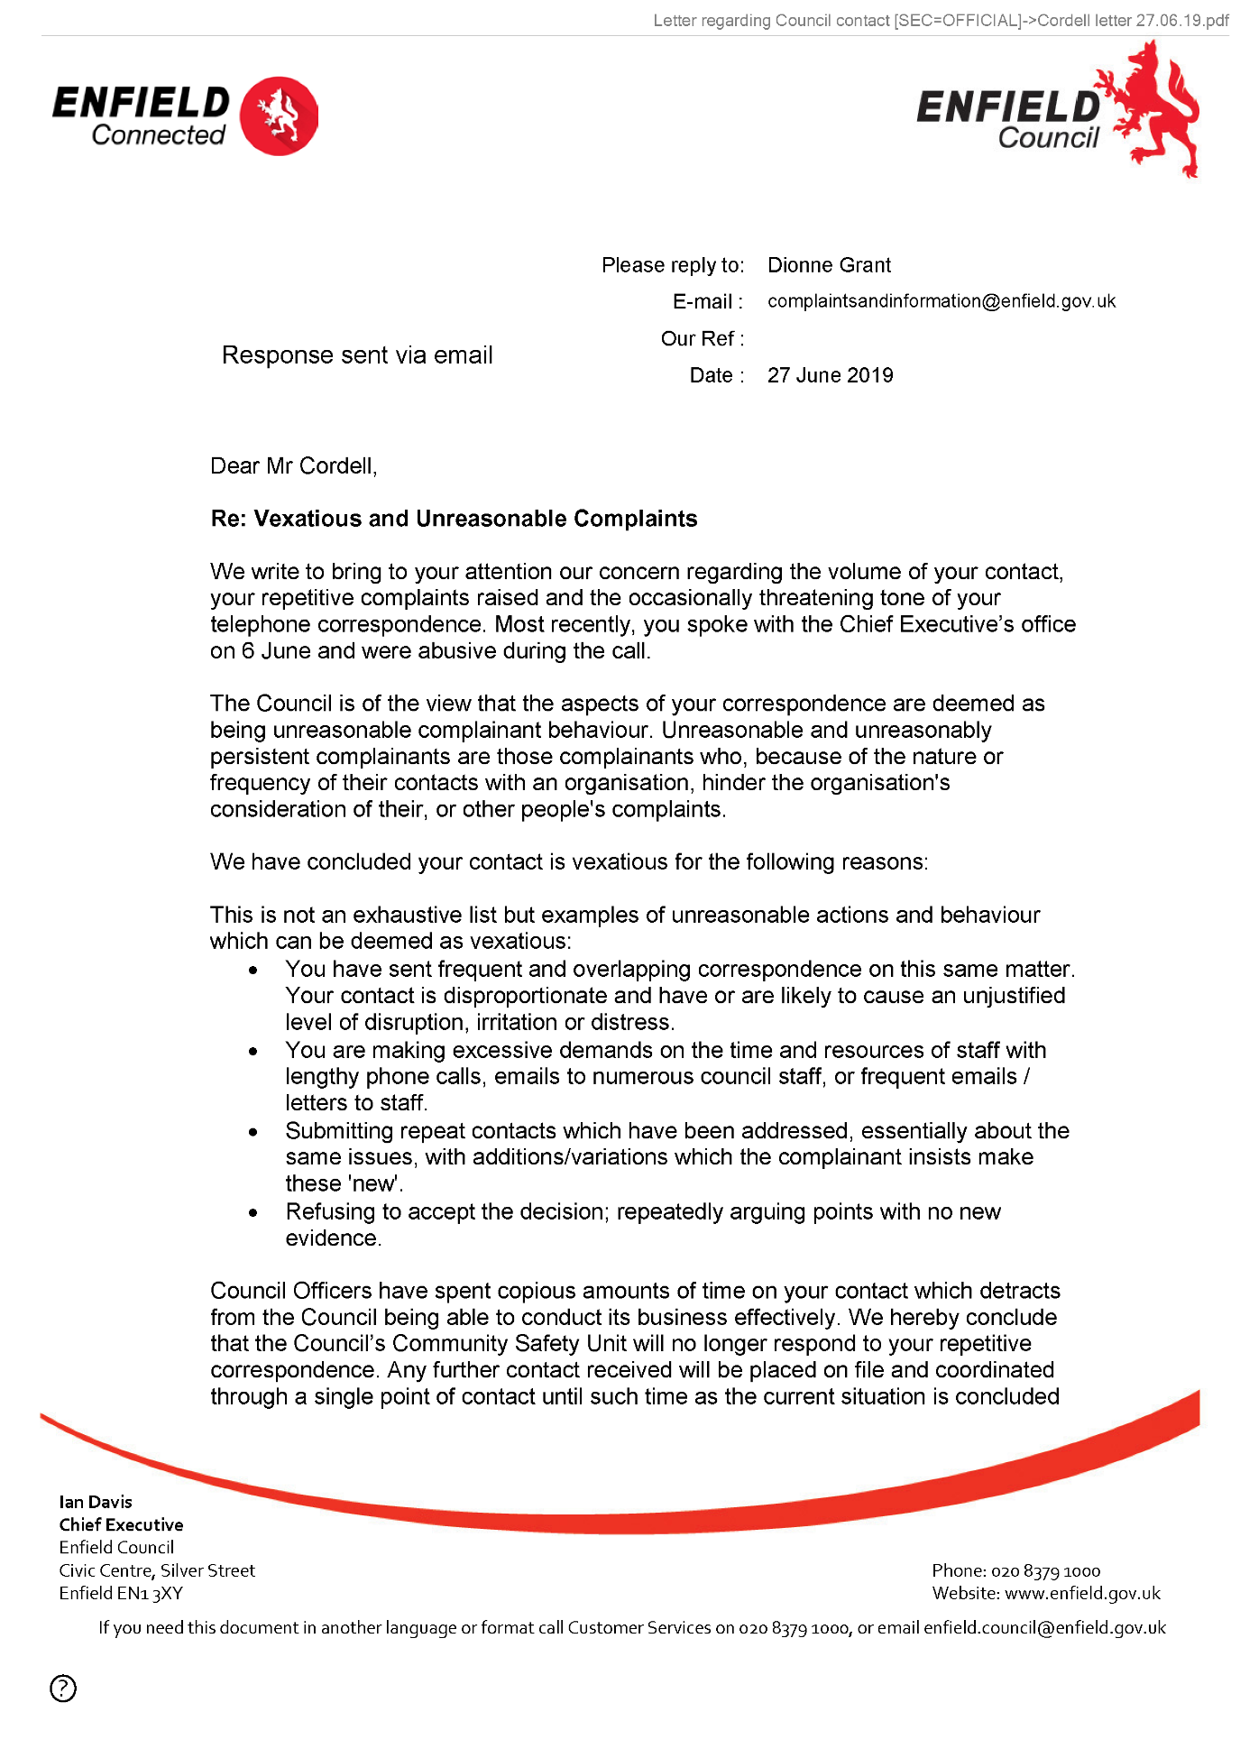
377,
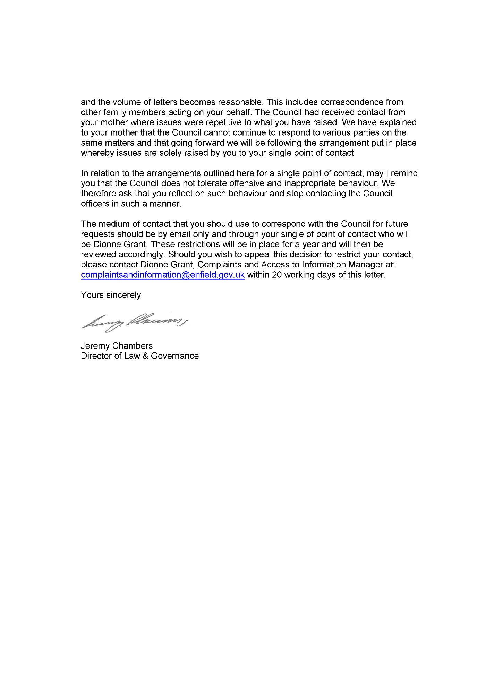
End of Picture!

37.
Additional Email Attachments & Emails / Issue:
37. 1. 1
Sean@tyrerroxburgh.co06.27.2019_Letter from Enfield 2
27/06/2019/
Page Numbers: 378,379
--
378,
From: Sean Shanmuganathan <sean@tyrerroxburgh.co.uk>
Sent: 27 June 2019 10:06
To: Lorraine Cordell
Cc: Ronak Ahmed
Subject: Letter from Enfield
Attachments: 20190627104617521.pdf
Dear Ms Cordell
Please find attached the letter we received from Enfield Council.
Kind Regards
D Shanmuganathan Partner
Tyrer Roxburgh Solicitors LLP
Tel +44 (0)20 8889 3319
Direct Dial +44 (0)20 8829 2937
Email sean@tyrerroxburgh.co.uk
Head Office:
1 St Michaels Terrace London N22 7SJ
DX 34704 WOOD GREEN 2
Tel +44 (0)20 8889 3319
Fax +44 (0)20 8881 6089
Luton Office:
Trend House Dallow Road Luton LU11LY
Tel +44 (0)1582 726579
Please reply to our Head Office
www.tyrerroxburgh.co.uk
Authorised by the Solicitors Regulation Authority. Tyrer Roxburgh Solicitors LLP is a limited liability partnership under the no.560748. A list of the members' names is open to inspection at the registered office. VAT REG No: 221 8088 78 SRA No: 560748
Contracted with the Legal Aid Agency
We do not accept service of documents or other process by e-mail Email us at lawmakers@tyrerroxburgh.co.uk
This message may contain privileged information and is only intended to be received by the person to whom it is addressed.
If you are not the intended recipient, please contact us as soon as possible.
Partners • Mukesh Badhan • D Shanmuganathan
379,
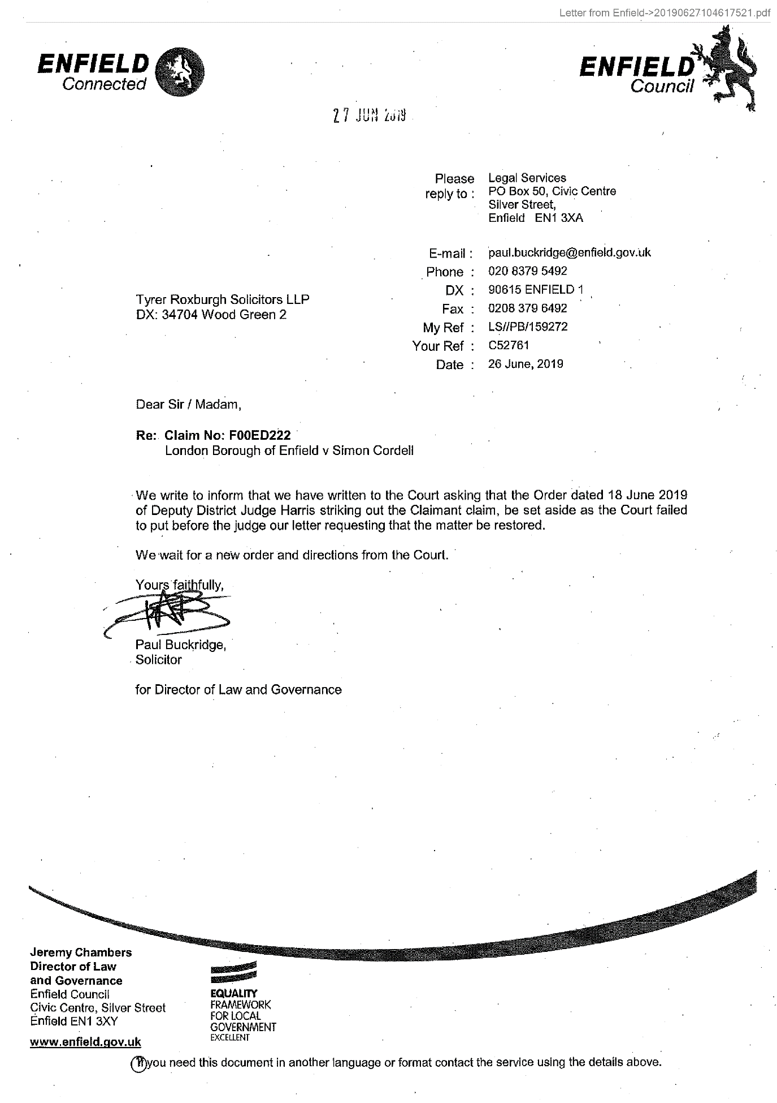
End of Picture!

The banging Started!

Summary!

Disrepair!

Time Spent Building.
In the background of everything going on I could no longer work on my first company Too Smooth due to the amount of time I had to put toward s defending myself.
My mother Stopped working on my website
Working at Home doing Court Case Defense Work!
I spent time and recourses costing expenditure building my defence case and website Horrific Corruption.com, against the allegations getting put against me at the Time Start: 00:00 and Time End: 00:00

Friday!
28/06/2019

Stain and the
Issues with Housing Disrepair!
Working on the Court Case Defence!
The Anti-Social Behaviour Order Case and the Verdict got made Guilty against me in error and the conditions got imposed against me till late 2020!
The Banging Continued: -
28/06/2019

- Disrepair!
- The Asbo Order got granted in Error with Full Conditions against me and Fraudulently!
- The banging Continued at me!
- Working at home!

- 117 Burncroft Avenue
The 3rd set of Tenant’s since the Problems Started with the Flat being used as an Offensives Weapons against my Person and against my free will.
has been “Re-Vacated” again by John Iron

--

The banging Started!

Si Note:
1

Summary!

Disrepair!

Time Spent Building.
In the background of everything going on I could no longer work on my first company Too Smooth due to the amount of time I had to put toward s defending myself.
My mother Stopped working on my website
Working at Home doing Court Case Defense Work!
I spent time and recourses costing expenditure building my defence case and website Horrific Corruption.com, against the allegations getting put against me at the Time Start: 00:00 and Time End: 00:00

Saturday!
29/06/2019

Stain and the
Issues with Housing Disrepair!
Working on the Court Case Defence!
The Anti-Social Behaviour Order Case and the Verdict got made Guilty against me in error and the conditions got imposed against me till late 2020!
The Banging Continued: -
29/06/2019

- Disrepair!
- The Asbo Order got granted in Error with Full Conditions against me and Fraudulently!
- The banging Continued at me!
- Working at home!

- 117 Burncroft Avenue
The 3rd set of Tenant’s since the Problems Started with the Flat being used as an Offensives Weapons against my Person and against my free will.
has been “Re-Vacated” again by John Iron

--

1
Because of my dog lady being ill with chest cancer I have had to spend special attention on her needs and lucky for me the Possession Order has now been dropped

2
Not going outside that much anymore because of what the police the Enfield Council who are also my Landlord’s and persific members of neighbours

The banging Started!

Si Note:
1

2

Summary!

Disrepair!

Time Spent Building.
In the background of everything going on I could no longer work on my first company Too Smooth due to the amount of time I had to put toward s defending myself.
My mother Stopped working on my website
Working at Home doing Court Case Defense Work!
I spent time and recourses costing expenditure building my defence case and website Horrific Corruption.com, against the allegations getting put against me at the Time Start: 00:00 and Time End: 00:00

Sunday!
30/06/2019

Stain and the
Issues with Housing Disrepair!
Working on the Court Case Defence!
The Anti-Social Behaviour Order Case and the Verdict got made Guilty against me in error and the conditions got imposed against me till late 2020!
The Banging Continued: -
30/06/2019

- Disrepair!
- The Asbo Order got granted in Error with Full Conditions against me and Fraudulently!
- The banging Continued at me!
- Working at home!

- 117 Burncroft Avenue
The 3rd set of Tenant’s since the Problems Started with the Flat being used as an Offensives Weapons against my Person and against my free will.
has been “Re-Vacated” again by John Iron

--

1
When in m y flat today I continued to work on the computer writing my report due to what has been and continues to happen to me.
I have noticed that the new tenants are also attacking me.
What I mean is that when I wake up in the morning time I will do so in my front room as this is where I tend to sleep
Today while in my flat I continued to notice that the new tenants in 117 had been attacking me.
I found this strange after talking to the new lady who moved into the flat on the 30/06/2019

The banging Started!

Si Note:
1

Summary!

Disrepair!

Time Spent Building.
In the background of everything going on I could no longer work on my first company Too Smooth due to the amount of time I had to put toward s defending myself.
My mother Stopped working on my website
Working at Home doing Court Case Defense Work!
I spent time and recourses costing expenditure building my defence case and website Horrific Corruption.com, against the allegations getting put against me at the Time Start: 00:00 and Time End: 00:00

Monday!
01/07/2019

Stain and the
Issues with Housing Disrepair!
Working on the Court Case Defence!
The Anti-Social Behaviour Order Case and the Verdict got made Guilty against me in error and the conditions got imposed against me till late 2020!
The Banging Continued: -
01/07/2019

- Disrepair!
- The Asbo Order got granted in Error with Full Conditions against me and Fraudulently!
- The banging Continued at me!
- Working at home!

- 117 Burncroft Avenue
The 3rd set of Tenant’s since the Problems Started with the Flat being used as an Offensives Weapons against my Person and against my free will.
has been “Re-Vacated” again by John Iron

--

1
I got stabbed with a large knife with a white handle. I know who stabbed me with the knife and the reason that I know
who hurt me is that it was my next door neighbour, who lives above me in the address of 117 Burncroft Avenue that have just gotten moved into the flat of 117 on the date of 00/00/2019

The banging Started!

Si Note:
1

Summary!

Disrepair!

Time Spent Building.
In the background of everything going on I could no longer work on my first company Too Smooth due to the amount of time I had to put toward s defending myself.
My mother Stopped working on my website
Working at Home doing Court Case Defense Work!
I spent time and recourses costing expenditure building my defence case and website Horrific Corruption.com, against the allegations getting put against me at the Time Start: 00:00 and Time End: 00:00

Tuesday!
02/07/2019

Stain and the
Issues with Housing Disrepair!
Working on the Court Case Defence!
The Anti-Social Behaviour Order Case and the Verdict got made Guilty against me in error and the conditions got imposed against me till late 2020!
The Banging Continued: -
02/07/2019

- Disrepair!
- The Asbo Order got granted in Error with Full Conditions against me and Fraudulently!
- The banging Continued at me!
- Working at home!

- 117 Burncroft Avenue
The 3rd set of Tenant’s since the Problems Started with the Flat being used as an Offensives Weapons against my Person and against my free will.
has been “Re-Vacated” again by John Iron

--

1
No person stayed in the flat of 117 after what happened to me last night I.e. Getting stabbed with a big Kitching Knife.
After what happened between myself and the current new occupiers of 117 Burncroft Avenue yesterday I decided to stay cautious in regards to my safety.
I stayed on the computer working hard on my report right until the time of 21:00 hours when I noticed a lot of bagging coming from inside of the communal hall. When paying attention to what the notice was, I could tell it was the communal door getting slammed hard as a person or persons were going up and down the stairs carrying things.
At the time I was on the mobile phone at the time and I got asked who was making all the noticed while in my front room at my computer desk
While hearing the noise and there on after I decided not to go out of my front door due to what might re occur.
I could hear footsteps in the flat 2 floors above me soon afterwards so I knew that the new occupiers of 117 had returned.

The banging Started!

Si Note:
1

Summary!

Disrepair!

Time Spent Building.
In the background of everything going on I could no longer work on my first company Too Smooth due to the amount of time I had to put toward s defending myself.
My mother Stopped working on my website
Working at Home doing Court Case Defense Work!
I spent time and recourses costing expenditure building my defence case and website Horrific Corruption.com, against the allegations getting put against me at the Time Start: 00:00 and Time End: 00:00

Wednesday!
03/07/2019

Stain and the
Issues with Housing Disrepair!
Working on the Court Case Defence!
The Anti-Social Behaviour Order Case and the Verdict got made Guilty against me in error and the conditions got imposed against me till late 2020!
The Banging Continued: -
03/07/2019

- Disrepair!
- The Asbo Order got granted in Error with Full Conditions against me and Fraudulently!
- The banging Continued at me!
- Working at home!

- 117 Burncroft Avenue
The 3rd set of Tenant’s since the Problems Started with the Flat being used as an Offensives Weapons against my Person and against my free will.
has been “Re-Vacated” again by John Iron

--

The banging Started!

Summary!

Disrepair!

Time Spent Building.
In the background of everything going on I could no longer work on my first company Too Smooth due to the amount of time I had to put toward s defending myself.
My mother Stopped working on my website
Working at Home doing Court Case Defense Work!
I spent time and recourses costing expenditure building my defence case and website Horrific Corruption.com, against the allegations getting put against me at the Time Start: 00:00 and Time End: 00:00

Thursday!
04/07/2019

Stain and the
Issues with Housing Disrepair!
Working on the Court Case Defence!
The Anti-Social Behaviour Order Case and the Verdict got made Guilty against me in error and the conditions got imposed against me till late 2020!
The Banging Continued: -
04/07/2019

- Disrepair!
- The Asbo Order got granted in Error with Full Conditions against me and Fraudulently!
- The banging Continued at me!
- Working at home!

- 117 Burncroft Avenue
The 3rd set of Tenant’s since the Problems Started with the Flat being used as an Offensives Weapons against my Person and against my free will.
has been “Re-Vacated” again by John Iron

--

The banging Started!

Summary!

Disrepair!

Time Spent Building.
In the background of everything going on I could no longer work on my first company Too Smooth due to the amount of time I had to put toward s defending myself.
My mother Stopped working on my website
Working at Home doing Court Case Defense Work!
I spent time and recourses costing expenditure building my defence case and website Horrific Corruption.com, against the allegations getting put against me at the Time Start: 00:00 and Time End: 00:00

Friday!
05/07/2019

Stain and the
Issues with Housing Disrepair!
Working on the Court Case Defence!
The Anti-Social Behaviour Order Case and the Verdict got made Guilty against me in error and the conditions got imposed against me till late 2020!
The Banging Continued: -
05/07/2019

- Disrepair!
- The Asbo Order got granted in Error with Full Conditions against me and Fraudulently!
- The banging Continued at me!
- Working at home!

- 117 Burncroft Avenue
The 3rd set of Tenant’s since the Problems Started with the Flat being used as an Offensives Weapons against my Person and against my free will.
has been “Re-Vacated” again by John Iron

--

1
Mother came to mine to sort out a few bits for me and asked me to come outside to her car when she arrived to give her what I needed to.
This was at the Time of 2:00 Pm and when I done this, I decided to bring lady out to see mother as that is what my dog seem to want to do.
Mother was in a frantic rush and seemed to be a bit high rate, this may have been due to the sun being very hot and therefore making it aa hot day. When outside mother undone her passenger window so that she could quickly hurry off and as she done this, I felt the heat from inside her car hit my face. Straight away I understood that she could not take lady along with her as she was due to come back within five minutes and then disappear until I next see her.
I must have been outside for no longer than three minutes in total and I was heading back into my flat I took a look at my dog lady who had followed me up to the car door and she look a bit more unwell than she had been already so I knew that she was not going to be good at all.
Once I had noticed how my dog lady was acting, I asked her to follow me back into my home, she seem to still want to say hello to my mother but she was already of within them moments of seconds.

2
Quite all day I did hear people come in and go out at the time of 19:32!

The banging Started!

Si Note:
1

2

Summary!

Disrepair!

Time Spent Building.
In the background of everything going on I could no longer work on my first company Too Smooth due to the amount of time I had to put toward s defending myself.
My mother Stopped working on my website
Working at Home doing Court Case Defense Work!
I spent time and recourses costing expenditure building my defence case and website Horrific Corruption.com, against the allegations getting put against me at the Time Start: 00:00 and Time End: 00:00

Saturday!
06/07/2019

Stain and the
Issues with Housing Disrepair!
Working on the Court Case Defence!
The Anti-Social Behaviour Order Case and the Verdict got made Guilty against me in error and the conditions got imposed against me till late 2020!
The Banging Continued: -
06/07/2019

- Disrepair!
- The Asbo Order got granted in Error with Full Conditions against me and Fraudulently!
- The banging Continued at me!
- Working at home!

- 117 Burncroft Avenue
The 3rd set of Tenant’s since the Problems Started with the Flat being used as an Offensives Weapons against my Person and against my free will.
has been “Re-Vacated” again by John Iron

--

The banging Started!

Summary!

Disrepair!

Time Spent Building.
In the background of everything going on I could no longer work on my first company Too Smooth due to the amount of time I had to put toward s defending myself.
My mother Stopped working on my website
Working at Home doing Court Case Defense Work!
I spent time and recourses costing expenditure building my defence case and website Horrific Corruption.com, against the allegations getting put against me at the Time Start: 00:00 and Time End: 00:00

Sunday!
07/07/2019

Stain and the
Issues with Housing Disrepair!
Working on the Court Case Defence!
The Anti-Social Behaviour Order Case and the Verdict got made Guilty against me in error and the conditions got imposed against me till late 2020!
The Banging Continued: -
07/07/2019

- Disrepair!
- The Asbo Order got granted in Error with Full Conditions against me and Fraudulently!
- The banging Continued at me!
- Working at home!

- 117 Burncroft Avenue
The 3rd set of Tenant’s since the Problems Started with the Flat being used as an Offensives Weapons against my Person and against my free will.
has been “Re-Vacated” again by John Iron

--

1
Someone and most likely Stain started with a drill on the wall from 117

2
Ozzie then afterwards started on his wall with a drill.

The banging Started!

Si Note:
1

2

Summary!

Disrepair!

Time Spent Building.
In the background of everything going on I could no longer work on my first company Too Smooth due to the amount of time I had to put toward s defending myself.
My mother Stopped working on my website
Working at Home doing Court Case Defense Work!
I spent time and recourses costing expenditure building my defence case and website Horrific Corruption.com, against the allegations getting put against me at the Time Start: 00:00 and Time End: 00:00

Monday!
08/07/2019

Stain and the
Issues with Housing Disrepair!
Working on the Court Case Defence!
The Anti-Social Behaviour Order Case and the Verdict got made Guilty against me in error and the conditions got imposed against me till late 2020!
The Banging Continued: -
08/07/2019

- Disrepair!
- The Asbo Order got granted in Error with Full Conditions against me and Fraudulently!
- The banging Continued at me!
- Working at home!

- 117 Burncroft Avenue
The 3rd set of Tenant’s since the Problems Started with the Flat being used as an Offensives Weapons against my Person and against my free will.
has been “Re-Vacated” again by John Iron

38.
- Additional Email Attachments & Emails / Issue:
38. 1. 1
lorraine32@blueyonder Council contact [SEC=OFFICIAL 5
08/07/2019
/ Page Numbers: 380,381,382,383,384

--

38.
Additional Email Attachments & Emails / Issue:
38. 1. 1
lorraine32@blueyonder Council contact [SEC=OFFICIAL 5
08/07/2019
/ Page Numbers: 380,381,382,383,384
--
380,
From: Lorraine Cordell <lorraine32@blueyonder.co.uk>
Sent: 08 July 2019 17:58
To: 'complaints and information'
Subject: RE: Letter regarding Council contact [SEC=OFFICIAL]
Attachments: Reply to Enfield Councils Letter 27-06-2019.pdf
Dear Dionne Grant
Please see attached letter.
Regards
Lorraine Cordell
From: complaints and information
Mailto: complaintsandinformation@enfield.gov.uk
Sent: 27 June 2019 15:03
To: Lorraine32@blueyonder.co.uk
Subject: Letter regarding Council contact [SEC=OFFICIAL]
Classification: OFFICIAL
Dear Mr Cordell,
Please find attached letter for your attention regarding communications with the Council.
Yours sincerely Dionne Grant
Complaints and Information Service Manager
Enfield Council
Civic Centre
Silver Street, Enfield
EN13XA
Classification: OFFICIAL
Enfield Council is committed to serving the whole borough fairly, delivering excellent services and building strong communities. Opinions expressed in this email are those of the individual and not necessarily those of the London Borough of Enfield. This email and any attachments or files transmitted with it are strictly confidential and intended solely for the named addressee. It may contain privileged and confidential information and if you are not the intended recipient and receive it in error you must not copy, distribute
381,
or use the communication in any other way. All traffic handled by the Government Connect Secure Extranet may be subject to recording/and or monitoring in accordance with relevant legislation.
This email has been scanned for viruses, but we cannot guarantee that it will be free of viruses or malware. The recipient should perform their own virus checks.
Disclaimer
The information contained in this communication from the sender is confidential. It is intended solely for use by the recipient and others authorized to receive it. If you are not the recipient, you are hereby notified that any disclosure, copying, distribution or taking action in relation of the contents of this information is strictly prohibited and may be unlawful.
This email has been scanned for viruses and malware, and may have been automatically archived by Mimecast Ltd, an innovator in Software as a Service (SaaS) for business. Providing a safer and more useful place for your human generated data. Specializing in; Security, archiving and compliance.
382,
RE: Letter regarding Council contact [SEC=OFFICIAL]->Reply to Enfield Councils Letter 27-06-2019.pdf
Miss Lorraine Cordell
08 July 2019
- Re: Vexatious and Unreasonable Complaints
Dear Dionne Grant
I am writing this letter regarding the email I received on the 27th June 2019 where it has been stated that rules have been set out in regard to us contracting Enfield Council, and that my correspondence has been deemed Vexatious and Unreasonable Complaints.
I have issues with what has been said in your letter that has been sent to me.
You state in the letter
“The Council is of the view that the aspects of your correspondence are deemed as being unreasonable complainant behaviour. Unreasonable and unreasonably persistent complainants are those complainants who, because of the nature or frequency of their contacts with an organisation, hinder the organisation's consideration of their, or other people's complaints.
- We have concluded your contact is vexatious for the following reasons:
- This is not an exhaustive list but examples of unreasonable actions and behaviour which can be deemed as vexatious: You have sent frequent and overlapping correspondence on this same matter. Your contact is disproportionate and have or are likely to cause an unjustified level of disruption, irritation, or distress.
- You are making excessive demands on the time and resources of staff with lengthy phone calls, emails to numerous council staff, or frequent emails / letters to staff.
1
383,
- Submitting repeat contacts which have been addressed, essentially about the same issues, with additions/variations which the complainant insists make these 'new'.
- Refusing to accept the decision; repeatedly arguing points with no new evidence.”
The issue I have with the above is yes, I have sent letters and complaints, but we do not get any replies to these or if we do get a reply it does not cover what we have asked.
The last time I wrote was I believe 05/12/2018 with no reply, so I sent a few follow up emails in 2019 asking if there was any update which I never got a reply back, which since then I have just given up due to the fact I know I will not get a reply, I do not feel my letters are Vexatious and Unreasonable I am asking questions I would like replies to, I do not just sit here each day spending all my time writing to Enfield Council when I know I will not get a reply. The only reason I wrote in 2018 was after the court case and that was to address things within the court order, which Enfield Council failed to comply with.
The other letter I sent was for a DSAR this was sent on 25/11/2018 which I did not really get what I asked for on the 16/02/2019, there was some issues with some of the files that Enfield Council had uploaded, I could not get and sent an email over which was corrected so I could download the files, but once I opened them most of the data was for 1997, I did write back asking why everything was missing and once again got no reply regarding all the missing data.
In fact I am in the process of drawing up a new DSAR in the hope this time I will get the data I am asking for which so far Enfield Council has failed to do, should this be addressed to yourself?
In fact from 2015 most of my letters or emails have in fact gone without a reply and this can be proven. It seems very strange this letter has been written and I wonder if it is only due to the court action Enfield Council wants to take regarding my son.
I cannot understand your point regarding the “volume of letters becomes reasonable” as I have not sent that many emails as I know in fact I will hardly ever get a reply, it is for that reason I do not take my time in writing to you in order to try and address issues as it seems Enfield Council is unwilling to try and address anything.
2
384,
I did ask Enfield Council to confirm in writing more than once, what stage my complaint was at due to no replies, but I have never had a reply back to tell me what stage it was at.
I was not going to reply back to this letter that was sent on the 27th June 2019 as I felt it was Enfield Council that was being Vexatious and Unreasonable, I already know nothing will be addressed but in the end I felt I had to say something.
Yours sincerely,
Miss L Cordell
3

The banging Started!

Summary!

Disrepair!

Time Spent Building.
In the background of everything going on I could no longer work on my first company Too Smooth due to the amount of time I had to put toward s defending myself.
My mother Stopped working on my website
Working at Home doing Court Case Defense Work!
I spent time and recourses costing expenditure building my defence case and website Horrific Corruption.com, against the allegations getting put against me at the Time Start: 00:00 and Time End: 00:00

Tuesday!
09/07/2019

Stain and the
Issues with Housing Disrepair!
Working on the Court Case Defence!
The Anti-Social Behaviour Order Case and the Verdict got made Guilty against me in error and the conditions got imposed against me till late 2020!
The Banging Continued: -
09/07/2019

- Disrepair!
- The Asbo Order got granted in Error with Full Conditions against me and Fraudulently!
- The banging Continued at me!
- Working at home!

- 117 Burncroft Avenue
The 3rd set of Tenant’s since the Problems Started with the Flat being used as an Offensives Weapons against my Person and against my free will.
has been “Re-Vacated” again by John Iron

--

1
Mother made a phone call to me and explained that the police had called her about the case from the other day had gotten dropped 117 2nd tenants.

The banging Started!

Si Note:
1

Summary!

Disrepair!

Time Spent Building.
In the background of everything going on I could no longer work on my first company Too Smooth due to the amount of time I had to put toward s defending myself.
My mother Stopped working on my website
Working at Home doing Court Case Defense Work!
I spent time and recourses costing expenditure building my defence case and website Horrific Corruption.com, against the allegations getting put against me at the Time Start: 00:00 and Time End: 00:00

Wednesday!
10/07/2019

Stain and the
Issues with Housing Disrepair!
Working on the Court Case Defence!
The Anti-Social Behaviour Order Case and the Verdict got made Guilty against me in error and the conditions got imposed against me till late 2020!
The Banging Continued: -
10/07/2019
- Disrepair!
- The Asbo Order got granted in Error with Full Conditions against me and Fraudulently!
- The banging Continued at me!
- Working at home!

- 117 Burncroft Avenue
The 3rd set of Tenant’s since the Problems Started with the Flat being used as an Offensives Weapons against my Person and against my free will.
has been “Re-Vacated” again by John Iron

--

1
Lady was very ill again today I had to phone mother and ask her for help in sorting out the next stages with her.
We went outside a few times and was going to try and make it to the park

The banging Started!

Si Note:
1

Summary!

Disrepair!

Time Spent Building.
In the background of everything going on I could no longer work on my first company Too Smooth due to the amount of time I had to put toward s defending myself.
My mother Stopped working on my website
Working at Home doing Court Case Defense Work!
I spent time and recourses costing expenditure building my defence case and website Horrific Corruption.com, against the allegations getting put against me at the Time Start: 00:00 and Time End: 00:00

Thursday!
11/07/2019

Stain and the
Issues with Housing Disrepair!
Working on the Court Case Defence!
The Anti-Social Behaviour Order Case and the Verdict got made Guilty against me in error and the conditions got imposed against me till late 2020!
The Banging Continued: -
11/07/2019

- Disrepair!
- The Asbo Order got granted in Error with Full Conditions against me and Fraudulently!
- The banging Continued at me!
- Working at home!

- 117 Burncroft Avenue
The 3rd set of Tenant’s since the Problems Started with the Flat being used as an Offensives Weapons against my Person and against my free will.
has been “Re-Vacated” again by John Iron

--

1
The day that Stain and the neighbours were waiting for another part of me to die:
Lady Passed Awayday” My best Friend / Dog”

2
The neighbours in 117 tried to rob my home.

The banging Started!

Si Note:
1

2

Summary!

Disrepair!

Time Spent Building.
In the background of everything going on I could no longer work on my first company Too Smooth due to the amount of time I had to put toward s defending myself.
My mother Stopped working on my website
Working at Home doing Court Case Defense Work!
I spent time and recourses costing expenditure building my defence case and website Horrific Corruption.com, against the allegations getting put against me at the Time Start: 00:00 and Time End: 00:00

Friday!
12/07/2019

Stain and the
Issues with Housing Disrepair!
Working on the Court Case Defence!
The Anti-Social Behaviour Order Case and the Verdict got made Guilty against me in error and the conditions got imposed against me till late 2020!
The Banging Continued: -
12/07/2019

- Disrepair!
- The Asbo Order got granted in Error with Full Conditions against me and Fraudulently!
- The banging Continued at me!
- Working at home!

- 117 Burncroft Avenue
The 3rd set of Tenant’s since the Problems Started with the Flat being used as an Offensives Weapons against my Person and against my free will.
has been “Re-Vacated” again by John Iron

--

The banging Started!

Summary!

Disrepair!

Time Spent Building.
In the background of everything going on I could no longer work on my first company Too Smooth due to the amount of time I had to put toward s defending myself.
My mother Stopped working on my website
Working at Home doing Court Case Defense Work!
I spent time and recourses costing expenditure building my defence case and website Horrific Corruption.com, against the allegations getting put against me at the Time Start: 00:00 and Time End: 00:00

Saturday!
13/07/2019

Stain and the
Issues with Housing Disrepair!
Working on the Court Case Defence!
The Anti-Social Behaviour Order Case and the Verdict got made Guilty against me in error and the conditions got imposed against me till late 2020!
The Banging Continued: -
13/07/2019

- Disrepair!
- The Asbo Order got granted in Error with Full Conditions against me and Fraudulently!
- The banging Continued at me!
- Working at home!

- 117 Burncroft Avenue
The 3rd set of Tenant’s since the Problems Started with the Flat being used as an Offensives Weapons against my Person and against my free will.
has been “Re-Vacated” again by John Iron

--

The banging Started!

Summary!

Disrepair!

Time Spent Building.
In the background of everything going on I could no longer work on my first company Too Smooth due to the amount of time I had to put toward s defending myself.
My mother Stopped working on my website
Working at Home doing Court Case Defense Work!
I spent time and recourses costing expenditure building my defence case and website Horrific Corruption.com, against the allegations getting put against me at the Time Start: 00:00 and Time End: 00:00

Sunday!
14/07/2019

Stain and the
Issues with Housing Disrepair!
Working on the Court Case Defence!
The Anti-Social Behaviour Order Case and the Verdict got made Guilty against me in error and the conditions got imposed against me till late 2020!
The Banging Continued: -
14/07/2019

- Disrepair!
- The Asbo Order got granted in Error with Full Conditions against me and Fraudulently!
- The banging Continued at me!
- Working at home!

- 117 Burncroft Avenue
The 3rd set of Tenant’s since the Problems Started with the Flat being used as an Offensives Weapons against my Person and against my free will.
has been “Re-Vacated” again by John Iron

--

The banging Started!

Summary!

Disrepair!

Time Spent Building.
In the background of everything going on I could no longer work on my first company Too Smooth due to the amount of time I had to put toward s defending myself.
My mother Stopped working on my website
Working at Home doing Court Case Defense Work!
I spent time and recourses costing expenditure building my defence case and website Horrific Corruption.com, against the allegations getting put against me at the Time Start: 00:00 and Time End: 00:00

Monday!
15/07/2019

Stain and the
Issues with Housing Disrepair!
Working on the Court Case Defence!
The Anti-Social Behaviour Order Case and the Verdict got made Guilty against me in error and the conditions got imposed against me till late 2020!
The Banging Continued: -
15/07/2019

- Disrepair!
- The Asbo Order got granted in Error with Full Conditions against me and Fraudulently!
- The banging Continued at me!
- Working at home!

- 117 Burncroft Avenue
The 3rd set of Tenant’s since the Problems Started with the Flat being used as an Offensives Weapons against my Person and against my free will.
has been “Re-Vacated” again by John Iron

--

1
Mother made a phone call to me at the time of 16:00 and told me that the doctors are coming to my house again to do another assessment on me for my Mental Health I told her that this is wrong and that I do not trust her anymore due to hearing her talk to the police outside of my front door “BT-DAY” man day.
I pulled the doctors letter out that I have been receiving since Soobah came to my front door the other day, to see what they said and when checking them they all said that it is up to myself whether I go to see them for any support I choose not to as I understood that what the doctors had being doing to my self was illegal alongside unmoral. For an instance if I was a venerable adult as the doctors have been trying label myself even low, I am not then they would have abused myself and their position as medical practitioners.
When thinking back of what my mother had said to me about the doctors coming to mine again, I released the following:
Waiting for the doctors to come to my home again the next day.

The banging Started!

Si Note:
1

Summary!

Disrepair!

Time Spent Building.
In the background of everything going on I could no longer work on my first company Too Smooth due to the amount of time I had to put toward s defending myself.
My mother Stopped working on my website
Working at Home doing Court Case Defense Work!
I spent time and recourses costing expenditure building my defence case and website Horrific Corruption.com, against the allegations getting put against me at the Time Start: 00:00 and Time End: 00:00

Tuesday!
16/07/2019

Stain and the
Issues with Housing Disrepair!
Working on the Court Case Defence!
The Anti-Social Behaviour Order Case and the Verdict got made Guilty against me in error and the conditions got imposed against me till late 2020!
The Banging Continued: -
16/07/2019

- Disrepair!
- The Asbo Order got granted in Error with Full Conditions against me and Fraudulently!
- The banging Continued at me!
- Working at home!

- 2nd Possession Order! 06/02/2019
I have good news in that the Council have decided to not pursue the case further due to a lack of recent incidents. Please see attached their letter received recently and our letter dated 22 October 2019 sent to your son.

1
- 113 Burncroft Avenue
Ambrose had moved for ever!
“Empty”

- 117 Burncroft Avenue
The 3rd set of Tenant’s since the Problems Started with the Flat being used as an Offensives Weapons against my Person and against my free will.
has been “Re-Vacated” again by John Iron

1
- Yahoo Mail - FW Simon Cordell FOOED222
FW: Simon Cordell FOOED222
From: Lorraine Cordell (lorraine32@blueyonder.co.uk)
To: re_wired@ymail.com
Date: Tuesday, 16 July 2019, 01:30 BST
here
From: Ronak Ahmed

2
- The Doctors Came to my Home to do an Assessment on me again.
I heard my “Atomic Alarm Clock” on my Pc set its

39.
- Additional Email Attachments & Emails / Issue:
39. 1. 2.
Mother 16-07-2019 -01-30
16/07/2019
/ Page Numbers: 385,386

--

1
Yahoo Mail - FW Simon Cordell FOOED222
FW: Simon Cordell FOOED222
From: Lorraine Cordell (lorraine32@blueyonder.co.uk)
To: re_wired@ymail.com
Date: Tuesday, 16 July 2019, 01:30 BST
here
From: Ronak Ahmed
mailto:ronak@tyrerroxburgh.co.uk
Sent:
To: Lorraine Cordell
Subject:
Good afternoon
Please see attached court order received today. We will wait a few weeks in case the Claimants apply to set aside the attached order. If no further action is taken by the Claimant in that time, I shall close this file. Please also note that this Order does not prevent a new claim being brought in the future.
Kind Regards
Ronak Ahmed
Consultant Solicitor
Tyrer Roxburgh Solicitors LLP
20190625093129269[20838].pdf
164.7kB
1/1
Attachment
General Form of Judgment or Order

111 the County Court at
Edmonton
Claim Number | F00ED222
Date | 21 June 2019
THE MAYOR AND BURGESSES OF THE LONDON BOROUGH OF ENFIELD |  | 1st Claimant  Ref LS/C/PB/159272
SIMON CORDELL |  | 1st Defendant Ref  D.SHANMUGANATIIAN
Before Deputy District Judge Harris sitting at the County Court at Edmonton, 59 Fore Street, London, N18 2TN. On court's own motion to request to restore having been made by 8th June 2019 as per Order of 8th March 2019
IT IS ORDERED THAT
1. Claimant's claim stands struck out.
Dated 18 June 2019
The court office at the County Court at Edmonton, 59 Fore Street, London, N18 2TN. When corresponding with the court, please address forms or letters to the Court Manager and quote the claim number. Tel: 020 8884 6500. Check if you can issue your claim online. It will save you time and money. Go to www.moneyclaim.gov.uk to find out more.
N24 General Form of Judgment or Order
Produced by: D. Humphreys CJR065C

2
The Doctors Came to my Home to do an Assessment on me again.
I heard my “Atomic Alarm Clock” on my Pc set its Siren of at eight Am as planed but somehow some way I lent over and turned it off and never got up, I think I left the mouse to control the pc to close to my hand.
I heard a knock at my front door and jumped up.
When I asked who it was, I heard the reply of my uncle’s voice and I can remember thinking to myself thank god for that! When rushing to open the front door I hurried and put my clothes on that I had pre paired the night before.
After a few minutes my uncle was in the house
We both had a short chat until, uncle checked the time.
At the time of 10:35 my uncle wanted to see what had held the doctors up and decoded to go outside and see if he could see any of them, I stayed inside of my flat while he did this. Uncle soon afterwards came back into my flat and told me that the doctors were sitting on the wall at the end of the road to the left as you walk outside of the block of flats that I live in.
I pressed record on the recording equipment inside of my home so to have the assessment on recording.
We waited some time and no doctors found their way to my front door.
As the time disappeared by, I spoke to my uncle and said that I am going outside to see what is going on, as I left my flat I picked up all of the Haringey and Barnet / Enfield NHS letters that I had recently received and made my way out to the doctors.
When I walked out of the block of flats front door, I took a look to my left and focused on were the doctors were.
I noticed that they were a group of people, some standing and some sitting down on the side of a wall. I never counted how many because my uncle had already told me a roundabout number of six people. From looking at them all together I could tell that they were the doctors.
I spoke in a voice that was not overpowering but fair to be heard by the group.
What I said was, why are you all sitting out here. Come into my house I am waiting to record the meeting, I showed the letters in my hand that I had brought with myself from inside of my home and showed them high in my right hand while continuing to speak.
The doctors acknowledged me and continued to hover around the same location to what I had seen them in from the start. I said to the doctors this is malicious proses alongside with malicious prosecution.
I pinpointed out my so-called care coordinator out of the group “Soobah” and headed towards them all.
Once with the doctors, Care Coordinators, Amp Works, I told them all that this is:
1) Out of order.
2) I started to explain common sense about the Dates of occurrences with themselves and or colleagues and introduced the letters raised high in my right hand. I told Soobah who I had pinout of the group “you sent me these letters with a doctor called Antonio.
3) I explained that I have never even met my care coordinator other than once in my life and that time was at my tribunal at Chase farm Hospital – Mental Health Department Dorset
As noted in Soobah’s own
“Social Circumstances Report for S.C Rio no 11214451 on Section 2 of the MHA
1983/2007”
4) I have never been diagnosed with a mental Health Illness but always get referred to Mental Health by bent police officers and the council corrupt staff inclusive of unmoral doctors or Mental health Workers, trying to avoid disciplinary actions against themselves and or colleagues.
5) Soobah “Social Circumstances Report for S.C Rio no 11214451 on Section 2 of the MHA
1983/2007” was maliciously forged which is a criminal Act of law “Fraud 2006” + “Fraud under the company Act 2006”
Finally, I got fed up of warning the doctors of their own negligee and gross Misconduct and headed back into my home were my uncle still was, When I got back inside it took a few minutes and I heard my communal front door open. So, I headed to my front door and took a look out into the corridor.
I caught all the doctors and Mental Health workers entering

39.
Additional Email Attachments & Emails / Issue:
39. 1. 2.
Mother 16-07-2019 -01-30
16/07/2019
/ Page Numbers: 385,386
--
385,
From: Lorraine Cordell <lorraine32@blueyonder.co.uk>
Sent time: 16/07/2019 01:30:39 AM
To: re_wired@ymail.com
Subject: FW: Simon Cordell FOOED222
Attachments: 20190625093129269[20838].pdf
here
From: Ronak Ahmed
Mailto: ronak@tyrerroxburgh.co.uk
Sent: 25 June 2019 15:34
To: Lorraine Cordell
Subject: Re: Simon Cordell FOOED222
Good afternoon
Please see attached court order received today.
We will wait a few weeks in case the Claimants apply to set aside the attached order. If no further action is taken by the Claimant in that time, I shall close this file.
Please also note that this Order does not prevent a new claim being brought in the future.
Kind Regards
Ronak Ahmed
Consultant Solicitor
Tyrer Roxburgh Solicitors LLP
386,
General Form of Judgment or Order
In the county Court at Edmonton
Claim Number: F00ED222
Date: 21 June 2019
Ref LS/C/PB/159272
Ref
THE MAYOR AND BURGESSES OF THE LONDON BOROUGH OF ENFIELD |i^{ts} Claimant
SIMON CORDELL
1st Defendant
D.SHANMUGANATHAN
Before Deputy District Judge Hands sitting at the County Court at Edmonton, 59 Fore Street, London, N18 2TN, on court's own motion to request to restore having been made by 8th June 2019 as per Order of 8th March 2019
IT IS ORDERED THAT
- Claimant's claim stands struck out.
Dated 18 June 2019
The court office at the County Court at Edmonton, 59 Fore Street, London, NI8 2TN. When corresponding with the court, please address forms or letters to the Court Manager and quote the claim number.
Tel: 020 88846500.
Check if you can issue your claim online. It will save you time and money.
Go to www.moneyclaim.gov.uk
to find out more.
Produced by: D, Humphreys
N24 Gen era I Form of Judgment or Order CJ R065 C

The banging Started!

Si Note:
1

2

Summary!

Disrepair!

Time Spent Building.
In the background of everything going on I could no longer work on my first company Too Smooth due to the amount of time I had to put toward s defending myself.
My mother Stopped working on my website
Working at Home doing Court Case Defense Work!
I spent time and recourses costing expenditure building my defence case and website Horrific Corruption.com, against the allegations getting put against me at the Time Start: 00:00 and Time End: 00:00

Wednesday!
17/07/2019

Stain and the
Issues with Housing Disrepair!
Working on the Court Case Defence!
The Anti-Social Behaviour Order Case and the Verdict got made Guilty against me in error and the conditions got imposed against me till late 2020!
The Banging Continued: -
17/07/2019

- Disrepair!
- The Asbo Order got granted in Error with Full Conditions against me and Fraudulently!
- The banging Continued at me!
- Working at home!

- 2nd Possession Order! 06/02/2019
I have good news in that the Council have decided to not pursue the case further due to a lack of recent incidents. Please see attached their letter received recently and our letter dated 22 October 2019 sent to your son.

1
- 113 Burncroft Avenue
Ambrose had moved for ever!
“Empty”

- 117 Burncroft Avenue
The 3rd set of Tenant’s since the Problems Started with the Flat being used as an Offensives Weapons against my Person and against my free will.
has been “Re-Vacated” again by John Iron

1
- 117 Burncroft Avenue
I woke up this morning laying down on my sofa.
Uncle Andrew turned

2
- 12:18
Called police upstairs knife

40.
- Additional Email Attachments & Emails / Issue:
40. 1. 1
Shelaine @tyrerroxburggh of Enfield -v- Simon Cordell 3
17/07/2019
/ Page Numbers: 387,388,389

--

1
I woke up this morning laying down on my sofa.
Uncle Andrew turned up at my home at the time of 03:15. He told me that he had been speaking to the Amp worker and Doctors.
I noticed that he had a writing book with him. At one point in or conversation I think when I was looking at the book Uncle Andrew started to explain what it was and why he had turned up with the book to my home in detail to me.
He said that after yesterday he talked to the doctors on the phone again and what he had one was document everything down.
I asked if it was ok to get a copy of the pages and if he knew the doctor’s names alongside with the rest of their crew.
He said that he had been speaking to one of the AMP workers who had been outside and knew his name only. Uncle also commented by saying that it will be ok for me to take a copy of the work.
He showed me a form and said that it was a release form, in relation to releasing my personal information with authorisation to him and asked me whether I would give him consent. I agreed that this would be ok if he could explain to me why I should and I also agreed with his reason.
He told me that what the doctors are doing to me is wrong i.e. illegal and that they had told him that they were now going to try and get a warrant under the Mental health Act 1963 to gain access to my premises with the police.

2
12:18
Called police upstairs knife

117 slamming window Time 21:00

40.
Additional Email Attachments & Emails / Issue:
40. 1. 1
Shelaine @tyrerroxburggh of Enfield -v- Simon Cordell 3
17/07/2019
/ Page Numbers: 387,388,389
--
387,
From: Shelaine Stanley-Mitchell <Shelaine@tyrerroxburgh.co.uk>
Sent: 17 July 2019 16:09
To: lorraine32@blueyonder.co.uk
Cc: Sean Shanmuganathan
Subject: RE: The London Borough of Enfield -v- Simon Cordell
Claim Number: F00ED222
Attachments: Court Order 12.07.19.pdf
Importance: High
Dear Ms Cordell,
RE: Housing Possession Matter
We write with regards to your son’s housing possession matter. Further enclosing a Court Order received from the court dated, 12th July 2019. Please read the enclosed Court Order carefully.
Please do not hesitate to contact Sean or Shelaine at our offices, with regards to this letter and the enclosed Order.
Yours sincerely
Shelaine Stanley-Mitchell Paralegal
Tyrer Roxburgh Solicitors LLP
Tel +44 (0)20 8889 3319
Direct Dial +44 (0)20 8829 2950
Email shelaine@tyrerroxburgh.co.uk
TR TYRER ROXBURGH
Head Office:
1 St Michaels Terrace London N22 7SJ
DX 34704 WOOD GREEN 2
Tel +44 (0)20 8889 3319
Fax +44 (0)20 8881 6089
Luton Office:
Trend House Dallow Road Luton LU1 1LY
Tel +44 (0)1582 726579
Please reply to our Head Office www.tvrerroxburah.co.uk
Authorised by the Solicitors Regulation Authority. Tyrer Roxburgh Solicitors LLP is a limited liability partnership under the no.560748. A list of the members' names is open to inspection at the registered office.
VAT REG No: 221 8088 78
SRA No: 560748
first for family law
Contracted with the Legal Aid Agency
We do not accept service of documents or other process by e-mail
Email us at lawmakers@tyrerroxburgh.co.uk
388,
This message may contain privileged information and is only intended to be received by the person to whom it is addressed. If you are not the intended recipient, please contact us as soon as possible.
Partners • Mukesh Badhan • D Shanmuganathan
389,
RE: The London Borough of Enfield -v- Simon Cordell Claim Number; F00ED222 ->Court Order 12.07.19.pdf:
General Form of Judgment or Order
In the County Court at Edmonton
Claim Number: F00ED222
Date: 12 July 2019
Ref: LS/C/PB/159272
Ref:
THE MAYOR AND BURGESSES OF THE LONDON BOROUGH OF ENFIELD
1st Claimant
And
SIMON CORDELL
1st Defendant
D.SHANMUGANATHAN
Before Deputy District Judge Harris sitting at the County Court at Edmonton, 59 Fore Street, London, N18 2TN.
Upon court's own motion and following consideration of Claimant's letter of 6 June and 26 June 2019, the letter of 6 June not having been before the court when it made the order of 18 June 2019
IT IS ORDERED THAT
- Order of Deputy District Judge Harris dated 18 June 2019 be set aside and claim be re-instated.
- Matter be listed for directions hearing only on 12 December 2019 at 14:00pm, time estimate 20 minutes Dated 9 July 2019
The court office at the County Court at Edmonton, 59 Fore Sheet, London, N18 2TN. When corresponding with the court, please address forms or letters to the Court Manager and quote the claim number.
Tel: 020 8884 6500. Check if you can issue your claim online. It will save you time and money. Go to www.moneyclaim,gov.uk to find out more.
N24 General Form of Judgment or Order
Produced by: A ABIODUN CJR065C

The banging Started!

Si Note:
1

Summary!

Disrepair!

Time Spent Building.
In the background of everything going on I could no longer work on my first company Too Smooth due to the amount of time I had to put toward s defending myself.
My mother Stopped working on my website
Working at Home doing Court Case Defense Work!
I spent time and recourses costing expenditure building my defence case and website Horrific Corruption.com, against the allegations getting put against me at the Time Start: 00:00 and Time End: 00:00

Thursday!
18/07/2019

Stain and the
Issues with Housing Disrepair!
Working on the Court Case Defence!
The Anti-Social Behaviour Order Case and the Verdict got made Guilty against me in error and the conditions got imposed against me till late 2020!
The Banging Continued: -
18/07/2019

The Start of the Possession order Again.

- Disrepair!
- The Asbo Order got granted in Error with Full Conditions against me and Fraudulently!
- The banging Continued at me!
- Working at home!

- 2nd Possession Order! 06/02/2019
I have good news in that the Council have decided to not pursue the case further due to a lack of recent incidents. Please see attached their letter received recently and our letter dated 22 October 2019 sent to your son.

1
- 113 Burncroft Avenue
Ambrose had moved for ever!
“Empty”

- 117 Burncroft Avenue
The 3rd set of Tenant’s since the Problems Started with the Flat being used as an Offensives Weapons against my Person and against my free will.
has been “Re-Vacated” again by John Iron

1
- I made a phone call to my mother once I had gotten up

41.
- Additional Email Attachments & Emails / Issue:
41. 1. 1
Ronak@tyrerroxburgh.ck_07.18.2019_Re Your Son' Case 2
18/07/2019
/ Page Numbers: 390,391

42.
- Additional Email Attachments & Emails / Issue:
42. 1. 1
Ronak@tyrerroxburgh.co.uk_07.18.2019_Your Son' Case 2
18/07/2019
/ Page Numbers: 392,393

--

1
I made a phone call to my mother once I had gotten up and sorted out my home and so forth. What I did ask her was does she understand whether or not the doctors are coming to my home with a warrant under the Mental Health Act 1963, she replied and told me as she understands no doctors are going to be issuing a warrant at the moment even low they wanted to because uncle Andrew has spoken to them. If the doctors do issue a warrant it will not be until Monday or Tuesday.
I asked her next why would that be so if a warrant under the mental health Act “A Section 137” is for emergency problems. So, if that was so, why wait another week seven day to execute one.
Mother had no answer for myself.
Next, I questioned her in regard to a M.O for Tuesday a bit more. What I said was are you sure that the doctors are not waiting because of my front door not being fixed until the 19/07/2019, Mother had no reply.
We ended the conversation.
I heard my mobile ringing at the time of 02:10, when looking at the display screen I see my mother telephone number and picked up the phone.
I was not to shocked to hear what she said to me next. My mother told me that she had just received another email in regard to the Enfield Council and the possession orders that they keep on putting onto me with malicious prosecution.
The Email Stated that the Enfield Council want to re-open the same old cases again that I have won time and time over again. I asked mother to send me a copy of the email and attachments, she agreed to do so.
By the sounds of all that has been explained to me again over the last few days it seems that the police are happy to continue to let any person violate my Syble liberty’s and Human Rights, while they continue to evade justice for the Asbo being made from fraud alongside with the council who created it as well.
The Enfield Council intend to make me not to be allowed to be homeless due to the Asbo conditions and then afterwards continued to create frauded documentation and produce it to the courts of the land and law to also take possession of my home.
They all allow other members of the public to act against my person with criminal activities. While involving the doctors to get involved to cover up all that has been done wrong to myself by undermining me and demoralising my liberties of Rights.
Year, so, as a cover up they all want to get me and put me on loads of medication to stop me writing this report about what they do to me on a day to day basis.
Mine and my mother’s phone conversation came to an end and I continue to document all down.

41.
Additional Email Attachments & Emails / Issue:
41. 1. 1
Ronak@tyrerroxburgh.ck_07.18.2019_Re Your Son' Case 2
18/07/2019
/ Page Numbers: 390,391
--
390,
From: Ronak Ahmed <ronak@tyrerroxburgh.co.uk>
Sent: 18 July 2019 15:05
To: Lorraine Cordell; Sean Shanmuganathan
Subject: Re: Your Son' Case
Dear Ms Cordell Thank you for your email.
We are somewhat constrained by the regulations related to Legal Aid in that we can deal with the Claim for possession only. This means we can take all necessary steps to deal with your son's defence only.
In relation to the correspondence, I have requested copies and will forward these on to you once received.
In terms of the Litigation Friend, the Official Solicitor will act only if there are no family members involved and here it is likely to be the case that you will be proposed as the litigation friend. If you refuse to act as such then the Official Solicitor will get involved and provide instructions to your son's solicitors as to how to proceed with your son's case. The London Borough of Enfield does not dictate who the Litigation Friend appointed is. All the Official Solicitor does is provide instructions on how to proceed with the case - which has been your role so far. They do not run the legal case.
Hope that answers your queries in relation to the Claim for Possession but if not either call or email back.
Kind Regards
Ronak Ahmed
Consultant Solicitor
Tyrer Roxburgh Solicitors LLP
From: Lorraine Cordell <lorraine32@blueyonder.co.uk>
Sent: Thursday, July 18, 2019 1:51:48 PM
To: Ronak Ahmed; Sean Shanmuganathan
Subject: RE: Your Son' Case
Dear Ronak and Sean
I have tried to call the office today to find out what is our next steps I do not understand what Enfield Council has done and what has been written in there letters to the court dated, 06/06/2019 10/06/2019 12/06/2019 and 26/06/2019, should we have not been included in these letters so we had an understanding of what and how Enfield Council wanted to process with this case?
Should we not be aware what Enfield Council has done regarding the Official Solicitor to consider whether he is prepared to act as Litigation Friend?
I am not sure what the Official Solicitor does, and how Enfield Council can get a solicitor they choose I just do not understand how this works and if Enfield Council has ever had contract with this Official Solicitor, does this also mean you will not be acting for my son and it will be this Official Solicitor Which would not be someone my son has chosen to act for him.?
Could someone please get back to me regarding this and can the letters that have been sent to the court via Enfield Council be requested, I do believe we have a right to know what is going on here and right now are we going to be left with not knowing anything until the 12/12/2019?
Regards
391,
Lorraine Cordell
From: Ronak Ahmed [mailto: ronak@tyrerroxburgh.co.uk
Sent: 18 July 2019 11:37
To: lorraine32@blueyonder.co.uk
Subject: Your Son' Case
Good morning
Please see attached order received from the Council today.
Kind Regards
Ronak Ahmed
Consultant Solicitor
Tyrer Roxburgh Solicitors LLP

42.
Additional Email Attachments & Emails / Issue:
42. 1. 1
Ronak@tyrerroxburgh.co.uk_07.18.2019_Your Son' Case 2
18/07/2019
/ Page Numbers: 392,393
--
392,
From: Ronak Ahmed <ronak@tyrerroxburgh.co.uk>
Sent: 18 July 2019 11:37
To: lorraine32@blueyonder.co.uk
Subject: Your Son' Case
Attachments: LBE-SV-PRN-002_PR-ECCBS-GPV59544-IRC5045_3382_001.pdf
Good morning
Please see attached order received from the Council today.
Kind Regards
Ronak Ahmed
Consultant Solicitor
Tyrer Roxburgh Solicitors LLP
393,
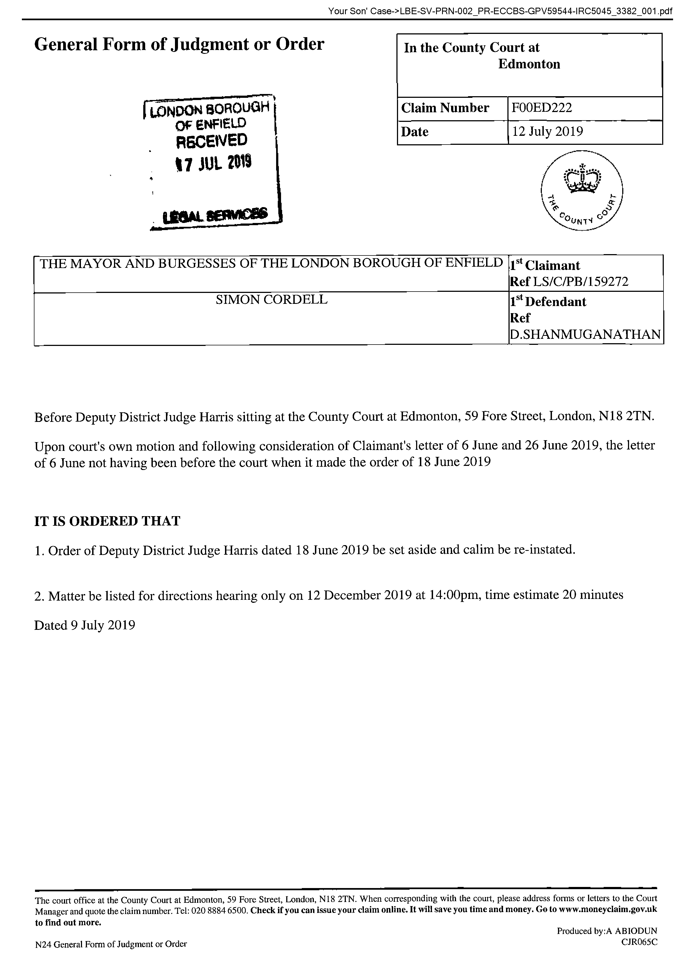
End of Picture!

The banging Started!

Si Note:
1

Summary!

Disrepair!

Time Spent Building.
In the background of everything going on I could no longer work on my first company Too Smooth due to the amount of time I had to put toward s defending myself.
My mother Stopped working on my website
Working at Home doing Court Case Defense Work!
I spent time and recourses costing expenditure building my defence case and website Horrific Corruption.com, against the allegations getting put against me at the Time Start: 00:00 and Time End: 00:00

Friday!
19/07/2019

Stain and the
Issues with Housing Disrepair!
Working on the Court Case Defence!
The Anti-Social Behaviour Order Case and the Verdict got made Guilty against me in error and the conditions got imposed against me till late 2020!
The Banging Continued: -
19/07/2019

- Disrepair!
- The Asbo Order got granted in Error with Full Conditions against me and Fraudulently!
- The banging Continued at me!
- Working at home!

- 2nd Possession Order! 06/02/2019
I have good news in that the Council have decided to not pursue the case further due to a lack of recent incidents. Please see attached their letter received recently and our letter dated 22 October 2019 sent to your son.

1
- 113 Burncroft Avenue
Ambrose had moved for ever!
“Empty”

- 117 Burncroft Avenue
The 3rd set of Tenant’s since the Problems Started with the Flat being used as an Offensives Weapons against my Person and against my free will.
has been “Re-Vacated” again by John Iron

--

The banging Started!

Summary!

Disrepair!

Time Spent Building.
In the background of everything going on I could no longer work on my first company Too Smooth due to the amount of time I had to put toward s defending myself.
My mother Stopped working on my website
Working at Home doing Court Case Defense Work!
I spent time and recourses costing expenditure building my defence case and website Horrific Corruption.com, against the allegations getting put against me at the Time Start: 00:00 and Time End: 00:00

Saturday!
20/07/2019

Stain and the
Issues with Housing Disrepair!
Working on the Court Case Defence!
The Anti-Social Behaviour Order Case and the Verdict got made Guilty against me in error and the conditions got imposed against me till late 2020!
The Banging Continued: -
20/07/2019

- Disrepair!
- The Asbo Order got granted in Error with Full Conditions against me and Fraudulently!
- The banging Continued at me!
- Working at home!

- 2nd Possession Order! 06/02/2019
I have good news in that the Council have decided to not pursue the case further due to a lack of recent incidents. Please see attached their letter received recently and our letter dated 22 October 2019 sent to your son.

1
- 113 Burncroft Avenue
Ambrose had moved for ever!
“Empty”

- 117 Burncroft Avenue
The 3rd set of Tenant’s since the Problems Started with the Flat being used as an Offensives Weapons against my Person and against my free will.
has been “Re-Vacated” again by John Iron

1
- I see stain as I was going to the shop.
I asked him why
--

1
I see stain as I was going to the shop.
I asked him why is he putting another fake application into to the Edmonton lower courts with the council and the police about the only two times incidents when I asked him to stop what he was doing illegally to me. He said that he has not spoken to the Enfield Council and or made any complaints.
Time: 10:40

The banging Started!

Si Note:
1

Summary!

Disrepair!

Time Spent Building.
In the background of everything going on I could no longer work on my first company Too Smooth due to the amount of time I had to put toward s defending myself.
My mother Stopped working on my website
Working at Home doing Court Case Defense Work!
I spent time and recourses costing expenditure building my defence case and website Horrific Corruption.com, against the allegations getting put against me at the Time Start: 00:00 and Time End: 00:00

Sunday!
21/07/2019

Stain and the
Issues with Housing Disrepair!
Working on the Court Case Defence!
The Anti-Social Behaviour Order Case and the Verdict got made Guilty against me in error and the conditions got imposed against me till late 2020!
The Banging Continued: -
21/07/2019

- Disrepair!
- The Asbo Order got granted in Error with Full Conditions against me and Fraudulently!
- The banging Continued at me!
- Working at home!

- 2nd Possession Order! 06/02/2019
I have good news in that the Council have decided to not pursue the case further due to a lack of recent incidents. Please see attached their letter received recently and our letter dated 22 October 2019 sent to your son.

1
- 113 Burncroft Avenue
Ambrose had moved for ever!
“Empty”

- 117 Burncroft Avenue
The 3rd set of Tenant’s since the Problems Started with the Flat being used as an Offensives Weapons against my Person and against my free will.
has been “Re-Vacated” again by John Iron

1
- Today
On the computer

--

1
Today
On the computer Quite so far 06:42
Uncle Andrew came around for a little wile and pipes was here.

The banging Started!

Si Note:
1

Summary!

Disrepair!

Time Spent Building.
In the background of everything going on I could no longer work on my first company Too Smooth due to the amount of time I had to put toward s defending myself.
My mother Stopped working on my website
Working at Home doing Court Case Defense Work!
I spent time and recourses costing expenditure building my defence case and website Horrific Corruption.com, against the allegations getting put against me at the Time Start: 00:00 and Time End: 00:00

Monday!
22/07/2019

Stain and the
Issues with Housing Disrepair!
Working on the Court Case Defence!
The Anti-Social Behaviour Order Case and the Verdict got made Guilty against me in error and the conditions got imposed against me till late 2020!
The Banging Continued: -
22/07/2019

- Disrepair!
- The Asbo Order got granted in Error with Full Conditions against me and Fraudulently!
- The banging Continued at me!
- Working at home!

- 2nd Possession Order! 06/02/2019
I have good news in that the Council have decided to not pursue the case further due to a lack of recent incidents. Please see attached their letter received recently and our letter dated 22 October 2019 sent to your son.

1
- 113 Burncroft Avenue
Ambrose had moved for ever!
“Empty”

- 117 Burncroft Avenue
The 3rd set of Tenant’s since the Problems Started with the Flat being used as an Offensives Weapons against my Person and against my free will.
has been “Re-Vacated” again by John Iron

1
- Uncle Andrew
gave me a phone call

--

1
Uncle Andrew gave me a phone call after coming out of the two meetings that he arranged with the Mental Health Team.
He told me at the moment they will not be issuing a warrant 135 under the Mental Health Act 1963.
He arranged to come around here tomorrow

The banging Started!

Si Note:
1

Summary!

Disrepair!

Time Spent Building.
In the background of everything going on I could no longer work on my first company Too Smooth due to the amount of time I had to put toward s defending myself.
My mother Stopped working on my website
Working at Home doing Court Case Defense Work!
I spent time and recourses costing expenditure building my defence case and website Horrific Corruption.com, against the allegations getting put against me at the Time Start: 00:00 and Time End: 00:00

Tuesday!
23/07/2019

Stain and the
Issues with Housing Disrepair!
Working on the Court Case Defence!
The Anti-Social Behaviour Order Case and the Verdict got made Guilty against me in error and the conditions got imposed against me till late 2020!
The Banging Continued: -
23/07/2019
- Disrepair!
- The Asbo Order got granted in Error with Full Conditions against me and Fraudulently!
- The banging Continued at me!
- Working at home!

- 2nd Possession Order! 06/02/2019
I have good news in that the Council have decided to not pursue the case further due to a lack of recent incidents. Please see attached their letter received recently and our letter dated 22 October 2019 sent to your son.

1
- 113 Burncroft Avenue
Ambrose had moved for ever!
“Empty”

- 117 Burncroft Avenue
The 3rd set of Tenant’s since the Problems Started with the Flat being used as an Offensives Weapons against my Person and against my free will.
has been “Re-Vacated” again by John Iron

--

The banging Started!

Summary!

Disrepair!

Time Spent Building.
In the background of everything going on I could no longer work on my first company Too Smooth due to the amount of time I had to put toward s defending myself.
My mother Stopped working on my website
Working at Home doing Court Case Defense Work!
I spent time and recourses costing expenditure building my defence case and website Horrific Corruption.com, against the allegations getting put against me at the Time Start: 00:00 and Time End: 00:00

Wednesday!
24/07/2019

Stain and the
Issues with Housing Disrepair!
Working on the Court Case Defence!
The Anti-Social Behaviour Order Case and the Verdict got made Guilty against me in error and the conditions got imposed against me till late 2020!
The Banging Continued: -
24/07/2019

- Disrepair!
- The Asbo Order got granted in Error with Full Conditions against me and Fraudulently!
- The banging Continued at me!
- Working at home!

- 2nd Possession Order! 06/02/2019
I have good news in that the Council have decided to not pursue the case further due to a lack of recent incidents. Please see attached their letter received recently and our letter dated 22 October 2019 sent to your son.

1
- 113 Burncroft Avenue
Ambrose had moved for ever!
“Empty”

- 117 Burncroft Avenue
The 3rd set of Tenant’s since the Problems Started with the Flat being used as an Offensives Weapons against my Person and against my free will.
has been “Re-Vacated” again by John Iron

1
- I got up at 6:00 Am
after my front door getting fitted yesterday.

--

1
I got up at 6:00 Am after my front door getting fitted yesterday.
I heard Stain go and get his newspaper and come back at around 7:00 Am
I then heard him leaving his flat at 09:15Am and decided to ask him what this possession order is in his name against me with the Enfield Council.
He told me that he does not know anything I told him to call the council because it’s in his name like he said he would do the last two times I spoke to him recently.

The banging Started!

Si Note:
1

Summary!

Disrepair!

Time Spent Building.
In the background of everything going on I could no longer work on my first company Too Smooth due to the amount of time I had to put toward s defending myself.
My mother Stopped working on my website
Working at Home doing Court Case Defense Work!
I spent time and recourses costing expenditure building my defence case and website Horrific Corruption.com, against the allegations getting put against me at the Time Start: 00:00 and Time End: 00:00

Thursday!
25/07/2019

Stain and the
Issues with Housing Disrepair!
Working on the Court Case Defence!
The Anti-Social Behaviour Order Case and the Verdict got made Guilty against me in error and the conditions got imposed against me till late 2020!
The Banging Continued: -
25/07/2019

- Disrepair!
- The Asbo Order got granted in Error with Full Conditions against me and Fraudulently!
- The banging Continued at me!
- Working at home!

- 2nd Possession Order! 06/02/2019
I have good news in that the Council have decided to not pursue the case further due to a lack of recent incidents. Please see attached their letter received recently and our letter dated 22 October 2019 sent to your son.

1
- 113 Burncroft Avenue
Ambrose had moved for ever!
“Empty”

- 117 Burncroft Avenue
The 3rd set of Tenant’s since the Problems Started with the Flat being used as an Offensives Weapons against my Person and against my free will.
has been “Re-Vacated” again by John Iron

--

The banging Started!

Summary!

Disrepair!

Time Spent Building.
In the background of everything going on I could no longer work on my first company Too Smooth due to the amount of time I had to put toward s defending myself.
My mother Stopped working on my website
Working at Home doing Court Case Defense Work!
I spent time and recourses costing expenditure building my defence case and website Horrific Corruption.com, against the allegations getting put against me at the Time Start: 00:00 and Time End: 00:00

Friday!
26/07/2019

Stain and the
Issues with Housing Disrepair!
Working on the Court Case Defence!
The Anti-Social Behaviour Order Case and the Verdict got made Guilty against me in error and the conditions got imposed against me till late 2020!
The Banging Continued: -
26/07/2019

- Disrepair!
- The Asbo Order got granted in Error with Full Conditions against me and Fraudulently!
- The banging Continued at me!
- Working at home!

- 2nd Possession Order! 06/02/2019
I have good news in that the Council have decided to not pursue the case further due to a lack of recent incidents. Please see attached their letter received recently and our letter dated 22 October 2019 sent to your son.

1
- 113 Burncroft Avenue
Ambrose had moved for ever!
“Empty”

- 117 Burncroft Avenue
The 3rd set of Tenant’s since the Problems Started with the Flat being used as an Offensives Weapons against my Person and against my free will.
has been “Re-Vacated” again by John Iron

--

The banging Started!

Summary!

Disrepair!

Time Spent Building.
In the background of everything going on I could no longer work on my first company Too Smooth due to the amount of time I had to put toward s defending myself.
My mother Stopped working on my website
Working at Home doing Court Case Defense Work!
I spent time and recourses costing expenditure building my defence case and website Horrific Corruption.com, against the allegations getting put against me at the Time Start: 00:00 and Time End: 00:00

Saturday!
27/07/2019

Stain and the
Issues with Housing Disrepair!
Working on the Court Case Defence!
The Anti-Social Behaviour Order Case and the Verdict got made Guilty against me in error and the conditions got imposed against me till late 2020!
The Banging Continued: -
27/07/2019

- Disrepair!
- The Asbo Order got granted in Error with Full Conditions against me and Fraudulently!
- The banging Continued at me!
- Working at home!

- 2nd Possession Order! 06/02/2019
I have good news in that the Council have decided to not pursue the case further due to a lack of recent incidents. Please see attached their letter received recently and our letter dated 22 October 2019 sent to your son.

1
- 113 Burncroft Avenue
Ambrose had moved for ever!
“Empty”

- 117 Burncroft Avenue
The 3rd set of Tenant’s since the Problems Started with the Flat being used as an Offensives Weapons against my Person and against my free will.
has been “Re-Vacated” again by John Iron

--

The banging Started!

Summary!

Disrepair!

Time Spent Building.
In the background of everything going on I could no longer work on my first company Too Smooth due to the amount of time I had to put toward s defending myself.
My mother Stopped working on my website
Working at Home doing Court Case Defense Work!
I spent time and recourses costing expenditure building my defence case and website Horrific Corruption.com, against the allegations getting put against me at the Time Start: 00:00 and Time End: 00:00

Sunday!
28/07/2019

Stain and the
Issues with Housing Disrepair!
Working on the Court Case Defence!
The Anti-Social Behaviour Order Case and the Verdict got made Guilty against me in error and the conditions got imposed against me till late 2020!
The Banging Continued: -
28/07/2019

- Disrepair!
- The Asbo Order got granted in Error with Full Conditions against me and Fraudulently!
- The banging Continued at me!
- Working at home!

- 2nd Possession Order! 06/02/2019
I have good news in that the Council have decided to not pursue the case further due to a lack of recent incidents. Please see attached their letter received recently and our letter dated 22 October 2019 sent to your son.

1
- 113 Burncroft Avenue
Ambrose had moved for ever!
“Empty”

- 117 Burncroft Avenue
The 3rd set of Tenant’s since the Problems Started with the Flat being used as an Offensives Weapons against my Person and against my free will.
has been “Re-Vacated” again by John Iron

1
- Simon Cordell’s MP3’S Indexed
Stage 1
1x Recording
01m. MP’s 5 __ 28/07/2019
Page Number: Update Page Number 1,
01m. MP’s 5 __ 28_07)2019.WMA
Update

2
- Simon Cordell’s MP3’S Indexed
Stage 1
1x Recording
01m. MP’s 6__ 28_07)2019
Page Number: Update Page Number 1,
01m. MP’s 6__ 28_07)2019.WMA
Update

--

1
Simon Cordell’s MP3’S Indexed
Stage 1
1x Recording
01m. MP’s 5 __ 28/07/2019
Page Number: Update Page Number 1,
01m. MP’s 5 __ 28_07)2019.WMA
Update

2
Simon Cordell’s MP3’S Indexed
Stage 1
1x Recording
01m. MP’s 6__ 28_07)2019
Page Number: Update Page Number 1,
01m. MP’s 6__ 28_07)2019.WMA
Update

Noticed window
2 days before fix

The banging Started!

Si Note:
1

Summary!

Disrepair!

Time Spent Building.
In the background of everything going on I could no longer work on my first company Too Smooth due to the amount of time I had to put toward s defending myself.
My mother Stopped working on my website
Working at Home doing Court Case Defense Work!
I spent time and recourses costing expenditure building my defence case and website Horrific Corruption.com, against the allegations getting put against me at the Time Start: 00:00 and Time End: 00:00

Monday!
29/07/2019

Stain and the
Issues with Housing Disrepair!
Working on the Court Case Defence!
The Anti-Social Behaviour Order Case and the Verdict got made Guilty against me in error and the conditions got imposed against me till late 2020!
The Banging Continued: -
29/07/2019
- Disrepair!
- The Asbo Order got granted in Error with Full Conditions against me and Fraudulently!
- The banging Continued at me!
- Working at home!

- 2nd Possession Order! 06/02/2019
I have good news in that the Council have decided to not pursue the case further due to a lack of recent incidents. Please see attached their letter received recently and our letter dated 22 October 2019 sent to your son.

1
- 113 Burncroft Avenue
Ambrose had moved for ever!
“Empty”

- 117 Burncroft Avenue
The 3rd set of Tenant’s since the Problems Started with the Flat being used as an Offensives Weapons against my Person and against my free will.
has been “Re-Vacated” again by John Iron

--

The banging Started!

Summary!

Disrepair!

Time Spent Building.
In the background of everything going on I could no longer work on my first company Too Smooth due to the amount of time I had to put toward s defending myself.
My mother Stopped working on my website
Working at Home doing Court Case Defense Work!
I spent time and recourses costing expenditure building my defence case and website Horrific Corruption.com, against the allegations getting put against me at the Time Start: 00:00 and Time End: 00:00

Tuesday!
30/07/2019

Stain and the
Issues with Housing Disrepair!
Working on the Court Case Defence!
The Anti-Social Behaviour Order Case and the Verdict got made Guilty against me in error and the conditions got imposed against me till late 2020!
The Banging Continued: -
30/07/2019

- Disrepair!
- The Asbo Order got granted in Error with Full Conditions against me and Fraudulently!
- The banging Continued at me!
- Working at home!

- 2nd Possession Order! 06/02/2019
I have good news in that the Council have decided to not pursue the case further due to a lack of recent incidents. Please see attached their letter received recently and our letter dated 22 October 2019 sent to your son.

1
- 113 Burncroft Avenue
Ambrose had moved for ever!
“Empty”

- 117 Burncroft Avenue
The 3rd set of Tenant’s since the Problems Started with the Flat being used as an Offensives Weapons against my Person and against my free will.
has been “Re-Vacated” again by John Iron

--

The banging Started!

Summary!

Disrepair!

Time Spent Building.
In the background of everything going on I could no longer work on my first company Too Smooth due to the amount of time I had to put toward s defending myself.
My mother Stopped working on my website
Working at Home doing Court Case Defense Work!
I spent time and recourses costing expenditure building my defence case and website Horrific Corruption.com, against the allegations getting put against me at the Time Start: 00:00 and Time End: 00:00

Wednesday!
31/07/2019

Stain and the
Issues with Housing Disrepair!
Working on the Court Case Defence!
The Anti-Social Behaviour Order Case and the Verdict got made Guilty against me in error and the conditions got imposed against me till late 2020!
The Banging Continued: -
31/07/2019

- Disrepair!
- The Asbo Order got granted in Error with Full Conditions against me and Fraudulently!
- The banging Continued at me!
- Working at home!

- 2nd Possession Order! 06/02/2019
I have good news in that the Council have decided to not pursue the case further due to a lack of recent incidents. Please see attached their letter received recently and our letter dated 22 October 2019 sent to your son.

1
- 113 Burncroft Avenue
Ambrose had moved for ever!
“Empty”

- 117 Burncroft Avenue
The 3rd set of Tenant’s since the Problems Started with the Flat being used as an Offensives Weapons against my Person and against my free will.
has been “Re-Vacated” again by John Iron

--

The banging Started!

Summary!

Disrepair!

Time Spent Building.
In the background of everything going on I could no longer work on my first company Too Smooth due to the amount of time I had to put toward s defending myself.
My mother Stopped working on my website
Working at Home doing Court Case Defense Work!
I spent time and recourses costing expenditure building my defence case and website Horrific Corruption.com, against the allegations getting put against me at the Time Start: 00:00 and Time End: 00:00

Thursday!
01/08/2019

Stain and the
Issues with Housing Disrepair!
Working on the Court Case Defence!
The Anti-Social Behaviour Order Case and the Verdict got made Guilty against me in error and the conditions got imposed against me till late 2020!
The Banging Continued: -
01/08/2019

- Disrepair!
- The Asbo Order got granted in Error with Full Conditions against me and Fraudulently!
- The banging Continued at me!
- Working at home!

- 2nd Possession Order! 06/02/2019
I have good news in that the Council have decided to not pursue the case further due to a lack of recent incidents. Please see attached their letter received recently and our letter dated 22 October 2019 sent to your son.

1
- 113 Burncroft Avenue
Ambrose had moved for ever!
“Empty”

- 117 Burncroft Avenue
The 3rd set of Tenant’s since the Problems Started with the Flat being used as an Offensives Weapons against my Person and against my free will.
has been “Re-Vacated” again by John Iron

--

The banging Started!

Summary!

Disrepair!

Time Spent Building.
In the background of everything going on I could no longer work on my first company Too Smooth due to the amount of time I had to put toward s defending myself.
My mother Stopped working on my website
Working at Home doing Court Case Defense Work!
I spent time and recourses costing expenditure building my defence case and website Horrific Corruption.com, against the allegations getting put against me at the Time Start: 00:00 and Time End: 00:00

Friday!
02/08/2019

Stain and the
Issues with Housing Disrepair!
Working on the Court Case Defence!
The Anti-Social Behaviour Order Case and the Verdict got made Guilty against me in error and the conditions got imposed against me till late 2020!
The Banging Continued: -
02/08/2019
- Disrepair!
- The Asbo Order got granted in Error with Full Conditions against me and Fraudulently!
- The banging Continued at me!
- Working at home!

- 2nd Possession Order! 06/02/2019
I have good news in that the Council have decided to not pursue the case further due to a lack of recent incidents. Please see attached their letter received recently and our letter dated 22 October 2019 sent to your son.

1
- 113 Burncroft Avenue
Ambrose had moved for ever!
“Empty”

- 117 Burncroft Avenue
The 3rd set of Tenant’s since the Problems Started with the Flat being used as an Offensives Weapons against my Person and against my free will.
has been “Re-Vacated” again by John Iron

--

The banging Started!

Summary!

Disrepair!

Time Spent Building.
In the background of everything going on I could no longer work on my first company Too Smooth due to the amount of time I had to put toward s defending myself.
My mother Stopped working on my website
Working at Home doing Court Case Defense Work!
I spent time and recourses costing expenditure building my defence case and website Horrific Corruption.com, against the allegations getting put against me at the Time Start: 00:00 and Time End: 00:00

Saturday!
03/08/2019

Stain and the
Issues with Housing Disrepair!
Working on the Court Case Defence!
The Anti-Social Behaviour Order Case and the Verdict got made Guilty against me in error and the conditions got imposed against me till late 2020!
The Banging Continued: -
03/08/2019

- Disrepair!
- The Asbo Order got granted in Error with Full Conditions against me and Fraudulently!
- The banging Continued at me!
- Working at home!

- 2nd Possession Order! 06/02/2019
I have good news in that the Council have decided to not pursue the case further due to a lack of recent incidents. Please see attached their letter received recently and our letter dated 22 October 2019 sent to your son.

1
- 113 Burncroft Avenue
Ambrose had moved for ever!
“Empty”

- 117 Burncroft Avenue
The 3rd set of Tenant’s since the Problems Started with the Flat being used as an Offensives Weapons against my Person and against my free will.
has been “Re-Vacated” again by John Iron

--

The banging Started!

Summary!

Disrepair!

Time Spent Building.
In the background of everything going on I could no longer work on my first company Too Smooth due to the amount of time I had to put toward s defending myself.
My mother Stopped working on my website
Working at Home doing Court Case Defense Work!
I spent time and recourses costing expenditure building my defence case and website Horrific Corruption.com, against the allegations getting put against me at the Time Start: 00:00 and Time End: 00:00

Sunday!
04/08/2019

Stain and the
Issues with Housing Disrepair!
Working on the Court Case Defence!
The Anti-Social Behaviour Order Case and the Verdict got made Guilty against me in error and the conditions got imposed against me till late 2020!
The Banging Continued: -
04/08/2019

- Disrepair!
- The Asbo Order got granted in Error with Full Conditions against me and Fraudulently!
- The banging Continued at me!
- Working at home!

- 2nd Possession Order! 06/02/2019
I have good news in that the Council have decided to not pursue the case further due to a lack of recent incidents. Please see attached their letter received recently and our letter dated 22 October 2019 sent to your son.

1
- 113 Burncroft Avenue
Ambrose had moved for ever!
“Empty”

- 117 Burncroft Avenue
The 3rd set of Tenant’s since the Problems Started with the Flat being used as an Offensives Weapons against my Person and against my free will.
has been “Re-Vacated” again by John Iron

43.
- Additional Email Attachments & Emails / Issue:
43. 1. 1
Ronak@tyrerroxburgh.ck_08.04.2019_RE Your Son' Case 4
04/08/2019
/ Page Numbers: 394,395,396,397

--

43.
Additional Email Attachments & Emails / Issue:
43. 1. 1
Ronak@tyrerroxburgh.ck_08.04.2019_RE Your Son' Case 4
04/08/2019
/ Page Numbers: 394,395,396,397
--
394,
From: Ronak Ahmed <ronak@tyrerroxburgh.co.uk>
Sent: 04 August 2019 19:42
To: Lorraine Cordell
Subject: RE: Your Son' Case
Attachments: 1101491.doc; 1113833.doc
Good afternoon
Thank you for your email of 1 August 2019; the Council's solicitors have provided the attached letters and have stated that "there were no letters to the court on 10/6/2019 and 12/6/2019".
I confirm that the letters do not contain anything of concern to our client.
Kind regards
Ronak Ahmed
Solicitor (Consultant)
Tel +44 (0) 20 8889 3319
Email ronak@tyrerroxburgh.co.uk
TR TYRER ROXBURGH
1 St Michaels Terrace London N22 7SJ DX 34704 WOOD GREEN 2
Tel +44 (0) 20 8889 3319
Fax +44 (0) 20 8881 6089
www.tyrerroxburgh.co.uk
Authorised by the Solicitors Regulation Authority. Tyrer Roxburgh Solicitors LLP is a limited liability partnership under the no.560748. A list of the members' names is open to inspection at the registered office.
VAT REG No: 221 8088 78
SRA No: 560748
Contracted with the Legal Aid Agency
We do not accept service of documents or other process by e-mail
Email us at lawmakers@tyrerroxburgh.co.uk
This message may contain privileged information and is only intended to be received by the person to whom it is addressed.
If you are not the intended recipient, please contact us as soon as possible.
ft resolution
first for family law
Partners • Mukesh Badhan • D Shanmuganathan
395,
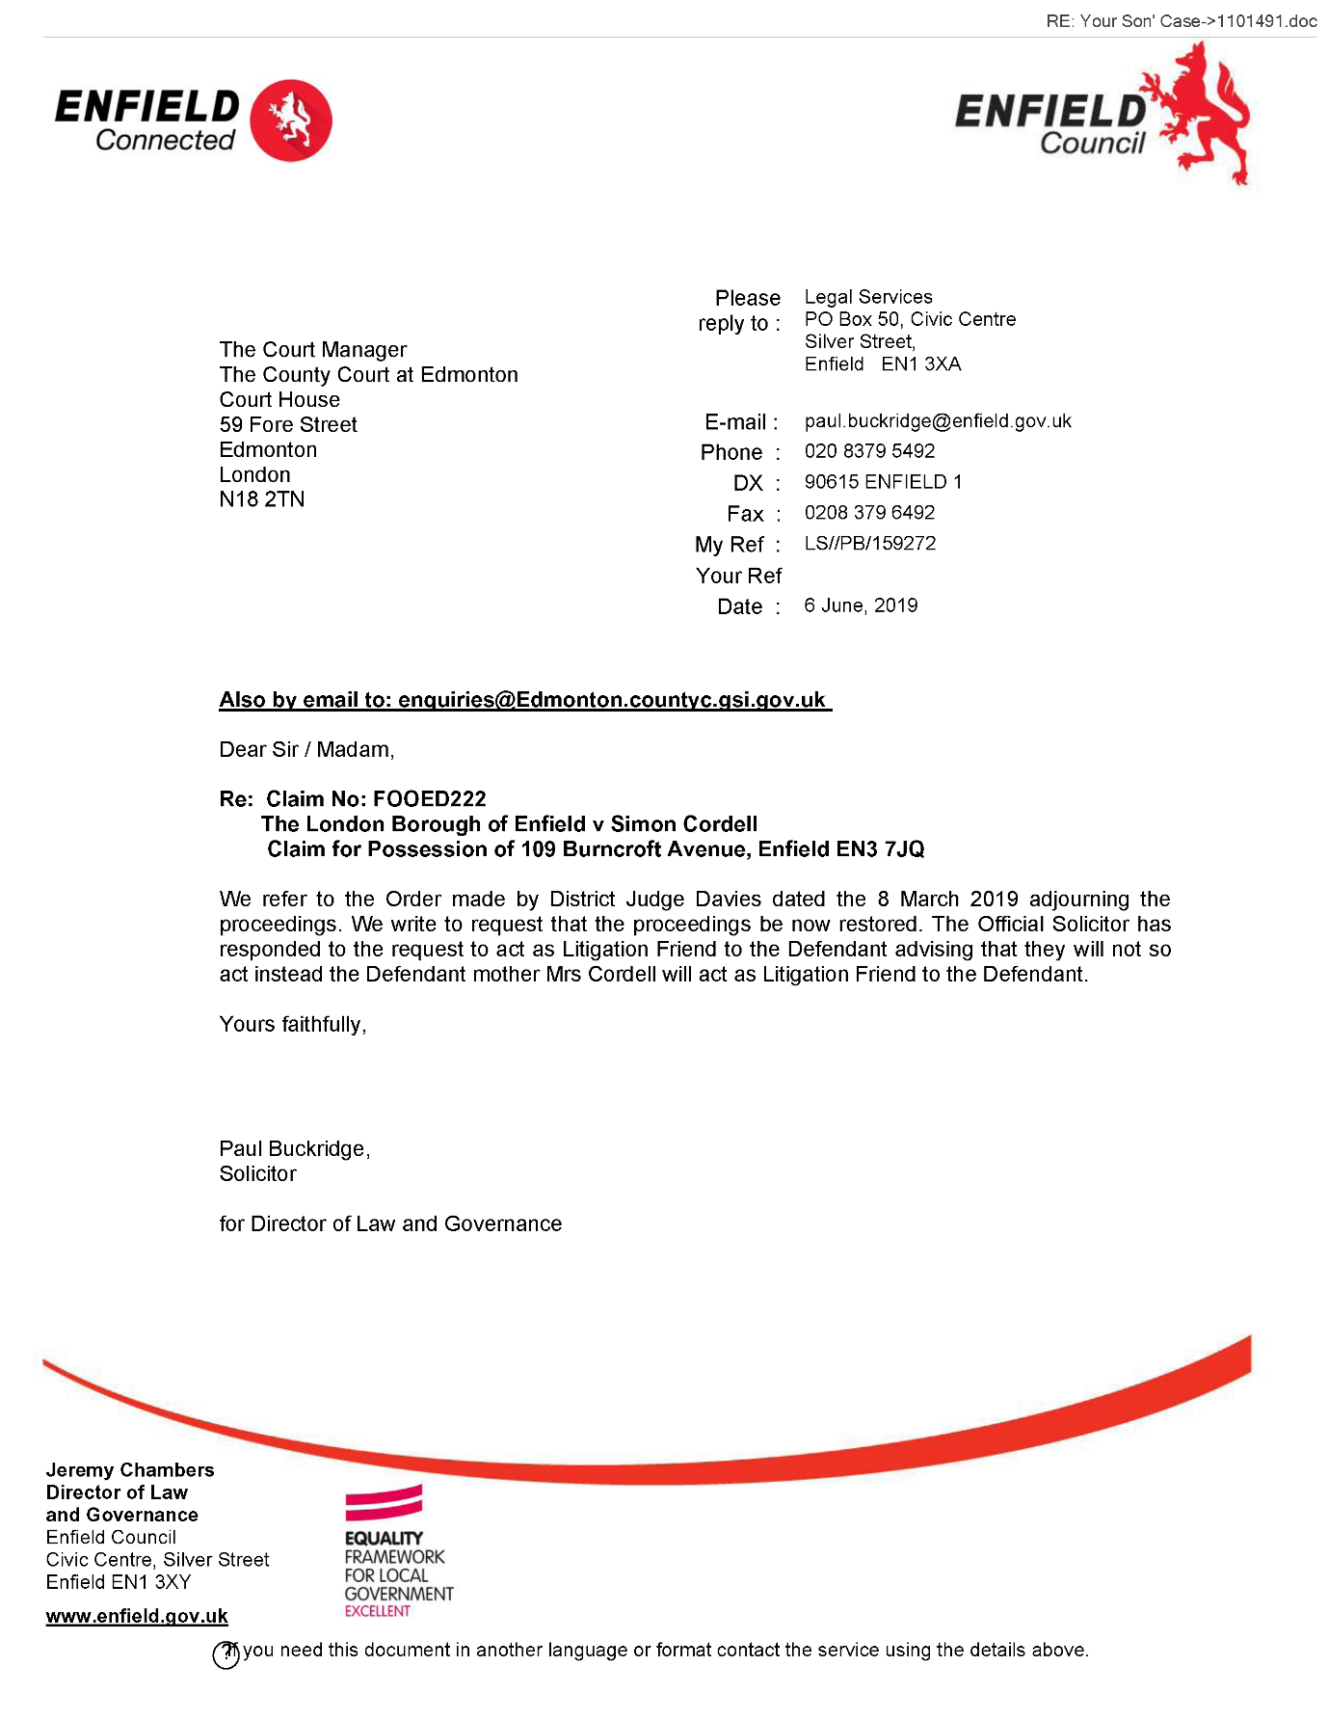
396,
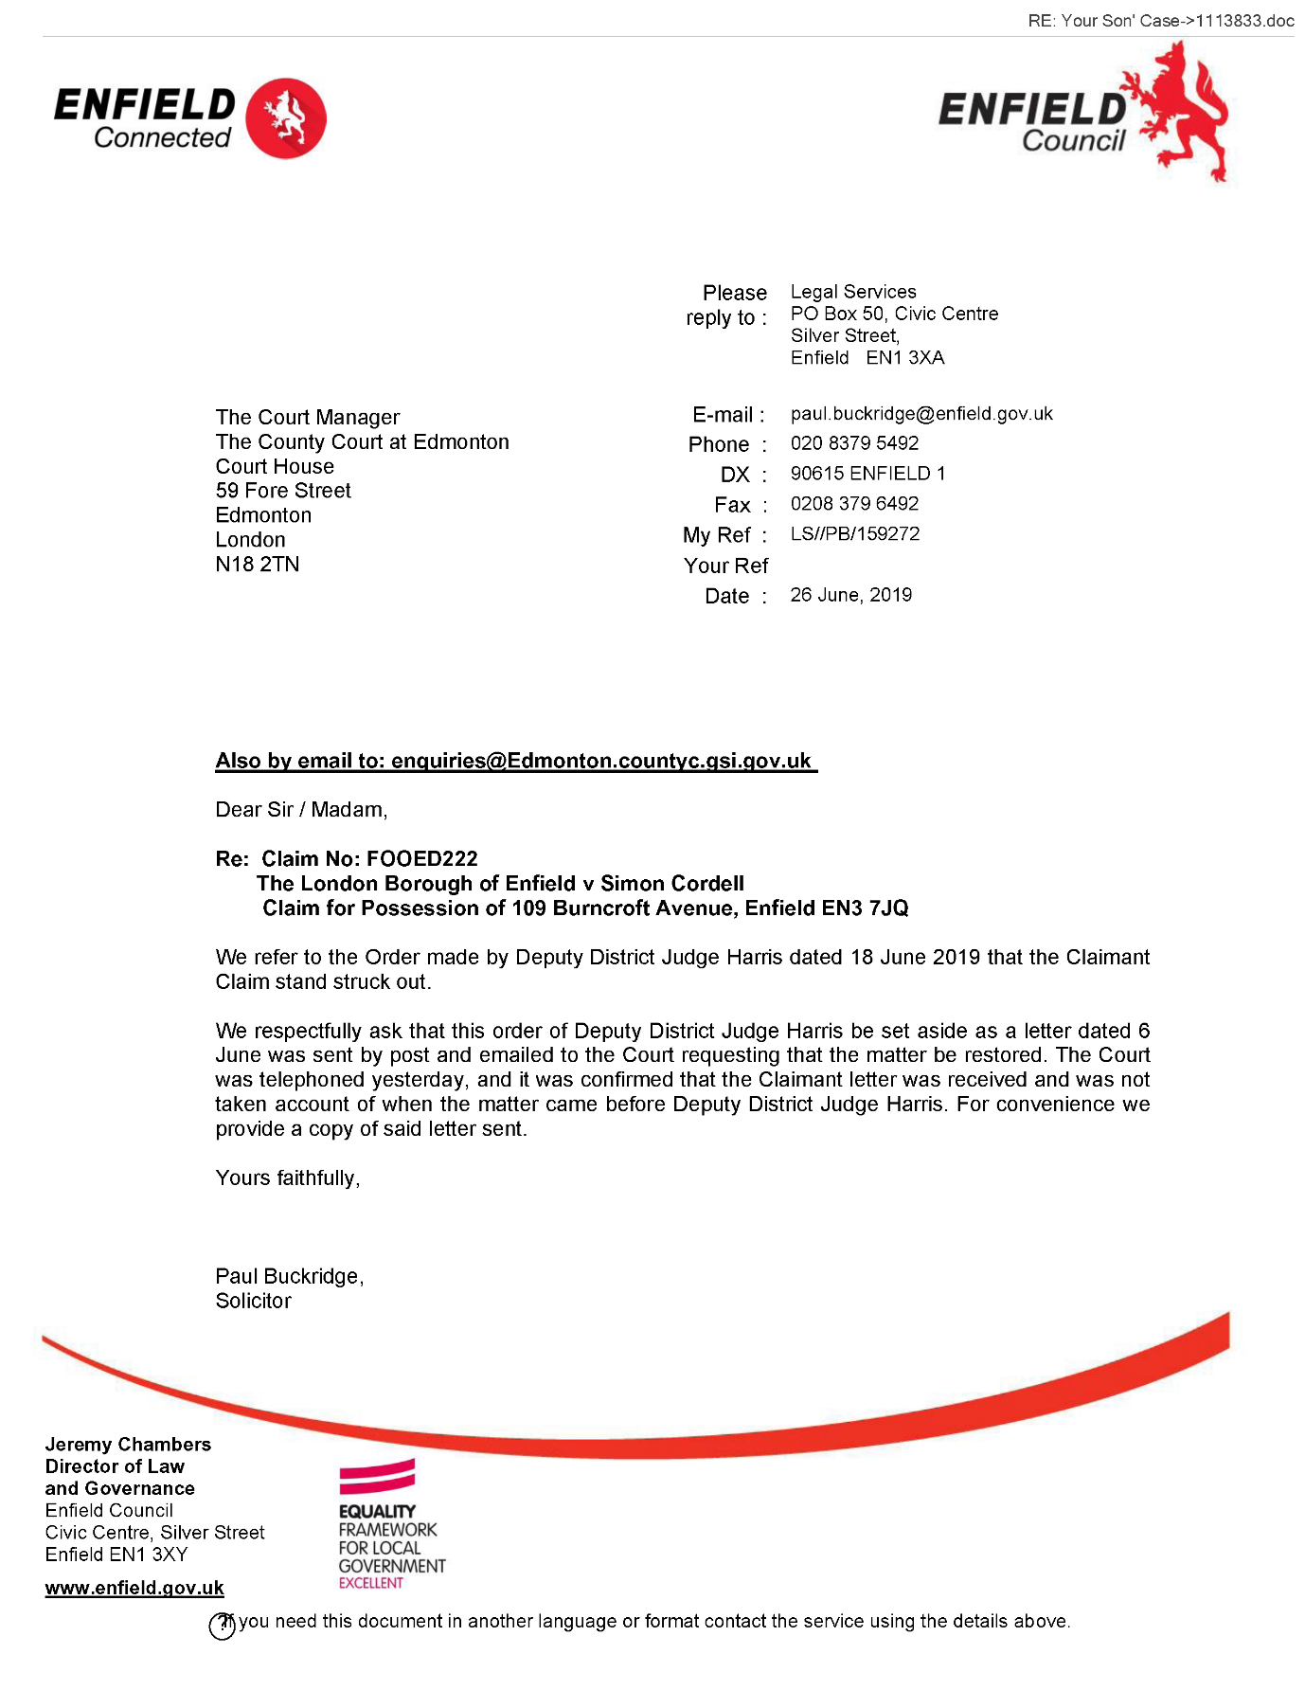
397,
for Director of Law and Governance
PB /159272/ 01113833
Page 2

The banging Started!

Summary!

Disrepair!

Time Spent Building.
In the background of everything going on I could no longer work on my first company Too Smooth due to the amount of time I had to put toward s defending myself.
My mother Stopped working on my website
Working at Home doing Court Case Defense Work!
I spent time and recourses costing expenditure building my defence case and website Horrific Corruption.com, against the allegations getting put against me at the Time Start: 00:00 and Time End: 00:00

Monday!
05/08/2019

Stain and the
Issues with Housing Disrepair!
Working on the Court Case Defence!
The Anti-Social Behaviour Order Case and the Verdict got made Guilty against me in error and the conditions got imposed against me till late 2020!
The Banging Continued: -
05/08/2019

- Disrepair!
- The Asbo Order got granted in Error with Full Conditions against me and Fraudulently!
- The banging Continued at me!
- Working at home!

- 2nd Possession Order! 06/02/2019
I have good news in that the Council have decided to not pursue the case further due to a lack of recent incidents. Please see attached their letter received recently and our letter dated 22 October 2019 sent to your son.

1
- 113 Burncroft Avenue
Ambrose had moved for ever!
“Empty”

- 117 Burncroft Avenue
The 3rd set of Tenant’s since the Problems Started with the Flat being used as an Offensives Weapons against my Person and against my free will.
has been “Re-Vacated” again by John Iron

--

The banging Started!

Summary!

Disrepair!

Time Spent Building.
In the background of everything going on I could no longer work on my first company Too Smooth due to the amount of time I had to put toward s defending myself.
My mother Stopped working on my website
Working at Home doing Court Case Defense Work!
I spent time and recourses costing expenditure building my defence case and website Horrific Corruption.com, against the allegations getting put against me at the Time Start: 00:00 and Time End: 00:00

Tuesday!
06/08/2019

Stain and the
Issues with Housing Disrepair!
Working on the Court Case Defence!
The Anti-Social Behaviour Order Case and the Verdict got made Guilty against me in error and the conditions got imposed against me till late 2020!
The Banging Continued: -
06/08/2019

- Disrepair!
- The Asbo Order got granted in Error with Full Conditions against me and Fraudulently!
- The banging Continued at me!
- Working at home!

- 2nd Possession Order! 06/02/2019
I have good news in that the Council have decided to not pursue the case further due to a lack of recent incidents. Please see attached their letter received recently and our letter dated 22 October 2019 sent to your son.

1
- 113 Burncroft Avenue
Ambrose had moved for ever!
“Empty”

- 117 Burncroft Avenue
The 3rd set of Tenant’s since the Problems Started with the Flat being used as an Offensives Weapons against my Person and against my free will.
has been “Re-Vacated” again by John Iron

44.
- Additional Email Attachments & Emails / Issue:
44. 1. 1
OS_Civil_Litigation@oov.uk_08.06.2019_Auto-response 1
06/08/2019
/ Page Numbers: 398

45.
- Additional Email Attachments & Emails / Issue:
45. 1. 1
OS_Civil_Litigation@ok_08.06.2019_Auto-response_001 1
06/08/2019
/ Page Numbers: 399

46.
- Additional Email Attachments & Emails / Issue:
46. 1. 1
OS_Civil_Litigation@ok_08.06.2019_Auto-response_002 1
06/08/2019
/ Page Numbers: 400

47.
- Additional Email Attachments & Emails / Issue:
47. 1. 1
OS_Civil_Litigation@o9_RE Simon Cordell information 4
06/08/2019
/ Page Numbers: 401,402,403,404

48.
- Additional Email Attachments & Emails / Issue:
48. 1. 1
OS_ Civil_ Litigation @o Simon Cordell information_001 2
06/08/2019
/ Page Numbers: 405,406

--

44.
Additional Email Attachments & Emails / Issue:
44. 1. 1
OS_Civil_Litigation@oov.uk_08.06.2019_Auto-response 1
06/08/2019
/ Page Numbers: 398
--
398,
From: OS Civil Litigation <OS_Civil_Litigation@ospt.gov.uk>
Sent: 06 August 2019 12:10
To: Lorraine Cordell
Subject: Auto-response
Your email has been received by the Official Solicitor's Civil Litigation Team. If you wish to speak to someone by telephone, please call 020 3681 2750.
If your enquiry is not about civil proceedings, you will find the contact details for other teams at the end of this auto response:
Request to the Official Solicitor to act as litigation friend in civil proceedings:
The Official Solicitor's criteria for acting as litigation friend in civil proceedings are:
- undisputed satisfactory evidence that the party lacks capacity to conduct the proceedings.
- security for the costs of legal representation (
- last resort (i.e. that there is no other person suitable and willing to act as litigation friend).
If your email is urgent, please ring the Civil Litigation enquiry line on 020 3681 2750 and speak to the Team Leader. If your email is not urgent, we aim to respond within 10 working days.
Contact details for other teams within the Official Solicitor's office:
public law family Tel: 020 3681 2755
private law family Tel: 020 3681 2754
COP healthcare & welfare Tel: 020 3681 2751
COP property & affairs Tel: 020 3681 2758
This e-mail and any attachments are intended only for the attention of the addressee(s). Its unauthorised use, disclosure, storage, or copying is not permitted. If you are not the intended recipient, please destroy all copies and inform the sender by return e-mail. Internet e-mail is not a secure medium. Any reply to this message could be intercepted and read by someone else. Please bear that in mind when deciding whether to send material in response to this message by e-mail. This e-mail (whether you are the sender or the recipient) may be monitored, recorded, and retained by the Ministry of Justice. Monitoring / blocking software may be used, and e-mail content may be read at any time. You have a responsibility to ensure laws are not broken when composing or forwarding e-mails and their contents.

45.
Additional Email Attachments & Emails / Issue:
45. 1. 1
OS_Civil_Litigation@ok_08.06.2019_Auto-response_001 1
06/08/2019
/ Page Numbers: 399
--
399,
From: OS Civil Litigation <OS_Civil_Litigation@ospt.gov.uk>
Sent: 06 August 2019 12:09
To: Lorraine Cordell
Subject: Auto-response
Your email has been received by the Official Solicitor's Civil Litigation Team. If you wish to speak to someone by telephone, please call 020 3681 2750.
If your enquiry is not about civil proceedings, you will find the contact details for other teams at the end of this auto response:
Request to the Official Solicitor to act as litigation friend in civil proceedings:
The Official Solicitor's criteria for acting as litigation friend in civil proceedings are:
- undisputed satisfactory evidence that the party lacks capacity to conduct the proceedings.
- security for the costs of legal representation (
- last resort (i.e. that there is no other person suitable and willing to act as litigation friend).
If your email is urgent, please ring the Civil Litigation enquiry line on 020 3681 2750 and speak to the Team Leader. If your email is not urgent, we aim to respond within 10 working days.
Contact details for other teams within the Official Solicitor's office:
public law family Tel: 020 3681 2755
private law family Tel: 020 3681 2754
COP healthcare & welfare Tel: 020 3681 2751
COP property & affairs Tel: 020 3681 2758
This e-mail and any attachments are intended only for the attention of the addressee(s). Its unauthorised use, disclosure, storage, or copying is not permitted. If you are not the intended recipient, please destroy all copies and inform the sender by return e-mail. Internet e-mail is not a secure medium. Any reply to this message could be intercepted and read by someone else. Please bear that in mind when deciding whether to send material in response to this message by e-mail. This e-mail (whether you are the sender or the recipient) may be monitored, recorded, and retained by the Ministry of Justice. Monitoring / blocking software may be used, and e-mail content may be read at any time. You have a responsibility to ensure laws are not broken when composing or forwarding e-mails and their contents.

46.
Additional Email Attachments & Emails / Issue:
46. 1. 1
OS_Civil_Litigation@ok_08.06.2019_Auto-response_002 1
06/08/2019
/ Page Numbers: 400
--
400,
From: OS Civil Litigation <OS_Civil_Litigation@ospt.gov.uk>
Sent: 06 August 2019 11:55
To: Lorraine Cordell
Subject: Auto-response
Your email has been received by the Official Solicitor's Civil Litigation Team. If you wish to speak to someone by telephone, please call 020 3681 2750.
If your enquiry is not about civil proceedings, you will find the contact details for other teams at the end of this auto response:
Request to the Official Solicitor to act as litigation friend in civil proceedings:
The Official Solicitor's criteria for acting as litigation friend in civil proceedings are:
- undisputed satisfactory evidence that the party lacks capacity to conduct the proceedings.
- security for the costs of legal representation (
- last resort (i.e. that there is no other person suitable and willing to act as litigation friend).
If your email is urgent, please ring the Civil Litigation enquiry line on 020 3681 2750 and speak to the Team Leader. If your email is not urgent, we aim to respond within 10 working days.
Contact details for other teams within the Official Solicitor's office:
public law family Tel: 020 3681 2755
private law family Tel: 020 3681 2754
COP healthcare & welfare Tel: 020 3681 2751
COP property & affairs Tel: 020 3681 2758
This e-mail and any attachments are intended only for the attention of the addressee(s). Its unauthorised use, disclosure, storage, or copying is not permitted. If you are not the intended recipient, please destroy all copies and inform the sender by return e-mail. Internet e-mail is not a secure medium. Any reply to this message could be intercepted and read by someone else. Please bear that in mind when deciding whether to send material in response to this message by e-mail. This e-mail (whether you are the sender or the recipient) may be monitored, recorded, and retained by the Ministry of Justice. Monitoring / blocking software may be used, and e-mail content may be read at any time. You have a responsibility to ensure laws are not broken when composing or forwarding e-mails and their contents.

47.
Additional Email Attachments & Emails / Issue:
47. 1. 1
OS_Civil_Litigation@o9_RE Simon Cordell information 4
06/08/2019
/ Page Numbers: 401,402,403,404
--
401,
From: OS Civil Litigation <OS_Civil_Litigation@ospt.gov.uk>
Sent: 06 August 2019 12:02
To: 'Lorraine Cordell'
Subject: RE: Simon Cordell information
Lorraine,
Thank you for your email. Can you please provide me with the contact details of Mr. Sean Shanmuganathan to enable me to resolve this matter.
Kind regards,
Bina
From: Lorraine Cordell [mailto:lorraine32@blueyonder.co.uk]
Sent: 06 August 2019 11:55
To: OS Civil Litigation <OS_Civil_Litigation@ospt.gov.uk>
Subject: RE: Simon Cordell information
Importance: High
Dear Bina
Thank you for the reply to my email I am not sure why Mr Ronak Ahmed advised the Official Solicitor’s I would be willing to act for my son as I clearly told Mr. Sean Shanmuganathan who was at court acting for my son on the 08/03/2019 I could not do this.
There is good reason for me not being able to act as litigation friend, which has been stated two times before in court action that Enfield Council brought regarding my son, which I refused these two times also.
Enfield Council has caused so much damage to my son in what has been ongoing since late 2014, Enfield council has never wanted to deal with my son nor me regarding issues which has happened and have just allowed me to live in the home he lives going through hell with what the neighbours have been doing to him, in fact there is a court order dated the 09/08/2018 in which Enfield Council should have moved my son, Enfield Council has refused to do so, and then just started the possession proceedings against my son, which is the case we are dealing with now.
Due to everything that has gone on my son has no trust in anyone and our relationship has suffered badly due to everything that is ongoing. I believe if I submitted to act as my son's litigation friend our relationship could suffer beyond repair, and at this point in time I feel everything that is going on is not helping my own health, and I cannot afford my relationship with my son to break down any further than it already is.
I am also very unwell myself and the stress I am suffering is making my health worse, I have been told by my doctors I need to have rest and at this point I am not doing that and the stress is not helping me at all.
My Health problems are listed below:
- Chronic Kidney Disease Stage 3
- Fibrillary Glomerulonephritis (GN)
- IGA Nephropathy
- Immune system issues
402,
- Fibromyalgia
- Chronic Obstructive Pulmonary Disease
- Chronic Asthma
- Possible Lupus
- Blood Issues
- Double Incontinence (Sacral Nerve Implant)
- Osteoarthritis Spine
- Nerve Damage Spine
- Spine Disc Degeneration
- Lumbar Spondylosis
- Osteophytic Narrowing Foramina
- Eye Disease
- Bile Salt Malabsorption
- Heart murmur, fast and slow heartbeat
I am there for my son and always will be but I cannot take on any more pressure due to my own health, and I cannot cause my relationship to break down any more than it already has with my son and the trust between me and my son to get worse.
Please can this email be kept confidential as I do not want Enfield Council knowing my personal health issues as I sure they would find a way to use it against my son, and also my son does not know how bad my health really is and this is how I would like it to stay?
Could you please re-open the case file for my son.
Best Regards
Lorraine Cordell
From: OS Civil Litigation [mailto:OS_Civil_Litigation@ospt.gov.uk]
Sent: 06 August 2019 07:42
To: 'lorraine32@blueyonder.co.uk'
Subject: RE: Simon Cordell information
Lorraine,
Thank you for your email.
It may help if I firstly, explain that the Official Solicitor will only act as a litigation friend if:
- nobody else is suitable and willing to be litigation friend.
- there's money available to pay the Official Solicitor's costs, e.g. legal aid.
- the person's doctor or another medical professional, e.g. their psychiatrist, confirms they lack capacity to manage the
case.
403,
The Official Solicitor was contacted on 30 April 2019 by Enfield Council regarding possession proceedings against your son, Simon Cordell. However, after contacting the representatives for Simon, Tyrer Roxburgh, the solicitor with conduct of this matter, Mr Ronak Ahmed advised that you, Simon's mother, is willing and suitable to act as his litigation friend in these proceeding and as such the Official Solicitor's last resort criteria was not met. Consequently, Enfield Council were requested to contact Mr Ronak Ahmed and were also notified that we would close our file.
I am sorry that you were misinformed. This may have been because a search was not undertaken to check the closed cases on the system. Please accept my apologises for this oversight.
I trust this clarifies the situation.
Regards,
Bina.
From: Lorraine Cordell [mailto:lorraine32@blueyonder.co.uk]
Sent: 05 August 2019 11:29
To: OS - Enquiries (OSPT) <Enquiries@ospt.gov.uk>
Subject: RE: Simon Cordell information
Importance: High
To Whom It May Concern:
I am writing this email after a call I made to your offices this morning where I was told no application had been made regarding my son Mr Simon Cordell DOB: 26/01/1981 address 109 Burncroft Avenue, Enfield EN3 7JQ to act in court proceedings as a Litigation Friend for a Claim for Possession of my son's home 109 Burncroft Avenue, Enfield EN3 7JQ by Enfield Council.
On the 8 March 2019 the court ordered that Enfield Council contract The Official Solicitor and ask if The Official Solicitor to consider whether they are prepared to act as Litigation Friend for the Defendant.
Enfield Council proceeded to restore their Claim for Possession with Edmonton County Court on the 06 June 2019 which was granted by the court on the grounds that The Official Solicitor had responded to the request from Enfield Council.
Yesterday I received an email from my son's acting solicitors with the letters sent to the court to restore by Enfield Council and this is the reason I made the call to The Official Solicitor this morning. I felt it very concerning that I have never been contracted since the 8 March 2019 from The Official Solicitor or Enfield Council, yet The Official Solicitor stated to Enfield Council that I could act as Litigation Friend for my son.
This is what has been stated in the letter to the court to restore the court proceedings from Enfield Council for the Claim for Possession.
"We write to request that the proceedings be now restored. The Official Solicitor has responded to the request to act as Litigation Friend to the Defendant advising that they not so act instead the Defendant mother Mrs Cordell will act as Litigation Friend to the Defendant".
Could you please confirm via this email, what was stated to me this morning on the phone call I made, that there has never been any application to The Official Solicitor from Enfield Council regarding my son Mr Simon Cordell to act as a Litigation Friend in court proceedings for a Claim for Possession?
404,
Regards
Lorraine Cordell
This e-mail and any attachments are intended only for the attention of the addressee(s). Its unauthorised use, disclosure, storage, or copying is not permitted. If you are not the intended recipient, please destroy all copies and inform the sender by return e-mail. Internet e-mail is not a secure medium. Any reply to this message could be intercepted and read by someone else. Please bear that in mind when deciding whether to send material in response to this message by e-mail. This e-mail (whether you are the sender or the recipient) may be monitored, recorded, and retained by the Ministry of Justice. Monitoring / blocking software may be used, and e-mail content may be read at any time. You have a responsibility to ensure laws are not broken when composing or forwarding e-mails and their contents.
This e-mail and any attachments are intended only for the attention of the addressee(s). Its unauthorised use, disclosure, storage, or copying is not permitted. If you are not the intended recipient, please destroy all copies and inform the sender by return e-mail. Internet e-mail is not a secure medium. Any reply to this message could be intercepted and read by someone else. Please bear that in mind when deciding whether to send material in response to this message by e-mail. This e-mail (whether you are the sender or the recipient) may be monitored, recorded, and retained by the Ministry of Justice. Monitoring / blocking software may be used, and e-mail content may be read at any time. You have a responsibility to ensure laws are not broken when composing or forwarding e-mails and their contents.

48.
Additional Email Attachments & Emails / Issue:
48. 1. 1
OS_ Civil_ Litigation @o Simon Cordell information_001 2
06/08/2019
/ Page Numbers: 405,406
--
405,
From: OS Civil Litigation <OS_Civil_Litigation@ospt.gov.uk>
Sent: 06 August 2019 07:42
To: 'lorraine32@blueyonder.co.uk'
Subject: RE: Simon Cordell information
Lorraine,
Thank you for your email.
It may help if I firstly, explain that the Official Solicitor will only act as a litigation friend if:
- nobody else is suitable and willing to be litigation friend.
- there's money available to pay the Official Solicitor's costs, e.g. legal aid.
- the person's doctor or another medical professional, e.g. their psychiatrist, confirms they lack capacity to manage the case.
The Official Solicitor was contacted on 30 April 2019 by Enfield Council regarding possession proceedings against your son, Simon Cordell. However, after contacting the representatives for Simon, Tyrer Roxburgh, the solicitor with conduct of this matter, Mr Ronak Ahmed advised that you, Simon's mother, is willing and suitable to act as his litigation friend in these proceeding and as such the Official Solicitor's last resort criteria was not met. Consequently, Enfield Council were requested to contact Mr Ronak Ahmed and were also notified that we would close our file.
I am sorry that you were misinformed. This may have been because a search was not undertaken to check the closed cases on the system. Please accept my apologises for this oversight.
I trust this clarifies the situation.
Regards,
Bina.
From: Lorraine Cordell [mailto:lorraine32@blueyonder.co.uk]
Sent: 05 August 2019 11:29
To: OS - Enquiries (OSPT) <Enquiries@ospt.gov.uk>
Subject: RE: Simon Cordell Information
Importance: High
To Whom It May Concern:
I am writing this email after a call I made to your offices this morning where I was told no application had been made regarding my son Mr Simon Cordell DOB: 26/01/1981 address 109 Burncroft Avenue, Enfield EN3 7JQ to act in court proceedings as a Litigation Friend for a Claim for Possession of my son's home 109 Burncroft Avenue, Enfield EN3 7JQ by Enfield Council.
On the 8 March 2019 the court ordered that Enfield Council contract The Official Solicitor and ask if The Official Solicitor to consider whether they are prepared to act as Litigation Friend for the Defendant.
Enfield Council proceeded to restore their Claim for Possession with Edmonton County Court on the 06 June 2019 which was granted by the court on the grounds that The Official Solicitor had responded to the request from Enfield Council.
Yesterday I received an email from my son's acting solicitors with the letters sent to the court to restore by Enfield Council and this
406,
is the reason I made the call to The Official Solicitor this morning. I felt it very concerning that I have never been contracted since the 8 March 2019 from The Official Solicitor or Enfield Council, yet The Official Solicitor stated to Enfield Council that I could act as Litigation Friend for my son.
This is what has been stated in the letter to the court to restore the court proceedings from Enfield Council for the Claim for Possession.
• "We write to request that the proceedings be now restored. The Official Solicitor has responded to the request to act as Litigation Friend to the Defendant advising that they will not so act instead the Defendant mother Mrs Cordell will act as Litigation Friend to the Defendant".
Could you please confirm via this email, what was stated to me this morning on the phone call I made, that there has never been any application to The Official Solicitor from Enfield Council regarding my son Mr Simon Cordell to act as a Litigation Friend in court proceedings for a Claim for Possession?
Regards
Lorraine Cordell
This e-mail and any attachments are intended only for the attention of the addressee(s). Its unauthorised use, disclosure, storage, or copying is not permitted. If you are not the intended recipient, please destroy all copies and inform the sender by return e-mail. Internet e-mail is not a secure medium. Any reply to this message could be intercepted and read by someone else. Please bear that in mind when deciding whether to send material in response to this message by e-mail. This e-mail (whether you are the sender or the recipient) may be monitored, recorded, and retained by the Ministry of Justice. Monitoring / blocking software may be used, and e-mail content may be read at any time. You have a responsibility to ensure laws are not broken when composing or forwarding e-mails and their contents.

The banging Started!

Summary!

Disrepair!

Time Spent Building.
In the background of everything going on I could no longer work on my first company Too Smooth due to the amount of time I had to put toward s defending myself.
My mother Stopped working on my website
Working at Home doing Court Case Defense Work!
I spent time and recourses costing expenditure building my defence case and website Horrific Corruption.com, against the allegations getting put against me at the Time Start: 00:00 and Time End: 00:00

Wednesday!
07/08/2019

Stain and the
Issues with Housing Disrepair!
Working on the Court Case Defence!
The Anti-Social Behaviour Order Case and the Verdict got made Guilty against me in error and the conditions got imposed against me till late 2020!
The Banging Continued: -
07/08/2019

- Disrepair!
- The Asbo Order got granted in Error with Full Conditions against me and Fraudulently!
- The banging Continued at me!
- Working at home!

- 2nd Possession Order! 06/02/2019
I have good news in that the Council have decided to not pursue the case further due to a lack of recent incidents. Please see attached their letter received recently and our letter dated 22 October 2019 sent to your son.

1
- 113 Burncroft Avenue
Ambrose had moved for ever!
“Empty”

- 117 Burncroft Avenue
The 3rd set of Tenant’s since the Problems Started with the Flat being used as an Offensives Weapons against my Person and against my free will.
has been “Re-Vacated” again by John Iron

--

The banging Started!

Summary!

Disrepair!

Time Spent Building.
In the background of everything going on I could no longer work on my first company Too Smooth due to the amount of time I had to put toward s defending myself.
My mother Stopped working on my website
Working at Home doing Court Case Defense Work!
I spent time and recourses costing expenditure building my defence case and website Horrific Corruption.com, against the allegations getting put against me at the Time Start: 00:00 and Time End: 00:00

Thursday!
08/08/2019

Stain and the
Issues with Housing Disrepair!
Working on the Court Case Defence!
The Anti-Social Behaviour Order Case and the Verdict got made Guilty against me in error and the conditions got imposed against me till late 2020!
The Banging Continued: -
08/08/2019

- Disrepair!
- The Asbo Order got granted in Error with Full Conditions against me and Fraudulently!
- The banging Continued at me!
- Working at home!

- 2nd Possession Order! 06/02/2019
I have good news in that the Council have decided to not pursue the case further due to a lack of recent incidents. Please see attached their letter received recently and our letter dated 22 October 2019 sent to your son.

1
- 113 Burncroft Avenue
Ambrose had moved for ever!
“Empty”

- 117 Burncroft Avenue
The 3rd set of Tenant’s since the Problems Started with the Flat being used as an Offensives Weapons against my Person and against my free will.
has been “Re-Vacated” again by John Iron

--

The banging Started!

Summary!

Disrepair!

Time Spent Building.
In the background of everything going on I could no longer work on my first company Too Smooth due to the amount of time I had to put toward s defending myself.
My mother Stopped working on my website
Working at Home doing Court Case Defense Work!
I spent time and recourses costing expenditure building my defence case and website Horrific Corruption.com, against the allegations getting put against me at the Time Start: 00:00 and Time End: 00:00

Friday!
09/08/2019

Stain and the
Issues with Housing Disrepair!
Working on the Court Case Defence!
The Anti-Social Behaviour Order Case and the Verdict got made Guilty against me in error and the conditions got imposed against me till late 2020!
The Banging Continued: -
09/08/2019

- Disrepair!
- The Asbo Order got granted in Error with Full Conditions against me and Fraudulently!
- The banging Continued at me!
- Working at home!

- 2nd Possession Order! 06/02/2019
I have good news in that the Council have decided to not pursue the case further due to a lack of recent incidents. Please see attached their letter received recently and our letter dated 22 October 2019 sent to your son.

1
- 113 Burncroft Avenue
Ambrose had moved for ever!
“Empty”

- 117 Burncroft Avenue
The 3rd set of Tenant’s since the Problems Started with the Flat being used as an Offensives Weapons against my Person and against my free will.
has been “Re-Vacated” again by John Iron

49.
- Additional Email Attachments & Emails / Issue:
49. 1. 1
Nasir. Uddin @enfield. G Alteration Form [SEC=OFFICIAL] 21
09/08/2019
/ Page Numbers: 407,408
409,410,411,412,413,414
415,416,417,418,419,420
421,422,423,424,425,426
427

--

49.
Additional Email Attachments & Emails / Issue:
49. 1. 1
Nasir. Uddin @enfield. G Alteration Form [SEC=OFFICIAL] 21
09/08/2019
/ Page Numbers: 407,408
409,410,411,412,413,414
415,416,417,418,419,420
421,422,423,424,425,426
427
--
407,
From: Nasir Uddin <Nasir.Uddin@enfield.gov.uk>
Sent: 09 August 2019 12:20
To: Lorraine32@blueyonder.co.uk
Subject: Improvement and Alteration Form [SEC=OFFICIAL]
Attachments: Improvement and alterations form and policy.pdf
Classification: OFFICIAL
Please complete and forward back to me.
Kind regards
Nasir Uddin Neighbourhood Officer
Housing Services Housing & Regeneration Place Department Enfield Council the Edmonton Centre 36-44 South Mall Edmonton Green N9 0TN
Email: nasir.uddin@enfield.gov.uk
Tel: 02083758008
Website: www.enfield.gov.uk
Protect the Environment - Think Before You Print
'Enfield Council is committed to serving the whole borough fairly, delivering excellent services and building strong communities'
We are consulting on our Housing Strategy and our Homelessness Prevention Strategy - tell us what you think
THE RIGHT HOME FOR EVERYONE
Classification: OFFICIAL
Be the first to receive the latest Council news straight to your inbox
SIGN UP ONLINE NOW
www.enfield.gov.uk/enewsletters
408,
http://www.enfield.gov.uk
Enfield Council is committed to serving the whole borough fairly, delivering excellent services and building strong communities. Opinions expressed in this email are those of the individual and not necessarily those of the London Borough of Enfield. This email and any attachments or files transmitted with it are strictly confidential and intended solely for the named addressee. It may contain privileged and confidential information and if you are not the intended recipient and receive it in error you must not copy, distribute, or use the communication in any other way. All traffic handled by the Government Connect Secure Extranet may be subject to recording/and or monitoring in accordance with relevant legislation.
This email has been scanned for viruses, but we cannot guarantee that it will be free of viruses or malware. The recipient should perform their own virus checks.
Disclaimer
The information contained in this communication from the sender is confidential. It is intended solely for use by the recipient and others authorized to receive it. If you are not the recipient, you are hereby notified that any disclosure, copying, distribution or taking action in relation of the contents of this information is strictly prohibited and may be unlawful.
This email has been scanned for viruses and malware, and may have been automatically archived by Mimecast Ltd, an innovator in Software as a Service (SaaS) for business. Providing a safer and more useful place for your human generated data. Specializing in; Security, archiving and compliance.
409,
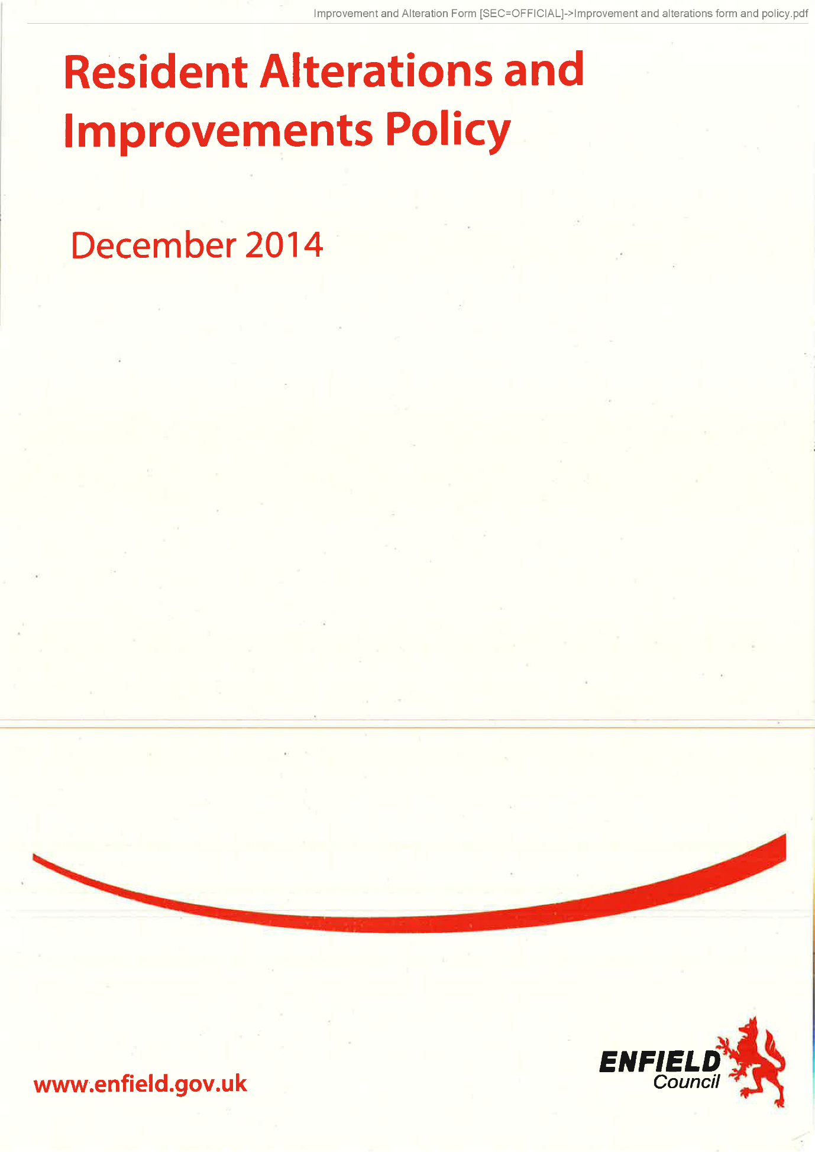
410,
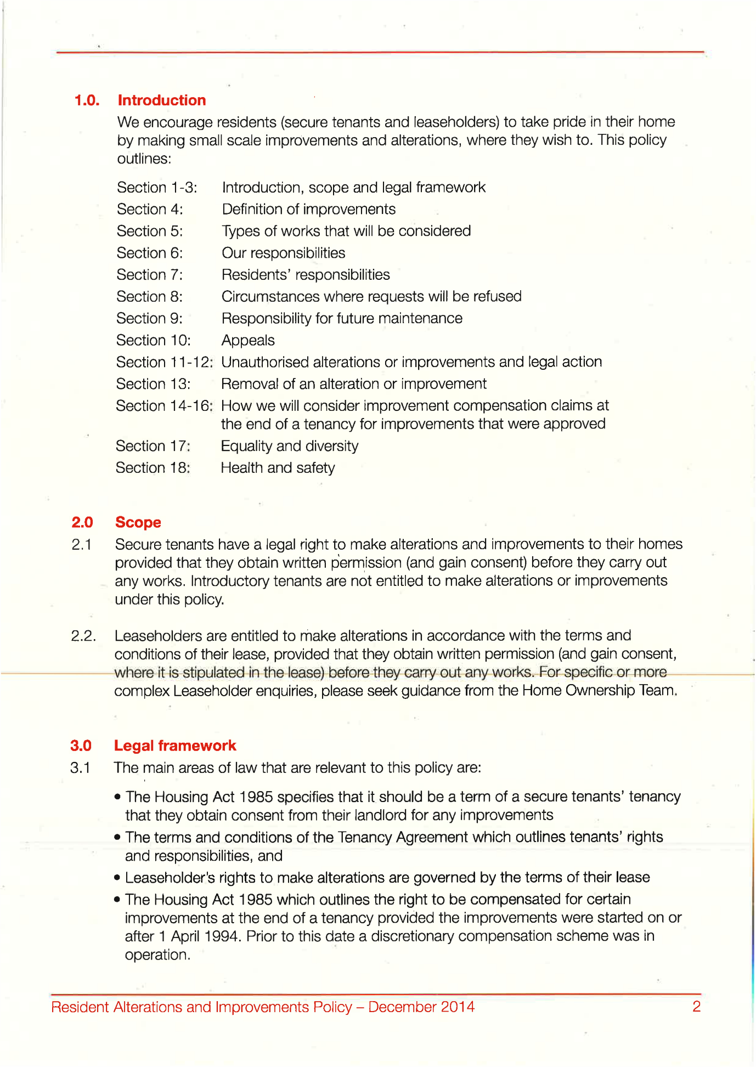
411,
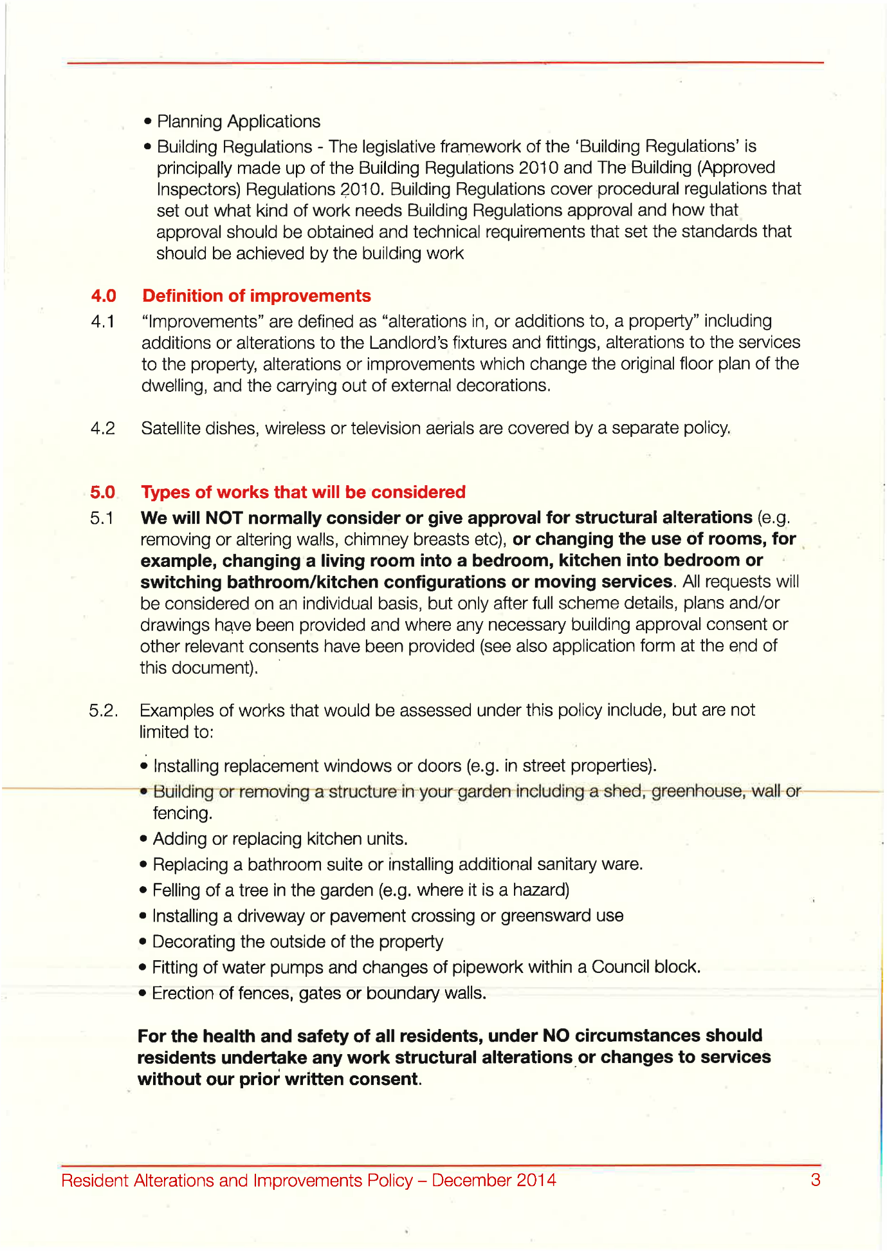
412,
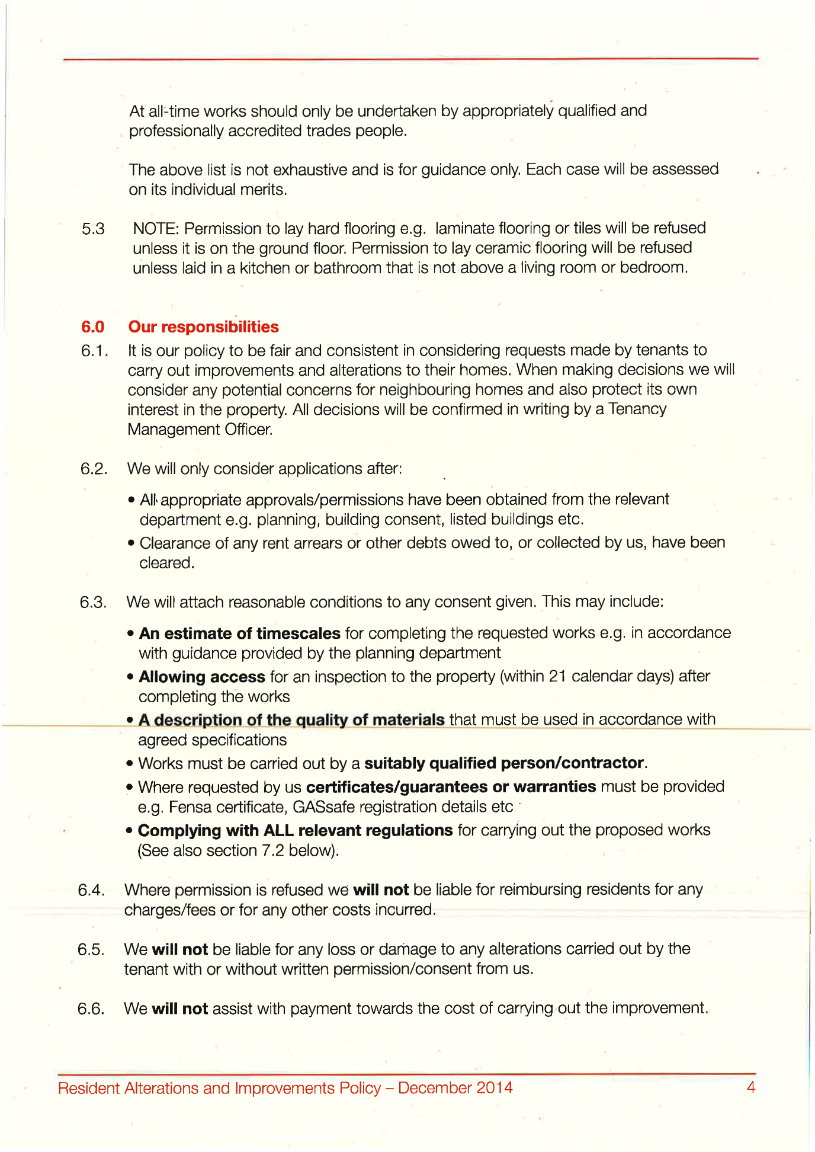
413,
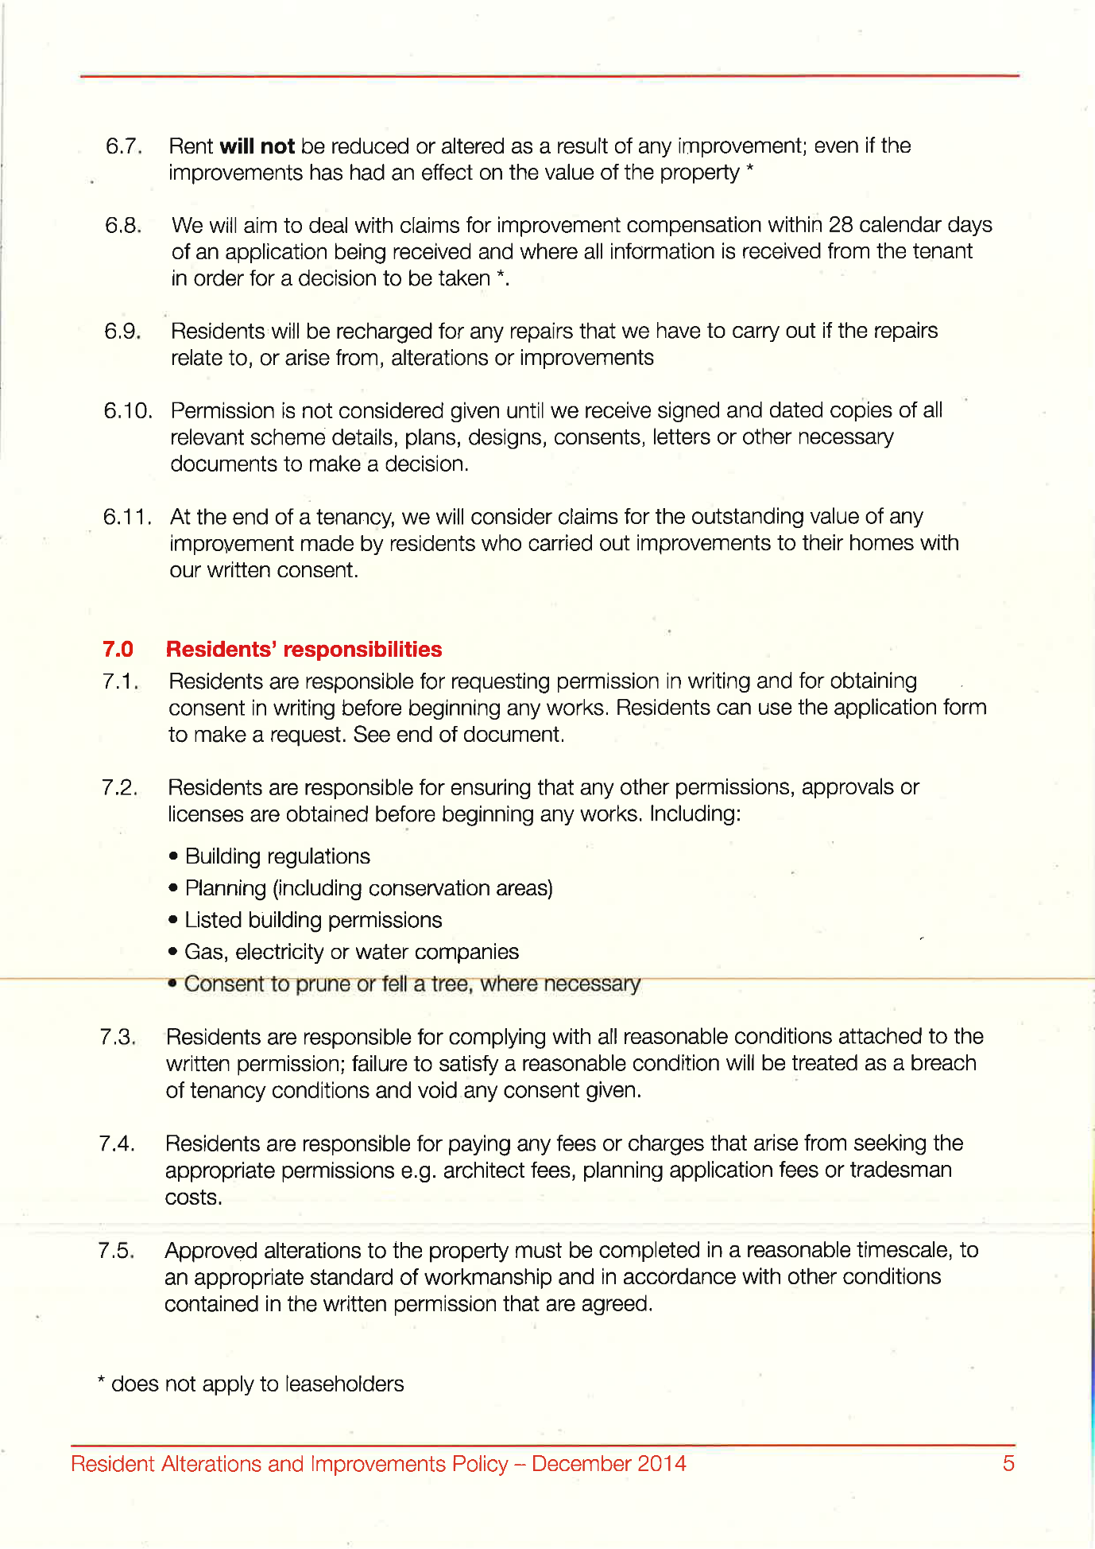
414,
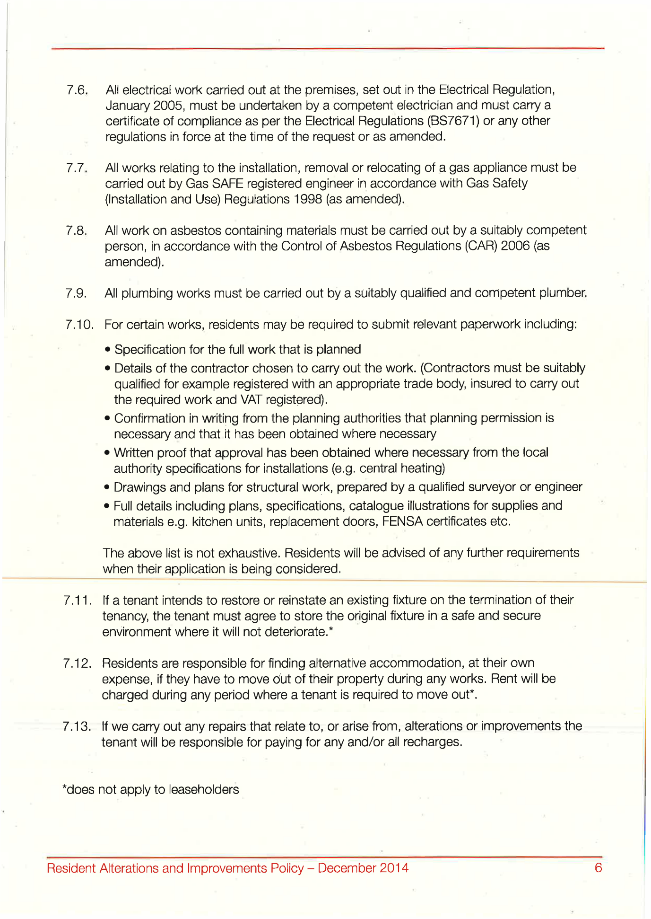
415,
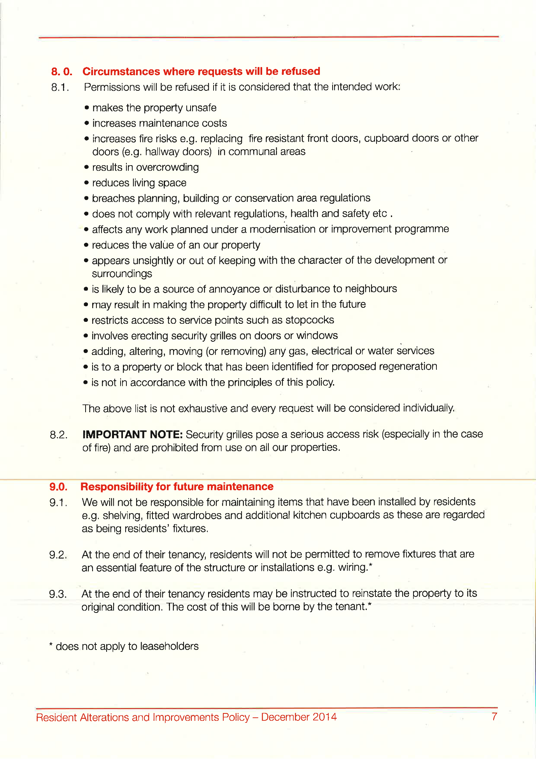
416,
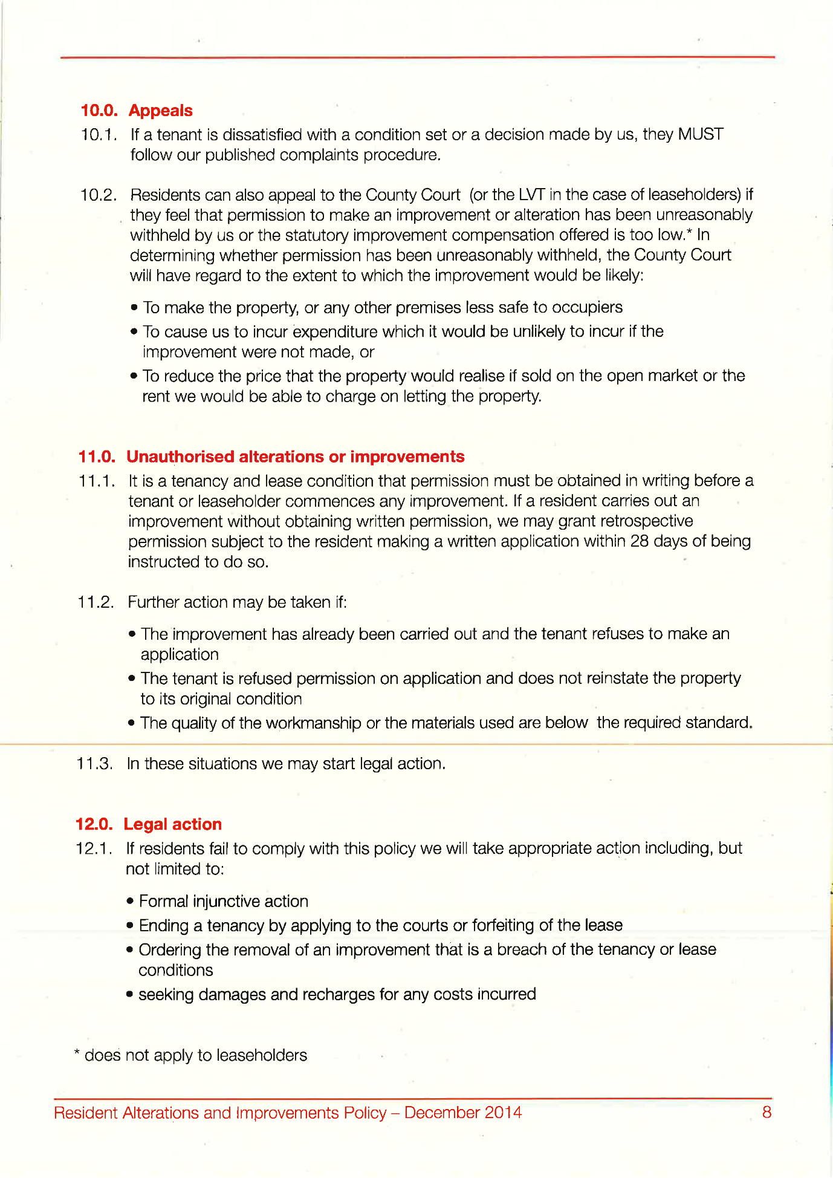
417,
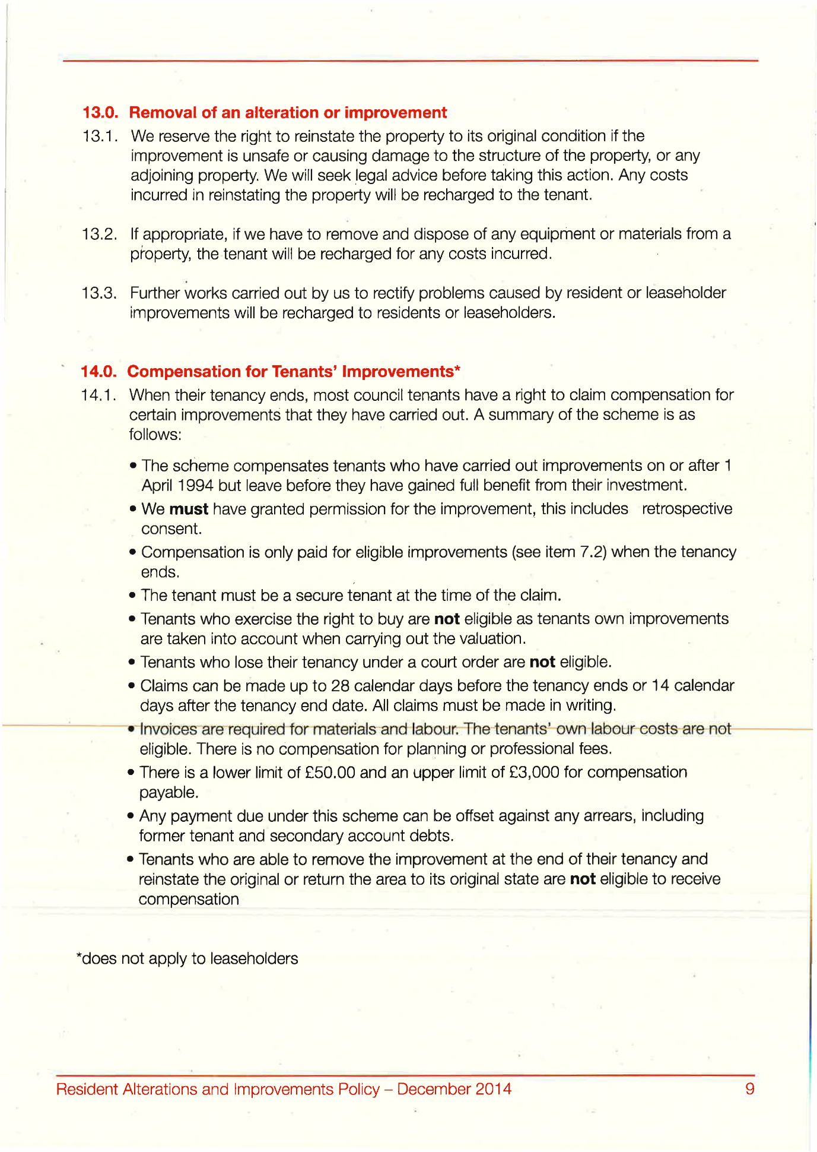
418,
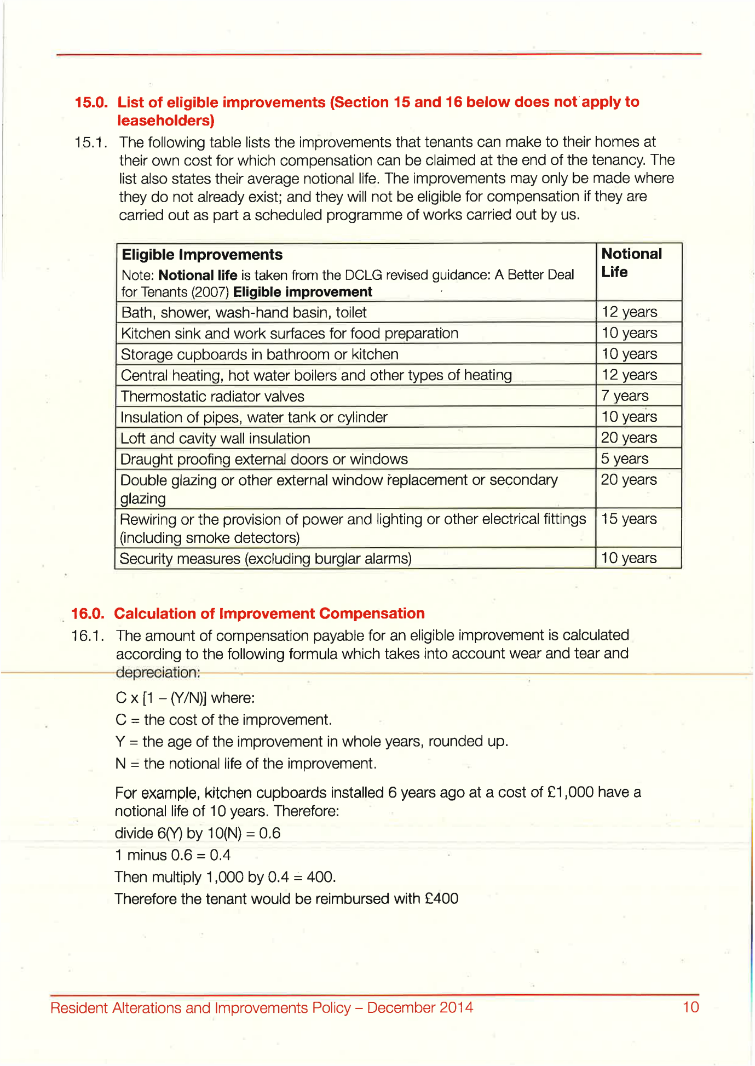
419,
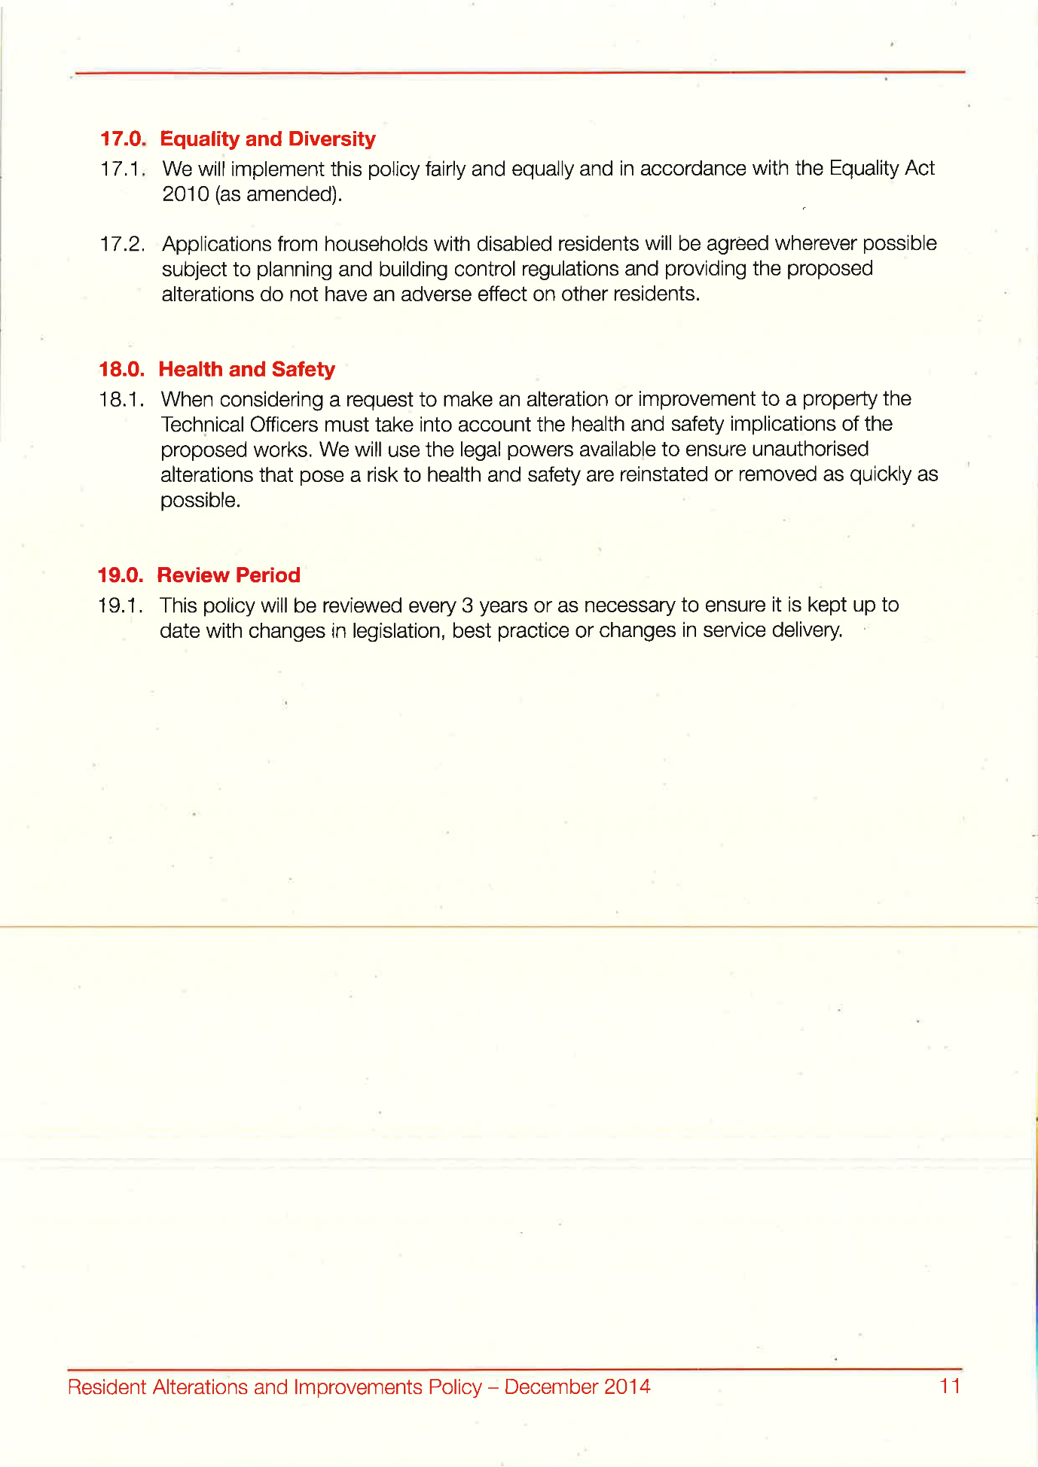
420,
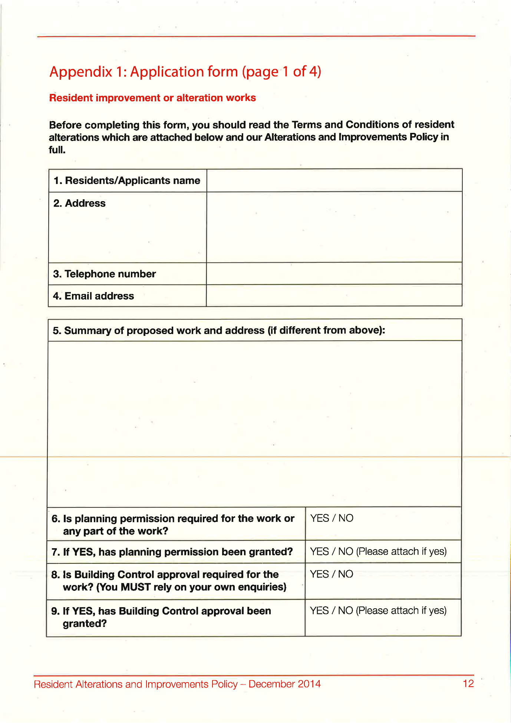
421,
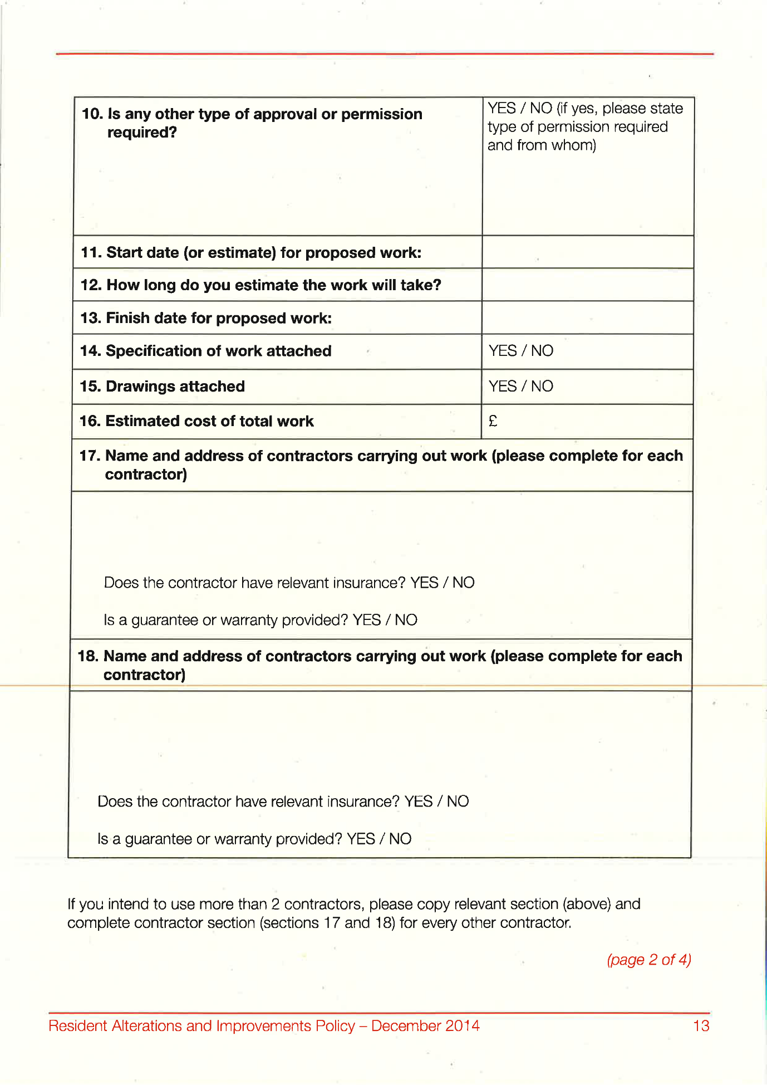
422,
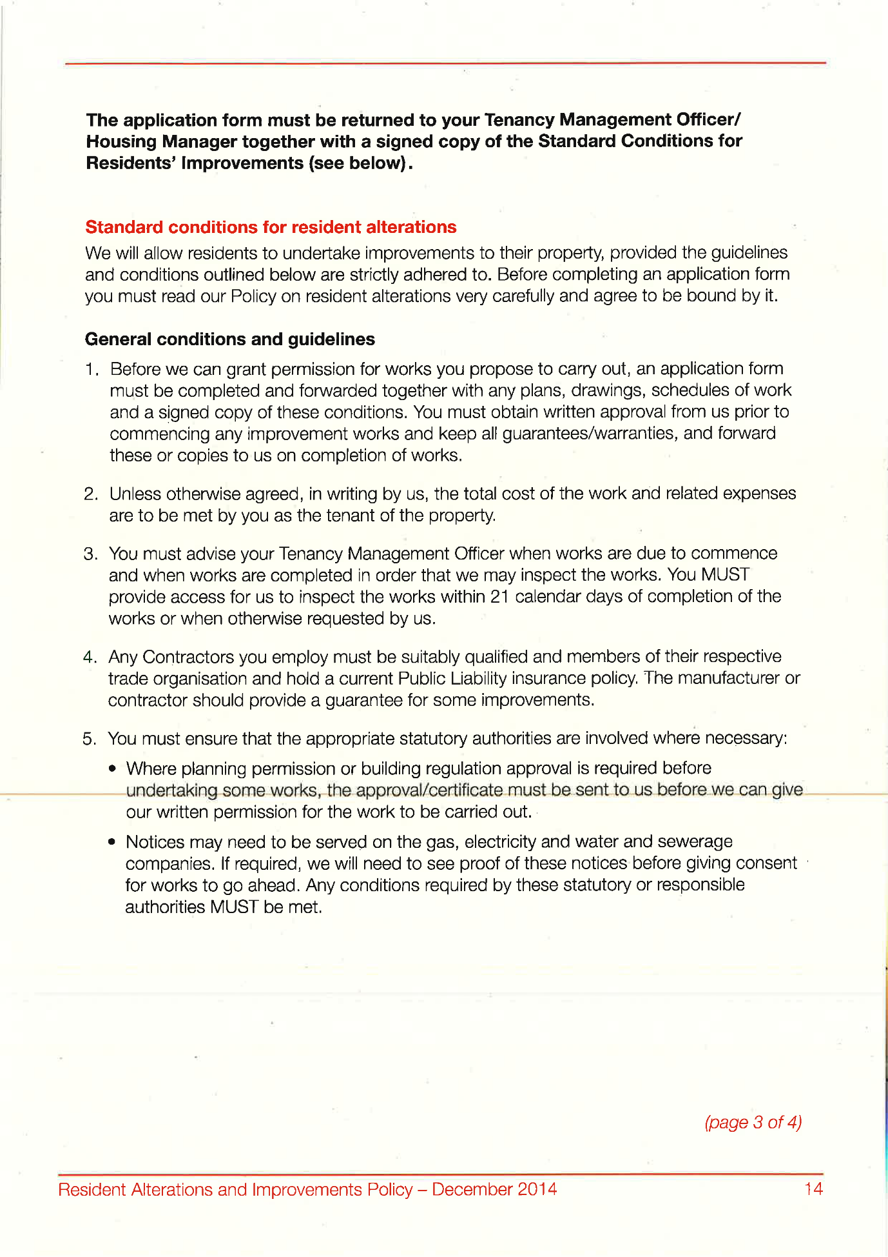
423,
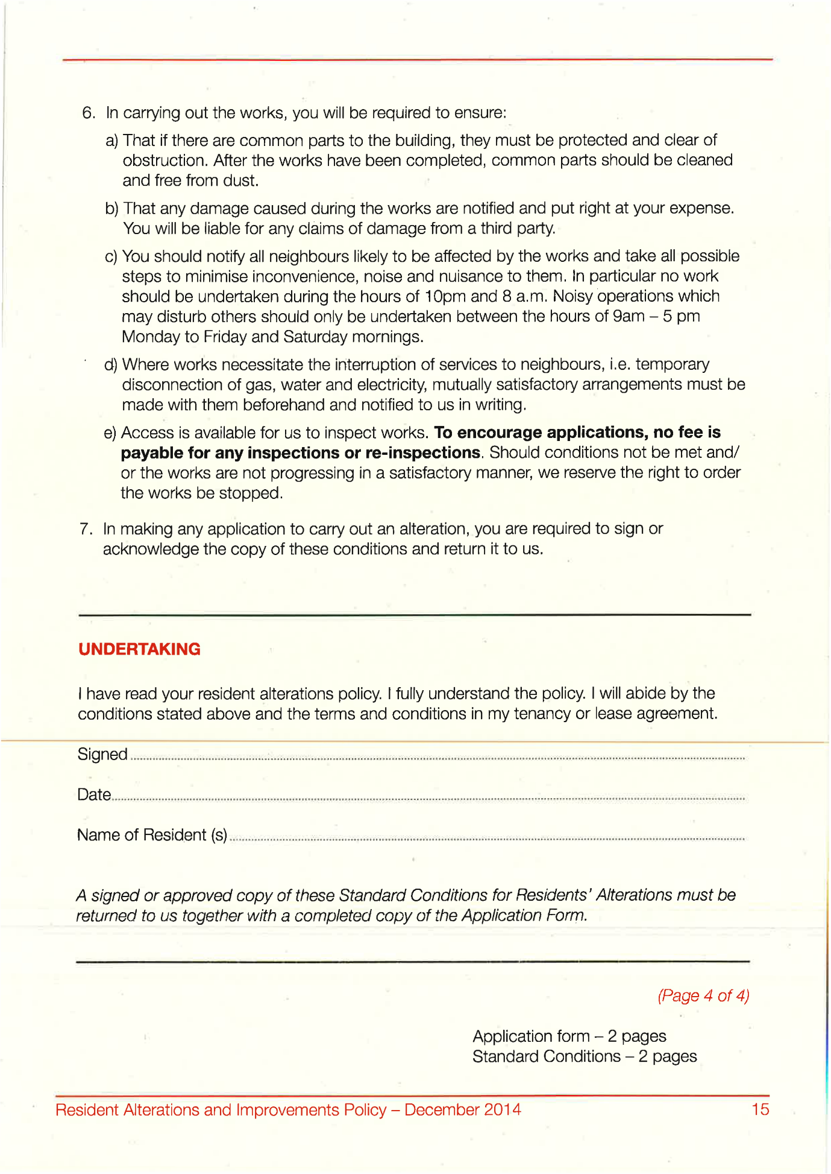
424,
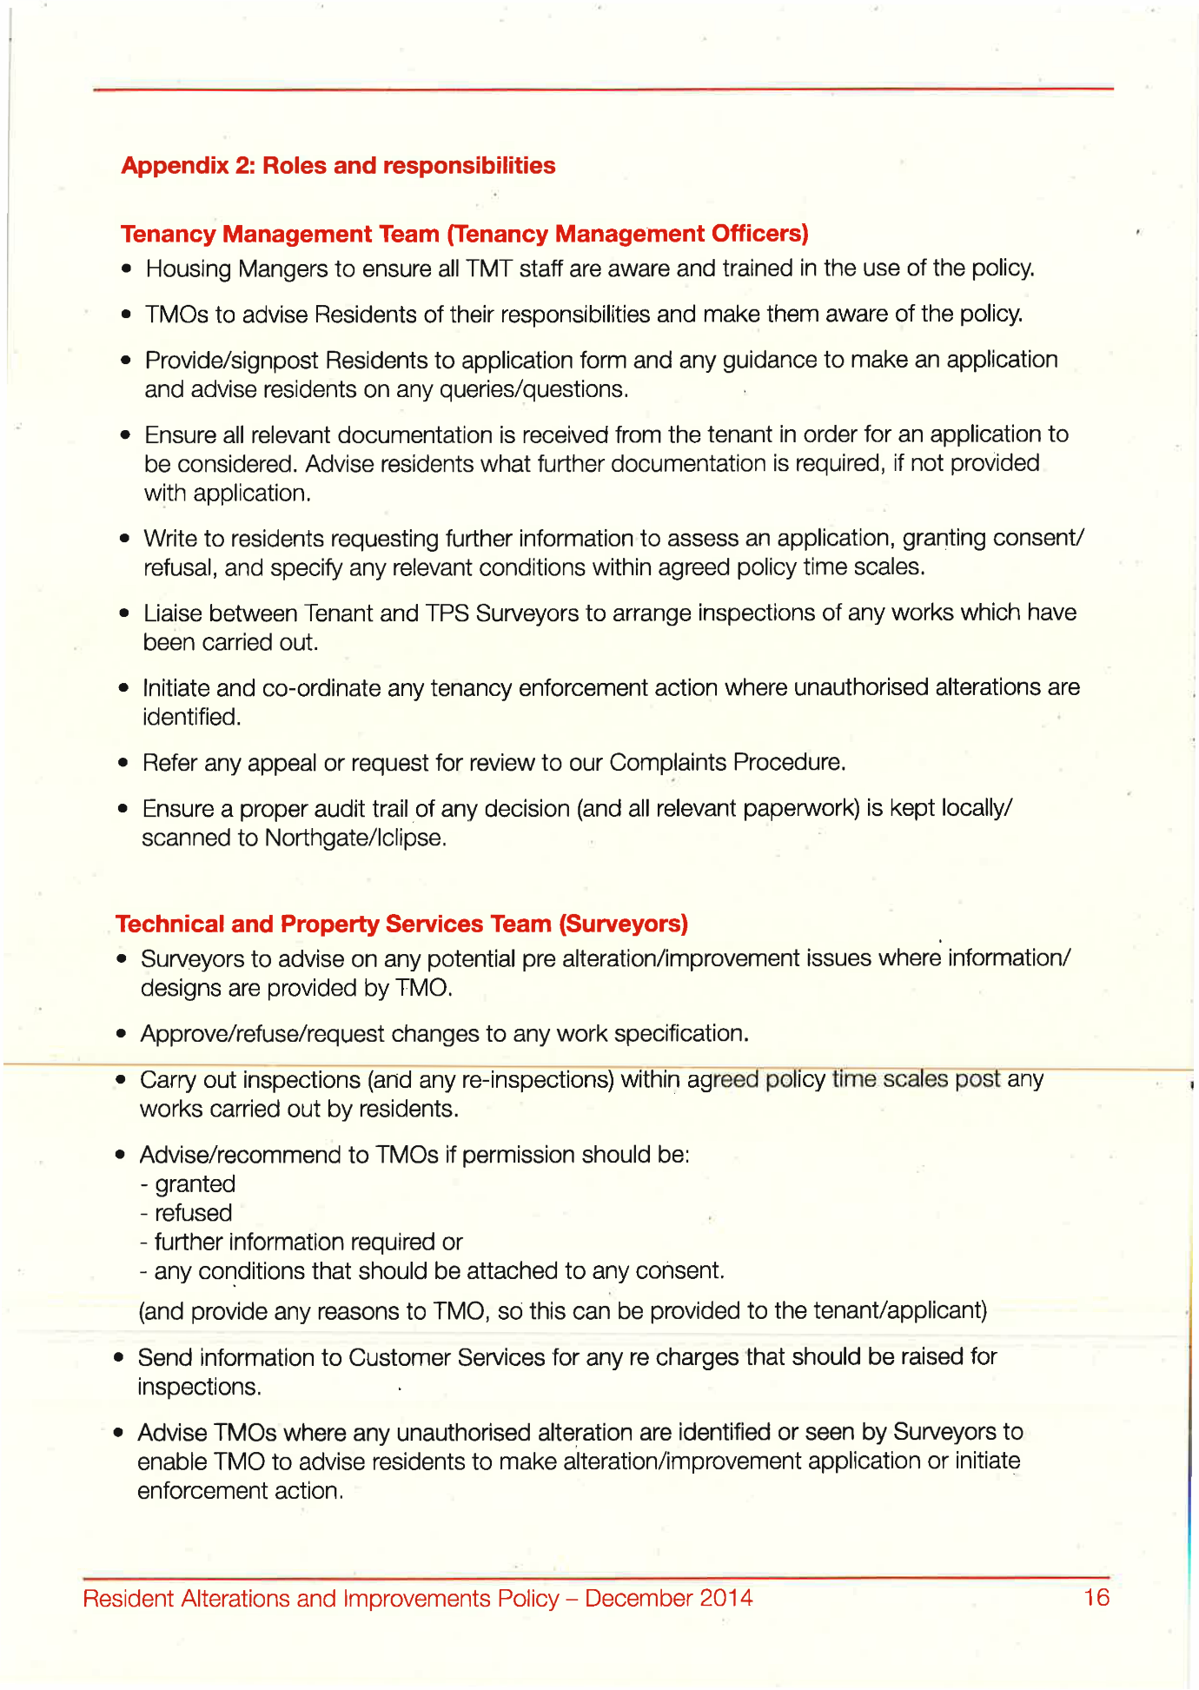
425,
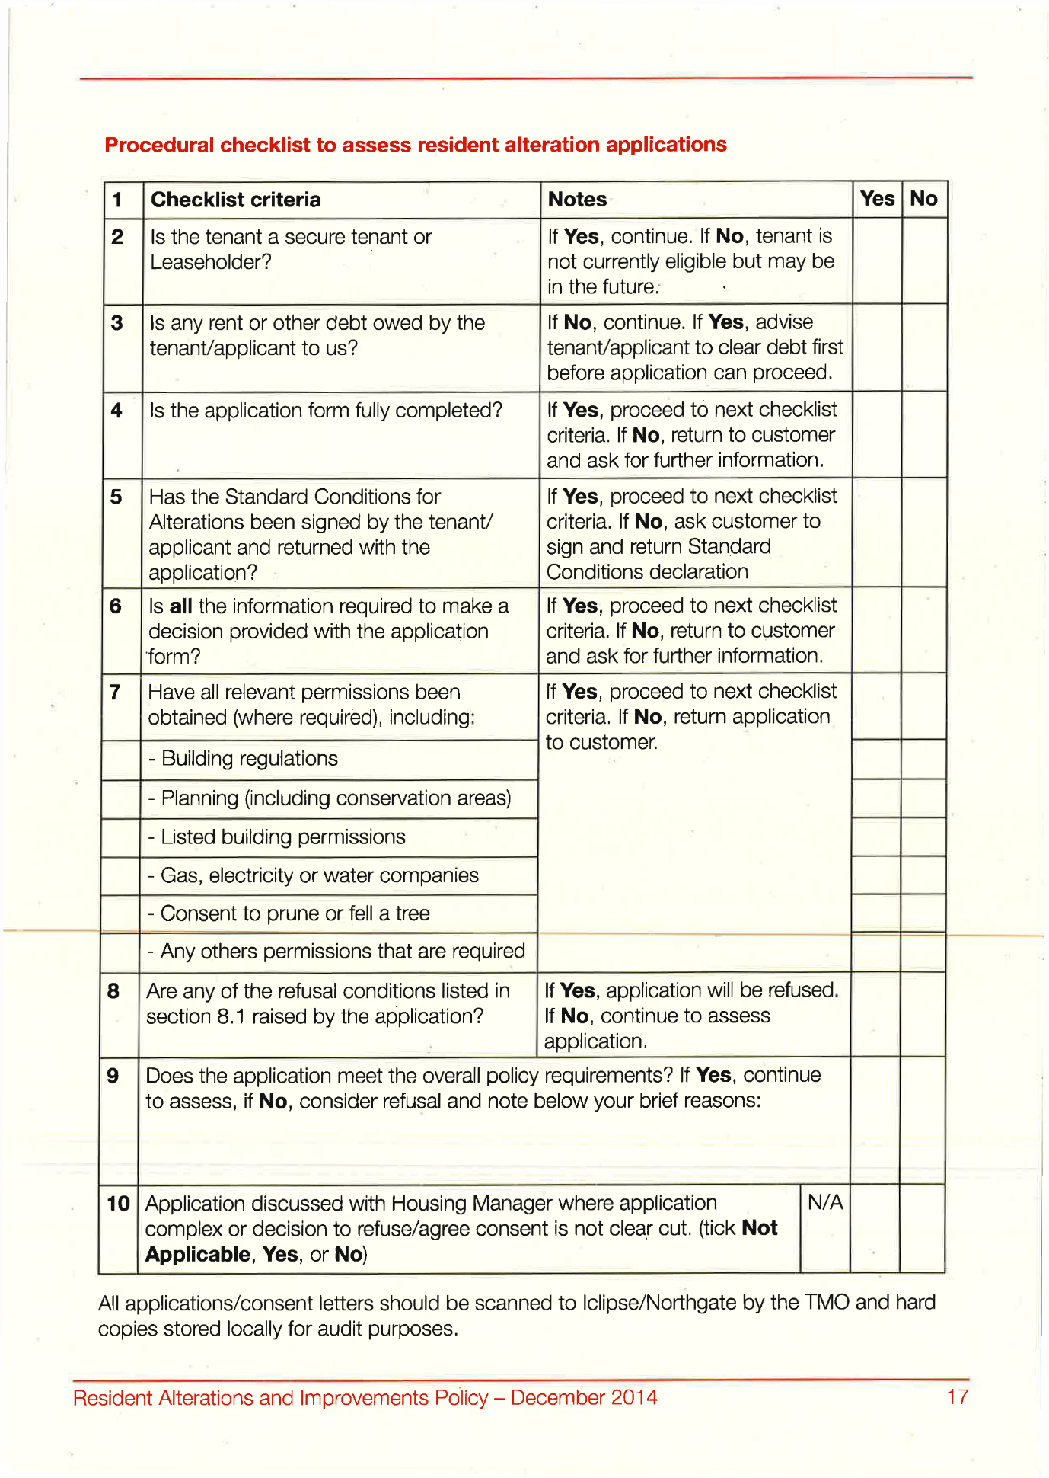
426,
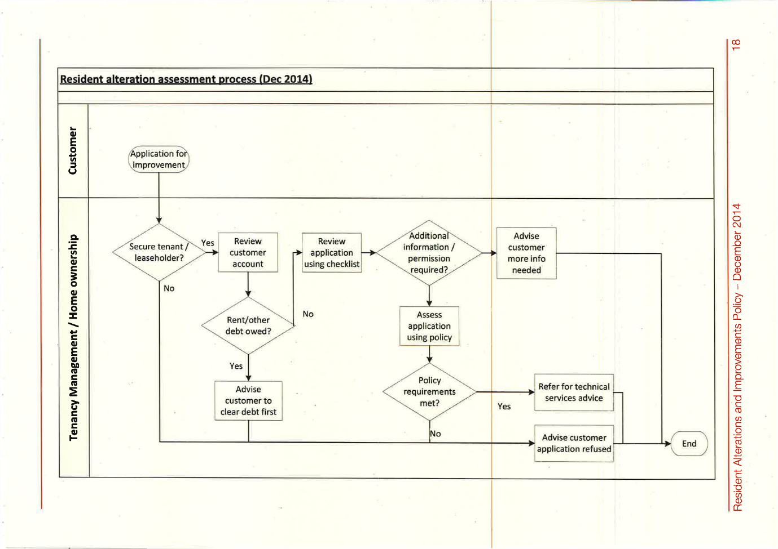
427,
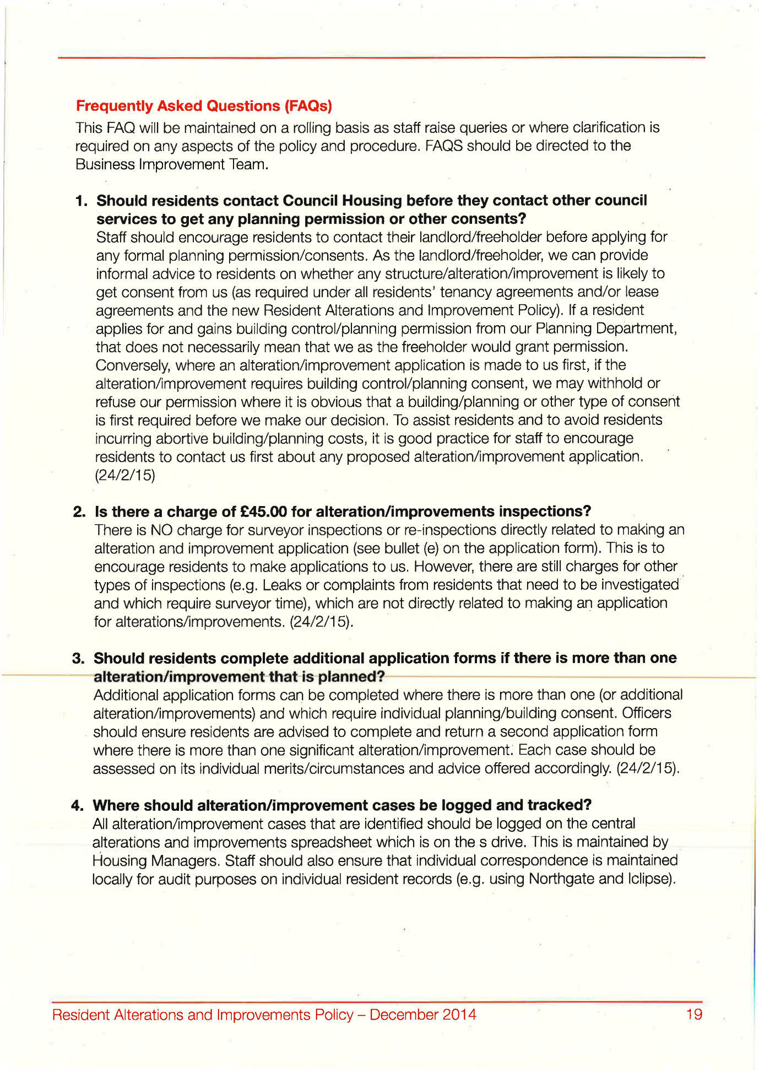
End of Picture!

The banging Started!

Summary!

Disrepair!

Time Spent Building.
In the background of everything going on I could no longer work on my first company Too Smooth due to the amount of time I had to put toward s defending myself.
My mother Stopped working on my website
Working at Home doing Court Case Defense Work!
I spent time and recourses costing expenditure building my defence case and website Horrific Corruption.com, against the allegations getting put against me at the Time Start: 00:00 and Time End: 00:00

Saturday!
10/08/2019

Stain and the
Issues with Housing Disrepair!
Working on the Court Case Defence!
The Anti-Social Behaviour Order Case and the Verdict got made Guilty against me in error and the conditions got imposed against me till late 2020!
The Banging Continued: -
10/08/2019

- Disrepair!
- The Asbo Order got granted in Error with Full Conditions against me and Fraudulently!
- The banging Continued at me!
- Working at home!

- 2nd Possession Order! 06/02/2019
I have good news in that the Council have decided to not pursue the case further due to a lack of recent incidents. Please see attached their letter received recently and our letter dated 22 October 2019 sent to your son.

1
- 113 Burncroft Avenue
Ambrose had moved for ever!
“Empty”

- 117 Burncroft Avenue
The 3rd set of Tenant’s since the Problems Started with the Flat being used as an Offensives Weapons against my Person and against my free will.
has been “Re-Vacated” again by John Iron

--

The banging Started!

Summary!

Disrepair!

Time Spent Building.
In the background of everything going on I could no longer work on my first company Too Smooth due to the amount of time I had to put toward s defending myself.
My mother Stopped working on my website
Working at Home doing Court Case Defense Work!
I spent time and recourses costing expenditure building my defence case and website Horrific Corruption.com, against the allegations getting put against me at the Time Start: 00:00 and Time End: 00:00

Sunday!
11/08/2019

Stain and the
Issues with Housing Disrepair!
Working on the Court Case Defence!
The Anti-Social Behaviour Order Case and the Verdict got made Guilty against me in error and the conditions got imposed against me till late 2020!
The Banging Continued: -
11/08/2019

- Disrepair!
- The Asbo Order got granted in Error with Full Conditions against me and Fraudulently!
- The banging Continued at me!
- Working at home!

- 2nd Possession Order! 06/02/2019
I have good news in that the Council have decided to not pursue the case further due to a lack of recent incidents. Please see attached their letter received recently and our letter dated 22 October 2019 sent to your son.

1
- 113 Burncroft Avenue
Ambrose had moved for ever!
“Empty”

- 117 Burncroft Avenue
The 3rd set of Tenant’s since the Problems Started with the Flat being used as an Offensives Weapons against my Person and against my free will.
has been “Re-Vacated” again by John Iron

--

The banging Started!

Summary!

Disrepair!

Time Spent Building.
In the background of everything going on I could no longer work on my first company Too Smooth due to the amount of time I had to put toward s defending myself.
My mother Stopped working on my website
Working at Home doing Court Case Defense Work!
I spent time and recourses costing expenditure building my defence case and website Horrific Corruption.com, against the allegations getting put against me at the Time Start: 00:00 and Time End: 00:00

Monday!
12/08/2019

Stain and the
Issues with Housing Disrepair!
Working on the Court Case Defence!
The Anti-Social Behaviour Order Case and the Verdict got made Guilty against me in error and the conditions got imposed against me till late 2020!
The Banging Continued: -
12/08/2019

- Disrepair!
- The Asbo Order got granted in Error with Full Conditions against me and Fraudulently!
- The banging Continued at me!
- Working at home!

- 2nd Possession Order! 06/02/2019
I have good news in that the Council have decided to not pursue the case further due to a lack of recent incidents. Please see attached their letter received recently and our letter dated 22 October 2019 sent to your son.

1
- 113 Burncroft Avenue
Ambrose had moved for ever!
“Empty”

- 117 Burncroft Avenue
The 3rd set of Tenant’s since the Problems Started with the Flat being used as an Offensives Weapons against my Person and against my free will.
has been “Re-Vacated” again by John Iron

--

The banging Started!

Summary!

Disrepair!

Time Spent Building.
In the background of everything going on I could no longer work on my first company Too Smooth due to the amount of time I had to put toward s defending myself.
My mother Stopped working on my website
Working at Home doing Court Case Defense Work!
I spent time and recourses costing expenditure building my defence case and website Horrific Corruption.com, against the allegations getting put against me at the Time Start: 00:00 and Time End: 00:00

Tuesday!
13/08/2019

Stain and the
Issues with Housing Disrepair!
Working on the Court Case Defence!
The Anti-Social Behaviour Order Case and the Verdict got made Guilty against me in error and the conditions got imposed against me till late 2020!
The Banging Continued: -
13/08/2019

- Disrepair!
- The Asbo Order got granted in Error with Full Conditions against me and Fraudulently!
- The banging Continued at me!
- Working at home!

- 2nd Possession Order! 06/02/2019
I have good news in that the Council have decided to not pursue the case further due to a lack of recent incidents. Please see attached their letter received recently and our letter dated 22 October 2019 sent to your son.

1
- 113 Burncroft Avenue
Ambrose had moved for ever!
“Empty”

- 117 Burncroft Avenue
The 3rd set of Tenant’s since the Problems Started with the Flat being used as an Offensives Weapons against my Person and against my free will.
has been “Re-Vacated” again by John Iron

--

The banging Started!

Summary!

Disrepair!

Time Spent Building.
In the background of everything going on I could no longer work on my first company Too Smooth due to the amount of time I had to put toward s defending myself.
My mother Stopped working on my website
Working at Home doing Court Case Defense Work!
I spent time and recourses costing expenditure building my defence case and website Horrific Corruption.com, against the allegations getting put against me at the Time Start: 00:00 and Time End: 00:00

Wednesday!
14/08/2019

Stain and the
Issues with Housing Disrepair!
Working on the Court Case Defence!
The Anti-Social Behaviour Order Case and the Verdict got made Guilty against me in error and the conditions got imposed against me till late 2020!
The Banging Continued: -
14/08/2019

- Disrepair!
- The Asbo Order got granted in Error with Full Conditions against me and Fraudulently!
- The banging Continued at me!
- Working at home!

- 2nd Possession Order! 06/02/2019
I have good news in that the Council have decided to not pursue the case further due to a lack of recent incidents. Please see attached their letter received recently and our letter dated 22 October 2019 sent to your son.

1
- 113 Burncroft Avenue
Ambrose had moved for ever!
“Empty”

- 117 Burncroft Avenue
The 3rd set of Tenant’s since the Problems Started with the Flat being used as an Offensives Weapons against my Person and against my free will.
has been “Re-Vacated” again by John Iron

--

The banging Started!

Summary!

Disrepair!

Time Spent Building.
In the background of everything going on I could no longer work on my first company Too Smooth due to the amount of time I had to put toward s defending myself.
My mother Stopped working on my website
Working at Home doing Court Case Defense Work!
I spent time and recourses costing expenditure building my defence case and website Horrific Corruption.com, against the allegations getting put against me at the Time Start: 00:00 and Time End: 00:00

Thursday!
15/08/2019

Stain and the
Issues with Housing Disrepair!
Working on the Court Case Defence!
The Anti-Social Behaviour Order Case and the Verdict got made Guilty against me in error and the conditions got imposed against me till late 2020!
The Banging Continued: -
15/08/2019

- Disrepair!
- The Asbo Order got granted in Error with Full Conditions against me and Fraudulently!
- The banging Continued at me!
- Working at home!

- 2nd Possession Order! 06/02/2019
I have good news in that the Council have decided to not pursue the case further due to a lack of recent incidents. Please see attached their letter received recently and our letter dated 22 October 2019 sent to your son.

1
- 113 Burncroft Avenue
Ambrose had moved for ever!
“Empty”

- 117 Burncroft Avenue
The 3rd set of Tenant’s since the Problems Started with the Flat being used as an Offensives Weapons against my Person and against my free will.
has been “Re-Vacated” again by John Iron

--

The banging Started!

Summary!

Disrepair!

Time Spent Building.
In the background of everything going on I could no longer work on my first company Too Smooth due to the amount of time I had to put toward s defending myself.
My mother Stopped working on my website
Working at Home doing Court Case Defense Work!
I spent time and recourses costing expenditure building my defence case and website Horrific Corruption.com, against the allegations getting put against me at the Time Start: 00:00 and Time End: 00:00

Friday!
16/08/2019

Stain and the
Issues with Housing Disrepair!
Working on the Court Case Defence!
The Anti-Social Behaviour Order Case and the Verdict got made Guilty against me in error and the conditions got imposed against me till late 2020!
The Banging Continued: -
16/08/2019

- Disrepair!
- The Asbo Order got granted in Error with Full Conditions against me and Fraudulently!
- The banging Continued at me!
- Working at home!

- 2nd Possession Order! 06/02/2019
I have good news in that the Council have decided to not pursue the case further due to a lack of recent incidents. Please see attached their letter received recently and our letter dated 22 October 2019 sent to your son.

1
- 113 Burncroft Avenue
Ambrose had moved for ever!
“Empty”

- 117 Burncroft Avenue
The 3rd set of Tenant’s since the Problems Started with the Flat being used as an Offensives Weapons against my Person and against my free will.
has been “Re-Vacated” again by John Iron

--

The banging Started!

Summary!

Disrepair!

Time Spent Building.
In the background of everything going on I could no longer work on my first company Too Smooth due to the amount of time I had to put toward s defending myself.
My mother Stopped working on my website
Working at Home doing Court Case Defense Work!
I spent time and recourses costing expenditure building my defence case and website Horrific Corruption.com, against the allegations getting put against me at the Time Start: 00:00 and Time End: 00:00

Saturday!
17/08/2019

Stain and the
Issues with Housing Disrepair!
Working on the Court Case Defence!
The Anti-Social Behaviour Order Case and the Verdict got made Guilty against me in error and the conditions got imposed against me till late 2020!
The Banging Continued: -
17/08/2019

- Disrepair!
- The Asbo Order got granted in Error with Full Conditions against me and Fraudulently!
- The banging Continued at me!
- Working at home!

- 2nd Possession Order! 06/02/2019
I have good news in that the Council have decided to not pursue the case further due to a lack of recent incidents. Please see attached their letter received recently and our letter dated 22 October 2019 sent to your son.

1
- 113 Burncroft Avenue
Ambrose had moved for ever!
“Empty”

- 117 Burncroft Avenue
The 3rd set of Tenant’s since the Problems Started with the Flat being used as an Offensives Weapons against my Person and against my free will.
has been “Re-Vacated” again by John Iron

--

The banging Started!

Summary!

Disrepair!

Time Spent Building.
In the background of everything going on I could no longer work on my first company Too Smooth due to the amount of time I had to put toward s defending myself.
My mother Stopped working on my website
Working at Home doing Court Case Defense Work!
I spent time and recourses costing expenditure building my defence case and website Horrific Corruption.com, against the allegations getting put against me at the Time Start: 00:00 and Time End: 00:00

Sunday!
18/08/2019

Stain and the
Issues with Housing Disrepair!
Working on the Court Case Defence!
The Anti-Social Behaviour Order Case and the Verdict got made Guilty against me in error and the conditions got imposed against me till late 2020!
The Banging Continued: -
18/08/2019

- Disrepair!
- The Asbo Order got granted in Error with Full Conditions against me and Fraudulently!
- The banging Continued at me!
- Working at home!

- 2nd Possession Order! 06/02/2019
I have good news in that the Council have decided to not pursue the case further due to a lack of recent incidents. Please see attached their letter received recently and our letter dated 22 October 2019 sent to your son.

1
- 113 Burncroft Avenue
Ambrose had moved for ever!
“Empty”

- 117 Burncroft Avenue
The 3rd set of Tenant’s since the Problems Started with the Flat being used as an Offensives Weapons against my Person and against my free will.
has been “Re-Vacated” again by John Iron

--

The banging Started!

Summary!

Disrepair!

Time Spent Building.
In the background of everything going on I could no longer work on my first company Too Smooth due to the amount of time I had to put toward s defending myself.
My mother Stopped working on my website
Working at Home doing Court Case Defense Work!
I spent time and recourses costing expenditure building my defence case and website Horrific Corruption.com, against the allegations getting put against me at the Time Start: 00:00 and Time End: 00:00

Monday!
19/08/2019

Stain and the
Issues with Housing Disrepair!
Working on the Court Case Defence!
The Anti-Social Behaviour Order Case and the Verdict got made Guilty against me in error and the conditions got imposed against me till late 2020!
The Banging Continued: -
19/08/2019

- Disrepair!
- The Asbo Order got granted in Error with Full Conditions against me and Fraudulently!
- The banging Continued at me!
- Working at home!

- 2nd Possession Order! 06/02/2019
I have good news in that the Council have decided to not pursue the case further due to a lack of recent incidents. Please see attached their letter received recently and our letter dated 22 October 2019 sent to your son.

1
- 113 Burncroft Avenue
Ambrose had moved for ever!
“Empty”

- 117 Burncroft Avenue
The 3rd set of Tenant’s since the Problems Started with the Flat being used as an Offensives Weapons against my Person and against my free will.
has been “Re-Vacated” again by John Iron

1
- Simon Cordell’s MP3’S Indexed
Stage 1
1x Recording
01m. Enfield Council (6) 19_08_2019
Page Number: Update Page Number 1,
01m. Enfield Council (6) 19_08_2019.WMA
Update

2
- Simon Cordell’s MP3’S Indexed
Stage 1
1x Recording
01m. Enfield Council (7) 19_08_2019
Page Number: Update Page Number 1,
01m. Enfield Council (7) 19_08_2019.WMA
Update

3
- Simon Cordell’s MP3’S Indexed
Stage 1
1x Recording
01m. Enfield Council (8) 19_08_2019
Page Number: Update Page Number 1,
01m. Enfield Council (8) 19_08_2019.WMA
Update

4
- Simon Cordell’s MP3’S Indexed
Stage 1
1x Recording
01m. Enfield Council (9) 19_08_2019
Page Number: Update Page Number 1,
01m. Enfield Council (9) 19_08_2019 Kay.WMA
Update

50.
- Additional Email Attachments & Emails / Issue:
50. 1. 2.
Mother 19-08-2019-10-09
19/08/2019
/ Page Numbers: 428,429

--

1
Simon Cordell’s MP3’S Indexed
Stage 1
1x Recording
01m. Enfield Council (6) 19_08_2019
Page Number: Update Page Number 1,
01m. Enfield Council (6) 19_08_2019.WMA
Update

2
Simon Cordell’s MP3’S Indexed
Stage 1
1x Recording
01m. Enfield Council (7) 19_08_2019
Page Number: Update Page Number 1,
01m. Enfield Council (7) 19_08_2019.WMA
Update

3
Simon Cordell’s MP3’S Indexed
Stage 1
1x Recording
01m. Enfield Council (8) 19_08_2019
Page Number: Update Page Number 1,
01m. Enfield Council (8) 19_08_2019.WMA
Update

4
Simon Cordell’s MP3’S Indexed
Stage 1
1x Recording
01m. Enfield Council (9) 19_08_2019
Page Number: Update Page Number 1,
01m. Enfield Council (9) 19_08_2019 Kay.WMA
Update

50.
Additional Email Attachments & Emails / Issue:
50. 1. 2.
Mother 19-08-2019-10-09
19/08/2019
/ Page Numbers: 428,429
--
428,
From: Lorraine Cordell <lorraine32@blueyonder.co.uk>
Sent time: 19/08/2019 10:09:24 PM
To: re_wired@ymail.com
Subject: RE; insurance
Attachments: public liability insurance-2019.doc
here
429,
public liability insurance-2019.doc
Mr Simon Cordell 109 Burncroft Ave Enfield Middlesex EN3 7JQ 04/04/2019
To Whom It May Concern:
I am writing this Letter to request the information relating to your public liability insurance, can you please confirm the details of who your public liability insurance is held by and the policy certificate details.
This would include all policy certificate details held by for each year from 2014 to 2019. Could the information please be sent via this email address?
Yours faithfully
Mr Simon Cordell

The banging Started!

Si Note:
1

2

3

4

Summary!

Disrepair!

Time Spent Building.
In the background of everything going on I could no longer work on my first company Too Smooth due to the amount of time I had to put toward s defending myself.
My mother Stopped working on my website
Working at Home doing Court Case Defense Work!
I spent time and recourses costing expenditure building my defence case and website Horrific Corruption.com, against the allegations getting put against me at the Time Start: 00:00 and Time End: 00:00

Tuesday!
20/08/2019

Stain and the
Issues with Housing Disrepair!
Working on the Court Case Defence!
The Anti-Social Behaviour Order Case and the Verdict got made Guilty against me in error and the conditions got imposed against me till late 2020!
The Banging Continued: -
20/08/2019

- Disrepair!
- The Asbo Order got granted in Error with Full Conditions against me and Fraudulently!
- The banging Continued at me!
- Working at home!

- 2nd Possession Order! 06/02/2019
I have good news in that the Council have decided to not pursue the case further due to a lack of recent incidents. Please see attached their letter received recently and our letter dated 22 October 2019 sent to your son.

1
- 113 Burncroft Avenue
Ambrose had moved for ever!
“Empty”

- 117 Burncroft Avenue
The 3rd set of Tenant’s since the Problems Started with the Flat being used as an Offensives Weapons against my Person and against my free will.
has been “Re-Vacated” again by John Iron

--

The banging Started!

Summary!

Disrepair!

Time Spent Building.
In the background of everything going on I could no longer work on my first company Too Smooth due to the amount of time I had to put toward s defending myself.
My mother Stopped working on my website
Working at Home doing Court Case Defense Work!
I spent time and recourses costing expenditure building my defence case and website Horrific Corruption.com, against the allegations getting put against me at the Time Start: 00:00 and Time End: 00:00

Wednesday!
21/08/2019

Stain and the
Issues with Housing Disrepair!
Working on the Court Case Defence!
The Anti-Social Behaviour Order Case and the Verdict got made Guilty against me in error and the conditions got imposed against me till late 2020!
The Banging Continued: -
21/08/2019

- Disrepair!
- The Asbo Order got granted in Error with Full Conditions against me and Fraudulently!
- The banging Continued at me!
- Working at home!

- 2nd Possession Order! 06/02/2019
I have good news in that the Council have decided to not pursue the case further due to a lack of recent incidents. Please see attached their letter received recently and our letter dated 22 October 2019 sent to your son.

1
- 113 Burncroft Avenue
Ambrose had moved for ever!
“Empty”

- 117 Burncroft Avenue
The 3rd set of Tenant’s since the Problems Started with the Flat being used as an Offensives Weapons against my Person and against my free will.
has been “Re-Vacated” again by John Iron

--

The banging Started!

Summary!

Disrepair!

Time Spent Building.
In the background of everything going on I could no longer work on my first company Too Smooth due to the amount of time I had to put toward s defending myself.
My mother Stopped working on my website
Working at Home doing Court Case Defense Work!
I spent time and recourses costing expenditure building my defence case and website Horrific Corruption.com, against the allegations getting put against me at the Time Start: 00:00 and Time End: 00:00

Thursday!
22/08/2019

Stain and the
Issues with Housing Disrepair!
Working on the Court Case Defence!
The Anti-Social Behaviour Order Case and the Verdict got made Guilty against me in error and the conditions got imposed against me till late 2020!
The Banging Continued: -
22/08/2019

- Disrepair!
- The Asbo Order got granted in Error with Full Conditions against me and Fraudulently!
- The banging Continued at me!
- Working at home!

- 2nd Possession Order! 06/02/2019
I have good news in that the Council have decided to not pursue the case further due to a lack of recent incidents. Please see attached their letter received recently and our letter dated 22 October 2019 sent to your son.

1
- 113 Burncroft Avenue
Ambrose had moved for ever!
“Empty”

- 117 Burncroft Avenue
The 3rd set of Tenant’s since the Problems Started with the Flat being used as an Offensives Weapons against my Person and against my free will.
has been “Re-Vacated” again by John Iron

--

The banging Started!

Summary!

Disrepair!

Time Spent Building.
In the background of everything going on I could no longer work on my first company Too Smooth due to the amount of time I had to put toward s defending myself.
My mother Stopped working on my website
Working at Home doing Court Case Defense Work!
I spent time and recourses costing expenditure building my defence case and website Horrific Corruption.com, against the allegations getting put against me at the Time Start: 00:00 and Time End: 00:00

Friday!
23/08/2019

Stain and the
Issues with Housing Disrepair!
Working on the Court Case Defence!
The Anti-Social Behaviour Order Case and the Verdict got made Guilty against me in error and the conditions got imposed against me till late 2020!
The Banging Continued: -
23/08/2019

- Disrepair!
- The Asbo Order got granted in Error with Full Conditions against me and Fraudulently!
- The banging Continued at me!
- Working at home!

- 2nd Possession Order! 06/02/2019
I have good news in that the Council have decided to not pursue the case further due to a lack of recent incidents. Please see attached their letter received recently and our letter dated 22 October 2019 sent to your son.

1
- 113 Burncroft Avenue
Ambrose had moved for ever!
“Empty”

- 117 Burncroft Avenue
The 3rd set of Tenant’s since the Problems Started with the Flat being used as an Offensives Weapons against my Person and against my free will.
has been “Re-Vacated” again by John Iron

--

The banging Started!

Summary!

Disrepair!

Time Spent Building.
In the background of everything going on I could no longer work on my first company Too Smooth due to the amount of time I had to put toward s defending myself.
My mother Stopped working on my website
Working at Home doing Court Case Defense Work!
I spent time and recourses costing expenditure building my defence case and website Horrific Corruption.com, against the allegations getting put against me at the Time Start: 00:00 and Time End: 00:00

Saturday!
24/08/2019

Stain and the
Issues with Housing Disrepair!
Working on the Court Case Defence!
The Anti-Social Behaviour Order Case and the Verdict got made Guilty against me in error and the conditions got imposed against me till late 2020!
The Banging Continued: -
24/08/2019

- Disrepair!
- The Asbo Order got granted in Error with Full Conditions against me and Fraudulently!
- The banging Continued at me!
- Working at home!

- 2nd Possession Order! 06/02/2019
I have good news in that the Council have decided to not pursue the case further due to a lack of recent incidents. Please see attached their letter received recently and our letter dated 22 October 2019 sent to your son.

1
- 113 Burncroft Avenue
Ambrose had moved for ever!
“Empty”

- 117 Burncroft Avenue
The 3rd set of Tenant’s since the Problems Started with the Flat being used as an Offensives Weapons against my Person and against my free will.
has been “Re-Vacated” again by John Iron

--

The banging Started!

Summary!

Disrepair!

Time Spent Building.
In the background of everything going on I could no longer work on my first company Too Smooth due to the amount of time I had to put toward s defending myself.
My mother Stopped working on my website
Working at Home doing Court Case Defense Work!
I spent time and recourses costing expenditure building my defence case and website Horrific Corruption.com, against the allegations getting put against me at the Time Start: 00:00 and Time End: 00:00

Sunday!
25/08/2019

Stain and the
Issues with Housing Disrepair!
Working on the Court Case Defence!
The Anti-Social Behaviour Order Case and the Verdict got made Guilty against me in error and the conditions got imposed against me till late 2020!
The Banging Continued: -
25/08/2019

- Disrepair!
- The Asbo Order got granted in Error with Full Conditions against me and Fraudulently!
- The banging Continued at me!
- Working at home!

- 2nd Possession Order! 06/02/2019
I have good news in that the Council have decided to not pursue the case further due to a lack of recent incidents. Please see attached their letter received recently and our letter dated 22 October 2019 sent to your son.

1
- 113 Burncroft Avenue
Ambrose had moved for ever!
“Empty”

- 117 Burncroft Avenue
The 3rd set of Tenant’s since the Problems Started with the Flat being used as an Offensives Weapons against my Person and against my free will.
has been “Re-Vacated” again by John Iron

--

1
Woman with lorn mower day!

The banging Started!

Si Note:
1

Summary!

Disrepair!

Time Spent Building.
In the background of everything going on I could no longer work on my first company Too Smooth due to the amount of time I had to put toward s defending myself.
My mother Stopped working on my website
Working at Home doing Court Case Defense Work!
I spent time and recourses costing expenditure building my defence case and website Horrific Corruption.com, against the allegations getting put against me at the Time Start: 00:00 and Time End: 00:00

Monday!
26/08/2019

Stain and the
Issues with Housing Disrepair!
Working on the Court Case Defence!
The Anti-Social Behaviour Order Case and the Verdict got made Guilty against me in error and the conditions got imposed against me till late 2020!
The Banging Continued: -
26/08/2019

- Disrepair!
- The Asbo Order got granted in Error with Full Conditions against me and Fraudulently!
- The banging Continued at me!
- Working at home!

- 2nd Possession Order! 06/02/2019
I have good news in that the Council have decided to not pursue the case further due to a lack of recent incidents. Please see attached their letter received recently and our letter dated 22 October 2019 sent to your son.

1
- 113 Burncroft Avenue
Ambrose had moved for ever!
“Re-Vacated with Builders”
113 Burncroft Avenue / Ambrose’s old flat is getting fixed and the builders: --
are arss holes and I had to go upstairs and speak to them about it!

- 117 Burncroft Avenue
The 3rd set of Tenant’s since the Problems Started with the Flat being used as an Offensives Weapons against my Person and against my free will.
has been “Re-Vacated” again by John Iron

--

1
Ambrose’s flat builders have entered into it and started to get the flat ready for the next occupiers to get moved in by the Enfield Council.

The banging Started!

Si Note:
1

Summary!

Disrepair!

Time Spent Building.
In the background of everything going on I could no longer work on my first company Too Smooth due to the amount of time I had to put toward s defending myself.
My mother Stopped working on my website
Working at Home doing Court Case Defense Work!
I spent time and recourses costing expenditure building my defence case and website Horrific Corruption.com, against the allegations getting put against me at the Time Start: 00:00 and Time End: 00:00

Tuesday!
27/08/2019

Stain and the
Issues with Housing Disrepair!
Working on the Court Case Defence!
The Anti-Social Behaviour Order Case and the Verdict got made Guilty against me in error and the conditions got imposed against me till late 2020!
The Banging Continued: -
27/08/2019

- Disrepair!
- The Asbo Order got granted in Error with Full Conditions against me and Fraudulently!
- The banging Continued at me!
- Working at home!

- 2nd Possession Order! 06/02/2019
I have good news in that the Council have decided to not pursue the case further due to a lack of recent incidents. Please see attached their letter received recently and our letter dated 22 October 2019 sent to your son.

1
- 113 Burncroft Avenue
Ambrose had moved for ever!
“Re-Vacated with Builders”
113 Burncroft Avenue / Ambrose’s old flat is getting fixed and the builders: --
are arss holes and I had to go upstairs and speak to them about it!

- 117 Burncroft Avenue
The 3rd set of Tenant’s since the Problems Started with the Flat being used as an Offensives Weapons against my Person and against my free will.
has been “Re-Vacated” again by John Iron

--

1
Ambrose’s old flat is getting fixed and the builders: --
Problems with the builders banging at me and then I went outside to speak to my mother and they were recording me out of the bathroom window with their mobile phone in his hand I could only see one person but would recognize them again.

The banging Started!

Si Note:
1

Summary!

Disrepair!

Time Spent Building.
In the background of everything going on I could no longer work on my first company Too Smooth due to the amount of time I had to put toward s defending myself.
My mother Stopped working on my website
Working at Home doing Court Case Defense Work!
I spent time and recourses costing expenditure building my defence case and website Horrific Corruption.com, against the allegations getting put against me at the Time Start: 00:00 and Time End: 00:00

Wednesday!
28/08/2019

Stain and the
Issues with Housing Disrepair!
Working on the Court Case Defence!
The Anti-Social Behaviour Order Case and the Verdict got made Guilty against me in error and the conditions got imposed against me till late 2020!
The Banging Continued: -
28/08/2019

- Disrepair!
- The Asbo Order got granted in Error with Full Conditions against me and Fraudulently!
- The banging Continued at me!
- Working at home!

- 2nd Possession Order! 06/02/2019
I have good news in that the Council have decided to not pursue the case further due to a lack of recent incidents. Please see attached their letter received recently and our letter dated 22 October 2019 sent to your son.

1
- 113 Burncroft Avenue
Ambrose had moved for ever!
“Re-Vacated with Builders”
113 Burncroft Avenue / Ambrose’s old flat is getting fixed and the builders: --
are arss holes and I had to go upstairs and speak to them about it!

- 117 Burncroft Avenue
The 3rd set of Tenant’s since the Problems Started with the Flat being used as an Offensives Weapons against my Person and against my free will.
has been “Re-Vacated” again by John Iron

--

1
113 Burncroft Avenue / Ambrose’s old flat is getting fixed and the builders: --
Ambrose’s old flat is getting fixed and the builders are arss holes I had to go upstairs and speak to them

The banging Started!

Si Note:
1

Summary!

Disrepair!

Time Spent Building.
In the background of everything going on I could no longer work on my first company Too Smooth due to the amount of time I had to put toward s defending myself.
My mother Stopped working on my website
Working at Home doing Court Case Defense Work!
I spent time and recourses costing expenditure building my defence case and website Horrific Corruption.com, against the allegations getting put against me at the Time Start: 00:00 and Time End: 00:00

Thursday!
29/08/2019

Stain and the
Issues with Housing Disrepair!
Working on the Court Case Defence!
The Anti-Social Behaviour Order Case and the Verdict got made Guilty against me in error and the conditions got imposed against me till late 2020!
The Banging Continued: -
29/08/2019

- Disrepair!
- The Asbo Order got granted in Error with Full Conditions against me and Fraudulently!
- The banging Continued at me!
- Working at home!

- 2nd Possession Order! 06/02/2019
I have good news in that the Council have decided to not pursue the case further due to a lack of recent incidents. Please see attached their letter received recently and our letter dated 22 October 2019 sent to your son.

- 113 Burncroft Avenue
Ambrose had moved for ever!
“Empty”

- 117 Burncroft Avenue
The 3rd set of Tenant’s since the Problems Started with the Flat being used as an Offensives Weapons against my Person and against my free will.
has been “Re-Vacated” again by John Iron

--

The banging Started!

Summary!

Disrepair!

Time Spent Building.
In the background of everything going on I could no longer work on my first company Too Smooth due to the amount of time I had to put toward s defending myself.
My mother Stopped working on my website
Working at Home doing Court Case Defense Work!
I spent time and recourses costing expenditure building my defence case and website Horrific Corruption.com, against the allegations getting put against me at the Time Start: 00:00 and Time End: 00:00

Friday!
30/08/2019

Stain and the
Issues with Housing Disrepair!
Working on the Court Case Defence!
The Anti-Social Behaviour Order Case and the Verdict got made Guilty against me in error and the conditions got imposed against me till late 2020!
The Banging Continued: -
30/08/2019

- Disrepair!
- The Asbo Order got granted in Error with Full Conditions against me and Fraudulently!
- The banging Continued at me!
- Working at home!

- 2nd Possession Order! 06/02/2019
I have good news in that the Council have decided to not pursue the case further due to a lack of recent incidents. Please see attached their letter received recently and our letter dated 22 October 2019 sent to your son.

- 113 Burncroft Avenue
Ambrose had moved for ever!
“Empty”

- 117 Burncroft Avenue
The 3rd set of Tenant’s since the Problems Started with the Flat being used as an Offensives Weapons against my Person and against my free will.
has been “Re-Vacated” again by John Iron

--

The banging Started!

Summary!

Disrepair!

Time Spent Building.
In the background of everything going on I could no longer work on my first company Too Smooth due to the amount of time I had to put toward s defending myself.
My mother Stopped working on my website
Working at Home doing Court Case Defense Work!
I spent time and recourses costing expenditure building my defence case and website Horrific Corruption.com, against the allegations getting put against me at the Time Start: 00:00 and Time End: 00:00

Saturday!
31/08/2019

Stain and the
Issues with Housing Disrepair!
Working on the Court Case Defence!
The Anti-Social Behaviour Order Case and the Verdict got made Guilty against me in error and the conditions got imposed against me till late 2020!
The Banging Continued: -
31/08/2019

- Disrepair!
- The Asbo Order got granted in Error with Full Conditions against me and Fraudulently!
- The banging Continued at me!
- Working at home!

- 2nd Possession Order! 06/02/2019
I have good news in that the Council have decided to not pursue the case further due to a lack of recent incidents. Please see attached their letter received recently and our letter dated 22 October 2019 sent to your son.

- 113 Burncroft Avenue
Ambrose had moved for ever!
“Empty”

- 117 Burncroft Avenue
The 3rd set of Tenant’s since the Problems Started with the Flat being used as an Offensives Weapons against my Person and against my free will.
has been “Re-Vacated” again by John Iron

--

The banging Started!

Summary!

Disrepair!

Time Spent Building.
In the background of everything going on I could no longer work on my first company Too Smooth due to the amount of time I had to put toward s defending myself.
My mother Stopped working on my website
Working at Home doing Court Case Defense Work!
I spent time and recourses costing expenditure building my defence case and website Horrific Corruption.com, against the allegations getting put against me at the Time Start: 00:00 and Time End: 00:00

Sunday!
01/09/2019

Stain and the
Issues with Housing Disrepair!
Working on the Court Case Defence!
The Anti-Social Behaviour Order Case and the Verdict got made Guilty against me in error and the conditions got imposed against me till late 2020!
The Banging Continued: -
01/09/2019

- Disrepair!
- The Asbo Order got granted in Error with Full Conditions against me and Fraudulently!
- The banging Continued at me!
- Working at home!

- 2nd Possession Order! 06/02/2019
I have good news in that the Council have decided to not pursue the case further due to a lack of recent incidents. Please see attached their letter received recently and our letter dated 22 October 2019 sent to your son.

- 113 Burncroft Avenue
Ambrose had moved for ever!
“Empty”

- 117 Burncroft Avenue
The 3rd set of Tenant’s since the Problems Started with the Flat being used as an Offensives Weapons against my Person and against my free will.
has been “Re-Vacated” again by John Iron

--

The banging Started!

Summary!

Disrepair!

Time Spent Building.
In the background of everything going on I could no longer work on my first company Too Smooth due to the amount of time I had to put toward s defending myself.
My mother Stopped working on my website
Working at Home doing Court Case Defense Work!
I spent time and recourses costing expenditure building my defence case and website Horrific Corruption.com, against the allegations getting put against me at the Time Start: 00:00 and Time End: 00:00

Monday!
02/09/2019

Stain and the
Issues with Housing Disrepair!
Working on the Court Case Defence!
The Anti-Social Behaviour Order Case and the Verdict got made Guilty against me in error and the conditions got imposed against me till late 2020!
The Banging Continued: -
02/09/2019

- Disrepair!
- The Asbo Order got granted in Error with Full Conditions against me and Fraudulently!
- The banging Continued at me!
- Working at home!

- 2nd Possession Order! 06/02/2019
I have good news in that the Council have decided to not pursue the case further due to a lack of recent incidents. Please see attached their letter received recently and our letter dated 22 October 2019 sent to your son.

- 113 Burncroft Avenue
Ambrose had moved for ever!
“Empty”

- 117 Burncroft Avenue
The 3rd set of Tenant’s since the Problems Started with the Flat being used as an Offensives Weapons against my Person and against my free will.
has been “Re-Vacated” again by John Iron

--

Phone call to Edmonton Lower Court Time: 10:00Am

The banging Started!

Summary!

Disrepair!

Time Spent Building.
In the background of everything going on I could no longer work on my first company Too Smooth due to the amount of time I had to put toward s defending myself.
My mother Stopped working on my website
Working at Home doing Court Case Defense Work!
I spent time and recourses costing expenditure building my defence case and website Horrific Corruption.com, against the allegations getting put against me at the Time Start: 00:00 and Time End: 00:00

Tuesday!
03/09/2019

Stain and the
Issues with Housing Disrepair!
Working on the Court Case Defence!
The Anti-Social Behaviour Order Case and the Verdict got made Guilty against me in error and the conditions got imposed against me till late 2020!
The Banging Continued: -
03/09/2019

- Disrepair!
- The Asbo Order got granted in Error with Full Conditions against me and Fraudulently!
- The banging Continued at me!
- Working at home!

- 2nd Possession Order! 06/02/2019
I have good news in that the Council have decided to not pursue the case further due to a lack of recent incidents. Please see attached their letter received recently and our letter dated 22 October 2019 sent to your son.

- 113 Burncroft Avenue
Ambrose had moved for ever!
“Empty”

- 117 Burncroft Avenue
The 3rd set of Tenant’s since the Problems Started with the Flat being used as an Offensives Weapons against my Person and against my free will.
has been “Re-Vacated” again by John Iron

--

The banging Started!

Summary!

Disrepair!

Time Spent Building.
In the background of everything going on I could no longer work on my first company Too Smooth due to the amount of time I had to put toward s defending myself.
My mother Stopped working on my website
Working at Home doing Court Case Defense Work!
I spent time and recourses costing expenditure building my defence case and website Horrific Corruption.com, against the allegations getting put against me at the Time Start: 00:00 and Time End: 00:00

Wednesday!
04/09/2019

Stain and the
Issues with Housing Disrepair!
Working on the Court Case Defence!
The Anti-Social Behaviour Order Case and the Verdict got made Guilty against me in error and the conditions got imposed against me till late 2020!
The Banging Continued: -
04/09/2019

- Disrepair!
- The Asbo Order got granted in Error with Full Conditions against me and Fraudulently!
- The banging Continued at me!
- Working at home!

- 2nd Possession Order! 06/02/2019
I have good news in that the Council have decided to not pursue the case further due to a lack of recent incidents. Please see attached their letter received recently and our letter dated 22 October 2019 sent to your son.

- 113 Burncroft Avenue
Ambrose had moved for ever!
“Empty”

- 117 Burncroft Avenue
The 3rd set of Tenant’s since the Problems Started with the Flat being used as an Offensives Weapons against my Person and against my free will.
has been “Re-Vacated” again by John Iron

--

The banging Started!

Summary!

Disrepair!

Time Spent Building.
In the background of everything going on I could no longer work on my first company Too Smooth due to the amount of time I had to put toward s defending myself.
My mother Stopped working on my website
Working at Home doing Court Case Defense Work!
I spent time and recourses costing expenditure building my defence case and website Horrific Corruption.com, against the allegations getting put against me at the Time Start: 00:00 and Time End: 00:00

Thursday!
05/09/2019

Stain and the
Issues with Housing Disrepair!
Working on the Court Case Defence!
The Anti-Social Behaviour Order Case and the Verdict got made Guilty against me in error and the conditions got imposed against me till late 2020!
The Banging Continued: -
05/09/2019

- Disrepair!
- The Asbo Order got granted in Error with Full Conditions against me and Fraudulently!
- The banging Continued at me!
- Working at home!

- 2nd Possession Order! 06/02/2019
I have good news in that the Council have decided to not pursue the case further due to a lack of recent incidents. Please see attached their letter received recently and our letter dated 22 October 2019 sent to your son.

- 113 Burncroft Avenue
Ambrose had moved for ever!
“Empty”

- 117 Burncroft Avenue
The 3rd set of Tenant’s since the Problems Started with the Flat being used as an Offensives Weapons against my Person and against my free will.
has been “Re-Vacated” again by John Iron

--

The banging Started!

Summary!

Disrepair!

Time Spent Building.
In the background of everything going on I could no longer work on my first company Too Smooth due to the amount of time I had to put toward s defending myself.
My mother Stopped working on my website
Working at Home doing Court Case Defense Work!
I spent time and recourses costing expenditure building my defence case and website Horrific Corruption.com, against the allegations getting put against me at the Time Start: 00:00 and Time End: 00:00

Friday!
06/09/2019

Stain and the
Issues with Housing Disrepair!
Working on the Court Case Defence!
The Anti-Social Behaviour Order Case and the Verdict got made Guilty against me in error and the conditions got imposed against me till late 2020!
The Banging Continued: -
06/09/2019

- Disrepair!
- The Asbo Order got granted in Error with Full Conditions against me and Fraudulently!
- The banging Continued at me!
- Working at home!

- 2nd Possession Order! 06/02/2019
I have good news in that the Council have decided to not pursue the case further due to a lack of recent incidents. Please see attached their letter received recently and our letter dated 22 October 2019 sent to your son.

- 113 Burncroft Avenue
Ambrose had moved for ever!
“Empty”

- 117 Burncroft Avenue
The 3rd set of Tenant’s since the Problems Started with the Flat being used as an Offensives Weapons against my Person and against my free will.
has been “Re-Vacated” again by John Iron

--

The banging Started!

Summary!

Disrepair!

Time Spent Building.
In the background of everything going on I could no longer work on my first company Too Smooth due to the amount of time I had to put toward s defending myself.
My mother Stopped working on my website
Working at Home doing Court Case Defense Work!
I spent time and recourses costing expenditure building my defence case and website Horrific Corruption.com, against the allegations getting put against me at the Time Start: 00:00 and Time End: 00:00

Saturday!
07/09/2019

Stain and the
Issues with Housing Disrepair!
Working on the Court Case Defence!
The Anti-Social Behaviour Order Case and the Verdict got made Guilty against me in error and the conditions got imposed against me till late 2020!
The Banging Continued: -
07/09/2019

- Disrepair!
- The Asbo Order got granted in Error with Full Conditions against me and Fraudulently!
- The banging Continued at me!
- Working at home!

- 2nd Possession Order! 06/02/2019
I have good news in that the Council have decided to not pursue the case further due to a lack of recent incidents. Please see attached their letter received recently and our letter dated 22 October 2019 sent to your son.

- 113 Burncroft Avenue
Ambrose had moved for ever!
“Empty”

- 117 Burncroft Avenue
The 3rd set of Tenant’s since the Problems Started with the Flat being used as an Offensives Weapons against my Person and against my free will.
has been “Re-Vacated” again by John Iron

--

The banging Started!

Summary!

Disrepair!

Time Spent Building.
In the background of everything going on I could no longer work on my first company Too Smooth due to the amount of time I had to put toward s defending myself.
My mother Stopped working on my website
Working at Home doing Court Case Defense Work!
I spent time and recourses costing expenditure building my defence case and website Horrific Corruption.com, against the allegations getting put against me at the Time Start: 00:00 and Time End: 00:00

Sunday!
08/09/2019

Stain and the
Issues with Housing Disrepair!
Working on the Court Case Defence!
The Anti-Social Behaviour Order Case and the Verdict got made Guilty against me in error and the conditions got imposed against me till late 2020!
The Banging Continued: -
08/09/2019

- Disrepair!
- The Asbo Order got granted in Error with Full Conditions against me and Fraudulently!
- The banging Continued at me!
- Working at home!

- 2nd Possession Order! 06/02/2019
I have good news in that the Council have decided to not pursue the case further due to a lack of recent incidents. Please see attached their letter received recently and our letter dated 22 October 2019 sent to your son.

- 113 Burncroft Avenue
Ambrose had moved for ever!
“Empty”

- 117 Burncroft Avenue
The 3rd set of Tenant’s since the Problems Started with the Flat being used as an Offensives Weapons against my Person and against my free will.
has been “Re-Vacated” again by John Iron

--

The banging Started!

Summary!

Disrepair!

Time Spent Building.
In the background of everything going on I could no longer work on my first company Too Smooth due to the amount of time I had to put toward s defending myself.
My mother Stopped working on my website
Working at Home doing Court Case Defense Work!
I spent time and recourses costing expenditure building my defence case and website Horrific Corruption.com, against the allegations getting put against me at the Time Start: 00:00 and Time End: 00:00

Monday!
09/09/2019

Stain and the
Issues with Housing Disrepair!
Working on the Court Case Defence!
The Anti-Social Behaviour Order Case and the Verdict got made Guilty against me in error and the conditions got imposed against me till late 2020!
The Banging Continued: -
09/09/2019

- Disrepair!
- The Asbo Order got granted in Error with Full Conditions against me and Fraudulently!
- The banging Continued at me!
- Working at home!

- 2nd Possession Order! 06/02/2019
I have good news in that the Council have decided to not pursue the case further due to a lack of recent incidents. Please see attached their letter received recently and our letter dated 22 October 2019 sent to your son.

- 113 Burncroft Avenue
Ambrose had moved for ever!
“Empty”

- 117 Burncroft Avenue
The 3rd set of Tenant’s since the Problems Started with the Flat being used as an Offensives Weapons against my Person and against my free will.
has been “Re-Vacated” again by John Iron

--

The banging Started!

Summary!

Disrepair!

Time Spent Building.
In the background of everything going on I could no longer work on my first company Too Smooth due to the amount of time I had to put toward s defending myself.
My mother Stopped working on my website
Working at Home doing Court Case Defense Work!
I spent time and recourses costing expenditure building my defence case and website Horrific Corruption.com, against the allegations getting put against me at the Time Start: 00:00 and Time End: 00:00

Tuesday!
10/09/2019

Stain and the
Issues with Housing Disrepair!
Working on the Court Case Defence!
The Anti-Social Behaviour Order Case and the Verdict got made Guilty against me in error and the conditions got imposed against me till late 2020!
The Banging Continued: -
10/09/2019

- Disrepair!
- The Asbo Order got granted in Error with Full Conditions against me and Fraudulently!
- The banging Continued at me!
- Working at home!

- 2nd Possession Order! 06/02/2019
I have good news in that the Council have decided to not pursue the case further due to a lack of recent incidents. Please see attached their letter received recently and our letter dated 22 October 2019 sent to your son.

- 113 Burncroft Avenue
Ambrose had moved for ever!
“Empty”

- 117 Burncroft Avenue
The 3rd set of Tenant’s since the Problems Started with the Flat being used as an Offensives Weapons against my Person and against my free will.
has been “Re-Vacated” again by John Iron

--

The banging Started!

Summary!

Disrepair!

Time Spent Building.
In the background of everything going on I could no longer work on my first company Too Smooth due to the amount of time I had to put toward s defending myself.
My mother Stopped working on my website
Working at Home doing Court Case Defense Work!
I spent time and recourses costing expenditure building my defence case and website Horrific Corruption.com, against the allegations getting put against me at the Time Start: 00:00 and Time End: 00:00

Wednesday!
11/09/2019

Stain and the
Issues with Housing Disrepair!
Working on the Court Case Defence!
The Anti-Social Behaviour Order Case and the Verdict got made Guilty against me in error and the conditions got imposed against me till late 2020!
The Banging Continued: -
11/09/2019

- Disrepair!
- The Asbo Order got granted in Error with Full Conditions against me and Fraudulently!
- The banging Continued at me!
- Working at home!

- 2nd Possession Order! 06/02/2019
I have good news in that the Council have decided to not pursue the case further due to a lack of recent incidents. Please see attached their letter received recently and our letter dated 22 October 2019 sent to your son.

- 113 Burncroft Avenue
Ambrose had moved for ever!
“Empty”

- 117 Burncroft Avenue
The 3rd set of Tenant’s since the Problems Started with the Flat being used as an Offensives Weapons against my Person and against my free will.
has been “Re-Vacated” again by John Iron

--

The banging Started!

Summary!

Disrepair!

Time Spent Building.
In the background of everything going on I could no longer work on my first company Too Smooth due to the amount of time I had to put toward s defending myself.
My mother Stopped working on my website
Working at Home doing Court Case Defense Work!
I spent time and recourses costing expenditure building my defence case and website Horrific Corruption.com, against the allegations getting put against me at the Time Start: 00:00 and Time End: 00:00

Thursday!
12/09/2019

Stain and the
Issues with Housing Disrepair!
Working on the Court Case Defence!
The Anti-Social Behaviour Order Case and the Verdict got made Guilty against me in error and the conditions got imposed against me till late 2020!
The Banging Continued: -
12/09/2019

- Disrepair!
- The Asbo Order got granted in Error with Full Conditions against me and Fraudulently!
- The banging Continued at me!
- Working at home!

- 2nd Possession Order! 06/02/2019
I have good news in that the Council have decided to not pursue the case further due to a lack of recent incidents. Please see attached their letter received recently and our letter dated 22 October 2019 sent to your son.

- 113 Burncroft Avenue
Ambrose had moved for ever!
“Empty”

- 117 Burncroft Avenue
The 3rd set of Tenant’s since the Problems Started with the Flat being used as an Offensives Weapons against my Person and against my free will.
has been “Re-Vacated” again by John Iron

--

The banging Started!

Summary!

Disrepair!

Time Spent Building.
In the background of everything going on I could no longer work on my first company Too Smooth due to the amount of time I had to put toward s defending myself.
My mother Stopped working on my website
Working at Home doing Court Case Defense Work!
I spent time and recourses costing expenditure building my defence case and website Horrific Corruption.com, against the allegations getting put against me at the Time Start: 00:00 and Time End: 00:00

Friday!
13/09/2019

Stain and the
Issues with Housing Disrepair!
Working on the Court Case Defence!
The Anti-Social Behaviour Order Case and the Verdict got made Guilty against me in error and the conditions got imposed against me till late 2020!
The Banging Continued: -
13/09/2019

- Disrepair!
- The Asbo Order got granted in Error with Full Conditions against me and Fraudulently!
- The banging Continued at me!
- Working at home!

- 2nd Possession Order! 06/02/2019
I have good news in that the Council have decided to not pursue the case further due to a lack of recent incidents. Please see attached their letter received recently and our letter dated 22 October 2019 sent to your son.

- 113 Burncroft Avenue
Ambrose had moved for ever!
“Empty”

- 117 Burncroft Avenue
The 3rd set of Tenant’s since the Problems Started with the Flat being used as an Offensives Weapons against my Person and against my free will.
has been “Re-Vacated” again by John Iron

--

The banging Started!

Summary!

Disrepair!

Time Spent Building.
In the background of everything going on I could no longer work on my first company Too Smooth due to the amount of time I had to put toward s defending myself.
My mother Stopped working on my website
Working at Home doing Court Case Defense Work!
I spent time and recourses costing expenditure building my defence case and website Horrific Corruption.com, against the allegations getting put against me at the Time Start: 00:00 and Time End: 00:00

Saturday!
14/09/2019

Stain and the
Issues with Housing Disrepair!
Working on the Court Case Defence!
The Anti-Social Behaviour Order Case and the Verdict got made Guilty against me in error and the conditions got imposed against me till late 2020!
The Banging Continued: -
14/09/2019

- Disrepair!
- The Asbo Order got granted in Error with Full Conditions against me and Fraudulently!
- The banging Continued at me!
- Working at home!

- 2nd Possession Order! 06/02/2019
I have good news in that the Council have decided to not pursue the case further due to a lack of recent incidents. Please see attached their letter received recently and our letter dated 22 October 2019 sent to your son.

- 113 Burncroft Avenue
Ambrose had moved for ever!
“Empty”

- 117 Burncroft Avenue
The 3rd set of Tenant’s since the Problems Started with the Flat being used as an Offensives Weapons against my Person and against my free will.
has been “Re-Vacated” again by John Iron

--

113 The builders have left the flat!

Met Mo

Mother called me
and told me that Lady my dog had cancer again at the time of 17:20

The banging Started!

Summary!

Disrepair!

Time Spent Building.
In the background of everything going on I could no longer work on my first company Too Smooth due to the amount of time I had to put toward s defending myself.
My mother Stopped working on my website
Working at Home doing Court Case Defense Work!
I spent time and recourses costing expenditure building my defence case and website Horrific Corruption.com, against the allegations getting put against me at the Time Start: 00:00 and Time End: 00:00

Sunday!
15/09/2019

Stain and the
Issues with Housing Disrepair!
Working on the Court Case Defence!
The Anti-Social Behaviour Order Case and the Verdict got made Guilty against me in error and the conditions got imposed against me till late 2020!
The Banging Continued: -
15/09/2019

- Disrepair!
- The Asbo Order got granted in Error with Full Conditions against me and Fraudulently!
- The banging Continued at me!
- Working at home!

- 2nd Possession Order! 06/02/2019
I have good news in that the Council have decided to not pursue the case further due to a lack of recent incidents. Please see attached their letter received recently and our letter dated 22 October 2019 sent to your son.

- 113 Burncroft Avenue
Ambrose had moved for ever!
“Empty”

- 117 Burncroft Avenue
The 3rd set of Tenant’s since the Problems Started with the Flat being used as an Offensives Weapons against my Person and against my free will.
has been “Re-Vacated” again by John Iron

--

113 The builders have left the flat!

No Mo

The banging Started!

Summary!

Disrepair!

Time Spent Building.
In the background of everything going on I could no longer work on my first company Too Smooth due to the amount of time I had to put toward s defending myself.
My mother Stopped working on my website
Working at Home doing Court Case Defense Work!
I spent time and recourses costing expenditure building my defence case and website Horrific Corruption.com, against the allegations getting put against me at the Time Start: 00:00 and Time End: 00:00

Monday!
16/09/2019

Stain and the
Issues with Housing Disrepair!
Working on the Court Case Defence!
The Anti-Social Behaviour Order Case and the Verdict got made Guilty against me in error and the conditions got imposed against me till late 2020!
The Banging Continued: -
16/09/2019

- Disrepair!
- The Asbo Order got granted in Error with Full Conditions against me and Fraudulently!
- The banging Continued at me!
- Working at home!

- 2nd Possession Order! 06/02/2019
I have good news in that the Council have decided to not pursue the case further due to a lack of recent incidents. Please see attached their letter received recently and our letter dated 22 October 2019 sent to your son.

- 113 Burncroft Avenue
Ambrose had moved for ever!
“Empty”

- 117 Burncroft Avenue
The 3rd set of Tenant’s since the Problems Started with the Flat being used as an Offensives Weapons against my Person and against my free will.
has been “Re-Vacated” again by John Iron

--

113 The builders have left the flat!

No Mo

The banging Started!

Summary!

Disrepair!

Time Spent Building.
In the background of everything going on I could no longer work on my first company Too Smooth due to the amount of time I had to put toward s defending myself.
My mother Stopped working on my website
Working at Home doing Court Case Defense Work!
I spent time and recourses costing expenditure building my defence case and website Horrific Corruption.com, against the allegations getting put against me at the Time Start: 00:00 and Time End: 00:00

Tuesday!
17/09/2019

Stain and the
Issues with Housing Disrepair!
Working on the Court Case Defence!
The Anti-Social Behaviour Order Case and the Verdict got made Guilty against me in error and the conditions got imposed against me till late 2020!
The Banging Continued: -
17/09/2019

- Disrepair!
- The Asbo Order got granted in Error with Full Conditions against me and Fraudulently!
- The banging Continued at me!
- Working at home!

- 2nd Possession Order! 06/02/2019
I have good news in that the Council have decided to not pursue the case further due to a lack of recent incidents. Please see attached their letter received recently and our letter dated 22 October 2019 sent to your son.

- 113 Burncroft Avenue
Ambrose had moved for ever!
“Empty”

- 117 Burncroft Avenue
The 3rd set of Tenant’s since the Problems Started with the Flat being used as an Offensives Weapons against my Person and against my free will.
has been “Re-Vacated” again by John Iron

--

113 has been moved into again
I noticed that the tenant had started to follow me around inside of my own home.

I let the new Mo stay in my bedroom

The banging Started!

Summary!

Disrepair!

Time Spent Building.
In the background of everything going on I could no longer work on my first company Too Smooth due to the amount of time I had to put toward s defending myself.
My mother Stopped working on my website
Working at Home doing Court Case Defense Work!
I spent time and recourses costing expenditure building my defence case and website Horrific Corruption.com, against the allegations getting put against me at the Time Start: 00:00 and Time End: 00:00

Wednesday!
18/09/2019

Stain and the
Issues with Housing Disrepair!
Working on the Court Case Defence!
The Anti-Social Behaviour Order Case and the Verdict got made Guilty against me in error and the conditions got imposed against me till late 2020!
The Banging Continued: -
18/09/2019

- Disrepair!
- The Asbo Order got granted in Error with Full Conditions against me and Fraudulently!
- The banging Continued at me!
- Working at home!

- 2nd Possession Order! 06/02/2019
I have good news in that the Council have decided to not pursue the case further due to a lack of recent incidents. Please see attached their letter received recently and our letter dated 22 October 2019 sent to your son.

- 113 Burncroft Avenue
Ambrose had moved for ever!
“Empty”

- 117 Burncroft Avenue
The 3rd set of Tenant’s since the Problems Started with the Flat being used as an Offensives Weapons against my Person and against my free will.
has been “Re-Vacated” again by John Iron

--

The banging Started!

Summary!

Disrepair!

Time Spent Building.
In the background of everything going on I could no longer work on my first company Too Smooth due to the amount of time I had to put toward s defending myself.
My mother Stopped working on my website
Working at Home doing Court Case Defense Work!
I spent time and recourses costing expenditure building my defence case and website Horrific Corruption.com, against the allegations getting put against me at the Time Start: 00:00 and Time End: 00:00

Thursday!
19/09/2019

Stain and the
Issues with Housing Disrepair!
Working on the Court Case Defence!
The Anti-Social Behaviour Order Case and the Verdict got made Guilty against me in error and the conditions got imposed against me till late 2020!
The Banging Continued: -
19/09/2019

- Disrepair!
- The Asbo Order got granted in Error with Full Conditions against me and Fraudulently!
- The banging Continued at me!
- Working at home!

- 2nd Possession Order! 06/02/2019
I have good news in that the Council have decided to not pursue the case further due to a lack of recent incidents. Please see attached their letter received recently and our letter dated 22 October 2019 sent to your son.

- 113 Burncroft Avenue
Ambrose had moved for ever!
“Empty”

- 117 Burncroft Avenue
The 3rd set of Tenant’s since the Problems Started with the Flat being used as an Offensives Weapons against my Person and against my free will.
has been “Re-Vacated” again by John Iron

--

The banging Started!

Summary!

Disrepair!

Time Spent Building.
In the background of everything going on I could no longer work on my first company Too Smooth due to the amount of time I had to put toward s defending myself.
My mother Stopped working on my website
Working at Home doing Court Case Defense Work!
I spent time and recourses costing expenditure building my defence case and website Horrific Corruption.com, against the allegations getting put against me at the Time Start: 00:00 and Time End: 00:00

Friday!
20/09/2019

Stain and the
Issues with Housing Disrepair!
Working on the Court Case Defence!
The Anti-Social Behaviour Order Case and the Verdict got made Guilty against me in error and the conditions got imposed against me till late 2020!
The Banging Continued: -
20/09/2019

- Disrepair!
- The Asbo Order got granted in Error with Full Conditions against me and Fraudulently!
- The banging Continued at me!
- Working at home!

- 2nd Possession Order! 06/02/2019
I have good news in that the Council have decided to not pursue the case further due to a lack of recent incidents. Please see attached their letter received recently and our letter dated 22 October 2019 sent to your son.

- 113 Burncroft Avenue
Ambrose had moved for ever!
“Empty”

- 117 Burncroft Avenue
The 3rd set of Tenant’s since the Problems Started with the Flat being used as an Offensives Weapons against my Person and against my free will.
has been “Re-Vacated” again by John Iron

1
- Simon Cordell’s MP3’S Indexed
Stage 1
1x Recording
01m. my solicitor Ronad Ahmhed 20_09_2019
Page Number: Update Page Number 1,
01m. my solicitor Ronad Ahmhed 20_09_2019.WMA
Update

--

1
Simon Cordell’s MP3’S Indexed
Stage 1
1x Recording
01m. my solicitor Ronad Ahmhed 20_09_2019
Page Number: Update Page Number 1,
01m. my solicitor Ronad Ahmhed 20_09_2019.WMA
Update

The banging Started!

Summary!

Disrepair!

Time Spent Building.
In the background of everything going on I could no longer work on my first company Too Smooth due to the amount of time I had to put toward s defending myself.
My mother Stopped working on my website
Working at Home doing Court Case Defense Work!
I spent time and recourses costing expenditure building my defence case and website Horrific Corruption.com, against the allegations getting put against me at the Time Start: 00:00 and Time End: 00:00

Saturday!
21/09/2019

Stain and the
Issues with Housing Disrepair!
Working on the Court Case Defence!
The Anti-Social Behaviour Order Case and the Verdict got made Guilty against me in error and the conditions got imposed against me till late 2020!
The Banging Continued: -
21/09/2019

- Disrepair!
- The Asbo Order got granted in Error with Full Conditions against me and Fraudulently!
- The banging Continued at me!
- Working at home!

- 2nd Possession Order! 06/02/2019
I have good news in that the Council have decided to not pursue the case further due to a lack of recent incidents. Please see attached their letter received recently and our letter dated 22 October 2019 sent to your son.

- 113 Burncroft Avenue
Ambrose had moved for ever!
“Empty”

- 117 Burncroft Avenue
The 3rd set of Tenant’s since the Problems Started with the Flat being used as an Offensives Weapons against my Person and against my free will.
has been “Re-Vacated” again by John Iron

--

The banging Started!

Summary!

Disrepair!

Time Spent Building.
In the background of everything going on I could no longer work on my first company Too Smooth due to the amount of time I had to put toward s defending myself.
My mother Stopped working on my website
Working at Home doing Court Case Defense Work!
I spent time and recourses costing expenditure building my defence case and website Horrific Corruption.com, against the allegations getting put against me at the Time Start: 00:00 and Time End: 00:00

Sunday!
22/09/2019

Stain and the
Issues with Housing Disrepair!
Working on the Court Case Defence!
The Anti-Social Behaviour Order Case and the Verdict got made Guilty against me in error and the conditions got imposed against me till late 2020!
The Banging Continued: -
22/09/2019

- Disrepair!
- The Asbo Order got granted in Error with Full Conditions against me and Fraudulently!
- The banging Continued at me!
- Working at home!

- 2nd Possession Order! 06/02/2019
I have good news in that the Council have decided to not pursue the case further due to a lack of recent incidents. Please see attached their letter received recently and our letter dated 22 October 2019 sent to your son.

- 113 Burncroft Avenue
Ambrose had moved for ever!
“Empty”

- 117 Burncroft Avenue
The 3rd set of Tenant’s since the Problems Started with the Flat being used as an Offensives Weapons against my Person and against my free will.
has been “Re-Vacated” again by John Iron

--

The banging Started!

Summary!

Disrepair!

Time Spent Building.
In the background of everything going on I could no longer work on my first company Too Smooth due to the amount of time I had to put toward s defending myself.
My mother Stopped working on my website
Working at Home doing Court Case Defense Work!
I spent time and recourses costing expenditure building my defence case and website Horrific Corruption.com, against the allegations getting put against me at the Time Start: 00:00 and Time End: 00:00

Monday!
23/09/2019

Stain and the
Issues with Housing Disrepair!
Working on the Court Case Defence!
The Anti-Social Behaviour Order Case and the Verdict got made Guilty against me in error and the conditions got imposed against me till late 2020!
The Banging Continued: -
23/09/2019

- Disrepair!
- The Asbo Order got granted in Error with Full Conditions against me and Fraudulently!
- The banging Continued at me!
- Working at home!

- 2nd Possession Order! 06/02/2019
I have good news in that the Council have decided to not pursue the case further due to a lack of recent incidents. Please see attached their letter received recently and our letter dated 22 October 2019 sent to your son.

- 113 Burncroft Avenue
Ambrose had moved for ever!
“Empty”

- 117 Burncroft Avenue
The 3rd set of Tenant’s since the Problems Started with the Flat being used as an Offensives Weapons against my Person and against my free will.
has been “Re-Vacated” again by John Iron

--

The banging Started!

Summary!

Disrepair!

Time Spent Building.
In the background of everything going on I could no longer work on my first company Too Smooth due to the amount of time I had to put toward s defending myself.
My mother Stopped working on my website
Working at Home doing Court Case Defense Work!
I spent time and recourses costing expenditure building my defence case and website Horrific Corruption.com, against the allegations getting put against me at the Time Start: 00:00 and Time End: 00:00

Tuesday!
24/09/2019

Stain and the
Issues with Housing Disrepair!
Working on the Court Case Defence!
The Anti-Social Behaviour Order Case and the Verdict got made Guilty against me in error and the conditions got imposed against me till late 2020!
The Banging Continued: -
24/09/2019

- Disrepair!
- The Asbo Order got granted in Error with Full Conditions against me and Fraudulently!
- The banging Continued at me!
- Working at home!

- 2nd Possession Order! 06/02/2019
I have good news in that the Council have decided to not pursue the case further due to a lack of recent incidents. Please see attached their letter received recently and our letter dated 22 October 2019 sent to your son.

- 113 Burncroft Avenue
Ambrose had moved for ever!
“Empty”

- 117 Burncroft Avenue
The 3rd set of Tenant’s since the Problems Started with the Flat being used as an Offensives Weapons against my Person and against my free will.
has been “Re-Vacated” again by John Iron

--

The banging Started!

Summary!

Disrepair!

Time Spent Building.
In the background of everything going on I could no longer work on my first company Too Smooth due to the amount of time I had to put toward s defending myself.
My mother Stopped working on my website
Working at Home doing Court Case Defense Work!
I spent time and recourses costing expenditure building my defence case and website Horrific Corruption.com, against the allegations getting put against me at the Time Start: 00:00 and Time End: 00:00

Wednesday!
25/09/2019

Stain and the
Issues with Housing Disrepair!
Working on the Court Case Defence!
The Anti-Social Behaviour Order Case and the Verdict got made Guilty against me in error and the conditions got imposed against me till late 2020!
The Banging Continued: -
25/09/2019

- Disrepair!
- The Asbo Order got granted in Error with Full Conditions against me and Fraudulently!
- The banging Continued at me!
- Working at home!

- 2nd Possession Order! 06/02/2019
I have good news in that the Council have decided to not pursue the case further due to a lack of recent incidents. Please see attached their letter received recently and our letter dated 22 October 2019 sent to your son.

- 113 Burncroft Avenue
Ambrose had moved for ever!
“Re-Vacated”

- 117 Burncroft Avenue
The 3rd set of Tenant’s since the Problems Started with the Flat being used as an Offensives Weapons against my Person and against my free will.
has been “Re-Vacated” again by John Iron

--

The banging Started!

Summary!

Disrepair!

Time Spent Building.
In the background of everything going on I could no longer work on my first company Too Smooth due to the amount of time I had to put toward s defending myself.
My mother Stopped working on my website
Working at Home doing Court Case Defense Work!
I spent time and recourses costing expenditure building my defence case and website Horrific Corruption.com, against the allegations getting put against me at the Time Start: 00:00 and Time End: 00:00

Thursday!
26/09/2019

Stain and the
Issues with Housing Disrepair!
Working on the Court Case Defence!
The Anti-Social Behaviour Order Case and the Verdict got made Guilty against me in error and the conditions got imposed against me till late 2020!
The Banging Continued: -
26/09/2019

- Disrepair!
- The Asbo Order got granted in Error with Full Conditions against me and Fraudulently!
- The banging Continued at me!
- Working at home!

- 2nd Possession Order! 06/02/2019
I have good news in that the Council have decided to not pursue the case further due to a lack of recent incidents. Please see attached their letter received recently and our letter dated 22 October 2019 sent to your son.

- 113 Burncroft Avenue
Ambrose had moved for ever!
“Re-Vacated”

- 117 Burncroft Avenue
The 3rd set of Tenant’s since the Problems Started with the Flat being used as an Offensives Weapons against my Person and against my free will.
has been “Re-Vacated” again by John Iron

--

The banging Started!

Summary!

Disrepair!

Time Spent Building.
In the background of everything going on I could no longer work on my first company Too Smooth due to the amount of time I had to put toward s defending myself.
My mother Stopped working on my website
Working at Home doing Court Case Defense Work!
I spent time and recourses costing expenditure building my defence case and website Horrific Corruption.com, against the allegations getting put against me at the Time Start: 00:00 and Time End: 00:00

Friday!
27/09/2019

Stain and the
Issues with Housing Disrepair!
Working on the Court Case Defence!
The Anti-Social Behaviour Order Case and the Verdict got made Guilty against me in error and the conditions got imposed against me till late 2020!
The Banging Continued: -
27/09/2019

- Disrepair!
- The Asbo Order got granted in Error with Full Conditions against me and Fraudulently!
- The banging Continued at me!
- Working at home!

- 2nd Possession Order! 06/02/2019
I have good news in that the Council have decided to not pursue the case further due to a lack of recent incidents. Please see attached their letter received recently and our letter dated 22 October 2019 sent to your son.

- 113 Burncroft Avenue
Ambrose had moved for ever!
“Re-Vacated”

- 117 Burncroft Avenue
The 3rd set of Tenant’s since the Problems Started with the Flat being used as an Offensives Weapons against my Person and against my free will.
has been “Re-Vacated” again by John Iron

--

The banging Started!

Summary!

Disrepair!

Time Spent Building.
In the background of everything going on I could no longer work on my first company Too Smooth due to the amount of time I had to put toward s defending myself.
My mother Stopped working on my website
Working at Home doing Court Case Defense Work!
I spent time and recourses costing expenditure building my defence case and website Horrific Corruption.com, against the allegations getting put against me at the Time Start: 00:00 and Time End: 00:00

Saturday!
28/09/2019

Stain and the
Issues with Housing Disrepair!
Working on the Court Case Defence!
The Anti-Social Behaviour Order Case and the Verdict got made Guilty against me in error and the conditions got imposed against me till late 2020!
The Banging Continued: -
28/09/2019

- Disrepair!
- The Asbo Order got granted in Error with Full Conditions against me and Fraudulently!
- The banging Continued at me!
- Working at home!

- 2nd Possession Order! 06/02/2019
I have good news in that the Council have decided to not pursue the case further due to a lack of recent incidents. Please see attached their letter received recently and our letter dated 22 October 2019 sent to your son.

- 113 Burncroft Avenue
Ambrose had moved for ever!
“Re-Vacated”

- 117 Burncroft Avenue
The 3rd set of Tenant’s since the Problems Started with the Flat being used as an Offensives Weapons against my Person and against my free will.
has been “Re-Vacated” again by John Iron

--

The banging Started!

Summary!

Disrepair!

Time Spent Building.
In the background of everything going on I could no longer work on my first company Too Smooth due to the amount of time I had to put toward s defending myself.
My mother Stopped working on my website
Working at Home doing Court Case Defense Work!
I spent time and recourses costing expenditure building my defence case and website Horrific Corruption.com, against the allegations getting put against me at the Time Start: 00:00 and Time End: 00:00

Sunday!
29/09/2019

Stain and the
Issues with Housing Disrepair!
Working on the Court Case Defence!
The Anti-Social Behaviour Order Case and the Verdict got made Guilty against me in error and the conditions got imposed against me till late 2020!
The Banging Continued: -
29/09/2019

- Disrepair!
- The Asbo Order got granted in Error with Full Conditions against me and Fraudulently!
- The banging Continued at me!
- Working at home!

- 2nd Possession Order! 06/02/2019
I have good news in that the Council have decided to not pursue the case further due to a lack of recent incidents. Please see attached their letter received recently and our letter dated 22 October 2019 sent to your son.

- 113 Burncroft Avenue
Ambrose had moved for ever!
“Re-Vacated”

- 117 Burncroft Avenue
The 3rd set of Tenant’s since the Problems Started with the Flat being used as an Offensives Weapons against my Person and against my free will.
has been “Re-Vacated” again by John Iron

--

The banging Started!

Summary!

Disrepair!

Time Spent Building.
In the background of everything going on I could no longer work on my first company Too Smooth due to the amount of time I had to put toward s defending myself.
My mother Stopped working on my website
Working at Home doing Court Case Defense Work!
I spent time and recourses costing expenditure building my defence case and website Horrific Corruption.com, against the allegations getting put against me at the Time Start: 00:00 and Time End: 00:00

Monday!
30/09/2019

Stain and the
Issues with Housing Disrepair!
Working on the Court Case Defence!
The Anti-Social Behaviour Order Case and the Verdict got made Guilty against me in error and the conditions got imposed against me till late 2020!
The Banging Continued: -
30/09/2019

- Disrepair!
- The Asbo Order got granted in Error with Full Conditions against me and Fraudulently!
- The banging Continued at me!
- Working at home!

- 2nd Possession Order! 06/02/2019
I have good news in that the Council have decided to not pursue the case further due to a lack of recent incidents. Please see attached their letter received recently and our letter dated 22 October 2019 sent to your son.

- 113 Burncroft Avenue
Ambrose had moved for ever!
“Re-Vacated”

- 117 Burncroft Avenue
The 3rd set of Tenant’s since the Problems Started with the Flat being used as an Offensives Weapons against my Person and against my free will.
has been “Re-Vacated” again by John Iron

--

The banging Started!

Summary!

Disrepair!

Time Spent Building.
In the background of everything going on I could no longer work on my first company Too Smooth due to the amount of time I had to put toward s defending myself.
My mother Stopped working on my website
Working at Home doing Court Case Defense Work!
I spent time and recourses costing expenditure building my defence case and website Horrific Corruption.com, against the allegations getting put against me at the Time Start: 00:00 and Time End: 00:00

Tuesday!
01/10/2019

Stain and the
Issues with Housing Disrepair!
Working on the Court Case Defence!
The Anti-Social Behaviour Order Case and the Verdict got made Guilty against me in error and the conditions got imposed against me till late 2020!
The Banging Continued: -
01/10/2019

- Disrepair!
- The Asbo Order got granted in Error with Full Conditions against me and Fraudulently!
- The banging Continued at me!
- Working at home!

- 2nd Possession Order! 06/02/2019
I have good news in that the Council have decided to not pursue the case further due to a lack of recent incidents. Please see attached their letter received recently and our letter dated 22 October 2019 sent to your son.

- 113 Burncroft Avenue
I met Richard new 113 at 17:45, he was with his sister
“Re-Vacated”

- 117 Burncroft Avenue
The 3rd set of Tenant’s since the Problems Started with the Flat being used as an Offensives Weapons against my Person and against my free will.
has been “Re-Vacated” again by John Iron

- Simon Cordell’s MP3’S Indexed
Stage 1
1x Recording
01m. Mental Health (2) 01 11 2019
Page Number: Update Page Number 1,

--

Simon Cordell’s MP3’S Indexed
Stage 1
1x Recording
01m. Mental Health (2) 01 11 2019
Page Number: Update Page Number 1,
Update

The banging Started!

Summary!

Disrepair!

Time Spent Building.
In the background of everything going on I could no longer work on my first company Too Smooth due to the amount of time I had to put toward s defending myself.
My mother Stopped working on my website
Working at Home doing Court Case Defense Work!
I spent time and recourses costing expenditure building my defence case and website Horrific Corruption.com, against the allegations getting put against me at the Time Start: 00:00 and Time End: 00:00

Wednesday!
02/10/2019

Stain and the
Issues with Housing Disrepair!
Working on the Court Case Defence!
The Anti-Social Behaviour Order Case and the Verdict got made Guilty against me in error and the conditions got imposed against me till late 2020!
The Banging Continued: -
02/10/2019

- Disrepair!
- The Asbo Order got granted in Error with Full Conditions against me and Fraudulently!
- The banging Continued at me!
- Working at home!

- 2nd Possession Order! 06/02/2019
I have good news in that the Council have decided to not pursue the case further due to a lack of recent incidents. Please see attached their letter received recently and our letter dated 22 October 2019 sent to your son.

- 113 Burncroft Avenue
Richard Had moved into 113 Burncroft Avenue and started on me straight away, I knew this because I had met them for the first time on the 01-10-2019 due to them attacking me prior to the 10th and on that day!
“Re-Vacated”

- 117 Burncroft Avenue
The 3rd set of Tenant’s since the Problems Started with the Flat being used as an Offensives Weapons against my Person and against my free will.
has been “Re-Vacated” again by John Iron

--

The banging Started!

Summary!

Disrepair!

Time Spent Building.
In the background of everything going on I could no longer work on my first company Too Smooth due to the amount of time I had to put toward s defending myself.
My mother Stopped working on my website
Working at Home doing Court Case Defense Work!
I spent time and recourses costing expenditure building my defence case and website Horrific Corruption.com, against the allegations getting put against me at the Time Start: 00:00 and Time End: 00:00

Thursday!
03/10/2019

Stain and the
Issues with Housing Disrepair!
Working on the Court Case Defence!
The Anti-Social Behaviour Order Case and the Verdict got made Guilty against me in error and the conditions got imposed against me till late 2020!
The Banging Continued: -
03/10/2019

- Disrepair!
- The Asbo Order got granted in Error with Full Conditions against me and Fraudulently!
- The banging Continued at me!
- Working at home!

- 2nd Possession Order! 06/02/2019
I have good news in that the Council have decided to not pursue the case further due to a lack of recent incidents. Please see attached their letter received recently and our letter dated 22 October 2019 sent to your son.

- 113 Burncroft Avenue
Richard Had moved into 113 Burncroft Avenue and started on me straight away, I knew this because I had met them for the first time on the 01-10-2019 due to them attacking me prior to the 10th and on that day!
“Re-Vacated”

- 117 Burncroft Avenue
The 3rd set of Tenant’s since the Problems Started with the Flat being used as an Offensives Weapons against my Person and against my free will.
has been “Re-Vacated” again by John Iron

--

The banging Started!

Summary!

Disrepair!

Time Spent Building.
In the background of everything going on I could no longer work on my first company Too Smooth due to the amount of time I had to put toward s defending myself.
My mother Stopped working on my website
Working at Home doing Court Case Defense Work!
I spent time and recourses costing expenditure building my defence case and website Horrific Corruption.com, against the allegations getting put against me at the Time Start: 00:00 and Time End: 00:00

Friday!
04/10/2019

Stain and the
Issues with Housing Disrepair!
Working on the Court Case Defence!
The Anti-Social Behaviour Order Case and the Verdict got made Guilty against me in error and the conditions got imposed against me till late 2020!
The Banging Continued: -
04/10/2019

- Disrepair!
- The Asbo Order got granted in Error with Full Conditions against me and Fraudulently!
- The banging Continued at me!
- Working at home!

- 2nd Possession Order! 06/02/2019
I have good news in that the Council have decided to not pursue the case further due to a lack of recent incidents. Please see attached their letter received recently and our letter dated 22 October 2019 sent to your son.

- 113 Burncroft Avenue
Richard Had moved into 113 Burncroft Avenue and started on me straight away, I knew this because I had met them for the first time on the 01-10-2019 due to them attacking me prior to the 10th and on that day!
“Re-Vacated”

- 117 Burncroft Avenue
The 3rd set of Tenant’s since the Problems Started with the Flat being used as an Offensives Weapons against my Person and against my free will.
has been “Re-Vacated” again by John Iron

--

The banging Started!

Summary!

Disrepair!

Time Spent Building.
In the background of everything going on I could no longer work on my first company Too Smooth due to the amount of time I had to put toward s defending myself.
My mother Stopped working on my website
Working at Home doing Court Case Defense Work!
I spent time and recourses costing expenditure building my defence case and website Horrific Corruption.com, against the allegations getting put against me at the Time Start: 00:00 and Time End: 00:00

Saturday!
05/10/2019

Stain and the
Issues with Housing Disrepair!
Working on the Court Case Defence!
The Anti-Social Behaviour Order Case and the Verdict got made Guilty against me in error and the conditions got imposed against me till late 2020!
The Banging Continued: -
05/10/2019

- Disrepair!
- The Asbo Order got granted in Error with Full Conditions against me and Fraudulently!
- The banging Continued at me!
- Working at home!

- 2nd Possession Order! 06/02/2019
I have good news in that the Council have decided to not pursue the case further due to a lack of recent incidents. Please see attached their letter received recently and our letter dated 22 October 2019 sent to your son.

- 113 Burncroft Avenue
Richard Had moved into 113 Burncroft Avenue and started on me straight away, I knew this because I had met them for the first time on the 01-10-2019 due to them attacking me prior to the 10th and on that day!
“Re-Vacated”

- 117 Burncroft Avenue
The 3rd set of Tenant’s since the Problems Started with the Flat being used as an Offensives Weapons against my Person and against my free will.
has been “Re-Vacated” again by John Iron

--

The banging Started!

Summary!

Disrepair!

Time Spent Building.
In the background of everything going on I could no longer work on my first company Too Smooth due to the amount of time I had to put toward s defending myself.
My mother Stopped working on my website
Working at Home doing Court Case Defense Work!
I spent time and recourses costing expenditure building my defence case and website Horrific Corruption.com, against the allegations getting put against me at the Time Start: 00:00 and Time End: 00:00

Sunday!
06/10/2019

Stain and the
Issues with Housing Disrepair!
Working on the Court Case Defence!
The Anti-Social Behaviour Order Case and the Verdict got made Guilty against me in error and the conditions got imposed against me till late 2020!
The Banging Continued: -
06/10/2019

- Disrepair!
- The Asbo Order got granted in Error with Full Conditions against me and Fraudulently!
- The banging Continued at me!
- Working at home!

- 2nd Possession Order! 06/02/2019
I have good news in that the Council have decided to not pursue the case further due to a lack of recent incidents. Please see attached their letter received recently and our letter dated 22 October 2019 sent to your son.

- 113 Burncroft Avenue
Richard Had moved into 113 Burncroft Avenue and started on me straight away, I knew this because I had met them for the first time on the 01-10-2019 due to them attacking me prior to the 10th and on that day!
“Re-Vacated”

- 117 Burncroft Avenue
The 3rd set of Tenant’s since the Problems Started with the Flat being used as an Offensives Weapons against my Person and against my free will.
has been “Re-Vacated” again by John Iron

--

The banging Started!

Summary!

Disrepair!

Time Spent Building.
In the background of everything going on I could no longer work on my first company Too Smooth due to the amount of time I had to put toward s defending myself.
My mother Stopped working on my website
Working at Home doing Court Case Defense Work!
I spent time and recourses costing expenditure building my defence case and website Horrific Corruption.com, against the allegations getting put against me at the Time Start: 00:00 and Time End: 00:00

Monday!
07/10/2019

Stain and the
Issues with Housing Disrepair!
Working on the Court Case Defence!
The Anti-Social Behaviour Order Case and the Verdict got made Guilty against me in error and the conditions got imposed against me till late 2020!
The Banging Continued: -
07/10/2019

- Disrepair!
- The Asbo Order got granted in Error with Full Conditions against me and Fraudulently!
- The banging Continued at me!
- Working at home!

- 2nd Possession Order! 06/02/2019
I have good news in that the Council have decided to not pursue the case further due to a lack of recent incidents. Please see attached their letter received recently and our letter dated 22 October 2019 sent to your son.

- 113 Burncroft Avenue
Richard Had moved into 113 Burncroft Avenue and started on me straight away, I knew this because I had met them for the first time on the 01-10-2019 due to them attacking me prior to the 10th and on that day!
“Re-Vacated”

- 117 Burncroft Avenue
The 3rd set of Tenant’s since the Problems Started with the Flat being used as an Offensives Weapons against my Person and against my free will.
has been “Re-Vacated” again by John Iron

--

The banging Started!

Summary!

Disrepair!

Time Spent Building.
In the background of everything going on I could no longer work on my first company Too Smooth due to the amount of time I had to put toward s defending myself.
My mother Stopped working on my website
Working at Home doing Court Case Defense Work!
I spent time and recourses costing expenditure building my defence case and website Horrific Corruption.com, against the allegations getting put against me at the Time Start: 00:00 and Time End: 00:00

Tuesday!
08/10/2019

Stain and the
Issues with Housing Disrepair!
Working on the Court Case Defence!
The Anti-Social Behaviour Order Case and the Verdict got made Guilty against me in error and the conditions got imposed against me till late 2020!
The Banging Continued: -
08/10/2019

- Disrepair!
- The Asbo Order got granted in Error with Full Conditions against me and Fraudulently!
- The banging Continued at me!
- Working at home!

- 2nd Possession Order! 06/02/2019
I have good news in that the Council have decided to not pursue the case further due to a lack of recent incidents. Please see attached their letter received recently and our letter dated 22 October 2019 sent to your son.

- 113 Burncroft Avenue
Richard Had moved into 113 Burncroft Avenue and started on me straight away, I knew this because I had met them for the first time on the 01-10-2019 due to them attacking me prior to the 10th and on that day!
“Re-Vacated”

- 117 Burncroft Avenue
The 3rd set of Tenant’s since the Problems Started with the Flat being used as an Offensives Weapons against my Person and against my free will.
has been “Re-Vacated” again by John Iron

--

The banging Started!

Summary!

Disrepair!

Time Spent Building.
In the background of everything going on I could no longer work on my first company Too Smooth due to the amount of time I had to put toward s defending myself.
My mother Stopped working on my website
Working at Home doing Court Case Defense Work!
I spent time and recourses costing expenditure building my defence case and website Horrific Corruption.com, against the allegations getting put against me at the Time Start: 00:00 and Time End: 00:00

Wednesday!
09/10/2019

Stain and the
Issues with Housing Disrepair!
Working on the Court Case Defence!
The Anti-Social Behaviour Order Case and the Verdict got made Guilty against me in error and the conditions got imposed against me till late 2020!
The Banging Continued: -
09/10/2019

- Disrepair!
- The Asbo Order got granted in Error with Full Conditions against me and Fraudulently!
- The banging Continued at me!
- Working at home!

- 2nd Possession Order! 06/02/2019
I have good news in that the Council have decided to not pursue the case further due to a lack of recent incidents. Please see attached their letter received recently and our letter dated 22 October 2019 sent to your son.

- 113 Burncroft Avenue
Richard Had moved into 113 Burncroft Avenue and started on me straight away, I knew this because I had met them for the first time on the 01-10-2019 due to them attacking me prior to the 10th and on that day!
“Re-Vacated”

- 117 Burncroft Avenue
The 3rd set of Tenant’s since the Problems Started with the Flat being used as an Offensives Weapons against my Person and against my free will.
has been “Re-Vacated” again by John Iron

--

The banging Started!

Summary!

Disrepair!

Time Spent Building.
In the background of everything going on I could no longer work on my first company Too Smooth due to the amount of time I had to put toward s defending myself.
My mother Stopped working on my website
Working at Home doing Court Case Defense Work!
I spent time and recourses costing expenditure building my defence case and website Horrific Corruption.com, against the allegations getting put against me at the Time Start: 00:00 and Time End: 00:00

Thursday!
10/10/2019

Stain and the
Issues with Housing Disrepair!
Working on the Court Case Defence!
The Anti-Social Behaviour Order Case and the Verdict got made Guilty against me in error and the conditions got imposed against me till late 2020!
The Banging Continued: -
10/10/2019

- Disrepair!
- The Asbo Order got granted in Error with Full Conditions against me and Fraudulently!
- The banging Continued at me!
- Working at home!

- 2nd Possession Order! 06/02/2019
I have good news in that the Council have decided to not pursue the case further due to a lack of recent incidents. Please see attached their letter received recently and our letter dated 22 October 2019 sent to your son.

- 113 Burncroft Avenue
Richard Had moved into 113 Burncroft Avenue and started on me straight away, I knew this because I had met them for the first time on the 01-10-2019 due to them attacking me prior to the 10th and on that day!
“Re-Vacated”

- 117 Burncroft Avenue
The 3rd set of Tenant’s since the Problems Started with the Flat being used as an Offensives Weapons against my Person and against my free will.
has been “Re-Vacated” again by John Iron

--

The banging Started!

Summary!

Disrepair!

Time Spent Building.
In the background of everything going on I could no longer work on my first company Too Smooth due to the amount of time I had to put toward s defending myself.
My mother Stopped working on my website
Working at Home doing Court Case Defense Work!
I spent time and recourses costing expenditure building my defence case and website Horrific Corruption.com, against the allegations getting put against me at the Time Start: 00:00 and Time End: 00:00

Friday!
11/10/2019

Stain and the
Issues with Housing Disrepair!
Working on the Court Case Defence!
The Anti-Social Behaviour Order Case and the Verdict got made Guilty against me in error and the conditions got imposed against me till late 2020!
The Banging Continued: -
11/10/2019

- Disrepair!
- The Asbo Order got granted in Error with Full Conditions against me and Fraudulently!
- The banging Continued at me!
- Working at home!

- 2nd Possession Order! 06/02/2019
I have good news in that the Council have decided to not pursue the case further due to a lack of recent incidents. Please see attached their letter received recently and our letter dated 22 October 2019 sent to your son.

- 113 Burncroft Avenue
Richard Had moved into 113 Burncroft Avenue and started on me straight away, I knew this because I had met them for the first time on the 01-10-2019 due to them attacking me prior to the 10th and on that day!
“Re-Vacated”

- 117 Burncroft Avenue
The 3rd set of Tenant’s since the Problems Started with the Flat being used as an Offensives Weapons against my Person and against my free will.
has been “Re-Vacated” again by John Iron

--

The banging Started!

Summary!

Disrepair!

Time Spent Building.
In the background of everything going on I could no longer work on my first company Too Smooth due to the amount of time I had to put toward s defending myself.
My mother Stopped working on my website
Working at Home doing Court Case Defense Work!
I spent time and recourses costing expenditure building my defence case and website Horrific Corruption.com, against the allegations getting put against me at the Time Start: 00:00 and Time End: 00:00

Saturday!
12/10/2019

Stain and the
Issues with Housing Disrepair!
Working on the Court Case Defence!
The Anti-Social Behaviour Order Case and the Verdict got made Guilty against me in error and the conditions got imposed against me till late 2020!
The Banging Continued: -
12/10/2019

- Disrepair!
- The Asbo Order got granted in Error with Full Conditions against me and Fraudulently!
- The banging Continued at me!
- Working at home!

- 2nd Possession Order! 06/02/2019
I have good news in that the Council have decided to not pursue the case further due to a lack of recent incidents. Please see attached their letter received recently and our letter dated 22 October 2019 sent to your son.

- 113 Burncroft Avenue
Richard Had moved into 113 Burncroft Avenue and started on me straight away, I knew this because I had met them for the first time on the 01-10-2019 due to them attacking me prior to the 10th and on that day!
“Re-Vacated”

- 117 Burncroft Avenue
The 3rd set of Tenant’s since the Problems Started with the Flat being used as an Offensives Weapons against my Person and against my free will.
has been “Re-Vacated” again by John Iron

--

The banging Started!

Summary!

Disrepair!

Time Spent Building.
In the background of everything going on I could no longer work on my first company Too Smooth due to the amount of time I had to put toward s defending myself.
My mother Stopped working on my website
Working at Home doing Court Case Defense Work!
I spent time and recourses costing expenditure building my defence case and website Horrific Corruption.com, against the allegations getting put against me at the Time Start: 00:00 and Time End: 00:00

Sunday!
13/10/2019

Stain and the
Issues with Housing Disrepair!
Working on the Court Case Defence!
The Anti-Social Behaviour Order Case and the Verdict got made Guilty against me in error and the conditions got imposed against me till late 2020!
The Banging Continued: -
13/10/2019

- Disrepair!
- The Asbo Order got granted in Error with Full Conditions against me and Fraudulently!
- The banging Continued at me!
- Working at home!

- 2nd Possession Order! 06/02/2019
I have good news in that the Council have decided to not pursue the case further due to a lack of recent incidents. Please see attached their letter received recently and our letter dated 22 October 2019 sent to your son.

- 113 Burncroft Avenue
Richard Had moved into 113 Burncroft Avenue and started on me straight away, I knew this because I had met them for the first time on the 01-10-2019 due to them attacking me prior to the 10th and on that day!
“Re-Vacated”

- 117 Burncroft Avenue
The 3rd set of Tenant’s since the Problems Started with the Flat being used as an Offensives Weapons against my Person and against my free will.
has been “Re-Vacated” again by John Iron

--

The banging Started!

Summary!

Disrepair!

Time Spent Building.
In the background of everything going on I could no longer work on my first company Too Smooth due to the amount of time I had to put toward s defending myself.
My mother Stopped working on my website
Working at Home doing Court Case Defense Work!
I spent time and recourses costing expenditure building my defence case and website Horrific Corruption.com, against the allegations getting put against me at the Time Start: 00:00 and Time End: 00:00

Monday!
14/10/2019

Stain and the
Issues with Housing Disrepair!
Working on the Court Case Defence!
The Anti-Social Behaviour Order Case and the Verdict got made Guilty against me in error and the conditions got imposed against me till late 2020!
The Banging Continued: -
14/10/2019

- Disrepair!
- The Asbo Order got granted in Error with Full Conditions against me and Fraudulently!
- The banging Continued at me!
- Working at home!

- 2nd Possession Order! 06/02/2019
I have good news in that the Council have decided to not pursue the case further due to a lack of recent incidents. Please see attached their letter received recently and our letter dated 22 October 2019 sent to your son.

- 113 Burncroft Avenue
Richard Had moved into 113 Burncroft Avenue and started on me straight away, I knew this because I had met them for the first time on the 01-10-2019 due to them attacking me prior to the 10th and on that day!
“Re-Vacated”

- 117 Burncroft Avenue
The 3rd set of Tenant’s since the Problems Started with the Flat being used as an Offensives Weapons against my Person and against my free will.
has been “Re-Vacated” again by John Iron

--

The banging Started!

Summary!

Disrepair!

Time Spent Building.
In the background of everything going on I could no longer work on my first company Too Smooth due to the amount of time I had to put toward s defending myself.
My mother Stopped working on my website
Working at Home doing Court Case Defense Work!
I spent time and recourses costing expenditure building my defence case and website Horrific Corruption.com, against the allegations getting put against me at the Time Start: 00:00 and Time End: 00:00

Tuesday!
15/10/2019

Stain and the
Issues with Housing Disrepair!
Working on the Court Case Defence!
The Anti-Social Behaviour Order Case and the Verdict got made Guilty against me in error and the conditions got imposed against me till late 2020!
The Banging Continued: -
15/10/2019

- Disrepair!
- The Asbo Order got granted in Error with Full Conditions against me and Fraudulently!
- The banging Continued at me!
- Working at home!

- 2nd Possession Order! 06/02/2019
I have good news in that the Council have decided to not pursue the case further due to a lack of recent incidents. Please see attached their letter received recently and our letter dated 22 October 2019 sent to your son.

- 113 Burncroft Avenue
Richard Had moved into 113 Burncroft Avenue and started on me straight away, I knew this because I had met them for the first time on the 01-10-2019 due to them attacking me prior to the 10th and on that day!
“Re-Vacated”

- 117 Burncroft Avenue
The 3rd set of Tenant’s since the Problems Started with the Flat being used as an Offensives Weapons against my Person and against my free will.
has been “Re-Vacated” again by John Iron

--

The banging Started!

Summary!

Disrepair!

Time Spent Building.
In the background of everything going on I could no longer work on my first company Too Smooth due to the amount of time I had to put toward s defending myself.
My mother Stopped working on my website
Working at Home doing Court Case Defense Work!
I spent time and recourses costing expenditure building my defence case and website Horrific Corruption.com, against the allegations getting put against me at the Time Start: 00:00 and Time End: 00:00

Wednesday!
16/10/2019

Stain and the
Issues with Housing Disrepair!
Working on the Court Case Defence!
The Anti-Social Behaviour Order Case and the Verdict got made Guilty against me in error and the conditions got imposed against me till late 2020!
The Banging Continued: -
16/10/2019

- Disrepair!
- The Asbo Order got granted in Error with Full Conditions against me and Fraudulently!
- The banging Continued at me!
- Working at home!

- 2nd Possession Order! 06/02/2019
I have good news in that the Council have decided to not pursue the case further due to a lack of recent incidents. Please see attached their letter received recently and our letter dated 22 October 2019 sent to your son.

- 113 Burncroft Avenue
Richard Had moved into 113 Burncroft Avenue and started on me straight away, I knew this because I had met them for the first time on the 01-10-2019 due to them attacking me prior to the 10th and on that day!
“Re-Vacated”

- 117 Burncroft Avenue
The 3rd set of Tenant’s since the Problems Started with the Flat being used as an Offensives Weapons against my Person and against my free will.
has been “Re-Vacated” again by John Iron

--

The banging Started!

Summary!

Disrepair!

Time Spent Building.
In the background of everything going on I could no longer work on my first company Too Smooth due to the amount of time I had to put toward s defending myself.
My mother Stopped working on my website
Working at Home doing Court Case Defense Work!
I spent time and recourses costing expenditure building my defence case and website Horrific Corruption.com, against the allegations getting put against me at the Time Start: 00:00 and Time End: 00:00

Thursday!
17/10/2019

Stain and the
Issues with Housing Disrepair!
Working on the Court Case Defence!
The Anti-Social Behaviour Order Case and the Verdict got made Guilty against me in error and the conditions got imposed against me till late 2020!
The Banging Continued: -
17/10/2019

- Disrepair!
- The Asbo Order got granted in Error with Full Conditions against me and Fraudulently!
- The banging Continued at me!
- Working at home!

- 2nd Possession Order! 06/02/2019
I have good news in that the Council have decided to not pursue the case further due to a lack of recent incidents. Please see attached their letter received recently and our letter dated 22 October 2019 sent to your son.

- 113 Burncroft Avenue
Richard Had moved into 113 Burncroft Avenue and started on me straight away, I knew this because I had met them for the first time on the 01-10-2019 due to them attacking me prior to the 10th and on that day!
“Re-Vacated”

- 117 Burncroft Avenue
The 3rd set of Tenant’s since the Problems Started with the Flat being used as an Offensives Weapons against my Person and against my free will.
has been “Re-Vacated” again by John Iron

--

The banging Started!

Summary!

Disrepair!

Time Spent Building.
In the background of everything going on I could no longer work on my first company Too Smooth due to the amount of time I had to put toward s defending myself.
My mother Stopped working on my website
Working at Home doing Court Case Defense Work!
I spent time and recourses costing expenditure building my defence case and website Horrific Corruption.com, against the allegations getting put against me at the Time Start: 00:00 and Time End: 00:00

Friday!
18/10/2019

Stain and the
Issues with Housing Disrepair!
Working on the Court Case Defence!
The Anti-Social Behaviour Order Case and the Verdict got made Guilty against me in error and the conditions got imposed against me till late 2020!
The Banging Continued: -
18/10/2019

- Disrepair!
- The Asbo Order got granted in Error with Full Conditions against me and Fraudulently!
- The banging Continued at me!
- Working at home!

- 2nd Possession Order! 06/02/2019
I have good news in that the Council have decided to not pursue the case further due to a lack of recent incidents. Please see attached their letter received recently and our letter dated 22 October 2019 sent to your son.

- 113 Burncroft Avenue
Richard Continued to victimise me the same way the past occupiers had prior!
“Re-Vacated”

- 117 Burncroft Avenue
The 3rd set of Tenant’s since the Problems Started with the Flat being used as an Offensives Weapons against my Person and against my free will.
has been “Re-Vacated” again by John Iron

--

The banging Started!

Summary!

Disrepair!

Time Spent Building.
In the background of everything going on I could no longer work on my first company Too Smooth due to the amount of time I had to put toward s defending myself.
My mother Stopped working on my website
Working at Home doing Court Case Defense Work!
I spent time and recourses costing expenditure building my defence case and website Horrific Corruption.com, against the allegations getting put against me at the Time Start: 00:00 and Time End: 00:00

Saturday!
19/10/2019

Stain and the
Issues with Housing Disrepair!
Working on the Court Case Defence!
The Anti-Social Behaviour Order Case and the Verdict got made Guilty against me in error and the conditions got imposed against me till late 2020!
The Banging Continued: -
19/10/2019

- Disrepair!
- The Asbo Order got granted in Error with Full Conditions against me and Fraudulently!
- The banging Continued at me!
- Working at home!

- 2nd Possession Order! 06/02/2019
I have good news in that the Council have decided to not pursue the case further due to a lack of recent incidents. Please see attached their letter received recently and our letter dated 22 October 2019 sent to your son.

- 113 Burncroft Avenue
Richard Continued to victimise me the same way the past occupiers had prior!
“Re-Vacated”

- 117 Burncroft Avenue
The 3rd set of Tenant’s since the Problems Started with the Flat being used as an Offensives Weapons against my Person and against my free will.
has been “Re-Vacated” again by John Iron

--

The banging Started!

Summary!

Disrepair!

Time Spent Building.
In the background of everything going on I could no longer work on my first company Too Smooth due to the amount of time I had to put toward s defending myself.
My mother Stopped working on my website
Working at Home doing Court Case Defense Work!
I spent time and recourses costing expenditure building my defence case and website Horrific Corruption.com, against the allegations getting put against me at the Time Start: 00:00 and Time End: 00:00

Sunday!
20/10/2019

Stain and the
Issues with Housing Disrepair!
Working on the Court Case Defence!
The Anti-Social Behaviour Order Case and the Verdict got made Guilty against me in error and the conditions got imposed against me till late 2020!
The Banging Continued: -
20/10/2019

- Disrepair!
- The Asbo Order got granted in Error with Full Conditions against me and Fraudulently!
- The banging Continued at me!
- Working at home!

- 2nd Possession Order! 06/02/2019
I have good news in that the Council have decided to not pursue the case further due to a lack of recent incidents. Please see attached their letter received recently and our letter dated 22 October 2019 sent to your son.

- 113 Burncroft Avenue
Richard Continued to victimise me the same way the past occupiers had prior!
“Re-Vacated”

- 117 Burncroft Avenue
The 3rd set of Tenant’s since the Problems Started with the Flat being used as an Offensives Weapons against my Person and against my free will.
has been “Re-Vacated” again by John Iron

--

The banging Started!

Summary!

Disrepair!

Time Spent Building.
In the background of everything going on I could no longer work on my first company Too Smooth due to the amount of time I had to put toward s defending myself.
My mother Stopped working on my website
Working at Home doing Court Case Defense Work!
I spent time and recourses costing expenditure building my defence case and website Horrific Corruption.com, against the allegations getting put against me at the Time Start: 00:00 and Time End: 00:00

Monday!
21/10/2019

Stain and the
Issues with Housing Disrepair!
Working on the Court Case Defence!
The Anti-Social Behaviour Order Case and the Verdict got made Guilty against me in error and the conditions got imposed against me till late 2020!
The Banging Continued: -
21/10/2019

- Disrepair!
- The Asbo Order got granted in Error with Full Conditions against me and Fraudulently!
- The banging Continued at me!
- Working at home!

- 2nd Possession Order! 06/02/2019
I have good news in that the Council have decided to not pursue the case further due to a lack of recent incidents. Please see attached their letter received recently and our letter dated 22 October 2019 sent to your son.

- 113 Burncroft Avenue
Richard Continued to victimise me the same way the past occupiers had prior!
“Re-Vacated”

- 117 Burncroft Avenue
The 3rd set of Tenant’s since the Problems Started with the Flat being used as an Offensives Weapons against my Person and against my free will.
has been “Re-Vacated” again by John Iron

Ozzie started with the drill on the wall again in the front room trying to stop me working on my computer so to stop me finishing my report.

--

The banging Started!

Summary!

Disrepair!

Time Spent Building.
In the background of everything going on I could no longer work on my first company Too Smooth due to the amount of time I had to put toward s defending myself.
My mother Stopped working on my website
Working at Home doing Court Case Defense Work!
I spent time and recourses costing expenditure building my defence case and website Horrific Corruption.com, against the allegations getting put against me at the Time Start: 00:00 and Time End: 00:00

Tuesday!
22/10/2019

Stain and the
Issues with Housing Disrepair!
Working on the Court Case Defence!
The Anti-Social Behaviour Order Case and the Verdict got made Guilty against me in error and the conditions got imposed against me till late 2020!
The Banging Continued: -
22/10/2019

- Disrepair!
- The Asbo Order got granted in Error with Full Conditions against me and Fraudulently!
- The banging Continued at me!
- Working at home!

- 2nd Possession Order! 06/02/2019
I have good news in that the Council have decided to not pursue the case further due to a lack of recent incidents. Please see attached their letter received recently and our letter dated 22 October 2019 sent to your son.

- 113 Burncroft Avenue
Richard Continued to victimise me the same way the past occupiers had prior!
“Re-Vacated”

- 117 Burncroft Avenue
The 3rd set of Tenant’s since the Problems Started with the Flat being used as an Offensives Weapons against my Person and against my free will.
has been “Re-Vacated” again by John Iron

51.
- Additional Email Attachments & Emails / Issue:
51. 1. 1
Ronak @tyrerroxburgh.c Case - Withdrawal of the Case 3
22/10/2019
/ Page Numbers: 430,431,432
--

51.
Additional Email Attachments & Emails / Issue:
51. 1. 1
Ronak @tyrerroxburgh.c Case - Withdrawal of the Case 3
22/10/2019
/ Page Numbers: 430,431,432
--
430,
From: Ronak Ahmed <ronak@tyrerroxburgh.co.uk>
Sent: 22 October 2019 20:30
To: Lorraine Cordell
Subject: RE: Your Son' Case - Withdrawal of the Case
Attachments: LB Enfield 21 Oct 2019.pdf
CL 22 Oct 2019.pdf
Dear Ms Cordell
I trust you are well.
I have good news in that the Council have decided to not pursue the case further due to a lack of recent incidents. Please see attached their letter received recently and our letter dated 22 October 2019 sent to your son.
Please speak to your son and get back to me with any questions.
Kind regards
Mr. Ronak Ahmed LL. B, LL.M
Solicitor (Consultant)
Direct Dial 07515 121781
Office 0208 889 3319
Email ronak@tvrerroxburah.co.uk
TR TYRER ROXBURGH
1 St Michaels Terrace
London
N22 7SJ
DX 34704 WOOD GREEN 2 t
Tel +44 (0)20 8889 3319
Fax +44 (0)20 8881 6089
www.tvrerroxburah.co.uk
Authorised by the Solicitors Regulation Authority. Tyrer Roxburgh Solicitors LLP is a limited liability partnership under the no.560748. A list of the members' names is open to inspection at the registered office.
VAT REG No: 221 8088 78 SRA No: 560748
Contracted with the Legal Aid Agency
We do not accept service of documents or other process by e-mail
Email us at lawmakers@tyrerroxburgh.co.uk
This message may contain privileged information and is only intended to be received by the person to whom it is addressed. If you are not the intended recipient, please contact us as soon as possible.
Partners - Mukesh Badhan - D Shanmuganathan - Vasoulla Constantinou
431,
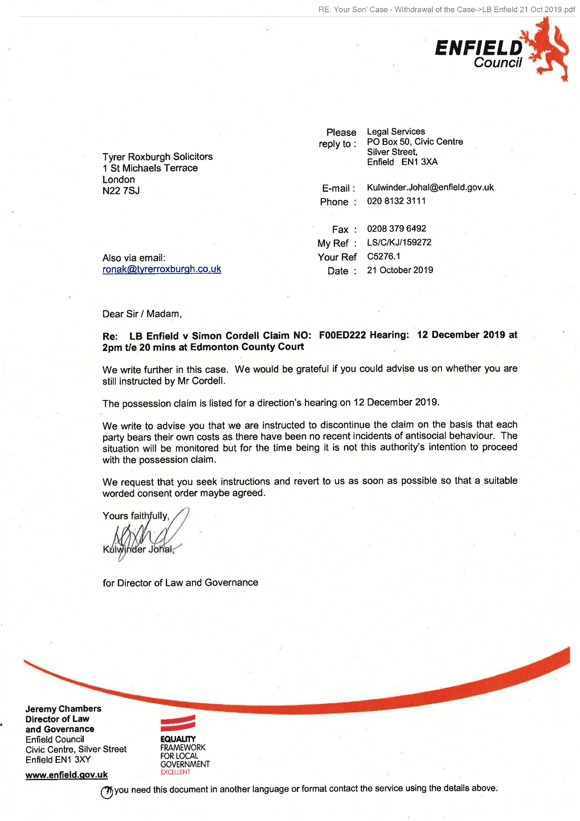
432,
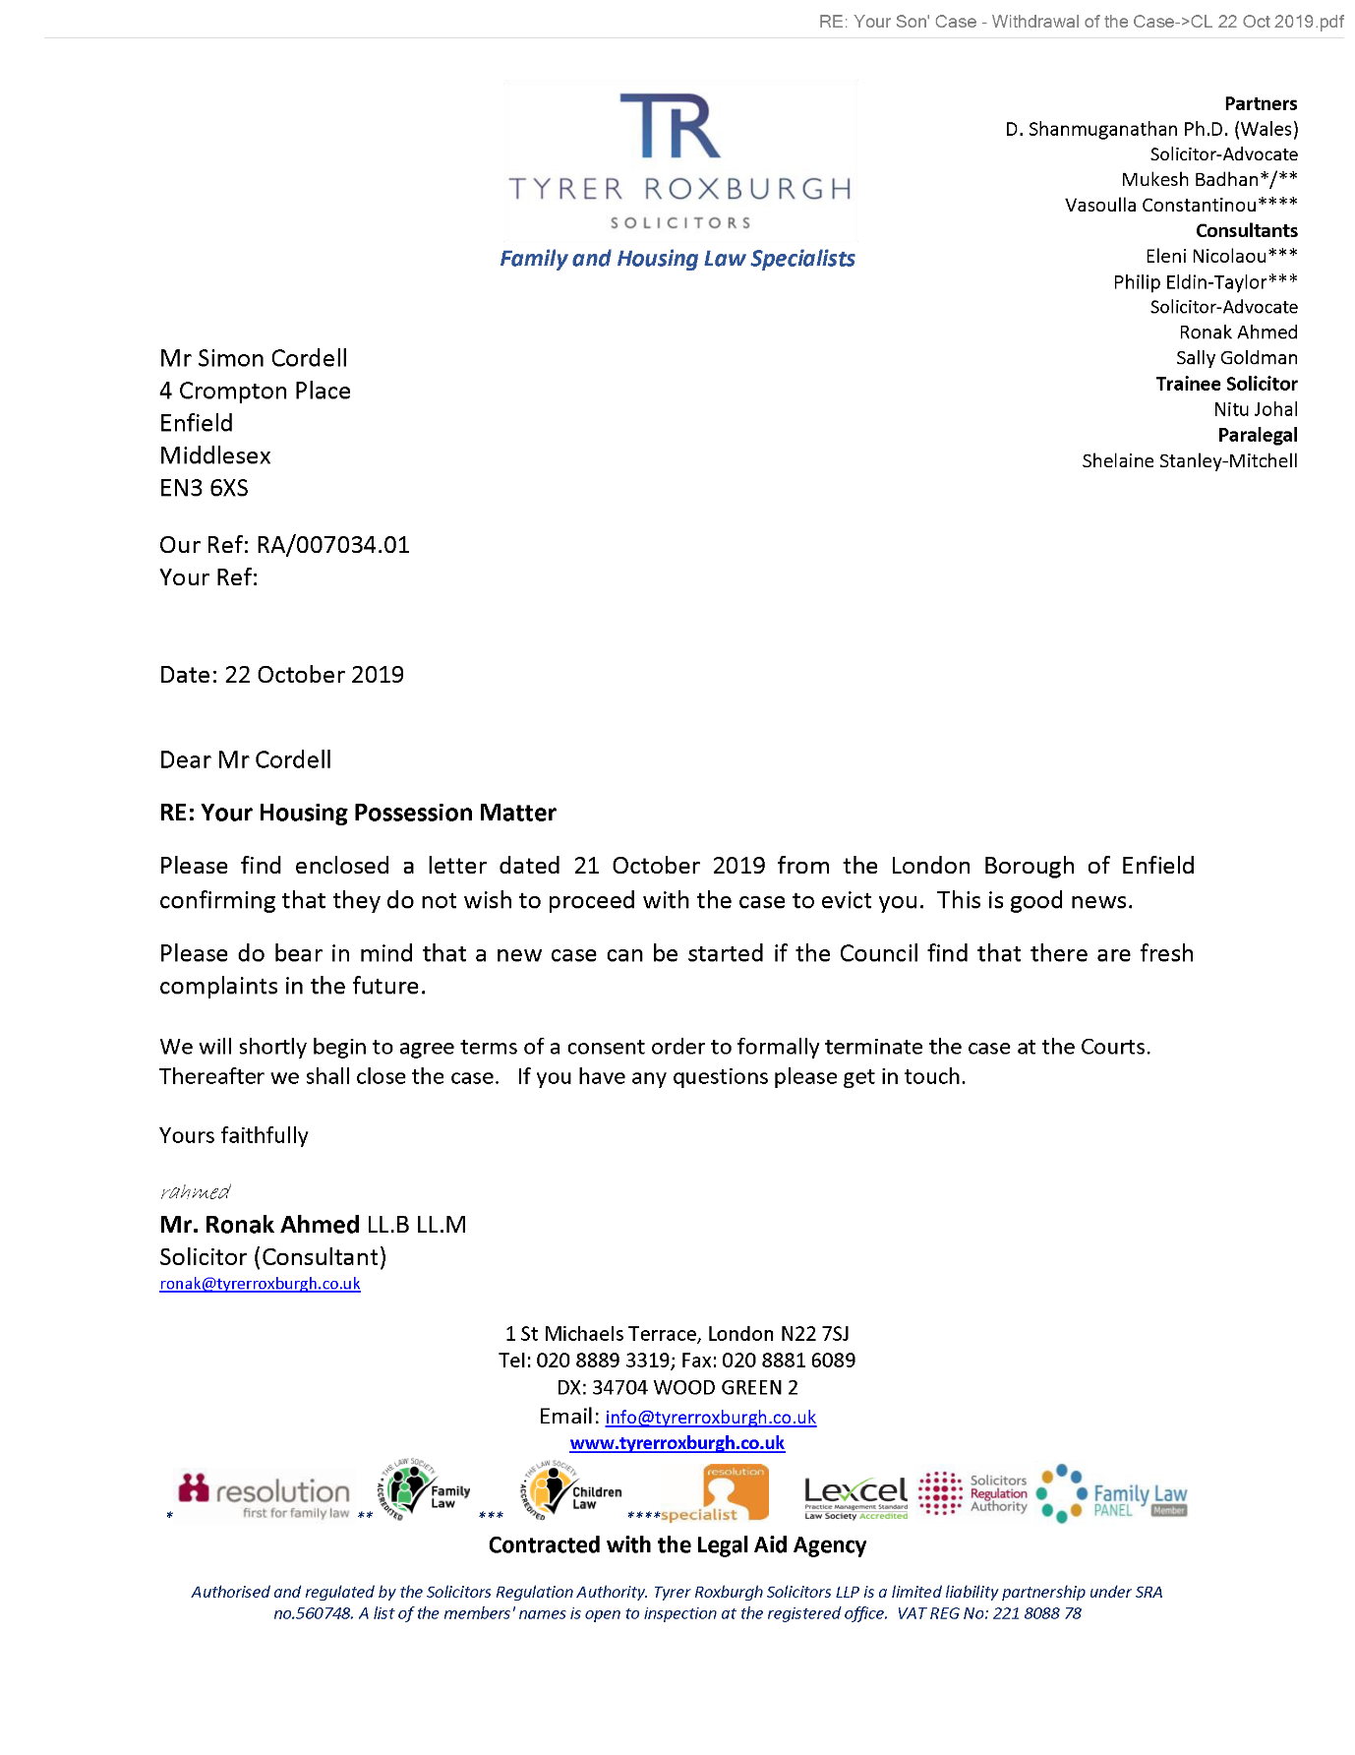
End of picture!

The banging Started!

Summary!

Disrepair!

Time Spent Building.
In the background of everything going on I could no longer work on my first company Too Smooth due to the amount of time I had to put toward s defending myself.
My mother Stopped working on my website
Working at Home doing Court Case Defense Work!
I spent time and recourses costing expenditure building my defence case and website Horrific Corruption.com, against the allegations getting put against me at the Time Start: 00:00 and Time End: 00:00

Wednesday!
23/10/2019

Stain and the
Issues with Housing Disrepair!
Working on the Court Case Defence!
The Anti-Social Behaviour Order Case and the Verdict got made Guilty against me in error and the conditions got imposed against me till late 2020!
The Banging Continued: -
23/10/2019

- Disrepair!
- The Asbo Order got granted in Error with Full Conditions against me and Fraudulently!
- The banging Continued at me!
- Working at home!

- 113 Burncroft Avenue
Richard Continued to victimise me the same way the past occupiers had prior!
“Re-Vacated”

- 117 Burncroft Avenue
The 3rd set of Tenant’s since the Problems Started with the Flat being used as an Offensives Weapons against my Person and against my free will.
has been “Re-Vacated” again by John Iron

52.
- Additional Email Attachments & Emails / Issue:
52. 1. 2.
Mother 23-10-2019-10-13
23/10/2019
/ Page Numbers: 433,434,435

53.
- Additional Email Attachments & Emails / Issue:
54. 1. 1
Ronak @tyrerroxburgh. ce - Withdrawal of the Case_001 5
23/10/2019
/ Page Numbers: 436,437,438,439,440,441

54.
- Additional Email Attachments & Emails / Issue:
54. 1. 1
Ronak @tyrerroxburgh. ce - Withdrawal of the Case_001 5
23/10/2019
/ Page Numbers: 442,443,444,445,446

55.
- Additional Email Attachments & Emails / Issue:
55. 1. 1
Ronak @tyrerroxburgh. ce - Withdrawal of the Case_002 3
23/10/2019
/ Page Numbers: 447,448,449
--

I made a phone call to mother at 07:30 about an SMS she sent to me about the possession order being dropped

52.
Additional Email Attachments & Emails / Issue:
52. 1. 2.
Mother 23-10-2019-10-13
23/10/2019
/ Page Numbers: 433,434,435
--
433,
From: Lorraine Cordell <lorraine32@blueyonder.co.uk>
Sent time: 23/10/2019 10:13:56 AM
To: re_wired@ymail.com
Subject: FW: Your Son' Case - Withdrawal of the Case
Attachments: LB Enfield 21 Oct 2019.pdf CL 22 Oct 2019.pdf
here is the email he has sent you the letters in the post but please don't start calling Enfield Council as that will just cause more problems you need this case to be dropped and it has not been fully yet until you get a court letters to say it dropped.
mum
From: Ronak Ahmed [mailto:ronak@tyrerroxburgh.co.uk]
Sent: 22 October 2019 20:30
To: Lorraine Cordell
Subject: RE: Your Son' Case - Withdrawal of the Case Dear Ms Cordell I trust you are well.
I have good news in that the Council have decided to not pursue the case further due to a lack of recent incidents. Please see attached their letter received recently and our letter dated 22October 2019 sent to your son.
Please speak to your son and get back to me with any questions.
Kind regards
Mr. Ronak Ahmed LL. B, LL.M
Solicitor (Consultant)
Direct Dial 07515 121781
Office 0208 889 3319
Email ronak@tvrerroxburgh.co.uk
TR TYRER ROXBURGH
1 St Michaels Terrace
London
N22 7SJ
DX 34704 WOOD GREEN 2
Tel +44 (0)20 8889 3319
Fax +44 (0)20 8881 6089
www.tyrerroxburgh.co.uk
Authorised by the Solicitors Regulation Authority. Tyrer Roxburgh Solicitors LLP is a limited liability partnership under the no.560748. A list of the members' names is open to inspection at the registered office.
VAT REG No: 221 8088 78
SRA No: 560748
Contracted with the Legal Aid Agency
We do not accept service of documents or other process by-mail
Email us at lawmakers@tyrerroxburgh.co.uk
This message may contain privileged information and is only intended to be received by the person to whom it is addressed.
If you are not the intended recipient, please contact us as soon as possible.
Partners - Mukesh Badhan - D Shanmuganathan - Vasoulla Constantinou
434,
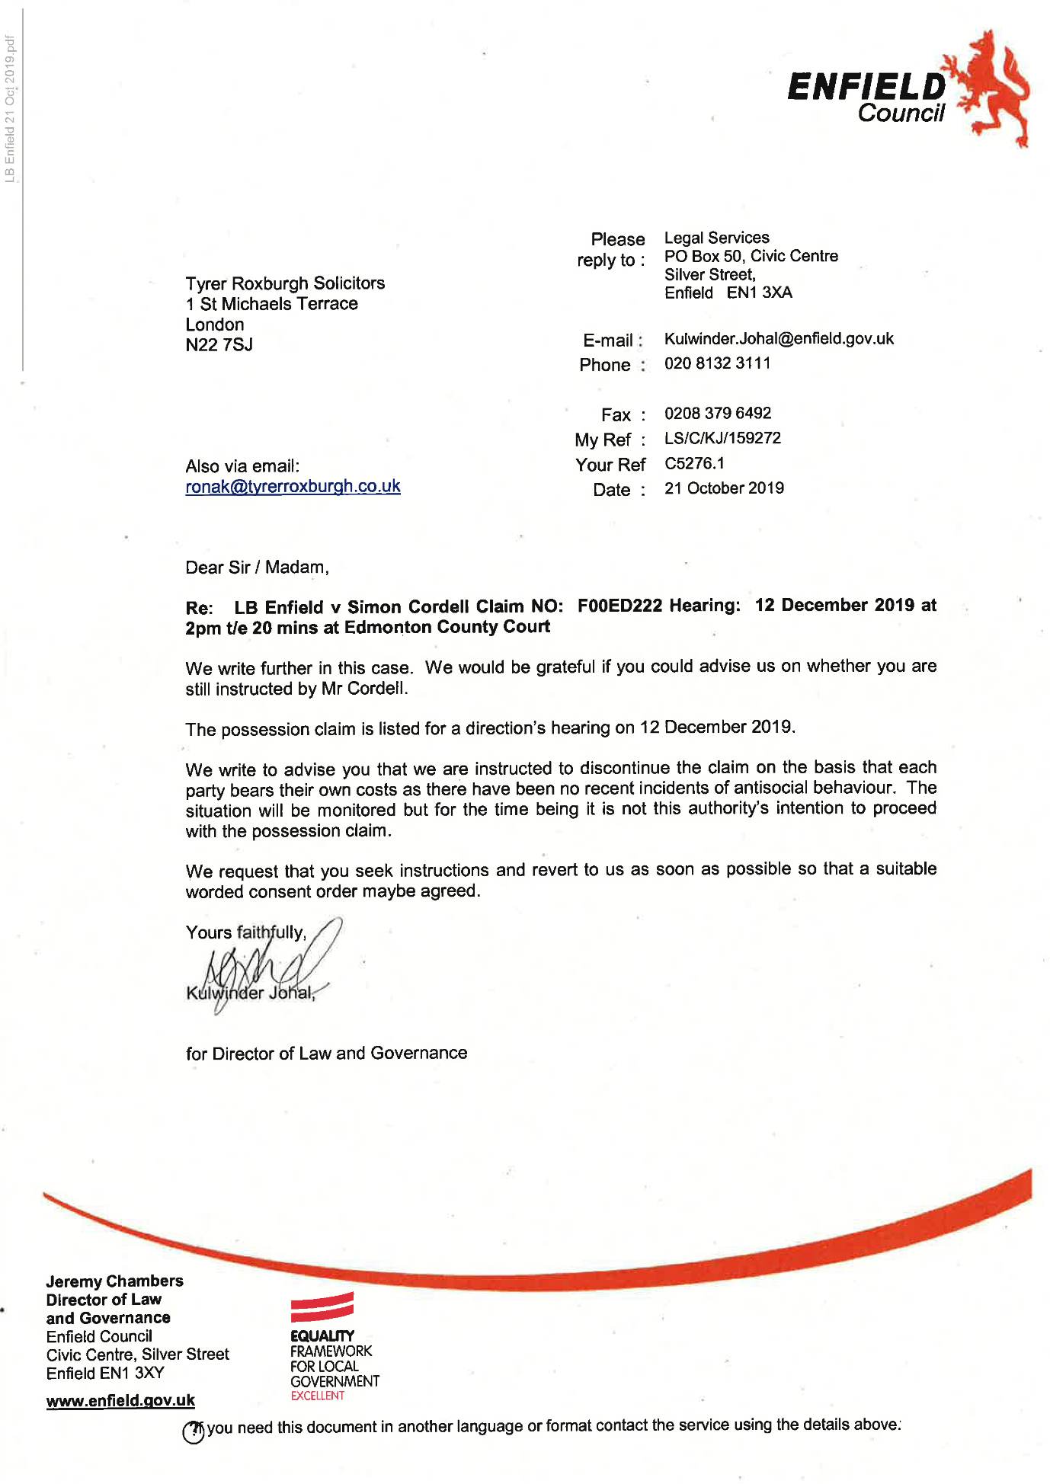
435,
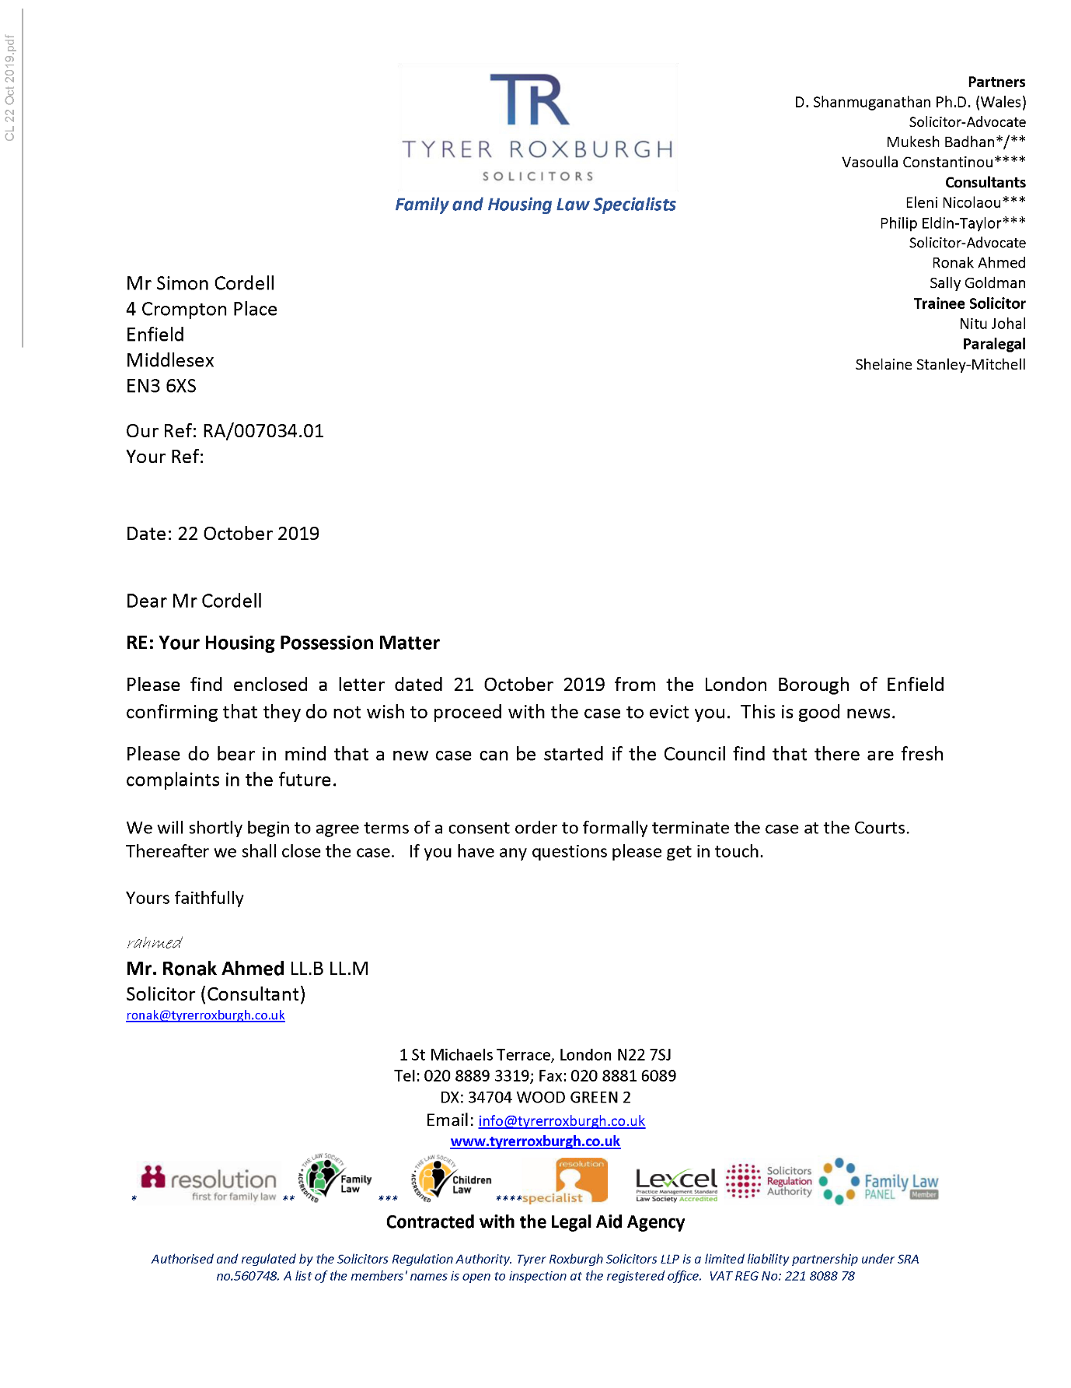
End of picture!

53.
- Additional Email Attachments & Emails / Issue:
54. 1. 1
Ronak @tyrerroxburgh. ce - Withdrawal of the Case_001 5
23/10/2019
/ Page Numbers: 436,437,438,439,440,441
--
436,
From: Ronak Ahmed <ronak@tyrerroxburgh.co.uk>
Sent: 23 October 2019 12:46
To: Lorraine Cordell
Subject: Re: Your Son' Case - Withdrawal of the Case
Dear Ms Cordell
That is fine I can hold off until Monday (the Council called me today requesting a response). However legally as you have not been appointed as a litigation friend, yet by the Court, if your son instructs us to refuse the offer we will need to comply (his instructions override your instructions). Currently our instructions are to refuse the offer.
Following on from this morning’s telephone call, I am afraid that I have asked the office to not take calls from your son any longer and to request anything to be put in writing from him. I was unable to get through to your son and he began attacking me. Ordinarily we would cease to act but we are aware of his underlying health issues.
Finally, I appreciate the feeling of injustice but quite simply, the legal aid agency will only pay for a case if there is a risk of eviction. Here there is no longer a risk of eviction as the Council are offering to withdraw their case.
As an added precaution, the consent order will need to be signed by your son - normally we would sign such documents.
Please let me know next week or over the weekend of your son's final instructions.
Kind regards
Mr. Ronak Ahmed LL. B, LL.M Solicitor (Consultant)
Tel +44 (0) 20 8889 3319
Email ronak@tyrerroxburgh.co.uk
1 St Michaels Terrace
London
N22 7SJ
DX 34704 WOOD GREEN 2
Tel +44 (0)20 8889 3319
Fax +44 (0)20 8881 6089
www.tyrerroxburgh.co.uk
437,
Authorised by the Solicitors Regulation Authority. Tyrer Roxburgh Solicitors LLP is a limited liability partnership under the no.560748. A list of the members' names is open to inspection at the registered office.
VAT REG No: 221 8088 78
SRA No: 560748
Contracted with the Legal Aid Agency
We do not accept service of documents or other process by e-mail Email us at lawmakers@tyrerroxburgh.co.uk
This message may contain privileged information and is only intended to be received by the person to whom it is addressed.
If you are not the intended recipient, please contact us as soon as possible.
Partners - Mukesh Badhan - D Shanmuganathan - Vasoulla Constantinou
From: Lorraine Cordell <lorraine32@blueyonder.co.uk>
Sent: Wednesday, October 23, 2019 12:34:47 PM
To: Ronak Ahmed <ronak@tyrerroxburgh.co.uk>
Subject: Re: Your Son' Case - Withdrawal of the Case
Hi Ronak
I do not think my son understands fully can you hold off for a few days and let me speak to my son please I have to do it in a way he understands.
Can you let me know please.
Regards
Lorraine
Sent from my iPhone
On 23 Oct 2019, at 12:11, Ronak Ahmed <ronak@tyrerroxburgh.co.uk> wrote:
438,
Good afternoon
A consent order in this case will say that the Councils case is dismissed. You will have a copy of this I’m advance.
I have just spoken to your son on the phone and had to terminate the call due to him shouting. Your son has said he refuses to agree to the Councils offer and as he is the client, I will follow through with this.
Kind regards
Mr. Ronak Ahmed LL. B, LL.M Solicitor (Consultant)
Tel +44 (0) 20 8889 3319
Email ronak@tyrerroxburgh.co.uk
1 St Michaels Terrace
London
N22 7SJ
DX 34704 WOOD GREEN 2
Tel +44 (0)20 8889 3319
Fax +44 (0)20 8881 6089 www.tyrerroxburgh.co.uk
Authorised by the Solicitors Regulation Authority. Tyrer Roxburgh Solicitors LLP is a limited liability partnership under the no.560748. A list of the members' names is open to inspection at the registered office.
VAT REG No: 221808878
SRA No: 560748
Contracted with the Legal Aid Agency
439,
We do not accept service of documents or other process by e-mail Email us at lawmakers@tyrerroxburgh.co.uk
This message may contain privileged information and is only intended to be received by the person to whom it is addressed.
If you are not the intended recipient, please contact us as soon as possible.
Partners - Mukesh Badhan - D Shanmuganathan - Vasoulla Constantinou
From: Lorraine Cordell <lorraine32@blueyonder.co.uk>
Sent: Wednesday, October 23, 2019 11:26:24 AM
To: Ronak Ahmed <ronak@tyrerroxburgh.co.uk>
Subject: RE: Your Son' Case - Withdrawal of the Case
Dear Ronak
Can you please explain what a consent order is and what will be in this consent order, and can we be supplied a copy of it before it goes to the court?
My son is really unhappy regarding the way in which he has been treated by Enfield Council and the lies in which they have told about him and the way in which they have made him suffered and the fact that they could just start this backup at any time they want.
He said it seems funny that the neighbours that caused all these issues and put in all the complaints and Enfield Council believed 100% without once looking or seeing any evidence my son had and we offered that many times but no Enfield Council just did what they wanted and my son was suffering badly and had to deal with 4 cases against him which Enfield Council took. It seems funny now that the neighbours got what they wanted and was moved now Enfield Council does not have any complaints to still want to take this to court.
Could it be maybe that Enfield Council can't get them to come to court as witnesses now they have got what they want. My son does not feel safe in that flat the court ordered them to move my son on the 09/08/2019 yet Enfield Council done nothing and left him to suffer and my son is still there.
Seems Enfield Council can just get away with what they have done to my son, start a case when they want to and end it will they want to is there a way that it can be asked at court that Enfield Council cannot bring a new case with the same information in it as what's in it now they have put the same information in 3 court cases and I believe they should not be allowed to be able to use it again and again whenever they want.
My son feels he should just go to court and have this dealt with once and for all, but that could lead to my son losing his home and that should not be allowed.
Regards
Lorraine
440,
From: Ronak Ahmed [mailto:ronak@tyrerroxburgh.co.uk]
Sent: 22 October 2019 20:30
To: Lorraine Cordell
Subject: RE: Your Son' Case - Withdrawal of the Case Dear Ms Cordell I trust you are well.
I have good news in that the Council have decided to not pursue the case further due to a lack of recent incidents. Please see attached their letter received recently and our letter dated 22 October 2019 sent to your son.
Please speak to your son and get back to me with any questions.
Kind regards
Mr. Ronak Ahmed LL. B, LL.M
Solicitor (Consultant)
Direct Dial 07515 121781
Office 0208 889 3319
Email ronak@tvrerroxburah.co.uk
1 St Michaels Terrace
London
N22 7SJ
DX 34704 WOOD GREEN 2
Tel +44 (0)20 8889 3319
Fax +44 (0)20 8881 6089
www.tvrerroxburah.co.uk
Authorised by the Solicitors Regulation Authority. Tyrer Roxburgh Solicitors LLP is a limited liability partnership under the no.560748. A list of the members' names is open to inspection at the registered office.
VAT REG No: 221 8088 78
SRA No: 560748
Contracted with the Legal Aid Agency
We do not accept service of documents or other process by e-mail
441,
Email us at lawmakers@tyrerroxburgh.co.uk
This message may contain privileged information and is only intended to be received by the person to whom it is addressed. If you are not the intended recipient, please contact us as soon as possible.
Partners - Mukesh Badhan - D Shanmuganathan - Vasoulla Constantinou

54.
Additional Email Attachments & Emails / Issue:
54. 1. 1
Ronak @tyrerroxburgh. ce - Withdrawal of the Case_001 5
23/10/2019
/ Page Numbers: 442,443,444,445,446
--
442,
From: Ronak Ahmed <ronak@tyrerroxburgh.co.uk>
Sent: 23 October 2019 12:15
To: Lorraine Cordell
Subject: Re: Your Son' Case – Withdrawal of the Case
I omitted to add that I advised your son that the Legal Aid Agency will not fund a possession case where the Landlord has offered to withdraw the case. You could decide to continue the case, but it would be privately paid, and such costs easily amount to thousands of pounds.
I will let the Council know tomorrow that their offer to withdraw the case has been rejected. I will also inform the Legal Aid Agency of the offer being made as I am duty bound.
Kind regards
Mr. Ronak Ahmed LL. B, LL.M Solicitor (Consultant)
Tel +44 (0) 20 8889 3319
Email ronak@tyrerroxburgh.co.uk
1 St Michaels Terrace
London
N22 7SJ
DX 34704 WOOD GREEN 2
Tel +44 (0)20 8889 3319
Fax +44 (0)20 8881 6089
www.tyrerroxburgh.co.uk
Authorised by the Solicitors Regulation Authority. Tyrer Roxburgh Solicitors LLP is a limited liability partnership under the no.560748. A list of the members' names is open to inspection at the registered office.
VAT REG No: 221808878
SRA No: 560748
443,
Contracted with the Legal Aid Agency
We do not accept service of documents or other process by e-mail Email us at lawmakers@tyrerroxburgh.co.uk
This message may contain privileged information and is only intended to be received by the person to whom it is addressed.
If you are not the intended recipient, please contact us as soon as possible.
Partners - Mukesh Badhan - D Shanmuganathan - Vasoulla Constantinou
From: Ronak Ahmed <ronak@tyrerroxburgh.co.uk>
Sent: Wednesday, October 23, 2019 12:11:14 PM
To: Lorraine Cordell <lorraine32@blueyonder.co.uk>
Subject: Re: Your Son' Case - Withdrawal of the Case
Good afternoon
A consent order in this case will say that the Councils case is dismissed. You will have a copy of this I’m advance.
I have just spoken to your son on the phone and had to terminate the call due to him shouting. Your son has said he refuses to agree to the Councils offer and as he is the client, I will follow through with this.
Kind regards
Mr. Ronak Ahmed LL. B, LL.M Solicitor (Consultant)
Tel +44 (0) 20 8889 3319
Email ronak@tyrerroxburgh.co.uk
1 St Michaels Terrace
444,
London
N22 7SJ
DX 34704 WOOD GREEN 2
Tel +44 (0)20 8889 3319
Fax +44 (0)20 8881 6089
www.tyrerroxburgh.co.uk
Authorised by the Solicitors Regulation Authority. Tyrer Roxburgh Solicitors LLP is a limited liability partnership under the no.560748. A list of the members' names is open to inspection at the registered office.
VAT REG No: 221 8088 78
SRA No: 560748
Contracted with the Legal Aid Agency
We do not accept service of documents or other process by e-mail Email us at lawmakers@tyrerroxburgh.co.uk
This message may contain privileged information and is only intended to be received by the person to whom it is addressed.
If you are not the intended recipient, please contact us as soon as possible.
Partners - Mukesh Badhan - D Shanmuganathan - Vasoulla Constantinou
From: Lorraine Cordell <lorraine32@blueyonder.co.uk>
Sent: Wednesday, October 23, 2019 11:26:24 AM
To: Ronak Ahmed <ronak@tyrerroxburgh.co.uk>
Subject: RE: Your Son' Case - Withdrawal of the Case
Dear Ronak
Can you please explain what a consent order is and what will be in this consent order, and can we be supplied a copy of it before it goes to the court?
445,
My son is really unhappy regarding the way in which he has been treated by Enfield Council and the lies in which they have told about him and the way in which they have made him suffered and the fact that they could just start this backup at any time they want.
He said it seems funny that the neighbours that caused all these issues and put in all the complaints and Enfield Council believed 100% without once looking or seeing any evidence my son had and we offered that many times but no Enfield Council just did what they wanted and my son was suffering badly and had to deal with 4 cases against him which Enfield Council took. It seems funny now that the neighbours got what they wanted and was moved now Enfield Council does not have any complaints to still want to take this to court.
Could it be maybe that Enfield Council can't get them to come to court as witnesses now they have got what they want. My son does not feel safe in that flat the court ordered them to move my son on the 09/08/2019 yet Enfield Council done nothing and left him to suffer and my son is still there.
Seems Enfield Council can just get away with what they have done to my son, start a case when they want to and end it will they want to is there a way that it can be asked at court that Enfield Council cannot bring a new case with the same information in it as what's in it now they have put the same information in 3 court cases and I believe they should not be allowed to be able to use it again and again whenever they want.
My son feels he should just go to court and have this dealt with once and for all, but that could lead to my son losing his home and that should not be allowed.
Regards
Lorraine
From: Ronak Ahmed [mailto:ronak@tyrerroxburgh.co.uk]
Sent: 22 October 2019 20:30
To: Lorraine Cordell
Subject: RE: Your Son' Case - Withdrawal of the Case
Dear Ms Cordell, I trust you are well.
I have good news in that the Council have decided to not pursue the case further due to a lack of recent incidents. Please see attached their letter received recently and our letter dated 22 October 2019 sent to your son.
Please speak to your son and get back to me with any questions.
Kind regards
Mr. Ronak Ahmed LL. B, LL.M
Solicitor (Consultant)
Direct Dial 07515 121781
Office 0208 889 3319
Email ronak@tvrerroxburgh.co.uk
1 St Michaels Terrace
London
N22 7SJ
446,
DX 34704 WOOD GREEN 2
Tel +44 (0)20 8889 3319
Fax +44 (0)20 8881 6089
www.tvrerroxburgh.co.uk
Authorised by the Solicitors Regulation Authority. Tyrer Roxburgh Solicitors LLP is a limited liability partnership under the no.560748. A list of the members' names is open to inspection at the registered office.
VAT REG No: 221 8088 78 SRA No: 560748
Contracted with the Legal Aid Agency
We do not accept service of documents or other process by e-mail
Email us at lawmakers@tyrerroxburgh.co.uk
This message may contain privileged information and is only intended to be received by the person to whom it is addressed. If you are not the intended recipient, please contact us as soon as possible.
Partners - Mukesh Badhan - D Shanmuganathan - Vasoulla Constantinou

55.
Additional Email Attachments & Emails / Issue:
55. 1. 1
Ronak @tyrerroxburgh. ce - Withdrawal of the Case_002 3
23/10/2019
/ Page Numbers: 447,448,449
--
447,
From: Ronak Ahmed <ronak@tyrerroxburgh.co.uk>
Sent: 23 October 2019 12:11
To: Lorraine Cordell
Subject: Re: Your Son' Case - Withdrawal of the Case
Good afternoon
A consent order in this case will say that the Councils case is dismissed. You will have a copy of this I’m advance.
I have just spoken to your son on the phone and had to terminate the call due to him shouting. Your son has said he refuses to agree to the Councils offer and as he is the client, I will follow through with this.
Kind regards
Mr. Ronak Ahmed LL. B, LL.M Solicitor (Consultant)
Tel +44 (0) 20 8889 3319
Email ronak@tyrerroxburgh.co.uk
1 St Michaels Terrace
London
N22 7SJ
DX 34704 WOOD GREEN 2
Tel +44 (0)20 8889 3319
Fax +44 (0)20 8881 6089
www.tyrerroxburgh.co.uk
Authorised by the Solicitors Regulation Authority. Tyrer Roxburgh Solicitors LLP is a limited liability partnership under the no.560748. A list of the members' names is open to inspection at the registered office.
VAT REG No: 221808878
SRA No: 560748
448,
Contracted with the Legal Aid Agency
We do not accept service of documents or other process by e-mail Email us at lawmakers@tyrerroxburgh.co.uk
This message may contain privileged information and is only intended to be received by the person to whom it is addressed.
If you are not the intended recipient, please contact us as soon as possible.
Partners - Mukesh Badhan - D Shanmuganathan - Vasoulla Constantinou
From: Lorraine Cordell <lorraine32@blueyonder.co.uk>
Sent: Wednesday, October 23, 2019 11:26:24 AM
To: Ronak Ahmed <ronak@tyrerroxburgh.co.uk>
Subject: RE: Your Son' Case - Withdrawal of the Case
Dear Ronak
Can you please explain what a consent order is and what will be in this consent order, and can we be supplied a copy of it before it goes to the court?
My son is really unhappy regarding the way in which he has been treated by Enfield Council and the lies in which they have told about him and the way in which they have made him suffered and the fact that they could just start this backup at any time they want.
He said it seems funny that the neighbours that caused all these issues and put in all the complaints and Enfield Council believed 100% without once looking or seeing any evidence my son had and we offered that many times but no Enfield Council just did what they wanted and my son was suffering badly and had to deal with 4 cases against him which Enfield Council took. It seems funny now that the neighbours got what they wanted and was moved now Enfield Council does not have any complaints to still want to take this to court.
Could it be maybe that Enfield Council can't get them to come to court as witnesses now they have got what they want. My son does not feel safe in that flat the court ordered them to move my son on the 09/08/2019 yet Enfield Council done nothing and left him to suffer and my son is still there.
Seems Enfield Council can just get away with what they have done to my son, start a case when they want to and end it will they want to is there a way that it can be asked at court that Enfield Council cannot bring a new case with the same information in it as what's in it now they have put the same information in 3 court cases and I believe they should not be allowed to be able to use it again and again whenever they want.
My son feels he should just go to court and have this dealt with once and for all, but that could lead to my son losing his home and that should not be allowed.
Regards
449,
Lorraine
From: Ronak Ahmed [mailto:ronak@tyrerroxburgh.co.uk]
Sent: 22 October 2019 20:30
To: Lorraine Cordell
Subject: RE: Your Son' Case - Withdrawal of the Case Dear Ms Cordell I trust you are well.
I have good news in that the Council have decided to not pursue the case further due to a lack of recent incidents. Please see attached their letter received recently and our letter dated 22 October 2019 sent to your son.
Please speak to your son and get back to me with any questions.
Kind regards
Mr. Ronak Ahmed LL. B, LL.M
Solicitor (Consultant)
Direct Dial 07515 121781
Office 0208 889 3319
Email ronak@tvrerroxburah.co.uk
TR TYRER ROXBURGH
1 St Michaels Terrace
London
N22 7SJ
DX 34704 WOOD GREEN 2
Tel +44 (0)20 8889 3319
Fax +44 (0)20 8881 6089
www.tvrerroxburah.co.uk
Authorised by the Solicitors Regulation Authority. Tyrer Roxburgh Solicitors LLP is a limited liability partnership under the no.560748. A list of the members' names is open to inspection at the registered office.
VAT REG No: 221808878
SRA No: 560748
Contracted with the Legal Aid Agency
We do not accept service of documents or other process by e-mail
Email us at lawmakers@tyrerroxburgh.co.uk
This message may contain privileged information and is only intended to be received by the person to whom it is addressed. If you are not the intended recipient, please contact us as soon as possible.
Partners - Mukesh Badhan - D Shanmuganathan - Vasoulla Constantinou

The banging Started!

Summary!

Disrepair!

Time Spent Building.
In the background of everything going on I could no longer work on my first company Too Smooth due to the amount of time I had to put toward s defending myself.
My mother Stopped working on my website
Working at Home doing Court Case Defense Work!
I spent time and recourses costing expenditure building my defence case and website Horrific Corruption.com, against the allegations getting put against me at the Time Start: 00:00 and Time End: 00:00

Thursday!
24/10/2019

Stain and the
Issues with Housing Disrepair!
Working on the Court Case Defence!
The Anti-Social Behaviour Order Case and the Verdict got made Guilty against me in error and the conditions got imposed against me till late 2020!
The Banging Continued: -
24/10/2019

- Disrepair!
- The Asbo Order got granted in Error with Full Conditions against me and Fraudulently!
- The banging Continued at me!
- Working at home!

- 113 Burncroft Avenue
Richard Continued to victimise me the same way the past occupiers had prior!
“Re-Vacated”

- 117 Burncroft Avenue
The 3rd set of Tenant’s since the Problems Started with the Flat being used as an Offensives Weapons against my Person and against my free will.
has been “Re-Vacated” again by John Iron

1
- Simon Cordell’s MP3’S Indexed
Stage 1
1x Recording
01m. My Solicitor (2) 24_10_2019
Page Number: Update Page Number 1,
01m. My Solicitor (2) 24_10_2019.WMA
Update

56.
- Additional Email Attachments & Emails / Issue:
56. 1. 2.
Mother 24-10-2019 -12-22
24/10/2019
/ Page Numbers: 450

--

56.
Additional Email Attachments & Emails / Issue:
56. 1. 2.
Mother 24-10-2019 -12-22
24/10/2019
/ Page Numbers: 450
--
450,
From: Lorraine Cordell <lorraine32@blueyonder.co.uk>
Sent time: 24/10/2019 12:22:24 PM
To: Rewired <re_wired@ymail.com>
Subject: RE: MP3 Solicitor
You were not that bad but when you started saying they have not done their job in so many ways that's what done it. No solicitors will accept they are not working for your best interest. (I told you this on the phone)
What you need to understand what he is trying to say, which you just seem to think he is going against you is.
- Enfield Council started this case and it does not matter what you say Enfield Council has the right to withdraw the case whenever they want, and for whatever reason they want, and you cannot do anything about that.
- Legal Aid will see it you have chosen to carry on, and you was no longer at risk of losing your home as Enfield Council was willing to withdraw the case, so they are no longer legal bound to pay for you to carry on as at the stage Enfield Council wanted to withdraw you did not wish to do so and by the withdrawal you are no longer at risk, so you have chosen to carry on at the risk yourself of losing your home and you did not care of the risk.
- As I tried to say to you yesterday you are better to allow them to withdraw and allow your solicitors to get the case dismissed as that is what they were going to address, Enfield Council had to dismiss there case against you which would mean they did not have a case that would stand up which goes in your favour.
- Once this is done you would then have 3 cases that Enfield Council had dismissed against you at the same court all for the same allegations, which would show Enfield Council in bad light. Then you bring a case against Enfield Council for what they have done the case is your case you don't have to pay for the application to the court, and you can use the 3 cases that has been dismissed which gives your case more grounds in your favour, also you would not be at risk of losing your home as that will be off the table, so you are in a much better place then Enfield Council would be, as it would not be there case but yours. there is more to this, but I know you are not going to agree with anything I am saying.
From: Rewired [mailto: re_wired@ymail.com]
Sent: 23 October 2019 14:12
To: Lorraine Cordell
Subject: MP3 Solicitor
This is the only two times that I have spoken to him. The 38 one is the newest and quickest to listen to.

The banging Started!

Summary!

Disrepair!

Time Spent Building.
In the background of everything going on I could no longer work on my first company Too Smooth due to the amount of time I had to put toward s defending myself.
My mother Stopped working on my website
Working at Home doing Court Case Defense Work!
I spent time and recourses costing expenditure building my defence case and website Horrific Corruption.com, against the allegations getting put against me at the Time Start: 00:00 and Time End: 00:00

Friday!
25/10/2019

Stain and the
Issues with Housing Disrepair!
Working on the Court Case Defence!
The Anti-Social Behaviour Order Case and the Verdict got made Guilty against me in error and the conditions got imposed against me till late 2020!
The Banging Continued: -
25/10/2019

Saturday!
26/10/2019

Stain and the
Issues with Housing Disrepair!
Working on the Court Case Defence!
The Anti-Social Behaviour Order Case and the Verdict got made Guilty against me in error and the conditions got imposed against me till late 2020!
The Banging Continued: -
26/10/2019

- Disrepair!
- The Asbo Order got granted in Error with Full Conditions against me and Fraudulently!
- The banging Continued at me!
- Working at home!

- 113 Burncroft Avenue
Richard Continued to victimise me the same way the past occupiers had prior!
“Re-Vacated”

- 117 Burncroft Avenue
The 3rd set of Tenant’s since the Problems Started with the Flat being used as an Offensives Weapons against my Person and against my free will.
has been “Re-Vacated” again by John Iron

1
- Simon Cordell’s MP3’S Indexed
Stage 1
1x Recording
01m. met police call centre (9) 26_10_2019
Page Number: Update Page Number 1,
01m. met police call centre (9) 26_10_2019.WMA
Update

2
- OZZIE Started banging on the?
Wall where my pc is to upset me.

--

1
Simon Cordell’s MP3’S Indexed
Stage 1
1x Recording
01m. met police call centre (9) 26_10_2019
Page Number: Update Page Number 1,
01m. met police call centre (9) 26_10_2019.WMA
Update

2
OZZIE Started banging on the?
Wall where my pc is to upset me.
OZZIE Started banging on the wall were my pc is to upset me. 09:35And the builders were upstairs
Carron outside Christine?

The banging Started!

Summary!

Disrepair!

Time Spent Building.
In the background of everything going on I could no longer work on my first company Too Smooth due to the amount of time I had to put toward s defending myself.
My mother Stopped working on my website
Working at Home doing Court Case Defense Work!
I spent time and recourses costing expenditure building my defence case and website Horrific Corruption.com, against the allegations getting put against me at the Time Start: 00:00 and Time End: 00:00

Sunday!
27/10/2019

Stain and the
Issues with Housing Disrepair!
Working on the Court Case Defence!
The Anti-Social Behaviour Order Case and the Verdict got made Guilty against me in error and the conditions got imposed against me till late 2020!
The Banging Continued: -
27/10/2019

- Disrepair!
- The Asbo Order got granted in Error with Full Conditions against me and Fraudulently!
- The banging Continued at me!
- Working at home!

- 113 Burncroft Avenue
Richard Continued to victimise me the same way the past occupiers had prior!
“Re-Vacated”

- 117 Burncroft Avenue
The 3rd set of Tenant’s since the Problems Started with the Flat being used as an Offensives Weapons against my Person and against my free will.
has been “Re-Vacated” again by John Iron

--

The banging Started!

Summary!

Disrepair!

Time Spent Building.
In the background of everything going on I could no longer work on my first company Too Smooth due to the amount of time I had to put toward s defending myself.
My mother Stopped working on my website
Working at Home doing Court Case Defense Work!
I spent time and recourses costing expenditure building my defence case and website Horrific Corruption.com, against the allegations getting put against me at the Time Start: 00:00 and Time End: 00:00

Monday!
28/10/2019

Stain and the
Issues with Housing Disrepair!
Working on the Court Case Defence!
The Anti-Social Behaviour Order Case and the Verdict got made Guilty against me in error and the conditions got imposed against me till late 2020!
The Banging Continued: -
28/10/2019

- Disrepair!
- The Asbo Order got granted in Error with Full Conditions against me and Fraudulently!
- The banging Continued at me!
- Working at home!

- 113 Burncroft Avenue
Richard Continued to victimise me the same way the past occupiers had prior!
“Re-Vacated”

- 117 Burncroft Avenue
The 3rd set of Tenant’s since the Problems Started with the Flat being used as an Offensives Weapons against my Person and against my free will.
has been “Re-Vacated” again by John Iron

1
- Simon Cordell’s MP3’S Indexed
Stage 1
1x Recording
01m. police insurance 28 10 19
Page Number: Update Page Number 1,
Update
01m. police insurance 28 10 19.wma

2
- Simon Cordell’s MP3’S Indexed
Stage 1
1x Recording
01m. QBE 28_10_2019
Page Number: Update Page Number 1,
01m. qbe 28_10_2019.wma
Update

3
- Simon Cordell’s MP3’S Indexed
Stage 1
1x Recording
01m. Sally 28_10_19_15_56
Page Number: Update Page Number 1,
01m. Sally 28_10_19_15_56.wma
Update

4
- Simon Cordell’s MP3’S Indexed
Stage 1
1x Recording
01m. 89. legal services met police Jackie 28_10_2019
Page Number: Update Page Number 1,
01m. 89. legal services met police Jackie 28_10_2019.wma
Update

57.
Additional Email Attachments & Emails / Issue:
57. 1. 1
Elections@enfield.gov9_RE 109 Burncroft Ave Enfield 2
28/10/2019
/ Page Numbers: 451,452

58.
- Additional Email Attachments & Emails / Issue:
58. 1. 1
Elections @enfield.gov RE 109 Burncroft Ave Enfield 1
28/10/2019
/ Page Numbers: 453

--

1
Simon Cordell’s MP3’S Indexed
Stage 1
1x Recording
01m. police insurance 28 10 19
Page Number: Update Page Number 1,
Update
01m. police insurance 28 10 19.wma

2
Simon Cordell’s MP3’S Indexed
Stage 1
1x Recording
01m. QBE 28_10_2019
Page Number: Update Page Number 1,
01m. QBE 28_10_2019.wma
Update

3
Simon Cordell’s MP3’S Indexed
Stage 1
1x Recording
01m. Sally 28_10_19_15_56
Page Number: Update Page Number 1,
01m. Sally 28_10_19_15_56.wma
Update

4
Simon Cordell’s MP3’S Indexed
Stage 1
1x Recording
01m. 89. legal services met police Jackie 28_10_2019
Page Number: Update Page Number 1,
01m. 89. legal services met police Jackie 28_10_2019.wma
Update

57.
Additional Email Attachments & Emails / Issue:
57. 1. 1
Elections@enfield.gov9_RE 109 Burncroft Ave Enfield 2
28/10/2019
/ Page Numbers: 451,452
--
451,
From: Elections <Elections@enfield.gov.uk>
Sent: 28 October 2019 11:38
To: Lorraine Cordell
Subject: RE: 109 Burncroft Ave Enfield
Good morning Lorraine,
Thank you for your email,
Unfortunately, the Household Enquiry Form is dispatched to every address in the borough and address to 'The Occupier' in case people have moved in/out. We would not be able to send this or any other forms within the nature of electoral services to yourself in order to complete for your son.
As you have confirmed he is the sole occupant and I have managed to check this against local sources, I have now taken the no change response and he will not be required to complete that form and I can assure you he will not be fined.
Apologies for any distress caused,
Kind regards,
Stefanie Vales
Senior Electoral Services Officer Chief Executives Department Electoral and Democratic Services Enfield Council
PO Box 50 Civic Centre Silver Street,
Enfield Middlesex, EN1 3ES
Direct Dial: 0208 379 3341
Main Office: 0208 379 8588
Enfield Council is committed to serving the whole borough fairly, delivering excellent services and building strong communities
From: Lorraine Cordell <lorraine32@blueyonder.co.uk>
Sent: 27 October 2019 12:14
To: Elections <Elections@enfield.gov.uk>
Subject: RE: 109 Burncroft Ave Enfield
Importance: High
To Whom It May Concern:
I am writing this email for my son Mr Simon Cordell he lives at 109 Burncroft Ave Enfield EN3 7JQ.
Enfield Council knows my son has health issues and everything that is sent to him should be sent to me so I can deal with it, this is on Enfield Councils system, and I know he would have been sent a form to register which he is meant to fill in or he can be fined.
I do not have the form in which to deal with this and do not want my son to be fined due to not filling the form in.
452,
My son is the only person who lives at the above address.
Could someone please get back to me in order that I can deal with this for my son as soon as possible?
Regards
Lorraine Cordell
Be the first to receive the latest Council news straight to your inbox
SIGN UP ONLINE NOW
www.enfield.gov.uk/enewsletters
http://www.enfield.gov.uk
Enfield Council is committed to serving the whole borough fairly, delivering excellent services and building strong communities. Opinions expressed in this email are those of the individual and not necessarily those of the London Borough of Enfield. This email and any attachments or files transmitted with it are strictly confidential and intended solely for the named addressee. It may contain privileged and confidential information and if you are not the intended recipient and receive it in error you must not copy, distribute, or use the communication in any other way. All traffic handled by the Government Connect Secure Extranet may be subject to recording/and or monitoring in accordance with relevant legislation.
This email has been scanned for viruses, but we cannot guarantee that it will be free of viruses or malware. The recipient should perform their own virus checks.
Disclaimer
The information contained in this communication from the sender is confidential. It is intended solely for use by the recipient and others authorized to receive it. If you are not the recipient, you are hereby notified that any disclosure, copying, distribution or taking action in relation of the contents of this information is strictly prohibited and may be unlawful.
This email has been scanned for viruses and malware, and may have been automatically archived by Mimecast Ltd, an innovator in Software as a Service (SaaS) for business. Providing a safer and more useful place for your human generated data. Specializing in; Security, archiving and compliance.

58.
Additional Email Attachments & Emails / Issue:
58. 1. 1
Elections @enfield.gov RE 109 Burncroft Ave Enfield 1
28/10/2019
/ Page Numbers: 453
--
453,
From: Elections <Elections@enfield.gov.uk>
Sent: 28 October 2019 11:34
To: Lorraine Cordell
Subject: Read: RE: 109 Burncroft Ave Enfield
Importance: High
[Campaign] https://public.govdelivery.com/accounts/UKENFIELD/subscriber/new?preferences=true
[Enfield] http://www.enfield.gov.uk
Enfield Council is committed to serving the whole borough fairly, delivering excellent services and building strong communities. Opinions expressed in this email are those of the individual and not necessarily those of the London Borough of Enfield. This email and any attachments or files transmitted with it are strictly confidential and intended solely for the named addressee. It may contain privileged and confidential information and if you are not the intended recipient and receive it in error you must not copy, distribute, or use the communication in any other way. All traffic handled by the Government Connect Secure Extranet may be subject to recording/and or monitoring in accordance with relevant legislation.
This email has been scanned for viruses, but we cannot guarantee that it will be free of viruses or malware. The recipient should perform their own virus checks.
Disclaimer
The information contained in this communication from the sender is confidential. It is intended solely for use by the recipient and others authorized to receive it. If you are not the recipient, you are hereby notified that any disclosure, copying, distribution or taking action in relation of the contents of this information is strictly prohibited and may be unlawful.
This email has been scanned for viruses and malware, and may have been automatically archived by Mimecast Ltd, an innovator in Software as a Service (SaaS) for business. Providing a safer and more useful place for your human generated data. Specializing in; Security, archiving and compliance.

The banging Started!

Summary!

Disrepair!

Time Spent Building.
In the background of everything going on I could no longer work on my first company Too Smooth due to the amount of time I had to put toward s defending myself.
My mother Stopped working on my website
Working at Home doing Court Case Defense Work!
I spent time and recourses costing expenditure building my defence case and website Horrific Corruption.com, against the allegations getting put against me at the Time Start: 00:00 and Time End: 00:00

Tuesday!
29/10/2019

Stain and the
Issues with Housing Disrepair!
Working on the Court Case Defence!
The Anti-Social Behaviour Order Case and the Verdict got made Guilty against me in error and the conditions got imposed against me till late 2020!
The Banging Continued: -
29/10/2019

- Disrepair!
- The Asbo Order got granted in Error with Full Conditions against me and Fraudulently!
- The banging Continued at me!
- Working at home!

- 113 Burncroft Avenue
Richard Continued to victimise me the same way the past occupiers had prior!
“Re-Vacated”

- 117 Burncroft Avenue
The 3rd set of Tenant’s since the Problems Started with the Flat being used as an Offensives Weapons against my Person and against my free will.
has been “Re-Vacated” again by John Iron

--

The banging Started!

Summary!

Disrepair!

Time Spent Building.
In the background of everything going on I could no longer work on my first company Too Smooth due to the amount of time I had to put toward s defending myself.
My mother Stopped working on my website
Working at Home doing Court Case Defense Work!
I spent time and recourses costing expenditure building my defence case and website Horrific Corruption.com, against the allegations getting put against me at the Time Start: 00:00 and Time End: 00:00

Wednesday!
30/10/2019

Stain and the
Issues with Housing Disrepair!
Working on the Court Case Defence!
The Anti-Social Behaviour Order Case and the Verdict got made Guilty against me in error and the conditions got imposed against me till late 2020!
The Banging Continued: -
30/10/2019

- Disrepair!
- The Asbo Order got granted in Error with Full Conditions against me and Fraudulently!
- The banging Continued at me!
- Working at home!

- 113 Burncroft Avenue
Richard Continued to victimise me the same way the past occupiers had prior!
“Re-Vacated”

- 117 Burncroft Avenue
The 3rd set of Tenant’s since the Problems Started with the Flat being used as an Offensives Weapons against my Person and against my free will.
has been “Re-Vacated” again by John Iron

--

The banging Started!

Summary!

Disrepair!

Time Spent Building.
In the background of everything going on I could no longer work on my first company Too Smooth due to the amount of time I had to put toward s defending myself.
My mother Stopped working on my website
Working at Home doing Court Case Defense Work!
I spent time and recourses costing expenditure building my defence case and website Horrific Corruption.com, against the allegations getting put against me at the Time Start: 00:00 and Time End: 00:00

Thursday!
31/10/2019

Stain and the
Issues with Housing Disrepair!
Working on the Court Case Defence!
The Anti-Social Behaviour Order Case and the Verdict got made Guilty against me in error and the conditions got imposed against me till late 2020!
The Banging Continued: -
31/10/2019

- Disrepair!
- The Asbo Order got granted in Error with Full Conditions against me and Fraudulently!
- The banging Continued at me!
- Working at home!

- 113 Burncroft Avenue
Richard Continued to victimise me the same way the past occupiers had prior!
“Re-Vacated”

- 117 Burncroft Avenue
The 3rd set of Tenant’s since the Problems Started with the Flat being used as an Offensives Weapons against my Person and against my free will.
has been “Re-Vacated” again by John Iron

59.
- Additional Email Attachments & Emails / Issue:
59. 1. 1
Ronak @tyrerroxburgh.c Case - Withdrawal of the Case 2
31/10/2019
/ Page Numbers: 454,455

--

59.
Additional Email Attachments & Emails / Issue:
59. 1. 1
Ronak @tyrerroxburgh.c Case - Withdrawal of the Case 2
31/10/2019
/ Page Numbers: 454,455
--
454,
From: Ronak Ahmed <ronak@tyrerroxburgh.co.uk>
Sent: 31 October 2019 14:36
To: Lorraine Cordell
Subject: RE: Your Son' Case - Withdrawal of the Case
Good afternoon
Thank you for your email dated 28 October 2019. You state “But I do think this is wrong that Enfield Council has put this on my son when Enfield Council know at this point no-one has been appointed for Simon by the court to act in his best interest. Enfield Council is well aware as it has been stated in their application that my son lacks capacity to litigate and give appropriate instructions in his defence.”. We cannot file a defence as the claim is being terminated. If the case had continued, then we would have had to prepare and file a Defence after the hearing in December 2019 - this is what I was expecting to occur.
I have let the Legal Aid Agency know of the Council’s offer to discontinue the claim. I will telephone Simon Cordell in the next day or so (unless you come back to me first) and ask again if he has changed his mind. The Agency are likely to terminate funding given the offer received. I will then let the Council’s lawyer know of the decision of Simon. If the claim is not agreed to be terminated, then at the next hearing the Judge will dismiss the Claim - as the Council want. So by Simon refusing to agree to terminate, all that is occurring is that the Council is being forced to attend the next hearing.
You also state in your above email “If Enfield Council have instructed their solicitors to discontinue, they should just do this, and not put costs first over welfare knowing no one has been appointed for Simon by the court at this stage.” This is not correct - if the Council wishes to end the Claim, they have to obtain the Defendant’s consent or the permission of the Court (The Council cannot just end the Claim). The latter option costs money as you can appreciate in court fees etc. Therefore the Council wants an agreement to be reached without a court hearing or having to ask the Court to end the claim- it is the cheaper option.
I would be grateful if you could explain this point to Simon the best you can.
Kind regards
Mr. Ronak Ahmed LL. B, LL.M
Solicitor (Consultant)
Direct Dial 07515 121781
Office 0208 889 3319
Email ronak@tvrerroxburah.co.uk
TR TYRER ROXBURGH
1 St Michaels Terrace
London
N22 7SJ
DX 34704 WOOD GREEN 2
Tel +44 (0)20 8889 3319
Fax +44 (0)20 8881 6089
www.tyrerroxburgh.co.uk
Authorised by the Solicitors Regulation Authority. Tyrer Roxburgh Solicitors LLP is a limited liability partnership under the no.560748. A list of the members' names is open to inspection at the registered office.
VAT REG No: 221 8088 78
SRA No: 560748
455,
Contracted with the Legal Aid Agency
We do not accept service of documents or other process by e-mail
Email us at lawmakers@tyrerroxburgh.co.uk
This message may contain privileged information and is only intended to be received by the person to whom it is addressed. If you are not the intended recipient, please contact us as soon as possible.
Partners - Mukesh Badhan - D Shanmuganathan - Vasoulla Constantinou

The banging Started!

Summary!

Disrepair!

Time Spent Building.
In the background of everything going on I could no longer work on my first company Too Smooth due to the amount of time I had to put toward s defending myself.
My mother Stopped working on my website
Working at Home doing Court Case Defense Work!
I spent time and recourses costing expenditure building my defence case and website Horrific Corruption.com, against the allegations getting put against me at the Time Start: 00:00 and Time End: 00:00

Friday!
01/11/2019

Stain and the
Issues with Housing Disrepair!
Working on the Court Case Defence!
The Anti-Social Behaviour Order Case and the Verdict got made Guilty against me in error and the conditions got imposed against me till late 2020!
The Banging Continued: -
01/11/2019

- Disrepair!
- The Asbo Order got granted in Error with Full Conditions against me and Fraudulently!
- The banging Continued at me!
- Working at home!

- 113 Burncroft Avenue
Richard Continued to victimise me the same way the past occupiers had prior!
“Re-Vacated”

- 117 Burncroft Avenue
The 3rd set of Tenant’s since the Problems Started with the Flat being used as an Offensives Weapons against my Person and against my free will.
has been “Re-Vacated” again by John Iron

1
- Simon Cordell’s MP3’S Indexed
Stage 1
1x Recording
01m. Mental Health (2) 01 11 2019
Page Number: Update Page Number 1,
01m. Mental Health (2) 01 11 2019.WMA
Update

--

The banging Started!

Summary!

Disrepair!

Time Spent Building.
In the background of everything going on I could no longer work on my first company Too Smooth due to the amount of time I had to put toward s defending myself.
My mother Stopped working on my website
Working at Home doing Court Case Defense Work!
I spent time and recourses costing expenditure building my defence case and website Horrific Corruption.com, against the allegations getting put against me at the Time Start: 00:00 and Time End: 00:00

Saturday!
02/11/2019

Stain and the
Issues with Housing Disrepair!
Working on the Court Case Defence!
The Anti-Social Behaviour Order Case and the Verdict got made Guilty against me in error and the conditions got imposed against me till late 2020!
The Banging Continued: -
02/11/2019

- Disrepair!
- The Asbo Order got granted in Error with Full Conditions against me and Fraudulently!
- The banging Continued at me!
- Working at home!

- 113 Burncroft Avenue
Richard Continued to victimise me the same way the past occupiers had prior!
“Re-Vacated”

- 117 Burncroft Avenue
The 3rd set of Tenant’s since the Problems Started with the Flat being used as an Offensives Weapons against my Person and against my free will.
has been “Re-Vacated” again by John Iron

--

The banging Started!

Summary!

Disrepair!

Time Spent Building.
In the background of everything going on I could no longer work on my first company Too Smooth due to the amount of time I had to put toward s defending myself.
My mother Stopped working on my website
Working at Home doing Court Case Defense Work!
I spent time and recourses costing expenditure building my defence case and website Horrific Corruption.com, against the allegations getting put against me at the Time Start: 00:00 and Time End: 00:00

Sunday!
03/11/2019

Stain and the
Issues with Housing Disrepair!
Working on the Court Case Defence!
The Anti-Social Behaviour Order Case and the Verdict got made Guilty against me in error and the conditions got imposed against me till late 2020!
The Banging Continued: -
03/11/2019

- Disrepair!
- The Asbo Order got granted in Error with Full Conditions against me and Fraudulently!
- The banging Continued at me!
- Working at home!

- 113 Burncroft Avenue
Richard Continued to victimise me the same way the past occupiers had prior!
“Re-Vacated”

- 117 Burncroft Avenue
The 3rd set of Tenant’s since the Problems Started with the Flat being used as an Offensives Weapons against my Person and against my free will.
has been “Re-Vacated” again by John Iron

--

The banging Started!

Summary!

Disrepair!

Time Spent Building.
In the background of everything going on I could no longer work on my first company Too Smooth due to the amount of time I had to put toward s defending myself.
My mother Stopped working on my website
Working at Home doing Court Case Defense Work!
I spent time and recourses costing expenditure building my defence case and website Horrific Corruption.com, against the allegations getting put against me at the Time Start: 00:00 and Time End: 00:00

Monday!
04/11/2019

Stain and the
Issues with Housing Disrepair!
Working on the Court Case Defence!
The Anti-Social Behaviour Order Case and the Verdict got made Guilty against me in error and the conditions got imposed against me till late 2020!
The Banging Continued: -
04/11/2019

- Disrepair!
- The Asbo Order got granted in Error with Full Conditions against me and Fraudulently!
- The banging Continued at me!
- Working at home!

- 113 Burncroft Avenue
Richard Continued to victimise me the same way the past occupiers had prior!
“Re-Vacated”

- 117 Burncroft Avenue
The 3rd set of Tenant’s since the Problems Started with the Flat being used as an Offensives Weapons against my Person and against my free will.
has been “Re-Vacated” again by John Iron

1
- Simon Cordell’s MP3’S Indexed
Stage 1
1x Recording
01m. Mental Health (3) 04 11 2019
Page Number: Update Page Number 1,
01m. Mental Health (3) 04 11 2019 aaaaaaaaa.WMA
Update

2
- Simon Cordell’s MP3’S Indexed
Stage 1
1x Recording
01m. Mental Health Resolution (2) 04 11 2019
Page Number: Update Page Number 1,
01m. Mental Health Resolution (2) 04 11 2019 aaaaaaaaaa.WMA
Update

3
- Simon Cordell’s MP3’S Indexed
Stage 1
1x Recording
01m. Mental Health Resolution (3) 04 11 2019
Page Number: Update Page Number 1,
01m. Mental Health Resolution (3) 04 11 2019.WMA
Update

4
- Simon Cordell’s MP3’S Indexed
Stage 1
1x Recording
01m. Mental Health Resolution (4) 04 11 2019
Page Number: Update Page Number 1,
01m. Mental Health Resolution (4) 04 11 2019.WMA
Update

5
- Simon Cordell’s MP3’S Indexed
Stage 1
1x Recording
Mental Health Resolution (5) 04 11 2019
Page Number: Update Page Number 1,
Mental Health Resolution (5) 04 11 2019.WMA
Update

6
- Simon Cordell’s MP3’S Indexed
Stage 1
1x Recording
01m. Mental Health Resolution (6) 04 11 2019
Page Number: Update Page Number 1,
01m. Mental Health Resolution (6) 04 11 2019.WMA
Update

7
- Simon Cordell’s MP3’S Indexed
Stage 1
1x Recording
01m. Mental Health Resolution (7) 04 11 2019
Page Number: Update Page Number 1,
01m. Mental Health Resolution (7) 04 11 2019.WMA
Update

8
- Simon Cordell’s MP3’S Indexed
Stage 1
1x Recording
01m. Mental Health Resolution 04 11 2019
Page Number: Update Page Number 1,
01m. Mental Health Resolution 04 11 2019.WMA
Update

--

1
Simon Cordell’s MP3’S Indexed
Stage 1
1x Recording
01m. Mental Health (3) 04 11 2019
Page Number: Update Page Number 1,
01m. Mental Health (3) 04 11 2019 aaaaaaaaa.WMA
Update

2
Simon Cordell’s MP3’S Indexed
Stage 1
1x Recording
01m. Mental Health Resolution (2) 04 11 2019
Page Number: Update Page Number 1,
01m. Mental Health Resolution (2) 04 11 2019 aaaaaaaaaa.WMA
Update

3
Simon Cordell’s MP3’S Indexed
Stage 1
1x Recording
01m. Mental Health Resolution (3) 04 11 2019
Page Number: Update Page Number 1,
01m. Mental Health Resolution (3) 04 11 2019.WMA
Update

4
Simon Cordell’s MP3’S Indexed
Stage 1
1x Recording
01m. Mental Health Resolution (4) 04 11 2019
Page Number: Update Page Number 1,
01m. Mental Health Resolution (4) 04 11 2019.WMA
Update

5
Simon Cordell’s MP3’S Indexed
Stage 1
1x Recording
Mental Health Resolution (5) 04 11 2019
Page Number: Update Page Number 1,
Mental Health Resolution (5) 04 11 2019.WMA
Update

6
Simon Cordell’s MP3’S Indexed
Stage 1
1x Recording
01m. Mental Health Resolution (6) 04 11 2019
Page Number: Update Page Number 1,
01m. Mental Health Resolution (6) 04 11 2019.WMA
Update

7
Simon Cordell’s MP3’S Indexed
Stage 1
1x Recording
01m. Mental Health Resolution (7) 04 11 2019
Page Number: Update Page Number 1,
01m. Mental Health Resolution (7) 04 11 2019.WMA
Update

8
Simon Cordell’s MP3’S Indexed
Stage 1
1x Recording
01m. Mental Health Resolution 04 11 2019
Page Number: Update Page Number 1,
01m. Mental Health Resolution 04 11 2019.WMA
Update

The banging Started!

Summary!

Disrepair!

Time Spent Building.
In the background of everything going on I could no longer work on my first company Too Smooth due to the amount of time I had to put toward s defending myself.
My mother Stopped working on my website
Working at Home doing Court Case Defense Work!
I spent time and recourses costing expenditure building my defence case and website Horrific Corruption.com, against the allegations getting put against me at the Time Start: 00:00 and Time End: 00:00

Tuesday!
05/11/2019

Stain and the
Issues with Housing Disrepair!
Working on the Court Case Defence!
The Anti-Social Behaviour Order Case and the Verdict got made Guilty against me in error and the conditions got imposed against me till late 2020!
The Banging Continued: -
05/11/2019

- Disrepair!
- The Asbo Order got granted in Error with Full Conditions against me and Fraudulently!
- The banging Continued at me!
- Working at home!

- 113 Burncroft Avenue
Richard Continued to victimise me the same way the past occupiers had prior!
“Re-Vacated”

- 117 Burncroft Avenue
The 3rd set of Tenant’s since the Problems Started with the Flat being used as an Offensives Weapons against my Person and against my free will.
has been “Re-Vacated” again by John Iron

1
- Simon Cordell’s MP3’S Indexed
Stage 1
1x Recording
01m. 05_11_19 neighbourhood
Page Number: Update Page Number 1,
05_11_19 neigbiourhood.wma
Update

60.
- Additional Email Attachments & Emails / Issue:
60. 1. 1
Ronak @tyrerroxburgh.c Case - Withdrawal of the Case 4
05/11/2019
/ Page Numbers: 456,457,458,459

--

1
Simon Cordell’s MP3’S Indexed
Stage 1
1x Recording
01m. 05_11_19 neighbourhood
Page Number: Update Page Number 1,
05_11_19 neigbiourhood.wma
Update

60.
- Additional Email Attachments & Emails / Issue:
60. 1. 1
Ronak @tyrerroxburgh.c Case - Withdrawal of the Case 4
05/11/2019
/ Page Numbers: 456,457,458,459
--
456,
From: Ronak Ahmed <ronak@tyrerroxburgh.co.uk>
Sent: 05 November 2019 14:25
To: Lorraine Cordell
Subject: RE: Your Son' Case - Withdrawal of the Case
Attachments: CL 5-nov 2019.pdf.
LB Enfield 5 Nov 2019.pdf
Good afternoon I trust you are well.
The lawyer for the Council telephoned me again today and I explained the situation. I have today written a letter to the Council which is attached and sent a copy to Simon Cordell also attached.
I think what will next happen is the Legal Aid contact us and then seek to terminate the Public Funding.
Kind regards
Mr. Ronak Ahmed LL. B, LL.M
Solicitor (Consultant)
Direct Dial 07515 121781
Office 0208 889 3319
Email ronak@tvrerroxburah.co.uk
TR TYRER ROXBURGH
1 St Michaels Terrace
London
N22 7SJ
DX 34704 WOOD GREEN 2
Tel +44 (0)20 8889 3319
Fax +44 (0)20 8881 6089
www.tyrerroxburgh.co.uk
Authorised by the Solicitors Regulation Authority. Tyrer Roxburgh Solicitors LLP is a limited liability partnership under the no.560748. A list of the members' names is open to inspection at the registered office.
VAT REG No: 221 8088 78
SRA No: 560748
Contracted with the Legal Aid Agency
We do not accept service of documents or other process by e-mail
Email us at lawmakers@tyrerroxburgh.co.uk
This message may contain privileged information and is only intended to be received by the person to whom it is addressed.
If you are not the intended recipient, please contact us as soon as possible.
Partners - Mukesh Badhan - D Shanmuganathan - Vasoulla Constantinou
457,
RE: Your Son' Case - Withdrawal of the Case-CL 5-nov 2019.pdf
Family and Housing Law Specialists
Mr Simon Cordell 4 Crompton Place Enfield Middlesex EN3 6XS
Our Ref: RA/007034.01 Your Ref:
Partners
D. Shanmuganathan Ph.D. (Wales) Solicitor-Advocate Mukesh Badhan*/** Vasoulla Constantinou**** Consultants Eleni Nicolaou*** Philip Eldin-Taylor*** Solicitor-Advocate Ronak Ahmed Sally Goldman Trainee Solicitor Nitu Johal Paralegal Shelaine Stanley-Mitchell
Date: 5 November 2019
Dear Mr Cordell
RE: Your Housing Possession Matter
Please find enclosed a letter dated 5 November 2019 sent to the London Borough of Enfield confirming that you do not agree to their proposal to withdraw the claim. Additionally, we have informed the Legal Aid Agency of the offer made by the Council and it is likely that they will withdraw the Public Funding shortly as they will consider that further costs are not justified.
We did leave a voicemail for you on 1 Nov 2019 at 16:16 to see if you had changed your mind after calming down but to date you have not contacted us back. You may recall that the previous telephone conversation was terminated abruptly due to your conduct.
Yours faithfully
rahmed
Mr. Ronak Ahmed LL.B LL.M Solicitor (Consultant)
ronak@tyrerroxburgh.co.uk
1 St Michaels Terrace, London N22 7SJ
Tel: 020 8889 3319
Fax: 020 8881 6089 DX: 34704 WOOD GREEN 2
Email: info@tvrerroxbureh.co.uk
www.tyrerroxburgh.co.uk
Authority *PANEL CBE3
Contracted with the Legal Aid Agency
Authorised and regulated by the Solicitors Regulation Authority. Tyrer Roxburgh Solicitors LLP is a limited liability partnership under SRA
no.560748. A list of the members' names is open to inspection at the registered office.
VAT REG No: 221 8088 78
458,
RE: Your Son' Case - Withdrawal of the Case->LB Enfield 5 Nov 2019.pdf
Family and Housing Law Specialists
Attention: Ms Kulwinder Johal Legal Services, The London Borough of Enfield PO Box 50, Civic Centre Enfield EN1 3AA
Our Ref: RA/007034.01
Your Ref: LS/C/KJ/159272
Partners
D. Shanmuganathan Ph.D. (Wales) Solicitor-Advocate Mukesh Badhan*/** Vasoulla Constantinou**** Consultants Eleni Nicolaou*** Philip Eldin-Taylor*** Solicitor-Advocate Ronak Ahmed Sally Goldman Trainee Solicitor Nitu Johal Paralegal Shelaine Stanley-Mitchell
Date: 05 November 2019
Dear Sirs
RE: LB Enfield v Simon Cordell CLAIM: F00ED222
Further to recent telephone conversations, we can confirm that we have conveyed the contents of your letter dated 21 October 2019 to both our client and his mother. We remind you that our client suffers from serious mental health issues and there is currently no litigation friend appointed which places us in difficulties in relation to disposing of this matter.
Our client has instructed us that he does not agree to the terms as stipulated in your above letter. The reason for this is that our client feels a great injustice has been inflicted upon him due to the false allegations founding the current claim and by it being discontinued, our Client is being deprived of his day in court.
As discussed, you may file a notice of discontinuance to the Court immediately or wait until the hearing on 12 December 2019 and ask the Court to dismiss the Claim. Should Public Funding be terminated, please note that we will not attend that hearing but is it likely that our client will attend.
1 St Michaels Terrace, London N22 7SJ
Tel: 020 8889 3319
Fax: 020 8881 6089
DX: 34704 WOOD GREEN 2
Email: info@tyrerroxburgh.co.uk
www.tyrerroxburgh.co.uk
Authority *PANEL CBE3
Contracted with the Legal Aid Agency
Authorised and regulated by the Solicitors Regulation Authority. Tyrer Roxburgh Solicitors LLP is a limited liability partnership under SRA
no.560748. A list of the members' names is open to inspection at the registered office.
VAT REG No: 221 8088 78
459,
We will of course, update you should our instructions change but this is unlikely to be the case.
Yours faithfully
Rahmed
Mr. Ronak Ahmed LL. B LL.M Solicitor (Consultant)
Direct Dial 07515 121781
Office 0208 889 3319
ronak@tyrerroxburgh.co.uk

The banging Started!

Summary!

Disrepair!

Time Spent Building.
In the background of everything going on I could no longer work on my first company Too Smooth due to the amount of time I had to put toward s defending myself.
My mother Stopped working on my website
Working at Home doing Court Case Defense Work!
I spent time and recourses costing expenditure building my defence case and website Horrific Corruption.com, against the allegations getting put against me at the Time Start: 00:00 and Time End: 00:00

Wednesday!
06/11/2019

Stain and the
Issues with Housing Disrepair!
Working on the Court Case Defence!
The Anti-Social Behaviour Order Case and the Verdict got made Guilty against me in error and the conditions got imposed against me till late 2020!
The Banging Continued: -
06/11/2019

- Disrepair!
- The Asbo Order got granted in Error with Full Conditions against me and Fraudulently!
- The banging Continued at me!
- Working at home!

- 113 Burncroft Avenue
Richard Continued to victimise me the same way the past occupiers had prior!
“Re-Vacated”

- 117 Burncroft Avenue
The 3rd set of Tenant’s since the Problems Started with the Flat being used as an Offensives Weapons against my Person and against my free will.
has been “Re-Vacated” again by John Iron

--

The banging Started!

Summary!

Disrepair!

Time Spent Building.
In the background of everything going on I could no longer work on my first company Too Smooth due to the amount of time I had to put toward s defending myself.
My mother Stopped working on my website
Working at Home doing Court Case Defense Work!
I spent time and recourses costing expenditure building my defence case and website Horrific Corruption.com, against the allegations getting put against me at the Time Start: 00:00 and Time End: 00:00

Thursday!
07/11/2019

Stain and the
Issues with Housing Disrepair!
Working on the Court Case Defence!
The Anti-Social Behaviour Order Case and the Verdict got made Guilty against me in error and the conditions got imposed against me till late 2020!
The Banging Continued: -
07/11/2019

- Disrepair!
- The Asbo Order got granted in Error with Full Conditions against me and Fraudulently!
- The banging Continued at me!
- Working at home!

- 113 Burncroft Avenue
Richard Continued to victimise me the same way the past occupiers had prior!
“Re-Vacated”

- 117 Burncroft Avenue
The 3rd set of Tenant’s since the Problems Started with the Flat being used as an Offensives Weapons against my Person and against my free will.
has been “Re-Vacated” again by John Iron

--

The banging Started!

Summary!

Disrepair!

Time Spent Building.
In the background of everything going on I could no longer work on my first company Too Smooth due to the amount of time I had to put toward s defending myself.
My mother Stopped working on my website
Working at Home doing Court Case Defense Work!
I spent time and recourses costing expenditure building my defence case and website Horrific Corruption.com, against the allegations getting put against me at the Time Start: 00:00 and Time End: 00:00

Friday!
08/11/2019

Stain and the
Issues with Housing Disrepair!
Working on the Court Case Defence!
The Anti-Social Behaviour Order Case and the Verdict got made Guilty against me in error and the conditions got imposed against me till late 2020!
The Banging Continued: -
08/11/2019

- Disrepair!
- The Asbo Order got granted in Error with Full Conditions against me and Fraudulently!
- The banging Continued at me!
- Working at home!

- 113 Burncroft Avenue
Richard Continued to victimise me the same way the past occupiers had prior!
“Re-Vacated”

- 117 Burncroft Avenue
The 3rd set of Tenant’s since the Problems Started with the Flat being used as an Offensives Weapons against my Person and against my free will.
has been “Re-Vacated” again by John Iron

61.
- Additional Email Attachments & Emails / Issue:
61. 1. 2.
Mother 08-11-2019 -11-48
08/11/2019
/ Page Numbers: 460,461,462
--

61.
- Additional Email Attachments & Emails / Issue:
61. 1. 2.
Mother 08-11-2019 -11-48
08/11/2019
/ Page Numbers: 460,461,462
--
460,
From: Lorraine Cordell <lorraine32@blueyonder.co.uk>
Sent time: 08/11/2019 11:48:08 AM
To: re_wired@ymail.com
Subject: FW: A/C No. 13039124P Name Mr SIMON PAUL CORDELL Account in London North East
see here
From: Ansen, Simone [mailto: Simone.Ansen@justice.gov.uk] On Behalf Of NCESCCC
Sent: 08 November 2019 10:50
To: lorraine32@blueyonder.co.uk
Subject: A/C No. 13039124P Name Mr SIMON PAUL CORDELL Account in London North East Good Morning,
Please see a breakdown of payment below:
22/07/2013 | TTPAY BD 19/08/2013 | UE
01/07/2014 | TTPAY £20.00 MO 23/09/2014 | MD
26/09/2014 | PAYMNT CT | KC | £20.00  CR
23/10/2014 | PAYMNT CT | KC | £20.00  CR
24/11/2014 | PAYMNT CT | KC | £20.00  CR
18/12/2014 | PAYMNT CT | KC | £20.00  CR
22/12/2014 | ACCOUNT CONSOLIDATED |  | £0.00
22/12/2014 | 14060821C IA TOTAL PAID |  | CR
22/12/2014 | ACCOUNT CONSOLIDATED |  | £0.00
22/12/2014 | 14060824N IA TOTAL PAID |  | CR
15/01/2015 | PAYMNT CT | KC | £20.00  CR
12/02/2015 | PAYMNT CT | KC | £20.00  CR
27/02/2015 | ACCOUNT CONSOLIDATED |  | £0.00
27/02/2015 | 15010349C VN TOTAL PAID |  | CR
27/02/2015 | ACCOUNT CONSOLIDATED |  | £0.00
27/02/2015 | 15010360N VN TOTAL PAID |  | CR
13/03/2015 | PAYMNT CT | KC | £20.00  CR
10/04/2015 | PAYMNT CT | KC | £20.00  CR
08/05/2015 | PAYMNT CT | KC | £20.00  CR
05/06/2015 | PAYMNT CT | KC | £20.00  CR
03/07/2015 | PAYMNT CT | KC | £20.00  CR
04/08/2015 | PAYMNT CT | KC | £20.00  CR
26/08/2015 | PAYMNT CT | DH | £20.00  CR
24/09/2015 | PAYMNT CT | KC | £20.00  CR
21/10/2015 | PAYMNT CT | KC | £20.00  CR
20/11/2015 | PAYMNT CT | DH | £20.00  CR
17/12/2015 | PAYMNT CT | KC | £20.00  CR
15/01/2016 | PAYMNT CT | KC | £20.00  CR
12/02/2016 | PAYMNT CT | KC | £20.00  CR
11/03/2016 | PAYMNT CT | KC | £20.00  CR
461,
08/04/2016 | PAYMNT CT |  | KC | £20.00  CR
06/05/2016 | PAYMNT CT |  | KC | £20.00  CR
03/06/2016 | PAYMNT CT |  | KC | £20.00  CR
30/06/2016 | PAYMNT CT |  | KC | £20.00  CR
27/07/2016 | PAYMNT CT |  | KC | £20.00  CR
24/08/2016 | PAYMNT CT |  | KC | £20.00  CR
21/09/2016 | PAYMNT CT |  | WZ | £20.00  CR
24/10/2016 | PAYMNT CT |  | WZ | £20.00  CR
21/11/2016 | PAYMNT CT |  | KC | £20.00  CR
14/12/2016 | PAYMNT CT |  | KC | £20.00  CR
11/01/2017 | PAYMNT CT |  | KC | £20.00  CR
08/02/2017 | PAYMNT CT |  | DH | £20.00  CR
09/03/2017 | PAYMNT CT |  | KC | £20.00  CR
05/04/2017 | PAYMNT CT |  | FP | £20.00  CR
16/06/2017 | PAYMNT CT |  | KC | £20.00  CR
02/09/2017 | PAYMNT CT |  | OB | £20.00  CR
04/01/2018 | PAYMNT CT |  | OB | £20.00  CR
04/10/2017 | PAYMNT CT |  | GS | £20.00  CR
24/10/2017 | PAYMNT CT |  | KC | £10.00  CR
16/11/2017 | PAYMNT CT |  | KC | £20.00  CR
13/12/2017 | PAYMNT CT |  | KC | £20.00  CR
10/01/2018 | PAYMNT CT |  | KC | £20.00  CR
07/02/2018 | PAYMNT CT |  | KC | £20.00  CR
08/03/2018 | PAYMNT CT |  | KC | £20.00  CR
05/04/2018 | PAYMNT CT |  | KC | £20.00  CR
02/05/2018 | PAYMNT CT |  | KC | £20.00  CR
31/05/2018 | PAYMNT CT |  | KC | £20.00  CR
28/06/2018 | PAYMNT CT |  | KC | £20.00  CR
26/07/2018 | PAYMNT CT |  | KC | £20.00  CR
23/08/2018 | PAYMNT CT |  | KC | £20.00  CR
21/09/2018 | PAYMNT CT |  | KC | £20.00  CR
17/10/2018 | PAYMNT CT |  | KC | £20.00  CR
16/11/2018 | PAYMNT CT |  | KC | £20.00  CR
12/12/2018 | PAYMNT CT |  | DP | £20.00  CR
462,
15/01/2019 | PAYMNT CT |  | KC | £20.00  CR
08/02/2019 | PAYMNT CT |  | DP | £20.00  CR
12/12/2018 | PAYMNT CT |  | DP | £20.00  CR
Thanks
Simone
HMCTS Enforcement Contact Centre | HMCTS/GLITEM | Wales |
Phone: 01633 645112
Web: www.gov.uk/hmcts
For information on how HMCTS uses personal data about you, please see: https://www.gov.uk/government/organisations/hm- courts-and-tribunals-service/about/personal-information-charter
This e-mail and any attachments are intended only for the attention of the addressee(s). Its unauthorised use, disclosure, storage, or copying is not permitted. If you are not the intended recipient, please destroy all copies and inform the sender by return e-mail. Internet e-mail is not a secure medium. Any reply to this message could be intercepted and read by someone else. Please bear that in mind when deciding whether to send material in response to this message by e-mail. This e-mail (whether you are the sender or the recipient) may be monitored, recorded, and retained by the Ministry of Justice. Monitoring / blocking software may be used, and e-mail content may be read at any time. You have a responsibility to ensure laws are not broken when composing or forwarding e-mails and their contents.

The banging Started!

Summary!

Disrepair!

Time Spent Building.
In the background of everything going on I could no longer work on my first company Too Smooth due to the amount of time I had to put toward s defending myself.
My mother Stopped working on my website
Working at Home doing Court Case Defense Work!
I spent time and recourses costing expenditure building my defence case and website Horrific Corruption.com, against the allegations getting put against me at the Time Start: 00:00 and Time End: 00:00

Saturday!
09/11/2019

Stain and the
Issues with Housing Disrepair!
Working on the Court Case Defence!
The Anti-Social Behaviour Order Case and the Verdict got made Guilty against me in error and the conditions got imposed against me till late 2020!
The Banging Continued: -
09/11/2019

- Disrepair!
- The Asbo Order got granted in Error with Full Conditions against me and Fraudulently!
- The banging Continued at me!
- Working at home!

- 113 Burncroft Avenue
Richard Continued to victimise me the same way the past occupiers had prior!
“Re-Vacated”

- 117 Burncroft Avenue
The 3rd set of Tenant’s since the Problems Started with the Flat being used as an Offensives Weapons against my Person and against my free will.
has been “Re-Vacated” again by John Iron

--

The banging Started!

Summary!

Disrepair!

Time Spent Building.
In the background of everything going on I could no longer work on my first company Too Smooth due to the amount of time I had to put toward s defending myself.
My mother Stopped working on my website
Working at Home doing Court Case Defense Work!
I spent time and recourses costing expenditure building my defence case and website Horrific Corruption.com, against the allegations getting put against me at the Time Start: 00:00 and Time End: 00:00

Sunday!
10/11/2019

Stain and the
Issues with Housing Disrepair!
Working on the Court Case Defence!
The Anti-Social Behaviour Order Case and the Verdict got made Guilty against me in error and the conditions got imposed against me till late 2020!
The Banging Continued: -
10/11/2019

- Disrepair!
- The Asbo Order got granted in Error with Full Conditions against me and Fraudulently!
- The banging Continued at me!
- Working at home!

- 113 Burncroft Avenue
Richard Continued to victimise me the same way the past occupiers had prior!
“Re-Vacated”

- 117 Burncroft Avenue
The 3rd set of Tenant’s since the Problems Started with the Flat being used as an Offensives Weapons against my Person and against my free will.
has been “Re-Vacated” again by John Iron

--

The banging Started!

Summary!

Disrepair!

Time Spent Building.
In the background of everything going on I could no longer work on my first company Too Smooth due to the amount of time I had to put toward s defending myself.
My mother Stopped working on my website
Working at Home doing Court Case Defense Work!
I spent time and recourses costing expenditure building my defence case and website Horrific Corruption.com, against the allegations getting put against me at the Time Start: 00:00 and Time End: 00:00

Monday!
11/11/2019

Stain and the
Issues with Housing Disrepair!
Working on the Court Case Defence!
The Anti-Social Behaviour Order Case and the Verdict got made Guilty against me in error and the conditions got imposed against me till late 2020!
The Banging Continued: -

11/11/2019

- Disrepair!
- The Asbo Order got granted in Error with Full Conditions against me and Fraudulently!
- The banging Continued at me!
- Working at home!

- 113 Burncroft Avenue
Richard Continued to victimise me the same way the past occupiers had prior!
“Re-Vacated”

- 117 Burncroft Avenue
The 3rd set of Tenant’s since the Problems Started with the Flat being used as an Offensives Weapons against my Person and against my free will.
has been “Re-Vacated” again by John Iron

--

The banging Started!

Summary!

Disrepair!

Time Spent Building.
In the background of everything going on I could no longer work on my first company Too Smooth due to the amount of time I had to put toward s defending myself.
My mother Stopped working on my website
Working at Home doing Court Case Defense Work!
I spent time and recourses costing expenditure building my defence case and website Horrific Corruption.com, against the allegations getting put against me at the Time Start: 00:00 and Time End: 00:00

Tuesday!
12/11/2019

Stain and the
Issues with Housing Disrepair!
Working on the Court Case Defence!
The Anti-Social Behaviour Order Case and the Verdict got made Guilty against me in error and the conditions got imposed against me till late 2020!
The Banging Continued: -
12/11/2019

- Disrepair!
- The Asbo Order got granted in Error with Full Conditions against me and Fraudulently!
- The banging Continued at me!
- Working at home!

- 113 Burncroft Avenue
Richard Continued to victimise me the same way the past occupiers had prior!
“Re-Vacated”

- 117 Burncroft Avenue
The 3rd set of Tenant’s since the Problems Started with the Flat being used as an Offensives Weapons against my Person and against my free will.
has been “Re-Vacated” again by John Iron

62.
- Additional Email Attachments & Emails / Issue:
62. 1. 2.
Mother 12-11-2019-11-25
12/11/2019
/ Page Numbers: 463,464,465,466,467,468,469

--

62.
- Additional Email Attachments & Emails / Issue:
62. 1. 2.
Mother 12-11-2019-11-25
12/11/2019
/ Page Numbers: 463,464,465,466,467,468,469
--
463,
From: Lorraine Cordell <lorraine32@blueyonder.co.uk>
Sent time: 12/11/2019 11:25:44 AM
To: re_wired@ymail.com
Subject: RE; DWP-Letter-30-10-2019-Rent-Statment-2019
Attachments: Simon-Rent-Account-2019.pdf
Simon-DWP-30-10-2019.pdf
Please see attached
464,
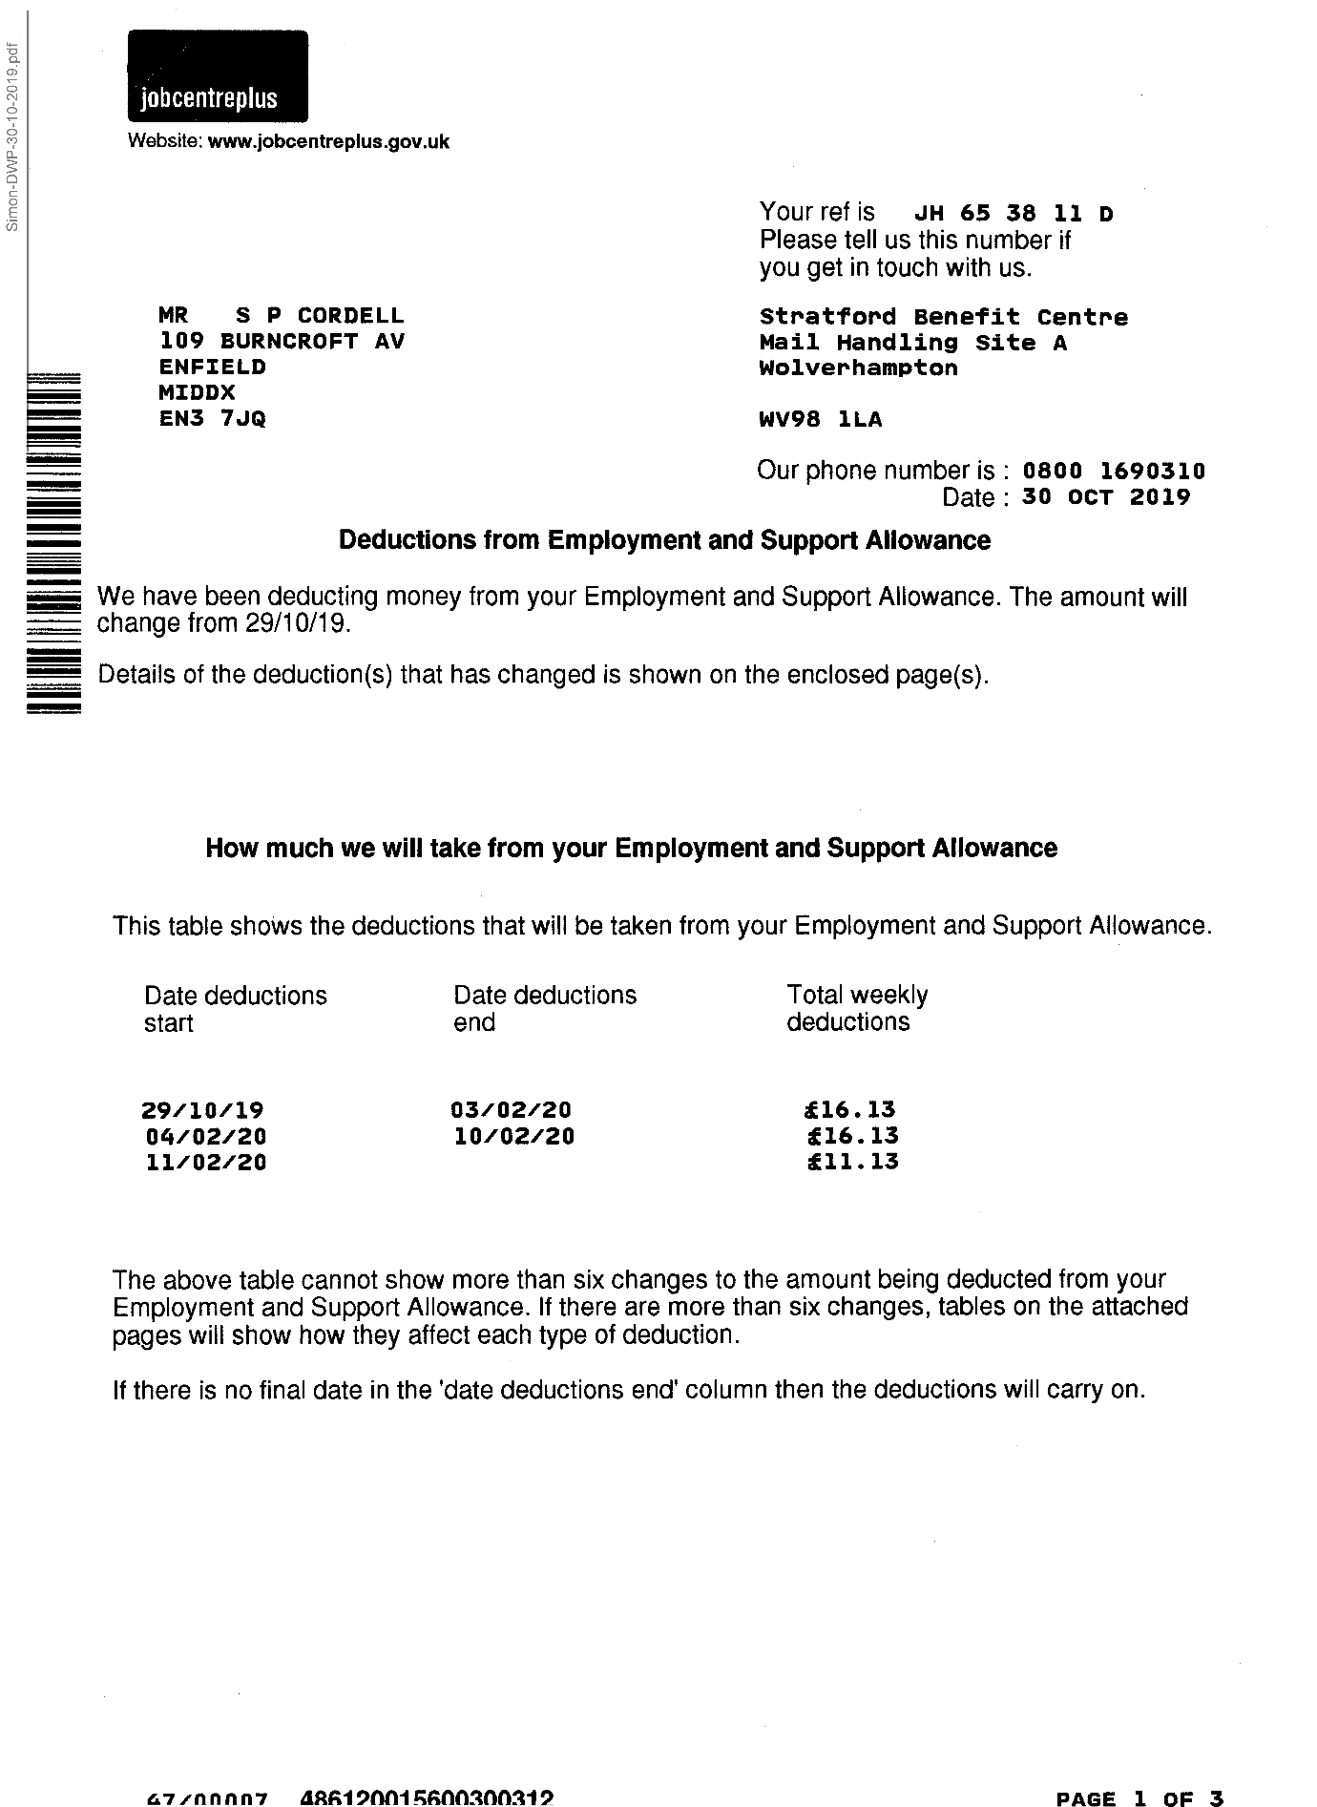
465,
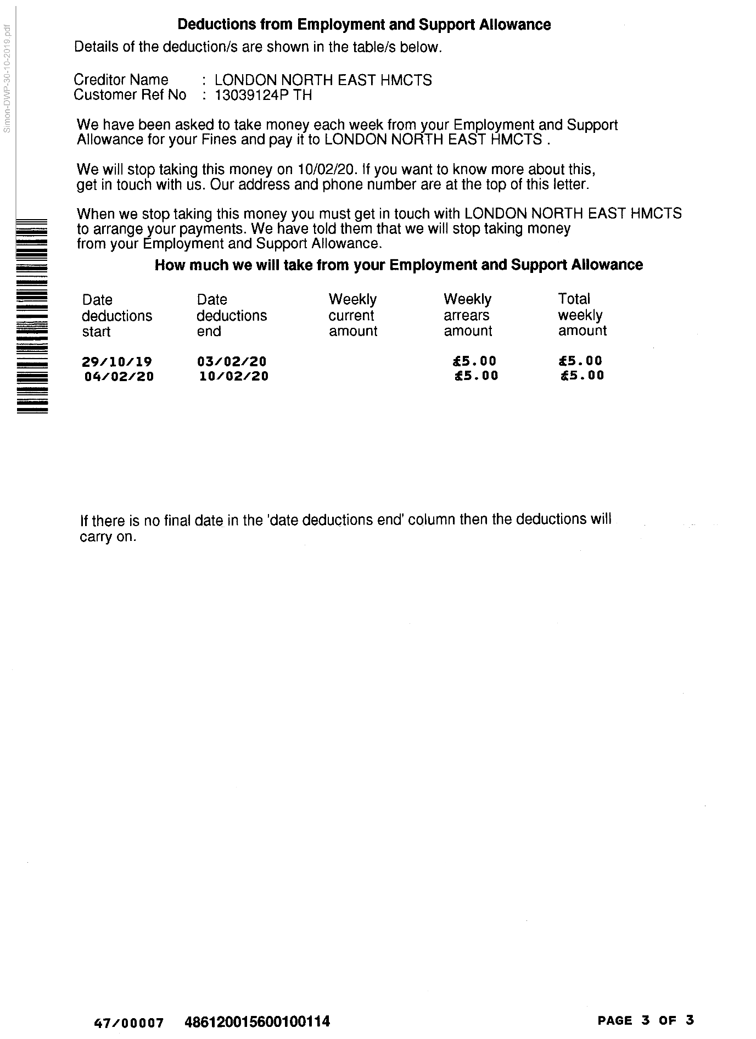
466,
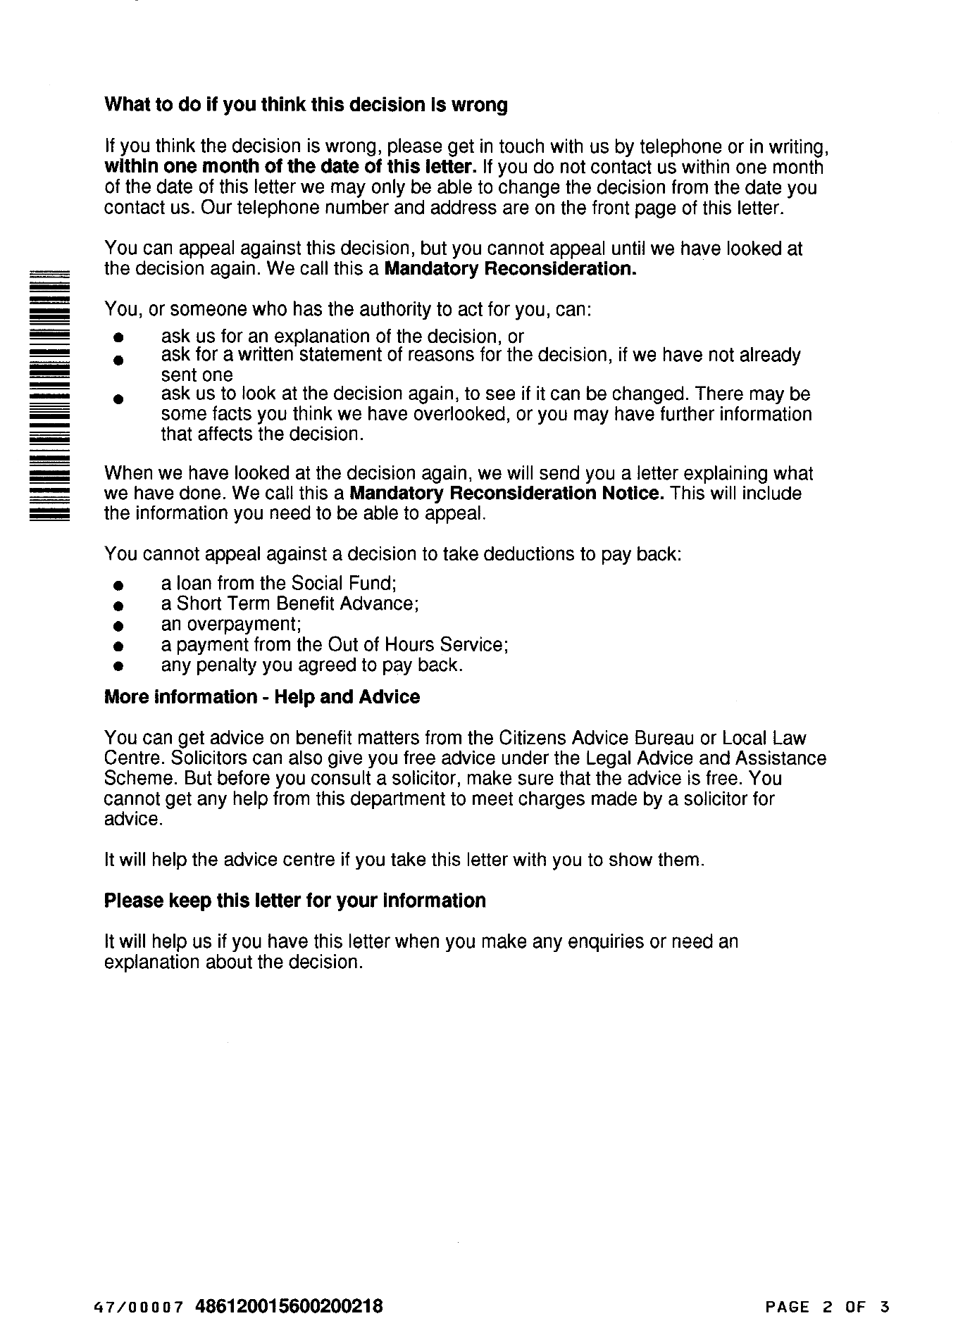
467,
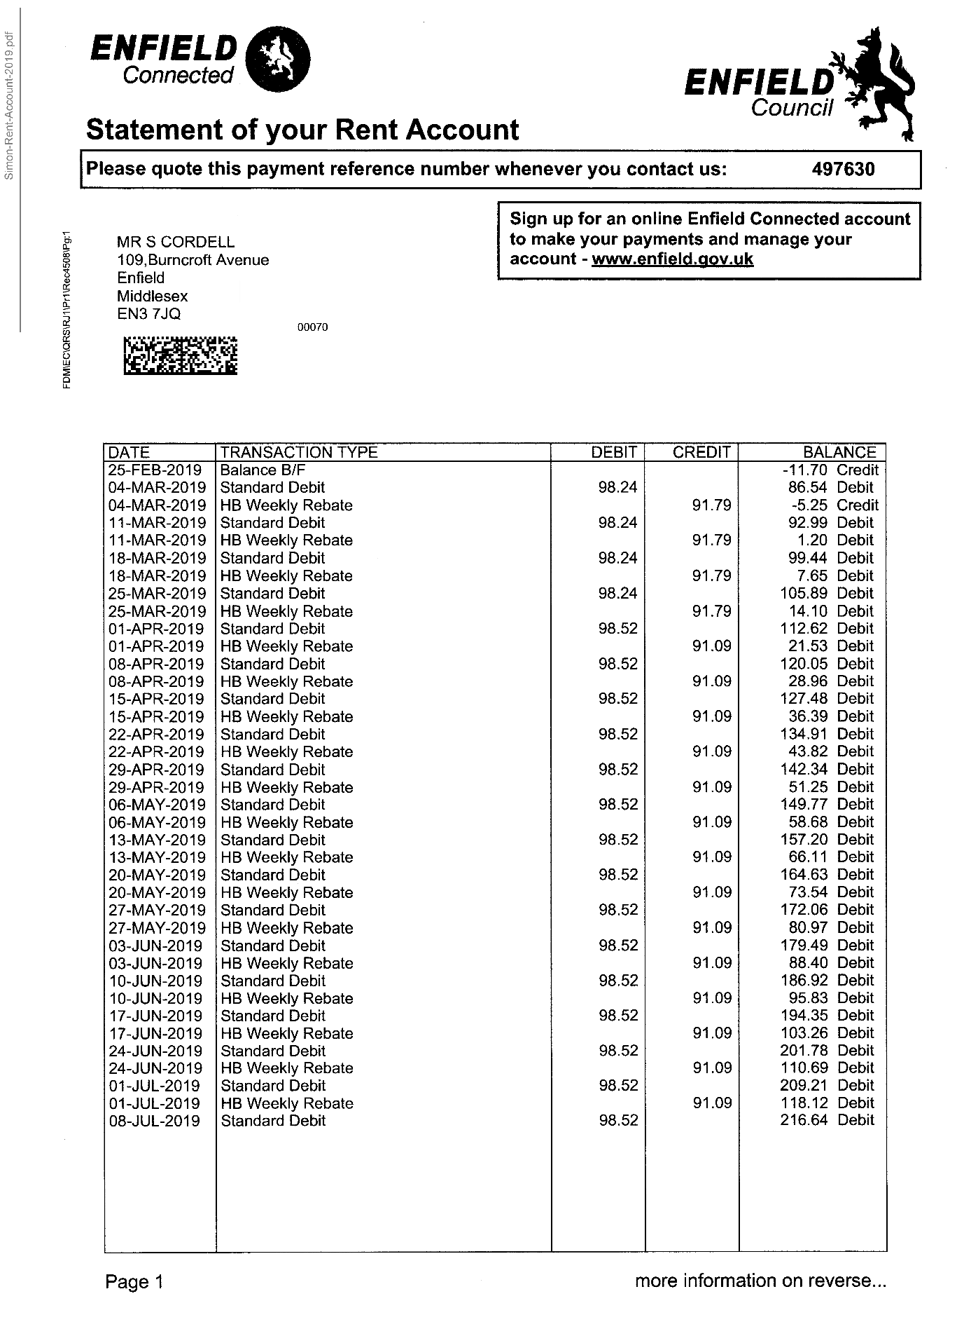
468,
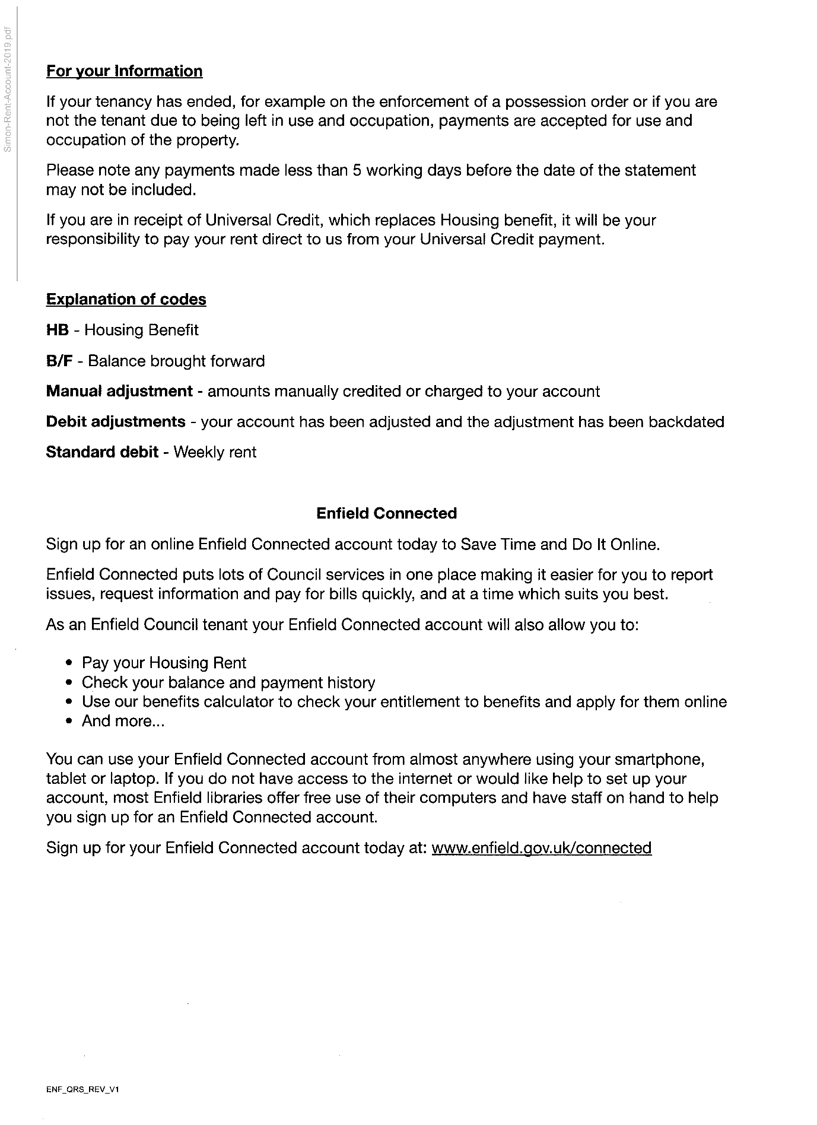
469,
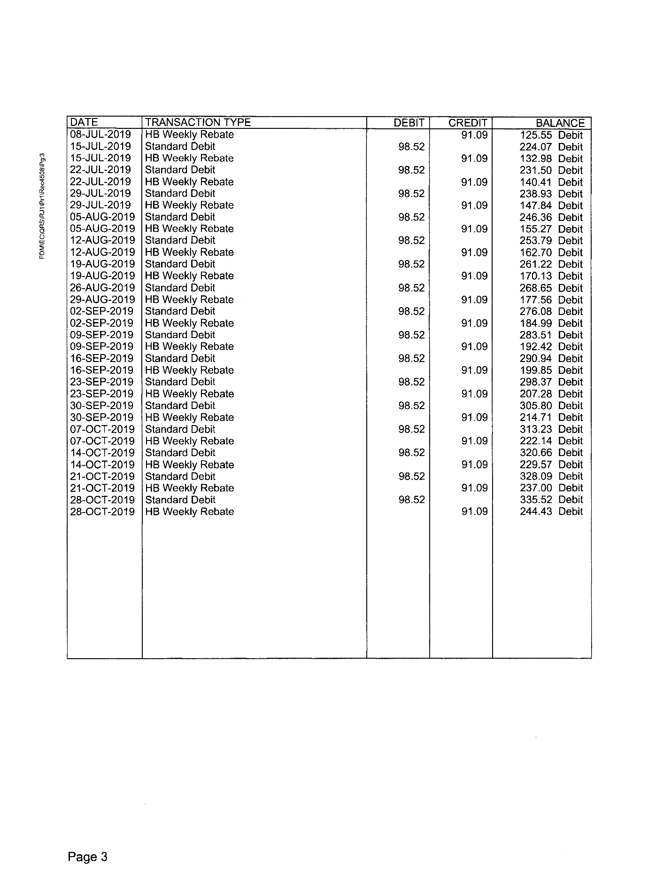
End of picture!

The banging Started!

Summary!

Disrepair!

Time Spent Building.
In the background of everything going on I could no longer work on my first company Too Smooth due to the amount of time I had to put toward s defending myself.
My mother Stopped working on my website
Working at Home doing Court Case Defense Work!
I spent time and recourses costing expenditure building my defence case and website Horrific Corruption.com, against the allegations getting put against me at the Time Start: 00:00 and Time End: 00:00

Wednesday!
13/11/2019

Stain and the
Issues with Housing Disrepair!
Working on the Court Case Defence!
The Anti-Social Behaviour Order Case and the Verdict got made Guilty against me in error and the conditions got imposed against me till late 2020!
The Banging Continued: -
13/11/2019

- Disrepair!
- The Asbo Order got granted in Error with Full Conditions against me and Fraudulently!
- The banging Continued at me!
- Working at home!

- 113 Burncroft Avenue
Richard Continued to victimise me the same way the past occupiers had prior!
“Re-Vacated”

- 117 Burncroft Avenue
The 3rd set of Tenant’s since the Problems Started with the Flat being used as an Offensives Weapons against my Person and against my free will.
has been “Re-Vacated” again by John Iron

--

The banging Started!

Summary!

Disrepair!

Time Spent Building.
In the background of everything going on I could no longer work on my first company Too Smooth due to the amount of time I had to put toward s defending myself.
My mother Stopped working on my website
Working at Home doing Court Case Defense Work!
I spent time and recourses costing expenditure building my defence case and website Horrific Corruption.com, against the allegations getting put against me at the Time Start: 00:00 and Time End: 00:00

Thursday!
14/11/2019

Stain and the
Issues with Housing Disrepair!
Working on the Court Case Defence!
The Anti-Social Behaviour Order Case and the Verdict got made Guilty against me in error and the conditions got imposed against me till late 2020!
The Banging Continued: -
14/11/2019

- Disrepair!
- The Asbo Order got granted in Error with Full Conditions against me and Fraudulently!
- The banging Continued at me!
- Working at home!

- 113 Burncroft Avenue
Richard Continued to victimise me the same way the past occupiers had prior!
“Re-Vacated”

- 117 Burncroft Avenue
The 3rd set of Tenant’s since the Problems Started with the Flat being used as an Offensives Weapons against my Person and against my free will.
has been “Re-Vacated” again by John Iron

--

The banging Started!

Summary!

Disrepair!

Time Spent Building.
In the background of everything going on I could no longer work on my first company Too Smooth due to the amount of time I had to put toward s defending myself.
My mother Stopped working on my website
Working at Home doing Court Case Defense Work!
I spent time and recourses costing expenditure building my defence case and website Horrific Corruption.com, against the allegations getting put against me at the Time Start: 00:00 and Time End: 00:00

Friday!
15/11/2019

Stain and the
Issues with Housing Disrepair!
Working on the Court Case Defence!
The Anti-Social Behaviour Order Case and the Verdict got made Guilty against me in error and the conditions got imposed against me till late 2020!
The Banging Continued: -
15/11/2019

- Disrepair!
- The Asbo Order got granted in Error with Full Conditions against me and Fraudulently!
- The banging Continued at me!
- Working at home!

- 113 Burncroft Avenue
Richard Continued to victimise me the same way the past occupiers had prior!
“Re-Vacated”

- 117 Burncroft Avenue
The 3rd set of Tenant’s since the Problems Started with the Flat being used as an Offensives Weapons against my Person and against my free will.
has been “Re-Vacated” again by John Iron

--

The banging Started!

Summary!

Disrepair!

Time Spent Building.
In the background of everything going on I could no longer work on my first company Too Smooth due to the amount of time I had to put toward s defending myself.
My mother Stopped working on my website
Working at Home doing Court Case Defense Work!
I spent time and recourses costing expenditure building my defence case and website Horrific Corruption.com, against the allegations getting put against me at the Time Start: 00:00 and Time End: 00:00

Saturday!
16/11/2019

Stain and the
Issues with Housing Disrepair!
Working on the Court Case Defence!
The Anti-Social Behaviour Order Case and the Verdict got made Guilty against me in error and the conditions got imposed against me till late 2020!
The Banging Continued: -
16/11/2019

- Disrepair!
- The Asbo Order got granted in Error with Full Conditions against me and Fraudulently!
- The banging Continued at me!
- Working at home!

- 113 Burncroft Avenue
Richard Continued to victimise me the same way the past occupiers had prior!
“Re-Vacated”

- 117 Burncroft Avenue
The 3rd set of Tenant’s since the Problems Started with the Flat being used as an Offensives Weapons against my Person and against my free will.
has been “Re-Vacated” again by John Iron

--

The banging Started!

Summary!

Disrepair!

Time Spent Building.
In the background of everything going on I could no longer work on my first company Too Smooth due to the amount of time I had to put toward s defending myself.
My mother Stopped working on my website
Working at Home doing Court Case Defense Work!
I spent time and recourses costing expenditure building my defence case and website Horrific Corruption.com, against the allegations getting put against me at the Time Start: 00:00 and Time End: 00:00

Sunday!
17/11/2019

Stain and the
Issues with Housing Disrepair!
Working on the Court Case Defence!
The Anti-Social Behaviour Order Case and the Verdict got made Guilty against me in error and the conditions got imposed against me till late 2020!
The Banging Continued: -
17/11/2019

- Disrepair!
- The Asbo Order got granted in Error with Full Conditions against me and Fraudulently!
- The banging Continued at me!
- Working at home!

- 113 Burncroft Avenue
Richard Continued to victimise me the same way the past occupiers had prior!
“Re-Vacated”

- 117 Burncroft Avenue
The 3rd set of Tenant’s since the Problems Started with the Flat being used as an Offensives Weapons against my Person and against my free will.
has been “Re-Vacated” again by John Iron

--

The banging Started!

Summary!

Disrepair!

Time Spent Building.
In the background of everything going on I could no longer work on my first company Too Smooth due to the amount of time I had to put toward s defending myself.
My mother Stopped working on my website
Working at Home doing Court Case Defense Work!
I spent time and recourses costing expenditure building my defence case and website Horrific Corruption.com, against the allegations getting put against me at the Time Start: 00:00 and Time End: 00:00

Monday!
18/11/2019

Stain and the
Issues with Housing Disrepair!
Working on the Court Case Defence!
The Anti-Social Behaviour Order Case and the Verdict got made Guilty against me in error and the conditions got imposed against me till late 2020!
The Banging Continued: -
18/11/2019

- Disrepair!
- The Asbo Order got granted in Error with Full Conditions against me and Fraudulently!
- The banging Continued at me!
- Working at home!

- 113 Burncroft Avenue
Richard Continued to victimise me the same way the past occupiers had prior!
“Re-Vacated”

- 117 Burncroft Avenue
The 3rd set of Tenant’s since the Problems Started with the Flat being used as an Offensives Weapons against my Person and against my free will.
has been “Re-Vacated” again by John Iron

--

The banging Started!

Summary!

Disrepair!

Time Spent Building.
In the background of everything going on I could no longer work on my first company Too Smooth due to the amount of time I had to put toward s defending myself.
My mother Stopped working on my website
Working at Home doing Court Case Defense Work!
I spent time and recourses costing expenditure building my defence case and website Horrific Corruption.com, against the allegations getting put against me at the Time Start: 00:00 and Time End: 00:00

Tuesday!
19/11/2019

Stain and the
Issues with Housing Disrepair!
Working on the Court Case Defence!
The Anti-Social Behaviour Order Case and the Verdict got made Guilty against me in error and the conditions got imposed against me till late 2020!
The Banging Continued: -
19/11/2019

- Disrepair!
- The Asbo Order got granted in Error with Full Conditions against me and Fraudulently!
- The banging Continued at me!
- Working at home!

- 113 Burncroft Avenue
Richard Continued to victimise me the same way the past occupiers had prior!
“Re-Vacated”

- 117 Burncroft Avenue
The 3rd set of Tenant’s since the Problems Started with the Flat being used as an Offensives Weapons against my Person and against my free will.
has been “Re-Vacated” again by John Iron

--

The banging Started!

Summary!

Disrepair!

Time Spent Building.
In the background of everything going on I could no longer work on my first company Too Smooth due to the amount of time I had to put toward s defending myself.
My mother Stopped working on my website
Working at Home doing Court Case Defense Work!
I spent time and recourses costing expenditure building my defence case and website Horrific Corruption.com, against the allegations getting put against me at the Time Start: 00:00 and Time End: 00:00

Wednesday!
20/11/2019

Stain and the
Issues with Housing Disrepair!
Working on the Court Case Defence!
The Anti-Social Behaviour Order Case and the Verdict got made Guilty against me in error and the conditions got imposed against me till late 2020!
The Banging Continued: -
20/11/2019

- Disrepair!
- The Asbo Order got granted in Error with Full Conditions against me and Fraudulently!
- The banging Continued at me!
- Working at home!

- 113 Burncroft Avenue
Richard Continued to victimise me the same way the past occupiers had prior!
“Re-Vacated”

- 117 Burncroft Avenue
The 3rd set of Tenant’s since the Problems Started with the Flat being used as an Offensives Weapons against my Person and against my free will.
has been “Re-Vacated” again by John Iron

63.
- Additional Email Attachments & Emails / Issue:
63. 1. 1
Ronak @tyrerroxburgh.c Case - Withdrawal of the Case 4
20/11/2019
/ Page Numbers: 470,471,472,473

--

63.
- Additional Email Attachments & Emails / Issue:
63. 1. 1
Ronak @tyrerroxburgh.c Case - Withdrawal of the Case 4
20/11/2019
/ Page Numbers: 470,471,472,473
--
470,
From: Ronak Ahmed <ronak@tyrerroxburgh.co.uk>
Sent: 20 November 2019 19:49
To: Lorraine Cordell
Subject: RE: Your Son' Case - Withdrawal of the Case
Attachments: 23799436_15871692.PDF
CL20-nov-2019.pdf
Good afternoon I trust you are well.
Please find attached a copy of a letter sent to your son and a notification from the Legal Aid Agency dated 20 November 2019.
Kind regards
Mr. Ronak Ahmed LL. B, LL.M
Solicitor (Consultant)
Direct Dial 07515 121781
Office 0208 889 3319
Email ronak@tvrerroxburah.co.uk
TR TYRER ROXBURGH
1 St Michaels Terrace
London
N22 7SJ
DX 34704 WOOD GREEN 2
Tel +44 (0)20 8889 3319
Fax +44 (0)20 8881 6089
www.tyrerroxburah.co.uk
Authorised by the Solicitors Regulation Authority. Tyrer Roxburgh Solicitors LLP is a limited liability partnership under the no.560748. A list of the members' names is open to inspection at the registered office.
VAT REG No: 221 8088 78
SRA No: 560748
Contracted with the Legal Aid Agency
We do not accept service of documents or other process by e-mail
Email us at lawmakers@tyrerroxburgh.co.uk
This message may contain privileged information and is only intended to be received by the person to whom it is addressed.
If you are not the intended recipient, please contact us as soon as possible.
Partners - Mukesh Badhan - D Shanmuganathan - Vasoulla Constantinou
471,
RE: Your Son’ Case - Withdrawal of the Case->23799436_15871692.PDF
Legal Aid Agency
Legal Aid Agency
1
PO BOX 10619
Nottingham
NG66DX
DX 324205
Nottingham 59
Telephone: 0300 200 2020
TYRER ROXBURGH SOLICITORS LLP
Our Ref: 300000520852
Your Ref: RA/007034.02
Date: 20/11/2019
To Whom It May Concern:
Re: SIMON CORDELL
We refer to the client's Legal Aid certificate, which was issued on 15/02/2019.
The certificate was placed under review on 20/11/2019 for the following reasons:
- Your case has been reviewed in the light of an offer to discontinue pursuit of the claim by the claimant. It is therefore unreasonable for further funding to be given by civil legal aid under the relevant Funding Code criteria or the equivalent regulations under the Legal Aid, Sentencing & Punishment of Offenders Act 2012.
You are entitled to reply to this certificate embargo with your reasons as to why you feel legal aid funding should continue. Please be advised that, if no reply is received within 21 days, a decision will be made as to whether the certificate should be discharged.
Any work undertaken after the review date will not be covered under your certificate, unless we decide that this can continue.
If you think Legal Aid should continue, please contact us within 14 days of the date of this letter to provide full reasons. Please note that if you do not take the action required within this time the certificate will be discharged.
We have written to the client separately to advise them.
If you have any questions or queries, please do not hesitate to contact us. Details can be found at the top of this letter.
Yours faithfully,
472,
Ms Jane E Harbottle
Head of Civil Case Management
473,
RE: Your Son' Case - Withdrawal of the Case->CL 20-nov-2019.pdf
Family and Housing Law Specialists
Mr Simon Cordell 4 Crompton Place Enfield Middlesex EN3 6XS
Our Ref: RA/007034.01
Your Ref:
Partners
D. Shanmuganathan Ph.D. (Wales) Solicitor-Advocate Mukesh Badhan*/** Vasoulla Constantinou**** Consultants Eleni Nicolaou*** Philip Eldin-Taylor*** Solicitor-Advocate Ronak Ahmed Sally Goldman Trainee Solicitor Nitu Johal Paralegal Shelaine Stanley-Mitchell
Date: 20 November 2019
Dear Mr Cordell
RE: Your Housing Possession Matter
Please find enclosed a letter dated 20 November 2019 from the Legal Aid Agency which states that Public Funding will be terminated as the Claimant has offered to withdraw the case. Should Public Funding be terminated then we will close your case and you will need to represent yourself.
If you wish to have Funding continue then please contact the Legal Aid Agency on 0300 200 2020
Yours sincerely
rahmed
Mr. Ronak Ahmed LL. B LL.M Solicitor (Consultant)
ronak@tyrerroxburgh.co.uk
1 St Michaels Terrace, London N22 7SJ
Tel: 020 8889 3319
Fax: 020 8881 6089
DX: 34704 WOOD GREEN 2
Email: info@tvrerroxbureh.co.uk
www.tyrerroxburgh.co.uk
Authority *PANEL CBE3
Contracted with the Legal Aid Agency
Authorised and regulated by the Solicitors Regulation Authority. Tyrer Roxburgh Solicitors LLP is a limited liability partnership under SRA no.560748. A list of the members' names is open to inspection at the registered office.
VAT REG No: 221 8088 78

The banging Started!

Summary!

Disrepair!

Time Spent Building.
In the background of everything going on I could no longer work on my first company Too Smooth due to the amount of time I had to put toward s defending myself.
My mother Stopped working on my website
Working at Home doing Court Case Defense Work!
I spent time and recourses costing expenditure building my defence case and website Horrific Corruption.com, against the allegations getting put against me at the Time Start: 00:00 and Time End: 00:00

Thursday!
21/11/2019

Stain and the
Issues with Housing Disrepair!
Working on the Court Case Defence!
The Anti-Social Behaviour Order Case and the Verdict got made Guilty against me in error and the conditions got imposed against me till late 2020!
The Banging Continued: -
21/11/2019

- Disrepair!
- The Asbo Order got granted in Error with Full Conditions against me and Fraudulently!
- The banging Continued at me!
- Working at home!

- 113 Burncroft Avenue
Richard Continued to victimise me the same way the past occupiers had prior!
“Re-Vacated”

- 117 Burncroft Avenue
The 3rd set of Tenant’s since the Problems Started with the Flat being used as an Offensives Weapons against my Person and against my free will.
has been “Re-Vacated” again by John Iron

--

The banging Started!

Summary!

Disrepair!

Time Spent Building.
In the background of everything going on I could no longer work on my first company Too Smooth due to the amount of time I had to put toward s defending myself.
My mother Stopped working on my website
Working at Home doing Court Case Defense Work!
I spent time and recourses costing expenditure building my defence case and website Horrific Corruption.com, against the allegations getting put against me at the Time Start: 00:00 and Time End: 00:00

Friday!
22/11/2019

Stain and the
Issues with Housing Disrepair!
Working on the Court Case Defence!
The Anti-Social Behaviour Order Case and the Verdict got made Guilty against me in error and the conditions got imposed against me till late 2020!
The Banging Continued: -
22/11/2019

- Disrepair!
- The Asbo Order got granted in Error with Full Conditions against me and Fraudulently!
- The banging Continued at me!
- Working at home!

- 113 Burncroft Avenue
Richard Continued to victimise me the same way the past occupiers had prior!
“Re-Vacated”

- 117 Burncroft Avenue
The 3rd set of Tenant’s since the Problems Started with the Flat being used as an Offensives Weapons against my Person and against my free will.
has been “Re-Vacated” again by John Iron

--

The banging Started!

Summary!

Disrepair!

Time Spent Building.
In the background of everything going on I could no longer work on my first company Too Smooth due to the amount of time I had to put toward s defending myself.
My mother Stopped working on my website
Working at Home doing Court Case Defense Work!
I spent time and recourses costing expenditure building my defence case and website Horrific Corruption.com, against the allegations getting put against me at the Time Start: 00:00 and Time End: 00:00

Saturday!
23/11/2019

Stain and the
Issues with Housing Disrepair!
Working on the Court Case Defence!
The Anti-Social Behaviour Order Case and the Verdict got made Guilty against me in error and the conditions got imposed against me till late 2020!
The Banging Continued: -
23/11/2019

- Disrepair!
- The Asbo Order got granted in Error with Full Conditions against me and Fraudulently!
- The banging Continued at me!
- Working at home!

- 113 Burncroft Avenue
Richard Continued to victimise me the same way the past occupiers had prior!
“Re-Vacated”

- 117 Burncroft Avenue
The 3rd set of Tenant’s since the Problems Started with the Flat being used as an Offensives Weapons against my Person and against my free will.
has been “Re-Vacated” again by John Iron

--

The banging Started!

Summary!

Disrepair!

Time Spent Building.
In the background of everything going on I could no longer work on my first company Too Smooth due to the amount of time I had to put toward s defending myself.
My mother Stopped working on my website
Working at Home doing Court Case Defense Work!
I spent time and recourses costing expenditure building my defence case and website Horrific Corruption.com, against the allegations getting put against me at the Time Start: 00:00 and Time End: 00:00

Sunday!
24/11/2019

Stain and the
Issues with Housing Disrepair!
Working on the Court Case Defence!
The Anti-Social Behaviour Order Case and the Verdict got made Guilty against me in error and the conditions got imposed against me till late 2020!
The Banging Continued: -
24/11/2019

- Disrepair!
- The Asbo Order got granted in Error with Full Conditions against me and Fraudulently!
- The banging Continued at me!
- Working at home!

- 113 Burncroft Avenue
Richard Continued to victimise me the same way the past occupiers had prior!
“Re-Vacated”

- 117 Burncroft Avenue
The 3rd set of Tenant’s since the Problems Started with the Flat being used as an Offensives Weapons against my Person and against my free will.
has been “Re-Vacated” again by John Iron

--

The banging Started!

Summary!

Disrepair!

Time Spent Building.
In the background of everything going on I could no longer work on my first company Too Smooth due to the amount of time I had to put toward s defending myself.
My mother Stopped working on my website
Working at Home doing Court Case Defense Work!
I spent time and recourses costing expenditure building my defence case and website Horrific Corruption.com, against the allegations getting put against me at the Time Start: 00:00 and Time End: 00:00

Monday!
25/11/2019

Stain and the
Issues with Housing Disrepair!
Working on the Court Case Defence!
The Anti-Social Behaviour Order Case and the Verdict got made Guilty against me in error and the conditions got imposed against me till late 2020!
The Banging Continued: -
25/11/2019

- Disrepair!
- The Asbo Order got granted in Error with Full Conditions against me and Fraudulently!
- The banging Continued at me!
- Working at home!

- 113 Burncroft Avenue
Richard Continued to victimise me the same way the past occupiers had prior!
“Re-Vacated”

- 117 Burncroft Avenue
The 3rd set of Tenant’s since the Problems Started with the Flat being used as an Offensives Weapons against my Person and against my free will.
has been “Re-Vacated” again by John Iron

--

The banging Started!

Summary!

Disrepair!

Time Spent Building.
In the background of everything going on I could no longer work on my first company Too Smooth due to the amount of time I had to put toward s defending myself.
My mother Stopped working on my website
Working at Home doing Court Case Defense Work!
I spent time and recourses costing expenditure building my defence case and website Horrific Corruption.com, against the allegations getting put against me at the Time Start: 00:00 and Time End: 00:00

Tuesday!
26/11/2019

Stain and the
Issues with Housing Disrepair!
Working on the Court Case Defence!
The Anti-Social Behaviour Order Case and the Verdict got made Guilty against me in error and the conditions got imposed against me till late 2020!
The Banging Continued: -
26/11/2019

- Disrepair!
- The Asbo Order got granted in Error with Full Conditions against me and Fraudulently!
- The banging Continued at me!
- Working at home!

- 113 Burncroft Avenue
Richard Continued to victimise me the same way the past occupiers had prior!
“Re-Vacated”

- 117 Burncroft Avenue
The 3rd set of Tenant’s since the Problems Started with the Flat being used as an Offensives Weapons against my Person and against my free will.
has been “Re-Vacated” again by John Iron

--

The banging Started!

Summary!

Disrepair!

Time Spent Building.
In the background of everything going on I could no longer work on my first company Too Smooth due to the amount of time I had to put toward s defending myself.
My mother Stopped working on my website
Working at Home doing Court Case Defense Work!
I spent time and recourses costing expenditure building my defence case and website Horrific Corruption.com, against the allegations getting put against me at the Time Start: 00:00 and Time End: 00:00

Wednesday!
27/11/2019

Stain and the
Issues with Housing Disrepair!
Working on the Court Case Defence!
The Anti-Social Behaviour Order Case and the Verdict got made Guilty against me in error and the conditions got imposed against me till late 2020!
The Banging Continued: -
27/11/2019

- Disrepair!
- The Asbo Order got granted in Error with Full Conditions against me and Fraudulently!
- The banging Continued at me!
- Working at home!

- 113 Burncroft Avenue
Richard Continued to victimise me the same way the past occupiers had prior!
“Re-Vacated”

- 117 Burncroft Avenue
The 3rd set of Tenant’s since the Problems Started with the Flat being used as an Offensives Weapons against my Person and against my free will.
has been “Re-Vacated” again by John Iron

--

The banging Started!

Summary!

Disrepair!

Time Spent Building.
In the background of everything going on I could no longer work on my first company Too Smooth due to the amount of time I had to put toward s defending myself.
My mother Stopped working on my website
Working at Home doing Court Case Defense Work!
I spent time and recourses costing expenditure building my defence case and website Horrific Corruption.com, against the allegations getting put against me at the Time Start: 00:00 and Time End: 00:00

Thursday!
28/11/2019

Stain and the
Issues with Housing Disrepair!
Working on the Court Case Defence!
The Anti-Social Behaviour Order Case and the Verdict got made Guilty against me in error and the conditions got imposed against me till late 2020!
The Banging Continued: -
28/11/2019

- Disrepair!
- The Asbo Order got granted in Error with Full Conditions against me and Fraudulently!
- The banging Continued at me!
- Working at home!

- 113 Burncroft Avenue
Richard Continued to victimise me the same way the past occupiers had prior!
“Re-Vacated”

- 117 Burncroft Avenue
The 3rd set of Tenant’s since the Problems Started with the Flat being used as an Offensives Weapons against my Person and against my free will.
has been “Re-Vacated” again by John Iron

--

The banging Started!

Summary!

Disrepair!

Time Spent Building.
In the background of everything going on I could no longer work on my first company Too Smooth due to the amount of time I had to put toward s defending myself.
My mother Stopped working on my website
Working at Home doing Court Case Defense Work!
I spent time and recourses costing expenditure building my defence case and website Horrific Corruption.com, against the allegations getting put against me at the Time Start: 00:00 and Time End: 00:00

Friday!
29/11/2019

Stain and the
Issues with Housing Disrepair!
Working on the Court Case Defence!
The Anti-Social Behaviour Order Case and the Verdict got made Guilty against me in error and the conditions got imposed against me till late 2020!
The Banging Continued: -
29/11/2019

- Disrepair!
- The Asbo Order got granted in Error with Full Conditions against me and Fraudulently!
- The banging Continued at me!
- Working at home!

- 113 Burncroft Avenue
Richard Continued to victimise me the same way the past occupiers had prior!
“Re-Vacated”

- 117 Burncroft Avenue
The 3rd set of Tenant’s since the Problems Started with the Flat being used as an Offensives Weapons against my Person and against my free will.
has been “Re-Vacated” again by John Iron

1
- Simon Cordell’s MP3’S Indexed
Stage 1
Simon MP3’S Indexed
1x Recording
01m. 29 11 2019 director legal services (1)
Page Number: Update Page Number 1,
01m. 29 11 2019 director legal srevices (1).wma
31 11 2019 director legal services (1).wma
Update

2
- Simon Cordell’s MP3’S Indexed
Stage 1
1x Recording
01m. 29 11 2019 director legal services (2)
Page Number: Update Page Number 1,
01m. 29 11 2019 director legal srevices (2).wma
31 11 2019 director legal services (2).wma
Update

3
- Simon Cordell’s MP3’S Indexed
Stage 1
1x Recording
01m. 29 11 2019 Jeremy (1)
Page Number: Update Page Number 1,
01m. 29 11 2019 Jeremy (1).wma
Update

4
- Simon Cordell’s MP3’S Indexed
Stage 1
1x Recording
01m. 29 11 2019 Jeremy (2)
Page Number: Update Page Number 1,
01m. 29 11 2019 Jeremy (2).wma
Update

5
- Simon Cordell’s MP3’S Indexed
Stage 1
1x Recording
01m. Enfield Council - Jeremy again - 29_11_2019
Page Number: Update Page Number 1,
01m. Enfield Council - Jeremy again - 29_11_2019.wma
Update

--

1
Simon Cordell’s MP3’S Indexed
Stage 1
Simon MP3’S Indexed
1x Recording
01m. 29 11 2019 director legal services (1)
Page Number: Update Page Number 1,
01m. 29 11 2019 director legal srevices (1).wma
31 11 2019 director legal services (1).wma
Update

2
Simon Cordell’s MP3’S Indexed
Stage 1
1x Recording
01m. 29 11 2019 director legal services (2)
Page Number: Update Page Number 1,
01m. 29 11 2019 director legal srevices (2).wma
31 11 2019 director legal services (2).wma
Update

3
Simon Cordell’s MP3’S Indexed
Stage 1
1x Recording
01m. 29 11 2019 Jeremy (1)
Page Number: Update Page Number 1,
01m. 29 11 2019 Jeremy (1).wma
Update

4
Simon Cordell’s MP3’S Indexed
Stage 1
1x Recording
01m. 29 11 2019 Jeremy (2)
Page Number: Update Page Number 1,
01m. 29 11 2019 Jeremy (2).wma
Update

5
Simon Cordell’s MP3’S Indexed
Stage 1
1x Recording
01m. Enfield Council - Jeremy again - 29_11_2019
Page Number: Update Page Number 1,
01m. Enfield Council - Jeremy again - 29_11_2019.wma
Update

The banging Started!

Summary!

Disrepair!

Time Spent Building.
In the background of everything going on I could no longer work on my first company Too Smooth due to the amount of time I had to put toward s defending myself.
My mother Stopped working on my website
Working at Home doing Court Case Defense Work!
I spent time and recourses costing expenditure building my defence case and website Horrific Corruption.com, against the allegations getting put against me at the Time Start: 00:00 and Time End: 00:00

Saturday!
30/11/2019

Stain and the
Issues with Housing Disrepair!
Working on the Court Case Defence!
The Anti-Social Behaviour Order Case and the Verdict got made Guilty against me in error and the conditions got imposed against me till late 2020!
The Banging Continued: -
30/11/2019

- Disrepair!
- The Asbo Order got granted in Error with Full Conditions against me and Fraudulently!
- The banging Continued at me!
- Working at home!

- 113 Burncroft Avenue
Richard Continued to victimise me the same way the past occupiers had prior!
“Re-Vacated”

- 117 Burncroft Avenue
The 3rd set of Tenant’s since the Problems Started with the Flat being used as an Offensives Weapons against my Person and against my free will.
has been “Re-Vacated” again by John Iron

--

The banging Started!

Summary!

Disrepair!

Time Spent Building.
In the background of everything going on I could no longer work on my first company Too Smooth due to the amount of time I had to put toward s defending myself.
My mother Stopped working on my website
Working at Home doing Court Case Defense Work!
I spent time and recourses costing expenditure building my defence case and website Horrific Corruption.com, against the allegations getting put against me at the Time Start: 00:00 and Time End: 00:00

Sunday!
01/12/2019

Stain and the
Issues with Housing Disrepair!
Working on the Court Case Defence!
The Anti-Social Behaviour Order Case and the Verdict got made Guilty against me in error and the conditions got imposed against me till late 2020!
The Banging Continued: -
01/12/2019

- Disrepair!
- The Asbo Order got granted in Error with Full Conditions against me and Fraudulently!
- The banging Continued at me!
- Working at home!

- 113 Burncroft Avenue
Richard Continued to victimise me the same way the past occupiers had prior!
“Re-Vacated”

- 117 Burncroft Avenue
The 3rd set of Tenant’s since the Problems Started with the Flat being used as an Offensives Weapons against my Person and against my free will.
has been “Re-Vacated” again by John Iron

1
- Simon Cordell’s MP3’S Indexed
Stage 1
1x Recording
01m. 01 12 2019 finding Paul 2
Page Number: Update Page Number 1,
01 12 2019 finding Paul 2.wma
Update

2
- Simon Cordell’s MP3’S Indexed
Stage 1
1x Recording
01m. 01 12 2019 Jeremey
Page Number: Update Page Number 1,
01 12 2019 jerrmey.wma
Update

3
- Simon Cordell’s MP3’S Indexed
Stage 1
1x Recording
01m. 01 12 2019 Paul Buck ridge
Page Number: Update Page Number 1,
01 12 2019 Paul Bucjaridge.wma
Update

4
- Simon Cordell’s MP3’S Indexed
Stage 1
1x Recording
01m. hmm recording 01 12 2019
Page Number: Update Page Number 1,
hmm recording 01 12 2019.wma
Update

--

1
Simon Cordell’s MP3’S Indexed
Stage 1
1x Recording
01m. 01 12 2019 finding Paul 2
Page Number: Update Page Number 1,
01 12 2019 finding Paul 2.wma
Update

2
Simon Cordell’s MP3’S Indexed
Stage 1
1x Recording
01m. 01 12 2019 Jeremey
Page Number: Update Page Number 1,
01 12 2019 jerrmey.wma
Update

3
Simon Cordell’s MP3’S Indexed
Stage 1
1x Recording
01m. 01 12 2019 Paul Buck ridge
Page Number: Update Page Number 1,
01 12 2019 Paul Bucjaridge.wma
Update

4
Simon Cordell’s MP3’S Indexed
Stage 1
1x Recording
01m. hmm recording 01 12 2019
Page Number: Update Page Number 1,
hmm recording 01 12 2019.wma
Update

The banging Started!

Summary!

Disrepair!

Time Spent Building.
In the background of everything going on I could no longer work on my first company Too Smooth due to the amount of time I had to put toward s defending myself.
My mother Stopped working on my website
Working at Home doing Court Case Defense Work!
I spent time and recourses costing expenditure building my defence case and website Horrific Corruption.com, against the allegations getting put against me at the Time Start: 00:00 and Time End: 00:00

Monday!
02/12/2019

Stain and the
Issues with Housing Disrepair!
Working on the Court Case Defence!
The Anti-Social Behaviour Order Case and the Verdict got made Guilty against me in error and the conditions got imposed against me till late 2020!
The Banging Continued: -
02/12/2019

- Disrepair!
- The Asbo Order got granted in Error with Full Conditions against me and Fraudulently!
- The banging Continued at me!
- Working at home!

- 113 Burncroft Avenue
Richard Continued to victimise me the same way the past occupiers had prior!
“Re-Vacated”

- 117 Burncroft Avenue
The 3rd set of Tenant’s since the Problems Started with the Flat being used as an Offensives Weapons against my Person and against my free will.
has been “Re-Vacated” again by John Iron

64.
Additional Email Attachments & Emails / Issue:
64. 1. 2.
Mother 02-12-2019 -12-58
02/12/2019
/ Page Numbers: 474,475,476

65.
- Additional Email Attachments & Emails / Issue:
65. 1. 2.
Mother 02-12-2019-12-51
02/12/2019
/ Page Numbers: 477,478

66.
- Additional Email Attachments & Emails / Issue:
66. 1. 2.
Mother 02-12-2019-12-56
02/12/2019
/ Page Numbers: 479,480,481,482

--

64.
- Additional Email Attachments & Emails / Issue:
64. 1. 2.
Mother 02-12-2019 -12-58
02/12/2019
/ Page Numbers: 474,475,476
--
474,
From: Lorraine Cordell <lorraine32@blueyonder.co.uk>
Sent time: 02/12/2019 12:58:17 PM
To: re_wired@ymail.com
Subject: FW: Your Son' Case - Withdrawal of the Case
Attachments: LB Enfield 21 Oct 2019.pdf
CL-22 Oct 2019.pdf
see letters
From: Ronak Ahmed [mailto: ronak@tyrerroxburgh.co.uk]
Sent: 22 October 2019 20:30
To: Lorraine Cordell
Subject: RE: Your Son' Case - Withdrawal of the Case
Dear Ms Cordell, I trust you are well.
I have good news in that the Council have decided to not pursue the case further due to a lack of recent incidents. Please see attached their letter received recently and our letter dated 22October 2019 sent to your son.
Please speak to your son and get back to me with any questions.
Kind regards
Mr. Ronak Ahmed LL. B, LL.M
Solicitor (Consultant)
Direct Dial 07515 121781
Office 0208 889 3319
Email ronak@tvrerroxburah.co.uk
TR TYRER ROXBURGH
1 St Michaels Terrace
London
N22 7SJ
DX 34704 WOOD GREEN 2
Tel +44 (0)20 8889 3319
Fax +44 (0)20 8881 6089
www.tvrerroxburah.co.uk
Authorised by the Solicitors Regulation Authority. Tyrer Roxburgh Solicitors LLP is a limited liability partnership under the no.560748. A list of the members' names is open to inspection at the registered office.
VAT REG No: 221 8088 78
SRA No: 560748
Contracted with the Legal Aid Agency
We do not accept service of documents or other process by Email.
Email us at lawmakers@tyrerroxburgh.co.uk
This message may contain privileged information and is only intended to be received by the person to whom it is addressed.
If you are not the intended recipient, please contact us as soon as possible.
Partners - Mukesh Badhan - D Shanmuganathan - Vasoulla Constantinou
475,
476,
End of picture!

65.
- Additional Email Attachments & Emails / Issue:
65. 1. 2.
Mother 02-12-2019-12-51
02/12/2019
/ Page Numbers: 477,478
--
477,
From: Lorraine Cordell <lorraine32@blueyonder.co.uk>
Sent time: 02/12/2019 12:51:02 PM
To: re_wired@ymail.com
Subject: RE: your sol letter
Attachments: CL 22 Oct 2019-si-sol-001.pdf
here look
478,
CL 22 Oct 2019-si-sol-001.pdf
Family and Housing Law Specialists
Mr Simon Cordell 4 Crompton Place Enfield Middlesex EN3 6XS
Our Ref: RA/007034.01
Your Ref:
Partners
D. Shanmuganathan Ph.D. (Wales) Solicitor-Advocate Mukesh Badhan*/** Vasoulla Constantinou**** Consultants Eleni Nicolaou*** Philip Eldin-Taylor*** Solicitor-Advocate Ronak Ahmed Sally Goldman Trainee Solicitor Nitu Johal Paralegal Shelaine Stanley-Mitchell
Date: 22 October 2019
Dear Mr Cordell
RE: Your Housing Possession Matter
Please find enclosed a letter dated 21 October 2019 from the London Borough of Enfield confirming that they do not wish to proceed with the case to evict you. This is good news.
Please do bear in mind that a new case can be started if the Council find that there are fresh complaints in the future.
We will shortly begin to agree terms of a consent order to formally terminate the case at the Courts. Thereafter we shall close the case. If you have any questions, please get in touch.
Yours faithfully
rahmed
Mr. Ronak Ahmed LL. B LL.M Solicitor (Consultant)
ronak@tyrerroxburgh.co.uk
1 St Michaels Terrace, London N22 7SJ
Tel: 020 8889 3319
Fax: 020 8881 6089 DX: 34704 WOOD GREEN 2
Email: info@tyrerroxburgh.co.uk
www.tyrerroxburgh.co.uk
Authority *PANEL C1BB1
Contracted with the Legal Aid Agency
Authorised and regulated by the Solicitors Regulation Authority. Tyrer Roxburgh Solicitors LLP is a limited liability partnership under SRA no.560748. A list of the members' names is open to inspection at the registered office.
VAT REG No: 221 8088 78

66.
- Additional Email Attachments & Emails / Issue:
66. 1. 2.
Mother 02-12-2019-12-56
02/12/2019
/ Page Numbers: 479,480,481,482
--
479,
From: Lorraine Cordell <lorraine32@blueyonder.co.uk>
Sent time: 02/12/2019 12:56:00 PM
To: re_wired@ymail.com
Subject: FW: Your Son' Case - Withdrawal of the Case
Attachments: 23799436-15871692.PDF
CL 20-nov-2019.pdf
please see attached letters
From: Ronak Ahmed [mailto: ronak@tyrerroxburgh.co.uk]
Sent: 20 November 2019 19:49
To: Lorraine Cordell
Subject: RE: Your Son' Case - Withdrawal of the Case Good afternoon I trust you are well.
Please find attached a copy of a letter sent to your son and a notification from the Legal Aid Agency dated 20 November 2019.
Kind regards
Mr. Ronak Ahmed LL. B, LL.M
Solicitor (Consultant)
Direct Dial 07515 121781
Office 0208 889 3319
Email ronak@tvrerroxburah.co.uk
TR TYRER ROXBURGH
1 St Michaels Terrace
London
N22 7SJ
DX 34704 WOOD GREEN 2
Tel +44 (0)20 8889 3319
Fax +44 (0)20 8881 6089
www.tyrerroxburah.co.uk
Authorised by the Solicitors Regulation Authority. Tyrer Roxburgh Solicitors LLP is a limited liability partnership under the no.560748. A list of the members' names is open to inspection at the registered office.
VAT REG No: 221808878
SRA No: 560748
Contracted with the Legal Aid Agency
We do not accept service of documents or other process by e-mail Email us at lawmakers@tyrerroxburgh.co.uk
This message may contain privileged information and is only intended to be received by the person to whom it is addressed.
If you are not the intended recipient, please contact us as soon as possible.
Partners - Mukesh Badhan - D Shanmuganathan - Vasoulla Constantinou
480,
23799436-15871692.PDF
Legal Aid Agency
Legal Aid Agency
1 PO BOX 10619
Nottingham
NG66DX
DX 324205 Nottingham 59
Telephone: 0300 200 2020
TYRER ROXBURGH SOLICITORS LLP
Our Ref: 300000520852
Your Ref: RA/007034.02
Date: 20/11/2019
To Whom It May Concern:
Re: SIMON CORDELL
We refer to the client's Legal Aid certificate, which was issued on 15/02/2019.
The certificate was placed under review on 20/11/2019 for the following reasons:
• Your case has been reviewed in the light of an offer to discontinue pursuit of the claim by the claimant. It is therefore unreasonable for further funding to be given by civil legal aid under the relevant Funding Code criteria or the equivalent regulations under the Legal Aid, Sentencing & Punishment of Offenders Act 2012.
You are entitled to reply to this certificate embargo with your reasons as to why you feel legal aid funding should continue. Please be advised that, if no reply is received within 21 days, a decision will be made as to whether the certificate should be discharged.
Any work undertaken after the review date will not be covered under your certificate, unless we decide that this can continue.
If you think Legal Aid should continue, please contact us within 14 days of the date of this letter to provide full reasons. Please note that if you do not take the action required within this time the certificate will be discharged.
We have written to the client separately to advise them.
If you have any questions or queries, please do not hesitate to contact us. Details can be found at the top of this letter.
Yours faithfully,
481,
Ms Jane E Harbottle
Head of Civil Case Management
482,
CL 20-nov-2019.pdf
Family and Housing Law Specialists
Mr Simon Cordell 4 Crompton Place Enfield Middlesex EN3 6XS
Our Ref: RA/007034.01
Your Ref:
Partners
D. Shanmuganathan Ph.D. (Wales) Solicitor-Advocate Mukesh Badhan*/** Vasoulla Constantinou**** Consultants Eleni Nicolaou*** Philip Eldin-Taylor*** Solicitor-Advocate Ronak Ahmed Sally Goldman Trainee Solicitor Nitu Johal Paralegal Shelaine Stanley-Mitchell
Date: 20 November 2019
Dear Mr Cordell
RE: Your Housing Possession Matter
Please find enclosed a letter dated 20 November 2019 from the Legal Aid Agency which states that Public Funding will be terminated as the Claimant has offered to withdraw the case. Should Public Funding be terminated then we will close your case and you will need to represent yourself.
If you wish to have Funding continue then please contact the Legal Aid Agency on 0300 200 2020
Yours sincerely
rahmed
Mr. Ronak Ahmed LL. B LL.M Solicitor (Consultant)
ronak@tyrerroxburgh.co.uk
1 St Michaels Terrace, London N22 7SJ
Tel: 020 8889 3319
Fax: 020 8881 6089
DX: 34704 WOOD GREEN 2
Email: info@tvrerroxbureh.co.uk
www.tyrerroxburgh.co.uk
Authority *PANEL C1BB1
Contracted with the Legal Aid Agency
Authorised and regulated by the Solicitors Regulation Authority. Tyrer Roxburgh Solicitors LLP is a limited liability partnership under SRA no.560748. A list of the members' names is open to inspection at the registered office.
VAT REG No: 221 8088 78

The banging Started!

Summary!

Disrepair!

Time Spent Building.
In the background of everything going on I could no longer work on my first company Too Smooth due to the amount of time I had to put toward s defending myself.
My mother Stopped working on my website
Working at Home doing Court Case Defense Work!
I spent time and recourses costing expenditure building my defence case and website Horrific Corruption.com, against the allegations getting put against me at the Time Start: 00:00 and Time End: 00:00

Tuesday!
03/12/2019

Stain and the
Issues with Housing Disrepair!
Working on the Court Case Defence!
The Anti-Social Behaviour Order Case and the Verdict got made Guilty against me in error and the conditions got imposed against me till late 2020!
The Banging Continued: -
03/12/2019

- Disrepair!
- The Asbo Order got granted in Error with Full Conditions against me and Fraudulently!
- The banging Continued at me!
- Working at home!

- 113 Burncroft Avenue
Richard Continued to victimise me the same way the past occupiers had prior!
“Re-Vacated”

- 117 Burncroft Avenue
The 3rd set of Tenant’s since the Problems Started with the Flat being used as an Offensives Weapons against my Person and against my free will.
has been “Re-Vacated” again by John Iron

1
- Simon Cordell’s MP3’S Indexed
Stage 1
1x Recording
01m. Jeremy 03 12 2019
Page Number: Update Page Number 1,
01m. Jeremy 03 12 2019.wma
Update

19
- Additional Email Attachments & Emails / Issue:
19. 1. 1
Enquiries.edmonton.countycourt@justice.gov.uk_
03/12/2019_
Auto reply
/ Page Numbers: A, B, C

--

1
Simon Cordell’s MP3’S Indexed
Stage 1
1x Recording
01m. Jeremy 03 12 2019
Page Number: Update Page Number 1,
01m. Jeremy 03 12 2019.wma
Update

19
Additional Email Attachments & Emails / Issue:
19. 1. 1
Enquiries.edmonton.countycourt@justice.gov.uk_03.12.2019_Auto reply
/ Page Numbers: A, B, C,
A,
From: Edmonton County, Enquiries <enquiries.edmonton.countycourt@justice.gov.uk>
Sent: 12 March 2019 17:03
To: Lorraine Cordell
Subject: Auto reply
** IMPORTANT NOTICE ON EMAIL COMMUNICATIONS **
Thank you for your email, which has been received by the court. Depending on the nature of your email you may receive a response via email or post.
What documents can be sent by email?
You can send all letters and documents relevant to the case including adoption cases. However, due to the sensitive nature of adoption work the court will only send emails to secure email accounts. If a hard copy of a document has been filed at court by DX or Post, an electronic copy should not be sent. As yet please note that court bundles are not part of this process and will not be printed.
For more information regarding e-mails please go to the following http://www.justice.gov.uk/courts/email-guidance What is a secure email account?
An email account is considered secure when security measures are in place to make sure the data in the email can’t be accessed by users without the relevant approval. Any account that ends in the following is considered secured: gsi, pnn, gsx, gcsx, gse, cjsm, and nhs.net.
What emails will HMCTS accept?
To make sure we operate this service as efficiently and effectively as possible there are exemptions.
All Civil and Family process, applications and documents will be accepted by email as long as when the entire email is printed out it is not more than 50 pages. This should include the email, all attachments (including any documents embedded in another) and enough copies to serve on required parties.
Please note that:
- A page is one side, so 50 pages equals 25 pieces of paper printed on both sides.
- Do not use more than one email to take any step in a case which requires a document or documents to be filed.
DOCUMENTS FOR HEARINGS IN ACCORDANCE WITH
CIVIL PROCEDURE RULES PD, 5B.2. FAMILY PROCEDURE RULE PD 5B
You have received an order to attend court for a hearing.
It would greatly assist the court staff if you could ensure documents you file into court have a hearing date endorsed on the covering letter, paperwork, or email.
This will then enable the court staff to identify the document is placed on file in readiness for the hearing.
Please note, if the court is unaware of the pending hearing, when you file your documents, this may result in the document not reaching the court file in time for the hearing.
Can processes that carry a fee be sent by email?
In both Civil and Family cases court processes that carry a fee can also be received by email and processed by court staff. However the same conditions as above must apply and in addition the party issuing the process must either quote a Fee Account number, or the party who wants to pay has a valid credit or debit card. If you wish to pay using this method, please say this on the
B,
email and include a contact number for the Court to contact you to take payment.
What is Fee Account?
This is a Direct Debit function that is quick, safe, and easy to use. It is available for solicitors and large organisations. Once you have set up an account all you need is to provide your fee account number within the body of the email. The fee will then be deducted from your account. For more information and to apply for Fee Account please visit www.justice.gov.uk/courts/fees/payment-by-account.
Any document submitted that breaches any of the above terms will remain unprocessed. This is in line with Court Practice Directions 5BPD.1 - 5BPD.9.3.
When you email the court the subject line of your mail must contain (in the following order): -
- The claim numbers
- The title of the claim (abbreviated if necessary) **
- The subject matter (e.g. defence)
- If relating to a hearing the date and time of hearing in bold black
- The judge’s name, where the correspondence/document is for their attention
**If your email is in relation to a family matter, please refer to the initials only.
Your message should also contain the name, telephone number and email address of the sender. Correspondence and documents may be sent as either text or attachments. Where there is a practice form, it must be sent in that form by attachment. The complete email (including any attachment(s)) must not exceed 10Mb.
The rest of this automated message provides information that customers often find useful.
Edmonton County Court
The public counter services are no longer available at this court.
Urgent applications and processes that need to be dealt with in person will be through an appointment only system. Users should contact the court on 0208 8846510 between 9.00 am and 5.00 pm Monday to Friday to make an appointment.
The main telephone number for Civil and Family enquiries is 0208 884 6500 Gold fax 0870 3240314
Our address is The County Court at Edmonton, 59 Fore Street, Edmonton, London, N18 2TN
DX 136686 Edmonton 3
The court building is open between 9.00 am and 4.00 pm Monday to Friday.
We have a secure drop box located in reception for personal deliveries to the court, which is opened once a day at 9.00 am Monday to Friday.
Website links
Information on Court forms and fees can be also be obtained from www.justice.gov.uk
Issuing a claim for Money or Possession of Property - MCOL & PCOL
C,
If you would like to issue a claim for money or property you can do so 24 hours a day, 7 days a week by visiting: www.moneydaim.gov.uk or www.possessionclaim.gov.uk.You will save money by issuing a claim for possession of property or a money claim online rather than sending it to the court.
Legal Advice
If you are uncertain how to proceed, the Civil Procedure Rules available on the Ministry of Justice website - http://www.justice.gov.uk - provide details. On many occasions it is best for people to seek professional legal advice from a solicitor, legal executive, legal advice agency or Citizens Advice Bureau. You can also contact Civil Legal Advice on 0845 345 4 345 or via their website.
For information on how HMCTS uses personal data about you please see:
https://www.gov.uk/government/organisations/hm-courts-and-tribunals-service/about/personal-information-charter
This e-mail and any attachments are intended only for the attention of the addressee(s). Its unauthorised use, disclosure, storage, or copying is not permitted. If you are not the intended recipient, please destroy all copies and inform the sender by return e-mail. Internet e-mail is not a secure medium. Any reply to this message could be intercepted and read by someone else. Please bear that in mind when deciding whether to send material in response to this message by e-mail. This e-mail (whether you are the sender or the recipient) may be monitored, recorded, and retained by the Ministry of Justice. Monitoring / blocking software may be used, and e-mail content may be read at any time. You have a responsibility to ensure laws are not broken when composing or forwarding e-mails and their contents.

Simon Cordell’s MP3’S Indexed
Stage 1
1x Recording
01m. Jeremy 03 12 2019
Page Number: Update Page Number 1,
Update

The banging Started!

Summary!

Disrepair!

Time Spent Building.
In the background of everything going on I could no longer work on my first company Too Smooth due to the amount of time I had to put toward s defending myself.
My mother Stopped working on my website
Working at Home doing Court Case Defense Work!
I spent time and recourses costing expenditure building my defence case and website Horrific Corruption.com, against the allegations getting put against me at the Time Start: 00:00 and Time End: 00:00

Wednesday!
04/12/2019

Stain and the
Issues with Housing Disrepair!
Working on the Court Case Defence!
The Anti-Social Behaviour Order Case and the Verdict got made Guilty against me in error and the conditions got imposed against me till late 2020!
The Banging Continued: -
04/12/2019

- Disrepair!
- The Asbo Order got granted in Error with Full Conditions against me and Fraudulently!
- The banging Continued at me!
- Working at home!

- 113 Burncroft Avenue
Richard Continued to victimise me the same way the past occupiers had prior!
“Re-Vacated”

- 117 Burncroft Avenue
The 3rd set of Tenant’s since the Problems Started with the Flat being used as an Offensives Weapons against my Person and against my free will.
has been “Re-Vacated” again by John Iron

--

The banging Started!

Summary!

Disrepair!

Time Spent Building.
In the background of everything going on I could no longer work on my first company Too Smooth due to the amount of time I had to put toward s defending myself.
My mother Stopped working on my website
Working at Home doing Court Case Defense Work!
I spent time and recourses costing expenditure building my defence case and website Horrific Corruption.com, against the allegations getting put against me at the Time Start: 00:00 and Time End: 00:00

Thursday!
05/12/2019

Stain and the
Issues with Housing Disrepair!
Working on the Court Case Defence!
The Anti-Social Behaviour Order Case and the Verdict got made Guilty against me in error and the conditions got imposed against me till late 2020!
The Banging Continued: -
05/12/2019

- Disrepair!
- The Asbo Order got granted in Error with Full Conditions against me and Fraudulently!
- The banging Continued at me!
- Working at home!

- 113 Burncroft Avenue
Richard Continued to victimise me the same way the past occupiers had prior!
“Re-Vacated”

- 117 Burncroft Avenue
The 3rd set of Tenant’s since the Problems Started with the Flat being used as an Offensives Weapons against my Person and against my free will.
has been “Re-Vacated” again by John Iron

1
- Simon Cordell’s MP3’S Indexed
Stage 1
1x Recording
01m. Jeremy 05 12 2019
Page Number: Update Page Number 1,
01m. Jeremy 05 12 2019.wma
Update

2
- Simon Cordell’s MP3’S Indexed
Stage 1
1x Recording
01m. Jeremy and Jane 05_12_2019
Page Number: Update Page Number 1,
01m. Jeremy and Jane 05_12_2019.wma
Update

3
- Simon Cordell’s MP3’S Indexed
Stage 1
1x Recording
01m. Jeremy 05_12_2019
Page Number: Update Page Number 1,
01m. Jeremy 05_12_2019.wma
Update

--

1
Simon Cordell’s MP3’S Indexed
Stage 1
1x Recording
01m. Jeremy 05 12 2019
Page Number: Update Page Number 1,
01m. Jeremy 05 12 2019.wma
Update

2
Simon Cordell’s MP3’S Indexed
Stage 1
1x Recording
01m. Jeremy and Jane 05_12_2019
Page Number: Update Page Number 1,
01m. Jeremy and Jane 05_12_2019.wma
Update

3
Simon Cordell’s MP3’S Indexed
Stage 1
1x Recording
01m. Jeremy 05_12_2019
Page Number: Update Page Number 1,
01m. Jeremy 05_12_2019.wma
Update

The banging Started!

Summary!

Disrepair!

Time Spent Building.
In the background of everything going on I could no longer work on my first company Too Smooth due to the amount of time I had to put toward s defending myself.
My mother Stopped working on my website
Working at Home doing Court Case Defense Work!
I spent time and recourses costing expenditure building my defence case and website Horrific Corruption.com, against the allegations getting put against me at the Time Start: 00:00 and Time End: 00:00

Friday!
06/12/2019

Stain and the
Issues with Housing Disrepair!
Working on the Court Case Defence!
The Anti-Social Behaviour Order Case and the Verdict got made Guilty against me in error and the conditions got imposed against me till late 2020!
The Banging Continued: -
06/12/2019

- Disrepair!
- The Asbo Order got granted in Error with Full Conditions against me and Fraudulently!
- The banging Continued at me!
- Working at home!

- 113 Burncroft Avenue
Richard Continued to victimise me the same way the past occupiers had prior!
“Re-Vacated”

- 117 Burncroft Avenue
The 3rd set of Tenant’s since the Problems Started with the Flat being used as an Offensives Weapons against my Person and against my free will.
has been “Re-Vacated” again by John Iron

--

The banging Started!

Summary!

Disrepair!

Time Spent Building.
In the background of everything going on I could no longer work on my first company Too Smooth due to the amount of time I had to put toward s defending myself.
My mother Stopped working on my website
Working at Home doing Court Case Defense Work!
I spent time and recourses costing expenditure building my defence case and website Horrific Corruption.com, against the allegations getting put against me at the Time Start: 00:00 and Time End: 00:00

Saturday!
07/12/2019

Stain and the
Issues with Housing Disrepair!
Working on the Court Case Defence!
The Anti-Social Behaviour Order Case and the Verdict got made Guilty against me in error and the conditions got imposed against me till late 2020!
The Banging Continued: -
07/12/2019

- Disrepair!
- The Asbo Order got granted in Error with Full Conditions against me and Fraudulently!
- The banging Continued at me!
- Working at home!

- 113 Burncroft Avenue
Richard Continued to victimise me the same way the past occupiers had prior!
“Re-Vacated”

- 117 Burncroft Avenue
The 3rd set of Tenant’s since the Problems Started with the Flat being used as an Offensives Weapons against my Person and against my free will.
has been “Re-Vacated” again by John Iron

--

The banging Started!

Summary!

Disrepair!

Time Spent Building.
In the background of everything going on I could no longer work on my first company Too Smooth due to the amount of time I had to put toward s defending myself.
My mother Stopped working on my website
Working at Home doing Court Case Defense Work!
I spent time and recourses costing expenditure building my defence case and website Horrific Corruption.com, against the allegations getting put against me at the Time Start: 00:00 and Time End: 00:00

Sunday!
08/12/2019

Stain and the
Issues with Housing Disrepair!
Working on the Court Case Defence!
The Anti-Social Behaviour Order Case and the Verdict got made Guilty against me in error and the conditions got imposed against me till late 2020!
The Banging Continued: -
08/12/2019

- Disrepair!
- The Asbo Order got granted in Error with Full Conditions against me and Fraudulently!
- The banging Continued at me!
- Working at home!

- 113 Burncroft Avenue
Richard Continued to victimise me the same way the past occupiers had prior!
“Re-Vacated”

- 117 Burncroft Avenue
The 3rd set of Tenant’s since the Problems Started with the Flat being used as an Offensives Weapons against my Person and against my free will.
has been “Re-Vacated” again by John Iron

67.
- Additional Email Attachments & Emails / Issue:
67. 1. 1
Ronak @tyrerroxburgh.c Termination of Public Funding 6
08/12/2019
/ Page Numbers: 483,484,485,486,487,488

--

67.
- Additional Email Attachments & Emails / Issue:
67. 1. 1
Ronak @tyrerroxburgh.c Termination of Public Funding 6
08/12/2019
/ Page Numbers: 483,484,485,486,487,488
--
483,
From: Ronak Ahmed <ronak@tyrerroxburgh.co.uk>
Sent: 08 December 2019 23:31
To: Lorraine Cordell
Subject: RE: Your Son' Case - Termination of Public Funding
Attachments: Cert Discharged-24094496-16073974.pdf
Dear Ms Cordell
Please find attached a letter dated 5 December 2019 which confirms that your son’s case has no Legal Aid. Therefore there is no funding to cover the Court hearing on 12 December 2019 and we shall not be attending.
I would be grateful if you could speak to your son about this issue.
Kind regards
Mr. Ronak Ahmed LL. B, LL.M
Solicitor (Consultant)
Direct Dial 07515 121781
Office 0208 889 3319
Email ronak@tyrerroxburgh.co.uk
TR TYRER ROXBURGH
1 St Michaels Terrace
London
N22 7SJ
DX 34704 WOOD GREEN 2
Tel +44 (0)20 8889 3319
Fax +44 (0)20 8881 6089
www.tyrerroxburgh.co.uk
Authorised by the Solicitors Regulation Authority. Tyrer Roxburgh Solicitors LLP is a limited liability partnership under the no.560748. A list of the members' names is open to inspection at the registered office.
VAT REG No: 221 8088 78
SRA No: 560748
Contracted with the Legal Aid Agency
We do not accept service of documents or other process by e-mail
Email us at lawmakers@tyrerroxburgh.co.uk
This message may contain privileged information and is only intended to be received by the person to whom it is addressed.
If you are not the intended recipient, please contact us as soon as possible.
Partners - Mukesh Badhan - D Shanmuganathan - Vasoulla Constantinou
484,
RE: Your Son’ Case - Termination of Public Funding->Cert Discharged 24094496_16073974.pdf
Legal Aid Agency
Legal Aid Agency
1 PO BOX 10619
Nottingham
NG66DX
DX 324205
Nottingham 59
Telephone: 0300 200 2020
TYRER ROXBURGH SOLICITORS LLP
Our Ref: 300000520852
Your Ref: RA/007034.02
Date: 05/12/2019
To Whom It May Concern:
Re: SIMON CORDELL
The above certificate, granted on 15/02/2019, has been discharged with effect from 05/12/2019 for the following reasons:
- This certificate has been discharged, effective from the date of this letter, for the reasons listed below.
Your case has been reviewed in the light of an offer to discontinue pursuit of the claim by the claimant. It is therefore unreasonable for further funding to be given by civil legal aid under the relevant Funding Code criteria or the equivalent regulations under the Legal Aid, Sentencing & Punishment of Offenders Act 2012.
We have attached a copy of the cancelled certificate.
Please note that if you continue to work on this case on a private basis, you are obliged to report the outcome to us when the matter concludes. You will also need to notify us of any monies awarded to the client as a result of the proceedings, in accordance with Regulation 49 of the CLS (Financial) Regulations 2000.
If you wish to request an appeal/review in relation to the discharge of the above certificate, this will need to be submitted online within 14 days of the date of this letter.
If you have any questions or queries, please do not hesitate to contact us. Details can be found at the top of this letter.
Yours faithfully,
Ms Jane E Harbottle
Head of Civil Case Management
485,
CIVIL LEGAL AID CERTIFICATE
Reference Number: 300000520852
Agency
Client Name | SIMON CORDELL
Client Address | 109, Burncroft Avenue ENFIELD Middlesex EN3 7JQ
Firm Name | TYRER ROXBURGH SOLICITORS LLP
Fee Earner
Provider Internal Reference | RA/007034.02
Office Address | 1 ST MICHAELS TERRACE WOOD GREEN LONDON N22 7SJ
Opponent Details | Guardian Name | Guardian Address
London Borough of Enfield Council
This is to certify that the status of the Certificate is as specified in the 'Certificate Summary' box below. Its scope is specified in the 'Notice' overleaf. It covers the proceedings listed overleaf and is subject to the limitations and conditions listed overleaf.
The date and limitations on substantive certificates issued on or after 13th October 2015 are effective from the date of issue of the emergency (if an emergency has been issued).
Certificate Summary
Substantive Certificate Status: | Discharged
Effective Date: | 15/02/2019
End Date: | 05/12/2019
Reinstatement Date:
Cost Limitation: | £2,250.00
Cost Limitation effective date: | 20/03/2019
Certificate Limitation: | N/A
This certificate imposes both scope and financial limitations on the work to be done under it.
Solicitors should check the limitations imposed carefully and apply for an amendment where
appropriate.
486,
Payment will not be made for work undertaken outside the scope specified or
in excess of the costs limit.
487,
NOTICE
Proceeding(s)
CATEGORY OF LAW: Housing
Recover possession - tenant - Housing | Current Status:
to be represented in an action for possession of property and/or demotion of tenancy and, if appropriate, for arrears of rent and/or other remedies in the same action.
Date work can commence on the above proceeding: | 15/02/2019
Proceeding end date:
Client involvement type: | Defendant/respondent
Form of Service: | Full Representation
Date current Form of Service effective: | 15/02/2019
Previous Form of Service:
Date previous Form of Service effective:
Limitation |  | Effective Date End Date
Limited to all steps up to and including the hearing on 8 March 2019 |  | 15/02/2019 12/04/2019
Limited to all steps up to and including trial/final hearing and any action to implement (but not enforce) the judgment or order. |  | 20/03/2019

488,
Legal Aid Agency
Address
PO BOX 10619 Nottingham NG66DX
Signed
Ms Jane E Harbottle
Head of Civil Case Management

The banging Started!

Summary!

Disrepair!

Time Spent Building.
In the background of everything going on I could no longer work on my first company Too Smooth due to the amount of time I had to put toward s defending myself.
My mother Stopped working on my website
Working at Home doing Court Case Defense Work!
I spent time and recourses costing expenditure building my defence case and website Horrific Corruption.com, against the allegations getting put against me at the Time Start: 00:00 and Time End: 00:00

Monday!
09/12/2019

Stain and the
Issues with Housing Disrepair!
Working on the Court Case Defence!
The Anti-Social Behaviour Order Case and the Verdict got made Guilty against me in error and the conditions got imposed against me till late 2020!
The Banging Continued: -
09/12/2019

- Disrepair!
- The Asbo Order got granted in Error with Full Conditions against me and Fraudulently!
- The banging Continued at me!
- Working at home!

- 113 Burncroft Avenue
Richard Continued to victimise me the same way the past occupiers had prior!
“Re-Vacated”

- 117 Burncroft Avenue
The 3rd set of Tenant’s since the Problems Started with the Flat being used as an Offensives Weapons against my Person and against my free will.
has been “Re-Vacated” again by John Iron

1
- Simon Cordell’s MP3’S Indexed
Stage 1
1x Recording
01m. 09_12_2019 time 14_23
Page Number: Update Page Number 1,
01m. 09_12_2019 time 14_23.wma
Update

2
- Simon Cordell’s MP3’S Indexed
Stage 1
1x Recording
01m. Legal Aid 09_12_2019 time14_13
Page Number: Update Page Number 1,
01m. Legal Aid 09_12_2019 time14_13.wma
Update

--

1
Simon Cordell’s MP3’S Indexed
Stage 1
1x Recording
01m. 09_12_2019 time 14_23
Page Number: Update Page Number 1,
01m. 09_12_2019 time 14_23.wma
Update

2
Simon Cordell’s MP3’S Indexed
Stage 1
1x Recording
01m. Legal Aid 09_12_2019 time14_13
Page Number: Update Page Number 1,
01m. Legal Aid 09_12_2019 time14_13.wma
Update

The banging Started!

Summary!

Disrepair!

Time Spent Building.
In the background of everything going on I could no longer work on my first company Too Smooth due to the amount of time I had to put toward s defending myself.
My mother Stopped working on my website
Working at Home doing Court Case Defense Work!
I spent time and recourses costing expenditure building my defence case and website Horrific Corruption.com, against the allegations getting put against me at the Time Start: 00:00 and Time End: 00:00

Tuesday!
10/12/2019

Stain and the
Issues with Housing Disrepair!
Working on the Court Case Defence!
The Anti-Social Behaviour Order Case and the Verdict got made Guilty against me in error and the conditions got imposed against me till late 2020!
The Banging Continued: -
10/12/2019

- Disrepair!
- The Asbo Order got granted in Error with Full Conditions against me and Fraudulently!
- The banging Continued at me!
- Working at home!

- 113 Burncroft Avenue
Richard Continued to victimise me the same way the past occupiers had prior!
“Re-Vacated”

- 117 Burncroft Avenue
The 3rd set of Tenant’s since the Problems Started with the Flat being used as an Offensives Weapons against my Person and against my free will.
has been “Re-Vacated” again by John Iron

--

The banging Started!

Summary!

Disrepair!

Time Spent Building.
In the background of everything going on I could no longer work on my first company Too Smooth due to the amount of time I had to put toward s defending myself.
My mother Stopped working on my website
Working at Home doing Court Case Defense Work!
I spent time and recourses costing expenditure building my defence case and website Horrific Corruption.com, against the allegations getting put against me at the Time Start: 00:00 and Time End: 00:00

Wednesday!
11/12/2019

Stain and the
Issues with Housing Disrepair!
Working on the Court Case Defence!
The Anti-Social Behaviour Order Case and the Verdict got made Guilty against me in error and the conditions got imposed against me till late 2020!
The Banging Continued: -
11/12/2019

- Disrepair!
- The Asbo Order got granted in Error with Full Conditions against me and Fraudulently!
- The banging Continued at me!
- Working at home!

- 113 Burncroft Avenue
Richard Continued to victimise me the same way the past occupiers had prior!
“Re-Vacated”

- 117 Burncroft Avenue
The 3rd set of Tenant’s since the Problems Started with the Flat being used as an Offensives Weapons against my Person and against my free will.
has been “Re-Vacated” again by John Iron

1
- Simon Cordell’s MP3’S Indexed
Stage 1
1x Recording
01m. Jeremy passed to Deion grant 11_12_2019 time 09_42
Page Number: Update Page Number 1,
01m. Jeremy passed to Deion grant 11_12_2019 time 09_42.wma
Update

68.
Additional Email Attachments & Emails / Issue:
68. 1. 1
Sean@tyrerroxburgh.co.uk_12.11.2019_ 3
11/12/2019
/ Page Numbers: 489,490,491

69.
- Additional Email Attachments & Emails / Issue:
69. 1. 1
Sean@tyrerroxburgh.co.uk_12.11.2019__001 3
11/12/2019
/ Page Numbers: 492,493,494

70.
- Additional Email Attachments & Emails / Issue:
70. 1. 1
lorraine32@blueyonder Cordell Claim Number
FOOED222 1
11/12/2019
/ Page Numbers: 495

--

1
Simon Cordell’s MP3’S Indexed
Stage 1
1x Recording
01m. Jeremy passed to Deion grant 11_12_2019 time 09_42
Page Number: Update Page Number 1,
01m. Jeremy passed to Deion grant 11_12_2019 time 09_42.wma
Update

68.
- Additional Email Attachments & Emails / Issue:
68. 1. 1
Sean@tyrerroxburgh.co.uk_12.11.2019_ 3
11/12/2019
/ Page Numbers: 489,490,491
--
489,
From: Sean Shanmuganathan <sean@tyrerroxburgh.co.uk>
Sent: 11 December 2019 17:35
To: lorraine32@blueyonder.co.uk
Attachments: 20191211184453485.pdf
Dear Lorraine
Please see the attached the order.
D Shanmuganathan Partner
Tel +44 (0)20 8889 3319
Direct Dial +44 (0)20 8829 2943
1 St Michaels Terrace
London
N22 7SJ
DX 34704 WOOD GREEN 2
Tel +44 (0)20 8889 3319
Fax +44 (0)20 8881 6089
www.tyrerroxburgh.co.uk
Christmas Opening Hours
The office will close on Tuesday 24th December 2019 at 13:00pm- reopening at 09:00am on Thursday 2nd January 2020 at 9.00am We wish you a Merry Christmas and a Happy New Year
Authorised by the Solicitors Regulation Authority. Tyrer Roxburgh Solicitors LLP is a limited liability partnership under the no.560748. A list of the members' names is open to inspection at the registered office.
VAT REG No: 221 8088 78
SRA No: 560748
Contracted with the Legal Aid Agency
We do not accept service of documents or other process by e-mail Email us at lawmakers@tyrerroxburgh.co.uk
This message may contain privileged information and is only intended to be received by the person to whom it is addressed.
If you are not the intended recipient, please contact us as soon as possible.
Partners P Mukesh Badhan D Shanmuganathan - Vasoulla Constantinou
490,
'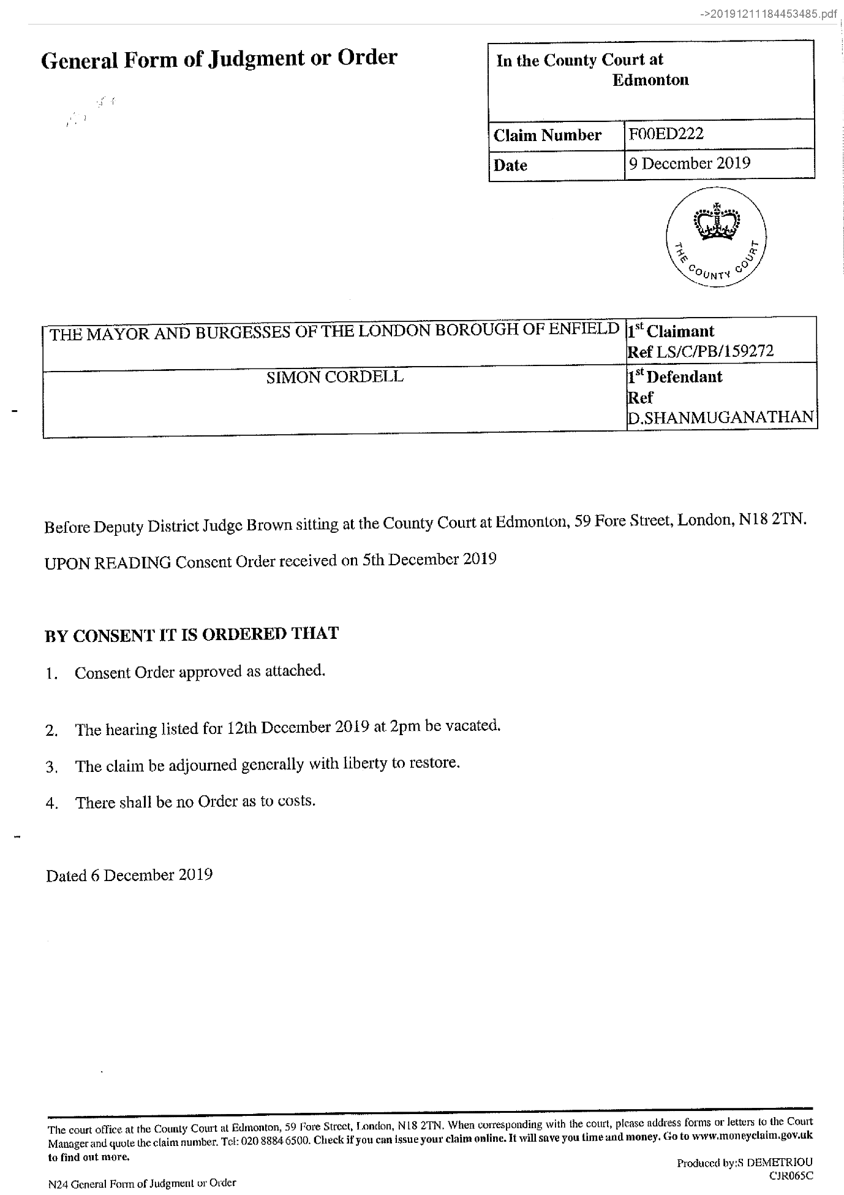
491,
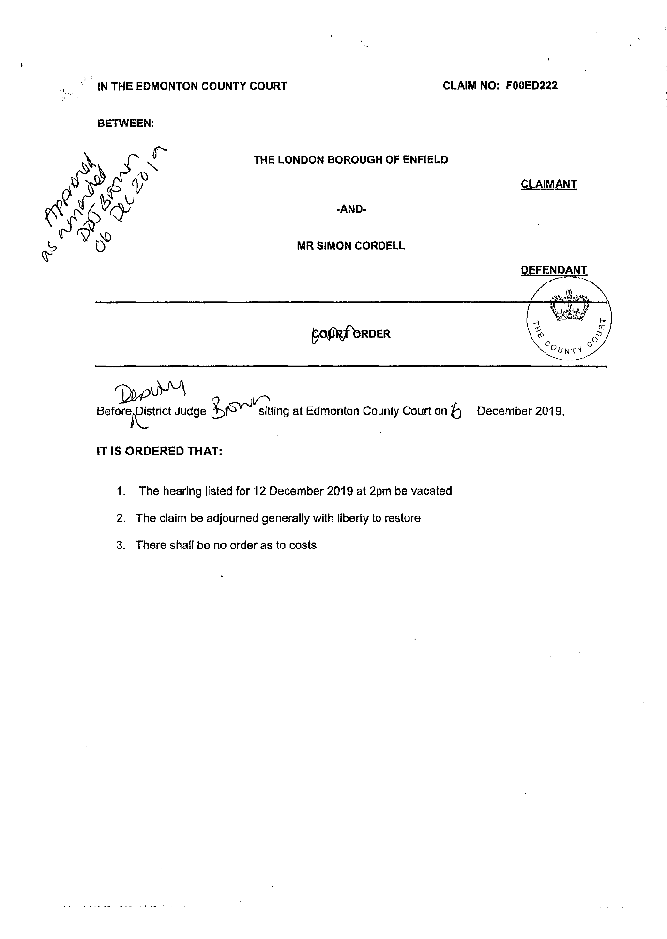
End of picture!

69.
- Additional Email Attachments & Emails / Issue:
69. 1. 1
Sean@tyrerroxburgh.co.uk_12.11.2019__001 3
11/12/2019
/ Page Numbers: 492,493,494
--
492,
From: Sean Shanmuganathan <sean@tyrerroxburgh.co.uk>
Sent: 11 December 2019 17:35
To: lorraine32@blueyonder.co.uk
Attachments: 20191211184453485.pdf
Dear Lorraine
Please see the attached the order.
D Shanmuganathan Partner
Tel +44 (0)20 8889 3319
Direct Dial +44 (0)20 8829 2943
1 St Michaels Terrace
London
N22 7SJ
DX 34704 WOOD GREEN 2
Tel +44 (0)20 8889 3319
Fax +44 (0)20 8881 6089
www.tyrerroxburgh.co.uk
Christmas Opening Hours
The office will close on Tuesday 24th December 2019 at 13:00pm- reopening at 09:00am on Thursday 2nd January 2020 at 9.00am We wish you a Merry Christmas and a Happy New Year
Authorised by the Solicitors Regulation Authority. Tyrer Roxburgh Solicitors LLP is a limited liability partnership under the no.560748. A list of the members' names is open to inspection at the registered office.
VAT REG No: 221 8088 78
SRA No: 560748
Contracted with the Legal Aid Agency
We do not accept service of documents or other process by e-mail Email us at lawmakers@tyrerroxburgh.co.uk
This message may contain privileged information and is only intended to be received by the person to whom it is addressed.
If you are not the intended recipient, please contact us as soon as possible.
Partners P Mukesh Badhan D Shanmuganathan - Vasoulla Constantinou
493,
494,
End of picture!

70.
Additional Email Attachments & Emails / Issue:
70. 1. 1
lorraine32@blueyonder Cordell Claim Number
FOOED222 1
11/12/2019
/ Page Numbers: 495
--
495,
From: Lorraine Cordell <lorraine32@blueyonder.co.uk>
Sent: 11 December 2019 23:41
To: 'Kulwinder.Johal@enfield.gov.uk'
Subject: RE: Simon Cordell Claim Number FOOED222
Dear Kulwinder Johal
I am writing this email with regard to a telephone call that I received tonight from my son Mr Simon Cordell solicitor, Tyrer Roxburgh Solicitors.
I was forwarded a court order dated the 09/12/2019 from Edmonton Country Court, heard on the 06/12/2019.
It would seem that Edmonton Country Court received a consent order at the court on the 5th December 2019, and Deputy District Judge Brown made a court order on the 06/12/2019.
Can you please forward this consent order over via this email ASAP as we have never seen it yet alone agreed to it or signed it? As you will be aware, no consent order has been agreed upon or signed, so how has the court been sent a consent order by you?
Regards
Lorraine Cordell

Simon Cordell’s MP3’S Indexed
Stage 1
1x Recording
01m. Jeremy passed to Deion grant 11_12_2019 time 09_42
Page Number: Update Page Number 1,
Update

The banging Started!

Summary!

Disrepair!

Time Spent Building.
In the background of everything going on I could no longer work on my first company Too Smooth due to the amount of time I had to put toward s defending myself.
My mother Stopped working on my website
Working at Home doing Court Case Defense Work!
I spent time and recourses costing expenditure building my defence case and website Horrific Corruption.com, against the allegations getting put against me at the Time Start: 00:00 and Time End: 00:00

Thursday!
12/12/2019

Stain and the
Issues with Housing Disrepair!
Working on the Court Case Defence!
The Anti-Social Behaviour Order Case and the Verdict got made Guilty against me in error and the conditions got imposed against me till late 2020!
The Banging Continued: -
12/12/2019

- Disrepair!
- The Asbo Order got granted in Error with Full Conditions against me and Fraudulently!
- The banging Continued at me!
- Working at home!

- 113 Burncroft Avenue
Richard Continued to victimise me the same way the past occupiers had prior!
“Re-Vacated”

- 117 Burncroft Avenue
The 3rd set of Tenant’s since the Problems Started with the Flat being used as an Offensives Weapons against my Person and against my free will.
has been “Re-Vacated” again by John Iron

71.
Additional Email Attachments & Emails / Issue:
71. 1. 1
enquiries.edmonton.countycourt@justice.gov.uk
12.12.2019_Auto reply
12/12/2019
/ Page Numbers: 496,497,498

72.
- Additional Email Attachments & Emails / Issue:
72. 1. 1
enquiries.edmonton.countycourt@justice.gov.uk
12.12.2019_Auto reply_001
12/12/2019
/ Page Numbers: 499,500,501

73.
- Additional Email Attachments & Emails / Issue:
73. 1. 1
enquiries.edmonton.countycourt@justice.gov.uk_
12.12.2019_Read RE FOOED222
Enfield Council V Simon Cordell
12/12/2019
/ Page Numbers: 502,503

74.
- Additional Email Attachments & Emails / Issue:
74. 1. 1
Kulwinder.Johal@enfield.gov.uk_
12.12.2019_Automatic reply RE Simon Cordell Claim Number FO
12/12/2019
/ Page Numbers: 504

75.
- Additional Email Attachments & Emails / Issue:
75. 1. 1
Kulwinder.Johal@enfield.gov.uk_
12.12.2019_RE RE Simon Cordell Claim Number FOOED222 Author
12/12/2019
/ Page Numbers: 505,506

76.
- Additional Email Attachments & Emails / Issue:
76. 1. 1
Kulwinder.Johal@enfield.gov.uk_
12.12.2019_Read RE Simon Cordell Claim Number FOOED222 Auth
12/12/2019
/ Page Numbers: 507,508

77.
- Additional Email Attachments & Emails / Issue:
77. 1. 1
Kulwinder.Johal@enfield.gov.uk_
12.12.2019_Read Simon Cordell Claim Number FOOED222
12/12/2019
/ Page Numbers: 509,510

78.
- Additional Email Attachments & Emails / Issue:
78. 1. 1
lorraine32@blueyonder.co.uk_
12.12.2019_
RE FOOED222 Enfield Council V Simon Cordell
12/12/2019
/ Page Numbers: 511,512,513,514,515,516,517,518

79.
- Additional Email Attachments & Emails / Issue:
79. 1. 1
lorraine32@blueyonder.co.uk_
12.12.2019_FW RE Simon Cordell Claim Number FOOED222
12/12/2019
/ Page Numbers: 519,520,521,522

80.
- Additional Email Attachments & Emails / Issue:
80. 1. 1
lorraine32@blueyonder.co.uk_
12.12.2019_FW RE Simon Cordell Claim Number FOOED222_001
12/12/2019
/ Page Numbers: 523,524,525,526

81.
- Additional Email Attachments & Emails / Issue:
81. 1. 1
lorraine32@blueyonder.co.uk_
12.12.2019_RE FOOED222 Enfield Council V Simon Cordell_001
12/12/2019
/ Page Numbers: 527,528,529,530,531,532

82.
- Additional Email Attachments & Emails / Issue:
82. 1. 1
lorraine32@blueyonder.co.uk_
12.12.2019_RE RE Simon Cordell Claim Number FOOED222 Author
12/12/2019
/ Page Numbers: 533,534,535

83.
- Additional Email Attachments & Emails / Issue:
83. 1. 1
lorraine32@blueyonder.co.uk_
12.12.2019_RE RE Simon Cordell Claim Number FOOED222 Author_001
12/12/2019
/ Page Numbers: 536,537,538

84.
- Additional Email Attachments & Emails / Issue:
84. 1. 1
lorraine32@blueyonder.co.uk_
12.12.2019_RE RE Simon Cordell Claim Number FOOED222
12/12/2019
/ Page Numbers: 539,540,541,542,543

85.
- Additional Email Attachments & Emails / Issue:
85. 1. 1
lorraine32@blueyonder.co.uk_
12.12.2019_RE RE Simon Cordell Claim Number FOOED222_001
12/12/2019
/ Page Numbers: 544,545,546,547

--

Possession Order day in Court
I did not have to attended the court house on this day due to the fact that there was

71.
Additional Email Attachments & Emails / Issue:
71. 1. 1
enquiries.edmonton.countycourt@justice.gov.uk
12.12.2019_Auto reply
12/12/2019
/ Page Numbers: 496,497,498
--
496,
From: Edmonton County, Enquiries <enquiries.edmonton.countycourt@justice.gov.uk>
Sent: 12 December 2019 09:35
To: Lorraine Cordell
Subject: Auto reply
** IMPORTANT NOTICE ON EMAIL COMMUNICATIONS **
Thank you for your email, which has been received by the court. Depending on the nature of your email you may receive a response via email or post.
What documents can be sent by email?
You can send all letters and documents relevant to the case including adoption cases. However, due to the sensitive nature of adoption work the court will only send emails to secure email accounts. If a hard copy of a document has been filed at court by DX or Post, an electronic copy should not be sent. As yet please note that court bundles are not part of this process and will not be printed.
For more information regarding e-mails please go to the following http://www.justice.gov.uk/courts/email-guidance What is a secure email account?
An email account is considered secure when security measures are in place to make sure the data in the email can’t be accessed by users without the relevant approval. Any account that ends in the following is considered secured: gsi, pnn, gsx, gcsx, gse, cjsm, and nhs.net.
What emails will HMCTS accept?
To make sure we operate this service as efficiently and effectively as possible there are exemptions.
All Civil and Family process, applications and documents will be accepted by email as long as when the entire email is printed out it is not more than 50 pages. This should include the email, all attachments (including any documents embedded in another) and enough copies to serve on required parties.
Please note that:
- A page is one side, so 50 pages equals 25 pieces of paper printed on both sides.
- Do not use more than one email to take any step in a case which requires a document or documents to be filed.
DOCUMENTS FOR HEARINGS IN ACCORDANCE WITH
CIVIL PROCEDURE RULES PD, 5B.2. FAMILY PROCEDURE RULE PD 5B
You have received an order to attend court for a hearing.
It would greatly assist the court staff if you could ensure documents you file into court have a hearing date endorsed on the covering letter, paperwork or email.
This will then enable the court staff to identify the document is placed on file in readiness for the hearing.
Please note, if the court is unaware of the pending hearing, when you file your documents, this may result in the document not reaching the court file in time for the hearing.
Can processes that carry a fee be sent by email?
In both Civil and Family cases court processes that carry a fee can also be received by email and processed by court staff. However the same conditions as above must apply and in addition the party issuing the process must either quote a Fee Account number, or the party who wants to pay has a valid credit or debit card. If you wish to pay using this method, please say this on the
497,
email and include a contact number for the Court to contact you to take payment.
What is Fee Account?
This is a Direct Debit function that is quick, safe and easy to use. It is available for solicitors and large organisations. Once you have set up an account all you need is to provide your fee account number within the body of the email. The fee will then be deducted from your account. For more information and to apply for Fee Account please visit www.justice.gov.uk/courts/fees/payment-by-account.
Any document submitted that breaches any of the above terms will remain unprocessed. This is in line with Court Practice Directions 5BPD.1 - 5BPD.9.3.
When you email the court the subject line of your mail must contain (in the following order): -
- The claim numbers
- The title of the claim (abbreviated if necessary) **
- The subject matter (e.g. defence)
- If relating to a hearing the date and time of hearing in bold black
- The judge’s name, where the correspondence/document is for their attention
**If your email is in relation to a family matter, please refer to the initials only.
Your message should also contain the name, telephone number and email address of the sender. Correspondence and documents may be sent as either text or attachments. Where there is a practice form, it must be sent in that form by attachment. The complete email (including any attachment(s)) must not exceed 10Mb.
The rest of this automated message provides information that customers often find useful.
Edmonton County Court
The public counter services are no longer available at this court.
Urgent applications and processes that need to be dealt with in person will be through an appointment only system. Users should contact the court on 0208 8846510 between 9.00 am and 5.00 pm Monday to Friday to make an appointment.
The main telephone number for Civil and Family enquiries is 0208 884 6500 Gold fax 0870 3240314
Our address is The County Court at Edmonton, 59 Fore Street, Edmonton, London, N18 2TN DX 136686 Edmonton 3
The court building is open between 9.00 am and 4.00 pm Monday to Friday.
We have a secure drop box located in reception for personal deliveries to the court, which is opened once a day at 9.00 am Monday to Friday.
Website links
Information on Court forms and fees can be also be obtained from www.justice.gov.uk Issuing a claim for Money or Possession of Property - MCOL & PCOL
498,
If you would like to issue a claim for money or property you can do so 24 hours a day, 7 days a week by visiting: www.moneydaim.gov.uk or www.possessionclaim.gov.uk.You will save money by issuing a claim for possession of property or a money claim online rather than sending it to the court.
Legal Advice
If you are uncertain how to proceed, the Civil Procedure Rules available on the Ministry of Justice website - http://www.justice.gov.uk - provide details. On many occasions it is best for people to seek professional legal advice from a solicitor, legal executive, legal advice agency or Citizens Advice Bureau. You can also contact Civil Legal Advice on 0845 345 4 345 or via their website.
For information on how HMCTS uses personal data about you please see:
https://www.gov.uk/government/organisations/hm-courts-and-tribunals-service/about/personal-information-charter
This e-mail and any attachments are intended only for the attention of the addressee(s). Its unauthorised use, disclosure, storage, or copying is not permitted. If you are not the intended recipient, please destroy all copies and inform the sender by return e-mail. Internet e-mail is not a secure medium. Any reply to this message could be intercepted and read by someone else. Please bear that in mind when deciding whether to send material in response to this message by e-mail. This e-mail (whether you are the sender or the recipient) may be monitored, recorded, and retained by the Ministry of Justice. Monitoring / blocking software may be used, and e-mail content may be read at any time. You have a responsibility to ensure laws are not broken when composing or forwarding e-mails and their contents.

72.
Additional Email Attachments & Emails / Issue:
72. 1. 1
enquiries.edmonton.countycourt@justice.gov.uk
12.12.2019_Auto reply_001
12/12/2019
/ Page Numbers: 499,500,501
--
499,
From: Edmonton County, Enquiries <enquiries.edmonton.countycourt@justice.gov.uk>
Sent: 12 December 2019 00:00
To: Lorraine Cordell
Subject: Auto reply
** IMPORTANT NOTICE ON EMAIL COMMUNICATIONS **
Thank you for your email, which has been received by the court. Depending on the nature of your email you may receive a response via email or post.
What documents can be sent by email?
You can send all letters and documents relevant to the case including adoption cases. However, due to the sensitive nature of adoption work the court will only send emails to secure email accounts. If a hard copy of a document has been filed at court by DX or Post, an electronic copy should not be sent. As yet please note that court bundles are not part of this process and will not be printed.
For more information regarding e-mails please go to the following http://www.justice.gov.uk/courts/email-guidance What is a secure email account?
An email account is considered secure when security measures are in place to make sure the data in the email can’t be accessed by users without the relevant approval. Any account that ends in the following is considered secured: gsi, pnn, gsx, gcsx, gse, cjsm, and nhs.net.
What emails will HMCTS accept?
To make sure we operate this service as efficiently and effectively as possible there are exemptions.
All Civil and Family process, applications and documents will be accepted by email as long as when the entire email is printed out it is not more than 50 pages. This should include the email, all attachments (including any documents embedded in another) and enough copies to serve on required parties.
Please note that:
- A page is one side, so 50 pages equals 25 pieces of paper printed on both sides.
- Do not use more than one email to take any step in a case which requires a document or documents to be filed.
DOCUMENTS FOR HEARINGS IN ACCORDANCE WITH
CIVIL PROCEDURE RULES PD, 5B.2. FAMILY PROCEDURE RULE PD 5B
You have received an order to attend court for a hearing.
It would greatly assist the court staff if you could ensure documents you file into court have a hearing date endorsed on the covering letter, paperwork, or email.
This will then enable the court staff to identify the document is placed on file in readiness for the hearing.
Please note, if the court is unaware of the pending hearing, when you file your documents, this may result in the document not reaching the court file in time for the hearing.
Can processes that carry a fee be sent by email?
In both Civil and Family cases court processes that carry a fee can also be received by email and processed by court staff. However the same conditions as above must apply and in addition the party issuing the process must either quote a Fee Account number, or the party who wants to pay has a valid credit or debit card. If you wish to pay using this method, please say this on the
500,
email and include a contact number for the Court to contact you to take payment.
What is Fee Account?
This is a Direct Debit function that is quick, safe, and easy to use. It is available for solicitors and large organisations. Once you have set up an account all you need is to provide your fee account number within the body of the email. The fee will then be deducted from your account. For more information and to apply for Fee Account please visit www.justice.gov.uk/courts/fees/payment-by-account.
Any document submitted that breaches any of the above terms will remain unprocessed. This is in line with Court Practice Directions 5BPD.1 - 5BPD.9.3.
When you email the court the subject line of your mail must contain (in the following order): -
- The claim numbers
- The title of the claim (abbreviated if necessary) **
- The subject matter (e.g. defence)
- If relating to a hearing the date and time of hearing in bold black
- The judge’s name, where the correspondence/document is for their attention
**If your email is in relation to a family matter, please refer to the initials only.
Your message should also contain the name, telephone number and email address of the sender. Correspondence and documents may be sent as either text or attachments. Where there is a practice form, it must be sent in that form by attachment. The complete email (including any attachment(s)) must not exceed 10Mb.
The rest of this automated message provides information that customers often find useful.
Edmonton County Court
The public counter services are no longer available at this court.
Urgent applications and processes that need to be dealt with in person will be through an appointment only system. Users should contact the court on 0208 8846510 between 9.00 am and 5.00 pm Monday to Friday to make an appointment.
The main telephone number for Civil and Family enquiries is 0208 884 6500 Gold fax 0870 3240314
Our address is The County Court at Edmonton, 59 Fore Street, Edmonton, London, N18 2TN DX 136686 Edmonton 3
The court building is open between 9.00 am and 4.00 pm Monday to Friday.
We have a secure drop box located in reception for personal deliveries to the court, which is opened once a day at 9.00 am Monday to Friday.
Website links
Information on Court forms and fees can be also be obtained from www.justice.gov.uk Issuing a claim for Money or Possession of Property - MCOL & PCOL
501,
If you would like to issue a claim for money or property you can do so 24 hours a day, 7 days a week by visiting: www.moneydaim.gov.uk or www.possessionclaim.gov.uk.You will save money by issuing a claim for possession of property or a money claim online rather than sending it to the court.
Legal Advice
If you are uncertain how to proceed, the Civil Procedure Rules available on the Ministry of Justice website - http://www.justice.gov.uk - provide details. On many occasions it is best for people to seek professional legal advice from a solicitor, legal executive, legal advice agency or Citizens Advice Bureau. You can also contact Civil Legal Advice on 0845 345 4 345 or via their website.
For information on how HMCTS uses personal data about you please see:
https://www.gov.uk/government/organisations/hm-courts-and-tribunals-service/about/personal-information-charter
This e-mail and any attachments are intended only for the attention of the addressee(s). Its unauthorised use, disclosure, storage, or copying is not permitted. If you are not the intended recipient, please destroy all copies and inform the sender by return e-mail. Internet e-mail is not a secure medium. Any reply to this message could be intercepted and read by someone else. Please bear that in mind when deciding whether to send material in response to this message by e-mail. This e-mail (whether you are the sender or the recipient) may be monitored, recorded, and retained by the Ministry of Justice. Monitoring / blocking software may be used, and e-mail content may be read at any time. You have a responsibility to ensure laws are not broken when composing or forwarding e-mails and their contents.

73.
Additional Email Attachments & Emails / Issue:
73. 1. 1
enquiries.edmonton.countycourt@justice.gov.uk_
12.12.2019_Read RE FOOED222
Enfield Council V Simon Cordell
12/12/2019
/ Page Numbers: 502,503
--
502,
From: Edmonton County, Enquiries <enquiries.edmonton.countycourt@justice.gov.uk>
Sent: 12 December 2019 09:41
To: Lorraine Cordell
Subject: Read: RE: FOOED222 Enfield Council V Simon Cordell
Attachments: Read: RE: FOOED222 Enfield Council V Simon Cordell (10.1KB)
Importance: High
This e-mail and any attachments are intended only for the attention of the addressee(s). Its unauthorised use, disclosure, storage, or copying is not permitted. If you are not the intended recipient, please destroy all copies and inform the sender by return e-mail. Internet e-mail is not a secure medium. Any reply to this message could be intercepted and read by someone else. Please bear that in mind when deciding whether to send material in response to this message by e-mail. This e-mail (whether you are the sender or the recipient) may be monitored, recorded, and retained by the Ministry of Justice. Monitoring / blocking software may be used, and e-mail content may be read at any time. You have a responsibility to ensure laws are not broken when composing or forwarding e-mails and their contents.
503,
Read: RE: FOOED222 Enfield Council V Simon Cordell->Read_ RE_ FOOED222 Enfield Council V Simon Cordell (10.1 KB).msg
From: Edmonton County, Enquiries [enquiries.edmonton.countycourt@justice.gov.uk]
To: Lorraine Cordell
Sent: 12 December 2019 09:41:13
Subject: Read: RE: FOOED222 Enfield Council V Simon Cordell Your message
To: Edmonton County, Enquiries
Subject: RE: FOOED222 Enfield Council V Simon Cordell
Sent: 12/12/2019 00:00
was read on 12/12/2019 09:41

74.
Additional Email Attachments & Emails / Issue:
74. 1. 1
Kulwinder.Johal@enfield.gov.uk_
12.12.2019_Automatic reply RE Simon Cordell Claim Number FO
12/12/2019
/ Page Numbers: 504
--
504,
From: Kulwinder Johal <Kulwinder.Johal@enfield.gov.uk>
Sent: 12 December 2019 20:11
To: Lorraine Cordell
Subject: Automatic reply: RE: Simon Cordell
Claim Number: FOOED222
I am on annual leave on 13, 16 and 17 December 2019. I shall return to the office on 18 December. During my absence I will not have access to my emails until my return. If your matter is urgent please refer to Antonia Makanjuola on Antonia.makanjuola@enfield.gov.uk or Jill Bayley on Jill.Bayley@enfield.gov.uk.
Kind regards,
Enfield Council is committed to serving the whole borough fairly, delivering excellent services and building strong communities. Opinions expressed in this email are those of the individual and not necessarily those of the London Borough of Enfield. This email and any attachments or files transmitted with it are strictly confidential and intended solely for the named addressee. It may contain privileged and confidential information and if you are not the intended recipient and receive it in error you must not copy, distribute, or use the communication in any other way. All traffic handled by the Government Connect Secure Extranet may be subject to recording/and or monitoring in accordance with relevant legislation.
This email has been scanned for viruses, but we cannot guarantee that it will be free of viruses or malware. The recipient should perform their own virus checks.
Disclaimer
The information contained in this communication from the sender is confidential. It is intended solely for use by the recipient and others authorized to receive it. If you are not the recipient, you are hereby notified that any disclosure, copying, distribution or taking action in relation of the contents of this information is strictly prohibited and may be unlawful.
This email has been scanned for viruses and malware, and may have been automatically archived by Mimecast Ltd, an innovator in Software as a Service (SaaS) for business. Providing a safer and more useful place for your human generated data. Specializing in; Security, archiving and compliance.

75.
Additional Email Attachments & Emails / Issue:
75. 1. 1
Kulwinder.Johal@enfield.gov.uk_
12.12.2019_RE RE Simon Cordell Claim Number FOOED222 Author
12/12/2019
/ Page Numbers: 505,506
--
505,
From: Kulwinder Johal <Kulwinder.Johal@enfield.gov.uk>
Sent: 12 December 2019 09:41
To: Lorraine Cordell; ronak@tyrerroxburgh.co.uk
Subject: RE: RE: Simon Cordell
Claim Number FOOED222 Authority
Dear Ms Cordell and Mr Ahmed,
Further to Ms Cordell's emails this morning (see below) I am writing to refer the matter to Mr Ahmed, who will advise you. I have included Mr Ahmed into this email for completeness.
Mr Ahmed - I trust that you will advise Ms Cordell.
Yours sincerely,
Kulwinder Johal
Litigation Lawyer |Corporate Team | Legal Services On behalf of the Director of Law and Governance
PO Box 50, Civic Centre, Silver Street, Enfield EN1 3XA
Enfield Council is committed to serving the whole borough fairly, delivering excellent services and building strong communities.
Legal advice in this email is given on behalf of the Assistant Director of Legal Services; it is subject to legal professional privilege and should not be disclosed without expressed prior authorisation.
From: Lorraine Cordell <lorraine32@blueyonder.co.uk>
Sent: 12 December 2019 09:12
To: Kulwinder Johal <Kulwinder.Johal@enfield.gov.uk>
Subject: RE: RE: Simon Cordell Claim Number FOOED222 Authority
Importance: High
Dear Kulwinder Johal
Please see attached letter of Authority, could you please send me over the letters, which have been sent to the court.
Regards
Lorraine Cordell on behalf of Simon Cordell
From: Lorraine Cordell mailto: lorraine32@bluevonder.co.uk
Sent: 11 December 2019 23:41
To: 'Kulwinder.Johal@enfield.gov.uk'
Subject: RE: Simon Cordell Claim Number FOOED222
Dear Kulwinder Johal
I am writing this email with regard to a telephone call that I received tonight from my son Mr Simon Cordell solicitor, Tyrer Roxburgh Solicitors.
506,
I was forwarded a court order dated the 09/12/2019 from Edmonton Country Court, heard on the 06/12/2019.
It would seem that Edmonton Country Court received a consent order at the court on the 5 th December 2019, and Deputy District Judge Brown made a court order on the 06/12/2019.
Can you please forward this consent order over via this email ASAP as we have never seen it yet alone agreed to it or signed it? As you will be aware, no consent order has been agreed upon or signed, so how has the court been sent a consent order by you?
Regards Lorraine Cordell
Enfield Council is committed to serving the whole borough fairly, delivering excellent services and building strong communities. Opinions expressed in this email are those of the individual and not necessarily those of the London Borough of Enfield. This email and any attachments or files transmitted with it are strictly confidential and intended solely for the named addressee. It may contain privileged and confidential information and if you are not the intended recipient and receive it in error you must not copy, distribute, or use the communication in any other way. All traffic handled by the Government Connect Secure Extranet may be subject to recording/and or monitoring in accordance with relevant legislation.
This email has been scanned for viruses, but we cannot guarantee that it will be free of viruses or malware. The recipient should perform their own virus checks.
Disclaimer
The information contained in this communication from the sender is confidential. It is intended solely for use by the recipient and others authorized to receive it. If you are not the recipient, you are hereby notified that any disclosure, copying, distribution or taking action in relation of the contents of this information is strictly prohibited and may be unlawful.
This email has been scanned for viruses and malware, and may have been automatically archived by Mimecast Ltd, an innovator in Software as a Service (SaaS) for business. Providing a safer and more useful place for your human generated data. Specializing in; Security, archiving and compliance.

76.
Additional Email Attachments & Emails / Issue:
76. 1. 1
Kulwinder.Johal@enfield.gov.uk_
12.12.2019_Read RE Simon Cordell Claim Number FOOED222 Auth
12/12/2019
/ Page Numbers: 507,508
--
507,
From: Kulwinder Johal <Kulwinder.Johal@enfield.gov.uk>
Sent: 12 December 2019 10:17
To: Lorraine Cordell
Subject: Read: RE: Simon Cordell
Claim Number: FOOED222 Authority
Attachments: Read: RE: Simon Cordell
Claim Number: FOOED222 Authority (10.9 KB)
[Campaign]
www.enfield.gov.uk
http://www.enfield.gov.uk
Enfield Council is committed to serving the whole borough fairly, delivering excellent services and building strong communities. Opinions expressed in this email are those of the individual and not necessarily those of the London Borough of Enfield. This email and any attachments or files transmitted with it are strictly confidential and intended solely for the named addressee. It may contain privileged and confidential information and if you are not the intended recipient and receive it in error you must not copy, distribute, or use the communication in any other way. All traffic handled by the Government Connect Secure Extranet may be subject to recording/and or monitoring in accordance with relevant legislation.
This email has been scanned for viruses, but we cannot guarantee that it will be free of viruses or malware. The recipient should perform their own virus checks.
508,
Read: RE: Simon Cordell Claim Number FOOED222 Authority->Read_ RE_ Simon Cordell Claim Number FOOED222 Authority (10.9 KB).msg
From: Kulwinder Johal [Kulwinder.Johal@enfield.gov.uk]
To: Lorraine Cordell
Sent: 12 December 2019 10:16:36
Subject: Read: RE: Simon Cordell Claim Number FOOED222 Authority
Attachments: winmail.dat (6 KB)

77.
Additional Email Attachments & Emails / Issue:
77. 1. 1
Kulwinder.Johal@enfield.gov.uk_
12.12.2019_Read Simon Cordell Claim Number FOOED222
12/12/2019
/ Page Numbers: 509,510
--
509,
From: Kulwinder Johal <Kulwinder.Johal@enfield.gov.uk>
Sent: 12 December 2019 07:46
To: Lorraine Cordell
Subject: Read: Simon Cordell Claim Number FOOED222
Attachments: Simon Cordell Claim Number FOOED222 (10.7KB)
[Campaign]
www.enfield.gov.uk
http://www.enfield.gov.uk
Enfield Council is committed to serving the whole borough fairly, delivering excellent services and building strong communities. Opinions expressed in this email are those of the individual and not necessarily those of the London Borough of Enfield. This email and any attachments or files transmitted with it are strictly confidential and intended solely for the named addressee. It may contain privileged and confidential information and if you are not the intended recipient and receive it in error you must not copy, distribute, or use the communication in any other way. All traffic handled by the Government Connect Secure Extranet may be subject to recording/and or monitoring in accordance with relevant legislation.
This email has been scanned for viruses, but we cannot guarantee that it will be free of viruses or malware. The recipient should perform their own virus checks.
510,
Read: Simon Cordell Claim Number FOOED222-> Simon Cordell Claim Number FOOED222 (10.7 KB).msg
From: Kulwinder Johal [Kulwinder.Johal@enfield.gov.uk]
To: Lorraine Cordell
Sent: 12 December 2019 07:45:30
Subject: Read: Simon Cordell Claim Number FOOED222
Attachments: winmail.dat (6 KB)

78.
Additional Email Attachments & Emails / Issue:
78. 1. 1
lorraine32@blueyonder.co.uk_
12.12.2019_
RE FOOED222 Enfield Council V Simon Cordell
12/12/2019
/ Page Numbers: 511,512,513,514,515,516,517,518
--
511,
From: Lorraine Cordell <lorraine32@blueyonder.co.uk>
Sent: 12 December 2019 09:34
To: 'Edmonton County, Enquiries'
Subject: RE: FOOED222 Enfield Council V Simon Cordell
Attachments: Simon-Cordell-authority-Letter-Edmonton-Country-Court-11-12-2019.pdf.
Claim Number FOOED22211-12-2019.pdf
20191211184453485.pdf
Importance: High
To Whom It May Concern:
Please see attached letter of complaint and a court order dated the 06/12/2019 regarding claim number FOOED222.
I have resent this email as I forgot to add the letter of authority. Please see attached documents.
Regards
Miss Lorraine Cordell on behalf of Mr Simon Cordell
512,
RE: FOOED222 Enfield Council V Simon Cordell->Simon_Cordell_authority_Letter-Edmonton-Country-Court-11-12-2019.pdf
Mr Simon Cordell 109 Burncroft Ave Enfield Middlesex EN3 7JQ 11/12/2019
RE: Letter of Authority for my mother Miss Lorraine Cordell dated 11/12/2019
To whom it may concern:
I Mr Simon Paul Cordell of 109 Burncroft Ave, Enfield EN3 7JQ am writing this letter to confirm I give authority for my mother Miss Lorraine Cordell to speak or send any data or letters and for my mother to receive any information requested from Edmonton Country Court, regarding Claim Number FOOED222. In addition, any other court applications Enfield Council has submitted to Edmonton Country Court against me Mr Simon Cordell
I also agree my mother can request to see the complete files held via the court for any applications Enfield Council has made against me.
I have the right to withdraw my authority for my mother Miss Lorraine Cordell at any time I wish to do so.
Contact can be made to my mother Miss Lorraine Cordell via the information below and you may speak to her or send data what is being asked for on my behalf.
Phone: 07807 3335454
Email: lorraine32@blueyonder.co.uk
Letter: 23 Byron Terrace, Edmonton, London N9 7DG
1
513,
Regards
Simon Cordell
2
514,
RE: FOOED222 Enfield Council V Simon Cordell->Claim Number FOOED222 11-12-2019.pdf
- Complaint: Fraudulent Consent Order in Claim Number FOOED222:
- 11th December 2019
To Whom It May Concern:
I am writing this email after I got a call from my son’s Mr Simon Cordell’s solicitor, Tyrer Roxburgh Solicitors at around 17:20 hours on the 11thDecember 2019. The solicitors are no longer acting due to legal aid being removed, which The Mayor and Burgesses of the London Borough of Enfield are already aware of due to being told via my son’s solicitors.
I was informed that they had received a Court order today the 11th December 2019 regarding the hearing, which was listed for 12th December 2019 at 2pm at the County Court at Edmonton, under Claim Number FOOED222.
It would seem that The Mayor and Burgesses of the London Borough of Enfield has contacted the court via letter and a court order has been made on their behalf via Deputy District Judge Brown on the 06th December 2019. Please see attached Court Order.
The Mayor and Burgesses of the London Borough of Enfield sent a Consent Order received by the Court on 5th December 2019, and this is how Deputy District Judge Brown made the court order on the 06th December 2019.
I am upset regarding this Court Order, It is my believe a Consent Order would need to be signed and agreed by all parties, in the Claim Number FOOED222, this has not happened therefore I believe it is a Fraudulent Consent Order that has been submitted to the court, which was never agreed to or signed.
I know my son Mr Simon Cordell also his solicitor Tyrer Roxburgh Solicitors have not signed and agreed to any Consent Order for Claim Number FOOED222.
So how has, The Mayor and Burgesses of the London Borough of Enfield sent a Consent Order to the court, which was received by the Court on 5th December 2019. Then a court order made from this Consent Order when only one party has signed it, no agreement made by the parties involved in
1
515,
this case. It is me believe it is the rule of law that all parties have to agree and sign a Consent Order for the court to be able to accept it.
Neither my son nor his solicitors Tyrer Roxburgh Solicitors have seen this Consent Order so could the court please forward it to this email as soon as possible.
Also within the Court order dated the 09th December 2019, Deputy District Judge Brown has allowed the Claim Number FOOED222 to be adjourned generally with liberty to restore. There is no date set by the court by which time The Mayor And Burgesses of the London Borough of Enfield would need to restore this case, so in fact no End date for this Claim Number FOOED222 it would seem it is an unlimited case with no time limited set by the court.
How can this be allowed so by no date being placed on the court order, The Mayor And Burgesses of the London Borough of Enfield can wait five or Ten years or a lifetime and then decide to being this case back to court whenever they wish to do so.
This is not acceptable by any means, and would never have been agreed, I do not understand how a court could allow this.
My son is unwell which the court is aware, and to have this hanging over his head for the rest of his life I believe is unlawful and would make my son’s health worse, knowing whenever they want they can bring this case up again for the rest of his life.
District Judge Das warned The Mayor and Burgesses of the London Borough of Enfield about bring a Possession claim on the 09/08/2018. Yet all The Mayor and Burgesses of the London Borough of Enfield did was wait some months and then submitted the Possession claim to the court. Moreover, failed to comply with District Judge Das court order dated 09/08/2018.
The Mayor and Burgesses of the London Borough of Enfield acting solicitors wrote to my son’s solicitors Tyrer Roxburgh Solicitors the letter was dated 21/10/2019. The Mayor and Burgesses of the London Borough of Enfield had instructed their acting solicitors to discontinue the claim on the basis that each party bears their own costs. In addition, that could my son’s acting solicitors Tyrer Roxburgh Solicitors contact them as soon as possible so a suitable worded consent order maybe agreed.
The Mayor and Burgesses of the London Borough of Enfield would know my son is unwell and that someone should have been placed to act in his best interest, this is listed on court orders, from
2
516,
the court. This was due to happen on the 12thDecember 2019 hearing which Deputy District Judge Brown has now vacated.
This is not the first time The Mayor and Burgesses of the London Borough of Enfield has submitted a draft court order, which was not agreed. The Mayor and Burgesses of the London Borough of Enfield have had my son in the County Court at Edmonton three times different Claim Numbers for the same said alleged allegations, since 2017. The last case was dismissed, and The Mayor and Burgesses of the London Borough of Enfield are in breach of that court order. The Mayor and Burgesses of the London Borough of Enfield was meant to have moved my son yet have not; District Judge Das made this court order on the 09/08/2018.
My son has had no input regarding this court order dated 09th December 2019 that has been made, under a consent order via Deputy District Judge Brown.
Therefore, I am asking for the court order dated the 09thDecember 2019 is Set Aside in Claim Number FOOED222.
The court will have on file I Miss Lorraine Cordell has been trying to deal with cases for my son Mr Simon Cordell and this will be on record at the court. Since legal Aid has been withdrawn and The Mayor and Burgesses of the London Borough of Enfield know this fact I have been left to write this letter and try to deal with this serious matter.
I would also request to see the complete file on demand in Claim Number FOOED222 and this is my demand. I will attend the court as soon as a date is set to see the complete case file. This to be as soon as possible as I believe this cannot wait. In addition, we have not agreed to anything that The Mayor and Burgesses of the London Borough of Enfield have submitted to the court, and I would like this addressed.
I wait to hear from you regarding this most serious matter.
Regards
Miss Lorraine Cordell on behalf of Mr. Simon Cordell
3
517,
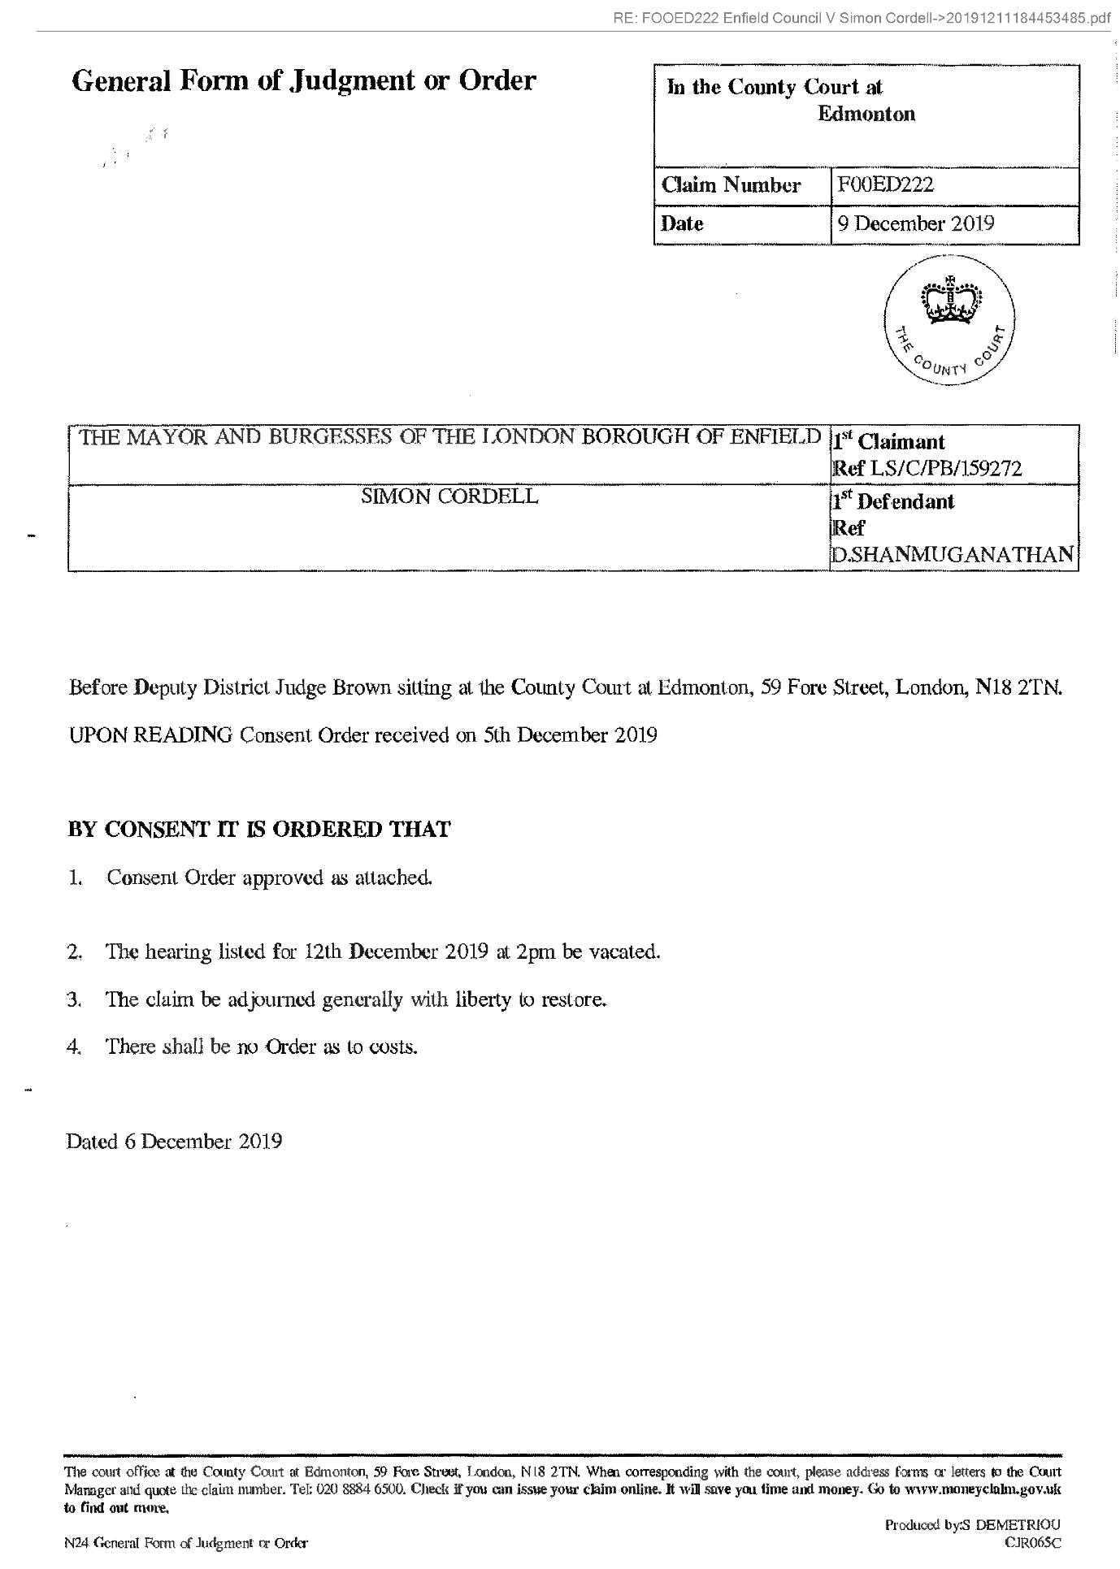
518,
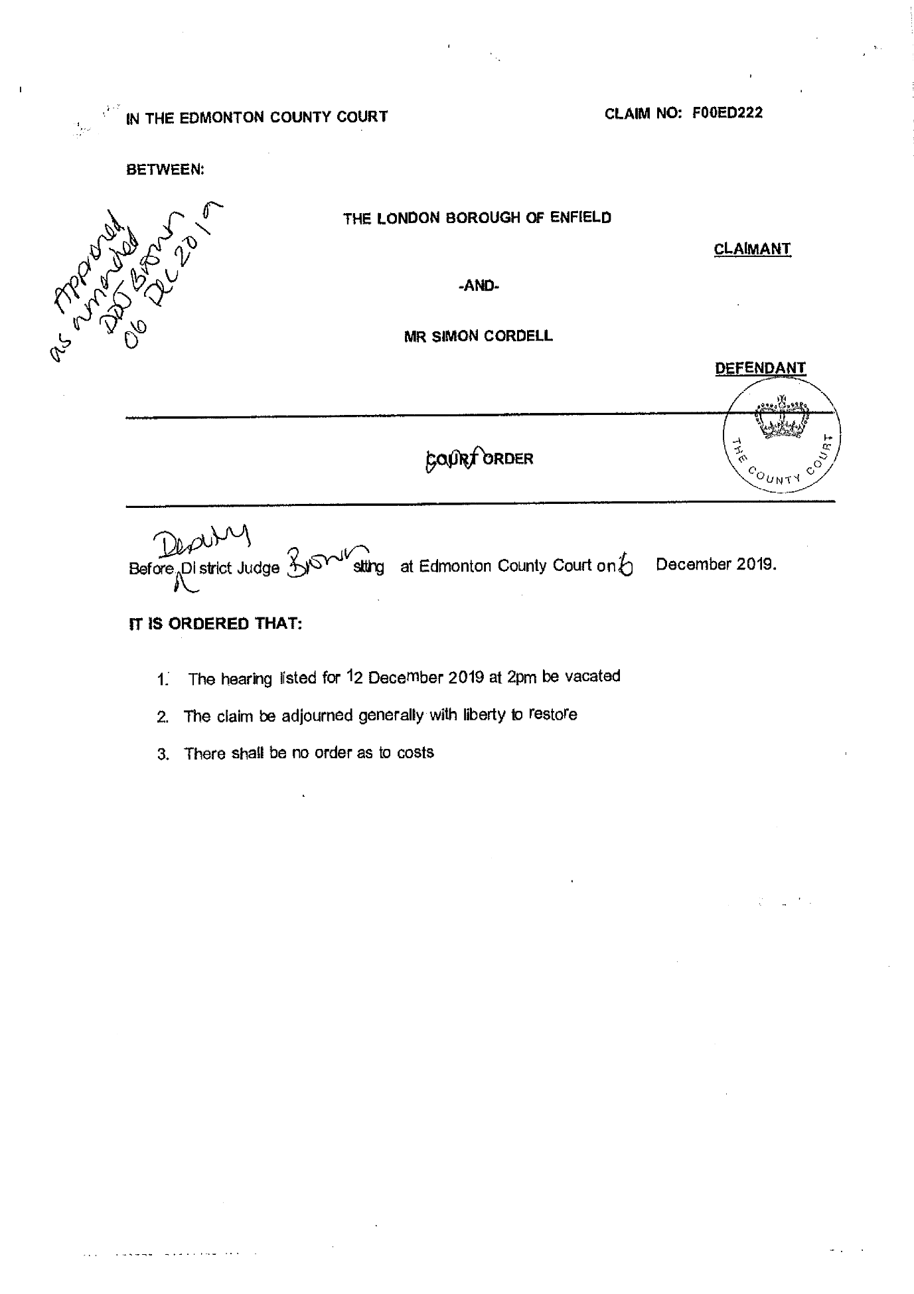
End of picture!

79.
Additional Email Attachments & Emails / Issue:
79. 1. 1
lorraine32@blueyonder.co.uk_
12.12.2019_FW RE Simon Cordell Claim Number FOOED222
12/12/2019
/ Page Numbers: 519,520,521,522
--
519,
From: Lorraine Cordell <lorraine32@blueyonder.co.uk>
Sent: 12 December 2019 13:46
To: Jill.bayley@enfield.gov.uk
Ronak Ahmed
Sean Shanmuganathan
Subject: FW: RE: Simon Cordell
Claim Number: FOOED222
Importance: High
Dear Jill Bayley
I have been given your email regarding an issue I have, I believe you are the manager of Kulwinder Johal, Kulwinder Johal is dealing with a case for Enfield Council which relates to my son Mr Simon Cordell.
It would seem a letter which was deemed by the court and Judge as a consent order was sent to the court by Kulwinder Johal. I have requested that the letter be sent to me via this email as we have never seen it.
I do have Authority to address things for my son Simon Cordell, but it would seem I am being ignored, which my request to be sent the letter that was sent to the court by Kulwinder Johal.
Please see below a list of emails sent which there has only been one reply, with all the information for the case.
Could you please address this matter as a matter of urgency?
I look forward to your reply to this matter.
Regards
Lorraine Cordell on behalf of Simon Cordell
From: Lorraine Cordell [mailto: lorraine32@blueyonder.co.uk]
Sent: 12 December 2019 11:44
To: 'Kulwinder Johal
Ronak Ahmed
Sean Shanmuganathan
Subject: RE: RE: Simon Cordell
Claim Number: FOOED222
Importance: High
Dear Kulwinder Johal
I know you have read the below email so cannot understand why you have not replied and sent over the letter sent to the court which they received on the 05/12/2019 and deemed it to be a consent order.
I have just made a call to Tyrer Roxburgh Solicitors who are no longer dealing with this case as legal aid was withdrawn which you will be aware of.
Mr Ahmed is on leave so I have asked Sean Shanmuganathan to call me back, as he is the one who called me last night to explain regarding the court order which was received in there office on the 11/12/2019 which he forwarded me the court order over via my email last night.
520,
I do not understand why you are not sending me the letter, which was sent to the court for this court order to be made up.
Could you please forward me the letter sent to the court. You did ask me on the phone call we had this morning you would need an Authority letter which you have had so there is no reason the letter cannot be sent to me, as you have had what you asked for.
In addition, can you please forward it to Sean Shanmuganathan sean@tyrerroxburgh.co.uk as he does know about my son's case and the letter can then be added to their file, as Mr Ahmed is on leave, he will not be able to deal with this until his return. I have CC in both Mr Ahmed and Sean Shanmuganathan all the emails.
Could this matter please be addressed as a matter of urgency?
Regards
Lorraine Cordell on behalf of Simon Cordell
From: Lorraine Cordell [mailto: lorraine32@blueyonder.co.uk]
Sent: 12 December 2019 10:10
To: 'Kulwinder Johal
Ronak Ahmed
Subject: RE: RE: Simon Cordell Claim Number FOOED222 Authority Dear Kulwinder Johal
As you will already be aware Legal Aid funding has been withdrawn from this case, as you stated in your in your letter dated the 21/10/2019 to Mr Ahmed, you had been instructed to discontinue the claim from your clients Enfield Council, so Mr Ahmed is no longer dealing with this matter.
You have had the letter of Authority, which you asked for on the phone today and received this, which has been confirmed in your below email. However, there has always been Authority on Enfield Councils systems for me to address matters for my son, Mr Simon Cordell.
I would like to see the letter that that has been sent to the court which the court received on the 05/12/2019, which the court has deemed as a consent order for claim number FOOED222. No consent order has been agreed or signed, so I cannot understand how Edmonton Country Court, more so a judge has deemed you letter as a consent order, which is stated in the court order dated 06/12/2019.
Also there is a large issue your client Enfield Council instructed you for this claim to be discontinue, I will state the court order is far from being discontinue as you have it would seem instructed the court for it to be adjourned generally with liberty to restore this is far from what your clients asked to be done on this case.
Regards
Lorraine Cordell on behalf of Simon Cordell
From: Kulwinder Johal [mailto:Kulwinder.Johal@enfield.gov.uk]
Sent: 12 December 2019 09:41
To: Lorraine Cordell; ronak@tyrerroxburgh.co.uk
Subject: RE: RE: Simon Cordell
Claim Number: FOOED222 Authority
521,
Dear Ms Cordell and Mr Ahmed,
Further to Ms Cordell's emails this morning (see below) I am writing to refer the matter to Mr Ahmed, who will advise you. I have included Mr Ahmed into this email for completeness.
Mr Ahmed - I trust that you will advise Ms Cordell.
Yours sincerely,
Kulwinder Johal
Litigation Lawyer |Corporate Team | Legal Services On behalf of the Director of Law and Governance
PO Box 50, Civic Centre, Silver Street, Enfield EN1 3XA
Enfield Council is committed to serving the whole borough fairly, delivering excellent services and building strong communities.
Legal advice in this email is given on behalf of the Assistant Director of Legal Services; it is subject to legal professional privilege and should not be disclosed without expressed prior authorisation.
From: Lorraine Cordell <lorraine32@blueyonder.co.uk>
Sent: 12 December 2019 09:12
To: Kulwinder Johal <Kulwinder.Johal@enfield.gov.uk>
Subject: RE: RE: Simon Cordell
Claim Number: FOOED222 Authority
Importance: High
Dear Kulwinder Johal
Please see attached letter of Authority, could you please send me over the letters, which have been sent to the court.
Regards
Lorraine Cordell on behalf of Simon Cordell
From: Lorraine Cordell mailto: lorraine32@bluevonder.co.uk
Sent: 11 December 2019 23:41
To: 'Kulwinder.Johal@enfield.gov.uk'
Subject: RE: Simon Cordell Claim Number FOOED222
Dear Kulwinder Johal
I am writing this email with regard to a telephone call that I received tonight from my son Mr Simon Cordell solicitor, Tyrer Roxburgh Solicitors.
I was forwarded a court order dated the 09/12/2019 from Edmonton Country Court, heard on the 06/12/2019.
It would seem that Edmonton Country Court received a consent order at the court on the 5th December 2019, and Deputy
522,
District Judge Brown made a court order on the 06/12/2019.
Can you please forward this consent order over via this email ASAP as we have never seen it yet alone agreed to it or signed it? As you will be aware, no consent order has been agreed upon or signed, so how has the court been sent a consent order by you?
Regards
Lorraine Cordell
Be the first to receive the latest Council news straight to your inbox
SIGN UP ONLINE NOW
www.enfield.gov.uk/enewsletters
Enfield Council is committed to serving the whole borough fairly, delivering excellent services and building strong communities. Opinions expressed in this email are those of the individual and not necessarily those of the London Borough of Enfield. This email and any attachments or files transmitted with it are strictly confidential and intended solely for the named addressee. It may contain privileged and confidential information and if you are not the intended recipient and receive it in error you must not copy, distribute, or use the communication in any other way. All traffic handled by the Government Connect Secure Extranet may be subject to recording/and or monitoring in accordance with relevant legislation.
This email has been scanned for viruses, but we cannot guarantee that it will be free of viruses or malware. The recipient should perform their own virus checks.
Disclaimer
The information contained in this communication from the sender is confidential. It is intended solely for use by the recipient and others authorized to receive it. If you are not the recipient, you are hereby notified that any disclosure, copying, distribution or taking action in relation of the contents of this information is strictly prohibited and may be unlawful.
This email has been scanned for viruses and malware, and may have been automatically archived by Mimecast Ltd, an innovator in Software as a Service (SaaS) for business. Providing a safer and more useful place for your human generated data. Specializing in; Security, archiving and compliance.

80.
Additional Email Attachments & Emails / Issue:
80. 1. 1
lorraine32@blueyonder.co.uk_
12.12.2019_FW RE Simon Cordell Claim Number FOOED222_001
12/12/2019
/ Page Numbers: 523,524,525,526
--
523,
From: Lorraine Cordell <lorraine32@blueyonder.co.uk>
Sent: 12 December 2019 13:44
To: Jill.bayley@enfield.gov.uk
Ronak Ahmed
Sean Shanmuganathan
Subject: FW: RE: Simon Cordell
Claim Number: FOOED222
Importance: High
Dear Jill Bayley
I have been given your email regarding an issue I have, I believe you are the manager of Kulwinder Johal, Kulwinder Johal is dealing with a case for Enfield Council which relates to my son Mr Simon Cordell.
It would seem a letter which was deemed by the court and Judge as a consent order was sent to the court by Kulwinder Johal. I have requested that the letter be sent to me via this email as we have never seen it.
I do have Authority to address things for my son Simon Cordell, but it would seem I am being ignored, which my request to be sent the letter that was sent to the court by Kulwinder Johal.
Please see below a list of emails sent which there has only been one reply, with all the information for the case.
Could you please address this matter as a matter of urgency?
I look forward to your reply to this matter.
Regards
Lorraine Cordell on behalf of Simon Cordell
From: Lorraine Cordell [mailto:lorraine32@blueyonder.co.uk]
Sent: 12 December 2019 11:44
To: Kulwinder Johal
Ronak Ahmed
Sean Shanmuganathan
Subject: RE: RE: Simon Cordell Claim Number FOOED222
Importance: High
Dear Kulwinder Johal
I know you have read the below email so cannot understand why you have not replied and sent over the letter sent to the court which they received on the 05/12/2019 and deemed it to be a consent order.
I have just made a call to Tyrer Roxburgh Solicitors who are no longer dealing with this case as legal aid was withdrawn which you will be aware of.
Mr Ahmed is on leave so I have asked Sean Shanmuganathan to call me back, as he is the one who called me last night to explain regarding the court order which was received in there office on the 11/12/2019 which he forwarded me the court order over via my email last night.
I do not understand why you are not sending me the letter, which was sent to the court for this court order to be made up.
524,
Could you please forward me the letter sent to the court. You did ask me on the phone call we had this morning you would need an Authority letter which you have had so there is no reason the letter cannot be sent to me, as you have had what you asked for.
In addition, can you please forward it to Sean Shanmuganathan sean@tvrerroxburgh.co.uk as he does know about my son's case and the letter can then be added to their file, as Mr Ahmed is on leave, he will not be able with this until his return. I have CC in both Mr Ahmed and Sean Shanmuganathan all the emails.
Could this matter please be addressed as a matter of urgency?
Regards
Lorraine Cordell on behalf of Simon Cordell
From: Lorraine Cordell [mailto:lorraine32@blueyonder.co.uk]
Sent: 12 December 2019 10:10
To: 'Kulwinder Johal
Ronak Ahmed
Subject: RE: RE: Simon Cordell Claim Number FOOED222 Authority
Dear Kulwinder Johal
As you will already be aware Legal Aid funding has been withdrawn from this case, as you stated in your in your letter dated the 21/10/2019 to Mr Ahmed, you had been instructed to discontinue the claim from your clients Enfield Council, so Mr Ahmed is no longer dealing with this matter.
You have had the letter of Authority, which you asked for on the phone today and received this, which has been confirmed in your below email. However, there has always been Authority on Enfield Councils systems for me to address matters for my son, Mr Simon Cordell.
I would like to see the letter that that has been sent to the court which the court received on the 05/12/2019, which the court has deemed as a consent order for claim number FOOED222. No consent order has been agreed or signed, so I cannot understand how Edmonton Country Court, more so a judge has deemed you letter as a consent order, which is stated in the court order dated 06/12/2019.
Also there is a large issue your client Enfield Council instructed you for this claim to be discontinue, I will state the court order is far from being discontinue as you have it would seem instructed the court for it to be adjourned generally with liberty to restore this is far from what your clients asked to be done on this case.
Regards
Lorraine Cordell on behalf of Simon Cordell
From: Kulwinder Johal [mailto:Kulwinder.Johal@enfield.gov.uk]
Sent: 12 December 2019 09:41
To: Lorraine Cordell; ronak@tyrerroxburgh.co.uk
Subject: RE: RE: Simon Cordell Claim Number FOOED222 Authority
525,
Dear Ms Cordell and Mr Ahmed,
Further to Ms Cordell's emails this morning (see below) I am writing to refer the matter to Mr Ahmed, who will advise you. I have included Mr Ahmed into this email for completeness.
Mr Ahmed - I trust that you will advise Ms Cordell.
Yours sincerely,
Kulwinder Johal
Litigation Lawyer |Corporate Team | Legal Services On behalf of the Director of Law and Governance
PO Box 50, Civic Centre, Silver Street, Enfield EN1 3XA
Enfield Council is committed to serving the whole borough fairly, delivering excellent services and building strong communities.
Legal advice in this email is given on behalf of the Assistant Director of Legal Services; it is subject to legal professional privilege and should not be disclosed without expressed prior authorisation.
From: Lorraine Cordell <lorraine32@blueyonder.co.uk>
Sent: 12 December 2019 09:12
To: Kulwinder Johal <Kulwinder.Johal@enfield.gov.uk>
Subject: RE: RE: Simon Cordell Claim Number FOOED222 Authority
Importance: High
Dear Kulwinder Johal
Please see attached letter of Authority, could you please send me over the letters, which have been sent to the court.
Regards
Lorraine Cordell on behalf of Simon Cordell
From: Lorraine Cordell mailto: lorraine32@bluevonder.co.uk
Sent: 11 December 2019 23:41
To: 'Kulwinder.Johal@enfield.gov.uk'
Subject: RE: Simon Cordell
Claim Number: FOOED222
Dear Kulwinder Johal
I am writing this email with regard to a telephone call that I received tonight from my son Mr Simon Cordell solicitor, Tyrer Roxburgh Solicitors.
I was forwarded a court order dated the 09/12/2019 from Edmonton Country Court, heard on the 06/12/2019.
It would seem that Edmonton Country Court received a consent order at the court on the 5 th December 2019, and Deputy District Judge Brown made a court order on the 06/12/2019.
526,
Can you please forward this consent order over via this email ASAP as we have never seen it yet alone agreed to it or signed it?
As you will be aware, no consent order has been agreed upon or signed, so how has the court been sent a consent order by you?
Regards
Lorraine Cordell
Be the first to receive the latest Council news straight to your inbox
SIGN UP ONLINE NOW
www.enfield.gov.uk/enewsletters
Enfield Council is committed to serving the whole borough fairly, delivering excellent services and building strong communities. Opinions expressed in this email are those of the individual and not necessarily those of the London Borough of Enfield. This email and any attachments or files transmitted with it are strictly confidential and intended solely for the named addressee. It may contain privileged and confidential information and if you are not the intended recipient and receive it in error you must not copy, distribute, or use the communication in any other way. All traffic handled by the Government Connect Secure Extranet may be subject to recording/and or monitoring in accordance with relevant legislation.
This email has been scanned for viruses, but we cannot guarantee that it will be free of viruses or malware. The recipient should perform their own virus checks.
Disclaimer
The information contained in this communication from the sender is confidential. It is intended solely for use by the recipient and others authorized to receive it. If you are not the recipient, you are hereby notified that any disclosure, copying, distribution or taking action in relation of the contents of this information is strictly prohibited and may be unlawful.
This email has been scanned for viruses and malware, and may have been automatically archived by Mimecast Ltd, an innovator in Software as a Service (SaaS) for business. Providing a safer and more useful place for your human generated data. Specializing in; Security, archiving and compliance.

81.
Additional Email Attachments & Emails / Issue:
81. 1. 1
lorraine32@blueyonder.co.uk_
12.12.2019_RE FOOED222 Enfield Council V Simon Cordell_001
12/12/2019
/ Page Numbers: 527,528,529,530,531,532
--
527,
From: Lorraine Cordell <lorraine32@blueyonder.co.uk>
Sent: 12 December 2019 00:00
To: 'Edmonton County, Enquiries'
Subject: RE: FOOED222 Enfield Council V Simon Cordell
Attachments: Claim Number FOOED222 11-12-2019.pdf
20191211184453485.pdf
Importance: High
To Whom It May Concern:
Please see attached letter of complaint and a court order dated the 06/12/2019 regarding claim number FOOED222.
Regards
Lorraine Cordell
528,
RE: FOOED222 Enfield Council V Simon Cordell->Claim Number FOOED222 11-12-2019.pdf
- Complaint: Fraudulent Consent Order in Claim Number FOOED222:
- 11th December 2019
To Whom It May Concern:
I am writing this email after I got a call from my son’s Mr Simon Cordell’s solicitor, Tyrer Roxburgh Solicitors at around 17:20 hours on the 11thDecember 2019. The solicitors are no longer acting due to legal aid being removed, which The Mayor and Burgesses of the London Borough of Enfield are already aware of due to being told via my son’s solicitors.
I was informed that they had received a Court order today the 11th December 2019 regarding the hearing, which was listed for 12th December 2019 at 2pm at the County Court at Edmonton, under Claim Number FOOED222.
It would seem that The Mayor and Burgesses of the London Borough of Enfield has contacted the court via letter and a court order has been made on their behalf via Deputy District Judge Brown on the 06th December 2019. Please see attached Court Order.
The Mayor and Burgesses of the London Borough of Enfield sent a Consent Order received by the Court on 5th December 2019, and this is how Deputy District Judge Brown made the court order on the 06th December 2019.
I am upset regarding this Court Order, It is my believe a Consent Order would need to be signed and agreed by all parties, in the Claim Number FOOED222, this has not happened therefore I believe it is a Fraudulent Consent Order that has been submitted to the court, which was never agreed to or signed.
I know my son Mr Simon Cordell also his solicitor Tyrer Roxburgh Solicitors have not signed and agreed to any Consent Order for Claim Number FOOED222.
So how has, The Mayor and Burgesses of the London Borough of Enfield sent a Consent Order to the court, which was received by the Court on 5th December 2019. Then a court order made from this Consent Order when only one party has signed it, no agreement made by the parties involved in
1
529,
this case. It is me believe it is the rule of law that all parties have to agree and sign a Consent Order for the court to be able to accept it.
Neither my son nor his solicitors Tyrer Roxburgh Solicitors have seen this Consent Order so could the court please forward it to this email as soon as possible.
Also within the Court order dated the 09th December 2019, Deputy District Judge Brown has allowed the Claim Number FOOED222 to be adjourned generally with liberty to restore. There is no date set by the court by which time The Mayor And Burgesses of the London Borough of Enfield would need to restore this case, so in fact no End date for this Claim Number FOOED222 it would seem it is an unlimited case with no time limited set by the court.
How can this be allowed so by no date being placed on the court order, The Mayor And Burgesses of the London Borough of Enfield can wait five or Ten years or a lifetime and then decide to being this case back to court whenever they wish to do so.
This is not acceptable by any means, and would never have been agreed, I do not understand how a court could allow this.
My son is unwell which the court is aware, and to have this hanging over his head for the rest of his life I believe is unlawful and would make my son’s health worse, knowing whenever they want they can bring this case up again for the rest of his life.
District Judge Das warned The Mayor and Burgesses of the London Borough of Enfield about bring a Possession claim on the 09/08/2018. Yet all The Mayor and Burgesses of the London Borough of Enfield did was wait some months and then submitted the Possession claim to the court. Moreover, failed to comply with District Judge Das court order dated 09/08/2018.
The Mayor and Burgesses of the London Borough of Enfield acting solicitors wrote to my son’s solicitors Tyrer Roxburgh Solicitors the letter was dated 21/10/2019. The Mayor and Burgesses of the London Borough of Enfield had instructed there acting solicitors to discontinue the claim on the basis that each party bears their own costs. In addition, that could my son’s acting solicitors Tyrer Roxburgh Solicitors contact them as soon as possible so a suitable worded consent order maybe agreed.
The Mayor and Burgesses of the London Borough of Enfield would know my son is unwell and that someone should have been placed to act in his best interest, this is listed on court orders, from
2
530,
the court. This was due to happen on the 12thDecember 2019 hearing which Deputy District Judge Brown has now vacated.
This is not the first time The Mayor and Burgesses of the London Borough of Enfield has submitted a draft court order, which was not agreed. The Mayor and Burgesses of the London Borough of Enfield have had my son in the County Court at Edmonton three times different Claim Numbers for the same said alleged allegations, since 2017. The last case was dismissed, and The Mayor and Burgesses of the London Borough of Enfield are in breach of that court order. The Mayor and Burgesses of the London Borough of Enfield was meant to have moved my son yet have not; District Judge Das made this court order on the 09/08/2018.
My son has had no input regarding this court order dated 09th December 2019 that has been made, under a consent order via Deputy District Judge Brown.
Therefore, I am asking for the court order dated the 09thDecember 2019 is Set Aside in Claim Number FOOED222.
The court will have on file I Miss Lorraine Cordell has been trying to deal with cases for my son Mr Simon Cordell and this will be on record at the court. Since legal Aid has been withdrawn and The Mayor and Burgesses of the London Borough of Enfield know this fact, I have been left to write this letter and try to deal with this serious matter.
I would also request to see the complete file on demand in Claim Number FOOED222 and this is my demand. I will attend the court as soon as a date is set to see the complete case file. This to be as soon as possible as I believe this cannot wait. In addition, we have not agreed to anything that The Mayor and Burgesses of the London Borough of Enfield have submitted to the court, and I would like this addressed.
I wait to hear from you regarding this most serious matter.
Regards
Miss Lorraine Cordell on behalf of Mr. Simon Cordell
3
531,
532,
End of picture!

82.
Additional Email Attachments & Emails / Issue:
82. 1. 1
lorraine32@blueyonder.co.uk_
12.12.2019_RE RE Simon Cordell Claim Number FOOED222 Author
12/12/2019
/ Page Numbers: 533,534,535
--
533,
From: Lorraine Cordell <lorraine32@blueyonder.co.uk>
Sent: 12 December 2019 09:12
To: 'Kulwinder Johal'
Subject: RE: RE: Simon Cordell Claim Number FOOED222 Authority
Attachments: Simon-Cordell-authority-Letter-Enfield-Council-11-12-2019.pdf
Importance: High
Dear Kulwinder Johal
Please see attached letter of Authority, could you please send me over the letters, which have been sent to the court.
Regards
Lorraine Cordell on behalf of Simon Cordell
From: Lorraine Cordell [mailto: lorraine32@blueyonder.co.uk]
Sent: 11 December 2019 23:41
To: 'Kulwinder.Johal@enfield.gov.uk'
Subject: RE: Simon Cordell
Claim Number: FOOED222
Dear Kulwinder Johal
I am writing this email with regard to a telephone call that I received tonight from my son Mr Simon Cordell solicitor, Tyrer Roxburgh Solicitors.
I was forwarded a court order dated the 09/12/2019 from Edmonton Country Court, heard on the 06/12/2019.
It would seem that Edmonton Country Court received a consent order at the court on the 5 th December 2019, and Deputy District Judge Brown made a court order on the 06/12/2019.
Can you please forward this consent order over via this email ASAP as we have never seen it yet alone agreed to it or signed it? As you will be aware, no consent order has been agreed upon or signed, so how has the court been sent a consent order by you?
Regards Lorraine Cordell
534,
RE: RE: Simon Cordell
Claim Number: FOOED222 Authority-Simon_Cordell_authority-Letter-Enfield-Council-11-12-2019.pdf
Mr Simon Cordell 109 Burncroft Ave Enfield Middlesex EN3 7JQ 11/12/2019
RE: Letter of Authority for my mother Miss Lorraine Cordell dated 11/12/2019
To whom it may concern:
I Mr Simon Paul Cordell of 109 Burncroft Ave, Enfield EN3 7JQ am writing this letter to confirm I give authority for my mother Miss Lorraine Cordell to speak or send any data and for my mother to receive any information requested from Enfield Council.
My authority for my mother Miss Lorraine Cordell is already on Enfield Council systems and I do not understand why it needs to be resent so many times.
I have the right to withdraw my authority for my mother Miss Lorraine Cordell at any time I wish to do so.
Contact can be made to my mother Miss Lorraine Cordell via the information below and you may speak to her or send data what is being asked for on my behalf.
Phone: 07807
Email: lorraine32@blueyonder.co.uk
Letter: 23 Byron Terrace, Edmonton, London N9 7DG
1
535,
Regards
Simon Cordell
2

83.
Additional Email Attachments & Emails / Issue:
83. 1. 1
lorraine32@blueyonder.co.uk_
12.12.2019_RE RE Simon Cordell Claim Number FOOED222 Author_001
12/12/2019
/ Page Numbers: 536,537,538
--
536,
From: Lorraine Cordell <lorraine32@blueyonder.co.uk>
Sent: 12 December 2019 10:10
To: 'Kulwinder Johal'; 'Ronak Ahmed'
Subject: RE: RE: Simon Cordell
Claim Number: FOOED222 Authority
Dear Kulwinder Johal
As you will already be aware Legal Aid funding has been withdrawn from this case, as you stated in your in your letter dated the 21/10/2019 to Mr Ahmed, you had been instructed to discontinue the claim from your clients Enfield Council, so Mr Ahmed is no longer dealing with this matter.
You have had the letter of Authority, which you asked for on the phone today and received this, which has been confirmed in your below email. However, there has always been Authority on Enfield Councils systems for me to address matters for my son, Mr Simon Cordell.
I would like to see the letter that that has been sent to the court which the court received on the 05/12/2019, which the court has deemed as a consent order for claim number FOOED222. No consent order has been agreed or signed, so I cannot understand how Edmonton Country Court, more so a judge has deemed you letter as a consent order, which is stated in the court order dated 06/12/2019.
Also there is a large issue your client Enfield Council instructed you for this claim to be discontinue, I will state the court order is far from being discontinue as you have it would seem instructed the court for it to be adjourned generally with liberty to restore this is far from what your clients asked to be done on this case.
Regards
Lorraine Cordell on behalf of Simon Cordell
From: Kulwinder Johal [mailto: Kulwinder.Johal@enfield.gov.uk]
Sent: 12 December 2019 09:41
To: Lorraine Cordell; ronak@tyrerroxburgh.co.uk
Subject: RE: RE: Simon Cordell
Claim Number: FOOED222 Authority
Dear Ms Cordell and Mr Ahmed,
Further to Ms Cordell's emails this morning (see below) I am writing to refer the matter to Mr Ahmed, who will advise you. I have included Mr Ahmed into this email for completeness.
Mr Ahmed - I trust that you will advise Ms Cordell.
Yours sincerely,
Kulwinder Johal
Litigation Lawyer |Corporate Team | Legal Services On behalf of the Director of Law and Governance
PO Box 50, Civic Centre, Silver Street, Enfield EN1 3XA
Enfield Council is committed to serving the whole borough fairly, delivering excellent services and building strong communities.
Legal advice in this email is given on behalf of the Assistant Director of Legal Services; it is subject to legal professional privilege and should not be disclosed
537,
without expressed prior authorisation.
From: Lorraine Cordell <lorraine32@blueyonder.co.uk>
Sent: 12 December 2019 09:12
To: Kulwinder Johal <Kulwinder.Johal@enfield.gov.uk>
Subject: RE: RE: Simon Cordell
Claim Number: FOOED222 Authority
Importance: High
Dear Kulwinder Johal
Please see attached letter of Authority, could you please send me over the letters, which have been sent to the court.
Regards
Lorraine Cordell on behalf of Simon Cordell
From: Lorraine Cordell mailto: lorraine32@bluevonder.co.uk
Sent: 11 December 2019 23:41
To: 'Kulwinder.Johal@enfield.gov.uk'
Subject: RE: Simon Cordell Claim Number FOOED222
Dear Kulwinder Johal
I am writing this email with regard to a telephone call that I received tonight from my son Mr Simon Cordell solicitor, Tyrer Roxburgh Solicitors.
I was forwarded a court order dated the 09/12/2019 from Edmonton Country Court, heard on the 06/12/2019.
It would seem that Edmonton Country Court received a consent order at the court on the 5th December 2019, and Deputy District Judge Brown made a court order on the 06/12/2019.
Can you please forward this consent order over via this email ASAP as we have never seen it yet alone agreed to it or signed it? As you will be aware, no consent order has been agreed upon or signed, so how has the court been sent a consent order by you?
Regards
Lorraine Cordell
538,
Be the first to receive the latest Council news straight to your inbox
SIGN UP ONLINE NOW
www.enfield.gov.uk/enewsletters
Enfield Council is committed to serving the whole borough fairly, delivering excellent services and building strong communities. Opinions expressed in this email are those of the individual and not necessarily those of the London Borough of Enfield. This email and any attachments or files transmitted with it are strictly confidential and intended solely for the named addressee. It may contain privileged and confidential information and if you are not the intended recipient and receive it in error you must not copy, distribute, or use the communication in any other way. All traffic handled by the Government Connect Secure Extranet may be subject to recording/and or monitoring in accordance with relevant legislation.
This email has been scanned for viruses, but we cannot guarantee that it will be free of viruses or malware. The recipient should perform their own virus checks.
Disclaimer
The information contained in this communication from the sender is confidential. It is intended solely for use by the recipient and others authorized to receive it. If you are not the recipient, you are hereby notified that any disclosure, copying, distribution or taking action in relation of the contents of this information is strictly prohibited and may be unlawful.
This email has been scanned for viruses and malware, and may have been automatically archived by Mimecast Ltd, an innovator in Software as a Service (SaaS) for business. Providing a safer and more useful place for your human generated data. Specializing in; Security, archiving and compliance.

84.
Additional Email Attachments & Emails / Issue:
84. 1. 1
lorraine32@blueyonder.co.uk_
12.12.2019_RE RE Simon Cordell Claim Number FOOED222
12/12/2019
/ Page Numbers: 539,540,541,542,543
--
539,
From: Lorraine Cordell <lorraine32@blueyonder.co.uk>
Sent: 12 December 2019 20:11
To: 'Jill.bayley@enfield.gov.uk'; 'Kulwinder Johal'; 'Ronak Ahmed'; 'Sean Shanmuganathan'
Subject: RE: RE: Simon Cordell
Claim Number: FOOED222
Dear Kulwinder Johal and Jill Bayley
I do not understand why I am being ignored well this is what it feels like and I can only ask why.
When I spoke to Kulwinder Johal today on the phone, she told me that it was the court that had made an error and it was not a consent order that was sent to the court, so the Judge that made the order misread the letter Kulwinder Johal had sent the court and mistakenly approved it as a consent order.
So can I ask if there is nothing being hidden in the letter that was sent to the court why is Kulwinder Johal withholding it, if it was the court that made an error there is nothing to hide and it should be able to be corrected via the court?
It would seem only Kulwinder Johal and the court has seen a letter that the Judge deemed as a consent order,
Do you not feel we have the right to see the letter, if not can you please explain why? Also why would it have not been sent to the solicitors that were acting for my son before Legal Aid was withdrawn, why was it only to the court?
My son Mr Simon Cordell no longer has a solicitor acting for him as legal aid was withdraw, which you will be aware of. I have also stated this in emails that have been sent today, but I still feel I am being ignored, and the only reason I can think of why I am being ignored is something is written in the letter that has been sent to the court that you don’t want us to see, or why would you withhold it?
Can this issue please be addressed as a matter of urgency and a copy of the letter sent to the court forwarded via this email?
I do feel we have a right to see what was written to the court for them to make such an order and word it the way it has been, moreover listed your letter as Consent Order approved.
Could you please address this matter as a matter of urgency?
Regards
Lorraine Cordell on behalf of Simon Cordell
From: Lorraine Cordell [mailto: lorraine32@blueyonder.co.uk]
Sent: 12 December 2019 13:46
To: 'Jill.bayley@enfield.gov.uk'; 'Ronak Ahmed'; 'Sean Shanmuganathan'
Subject: FW: RE: Simon Cordell Claim Number FOOED222
540,
Importance: High
Dear Jill Bayley
I have been given your email regarding an issue I have, I believe you are the manager of Kulwinder Johal, Kulwinder Johal is dealing with a case for Enfield Council which relates to my son Mr Simon Cordell.
It would seem a letter which was deemed by the court and Judge as a consent order was sent to the court by Kulwinder Johal. I have requested that the letter be sent to me via this email as we have never seen it.
I do have Authority to address things for my son Simon Cordell, but it would seem I am being ignored, which my request to be sent the letter that was sent to the court by Kulwinder Johal.
Please see below a list of emails sent which there has only been one reply, with all the information for the case.
Could you please address this matter as a matter of urgency?
I look forward to your reply to this matter.
Regards
Lorraine Cordell on behalf of Simon Cordell
From: Lorraine Cordell [mailto: lorraine32@blueyonder.co.uk]
Sent: 12 December 2019 11:44
To: 'Kulwinder Johal'; 'Ronak Ahmed'; 'Sean Shanmuganathan'
Subject: RE: RE: Simon Cordell Claim Number FOOED222
Importance: High
Dear Kulwinder Johal
I know you have read the below email so cannot understand why you have not replied and sent over the letter sent to the court which they received on the 05/12/2019 and deemed it to be a consent order.
I have just made a call to Tyrer Roxburgh Solicitors who are no longer dealing with this case as legal aid was withdrawn which you will be aware of.
Mr Ahmed is on leave so I have asked Sean Shanmuganathan to call me back, as he is the one who called me last night to explain regarding the court order which was received in there office on the 11/12/2019 which he forwarded me the court order over via my email last night.
I do not understand why you are not sending me the letter, which was sent to the court for this court order to be made up.
Could you please forward me the letter sent to the court. You did ask me on the phone call we had this morning you would need an Authority letter which you have had so there is no reason the letter cannot be sent to me, as you have had what you asked for.
541,
In addition, can you please forward it to Sean Shanmuganathan sean@,tvrerroxburgh.co.uk as he does know about my son's case and the letter can then be added to their file, as Mr Ahmed is on leave, he will not be able to deal with this until his return. I have CC in both Mr Ahmed and Sean Shanmuganathan all the emails.
Could this matter please be addressed as a matter of urgency?
Regards
Lorraine Cordell on behalf of Simon Cordell
From: Lorraine Cordell [mailto:lorraine32@blueyonder.co.uk]
Sent: 12 December 2019 10:10
To: 'Kulwinder Johal'; 'Ronak Ahmed'
Subject: RE: RE: Simon Cordell Claim Number FOOED222 Authority Dear Kulwinder Johal
As you will already be aware Legal Aid funding has been withdrawn from this case, as you stated in your in your letter dated the 21/10/2019 to Mr Ahmed, you had been instructed to discontinue the claim from your clients Enfield Council, so Mr Ahmed is no longer dealing with this matter.
You have had the letter of Authority, which you asked for on the phone today and received this, which has been confirmed in your below email. However, there has always been Authority on Enfield Councils systems for me to address matters for my son, Mr Simon Cordell.
I would like to see the letter that that has been sent to the court which the court received on the 05/12/2019, which the court has deemed as a consent order for claim number FOOED222. No consent order has been agreed or signed, so I cannot understand how Edmonton Country Court, more so a judge has deemed you letter as a consent order, which is stated in the court order dated 06/12/2019.
Also there is a large issue your client Enfield Council instructed you for this claim to be discontinue, I will state the court order is far from being discontinue as you have it would seem instructed the court for it to be adjourned generally with liberty to restore this is far from what your clients asked to be done on this case.
Regards
Lorraine Cordell on behalf of Simon Cordell
From: Kulwinder Johal [mailto:Kulwinder.Johal@enfield.gov.uk]
Sent: 12 December 2019 09:41
To: Lorraine Cordell; ronak@tyrerroxburgh.co.uk
Subject: RE: RE: Simon Cordell
Claim Number FOOED222 Authority
Dear Ms Cordell and Mr Ahmed,
Further to Ms Cordell's emails this morning (see below) I am writing to refer the matter to Mr Ahmed, who will advise you. I have included Mr Ahmed into this email for completeness.
542,
Mr Ahmed - I trust that you will advise Ms Cordell.
Yours sincerely,
Kulwinder Johal
Litigation Lawyer |Corporate Team | Legal Services On behalf of the Director of Law and Governance
PO Box 50, Civic Centre, Silver Street, Enfield EN1 3XA
Enfield Council is committed to serving the whole borough fairly, delivering excellent services and building strong communities.
Legal advice in this email is given on behalf of the Assistant Director of Legal Services; it is subject to legal professional privilege and should not be disclosed without expressed prior authorisation.
From: Lorraine Cordell <lorraine32@blueyonder.co.uk>
Sent: 12 December 2019 09:12
To: Kulwinder Johal <Kulwinder.Johal@enfield.gov.uk>
Subject: RE: RE: Simon Cordell Claim Number FOOED222 Authority
Importance: High
Dear Kulwinder Johal
Please see attached letter of Authority, could you please send me over the letters, which have been sent to the court.
Regards
Lorraine Cordell on behalf of Simon Cordell
From: Lorraine Cordell mailto: lorraine32@bluevonder.co.uk
Sent: 11 December 2019 23:41
To: 'Kulwinder.Johal@enfield.gov.uk'
Subject: RE: Simon Cordell Claim Number FOOED222
Dear Kulwinder Johal
I am writing this email with regard to a telephone call that I received tonight from my son Mr Simon Cordell solicitor, Tyrer Roxburgh Solicitors.
I was forwarded a court order dated the 09/12/2019 from Edmonton Country Court, heard on the 06/12/2019.
It would seem that Edmonton Country Court received a consent order at the court on the 5 th December 2019, and Deputy District Judge Brown made a court order on the 06/12/2019.
Can you please forward this consent order over via this email ASAP as we have never seen it yet alone agreed to it or signed it?
As you will be aware, no consent order has been agreed upon or signed, so how has the court been sent a consent order by you?
543,
Regards
Lorraine Cordell
Be the first to receive the latest Council news straight to your inbox
SIGN UP ONLINE NOW
www.enfield.gov.uk/enewsletters
Enfield Council is committed to serving the whole borough fairly, delivering excellent services and building strong communities. Opinions expressed in this email are those of the individual and not necessarily those of the London Borough of Enfield. This email and any attachments or files transmitted with it are strictly confidential and intended solely for the named addressee. It may contain privileged and confidential information and if you are not the intended recipient and receive it in error you must not copy, distribute, or use the communication in any other way. All traffic handled by the Government Connect Secure Extranet may be subject to recording/and or monitoring in accordance with relevant legislation.
This email has been scanned for viruses but we cannot guarantee that it will be free of viruses or malware. The recipient should perform their own virus checks.
Disclaimer
The information contained in this communication from the sender is confidential. It is intended solely for use by the recipient and others authorized to receive it. If you are not the recipient, you are hereby notified that any disclosure, copying, distribution or taking action in relation of the contents of this information is strictly prohibited and may be unlawful.
This email has been scanned for viruses and malware, and may have been automatically archived by Mimecast Ltd, an innovator in Software as a Service (SaaS) for business. Providing a safer and more useful place for your human generated data. Specializing in; Security, archiving and compliance.

85.
Additional Email Attachments & Emails / Issue:
85. 1. 1
lorraine32@blueyonder.co.uk_
12.12.2019_RE RE Simon Cordell Claim Number FOOED222_001
12/12/2019
/ Page Numbers: 544,545,546,547
--
544,
From: Lorraine Cordell <lorraine32@blueyonder.co.uk>
Sent: 12 December 2019 11:44
To: 'Kulwinder Johal'; 'Ronak Ahmed'; 'Sean Shanmuganathan'
Subject: RE: RE: Simon Cordell Claim Number FOOED222
Importance: High
Dear Kulwinder Johal
I know you have read the below email so cannot understand why you have not replied and sent over the letter sent to the court which they received on the 05/12/2019 and deemed it to be a consent order.
I have just made a call to Tyrer Roxburgh Solicitors who are no longer dealing with this case as legal aid was withdrawn which you will be aware of.
Mr Ahmed is on leave so I have asked Sean Shanmuganathan to call me back, as he is the one who called me last night to explain regarding the court order which was received in there office on the 11/12/2019 which he forwarded me the court order over via my email last night.
I do not understand why you are not sending me the letter, which was sent to the court for this court order to be made up.
Could you please forward me the letter sent to the court. You did ask me on the phone call we had this morning you would need an Authority letter which you have had so there is no reason the letter cannot be sent to me, as you have had what you asked for.
In addition, can you please forward it to Sean Shanmuganathan sean@tyrerroxburgh.co.uk as he does know about my son's case and the letter can then be added to their file, as Mr Ahmed is on leave, he will not be able to deal with this until his return. I have CC in both Mr Ahmed and Sean Shanmuganathan all the emails.
Could this matter please be addressed as a matter of urgency?
Regards
Lorraine Cordell on behalf of Simon Cordell
From: Lorraine Cordell [mailto: lorraine32@blueyonder.co.uk]
Sent: 12 December 2019 10:10
To: 'Kulwinder Johal'; 'Ronak Ahmed'
Subject: RE: RE: Simon Cordell
Claim Number: FOOED222 Authority
Dear Kulwinder Johal
As you will already be aware Legal Aid funding has been withdrawn from this case, as you stated in your in your letter dated the 21/10/2019 to Mr Ahmed, you had been instructed to discontinue the claim from your clients Enfield Council, so Mr Ahmed is no longer dealing with this matter.
You have had the letter of Authority, which you asked for on the phone today and received this, which has been confirmed in your below email. However, there has always been Authority on Enfield Councils systems for me to address matters for my son, Mr
545,
Simon Cordell.
I would like to see the letter that that has been sent to the court which the court received on the 05/12/2019, which the court has deemed as a consent order for claim number FOOED222. No consent order has been agreed or signed, so I cannot understand how Edmonton Country Court, more so a judge has deemed you letter as a consent order, which is stated in the court order dated 06/12/2019.
Also there is a large issue your client Enfield Council instructed you for this claim to be discontinue, I will state the court order is far from being discontinue as you have it would seem instructed the court for it to be adjourned generally with liberty to restore this is far from what your clients asked to be done on this case.
Regards
Lorraine Cordell on behalf of Simon Cordell
From: Kulwinder Johal [mailto:Kulwinder.Johal@enfield.gov.uk]
Sent: 12 December 2019 09:41
To: Lorraine Cordell; ronak@tyrerroxburgh.co.uk
Subject: RE: RE: Simon Cordell
Claim Number: FOOED222 Authority
Dear Ms Cordell and Mr Ahmed,
Further to Ms Cordell's emails this morning (see below) I am writing to refer the matter to Mr Ahmed, who will advise you. I have included Mr Ahmed into this email for completeness.
Mr Ahmed - I trust that you will advise Ms Cordell.
Yours sincerely,
Kulwinder Johal
Litigation Lawyer |Corporate Team | Legal Services On behalf of the Director of Law and Governance
PO Box 50, Civic Centre, Silver Street, Enfield EN1 3XA
Enfield Council is committed to serving the whole borough fairly, delivering excellent services and building strong communities.
Legal advice in this email is given on behalf of the Assistant Director of Legal Services; it is subject to legal professional privilege and should not be disclosed without expressed prior authorisation.
From: Lorraine Cordell <lorraine32@blueyonder.co.uk>
Sent: 12 December 2019 09:12
To: Kulwinder Johal <Kulwinder.Johal@enfield.gov.uk>
Subject: RE: RE: Simon Cordell Claim Number FOOED222 Authority
Importance: High
Dear Kulwinder Johal
Please see attached letter of Authority, could you please send me over the letters, which have been sent to the court.
546,
Regards
Lorraine Cordell on behalf of Simon Cordell
From: Lorraine Cordell mailto: lorraine32@bluevonder.co.uk
Sent: 11 December 2019 23:41
To: 'Kulwinder.Johal@enfield.gov.uk'
Subject: RE: Simon Cordell Claim Number FOOED222
Dear Kulwinder Johal
I am writing this email with regard to a telephone call that I received tonight from my son Mr Simon Cordell solicitor, Tyrer Roxburgh Solicitors.
I was forwarded a court order dated the 09/12/2019 from Edmonton Country Court, heard on the 06/12/2019.
It would seem that Edmonton Country Court received a consent order at the court on the 5th December 2019, and Deputy District Judge Brown made a court order on the 06/12/2019.
Can you please forward this consent order over via this email ASAP as we have never seen it yet alone agreed to it or signed it? As you will be aware, no consent order has been agreed upon or signed, so how has the court been sent a consent order by you?
Regards
Lorraine Cordell
Be the first to receive the latest Council news straight to your inbox
SIGN UP ONLINE NOW
www.enfield.gov.uk/enewsletters
Enfield Council is committed to serving the whole borough fairly, delivering excellent services and building strong communities.
547,
Opinions expressed in this email are those of the individual and not necessarily those of the London Borough of Enfield. This email and any attachments or files transmitted with it are strictly confidential and intended solely for the named addressee. It may contain privileged and confidential information and if you are not the intended recipient and receive it in error you must not copy, distribute, or use the communication in any other way. All traffic handled by the Government Connect Secure Extranet may be subject to recording/and or monitoring in accordance with relevant legislation.
This email has been scanned for viruses, but we cannot guarantee that it will be free of viruses or malware. The recipient should perform their own virus checks.
Disclaimer
The information contained in this communication from the sender is confidential. It is intended solely for use by the recipient and others authorized to receive it. If you are not the recipient, you are hereby notified that any disclosure, copying, distribution or taking action in relation of the contents of this information is strictly prohibited and may be unlawful.
This email has been scanned for viruses and malware, and may have been automatically archived by Mimecast Ltd, an innovator in Software as a Service (SaaS) for business. Providing a safer and more useful place for your human generated data. Specializing in; Security, archiving and compliance.

The banging Started!

Summary!

Disrepair!

Time Spent Building.
In the background of everything going on I could no longer work on my first company Too Smooth due to the amount of time I had to put toward s defending myself.
My mother Stopped working on my website
Working at Home doing Court Case Defense Work!
I spent time and recourses costing expenditure building my defence case and website Horrific Corruption.com, against the allegations getting put against me at the Time Start: 00:00 and Time End: 00:00

Friday!
13/12/2019

Stain and the
Issues with Housing Disrepair!
Working on the Court Case Defence!
The Anti-Social Behaviour Order Case and the Verdict got made Guilty against me in error and the conditions got imposed against me till late 2020!
The Banging Continued: -
13/12/2019

- Disrepair!
- The Asbo Order got granted in Error with Full Conditions against me and Fraudulently!
- The banging Continued at me!
- Working at home!

- 113 Burncroft Avenue
Richard Continued to victimise me the same way the past occupiers had prior!
“Re-Vacated”

- 117 Burncroft Avenue
The 3rd set of Tenant’s since the Problems Started with the Flat being used as an Offensives Weapons against my Person and against my free will.
has been “Re-Vacated” again by John Iron

86.
- Additional Email Attachments & Emails / Issue:
86. 1. 1
Jill.Bayley@enfield.gov.uk_
12.13.2019_RE RE Simon Cordell Claim Number FOOED222
13/12/2019
/ Page Numbers: 548,549,550,551,552,553,554

--

86.
Additional Email Attachments & Emails / Issue:
86. 1. 1
Jill.Bayley@enfield.gov.uk_
12.13.2019_RE RE Simon Cordell Claim Number FOOED222
13/12/2019
/ Page Numbers: 548,549,550,551,552,553,554
--
548,
From: Jill Bayley <Jill.Bayley@enfield.gov.uk>
Sent: 13 December 2019 15:41
To: Lorraine Cordell; 'Ronak Ahmed'; 'Sean Shanmuganathan'
Cc: Kulwinder Johal
Subject: RE: RE: Simon Cordell Claim Number FOOED222
Attachments: 1221485 - Letter to court and draft Court Order.pdf
Dear Madam,
Further to your emails, please find attached the letter sent to the court by Ms Johal as you request. This letter was sent to Mr Cordell's solicitors, but they have since stopped acting for him.
Yours faithfully
Jill Bayley
Jill Bayley
Principal Lawyer, Safeguarding and Corporate Teams Legal Services, Enfield Council Silver Street Enfield EN1 3XY
Please note my new telephone number 020 8132 1221
Telephone: 020 8132 1221
Fax: 020 8379 6492
Mobile: 07930 858193
Enfield Council is committed to serving the whole borough fairly, delivering excellent services and building strong communities.
Legal advice in this e-mail is given on behalf of the Director of Law and Governance; it is subject to legal professional privilege and should not be disclosed without authorisation.
From: Lorraine Cordell <lorraine32@blueyonder.co.uk>
Sent: 12 December 2019 13:44
To: Jill Bayley
Jill.Bayley@enfield.gov.uk
Ronak Ahmed
ronak@tyrerroxburgh.co.uk
Sean Shanmuganathan
sean@tyrerroxburgh.co.uk
Subject: FW: RE: Simon Cordell Claim Number FOOED222
Importance: High
Dear Jill Bayley
I have been given your email regarding an issue I have, I believe you are the manager of Kulwinder Johal, Kulwinder Johal is dealing with a case for Enfield Council which relates to my son Mr Simon Cordell.
It would seem a letter which was deemed by the court and Judge as a consent order was sent to the court by Kulwinder Johal. I have requested that the letter be sent to me via this email as we have never seen it.
I do have Authority to address things for my son Simon Cordell, but it would seem I am being ignored, which my request to be sent the letter that was sent to the court by Kulwinder Johal.
Please see below a list of emails sent which there has only been one reply, with all the information for the case.
549,
Could you please address this matter as a matter of urgency?
I look forward to your reply to this matter.
Regards
Lorraine Cordell on behalf of Simon Cordell
From: Lorraine Cordell [mailto:lorraine32@blueyonder.co.uk]
Sent: 12 December 2019 11:44
To: 'Kulwinder Johal'; 'Ronak Ahmed'; 'Sean Shanmuganathan'
Subject: RE: RE: Simon Cordell Claim Number FOOED222
Importance: High
Dear Kulwinder Johal
I know you have read the below email so cannot understand why you have not replied and sent over the letter sent to the court which they received on the 05/12/2019 and deemed it to be a consent order.
I have just made a call to Tyrer Roxburgh Solicitors who are no longer dealing with this case as legal aid was withdrawn which you will be aware of.
Mr Ahmed is on leave so I have asked Sean Shanmuganathan to call me back, as he is the one who called me last night to explain regarding the court order which was received in there office on the 11/12/2019 which he forwarded me the court order over via my email last night.
I do not understand why you are not sending me the letter, which was sent to the court for this court order to be made up.
Could you please forward me the letter sent to the court. You did ask me on the phone call we had this morning you would need an Authority letter which you have had so there is no reason the letter cannot be sent to me, as you have had what you asked for.
In addition, can you please forward it to Sean Shanmuganathan sean@tvrerroxburgh.co.uk as he does know about my son's case and the letter can then be added to their file, as Mr Ahmed is on leave, he will not be able to deal with this until his return. I have CC in both Mr Ahmed and Sean Shanmuganathan all the emails.
Could this matter please be addressed as a matter of urgency?
Regards
Lorraine Cordell on behalf of Simon Cordell
From: Lorraine Cordell [mailto:lorraine32@blueyonder.co.uk]
Sent: 12 December 2019 10:10
To: 'Kulwinder Johal'; 'Ronak Ahmed'
Subject: RE: RE: Simon Cordell Claim Number FOOED222 Authority
550,
Dear Kulwinder Johal
As you will already be aware Legal Aid funding has been withdrawn from this case, as you stated in your in your letter dated the 21/10/2019 to Mr Ahmed, you had been instructed to discontinue the claim from your clients Enfield Council, so Mr Ahmed is no longer dealing with this matter.
You have had the letter of Authority, which you asked for on the phone today and received this, which has been confirmed in your below email. However, there has always been Authority on Enfield Councils systems for me to address matters for my son, Mr Simon Cordell.
I would like to see the letter that that has been sent to the court which the court received on the 05/12/2019, which the court has deemed as a consent order for claim number FOOED222. No consent order has been agreed or signed, so I cannot understand how Edmonton Country Court, more so a judge has deemed you letter as a consent order, which is stated in the court order dated 06/12/2019.
Also there is a large issue your client Enfield Council instructed you for this claim to be discontinue, I will state the court order is far from being discontinue as you have it would seem instructed the court for it to be adjourned generally with liberty to restore this is far from what your clients asked to be done on this case.
Regards
Lorraine Cordell on behalf of Simon Cordell
From: Kulwinder Johal [mailto:Kulwinder.Johal@enfield.gov.uk]
Sent: 12 December 2019 09:41
To: Lorraine Cordell; ronak@tyrerroxburgh.co.uk
Subject: RE: RE: Simon Cordell Claim Number FOOED222 Authority
Dear Ms Cordell and Mr Ahmed,
Further to Ms Cordell's emails this morning (see below) I am writing to refer the matter to Mr Ahmed, who will advise you. I have included Mr Ahmed into this email for completeness.
Mr Ahmed - I trust that you will advise Ms Cordell.
Yours sincerely,
Kulwinder Johal
Litigation Lawyer |Corporate Team | Legal Services On behalf of the Director of Law and Governance
PO Box 50, Civic Centre, Silver Street, Enfield EN1 3XA
Enfield Council is committed to serving the whole borough fairly, delivering excellent services and building strong communities.
Legal advice in this email is given on behalf of the Assistant Director of Legal Services; it is subject to legal professional privilege and should not be disclosed without expressed prior authorisation.
From: Lorraine Cordell <lorraine32@blueyonder.co.uk>
551,
Sent: 12 December 2019 09:12
To: Kulwinder Johal <Kulwinder.Johal@enfield.gov.uk>
Subject: RE: RE: Simon Cordell Claim Number FOOED222 Authority
Importance: High
Dear Kulwinder Johal
Please see attached letter of Authority, could you please send me over the letters, which have been sent to the court.
Regards
Lorraine Cordell on behalf of Simon Cordell
From: Lorraine Cordell mailto: lorraine32@bluevonder.co.uk
Sent: 11 December 2019 23:41
To: 'Kulwinder.Johal@enfield.gov.uk'
Subject: RE: Simon Cordell Claim Number FOOED222
Dear Kulwinder Johal
I am writing this email with regard to a telephone call that I received tonight from my son Mr Simon Cordell solicitor, Tyrer Roxburgh Solicitors.
I was forwarded a court order dated the 09/12/2019 from Edmonton Country Court, heard on the 06/12/2019.
It would seem that Edmonton Country Court received a consent order at the court on the 5th December 2019, and Deputy District Judge Brown made a court order on the 06/12/2019.
Can you please forward this consent order over via this email ASAP as we have never seen it yet alone agreed to it or signed it? As you will be aware, no consent order has been agreed upon or signed, so how has the court been sent a consent order by you?
Regards
Lorraine Cordell
552,
Enfield Council is committed to serving the whole borough fairly, delivering excellent services and building strong communities. Opinions expressed in this email are those of the individual and not necessarily those of the London Borough of Enfield. This email and any attachments or files transmitted with it are strictly confidential and intended solely for the named addressee. It may contain privileged and confidential information and if you are not the intended recipient and receive it in error you must not copy, distribute, or use the communication in any other way. All traffic handled by the Government Connect Secure Extranet may be subject to recording/and or monitoring in accordance with relevant legislation.
This email has been scanned for viruses, but we cannot guarantee that it will be free of viruses or malware. The recipient should perform their own virus checks.
Disclaimer
The information contained in this communication from the sender is confidential. It is intended solely for use by the recipient and others authorized to receive it. If you are not the recipient, you are hereby notified that any disclosure, copying, distribution or taking action in relation of the contents of this information is strictly prohibited and may be unlawful.
This email has been scanned for viruses and malware, and may have been automatically archived by Mimecast Ltd, an innovator in Software as a Service (SaaS) for business. Providing a safer and more useful place for your human generated data. Specializing in; Security, archiving and compliance.
Be the first to receive the latest Council news straight to your inbox
SIGN UP ONLINE NOW
www.enfield.gov.uk/enewsletters
Enfield Council is committed to serving the whole borough fairly, delivering excellent services and building strong communities. Opinions expressed in this email are those of the individual and not necessarily those of the London Borough of Enfield. This email and any attachments or files transmitted with it are strictly confidential and intended solely for the named addressee. It may contain privileged and confidential information and if you are not the intended recipient and receive it in error you must not copy, distribute, or use the communication in any other way. All traffic handled by the Government Connect Secure Extranet may be subject to recording/and or monitoring in accordance with relevant legislation.
This email has been scanned for viruses, but we cannot guarantee that it will be free of viruses or malware. The recipient should perform their own virus checks.
553,
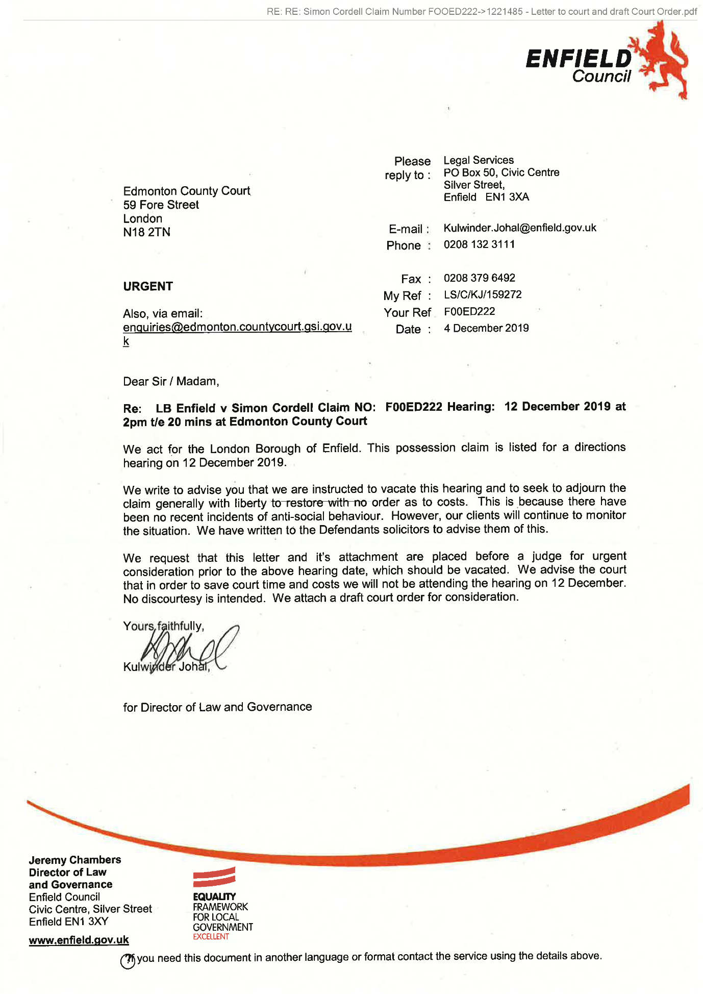
554,
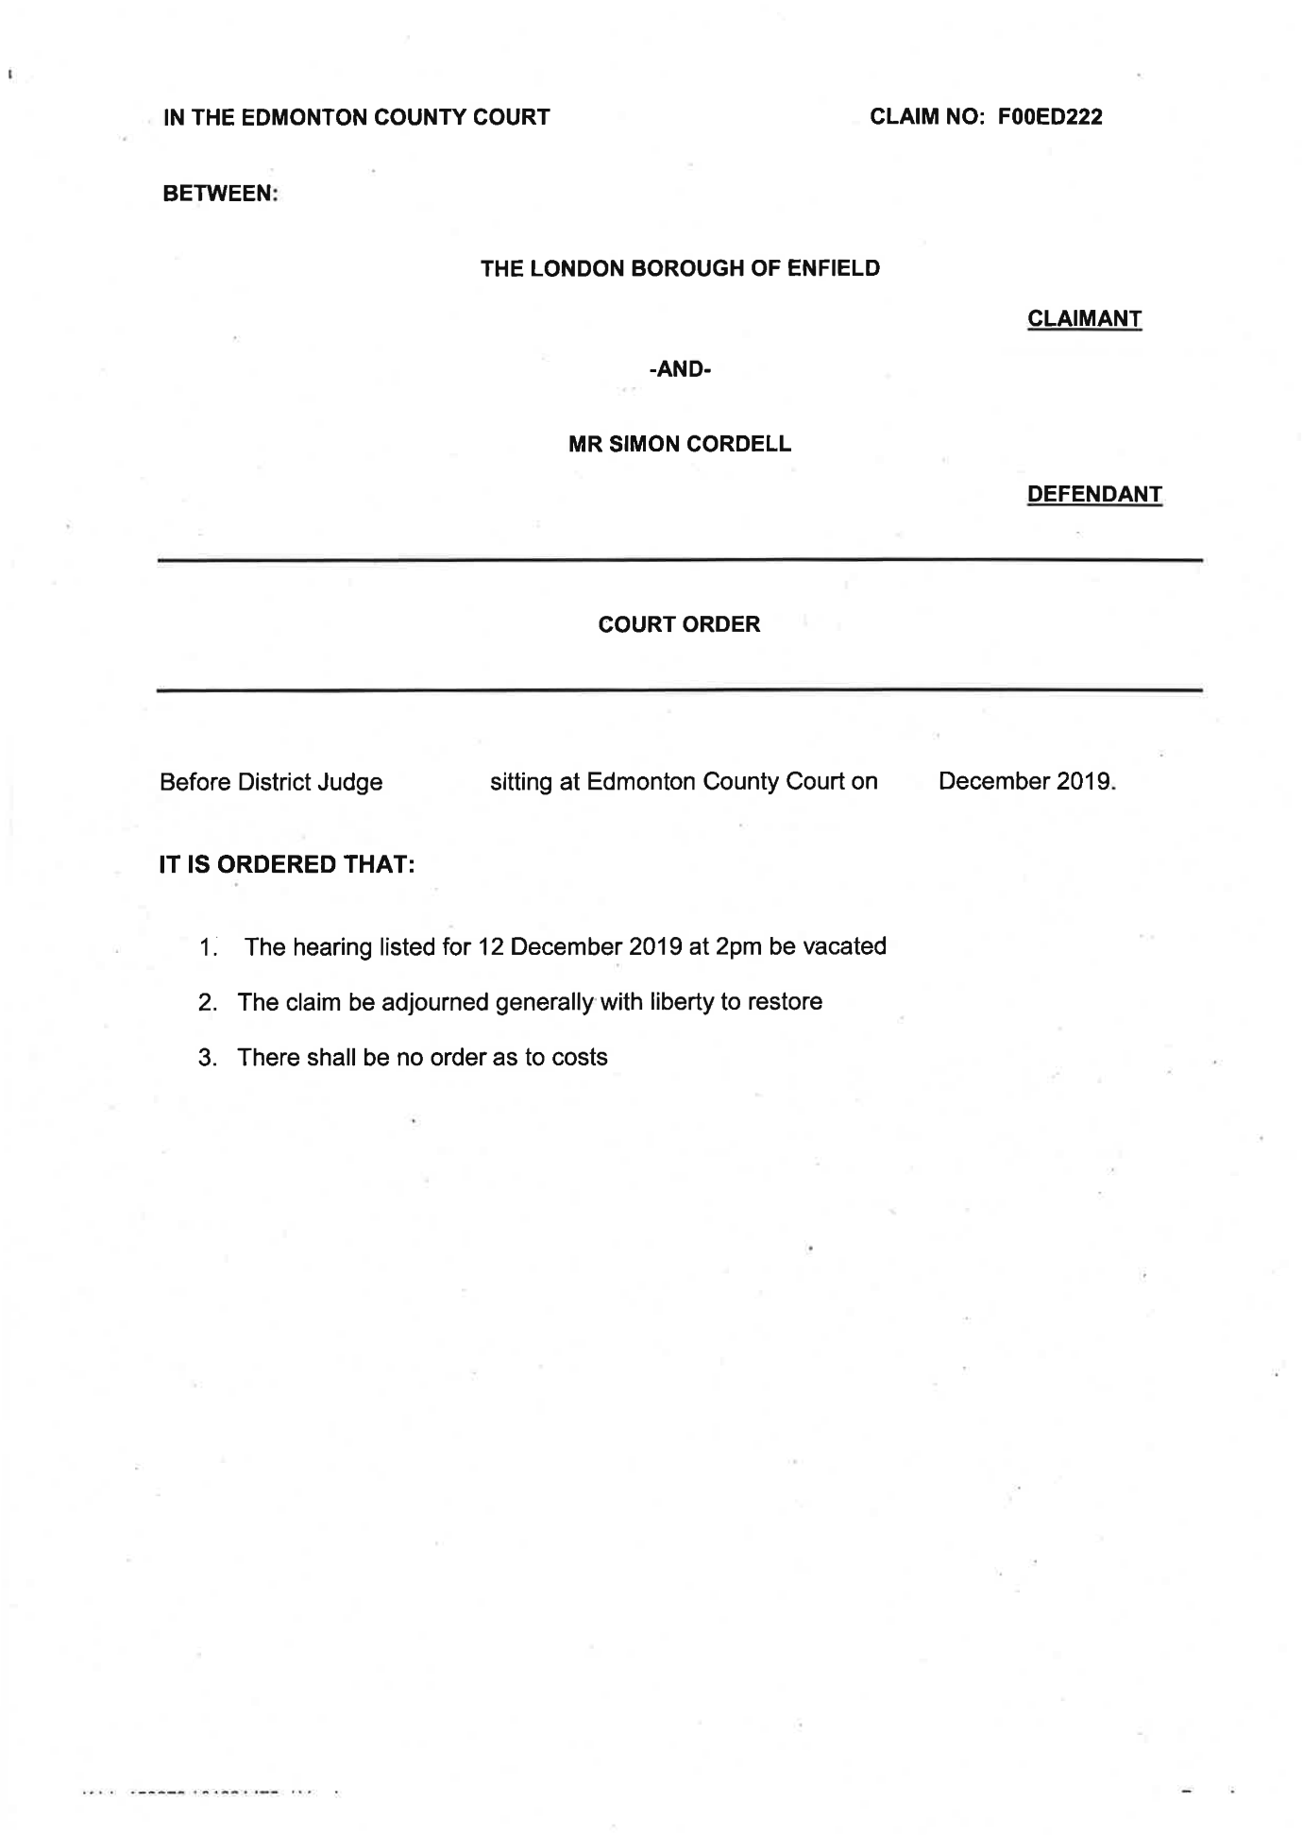
End of picture!

The banging Started!

Summary!

Disrepair!

Time Spent Building.
In the background of everything going on I could no longer work on my first company Too Smooth due to the amount of time I had to put toward s defending myself.
My mother Stopped working on my website
Working at Home doing Court Case Defense Work!
I spent time and recourses costing expenditure building my defence case and website Horrific Corruption.com, against the allegations getting put against me at the Time Start: 00:00 and Time End: 00:00

Saturday!
14/12/2019

Stain and the
Issues with Housing Disrepair!
Working on the Court Case Defence!
The Anti-Social Behaviour Order Case and the Verdict got made Guilty against me in error and the conditions got imposed against me till late 2020!
The Banging Continued: -
14/12/2019

- Disrepair!
- The Asbo Order got granted in Error with Full Conditions against me and Fraudulently!
- The banging Continued at me!
- Working at home!

- 113 Burncroft Avenue
Richard Continued to victimise me the same way the past occupiers had prior!
“Re-Vacated”

- 117 Burncroft Avenue
The 3rd set of Tenant’s since the Problems Started with the Flat being used as an Offensives Weapons against my Person and against my free will.
has been “Re-Vacated” again by John Iron

1
- Simon Cordell’s MP3’S Indexed
Stage 1
1x Recording
01m. Jeremy 14_12_2019 time 10_22
Page Number: Update Page Number 1,
01m. Jeremy 14_12_2019-time 10_22.wma
Update

--

1
Simon Cordell’s MP3’S Indexed
Stage 1
1x Recording
01m. Jeremy 14_12_2019 time 10_22
Page Number: Update Page Number 1,
01m. Jeremy 14_12_2019-time 10_22.wma
Update

The banging Started!

Summary!

Disrepair!

Time Spent Building.
In the background of everything going on I could no longer work on my first company Too Smooth due to the amount of time I had to put toward s defending myself.
My mother Stopped working on my website
Working at Home doing Court Case Defense Work!
I spent time and recourses costing expenditure building my defence case and website Horrific Corruption.com, against the allegations getting put against me at the Time Start: 00:00 and Time End: 00:00

Sunday!
15/12/2019

Stain and the
Issues with Housing Disrepair!
Working on the Court Case Defence!
The Anti-Social Behaviour Order Case and the Verdict got made Guilty against me in error and the conditions got imposed against me till late 2020!
The Banging Continued: -
15/12/2019

- Disrepair!
- The Asbo Order got granted in Error with Full Conditions against me and Fraudulently!
- The banging Continued at me!
- Working at home!

- 113 Burncroft Avenue
Richard Continued to victimise me the same way the past occupiers had prior!
“Re-Vacated”

- 117 Burncroft Avenue
The 3rd set of Tenant’s since the Problems Started with the Flat being used as an Offensives Weapons against my Person and against my free will.
has been “Re-Vacated” again by John Iron

--

The banging Started!

Summary!

Disrepair!

Time Spent Building.
In the background of everything going on I could no longer work on my first company Too Smooth due to the amount of time I had to put toward s defending myself.
My mother Stopped working on my website
Working at Home doing Court Case Defense Work!
I spent time and recourses costing expenditure building my defence case and website Horrific Corruption.com, against the allegations getting put against me at the Time Start: 00:00 and Time End: 00:00

Monday!
16/12/2019

Stain and the
Issues with Housing Disrepair!
Working on the Court Case Defence!
The Anti-Social Behaviour Order Case and the Verdict got made Guilty against me in error and the conditions got imposed against me till late 2020!
The Banging Continued: -
16/12/2019

- Disrepair!
- The Asbo Order got granted in Error with Full Conditions against me and Fraudulently!
- The banging Continued at me!
- Working at home!

- 113 Burncroft Avenue
Richard Continued to victimise me the same way the past occupiers had prior!
“Re-Vacated”

- 117 Burncroft Avenue
The 3rd set of Tenant’s since the Problems Started with the Flat being used as an Offensives Weapons against my Person and against my free will.
has been “Re-Vacated” again by John Iron

--

The banging Started!

Summary!

Disrepair!

Time Spent Building.
In the background of everything going on I could no longer work on my first company Too Smooth due to the amount of time I had to put toward s defending myself.
My mother Stopped working on my website
Working at Home doing Court Case Defense Work!
I spent time and recourses costing expenditure building my defence case and website Horrific Corruption.com, against the allegations getting put against me at the Time Start: 00:00 and Time End: 00:00

Tuesday!
17/12/2019

Stain and the
Issues with Housing Disrepair!
Working on the Court Case Defence!
The Anti-Social Behaviour Order Case and the Verdict got made Guilty against me in error and the conditions got imposed against me till late 2020!
The Banging Continued: -
17/12/2019

- Disrepair!
- The Asbo Order got granted in Error with Full Conditions against me and Fraudulently!
- The banging Continued at me!
- Working at home!

- 113 Burncroft Avenue
Richard Continued to victimise me the same way the past occupiers had prior!
“Re-Vacated”

- 117 Burncroft Avenue
The 3rd set of Tenant’s since the Problems Started with the Flat being used as an Offensives Weapons against my Person and against my free will.
has been “Re-Vacated” again by John Iron

--

The banging Started!

Summary!

Disrepair!

Time Spent Building.
In the background of everything going on I could no longer work on my first company Too Smooth due to the amount of time I had to put toward s defending myself.
My mother Stopped working on my website
Working at Home doing Court Case Defense Work!
I spent time and recourses costing expenditure building my defence case and website Horrific Corruption.com, against the allegations getting put against me at the Time Start: 00:00 and Time End: 00:00

Wednesday!
18/12/2019

Stain and the
Issues with Housing Disrepair!
Working on the Court Case Defence!
The Anti-Social Behaviour Order Case and the Verdict got made Guilty against me in error and the conditions got imposed against me till late 2020!
The Banging Continued: -
18/12/2019

- Disrepair!
- The Asbo Order got granted in Error with Full Conditions against me and Fraudulently!
- The banging Continued at me!
- Working at home!

- 113 Burncroft Avenue
Richard Continued to victimise me the same way the past occupiers had prior!
“Re-Vacated”

- 117 Burncroft Avenue
The 3rd set of Tenant’s since the Problems Started with the Flat being used as an Offensives Weapons against my Person and against my free will.
has been “Re-Vacated” again by John Iron

87.
- Additional Email Attachments & Emails / Issue:
87. 1. 1
Jill.Bayley@enfield.gov.uk_
12.18.2019_RE RE Simon Cordell Claim Number FOOED222
18/12/2019
/ Page Numbers: 555,556,557,558,559,560,561

88.
- Additional Email Attachments & Emails / Issue:
88. 1. 1
Kulwinder.Johal@enfield.gov.uk_
12.18.2019_Read RE Simon Cordell Claim Number FOOED222
18/12/2019
/ Page Numbers: 562

89.
- Additional Email Attachments & Emails / Issue:
89. 1. 1
Ronak@tyrerroxburgh.co.uk_
12.18.2019_Re RE Simon Cordell Claim Number FOOED222
18/12/2019
/ Page Numbers: 563,564,565,566,567,568,569,570

90.
- Additional Email Attachments & Emails / Issue:
90. 1. 1
ronak@tyrerroxburgh.co.uk_
12.18.2019_RE RE Simon Cordell Claim Number FOOED222_001
18/12/2019
/ Page Numbers: 571,572,573,574,575,576

--

87.
Additional Email Attachments & Emails / Issue:
87. 1. 1
Jill.Bayley@enfield.gov.uk_
12.18.2019_RE RE Simon Cordell Claim Number FOOED222
18/12/2019
/ Page Numbers: 555,556,557,558,559,560,561
--
555,
From: Jill Bayley <Jill.Bayley@enfield.gov.uk>
Sent: 18 December 2019 16:07
To: Ronak Ahmed; Lorraine Cordell; Sean Shanmuganathan
Cc: Kulwinder Johal
Subject: RE: RE: Simon Cordell
Claim Number: FOOED222
Dear Mr Ahmed,
Thank you for your email, the contents of which are noted.
Yours sincerely Jill Bayley Jill Bayley
Principal Lawyer, Safeguarding and Corporate Teams Legal Services, Enfield Council Silver Street Enfield EN1 3XY
Please note my new telephone number 020 8132 1221
Telephone: 020 8132 1221
Fax: 020 8379 6492
Mobile: 07930 858193
Enfield Council is committed to serving the whole borough fairly, delivering excellent services and building strong communities.
Legal advice in this e-mail is given on behalf of the Director of Law and Governance; it is subject to legal professional privilege and should not be disclosed without authorisation.
From: Ronak Ahmed
ronak@tyrerroxburgh.co.uk
Sent: 18 December 2019 15:24
To: Jill Bayley
Jill.Bayley@enfield.gov.uk
Lorraine Cordell
lorraine32@blueyonder.co.uk
Sean Shanmuganathan
sean@tyrerroxburgh.co.uk
Cc: Kulwinder Johal
Kulwinder.Johal@enfield.gov.uk
Subject: RE: RE: Simon Cordell
Claim Number: FOOED222
Good afternoon
It is correct to say that we no longer are on record as acting for the Defendant as Legal Aid has been terminated. However, we can confirm receipt of the letter dated 4 December 2019 from the Claimants to the Court requesting the December hearing be vacated. It does appear that the most recent sealed court order was incorrect when it referred to a "consent order” when it should have referred to the draft order that was attached. No such consent order was agreed given the specific and direct instructions from the Defendant, Mr Cordell. It appears that the court made an order in accordance with the draft order provided by the claimant.
It is also important to note that the Claim is not struck out and the Claimant can apply for it to be reinstated. Therefore the Claim is live but with no hearing date listed so if there are any further allegations then the case is likely to be restored.
If Mr Cordell is unhappy about the Court making any such order, he can apply using Form N244 to set it aside.
I am not proposing to engage in further debate on this matter given we are not getting paid for our continued
556,
involvement.
Kind regards
Mr. Ronak Ahmed LL. B, LL.M
Solicitor (Consultant)
Direct Dial 07515 121781
Office 0208 889 3319
Email ronak@tyrerroxburgh.co.uk
From: Jill Bayley [mailto: Jill.Bayley@enfield.gov.uk]
Sent: 13 December 2019 15:41
To: Lorraine Cordell <lorraine32@blueyonder.co.uk
Ronak Ahmed
ronak@tyrerroxburgh.co.uk
Sean Shanmuganathan
sean@tyrerroxburgh.co.uk
Cc: Kulwinder Johal
Kulwinder.Johal@enfield.gov.uk
Subject: RE: RE: Simon Cordell
Claim Number: FOOED222
Dear Madam,
Further to your emails, please find attached the letter sent to the court by Ms Johal as you request. This letter was sent to Mr Cordell's solicitors, but they have since stopped acting for him.
Yours faithfully
Jill Bayley
Jill Bayley
Principal Lawyer, Safeguarding and Corporate Teams Legal Services, Enfield Council Silver Street Enfield EN1 3XY
Please note my new telephone number 020 8132 1221
Telephone: 020 8132 1221
Fax: 020 8379 6492
Mobile: 07930 858193
Enfield Council is committed to serving the whole borough fairly, delivering excellent services and building strong communities.
Legal advice in this e-mail is given on behalf of the Director of Law and Governance; it is subject to legal professional privilege and should not be disclosed without authorisation.
From: Lorraine Cordell
lorraine32@bluevonder.co.uk
Sent: 12 December 2019 13:44
To: Jill Bayley
Jill.Bayley@enfield.gov.uk
Ronak Ahmed
ronak@tyrerroxburgh.co.uk
Sean Shanmuganathan
sean@tyrerroxburgh.co.uk
Subject: FW: RE: Simon Cordell Claim Number FOOED222 Importance: High
Dear Jill Bayley
557,
I have been given your email regarding an issue I have, I believe you are the manager of Kulwinder Johal, Kulwinder Johal is dealing with a case for Enfield Council which relates to my son Mr Simon Cordell.
It would seem a letter which was deemed by the court and Judge as a consent order was sent to the court by Kulwinder Johal. I have requested that the letter be sent to me via this email as we have never seen it.
I do have Authority to address things for my son Simon Cordell, but it would seem I am being ignored, which my request to be sent the letter that was sent to the court by Kulwinder Johal.
Please see below a list of emails sent which there has only been one reply, with all the information for the case.
Could you please address this matter as a matter of urgency?
I look forward to your reply to this matter.
Regards
Lorraine Cordell on behalf of Simon Cordell
From: Lorraine Cordell mailto: lorraine32@bluevonder.co.uk
Sent: 12 December 2019 11:44
To: 'Kulwinder Johal'; 'Ronak Ahmed'; 'Sean Shanmuganathan
Subject: RE: RE: Simon Cordell
Claim Number: FOOED222
Importance: High
Dear Kulwinder Johal
I know you have read the below email so cannot understand why you have not replied and sent over the letter sent to the court which they received on the 05/12/2019 and deemed it to be a consent order.
I have just made a call to Tyrer Roxburgh Solicitors who are no longer dealing with this case as legal aid was withdrawn which you will be aware of.
Mr Ahmed is on leave so I have asked Sean Shanmuganathan to call me back, as he is the one who called me last night to explain regarding the court order which was received in there office on the 11/12/2019 which he forwarded me the court order over via my email last night.
I do not understand why you are not sending me the letter, which was sent to the court for this court order to be made up.
Could you please forward me the letter sent to the court. You did ask me on the phone call we had this morning you would need an Authority letter which you have had so there is no reason the letter cannot be sent to me, as you have had what you asked for.
In addition, can you please forward it to Sean Shanmuganathan sean@tvrerroxburgh.co.uk as he does know about my son's case and the letter can then be added to their file, as Mr Ahmed is on leave, he will not be able to deal with this until his return. I have CC in both Mr Ahmed and Sean Shanmuganathan all the emails.
558,
Could this matter please be addressed as a matter of urgency?
Regards
Lorraine Cordell on behalf of Simon Cordell
From: Lorraine Cordell I~mailto:lorraine32@bluevonder.co.uk
Sent: 12 December 2019 10:10
To: 'Kulwinder Johal'; 'Ronak Ahmed'
Subject: RE: RE: Simon Cordell
Claim Number: FOOED222 Authority
Dear Kulwinder Johal
As you will already be aware Legal Aid funding has been withdrawn from this case, as you stated in your in your letter dated the 21/10/2019 to Mr Ahmed, you had been instructed to discontinue the claim from your clients Enfield Council, so Mr Ahmed is no longer dealing with this matter.
You have had the letter of Authority, which you asked for on the phone today and received this, which has been confirmed in your below email. However, there has always been Authority on Enfield Councils systems for me to address matters for my son, Mr Simon Cordell.
I would like to see the letter that that has been sent to the court which the court received on the 05/12/2019, which the court has deemed as a consent order for claim number FOOED222. No consent order has been agreed or signed, so I cannot understand how Edmonton Country Court, more so a judge has deemed you letter as a consent order, which is stated in the court order dated 06/12/2019.
Also there is a large issue your client Enfield Council instructed you for this claim to be discontinue, I will state the court order is far from being discontinue as you have it would seem instructed the court for it to be adjourned generally with liberty to restore this is far from what your clients asked to be done on this case.
Regards
Lorraine Cordell on behalf of Simon Cordell
From: Kulwinder Johal mailto: Kulwinder.Johal@enfield.gov.uk
Sent: 12 December 2019 09:41
To: Lorraine Cordell; ronak@tvrerroxburgh.co.uk
Subject: RE: RE: Simon Cordell
Claim Number: FOOED222 Authority
Dear Ms Cordell and Mr Ahmed,
Further to Ms Cordell's emails this morning (see below) I am writing to refer the matter to Mr Ahmed, who will advise you. I have included Mr Ahmed into this email for completeness.
Mr Ahmed - I trust that you will advise Ms Cordell.
Yours sincerely,
559,
Kulwinder Johal
Litigation Lawyer |Corporate Team | Legal Services On behalf of the Director of Law and Governance
PO Box 50, Civic Centre, Silver Street, Enfield EN1 3XA
Enfield Council is committed to serving the whole borough fairly, delivering excellent services and building strong communities.
Legal advice in this email is given on behalf of the Assistant Director of Legal Services; it is subject to legal professional privilege and should not be disclosed without expressed prior authorisation.
From: Lorraine Cordell <lorraine32@blueyonder.co.uk>
Sent: 12 December 2019 09:12
To: Kulwinder Johal <Kulwinder.Johal@enfield.gov.uk>
Subject: RE: RE: Simon Cordell Claim Number FOOED222 Authority
Importance: High
Dear Kulwinder Johal
Please see attached letter of Authority, could you please send me over the letters, which have been sent to the court.
Regards
Lorraine Cordell on behalf of Simon Cordell
From: Lorraine Cordell mailto: lorraine32@bluevonder.co.uk
Sent: 11 December 2019 23:41
To: 'Kulwinder.Johal@enfield.gov.uk'
Subject: RE: Simon Cordell Claim Number FOOED222
Dear Kulwinder Johal
I am writing this email with regard to a telephone call that I received tonight from my son Mr Simon Cordell solicitor, Tyrer Roxburgh Solicitors.
I was forwarded a court order dated the 09/12/2019 from Edmonton Country Court, heard on the 06/12/2019.
It would seem that Edmonton Country Court received a consent order at the court on the 5 th December 2019, and Deputy District Judge Brown made a court order on the 06/12/2019.
Can you please forward this consent order over via this email ASAP as we have never seen it yet alone agreed to it or signed it? As you will be aware, no consent order has been agreed upon or signed, so how has the court been sent a consent order by you?
Regards
560,
Lorraine Cordell
Enfield Council is committed to serving the whole borough fairly, delivering excellent services and building strong communities. Opinions expressed in this email are those of the individual and not necessarily those of the London Borough of Enfield. This email and any attachments or files transmitted with it are strictly confidential and intended solely for the named addressee. It may contain privileged and confidential information and if you are not the intended recipient and receive it in error you must not copy, distribute, or use the communication in any other way. All traffic handled by the Government Connect Secure Extranet may be subject to recording/and or monitoring in accordance with relevant legislation.
This email has been scanned for viruses, but we cannot guarantee that it will be free of viruses or malware. The recipient should perform their own virus checks.
Disclaimer
The information contained in this communication from the sender is confidential. It is intended solely for use by the recipient and others authorized to receive it. If you are not the recipient, you are hereby notified that any disclosure, copying, distribution or acting in relation of the contents of this information is strictly prohibited and may be unlawful.
This email has been scanned for viruses and malware, and may have been automatically archived by Mimecast Ltd, an innovator in Software as a Service (SaaS) for business. Providing a safer and more useful place for your human generated data. Specializing in; Security, archiving and compliance.
Enfield Council is committed to serving the whole borough fairly, delivering excellent services and building strong communities. Opinions expressed in this email are those of the individual and not necessarily those of the London Borough of Enfield. This email and any attachments or files transmitted with it are strictly confidential and intended solely for the named addressee. It may contain privileged and confidential information and if you are not the intended recipient and receive it in error you must not copy, distribute, or use the communication in any other way. All traffic handled by the Government Connect Secure Extranet may be subject to recording/and or monitoring in accordance with relevant legislation.
561,
This email has been scanned for viruses, but we cannot guarantee that it will be free of viruses or malware. The recipient should perform their own virus checks.
Be the first to receive the latest Council news straight to your inbox
SIGN UP ONLINE NOW
www.enfield.gov.uk/enewsletters
Enfield Council is committed to serving the whole borough fairly, delivering excellent services and building strong communities. Opinions expressed in this email are those of the individual and not necessarily those of the London Borough of Enfield. This email and any attachments or files transmitted with it are strictly confidential and intended solely for the named addressee. It may contain privileged and confidential information and if you are not the intended recipient and receive it in error you must not copy, distribute, or use the communication in any other way. All traffic handled by the Government Connect Secure Extranet may be subject to recording/and or monitoring in accordance with relevant legislation.
This email has been scanned for viruses, but we cannot guarantee that it will be free of viruses or malware. The recipient should perform their own virus checks.

88.
Additional Email Attachments & Emails / Issue:
88. 1. 1
Kulwinder.Johal@enfield.gov.uk_
12.18.2019_Read RE Simon Cordell Claim Number FOOED222
18/12/2019
/ Page Numbers: 562
--
562,
From: Kulwinder Johal <Kulwinder.Johal@enfield.gov.uk>
Sent: 18 December 2019 07:48
To: Lorraine Cordell
Subject: Read: RE: Simon Cordell
Claim Number: FOOED222
[Campaign] <https://enfield-council.msgfocus.eom/k/Enfield-Council/sign up>
www.enfield.gov.uk<http://www.enfield.gov.uk>
Enfield Council is committed to serving the whole borough fairly, delivering excellent services and building strong communities. Opinions expressed in this email are those of the individual and not necessarily those of the London Borough of Enfield. This email and any attachments or files transmitted with it are strictly confidential and intended solely for the named addressee. It may contain privileged and confidential information and if you are not the intended recipient and receive it in error you must not copy, distribute, or use the communication in any other way. All traffic handled by the Government Connect Secure Extranet may be subject to recording/and or monitoring in accordance with relevant legislation.
This email has been scanned for viruses, but we cannot guarantee that it will be free of viruses or malware. The recipient should perform their own virus checks.
Disclaimer
The information contained in this communication from the sender is confidential. It is intended solely for use by the recipient and others authorized to receive it. If you are not the recipient, you are hereby notified that any disclosure, copying, distribution or taking action in relation of the contents of this information is strictly prohibited and may be unlawful.
This email has been scanned for viruses and malware, and may have been automatically archived by Mimecast Ltd, an innovator in Software as a Service (SaaS) for business. Providing a safer and more useful place for your human generated data. Specializing in; Security, archiving and compliance.

89.
Additional Email Attachments & Emails / Issue:
89. 1. 1
Ronak@tyrerroxburgh.co.uk_
12.18.2019_Re RE Simon Cordell Claim Number FOOED222
18/12/2019
/ Page Numbers: 563,564,565,566,567,568,569,570
--
563,
From: Ronak Ahmed <ronak@tyrerroxburgh.co.uk>
Sent: 18 December 2019 16:36
To: Lorraine Cordell; Sean Shanmuganathan
Subject: Re: RE: Simon Cordell Claim Number FOOED222
Attachments: image001.jpg
Dear Ms Cordell
You will need to call the office and ask them. I am not sure what difference that makes. The most important issue is that the case is still live.
Kind regards
Mr. Ronak Ahmed LL. B, LL.M Solicitor (Consultant)
Tel +44 (0) 20 8889 3319
Email ronak@tyrerroxburgh.co.uk
1 St Michaels Terrace
London
N22 7SJ
DX 34704 WOOD GREEN 2
Tel +44 (0)20 8889 3319
Fax +44 (0)20 8881 6089 www.tyrerroxburgh.co.uk
Authorised by the Solicitors Regulation Authority. Tyrer Roxburgh Solicitors LLP is a limited liability partnership under the no.560748. A list of the members' names is open to inspection at the registered office.
VAT REG No: 221 8088 78
SRA No: 560748
564,
Contracted with the Legal Aid Agency
We do not accept service of documents or other process by e-mail Email us at lawmakers@tyrerroxburgh.co.uk
This message may contain privileged information and is only intended to be received by the person to whom it is addressed.
If you are not the intended recipient, please contact us as soon as possible.
Partners - Mukesh Badhan - D Shanmuganathan - Vasoulla Constantinou
From: Lorraine Cordell <lorraine32@blueyonder.co.uk>
Sent: Wednesday, December 18, 2019 4:31:40 PM
To: Ronak Ahmed
ronak@tyrerroxburgh.co.uk
Sean Shanmuganathan
sean@tyrerroxburgh.co.uk
Subject: RE: RE: Simon Cordell
Claim Number FOOED222
Dear Ronak Ahmed
May I ask on what date your office got the letter dated the 04th December 2019 from the Claimants, was it sent via post or email?
Did your office have the letter before the court made the order or after? As we knew nothing about this letter until the 11th December 2019, when Sean made a call to me, and sent the court order via my email which he got in the office on the 11th December 2019 from the court.
You state in your reply email below you confirm receipt of the letter dated 4th December 2019 from the Claimants but have not confirmed what date you received it.
It does seem it was delivered to the court very fast; the letter is dated the 04th December 2019, the court got the letter on the 05th December 2019, and the court made there ruling on the 06th December 2019.
I await your reply.
Regards
Lorraine Cordell
565,
From: Ronak Ahmed [mailto:ronak@tyrerroxburgh.co.uk]
Sent: 18 December 2019 15:24
To: Jill Bayley; Lorraine Cordell; Sean Shanmuganathan
Cc: Kulwinder Johal
Subject: RE: RE: Simon Cordell Claim Number FOOED222 Good afternoon
It is correct to say that we no longer are on record as acting for the Defendant as Legal Aid has been terminated. However, we can confirm receipt of the letter dated 4 December 2019 from the Claimants to the Court requesting the December hearing be vacated. It does appear that the most recent sealed court order was incorrect when it referred to a "consent order” when it should have referred to the draft order that was attached. No such consent order was agreed given the specific and direct instructions from the Defendant, Mr Cordell. It appears that the court made an order in accordance with the draft order provided by the claimant.
It is also important to note that the Claim is not struck out and the Claimant can apply for it to be reinstated. Therefore the Claim is live but with no hearing date listed so if there are any further allegations then the case is likely to be restored.
If Mr Cordell is unhappy about the Court making any such order, he can apply using Form N244 to set it aside.
I am not proposing to engage in further debate on this matter given we are not getting paid for our continued involvement.
Kind regards
Mr. Ronak Ahmed LL. B, LL.M
Solicitor (Consultant)
Direct Dial 07515 121781
Office 0208 889 3319
Email ronak@tyrerroxburgh.co.uk
From: Jill Bayley [mailto:Jill.Bayley@enfield.gov.uk]
Sent: 13 December 2019 15:41
To: Lorraine Cordell <lorraine32@blueyonder.co.uk>; Ronak Ahmed <ronak@tyrerroxburgh.co.uk>; Sean Shanmuganathan <sean@tyrerroxburgh.co.uk>
Cc: Kulwinder Johal <Kulwinder.Johal@enfield.gov.uk>
Subject: RE: RE: Simon Cordell Claim Number FOOED222
Dear Madam,
Further to your emails, please find attached the letter sent to the court by Ms Johal as you request. This letter was sent to Mr Cordell's solicitors, but they have since stopped acting for him.
Yours faithfully
Jill Bayley
Jill Bayley
566,
Principal Lawyer, Safeguarding and Corporate Teams Legal Services, Enfield Council Silver Street Enfield EN1 3XY
Please note my new telephone number 020 8132 1221
Telephone: 020 8132 1221
Fax: 020 8379 6492
Mobile: 07930 858193
Enfield Council is committed to serving the whole borough fairly, delivering excellent services and building strong communities.
Legal advice in this e-mail is given on behalf of the Director of Law and Governance; it is subject to legal professional privilege and should not be disclosed without authorisation.
From: Lorraine Cordell <lorraine32@blueyonder.co.uk>
Sent: 12 December 2019 13:44
To: Jill Bayley <Jill.Bavlev@enfield.gov.uk>: 'Ronak Ahmed' <ronak@tyrerroxburgh.co.uk>: 'Sean Shanmuganathan' <sean@tyrerroxburgh.co.uk>
Subject: FW: RE: Simon Cordell Claim Number FOOED222
Importance: High
Dear Jill Bayley
I have been given your email regarding an issue I have, I believe you are the manager of Kulwinder Johal, Kulwinder Johal is dealing with a case for Enfield Council which relates to my son Mr Simon Cordell.
It would seem a letter which was deemed by the court and Judge as a consent order was sent to the court by Kulwinder Johal. I have requested that the letter be sent to me via this email as we have never seen it.
I do have Authority to address things for my son Simon Cordell, but it would seem I am being ignored, which my request to be sent the letter that was sent to the court by Kulwinder Johal.
Please see below a list of emails sent which there has only been one reply, with all the information for the case.
Could you please address this matter as a matter of urgency?
I look forward to your reply to this matter.
Regards
Lorraine Cordell on behalf of Simon Cordell
From: Lorraine Cordell mailto: lorraine32@bluevonder.co.uk
Sent: 12 December 2019 11:44
To: 'Kulwinder Johal'; 'Ronak Ahmed'; 'Sean Shanmuganathan
Subject: RE: RE: Simon Cordell Claim Number FOOED222
Importance: High
Dear Kulwinder Johal
567,
I know you have read the below email so cannot understand why you have not replied and sent over the letter sent to the court which they received on the 05/12/2019 and deemed it to be a consent order.
I have just made a call to Tyrer Roxburgh Solicitors who are no longer dealing with this case as legal aid was withdrawn which you will be aware of.
Mr Ahmed is on leave so I have asked Sean Shanmuganathan to call me back, as he is the one who called me last night to explain regarding the court order which was received in there office on the 11/12/2019 which he forwarded me the court order over via my email last night.
I do not understand why you are not sending me the letter, which was sent to the court for this court order to be made up.
Could you please forward me the letter sent to the court. You did ask me on the phone call we had this morning you would need an Authority letter which you have had so there is no reason the letter cannot be sent to me, as you have had what you asked for.
In addition, can you please forward it to Sean Shanmuganathan sean@tvrerroxburgh.co.uk as he does know about my son's case and the letter can then be added to their file, as Mr Ahmed is on leave, he will not be able to deal with this until his return. I have CC in both Mr Ahmed and Sean Shanmuganathan all the emails.
Could this matter please be addressed as a matter of urgency?
Regards
Lorraine Cordell on behalf of Simon Cordell
From: Lorraine Cordell mailto: lorraine32@bluevonder.co.uk
Sent: 12 December 2019 10:10
To: 'Kulwinder Johal'; 'Ronak Ahmed'
Subject: RE: RE: Simon Cordell
Claim Number FOOED222 Authority
Dear Kulwinder Johal
As you will already be aware Legal Aid funding has been withdrawn from this case, as you stated in your in your letter dated the 21/10/2019 to Mr Ahmed, you had been instructed to discontinue the claim from your clients Enfield Council, so Mr Ahmed is no longer dealing with this matter.
You have had the letter of Authority, which you asked for on the phone today and received this, which has been confirmed in your below email. However, there has always been Authority on Enfield Councils systems for me to address matters for my son, Mr Simon Cordell.
I would like to see the letter that that has been sent to the court which the court received on the 05/12/2019, which the court has deemed as a consent order for claim number FOOED222. No consent order has been agreed or signed, so I cannot understand how Edmonton Country Court, more so a judge has deemed you letter as a consent order, which is stated in the court order dated 06/12/2019.
Also there is a large issue your client Enfield Council instructed you for this claim to be discontinue, I will state the court order is far
568,
from being discontinue as you have it would seem instructed the court for it to be adjourned generally with liberty to restore this is far from what your clients asked to be done on this case.
Regards
Lorraine Cordell on behalf of Simon Cordell
From: Kulwinder Johal mailto: Kulwinder.Johal@enfield.gov.uk
Sent: 12 December 2019 09:41
To: Lorraine Cordell ronak@tyrerroxburgh.co.uk
Subject: RE: RE: Simon Cordell
Claim Number FOOED222 Authority
Dear Ms Cordell and Mr Ahmed,
Further to Ms Cordell's emails this morning (see below) I am writing to refer the matter to Mr Ahmed, who will advise you. I have included Mr Ahmed into this email for completeness.
Mr Ahmed - I trust that you will advise Ms Cordell.
Yours sincerely,
Kulwinder Johal
Litigation Lawyer |Corporate Team | Legal Services On behalf of the Director of Law and Governance
PO Box 50, Civic Centre, Silver Street, Enfield EN1 3XA
Enfield Council is committed to serving the whole borough fairly, delivering excellent services and building strong communities.
Legal advice in this email is given on behalf of the Assistant Director of Legal Services; it is subject to legal professional privilege and should not be disclosed without expressed prior authorisation.
From: Lorraine Cordell <lorraine32@bluevonder.co.uk>
Sent: 12 December 2019 09:12
To: Kulwinder Johal <Kulwinder.Johal@enfield.gov.uk>
Subject: RE: RE: Simon Cordell
Claim Number FOOED222 Authority
Importance: High
Dear Kulwinder Johal
Please see attached letter of Authority, could you please send me over the letters, which have been sent to the court.
Regards
Lorraine Cordell on behalf of Simon Cordell
569,
From: Lorraine Cordell
mailto: lorraine32@bluevonder.co.uk
Sent: 11 December 2019 23:41
To: 'Kulwinder.Johal@enfield.gov.uk'
Subject: RE: Simon Cordell
Claim Number FOOED222
Dear Kulwinder Johal
I am writing this email with regard to a telephone call that I received tonight from my son Mr Simon Cordell solicitor, Tyrer Roxburgh Solicitors.
I was forwarded a court order dated the 09/12/2019 from Edmonton Country Court, heard on the 06/12/2019.
It would seem that Edmonton Country Court received a consent order at the court on the 5 th December 2019, and Deputy District Judge Brown made a court order on the 06/12/2019.
Can you please forward this consent order over via this email ASAP as we have never seen it yet alone agreed to it or signed it? As you will be aware, no consent order has been agreed upon or signed, so how has the court been sent a consent order by you?
Regards
Lorraine Cordell
Enfield Council is committed to serving the whole borough fairly, delivering excellent services and building strong communities. Opinions expressed in this email are those of the individual and not necessarily those of the London Borough of Enfield. This email and any attachments or files transmitted with it are strictly confidential and intended solely for the named addressee. It may contain privileged and confidential information and if you are not the intended recipient and receive it in error you must not copy, distribute, or use the communication in any other way. All traffic handled by the Government Connect Secure Extranet may be subject to recording/and or monitoring in accordance with relevant legislation.
This email has been scanned for viruses, but we cannot guarantee that it will be free of viruses or malware. The recipient should perform their own virus checks.
570,
Disclaimer
The information contained in this communication from the sender is confidential. It is intended solely for use by the recipient and others authorized to receive it. If you are not the recipient, you are hereby notified that any disclosure, copying, distribution or taking action in relation of the contents of this information is strictly prohibited and may be unlawful.
This email has been scanned for viruses and malware, and may have been automatically archived by Mimecast Ltd, an innovator in Software as a Service (SaaS) for business. Providing a safer and more useful place for your human generated data. Specializing in; Security, archiving and compliance.
Be the first to receive the latest Council news straight to your inbox
SIGN UP ONLINE NOW
www.enfield.gov.uk/enewsletters
Enfield Council is committed to serving the whole borough fairly, delivering excellent services and building strong communities. Opinions expressed in this email are those of the individual and not necessarily those of the London Borough of Enfield. This email and any attachments or files transmitted with it are strictly confidential and intended solely for the named addressee. It may contain privileged and confidential information and if you are not the intended recipient and receive it in error you must not copy, distribute, or use the communication in any other way. All traffic handled by the Government Connect Secure Extranet may be subject to recording/and or monitoring in accordance with relevant legislation.
This email has been scanned for viruses, but we cannot guarantee that it will be free of viruses or malware. The recipient should perform their own virus checks.

90.
Additional Email Attachments & Emails / Issue:
90. 1. 1
ronak@tyrerroxburgh.co.uk_
12.18.2019_RE RE Simon Cordell Claim Number FOOED222_001
18/12/2019
/ Page Numbers: 571,572,573,574,575,576
--
571,
From: Ronak Ahmed <ronak@tyrerroxburgh.co.uk>
Sent: 18 December 2019 15:24
To: Jill Bayley; Lorraine Cordell; Sean Shanmuganathan
Cc: Kulwinder Johal
Subject: RE: RE: Simon Cordell Claim Number FOOED222
Good afternoon
It is correct to say that we no longer are on record as acting for the Defendant as Legal Aid has been terminated. However, we can confirm receipt of the letter dated 4 December 2019 from the Claimants to the Court requesting the December hearing be vacated. It does appear that the most recent sealed court order was incorrect when it referred to a "consent order” when it should have referred to the draft order that was attached. No such consent order was agreed given the specific and direct instructions from the Defendant, Mr Cordell. It appears that the court made an order in accordance with the draft order provided by the claimant.
It is also important to note that the Claim is not struck out and the Claimant can apply for it to be reinstated. Therefore the Claim is live but with no hearing date listed so if there are any further allegations then the case is likely to be restored.
If Mr Cordell is unhappy about the Court making any such order, he can apply using Form N244 to set it aside.
I am not proposing to engage in further debate on this matter given we are not getting paid for our continued involvement.
Kind regards
Mr. Ronak Ahmed LL. B, LL.M
Solicitor (Consultant)
Direct Dial 07515 121781
Office 0208 889 3319
Email ronak@tyrerroxburgh.co.uk
From: Jill Bayley [mailto:Jill.Bayley@enfield.gov.uk]
Sent: 13 December 2019 15:41
To: Lorraine Cordell
lorraine32@blueyonder.co.uk
Ronak Ahmed
ronak@tyrerroxburgh.co.uk
Sean Shanmuganathan
sean@tyrerroxburgh.co.uk
Cc: Kulwinder Johal <Kulwinder.Johal@enfield.gov.uk>
Subject: RE: RE: Simon Cordell Claim Number FOOED222
Dear Madam,
Further to your emails, please find attached the letter sent to the court by Ms Johal as you request. This letter was sent to Mr Cordell's solicitors, but they have since stopped acting for him.
Yours faithfully
Jill Bayley
Jill Bayley
Principal Lawyer, Safeguarding and Corporate Teams
572,
Legal Services, Enfield Council Silver Street Enfield EN1 3XY
Please note my new telephone number 020 8132 1221
Telephone: 020 8132 1221
Fax: 020 8379 6492
Mobile: 07930 858193
Enfield Council is committed to serving the whole borough fairly, delivering excellent services and building strong communities.
Legal advice in this e-mail is given on behalf of the Director of Law and Governance; it is subject to legal professional privilege and should not be disclosed without authorisation.
From: Lorraine Cordell <lorraine32@blueyonder.co.uk>
Sent: 12 December 2019 13:44
To: Jill Bayley
Jill.Bayley@enfield.gov.uk
Ronak Ahmed
ronak@tyrerroxburgh.co.uk
Sean Shanmuganathan
sean@tyrerroxburgh.co.uk
Subject: FW: RE: Simon Cordell
Claim Number: FOOED222
Importance: High
Dear Jill Bayley
I have been given your email regarding an issue I have, I believe you are the manager of Kulwinder Johal, Kulwinder Johal is dealing with a case for Enfield Council which relates to my son Mr Simon Cordell.
It would seem a letter which was deemed by the court and Judge as a consent order was sent to the court by Kulwinder Johal. I have requested that the letter be sent to me via this email as we have never seen it.
I do have Authority to address things for my son Simon Cordell, but it would seem I am being ignored, which my request to be sent the letter that was sent to the court by Kulwinder Johal.
Please see below a list of emails sent which there has only been one reply, with all the information for the case.
Could you please address this matter as a matter of urgency?
I look forward to your reply to this matter.
Regards
Lorraine Cordell on behalf of Simon Cordell
From: Lorraine Cordell mailto: lorraine32@bluevonder.co.uk
Sent: 12 December 2019 11:44
To: 'Kulwinder Johal'; 'Ronak Ahmed'; 'Sean Shanmuganathan'
Subject: RE: RE: Simon Cordell
Claim Number: FOOED222
Importance: High
Dear Kulwinder Johal
573,
I know you have read the below email so cannot understand why you have not replied and sent over the letter sent to the court which they received on the 05/12/2019 and deemed it to be a consent order.
I have just made a call to Tyrer Roxburgh Solicitors who are no longer dealing with this case as legal aid was withdrawn which you will be aware of.
Mr Ahmed is on leave so I have asked Sean Shanmuganathan to call me back, as he is the one who called me last night to explain regarding the court order which was received in there office on the 11/12/2019 which he forwarded me the court order over via my email last night.
I do not understand why you are not sending me the letter, which was sent to the court for this court order to be made up.
Could you please forward me the letter sent to the court. You did ask me on the phone call we had this morning you would need an Authority letter which you have had so there is no reason the letter cannot be sent to me, as you have had what you asked for.
In addition, can you please forward it to Sean Shanmuganathan sean@tvrerroxburgh.co.uk as he does know about my son's case and the letter can then be added to their file, as Mr Ahmed is on leave, he will not be able to deal with this until his return. I have CC in both Mr Ahmed and Sean Shanmuganathan all the emails.
Could this matter please be addressed as a matter of urgency?
Regards
Lorraine Cordell on behalf of Simon Cordell
From: Lorraine Cordell mailto: lorraine32@bluevonder.co.uk
Sent: 12 December 2019 10:10
To: 'Kulwinder Johal'; 'Ronak Ahmed'
Subject: RE: RE: Simon Cordell Claim Number FOOED222 Authority
Dear Kulwinder Johal
As you will already be aware Legal Aid funding has been withdrawn from this case, as you stated in your in your letter dated the 21/10/2019 to Mr Ahmed, you had been instructed to discontinue the claim from your clients Enfield Council, so Mr Ahmed is no longer dealing with this matter.
You have had the letter of Authority, which you asked for on the phone today and received this, which has been confirmed in your below email. However, there has always been Authority on Enfield Councils systems for me to address matters for my son, Mr Simon Cordell.
I would like to see the letter that that has been sent to the court which the court received on the 05/12/2019, which the court has deemed as a consent order for claim number FOOED222. No consent order has been agreed or signed, so I cannot understand how Edmonton Country Court, more so a judge has deemed you letter as a consent order, which is stated in the court order dated 06/12/2019.
Also there is a large issue your client Enfield Council instructed you for this claim to be discontinue, I will state the court order is far
574,
from being discontinue as you have it would seem instructed the court for it to be adjourned generally with liberty to restore this is far from what your clients asked to be done on this case.
Regards
Lorraine Cordell on behalf of Simon Cordell
From: Kulwinder Johal mailto: Kulwinder.Johal@enfield.gov.uk
Sent: 12 December 2019 09:41
To: Lorraine Cordell; ronak@tyrerroxburgh.co.uk
Subject: RE: RE: Simon Cordell Claim Number FOOED222 Authority
Dear Ms Cordell and Mr Ahmed,
Further to Ms Cordell's emails this morning (see below) I am writing to refer the matter to Mr Ahmed, who will advise you. I have included Mr Ahmed into this email for completeness.
Mr Ahmed - I trust that you will advise Ms Cordell.
Yours sincerely,
Kulwinder Johal
Litigation Lawyer |Corporate Team | Legal Services On behalf of the Director of Law and Governance
PO Box 50, Civic Centre, Silver Street, Enfield EN1 3XA
Enfield Council is committed to serving the whole borough fairly, delivering excellent services and building strong communities.
Legal advice in this email is given on behalf of the Assistant Director of Legal Services; it is subject to legal professional privilege and should not be disclosed without expressed prior authorisation.
From: Lorraine Cordell <lorraine32@bluevonder.co.uk>
Sent: 12 December 2019 09:12
To: Kulwinder Johal <Kulwinder.Johal@enfield.gov.uk>
Subject: RE: RE: Simon Cordell Claim Number FOOED222 Authority
Importance: High
Dear Kulwinder Johal
Please see attached letter of Authority, could you please send me over the letters, which have been sent to the court.
Regards
Lorraine Cordell on behalf of Simon Cordell
575,
From: Lorraine Cordell mailto: lorraine32@bluevonder.co.uk
Sent: 11 December 2019 23:41
To: 'Kulwinder.Johal@enfield.gov.uk'
Subject: RE: Simon Cordell Claim Number FOOED222
Dear Kulwinder Johal
I am writing this email with regard to a telephone call that I received tonight from my son Mr Simon Cordell solicitor, Tyrer Roxburgh Solicitors.
I was forwarded a court order dated the 09/12/2019 from Edmonton Country Court, heard on the 06/12/2019.
It would seem that Edmonton Country Court received a consent order at the court on the 5 th December 2019, and Deputy District Judge Brown made a court order on the 06/12/2019.
Can you please forward this consent order over via this email ASAP as we have never seen it yet alone agreed to it or signed it? As you will be aware, no consent order has been agreed upon or signed, so how has the court been sent a consent order by you?
Regards
Lorraine Cordell
Enfield Council is committed to serving the whole borough fairly, delivering excellent services and building strong communities. Opinions expressed in this email are those of the individual and not necessarily those of the London Borough of Enfield. This email and any attachments or files transmitted with it are strictly confidential and intended solely for the named addressee. It may contain privileged and confidential information and if you are not the intended recipient and receive it in error you must not copy, distribute, or use the communication in any other way. All traffic handled by the Government Connect Secure Extranet may be subject to recording/and or monitoring in accordance with relevant legislation.
This email has been scanned for viruses, but we cannot guarantee that it will be free of viruses or malware. The recipient should perform their own virus checks.
576,
Disclaimer
The information contained in this communication from the sender is confidential. It is intended solely for use by the recipient and others authorized to receive it. If you are not the recipient, you are hereby notified that any disclosure, copying, distribution or taking action in relation of the contents of this information is strictly prohibited and may be unlawful.
This email has been scanned for viruses and malware, and may have been automatically archived by Mimecast Ltd, an innovator in Software as a Service (SaaS) for business. Providing a safer and more useful place for your human generated data. Specializing in; Security, archiving and compliance.
Be the first to receive the latest Council news straight to your inbox
SIGN UP ONLINE NOW
www.enfield.gov.uk/enewsletters
Enfield Council is committed to serving the whole borough fairly, delivering excellent services and building strong communities. Opinions expressed in this email are those of the individual and not necessarily those of the London Borough of Enfield. This email and any attachments or files transmitted with it are strictly confidential and intended solely for the named addressee. It may contain privileged and confidential information and if you are not the intended recipient and receive it in error you must not copy, distribute, or use the communication in any other way. All traffic handled by the Government Connect Secure Extranet may be subject to recording/and or monitoring in accordance with relevant legislation.
This email has been scanned for viruses, but we cannot guarantee that it will be free of viruses or malware. The recipient should perform their own virus checks.

The banging Started!

Summary!

Disrepair!

Time Spent Building.
In the background of everything going on I could no longer work on my first company Too Smooth due to the amount of time I had to put toward s defending myself.
My mother Stopped working on my website
Working at Home doing Court Case Defense Work!
I spent time and recourses costing expenditure building my defence case and website Horrific Corruption.com, against the allegations getting put against me at the Time Start: 00:00 and Time End: 00:00

Thursday!
19/12/2019

Stain and the
Issues with Housing Disrepair!
Working on the Court Case Defence!
The Anti-Social Behaviour Order Case and the Verdict got made Guilty against me in error and the conditions got imposed against me till late 2020!
The Banging Continued: -
19/12/2019

- Disrepair!
- The Asbo Order got granted in Error with Full Conditions against me and Fraudulently!
- The banging Continued at me!
- Working at home!

- 113 Burncroft Avenue
Richard Continued to victimise me the same way the past occupiers had prior!
“Re-Vacated”

- 117 Burncroft Avenue
The 3rd set of Tenant’s since the Problems Started with the Flat being used as an Offensives Weapons against my Person and against my free will.
has been “Re-Vacated” again by John Iron

--

The banging Started!

Summary!

Disrepair!

Time Spent Building.
In the background of everything going on I could no longer work on my first company Too Smooth due to the amount of time I had to put toward s defending myself.
My mother Stopped working on my website
Working at Home doing Court Case Defense Work!
I spent time and recourses costing expenditure building my defence case and website Horrific Corruption.com, against the allegations getting put against me at the Time Start: 00:00 and Time End: 00:00

Friday!
20/12/2019

Stain and the
Issues with Housing Disrepair!
Working on the Court Case Defence!
The Anti-Social Behaviour Order Case and the Verdict got made Guilty against me in error and the conditions got imposed against me till late 2020!
The Banging Continued: -
20/12/2019

- Disrepair!
- The Asbo Order got granted in Error with Full Conditions against me and Fraudulently!
- The banging Continued at me!
- Working at home!

- 113 Burncroft Avenue
Richard Continued to victimise me the same way the past occupiers had prior!
“Re-Vacated”

- 117 Burncroft Avenue
The 3rd set of Tenant’s since the Problems Started with the Flat being used as an Offensives Weapons against my Person and against my free will.
has been “Re-Vacated” again by John Iron

1
- Simon Cordell’s MP3’S Indexed
Stage 1
1x Recording
01m. Jeremy 20_12_2019
Page Number: Update Page Number 1,
01m. Jeremy 20_12_2019.wma
Update

--

1
Simon Cordell’s MP3’S Indexed
Stage 1
1x Recording
01m. Jeremy 20_12_2019
Page Number: Update Page Number 1,
01m. Jeremy 20_12_2019.wma
Update

The banging Started!

Summary!

Disrepair!

Time Spent Building.
In the background of everything going on I could no longer work on my first company Too Smooth due to the amount of time I had to put toward s defending myself.
My mother Stopped working on my website
Working at Home doing Court Case Defense Work!
I spent time and recourses costing expenditure building my defence case and website Horrific Corruption.com, against the allegations getting put against me at the Time Start: 00:00 and Time End: 00:00

Saturday!
21/12/2019

Stain and the
Issues with Housing Disrepair!
Working on the Court Case Defence!
The Anti-Social Behaviour Order Case and the Verdict got made Guilty against me in error and the conditions got imposed against me till late 2020!
The Banging Continued: -
21/12/2019

- Disrepair!
- The Asbo Order got granted in Error with Full Conditions against me and Fraudulently!
- The banging Continued at me!
- Working at home!

- 113 Burncroft Avenue
Richard Continued to victimise me the same way the past occupiers had prior!
“Re-Vacated”

- 117 Burncroft Avenue
The 3rd set of Tenant’s since the Problems Started with the Flat being used as an Offensives Weapons against my Person and against my free will.
has been “Re-Vacated” again by John Iron

--

Someone signed or gave my consent to shut down the possession order against me when I never really agreed to anything of the sort, mother waiting for a response of the Edmonton Lower Court

The police ended up coming to my home once again
At the time of 2:00 Pm I was laying down on my sofa trying to get some rest because I had realised that it was yet again another Christmas that I was going to miss due to other people’s neglect and Criminal intentions towards my life.
What did happen is that I was asleep in my front room because I needed some rest after all the work that I had been committing myself towards to defend my definition of Character. When I noticed the same old hate crime taking place against me.
I got awoke by 117 or, 113 Burncroft Avenue tenants as the squeaked the floor bord above to where I was sitting

I stayed quiet and listened to what was going on above me and noticed that

The banging Started!

Summary!

Disrepair!

Time Spent Building.
In the background of everything going on I could no longer work on my first company Too Smooth due to the amount of time I had to put toward s defending myself.
My mother Stopped working on my website
Working at Home doing Court Case Defense Work!
I spent time and recourses costing expenditure building my defence case and website Horrific Corruption.com, against the allegations getting put against me at the Time Start: 00:00 and Time End: 00:00

Sunday!
22/12/2019

Stain and the
Issues with Housing Disrepair!
Working on the Court Case Defence!
The Anti-Social Behaviour Order Case and the Verdict got made Guilty against me in error and the conditions got imposed against me till late 2020!
The Banging Continued: -
22/12/2019

- Disrepair!
- The Asbo Order got granted in Error with Full Conditions against me and Fraudulently!
- The banging Continued at me!
- Working at home!

- 113 Burncroft Avenue
Richard Continued to victimise me the same way the past occupiers had prior!
“Re-Vacated”

- 117 Burncroft Avenue
The 3rd set of Tenant’s since the Problems Started with the Flat being used as an Offensives Weapons against my Person and against my free will.
has been “Re-Vacated” again by John Iron

--

Today
I am still in doors locked in my flat and not allowed out over the Christmas and the new year’s. Even after making loads of phone calls to all the relevant people involved. I decided to start to type my notes up into my diary.

The banging Started!

Summary!

Disrepair!

Time Spent Building.
In the background of everything going on I could no longer work on my first company Too Smooth due to the amount of time I had to put toward s defending myself.
My mother Stopped working on my website
Working at Home doing Court Case Defense Work!
I spent time and recourses costing expenditure building my defence case and website Horrific Corruption.com, against the allegations getting put against me at the Time Start: 00:00 and Time End: 00:00

Monday!
23/12/2019

Stain and the
Issues with Housing Disrepair!
Working on the Court Case Defence!
The Anti-Social Behaviour Order Case and the Verdict got made Guilty against me in error and the conditions got imposed against me till late 2020!
The Banging Continued: -
23/12/2019

- Disrepair!
- The Asbo Order got granted in Error with Full Conditions against me and Fraudulently!
- The banging Continued at me!
- Working at home!

- 113 Burncroft Avenue
Richard Continued to victimise me the same way the past occupiers had prior!
“Re-Vacated”

- 117 Burncroft Avenue
The 3rd set of Tenant’s since the Problems Started with the Flat being used as an Offensives Weapons against my Person and against my free will.
has been “Re-Vacated” again by John Iron

--

The banging Started!

Summary!

Disrepair!

Time Spent Building.
In the background of everything going on I could no longer work on my first company Too Smooth due to the amount of time I had to put toward s defending myself.
My mother Stopped working on my website
Working at Home doing Court Case Defense Work!
I spent time and recourses costing expenditure building my defence case and website Horrific Corruption.com, against the allegations getting put against me at the Time Start: 00:00 and Time End: 00:00

Tuesday!
24/12/2019

Stain and the
Issues with Housing Disrepair!
Working on the Court Case Defence!
The Anti-Social Behaviour Order Case and the Verdict got made Guilty against me in error and the conditions got imposed against me till late 2020!
The Banging Continued: -
24/12/2019

- Disrepair!
- The Asbo Order got granted in Error with Full Conditions against me and Fraudulently!
- The banging Continued at me!
- Working at home!

- 113 Burncroft Avenue
Richard Continued to victimise me the same way the past occupiers had prior!
“Re-Vacated”

- 117 Burncroft Avenue
The 3rd set of Tenant’s since the Problems Started with the Flat being used as an Offensives Weapons against my Person and against my free will.
has been “Re-Vacated” again by John Iron

--

The banging Started!

Summary!

Disrepair!

Time Spent Building.
In the background of everything going on I could no longer work on my first company Too Smooth due to the amount of time I had to put toward s defending myself.
My mother Stopped working on my website
Working at Home doing Court Case Defense Work!
I spent time and recourses costing expenditure building my defence case and website Horrific Corruption.com, against the allegations getting put against me at the Time Start: 00:00 and Time End: 00:00

Wednesday!
25/12/2019

Stain and the
Issues with Housing Disrepair!
Working on the Court Case Defence!
The Anti-Social Behaviour Order Case and the Verdict got made Guilty against me in error and the conditions got imposed against me till late 2020!
The Banging Continued: -
25/12/2019

- Disrepair!
- The Asbo Order got granted in Error with Full Conditions against me and Fraudulently!
- The banging Continued at me!
- Working at home!

- 113 Burncroft Avenue
Richard Continued to victimise me the same way the past occupiers had prior!
“Re-Vacated”

- 117 Burncroft Avenue
The 3rd set of Tenant’s since the Problems Started with the Flat being used as an Offensives Weapons against my Person and against my free will.
has been “Re-Vacated” again by John Iron

- In doors with
Perry!

The banging Started!

Summary!

Disrepair!

Time Spent Building.
In the background of everything going on I could no longer work on my first company Too Smooth due to the amount of time I had to put toward s defending myself.
My mother Stopped working on my website
Working at Home doing Court Case Defense Work!
I spent time and recourses costing expenditure building my defence case and website Horrific Corruption.com, against the allegations getting put against me at the Time Start: 00:00 and Time End: 00:00

Thursday!
26/12/2019

Stain and the
Issues with Housing Disrepair!
Working on the Court Case Defence!
The Anti-Social Behaviour Order Case and the Verdict got made Guilty against me in error and the conditions got imposed against me till late 2020!
The Banging Continued: -
26/12/2019

- Disrepair!
- The Asbo Order got granted in Error with Full Conditions against me and Fraudulently!
- The banging Continued at me!
- Working at home!

- In doors with perry!

- 113 Burncroft Avenue
Richard Continued to victimise me the same way the past occupiers had prior!
“Re-Vacated”

- 117 Burncroft Avenue
The 3rd set of Tenant’s since the Problems Started with the Flat being used as an Offensives Weapons against my Person and against my free will.
has been “Re-Vacated” again by John Iron

--

The banging Started!

Summary!

Disrepair!

Time Spent Building.
In the background of everything going on I could no longer work on my first company Too Smooth due to the amount of time I had to put toward s defending myself.
My mother Stopped working on my website
Working at Home doing Court Case Defense Work!
I spent time and recourses costing expenditure building my defence case and website Horrific Corruption.com, against the allegations getting put against me at the Time Start: 00:00 and Time End: 00:00

Friday!
27/12/2019

Stain and the
Issues with Housing Disrepair!
Working on the Court Case Defence!
The Anti-Social Behaviour Order Case and the Verdict got made Guilty against me in error and the conditions got imposed against me till late 2020!
The Banging Continued: -
27/12/2019
- Disrepair!
- The Asbo Order got granted in Error with Full Conditions against me and Fraudulently!
- The banging Continued at me!
- Working at home!

- In doors with perry!

- 113 Burncroft Avenue
Richard Continued to victimise me the same way the past occupiers had prior!
“Re-Vacated”

- 117 Burncroft Avenue
The 3rd set of Tenant’s since the Problems Started with the Flat being used as an Offensives Weapons against my Person and against my free will.
has been “Re-Vacated” again by John Iron

--

The banging Started!

Summary!

Disrepair!

Time Spent Building.
In the background of everything going on I could no longer work on my first company Too Smooth due to the amount of time I had to put toward s defending myself.
My mother Stopped working on my website
Working at Home doing Court Case Defense Work!
I spent time and recourses costing expenditure building my defence case and website Horrific Corruption.com, against the allegations getting put against me at the Time Start: 00:00 and Time End: 00:00

Saturday!
28/12/2019

Stain and the
Issues with Housing Disrepair!
Working on the Court Case Defence!
The Anti-Social Behaviour Order Case and the Verdict got made Guilty against me in error and the conditions got imposed against me till late 2020!
The Banging Continued: -
28/12/2019

- Disrepair!
- The Asbo Order got granted in Error with Full Conditions against me and Fraudulently!
- The banging Continued at me!
- Working at home!

- In doors with perry!

- 113 Burncroft Avenue
Richard Continued to victimise me the same way the past occupiers had prior!
“Re-Vacated”

- 117 Burncroft Avenue
The 3rd set of Tenant’s since the Problems Started with the Flat being used as an Offensives Weapons against my Person and against my free will.
has been “Re-Vacated” again by John Iron

1
- Simon Cordell’s MP3’S Indexed
Stage 1
1x Recording
01m. 2. - 28_12_2019 Please leave a message over the weakened - Chief Heather littler – Enfield Council
Page Number: Update Page Number 1,
01m. 2. - 28_12_2019 Please leave a message over the weakened - Chief Heather littler – Enfield Council.mp3
Update

--

1
Simon Cordell’s MP3’S Indexed
Stage 1
1x Recording
01m. 2. - 28_12_2019 Please leave a message over the weakened - Chief Heather littler – Enfield Council
Page Number: Update Page Number 1,
01m. 2. - 28_12_2019 Please leave a message over the weakened - Chief Heather littler – Enfield Council.mp3
Update

The banging Started!

Summary!

Disrepair!

Time Spent Building.
In the background of everything going on I could no longer work on my first company Too Smooth due to the amount of time I had to put toward s defending myself.
My mother Stopped working on my website
Working at Home doing Court Case Defense Work!
I spent time and recourses costing expenditure building my defence case and website Horrific Corruption.com, against the allegations getting put against me at the Time Start: 00:00 and Time End: 00:00

Sunday!
29/12/2019

Stain and the
Issues with Housing Disrepair!
Working on the Court Case Defence!
The Anti-Social Behaviour Order Case and the Verdict got made Guilty against me in error and the conditions got imposed against me till late 2020!
The Banging Continued: -
29/12/2019

- Disrepair!
- The Asbo Order got granted in Error with Full Conditions against me and Fraudulently!
- The banging Continued at me!
- Working at home!

- In doors with perry!

- 113 Burncroft Avenue
Richard Continued to victimise me the same way the past occupiers had prior!
“Re-Vacated”

- 117 Burncroft Avenue
The 3rd set of Tenant’s since the Problems Started with the Flat being used as an Offensives Weapons against my Person and against my free will.
has been “Re-Vacated” again by John Iron

--

The banging Started!

Summary!

Disrepair!

Time Spent Building.
In the background of everything going on I could no longer work on my first company Too Smooth due to the amount of time I had to put toward s defending myself.
My mother Stopped working on my website
Working at Home doing Court Case Defense Work!
I spent time and recourses costing expenditure building my defence case and website Horrific Corruption.com, against the allegations getting put against me at the Time Start: 00:00 and Time End: 00:00

Monday!
30/12/2019

Stain and the
Issues with Housing Disrepair!
Working on the Court Case Defence!
The Anti-Social Behaviour Order Case and the Verdict got made Guilty against me in error and the conditions got imposed against me till late 2020!
The Banging Continued: -
30/12/2019

- Disrepair!
- The Asbo Order got granted in Error with Full Conditions against me and Fraudulently!
- The banging Continued at me!
- Working at home!

- In doors with perry!

- 113 Burncroft Avenue
Richard Continued to victimise me the same way the past occupiers had prior!
“Re-Vacated”

- 117 Burncroft Avenue
The 3rd set of Tenant’s since the Problems Started with the Flat being used as an Offensives Weapons against my Person and against my free will.
has been “Re-Vacated” again by John Iron

--

The banging Started!

Summary!

Disrepair!

Time Spent Building.
In the background of everything going on I could no longer work on my first company Too Smooth due to the amount of time I had to put toward s defending myself.
My mother Stopped working on my website
Working at Home doing Court Case Defense Work!
I spent time and recourses costing expenditure building my defence case and website Horrific Corruption.com, against the allegations getting put against me at the Time Start: 00:00 and Time End: 00:00

Tuesday!
31/12/2019

Stain and the
Issues with Housing Disrepair!
Working on the Court Case Defence!
The Anti-Social Behaviour Order Case and the Verdict got made Guilty against me in error and the conditions got imposed against me till late 2020!
The Banging Continued: -
31/12/2019

- Disrepair!
- The Asbo Order got granted in Error with Full Conditions against me and Fraudulently!
- The banging Continued at me!
- Working at home!

- In doors with perry!

- 113 Burncroft Avenue
Richard Continued to victimise me the same way the past occupiers had prior!
“Re-Vacated”

- 117 Burncroft Avenue
The 3rd set of Tenant’s since the Problems Started with the Flat being used as an Offensives Weapons against my Person and against my free will.
has been “Re-Vacated” again by John Iron

--

In doors with perry
Perry came to my home and stayed

The banging Started!

Summary!

Disrepair!

Time Spent Building.
In the background of everything going on I could no longer work on my first company Too Smooth due to the amount of time I had to put toward s defending myself.
My mother Stopped working on my website
Working at Home doing Court Case Defense Work!
I spent time and recourses costing expenditure building my defence case and website Horrific Corruption.com, against the allegations getting put against me at the Time Start: 00:00 and Time End: 00:00

