Read: RE: [DL Admin] RE: [B184500002] RE: [B184500002] Re: Your Homelessness Matter (S204 Appeal)
From: Andre Cummings <AndreC@Duncanlewis.com>
To: Lorraine Cordell <lorraine32@blueyonder.co.uk>
Date: Tue, 05 Dec 2023 16:07:46 +0000
- Your message

Deon Natwest main
From: Lorraine Cordell <lorraine32@blueyonder.co.uk>
To: Lorraine Mob <lorraine32@blueyonder.co.uk>
Date: Tue, 05 Dec 2023 17:21:31 +0000

Attachments:
- Statement--600738-49508989--30-09-2023-01-11-2023.pdf,
- Untitled attachment 00884.txt,
- Statement--600738-49508989--02-09-2023-29-09-2023.pdf,
- Untitled attachment 00887.txt,
- Statement--600738-49508989--02-11-2023-01-12-2023.pdf,
- Untitled attachment 00890.txt,
- Statement--600738-49508989--02-08-2023-01-09-2023.pdf,
- Untitled attachment 00893.txt
(No body content)

Deon natWest savings
From: Lorraine Cordell <lorraine32@blueyonder.co.uk>
To: Lorraine Mob <lorraine32@blueyonder.co.uk>
Date: Tue, 05 Dec 2023 17:23:06 +0000

Attachments:
- Statement--600738-57218161--08-09-2023-06-10-2023.pdf,
- Untitled attachment 00872.txt,
- Statement--600738-57218161--08-08-2023-07-09-2023.pdf,
- Untitled attachment 00875.txt,
- Statement--600738-57218161--07-10-2023-07-11-2023.pdf,
- Untitled attachment 00878.txt
(No body content)

Deon Barclays statements
From: Lorraine Cordell <lorraine32@blueyonder.co.uk>
To: Lorraine Mob <lorraine32@blueyonder.co.uk>
Date: Tue, 05 Dec 2023 18:16:48 +0100
Attachments:
- Statement 30-NOV-23 AC 00935867 02044031.pdf,
- Untitled attachment 00899.txt,
- Statement 23-NOV-23 AC 00935867 26231616.pdf,
- Untitled attachment 00902.txt,
- Statement 23-NOV-23 AC 00935867 28050927.pdf,
- Untitled attachment 00905.txt,
- Statement 16-NOV-23 AC 00935867 18044026.pdf,
- Untitled attachment 00908.txt,
- Statement 09-NOV-23 AC 00935867 11043952.pdf,
- Untitled attachment 00911.txt,
- Statement 02-NOV-23 AC 00935867 04041614.pdf,
- Untitled attachment 00914.txt,
- Statement 26-OCT-23 AC 00935867 29123101.pdf,
- Untitled attachment 00917.txt,
- Statement 19-OCT-23 AC 00935867 21041519.pdf,
- Untitled attachment 00920.txt,
- Statement 12-OCT-23 AC 00935867 14041206.pdf,
- Untitled attachment 00923.txt,
- Statement 05-OCT-23 AC 00935867 07163259.pdf,
- Untitled attachment 00926.txt,
- Statement 28- SEP-23 AC 00935867 02124222.pdf,
- Untitled attachment 00929.txt,
- Statement 21-SEP-23 AC 00935867 23121126.pdf,
- Untitled attachment 00932.txt,
- Statement 14-SEP-23 AC 00935867 16041212.pdf,
- Untitled attachment 00935.txt,
- Statement 07-SEP-23 AC 00935867 09100859.pdf,
- Untitled attachment 00938.txt
(No body content)

Deon savings pic
From: Lorraine Cordell <lorraine32@blueyonder.co.uk>
To: Lorraine Mob <lorraine32@blueyonder.co.uk>
Date: Tue, 05 Dec 2023 18:27:07 +0100

Attachments:
- PHOTO-2023-12-05-17-25-29.jpg,
- Untitled attachment 00815.txt,
- PHOTO-2023-12-05-17-25-31.jpg,
- Untitled attachment 00818.txt,
- PHOTO-2023-12-05-17-25-31.jpg,
- Untitled attachment 00821.txt,
- PHOTO-2023-12-05-17-25-31.jpg,
- Untitled attachment 00824.txt,
- PHOTO-2023-12-05-17-25-32.jpg,
- Untitled attachment 00827.txt,
- PHOTO-2023-12-05-17-25-33.jpg,
- Untitled attachment 00830.txt,
- PHOTO-2023-12-05-17-25-33.jpg,
- Untitled attachment 00833.txt,
- PHOTO-2023-12-05-17-25-34.jpg,
- Untitled attachment 00836.txt,
- PHOTO-2023-12-05-17-25-34.jpg,
- Untitled attachment 00839.txt,
- PHOTO-2023-12-05-17-25-35.jpg,
- Untitled attachment 00842.txt,
- PHOTO-2023-12-05-17-25-35.jpg,
- Untitled attachment 00845.txt,
- PHOTO-2023-12-05-17-25-35.jpg,
- Untitled attachment 00848.txt,
- PHOTO-2023-12-05-17-25-36.jpg,
- Untitled attachment 00851.txt,
- PHOTO-2023-12-05-17-25-36.jpg,
- Untitled attachment 00854.txt,
- PHOTO-2023-12-05-17-25-37.jpg,
- Untitled attachment 00857.txt,
- PHOTO-2023-12-05-17-25-38.jpg,
- Untitled attachment 00860.txt,
- PHOTO-2023-12-05-17-25-38.jpg,
- Untitled attachment 00863.txt,
- PHOTO-2023-12-05-17-25-39.jpg,
- Untitled attachment 00866.txt
(No body content)

Read: RE: [DL Admin] RE: [B184500002] RE: [B184500002] Re: Your Homelessness Matter (S204 Appeal)
From: Andre Cummings <AndreC@Duncanlewis.com>
To: Lorraine Cordell <lorraine32@blueyonder.co.uk>
Date: Wed, 06 Dec 2023 11:15:14 +0000
- Your message

RE: [DL Admin] RE: [B184500002] RE: [B184500002] Re: Your
Homelessness Matter (S204 Appeal)
From: Andre Cummings <AndreC@Duncanlewis.com>
To: 'Lorraine Cordell' <lorraine32@blueyonder.co.uk>, 'deon benjamin' <deonbenjamin@yahoo.com>
Date: Wed, 06 Dec 2023 13:18:52 +0100
Dear Lorraine
- Hope you are well, having reviewed the documents we require the following to open the case as some are missing unless we get these documents I can’t open the file.
- Bank statements can only be a week old so the bank statement needs to run until at least the 1/12/2023.
- We require the following
- Barclays account 009635867 only runs until 30/11/2023 can you provide
- statements from 30/11/2023-6/12/2023
- everyday saver account 60930695 you did not provide statements for it can you provide statements between 3/9/2023-5/12/2023 you still did not provide the statements for the savings account.
- Nat west bank account 57218161 on runs until 7/11/2023 we need 8/11/2023¬6/12/2023
- Nat west bank account 49508989 need 1/12/2023-6/12/2023
- You can get these printed at the bank or see if you can get the pdf online that shows the transactions and balance.
- If your unable to get it to today’s date, if your able to get all the bank statements to run until the 1/12/2023 and get it to me by 4pm tomorrow and its ok. I will send over the legal aid form for you to sign and try to open the case before 7 days have past as the deadline would be Friday if bank
- statements end on 1/12/2023.
Kind regards
Andre Cummings
Apprentice Solicitor
DDI: 02072752883
To unsubscribe please submit a request
<https://www.duncanlewis.co.uk/Home/Unsubscribe> here
<https://m.facebook.com/duncanlewislawfirm/>
<https://twitter.com/DuncanLewis>
<https://www.linkedin.com/authwall?
trk=gf&trkInfo=AQH09ZGdLIf8UgAAAWQnI0gIORO3toIqAyYl0gflWMqXC11x_GaLYoZunVJZ8ba VnqpmHc_JMYNtfBCBrUhg9kwBheb0B8V8QSjNsT8GXoQxE2ksr1dfLMC6Q=&originalReferer=& %3A%2F%2Fwww.linkedin.com%2Fcompany%2Fduncan-lewis-%26-co-solicitors-greater- london>

From: Lorraine Cordell <lorraine32@blueyonder.co.uk>
Sent: 05 December 2023 20:08
To: Andre Cummings <AndreC@Duncanlewis.com>; 'deon benjamin'
<deonbenjamin@yahoo.com>
Subject: RE: [DL Admin] RE: [B184500002] RE: [B184500002]Re: Your Homelessness Matter (S204 Appeal)
Alert: This is an external email received from outside Duncan Lewis. Please do not click on any links in the email or open attachments unless you are
expecting this email.
Dear Andre
- We have tried all day to get what you have asked most of the banks in this area are all closed or never had any paper in 1 which we found and they wont have any as that one is closing also. We were also told when we called them is there a way to do it and they stated only online.
- We have done our best to get the latest online ones, some had to be done via photo as that was the only way in which to do it.

- I really hope you are able to deal with this as I am not sure what we will do, surely Legal Aid know most banks are closing and everything is being made online.
Regards
Lorraine

From: Andre Cummings <AndreC@Duncanlewis.com <mailto:AndreC@Duncanlewis.com> >
Sent: 05 December 2023 08:07
To: 'Lorraine Cordell' <lorraine32@blueyonder.co.uk
<mailto:lorraine32@blueyonder.co.uk> >
Subject: [DL Admin] RE: [B184500002] RE: [B184500002] Re: Your Homelessness
Matter (S204 Appeal)
Dear Lorraine
- Hope you are well, having reviewed the documents we require the following to
- open the case as some are missing
- Barclays account 009635867 only runs until 16/11/2023 can you provide statements from 17/11/2023-5/12/2023 everyday saver account 60930695 you did not provide statements for it ca you provide statements between 3/9/2023-5/12/2023
- Nat west bank account only shows transactions , we need the bank statement to show the account balance as well as transaction similar to Barclays account. Can you provided this for the dates of 3/9/12-5/12/2023
- Once you get these documents to me I can review them and hopefully open the case.
- Could you please get these to me ASAP and before Friday if possible.
Kind regards
Andre Cummings
Apprentice Solicitor
DDI: 02072752883
To unsubscribe please submit a request
<https://www.duncanlewis.co.uk/Home/Unsubscribe> here
<https://m.facebook.com/duncanlewislawfirm/>
<https://twitter.com/DuncanLewis>
<https://www.linkedin.com/authwall?
trk=gf&trkInfo=AQH09ZGdLIf8UgAAAWQnI0gIORO3toIqAyYl0gflWMqXC11x_GaLYoZunVJZ8ba VnqpmHc_JMYNtfBCBrUhg9kwBheb0B8V8QSjNsT8GXoQxE2ksr1dfLMC6Q=&originalReferer=& %3A%2F%2Fwww.linkedin.com%2Fcompany%2Fduncan-lewis-%26-co-solicitors-greater- london>

From: Lorraine Cordell <lorraine32@blueyonder.co.uk
<mailto:lorraine32@blueyonder.co.uk> >
Sent: 04 December 2023 12:39
To: Andre Cummings <AndreC@Duncanlewis.com <mailto:AndreC@Duncanlewis.com> >
Subject: RE: [B184500002] RE: [B184500002]Re: Your Homelessness Matter (S204
Appeal)
Alert: This is an external email received from outside Duncan Lewis. Please
do not click on any links in the email or open attachments unless you are expecting this email.
Dear Andre
Please see the below email from David, he has sent over the document I sent him for the legal aid.
I hope we can deal with this new homelessness matter with the local
authority for Deon as fast as possible and hope you could see if they will
do her somewhere to stay while they carry out the review.

Regards
Lorraine
From: David Quee < <mailto:Davidq@Duncanlewis.com> Davidq@Duncanlewis.com>
Sent: 04 December 2023 12:06
To: 'Lorraine Cordell' < <mailto:lorraine32@blueyonder.co.uk>
lorraine32@blueyonder.co.uk>; 'deon benjamin' <
<mailto:deonbenjamin@yahoo.com> deonbenjamin@yahoo.com>
Subject: FW: [B184500002] RE: [B184500002]Re: Your Homelessness Matter (S204
Appeal)
Dear Ms Cordell,

Further to my below email, please find below the contact details for Andre
Cummings:
Email: <mailto:AndreC@duncanlewis.com> AndreC@duncanlewis.com
Tel no: 020 7275 2883.
Mr Cummings does not work on Monday.
Kind regards

David Quee
Trainee Solicitor
DDI: 02072752023
To unsubscribe please submit a request
<https://www.duncanlewis.co.uk/Home/Unsubscribe> here
<https://m.facebook.com/duncanlewislawfirm/>
<https://twitter.com/DuncanLewis>
<https://www.linkedin.com/authwall?
trk=gf&trkInfo=AQH09ZGdLIf8UgAAAWQnI0gIORO3toIqAyYl0gflWMqXC11x_GaLYoZunVJZ8ba VnqpmHc_JMYNtfBCBrUhg9kwBheb0B8V8QSjNsT8GXoQxE2ksr1dfLMC6Q=&originalReferer=& %3A%2F%2Fwww.linkedin.com%2Fcompany%2Fduncan-lewis-%26-co-solicitors-greater- london>

From: David Quee
Sent: 04 December 2023 11:59 AM
To: 'Lorraine Cordell' < <mailto:lorraine32@blueyonder.co.uk>
lorraine32@blueyonder.co.uk>; 'deon benjamin' <
<mailto:deonbenjamin@yahoo.com> deonbenjamin@yahoo.com>
Subject: RE: [B184500002] RE: [B184500002]Re: Your Homelessness Matter (S204
Appeal)
Dear Ms Cordell,
Thank you for your email and attached documents.
I have sent your email to my colleague, Andre Cummings, who will now be
responsible for handling your homelessness matter with the local authority.

I suggest you liaise with him regarding your new homelessness application
with the local authority now.
Kind regards
David Quee
Trainee Solicitor
DDI: 02072752023
To unsubscribe please submit a request
<https://www.duncanlewis.co.uk/Home/Unsubscribe> here
<https://m.facebook.com/duncanlewislawfirm/>
<https://twitter.com/DuncanLewis>

<https://www.linkedin.com/authwall?
trk=gf&trkInfo=AQH09ZGdLIf8UgAAAWQnI0gIORO3toIqAyYl0gflWMqXC11x_GaLYoZunVJZ8ba VnqpmHc_JMYNtfBCBrUhg9kwBheb0B8V8QSjNsT8GXoQxE2ksr1dfLMC6Q=&originalReferer=& %3A%2F%2Fwww.linkedin.com%2Fcompany%2Fduncan-lewis-%26-co-solicitors-greater- london>
From: Lorraine Cordell < <mailto:lorraine32@blueyonder.co.uk>
lorraine32@blueyonder.co.uk>
Sent: 03 December 2023 12:54 PM
To: David Quee < <mailto:Davidq@Duncanlewis.com> Davidq@Duncanlewis.com>;
'deon benjamin' < <mailto:deonbenjamin@yahoo.com> deonbenjamin@yahoo.com>
Subject: [B184500002] RE: [B184500002]Re: Your Homelessness Matter (S204
Appeal)
Alert: This is an external email received from outside Duncan Lewis. Please

do not click on any links in the email or open attachments unless you are
expecting this email.
Dear David
Thank you for the below email and sorry it’s taken me time to send you the updated information for you to deal with the review with Enfield Council I was waiting for the new updated letter from the DWP as Andre Cummings said at court this would be needed for Legal Aid. Deon was very upset at court due to what happened and the document not being put in to court in time, well we all was as we did not know what was going on.
Please see attached documents

I await to hear from you regarding the review for housing for Deon with
Enfield Council, I hope they can put her somewhere temporary until this is addressed, there has been a great deal going on also with L&Q which I will list out in a new email.
Regards
Lorraine
From: David Quee < <mailto:Davidq@Duncanlewis.com> Davidq@Duncanlewis.com>
Sent: 29 November 2023 11:19

To: 'deonbenjamin@yahoo.com' < <mailto:deonbenjamin@yahoo.com>
deonbenjamin@yahoo.com>
Cc: 'Lorraine Cordell' < <mailto:lorraine32@blueyonder.co.uk>
lorraine32@blueyonder.co.uk>
Subject: [B184500002]Re: Your Homelessness Matter (S204 Appeal)
Dear Ms Benjamin,
Please find the attached letter regarding your above matter for your information.
If you have any queries, please do not hesitate to contact me.
Kind regards

David Quee
Trainee Solicitor
DDI: 02072752023
To unsubscribe please submit a request
<https://www.duncanlewis.co.uk/Home/Unsubscribe> here
<https://m.facebook.com/duncanlewislawfirm/>
<https://twitter.com/DuncanLewis>
<https://www.linkedin.com/authwall?
trk=gf&trkInfo=AQH09ZGdLIf8UgAAAWQnI0gIORO3toIqAyYl0gflWMqXC11x_GaLYoZunVJZ8ba VnqpmHc_JMYNtfBCBrUhg9kwBheb0B8V8QSjNsT8GXoQxE2ksr1dfLMC6Q=&originalReferer=& %3A%2F%2Fwww.linkedin.com%2Fcompany%2Fduncan-lewis-%26-co-solicitors-greater- london>

Disclaimer
The information contained in this communication from the sender is confidential. It is intended solely for use by the recipient and others authorized to receive it. If you are not the recipient, you are hereby notified that any disclosure, copying, distribution or taking action in relation of the contents of this information is strictly prohibited and may be unlawful.
This email has been scanned for viruses and malware, and may have been automatically archived by Mimecast.
To view our Disclaimer and Privacy Policy <https://www.duncanlewis.co.uk/Email-Disclaimer.html> Click Here.
Disclaimer

The information contained in this communication from the sender is
confidential. It is intended solely for use by the recipient and others authorized to receive it. If you are not the recipient, you are hereby notified that any disclosure, copying, distribution or taking action in relation of the contents of this information is strictly prohibited and may be unlawful.
This email has been scanned for viruses and malware, and may have been automatically archived by Mimecast.
To view our Disclaimer and Privacy Policy
<https://www.duncanlewis.co.uk/Email-Disclaimer.html> Click Here.
Disclaimer
The information contained in this communication from the sender is confidential. It is intended solely for use by the recipient and others authorized to receive it. If you are not the recipient, you are hereby notified that any disclosure, copying, distribution or taking action in
relation of the contents of this information is strictly prohibited and may

be unlawful.
This email has been scanned for viruses and malware, and may have been automatically archived by Mimecast.
To view our Disclaimer and Privacy Policy
<https://www.duncanlewis.co.uk/Email-Disclaimer.html> Click Here.
Disclaimer
The information contained in this communication from the sender is confidential. It is intended solely for use by the recipient and others authorized to receive it. If you are not the recipient, you are hereby notified that any disclosure, copying, distribution or taking action in relation of the contents of this information is strictly prohibited and may be unlawful.
This email has been scanned for viruses and malware, and may have been
automatically archived by Mimecast.

To view our Disclaimer and Privacy Policy Click Here
<https://www.duncanlewis.co.uk/Email-Disclaimer.html> .

[B184500002] Re: Your Homelessness Matter (s204 Appeal)
From: David Quee <Davidq@Duncanlewis.com>
To: 'deon benjamin' <deonbenjamin@yahoo.com>
Date: Wed, 06 Dec 2023 17:21:09 +0000
Attachments:
- SEALED COURT ORDER.pdf
Dear Ms Benjamin,
Please find attached the sealed Order received from the court for your information.
Kind regards
David Quee
Trainee Solicitor
DDI: 02072752023
To unsubscribe please submit a request
<https://www.duncanlewis.co.uk/Home/Unsubscribe> here
<https://m.facebook.com/duncanlewislawfirm/>
<https://twitter.com/DuncanLewis>
<https://www.linkedin.com/authwall?
trk=gf&trkInfo=AQH09ZGdLIf8UgAAAWQnI0gIORO3toIqAyYl0gflWMqXC11x_GaLYoZunVJZ8ba VnqpmHc_JMYNtfBCBrUhg9kwBheb0B8V8QSjNsT8GXoQxE2ksr1dfLMC6Q=&originalReferer=& %3A%2F%2Fwww.linkedin.com%2Fcompany%2Fduncan-lewis-%26-co-solicitors-greater- london>

Disclaimer
The information contained in this communication from the sender is confidential. It is intended solely for use by the recipient and others authorized to receive it. If you are not the recipient, you are hereby notified that any disclosure, copying, distribution or taking action in relation of the contents of this information is strictly prohibited and may be unlawful.
This email has been scanned for viruses and malware, and may have been automatically archived by Mimecast.
To view our Disclaimer and Privacy Policy Click Here <https://www.duncanlewis.co.uk/Email-Disclaimer.html> .

RE: [DL Admin] RE: [B184500002] RE: [B184500002] Re: Your
Homelessness Matter (S204 Appeal)
From: Lorraine Cordell <lorraine32@blueyonder.co.uk>
To: 'Andre Cummings' <AndreC@Duncanlewis.com>, 'deon benjamin' <deonbenjamin@yahoo.com>
Date: Thu, 07 Dec 2023 07:45:09 +0000
Attachments:
- ESA-Benefit-letter-23-11-23.pdf,
- Barclays-00935867-New.pdf,
- Transactions--600738-49508989--06-09-2023-05-12-2023.pdf,
- Transactions--600738-57218161--06-09-2023-05-12-2023.pdf
Dear Andre
- Please see attached documents, from a bank print out.
Regards
Lorraine

From: Andre Cummings <AndreC@Duncanlewis.com>
Sent: 06 December 2023 12:19
To: 'Lorraine Cordell' <lorraine32@blueyonder.co.uk>; 'deon benjamin'
<deonbenjamin@yahoo.com>
Cc: David Quee <Davidq@Duncanlewis.com>
Subject: RE: [DL Admin] RE: [B184500002] RE: [B184500002]Re: Your Homelessness Matter (S204 Appeal)
Importance: High
Dear Lorraine
- Hope you are well, having reviewed the documents we require the following to open the case as some are missing unless we get these documents I can’t open the file.
- Bank statements can only be a week old so the bank statement needs to run until at least the 1/12/2023.
- We require the following
- Barclays account 009635867 only runs until 30/11/2023 can you provide statements from 30/11/2023-6/12/2023 everyday saver account 60930695 you did not provide statements for it can you provide statements between 3/9/2023-5/12/2023 you still did not provide the statements for the savings account.
- Nat west bank account 57218161 on runs until 7/11/2023 we need 8/11/2023- 6/12/2023
- Nat west bank account 49508989 need 1/12/2023-6/12/2023
- You can get these printed at the bank or see if you can get the pdf online that shows the transactions and balance.
- If your unable to get it to today’s date, if your able to get all the bank statements to run until the 1/12/2023 and get it to me by 4pm tomorrow and its ok. I will send over the legal aid form for you to sign and try to open the case before 7 days have past as the deadline would be Friday if bank statements end on 1/12/2023.
Kind regards
Andre Cummings
Apprentice Solicitor
DDI: 02072752883
To unsubscribe please submit a request here

From: Lorraine Cordell <lorraine32@blueyonder.co.uk>
Sent: 05 December 2023 20:08
To: Andre Cummings <AndreC@Duncanlewis.com>; 'deon benjamin'
<deonbenjamin@yahoo.com>
Subject: RE: [DL Admin] RE: [B184500002] RE: [B184500002]Re: Your Homelessness Matter (S204 Appeal)
Alert: This is an external email received from outside Duncan Lewis. Please do not click on any links in the email or open attachments unless you are expecting this email.
Dear Andre
- We have tried all day to get what you have asked most of the banks in this area are all closed or never had any paper in 1 which we found and they wont have any as that one is closing also. We were also told when we called them is there a way to do it and they stated only online.
- We have done our best to get the latest online ones, some had to be done via photo as that was the only way in which to do it.
- I really hope you are able to deal with this as I am not sure what we will do, surely Legal Aid know most banks are closing and everything is being made online.
Regards
Lorraine

From: Andre Cummings <AndreC@Duncanlewis.com>
Sent: 05 December 2023 08:07
To: 'Lorraine Cordell' <lorraine32@blueyonder.co.uk>
Subject: [DL Admin] RE: [B184500002] RE: [B184500002]Re: Your Homelessness Matter (S204 Appeal)
Dear Lorraine
- Hope you are well, having reviewed the documents we require the following to open the case as some are missing
- Barclays account 009635867 only runs until 16/11/2023 can you provide statements from 17/11/2023-5/12/2023 everyday saver account 60930695 you did not provide statements for it can you provide statements between 3/9/2023-5/12/2023
- Nat west bank account only shows transactions , we need the bank statement to show the account balance as well as transaction similar to Barclays account. Can you provided this for the dates of 3/9/12-5/12/2023
- Once you get these documents to me I can review them and hopefully open the case.
- Could you please get these to me ASAP and before Friday if possible.
Kind regards
Andre Cummings
Apprentice Solicitor
DDI: 02072752883
To unsubscribe please submit a request here

From: Lorraine Cordell <lorraine32@blueyonder.co.uk>
Sent: 04 December 2023 12:39
To: Andre Cummings <AndreC@Duncanlewis.com>
Subject: RE: [B184500002] RE: [B184500002]Re: Your Homelessness Matter (S204 Appeal) Alert: This is an external email received from outside Duncan Lewis. Please do not click on any links in the email or open attachments unless you are expecting this email.
Dear Andre
Please see the below email from David, he has sent over the document I sent him for the legal aid.
I hope we can deal with this new homelessness matter with the local authority for Deon as fast as possible and hope you could see if they will do her somewhere to stay while they carry out the review.
Regards
Lorraine
From: David Quee <Davidq@Duncanlewis.com>
Sent: 04 December 2023 12:06
To: 'Lorraine Cordell' <lorraine32@blueyonder.co.uk>; 'deon benjamin'
<deonbenjamin@yahoo.com>
Subject: FW: [B184500002] RE: [B184500002]Re: Your Homelessness Matter (S204 Appeal) Dear Ms Cordell,
Further to my below email, please find below the contact details for Andre Cummings:
Email: AndreC@duncanlewis.com
Tel no: 020 7275 2883.
Mr Cummings does not work on Monday.
Kind regards
David Quee
Trainee Solicitor
DDI: 02072752023
To unsubscribe please submit a request here
From: David Quee
Sent: 04 December 2023 11:59 AM
To: 'Lorraine Cordell' <lorraine32@blueyonder.co.uk>; 'deon benjamin'
<deonbenjamin@yahoo.com>
Subject: RE: [B184500002] RE: [B184500002]Re: Your Homelessness Matter (S204 Appeal) Dear Ms Cordell,
Thank you for your email and attached documents.
I have sent your email to my colleague, Andre Cummings, who will now be responsible for handling your homelessness matter with the local authority.
I suggest you liaise with him regarding your new homelessness application with the local authority now.
Kind regards
David Quee
Trainee Solicitor
DDI: 02072752023

To unsubscribe please submit a request here
From: Lorraine Cordell <lorraine32@blueyonder.co.uk>
Sent: 03 December 2023 12:54 PM
To: David Quee <Davidq@Duncanlewis.com>; 'deon benjamin' <deonbenjamin@yahoo.com> Subject: [B184500002] RE: [B184500002]Re: Your Homelessness Matter (S204 Appeal) Alert: This is an external email received from outside Duncan Lewis. Please do not click on any links in the email or open attachments unless you are expecting this email.
Dear David
Thank you for the below email and sorry it’s taken me time to send you the updated information for you to deal with the review with Enfield Council I was waiting for the new updated letter from the DWP as Andre Cummings said at court this would be needed for Legal Aid. Deon was very upset at court due to what happened and the document not being put in to court in time, well we all was as we did not know what was going on.
Please see attached documents
I await to hear from you regarding the review for housing for Deon with Enfield Council, I hope they can put her somewhere temporary until this is addressed, there has been a great deal going on also with L&Q which I will list out in a new email.
Regards
Lorraine
From: David Quee <Davidq@Duncanlewis.com>
Sent: 29 November 2023 11:19
To: 'deonbenjamin@yahoo.com' <deonbenjamin@yahoo.com>
Cc: 'Lorraine Cordell' <lorraine32@blueyonder.co.uk>
Subject: [B184500002]Re: Your Homelessness Matter (S204 Appeal)
Dear Ms Benjamin,
Please find the attached letter regarding your above matter for your information.
If you have any queries, please do not hesitate to contact me.
Kind regards David Quee Trainee Solicitor DDI: 02072752023
To unsubscribe please submit a request here
Disclaimer
The information contained in this communication from the sender is confidential. It is intended solely for use by the recipient and others authorized to receive it. If you are not the recipient, you are hereby notified that any disclosure, copying, distribution or taking action in relation of the contents of this information is strictly prohibited and may be unlawful.
This email has been scanned for viruses and malware, and may have been automatically archived by Mimecast.
To view our Disclaimer and Privacy Policy Click Here.
Disclaimer
The information contained in this communication from the sender is confidential. It is intended solely for use by the recipient and others authorized to receive it. If you are not the recipient, you are hereby notified that any disclosure, copying, distribution or taking action in relation of

the contents of this information is strictly prohibited and may be unlawful.
This email has been scanned for viruses and malware, and may have been automatically archived by Mimecast.
To view our Disclaimer and Privacy Policy Click Here.
Disclaimer
The information contained in this communication from the sender is confidential. It is intended solely for use by the recipient and others authorized to receive it. If you are not the recipient, you are hereby notified that any disclosure, copying, distribution or taking action in relation of the contents of this information is strictly prohibited and may be unlawful.
This email has been scanned for viruses and malware, and may have been automatically archived by Mimecast.
To view our Disclaimer and Privacy Policy Click Here.
Disclaimer
The information contained in this communication from the sender is confidential. It is intended solely for use by the recipient and others authorized to receive it. If you are not the recipient, you are hereby notified that any disclosure, copying, distribution or taking action in relation of the contents of this information is strictly prohibited and may be unlawful.
This email has been scanned for viruses and malware, and may have been automatically archived by Mimecast.
To view our Disclaimer and Privacy Policy Click Here.

Read: RE: [DL Admin] RE: [B184500002] RE: [B184500002] Re: Your Homelessness Matter (S204 Appeal)
From: Andre Cummings <AndreC@Duncanlewis.com>
To: Lorraine Cordell <lorraine32@blueyonder.co.uk>
Date: Thu, 07 Dec 2023 10:56:12 +0000
- Your message

RE: [DL Admin] RE: [B184500002] RE: [B184500002] Re: Your
Homelessness Matter (S204 Appeal)
From: Andre Cummings <AndreC@Duncanlewis.com>
To: 'Lorraine Cordell' <lorraine32@blueyonder.co.uk>, 'deon benjamin' <deonbenjamin@yahoo.com>
Date: Thu, 07 Dec 2023 12:12:16 +0100
Attachments:
- Extracted pages from CW1_form__Version_31_August_2023_.pdf
Dear Lorraine
- Thank you for the bank accounts, please find attached legal aid form for deon to sing.
- I can send the document via docusign if that’s easier if you do not have an electrical signature.
- I have set the date the form needs to be sign with so deon just needs to
- sign.
- Can you confirm Deon address should I list the address as no fix abode, as deon is homeless correct.
Kind regard
Andre Cummings
Apprentice Solicitor
DDI: 02072752883
To unsubscribe please submit a request
<https://www.duncanlewis.co.uk/Home/Unsubscribe> here
<https://m.facebook.com/duncanlewislawfirm/>
<https://twitter.com/DuncanLewis>
<https://www.linkedin.com/authwall?
trk=gf&trkInfo=AQH09ZGdLIf8UgAAAWQnI0gIORO3toIqAyYl0gflWMqXC11x_GaLYoZunVJZ8ba VnqpmHc_JMYNtfBCBrUhg9kwBheb0B8V8QSjNsT8GXoQxE2ksr1dfLMC6Q=&originalReferer=& %3A%2F%2Fwww.linkedin.com%2Fcompany%2Fduncan-lewis-%26-co-solicitors-greater- london>

From: Lorraine Cordell <lorraine32@blueyonder.co.uk>
Sent: 07 December 2023 07:45
To: Andre Cummings <AndreC@Duncanlewis.com>; 'deon benjamin'
<deonbenjamin@yahoo.com>
Subject: RE: [DL Admin] RE: [B184500002] RE: [B184500002]Re: Your Homelessness Matter (S204 Appeal)
Alert: This is an external email received from outside Duncan Lewis. Please
do not click on any links in the email or open attachments unless you are expecting this email.
Dear Andre
- Please see attached documents, from a bank print out.
Regards
Lorraine

From: Andre Cummings <AndreC@Duncanlewis.com <mailto:AndreC@Duncanlewis.com> >
Sent: 06 December 2023 12:19
To: 'Lorraine Cordell' <lorraine32@blueyonder.co.uk
<mailto:lorraine32@blueyonder.co.uk> >; 'deon benjamin'
<deonbenjamin@yahoo.com <mailto:deonbenjamin@yahoo.com> >
Cc: David Quee <Davidq@Duncanlewis.com <mailto:Davidq@Duncanlewis.com> >
Subject: RE: [DL Admin] RE: [B184500002] RE: [B184500002] Re: Your Homelessness Matter (S204 Appeal)
Importance: High
Dear Lorraine
Hope you are well, having reviewed the documents we require the following to

open the case as some are missing unless we get these documents I can’t open
the file.
Bank statements can only be a week old so the bank statement needs to run until at least the 1/12/2023.
We require the following
* Barclays account 009635867 only runs until 30/11/2023 can you provide statements from 30/11/2023-6/12/2023
* everyday saver account 60930695 you did not provide statements for it can you provide statements between 3/9/2023-5/12/2023 you still did not provide the statements for the savings account.
* Nat west bank account 57218161 on runs until 7/11/2023 we need 8/11/2023¬
6/12/2023
* Nat west bank account 49508989 need 1/12/2023-6/12/2023

You can get these printed at the bank or see if you can get the pdf online
that shows the transactions and balance.
If your unable to get it to today’s date, if your able to get all the bank statements to run until the 1/12/2023 and get it to me by 4pm tomorrow and its ok. I will send over the legal aid form for you to sign and try to open the case before 7 days have past as the deadline would be Friday if bank statements end on 1/12/2023.
Kind regards

Andre Cummings
Apprentice Solicitor
DDI: 02072752883
To unsubscribe please submit a request
<https://www.duncanlewis.co.uk/Home/Unsubscribe> here
<https://m.facebook.com/duncanlewislawfirm/>
<https://twitter.com/DuncanLewis>
<https://www.linkedin.com/authwall?
trk=gf&trkInfo=AQH09ZGdLIf8UgAAAWQnI0gIORO3toIqAyYl0gflWMqXC11x_GaLYoZunVJZ8ba VnqpmHc_JMYNtfBCBrUhg9kwBheb0B8V8QSjNsT8GXoQxE2ksr1dfLMC6Q=&originalReferer=& %3A%2F%2Fwww.linkedin.com%2Fcompany%2Fduncan-lewis-%26-co-solicitors-greater- london>

From: Lorraine Cordell <lorraine32@blueyonder.co.uk
<mailto:lorraine32@blueyonder.co.uk> >
Sent: 05 December 2023 20:08
To: Andre Cummings <AndreC@Duncanlewis.com <mailto:AndreC@Duncanlewis.com>
>; 'deon benjamin' <deonbenjamin@yahoo.com <mailto:deonbenjamin@yahoo.com> >
Subject: RE: [DL Admin] RE: [B184500002] RE: [B184500002]Re: Your
Homelessness Matter (S204 Appeal)
Alert: This is an external email received from outside Duncan Lewis. Please do not click on any links in the email or open attachments unless you are expecting this email.
Dear Andre

We have tried all day to get what you have asked most of the banks in this
area are all closed or never had any paper in 1 which we found and they wont have any as that one is closing also. We were also told when we called them is there a way to do it and they stated only online.
We have done our best to get the latest online ones, some had to be done via photo as that was the only way in which to do it.
I really hope you are able to deal with this as I am not sure what we will do, surely Legal Aid know most banks are closing and everything is being made online.
Regards

Lorraine
From: Andre Cummings <AndreC@Duncanlewis.com <mailto:AndreC@Duncanlewis.com> >
Sent: 05 December 2023 08:07
To: 'Lorraine Cordell' <lorraine32@blueyonder.co.uk
<mailto:lorraine32@blueyonder.co.uk> >
Subject: [DL Admin] RE: [B184500002] RE: [B184500002]Re: Your Homelessness
Matter (S204 Appeal)
Dear Lorraine
Hope you are well, having reviewed the documents we require the following to
open the case as some are missing

* Barclays account 009635867 only runs until 16/11/2023 can you provide
statements from 17/11/2023-5/12/2023
* everyday saver account 60930695 you did not provide statements for it can
you provide statements between 3/9/2023-5/12/2023
* Nat west bank account only shows transactions , we need the bank statement
to show the account balance as well as transaction similar to Barclays
account. Can you provided this for the dates of 3/9/12-5/12/2023
Once you get these documents to me I can review them and hopefully open the case.
Could you please get these to me ASAP and before Friday if possible.

Kind regards
Andre Cummings
Apprentice Solicitor
DDI: 02072752883
To unsubscribe please submit a request
<https://www.duncanlewis.co.uk/Home/Unsubscribe> here
<https://m.facebook.com/duncanlewislawfirm/>
<https://twitter.com/DuncanLewis>
<https://www.linkedin.com/authwall?
trk=gf&trkInfo=AQH09ZGdLIf8UgAAAWQnI0gIORO3toIqAyYl0gflWMqXC11x_GaLYoZunVJZ8ba VnqpmHc_JMYNtfBCBrUhg9kwBheb0B8V8QSjNsT8GXoQxE2ksr1dfLMC6Q=&originalReferer=& %3A%2F%2Fwww.linkedin.com%2Fcompany%2Fduncan-lewis-%26-co-solicitors-greater- london>

From: Lorraine Cordell <lorraine32@blueyonder.co.uk
<mailto:lorraine32@blueyonder.co.uk> >
Sent: 04 December 2023 12:39
To: Andre Cummings <AndreC@Duncanlewis.com <mailto:AndreC@Duncanlewis.com> >
Subject: RE: [B184500002] RE: [B184500002]Re: Your Homelessness Matter (S204
Appeal)
Alert: This is an external email received from outside Duncan Lewis. Please do not click on any links in the email or open attachments unless you are
expecting this email.

Dear Andre
Please see the below email from David, he has sent over the document I sent him for the legal aid.
I hope we can deal with this new homelessness matter with the local authority for Deon as fast as possible and hope you could see if they will do her somewhere to stay while they carry out the review.
Regards
Lorraine

From: David Quee < <mailto:Davidq@Duncanlewis.com> Davidq@Duncanlewis.com>
Sent: 04 December 2023 12:06
To: 'Lorraine Cordell' < <mailto:lorraine32@blueyonder.co.uk>
lorraine32@blueyonder.co.uk>; 'deon benjamin' <
<mailto:deonbenjamin@yahoo.com> deonbenjamin@yahoo.com>
Subject: FW: [B184500002] RE: [B184500002]Re: Your Homelessness Matter (S204
Appeal)
Dear Ms Cordell,
Further to my below email, please find below the contact details for Andre
Cummings:
Email: <mailto:AndreC@duncanlewis.com> AndreC@duncanlewis.com

Tel no: 020 7275 2883.
Mr Cummings does not work on Monday.
Kind regards
David Quee
Trainee Solicitor
DDI: 02072752023
To unsubscribe please submit a request
<https://www.duncanlewis.co.uk/Home/Unsubscribe> here

<https://m.facebook.com/duncanlewislawfirm/>
<https://twitter.com/DuncanLewis>
<https://www.linkedin.com/authwall?
trk=gf&trkInfo=AQH09ZGdLIf8UgAAAWQnI0gIORO3toIqAyYl0gflWMqXC11x_GaLYoZunVJZ8ba VnqpmHc_JMYNtfBCBrUhg9kwBheb0B8V8QSjNsT8GXoQxE2ksr1dfLMC6Q=&originalReferer=& %3A%2F%2Fwww.linkedin.com%2Fcompany%2Fduncan-lewis-%26-co-solicitors-greater- london>
From: David Quee
Sent: 04 December 2023 11:59 AM
To: 'Lorraine Cordell' < <mailto:lorraine32@blueyonder.co.uk>
lorraine32@blueyonder.co.uk>; 'deon benjamin' <
<mailto:deonbenjamin@yahoo.com> deonbenjamin@yahoo.com>
Subject: RE: [B184500002] RE: [B184500002]Re: Your Homelessness Matter (S204
Appeal)

Dear Ms Cordell,
Thank you for your email and attached documents.
I have sent your email to my colleague, Andre Cummings, who will now be responsible for handling your homelessness matter with the local authority.
I suggest you liaise with him regarding your new homelessness application with the local authority now.
Kind regards

David Quee
Trainee Solicitor
DDI: 02072752023
To unsubscribe please submit a request
<https://www.duncanlewis.co.uk/Home/Unsubscribe> here
<https://m.facebook.com/duncanlewislawfirm/>
<https://twitter.com/DuncanLewis>
<https://www.linkedin.com/authwall?
trk=gf&trkInfo=AQH09ZGdLIf8UgAAAWQnI0gIORO3toIqAyYl0gflWMqXC11x_GaLYoZunVJZ8ba VnqpmHc_JMYNtfBCBrUhg9kwBheb0B8V8QSjNsT8GXoQxE2ksr1dfLMC6Q=&originalReferer=& %3A%2F%2Fwww.linkedin.com%2Fcompany%2Fduncan-lewis-%26-co-solicitors-greater- london>

From: Lorraine Cordell < <mailto:lorraine32@blueyonder.co.uk>
lorraine32@blueyonder.co.uk>
Sent: 03 December 2023 12:54 PM
To: David Quee < <mailto:Davidq@Duncanlewis.com> Davidq@Duncanlewis.com>;
'deon benjamin' < <mailto:deonbenjamin@yahoo.com> deonbenjamin@yahoo.com>
Subject: [B184500002] RE: [B184500002]Re: Your Homelessness Matter (S204
Appeal)
Alert: This is an external email received from outside Duncan Lewis. Please do not click on any links in the email or open attachments unless you are expecting this email.
Dear David

Thank you for the below email and sorry it’s taken me time to send you the
updated information for you to deal with the review with Enfield Council I
was waiting for the new updated letter from the DWP as Andre Cummings said at court this would be needed for Legal Aid. Deon was very upset at court due to what happened and the document not being put in to court in time, well we all was as we did not know what was going on.
Please see attached documents
I await to hear from you regarding the review for housing for Deon with
Enfield Council, I hope they can put her somewhere temporary until this is addressed, there has been a great deal going on also with L&Q which I will
list out in a new email.

Regards
Lorraine
From: David Quee < <mailto:Davidq@Duncanlewis.com> Davidq@Duncanlewis.com>
Sent: 29 November 2023 11:19
To: 'deonbenjamin@yahoo.com' < <mailto:deonbenjamin@yahoo.com>
deonbenjamin@yahoo.com>
Cc: 'Lorraine Cordell' < <mailto:lorraine32@blueyonder.co.uk>
lorraine32@blueyonder.co.uk>
Subject: [B184500002]Re: Your Homelessness Matter (S204 Appeal)

Dear Ms Benjamin,
Please find the attached letter regarding your above matter for your information.
If you have any queries, please do not hesitate to contact me.
Kind regards
David Quee
Trainee Solicitor
DDI: 02072752023
To unsubscribe please submit a request

<https://www.duncanlewis.co.uk/Home/Unsubscribe> here
<https://m.facebook.com/duncanlewislawfirm/>
<https://twitter.com/DuncanLewis>
<https://www.linkedin.com/authwall?
trk=gf&trkInfo=AQH09ZGdLIf8UgAAAWQnI0gIORO3toIqAyYl0gflWMqXC11x_GaLYoZunVJZ8ba VnqpmHc_JMYNtfBCBrUhg9kwBheb0B8V8QSjNsT8GXoQxE2ksr1dfLMC6Q=&originalReferer=& %3A%2F%2Fwww.linkedin.com%2Fcompany%2Fduncan-lewis-%26-co-solicitors-greater- london>
Disclaimer
The information contained in this communication from the sender is confidential. It is intended solely for use by the recipient and others
authorized to receive it. If you are not the recipient, you are hereby

notified that any disclosure, copying, distribution or taking action in
relation of the contents of this information is strictly prohibited and may be unlawful.
This email has been scanned for viruses and malware, and may have been automatically archived by Mimecast.
To view our Disclaimer and Privacy Policy
<https://www.duncanlewis.co.uk/Email-Disclaimer.html> Click Here.
Disclaimer
The information contained in this communication from the sender is confidential. It is intended solely for use by the recipient and others authorized to receive it. If you are not the recipient, you are hereby notified that any disclosure, copying, distribution or taking action in relation of the contents of this information is strictly prohibited and may be unlawful.
This email has been scanned for viruses and malware, and may have been

automatically archived by Mimecast.
To view our Disclaimer and Privacy Policy
<https://www.duncanlewis.co.uk/Email-Disclaimer.html> Click Here.
Disclaimer
The information contained in this communication from the sender is confidential. It is intended solely for use by the recipient and others authorized to receive it. If you are not the recipient, you are hereby notified that any disclosure, copying, distribution or taking action in relation of the contents of this information is strictly prohibited and may be unlawful.
This email has been scanned for viruses and malware, and may have been automatically archived by Mimecast.
To view our Disclaimer and Privacy Policy
<https://www.duncanlewis.co.uk/Email-Disclaimer.html> Click Here.

Disclaimer
The information contained in this communication from the sender is confidential. It is intended solely for use by the recipient and others authorized to receive it. If you are not the recipient, you are hereby notified that any disclosure, copying, distribution or taking action in relation of the contents of this information is strictly prohibited and may be unlawful.
This email has been scanned for viruses and malware, and may have been automatically archived by Mimecast.
To view our Disclaimer and Privacy Policy <https://www.duncanlewis.co.uk/Email-Disclaimer.html> Click Here.
Disclaimer
The information contained in this communication from the sender is

confidential. It is intended solely for use by the recipient and others
authorized to receive it. If you are not the recipient, you are hereby notified that any disclosure, copying, distribution or taking action in relation of the contents of this information is strictly prohibited and may be unlawful.
This email has been scanned for viruses and malware, and may have been automatically archived by Mimecast.
To view our Disclaimer and Privacy Policy Click Here <https://www.duncanlewis.co.uk/Email-Disclaimer.html> .

RE: [DL Admin] RE: [B184500002] RE: [B184500002] Re: Your
Homelessness Matter (S204 Appeal)
From: Lorraine Cordell <lorraine32@blueyonder.co.uk>
To: 'Andre Cummings' <AndreC@Duncanlewis.com>, 'deon benjamin' <deonbenjamin@yahoo.com>
Date: Thu, 07 Dec 2023 13:01:44 +0100
Attachments:
- Extracted pages from CW1_form__Version_31_August_2023_.pdf
Dear Andre
- Please see attached signed document
- Yes Deon is of no fixed abode.
- And there is a great deal to address regarding L&Q also that’s came up over the last few weeks, which I am not sure if it will help Deon case with Enfield Council.
Regards
Lorraine

From: Andre Cummings <AndreC@Duncanlewis.com>
Sent: 07 December 2023 11:12
To: 'Lorraine Cordell' <lorraine32@blueyonder.co.uk>; 'deon benjamin'
<deonbenjamin@yahoo.com>
Subject: RE: [DL Admin] RE: [B184500002] RE: [B184500002]Re: Your
Homelessness Matter (S204 Appeal)
Dear Lorraine
- Thank you for the bank accounts, please find attached legal aid form for deon to sing.
- I can send the document via docusign if that’s easier if you do not have an electrical signature.
- I have set the date the form needs to be sign with so deon just needs to sign.
- Can you confirm Deon address should I list the address as no fix abode, as deon is homeless correct.
Kind regard
Andre Cummings
Apprentice Solicitor
DDI: 02072752883
To unsubscribe please submit a request
<https://www.duncanlewis.co.uk/Home/Unsubscribe> here
<https://m.facebook.com/duncanlewislawfirm/>
<https://twitter.com/DuncanLewis>
<https://www.linkedin.com/authwall?
trk=gf&trkInfo=AQH09ZGdLIf8UgAAAWQnI0gIORO3toIqAyYl0gflWMqXC11x_GaLYoZunVJZ8ba VnqpmHc_JMYNtfBCBrUhg9kwBheb0B8V8QSjNsT8GXoQxE2ksr1dfLMC6Q=&originalReferer=& %3A%2F%2Fwww.linkedin.com%2Fcompany%2Fduncan-lewis-%26-co-solicitors-greater- london>

From: Lorraine Cordell <lorraine32@blueyonder.co.uk
<mailto:lorraine32@blueyonder.co.uk> >
Sent: 07 December 2023 07:45
To: Andre Cummings <AndreC@Duncanlewis.com <mailto:AndreC@Duncanlewis.com>
>; 'deon benjamin' <deonbenjamin@yahoo.com <mailto:deonbenjamin@yahoo.com> >
Subject: RE: [DL Admin] RE: [B184500002] RE: [B184500002]Re: Your
Homelessness Matter (S204 Appeal)
Alert: This is an external email received from outside Duncan Lewis. Please do not click on any links in the email or open attachments unless you are
expecting this email.

Dear Andre
Please see attached documents, from a bank print out.
Regards
Lorraine
From: Andre Cummings <AndreC@Duncanlewis.com <mailto:AndreC@Duncanlewis.com> >
Sent: 06 December 2023 12:19

To: 'Lorraine Cordell' <lorraine32@blueyonder.co.uk
<mailto:lorraine32@blueyonder.co.uk> >; 'deon benjamin'
<deonbenjamin@yahoo.com <mailto:deonbenjamin@yahoo.com> >
Cc: David Quee <Davidq@Duncanlewis.com <mailto:Davidq@Duncanlewis.com> >
Subject: RE: [DL Admin] RE: [B184500002] RE: [B184500002]Re: Your
Homelessness Matter (S204 Appeal)
Importance: High
Dear Lorraine
Hope you are well, having reviewed the documents we require the following to open the case as some are missing unless we get these documents I can’t open the file.
Bank statements can only be a week old so the bank statement needs to run
until at least the 1/12/2023.

We require the following
* Barclays account 009635867 only runs until 30/11/2023 can you provide statements from 30/11/2023-6/12/2023
* everyday saver account 60930695 you did not provide statements for it can you provide statements between 3/9/2023-5/12/2023 you still did not provide the statements for the savings account.
* Nat west bank account 57218161 on runs until 7/11/2023 we need 8/11/2023¬6/12/2023
* Nat west bank account 49508989 need 1/12/2023-6/12/2023
You can get these printed at the bank or see if you can get the pdf online
that shows the transactions and balance.

If your unable to get it to today’s date, if your able to get all the bank
statements to run until the 1/12/2023 and get it to me by 4pm tomorrow and its ok. I will send over the legal aid form for you to sign and try to open the case before 7 days have past as the deadline would be Friday if bank statements end on 1/12/2023.
Kind regards
Andre Cummings
Apprentice Solicitor
DDI: 02072752883
To unsubscribe please submit a request
<https://www.duncanlewis.co.uk/Home/Unsubscribe> here

<https://m.facebook.com/duncanlewislawfirm/>
<https://twitter.com/DuncanLewis>
<https://www.linkedin.com/authwall?
trk=gf&trkInfo=AQH09ZGdLIf8UgAAAWQnI0gIORO3toIqAyYl0gflWMqXC11x_GaLYoZunVJZ8ba VnqpmHc_JMYNtfBCBrUhg9kwBheb0B8V8QSjNsT8GXoQxE2ksr1dfLMC6Q=&originalReferer=& %3A%2F%2Fwww.linkedin.com%2Fcompany%2Fduncan-lewis-%26-co-solicitors-greater- london>
From: Lorraine Cordell <lorraine32@blueyonder.co.uk
<mailto:lorraine32@blueyonder.co.uk> >
Sent: 05 December 2023 20:08
To: Andre Cummings <AndreC@Duncanlewis.com <mailto:AndreC@Duncanlewis.com>
>; 'deon benjamin' <deonbenjamin@yahoo.com <mailto:deonbenjamin@yahoo.com> >
Subject: RE: [DL Admin] RE: [B184500002] RE: [B184500002]Re: Your

Homelessness Matter (S204 Appeal)
Alert: This is an external email received from outside Duncan Lewis. Please do not click on any links in the email or open attachments unless you are expecting this email.
Dear Andre
We have tried all day to get what you have asked most of the banks in this area are all closed or never had any paper in 1 which we found and they wont have any as that one is closing also. We were also told when we called them
is there a way to do it and they stated only online.

We have done our best to get the latest online ones, some had to be done via
photo as that was the only way in which to do it.
I really hope you are able to deal with this as I am not sure what we will do, surely Legal Aid know most banks are closing and everything is being made online.
Regards
Lorraine
From: Andre Cummings <AndreC@Duncanlewis.com <mailto:AndreC@Duncanlewis.com> >

Sent: 05 December 2023 08:07
To: 'Lorraine Cordell' <lorraine32@blueyonder.co.uk
<mailto:lorraine32@blueyonder.co.uk> >
Subject: [DL Admin] RE: [B184500002] RE: [B184500002]Re: Your Homelessness
Matter (S204 Appeal)
Dear Lorraine
Hope you are well, having reviewed the documents we require the following to
open the case as some are missing
* Barclays account 009635867 only runs until 16/11/2023 can you provide statements from 17/11/2023-5/12/2023
* everyday saver account 60930695 you did not provide statements for it can you provide statements between 3/9/2023-5/12/2023
* Nat west bank account only shows transactions , we need the bank statement

to show the account balance as well as transaction similar to Barclays
account. Can you provided this for the dates of 3/9/12-5/12/2023
Once you get these documents to me I can review them and hopefully open the case.
Could you please get these to me ASAP and before Friday if possible.
Kind regards

Andre Cummings
Apprentice Solicitor
DDI: 02072752883
To unsubscribe please submit a request
<https://www.duncanlewis.co.uk/Home/Unsubscribe> here
<https://m.facebook.com/duncanlewislawfirm/>
<https://twitter.com/DuncanLewis>
<https://www.linkedin.com/authwall?
trk=gf&trkInfo=AQH09ZGdLIf8UgAAAWQnI0gIORO3toIqAyYl0gflWMqXC11x_GaLYoZunVJZ8ba VnqpmHc_JMYNtfBCBrUhg9kwBheb0B8V8QSjNsT8GXoQxE2ksr1dfLMC6Q=&originalReferer=& %3A%2F%2Fwww.linkedin.com%2Fcompany%2Fduncan-lewis-%26-co-solicitors-greater- london>

From: Lorraine Cordell <lorraine32@blueyonder.co.uk
<mailto:lorraine32@blueyonder.co.uk> >
Sent: 04 December 2023 12:39
To: Andre Cummings <AndreC@Duncanlewis.com <mailto:AndreC@Duncanlewis.com> >
Subject: RE: [B184500002] RE: [B184500002]Re: Your Homelessness Matter (S204
Appeal)
Alert: This is an external email received from outside Duncan Lewis. Please do not click on any links in the email or open attachments unless you are expecting this email.
Dear Andre

Please see the below email from David, he has sent over the document I sent
him for the legal aid.
I hope we can deal with this new homelessness matter with the local authority for Deon as fast as possible and hope you could see if they will do her somewhere to stay while they carry out the review.
Regards
Lorraine
From: David Quee < <mailto:Davidq@Duncanlewis.com> Davidq@Duncanlewis.com>
Sent: 04 December 2023 12:06
To: 'Lorraine Cordell' < <mailto:lorraine32@blueyonder.co.uk>

lorraine32@blueyonder.co.uk>; 'deon benjamin' <
<mailto:deonbenjamin@yahoo.com> deonbenjamin@yahoo.com>
Subject: FW: [B184500002] RE: [B184500002]Re: Your Homelessness Matter (S204
Appeal)
Dear Ms Cordell,
Further to my below email, please find below the contact details for Andre
Cummings:
Email: <mailto:AndreC@duncanlewis.com> AndreC@duncanlewis.com
Tel no: 020 7275 2883.

Mr Cummings does not work on Monday.
Kind regards
David Quee
Trainee Solicitor
DDI: 02072752023
To unsubscribe please submit a request
<https://www.duncanlewis.co.uk/Home/Unsubscribe> here
<https://m.facebook.com/duncanlewislawfirm/>
<https://twitter.com/DuncanLewis>
<https://www.linkedin.com/authwall?
trk=gf&trkInfo=AQH09ZGdLIf8UgAAAWQnI0gIORO3toIqAyYl0gflWMqXC11x_GaLYoZunVJZ8ba VnqpmHc_JMYNtfBCBrUhg9kwBheb0B8V8QSjNsT8GXoQxE2ksr1dfLMC6Q=&originalReferer=& %3A%2F%2Fwww.linkedin.com%2Fcompany%2Fduncan-lewis-%26-co-solicitors-greater- london>

From: David Quee
Sent: 04 December 2023 11:59 AM
To: 'Lorraine Cordell' < <mailto:lorraine32@blueyonder.co.uk>
lorraine32@blueyonder.co.uk>; 'deon benjamin' <
<mailto:deonbenjamin@yahoo.com> deonbenjamin@yahoo.com>
Subject: RE: [B184500002] RE: [B184500002]Re: Your Homelessness Matter (S204
Appeal)
Dear Ms Cordell,

Thank you for your email and attached documents.
I have sent your email to my colleague, Andre Cummings, who will now be responsible for handling your homelessness matter with the local authority.
I suggest you liaise with him regarding your new homelessness application with the local authority now.
Kind regards

David Quee
Trainee Solicitor
DDI: 02072752023
To unsubscribe please submit a request
<https://www.duncanlewis.co.uk/Home/Unsubscribe> here
<https://m.facebook.com/duncanlewislawfirm/>
<https://twitter.com/DuncanLewis>
<https://www.linkedin.com/authwall?
trk=gf&trkInfo=AQH09ZGdLIf8UgAAAWQnI0gIORO3toIqAyYl0gflWMqXC11x_GaLYoZunVJZ8ba VnqpmHc_JMYNtfBCBrUhg9kwBheb0B8V8QSjNsT8GXoQxE2ksr1dfLMC6Q=&originalReferer=& %3A%2F%2Fwww.linkedin.com%2Fcompany%2Fduncan-lewis-%26-co-solicitors-greater- london>
From: Lorraine Cordell < <mailto:lorraine32@blueyonder.co.uk>

lorraine32@blueyonder.co.uk>
Sent: 03 December 2023 12:54 PM
To: David Quee < <mailto:Davidq@Duncanlewis.com> Davidq@Duncanlewis.com>;
'deon benjamin' < <mailto:deonbenjamin@yahoo.com> deonbenjamin@yahoo.com>
Subject: [B184500002] RE: [B184500002]Re: Your Homelessness Matter (S204
Appeal)
Alert: This is an external email received from outside Duncan Lewis. Please do not click on any links in the email or open attachments unless you are expecting this email.
Dear David
Thank you for the below email and sorry it’s taken me time to send you the

updated information for you to deal with the review with Enfield Council I
was waiting for the new updated letter from the DWP as Andre Cummings said at court this would be needed for Legal Aid. Deon was very upset at court due to what happened and the document not being put in to court in time, well we all was as we did not know what was going on.
Please see attached documents
I await to hear from you regarding the review for housing for Deon with Enfield Council, I hope they can put her somewhere temporary until this is addressed, there has been a great deal going on also with L&Q which I will list out in a new email.
Regards

Lorraine
From: David Quee < <mailto:Davidq@Duncanlewis.com> Davidq@Duncanlewis.com>
Sent: 29 November 2023 11:19
To: 'deonbenjamin@yahoo.com' < <mailto:deonbenjamin@yahoo.com>
deonbenjamin@yahoo.com>
Cc: 'Lorraine Cordell' < <mailto:lorraine32@blueyonder.co.uk>
lorraine32@blueyonder.co.uk>
Subject: [B184500002]Re: Your Homelessness Matter (S204 Appeal)
Dear Ms Benjamin,

Please find the attached letter regarding your above matter for your
information.
If you have any queries, please do not hesitate to contact me.
Kind regards
David Quee
Trainee Solicitor
DDI: 02072752023
To unsubscribe please submit a request
<https://www.duncanlewis.co.uk/Home/Unsubscribe> here
<https://m.facebook.com/duncanlewislawfirm/>
<https://twitter.com/DuncanLewis>

<https://www.linkedin.com/authwall?
trk=gf&trkInfo=AQH09ZGdLIf8UgAAAWQnI0gIORO3toIqAyYl0gflWMqXC11x_GaLYoZunVJZ8ba VnqpmHc_JMYNtfBCBrUhg9kwBheb0B8V8QSjNsT8GXoQxE2ksr1dfLMC6Q=&originalReferer=& %3A%2F%2Fwww.linkedin.com%2Fcompany%2Fduncan-lewis-%26-co-solicitors-greater- london>
Disclaimer
The information contained in this communication from the sender is confidential. It is intended solely for use by the recipient and others authorized to receive it. If you are not the recipient, you are hereby notified that any disclosure, copying, distribution or taking action in relation of the contents of this information is strictly prohibited and may
be unlawful.

This email has been scanned for viruses and malware, and may have been
automatically archived by Mimecast.
To view our Disclaimer and Privacy Policy
<https://www.duncanlewis.co.uk/Email-Disclaimer.html> Click Here.
Disclaimer
The information contained in this communication from the sender is confidential. It is intended solely for use by the recipient and others authorized to receive it. If you are not the recipient, you are hereby notified that any disclosure, copying, distribution or taking action in relation of the contents of this information is strictly prohibited and may be unlawful.
This email has been scanned for viruses and malware, and may have been automatically archived by Mimecast.
To view our Disclaimer and Privacy Policy
<https://www.duncanlewis.co.uk/Email-Disclaimer.html> Click Here.

Disclaimer
The information contained in this communication from the sender is confidential. It is intended solely for use by the recipient and others authorized to receive it. If you are not the recipient, you are hereby notified that any disclosure, copying, distribution or taking action in relation of the contents of this information is strictly prohibited and may be unlawful.
This email has been scanned for viruses and malware, and may have been automatically archived by Mimecast.
To view our Disclaimer and Privacy Policy Click Here <https://www.duncanlewis.co.uk/Email-Disclaimer.html> .
Disclaimer

The information contained in this communication from the sender is
confidential. It is intended solely for use by the recipient and others authorized to receive it. If you are not the recipient, you are hereby notified that any disclosure, copying, distribution or taking action in relation of the contents of this information is strictly prohibited and may be unlawful.
This email has been scanned for viruses and malware, and may have been automatically archived by Mimecast.
To view our Disclaimer and Privacy Policy Click Here <https://www.duncanlewis.co.uk/Email-Disclaimer.html> .
Disclaimer
The information contained in this communication from the sender is confidential. It is intended solely for use by the recipient and others authorized to receive it. If you are not the recipient, you are hereby notified that any disclosure, copying, distribution or taking action in
relation of the contents of this information is strictly prohibited and may

be unlawful.
This email has been scanned for viruses and malware, and may have been automatically archived by Mimecast.
To view our Disclaimer and Privacy Policy Click Here
<https://www.duncanlewis.co.uk/Email-Disclaimer.html> .

Read: RE: [DL Admin] RE: [B184500002] RE: [B184500002] Re: Your Homelessness Matter (S204 Appeal)
From: Andre Cummings <AndreC@Duncanlewis.com>
To: Lorraine Cordell <lorraine32@blueyonder.co.uk>
Date: Thu, 07 Dec 2023 13:31:18 +0000
- Your message

Read: RE: [DL Admin] RE: [B184500002] RE: [B184500002] Re: Your Homelessness Matter (S204 Appeal)
From: Andre Cummings <AndreC@Duncanlewis.com>
To: Lorraine Cordell <lorraine32@blueyonder.co.uk>
Date: Thu, 07 Dec 2023 14:36:25 +0000
- Your message

RE: [DL Admin] RE: [B184500002] RE: [B184500002] Re: Your
Homelessness Matter (S204 Appeal)
From: Andre Cummings <AndreC@Duncanlewis.com>
To: 'Lorraine Cordell' <lorraine32@blueyonder.co.uk>, 'deon benjamin' <deonbenjamin@yahoo.com>
Date: Thu, 07 Dec 2023 15:21:17 +0100
Dear Lorraine
- Thank you for the documents , could you confirm the best number to contact you or deon on as I am opening a file and need to write down the phone number.
Kind regards
Andre Cummings
Apprentice Solicitor
DDI: 02072752883
To unsubscribe please submit a request
<https://www.duncanlewis.co.uk/Home/Unsubscribe> here
<https://m.facebook.com/duncanlewislawfirm/>
<https://twitter.com/DuncanLewis>
<https://www.linkedin.com/authwall?
trk=gf&trkInfo=AQH09ZGdLIf8UgAAAWQnI0gIORO3toIqAyYl0gflWMqXC11x_GaLYoZunVJZ8ba VnqpmHc_JMYNtfBCBrUhg9kwBheb0B8V8QSjNsT8GXoQxE2ksr1dfLMC6Q=&originalReferer=& %3A%2F%2Fwww.linkedin.com%2Fcompany%2Fduncan-lewis-%26-co-solicitors-greater- london>

From: Lorraine Cordell <lorraine32@blueyonder.co.uk>
Sent: 07 December 2023 12:02
To: Andre Cummings <AndreC@Duncanlewis.com>; 'deon benjamin'
<deonbenjamin@yahoo.com>
Subject: RE: [DL Admin] RE: [B184500002] RE: [B184500002]Re: Your Homelessness Matter (S204 Appeal)
Alert: This is an external email received from outside Duncan Lewis. Please do not click on any links in the email or open attachments unless you are expecting this email.
Dear Andre
- Please see attached signed document
- Yes, Deon is of no fixed abode.
- And there is a great deal to address regarding L&Q also that’s came up over the last few weeks, which I am not sure if it will help Deon case with Enfield Council.
Regards
Lorraine

From: Andre Cummings <AndreC@Duncanlewis.com <mailto:AndreC@Duncanlewis.com> >
Sent: 07 December 2023 11:12
To: 'Lorraine Cordell' <lorraine32@blueyonder.co.uk
<mailto:lorraine32@blueyonder.co.uk> >; 'deon benjamin'
<deonbenjamin@yahoo.com <mailto:deonbenjamin@yahoo.com> >
Subject: RE: [DL Admin] RE: [B184500002] RE: [B184500002]Re: Your
Homelessness Matter (S204 Appeal)
Dear Lorraine
Thank you for the bank accounts, please find attached legal aid form for deon to sing.
I can send the document via docusign if that’s easier if you do not have an
electrical signature.

I have set the date the form needs to be sign with so deon just needs to
sign.
Can you confirm Deon address should I list the address as no fix abode, as deon is homeless correct.
Kind regard
Andre Cummings
Apprentice Solicitor
DDI: 02072752883

To unsubscribe please submit a request
<https://www.duncanlewis.co.uk/Home/Unsubscribe> here
<https://m.facebook.com/duncanlewislawfirm/>
<https://twitter.com/DuncanLewis>
<https://www.linkedin.com/authwall?
trk=gf&trkInfo=AQH09ZGdLIf8UgAAAWQnI0gIORO3toIqAyYl0gflWMqXC11x_GaLYoZunVJZ8ba VnqpmHc_JMYNtfBCBrUhg9kwBheb0B8V8QSjNsT8GXoQxE2ksr1dfLMC6Q=&originalReferer=& %3A%2F%2Fwww.linkedin.com%2Fcompany%2Fduncan-lewis-%26-co-solicitors-greater- london>
From: Lorraine Cordell <lorraine32@blueyonder.co.uk
<mailto:lorraine32@blueyonder.co.uk> >
Sent: 07 December 2023 07:45
To: Andre Cummings <AndreC@Duncanlewis.com <mailto:AndreC@Duncanlewis.com>

>; 'deon benjamin' <deonbenjamin@yahoo.com <mailto:deonbenjamin@yahoo.com> >
Subject: RE: [DL Admin] RE: [B184500002] RE: [B184500002]Re: Your
Homelessness Matter (S204 Appeal)
Alert: This is an external email received from outside Duncan Lewis. Please do not click on any links in the email or open attachments unless you are expecting this email.
Dear Andre
Please see attached documents, from a bank print out.

Regards
Lorraine
From: Andre Cummings <AndreC@Duncanlewis.com <mailto:AndreC@Duncanlewis.com> >
Sent: 06 December 2023 12:19
To: 'Lorraine Cordell' <lorraine32@blueyonder.co.uk
<mailto:lorraine32@blueyonder.co.uk> >; 'deon benjamin'
<deonbenjamin@yahoo.com <mailto:deonbenjamin@yahoo.com> >
Cc: David Quee <Davidq@Duncanlewis.com <mailto:Davidq@Duncanlewis.com> >
Subject: RE: [DL Admin] RE: [B184500002] RE: [B184500002]Re: Your
Homelessness Matter (S204 Appeal)
Importance: High
Dear Lorraine

Hope you are well, having reviewed the documents we require the following to
open the case as some are missing unless we get these documents I can’t open the file.
Bank statements can only be a week old so the bank statement needs to run until at least the 1/12/2023.
We require the following
* Barclays account 009635867 only runs until 30/11/2023 can you provide
statements from 30/11/2023-6/12/2023
* everyday saver account 60930695 you did not provide statements for it can
you provide statements between 3/9/2023-5/12/2023 you still did not provide

the statements for the savings account.
* Nat west bank account 57218161 on runs until 7/11/2023 we need 8/11/2023¬
6/12/2023
* Nat west bank account 49508989 need 1/12/2023-6/12/2023
You can get these printed at the bank or see if you can get the pdf online that shows the transactions and balance.
If your unable to get it to today’s date, if your able to get all the bank statements to run until the 1/12/2023 and get it to me by 4pm tomorrow and its ok. I will send over the legal aid form for you to sign and try to open the case before 7 days have past as the deadline would be Friday if bank
statements end on 1/12/2023.

Kind regards
Andre Cummings
Apprentice Solicitor
DDI: 02072752883
To unsubscribe please submit a request
<https://www.duncanlewis.co.uk/Home/Unsubscribe> here
<https://m.facebook.com/duncanlewislawfirm/>
<https://twitter.com/DuncanLewis>
<https://www.linkedin.com/authwall?
trk=gf&trkInfo=AQH09ZGdLIf8UgAAAWQnI0gIORO3toIqAyYl0gflWMqXC11x_GaLYoZunVJZ8ba VnqpmHc_JMYNtfBCBrUhg9kwBheb0B8V8QSjNsT8GXoQxE2ksr1dfLMC6Q=&originalReferer=& %3A%2F%2Fwww.linkedin.com%2Fcompany%2Fduncan-lewis-%26-co-solicitors-greater- london>

From: Lorraine Cordell <lorraine32@blueyonder.co.uk
<mailto:lorraine32@blueyonder.co.uk> >
Sent: 05 December 2023 20:08
To: Andre Cummings <AndreC@Duncanlewis.com <mailto:AndreC@Duncanlewis.com>
>; 'deon benjamin' <deonbenjamin@yahoo.com <mailto:deonbenjamin@yahoo.com> >
Subject: RE: [DL Admin] RE: [B184500002] RE: [B184500002]Re: Your
Homelessness Matter (S204 Appeal)
Alert: This is an external email received from outside Duncan Lewis. Please do not click on any links in the email or open attachments unless you are
expecting this email.

Dear Andre
We have tried all day to get what you have asked most of the banks in this area are all closed or never had any paper in 1 which we found and they wont have any as that one is closing also. We were also told when we called them is there a way to do it and they stated only online.
We have done our best to get the latest online ones, some had to be done via photo as that was the only way in which to do it.
I really hope you are able to deal with this as I am not sure what we will
do, surely Legal Aid know most banks are closing and everything is being
made online.

Regards
Lorraine
From: Andre Cummings <AndreC@Duncanlewis.com <mailto:AndreC@Duncanlewis.com> >
Sent: 05 December 2023 08:07
To: 'Lorraine Cordell' <lorraine32@blueyonder.co.uk
<mailto:lorraine32@blueyonder.co.uk> >
Subject: [DL Admin] RE: [B184500002] RE: [B184500002]Re: Your Homelessness
Matter (S204 Appeal)
Dear Lorraine

Hope you are well, having reviewed the documents we require the following to
open the case as some are missing
* Barclays account 009635867 only runs until 16/11/2023 can you provide statements from 17/11/2023-5/12/2023
* everyday saver account 60930695 you did not provide statements for it can
you provide statements between 3/9/2023-5/12/2023
* Nat west bank account only shows transactions , we need the bank statement to show the account balance as well as transaction similar to Barclays
account. Can you provided this for the dates of 3/9/12-5/12/2023
Once you get these documents to me I can review them and hopefully open the case.
Could you please get these to me ASAP and before Friday if possible.

Kind regards
Andre Cummings
Apprentice Solicitor
DDI: 02072752883
To unsubscribe please submit a request
<https://www.duncanlewis.co.uk/Home/Unsubscribe> here
<https://m.facebook.com/duncanlewislawfirm/>
<https://twitter.com/DuncanLewis>
<https://www.linkedin.com/authwall?
trk=gf&trkInfo=AQH09ZGdLIf8UgAAAWQnI0gIORO3toIqAyYl0gflWMqXC11x_GaLYoZunVJZ8ba VnqpmHc_JMYNtfBCBrUhg9kwBheb0B8V8QSjNsT8GXoQxE2ksr1dfLMC6Q=&originalReferer=& %3A%2F%2Fwww.linkedin.com%2Fcompany%2Fduncan-lewis-%26-co-solicitors-greater- london>

From: Lorraine Cordell <lorraine32@blueyonder.co.uk
<mailto:lorraine32@blueyonder.co.uk> >
Sent: 04 December 2023 12:39
To: Andre Cummings <AndreC@Duncanlewis.com <mailto:AndreC@Duncanlewis.com> >
Subject: RE: [B184500002] RE: [B184500002]Re: Your Homelessness Matter (S204
Appeal)
Alert: This is an external email received from outside Duncan Lewis. Please do not click on any links in the email or open attachments unless you are
expecting this email.

Dear Andre
Please see the below email from David, he has sent over the document I sent him for the legal aid.
I hope we can deal with this new homelessness matter with the local authority for Deon as fast as possible and hope you could see if they will do her somewhere to stay while they carry out the review.
Regards

Lorraine
From: David Quee < <mailto:Davidq@Duncanlewis.com> Davidq@Duncanlewis.com>
Sent: 04 December 2023 12:06
To: 'Lorraine Cordell' < <mailto:lorraine32@blueyonder.co.uk>
lorraine32@blueyonder.co.uk>; 'deon benjamin' <
<mailto:deonbenjamin@yahoo.com> deonbenjamin@yahoo.com>
Subject: FW: [B184500002] RE: [B184500002]Re: Your Homelessness Matter (S204
Appeal)
Dear Ms Cordell,
Further to my below email, please find below the contact details for Andre
Cummings:

Email: <mailto:AndreC@duncanlewis.com> AndreC@duncanlewis.com
Tel no: 020 7275 2883.
Mr Cummings does not work on Monday.
Kind regards
David Quee
Trainee Solicitor
DDI: 02072752023

To unsubscribe please submit a request
<https://www.duncanlewis.co.uk/Home/Unsubscribe> here
<https://m.facebook.com/duncanlewislawfirm/>
<https://twitter.com/DuncanLewis>
<https://www.linkedin.com/authwall?
trk=gf&trkInfo=AQH09ZGdLIf8UgAAAWQnI0gIORO3toIqAyYl0gflWMqXC11x_GaLYoZunVJZ8ba VnqpmHc_JMYNtfBCBrUhg9kwBheb0B8V8QSjNsT8GXoQxE2ksr1dfLMC6Q=&originalReferer=& %3A%2F%2Fwww.linkedin.com%2Fcompany%2Fduncan-lewis-%26-co-solicitors-greater- london>
From: David Quee
Sent: 04 December 2023 11:59 AM
To: 'Lorraine Cordell' < <mailto:lorraine32@blueyonder.co.uk>

lorraine32@blueyonder.co.uk>; 'deon benjamin' <
<mailto:deonbenjamin@yahoo.com> deonbenjamin@yahoo.com>
Subject: RE: [B184500002] RE: [B184500002]Re: Your Homelessness Matter (S204
Appeal)
Dear Ms Cordell,
Thank you for your email and attached documents.
I have sent your email to my colleague, Andre Cummings, who will now be responsible for handling your homelessness matter with the local authority.
I suggest you liaise with him regarding your new homelessness application
with the local authority now.

Kind regards
David Quee
Trainee Solicitor
DDI: 02072752023
To unsubscribe please submit a request
<https://www.duncanlewis.co.uk/Home/Unsubscribe> here
<https://m.facebook.com/duncanlewislawfirm/>
<https://twitter.com/DuncanLewis>
<https://www.linkedin.com/authwall?
trk=gf&trkInfo=AQH09ZGdLIf8UgAAAWQnI0gIORO3toIqAyYl0gflWMqXC11x_GaLYoZunVJZ8ba VnqpmHc_JMYNtfBCBrUhg9kwBheb0B8V8QSjNsT8GXoQxE2ksr1dfLMC6Q=&originalReferer=& %3A%2F%2Fwww.linkedin.com%2Fcompany%2Fduncan-lewis-%26-co-solicitors-greater- london>

From: Lorraine Cordell < <mailto:lorraine32@blueyonder.co.uk>
lorraine32@blueyonder.co.uk>
Sent: 03 December 2023 12:54 PM
To: David Quee < <mailto:Davidq@Duncanlewis.com> Davidq@Duncanlewis.com>;
'deon benjamin' < <mailto:deonbenjamin@yahoo.com> deonbenjamin@yahoo.com>
Subject: [B184500002] RE: [B184500002]Re: Your Homelessness Matter (S204
Appeal)
Alert: This is an external email received from outside Duncan Lewis. Please do not click on any links in the email or open attachments unless you are
expecting this email.

Dear David
Thank you for the below email and sorry it’s taken me time to send you the updated information for you to deal with the review with Enfield Council I was waiting for the new updated letter from the DWP as Andre Cummings said at court this would be needed for Legal Aid. Deon was very upset at court due to what happened and the document not being put in to court in time, well we all was as we did not know what was going on.
Please see attached documents
I await to hear from you regarding the review for housing for Deon with
Enfield Council, I hope they can put her somewhere temporary until this is

addressed, there has been a great deal going on also with L&Q which I will
list out in a new email.
Regards
Lorraine
From: David Quee < <mailto:Davidq@Duncanlewis.com> Davidq@Duncanlewis.com>
Sent: 29 November 2023 11:19
To: 'deonbenjamin@yahoo.com' < <mailto:deonbenjamin@yahoo.com>
deonbenjamin@yahoo.com>
Cc: 'Lorraine Cordell' < <mailto:lorraine32@blueyonder.co.uk>
lorraine32@blueyonder.co.uk>

Subject: [B184500002]Re: Your Homelessness Matter (S204 Appeal)
Dear Ms Benjamin,
Please find the attached letter regarding your above matter for your information.
If you have any queries, please do not hesitate to contact me.
Kind regards
David Quee

Trainee Solicitor
DDI: 02072752023
To unsubscribe please submit a request
<https://www.duncanlewis.co.uk/Home/Unsubscribe> here
<https://m.facebook.com/duncanlewislawfirm/>
<https://twitter.com/DuncanLewis>
<https://www.linkedin.com/authwall?
trk=gf&trkInfo=AQH09ZGdLIf8UgAAAWQnI0gIORO3toIqAyYl0gflWMqXC11x_GaLYoZunVJZ8ba VnqpmHc_JMYNtfBCBrUhg9kwBheb0B8V8QSjNsT8GXoQxE2ksr1dfLMC6Q=&originalReferer=& %3A%2F%2Fwww.linkedin.com%2Fcompany%2Fduncan-lewis-%26-co-solicitors-greater- london>
Disclaimer

The information contained in this communication from the sender is
confidential. It is intended solely for use by the recipient and others authorized to receive it. If you are not the recipient, you are hereby notified that any disclosure, copying, distribution or taking action in relation of the contents of this information is strictly prohibited and may be unlawful.
This email has been scanned for viruses and malware, and may have been automatically archived by Mimecast.
To view our Disclaimer and Privacy Policy
<https://www.duncanlewis.co.uk/Email-Disclaimer.html> Click Here.
Disclaimer
The information contained in this communication from the sender is confidential. It is intended solely for use by the recipient and others authorized to receive it. If you are not the recipient, you are hereby
notified that any disclosure, copying, distribution or taking action in

relation of the contents of this information is strictly prohibited and may
be unlawful.
This email has been scanned for viruses and malware, and may have been automatically archived by Mimecast.
To view our Disclaimer and Privacy Policy
<https://www.duncanlewis.co.uk/Email-Disclaimer.html> Click Here.
Disclaimer
The information contained in this communication from the sender is confidential. It is intended solely for use by the recipient and others authorized to receive it. If you are not the recipient, you are hereby notified that any disclosure, copying, distribution or taking action in relation of the contents of this information is strictly prohibited and may be unlawful.
This email has been scanned for viruses and malware, and may have been
automatically archived by Mimecast.

To view our Disclaimer and Privacy Policy
<https://www.duncanlewis.co.uk/Email-Disclaimer.html> Click Here.
Disclaimer
The information contained in this communication from the sender is confidential. It is intended solely for use by the recipient and others authorized to receive it. If you are not the recipient, you are hereby notified that any disclosure, copying, distribution or taking action in relation of the contents of this information is strictly prohibited and may be unlawful.
This email has been scanned for viruses and malware, and may have been automatically archived by Mimecast.
To view our Disclaimer and Privacy Policy
<https://www.duncanlewis.co.uk/Email-Disclaimer.html> Click Here.

Disclaimer
The information contained in this communication from the sender is confidential. It is intended solely for use by the recipient and others authorized to receive it. If you are not the recipient, you are hereby notified that any disclosure, copying, distribution or taking action in relation of the contents of this information is strictly prohibited and may be unlawful.
This email has been scanned for viruses and malware, and may have been automatically archived by Mimecast.
To view our Disclaimer and Privacy Policy <https://www.duncanlewis.co.uk/Email-Disclaimer.html> Click Here.
Disclaimer
The information contained in this communication from the sender is
confidential. It is intended solely for use by the recipient and others

authorized to receive it. If you are not the recipient, you are hereby
notified that any disclosure, copying, distribution or taking action in relation of the contents of this information is strictly prohibited and may be unlawful.
This email has been scanned for viruses and malware, and may have been automatically archived by Mimecast.
To view our Disclaimer and Privacy Policy Click Here
<https://www.duncanlewis.co.uk/Email-Disclaimer.html> .

RE: [DL Admin] RE: [B184500002] RE: [B184500002] Re: Your Homelessness Matter (S204 Appeal)
From: Lorraine Cordell <lorraine32@blueyonder.co.uk>
To: 'Andre Cummings' <AndreC@Duncanlewis.com>, 'deon benjamin' <deonbenjamin@yahoo.com>
Date: Thu, 07 Dec 2023 15:32:45 +0100
Dear Andre
- Thank you for your email
- My number is 07807 333545 and deon number is 07383 748999. Deon email is also included with this email
- deonbenjamin@yahoo.com
- <mailto:deonbenjamin@yahoo.com>
- Once Legion Aid is granted I will do a writeup as to what’s going on also with L&Q
Regards
Lorrane

From: Andre Cummings <AndreC@Duncanlewis.com>
Sent: 07 December 2023 14:21
To: 'Lorraine Cordell' <lorraine32@blueyonder.co.uk>; 'deon benjamin'
<deonbenjamin@yahoo.com>
Subject: RE: [DL Admin] RE: [B184500002] RE: [B184500002]Re: Your
Homelessness Matter (S204 Appeal)
Dear Lorraine
- Thank you for the documents , could you confirm the best number to contact
- you or deon on as I am opening a file and need to write down the phone number.
Kind regards
Andre Cummings
Apprentice Solicitor
DDI: 02072752883
To unsubscribe please submit a request
<https://www.duncanlewis.co.uk/Home/Unsubscribe> here
<https://m.facebook.com/duncanlewislawfirm/>
<https://twitter.com/DuncanLewis>
<https://www.linkedin.com/authwall?
trk=gf&trkInfo=AQH09ZGdLIf8UgAAAWQnI0gIORO3toIqAyYl0gflWMqXC11x_GaLYoZunVJZ8ba VnqpmHc_JMYNtfBCBrUhg9kwBheb0B8V8QSjNsT8GXoQxE2ksr1dfLMC6Q=&originalReferer=& %3A%2F%2Fwww.linkedin.com%2Fcompany%2Fduncan-lewis-%26-co-solicitors-greater- london>

From: Lorraine Cordell <lorraine32@blueyonder.co.uk
<mailto:lorraine32@blueyonder.co.uk> >
Sent: 07 December 2023 12:02
To: Andre Cummings <AndreC@Duncanlewis.com <mailto:AndreC@Duncanlewis.com>
>; 'deon benjamin' <deonbenjamin@yahoo.com <mailto:deonbenjamin@yahoo.com> >
Subject: RE: [DL Admin] RE: [B184500002] RE: [B184500002] Re: Your Homelessness Matter (S204 Appeal)
Alert: This is an external email received from outside Duncan Lewis. Please
do not click on any links in the email or open attachments unless you are expecting this email.
Dear Andre
- Please see attached signed document
- Yes, Deon is of no fixed abode.
- And there is a great deal to address regarding L&Q also that’s came up over the last few weeks, which I am not sure if it will help Deon case with Enfield Council.
Regards
Lorraine

From: Andre Cummings <AndreC@Duncanlewis.com <mailto:AndreC@Duncanlewis.com> >
Sent: 07 December 2023 11:12
To: 'Lorraine Cordell' <lorraine32@blueyonder.co.uk
<mailto:lorraine32@blueyonder.co.uk> >; 'deon benjamin'
<deonbenjamin@yahoo.com <mailto:deonbenjamin@yahoo.com> >
Subject: RE: [DL Admin] RE: [B184500002] RE: [B184500002]Re: Your Homelessness Matter (S204 Appeal)
Dear Lorraine
- Thank you for the bank accounts, please find attached legal aid form for deon to sing.
- I can send the document via docusign if that’s easier if you do not have an electrical signature.
- I have set the date the form needs to be sign with so deon just needs to
- sign.
- Can you confirm Deon address should I list the address as no fix abode, as deon is homeless correct.
Kind regard
Andre Cummings
Apprentice Solicitor
DDI: 02072752883
To unsubscribe please submit a request
<https://www.duncanlewis.co.uk/Home/Unsubscribe> here
<https://m.facebook.com/duncanlewislawfirm/>
<https://twitter.com/DuncanLewis>
<https://www.linkedin.com/authwall?
trk=gf&trkInfo=AQH09ZGdLIf8UgAAAWQnI0gIORO3toIqAyYl0gflWMqXC11x_GaLYoZunVJZ8ba VnqpmHc_JMYNtfBCBrUhg9kwBheb0B8V8QSjNsT8GXoQxE2ksr1dfLMC6Q=&originalReferer=& %3A%2F%2Fwww.linkedin.com%2Fcompany%2Fduncan-lewis-%26-co-solicitors-greater- london>

From: Lorraine Cordell <lorraine32@blueyonder.co.uk
<mailto:lorraine32@blueyonder.co.uk> >
Sent: 07 December 2023 07:45
To: Andre Cummings <AndreC@Duncanlewis.com <mailto:AndreC@Duncanlewis.com>
>; 'deon benjamin' <deonbenjamin@yahoo.com <mailto:deonbenjamin@yahoo.com> >
Subject: RE: [DL Admin] RE: [B184500002] RE: [B184500002]Re: Your Homelessness Matter (S204 Appeal)
Alert: This is an external email received from outside Duncan Lewis. Please
do not click on any links in the email or open attachments unless you are expecting this email.
Dear Andre
- Please see attached documents, from a bank print out.
Regards
Lorraine

From: Andre Cummings <AndreC@Duncanlewis.com <mailto:AndreC@Duncanlewis.com>
>
Sent: 06 December 2023 12:19
To: 'Lorraine Cordell' <lorraine32@blueyonder.co.uk
<mailto:lorraine32@blueyonder.co.uk> >; 'deon benjamin'
<deonbenjamin@yahoo.com <mailto:deonbenjamin@yahoo.com> >
Cc: David Quee <Davidq@Duncanlewis.com <mailto:Davidq@Duncanlewis.com> >
Subject: RE: [DL Admin] RE: [B184500002] RE: [B184500002]Re: Your
Homelessness Matter (S204 Appeal)
Importance: High
Dear Lorraine
Hope you are well, having reviewed the documents we require the following to
open the case as some are missing unless we get these documents I can’t open

the file.
Bank statements can only be a week old so the bank statement needs to run until at least the 1/12/2023.
We require the following
* Barclays account 009635867 only runs until 30/11/2023 can you provide statements from 30/11/2023-6/12/2023
* everyday saver account 60930695 you did not provide statements for it can you provide statements between 3/9/2023-5/12/2023 you still did not provide the statements for the savings account.
* Nat west bank account 57218161 on runs until 7/11/2023 we need 8/11/2023¬
6/12/2023
* Nat west bank account 49508989 need 1/12/2023-6/12/2023

You can get these printed at the bank or see if you can get the pdf online
that shows the transactions and balance.
If your unable to get it to today’s date, if your able to get all the bank statements to run until the 1/12/2023 and get it to me by 4pm tomorrow and its ok. I will send over the legal aid form for you to sign and try to open the case before 7 days have past as the deadline would be Friday if bank statements end on 1/12/2023.
Kind regards
Andre Cummings

Apprentice Solicitor
DDI: 02072752883
To unsubscribe please submit a request
<https://www.duncanlewis.co.uk/Home/Unsubscribe> here
<https://m.facebook.com/duncanlewislawfirm/>
<https://twitter.com/DuncanLewis>
<https://www.linkedin.com/authwall?
trk=gf&trkInfo=AQH09ZGdLIf8UgAAAWQnI0gIORO3toIqAyYl0gflWMqXC11x_GaLYoZunVJZ8ba VnqpmHc_JMYNtfBCBrUhg9kwBheb0B8V8QSjNsT8GXoQxE2ksr1dfLMC6Q=&originalReferer=& %3A%2F%2Fwww.linkedin.com%2Fcompany%2Fduncan-lewis-%26-co-solicitors-greater- london>

From: Lorraine Cordell <lorraine32@blueyonder.co.uk
<mailto:lorraine32@blueyonder.co.uk> >
Sent: 05 December 2023 20:08
To: Andre Cummings <AndreC@Duncanlewis.com <mailto:AndreC@Duncanlewis.com>
>; 'deon benjamin' <deonbenjamin@yahoo.com <mailto:deonbenjamin@yahoo.com> >
Subject: RE: [DL Admin] RE: [B184500002] RE: [B184500002]Re: Your
Homelessness Matter (S204 Appeal)
Alert: This is an external email received from outside Duncan Lewis. Please do not click on any links in the email or open attachments unless you are expecting this email.
Dear Andre

We have tried all day to get what you have asked most of the banks in this
area are all closed or never had any paper in 1 which we found and they wont have any as that one is closing also. We were also told when we called them is there a way to do it and they stated only online.
We have done our best to get the latest online ones, some had to be done via photo as that was the only way in which to do it.
I really hope you are able to deal with this as I am not sure what we will do, surely Legal Aid know most banks are closing and everything is being made online.
Regards

Lorraine
From: Andre Cummings <AndreC@Duncanlewis.com <mailto:AndreC@Duncanlewis.com> >
Sent: 05 December 2023 08:07
To: 'Lorraine Cordell' <lorraine32@blueyonder.co.uk
<mailto:lorraine32@blueyonder.co.uk> >
Subject: [DL Admin] RE: [B184500002] RE: [B184500002]Re: Your Homelessness
Matter (S204 Appeal)
Dear Lorraine
Hope you are well, having reviewed the documents we require the following to
open the case as some are missing

* Barclays account 009635867 only runs until 16/11/2023 can you provide
statements from 17/11/2023-5/12/2023
* everyday saver account 60930695 you did not provide statements for it can
you provide statements between 3/9/2023-5/12/2023
* Nat west bank account only shows transactions , we need the bank statement
to show the account balance as well as transaction similar to Barclays
account. Can you provided this for the dates of 3/9/12-5/12/2023
Once you get these documents to me I can review them and hopefully open the case.
Could you please get these to me ASAP and before Friday if possible.

Kind regards
Andre Cummings
Apprentice Solicitor
DDI: 02072752883
To unsubscribe please submit a request
<https://www.duncanlewis.co.uk/Home/Unsubscribe> here
<https://m.facebook.com/duncanlewislawfirm/>
<https://twitter.com/DuncanLewis>
<https://www.linkedin.com/authwall?
trk=gf&trkInfo=AQH09ZGdLIf8UgAAAWQnI0gIORO3toIqAyYl0gflWMqXC11x_GaLYoZunVJZ8ba VnqpmHc_JMYNtfBCBrUhg9kwBheb0B8V8QSjNsT8GXoQxE2ksr1dfLMC6Q=&originalReferer=& %3A%2F%2Fwww.linkedin.com%2Fcompany%2Fduncan-lewis-%26-co-solicitors-greater- london>

From: Lorraine Cordell <lorraine32@blueyonder.co.uk
<mailto:lorraine32@blueyonder.co.uk> >
Sent: 04 December 2023 12:39
To: Andre Cummings <AndreC@Duncanlewis.com <mailto:AndreC@Duncanlewis.com> >
Subject: RE: [B184500002] RE: [B184500002]Re: Your Homelessness Matter (S204
Appeal)
Alert: This is an external email received from outside Duncan Lewis. Please do not click on any links in the email or open attachments unless you are
expecting this email.

Dear Andre
Please see the below email from David, he has sent over the document I sent him for the legal aid.
I hope we can deal with this new homelessness matter with the local authority for Deon as fast as possible and hope you could see if they will do her somewhere to stay while they carry out the review.
Regards
Lorraine

From: David Quee < <mailto:Davidq@Duncanlewis.com> Davidq@Duncanlewis.com>
Sent: 04 December 2023 12:06
To: 'Lorraine Cordell' < <mailto:lorraine32@blueyonder.co.uk>
lorraine32@blueyonder.co.uk>; 'deon benjamin' <
<mailto:deonbenjamin@yahoo.com> deonbenjamin@yahoo.com>
Subject: FW: [B184500002] RE: [B184500002]Re: Your Homelessness Matter (S204
Appeal)
Dear Ms Cordell,
Further to my below email, please find below the contact details for Andre
Cummings:

Email: <mailto:AndreC@duncanlewis.com> AndreC@duncanlewis.com
Tel no: 020 7275 2883.
Mr Cummings does not work on Monday.
Kind regards
David Quee
Trainee Solicitor
DDI: 02072752023
To unsubscribe please submit a request
<https://www.duncanlewis.co.uk/Home/Unsubscribe> here

<https://m.facebook.com/duncanlewislawfirm/>
<https://twitter.com/DuncanLewis>
<https://www.linkedin.com/authwall?
trk=gf&trkInfo=AQH09ZGdLIf8UgAAAWQnI0gIORO3toIqAyYl0gflWMqXC11x_GaLYoZunVJZ8ba VnqpmHc_JMYNtfBCBrUhg9kwBheb0B8V8QSjNsT8GXoQxE2ksr1dfLMC6Q=&originalReferer=& %3A%2F%2Fwww.linkedin.com%2Fcompany%2Fduncan-lewis-%26-co-solicitors-greater- london>
From: David Quee
Sent: 04 December 2023 11:59 AM
To: 'Lorraine Cordell' < <mailto:lorraine32@blueyonder.co.uk>
lorraine32@blueyonder.co.uk>; 'deon benjamin' <
<mailto:deonbenjamin@yahoo.com> deonbenjamin@yahoo.com>

Subject: RE: [B184500002] RE: [B184500002]Re: Your Homelessness Matter (S204
Appeal)
Dear Ms Cordell,
Thank you for your email and attached documents.
I have sent your email to my colleague, Andre Cummings, who will now be responsible for handling your homelessness matter with the local authority.
I suggest you liaise with him regarding your new homelessness application
with the local authority now.

Kind regards
David Quee
Trainee Solicitor
DDI: 02072752023
To unsubscribe please submit a request
<https://www.duncanlewis.co.uk/Home/Unsubscribe> here
<https://m.facebook.com/duncanlewislawfirm/>
<https://twitter.com/DuncanLewis>
<https://www.linkedin.com/authwall?
trk=gf&trkInfo=AQH09ZGdLIf8UgAAAWQnI0gIORO3toIqAyYl0gflWMqXC11x_GaLYoZunVJZ8ba VnqpmHc_JMYNtfBCBrUhg9kwBheb0B8V8QSjNsT8GXoQxE2ksr1dfLMC6Q=&originalReferer=& %3A%2F%2Fwww.linkedin.com%2Fcompany%2Fduncan-lewis-%26-co-solicitors-greater- london>

From: Lorraine Cordell < <mailto:lorraine32@blueyonder.co.uk>
lorraine32@blueyonder.co.uk>
Sent: 03 December 2023 12:54 PM
To: David Quee < <mailto:Davidq@Duncanlewis.com> Davidq@Duncanlewis.com>;
'deon benjamin' < <mailto:deonbenjamin@yahoo.com> deonbenjamin@yahoo.com>
Subject: [B184500002] RE: [B184500002]Re: Your Homelessness Matter (S204
Appeal)
Alert: This is an external email received from outside Duncan Lewis. Please do not click on any links in the email or open attachments unless you are
expecting this email.

Dear David
Thank you for the below email and sorry it’s taken me time to send you the updated information for you to deal with the review with Enfield Council I was waiting for the new updated letter from the DWP as Andre Cummings said at court this would be needed for Legal Aid. Deon was very upset at court due to what happened and the document not being put in to court in time, well we all was as we did not know what was going on.
Please see attached documents
I await to hear from you regarding the review for housing for Deon with
Enfield Council, I hope they can put her somewhere temporary until this is addressed, there has been a great deal going on also with L&Q which I will
list out in a new email.

Regards
Lorraine
From: David Quee < <mailto:Davidq@Duncanlewis.com> Davidq@Duncanlewis.com>
Sent: 29 November 2023 11:19
To: 'deonbenjamin@yahoo.com' < <mailto:deonbenjamin@yahoo.com>
deonbenjamin@yahoo.com>
Cc: 'Lorraine Cordell' < <mailto:lorraine32@blueyonder.co.uk>
lorraine32@blueyonder.co.uk>
Subject: [B184500002]Re: Your Homelessness Matter (S204 Appeal)

Dear Ms Benjamin,
Please find the attached letter regarding your above matter for your information.
If you have any queries, please do not hesitate to contact me.
Kind regards
David Quee
Trainee Solicitor
DDI: 02072752023

To unsubscribe please submit a request
<https://www.duncanlewis.co.uk/Home/Unsubscribe> here
<https://m.facebook.com/duncanlewislawfirm/>
<https://twitter.com/DuncanLewis>
<https://www.linkedin.com/authwall?
trk=gf&trkInfo=AQH09ZGdLIf8UgAAAWQnI0gIORO3toIqAyYl0gflWMqXC11x_GaLYoZunVJZ8ba VnqpmHc_JMYNtfBCBrUhg9kwBheb0B8V8QSjNsT8GXoQxE2ksr1dfLMC6Q=&originalReferer=& %3A%2F%2Fwww.linkedin.com%2Fcompany%2Fduncan-lewis-%26-co-solicitors-greater- london>
Disclaimer
The information contained in this communication from the sender is

confidential. It is intended solely for use by the recipient and others
authorized to receive it. If you are not the recipient, you are hereby notified that any disclosure, copying, distribution or taking action in relation of the contents of this information is strictly prohibited and may be unlawful.
This email has been scanned for viruses and malware, and may have been automatically archived by Mimecast.
To view our Disclaimer and Privacy Policy
<https://www.duncanlewis.co.uk/Email-Disclaimer.html> Click Here.
Disclaimer
The information contained in this communication from the sender is confidential. It is intended solely for use by the recipient and others authorized to receive it. If you are not the recipient, you are hereby notified that any disclosure, copying, distribution or taking action in relation of the contents of this information is strictly prohibited and may
be unlawful.

This email has been scanned for viruses and malware, and may have been
automatically archived by Mimecast.
To view our Disclaimer and Privacy Policy
<https://www.duncanlewis.co.uk/Email-Disclaimer.html> Click Here.
Disclaimer
The information contained in this communication from the sender is confidential. It is intended solely for use by the recipient and others authorized to receive it. If you are not the recipient, you are hereby notified that any disclosure, copying, distribution or taking action in relation of the contents of this information is strictly prohibited and may be unlawful.
This email has been scanned for viruses and malware, and may have been automatically archived by Mimecast.
To view our Disclaimer and Privacy Policy Click Here

<https://www.duncanlewis.co.uk/Email-Disclaimer.html> .
Disclaimer
The information contained in this communication from the sender is confidential. It is intended solely for use by the recipient and others authorized to receive it. If you are not the recipient, you are hereby notified that any disclosure, copying, distribution or taking action in relation of the contents of this information is strictly prohibited and may be unlawful.
This email has been scanned for viruses and malware, and may have been automatically archived by Mimecast.
To view our Disclaimer and Privacy Policy Click Here <https://www.duncanlewis.co.uk/Email-Disclaimer.html> .
Disclaimer

The information contained in this communication from the sender is
confidential. It is intended solely for use by the recipient and others authorized to receive it. If you are not the recipient, you are hereby notified that any disclosure, copying, distribution or taking action in relation of the contents of this information is strictly prohibited and may be unlawful.
This email has been scanned for viruses and malware, and may have been automatically archived by Mimecast.
To view our Disclaimer and Privacy Policy Click Here <https://www.duncanlewis.co.uk/Email-Disclaimer.html> .
Disclaimer
The information contained in this communication from the sender is confidential. It is intended solely for use by the recipient and others authorized to receive it. If you are not the recipient, you are hereby
notified that any disclosure, copying, distribution or taking action in

relation of the contents of this information is strictly prohibited and may
be unlawful.
This email has been scanned for viruses and malware, and may have been automatically archived by Mimecast.
To view our Disclaimer and Privacy Policy Click Here
<https://www.duncanlewis.co.uk/Email-Disclaimer.html> .

RE: [DL Admin] RE: [B184500002] RE: [B184500002] Re: Your
Homelessness Matter (S204 Appeal)
From: Andre Cummings <AndreC@Duncanlewis.com>
To: 'Lorraine Cordell' <lorraine32@blueyonder.co.uk>, 'deon benjamin' <deonbenjamin@yahoo.com>
Date: Thu, 07 Dec 2023 15:39:35 +0100
Dear Lorraine
- Thank you for the email, once legal aid is granted I will arrange a phone call hopefully tomorrow.
- I am apply for legal aid now .
Kind regards
Andre Cummings
Apprentice Solicitor
DDI: 02072752883
To unsubscribe please submit a request
<https://www.duncanlewis.co.uk/Home/Unsubscribe> here
<https://m.facebook.com/duncanlewislawfirm/>
<https://twitter.com/DuncanLewis>
<https://www.linkedin.com/authwall?
trk=gf&trkInfo=AQH09ZGdLIf8UgAAAWQnI0gIORO3toIqAyYl0gflWMqXC11x_GaLYoZunVJZ8ba VnqpmHc_JMYNtfBCBrUhg9kwBheb0B8V8QSjNsT8GXoQxE2ksr1dfLMC6Q=&originalReferer=& %3A%2F%2Fwww.linkedin.com%2Fcompany%2Fduncan-lewis-%26-co-solicitors-greater- london>

From: Lorraine Cordell <lorraine32@blueyonder.co.uk>
Sent: 07 December 2023 14:33
To: Andre Cummings <AndreC@Duncanlewis.com>; 'deon benjamin'
<deonbenjamin@yahoo.com>
Subject: RE: [DL Admin] RE: [B184500002] RE: [B184500002]Re: Your Homelessness Matter (S204 Appeal)
Alert: This is an external email received from outside Duncan Lewis. Please do not click on any links in the email or open attachments unless you are expecting this email.
Dear Andre
- Thank you for your email
- My number is 07807 333545 and deon number is 07383 748999. Deon email is
- also included with this email
- deonbenjamin@yahoo.com
- <mailto:deonbenjamin@yahoo.com>
- Once Legion Aid is granted I will do a writeup as to what’s going on also with L&Q
Regards
Lorrane

From: Andre Cummings <AndreC@Duncanlewis.com <mailto:AndreC@Duncanlewis.com>
Sent: 07 December 2023 14:21
To: 'Lorraine Cordell' <lorraine32@blueyonder.co.uk
<mailto:lorraine32@blueyonder.co.uk> >; 'deon benjamin'
<deonbenjamin@yahoo.com <mailto:deonbenjamin@yahoo.com> >
Subject: RE: [DL Admin] RE: [B184500002] RE: [B184500002]Re: Your Homelessness Matter (S204 Appeal)
Dear Lorraine
- Thank you for the documents , could you confirm the best number to contact you or deon on as I am opening a file and need to write down the phone number.
Kind regards
Andre Cummings
Apprentice Solicitor
DDI: 02072752883
To unsubscribe please submit a request
<https://www.duncanlewis.co.uk/Home/Unsubscribe> here
<https://m.facebook.com/duncanlewislawfirm/>
<https://twitter.com/DuncanLewis>
<https://www.linkedin.com/authwall?
trk=gf&trkInfo=AQH09ZGdLIf8UgAAAWQnI0gIORO3toIqAyYl0gflWMqXC11x_GaLYoZunVJZ8ba VnqpmHc_JMYNtfBCBrUhg9kwBheb0B8V8QSjNsT8GXoQxE2ksr1dfLMC6Q=&originalReferer=& %3A%2F%2Fwww.linkedin.com%2Fcompany%2Fduncan-lewis-%26-co-solicitors-greater- london>

From: Lorraine Cordell <lorraine32@blueyonder.co.uk
<mailto:lorraine32@blueyonder.co.uk> >
Sent: 07 December 2023 12:02
To: Andre Cummings <AndreC@Duncanlewis.com <mailto:AndreC@Duncanlewis.com>
>; 'deon benjamin' <deonbenjamin@yahoo.com <mailto:deonbenjamin@yahoo.com> >
Subject: RE: [DL Admin] RE: [B184500002] RE: [B184500002]Re: Your
Homelessness Matter (S204 Appeal)
Alert: This is an external email received from outside Duncan Lewis. Please do not click on any links in the email or open attachments unless you are
expecting this email.

Dear Andre
Please see attached signed document
Yes Deon is of no fixed abode.
And there is a great deal to address regarding L&Q also that’s came up over
the last few weeks, which I am not sure if it will help Deon case with
Enfield Council.
Regards

Lorraine
From: Andre Cummings <AndreC@Duncanlewis.com <mailto:AndreC@Duncanlewis.com> >
Sent: 07 December 2023 11:12
To: 'Lorraine Cordell' <lorraine32@blueyonder.co.uk
<mailto:lorraine32@blueyonder.co.uk> >; 'deon benjamin'
<deonbenjamin@yahoo.com <mailto:deonbenjamin@yahoo.com> >
Subject: RE: [DL Admin] RE: [B184500002] RE: [B184500002]Re: Your
Homelessness Matter (S204 Appeal)
Dear Lorraine
Thank you for the bank accounts, please find attached legal aid form for
deon to sing.

I can send the document via docusign if that’s easier if you do not have an
electrical signature.
I have set the date the form needs to be sign with so deon just needs to sign.
Can you confirm Deon address should I list the address as no fix abode, as deon is homeless correct.
Kind regard

Andre Cummings
Apprentice Solicitor
DDI: 02072752883
To unsubscribe please submit a request
<https://www.duncanlewis.co.uk/Home/Unsubscribe> here
<https://m.facebook.com/duncanlewislawfirm/>
<https://twitter.com/DuncanLewis>
<https://www.linkedin.com/authwall?
trk=gf&trkInfo=AQH09ZGdLIf8UgAAAWQnI0gIORO3toIqAyYl0gflWMqXC11x_GaLYoZunVJZ8ba VnqpmHc_JMYNtfBCBrUhg9kwBheb0B8V8QSjNsT8GXoQxE2ksr1dfLMC6Q=&originalReferer=& %3A%2F%2Fwww.linkedin.com%2Fcompany%2Fduncan-lewis-%26-co-solicitors-greater- london>

From: Lorraine Cordell <lorraine32@blueyonder.co.uk
<mailto:lorraine32@blueyonder.co.uk> >
Sent: 07 December 2023 07:45
To: Andre Cummings <AndreC@Duncanlewis.com <mailto:AndreC@Duncanlewis.com>
>; 'deon benjamin' <deonbenjamin@yahoo.com <mailto:deonbenjamin@yahoo.com> >
Subject: RE: [DL Admin] RE: [B184500002] RE: [B184500002]Re: Your
Homelessness Matter (S204 Appeal)
Alert: This is an external email received from outside Duncan Lewis. Please do not click on any links in the email or open attachments unless you are expecting this email.
Dear Andre

Please see attached documents, from a bank print out.
Regards
Lorraine
From: Andre Cummings <AndreC@Duncanlewis.com <mailto:AndreC@Duncanlewis.com> >
Sent: 06 December 2023 12:19
To: 'Lorraine Cordell' <lorraine32@blueyonder.co.uk
<mailto:lorraine32@blueyonder.co.uk> >; 'deon benjamin'
<deonbenjamin@yahoo.com <mailto:deonbenjamin@yahoo.com> >
Cc: David Quee <Davidq@Duncanlewis.com <mailto:Davidq@Duncanlewis.com> >

Subject: RE: [DL Admin] RE: [B184500002] RE: [B184500002]Re: Your
Homelessness Matter (S204 Appeal)
Importance: High
Dear Lorraine
Hope you are well, having reviewed the documents we require the following to open the case as some are missing unless we get these documents I can’t open the file.
Bank statements can only be a week old so the bank statement needs to run until at least the 1/12/2023.
We require the following

* Barclays account 009635867 only runs until 30/11/2023 can you provide
statements from 30/11/2023-6/12/2023
* everyday saver account 60930695 you did not provide statements for it can you provide statements between 3/9/2023-5/12/2023 you still did not provide the statements for the savings account.
* Nat west bank account 57218161 on runs until 7/11/2023 we need 8/11/2023¬6/12/2023
* Nat west bank account 49508989 need 1/12/2023-6/12/2023
You can get these printed at the bank or see if you can get the pdf online that shows the transactions and balance.
If your unable to get it to today’s date, if your able to get all the bank
statements to run until the 1/12/2023 and get it to me by 4pm tomorrow and
its ok. I will send over the legal aid form for you to sign and try to open

the case before 7 days have past as the deadline would be Friday if bank
statements end on 1/12/2023.
Kind regards
Andre Cummings
Apprentice Solicitor
DDI: 02072752883
To unsubscribe please submit a request
<https://www.duncanlewis.co.uk/Home/Unsubscribe> here
<https://m.facebook.com/duncanlewislawfirm/>
<https://twitter.com/DuncanLewis>
<https://www.linkedin.com/authwall?
trk=gf&trkInfo=AQH09ZGdLIf8UgAAAWQnI0gIORO3toIqAyYl0gflWMqXC11x_GaLYoZunVJZ8ba
VnqpmHc_JMYNtfBCBrUhg9kwBheb0B8V8QSjNsT8GXoQxE2ksr1dfLMC6Q=&originalReferer=&

%3A%2F%2Fwww.linkedin.com%2Fcompany%2Fduncan-lewis-%26-co-solicitors-greater- london>
From: Lorraine Cordell <lorraine32@blueyonder.co.uk
<mailto:lorraine32@blueyonder.co.uk> >
Sent: 05 December 2023 20:08
To: Andre Cummings <AndreC@Duncanlewis.com <mailto:AndreC@Duncanlewis.com>
>; 'deon benjamin' <deonbenjamin@yahoo.com <mailto:deonbenjamin@yahoo.com> >
Subject: RE: [DL Admin] RE: [B184500002] RE: [B184500002]Re: Your
Homelessness Matter (S204 Appeal)
Alert: This is an external email received from outside Duncan Lewis. Please

do not click on any links in the email or open attachments unless you are
expecting this email.
Dear Andre
We have tried all day to get what you have asked most of the banks in this area are all closed or never had any paper in 1 which we found and they wont have any as that one is closing also. We were also told when we called them is there a way to do it and they stated only online.
We have done our best to get the latest online ones, some had to be done via
photo as that was the only way in which to do it.

I really hope you are able to deal with this as I am not sure what we will
do, surely Legal Aid know most banks are closing and everything is being made online.
Regards
Lorraine
From: Andre Cummings <AndreC@Duncanlewis.com <mailto:AndreC@Duncanlewis.com> >
Sent: 05 December 2023 08:07
To: 'Lorraine Cordell' <lorraine32@blueyonder.co.uk
<mailto:lorraine32@blueyonder.co.uk> >
Subject: [DL Admin] RE: [B184500002] RE: [B184500002]Re: Your Homelessness
Matter (S204 Appeal)

Dear Lorraine
Hope you are well, having reviewed the documents we require the following to
open the case as some are missing
* Barclays account 009635867 only runs until 16/11/2023 can you provide statements from 17/11/2023-5/12/2023
* everyday saver account 60930695 you did not provide statements for it can you provide statements between 3/9/2023-5/12/2023
* Nat west bank account only shows transactions , we need the bank statement to show the account balance as well as transaction similar to Barclays
account. Can you provided this for the dates of 3/9/12-5/12/2023

Once you get these documents to me I can review them and hopefully open the
case.
Could you please get these to me ASAP and before Friday if possible.
Kind regards
Andre Cummings
Apprentice Solicitor
DDI: 02072752883
To unsubscribe please submit a request

<https://www.duncanlewis.co.uk/Home/Unsubscribe> here
<https://m.facebook.com/duncanlewislawfirm/>
<https://twitter.com/DuncanLewis>
<https://www.linkedin.com/authwall?
trk=gf&trkInfo=AQH09ZGdLIf8UgAAAWQnI0gIORO3toIqAyYl0gflWMqXC11x_GaLYoZunVJZ8ba VnqpmHc_JMYNtfBCBrUhg9kwBheb0B8V8QSjNsT8GXoQxE2ksr1dfLMC6Q=&originalReferer=& %3A%2F%2Fwww.linkedin.com%2Fcompany%2Fduncan-lewis-%26-co-solicitors-greater- london>
From: Lorraine Cordell <lorraine32@blueyonder.co.uk
<mailto:lorraine32@blueyonder.co.uk> >
Sent: 04 December 2023 12:39
To: Andre Cummings <AndreC@Duncanlewis.com <mailto:AndreC@Duncanlewis.com> >
Subject: RE: [B184500002] RE: [B184500002]Re: Your Homelessness Matter (S204

Appeal)
Alert: This is an external email received from outside Duncan Lewis. Please do not click on any links in the email or open attachments unless you are expecting this email.
Dear Andre
Please see the below email from David, he has sent over the document I sent him for the legal aid.
I hope we can deal with this new homelessness matter with the local

authority for Deon as fast as possible and hope you could see if they will
do her somewhere to stay while they carry out the review.
Regards
Lorraine
From: David Quee < <mailto:Davidq@Duncanlewis.com> Davidq@Duncanlewis.com>
Sent: 04 December 2023 12:06
To: 'Lorraine Cordell' < <mailto:lorraine32@blueyonder.co.uk>
lorraine32@blueyonder.co.uk>; 'deon benjamin' <
<mailto:deonbenjamin@yahoo.com> deonbenjamin@yahoo.com>
Subject: FW: [B184500002] RE: [B184500002]Re: Your Homelessness Matter (S204
Appeal)

Dear Ms Cordell,
Further to my below email, please find below the contact details for Andre
Cummings:
Email: <mailto:AndreC@duncanlewis.com> AndreC@duncanlewis.com
Tel no: 020 7275 2883.
Mr Cummings does not work on Monday.
Kind regards

David Quee
Trainee Solicitor
DDI: 02072752023
To unsubscribe please submit a request
<https://www.duncanlewis.co.uk/Home/Unsubscribe> here
<https://m.facebook.com/duncanlewislawfirm/>
<https://twitter.com/DuncanLewis>
<https://www.linkedin.com/authwall?
trk=gf&trkInfo=AQH09ZGdLIf8UgAAAWQnI0gIORO3toIqAyYl0gflWMqXC11x_GaLYoZunVJZ8ba VnqpmHc_JMYNtfBCBrUhg9kwBheb0B8V8QSjNsT8GXoQxE2ksr1dfLMC6Q=&originalReferer=& %3A%2F%2Fwww.linkedin.com%2Fcompany%2Fduncan-lewis-%26-co-solicitors-greater- london>

From: David Quee
Sent: 04 December 2023 11:59 AM
To: 'Lorraine Cordell' < <mailto:lorraine32@blueyonder.co.uk>
lorraine32@blueyonder.co.uk>; 'deon benjamin' <
<mailto:deonbenjamin@yahoo.com> deonbenjamin@yahoo.com>
Subject: RE: [B184500002] RE: [B184500002]Re: Your Homelessness Matter (S204
Appeal)
Dear Ms Cordell,
Thank you for your email and attached documents.

I have sent your email to my colleague, Andre Cummings, who will now be
responsible for handling your homelessness matter with the local authority.
I suggest you liaise with him regarding your new homelessness application with the local authority now.
Kind regards
David Quee
Trainee Solicitor
DDI: 02072752023
To unsubscribe please submit a request
<https://www.duncanlewis.co.uk/Home/Unsubscribe> here

<https://m.facebook.com/duncanlewislawfirm/>
<https://twitter.com/DuncanLewis>
<https://www.linkedin.com/authwall?
trk=gf&trkInfo=AQH09ZGdLIf8UgAAAWQnI0gIORO3toIqAyYl0gflWMqXC11x_GaLYoZunVJZ8ba VnqpmHc_JMYNtfBCBrUhg9kwBheb0B8V8QSjNsT8GXoQxE2ksr1dfLMC6Q=&originalReferer=& %3A%2F%2Fwww.linkedin.com%2Fcompany%2Fduncan-lewis-%26-co-solicitors-greater- london>
From: Lorraine Cordell < <mailto:lorraine32@blueyonder.co.uk>
lorraine32@blueyonder.co.uk>
Sent: 03 December 2023 12:54 PM
To: David Quee < <mailto:Davidq@Duncanlewis.com> Davidq@Duncanlewis.com>;
'deon benjamin' < <mailto:deonbenjamin@yahoo.com> deonbenjamin@yahoo.com>
Subject: [B184500002] RE: [B184500002]Re: Your Homelessness Matter (S204
Appeal)

Alert: This is an external email received from outside Duncan Lewis. Please
do not click on any links in the email or open attachments unless you are expecting this email.
Dear David
Thank you for the below email and sorry it’s taken me time to send you the updated information for you to deal with the review with Enfield Council I was waiting for the new updated letter from the DWP as Andre Cummings said at court this would be needed for Legal Aid. Deon was very upset at court due to what happened and the document not being put in to court in time,
well we all was as we did not know what was going on.

Please see attached documents
I await to hear from you regarding the review for housing for Deon with Enfield Council, I hope they can put her somewhere temporary until this is addressed, there has been a great deal going on also with L&Q which I will list out in a new email.
Regards
Lorraine

From: David Quee < <mailto:Davidq@Duncanlewis.com> Davidq@Duncanlewis.com>
Sent: 29 November 2023 11:19
To: 'deonbenjamin@yahoo.com' < <mailto:deonbenjamin@yahoo.com>
deonbenjamin@yahoo.com>
Cc: 'Lorraine Cordell' < <mailto:lorraine32@blueyonder.co.uk>
lorraine32@blueyonder.co.uk>
Subject: [B184500002]Re: Your Homelessness Matter (S204 Appeal)
Dear Ms Benjamin,
Please find the attached letter regarding your above matter for your information.
If you have any queries, please do not hesitate to contact me.

Kind regards
David Quee
Trainee Solicitor
DDI: 02072752023
To unsubscribe please submit a request
<https://www.duncanlewis.co.uk/Home/Unsubscribe> here
<https://m.facebook.com/duncanlewislawfirm/>
<https://twitter.com/DuncanLewis>
<https://www.linkedin.com/authwall?
trk=gf&trkInfo=AQH09ZGdLIf8UgAAAWQnI0gIORO3toIqAyYl0gflWMqXC11x_GaLYoZunVJZ8ba VnqpmHc_JMYNtfBCBrUhg9kwBheb0B8V8QSjNsT8GXoQxE2ksr1dfLMC6Q=&originalReferer=& %3A%2F%2Fwww.linkedin.com%2Fcompany%2Fduncan-lewis-%26-co-solicitors-greater- london>

Disclaimer
The information contained in this communication from the sender is confidential. It is intended solely for use by the recipient and others authorized to receive it. If you are not the recipient, you are hereby notified that any disclosure, copying, distribution or taking action in relation of the contents of this information is strictly prohibited and may be unlawful.
This email has been scanned for viruses and malware, and may have been automatically archived by Mimecast.
To view our Disclaimer and Privacy Policy
<https://www.duncanlewis.co.uk/Email-Disclaimer.html> Click Here.

Disclaimer
The information contained in this communication from the sender is confidential. It is intended solely for use by the recipient and others authorized to receive it. If you are not the recipient, you are hereby notified that any disclosure, copying, distribution or taking action in relation of the contents of this information is strictly prohibited and may be unlawful.
This email has been scanned for viruses and malware, and may have been automatically archived by Mimecast.
To view our Disclaimer and Privacy Policy <https://www.duncanlewis.co.uk/Email-Disclaimer.html> Click Here.
Disclaimer
The information contained in this communication from the sender is
confidential. It is intended solely for use by the recipient and others

authorized to receive it. If you are not the recipient, you are hereby
notified that any disclosure, copying, distribution or taking action in relation of the contents of this information is strictly prohibited and may be unlawful.
This email has been scanned for viruses and malware, and may have been automatically archived by Mimecast.
To view our Disclaimer and Privacy Policy
<https://www.duncanlewis.co.uk/Email-Disclaimer.html> Click Here.
Disclaimer
The information contained in this communication from the sender is confidential. It is intended solely for use by the recipient and others authorized to receive it. If you are not the recipient, you are hereby notified that any disclosure, copying, distribution or taking action in relation of the contents of this information is strictly prohibited and may
be unlawful.

This email has been scanned for viruses and malware, and may have been
automatically archived by Mimecast.
To view our Disclaimer and Privacy Policy
<https://www.duncanlewis.co.uk/Email-Disclaimer.html> Click Here.
Disclaimer
The information contained in this communication from the sender is confidential. It is intended solely for use by the recipient and others authorized to receive it. If you are not the recipient, you are hereby notified that any disclosure, copying, distribution or taking action in relation of the contents of this information is strictly prohibited and may be unlawful.
This email has been scanned for viruses and malware, and may have been automatically archived by Mimecast.
To view our Disclaimer and Privacy Policy
<https://www.duncanlewis.co.uk/Email-Disclaimer.html> Click Here.

Disclaimer
The information contained in this communication from the sender is confidential. It is intended solely for use by the recipient and others authorized to receive it. If you are not the recipient, you are hereby notified that any disclosure, copying, distribution or taking action in relation of the contents of this information is strictly prohibited and may be unlawful.
This email has been scanned for viruses and malware, and may have been automatically archived by Mimecast.
To view our Disclaimer and Privacy Policy <https://www.duncanlewis.co.uk/Email-Disclaimer.html> Click Here.
Disclaimer

The information contained in this communication from the sender is
confidential. It is intended solely for use by the recipient and others authorized to receive it. If you are not the recipient, you are hereby notified that any disclosure, copying, distribution or taking action in relation of the contents of this information is strictly prohibited and may be unlawful.
This email has been scanned for viruses and malware, and may have been automatically archived by Mimecast.
To view our Disclaimer and Privacy Policy Click Here
<https://www.duncanlewis.co.uk/Email-Disclaimer.html> .

Support Letter and appointment reminder. Rio: 1048195
From: "GENERALENQUIRIES (BARNET, ENFIELD AND HARINGEY MENTAL HEALTH NHS TRUST)"
<beh-tr.generalenquiries@nhs.net>
To: deonbenjamin@yahoo.com
Date: Mon, 08 Apr 2024 10:04:38 +0100
Attachments:
- Deon Benjamin letter for housing .pdf
Dear Deon
- Please find attached the letter that I had read out to you over the phone, with regards to housing.
- I also wanted to remind you that our next appointment is on Friday 12th April at 3pm, at Chase Building, Chase Farm Hospital.
- You are welcome to bring your mother to the meeting, for part of the session.
Kind regards,
Administrators on behalf of Kuntal Mehta
Enfield Integrated Core Mental Health Team
Barnet, Enfield and Haringey Mental Health NHS Trust
and Camden and Islington NHS Foundation Trust
The Chase Building | Chase Farm Hospital site |The Ridgeway |Enfield | EN2
8JL
Telephone : 020 8702 5011
Web: <http://www.beh-mht.nhs.uk/> www.beh-mht.nhs.uk
Twitter: @BEHMHTNHS / Facebook: <http://www.fb.com/behmht>
www.fb.com/behmht

**************************************************************************
This message may contain confidential information. If you are not the intended recipient please:
i) inform the sender that you have received the message in error before deleting it; and
ii) do not disclose, copy or distribute information in this e-mail or take any action in relation to its content (to do so is strictly prohibited and may be unlawful).
Thank you for your co-operation.
NHSmail is the secure email, collaboration and directory service available for all NHS staff in England. NHSmail is approved for exchanging patient
data and other sensitive information with NHSmail and other accredited

email services.
For more information and to find out how you can switch visit
<https://support.nhs.net/article-categories/joining-nhsmail/> Joining
NHSmail - NHSmail Support

RE: [DL Admin] RE: [B184500002] RE: [B184500002] Re: Your
Homelessness Matter (S204 Appeal)
From: Lorraine Cordell <lorraine32@blueyonder.co.uk>
To: 'Andre Cummings' <AndreC@Duncanlewis.com>, 'deon benjamin' <deonbenjamin@yahoo.com>
Date: Fri, 08 Dec 2023 11:51:49 +0100
Dear Abdre
- Thank you for the update, I await to hear from you.
Regards
Lorraine

From: Andre Cummings <AndreC@Duncanlewis.com>
Sent: 08 December 2023 10:28
To: 'Lorraine Cordell' <lorraine32@blueyonder.co.uk>; 'deon benjamin'
<deonbenjamin@yahoo.com>
Subject: RE: [DL Admin] RE: [B184500002] RE: [B184500002] Re: Your
Homelessness Matter (S204 Appeal)
Dear Lorraine and deon
- Legal aid has now been approved, and your case has now been opened.
- As I have not dealt with your case since the no priority need decision which was some months ago, I would need to be updated on what has changed since.
- I will look at your file with David to see what medical evidence has been submitted for the trial you had previously that was settled.
Kind regards
Andre Cummings
Apprentice Solicitor
DDI: 02072752883
To unsubscribe please submit a request
<https://www.duncanlewis.co.uk/Home/Unsubscribe> here
<https://m.facebook.com/duncanlewislawfirm/>
<https://twitter.com/DuncanLewis>
<https://www.linkedin.com/authwall?
trk=gf&trkInfo=AQH09ZGdLIf8UgAAAWQnI0gIORO3toIqAyYl0gflWMqXC11x_GaLYoZunVJZ8ba VnqpmHc_JMYNtfBCBrUhg9kwBheb0B8V8QSjNsT8GXoQxE2ksr1dfLMC6Q=&originalReferer=& %3A%2F%2Fwww.linkedin.com%2Fcompany%2Fduncan-lewis-%26-co-solicitors-greater- london>

From: Lorraine Cordell <lorraine32@blueyonder.co.uk
<mailto:lorraine32@blueyonder.co.uk> >
Sent: 07 December 2023 14:33
To: Andre Cummings <AndreC@Duncanlewis.com <mailto:AndreC@Duncanlewis.com>
>; 'deon benjamin' <deonbenjamin@yahoo.com <mailto:deonbenjamin@yahoo.com> >
Subject: RE: [DL Admin] RE: [B184500002] RE: [B184500002]Re: Your Homelessness Matter (S204 Appeal)
Alert: This is an external email received from outside Duncan Lewis. Please
do not click on any links in the email or open attachments unless you are expecting this email.
Dear Andre
- Thank you for your email
- My number is 07807 333545 and deon number is 07383 748999. Deon email is also included with this email
- deonbenjamin@yahoo.com
- <mailto:deonbenjamin@yahoo.com>
- Once Legion Aid is granted I will do a writeup as to what’s going on also with L&Q
Regards
Lorrane

From: Andre Cummings <AndreC@Duncanlewis.com <mailto:AndreC@Duncanlewis.com> >
Sent: 07 December 2023 14:21
To: 'Lorraine Cordell' <lorraine32@blueyonder.co.uk
<mailto:lorraine32@blueyonder.co.uk> >; 'deon benjamin'
<deonbenjamin@yahoo.com <mailto:deonbenjamin@yahoo.com> >
Subject: RE: [DL Admin] RE: [B184500002] RE: [B184500002]Re: Your
Homelessness Matter (S204 Appeal)

Dear Lorraine
Thank you for the documents , could you confirm the best number to contact you or deon on as I am opening a file and need to write down the phone number.
Kind regards
Andre Cummings
Apprentice Solicitor
DDI: 02072752883

To unsubscribe please submit a request
<https://www.duncanlewis.co.uk/Home/Unsubscribe> here
<https://m.facebook.com/duncanlewislawfirm/>
<https://twitter.com/DuncanLewis>
<https://www.linkedin.com/authwall?
trk=gf&trkInfo=AQH09ZGdLIf8UgAAAWQnI0gIORO3toIqAyYl0gflWMqXC11x_GaLYoZunVJZ8ba VnqpmHc_JMYNtfBCBrUhg9kwBheb0B8V8QSjNsT8GXoQxE2ksr1dfLMC6Q=&originalReferer=& %3A%2F%2Fwww.linkedin.com%2Fcompany%2Fduncan-lewis-%26-co-solicitors-greater- london>
From: Lorraine Cordell <lorraine32@blueyonder.co.uk
<mailto:lorraine32@blueyonder.co.uk> >

Sent: 07 December 2023 12:02
To: Andre Cummings <AndreC@Duncanlewis.com <mailto:AndreC@Duncanlewis.com>
>; 'deon benjamin' <deonbenjamin@yahoo.com <mailto:deonbenjamin@yahoo.com> >
Subject: RE: [DL Admin] RE: [B184500002] RE: [B184500002]Re: Your
Homelessness Matter (S204 Appeal)
Alert: This is an external email received from outside Duncan Lewis. Please do not click on any links in the email or open attachments unless you are expecting this email.
Dear Andre
Please see attached signed document

Yes Deon is of no fixed abode.
And there is a great deal to address regarding L&Q also that’s came up over
the last few weeks, which I am not sure if it will help Deon case with
Enfield Council.
Regards
Lorraine
From: Andre Cummings <AndreC@Duncanlewis.com <mailto:AndreC@Duncanlewis.com> >

Sent: 07 December 2023 11:12
To: 'Lorraine Cordell' <lorraine32@blueyonder.co.uk
<mailto:lorraine32@blueyonder.co.uk> >; 'deon benjamin'
<deonbenjamin@yahoo.com <mailto:deonbenjamin@yahoo.com> >
Subject: RE: [DL Admin] RE: [B184500002] RE: [B184500002]Re: Your
Homelessness Matter (S204 Appeal)
Dear Lorraine
Thank you for the bank accounts, please find attached legal aid form for deon to sing.
I can send the document via docusign if that’s easier if you do not have an
electrical signature.

I have set the date the form needs to be sign with so deon just needs to
sign.
Can you confirm Deon address should I list the address as no fix abode, as deon is homeless correct.
Kind regard
Andre Cummings
Apprentice Solicitor
DDI: 02072752883

To unsubscribe please submit a request
<https://www.duncanlewis.co.uk/Home/Unsubscribe> here
<https://m.facebook.com/duncanlewislawfirm/>
<https://twitter.com/DuncanLewis>
<https://www.linkedin.com/authwall?
trk=gf&trkInfo=AQH09ZGdLIf8UgAAAWQnI0gIORO3toIqAyYl0gflWMqXC11x_GaLYoZunVJZ8ba VnqpmHc_JMYNtfBCBrUhg9kwBheb0B8V8QSjNsT8GXoQxE2ksr1dfLMC6Q=&originalReferer=& %3A%2F%2Fwww.linkedin.com%2Fcompany%2Fduncan-lewis-%26-co-solicitors-greater- london>
From: Lorraine Cordell <lorraine32@blueyonder.co.uk
<mailto:lorraine32@blueyonder.co.uk> >

Sent: 07 December 2023 07:45
To: Andre Cummings <AndreC@Duncanlewis.com <mailto:AndreC@Duncanlewis.com>
>; 'deon benjamin' <deonbenjamin@yahoo.com <mailto:deonbenjamin@yahoo.com> >
Subject: RE: [DL Admin] RE: [B184500002] RE: [B184500002]Re: Your
Homelessness Matter (S204 Appeal)
Alert: This is an external email received from outside Duncan Lewis. Please do not click on any links in the email or open attachments unless you are expecting this email.
Dear Andre
Please see attached documents, from a bank print out.

Regards
Lorraine
From: Andre Cummings <AndreC@Duncanlewis.com <mailto:AndreC@Duncanlewis.com> >
Sent: 06 December 2023 12:19
To: 'Lorraine Cordell' <lorraine32@blueyonder.co.uk
<mailto:lorraine32@blueyonder.co.uk> >; 'deon benjamin'
<deonbenjamin@yahoo.com <mailto:deonbenjamin@yahoo.com> >
Cc: David Quee <Davidq@Duncanlewis.com <mailto:Davidq@Duncanlewis.com> >
Subject: RE: [DL Admin] RE: [B184500002] RE: [B184500002]Re: Your
Homelessness Matter (S204 Appeal)
Importance: High

Dear Lorraine
Hope you are well, having reviewed the documents we require the following to open the case as some are missing unless we get these documents I can’t open the file.
Bank statements can only be a week old so the bank statement needs to run until at least the 1/12/2023.
We require the following
* Barclays account 009635867 only runs until 30/11/2023 can you provide
statements from 30/11/2023-6/12/2023

* everyday saver account 60930695 you did not provide statements for it can
you provide statements between 3/9/2023-5/12/2023 you still did not provide the statements for the savings account.
* Nat west bank account 57218161 on runs until 7/11/2023 we need 8/11/2023¬6/12/2023
* Nat west bank account 49508989 need 1/12/2023-6/12/2023
You can get these printed at the bank or see if you can get the pdf online that shows the transactions and balance.
If your unable to get it to today’s date, if your able to get all the bank statements to run until the 1/12/2023 and get it to me by 4pm tomorrow and its ok. I will send over the legal aid form for you to sign and try to open the case before 7 days have past as the deadline would be Friday if bank
statements end on 1/12/2023.

Kind regards
Andre Cummings
Apprentice Solicitor
DDI: 02072752883
To unsubscribe please submit a request
<https://www.duncanlewis.co.uk/Home/Unsubscribe> here
<https://m.facebook.com/duncanlewislawfirm/>
<https://twitter.com/DuncanLewis>
<https://www.linkedin.com/authwall?
trk=gf&trkInfo=AQH09ZGdLIf8UgAAAWQnI0gIORO3toIqAyYl0gflWMqXC11x_GaLYoZunVJZ8ba VnqpmHc_JMYNtfBCBrUhg9kwBheb0B8V8QSjNsT8GXoQxE2ksr1dfLMC6Q=&originalReferer=& %3A%2F%2Fwww.linkedin.com%2Fcompany%2Fduncan-lewis-%26-co-solicitors-greater- london>

From: Lorraine Cordell <lorraine32@blueyonder.co.uk
<mailto:lorraine32@blueyonder.co.uk> >
Sent: 05 December 2023 20:08
To: Andre Cummings <AndreC@Duncanlewis.com <mailto:AndreC@Duncanlewis.com>
>; 'deon benjamin' <deonbenjamin@yahoo.com <mailto:deonbenjamin@yahoo.com> >
Subject: RE: [DL Admin] RE: [B184500002] RE: [B184500002]Re: Your
Homelessness Matter (S204 Appeal)
Alert: This is an external email received from outside Duncan Lewis. Please do not click on any links in the email or open attachments unless you are
expecting this email.

Dear Andre
We have tried all day to get what you have asked most of the banks in this area are all closed or never had any paper in 1 which we found and they wont have any as that one is closing also. We were also told when we called them is there a way to do it and they stated only online.
We have done our best to get the latest online ones, some had to be done via photo as that was the only way in which to do it.
I really hope you are able to deal with this as I am not sure what we will

do, surely Legal Aid know most banks are closing and everything is being
made online.
Regards
Lorraine
From: Andre Cummings <AndreC@Duncanlewis.com <mailto:AndreC@Duncanlewis.com> >
Sent: 05 December 2023 08:07
To: 'Lorraine Cordell' <lorraine32@blueyonder.co.uk
<mailto:lorraine32@blueyonder.co.uk> >
Subject: [DL Admin] RE: [B184500002] RE: [B184500002]Re: Your Homelessness
Matter (S204 Appeal)
Dear Lorraine

Hope you are well, having reviewed the documents we require the following to
open the case as some are missing
* Barclays account 009635867 only runs until 16/11/2023 can you provide statements from 17/11/2023-5/12/2023
* everyday saver account 60930695 you did not provide statements for it can you provide statements between 3/9/2023-5/12/2023
* Nat west bank account only shows transactions , we need the bank statement to show the account balance as well as transaction similar to Barclays account. Can you provided this for the dates of 3/9/12-5/12/2023
Once you get these documents to me I can review them and hopefully open the
case.

Could you please get these to me ASAP and before Friday if possible.
Kind regards
Andre Cummings
Apprentice Solicitor
DDI: 02072752883
To unsubscribe please submit a request
<https://www.duncanlewis.co.uk/Home/Unsubscribe> here
<https://m.facebook.com/duncanlewislawfirm/>
<https://twitter.com/DuncanLewis>

<https://www.linkedin.com/authwall?
trk=gf&trkInfo=AQH09ZGdLIf8UgAAAWQnI0gIORO3toIqAyYl0gflWMqXC11x_GaLYoZunVJZ8ba VnqpmHc_JMYNtfBCBrUhg9kwBheb0B8V8QSjNsT8GXoQxE2ksr1dfLMC6Q=&originalReferer=& %3A%2F%2Fwww.linkedin.com%2Fcompany%2Fduncan-lewis-%26-co-solicitors-greater- london>
From: Lorraine Cordell <lorraine32@blueyonder.co.uk
<mailto:lorraine32@blueyonder.co.uk> >
Sent: 04 December 2023 12:39
To: Andre Cummings <AndreC@Duncanlewis.com <mailto:AndreC@Duncanlewis.com> >
Subject: RE: [B184500002] RE: [B184500002]Re: Your Homelessness Matter (S204
Appeal)

Alert: This is an external email received from outside Duncan Lewis. Please
do not click on any links in the email or open attachments unless you are expecting this email.
Dear Andre
Please see the below email from David, he has sent over the document I sent him for the legal aid.
I hope we can deal with this new homelessness matter with the local
authority for Deon as fast as possible and hope you could see if they will
do her somewhere to stay while they carry out the review.

Regards
Lorraine
From: David Quee < <mailto:Davidq@Duncanlewis.com> Davidq@Duncanlewis.com>
Sent: 04 December 2023 12:06
To: 'Lorraine Cordell' < <mailto:lorraine32@blueyonder.co.uk>
lorraine32@blueyonder.co.uk>; 'deon benjamin' <
<mailto:deonbenjamin@yahoo.com> deonbenjamin@yahoo.com>
Subject: FW: [B184500002] RE: [B184500002]Re: Your Homelessness Matter (S204
Appeal)
Dear Ms Cordell,

Further to my below email, please find below the contact details for Andre
Cummings:
Email: <mailto:AndreC@duncanlewis.com> AndreC@duncanlewis.com
Tel no: 020 7275 2883.
Mr Cummings does not work on Monday.
Kind regards

David Quee
Trainee Solicitor
DDI: 02072752023
To unsubscribe please submit a request
<https://www.duncanlewis.co.uk/Home/Unsubscribe> here
<https://m.facebook.com/duncanlewislawfirm/>
<https://twitter.com/DuncanLewis>
<https://www.linkedin.com/authwall?
trk=gf&trkInfo=AQH09ZGdLIf8UgAAAWQnI0gIORO3toIqAyYl0gflWMqXC11x_GaLYoZunVJZ8ba VnqpmHc_JMYNtfBCBrUhg9kwBheb0B8V8QSjNsT8GXoQxE2ksr1dfLMC6Q=&originalReferer=& %3A%2F%2Fwww.linkedin.com%2Fcompany%2Fduncan-lewis-%26-co-solicitors-greater- london>

From: David Quee
Sent: 04 December 2023 11:59 AM
To: 'Lorraine Cordell' < <mailto:lorraine32@blueyonder.co.uk>
lorraine32@blueyonder.co.uk>; 'deon benjamin' <
<mailto:deonbenjamin@yahoo.com> deonbenjamin@yahoo.com>
Subject: RE: [B184500002] RE: [B184500002]Re: Your Homelessness Matter (S204
Appeal)
Dear Ms Cordell,
Thank you for your email and attached documents.
I have sent your email to my colleague, Andre Cummings, who will now be
responsible for handling your homelessness matter with the local authority.

I suggest you liaise with him regarding your new homelessness application
with the local authority now.
Kind regards
David Quee
Trainee Solicitor
DDI: 02072752023
To unsubscribe please submit a request
<https://www.duncanlewis.co.uk/Home/Unsubscribe> here
<https://m.facebook.com/duncanlewislawfirm/>

<https://twitter.com/DuncanLewis>
<https://www.linkedin.com/authwall?
trk=gf&trkInfo=AQH09ZGdLIf8UgAAAWQnI0gIORO3toIqAyYl0gflWMqXC11x_GaLYoZunVJZ8ba VnqpmHc_JMYNtfBCBrUhg9kwBheb0B8V8QSjNsT8GXoQxE2ksr1dfLMC6Q=&originalReferer=& %3A%2F%2Fwww.linkedin.com%2Fcompany%2Fduncan-lewis-%26-co-solicitors-greater- london>
From: Lorraine Cordell < <mailto:lorraine32@blueyonder.co.uk>
lorraine32@blueyonder.co.uk>
Sent: 03 December 2023 12:54 PM
To: David Quee < <mailto:Davidq@Duncanlewis.com> Davidq@Duncanlewis.com>;
'deon benjamin' < <mailto:deonbenjamin@yahoo.com> deonbenjamin@yahoo.com>
Subject: [B184500002] RE: [B184500002]Re: Your Homelessness Matter (S204
Appeal)

Alert: This is an external email received from outside Duncan Lewis. Please
do not click on any links in the email or open attachments unless you are expecting this email.
Dear David
Thank you for the below email and sorry it’s taken me time to send you the updated information for you to deal with the review with Enfield Council I was waiting for the new updated letter from the DWP as Andre Cummings said at court this would be needed for Legal Aid. Deon was very upset at court due to what happened and the document not being put in to court in time, well we all was as we did not know what was going on.
Please see attached documents

I await to hear from you regarding the review for housing for Deon with
Enfield Council, I hope they can put her somewhere temporary until this is addressed, there has been a great deal going on also with L&Q which I will list out in a new email.
Regards
Lorraine
From: David Quee < <mailto:Davidq@Duncanlewis.com> Davidq@Duncanlewis.com>

Sent: 29 November 2023 11:19
To: 'deonbenjamin@yahoo.com' < <mailto:deonbenjamin@yahoo.com>
deonbenjamin@yahoo.com>
Cc: 'Lorraine Cordell' < <mailto:lorraine32@blueyonder.co.uk>
lorraine32@blueyonder.co.uk>
Subject: [B184500002]Re: Your Homelessness Matter (S204 Appeal)
Dear Ms Benjamin,
Please find the attached letter regarding your above matter for your information.
If you have any queries, please do not hesitate to contact me.

Kind regards
David Quee
Trainee Solicitor
DDI: 02072752023
To unsubscribe please submit a request
<https://www.duncanlewis.co.uk/Home/Unsubscribe> here
<https://m.facebook.com/duncanlewislawfirm/>
<https://twitter.com/DuncanLewis>
<https://www.linkedin.com/authwall?
trk=gf&trkInfo=AQH09ZGdLIf8UgAAAWQnI0gIORO3toIqAyYl0gflWMqXC11x_GaLYoZunVJZ8ba VnqpmHc_JMYNtfBCBrUhg9kwBheb0B8V8QSjNsT8GXoQxE2ksr1dfLMC6Q=&originalReferer=& %3A%2F%2Fwww.linkedin.com%2Fcompany%2Fduncan-lewis-%26-co-solicitors-greater- london>

Disclaimer
The information contained in this communication from the sender is confidential. It is intended solely for use by the recipient and others authorized to receive it. If you are not the recipient, you are hereby notified that any disclosure, copying, distribution or taking action in relation of the contents of this information is strictly prohibited and may be unlawful.
This email has been scanned for viruses and malware, and may have been automatically archived by Mimecast.
To view our Disclaimer and Privacy Policy <https://www.duncanlewis.co.uk/Email-Disclaimer.html> Click Here.
Disclaimer

The information contained in this communication from the sender is
confidential. It is intended solely for use by the recipient and others authorized to receive it. If you are not the recipient, you are hereby notified that any disclosure, copying, distribution or taking action in relation of the contents of this information is strictly prohibited and may be unlawful.
This email has been scanned for viruses and malware, and may have been automatically archived by Mimecast.
To view our Disclaimer and Privacy Policy
<https://www.duncanlewis.co.uk/Email-Disclaimer.html> Click Here.
Disclaimer
The information contained in this communication from the sender is confidential. It is intended solely for use by the recipient and others authorized to receive it. If you are not the recipient, you are hereby
notified that any disclosure, copying, distribution or taking action in

relation of the contents of this information is strictly prohibited and may
be unlawful.
This email has been scanned for viruses and malware, and may have been automatically archived by Mimecast.
To view our Disclaimer and Privacy Policy Click Here
<https://www.duncanlewis.co.uk/Email-Disclaimer.html> .
Disclaimer
The information contained in this communication from the sender is confidential. It is intended solely for use by the recipient and others authorized to receive it. If you are not the recipient, you are hereby notified that any disclosure, copying, distribution or taking action in relation of the contents of this information is strictly prohibited and may be unlawful.
This email has been scanned for viruses and malware, and may have been
automatically archived by Mimecast.

To view our Disclaimer and Privacy Policy Click Here
<https://www.duncanlewis.co.uk/Email-Disclaimer.html> .
Disclaimer
The information contained in this communication from the sender is confidential. It is intended solely for use by the recipient and others authorized to receive it. If you are not the recipient, you are hereby notified that any disclosure, copying, distribution or taking action in relation of the contents of this information is strictly prohibited and may be unlawful.
This email has been scanned for viruses and malware, and may have been automatically archived by Mimecast.
To view our Disclaimer and Privacy Policy Click Here
<https://www.duncanlewis.co.uk/Email-Disclaimer.html> .

Disclaimer
The information contained in this communication from the sender is confidential. It is intended solely for use by the recipient and others authorized to receive it. If you are not the recipient, you are hereby notified that any disclosure, copying, distribution or taking action in relation of the contents of this information is strictly prohibited and may be unlawful.
This email has been scanned for viruses and malware, and may have been automatically archived by Mimecast.
To view our Disclaimer and Privacy Policy Click Here <https://www.duncanlewis.co.uk/Email-Disclaimer.html> .
Disclaimer
The information contained in this communication from the sender is
confidential. It is intended solely for use by the recipient and others

authorized to receive it. If you are not the recipient, you are hereby
notified that any disclosure, copying, distribution or taking action in relation of the contents of this information is strictly prohibited and may be unlawful.
This email has been scanned for viruses and malware, and may have been automatically archived by Mimecast.
To view our Disclaimer and Privacy Policy Click Here
<https://www.duncanlewis.co.uk/Email-Disclaimer.html> .


Duncan Lewis
Solicitors
 | CLIENT AUTHORITY FORM – TO THIRD PARTIES
Name of Client: | DB
Client’s Address: | NFA
Date of birth:
NI Number:
**********
My Solicitors | Duncan Lewis Solicitors
Correspondence Address | Sackville House, 143-149 Fenchurch Street, London, EC3M 6BL
Fee Earner | Andre Cummings
Direct Dial
Case Ref. Number | B184******
Confirmation
For the purposes of progressing my legal matter and processing data under one or all of the following: Article 6(1)(b) contract, Article 6(1)(c) legal obligation, and/or Article 6(1)(f) legitimate interests of the General Data Protection Regulation (GDPR); I hereby authorise you to release to my solicitors above, any notes, records, reports, papers, correspondence, information or documentation concerning me, in your possession, which they may require of you, including specifically if requested, my previous solicitors’ files (including attendance notes), and all medical records relating to me that you may hold.

Please quote the above case reference number in all correspondence.





Read: [B184500003] RE: [DL Admin] RE: [B184500002] RE: [B184500002]Re: Your Homelessness Matter (S204 Appeal)
From: Andre Cummings <AndreC@Duncanlewis.com>
To: Lorraine Cordell <lorraine32@blueyonder.co.uk>
Date: Fri, 08 Dec 2023 13:38:28 +0000
Your message

Read: RE: [DL Admin] RE: [B184500002] RE: [B184500002]Re: Your Homelessness Matter (S204 Appeal)
From: Andre Cummings <AndreC@Duncanlewis.com>
To: Lorraine Cordell <lorraine32@blueyonder.co.uk>
Date: Fri, 08 Dec 2023 14:14:16 +0000
Your message

RE: [DL Admin] RE: [B184500002] RE: [B184500002]Re: Your
Homelessness Matter (S204 Appeal)
From: Lorraine Cordell <lorraine32@blueyonder.co.uk>
To: 'Andre Cummings' <AndreC@Duncanlewis.com>
Date: Fri, 08 Dec 2023 15:01:08 +0100
Attachments:
- Deon-Flat-01.JPG,
- Deon-Flat-02.JPG,
- Deon-Flat-03.JPG,
- Deon-Flat-04.JPG,
- Deon-Flat-05.JPG,
- Deon-Flat-06.JPG,
- Deon-Flat-07.JPG,
- Deon-Flat-08.JPG,
- Deon-Flat-09.JPG,
- Deon-Flat-10.JPG,
- Deon- Flat-11.JPG,
- Deon-Flat-12.JPG,
- Deon-Flat-13.JPG,
- Deon-Flat-14.JPG,
- Deon-Flat-15.JPG,
- Deon-Flat-16.JPG,
- Deon-Flat-17.JPG,
- Deon-Flat-18.JPG,
- Deon-Flat-19.JPG,
- Deon-Flat-20.JPG,
- Deon-Flat-21.JPG,
- Deon- Flat-22.JPG,
- Deon-Flat-23.JPG,
- Deon-Flat-24.JPG,
- Deon-Flat-25.JPG,
- Deon-Flat-26.JPG,
- Deon-Flat-27.JPG,
- Deon-Flat-28.JPG,
- Deon-Flat-29.JPG
Dear Andre
Please see attached pictures of some of Deon flat. A complaint has gone into
L&Q and been upheld.
Regards
Lorraine

From: Andre Cummings <AndreC@Duncanlewis.com>
Sent: 08 December 2023 10:28
To: 'Lorraine Cordell' <lorraine32@blueyonder.co.uk>; 'deon benjamin'
<deonbenjamin@yahoo.com>
Subject: RE: [DL Admin] RE: [B184500002] RE: [B184500002]Re: Your
Homelessness Matter (S204 Appeal)
Dear Lorraine and deon
- Legal aid has now been approved and your case has now been opened.
- As I have not dealt with your case since the no priority need decision which was some months ago, I would need to be updated on what has changed since.
- I will look at your file with David to see what medical evidence has been
- submitted for the trial you had previously that was settled.
Kind regards
Andre Cummings
Apprentice Solicitor
DDI: 02072752883
To unsubscribe please submit a request
<https://www.duncanlewis.co.uk/Home/Unsubscribe> here
<https://m.facebook.com/duncanlewislawfirm/>
<https://twitter.com/DuncanLewis>
<https://www.linkedin.com/authwall?
trk=gf&trkInfo=AQH09ZGdLIf8UgAAAWQnI0gIORO3toIqAyYl0gflWMqXC11x_GaLYoZunVJZ8ba VnqpmHc_JMYNtfBCBrUhg9kwBheb0B8V8QSjNsT8GXoQxE2ksr1dfLMC6Q=&originalReferer=& %3A%2F%2Fwww.linkedin.com%2Fcompany%2Fduncan-lewis-%26-co-solicitors-greater- london>

From: Lorraine Cordell <lorraine32@blueyonder.co.uk
<mailto:lorraine32@blueyonder.co.uk> >
Sent: 07 December 2023 14:33
To: Andre Cummings <AndreC@Duncanlewis.com <mailto:AndreC@Duncanlewis.com>
>; 'deon benjamin' <deonbenjamin@yahoo.com <mailto:deonbenjamin@yahoo.com> >
Subject: RE: [DL Admin] RE: [B184500002] RE: [B184500002] Re: Your Homelessness Matter (S204 Appeal)
Alert: This is an external email received from outside Duncan Lewis. Please
do not click on any links in the email or open attachments unless you are expecting this email.
Dear Andre
Thank you for your email
- My number is 07807 333545 and deon number is 07383 748999. Deon email is also included with this email deonbenjamin@yahoo.com
<mailto:deonbenjamin@yahoo.com>
Once Legion Aid is granted I will do a writeup as to what’s going on also with L&Q
Regards
Lorrane

From: Andre Cummings <AndreC@Duncanlewis.com <mailto:AndreC@Duncanlewis.com> >
Sent: 07 December 2023 14:21
To: 'Lorraine Cordell' <lorraine32@blueyonder.co.uk
<mailto:lorraine32@blueyonder.co.uk> >; 'deon benjamin'
<deonbenjamin@yahoo.com <mailto:deonbenjamin@yahoo.com> >
Subject: RE: [DL Admin] RE: [B184500002] RE: [B184500002]Re: Your Homelessness Matter (S204 Appeal)
Dear Lorraine
- Thank you for the documents , could you confirm the best number to contact you or deon on as I am opening a file and need to write down the phone number.
Kind regards
Andre Cummings
Apprentice Solicitor
DDI: 02072752883
To unsubscribe please submit a request
<https://www.duncanlewis.co.uk/Home/Unsubscribe> here
<https://m.facebook.com/duncanlewislawfirm/>
<https://twitter.com/DuncanLewis>
<https://www.linkedin.com/authwall?
trk=gf&trkInfo=AQH09ZGdLIf8UgAAAWQnI0gIORO3toIqAyYl0gflWMqXC11x_GaLYoZunVJZ8ba VnqpmHc_JMYNtfBCBrUhg9kwBheb0B8V8QSjNsT8GXoQxE2ksr1dfLMC6Q=&originalReferer=& %3A%2F%2Fwww.linkedin.com%2Fcompany%2Fduncan-lewis-%26-co-solicitors-greater- london>

From: Lorraine Cordell <lorraine32@blueyonder.co.uk
<mailto:lorraine32@blueyonder.co.uk> >
Sent: 07 December 2023 12:02
To: Andre Cummings <AndreC@Duncanlewis.com <mailto:AndreC@Duncanlewis.com>
>; 'deon benjamin' <deonbenjamin@yahoo.com <mailto:deonbenjamin@yahoo.com> >
Subject: RE: [DL Admin] RE: [B184500002] RE: [B184500002] Re: Your Homelessness Matter (S204 Appeal)
Alert: This is an external email received from outside Duncan Lewis. Please do not click on any links in the email or open attachments unless you are expecting this email.
Dear Andre
- Please see attached signed document
- Yes, Deon is of no fixed abode.
- And there is a great deal to address regarding L&Q also that’s came up over the last few weeks, which I am not sure if it will help Deon case with Enfield Council.
Regards
Lorraine
From: Andre Cummings <AndreC@Duncanlewis.com <mailto:AndreC@Duncanlewis.com> >

Sent: 07 December 2023 11:12
To: 'Lorraine Cordell' <lorraine32@blueyonder.co.uk
<mailto:lorraine32@blueyonder.co.uk> >; 'deon benjamin'
<deonbenjamin@yahoo.com <mailto:deonbenjamin@yahoo.com> >
Subject: RE: [DL Admin] RE: [B184500002] RE: [B184500002]Re: Your
Homelessness Matter (S204 Appeal)
Dear Lorraine
- Thank you for the bank accounts, please find attached legal aid form for deon to sing.
- I can send the document via docusign if that’s easier if you do not have an electrical signature.
- I have set the date the form needs to be sign with so deon just needs to sign.
- Can you confirm Deon address should I list the address as no fix abode, as deon is homeless correct.
Kind regard
Andre Cummings
Apprentice Solicitor
DDI: 02072752883

To unsubscribe please submit a request
<https://www.duncanlewis.co.uk/Home/Unsubscribe> here
<https://m.facebook.com/duncanlewislawfirm/>
<https://twitter.com/DuncanLewis>
<https://www.linkedin.com/authwall?
trk=gf&trkInfo=AQH09ZGdLIf8UgAAAWQnI0gIORO3toIqAyYl0gflWMqXC11x_GaLYoZunVJZ8ba VnqpmHc_JMYNtfBCBrUhg9kwBheb0B8V8QSjNsT8GXoQxE2ksr1dfLMC6Q=&originalReferer=& %3A%2F%2Fwww.linkedin.com%2Fcompany%2Fduncan-lewis-%26-co-solicitors-greater- london>
From: Lorraine Cordell <lorraine32@blueyonder.co.uk
<mailto:lorraine32@blueyonder.co.uk> >

Sent: 07 December 2023 07:45
To: Andre Cummings <AndreC@Duncanlewis.com <mailto:AndreC@Duncanlewis.com>
>; 'deon benjamin' <deonbenjamin@yahoo.com <mailto:deonbenjamin@yahoo.com> >
Subject: RE: [DL Admin] RE: [B184500002] RE: [B184500002]Re: Your
Homelessness Matter (S204 Appeal)
Alert: This is an external email received from outside Duncan Lewis. Please do not click on any links in the email or open attachments unless you are expecting this email.
Dear Andre
Please see attached documents, from a bank print out.

Regards
Lorraine
From: Andre Cummings <AndreC@Duncanlewis.com <mailto:AndreC@Duncanlewis.com> >
Sent: 06 December 2023 12:19
To: 'Lorraine Cordell' <lorraine32@blueyonder.co.uk
<mailto:lorraine32@blueyonder.co.uk> >; 'deon benjamin'
<deonbenjamin@yahoo.com <mailto:deonbenjamin@yahoo.com> >
Cc: David Quee <Davidq@Duncanlewis.com <mailto:Davidq@Duncanlewis.com> >
Subject: RE: [DL Admin] RE: [B184500002] RE: [B184500002]Re: Your
Homelessness Matter (S204 Appeal)
Importance: High

Dear Lorraine
Hope you are well, having reviewed the documents we require the following to open the case as some are missing unless we get these documents I can’t open the file.
Bank statements can only be a week old so the bank statement needs to run until at least the 1/12/2023.
We require the following
* Barclays account 009635867 only runs until 30/11/2023 can you provide
statements from 30/11/2023-6/12/2023

* everyday saver account 60930695 you did not provide statements for it can
you provide statements between 3/9/2023-5/12/2023 you still did not provide the statements for the savings account.
* Nat west bank account 57218161 on runs until 7/11/2023 we need 8/11/2023¬6/12/2023
* Nat west bank account 49508989 need 1/12/2023-6/12/2023
You can get these printed at the bank or see if you can get the pdf online that shows the transactions and balance.
If your unable to get it to today’s date, if your able to get all the bank statements to run until the 1/12/2023 and get it to me by 4pm tomorrow and its ok. I will send over the legal aid form for you to sign and try to open the case before 7 days have past as the deadline would be Friday if bank
statements end on 1/12/2023.

Kind regards
Andre Cummings
Apprentice Solicitor
DDI: 02072752883
To unsubscribe please submit a request
<https://www.duncanlewis.co.uk/Home/Unsubscribe> here
<https://m.facebook.com/duncanlewislawfirm/>
<https://twitter.com/DuncanLewis>
<https://www.linkedin.com/authwall?
trk=gf&trkInfo=AQH09ZGdLIf8UgAAAWQnI0gIORO3toIqAyYl0gflWMqXC11x_GaLYoZunVJZ8ba VnqpmHc_JMYNtfBCBrUhg9kwBheb0B8V8QSjNsT8GXoQxE2ksr1dfLMC6Q=&originalReferer=& %3A%2F%2Fwww.linkedin.com%2Fcompany%2Fduncan-lewis-%26-co-solicitors-greater- london>

From: Lorraine Cordell <lorraine32@blueyonder.co.uk
<mailto:lorraine32@blueyonder.co.uk> >
Sent: 05 December 2023 20:08
To: Andre Cummings <AndreC@Duncanlewis.com <mailto:AndreC@Duncanlewis.com>
>; 'deon benjamin' <deonbenjamin@yahoo.com <mailto:deonbenjamin@yahoo.com> >
Subject: RE: [DL Admin] RE: [B184500002] RE: [B184500002]Re: Your
Homelessness Matter (S204 Appeal)
Alert: This is an external email received from outside Duncan Lewis. Please do not click on any links in the email or open attachments unless you are
expecting this email.

Dear Andre
We have tried all day to get what you have asked most of the banks in this area are all closed or never had any paper in 1 which we found and they wont have any as that one is closing also. We were also told when we called them is there a way to do it and they stated only online.
We have done our best to get the latest online ones, some had to be done via photo as that was the only way in which to do it.
I really hope you are able to deal with this as I am not sure what we will

do, surely Legal Aid know most banks are closing and everything is being
made online.
Regards
Lorraine
From: Andre Cummings <AndreC@Duncanlewis.com <mailto:AndreC@Duncanlewis.com> >
Sent: 05 December 2023 08:07
To: 'Lorraine Cordell' <lorraine32@blueyonder.co.uk
<mailto:lorraine32@blueyonder.co.uk> >
Subject: [DL Admin] RE: [B184500002] RE: [B184500002]Re: Your Homelessness
Matter (S204 Appeal)
Dear Lorraine

Hope you are well, having reviewed the documents we require the following to
open the case as some are missing
* Barclays account 009635867 only runs until 16/11/2023 can you provide statements from 17/11/2023-5/12/2023
* everyday saver account 60930695 you did not provide statements for it can
you provide statements between 3/9/2023-5/12/2023
* Nat west bank account only shows transactions , we need the bank statement to show the account balance as well as transaction similar to Barclays
account. Can you provided this for the dates of 3/9/12-5/12/2023
Once you get these documents to me I can review them and hopefully open the
case.

Could you please get these to me ASAP and before Friday if possible.
Kind regards
Andre Cummings
Apprentice Solicitor
DDI: 02072752883
To unsubscribe please submit a request
<https://www.duncanlewis.co.uk/Home/Unsubscribe> here
<https://m.facebook.com/duncanlewislawfirm/>
<https://twitter.com/DuncanLewis>

<https://www.linkedin.com/authwall?
trk=gf&trkInfo=AQH09ZGdLIf8UgAAAWQnI0gIORO3toIqAyYl0gflWMqXC11x_GaLYoZunVJZ8ba VnqpmHc_JMYNtfBCBrUhg9kwBheb0B8V8QSjNsT8GXoQxE2ksr1dfLMC6Q=&originalReferer=& %3A%2F%2Fwww.linkedin.com%2Fcompany%2Fduncan-lewis-%26-co-solicitors-greater- london>
From: Lorraine Cordell <lorraine32@blueyonder.co.uk
<mailto:lorraine32@blueyonder.co.uk> >
Sent: 04 December 2023 12:39
To: Andre Cummings <AndreC@Duncanlewis.com <mailto:AndreC@Duncanlewis.com> >
Subject: RE: [B184500002] RE: [B184500002]Re: Your Homelessness Matter (S204
Appeal)

Alert: This is an external email received from outside Duncan Lewis. Please
do not click on any links in the email or open attachments unless you are expecting this email.
Dear Andre
Please see the below email from David, he has sent over the document I sent him for the legal aid.
I hope we can deal with this new homelessness matter with the local
authority for Deon as fast as possible and hope you could see if they will
do her somewhere to stay while they carry out the review.

Regards
Lorraine

From: David Quee < <mailto:Davidq@Duncanlewis.com> Davidq@Duncanlewis.com>
Sent: 04 December 2023 12:06
To: 'Lorraine Cordell' < <mailto:lorraine32@blueyonder.co.uk>
lorraine32@blueyonder.co.uk>; 'deon benjamin' <
<mailto:deonbenjamin@yahoo.com> deonbenjamin@yahoo.com>
Subject: FW: [B184500002] RE: [B184500002]Re: Your Homelessness Matter (S204
Appeal)
Dear Ms Cordell,
- Further to my below email, please find below the contact details for Andre
Cummings:
Email: <mailto:AndreC@duncanlewis.com> AndreC@duncanlewis.com
Tel no: 020 7275 2883.
- Mr Cummings does not work on Monday.
Kind regards
David Quee
Trainee Solicitor
DDI: 02072752023
To unsubscribe please submit a request
<https://www.duncanlewis.co.uk/Home/Unsubscribe> here
<https://m.facebook.com/duncanlewislawfirm/>
<https://twitter.com/DuncanLewis>
<https://www.linkedin.com/authwall?
trk=gf&trkInfo=AQH09ZGdLIf8UgAAAWQnI0gIORO3toIqAyYl0gflWMqXC11x_GaLYoZunVJZ8ba VnqpmHc_JMYNtfBCBrUhg9kwBheb0B8V8QSjNsT8GXoQxE2ksr1dfLMC6Q=&originalReferer=& %3A%2F%2Fwww.linkedin.com%2Fcompany%2Fduncan-lewis-%26-co-solicitors-greater- london>

From: David Quee
Sent: 04 December 2023 11:59 AM
To: 'Lorraine Cordell' < <mailto:lorraine32@blueyonder.co.uk>
lorraine32@blueyonder.co.uk>; 'deon benjamin' <
<mailto:deonbenjamin@yahoo.com> deonbenjamin@yahoo.com>
Subject: RE: [B184500002] RE: [B184500002] Re: Your Homelessness Matter (S204
Appeal)
Dear Ms Cordell,
- Thank you for your email and attached documents.
- I have sent your email to my colleague, Andre Cummings, who will now be responsible for handling your homelessness matter with the local authority.
- I suggest you liaise with him regarding your new homelessness application
- with the local authority now.
Kind regards
David Quee
Trainee Solicitor
DDI: 02072752023
To unsubscribe please submit a request
<https://www.duncanlewis.co.uk/Home/Unsubscribe> here
<https://m.facebook.com/duncanlewislawfirm/>

<https://twitter.com/DuncanLewis>
<https://www.linkedin.com/authwall?
trk=gf&trkInfo=AQH09ZGdLIf8UgAAAWQnI0gIORO3toIqAyYl0gflWMqXC11x_GaLYoZunVJZ8ba VnqpmHc_JMYNtfBCBrUhg9kwBheb0B8V8QSjNsT8GXoQxE2ksr1dfLMC6Q=&originalReferer=& %3A%2F%2Fwww.linkedin.com%2Fcompany%2Fduncan-lewis-%26-co-solicitors-greater- london>

From: Lorraine Cordell < <mailto:lorraine32@blueyonder.co.uk>
lorraine32@blueyonder.co.uk>
Sent: 03 December 2023 12:54 PM
To: David Quee < <mailto:Davidq@Duncanlewis.com> Davidq@Duncanlewis.com>;
'deon benjamin' < <mailto:deonbenjamin@yahoo.com> deonbenjamin@yahoo.com>
Subject: [B184500002] RE: [B184500002]Re: Your Homelessness Matter (S204
Appeal)
Alert: This is an external email received from outside Duncan Lewis. Please
do not click on any links in the email or open attachments unless you are expecting this email.
Dear David
- Thank you for the below email and sorry it’s taken me time to send you the updated information for you to deal with the review with Enfield Council I was waiting for the new updated letter from the DWP as Andre Cummings said at court this would be needed for Legal Aid. Deon was very upset at court due to what happened and the document not being put in to court in time, well we all was as we did not know what was going on.
Please see attached documents
- I await to hear from you regarding the review for housing for Deon with
- Enfield Council, I hope they can put her somewhere temporary until this is addressed, there has been a great deal going on also with L&Q which I will list out in a new email.
Regards
Lorraine

From: David Quee < <mailto:Davidq@Duncanlewis.com> Davidq@Duncanlewis.com>
Sent: 29 November 2023 11:19
To: 'deonbenjamin@yahoo.com' < <mailto:deonbenjamin@yahoo.com>
deonbenjamin@yahoo.com>
Cc: 'Lorraine Cordell' < <mailto:lorraine32@blueyonder.co.uk>
lorraine32@blueyonder.co.uk>
Subject: [B184500002]Re: Your Homelessness Matter (S204 Appeal)
Dear Ms Benjamin,
Please find the attached letter regarding your above matter for your information.
If you have any queries, please do not hesitate to contact me.
Kind regards
David Quee
Trainee Solicitor
DDI: 02072752023
To unsubscribe please submit a request
<https://www.duncanlewis.co.uk/Home/Unsubscribe> here
<https://m.facebook.com/duncanlewislawfirm/>
<https://twitter.com/DuncanLewis>
<https://www.linkedin.com/authwall?
trk=gf&trkInfo=AQH09ZGdLIf8UgAAAWQnI0gIORO3toIqAyYl0gflWMqXC11x_GaLYoZunVJZ8ba VnqpmHc_JMYNtfBCBrUhg9kwBheb0B8V8QSjNsT8GXoQxE2ksr1dfLMC6Q=&originalReferer=& %3A%2F%2Fwww.linkedin.com%2Fcompany%2Fduncan-lewis-%26-co-solicitors-greater- london>

Disclaimer
The information contained in this communication from the sender is confidential. It is intended solely for use by the recipient and others authorized to receive it. If you are not the recipient, you are hereby notified that any disclosure, copying, distribution or taking action in relation of the contents of this information is strictly prohibited and may be unlawful.
This email has been scanned for viruses and malware, and may have been automatically archived by Mimecast.
To view our Disclaimer and Privacy Policy <https://www.duncanlewis.co.uk/Email-Disclaimer.html> Click Here.

Disclaimer
The information contained in this communication from the sender is
confidential. It is intended solely for use by the recipient and others authorized to receive it. If you are not the recipient, you are hereby notified that any disclosure, copying, distribution or taking action in relation of the contents of this information is strictly prohibited and may be unlawful.
This email has been scanned for viruses and malware and may have been automatically archived by Mimecast.
To view our Disclaimer and Privacy Policy
<https://www.duncanlewis.co.uk/Email-Disclaimer.html> Click Here.

Disclaimer
The information contained in this communication from the sender is confidential. It is intended solely for use by the recipient and others authorized to receive it. If you are not the recipient, you are hereby
notified that any disclosure, copying, distribution or taking action in relation of the contents of this information is strictly prohibited and may
be unlawful.
This email has been scanned for viruses and malware, and may have been automatically archived by Mimecast.
To view our Disclaimer and Privacy Policy Click Here
<https://www.duncanlewis.co.uk/Email-Disclaimer.html> .

Disclaimer
The information contained in this communication from the sender is confidential. It is intended solely for use by the recipient and others authorized to receive it. If you are not the recipient, you are hereby notified that any disclosure, copying, distribution or taking action in relation of the contents of this information is strictly prohibited and may be unlawful.
This email has been scanned for viruses and malware, and may have been
automatically archived by Mimecast.

To view our Disclaimer and Privacy Policy Click Here
<https://www.duncanlewis.co.uk/Email-Disclaimer.html> .

Disclaimer
The information contained in this communication from the sender is confidential. It is intended solely for use by the recipient and others authorized to receive it. If you are not the recipient, you are hereby notified that any disclosure, copying, distribution or taking action in relation of the contents of this information is strictly prohibited and may be unlawful.
This email has been scanned for viruses and malware, and may have been automatically archived by Mimecast.
To view our Disclaimer and Privacy Policy Click Here
<https://www.duncanlewis.co.uk/Email-Disclaimer.html> .

Disclaimer
The information contained in this communication from the sender is confidential. It is intended solely for use by the recipient and others authorized to receive it. If you are not the recipient, you are hereby notified that any disclosure, copying, distribution or taking action in relation of the contents of this information is strictly prohibited and may be unlawful.
This email has been scanned for viruses and malware, and may have been automatically archived by Mimecast.
To view our Disclaimer and Privacy Policy Click Here <https://www.duncanlewis.co.uk/Email-Disclaimer.html> .

Disclaimer
The information contained in this communication from the sender is confidential. It is intended solely for use by the recipient and others authorized to receive it. If you are not the recipient, you are hereby
notified that any disclosure, copying, distribution or taking action in
relation of the contents of this information is strictly prohibited and may be unlawful.
This email has been scanned for viruses and malware, and may have been automatically archived by Mimecast.
To view our Disclaimer and Privacy Policy Click Here
<https://www.duncanlewis.co.uk/Email-Disclaimer.html> .

Fw: Correspondence from London & Quadrant: Works Order AM/5801670-1
From: deon benjamin <deonbenjamin@yahoo.com>
To: Lorraine Cordell <lorraine32@blueyonder.co.uk>
Date: Fri, 08 Dec 2023 15:10:40 +0100

Attachments:
- 19819474.pdf

Sent from Yahoo Mail for iPhone
<https://mail.onelink.me/107872968?
pid=nativeplacement&c=Global_Acquisition_YMktg_315_Internal_EmailSignature&af_sub1=Acqui
Begin forwarded message:
On Monday, November 27, 2023, 12:52 pm, L&Q Correspondence
<donotreply@lqgroup.org.uk> wrote:
Correspondence from London & Quadrant: Works Order AM/5801670-1.
This email is sent from an unattended mailbox. Replies to this email address
will not be processed. Please direct any enquiries to
reportarepair@lqgroup.org.uk or your usual point of contact.
This message (and any associated files) is intended only for the use of the
individual or entity to which it is addressed and may contain information that is confidential, subject to copyright. If you are not the intended recipient you are hereby notified that any dissemination, copying or distribution of this message, or files associated with this message, is strictly prohibited. If you have received this message in error, please notify us immediately by replying to the message and deleting it from your computer. Messages sent to and from us may be monitored. Internet communications cannot be guaranteed to be secure or error-free as information could be intercepted, corrupted, lost, destroyed, arrive late or incomplete, or contain viruses. Therefore, we do not accept responsibility for any errors or omissions that are present in this message, or any attachment, that have arisen as a result of e-mail transmission. It is not intended to serve as part of a legally binding contract. Any views or opinions presented are solely those of the author and do not necessarily
represent those of the company.

Read: [B184500003] Deon Benjamin L&Q FW: Stage One
Complaint Acknowledgement and Decision Ref:
CAS-707727-B7H4X4
From: Andre Cummings <AndreC@Duncanlewis.com>
To: Lorraine Cordell <lorraine32@blueyonder.co.uk>
Date: Fri, 08 Dec 2023 15:14:15 +0000
Your message


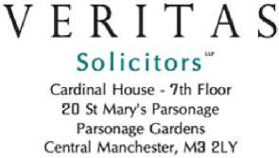
FZ/DB
T: +44 (0)844 478 1999
F : +44 (0)844 478 1998 www.veritassolicitors.co.uk
Date: 18 December 2023
Miss DB
7 Tennyson Close, Scottland green road Enfield
EN3 4SN
Email: Lorraine32@blueyonder.co.uk
Dear DB

Re: Your housing disrepair claim
Thank you for your instructions in relation to the disrepair problems you are experiencing at your home as a result of your landlord's failure to carry out the necessary remedial works of repair.
Please note your claim will be dealt with by a designated fee earner who is experienced in housing disrepair, the details of which will be supplied to you post allocation of your claim. Your claim will be supervised by a team leader of the delegated fee earner, who details will be supplied in due course, alongside that of the fee earner.

Your Claim
We confirm that Veritas Solicitors is regulated by the Solicitors Regulations Authority, and we will always act in your best interest.
Also, we confirm we do not pay any referral fees for the introduction of any cases. However, we may partake in either a marketing campaign to marketing companies or claims management companies with whom we agree a marketing budget that we pay them for which they would carry out marketing on our behalf or pay recommendation fees to similar entities which result in the production of cases. Both methods result in obtaining cases from them and rest assured both are compliant with rules and regulations under which we are governed. Should you require further details on our onboarding processes, please contact our offices and one of our staff would be happy to explain how we acquired your case in more detail.
We will act independently for you without being compromised on integrity. We must keep affairs of clients and former clients confidential except where disclosure is required or permitted by law. If you are happy for us to discuss and disclose confidential information regarding your matter to a third party, then kindly provide an authority to do so. We can confirm that even where you have granted us authority to discuss your claim with a third party, we will only ever contact you and will only discuss your claim with them where the relevant party may have advised us that you have reached out to them to find out the progress of your claim.
From the limited information you have supplied it would appear you have reasonable prospects of success in pursuing your claim to have the necessary works of repair carried out and to recover compensation. However please note that this assessment of the prospects of success may change once we have obtained the report of an Independent Chartered Surveyor on the causes and effects of the alleged disrepair at your home. Our role in acting for you is to carry out investigations and to value your claim with a view to ultimately obtaining compensation on your behalf. Our professional practice rules dictate we must inform you of a number of matters concerning this claim and how we intend to deal with it on your behalf. We appreciate that this correspondence is comprehensive, but it is important that you thoroughly read it and understand its contents.
By law, you only have 6 years from the date of knowledge of the disrepair (or 3 years when personal injury is alleged) with which to bring your claim. This means, either the claim must be resolved, or Court proceedings are issued, prior to the expiration of any limitation period. Consequently, it is extremely important that you swiftly respond to our correspondence and remain in contact, which includes advising us of any contact that you receive from your landlord or its representatives.
Veritas Solicitors. LLP is a limited liability partnership registered in England & Wales, with registered number OC 332894. Veritas is Regulated by the Solicitors Regulation Authority under SRA number 47203b. * Registered office.
Any reference to a partner means a member of Veritas Solicitors LLP or a consultant or employee with equivalent standing and qualifications. A list or partners is available at our registered office,
There are two main types of compensation you may claim
- General damages: Compensation for trouble and inconvenience you have experienced as a result of disrepair at your property, due to your landlord's failure to carry out the repairs within a reasonable timescale.
- Special damages. This will include out-of-pocket expenses you have incurred as a result of the disrepair. Examples include redecoration costs, excessive heating bills and damage to your personal belongings. We remind you to keep a note of such expenses and retain any original receipts.
In certain circumstances, if it can be shown that the condition of the property has adversely affected your health, and it is confirmed by an independent medical expert, you may also be able to include a claim for damages for personal injury.

Special Needs
If you have any special needs, of any kind, but especially in respect of communicating with us, then please tell us at once. Such special needs may include hearing difficulties, visual impairment, some other physical disability, learning difficulties, language barriers or other cross-cultural issues. Once we know about the issue, we can work together to overcome any anticipated difficulty. If there is ever anything that you do not understand, then please contact the file handler and we will endeavour to assist.

Our Charges and Funding Options
It is important you understand your responsibilities for the landlord and our costs. A person who succeeds in pursuing a claim is responsible for his/her own legal costs and must recover them from the other party, at the conclusion of the case. If you lose your case, you are responsible not only for their own costs but also for the other side's legal costs. The paragraphs below explain how we intend to ensure that you are not exposed to such cost risks.
It is now generally very difficult/not possible to obtain Legal Aid for damages for housing disrepair claims. However, there are several other alternatives that may be open to you in terms of funding your claim. You may have a legal expenses insurance policy attached to your vehicle or home contents insurance policy. You may be a member of a Trade Union or other organisation who assists their members in funding litigation. Please advise us immediately should you or your spouse or partner have a credit card, household, or motor policy, or are members of a union or similar organisation since this may include an entitlement to legal expenses insurance.
We confirm that we will conduct your claim on a “no win, no fee” basis supported by a policy of insurance to cover your disbursements, such as surveyors report fees, engineer report fees, barrister fees and Court fees, which must inevitably be incurred from time to time to progress your case.
Typical disbursement fees incurred to progress your case can range between £500 to £2,000 each. In the event of you winning the case, such sums for disbursements would be paid for by the other party or their insurers excluding the “after the event” legal expenses insurance policy premiums, if applicable, which is not recoverable from the other party.
If you lose your case, the policy insurance should reimburse the disbursements incurred including “after the event” legal expense insurance premium. This is conditional upon your consistent co-operation and provision of accurate instructions. If subsequently it is established you have pursued a fraudulent claim or provided materially inconsistent instructions then you will not have any protection under legal expenses insurance (“before the event” for example pre-existing motor, house contents, credit card policies or “after the event” policy) and will personally be responsible for your own and the opponents’ legal costs, which may be quite substantial.
If applicable, the success fee, namely the percentage uplift that we add to your bill if you are successful in bringing your claim for housing disrepair and associated losses, is not recoverable from your opponent even if your claim is successful. The success fee, if applicable, is payable by you. We shall charge you a success fee, if applicable, of 100% of our basic charges where the claim concludes at trial, or up to 25% if your claim relates to a housing disrepair matter.
There is a maximum limit on the amount of success fee which we can recover from you. That maximum limit is 25% of the total amount of any: i) general damages for distress, inconvenience, and loss of quiet enjoyment of your property, and ii) damages for pecuniary loss (financial losses element of your compensation), other than future pecuniary loss, which are awarded to you in the proceedings covered by this agreement. The maximum limit is inclusive of any VAT which is chargeable.
The maximum limit includes any success fee payable to a barrister who has a Conditional Fee Agreement (“CFA”) with us. However, this maximum limit applies only to a success fee for proceedings at first instance and not to a success fee on other proceedings (such as, for example, an appeal against a final judgement or order).
This firm is not authorised by the Financial Conduct Authority (formerly the Financial Services Authority). However, it is included on the register maintained by the Financial Conduct Authority so that this firm can carry on insurance mediation activity. This part of the business, including arrangements for complaints or redress if something goes wrong, is regulated by the Solicitors Regulation Authority. The financial services register can be accessed via the website at www.fsa.gov.uk/register.
We have considered a variety of the insurance policies available to cover your liability for the legal costs of the other party, and although we are not acting as an insurance broker, we believe that a policy with Financial & Legal is one which is appropriate for your requirements in that it is reasonable in cost and provides adequate cover against your opponent’s costs, including disbursements, should your claim be unsuccessful.
The cost of the insurance policy will be £448.00 (inclusive of IPT) however, you do not need to pay this at this stage as it is on a deferred credit basis and will be settled at the conclusion of the claim. The cost will be collected from your compensation/damages, if awarded.
Authority to Deduct Monies
By agreeing to these terms and conditions, you authorise Veritas Solicitors to deduct, if applicable, from your compensation monies recovered from your opponents the following:
- Success Fee - Up to 25 %; and
- After the Event Insurance Policy Gross Premium of £448.00 inclusive of IPT:
- Net Premium £400.00 exclusive of IPT; and
- IPT £48.00
Fees can increase in accordance with inflation. We will let you have further information if inflation causes our fees to increase. If your claim is unsuccessful the policy itself covers the cost of the policy, meaning that you do not pay for its fee.
We will bear the cost of running the action along with ongoing disbursements such as obtaining a surveyor’s report, medical records, medical reports and obtaining the Financial & Legal policy. The normal position is that if your claim succeeds your landlord will pay your compensation and will pay our costs. Therefore, there is no charge to you if your claim succeeds apart from the success fee of 25% of damages and the insurance premium if applicable of £448.00.
Upon receiving an offer of settlement from your landlord, when advising you of the offer, we may choose to inform you of the ‘net’ sum you would receive after the agreed deductions. This is for your convenience so that you are entirely clear on the sum you would receive. If at any point, you would prefer to have a detailed breakdown including the gross offer then please advise us by contacting your designated file handler.

Costs
Although we will be claiming our costs from your opponent, we are obliged to inform you how our fees are calculated.
If your claim settled without the need of issuing Court Proceedings, in any claim worth over £1,000 in respect of the housing disrepair, we will be entitled to receive standard costs.
We will be entitled to charge an hourly rate for the work carried out on your file and the hourly rate will be that which is prescribed by the local County Court as follows:
- Grade A: £261.00 per hour
- Grade B: £218.00 per hour
- Grade C: £178.00 per hour
- Grade D: £126.00 per hour
We will also recover most disbursements such as the cost of obtaining a surveyor’s report, medical report and an insurance policy.
If your claim is successfully completed in your favour, then we will look to your opponent to pay your basic charges and disbursements. This excludes the success fee and the after the event legal expenses insurance premium which are not recoverable from your opponents.
Please find attached a Conditional Fee Agreement, which we require you to sign where indicated and return the same to us in the pre-paid envelope provided.
We will make arrangements for the funding of your disbursements in this matter, as appropriate. Disbursements are any monies owed or paid as a result of progressing your case, for example: Medical fees, Surveyors Fees, Barristers Fees, Court Fees etc. On average cases, these range between £500.00 and £1600.00. If you win your case, these sums will be paid by your opponents, excluding the After the Event Insurance policy premium, which will not be paid by your opponents. If you lose your case, the insurance policy should reimburse the disbursements incurred, including the after-the-event insurance policy gross premium, if applicable. Please note that this recovery is subject to you cooperating with us in the progression of your claim and providing accurate instructions. If it later transpires that you have attempted to pursue a fraudulent claim, then you will not have any protection under your any form of insurance and be personally responsible for our costs and your opponent’s costs.
If you are successful in bringing a claim against your opponents, you may recover your costs, disbursements, excluding the success fee, and any after the event insurance policy premium, as explained in more detail above.
If you are unsuccessful in bringing a claim against your opponents, generally you are not responsible for their legal costs and disbursements. However, you will continue to remain responsible for your own disbursements, but these may be recoverable from the legal expenses insurance policy covering your matter.
In certain circumstances when court proceedings have been issued, the presiding judge may find that you had no reasonable grounds in pursuing your matter or that you were dishonest in bringing your matter. If this is found, then you may be held personally responsible for payment of your opponent’s reasonable legal costs and disbursements, as well as, responsible for your own legal costs and disbursements.
Based on the information provided to us by you and on assessment of your case, we believe your case is suitable for ‘after the event’ insurance policy namely with Financial and Legal Insurance as recommended to us by the broker we employ. This insurance provides an indemnity limit of £25,000.00, which is sufficient to cover the costs of your opponent’s legal costs and disbursements and cover your own disbursement, unless there is a finding of fraud or dishonesty on your part.
The cost of this policy gross premium is in the sum of £400.00 (+ insurance premium tax at 12%) for housing disrepair claims. This sum is deferred and therefore you will be required to pay it if you are successful, at the conclusion of your claim. As we are unable to recover this premium from your opponents, regardless of whether you are successful, you will be bound by these terms and conditions to instruct and authorise us to deduct the full insurance policy premium from any compensation you will recover and forward this to the insurance provider, to discharge your liability to them. However, if you are not successful, we will not require payment from you.

Your Responsibilities
We would briefly advise that as long as you fully and reasonably cooperate with us and attend any medical examination or surveyor inspection and your claim is successful then we would accept the costs that your landlord pays, and you would receive your compensation less the 25% success fee and less the insurance premium of £448.00. The latter has been explained above.

Your Duties
- You must be honest with us.
- You have an active duty to keep your losses to a minimum.
- You must tell us anything that may affect our advice. If in any doubt, tell us about it and we can decide with you if the issue is relevant to the case or not.
- You must cooperate with us.
- You must not ask us to act improperly or unreasonably.
- You must attend expert’s meetings, meet us or a barrister for interviews and attend court if necessary.
You must keep all relevant documents and provide them to us, even if they may adversely affect your case. It is possible that a court will order you to hand them over to prove your case and your case can be damaged if documents have become lost. You must promptly give us your instructions.
If you receive any documents (including court papers) relating to your matter, you should immediately send these to us.
It is vital that we can contact you at all times until your case is settled. Please inform us in writing of any change of address or telephone number, as failure to do so could delay and prejudice your claim.
Furthermore, please inform us of any other Court proceedings in which you are involved or relevant to this matter and immediately forward copies of any documents you may have received.
You must provide documents to support any losses claimed. It helps us to effectively present your case if you record your losses in a diary or similar log.
Promptly inform us of your instructions when required and we cannot deal with any other person without your permission in advance.
Once information has been provided to us and subsequently changes occur, please inform us in writing. You should not contact any other party or their insurers, as it could severely prejudice your case.
If your housing disrepair matter includes a claim for personal injury, in due course it is likely we will instruct a medical expert to prepare a report. The medical expert will need to review your health records. Therefore, we will in such circumstances require you to complete an attached form of medical authority and return the same to us in the enclosed prepaid envelope.
We shall of course report to you at regular intervals as progress is made with your claim, but should you require any interim reports on progress made at any stage, please feel free to contact us.

Conditional Fee Agreement
We have agreed to take your case on a "no win, no fee” basis. The correct term for these agreements is a "Conditional Fee Agreement".
A feature of the Conditional Fee Agreement is that, in exchange for us taking the risk of not being paid for any of our work if you are unsuccessful, we are entitled to a "success fee" if you win, (you "win" if, on your behalf we obtain an agreement from your opponent to pay, or a court awards, compensation in your favour and any appeal against that award has failed). The success fee in this agreement is set at 25%.
If you win your claim, you pay our fees (as described above), our disbursements (payment of expenses on your behalf), the success fee and the premium for any after the event insurance product. VAT is charged on our base costs and the success fee.
You are entitled to seek recovery from your opponent of our basic charges, and our expenses and disbursements, BUT not the success fee or any insurance premium, if applicable.
If your opponent fails to pay any of the compensation or costs owed to you, we have the right to take recovery action in your name to enforce any judgement, order, or agreement. The charges of this action become part of our basic charges.
It may be that your opponent, during the course of the case, makes a Part 36 offer or payment which you reject, on our advice and your claim for damages goes ahead to trial where you recover damages that are less than that of the Part 36 offer
or payment. If this happens, we will not claim any charges or success fee for work done after we received notice of the offer or payment.
If you receive interim damages, we may require you to pay some or all our disbursements at that point and to deposit a reasonable amount on account against our future disbursements.
If you receive provisional damages we are entitled to payment of our basic charges, our disbursements, and the success fee at that point.
If on the way to winning or losing you are awarded any costs by agreement or court order, then we are entitled to payment of those costs, together with a success fee on those charges if you win overall.
We can end this agreement if we believe you are unlikely to win. You will not have to pay any fees for our work (other than any expenses paid out on your behalf).
If you end the agreement between us, we have the right to decide whether you should pay our fees, VAT, and disbursements at once, or at the end of the case. This is entirely at our discretion.
We would hope to be able to negotiate a settlement of your claim without the need to involve a specialist barrister. If, however, it does become necessary to do so, we will aim to arrange a “no win, no fee” arrangement with them, so that your responsibility for such fees will be covered on the same basis as our own. However, this is entirely based upon the then instructed barrister and their chambers and they may wish to arrange instruction on a private basis. We will inform you accordingly when we instruct/receive notice from the barrister.
If we must issue court proceedings on your behalf, your liability for costs may increase. We will inform you at that time what additional costs could be incurred.
Our service is a continuing service and so our costs are payable when we cease to act for you.
Where costs are awarded on an interim basis, we may render a bill for the work covered by that interim cost award and keep the money awarded against that interim bill.
We have the right to keep any papers or money until payment is made to us. We may keep any interest on costs and disbursements that we recover.
You have the right to object to any bill we deliver to you, and you can apply for our bill to be assessed by the court under Part III of the Solicitors Act 1974, or you can make a complaint to the Legal Complaints Services.
We are entitled to charge interest on all, or part, of any bill if it is unpaid.
If you win your claim through court proceedings, your opponent may be required to pay interest on the charges and disbursements incurred by us on your behalf. Since you will have not been paying our charges through the duration of the case, we will be entitled to retain such interest.

PLEASE NOTE: IF YOU DO NOT CO-OPERATE WITH US, OR IF YOU MISLEAD US, WE WILL LOOK TO YOU FOR ALL OF OUR COSTS.
We apologise if this appears as somewhat candid, however, some clients believe the service we offer is totally free unless we win. That is not the case. If you are honest and co-operate, then the agreement with us protects you in respect of our costs. If you lose, there is no charge. If you tell us something that is not true, or you stop cooperating with us, then we can and will ask you to pay our fees. We are sure that this will not happen, but we do want to make sure that you understand how the agreement between us works. The most important feature of this agreement is that if you are unsuccessful with your claim, you will not have to pay any costs to this firm, except as set out below.
Whether successful or not, you may be asked to pay costs and expenses in the following circumstances:
- If you ask us to obtain extra evidence in support of your claim, in circumstances where we might not be able to recover the cost of such evidence from your opponent. We would warn you before obtaining such evidence that this cost would be your responsibility whether the case was or was not successful.
- If you fail to cooperate with us in the conduct of your claim or provide us with misleading information. In such a situation we would have the right to stop working for you and to charge you for the work which has been done at the hourly rate set out in this correspondence and for expenses incurred on your behalf.
- Our fees to act for you are your responsibility. They will form part of your claim against the other party. If you win the case the other side will usually be ordered to pay your basic costs, expenses, and disbursements, BUT not the success fee or any insurance premium, if applicable.
- If you lose, unless your claim is judged fraudulent, or the claim is struck out, or you are claiming for the benefit of someone else; you should have the benefit of Qualified one-way Cost Shifting which effectively means no order for costs will be made against you. This however does not apply in claims for housing disrepair.
- If you win, we are entitled to be paid for the work we have done from the sums recovered from the other side, whether those sums are for costs or not. Normally there will be a delay between settlement of the claim and agreement on costs, especially in litigated cases. We have no wish to unnecessarily withhold payment of your damages; however, we reserve the right to raise an interim bill and retain an amount up to our maximum potential entitlement in costs against you pending our true entitlement crystallising.
- There may be other situations where you could end up paying a fee to us, whether sums are recovered from the other side. These situations are: if you fail to cooperate with us; if you fail to attend a medical/expert examination or court hearing that we reasonably ask you to attend; if you fail to give us necessary instructions; and/or if you withdraw instructions from us (i.e., stop using our firm).
- Another situation where you may end up paying us some fees even from your damages if we are not able to recover some of our costs from the paying party which has been as a result of either our offices not receiving proper instructions and us having to continually chase you for them, or if you keep asking us for unnecessary updates in relation to your matter time, which cannot be properly charged to the Defendant or their insurers. In this situation we reserve the right to send you a bill for the extra work we have carried out which the Defendants do not have to pay.
If you end the agreement between us, we have the right to decide whether you should pay our fees, VAT. and disbursements at once; or at the end of the case. This is entirely at our discretion.
If there is ever any doubt about you being able to recover costs, we will tell you. Please remember, we are acting on a ‘No Win – No Fee’ basis, as detailed above and you have the option of taking out cover for our expenses and disbursements under an after the event insurance policy.

Disclosure of relationships
We only select Conditional Fee Insurance products from a limited number of insurers, but we are not contractually obliged to conduct business in this way. You may ask us for a list of the insurers.
Our terms of business form the agreement between us. However, as it is your case, under our professional rules, we are obliged to tell you about the fees being incurred in your name.

Timescales
A straightforward case, where the council / housing association / private landlord whereby liability is known from the date of knowledge and is not in dispute the matter will take 6 to 12 months from our being instructed.
Where the council / housing association / private landlord dispute liability it will take about 12 months to 2 years.
More complex or higher value cases, cases that must go to court and more serious injury claims can potentially take longer than the above stipulated time frames.
These are guidelines/estimates which are only based on an average and not intended to bind us.

Levels of Service and Complaints Procedure
During the course of your matter, if there is any aspect about which you are concerned or require clarification, then please raise it with the person who is handling the matter, with a view to the matter being resolved quickly. If you remain concerned or we could not agree on an appropriate course of action, then your complaint would be referred to Mr Pete Graham, the firm’s compliance manager, who will contact you, and attempt to resolve the matter to your satisfaction.
The firm has a Complaints Procedure document, which is available on request, and which would be sent to you should you make a complaint.
Your right to complain might relate to the way in which your matter is being handled, or about a bill which we have issued. In the case of a complaint about a bill, there might also be a right to object to the bill by applying to the court for an assessment of the bill under Part III of the Solicitors Act 1974. However, we would point out that if all or part of a bill remains unpaid, we may be entitled to charge interest – any such entitlement being set out in our Terms and Conditions of Business and/or on the reverse side of the bill.
If you remain dissatisfied at the end of our complaints process, you would then be at liberty to contact the Legal Ombudsman, whose address is PO Box 15870, Birmingham, B30 9EB.
That organisation is the statutory body to whom you may refer your complaint once we have concluded out professional obligation to try and resolve it. The time limits for you to make a complaint to the Legal Ombudsman are one year from you becoming aware of your right to complain and six months from our final responses to the complaint.

File storage
We store files at no charge to you for six years after the end of your case with us has ended. The file will then be destroyed, and we shall take it that we have your permission to do this unless you tell us otherwise in writing. Should you require any documents from the file at any time during the 6 years, kindly note that there will be an administration charge of £50.

Money Laundering
We are required by the government to ask all our clients for proof of identity. We would stress that this does not mean that you are or anyone else is suspected of any wrongdoing. The purpose is to make it harder for the proceeds of crime to go undetected and to improve financial security for everyone throughout the financial and business sectors.
Please could you provide us with one of the following documents:
- Your current passport
- Your photo card driving license
- Your benefit book
And in all cases an electricity, gas, or other household bill in your name and at your current address which is no more than 3 calendar months old at the time it is produced.
In addition, we may carry out further checks via third party company, like ‘Verify’, to ascertain further confirmation in respect of your identity. If no objections are received, we will presume you consent to our use of Verify.

Please do not forward originals only forward copies of the above by post

Making a disclosure
We are professionally and legally obliged to keep your affairs confidential. However, solicitors may be required by statute to make a disclosure to the National Crime Agency where they know or suspect that a transaction may involve money
laundering or terrorist financing. If we make a disclosure in relation to your matter, we may not be able to tell you that a disclosure has been made. We may have to stop working on your matter for a period of time and may not be able to tell you why.

Action Plan
We will notify the Third Party and/or their insurance company and pursue the claim on your behalf. We shall keep you informed of further developments.
Unless you inform us otherwise, we trust we have your permission to sign any court documents on your behalf.

Confidentiality
External firms or organisations may conduct audit or quality checks on our practice. This could mean that your file is selected for checking, in which case we would need your consent for inspection to occur. All inspections are, of course, conducted in confidence. If you prefer to withhold consent, work on your file will not be affected in any way. Since very few of our clients do object to this, I propose to assume that we have your consent unless you notify us to the contrary.
We will also assume that, unless you indicate otherwise, your consent on this occasion will extend to all future matters that we conduct on your behalf. Please do not hesitate to contact me if I can explain this further or if you would like me to mark your file as not to be inspected. If you would prefer to withhold consent, please put a line through this section in the copy letter for return to me. Please note that external firms or organisation that conduct audits or quality checks on our practice are required to maintain confidentiality in relation to your file.
Again, this will be an exception to the recent changes brought about GDPR and data protection under disclosure rules.
We are obliged to advise that we work with external companies of a variety in nature in order to provide you with the best service we can. Details of the types of external services provided to us are as follows:
- I.T. and Legal Software Companies: e.g Global Asset Support Ltd., Select Legal, Y.P. Solutions Ltd., Legal Support Ltd. and other Consultants. These are providers of I.T. support, case management software and general assistance with our website or other social media support. Some of these consultants may be based outside of the U.K and carry out works outside of the U.K.
- General Consultants: Accountants, Bookkeepers, File Handlers, Legal Compliance firms, Auditors, Data Processing and Administrative assistants are often used to process accounting information, files or assist the current file handlers within our offices. Again, these may carry out works outside of the U.K.
Should you require more detail of the above-named companies roles within our company or specific names of individuals who may carry out works upon your file of papers, we invite you to contact our offices to discuss further.
- Data Protection
Primarily, we use information you provide for the provision of legal services. Our use of that information is subject to your instructions, the Data Protection Act 1998, as reformed by GDPR and our duty of confidentiality. A copy of the GDPR policy of our firm can be viewed on our website or provided to you upon request. Please note that our work for you may require us to give information to third parties such as government agencies/bodies and other professional advisors or experts. You have a right of access under the data protection legislation and GDPR to the personal data that we hold about you.
I enclose the following documentation which I require you to complete, sign and return in the pre-paid envelope provided:
- Conditional Fee Agreement x 2
- Client Care Letter Confirming Losses
This is required to ensure that you do not have any before the event insurance which would cover your legal costs in bringing a claim. I also enclose the guidance booklet for conditional fee agreements, which you should read carefully and keep for your information.
We hope that by sending this letter we have addressed your immediate queries about the day-to-day handling of your work and our terms of business.
You will be considered and deemed to have accepted the terms herein on the basis of Veritas Solicitors continuing to receive instructions from you and in the absence of any objections within the next 14 days.
Please note that if you have queries, please do not hesitate to contact us Monday to Friday between 9.00am and 5.30pm on 0844 478 1999.
Thank you for your valued instructions in this matter and we are confident that we will be able to provide you with an excellent standard of service now and in the future.

DECLARATION
I confirm that I have read and understood the above terms and conditions of business for Veritas Solicitors LLP and agree to being bound to these terms and conditions. I understand that Veritas Solicitors LLP will now act on my behalf in pursuing my consequential losses against my opponents. I note that my continuing instructions will also amount to acceptance of these terms and conditions as well.

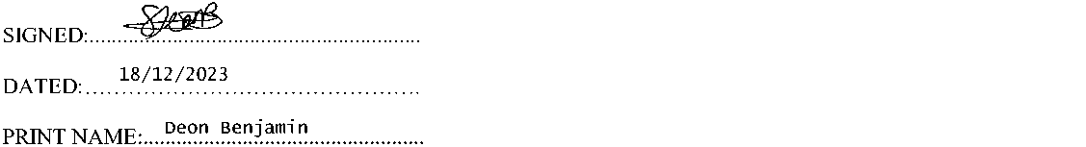

Please sign, date and return
We enclose a self-addressed envelope to assist in replying.
If there are any matters within this letter that you do not understand please do not hesitate to contact us.
Yours sincerely,
Veritas Solicitors LLP
I note Veritas Solicitors costs in this matter and their entitlement to a success fee of up to 25% and continue to agree to instruct Veritas Solicitors


Date: 18 December 2023
T: +44 (0)844 478 1999 F : +44 (0)844 478 1998 www.veritassolicitors.co.uk

Conditional Fee Agreement (‘CFA’)
For use in Housing Disrepair cases (including where appropriate those with an element of personal injury)
This agreement is a binding legal contract between you and your solicitor/s. Before you sign, please read everything carefully. This agreement must be read in conjunction with the Schedules and the Law Society Conditions attached.

Agreement date: 18/12/2023
We, the Solicitors Veritas Solicitors LLP of 7th Floor | Cardinal House | 20 St Mary’s Parsonage | Parsonage Gardens | Manchester | M32LY
You, the client, DB 7 Tennyson Close, Scottland green road Enfield London EN3 4SN
What is covered by this agreement:
- Your claim and / or application for an order for specific performance of your landlord’s (London & Quadrant) repairing obligations pursuant to s 11 of Landlord and Tenant Act 1985 and /or s4 of Defective Premises Act 1972 and /or Section 9(a) of Homes (Fitness For Human Habitation) Act 2018 the provisions of the tenancy agreement between you and your landlord.
- Your claim for general and/or special damages arising from your landlord's breaches of the statutory and / or contractual provisions set out in paragraph 1 herein.
- Any claim for damages for personal injury suffered as a result of your occupation of rented accommodation situate and whereat you are, or were, the tenant of (London & Quadrant)
- Any application for pre-action or non-party disclosure.
- Any appeal by your opponent.
- Any appeal you make against an interim order or an assessment of costs.
- Any proceedings you take to enforce a judgment, order or agreement.
- Negotiations about and/or a court assessment of the costs of this claim.

What is not covered by this agreement
- Any counterclaim against you.
- Any appeal you make against the final judgment or order.

Paying us if you win
If you win your claim, you pay our basic charges, our expenses and disbursements and a success fee together with the premium for any insurance you take out. You are entitled to seek recovery from your opponent of part or all of our basic charges and our expenses and disbursements, but not the success fee or any insurance premium.
The overall amount we will charge you for our basic charges, success fees, expenses and disbursements is limited as set out in Schedule 2 below.
It may be that your opponent makes a formal offer to settle your claim which you reject on our advice, and your claim for
Veritas Solicitors LLP is a limited liability partnership registered in England & Wales, with registered number OC 332899. Veritas is Regulated by the Solicitors Regulation Authority under SRA number 472036. 'Registered office.
Any reference to a partner means a member of Veritas Solicitors LLP of a consultant or employee with equivalent standing and qualifications. A list of partners is available at our registered office.
damages goes ahead to trial where you recover damages that are less than that offer. If this happens, we will not add our success fee to the basic charges for the work done after we received notice of the offer or payment. In these circumstances, you may be ordered to pay your opponent’s costs, but only up to the amount of damages and interest awarded to you.

Expenses and Disbursements
If you receive interim damages, we may require you to pay our expenses and disbursements at that point and a reasonable amount for our future expenses and disbursements.
If you receive provisional damages, we are entitled to payment of our basic charges, our expenses and disbursements and success fee at that point.
If you win overall but, on the way, lose an interim hearing, you may be required to pay your opponent’s charges of that hearing, but usually only up to the amount of damages awarded to you.
If on the way to winning or losing you are awarded any costs, by agreement or court order, then we are entitled to payment of those costs, together with a success fee on those charges if you win overall.

What do I pay if I lose?
If you lose you will normally have the benefit of Qualified One-Way Cost Shifting so the court will not usually enforce an order for costs against you, unless:
- the proceedings have been struck out; or
- the claim is fundamentally dishonest; or
- the claim includes a claim for the financial benefit of someone else.
If you lose, you do not pay our charges but we may require you to pay our expenses and disbursements.

The Success Fee
The success fee is set out in Schedule 1.

Basic Charges
Details of our basic charges are set out in Schedule 2.

Ending this agreement
If you have a right to cancel this agreement under Schedule 3 (see below) and do so within the 14 day time limit, you will pay nothing. Otherwise if you end this agreement before you win or lose, you pay our basic charges and expenses and disbursements. If you go on to win, you also pay a success fee.
We may end this agreement before you win or lose, with the consequences set out in the Law Society Conditions.

Other points
Definitions of words used in this CFA are explained in the Law Society Conditions.
You have the right to cancel this agreement in the circumstances set out in Schedule 3.
We add VAT, at the rate that applies when the work is done, to the total of the basic charges and success fee. Our VAT Registration Number is 925807213.
You may be able to take out an insurance policy against the risk of paying expenses and disbursements (but not our charges) if you lose, or some or all of your opponent’s costs even if you win. You will be responsible for paying the insurance premium for this if you win. If you lose the premium is not payable. Full details are contained in the insurance policy documents. We will give further information about insurance policies to you so that you can decide whether you wish to take one out.
The parties acknowledge and agree that this agreement is not a Contentious Business Agreement within the terms of the Solicitors Act 1974.


Note: We are not bound to act on a conditional fee basis until both you and we have signed this agreement.

The Law Society

Schedule 1

Success fee
The success fee is set at 100 % of our basic charges, where the claim concludes at trial; or 25% where the claim concludes before a trial has commenced.
The success fee percentage reflects the following:
- the fact that if you lose, we will not earn
anything;
- our assessment of the risks of your case;
- any other appropriate matters;
- the fact that if you win we will not be paid our basic charges; until the end of the claim
- our arrangements with you about paying
expenses and disbursements.
- the arrangements about payment of our costs if
your opponent makes a Part 36 offer or payment which you reject on our advice, and your claim for damages goes ahead to trial where you recover damages that are less than that offer or payment.
The Success Fee cannot be more than 100% of the basic charges in total.
Cap on the amount of Success Fee which you will pay us in the event of Success in proceedings at first instance
There is a maximum limit on the amount of the success fee which we can recover from you.
That maximum limit is 25% of the total amount of any:
- general damages for pain suffering and loss of amenity; and
- damages for pecuniary loss, other than future pecuniary loss;
which are awarded to you in the proceedings covered by this agreement. The maximum limit is applicable to these damages net of any sums recoverable by the Compensation Recovery Unit of the Department of Work and Pensions. The maximum limit is inclusive of any VAT which is chargeable.
The maximum limit includes any success fee payable to a barrister who has a CFA with us.
However, this maximum limit applies only to a success fee for proceedings at first instance and not to a success fee on other proceedings (such as, for example, an appeal against a final judgment or order).
We will provide you with a copy of any relevant judgment or of our calculation of any settlement showing how much of your damages should be attributed to General Damages and Past Pecuniary Loss, net of any sums recoverable by the Compensation Recovery Unit. If you do not agree our calculation and
this makes a difference to the amount of the Success Fee payable by you, then we will put the matter for determination by an independent barrister of at least 10 years call, to be appointed by agreement between us or, in default of agreement, by the President of the Law Society of England and Wales, such barrister to act as expert and not as arbitrator and his decision shall be binding. The barrister’s costs for assessing this issue are to be paid by you if the barrister agrees with us, but otherwise are to be paid by us.
You also have the right to apply to the court for assessment of our costs, including our success fee.

Schedule 2

Basic charges
These are for work done from now until this agreement ends. These are subject to review.

How we calculate our basic charges
These are calculated for each hour engaged on your matter. Routine letters and telephone calls will be charged as units of one tenth of an hour. Other letters and telephone calls will be charged on a time basis. The hourly rates are:
Grade of Fee Earner | Hourly Rate
1 Solicitors, Legal Executives and Other fee earners with over eight years post qualification experience including at least eight years litigation experience. | £261.00
2 Solicitors, Legal Executives and Other fee earners with over four years post qualification experience including at least four years litigation experience. | £218.00
3 Other Solicitors, Legal Executives and  Other fee earners. | £178.00
4 Trainee solicitors, paralegals and other fee earners | £126.00

We review the hourly rate in January each year and we will notify you of any change in the rates in writing.
The above hourly rates may not apply if your claim is subject to a specific fixed fee arrangement agreed between us. If a specific fixed fee arrangement has been agreed with you it is set out below and that fee plus expenses payable by you will be the amount of legal costs payable by you less any amount recovered from your opponent.
Schedule 3
Notice of the Right to Cancel
This only applies if you sign the Conditional Fee Agreement:
- At your home, workplace or at someone else’s home; or
- At our offices but following a visit by us (or by someone acting on our behalf) to your home, workplace or someone else’s home; or
- At our offices but following a meeting between us away from our offices.
You have the right to cancel this contract if you wish and can do so by delivering, sending (including electronic mail) a cancellation notice to the person mentioned below at any time within 14 days starting with the day of receipt of this Notice.
The person to whom a cancellation notice may be given is Mr F Fazal of Veritas Solicitors LLP of 7th Floor | Cardinal House | 20 St Mary’s Parsonage | Parsonage Gardens | Manchester | M32LY
Notice of cancellation is deemed to be served as soon as it is posted or sent to us.
You can use the cancellation form provided below if you wish.
Signed on behalf of Veritas Solicitors LLP
Dated:
If you wish to cancel the contract, you must do so in writing and deliver personally or send (which maybe by electronic mail) this to the person named below. You may use this form if you want to but you do not have to.
(Complete, detach and return this form ONLY IF YOU WISH TO CANCEL THE CONTRACT)
To: Mr F Fazal of Veritas Solicitors LLP
At 7th Floor | Cardinal House | 20 St Mary’s Parsonage | Parsonage Gardens | Manchester | M32LY
Case Reference No:
I hereby give notice that I wish to cancel my Conditional Fee Agreement with your firm.
Signed:………………………………………………………………………
Name (please print):…………………………………………………
Address:………………………………………………………………………
Date:…………………………………

Law Society Conditions
The Law Society Conditions below are part of this agreement. Any amendments or additions to them will apply to you. You should read the conditions carefully and ask us about anything you find unclear.

Our responsibilities
We must:
- always act in your best interests, subject to our duty to the court;
- explain to you the risks and benefits of taking legal action;
- give you our best advice about whether to accept any offer of settlement;
- give you the best information possible about the likely costs of your claim for damages.

Your responsibilities
You must:
- give us instructions that allow us to do our work properly;
- not ask us to work in an improper or unreasonable way;
- not deliberately mislead us;
- cooperate with us;
- go to any medical or expert examination or court hearing.

Dealing with costs if you win
- you are liable to pay all our basic charges, our expenses and disbursements and the success fee (up to the maximum limit) together with the premium of any insurance policy incepted on your behalf.
- Normally, you can claim part or all of our basic charges and our expenses and disbursements from your opponent. You provide us with your irrevocable agreement to pursue such a claim on your behalf. However, you cannot claim from your opponent the success fees or the premium of any insurance policy you take out.
- If we and your opponent cannot agree the amount, the court will decide how much you can recover. If the amount agreed or allowed by the court does not cover all our basic charges and our expenses and disbursements, then you pay the difference.
- You, not your opponent, pay our success fee and any insurance premium.
- You agree that after winning, the reasons for setting the success fee at the amount stated may be disclosed to the court and any other person required by the court.
- If your opponent is receiving Community Legal Service funding, we are unlikely to get any money from him or her. So if this happens, you have to pay us our basic charges, expenses and disbursements and success fee.
We are allowed to keep any interest your opponent pays on the charges.
You agree to pay into a designated account any cheque received by you or by us from your opponent and made payable to you. Out of the money, you agree to let us take the balance of the basic charges; success fee; insurance premium; our remaining expenses and disbursements; and VAT. You take the rest.
If your opponent fails to pay monies due to you
If your opponent does not pay any damages or charges owed to you, we have the right to take recovery action in your name to enforce a judgement, order or agreement. The charges of this action become part of the basic


charges.

Payment for advocacy
The cost of advocacy and any other work by us, or by any solicitor agent on our behalf, forms part of our basic charges. We shall discuss with you the identity of any barrister instructed, and the arrangements made for payment.
Barristers who have a conditional fee agreement with us
If you win, you are normally entitled to recover their fee from your opponent, but not their success fee. The barrister's success fee is shown in the separate conditional fee agreement we make with the barrister. You must pay the barrister’s success fee shown in the separate conditional fee agreement we make with the barrister. We will discuss the barrister’s success fee with you before we instruct him or her. If you lose, you pay nothing to the barrister.
The barrister’s success fee is included within the maximum limit to the recoverable success fee in proceedings at first instance as explained in Schedule 1.
Barristers who do not have a conditional fee agreement with us
If you win, then you will normally be entitled to recover all or part of their fee from your opponent. If you lose, then you must pay their fee.
What happens when this agreement ends before your claim for damages ends?
- Paying us if you end this agreement
You can end the agreement at any time. Unless you have a right to cancel this agreement under Schedule 3 and do so within the 7 day time limit we then have the right to decide whether you must:
- pay our basic charges and our expenses and disbursements including barristers’ fees but not the success fee when we ask for them; or
- pay our basic charges, and our expenses and disbursements including barristers’ fees and success fees if you go on to win your claim for damages.
- Paying us if we end this agreement
We can end this agreement if you do not keep to your responsibilities. We then have the right to decide whether you must:
- pay our basic charges and our expenses and disbursements including barristers’ fees but not the success fee when we ask for them; or
- pay our basic charges and our expenses and disbursements including barristers’ fees and success fees if you go on to win your claim for damages.
- We can end this agreement if we believe you are unlikely to win. If this happens, you will only have to pay our expenses and disbursements. These will include barristers’ fees if the barrister does not have a conditional fee agreement with us.
(ii)We can end this agreement if you reject our opinion about making a settlement with your opponent. You must then:
- pay the basic charges and our expenses and disbursements, including barristers’ fees;
- pay the success fee if you go on to win your claim for damages.
If you ask us to get a second opinion from a specialist solicitor outside our firm, we will do so. You will pay in advance the cost of a second opinion.
(iv) We can end this agreement if you do not pay your insurance premium when asked to do so.
(c) Death
This agreement automatically ends if you die before your claim for damages is concluded. We will be entitled to recover our basic charges up to the date of your death from your estate.
If your personal representatives wish to continue your claim for damages, we may offer them a new conditional fee agreement, as long as they agree to pay the success fee on our basic charges from the beginning of the agreement with you.

What happens after this agreement ends
After this agreement ends, we may apply to have our name removed from the record of any court proceedings in which we are acting unless you have another form of funding and ask us to work for you.
We have the right to preserve our lien unless another solicitor working for you undertakes to pay us what we are owed including a success fee if you win.
Explanation of words used
- Advocacy
Appearing for you at court hearings.
- Basic charges
Our charges for the legal work we do on your claim for damages as set out in Schedule 2.
- Claim
Your demand for damages for personal injury whether or not court proceedings are issued.
- Counterclaim
A claim that your opponent makes against you in response to your claim.
- Damages
Money that you win whether by a court decision or settlement.
- Our expenses and disbursements
Payments we make on your behalf such as:
- court fees;
- experts' fees;
- accident report fees;
- travelling expenses.
- Interim damages
Money that a court says your opponent must pay or your opponent agrees to pay while waiting for a settlement or the court's final decision.
- Interim hearing
A court hearing that is not final.
- Lien
Our right to keep all papers, documents, money or other property held on your behalf until all money due to us is paid. A lien may be applied after this agreement ends.
- Lose
The court has dismissed your claim or you have stopped it on our advice.
- Formal Offer to Settle
An offer to settle your claim made in accordance with Part 36 of the Civil Procedure Rules.
- Provisional damages
Money that a court says your opponent must pay or your opponent agrees to pay, on the basis that you will be able to go back to court at a future date for further damages if:
- you develop a serious disease; or
- your condition deteriorates;
in a way that has been proved or admitted to be linked to your personal injury claim.
- Qualified One-Way Cost Shifting
The rules in respect of costs payable if you lose a personal injury claim set out in [Part 44 Section II ] of the Civil Procedure Rules.
- Success fee
The percentage of basic charges that we add to your bill if you win your claim for damages
- Trial
The final contested hearing or the contested hearing of any issue to be tried separately and a reference to a claim concluding at trial includes a claim settled after the trial has commenced or a judgement.
- Win
Your claim for damages is finally decided in your favour, whether by a court decision or an agreement to pay you damages or in any way that you derive benefit
from pursuing the claim.
'Finally' means that your opponent:
- is not allowed to appeal against the court decision; or
- has not appealed in time; or
- has lost any appeal




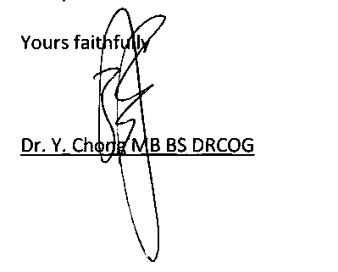
T: +44 (0)844 478 1999 F : +44 (0)844 478 1998 www.veritassolicitors.co.uk

FORM OF AUTHORITY
PERSONAL DETAILS
NAME | DB
DOB | ********
ADDRESS | 7 Tennyson Close, Scottland green road Enfield London EN3 4SN

Hereby confirm that I irrevocably instruct and authorise Veritas Solicitors of 7th Floor, Cardinal House, 20 St Mary’s parsonage, Parsonage Gardens, Manchester, M3 2LY to act as my legal representatives for my Housing Disrepair matter:
1. to act on my behalf in accordance with the terms and conditions of business supplied to me in relation to the repairs and recovery of damages and/or any other losses arising from the above matter.
2. to commence court proceedings in my name, unless otherwise confirmed by me in writing, in order to progress with my claim as they see fit and appropriate.
I confirm:
3. I will provide honest and timely instructions when requested to do so by Veritas Solicitors.
4. I will not and do not instruct any other firm to act on my behalf in relation to this index matter.
5. I understand that filling in and signing this form gives you permission to give copies of all relevant records or documents relating to my claim for housing disrepair including:-(i) copy of tenancy agreement including tenancy conditions (ii) tenancy file (iii) documents relating to notice given, disrepair reported, inspection reports or repair works to the property (iv) computerised records to my solicitor Veritas Solicitors or agent whose details are given below pursuant to the Data Protection Act 2018, and as superseded by GDPR Regulations.
6. I Authorise my Landlord (London & Quadrant) to provide the following: (i) copy of tenancy agreement including tenancy conditions (ii) tenancy file (iii) documents relating to notice given, disrepair reported, inspection reports or repair works to the property (iv) computerised records to my solicitor Veritas Solicitors or agent whose details are given below pursuant to the Data Protection Act 2018.
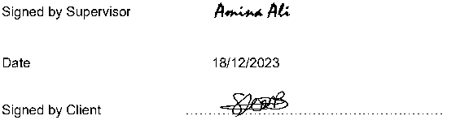

Veritas Solicitors New Claims Risk Assessment (HDR)
Client Name | DB
Reference | FZ/DB
Fee Earner | Faraz Fazal
Date | 18 December 2023

RISK ISSUE | percentile RISK
Disclosure | 3
Surveyor Report | 5
Photographs | 5
Reported dates | 5
Joint Tenancy | 5
Live tenancy | 5
Personal Injury caused by HDR | 5
Rent Arrears | 3
Witnesses | 3
Litigation Risk | 5
Client as witness | 3
Case cost bearing | 3
Special damages evidence | 3
Part 36 Offers/Payments | 5
Client Must not allow repairs | 3
TOTAL SUCCESS FEE | 61

• Prospects of Success greater than 61% | yes 0 no □
• Damages likely to exceed small claims limit | yes 0 no □
• Damages not likely to exceed fast track limit | yes 12 no □
• More than 3 months to Limitation | yes 2 no □

to be uninsured for third party risks | yes 2 no □
Claimant does not have suitable BTE cover | yes 2 no □

Injury complained of caused by negligence and/or breach of statutory duty of an identified third party who is not likely
18/12/2023
Date

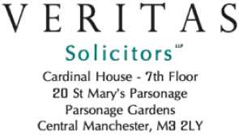
7: +44 {0)844 478 1999
F : +44 (0)844 478 1998 www. ver ita$oHcitors.co ₊ uk
Dated:18 December 2023
Ref: FZ/DB

RE: Housing Disrepair Claim
We write further to the above matter and to your claim for housing disrepair.
We have reviewed the risk of your claim and therefore its merits and believe that you require an after the event (ATE) insurance policy to protect you on your matter.
In accordance with this we draw you attention to the below, which explains about after the event insurance and how it will protect you in this matter against adverse costs and disbursements.
What you need to know about ATE Insurance
Claiming compensation is costly and we have a duty to ensure you are fully aware of the risks involved.
A “No win, No Fee” Agreement (Conditional Fee Agreement (CFA)) means you do not pay us ‐ your solicitor unless you win your case. However, you will be liable to pay for any disbursements and expenses incurred on your behalf and your opponent’s costs as well, unless you take out ATE insurance.
We recommend that you purchase an After the Event Insurance policy to protect yourself against such unexpected costs.
If you do not purchase an ATE Insurance Policy now but decide to purchase insurance when it’s needed later, the premium will be considerably higher, and it will probably be uneconomical to do so.
We are only able to secure low premiums if you agree to purchase a policy now.
Premiums rise dramatically after this period.

Why do I need to insure my claim?
It is not a legal requirement to purchase insurance to protect yourself from unexpected legal costs, however if you choose not to you must understand that you will be personally responsible for any costs due to your opponent in circumstances outlined below as well as any disbursements incurred on your behalf which cannot be recovered from your opponent.
There is nothing new about insuring the legal costs of litigation and due to the uncertainty of litigation and the high costs involved we strongly advise you to purchase ATE insurance rather than encounter any unexpected costs consequences. You can of course arrange your own insurance if you prefer to arrange this yourself, however you must advise us if this is the case as there are strict terms and conditions within policies which we and you must comply.
Financial & Legal Insurance Company Limited (F&L) is a well‐ known specialist insurer who have insured and protected thousands of customers over the years against opponent’s costs and disbursements. As you are liable for your own incurred disbursements and in certain scenarios opponent’s costs and disbursements, ATE insurance can provide peace of mind and security against unexpected costs.

What are disbursements?
Disbursements are expenses that we as your solicitor, incur on your behalf for items such as copies of your medical records, an incident report, surveyor or other expert reports, medical reports (necessary to detail your injuries) as well as court fees and counsel’s fees for both advice and court appearances, if necessary. It is difficult to predict what the total of these disbursements may be because many of them depend on the complexity of issues which may only come to light later in the case. Much will depend on whether the Defendant agrees to settle with you, and if so at what stage. However, we can say that disbursements will certainly be many hundreds of pounds and often run into thousands of pounds if counsel is involved and/or trial takes place.

What are opponent’s costs?
Opponent’s costs are the legal costs plus any disbursements your opponent incurs in defending a claim against you. Costs can often be extremely high and in some circumstances (failing to beat a Part 36 offer) you could win your case but all of your damages could be consumed by paying your opponent’s costs.

Who is the insurance policy designed for?
After the Event insurance is designed to help any Claimant, including commercial customers who need to take legal action and could be facing considerable adverse costs in the event they lose their claim or even win their claim but are still ordered to pay costs to their opponent.
When do I pay the premium?
There are no up‐ front costs
You do not have to pay anything for this policy now.
No win, no fee Premium
You only ever pay us the premium in the event you win your claim for compensation
If your claim is unsuccessful, you do not have to pay the premium for this policy.
If your claim is successful, the premium will be deducted from the damages you recover.
The policy gives you the ability to ensure that an opponent pays you the correct level of damages because with our consent you can reject a damages offer which is deemed to be too low and if you later receive less than the sum you rejected, the policy will pay your liability for your opponent’s costs. This benefit alone may well outweigh the cost of the premium.
On the 1st April 2013 the court rules were amended so that you will now recover extra 10% damages compared to what you would have recovered before April 2013, and this will in part enable you to pay for this sort of ATE Insurance out of the money you recover.

What does F&L Insurance offer?
Provided your case is accepted by the insurer and you have agreed to pay the premium F&L Insurance can provide costs protection cover in the event you lose your case by paying reasonably incurred disbursements as well as protect your compensation in the event you fail to beat your opponent’s offer to settle.

When should I get covered?
The earlier you take out the policy, the lower your premium will be. Insurance taken out later in your case will mean you will have to pay a considerably higher premium, and in some cases will mean you cannot get your case insured at all.

How do I arrange cover?
We will arrange cover on your behalf which is appropriate for your needs providing you have authorised us to do so. If you do not provide your consent, we will not arrange cover for you and therefore agree to pay for any disbursements or opponents costs yourself if you lose your case or are ordered to do so.

Premiums?
Premiums vary according to the type of legal case you are pursuing because some cases are more complex than others and are therefore more expensive to pursue. The premiums below apply to fast‐ track cases with cover up to £25,000.
We will advise you if F&L Insurance reject your application for cover or if the premium differs from the figures below.

The insurance premium tax (currently 12%) will be payable at the rate in force at the time the premium is paid.
Housing Disrepair Claim - £448 inclusive of IPT

Who is F&L Insurance?
F&L Insurance Company Limited is an insurance company that specializes in After the Event (ATE) legal expenses insurance.
The policy is covered in the United Kingdom by the Financial Services Compensation Scheme (FSCS).
We would advise you however that we are not insurance brokers. The legal expenses insurance market is complex and frequently changes. Accordingly, we do not offer professional advice on all policies available in the market, but we will advise you in detail on the circumstances of your own case, should at any stage your interest’s conflict with ours, and if this occurs, we may recommend that Counsel’s advice should be obtained on those areas of conflict.
Unless you instruct us otherwise, we will arrange for an insurance policy to be taken out with F&L Insurance Company to protect you against the risks set out above. In doing so you will be agreeing to allow the insurer, to inspect your file and receive ongoing information from us regarding the progress of your case and its outcome. You will also be agreeing with F&L that we can act on your behalf to ensure compliance with the policy terms. Most importantly, instructing us to proceed will constitute your irrevocable agreement to allow us to receive your damages and to deduct the appropriate premium from the damages and to send it to the insurer in settlement of the liability to pay the premium.

Authorisation
We are not directly authorised by the Financial Conduct Authority; however, we are included on the exempt professional’s register maintained by the Financial Conduct Authority so that we may carry out insurance mediation activity. This means broadly that we can arrange, sell and administer insurance contracts. This part of our business, including arrangements for complaints or redress if something goes wrong, is regulated by the Solicitors Regulation Authority.
The register can be accessed via the Financial Services website at:
www.fsa.gov.uk/register/epfSearchForm.do
The Law Society of England and Wales is a designated professional body for the purposes of the Financial Services and Markets Act 2000. The Solicitors Regulation Authority is the independent regulatory arm of the Law Society. The Legal Ombudsman deals with complaints against lawyers. If you are unhappy with any insurance advice you receive from us, you should raise your concerns with either of those bodies.

CANCELLATION MANDATE
If we do not receive back the document/mandate signed and dated below within the next 7 days, we will presume you would like us to keep your insurance premium in place to cover any outstanding costs or disbursements.

Products
We only deal with products from F&L Insurance Company Limited for legal expenses insurance policies, but we are not contractually obliged to conduct business in this way.
VERITAS SOLICITORS

MANDATE AFTER THE EVENT INSURANCE POLICY
I have read this letter regarding the insurance policy you have taken out on my behalf.
I request that my insurance premium taken out on my behalf is cancelled and are aware that I will be liable / responsible for paying any outstanding disbursement and costs from my damages if I was not able to beat an offer to settle.
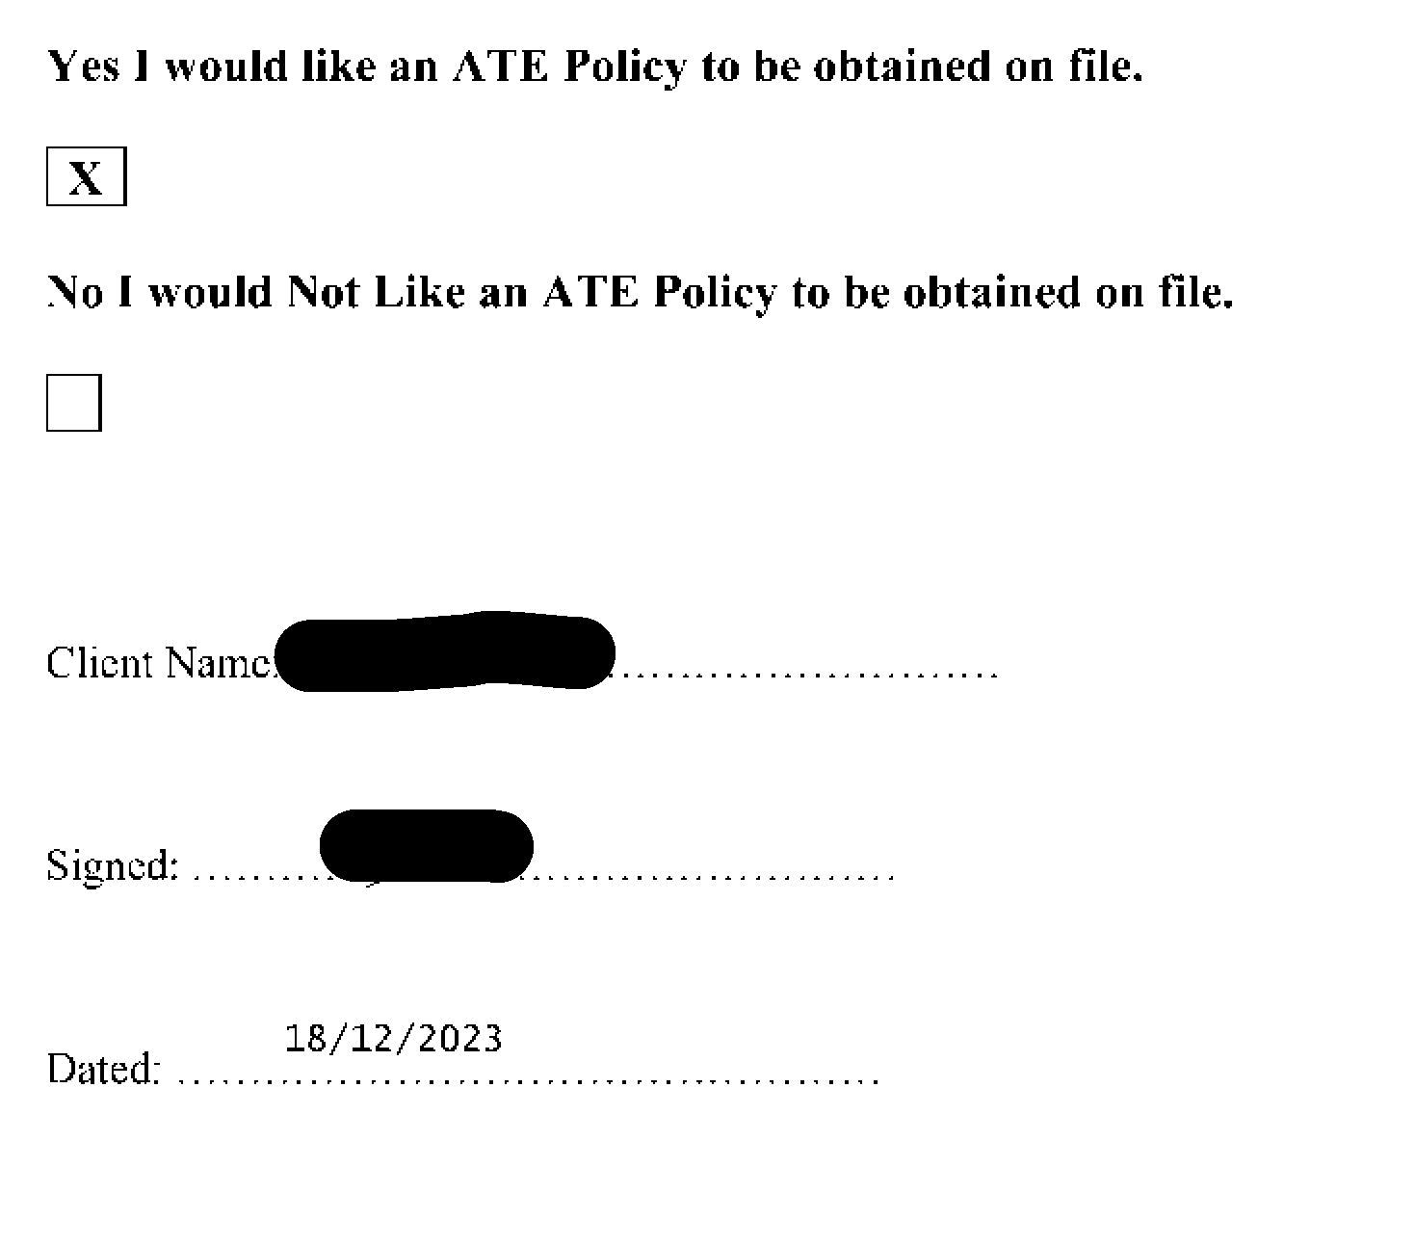

Document Index
GP Medical Letters dated 13/01/2023, 26/01/2023 and 16/03/2023 1-6
Department of Plastic & Reconstructive Surgery letters 7-10
Photo of Hand 11-17
Discharge summary Royal Free Hospital 18-22
DR Hilary Scurlock Medical report dated 03/07/2023 23-27
Enfield personality Disorder Stream appointment letter dated 8/11/23 28-37
Medication received dated 29/06/2023 38
Community Psychiatric Nurse Enfield Assessment Service letter dated 8/3/2023 39-42
L&Q Medical Assessment letter dated 21/10/2019 43
L&Q application for assistance under S183 letter dated 09/12/2022 44-45
Email from DC Neha Chadda Met Police dated 08/12/2022 46
Medical appointment letter dated 22/02/2023 and 6/12/2023 47-48
49-77
Mould pictures of client flat
NIGHTINGALE HOUSE SURGERY 1-3 NIGHTINGALE ROAD EDMONTON LONDON N9 8AJ Tel: 0208 805 9997 www.nightingalehousesurgery.nhs.uk
DRDABIDOYE DR Y CHONG
13 January 2023
YC/KM
PRIVATE & CONFIDENTIAL
TO WHOM IT MAY CONCERN
Dear Sir/Madam
Re: Miss DB dob ***** NHS No: ***** 23 Byron Terrace, Hertford Road, London, N9 7DG
I can confirm that the above 33-year-old lady is a patient registered at our practice.
Going through her medical records she has had a history of depression since 2008.
She was assaulted on 26th November 2022 and was admitted to North Middlesex Hospital A&E department with bleeding in the right hand. She was examined by the surgeons and had a rupture of the flexor digitorum superficialis tendon and was treated with antibiotics and bandaging.
According to the patient, following review, they are going to have to operate on the injury to repair the tendon in March.
Due to the assault, she has been suffering an acute exacerbation of her mental health issues. She informs us that the police have assessed her flat and deemed it unsafe to live in and therefore currently she is homeless and has been put up by her friends and temporary accommodation.
She is struggling to sleep. She was very tearful when she spoke to my colleague Priya Sharma and was started on anti-depressants Mirtazapine On 7th December 2022.
When she was reviewed by Miss Sharma on 21st December, she was extremely stressed and has self-harmed. She was also getting thoughts of self-harm and is waiting for therapy from the mental health team. She is very stressed about her homeless situation.
We would be grateful if she could be provided with suitable accommodation as soon as possible due to the impact it is having on her mental health and as well as her recovery from the hand injury.
Many thanks.

2
NIGHTINGALE HOUSE SURGERY 1-3 NIGHTINGALE ROAD EDMONTON LONDON N9 8AJ Tel: 0208 805 9997 www.nightingalehousesurgery.nhs.uk
DRDABIDOYE
DR Y CHONG
26 January 2023
PRIVATE & CONFIDENTIAL
Re: Miss DB dob ***** NHS No: ***** 23 Byron Terrace, Hertford Road, London, N9 7DG
I can confirm that the above 33-year-old lady is a patient registered at our practice.
Going through her medical records she has had a history of depression since 2008.
She was assaulted on 26th November 2022 and was admitted to North Middlesex Hospital A&E department with bleeding in the right hand. She was examined by the surgeons and had a rupture of the flexor digitorum superficialis tendon and was treated with antibiotics and bandaging. She notes that she had a form of surgery initially in November 2022 and she has been having hand therapy since.
According to the patient, following review, they are going to have to operate on the injury to repair the tendon in March 2023.
Due to the assault, she has been suffering an acute exacerbation of her mental health issues. She informs us that the police have assessed her flat and deemed it unsafe to live in and therefore currently she is homeless and has to stay sometimes with friends in the day. She has to leave the friends at night and stays in the streets and sometimes wherever she can.
She is struggling to sleep. She was very tearful when she spoke to my colleague! Priya Sharma and was started on anti-depressants Mirtazapine On 7th December 2022. When she was reviewed by Miss Sharma on 21st December, she was extremely stressed and has self-harmed. She was also getting thoughts of self-harm and is waiting for therapy from the mental health team. She is very stressed about her homeless situation.
She is having repeated flashbacks and dreams about the assault. She feels low when these happen, with nausea and sickness. She has dreams about people stabbing her and has significant numbness in the hand.
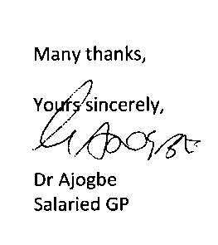
We would be grateful if she could be provided with suitable accommodation as soon as possible due to the impact it is having on her mental health and as well as her recovery from the hand injury.

4

DRDABIDOYE | NIGHTINGALE HOUSE SURGERY
DR Y CHONG | 1-3 NIGHTINGALE ROAD EDMONTON LONDON N9 8AJ Tel: 0208 805 9997  www.nightingalehousesurgery.nhs.uk

16 March 2023
PRIVATE & CONFIDENTIAL
Re: Miss DB dob ***** NHS No: ***** 23 Byron Terrace, Hertford Road, London, N9 7DG
- can confirm that the above 33-year-old lady is a patient registered at our practice.
Going through her medical records she has a history of depression since 2008.
She was assaulted on 26th November 2022 and was admitted to North Middlesex Hospital A&E department with bleeding in the right hand. She was examined by the surgeons and had a rupture of the flexor digitorum superficialis tendon and was treated with antibiotics and bandaging. She notes that she had a form of surgery initially in November 2022 and she has been having hand therapy since.
According to the patient, following review, they are going to have to operate on the injury to repair the tendon in March 2023.
Due to the assault, she has been suffering an acute exacerbation of her mental health issues. She informs us that the police have assessed her flat and deemed it unsafe to live in and therefore currently she is homeless and has to stay sometimes with friends in the day. She has to leave the friends at night and stays in the streets and sometimes wherever she can.
She is struggling to sleep. She was very tearful when she spoke to my colleague Priya Sharma and was started on anti-depressants Mirtazapine On 7th December 2022. When she was reviewed by Miss Sharma on 21st December, she was extremely stressed and has self-harmed. She was also getting thoughts of self-harm

and is waiting for therapy from the mental health team. She is very stressed about her homeless situation.
She is having repeated flashbacks and dreams about the assault. She feels low when these happen, with nausea and sickness. She has dreams about people stabbing her and has significant numbness in the hand. She has seen the Enfield Community Psychiatric nurse, Kris Gopaulen who has noted that "her presentation is suggestive of traits of PTSD" and the Clinical Psychologist at Royal free Hospital Lisa Goodman, has also seen DB. She scored 67 on the PCL-5 test by Lisa Goodman which she has stated indicates "symptoms consistent with PTSD", see reports attached. As such, DB has been referred to IAPT for PTSD management.
DB has had a recent pelvic scan. This has shown a 3cm ovarian cyst. She will need to be scanned again in 3 months. She has complained of pelvic pain.
We would be grateful if she could be provided with suitable accommodation as soon as possible due to the impact it is having on her mental health and as well as her recovery from the hand injury.
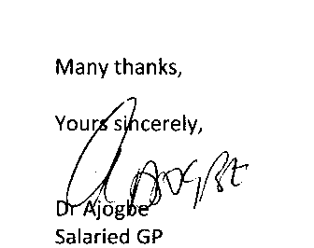
6



Royal Free London
NHS Foundation Trust
Tel: 020 7443 9757

369
MISS DB 23 BYRON TERRACE HERTFORD ROAD LONDON
N9 7DG
F514STI583HW
S369 cl.350/504 bl
12 January 2023




MRN Number: 50****
NHS Number: *********
Dear Miss DB
This letter is to confirm that an appointment has been made for you to see a member of the Plastic Surgery Service team on: Tuesday 28 February 2023 at 13:30
At: Clinic 4,
1st Floor
Royal Free Hospital
Pond Street
London, NW3 2QG
This appointment is with a Psychologist who works within The Plastic surgery team:
Please bring this letter with you when you attend, with any current medication that you are taking, in original containers.
If you need to cancel or reschedule this appointment please contact us on the telephone number above, as if you fail to notify us and do not attend this appointment, you may be discharged back to the care of your GP.
Please Note: If you are late for this appointment there is a risk that you will not be seen and your appointment will have to be rescheduled.
For further information about The Royal Free London, our Sites and Services, Transport Links and Parking etc. please visit our website.
https://www.royalfree.nhs.uk
Please let us know on the above number if your contact details have changed.
Yours sincerely
Outpatient Appointment Centre

world class expertise ♦ local care

www.royalfree.nhs.uk
Mark Lam, chairman Caroline Clarke, chief executive

Department of Plastic & Reconstructive Surgery

Ext: 36988
Private & Confidential
Suzanne
Hand Therapist
Royal Free Hospital
Pond Street
London '
NW3 2QG
/J05969890/MRN50369287
NHS No: 434 751 8617
Clinic Date: 16/02/2023
Date Typed: 24/02/2023
Dear Suzanne
Royal Free London
NHS Foundation Trust
Royal Free Hospital
Pond Street London NW3 2QG www.royalfree.nhs.uk Switchboard: 020 7794 0500 Fax: 020 7830 2195

Re: Miss DB DOB: 26/08/1989
23 Byron Terrace, Hertford Road, London, N9 7DG

Thank you for referring DB to the plastic surgery psychology service. I met with her on 16th February for a psychological assessment. She attended the clinic with her friend James who/waited outside but helped her complete measures as DB is dyslexic.
DB reports that she was involved in an altercation during which she was stabbed in the palm of her hand in November 2022. She remembers the period before the stabbing but has no memory of what & happened thereafter. DB reports experiencing constant intrusive thoughts in relation to the incident.
She thinks these may be memories but is not sure. She has constant nightmares, during which she is stabbed or otherwise unsafe. She is therefore getting very little sleep and feeling exhausted during the day.
DB finds that her traumatic “memories” are easily triggered. Triggers include walking past the site of the incident. Thoughts of the incident immediately flooded back and felt like she couldn’t breathe. DB needed to put a plastic bag over her hand to try and stem the blood flow (she needed a blood
transfusion as part of hospital treatment). Recently when she needed to cover her hand with the bath, this triggered memories and severe anxiety.
bag in
DB scored a total of 67 today on the PCL-5 indicating symptoms consistent with PTSD. DB reports that she has been sectioned in the past and has previously experienced auditory hallucinations. I understand that she has a diagnosis of bipolar and has been under mental health services since childhood. It was unclear why. DB is feeling that her friends and family may be manipulating her, by this-she meant they are encouraging her to go out and go to appointment^. She is unable to articulate why but feels the intent may not be benign. She recognises this may represent paranoid thinking which can be considered in the context of her bipolar diagnosis.
DB reports that since the stabbing she is finding it difficult to go out. She is unable to go to her home as the perpetrators are known to her and there is a pending court case. They know where she lives and she is fearful of another attack. She is therefore moving around between friends' houses.
DB finds that she does not want to care for her injured hand. She feels that it is not hers. She feels she does not want to use it or care for it and that it is bad. She reports that she tells hand therapy she is engaging in exercises, when actually she is finding it very difficult to find the motivation to do this. We discussed the concept of embodiment and how we might work with that within the service. DB / reports feeling low, anxious and exhausted. She is experiencing some suicidal ideation but has no ' current plans or intent. She rates herself 3/10 likely to act, with her mother and family being protective factors.
DB has a history of self-harm, involving horizontal cutting of her arms. The last occurrence of this was over a year ago. DB reports that she saw her GP two weeks ago who is aware of her history of self-harm and suicidal ideation. She was advised to self-refer to the crisis team but had not felt able to do this. We made this referral today together in clinic. The referral was taken by Jubeda Akthar, Assistant Practitioner. DB was advised that a clinician would contact her within four hours today. I have asked for an email to update in due course.
DB would need to be stable under community services before psychological therapy in relation to her hand would be indicated. Her scores today on the PHQ-9 were 17/24 and her scores on the GAD- 7 were 19/21 indicating both severe depression and severe anxiety. As psychological therapy in relation to the hand is not indicated at this point, I will now discharge DB from the plastic surgery psychology service back to the care of the crisis team and her GP. However, when she is stable, she is most welcome to return to the plastic surgery psychology service for support in relation to engaging with hand therapy, should that be deemed necessary.
Yours sincerely
Dictated and approved electronically to avoid delay.
Lisa Goodman
Clinical Psychologist
cc
Private & Confidential
Dr J M Thomas
Nightingale House Surgery
- Nightingale Road Edmonton
London
N9 8AJ
Miss DB
23 Byron Terrace
Hertford Road
London
N9 7DG
. fnllotfinS re^erra' ^Om hand therapy. Attended clinic with Seen today for psychology assessment asure$.
her friend James who helped her complete
n n altercation dur'n8 which she was stabbed in the palm of
eon reports that she was involved in a ^ stabbi„gr ^^ ^ mcmon, o( ^ happened her hand. She remembers the period be inlrusive ^^ |n re|atipp tp ,be jncWe„t _ she W^' D“n'"”'” “*"“ sure. She has constant nightmares, during which she is thinks these may be memories, but is not su , ,

stabbed or otherwise unsafe. She Is therefore getting very Me sleep and feehrlg exhausted during the day.
DB finds that her traumatic "memories" are easily triggered. Triggers include walking past the s of the incident. Thoughts of the incident immediately flooded back and felt like she couldn’t breathe. DB needed to put a plastic bag over her hand to try and stem the blood flow (she needed a blood transfusion as part of hospital treatment). Recently when she needed to cover er hand with a bag in the bath, this triggered memories and severe anxiety.
Total score on PCL-5 is 67, indicating PTSD. Symptoms consistent with PTSD.
DB reports that she has been sectioned in the past and has previously experienced auditory hallucinations. I understand that she has a diagnosis of bi-polar and has been under services since childhood. It was unclear why. DB reports that since the stabbing, she is finding it difficult to go out. She is unable to go to her home, as perpetrators are known to her and there is a court case pending. They know where she lives and she is fearful of another attack. She is therefore moving around between friends' houses. DB is feeling that her friends and family may be manipulating her - by this she meant they are encouraging her to go out and to appointments. She is unable to articulate why but feels the intent may not be benign. She recognises this may represent paranoid thinking, which can be considered in the context of other bi-polar diagnosis.
DB finds that she does not want to care for her injured hand. She feels it is not hers. She feels she does not want to use it or care for it and that it is bad. She reports that she tells hand therapy she is engaging in exercises when actually she is finding it very difficult to find the motivation to do this. We discussed the concept of embodiment and how we might work with that within this service.
DB reports feeling low, anxious and exhausted. She is experiencing some suicidal ideation but has no current plans or intent. She rates herself 3/10 likely to act, with her mother and family being protective factors. She has a history of self-harm involving horizontal cutting of the arms. Last occurrence was circa one year ago.
DB reports that she saw her GP two weeks ago, who is aware of history of self-harm and suicidal ideation. She had advised herself to self-refer to the crisis team. She had not felt able to do this. We did this together today in clinic. Referral was taken by Jubeda Akthar, Assistant Practitioner. DB was advised that a clinician would contact her within four hours today. I have asked for an e-mail update in due course. DB would need to be stable under community services, before psychological therapy in relation to her hand would be indicated.

Scores on PHQ9 = 19/24 (8 questions) indicating severe depression
Scores on GAD7 = 19/21 indicating severe anxiety .
Copy of this note provided to patient today at her request, as she is concerned, she will not remember the content of our consultation.
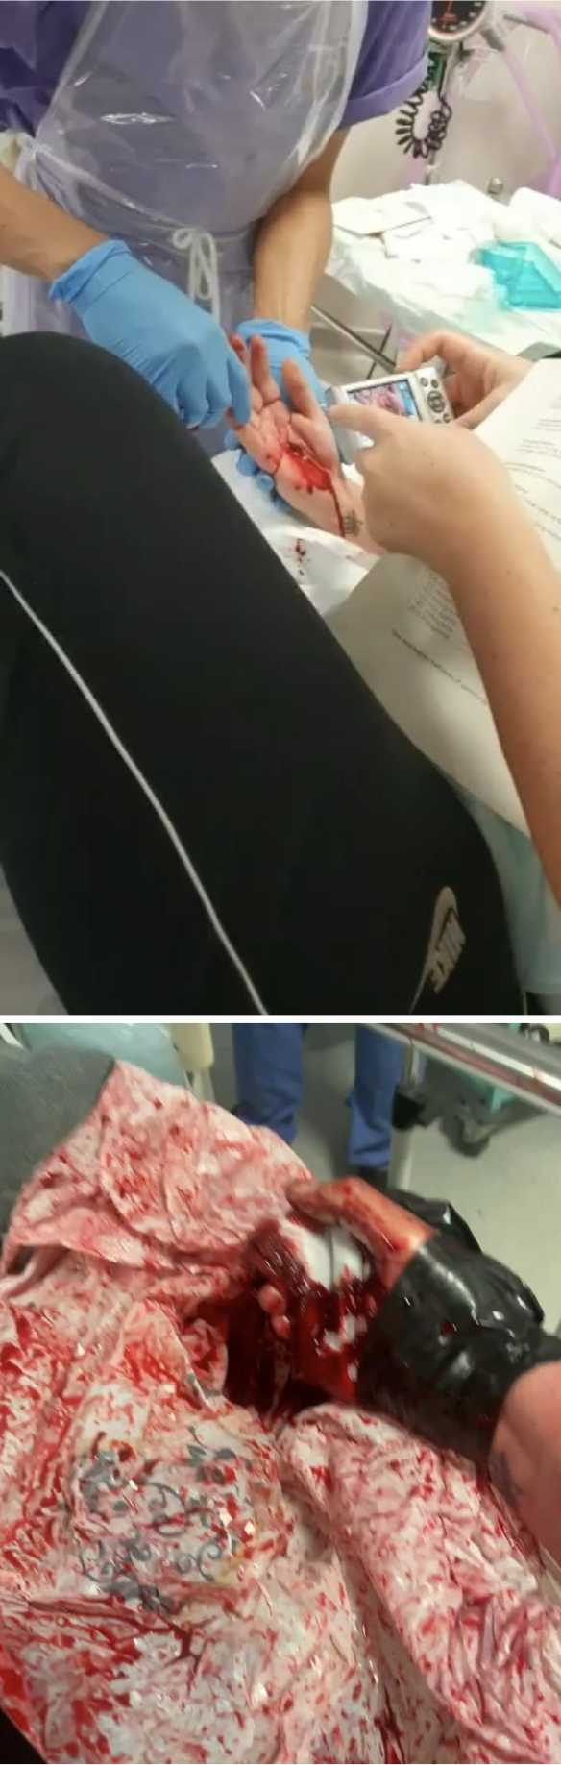
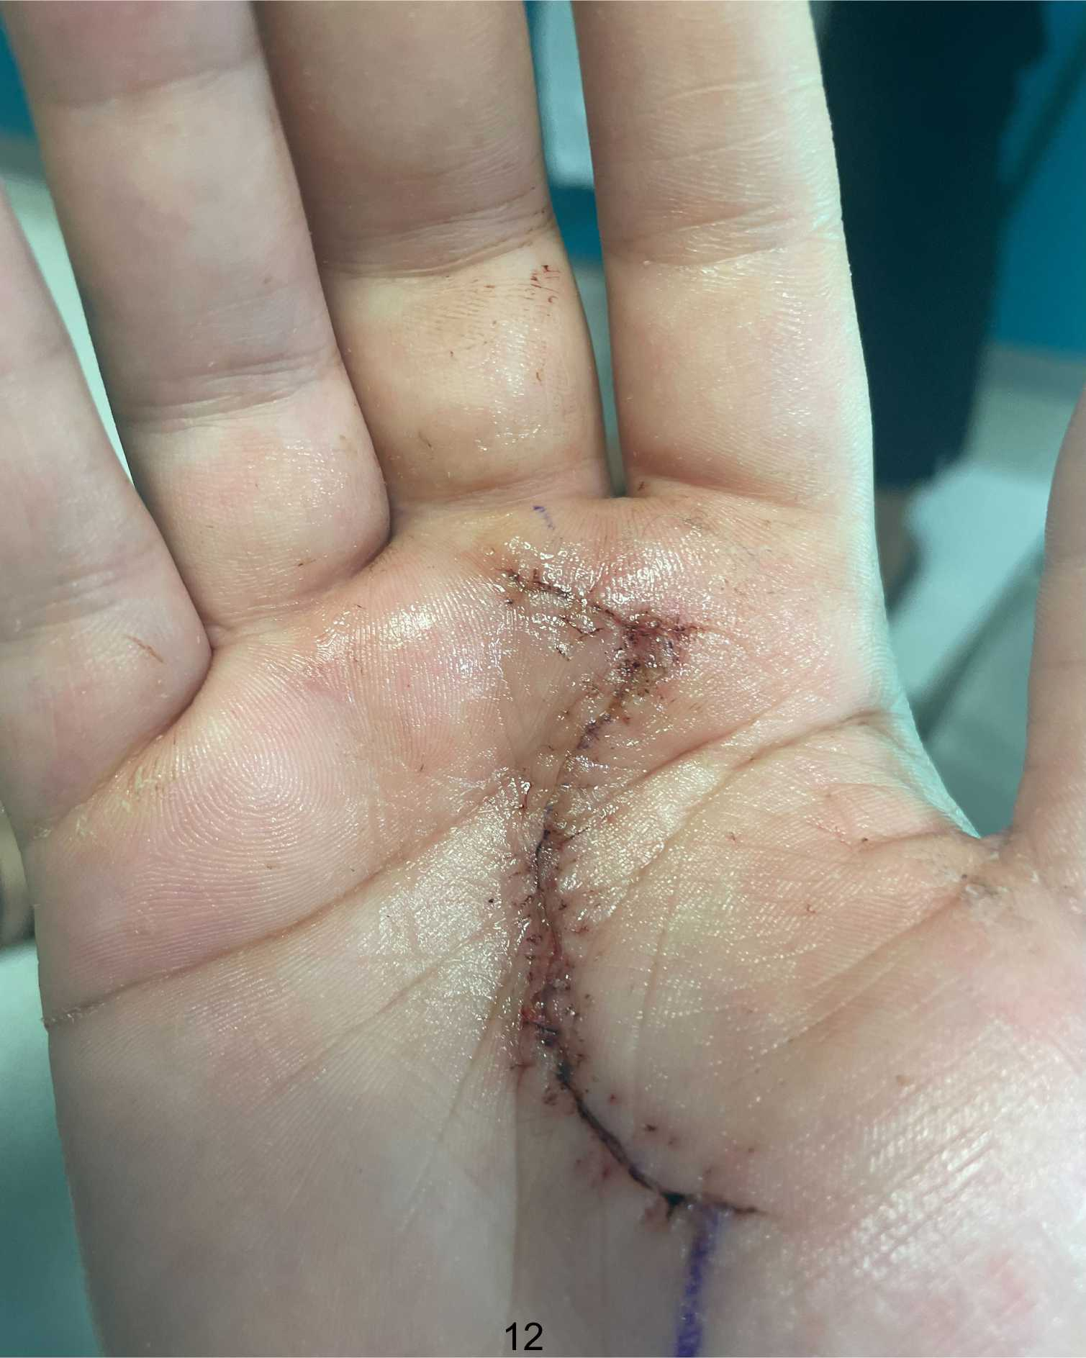

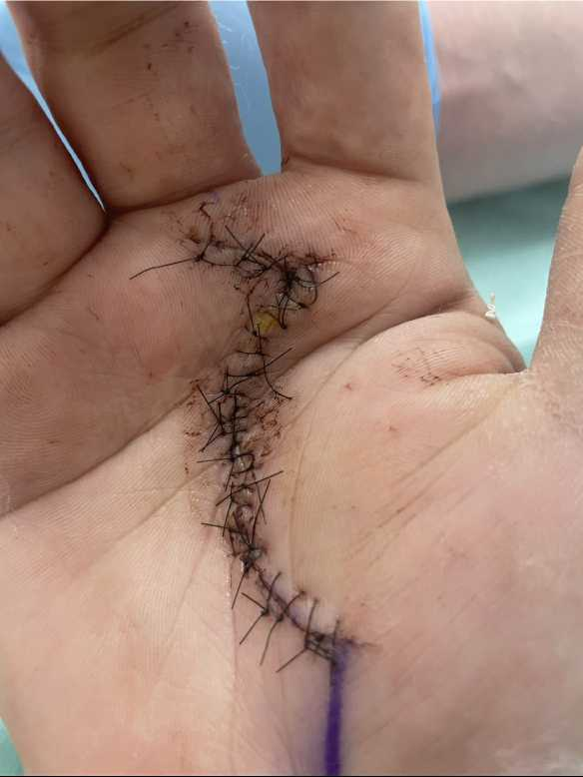
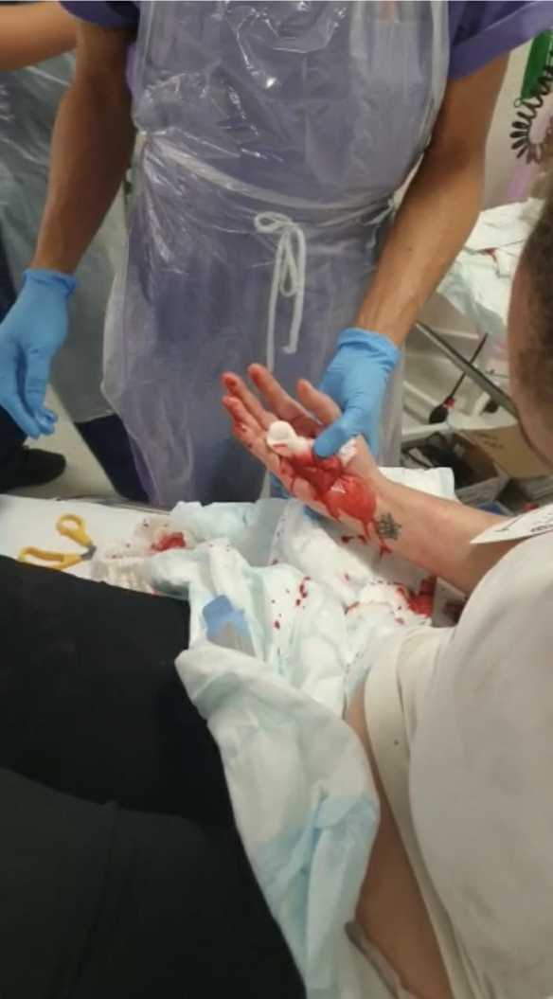
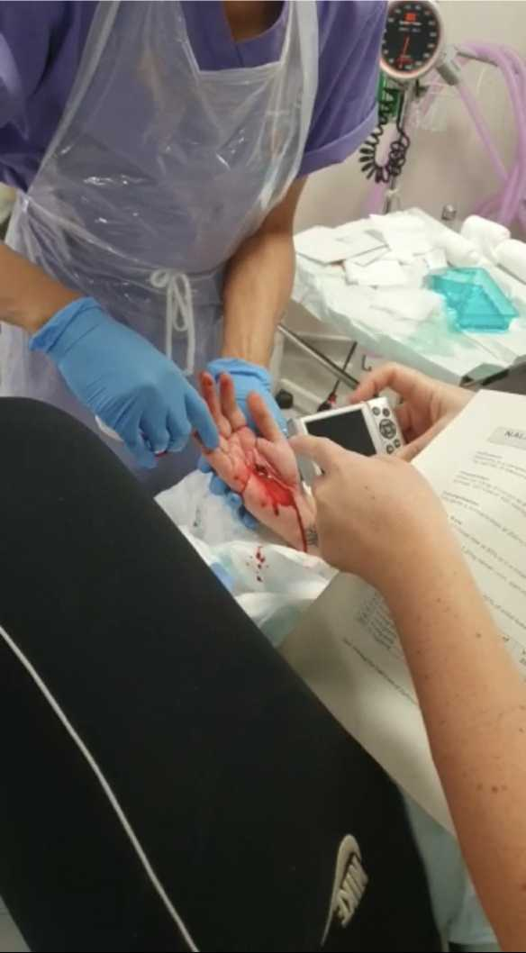

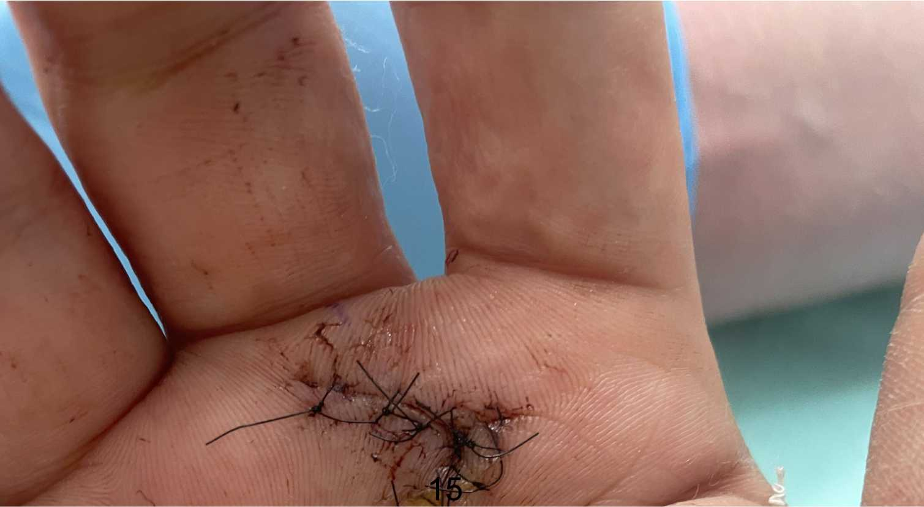
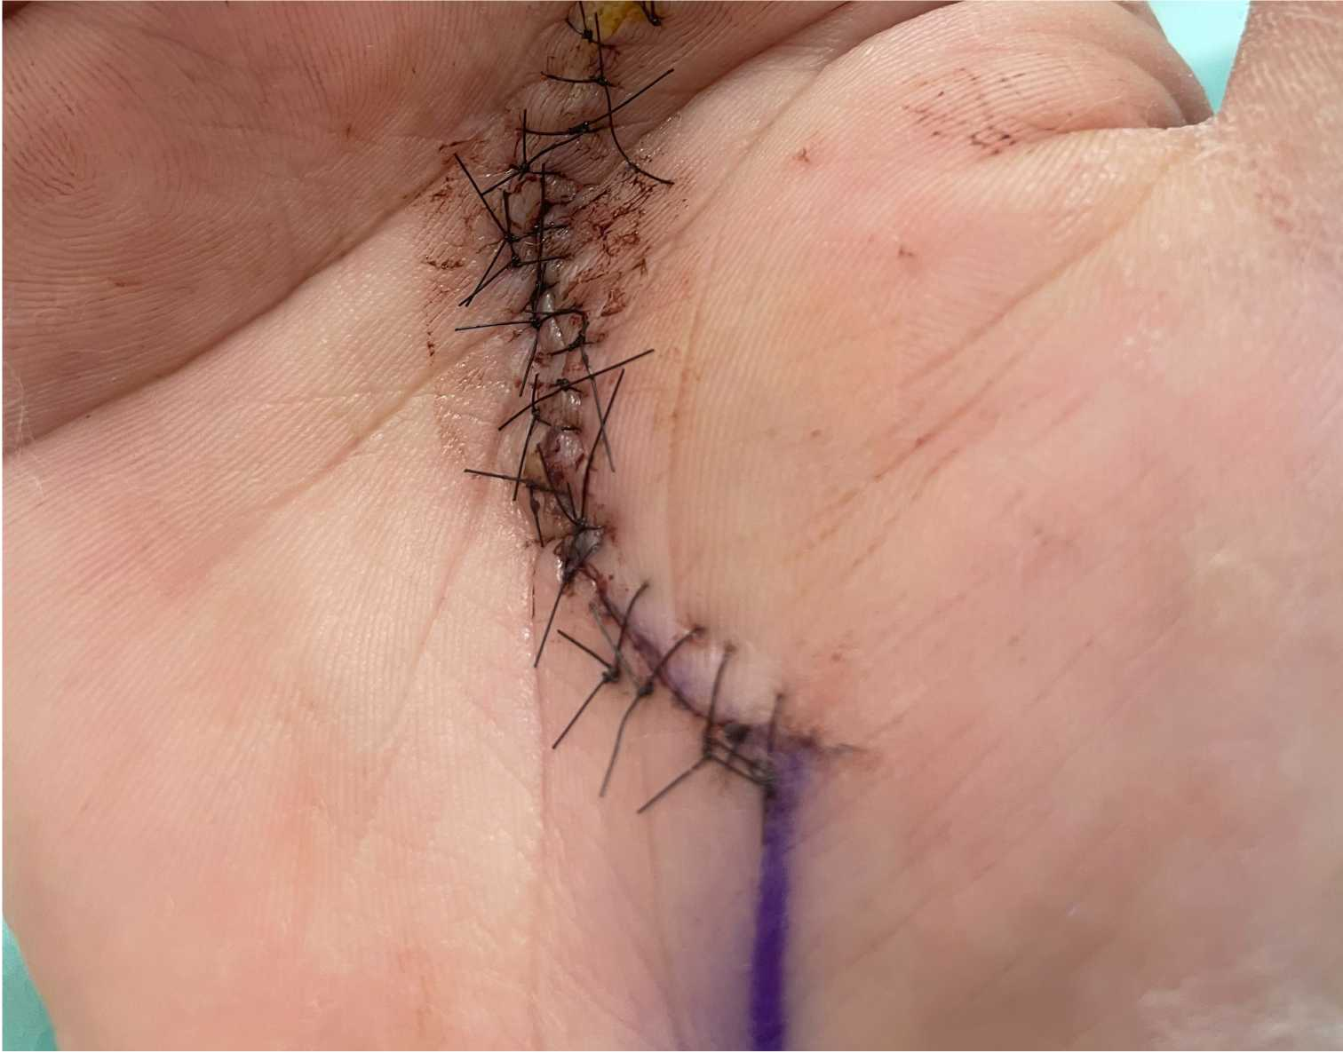
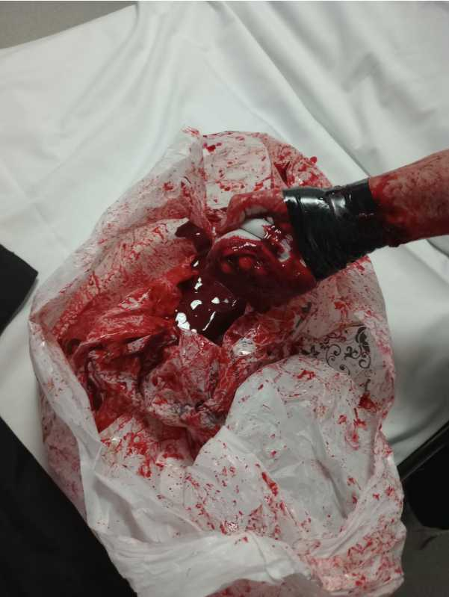
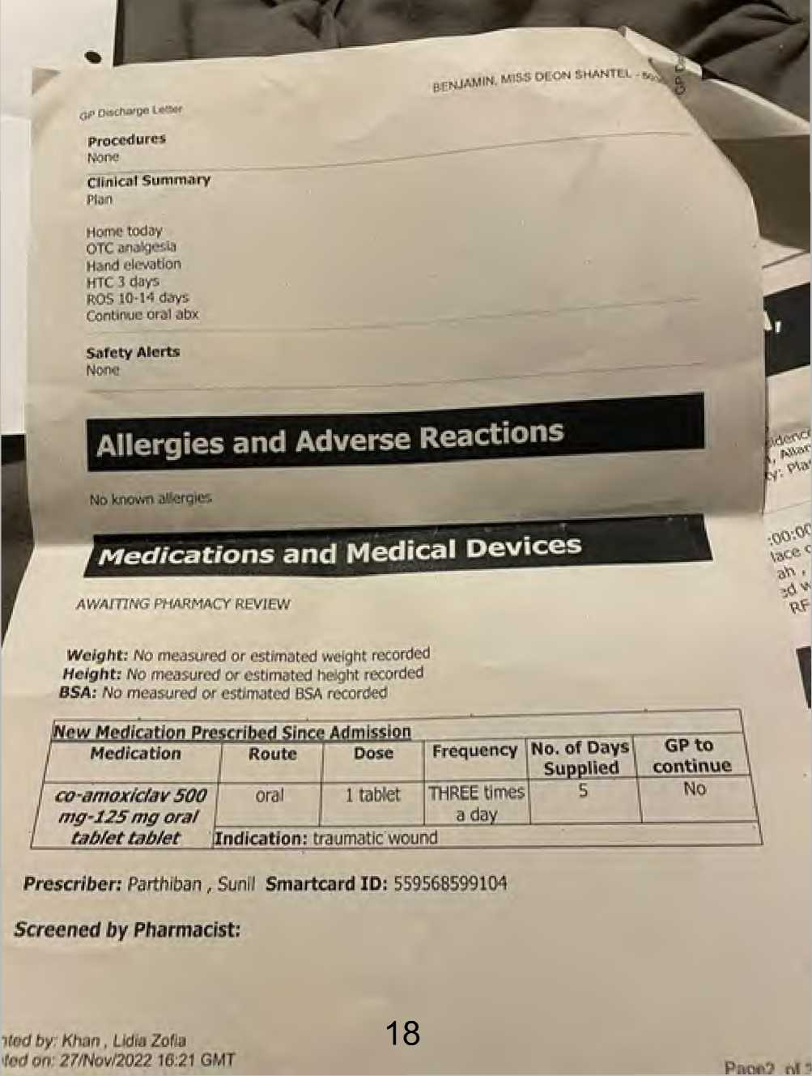
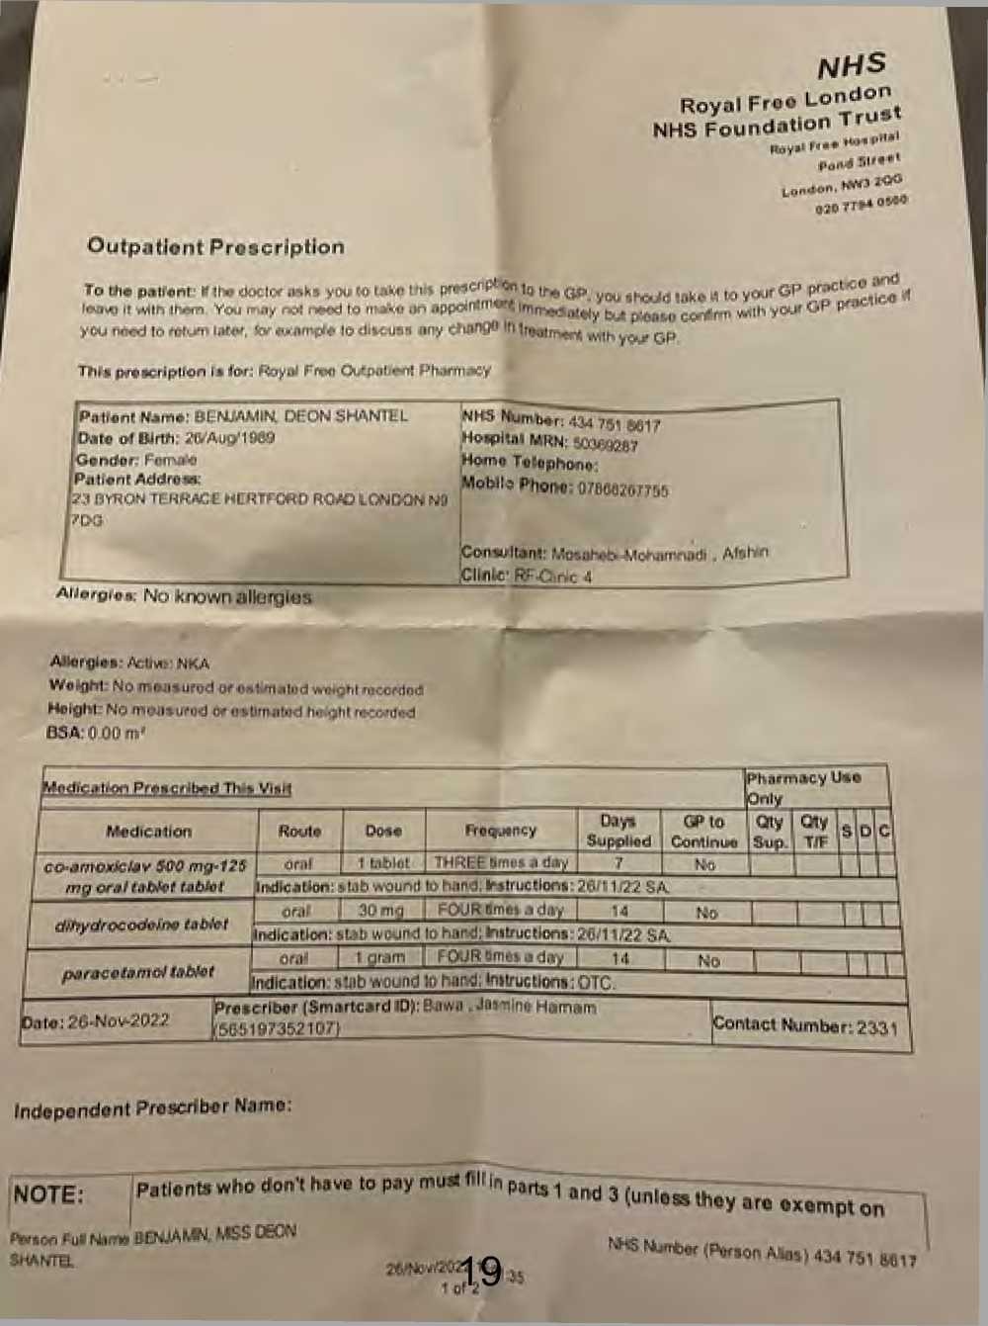
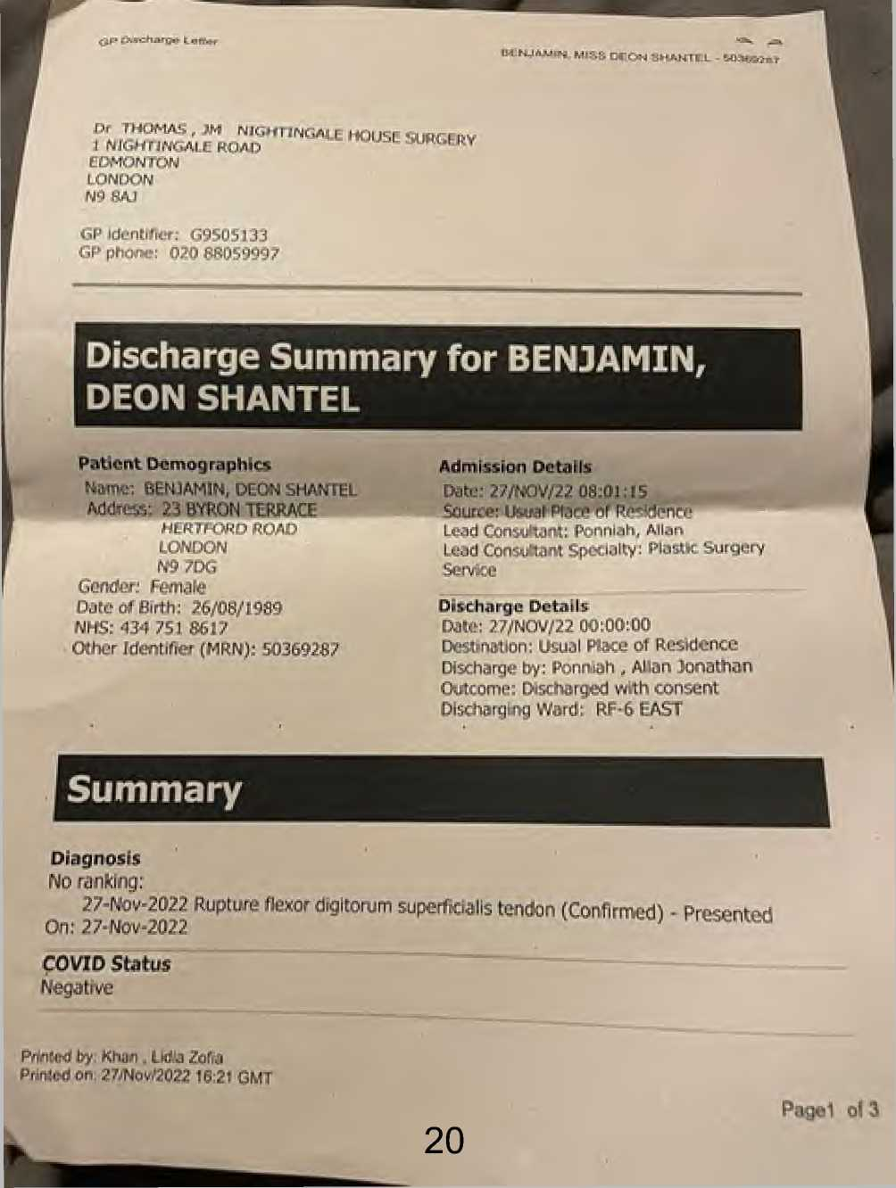
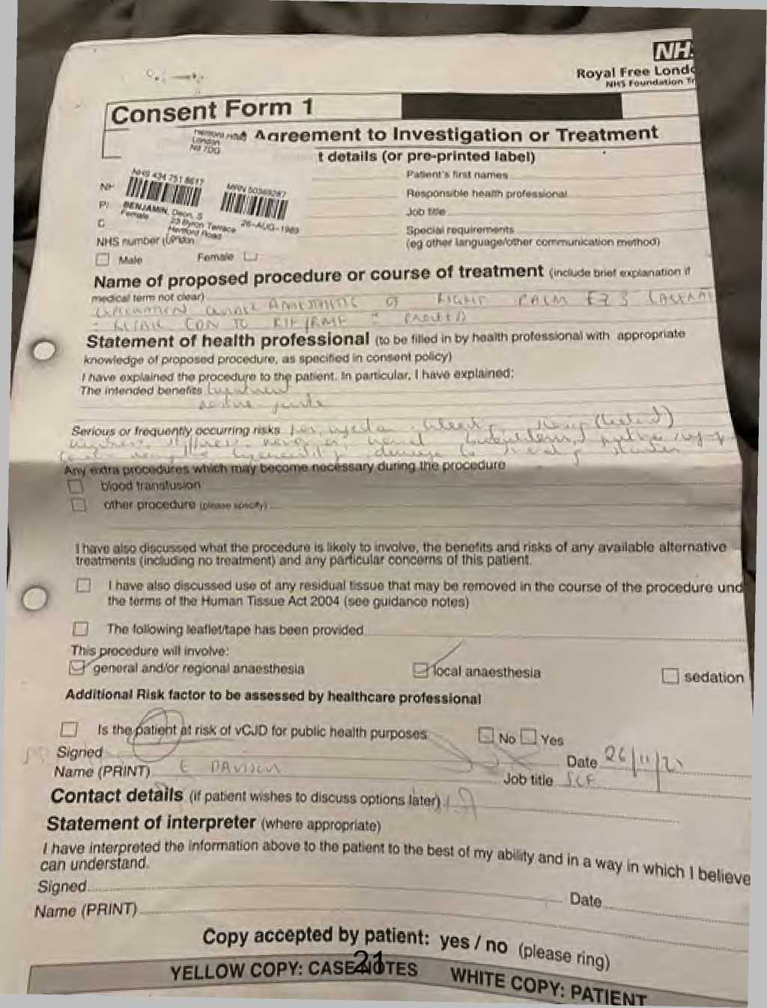
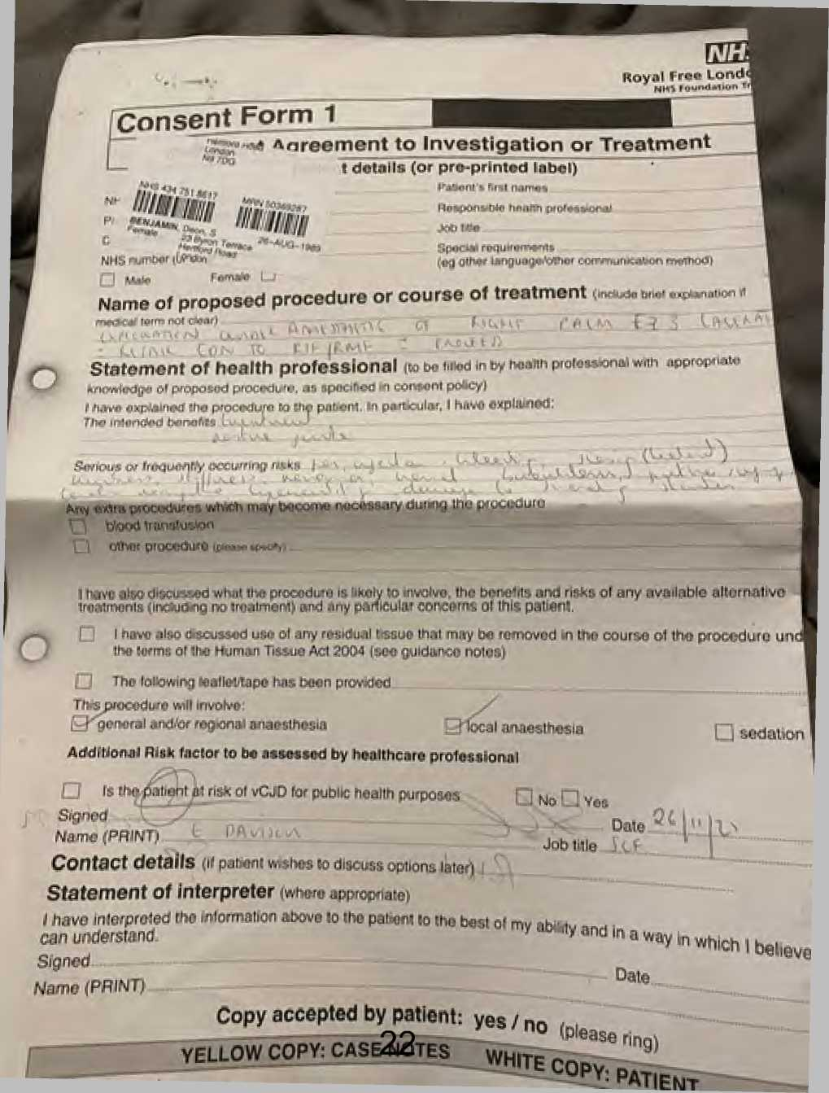

Barnet, Enfield and Haringey Mental Health Trust
Enfield Mental Health Single Point of Access
25 Crown Lane Southgate London
N14 5SH
Tel: 0208 702 3329


Barnet, Enfield and Haringey
Mental Health NHS Trust

Camden and Islington
NHS Foundation Trust
Private & Confidential
To be opened by addressee only
Dr Abidoye
Nightingale House Surgery
1-3 Nightingale Road
Edmonton
London
N9 8AJ
3rd July 2023 NHS No. 434 751 8617
RiO No. 1048105
Re: Miss DB - DoB: 26 Aug 1989
23 Byron Terrace Hertford Road, Edmonton, London, N9 7DG
Miss DB is a 33-year-old unemployed single woman seen in a face-to-face appointment at Crown Lane clinic.
She has had mental health referrals this year from her GP Dr Abdoye, Nightingale Surgery (referral dated April 23) and Dr Lisa Goodman Psychologist in the RFHosp hand plastic surgery team (she referred her in Feb 23 with PTSD).
She seemed restless during the interview and dissatisfied with many aspects of her life and interactions with health professionals.
She swore frequently when speaking to me.
She told me that she has a boyfriend and has been with him for "a while" but the relationship is difficult sometimes "because of her mood swings" (said Mum).
She feels her friends and her boyfriend "don't like me " "I feel like I'm on my own and no-one gets me...I'm losing everyone" "I feel like I'm unlucky...proper unlucky, and everything bad happens to me...I've always felt like that and it makes me so angry...I lose a lot of things...everything I touch turns into shit ...everyone else gets chances".
"If I do get friends, they find the truth of me and then they don't want to be with me anymore" and she feels she needs to "pretend" to keep relationships.
She attended her appointment on time with Mum (Lorraine) and Uncle (Andrew).
She won't go back to live in her London Quadrant flat (because of the attack) and they're relationship can be tense and Mum is unwell (heart op recently and on dialysis, now on the transplant list) so she's staying with different friends and "Holly doesn't want me to stay there no more".
She is using her mother's address (Byron Terrace N9) for correspondence etc.
She has a solicitor (going through Court at the moment) trying to get her a place to live.
Interim Chair: Peter Molyneux
Better Mental Health. Better Lives. Better Communities.
Chief Executive: Jinjer Kandola MBE



Barnet, Enfield and Haringey
North London
Mental Health Partnership
Mental Health NHS Trust

Camden and Islington
NHS Foundation Trust
Her Uncle says, "she has no stability" although her family try to support her "but she argues with us all the time".
History of presenting complaint:
"I'm just stressed out ...I don't feel right and I get angry all the time" (to which Mum responds "she's had those issues for years").
Mum says, "she's getting high and low really quickly".
Andrew said that "she has been much worse since the attack" (when she was assaulted end Nov 22 and sustained a severe cut to her, dominant, right hand).
Nightmares have been worse after the attack (end November 22) "I can't sleep and I wake up sweaty and shivering" the nightmares are not just related to the attack and when she wakes it takes her a long time "to calm down",
The dreams have got worse and she has been nauseated and shaky since she has been on risperidone,
She sometimes believes "family and friends...people are talking about me and being funny with me ...I can't explain it ...I don't know it's just the way I feel...sometimes I feel like it's real other times I think I'm being stupid".
She doesn't like the way people look at her and if people are round her laughing, she feels they are laughing at her "I've always felt people laugh and look at me funny...some people are just horrible".
"I feel people are against me because they think I am lying and chatting shit".
She sometimes relates TV to her and gives the example that she sees a character on TV and they are stabbed and she feels it is more than a coincidence "is it to do with me?" - not clearly an idea of reference.
She says her hand (cut in the attack) "doesn't feel like my hand" since the attack but she can't explain this. She is right-handed but isn't using her damaged right hand. "I don't even like the sight of it".
She says she thinks about the attack very often and " it just comes into my head".
She is avoidant of memories of the attack.
She doesn't want to use knives for cooking because a cut was used in the attack.
Similarly, she gets upset by plastic bags because after the attack they used a plastic bag to try to stop the bleeding.
She was "bad before the attack but she's gone ballistic since".
She has never gone out much but less wanting to go out since the attack.



Barnet, Enfield and Haringey
Mental Health NHS Trust

Camden and Islington
NHS Foundation Trust
She continues to have treatment from the hand plastic surgery team at the Royal free hospital.
She has a psychologist from that team (Lisa Goodman).
She is waiting for her next hand clinic appointment.
She should be wearing a splint but she puts bandages on it instead because she finds the splint painful and doesn't want to look at her hand.
"I need someone to talk to you can't just give me tablets".
"I can't keep living like this ...it's stupid ...no-one is listening... I'm sick and tired of this... I want to know I can be safe.
"I don't believe people that just chat shit" (referring to health professionals) "she's getting no help".
Sleep? "I never sleep", initial insomnia - when I asked why and she said "fuck knows" but she sleeps with the light on, feels scared and any noise startles her.
She wakes sweaty every night.
If she wakes in the night, she sometimes feels the need to check there is no-one there before she can go back to sleep.
"Sometimes I feel alright and sometimes I feel like shit".
Limited pleasure from life since the attack.
I feel "so down".
Some diurnal mood variation "not very good in the morning".
Appetite variable "I don't fancy food...I feel sick thinking about it".
Weight - has lost 2 stone (without trying to) since she was stabbed (approx 6 months).
Social Hx
Benefits ESA, PIP (for hand and mental health)
No debt
Homeless at the moment (“sofa-surfing").
Forensic Hx
Caution for drunk and disorderly 18/12 ago and she said angrily "I had a little too much to drink at a funeral...that was ages ago".
Caution and probation and a tag for ABH as a teenager "I was only young...it was ages ago".
Personal Hx
Premature - Born at 27/40 "she died about 20 times and they brought her back to life" - "lung collapses" and ventilated.



Barnet, Enfield and Haringey
Mental Health NHS Trust

Camden and Islington
NHS Foundation Trust
Long periods in hospital including GOSH, in an out of hospital up until 7
School - "primary was good".
Her emotional problems got worse "at secondary school".
Mum feels her mood changed after her periods started.
Physical health
Recent ECG because "her heart was going .fast" and she need to be " monitored by a specialist".
GP also told her she is "borderline diabetic".
Polycystic ovaries (she is waiting for a gynae appointment) and a separate issue with other "cysts on her ovaries".
Asthma.
Her blood pressure has been raised.
Past Psych Hx:
Never admitted for mental health problems.
No period of treatment from Crisis Home Treatment team although she has called them.
Diagnosed with dyslexia.
She saw school counsellors for "mood swings”, anger and "cutting" from "early teens"
Not sure if she saw CAMHS (child and adolescent services).
DSH history - she was cutting (wrists /legs) but stopped around 22 years.
She explained it was "for release" not with the intention to die "it makes me feels less numb...it makes me feel better".
She cut herself in COVID and the last time was? early Dec and she says she has stopped now.
She says she tried to hang herself? age 20 when attending Lucas House OP for anxiety/depression and she had a variety of antidepressants including fluoxetine, sertraline, venlafaxine.
"I don't want to kill myself.
She saw CPN Gopaulen for assessment 1.3.23 when no psychotic symptoms were elicited.
Current medication:
Risperidone 2mg (1mg bd) - prescribed by GP- but feels it makes her sweaty and shaky and dizzy and "horrible".



Barnet, Enfield and Haringey
North London
Mental Health
Partnership
Mental Health NHS Trust

Camden and Islington
NHS Foundation Trust
No other medication.
Analgesics for headaches (her headaches have been worse recently) and period pains (she has heavy, painful periods).
Substance misuse:
No recreational drugs use
Tried cannabis and coke "but it made me feel funny and I didn't like it"
Infrequent alcohol "but when she does, she gets plastered"
Smokes tobacco (roll ups, a pouch a week approx).
Impression:
EUPD
Mixed anxiety/depressive symptoms? part of - PTSD.
Plan:
Given MIND leaflets on EUPD and PTSD.
Given Choice and medication leaflets for risperidone and mirtazapine.
"I don't want to keep taking tablets...but I hundred per cent need something" so we agreed she will reduce risperidone to 1mg nocte for a week and then stop.
I have given her an FP10 for 28 days mirtazapine 15mg nocte - after a week she could increase the dose to 30mg nocte.

I will refer to the South locality team at Lucas House.
Yours sincerely

Dr Hilary Scurlock
Consultant Psychiatrist
Enfield Mental Health Single Point of Access

Cc:
Miss DB

Mental Health Partnership
Private & Confidential Miss DB 23 Byron Terrace Hertford Road Edmonton London
N9 7DG

Barnet, Enfield and Haringey
Mental Health NHS Trust

Camden and Islington
NHS Foundation Trust
Enfield Personality Disorder Stream
ield Integrated Core Mental Health Team
The Chase Building
Chase Farm Hospital Site The Ridgeway Enfield EN2 8JL
Tel: 020 8702 5011/5023
PD Team Direct Dial: 020 8702 5020
Email: beh-tr.generalenquiries(8)nhs.net
8th November 2023
NHS number: 434 7518617
Hospital number: 1048195
\Olini\RRIUinAAA\C7l IRA 0070701 I. CI QIU
Dear DB,
Following your referral to Enfield Integrated Core Team, we have booked your initial assessment, I can confirm this will be a face-to-face appointment, your appointment details are as below:
Date & Time: 2nd February 2023 at 09:30am
Location: The Chase Building, Chase Farm Hospital Site
Clinician: Kuntal Mehta
We have enclosed several documents which we would be grateful if you could complete and bring with you to your appointment. If you cannot complete these at home, or would like some help filling them in, your clinician will be happy to help you with these at your appointment. Please note this appointment is an assessment and is not the start of therapy. We ask that if you cannot attend the appointment as above, please contact us at your earliest convenience 020 8702 5023/5011. Please be aware that failure to attend this appointment may result in a discharge from our service. We look forward to meeting you.
Yours sincerely,
I
I
Administrator for Enfield Personality Disorder Stream
On Behalf of Barnet, Enfield and Haringey Mental Health Trust
Cc: NIGHTINGALE HOUSE SURGERY, 1 NIGHTINGALE ROAD, EDMONTON, N9 8AJ
Interim Chair: Peter Molyneux
Chief Executive: Jinjer Kandola MBE





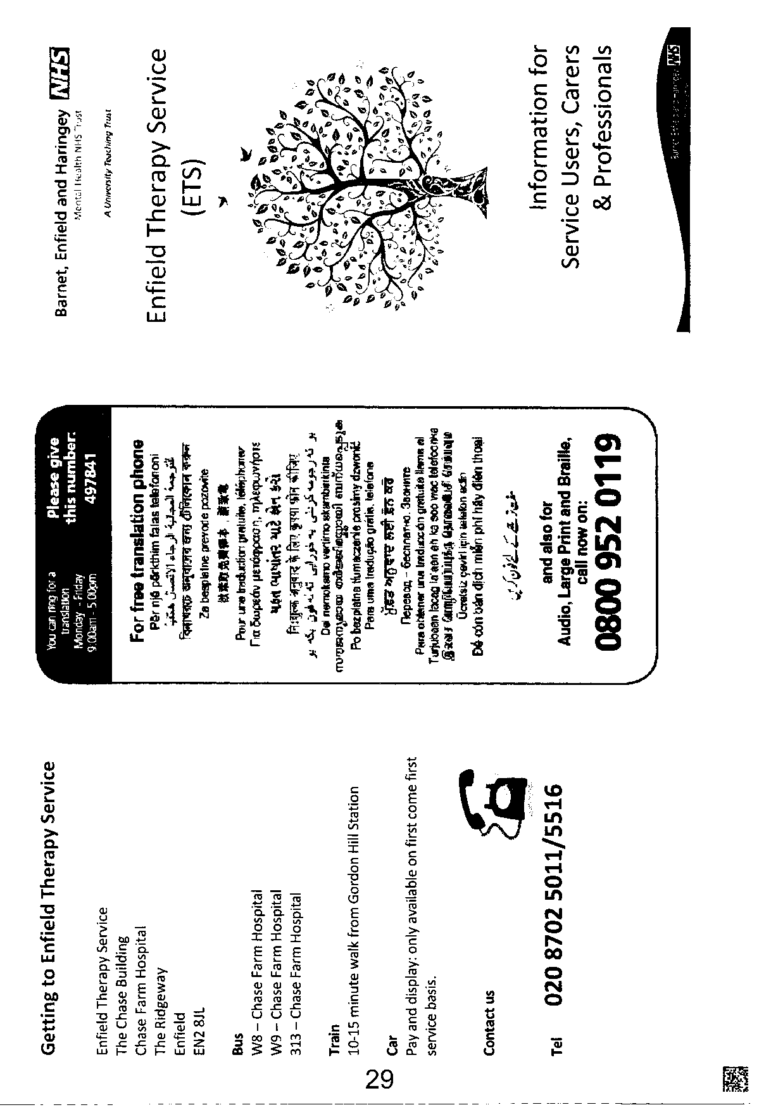
HYB13 1 L626286 0911231000017\201\3of16\
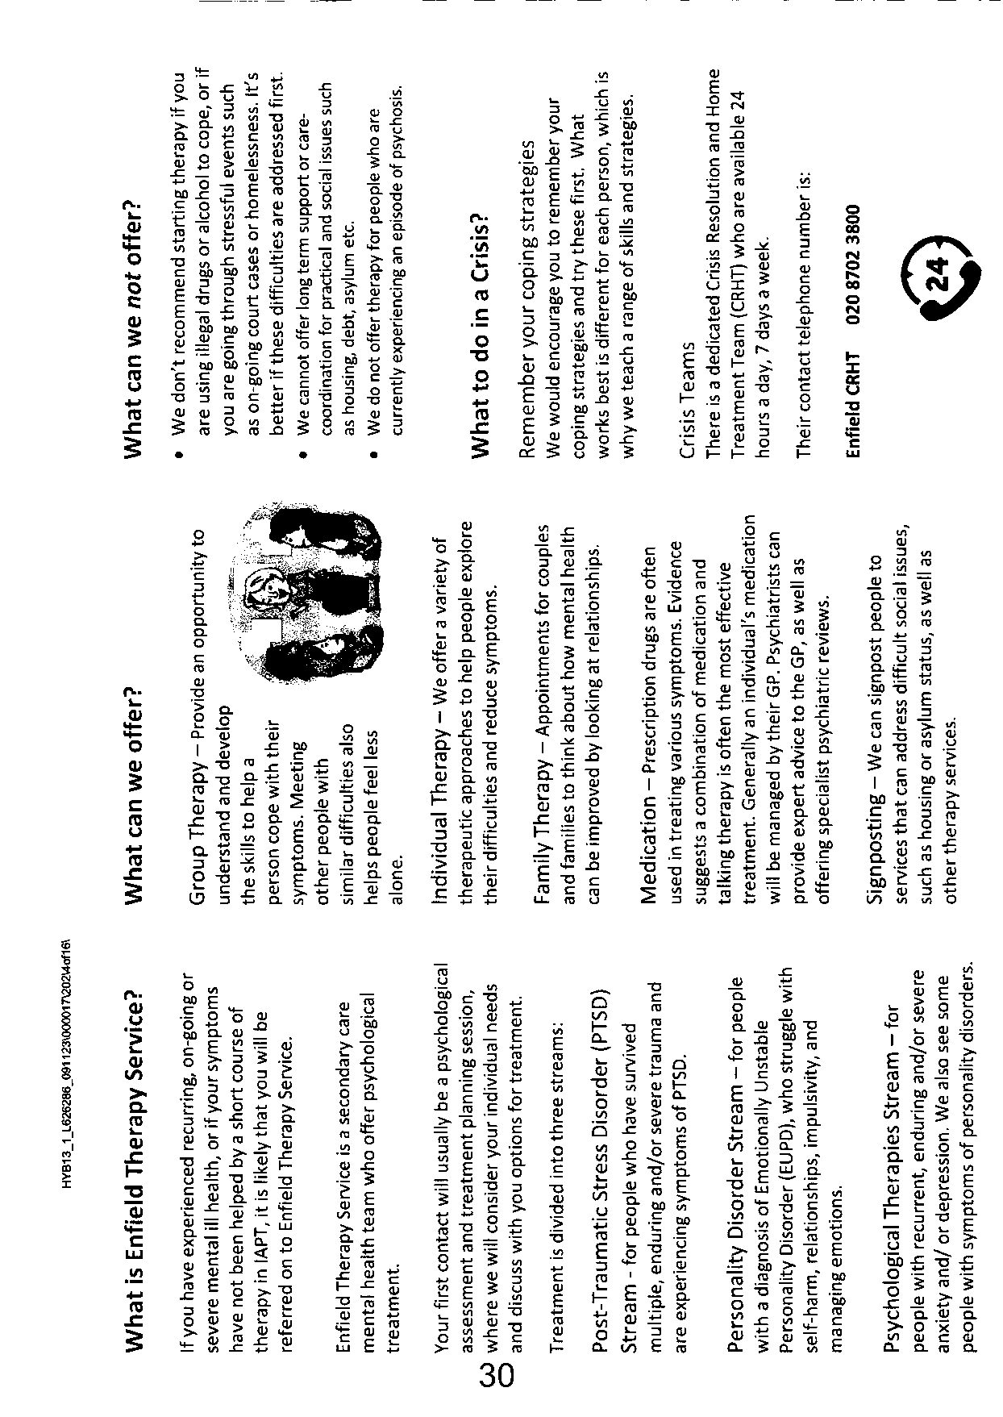
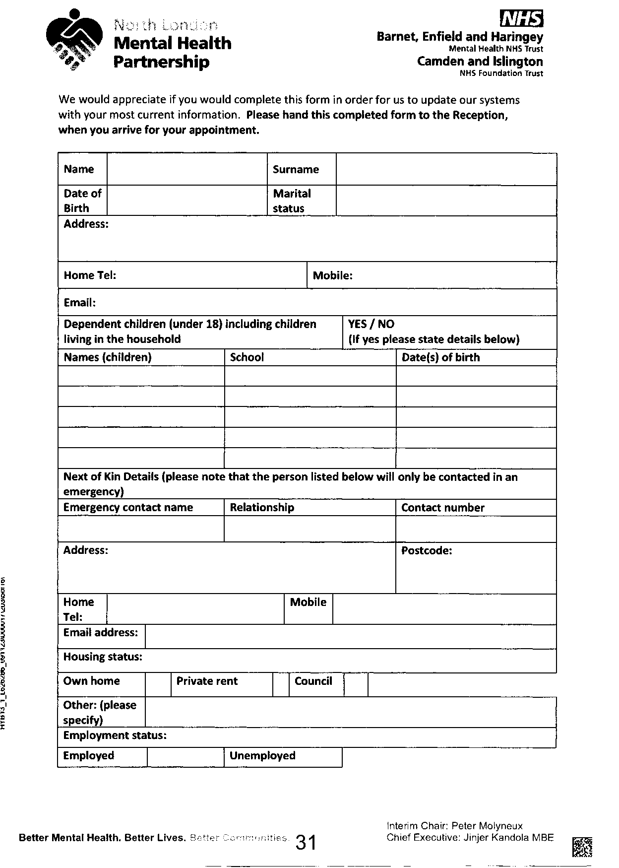
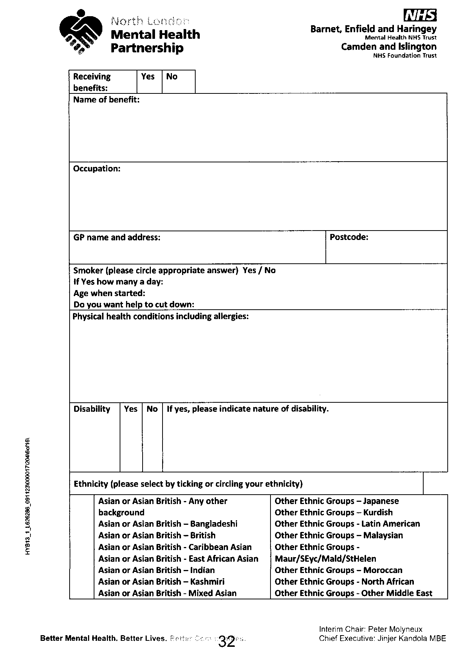
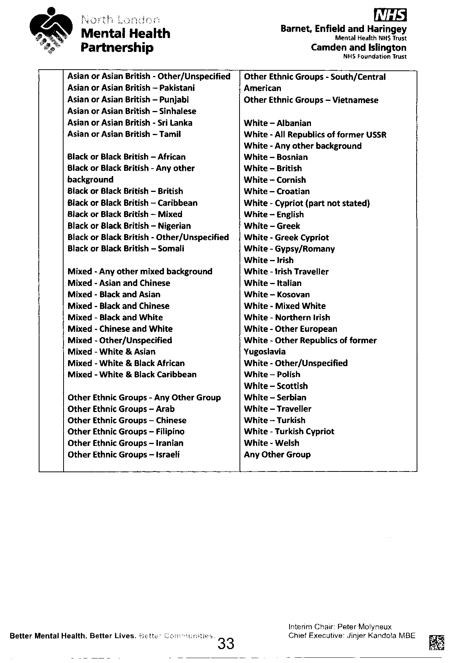
HYB13 1 L626286 091123X000017\205\7of16\
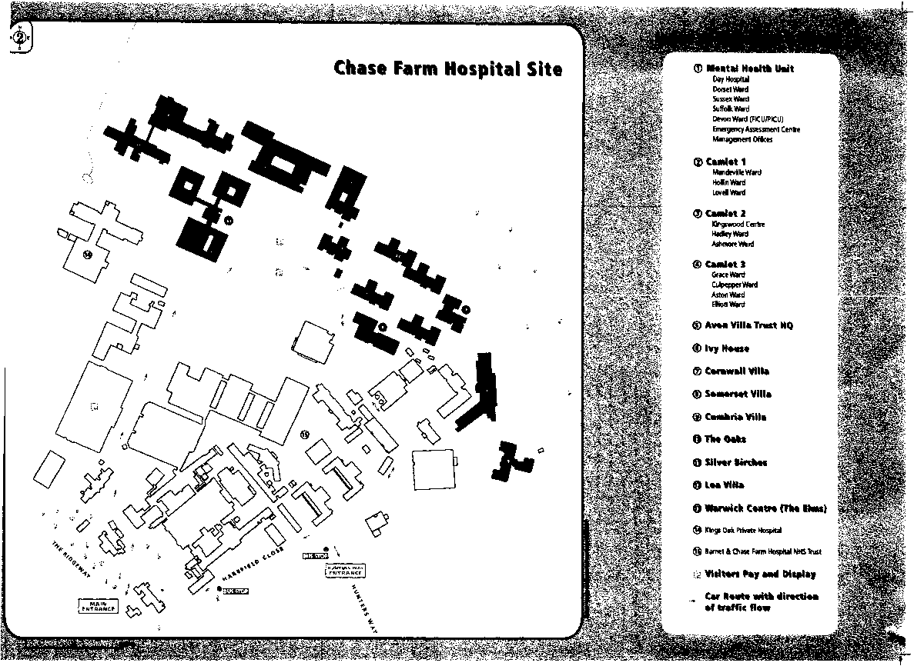

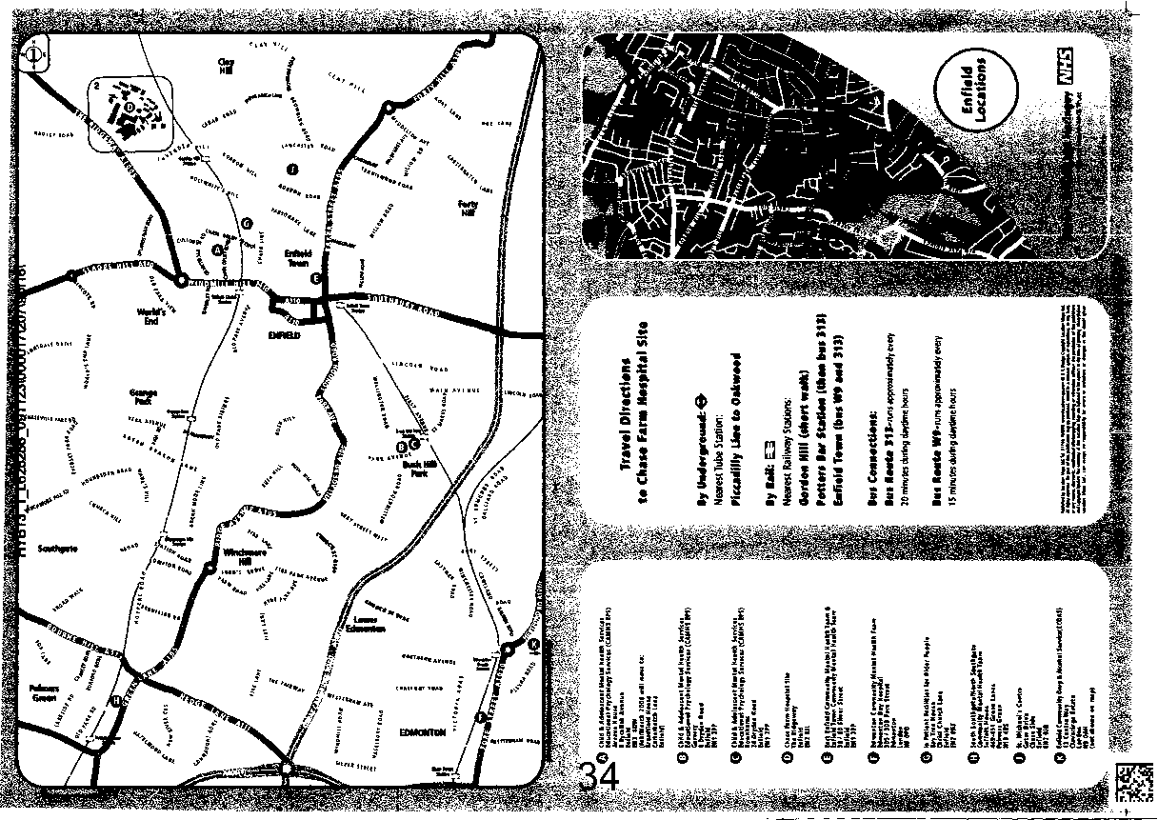
The Short Warwick-Edinburgh Mental Well-being Scale
(SWEMWBS)
HYB13_1_L626286_091123X000017X209X11of16\
Below are some statements about feelings and thoughts.
Please tick the box that best describes your experience of each over the last 2 weeks
STATEMENTS | None of the time | Rarely | Some of the time | Often | All of the time
I've been feeling optimistic about the future | 1 | 2 | 3 | 4 | 5
I've been feeling useful | 1 | 2 | 3 | 4 | 5
I've been feeling relaxed | 1 | 2 | 3 | 4 | 5
I've been dealing with problems well | 1 | 2 | 3 | 4 | 5
I've been  thinking clearly | 1 | 2 | 3 | 4 | 5
I've been feeling close to other people | 1 | 2 | 3 | 4 | 5
I've been able to make up my own mind about things | 1 | 2 | 3 | 4 | 5


NAME:
Patient Health Questionnaire (PHQ-9)
HYB13_1_L626286_091123\000017\211\13of16\
Over the last 2 weeks, how often have you been bothered by any of the following problems? (use  “ □" to indicate your answer) | Not at j Several ; all days |  | More than half the days | Nearly every day
1. Little interest or pleasure in doing things | 0 | 1 | 2 | 3
2. Feeling down, depressed, or hopeless | o | 1 | 2 | 3
3. Troubling falling or staying asleep | 0 | 1 | 2 | 3
4. Feeling tired or having little energy | b | i ' | 2 | 3
5. Poor appetite or overeating | 0 | 1 | 2 | 3
6. Feeling bad about yourself - or that you are a failure or have let yourself or your family down | b | 1 | 2 | 3
7. Trouble concentrating on things, such as reading the newspaper or watching television | o | 1 | I ² | 3
8. Moving or speaking so slowly that other people could have noticed. Or the opposite - being so fidgety or restless that you have been moving ■ around a lot more than usual | o ‘ | 1 | 2 | 3
9. Thoughts that you would be better off dead, or of hurting yourself | b | 1 | i ² | ³
Add columns
 | TOTAL:

DATE:
10. If you checked off any problems, how | Not at all
difficult have these problems made it for | Somewhat
you to do your work, take care of things | difficult
at home, or get along with other people? | Very difficult

Extremely difficult

Generalised Anxiety Disorder 7-item (GAD-7) scale
Over the last 2 weeks, how often have you been bothered by the following problems? | Not at all | Several days | Over half the days | Nearly every day
1. Feeling nervous, anxious, or on edge | 0 | 1 | 2 | 3
2. Not being able to stop or control worrying | 0 | 1 | 2 | 3
3. Worrying too much about different things | 0 | 1 | 2 | 3
4. Trouble relaxing | 0 | 1 | 2 | 3
5. Being so restless that it's hard to sit still | 0 | 1 | 2 | 3
6. Becoming easily annoyed or irritable | 0 | 1 | 2 | 3
7. Feeling afraid as if something awful might happen | 0 | 1 | 2 | 3

Add the score for each column + + +
Total Score (add your column scores) =
If you checked off any problems, how difficult have these made it for you to do your work, take care of things at home, or get along with other people?
Not difficult at all
Somewhat difficult
Very difficult
HYB13 _1_L626286_091123\000017\213\15of 16\
Extremely difficult



Pharmacy Stamp
Please don't stamp over age bi
Age
D.o.l
Title, Forename, Surname & Address
JL/^lWi 64^ ^^^ UtAi^
^1^ _{w}^hN^
Number of days' treatment N.B. Ensure dose is stated
NHS Number:

ft)?
HP
Endorsements
HOSPITAL PRESCRIBER
Prescriber's name and initials in block capitals
Signature of Prescriber
Date
NHS
enfieuTASsessment serv | RRPE6
25 CROWN LANE SOUTHGATE LONDON | N14 5SH
020 87023329 BEHMHT | RRP

For dispenser No. of Prescns. on form
FP10NC0608
HP
64189999390


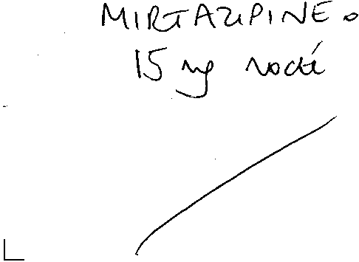




A Unlvcalty Teething Tnist
Private & Confidential | Barnet, Enfield and Haringey Mental Health Trust
To be opened by addressee only | Enfield Assessment Service  25 Crown Lane
Date: 08.03.2023 | Southgate London
Dr Abidoye  Nightingale House Surgery | N14 5SH
Nightingale Road Edmonton | Tei: 0208 702 3329
N9 8AJ | ****

Dear Dr Abidoye,
Re: Miss DB DoB **** (*** years) Address - Currently of no fixed abode - Sofa surfing
I had opportunity to assess Ms DB in our Silver Street Clinic on 01 March 2023 after she was referred by our Crisis Telephone Service. She presented with her partner.
Reason for Referral
Referrer reported history of auditory hallucinations and suspected that DB has PTSD.
Clinical Documentation recorded diagnosis of depression and anxiety.
Experiencing a deterioration in MH triggered by:
- Assaulted and stabbed on 27th November 2022- In hospital for 3 days
- Mum is currently in hospital- had a heart operation
- Not able to return to her home address due to assault.
DB reported that she has been having disturbed sleep and-nightmares at night.
No changes in appetite highlighted.
DB has a history of having auditory hallucinations but denied experiencing psychotic symptoms at time of triage.
DB is not taking any medication at present; she was previously prescribed sertraline but stopped taking medication 3.weeks ago, GP is aware and she reported they would review medication. - — - No currently using drugs or drinking alcohol.
Reported that she used to socially use cocaine but stopped after she was assaulted last year.
No clear diagnosis
History of presenting Problem:
Gave verbal consent to information sharing along Trust guidelines, happy for final letter to go to GP and to home address
Ms DB told me last November she went to pick up her boyfriend at a Bar. When they came out, her boyfriend who was intoxicated with alcohol had an altercation with a man and a woman whom she alleged were both under the influence of alcohol. She got involved during the altercation pulling



Chairman: Jackie Smith Chief Executive: Jinjer Kandola
A University Teaching Trust
her boyfriend away and she alleged she was pushed to the ground and the woman stabbed her. She sustained deep cut in her right hand, and she told me she fainted because of the bleeding and she now unable to remember much what actually happened.
Police now is investigating the incident. No one has been arrested yet and they are still looking for the alleged assailant. She is now stressed out of having to attend court. She told CCTV footage is not clear.
She told me she has been told by police not go to her flat "kicked me out and told me it is dangerous for me to go back.” and subsequently has been of no fixed abode since. She told me she has been sofa surfing at her boyfriend and other friends since the incident.
Since the incident, she has been experiencing symptoms suggestive of PTSD - .
Hyperarousal - easily irritable and aggressive at time, hypervigilance, can’t go outside - afraid of the dark, difficulty concentrating, and difficulty sleeping, experiencing bad dreams, and waking up in sweat. Constant ruminating and flashbacks about the incident ‘in my head’, Crying for no reason.
Compounded to the trauma following the incident, she attended North Middlesex University hospital yesterday and was told that she must have her ovary removed and she is worried she wouldn’t be able to have any kids.
She also told me she is also stressed out as her mum is in ICU following a heart operation and she is physically very unwell.
Before the incident she told me was paranoid about people betraying her and she has been diagnosed with dyslexia when she was at school, and she has had depression and anxiety since she was 13 years of age.
She told me she was previously diagnosed with bipolar affective disorder and when challenged as her health records doesn’t indicate such a diagnosis, she then told me it was the charity MIND who told her she may have had Bipolar. .
Past Psychiatric History:
Previously treated with depression and anxiety from 2008 - 2011.
Otherwise, no previous history on Rio.
Current Medication:
Sertraline 150mg
Sleeping tablet - Zopiclone
She told me she has been on Sertraline most of her life although she never felt any benefit since on it and has been taking it as prescribed.
To the contrary, notes from our CTS indicate she stopped taking her antidepressant.



A University Teaching Trust
Information provided about her condition by her GP
Ms DB understands the risk and benefit of medication prescribed and was involved in decision^ about medication.
Drug/ Alcohol and smoking status:
Smoke cigarettes.
Only drinks alcohol socially when out with her friends - She used to drink in excess during her teenage years but denied any problematic drinking recently.
She told me she used to sniff ‘Charlie’ cocaine during her teenage years. However, when our CTS spoke with her recently, she reported to socially use cocaine but only stopped after she was assaulted last November.
Present Social Circumstances:
She is currently of NFA and sofa surfing She receives ESA and PIP.
Mental State Examination:
A+B: Revealed a 33-year-old Caucasian woman. Her right hand was bandaged and told me she is scheduled to attend special unit for plastic surgery on her hand. She was casually dressed, and her self-care was good. She established a rapport easily and she was mildly agitated shaking her leg incessantly during the interview. Her speech was fluent, coherent and normal in volume, rate and content
Subjectively she rated her mood as being (0) on a scale of 0 to 10 (where 0 is most depressed and 10 happiest). However objectively her mood appears normal with a reactive and mildly anxious affect
She told she attempted self harm by cutting her wrists about 7 months ago. No scar or mark noted. Her left wrist is covered with tattooed. She has no current suicidal ideation, plan or intent and cited her mum as a protective factor. .
With regards to her perception, she reported hearing her boyfriend whispering to her from inside her head "playing games in my head’ and not from external spaces about 3 to 4 times in a week since the incident. This appears more related to her traumatic experiences and unlikely to be psychotic. She also reported a history of feeling paranoid about other people betraying her, likely in the context of her personality and a history of using cocaine.
Her appetite is not great, although she is eating, and she is not sleeping well although she reported having 8 hours sleep last night.



A University Toothing Trust
Nursing Impression:
Her presentation is suggestive of traits of PTSD following an incident last November when she alleges, she got stabbed in her right arm.
She is also stressed out as she subsequently lost her accommodation following the incident and her mum is currently very unwell in hospital.
Management plan:
We discussed therapy to manage her PTSD and advised her to engage with IAPT.
Please refer her to Enfield IAPT for therapy. _
She told me a housing solicitor is helping her with her accommodation and I have advised her to go to the homeless person unit and MIND for support.
She told me she is seeing her GP for a review of her medication.
I have discharged her back to your care,
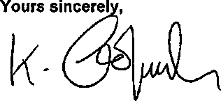
Kris Gopaulen Community Psychiatric Nurse Enfield Assessment Service

Copy to: Ms DB



L&Q
West Ham Lane Office
29-35 West Ham Lane
London E15 4PH
Tel: 0300 456 9998
Email: info@lqgroup.org.uk
Website: www.lqgroup.org.uk
Confidential
Miss DB 7 Tenneyson Close, Enfield, London, EN34SN
21 October 2019
Dear Miss D DB
Medical Assessment - Priority Awarded
Following your recent medical assessment, I can confirm that medical priority has been awarded and the recommendations are:
Bed Size - According to L&Q Policy
Max Floor Level with a lift - 4th Floor or Above
Max Floor Level without a lift - 2nd Floor
Gas Central Heating - Desirable
Garden - No Special Requirement.
Please note, as L&Q operate a Choice Based Lettings System you are able to place on bids on properties that you deem as suitable for your household needs. If there are any concerns regarding the suitability of a property, a Lettings officer will discuss this with you during the Lettings process.
Your transfer application is now in Band 3 - All priority cases.
It is recommended that you also register with your local authority as you have a medical reason for moving homes. To do this, you will need to complete an application form and submit any supporting documents. Details can be obtained from each council website.
Yours sincerely
Lettings Team
BECAUSE HOMES MATTER

L&Q
L&Q Direct
PO Box 194
Sidcup DA15 0AJ
Tel: +44 (0)300 456 9998
Email: info@lqgroup.org.uk
Website: www.lqgroup.org.uk
09th December 2022
URGENT – For the attention of the Duty Homeless Persons Unit Officer, Homelessness Section
Dear Sir/Madam,
Application for assistance under section 183 of the Housing Act 1996
Please treat this letter as an application for assistance under section 183, Housing Act 1996.
Homelessness or threatened with homelessness (Section 175 Housing Act 1996)
We believe that our client should be treated as homeless or threatened with homelessness. This is because:
Please see summary notes for the case below
Ms DB contacted L&Q and has reported that on 25th November she was stabbed outside a pub by two unknown persons. She was hospitalised and needed surgery after sustaining life changing injuries. Ms DB has seen both of the perpetrators on her estate while walking her dog and believes they live on the estate and know where she lives. She has not stayed in her property due to fear for her life. While she was in hospital, she has received a call from an unknown number telling her to drop the charges. She has stayed in the hospital last few nights as she has no where else to stay. Police are investigating her case crime ref: 5232489/22. I have received an email from the police officer stating, ‘The victim currently resides at an address where both suspect live within the same estate and there has been escalation of violent behaviour within this estate since the incident on 25/11/2022’. They advised that it is not safe for Ms DB to remain at her property and she should be moved.
Advised resident to approach the local authority explain her situation regarding the incident and that she wants to make a homeless application.
Ms DB has requested urgent re-housing.
It is of the recommendation of L&Q that accommodation is considered to ensure the safety and wellbeing of DB.
Interim accommodation duty (section 188 Housing Act 1996)
BECAUSE HOMES MATTER
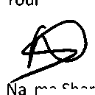
We believe that on the basis of the above that your authority has reason to believe that our client may be homeless, eligible and in priority need. Therefore, your authority has a duty to provide suitable accommodation pending completion of your enquiries. We would remind you that this duty arises irrespective of location connection with your authority.
Ms DB is a tenant of London & Quadrant Housing Trust (L&Q). However, due to:
• Please see details of case above
This tenant feels it is not safe for them to remain at their property at 7 Tenneyson Close, Enfield, London EN3 4SN.
Police details
DC Neha Chadda
North Area BCU
Local Investigations Team 2a
Metropolitan Police Service
North Area BCU (Enfield & Haringey)
07717850110
For this reason, I am referring them for emergency re-housing as per s188 of the Housing Act 1996 (Homelessness). “Interim duty to accommodate in case of apparent priority need.” And also, under section 10 of the Homeless Act 2002, where it is not reasonable for a person to continue to occupy accommodation if it is probable that this will lead to threats of violence from another person.
Details of Ms DB, tenancy are as follows:
Tenancy start date with L&Q – 15/08/2011
Date of birth: 26/08/1989
I would be grateful if you can contact me to confirm receipt of this letter. Please can you also keep me informed of the progress of your enquiries as an authorised representative of our client and provide us with a copy of your decision letter. You can contact me on 0300 456 9996 or via email to nsharif@lqgroup.org.uk Thank you for your assistance.
Yours faithfully
Nazma Sharif
ASB Case worker
Valerie Opara
From: | Neha.Chadda@met.police.uk
Sent:  To: Cc: | 08 December 2022 17:55  RROteam  emily.berry@emfield.gov.uk; Nazma Sharif
Subject: | 5232489/22
Follow Up Flag: | Follow up
Flag Status: | Flagged

Good evening,
I am emailing in relation to the above crime report. This a GBH with intent investigation where the victim was assaulted in a pub which resulted in life changing injuries to her hand.
The victim currently resides at an address where both suspect live within the same estate and there has been escalation of violent behaviour within this estate since the incidnet on 25/11/2022.
The victim’s name is DB Shantel DB she currently resides at 7 TENNYSON CLOSE, SCOTLAND GREEN ROAD, ENFIELD, EN3 4SN.
We would recommend a move due to the proximity of the suspects of this investigation and the mental/physical toll this incidnet has been on Ms DB.
Kind Regards,

DC Neha Chadda
North Area BCU
Local Investigations Team 2a
Metropolitan Police Service
North Area BCU (Enfield & Haringey)
X07717850110
Vwww.met.police.uk ^ Neha.Chadda@met.police.uk
Enfield Haringey
Unless otherwise stated this email is GSC Code – Official
NOTICE - This email and any attachments are solely for the intended recipient and may be confidential. If you have received this email in error, please notify the sender and delete it from your system. Do not use, copy or disclose the information contained in this email or in any attachment without the permission of the sender. Metropolitan Police Service (MPS) communication systems are monitored to the extent permitted by law and any email and/or attachments may be read by monitoring staff. Only specified personnel are authorised to conclude binding agreements on behalf of the MPS by email and no responsibility is accepted for unauthorised agreements reached with other personnel. While reasonable precautions have been taken to ensure no viruses are present in this email, its security and that of any attachments cannot be guaranteed.

A University Teething Trust

Your Ref:
Enfield Assessment Service
25 Crown Lane Southgate London N14 5SH
Tel: 0208 702 3329
NHS Number 434 751 8617
Hospital Number: 1048195
22 Feb 2023
Private and Confidential to be opened by addressee
Miss DB Shantel DB
23 Byron Terrace Hertford Road
Edmonton
London
N9 7DG
Dear Miss DB,
Following our recent phone conversation, we would like to confirm your appointment as follows
Date: 01 Mar 2023
Time: 11 30
Clinician: Kylassum Gopaulen
Location: 58-60 Silver Street, Enfield, Middlesex, ENI 3EP
To make sure that access to our services is fair, please:
- Call the above number if you are unable to attend this appointment
We may not be able to offer you another appointment if you don't attend this one, or don't tell us that you can't come
- Arrive on time for your appointment as we may not be able to see you if you are late
Please contact us on the above number if English is not your first language and you need help or an interpreter.

Yours sincerely
Annalynn Kamulete
On Behalf of Barnet, Enfield and Haringey Mental Health Trust
Interim Chair: Peter Molyne Chief Executive: Jinjer Kand
Mental Health Partnership
Private & Confidential Miss DB 23 Byron Terrace Hertford Road Edmonton
London N9 7DG

Barnet, Enfield and Haringey
Mental Health NHS Trust

Camden and Islington
NHS Foundation Trust
Enfield Personality Disorder Stream ield Integrated Core Mental Health Team
The Chase Building Chase Farm Hospital Site
The Ridgeway
Enfield EN2 8JL
Tel: 020 8702 5011/5023
PD Team Direct Dial: 020 8702 5020
Email: beh-tr.generalenquiries@nhs.net
6th December 2023
NHS number: 434 7518617
Hospital number: 1048195
HYB13_1_L665385_061223\000035\469\1 of24\
Dear DB,
Due to unforeseen circumstances, we have had to amend the assessment date that we previously booked for you. I can confirm this will be a face-to-face appointment, your appointment details are as below:
Date & Time: 23rd February 2024 at 09:30am
Location: The Chase Building, Chase Farm Hospital Site
Clinician: Kuntal Mehta
We have enclosed several documents which we would be grateful if you could complete and bring with you to your appointment. If you cannot complete these at home, or would like some help filling them in, your clinician will be happy to help you with these at your appointment. Please note this appointment is an assessment and is not the start of therapy. We ask that if you cannot attend the appointment as above, please contact us at your earliest convenience 020 8702 5023/5011. Please be aware that failure to attend this appointment may result in a discharge from our service. We look forward to meeting you.
Yours sincerely,
Administrator for Enfield Personality Disorder Stream
On Behalf of Barnet, Enfield and Haringey Mental Health Trust
Cc: NIGHTINGALE HOUSE SURGERY, 1 NIGHTINGALE ROAD, EDMONTON, N9 8AJ
Better Mental Health. Better Lives. Be:? _
Interim Chair: Peter Molyneux
Chief Executive: Jinjer Kandola MBE




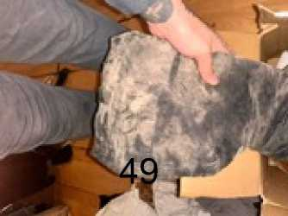
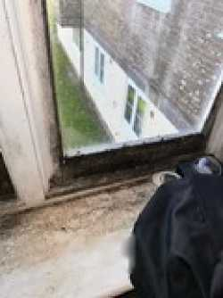
50
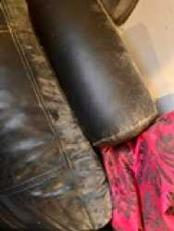
51

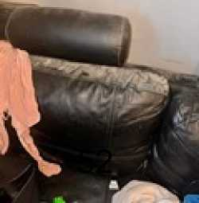
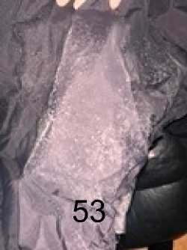
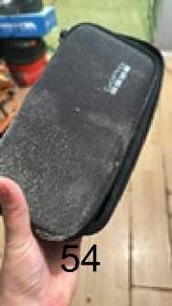
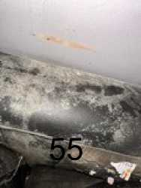

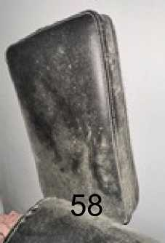
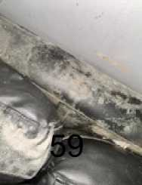
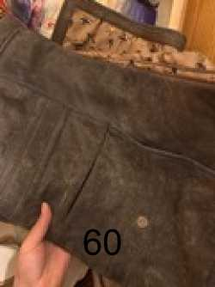

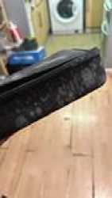
62
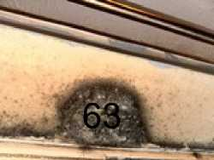
64
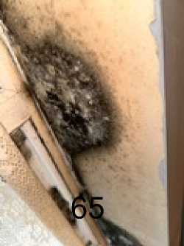
fl66
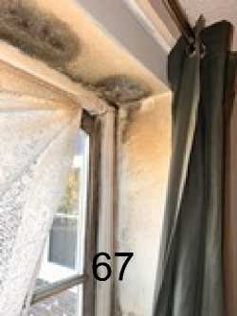
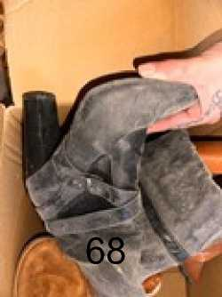
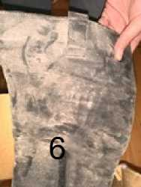
9
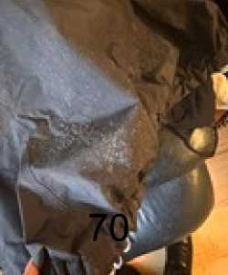
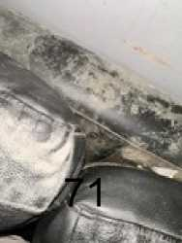
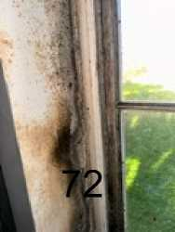
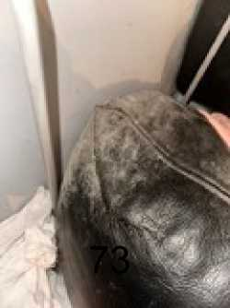
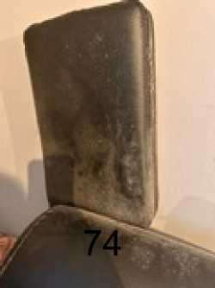
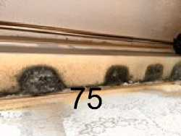
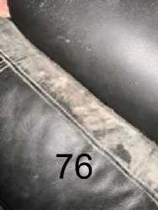
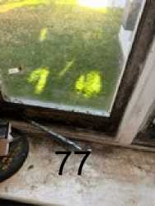

Document Index
GP Medical Letters dated 13/01/2023, 26/01/2023 and 16/03/2023 1-6
Department of Plastic & Reconstructive Surgery letters 7-10
Photo of Hand 11-17
Discharge summary Royal Free Hospital 18-22
DR Hilary Scurlock Medical report dated 03/07/2023 23-27
Enfield personality Disorder Stream appointment letter dated 8/11/23 28-37
Medication received dated 29/06/2023 38
Community Psychiatric Nurse Enfield Assessment Service letter dated 8/3/2023 39-42
L&Q Medical Assessment letter dated 21/10/2019 43
L&Q application for assistance under S183 letter dated 09/12/2022 44-45
Email from DC Neha Chadda Met Police dated 08/12/2022 46
Medical appointment letter dated 22/02/2023 and 6/12/2023 47-48
Mould pictures of client flat

NIGHTINGALE HOUSE SURGERY 1-3 NIGHTINGALE ROAD EDMONTON LONDON N9 8AJ Tel: 0208 805 9997 www.nightingalehousesurgery.nhs.uk
DRDABIDOYE DR Y CHONG
13 January 2023
YC/KM
PRIVATE & CONFIDENTIAL
TO WHOM IT MAY CONCERN
Dear Sir/Madam
Re: Miss DB dob ***** NHS No: ***** 23 Byron Terrace, Hertford Road, London, N9 7DG
I can confirm that the above 33-year-old lady is a patient registered at our practice.
Going through her medical records she has had a history of depression since 2008.
She was assaulted on 26th November 2022 and was admitted to North Middlesex Hospital A&E department with bleeding in the right hand. She was examined by the surgeons and had a rupture of the flexor digitorum superficialis tendon and was treated with antibiotics and bandaging.
According to the patient, following review, they are going to have to operate on the injury to repair the tendon in March.
Due to the assault, she has been suffering an acute exacerbation of her mental health issues. She informs us that the police have assessed her flat and deemed it unsafe to live in and therefore currently she is homeless and has been put up by her friends and temporary accommodation.
She is struggling to sleep. She was very tearful when she spoke to my colleague Priya Sharma and was started on anti-depressants Mirtazapine On 7th December 2022.
When she was reviewed by Miss Sharma on 21st December, she was extremely stressed and has self-harmed. She was also getting thoughts of self-harm and is waiting for therapy from the mental health team. She is very stressed about her homeless situation

We would be grateful if she could be provided with suitable accommodation as soon as possible due to the impact it is having on her mental health and as well as her recovery from the hand injury.

Many thanks.

NIGHTINGALE HOUSE SURGERY 1-3 NIGHTINGALE ROAD EDMONTON LONDON N9 8AJ Tel: 0208 805 9997 www.nightingalehousesurgery.nhs.uk
DRDABIDOYE
DR Y CHONG
26 January 2023
PRIVATE & CONFIDENTIAL
Re: Miss DB dob ***** NHS No: ***** 23 Byron Terrace, Hertford Road, London, N9 7DG

I can confirm that the above 33-year-old lady is a patient registered at our practice.
Going through her medical records she has had a history of depression since 2008.
She was assaulted on 26th November 2022 and was admitted to North Middlesex Hospital A&E department with bleeding in the right hand. She was examined by the surgeons and had a rupture of the flexor digitorum superficialis tendon and was treated with antibiotics and bandaging. She notes that she had a form of surgery initially in November 2022 and she has been having hand therapy since.
According to the patient, following review, they are going to have to operate on the injury to repair the tendon in March 2023.
Due to the assault, she has been suffering an acute exacerbation of her mental health issues. She informs us that the police have assessed her flat and deemed it unsafe to live in and therefore currently she is homeless and has to stay sometimes with friends in the day. She has to leave the friends at night and stays in the streets and sometimes wherever she can.
She is struggling to sleep. She was very tearful when she spoke to my colleague! Priya Sharma and was started on anti-depressants Mirtazapine On 7th December 2022. When she was reviewed by Miss Sharma on 21st December, she was extremely stressed and has self-harmed. She was also getting thoughts of self-harm and is waiting for therapy from the mental health team. She is very stressed about her homeless situation.
She is having repeated flashbacks and dreams about the assault. She feels low when these happen, with nausea and sickness. She has dreams about people stabbing her and has significant numbness in the hand
We would be grateful if she could be provided with suitable accommodation as soon as possible due to the impact it is having on her mental health and as well as her recovery from the hand injury.

DRDABIDOYE | NIGHTINllGALE HOUSE SURGERY
DR Y CHONG | 1-3 NIGHTINGALE ROAD EDMONTON LONDON N9 8AJ  Tel: 0208 805 9997  www.nightingalehousesurgery.nhs.uk

16 March 2023

PRIVATE & CONFIDENTIAL

Re: Miss DB dob ***** NHS No: ***** 23 Byron Terrace, Hertford Road, London, N9 7DG

I can confirm that the above 33-year-old lady is a patient registered at our practice.

Going through her medical records she has a history of depression since 2008.

She was assaulted on 26th November 2022 and was admitted to North Middlesex Hospital A&E department with bleeding in the right hand. She was examined by the surgeons and had a rupture of the flexor digitorum superficialis tendon and was treated with antibiotics and bandaging. She notes that she had a form of surgery initially in November 2022 and she has been having hand therapy since.

According to the patient, following review, they are going to have to operate on the injury to repair the tendon in March 2023.

Due to the assault, she has been suffering an acute exacerbation of her mental health issues. She informs us that the police have assessed her flat and deemed it unsafe to live in and therefore currently she is homeless and has to stay sometimes with friends in the day. She has to leave the friends at night and stays in the streets and sometimes wherever she can.

She is struggling to sleep. She was very tearful when she spoke to my colleague Priya Sharma and was started on anti-depressants Mirtazapine On 7th December 2022. When she was reviewed by Miss Sharma on 21st December, she was extremely stressed and has self-harmed. She was also getting thoughts of self-harm and is waiting for therapy from the mental health team. She is very stressed about her homeless situation.

She is having repeated flashbacks and dreams about the assault. She feels low when these happen, with nausea and sickness. She has dreams about people stabbing her and has significant numbness in the hand. She has seen the Enfield Community Psychiatric nurse, Kris Gopaulen who has noted that "her presentation is suggestive of traits of PTSD" and the Clinical Psychologist at Royal free Hospital Lisa Goodman, has also seen DB. She scored 67 on the PCL-5 test by Lisa Goodman which she has stated indicates "symptoms consistent with PTSD", see reports attached. As such, DB has been referred to IAPT for PTSD management.

DB has had a recent pelvic scan. This has shown a 3cm ovarian cyst. She will need to be scanned again in 3 months. She has complained of pelvic pain.
We would be grateful if she could be provided with suitable accommodation as soon as possible due to the impact it is having on her mental health and as well as her recovery from the hand injury.hhh

Royal Free London
NHS Foundation Trust
Tel: 020 7443 9757

]]

369
MISS DB 23 BYRON TERRACE HERTFORD ROAD LONDON
N9 7DG
F514STI583HW
S369 cl.350/504 bl
12 January 2023
‘’

MRN Number: 50****
NHS Number: *********
Dear Miss DB
This letter is to confirm that an appointment has been made for you to see a member of the Plastic Surgery Service team on: Tuesday 28 February 2023 at 13:30
At: Clinic 4,
1st Floor
Royal Free Hospital
Pond Street
London, NW3 2QG
This appointment is with a Psychologist who works within The Plastic surgery team:
Please bring this letter with you when you attend, with any current medication that you are taking, in original containers.
If you need to cancel or reschedule this appointment please contact us on the telephone number above, as if you fail to notify us and do not attend this appointment, you may be discharged back to the care of your GP.
Please Note: If you are late for this appointment there is a risk that you will not be seen and your appointment will have to be rescheduled.
For further information about The Royal Free London, our Sites and Services, Transport Links and Parking etc. please visit our website.
https://www.royalfree.nhs.uk
Please let us know on the above number if your contact details have changed.
Yours sincerely
Outpatient Appointment Centre

world class expertise ♦ local care

www.royalfree.nhs.uk
Mark Lam, chairman Caroline Clarke, chief executive
Department of Plastic & Reconstructive Surgery
Ext: 36988
Private & Confidential
Suzanne
Hand Therapist
Royal Free Hospital
Pond Street
London '
NW3 2QG
/J05969890/MRN50369287
NHS No: 434 751 8617
Clinic Date: 16/02/2023
Date Typed: 24/02/2023
Dear Suzanne
Royal Free London
NHS Foundation Trust
Royal Free Hospital
Pond Street London NW3 2QG www.royalfree.nhs.uk Switchboard: 020 7794 0500 Fax: 020 7830 2195

Re: Miss DB DOB: 26/08/1989
23 Byron Terrace, Hertford Road, London, N9 7DG

Thank you for referring DB to the plastic surgery psychology service. I met with her on 16th February for a psychological assessment. She attended the clinic with her friend James who/waited outside but helped her complete measures as DB is dyslexic.
DB reports that she was involved in an altercation during which she was stabbed in the palm of her hand in November 2022. She remembers the period before the stabbing but has no memory of what & happened thereafter. DB reports experiencing constant intrusive thoughts in relation to the incident.
She thinks these may be memories but is not sure. She has constant nightmares, during which she is stabbed or otherwise unsafe. She is therefore getting very little sleep and feeling exhausted during the day.
DB finds that her traumatic “memories” are easily triggered. Triggers include walking past the site of the incident. Thoughts of the incident immediately flooded back and felt like she couldn’t breathe. DB needed to put a plastic bag over her hand to try and stem the blood flow (she needed a blood
transfusion as part of hospital treatment). Recently when she needed to cover her hand with the bath, this triggered memories and severe anxiety.
bag in
DB scored a total of 67 today on the PCL-5 indicating symptoms consistent with PTSD. DB reports that she has been sectioned in the past and has previously experienced auditory hallucinations. I understand that she has a diagnosis of bipolar and has been under mental health services since childhood. It was unclear why. DB is feeling that her friends and family may be manipulating her, by this-she meant they are encouraging her to go out and go to appointment^. She is unable to articulate why but feels the intent may not be benign. She recognises this may represent paranoid thinking which can be considered in the context of her bipolar diagnosis.
DB reports that since the stabbing she is finding it difficult to go out. She is unable to go to her home as the perpetrators are known to her and there is a pending court case. They know where she lives and she is fearful of another attack. She is therefore moving around between friends' houses.
DB finds that she does not want to care for her injured hand. She feels that it is not hers. She feels she does not want to use it or care for it and that it is bad. She reports that she tells hand therapy she is engaging in exercises, when actually she is finding it very difficult to find the motivation to do this. We discussed the concept of embodiment and how we might work with that within the service. DB / reports feeling low, anxious and exhausted. She is experiencing some suicidal ideation but has no ' current plans or intent. She rates herself 3/10 likely to act, with her mother and family being protective factors.
DB has a history of self-harm, involving horizontal cutting of her arms. The last occurrence of this was over a year ago. DB reports that she saw her GP two weeks ago who is aware of her history of self-harm and suicidal ideation. She was advised to self-refer to the crisis team but had not felt able to do this. We made this referral today together in clinic. The referral was taken by Jubeda Akthar, Assistant Practitioner. DB was advised that a clinician would contact her within four hours today. I have asked for an email to update in due course.
DB would need to be stable under community services before psychological therapy in relation to her hand would be indicated. Her scores today on the PHQ-9 were 17/24 and her scores on the GAD- 7 were 19/21 indicating both severe depression and severe anxiety. As psychological therapy in relation to the hand is not indicated at this point, I will now discharge DB from the plastic surgery psychology service back to the care of the crisis team and her GP. However, when she is stable, she is most welcome to return to the plastic surgery psychology service for support in relation to engaging with hand therapy, should that be deemed necessary.
Yours sincerely
Dictated and approved electronically to avoid delay.
Lisa Goodman
Clinical Psychologist
cc
Private & Confidential
Dr J M Thomas
Nightingale House Surgery
- Nightingale Road Edmonton
London
N9 8AJ
Miss DB
23 Byron Terrace
Hertford Road
London
N9 7DG
. fnllotfinS re^erra' ^Om hand therapy. Attended clinic with Seen today for psychology assessment asure$.
her friend James who helped her complete
n n altercation dur'n8 which she was stabbed in the palm of
eon reports that she was involved in a ^ stabbi„gr ^^ ^ mcmon, o( ^ happened her hand. She remembers the period be inlrusive ^^ |n re|atipp tp ,be jncWe„t _ she W^' D“n'"”'” “*"“ sure. She has constant nightmares, during which she is thinks these may be memories, but is not su , ,

stabbed or otherwise unsafe. She Is therefore getting very Me sleep and feehrlg exhausted during the day.
DB finds that her traumatic "memories" are easily triggered. Triggers include walking past the s of the incident. Thoughts of the incident immediately flooded back and felt like she couldn’t breathe. DB needed to put a plastic bag over her hand to try and stem the blood flow (she needed a blood transfusion as part of hospital treatment). Recently when she needed to cover er hand with a bag in the bath, this triggered memories and severe anxiety.
Total score on PCL-5 is 67, indicating PTSD. Symptoms consistent with PTSD.
DB reports that she has been sectioned in the past and has previously experienced auditory hallucinations. I understand that she has a diagnosis of bi-polar and has been under services since childhood. It was unclear why. DB reports that since the stabbing, she is finding it difficult to go out. She is unable to go to her home, as perpetrators are known to her and there is a court case pending. They know where she lives and she is fearful of another attack. She is therefore moving around between friends' houses. DB is feeling that her friends and family may be manipulating her - by this she meant they are encouraging her to go out and to appointments. She is unable to articulate why but feels the intent may not be benign. She recognises this may represent paranoid thinking, which can be considered in the context of other bi-polar diagnosis.
DB finds that she does not want to care for her injured hand. She feels it is not hers. She feels she does not want to use it or care for it and that it is bad. She reports that she tells hand therapy she is engaging in exercises when actually she is finding it very difficult to find the motivation to do this. We discussed the concept of embodiment and how we might work with that within this service.
DB reports feeling low, anxious and exhausted. She is experiencing some suicidal ideation but has no current plans or intent. She rates herself 3/10 likely to act, with her mother and family being protective factors. She has a history of self-harm involving horizontal cutting of the arms. Last occurrence was circa one year ago.
DB reports that she saw her GP two weeks ago, who is aware of history of self-harm and suicidal ideation. She had advised herself to self-refer to the crisis team. She had not felt able to do this. We did this together today in clinic. Referral was taken by Jubeda Akthar, Assistant Practitioner. DB was advised that a clinician would contact her within four hours today. I have asked for an e-mail update in due course. DB would need to be stable under community services, before psychological therapy in relation to her hand would be indicated.

Scores on PHQ9 = 19/24 (8 questions) indicating severe depression
Scores on GAD7 = 19/21 indicating severe anxiety .
Copy of this note provided to patient today at her request, as she is concerned, she will not remember the content of our consultation.

Barnet, Enfield and Haringey Mental Health Trust
Enfield Mental Health Single Point of Access
25 Crown Lane Southgate London
N14 5SH
Tel: 0208 702 3329

Barnet, Enfield and Haringey
Mental Health NHS Trust

Camden and Islington
NHS Foundation Trust
Private & Confidential
To be opened by addressee only
Dr Abidoye
Nightingale House Surgery
1-3 Nightingale Road
Edmonton
London
N9 8AJ
3rd July 2023 NHS No. 434 751 8617
RiO No. 1048105
Re: Miss DB - DoB: 26 Aug 1989
23 Byron Terrace Hertford Road, Edmonton, London, N9 7DG
Miss DB is a 33-year-old unemployed single woman seen in a face-to-face appointment at Crown Lane clinic.
She has had mental health referrals this year from her GP Dr Abdoye, Nightingale Surgery (referral dated April 23) and Dr Lisa Goodman Psychologist in the RFHosp hand plastic surgery team (she referred her in Feb 23 with PTSD).
She seemed restless during the interview and dissatisfied with many aspects of her life and interactions with health professionals.
She swore frequently when speaking to me.
She told me that she has a boyfriend and has been with him for "a while" but the relationship is difficult sometimes "because of her mood swings" (said Mum).
She feels her friends and her boyfriend "don't like me " "I feel like I'm on my own and no-one gets me...I'm losing everyone" "I feel like I'm unlucky...proper unlucky, and everything bad happens to me...I've always felt like that and it makes me so angry...I lose a lot of things...everything I touch turns into shit ...everyone else gets chances".
"If I do get friends, they find the truth of me and then they don't want to be with me anymore" and she feels she needs to "pretend" to keep relationships.
She attended her appointment on time with Mum (Lorraine) and Uncle (Andrew).
She won't go back to live in her London Quadrant flat (because of the attack) and they're relationship can be tense and Mum is unwell (heart op recently and on dialysis, now on the transplant list) so she's staying with different friends and "Holly doesn't want me to stay there no more".
She is using her mother's address (Byron Terrace N9) for correspondence etc.
She has a solicitor (going through Court at the moment) trying to get her a place to live.
Interim Chair: Peter Molyneux
Better Mental Health. Better Lives. Better Communities.
Chief Executive: Jinjer Kandola MBE

Barnet, Enfield and Haringey
North London
Mental Health Partnership
Mental Health NHS Trust

Camden and Islington
NHS Foundation Trust
Her Uncle says, "she has no stability" although her family try to support her "but she argues with us all the time".
History of presenting complaint:
"I'm just stressed out ...I don't feel right and I get angry all the time" (to which Mum responds "she's had those issues for years").
Mum says, "she's getting high and low really quickly".
Andrew said that "she has been much worse since the attack" (when she was assaulted end Nov 22 and sustained a severe cut to her, dominant, right hand).
Nightmares have been worse after the attack (end November 22) "I can't sleep and I wake up sweaty and shivering" the nightmares are not just related to the attack and when she wakes it takes her a long time "to calm down",
The dreams have got worse and she has been nauseated and shaky since she has been on risperidone,
She sometimes believes "family and friends...people are talking about me and being funny with me ...I can't explain it ...I don't know it's just the way I feel...sometimes I feel like it's real other times I think I'm being stupid".
She doesn't like the way people look at her and if people are round her laughing, she feels they are laughing at her "I've always felt people laugh and look at me funny...some people are just horrible".
"I feel people are against me because they think I am lying and chatting shit".
She sometimes relates TV to her and gives the example that she sees a character on TV and they are stabbed and she feels it is more than a coincidence "is it to do with me?" - not clearly an idea of reference.
She says her hand (cut in the attack) "doesn't feel like my hand" since the attack but she can't explain this. She is right-handed but isn't using her damaged right hand. "I don't even like the sight of it".
She says she thinks about the attack very often and " it just comes into my head".
She is avoidant of memories of the attack.
She doesn't want to use knives for cooking because a cut was used in the attack.
Similarly, she gets upset by plastic bags because after the attack they used a plastic bag to try to stop the bleeding.
She was "bad before the attack but she's gone ballistic since".
She has never gone out much but less wanting to go out since the attack.

Barnet, Enfield and Haringey
Mental Health NHS Trust

Camden and Islington
NHS Foundation Trust
She continues to have treatment from the hand plastic surgery team at the Royal free hospital.
She has a psychologist from that team (Lisa Goodman).
She is waiting for her next hand clinic appointment.
She should be wearing a splint but she puts bandages on it instead because she finds the splint painful and doesn't want to look at her hand.
"I need someone to talk to you can't just give me tablets".
"I can't keep living like this ...it's stupid ...no-one is listening... I'm sick and tired of this... I want to know I can be safe.
"I don't believe people that just chat shit" (referring to health professionals) "she's getting no help".
Sleep? "I never sleep", initial insomnia - when I asked why and she said "fuck knows" but she sleeps with the light on, feels scared and any noise startles her.
She wakes sweaty every night.
If she wakes in the night, she sometimes feels the need to check there is no-one there before she can go back to sleep.
"Sometimes I feel alright and sometimes I feel like shit".
Limited pleasure from life since the attack.
I feel "so down".
Some diurnal mood variation "not very good in the morning".
Appetite variable "I don't fancy food...I feel sick thinking about it".
Weight - has lost 2 stone (without trying to) since she was stabbed (approx 6 months).
Social Hx
Benefits ESA, PIP (for hand and mental health)
No debt
Homeless at the moment (“sofa-surfing").
Forensic Hx
Caution for drunk and disorderly 18/12 ago and she said angrily "I had a little too much to drink at a funeral...that was ages ago".
Caution and probation and a tag for ABH as a teenager "I was only young...it was ages ago".
Personal Hx
Premature - Born at 27/40 "she died about 20 times and they brought her back to life" - "lung collapses" and ventilated.

Barnet, Enfield and Haringey
Mental Health NHS Trust

Camden and Islington
NHS Foundation Trust
Long periods in hospital including GOSH, in an out of hospital up until 7
School - "primary was good".
Her emotional problems got worse "at secondary school".
Mum feels her mood changed after her periods started.
Physical health
Recent ECG because "her heart was going .fast" and she need to be " monitored by a specialist".
GP also told her she is "borderline diabetic".
Polycystic ovaries (she is waiting for a gynae appointment) and a separate issue with other "cysts on her ovaries".
Asthma.
Her blood pressure has been raised.
Past Psych Hx:
Never admitted for mental health problems.
No period of treatment from Crisis Home Treatment team although she has called them.
Diagnosed with dyslexia.
She saw school counsellors for "mood swings”, anger and "cutting" from "early teens"
Not sure if she saw CAMHS (child and adolescent services).
DSH history - she was cutting (wrists /legs) but stopped around 22 years.
She explained it was "for release" not with the intention to die "it makes me feels less numb...it makes me feel better".
She cut herself in COVID and the last time was? early Dec and she says she has stopped now.
She says she tried to hang herself? age 20 when attending Lucas House OP for anxiety/depression and she had a variety of antidepressants including fluoxetine, sertraline, venlafaxine.
"I don't want to kill myself.
She saw CPN Gopaulen for assessment 1.3.23 when no psychotic symptoms were elicited.
Current medication:
Risperidone 2mg (1mg bd) - prescribed by GP- but feels it makes her sweaty and shaky and dizzy and "horrible".

Barnet, Enfield and Haringey
North London
Mental Health
Partnership
Mental Health NHS Trust

Camden and Islington
NHS Foundation Trust
No other medication.
Analgesics for headaches (her headaches have been worse recently) and period pains (she has heavy, painful periods).
Substance misuse:
No recreational drugs use
Tried cannabis and coke "but it made me feel funny and I didn't like it"
Infrequent alcohol "but when she does, she gets plastered"
Smokes tobacco (roll ups, a pouch a week approx).
Impression:
EUPD
Mixed anxiety/depressive symptoms? part of - PTSD.
Plan:
Given MIND leaflets on EUPD and PTSD.
Given Choice and medication leaflets for risperidone and mirtazapine.
"I don't want to keep taking tablets...but I hundred per cent need something" so we agreed she will reduce risperidone to 1mg nocte for a week and then stop.
I have given her an FP10 for 28 days mirtazapine 15mg nocte - after a week she could increase the dose to 30mg nocte.
I will refer to the South locality team at Lucas House.
Yours sincerely

Dr Hilary Scurlock
Consultant Psychiatrist
Enfield Mental Health Single Point of Access

Cc:
Miss DB

Mental Health Partnership
Private & Confidential Miss DB 23 Byron Terrace Hertford Road Edmonton London
N9 7DG

Barnet, Enfield and Haringey
Mental Health NHS Trust

Camden and Islington
NHS Foundation Trust
Enfield Personality Disorder Stream
ield Integrated Core Mental Health Team
The Chase Building
Chase Farm Hospital Site The Ridgeway Enfield EN2 8JL
Tel: 020 8702 5011/5023
PD Team Direct Dial: 020 8702 5020
Email: beh-tr.generalenquiries(8)nhs.net
8th November 2023
NHS number: 434 7518617
Hospital number: 1048195
\Olini\RRIUinAAA\C7l IRA 0070701 I. CI QIU
Dear DB,
Following your referral to Enfield Integrated Core Team, we have booked your initial assessment, I can confirm this will be a face-to-face appointment, your appointment details are as below:
Date & Time: 2nd February 2023 at 09:30am
Location: The Chase Building, Chase Farm Hospital Site
Clinician: Kuntal Mehta
We have enclosed several documents which we would be grateful if you could complete and bring with you to your appointment. If you cannot complete these at home, or would like some help filling them in, your clinician will be happy to help you with these at your appointment. Please note this appointment is an assessment and is not the start of therapy. We ask that if you cannot attend the appointment as above, please contact us at your earliest convenience 020 8702 5023/5011. Please be aware that failure to attend this appointment may result in a discharge from our service. We look forward to meeting you.
Yours sincerely,
I
I
Administrator for Enfield Personality Disorder Stream
On Behalf of Barnet, Enfield and Haringey Mental Health Trust
Cc: NIGHTINGALE HOUSE SURGERY, 1 NIGHTINGALE ROAD, EDMONTON, N9 8AJ
Interim Chair: Peter Molyneux
Chief Executive: Jinjer Kandola MBE

HYB13 1 L626286 0911231000017\201\3of16\
HYB13 1 L626286 091123X000017\205\7of16\

The Short Warwick-Edinburgh Mental Well-being Scale
(SWEMWBS)
HYB13_1_L626286_091123X000017X209X11of16\
Below are some statements about feelings and thoughts.
Please tick the box that best describes your experience of each over the last 2 weeks
STATEMENTS | None of the time | Rarely | Some of the time | Often | All of the time
I've been feeling optimistic about the future | 1 | 2 | 3 | 4 | 5
I've been feeling useful | 1 | 2 | 3 | 4 | 5
I've been feeling relaxed | 1 | 2 | 3 | 4 | 5
I've been dealing with problems well | 1 | 2 | 3 | 4 | 5
I've been  thinking clearly | 1 | 2 | 3 | 4 | 5
I've been feeling close to other people | 1 | 2 | 3 | 4 | 5
I've been able to make up my own mind about things | 1 | 2 | 3 | 4 | 5

NAME:
Patient Health Questionnaire (PHQ-9)
HYB13_1_L626286_091123\000017\211\13of16\
Over the last 2 weeks, how often have you been bothered by any of the following problems? (use  “ □" to indicate your answer) | Not at j Several ; all days |  | More than half the days | Nearly every day
1. Little interest or pleasure in doing things | 0 | 1 | 2 | 3
2. Feeling down, depressed, or hopeless | o | 1 | 2 | 3
3. Troubling falling or staying asleep | 0 | 1 | 2 | 3
4. Feeling tired or having little energy | b | i ' | 2 | 3
5. Poor appetite or overeating | 0 | 1 | 2 | 3
6. Feeling bad about yourself - or that you are a failure or have let yourself or your family down | b | 1 | 2 | 3
7. Trouble concentrating on things, such as reading the newspaper or watching television | o | 1 | I ² | 3
8. Moving or speaking so slowly that other people could have noticed. Or the opposite - being so fidgety or restless that you have been moving ■ around a lot more than usual | o ‘ | 1 | 2 | 3
9. Thoughts that you would be better off dead, or of hurting yourself | b | 1 | i ² | ³
Add columns
 | TOTAL:

DATE:
10. If you checked off any problems, how | Not at all
difficult have these problems made it for | Somewhat
you to do your work, take care of things | difficult
at home, or get along with other people? | Very difficult

Extremely difficult

Generalised Anxiety Disorder 7-item (GAD-7) scale
Over the last 2 weeks, how often have you been bothered by the following problems? | Not at all | Several days | Over half the days | Nearly every day
1. Feeling nervous, anxious, or on edge | 0 | 1 | 2 | 3
2. Not being able to stop or control worrying | 0 | 1 | 2 | 3
3. Worrying too much about different things | 0 | 1 | 2 | 3
4. Trouble relaxing | 0 | 1 | 2 | 3
5. Being so restless that it's hard to sit still | 0 | 1 | 2 | 3
6. Becoming easily annoyed or irritable | 0 | 1 | 2 | 3
7. Feeling afraid as if something awful might happen | 0 | 1 | 2 | 3

Add the score for each column + + +
Total Score (add your column scores) =
If you checked off any problems, how difficult have these made it for you to do your work, take care of things at home, or get along with other people?
Not difficult at all
Somewhat difficult
Very difficult
HYB13 _1_L626286_091123\000017\213\15of 16\
Extremely difficult

Pharmacy Stamp
Please don't stamp over age bi
Age
D.o.l
Title, Forename, Surname & Address
JL/^lWi 64^ ^^^ UtAi^
^1^ _{w}^hN^
Number of days' treatment N.B. Ensure dose is stated
NHS Number:

ft)?
HP
Endorsements
HOSPITAL PRESCRIBER
Prescriber's name and initials in block capitals
Signature of Prescriber
Date
NHS
enfieuTASsessment serv | RRPE6
25 CROWN LANE SOUTHGATE LONDON | N14 5SH
020 87023329 BEHMHT | RRP

For dispenser No. of Prescns. on form
FP10NC0608
HP
64189999390

A Unlvcalty Teething Tnist
Private & Confidential | Barnet, Enfield and Haringey Mental Health Trust
To be opened by addressee only | Enfield Assessment Service  25 Crown Lane
Date: 08.03.2023 | Southgate London
Dr Abidoye  Nightingale House Surgery | N14 5SH
Nightingale Road Edmonton | Tei: 0208 702 3329
N9 8AJ | ****

Dear Dr Abidoye,
Re: Miss DB DoB **** (*** years) Address - Currently of no fixed abode - Sofa surfing
I had opportunity to assess Ms DB in our Silver Street Clinic on 01 March 2023 after she was referred by our Crisis Telephone Service. She presented with her partner.
Reason for Referral
Referrer reported history of auditory hallucinations and suspected that DB has PTSD.
Clinical Documentation recorded diagnosis of depression and anxiety.
Experiencing a deterioration in MH triggered by:
- Assaulted and stabbed on 27th November 2022- In hospital for 3 days
- Mum is currently in hospital- had a heart operation
- Not able to return to her home address due to assault.
DB reported that she has been having disturbed sleep and-nightmares at night.
No changes in appetite highlighted.
DB has a history of having auditory hallucinations but denied experiencing psychotic symptoms at time of triage.
DB is not taking any medication at present; she was previously prescribed sertraline but stopped taking medication 3.weeks ago, GP is aware and she reported they would review medication. - — - No currently using drugs or drinking alcohol.
Reported that she used to socially use cocaine but stopped after she was assaulted last year.
No clear diagnosis
History of presenting Problem:
Gave verbal consent to information sharing along Trust guidelines, happy for final letter to go to GP and to home address
Ms DB told me last November she went to pick up her boyfriend at a Bar. When they came out, her boyfriend who was intoxicated with alcohol had an altercation with a man and a woman whom she alleged were both under the influence of alcohol. She got involved during the altercation pulling

Chairman: Jackie Smith Chief Executive: Jinjer Kandola

A University Teaching Trust
her boyfriend away and she alleged she was pushed to the ground and the woman stabbed her. She sustained deep cut in her right hand, and she told me she fainted because of the bleeding and she now unable to remember much what actually happened.
Police now is investigating the incident. No one has been arrested yet and they are still looking for the alleged assailant. She is now stressed out of having to attend court. She told CCTV footage is not clear.
She told me she has been told by police not go to her flat "kicked me out and told me it is dangerous for me to go back.” and subsequently has been of no fixed abode since. She told me she has been sofa surfing at her boyfriend and other friends since the incident.
Since the incident, she has been experiencing symptoms suggestive of PTSD - .
Hyperarousal - easily irritable and aggressive at time, hypervigilance, can’t go outside - afraid of the dark, difficulty concentrating, and difficulty sleeping, experiencing bad dreams, and waking up in sweat. Constant ruminating and flashbacks about the incident ‘in my head’, Crying for no reason.
Compounded to the trauma following the incident, she attended North Middlesex University hospital yesterday and was told that she must have her ovary removed and she is worried she wouldn’t be able to have any kids.
She also told me she is also stressed out as her mum is in ICU following a heart operation and she is physically very unwell.
Before the incident she told me was paranoid about people betraying her and she has been diagnosed with dyslexia when she was at school, and she has had depression and anxiety since she was 13 years of age.
She told me she was previously diagnosed with bipolar affective disorder and when challenged as her health records doesn’t indicate such a diagnosis, she then told me it was the charity MIND who told her she may have had Bipolar. .
Past Psychiatric History:
Previously treated with depression and anxiety from 2008 - 2011.
Otherwise, no previous history on Rio.
Current Medication:
Sertraline 150mg
Sleeping tablet - Zopiclone
She told me she has been on Sertraline most of her life although she never felt any benefit since on it and has been taking it as prescribed.
To the contrary, notes from our CTS indicate she stopped taking her antidepressant.

A University Teaching Trust
Information provided about her condition by her GP
Ms DB understands the risk and benefit of medication prescribed and was involved in decision^ about medication.
Drug/ Alcohol and smoking status:
Smoke cigarettes.
Only drinks alcohol socially when out with her friends - She used to drink in excess during her teenage years but denied any problematic drinking recently.
She told me she used to sniff ‘Charlie’ cocaine during her teenage years. However, when our CTS spoke with her recently, she reported to socially use cocaine but only stopped after she was assaulted last November.
Present Social Circumstances:
She is currently of NFA and sofa surfing She receives ESA and PIP.
Mental State Examination:
A+B: Revealed a 33-year-old Caucasian woman. Her right hand was bandaged and told me she is scheduled to attend special unit for plastic surgery on her hand. She was casually dressed, and her self-care was good. She established a rapport easily and she was mildly agitated shaking her leg incessantly during the interview. Her speech was fluent, coherent and normal in volume, rate and content
Subjectively she rated her mood as being (0) on a scale of 0 to 10 (where 0 is most depressed and 10 happiest). However objectively her mood appears normal with a reactive and mildly anxious affect
She told she attempted self harm by cutting her wrists about 7 months ago. No scar or mark noted. Her left wrist is covered with tattooed. She has no current suicidal ideation, plan or intent and cited her mum as a protective factor. .
With regards to her perception, she reported hearing her boyfriend whispering to her from inside her head "playing games in my head’ and not from external spaces about 3 to 4 times in a week since the incident. This appears more related to her traumatic experiences and unlikely to be psychotic. She also reported a history of feeling paranoid about other people betraying her, likely in the context of her personality and a history of using cocaine.
Her appetite is not great, although she is eating, and she is not sleeping well although she reported having 8 hours sleep last night.

A University Toothing Trust
Nursing Impression:
Her presentation is suggestive of traits of PTSD following an incident last November when she alleges, she got stabbed in her right arm.
She is also stressed out as she subsequently lost her accommodation following the incident and her mum is currently very unwell in hospital.
Management plan:
We discussed therapy to manage her PTSD and advised her to engage with IAPT.
Please refer her to Enfield IAPT for therapy. _
She told me a housing solicitor is helping her with her accommodation and I have advised her to go to the homeless person unit and MIND for support.
She told me she is seeing her GP for a review of her medication.
I have discharged her back to your care,
Kris Gopaulen Community Psychiatric Nurse Enfield Assessment Service

Copy to: Ms DB

L&Q
West Ham Lane Office
29-35 West Ham Lane
London E15 4PH
Tel: 0300 456 9998
Email: info@lqgroup.org.uk
Website: www.lqgroup.org.uk
Confidential
Miss DB 7 Tenneyson Close, Enfield, London, EN34SN
21 October 2019
Dear Miss D DB
Medical Assessment - Priority Awarded
Following your recent medical assessment, I can confirm that medical priority has been awarded and the recommendations are:
Bed Size - According to L&Q Policy
Max Floor Level with a lift - 4th Floor or Above
Max Floor Level without a lift - 2nd Floor
Gas Central Heating - Desirable
Garden - No Special Requirement.
Please note, as L&Q operate a Choice Based Lettings System you are able to place on bids on properties that you deem as suitable for your household needs. If there are any concerns regarding the suitability of a property, a Lettings officer will discuss this with you during the Lettings process.
Your transfer application is now in Band 3 - All priority cases.
It is recommended that you also register with your local authority as you have a medical reason for moving homes. To do this, you will need to complete an application form and submit any supporting documents. Details can be obtained from each council website.
Yours sincerely
Lettings Team
BECAUSE HOMES MATTER

L&Q
L&Q Direct
PO Box 194
Sidcup DA15 0AJ
Tel: +44 (0)300 456 9998
Email: info@lqgroup.org.uk
Website: www.lqgroup.org.uk
09th December 2022
URGENT – For the attention of the Duty Homeless Persons Unit Officer, Homelessness Section
Dear Sir/Madam,
Application for assistance under section 183 of the Housing Act 1996
Please treat this letter as an application for assistance under section 183, Housing Act 1996.
Homelessness or threatened with homelessness (Section 175 Housing Act 1996)
We believe that our client should be treated as homeless or threatened with homelessness. This is because:
Please see summary notes for the case below
Ms DB contacted L&Q and has reported that on 25th November she was stabbed outside a pub by two unknown persons. She was hospitalised and needed surgery after sustaining life changing injuries. Ms DB has seen both of the perpetrators on her estate while walking her dog and believes they live on the estate and know where she lives. She has not stayed in her property due to fear for her life. While she was in hospital, she has received a call from an unknown number telling her to drop the charges. She has stayed in the hospital last few nights as she has no where else to stay. Police are investigating her case crime ref: 5232489/22. I have received an email from the police officer stating, ‘The victim currently resides at an address where both suspect live within the same estate and there has been escalation of violent behaviour within this estate since the incident on 25/11/2022’. They advised that it is not safe for Ms DB to remain at her property and she should be moved.
Advised resident to approach the local authority explain her situation regarding the incident and that she wants to make a homeless application.
Ms DB has requested urgent re-housing.
It is of the recommendation of L&Q that accommodation is considered to ensure the safety and wellbeing of DB.
Interim accommodation duty (section 188 Housing Act 1996)
BECAUSE HOMES MATTER
We believe that on the basis of the above that your authority has reason to believe that our client may be homeless, eligible and in priority need. Therefore, your authority has a duty to provide suitable accommodation pending completion of your enquiries. We would remind you that this duty arises irrespective of location connection with your authority.
Ms DB is a tenant of London & Quadrant Housing Trust (L&Q). However, due to:
• Please see details of case above
This tenant feels it is not safe for them to remain at their property at 7 Tenneyson Close, Enfield, London EN3 4SN.
Police details
DC Neha Chadda
North Area BCU
Local Investigations Team 2a
Metropolitan Police Service
North Area BCU (Enfield & Haringey)
07717850110
For this reason, I am referring them for emergency re-housing as per s188 of the Housing Act 1996 (Homelessness). “Interim duty to accommodate in case of apparent priority need.” And also, under section 10 of the Homeless Act 2002, where it is not reasonable for a person to continue to occupy accommodation if it is probable that this will lead to threats of violence from another person.
Details of Ms DB, tenancy are as follows:
Tenancy start date with L&Q – 15/08/2011
Date of birth: 26/08/1989
I would be grateful if you can contact me to confirm receipt of this letter. Please can you also keep me informed of the progress of your enquiries as an authorised representative of our client and provide us with a copy of your decision letter. You can contact me on 0300 456 9996 or via email to nsharif@lqgroup.org.uk Thank you for your assistance.
Yours faithfully
Nazma Sharif
ASB Case worker
Valerie Opara
From: | Neha.Chadda@met.police.uk
Sent:  To: Cc: | 08 December 2022 17:55  RROteam  emily.berry@emfield.gov.uk; Nazma Sharif
Subject: | 5232489/22
Follow Up Flag: | Follow up
Flag Status: | Flagged

Good evening,
I am emailing in relation to the above crime report. This a GBH with intent investigation where the victim was assaulted in a pub which resulted in life changing injuries to her hand.
The victim currently resides at an address where both suspect live within the same estate and there has been escalation of violent behaviour within this estate since the incidnet on 25/11/2022.
The victim’s name is DB Shantel DB she currently resides at 7 TENNYSON CLOSE, SCOTLAND GREEN ROAD, ENFIELD, EN3 4SN.
We would recommend a move due to the proximity of the suspects of this investigation and the mental/physical toll this incidnet has been on Ms DB.
Kind Regards,
DC Neha Chadda
North Area BCU
Local Investigations Team 2a
Metropolitan Police Service
North Area BCU (Enfield & Haringey)
X07717850110
Vwww.met.police.uk ^ Neha.Chadda@met.police.uk
Enfield Haringey
Unless otherwise stated this email is GSC Code – Official
NOTICE - This email and any attachments are solely for the intended recipient and may be confidential. If you have received this email in error, please notify the sender and delete it from your system. Do not use, copy or disclose the information contained in this email or in any attachment without the permission of the sender. Metropolitan Police Service (MPS) communication systems are monitored to the extent permitted by law and any email and/or attachments may be read by monitoring staff. Only specified personnel are authorised to conclude binding agreements on behalf of the MPS by email and no responsibility is accepted for unauthorised agreements reached with other personnel. While reasonable precautions have been taken to ensure no viruses are present in this email, its security and that of any attachments cannot be guaranteed.

A University Teething Trust

Your Ref:
Enfield Assessment Service
25 Crown Lane Southgate London N14 5SH
Tel: 0208 702 3329
NHS Number 434 751 8617
Hospital Number: 1048195
22 Feb 2023
Private and Confidential to be opened by addressee
Miss DB Shantel DB
23 Byron Terrace Hertford Road
Edmonton
London
N9 7DG
Dear Miss DB,
Following our recent phone conversation, we would like to confirm your appointment as follows
Date: 01 Mar 2023
Time: 11 30
Clinician: Kylassum Gopaulen
Location: 58-60 Silver Street, Enfield, Middlesex, ENI 3EP
To make sure that access to our services is fair, please:
- Call the above number if you are unable to attend this appointment
We may not be able to offer you another appointment if you don't attend this one, or don't tell us that you can't come
- Arrive on time for your appointment as we may not be able to see you if you are late
Please contact us on the above number if English is not your first language and you need help or an interpreter.
Yours sincerely
Annalynn Kamulete
On Behalf of Barnet, Enfield and Haringey Mental Health Trust
Interim Chair: Peter Molyne Chief Executive: Jinjer Kand
Mental Health Partnership
Private & Confidential Miss DB 23 Byron Terrace Hertford Road Edmonton
London N9 7DG

Barnet, Enfield and Haringey
Mental Health NHS Trust

Camden and Islington
NHS Foundation Trust
Enfield Personality Disorder Stream ield Integrated Core Mental Health Team
The Chase Building Chase Farm Hospital Site
The Ridgeway
Enfield EN2 8JL
Tel: 020 8702 5011/5023
PD Team Direct Dial: 020 8702 5020
Email: beh-tr.generalenquiries@nhs.net
6th December 2023
NHS number: 434 7518617
Hospital number: 1048195
HYB13_1_L665385_061223\000035\469\1 of24\
Dear DB,
Due to unforeseen circumstances, we have had to amend the assessment date that we previously booked for you. I can confirm this will be a face-to-face appointment, your appointment details are as below:
Date & Time: 23rd February 2024 at 09:30am
Location: The Chase Building, Chase Farm Hospital Site
Clinician: Kuntal Mehta
We have enclosed several documents which we would be grateful if you could complete and bring with you to your appointment. If you cannot complete these at home, or would like some help filling them in, your clinician will be happy to help you with these at your appointment. Please note this appointment is an assessment and is not the start of therapy. We ask that if you cannot attend the appointment as above, please contact us at your earliest convenience 020 8702 5023/5011. Please be aware that failure to attend this appointment may result in a discharge from our service. We look forward to meeting you.
Yours sincerely,
Administrator for Enfield Personality Disorder Stream
On Behalf of Barnet, Enfield and Haringey Mental Health Trust
Cc: NIGHTINGALE HOUSE SURGERY, 1 NIGHTINGALE ROAD, EDMONTON, N9 8AJ
Better Mental Health. Better Lives. Be:? _
Interim Chair: Peter Molyneux
Chief Executive: Jinjer Kandola MBE

50
51

62
64
fl66
9

Duncan Lewis

Solicitors
London borough of Enfield
By way of email
housingadviceservice@enfield.gov.uk
Our ref: ANDREC/ B184****3/DB
Date: 15th December 2023
Correspondence Address:
Sackville House
143-149 Fenchurch Street
London
EC3M 6BL
DX 1074 CDE
t: 020 7923 4020
f: 020 7923 3320
www.duncanlewis.com
Andre Cummings
Housing
ddi: 02072752883
AndreC@duncanlewis.com
City Office



We refer your authority to section 175 of the Housing Act 1996 (the 1996 Act):
Dear Sirs

APPLICATION FOR HOUSING UNDER THE HOUSING ACT 1996 PART VII S183.

Our Client:

DOB ****
The above instructs us. Please find enclosed signed client authority form.
Our client is presenting as homeless to your authority. Please treat this letter as an application for housing under the Housing Act 1996 Part VII, s183.

Homelessness or threatened with Homelessness (s175)


Duncan Lewis

Solicitors
We refer your authority to section 175 of the Housing Act 1996 (the 1996 Act):
- A person is homeless if he has no accommodation available for his occupation, in the United Kingdom or elsewhere, which he—
- is entitled to occupy by virtue of an interest in it or by virtue of an order of a court,
- has an express or implied licence to occupy, or
- Occupies as a residence by virtue of any enactment or rule of law giving him the right to remain in occupation or restricting the right of another person to recover possession.
- A person shall not be treated as having accommodation unless it is accommodation which it would be reasonable for him to continue to occupy.
A person is threatened with homelessness if it is likely that he will become homeless within 56 days
Our client falls under S 175 (3) as person who is homeless due to accommodation not being reasonable for them to occupy. She is the tenant of 7 Tennyson Close, Enfield, London. Our client instructs she was assaulted on 26th November 2022 as a result of an altercation at a bar and since then she has been frightened to return to the flat. DC Neha Chadda confirmed that the injury to her hand was caused by the assault and that the suspects lived in the same estate as her, and recommended that she should be moved due to the proximity of the suspects and the mental and physical toll the incident had taken on her(see attached).
Since this incident our client has been homelessness rough sleeping at friends’ houses. Further our
client recently got a call from a neighbour informing her that they could smell burning coming


Duncan Lewis

Solicitors
from the flat. Our client returned to the flat with her family who could not believe the state the flat was in, the mould has taken over the flat which our client had reported previously to London and quadrant. The plug in the property had burned out and melted which has now caused the system to no longer work, further the water and heating system. (See attached)

Eligible for Assistance (s185)
Our client is eligible for assistance as they are a British citizen and was born in London, England on 26/08/1989

Priority Need (s189)
Our client is in priority need under section 189(1) Housing Act 1996.
(1)The following have a priority need for accommodation—
(a)a pregnant woman or a person with whom she resides or might reasonably be expected to reside;
(b)a person with whom dependent children reside or might reasonably be expected to reside;
(c)a person who is vulnerable as a result of old age, mental illness or handicap or physical disability or other special reason, or with whom such a person resides or might reasonably be expected to reside;
(d)a person who is homeless or threatened with homelessness as a result of an emergency such as flood, fire or other disaster.


Duncan Lewis

Solicitors
Our client falls under section 189(1) (c) Housing Act 1996 as she is a person who is vulnerable as a result of old age, mental illness or handicap or physical disability or other special reason, or with whom such a person resides or might reasonably be expected to reside.
Our client suffers from the following health conditions:
- Depression
- Anxiety
- Post-traumatic stress disorder
- Asthma
- Insomnia
- The loss of use of her right (and dominant) hand
- emotionally unstable personality disorder (EUPD)
Our client has a history of anxiety, asthma and depression, being homelessness has exacerbated her health conditions. Our client has a physical impairment as stated under s6(1) equality act 2010 as the impairment has a substantial and long term advise effect on our client to carry out normal day to day task. Our client instructs that she has lost the use of her right hand and she needs help with shopping, cooking, cleaning and literacy (specially, completing form) as a result of her injury.


Duncan Lewis

Solicitors
Our client medical conditions are supported by Psychiatrist, Dr Hilary Scurlock, whom states our client has “EUPD” (which stands for emotionally unstable personality disorder) and mixed anxiety and depressive symptoms, possibly related to PTSD. Our client is currently prescribed mirtrazapine by her GP
Our client further falls under the Homelessness code of guidance for local authority’S8:
8.14 A person has a priority need for accommodation if they are vulnerable as a result of: (f) ceasing to occupy accommodation because of violence from another person or threats of violence from another person which are likely to be carried out; or,
Our client was assaulted on 26th November 2022 as a result of an altercation our client is now in fear to return to the property and thus sleeps at different friends’ houses.

Duty to make enquiries (s184)
We submit that on the basis of the presenting evidence your authority has reason to believe that our client may be homeless/ threatened with homelessness and therefore has a duty under s184(1) to make reasonable enquiries into this case and to provide a written decision (s184(3) & (6).

Interim Accommodation Duty (s188)


Duncan Lewis

Solicitors
The main homelessness duties in s.193(2) and s.195(2) of the 1996 Act (to secure accommodation or take reasonable steps to prevent the loss of accommodation) apply only to applicants who have a priority need for accommodation (paragraph 10.2 of the Homelessness Code of Guidance).
We believe that on the basis of the presenting evidence from our client and the evidence contained in this letter, that your authority has reason to believe that our client may be homeless, eligible for assistance and in priority need and therefore is required by s.188(1) to provide suitable accommodation pending completion of your enquiries. This duty arises and is irrespective of local connection with your authority.
In R(Aweys and others) v Birmingham City Council [2007] EWHC 52 (Admin) (approved by the Court of Appeal [2008] EWCA Civ 48), Collins J rehearsed what should be trite law to any housing authority: “It is apparent that the threshold for the duty of Councils to act under s.184 is a low one (cf: Mohamed v Manek & another (1995) 27 H.L.R. 439@449) since it arises if they have reason to believe the applicant may be homeless or threatened with homelessness. In the vast majority of cases, the making of the application will mean that it is difficult if not impossible for the Council not to believe that the applicant may be homeless or threatened with homelessness.
Furthermore, no particular form of application is prescribed. This is not surprising since the provisions are dealing with people who are likely to be vulnerable and who cannot be expected to have obtained legal advice or to have an acquaintance with the statutory provisions. If it is apparent


Duncan Lewis

Solicitors
from what is said by an applicant (for there is no requirement that an application be in writing) or from anything in writing that he may be homeless or threatened with homelessness, the duty is triggered.”
Should you refuse to accommodate our client, Ms. DB will suffer detriment, and we will have no option but to advise our client of Judicial Review proceedings for the failure to discharge statutory duty towards our client. Ms. DB requires immediate accommodations from the council that will take into consideration their medical needs.
If you have any queries, please contact Andre Cummings by telephone on 02072752883 or by email at AndreC@duncanlewis.com . Please ensure that you quote our reference number above in all correspondence and communications with this office.
Yours sincerely
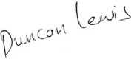

Duncan Lewis

Encls.


[B184500003] Client care letter
From: Andre Cummings <AndreC@Duncanlewis.com>
To: 'Lorraine Cordell' <lorraine32@blueyonder.co.uk>, 'deon benjamin' <deonbenjamin@yahoo.com>
Date: Fri, 08 Dec 2023 16:56:01 +0100
Attachments:
- Terms of Engagement - Public (1 April 2023) -08122023150704.pdf,
- ADM004 -Client Authority Form – Deon.pdf,
- HAL001-Initial client care letter-Deon Benjamin.pdf
Dear Lorraine and Deon
- Please find attached client care letter, terms of engagement and client authority form.
- Could you please sign the terms of engagement and client authority form and return them to me.
Kind regards
Andre Cummings
Apprentice Solicitor
DDI: 02072752883
To unsubscribe please submit a request
<https://www.duncanlewis.co.uk/Home/Unsubscribe> here
<https://m.facebook.com/duncanlewislawfirm/>
<https://twitter.com/DuncanLewis>
<https://www.linkedin.com/authwall?
trk=gf&trkInfo=AQH09ZGdLIf8UgAAAWQnI0gIORO3toIqAyYl0gflWMqXC11x_GaLYoZunVJZ8ba VnqpmHc_JMYNtfBCBrUhg9kwBheb0B8V8QSjNsT8GXoQxE2ksr1dfLMC6Q=&originalReferer=& %3A%2F%2Fwww.linkedin.com%2Fcompany%2Fduncan-lewis-%26-co-solicitors-greater- london>

Disclaimer
The information contained in this communication from the sender is confidential. It is intended solely for use by the recipient and others authorized to receive it. If you are not the recipient, you are hereby notified that any disclosure, copying, distribution or taking action in relation of the contents of this information is strictly prohibited and may be unlawful.
This email has been scanned for viruses and malware, and may have been automatically archived by Mimecast.
To view our Disclaimer and Privacy Policy Click Here
<https://www.duncanlewis.co.uk/Email-Disclaimer.html> .

Read: [B184500003] [B184500003] RE: [B184500003] Client care letter
From: Andre Cummings <AndreC@Duncanlewis.com>
To: Lorraine Cordell <lorraine32@blueyonder.co.uk>
Date: Fri, 08 Dec 2023 17:37:49 +0000
- Your message

RE: [B184500003] Client care letter
From: Lorraine Cordell <lorraine32@blueyonder.co.uk>
To: 'Andre Cummings' <AndreC@Duncanlewis.com>, 'deon benjamin' <deonbenjamin@yahoo.com>
Date: Fri, 08 Dec 2023 18:00:21 +0100
Attachments:
- ADM004 -Client Authority Form Deon.pdf,
- Terms of Engagement - Public (1 April 2023) -08122023150704.pdf
Dear Andre
- Please see attached documents did not release they needed signing or I would have got them across to you sooner.
Regards
Lorraine

From: Andre Cummings <AndreC@Duncanlewis.com>
Sent: 08 December 2023 15:56
To: 'Lorraine Cordell' <lorraine32@blueyonder.co.uk>; 'deon benjamin'
<deonbenjamin@yahoo.com>
Subject: [B184500003]Client care letter
Dear Lorraine and Deon
- Please find attached client care letter, terms of engagement and client authority form.
- Could you please sign the terms of engagement and client authority form and return them to me.
Kind regards
Andre Cummings
Apprentice Solicitor
DDI: 02072752883
To unsubscribe please submit a request
<https://www.duncanlewis.co.uk/Home/Unsubscribe> here
<https://m.facebook.com/duncanlewislawfirm/>
<https://twitter.com/DuncanLewis>
<https://www.linkedin.com/authwall?
trk=gf&trkInfo=AQH09ZGdLIf8UgAAAWQnI0gIORO3toIqAyYl0gflWMqXC11x_GaLYoZunVJZ8ba VnqpmHc_JMYNtfBCBrUhg9kwBheb0B8V8QSjNsT8GXoQxE2ksr1dfLMC6Q=&originalReferer=& %3A%2F%2Fwww.linkedin.com%2Fcompany%2Fduncan-lewis-%26-co-solicitors-greater- london>

Disclaimer
The information contained in this communication from the sender is confidential. It is intended solely for use by the recipient and others authorized to receive it. If you are not the recipient, you are hereby notified that any disclosure, copying, distribution or taking action in relation of the contents of this information is strictly prohibited and may be unlawful.
This email has been scanned for viruses and malware, and may have been automatically archived by Mimecast.
To view our Disclaimer and Privacy Policy Click Here
<https://www.duncanlewis.co.uk/Email-Disclaimer.html> .

Automatic reply: [B184500003] Client care letter
From: Andre Cummings <AndreC@Duncanlewis.com>
To: Lorraine Cordell <lorraine32@blueyonder.co.uk>
Date: Mon, 11 Dec 2023 10:52:59 +0000
Thank you for your email.
- I do not work Mondays, please contact the Switchboard team.
- I will respond to your emails upon my return

Disclaimer
The information contained in this communication from the sender is confidential. It is intended solely for use by the recipient and others authorized to receive it. If you are not the recipient, you are hereby notified that any disclosure, copying, distribution or taking action in relation of the contents of this information is strictly prohibited and may be unlawful.
This email has been scanned for viruses and malware, and may have been automatically archived by Mimecast.
To view our Disclaimer and Privacy Policy Click Here
<https://www.duncanlewis.co.uk/Email-Disclaimer.html> .

Read: RE: [B184500003] Client care letter
From: Andre Cummings <AndreC@Duncanlewis.com>
To: Lorraine Cordell <lorraine32@blueyonder.co.uk>
Date: Mon, 11 Dec 2023 12:28:31 +0000
- Your message

RE: [B184500003] Client care letter
From: Andre Cummings <AndreC@Duncanlewis.com>
To: 'Lorraine Cordell' <lorraine32@blueyonder.co.uk>, 'deon benjamin' <deonbenjamin@yahoo.com>
Date: Tue, 12 Dec 2023 16:11:12 +0100
Dear Lorraine
- Did Deon get an updated pip assessment after the attack that happened to her
- I am piecing the evidence together as I was not able to do it yesterday.
- I will show you the draft once I have completed it and you can let me know if ive missed anything or any documents
Kind regards
Andre Cummings
Apprentice Solicitor
DDI: 02072752883
To unsubscribe please submit a request
<https://www.duncanlewis.co.uk/Home/Unsubscribe> here
<https://m.facebook.com/duncanlewislawfirm/>
<https://twitter.com/DuncanLewis>
<https://www.linkedin.com/authwall?
trk=gf&trkInfo=AQH09ZGdLIf8UgAAAWQnI0gIORO3toIqAyYl0gflWMqXC11x_GaLYoZunVJZ8ba VnqpmHc_JMYNtfBCBrUhg9kwBheb0B8V8QSjNsT8GXoQxE2ksr1dfLMC6Q=&originalReferer=& %3A%2F%2Fwww.linkedin.com%2Fcompany%2Fduncan-lewis-%26-co-solicitors-greater- london>

From: Lorraine Cordell <lorraine32@blueyonder.co.uk>
Sent: 11 December 2023 10:53
To: Andre Cummings <AndreC@Duncanlewis.com>; 'deon benjamin'
<deonbenjamin@yahoo.com>
Subject: RE: [B184500003] Client care letter
Alert: This is an external email received from outside Duncan Lewis. Please do not click on any links in the email or open attachments unless you are expecting this email.
Dear Andre
- Please see attached new hospital letter for Deon.
Regards
Lorraine

From: Andre Cummings <AndreC@Duncanlewis.com <mailto:AndreC@Duncanlewis.com> >
Sent: 08 December 2023 15:56
To: 'Lorraine Cordell' <lorraine32@blueyonder.co.uk
<mailto:lorraine32@blueyonder.co.uk> >; 'deon benjamin'
<deonbenjamin@yahoo.com <mailto:deonbenjamin@yahoo.com> >
Subject: [B184500003] Client care letter
Dear Lorraine and Deon
- Please find attached client care letter, terms of engagement and client authority form.
- Could you please sign the terms of engagement and client authority form and return them to me.
Kind regards
Andre Cummings
Apprentice Solicitor
DDI: 02072752883
To unsubscribe please submit a request
<https://www.duncanlewis.co.uk/Home/Unsubscribe> here
<https://m.facebook.com/duncanlewislawfirm/>
<https://twitter.com/DuncanLewis>
<https://www.linkedin.com/authwall?
trk=gf&trkInfo=AQH09ZGdLIf8UgAAAWQnI0gIORO3toIqAyYl0gflWMqXC11x_GaLYoZunVJZ8ba VnqpmHc_JMYNtfBCBrUhg9kwBheb0B8V8QSjNsT8GXoQxE2ksr1dfLMC6Q=&originalReferer=& %3A%2F%2Fwww.linkedin.com%2Fcompany%2Fduncan-lewis-%26-co-solicitors-greater- london>

Disclaimer
The information contained in this communication from the sender is confidential. It is intended solely for use by the recipient and others authorized to receive it. If you are not the recipient, you are hereby notified that any disclosure, copying, distribution or taking action in relation of the contents of this information is strictly prohibited and may be unlawful.
This email has been scanned for viruses and malware, and may have been automatically archived by Mimecast.
To view our Disclaimer and Privacy Policy <https://www.duncanlewis.co.uk/Email-Disclaimer.html> Click Here.

Disclaimer
The information contained in this communication from the sender is confidential. It is intended solely for use by the recipient and others authorized to receive it. If you are not the recipient, you are hereby
notified that any disclosure, copying, distribution or taking action in relation of the contents of this information is strictly prohibited and may be unlawful.
This email has been scanned for viruses and malware, and may have been automatically archived by Mimecast.
To view our Disclaimer and Privacy Policy Click Here
<https://www.duncanlewis.co.uk/Email-Disclaimer.html> .

Re: [B184500003] Client care letter
From: deon benjamin <deonbenjamin@yahoo.com>
To: Lorraine Cordell <lorraine32@blueyonder.co.uk>, 'Andre Cummings' <AndreC@Duncanlewis.com> Date: Tue, 12 Dec 2023 19:23:35 +0100
Hi Andre
- And here is the letter they sent me
Sent from Yahoo Mail for iPhone
<https://mail.onelink.me/107872968?
pid=nativeplacement&c=Global_Acquisition_YMktg_315_Internal_EmailSignature&af_sub1=Acqui

On Tuesday, December 12, 2023, 5:37 pm, Lorraine Cordell
<lorraine32@blueyonder.co.uk> wrote:
Hi Andre
- No Deon did not get an updated one, but she had a renewal form and that was sent in including the details regarding her hand, PIP is running way be hide so Deon at this time is waiting for an assessment so they carried on the old claim while she is waiting.
Regards
Lorraine

From: Andre Cummings <AndreC@Duncanlewis.com>
Sent: 12 December 2023 15:11
To: 'Lorraine Cordell' <lorraine32@blueyonder.co.uk>; 'deon benjamin'
<deonbenjamin@yahoo.com>
Subject: RE: [B184500003]Client care letter
Dear Lorraine
- Did Deon get an updated pip assessment after the attack that happened to her I am piecing the evidence together as I was not able to do it yesterday.
- I will show you the draft once I have completed it and you can let me know if ive missed anything or any documents
Kind regards
Andre Cummings
Apprentice Solicitor
DDI: 02072752883
To unsubscribe please submit a request
<https://www.duncanlewis.co.uk/Home/Unsubscribe> here
<https://m.facebook.com/duncanlewislawfirm/>
<https://twitter.com/DuncanLewis>
<https://www.linkedin.com/authwall?
trk=gf&trkInfo=AQH09ZGdLIf8UgAAAWQnI0gIORO3toIqAyYl0gflWMqXC11x_GaLYoZunVJZ8ba VnqpmHc_JMYNtfBCBrUhg9kwBheb0B8V8QSjNsT8GXoQxE2ksr1dfLMC6Q=&originalReferer=& %3A%2F%2Fwww.linkedin.com%2Fcompany%2Fduncan-lewis-%26-co-solicitors-greater- london>

From: Lorraine Cordell <lorraine32@blueyonder.co.uk
<mailto:lorraine32@blueyonder.co.uk> >
Sent: 11 December 2023 10:53
To: Andre Cummings <AndreC@Duncanlewis.com <mailto:AndreC@Duncanlewis.com>
>; 'deon benjamin' <deonbenjamin@yahoo.com <mailto:deonbenjamin@yahoo.com> >
Subject: RE: [B184500003]Client care letter
Alert: This is an external email received from outside Duncan Lewis. Please do not click on any links in the email or open attachments unless you are
expecting this email.
Dear Andre
- Please see attached new hospital letter for Deon.
Regards
Lorraine

From: Andre Cummings <AndreC@Duncanlewis.com <mailto:AndreC@Duncanlewis.com>
Sent: 08 December 2023 15:56
To: 'Lorraine Cordell' <lorraine32@blueyonder.co.uk
<mailto:lorraine32@blueyonder.co.uk> >; 'deon benjamin'
<deonbenjamin@yahoo.com <mailto:deonbenjamin@yahoo.com> >
Subject: [B184500003]Client care letter
Dear Lorraine and Deon
Please find attached client care letter, terms of engagement and client authority form.
Could you please sign the terms of engagement and client authority form and
return them to me.

Kind regards
Andre Cummings
Apprentice Solicitor
DDI: 02072752883
To unsubscribe please submit a request
<https://www.duncanlewis.co.uk/Home/Unsubscribe> here
<https://m.facebook.com/duncanlewislawfirm/>
<https://twitter.com/DuncanLewis>
<https://www.linkedin.com/authwall?
trk=gf&trkInfo=AQH09ZGdLIf8UgAAAWQnI0gIORO3toIqAyYl0gflWMqXC11x_GaLYoZunVJZ8ba VnqpmHc_JMYNtfBCBrUhg9kwBheb0B8V8QSjNsT8GXoQxE2ksr1dfLMC6Q=&originalReferer=& %3A%2F%2Fwww.linkedin.com%2Fcompany%2Fduncan-lewis-%26-co-solicitors-greater- london>

Disclaimer
The information contained in this communication from the sender is confidential. It is intended solely for use by the recipient and others authorized to receive it. If you are not the recipient, you are hereby notified that any disclosure, copying, distribution or taking action in relation of the contents of this information is strictly prohibited and may be unlawful.
This email has been scanned for viruses and malware, and may have been
automatically archived by Mimecast.

To view our Disclaimer and Privacy Policy Click Here
<https://www.duncanlewis.co.uk/Email-Disclaimer.html> .
Disclaimer
The information contained in this communication from the sender is confidential. It is intended solely for use by the recipient and others authorized to receive it. If you are not the recipient, you are hereby notified that any disclosure, copying, distribution or taking action in relation of the contents of this information is strictly prohibited and may be unlawful.
This email has been scanned for viruses and malware, and may have been automatically archived by Mimecast.
To view our Disclaimer and Privacy Policy Click Here
<https://www.duncanlewis.co.uk/Email-Disclaimer.html> .

RE: [B184500003] Homelessness application
From: Lorraine Cordell <lorraine32@blueyonder.co.uk>
To: 'Andre Cummings' <AndreC@Duncanlewis.com>
Date: Wed, 13 Dec 2023 23:12:10 +0100
Attachments:
- Deon-Mental-Health-Letter-03-07-2023.pdf,
- Deon-Mental-Health-Chase Farm Hospital-Date-23-02-2024.pdf
Dear Andre
- There is a few mistakes the flat did not caught on fire, but the plug had burned out and melted and the system no longer worked. It was at this time we saw all the mould over everything in the flat. As seen from the pictures. Deon did not go to the flat on her own she went with family who could not believe the state of the flat. Since Deon moved into the flat from L&Q she has been telling them about the Mould and nothing has been done. The water/heating system has also had issues with it since she moved in to the flat.
- Also you missed out the Borderline personality disorder / Emotionally unstable personality disorder (EUPD), this is the letter Enfield Council was sent and done nothing about the letter is dated 03/07/2023 and as soon as I got it I sent it to David who passed it on to Enfield Council.
- Deon has to see the mental health team at chase farm hospital regarding the above Borderline personality disorder / Emotionally unstable personality disorder (EUPD), and the PTSD on the 23/02/2024.
- I will include the letter dated the 03/07/2023 and also the letter to go to the hospital on the 23/02/2024.
Regards
Lorraine

From: Andre Cummings <AndreC@Duncanlewis.com>
Sent: 13 December 2023 18:24
To: Lorraine Cordell <lorraine32@blueyonder.co.uk>; 'deon benjamin'
<deonbenjamin@yahoo.com>
Subject: [B184500003]Homelessness application
Dear Deon Lorraine
- Please find homelessness application draft and documents, please let me know if your happy with it or want to include further documents or comments.
Kind regards
Andre Cummings
Apprentice Solicitor
DDI: 02072752883
To unsubscribe please submit a request
<https://www.duncanlewis.co.uk/Home/Unsubscribe> here
<https://m.facebook.com/duncanlewislawfirm/>
<https://twitter.com/DuncanLewis>
<https://www.linkedin.com/authwall?
trk=gf&trkInfo=AQH09ZGdLIf8UgAAAWQnI0gIORO3toIqAyYl0gflWMqXC11x_GaLYoZunVJZ8ba VnqpmHc_JMYNtfBCBrUhg9kwBheb0B8V8QSjNsT8GXoQxE2ksr1dfLMC6Q=&originalReferer=& %3A%2F%2Fwww.linkedin.com%2Fcompany%2Fduncan-lewis-%26-co-solicitors-greater- london>

Disclaimer
The information contained in this communication from the sender is confidential. It is intended solely for use by the recipient and others authorized to receive it. If you are not the recipient, you are hereby notified that any disclosure, copying, distribution or taking action in relation of the contents of this information is strictly prohibited and may be unlawful.
This email has been scanned for viruses and malware, and may have been automatically archived by Mimecast.
To view our Disclaimer and Privacy Policy Click Here
<https://www.duncanlewis.co.uk/Email-Disclaimer.html> .

FW: [B184500003] Homelessness application
From: Lorraine Cordell <lorraine32@blueyonder.co.uk>
To: 'deon benjamin' <deonbenjamin@yahoo.com>
Date: Wed, 13 Dec 2023 23:13:58 +0100

Attachments:
- Deon-Mental-Health-Letter-03-07-2023.pdf,
- Deon-Mental-Health-Chase Farm Hospital-Date-23-02-2024.pdf
- Deon read below

From: Lorraine Cordell <lorraine32@blueyonder.co.uk
<mailto:lorraine32@blueyonder.co.uk> >
Sent: 13 December 2023 22:12
To: 'Andre Cummings' <AndreC@Duncanlewis.com <mailto:AndreC@Duncanlewis.com> >
Subject: RE: [B184500003]Homelessness application
Dear Andre
- There is a few mistakes the flat did not caught on fire, but the plug had burned out and melted and the system no longer worked. It was at this time
- we saw all the mould over everything in the flat. As seen from the pictures. Deon did not go to the flat on her own she went with family who could not believe the state of the flat. Since Deon moved into the flat from L&Q she has been telling them about the Mould and nothing has been done. The water/heating system has also had issues with it since she moved in to the flat.
- Also you missed out the Borderline personality disorder / Emotionally unstable personality disorder (EUPD), this is the letter Enfield Council was sent and done nothing about the letter is dated 03/07/2023 and as soon as I got it I sent it to David who passed it on to Enfield Council.
- Deon has to see the mental health team at chase farm hospital regarding the above Borderline personality disorder / Emotionally unstable personality disorder (EUPD), and the PTSD on the 23/02/2024.
- I will include the letter dated the 03/07/2023 and also the letter to go to the hospital on the 23/02/2024.
Regards
Lorraine

From: Andre Cummings <AndreC@Duncanlewis.com <mailto:AndreC@Duncanlewis.com> >
Sent: 13 December 2023 18:24
To: Lorraine Cordell <lorraine32@blueyonder.co.uk
<mailto:lorraine32@blueyonder.co.uk> >; 'deon benjamin'
<deonbenjamin@yahoo.com <mailto:deonbenjamin@yahoo.com> >
Subject: [B184500003]Homelessness application
Dear Deon Lorraine
- Please find homelessness application draft and documents, please let me know if your happy with it or want to include further documents or comments.
Kind regards
Andre Cummings
Apprentice Solicitor
DDI: 02072752883
To unsubscribe please submit a request
<https://www.duncanlewis.co.uk/Home/Unsubscribe> here
<https://m.facebook.com/duncanlewislawfirm/>
<https://twitter.com/DuncanLewis>
<https://www.linkedin.com/authwall?
trk=gf&trkInfo=AQH09ZGdLIf8UgAAAWQnI0gIORO3toIqAyYl0gflWMqXC11x_GaLYoZunVJZ8ba VnqpmHc_JMYNtfBCBrUhg9kwBheb0B8V8QSjNsT8GXoQxE2ksr1dfLMC6Q=&originalReferer=& %3A%2F%2Fwww.linkedin.com%2Fcompany%2Fduncan-lewis-%26-co-solicitors-greater- london>

Disclaimer
The information contained in this communication from the sender is confidential. It is intended solely for use by the recipient and others authorized to receive it. If you are not the recipient, you are hereby notified that any disclosure, copying, distribution or taking action in relation of the contents of this information is strictly prohibited and may be unlawful.
This email has been scanned for viruses and malware, and may have been automatically archived by Mimecast.
To view our Disclaimer and Privacy Policy Click Here
<https://www.duncanlewis.co.uk/Email-Disclaimer.html> .

Read: RE: [B184500003] Homelessness application
From: Andre Cummings <AndreC@Duncanlewis.com>
To: Lorraine Cordell <lorraine32@blueyonder.co.uk>
Date: Thu, 14 Dec 2023 09:13:43 +0000
- Your message

RE: [B184500003] Homelessness application
From: Andre Cummings <AndreC@Duncanlewis.com> To: 'Lorraine Cordell' <lorraine32@blueyonder.co.uk> Date: Thu, 14 Dec 2023 11:14:29 +0100
Dear Lorraine
- The letter dated the 03/07/2023 and the appointment letter are attached in the bundle already on pages 23-27 and page 48.
- I will add the details in regards to the flat incident
Kind regards
Andre Cummings
Apprentice Solicitor
DDI: 02072752883
To unsubscribe please submit a request
<https://www.duncanlewis.co.uk/Home/Unsubscribe> here
<https://m.facebook.com/duncanlewislawfirm/>
<https://twitter.com/DuncanLewis>
<https://www.linkedin.com/authwall?
trk=gf&trkInfo=AQH09ZGdLIf8UgAAAWQnI0gIORO3toIqAyYl0gflWMqXC11x_GaLYoZunVJZ8ba VnqpmHc_JMYNtfBCBrUhg9kwBheb0B8V8QSjNsT8GXoQxE2ksr1dfLMC6Q=&originalReferer=& %3A%2F%2Fwww.linkedin.com%2Fcompany%2Fduncan-lewis-%26-co-solicitors-greater- london>

From: Lorraine Cordell <lorraine32@blueyonder.co.uk>
Sent: 13 December 2023 22:12
To: Andre Cummings <AndreC@Duncanlewis.com>
Subject: RE: [B184500003]Homelessness application
Alert: This is an external email received from outside Duncan Lewis. Please do not click on any links in the email or open attachments unless you are expecting this email.
Dear Andre
- There is a few mistakes the flat did not caught on fire, but the plug had burned out and melted and the system no longer worked. It was at this time we saw all the mould over everything in the flat. As seen from the pictures.
- Deon did not go to the flat on her own she went with family who could not
- believe the state of the flat. Since Deon moved into the flat from L&Q she has been telling them about the Mould and nothing has been done. The water/heating system has also had issues with it since she moved in to the flat.
- Also you missed out the Borderline personality disorder / Emotionally unstable personality disorder (EUPD), this is the letter Enfield Council was sent and done nothing about the letter is dated 03/07/2023 and as soon as I got it I sent it to David who passed it on to Enfield Council.
- Deon has to see the mental health team at chase farm hospital regarding the above Borderline personality disorder / Emotionally unstable personality disorder (EUPD), and the PTSD on the 23/02/2024.
- I will include the letter dated the 03/07/2023 and also the letter to go to the hospital on the 23/02/2024.
Regards
Lorraine
From: Andre Cummings <AndreC@Duncanlewis.com <mailto:AndreC@Duncanlewis.com> >
Sent: 13 December 2023 18:24
To: Lorraine Cordell <lorraine32@blueyonder.co.uk
<mailto:lorraine32@blueyonder.co.uk> >; 'deon benjamin'
<deonbenjamin@yahoo.com <mailto:deonbenjamin@yahoo.com> >
Subject: [B184500003]Homelessness application
Dear Deon Lorraine
- Please find homelessness application draft and documents, please let me know if your happy with it or want to include further documents or comments.
Kind regards
Andre Cummings
Apprentice Solicitor
DDI: 02072752883
To unsubscribe please submit a request
<https://www.duncanlewis.co.uk/Home/Unsubscribe> here
<https://m.facebook.com/duncanlewislawfirm/>
<https://twitter.com/DuncanLewis>
<https://www.linkedin.com/authwall?
trk=gf&trkInfo=AQH09ZGdLIf8UgAAAWQnI0gIORO3toIqAyYl0gflWMqXC11x_GaLYoZunVJZ8ba VnqpmHc_JMYNtfBCBrUhg9kwBheb0B8V8QSjNsT8GXoQxE2ksr1dfLMC6Q=&originalReferer=& %3A%2F%2Fwww.linkedin.com%2Fcompany%2Fduncan-lewis-%26-co-solicitors-greater- london>

Disclaimer
The information contained in this communication from the sender is confidential. It is intended solely for use by the recipient and others authorized to receive it. If you are not the recipient, you are hereby notified that any disclosure, copying, distribution or taking action in
relation of the contents of this information is strictly prohibited and may be unlawful.
This email has been scanned for viruses and malware, and may have been automatically archived by Mimecast.
To view our Disclaimer and Privacy Policy
<https://www.duncanlewis.co.uk/Email-Disclaimer.html> Click Here.

Disclaimer
The information contained in this communication from the sender is confidential. It is intended solely for use by the recipient and others authorized to receive it. If you are not the recipient, you are hereby notified that any disclosure, copying, distribution or taking action in relation of the contents of this information is strictly prohibited and may be unlawful.
This email has been scanned for viruses and malware, and may have been automatically archived by Mimecast.
To view our Disclaimer and Privacy Policy Click Here
<https://www.duncanlewis.co.uk/Email-Disclaimer.html> .

Read: RE: [B184500003] Homelessness application
From: Andre Cummings <AndreC@Duncanlewis.com>
To: Lorraine Cordell <lorraine32@blueyonder.co.uk>
Date: Thu, 14 Dec 2023 11:34:15 +0000
- Your message

RE: [B184500003] Homelessness application
From: Lorraine Cordell <lorraine32@blueyonder.co.uk>
To: 'Andre Cummings' <AndreC@Duncanlewis.com>
Date: Thu, 14 Dec 2023 12:32:04 +0100
Dear Andre
- We have just had a surveyor to Deon flat that L&Q sent it was booked for today and he stated it the worse he has seen and it a health and safety major issue and he going to do a full report and send it to L&Q I will have the ref and his details later.
Regards
Lorraine

From: Andre Cummings <AndreC@Duncanlewis.com>
Sent: 14 December 2023 10:14
To: 'Lorraine Cordell' <lorraine32@blueyonder.co.uk>
Subject: RE: [B184500003] Homelessness application
Dear Lorraine
- The letter dated the 03/07/2023 and the appointment letter are attached in the bundle already on pages 23-27 and page 48.
- I will add the details in regards to the flat incident
Kind regards
Andre Cummings
Apprentice Solicitor
DDI: 02072752883
To unsubscribe please submit a request
<https://www.duncanlewis.co.uk/Home/Unsubscribe> here
<https://m.facebook.com/duncanlewislawfirm/>
<https://twitter.com/DuncanLewis>
<https://www.linkedin.com/authwall?
trk=gf&trkInfo=AQH09ZGdLIf8UgAAAWQnI0gIORO3toIqAyYl0gflWMqXC11x_GaLYoZunVJZ8ba VnqpmHc_JMYNtfBCBrUhg9kwBheb0B8V8QSjNsT8GXoQxE2ksr1dfLMC6Q=&originalReferer=& %3A%2F%2Fwww.linkedin.com%2Fcompany%2Fduncan-lewis-%26-co-solicitors-greater- london>

From: Lorraine Cordell <lorraine32@blueyonder.co.uk
<mailto:lorraine32@blueyonder.co.uk> >
Sent: 13 December 2023 22:12
To: Andre Cummings <AndreC@Duncanlewis.com <mailto:AndreC@Duncanlewis.com> >
Subject: RE: [B184500003]Homelessness application
Alert: This is an external email received from outside Duncan Lewis. Please do not click on any links in the email or open attachments unless you are expecting this email.
Dear Andre
- There is a few mistakes the flat did not caught on fire, but the plug had burned out and melted and the system no longer worked. It was at this time we saw all the mould over everything in the flat. As seen from the pictures. Deon did not go to the flat on her own she went with family who could not believe the state of the flat. Since Deon moved into the flat from L&Q she has been telling them about the Mould and nothing has been done. The water/heating system has also had issues with it since she moved in to the flat.
- Also you missed out the Borderline personality disorder / Emotionally unstable personality disorder (EUPD), this is the letter Enfield Council was sent and done nothing about the letter is dated 03/07/2023 and as soon as I got it I sent it to David who passed it on to Enfield Council.
- Deon has to see the mental health team at chase farm hospital regarding the above Borderline personality disorder / Emotionally unstable personality
- disorder (EUPD), and the PTSD on the 23/02/2024.
- I will include the letter dated the 03/07/2023 and also the letter to go to the hospital on the 23/02/2024.
Regards
Lorraine

From: Andre Cummings <AndreC@Duncanlewis.com <mailto:AndreC@Duncanlewis.com>
Sent: 13 December 2023 18:24
To: Lorraine Cordell <lorraine32@blueyonder.co.uk
<mailto:lorraine32@blueyonder.co.uk> >; 'deon benjamin'
<deonbenjamin@yahoo.com <mailto:deonbenjamin@yahoo.com> >
Subject: [B184500003]Homelessness application
Dear Deon Lorraine
- Please find homelessness application draft and documents, please let me know if your happy with it or want to include further documents or comments.
Kind regards
Andre Cummings
Apprentice Solicitor
DDI: 02072752883
To unsubscribe please submit a request
<https://www.duncanlewis.co.uk/Home/Unsubscribe> here
<https://m.facebook.com/duncanlewislawfirm/>
<https://twitter.com/DuncanLewis>
<https://www.linkedin.com/authwall?
trk=gf&trkInfo=AQH09ZGdLIf8UgAAAWQnI0gIORO3toIqAyYl0gflWMqXC11x_GaLYoZunVJZ8ba VnqpmHc_JMYNtfBCBrUhg9kwBheb0B8V8QSjNsT8GXoQxE2ksr1dfLMC6Q=&originalReferer=& %3A%2F%2Fwww.linkedin.com%2Fcompany%2Fduncan-lewis-%26-co-solicitors-greater- london>

Disclaimer
The information contained in this communication from the sender is confidential. It is intended solely for use by the recipient and others authorized to receive it. If you are not the recipient, you are hereby notified that any disclosure, copying, distribution or taking action in relation of the contents of this information is strictly prohibited and may be unlawful.
This email has been scanned for viruses and malware, and may have been automatically archived by Mimecast.
To view our Disclaimer and Privacy Policy Click Here <https://www.duncanlewis.co.uk/Email-Disclaimer.html> .

Disclaimer
The information contained in this communication from the sender is confidential. It is intended solely for use by the recipient and others
authorized to receive it. If you are not the recipient, you are hereby notified that any disclosure, copying, distribution or taking action in
relation of the contents of this information is strictly prohibited and may be unlawful.
This email has been scanned for viruses and malware, and may have been automatically archived by Mimecast.
To view our Disclaimer and Privacy Policy Click Here
<https://www.duncanlewis.co.uk/Email-Disclaimer.html> .

RE: [B184500003] Homelessness application
From: Lorraine Cordell <lorraine32@blueyonder.co.uk>
To: 'Andre Cummings' <AndreC@Duncanlewis.com>, 'deon benjamin' <deonbenjamin@yahoo.com>
Date: Thu, 14 Dec 2023 12:34:36 +0100
Dear Andre
- We have just had a surveyor to Deon flat that L&Q sent it was booked for today and he stated it the worse he has seen and it a health and safety major issue and he going to do a full report and send it to L&Q I will have the ref and his details later.
- I forgot to say this is regarding the mould and damp.
Regards
Lorraine

From: Lorraine Cordell <lorraine32@blueyonder.co.uk>
Sent: 14 December 2023 11:32
To: 'Andre Cummings' <AndreC@Duncanlewis.com>
Subject: RE: [B184500003]Homelessness application
Dear Andre
- We have just had a surveyor to Deon flat that L&Q sent it was booked for today and he stated it the worse he has seen and it a health and safety major issue and he going to do a full report and send it to L&Q I will have the ref and his details later.
Regards
Lorraine

From: Andre Cummings <AndreC@Duncanlewis.com <mailto:AndreC@Duncanlewis.com> >
Sent: 14 December 2023 10:14
To: 'Lorraine Cordell' <lorraine32@blueyonder.co.uk
<mailto:lorraine32@blueyonder.co.uk> >
Subject: RE: [B184500003]Homelessness application
Dear Lorraine
- The letter dated the 03/07/2023 and the appointment letter are attached in
- the bundle already on pages 23-27 and page 48.
- I will add the details in regards to the flat incident
Kind regards
Andre Cummings
Apprentice Solicitor
DDI: 02072752883
To unsubscribe please submit a request
<https://www.duncanlewis.co.uk/Home/Unsubscribe> here
<https://m.facebook.com/duncanlewislawfirm/>
<https://twitter.com/DuncanLewis>
<https://www.linkedin.com/authwall?
trk=gf&trkInfo=AQH09ZGdLIf8UgAAAWQnI0gIORO3toIqAyYl0gflWMqXC11x_GaLYoZunVJZ8ba VnqpmHc_JMYNtfBCBrUhg9kwBheb0B8V8QSjNsT8GXoQxE2ksr1dfLMC6Q=&originalReferer=& %3A%2F%2Fwww.linkedin.com%2Fcompany%2Fduncan-lewis-%26-co-solicitors-greater- london>

From: Lorraine Cordell <lorraine32@blueyonder.co.uk
<mailto:lorraine32@blueyonder.co.uk> >
Sent: 13 December 2023 22:12
To: Andre Cummings <AndreC@Duncanlewis.com <mailto:AndreC@Duncanlewis.com> >
Subject: RE: [B184500003]Homelessness application
Alert: This is an external email received from outside Duncan Lewis. Please
do not click on any links in the email or open attachments unless you are expecting this email.
Dear Andre
- There is a few mistakes the flat did not caught on fire, but the plug had burned out and melted and the system no longer worked. It was at this time we saw all the mould over everything in the flat. As seen from the pictures. Deon did not go to the flat on her own she went with family who could not believe the state of the flat. Since Deon moved into the flat from L&Q she has been telling them about the Mould and nothing has been done. The water/heating system has also had issues with it since she moved in to the flat.
- Also you missed out the Borderline personality disorder / Emotionally
- unstable personality disorder (EUPD), this is the letter Enfield Council was sent and done nothing about the letter is dated 03/07/2023 and as soon as I got it I sent it to David who passed it on to Enfield Council.
- Deon has to see the mental health team at chase farm hospital regarding the above Borderline personality disorder / Emotionally unstable personality disorder (EUPD), and the PTSD on the 23/02/2024.
- I will include the letter dated the 03/07/2023 and also the letter to go to the hospital on the 23/02/2024.
Regards

Lorraine
From: Andre Cummings <AndreC@Duncanlewis.com <mailto:AndreC@Duncanlewis.com> >
Sent: 13 December 2023 18:24
To: Lorraine Cordell <lorraine32@blueyonder.co.uk
<mailto:lorraine32@blueyonder.co.uk> >; 'deon benjamin'
<deonbenjamin@yahoo.com <mailto:deonbenjamin@yahoo.com> >
Subject: [B184500003]Homelessness application
Dear Deon Lorraine
Please find homelessness application draft and documents, please let me know

if your happy with it or want to include further documents or comments.
Kind regards
Andre Cummings
Apprentice Solicitor
DDI: 02072752883
To unsubscribe please submit a request
<https://www.duncanlewis.co.uk/Home/Unsubscribe> here
<https://m.facebook.com/duncanlewislawfirm/>
<https://twitter.com/DuncanLewis>
<https://www.linkedin.com/authwall?
trk=gf&trkInfo=AQH09ZGdLIf8UgAAAWQnI0gIORO3toIqAyYl0gflWMqXC11x_GaLYoZunVJZ8ba VnqpmHc_JMYNtfBCBrUhg9kwBheb0B8V8QSjNsT8GXoQxE2ksr1dfLMC6Q=&originalReferer=& %3A%2F%2Fwww.linkedin.com%2Fcompany%2Fduncan-lewis-%26-co-solicitors-greater- london>

Disclaimer
The information contained in this communication from the sender is confidential. It is intended solely for use by the recipient and others authorized to receive it. If you are not the recipient, you are hereby notified that any disclosure, copying, distribution or taking action in relation of the contents of this information is strictly prohibited and may be unlawful.
This email has been scanned for viruses and malware, and may have been
automatically archived by Mimecast.

To view our Disclaimer and Privacy Policy Click Here
<https://www.duncanlewis.co.uk/Email-Disclaimer.html> .
Disclaimer
The information contained in this communication from the sender is confidential. It is intended solely for use by the recipient and others authorized to receive it. If you are not the recipient, you are hereby notified that any disclosure, copying, distribution or taking action in relation of the contents of this information is strictly prohibited and may be unlawful.
This email has been scanned for viruses and malware, and may have been automatically archived by Mimecast.
To view our Disclaimer and Privacy Policy Click Here
<https://www.duncanlewis.co.uk/Email-Disclaimer.html> .

Read: [B184500003] RE: [B184500003] Homelessness application
From: Andre Cummings <AndreC@Duncanlewis.com>
To: Lorraine Cordell <lorraine32@blueyonder.co.uk>
Date: Thu, 14 Dec 2023 15:39:36 +0000
- Your message

RE: [B184500003] RE: [B184500003] Homelessness application
From: Andre Cummings <AndreC@Duncanlewis.com>
To: 'Lorraine Cordell' <lorraine32@blueyonder.co.uk>, 'deon benjamin' <deonbenjamin@yahoo.com>
Date: Thu, 14 Dec 2023 17:22:55 +0100
Attachments:
- Ms Benjamin homelessness application-13122023-173259.pdf
Dear Lorraine
- Please see updated letter that I will send to the council.
Kind regards
Andre Cummings
Apprentice Solicitor
DDI: 02072752883
To unsubscribe please submit a request
<https://www.duncanlewis.co.uk/Home/Unsubscribe> here
<https://m.facebook.com/duncanlewislawfirm/>
<https://twitter.com/DuncanLewis>
<https://www.linkedin.com/authwall?
trk=gf&trkInfo=AQH09ZGdLIf8UgAAAWQnI0gIORO3toIqAyYl0gflWMqXC11x_GaLYoZunVJZ8ba VnqpmHc_JMYNtfBCBrUhg9kwBheb0B8V8QSjNsT8GXoQxE2ksr1dfLMC6Q=&originalReferer=& %3A%2F%2Fwww.linkedin.com%2Fcompany%2Fduncan-lewis-%26-co-solicitors-greater- london>

From: Lorraine Cordell <lorraine32@blueyonder.co.uk>
Sent: 14 December 2023 11:35
To: Andre Cummings <AndreC@Duncanlewis.com>; 'deon benjamin'
<deonbenjamin@yahoo.com>
Subject: [B184500003] RE: [B184500003] Homelessness application
Alert: This is an external email received from outside Duncan Lewis. Please do not click on any links in the email or open attachments unless you are expecting this email.
Dear Andre
- We have just had a surveyor to Deon flat that L&Q sent it was booked for today and he stated it the worse he has seen and it a health and safety major issue and he going to do a full report and send it to L&Q I will have the ref and his details later.
- I forgot to say this is regarding the mould and damp.
Regards
Lorraine

From: Lorraine Cordell <lorraine32@blueyonder.co.uk
<mailto:lorraine32@blueyonder.co.uk> >
Sent: 14 December 2023 11:32
To: 'Andre Cummings' <AndreC@Duncanlewis.com <mailto:AndreC@Duncanlewis.com> >
Subject: RE: [B184500003] Homelessness application
Dear Andre
- We have just had a surveyor to Deon flat that L&Q sent it was booked for today and he stated it the worse he has seen and it a health and safety major issue and he going to do a full report and send it to L&Q I will have the ref and his details later.
Regards
Lorraine

From: Andre Cummings <AndreC@Duncanlewis.com <mailto:AndreC@Duncanlewis.com>
>
Sent: 14 December 2023 10:14
To: 'Lorraine Cordell' <lorraine32@blueyonder.co.uk
<mailto:lorraine32@blueyonder.co.uk> >
Subject: RE: [B184500003]Homelessness application
Dear Lorraine
- The letter dated the 03/07/2023 and the appointment letter are attached in the bundle already on pages 23-27 and page 48.
- I will add the details in regards to the flat incident
Kind regards
Andre Cummings
Apprentice Solicitor
DDI: 02072752883
To unsubscribe please submit a request
<https://www.duncanlewis.co.uk/Home/Unsubscribe> here
<https://m.facebook.com/duncanlewislawfirm/>
<https://twitter.com/DuncanLewis>
<https://www.linkedin.com/authwall?
trk=gf&trkInfo=AQH09ZGdLIf8UgAAAWQnI0gIORO3toIqAyYl0gflWMqXC11x_GaLYoZunVJZ8ba VnqpmHc_JMYNtfBCBrUhg9kwBheb0B8V8QSjNsT8GXoQxE2ksr1dfLMC6Q=&originalReferer=& %3A%2F%2Fwww.linkedin.com%2Fcompany%2Fduncan-lewis-%26-co-solicitors-greater- london>

From: Lorraine Cordell <lorraine32@blueyonder.co.uk
<mailto:lorraine32@blueyonder.co.uk> >
Sent: 13 December 2023 22:12
To: Andre Cummings <AndreC@Duncanlewis.com <mailto:AndreC@Duncanlewis.com> >
Subject: RE: [B184500003]Homelessness application
Alert: This is an external email received from outside Duncan Lewis. Please do not click on any links in the email or open attachments unless you are expecting this email.
Dear Andre
- There is a few mistakes the flat did not caught on fire, but the plug had burned out and melted and the system no longer worked. It was at this time we saw all the mould over everything in the flat. As seen from the pictures. Deon did not go to the flat on her own she went with family who could not believe the state of the flat. Since Deon moved into the flat from L&Q she has been telling them about the Mould and nothing has been done. The water/heating system has also had issues with it since she moved in to the flat.
- Also you missed out the Borderline personality disorder / Emotionally unstable personality disorder (EUPD), this is the letter Enfield Council was sent and done nothing about the letter is dated 03/07/2023 and as soon as I got it I sent it to David who passed it on to Enfield Council.
- Deon has to see the mental health team at chase farm hospital regarding the above Borderline personality disorder / Emotionally unstable personality disorder (EUPD), and the PTSD on the 23/02/2024.
- I will include the letter dated the 03/07/2023 and also the letter to go to the hospital on the 23/02/2024.
Regards
Lorraine

From: Andre Cummings <AndreC@Duncanlewis.com <mailto:AndreC@Duncanlewis.com> >
Sent: 13 December 2023 18:24
To: Lorraine Cordell <lorraine32@blueyonder.co.uk
<mailto:lorraine32@blueyonder.co.uk> >; 'deon benjamin'
<deonbenjamin@yahoo.com <mailto:deonbenjamin@yahoo.com> >
Subject: [B184500003]Homelessness application
Dear Deon Lorraine
- Please find homelessness application draft and documents, please let me know if your happy with it or want to include further documents or comments.
Kind regards
Andre Cummings
Apprentice Solicitor
DDI: 02072752883

To unsubscribe please submit a request
<https://www.duncanlewis.co.uk/Home/Unsubscribe> here
<https://m.facebook.com/duncanlewislawfirm/>
<https://twitter.com/DuncanLewis>
<https://www.linkedin.com/authwall?
trk=gf&trkInfo=AQH09ZGdLIf8UgAAAWQnI0gIORO3toIqAyYl0gflWMqXC11x_GaLYoZunVJZ8ba VnqpmHc_JMYNtfBCBrUhg9kwBheb0B8V8QSjNsT8GXoQxE2ksr1dfLMC6Q=&originalReferer=& %3A%2F%2Fwww.linkedin.com%2Fcompany%2Fduncan-lewis-%26-co-solicitors-greater- london>

Disclaimer
The information contained in this communication from the sender is confidential. It is intended solely for use by the recipient and others authorized to receive it. If you are not the recipient, you are hereby
notified that any disclosure, copying, distribution or taking action in
relation of the contents of this information is strictly prohibited and may be unlawful.
This email has been scanned for viruses and malware, and may have been automatically archived by Mimecast.
To view our Disclaimer and Privacy Policy
<https://www.duncanlewis.co.uk/Email-Disclaimer.html> Click Here.

Disclaimer
The information contained in this communication from the sender is confidential. It is intended solely for use by the recipient and others authorized to receive it. If you are not the recipient, you are hereby notified that any disclosure, copying, distribution or taking action in relation of the contents of this information is strictly prohibited and may
be unlawful.
This email has been scanned for viruses and malware, and may have been
automatically archived by Mimecast.
To view our Disclaimer and Privacy Policy
<https://www.duncanlewis.co.uk/Email-Disclaimer.html> Click Here.

Disclaimer
The information contained in this communication from the sender is confidential. It is intended solely for use by the recipient and others authorized to receive it. If you are not the recipient, you are hereby notified that any disclosure, copying, distribution or taking action in relation of the contents of this information is strictly prohibited and may be unlawful.
This email has been scanned for viruses and malware, and may have been automatically archived by Mimecast.
To view our Disclaimer and Privacy Policy Click Here
<https://www.duncanlewis.co.uk/Email-Disclaimer.html> .

RE: [B184500003] RE: [B184500003] Homelessness application
From: Lorraine Cordell <lorraine32@blueyonder.co.uk>
To: 'Andre Cummings' <AndreC@Duncanlewis.com>, 'deon benjamin' <deonbenjamin@yahoo.com> Date: Thu, 14 Dec 2023 18:07:34 +0100
Dear Andre
- I edited you file a little as Deon’s DOB was wrong and also included something else I written it in red so you will see where I have edited it for you to change.
Regards
Lorraine

From: Andre Cummings <AndreC@Duncanlewis.com>
Sent: 14 December 2023 16:23
To: 'Lorraine Cordell' <lorraine32@blueyonder.co.uk>; 'deon benjamin'
<deonbenjamin@yahoo.com>
Subject: RE: [B184500003] RE: [B184500003]Homelessness application
Dear Lorraine
- Please see updated letter that I will send to the council.
Kind regards
Andre Cummings
Apprentice Solicitor
DDI: 02072752883
To unsubscribe please submit a request
<https://www.duncanlewis.co.uk/Home/Unsubscribe> here
<https://m.facebook.com/duncanlewislawfirm/>
<https://twitter.com/DuncanLewis>
<https://www.linkedin.com/authwall?
trk=gf&trkInfo=AQH09ZGdLIf8UgAAAWQnI0gIORO3toIqAyYl0gflWMqXC11x_GaLYoZunVJZ8ba VnqpmHc_JMYNtfBCBrUhg9kwBheb0B8V8QSjNsT8GXoQxE2ksr1dfLMC6Q=&originalReferer=& %3A%2F%2Fwww.linkedin.com%2Fcompany%2Fduncan-lewis-%26-co-solicitors-greater- london>

From: Lorraine Cordell <lorraine32@blueyonder.co.uk
<mailto:lorraine32@blueyonder.co.uk> >
Sent: 14 December 2023 11:35
To: Andre Cummings <AndreC@Duncanlewis.com <mailto:AndreC@Duncanlewis.com>
>; 'deon benjamin' <deonbenjamin@yahoo.com <mailto:deonbenjamin@yahoo.com> >
Subject: [B184500003] RE: [B184500003]Homelessness application
Alert: This is an external email received from outside Duncan Lewis. Please do not click on any links in the email or open attachments unless you are expecting this email.
Dear Andre
- We have just had a surveyor to Deon flat that L&Q sent it was booked for today and he stated it the worse he has seen and it a health and safety major issue and he going to do a full report and send it to L&Q I will have the ref and his details later.
- I forgot to say this is regarding the mould and damp.
Regards
Lorraine

From: Lorraine Cordell <lorraine32@blueyonder.co.uk
<mailto:lorraine32@blueyonder.co.uk> >
Sent: 14 December 2023 11:32
To: 'Andre Cummings' <AndreC@Duncanlewis.com <mailto:AndreC@Duncanlewis.com>
>
Subject: RE: [B184500003]Homelessness application
Dear Andre
We have just had a surveyor to Deon flat that L&Q sent it was booked for today and he stated it the worse he has seen and it a health and safety major issue and he going to do a full report and send it to L&Q I will have the ref and his details later.
Regards
Lorraine

From: Andre Cummings <AndreC@Duncanlewis.com <mailto:AndreC@Duncanlewis.com> >
Sent: 14 December 2023 10:14
To: 'Lorraine Cordell' <lorraine32@blueyonder.co.uk
<mailto:lorraine32@blueyonder.co.uk> >
Subject: RE: [B184500003]Homelessness application
Dear Lorraine
- The letter dated the 03/07/2023 and the appointment letter are attached in the bundle already on pages 23-27 and page 48.
- I will add the details in regards to the flat incident
Kind regards
Andre Cummings
Apprentice Solicitor
DDI: 02072752883
To unsubscribe please submit a request
<https://www.duncanlewis.co.uk/Home/Unsubscribe> here
<https://m.facebook.com/duncanlewislawfirm/>
<https://twitter.com/DuncanLewis>
<https://www.linkedin.com/authwall?
trk=gf&trkInfo=AQH09ZGdLIf8UgAAAWQnI0gIORO3toIqAyYl0gflWMqXC11x_GaLYoZunVJZ8ba VnqpmHc_JMYNtfBCBrUhg9kwBheb0B8V8QSjNsT8GXoQxE2ksr1dfLMC6Q=&originalReferer=& %3A%2F%2Fwww.linkedin.com%2Fcompany%2Fduncan-lewis-%26-co-solicitors-greater- london>

From: Lorraine Cordell <lorraine32@blueyonder.co.uk
<mailto:lorraine32@blueyonder.co.uk> >
Sent: 13 December 2023 22:12
To: Andre Cummings <AndreC@Duncanlewis.com <mailto:AndreC@Duncanlewis.com> >
Subject: RE: [B184500003]Homelessness application
Alert: This is an external email received from outside Duncan Lewis. Please do not click on any links in the email or open attachments unless you are
expecting this email.
Dear Andre
- There is a few mistakes the flat did not caught on fire, but the plug had burned out and melted and the system no longer worked. It was at this time we saw all the mould over everything in the flat. As seen from the pictures. Deon did not go to the flat on her own she went with family who could not believe the state of the flat. Since Deon moved into the flat from L&Q she has been telling them about the Mould and nothing has been done. The water/heating system has also had issues with it since she moved in to the flat.
- Also you missed out the Borderline personality disorder / Emotionally unstable personality disorder (EUPD), this is the letter Enfield Council was sent and done nothing about the letter is dated 03/07/2023 and as soon as I got it I sent it to David who passed it on to Enfield Council.
- Deon has to see the mental health team at chase farm hospital regarding the above Borderline personality disorder / Emotionally unstable personality disorder (EUPD), and the PTSD on the 23/02/2024.
- I will include the letter dated the 03/07/2023 and also the letter to go to the hospital on the 23/02/2024.
Regards
Lorraine

From: Andre Cummings <AndreC@Duncanlewis.com <mailto:AndreC@Duncanlewis.com>
>
Sent: 13 December 2023 18:24
To: Lorraine Cordell <lorraine32@blueyonder.co.uk
<mailto:lorraine32@blueyonder.co.uk> >; 'deon benjamin'
<deonbenjamin@yahoo.com <mailto:deonbenjamin@yahoo.com> >
Subject: [B184500003]Homelessness application
Dear Deon Lorraine
Please find homelessness application draft and documents, please let me know if your happy with it or want to include further documents or comments.
Kind regards

Andre Cummings
Apprentice Solicitor
DDI: 02072752883
To unsubscribe please submit a request
<https://www.duncanlewis.co.uk/Home/Unsubscribe> here
<https://m.facebook.com/duncanlewislawfirm/>
<https://twitter.com/DuncanLewis>
<https://www.linkedin.com/authwall?
trk=gf&trkInfo=AQH09ZGdLIf8UgAAAWQnI0gIORO3toIqAyYl0gflWMqXC11x_GaLYoZunVJZ8ba VnqpmHc_JMYNtfBCBrUhg9kwBheb0B8V8QSjNsT8GXoQxE2ksr1dfLMC6Q=&originalReferer=& %3A%2F%2Fwww.linkedin.com%2Fcompany%2Fduncan-lewis-%26-co-solicitors-greater- london>

Disclaimer
The information contained in this communication from the sender is confidential. It is intended solely for use by the recipient and others authorized to receive it. If you are not the recipient, you are hereby notified that any disclosure, copying, distribution or taking action in relation of the contents of this information is strictly prohibited and may be unlawful.
This email has been scanned for viruses and malware, and may have been automatically archived by Mimecast.
To view our Disclaimer and Privacy Policy Click Here <https://www.duncanlewis.co.uk/Email-Disclaimer.html> .

Disclaimer
The information contained in this communication from the sender is
confidential. It is intended solely for use by the recipient and others authorized to receive it. If you are not the recipient, you are hereby notified that any disclosure, copying, distribution or taking action in relation of the contents of this information is strictly prohibited and may be unlawful.
This email has been scanned for viruses and malware, and may have been automatically archived by Mimecast.
To view our Disclaimer and Privacy Policy Click Here <https://www.duncanlewis.co.uk/Email-Disclaimer.html> .
Disclaimer
The information contained in this communication from the sender is confidential. It is intended solely for use by the recipient and others authorized to receive it. If you are not the recipient, you are hereby notified that any disclosure, copying, distribution or taking action in
relation of the contents of this information is strictly prohibited and may

be unlawful.
This email has been scanned for viruses and malware, and may have been automatically archived by Mimecast.
To view our Disclaimer and Privacy Policy Click Here
<https://www.duncanlewis.co.uk/Email-Disclaimer.html> .

RE: [B184500003] RE: [B184500003] Homelessness application
From: Lorraine Cordell <lorraine32@blueyonder.co.uk>
To: 'Andre Cummings' <AndreC@Duncanlewis.com>, 'deon benjamin' <deonbenjamin@yahoo.com> Date: Thu, 14 Dec 2023 18:08:26 +0100
Attachments: Ms Benjamin homelessness application-13122023-173259-edited.pdf
Dear Andre
- I edited you file a little as Deon’s DOB was wrong and also included something else I written it in red so you will see where I have edited it for you to change.
Regards
Lorraine

From: Andre Cummings <AndreC@Duncanlewis.com <mailto:AndreC@Duncanlewis.com>
Sent: 14 December 2023 16:23
To: 'Lorraine Cordell' <lorraine32@blueyonder.co.uk
<mailto:lorraine32@blueyonder.co.uk> >; 'deon benjamin'
<deonbenjamin@yahoo.com <mailto:deonbenjamin@yahoo.com> >
Subject: RE: [B184500003] RE: [B184500003]Homelessness application
Dear Lorraine
- Please see updated letter that I will send to the council.
Kind regards
Andre Cummings
Apprentice Solicitor
DDI: 02072752883
To unsubscribe please submit a request
<https://www.duncanlewis.co.uk/Home/Unsubscribe> here
<https://m.facebook.com/duncanlewislawfirm/>
<https://twitter.com/DuncanLewis>
<https://www.linkedin.com/authwall?
trk=gf&trkInfo=AQH09ZGdLIf8UgAAAWQnI0gIORO3toIqAyYl0gflWMqXC11x_GaLYoZunVJZ8ba VnqpmHc_JMYNtfBCBrUhg9kwBheb0B8V8QSjNsT8GXoQxE2ksr1dfLMC6Q=&originalReferer=& %3A%2F%2Fwww.linkedin.com%2Fcompany%2Fduncan-lewis-%26-co-solicitors-greater- london>

From: Lorraine Cordell <lorraine32@blueyonder.co.uk
<mailto:lorraine32@blueyonder.co.uk> >
Sent: 14 December 2023 11:35
To: Andre Cummings <AndreC@Duncanlewis.com <mailto:AndreC@Duncanlewis.com>
>; 'deon benjamin' <deonbenjamin@yahoo.com <mailto:deonbenjamin@yahoo.com> >
Subject: [B184500003] RE: [B184500003]Homelessness application
Alert: This is an external email received from outside Duncan Lewis. Please do not click on any links in the email or open attachments unless you are
expecting this email.
Dear Andre
- We have just had a surveyor to Deon flat that L&Q sent it was booked for today and he stated it the worse he has seen and it a health and safety major issue and he going to do a full report and send it to L&Q I will have the ref and his details later.
- I forgot to say this is regarding the mould and damp.
Regards
Lorraine

From: Lorraine Cordell <lorraine32@blueyonder.co.uk
<mailto:lorraine32@blueyonder.co.uk> >
Sent: 14 December 2023 11:32
To: 'Andre Cummings' <AndreC@Duncanlewis.com <mailto:AndreC@Duncanlewis.com>
>
Subject: RE: [B184500003]Homelessness application
Dear Andre
- We have just had a surveyor to Deon flat that L&Q sent it was booked for today and he stated it the worse he has seen and it a health and safety major issue and he going to do a full report and send it to L&Q I will have the ref and his details later.
Regards
Lorraine

From: Andre Cummings <AndreC@Duncanlewis.com <mailto:AndreC@Duncanlewis.com> >
Sent: 14 December 2023 10:14
To: 'Lorraine Cordell' <lorraine32@blueyonder.co.uk
<mailto:lorraine32@blueyonder.co.uk> >
Subject: RE: [B184500003]Homelessness application
Dear Lorraine
- The letter dated the 03/07/2023 and the appointment letter are attached in the bundle already on pages 23-27 and page 48.
- I will add the details in regards to the flat incident
Kind regards
Andre Cummings
Apprentice Solicitor
DDI: 02072752883
To unsubscribe please submit a request
<https://www.duncanlewis.co.uk/Home/Unsubscribe> here

<https://m.facebook.com/duncanlewislawfirm/>
<https://twitter.com/DuncanLewis>
<https://www.linkedin.com/authwall?
trk=gf&trkInfo=AQH09ZGdLIf8UgAAAWQnI0gIORO3toIqAyYl0gflWMqXC11x_GaLYoZunVJZ8ba VnqpmHc_JMYNtfBCBrUhg9kwBheb0B8V8QSjNsT8GXoQxE2ksr1dfLMC6Q=&originalReferer=& %3A%2F%2Fwww.linkedin.com%2Fcompany%2Fduncan-lewis-%26-co-solicitors-greater- london>
From: Lorraine Cordell <lorraine32@blueyonder.co.uk
<mailto:lorraine32@blueyonder.co.uk> >
Sent: 13 December 2023 22:12
To: Andre Cummings <AndreC@Duncanlewis.com <mailto:AndreC@Duncanlewis.com> >
Subject: RE: [B184500003]Homelessness application
Alert: This is an external email received from outside Duncan Lewis. Please

do not click on any links in the email or open attachments unless you are
expecting this email.
Dear Andre
There is a few mistakes the flat did not caught on fire, but the plug had burned out and melted and the system no longer worked. It was at this time we saw all the mould over everything in the flat. As seen from the pictures. Deon did not go to the flat on her own she went with family who could not believe the state of the flat. Since Deon moved into the flat from L&Q she has been telling them about the Mould and nothing has been done. The water/heating system has also had issues with it since she moved in to the
flat.

Also you missed out the Borderline personality disorder / Emotionally
unstable personality disorder (EUPD), this is the letter Enfield Council was sent and done nothing about the letter is dated 03/07/2023 and as soon as I got it I sent it to David who passed it on to Enfield Council.
Deon has to see the mental health team at chase farm hospital regarding the above Borderline personality disorder / Emotionally unstable personality disorder (EUPD), and the PTSD on the 23/02/2024.
I will include the letter dated the 03/07/2023 and also the letter to go to the hospital on the 23/02/2024.
Regards

Lorraine
From: Andre Cummings <AndreC@Duncanlewis.com <mailto:AndreC@Duncanlewis.com> >
Sent: 13 December 2023 18:24
To: Lorraine Cordell <lorraine32@blueyonder.co.uk
<mailto:lorraine32@blueyonder.co.uk> >; 'deon benjamin'
<deonbenjamin@yahoo.com <mailto:deonbenjamin@yahoo.com> >
Subject: [B184500003]Homelessness application
Dear Deon Lorraine
Please find homelessness application draft and documents, please let me know
if your happy with it or want to include further documents or comments.

Kind regards
Andre Cummings
Apprentice Solicitor
DDI: 02072752883
To unsubscribe please submit a request
<https://www.duncanlewis.co.uk/Home/Unsubscribe> here
<https://m.facebook.com/duncanlewislawfirm/>
<https://twitter.com/DuncanLewis>
<https://www.linkedin.com/authwall?
trk=gf&trkInfo=AQH09ZGdLIf8UgAAAWQnI0gIORO3toIqAyYl0gflWMqXC11x_GaLYoZunVJZ8ba VnqpmHc_JMYNtfBCBrUhg9kwBheb0B8V8QSjNsT8GXoQxE2ksr1dfLMC6Q=&originalReferer=& %3A%2F%2Fwww.linkedin.com%2Fcompany%2Fduncan-lewis-%26-co-solicitors-greater- london>

Disclaimer
The information contained in this communication from the sender is confidential. It is intended solely for use by the recipient and others authorized to receive it. If you are not the recipient, you are hereby notified that any disclosure, copying, distribution or taking action in relation of the contents of this information is strictly prohibited and may be unlawful.
This email has been scanned for viruses and malware, and may have been automatically archived by Mimecast.
To view our Disclaimer and Privacy Policy Click Here
<https://www.duncanlewis.co.uk/Email-Disclaimer.html> .

Disclaimer
The information contained in this communication from the sender is confidential. It is intended solely for use by the recipient and others authorized to receive it. If you are not the recipient, you are hereby notified that any disclosure, copying, distribution or taking action in relation of the contents of this information is strictly prohibited and may be unlawful.
This email has been scanned for viruses and malware, and may have been automatically archived by Mimecast.
To view our Disclaimer and Privacy Policy Click Here <https://www.duncanlewis.co.uk/Email-Disclaimer.html> .
Disclaimer
The information contained in this communication from the sender is confidential. It is intended solely for use by the recipient and others
authorized to receive it. If you are not the recipient, you are hereby notified that any disclosure, copying, distribution or taking action in relation of the contents of this information is strictly prohibited and may be unlawful.
This email has been scanned for viruses and malware, and may have been automatically archived by Mimecast.
To view our Disclaimer and Privacy Policy Click Here
<https://www.duncanlewis.co.uk/Email-Disclaimer.html> .

FW: [B184500003] RE: [B184500003] Homelessness application
From: Lorraine Cordell <lorraine32@blueyonder.co.uk>
To: 'deon benjamin' <deonbenjamin@yahoo.com>
Date: Thu, 14 Dec 2023 18:12:33 +0100
Attachments:
- Ms Benjamin homelessness application-13122023-173259-edited.pdf
- Here see

From: Lorraine Cordell <lorraine32@blueyonder.co.uk>
Sent: 14 December 2023 17:08
To: 'Andre Cummings' <AndreC@Duncanlewis.com>; 'deon benjamin'
<deonbenjamin@yahoo.com>
Subject: RE: [B184500003] RE: [B184500003] Homelessness application
Dear Andre
- I edited you file a little as Deon’s DOB was wrong and also included something else I written it in red so you will see where I have edited it for you to change.
Regards
Lorraine

From: Andre Cummings <AndreC@Duncanlewis.com <mailto:AndreC@Duncanlewis.com> >
Sent: 14 December 2023 16:23
To: 'Lorraine Cordell' <lorraine32@blueyonder.co.uk
<mailto:lorraine32@blueyonder.co.uk> >; 'deon benjamin'
<deonbenjamin@yahoo.com <mailto:deonbenjamin@yahoo.com> >
Subject: RE: [B184500003] RE: [B184500003] Homelessness application
Dear Lorraine
- Please see updated letter that I will send to the council.
Kind regards
Andre Cummings
Apprentice Solicitor
DDI: 02072752883
To unsubscribe please submit a request
<https://www.duncanlewis.co.uk/Home/Unsubscribe> here
<https://m.facebook.com/duncanlewislawfirm/>
<https://twitter.com/DuncanLewis>
<https://www.linkedin.com/authwall?
trk=gf&trkInfo=AQH09ZGdLIf8UgAAAWQnI0gIORO3toIqAyYl0gflWMqXC11x_GaLYoZunVJZ8ba VnqpmHc_JMYNtfBCBrUhg9kwBheb0B8V8QSjNsT8GXoQxE2ksr1dfLMC6Q=&originalReferer=& %3A%2F%2Fwww.linkedin.com%2Fcompany%2Fduncan-lewis-%26-co-solicitors-greater- london>

From: Lorraine Cordell <lorraine32@blueyonder.co.uk
<mailto:lorraine32@blueyonder.co.uk> >
Sent: 14 December 2023 11:35
To: Andre Cummings <AndreC@Duncanlewis.com <mailto:AndreC@Duncanlewis.com>
>; 'deon benjamin' <deonbenjamin@yahoo.com <mailto:deonbenjamin@yahoo.com> >
Subject: [B184500003] RE: [B184500003] Homelessness application
Alert: This is an external email received from outside Duncan Lewis. Please
do not click on any links in the email or open attachments unless you are expecting this email.
Dear Andre
- We have just had a surveyor to Deon flat that L&Q sent it was booked for today and he stated it the worse he has seen and it a health and safety major issue and he going to do a full report and send it to L&Q I will have the ref and his details later.
- I forgot to say this is regarding the mould and damp.
Regards
Lorraine

From: Lorraine Cordell <lorraine32@blueyonder.co.uk
<mailto:lorraine32@blueyonder.co.uk> >
Sent: 14 December 2023 11:32
To: 'Andre Cummings' <AndreC@Duncanlewis.com <mailto:AndreC@Duncanlewis.com> >
Subject: RE: [B184500003]Homelessness application
Dear Andre
- We have just had a surveyor to Deon flat that L&Q sent it was booked for today and he stated it the worse he has seen and it a health and safety major issue and he going to do a full report and send it to L&Q I will have the ref and his details later.
Regards
Lorraine

From: Andre Cummings <AndreC@Duncanlewis.com <mailto:AndreC@Duncanlewis.com> >
Sent: 14 December 2023 10:14
To: 'Lorraine Cordell' <lorraine32@blueyonder.co.uk
<mailto:lorraine32@blueyonder.co.uk> >
Subject: RE: [B184500003]Homelessness application
Dear Lorraine
- The letter dated the 03/07/2023 and the appointment letter are attached in the bundle already on pages 23-27 and page 48.
- I will add the details in regards to the flat incident
Kind regards
Andre Cummings
Apprentice Solicitor
DDI: 02072752883
To unsubscribe please submit a request
<https://www.duncanlewis.co.uk/Home/Unsubscribe> here
<https://m.facebook.com/duncanlewislawfirm/>
<https://twitter.com/DuncanLewis>
<https://www.linkedin.com/authwall?
trk=gf&trkInfo=AQH09ZGdLIf8UgAAAWQnI0gIORO3toIqAyYl0gflWMqXC11x_GaLYoZunVJZ8ba VnqpmHc_JMYNtfBCBrUhg9kwBheb0B8V8QSjNsT8GXoQxE2ksr1dfLMC6Q=&originalReferer=& %3A%2F%2Fwww.linkedin.com%2Fcompany%2Fduncan-lewis-%26-co-solicitors-greater- london>

From: Lorraine Cordell <lorraine32@blueyonder.co.uk
<mailto:lorraine32@blueyonder.co.uk> >
Sent: 13 December 2023 22:12
To: Andre Cummings <AndreC@Duncanlewis.com <mailto:AndreC@Duncanlewis.com> >
Subject: RE: [B184500003]Homelessness application
Alert: This is an external email received from outside Duncan Lewis. Please do not click on any links in the email or open attachments unless you are expecting this email.
Dear Andre
- There is a few mistakes the flat did not caught on fire, but the plug had burned out and melted and the system no longer worked. It was at this time
- we saw all the mould over everything in the flat. As seen from the pictures. Deon did not go to the flat on her own she went with family who could not believe the state of the flat. Since Deon moved into the flat from L&Q she has been telling them about the Mould and nothing has been done. The water/heating system has also had issues with it since she moved in to the flat.
- Also, you missed out the Borderline personality disorder / Emotionally unstable personality disorder (EUPD), this is the letter Enfield Council was sent and done nothing about the letter is dated 03/07/2023 and as soon as I got it I sent it to David who passed it on to Enfield Council.
- Deon has to see the mental health team at chase farm hospital regarding the above Borderline personality disorder / Emotionally unstable personality disorder (EUPD), and the PTSD on the 23/02/2024.
- I will include the letter dated the 03/07/2023 and also the letter to go to the hospital on the 23/02/2024.
Regards
Lorraine

From: Andre Cummings <AndreC@Duncanlewis.com <mailto:AndreC@Duncanlewis.com>
Sent: 13 December 2023 18:24
To: Lorraine Cordell <lorraine32@blueyonder.co.uk
<mailto:lorraine32@blueyonder.co.uk> >; 'deon benjamin'
<deonbenjamin@yahoo.com <mailto:deonbenjamin@yahoo.com> >
Subject: [B184500003]Homelessness application
Dear Deon Lorraine
- Please find homelessness application draft and documents, please let me know if your happy with it or want to include further documents or comments.
Kind regards
Andre Cummings
Apprentice Solicitor
DDI: 02072752883
To unsubscribe please submit a request
<https://www.duncanlewis.co.uk/Home/Unsubscribe> here
<https://m.facebook.com/duncanlewislawfirm/>
<https://twitter.com/DuncanLewis>
<https://www.linkedin.com/authwall?
trk=gf&trkInfo=AQH09ZGdLIf8UgAAAWQnI0gIORO3toIqAyYl0gflWMqXC11x_GaLYoZunVJZ8ba VnqpmHc_JMYNtfBCBrUhg9kwBheb0B8V8QSjNsT8GXoQxE2ksr1dfLMC6Q=&originalReferer=& %3A%2F%2Fwww.linkedin.com%2Fcompany%2Fduncan-lewis-%26-co-solicitors-greater- london>

Disclaimer
The information contained in this communication from the sender is confidential. It is intended solely for use by the recipient and others authorized to receive it. If you are not the recipient, you are hereby notified that any disclosure, copying, distribution or taking action in
relation of the contents of this information is strictly prohibited and may be unlawful.
This email has been scanned for viruses and malware, and may have been automatically archived by Mimecast.
To view our Disclaimer and Privacy Policy Click Here
<https://www.duncanlewis.co.uk/Email-Disclaimer.html> .

Disclaimer
The information contained in this communication from the sender is confidential. It is intended solely for use by the recipient and others authorized to receive it. If you are not the recipient, you are hereby notified that any disclosure, copying, distribution or taking action in relation of the contents of this information is strictly prohibited and may be unlawful.
This email has been scanned for viruses and malware, and may have been
automatically archived by Mimecast.

To view our Disclaimer and Privacy Policy Click Here
<https://www.duncanlewis.co.uk/Email-Disclaimer.html> .
Disclaimer
The information contained in this communication from the sender is confidential. It is intended solely for use by the recipient and others authorized to receive it. If you are not the recipient, you are hereby notified that any disclosure, copying, distribution or taking action in relation of the contents of this information is strictly prohibited and may be unlawful.
This email has been scanned for viruses and malware, and may have been automatically archived by Mimecast.
To view our Disclaimer and Privacy Policy Click Here
<https://www.duncanlewis.co.uk/Email-Disclaimer.html> .

Housing Disrepair Matter
From: Daniel Green via DocuSign <dse@eumail.docusign.net>
To: Deon Benjamin <Lorraine32@blueyonder.co.uk>
Date: Fri, 15 Dec 2023 06:00:34 -0800
<https://eu.docusign.net/Member/Image.aspx?i=logo&l=28bda105-59fe-4639-acb4- b8ac5fa6db33>
<https://eu.docusign.net/member/Images/email/docInvite-white.png>

Daniel Green sent you a document to review and sign.
<https://eu.docusign.net/Signing/EmailStart.aspx?
a=89ac55f3-6dac-4eda-87f3-6c38664fafcd&acct=80cd4a98-4d06-48f7-ade3- e26c956f00cb&er=6eaee4c5-8702-4e33-8195-41172d4145da>
REVIEW DOCUMENT
Daniel Green
daniel.green@veritassolicitors.co.uk
Deon Benjamin,
- Please DocuSign In-House CFA Deon Benjamin.docx
- Thank You, Daniel Green Powered by
<https://eu.docusign.net/Signing/Images/email/Email_PowerByLogo.png>
Do Not Share This Email
This email contains a secure link to DocuSign. Please do not share this email, link, or access code with others.
Alternate Signing Method
Visit DocuSign.com, click 'Access Documents', and enter the security code:
89AC55F36DAC4EDA87F36C38664FAFCD4
About DocuSign
Sign documents electronically in just minutes. It's safe, secure, and legally binding. Whether you're in an office, at home, on-the-go -- or even across the globe -- DocuSign provides a professional trusted solution for Digital Transaction Management™.
Questions about the Document?
If you need to modify the document or have questions about the details in the document, please reach out to the sender by emailing them directly.

Stop receiving this email
Report this email or read more about Declining to sign
<https://support.docusign.com/en/guides/Declining-to-sign-DocuSign-Signer-Guide>
and Managing notifications
https://support.docusign.com/en/articles/How-do-I-manage-my-email-notifications If you are having trouble signing the document, please visit the Help with
Signing
<https://support.docusign.com/s/articles/How-do-I-sign-a-DocuSign-document-Basic-Signing?
language=en_US&utm_campaign=GBL_XX_DBU_UPS_2211_SignNotificationEmailFooter&utm
page on our Support Center <https://www.docusign.com/support> .
<https://www.docusign.com/features-and-benefits/mobile?
utm_campaign=GBL_XX_DBU_UPS_2211_SignNotificationEmailFooter&utm_medium=product&
Download the DocuSign App

This message was sent to you by Daniel Green who is using the DocuSign Electronic Signature Service. If you would rather not receive email from this sender you may contact the sender with your request.

