URGENT
INTRO EMAIL
STAGE-ONE LEVEL RAISED COMPLAINT

Dated: 14th September 2026

To:
ICO
casework@ico.org.uk
Met Police PSD
complaints@met.police.uk
My MP (Feryal Clark)
feryal.clark.mp@parliament.uk
CC: legal@enfield.gov.uk
housing.enquiries@enfield.gov.uk
georgina.solan@enfield.gov.uk
joanne.drew@enfield.gov.uk
chief.executive@enfield.gov.uk
rob.johnston@met.police.uk
aleana.knox@met.police.uk

Housing Ombudsman
info@housing-ombudsman.org.uk
Local Government Ombudsman (LGSCO)
complaint.info@lgo.org.uk

Me:
re_wired@ymail.com (for Record Keeping!)

Official Complaint, My Opening Statement

Subject: URGENT COMPLAINT: MISCONDUCT, SUCCESSION FAILURE, SECTION 41 DISPOSAL & POLICE BAIL ERRORS (23 BYRON TERRACE)

I must begin this Official Complaint by formally stating that I have been misled, deceived, and placed at significant risk by Enfield Council Housing Management—specifically by Resident Relationship Officer Georgina Solan—and by her senior management within Enfield Council’s Housing and Regeneration Directorate, including Strategic Director Joanne Drew, as named on the Notice to Quit dated 19 May 2026 (Exhibit 38).
Ms. Solan has demanded that I remove all substantial equipment and belongings from my home at 23 Byron Terrace within two weeks, while simultaneously failing to submit my succession claim and then using that admitted failure as a weapon against me.
She has not explained the basic legal process that must be followed: that Enfield Council would be required to apply to the Edmonton County Court for a possession order before any lawful eviction could take place, and that until such an order is granted—especially where I am actively contesting their decision—I am under no legal obligation to empty the flat or surrender possession.
Instead, I have been told in her latest correspondence that their decision is “Final” and that I have “No Legal Right to Appeal”, which is gross misconduct at the very least and bears the evidential footprint of potentially criminal conduct that interferes with my human rights.
At no stage have my rights as a vulnerable disabled person been explained to me, and had it not been for AI assistance I would have been unable to understand or articulate any of this.

IMPORTANT UPDATE — What Happened on 17–18 August 2026
On 17 August 2026, everything finally connected, and I understood what had been happening behind my back while I was blocked from entering my mother’s home.
I was contacted by Aleana Knox from the Metropolitan Police. She called me because I had never gone to the police station to sign the new bail conditions as I refused to sign them when I was originally arrested for bail.
She told me that my bail conditions had now changed and that I was allowed to go to 23 Byron Terrace. This was the first time since my mother’s funeral passed and I was not allowed to attend due to bail conditions wrongfully imposed that I was legally allowed to return to my home.
I understood from her tone that she had spoken to Deon and Enfield Council, and that they had agreed, or she would not be agreeing. She also advised me that she personally has asked for the case to be No Further Actioned in my favour but awaits the CPS still.

Exhibit A1 — Bail Variation Call Summary
1. What Happened Today — 17 August 2026
This morning at 9 AM, I received a call from Michael Carroll’s secretary. She told me that my bail conditions have now been “Agreed as Varied” and that I must attend at 8 AM tomorrow to sign them. “No Police Station Was Specified.” I thanked her for the update, but I explained that this does not resolve the original procedural defect. What is happening today is directly connected to what happened on 9th of May, and the police are now trying to fix a process that was never lawfully completed.

2. My Refusal on 9 May 2026: And the Legal Requirements Not Followed
On 9th of May 2026 at Wood Green custody suite, when the officer first took me out of the police cell, he told me I was being released on police bail with conditions. Before we even reached the custody desk, I immediately asked him whether any of those conditions would restrict me from 23 Byron Terrace. He said yes, and at that moment in time, before any paperwork was attempted to be shown or read out by the sergeant or OIC in the case.
I already understood that any restriction on my access to 23 Byron Terrace would Breach My Legal Rights, Including My Human Rights, because of my bereavement, my succession case, my status as the primary resident, and the fact that my chosen support was in the property with me at the time of arrest, I knew that a bail condition excluding me from my home would unlawfully interfere with my Legal Rights in respect for my home and private life under Article 8 ECHR.
When we arrived at the custody desk and the bail process began, I refused to sign. I asked for a solicitor, either on the phone or in person, and that request was denied. I then refused to listen to the bail conditions being read out and stated clearly that the officers in charge “Needed to Be Varied Because They Breached My Human Rights” and my legal rights in relation to 23 Byron Terrace.
Under the Bail Act 1976 and PACE Code C, refusal to sign bail requires an immediate court hearing unless the custody sergeant and the officer in charge decide to vary the conditions on the spot. “Those are the only two lawful options!” I demonstrated that I understood this: I refused to accept conditions that would unlawfully exclude me from my home, and I made clear that either the conditions had to be varied immediately or I had to be remanded to court.
Neither lawful option was taken. Instead, I was removed from police custody suite forcefully even though I complied before any need for force was used, the bail process itself was unlawful.

3. Unlawful Release Without Signature
Despite my refusal and despite the legal requirement to either vary the conditions or remand me to court, the custody sergeant and officers released me anyway. “There Was No Lawful Service of The MG4A, No Signature from Me, The Form Was Not Signed in Front of Me by Any Witness Signature or Officers Due To My Refusal While in My Presence and I Received No Copy of The Bail Sheet While in Custody.”
As my own record states: “I Refused the Conditions and They Decided It Was Ok to Release Me and Not Detain Me to Court! No Legal Signature No Legal Binding Agreement.”
This means the bail conditions were never lawfully imposed at the point of my release.

4. CAD and Custody Record Left Open — System Failure
After my release, the custody record and CAD were left open. Shift changes failed to recognise my absence and the record remained open for days. The sergeant failed to review at 24 hours, and the officer in the case failed to submit the case to CPS.
During this period, I repeatedly contacted MET CCC “Because I Had No Paperwork and No Clear Bail Conditions!” MET CCC sent multiple texts confirming CAD references and, crucially, one message on 9 May 2026 stating:
“I Have Passed to Our Dispatch and Control Room Team for Them to Contact the Officer in Charge and Get Him to Contact You Explaining Your Bail Conditions.”
This proves that, even on 9th of May 26, the conditions were not properly recorded or explained, and the officer did not contact me.

5. Officer’s Admission — Bail Conditions Were Not Uploaded
MET CCC also told me that the bail conditions were not visible on the system and that the custody record was still open. They advised me to contact the officer in charge.
When I eventually reached him on his mobile, he went away to check and then admitted that the CAD/custody record was still open. He said he had “Just Closed It” and had “Just Uploaded” the bail conditions, and that he would send me a bail sheet.
This confirms that the bail conditions were only uploaded after my repeated contact and MET CCC’s escalation and not at the time of my release.

6. Rob Johnston’s Email — PNC and CPS Delay Confirmed
On 18 June 2026, DS/PC Rob Johnston wrote to me:
“Concerning The Issues of The Closing of The Custody Record, This Resulted in PNC Not Being Immediately Updated.” “Your Case Is Being Submitted to The CPS For a Charging Decision.”

This proves:
- PNC Was Not Updated Because the Custody Record Was Left Open
- The Case Had NOT Been Submitted Earlier
- CPS Could Not Review the Case Until After 18 June 26
- The Delay Was Caused Entirely by Police Procedural Failures

7. Why PSD Cannot Fix This Now
From past negative experiences, I understand that a formal complaint to “Professional Standards Will Not Be Investigated While a Criminal Case Is Active.” PSD will only log the complaint and wait until the case concludes.
This means that filing a complaint now would not correct the bail errors, custody errors, CONNECT/PNC Errors, or CPS Submission Failures. I will remain in the same bail conditions until the case ends.
For This Reason, The Correct Method During an Active Case Is To: raise concerns directly with “The Officers Involved, Which I Did.” Despite this, no rectification was made at the time.

8. Why Asking Me to Sign Now Is Contradictory
The Police Bail Conditions of the 9 May 2026 were:
- Unsigned,
- Unserved,
- Unexplained,
- And Never Lawfully Imposed.

Because the officer attempted to apply conditions Without Signature, Without Service, And Without Explanation, the police are now trying to claim those same conditions “Still Applied,” yet they are simultaneously insisting I must attend at 8 AM to sign them.

- THIS IS THE CORE CONTRADICTION.
If unsigned, unserved conditions were valid in May, then Unsigned Conditions Would Apply Automatically Now, meaning there is No Need for me to attend at 8 AM to sign anything.
They cannot have it both ways.

Either:
- Bail conditions require lawful service and signature → in which case the conditions were never validly imposed on 9 May, OR
- Bail conditions apply automatically without signature → in which case asking me to sign now is unnecessary, contradictory, and procedurally impossible.
There is no third option.

Kind Regards
Mr. S. P. Cordell

Exhibit A2 — Bail Variation Text Message
(Your screenshot description stays unchanged)
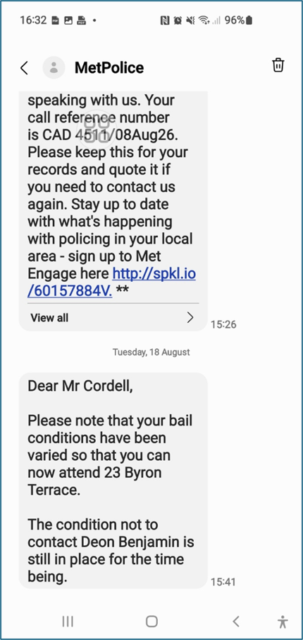

I Returned to My Property on the 17th & 18th of August 2026 to find out that:
- My Home is badly damaged
- Sentimental items are missing
- Furniture is gone
- My Cooker Mum Gave me is gone
- Most of my Expensive belongings are gone without my consent.
- I had No mail from the Enfield Council or Police
- I had to take Photographs and videos of the damage as well as document everything down!
- Changed the Locks

Exhibit A3 — Section 41 Notice (OCR Corrected)
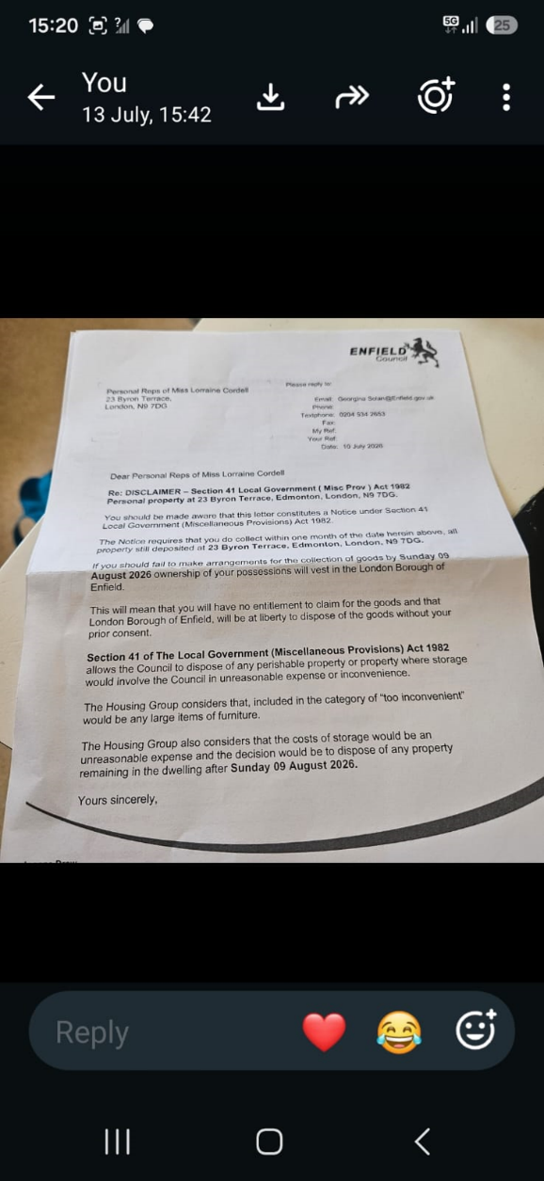

(MY OCR TEXT UNCHANGED)
Personal Reps of Miss Lorraine Cordell 23 Byron Terrace
PLEASE REPLY TO
Email: Georgina Solan
Telephone: 0204 504 2653
Fax:
My Ref:
Your Ref:
Date: 10 July 2026
London
N9 7DG

Dear Personal Reps of Miss Lorraine Cordell

Re: DISCLAIMER — Section 41 Local Government (Misc. Prov) Act 1982 Personal property at 23 Byron Terrace. Edmonton. London. N9 7DG
You should be made aware that this letter constitutes a Notice under Section 41 Local Government (Miscellaneous Provisions) Act 1982.
The Notion requires that you do collect within one month of the date hemin above. All property is still deposited at 23 Byron Terrace. Edmonton. London. N9 TOG.
If you should fail to make arrangements for the collection of your goods by Sunday 09 August 2026 ownership of your
of your possessions will vest in the London Borough of Enfield.
This will mean that you will have no entitlement to claim for the goods and that London Borough of Enfield will be at liberty to dispose of the goods without your prior consent.
Section 41 of The Local Government (Miscellaneous Provisions) Act 1982 allows the Council to dispose of any perishable property or property where storage would involve the Council in unreasonable expense or inconvenience.
The Housing Group considers that. Included In the category of loo inconvenient' would be any large items of furniture.
The Housing Group also considers that the costs of storage would be an unreasonable expense, and the decision would be to dispose of any property remaining in the dwelling after Sunday 09 August 2026.
Yours sincerely.

“Reading that notice broke my heart due to what she has done!”
It explained why the home had been emptied. It said all property at 23 Byron Terrace had to be collected within one month, and if not, the council would take ownership and dispose of it. It said large items were “Too Inconvenient” and storage was “Too Expensive,” and it will become council property. It was the first time I realised Sheila had received this notice, acted on it, and never told me — while I was legally blocked from entering the home and had no chance to protect anything.
After understanding what happened, I wrote an official complaint explaining everything I had discovered.

Exhibit A4 — Formal Complaint (Gross Misconduct)
(Already indexed — unchanged)

Yours faithfully, Mr. Simon Paul Cordell

Address: 23 Byron Terrace Edmonton N9 7DG
Dated: 14/09/1026
Contact Email: Re_wired@ymail.com
Signed: 

