URGENT
CHRONOLOGY OF GROSS MISCONDUCT
TIMELINE
STAGE-ONE LEVEL RAISED COMPLAINT

PHASE 1: THE SETUP (Enfield Councils Housing Staff Concealment of Rights)
Date |  | Events + Misconduct & Legal Errors | File Name
7 April 2026 | Event:  - My mother, Miss Lorraine Cordell, passes Away.  - I am her eldest son, living at 23 Byron Terrace  - Let it be known that 23 Byron Terrace is my principal home!  Misconduct & Legal Errors:  Nothing yet, but Council records show I was known as a household member at 23Byron Terrace as Exhibited Below! |  | N/a
11 May 2026, 08:59 | Event:  - I phone Enfield Council to report my mother death and request for the succession process to formal proceed.  Misconduct & Legal Errors:  Customer service creates internal requests, but no reference number or guidelines are provided so an administrative gap was created due to no follow-up! |  | N/a
11 May 2026, 12:54 | Event:  - I created and sent a formal email requesting succession:  - Quoted by Myself: “I am writing to formally request the commencement of the Right to Succession process for the property at: 23 Byron Terrace Hertford Road Edmonton London N9 7DG!”  - “I am therefore requesting:  - Confirmation that the succession process has been opened in my name.  - The official succession application form and details of the evidence required.  - Written confirmation that I am permitted to remain in the property while the succession investigation is ongoing, in accordance with Enfield Council’s Tenancy Policy (including Section 3.11).”  - I Explicitly State:  - “I HAVE LIVED AT 23 BYRON TERRACE as part of the household for many years!”  - “All of my official correspondence (council, police, DWP, banks, NHS) is addressed to this property!”  - “I SUPPORTED MY MOTHER DURING HER ILLNESS. My temporary stays at other family addresses were solely due to her need for intimate personal care from a female relative, which caused her embarrassment and distress if I assisted!”  - “The death certificate has not yet been issued due to delays outside of my control!”  - “I am currently VULNERABLE AND HAVE NO SAFE ALTERNATIVE ACCOMMODATION!”  - “I RESPECTFULLY REQUEST THAT THIS EMAIL IS LOGGED ON YOUR SYSTEM and that I am contacted as soon as possible WITH THE NEXT STEPS!”  Misconduct & Legal Errors:  I had to wait! |  | 01. Sent.pdf  01.1. Sent.pdf  02. Received.pdf
11 May 2026, 15:32 | Event:  - Georgina Solan responds to my succession request: “I WAS CONTACTED BACK!”  - She Quotes: “I am contacting you because I have been notified that Miss Lorraine Cordell of 23 Byron Terrace, Edmonton, London, N9 7DG had passed away on 07 April 2026. I would like to take this opportunity to offer my sincere condolences to you and your family for your loss on behalf of Enfield Council.”  - “She would like to speak to me regarding the tenancy and what is going to happen next.!  - “She attached a succession application form for me to complete and sent the application to me in the post. “  - “Once completed, please contact her to arrange a home visit so she can collect the form. Alternatively, i can email it to me at Georgina.Solan@enfield.gov.uk with copies of all of the supporting documents.”  Misconduct & Legal Errors:  - She acknowledges me as the eldest child and recognises the impact of me losing my mother yet fails to give proper weight to my sworn statements, my continuous presence, and the factual evidence of my role. This includes government verified records confirming that I have been registered as an overnight carer at the address of 23 Byron Terrace since the year of 2013, as I “Supported My Mother Throughout Her Illness”  - She fails to talk to me regarding my housing legal rights for succession as she said she would, in a fair and informative manner so that I know as she quoted “What Is Going to Happen Next!” This is a Deliberate concealment of my legal statutory rights.  - She sends me a housing succession application under the housing act 1985 as a pdf form after she confirmed that I qualify to apply.  - She closes the door to a meeting with her if I email her the form back the same way she sent it to me!  - Despite my explicit statement that I lived at 23 Byron Terrace for years with all official correspondence addressed there, She Fails to inform me that I am a protected occupant with immediate right to remain under Housing Act 1985. By withholding this critical information, she ensured that I did not assert my legal rights, therefore making me a vulnerable person to her wrongful housing exclusion.  - She starts to lay down the groundwork for the false narrative she gives police six days later, so, she treats my home 23 Byron Terrace as vacant and me as a trespasser,  - This is a Breach of duty to advise vulnerable resident of statutory rights  - Breach of the Housing Act 1985, s.87, deliberate or reckless!  - Breach of Enfield Council Tenancy Policy Section 3.11  - And demonstrates Constructive fraud that created conditions for harm by official persons concealments! |  | 03. Received.pdf
17 May 2026 | Event:  - CRITICAL: “Email from Met Police Due To Georgina Solan Enfield Council Officers Legal Advice to The Metropolitan Police!”  Misconduct & Legal Errors:  Deliberate Misrepresentation of Housing Law as a Housing Officer!  Georgina Solan sends an email to Metropolitan Police with this false legal statement:  She writes: "Until a succession application is submitted, assessed, and approved, Mr. Cordell has no confirmed legal right of occupation under the tenancy."  This is legally false. Under Housing Act 1985 s.87, I had immediate right to occupy as family member living at property as my principal home.  This false statement directly caused my exclusion via police bail conditions.  - Deliberate misrepresentation of housing law to police  - Breach of statutory duty  This statement of hers caused my unlawful exclusion from my Primary Home! |  | 0. 1Met & Council Police Cad.pdf
18 May 2026 | Event:  - I submitted my completed succession application Form back to Georgina alongside with my supporting statement and Exhibited Evidence of occupation.  Misconduct & Legal Errors:  I provide evidence of 39 years residence, care for mothers, disability needs, the Edmonton Lower County Court Juge ordering a 2-bedroom property to be supplied to me in exchange of 109 Burncroft Avenue EN3 7JQ. |  | - 04. Sent 18-05-26.pdf  - 04.1. New Succession application 18-05-26.pdf  - 04.2. Housing Succession Request 18-05-26.pdf
18 May 2026 | Event:  Georgina Solan responds to my submitted Housing succession application and Correspondence:  - “Thanks for your application and supporting letter.”  - “We can only consider your application once we have the supporting documents!”  Misconduct & Legal Errors:  In her email dated 18 May 2026, Housing Officer Georgina Solan stated:  “We can only consider your application once we have the supporting documents.”  This statement created confusion about the legal start date of the succession application and implied that the application had not yet begun, despite earlier notifications. Given her professional role, experience in the housing department, and oversight responsibilities, this advice is misleading, incorrect in law, and inappropriate when dealing with a vulnerable applicant applying under bereavement circumstances.  Her wording suggests a false procedural requirement that could disadvantage or delay a vulnerable person’s statutory rights.  Misleading Conduct & Professional Concerns  - As a trained housing officer, she should know the correct legal process under the Housing Act 1985.  - She failed to provide accurate guidance, despite being in a position of authority and responsibility.  - She knowingly gave an interpretation that suggests the application “does not start” until evidence is provided which is legally incorrect.  - This creates a power imbalance, where a vulnerable applicant (recent bereavement, long-term carer, emotionally distressed) is misled about their rights.  - Her statement could cause unnecessary delay, procedural disadvantage, or misunderstanding of statutory entitlement.  This behaviour is inconsistent with expected professional standards for housing officers, especially when dealing with succession cases involving bereavement and vulnerability.  My Questions (Raised for Legal Clarity)  - When does a succession application legally start?  - When I first notify the council by phone or email?  - When the council sends me the form?  - Or only when I return the completed form?  - If I return the form without supporting evidence, does the application legally “not start” until evidence is supplied?  These questions were necessary because the officer’s statement contradicted the law and created uncertainty.  Legal Answers (Based on Housing Act 1985 & Standard Local Authority Procedure)  - A succession application legally starts the moment the landlord is notified of the intention to succeed the tenancy. Notification can be by phone, email, letter, or any formal communication. My application legally started on 11 May 2026, when succession was first acknowledged.  - Returning the form validates the application for processing, but does not change the legal start date. Georgina confirmed receipt of my completed form on 18 May 2026.  - Supporting evidence is part of the assessment stage, not the start date. Evidence affects whether the council can make a decision, but it does not delay, reset, or prevent the application from being officially “made.”  Her statement incorrectly merges assessment with start date, which is a legal error.  Conclusion for Timeline  - Legal Start Date: 11 May 2026  - Form Submitted: 18 May 2026  - Evidence Requested: After form submission  - Officer’s Statement: Incorrectly implied the application had not started  - Impact: Misleading advice, procedural confusion, and potential disadvantage to a vulnerable applicant  - Professional Concern: Officer failed to provide accurate legal guidance despite her role, training, and oversight responsibilities. |  | 05. Received.pdf
19 May 2026 | Event:  - I provide extensive ID and evidence  - “Which contains 11 folders in total. These folders include my identification documents and supporting evidence, all organised and ready for you to review”  - “I also want to confirm that I have a large amount of ID and documentation showing my long-term residence at 23 Byron Terrace. If you need any additional proof, I will be happy to provide it immediately upon request.”  Misconduct & Legal Errors:  On 19 May 2026, I provided extensive identification and supporting evidence to Enfield Council Housing Officer Georgina Solan. This included:  - “Which contains 11 folders in total. These folders include my identification documents and supporting evidence, all organised and ready for you to review.”  - “I also want to confirm that I have a large amount of ID and documentation showing my long-term residence at 23 Byron Terrace. If you need any additional proof, I will be happy to provide it immediately upon request.”  These documents were provided solely for the purpose of a Housing Succession Claim under the Housing Act 1985.  Misconduct & Legal Errors, Professional Misleading of a Vulnerable Applicant  1. Misuse and Mishandling of Evidence  Despite providing 11 folders of primary residence evidence, staff later reported:  - No files were attached to the tenancy account for 23 Byron Terrace.  - My ID was sent to “management”, but no officer would identify who received it.  - There is no audit trail, no record, and no explanation for the disappearance of my evidence.  This is a serious procedural failure and a breach of basic housing administration standards.  2. Admission of Misconduct by the Officer  Housing Officer Georgina Solan later admitted:  - She gave my application to management instead of submitting it as a succession claim.  - My succession claim was never logged, never submitted, and never processed.  - This occurred despite her requesting my evidence specifically for succession.  This is not a mistake — it is professional misconduct.  3. Exploiting a Vulnerable Applicant  At the time of this event:  - I was bereaved,  - emotionally vulnerable,  - and had been my mother’s overnight carer since 2013.  Georgina, as a trained housing officer with departmental experience and oversight responsibilities, knew:  - I was applying under distress,  - I relied on her professional guidance,  - and I trusted her to handle my evidence correctly.  Instead, She:  - Misled Me: about the process,  - Took Advantage: of my vulnerability,  - Withheld The Truth: about the status of my application,  - And Failed to Submit: the very claim she instructed me to prepare.  This behaviour is inconsistent with professional housing standards, contrary to duty of care, and harmful to a vulnerable applicant.  4. Legal Impact  Under the Housing Act 1985:  - A succession application starts the moment the applicant notifies the landlord.  - Evidence is part of assessment, not the start date.  - By failing to submit my claim, she obstructed the statutory process.  - By misdirecting my evidence, she compromised the integrity of the application.  - By misleading me, she created procedural disadvantage and delayed my legal rights.  This constitutes procedural failure, misleading advice, and professional misconduct. |  | 06. Sent 19-05-26.pdf
19 May 2026 | Event:  - “Thank you for the additional documents.”  - “We also require you to supply bank statements for all of your bank accounts covering the 12 months before Miss Lorraine Cordell passing away. In this case, the period would therefore be from 07 April 2025 up until 07 April 2026”  Misconduct & Legal Errors:  1. Who received my documents?  Despite Georgina thanking me for the documents, staff later confirmed:  - No documents were attached to the tenancy account for 23 Byron Terrace.  - My evidence was sent to “management”, but no officer will identify who received it.  - There is no record of where my documents went, how they were handled, or whether they were ever used for succession.  This raises serious legal concerns:  - Why were my documents taken if my succession claim was never submitted?  - Who handled my personal information?  - Where is the evidence now?  - Has it been destroyed?  - If so, how and by whom?  - Why is there no audit trail?  This is a major breach of proper housing procedure and data protection standards.  2. Why were my personal details requested if I “did not qualify”?  Georgina later admitted:  - My succession claim was never submitted  - My evidence was never logged  - My case was never registered as a succession application  This creates a direct contradiction:  - If I “did not qualify,”  - Why did she request my identification?  - Why did she request my supporting documents?  - Why did she request my banking history?  This behaviour is not lawful, not transparent, and not consistent with the Housing Act 1985 succession process.  3. Manipulation of the legal process to obtain my banking information  The request for 12 months of bank statements (07 April 2025 – 07 April 2026) is normally made only after:  - a succession claim is formally logged  - the application is registered  - the evidence is attached  - the case is under assessment  But In This Case:  - My claim was not logged  - My evidence was not attached  - My application was not submitted  - Yet she still requested my full banking history  This means she used the appearance of a legitimate legal process to obtain:  - my financial activity  - my account details  - my private transactions  - my personal financial patterns  This is manipulation of process and misuse of authority.  4. No explanation for the disappearance of my documents  There is still no answer to:  - Who received my documents  - Where they were stored  - Whether they were destroyed  - How destruction would be proven  - Why no record exists  - Why no officer will confirm the chain of custody  This is a complete failure of professional responsibility and a serious data-handling breach. |  | 07. Received.pdf
 | Event:  - “I have now prepared the bank statements for all of my accounts covering the period 07 April 2025 to 07 April 2026, as requested”  Misconduct & Legal Errors:  N/a |  | 08. Sent 19-05-26.pdf
20 May 2026 | Event:  - Georgina Solan Emails Me  - “I can confirm that in line with our procedures for when tenants pass away, a Notice to Quit was served on the property yesterday to start the process of ending the tenancy.”  - “After the notice expires, a ‘Left in Occupation’ account will be set up so that payments can be made towards the property.”  - “This account will be OPEN WHILST YOUR APPLICATION IS BEING CONSIDERED.”  - “Thank you for providing the bank statements.”  - “Please could you confirm whether you have an interim death certificate whilst you are waiting for the official death certificate? If not, are you able to confirm when you are likely to receive the official death certificate?”  - “Are you also able to confirm the reasons why a 2-bedroom property is required?”  Misconduct & Legal Errors:  Premature hostile action.  She States: "A Notice to Quit was served on the property yesterday" and "'Left in Occupation' account will be set up"  This was NOT standard procedure. She accelerated termination of the secure tenancy before succession decision, while police exclusion was being enforced based on her false 17 May email. The "Left in Occupation" account transformed me from protected family members with succession rights into commercial license with no security, deliberately degrading my legal status to facilitate my eventual exclusion and defeat my succession claim.  She told me this was "standard procedure to take deceased person's name off” this was misleading. The proper procedure is to maintain the tenancy pending succession assessment, not terminating it.  - Premature hostile action against bereaved resident applicants  - Serving Notice to Quit while succession pending is improper and prejudicial  - Deliberate degradation of legal status  - Misrepresentation of procedure  - Breach of Housing Ombudsman guidance  Breach of duty to preserve status quo pending decision |  | 09. Received 20-05-26.pdf
20 May 2026 | Event:  - Enfield Council ask me to supply them with my mother death certificate.  Misconduct & Legal Errors:  Emails 10 – 17 are all proof of myself sending my mother death certificate as requested. I provided an interim death certificate while I acquired the real certificate and in “Email 12.” I explain the need for a second bedroom being due to disability/care needs that a Judge Ordered!  I Explained The 2018 Edmonton Lower Court Order Due To Enfield Council Requesting It from The Start Against Me and the new police, bail restrictions due to Deon my sisters case and, my vulnerability at 109 Burncroft Avenue.  She ignores safeguarding duty |  | - 10. Sent 20-05-26.pdf  - 11. Received 20-05-26.pdf  - 12. Sent 20-05-26.pdf  - 13. Sent 20-05-26.pdf  - 14. Sent 20-05-26 New Email Used.pdf  - 15. Received 12-06-26.pdf  - 16. Sent 16-06-26.pdf  - 17. Sent 16-06-26.pdf

PHASE 2: THE EXCLUSION (Active Harm — Police Bail Based on Her False Advice)
Date | Events + Misconduct & Legal Errors | Files
23 June 2026 | Event:  - “I sent an urgent email begging for confirmation of my rights due to Police enforce bail conditions excluding me from my primary home 23 Byron Terrace”  - “I respectfully request that Housing confirm in writing, as a matter of urgency:  - That I am lawfully entitled to remain in occupation at 23 Byron Terrace while my succession application is under consideration, in accordance with the Housing Act 1985.  - That the earlier email to the police should not be interpreted as meaning I have “no right to be inside the property”, and that such an interpretation is incorrect.  - That this matter is governed solely by Housing legislation and not by police powers, and that the police cannot determine or restrict my occupation rights.  - That my sister’s dispute and her claim of residency do not alter my legal standing, do not constitute evidence of occupation, and do not affect my right to remain in the property.”  - “That Housing will provide clear written clarification to the police if requested, to prevent further misunderstanding or unlawful exclusion.”  This email was sent because the police were enforcing bail conditions Based Entirely on Georgina’s Earlier Misleading Email, which incorrectly implied I had “No Right” to be inside my own home.  Misconduct & Legal Errors:  - Joint Council–Police Misconduct  Detective Sergeant Johnson relied Solely on Georgina’s 17 May Email to justify excluding me from my home. This email was Legally Incorrect, Professionally Negligent, And Outside the Scope of Police Authority. The police acted on False Information Provided by The Council, creating a joint failure.  - I was made homeless  As a direct result of Georgina’s misleading communication:  - I Was Excluded from My Primary Residence  - I Could Not Access My Belongings  - I Could Not Manage My Mother’s Estate  - I Could Not Secure the Property  - I Was Left Homeless, Despite Being the Lawful Successor Under the Housing Act 1985  This is a serious safeguarding failure.  - Council and Police Joint Misconduct  Both parties acted outside their lawful powers:  - The Police Interfered in A Civil Housing Matter  - The Council Provided Misleading Information That Triggered Unlawful Police Action  - Neither Party Corrected the Error Despite Being Notified  This constitutes joint misconduct and procedural abuse.  - PACE 1984 Breach — Police Interfering in Civil Housing  Under PACE 1984, police cannot:  - Determine Occupation Rights  - Interpret Housing Legislation  - Enforce Civil Tenancy Matters  - Exclude Lawful Occupants Based on Council Misunderstanding  Their actions breached statutory limits and relied on incorrect council guidance.  - I formally corrected the legal position to the Housing Officer  I expressed my concerns directly to Georgina, who was:  - The Housing Officer  - The Case Handler for My Succession Claim  - Responsible For Providing Accurate Legal Guidance  I Reinstated Correct Housing Policy by Stating:  - This Is a Civil Housing Matter  - The Police Have No Authority to Determine Succession or Occupation Rights  - Their Position Was Based On: 1) A Misunderstanding of Housing’s Earlier Email 2) My Sister’s Inaccurate Statements  Despite this, Georgina failed to correct the police, failed to protect my rights, and failed to provide urgent clarification, resulting in my unlawful exclusion. | 18. Sent 23-06-26.pdf
25 June 2026 | Event:  - “SUBJECT: Formal Escalation - Due to No Response to Urgent Request for Confirmation of Occupation Rights (23 Byron Terrace)”  “Dear Ronnie, Georgina, and Housing Team,”  I am formally escalating this matter “due to receiving no response for over 48 hours to my urgent request dated 23/06/26, concerning my lawful right to remain in occupation at 23 Byron Terrace while my succession application is being processed.”  Given the involvement of the police, the risk of unlawful exclusion, and the ongoing misinterpretation of Housing's previous email, this lack of response is unacceptable and places me at continued risk of harm.  Summary of the unresolved issue  The police have incorrectly interpreted a Housing email (“my name is not on the tenancy”) as meaning I have no right to be inside the property. This is legally incorrect under the Housing Act 1985, Sections 87-89, which clearly protects my right to remain in occupation pending a succession decision.  I have already provided Housing with:  - Evidence of my long-term residence and dependency  - Evidence of my immediate succession application  - Evidence that my sister was not resident at the time of my mother's death  - Evidence that the police are seeking clarification from Housing  What I urgently require  I am requesting written confirmation of the following:  - That I am lawfully entitled to remain in occupation at 23 Byron Terrace while my succession application is under consideration.  - That the earlier Housing email to the police must not be interpreted as meaning I have “no right to be inside the property”.  - That this matter is governed solely by Housing legislation, not police powers.  - That my sister’s dispute does not alter my legal standing or occupation rights.  - That Housing will provide clear written clarification to the police if requested.  Misconduct & Legal Errors:  - Failure to Respond to an Urgent Legal-Safeguarding Request (48+ Hours): Housing ignored an urgent escalation relating to police involvement and risk of unlawful exclusion. This delay is provable from the timestamped emails and shows a failure to act when immediate clarification was required.  - Neglect of Duty During a Known Safeguarding Risk: Housing were aware the police were acting on a misinterpreted Housing email. Their failure to correct this or respond promptly left me at continued risk of unlawful exclusion. This is a new, distinct misconduct point arising from this event.  - Obstruction of Access to Legal Remedies: By not responding, Housing prevented me from obtaining the written confirmation needed to challenge police misinterpretation and regain safe access to my home. This delay directly obstructed my ability to seek legal remedy.  - Failure to Correct Their Own Misleading Communication to Police: Housing did not issue clarification despite knowing the police were relying on their earlier email (“my name is not on the tenancy”). This failure is provable and directly linked to this event. | 19. Sent 25-06-26.pdf
26 June 2026 | Event:  - Georgina Solan denies succession  - Email states: "Your succession application has been reviewed by management and has been denied as you do not fulfil the criteria for succession due to having your own tenancy at 109 Burncroft Avenue"  - "This means that you have no legal right of occupation at 23 Byron Terrace"  - “I cannot comment on any actions taken by the police.”  - “I cannot comment on any disputes between yourself and any of your family members.”  - “The above information would be shared with the police upon request.”  Misconduct & Legal Errors:  - She issued a refusal based on a reason that is not a lawful ground for refusal, and she presented it as a final management decision. This is a provable misuse of authority because she relied on a criterion that does not exist in succession law.  - She made a false legal statement about occupation rights and communicated it as fact. This is provable harm, because her wording directly caused police action and my exclusion.  - She refused to clarify the consequences of her own email; despite knowing the police were acting on it. This is a failure of duty, because she created the misunderstanding and then refused to correct it.  - She dismissed relevant information about residency and household composition, despite it being directly required for assessing succession. This is a procedural failure, because she ignored evidence, she was legally required to consider.  - She confirmed she would share the same incorrect legal statements with police; despite knowing they were already misinterpreting her wording. This is provable misconduct, because she knowingly risked further harm by repeating false information.  - She applied a non-existent rule, misrepresented it as policy, and used it to deny my housing succession claim. This is a clear procedural breach.  - Her refusal contradicts statutory law. This is provable legal error, because the Act does not contain the rule she relied on.  - Her decision contradicts established Ombudsman findings confirming that holding another tenancy does not automatically bar succession. This is a professional competence failure, because she ignored known precedent.  - When holding another tenancy, law does not state this bars succession.  Contradicts Housing Act 1985, S.87-88  Contradicts Housing Ombudsman precedent (L&Q 202127252) | 20. Received 26-06-26.pdf
27 June 2026 | Event:  - I formally request a Statutory Review of Enfield Council’s refusal of my succession application for 23 Byron Terrace, arguing the decision is unlawful under the Housing Act 1985 and Enfield’s own tenancy policies.  Misconduct & Legal Errors:  1. Refusal reason is unlawful  2. 109 Burncroft was not my principal home  3. I cannot return to 109 Burncroft Avenue in Safety  4. I have legal rights to remain at 23 Byron Terrace  I state the refusal email is not a lawful decision because it lacks:  - Legal basis  - Evidence  - Review rights  - Signatures/authorisation  - Equality Act assessment  - Safeguarding assessment  I request written confirmation that I may remain in the property again during the review.  5. I Highlight That I Am The Only Qualifying Successor  Under Section 89(7), you are the sole qualifying successor because:  - I alone lived with the tenant  - I alone meet the 12-month rule  - I alone have evidence of residency  - My sister does not qualify  6. Equality Act & Care Act duties ignored  The refusal failed to consider:  - My disability  - Support needs  - Dependency on my mother  - Reasonable adjustments  - Safeguarding  - Risk of harm if displaced  7. I Request Full Disclosure  I ask for all decision-making records, including:  - Names/titles of reviewing and approving officers  - Signed decision  - Internal notes  - Evidence used  - Policies relied upon  - Safeguarding and Equality Act assessments  - Details of any other applicants  8. Conclusion  I state the refusal is:  - Not supported by law, policy, or case law  - Contradicted by the 2018 court order  - Procedurally unlawful  I request confirmation that the statutory review has begun and that the refusal be overturned. | 21. Sent 26-06-26.pdf
29 June 2026 | Event:  - Georgina Solan  - “I acknowledge receipt of your request for a review of the decision regarding your succession application for 23 Byron Terrace.”  - “You will be provided with a formal response.”  - “Nor can I provide any further information regarding the decision-making process while the matter is under review.”  - “With Regard to Your Request for Internal Records, Officer Details, Notes and Other Documentation, Requests for Personal Information and Council Records should be Submitted Through the Appropriate Information Rights Process.”  - “For the avoidance of doubt, the Council's position remains as set out in the decision previously communicated to you. However, the issues raised in your latest correspondence will be considered by management and responded to formally.”  Misconduct & Legal Errors:  - By acknowledging my request for a review of the succession decision, she misled me that my succession claim was active after I filed it into herself and she failed to place it on the Council systems as logged, accordingly, to company policies!  Exhibit: 34. Recording - Enfield Council Georgina 20-08-26 at1226.pdf  - Her promise of a formal response proves she knew no lawful succession decision had ever been made, even though she had already refused my claim, told police I had no right to remain, and later admitted she never submitted my application to the statutory panel. This shows she knew the earlier refusals were invalid and continued misleading me into believing a lawful succession process was taking place.  - Her refusal to explain the decision-making process shows she was hiding the fact that no lawful process had occurred: No Panel Submission, No Evidence Reviews, No Authorised Officer, And No Section 202 Rights. She used ‘Review’ as a shield to conceal procedural failures and prevent me from discovering that my succession claim had never been lawfully processed.  - By redirecting me to the information rights process, she misled me into believing lawful records existed for my succession case, while concealing that she had never logged my application, never created a case file, never submitted it to the statutory panel, and never produced any authorised decision. This withholding prevented me from discovering her procedural failures and blocked my ability to challenge the unlawful refusal.  - She claimed the decision was final while simultaneously admitting it was still under review by unnamed management and not the statutory panel. This contradiction proves predetermination, lack of lawful procedure, and that the refusal was not based on full evidence or the required legal process. | 21.1. Extra Found.pdf
30 July 2026 | Event:  - I wrote to urgently update Georgina & Co with information that must be added to my housing file regarding the recent court case, the restrictions now placed on me, and the ongoing safety issues at 109 Burncroft Avenue  Misconduct & Legal Errors:  - 1. Court outcome & legal restrictions “Another Case” to do with my neighbour.  - I was wrongly found guilty and am appealing the conviction.  - A 5-year restraining order was issued.  - The Court Ordered that I must not contact Rebecca O’Hare, directly or indirectly but or paths must pass each other!  - The Court Ordered I must not enter the second floor at Burncroft Avenue.  - 2. Safety concerns at 109 Burncroft Avenue for Myself are:  - Ongoing hate-motivated behaviour from neighbours (banging, intimidation) at me.  - I cannot safely enter the building alone.  - I avoid shops due to fear of encountering Rebecca.  - I had to drive away when seeing her outside.  - 3. Evidence of harassment  - Banging on walls and floors, including at 5 AM while I was with a friend and her child.  - Intimidation designed to make me fear staying in the property.  - 4. Loss of support  - My mother previously helped me manage risks; now I have no support.  - I must phone around to find someone to accompany me to gain access to 109 Burncroft Avenue and to leave safely.  - 5. Council failures  - Council avoided acting on my complaints of Neighbours illegal behaviour towards me and ignored evidence myself and others supplied them with!  - Council failed to follow law and policy.  - Council failed to follow the court-ordered and provide me with a like-for-like two-bedroom property, other than registering me at my mother as care of address 2013 & 14!  - 6. Impact of restrictions  - I cannot record myself entering the building while carrying items.  - I cannot safely collect food deliveries.  - I cannot safely access my rented corridor.  - 7. Fear of reprisals  - I am genuinely scared of retaliation.  - I know Rebecca’s claims are fabricated and used wrongly against me.  - 8. Request to update my housing file  - I asked for all this information to be added to my housing file and escalated urgently. | 22. Sent 30-06-26.pdf
02nd July 2026 | Event:  - Georgina Solan, the Resident Relationship Officer for Housing & Regeneration of the Enfield Council, states that: “she appreciates that I feel anxious about my current circumstances.”  - The Council has considered the information available regarding my occupation of 23 Byron Terrace. As previously advised, you do not have succession rights to this tenancy and  - Therefore, I do not have a legal right to succeed in the tenancy at 23 Byron Terrace.  - The Council's records confirm that I remain the tenant at 109 Burncroft Avenue.  - Whilst I have outlined concerns regarding that property and my personal circumstances, the Council is not aware of any legal restriction that prevents me from returning to and occupying my own tenancy address.  - The matters I have raised regarding neighbour disputes, court proceedings and personal Safety concerns do not alter the Council's decision regarding succession at 23 Byron Terrace  Misconduct & Legal Errors:  - By acknowledging my anxiety, she confirmed she was aware of my vulnerability, yet she still proceeded with an unlawful refusal and continued excluding me from my mother’s home without following the statutory succession process.  - She repeated the refusal of succession against my Legal Succession rights even though she had never filed my application, because She Never Submitted It to The Statutory Panel, and never carried out the required evidence review. This proves she issued a refusal without any lawful process or legally authorised decision.  - She asserted I had no legal right to succeed despite knowing She Did Not Follow the Correct Housing Act 1985 Succession Procedure, Georgina Soloman had not reviewed the evidence and had not submitted my claim to the panel. Her statutory assessment was flawed with procedure failures created by herself as well as false legal statement made by her!  - She relied on Burncroft Avenue to deny succession even though the Housing Act 1985 explicitly states that holding another tenancy does not automatically prevent succession. This shows she applied the wrong legal test and misused irrelevant tenancy data to justify an unlawful refusal.  - She ignored my documented safety concerns, police involvement, neighbour disputes, and court restrictions, And Falsely Claimed There Were No Barriers to Returning to Burncroft. This shows she failed to consider relevant evidence and dismissed safeguarding risks in breach of duty.  - She admitted she disregarded critical evidence affecting my residence and principal home status, including police restrictions and safety risks. By refusing to consider these factors, she failed to assess my actual residence at the material time, making the succession decision unlawful under the Housing Act 1985. | 23. Received 02-07-26.pdf

PHASE 3: THE DECEPTION (Same-Day Fraud — 10 July 2026)
Date | Events + Misconduct & Legal Errors | Files
 | Event:  - Formal review requested: I explicitly requested a formal reconsideration of the succession decision for 23 Byron Terrace.  - Council failed to consider law/evidence earlier:  - Legal authorities supplied:  - Council’s stated reason is legally wrong  - The Correct legal test clearly set out:  - Specific requests made to the Council:  - Proof of proper, structured challenge:  Misconduct & Legal Errors:  - Council failed to consider law/evidence earlier: I state the Council did not consider the legal position or the evidence when I previously asked for a review.  - Legal authorities supplied: I provided specific legal authorities and attached them:  - Housing Ombudsman L&Q decision – confirms a second tenancy does not prevent succession; landlord must assess actual occupation and principal home.  - Housing Act 1985 ss.87–88 – the only test is whether I occupied 23 Byron Terrace as my principal home.  - Crawley BC v Sawyer (1988) – principal home is a factual test.  - Islington LBC v Boyle [2011] – registration elsewhere does not determine principal home.  - Camden LBC v Goldenberg (1996) – another tenancy does **not automatically bar succession.  - Council’s stated reason is legally wrong: I directly challenge Georgina’s position that my tenancy at 109 Burncroft automatically disqualifies me from succession, stating this is not supported by:  - The Housing Act 1985  - The L&Q Ombudsman decision  - The case law cited  - The Correct legal test clearly set out: what I state!  - The issue is principal home, not the mere existence of another tenancy.  - The Council must assess actual occupation, not rely on assumptions.  - Specific requests made to the Council:  - A lawful reconsideration applying the correct statutory test under ss.87–88 Housing Act 1985.  - Confirmation that the Council will now assess principal home properly, instead of assuming another tenancy bars succession.  - Proof of proper, structured challenge: The email shows I:  - Used case law and Ombudsman precedent.  - Identified the exact legal error in the Council’s reasoning.  - Requested a lawful reassessment, not just a general complaint.  - Asked for receipt confirmation and acknowledgment of the attached authorities.  I appeal with case law, with Ombudsman decisions, while offering to surrender Burncroft tenancy  I Provide:  - London & Quadrant,  - Islington v Boyle,  - Crawley BC v Sawyer,  - Shelter guidance.  Explain Burncroft is unsafe, inaccessible due to bail/restraining order, medically unsuitable per 2018 court order  - She ignores all legal arguments.  - Closed mind — predetermined decision  - Fails to explain management has refused to allow my application to go before a Housing panel!  - Misleads me that it has gone before a Housing panel! | 24. Sent 06-07-26 Mum Housing Rules1.pdf  24.1. 1Mum Housing Rules1.pdf  25. Sent 06-07-26 1Mum Housing Rules1.pdf
8 July 2026 | Event:  - "Final position" email  - “Thank you for your recent emails and for providing further information regarding your current circumstances,”  - “Together with the legal authorities You Consider Relevant to Your Request for Succession to the tenancy of 23 Byron Terrace.”  - I Have Noted the Concerns You Have Raised Regarding:  - The Recent Court Proceedings,  - The Restrictions Now in Place,  - Your Current Living Arrangements,  - Your Personal Safety,  - And Your Views in Relation to Both 109 Burncroft Avenue and The Succession Decision For 23 Byron Terrace.  - I Have Also Acknowledged the Legal Arguments and Case Law Referred to in Your Correspondence.  - “The Council has carefully reviewed the information and representations you have provided. However, the Council's position remains unchanged.”  - “Whilst we acknowledge that the existence of another tenancy does not, in itself, automatically prevent a person from succeeding to a secure tenancy,”  - “The Council must consider all available evidence when determining whether an applicant occupied the property as their ONLY or principal home at the relevant time, In Accordance with the Requirements of The Housing Act 1985.  - “In reaching its decision, the Council has not relied solely upon the fact that you remain the tenant of 109 Burncroft Avenue.”  - “Rather, the Council has considered the wider evidence available regarding your occupancy and residence arrangements.”  - “The continued holding of another tenancy is one factor amongst a number of considerations relevant to determining where your principal home was at the material time.”  - “Whilst I acknowledge that you disagree with the Council's decision and have referred to legal, medical and personal circumstances in support of your position, the Council is not satisfied that the evidence provided demonstrates that 23 Byron Terrace was your only or principal home for the purposes of a statutory succession claim.”  - “Accordingly, the Council remains satisfied that you do not qualify to succeed to the tenancy.”  - “I also acknowledge the concerns you have raised regarding alleged:  - Harassment,  - Neighbour Disputes  - And The Impact These Matters Have Had on You.  However, these issues are separate from the succession assessment and do not alter the Council's determination regarding your request to succeed to the tenancy at 23 Byron Terrace.”  - “The authorities referred to in your correspondence have been noted.”  - “However, each succession case must be determined on its own facts and evidence. Having reviewed all information available, the Council remains satisfied that its decision has been reached in accordance with the relevant statutory provisions and the particular circumstances of this case.”  - “If you have concerns regarding anti-social behaviour, harassment or other tenancy management issues at 109 Burncroft Avenue, these should be reported through the appropriate channels so they can be assessed by the relevant service. “  - “You may also wish to seek independent legal advice regarding your housing circumstances and any rights you believe you may have.”  - “This correspondence constitutes the Council's final position in relation to your request for succession.”  - “Unless significant new evidence is provided that has not previously been considered and materially affects the facts upon which the decision has been made, the Council's position will remain unchanged.”  Misconduct & Legal Errors:  EMAIL 26 — WHAT IT PROVES  This is a breakdown of the times the words: “only or principal home” are used inside of “The Housing Act 1985,” to determine their demeanours!  Exhibit A1: “The Housing Act 1985”  06. Housing act ukpga_19850068_en 1.pdf  History of the “The Housing Act 1985,” the act only included the wording: “only or principal home” until the year 2012 when the act was amended by the Localism Act 2012. Before this date dealings with housing succession cases did not include the word “Only!”  The Localism Act 2012 created “Section 86A,” titled as: Persons qualified to succeed (England,) which states: “P occupies the dwelling-house as P’s only or principal home at the time of the tenant’s death…”  Exhibit A2: “Section 86A”  https://www.legislation.gov.uk/ukpga/1985/68/section/86A  In Section 86A, the word “Only” does not mean a person must have only one home. It means the person is using and treating the property as their home — living there, keeping their belongings there, returning there, and behaving as someone who belongs there. The key word is “As”: “P occupies the dwelling-house as P’s only or principal home.” This is about how you live in the home, not how many homes you have. Even if you have another tenancy, you can still occupy one home as your “Only” main home. In my case, I lived at 23 Byron Terrace in the way a person lives in their real home — my belongings, vehicles, tools, possessions, daily life, and intention were all there — so I occupied it as my principal home under Section 86A.  When the law says:  “P occupies the dwelling-house as P’s only or principal home” (Section 86A)  The key word is “AS.”  It does NOT say:  - “P must have only one home.”  - “P must not have another tenancy.”  - “P must not be registered elsewhere.”  - “P must not have documents at another address.”  It says:  “P occupies the dwelling-house AS P’s only or principal home.”  Meaning:  - How you behave  - How you use the home  - How you treat the home  - How you live in the home  - How you intend the home to function in your life  It is about your relationship with the home, not your paperwork.  “PRINCIPAL” covers people who have two homes — which is my situation.  Parliament added “principal” because:  - Many people have two homes  - Many people have two tenancies  - Many people have two addresses  - Many people stay with family  - Many people have temporary accommodation  - Many people have work accommodation  - Many people care for relatives  - Many people move around  So, the law says:  - If you have one home  - that is your only home. If you have two homes  - the main one is your principal home.  This is EXACTLY my situation.  Exhibit: Case Law & Statutory Authorities on “Only or Principal Home”  THE LEGAL REASON THESE OLDER CASES STILL APPLY  Section 86A did NOT create a new concept.  It simply inserted the same phrase:  “Only Or Principal Home”  This phrase existed in:  - Section 81  - Section 87  - Section 88  - Section 89  - Section 90  - Schedules  - Case law  - Ombudsman decisions  - Secure tenancy rules  - Right to Buy rules  - Occupation rules  - Possession rules  So, when Section 86A was added in 2012, it inherited the same meaning that courts had already defined for decades.  That’s why:  - Older cases STILL define “principal home”  - Older cases STILL apply to modern succession  - Older cases STILL bind councils  - Older cases STILL bind the Ombudsman  - Older cases STILL bind the courts  This is normal in UK law.  Mandatory Succession Procedure. All UK Councils  This is the official legal sequence every UK council must follow when someone applies for succession.  1. Get the Succession Form  The council must provide the form immediately. I did this then Georgina emailed it to me.  2. Fill It In + Attach Evidence  I must complete the form and provide:  - Death Certificate  - Proof Of Residency  - Proof Of Relationship  - Supporting Documents  I did this!  3. Return the Form to the Housing Officer  I then handed it back to the same Housing officer from the Enfield Council Georgina.  This is the point where her mandatory legal duties begin.  4. Housing Officer Mandatory Duties  (This is Georgina’s job as required by ALL UK councils)  Once she receives my form, SHE MUST:  - Log The Application on The Council System  - Upload All My Evidence  - Create A Succession Case File  - Acknowledge Receipt  - Pass The Case to Housing Management  - Trigger The Housing Act 1985 Legal Assessment  - Trigger Safeguarding Checks  - Trigger Equality Act Checks  These steps are not optional for her or other staff as they are mandatory legal procedure to be complied with.  What We Can PROVE Georgina Did NOT Do  1. She did NOT log my Housing Succession application  Housing told me:  “There is no record of it on the system… she double-confirmed, as did another member of staff”  This proves the application was never entered, meaning the legal process never started.  2. She did NOT upload my evidence  No documents appear on the Enfield Councils system attached to my mother’s name or the address of 23 Byron Terrace Edmon London N9 7DG. This means my evidence was never legally reviewed.  3. She did NOT create a Housing Succession case file in my Name as Submitted to her!  Other Housing Staff could not find it attached to:  - My mother’s name  - My address  - Any succession record  This proves no case file exists.  4. She did NOT pass my case to management  Management cannot review a case that does not exist.  This is a breach of mandatory procedure.  5. She issued a “decision” without a case file  Her email saying “A Decision Has Been Made” is unlawful because:  - My succession form and evidence were never reviewed  - Even though I met the legal threshold, no legal criteria was applied fairly  - She failed to carry out her mandatory duties when handling sensitive client information  - No Evidence Collected  - No Internal System Checks  - No Safeguarding  - No Equality Act Assessment Was Done  - No Formal Decision Letter Was Issued  - No Review Rights Were Provided  This Decision of hers is procedurally invalid.  6. The Enfield Council Staff since the Edmonton Lower County Court Ordered For them to re House me into A 2 Bedroom Home have blocked my ability to contact them by Phone:  My PDF shows:  “If I ring Normally from my mobile number I can’t get through but if I ring them on a withheld number I can as it rings. So, I’m blocked.”  This Prevented Me From:  - Chasing my application  - Reporting errors  - Submitting evidence  - Making Complaints Speedy, Fairly or Equally to other persons!  Blocking me as a successor applicant is an unfair obstruction of process.  - She Failed to Comply with Mandatory UK Succession Procedure  Every step she was legally required to do as a housing council officer while acting on the landlord’s behalf and for me as a local member of the public. she did not do.  PROCEDURAL UNFAIRNESS  1. They admit receiving my evidence but refused to consider it  Enfield Councils Staff Georgina, literally says:  “I have noted the concerns… I have also acknowledged the legal arguments and case law…”  So, they:  - Admit They Received Everything,  - Admit They Read Everything,  - Admit They Saw the Case Law,  - Admit They Saw the Medical, Legal, And Personal Evidence…  …and still ignored all of it.  That Is Procedural Unfairness, Maladministration, And A Breach of Statutory Duty.  2. They Admit Their First Refusal Reason Was Unlawful  They write:  “The existence of another tenancy does not, in itself, automatically prevent succession.”  This destroys their first refusal reason.  It proves:  - Their First Refusal Was Legally Wrong,  - They Knew It Was Wrong,  - They Changed the Reason Only After I Disproved It.  This is shifting grounds, bad faith, and abuse of process.  3. They Claim They Considered “Wider Evidence” — But This Is False  They say:  “The Council has considered the wider evidence available…”  But:  - They Never Asked Me for More Evidence,  - They Never Identified Missing Evidence,  - They Never Logged My Succession Application,  - Staff Later Confirmed No Succession Case Exists on The System.  So “wider evidence” was never reviewed, fairly.  This is:  - Procedural Defect,  - Dishonesty,  - Predetermination,  - Breach Of Statutory Duty.  4. They Admit They Used Burncroft Against Me  They say:  “The continued holding of another tenancy is one factor…”  They admit they used Burncroft as a negative factor even after admitting it carries no legal weight.  This is misapplication of law.  5. They Refused to Consider My Vulnerability, Displacement, Bail Restrictions, Or Court Orders  They say:  “These issues are separate…”  They Refused to Consider:  - My Displacement Caused by Police Bail (Which They Caused),  - My Safeguarding Needs,  - The 2018 Court Order Requiring Rehousing,  - My Medical Evidence,  - My Dependency on My Mother,  - My Inability to Return to Burncroft Due To Restraining Orders and Danger.  This Breaches:  - Housing Act 1985,  - Equality Act 2010,  - Care Act 2014,  - Public Sector Equality Duty,  - Basic Safeguarding Obligations.  6. They Declare the Decision “Final” Without Issuing Any Lawful Decision  They say:  “This correspondence constitutes the Council’s final position…”  But:  - No Section 202 Rights,  - No Lawful Refusal Letter,  - No Authorised Officer,  - No Panel,  - No Minutes,  - No Logged Succession Case.  This is ultra vires of them acting outside of their legal authority.  7. They As the Enfield Councils Staff Contradict Themselves Inside the Same Email  They say:  “Unless significant new evidence is provided…”  But also:  “The Council has considered the wider evidence available…”  They cannot claim they considered “wider evidence” while also demanding “significant new evidence”.  This contradiction proves:  - They Did Not Consider All Evidence,  - The Decision Was Made Without Full Facts,  - The Decision Is Unlawful.  8. They Tell Me to Seek Legal Advice, Meaning They Know the Decision Is not favoured by me and therefore Unsafe, considering my Case File!  When a council tells a resident to seek legal advice, it means:  - They Know the Decision Is Challengeable,  - They Know It Is Possibly Procedurally Defective,  - They Know They Cannot Always Defend It Internally.  In my case this is an implicit admission of their own faults while acting on the Enfield Councils Behalf.  9. They Wrongly State I Have No Right Of Occupation  They say:  “You do not have a legal right of occupation…”  This Is Legally False.  Under Housing Act 1985:  - I Had and had the Legal Right to Occupy Until a Lawful Succession Decision Is or Was Made.  - They Removed Me Unlawfully.  - They Misled Police, Causing Bail Conditions and Exclusion.  THIS IS JOINT AGENCY MISCONDUCT.  10. They Treat My Issues of Concern Such As: Victimisation, Harassment, Displacement, And Bail Restrictions as Irrelevant as if I have no Right to Life or fair Citizenship!  They say:  “These issues are separate…”  They Refuse to Consider:  - Why I Was Displaced,  - Why I Could Not Physically Occupy the Home,  - That Their Own Misinformation Caused the Bail Restrictions,  - That Their Actions Directly Prevented Me from Meeting the Succession Test.  This Is Irrational Decision-Making and Maladministration. | 26. Received 08-07-26.pdf
  # | Housing Act Section | Exact wording (from my scanned copy) | What this section actually means | Why it cannot be used against me
  1 | Part IV – Secure Tenancies – s.81 | “Occupies the dwelling-house as his only or principal home” | This defines the tenant condition for the original secure tenant. | This applies only to my late mother, not to me. It is not part of succession law. The Council relied on this section incorrectly.
  2 | Part V – Right to Buy (Joint Tenants) | “at least one of them occupies the dwelling-house as his only or principal home” | This governs Right to Buy eligibility for joint tenants. | Right to Buy has no connection to succession. This section is irrelevant.
  3 | Part V – Right to Buy (Family Sharing) | “Members of his family… occupy the dwelling-house as their only or principal home” | Allows family members to share the Right to Buy. | Again, this is Right to Buy, not succession. Cannot be used in a succession decision.
  4 | Sections 553–557 – Definition of “Occupier” | “Occupies the dwelling-house as his only or principal home” | Defines “occupier” for repurchase situations. | This definition has nothing to do with succession. Irrelevant.
  5 | Ground 8 – Temporary Decanting | “Dwelling-house which he previously occupied as his only or principal home” | Applies when a tenant is temporarily rehoused during repairs. | Not succession law. Irrelevant to my case.
  6 | Ground 16 – Reasonableness Factors | “Period during which the tenant has occupied the dwelling-house as his only or principal home” | Used in possession cases to judge reasonableness. | Not succession law. Cannot be used against me.
  7 | Schedule 4 – Right to Buy Discount Qualification | “Occupied as his only or principal home” | Determines discount eligibility. | Right to Buy discount rules do not apply to succession.
  8 | Schedule 4 – Tenant Condition (Right to Buy) | “Occupied the dwelling-house as his only or principal home” | Defines tenant condition for Right to Buy. | Again, this is Right to Buy, not succession. Irrelevant.
  # | Case / Statute | Year | Key Legal Principle
  1 | Crawley BC v Sawyer | 1988 | Principal home is a factual test. Courts look at where you actually lived, not paperwork or registrations.
  2 | Camden LBC v Goldenberg | 1996 | Having another tenancy does NOT block succession. What matters is which home was your real/main home.
  3 | Islington LBC v Boyle | 2011 | Registration elsewhere does NOT determine principal home. Paperwork is not decisive; occupation is.
  4 | Housing Ombudsman – L&Q Decision | (Post-2000s) | Landlord must assess actual occupation, not documents. A second tenancy does not prevent succession.
  5 | Housing Act 1985 – Sections 87–88 | 1985 | Defines succession using the same phrase “only or principal home.” Meaning has never changed.
  6 | Housing Act 1985 – Section 86A | 2012 | Modern succession rule: P must occupy the dwelling as P’s only or principal home at the time of death. This section inherits the same meaning defined by earlier case law.
09 July  2026 | Event:  - 27. Sent -09-07-26.pdf  “Following the recent correspondence and the new reason provided for denying my legal right to succeed the tenancy at 23 Byron Terrace, I am sending the two attached documents which set out my full legal position.  - Part 1 explains the statutory and procedural issues with the previous handling, and  - Part 2 provides a clear summary of each evidential exhibit relevant under the Housing Act 1985.”  ----  - 27.1. Sent Pt1 of 2 -09-07-26.pdf  Event:  Subject: Formal Challenge – Invalid Succession Refusal & Demand for Lawful Decision  - “I wrote to formally challenge the succession refusal communicated to me by Resident Relationship Officer Georgina Solan. “  - “The correspondence issued are not a lawful succession decision under the Housing Act 1985 or the Housing Act 1996, and therefore cannot be treated as final, binding, or enforceable.”  - “Their refusal is procedurally defective, legally invalid, and issued by an officer who does not possess the statutory authority to make such determinations.”  1. The refusal is invalid due to improper service  A lawful succession refusal must:  - Be Issued by the Landlord Authority (Housing Act 1985, S.114)  - Be Signed by an Authorised Housing Decision-Maker  - Set Out the Evidence Relied Upon  - Set Out the Legal Reasoning Applied  - Include Mandatory Section 202 Review Rights  None of these requirements were met.  The refusal issued is therefore invalid, non-compliant, and cannot stand.  2. The decision was issued by someone without legal authority  A Resident Relationship Officer is not authorised to:  - Make Statutory Succession Decisions  - Determine Principal Home Under S.86A  - Issue Final Legal Decisions  - Issue Section 202 Review Rights  - Act As the Landlord Authority  The refusal is therefore ultra vires (outside legal power).  3. The Council changed its reason after the first was disproven  This is procedurally improper, suggests the decision was not made on a lawful basis, and raises concerns of maladministration.  4. The Council did not request further evidence  This is a breach of procedural fairness and contradicts their statutory duty to make decisions based on full and proper evidence.  5. The evidence already provided is overwhelming  This evidence meets the statutory requirements under the Housing Act 1985 and relevant case law.  6. Formal demand for lawful decision  I now formally request:  - A Lawful Written Succession Decision Issued by An Authorised Officer.  - A Full Explanation of the Evidence Relied Upon.  - A Full Explanation of The Legal Reasoning Applied.  - Confirmation Of My Section 202 Review Rights.  - Escalation To the Authorised Housing Decision-Maker.  - Confirmation That the Refusal Issued by Ms. Solan Is Withdrawn Due To Invalidity.  7. Notice of escalation  If the Council fails to provide a lawful decision, I will escalate this matter to:  - The Housing Ombudsman  - The Monitoring Officer  - The Chief Executive  - My Member of Parliament  The Ombudsman requires that I first give the landlord a reasonable opportunity to issue a lawful response. This letter now provides that opportunity.  8. Deadline  Please confirm receipt straight away and provide the required documentation within 10 working days.  Failure to do so will result in immediate escalation.  P.S.  The Council has also admitted that it placed the Burncroft tenancy on the legal scales as a factor. However, under succession law, the existence of another tenancy carries no legal weight and cannot be used as a negative point, barrier, or determinant. Its inclusion was procedurally improper and materially affected the outcome.  This is devastating for me to understand, as it was used as “One” of the points to weigh the refusal also:  The Council’s assertion that “Unless Significant New Evidence Is Provided… The Council’s Position Will Remain Unchanged” collapses under the weight of its own contradiction. It cannot coexist with the Council’s earlier claim to have already considered “The Wider Evidence Available Regarding My Occupancy and Residence Arrangements.” Both statements cannot be true at the same time.  If the Council had genuinely reviewed the “Wider Evidence,” it would not be demanding “Significant New Evidence,” nor implying that the factual basis of its decision is capable of being materially altered. That admission alone exposes the flaw: “The Council Is Acknowledging That Its Decision Rests on An Incomplete, Unstable Foundation.”  This contradiction is not a minor inconsistency — it is a procedural fault line running straight through the refusal. It demonstrates that the Council did not consider the full body of evidence already provided, including:  Every one of these items materially affects the factual matrix the Council claims to have relied upon. Every one of them is legally relevant under the Housing Act 1985. And every one of them was either ignored, misinterpreted, or improperly weighted.  ----  - 27.2. Sent Pt2 of 2 -09-07-26.pdf  Exhibit: . Binder.pdf  FINAL LEGAL REBUTTAL TO THE COUNCIL’S CLAIM OF HAVING CONSIDERED “Wider Evidence Available Regarding My Occupancy and Residence Arrangements”  The evidence submitted demonstrates continuous occupation, constructive occupation, dependency, vulnerability, and long-term connection to 23 Byron Terrace. The Council has already received sufficient evidence to determine succession under the Housing Act 1985. The refusal issued is invalid, procedurally defective, and issued by an officer without legal authority. I request immediate escalation to an authorised officer and issuance of a lawful decision with Section 202 rights.  EVIDENCE TABLE  Weblink 1: 01. 18-5-2026www.universal-credit.service.gov.uk.pdf  Weblink 1: 02 Passport Uk Residence.pdf  Weblink 1 of 3: 03- 01. Parking Tickets11.pdf  Weblink 2 of 3: 03- 02. Parking Tickets12.pdf  Weblink 3 of 3: 03- 04. Parking Tickets14.pdf  Weblink 4 of 3: 03- 04. Parking Tickets14.pdf  Weblink 1: 04. Kings Oak Hospital Hernia.pdf  Weblink 1: 05. Screenshot_18-5-2026_19163_www.just-eat.co.uk.pdf  Weblink 1: 06. Giff Gaff Binder1.pdf  Weblink 1 of 7: 07- 11. - re_wired@ymail.com - Yahoo Mail.pdf  Weblink 2 of 7: 07- 01. 10-08-2018-LBE v Simon Cordell-E00ED049 amended Order 09082018.pdf  Weblink 3 of 7: 07- 02. Edmonton Lower Court Order Correspondence .pdf  Weblink 4 of 7: 07- 03. LBE v Simon Cordell-E00ED049 Amended Order.pdf  Weblink 5 of 7: 07- 04. LBE v Simon Cordell-E00ED049 Amended Order.pdf  Weblink 6 of 7: 07- 09. Seal-Court-Order-09-08-2018-got-on-the-06-12-2018.pdf  Weblink 7 of 7: 07- 10. 11.22.2018_RE For the attention of District Judge Dias E00.pdf  Weblink 1: 08. Si Driving Licence (1).pdf  Weblink 1: 09. Doctors Gp.pdf  Weblink 1 of 2: 10.1. Co - Care of Address 23 Byron Terrace (2).pdf  Weblink 2 of 2: 10.2. Co - Care of Address 23 Byron Terrace (1).pdf  Weblink 1: 11- Motor-Insurance Schedule (1).pdf  In addition to the documentary evidence, the police attended 23 Byron Terrace and physically found me living inside the property. Their body-worn footage records my presence in the home at the time of attendance. Following this, the officers issued me with a bail letter stating that I “cannot go back” to 23 Byron Terrace. This restriction was only applied because the police themselves recognised that my intention was to continue living at the address. The police attendance, the body-worn video, and the bail letter together provide independent confirmation that 23 Byron Terrace was my residence at the relevant time.  If any further evidence is required, I am fully able to provide it upon request. Thank you for taking the time to review my succession application and the supporting material I have submitted.  Kind Regards Mr. Simon Paul Cordell  ---  - 27.3. Sent -09-07-26.pdf  - <Dir> 28.1. All Sent Before “Is My Evidence Clearer!”  These are the files I resent to Geogina!  Misconduct & Legal Errors:  1. Only ONE Reason for Denial Was Given For 62 Days  - From 07 May 2026 To 08 July 2026 (62 Days Total), Georgina Provided Only One Reason for Denying Succession: “You Cannot Succeed Because You Hold a Tenancy At 109 Burncroft Avenue.”  - This Was Repeated Consistently and Was the Sole Reason Given Throughout That Entire 62-Day Period.  - This Reason Is Legally Incorrect Under the Housing Act 1985.  2. A Second Reason Was Introduced Much Later by Them and Without Prior Warning  - After The 62-Day Period, The Council Suddenly Claimed: “You Did Not Provide Enough Evidence to Prove 23 Byron Terrace is my Primary Home.”  - This Second Reason Was Never Mentioned at Any Earlier Stage.  - No Request for Additional Evidence Was Ever Made Before This New Reason Appeared.  3. No Second Reason Was Ever Communicated During the Succession Process  - Between 11 May 2026 (First Request) And 08 July 2026, Not A Single Email Mentions Any Issue with Evidence or Principal Home Status.  - The Council Never Asked for More Evidence.  - The Council Never Stated That Evidence Was Insufficient.  - The Council Never Indicated That a Second Reason Existed.  4. The Late Introduction of a Second Reason Caused Unnecessary Delay During Bereavement  - The Council Allowed 62 Days to Pass While I Was Grieving, Without Disclosing That They Intended to Rely on A Second Reason.  - This Prevented Me from Addressing the Issue Earlier and Prolonged the Process.  5. Part 1 Proves Statutory and Procedural Failures  Part 1 demonstrates that:  - The Succession Application Was Never Submitted to A Panel.  - No Minutes Exist.  - No Authorised Landlord Decision Letter Was Issued.  - No Appeal Rights Were Provided.  - The Council Applied the Wrong Legal Test.  - The Council Failed to Follow the Housing Act 1985.  - The Council Failed to Follow Required Succession Procedure.  6. Part 2 Proves the Evidential Basis for Succession  Part 2 summarises exhibits showing:  - Long-Term Residence At 23 Byron Terrace.  - Dependency On My Mother.  - Displacement From 109 Burncroft Avenue.  - Vulnerability And Safeguarding Concerns.  - Court Orders Confirming Unsuitability Of 109 Burncroft.  - Evidence Of Principal Home Status.  - Evidence Of Daily Living, Correspondence, And Official Records Tied To 23 Byron Terrace.  7. The Council’s New Reason Contradicts Their Own Earlier Correspondence and The Evidence I Submitted to Them!  - All Earlier Emails Confirm They Believed the Case Was Decided Solely Because Of Burncroft.  - The Sudden Introduction Of “Insufficient Evidence” Contradicts Their Previous Position.  - These Contradictions are all Clearly Visible in The Enfield Councils Staffs Email Chain Sent to Me by Themselves! | - 27. Sent -09-07-26.pdf  - 27.1. Sent Pt1 of 2 -09-07-26.pdf  - 27.2. Sent Pt2 of 2 -09-07-26.pdf  - 27.3. Sent -09-07-26.pdf  - Evidence Clearer:  - <Dir> 28.1. All Sent Before
  The Universal Credit journal is a contemporaneous, government-recorded timeline proving my vulnerability, displacement, dependency, and long-term residence at 23 Byron Terrace. It shows repeated confirmation that all my mail goes to Byron Terrace, that I cannot manage communication independently, that my mother acts as my representative, that I experience panic and incapacity, and that my tenancy was being administratively managed due to my condition. This evidence materially affects the statutory test under the Housing Act 1985 and must be reviewed as part of the “wider evidence” the Council claims to have considered.
  My passport confirms that I was born in Enfield, that I am a British citizen, and that my identity is consistent across all evidence submitted. This document alone establishes a lifelong connection to the borough and reinforces my status as a qualifying family member under the Housing Act 1985. It is high-weight, government-verified evidence that materially affects the statutory test and must be reviewed as part of the wider evidence the Council claims to have considered.
  “ALL FOUR”
  The parking-ticket documents issued by Enfield Council repeatedly list my name and address as “Mr Simon Cordell, 23 Byron Terrace, Hertford Road, London, N9 7DG.” These are official enforcement notices, receipts, and correspondence generated directly by the Council. They demonstrate continuous residence, physical presence in the borough, active administrative engagement, and long-term use of the succession address. This evidence materially affects the statutory test under the Housing Act 1985 and must be reviewed as part of the wider evidence the Council claims to have considered.
  The Kings Oak Hospital documents confirm my identity, medical vulnerability, and long-term residence at 23 Byron Terrace. They show that I underwent a significant surgical procedure, required ongoing care, and relied on local Enfield medical services. My address is recorded throughout as 23 Byron Terrace, demonstrating that both the NHS and Circle Health Group recognise this as my home. This evidence materially affects the statutory test under the Housing Act 1985 and must be reviewed as part of the wider evidence the Council claims to have considered.
  The Just Eat delivery record confirms that food was delivered directly to me at 23 Byron Terrace, Hertford Road, London, N9 7DG, with the order placed late at night and paid for using my own card. This is real-world evidence of daily occupation, physical presence, and active use of the succession address. Delivery-service records are recognised as modern indicators of principal home, and this evidence materially affects the statutory test under the Housing Act 1985. It must be reviewed as part of the wider evidence the Council claims to have considered.
  The Giff Gaff account records confirm my identity, billing address, financial activity, and long-term residence at 23 Byron Terrace. My name, phone number, and payment history are all registered to this address, and my billing card is tied to the same location. The account also shows dependency on my mother for managing digital and administrative tasks, reinforcing vulnerability and household integration. This evidence materially affects the statutory test under the Housing Act 1985 and must be reviewed as part of the wider evidence the Council claims to have considered.
  COUNCIL MANIPULATION OF A SEALED COURT ORDER
  The Edmonton County Court orders, and correspondence confirm my vulnerability, displacement, dependency, and long-term tenancy involvement. They show that I required a two-bedroom property, that my mother acted as my support and representative throughout this period, and that she continued to provide me with safe accommodation and essential care. They also confirm that my absence from Burncroft was involuntary and legally recognised.
  Critically, these documents reveal that the Council interfered with a County Court order in a manner that was procedurally improper, unfair, and undertaken while I was clinically vulnerable. The amended orders, the correspondence addressed to District Judge Dias, and the sealed order dated 09/08/2018 demonstrate that the Council altered the wording of the order, bypassed the correct legal procedure, and submitted their version to the court behind the defending party’s back. This resulted in the order being sealed without my knowledge, without my understanding to challenge it, and without the involvement or approval of my legal representative or my mother, who was acting on my behalf.
  This conduct prevented the implementation of the court’s intention to protect me through rehousing, and instead left me unhoused, unsupported, and exposed to ongoing danger. The sealed order carries judicial authority; any alteration, avoidance, or manipulation of its terms constitutes a serious procedural failure and raises significant concerns about the Council’s compliance with judicial directions.
  This evidence materially affects the statutory test under the Housing Act 1985 and must be reviewed as part of the wider evidence the Council claims to have considered. It also raises grave concerns about procedural fairness, safeguarding obligations, and the Council’s handling of a vulnerable resident’s legal protections.
  My UK driving licence, issued by the DVLA, confirms my full legal identity and residence at 23 Byron Terrace, Hertford Road, London, N9 7DG. It is current, government‑verified, and consistent with all other official records. This document provides high‑weight proof of principal home, lawful residence, and long‑term connection to the borough. It materially affects the statutory test under the Housing Act 1985 and must be reviewed as part of the wider evidence the Council claims to have considered.
  I have always been registered with my GP directly across the road from my home at 23 Byron Terrace. While living at this address, an administrative error led to me being deregistered without notice, even though I was fully resident there. The email confirms that I had not received any letters about this and that the NHS later acknowledged the deregistration “Should Not Have Happened.”
  Because of this mistake, I temporarily could not access emergency medical care for a severe hernia and had to provide proof of identity and residence— including my passport and driving licence including bills — to show that I was still living at 23 Byron Terrace and the issue was fairly addressed. This situation demonstrates my long-term residence at the succession address.
  The Council Tax Bill for 109 Burncroft Avenue (2026/27) was issued by Enfield Council and sent directly to my care-of address at 23 Byron Terrace, Hertford Road, London, N9 7DG. This demonstrates that the Council itself formally acknowledges my residence and correspondence address at 23 Byron Terrace. Despite the bill relating to 109 Burncroft, the Council’s own records show that all official mail and billing communications are directed to 23 Byron Terrace, confirming their knowledge of my long-term occupancy and care-of status.
  This evidence proves that Enfield Council has been fully aware of my living arrangements and correspondence location. It materially affects the statutory test under the Housing Act 1985 and must be reviewed as part of the wider evidence the Council claims to have considered.
  My Motor-Insurance Schedule confirms a full 12-month period of cover from 06/12/2025 at 17:35 to 05/12/2026 at 23:59, registered at my home address of 23 Byron Terrace, Hertford Road, London, N9 7DG. This establishes continuous residence at the succession address throughout the entire policy year. As insurance is a regulated financial product that requires a true and verified residential address, this document provides high-weight proof that I was living at 23 Byron Terrace for the whole of the 2025–2026 policy year.
  As of today, the policy has already covered approximately eight months of verified residence at 23 Byron Terrace (from 06/12/2025 to 09/07/2026). Importantly, this includes the period before my mother’s death on 04/04/2026, demonstrating that I was already living at 23 Byron Terrace months prior to her passing and remained there afterwards. This evidence directly contradicts the Council’s claim that I was not residing at the property and must be reviewed as part of the wider material the Council asserts it considered under the Housing Act 1985.
10 July  2026 | Event:  - Thank you for your correspondence regarding the succession decision for the tenancy at 23 Byron Terrace.  - I acknowledge receipt of your formal challenge and the detailed points you have raised.  - As a member of Enfield Council staff, I confirm that both I and my managers are authorised to act on behalf of the Council in matters relating to housing and tenancy decisions. Our authorityis derived from the relevant statutory provisions, including the Housing Act 1985 and the Housing Act 1996,  - We are committed to ensuring that all decisions are made in accordance with these legal requirements.  - I understand the importance of procedural fairness and transparency in this process.  - Please be assured that your evidence and representations have been noted but does not change the outcome of you not meeting the criteria for succession.  - However, we will review the matter and include your latest evidence. I will update you on the outcome.  Misconduct & Legal Errors:  To Me: "However, we will review the matter and include my latest evidence. I will update you on the outcome."  1. They Admit Receiving My Formal Challenge and Evidence  She says:  “I acknowledge receipt of your formal challenge and the detailed points you have raised.”  This proves:  - They Received My Challenge.  - They Received My Evidence.  - They Cannot Claim Ignorance or Missing Documents Later.  2. They Claim They Are Authorised Under Housing Act 1985 & 1996  She says:  “I and my managers are authorised… under the Housing Act 1985 and 1996…”  This proves:  - She is not the landlord. She works for Enfield Council as a staff member, not the legal landlord entity named on the tenancy. Under the Housing Act, only the landlord or someone who can prove delegated landlord authority in writing, has the legal power to approve or refuse a succession. She has never provided any document proving she holds delegated landlord authority. Without that proof, she has no legal standing to make any succession decision.  - She openly contradicted herself. She claimed she “Has the Powers to Manage the Case,” but also stated she “has no responsibility for the decision or legal process as the case handler.” These two statements cannot both be true. If she has no responsibility for the legal process, she cannot claim authority to make a legal decision. If she claims authority, she must take responsibility for the legal process. She did neither. This contradiction alone destroys the validity of anything she claimed.  - She stated she does not have to provide any official documentation from the landlord and that “Her Words Alone, “In an Email” Are Sufficient to Deny Succession.” This is legally impossible. A lawful succession refusal must come from the landlord, must be issued formally in writing, must include Section 202 review rights, and must follow the statutory process. An email from a council staff member is not a lawful decision. It is not recognised under the Housing Act. It carries no legal force.  And in Real Terms, This Means:  - She Does Not Own the Property.  - She Is Not Named on The Tenancy.  - She Is Not the Legal Landlord Entity.  - She Cannot Make a Legally Binding Succession Decision.  - She Cannot Refuse Succession Unless She Follows the Statutory Rules — And She Did Not.  - She Cannot Issue a Lawful Decision Letter.  - She Cannot Remove Your Rights.  - She Cannot Block Your Application.  - She Cannot Deny You Section 202 Review Rights.  - She Cannot Act as The Landlord Unless She Proves Delegated Authority in Writing.  - She Never Provided That Authority.  Because she never provided delegated authority, anything she “Decided” is legally void. It carries no force, no validity, and cannot be treated as a lawful refusal under the Housing Act. Her email is not a decision; it is an unauthorised opinion. An unauthorised opinion cannot end a tenancy, cannot block succession, and cannot remove statutory rights.  This is the part councils hate once proved because it is simple, factual, and fatal to their position. They cannot escape it, reinterpret it, or repair it after the fact.  This Reckless Behaviour of Enfield Councils Staff is ULTRA VIRES of her and her managers as she and they was acting outside of their legal power.  3. She Claims, “Procedural Fairness and Transparency” While Doing the Opposite:  She says:  “I understand the importance of procedural fairness and transparency…”  But:  - No Succession Case Was Logged. While she mislead me otherwise!  - No Panel Ever Reviewed My Case.  - No Appeal Rights Were Issued.  - No Lawful Decision Letter Was Provided.  - No Evidence Was Reviewed.  - They Communicated with Unauthorised Third Parties Instead of Me.  This is False Transparency, False Fairness, And Maladministration.  4. She Admits My Evidence Was Noted by Her and Her Managers but Refuses to Change the Outcome!  She says:  “Your evidence and representations have been noted but does not change the outcome…”  This proves:  - They Ignored My Evidence.  - The Decision Was Predetermined.  - They Refused to Consider Legally Relevant Facts.  - They Refused to Consider Medical, Legal, And Personal Circumstances.  This is Procedural Unfairness and Breach of Statutory Duty.  5. She Contradicts Herself by Saying the Decision Is Final AND Will Be Reviewed  She says:  “Does not change the outcome…”  But then:  “We will review the matter and include your latest evidence.”  This is a Direct Contradiction.  It Proves:  - The Decision Was Not Final.  - The Decision Was Not Based on Full Evidence.  - They Admitted They Had Not Reviewed Everything.  - They Admitted They Needed to Re-Review the Case.  Her Contradiction Alone Makes the Decision Unlawful.  6. She Promises an Update to Me but Never Provided One  She says:  “I will update you on the outcome.”  But:  - No Update Was Ever Given.  - No Lawful Decision Letter Was Ever Issued.  - No Section 202 Rights Were Ever Provided.  - No Panel Minutes Exist.  This Is Failure to Communicate, Failure to Follow Procedure, And MALADMINISTRATION.  7. She Confirms the Council Is Acting on A Predetermined Outcome  She says:  “Does not change the outcome…”  This proves:  - They Made the Decision BEFORE Reviewing Evidence.  - They Refused to Consider New Evidence.  - They Refused to Consider Legal Authorities.  - They Refused to Consider Safeguarding or Displacement.  This is Predetermination and Abuse of Process.  8. She Claims Authority but Fails to Follow Statutory Succession Procedure  She claims:  - She Is Authorised.  - Her Managers Are Authorised.  - They Act Under Housing Act 1985 & 1996.  But:  - No Landlord Decision.  - No Panel.  - No Minutes.  - No Appeal Rights.  - No Lawful Refusal Letter.  This is Acting Outside Legal Authority.  9. She Confirms the Council Ignored the Legal Test for Succession  She does NOT mention:  - Principal Home Test,  - Household Member Test,  - Right To Occupy Pending Determination,  - Statutory Succession Criteria.  She simply repeats the refusal without legal basis.  This Is Misapplication of Law.  10. She Acknowledges My Evidence but Refuses to Act on It with Management After Stating They All Considered It!  She says:  “Your evidence… has been noted…”  But:  - She & Management Did Not Review It fairly!  - She Did Not Submit It to A Panel.  - She Did Not Log the Succession Case.  - She Did Not Provide Any Mandatory Appeal Rights.  This Is Procedural Defect and Maladministration.  Finaly She States as Prior Mentioned About the Following:  Morning/Afternoon  To Me: "However, we will review the matter and include your latest evidence. I will update you on the outcome." However, she does not respond back to me.  The Real Failure of How Georgina Solan, Ds Robert Johnston & Alina Knox Caused Everything by Ignoring Our Safeguarding Flags, Our Colterol Histories, Our Exhibited Evidence, And the Danger-Zone Distance  SAFEGUARDING FAILURES,  LEGAL MISCONDUCT,  AND  MISIDENTIFICATION  BY  ENFIELD COUNCIL & METROPOLITAN POLICE  1. Safeguarding Flags and Colterol Histories Were Ignored by All Staff Involved  Both me and my sister Deon had safeguarding flags, colterol histories, vulnerability markers as well as tenancy related risk indicators, and displacement records already stored on Enfield Council and Metropolitan Police systems long before any of this happened.  If ANY Staff Involved Had Checked the Official Records Properly, They Would Have Seen:  My Safeguarding History Included:  - Colterol markers  - Vulnerability flags  - Displacement caused by police bail  - Restrictions preventing me from returning to Burncroft  - Dependency on my mother  - Tenancy rights pending succession  - Risk markers from previous incidents  Deon’s Safeguarding History Included:  - A Violent Machete Attack In 2017  - Police Warnings She Could Not Return to Her Secure Tenancy  - L&Q Confirming She Was Unsafe  - Risk Assessments Confirming Danger  - Temporary Accommodation Placement  - Colterol Markers  - Vulnerability Flags  Our exhibited evidence proves Deon was a safeguarded person, displaced from her secure tenancy, and NOT allowed to reside in the danger zone of her flat at 7 Tennyson Close.  All of this was already on council and police systems but none of them checked, causing the entire chain of failures.  2. Deon Was NOT Homeless, She Was in Temporary Accommodation for Protection  Deon’s secure tenancy address was:  7 Tennyson Close, Scotland Green Road, Ponders End, EN3 4SN  She was not allowed to return because:  - She Was Attacked with A Machete  - Police Confirmed Danger  - L&Q Confirmed Danger  - Risk Assessments Confirmed Danger  - Safeguarding Confirmed Danger  She was placed in temporary accommodation for her safety.  She was NOT living at 23 Byron Terrace, which is inside the danger zone. She was NOT a successor, NOT a tenant, and NOT authorised to live there.  Georgina ignored this. DS Johnston ignored this. Alina Knox ignored this.  3. The Distance Between the Danger Zone and Byron Terrace Proves a Safeguarding Breach  Distance:  23 Byron Terrace → 7 Tennyson Close = approx. 0.8 miles (8–11 minutes walking)  This means:  - They Placed Her Back in The SAME Danger Zone  - They Placed Her Within Walking Distance of the Attackers  - They Placed Her in the SAME Borough She Was Fleeing From  - They Placed Her in the SAME Area Police Said She Could Not Return To  - They Placed Her Minutes Away from the Machete Attack Location  This is a gross safeguarding failure by BOTH council and police.  This distance alone proves:  - Deon Was NOT Safe  - Deon Was NOT Protected  - Deon Was NOT Supported  - Deon Was NOT Meant to Be Anywhere Near Byron Terrace  Yet Georgina and DS Johnston acted like she was allowed to live there.  4. Georgina Gave Police Wrong Legal Advice Without Checking ANY Systems  The police called Georgina first.  Whether she checked the system during the call or afterwards, she gave incorrect law:  She told police: “He has no legal right to occupy the property.”  This was false.  Under succession law, I had full legal right to occupy 23 Byron Terrace until the council completed a lawful succession assessment and issued a formal decision.  She misapplied the law. She misinformed police. She caused the bail conditions.  She failed to check:  - My Safeguarding History  - Deon’s Safeguarding History  - My Colterol History  - Deon’s Colterol History  - My Tenancy Rights  - Deon’s Temporary Accommodation  - Deon’s Secure Tenancy Restrictions  - Deon’s Risk Assessments  - My Displacement Caused by Bail  - Household Composition  - Homelessness Records  - Transfer Requests  - Police Warnings  - Medical Evidence  If she DID check, it is gross misconduct. If she DIDN’T check, it is negligence. Either way, she caused the damage.  5. Georgina Misidentified Who She Was Dealing with and Triggered the Entire Chain Reaction  When she finally checked the tenancy system, she realised:  - The Tenancy Belonged to My Mother  - The Lawful Successor Was Me  - I Was the Eldest Child and The Responsible Successor  - Deon Was the Youngest and Already Housed  - Deon Was Not a Tenant  - Deon Was Not a Successor  - Deon Had No Legal Right to Occupy 23 Byron Terrace  But she had ALREADY told police:  “The only person with legal occupation was your deceased mother.”  She also misled me by claiming the statutory succession rules were “not mandatory.”  Her failure to check my name, my safeguarding history, my colterol history, and the tenancy rules caused police to impose unlawful bail conditions.  This is Georgina’s negligence.  6. Deon Admitted She Pre-Planned the Incident, Yet They Still Acted Against Me  I exhibited:  - Audio Recordings  - Video Recordings  - Her Own Admissions  She admitted:  - She Was Living in Temporary Accommodation  - She Was Not Living At 23 Byron  - She Pre-Planned Arriving At 23 Byron  - She Fabricated Allegations  - She Intended to Set Me Up  I gave this evidence to DS Johnston, Alina Knox, and Georgina. They ignored it.  This is police negligence AND council negligence.  7. DS Johnston Ignored Overwhelming Evidence and Imposed Bail Anyway  I provided proof of:  - 23 Byron Being My Primary Home  - My Tenancy Rights  - Deon Not Living There  - Deon Having Temporary Accommodation  - Deon Having Keys to Two Other Flats  - Deon Being a Part-Share Homeowner  - Deon Fabricating Her Allegation  - Deon Admitting She Pre-Planned the Incident  He ignored all of it.  He failed to check:  - My Safeguarding History  - Deon’s Safeguarding History  - My Colterol History  - Deon’s Colterol History  - My Tenancy Rights  - Deon’s Temporary Accommodation  - Deon’s Secure Tenancy Restrictions  This is DS Johnston’s negligence.  Both me and Deon had safeguarding flags, colterol histories, and risk markers on police and council systems long before any of this happened. Deon was a safeguarded person displaced from her secure tenancy and NOT allowed to reside in the danger zone. She was not homeless as she was in temporary accommodation because she could not return to her secure tenancy due to a violent machete attack. She was placed dangerously close to the attack location, which is a direct safeguarding breach.  The police called Georgina, and she gave them wrong legal advice without checking ANY systems, falsely stating I had no legal right to occupy 23 Byron Terrace. She failed to check my safeguarding history, Deon’s safeguarding history, our colterol histories, her temporary accommodation status, her secure tenancy restrictions, and my legal right to occupy pending succession. DS Johnston and Alina Knox ignored the same records and imposed bail conditions that should never have existed.  Their combined failure caused every unlawful action that followed. | Email 29,  10 July 2026  29. Received 10-07-26.pdf  <Dir> 29. A Received Si Mum DB All Housing Files
07  August  2026 | Event:  - I RECEIVED TEXT MESSAGES FROM MY SISTER & HER BOYFRIEND. “As Exhibited Below!”  Misconduct & Legal Errors:  On 07th of August 2026, two days before my bail date of 09th of August 2026, I contacted my solicitor because they still had not been able to reach the officers handling my case. I provided them with the officers’ email addresses myself. Later that same day, my solicitor telephoned me to confirm that the officers had finally responded and that I had now been re-bailed again, this time until 11th of November 2026. This was the first time I was informed of this extension.  Around the same period, I also received further unwanted telephone calls from my sister Deon and her boyfriend Jimmy on 01st of August 2026 and 03rd of August 2026, which are evidenced in my WhatsApp records and stored in my documented timeline folder. These calls continued the pattern of harassment and pressure that had already been reported to the police and also show that “My Sister Has Told Me Herself to Go Back to My Home and Collect My Stuff as The Council Are Taking It Away as She Is Not Allowed It,” as her history already proved. What the officers done her with my bail conditions is horrific and devastating to my life.  Deon 01/08/2026:  Deon More Calls 01-08-26  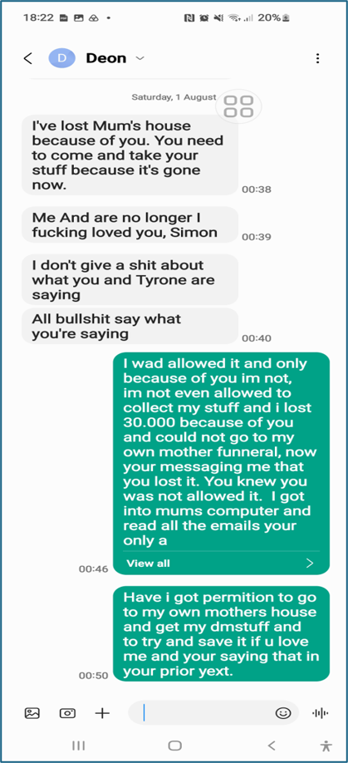  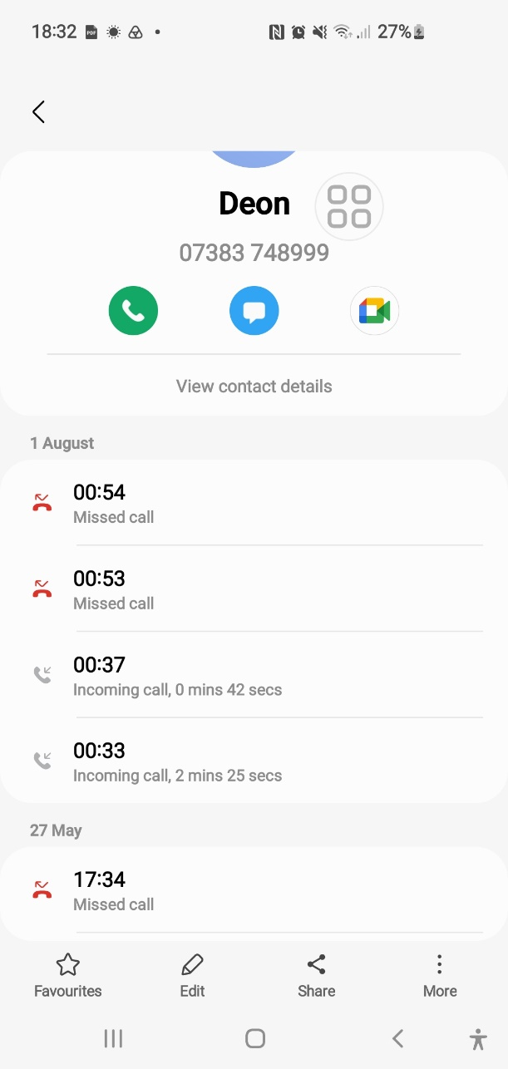  Jimmy 01/08/2026:  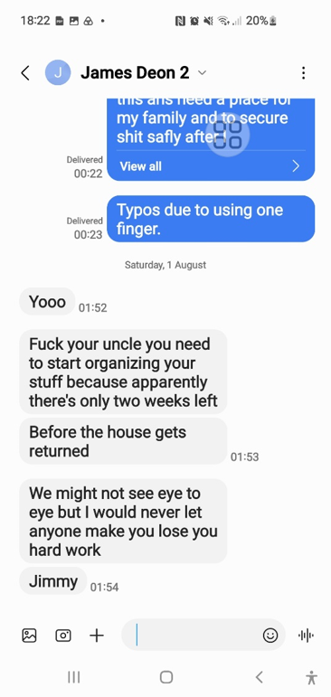 | As Exhibited in 0J:  03. Deon and Jimmy 01-08-26  192.168.0.49 - /15. DB 23 Byron My Home Folder 28-04-26/04. What’s Happened/
12th of August 2026 | Event:  - My Urgent Warning to All Parties Involved from Me Due To My Sister and Her Boyfriend Contact!  Misconduct & Legal Errors:  SENT & RECEIVED FILES | MAIN COMBINED FILE.  31. A10. I love pdf merged (1).pdf  SENT & RECEIVED FILES  - A1. Draft Formal Email.pdf  - A1. Formal Attachment .pdf  - A1. Intro.docx  - A1. Sent -12-08-26.pdf  - A2.1 Sent Email Part Two 13-08-26.pdf  - A2.2. WhatsApp Chat Sent to me From Deon and Aunt Shelia.pdf  - <Dir> Files ID
   | - A1. Draft Formal Email.pdf  - A1. Formal Attachment .pdf | “Used Below, do not Read!”
   | - A1. Intro.docx | “Admin Note of what’s about to happen and why!”
   | - A1. Sent -12-08-26.pdf | “This is the First Email I Sent with 2 Attachments as Below and I used Yahoo to send the Files!”  Notes Are: I cannot be sure if these files were received as Yahoo tends not to send email to Government Staff.
   | A2.1 Sent Email Part Two 13-08-26.pdf | “Part 1 Attachment to Email Above!”  Notes Are: The Same as Above, I used Yahoo.
   | A2.2. WhatsApp Chat Sent to me From Deon and Aunt Shelia.pdf | “Part 2 Attachment to Email & Attachment Above!”  Notes Are: The Same as Above, I used Yahoo.
   | <Dir> Files ID | These files were enhanced and re sent due to the second reason Enfield Council Management gave Housing Officer Georgina to refuse me. I also offered my evidenc4 if required to prove 23 Byron Terrance is my Primary Home, but no one ever asked for anymore!
  END
12th of August 2026 | Event:  - 30. Notes Succession Rights “Me Reading My Legal Rights!”  - 30. Sent -12-08-26. + 30.1. Formal Attachment.  Misconduct & Legal Errors:  Joining This Succession Case and the Police Case Together Officially as They Are Stopping Me from Going to My Primary Home 23 Byron Terrace Wrongfully All Together Due To What My Sister and Her Boyfriend and My Aunt Sent Me!  I resent the files I built above again but with the use of outlook email provider rather than Yahoo, as Yahoo tends to Mail Failure to Government Officials!  My Complaints Were Emailed To: Georgina Solan, DS Johnston, Alina Knox and my solicitor:  Subject: "URGENT + IMMEDIATE FREEZE STOP REQUIRED” explicitly stating any removal would be unlawful.  The Enfield Councils Housing Officer Handling My Case Ignores This Legal Notice.  - 30. Notes Succession Rights in Social Housing_ England & Wales Guide.pdf  - 30. Sent -12-08-26.pdf  - 30.1. Formal Attachment.pdf | - 30. Notes Succession Rights in Social Housing_ England & Wales Guide.pdf  - 30. Sent -12-08-26.pdf  - 30.1. Formal Attachment.pdf
13th of August 2026 | Event:  - Same as above! I resent the files I built again but with the use of outlook email provider rather than Yahoo, to sue of their urgent delivery requirements!  Misconduct & Legal Errors:  A3. Sent to All 13-08-26.pdf  “This is the Second Email I Sent!”  Notes Are: I Used Outlook to be 100% Sure it was sent! | A3. Sent to All 13-08-26.pdf
13th of August 2026 | Event:  “This Is Me Requesting for Housing Ombudsman Support!”  Notes Are: Self-explanatory.  Misconduct & Legal Errors:  - A4.1. Screenshot_13-8-2026_141326_www.housing-ombudsman.org.uk.jpeg  - A4.2. Screenshot_13-8-2026_141415_www.housing-ombudsman.org.uk.jpeg | - A4.1. Screenshot_13-8-2026_141326_www.housing-ombudsman.org.uk.jpeg  - A4.2. Screenshot_13-8-2026_141415_www.housing-ombudsman.org.uk.jpeg
13th of August 2026 | Event:  - “I Telephoned the Police Officers in Charge and These Are My Official Notes of Those Two Calls!”  Misconduct & Legal Errors:  A5. First Contact.pdf  Notes Are: I telephoned the DS in charge of the case and got through to him. He sent an email to the OIC in the case due to what Deon had text me asking her to contact Deon and the council to confirm I can go back to my home. He also said that the OIC will then afterwards contact me and this should be in the morning as to an update about the bail variation requests! | A5. First Contact.pdf
14th of August 2026 | Event:  N/a from the Council!  Misconduct & Legal Errors:  My Housing issues continue to be abused through my request for legal process by Georgina & her Management! | N/a
15th of August 2026 | Event:  N/a from the Council!  Misconduct & Legal Errors:  My Housing issues continue to be abused through my request for legal process by Georgina & her Management! | N/a
16th of August 2026 | Event:  N/a from the Council!  Misconduct & Legal Errors:  My Housing issues continue to be abused through my request for legal process by Georgina & her Management! | N/a
17th of August 2026 | Event:  - A Snippet out of My Official Diary Notes for this Case Exhibits the Below Occurrences!  Misconduct & Legal Errors:  A6. Bail Deon’s case 17-08-26.pdf  What Happened Today: 17 August 2026 This morning at 9 AM, I received a call from Michael Carroll’s secretary. She told me that my bail conditions have now been “Agreed as Varied” and that I must attend at 8 AM tomorrow to sign them. “No Police Station Was Specified.” | A6. Bail Deon’s case 17-08-26.pdf
18th of August 2026 | Event:  32. Photo from SI.jpg  - I did not attend the police station and just went to 23 Byron Terrace my Primary Home for the first time but could not stay for too long due to the damage and being a human with a good heart!  Misconduct & Legal Errors:  - The house was empty.  I called my aunt as the house was empty and she sent me by text a section 41 Notice and told me Geogina from Enfield Council and Co gave her Andrew and Deon it by post, leaving them with no other option but to remove everything from the house but this did not answer why she did not inform me of the ongoings as she has no consent from me and there is a Caveat Preventing My Mothers Children From Splitting The Belongings! | Created latter but belongs here!  32. COMPLAINT TIMELINE 1.pdf “Never Sent”
18th of August 2026 | Event:  - The Metropolitan police sent a text to my mobile phone!  Misconduct & Legal Errors:  The Met Police sent me a text saying bail conditions are changed  Exhibit:  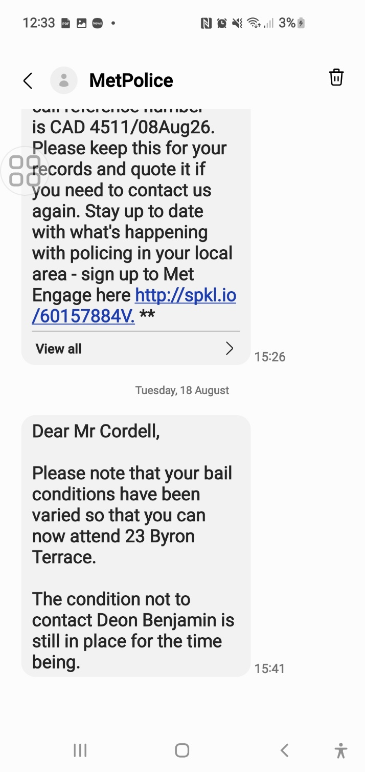 | 32. Met CCC 18-08-26 Screenshot.jpg
18th of August 2026 | Event:  On 18th of August 2026, Metropolitan Police Officer Alina Knox (OIC) emailed me confirming that my bail conditions had finally been changed. This was the first time the police acknowledged the errors surrounding the original conditions and took steps to correct them.  Misconduct & Legal Errors:  Bail Conditions Must Be Proportionate, Lawful, Justified, And Clearly Explained to The Person They Are Imposed On. In my case, none of these requirements were met.  Despite having evidence and exceptional circumstances from the start of the case, Officer Alina Knox (OIC) allowed the original bail conditions to be imposed and continue for months, even though:  - They were based on incorrect tenancy information supplied by Enfield Council.  - The Metropolitan Police’s own system confirmed my long-term residence at 23 Byron Terrace.  - The conditions prevented me from entering my own home, which is a serious interference with my right to a private and family life.  - They created unlawful displacement and safeguarding risks, including vulnerability and inability to access essential belongings.  - They blocked me from collecting evidence, belongings, and legal documents, directly affecting my ability to prepare my defence.  The review that led to the decision to change the conditions was carried out far too late, meaning the conditions:  - Should Never Have Been Imposed,  - Should Not Have Continued,  - Should Have Been Corrected Much Earlier,  - Were Allowed to Operate Wrongly Throughout the Case.  This delay caused significant harm, procedural unfairness, and unlawful interference with my private and family life (Article 8 ECHR). | 32.3. Received Police .pdf
19th of August 2026 | Event:  - A list of most my missing property due to Geogina & Co refusing to act to protect me and my belongings and requesting the wrongful removal of them behind my back!  Misconduct & Legal Errors:  My Return to the Property and Initial Inventory of Missing Items  On 19th of August 2026, I returned to mine and my mother’s home at 23 Byron Terrace for the second time and I knew that a significant amount of my personal property had been removed, given away, or destroyed by individuals acting under the direction of Enfield Council Housing staff. So, upon entering, I picked up the strength to start to document as much of the missing item that had been taken down into my notepad!  This process continued to take the next several days and is still ongoing, as of 10/09/26. My mother and I lived inside of the property for many years, with my brother and sister as well as father, friends and other family members too, so, the volume of belongings accumulated over that time is substantial. The emotional impact of discovering the home emptied off belongings that should not have been moved without my legal knowledge or legal consent, as well as legal ability to intervene due to the police and council wrongful assumptions of me legally being allowed to occupy 23 Byron Terrace, has made the task even more difficult for me, as now all of this has happened and at no fault of my own!  To ensure accuracy, I have moved Exhibit 39 “Stolen from My Home A.pdf” to further down in this official document of ours as “Email 41” as this is where the files are up to till date as of the 10/09/2026 and for that reason this exhibit contains the first set of items identified as missing, stolen, or unlawfully disposed of that I managed to document down with help of others!  The full inventory continues to be compiled and will be completed as “Exhibit Email 41,” which will document every item removed from the property and the circumstances under which they are wrongfully taken. | Number 39. Is Moved Here to Fit into Place  39. Stolen From My Home A.pdf
19th of August 2026 | Event:  - I never recorded the conversation  Misconduct & Legal Errors:  I received a telephone call of the OIC in charge of the case!  Stating I can go back to my home 23 Byron terrace.
19th of August 2026 | Event:  - Being used for emails 41 and 42!  Misconduct & Legal Errors:  N/a: I realised the damage that the official persons involved had caused to my life and the severity of it. I started to gather more evidence of the true ongoings, so I can defend myself. I became aware of my circumstances even more due to everything that all the official persons involved had failed to comply with to prevent this catastrophe from happening to me and my Primary Home. | 32. COMPLAINT TIMELINE 1.pdf “Never Sent”
20th of August 2026 | Event:  - I Then Telephoned the Enfield Council and These Are My Official Notes of Those Two Calls!  Misconduct & Legal Errors:  Legal Error  During my first call’s to Enfield Council, staff confirmed they could not locate any succession case for 23 Byron Terrace, proving that Georgina never logged my application onto the Council system despite taking my forms months earlier. This concealed the fact that no lawful process had ever begun.  Legal Error  Council staff struggled to find records for my mother, the tenancy, and my succession request, confirming that the case file was missing or never created. This shows a complete failure of statutory record keeping and proves the refusal issued earlier had no legal foundation.  Legal Error  Staff advised me to contact Georgina directly because no succession review or decision existed on the system. This proves she misled me by pretending a lawful process was underway when she had never submitted my claim to the statutory panel. | 33. First 2 calls Notes .pdf
20th of August 2026 | Event:  - I Called her Phone and she Answered to me!  - I recorded the telephone call and transcribed it.  Misconduct & Legal Errors:  Legal Error  When I called her directly, she admitted she never submitted my succession application to the statutory panel and instead sent it only to “Unnamed Management”. This proves she knowingly bypassed the legal process required under the Housing Act 1985.  Legal Error  She refused to identify who “Management” was or why they blocked the case, concealing the decision-maker and preventing me from exercising my statutory right to challenge the refusal. This is a breach of transparency and procedural fairness.  Legal Error  She Continued to Speak as If a Lawful Succession Process Existed, even though she admitted she had not logged my application, had not created a case file, and had not submitted it to the panel. This shows she knowingly misled me for months about the status of my claim.  Legal Error  Her statements on The Call Contradict Earlier Emails where she claimed the decision was final and reviewed by management. The call proves she knew the earlier refusals were invalid because no lawful process had ever taken place.  Legal Error  By Georgina Solman Admitting These Failures on Recording: as well as more than once in the same recording and only when confronted by me on the phone, after so much important time had passed away, it proved that she concealed critical information for months, causing me and my family home harm as well as confusion, and Proves That She Prevented Me from Accessing My Legal Rights Under the Housing Act 1985. | - 34. Recording - Enfield Council Georgina 20-08-26 at1226.m4a  - 34. Recording - Enfield Council Georgina 20-08-26 at1226.pdf
 | Event:  These Files Were Later Recovered by Me as I Re Gained Access to My Mother’s Computer That She Gave Me:  This means as of this date 10/09/2026 Georgina & Co have not seen me with a copy of these new files that I exhibited as web linked! And this is even aloe they as the Enfield Council already hold the very same Exhibits on their internal systems! These files are about me and my mother! They together prove one of the many grounded reasons as to why I’m Care of Address of 23 Byron Terrace and lived there registered with my mother Miss Lorraine Cordell after and before she passed away!  As of this date as mentioned above, we are now up to the 41st Email about to be sent by myself and as documented further below!  Misconduct & Legal Errors:  01. All merged_merged.pdf  - The Council hid evidence that was already stored inside their own systems. Their own staff admitted on the phone that my succession application was never logged on my mother’s tenancy account. That admission alone proves the refusal was unlawful because no legal process ever started.  - It also proves how simple it would have been for Georgina to check the internal notes, see my mother’s real address, see my Care-of-Address status, see my role as an overnight carer, and see the years of documents my mother submitted. She didn’t check anything. She didn’t log anything. She didn’t review anything. She didn’t follow policy. She Didn’t Follow Procedure. She didn’t follow the Housing Act 1985.  - They avoided the evidence on purpose. They avoided it knowing I was vulnerable, grieving, displaced, and without access to my mother’s files. They avoided it knowing I was asking for help. They avoided it knowing the evidence existed. They avoided it knowing the evidence would prove my succession rights.  - They blindsided me and the only reason I have the truth now is because I recovered the documents myself from my mother’s computer. These documents prove my mother lived at 23 Byron Terrace, prove I lived with her, prove I was her career, prove I was Care-of-Address, and prove the Council already had everything they needed to approve my succession claim.  - They didn’t just fail me they hid the evidence that would have protected me. | <Dir> 35. I got Mothers Start 30X.Pdf
INTRO
INTO THE NEXT
COUNCIL TAX LETTER EXHIBITS
BEFORE
THE OFFICIAL COMPLAINT IS SENT
AS EMAIL 41, 42!

The Exhibited Council Tax Letters: “As Below in this Timetable”
The following Council Tax letters have been exhibited to support and explain the issues relevant to my succession proceedings:
- 10 March 2026 – Council Tax Letter addressed to 23 Byron Terrace (Care of my mother).
- 9 June 2026 – Council Tax Bill (PDF).
- 9 June 2026 – Council Tax Bill (JPEG).

What I can explain based on these exhibited Council Tax letters:
These Council Tax letters allow me to explain two key issues that are directly relevant to my case.
First, the Council Tax documentation clearly shows that Enfield Council formally recorded me at 23 Byron Terrace as My Primary Home. Multiple bills ARE addressed to “Mr. Simon Cordell, C/O Mrs. L Cordell, 23 Byron Terrace.” This is the Council’s own confirmation of my residence and household membership before and after my mother’s passing. It also shows that the records held on Enfield Council’s systems were not fairly reviewed and were later changed in a way that did not reflect my name at 23 Byron Terrace during my succession claim, demonstrating that staff interfered with or mishandled the process.
Second, despite my repeated requests for my Council Tax account to be reviewed in light of my circumstances and the legal restrictions preventing me from living at 109 Burncroft Avenue, Enfield Council left me in debit for the year 2025 without providing any explanation or outcome. I was never informed why the review was upheld or why my evidence was not applied, leaving the situation unclear and inconsistent. I provided multiple reasons for exemption, including a judge’s order supported by a court-ruling precedent — “THE TALFORD CASE!” yet I was not updated or informed of any decision by Enfield Council. This confusion increased when I later received a 2026 Council Tax bill confirming that I was exempt and that 109 Burncroft Avenue was unoccupied, which directly supports the evidence I had already provided. The fact that 2026 was corrected while 2025 was not, despite identical circumstances, raises further questions that the Council must address.

# | Reason | What it Proves for Succession
1 | Council formally recorded me at 23 Byron Terrace | My name appears on multiple Council Tax bills addressed to my home 23 Byron Terrace, which is an official recognition of residence by the Enfield Council Staff & Systems!
2 | Council billed me at 23 Byron Terrace | Billing is legal acknowledgment of residence.
3 | Council recognised me as part of my mother’s household | “C/O Mrs L Cordell” shows household membership.
4 | Council knew I lived at 23 Byron before and after my mother died | Bills dated 10 March and 9 June 2026 prove continuous residence.
5 | Council held medical evidence proving my overnight carer role | My mother submitted forms naming me as her overnight carer.
6 | Council knew I required a bedroom at 23 Byron Terrace | Edmonton Lower Court ordered a two-bedroom requirement due to my caring role.
7 | Council knew I was legally prohibited from living at 109 Burncroft | Council Tax bill shows “Empty – occupation prohibited by law.”
8 | Council accepted 109 Burncroft was decommissioned | Matches the County Court order.
9 | Council accepted police bail conditions prevented me living at 109 | Bail conditions legally barred occupation.
10 | Council accepted Council Tax Support was misapplied | CTS overpayment proves it was applied to the wrong address.
11 | Council reversed the 2026 bill to £0.00 | Full reversal proves I was not liable for 109.
12 | Council continued sending all correspondence to 23 Byron Terrace | Shows ongoing recognition of residence.
13 | Council’s own system contradicts Georgina’s statements | Georgina claimed I did not live there; Council Tax letters prove otherwise.
14 | Council had evidence of my vulnerability and caring responsibilities | Mental health assessment and court order confirm this.
15 | Council had evidence I was part of the household for years | Overnight care, medical support, billing, CTS corrections, and grants.
16 | Council refused succession without reviewing their own evidence | Staff admitted my application was never logged.
17 | Council’s own documents prove I met statutory succession criteria | Residence, household membership, carer status, vulnerability, prohibition from living elsewhere.

What These Exhibits Were Sent for and What Else They Prove
Together, these exhibits explain:
- Why I was not living at 109 Burncroft
- Why I was legally prohibited from living there
- Why I was registered at 23 Byron Terrace
- Why Council Tax Support was misapplied
- Why the Council Tax liability was incorrect
- Why enforcement was unlawful
- Why the 2026 reversal proves the 2025 debt is wrong

 | Event:  - As Exhibited in the Weblink!  - While My Mother Was Still Alive!  Misconduct & Legal Errors:  Enfield Council Revenues Department Had Continued to Wrongfully Pursue Me:  Enfield Council Revenues Department continued to pursue me for a council tax debt that I did not owe. They stated that I owed money because of their 2014 Council Tax Support scheme, but this was incorrect. Their calculation was based on a misunderstanding of my circumstances and did not reflect the deductions and protections that applied to me.  I contacted the Revenues Department and provided evidence showing that I did not owe any money. My evidence included two main reasons:  1. I was legally prohibited from living at the property for five full months  As shown in my correspondence (Exhibited), my bail conditions from 02/08/2025 made it legally impossible for me to reside at 109 Burncroft Avenue. Enfield Council’s own rules state that people who cannot legally occupy their home are exempt from council tax during that period.  - I also formally requested exemption based on the Trafford High Court ruling, which found that CTS schemes disadvantaging disabled claimants or carers were unlawful and discriminatory. I Explained That This Precedent Affects All Residents in The Borough, Not Just Me but Enfield Council Avoided Answering This Point Entirely, Despite Multiple Emails.  2. Enfield continued sending all council tax mail to 23 Byron Terrace  My PDF shows that Enfield repeatedly sent council tax letters to:  - C/O Mrs L Cordell 23 Byron Terrace Edmonton N9 7DG  This includes:  - CDER enforcement letter — 9 November 2025  - Council Tax Bill 2026/27 — 10 March 2026  - Two letters — 25 August 2026  This proves that Enfield treated 23 Byron Terrace as my care-of address, even though:  - I have lived there since age 5 years old and at 16 my mum was appointed to be my appropriate adult by police until she passed away!  - My bail conditions prevented me from attending 109 and the restraining order since has caused Havok with treating it as my primary home alongside with all the other issues I have raised!  - Government officials are very aware of my reasons for displacement as 109 Burncroft avenue as my case files for prior case proves beyond reasonable doubt!  - They continued enforcement at the wrong address 23 Byron Terrace as well!  This Exhibited Letter of Mail Proves the Decision Was Made in My Favour, But I Was Never Told.  The letters sent ONLY to 23 Byron Terrace show that:  - Enfield Updated My Status  - They Recognised 23 Byron Terrace as Mine & my Mothers Care-Of Address, As We Looked After Each Other Were We Could Not Look After Ourselves!  - They Accepted That I Was Not Living At 109 Burncroft Avenue. . .  - They Issued Council Tax Documents Based on That Corrected Status!  This means:  - The council accepted I was NOT living at 109  - Therefore, I was NOT liable for council tax during the non-residence period  - The council accepted I was CO of 23Byron Terrace as an overnight Carer and due to the Edmonton Lower Court Order Mandating that Enfield Council Sully me with a two Bedroom Home!  - My liability is and should have been £0.00  - I was never informed of this correction!  - I only discovered this when I found the letters at 23 Byron Terrace  This is a procedural failure, a communication failure, and a data handling breach. | <Dir> 35. Revs 109 Sorted
10th March2026 | Event:  - As Exhibited Below!  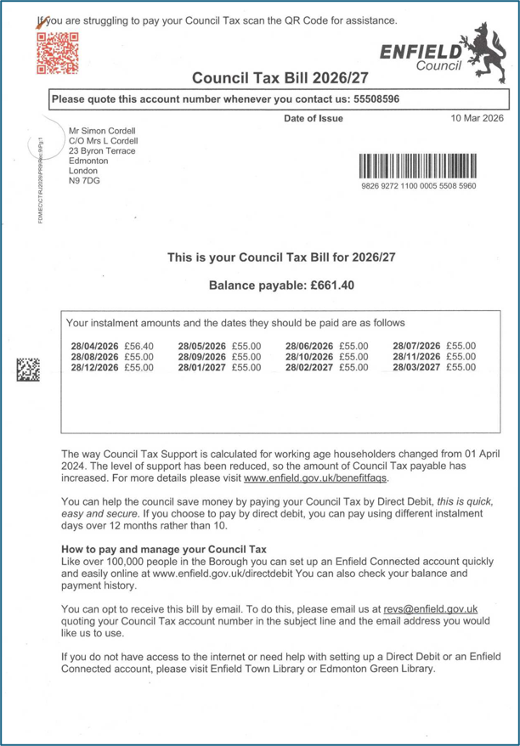  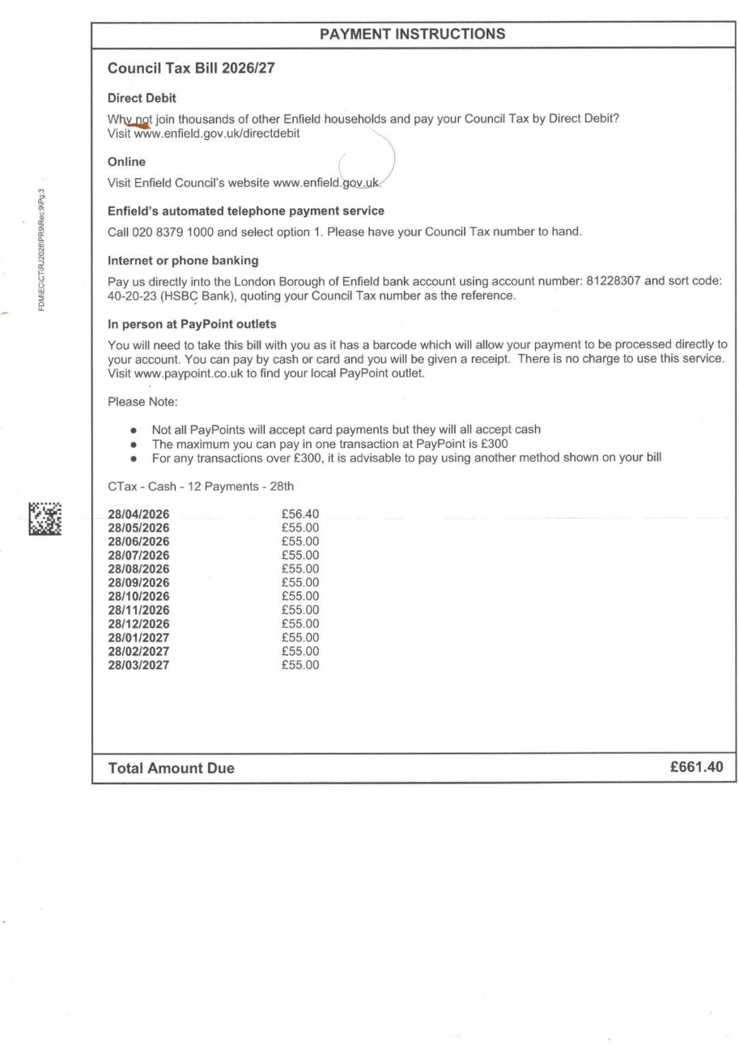  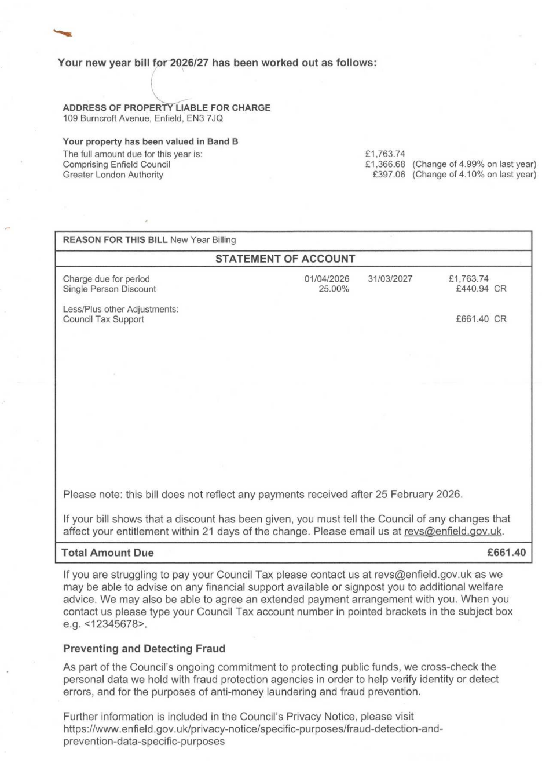  Misconduct & Legal Errors:  This letter proves I was classified by the Enfield Council as in debit at the date of the letter for council tax at 109 Burncroft Avenue the 10th March2026, wrongly.  The council was charging me, even aloe I was known to be registered as a career living at 23 Byron Terrace the Now Succession address.  My mother was still alive and in need of around-the-clock care and this was not being taken into consideration considering my council tax at 109 Burncroft Avenue!  I escalated the council tax issue on the (30 Sept 2025) and before my Housing Succession Application was Submitted:  - 01.My Initial Email (30 Sept 2025)  - 1+ I explained displacement due to bail conditions, receipt of PIP/Universal Credit/ESA, and confusion caused by ESA → UC transition.  - 2+ Requested reassessment of liability, citing protected claimant status and Single Person Discount.  - 3+ Challenged the £662.08 liability figure and referenced the Trafford High Court case (2025) as precedent.  This Council Tax Bill dated 10 March 2026 addressed to ME, “Mr. Simon Cordell, C/O Mrs L Cordell, 23 Byron Terrace” proves beyond any doubt that the Council themselves officially recognised me at 23 Byron Terrace.  This is not my claim. This is THEIR document. THEIR system. THEIR address. THEIR recognition of me living at 23 Byron Terrace.  This proves:  - I was Care-of-Address at 23 Byron Terrace dated 10/03/2026!  - The Council formally recorded me at that address  - They accepted me as part of the household  - They billed me at that address  - They knew I lived there  - They knew I was connected to my mother’s tenancy  - They knew I was part of the residence BEFORE my mother passed away!  And yet Georgina still told me I had “No Succession Rights” and “No Legal Rights of Occupation,” which is wrong.  She told the police I didn’t live there. She arranged with other Housing team members of the Enfield Council that I don’t have no legal right to remain there. Her and management agreed to this, unfair ruling.  But the Council Tax Bill proves she was wrong and she had access to this information the entire time.  On Top of That, They Already Knew the Reasons I Was Living At 23 Byron Terrace:  - I Was an Overnight Carer for My Mother: This wasn’t casual help, it was documented, declared, and accepted by Enfield Council and the DWP.  - My mother had an overnight-carer guarantee: She submitted forms stating:  - “My Family Take It in Turns to Help Me and Stay Overnight.”  - My Name Was Included.  - Her medical conditions REQUIRED overnight care  The Council Had Records Showing:  - Spinal Conditions  - Bowel And Bladder Complications  - Pulmonary Embolism  - Continence Issues  - Mobility Restrictions  - Depression  - Chronic Pain  - Multiple Surgeries  This is exactly the type of situation where a family member becomes part of the household.  The Edmonton Lower Court Ordered a Two-Bedroom Requirement BECAUSE Of My Caring Needs  The Judge Ordered:  - A Mental-Health Assessment Requested by Enfield Council,  - A Two-Bedroom Requirement,  - Because You Were an Overnight Carer,  - And Because the Council Themselves Raised Concerns About my Wellbeing.  This proves:  The Council KNEW I was living with my mother. The Council KNEW you needed a bedroom there. The Council KNEW you were her career. The Council KNEW you were part of the household.  And yet they pretended none of this existed. | <Dir> 35. Revs 109 Sorted  <Dir> 17. CO Care of Address 23 Byron and Mother Council Tax Letter  17. CO Care of Address 23 Byron and Mother Council Tax Letter.pdf
9th June 2026  Found  25/08/2026 | Event:  - As Exhibited Below!  A Council Tax Debit Letter that Arrived on the 9^{th of} June 2026 what stats that I am in debit for the year 2025, as exhibited as “18. Received 25-08-26-page1.jpeg.” below! This letter is addressed to me at 23 Byron Terrace and is for a109 Burncroft avenue proving that even the Enfield council treated 109 not to be my Primary Home!  The next letter as Exhibited below this Exhibit was also sent on the same date as this one and therefore is dated the 9^{th of} June 2026 as well! But is for the year 2026, with the difference being that it shows no debit for the years council tax as I was made exempt. I exhibit this below as Exhibit “18. Received 25-08-26-page1.jpeg.”  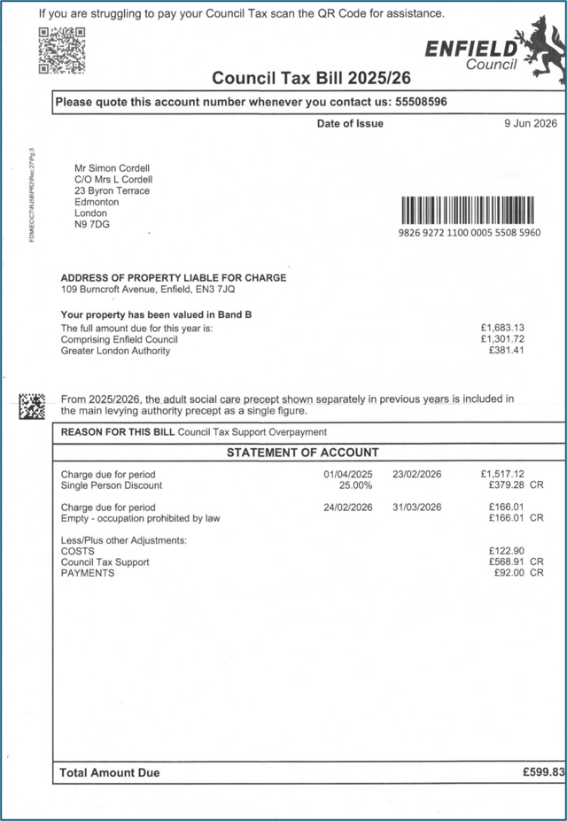  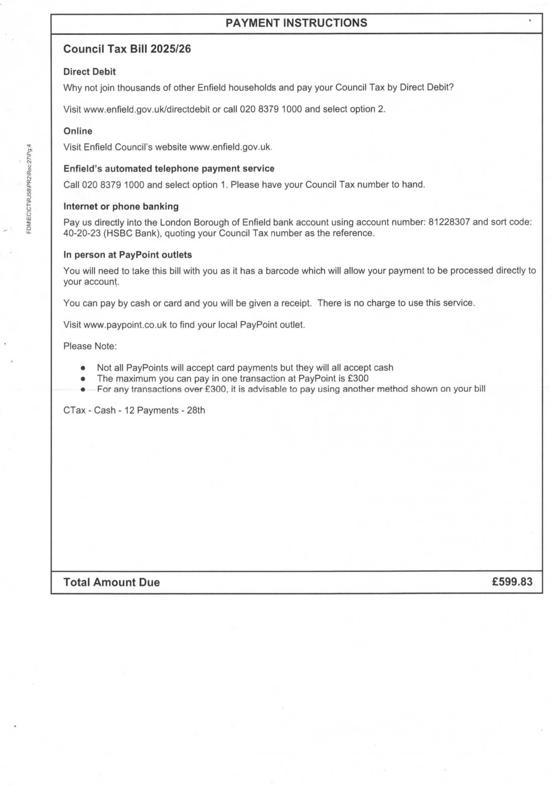  Misconduct & Legal Errors:  9 June 2026 NEW Evidence  Exactly one month after the start of this case, Enfield Council issued another Council Tax Bill again addressed to me at 23 Byron Terrace. This proves I remained officially registered at the property throughout the period of the succession dispute. This directly contradicts Georgina’s statements that I “Did Not Live There” or had “No Right of Occupation.”  Carer Role NEW Evidence  My residence at 23 Byron Terrace was due to my role as an overnight carer for my mother. Her medical conditions required overnight support, and she submitted an overnight carer declaration naming me. This was known to Enfield Council and supported by medical and social care documentation.  Court Order from My Original Evidence Pack  The Edmonton Lower Court issued an order requiring a two-bedroom property and a mental-health assessment (Requested by Enfield Council) because of my caring responsibilities and vulnerability. This confirms the Council already knew I lived with my mother and required a bedroom in the property.  Succession Application Failure NEW Evidence  Council staff later confirmed by telephone that my succession application was never logged on my mother’s tenancy account, even aloe given to her and then afterwards guaranteed as submitted by her due to no mention of anything else occurring!  This shows the refusal was issued without reviewing any of the evidence the Council already held confirming my residence, carer role, and vulnerability.  Amount Due  This Council Tax Bill (Dated 9 June 2026) was sent to me at 23 Byron Terrace after my mother passed away, exactly as all previous Enfield Council correspondence had been. This proves that even during the period where the Council later claimed I “Did Not Live There,” they continued to officially recognise me at 23 Byron Terrace.  The bill itself relates to 109 Burncroft Avenue a property I was disputing liability for, and it was issued during the period where I was challenging Council Tax charges for that address.  The reasons for my dispute were already known to Enfield Council and supported by legal and factual evidence:  - Trafford Case Precedent (Legal Basis)  The Trafford case established that a person cannot be held liable for Council Tax on a property they are legally prevented from occupying. This applied directly to my situation at 109 Burncroft Avenue.  - Edmonton County Court Order (Housing & Safety Basis)  The Edmonton County Court issued an order confirming that:  - 109 Burncroft Avenue Was Decommissioned,  - I Was Legally Required to Be Rehoused into A Two-Bedroom Property,  - Enfield Council Was Responsible for Providing That Accommodation,  - I Was Not Permitted to Occupy 109 Burncroft Avenue.  This means I could not legally be charged Council Tax for a property I was barred from living in.  - Police Bail Conditions (Public Protection Basis)  Police bail conditions were imposed because Enfield Council failed to follow the County Court’s rehousing order, leaving me exposed to repeated harassment, false allegations, and hate-motivated neighbour complaints.  These conditions:  - Legally Prevented Me from Returning To 109 Burncroft Avenue,  - Were Known to Enfield Council,  - Made Council Tax Liability Impossible Under the Trafford Precedent.  The Council was aware that multiple neighbour allegations were proven false or malicious, and that none resulted in trial.  - Carer Status & Overnight Grant (Residence Basis)  My mother’s overnight-carer declaration formally registered me at 23 Byron Terrace. This was supported by:  - Medical Documentation,  - Social Care Records,  - The Overnight Carer Grant,  - And Council-Held Evidence.  This confirms I was legally and officially resident at 23 Byron Terrace not 109 Burncroft Avenue.  Empty Occupation Grant at 109 Burncroft Avenue!  - Empty Occupation Grant (Council’s Own Classification)  The Council applied an Empty Occupation Grant to 109 Burncroft Avenue, acknowledging that:  - The Property Was Empty,  - Occupation Was Prohibited by Law,  - And This Proves I Was and Do Not Living There as My Primary Home Due To Everything.  This classification directly supports my dispute and contradicts any attempt to charge me Council Tax for that address. | <Dir> 35. Revs 109 Sorted  18. Received 25-08-26-page1.jpeg  18. Received 25-08-26-page2.jpeg  18. Received 25-08-26.pdf
9th June 2026 | Event:  - As Exhibited Below!  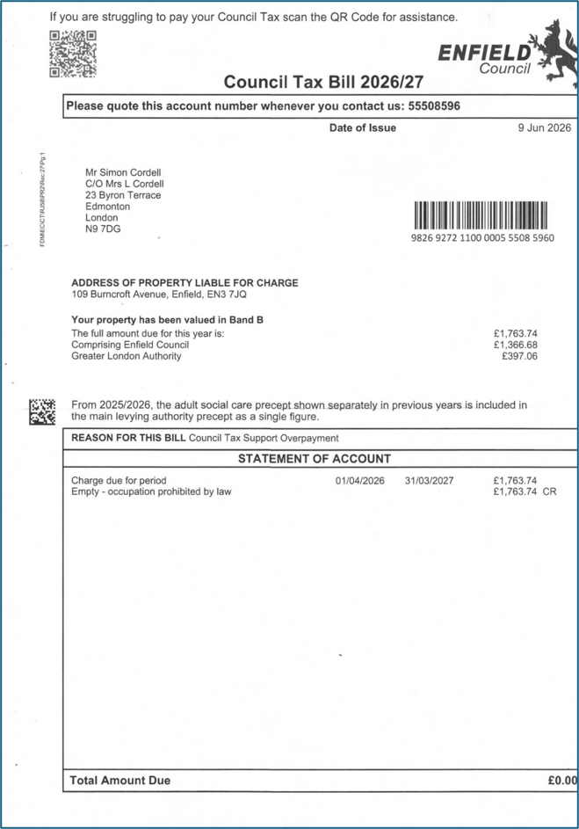  Misconduct & Legal Errors:  Another Official Letter sent to 23 Byron Terrace from Enfield Council to me addressing issues of council tax for 109 Burncroft Avenue dated 9th of June 2026  Amount Due  Still Requested After My mother passed away!  Explanation of My Living Situation Prior to 2025  1. Why I was living at 23 Byron Terrace  Before 2025, I was living at my mother’s home at 23 Byron Terrace because Enfield Council had taken me to Edmonton County Court for a possession case relating to 109 Burncroft Avenue. This case was:  - Built On False Allegations,  - Based On Neighbour Harassment,  - Supported By Incorrect Evidence,  - And Repeatedly Unable to Proceed to Trial Because the Allegations Could Not Be Proven.  I was kept in a five-year abusive legal process where the Council attempted to remove me from my home using evidence that was later shown to be unreliable or fraudulent. Because of this, I could not safely remain at 109 Burncroft Avenue because they had encouraged and allowed my neighbours to turn against me, to an extent that they victimised me daily with torchers and therefore illegal acts, against the law. . .  My mother allowed me to stay with her at 23 Byron Terrace due to this and the council failing to safeguard me.  23 Byron Terrace meant I had my own room due to this and that I was acting as my mother’s overnight carer at the same time.  2. The Council requested a mental health assessment  During the possession case, Enfield Council asked the judge to order a mental health assessment on me. The judge agreed this based on the Council’s request and the assessment concluded that I am vulnerability and had capacity issues.  This finding was not my fault. It was the result of:  - The Council’s Repeated Legal Pressure,  - Neighbour Harassment,  - And The Stress of The Ongoing Possession Case.  The judge then disposed of the Council’s case, meaning the possession claim was effectively shut down.  3. The Judge Issued a Protective Court Order  After reviewing the situation, the judge issued a formal protective court order requiring Enfield Council to:  - protect me from my neighbours,  - stop the harassment,  - provide me with a safe home,  - rehouse me into a two-bedroom property,  - because of my vulnerability and caring responsibilities.  This Order Legally Confirmed:  - I could not return to 109 Burncroft Avenue.  - I required a two-bedroom home.  - I was recognised as vulnerable.  - I was recognised as needing protection.  - I was recognised as living with my mother.  4. Enfield Council Refused to Comply with The Judge’s Order  Despite the judge’s instructions, Enfield Council:  - Refused To Rehome Me,  - Ignored The Court Order,  - Delayed Compliance for Months and Years,  - Left Me Exposed to Neighbour Harassment,  - And Failed to Protect Me.  - Because Of This Failure, My Mother Continued to House Me At 23 Byron Terrace, Giving Me the Spare Room the Judge Said I Needed. This Was the Only Safe Place for Me to Live.  What the Revs Exhibits Contain  These Revs exhibits contain:  - Bailiff notices  - Liability Order references  - Council Tax Support overpayment notices  - Emails between me and Revenues  - Enforcement warnings  - Payment demands  - Dispute correspondence  My Council Tax Bills Contain  - The exact charges for 2025/26  - The Empty – occupation prohibited by law credit  - The Single Person Discount  - The Council Tax Support overpayment  - The remaining balance of £599.83  - The full reversal for 2026/27  Month-by-Month Explanation for 2025 (based on my evidence)  2013, 2014 And Onwards What Dates Mother Registered Me and Herself as Caring for Each Other!  The 2018 Edmonton lower Sealed-Court-Order- Judges Orders 09-08-2018-for Enfield Council to provide me with a 2-Bedroom Home. With an issue being we revived it on-the-06-12-2018  January–February 2025  I was living at 23 Byron Terrace as my mother’s overnight carer.  Evidence:  - Overnight carer declaration  - Medical documentation  - Social care records  - Council correspondence addressed to 23 Byron Terrace  - Revs emails showing you were already disputing liability  March–April 2025  Council Tax Support was applied incorrectly to 109 Burncroft Avenue, even though:  - You were not living there  - You were legally prohibited from living there  - The property was decommissioned  - Police bail conditions prevented occupation  - The Trafford precedent applied  May–June 2025  My mother’s health deteriorated. My caring responsibilities increased. You remained at 23 Byron Terrace.  Council continued sending all correspondence to 23 Byron Terrace, proving my residence.  July–August 2025  Neighbour harassment escalated. Police bail conditions were imposed. I was barred from returning to 109.  Council Tax liability for 109 was now even further legally impossible.  September–October 2025  Council Tax Support overpayment was created because:  - CTS was applied to a property I was not living in due to everything out of my control!  - CTS was applied to a property that I was legally prohibited from occupying  - CTS was still applied despite the decommissioning order  My Revs emails show I was already disputing this.  November–December 2025  Council enforcement escalated. CDER became involved. My Revs tab shows:  - Bailiff Threats  - Enforcement Notices  - Liability Order Warnings  - All Of This Was Based on Incorrect Liability.  What the Council Tax bills prove about 2025  - I was not living at 109: Both bills were addressed to 23 Byron Terrace.  - I was legally prohibited from living at 109: The bill shows:  Empty – occupation prohibited by law: £166.01 CR: This is very strongest evidence alongside with the rest that I have.  - The Council accepted the property of 109Burncroft Avenue is decommissioned: this Now Matches the Edmonton County Court order.  - The Council accepted police bail restrictions: Matches My Revs emails as well.  - The Council accepted CTS was misapplied: The bill shows:  Council Tax Support: £568.91 CR  - The Council accepted their mistake: The 2026/27 bill shows:  Charge: £1,763.74 Credit: £1,763.74 Total Due: £0.00: This proves the Council wiped My liability.  Why the portal still shows a debt for 2025  - Because the portal only shows:  - automated charges  - automated payments  It does not show:  - manual corrections  - legal adjustments  - Empty Occupation Grant  - decommissioning  - bail restrictions  - court-ordered prohibition  - succession-related corrections  - manual CTS reversals  my bills are the legal record. The portal is not.  New Exhibit:  - For 2025 it shows me as in debit. And still to date of the 08/09/26 still States I am in debit as Exhibited:  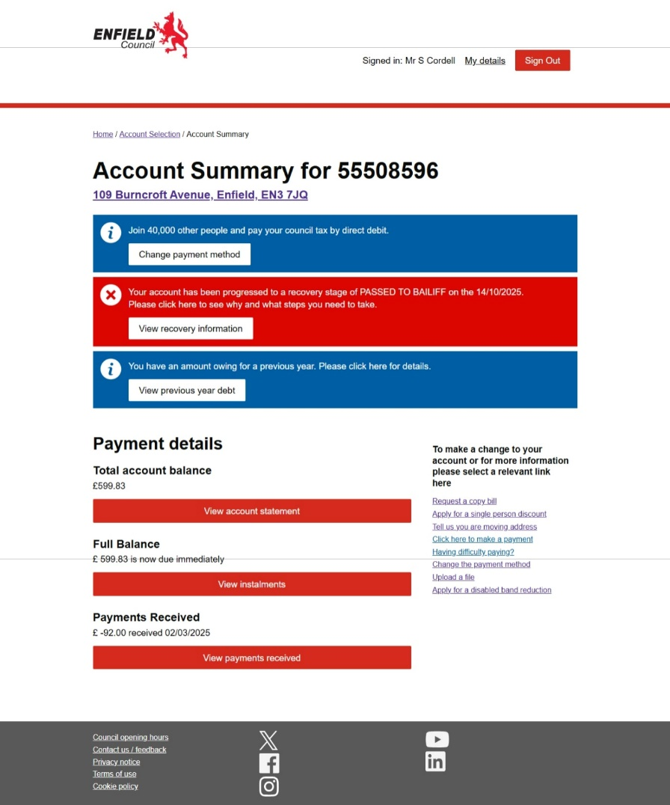  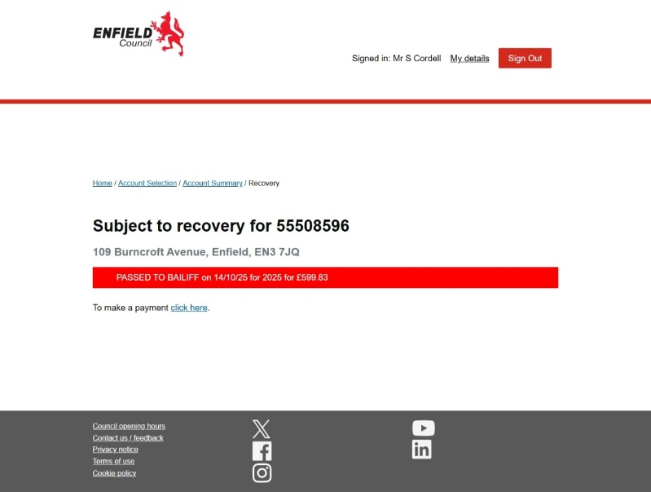 | <Dir> 35. Revs 109 Sorted  19. Received 25-08-26.jpeg  19. Received 25-08-26.pdf
  Date | What Was Registered | Source
  05 May 2013 | Mother declares she needs overnight carers; lists family staying overnight (including you). | <Dir> 35. I got Mothers Start 30X.Pdf
  14 August 2013 | Second declaration confirming overnight carers and medical need. | 01. All merged_merged.pdf
  22 May 2014 | Confirms ongoing overnight care need; still paying bedroom tax incorrectly. | 01. All merged_merged.pdf
  09 February 2015 | Formal list of overnight carers including Simon Cordell; confirms medical need. | 01. All merged_merged.pdf
  Date | Event / Misconduct & Legal Errors | Evidence
  Before 2025 | • I was living at 23 Byron Terrace as my mother’s overnight carer. • Enfield Council kept you in a 5-year abusive possession case for 109 Burncroft Avenue. • Case built on false neighbour allegations, harassment, and unreliable evidence. • Judge ordered a mental health assessment (requested by Enfield Council). • Assessment found vulnerability and capacity issues. • Judge disposed of the Council’s case. • Judge issued a protective order: protection from neighbours, 2-bedroom requirement, prohibition from returning to 109. • Enfield Council refused to comply. • my mother housed you in her spare room at 23 Byron Terrace. | • Overnight carer declaration • Medical documentation • Social care records • Court order • Bail conditions • Decommissioning of 109 Burncroft • Trafford precedent
07/04/2026  Found  25/08/2026 | Event:  - Once I was allowed back into my home 23 Byron Terrace again on the 25/08/2026 due to wrongful bail conditions imposed, I Found this letter I Exhibit as below from the Enfield Councils ASC Income Collection team!  - The letter is dated the day before she passed away, which was on 08/04/2026!  - Re: Important information about your account:  - Please note that your account had two credits applied for £50.50 each  - Therefore, the revised balance on your account is now £4914.40  - Please note you will now only need to pay £4914.40 to clear the balance on your account.  Misconduct & Legal Errors:  Even though my mother was on benefits and assessed as terminally ill due to kidney failure, she was still required to pay for her home care services. Adult Social Care charges are separate from Housing Benefit and are not automatically removed for terminal illness unless the person receives NHS Continuing Healthcare, which she was never granted. As a result, ASC continued billing her for care support, personal care, and domestic assistance, placing her into over £4,000 debt while she was seriously ill.  Amount Due £4914.40  This was while she was still alive! | 36. Received 25-08-26.pdf
  ASC Income Collection
  London Borough of Enfield
  4th Floor
  Civic Centre
  Silver Street
  Enfield, Middx
  EN1 3XW
  ASCIncomeCollection@enfield.gov.uk
  Tel: 020 8379 3521
  Customer ID: 10037155
  07/04/2026
  Miss Lorraine Cordell
  23 Byron Terrace
  Hertford Road
  Edmonton
  London
  N9 7DG
  Dear Miss Lorraine Cordell
  Re: Important information about your account:
  Please note that your account had two credits applied of £50.50 each
  Therefore, the revised balance on your account is now £4914.40
  Please note you will now only need to pay £4914.40 to clear the balance on your account.
  Please see attached Credit Notes for more information.
  If you have any questions, concerns or queries, please do not hesitate to get in contact via above details
  Yours sincerely,
  David Carey
  Assistant ASC Income Collection Officer
  Olga Bennet
  Executive Director of Resources
  Enfield Council
  Civic Centre, Silver Street
  Enfield EN1 3XY
  www.enfield.gov.uk
  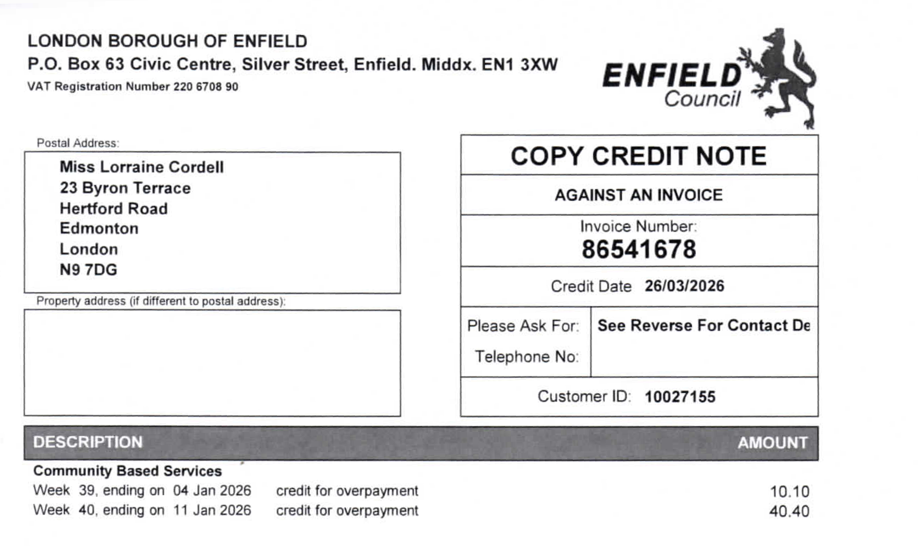
  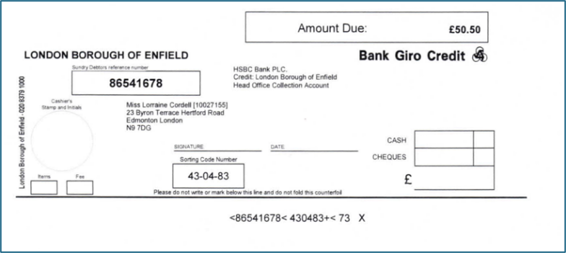
  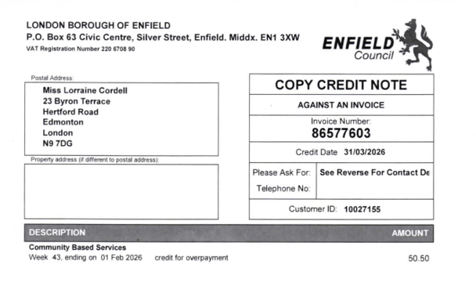
  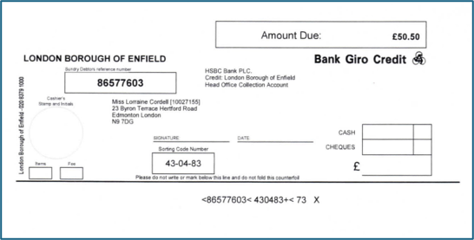
17/08/2026  Found  25/08/2026 | Event:  - As Exhibited Below!  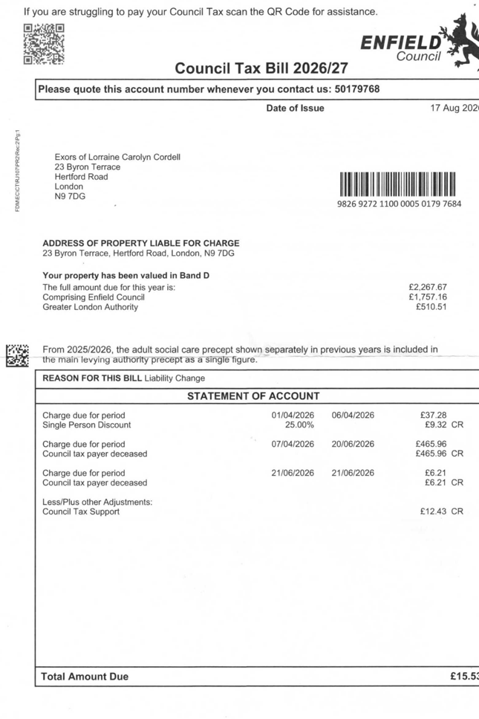  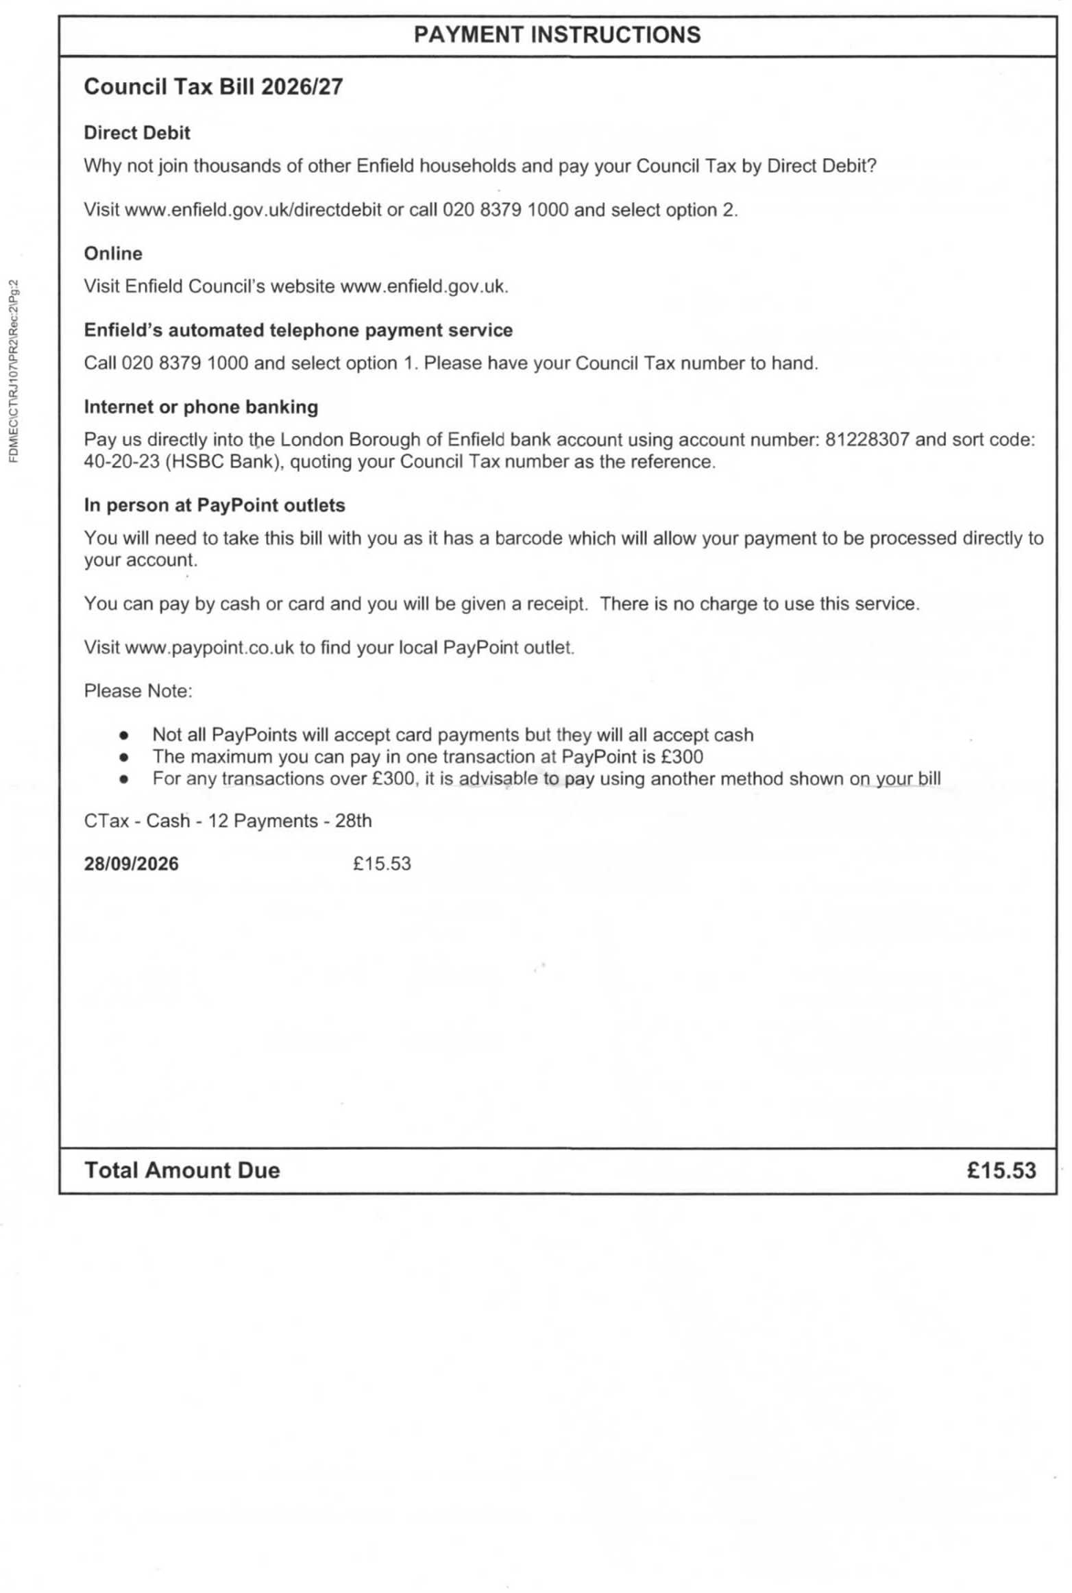  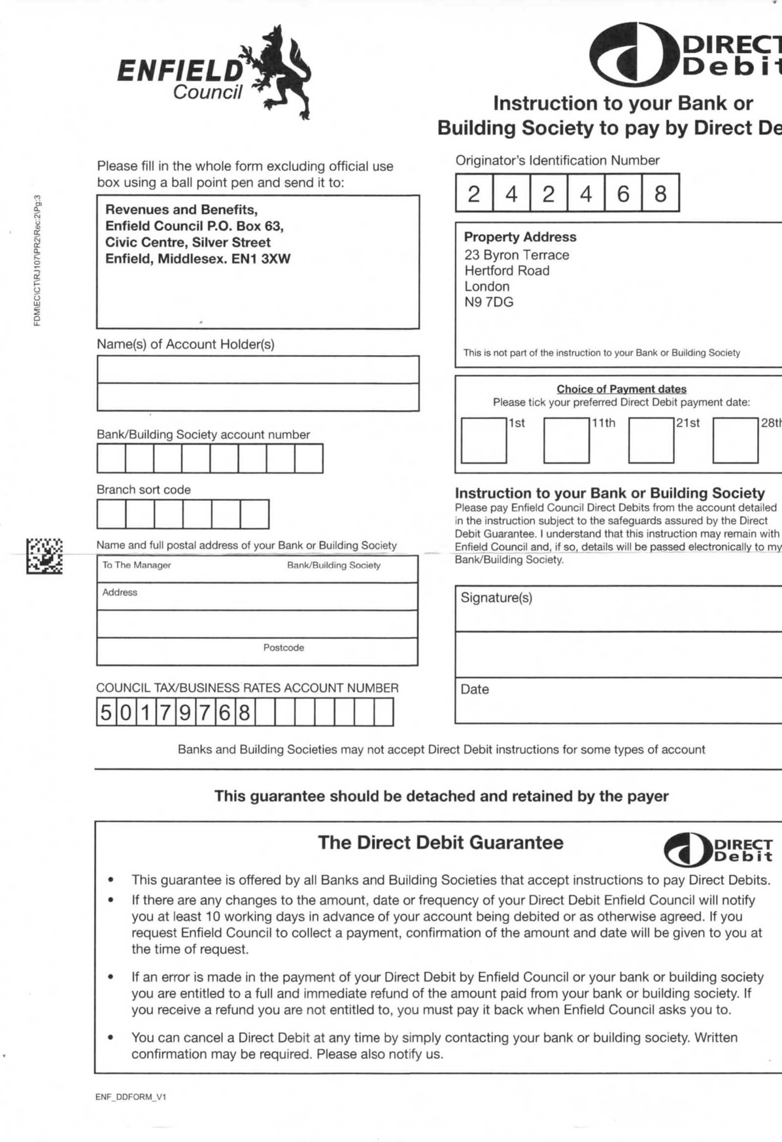  Misconduct & Legal Errors:  Amount Due  Once mother passed away!  1. No Left-in-Occupation Account Was Created (Provable via the Council Tax Letter)  The council tax letter dated 17/08/2026 proves that no rent or occupation account was ever created for you, despite Georgina stating she would set one up while your succession claim was ongoing. This is provable because your name does not appear anywhere on the account records.  2. You Were Prevented from Attending the Property Because of Georgina’s Incorrect Information to Police  You could not enter 23 Byron Terrace from 09/05/2026, due to police acting on Georgina’s incorrect statement. Despite knowing this, she still claimed she would set up the account “while you were in occupation,” which was impossible — and she did not do it.  3. 100 Days Passed with No Account Created (09 May → 17 August 2026)  From the date of your arrest (09/05/2026) to the date the council sent the letter (17/08/2026) is 100 days. During this entire period, Georgina was responsible for your case and failed to create any account.  4. 131 Days Passed Since Your Mother’s Death with No Account Created (08 April → 17 August 2026)  Your mother passed on 08/04/2026. The council tax letter was issued 131 days later, with no account created for you. This is a measurable administrative failure.  5. You Could Not Access the Letter for 8 Days (17 August → 25 August 2026)  The letter was sent on 17/08/2026, but you could not access it until 25/08/2026 — 8 days later — because you were excluded from the property due to Housing’s misinformation to police. This delay is directly caused by Housing’s actions. | 37. Received 25-08-26.pdf
19/05/2026  Found  25/08/2026 | Event:  - As Exhibited Below!  Letter Delivered Just to 23 Byron Terrace and not Emailed to Me!  - “I have to point out our obligation as landlord of the property and am very sorry that I have to serve a Notice to Quit soon after the death of Miss Lorraine Cordell, but this is necessary in order to formally end the tenancy.”  - “In line with the regulations, we have to serve a Notice to Quit on the Personal Representative of the deceased tenant. Please find attached a copy of the said notice.  - “Alternatively, the next of kin of the deceased tenant can complete a Termination Form and return it to this office with the keys. Please find enclosed a copy of the form. You will need to ensure that a copy of the death certificate is enclosed as we cannot act on the form without this document.”  - “Please note that any Housing Benefit paid to the rent account ceases on the Sunday following the death of the tenant as per Government legislation.  - This means that full rent will be charged from the Monday following the date of death to the rent account until the surrender form and the keys are returned to this office.”  - “If you are still arranging clearance of the property, please note that the keys should be returned to this office within 2 weeks of the date of death of the tenant.”  - “If the keys are retained for longer than 2 weeks, an account for ‘use and occupation’ of the property will be set up and the next of kin may be held responsible for any arrears, and associated costs, that accrue.”  LONDON BOROUGH OF ENFIELD NOTICE TO QUIT  - If the tenant or licensee does not leave the dwelling, the landlord or licensor must get an order for possession from the court before the tenant or licensee can lawfully be evicted. The landlord or licensor cannot apply for such an order before the notice to quit or notice to determine has run out.  - A tenant or licensee who does not know if he has any right to remain in possession after a notice to quit or a notice to determine runs out can obtain advice from a solicitor.  - Help with all or part of the cost of legal advice and assistance may be available under the Legal Aid Scheme. He should also be able to obtain information from a Citizen’s Advice Bureau, a Housing Aid Centre or a rent officer.  Misconduct & Legal Errors:  1. Letter Was Delivered Only to 23 Byron Terrace — Not Emailed to Me  Housing sent the Notice to Quit only to my mother’s address, even though they knew I was barred from entering the property because of Georgina’s misinformation to police. This caused a three-month delay in me receiving a legally time-sensitive notice.  2. I Could Not Access the Letter for 98 Days (19/05/2026 → 25/08/2026)  Because I was excluded from my home from 09/05/2026, the letter dated 19/05/2026 remained inaccessible until 25/08/2026. This delay was caused entirely by Housing’s incorrect communication to police — not by me.  3. Notice to Quit Was Sent After I Submitted My Succession Application  I had already spoken with Georgina and submitted my succession evidence before 19/05/2026. She told me the Notice to Quit was being sent as part of the succession process to “take the house out of my mother’s name and put it into mine.” This was false — a Notice to Quit ends a tenancy, it does not transfer it. This is a misrepresentation of process.  4. Multiple Council Letters Were Addressed to Me at 23 Byron Terrace While I Was Barred  Council documents dated 10 March, 9 June, 9 July, and 10 July 2026 were all addressed to me at 23 Byron Terrace, despite Housing knowing I was legally prevented from entering the property. This shows a pattern of withholding essential documents by sending them only to an address I could not access.  5. Housing Failed to Inform Me About the Broken File / Upload Failure (09 July 2026)  On 09 July 2026, Housing generated a file they later admitted “was not working.” They never told me, causing my evidence submission to fail silently. This directly obstructed my succession claim.  6. Housing Stopped Responding After 10 July 2026  The letter dated 10 July 2026 stated:  “We will review the matter and include your latest evidence. I will update you on the outcome.”  I did not receive this letter until 18 August 2026, and no update was ever provided. This is a failure to act on a live succession claim.  7. A Section 41 Notice Was Sent Behind My Back  On 07 August 2026, my sister informed me that Georgina & Co sent a Section 41 Notice behind my back, telling others they could take my belongings. This was done without notifying me, while I was excluded from the property. This is a serious procedural breach.  8. Georgina Only Replied on 28 August 2026, After Over 100 Days of Silence  Her reply on 28/08/2026 came more than 100 days after the Notice to Quit was issued and only after I finally accessed the property. This shows prolonged neglect of my active succession case.  Exhibited: Mini Timeline!  On the 10th of July, Georgina sent me a letter and also sent my sister a separate letter instructing her to empty the house, but she never told me this, never emailed me, and never addressed the letter to me properly. At the time, she knew I was barred from entering 23 Byron Terrace because of her own misinformation to police, yet she continued sending critical documents only to the property and even authorised others to remove my belongings behind my back. This proves that Housing deliberately withheld essential correspondence from me, misdirected notices to third parties, and failed to address legally significant letters in my name, causing me to miss key information and obstructing my succession claim.  10 July 2026  I received this 18th of August 2026 once allowed back in the property as it was not sent to me. I was only allowed back into my home due to me contacting the police as my sister sent me a message on the 07 August 2026.  “Geogina & Co sent a section 41 Notice behind my back advising others to take my belongings who she knows I am in legal disputes with.”  - 32. Photo from SI.jpg  - 32. COMPLAINT TIMELINE 1.pdf “Never Sent” | 38. Georgina 19-05-26 Notice to Quit Found 25-08-26.pdf “Found in 23 Byron Terrace”
  
  Please reply to: Georgina Solan
  The Edmonton Centre
  36 - 44 South Mall
  Edmonton Green
  N9 0TN
  Mr. Simon Cordell
  23 Byron Terrace
  London
  N9 7DG
  Email: Georqina.Solan@enfield.qov.uk
  Phone: 0204 534 2653
  Date: 19/05/2026
  Dear Mr. Simon Cordell
  Re: Miss Lorraine Cordell - 23 Byron Terrace, Edmonton, London, N9 7DG
  I write to offer my sincere condolences at your sad loss.
  I have to point out our obligation as landlord of the property and am very sorry that I have to serve a Notice to Quit soon after the death of Miss Lorraine Cordell, but this is necessary in order to formally end the tenancy.
  In line with the regulations, we have to serve a Notice to Quit on the Personal Representative of the deceased tenant. Please find attached a copy of the said notice.
  Alternatively, the next of kin of the deceased tenant can complete a Termination Form and return it to this office with the keys. Please find enclosed a copy of the form. You will need to ensure that a copy of the death certificate is enclosed as we cannot act on the form without this document.
  Please note that any Housing Benefit paid to the rent account ceases on the Sunday following the death of the tenant as per Government legislation.
  This means that full rent will be charged from the Monday following the date of death to the rent account until the surrender form and the keys are returned to this office. If you are still arranging clearance of the property, please note that the keys should be returned to this office within 2 weeks of the date of death of the tenant.
  If the keys are retained for longer than 2 weeks, an account for ‘use and occupation’ of the property will be set up and the next of kin may be held responsible for any arrears, and associated costs, that accrue.
  - JOANNE DREW
  STRATEGIC DIRECTOR OF HOUSING AND REGENERATION
  - Enfield Council
  - Civic Centre, Silver Street
  Enfield EN1 3XY
  - www.enfield.gov.uk
  If you need this document in another language or format contact the service using the details above.
  If you have any queries regarding this or would like to discuss the matter further, please contact me via the contact details stated at the top of this letter.
  Thank you for your assistance at this sad time.
  Yours sincerely
  Tenancy Management Officer
  Tenancy Management Team
  LONDON BOROUGH OF ENFIELD
  NOTICE TO QUIT
  To: The Personal Representatives of the late Miss Lorraine Cordell 23 Byron Terrace, Edmonton, London, N9 7DG
  On behalf of the Council of the London Borough of Enfield, I hereby give you Notice to Quit and deliver up to the Council or to whom they may appoint possession of the dwelling and premises known as 23 Byron Terrace, Edmonton, London, N9 7DG on Sunday 21 June 2026 or on such date (if any) as may be the end of the week of the tenancy which will expire next after the expiration of four weeks from the service of this notice.
  YOUR ATTENTION IS DRAWN TO THE PRESCRIBED INFORMATION SET OUT
  BELOW
  PRESCRIBED INFORMATION
  - If the tenant or licensee does not leave the dwelling, the landlord or licensor must get an order for possession from the court before the tenant or licensee can lawfully be evicted. The landlord or licensor cannot apply for such an order before the notice to quit or notice to determine has run out.
  - A tenant or licensee who does not know if he has any right to remain in possession after a notice to quit or a notice to determine runs out can obtain advice from a solicitor.
  - Help with all or part of the cost of legal advice and assistance may be available under the Legal Aid Scheme. He should also be able to obtain information from a Citizen’s Advice Bureau, a Housing Aid Centre or a rent officer.
  DATED THIS 19.05.2026
  Neighborhood Team Manager Enfield Council
  Date | What Happened | Document / Evidence | Key Issue
  10 March 2026 | Council Tax letter addressed to me at 23 Byron Terrace | 17. CO Care of Address 23 Byron and Mother Council Tax Letter.pdf | Shows council already recognised me at the address
  19 May 2026 | Georgina sends Notice to Quit after I submitted my succession application | NTQ letter | She told me it was “part of succession” to put the house into my name — which was false
  9 June 2026 | Letter addressed to me at 23 Byron Terrace | 18. Received 25-08-26.pdf | Sent to a property I was barred from entering
  9 June 2026 | Another letter addressed to me at 23 Byron Terrace | 19. Received 25-08-26.pdf | Again, sent to an address I could not access
  9 July 2026 | File created that “was not working.” She never told to me | 27.2. Sent Pt2 of 2 -09-07-26.pdf | Evidence upload failure hidden from me
  10 July 2026 | Last response for a long time, promised update | 29. Received 10-07-26.pdf | I did not receive this until 18 August 2026
  10 July 2026 | A letter was sent to my sister telling her to empty the house | 32. COMPLAINT TIMELINE 1.pdf “Never Sent” | I was never told; letter not addressed to me
  07 August 2026 | My sister messages me: Section 41 Notice sent behind my back | 32. Photo from SI.jpg | Georgina authorised others to take my belongings
  18 August 2026 | I finally receive the 10 July letter once allowed back in | — | Shows Housing withheld documents while I was excluded
  25 August 2026 | I find the 19 May Notice to Quit at the property | — | Proves NTQ was never emailed to me
  28 August 2026 | Georgina finally replies after months of silence | 40. Received 28-08-26.pdf | Shows prolonged neglect of my succession case
Friday, 28 August 2026 at 14:51 BST | Event:  - “I write in response to your emails dated 9 July 2026 and 12 August 2026 regarding the succession decision for 23 Byron Terrace, your occupation rights, and the belongings remaining at the property.”  - “Having carefully reviewed all of the information and evidence you have provided throughout this matter, together with the Council's records,  - I can confirm that the Council's decision remains unchanged.”  - “The Council is not satisfied that you meet the statutory criteria for succession and, therefore, you do not qualify to succeed to the tenancy of 23 Byron Terrace.”  - “This decision is final”  - “And there is no appeals process available in relation to this succession decision.”  - However, you are entitled to seek independent legal advice if you disagree with the Council's position”.  - “For clarity, the Section 41 Notice was served at the property on 9 July 2026 and expired on 9 August 2026.  - “The Council subsequently granted a two-week extension until 23 August 2026 because we understood that a significant quantity of belongings remained at the property.”  - “We now understand that the majority of the deceased tenant's belongings have been removed and that the remaining items at the property belong to you. We understand these items include, but may not be limited to:  - A Sound System  - An Ice Cream Trailer  - A Generator  - Other Personal Belongings!”  - “We have received information indicating that you have since obtained access to the property and changed the locks.”  - “In view of these circumstances, and without prejudice to the Council's position regarding succession, we are prepared to allow a further 2 weeks for arrangements to be made to remove your belongings from the property and provide vacant possession. All belongings must therefore be removed no later than Friday 11 September 2026.”  - “You may wish to seek assistance from family members or friends to facilitate the removals. If you require further assistance with the removal of your belongings,  - “Please contact me as soon as possible so that arrangements can be discussed.”  - “Please also confirm whether you are currently receiving support from any care, health, advocacy, social care, housing support, or other support services or organisations. This information will assist us in understanding whether any additional support may be available to help you with the removal process.”  - “Following the death of the late tenant, a Notice to Quit was served to the property on 19 May 2026, with an expiry date of 21 June 2026. The tenancy has therefore ended.  - “Our records indicate that nobody is currently residing at the property.”  - “However, the property continues to be occupied through the storage of personal belongings and vacant possession has not yet been provided, as the keys have not been returned to the Council.  - As the property remains unavailable for reletting, a Use and Occupation Account has been established. Charges continue to accrue until all belongings have been removed, vacant possession has been provided, and the keys have been returned to Enfield Council.”  - “The current charge is £146.71 per week, which equates to £20.96 per day. As of 28 August 2026, the outstanding balance on the Use and Occupation Account is £1,467.10. These charges continue to accrue daily and will increase until the Council receives vacant possession and the keys are returned.”  - “Please note that this is a use and occupation charge only and is not rent. No landlord and tenant relationship exists between the Council and any person using the property following the termination of the tenancy.”  - “We strongly encourage you to make arrangements to clear the remaining belongings and return the keys by the date specified above in order to avoid further charges being accrued.  - “Please also note that, should the Council be required to commence possession proceedings, the Council may seek a money judgment from the Court in respect of the outstanding use and occupation charges and any further charges that accrue up to the date vacant possession is obtained.”  - “If there are any issues preventing the removal of your belongings, please contact me immediately.”  Georgina Solan  Resident Relationship Officer  Housing & Regeneration  Enfield Council  Edmonton Centre  36-44 South Mall, Edmonton Green, N9 0TN  Tel: 0204 534 2653  Misconduct & Legal Errors:  1. “I write in response to your emails…”  Your response ignores the fact that my succession application was never logged, never processed, and never reviewed, despite multiple submissions. This is not an administrative error it is gross misconduct and manipulation of process, especially given the statutory importance of succession rights.  2. “Having carefully reviewed all of the information and evidence…”  This statement is demonstrably false.  Your decision contradicts:  - Council Tax Bills Addressed to Me At 23 Byron Terrace,  - Medical Evidence Naming Me as an Overnight Carer,  - Court Orders Confirming My Residence, Vulnerability, And Two-Bedroom Requirement,  - Bail Restrictions Prohibiting Me From 109 Burncroft,  - The Council’s Own CTS Reversal For 2026,  - The “Empty – Occupation Prohibited by Law” Credit,  - And Your Own System Records Showing Continuous Correspondence To 23 Byron.  Claiming a “Careful Review” while ignoring your own documents is manipulation, abuse of process, and malfeasance in public office.  3. “The Council’s decision remains unchanged.”  A decision cannot “remain unchanged” when:  - The Evidence Was Never Reviewed,  - The Application Was Never Logged,  - The Council’s Own Documents Contradict the Decision,  - And The 2026 Council Tax Bill Proves I Was Exempt and Not Liable For 109.  Maintaining a decision built on false premises is gross misconduct and procedural unfairness.  4. “You do not meet the statutory criteria for succession.”  Your own records prove the opposite:  - I Was Formally Recorded At 23 Byron Terrace.  - I Was Part of My Mother’s Household.  - I Was Her Overnight Carer for Years.  - I Was Legally Prohibited from Living Anywhere Else.  - I Met the Residence Requirement, Household Membership, And Vulnerability Criteria.  - Council Tax Bills Confirm My Residence Before and After Her Passing.  Your statement is a misrepresentation of facts, amounting to manipulation and abuse of process.  5. “This decision is final.”  A decision made without reviewing evidence is not final it is invalid.  Declaring it “final” while ignoring statutory evidence is coercive, misleading, and breaches Article 6 (right to a fair process).  This is harassment, not procedure.  6. “There is no appeals process.”  This is factually incorrect and misleading.  Succession decisions can be challenged through:  - Housing Ombudsman,  - Judicial Review,  - Human Rights Act,  - Local Government Ombudsman,  - Internal Escalation.  Stating “no appeals process” is manipulation, designed to shut down scrutiny.  7. Section 41 Notice and extensions  You reference the Section 41 Notice but ignore the fact that:  - I Was Lawfully Residing At 23 Byron,  - Council Tax Bills Prove This,  - Medical Evidence Confirms This,  - Court Orders Confirm This,  - And Your Own Records Contradict Your Claim That “Nobody Was Residing.”  Issuing notices based on false assumptions is malicious prosecution and abuse of authority.  8. “Remaining items belong to you…”  This is irrelevant to succession.  You used personal belongings to distract from statutory criteria a tactic of manipulation and misdirection.  9. “You changed the locks.”  I changed the locks to protect my mother’s property and my belongings from theft and harassment which the Council failed to prevent.  Your failure to protect the property breaches Article 8 (right to home and family life).  Your attempt to frame this as wrongdoing is manipulative.  10. “We are prepared to allow a further 2 weeks…”  You “Allowed” time based on a false assumption that I was unlawfully occupying the property.  Your own Council Tax bills prove I was lawfully resident.  This is abuse of authority and procedural manipulation.  11. “Please confirm whether you are receiving support…”  You already held:  - Mental Health Assessment Results,  - Vulnerability Findings,  - Court Orders,  - Social Care Records,  - Overnight Carer Declarations.  Requesting information, you already possess is gross negligence, manipulation, and malfeasance in public office.  12. “The tenancy has ended.”  Succession rights continue after death if statutory criteria are met.  Your refusal to review evidence is abuse of process and malfeasance.  13. “Nobody is currently residing at the property.”  This is disproven by:  - Council Tax Bills Addressed to Me At 23 Byron,  - Correspondence Sent To 23 Byron,  - Medical Evidence,  - Overnight Carer Declarations,  - Court Orders,  - And Your Own System Records.  This false statement is manipulation, misrepresentation, and gross misconduct.  14. Use and Occupation charges  These charges are based on the false assumption that I was unlawfully occupying the property.  Your own 2026 Council Tax bill shows:  - Empty – Occupation Prohibited by Law,  - Full Reversal,  - £0.00 Liability,  - Council Acceptance That I Was Not Liable For 109.  Charging me for occupation while your own records show I was exempt is malicious prosecution, abuse of process, and misuse of enforcement powers.  15. “Council may seek a money judgment…”  Threatening court action based on incorrect liability is harassment, malicious prosecution, and procedural coercion.  FINAL STATEMENT  Every point in your email is contradicted by:  - Council Tax Bills,  - Medical Evidence,  - Court Orders,  - Bail Restrictions,  - CTS Reversals,  - Decommissioning Records,  - And Your Own System Data.  Your decision is built on:  - Manipulation,  - Gross Misconduct,  - Malfeasance In Public Office,  - Harassment,  - Abuse Of Process,  - Misrepresentation,  - Procedural Unfairness,  - And Human Rights Breaches.  Based on the evidence, your decision cannot stand. | 40. Received 28-08-26.pdf
 | Event:  Misconduct & Legal Errors: | 41. COMPLAINT “Sent Soon!”  <Dir> 41. Built for Mums and My Home
01-09-26 | Event:  I had no other option but to report the missing property from my mother’s!  I completed as much as I could at the time due to the circumstances being overwhelming regarding a missing inventory list.  I contacted the police by phone.  I recorded the conversation  Misconduct & Legal Errors: | - 39. Stolen From My Home A.pdf  - To 999 then 101 Recording 01-09-26 at 2046 New.m4a  - To 999 then 101 Recording 01-09-26 at 2046 New.pdf  - Met Screenshot_01-09-26 Message.jpg
01-09-26 | Event:  Dated the 27^{th of} August 2026 but found on the 01-09-26.  This was copied from email 40 the day after being sent to me by email and printed out then deliberately sent to my mother’s house in the belief that I could not go there and only my sister & Co Could!  Same as 40:  Following the death of the late tenant, the tenancy of the above property has now ended.  Same as 40:  Our records indicate that nobody is currently residing in the property; however, the property continues to be occupied through the storage of personal belongings and vacant possession has not yet been provided, as the keys have not been returned to the Council.  Same as 40:  As the property remains in use and is unavailable for reletting, a Use and Occupation Account has been established. Charges continue to accrue until all belongings have been removed, vacant possession has been provided, and the keys have been returned to the Council.  The current charge is £146.71 per week, which equates to £20.96 per day. As of 28 August 2026, the outstanding balance on the Use and Occupation Account is £1,467.10. These charges accumulate on a daily basis and will continue until the Council receives vacant possession of the property and the keys are returned.  Please note that this is a use and occupation charge only and is not rent. No landlord and tenant relationship exists between the Council and any person using the property following the termination of the tenancy.  We would be grateful if arrangements could now be made to remove any remaining belongings from the property and return the keys as soon as possible to avoid further charges accruing.  Joanne Drew  Strategic Director of Housing and Regeneration  Enfield Council  Civic Centre. Silver Street  Enfield EN1 3XY  www.enfield.gov.uk  2, If you need this document in another language or format contact the service using the details above.  If there are any difficulties preventing the clearance of the property or the return of the keys, please contact me immediately so that we can discuss the situation.  You may wish to seek independent legal advice regarding this matter. Advice may be available from the Citizens Advice Bureau, a law center, or a firm of solicitors.  Yours sincerely,  Georgina Solan  Enfield Council  Misconduct & Legal Errors:  The document Exhibit: 04. Si Notes.pdf proves that the letter Georgina emailed me on 28 August 2026 was the exact same letter she printed and delivered to 23 Byron Terrace the very next day. S exhibited as the main for this section, Exhibit: 03. Letter Received 01-09-26.pdf  By that time, I had only just been allowed back into the house on 18 August 2026, after undoing the illegal police restriction she caused. Even then, she still did not contact me until ten days later.  This shows a clear pattern:  1. She sent the Notice to Quit to both me and 23 Byron Terrace (19 May 2026)  SHE ADDRESSED THE NOTICE TO QUIT IN MY NAME, proving she knew I was the person dealing with the tenancy and housing succession claim. But she sent it only to the property, knowing I was barred from entering because of her own misinformation to police.  Addressed To Me by Her!  - Exhibit: 38. Georgina 19-05-26 Notice to Quit Found 25-08-26.pdf “Found in 23 Byron Terrace”  2. She sent the Section 41 Notice ONLY to my sister — never to me  This notice allowed my sister & Co to remove my belongings. She did not address it to me. She did not email it to me. She did not warn me. She sent it only to someone she knew I was in legal dispute with — while I was asking her to help me protect my belongings and my legal rights through succession.  This proves she intentionally excluded me from the notice that authorised disposal of my property.  - Exhibit: 41. Exhibit Section 41.pdf  3. She knew I submitted everything on 11 May 2026  I submitted all evidence on 11 May 2026. She wrote back to me at 23 Byron Terrace on 19 May 2026, addressed in my name, confirming she knew I was the applicant.  Yet she still sent the Section 41 only to my sister.  4. She only contacted me AFTER I regained access  Once I overturned the illegal police restriction and got back into the house on 18 August 2026, she suddenly emailed me on 28 August 2026 — after months of silence.  - Exhibit A1: 03. Letter Received 01-09-26.pdf  - Exhibit A2: 40. Received 28-08-26.pdf  5. She printed that same email and delivered it to 23 Byron Terrace the next day  Now that she knew I could access the property, she sent the printed version to 23 Byron Terrace.  This proves she deliberately withheld the same communication earlier when she knew I could NOT access the property.  - Exhibit A1: 03. Letter Received 01-09-26.pdf  - Exhibit A2: 40. Received 28-08-26.pdf  What This Proves  Georgina:  - Should have protected my belongings  - Should have communicated with me as the succession applicant  - Should have sent notices to me, not to third parties  - Should have ensured I received all legal documents  - Should have acted neutrally and fairly  Instead, she:  - Sent the Notice to Quit to an address she knew I could not enter  - Sent the Section 41 disposal notice only to my sister  - Never addressed the Section 41 in my name  - Never emailed me the Section 41  - Withheld all communication while my belongings were being removed  - Only resumed contact once she realised I had regained access  - Printed and delivered the same email to 23 Byron Terrace the next day, knowing I could now receive it  This behaviour is malicious, not accidental. It directly enabled the removal of my property and obstructed my legal rights through succession.  Also  In Email 40 Above:  SHE ADMITS SHE KNOWS EVERYTHING THAT BEEN DONE, WHILE GOING BEHIND MY BACK  “I WRITE IN RESPONSE TO:  and the belongings remaining at the property.”  “HAVING CAREFULLY REVIEWED:  all of the information and evidence you have provided throughout this matter,  “HAVING CAREFULLY REVIEWED:  together with the Council's records  ADMITTED TO:  My Uncle Contacting Her Back and Asking for An Extension with My Aunt and Younger Sister, As My Aunt Told Me He Did!  - “For clarity, the Section 41 Notice was served at the property on 9 July 2026 and expired on 9 August 2026.  - “THE COUNCIL SUBSEQUENTLY GRANTED A TWO-WEEK EXTENSION until 23 August 2026 because we understood that a significant quantity of belongings remained at the property.”  This was not granted to me, so who was it granted to, Geogina Done this behind my back!  ADMITTED TO:  “We Now Understand That the Majority of The Deceased Tenant's Belongings Have Been Removed And that The Remaining Items at the Property Belong to You!  ADMITTED TO:  - We understand these items include, but may not be limited to:  - A Sound System  - An Ice Cream Trailer  - A Generator  - Other Personal Belongings!”  ADMITTED TO:  - We have received information indicating that you have since obtained access to the property and changed the locks.”  - “In view of these circumstances, and without prejudice to the Council's position regarding succession, we are prepared to allow a further 2 weeks for arrangements to be made to remove your belongings from the property and provide vacant possession. All belongings must therefore be removed no later than Friday 11 September 2026.”  ADMITTED TO:  “Following the death of the late tenant, a Notice to Quit was served to the property on 19 May 2026, with an expiry date of 21 June 2026. The tenancy has therefore ended.  ADMITTED TO:  Occupation Account has been established.  As of 28 August 2026, the outstanding balance on the Use and Occupation Account is £1,467.10.  ADMITTED TO: | 03. Letter Received 01-09-26.pdf
  Category | Her Exact Admission | What It Proves
  Section 41 Notice | “For clarity, the Section 41 Notice was served at the property on 9 July 2026 and expired on 9 August 2026.” | She knew the exact dates and legal Orders given to other so they would remove my property behind my back.
  Extension Granted | “The Council subsequently granted a two-week extension until 23 August 2026 because we understood that a significant quantity of belongings remained at the property.” | She granted an extension behind my back, to hostel persons so they can remove the property in knowing that I was on bail conditions so could not contact them! This proving she communicated with others without informing me.
  Emails She Responded To | “I write in response to your emails dated 9 July 2026 and 12 August 2026 regarding the succession decision for 23 Byron Terrace,” | She acknowledged my succession claim was still ongoing at the same time and confirms she received and read my evidence while I was requesting a legal succession re-review. I made it clear that I would want to appeal if the decision was not in my favour, which would have allowed me more time to regain access and control over my belongings. Instead, she set dates with other persons while I was in the legal process for housing succession of the property, and I am therefore the legal addressee on record to be addressed at 23 Byron Terrace only, let alone I am Care of Address “Co” of the address as also proved to be true!
  Occupation Rights | “I write in response to your occupation rights,” | She acknowledges occupation rights exist in reality and that they are a matter to be acknowledged in Housing but fails to accept the fundamental principles mandatory implied in these circumstances.  As a Short List of Claims she made in Error, I provide a following:  First Claim: to police that I have no occupational right to remain in the property.  And also,  Second Claim: that I “did not live there,” said by her as most recently on the 28^{th of} August 2026.
  Belongings Inside Property | “I write in response to… the belongings remaining at the property.” | She acknowledges belongings of mine have been removed and also still remain present, from my home 23 Byron Terrace and this Showcases her attuite as proud of what she has managed to participate in achieving to me while committing Gross misconduct due to her own failure of actions and acknowledgment of them. She writes as if I’m so vulnerable that she can take advantage of me and do whatever she wants to do to me, while acting as a government official handling my case she tried to blindsight me with misinforming me of important matters then mimicking her own acknowledgment of those matter after she has caused server damage to me by doing so!
  Review of Evidence | “Having carefully reviewed all of the information and evidence you have provided throughout this matter,” | She admits she reviewed all my evidence of Occupation, meaning she cannot claim ignorance.
  Review of Council Records | “Having carefully reviewed… together with the Council’s records” | She had full access to internal records, Meaning She Knew Everything All the Time, IE. What my Exhibits prove were on their systems all the time: such as me being registered at 23 Byron Terrace as Care of address with other reasons also like the Edmonton County Cout Order but Georgina and Enfield Councils Management all together regulated them unmorally with Her’s and their reckless behaviours behind my back.
  Family Contacting Her | “The Council subsequently granted a two-week extension…” | This extension was requested by my uncle, aunt, and younger sister my aunt admitted this to me when she gave me the section 41 Notice by What’s app.  And Georgina Solman admits she acted on their request, not mine while I was the only legal Housing Succession applier!
  Belongings Removed | “We now understand that the majority of the deceased tenant’s belongings have been removed and that the remaining items at the property belong to you.” | Georgina Solman admits she knew off what was removed and what remained in my Home, proving hers and Enfield Councils staffs’ full awareness.
  List of Your Items | “We understand these items include but may not be limited to: a) A Sound System b) An Ice Cream Trailer c) A Generator d) Other Personal Belongings!” | She admits she understood items of mine were in the property while she managed my case & this included expensive sound system equipment, Generators and Catering trailer equipment, alongside with other personal effects as she describes them in short but I had continued to explain all of this to her for months while asking her to safeguard them. . . But she indulged in allowing the complete opposite with hostel third parties of mine! Causing property to go missing!
  Access & Locks | “We have received information indicating that you have since obtained access to the property and changed the locks.” | She admits she was monitoring who accessed the property and who changed the locks due to communication with the people she authorised to remove belonging from my home 23 Byron Terrace, while I was in legal proceeding with!
  Deadline Imposed | “We are prepared to allow a further 2 weeks… All belongings must therefore be removed no later than Friday 11 September 2026.” | She imposed new deadlines for myself to comply with after doing so much damage to my life as to her legal process while I applied through her for housing succession!
  Notice to Quit (Property Only) | “Following the death of the late tenant, a Notice to Quit was served to the property on 19 May 2026, with an expiry date of 21 June 2026.” | She admits the NTQ was served to the property but hides the NTQ was served in my name so she can negligently avoid my legal rights while committing gross misconduct in the hope of a complete deliberate concealment of these facts of attempts.  By quoting her stated she admitted to being aware of this official correspondence and failed with her legal teams when administrating the law as to its correct demeanours when upholding the legal thresholds and their principles to be meet!
  Tenancy Ended | “The tenancy has therefore ended.” | She deliberately created a process prematurely by using her own expertise in housing law. She misled me into believing I was at a stage where this statement must be complied with, when in reality it was not. She took advantage of me as a vulnerable person, especially because she had not properly explained the legal process or my statutory rights to me, nor did she follow that same process internally herself. By asserting that the tenancy had ended, she attempted to force compliance and remove my rights while failing to uphold the correct legal thresholds, duties, and principles required in law.  Georgina Solman ended mine and my mother homes Council tenancy this way while she handled my housing succession Claim In the hope that she made me skip the legal process she is supposed to mandate, without complaining about her or any named management and As I am!  She ended my mum’s tenancy before she was legally allowed to. She did it while my succession claim was still active, while I was still sending her evidence, and while I was still asking for a review and an appeal. She ignored the Ombudsman cases I gave her and court cases that clearly say, “your home stays your primary residence if you intend to return, even if you’re forced out or are staying somewhere else temporarily.” She even admitted she’d read those cases, and She Admitted That Someone Can Have Another Address and Still Legally Succeed a Tenancy. But instead of following the rules, she pushed ahead and declared “the tenancy has therefore ended,” even though she hadn’t finished the process, hadn’t given me my rights, and hadn’t followed the law she’s trained in. She took the tenancy out of my mum’s name early, without completing the legal steps, without safeguarding me, and without following the standards she’s supposed to uphold. That is not just wrong, it is a breach of duty, a breach of process, and a complete failure to act Transparently while lawfully.
  Occupation Account | “A Use and Occupation Account has been established.” | She admits she recognised my ongoing occupation, but this contradicts her claim that nobody lives there even aloe I am and intend to return after any day or night I choose not stay there, in accordance with Councils policy!  But even with all she tries to use abandoned property after knowing she has allowed the home to be damaged by removal of property that she had no right to authorise others to move.
  Charges | “As of 28 August 2026, the outstanding balance on the Use and Occupation Account is £1,467.10.” | She admits she is trying to charge me despite knowing I had no legal access due to bail restrictions she created with the police to exsist!
  Daily Charges | “Charges continue to accrue daily and will increase until the Council receives vacant possession and the keys are returned.” | She openly admits she intends to use daily charges as pressure! She is basically blackmail me, because she gave me no other legal advice, no fair process, and no proper handling of the case up to this point. She makes it clear that if I don’t give up the property to her, she will make me incur charges unfairly, even though the situation was caused by her own actions and manipulation. In simple terms: she was trying to force me out by threatening money charges if she didn’t get her own way.
  No Landlord Relationship | “Please note that this is a use and occupation charge only and is not rent. No landlord and tenant relationship exists…” | She admits she wants to charge me without a tenancy, which is legally questionable.
  Possession Proceedings Threat | “The Council may seek a money judgment from the Court…” | She threatens court action despite knowing what she has done and that I was excluded and given no right to appeal so this makes me unable to remove belongings.
  Support Inquiry | “Please also confirm whether you are currently receiving support from any care, health, advocacy, social care, housing support, or other support services…” | She admits she knew I was vulnerable and adds “may need support” confirming her lack of safeguarding duties.
  Contact Details | “Please contact me as soon as possible so that arrangements can be discussed.” | She admits she was the responsible officer and central decision-maker.
END

The Deception:
Georgina Solman told me the housing succession process was still ongoing, while at the same time arranging for other persons to dispose of my property, these persons she knew were hostile third parties to me and this is proven as Exhibited above. She also knew they were estranged from me because the police themselves told her personally about this personal information, what is a Breach of Fair GDPR principles. This happened while I kept asking her to protect me and my personal and family belongings because I had to following police bail conditions that she caused to be created and therefore restricted my access to prevent the damage now caused to me due to her own wrongfully intervention, as to when she provided the police with wrong law and process in housing guidance.
She knew I was relying on her for safeguarding, yet she authorised and allowed hostel others to interfere by writing to them behind my back so that they would remove my home of its possessions and when I prior warned her of my concerns about any such actions being permitted. She caused this damage to me and my home by claiming the succession process was active while secretly enabling the wrongful removal of my property and this all shows how I was misled by her and Co to suffer wrongful consequences that they manipulated to happen. This all caused me to be left unprotected, so this all this bad stuff can happened to me. Everything I asked her to protect me from, she later took the major active role in making everything happen to me through my home, with devastating effects on my life during and afterwards! Effects that have yet to fully impact me but yet hurt so much.
As of the date 12/09/2026, this is the ending of the TIMELINE and me demonstrating the extent of the misconduct I was subjected to, with future impact still pending.

Yours faithfully, Mr. Simon Paul Cordell

Address: 23 Byron Terrace Edmonton N9 7DG
Dated: 14/09/1026
Contact Email: Re_wired@ymail.com
Signed: 

