30th August 2026,

To:
1️⃣ Housing Ombudsman
Succession failure Section 41 misuse Property disposal Failure to follow procedure Failure to safeguard belongings
2️⃣ Local Government Ombudsman (LGSCO)
Misrepresentation Maladministration Failure to notify Failure to provide appeal rights Failure to follow statutory process Failure to follow transparency rules
3️⃣ ICO
GDPR breach Sharing your data with hostile third parties
4️⃣ Met Police PSD
Bail errors Custody record errors PNC errors CPS submission delays Failure to protect property Missing £30,000 cash
5️⃣ Myr MP
Political pressure Demanding answers Demanding review Demanding transparency

Dear all
I must begin this Official Complaint by formally stating that I have been misled, deceived, and placed at significant risk by Enfield Council Housing Management—specifically by Resident Relationship Officer Georgina Solan—and by her senior management within Enfield Council’s Housing and Regeneration Directorate, including Strategic Director Joanne Drew, as named on the Notice to Quit dated 19 May 2026 (Exhibit 38). Ms. Solan has demanded that I remove all substantial equipment and belongings from my home at 23 Byron Terrace within two weeks, while simultaneously failing to submit my succession claim and then using that admitted failure as a weapon against me. She has not explained the basic legal process that must be followed: that Enfield Council would be required to apply to the Edmonton County Court for a possession order before any lawful eviction could take place, and that until such an order is granted—especially where I am actively contesting their decision—I am under no legal obligation to empty the flat or surrender possession. Instead, I have been told in her latest correspondence that their decision is “final” and that I have “no legal right to appeal”, which is gross misconduct at the very least and bears the evidential footprint of potentially criminal conduct that interferes with my human rights. At no stage have my rights as a vulnerable disabled person been explained to me, and had it not been for AI assistance I would have been unable to understand or articulate any of this.

IMPORTANT UPDATE: What Happened on the 18th of August 2026
Today on the 17 August 2026, everything finally connected, and I understood what had been happening behind my back while I was blocked from entering my mother’s home.
I was contacted by Aleana Knox from the Metropolitan Police. She called me because I had never gone to the police station to sign the new bail conditions as I refused to sign them when I was originally arrested for bail.
She told me that my bail conditions had now changed and that I was allowed to go to 23 Byron Terrace. This was the first time since my mother’s funnel passed and I was not allowed to attend due to bail conditions wrongfully imposed that I was legally allowed to return to my home. I understood from her tone that she had spoken to Deon and Enfield Council, and that they had agreed, or she would not be agreeing! She also advised me that she personally has asked for the case to be No further actioned in my favor but awaits the CPS still.
Exhibit A1:
1. What Happened Today — 17 August 2026
This morning at 9 AM, I received a call from Michael Carroll’s secretary. She told me that my bail conditions have now been “Agreed as Varied” and that I must attend at 8 AM tomorrow to sign them. “No Police Station Was Specified.” I thanked her for the update, but I explained that this does not resolve the original procedural defect. What is happening today is directly connected to what happened on 9th of May, and the police are now trying to fix a process that was never lawfully completed.

2. My Refusal on 9 May 2026: And the Legal Requirements Not Followed
On 9th of May 2026 at Wood Green custody suite, when the officer first took me out of the police cell, he told me I was being released on police bail with conditions. Before we even reached the custody desk, I immediately asked him whether any of those conditions would restrict me from 23 Byron Terrace. He said yes, and at that moment in time, before any paperwork was attempted to be shown or read out by the sergeant or OIC in the case.
I already understood that any restriction on my access to 23 Byron Terrace would Breach My Legal Rights, Including My Human Rights, because of my bereavement, my succession case, my status as the primary resident, and the fact that my chosen support was in the property with me at the time of arrest, I knew that a bail condition excluding me from my home would unlawfully interfere with my Legal Rights in respect for my home and private life under Article 8 ECHR.
When we arrived at the custody desk and the bail process began, I refused to sign. I asked for a solicitor, either on the phone or in person, and that request was denied. I then refused to listen to the bail conditions being read out and stated clearly that the officers in charge “Needed to Be Varied Because They Breached My Human Rights” and my legal rights in relation to 23 Byron Terrace.
Under the Bail Act 1976 and PACE Code C, refusal to sign bail requires an immediate court hearing unless the custody sergeant and the officer in charge decide to vary the conditions on the spot. “Those are the only two lawful options!” I demonstrated that I understood this: I refused to accept conditions that would unlawfully exclude me from my home, and I made clear that either the conditions had to be varied immediately or I had to be remanded to court.
Neither lawful option was taken. Instead, I was removed from police custody suite forcefully even though I complied before any need for force was used, the bail process itself was unlawful.

3. Unlawful Release Without Signature
Despite my refusal and despite the legal requirement to either vary the conditions or remand me to court, the custody sergeant and officers released me anyway. “There Was No Lawful Service of The MG4A, No Signature from Me, The Form Was Not Signed in Front of Me by Any Witness Signature or Officers Due To My Refusal While in My Presence and I Received No Copy of The Bail Sheet While in Custody.”
As my own record states: “I Refused the Conditions and They Decided It Was Ok to Release Me and Not Detain Me to Court! No Legal Signature No Legal Binding Agreement.”
This means the bail conditions were never lawfully imposed at the point of my release.

4. CAD and Custody Record Left Open — System Failure
After my release, the custody record and CAD were left open. Shift changes failed to recognise my absence and the record remained open for days. The sergeant failed to review at 24 hours, and the officer in the case failed to submit the case to CPS.
During this period, I repeatedly contacted MET CCC “Because I Had No Paperwork and No Clear Bail Conditions!” MET CCC sent multiple texts confirming CAD references and, crucially, one message on 9 May 2026 stating:
“I Have Passed to Our Dispatch and Control Room Team for Them to Contact the Officer in Charge and Get Him to Contact You Explaining Your Bail Conditions.”
This proves that, even on 9th of May 26, the conditions were not properly recorded or explained, and the officer had not contacted me.

5. Officer’s Admission — Bail Conditions Were Not Uploaded
MET CCC also told me that the bail conditions were not visible on the system and that the custody record was still open. They advised me to contact the officer in charge.
When I eventually reached him on his mobile, he went away to check and then admitted that the CAD/custody record was still open. He said he had “Just Closed It” and had “Just Uploaded” the bail conditions, and that he would send me a bail sheet.
This confirms that the bail conditions were only uploaded after my repeated contact and MET CCC’s escalation and not at the time of my release.

6. Rob Johnston’s Email — PNC and CPS Delay Confirmed
On 18 June 2026, DS/PC Rob Johnston wrote to me:
“Concerning The Issues of The Closing of The Custody Record, This Resulted in PNC Not Being Immediately Updated.” “Your Case Is Being Submitted to The CPS For a Charging Decision.”

This proves:
- PNC Was Not Updated Because the Custody Record Was Left Open
- The Case Had NOT Been Submitted Earlier
- CPS Could Not Review the Case Until After 18 June 26
- The Delay Was Caused Entirely by Police Procedural Failures

7. Why PSD Cannot Fix This Now
From past negative experiences, I understand that a formal complaint to “Professional Standards Will Not Be Investigated While a Criminal Case Is Active.” PSD will only log the complaint and wait until the case concludes.
This means that filing a complaint now would not correct the bail errors, custody errors, CONNECT/PNC Errors, or CPS Submission Failures. I will remain in the same bail conditions until the case ends.
For This Reason, The Correct Method During an Active Case Is To: raise concerns directly with “The Officers Involved, Which I Did.” Despite this, no rectification was made at the time.

8. Why Asking Me to Sign Now Is Contradictory
The Police Bail Conditions of the 9 May 2026 were:
- Unsigned,
- Unserved,
- Unexplained,
- And Never Lawfully Imposed.

Because the officer attempted to apply conditions Without Signature, Without Service, And Without Explanation, the police are now trying to claim those same conditions “Still Applied,” yet they are simultaneously insisting I must attend at 8 AM to sign them.

- THIS IS THE CORE CONTRADICTION.
If unsigned, unserved conditions were valid in May, then Unsigned Conditions Would Apply Automatically Now, meaning there is No Need for me to attend at 8 AM to sign anything.
They cannot have it both ways.

Either:
- Bail conditions require lawful service and signature → in which case the conditions were never validly imposed on 9 May, OR
- Bail conditions apply automatically without signature → in which case asking me to sign now is unnecessary, contradictory, and procedurally impossible.
There is no third option.

Kind Regards
Mr. S. P. Cordell

Shortly after the call, I received a text message from the Met Police confirming the new bail conditions.
Exhibit A2:

Once I had permission, I went straight to the house.
When I arrived, I found the home badly damaged. The sentimental things, the furniture, the cooker and expensive belongings were gone. There was no mail anywhere from the council or police to do with my claim of success. The place looked disturbed, like someone had been through it and taken what they wanted and left the rest to be thrown in a skip and took. I took Pictures and video of everything to record the condition of the property. I then changed the locks to secure the home.
After seeing the damage, I contacted my aunt Sheila by SMS to ask what had happened. She replied by sending me a notice she had received from the council — a Section 41 notice from Georgina. The image she sent me was unreadable, blurry, and impossible to make out. I used Fine Abby Reader to OCR the image so I could read the text properly. Once I had a readable version, I added it to my binder between exhibits 25 and 26.
Exhibit A3:
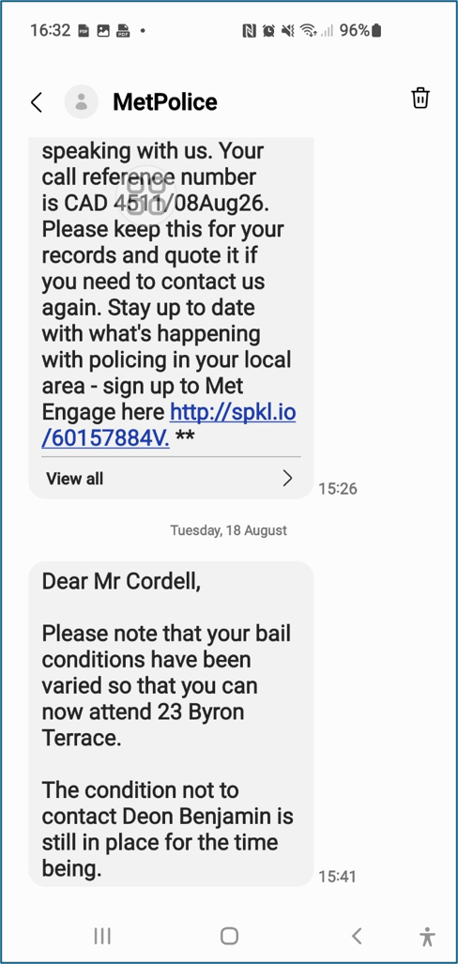
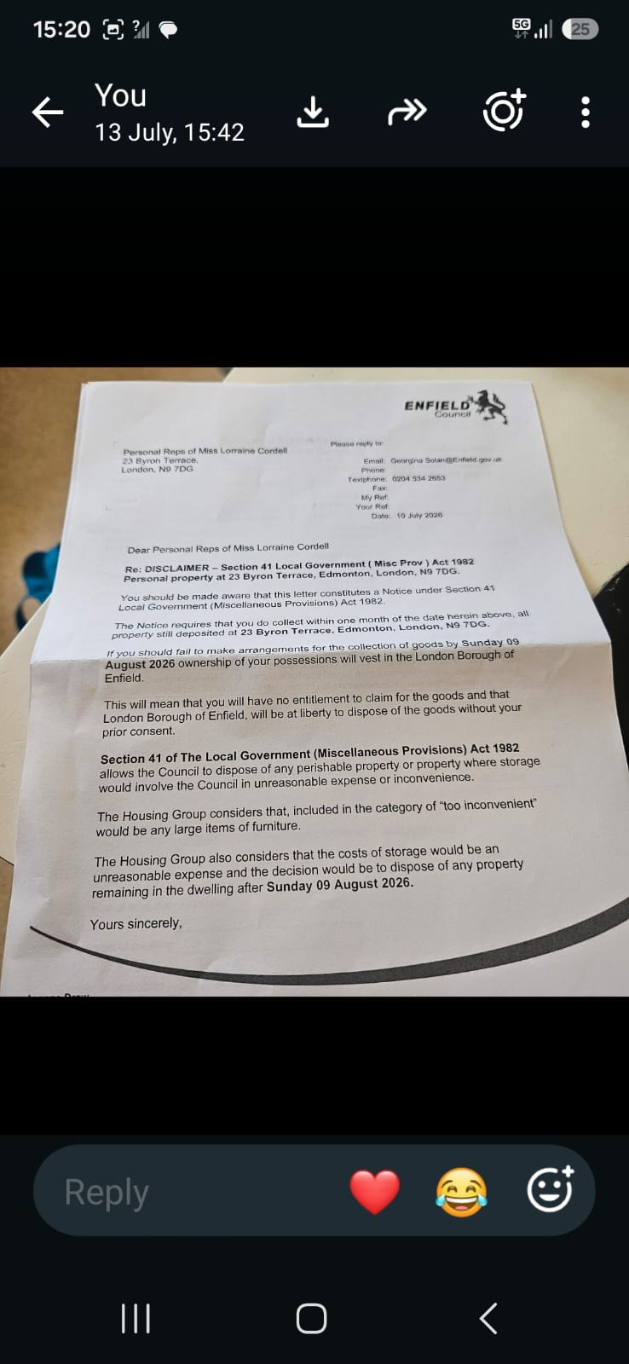

Here: Received 18-08-26
Sent by aunt what’s app. After I OCR image
Personal Reps of Miss Lorraine Cordell 23 Byron Terrace
PLEASE REPLY TO
Email: Georgina Solan
Telephone: 0204 504 2653
Fax:
My Ref:
Your Ref:
Date: 10 July 2026
London
N9 7DG

Dear Personal Reps of Miss Lorraine Cordell

Re: DISCLAIMER — Section 41 Local Government (Misc. Prov) Act 1982 Personal property at 23 Byron Terrace. Edmonton. London. N9 7DG
You should be made aware that this letter constitutes a Notice under Section 41 Local Government (Miscellaneous Provisions) Act 1982.
The Notion requires that you do collect within one month of the date hemin above. All property is still deposited at 23 Byron Terrace. Edmonton. London. N9 TOG.
If you should fail to make arrangements for the collection of your goods by Sunday 09 August 2026 ownership of your
of your possessions will vest in the London Borough of Enfield.
This will mean that you will have no entitlement to claim for the goods and that London Borough of Enfield will be at liberty to dispose of the goods without your prior consent.
Section 41 of The Local Government (Miscellaneous Provisions) Act 1982 allows the Council to dispose of any perishable property or property where storage would involve the Council in unreasonable expense or inconvenience.
The Housing Group considers that. Included In the category of loo inconvenient' would be any large items of furniture.
The Housing Group also considers that the costs of storage would be an unreasonable expense, and the decision would be to dispose of any property remaining in the dwelling after Sunday 09 August 2026.
Yours sincerely.

“Reading that notice broke my heart due to what she has done!”
It explained why the home had been emptied. It said all property at 23 Byron Terrace had to be collected within one month, and if not, the council would take ownership and dispose of it. It said large items were “Too Inconvenient” and storage was “Too Expensive,” and it will become council property. It was the first time I realised Sheila had received this notice, acted on it, and never told me — while I was legally blocked from entering the home and had no chance to protect anything.
After understanding what happened, I wrote an official complaint explaining everything I had discovered.

Exhibit Below A4:

URGENT
FORMAL COMPLAINT
COMPLAINANT
Name: Mr. Simon Paul Cordell
Address: 23 Byron Terrace,
Hertford Road,
Edmonton,
London
N9 7DG
Email: re_wired@ymail.com
Tel: 07864 217 519

RESPONDENT
Enfield Council Housing & Regeneration: Edmonton Centre, 36-44 South Mall, Edmonton Green, N9 0TN.

OFFICER SUBJECT TO COMPLAINT
Georgina Solan,
Resident Relationship Officer
Email: georgina.solan@enfield.gov.uk
Tel: 0204 534 2653

EXECUTIVE SUMMARY

This complaint concerns “Gross Misconduct by Enfield Council Officer Georgina Solan, Who:
- Deliberately Misrepresented Housing Law to Metropolitan Police: (17 May 2026), causing my unlawful exclusion from my home under false bail conditions!
- Fraudulently Misled Me: (10 July 2026) that my succession application was "Under Review" while simultaneously issuing a Section 41 notice to hostile third parties to dispose of my property
- Bypassed Me Entirely: the lawful applicant and bereaved son, to deal with my estranged sister, knowing I was legally barred from accessing the property due to her own actions!
- Caused Loss Of £100,000+ Property: including comic collection, £30,000 cash, and destruction of my mother's home!
This was more than negligence. This was intentional harm through procedural manipulation.

CHRONOLOGY OF GROSS MISCONDUCT

PHASE 1: THE SETUP (Enfield Councils Housing Staff Concealment of Rights)
Date |  | Events + Misconduct & Legal Errors | File Name
7 April 2026 | Event:  My mother, Miss Lorraine Cordell, passes Away. I am her eldest son, living at 23 Byron Terrace as my only and principal home  Misconduct & Legal Errors  Nothing yet — but Council records show I was known as household member as Exhibited Below! |  | N/a
11 May 2026, 08:59 | Event:  I phone Enfield Council to report death and request succession process  Misconduct & Legal Errors:  Customer service creates internal requests but no reference number  Administrative gap created |  | N/a
11 May 2026, 12:54 | Event:  I send formal email requesting succession  Misconduct & Legal Errors:  I explicitly state: "I have lived at 23 Byron Terrace as part of the household for many years. All my official correspondence (council, police, DWP, banks, NHS) is addressed to this property." |  | 01. Sent.pdf  01.1. Sent.pdf  02. Received.pdf
11 May 2026, 15:32 | Event:  Georgina Solan responds to my succession request  Misconduct & Legal Errors:  Deliberate concealment of statutory rights. Despite my explicit statement that I lived at 23 Byron Terrace for years with all official correspondence addressed there, She Fails to inform me that I am a protected occupant with immediate right to remain under Housing Act 1985. By withholding this critical information, she ensured that I did not assert my rights, making me vulnerable to exclusion. She treats the property as vacant and me as a trespasser, laying groundwork for the false narrative she gives police six days later.  - Deliberate or reckless omission of statutory rights  - Breach of duty to advise vulnerable resident  - Breach of Housing Act 1985, s.87  - Breach of Enfield Council Tenancy Policy Section 3.11  Constructive fraud — creating conditions for harm by concealment |  | 03. Received.pdf
17 May 2026 | Event:  CRITICAL: EMAIL TO MET POLICE  Misconduct & Legal Errors:  Deliberate misrepresentation of housing law.  Georgina Solan sends email to Metropolitan Police with this false legal statement:  She writes: "Until a succession application is submitted, assessed, and approved, Mr. Cordell has no confirmed legal right of occupation under the tenancy."  This is legally false. Under Housing Act 1985 s.87, I had immediate right to occupy as family member living at property as my principal home.  This false statement directly caused my exclusion via police bail conditions.  - Deliberate misrepresentation of housing law to police  - Breach of statutory duty  Caused my unlawful exclusion |  | 0. 1Met & Council Police Cad.pdf
18 May 2026 | Event:  I submit completed succession application and supporting statement  Misconduct & Legal Errors:  I provide evidence of 39 years residence, care for mothers, disability needs, court order requiring 2-bedroom property |  | 04. Sent 18-05-26.pdf  04.1. New Succession application 18-05-26.pdf  04.2. Housing Succession Request 18-05-26.pdf  05. Received.pdf
19 May 2026 | Event:  I provide extensive ID and evidence  Misconduct & Legal Errors:  Eleven Folders of documents proving residence at 23 Byron Terrace |  | 06. Sent 19-05-26.pdf  07. Received.pdf  08. Sent 19-05-26.pdf
20 May 2026 | Event:  Notice to Quit served  Georgina Solan emails me  Misconduct & Legal Errors:  Premature hostile action.  She States: "A Notice to Quit was served on the property yesterday" and "'Left in Occupation' account will be set up"  This was NOT standard procedure. She accelerated termination of the secure tenancy before succession decision, while police exclusion was being enforced based on her false 17 May email. The "Left in Occupation" account transformed me from protected family members with succession rights into commercial license with no security, deliberately degrading my legal status to facilitate my eventual exclusion and defeat my succession claim.  She told me this was "standard procedure to take deceased person's name off” this was misleading. The proper procedure is to maintain the tenancy pending succession assessment, not terminating it.  - Premature hostile action against bereaved resident applicants  - Serving Notice to Quit while succession pending is improper and prejudicial  - Deliberate degradation of legal status  - Misrepresentation of procedure  - Breach of Housing Ombudsman guidance  Breach of duty to preserve status quo pending decision |  | 09. Received 20-05-26.pdf
20 May 2026 | Event:  I provide interim death certificate and explain need for 2nd bedroom due to disability/care needs  Misconduct & Legal Errors:  I Explained The 2018 Edmonton Lower Court Order Due To Enfield Council Requesting It from The Start Against Me and the new police, bail restrictions due to Deon my sisters case and, my vulnerability at 109 Burncroft Avenue.  She ignores safeguarding duty |  | 10. Sent 20-05-26.pdf  11. Received 20-05-26.pdf  12. Sent 20-05-26.pdf  13. Sent 20-05-26.pdf  14. Sent 20-05-26 New Email Used.pdf  15. Received 12-06-26.pdf  16. Sent 16-06-26.pdf  17. Sent 16-06-26.pdf

PHASE 2: THE EXCLUSION (Active Harm — Police Bail Based on Her False Advice)
Date | Events + Misconduct & Legal Errors | Files
May-June 2026 | Event:  Police enforce bail conditions excluding me from 23 Byron Terrace  Misconduct & Legal Errors:  Joint Council-Police Misconduct. DS Johnson relies on her 17 May email to justify exclusion.  I am made homeless, unable to access belongings, manage mother's estate, or secure property.  - Council and Police joint misconduct  PACE 1984 breach — police interfering in civil housing
23 June 2026 | Event:  I sent urgent email begging for confirmation of my rights  Misconduct & Legal Errors:  No response for 48+ hours  Deliberate delay while I am homeless and at risk | 18. Sent 23-06-26.pdf  19. Sent 25-06-26.pdf
26 June 2026 | Event:  Georgina Solan denies succession  Misconduct & Legal Errors:  Email states: "Your succession application has been reviewed by management and has been denied as you do not fulfil the criteria for succession due to having your own tenancy at 109 Burncroft Avenue" "This means that you have no legal right of occupation of 23 Byron Terrace"  When holding another tenancy does not bar succession.  - Legally Wrong Reason — Holding Another Tenancy Does Not Bar Succession  - Contradicts Housing Act 1985, S.87-88  Contradicts Housing Ombudsman precedent (L&Q 202127252) | 20. Received 26-06-26.pdf
8 July 2026 | Event:  I appeal with case law, Ombudsman decisions, offer to surrender Burncroft tenancy  Misconduct & Legal Errors:  I Provide:  - London & Quadrant,  - Islington v Boyle,  - Crawley BC v Sawyer,  - Shelter guidance.  Explain Burncroft is unsafe, inaccessible due to bail/restraining order, medically unsuitable per 2018 court order  - She ignores all legal arguments.  Closed mind — predetermined decision | 21. Sent 26-06-26.pdf  22. Sent 30-06-26.pdf
02nd July 2026 | Event:  Misconduct & Legal Errors:  She appreciates that I feel anxious about me  current circumstances.  The Council has considered the information available regarding your occupation of 23 Byron  Terrace. As previously advised, you do not have succession rights to this tenancy and  Therefore, do not have a legal right to succeed in the tenancy at 23 Byron Terrace.  The Council's records confirm that you remain the tenant at 109 Burncroft Avenue. Whilst you  have outlined concerns regarding that property and your personal circumstances, the Council  is not aware of any legal restriction that prevents you from returning to and occupying your  own tenancy address.  The matters you have raised regarding neighbour disputes, court proceedings and personal  Safety concerns do not alter the Council's decision regarding succession at 23 Byron Terrace | 23. Received 02-07-26.pdf

PHASE 3: THE DECEPTION (Same-Day Fraud — 10 July 2026)
Date | Events + Misconduct & Legal Errors | Files
 | Event:  Misconduct & Legal Errors:  - Formal review requested: You explicitly requested a formal reconsideration of the succession decision for 23 Byron Terrace.  - Council failed to consider law/evidence earlier: You state the Council did not consider the legal position or the evidence when you previously asked for a review.  - Legal authorities supplied: You provided specific legal authorities and attached them:  - Housing Ombudsman L&Q decision – confirms a second tenancy does not prevent succession; landlord must assess actual occupation and principal home.  - Housing Act 1985 ss.87–88 – the only test is whether you occupied 23 Byron Terrace as your only or principal home.  - Crawley BC v Sawyer (1988) – principal home is a factual test.  - Islington LBC v Boyle [2011] – registration elsewhere does not determine principal home.  - Camden LBC v Goldenberg (1996) – another tenancy does **not automatically bar succession.  - Council’s stated reason is legally wrong: You directly challenge Georgina’s position that your tenancy at 109 Burncroft automatically disqualifies you from succession, stating this is not supported by:  - The Housing Act 1985  - The L&Q Ombudsman decision  - The case law cited  - Correct legal test clearly set out: You clearly state the correct legal test:  - The issue is principal home, not the mere existence of another tenancy.  - The Council must assess actual occupation, not rely on assumptions.  - Specific requests made to the Council:  - A lawful reconsideration applying the correct statutory test under ss.87–88 Housing Act 1985.  - Confirmation that the Council will now assess principal home properly, instead of assuming another tenancy bars succession.  - Proof of proper, structured challenge: The email shows you:  - Used case law and Ombudsman precedent.  - Identified the exact legal error in the Council’s reasoning.  - Requested a lawful reassessment, not just a general complaint.  - Asked for receipt confirmation and acknowledgment of the attached authorities. | 24. Sent 06-07-26 Mum Housing Rules1.pdf  24.1. 1Mum Housing Rules1.pdf  25. Sent 06-07-26 1Mum Housing Rules1.pdf
8 July 2026 | Event:  "Final position" email  Misconduct & Legal Errors:  EMAIL 26 — WHAT IT PROVES  (08-07-26 — Georgina Solan)  - Self-contradicting — cannot have considered "Wider Evidence" AND demand "significant new evidence"  PROCEDURAL UNFAIRNESS  1. They admit receiving my evidence but refused to consider it  They literally say:  “I have noted the concerns… I have also acknowledged the legal arguments and case law…”  So, they:  - Admit They Received Everything,  - Admit They Read Everything,  - Admit They Saw the Case Law,  - Admit They Saw the Medical, Legal, And Personal Evidence…  …and still ignored all of it.  That is procedural unfairness, maladministration, and a breach of statutory duty.  2. They admit their first refusal reason was unlawful  They write:  “The existence of another tenancy does not, in itself, automatically prevent succession.”  This destroys their first refusal reason.  It proves:  - Their First Refusal Was Legally Wrong,  - They Knew It Was Wrong,  - They Changed the Reason Only After I Disproved It.  This is shifting grounds, bad faith, and abuse of process.  3. They claim they considered “wider evidence” — but this is false  They say:  “The Council has considered the wider evidence available…”  But:  - They Never Asked Me for More Evidence,  - They Never Identified Missing Evidence,  - They Never Logged My Succession Application,  - Staff Later Confirmed No Succession Case Exists on The System.  So “wider evidence” was never reviewed.  This is:  - Procedural Defect,  - Dishonesty,  - Predetermination,  - Breach Of Statutory Duty.  4. They admit they used Burncroft against me  They say:  “The continued holding of another tenancy is one factor…”  They admit they used Burncroft as a negative factor even after admitting it carries no legal weight.  This is misapplication of law.  5. They refused to consider my vulnerability, displacement, bail restrictions, or court orders  They say:  “These issues are separate…”  They refused to consider:  - My Displacement Caused by Police Bail (Which They Caused),  - My Safeguarding Needs,  - The 2018 Court Order Requiring Rehousing,  - My Medical Evidence,  - My Dependency on My Mother,  - My Inability to Return to Burncroft Due To Restraining Orders and Danger.  This breaches:  - Housing Act 1985,  - Equality Act 2010,  - Care Act 2014,  - Public Sector Equality Duty,  - Basic Safeguarding Obligations.  6. They declare the decision “final” without issuing a lawful decision  They say:  “This correspondence constitutes the Council’s final position…”  But:  - No Section 202 Rights,  - No Lawful Refusal Letter,  - No Authorised Officer,  - No Panel,  - No Minutes,  - No Logged Succession Case.  This is ultra vires — acting outside legal authority.  7. They contradict themselves inside the same email  They say:  “Unless significant new evidence is provided…”  But also:  “The Council has considered the wider evidence available…”  They cannot claim they considered “wider evidence” while also demanding “significant new evidence”.  This contradiction proves:  - They Did Not Consider All Evidence,  - The Decision Was Made Without Full Facts,  - The Decision Is Unlawful.  8. They tell me to seek legal advice — meaning they know the decision is unsafe  When a council tells a resident to seek legal advice, it means:  - They Know the Decision Is Challengeable,  - They Know It Is Procedurally Defective,  - They Know They Cannot Defend It Internally.  This is an implicit admission of fault.  9. They wrongly state I have no right of occupation  They say:  “You do not have a legal right of occupation…”  This is legally false.  Under Housing Act 1985:  - I Had the Right to Occupy Until a Lawful Succession Decision Was Made.  - They Removed Me Unlawfully.  - They Misled Police, Causing Bail Conditions and Exclusion.  This is joint agency misconduct.  10. They treat harassment, displacement, and bail restrictions as irrelevant  They say:  “These issues are separate…”  They refused to consider:  - Why I Was Displaced,  - Why I Could Not Physically Occupy the Home,  - That Their Own Misinformation Caused the Bail Restrictions,  - That Their Actions Directly Prevented Me from Meeting the Succession Test.  This is irrational decision-making and maladministration. | 26. Received 08-07-26.pdf
09 July  2026 | Event:  Misconduct & Legal Errors:  1. Only ONE reason for denial was given for 62 days  - From 07 May 2026 To 08 July 2026 (62 Days Total), Georgina Provided Only One Reason for Denying Succession: “You Cannot Succeed Because You Hold a Tenancy At 109 Burncroft Avenue.”  - This Was Repeated Consistently and Was the Sole Reason Given Throughout That Entire 62-Day Period.  - This Reason Is Legally Incorrect Under the Housing Act 1985.  2. A second reason was introduced much later — without warning  - After The 62-Day Period, The Council Suddenly Claimed: “You Did Not Provide Enough Evidence to Prove 23 Byron Terrace Was Your Primary Home.”  - This Second Reason Was Never Mentioned at Any Earlier Stage.  - No Request for Additional Evidence Was Ever Made Before This New Reason Appeared.  3. No second reason was ever communicated during the succession process  - Between 11 May 2026 (First Request) And 08 July 2026, Not A Single Email Mentions Any Issue with Evidence or Principal Home Status.  - The Council Never Asked for More Evidence.  - The Council Never Stated That Evidence Was Insufficient.  - The Council Never Indicated That a Second Reason Existed.  4. The late introduction of a second reason caused unnecessary delay during bereavement  - The Council Allowed 62 Days to Pass While I Was Grieving, Without Disclosing That They Intended to Rely on A Second Reason.  - This Prevented Me from Addressing the Issue Earlier and Prolonged the Process.  5. Part 1 proves statutory and procedural failures  Part 1 demonstrates that:  - The Succession Application Was Never Submitted to A Panel.  - No Minutes Exist.  - No Authorised Landlord Decision Letter Was Issued.  - No Appeal Rights Were Provided.  - The Council Applied the Wrong Legal Test.  - The Council Failed to Follow the Housing Act 1985.  - The Council Failed to Follow Required Succession Procedure.  6. Part 2 proves the evidential basis for succession  Part 2 summarises exhibits showing:  - Long-Term Residence At 23 Byron Terrace.  - Dependency On My Mother.  - Displacement From 109 Burncroft Avenue.  - Vulnerability And Safeguarding Concerns.  - Court Orders Confirming Unsuitability Of 109 Burncroft.  - Evidence Of Principal Home Status.  - Evidence Of Daily Living, Correspondence, And Official Records Tied To 23 Byron Terrace.  7. The Council’s new reason contradicts their own earlier correspondence  - All Earlier Emails Confirm They Believed the Case Was Decided Solely Because Of Burncroft.  - The Sudden Introduction Of “Insufficient Evidence” Contradicts Their Previous Position.  - This Contradiction Is Clearly Visible in The Email Chain. | 27. Sent -09-07-26.pdf  27.1. Sent Pt1 of 2 -09-07-26.pdf  27.2. Sent Pt2 of 2 -09-07-26.pdf  27.3. Sent -09-07-26.pdf  Evidence Clearer:  <Dir> 28.1. All Sent Before
10 July  2026 | Event:  Misconduct & Legal Errors:  Morning/Afternoon  To Me: "However, we will review the matter and include your latest evidence. I will update you on the outcome."  1. They admit receiving my formal challenge and evidence  She says:  “I acknowledge receipt of your formal challenge and the detailed points you have raised.”  This proves:  - They Received My Challenge.  - They Received My Evidence.  - They Cannot Claim Ignorance or Missing Documents Later.  2. They claim they are authorised under Housing Act 1985 & 1996  She says:  “I and my managers are authorised… under the Housing Act 1985 and 1996…”  This proves:  - She Is Claiming Legal Authority to Make Succession Decisions.  - She Is Claiming Her “Managers” Have Legal Authority.  - But She Still Did Not Follow the Statutory Succession Process.  - No Panel, No Minutes, No Section 202 Rights, No Lawful Decision Letter.  This is ultra vires as she was acting outside of their legal power.  3. She claims “procedural fairness and transparency” while doing the opposite  She says:  “I understand the importance of procedural fairness and transparency…”  But:  - No Succession Case Was Logged. While she mislead me otherwise!  - No Panel Ever Reviewed My Case.  - No Appeal Rights Were Issued.  - No Lawful Decision Letter Was Provided.  - No Evidence Was Reviewed.  - They Communicated with Unauthorised Third Parties Instead of Me.  This is False Transparency, False Fairness, And Maladministration.  4. She admits my evidence was noted by her and her managers but refuses to change the outcome  She says:  “Your evidence and representations have been noted but does not change the outcome…”  This proves:  - They Ignored My Evidence.  - The Decision Was Predetermined.  - They Refused to Consider Legally Relevant Facts.  - They Refused to Consider Medical, Legal, And Personal Circumstances.  This is Procedural Unfairness and Breach of Statutory Duty.  5. She contradicts herself by saying the decision is final AND will be reviewed  She says:  “Does not change the outcome…”  But then:  “We will review the matter and include your latest evidence.”  This is a Direct Contradiction.  It Proves:  - The Decision Was Not Final.  - The Decision Was Not Based on Full Evidence.  - They Admitted They Had Not Reviewed Everything.  - They Admitted They Needed to Re-Review the Case.  Her Contradiction Alone Makes the Decision Unlawful.  6. She promises an update to me but never provided one  She says:  “I will update you on the outcome.”  But:  - No Update Was Ever Given.  - No Lawful Decision Letter Was Ever Issued.  - No Section 202 Rights Were Ever Provided.  - No Panel Minutes Exist.  This Is Failure to Communicate, Failure to Follow Procedure, And Maladministration.  7. She confirms the Council is acting on a predetermined outcome  She says:  “Does not change the outcome…”  This proves:  - They Made the Decision BEFORE Reviewing Evidence.  - They Refused to Consider New Evidence.  - They Refused to Consider Legal Authorities.  - They Refused to Consider Safeguarding or Displacement.  This is Predetermination and Abuse of Process.  8. She claims authority but fails to follow statutory succession procedure  She claims:  - She Is Authorised.  - Her Managers Are Authorised.  - They Act Under Housing Act 1985 & 1996.  But:  - No Landlord Decision.  - No Panel.  - No Minutes.  - No Appeal Rights.  - No Lawful Refusal Letter.  This is Acting Outside Legal Authority.  9. She confirms the Council ignored the legal test for succession  She does NOT mention:  - Principal Home Test,  - Household Member Test,  - Right To Occupy Pending Determination,  - Statutory Succession Criteria.  She simply repeats the refusal without legal basis.  This Is Misapplication of Law.  10. She acknowledges my evidence but refuses to consider it  She says:  “Your evidence… has been noted…”  But:  - She Did Not Review It.  - She Did Not Submit It to A Panel.  - She Did Not Log the Succession Case.  - She Did Not Provide Appeal Rights.  This Is Procedural Defect and Maladministration.  Finaly she states as prior mentioned about the following:  Morning/Afternoon  To Me: "However, we will review the matter and include your latest evidence. I will update you on the outcome." However, she does not respond back to me.  THE REAL FAILURE OF HOW GEORGINA SOLAN, DS ROBERT JOHNSTON & ALINA KNOX CAUSED EVERYTHING BY IGNORING OUR SAFEGUARDING FLAGS, OUR CALATROL HISTORIES, OUR EXHIBITED EVIDENCE, AND THE DANGER-ZONE DISTANCE  1. Both me and My Sister Deon have safeguarding flags and colterol histories on The Police and Councils systems and long before any of this happened  If ANY of them had checked the Official Records properly, they would have seen:  My safeguarding history included:  - Colterol Markers  - Vulnerability Flags  - Displacement Caused by Police Bail  - Restrictions Preventing Me from Returning to Burncroft  - Dependency On My Mother  - Tenancy Rights Pending Succession  - Risk Markers from Previous Incidents  Deon’s safeguarding history included:  - A Violent Machete Attack In 2017  - Police Warnings She Could Not Return to Her Secure Tenancy  - L&Q Confirming She Was Unsafe  - Risk Assessments Confirming Danger  - Temporary Accommodation Placement  - Colterol Markers  - Vulnerability Flags  Our exhibited evidence of Deon’s colterol history proves she was a safeguarded person, displaced from her secure tenancy, and “NOT Allowed to Reside in The Danger Zone,” of her flat, number Tennyson Close!  All of this was already on their systems.  None of them checked it as they must!  2. Deon was NOT “homeless” as she was in temporary accommodation because she could not return to her secure tenancy at 7 Tennyson Close due to the machete attack  Her secure tenancy address:  7 Tennyson Close, Scotland Green Road, Ponders End, EN3 4SN  She was Not Allowed to Return Because:  - She Was Attacked with A Machete  - Police Confirmed Danger  - L&Q Confirmed Danger  - Risk Assessments Confirmed Danger  - Safeguarding Confirmed Danger  She was placed in TEMPORARY ACCOMMODATION for protection.  “She Was NOT Living At 23 Byron Terrace as This Addressed Is in The Dager Zone!” She was NOT a successor to the address as well. She was NOT a tenant. She was NOT authorised to live there.  Georgina ignored this. DS Johnston ignored this. Alina Knox ignored this.  3. The DISTANCE proves the safeguarding breach Police and Council and makes their failure an urgent issue of concern that must be addressed.  23 Byron Terrace  17 7 Tennyson Close = 0.8 miles (Approx. 8 Minutes Walking, With Short Cuts.)  This means:  - They Placed Her Back in The SAME Danger Zone  - They Placed Her Within Walking Distance of The Attackers  - They Placed Her in The SAME Borough She Was Fleeing From  - They Placed Her in The SAME Area Police Said She Could Not Return To  - They Placed Her Only 11 Minutes Away from The Machete Attack Location  This is a Gross Misconduct Safeguarding Failure by BOTH Council and Police.  This distance alone proves:  - Deon was NOT safe.  - Deon was NOT protected.  - Deon was NOT supported.  - Deon was NOT meant to be anywhere near Byron Terrace as a fixed abode!  Our exhibited evidence of Deon’s colterol history proves she was to be a safeguarded person who was barred from residing in the danger zone, especially anywhere within walking distance of 7 Tennyson Close where the machete attack took place.  Yet Georgina and DS Johnston acted like she was allowed to live there.  4. The police called Georgina and she STILL failed to check ANY systems before she gave them wrong legal advice  Here is the truth:  The police called Georgina first.  We don’t know if she checked the system there and then while on the telephone or if she replied afterward the call made by the Police OIC but no matter what, she gave them wrong law.  She Told Police:  “He has no legal right to occupy the property.”  This was false.  Under succession law, I had full legal right to occupy 23 Byron Terrace until court proceedings were completed.  She misapplied the law. She misinformed police. She caused the bail conditions.  She also failed to check:  - My Safeguarding History  - Deon’s Safeguarding History  - My Colterol History  - Deon’s Colterol History  - My Tenancy Rights  - Deon’s Temporary Accommodation  - Deon’s Secure Tenancy Restrictions  - Deon’s Risk Assessments  - My Displacement Caused by Bail  - Deon’s Dependency on My Mother  - Household Composition  - Homelessness Records  - Transfer Requests  - Police Warnings  - Medical Evidence  If she DID check, then it is Gross Misconduct. If she DIDN’T check, then it is Negligence.  Either way She Caused the Damage.  5. Georgina misidentified who she was dealing with to police and caused the entire chain reaction  When she finally checked the tenancy system, she realised:  - The Tenancy Belonged to My Mother  - The Lawful Successor is Me  - I Was the Eldest Child and therefore the most responsible in most cases.  - Deon Was the Youngest and already being accommodated as housed!  - Deon Was Not a Tenant nor had she requested to succuss a premises she could not.  - Deon Was Not a Successor  - Deon Had No Legal Right to Occupy 23 Byron Terrace considering our colterol history held across Government Systems.  But she had ALREADY told police:  The only person with legal occupation according to the tenancy was my deceased mother.  And Further Mislead Me That the Following Is Not Mandatory Law for Them to Comply With: After my mother sadly passed away, the tenancy entered the statutory succession period, which means I had a legal right to remain in occupation until the Council carried out a lawful succession assessment and issued a formal decision.  Georgina misapplied the law by telling police I had “no legal right of occupation,” even though succession law protects the occupant until the process is completed. Her failure to check my name, my safeguarding history, my colterol history, and the tenancy rules caused the police to continue to impose unlawful bail conditions based on incorrect Housing Law.  And due to this my bail conditions were refused to be changed  “Allowing Deon to stay at 23 Byron Terrace,” My Home!  This was false.  She mixed us up. She treated Deon as the legal occupying tenant, while she treated me as the trespasser.  This is Georgina’s negligence.  6. Deon admitted she pre-planned to come to 23 Byron to set me up and Georgina & DS Johnston STILL acted against me  I Exhibited:  - Audio Recordings  - Video Recordings  - Her Own Admissions  She Admitted:  - She Was Living in Temporary Accommodation  - She Was Not Living At 23 Byron  - She Pre-Planned Arriving At 23 Byron  - She Fabricated Allegations  - She Intended to Set You Up  I gave this evidence to DS Johnston & Co.  He ignored it. Alina Knox ignored it. Georgina ignored it.  This is police negligence AND council negligence.  7. DS Johnston ignored overwhelming evidence and imposed bail anyway  I provided:  - Proof 23 Byron Was Your Primary Home  - Proof You Lived There  - Proof You Had Tenancy Rights  - Proof Deon Was Not Living There  - Proof Deon Had Temporary Accommodation  - Proof Deon Had Keys to Two Other Flats  - Proof Deon Was a Part-Share Homeowner  - Proof Deon Fabricated Her Allegation  - Proof Deon Admitted She Was Not Living At 23  - Proof Deon Admitted She Pre-Planned the Incident  DS Johnston & Co all ignored it all allowing this to continue!  He imposed bail anyway.  He Failed to Check:  - My Need for Safeguarding Based Upon My History  - Deon’s Safeguarding History  - My Colterol History  - Deon’s Caltrop History  - My Tenancy Rights  - Deon’s Temporary Accommodation  - Deon’s Secure Tenancy Restrictions.  This is DS Johnston’s negligence.  FINAL BUILT VERSION — DIRECTLY PINNING BLAME ON GEORGINA, DS JOHNSTON & ALINA KNOX  Both me and Deon had safeguarding flags, colterol histories, and risk markers on police and council systems long before any of this happened. Our exhibited evidence of Deon’s caltrop history proves she was a safeguarded person, displaced from her secure tenancy, and NOT allowed to reside in the danger zone. Deon was not homeless — she was in temporary accommodation because she could not return to her secure tenancy at 7 Tennyson Close due to a violent machete attack. She was placed dangerously close to the attack location, only 0.8 miles (11–15 minutes walking), which is a direct safeguarding breach. The police called Georgina, and she gave them wrong legal advice without checking ANY systems — misinforming them that I had no legal right to occupy 23 Byron Terrace. She failed to check my safeguarding history, Deon’s safeguarding history, our colterol histories, her temporary accommodation status, her secure tenancy restrictions, and my legal right to occupy pending succession. DS Johnston and Alina Knox ignored the same records and imposed bail conditions that should never have existed. Their combined failure caused every unlawful action that followed. | Email 29,  10 July 2026  29. Received 10-07-26.pdf  <Dir> 29. A Received Si Mum DB All Housing Files
07  August  2026 | Event:  I RECEIVED TEXT MESSAGES FROM MY SISTER & HER BOYFRIEND.  Misconduct & Legal Errors:  On 07 August 2026, two days before my bail date of 09 August 2026, I contacted my solicitor because they still had not been able to reach the officers handling my case. I provided them with the officers’ email addresses myself. Later that same day, my solicitor telephoned me to confirm that the officers had finally responded — and that I had now been re-bailed again, this time until 11 November 2026. This was the first time I was informed of this extension.  Around the same period, I also received further unwanted telephone calls from my sister Deon and her boyfriend Jimmy on 01 August 2026 and 03 August 2026, which are evidenced in my WhatsApp records and stored in my documented timeline folder. These calls continued the pattern of harassment and pressure that had already been reported to the police and also show that my sister has told me herself to go back to my home and collect my stuff if the council are taking it away as she is not allowed it as her history already proved. What the officers done her with my bail conditions is horrific and devastating to my life.  Deon 01/08/2026:  Deon More Calls 01-08-26  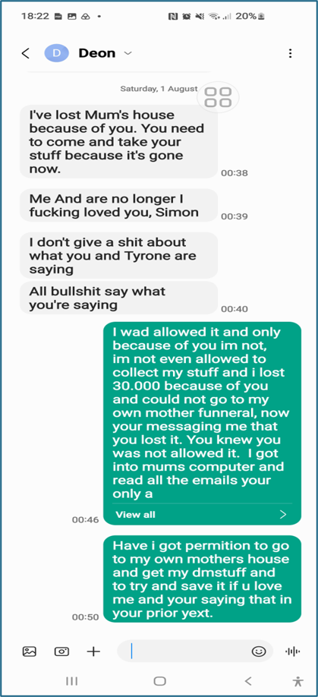  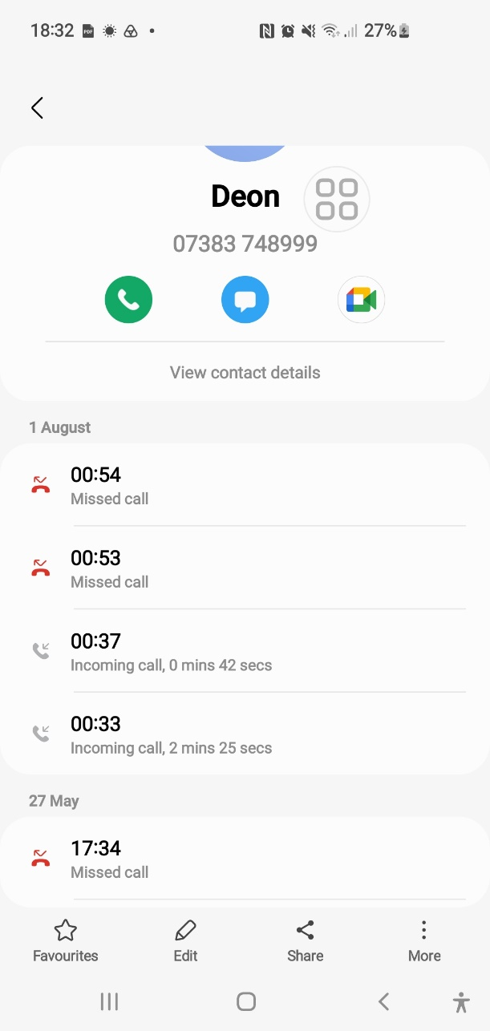  Jimmy 01/08/2026:  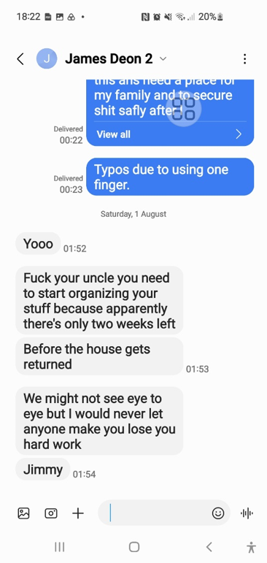 | As Exhibited in 0J:  03. Deon and Jimmy 01-08-26  http://everyoneloginto.me:90/15.%20DB%20  23%20Byron%20My%20Home%20Folder%2  028-04-26/04.%20Whats%20Happened/
12th of August 2026 | Event:  My urgent warning to all parties  Misconduct & Legal Errors:  SENT & RECEIVED FILES  - A1. Draft Formal Email.pdf  - A1. Formal Attachment .pdf  “Used Below, do not Read!”  - A1. Intro.docx  “Admin Note of what’s about to happen and why!”  - A1. Sent -12-08-26.pdf  “This is the First Email I Sent with 2 Attachments as Below and I used Yahoo to send the Files!”  Notes Are: I cannot be sure if these files were received as Yahoo tends not to send email to Government Staff.  - A2.1 Sent Email Part Two 13-08-26.pdf  “Part 1 Attachment to Email Above!”  Notes Are: The Same as Above, I used Yahoo.  - A2.2. WhatsApp Chat Sent to me From Deon and Aunt Shelia.pdf  “Part 2 Attachment to Email & Attachment Above!”  Notes Are: The Same as Above, I used Yahoo.  - <Dir> Files ID  These files were enhanced and re sent due to the second reason Enfield Council Management gave Housing Officer Georgina to refuse me. I also offered my evidenc4 if required to prove 23 Byron Terrance is my Primary Home, but no one ever asked for anymore! | MAIN COMBINED FILE.  31. A10. I love pdf merged (1).pdf  SENT & RECEIVED FILES  - A1. Draft Formal Email.pdf  - A1. Formal Attachment .pdf  - A1. Intro.docx  - A1. Sent -12-08-26.pdf  - A2.1 Sent Email Part Two 13-08-26.pdf  - A2.2. WhatsApp Chat Sent to me From Deon and Aunt Shelia.pdf  - <Dir> Files ID
12th of August 2026 | Event:  Misconduct & Legal Errors:  Joining This Succession Case and The Police Case Together Officially as They Are Stopping Me from Going to My Primary Home 23 Byron Terrace Wrongfully All Together!  I sent the files I built above again but with the use of outlook email provider rather than Yahoo, as Yahoo tends to Mail Failure to Government Officials!  My Complaints Were Emailed To: Georgina Solan, DS Johnston, Alina Knox and my solicitor:  Subject: "URGENT + IMMEDIATE FREEZE STOP REQUIRED” explicitly stating any removal would be unlawful.  The Enfield Councils Housing Officer Handling My Case Ignores This Legal Notice.  - 30. Notes Succession Rights in Social Housing_ England & Wales Guide.pdf  - 30. Sent -12-08-26.pdf  - 30.1. Formal Attachment.pdf | - 30. Notes Succession Rights in Social Housing_ England & Wales Guide.pdf  - 30. Sent -12-08-26.pdf  - 30.1. Formal Attachment.pdf
13th of August 2026 | Event:  Misconduct & Legal Errors:  A3. Sent to All 13-08-26.pdf  “This is the Second Email I Sent!”  Notes Are: I Used Outlook to be 100% Sure it was sent! | A3. Sent to All 13-08-26.pdf
13th of August 2026 | Event:  Misconduct & Legal Errors:  - A4.1. Screenshot_13-8-2026_141326_www.housing-ombudsman.org.uk.jpeg  - A4.2. Screenshot_13-8-2026_141415_www.housing-ombudsman.org.uk.jpeg  “This Is Me Requesting for Housing Ombudsman Support!”  Notes Are: Self-explanatory. | - A4.1. Screenshot_13-8-2026_141326_www.housing-ombudsman.org.uk.jpeg  - A4.2. Screenshot_13-8-2026_141415_www.housing-ombudsman.org.uk.jpeg
13th of August 2026 | Event:  Misconduct & Legal Errors:  A5. First Contact.pdf  “I Telephoned the Police Officers in Charge and These Are My Official Notes of Those Two Calls!”  Notes Are: I telephoned the DS in charge of the case and got through to him. He sent an email to the OIC in the case due to what Deon had text me asking her to contact Deon and the council to confirm I can go back to my home. He also said that the OIC will then afterwards contact me and this should be in the morning as to an update about the bail variation requests! | A5. First Contact.pdf
14th of August 2026 | Event:  Misconduct & Legal Errors:
15th of August 2026 | Event:  Misconduct & Legal Errors:
16th of August 2026 | Event:  Misconduct & Legal Errors:
17th of August 2026 | Event:  Misconduct & Legal Errors:  A6. Bail Deon’s case 17-08-26.pdf  What Happened Today: 17 August 2026 This morning at 9 AM, I received a call from Michael Carroll’s secretary. She told me that my bail conditions have now been “Agreed as Varied” and that I must attend at 8 AM tomorrow to sign them. “No Police Station Was Specified.” | A6. Bail Deon’s case 17-08-26.pdf
18th of August 2026 | Event:  Misconduct & Legal Errors:  I did not attend the police station and just went to 23 Byron Terrace  The house was empty.  I called my aunt  She showed me the section 41 Notice and told me Geogina from Enfield Council and Co gave her Andrew and Deon with no other option but to remove everything from the house for them!
18th of August 2026 | Event:  Misconduct & Legal Errors:  The Met Police sent me a text saying bail conditions are changed  Exhibit:  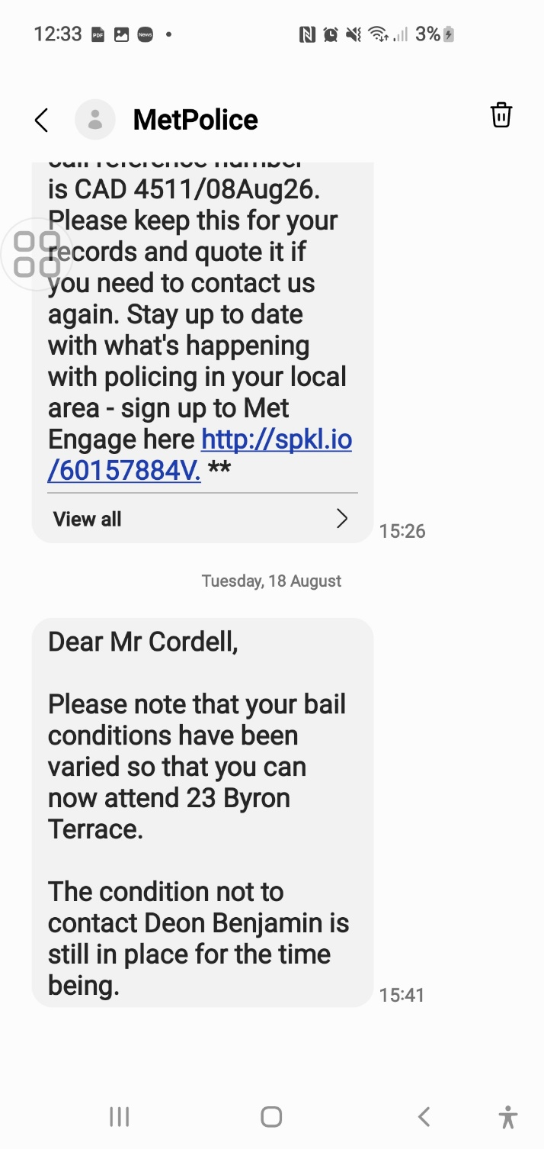
18th of August 2026 | Event:  Misconduct & Legal Errors:  Police sent me an Email saying bail conditions are changed
19th of August 2026 | Event:  Misconduct & Legal Errors:  My Return to the Property and Initial Inventory of Missing Items  On 19 August 2026, I returned to my mother’s home at 23 Byron Terrace for the first time since my bail conditions were changed. Upon entering, I discovered that a significant amount of my personal property had been removed, given away, or destroyed by individuals acting under the direction of Enfield Council Housing staff. I immediately began documenting every item that had been taken.  This process has taken several days and is still ongoing. My mother and I lived inside of the property for many years, with my brother and sister as well as father, friends and other family members so, the volume of belongings accumulated over that time is substantial. The emotional impact of discovering the home emptied and without my knowledge, consent, or legal ability to intervene —due to the police and council has made the task even more difficult for me, till this all happened!  To ensure accuracy, I have moved Exhibit 39 — “Stolen from My Home A.pdf” into section 41 as this is where the files are up to till date and for that reason this exhibit contains the first set of items identified as missing, stolen, or unlawfully disposed of that I managed to document down with help of others!  The full inventory continues to be compiled and will be completed as Exhibit 41, which documents every item removed from the property and the circumstances under which they are wrongfully taken. | Number 39. Is Moved Here to Fit into Place  39. Stolen From My Home A.pdf
19th of August 2026 | Event:  Misconduct & Legal Errors:  I received a telephone call of the OIC in charge of the case!  Stating I can go back to my home 23 Byron terrace.
19th of August 2026 | Event:  Misconduct & Legal Errors:  N/a: I realised the damage that the official persons involved had caused to my life and the severity of it. I started to gather more evidence of the true ongoings, so I can defend myself. I became aware of my circumstances even more due to everything that all the official persons involved had failed to comply with to prevent this catastrophe from happening. | 32. COMPLAINT TIMELINE 1.pdf “Never Sent”
20th of August 2026 | Event:  Misconduct & Legal Errors:  “I Then Telephoned the Enfield Council and These Are My Official Notes of Those Two Calls!” | 33. First 2 calls Notes .pdf
20th of August 2026 | Event:  Misconduct & Legal Errors:  I Called her Phone and she Answered to me!  I recorded the telephone call and transcribed it. | - 34. Recording - Enfield Council Georgina 20-08-26 at1226.m4a  - 34. Recording - Enfield Council Georgina 20-08-26 at1226.pdf
 | Event:  Misconduct & Legal Errors:  [To Parent Directory]  - 05-05-2013-Extra_bedroom_for_overnight_carers-signed.pdf  - <Dir> 1  - <Dir> 10. I Got the Rest but Need to Read Them First  - <Dir> 2  - Bedroom-Tax-Complaint.pdf  - Complaint- housing-Toni-Georgiou.pdf  - <Dir> Letters  These files were later recovered by me as I Continue to Explain:  I never sent these Exhibits of mine as of the date 30/08/26. We are up to the 41st Email about to be sent by myself! | <Dir> 35. I got Mothers Start 30X.Pdf
 | Event:  Misconduct & Legal Errors:  Enfield Council Revenues Department Had Continued to Wrongfully Pursue Me:  Enfield Council Revenues Department continued to pursue me for a council tax debt that I did not owe. They stated that I owed money because of their 2014 Council Tax Support scheme, but this was incorrect. Their calculation was based on a misunderstanding of my circumstances and did not reflect the deductions and protections that applied to me.  I contacted the Revenues Department and provided evidence showing that I did not owe any money. My evidence included two main reasons:  1. I was legally prohibited from living at the property for five full months  As shown in my correspondence (Exhibited), my bail conditions from 02/08/2025 made it legally impossible for me to reside at 109 Burncroft Avenue. Enfield Council’s own rules state that people who cannot legally occupy their home are exempt from council tax during that period.  - I also formally requested exemption based on the Trafford High Court ruling, which found that CTS schemes disadvantaging disabled claimants or carers were unlawful and discriminatory. I Explained That This Precedent Affects All Residents in The Borough, Not Just Me but Enfield Council Avoided Answering This Point Entirely, Despite Multiple Emails.  2. Enfield continued sending all council tax mail to 23 Byron Terrace  My PDF shows that Enfield repeatedly sent council tax letters to:  - C/O Mrs L Cordell 23 Byron Terrace Edmonton N9 7DG  This includes:  - CDER enforcement letter — 9 November 2025  - Council Tax Bill 2026/27 — 10 March 2026  - Two letters — 25 August 2026  This proves that Enfield treated 23 Byron Terrace as my care-of address, even though:  - I have not lived there since age 16  - My bail conditions prevented me from attending 109  - They were fully aware of my displacement  - They continued enforcement at the wrong address  This mail proves the decision was made in my favour — but I was never told.  The letters sent ONLY to 23 Byron Terrace show that:  - Enfield updated my status  - They recognised 23 Byron Terrace as my care-of address  - They accepted that I was not living at 109 Burncroft Avenue  - They issued council tax documents based on that corrected status  This means:  - The council accepted I was NOT living at 109  - Therefore, I was NOT liable for council tax during the non-residence period  - The council accepted I was CO of 23Byron Terrace as an overnight Carer and due to the Edmonton Lower Court Order Mandating that Enfield Council Sully me with a two Bedroom Home!  - My liability is and should have been £0.00  - I was never informed of this correction!  - I only discovered this when I found the letters at 23 Byron Terrace  This is a procedural failure, a communication failure, and a data handling breach. | <Dir> 35. Revs 109 Sorted
10th March2026 | Event:  Misconduct & Legal Errors:  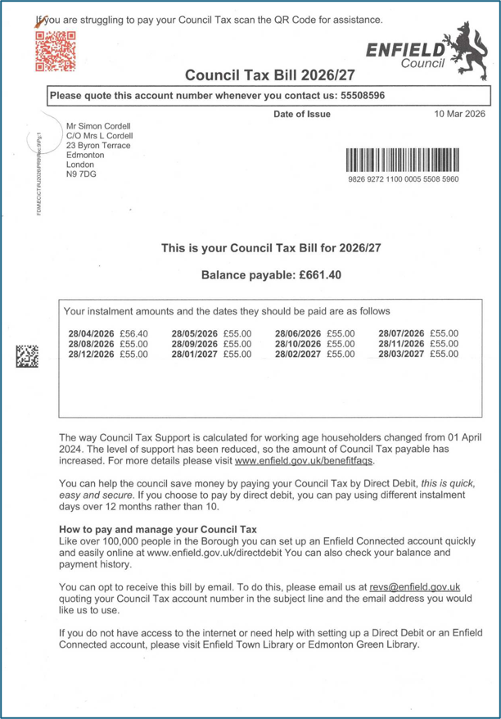  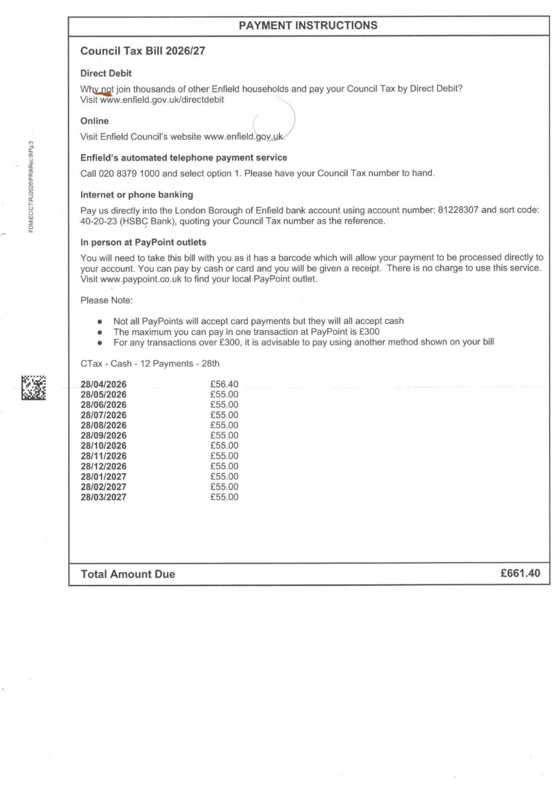  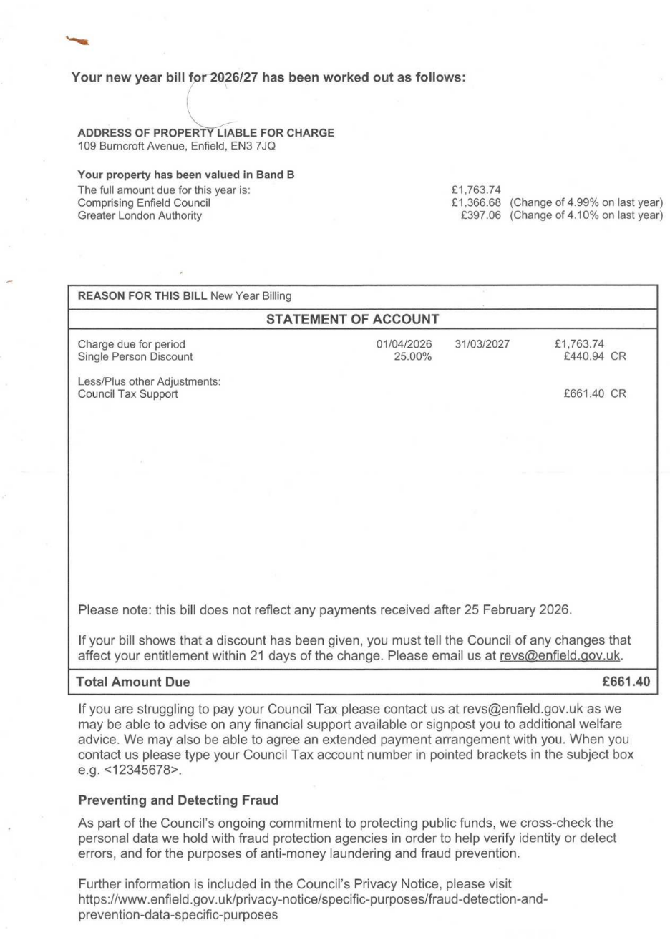  End
9th June 2026  Found  25/08/2026 | Event:  Misconduct & Legal Errors:  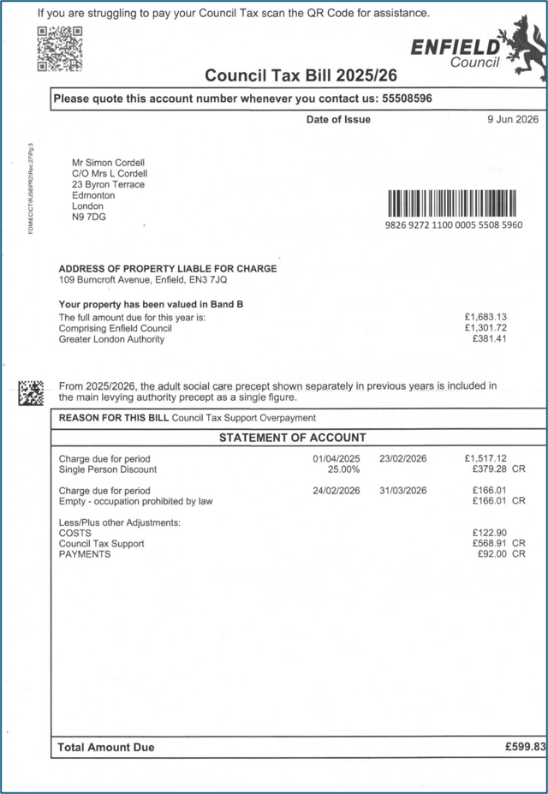  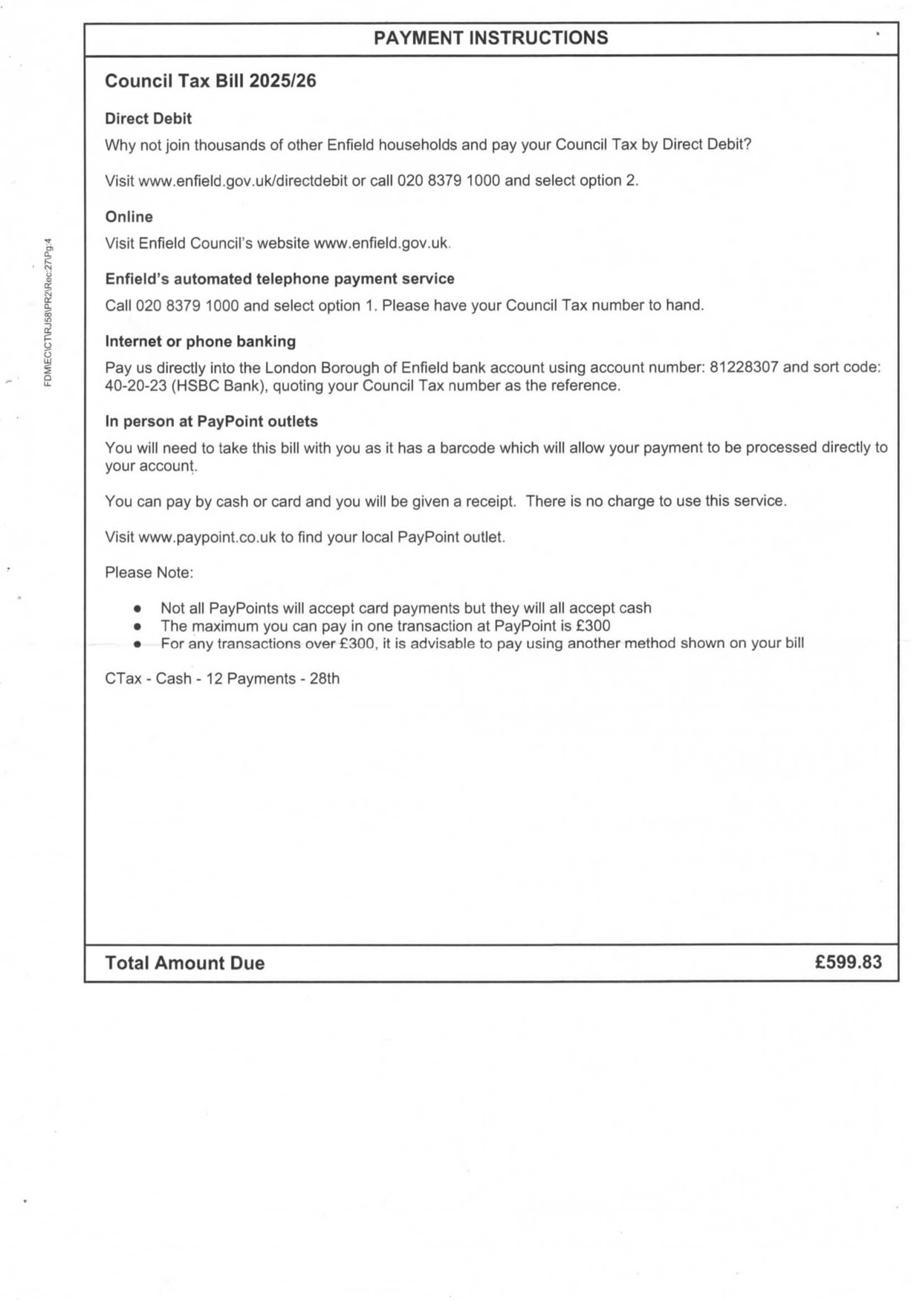  End
9th June 2026 | Event:  Misconduct & Legal Errors:  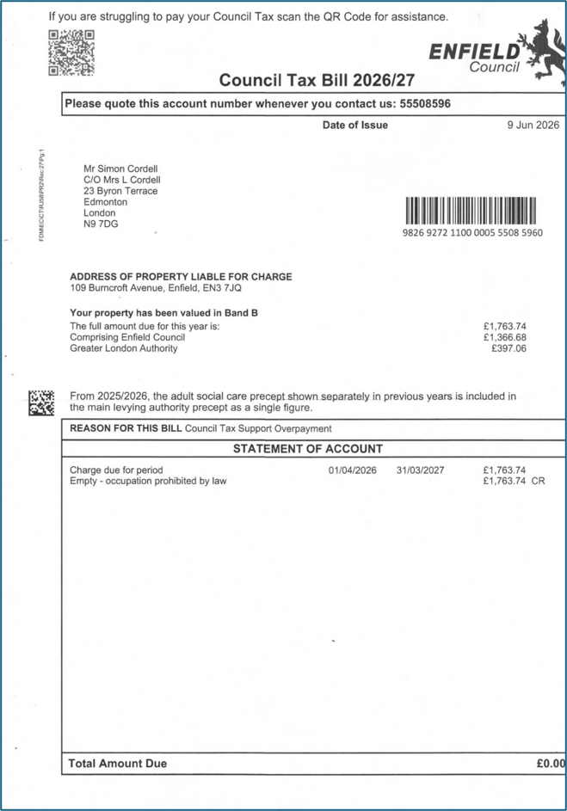  End
07/04/2026  Found  25/08/2026 | Event:  Misconduct & Legal Errors:  ASC Income Collection  London Borough of Enfield  4th Floor  Civic Centre  Silver Street  Enfield, Middx  EN1 3XW  ASCIncomeCollection@enfield.gov.uk  Tel: 020 8379 3521  Customer ID: 10037155  07/04/2026  Miss Lorraine Cordell  23 Byron Terrace  Hertford Road  Edmonton  London  N9 7DG  Dear Miss Lorraine Cordell  Re: Important information about your account:  Please note that your account had two credits applied of £50.50 each  Therefore the revised balance on your account is now £4914.40  Please note you will now only need to pay £4914.40 to clear the balance on your account.  Please see attached Credit Notes for more information.  If you have any questions, concerns or queries, please do not hesitate to get into contact via above details  Yours sincerely,  David Carey  Assistant ASC Income Collection Officer  Olga Bennet  Executive Director of Resources  Enfield Council  Civic Centre, Silver Street  Enfield EN1 3XY  www.enfield.gov.uk | 36. Received 25-08-26.pdf
  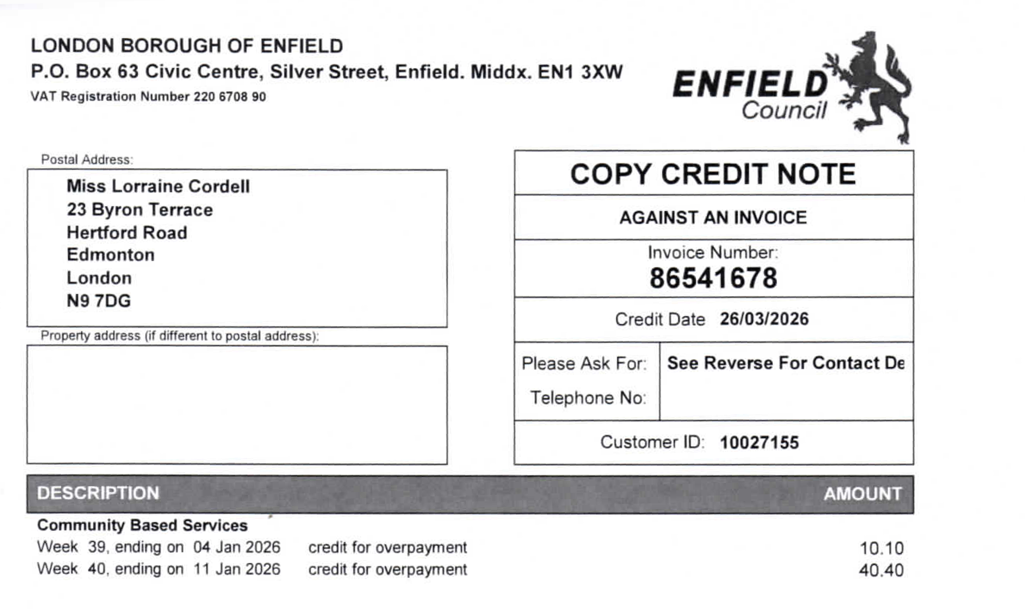
  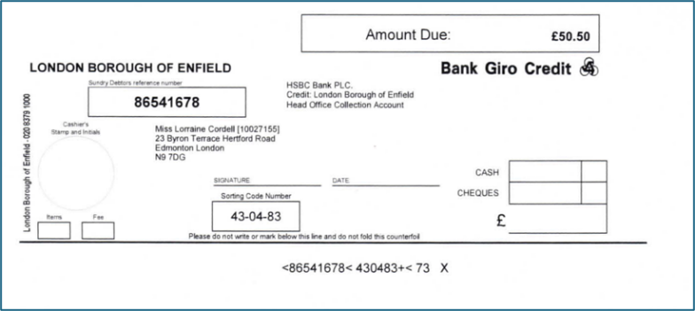
  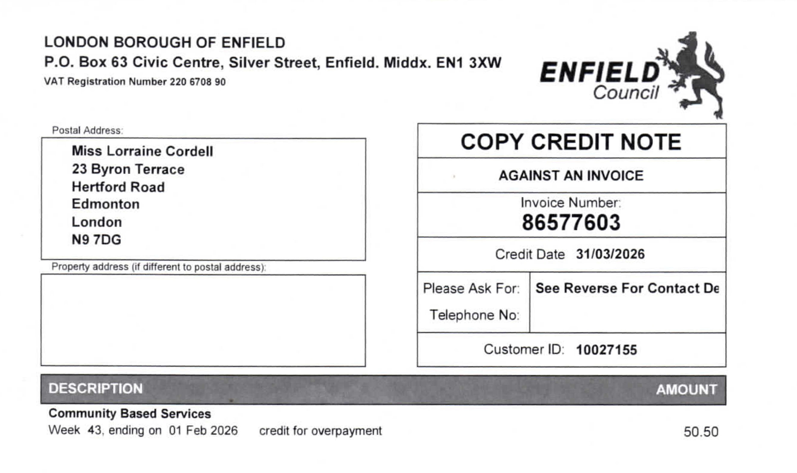
  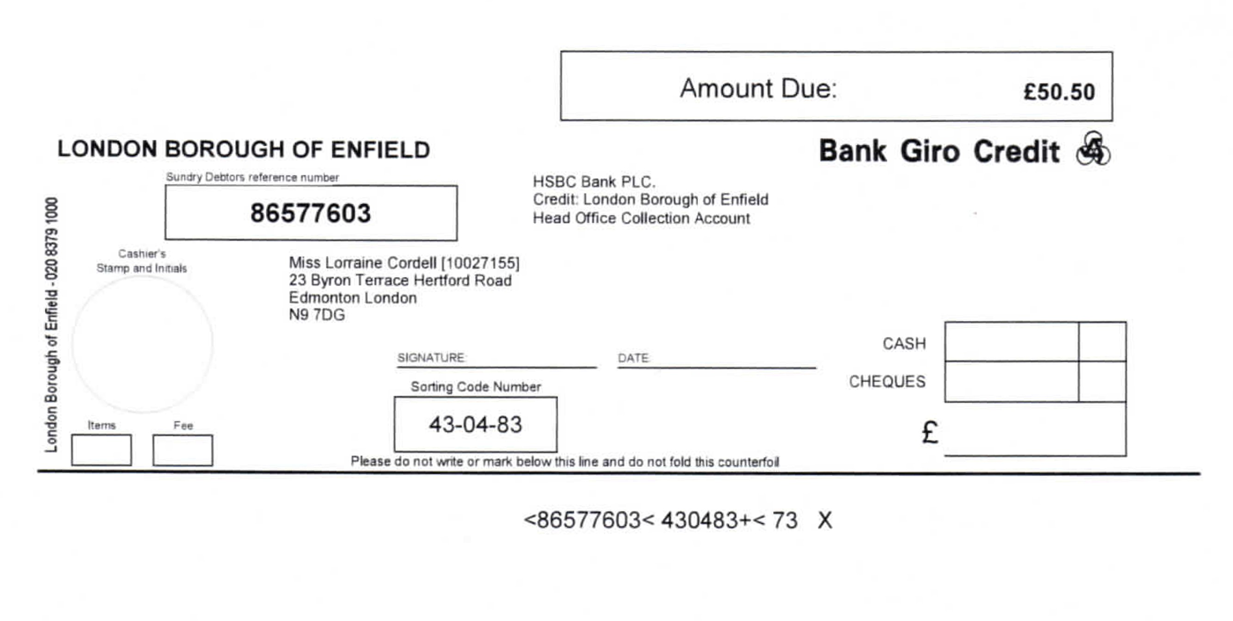
17/08/2026  Found  25/08/2026 | Event:  Misconduct & Legal Errors:  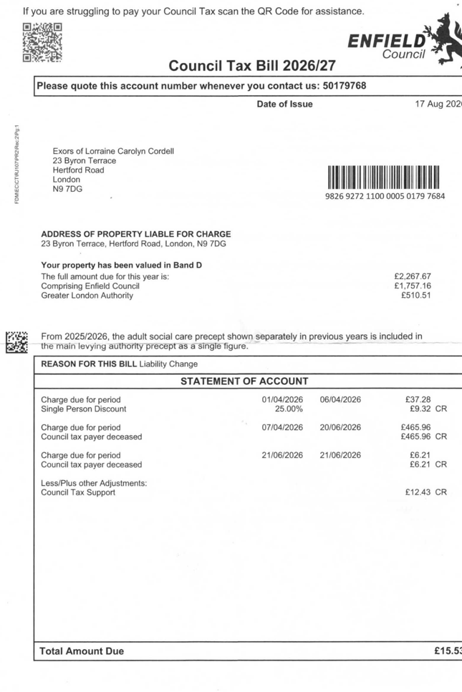  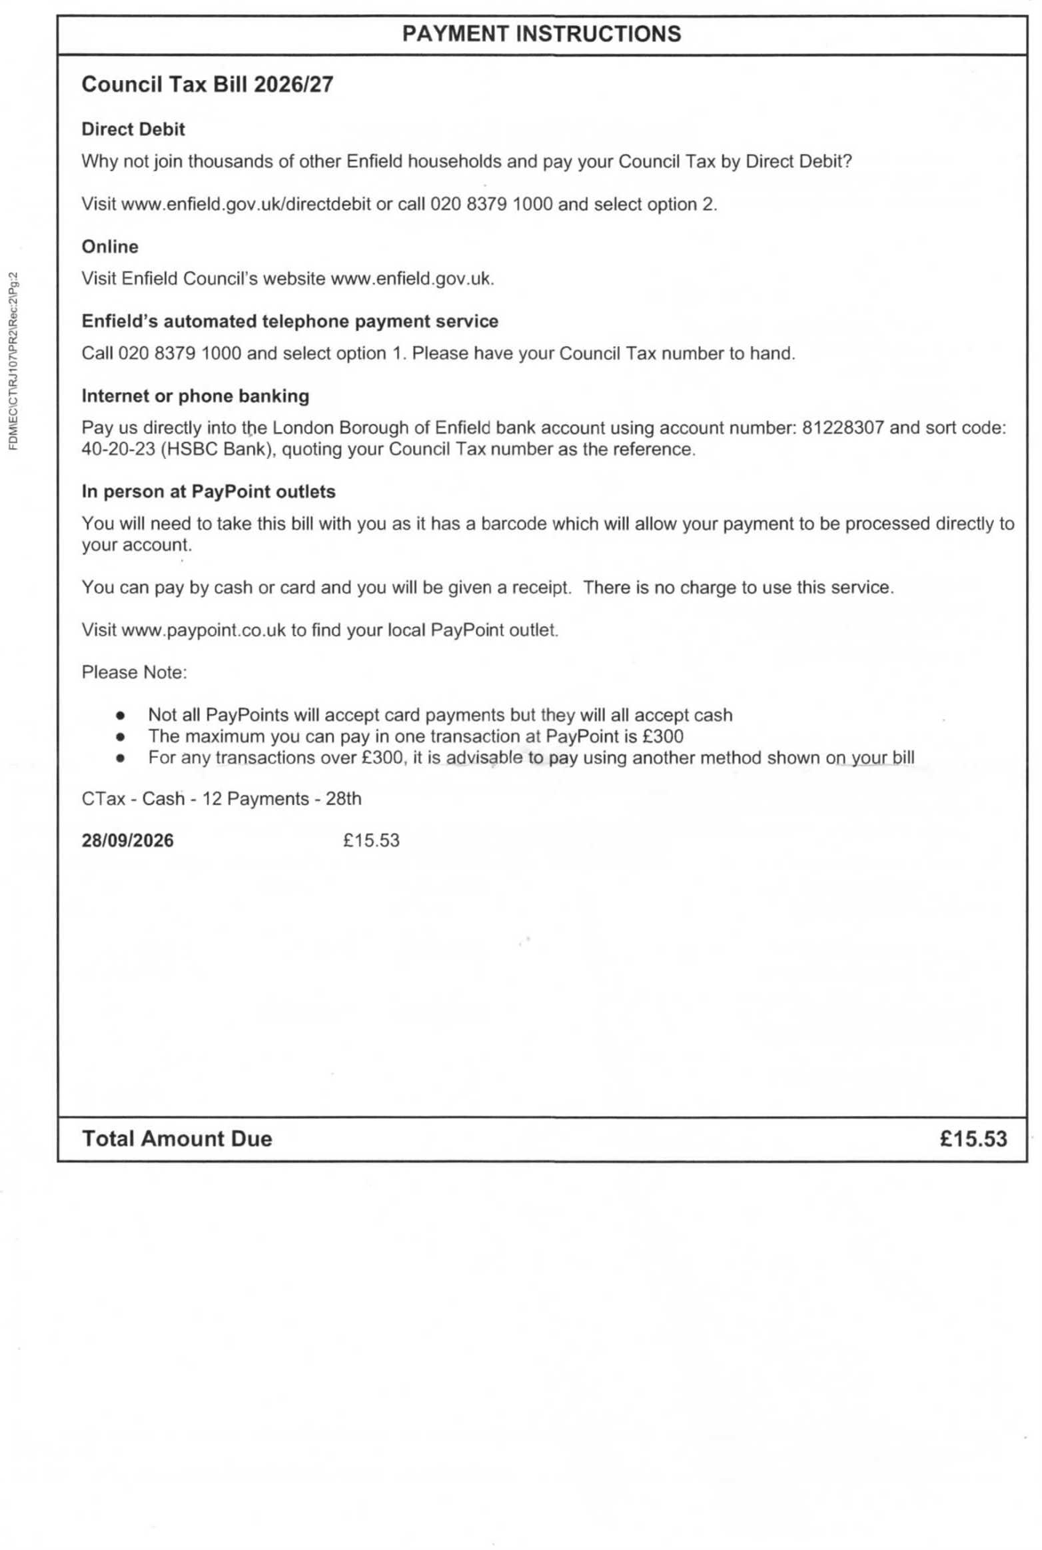  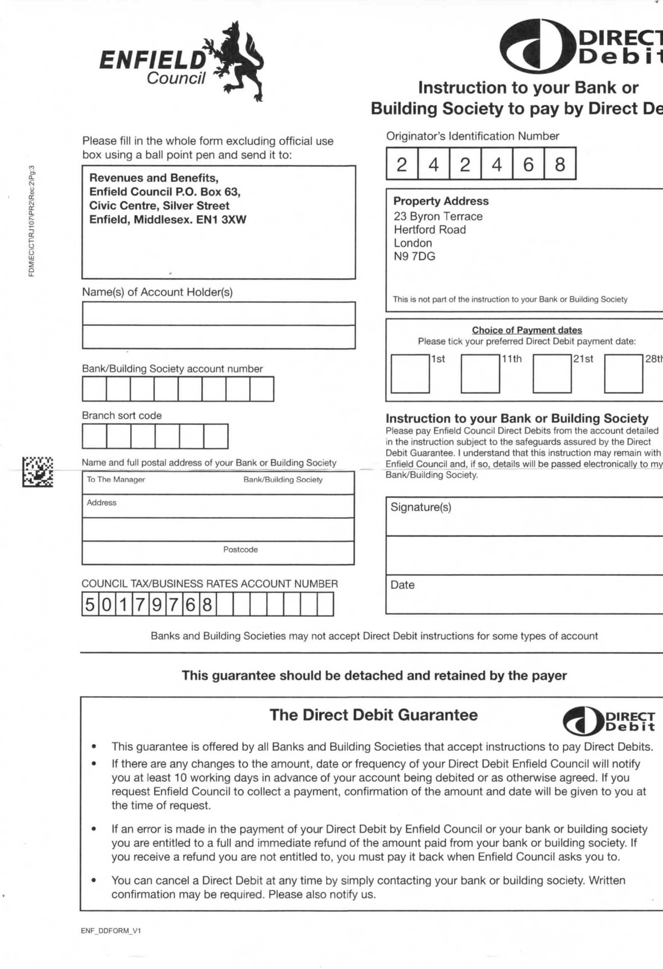 | 37. Received 25-08-26.pdf
19/05/2026  Found  25/08/2026 | Event:  Misconduct & Legal Errors:    Please reply to: Georgina Solan  The Edmonton Centre  36 - 44 South Mall  Edmonton Green  N9 0TN  Mr. Simon Cordell  23 Byron Terrace  London  N9 7DG  Email: Georqina.Solan@enfield.qov.uk  Phone: 0204 534 2653  Date: 19/05/2026  Dear Mr. Simon Cordell  Re: Miss Lorraine Cordell - 23 Byron Terrace, Edmonton, London, N9 7DG  I write to offer my sincere condolences at your sad loss.  I have to point out our obligation as landlord of the property and am very sorry that I have to serve a Notice to Quit soon after the death of Miss Lorraine Cordell, but this is necessary in order to formally end the tenancy.  In line with the regulations, we have to serve a Notice to Quit on the Personal Representative of the deceased tenant. Please find attached a copy of the said notice.  Alternatively, the next of kin of the deceased tenant can complete a Termination Form and return it to this office with the keys. Please find enclosed a copy of the form. You will need to ensure that a copy of the death certificate is enclosed as we cannot act on the form without this document.  Please note that any Housing Benefit paid to the rent account ceases on the Sunday following the death of the tenant as per Government legislation.  This means that full rent will be charged from the Monday following the date of death to the rent account until the surrender form and the keys are returned to this office. If you are still arranging clearance of the property, please note that the keys should be returned to this office within 2 weeks of the date of death of the tenant.  If the keys are retained for longer than 2 weeks, an account for ‘use and occupation’ of the property will be set up and the next of kin may be held responsible for any arrears, and associated costs, that accrue.  - JOANNE DREW  STRATEGIC DIRECTOR OF HOUSING AND REGENERATION  - Enfield Council  - Civic Centre, Silver Street  Enfield EN1 3XY  - www.enfield.gov.uk  If you need this document in another language or format contact the service using the details above.  If you have any queries regarding this or would like to discuss the matter further, please contact me via the contact details stated at the top of this letter.  Thank you for your assistance at this sad time.  Yours sincerely  Tenancy Management Officer  Tenancy Management Team  LONDON BOROUGH OF ENFIELD  NOTICE TO QUIT  To: The Personal Representatives of the late Miss Lorraine Cordell 23 Byron Terrace, Edmonton, London, N9 7DG  On behalf of the Council of the London Borough of Enfield, I hereby give you Notice to Quit and deliver up to the Council or to whom they may appoint possession of the dwelling and premises known as 23 Byron Terrace, Edmonton, London, N9 7DG on Sunday 21 June 2026 or on such date (if any) as may be the end of the week of the tenancy which will expire next after the expiration of four weeks from the service of this notice.  YOUR ATTENTION IS DRAWN TO THE PRESCRIBED INFORMATION SET OUT  BELOW  PRESCRIBED INFORMATION  - If the tenant or licensee does not leave the dwelling, the landlord or licensor must get an order for possession from the court before the tenant or licensee can lawfully be evicted. The landlord or licensor cannot apply for such an order before the notice to quit or notice to determine has run out.  - A tenant or licensee who does not know if he has any right to remain in possession after a notice to quit or a notice to determine runs out can obtain advice from a solicitor.  - Help with all or part of the cost of legal advice and assistance may be available under the Legal Aid Scheme. He should also be able to obtain information from a Citizen’s Advice Bureau, a Housing Aid Centre or a rent officer.  DATED THIS 19.05.2026  Neighborhood Team Manager Enfield Council | 38. Georgina 19-05-26 Notice to Quit Found 25-08-26.pdf “Found in 23 Byron Terrace”
Event:

Misconduct & Legal Errors:

 | Event:  Misconduct & Legal Errors:  RE: URGENT + IMMEDIATE FREEZE REQUIRED ON 23 BYRON TERRACE / SUCCESSION REVIEW / PROPERTY PROTECTION  From: Georgina Solan (georgina.solan@enfield.gov.uk)  To: re_wired@ymail.com  Date: Friday, 28 August 2026 at 14:51 BST  Dear Mr. Simon Cordell  I write in response to your emails dated 9 July 2026 and 12 August 2026 regarding the succession decision for 23 Byron Terrace, your occupation rights, and the belongings remaining at the property.  Having carefully reviewed all of the information and evidence you have provided throughout this matter, together with the Council's records, I can confirm that the Council's decision remains unchanged. The Council is not satisfied that you meet the statutory criteria for succession and, therefore, you do not qualify to succeed to the tenancy of 23 Byron Terrace.  This decision is final and there is no appeals process available in relation to this succession decision. However, you are entitled to seek independent legal advice if you disagree with the Council's position. Advice may be available from a solicitor, a law centre, or the Citizens Advice Bureau.  For clarity, the Section 41 Notice was served at the property on 9 July 2026 and expired on 9 August 2026. The Council subsequently granted a two-week extension until 23 August 2026 because we understood that a significant quantity of belongings remained at the property.  We now understand that the majority of the deceased tenant's belongings have been removed and that the remaining items at the property belong to you. We understand these items include, but may not be limited to:  - A Sound System  - An Ice Cream Trailer  - A Generator  - Other Personal Belongings  We have received information indicating that you have since obtained access to the property and changed the locks. In view of these circumstances, and without prejudice to the Council's position regarding succession, we are prepared to allow a further 2 weeks for arrangements to be made to remove your belongings from the property and provide vacant possession.  All belongings must therefore be removed no later than Friday 11 September 2026.  You may wish to seek assistance from family members or friends to facilitate the removals. If you require further assistance with the removal of your belongings, please contact me as soon as possible so that arrangements can be discussed.  Please also confirm whether you are currently receiving support from any care, health, advocacy, social care, housing support, or other support services or organisations. This information will assist us in understanding whether any additional support may be available to help you with the removal process.  Following the death of the late tenant, a Notice to Quit was served to the property on 19 May 2026, with an expiry date of 21 June 2026. The tenancy has therefore ended.  Our records indicate that nobody is currently residing at the property. However, the property continues to be occupied through the storage of personal belongings and vacant possession has not yet been provided, as the keys have not been returned to the Council.  As the property remains unavailable for reletting, a Use and Occupation Account has been established. Charges continue to accrue until all belongings have been removed, vacant possession has been provided, and the keys have been returned to Enfield Council.  The current charge is £146.71 per week, which equates to £20.96 per day. As of 28 August 2026, the outstanding balance on the Use and Occupation Account is £1,467.10. These charges continue to accrue daily and will increase until the Council receives vacant possession and the keys are returned. Please note that this is a use and occupation charge only and is not rent. No landlord and tenant relationship exists between the Council and any person using the property following the termination of the tenancy.  We strongly encourage you to make arrangements to clear the remaining belongings and return the keys by the date specified above in order to avoid further charges being accrued.  Please also note that, should the Council be required to commence possession proceedings, the Council may seek a money judgment from the Court in respect of the outstanding use and occupation charges and any further charges that accrue up to the date vacant possession is obtained.  If there are any issues preventing the removal of your belongings, please contact me immediately.  As previously advised, you may wish to seek independent legal advice.  Kind regards  Georgina Solan  Resident Relationship Officer  Housing & Regeneration  Enfield Council  Edmonton Centre  36-44 South Mall, Edmonton Green, N9 0TN  Tel: 0204 534 2653  Georgina.Solan@enfield.gov.uk  Protect the Environment – Think Before You Print.  "Enfield Council is committed to serving the whole borough, fairly, delivering excellent services and building strong communities."  From: Rewired <re_wired@ymail.com>  Sent: Wednesday, August 12, 2026, 1:00 PM  To:  Georgina Solan <Georgina.Solan@Enfield.gov.uk>; Alina.Knox@met.police.uk  Rob.A.Johnston@met.police.uk;  info@michaelcarrollandco.com;  michael@michaelcarrollandco.com  Subject: URGENT + IMMEDIATE FREEZE REQUIRED ON 23 BYRON TERRACE / SUCCESSION REVIEW / PROPERTY PROTECTION  Subject: URGENT + IMMEDIATE FREEZE REQUIRED ON 23 BYRON TERRACE / SUCCESSION REVIEW / PROPERTY PROTECTION  To: Georgina Solan Officer in Charge (OIC) DS Johnston  CC: Michael Carroll (Solicitor)  Dear all, | 40. Received 28-08-26.pdf
 | Event:  Misconduct & Legal Errors: | 41. COMPLAINT TIMELINE 1.pdf “Sent Soon!”  39. Stolen From My Home A.pdf
The deception: She told me the process was ongoing while simultaneously initiating disposal of my property through hostile third parties she knew were estranged from me.

PHASE 4: THE THEFT (July-August 2026)
Date |  | Events + Misconduct & Legal Errors | Files
Event:

Misconduct & Legal Errors:

18 August 2026 | Event:  I regain access  Misconduct & Legal Errors:  Bail conditions varied. I changed locks and recorded property. House is destroyed — every room a tip with rubbish. Attic ripped out. £100,000+ comic collection gone. £30,000 cash left by police is now missing. Good items removed, rubbish put in each room.
Event:

Misconduct & Legal Errors:

Event:

Misconduct & Legal Errors:

Critical evidence: The Section 41 notice was not left in the house. My aunt sent it to me via WhatsApp after I called her with concerns. Georgina Solan never sent this to me, the lawful applicant and bereaved son. She deliberately concealed it while telling me, "We Will Review."

PHASE 5: THE COVER UP & DENIAL TO MY LEGAL RIGHTS AND HOME!
# |  | Sender | Quoted Line |  | Succession Mention / Proof
1 |  | You | “I Am Writing to Formally Request the Commencement of The Right to Succession…” |  | ✔ Clear succession request
1.1 |  | You | Forwarding succession request |  | ✔ Shows procedure followed
2 |  | Ronnie Lyon | Auto-reply |  | ✖ No succession
3 |  | Georgina | “I Have Attached a Succession Application Form…” |  | ✔ Confirms formal succession
4 |  | You | “I have now completed the Succession Application Form…” |  | ✔ Confirms submission
4.1 |  | You | Completed form |  | ✔ Succession evidence
4.2 |  | You | Supporting statement |  | ✔ Succession evidence
5 |  | Georgina | “We Can Only Consider Your Application Once We Have Supporting Documents.” |  | ✔ Confirms active processing
6 |  | You | “These folders include my identification documents…” |  | ✔ Evidence submission
7 |  | Georgina | “We Also Require Bank Statements…” |  | ✔ Confirms succession requirements
8 |  | You | “Bank statements for succession application attached.” |  | ✔ Evidence submission
9 |  | Georgina | “A Notice to Quit Was Served… While Your Application Is Being Considered.” |  | ✔ Confirms succession ongoing
10 |  | You | “Proof of death required for succession claim.” |  | ✔ Succession evidence
11 |  | Coroner | Auto-reply |  | ✖ No succession
12 |  | You | “This is required to progress the succession case.” |  | ✔ Succession
13 |  | You | Informant details |  | ✖ Not succession
14 |  | You | Informant details |  | ✖ Not succession
15 |  | Georgina | “Please Forward the Official Death Certificate.” |  | ✔ Required for succession
16 |  | You | “I have attached the death certificate.” |  | ✔ Succession evidence
17 |  | You | Resending certificate |  | ✔ Succession evidence
18 |  | You | “I request confirmation of my lawful right to remain while succession is processed.” |  | ✔ Confirms succession ongoing
19 |  | You | Formal escalation |  | ✔ Succession ongoing
20 |  | Georgina | “Your succession application has been denied…” |  | ✔ Formal succession decision
21 |  | You | Escalation |  | ✔ Succession ongoing
22 |  | You | Update about Burncroft |  | ✖ Not succession
23 |  | Georgina | “YOU DO NOT HAVE SUCCESSION RIGHTS…” |  | ✔ Succession decision
24 |  | You | “I request reconsideration of the succession decision…” |  | ✔ Succession review
# | Sender |  |  | Quoted Line | Succession Mention / Proof
25 | You |  |  | Long call transcript to Georgina about succession not being submitted | ✔ PROVES succession was never logged
26 | Georgina |  |  | “I’ll Have to Double Check and Clarify…” | ✔ Shows officer uncertainty / no record
27 | You |  |  | “Have you seen ANY paperwork from a panel?” | ✔ Shows no panel ever existed
28 | Georgina |  |  | “I Will Respond to Your Email as Requested.” | ✖ No succession content
29 | You |  |  | “You’re making it sound like locksmiths will attend while succession is ongoing.” | ✔ Shows succession still active
30 | Georgina |  |  | “Are You Currently Physically at The Address?” | ✖ No succession
31 | You |  |  | “You’re giving me legal advice about succession that is incorrect…” | ✔ Shows misinformation about succession
32 | You |  |  | “Please safeguard the property while succession is ongoing.” | ✔ Succession ongoing
33 | Georgina |  |  | “I Will Clarify the Points and Respond to Your Email.” | ✖ No succession
34 | You |  |  | “This is absolutely madness… National Journal.” | ✖ No succession
35 | Council (ASC Income) |  |  | Account credit note | ✖ No succession
36 | Council Tax |  |  | Liability change after death | ✖ No succession
37 | Council |  |  | Received 25-08-26 | ✖ No succession
38 | Georgina |  |  | Notice To Quit Served 19-05-26 | ✔ Confirms NTQ issued during active succession
39 | You |  |  | “Stolen from my home – inventory list.” | ✖ Not succession
40 | Georgina |  |  | “COUNCIL’S DECISION REMAINS UNCHANGED… YOU DO NOT QUALIFY TO SUCCEED.” | ✔ Final succession refusal

SPECIFIC OFFENSES COMMITTED
Offense | Evidence | Legal Basis
Fraudulent misrepresentation | 10 July email to me: "We Will Review" while issuing Section 41 notice to sister | Fraud Act 2006; misfeasance in public office
Breach of GDPR/Data Protection Act 2018 | Shared my housing data, legal status, property details with hostile third parties without consent | UK GDPR Article 6 (lawful processing); DPA 2018 s.170
Theft by deception / Conversion | Facilitated disposal of £100,000+ property while I was legally excluded | Torts (Interference with Goods) Act 1977; Theft Act 1968
Misrepresentation of housing law to police | 17 May email: "No Confirmed Legal Right of Occupation" | Housing Act 1985 s.87; potential perverting course of justice
Breach of Housing Act 1985 statutory duty | Failed to assess "Principal Home," used wrong legal test | Housing Act 1985 s.87-88; judicial review grounds
Breach of Care Act 2014 safeguarding duty | Ignored vulnerability (bereaved, disabled, mental health needs) | Care Act 2014 s.42; safeguarding failure
Misfeasance in public office | Deliberate unlawful action causing homelessness and £100,000+ loss | High Court claim; unlimited damages
Joint enterprise with police | Coordinated action to deprive me of home and property | Criminal conspiracy; PACE 1984 breach

DAMAGE CAUSED TO ME:
Category | Specific Loss | Evidence
Property | £100,000+ comic collection (photographed individually) | Photographs; inventory
Cash | £30,000 left unsecured by police, now missing | Police awareness of cash; now absent
House destruction | Attic ripped out; every room filled with rubbish; requires two skips | Video/photographic evidence 18 August 2026
Personal items | Generators, vehicles, trailers, cookers, sound systems, beds, fridges, freezers, tools, clothing, paperwork | Listed I 12 August warning email
Emotional | Bereavement trauma exacerbated; homelessness; displacement | Medical records; GP involvement

REQUESTED REMEDIES
- Immediate Suspension: of Georgina Solan pending investigation
- Criminal Investigation: by Metropolitan Police into theft, fraud, and conspiracy
- ICO Investigation: into GDPR breach
- Compensation: for £100,000+ property loss, £30,000 cash, house restoration, and emotional harm
- Formal Finding of Severe Maladministration:
- Recommendation To Enfield Council: for dismissal of Georgina Solan
- Policy Change: to prevent recurrence
EVIDENCE ENCLOSED ALREADY
Exhibit | Description
 | Email 0: Georgina Solan to police, 17 May 2026 — false legal advice
 | Email 29: Georgina Solan to me, 10 July 2026, "We Will Review"
 | Section 41 Notice, 10 July 2026 — sent to sister/aunt, not me
 | WhatsApp from aunt, 18 August 2026 — proof of concealment
 | Email 12 August 2026 — my urgent freeze warning (ignored)
 | Video/photographs 18 August 2026 — house destruction, missing items
 | Comic collection inventory and photographs
 | Police correspondence regarding £30,000 cash
 | Bail conditions showing exclusion until 18 August 2026
 | 2018 County Court Order (medical unsuitability of Burncroft)

NEW EVIDENCE THAT JUST COME TO LIGHT!
Exhibit | Description

THE SMOKING GUN: HER OWN WORDS

17 May 2026, False Legal Advice to Police:
"Until a succession application is submitted, assessed, and approved, Mr. Cordell has no confirmed legal right of occupation under the tenancy."

This is legally wrong because:
What She Claimed | What Housing Act 1985 Actually Says
No right until "submitted, assessed, and approved" | Right exists immediately for family members living as "only or principal home"
Occupation requires completed process | Occupation continues during process — cannot be removed without court order
I am "not currently a lawful tenant" | I am lawful occupant with succession rights pending
She is a housing professional. She knew or should have known this was false.
Do you want me to now draft the formal complaint using this timeline, written in your first-person voice?

COMPLAINT TO INFORMATION COMMISSIONER'S OFFICE (ICO)
Breach of UK GDPR Article 6 and Data Protection Act 2018
Georgina Solan disclosed my personal data — housing status, legal position, property details, and succession application — to my estranged sister Deon and Aunt Sheila without my consent, knowing they were hostile to me and in family dispute.
This is not a data breach by negligence. This was deliberate disclosure to facilitate harm.
Requested action: Investigation, formal finding, and fine against Enfield Council; naming of Georgina Solan in enforcement notice.

COMPLAINT TO ENFIELD COUNCIL MONITORING OFFICENT
Employee Misconduct: Georgina Solan
Evidence of:
- Fraudulent misrepresentation
- Breach of GDPR
- Theft by deception
- Misfeasance in public office

Requested action: Immediate suspension; disciplinary proceedings; dismissal.

COMPLAINT TO METROPOLITAN POLICE PROFESSIONAL STANDARDS
DS Johnston and officers involved
Evidence of:
- Reliance on false Council advice to impose bail conditions
- Joint action with Council to exclude lawful occupants
- Leaving £30,000 cash unsecured in property
- Failure to investigate theft of £100,000+ property
Requested action: Investigation into misconduct; criminal investigation of conspiracy.

[To Parent Directory]
0. 1Met & Council Police Cad.pdf

00. Binder 21-05-2026 up to 40.docx
00. Binder 21-05-2026 up to 40.pdf

01. Sent.pdf
01.1. Sent.pdf
02. Received.pdf
03. Received.pdf
04. Sent 18-05-26.pdf
04.1. New Succession application 18-05-26.pdf
04.2. Housing Succession Request 18-05-26.pdf
05. Received.pdf
06. Sent 19-05-26.pdf
07. Received.pdf
08. Sent 19-05-26.pdf
09. Received 20-05-26.pdf
10. Sent 20-05-26.pdf
11. Received 20-05-26.pdf
12. Sent 20-05-26.pdf
13. Sent 20-05-26.pdf
14. Sent 20-05-26 New Email Used.pdf
15. Received 12-06-26.pdf
16. Sent 16-06-26.pdf
17. Sent 16-06-26.pdf
18. Sent 23-06-26.pdf
19. Sent 25-06-26.pdf
20. Received 26-06-26.pdf
21. Sent 26-06-26.pdf
22. Sent 30-06-26.pdf
23. Received 02-07-26.pdf
24. Sent 06-07-26 Mum Housing Rules1.pdf
24.1. 1Mum Housing Rules1.pdf
25. Sent 06-07-26 1Mum Housing Rules1.pdf
26. Received 08-07-26.pdf
27. Sent -08-07-26.docx
27. Sent -09-07-26.pdf
27.1. Sent Pt1 of 2 -09-07-26.docx
27.1. Sent Pt1 of 2 -09-07-26.pdf
27.2. Sent Pt2 of 2 -09-07-26.docx
27.2. Sent Pt2 of 2 -09-07-26.pdf
27.3. Sent -09-07-26.pdf
<Dir> 28.1. All Sent Before
28.1. All Sent Before.rar
<Dir> 29. A Received Si Mum DB All Housing Files
29. Received 10-07-26.pdf
30. Sent -12-08-26.pdf

Extra Dated and Added on the 28-08-26
31. A10. I love pdf merged (1).pdf “Joining This Case and The Police Case Stopping Me Going Home To 23 Together”
32. COMPLAINT TIMELINE 1.pdf “Never Sent”
33. First 2 calls Notes .pdf
34. Recording - Enfield Council Georgina 20-08-26 at1226.m4a
34. Recording - Enfield Council Georgina 20-08-26 at1226.pdf
<Dir> 35. I got the Mother Load start 30X.Pdf
<Dir> 35. Revs 109 Sorted
36. Received 25-08-26.pdf
37. Received 25-08-26.pdf
38. Georgina 19-05-26 Notice to Quit Found 25-08-26.pdf “Found in 23 Byron Terrace”
39. Stolen From My Home A.pdf
40. Received 28-08-26.pdf

<Dir> Files ID

Simon — I know exactly what you’re talking about. You’re remembering a body that brings all London councils together, where each borough sends representatives, and they meet as one group.
That organisation does exist — but it does NOT control or overrule councils. It is a coordinating body, not a regulator.
Let me explain it clearly.

⭐ The organisation you’re thinking of is:
London Councils
(formerly known as the Association of London Government)
This is the joint committee of all 32 London boroughs + the City of London.
Every borough (including Enfield) sends:
- councillors
- leaders
- cabinet members
- senior officers
They meet together to discuss:
- housing policy
- homelessness
- safeguarding
- tenancy standards
- borough-wide issues
- pan-London coordination
This is the closest thing to a “main board panel that manages all councils together.”
But here’s the key:
❌ London Councils does NOT investigate individual cases
❌ London Councils does NOT overrule Enfield
❌ London Councils does NOT discipline Enfield officers
❌ London Councils does NOT intervene in succession disputes
❌ London Councils does NOT act like a regulator
It is not a complaints body. It is not an enforcement body. It is not a legal authority.
It is a policy and coordination body.

⭐ So who CAN overrule Enfield?
Here is the real hierarchy:
✔ Housing Ombudsman
Handles housing management failures, succession failures, Section 41 misuse.
✔ Local Government Ombudsman (LGSCO)
Handles maladministration, procedural failure, unfair treatment, misrepresentation.
✔ Information Commissioner’s Office (ICO)
Handles GDPR breaches (Georgina sharing your data with Deon/Sheila).
✔ Met Police Professional Standards (PSD)
Handles bail errors, exclusion, missing cash, failure to investigate theft.
✔ Your MP
Can force Enfield to respond and escalate politically.
✔ Courts
Can overrule council decisions through judicial review or possession hearings.

⭐ Why London Councils is NOT the right place to report your case
Because:
- They do not investigate individual complaints
- They do not intervene in succession disputes
- They do not handle misconduct
- They do not handle theft
- They do not handle bail errors
- They do not handle Section 41 misuse
- They do not handle property disposal
- They do not handle procedural failure
They only set policy, not enforce it.

⭐ What London Councils can be used for
You can contact them to:
- raise awareness of systemic issues
- highlight failures in Enfield’s housing department
- request policy review
- request safeguarding review
- request investigation into borough-wide practices
But they will not fix your individual case.

⭐ The correct escalation path for YOUR case
Based on your evidence, recordings, emails, and the binder:

1️⃣ Housing Ombudsman
Succession failure Section 41 misuse Property disposal Failure to follow procedure Failure to safeguard belongings

2️⃣ Local Government Ombudsman (LGSCO)
Misrepresentation Maladministration Failure to notify Failure to provide appeal rights Failure to follow statutory process Failure to follow transparency rules

3️⃣ ICO
GDPR breach Sharing your data with hostile third parties

4️⃣ Met Police PSD
Bail errors Custody record errors PNC errors CPS submission delays Failure to protect property Missing £30,000 cash

5️⃣ Your MP
Political pressure Demanding answers Demanding review Demanding transparency

⭐ If you want, I can now:
🔹 Draft your Housing Ombudsman complaint
🔹 Draft your LGSCO complaint
🔹 Draft your ICO complaint
🔹 Draft your Met Police PSD complaint
🔹 Draft your MP escalation letter
🔹 Draft your police theft report
🔹 Draft your full timeline
🔹 Draft your evidence summary
Just tell me which one you want first.

1️⃣ Housing Ombudsman, v if I message both then what happens
Simon — I’ll give you the exact, correct, factual answer to your question:
“If I message BOTH the Housing Ombudsman and the Local Government Ombudsman, what happens?”
And I’ll explain it clearly, based on how the system actually works in London.

⭐ First: You CAN contact both
But they do not handle the same parts of your case.
They are two different authorities, with two different powers, and two different investigation scopes.
And in YOUR situation — because of the scale of failures — you SHOULD contact both.
Here’s why.

⭐ 1️⃣ Housing Ombudsman (HO) — handles the housing failures
This Ombudsman deals ONLY with:
✔ Succession failures
✔ Section 41 misuse
✔ Notice to Quit misuse
✔ Property disposal
✔ Housing officer misconduct
✔ Failure to follow housing procedure
✔ Failure to safeguard belongings
✔ Failure to assess principal home
✔ Failure to assess vulnerability
✔ Failure to assess displacement
✔ Failure to assess suitability
✔ Failure to follow tenancy law
✔ Failure to follow Housing Act 1985
✔ Failure to follow Ombudsman guidance
This Ombudsman CAN:
- investigate Enfield Housing
- demand documents
- demand emails
- demand recordings
- interview staff
- issue findings
- order compensation
- order Enfield to redo the succession decision
- order Enfield to apologise
- order Enfield to change policy
This is the Ombudsman that deals with Georgina’s actions.

⭐ 2️⃣ Local Government Ombudsman (LGSCO) — handles the council-wide failures
This Ombudsman deals with:
✔ Misrepresentation
✔ Maladministration
✔ Procedural failure
✔ Failure to notify
✔ Failure to give appeal rights
✔ Failure to follow statutory process
✔ Failure to follow transparency rules
✔ Failure to follow safeguarding duties
✔ Failure to follow public authority obligations
✔ Council-wide misconduct
✔ Council-wide negligence
✔ Council-wide policy breaches
This Ombudsman CAN:
- investigate the entire council
- investigate management
- investigate decision-makers
- investigate procedural failures
- investigate misrepresentation to police
- investigate failure to protect your rights
- investigate failure to protect your property
- investigate failure to follow law
- issue findings
- order compensation
- order Enfield to change procedures
- order Enfield to discipline staff
This is the Ombudsman that deals with management, policy, and systemic failure.

⭐ What happens if you contact BOTH?
Here is the clean, factual process:

⭐ Step 1 — They check your complaint
Both Ombudsmen will:
- read your complaint
- check which parts belong to them
- check which parts belong to the other Ombudsman
- check if Enfield has responded
- check if you have tried to resolve it internally

⭐ Step 2 — They split the case
They will NOT reject your complaint.
They will split it:
✔ Housing Ombudsman → housing failures
✔ LGSCO → council failures
This is normal.
They do this every day.

⭐ Step 3 — They investigate separately
You will get:

✔ One investigation for housing

✔ One investigation for council-wide failures
This is GOOD for you.
It means:
✔ Two investigations
✔ Two sets of findings
✔ Two sets of recommendations
✔ Two sets of accountabilities
✔ Two chances for compensation
✔ Two chances for procedural correction
This is not duplication. This is double oversight.

⭐ Step 4 — They contact Enfield Council
Both Ombudsmen will:
- demand documents
- demand emails
- demand internal notes
- demand recordings
- demand decision logs
- demand management names
- demand panel minutes
- demand succession paperwork
- demand Section 41 justification
- demand police liaison emails
- demand internal communications
Enfield cannot refuse.

⭐ Step 5 — They issue findings
You may receive:
✔ A finding of maladministration
✔ A finding of service failure
✔ A finding of procedural unfairness
✔ A finding of misrepresentation
✔ A finding of failure to follow law
✔ A finding of failure to safeguard
✔ A finding of failure to notify
✔ A finding of failure to give appeal rights
✔ A finding of failure to follow succession procedure
This is very common in cases like yours.

⭐ Step 6 — They order remedies
Possible remedies include:
✔ Compensation
✔ Redoing the succession decision
✔ Apology
✔ Policy change
✔ Staff training
✔ Staff discipline
✔ Correction of records
✔ Reassessment of your case
✔ Review of Section 41 misuse
✔ Review of Notice to Quit misuse
✔ Review of police liaison failures
This is real power.

