27/06/2019
  EXHIBIT  - 1 | - It is said by us that on the 00/00/0000 the following took place.
  EXHIBIT  - 2 | - It is said by us that on the 00/00/0000 the following took place.
  EXHIBIT  - 3 | - It is said by us that on the 00/00/0000 the following took place.
  EXHIBIT  - 4 | - It is said by us that on the 00/00/0000 the following took place.
  EXHIBIT  - 5 | - It is said by us that on the 00/00/0000 the following took place.
  EXHIBIT  - 6 | - It is said by us that on the 00/00/0000 the following took place.
  EXHIBIT  - 7 | - It is said by us that on the 00/00/0000 the following took place.
  EXHIBIT  - 8 | - It is said by us that on the 00/00/0000 the following took place.
  EXHIBIT  - 9 | - It is said by us that on the 00/00/0000 the following took place.
  EXHIBIT  - 10  - 2nd Possession Order! 06/02/2019  I have good news in that the Council have decided to not pursue the case further due to a lack of recent incidents. Please see attached their letter received recently and our letter dated 22 October 2019 sent to your son.  - Can’t Call the Enfield Council or Safer Neighborhood Watch Team  https://horrific-corruption-files.serveblog.net/Cant-Call-the-Council-4-Help/  --  My mother received a letter saying that I am not allowed to contact the Enfield Council any more until the following year for making telephone calls to try and sort out what was illegal getting done to myself by this stage in my life because of.  - The fraud in the Asbo  - My neighbors being allowed to attack me day in till day out  - The fraud in the 1st possession order  - The fraud in the 1st Injunction Order  - The fraud in the 2nd Injunction Order  - Using the Mental Health section of the NHS to cover up what I could prove.  After the day of trial for the second  - 117 Burncroft Avenue  The 3rd set of Tenant’s since the Problems Started with the Flat being used as an Offensives Weapons against my Person and against my free will.  has been “Re-Vacated” again by John Iron  36.  - Additional Email Attachments & Emails / Issue:  36. 1. 1  Complaints and inform at Council contact [SEC=OFFICIAL] 3  27/06/2019  / Page Numbers: 375,376,377  37.  - Additional Email Attachments & Emails / Issue:  37. 1. 1  Sean@tyrerroxburgh.co06.27.2019_Letter from Enfield 2  27/06/2019/  Page Numbers: 378,379  --  - Additional Email Attachments & Emails / Issue:  36. 1. 1  Complaints and inform at Council contact [SEC=OFFICIAL] 3  27/06/2019  / Page Numbers: 375,376,377  --  375,  From: complaints and information <complaintsandmformation@enfield.gov.uk>  Sent: 27 June 2019 15:03  To: Lorraine32@blueyonder.co.uk  Subject: Letter regarding Council contact [SEC=OFFICIAL]  Attachments: Cordell letter 27.06.19.pdf  Classification: OFFICIAL  Dear Mr. Cordell,  Please find attached letter for your attention regarding communications with the Council.  Yours sincerely Dionne Grant  Complaints and Information Service Manager  Enfield Council  Civic Centre  Silver Street, Enfield  EN13XA  Classification: OFFICIAL  Enfield Council is committed to serving the whole borough fairly, delivering excellent services and building strong communities. Opinions expressed in this email are those of the individual and not necessarily those of the London Borough of Enfield. This email and any attachments or files transmitted with it are strictly confidential and intended solely for the named addressee. It may contain privileged and confidential information and if you are not the intended recipient and receive it in error you must not copy, distribute, or use the communication in any other way. All traffic handled by the Government Connect Secure Extranet may be subject to recording/and or monitoring in accordance with relevant legislation.  This email has been scanned for viruses, but we cannot guarantee that it will be free of viruses or malware. The recipient should perform their own virus checks.  Disclaimer  The information contained in this communication from the sender is confidential. It is intended solely for use by the recipient and others authorized to receive it. If you are not the recipient, you are hereby notified that any disclosure, copying, distribution or taking action in relation of the contents of this information is strictly prohibited and may be unlawful.  This email has been scanned for viruses and malware, and may have been automatically archived by Mimecast Ltd, an innovator in Software as a Service (SaaS) for business. Providing a safer and more useful place for your human generated data. Specializing in; Security, archiving and compliance.  376,  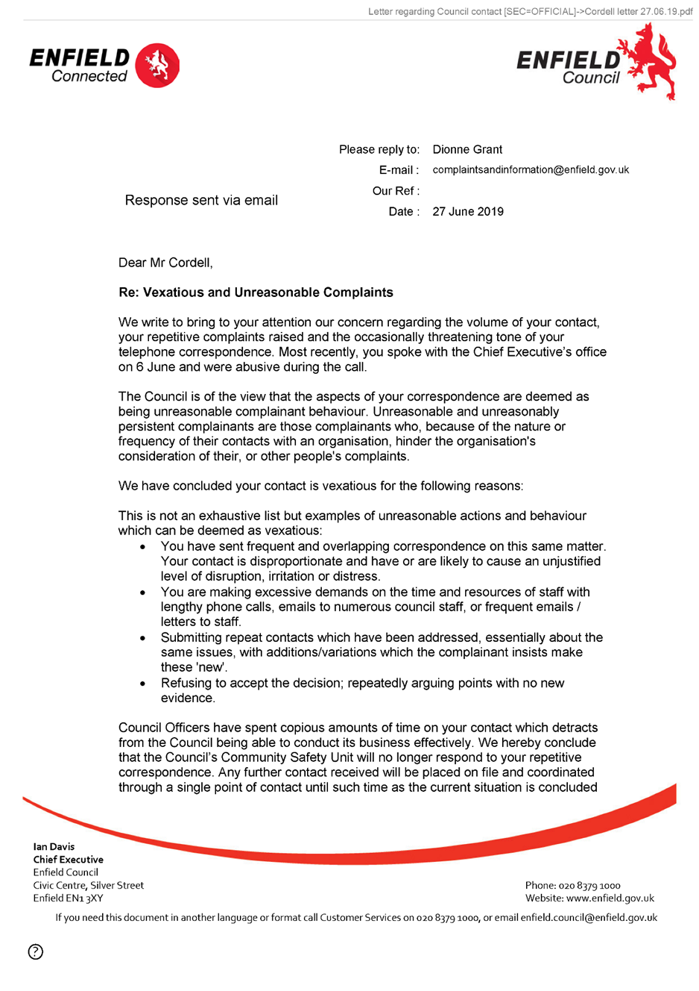  377,  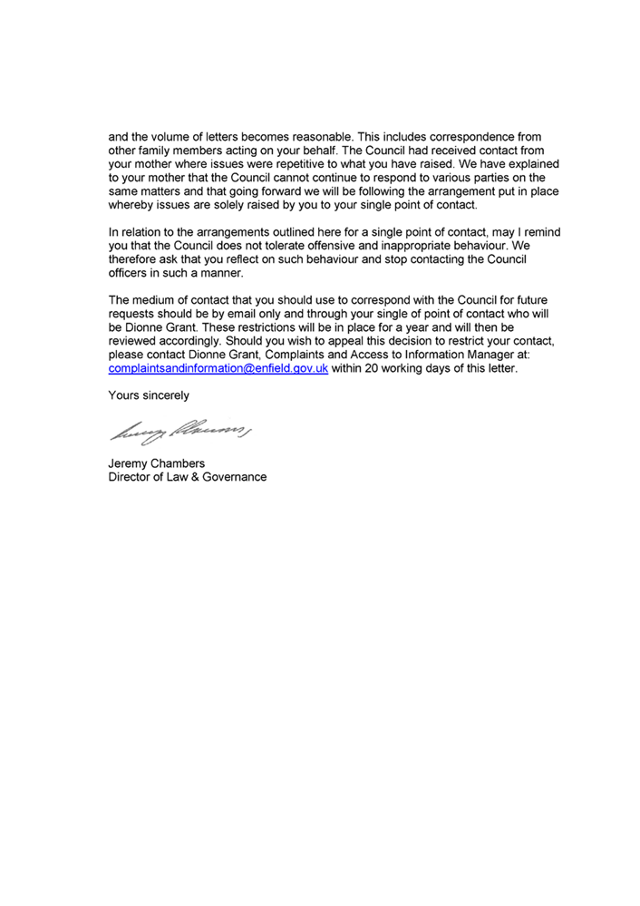  End of Picture!  - Additional Email Attachments & Emails / Issue:  37. 1. 1  Sean@tyrerroxburgh.co06.27.2019_Letter from Enfield 2  27/06/2019/  Page Numbers: 378,379  --  378,  From: Sean Shanmuganathan <sean@tyrerroxburgh.co.uk>  Sent: 27 June 2019 10:06  To: Lorraine Cordell  Cc: Ronak Ahmed  Subject: Letter from Enfield  Attachments: 20190627104617521.pdf  Dear Ms Cordell  Please find attached the letter we received from Enfield Council.  Kind Regards  D Shanmuganathan Partner  Tyrer Roxburgh Solicitors LLP  Tel +44 (0)20 8889 3319  Direct Dial +44 (0)20 8829 2937  Email sean@tyrerroxburgh.co.uk  Head Office:  1 St Michaels Terrace London N22 7SJ  DX 34704 WOOD GREEN 2  Tel +44 (0)20 8889 3319  Fax +44 (0)20 8881 6089  Luton Office:  Trend House Dallow Road Luton LU11LY  Tel +44 (0)1582 726579  Please reply to our Head Office  www.tyrerroxburgh.co.uk  Authorised by the Solicitors Regulation Authority. Tyrer Roxburgh Solicitors LLP is a limited liability partnership under the no.560748. A list of the members' names is open to inspection at the registered office. VAT REG No: 221 8088 78 SRA No: 560748  Contracted with the Legal Aid Agency  We do not accept service of documents or other process by e-mail Email us at lawmakers@tyrerroxburgh.co.uk  This message may contain privileged information and is only intended to be received by the person to whom it is addressed.  If you are not the intended recipient, please contact us as soon as possible.  Partners • Mukesh Badhan • D Shanmuganathan  379,  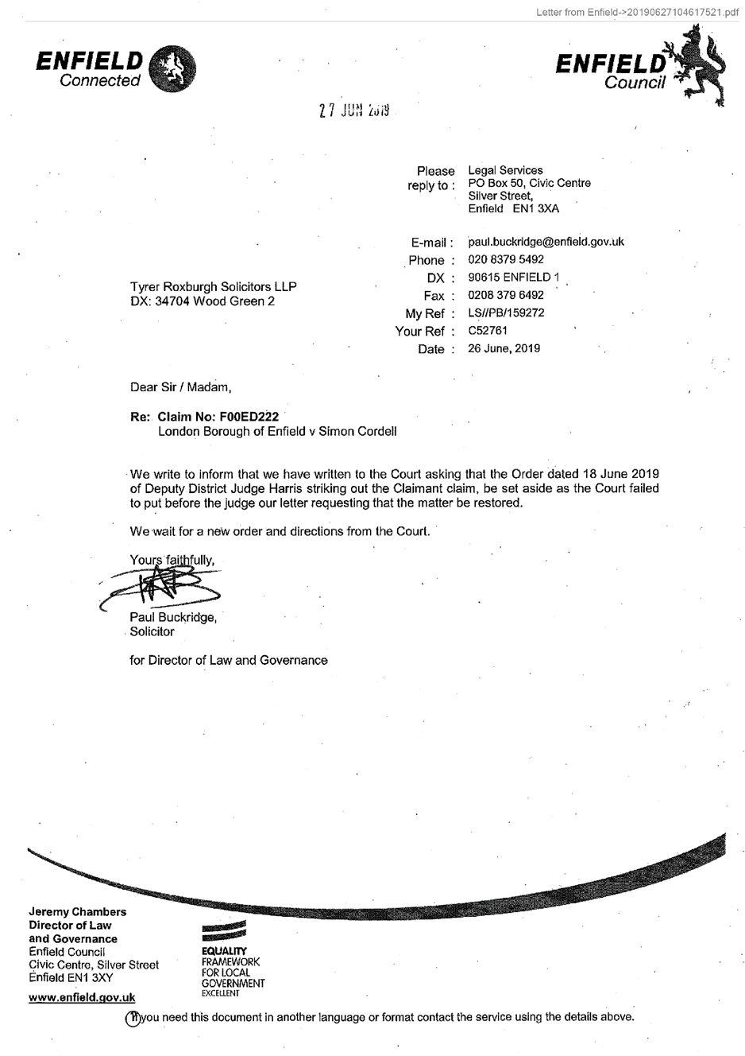  End of Picture! | - It is said by us that on the 00/00/0000 the following took place.

28/06/2019
  EXHIBIT  - 1 | - It is said by us that on the 00/00/0000 the following took place.
  EXHIBIT  - 2 | - It is said by us that on the 00/00/0000 the following took place.
  EXHIBIT  - 3 | - It is said by us that on the 00/00/0000 the following took place.
  EXHIBIT  - 4 | - It is said by us that on the 00/00/0000 the following took place.
  EXHIBIT  - 5 | - It is said by us that on the 00/00/0000 the following took place.
  EXHIBIT  - 6 | - It is said by us that on the 00/00/0000 the following took place.
  EXHIBIT  - 7 | - It is said by us that on the 00/00/0000 the following took place.
  EXHIBIT  - 8 | - It is said by us that on the 00/00/0000 the following took place.
  EXHIBIT  - 9 | - It is said by us that on the 00/00/0000 the following took place.
  EXHIBIT  - 10  - 2nd Possession Order! 06/02/2019  I have good news in that the Council have decided to not pursue the case further due to a lack of recent incidents. Please see attached their letter received recently and our letter dated 22 October 2019 sent to your son. | - It is said by us that on the 00/00/0000 the following took place.
29/06/2019 | - 2nd Possession Order! 06/02/2019  I have good news in that the Council have decided to not pursue the case further due to a lack of recent incidents. Please see attached their letter received recently and our letter dated 22 October 2019 sent to your son.

27/06/2020
  EXHIBIT  - 1 | - It is said by us that on the 00/00/0000 the following took place.
  EXHIBIT  - 2 | - It is said by us that on the 00/00/0000 the following took place.
  EXHIBIT  - 3 | - It is said by us that on the 00/00/0000 the following took place.
  EXHIBIT  - 4 | - It is said by us that on the 00/00/0000 the following took place.
  EXHIBIT  - 5 | - It is said by us that on the 00/00/0000 the following took place.
  EXHIBIT  - 6 | - It is said by us that on the 00/00/0000 the following took place.
  EXHIBIT  - 7 | - It is said by us that on the 00/00/0000 the following took place.
  EXHIBIT  - 8 | - It is said by us that on the 00/00/0000 the following took place.
  EXHIBIT  - 9 | - It is said by us that on the 00/00/0000 the following took place.
  EXHIBIT  - 10  23.  - Additional Email Attachments & Emails / Issue:  23. 2.  Letter regarding contact Enfield Council-24-06-2020 18-03  24/06/2020  / Page Numbers: 52,53  24.  - Additional Email Attachments & Emails / Issue:  24. 1. 1  Complaints and information act with Enfield Council [SEC  24/06/2020  / Page Numbers: 54,55,56,57,58  25.  - Additional Email Attachments & Emails / Issue:  25. 1. 1  lorraine32@blueyonderg contact with Enfield Council  24/06/2020  / Page Numbers: 59,60  77.  - Additional Email Attachments & Emails / Issue:  77. 2.  Letter regarding contact with Enfield Council-1-21487  24/06/2020  / Page Numbers: 176,177,178,179,180  --  - Additional Email Attachments & Emails / Issue:  23. 2.  Letter regarding contact Enfield Council-24-06-2020 18-03  24/06/2020  / Page Numbers: 52,53  --  52,  From: Lorraine Cordell <lorraine32@blueyonder.co.uk>  Sent time: 24/06/2020 08:18:03 PM  To: Rewired <re_wired@ymail.com>  Subject: FW: Letter regarding contact with Enfield Council [SEC=OFFICIAL]  This is what I have asked her  From: Lorraine Cordell <lorraine32@blueyonder.co.uk>  Sent: 24 June 2020 20:09  To: ' complaints and information' <complamtsandmfonriation@enfield.gov.uk>  Subject: RE: Letter regarding contact with Enfield Council [SEC=OFFICIAL]  Dear Karen Hale  I was wondering if you sent a copy of this to my son via his address. Or has it just been sent to me?  If you could also, please send me a list of dates and times my son has called for the past year I would be grateful.  Regards  Lorraine  From: complaints and information <complaintsandinformation@enfield.gov.uk>  Sent: 24 June 2020 15:33  To: 'Lorraine32@blueyonder.co.uk' <Lorraine32@bluevonder.co.uk>  Subject: Letter regarding contact with Enfield Council [SEC=OFFICIAL]  Classification: OFFICIAL  Dear Mr. Cordell,  Please find attached letter for your attention regarding communications with the Council. Yours sincerely  Karen Hale  Complaints and Information Service Manager Complaints and Information Team Enfield Council  Classification: OFFICIAL  Be the first to receive the latest Council news straight to your inbox  SIGN UP ONLINE NOW  www.enfield.gov.uk/enewsletters  Enfield Council is committed to serving the whole borough fairly, delivering excellent services and building strong communities. Opinions expressed in this email are those of the individual and not necessarily those of the London Borough of Enfield. This email and any attachments or files transmitted with it are strictly confidential and intended solely for the named addressee. It may contain privileged and confidential information and if you are not the intended recipient and receive it in error you must not copy, distribute, or use the communication in any other way. All traffic handled by the Government Connect Secure Extranet may be subject to recording/and or monitoring in accordance with relevant legislation.  This email has been scanned for viruses, but we cannot guarantee that it will be free of viruses or malware. The recipient  53,  should perform their own virus checks.  Disclaimer  The information contained in this communication from the sender is confidential. It is intended solely for use by the recipient and others authorized to receive it. If you are not the recipient, you are hereby notified that any disclosure, copying, distribution or taking action in relation of the contents of this information is strictly prohibited and may be unlawful.  This email has been scanned for viruses and malware, and may have been automatically archived by Mimecast Ltd, an innovator in Software as a Service (SaaS) for business. Providing a safer and more useful place for your human generated data. Specializing in; Security, archiving and compliance.  - Additional Email Attachments & Emails / Issue:  24. 1. 1  Complaints and information act with Enfield Council [SEC  24/06/2020  / Page Numbers: 54,55,56,57,58  --  54,  From: complaints and information <complaintsandmformation@enfield.gov.uk>  Sent: 24 June 2020 15:33  To: Lorraine32@blueyonder.co.uk  Subject: Letter regarding contact with Enfield Council [SEC=OFFICIAL]  Attachments: Cordell letter 24.6.2020.pdf; Cordell letter 27.06.19.pdf  Classification: OFFICIAL  Dear Mr. Cordell,  Please find attached letter for your attention regarding communications with the Council. Yours sincerely  Karen Hale  Complaints and Information Service Manager Complaints and Information Team Enfield Council  Classification: OFFICIAL  Be the first to receive the latest Council news straight to your inbox  SIGN UP ONLINE NOW  www.enfieldgov.uk/enewsletters  Enfield Council is committed to serving the whole borough fairly, delivering excellent services and building strong communities. Opinions expressed in this email are those of the individual and not necessarily those of the London Borough of Enfield. This email and any attachments or files transmitted with it are strictly confidential and intended solely for the named addressee. It may contain privileged and confidential information and if you are not the intended recipient and receive it in error you must not copy, distribute, or use the communication in any other way. All traffic handled by the Government Connect Secure Extranet may be subject to recording/and or monitoring in accordance with relevant legislation.  This email has been scanned for viruses, but we cannot guarantee that it will be free of viruses or malware. The recipient should perform their own virus checks.  Disclaimer  The information contained in this communication from the sender is confidential. It is intended solely for use by the recipient and others authorized to receive it. If you are not the recipient, you are hereby notified that any disclosure, copying, distribution or taking action in relation of the contents of this information is strictly prohibited and may be unlawful.  This email has been scanned for viruses and malware, and may have been automatically archived by Mimecast Ltd, an innovator in Software as a Service (SaaS) for business. Providing a safer and more useful place for your human generated data. Specializing in; Security, archiving and compliance.  55,  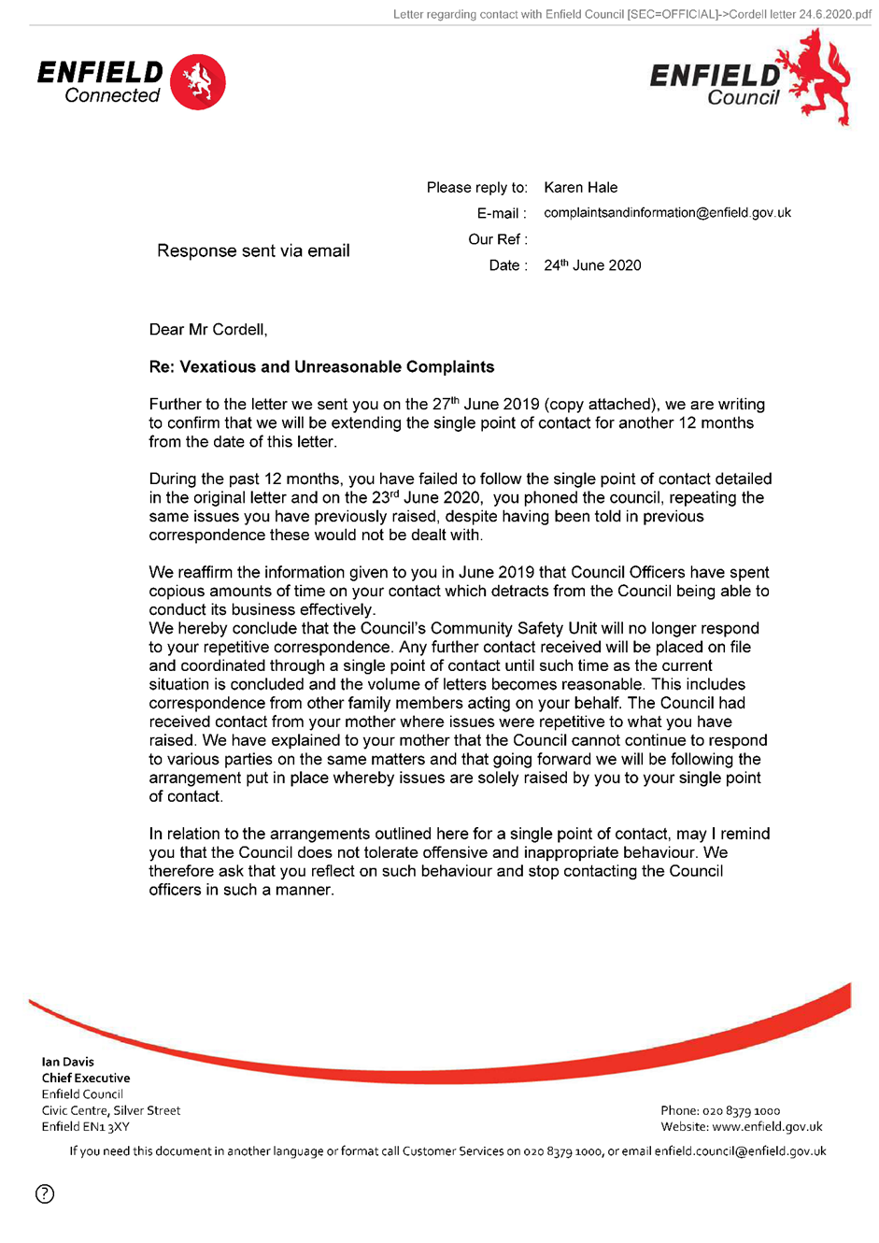  56,  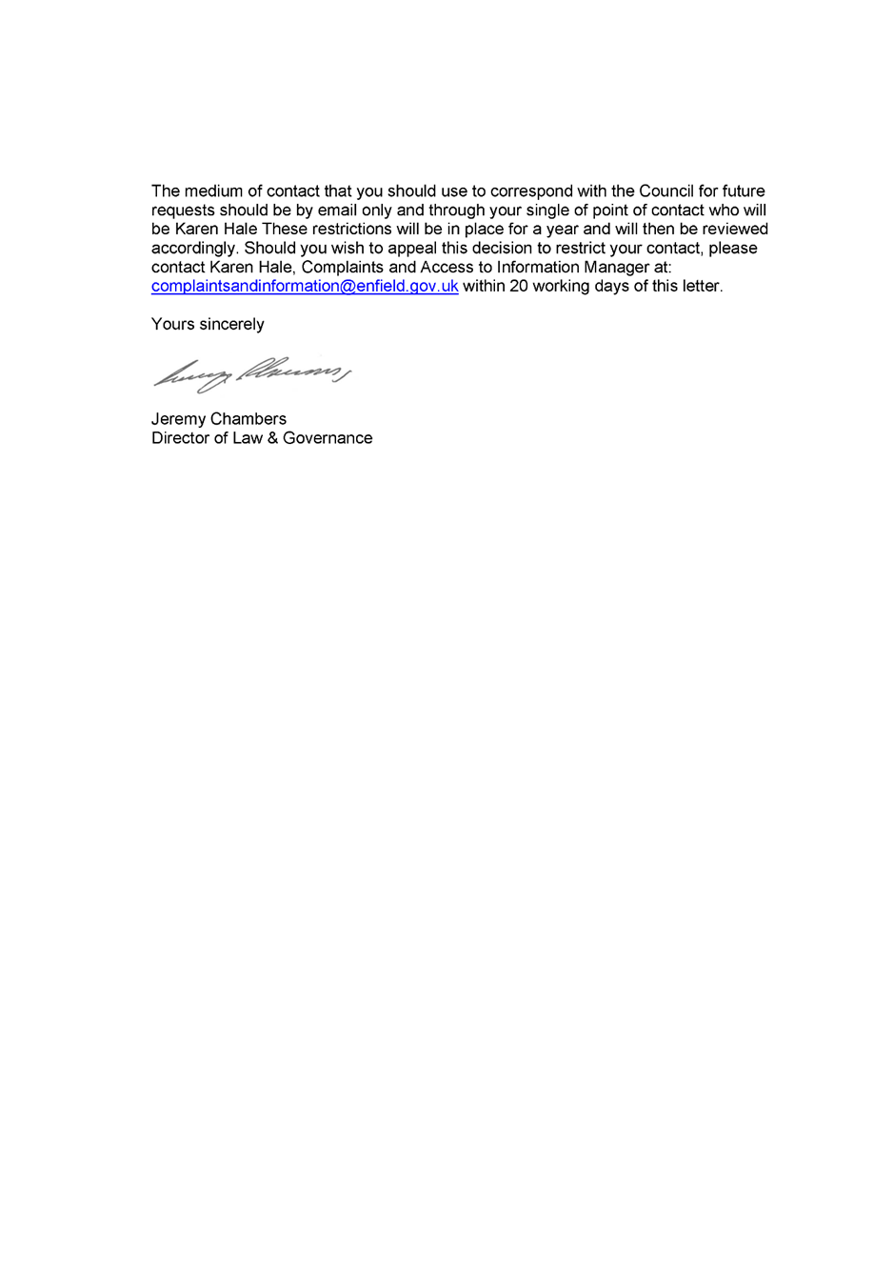  57,  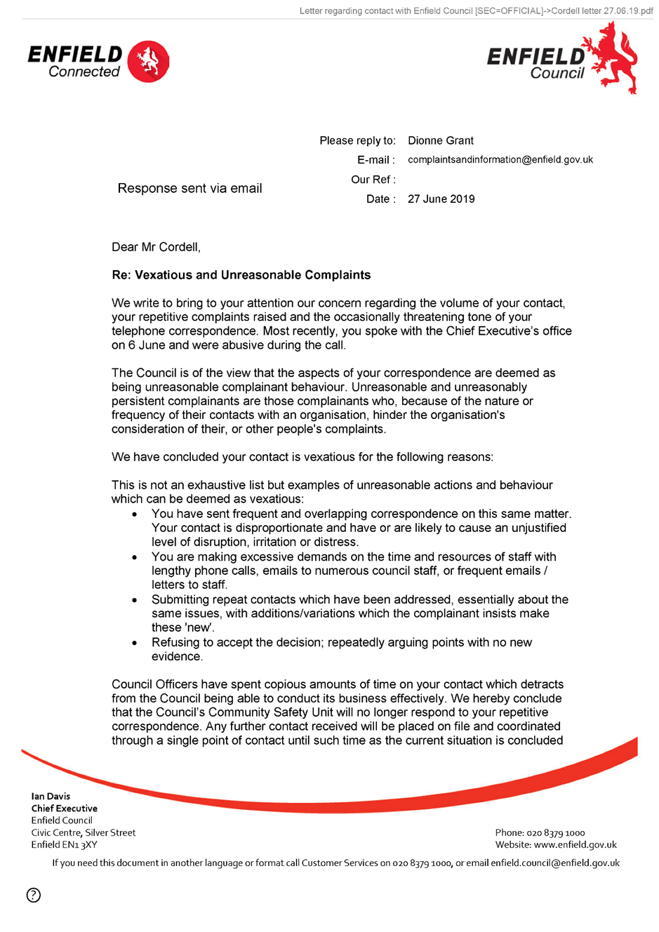  58,  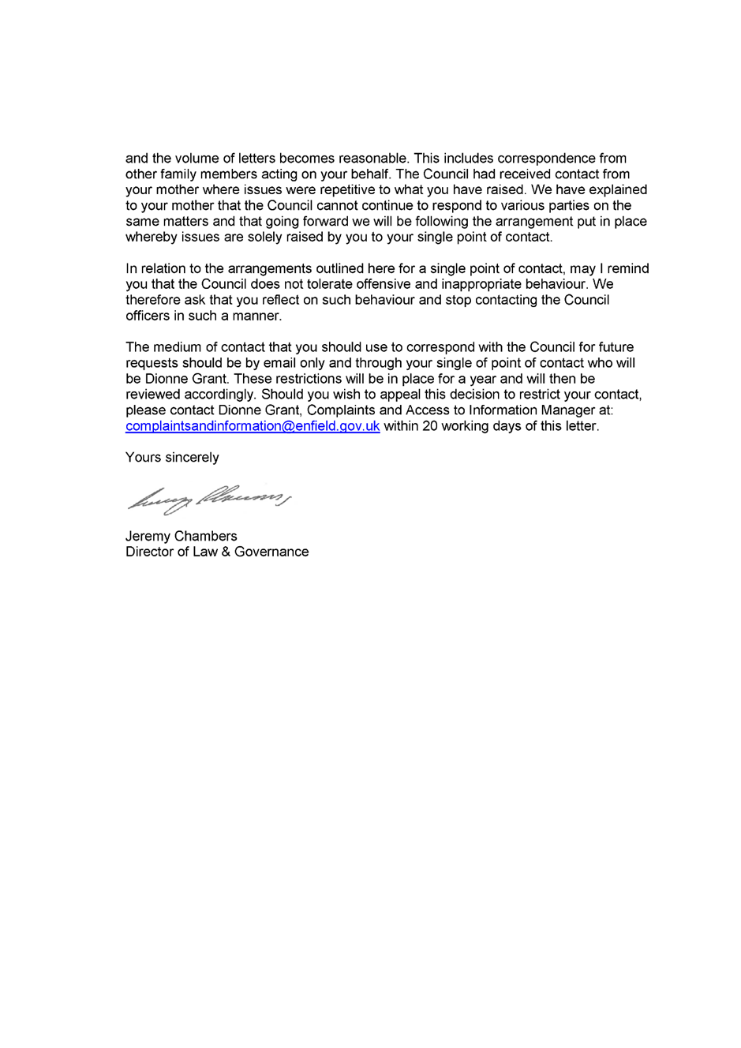  End of picture!  - Additional Email Attachments & Emails / Issue:  25. 1. 1  lorraine32@blueyonderg contact with Enfield Council  24/06/2020  / Page Numbers: 59,60  --  59,  From: Lorraine Cordell <lorraine32@blueyonder.co.uk>  Sent: 24 June 2020 23:19  To: complaints and information  Subject: RE: Letter regarding contact with Enfield Council [SEC=OFFICIAL]  Importance: High  Dear Karen Hale  I was wondering if you sent a copy of this to my son via his home address and if so on what date? Or has it just been sent to me?  If you could also, please send me a list of all dates and times my son has called and for what reason he has called for the past year, highlighting dates where you state he has been Vexatious, and Unreasonable, I would be most grateful.  Also, I am sorry for the updated email the reason is due to me reading the letter fully what you have written, can you also please supply me with dates in the last year I have contracted the council for my son regarding the issues listed in the letter dated the 23/06/2020, again highlighting all dates and times you state I have been Vexatious and Unreasonable.  - I believe I contracted the council named officer once after the letter dated 27/06/2020 which I had no reply to.  - The other contract I had was due to an ongoing court case, in which most of the time my son’s solicitors was contracting the council towards the end of the case, I had to address the council directly as my son no longer had a solicitor acting for him.  - The only other time I had contract was when the MP was addressing issues regarding a court order which the court made which the council did not comply with.  - And the only other time I have had contact is due to repairs that needed doing to my sons flat.  Could you therefore supply me with the above information as soon as possible so this can be addressed in a timely manner?  Regards  Lorraine  From: complaints and information <complaintsandinformation@enfield.gov.uk>  Sent: 24 June 2020 15:33  To: 'Lorraine32@blueyonder.co.uk' <Lorraine32@blueyonder.co.uk>  Subject: Letter regarding contact with Enfield Council [SEC=OFFICIAL]  Classification: OFFICIAL  Dear Mr. Cordell,  Please find attached letter for your attention regarding communications with the Council.  Yours sincerely  60,  Karen Hale  Complaints and Information Service Manager Complaints and Information Team Enfield Council  Classification: OFFICIAL  Be the first to receive the latest Council news straight to your inbox  SIGN UP ONLINE NOW  www.enfield.gov.uk/enewsletters  Enfield Council is committed to serving the whole borough fairly, delivering excellent services and building strong communities. Opinions expressed in this email are those of the individual and not necessarily those of the London Borough of Enfield. This email and any attachments or files transmitted with it are strictly confidential and intended solely for the named addressee. It may contain privileged and confidential information and if you are not the intended recipient and receive it in error you must not copy, distribute, or use the communication in any other way. All traffic handled by the Government Connect Secure Extranet may be subject to recording/and or monitoring in accordance with relevant legislation.  This email has been scanned for viruses, but we cannot guarantee that it will be free of viruses or malware. The recipient should perform their own virus checks.  Disclaimer  The information contained in this communication from the sender is confidential. It is intended solely for use by the recipient and others authorized to receive it. If you are not the recipient, you are hereby notified that any disclosure, copying, distribution or taking action in relation of the contents of this information is strictly prohibited and may be unlawful.  This email has been scanned for viruses and malware, and may have been automatically archived by Mimecast Ltd, an innovator in Software as a Service (SaaS) for business. Providing a safer and more useful place for your human generated data. Specializing in; Security, archiving and compliance.  - Additional Email Attachments & Emails / Issue:  77. 2.  Letter regarding contact with Enfield Council-1-21487  24/06/2020  / Page Numbers: 176,177,178,179,180  --  176,  From: Lorraine Cordell <lorraine32@blueyonder.co.uk>  Sent time: 24/06/2020 07:53:31 PM  To: Rewired <re_wired@ymail.com>  Subject: FW: Letter regarding contact with Enfield Council [SEC=OFFICIAL]  Attachments: Cordell letter 24.6.2020.pdf  Cordell letter 27.06.19.pdf  Here are the letters they sent today  From: complaints and information <complamtsandmfonriation@enfield.gov.uk>  Sent: 24 June 2020 15:33  To: 'Lorraine32@blueyonder.co.uk' <Lorraine32@blueyonder.co.uk>  Subject: Letter regarding contact with Enfield Council [SEC=OFFICIAL]  Classification: OFFICIAL  Dear Mr. Cordell,  Please find attached letter for your attention regarding communications with the Council.  Yours sincerely  Karen Hale  Complaints and Information Service Manager Complaints and Information Team Enfield Council  Classification: OFFICIAL  Enfield Council is committed to serving the whole borough fairly, delivering excellent services and building strong communities. Opinions expressed in this email are those of the individual and not necessarily those of the London Borough of Enfield. This email and any attachments or files transmitted with it are strictly confidential and intended solely for the named addressee. It may contain privileged and confidential information and if you are not the intended recipient and receive it in error you must not copy, distribute, or use the communication in any other way. All traffic handled by the Government Connect Secure Extranet may be subject to recording/and or monitoring in accordance with relevant legislation.  This email has been scanned for viruses, but we cannot guarantee that it will be free of viruses or malware. The recipient should perform their own virus checks.  Disclaimer  The information contained in this communication from the sender is confidential. It is intended solely for use by the recipient and others authorized to receive it. If you are not the recipient, you are hereby notified that any disclosure, copying, distribution or taking action in relation of the contents of this information is strictly prohibited and may be unlawful.  This email has been scanned for viruses and malware, and may have been automatically archived by Mimecast Ltd, an innovator in Software as a Service (SaaS) for business. Providing a safer and more useful place for your human generated data. Specializing in; Security, archiving and compliance.  177,  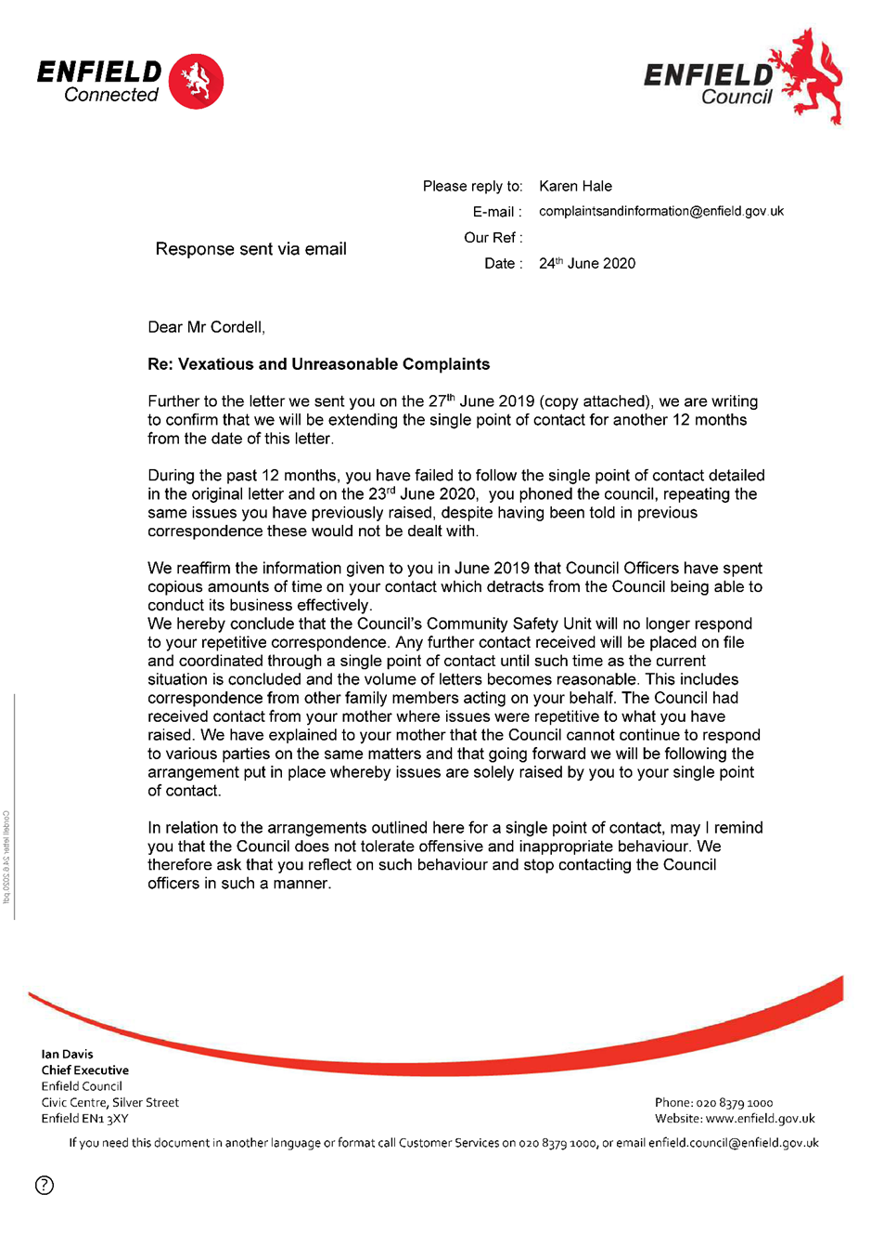  178,  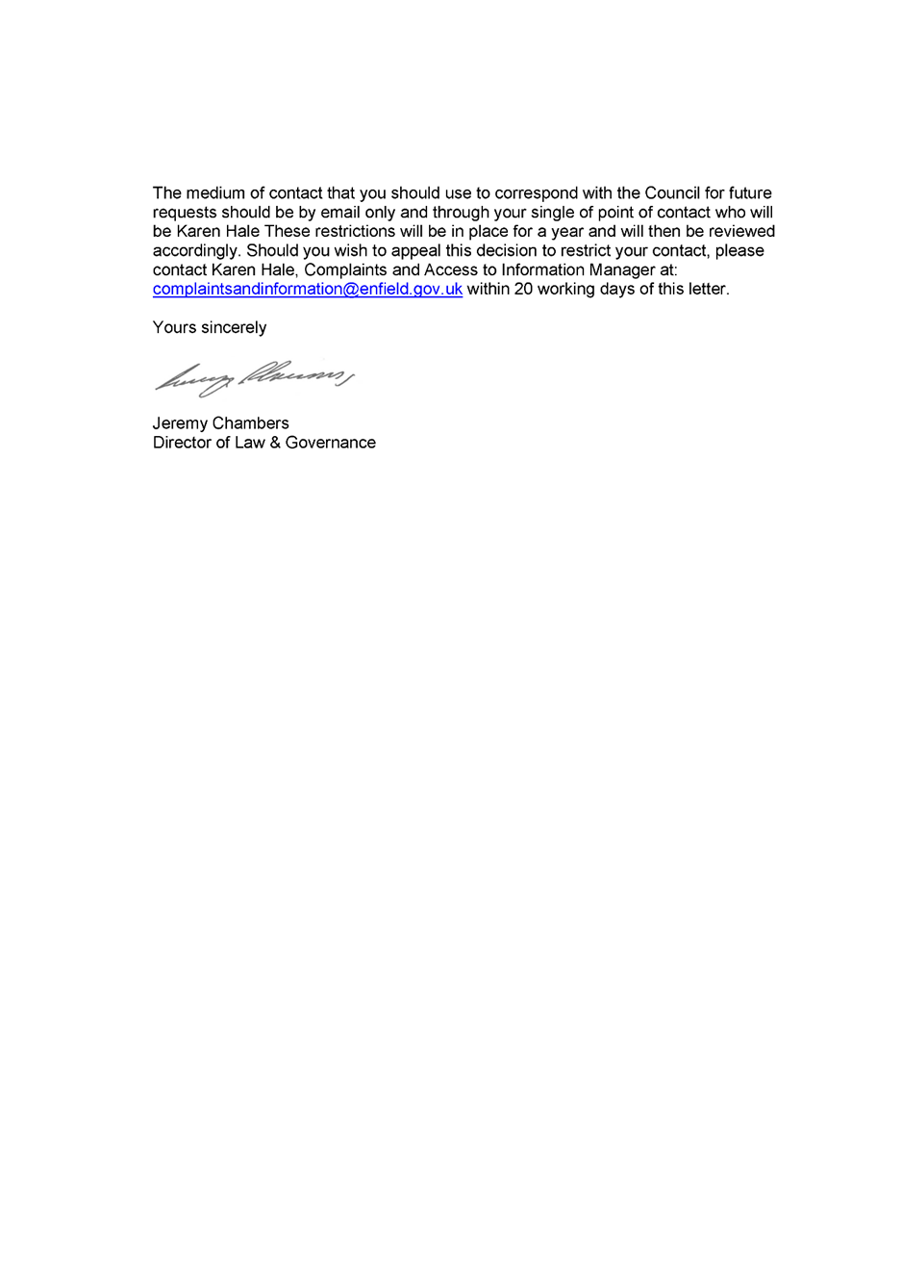  179,  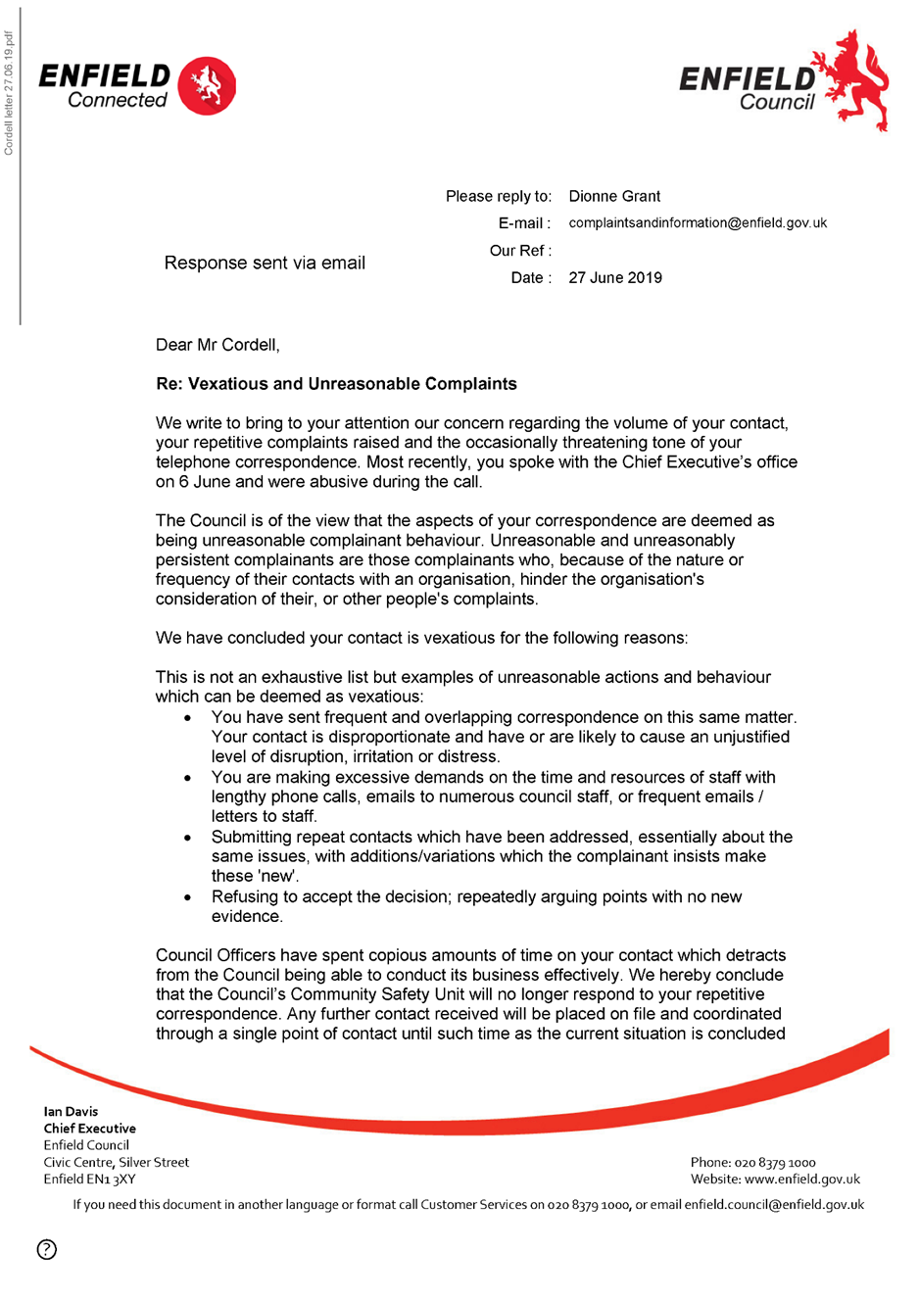  180,  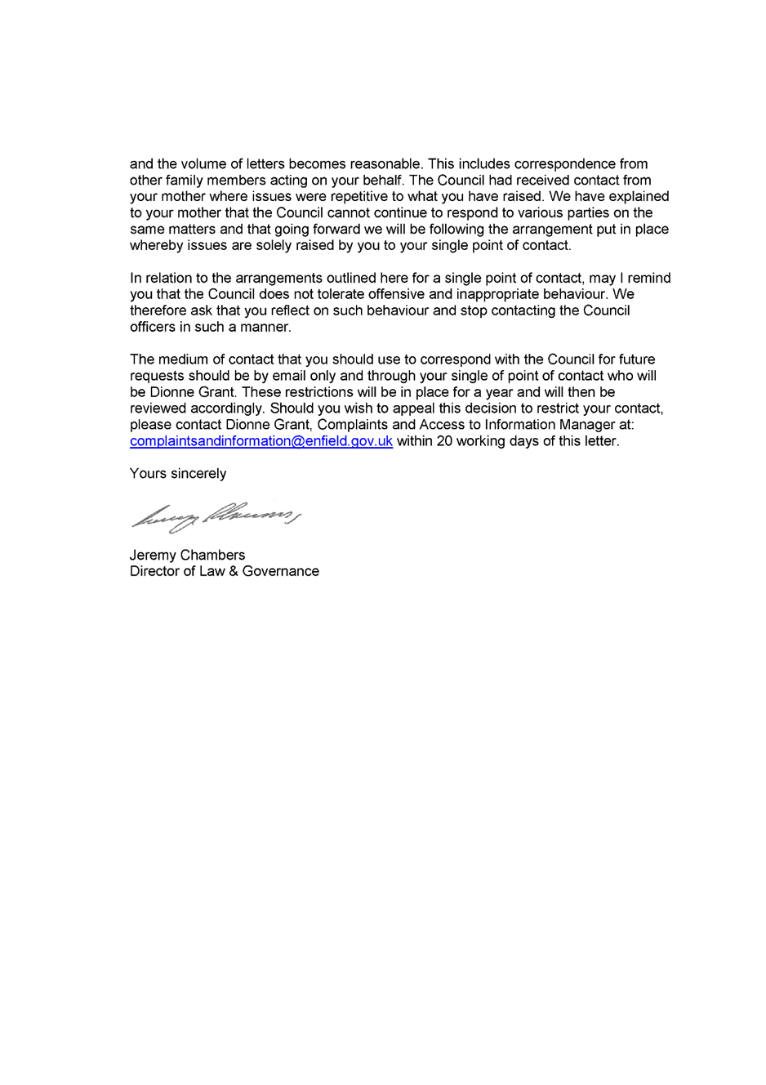  End of Pictures! | - It is said by us that on the 00/00/0000 the following took place.

Yours faithfully, Mr. Simon Paul Cordell

Address: 23 Byron Terrace Edmonton N9 7DG
Dated: 14/09/1026
Contact Email: Re_wired@ymail.com
Signed: 

