Exhibit Section 41:
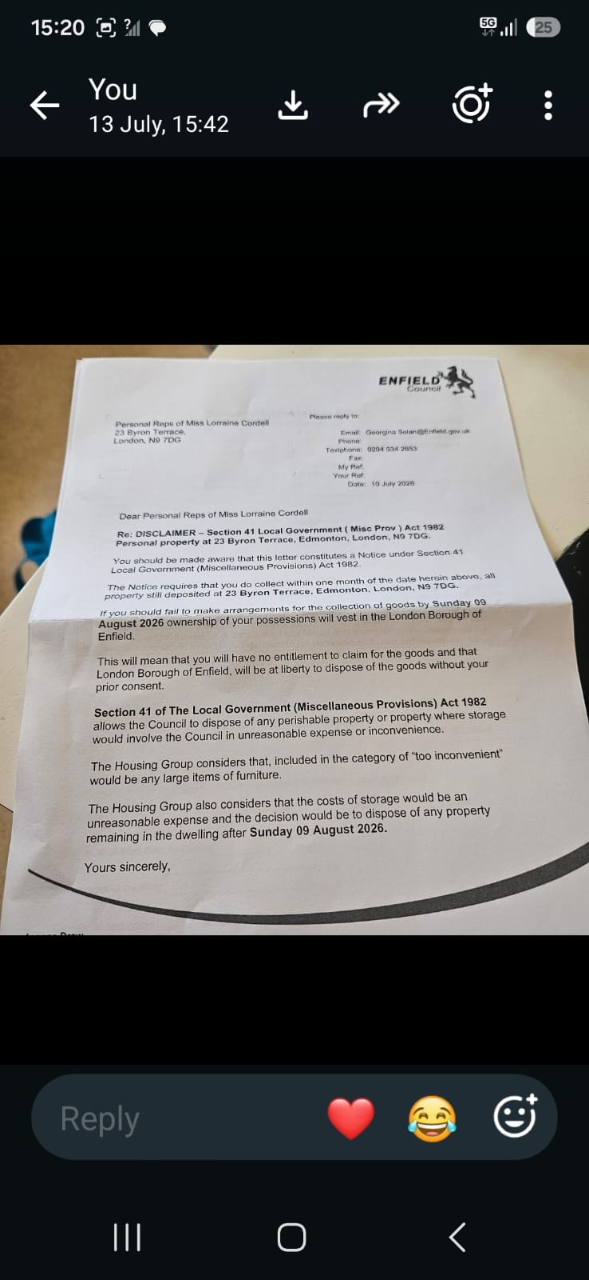

Here: Received 18-08-26
Sent by aunt what’s app. After I OCR image
Personal Reps of Miss Lorraine Cordell 23 Byron Terrace
PLEASE REPLY TO
Email: Georgina Solan
Telephone: 0204 504 2653
Fax:
My Ref:
Your Ref:
Date: 10 July 2026
London
N9 7DG

Dear Personal Reps of Miss Lorraine Cordell

Re: DISCLAIMER — Section 41 Local Government (Misc Prov) Act 1982 Personal property at 23 Byron Terrace. Edmonton. London. N9 7DG

You should be made aware that this letter constitutes a Notice under Section 41 Local Government (Miscellaneous Provisions) Act 1982.

The Notion requires that you do collect within one month of the date hemin above. All property is still deposited at 23 Byron Terrace. Edmonton. London. N9 TOG.

If you should fail to make arrangements for the collection of your goods by Sunday 09 August 2026 ownership of your
of your possessions will vest in the London Borough of Enfield.

This will mean that you will have no entitlement to claim for the goods and that London Borough of Enfield will be at liberty to dispose of the goods without your prior consent.

Section 41 of The Local Government (Miscellaneous Provisions) Act 1982 allows the Council to dispose of any perishable property or property where storage would involve the Council in unreasonable expense or inconvenience.

The Housing Group considers that. Included In the category of loo inconvenient' would be any large items of furniture.

The Housing Group also considers that the costs of storage would be an unreasonable expense, and the decision would be to dispose of any property remaining in the dwelling after Sunday 09 August 2026.

Yours sincerely.

“Reading that notice broke my heart due to what she has done!”

