02/05/2024, 08:05 - Messages and calls are end-to-end encrypted. Only people in this chat can read, listen to, or share them. *Learn more*
27/11/2024, 13:45 - SI: IMG-20241127-WA0002.jpg (file attached)
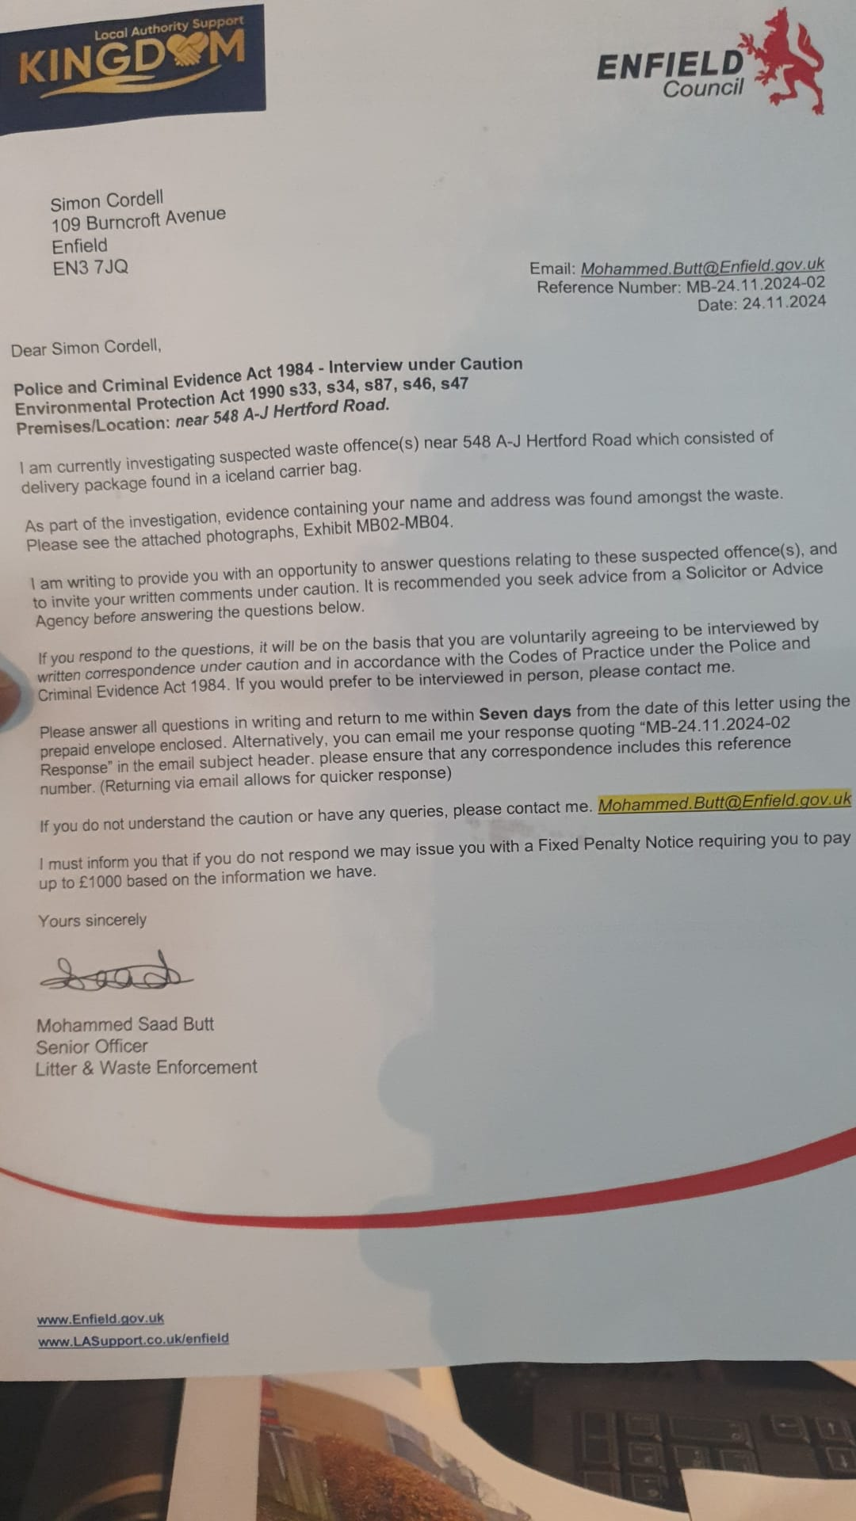

27/11/2024, 13:45 - SI: IMG-20241127-WA0004.jpg (file attached)
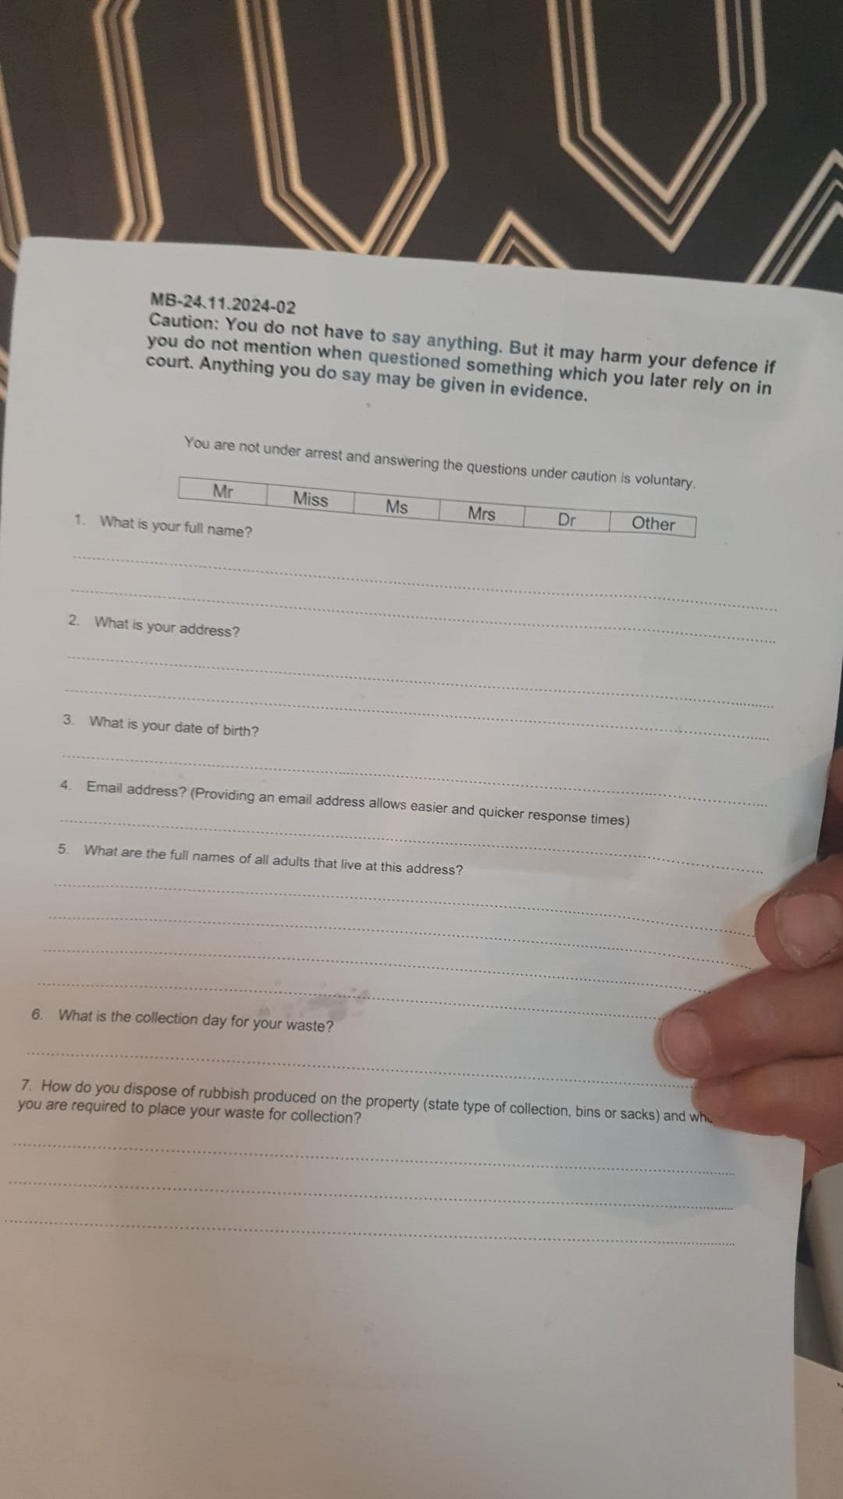

27/11/2024, 13:45 - SI: IMG-20241127-WA0006.jpg (file attached)
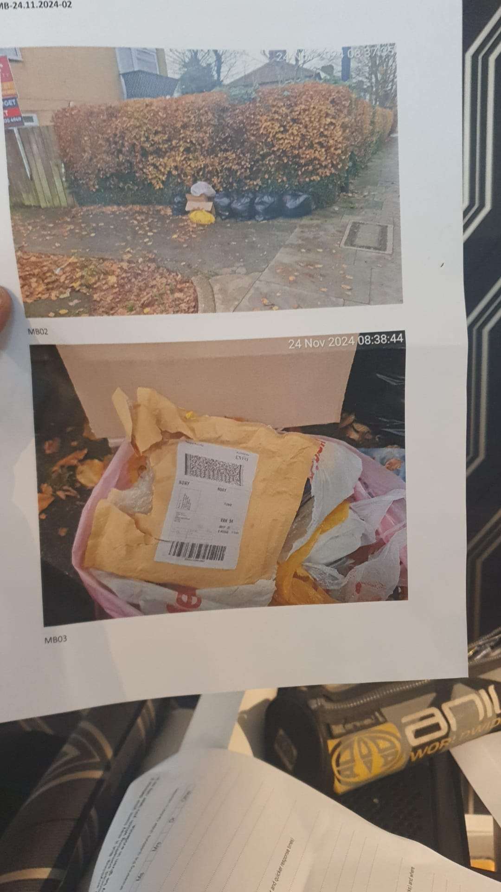

27/11/2024, 13:45 - SI: IMG-20241127-WA0008.jpg (file attached)
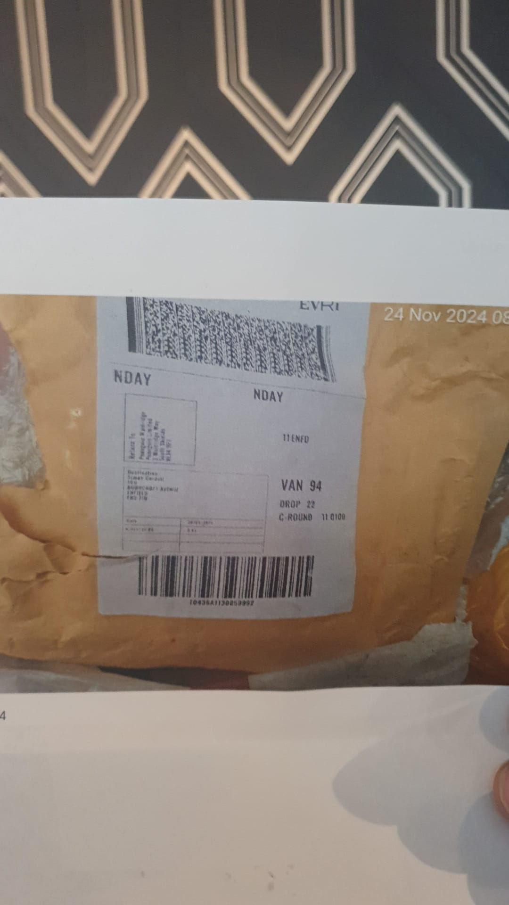

27/11/2024, 13:45 - SI: IMG-20241127-WA0010.jpg (file attached)
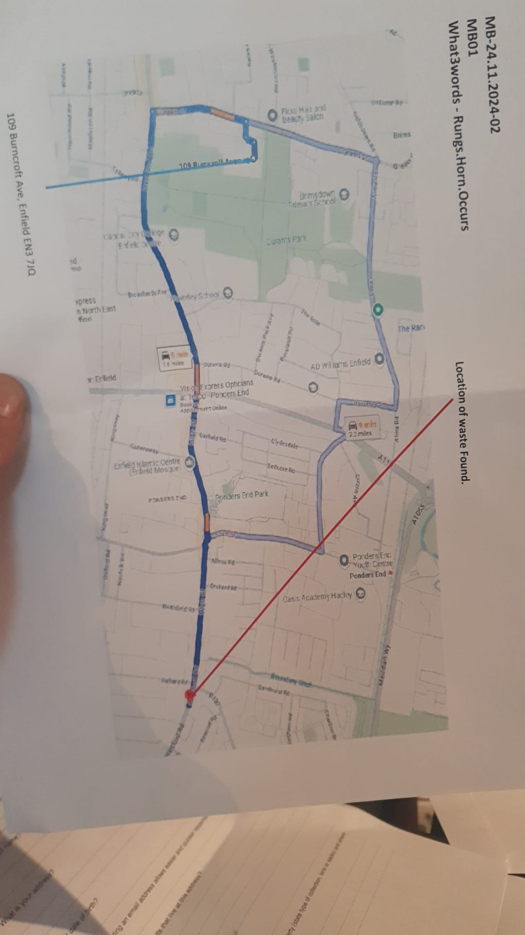

27/11/2024, 13:46 - SI: IMG-20241127-WA0012.jpg (file attached)
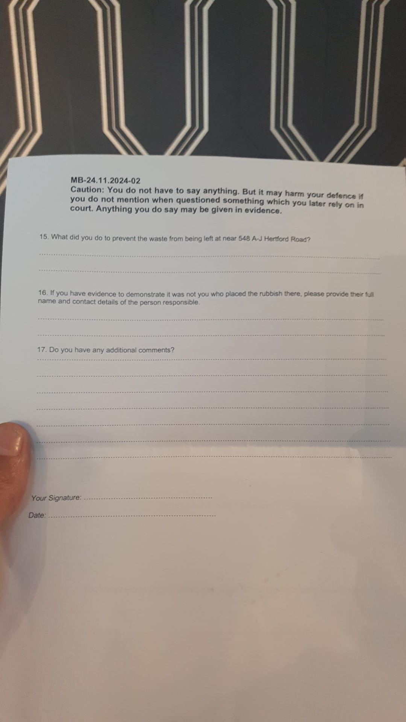

27/11/2024, 13:46 - SI: IMG-20241127-WA0014.jpg (file attached)
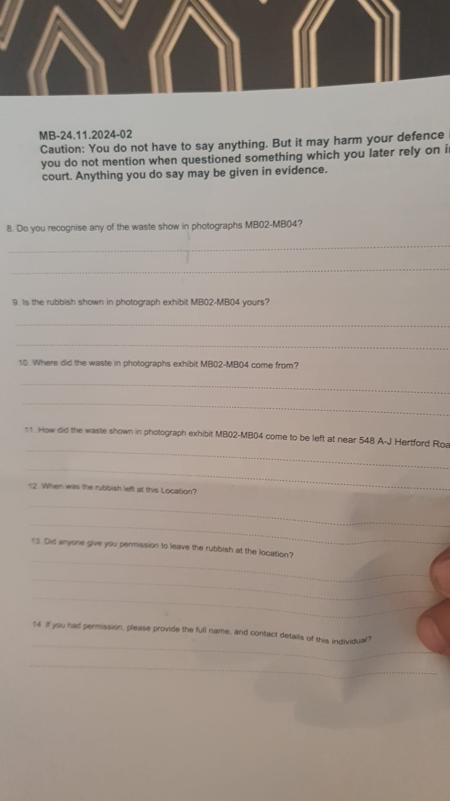

27/11/2024, 14:19 - +447968470159: IMG-20241127-WA0015.jpg (file attached)
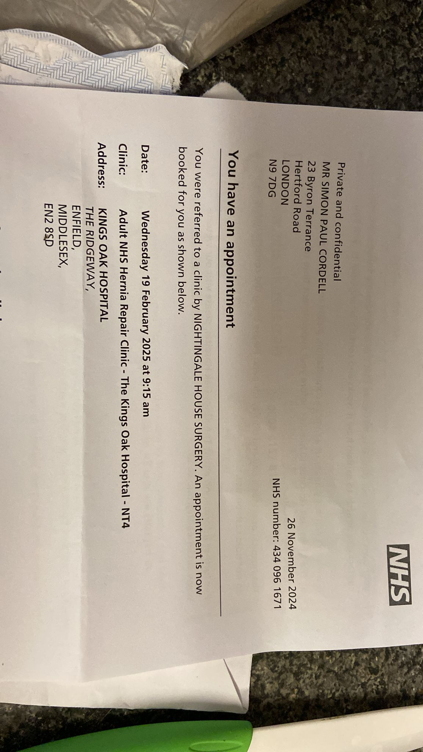

27/11/2024, 14:19 - +447968470159: IMG-20241127-WA0016.jpg (file attached)
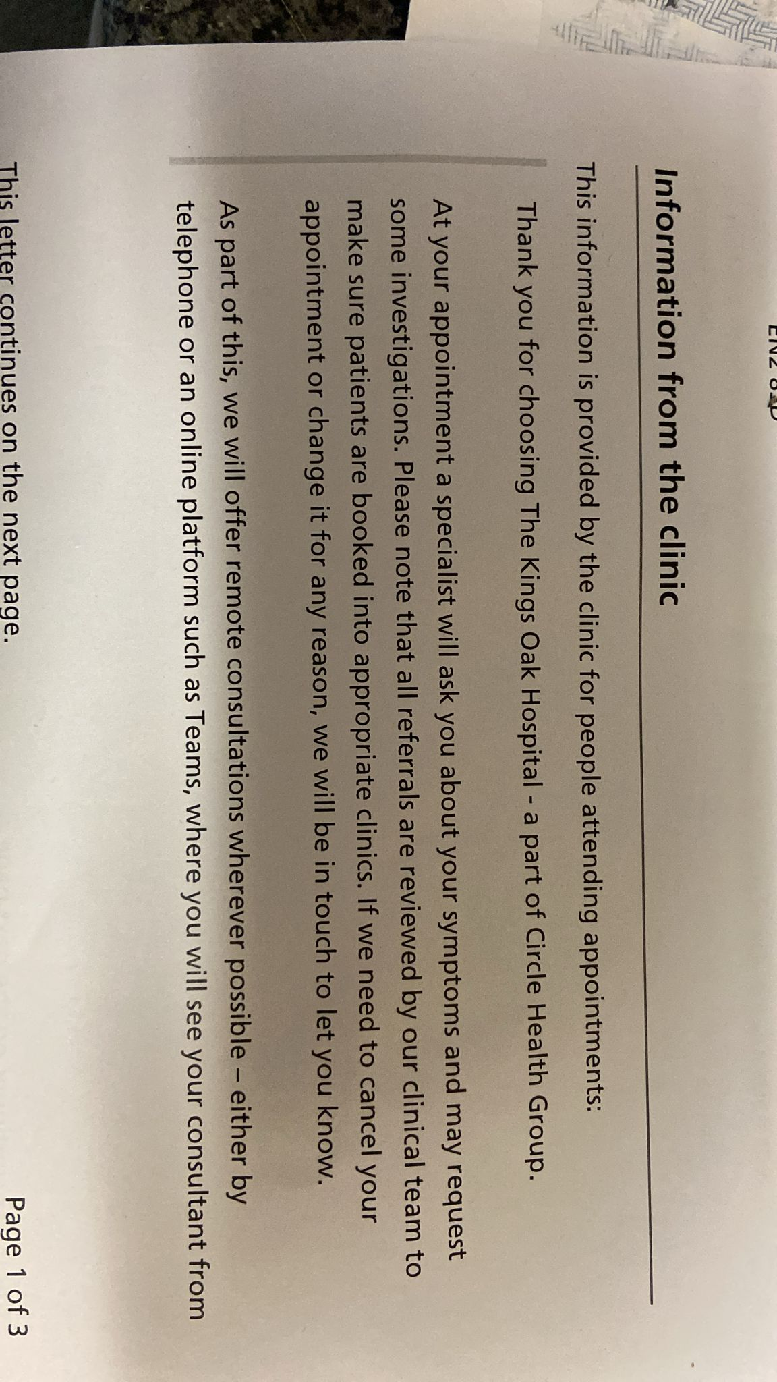

28/11/2024, 09:12 - +447968470159:

28/11/2024, 09:12 - +447968470159: IMG-20241128-WA0000.jpg (file attached)
E mail sent to enfield .
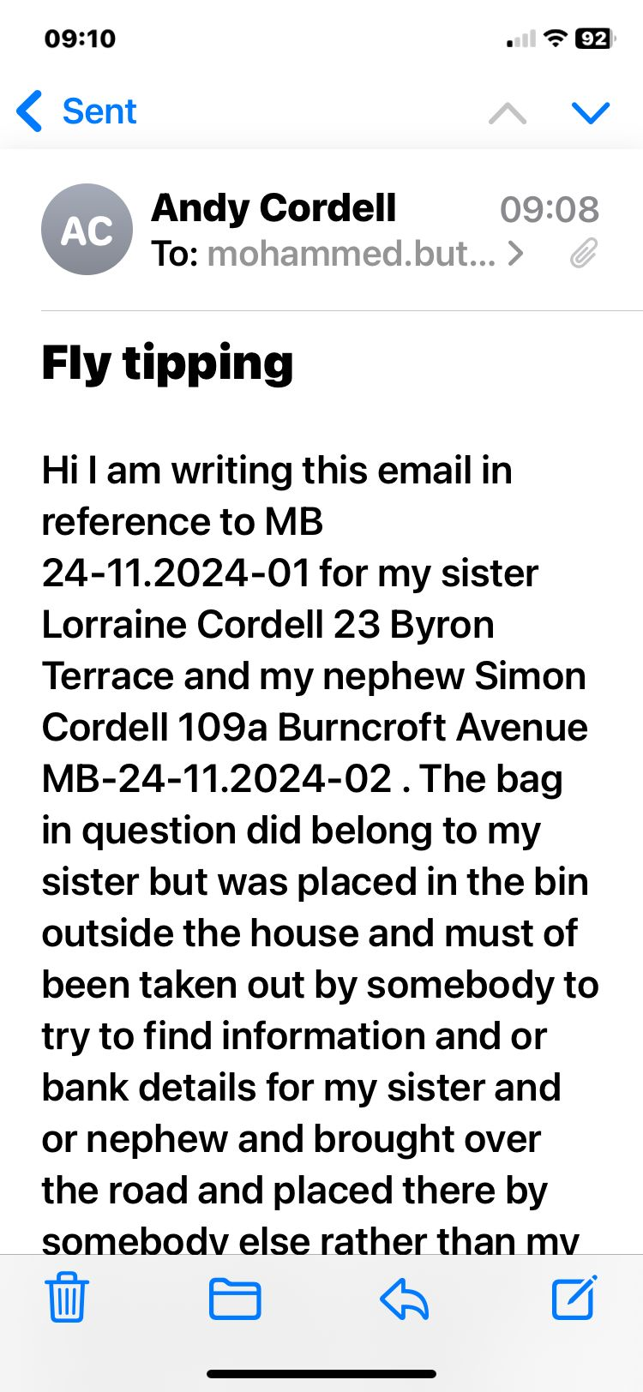

28/11/2024, 09:12 - +447968470159: IMG-20241128-WA0004.jpg (file attached)
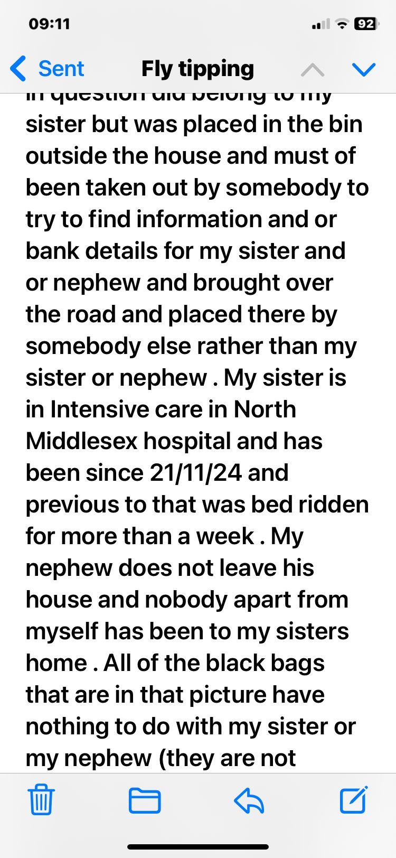

28/11/2024, 09:12 - +447968470159: IMG-20241128-WA0003.jpg (file attached)
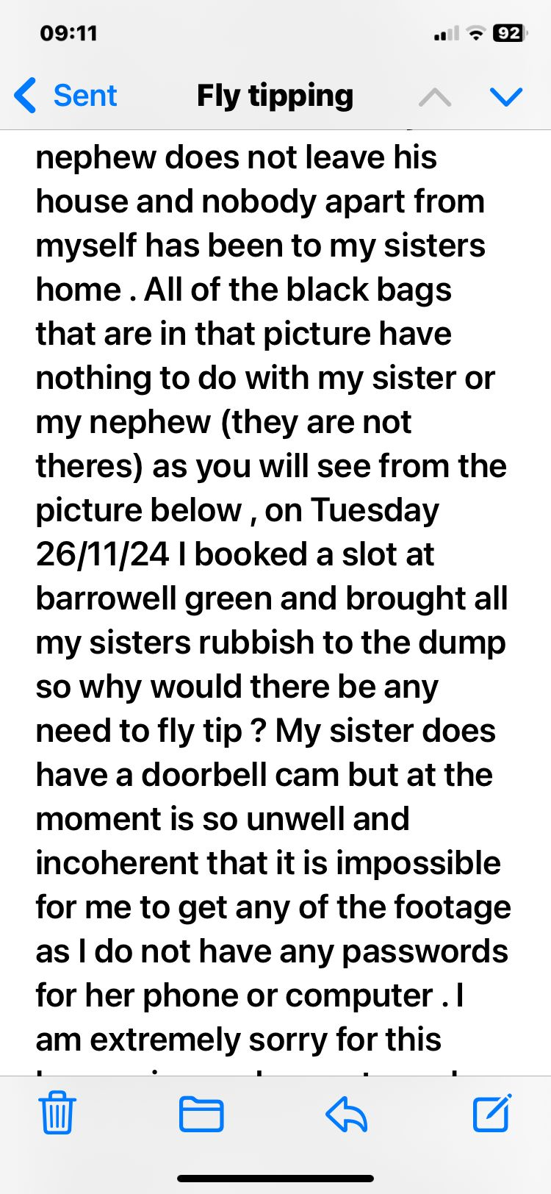

28/11/2024, 09:12 - +447968470159: IMG-20241128-WA0002.jpg (file attached)
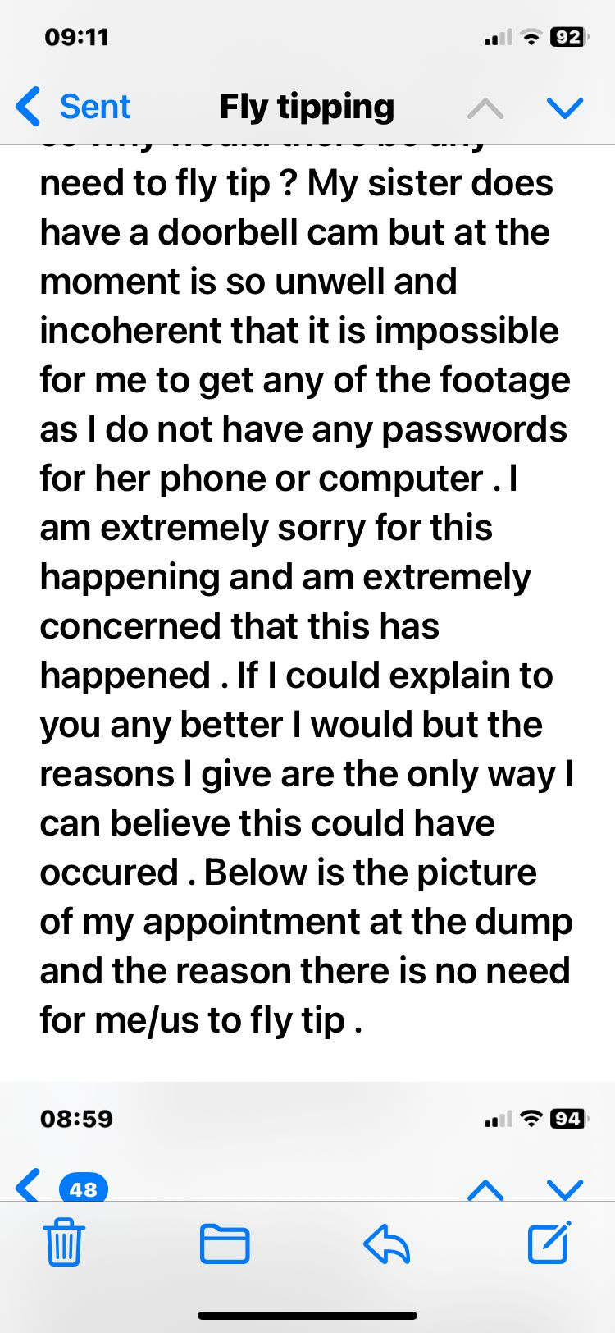

28/11/2024, 09:12 - +447968470159: IMG-20241128-WA0001.jpg (file attached)
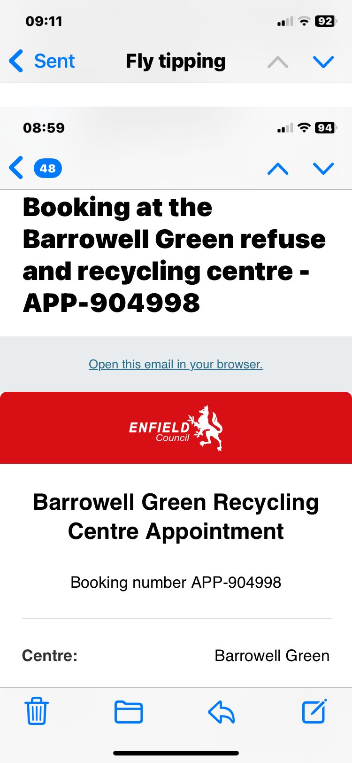

09/12/2024, 18:32 - +447968470159: IMG-20241209-WA0000.jpg (file attached)
Nfa with the fly tipping yayy …

09/12/2024, 18:45 - SI: That great thanks for helping xx

09/12/2024, 18:47 - +447968470159: No problem , was easy which I am shocked about . Will be ringing your hospital in morning and see if they have any cancellations ..

09/12/2024, 18:48 - SI: I am Just sorting something and will get back to u in a bit xx

16/12/2024, 15:55 - +447968470159:

20/12/2024, 13:35 - +447968470159: VID-20241220-WA0000.mp4 (file attached)
VID-20241220-WA0000.mp4

20/12/2024, 13:39 - SI: It looks good. I done my wood flooring I need marble tile effect for the kitchen and that, it's possible...

20/12/2024, 13:39 - SI: Ty no answer

21/12/2024, 11:23 - +447968470159: IMG-20241221-WA0010.jpg (file attached)
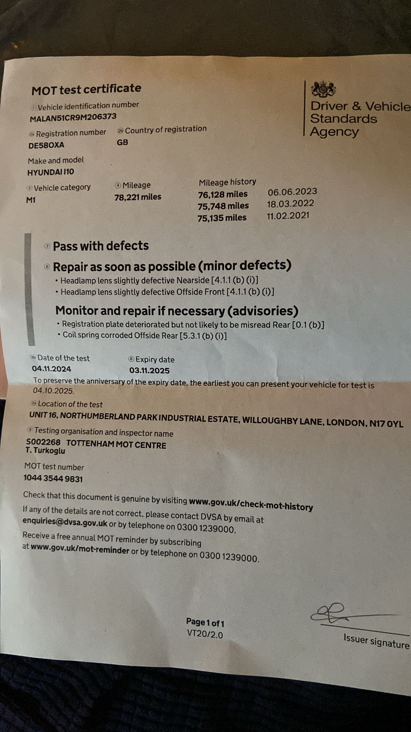

21/12/2024, 11:24 - +447968470159: IMG-20241221-WA0011.jpg (file attached)
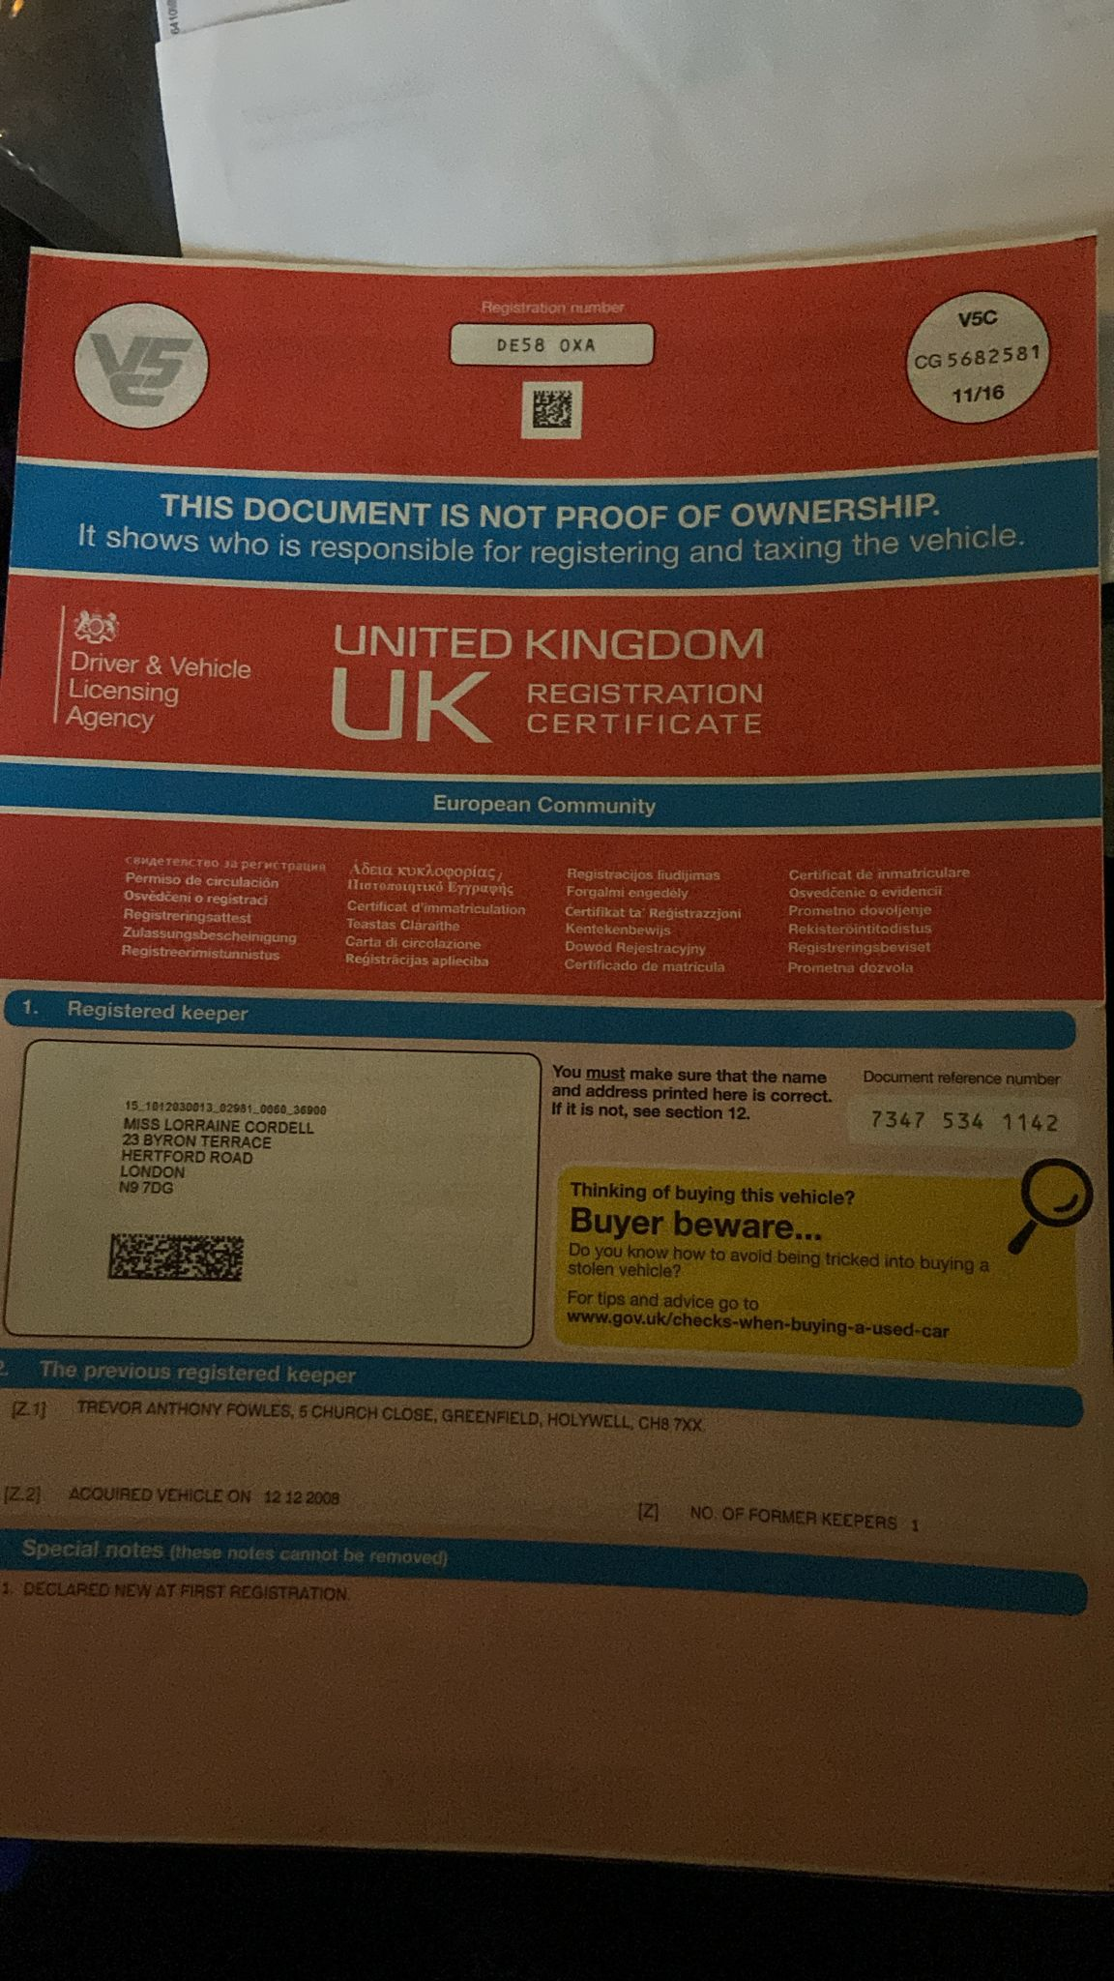

21/12/2024, 11:24 - +447968470159: IMG-20241221-WA0013.jpg (file attached)
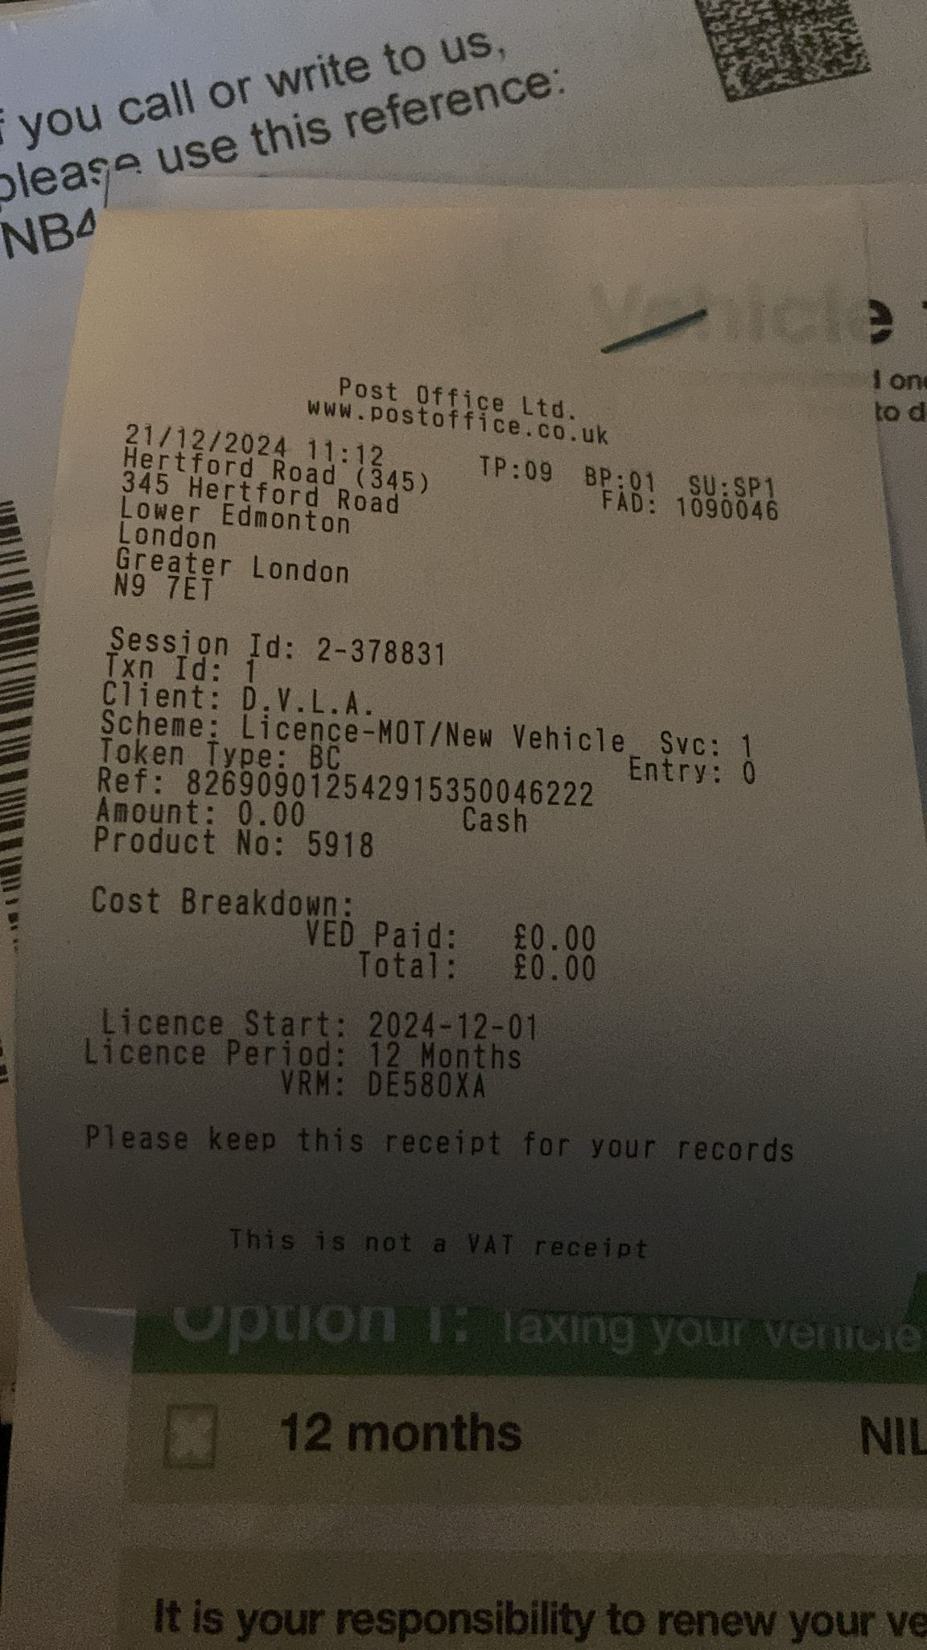

21/12/2024, 11:25 - +447968470159: IMG-20241221-WA0014.jpg (file attached)
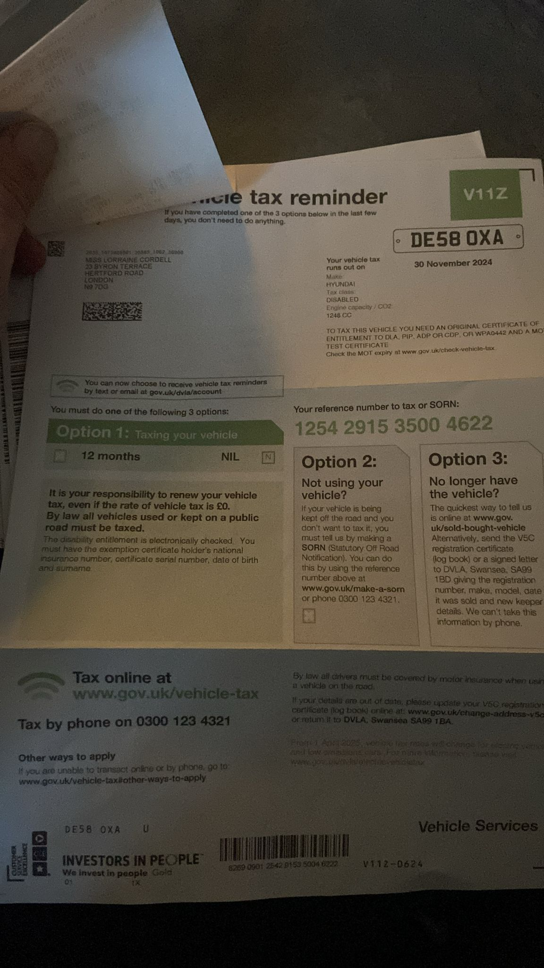

21/12/2024, 11:26 - +447968470159: Car is all done ..

21/12/2024, 11:34 - SI: Thank you both xxxx

21/12/2024, 11:41 - +447968470159: No problem ..

23/12/2024, 11:46 - SI: Asda paxo 3.50 each x2
Lucozade 150 each x2
Kingsmill Bread 1.25 each x 1
Coke 1.25 each 1.25ml x2
Sausage meat 3.00 each x3
Cheese 3.15 each x1
Potato's 1.65 each x2
Carrot 90p each x2
Schweppes 1.35 each x1
Sprouts 85p each x2
Oinios three 1.00 each x1
Asda onion and garlic 1.25 each x1
Broccoli 1.00 each x1

Total 38.23p but mother come upto 85 pounds
We're iz the rest????

23/12/2024, 11:46 - SI: IMG-20241222-WA0011.jpg (file attached)
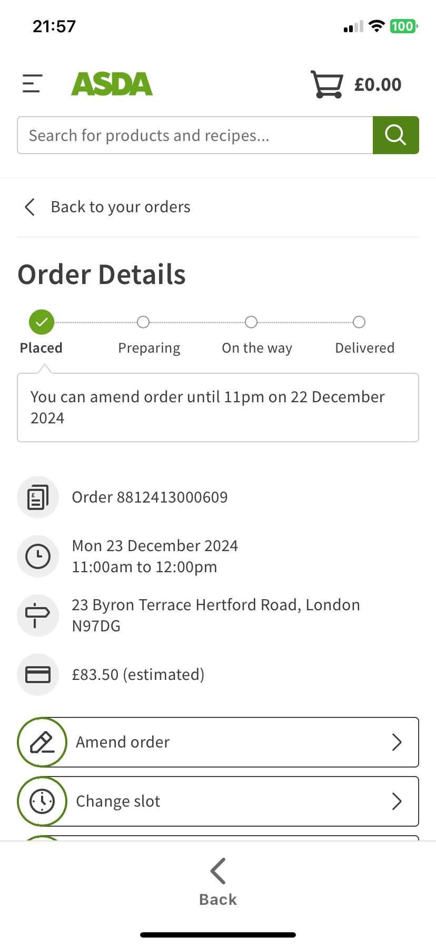

23/12/2024, 20:52 - +447968470159: PTT-20241223-WA0007.opus (file attached)
PTT-20241223-WA0007.opus

25/12/2024, 10:55 - SI:

25/12/2024, 10:55 - +447968470159:

25/12/2024, 10:59 - SI:

30/12/2024, 15:58 - SI:

30/12/2024, 16:01 - SI:

30/12/2024, 16:02 - SI:

30/12/2024, 16:02 - SI:

31/12/2024, 23:44 - SI: Happy new year love you lots xx

12/01/2025, 13:04 - +447968470159:

12/01/2025, 13:04 - +447968470159:

12/01/2025, 13:05 - +447968470159: He is calling the driver and he may wait .. get there ASAP …

12/01/2025, 13:05 - +447968470159:

17/06/2025, 19:53 - SI:

18/06/2025, 14:42 - +447968470159: VID-20250618-WA0000.mp4 (file attached)
VID-20250618-WA0000.mp4

18/06/2025, 16:08 - SI: It looks peaceful up there. Thanks for the video and i will show my mate who will be going with me and i will speak to you soon. Bambosh looks happy, have a great time, love si.

02/07/2025, 17:38 - +447968470159:

02/07/2025, 17:38 - +447968470159:

02/07/2025, 17:40 - +447968470159: I am in the hospital I cannot hear anybody waiting for mum to come out room .

10/08/2025, 16:09 - SI:

10/08/2025, 20:53 - +447968470159:

10/08/2025, 20:53 - SI:

11/08/2025, 12:52 - SI: IMG-20250811-WA0001.jpg (file attached)
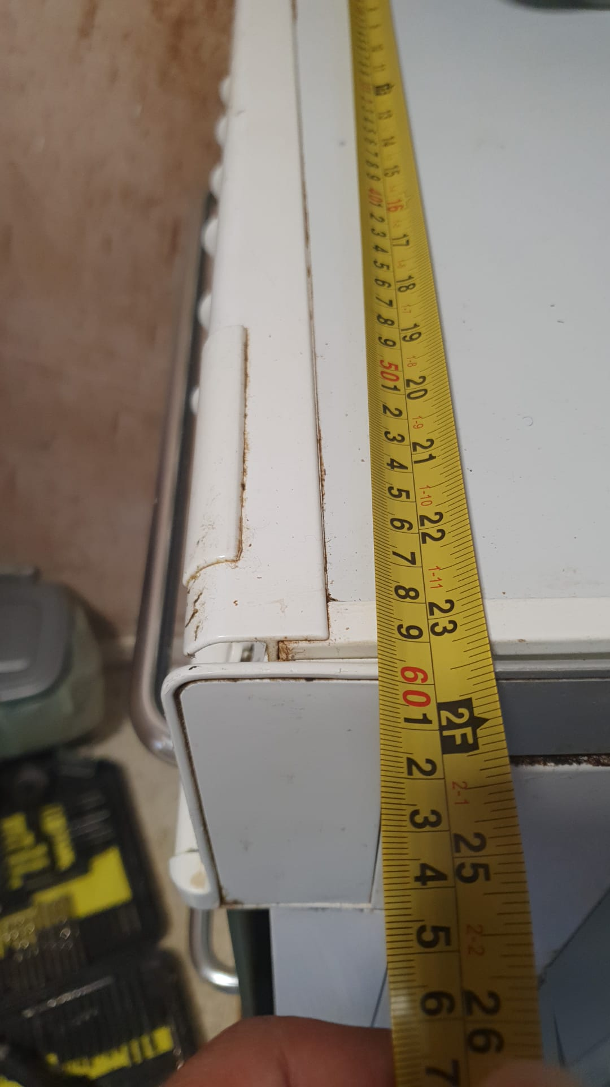

11/08/2025, 12:52 - SI: IMG-20250811-WA0003.jpg (file attached)
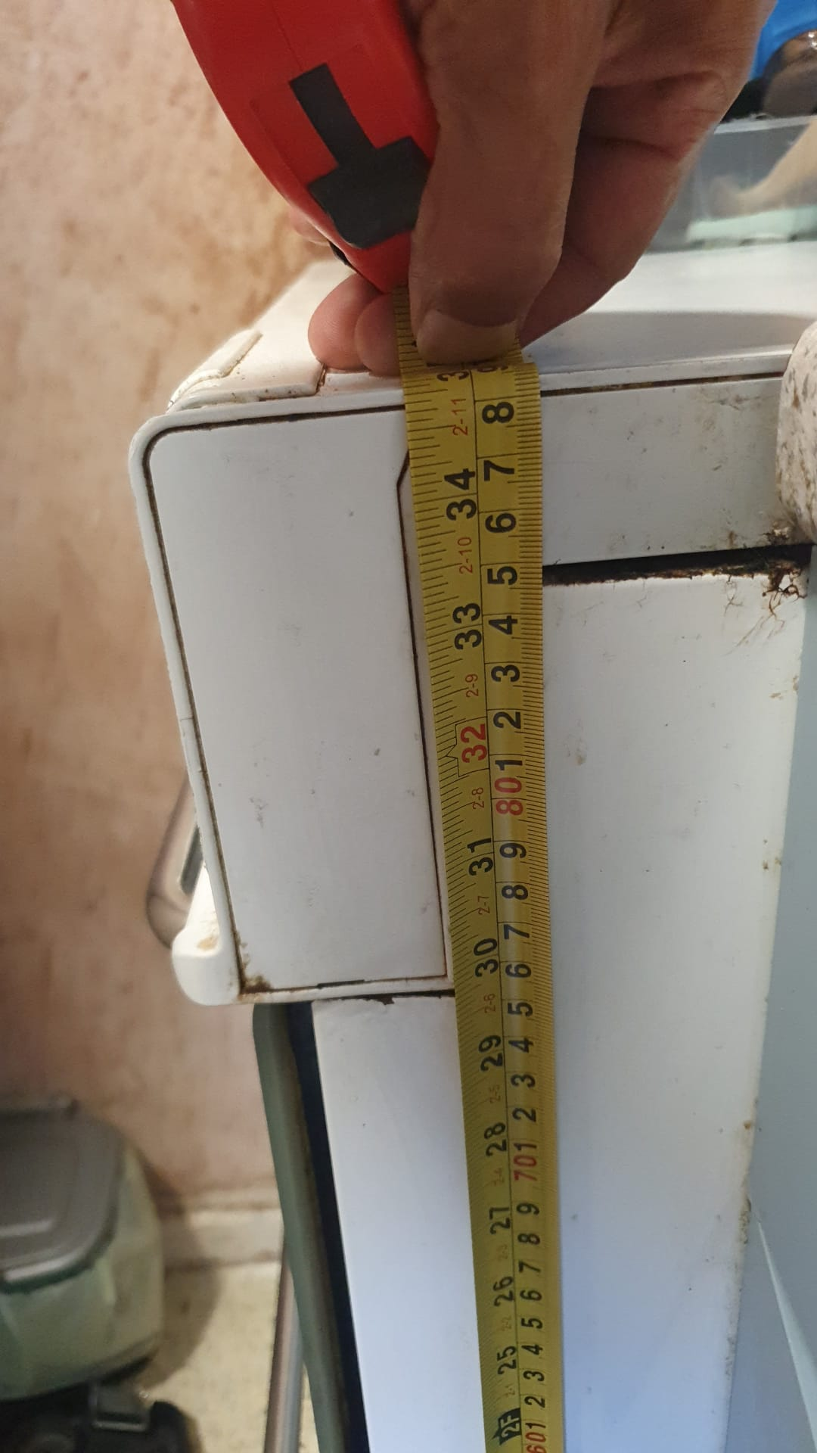

11/08/2025, 12:52 - SI: IMG-20250811-WA0005.jpg (file attached)
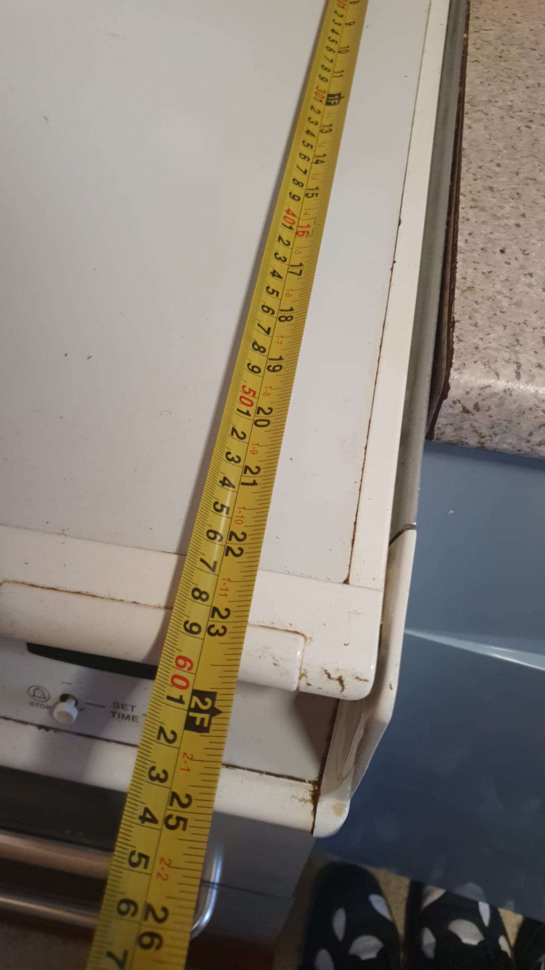

11/08/2025, 12:54 - +447968470159: Cheers Simon will go have a look Wednesday ..

13/08/2025, 12:52 - +447968470159: VID-20250813-WA0005.mp4 (file attached)
VID-20250813-WA0005.mp4

13/08/2025, 13:39 - +447968470159: VID-20250813-WA0006.mp4 (file attached)
VID-20250813-WA0006.mp4

Andrew video telling me when the boiler man will be available as I had to call him as the house had no hot water working when I got their and it came of the house insurance.

13/08/2025, 15:28 - +447968470159:

13/08/2025, 15:34 - SI:

13/08/2025, 16:04 - +447968470159:

13/08/2025, 16:25 - SI: Boiler man is here!

13/08/2025, 16:26 - +447968470159: Yes i tried calling to tell you lol

13/08/2025, 16:59 - SI: Do u see the video as it show when i send it to you

13/08/2025, 17:00 - +447968470159: I am on undergtround .

13/08/2025, 17:00 - +447968470159: And there is no video yet ..

13/08/2025, 17:07 - SI: VID-20250813-WA0004.mp4 (file attached)
Start
VID-20250813-WA0004.mp4
Me rebuilding the back garden at 280 and sending videos of it all to Andrew from the days I got there.

13/08/2025, 17:08 - SI: VID-20250813-WA0008.mp4 (file attached)
Close to finished
VID-20250813-WA0008.mp4
Me fixing the door and the broken glass and arranging for us to split the cost an dme do the labor!

13/08/2025, 18:06 - +447968470159: VID-20250813-WA0009.mp4 (file attached)
VID-20250813-WA0009.mp4
Andrew admitting the house is looking good since ive been there as ive been doing it up as my dad never and they never complained about him and what he let the house get like.

15/08/2025, 12:58 - +447968470159:

15/08/2025, 17:01 - SI: VID-20250815-WA0000.mp4 (file attached)
Im safe
VID-20250815-WA0000.mp4
Adrew accusing me of damaging a door that was not damaged at all.

15/08/2025, 17:48 - +447968470159:

15/08/2025, 17:49 - +447968470159: IMG-20250815-WA0001.jpg (file attached)
This was at your mums it was today ..
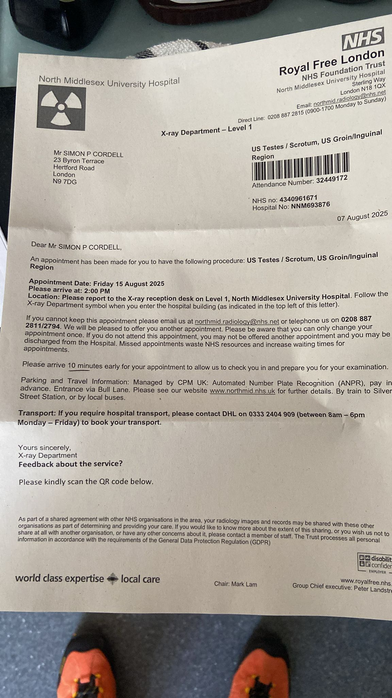

19/08/2025, 14:12 - SI: Ask mum if this is my ni number plz. “******** National insurance number was here!”

19/08/2025, 14:13 - SI: She done it already, cancel my last request plz, safe......

19/08/2025, 14:13 - SI: Already

21/08/2025, 13:18 - SI: VID-20250821-WA0000.mp4 (file attached)
VID-20250821-WA0000.mp4
Me show Andrew a video of me fixing the toilet a s it never worked and the windows and back garden. Fixed the clay pipe drainage.

01/09/2025, 08:13 - SI: VID-20250901-WA0002.mp4 (file attached)
VID-20250901-WA0002.mp4
Cleaning main room brought a carpet cleaner and renewed the carpets in every room.
Rebuilt the spare room and attic

01/09/2025, 08:15 - SI: VID-20250901-WA0003.mp4 (file attached)
VID-20250901-WA0003.mp4
Fixed the Frezza’s and sorted the food inside of them so I was safe to eat from.
Moved the washing machine and stuff.

01/09/2025, 08:18 - SI: IMG-20250901-WA0005.jpg (file attached)
I never done the top shelf
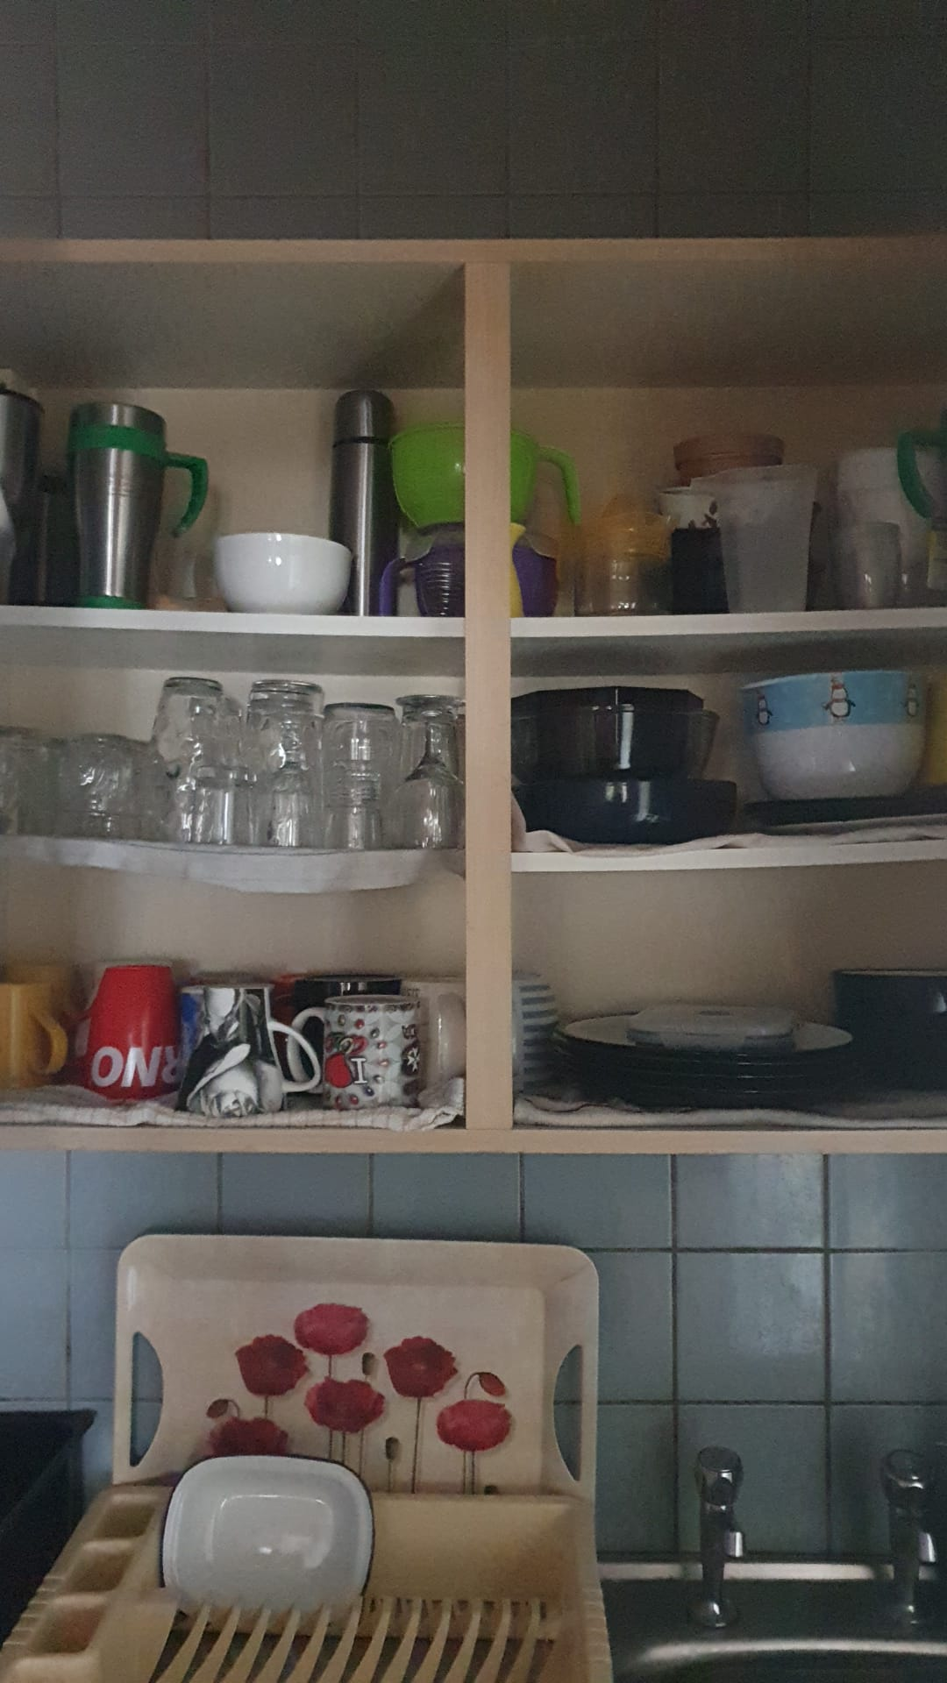

I washed all the cupboards and fitted new doors and handles as well as cleaned the cookery ware sinks and so forth.

01/09/2025, 08:25 - +447968470159: Where the damp is in the spare room (its also in your dads room , did have the roof done but could you ask your dad if that corner in his room is dry as may need to get someone back in .. Its looking good Simon ..

Andrew saying the house is looking good due to the work I’ve been doing in the house he admits dad lives there all this time as well!

01/09/2025, 08:27 - +447968470159: I will be down this week to sort out freezers and chuck stuff away (hopefully Wednesday) so it does not sit in the bins stinking the place up ..

01/09/2025, 09:05 - SI: I hovered around in there, it could do with a good old revamp!

02/09/2025, 09:55 - SI: VID-20250902-WA0001.mp4 (file attached)
VID-20250902-WA0001.mp4
No clothing or work shoes to stop me doing the house up. As they were trying to sell it to my brother behind my back. Installing a new kitchen that’s been sitting on the side for years.

19/09/2025, 14:50 - +447968470159: Sorry Simon have not forgotten you . I am on the phone to Universal Credit as they rang me and are trying to sort out my claim . They keep putting me on hold ..

19/09/2025, 15:20 - SI: Alright x

19/09/2025, 16:51 - SI: IMG-20250919-WA0001.jpg (file attached)
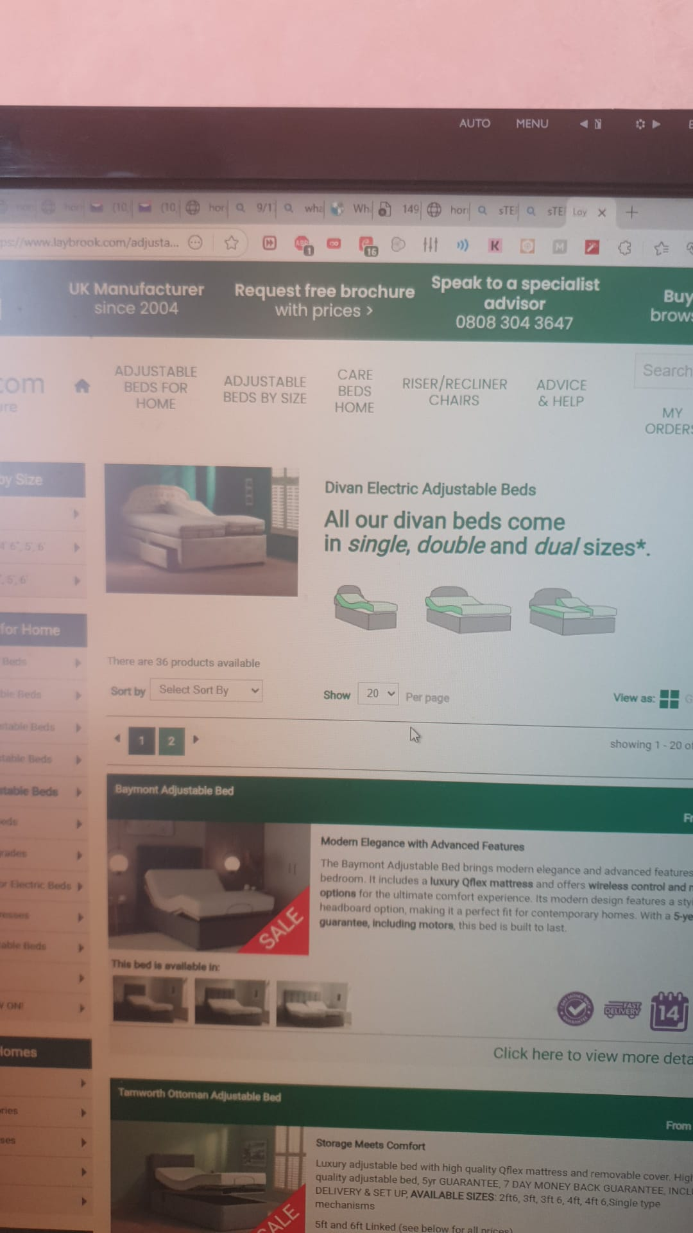

19/09/2025, 16:53 - +447968470159: IMG-20250919-WA0002.jpg (file attached)


19/09/2025, 16:55 - SI: IMG-20250919-WA0004.jpg (file attached)
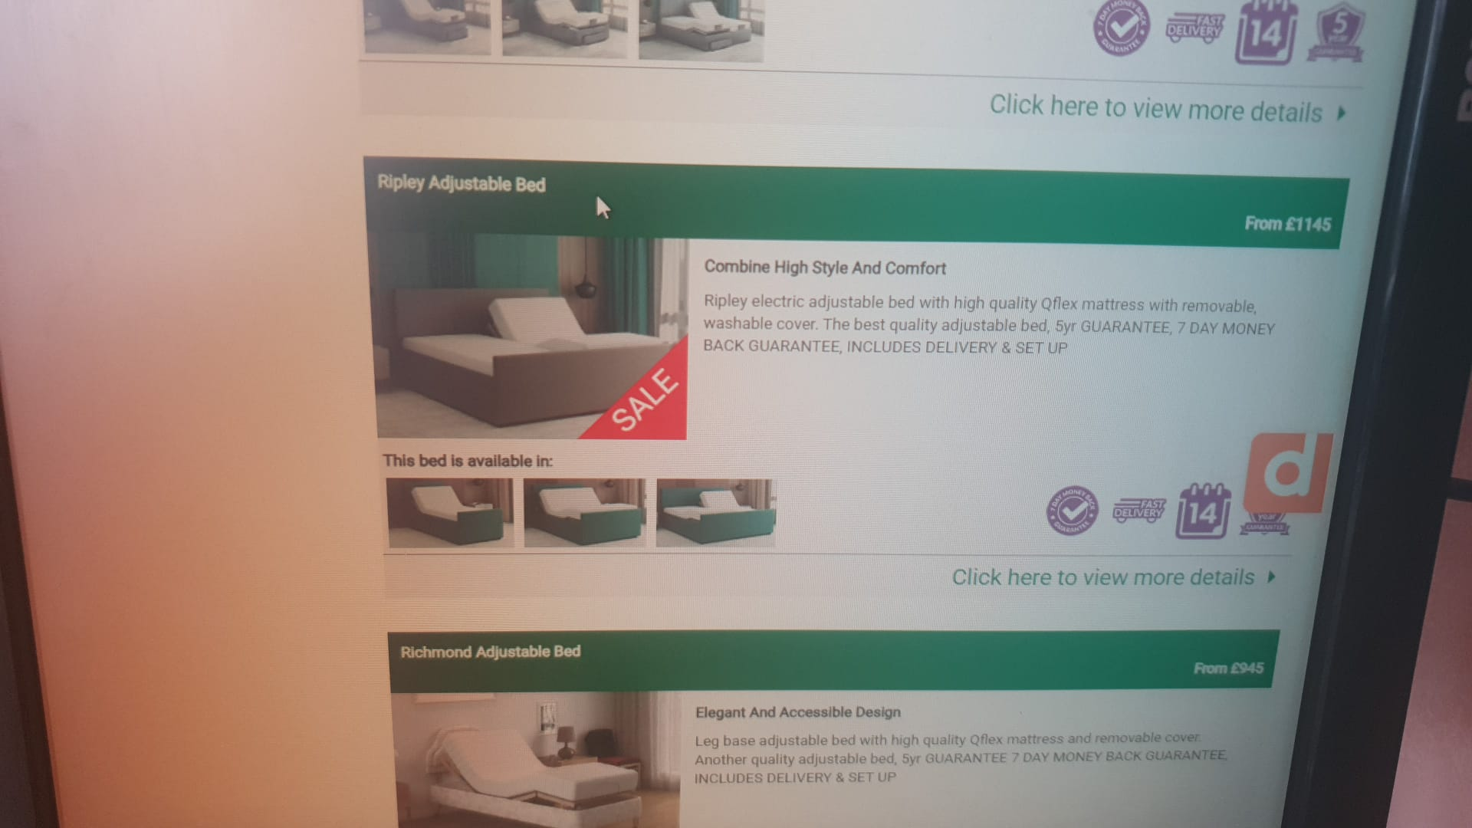

19/09/2025, 17:03 - SI: IMG-20250919-WA0006.jpg (file attached)
648 dreams needs mattress
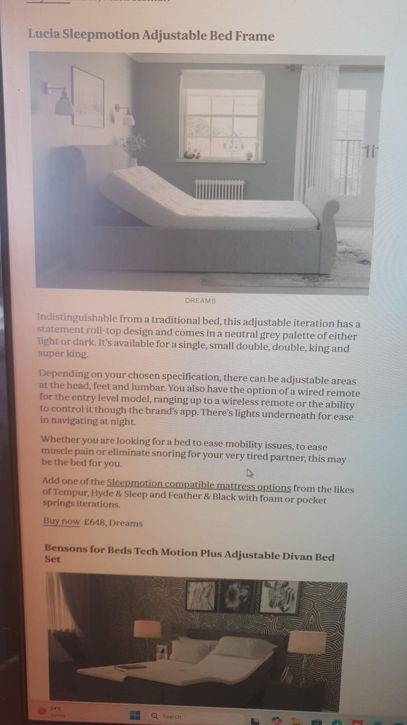

19/09/2025, 17:28 - +447968470159: Simon can you send me the link not the pic please ❤️

30/09/2025, 11:57 - +447968470159: IMG-20250930-WA0000.jpg (file attached)
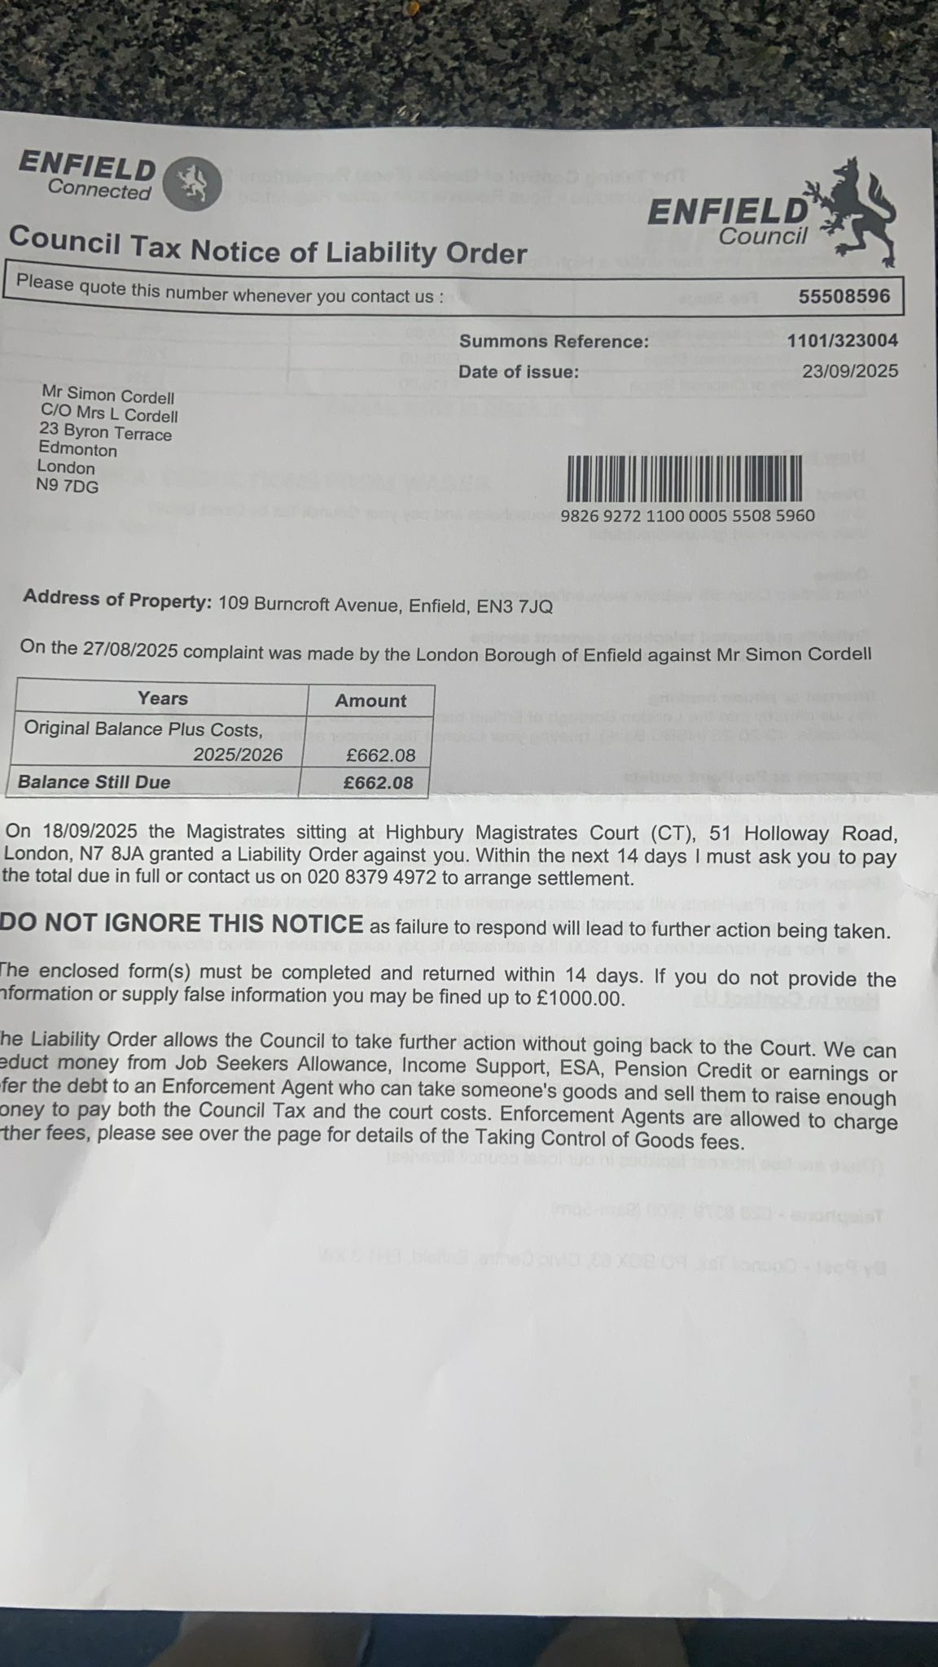

30/09/2025, 11:57 - +447968470159: IMG-20250930-WA0001.jpg (file attached)
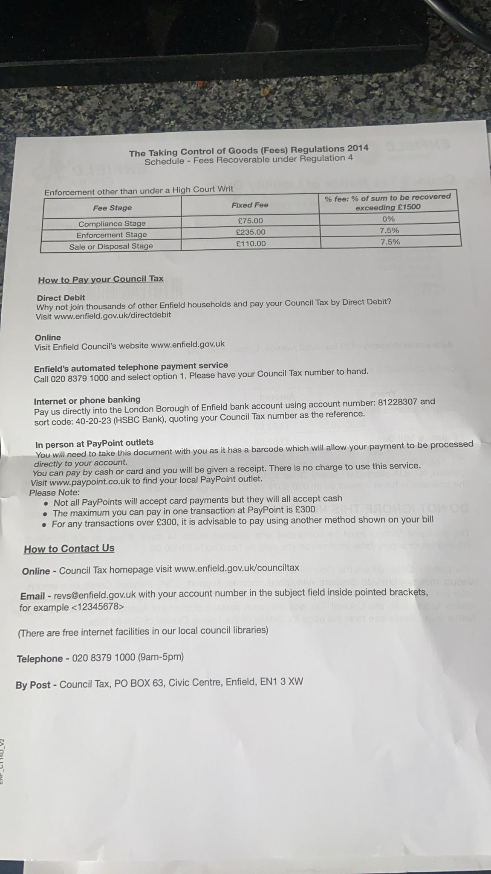

11/11/2025, 15:56 - SI: IMG-20251111-WA0000.jpg (file attached)
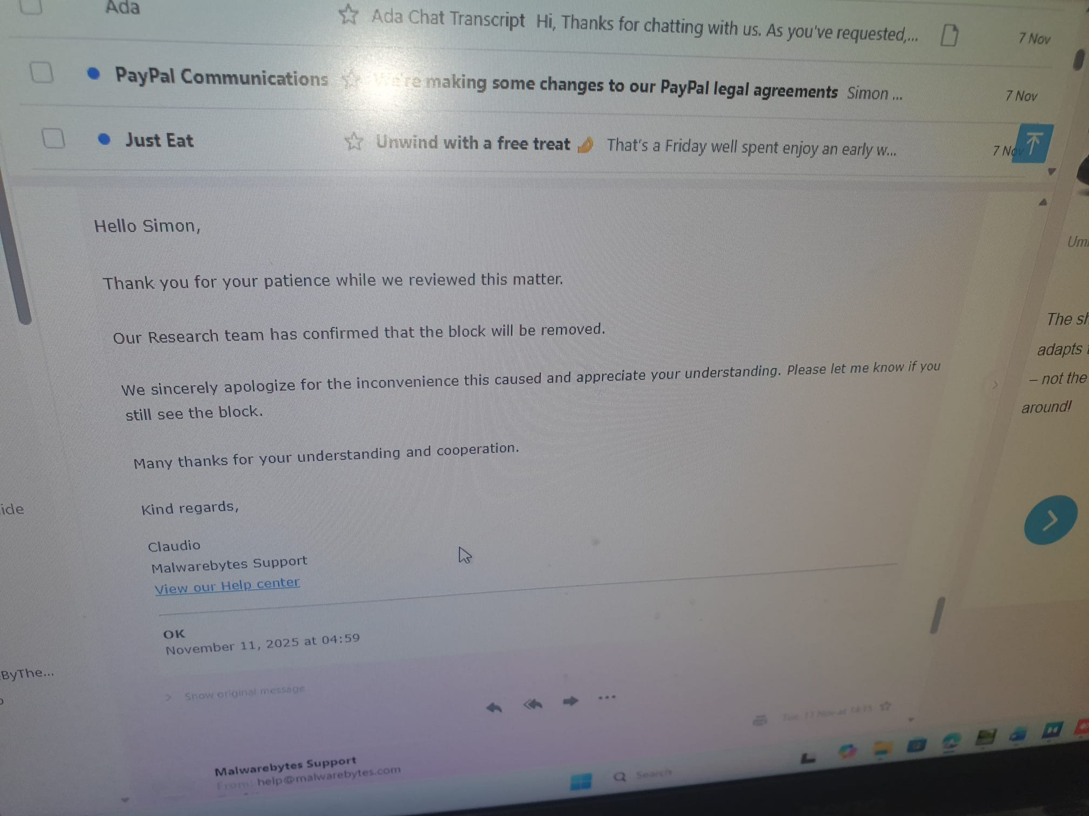

11/11/2025, 15:57 - SI: IMG-20251111-WA0002.jpg (file attached)
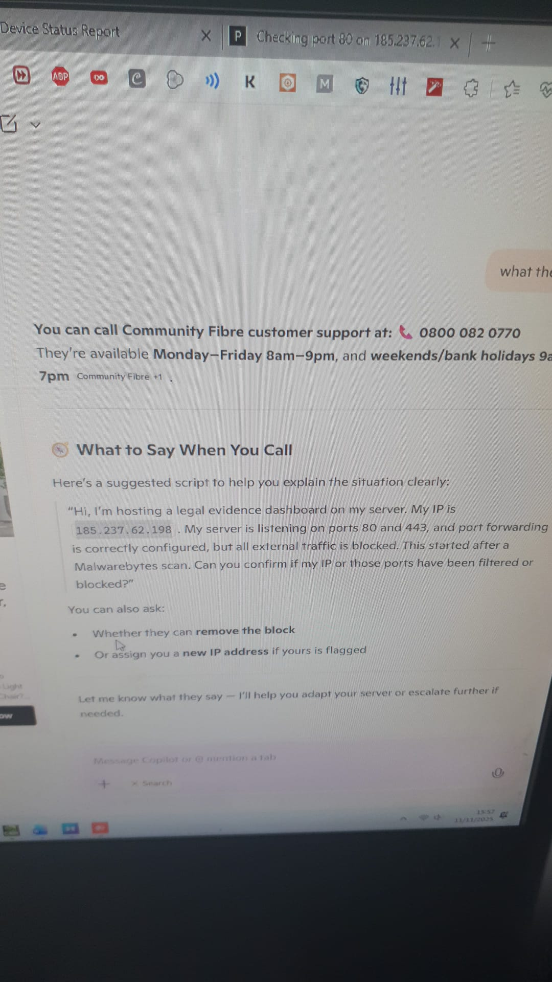

11/11/2025, 15:58 - SI: Love ya loads xxxx

11/11/2025, 17:23 - SI: What’s the 70 for electric a week or a month?

Andrew setting how much I must pay him for the electric at the house and gas, 4o Electric 30 Gas a month.

13/11/2025, 09:27 - +447968470159: Running late , needed to do bits for your mum , sorry ..

18/11/2025, 11:25 - SI: IMG-20251118-WA0003.jpg (file attached)
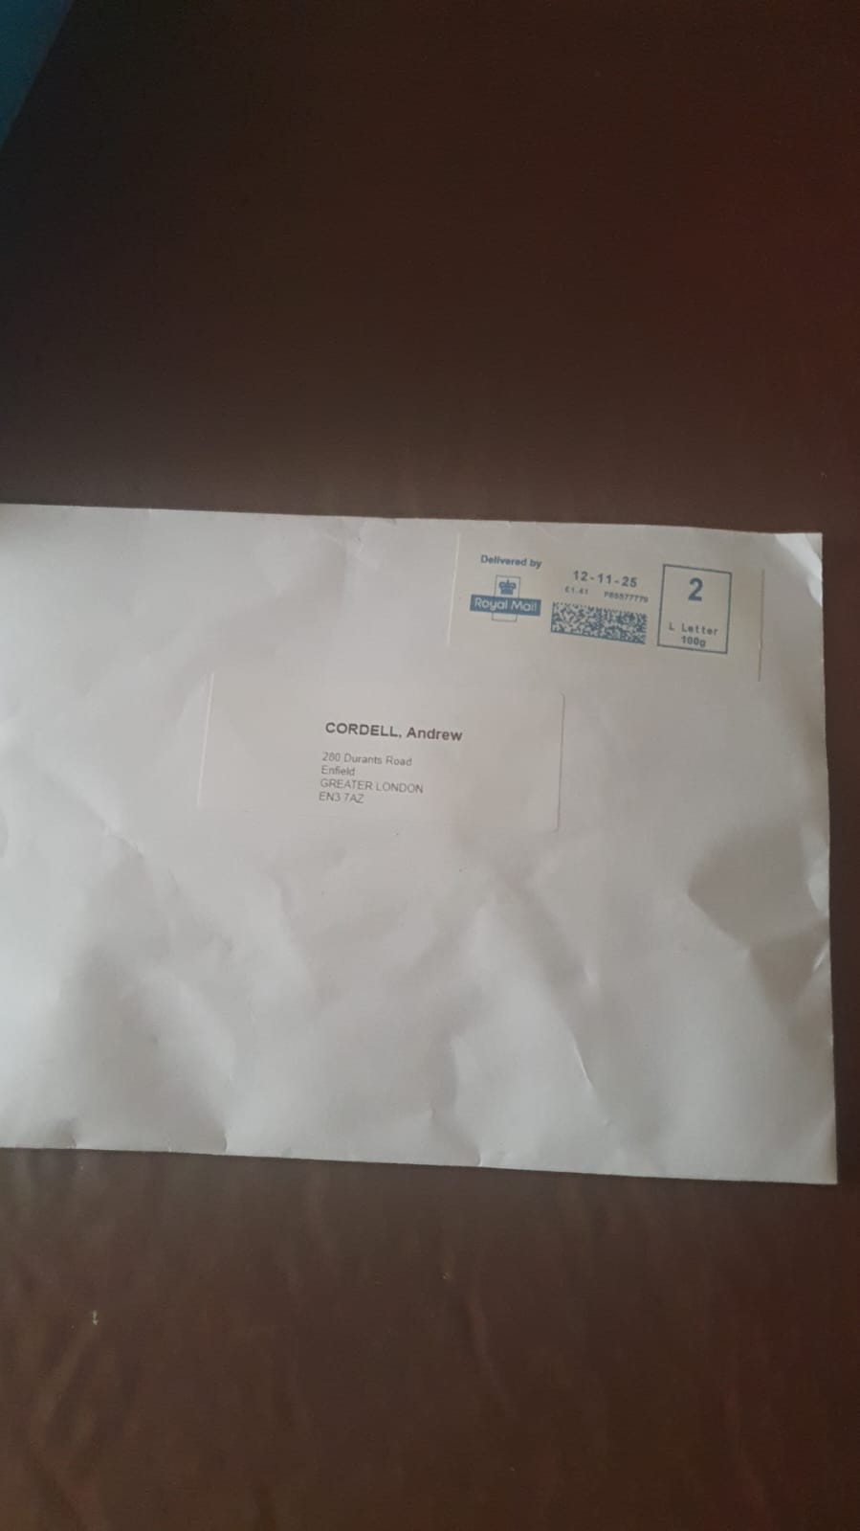

18/11/2025, 11:25 - SI: It’s got something in it

18/11/2025, 11:25 - SI: Earing aid

18/11/2025, 11:26 - SI: Am i right?

18/11/2025, 11:26 - +447968470159: Can you open it please I think its my hearing aid bits that were supposed to be delivered here but they constantly fuck up ..

18/11/2025, 11:26 - SI: I typed it fast text lol

18/11/2025, 11:26 - SI: Im right

18/11/2025, 11:27 - SI: Its not is parts for maybe

18/11/2025, 11:27 - SI: IMG-20251118-WA0005.jpg (file attached)
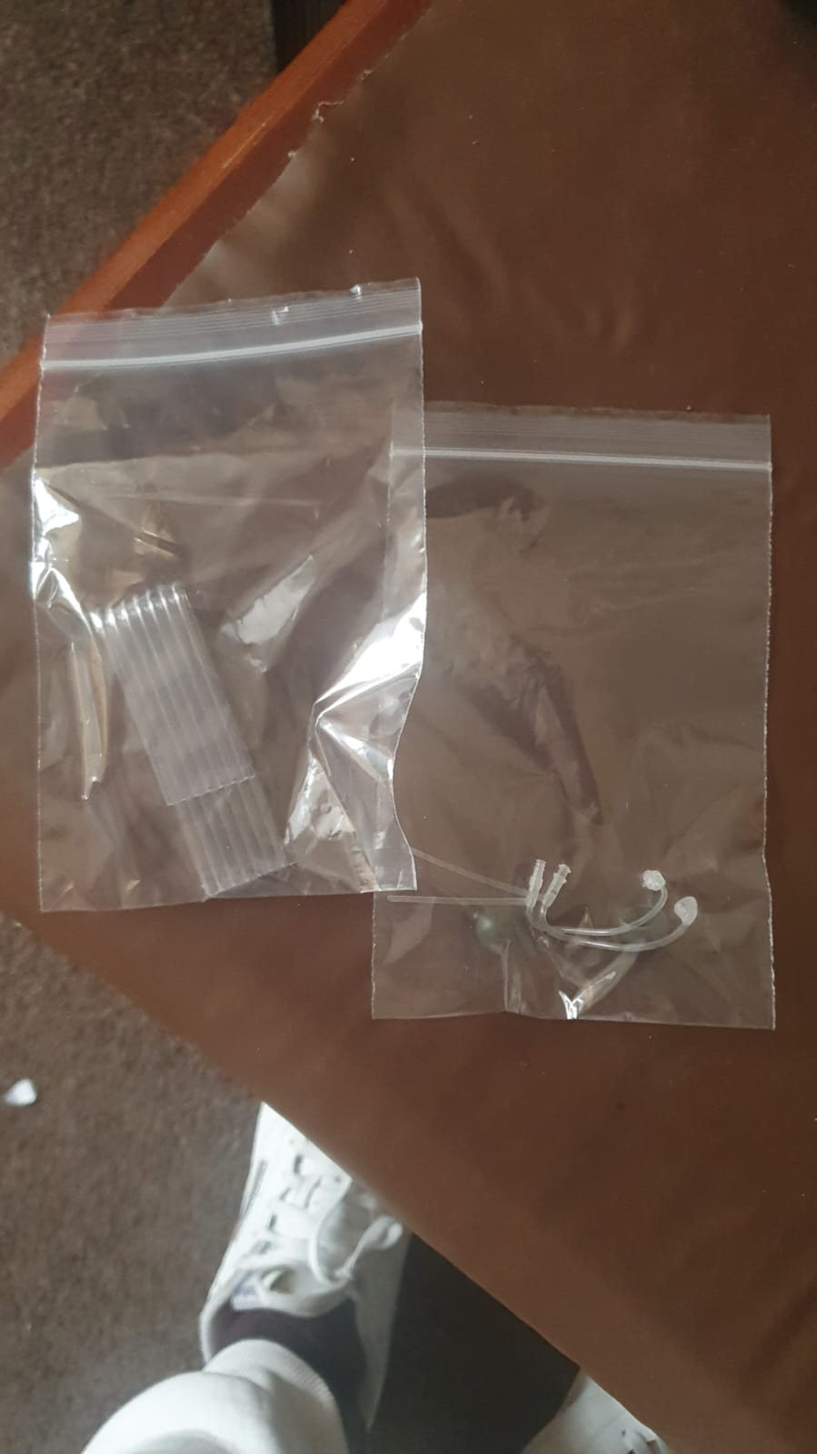

18/11/2025, 11:28 - +447968470159: Ok thanks will have to come pick em up , probably Thursday . Is it just those two bags ??

18/11/2025, 11:28 - SI: Yep

18/11/2025, 11:29 - +447968470159: Sent the wrong shit again ffs ..

18/11/2025, 11:29 - SI: Hmmm

18/11/2025, 11:30 - +447968470159: IMG-20251118-WA0006.jpg (file attached)
Is there any of these ???
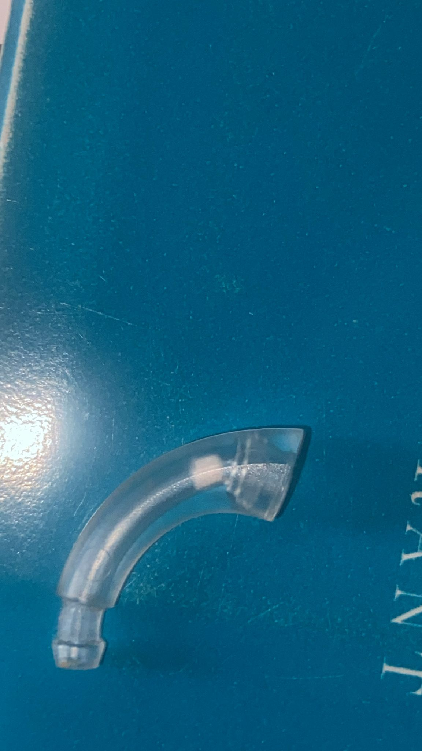

19/11/2025, 08:53 - +447968470159: IMG-20251119-WA0000.jpg (file attached)
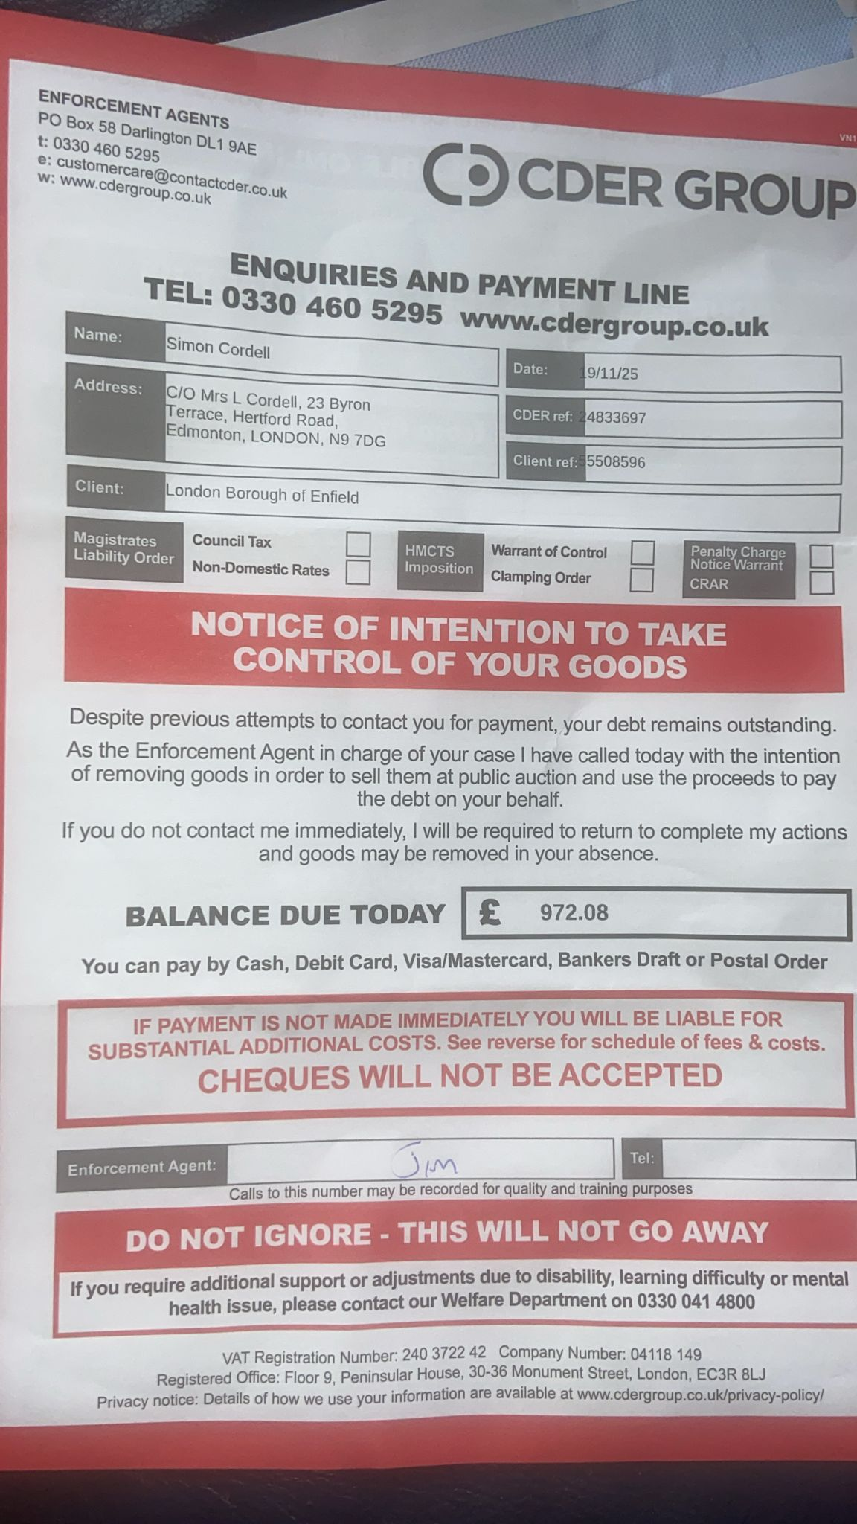

19/11/2025, 08:53 - +447968470159: IMG-20251119-WA0001.jpg (file attached)
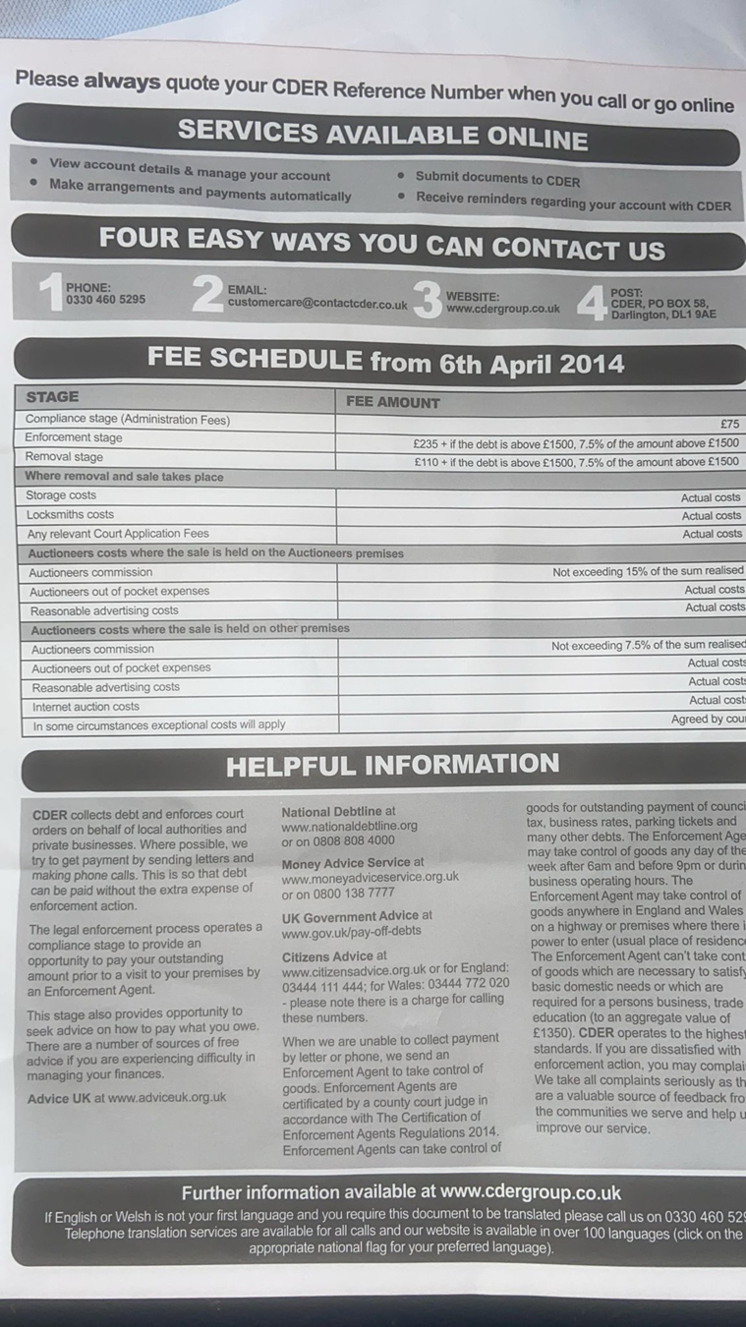

19/11/2025, 19:01 - SI:

26/11/2025, 12:57 - SI: https://everyoneloginto.me/Revs/

26/11/2025, 12:58 - SI: That’s the letter to revs I sent and there response

12/12/2025, 14:15 - +447968470159: Tried calling back and not connecting ..

01/02/2026, 16:47 - SI:

01/02/2026, 16:47 - SI:

27/02/2026, 20:02 - +447968470159: VID-20260227-WA0000.mp4 (file attached)
VID-20260227-WA0000.mp4
Andrew was staying at my mother and fixing the front door due to no fault of my own. Drug search due to one of Tyrone’s friends.

27/02/2026, 21:28 - SI: We got to go up there and speak to them!

27/02/2026, 22:26 - SI: VID-20260227-WA0003.mp4 (file attached)
VID-20260227-WA0003.mp4
Me trying to sort mother front door out legally due to Adrew and Tyrone being involved at my mothers.

15/03/2026, 11:30 - +447968470159: 5th floor . East b , bed six

15/03/2026, 14:22 - SI:

05/04/2026, 14:36 - +447968470159:

05/04/2026, 14:37 - SI:

09/04/2026, 16:41 - +447968470159: IMG-20260409-WA0000.jpg (file attached)
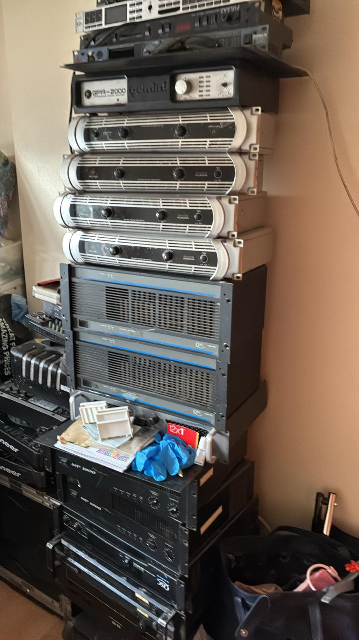

09/04/2026, 16:41 - +447968470159: IMG-20260409-WA0001.jpg (file attached)
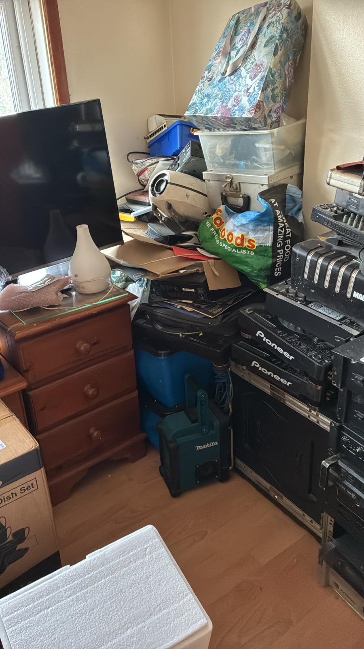

11/04/2026, 09:31 - SI: This is what i sent him on the 25 October 25
https://www.enfield.gov.uk/__data/assets/pdf_file/0028/4978/tenancy-agreement-2014-council-housing.pdf
3.11 the right to succeed... this is what must be done to make sure mother house is yours and safe afterwards...

11/04/2026, 09:31 - SI: I said send a phone chip to her home or tell us no and Deon or jam will have to

11/04/2026, 09:57 - +447968470159: PTT-20260411-WA0000.opus (file attached)
PTT-20260411-WA0000.opus

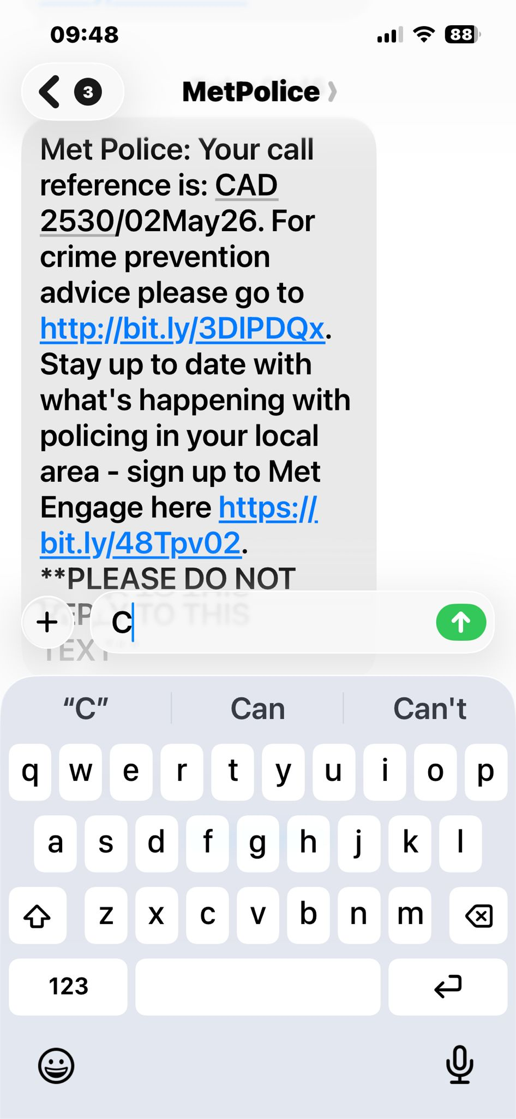
Andrew saying its alright for him to stay at nans to be in the area because he through my money away or stole it making my mother admit herself into hospital never to come back out. He was ok with me staying in house when my mother was alive.

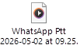
WhatsApp Ptt 2026-04-11 at 09.57.41.ogg
Same as above

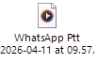
WhatsApp Ptt 2026-05-02 at 09.25.05.ogg
He admits to 9000 pounds of the 30,000 and paying it back, but this also happened a future conversation.

04/05/2026
WhatsApp Video 2026-05-04 at 17.27.50.mp4
Me looking for my money now I got the keys of Uncle Andrew and my aunt at my mothers house.

