28/01/2024, 15:36 - Messages and calls are end-to-end encrypted. Only people in this chat can read, listen to, or share them. *Learn more*

28/01/2024, 15:36 - SI:

16/04/2024, 19:06 - SI:

13/11/2024, 11:22 - SI:

13/11/2024, 11:35 - Aunt: IMG-20241113-WA0001.jpg (file attached)
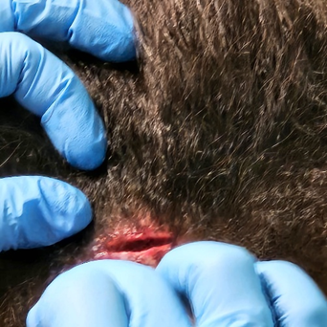

13/11/2024, 11:36 - Aunt: That was it but it's healed good

19/11/2024, 15:42 - SI:

20/12/2024, 14:44 - SI:

21/12/2024, 10:23 - SI: IMG-20241221-WA0009.jpg (file attached)
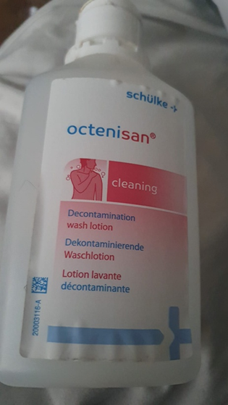

21/12/2024, 10:24 - SI: Order this to yours for your stomach and it will get better from the second you start to use it.

21/12/2024, 10:25 - SI: I will pay for it.

21/12/2024, 11:34 - Aunt: I've done it be here 31st Dec I had enough for that so your cool ty Simon xx

30/12/2024, 20:53 - SI:

31/12/2024, 23:44 - SI: Happy new year love you all lots xx

01/01/2025, 00:11 - Aunt: Happy new year Simon love u lots xx

02/01/2025, 14:03 - Aunt: Can you help me out? I am trying to get a free gift.
Hello friends, I need your help to click this link below to get more puppy snacks for my new pet!!
https://onelink.shein.com/6/4b2sgthw31zb

02/01/2025, 16:44 - SI: IMG-20250102-WA0001.jpg (file attached)
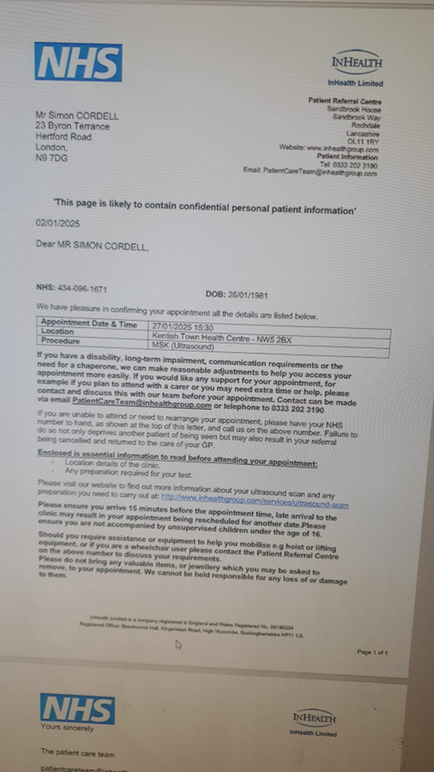

02/01/2025, 16:44 - SI: IMG-20250102-WA0003.jpg (file attached)
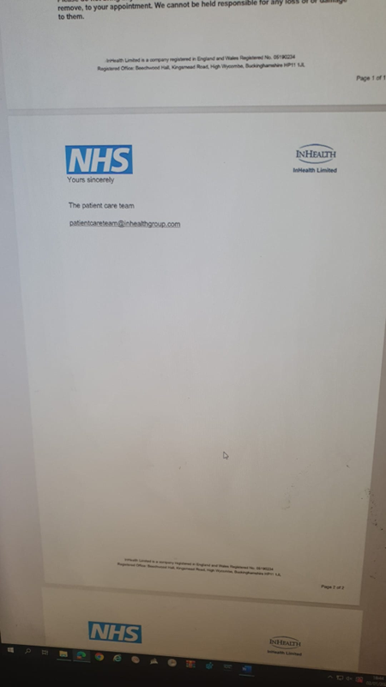

02/01/2025, 16:45 - SI: IMG-20250102-WA0006.jpg (file attached)
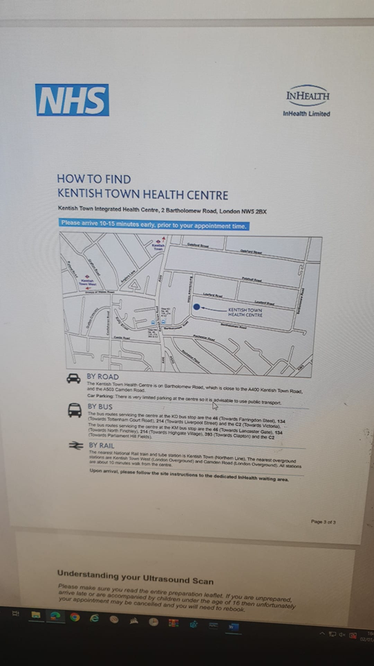

08/01/2025, 16:22 - Aunt:

08/01/2025, 20:29 - Aunt: Hoping your OK love u lots and gl with your teeth xx

09/01/2025, 06:46 - SI:

09/01/2025, 06:47 - Aunt:

09/01/2025, 06:51 - SI:

11/01/2025, 08:57 - Aunt:

11/01/2025, 09:45 - SI:

11/01/2025, 09:45 - SI:

15/01/2025, 11:34 - SI: IMG-20250115-WA0002.jpg (file attached)
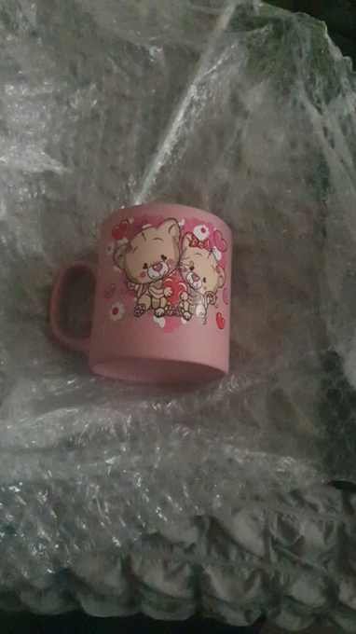

15/01/2025, 11:34 - SI: IMG-20250115-WA0004.jpg (file attached)
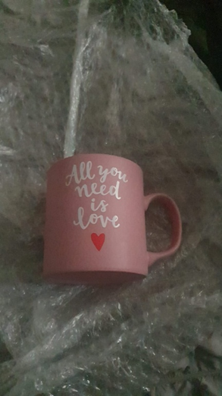

15/01/2025, 11:34 - SI: Cup yours

15/01/2025, 11:35 - SI: And i got some Turkish delight in the fridge for aunty Sonya as well.

15/01/2025, 15:55 - Aunt: I love it xx

15/01/2025, 15:56 - Aunt: She loves a bit of Turkish it's her fav

20/01/2025, 19:08 - Aunt: IMG-20250120-WA0001.jpg (file attached)
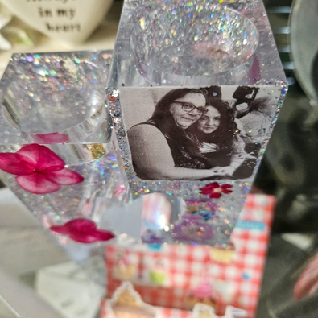

20/01/2025, 19:09 - Aunt: IMG-20250120-WA0002.jpg (file attached)
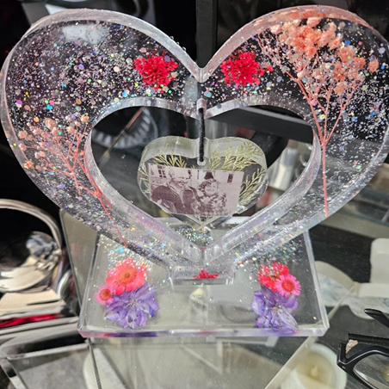

20/01/2025, 19:11 - SI: IMG-20250120-WA0006.jpg (file attached)
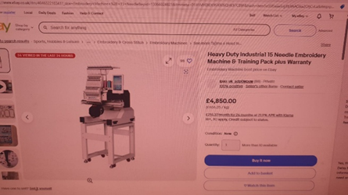

20/01/2025, 19:11 - SI: IMG-20250120-WA0008.jpg (file attached)
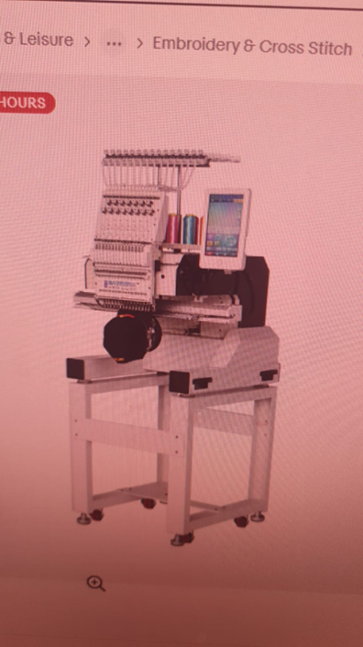

26/01/2025, 11:11 - Aunt:

26/01/2025, 11:46 - SI: IMG-20250126-WA0001.jpg (file attached)
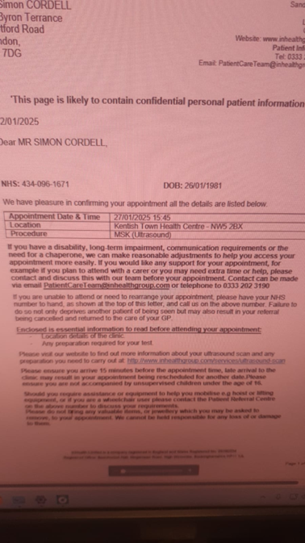

26/01/2025, 11:50 - SI: IMG-20250126-WA0001.jpg (file attached)

26/01/2025, 11:50 - SI:

02/02/2025, 12:03 - Aunt: Can you help me out? I am trying to get a free gift.
Hello friends, I need your help to click this link below to get more puppy snacks for my new pet!!
https://onelink.shein.com/8/4e7r5rkj3xoq

02/03/2025, 15:14 - Aunt: IMG-20250302-WA0000.jpg (file attached)


02/03/2025, 15:30 - SI: IMG-20250302-WA0004.jpg (file attached)
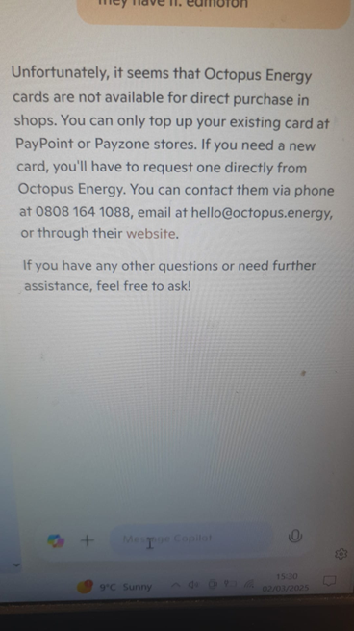

02/03/2025, 16:13 - Aunt: There keeping mummy in today xx

02/03/2025, 16:15 - SI:

19/03/2025, 15:45 - Aunt: IMG-20250319-WA0000.jpg (file attached)
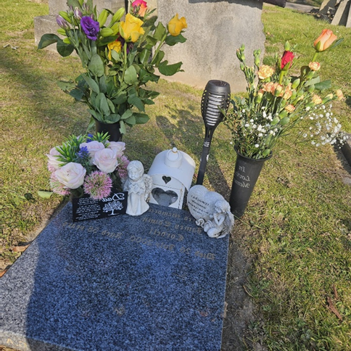

19/03/2025, 15:57 - SI: IMG-20231231-WA0000.jpg (file attached)
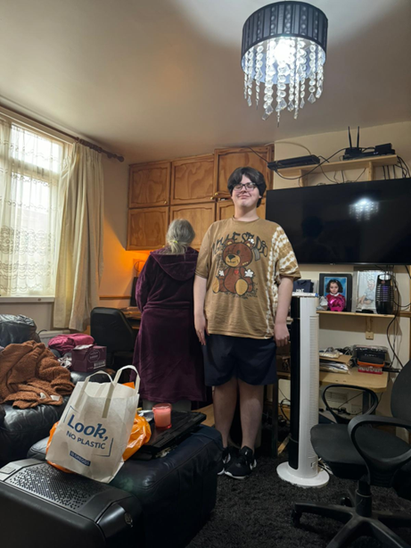

17/04/2025, 11:47 - SI: IMG-.jpg (file attached)
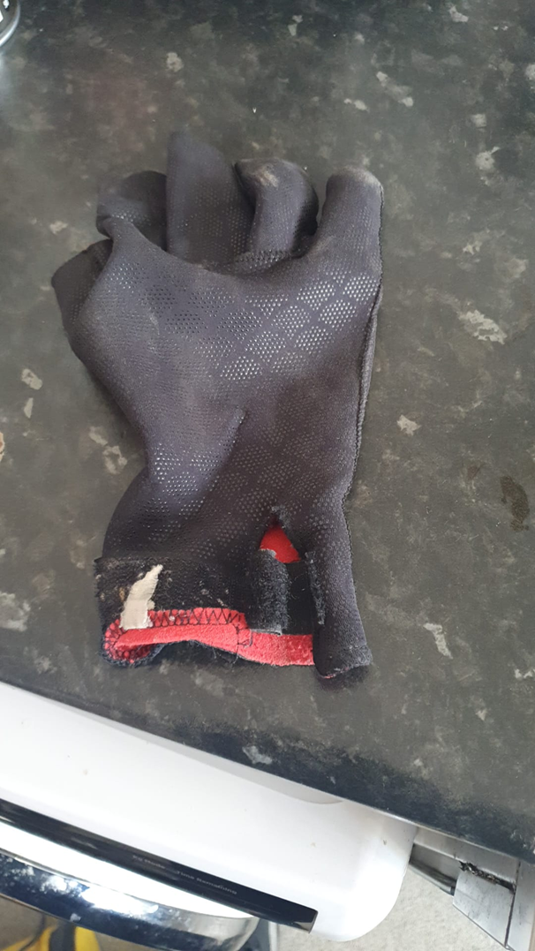

17/04/2025, 11:51 - Aunt: https://www.ebay.co.uk/itm/305210058145?mkcid=16&mkevt=1&mkrid=711-127632-2357-0&ssspo=cgUcbpSFSzG&sssrc=4429486&ssuid=HfMAktqsRHG&var=&widget_ver=artemis&media=MORE

17/04/2025, 11:53 - Aunt: https://www.ebay.co.uk/itm/197201051931?mkcid=16&mkevt=1&mkrid=711-127632-2357-0&ssspo=hakcor4nqm6&sssrc=4429486&ssuid=HfMAktqsRHG&var=&widget_ver=artemis&media=MORE

17/04/2025, 12:44 - SI: Can you find a set you like in pink. With the strap at the bottom like that.

17/05/2025, 13:09 - Aunt: IMG-20250517-WA0000.jpg (file attached)
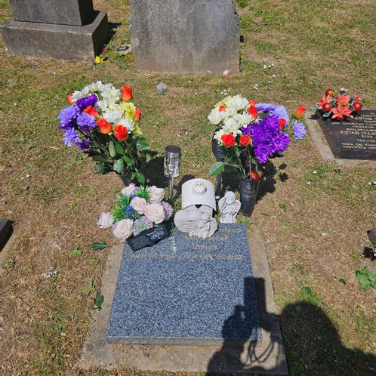

10/06/2025, 21:55 - SI:

15/06/2025, 15:10 - Aunt: IMG-20250615-WA0000.jpg (file attached)
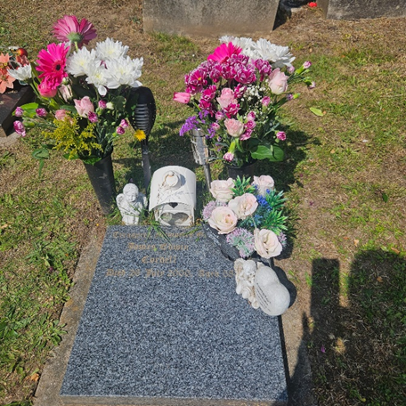

19/06/2025, 15:26 - Aunt: SHEIN Earning Program
Hey there! Just stumbled upon this amazing site, SHEIN. You can get £50 OFF on your shopping now. I just enjoyed this benefit . time's ticking! Just click here to claim it:
https://onelink.shein.com/13/4s4ozv7vw2mt

27/06/2025, 18:39 - Aunt: IMG-20250627-WA0000.jpg (file attached)
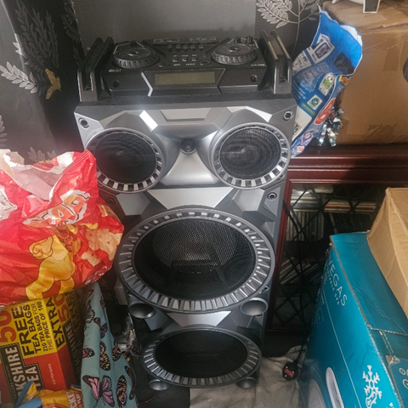

27/06/2025, 19:32 - SI: I got one of them already for the garden and that. Im after some for my bedroom.

27/06/2025, 19:33 - SI: IMG-20250627-WA0003.jpg (file attached)

27/06/2025, 21:14 - SI: IMG-20250627-WA0005.jpg (file attached)

27/06/2025, 21:14 - SI: Sorry wrong person

27/06/2025, 21:16 - SI: Love ya xxx

27/06/2025, 22:26 - Aunt: Lol love u 2 xx

05/07/2025, 11:13 - Aunt: Can you help me out? I am trying to get a free gift.
Hello friends, I need your help to click this link below to get more puppy snacks for my new pet!!
https://onelink.shein.com/14/4tqij09o4rho

14/07/2025, 10:35 - Aunt: "PUPPY EMERGENCY! "
This little puppy needs more helpers to claim its gift. Be our hero? 🦸
https://onelink.shein.com/14/4unazjrx1f65

14/07/2025, 19:08 - SI:

17/07/2025, 12:50 - SI: VID-20250717-WA0002.mp4 (file attached)
Fri 25th 1.30

VID-20250717-WA0002.mp4

17/07/2025, 12:52 - SI: IMG-20250717-WA0004.jpg (file attached)
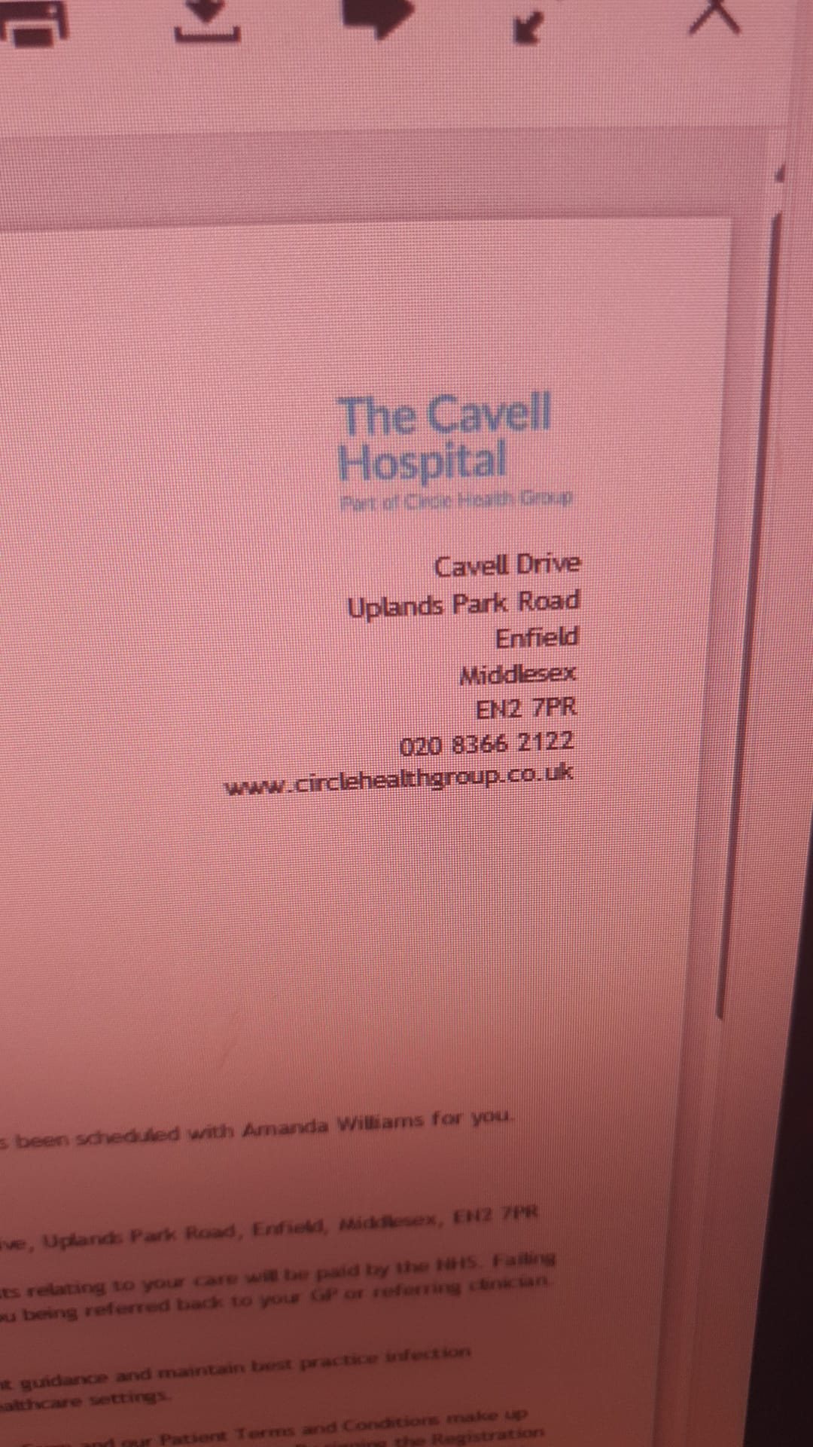

17/07/2025, 14:09 - Aunt: Ok Simon defo do those dates

17/07/2025, 14:09 - SI: Thank you xxxxx

25/07/2025, 12:41 - Aunt:

25/07/2025, 16:21 - Aunt:

28/07/2025, 08:31 - Aunt:

28/07/2025, 20:04 - Aunt:

28/07/2025, 20:05 - Aunt:

29/07/2025, 15:17 - Aunt:

30/07/2025, 10:45 - Aunt:

30/07/2025, 11:17 - Aunt:

30/07/2025, 11:44 - Aunt:

31/07/2025, 13:53 - Aunt:

31/07/2025, 13:54 - Aunt:

31/07/2025, 14:14 - Aunt:

31/07/2025, 14:43 - Aunt:

31/07/2025, 16:22 - Aunt:

31/07/2025, 16:25 - Aunt:

31/07/2025, 16:35 - Aunt:

02/08/2025, 21:32 - Aunt:

02/08/2025, 21:33 - Aunt:

02/08/2025, 21:39 - Aunt:

08/08/2025, 16:43 - Aunt:

11/08/2025, 08:01 - Aunt:

13/08/2025, 10:18 - SI: VID-20250813-WA0004.mp4 (file attached)
VID-20250813-WA0004.mp4

13/08/2025, 10:20 - Aunt: It looks good you done well nan be proud of you xx

13/08/2025, 17:03 - SI: VID-20250813-WA0008.mp4 (file attached)
Look now
VID-20250813-WA0008.mp4

13/08/2025, 17:06 - Aunt: Llijs gd xx

13/08/2025, 17:06 - Aunt: Looks good lol

14/08/2025, 16:16 - Aunt:

14/08/2025, 16:16 - SI:

18/08/2025, 15:56 - SI: IMG-20250818-WA0001.jpg (file attached)
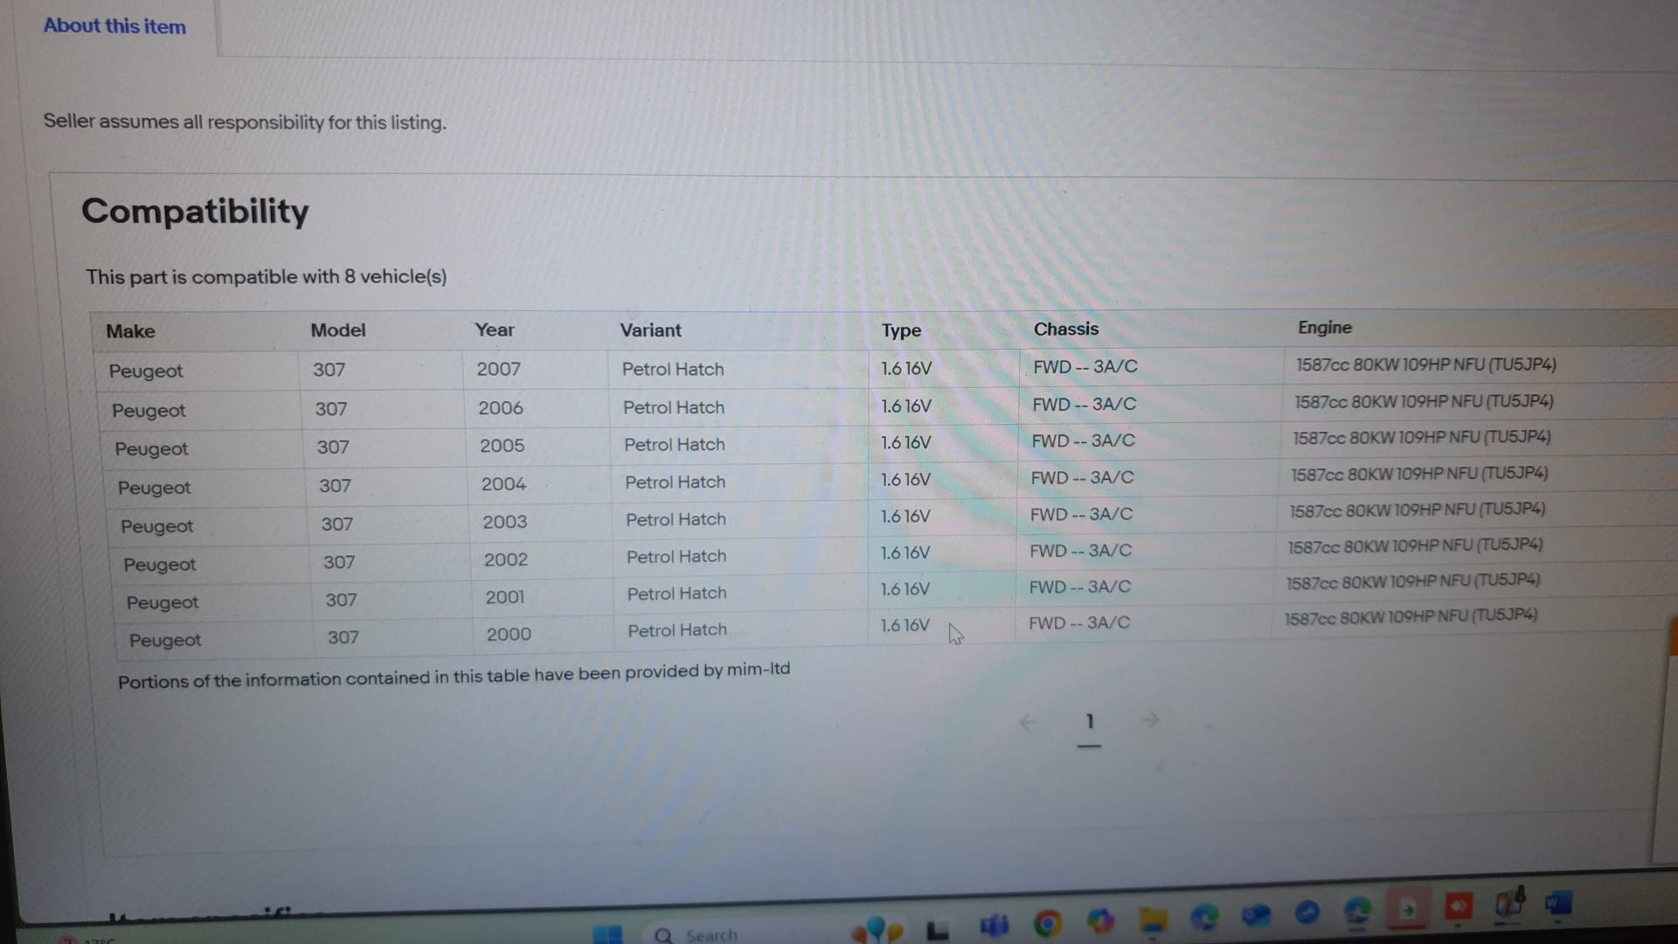

18/08/2025, 15:56 - SI: IMG-20250818-WA0003.jpg (file attached)
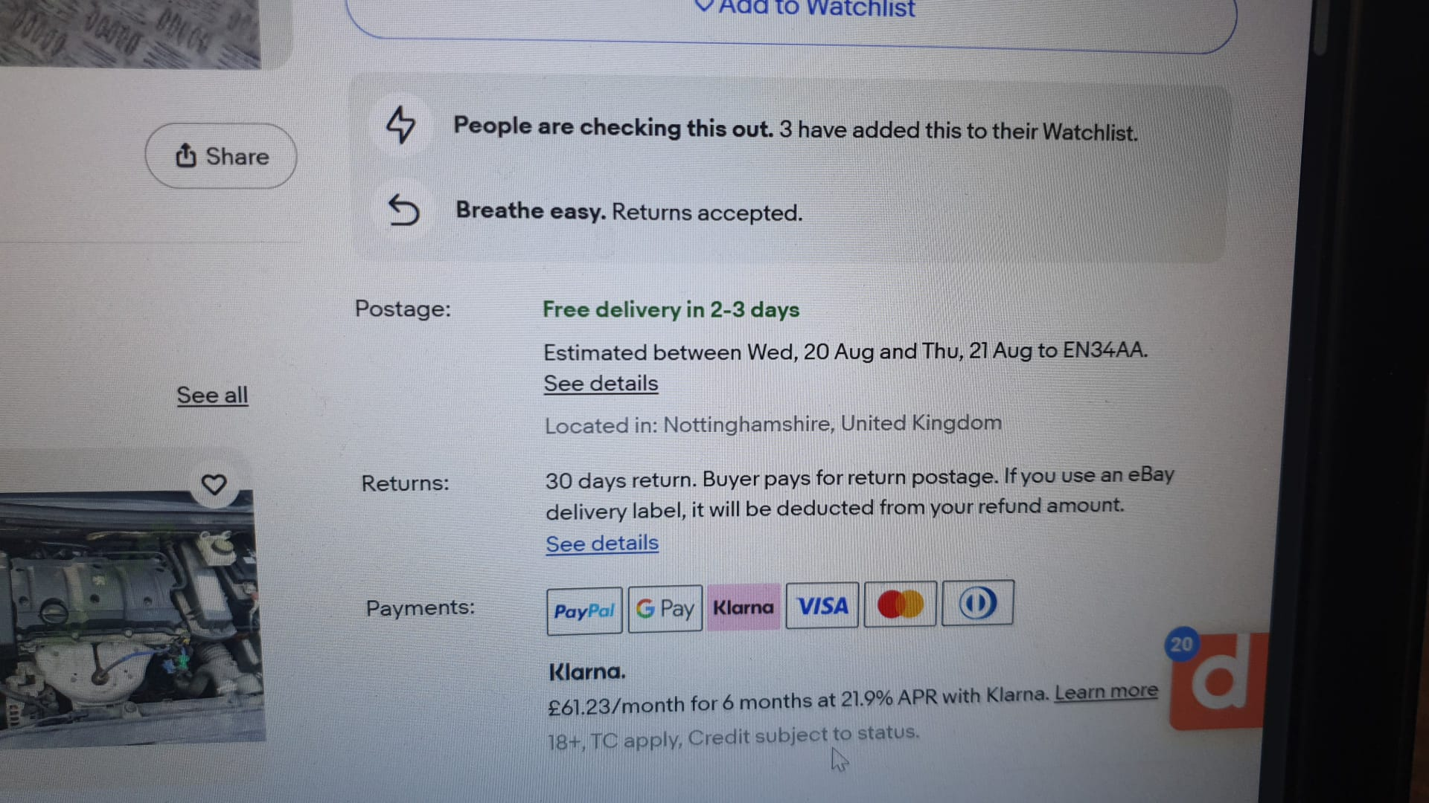

18/08/2025, 15:56 - SI: IMG-20250818-WA0005.jpg (file attached)
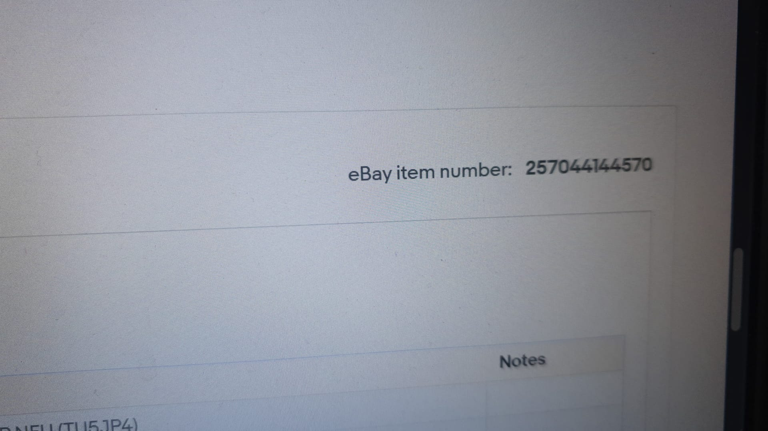

18/08/2025, 15:57 - SI: IMG-20250818-WA0007.jpg (file attached)
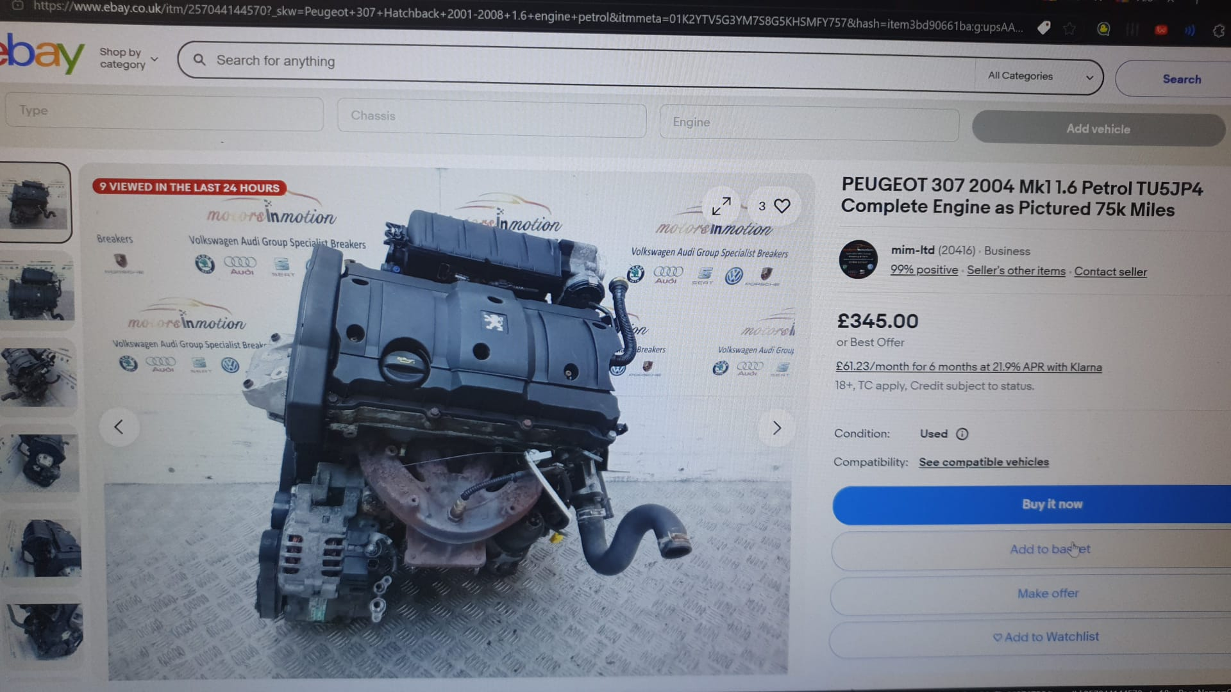

20/08/2025, 13:15 - SI: IMG-20250820-WA0001.jpg (file attached)
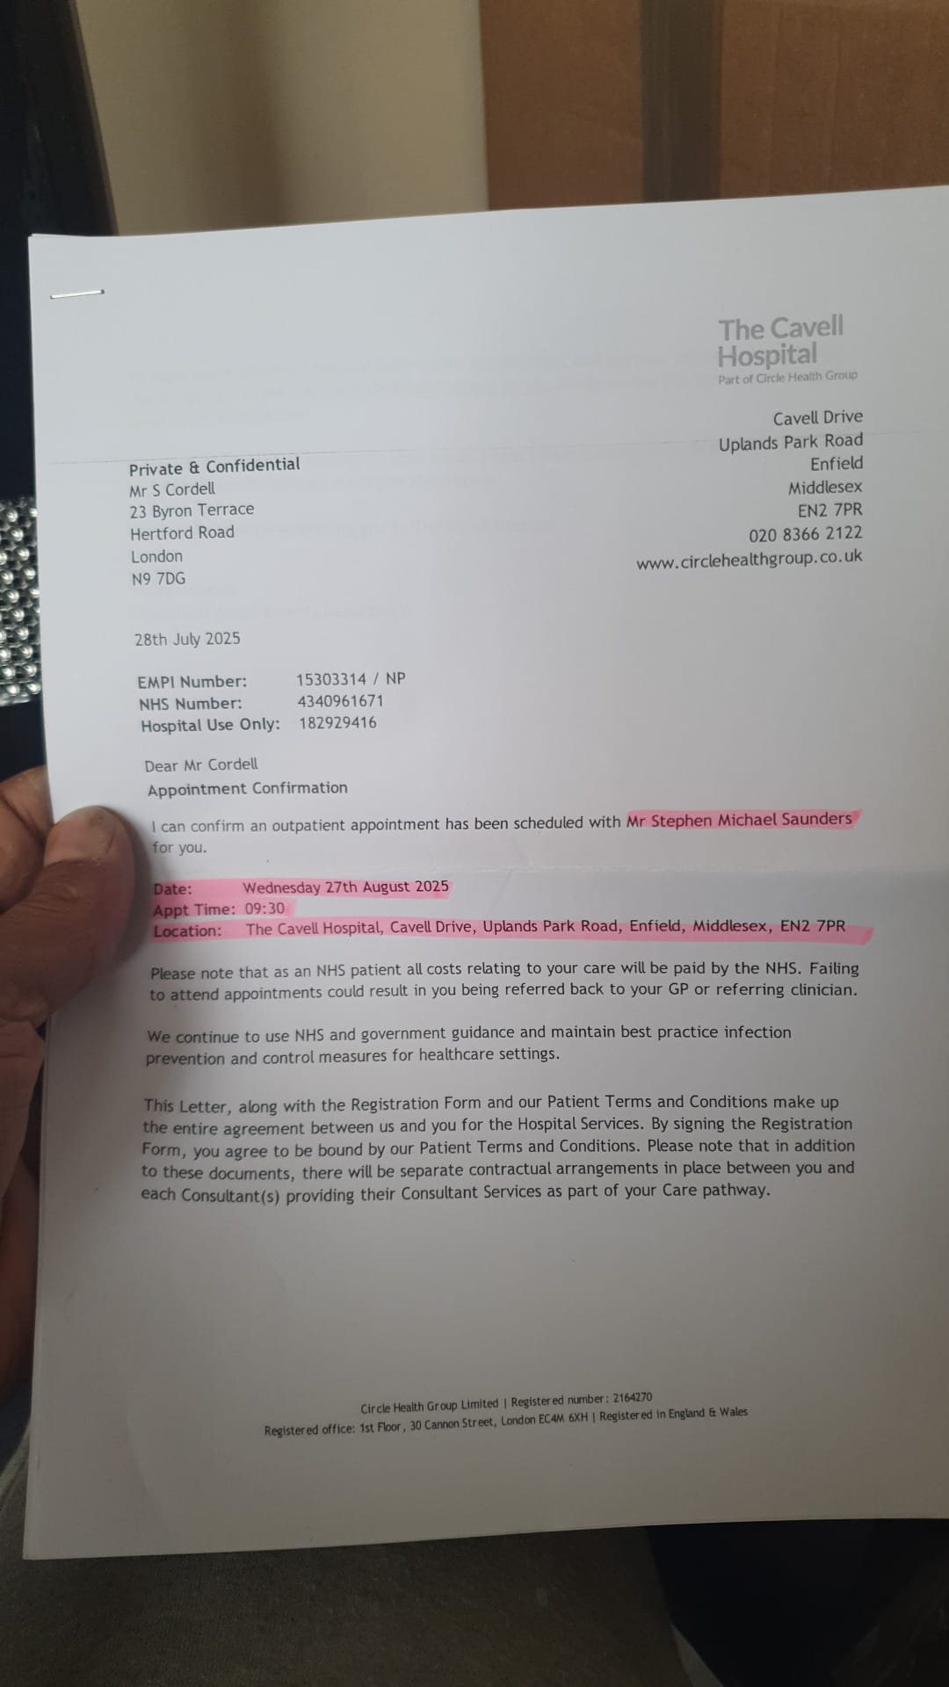

20/08/2025, 13:15 - SI: Its the 28 wed its a bit away yet xxxx

02/09/2025, 18:03 - Aunt: Get Your Free Gift!
🛒 Click here to claim your free item—SHEIN limited-time event!
https://onelink.shein.com/16/4zr4s82x5kms

03/09/2025, 17:06 - SI:

30/09/2025, 14:17 - Aunt:

30/09/2025, 14:17 - Aunt:

30/09/2025, 14:19 - SI:

06/10/2025, 14:55 - SI: https://horrificcorruption.com/Server2/Another-Police-Case-03-08-2025/index01a.asp

06/10/2025, 14:55 - SI: That’s all the case files in one place i will send you the last two emails to read next then my statement xx

06/10/2025, 14:57 - SI: https://horrificcorruption.com/Server2/Another-Police-Case-03-08-2025/01.%20Emails/38.%20Sent-.pdf

06/10/2025, 14:57 - SI: That’s the last email as 2

06/10/2025, 15:00 - SI: https://server2.pointto.us/durants/0.%20Title%20115-Rebbeca%20-Key.pdf

06/10/2025, 15:00 - SI: Her statement rip apart and cps files, I’m making now

06/10/2025, 15:00 - SI: Love you xxx

06/10/2025, 15:06 - Aunt: You done more than solicitors lol love u 2 x

06/10/2025, 18:39 - SI: Lol xx

10/10/2025, 15:54 - SI: https://server2.pointto.us/durants/New-02-08-25-Created-02-10-25/Disclosed-After-Solicitor-Left-10-%600-25/CKC_01_Witnessing_arrest_of_Simon_Cordell.mp4

10/10/2025, 15:59 - SI: We all are not outside anymore at the end of the video, no ambulance no nothing

10/10/2025, 16:24 - SI: I think I’m still inside of the flat by the seams of it....

10/10/2025, 16:42 - SI: https://server2.pointto.us/durants/0.%20Title%20115-Rebbeca%20-Key.pdf

25/10/2025, 13:53 - Aunt: IMG-20251025-WA0002.jpg (file attached)
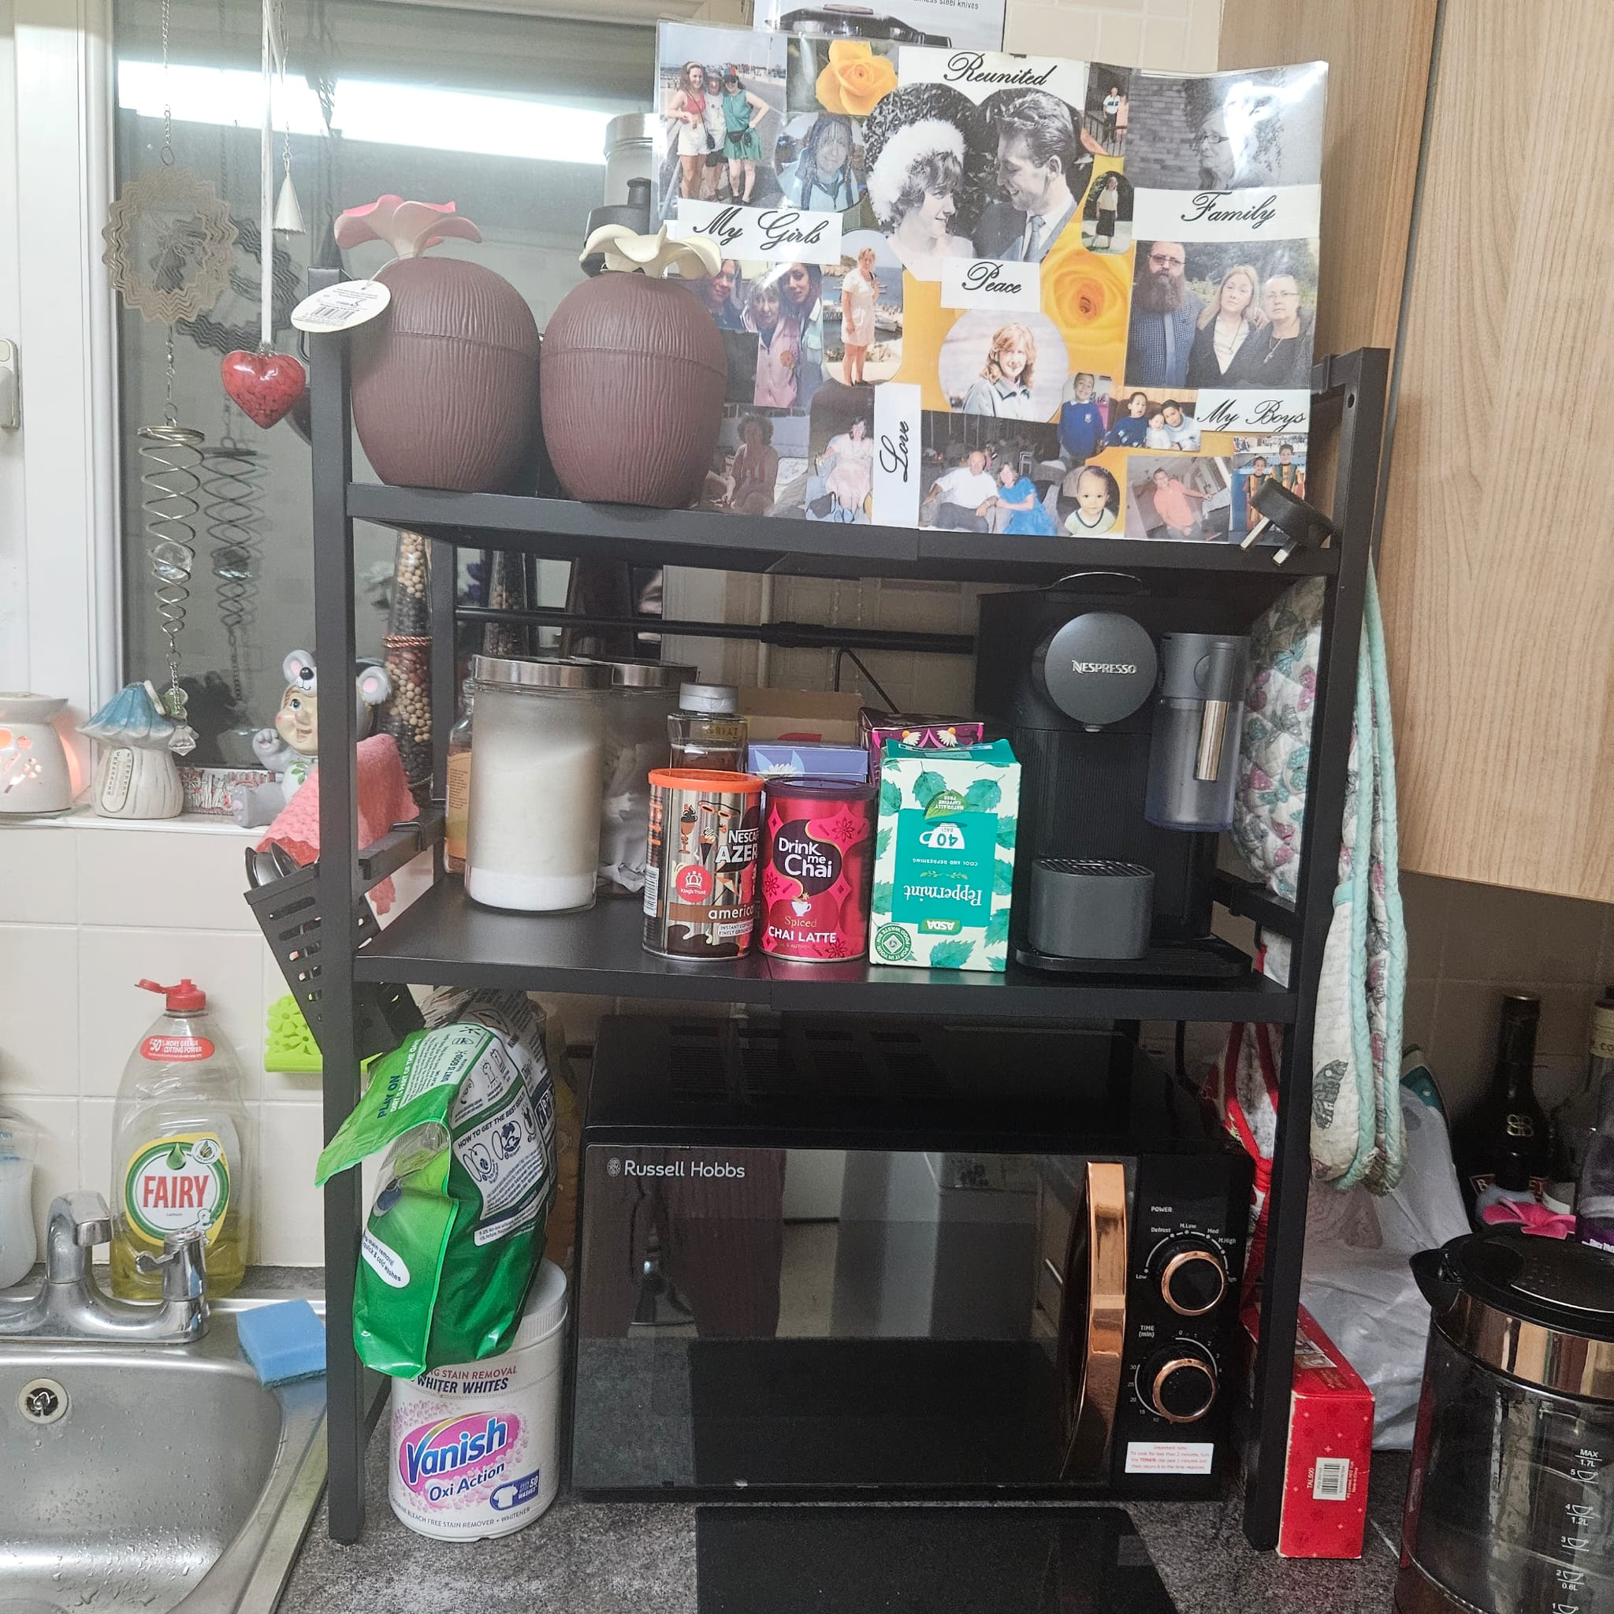

25/10/2025, 13:56 - SI: IMG-20251025-WA0004.jpg (file attached)
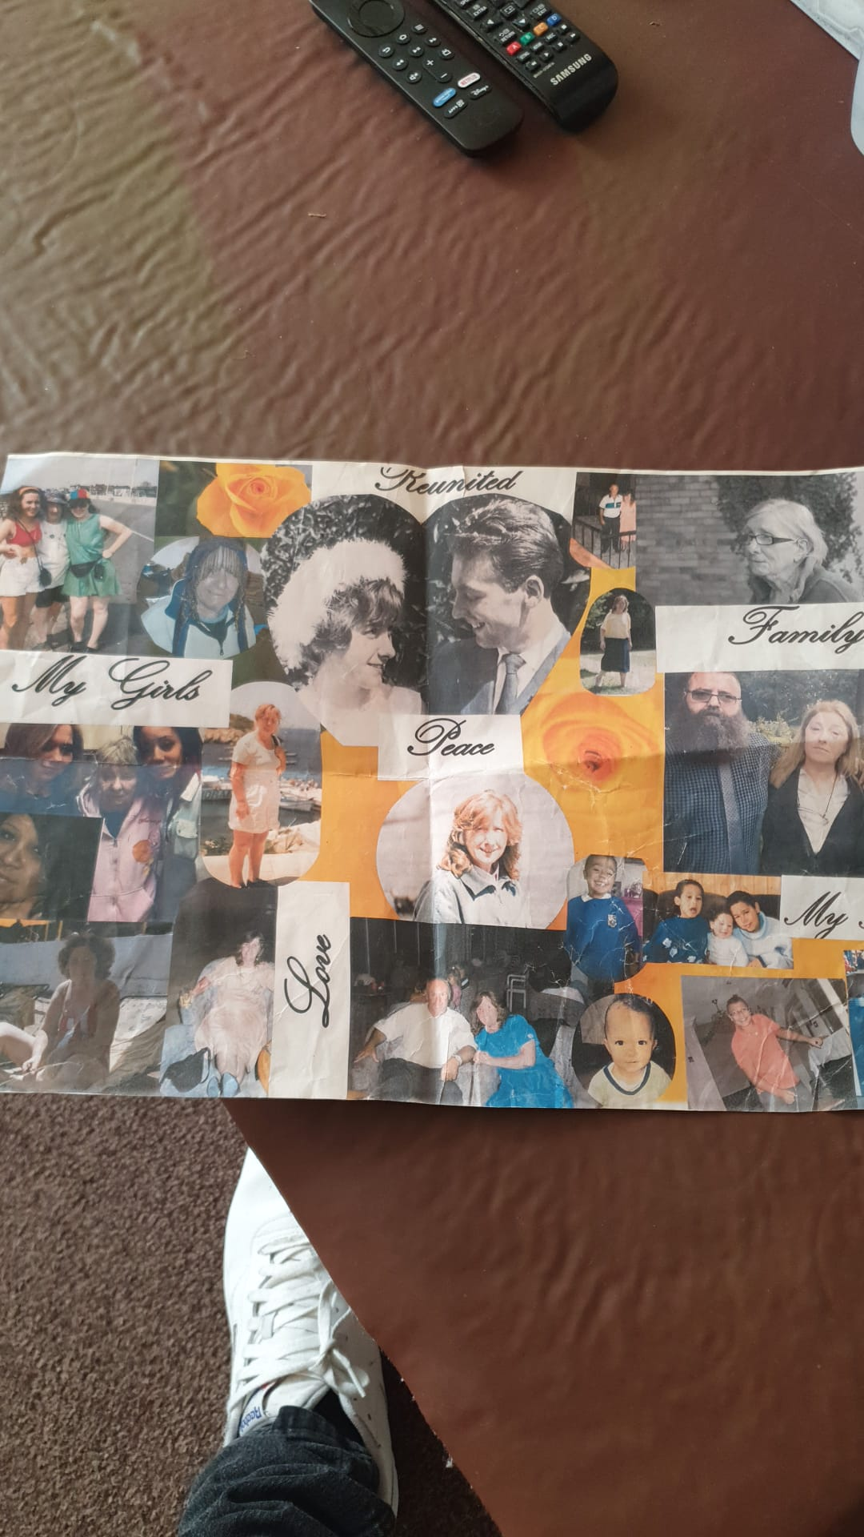

25/10/2025, 13:56 - SI: IMG-20251025-WA0006.jpg (file attached)
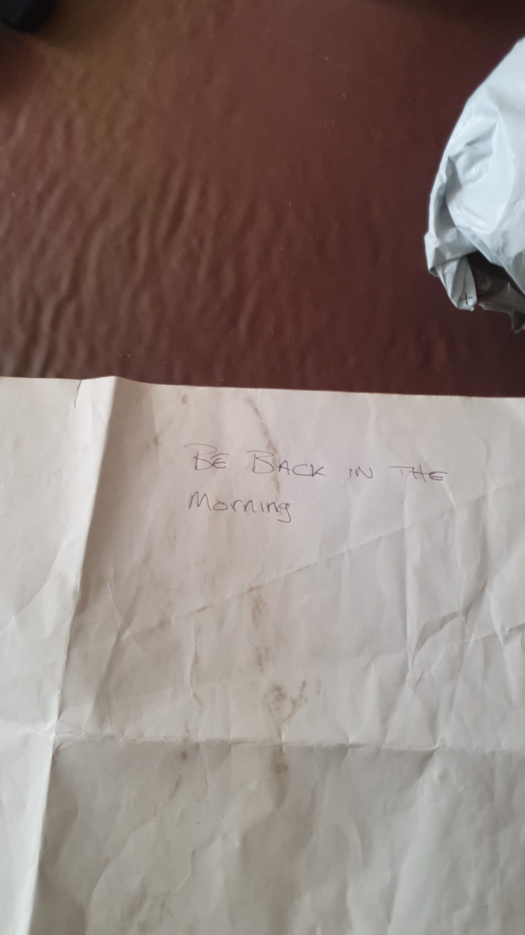

25/10/2025, 13:57 - Aunt: IMG-20251025-WA0007.jpg (file attached)
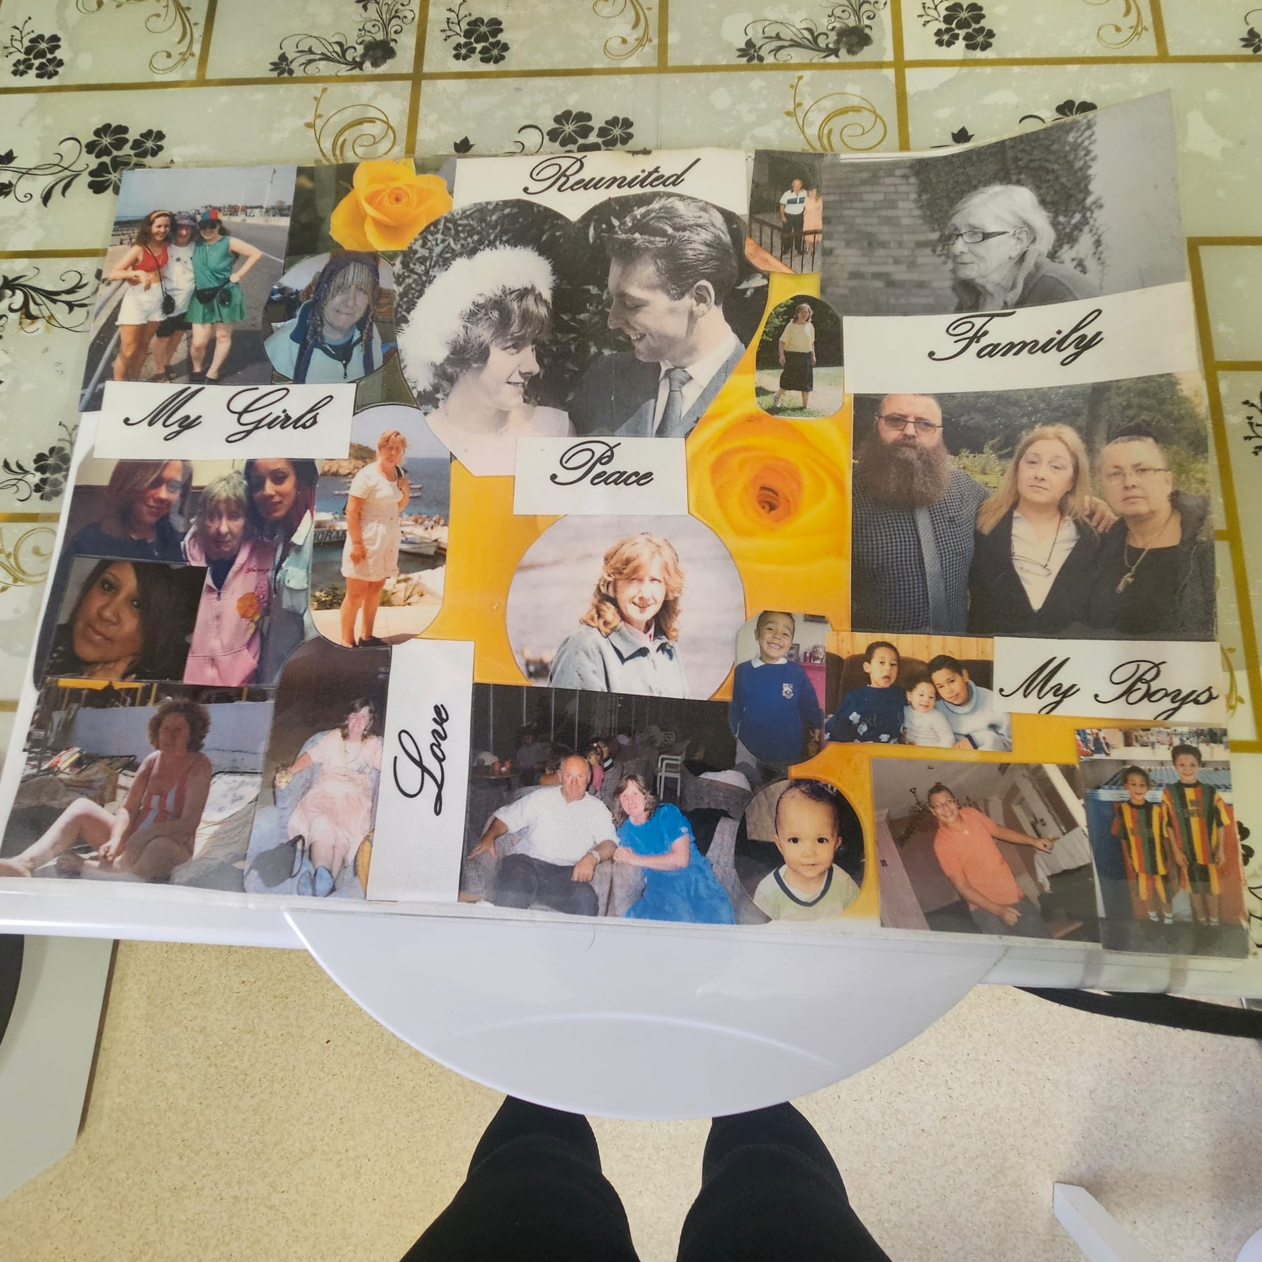

03/11/2025, 12:30 - Aunt:

06/11/2025, 13:28 - SI: VID-20251106-WA0001.mp4 (file attached)
For u lot xxx, collect them quick!

VID-20251106-WA0001.mp4

18/11/2025, 15:19 - Aunt: IMG-20251118-WA0007.jpg (file attached)
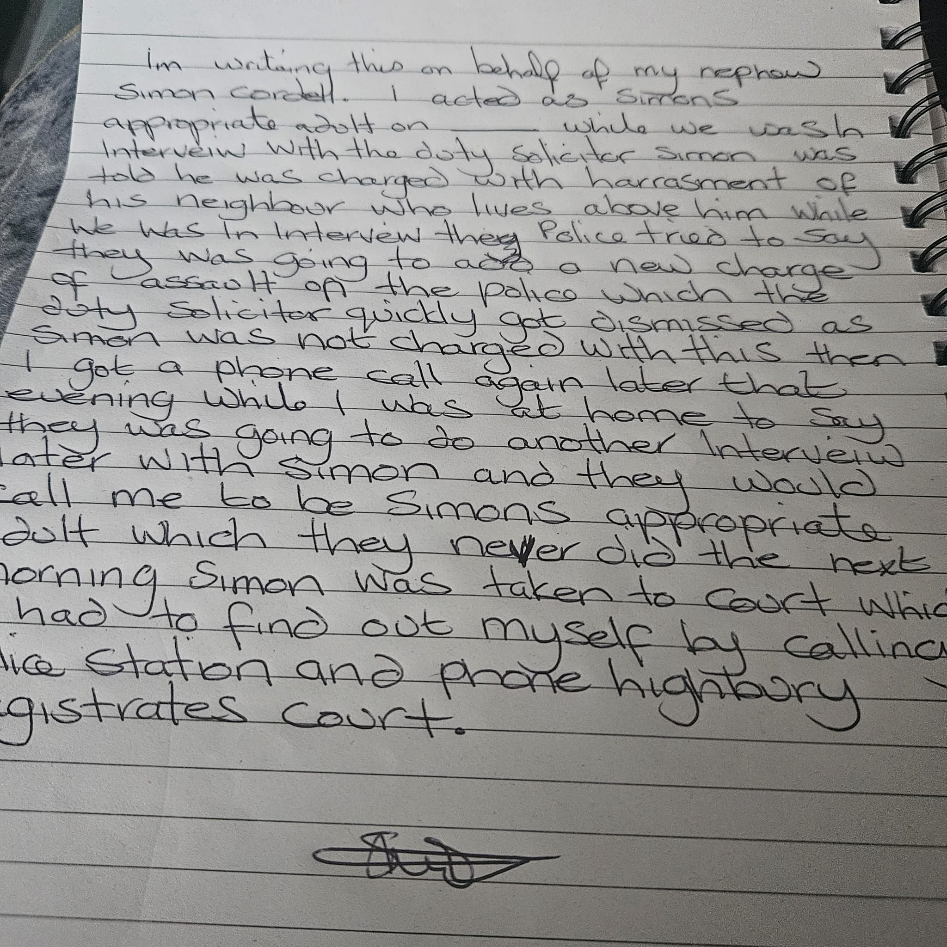

18/11/2025, 15:28 - SI: Aunt can you send another picture of it face down, as it hard to read the top of it plz

18/11/2025, 15:29 - Aunt: IMG-20251118-WA0008.jpg (file attached)
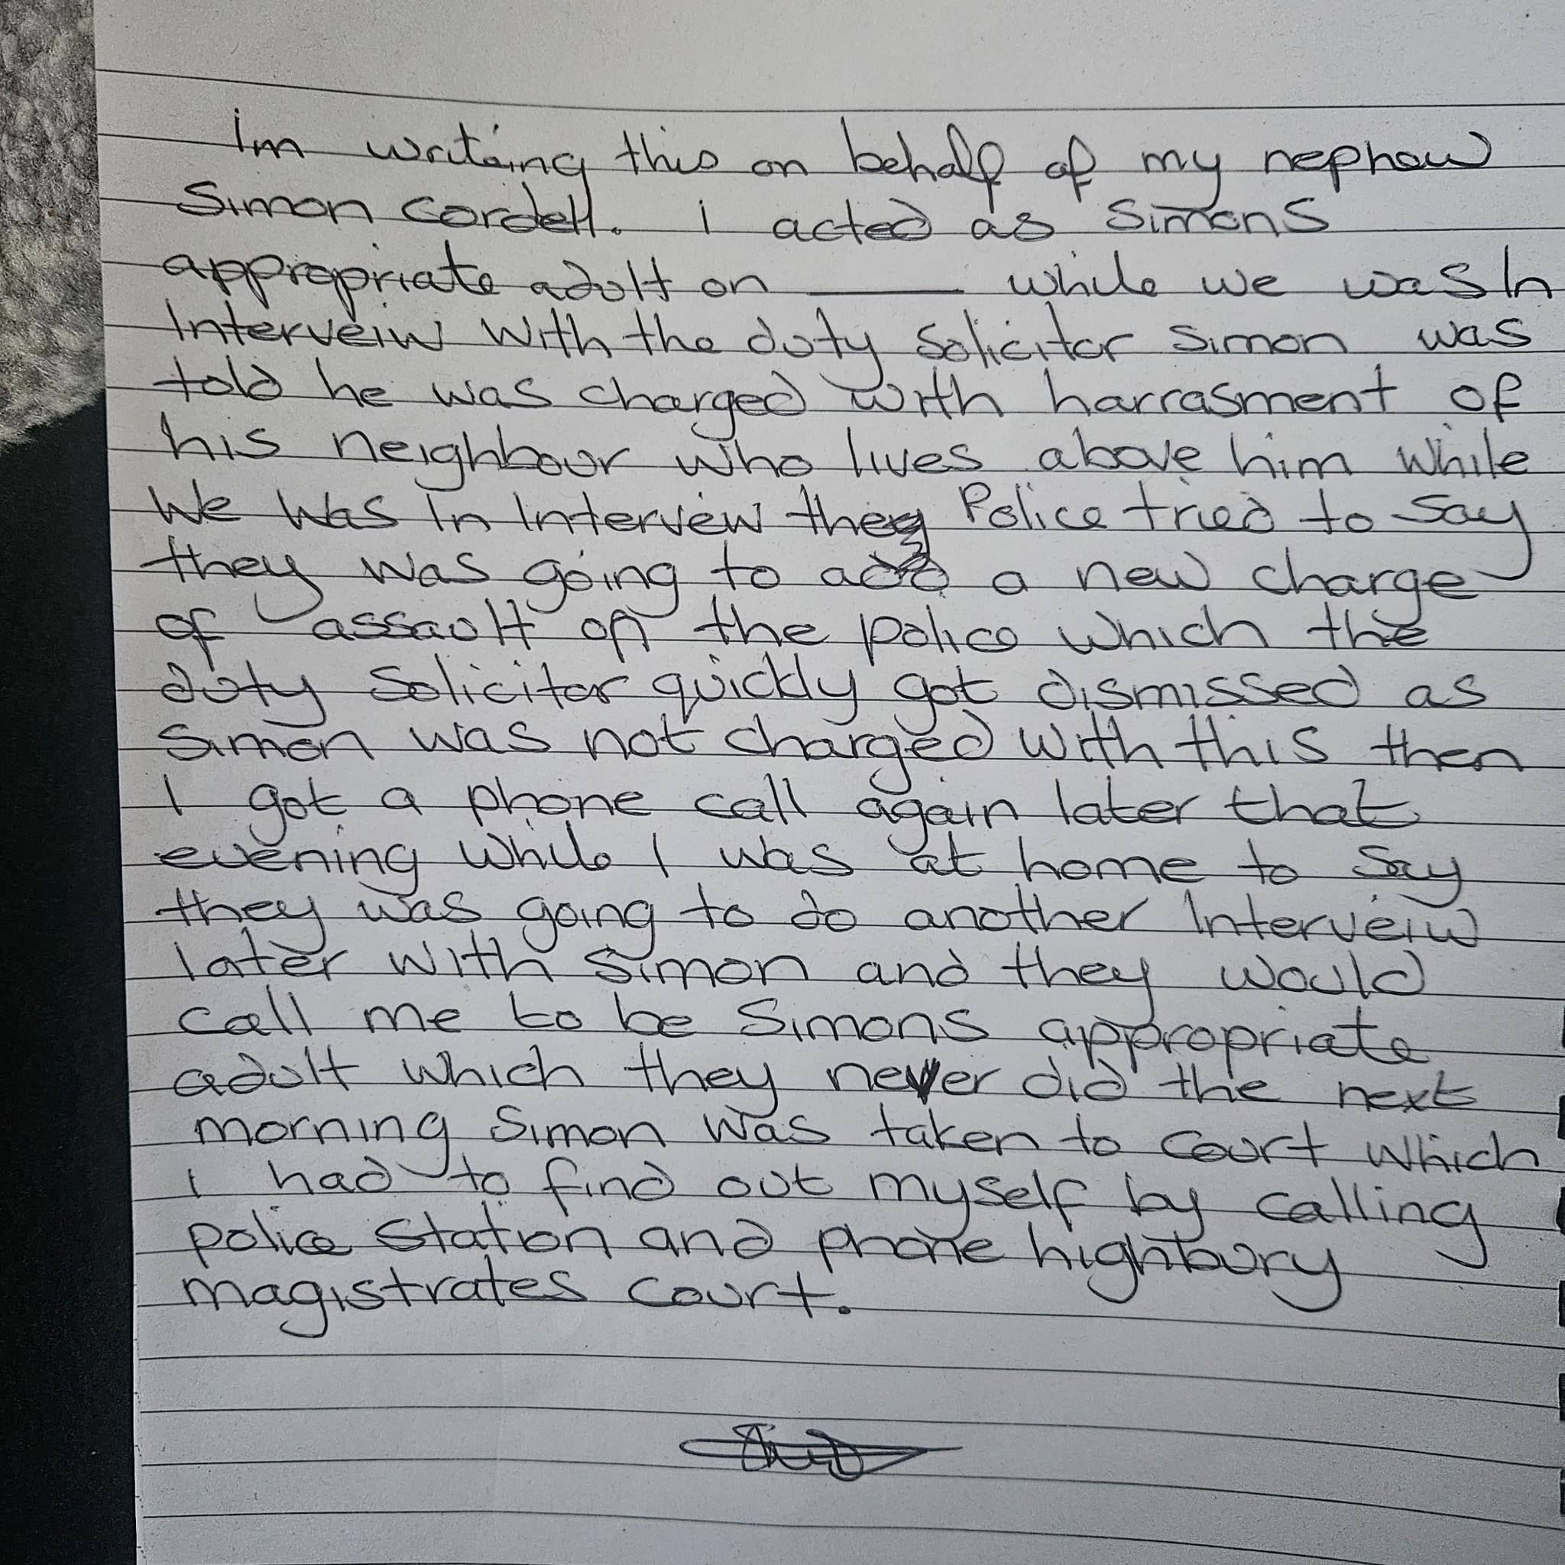

18/11/2025, 15:31 - SI: Thanks xxxx love ya

26/11/2025, 16:33 - SI: Everyoneloginto.me

05/12/2025, 13:13 - Aunt: IMG-20251205-WA0000.jpg (file attached)
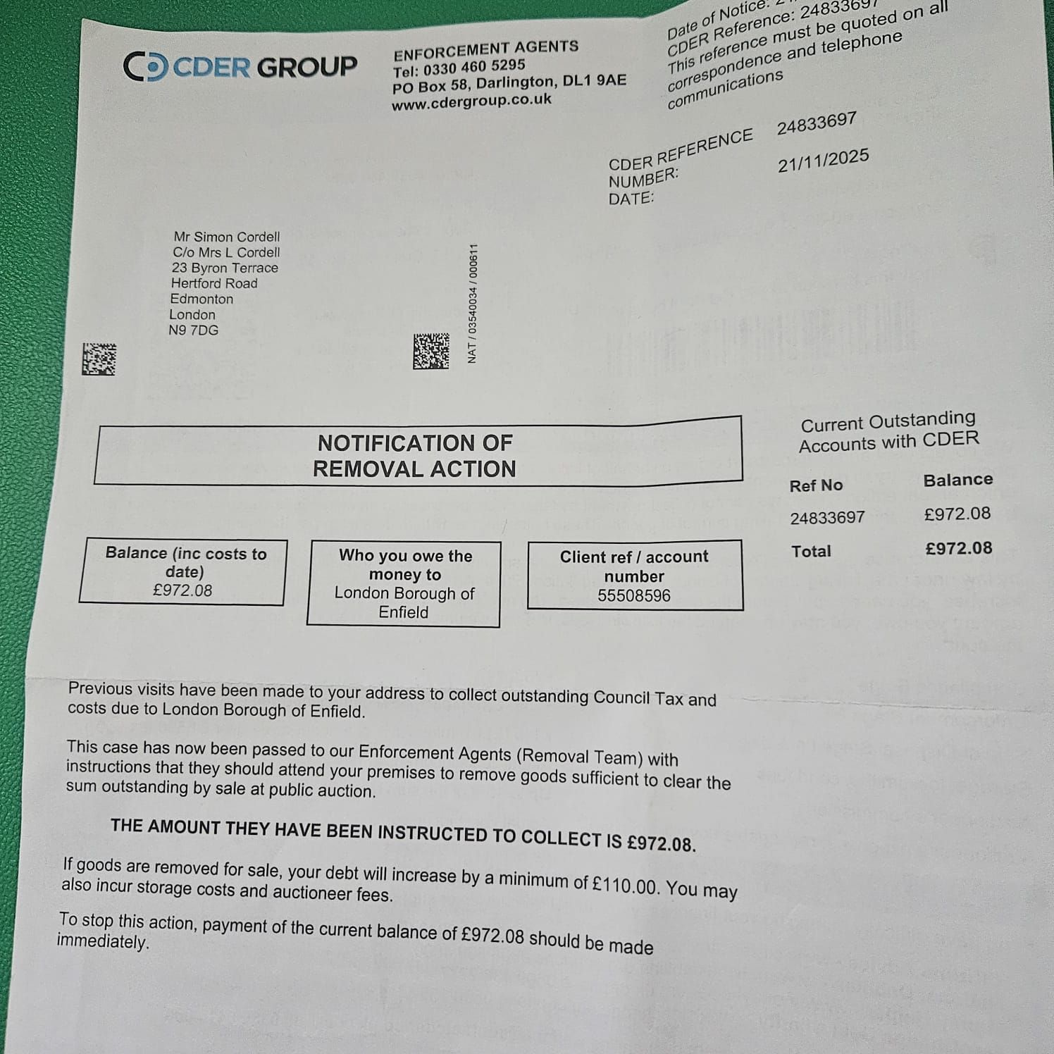

05/12/2025, 13:14 - Aunt: IMG-20251205-WA0001.jpg (file attached)
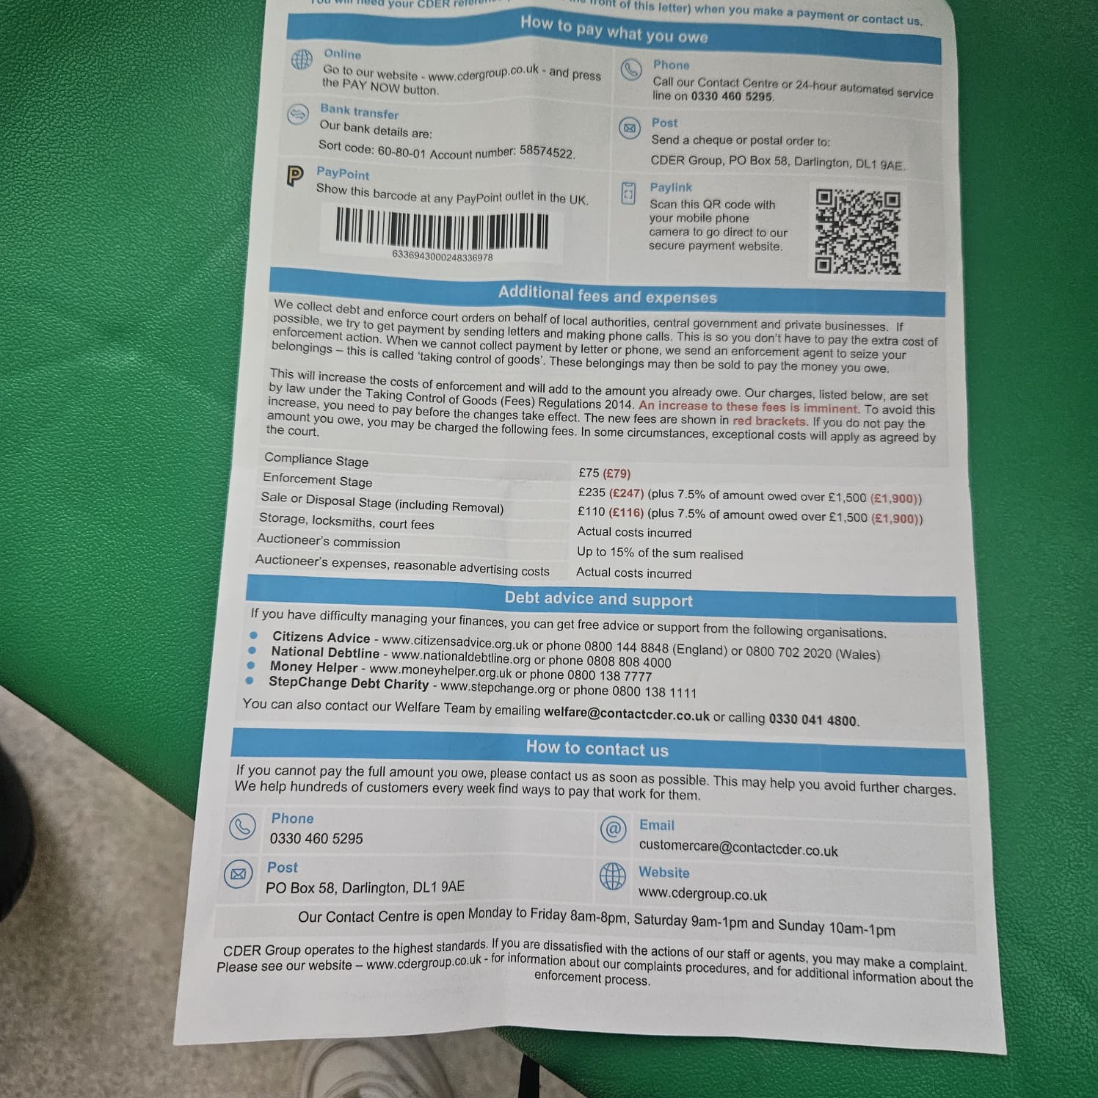

05/12/2025, 13:14 - Aunt:

05/12/2025, 13:14 - SI:

20/12/2025, 17:41 - Aunt: 🎉 Claim 5 free SHEIN products now!
Click the link to help and let’s both win big! ✨
https://onelink.shein.com/23/5athoh2vdkk2

25/12/2025, 13:34 - Aunt:

05/01/2026, 15:50 - SI:

07/01/2026, 19:00 - SI: IMG-20260107-WA0003.jpg (file attached)
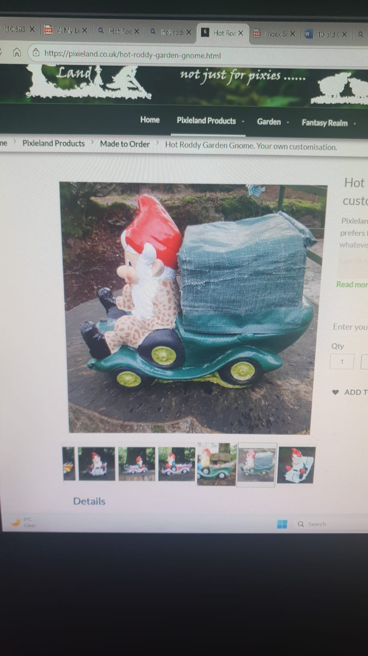

07/01/2026, 19:01 - SI: IMG-20260107-WA0002.jpg (file attached)
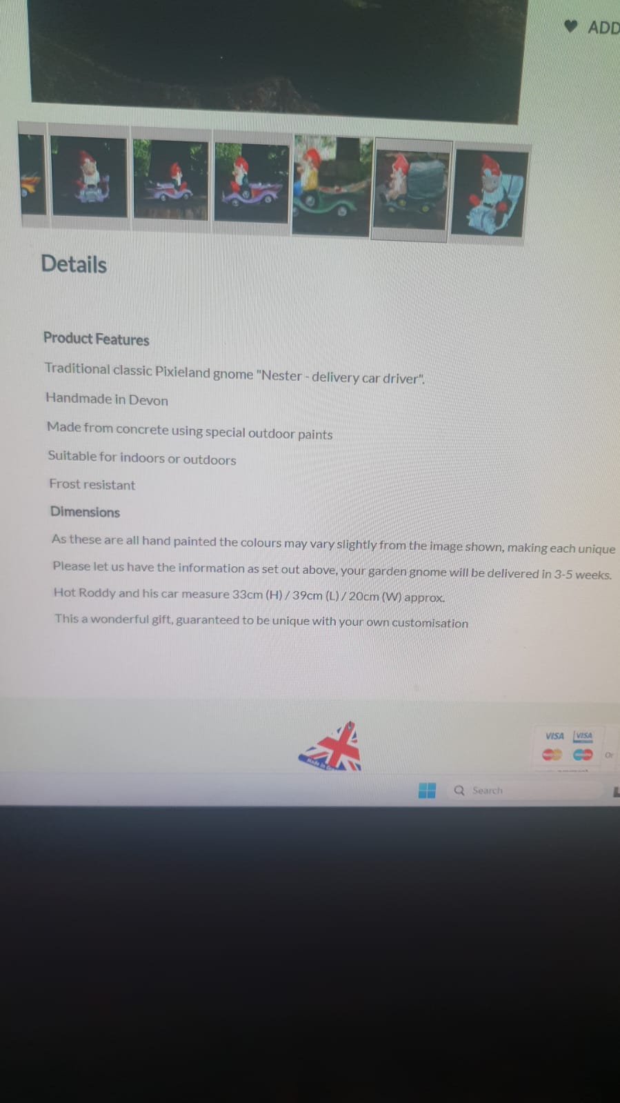

15/01/2026, 10:57 - Aunt: IMG-20260115-WA0000.jpg (file attached)
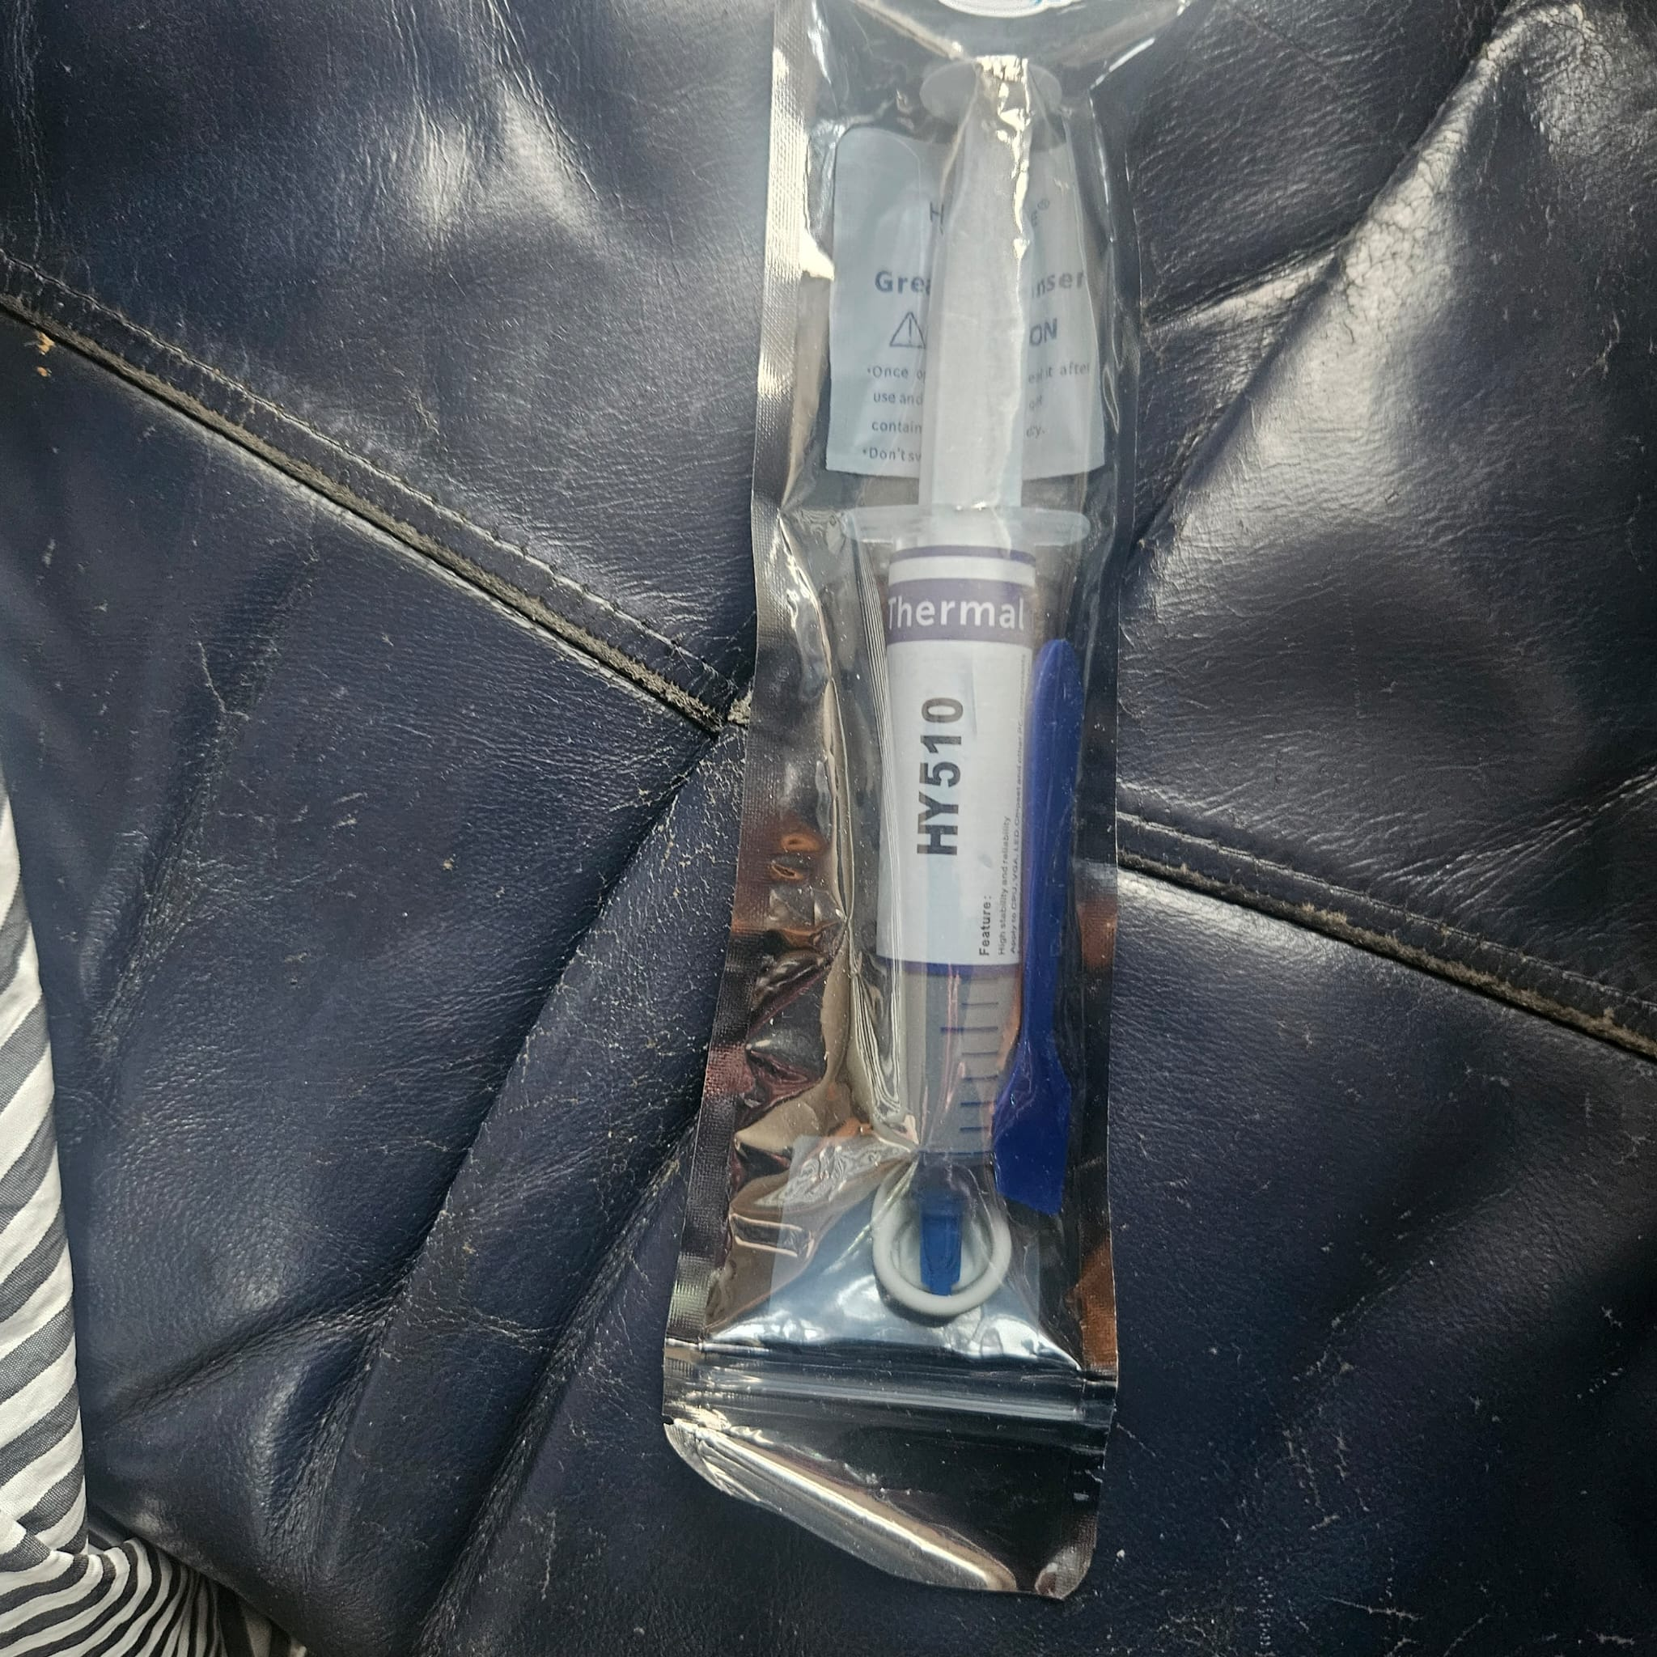

15/01/2026, 16:59 - Aunt:

20/01/2026, 12:22 - SI: IMG-20260120-WA0001.jpg (file attached)
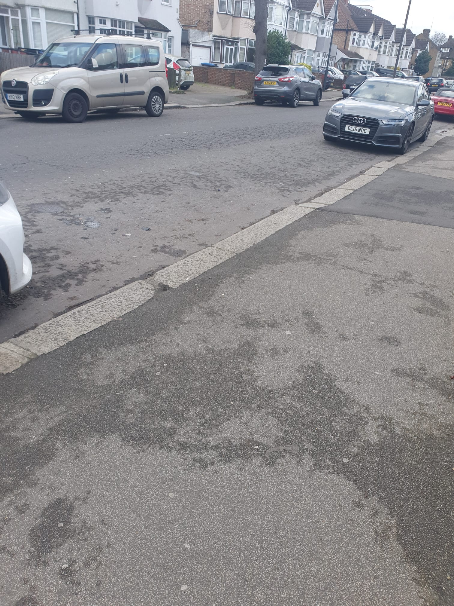

22/01/2026, 12:53 - SI: IMG-20260120-WA0000.jpg (file attached)
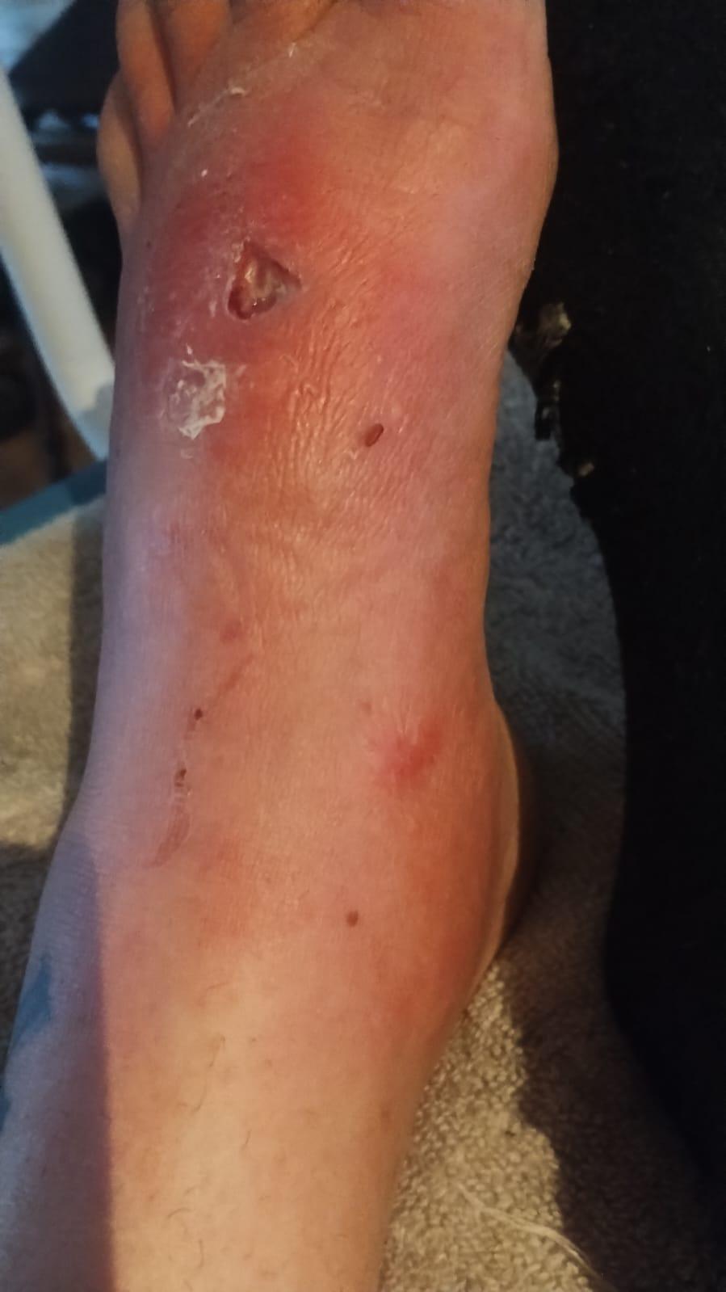

22/01/2026, 12:53 - SI: Yesterday

22/01/2026, 12:54 - SI: IMG-20260122-WA0000.jpg (file attached)
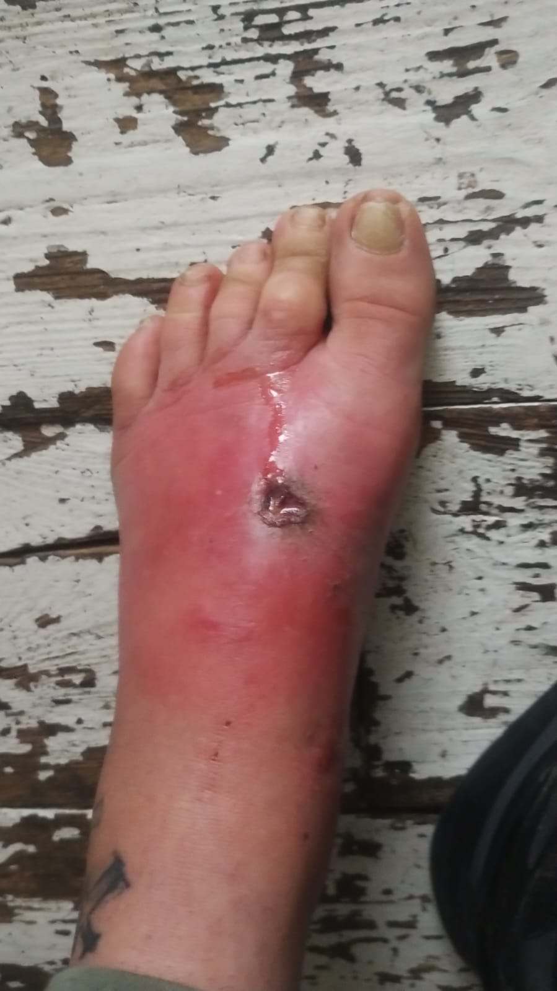

29/01/2026, 12:59 - SI: IMG-20260129-WA0004.jpg (file attached)
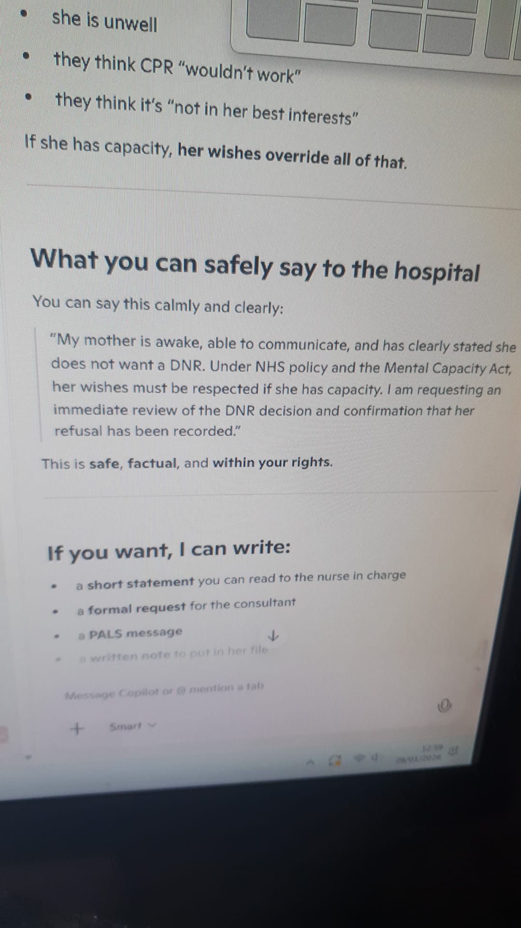

29/01/2026, 12:59 - SI: IMG-20260129-WA0006.jpg (file attached)
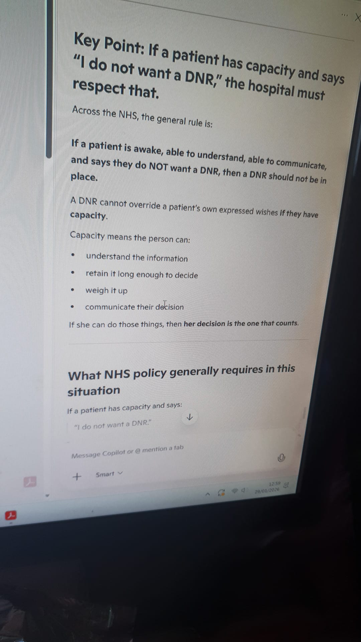

30/01/2026, 20:07 - Aunt:

30/01/2026, 20:07 - Aunt: IMG-20260130-WA0000.jpg (file attached)
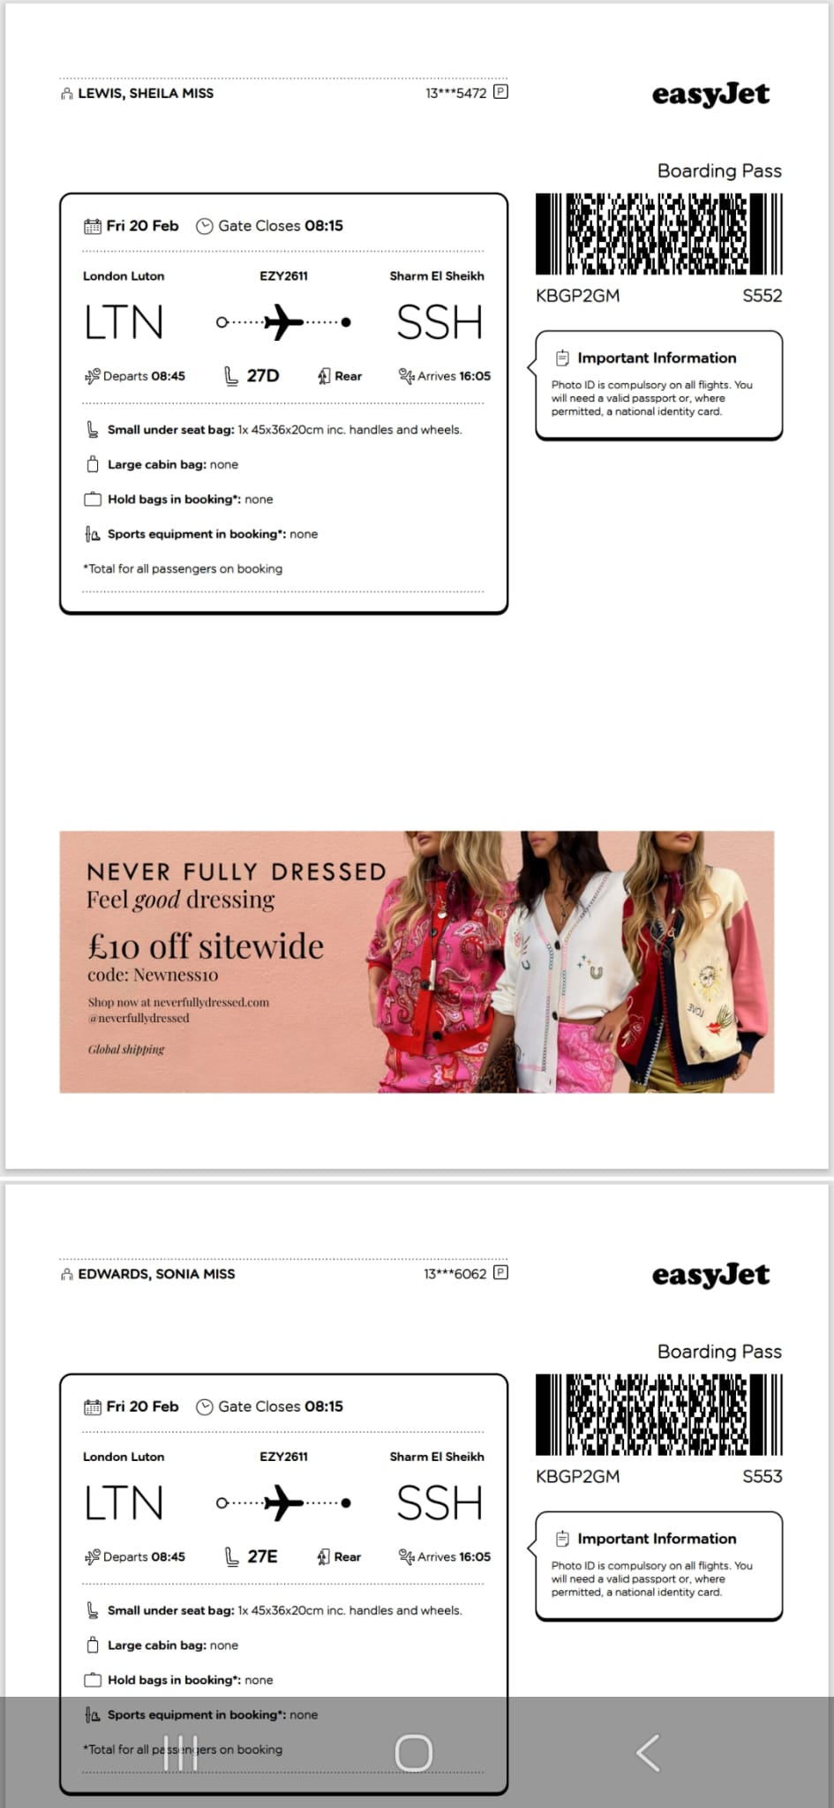

30/01/2026, 20:07 - Aunt: IMG-20260130-WA0001.jpg (file attached)
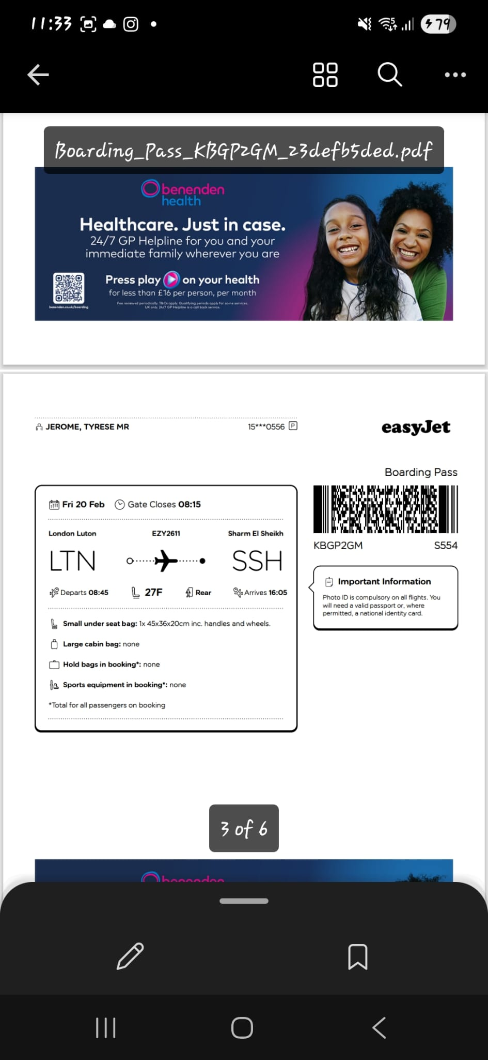

30/01/2026, 20:07 - Aunt: IMG-20260130-WA0002.jpg (file attached)
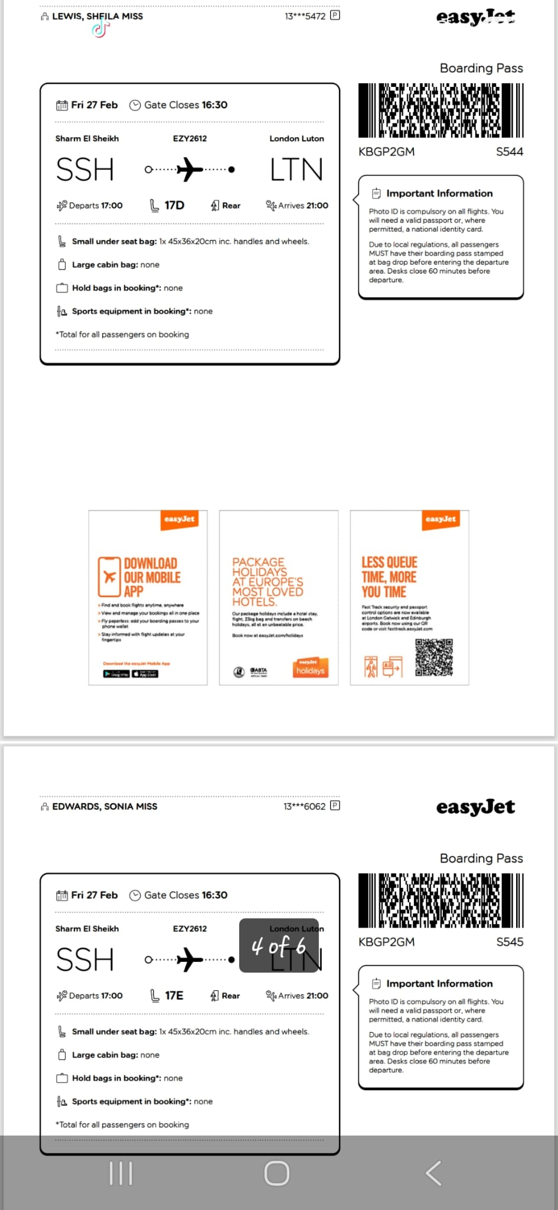

30/01/2026, 20:07 - Aunt: IMG-20260130-WA0003.jpg (file attached)
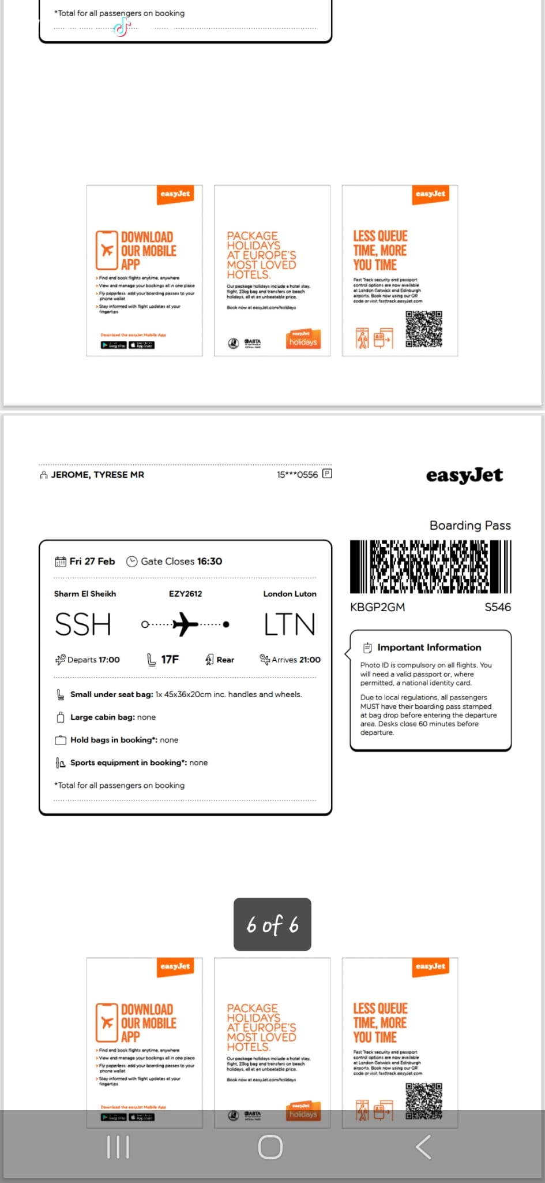

01/02/2026, 16:00 - SI:

01/02/2026, 16:34 - SI:

04/02/2026, 15:01 - SI:

10/02/2026, 13:04 - Aunt:

10/02/2026, 13:04 - Aunt: IMG-20260210-WA0000.jpg (file attached)
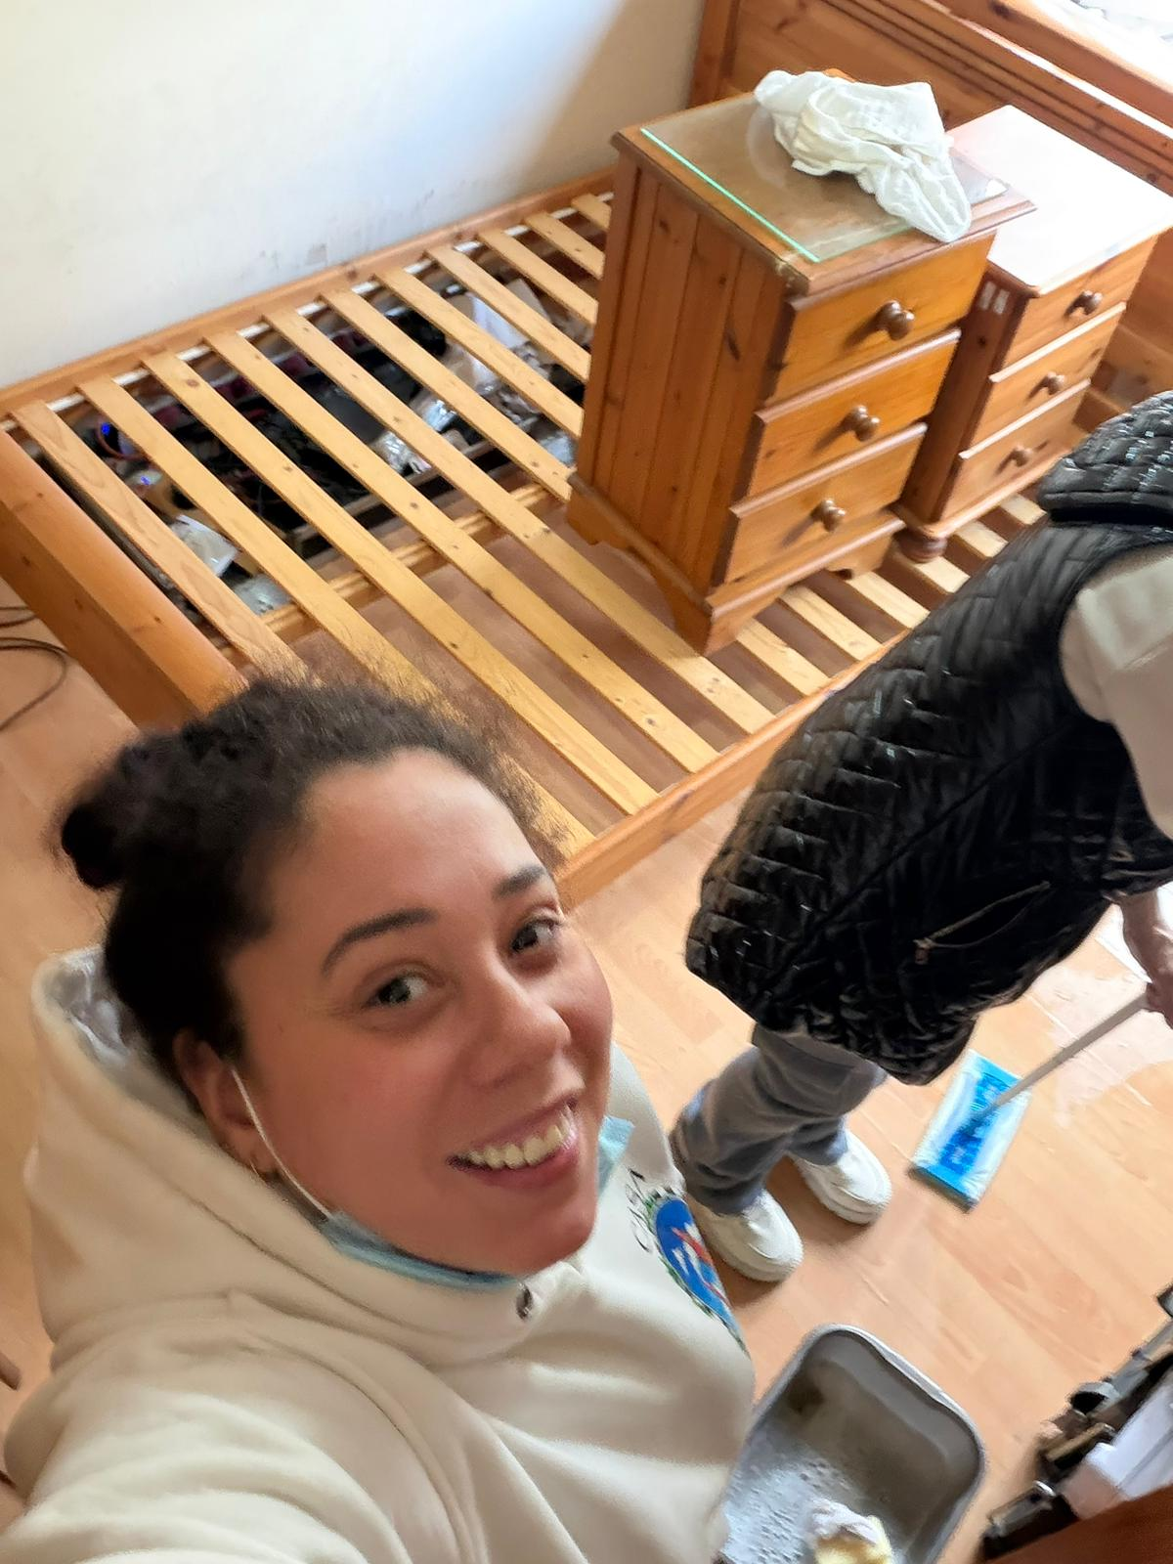

10/02/2026, 13:04 - Aunt: IMG-20260210-WA0001.jpg (file attached)
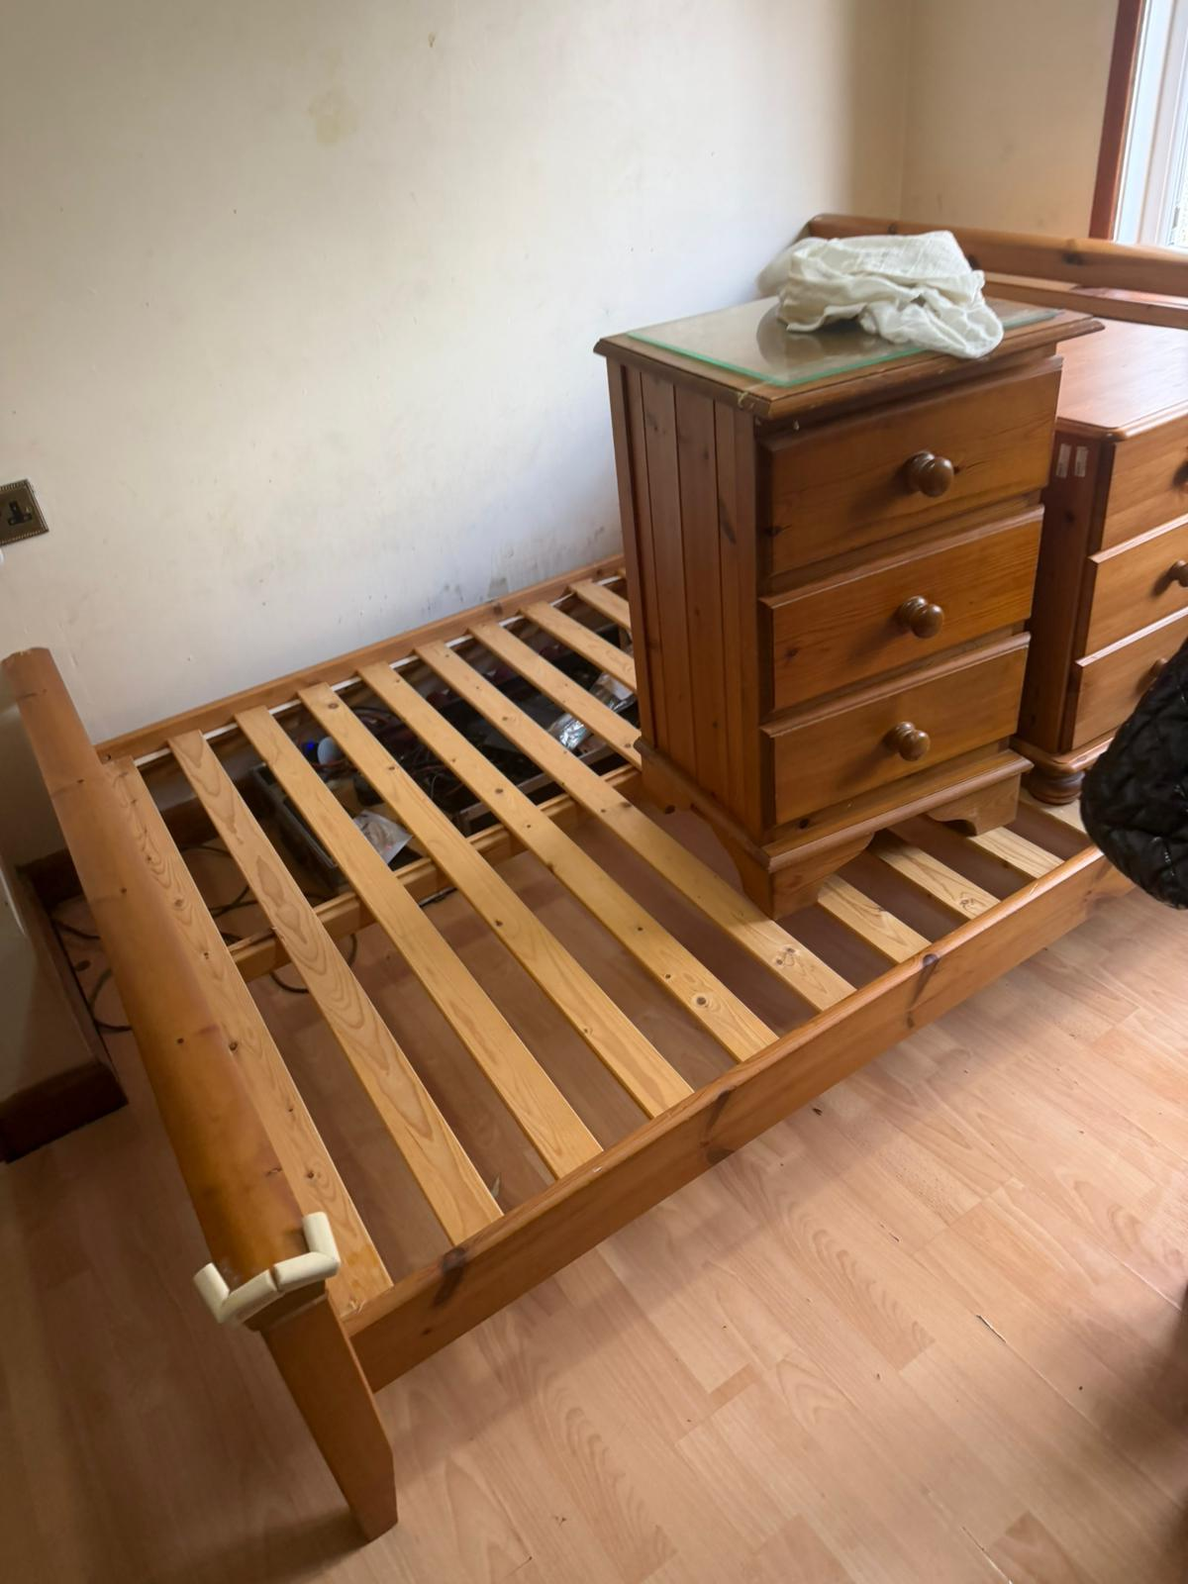

10/02/2026, 13:04 - Aunt: IMG-20260210-WA0002.jpg (file attached)
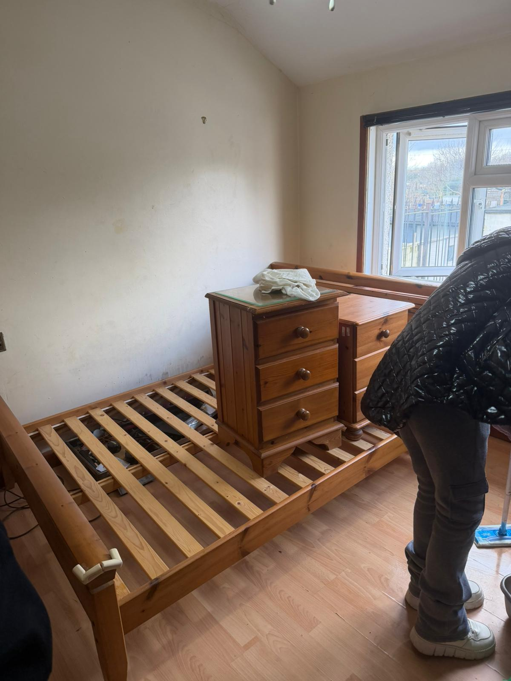

10/02/2026, 13:04 - Aunt: VID-20260210-WA0003.mp4 (file attached)
VID-20260210-WA0003.mp4

10/02/2026, 13:04 - Aunt: VID-20260210-WA0004.mp4 (file attached)
VID-20260210-WA0004.mp4

10/02/2026, 13:04 - Aunt: VID-20260210-WA0005.mp4 (file attached)
VID-20260210-WA0005.mp4

10/02/2026, 13:05 - Aunt: Sorting out one of mums bedrooms me Deon Jim and Sonia

14/02/2026, 11:31 - Aunt:

14/02/2026, 11:31 - Aunt: IMG-20260214-WA0000.jpg (file attached)
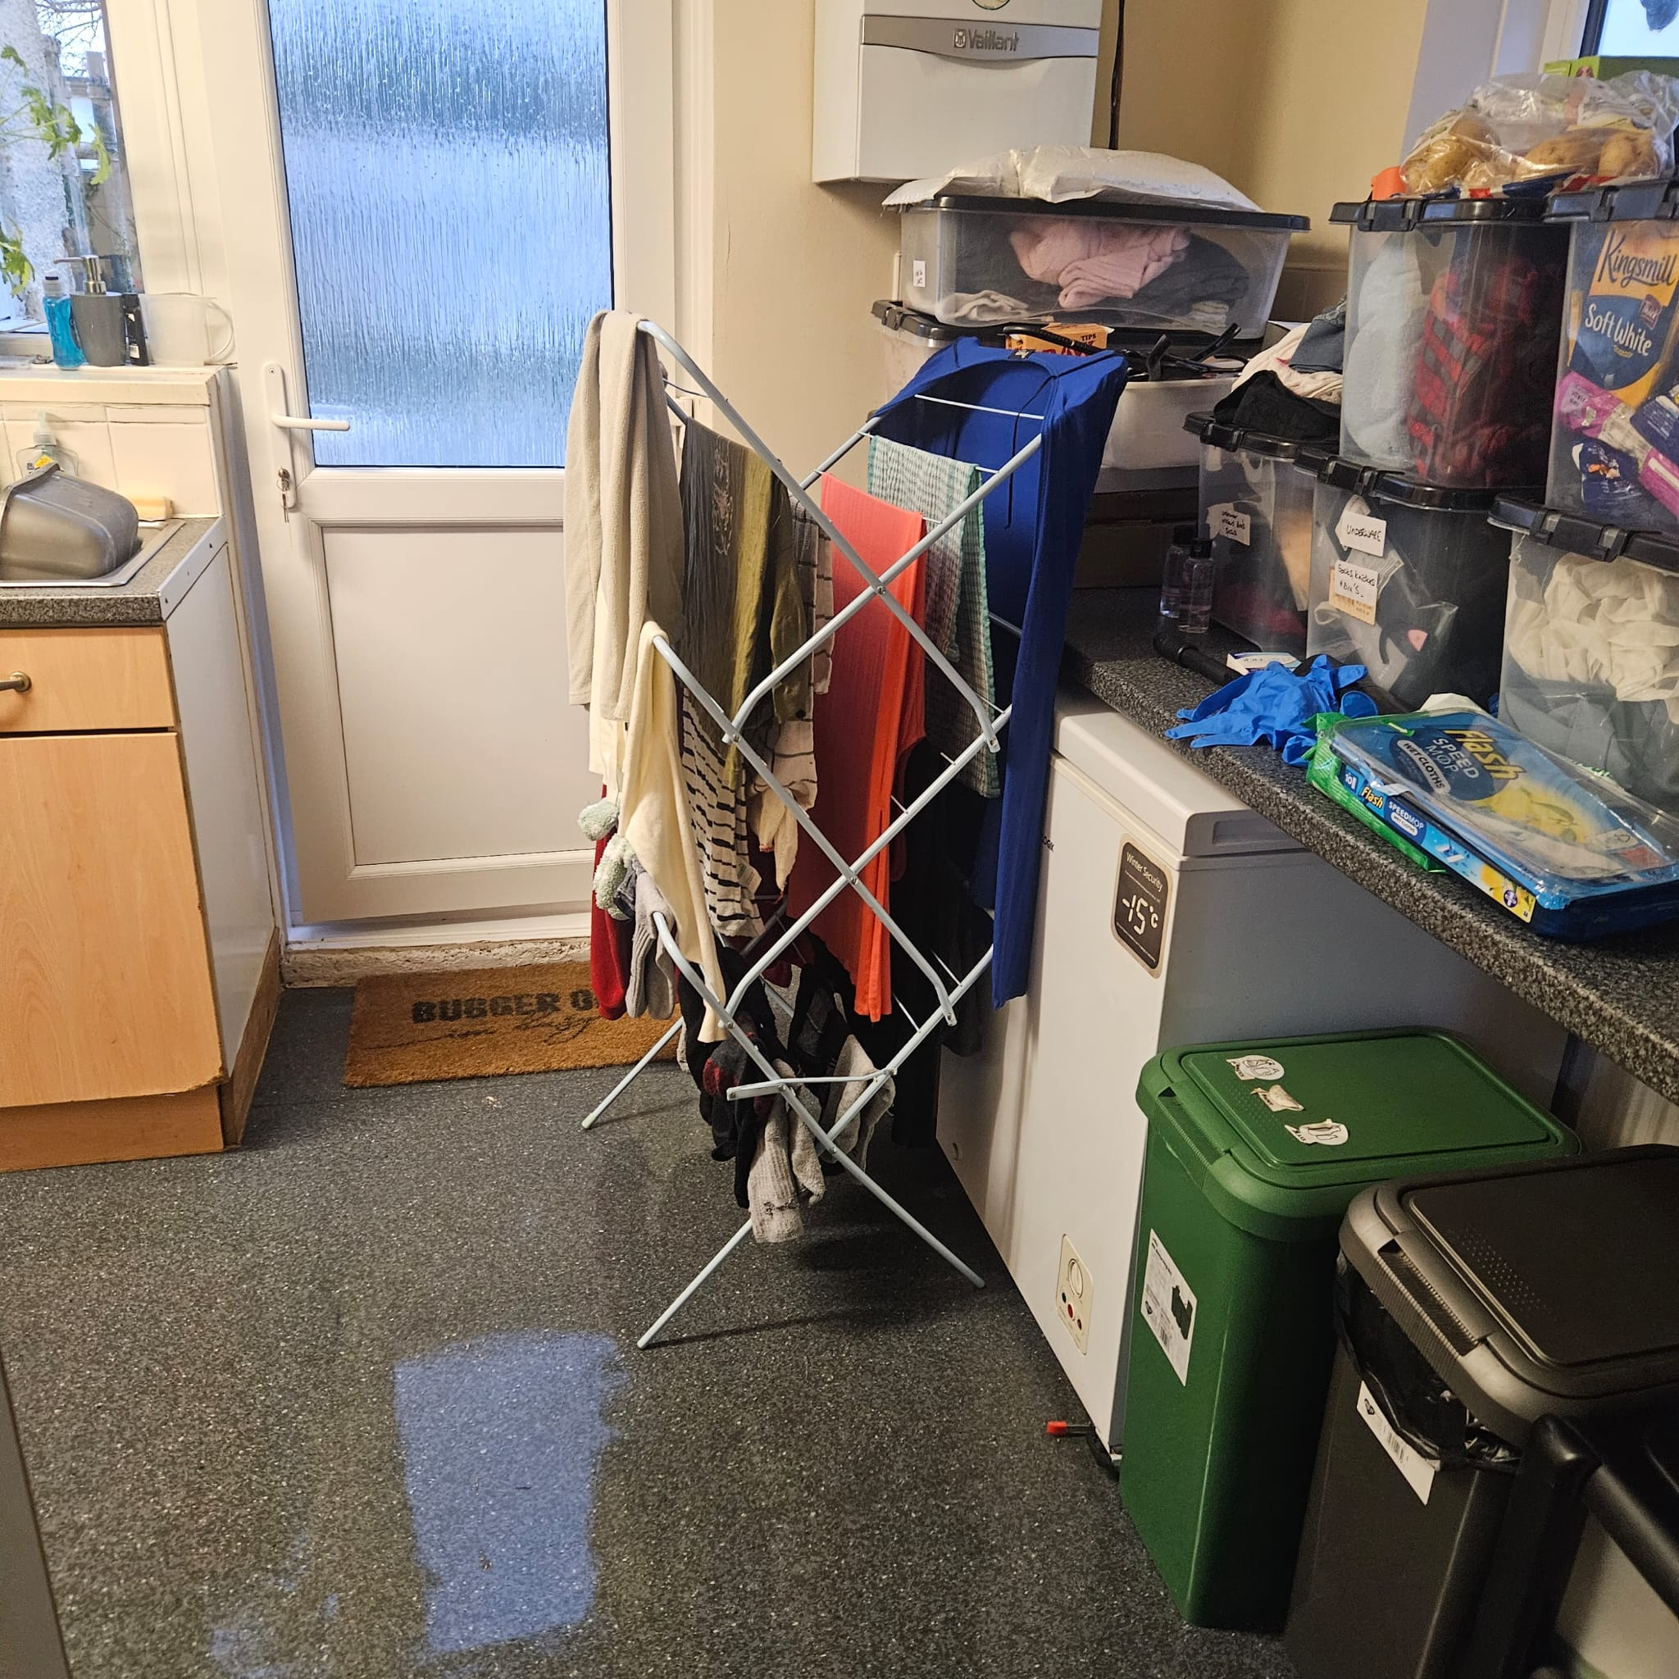

14/02/2026, 11:31 - Aunt: IMG-.jpg (file attached)

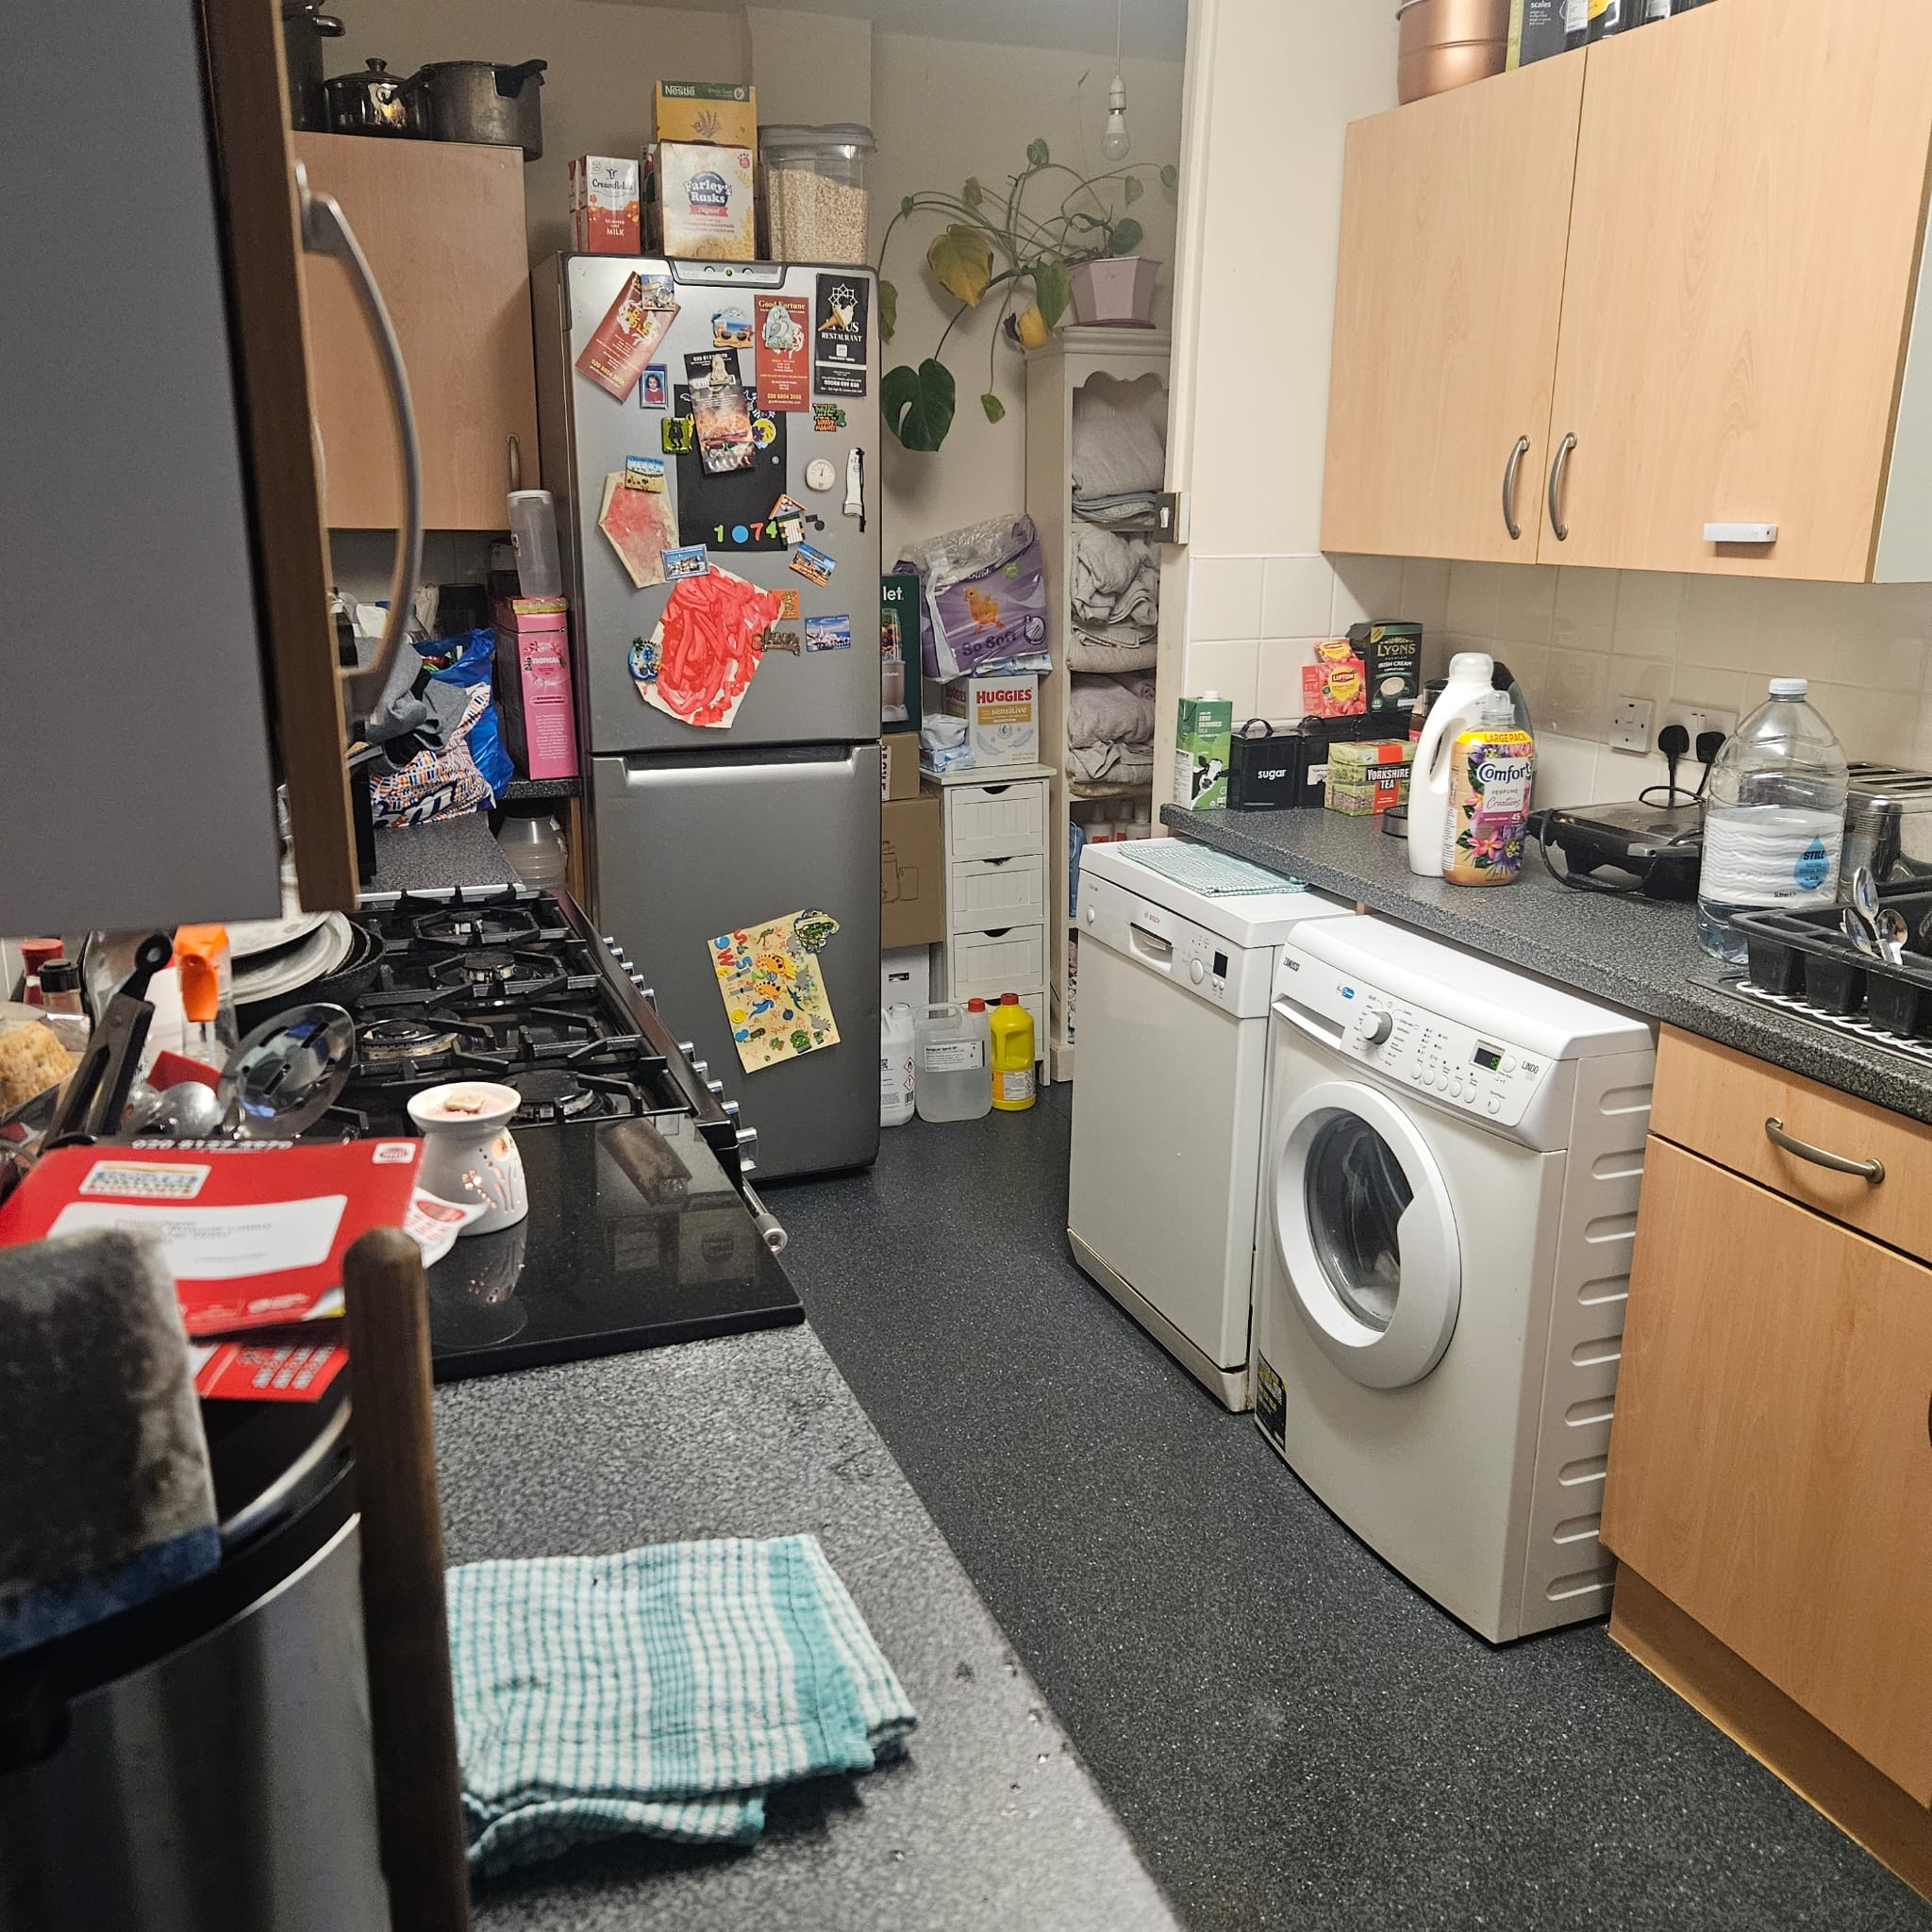

14/02/2026, 11:31 - Aunt: IMG-20260214-WA0002.jpg (file attached)
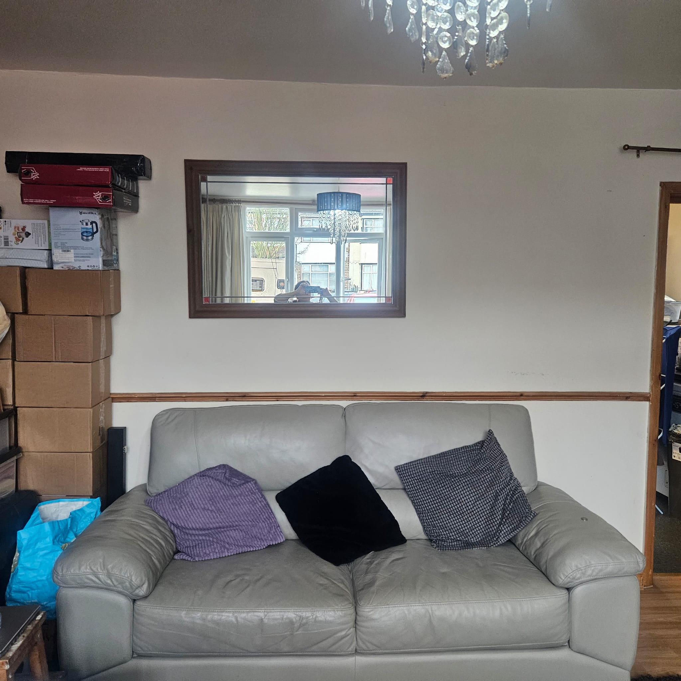

14/02/2026, 11:31 - Aunt: IMG-.jpg (file attached)
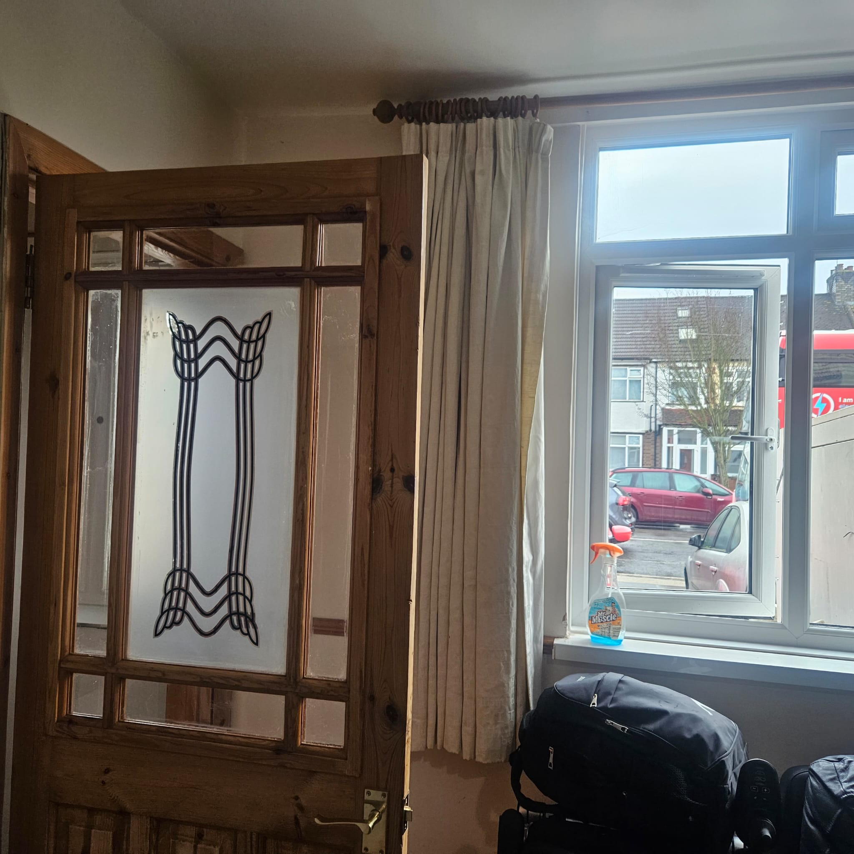

14/02/2026, 11:31 - Aunt: IMG-20260214-WA0004.jpg (file attached)
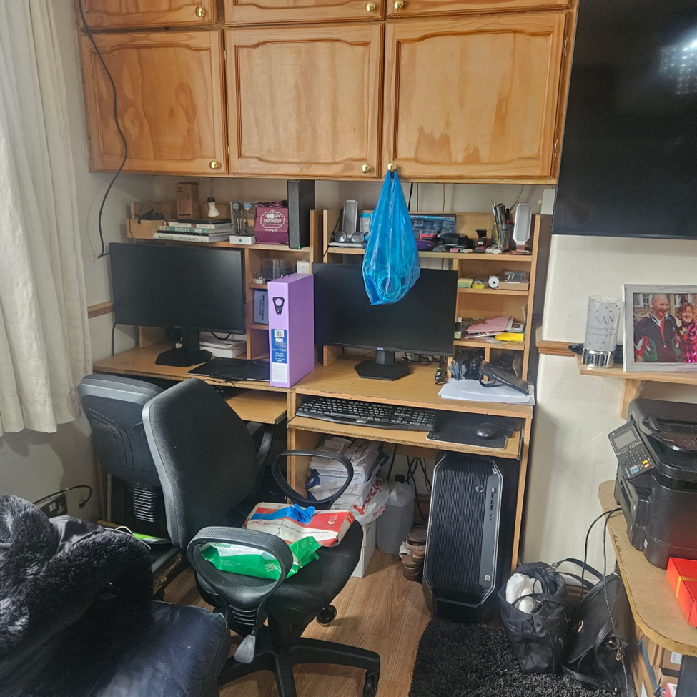

14/02/2026, 11:31 - Aunt: IMG-20260214-WA0005-.jpg (file attached)
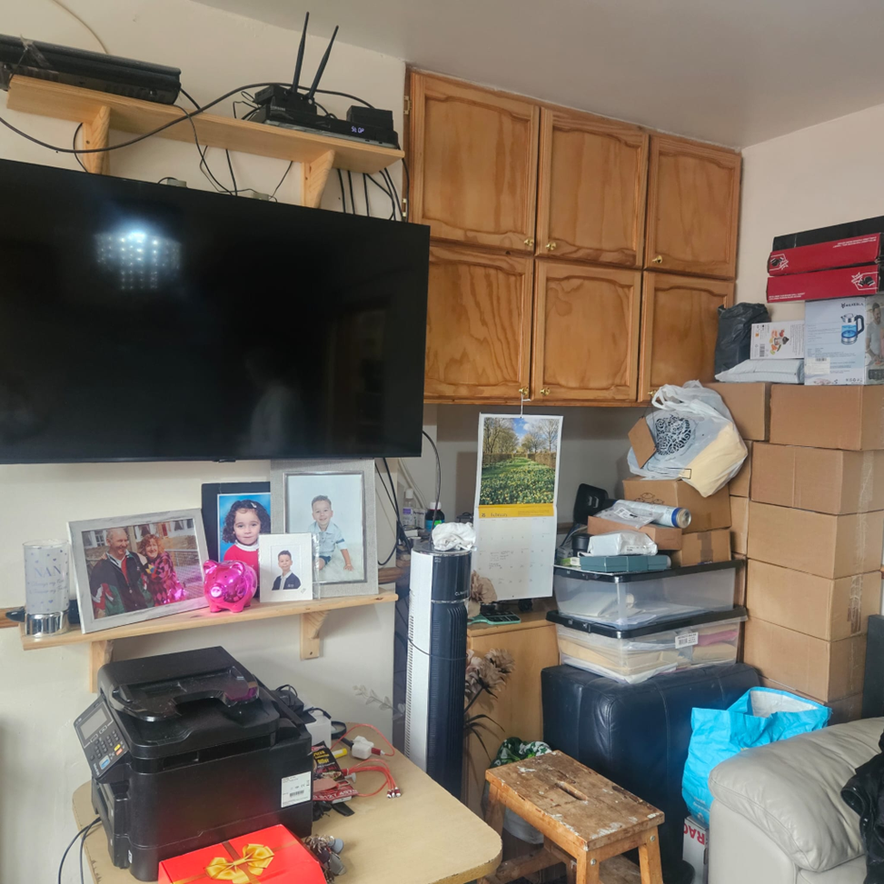

14/02/2026, 11:31 - Aunt: IMG-20260214-WA0006.jpg (file attached)
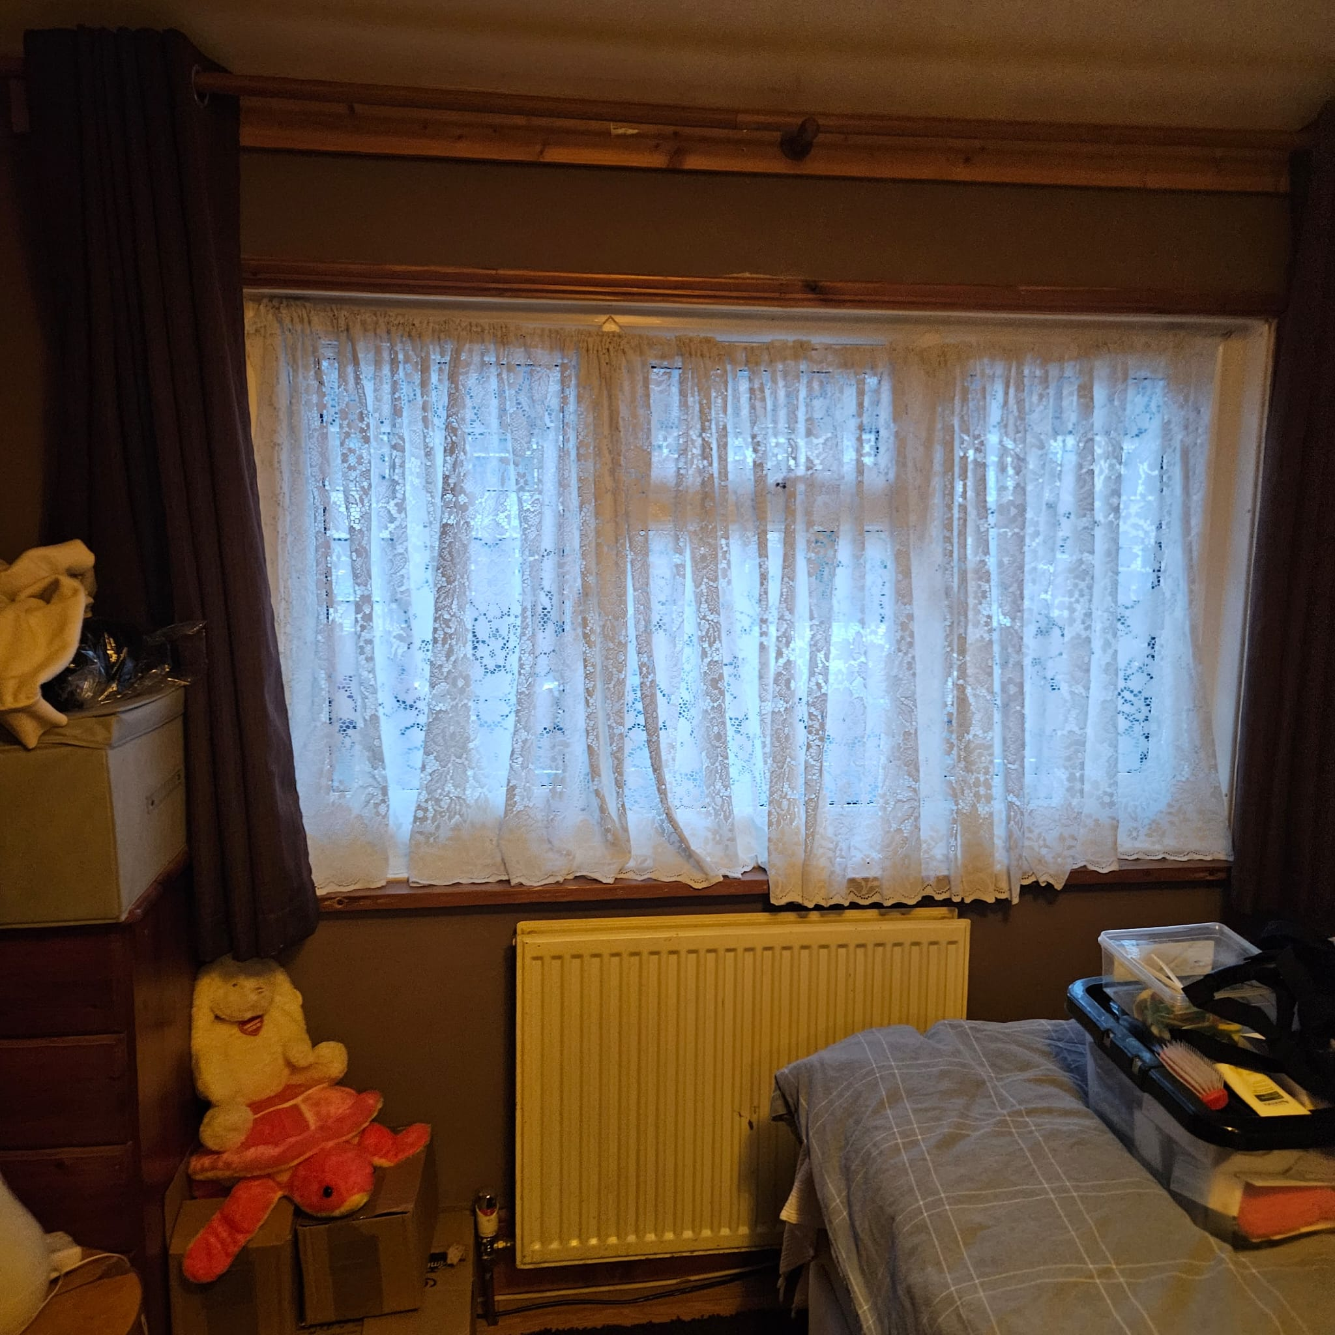

14/02/2026, 11:31 - Aunt: IMG-20260214-WA0007.jpg (file attached)
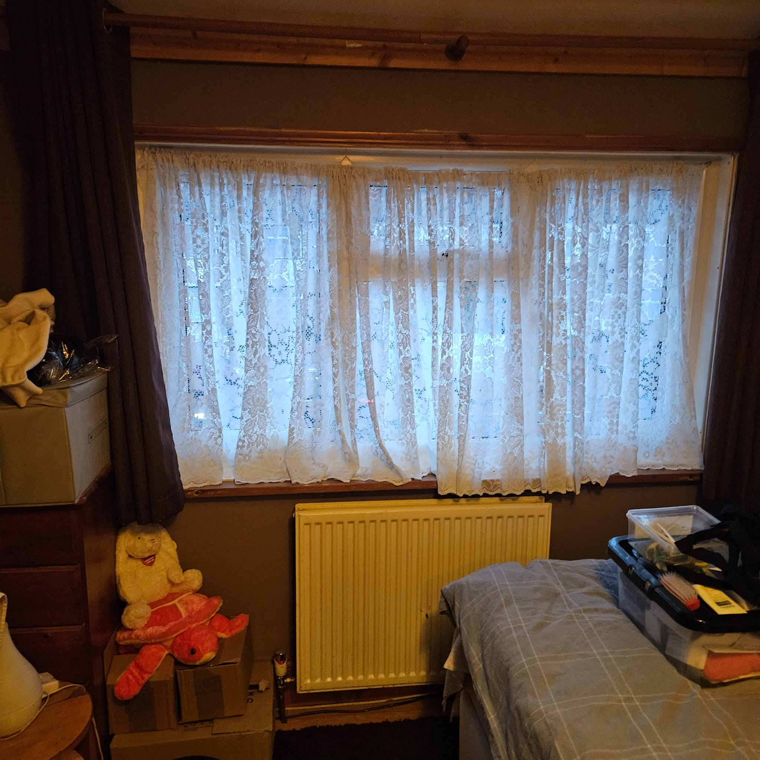

14/02/2026, 11:31 - Aunt: IMG-20260214-WA0008.jpg (file attached)
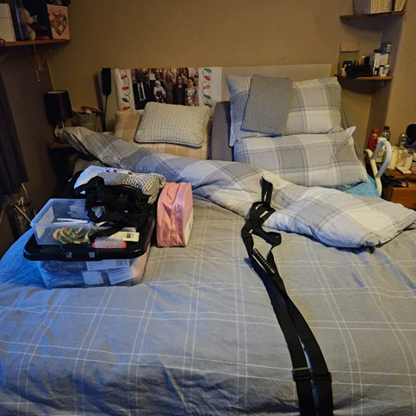

14/02/2026, 11:31 - Aunt: IMG-20260214-WA0009.jpg (file attached)
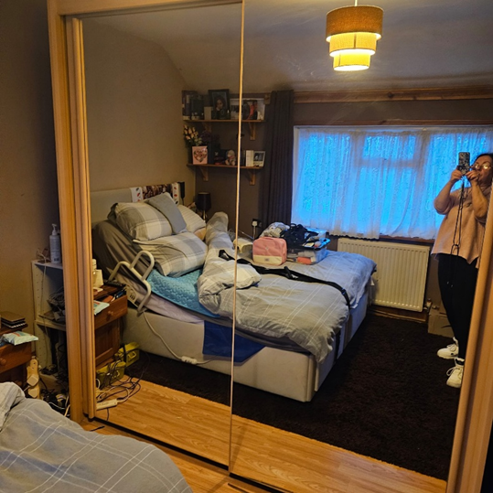

08/04/2026, 01:34 - Aunt: Did try to call check u was ok love u lots xx

08/04/2026, 09:54 - Aunt:

08/04/2026, 11:16 - Aunt:

08/04/2026, 11:42 - Aunt:

12/04/2026, 12:00 - Aunt:

23/04/2026, 08:36 - SI: This does not have Tyrone’s name on it, I hope he don’t have the keys to it and my Dow is still in their after all of this..

23/04/2026, 08:36 - SI: IMG-20260423-WA0001.jpg (file attached)
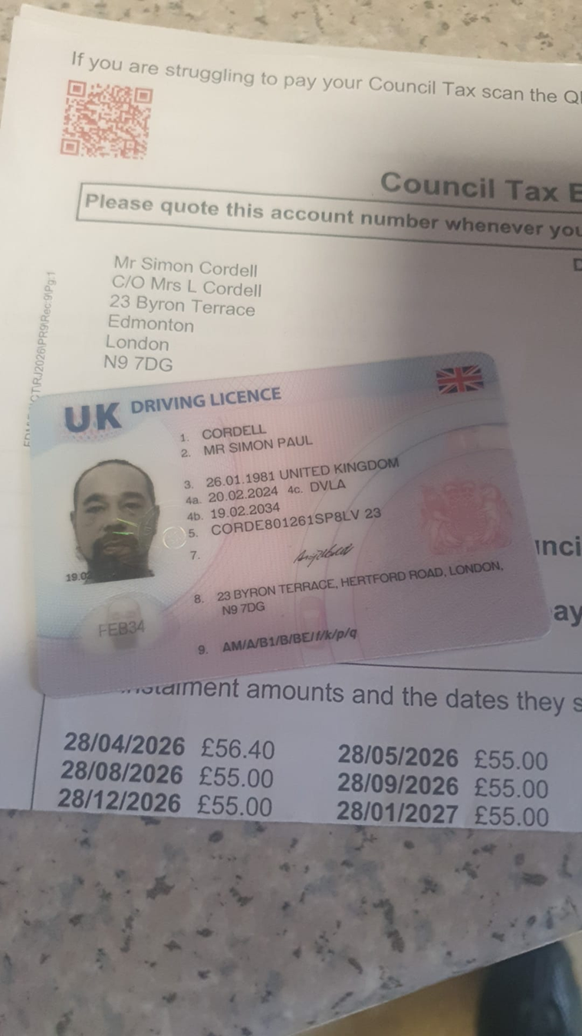

23/04/2026, 09:04 - Aunt: What are you going on about i don’t understand

23/04/2026, 09:06 - Aunt: And what doe are you on about no 9ne has been to house and touched anything

23/04/2026, 09:07 - Aunt: I gave your money to mum she put it under her pillow and i left not seen the money since night you got arrested

23/04/2026, 09:08 - Aunt: The money has to be in the house as that’s where i left it

23/04/2026, 09:09 - Aunt: I didn’t go and look after mum for quite awhile after

23/04/2026, 09:57 - SI: This is stopping the house being saved.. i need my time in the house, i don’t care about stripping it yet and even uncle said he was giving Deon bit already i never cared about that told her what to take, i need to have a plumber in their asap had him with me the other day but could not order what’s needed as no access, i am eldest i should have control of it if i want, now after all with ty and Deon mum passed on the 07th and its now the 23rd and only people been allowed in their is u and Andrew and Deon got in, I’ve been blocked and not given keys yet

23/04/2026, 09:59 - SI: You say you have not got the keys, ty says you have and Anrew says you have

23/04/2026, 10:07 - Aunt:

23/04/2026, 10:09 - Aunt: You no what u sort out mums funeral I’m not coming ill say good bye ny own way

23/04/2026, 10:10 - Aunt:

23/04/2026, 10:58 - Aunt:

24/04/2026, 13:19 - Aunt:

24/04/2026, 13:20 - Aunt: Look in the generator keys are in there

27/04/2026, 21:54 - SI:
Video Call No Answer

