26/09/2023, 11:08 - Messages and calls are end-to-end encrypted. Only people in this chat can read, listen to, or share them. *Learn more*

14/11/2023, 21:55 - Deon uses a default timer for disappearing messages in new chats. New messages will disappear from this chat 90 days after they're sent, except when kept. Tap to set your own default timer

06/07/2025, 13:42 - Deon: IMG-20250706-WA0000.jpg (file attached)
Simon look what I found
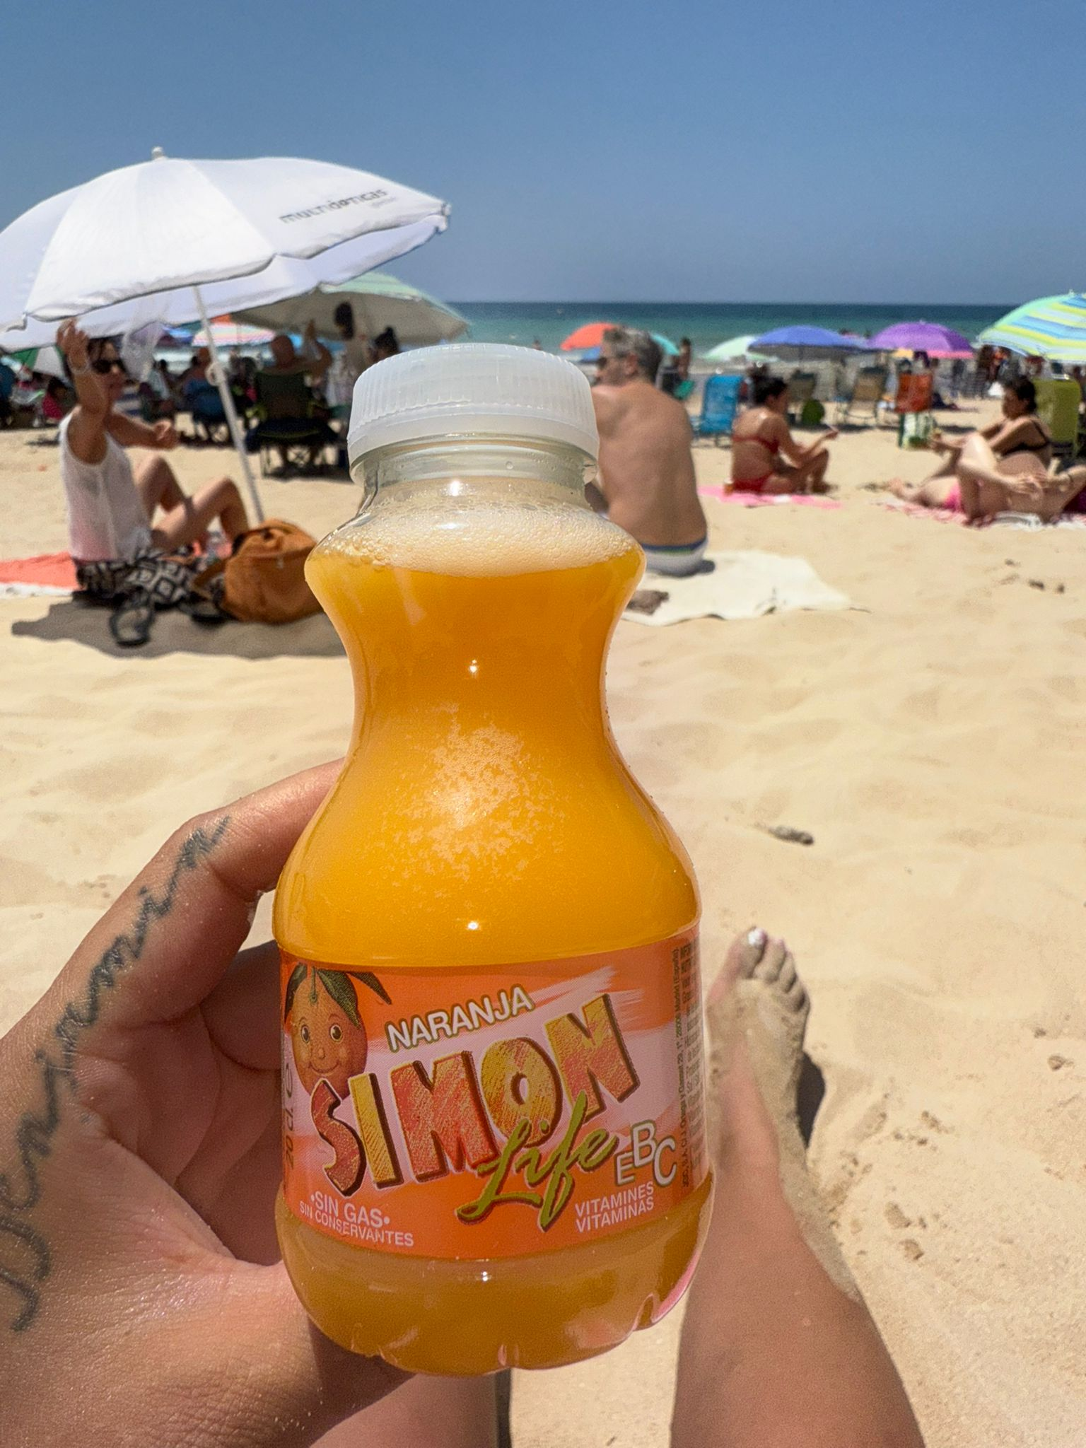

30/12/2025, 17:55 - Deon:

27/02/2026, 17:49 - Deon:

02/03/2026, 21:10 - SI:

13/03/2026, 20:16 - Deon:

13/03/2026, 20:16 - Deon: Phone me

13/03/2026, 20:20 - SI:

13/03/2026, 20:21 - SI:

13/03/2026, 20:23 - Deon:

13/03/2026, 20:23 - SI:

13/03/2026, 20:41 - SI: black men’s Parda jeans stretch trousers 32 ,, track suite, large xxx phone me on video when u are there xxx love you

14/03/2026, 07:01 - SI:

14/03/2026, 07:02 - SI: 😘

14/03/2026, 07:38 - SI: You’re a queen xxx

14/03/2026, 07:40 - Deon: Aww we haven’t left yet. We ended up staying in bed for a little bit longer.

14/03/2026, 09:28 - SI: IMG-20260314-WA0001.jpg (file attached)
Deon get tis for me as well, they will have, how do i owe you, i send now, I’m ready
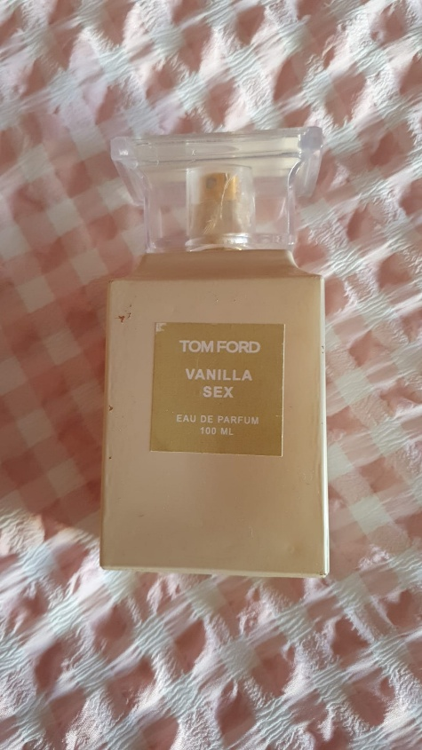

14/03/2026, 09:28 - SI: How much do i owe you, i meant i will send now

14/03/2026, 10:53 - Deon: I’m going to go shopping a bit later, but the perfumes out here are not good. Holly are already tried to buy one and it was not good.

14/03/2026, 13:16 - Deon:

14/03/2026, 13:26 - Deon:

14/03/2026, 13:26 - Deon: IMG-20260314-WA0002.jpg (file attached)
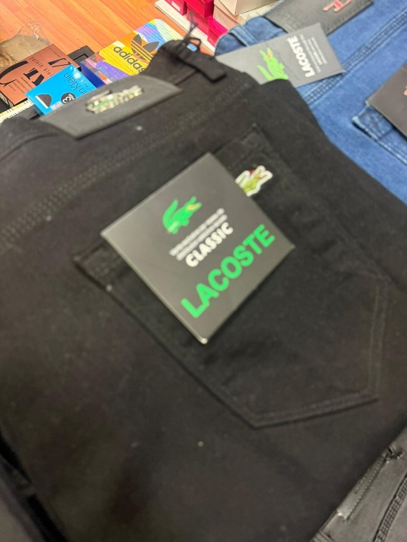

14/03/2026, 13:26 - Deon: IMG-20260314-WA0003.jpg (file attached)
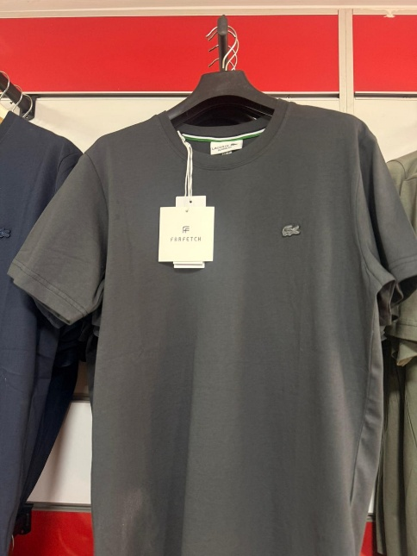

14/03/2026, 13:26 - Deon: IMG-20260314-WA0004.jpg (file attached)
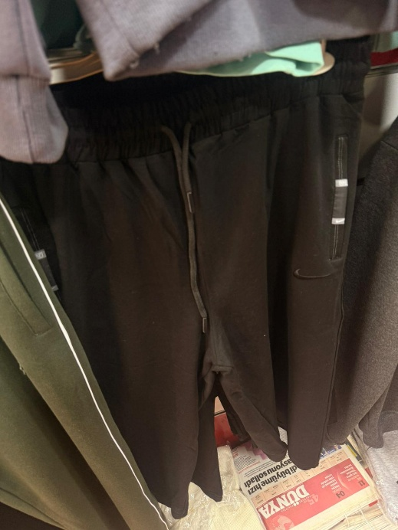

14/03/2026, 13:26 - Deon: IMG-20260314-WA0005.jpg (file attached)
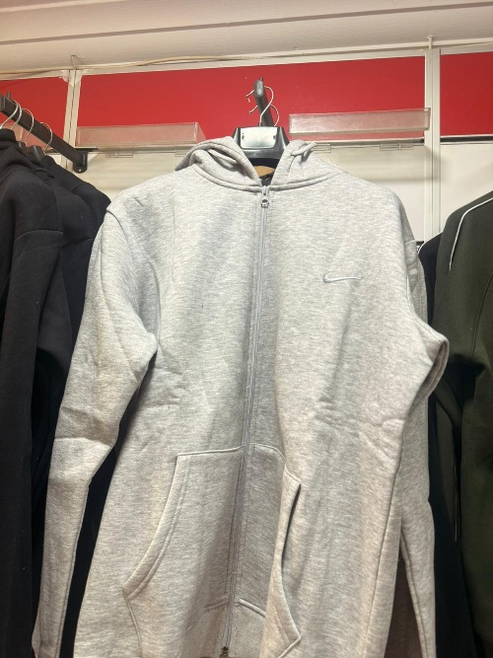

14/03/2026, 13:26 - Deon: IMG-20260314-WA0006.jpg (file attached)
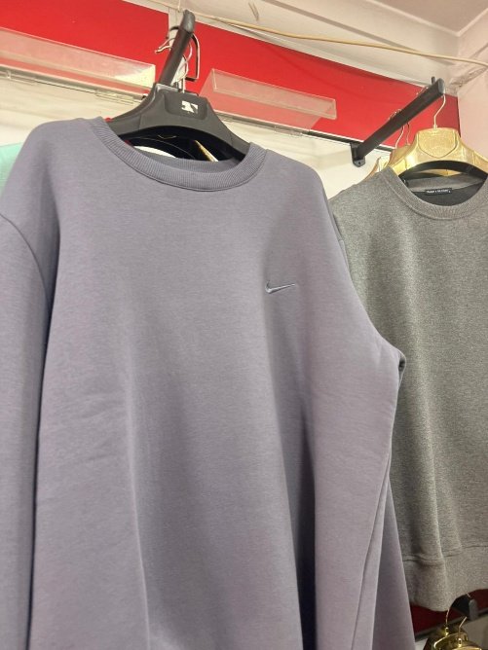

14/03/2026, 13:26 - Deon: IMG-20260314-WA0007.jpg (file attached)
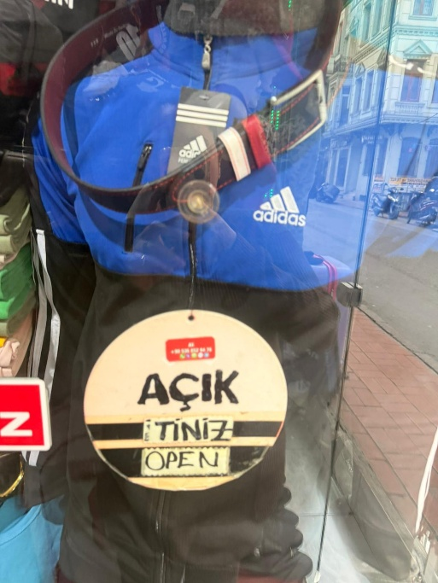

14/03/2026, 13:26 - Deon: IMG-20260314-WA0008.jpg (file attached)
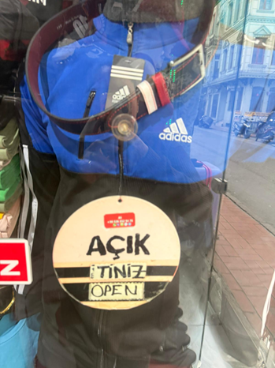

14/03/2026, 13:26 - Deon: IMG-20260314-WA0009.jpg (file attached)
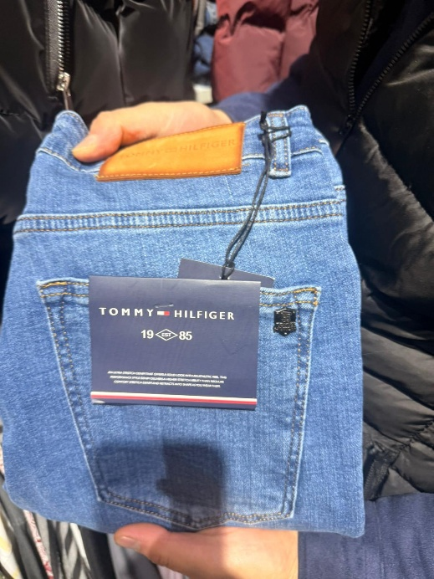

14/03/2026, 13:26 - Deon: IMG-20260314-WA0010.jpg (file attached)
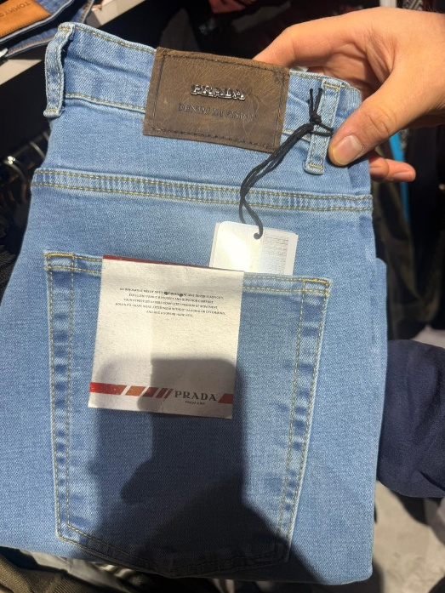

14/03/2026, 13:26 - Deon: IMG-20260314-WA0011.jpg (file attached)
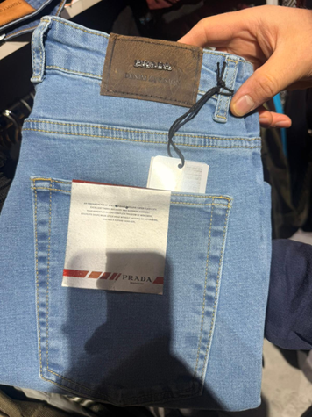

14/03/2026, 13:26 - Deon: IMG-20260314-WA0012.jpg (file attached)
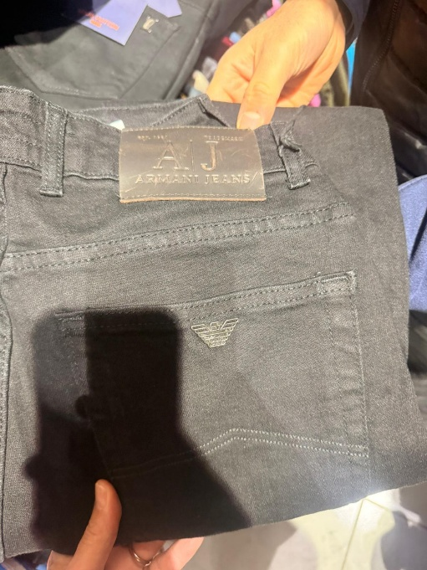

14/03/2026, 13:26 - Deon: IMG-20260314-WA0013.jpg (file attached)
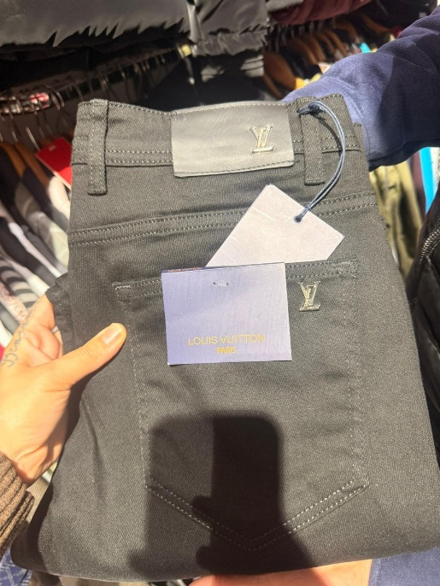

14/03/2026, 13:26 - Deon: IMG-20260314-WA0014.jpg (file attached)
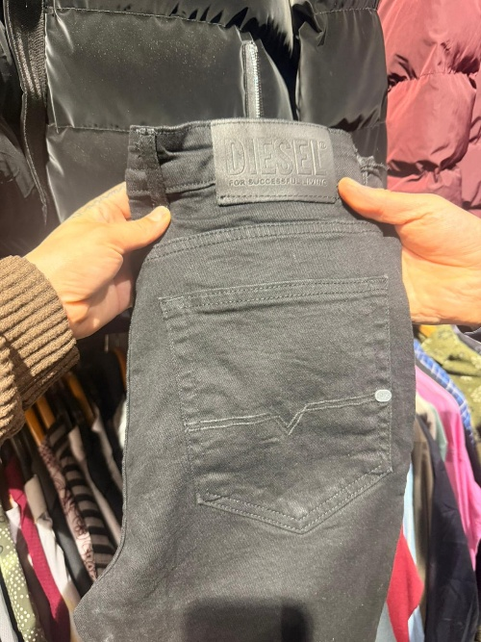

14/03/2026, 13:26 - Deon: IMG-20260314-WA0015.jpg (file attached)
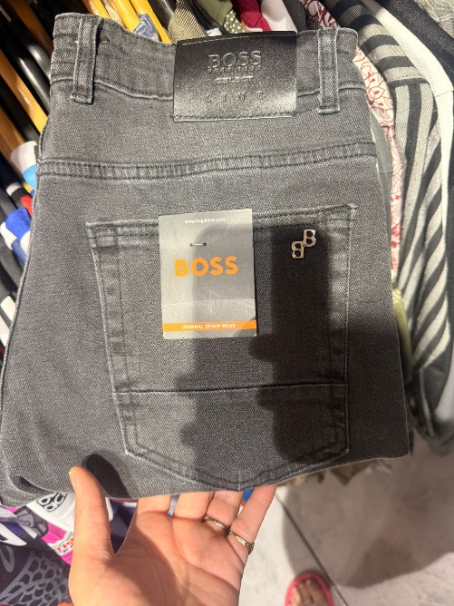

14/03/2026, 13:27 - Deon: I’ve seen these but the Prada jeans they haven’t got the jeans are about £25 each and the tops are like 15 quid each

14/03/2026, 13:27 - Deon: I’ve been in multiple shops some of them look really bad copies though

14/03/2026, 13:27 - Deon: But you’ve gotta tell me because I’m going home tomorrow

14/03/2026, 13:27 - Deon:

14/03/2026, 13:28 - SI:

14/03/2026, 17:03 - Deon:

14/03/2026, 21:06 - SI:

15/03/2026, 11:44 - SI:

17/03/2026, 14:51 - Deon:

17/03/2026, 14:51 - Deon: IMG-20260317-WA0002.jpg (file attached)
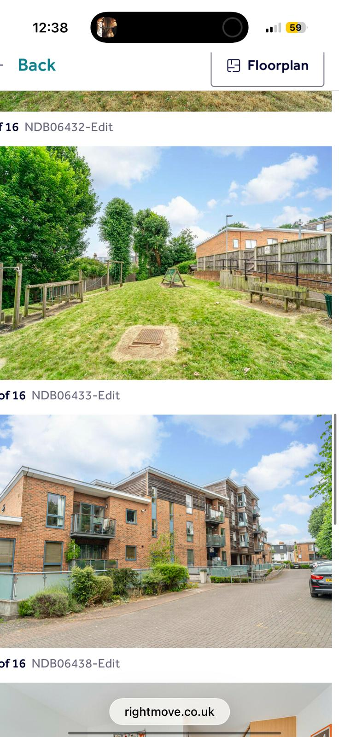

17/03/2026, 14:51 - Deon: IMG-20260317-WA0003.jpg (file attached)
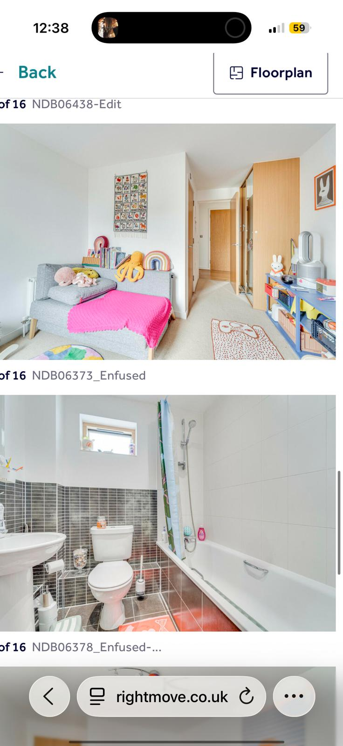

17/03/2026, 14:51 - Deon: IMG-20260317-WA0004.jpg (file attached)
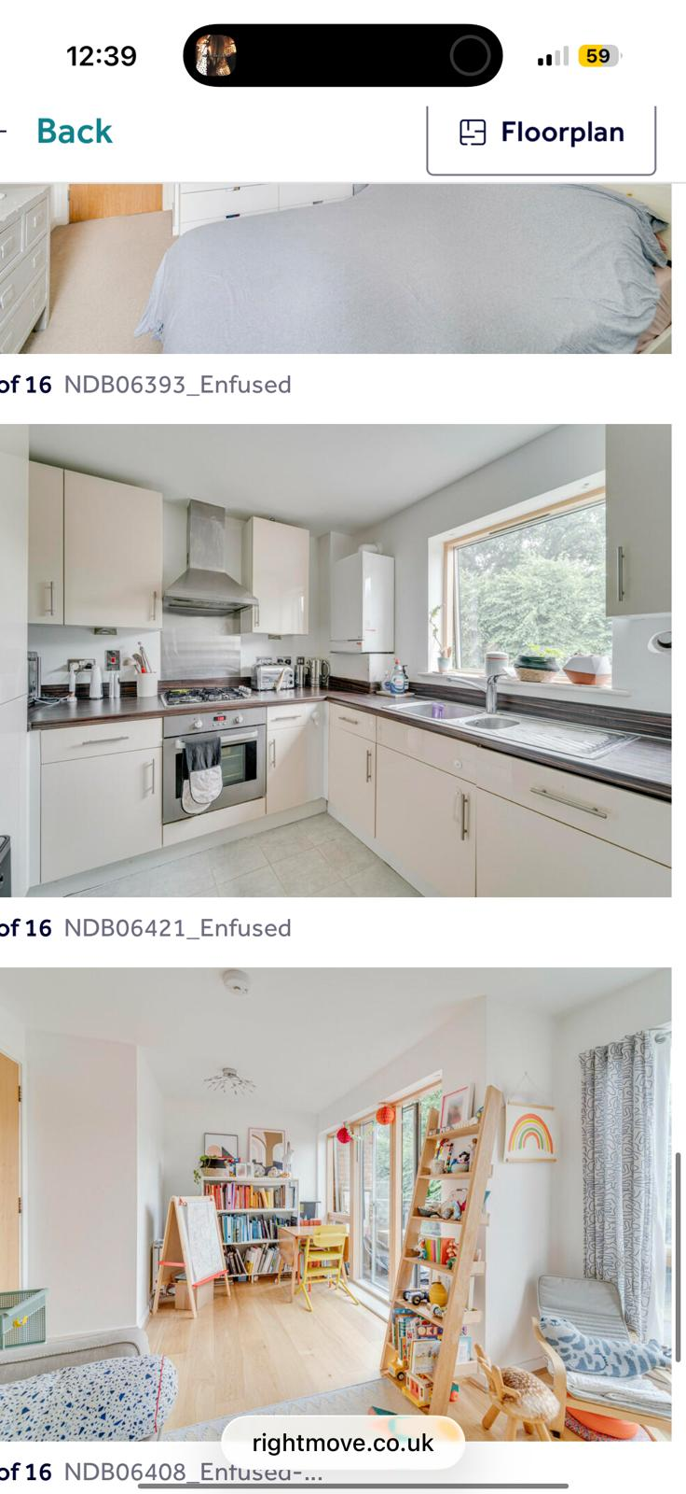

17/03/2026, 14:51 - Deon: IMG-20260317-WA0005.jpg (file attached)
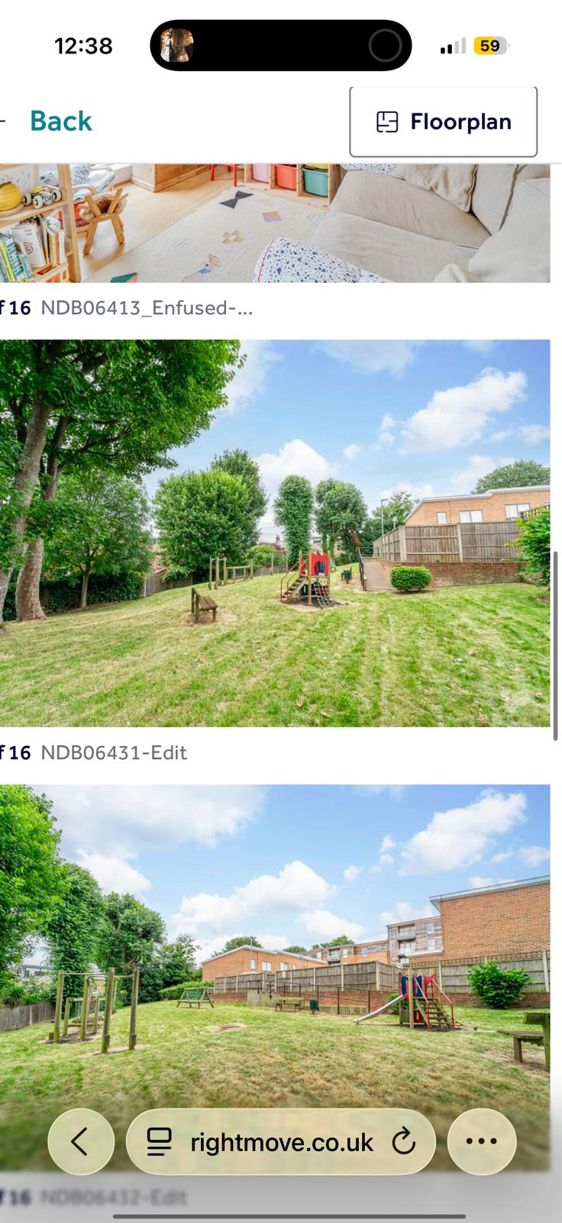

17/03/2026, 14:51 - Deon: IMG-20260317-WA0006.jpg (file attached)
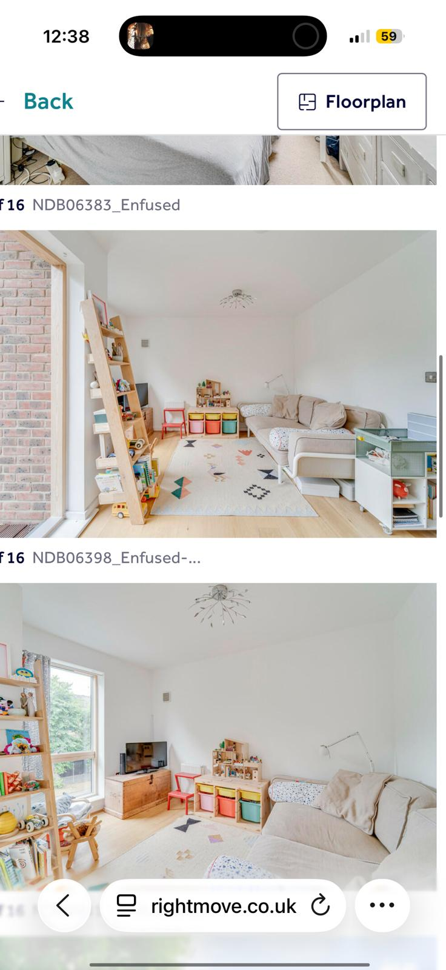

17/03/2026, 14:51 - Deon: IMG-20260317-WA0007.jpg (file attached)
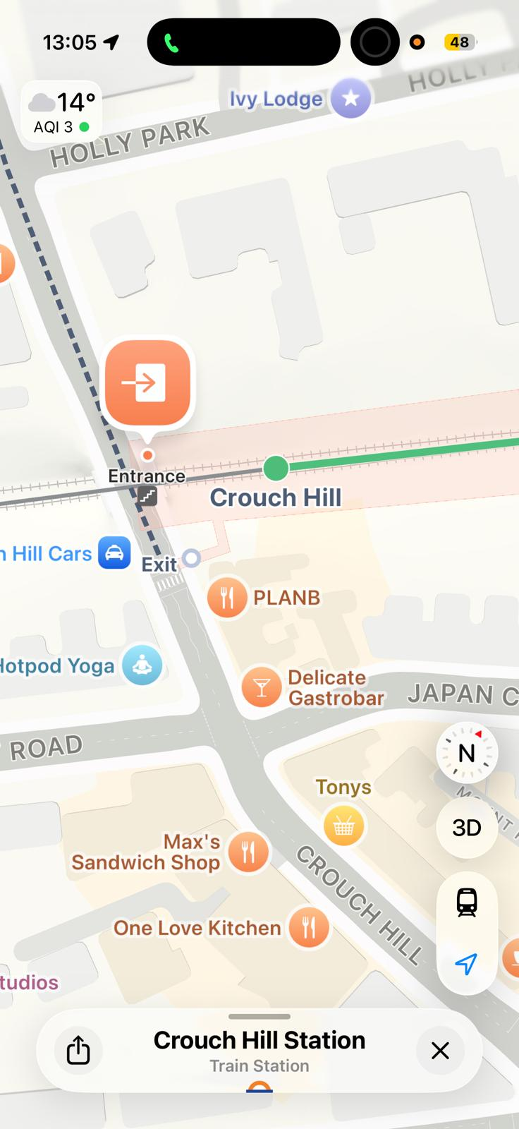

23/03/2026, 11:46 - SI:

30/03/2026, 19:01 - SI: https://horrific-corruption-files.webhop.me/dadsa-firesticks/

30/03/2026, 19:53 - Deon: I will send this to Jimmy

01/04/2026, 12:32 - Deon:

01/04/2026, 12:32 - SI:

04/04/2026, 10:05 - SI: https://horrific-corruption-files.webhop.me/dadsa-firesticks/

04/04/2026, 10:13 - Deon: IMG-20260404-WA0000.jpg (file attached)
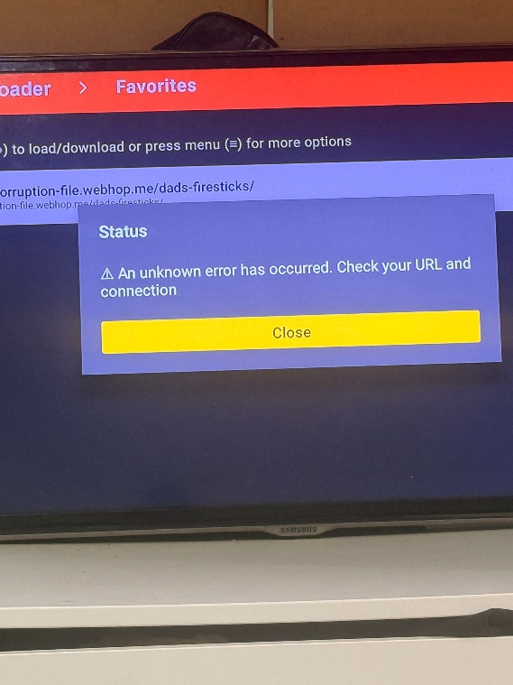

04/04/2026, 10:24 - Deon:

04/04/2026, 10:24 - SI:

04/04/2026, 10:26 - Deon: VID-20260404-WA0001.mp4 (file attached)
VID-20260404-WA0001.mp4

04/04/2026, 10:41 - Deon: IMG-20260404-WA0002.jpg (file attached)
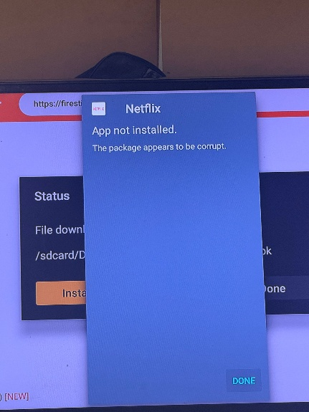

04/04/2026, 13:32 - SI: Call me

04/04/2026, 13:33 - SI: My phone went dead and we will sort it

13/04/2026, 11:30 - SI: VID-20260413-WA0001.mp4 (file attached)
Look and understand as you got it all wrong
VID-20260413-WA0001.mp4

16/04/2026, 13:48 - SI:

21/04/2026, 17:00 - Deon:

21/04/2026, 22:56 - SI:

21/04/2026, 23:00 - SI:

21/04/2026, 23:02 - SI:

21/04/2026, 23:04 - SI:

21/04/2026, 23:07 - SI: What the fuck I need the keys uncle said he never said that to you, i need to get into my mother’s house Deon yo get something of mine, GIVE ME THE KEYS.

21/04/2026, 23:09 - SI:

21/04/2026, 23:09 - SI: On o my way to yours

21/04/2026, 23:23 - SI:

22/04/2026, 13:43 - SI:

24/04/2026, 13:54 - Deon:

24/04/2026, 14:02 - Deon:

24/04/2026, 14:23 - Deon:

24/04/2026, 14:23 - Deon: Simon phone me

25/04/2026, 10:21 - Deon: Phone me

25/04/2026, 16:04 - Deon:

25/04/2026, 16:05 - Deon: Hello

26/04/2026, 11:09 - Deon:

27/04/2026, 14:27 - Deon: Phone me it’s about my housing

27/04/2026, 14:27 - Deon:

27/04/2026, 14:27 - SI:

27/04/2026, 15:00 - SI:

27/04/2026, 15:08 - Deon: Deonbenjamin@****

27/04/2026, 15:10 - SI:

28/04/2026, 14:44 - Deon:

29/04/2026, 09:59 - Deon:

02/05/2026, 18:27 - Deon:

02/05/2026, 18:46 - SI: 🥹

02/05/2026, 18:46 - Deon: I’ve been trying to call you

02/05/2026, 18:46 - Deon:

02/05/2026, 18:46 - Deon: IMG-20260502-WA0002.jpg (file attached)


02/05/2026, 18:47 - Deon: Call me

03/05/2026, 11:48 - Deon:

03/05/2026, 11:49 - Deon: Answer me I’m calling you

03/05/2026, 12:00 - Deon:

03/05/2026, 12:00 - Deon:

03/05/2026, 12:01 - Deon: Phone me

03/05/2026, 12:29 - Deon: This message was deleted

03/05/2026, 12:32 - Deon: Call me

03/05/2026, 12:51 - Deon: You have took this too far. You are not kicking me out of my mum’s house. You are being fucking disrespectful. I’ve had a fucking enough of you. I thought you was better than this but you’re clearly not. How come you’re not letting Dennean in my mum’s house and you let your Crackhead friends in the house carry on Simon and u will end up all alone with no one

04/05/2026, 22:57 - SI: ❤

06/05/2026, 11:25 - Deon:

06/05/2026, 11:29 - Deon: Simon, have you through all of Mum’s stuff because I haven’t even gone and got any of my stuff from that house?

06/05/2026, 13:03 - Deon:

06/05/2026, 13:07 - Deon:

06/05/2026, 13:19 - Deon: I’m coming home. I’m moving into Mum’s house tomorrow.

07/05/2026, 15:06 - Deon:

07/05/2026, 15:07 - Deon: I’m just got home. I’m packing some bits up because they’ve told me I’ve got to leave by Monday I’m coming to Mum’s tomorrow with Izzy and Toby

07/05/2026, 21:45 - SI:

07/05/2026, 21:46 - Deon:

07/05/2026, 21:47 - Deon: It’s not talking I can’t hear you at all

07/05/2026, 21:48 - Deon:

07/05/2026, 21:48 - Deon: We’re coming there right now

07/05/2026, 21:48 - Deon: You’re telling me I’m not coming there, yeah watch

07/05/2026, 21:49 - SI:

07/05/2026, 21:49 - Deon:

07/05/2026, 21:49 - Deon: Bro, the man name is coming for you now

07/05/2026, 21:50 - Deon: Bro, you’re goanna cause trouble you can’t actually sort out

07/05/2026, 21:50 - SI: Have a good life, stay away from me,

07/05/2026, 21:50 - Deon: PTT-20260507-WA0002.opus (file attached)
PTT-20260507-WA0002.opus

07/05/2026, 21:52 - Deon:

07/05/2026, 21:52 - SI: VID-20260507-WA0003.mp4 (file attached)
VID-20260507-WA0003.mp4

07/05/2026, 21:53 - Deon: You’re taking it too far Simon. You’re telling me I can’t come to
my mum’s house. You better watch.

07/05/2026, 21:54 - SI: No u cant

07/05/2026, 21:54 - SI: It’s in my name

07/05/2026, 22:18 - Deon:

07/05/2026, 22:19 - Deon: PTT-20260507-WA0004.opus (file attached)
PTT-20260507-WA0004.opus

07/05/2026, 22:31 - Deon:

07/05/2026, 22:32 - Deon: I’m goanna go to your house and stay at your house then sorry if I can’t go back to my mum’s house I’m going to your Simon

07/05/2026, 22:32 - Deon: You can’t save every house

07/05/2026, 22:32 - Deon: I’ll do some remodeling for you like you’ve done to my mum’s house

