07/05/2026, 22:32 - Deon: I’ll do some remodelling for you like you’ve done to my mum’s house
13/05/2026, 01:52 - SI: You turned off disappearing messages. Change timer
17/05/2026, 21:25 - SI:

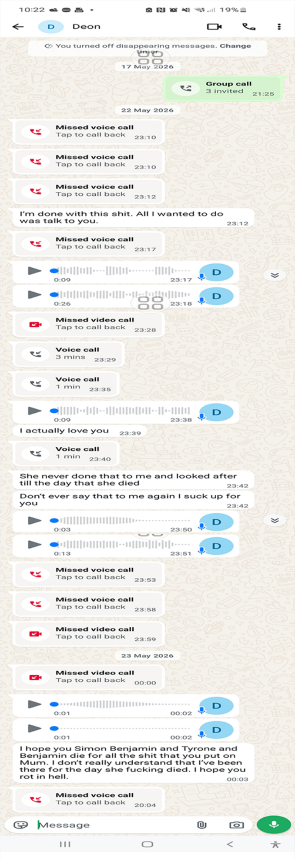

22/05/2026, 23:10 - Deon: Missed Voice Call
22/05/2026, 23:10 - Deon: Missed Voice Call
22/05/2026, 23:12 - Deon: Missed Voice Call
22/05/2026, 23:12 - Deon: I’m done with this shit. All I wanted to do was talk to you.
22/05/2026, 23:17 - Deon: Missed Voice Call

22/05/2026, 23:17 - Deon: PTT-20260522-WA0002.opus (file attached)
- PTT-20260522-WA0002.opus
22/05/2026, 23:18 - Deon: PTT-20260522-WA0003.opus (file attached)
- PTT-20260522-WA0003.opus
22/05/2026, 23:28 - Deon: missed video Call
22/05/2026, 23:29 - Deon: Voice Call 3Mins
22/05/2026, 23:35 - Deon: Voice Call 1Min
22/05/2026, 23:38 - Deon: PTT-20260522-WA0004.opus (file attached)
- PTT-20260522-WA0004.opus
22/05/2026, 23:38 - Deon: I actually love you
22/05/2026, 23:40 - Deon: Voice Call 1Min
22/05/2026, 23:42 - Deon: She never done that to me and looked after till the day that she died
22/05/2026, 23:42 - Deon: Don’t ever say that to me again I suck up for you

22/05/2026, 23:50 - Deon: PTT-20260522-WA0005.opus (file attached)
- PTT-20260522-WA0005.opus
22/05/2026, 23:51 - Deon: PTT-20260522-WA0006.opus (file attached)
- PTT-20260522-WA0006.opus
22/05/2026, 23:53 - Deon: Missed Voice Call
22/05/2026, 23:58 - Deon: Missed Voice Call
22/05/2026, 23:59 - Deon: missed video Call
23/05/2026, 00:00 - Deon: missed video Call

23/05/2026, 00:02 - Deon: PTT-20260523-WA0000.opus (file attached)
- PTT-20260523-WA0000.opus
23/05/2026, 00:02 - Deon: PTT-20260523-WA0001.opus (file attached)
- PTT-20260523-WA0001.opus

23/05/2026, 00:03 - Deon: I hope you Simon Benjamin and Tyrone and Benjamin die for all the shit that you put on Mum. I don’t really understand that I’ve been there for the day she fucking died. I hope you rot in hell.
23/05/2026, 20:04 - Deon: Missed Voice Call

- At one stage I got so worried due to the amount she called that I believed something bad had happened to her and once I realised it had not she still continued to ring.

