1031723001/04157 [1/1]
North London Magistrates' Court
Code 2572
Sitting at Highbury Corner Magistrates' Court

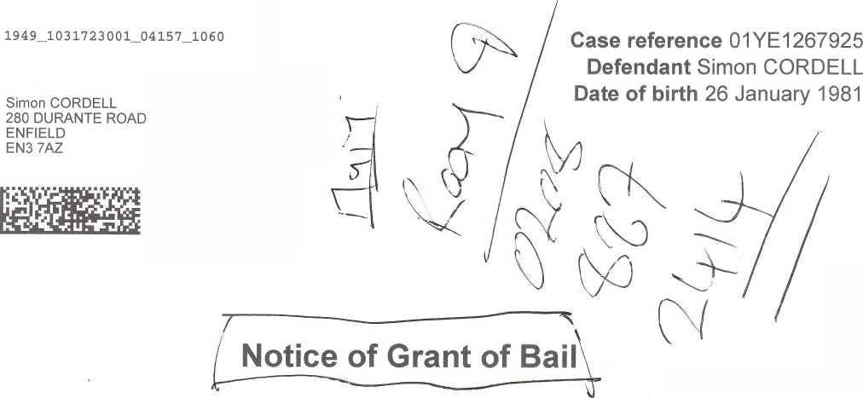
Date of notice 16 December 2025
The court has granted you bail.
You must attend court where and when required to do so.
Details of your next hearing
Date and time:
24 February 2026 at 14:00
Location:
Courtroom Courtroom 04 Highbury Corner Magistrates' Court 51 Holloway Road London N7 8JA
Simon CORDELL
Page 1 of 2

North London Magistrates' Court
Code 2572
Sitting at Highbury Corner Magistrates' Court


Conditions:
You must live and sleep each night at 280 Durante Road, Enfield, Middlesex, London, EN3 7AZ.
You must not enter Burncroft Avenue. .
Your exclusion condition will be electronically monitored with a GPS tag. .
You must not remove or interfere with the equipment in any way, and you must keep the battery charged, as instructed.
You must not contact directly or indirectly Rebecca O'Hare. .

Reasons:
To prevent offending, To ensure appearance

Warning
If you do not keep any of these conditions you can be arrested and brought back to court. You must attend court when and where required to do so.
Unless your attendance has been excused at the next hearing and recorded above, you will commit an offence if you do not attend court on the date and at the time and place as instructed, as shown above or on any other date and time as directed by the court. If you do not attend when told a warrant may be issued for your arrest.

Note
You should attend Court 30 minutes before the time shown above and have seen your Solicitor (if you have one), in good time before the date of hearing.

Case reference: 01 YE 1267925
On 02/08/2025 at Enfield in the Borough of Enfield, without lawful excuse, threatened Rebecca O'Hare that he would blow up the vehicle belonging to her intending that she would fear that the threat would be carried out
Contrary to sections 2(a) and 4 of the Criminal Damage Act 1971.
Simon CORDELL
Page 2 of 2

