01. sent Gov Website

07/07/2026, 16:31

Confirm your email address
From: HM Courts and Tribunals Registrations (hm.courts.and.tribunals.registrations@notifications.service.gov.uk)
To: re_wired@ymail.com
Date: Tuesday, 16 June 2026 at 11:34 BST

GOV.UK
Dear Simon Cordell,
- Click on the link to confirm your email address and finish creating your account. This link will only work once.
- Confirm your email address

From,
HM Courts & Tribunals Service
This is an automated message. Please don’t reply to this email. If you need help, go to https://hmcts-access.service.gov.uk/contact- us

02. Email 1

YOUR PAYMENT OF £48.00 TO PROBATE WAS SUCCESSFUL
From: GOV.UK Pay (gov.uk.pay@notifications.service.gov.uk)
To: re_wired@ymail.com
Date: Tuesday, 16 June 2026 at 12:07 BST

GOV.UK
- Your payment of £48.00 to Probate was successful
Payment for: Probate Fees
Reference: RC-1781-6079-2294-9008
Date of payment: 16 June 2026 – 12:05:23

This email address is not monitored. If you have any questions about your payment, contact the service you made the payment to directly.

03. Email 2

HMCTS PROBATE RECEIVED YOUR PROBATE APPLICATION
From: Probate registry (probate.registry@notifications.service.gov.uk)
To: re_wired@ymail.com
Date: Tuesday, 16 June 2026 at 12:07 BST
GOV.UK
Dear Mr. Simon Paul Cordell,
- Your probate application for Lorraine Caroline Cordell was received and the reference for this case is ‘1781606128650378‘.
- You’ll usually get probate within 12 weeks of submitting your application. It can take longer if you need to provide additional information.
- You don’t need to do anything else now, we’ll email you if we need more information.
- You can view your application progress at any time: https://www.apply-for-probate.service.gov.uk/citizens-hub
Regards,
HMCTS Probate
HM Courts and Tribunals Service

Check your answers
Check the information below carefully. This will form a record of your application for probate. It will also be stored as a public record and will be able to be viewed online.

About the person who died
Do you require a bilingual grant in English and Welsh? | No
First name and any middle names | Lorraine Caroline
Last name | Cordell
Did Lorraine Caroline Cordell have assets in another name? | No
What was their date of birth? | 3 October 1963
What was the date that they died? | 8 April 2026
What was Lorraine Caroline Cordell’s marital status? | Never married
What was Lorraine Caroline Cordell's permanent address at the time of their death? | 23 Byron Terrace Hertford Road London N9 7DG United Kingdom
Did Lorraine Caroline Cordell die in England or Wales? | Yes
Do you have a death certificate or an interim death certificate? | Death certificate

Inheritance tax
Have you checked whether you need to report the estate value to HMRC? | Yes
Did you need to submit form IHT400 to HMRC? | No forms required
Gross estate value for IHT: for the estate for inheritance tax in £ | 1500
Net estate value for IHT: for the estate for inheritance tax in £ | 1500
Net qualifying estate value for IHT: in £ | 1500
Gross value for probate in £ | 1500
Net value for probate in £ | 1500

04. check-your-answers (1)

About the people applying
What was your relationship to the person who died? | Child (this does not include stepchildren)
Did Lorraine Caroline Cordell have any other children? | Yes
Are all of Lorraine Caroline Cordell’s children over 18? | Yes
Did any of Lorraine Caroline Cordell’s children die before 8 April 2026? | No

About you
First name and any middle names Mr. Simon Paul
Last name | Cordell
Phone number | 07864217519
What is your address? | 280 Durants Road Enfield EN3 7AZ United Kingdom


CORONER'S CERTIFICATE OF THE FACT OF DEATH
Pursuant to Regulation 9 of the Coroners (Investigations) Regulations 2013
DEATH | Ref. 24573854 - 2026
Name and Surname  Lorraine Caroline CORDELL | Sex Female
Name and Surname  Lorraine Caroline CORDELL | Maiden name
Date and Place of Birth
3 October 1963 Edmonton, London
Occupation and Usual Address
Unemployed
23 Byron Terrace, Hertford Road, N9 7DG, Edmonton, London
Date and Place of Death
8 April 2026
Royal Free Hospital, Pond Street, Hampstead, London
Date Investigation Commenced 14 April 2026
The precise cause of death was as follows:
The precise cause of death has yet to be established.
I certify that in accordance with my statutory duty, I have commenced an investigation into the death of the above
named.
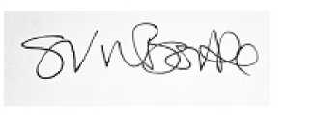 | Date 13 May 2026
S Bourke
HM Assistant Coroner for Inner North London
The Registrar of Deaths cannot issue a Death Certificate until the Investigation has been completed.

05. Interim fact of death certificate

HM Courts &

Tribunals Service

IN THE HIGH COURT OF JUSTICE
FAMILY DIVISION
(INTESTACY)

Legal statement
I, Mr. Simon Paul Cordell of 280 Durants Road Enfield EN3 7AZ United Kingdom, make the following statement:

The person who died
That Lorraine Caroline Cordell, of 23 Byron Terrace Hertford Road London N9 7DG United Kingdom, was born on 3 October 1963 and died on 8 April 2026 intestate.
They were never married and domiciled in England and Wales.
No children under 18 are entitled to the estate.

The estate of the person who died
The gross value for the estate amounts to £1500.00 and the net value for the estate amounts to £1500.00.
I confirm that the estate is an excepted estate.
To the best of my knowledge, information and belief, there was no land vested in Lorraine Caroline Cordell which was settled previously to the death of Lorraine Caroline Cordell and which remained settled land notwithstanding such death.
I am the child of Lorraine Caroline Cordell and one of the people now entitled to share in the estate.
I am applying for letters of administration. I have provided what I believe to be true and accurate information about Lorraine Caroline Cordell.
For further details on probate visit www.gov.uk/applying-for-probate
Downloaded on: 6/16/2026, 11:02:35 AM
© Crown copyright, Page 1 of 2

06. legal-declaration




HM Courts &

Tribunals Service

Declaration
I confirm that I will administer the estate of Lorraine Caroline Cordell, according to law. I will:
- collect the whole estate
- keep full details (an inventory) of the estate
- keep a full account of how the estate has been distributed
If the probate registry (court) asks me to do so, I will:
- provide the full details of the estate and how it has been distributed
- return the letters of administration to the court
I understand that:
- my application will be rejected if I do not provide information (if asked)
- proceedings for contempt of court may be brought against the undersigned if it is found that the evidence provided is deliberately untruthful or dishonest, as well as revocation of the grant
For further details on probate visit www.gov.uk/applying-for-probate
Downloaded on: 6/16/2026, 11:02:35 AM
© Crown copyright, Page 2 of 2

07. Received Gov Website

07/07/2026, 16:33
GRANT OF PROBATE STOPPED BY A CAVEAT
GRANT OF PROBATE STOPPED BY A CAVEAT
From: Probate registry (probate.registry@notifications.service.gov.uk)
To: re_wired@ymail.com
Date: Saturday, 27 June 2026 at 09:47 BST

GOV.UK
Dear Mr. Simon Paul Cordell
- We have stopped your application for a grant of representation for the estate of Lorraine Caroline Cordell.
- Application reference number: 1781606128650378
- This is because we received a request to stop the application from Tyrone Benjamin of Flat 61 Tiverton House, Exeter Road, Exeter Road, Enfield, EN3 7TW, United Kingdom. This is called ‘entering a caveat’.
- Caveat reference number: 1780-9657-3186-1397
- Your caveat expiry date is: 9th December 2026
- What happens now
- Your application can be stopped for up to 6 months. The caveat can also be renewed for a further 6 months.
- You should try and come to an agreement with the person who made the application to stop the grant of representation being issued.
- Giving a warning
- If you’re unable to resolve things with the person who has stopped your application, you can give them a formal ‘warning’.

https://mail.yahoo.com/c/d/folders/1?.intl=uk&.lang=en-GB&reason=cloud
1/3
07/07/2026, 16:33

GRANT OF PROBATE STOPPED BY A CAVEAT
- When you give a warning, you’ll need to say how you are entitled to apply for the grant of representation. This is known as stating your ‘interest’ in the estate. For example, you are named as an executor in the will, or you are entitled to inherit if there is no will (see https://www.gov.uk/inherits-someone-dies-without-will).
- You can request it from Leeds District Probate Registry.
- There is no fee for issuing a warning.
- The warning form must be sent to:
Leeds District Probate Registry,
York House,
31 York Place, Leeds, LS1 2BA
- The completed warning form will be recorded and stamped with the court stamp. It will then be returned to you to send or give to the person who entered the caveat.
- You should keep a copy of the warning. You also need to keep a record of how and when the warning was given, for example, by hand or by post. You cannot give a warning by email.
- You may also want to talk to a solicitor or contact Citizens Advice (https://www.citizensadvice.org.uk) to get advice. Giving a warning can result in a permanent caveat that needs further legal action to be resolved. You may also have to pay legal costs.
- If you follow the process for a warning
- The person who stopped the grant of probate will have 14 days to respond (including weekends and bank holidays).
- If they do respond, depending on their circumstances, they have 2 options:
- - Enter an ‘appearance’
- They could enter an ‘appearance’ if they believe they have a more legitimate right to apply for the grant than you. For example, they

https://mail.yahoo.com/c/d/folders/1?.intl=uk&.lang=en-GB&reason=cloud
2/3
07/07/2026, 16:33

GRANT OF PROBATE STOPPED BY A CAVEAT
- may have good reason to believe that the will is not valid.
- If there is no will and they are entitled to inherit, they may believe they have a prior right to apply for the grant.
- - Issue a ‘summons’
- They could issue a ‘summons’ if they believe they are equally entitled to apply for the grant. This may be because they want to apply themselves or they don’t want you to take the grant.
- They’ll need to complete a summons form and a sworn statement of facts setting out their reasons.
- If the summons is accepted directions may then be given by the registrar or a hearing date may be given. The summons will then be served on you by the person who entered the caveat.
- If they don’t respond in 14 days
- You’ll need to file an affidavit of service showing how you gave the warning. You can then apply to have the caveat removed and continue your application for the grant of representation.
- If you need to contact us
- You can contact the probate helpline on 0300 303 0648. We won’t be able to give you any legal advice.
Regards
The Probate Registry

https://mail.yahoo.com/c/d/folders/1?.intl=uk&.lang=en-GB&reason=cloud
3/3

08. COVERING LETTER TO LEEDS DISTRICT PROBATE REGISTRY

COVERING LETTER TO LEEDS DISTRICT PROBATE REGISTRY

Name: Mr. Simon Paul Cordell
Address:
280 Durrants Road Enfield EN3 7AZ
Email: Re_wired@ymail.com
Date First Sent to Court: 09/07/2026

To: Leeds District Probate Registry York House 31 York Place Leeds LS1 2BA
Date: 09th July 2026

Re: Warning Against Caveat – Estate of Lorraine Caroline Cordell
Application Reference: 1781606128650378
Caveat Reference: 1780-9657-3186-1397

Dear Registrar,
Please find enclosed my completed Warning relating to the caveat entered against the estate of my late mother, Lorraine Caroline Cordell.

I am the eldest of the three biological children of the deceased, and under the intestacy rules I hold statutory priority to apply for the grant of representation. I submitted the original application for the grant, which has now been stopped due to the caveat entered by Tyrone Benjamin, who is also a biological child of the deceased.

The caveator has provided no lawful grounds for entering the caveat, and no dispute has been raised regarding:
- The Identity of The Deceased,
- The Validity of the Death,
- The Intestacy Position, Or
- The Entitlement to Apply for The Grant.

I therefore request that the enclosed Warning be sealed and returned to me so that I may serve it on the caveator in accordance with the Probate Rules.
Once served, the caveator will have 14 days to enter an appearance. If no appearance is entered, I will apply for the caveat to be removed so that the grant of representation may proceed.
Please confirm receipt of this Warning and advise when the sealed copy has been issued.

Yours faithfully,
Mr. Simon Paul Cordell
Dated: 09/07/2026
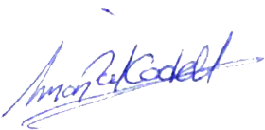

Signed:

08.1. WARNING TEXT
WARNING TEXT

Name: Mr. Simon Paul Cordell
Address:
280 Durrants Road Enfield EN3 7AZ
Email: Re_wired@ymail.com
Date First Sent to Court: 09/07/2026

Re: Warning Against Caveat – Estate of Lorraine Caroline Cordell
Application Reference: 1781606128650378
Caveat Reference: 1780-9657-3186-1397

To: Mr. Tyrone Benjamin Flat 61 Tiverton House Exeter Road Enfield EN3 7TW
Date: 09th July 2026

“I am the eldest of the three biological children of the deceased, Lorraine Caroline Cordell, and therefore hold statutory priority to apply for the grant of representation under the intestacy rules. As a child of the deceased, I am entitled to administer the estate, and no person has superior entitlement.
The caveator, Tyrone Benjamin, is also a biological child of the deceased and therefore of equal degree, but he does not have priority over me. No lawful grounds have been provided to justify the entry of the caveat, and no dispute has been raised regarding the identity of the deceased, the validity of the death, or the intestacy position.
I therefore require the caveator to enter an appearance within 14 days, setting out the legal basis on which he seeks to oppose or delay the grant. If no appearance is entered, I will apply for the caveat to be removed.”

Kind Regards Mr. Simon Paul Cordell
Dated: 09/07/2026

Signed:

08.2. Not Used Yet-AFFIDAVIT OF SERVICE

AFFIDAVIT OF SERVICE
(For removal of caveat if Tyrone does not respond within 14 days)

In the Leeds District Probate Registry Estate of: Lorraine Caroline Cordell
Deceased Caveat Reference: 1780-9657-3186-1397
Grant Application Reference: 1781606128650378

AFFIDAVIT OF SERVICE OF WARNING
I, Mr. Simon Paul Cordell, of 23 Byron Terrace, Edmonton, London, N9 7DG, MAKE OATH and say as follows:
- I am the eldest of the three biological children of the deceased, Lorraine Caroline Cordell, and I hold statutory priority under the intestacy rules to apply for the grant of representation.
- On [insert date you served it], I served a sealed Warning issued by the Leeds District Probate Registry upon the caveator, Mr. Tyrone Benjamin, of Flat 61, Tiverton House, Exeter Road, Enfield, EN3 7TW.
- The Warning was served by [choose one: first-class post / hand delivery] to the caveator at the above address.
- A true copy of the Warning served is attached to this affidavit.
- More than 14 days have passed since service of the Warning, and the caveator has not entered an appearance nor provided any lawful grounds to oppose the grant.
- I therefore respectfully request that the caveat be removed, and that my application for the grant of representation be allowed to proceed.

STATEMENT OF TRUTH
I believe that the facts stated in this affidavit are true.
Signed: __________________________
Mr. Simon Paul Cordell Date: __________________________

08.3. Not Used Yet - LETTER SERVED ON TYRONE BENJAMIN

LETTER SERVED ON TYRONE BENJAMIN

Name: Mr. Simon Paul Cordell
Address:
280 Durant’s Road Enfield EN3 7AZ
109 Burncroft Avenue Enfield EN3 7JQ
23 Byron Terrace Edmonton London N9 7DG

To: Mr. Tyrone Benjamin Flat 61 Tiverton House Exeter Road Enfield EN3 7TW
Date: 07th July 2026

Re: Warning Served – Caveat Entered Against the Estate of Lorraine Caroline Cordell
Caveat Reference: 1780-9657-3186-1397
Grant Application Reference: 1781606128650378

Dear Mr. Benjamin,
I am writing to formally serve you with a Warning relating to the caveat you entered against the estate of our late mother, Miss Lorraine Caroline Cordell.
I am the eldest of the three biological children of the deceased, and “Under the Intestacy Rules” I hold statutory priority to apply for the grant of representation. I submitted the original application for the grant.
You are also a biological child of the deceased and therefore of equal degree, but you do not have priority over me. No lawful grounds have been provided to justify the caveat, and no dispute has been raised regarding:
- The Identity of The Deceased,
- The Validity of The Death,
- The Intestacy Position, Or
- Entitlement To Apply for The Grant.

You are required to enter an appearance within 14 days of receiving this Warning, setting out the legal basis on which you seek to oppose or delay the grant.
If you do not enter an appearance within 14 days, I will apply to the Probate Registry for the caveat to be removed, and the grant of representation will proceed.

Yours sincerely,
Mr. Simon Paul Cordell
(Sign here)

09. Probate Receipt Pt1

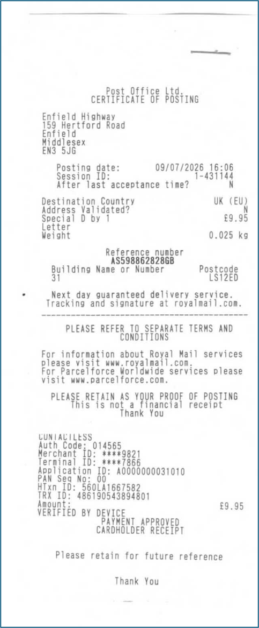

10. Probate Receipt Pt2
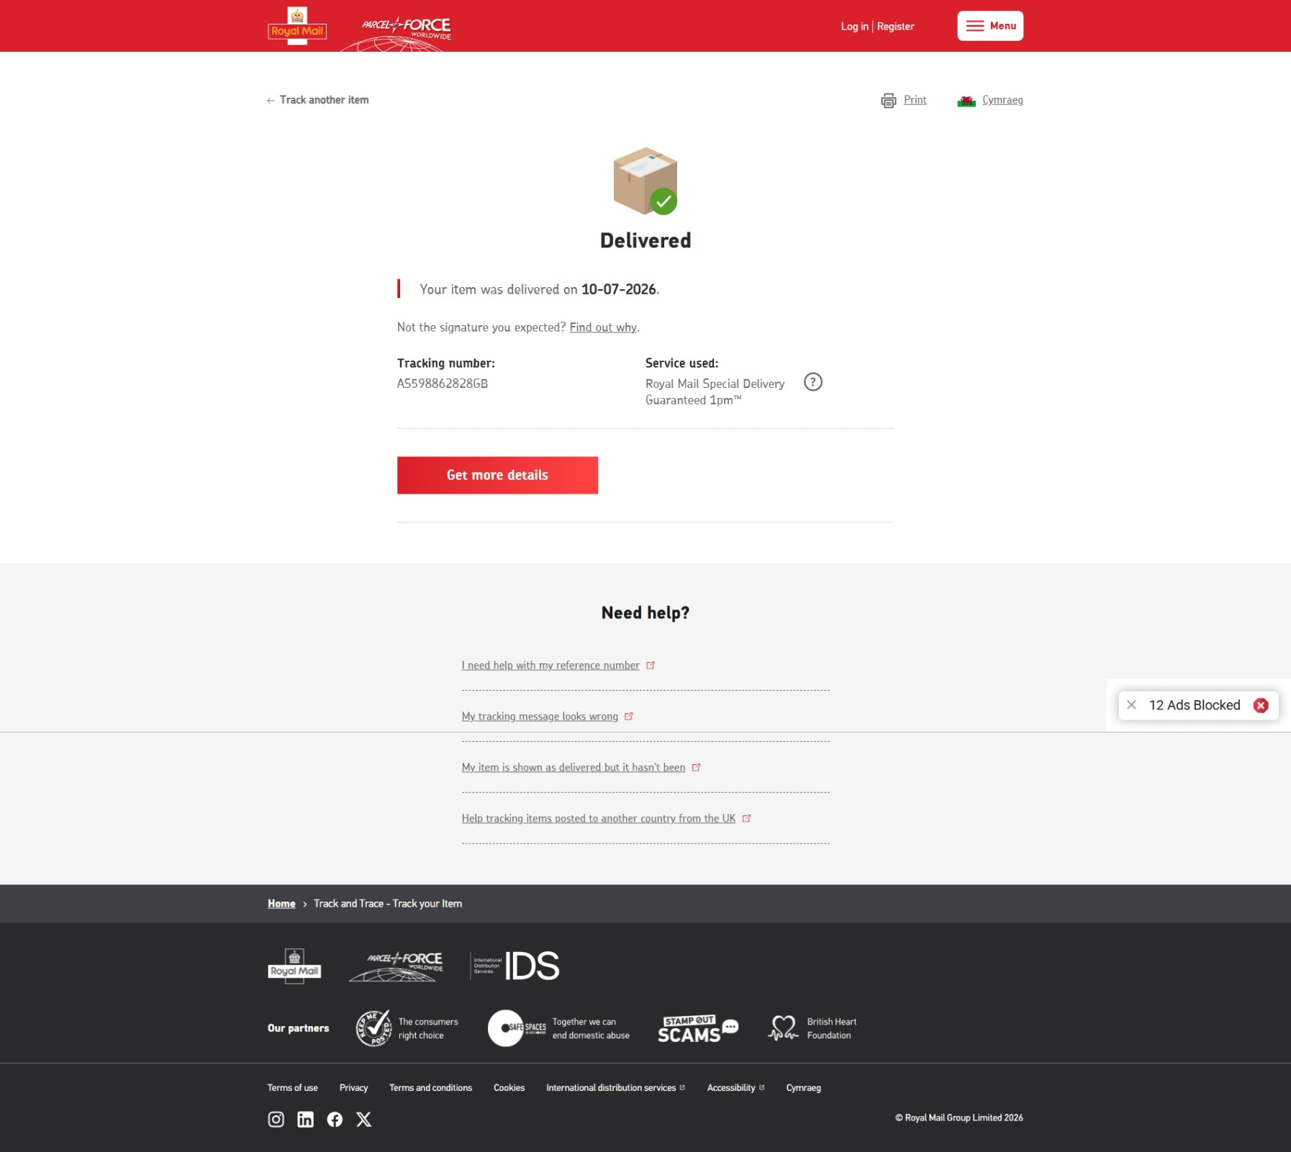

22/07/2026, 18:22
(814 unread) - re_wired@ymail.com - Yahoo Mail
https://mail.yahoo.com/c/d/folders/2?.intl=uk&.lang=en-GB&reason=cloud
1/4

11. Sent Probate 22-07-26

URGENT: WARNING DELIVERED TO INCORRECT POSTCODE – SEALED WARNING REQUIRED BY EMAIL AND POST
From: Rewired (re_wired@ymail.com)
To: contactprobate@justice.gov.uk
Date: Wednesday, 22 July 2026 at 18:22 BST

contactprobate@justice.gov.uk
Updated Email — Corrected for Wrong Postcode, Includes Warning Letter & Prior Letter
Subject: Urgent: Warning Delivered to Incorrect Postcode – Sealed Warning Required by Email and Post

Good morning, Leeds Probate Team.

I am writing to request an urgent update regarding the Warning I submitted. The Warning was sent by Royal Mail Special Delivery Guaranteed under tracking number AS598862828GB and delivered on 10/07/2026. However, it has now come to my attention that the Warning was delivered to the “Visit Us” address for Leeds District Probate Registry:
York House 31 York Place Leeds LS1 2ED

This postcode (LS1 2ED) is not the correct processing centre for caveats and warnings. The correct postal section on your official page is listed under “Write to Us”, which shows:
York House 31 York Place Leeds LS1 2BA

Because the Warning was delivered to LS1 2ED instead of LS1 2BA, it appears it may not have reached the correct internal department responsible for processing caveats and warnings.

As a result, twelve days have passed since delivery, and I have still not received confirmation of receipt nor the sealed Warning.

For clarity, I attach below the Warning letter I issued, along with the previous covering letter that accompanied it:
- Warning Letter Issued
WARNING TEXT

Name: Mr. Simon Paul Cordell
Address:
280 Durrants Road Enfield EN3 7AZ
Email: Re_wired@ymail.com
Date First Sent to Court: 09/07/2026

Re: Warning Against Caveat – Estate of Lorraine Caroline Cordell
Application Reference: 1781606128650378
Caveat Reference: 1780-9657-3186-1397

To: Mr. Tyrone Benjamin Flat 61 Tiverton House Exeter Road Enfield EN3 7TW
Date: 09th July 2026

“I am the eldest of the three biological children of the deceased, Lorraine Caroline Cordell, and therefore hold statutory priority to apply for the grant of representation under the intestacy rules. As a child of the deceased, I am entitled to administer the estate, and no person has superior entitlement.
The caveator, Tyrone Benjamin, is also a biological child of the deceased and therefore of equal degree, but he does not have priority over me. No lawful grounds have been provided to justify the entry of the caveat, and no dispute has been raised regarding the identity of the deceased, the validity of the death, or the intestacy position.
I therefore require the caveator to enter an appearance within 14 days, setting out the legal basis on which he seeks to oppose or delay the grant. If no appearance is entered, I will apply for the caveat to be removed.”

Kind Regards Mr. Simon Paul Cordell
Dated: 09/07/2026

Signed:

- Covering Letter Previously Sent
COVERING LETTER TO LEEDS DISTRICT PROBATE REGISTRY

Name: Mr. Simon Paul Cordell
Address:
280 Durrants Road Enfield EN3 7AZ
Email: Re_wired@ymail.com
Date First Sent to Court: 09/07/2026

To: Leeds District Probate Registry York House 31 York Place Leeds LS1 2BA
Date: 09th July 2026

Re: Warning Against Caveat – Estate of Lorraine Caroline Cordell
Application Reference: 1781606128650378
Caveat Reference: 1780-9657-3186-1397

Dear Registrar,
Please find enclosed my completed Warning relating to the caveat entered against the estate of my late mother, Lorraine Caroline Cordell.

I am the eldest of the three biological children of the deceased, and under the intestacy rules I hold statutory priority to apply for the grant of representation. I submitted the original application for the grant, which has now been stopped due to the caveat entered by Tyrone Benjamin, who is also a biological child of the deceased.

The caveator has provided no lawful grounds for entering the caveat, and no dispute has been raised regarding:
- The Identity of The Deceased,
- The Validity of the Death,
- The Intestacy Position, Or
- The Entitlement to Apply for The Grant.

I therefore request that the enclosed Warning be sealed and returned to me so that I may serve it on the caveator in accordance with the Probate Rules.
Once served, the caveator will have 14 days to enter an appearance. If no appearance is entered, I will apply for the caveat to be removed so that the grant of representation may proceed.
Please confirm receipt of this Warning and advise when the sealed copy has been issued.

Yours faithfully,
Mr. Simon Paul Cordell
Dated: 09/07/2026

Signed:

Please also note that the previous return address is now unsafe for me to receive mail. If the sealed Warning has already been sent to that address, I urgently request that it be re-issued.
I require the sealed Warning to be provided both:
- By email, due to the urgency of the matter, to: Re_Wired@live.co.uk
- And By post to my safe address: 109 Burncroft Avenue Edmonton London N9 9DG

Given that the Warning was delivered to an incorrect postcode and has not been processed, I urgently request confirmation of the following:
- Whether Leeds Probate Registry Has Forwarded the Warning to The Correct HMCTS Probate Processing Centre.
- Whether The Warning Has Been Sealed.
- Immediate Issuance of The Sealed Warning by Email.
- Re-Issue by Post to My Safe Address Above.

Thank you, Mr. Simon Paul Cordell

08.1. WARNING TEXT.pdf 72.6 kB
08. COVERING LETTER TO LEEDS DISTRICT PROBATE REGISTRY.pdf 163.3 kB
09. Probate Recipt Pt1.pdf 148.8 kB
10. Probate Recipt Pt2.pdf 160.3 kB

12. Received Leeds Teams.pdf

22/07/2026, 19:12
(814 unread) - re_wired@ymail.com - Yahoo Mail
https://mail.yahoo.com/c/d/folders/1?.intl=uk&.lang=en-GB&reason=cloud
1/1

Auto Reply
From: CTSC Probate Query (contactprobate@justice.gov.uk)
To: re_wired@ymail.com
Date: Wednesday, 22 July 2026 at 18:23 BST

HMCTS Probate has received your email. You don't need to contact us again; we'll email you if we need more information.

*** PLEASE NOTE***
- If the email you have sent us relates to your case, it will be automatically uploaded, and your case will be placed in a queue to be looked at by an examiner. Your email will be reviewed alongside your case; we may not directly respond to your email and will contact you with an update on your case where appropriate.

How long it takes to get probate
- It can take a minimum of 12 weeks from submitting a correct and complete application. It can take longer if you need to provide additional information. To learn more about how to submit an application you can visit - Applying for probate: Apply for probate - GOV.UK
- If you need an update on your application
- If you applied online, you could track your case by going to www.gov.uk/applying-for-probate . You can log in with the same details you used to complete your application.
- If you're a probate practitioner, you can check the progress of your case at Apply for probate with HMCTS - GOV.UK (www.gov.uk).
- If you have opted to track your post, you can check if we’ve received it via the courier’s website. You can also check the progress of your application online by visiting https://www.gov.uk/applying-for-probate/after-youve-applied, or on your MYHMCTS account for professional users.
- This email was automatically generated. Please do not reply directly to this message.

Privacy Notice
Here is how HMCTS uses personal data about you
This e-mail and any attachments is intended only for the attention of the addressee(s). Its unauthorised use, disclosure, storage or copying is not permitted. If you are not the intended recipient, please destroy all copies and inform the sender by return e-mail. Internet e-mail is not a secure medium. Any reply to this message could be intercepted and read by someone else. Please bear that in mind when deciding whether to send material in response to this message by e-mail. This e-mail (whether you are the sender or the recipient) may be monitored, recorded and retained by the Ministry of Justice. Monitoring / blocking software may be used, and e-mail content may be read at any time. You have a responsibility to ensure laws are not broken when composing or forwarding e¬mails and their contents.

13. Sent Probate 12-08-26

Re: Urgent: Warning Delivered to Incorrect Postcode – Sealed Warning Required by Email and Post
From: Rewired (re_wired@ymail.com)
To: leedsdprenquiries@justice.gov.uk
Date: Wednesday, 12 August 2026 at 14:10 BST

SUBJECT: URGENT FOLLOW‑UP REQUEST: SEALED WARNING NOT RECEIVED – CORRECT CONTACT DETAILS CONFIRMED

Good afternoon, Leeds Team,
- Thank you for confirming that post is accepted at both LS1 2ED and LS1 2BA.
- I am writing to follow up on my Warning submitted under Royal Mail Special Delivery tracking number AS598862828GB, delivered on 10/07/2026.
- Although the Warning was accepted, I have still not received the sealed Warning by email or post.
- Please note: my previous message contained a small typo in the contact details. Below are my correct and updated details for all future correspondence:
- Email (correct): re_wired@ymail.com
- Postal address (correct): 109 Burncroft Avenue Enfield EN3 7JQ
I kindly request:
- A sealed copy of the Warning sent to re_wired@ymail.com
- A hard copy posted to 109 Burncroft Avenue, Enfield, EN3 7JQ
- Written confirmation that my Warning is correctly recorded and active

Thank you for your assistance.
Kind regards, Simon Cordell

On Thursday, 23 July 2026 at 10:19:06 BST, Leeds DPR enquiries <leedsdprenquiries@justice.gov.uk> wrote:
Dear Sir/Madam
- We accept and receive post to both postcodes
Yours faithfully
Catherine
Caveat Manager
Leeds District Probate Registry| HMCTS | York House 31 York Place | Leeds | LS1 2BA
Phone: 0300 3030 648



14. Received 12-08-26

Automatic reply: URGENT: WARNING DELIVERED TO INCORRECT POSTCODE – SEALED WARNING REQUIRED BY EMAIL AND POST

From: LeedsDPRenquiries (leedsdprenquiries@justice.gov.uk)
To: re_wired@ymail.com
Date: Wednesday, 12 August 2026 at 14:10 BST

Autoreply
- Thank you for your email to HMCTS Courts &Tribunals Service.
- This message is automatically generated; please do not reply.
- HM Courts and Tribunals (HMCTS) has received your email.
- You do not need to contact us again. We will contact you if we need more information.
- If you need an update on your case
- We cannot give you an update on your application unless you applied 8 weeks ago.
- If you are a probate practitioner, you can check the progress of your case online:
- https://www.gov.uk/guidance/submit-an-application-with-myhmcts
- How long it will take to approve your application
- It will take 8 weeks to approve your application once we receive all of your documentation.
- If you need to send more documents to support your case
- When we’ve received these additional documents, it can take up to 6 more weeks to approve your application.
- If you have sent your inheritance tax form (IHT)
- You need to apply for probate once you have sent us your IHT form.
- If you haven’t applied for probate yet, you can apply online or by post: https://www.gov.uk/applying- for-probate
Probate

HM Courts & Tribunals Service
Speak to an advisor online: https://www.apply-for-probate.service.gov.uk/contact-us
Email: contactprobate@justice.gov.uk
Telephone: 0300 303 0648
Opening times:
Monday, Wednesday and Friday, 8am to 6pm
Tuesday and Thursday, 8am to 8pm
Saturday, 8am to 2pm Saturday
Closed Sundays and bank holidays

Make appointment at a probate registry office
Our Counters are closed unless you have an appointment.
An appointment will ONLY be made for the following services:
Caveats/ Deposit of Will/ Swearing of Affidavit/ Inspection of Wills.
Please note you will not be seen without an appointment
You can email your local registry to request an appointment for, to find the contact details for your local probate site: https://courttribunalfinder.service.gov.uk/courts/

Privacy Notice
Here is how HMCTS uses personal data about you
This e-mail and any attachments is intended only for the attention of the addressee(s). Its unauthorised use, disclosure, storage or copying is not permitted. If you are not the intended recipient, please destroy all copies and inform the sender by return e-mail. Internet e-mail is not a secure medium. Any reply to this message could be intercepted and read by someone else. Please bear that in mind when deciding whether to send material in response to this message by e-mail. This e-mail (whether you are the sender or the recipient) may be monitored, recorded and retained by the Ministry of Justice. Monitoring / blocking software may be used, and e-mail content may be read at any time. You have a responsibility to ensure laws are not broken when composing or forwarding e-mails and their contents.
This e-mail and any attachments is intended only for the attention of the addressee(s). Its unauthorised use, disclosure, storage or copying is not permitted. If you are not the intended recipient, please destroy all copies and inform the sender by return e-mail. Internet e-mail is not a secure medium. Any reply to this message could be intercepted and read by someone else. Please bear that in mind when deciding whether to send material in response to this message by e-mail. This e-mail (whether you are the sender or the recipient) may be monitored, recorded and retained by the Ministry of Justice. Monitoring / blocking software may be used, and e-mail content may be read at any time. You have a responsibility to ensure laws are not broken when composing or forwarding e¬mails and their contents.

15. Received 13-08-26

WARNING DELAYS
From: LeedsDPRenquiries (leedsdprenquiries@justice.gov.uk)
To: re_wired@ymail.com
Date: Thursday, 13 August 2026 at 09:26 BST
Dear Sirs
- Due to a high volume of warnings we are receiving at present we are currently working on ones received at the Registry on or before 09/06/2026
- Please accept our apologies for any inconvenience caused.
Yours faithfully
Probate Officer
Leeds District Probate Registry
2nd Floor, York House, 31 York Place, Leeds, LS1 2BA
Phone: 0300 3030 648

Gov.uk/HMCTS
This e-mail and any attachments is intended only for the attention of the addressee(s). Its unauthorised use, disclosure, storage or copying is not permitted. If you are not the intended recipient, please destroy all copies and inform the sender by return e-mail. Internet e-mail is not a secure medium. Any reply to this message could be intercepted and read by someone else. Please bear that in mind when deciding whether to send material in response to this message by e-mail. This e-mail (whether you are the sender or the recipient) may be monitored, recorded and retained by the Ministry of Justice. Monitoring / blocking software may be used, and e-mail content may be read at any time. You have a responsibility to ensure laws are not broken when composing or forwarding e-mails and their contents.

