AGREEMENT TO REPAY ARREARS
Name of Tenant(s): Mr S Cordell
Address: 109 Burncroft Avenue
Enfield Middlesex EN3 7JQ
Account No: 497630
Weekly Rent Payable: £7.43
Amount of Rent Arrears: £207.28
Garage Rented:
Tenant Working? Yes □ No Q
I agree to repay my debt at a rate of £ per week* until my account is clear.
(Insert amount)
l/we understand that should l/we be unable to maintain this agreement l/we must contact the Income Team and that my home will be at risk.
Tenant(s) Signature :
Official use only:
Agreement noted on rent account Yes/No Direct Debit: fortnightly □ monthly i—i
Date Direct Debit set up from:

DIRECT

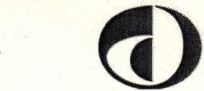Debit
Instruction to your bank or building society to pay by Direct Debit

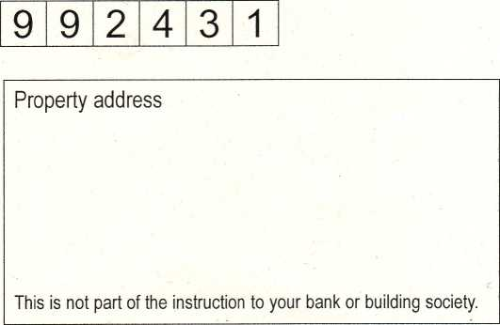
Please complete this form by typing, or writing in black ink, your details in the boxes. (If typing don’t forget to sign). Then post to: Income Team (Council Housing)
PO Box 63 Civic Centre EN13XW
Frequency of payment: EH fortnightly
EE monthly on 1st of each month EE monthly on 16th of each month
Name(s) of account holder(s)
Bank/building society account number
Branch sort cod |  |  | e

Name and full postal address of your bank or building society
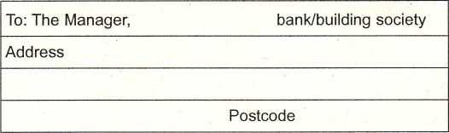

Payment reference number
Banks and building societies may not accept Direct
Originators identification number
Instruction to your bank or building society
Please pay Enfield Council Direct Debits from the account detailed in this instruction subject to the safeguards assured by the Direct Debit Guarantee. I understand that this Instruction may remain with Enfield Council and, if so, details will be passed electronically to my bank/building society.
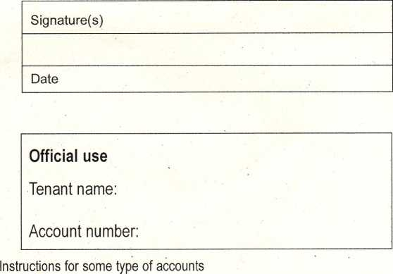

This guarantee should be detached and retained by the payer.
©
DIRECT
Debit
The Direct Debit Guarantee
• This Guarantee is offered by all banks and building societies that accept instructions to pay Direct Debits.
- If there are any changes to the amount, date or frequency of your Direct Debit Enfield Council will notify you 10 working days in advance of your account being debited or as otherwise agreed. If you request Enfield Council to collect a payment, confirmation of the amount and date will be given to you at the time of the request.
- If an error is made in the payment of your Direct Debit by Enfield Council or your bank or building society you are entitled to a full and immediate refund of the amount paid from your bank or building society.
- If you receive a refund you are not entitled to, you must pay it back when Enfield Council asks you to.
You can cancel a Direct Debit at any time by simply contacting your bank or building society. Written confirmation may be required. Please also notify us.

