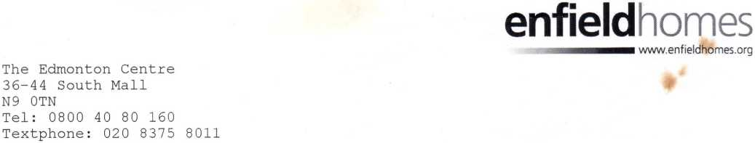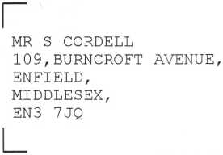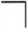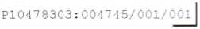
16569
N9
Sheet 1 of 1

This is a statement of your rent account. If there is anything on this statement that you do not understand, or you think is wrong, please contact the Housing Income Collection team. For contact details and definitions of abbreviations or terms, please see overleaf.

STATEMENT OF YOUR RENT ACCOUNT
Payment Reference : 497630
Statement Date : 25-NOV-2012
Weekly Rent : 89.13 Housing Benefit(Hb): 83.73 Rent to Pay : 5.40
DATE | TRANSACTION TYPE | DEBIT | CREDIT | BALANCE
20-AUG-2012  27-AUG-2012 | Balance B/F HB Weekly Rebate |  | 83.73 | 153.56 DR 158.96 DR
27-AUG-2012 | Standard Debit | 89.13 |  | 242.69 DR
29-AUG-2012 | Payment |  | 26.85 | 132.11 DR
03-SEP-2012 | HB Weekly Rebate |  | 83.73 | 137.51 DR
03-SEP-2012 | Standard Debit | 89.13 |  | 221.24 DR
10-SEP-2012 | HB Weekly Rebate |  | 83.73 | 142.91 DR
10-SEP-2012 | Standard Debit | 89.13 |  | 226.64 DR
17-SEP-2012 | Standard Debit | 89.13 |  | 232.04 DR
17-SEP-2012 | HB Weekly Rebate |  | 83.73 | 148.31 DR
24-SEP-2012 | HB Weekly Rebate |  | 83.73 | 153.71 DR
24-SEP-2012 | Standard Debit | 89.13 |  | 237.44 DR
28-SEP-2012 | Payment |  | 35.80 | 117.91 DR
01-OCT-2012 | HB Weekly Rebate |  | 83.73 | 123.31 DR
01-OCT-2012 | Standard Debit | 89.13 |  | 207.04 DR
08-OCT-2012 | HB Weekly Rebate |  | 83.73 | 128.71 DR
08-OCT-2012 | Standard Debit | 89.13 |  | 212.44 DR
15-OCT-2012 | Standard Debit | 89.13 |  | 217.84 DR
15-OCT-2012 | HB Weekly Rebate |  | 83.73 | 134.11 DR
22-OCT-2012 | Payment |  | 35.80 | 103.71 DR
22-OCT-2012 | HB Weekly Rebate |  | 83.73 | 139.51 DR
22-OCT-2012 | Standard Debit | 89.13 |  | 223.24 DR
29-OCT-2012 | Standard Debit | 89.13 |  | 192.84 DR
29-OCT-2012 | HB Weekly Rebate |  | 83.73 | 109.11 DR
05-NOV-2012 | HB Weekly Rebate |  | 83.73 | 114.51 DR
05-NOV-2012 | Standard Debit | 89.13 |  | 198.24 DR
12-NOV-2012 | Standard Debit | 89.13 |  | 203.64 DR
12-NOV-2012 | HB Weekly Rebate |  | 83.73 | 119.91 DR
19-NOV-2012 | Standard Debit | 89.13 |  | 209.04 DR
19-NOV-2012 | HB Weekly Rebate |  | 83.73 | 125.31 DR
20-NOV-2012 | Payment |  | 35.80 | 89.51 DR

See over for explanations of terms
HMSRA/8/300606

