Payment reference number 497630
ENFIELD
Council

Enfield Homes Customer Services The Edmonton Centre 36-44 South Mall Edmonton Green, London N9 0TN
Patch number N9
Mr S Cordell
109 Burncroft Avenue
Enfield
Middlesex
EN37JQ
Phone: 0800 40 80 160 E-mail: rent@enfieldhomes.org
For hearing-impaired callers ONLY Textphone: 020 8375 8011
Date: 2 March 2012

Notice of 2012/20
3 rent charges

Dear Mr S Cordell,
From 2 April 2012, your weekly net rent will be £79.70. In addition, the service charges for your property are:
Ground Maintenance £ 1.16
Caretaking £ 2.87
If you pay for water and sewerage services, you will continue to pay these on top of your rent and service charges.
If you get Housing Benefit, it will automatically be updated to take into account the new rent.
We will write to you again soon. The letter will show:
- all the individual charges and rebates that make up your new rent
- any Housing Benefit allowance, and
- 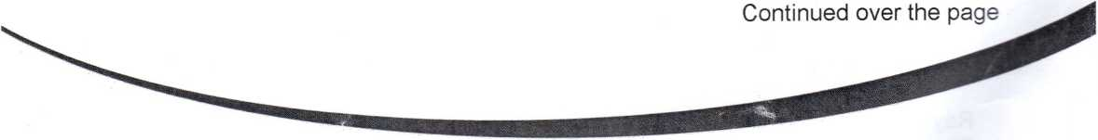the actual amount you must pay.
Ray James
Director of Health, Housing and Adult Social Care
Enfield Council
Civic Centre, Silver Street Phone: 020 8379 1000
Enfield EN1 3XY Website: wvvw.enfield.gov.uk
P10384099\005190
: ? If you need this document in another language or format call Customer Services on 020 8379 1000, or email enfield.council@enfield.gov.uk
Use and occupation
If you are still living at this address on 2 April 2012 and if e t^er
- you are not our tenant on that date; or
- we have ended your security of tenure because we have served you wi:~ a :e to quit:
then you must pay a weekly charge for your continued use and occupation of the property. If this applies to you, we will soon be sending you a letter showing the actual amount you must pay every week.
Garage charges
We have increased the rent for garages by 5.6%. Below are the current rents and the new rents that will come into effect from 2 April 2012.
Current rents New rents
Wire Cage garage £4.86 £5.13
Standard garage £8.48 £8.95
If you are a council tenant or leaseholder, and you rent 1 or 2 garages, you do not
have to pay VAT.
Private tenants who rent a garage from us, or any council tenant or leaseholder that rents more than 2 garages, must pay a Non Council Tenant Premium (NCTP) on top of the rent, and add VAT of 20% onto both charges.
Current charge New charge
NCTP charge £2.24 £2.37
You may also have to pay water rates to cover the cost of draining surface water from the area around the garage.
We will show details of the charges on your next letter, which we will be sending you soon.
If you have any questions or comments about your increased charges, please contact Enfield Homes. The address and telephone number are on the front of this letter.
The non-payment of rent is a breach of your tenancy conditions. If you are having difficulty paying your rent, Enfield Homes staff are available to give advice and help.
Yours sincerely,
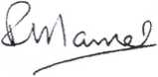

Ray James
Director of Health, Housing and Adult Social Care
We are sending this letter in accordance with the requirements of your tenancy agreement, and the
Housing Act 1985 Sections 24, 102 and 103.
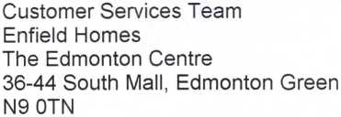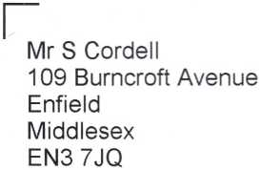Payment Ref No: 497630 Patch No: N9

RENT PAYMENT SCHEDULE
Useful Contact Numbers:
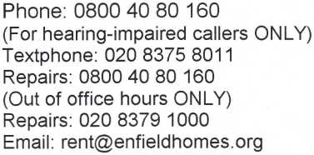

From 2 April 2012, your weekly rent is: £5.40
 | Dwelling | ‘Garage | Total
Rent | 79.70 |  | 79.70
Caretaking | 2.87 |  | 2.87
CCTV
Concierge
Ground Maintenance | 1.16 |  | 1.16
Heating
Heating Standing Charge
Water Rate | 5.40 |  | 5.40
VAT
TOTAL | 89.13 | 0.00 | 89.13
Housing Benefit | 83.73 |  | 83.73
YOU PAY | 5.40 | 0.00 | 5.40
*lf you rent more than one garage, the total charges will be displayed here. If you are a non-council tenant your garage charges will also be shown here.

Please note:
Your rent is payabie weekly, if you pay fortnightly or monthly, you must ensure your payments are made in advance, as per the terms and conditions of your tenancy agreement. There are several methods to pay your rent of which direct debit is the most convenient.
If you have rent arrears or an arrangement to repay the debt, please contact Enfield Homes on 0800 40 80 160. This is a free phone number, so there's no charge if you use a landline. If using a mobile phone, you may find it cheaper to call our landline number, 020 8379 1327.
Use & Occupation
If you are still living at this address on 2 April 2012 and if either:
P10396972\004625
- You are not our tenant on that date; or
- we have ended your security of tenure because we have served you with a notice to quit
Then you must pay a weekly charge for your continued use and occupation of the property as shown on this letter.
If found please return to:
London Borough of Enfield, PO Box 60, Civic Centre, Silver Street, Enfield Middlesex. EN1 3XN
HMCAR
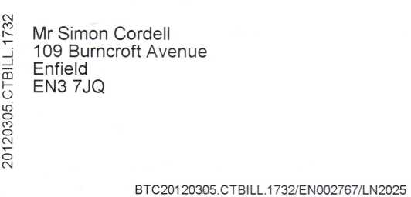
Council Tax Bill 2012/13

ENFIELD

Council
Please quote this account number whenever you contact us >

55508596
Date of Issue 14 Mar 2012
ADDRESS OF PROPERTY LIABLE FOR CHARGE
109 Burncroft Avenue, Enfield, EN3 7JQ

For information on how to contact us
and the various payment methods,
please see overleaf.

Council Tax Benefit

A separate letter dated 14/03/12 will be
sent, telling you how this has been worked

out.
This property has been valued in Band B.
The full amount due for this year is: | = | £1,094.38
Comprising Enfield Council | = | £855.82
Greater London Authority | = | £238.56
REASON FOR THIS BILL New Year Billing

STATEMENT OF ACCOUNT
Charge due for period | 01/04/2012 | 31/03/2013 | £1,094.38
Single person discount | 25.00% |  | £273.60 CR
Less/Plus other Adjustments:
BENEFITS |  |  | £820.78 CR

How To Pay Your Council Tax
this bill or call 020 8379 1000.
(9am - 4pm) (9am - 4pm) (8.30am - 5pm)
Direct Debit - Is the easiest form of payment for most people. Choose from payment dates of the 1st, 11th or 21st of each month. Payments are automatically debited from your bank account. You will be notified in advance of the payment due dates and you can cancel the arrangement at any time. To set up your Direct Debit fill in the Instruction form enclosed with
Online - Visit www.enfield.gov.uk and click on pay it online to pay with a Credit or a Debit Card.
Phone - Call 020 8379 1000 using your Debit or Credit card. Press option 1 and 1 again.
Payment Booklet Vouchers - If your bill has bank giro credits enclosed then pay using the
following methods:
- By Post to the Director of Finance, Resources and Customer Services, PO Box 63, Civic Centre, Silver Street, Enfield, EN1 3XW. Cheques and postal orders should be made payable to Enfield Council. Receipts will only be issued if a stamped addressed envelope is enclosed. Post dated and third party cheques will not be accepted.
- In Person at Civic Centre, Silver Street, Enfield from Monday - Friday between 9.00am and 4.30pm.
- Over the Counter at your Bank - there will be no charge by your own bank for this. Please allow 4 working days for your payment to reach your account.
- Handytill - At the Civic Centre, Ordnance Road Library or Edmonton Green library. Place your money and payment-slip in the envelope provided at these locations and place in the handytill. Write your account or invoice number on your payment slip or on the back of your cheque. The handytill will print a receipt.
Please note you cannot pay your Council Tax at Post Offices
Standing Order - Allow 10 working days for the payment to reach your Council Tax Account in advance of the instalment due date and quote the following Enfield Council Details:
Sort Code: 40 20 23, Account Number: 81228307 and your Council Tax account number as shown overleaf.

How to Contact Us
Email - revs@enfield.gov.uk. For general information and on-line forms visit www.enfield.gov.uk/counciltax
Phone - Lines are open Monday to Friday excluding bank holidays. We can only speak to the account holder or claimant unless we have written or verbal authorisation to speak to another person on their behalf.
Council Tax Enquiries 020 8379 1000 (8am - 6pm)
Benefit Enquiries (Housing and Council Tax) 020 8379 3798 (8:30am - 4:30pm)
Text Phone 020 8379 4419
In Person - at the following locations: Helpdesks open Monday - Friday
John Wilkes House, 79 High Street, Ponders End, Enfield, EN3 4EN Civic Centre (Ground Floor), Silver Street, Enfield, EN1 3XW Edmonton Centre (1st floor), 36 - 44 South Mall, Edmonton, N9 0TN For picking up forms and handing in documents plus appointment service:
Post - Revenues & Benefits, Enfield Council, PO Box 63, Civic Centre, Silver Street. Enfield EN1 3XW

