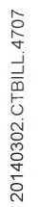
Council Tax Bill 2014/15

ENFIELD
Council
Date of Issue 14 Mar 2014

Protect - Private and Confidential
Mr Simon Cordell 109 Burncroft Avenue Enfield EN3 7JQ

BTC20140302.CTBILL.4707/EN002400/LN2092
This is your Council Tax Bill for 2014/15.
You owe: £159.17
Please see the back of this page for the full calcu ation of how th s | s worked out
Your instalment amounts and the dates they should be paid are as follows  01/04/2014 £15.17 01/05/2014 £16.00 01/06/2014 £16.00 01/08/2014 £16.00 01/09/2014 £16.00 01/10/2014 £16.00 01/12/2014 £16.00 01/01/2015 £16.00 | 01/07/2014 £16.00 01/11/2014 £16.00

You can help the council save money by paying your council tax by Direct Debit If you choose to pay by direct debit, you can pay using different instalment days and over 12 months rattier than 10-
Use the Direct Debit instruction enclosed or go to our website www.enfield.gov.uk/counciRax- Applications to pay over 12 monthly instalments need to be received by Monday 7th April 2014.
Alternatively you can pay
- Online at www.enfield.gov.uk
- Calling our automatic payment service on 020 8379 1000
- By any of the other methods on the back of your Payment Instructions Sheet
Enclosed with this bill is a booklet giving more information on how your council tax is spent to provide local services and other information about council tax. This is also available on our website.
If you cannot afford to pay or require other advice on this bill then please visit our website which is available 24 hours everyday at:
www.enfield.gov.uk/counciltaxonline
Other ways to contact us are on the back of this page.

Your new year bill for 2014/15 has been worked out as follows:

ADDRESS OF PROPERTY LIABLE FOR CHARGE
109 Burncroft Avenue, Enfield, EN3 7JQ

Your property has been valued in Band B.
The full amount due for this year is: = £1,088.38
Comprising Enfield Council = £855.82
Greater London Authority = £232.56

REASON FOR THIS BILL New Year Billing

STATEMENT OF ACCOUNT
Charge due for period | 01/04/2014 | 31/03/2015 | £1,088.38
Single Person Discount | 25.00% |  | £272.10 CR
Less/Plus other Adjustments: Council Tax Support |  |  | £657.11 CR

£254.64 is outstanding from previous years. Please pay as previously notified.

Total Amount Due £159.17
How to Contact Us
Online
Most frequently asked for information and online forms all in one place.vvww.enfield.aov.uk/counciltaxonline or www.enfield.aov.uk/benefitsonline. There are free internet facilities in local council libraries and at our major reception areas.
Or if you think your bill is incorrect visit www.enfield.gov.uk/incorrectbill
Email - revs@enfield.gov.uk Telephone - 020 8379 1000 (8am-6pm)
Post - Revenues and Benefits, PO Box 63, Civic Centre, Enfield, EN1 3XW In person
John Wilkes House, 79 High Street, Ponders End, Enfield EN3 4EN (9am-4pm)
Drop in documents any time between opening hours or see an advisor by booking an appointment on 0208 379 6023 lines open between 08:30 -16:30
Civic Centre, Silver Street, Enfield, EN1 3XW (9am-4pm)
Drop in documents any time between opening hours or see an advisor by booking an appointment on 0208 379 6023 lines open between 08:30 -16:30
Edmonton Centre, ground floor, 36-44 South Mall, Edmonton, N9 0TN (8:30am-5pm)
Drop in documents only at this office
For further details on how to contact us please visit www.enfield.Qov.uk/revscontact

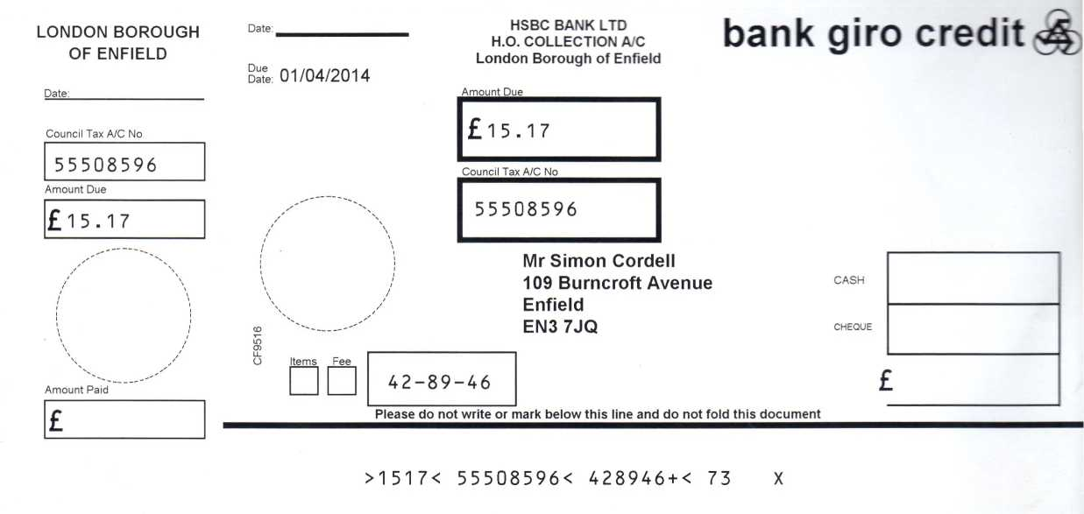

PAYMENT INSTRUCTIONS

Council Tax Bill 2014/15
You can pay your Council Tax bill using the enclosed Instalment slips. Deta s of the amounts and the dates they are to be paid are shown below.
These slips can be used to pay the Council Tax by any of the methods advised on the back of this sheet.
If you wish to pay by Direct Debit, simply call our Customer Services Centre on 020 8379 1000 or fill in the Direct Debit Instruction enclosed with this bill. (Please note it takes approximate . 15 cays to activate a Direct Debit).
CTax - Cash -10 Monthly Instalments 1st
01/04/2014 £15.17
01/05/2014 £16.00
01/06/2014 £16.00
01/07/2014 £16.00
01/08/2014 £16.00
01/09/2014 £16.00
01/10/2014 £16.00
01/11/2014 £16.00
01/12/2014 £16.00
01/01/2015 £16.00

Total Amount Due

£159.17

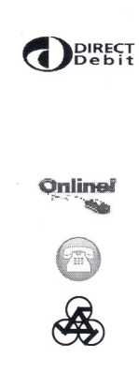How To Pay Your Council Tax
Direct Debit - Is the easiest form of payment for most people. Choose from payment dates of the 1st, 11th or 21st of each month. Payments are automatically debited from your bank account. You will be notified in advance of the payment due dates and you can cancel the arrangement at any time. To set up your Direct Debit fill in the Instruction form enclosed with this bill or call 020 8379 1000.
Online - Visit www.enfield.gov.uk and click on pay it online to pay with a Credit or a Debit Card.
Phone - Call 020 8379 1000 using your Debit or Credit card. Press option 1 and 1 again.
Payment Booklet Vouchers - If your bill has bank giro credits enclosed then pay using the following methods:
- By Post to the Director of Finance, Resources and Customer Services, PO Box 63, Civic Centre, Silver Street, Enfield, EN1 3XW. Cheques and postal orders should be made payable to Enfield Council. Receipts will only be issued if a stamped addressed envelope is enclosed. Post dated and third-party cheques will not be accepted.
- At our offices Civic centre: Monday to Friday Cashier desks from 10am - 2pm & Auto Pay Kiosks from 8:30am-6pm.There are also Auto Pay machines at Edmonton Library, John Wilkes House & Enfield Highway Library
- Over the Counter at your Bank - there will be no charge by your own bank for this. Please allow 4 working days for your payment to reach your account.
Please note you cannot pay your Council Tax at Post Offices
Standing Order - Allow 10 working days for the payment to reach your Council Tax Account in advance of the instalment due date and quote the following Enfield Council Details:
Sort Code: 40 20 23, Account Number: 81228307 and your Council Tax account number as shown overleaf.

