Payment reference number 497630
ENFIELD

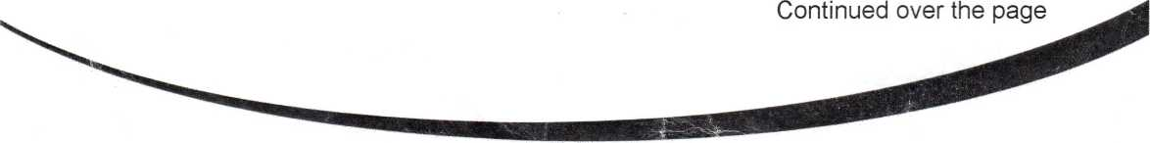
Council
Enfield Homes Customer Services The Edmonton Centre 36-44 South Mall Edmonton Green, London N9 OTN
Patch number N9
Mr S Cordell
109 Burncroft Avenue
Enfield
Middlesex
EN3 7JQ
Phone: 0800 40 80 160 E-mail: rent@enfieldhomes.org
For hearing-impaired callers ONLY Textphone: 020 8375 8011
Date: 1 March 2014

Notice of 2014/2015 rent charges
Dear Mr S Cordell,
From 7 April 2014, your weekly net rent will be £86.36. In addition, the service charge for your property are:
Ground Maintenance Caretaking
£ 1.25
£ 3.04
If you pay for water and sewerage services, you will continue to pay these on top of your rent and service charges.
If you get Housing Benefit, it will automatically be updated to take into account the new rent. If you are of working age and have at least one spare bedroom your Housing Benefit will be cut. This rule does not apply to people over pension age. If you are affected your HB will automatically be adjusted. More information about the rules can be found at www.enfieldhomes.org
We will write to you again soon. The letter will show:
- all the individual charges and rebates that make up your new rent
- any Housing Benefit allowance, and
- the actual amount you must pay.
Ray James
Director of Health, Housing and Adult Social Care
Enfield Council
Civic Centre, Silver Street •
Enfield EN1 3XY
P10669289\005020
Phone: 020 8379 1000
Website: www.enfteid.gov.uk

if you need this document in another language or format call Customer Services on 020 8379 1000, or email enfieid.eoundl@enfieklgQv.uk

