ENFIELD
ENFIELD
Council
Connected
Statement of your Rent Account
Please quote this payment reference number whenever you contact us » 497630
Protect - Private and Confidential
Sign up for an online Enfield Connected account to make your
payments and manage your account ■
MR S CORDELL
109,Burncroft Avenue,
Enfield,
Middlesex,
EN3 7JQ
DATE | TRANSACTION TYPE | DEBIT | CREDIT | BALANCE
20-NOV-2017 | Balance B/F |  |  | 253.49 Debit
23-NOV-2017 | Payment |  | 20.00 | 233.49 Debit
27-NOV-2017 | Standard Debit | 99.28 |  | 332.77 Debit
27-NOV-2017 | HB Weekly Rebate |  | 92.98 | 239.79 Debit
04-DEC-2017 | Standard Debit | 99.28 |  | 339.07 Debit
04-DEC-2017 | HB Weekly Rebate |  | 92.98 | 246.09 Debit
ll-DEC-2017 | Standard Debit | 99.28 |  | 345.37 Debit
ll-DEC-2017 | HB Weekly Rebate |  | 92.98 | 252.39 Debit
13-DEC-2017 | Payment |  | 40.00 | 212.39 Debit
18-DEC-2017 | Standard Debit | 99.28 |  | 311.67 Debit
18-DEC-2017 | HB Weekly Rebate |  | 92.98 | 218.69 Debit
25-DEC-2017 | Standard Debit | 99.28 |  | 317.97 Debit
25-DEC-2017 | HB Weekly Rebate |  | 92.98 | 224.99 Debit
01-JAN-2018 | Standard Debit | 99.28 |  | 324.27 Debit
01-JAN-2018 | HB Weekly Rebate |  | 92.98 | 231.29 Debit
08-JAN-2018 | Standard Debit | 99.28 |  | 330.57 Debit
GS-JAN-2018 | HB Weekly Rebate |  | 92.98 | 237.59 Debit
11-JAN-2018 | Payment |  | 40.00 | 197.59 Debit
15-JAN-2018 | Standard Debit | 99.28 |  | 296.87 Debit
16-JAN-2018 | HB Weekly Rebate |  | 92.98 | 203.89 Debit
22-JAN-2018 | Standard Debit | 99.28 |  | 303.17 Debit
22-JAN-2018 | HB Weekly Rebate |  | 92.98 | 210.19 Debit
26-JAN-2018 | Payment |  | 31.50 | 178.69 Debit
29-JAN-2018 | Standard Debit | 99.28 |  | 277.97 Debit
29-JAN-2018 | HB Weekly Rebate |  | 92.98 | 184.99 Debit
05-FEB-2018 | Standard Debit | 99.28 |  | 284.27 Debit
05-FEB-2018 | HB Weekly Rebate |  | 92.98 | 191.29 Debit
06-FEB-2018 | Payment |  | 40.00 | 151.29 Debit
12-FEB-2018 | Standard Debit | 99.28 |  | 250.57 Debit
12-FEB-2018 | HB Weekly Rebate |  | 92.96 | 157.59 Debit
19-FEB-2018 | Standard Debit | 99.28 |  | 256.87 Debit
19-FEB-2018 | HB Weekly Rebate |  | 92.98 | 163.89 Debit
26-FEB-2018 | Standard Debit | 99.28 |  | 263.17 Debit
26-FEB-2018 | HB Weekly Rebate |  | 92.98 | 170.19 Debit

Council Housing PO Box 63
60,000 residents have an Enfield Connected account - Sign up for yours to view your rent account and pay online at www.enfield.qov.uk
Payment reference number 497630
Mr S Cordell
109 Burncroft Avenue
Enfield
Middlesex
EN3 7JQ

ENFIELD Connected
ENFIELD
Council
1st March 2017
For Information: Notice of 2017/18 Rent Charges
No Further Action Needed
.
109 Burncroft Avenue, Enfield, Middlesex, EN3 7JQ

Dear Mr S Cordell
From 3rd April 2017, your weekly net rent will be £86.51. In addition, the weekly service charges for your property are:
Ground Maintenance | £1.89 |  | Caretaking | £3.54
Enhanced Cleaning Charge in | £0.59 |  | Landlord Communal Service Charge | £0.45
Communal Areas
If you currently pay for water and sewerage services, you will continue to pay for these on top of your rent and service charges.

If you receive Housing Benefit, this will be automatically updated to take into account the new rent amount above. You will be notified of your Housing Benefit entitlement on your Rent Payment Schedule. You do not need to contact us.
Information about the Housing Benefit rules can be found at www.enfield.qov.uk
We will write to you again mid-March, with a Payment Schedule for your rent. This schedule will show you:
All the individual charges, and any rebates, that make up your new rent
- Any Housing Benefit you receive
- The actual total amount you must pay
- Information on how to pay the amount due.
You do not need to take any action as a result of this letter
Visit www.enfieid.gov.uk to sign up for an Enfield Connected account. Through you can:
- Check your balance and payment history
- View your rent account
- View your benefit entitlement (if applicable)
- View your Council Tax account and set up a Direct Debit for your Council Tax payments
- Edit your account profile to tell us if things have changed
We have improved our online services, allowing you to access more Council services in one place, save time, and make payments easily.
If you do not have access to the internet, or would like help to set up your account, please book an appointment by telephone at one of our main Libraries where you can receive help. These are Enfield Town Library (020 8379 8341), Ordnance Unity Library (020 8379 2688), Palmers Green Library (020 8379 2711), and lnternet@31 (020 8803 5785) or Green Towers in Edmonton Green.
The non-payment of rent is a breach of your tenancy conditions. If you are having difficulty paying your rent please speak to a member of the Council Housing team who are available to give advice and help.
Garage charges and parking bays
Below is the current rent, and the new rent, which will come into effect from the 3rd April 2017.
 | Current rent | New rent
Standard garage | £10.00 | £11.00
Parking bay | £5.00 | £6.00

If you are a leaseholder, and you rent 1 or 2 garages, you do not need to pay VAT.
If you rent 3 or more garages, you must pay a Non Council Tenant Premium charge (NCTP) on top of the rent amount due, and pay VAT at the rate applicable, currently 20%.
If you are a private tenant, no matter how many garages you rent, you will have to pay a Non Council Tenant Premium charge (NCTP) on top of the rent, and pay VAT at the rate applicable, currently 20%.
 | Current charge | New charge
NCTP charge | £2.66 | £2.71

You may also have to pay water rates to cover the cost of draining surface water from the area around the garage.
We will show you details of these charges, what you owe, and how to pay on your Payment Schedule which we will send you soon.
Use and Occupation
If you are still living at this address on the 3rd April 2017 and if either:
- You are not our tenant on that date; or
- We have ended your security of tenure because we have served you with a notice to quit
Then you must pay a weekly charge for your continued use and occupation of the property. If this applies to you, we will soon send you a letter that will show the actual amount you must pay every week.
We are sending this letter in accordance with the requirements of your tenancy agreement, and the
Housing Act 1985 Sections 24, 102 and 103.
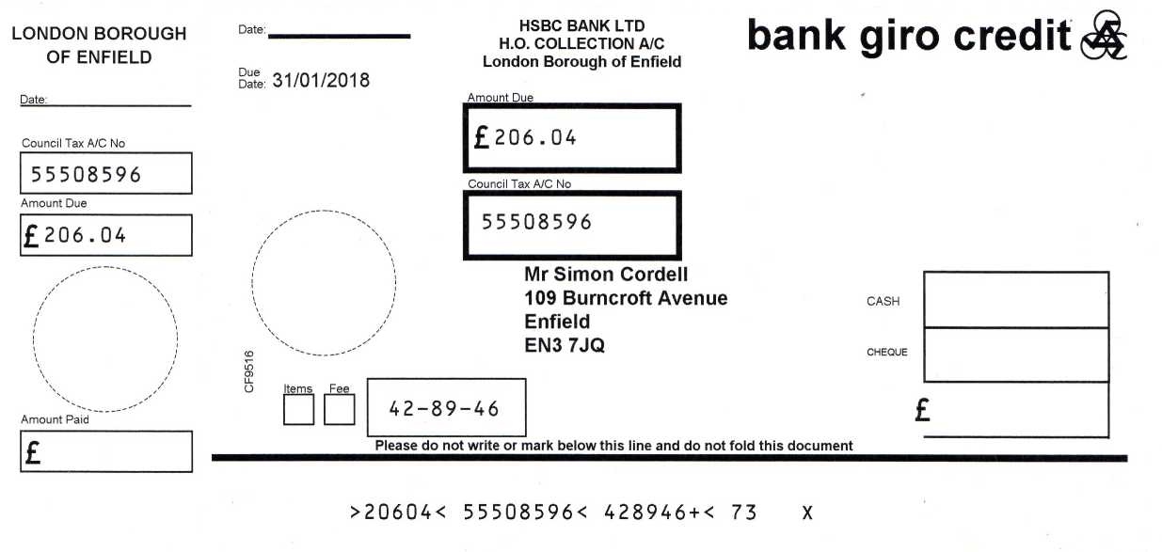
PAYMENT INSTRUCTIONS

Council Tax Bill 2017/18
You can pay your Council Tax bill using the enclosed Instalment slips. Details of the amounts and the dates they are to be paid are shown below.
These slips can be used to pay Council Tax using the following methods:
- At our offices - Civic Centre: Our auto pay kiosks are open Monday to Friday 8:30am - 6pm. There are also Auto pay kiosks at Edmonton Library, John Wilkes House and Enfield Highway Library.
- Over the counter at your own bank - there will be no charge for this. Please allow 4 days for your payment to reach your account.
CTax - Cash -10 Monthly Instalments 1st
31/01/2018 £206.04
Total Amount Due
£206.04

