

ENFIELD
Connected

ENFIELD
Council
Payment reference number: 497630
Mr S Cordell
109 Burncroft Avenue Enfield Middlesex EN3 7JQ
Council Housing
100,000 residents have an Enfield Connected
account ■ Sign up for yours to view your rent
account online at www.enfield.gov.uk
19th March 2018
Rent Payment Schedule 2018/19
109 Burncroft Avenue, Enfield, Middlesex, EN3 7JQ

 | Dwellina | Garaae* | Total
Rent | 85.64 |  | 85.64
Caretakinq | 3.80 |  | 3.80
Ground Maintenance | 1.89 |  | 1.89
Landlord Communal Service Charoe | 0.46 |  | 0.46
Water Rate | 6.45 |  | 6.45
TOTAL | 98.24 | 0.00 | 98.24
Housinq Benefit | 91.79 |  | 91.79
YOU PAY | 6.45 | 0.00 | 6.45
From 2nd April 2018, your weekly rent is £6.45. This breaks down as:
* If you rent more than one garage, the total charges for all the garages you rent will be shown here, including the Non Council Tenant Premium (NCTP) charge if you are not a Council Tenant.

If you receive Universal Credit, your monthly rent can be worked out by using the total weekly charge shown in this letter times 52 and divided by 12.
Your rent is payable weekly. If you have arranged to pay fortnightly or monthly, your payments must be made in advance, in line with the terms and conditions of your tenancy agreement.
What you need to do:
- The easiest and quickest way to pay your rent is by Direct Debit. You can set this up by filling out the Direct Debit form attached and returning this. 66,000 people in Enfield pay the Council by Direct Debit - it’s secure, easy and quick!
- If you pay your rent by a Standing Order, you need to change your Standing Order to make sure it covers the amount you need to pay. If you would like to switch to paying by Direct Debit please complete the attached form
- If you have an existing Direct Debit set up, this will be adjusted automatically. You do not need to change this, and you do not need to contact us
- For credit or debit card payments please go to www.enfield.qov.uk or call 020 8379 1000 (Option
1) for the automated payments line

Use & Occupation
If you are still living at this address on the 2nd April 2018 and if either:
- You are not our tenant on that date; or
- We have ended your security of tenure because we have served you with a notice to quit Then you must pay a weekly charge for your continued use and occupation of the property.
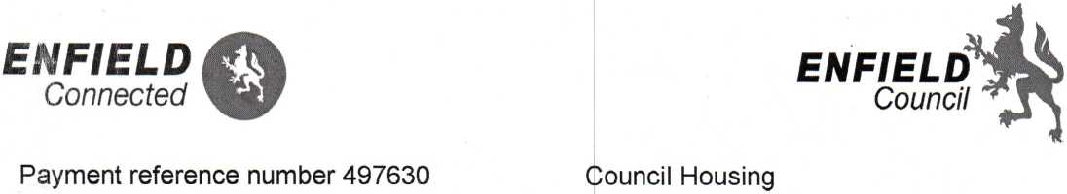Dear Mr S Cordell
Mr S Cordell
109 Burncroft Avenue
Enfield
Middlesex
EN3 7JQ
100,000 residents have an Enfield Connected ccount - Sign up for yours to view your rent account and pay online at www.enfield.gov.uk
5th March 2018
For Information: Notice of 2018/19 Rent Charges
No Further Action Needed
109 Burncroft Avenue, Enfield, Middlesex, EN3 7JQ
From 2nd April 2018, your weekly net rent will be £85.64. In addition, the weekly service charges for your property are:
Ground Maintenance | £1.89 | Caretaking | £3.80
Landlord Communal Service Charge | £0.46
If you currently pay for water, sewerage services and heating charge, you will continue to pay for these on .top of your rent and service charges.

If you receive Housing Benefit, this will be automatically updated to take into account the new rent amount above. You will be notified of your Housing Benefit entitlement on your Rent Payment Schedule. You do not need to contact us.
r
If you receive Universal Credit, which replaces Housing Benefit, you will be responsible for paying yoyr full rent because Universal Credit award includes your housing cost.
We will write to you again mid-March, with a Payment Schedule for your rent. This schedule will show you:
- All the individual charges that make up your new rent
- Any Housing Benefit you receive
- The actual total amount you must pay
- Information on how to pay the amount due.
You do not need to take any action as a result of this letter
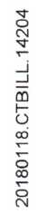Date of Issue 17 Jan 2018
Sign up for an online Enfield Connected account to make your payments and manage your account - www.enfield.gov.uk
Council Tax Bill 2017/18

ENFIELD
Council
Please quote this account number whenever you contact us 55508596
Mr Simon Cordell 109 Burncroft Avenue Enfield EN3 7JQ
BTC20180118.CTBILL.14204/EN000049/LN343
ADDRESS OF PROPERTY LIABLE FOR CHARGE
109 Burncroft Avenue, Enfield, EN3 7JQ
Your property has been valued in Band B.
The full amount due for this year is: | = £1,152.08
Comprising Enfield Council | = £907.59
Greater London Authority | = £217.79
Adult Social Care | = £26.70

Increase in council tax to fund Adult Social Care
The council tax attributable to Enfield Council includes a 3% precept to fund adult social care. For further information about the adult social care precept please visit www.enfield.qov.uk.
REASON FOR THIS BILL Council Tax Support Adjustment

STATEMENT OF ACCOUNT
Charge due for period | 01/04/2017 | 31/03/2018 | £1,152.08
Single Person Discount | 25.00% |  | £288.02 CR
Less/Plus other Adjustments: COSTS |  |  | £95.00
Council Tax Support |  |  | £753.02 CR

Total Amount Due (Please see reverse for payment instructions) £206.04
Please quote this payment reference number whenever you contact us » 497630
Protect - Private and Confidential
Sign up for an online Enfield Connected account to make your payments and manage your account - www.enfield.gov.uk
Statement of your Rent Account

ENFIELD

Council
MR S CORDELL
109, Burncroft Avenue,
Enfield,
Middlesex,
EN3 7JQ
DATE | TRANSACTION TYPE | DEBIT | CREDIT | BALANCE
26-FEB-2018 | Balance B/F |  |  | 170.19 Debit
05-MAR-2018 | Standard Debit | 99.28 |  | 269.47 Debit
05-MAR-2018 | HB Weekly Rebate |  | 92.98 | 176.49 Debit
06-MAR-2018 | Payment |  | 40.00 | 136.49 Debit
12-MAR-2018 | Standard Debit | 99.28 |  | 235.77 Debit
12-MAR-2018 | HB Weekly Rebate |  | 92.98 | 142.79 Debit
19-MAR-2018 | Standard Debit | 99.28 |  | 242.07 Debit
19-MAR-2018 | HB Weekly Rebate |  | 92.98 | 149.09 Debit
26-MAR-2018 | Standard Debit | 99.28 |  | 248.37 Debit
26-MAR-2018 | HB Weekly Rebate |  | 92.98 | 155.39 Debit
02-APR-2018 | Standard Debit | 98.24 |  | 253.63 Debit
03-APR-2018 | Payment |  | 40.00 | 213.63 Debit
03-APR-2018 | HB Weekly Rebate |  | 91.79 | 121.84 Debit
09-APR-2018 | Standard Debit | 98.24 |  | 220.08 Debit
09-APR-2018 | HB Weekly Rebate |  | 91.79 | 128.29 Debit
16-APR-2018 | Standard Debit | 98.24 |  | 226.53 Debit
16-APR-2018 | HB Weekly Rebate |  | 91.79 | 134.74 Debit
23-APR-2018 | Standard Debit | 98.24 |  | 232.98 Debit
23-APR-2018 | HB Weekly Rebate |  | 91.79 | 141.19 Debit
29-APR-2018 | Payment |  | 40.00 | 101.19 Debit
30-APR-2018 | Standard Debit | 98.24 |  | 199.43 Debit
30-APR-2018 | HB Weekly Rebate |  | 91.79 | 107.64 Debit
07-MAY-2018 | Standard Debit | 98.24 |  | 205.88 Debit
07-MAY-2018 | HB Weekly Rebate |  | 91.79 | 114.09 Debit
14-MAY-2018 | Standard Debit | 98.24 |  | 212.33 Debit
14-MAY-2018 | HB Weekly Rebate |  | 91.79 | 120.54 Debit
21-MAY-2018 | Standard Debit | 98.24 |  | 218.78 Debit
21-MAY-2018 | HB Weekly Rebate |  | 91.79 | 126.99 Debit

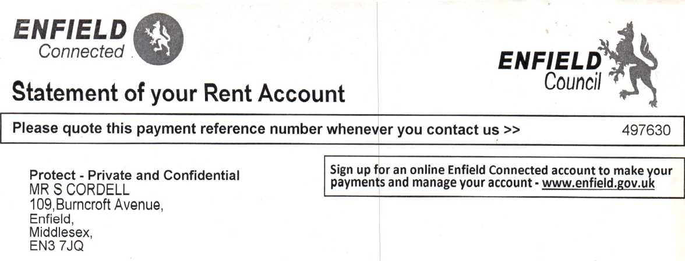

DATE | TRANSACTION TYPE | DEBIT | CREDIT | BALANCE
21-MAY-2018 | Balance B/F |  |  | 126.99 Debit
26-MAY-2018 | Payment |  | 40.00 | 86.99 Debit
28-MAY-2018 | Standard Debit | 98.24 |  | 185.23 Debit
28-MAY-2018 | HB Weekly Rebate |  | 91.79 | 93.44 Debit
04-JUN-2018 | Standard Debit | 98.24 |  | 191.68 Debit
04-JUN-2018 | HB Weekly Rebate |  | 91.79 | 99.89 Debit
ll-JUN-2018 | Standard Debit | 98.24 |  | 198.13 Debit
ll-JUN-2018 | HB Weekly Rebate |  | 91.79 | 106.34 Debit
18-JUN-2018 | Standard Debit | 98.24 |  | 204.58 Debit
18-JUN-2018 | HB Weekly Rebate |  | 91.79 | 112.79 Debit
25-JUN-2018 | Standard Debit | 98.24 |  | 211.03 Debit
25-JUN-2018 | HB Weekly Rebate |  | 91.79 | 119.24 Debit
25-JUN-2018 | Payment |  | 40.00 | 79.24 Debit
02-JUL-2018 | Standard Debit | 98.24 |  | 177.48 Debit
02-JUL-2018 | HB Weekly Rebate |  | 91.79 | 85.69 Debit
09-JUL-2018 | Standard Debit | 98.24 |  | 183.93 Debit
09-JUL-2018 | HB Weekly Rebate |  | 91.79 | 92.14 Debit
16-JUL-2018 | Standard Debit | 98.24 |  | 190.38 Debit
16-JUL-2018 | HB Weekly Rebate |  | 91.79 | 98.59 Debit
23-JUL-2018 | Standard Debit | 98.24 |  | 196.83 Debit
23-JUL-2018 | HB Weekly Rebate |  | 91.79 | 105.04 Debit
30-JUL-2018 | Standard Debit | 98.24 |  | 203.28 Debit
30-JUL-2018 | HB Weekly Rebate |  | 91.79 | 111.49 Debit
06-AUG-2018 | Standard Debit | 98.24 |  | 209.73 Debit
06-AUG-2018 | HB Weekly Rebate |  | 91.79 | 117.94 Debit
08-AUG-2018 | Payment |  | 40.00 | 77.94 Debit
13-AUG-2018 | Standard Debit | 98.24 |  | 176.18 Debit
13-AUG-2018 | HB Weekly Rebate |  | 91.79 | 84.39 Debit
20-AUG-2018 | Standard Debit | 98.24 |  | 182.63 Debit
20-AUG-2018 | HB Weekly Rebate |  | 91.79 | 90.84 Debit
23-AUG-2018 | Payment |  | 40.00 | 50.84 Debit
27-AUG-2018 | Standard Debit | 98.24 |  | 149.08 Debit
27-AUG-2018 | HB Weekly Rebate |  | 91.79 | 57.29 Debit

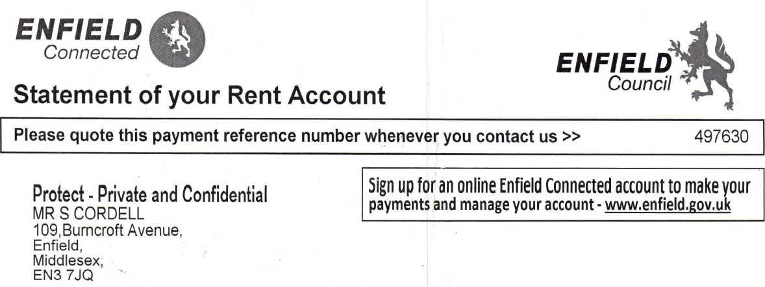

DATE | TRANSACTION TYPE | DEBIT | CREDIT | BALANCE
19-NOV-2018 | Balance B/F |  |  | 14.69 Debit
26-NOV-2018 | Standard Debit | 98.24 |  | 112.93 Debit
26-NOV-2018 | HB Weekly Rebate. |  | 91.79 | 21.14 Debit
03-DEC-2018 | Standard Debit | 98.24 |  | 119.38 Debit
03-DEC-2018 | HB Weekly Rebate |  | 91.79 | 27.59 Debit
10-DEC-2018 | Standard Debit | 98.24 |  | 125.83 Debit
10-DEC-2018 | HB Weekly Rebate |  | 91.79 | 34.04 Debit
13-DEC-2018 | Payment |  | 40.00 | -5.96 Credit
17-DEC-2018 | Standard Debit | 98.24 |  | 92.28 Debit
17-DEC-2018 | HB Weekly Rebate |  | 91.79 | 0.49 Debi t
24-DEC-2018 | Standard Debit | 98.24 |  | 98.73 Debit
24-DEC-2018 | HB Weekly Rebate |  | 91.79 | 6.94 Debit
31-DEC-2018 | Standard Debit | 98.24 |  | 105.18 Debit
31-DEC-2018 | HB Weekly Rebate |  | 91.79 | 13.39 Debit
07-JAN-2019 | Standard Debit | 98.24 |  | 111.63 Debit
07-JAN-2019 | HB Weekly Rebate |  | 91.79 | 19.84 Debit
14-JAN-2019 | Standard Debit | 98.24 |  | 118.08 Debit
14-JAN-2019 | HB Weekly Rebate |  | 91.79 | 26.29 Debit
21-JAN-2019 | Standard Debit | 98.24 |  | 124.53 Debit
21-JAN-2019 | HB Weekly Rebate |  | 91.79 | 32.74 Debit
26-JAN-2019 | Payment |  | 40.00 | -7.26 Credit
28-JAN-2019 | Standard Debit | 98.24 |  | 90.98 Debit
28-JAN-2019 | HB Weekly Rebate |  | 91.79 | -0.81 Credit
04-FEB-2019 | Standard Debit | 98.24 |  | 97.43 Debit
04-FEB-2019 | HB Weekly Rebate |  | 91.79 | 5.64 Debit
ll-FEB-2019 | Standard Debit | 98.24 |  | 103.88 Debit
ll-FEB-2019 | HB Weekly Rebate |  | 91.79 | 12.09 Debit
18-FEB-2019 | Standard Debit | 98.24 |  | 110.33 Debit
18-FEB-2019 | HB Weekly Rebate |  | 91.79 | 18.54 Debit
20—FEB—2019 | Payment |  | 16.69 | 1.85 Debit
20-FEB-2019 | Payment |  | 20.00 | -18.15 Credit
25-FEB-2019 | Standard Debit | 98.24 |  | 80.09 Debit
25-FEB-2019 | HB Weekly Rebate |  | 91.79 | -11.70 Credit


ENFIELD

Connected

ENFIELD
Council
Sign up for an Enfield Connect account to check your entitlement and payment history and manage your benefits at www.enfield.gov.uk
PROTECT: PRIVATE & CONFIDENTIAL

Claim Reference: 1623514 Nl Reference: JH653811D Rent Reference: 497630 Council Tax Account:55508596
Mr S Cordell
109 Burncroft Avenue
Enfield
EN3 7JQ
13/03/2018 Dear Mr Cordell No Change in Benefit Housing Benefit Notification
I have worked out your Housing Benefit again because your claim has been recalculated for the new financial year. However this has not changed your benefit, which remains as follows:
£92.98 per week from 25/09/2017 to 01/04/2018 £92.39 per week from 02/04/2018 Right of Appeal for Housing Benefit
If you do not agree with the Housing Benefit decision, you must challenge it within one month of the date of this letter.
You can:
- Write and ask us to reconsider
- Write to us and ask for our decision to be looked at by the Independent Tribunal run by the Tribunal Service.
Your letter must be written in English, be received within one month of the date of this letter, be signed by you and give your name, address, grounds for reconsideration and any evidence.
Changes in your circumstances
If your circumstances change, you must tell us about them immediately. For example:
- You start working or you earn more or less money
- Your benefits/tax credits change or are stopped
Claim reference: 1623514
Nl reference: JH653811D
How Your Housing Benefit Has Been Worked Out for the period
From 02/04/2018 your Housing Benefit will be £92.39 each week.
The rent you are charged each week is £98.84.
Housing Benefit cannot pay for some service charges that are included in your rent. The rent you pay has to be reduced by the amount of these service charges. These amounts are shown below:
Actual amount for Ineligible Water
£6.45
£6.45
Total deductions for services
The amount of rent after deducting these charges is called your maximum eligible rent. Your rent of £98.84 must be reduced by £6.45, to £92.39 each week. This is your maximum eligible rent.
The maximum Housing Benefit you can get is £92.39 each week. This figure is used when working out 'your total weekly Housing Benefit'.
Your Total Weekly Housing Benefit
Since you are receiving Employment and Support Allowance (income related), you are entitled to the maximum Housing Benefit of £92.39 each week.

Page 3 of 6
Mr S Cordell 109 Burncroft Avenue Enfield EN37JQ
Claim Reference: 1623514 Nl Reference: JH653811D Rent Reference: 497630 Council Tax Account:55508596
13/03/2018
Dear Mr Cordell
Change to your benefit
Council Tax Support Notification
I have changed your council tax support from 25/09/2017 because your claim has been recalculated for the new financial year. I have decided that your benefit is now as follows:
From £16.57 per week to £16.57 per week from 25/09/2017 to 31/03/2018 From £12.79 per week to £17.40 per week from 01/04/2018
How You Will Be Paid
£240.44 council tax support has been credited to your council tax account. The total amount of council tax support for 2018/19 is £907.32.
Your council tax support award for 2017/18 has not changed. The total amount of council tax support for that year is £753.02.
If you disagree with a Local Council Tax Support Scheme decision
If you do not agree with the Council Tax Support decision, you can write and ask us to reconsider our decision. If you still disagree you can ask for our decision to be looked at by the Valuation Service.
If you write to the Valuation Service you must state the matter that you disagree with and give your reasons. This must be received by the Valuation Service within two months of our decision. An appeal form can be found on their website at www.valuationtribunal.gov.uk
You can either submit the form on-line or send it
to the Valuation Tribunal, Hepworth

ENFIELD

Connected
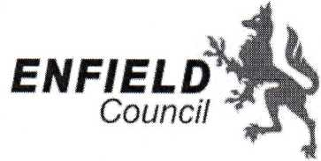
PROTECT: PRIVATE & CONFIDENTIAL
Sign up for an Enfield Connect account to check your entitlement and payment history and manage your benefits at www.enfield.gov.uk
Yours sincerely Benefit Assessment Team
How Your Council Tax Support Has Been Worked Out
Based on your circumstances I have decided to assess your claim using the Protected scheme.
From 01/04/2018, your council tax support is £17.40 each week.
The maximum council tax support you could get
Your council tax liability for the year is £907.32 which for this period is £17.40 each week.
The maximum council tax support you could get is therefore £17.40 each week. This figure is used when working out 'your total weekly council tax support'.
Your Total Weekly Council Tax Support
As you are receiving income related employment and support allowance, you are entitled to the maximum council tax support of £17.40 each week.
Mr S Cordell
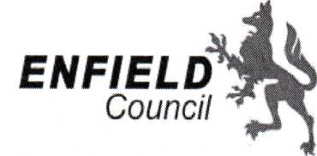109 Burncroft Avenue
Claim Reference: 1623514 Nl Reference: JH653811D Rent Reference: 497630 Council Tax Account:55508596

ENFIELD

Connected
PROTECT: PRIVATE & CONFIDENTIAL
Sign up for an Enfield Connect account to check your entitlement and payment history and manage your benefits at www.enfield.gov.uk
Enfield
EN37JQ
17/01/2018
Dear Mr Cordell
Change to your benefit Council Tax Support Notification
I have changed your council tax support from 25/09/2017 because there has been a change in a state benefit you receive. I have decided that your benefit is now as follows:
From £12.18 per week to £16.57 per week from 25/09/20T
How You Will Be Paid £117.94 council tax support has been credited to your council tax account. The total amount of council tax support for 2017/18 is £753.02.
You will receive a council tax bill that will tell you how much council tax you will now have to pay. On the back of the bill is a summary of how we have calculated your council tax.
If you disagree with a Local Council Tax Sup
p
ort Scheme decision

If you do not agree with the Council Tax Support decision, you can write and ask us to reconsider our decision. If you still disagree you can ask for our decision to be looked at by the Valuation Service.
If you write to the Valuation Service you must state the matter that you disagree with and give your reasons. This must be received by the Valuation Service within two months of our decision. An appeal form can be found on their website at www.valuationtribunal.gov.uk
You can either submit the form on-line or send it to the Valuation Tribunal, Hepworth
House, 2 Trafford Court, Doncaster, Yorkshire DN1 1PN
Yours sincerely
Victoria Jacobs
Revenues Information Assistant

ENFIELD i_!%
Connected
ENFIELD
Counci
Sign up for an Enfield Connect account to check your entitlement and payment history and manage your benefits at www.enfield.gov.uk
PROTECT: PRIVATE & CONFIDENTIAL

Claim Reference: 1623514 NI Reference: JH653811D
Mr S Cordell
109 Burncroft Avenue
Enfield
EN37JQ
Rent Reference: 497630
Council Tax Account:55508596
17/01/2018 Dear Mr Cordell No Change in Benefit Housing Benefit Notification
I have worked out your Housing Benefit again because there has been a change in a state benefit you receive. However this has not changed your benefit, which remains as follows:
£92.98 per week from 25/09/2017 Right of Appeal for Housing Benefit
If you do not agree with the Housing Benefit decision, you must challenge it within one month of the date of this letter.
You can:
- Write and ask us to reconsider
- Write to us and ask for our decision to be looked at by the Independent Tribunal run by the Tribunal Service.
Your letter must be written in English, be received within one month of the date of this letter, be signed by you and give your name, address, grounds for reconsideration and any evidence.
Changes in your circumstances
If your circumstances change, you must tell us about them immediately. For example:
- You start working or you earn more or less money
- Your benefits/tax credits change or are stopped
- You move home
- Your rent changes

Page 3 of 4
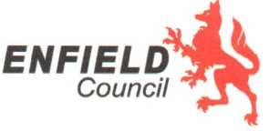Dear Resident,
Your Council Tax bill for 2018/19
Please find enclosed your Council Tax bill for the year ahead, along with information about how it has been calculated and your options for how to pay.
By 2020 central Government will have cut funding to Enfield Council by 60 per cent in real terms since 2010. Enfield Council has already delivered £161 m savings and needs to make a further £31 m saving by 2019/2020 - at a time of increasing need and demand from a growing population.
These savings have to be found from an inadequate funding pot. Enfield gets less than £320 per resident compared to some other London boroughs which get more than £500 per resident - making it more difficult for us to make a positive difference and properly fund our services. We will continue to lobby central Government for Fair Funding for Enfield on your behalf.
However, despite these challenges we are proud of our many recent achievements and remain hugely ambitious for the borough:
- Edmonton Green Library received a £4.2 million top-to-toe refurbishment
- Significant regeneration of our high streets and estates including Ponders End High Street, Dujardin Mews and Ladderswood
- 16 new police officers, funded by Enfield Council continue to keep our estates safer
- 93% of all our schools are described as ‘good’ or ‘outstanding’ by Ofsted
- Continuing to provide thousands of new school places to meet demand
We also continue to strive to protect local frontline services. Efficiencies alone are no longer enough and we have taken the difficult decision to increase Council Tax by 2.99% to help us do this.
In response to the increasing costs of adult social care services and the growth in the number of residents who need this support, the Government has again given all councils the option of levying a precept to help fund these services. We will be applying a 2% precept to help meet these rising costs, as the Government assumes that we will when calculating other grant allocations.
Councillor Doug Taylor Leader of the Council
Enfield Council
Civic Centre, Silver Street
Enfield EN1 3XY
www.enfield.gov.uk
(?) if you need this document in another language or format contact the service using the details above.


Council Tax Bill 2018/19
ENFIELD
Counci

Please quote this account number whenever you contact us »
55508596

Date of Issue
14 Mar 2018
Protect - Private and Confidential
Mr Simon Cordell 109 Burncroft Avenue Enfield EN3 7JQ
BTC20180306.CTBILL.14681 /EN001689/LN2156
100,000 Residents have an Enfield Connected account.
Sign up for yours at www.enfield.gov.uk
Use il lo manage your Council Tax online; set up a Direct : Debit; make a payment; tell us you're moving bouse; register for Council Tax support, and view your account

This is your Council Tax Bill for 2018/19.
Balance payable: £0.00
Increase in council tax to fund Adult Social Care
The council tax attributable to Enfield Council includes a 3% precept to fund adult social care. For further information about the adult social care precept please visit www.enfield.qov.uk.
How to pay and manage your Council Tax
Like over 100,000 people in the Borough you can set up an Enfield Connected account quickly and easily online at www.enfield.gov.uk
You can then quickly, securely and easily set up a Direct Debit through your account by following the instructions for a Direct Debit payment, or you can use your account to make your own single payments before each instalment date.
Through your Enfield Connected account you can:
- Check your balance and payment history
- Inform us of a change of circumstances by editing your account profile
- Access a wide range of Council services, which makes it quicker and easier for you to get in touch with us.
If you do not have access to the internet, or would like help with setting up a Direct Debit, or an Enfield Connected account, please visit Enfield Town Library, Ordnance Unity Library, Palmers Green Library, or Edmonton Green Library.
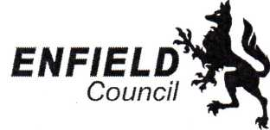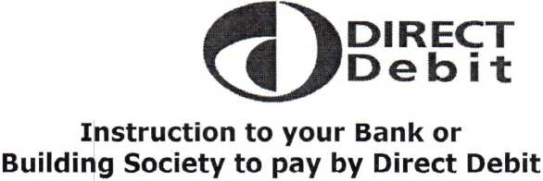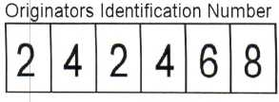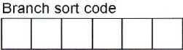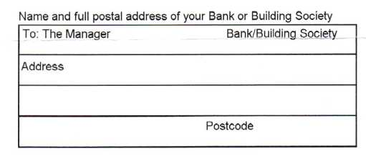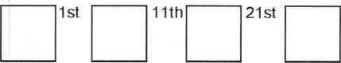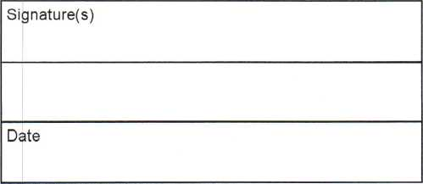
Please fill in the whole form excluding official
use box using a ball point pen and send to:
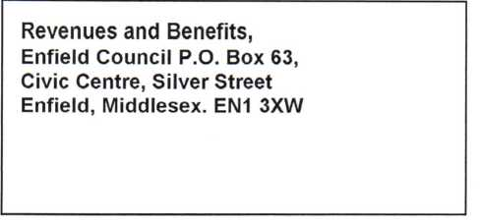
Name(s) of Account Holder(s)
Property Address
109 Burncroft Avenue
Enfield
EN3 7JQ
This is not part of the instruction to your Bank or Building Society
Bank/Building Society account number
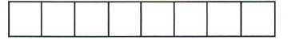
COUNCIL TAX/BUSINESS RATES ACCOUNT NUMBER
 | W 1  o  /■V/% | 55<

Choice of Payment dates
Please tick your preferred Direct Debit payment date;
28th
Instruction to your Bank or Building Society
Please pay Enfield Council Direct Debits from the account detailed in the instruction subject to the safeguards assured by the Direct Debit Guarantee. I understand that this instruction may remain with Enfield Council and, if so, details will be passed electronically to my Bank/Building Society.
Banks and Building Societies may not accept Direct Debit instructions for some types of account.
This guarantee should be detached and retained by the payer
The Direct Debit Guarantee
/■^DIRECT
yf| /Deb i t
- This guarantee is offered by all Banks and Building Societies that accept instructions to pay Direct Debits.
- If there are any changes to the amount, date or frequency of your Direct Debit Enfield Council will notify you at least 10 working days in advance of your account being debited or as otherwise agreed. If you request Enfield Council to collect a payment, confirmation of the amount and date will be given to you at the time of request.
If an error is made in the payment of your Direct Debit by Enfield Council on your bank or building society you
- are entitled to a full and immediate refund of the amount paid from your bank or building society.
If you receive a refund you are not entitled to, you must pay it back when Enfield Council asks you to.
You can cancel a Direct Debit at any time by simply contacting your bank or building society. Written
- confirmation maybe required. Please also notify us.

