Subject: Follow-up on Complaint – Misleading Baggage Information & Reimbursement Request
Dear Trip.com Customer Services Team,
I appreciate the effort your team has made to review my complaint regarding my travel experience from London to Antalya and back. However, I must firmly challenge several aspects of your response, particularly regarding baggage inclusion, misleading booking details, and the consequences of these discrepancies.
Misleading Baggage Information on Trip.com’s Platform
While I understand that baggage allowances are displayed during booking, my experience demonstrates that the options presented were unclear. Based on Trip.com’s website, I reasonably believed that my booking included a carry-on allowance. However, upon arriving at the airport, I was informed by EasyJet staff that my booking did not include “Any” “Baggage,” neither carry-on nor checked.
Your response indicates that carry-on baggage was successfully added, yet this was “Not Reflected In My Itinerary Or Acknowledged By Airline Staff At The Airport.” This inconsistency directly impacted on my ability to board smoothly, contradicting your assertion that all necessary baggage information was clearly presented.
Contradictory Information from Airline Staff at the Airport
Upon arrival at the airport, the “First EasyJet Area We Encountered Was The Bag Drop Check-In Area,” where EasyJet ground operations staff were present. Given our unfamiliarity with the terminal layout, we reasonably assumed this was the correct location to check in our baggage. However, after spending time at this area, it became clear that it was “Solely For Checked Baggage,” leading to unnecessary confusion.
Contradictions Between Trip.com’s Itinerary and EasyJet’s Policies
- Initial Interaction with EasyJet Staff:
  - A staff member reviewed my “Trip.Com Itinerary On My Mobile Device” and informed me that “Neither Checked Nor Carry-On Baggage” was included in my booking.
  - This was “Contrary To My Understanding” that I had “Already Paid For A Carry-On Allowance Through Trip.Com.”
  - To confirm, the staff member checked whether my suitcase fit into the designated sizing frame and instructed us to ‘Quickly Head Upstairs!’ to finalise the baggage process.
- Further Discrepancies Upstairs:
  - Once upstairs, another “EasyJet staff member claimed my bag was too large,” without even checking it with a “Baggage Sizer” or “Luggage Size Checker” and this required additional payment and despite the fact that “The Bag Had Already Been Checked Downstairs And Confirmed To Fit Within The Allowed Dimensions.”
  - I explained the prior verification and pointed out that “My Paid-For Baggage Was Not Showing On My Itinerary, and I Had Paid For It,” but the staff insisted that I had to pay again.
- Forced Additional Payment & Flight Cancellation:
  - The lack of clarity between “Trip.com’s booking details and EasyJet’s enforcement of baggage policies” resulted in my “Baggage Wrongly Being Refused.”
  - Ultimately, I was forced to “Return Downstairs And Pay For Checked Baggage,” despite I had paid for additional carryon luggage to Trip.com.
  - Even after making this payment, “The Flight Was Still Missed And Through No Fault Of Our Own” due to time lost resolving the baggage dispute.
Request for Claim Review: The “Failure Of Clear Communication And Misleading Information” on Trip.com’s platform directly contributed to these issues. I request a “Formal Review of My Claim,” considering:
- The confusion caused by “Trip.com’s Inconsistent Baggage Policy Presentation.”
- The “Contradictory Statements From EasyJet Staff,” which resulted in unnecessary financial costs and logistical delays.
- This systematic misalignment between “Trip.com’s Itinerary Details And EasyJet’s Baggage Enforcement Is A Clear Failure Of Transparency.” I urge you to “Re-Evaluate My Case Fairly,” acknowledging the financial losses and undue inconvenience I have suffered.
Incorrect Assessment of Why My Flight Was Missed
Your response states that my flight was missed due to travel document issues. This claim is “Factually Incorrect.” The primary factor contributing to the delay was the baggage dispute, which forced me to navigate inconsistent guidance from airport staff, ultimately resulting in time lost and the inability to board as scheduled.
Had Trip.com provided clearer, “Accurate” baggage information at the time of booking, this incident would have been avoided entirely. The claim that the airline transferred me to a later flight at no cost does not negate the undue stress, inconvenience, and additional expenses incurred due to misleading information on your platform.
Reimbursement Request & Next Steps
Given the “Lack Of Clarity” during booking and “Misalignment” between Trip.com’s itinerary details and EasyJet’s enforcement, I request a formal review of my claim for reimbursement. Specifically, I request compensation for the additional charges paid due to incorrect baggage classification:
- Direct Financial Losses Incurred
- These costs are a direct consequence of Trip.com's misleading booking system and EasyJet’s failure to recognize the added carry-on baggage allowance at check-in

- Baggage Fees Paid Due to Misrepresentation
- £40.00 at Gatwick Airport: Forced to pay for checked baggage due to EasyJet staff incorrectly claiming no baggage was attached to the booking.
- £69.63 at Antalya Airport: Additional unexpected baggage cost upon return flight due to same misclassification issue.

- Additional Expenses Caused by the Missed Flight
- £46.00 Train fare (Gatwick → Luton): Incurred to rebook after EasyJet refused boarding.
- £120.32 Hotel accommodation: Required due to missed flight and forced rebooking.
- £23.00 Food expenses (Luton Airport): Cost incurred while awaiting new travel arrangements.

- Stress, Disruption & Emotional Distress Compensation
- Beyond direct financial losses, Trip.com’s “Negligent Handling, Misleading Booking Process, And Repeated Refusal To Properly Investigate” have led to significant stress, inconvenience, and financial strain.
- £50.00 Daily inconvenience rate (starting from 20 March 2025): Ongoing personal disruption caused by handling the claim.
- £25,110.00 Legal Fees: Costs related to advocacy, research, correspondence, and case preparation.

- Accountability for Misleading Consumer Practices
- Trip.Com Knowingly Misrepresented Baggage Policies: through deceptive website layouts and visual elements, forcing unnecessary purchases.
- They Failed To Provide A Clear, Verifiable Booking Itinerary, resulting in contradictions with EasyJet staff and forcing additional payments.
- Their Responses Continuously Avoid Key Findings, causing unnecessary delays, which contributed to financial, emotional, and logistical distress.
I urge you to reconsider your decision and take responsibility for the misleading presentation of baggage details on your booking platform, which contributed to significant financial and logistical disruption. Kindly review my claim again and provide a fair resolution.
I look forward to your response.
Best regards, Mr. Simon Paul Cordell
P.S.
Here's a consolidated list of all the key issues that Trip.com has “Either Avoided Or Misrepresented” in their responses:
Checklist of Unresolved Issues in Trip.com’s Responses
1. Misleading Baggage Information During Booking
- Issue: Trip.com’s website implied that carry-on baggage was included, but EasyJet staff later claimed, “No Baggage Was Associated With The Booking.”
- Impact: This led to last-minute confusion at the airport.
- Previously Mentioned In:
  - Complaint Letter (Booking Process Section)
  - Emails on 10 & 14 April 2025
2. Contradictory Information from Airline Staff at the Airport
- Issue: Different EasyJet staff members gave “Conflicting Instructions” on whether my bags was acceptable.
- Impact: Led to wasted time, extra costs, and ultimately missing my flight.
- Previously Mentioned In:
  - Complaint Letter (Exhibit E – EasyJet Supervisor’s Response)
  - Email on 28 March 2025
3. Confusion Caused by Inconsistent Itinerary Details
- Issue: Your itinerary “Did Not Reflect The Added Carry-On Baggage,” causing rejection by EasyJet staff.
- Impact: Forced unnecessary payments for checked baggage.
- Previously Mentioned In:
  - Emails on 10 & 14 April 2025
4. Unjustified Airport Charges for Baggage
- Issue: You were charged “£40 at Gatwick” and “£69.63 at Antalya” due to misleading baggage policies.
- Impact: Financial loss caused by lack of clear booking information.
- Previously Mentioned In:
  - Complaint Letter (Exhibits D & J)
  - Emails with Trip.com (Karl & Jobert, 10–12 April 2025)
5. Misrepresentation of Why the Flight Was Missed
- Issue: Trip.com claims my flight was missed due to “Travel Document Issues,” ignoring that it was about the baggage dispute.
- Impact: Deflects responsibility for misleading baggage handling.
- Previously Mentioned In:
  - Email on 17 April 2025
  - Complaint Letter (Journey Details Section)
6. Failure to Assign a Dedicated Caseworker
- Issue: Multiple requests for “A Dedicated Caseworker” to oversee my complaint were ignored.
- Impact: No streamlined resolution or accountability.
- Previously Mentioned In:
  - Email on 24 March 2025
  - Follow-up on 28 March 2025
7. Lack of Transparency in Baggage Policy Links
- Issue: Trip.com “Did Not Provide Direct Airline Policy Links” before purchase, leading to assumptions about baggage inclusion.
- Impact: Created confusion about what was actually included.
- Previously Mentioned In:
  - Complaint Letter (Booking Experience Section)
  - Email on 10 April 2025
8. Misleading Use of Images to Push Baggage Fees
- Issue: Booking platforms—including Trip.com—use deceptive practices to misrepresent baggage policies.
Passengers are manipulated into believing they must “Pay For Any Suitcase,” even when airline policies allow certain personal and carry-on baggage at no extra cost. This practice results in “Unnecessary Spending” and confusion at check-in.

- How Manipulation is Achieved:
1. Misleading Visual Aids
- Booking platforms “Deliberately Depict Only Rucksacks” as acceptable personal items on flights.
- This “Excludes Suitcases” from visual representations, “Creating The False Impression” that passengers must pay extra to bring standard carry-on baggage.

2. Lack of Clear Text-Based Descriptions
- “No Clear Statements” explaining that “Small, Medium-Sized, And Large Suitcases” can qualify as personal or carry-on baggage under most airline policies.
- This omission “Leads Passengers To Assume They Cannot Bring A Suitcase Without Paying An Additional Fee.”

3. The Reality: Airline Policies vs. Booking Site Representations
- “99% Of Airlines Allow A Broad Range Of Personal Items,” including different sizes of suitcases, as long as they meet “weight and size regulations.”
- “Trip.Com And Similar Platforms Misrepresent These Policies,” leading consumers to believe restrictions exist when they do not.

4. Uniform Manipulation Across Travel Platforms
- The systematic use of misleading visuals and ambiguous descriptions is consistent across multiple booking agents.
- This creates widespread confusion, compelling passengers to purchase baggage they might not actually need.

5. Contradictory Information on EasyJet’s Website & Video
- “EasyJet’s Official Baggage Policy Does Not Require Passengers To Pay For Carry-On Suitcases” if they fit within the airline’s specified dimensions.
- However, “Trip.com’s Interface Displays Contradictory Baggage Requirements” that mislead customers into believing additional baggage fees are mandatory.
- A “Specific Video On EasyJet’s Website” intended to clarify baggage rules “Was Unavailable,” yet its content “Still Exists And Contradicts What Was Presented At Booking.”
  - Extract from EasyJet Video: Exhibit A1 (referenced)
  - Archived URL: horrific-corruption-files.webhop.me/PNC66/1. . PNC-Errors-and-Its-Other-Claims/05-01-25-till-25-01-25-File-Locked4Sharing/Teeth-14-01-25/02. Trip Com And Airlines-Claim-PartSent/00. Cabin-Bags-Explained-EasyJet-27-02-25/
Conclusion:
Trip.com and other platforms “Intentionally Mislead Consumers By Manipulating Visuals And Policy Descriptions,” resulting in passengers “Wrongly Believing They Must Pay For A Suitcase.” The inconsistencies between “EasyJet’s Official Policy, Trip.com’s Booking Interface, And The Missing Yet Contradictory Video Evidence Further Reinforce The Deceptive Nature Of These Practices.”

10. Opaque Revenue Model for Baggage Fees
- Issue: Trip.com “Prioritise Baggage Fees As A Separate Revenue Stream” rather than aligning with airline policies.
- Impact: Customers may “Unnecessarily” pay for luggage that should be included.
- Previously Mentioned In:
  - Complaint Letter (Baggage Revenue Analysis)
  - Email on 24 February 2025
11. Repetitive Excuses Instead of Proper Review
- Issue: Trip.com continually uses “Generic Responses” about baggage policies instead of directly addressing your concerns.
- Impact: Prevents a “Proper Investigation” into misleading booking details.
- Previously Mentioned In:
  - All Follow-up Emails (Feb–Apr 2025)
  - Latest Email (17 April 2025)
12. Hidden Taxes and Fees:

There seems to be some misunderstanding regarding my experience using Trip.com’s services. In reference to the statement quoted as Exhibited: “When booking a flight, please be aware that you have the option to review the baggage allowance included with your ticket. The details clearly indicate which types of baggage—personal, carry-on, or checked—are included with the flight. Please refer to the photos below for reference”.

Explanation: There are multiple stages during the booking process where additional baggage can be added. I chose to wait until the final stage to book my baggage so that I could better understand my flight options and select what suited me best. After I paid Trip.com for additional baggage along with my flight bookings, Trip.com sent me an email that allowed me to log into my booking account page. It was on this page that I finally managed to identify the issue as I observe the separation between paid and free sections related to baggage, as shown in the attached screenshot.
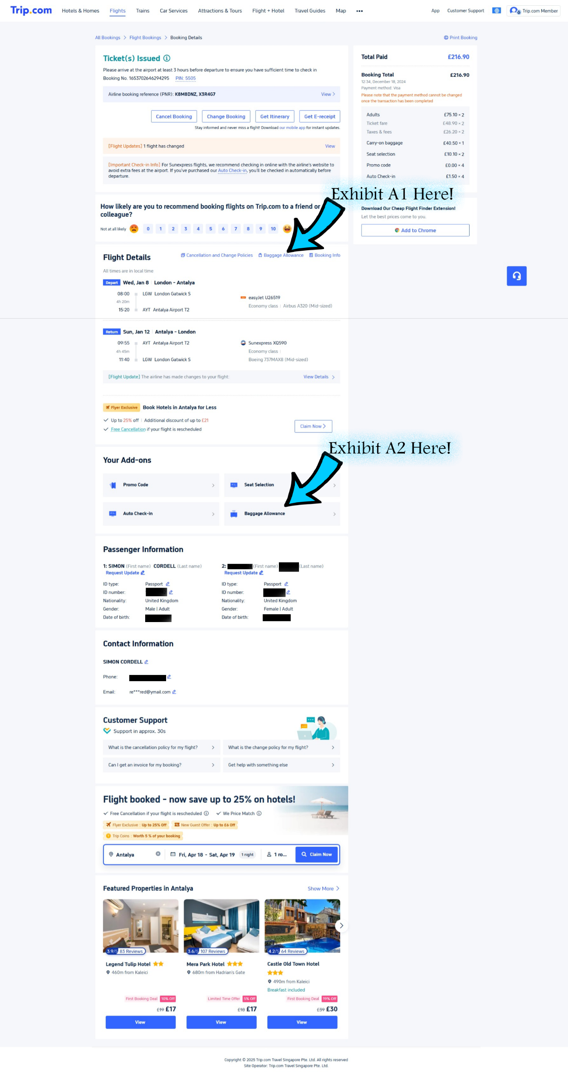

The confusion was not entirely caused by the booking process itself. It arose when I tried to verify that I had ordered everything I needed. I believed that the purpose of the email sent by Trip.com was to provide a final, sealed confirmation invoice that would be easy to understand—but it was not.
The screenshot I am referring to above is dated 19th of April 2025, and is from the Trip.com website, specifically from my personal account page.
I have since visited the Trip.com website, after the telephone call received as the 22nd, correspondence between myself and Trip.com staff, who then explained that they were unable to access my account due to security restrictions. As a result, they could not review my itinerary or booking confirmation page. I informed them that I had previously included screenshots of these documents in my claim letter, and that their failure to acknowledge these exhibits demonstrates a disregard for my claim. Consequently, I have re-submitted some of these files as exhibits.
Within my main claim letter, I included notes explaining that I became aware of sudden changes being made to the Trip.com and EasyJet websites, where the reasons to my claim’s existence were being edited. These changes began occurring after I disclosed the nature of the three ongoing claims, to all the accused as liable across the three claims. which all arose while I was traveling abroad to undergo dental treatment. The note I made is titled and dated as follows:
“3) Amendments and Feedback: Thank you for your understanding and cooperation. Also, Trip.com’s website is being updated 26-02-2025 at 22:28 as to when io looked at it I noticed the changes being made! The Additional Baggage Allowance has changed and more.”
Trip. Com’s customer services and its affiliated departments, i.e. Management and ground staff teams must work in coordination with one and other to avoid discrepancy so that consumers are not conflicted with contradictory information or mislead.
The inaccurate information initially supplied to customer service—and subsequently provided to me in their response emails regarding my claims—amounts to an illegal cover-up.
This cover-up arises because customer service was evidently not informed by their management staff about the actions taken by other affiliated departments.
Furthermore, it seems that Trip.com’s website development and management teams attempted to rectify the issues I raised, not to transparently resolve them, but rather to protect the company and limit further damage. In doing so, they effectively concealed my truthful claims, for which Trip.com is liable. Preventing me from pursuing my rightful claim by withholding relevant information that supports my case is an illegal action.
Initially, as shown in the screenshots above, Exhibit A1 and Exhibit A2 were located in completely separate sections of the website, effectively dividing and isolating the information. In the most recent version of the site, both Exhibit A1 and Exhibit A2 share the same heading: “Baggage Allowance,” which was not the case when I originally booked my travel.
Additionally, in the earlier website layout, clicking on Exhibit A1 and Exhibit A2 led to different pages. Now, both links redirect to the same new webpage—one that did not exist at the time of my booking. This updated page consolidates the previously separate content into a single, cleaner, and more user-friendly format, presumably designed to prevent customers from encountering the contradictory information that I experienced.
To illustrate this, I have provided screenshots of the new layout in two parts, including an additional weblink that deserves attention below, followed by images of the original website layout for comparison.
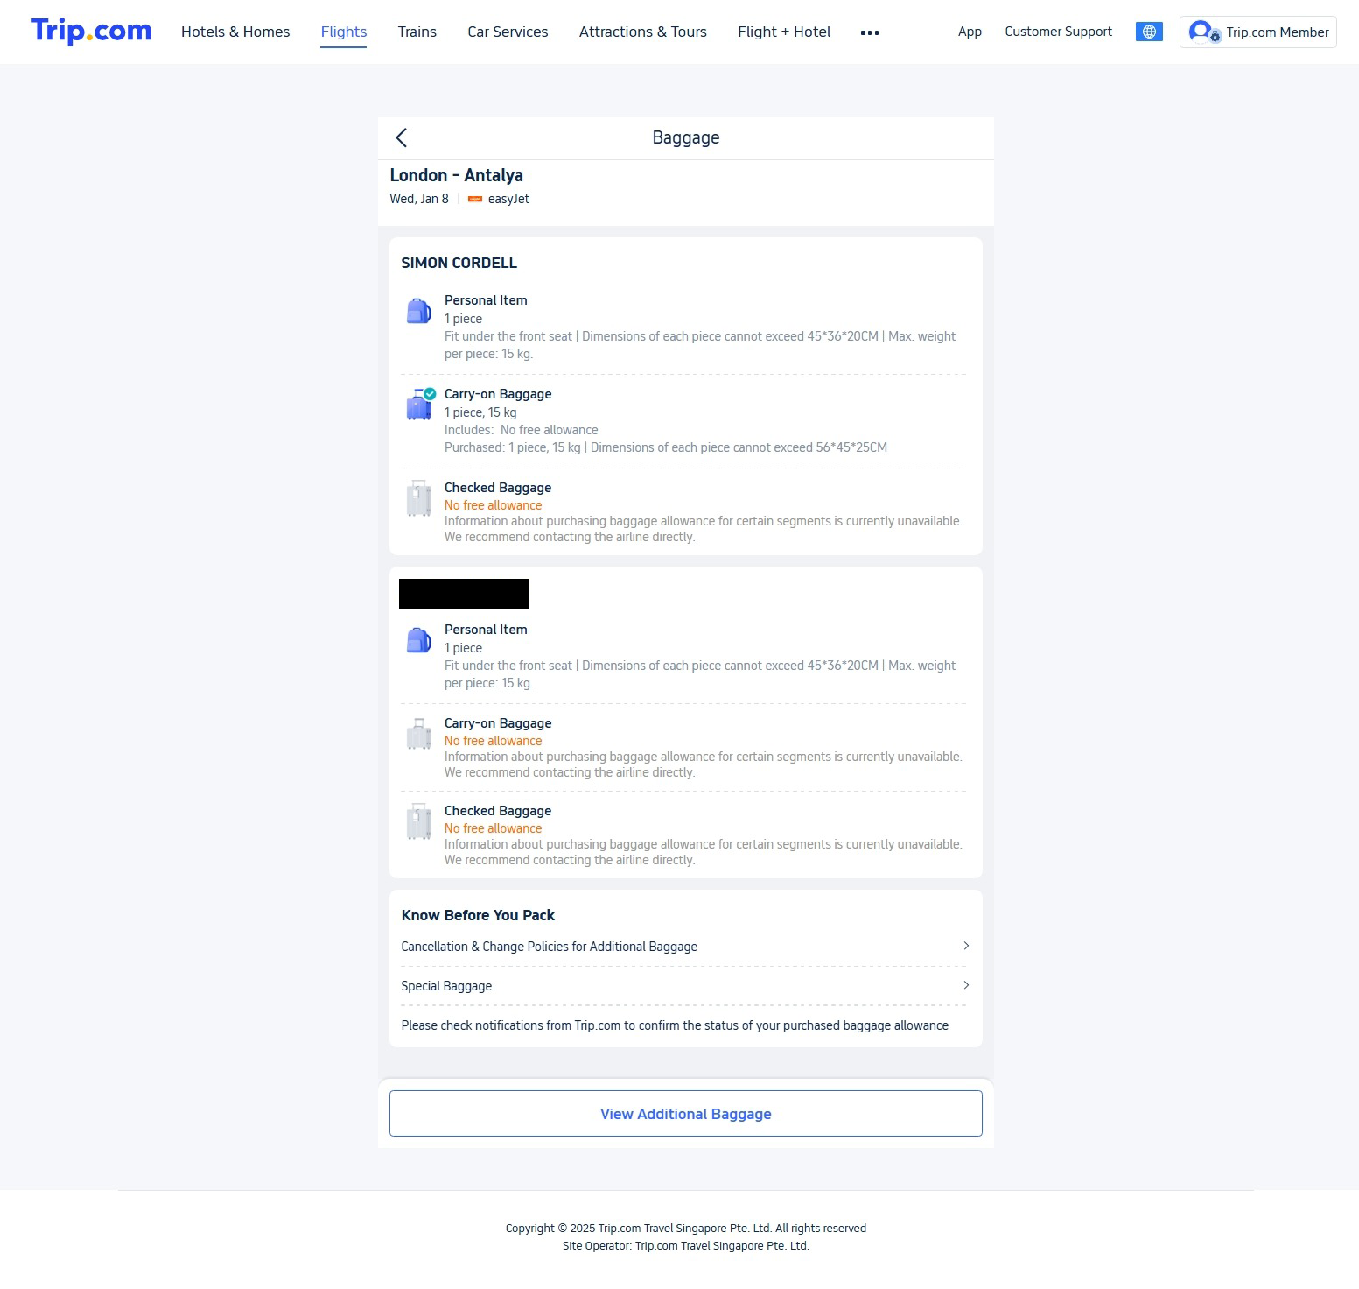
When you click the weblink that states “View Additional Baggage” the next screenshot is where you get directed to.
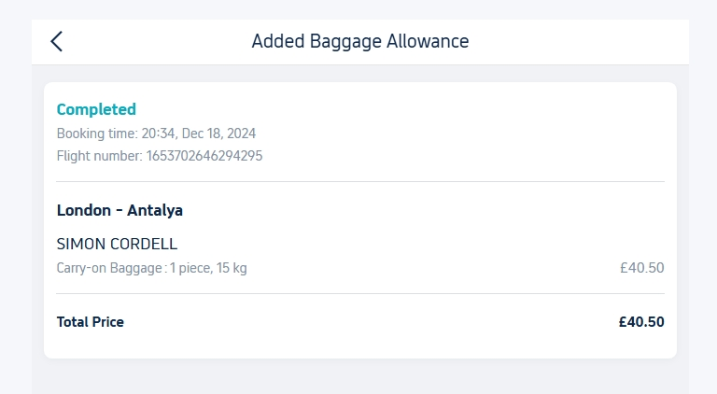
The next below screenshot is off the original Website layout that I used to book my orders.
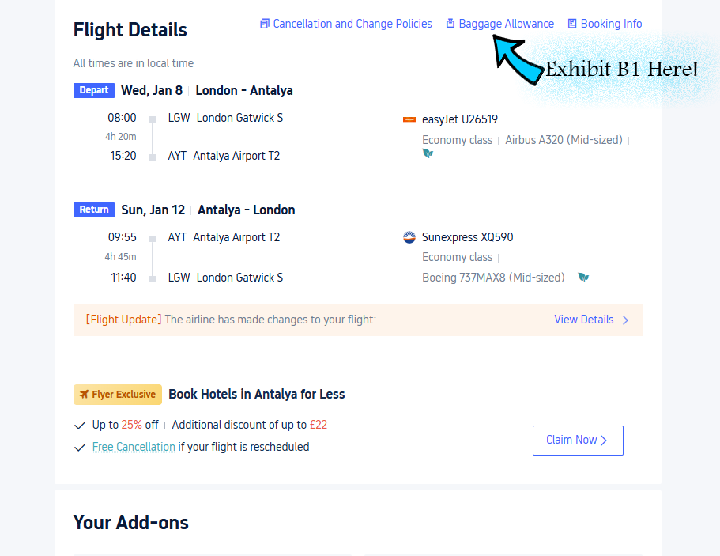

Inside of the Trip.com website there is a navigation menu, and these sorts of menu’s are normally an index of the content in the webpage. Website navigation menus are designed to easily navigate through large quantities of intel and the titles and content are to be of the same information. Trip.com’s website never followed this standard protocol and designated the top menu link to a free section for baggage allowance and while the weblink associated with it further down in the webpage directed you to another page content for paid for baggage. These weblinks are not normally different from one to the other to prevent people from going through what I am going through. Misinformed information that was not transparent to the consumer.
Throught the complete Trip.com website there was no weblinks or explanation as to EasyJet’s free 15kg “Carry-On” “Personal Item,” other than in the baggage allowance that without notification could any consumer understand as to why, unless they paid for Trip.com’s 15kg additional baggage allowance and confused the two.
In the exhibition there is an Exhibit B1 demonstrating the original weblink. The original weblinks title was and still is titled as “Baggage Allowance” and once clicked on it directed you to the following weblink that we have exhibited as a screenshot!

The original weblink directed you to the following screenshot below!

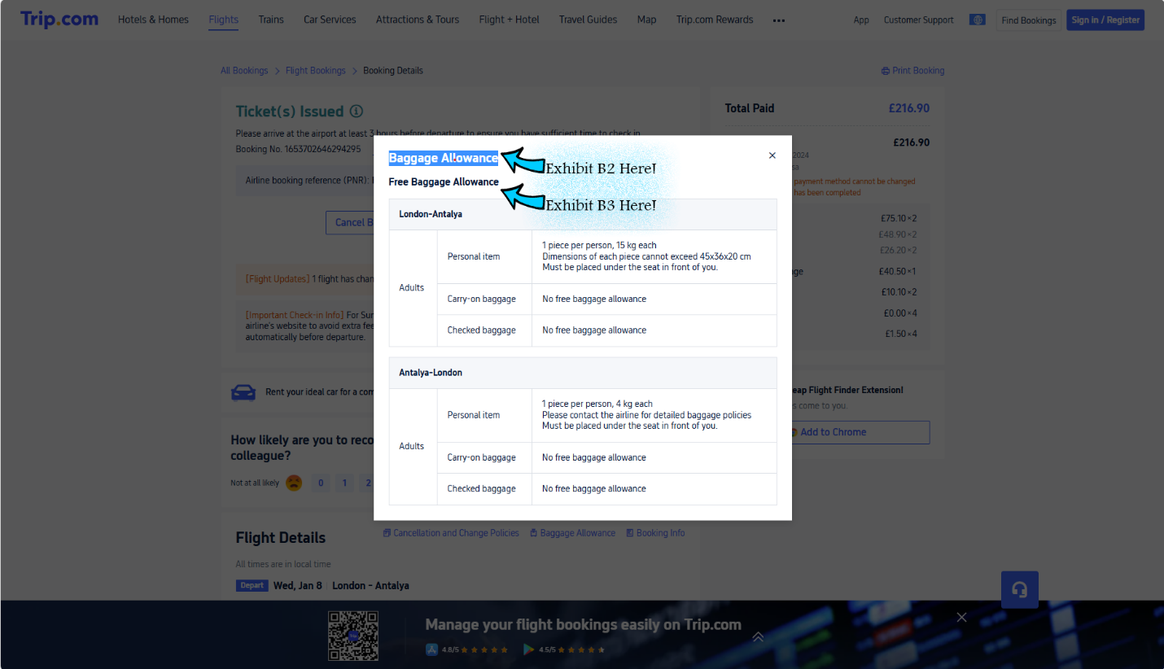

and underneath that is another title labeled as free baggage that is Exhibited as B2.

When any consumer was using the trip.com website “Exhibit B2” and Exhibit B3 both became confusing as to their real purpose was not identifiable enough. Consumers who had purchased additional baggage was led to believe that “Exhibit B2” was the paid for content and “Exhibit B3” was the free content and in instances where there was a free 15kg baggage allowance as EasyJet allows, and no explanation this easily misleads customers into believe this is there paid for baggage, as is what happened to me. There should be no reason s to why I would have to click on both different links in divided places and without instructions as to what is required to understand.

Demonstrating the original second “Baggage Allowance Button” weblink
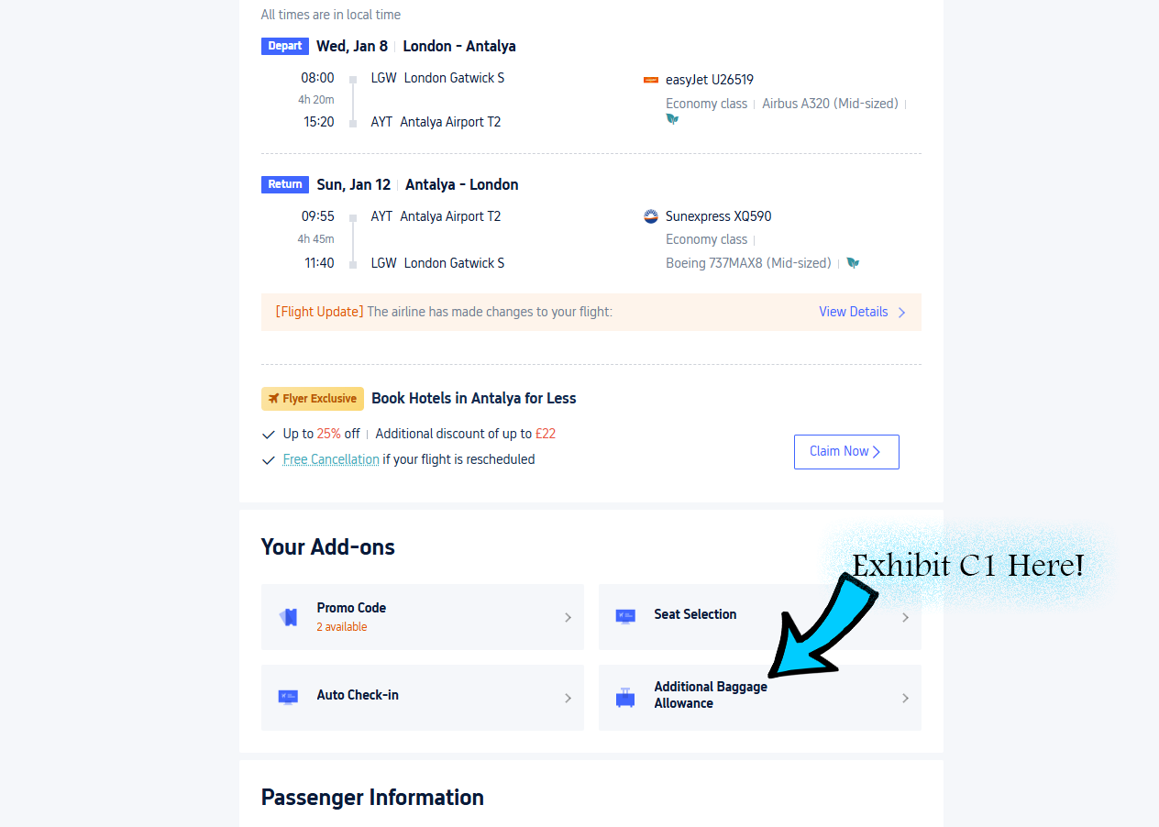

As you can now notice in Exhibit C1 the title has now been changed from what it once was tiled as! “Additional Baggage Allowance!”
Below is what the original Weblink button tiled as ! “Additional Baggage Allowance!” directed you towards as screenshot below!

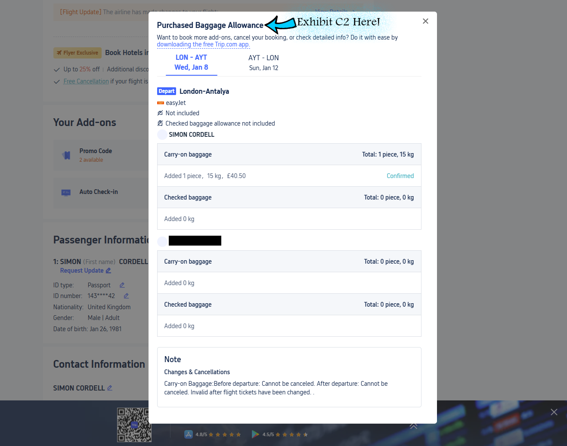

Exhibited Video Link:
Friday, April 18, 2025 3:30 PM 431246967 25. 25th-Sent-Soon.mp4

Transcribe taken From the Exhibited Video:
Saturday, April 19, 2025 10:21 AM 18774 25. 25th-Sent-Soon video transcribe.docx

Notes taken From the Exhibited Video:

“I have since been to the Trip.Com Website and in the 22nd-Received-Tel-Call it was explained by trip. Coms staff that they could not gain access to my account due to security challenges and due to this they could not review the Itinerary or my booking confirmation page. I explained that I had prior screenshot these exhibits in my claim letter and that their lack of acknowledgement to the exhibits shows disregard towards my claim. For this reason, I have re exhibited some of these files.”

The itinerary below proves my sealed invoice from trip.com did not include my purchased product of a baggage allowance from them.

- Itinerary
- I received an email containing a link that I can click to access my bookings page after making a purchase. Once there, I can find another link to download my itinerary as a PDF.

- Exhibit: 21

