Email:
Claim no.
Subject: Final Submission of Pre-Action Conduct Letter & N1 Claim Form – Booking No. 1653702646294295
Dear Trip.com Customer Success and Legal Team,
I am writing to formally enclose my “Pre-Action Conduct Letter” and completed “N1 Claim Form,” which detail the unresolved issues surrounding my compensation request. Despite Trip.com’s acknowledgment of liability, your continued refusal to honor your own “Customer Service Guarantee” and “Advance Compensation Policy” leaves me with no option but to escalate this matter further.
- Key Points in Support of My Claim:
- Acknowledgment of Liability:
  - Trip.com has “admitted fault” regarding baggage fees incurred; “£40 At Gatwick” and “£69.63 In Antalya,” but Trip.com staff continues to “Refuse Full Compensation” for additional losses caused by their service failures. Specifically, “Trip.Com Has Accepted Liability” for baggage purchased through their website but ultimately “Not Provided As Part Of The Service”.
  - While both “Departure And Return Flights” are acknowledged, Trip.com has only accounted for certain costs directly “Paid At The Airport,” ignoring “Original Payments” made through their website that have yet to be “Fairly Reimbursed.”
  - Additionally, compensation has “Not Been Provided” for “Extra Seats Purchased” to ensure passengers could sit together, despite these seats being “Paid For Via Their Platform But Never Honored.”
  - Trip.com's “Failure To Fulfill Their Service Obligations” forced us to travel to a “Different Airport” and book an alternative flight, “Resulting In Further Unavoidable Costs.” These expenses are “Clearly Exhibited In The Claim File” with detailed explanations proving that they were incurred “Through No Fault Of Our Own,” expenses for which “Trip.Com Has Accepted Liability Yet Refuses To Pay,” even when their own “Price Guarantee” explicitly states that full reimbursement is “Protected In Such Circumstances.”

- Contradiction of Policies:
  - Your “Customer Service Guarantee” states that verified claims must be processed within one working day after checkout, yet this timeframe has been repeatedly breached.
  - The “Advance Compensation Policy” promises reimbursement in cases where Trip.com is at fault, further supporting my entitlement to the requested amounts.

- Breach of Disclosure Obligations Under CPR 31.12:
  - Trip.com has failed to acknowledge my formal request for insurance policy disclosure, which is critical for case analysis. In accordance with “Civ il Procedure Rules (CPR) 31.12,” I reiterate my request for the immediate provision of all relevant policy documents.

- Substantial Financial and Emotional Impact:
  - Direct financial losses include legal fees, client, and legal expenses as well as stress fees & website analysis fees, total £26,647.19 and additional travel, and accommodation expenses.
  - The ongoing delays and mishandling have caused significant stress and disruption, which further amplifies the need for full compensation. £26,647.19.

- Next Steps:
- Trip.com must:
- Confirm Receipt Of This Submission: and your intention to comply with the compensation request.
- Provide A Clear Timeline For Action: or engage in meaningful alternative dispute resolution within 14 days.
- Comply With The CPR 31.12 Disclosure Request: by providing relevant policy documents within the same timeframe.
- Failure to respond adequately will result in the immediate filing of the enclosed “N1 Claim Form” with the Civil Court, seeking full compensation, costs, and statutory interest.
- For transparency, I have attached a “Chronological Summary Of All Correspondence” between myself and Trip.com to substantiate my claim.
- I urge Trip.com to take this opportunity to resolve the matter amicably and avoid unnecessary legal proceedings. I look forward to receiving your formal response.
- Acceptance of Partial Payment & Continued Claim for Full Compensation:
- “I appreciate Trip.com’s offer to compensate me” for the “Baggage Allowance Fees Paid” at the “London Gatwick Airport of GBP 40” and at “Antalya Airport GBP 69.63.” of “£109.63,” which I accept “Without Prejudice” as a “Partial Settlement.” However, this “Does Not Resolve” the full financial losses detailed in my claim, nor does it account for “Trip.com’s Admitted Liability” for consequential damages.
- Settlement Before Court Action:
- ✔ If Trip.com “Processes The Full Payment Immediately,” the total compensation remains as originally requested: 📌 £26,647.19, covering expenses up to ‘21/04/2025,’ per the Pre-Action Conduct Letter.

- Claim if Litigation Proceeds:
- ✔ If Trip.com fails to provide full reimbursement “Within The Specified Deadline,” the claim will escalate to court.
- ✔ The total amount will then “Increase,” reflecting legal costs, court fees, and additional expenses incurred “From 21/04/2025 To The Present Date (07/05/2025), With Ongoing Accruals.”
- 📌 “Current Total As Of 07/05/2025: £35,306.31,” per the N1 Claim Form.
- 📌 Additional amounts will be added “For Each Day Beyond This Date” until full resolution.

- Bank Details for Processing Partial Payment:
- Should Trip.com wish to settle the “Original Sum (£26,647.19)” before court action, please process payment to the following details:
- Account Holder: Simon Paul Cordell
- Bank Name: [Your Bank]
- Sort Code: [Your Sort Code]
- Account Number: [Your Account Number]
- Reference: [Include relevant reference for tracking]
- While I accept this present offered payment as “Partial Settlement, I Do Not Waive My Legal Rights” to pursue the full amount in court if necessary.

- Legal Basis for Continued Claim:
- This claim is legally supported by the following provisions:
- Consumer Rights Act 2015: Protects consumers from financial harm caused by unfulfilled service agreements.
- Civil Procedure Rules (CPR) 46.5: Confirms entitlement to recover costs incurred by litigants-in-person.
- CPR 31.12 (Disclosure Request): Requires Trip.com to provide all relevant policy documents for transparency.
- Customer Service Guarantee & Advance Compensation Policy: Trip.com’s own policies mandate timely compensation.

- I would also like to remind you that under the “Civil Procedure Rules (CPR) 2014,” litigants-in-person are entitled to recover reasonable costs and expenses related to pursuing a claim. The legal fees incurred were a necessary consequence of Trip.com’s inability to resolve my claim promptly and fairly. Therefore, I request an additional reimbursement to cover these expenses, which amount to the detailed invoices provided below!
- It is crucial to highlight that the compensation offered reflects a partial acknowledgment of Trip.com legal obligations under the “Consumer Rights Act 2015.” I request written confirmation that the offered compensation amount will be processed promptly.
- By addressing these issues comprehensively, Trip.com can demonstrate its commitment to fairness, accountability, and compliance within the United Kingdom’s legal standards, to be complied with.
Best regards, Simon Paul Cordell Attachments:
- Index
- Pre-Action Conduct Letter!
- N1 Claim Form!
- Chronological Summary of Correspondence!
Claim No.
Issue Date

Pre Action Conduct Letter

Claimant Name | - Name: Simon Paul Cordell |  | Defendant(S) Name | - Name: Trip.com Customer Success Team.  - Name: Trip.com Headquarters, Global Customer Support Division.
Address Including Postcode | - Address 1: 109 Burncroft Avenue  Enfield, London  - Post Code: EN3 7JQ. |  | Address Including Postcode | - Postal Address 1: 9F, Building A, Minhang District, Shanghai, China, 201107.  - Postal Address 2: Trip Air Ticketing (UK) Limited Address, 30 Raffles Place, #29-01, Singapore 048622  - UK customer service team helpline: 0808 196 9996

BRIEF DETAILS OF CLAIM
To: Trip.com Customer Success Team
From: Simon Paul Cordell
Date: 25th of April 2025
Booking Number: 1653702646294295

Subject: Formal Pre-Action Notice – “Failure to Honor Compensation Policies & Disclosure Request!”
Dear Trip.com, Legal Department,
This letter serves as “Formal Notice” under the “Pre-Action Protocol For Civil Claims In England And Wales.”
- COMPLIANCE WITH PRE-ACTION CONDUCT UNDER CIVIL PROCEDURE RULES

Given that Trip.com has “Already Accepted Liability,” I formally request the following:
- Settlement Confirmation: Full payment of outstanding compensation within “14 days” of receipt.
- Alternative Dispute Resolution Consideration: If full settlement is not confirmed, Trip.com must engage in “Mediation, Arbitration, Or Negotiation” within “28 days” before court proceedings commence.
- Formal Disclosure of Relevant Insurance Policies: Under “CPR 31.12,” Trip.com must provide all relevant policy documents within “14 days,” ensuring transparency before litigation.

Failure to comply will result in “Immediate Legal Escalation,” including a claim for “Costs And Statutory Interest” upon court filing.

- UNRESOLVED COMPENSATION OBLIGATIONS

Despite “Trip.com’s admission Of Liability,” you have refused to honor the “Full Compensation” owed, in direct contradiction to your “Customer Service Guarantee” and “Advance Compensation Policy.”

Additionally, Trip.com has “Failed To Acknowledge My Formal Legal Request” for disclosure of “Relevant Insurance Policies,” which are critically necessary for case analysis.

Under “CPR 31.12,” I formally demand “Specific Disclosure” of all relevant policies to ensure a fair legal process.

- This includes:
- Stress Fees: included in the 29. 29th-Sent
- Additional Client Expenses: included in the 29. 29th-Sent
- Legal Fees: As a “Litigant In Person,” I have undertaken “Significant Legal And Analytical Efforts” to seek resolution. This case aligns with “Rule 46.5 of the Civil Procedure Rules (CPR),” which entitles litigants to recover “Reasonable Costs” for their work. Given Trip.com’s repeated failure to process fair compensation, I am now prepared to escalate legal proceedings.

- FORMAL COMPENSATION REQUEST
- We hereby formally request full compensation for all losses and damages incurred as a direct result of Trip.com’s failure to uphold its Customer Service Guarantee and Advance Compensation Policy. This includes, but is not limited to:

Category | Reason for Compensation | Requested Amount | Exhibit Reference
Trip.com Invoice of Purchases | Misleading charges leading to additional financial burden.  - Seats Not Being Next To Each Other As Booked.  - Loss of Baggage Fees  - Loss of Flight. | £216.90 | A, F, G
Taxi Costs | Loss of taxi bookings due to disruptions, to London Gatwick | £51.50: | B
Omio Train Tickets | Disrupted travel resulting in additional ticket costs. To connect from London Bridge to Gatwick | £53.40 | C
EasyJet Baggage Charge | Reimbursed baggage fees accepted in liability. | £40.00 | D
Additionally  Transportation | Forwarded to Luton Airport  Unplanned travel expenses caused directly by the misinformation in the booking process. Train Tickets X2  (£23.00 + £23.00) | £46.00 | H
Food & Drink Expenses | Forwarded to Luton Airport  Extra expenses incurred during delays and disruptions. | £23.00 | I
Hotel Costs | Our original Booked Holiday accommodation was affected due to booking disruptions. | £120.32 | L
Antalya Airport Baggage Charge | Additional forced payment due to misinformation. | £69.63 | J

Category | Reason for Compensation | Requested Amount | Exhibit Reference
Total Client  Expenses | Subtotal (Without Legal Fees): £216.90 + £51.50 + £53.40 + £40.00 + £46.00 + £23.00 + £69.63 + £120.32 = £621.75.
Legal Fees & Expenses | This is incurred while pursuing this claim and proving financial harm.  Dates: From 12th January 2025 to 12th March 2025.  I have continued to send correspondence since but have not added the additional fees. | Solicitors Legal’  Fees: £12,327.50  Solicitors’  Expenses: £197.94  The total sum of  £12,327.50 +  £197.94 is.  £12,525.44 | N
Analysis Fees | Structured investigation required to verify the claim and provide concrete evidence. If further evidence to prove these claims is requested, it will be provided.  Dates: From 12th January 2025 to 12th March 2025. | £8,500.00 | M
Client Stress fees | Dates:  Starting from 12th January 2025 at a £50.00 Rate! Total £ : Exhibit: M, till the 21/04/2025.  The duration from 12th January 2025 to 21st April 2025 is 100 days.  At a £50.00  Days × £50.00 per day = £5,000.00 | £5,000.00
Pre-Approved  Holiday  Compensation | Your policies confirm compensation for verified disruptions.  I request clarity on how my case qualifies. | Pending confirmation | O
Grand Total as of the 21/04/2025 | The total sum of £621.75f5 + £12,525.44 + £8,500.00 + £5,000.00 is £26,647.19.

- BREACH OF TRIP.COM’S OWN COMPENSATION GUARANTEES
- Your “Customer Service Guarantee” explicitly states:
✔ Verified claims “Must Be Processed Within One Working Day After Checkout.”
✔ “Advance Compensation Policy” confirms reimbursement when Trip.com is found at fault.
- Given that “Trip.Com Has Acknowledged Fault,” refusal to process the full reimbursement “Constitutes A Breach Of These Commitments.”
- FINAL DEADLINE BEFORE COURT ACTION
- If full settlement is “Not Confirmed Within 14 Days,” I will escalate the matter via an “N1 Claim Form.”

- This Will Include Filing This Claim In The Civil Court,” seeking:
✔ Compensation under “CPR 46.5”
✔ Court fees and additional legal costs
✔ Enforcement of insurance policy disclosure under “CPR 31.12”

- Additionally, I have attached a “Chronological Record Of All Correspondence” related to this claim for reference: 🔗 All-Emails-TripCom-and-Co.

- This represents “Trip.com’s Final Opportunity” to resolve this matter “Amicably” before formal litigation. Kindly provide written confirmation of compensation and the requested policy documents “Within 14 Days.”

Best regards, Simon Paul Cordell

VALUE
- Value (Excluding Legal Fees Incurred After 21st April 2025): The total sum of the amounts claimed as of 21st April 2025 is as follows:
- £621.75: Compensation for inconvenience and minor expenses caused by the defendant's actions.
- £12,525.44: Reimbursement for consequential losses, such as missed flights and additional accommodation costs.
- £8,500.00: Compensation for emotional distress, disruption, and ongoing inconvenience.
- £5,000.00: Legal costs associated with filing and pursuing the claim as a litigant in person.

- Grand Total: £26,647.19
- This calculation reflects the claims up to “21st April 2025” and does not include any legal fees or additional expenses incurred beyond this date.

Defendant’s  name and  address for service including postcode. | - Name: Trip.com Customer Success Team.  - Name: Trip.com Headquarters, Global Customer Support Division. | - Postal Address 1: 9F, Building A, Minhang District, Shanghai, China, 201107.  - Postal Address 2: Trip Air Ticketing (UK) Limited Address, 30 Raffles Place, #29-01, Singapore 048622 | UK customer service team helpline: 0808 196 9996
Amount claimed
Total amount | £26,647.19

N1 Claim Form
☒Attached
☒To Follow

In the
Fee Account no.
Help with Fees - Ref no.  (if applicable)
  H | W | F | - |  |  |  | -


N1 Claim Form

For court use only
Claim no.
Issue date
You may be able to issue your claim online which may save time and money. Go to www.moneyclaim.gov.uk to find out more.

Claimant(s) name(s) and address(es) including postcode.
Claimant Name and Address:
- Name: Simon Paul Cordell
- Address 1: 109 Burncroft Avenue
Enfield, London
- Post Code: EN3 7JQ.

Defendant(s) name and address(es) including postcode.
Defendant Name and Name:
- Name: Trip.com Customer Success Team.
- Name: Trip.com Headquarters, Global Customer Support Division.
- Postal Address 1: 9F, Building A, Minhang District, Shanghai, China, 201107.
- Postal Address 2: Trip Air Ticketing (UK) Limited Address, 30 Raffles Place, #29-01, Singapore 048622
- UK customer service team helpline: 0808 196 9996

Brief details of claim
Brief Details of Claim:
- This claim arises from Trip.com’s failure to honor its “Customer Service Guarantee and Advance Compensation Policy,” despite accepting liability for additional baggage fees incurred by the claimant at Gatwick Airport (£40) and Antalya Airport (£69.63). While Trip.com attempted partial reimbursement, it has refused to compensate for consequential financial losses and disruptions caused by its actions.
- The claim also includes litigation fees, stress damages, and out-of-pocket expenses directly resulting from Trip.com's negligence and mishandling of the matter. These costs cover time spent on case preparation, correspondence, and legal consultations required to navigate the claim.
- Furthermore, Trip.com’s prolonged delays and failure to resolve the issue have caused significant emotional distress and disruption to the claimant’s daily life, for which compensation is sought.
- Additionally, Trip.com has failed to comply with formal disclosure requests under CPR 31.12, withholding essential documents critical to the claimant’s case preparation. These failures have further intensified the financial and emotional impact on the claimant.
- A detailed chronological summary of correspondence and supporting evidence is attached to this N1 Claim Form for reference.

Value
- Grand Total as of the 21/04/2025:
- The total sum of £621.75 + £12,525.44 + £8,500.00 + £5,000.00 is £26,647.19.

- New Grand Total:
- Final Invoice Summary:
Category | Amount (£)
Legal Fees (620.12 hours @ £24.70/hour) | £20,194.32
Solicitors’ Expenses | £990.24
Analysis Fees | £8,500.00
Client Stress Fees (100 days @ £50/day) till the 21/04/2025. | £5,000.00
Price Guarantee “Pre-Approved Holiday Compensation”
Other Compensation (Flights, Taxi, Baggage, Food, Hotel, E.g.)  Exhibit Reference: A, F, G. “Trip.com Invoice of Purchases.” £216.90  Exhibit Reference: B. “Taxi Costs” £51.50  Exhibit Reference: C. “Omio Train Tickets” £53.40  Exhibit Reference: D. “EasyJet Baggage Charge” £40.00  Exhibit Reference: H. “Additionally Transportation” £46.00  Exhibit Reference: I. “Food & Drink Expenses” £23.00  Exhibit Reference: L. “Hotel Costs” £120.32  Exhibit Reference: J. “Antalya Airport Baggage Charge” £69.63 | £621.75
Grand Total | £35,306.31

- Money Claims (based on claim amount):
- Over £10,000: 5% of the claim value

- Solicitor Fees (hourly rates vary by experience and location):
- Senior solicitors (8+ years): £282 - £566 per hour
- Mid-level solicitors (4+ years): £242 - £385 per hour
- Junior solicitors/paralegals: £139 - £205 per hour

- EX160 Form:
- https://horrific-corruption-files.webhop.me/PNC66/1.%20PNC-Errors-and-Its-Other-Claims/05-01-25-till-25-01-25-File-Locked4Sharing/Teeth-14-01-25/02.%20Trip%20Com%20And%20Airlines-Claim-PartSent/N1-Claim-Form-%20Used/EX160_1123.pdf

Defendant’s  name and  address for service including postcode. | - Name: Trip.com Customer Success Team.  - Name: Trip.com Headquarters, Global Customer Support Division. | - Postal Address 1: 9F, Building A, Minhang District, Shanghai, China, 201107.  - Postal Address 2: Trip Air Ticketing (UK) Limited Address, 30 Raffles Place, #29-01, Singapore 048622 | UK customer service team helpline: 0808 196 9996

Amount claimed | £
Court fee | £
Legal representative’s costs | £
Total amount | £

For further details of the courts www.gov.uk/find-court-tribunal.
When corresponding with the Court, please address forms or letters to the Manager and always quote the claim number.
N1 Claim form (CPR Part 7) (06.22) © Crown Copyright 2022

Claim no.
You must indicate your preferred County Court Hearing Centre for hearings here (see notes for guidance)

Do you believe you, or a witness who will give evidence on your behalf, are vulnerable in any way which the court needs to consider?

☐ Yes. Please explain in what way you or the witness are vulnerable and what steps, support or adjustments you wish the court and the judge to consider.

N/a

☒ No
Does, or will, your claim include any issues under the Human Rights Act 1998?

☒ Yes
☐ No

For further details of the courts www.gov.uk/find-court-tribunal.
When corresponding with the Court, please address forms or letters to the Manager and always quote the claim number.
N1 Claim form (CPR Part 7) (06.22) © Crown Copyright 2022

Particulars of Claim
☒ attached
Claim no.
☒ to follow
- Particulars of Claim:
- Background: The Claimant, “Simon Paul Cordell,” brings this claim against “Trip.com,” including its Customer Success Team and Global Headquarters, for failure to honor compensation policies despite admitting liability. The claim arises from misleading information provided at the time of booking, leading to financial and emotional damages.
- Admission of Liability: Trip.com has acknowledged fault regarding the additional baggage fees incurred at “Gatwick Airport (£40) And Antalya Airport (£69.63),” yet has refused full reimbursement for consequential losses caused by its misinformation and failure to process compensation in accordance with its own policies.
- Breach of Consumer Protection and Procedural Rules: The Defendant has violated multiple contractual and regulatory provisions, including:
  - Customer Service Guarantee: Trip.com failed to process verified compensation within the promised timeframe.
  - Advance Compensation Policy: Compensation was refused despite the Defendant’s clear fault.
  - Civil Procedure Rules (CPR) 31.12: The Defendant failed to disclose relevant insurance policies necessary for proper case assessment.
- Financial Losses and Emotional Impact: Due to Trip.com’s negligence, the Claimant suffered substantial financial damages, which are concluded but not limited to:
  - Legal fees: “£12,525.44” incurred while pursuing rightful compensation.
  - Analysis Fees: “£8,500.00” required for structured investigation and verification of financial harm.
  - Client Stress Fees: £5,000.00” for prolonged disruption and emotional distress.
  - Unresolved compensation: £621.75 covering flight-related costs, transportation, and additional expenses.
- Failure to Respond Adequately: The Defendant has been presented with multiple opportunities to settle this dispute amicably, including pre-action correspondence detailing all supporting evidence and policy violations. However, Trip.com has repeatedly failed to:
  - Acknowledge the full scope of losses incurred by the Claimant.
  - Process compensation in alignment with its “Customer Service Guarantee” and “Advance Compensation Policy.”
  - Comply with disclosure obligations under “CPR 31.12.”
- Relief Sought: The Claimant respectfully requests the following relief from the Court:
  - Full reimbursement of all losses (£26,647.19).
  - Compensation for legal costs.
  - Compliance with “CPR 31.12,” ensuring disclosure of relevant insurance policies.
  - Statutory interest as applicable.
- The Claimant seeks a formal resolution through the Civil Court unless full compensation is processed within “14 days” from the date of this filing.

- Chronological List of Emails and Telephone Calls:
- 01. 01st-Sent Date: Monday 24 February 2025 at 10:04 GMT: Email Sent: Subject: Ongoing Draft of Complaint - Update From: Rewired To: service@trip.com; customer.service@easyjet.com; customer.service@sunexpress.com
- 02. 02nd-Received 1 of 3 Emails for the second response! Date: Monday 24 February 2025 at 10:05 GMT Email Received: Automated Response from EasyJet Customer Service.
- 02. 02nd-Received 2 of 3 Emails for the second response! Date: Monday 24 February 2025 at 10:04 GMT Email Failed: Failure Notice when attempting to contact SunExpress Customer Service.
- 02. 02nd-Received 3 of 3 Emails for the second response! Date: Monday 24 February 2025 at 10:08:31 GMT Email Received: Response from Trip.com Customer Service.
- 03. 3rd Sent Date: Monday 24 March 2025 at 15:01 GMT Subject: Follow-Up and Request for Resolute Caseworker Regarding Complaint From: Rewired To: service@trip.com; EasyJet Customer Service; SunExpress Customer Service.
- 04. 04th-Sent Date: Friday 28 March 2025 at 11:59 GMT Subject: Follow-up on Previous Correspondence From: Rewired To: service@trip.com.
- 05. 05th-Received Date: Wednesday 2 April 2025 at 13:46 BST Email Received: Advertisement from Trip.com.
- 06. 06th-Made By Me, Making A Call: MP3, I made a telephone call and
- 07. 07th-Received Date: Wednesday 2 April 2025 at 16:48 BST Email Received: Request to Upload Proof for Order from Trip.com.
- 08. 08th-Made MP3 09th April 2025 Time: 23:44 BST Telephone Call Made: Call to Trip.com Customer Support.
- 09. 09th-Received Date: Thursday 10 April 2025 at 00:19 BST Email Received: Feedback Request from Trip.com regarding Booking No. 1653702646294295.
- 10. 10th-Sent Date: Thursday 10 April 2025 at 21:07 BST Email Sent: Response to Baggage Issue Inquiry – Booking No. 1653702646294295 From: Rewired To: en_flightservice@trip.com.
- 11. 11th-Received-Sent Date: Thursday 10 April 2025 at 23:17 BST Email Sent: Updated Claim Letter – Correct Version Attached From: Rewired To: en_flightservice@trip.com.
- 12. 12th-Received Date: Friday 11 April 2025 at 01:14 BST Email Received: Follow-Up from Trip.com regarding Baggage Issue.
- 13. 13th-Received Date: Friday 11 April 2025 at 01:18 BST: This email from Trip.com acknowledges a complaint about a baggage issue on flights between London and Antalya. They are apologizing for the inconvenience and requesting proof of the extra baggage fees paid, “£40.00 at Gatwick (Exhibit D) and £69.63 at Antalya (Exhibit J,)” to investigate the case further. However, they have overlooked the receipts that were already attached to the original claim letter, causing unnecessary delays. Their failure to carefully review the submission suggests a lack of thoroughness in handling the case. Essentially, they are requesting documentation that has already been provided, making it necessary to reassert that the claim was submitted correctly along with the necessary evidence.
- 14. 14th-Received Date: Saturday 12 April 2025 at 01:49 BST Email Received: Final Follow-Up from Trip.com, mentioning case closure if no response is received.
- 15. 15th-Sent Date: Monday 14 April 2025 at 09:52 BST Email Sent: Follow-Up on Claim Submission with Attachments Provided From: Rewired To: en_flightservice@trip.com.
- 16th-Received Monday, 14 April 2025 at 11:50 BST: Trip.com followed up, acknowledging receipt of attachments related to this claim and confirming that the documents would be reviewed to progress the case further.
- 17th-Received Tuesday, 15 April 2025 at 08:44 BST: I received a reminder from Trip.com requesting clarification and additional proof regarding this submitted claim. This email stressed the need for a timely response.
- 18th-Sent Wednesday, 16 April 2025 at 12:33 BST Email Sent: Subject: Supplementary Documents for Case Review From: re_wired@ymail.com To: en_flightservice@trip.com Details: Submission of additional supporting documents, including updated receipts.
- 19th-Received Wednesday, 16 April 2025 at 19:34 BST Email Received: Subject: Confirmation of Receipt of Additional Documents From: en_flightservice@trip.com To: re_wired@ymail.com Details: Confirmation that the supplementary documents have been received, and review is ongoing.
- 20th-Received Thursday, 17 April 2025 at 13:54 BST: Trip.com responded with a clarification email, highlighting specific areas that needed further details or corrections to ensure full review of this case.
- 21st-Received Friday, 18 April 2025 at 18:46 BST Email Received: Case escalation notice from a senior team member at Trip.com who was assigned to oversee the resolution of the case, indicating progression in the review process.
- 22nd-Received Friday, 18 April 2025 at 18:52 BST: I received a “Telephone Call From Trip.Com,” during which the senior case manager discussed additional confirmation of myself for certain expenses, still.
- 23rd-Received Friday, 18 April 2025 at 18:52 BST: Another follow-up email from Trip.com reiterated the information shared during the phone call, stating that they do not accept liability. Once I spoke with a member of staff, it became evident that the claims and accusations were being manipulated and that the information provided was being misleading, diverting attention away from the true nature of the claims.
- 24th-Received Friday, 18 April 2025 at 23:58 BST: Trip.com confirmed receipt of the information I provided them, both via email and over the phone. I was unhappy with how the case was being manipulated during the phone call and requested an email confirming our conversation. However, the email sent to me does not reflect the details I explained nor address my request for a copy of the telephone call recording. Instead, it manipulates the facts in my claim letter to avoid liability. While thanking me for my cooperation and promising a decision soon, the email disregards the key points I raised and highlights Trip.com's attempt to shift responsibility unfairly.
- 25th-Received Saturday, 19 April 2025 at 19:45 BST: While drafting my response, which I posted on my disclosed website, I received an email from Trip.com's Customer Success Team. The email clarified their stance regarding liability for reimbursement of the claim but still failed to address the original payment for the lost baggage and the additional costs incurred.
- 26th-Received Sunday, 20 April 2025 at 17:01 BST: I received an email informing me that a member of Trip.com staff had attempted to call me regarding the partial payment they agreed to provide. At that time, I was still preparing a detailed response to Trip.com, highlighting their price guarantee and formally requesting reimbursement for my additional losses.
- 27th-Received Sunday, 20 April 2025 at 17:07 BST: I received another Follow-up email in regard to the missed telephone call.
- 28th-Received Sunday, 20 April 2025 at 23:03 BST: Trip.com asked me by way of email to provide Feedback on my experience to which I am still responding.
- 29th-Sent Monday, 21 April 2025 at 18:01 BST: I submitted a comprehensive response to Trip.com’s requests, addressing all points of clarification and providing additional evidence as required. In my response, I also emphasised the importance of Trip.com’s compliance with their own policies, including the “Customer Service Guarantee And Advance Compensation Policy.”
- 30th-Received Tuesday, 22 April 2025 at 00:11 BST: Trip.com acknowledged receipt of my response regarding baggage fees and their “Customer Service Guarantee and Advance Compensation Policy,” but they refused to comply. Trip.com informed me that only the baggage fees paid at the airports (£40 at London Gatwick and £69.63 at Antalya) are refundable—not what was paid through their website—and that they will not refund my cost to Luton airport. They did not take any responsibility for the stress I faced, nor for the legal effort it took to get them to accept liability for the cause of the claim problems. Trip.com staff also asked me to confirm whether I would accept this as the only plausible refund offer.
- 31st-Received Wednesday, 23 April 2025 at 00:53 BST: Trip.com sent an email regarding my compensation claim. While acknowledging liability for the situation, the email failed to offer reimbursement for the complete losses I have incurred. Instead, it requested that I accept their current offer as it stands. Additionally, the email indicated that they are awaiting a reply from me to confirm my acceptance before proceeding further. In response, I have been diligently drafting my “Next Email,” including the “Pre-Action Conduct Letter” and “N1 Claim Form,” to address the need for “Recalculating The Complete Settlement” and ensuring that all consequential losses are fully accounted for, if the “Pre-Action Conduct Letter” is not adhered towards.

- 32nd-Received Wednesday, 23 April 2025 at 00:59 BST: I received a duplicate breakdown of the partially approved reimbursement, including amounts to be compensated.

- 33rd-Received Wednesday, 23 April 2025 at 23:25 BST: While I was drafting notes to be agreed upon for the reimbursement of compensation, pending Trip.com's compliance with their own terms and legal obligations for a fair resolution of the claim, Trip.com requested feedback from me again.

For further details of the courts www.gov.uk/find-court-tribunal.
When corresponding with the Court, please address forms or letters to the Manager and always quote the claim number.
N1 Claim form (CPR Part 7) (06.22) © Crown Copyright 2022

Note: you are reminded that a copy of this claim form must be served on all
other parties.
Statement of truth
I understand that proceedings for contempt of court may be brought against a person who makes, or causes to be made, a false statement in a document verified by a statement of truth without an honest belief in its truth.
☒ The facts stated in this claim form and any attached sheets are true.

☒ The claimant believes that the facts stated in this claim form and any attached sheets are true. I am authorised by the claimant to sign this statement.

Signature

☒ Claimant
☐ Litigation friend (where claimant is a child or protected party)
☐ Claimant’s legal representative (as defined by CPR 2.3(1))

Date
07
Day Month Year
May
2025

Full name
Mr. Simon Paul Cordell
Name of claimant’s legal representative’s firm
Mr. Simon Paul Cordell
If signing on behalf of firm or company give position or office held
Litigant

For further details of the courts www.gov.uk/find-court-tribunal.
When corresponding with the Court, please address forms or letters to the Manager and always quote the claim number.
N1 Claim form (CPR Part 7) (06.22) © Crown Copyright 2022

Claimant’s or claimant’s legal representative’s address to which documents should be sent.

Building and street
109 Burncroft Avenue, London, Enfield, EN3 7JQ.

Second line of address
N/a

Town or city
London, Enfield

County (optional)
United Kingdom
Postcode

E | N | 3 |  | 7 | J | Q

If applicable Phone number

DX number

Your Ref.

Email
Re_wired@ymail.com

Find out how HM Courts and Tribunals Service uses personal information you give them when you fill in a form: https://www.gov.uk/government/organisations/hm-courts-and-tribunals-service/about/personal-information-charter

For further details of the courts www.gov.uk/find-court-tribunal.
When corresponding with the Court, please address forms or letters to the Manager and always quote the claim number.
N1 Claim form (CPR Part 7) (06.22) © Crown Copyright 2022

- Summary of Misleading Information:
- The claimant booked a flight through Trip.com’s platform, which presented “Unclear And Inconsistent Baggage Allowance Details.”
- Based on the information provided during booking, the claimant reasonably believed “Carry-On Baggage Was Included” in the booking.
- Upon arriving at Gatwick Airport, EasyJet staff informed the claimant that “No Baggage, Neither Carry-On Nor Checked, Was Included” in the booking, despite the claimant's understanding.
- “Trip.com’s Response Indicated” that carry-on baggage had been successfully added to the booking, yet this “Was Not Reflected In The Claimant’s Itinerary” or acknowledged by EasyJet staff at the airport.
- This “Discrepancy Directly Impacted The Claimant’s Ability To Board Smoothly,” leading to disputes, delays, and financial losses at both Gatwick and Antalya airports.
- Contradictory Information from Airline Staff at the Airport:
- Upon arrival at the airport, the “First EasyJet Area We Encountered Was The Bag Drop Check-In Area,” where EasyJet ground operations staff were present. Given our unfamiliarity with the terminal layout, we reasonably assumed this was the correct location to check in our baggage. However, after spending time at this area, it became clear that it was “Solely For Checked Baggage,” leading to unnecessary confusion.
- Contradictions Between Trip.com’s Itinerary and EasyJet’s Policies:
- Initial Interaction with EasyJet Staff:
  - A staff member reviewed my “Trip.Com Itinerary On My Mobile Device” and informed me that “Neither Checked Nor Carry-On Baggage” was included in my booking.
  - This was “Contrary To My Understanding” that I had “Already Paid For A Carry-On Allowance Through Trip.Com.”
  - To confirm, the staff member checked whether my suitcase fit into the designated sizing frame and instructed us to ‘Quickly Head Upstairs!’ to finalise the baggage process.

- Further Discrepancies Upstairs:
  - Once upstairs, another “EasyJet staff member claimed my bag was too large,” without even checking it with a “Baggage Sizer” or “Luggage Size Checker” and this required additional payment and despite the fact that “The Bag Had Already Been Checked Downstairs And Confirmed To Fit Within The Allowed Dimensions.”
  - I explained the prior verification and pointed out that “My Paid-For Baggage Was Not Showing On My Itinerary, and I Had Paid For It,” but the staff insisted that I had to pay again.

- Forced Additional Payment & Flight Cancellation:
  - The lack of clarity between “Trip.com’s booking details and EasyJet’s enforcement of baggage policies” resulted in my “Baggage Wrongly Being Refused.”
  - Ultimately, I was forced to “Return Downstairs And Pay For Checked Baggage,” despite I had paid for additional carryon luggage to Trip.com.
  - Even after making this payment, “The Flight Was Still Missed And Through No Fault Of Our Own” due to time lost resolving the baggage dispute.

- Request for Claim Review:
- The “Failure Of Clear Communication And The Provision Of Misleading Information” on Trip.com’s platform directly contributed to the issues faced by the claimant. A formal review of the claim is requested, considering the following points:
- Confusion Caused by Trip.com’s Inconsistent Baggage Policy Presentation: The platform's unclear and contradictory information led the claimant to reasonably believe that a carry-on baggage allowance was included in the booking, which was later disputed by EasyJet staff.
- Contradictory Statements from EasyJet Staff: Misaligned instructions from EasyJet staff at Gatwick Airport resulted in unnecessary financial costs, logistical delays, and emotional distress.
- Systematic Misalignment Between Trip.com’s Itinerary Details and EasyJet’s Baggage Enforcement: The discrepancies between Trip.com’s booking confirmation and EasyJet’s policies demonstrate a “Clear Failure Of Transparency,” directly impacting the claimant's ability to complete their journey without undue inconvenience and financial loss.
- Despite Trip.com's “Admission Of Liability For Specific Baggage Fees,” they have refused to reimburse the additional costs incurred as a direct consequence of their failures. This includes stress-related litigant fees and further consequential expenses. The claimant asserts that this refusal has now become the “Central Issue Of The Claim,” highlighting the following:
- Litigant Fees and Expenses: As a result of Trip.com's negligence, the claimant has incurred significant legal costs while pursuing a resolution.
- Additional Financial Losses: Expenses related to missed flights, rebooking, accommodation, and transportation remain unresolved.
- Emotional Distress: The prolonged handling of this case and lack of a satisfactory outcome has caused ongoing emotional and logistical strain.
- Trip.com's failure to provide comprehensive compensation constitutes a violation of fair practice obligations. The claimant urges the court to recognize this as the core grievance and requests a fair resolution.

- Incorrect Assessment of Why My Flight Was Missed:
- Trip.com's response inaccurately states that the flight was missed due to travel document issues. This assertion is “Factually Incorrect.” The “Primary Factor” contributing to the delay was the baggage dispute, which stemmed from misleading and inconsistent guidance provided by Trip.com’s booking system. This dispute forced the claimant to navigate “Contradictory Instructions From Airport Staff,” resulting in lost time and the inability to board as scheduled.
- Had Trip.com provided “Clear And Accurate Baggage Information” at the time of booking, this incident would have been entirely avoidable. The claim that the airline transferred the claimant to a later flight at no cost does not negate the “Undue Stress, Inconvenience, And Financial Losses” incurred due to the misleading information on Trip.com’s platform.
- Trip.com's explanation also misunderstands the claimant’s experience using the platform. The quoted statement, "When Booking A Flight, Please Be Aware That You Have The Option To Review The Baggage Allowance Included With Your Ticket," fails to account for the lack of clarity in the information provided during booking. This statement implies transparency, yet the claimant's experience demonstrates otherwise.
- Clarification of Booking Process:
  - During the multiple stages of the booking process, passengers are presented with options to add baggage. The claimant opted to finalise his baggage selection at the last stage to ensure the best understanding of flight options and suitability.
  - After payment for additional baggage along with the flight booking, Trip.com sent a confirmation email allowing access to the claimant's booking account page. It was only through careful review on this page and at a date too late to prevent the errors occurred that the “Separation Between Paid for and Free Baggage Sections” became apparent, an issue that could not clearly be conveyed earlier.
- Impact of Misleading Information:
  - The lack of transparency and inconsistent details provided by Trip.com led to confusion at the airport, disputes with airline staff, and forced additional payments for checked baggage.
  - The claimant’s ability to board as planned was directly hindered, and subsequent costs and emotional distress followed as a result.

- The separation between paid and free sections related to baggage is Exhibited in the attached screenshot.
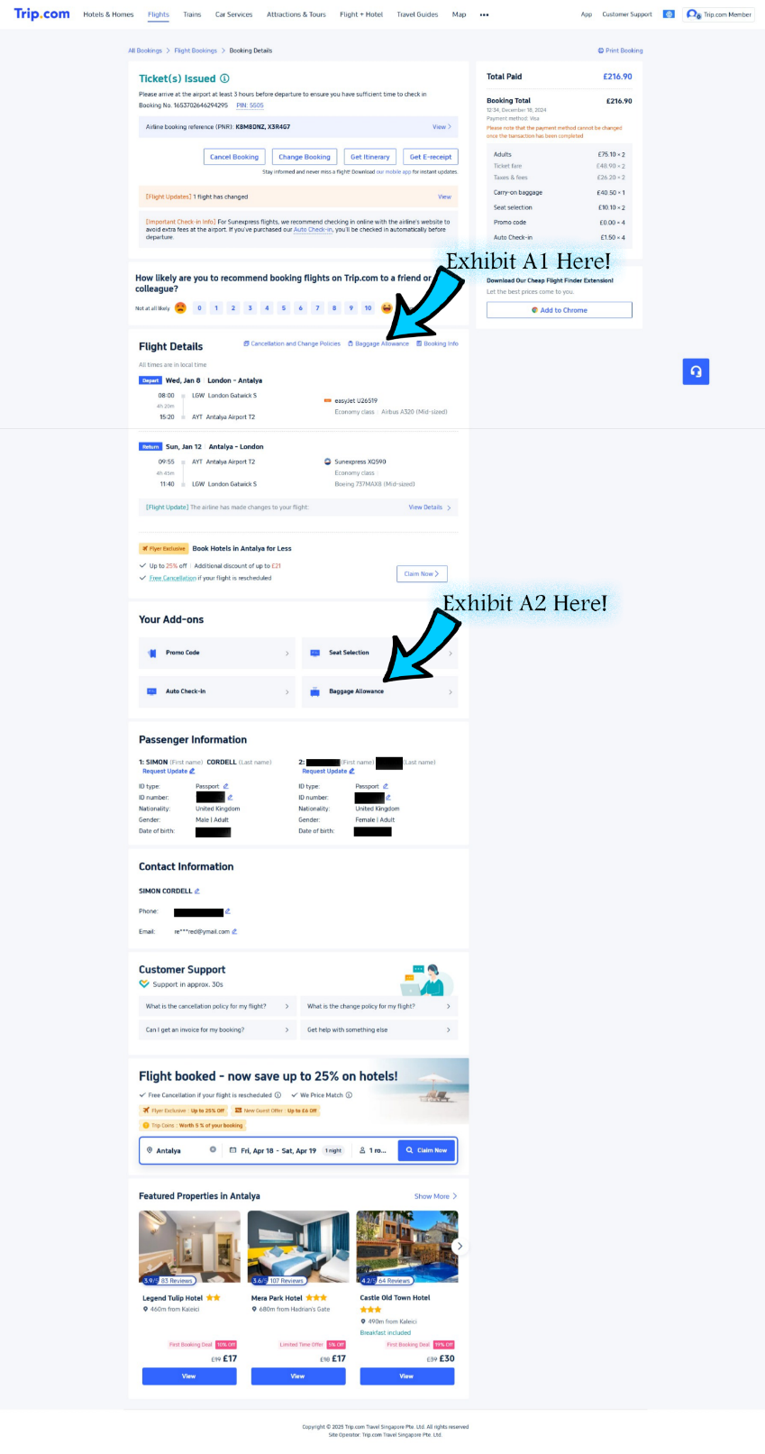

- Additional Issues Highlighted: Misleading Communication and Concealment:
- The confusion was not entirely caused by the booking process itself but arose when I tried to verify that I had ordered everything I needed. I reasonably believed the purpose of the email sent by Trip.com was to provide a “Final, Sealed Confirmation Invoice That Would Be Easy To Understand.” However, this was not the case.
- A screenshot dated “19th April 2025,” taken from my Trip.com personal account page, demonstrates the misleading nature of the confirmation process. Following a telephone call on the “22nd of April 2025,” correspondence with Trip.com staff revealed that they were unable to access my account due to “Security Restrictions,” and as a result, could not review my itinerary or booking confirmation page. I informed them that I had already included screenshots of these documents in my claim letter. Their failure to acknowledge these exhibits demonstrates a “Disregard For My Claim,” necessitating their resubmission as part of this action.
- In my main claim letter, I detailed that I became aware of sudden changes to the Trip.com and EasyJet websites after disclosing the nature of my claims to all parties held liable. These changes, which began after this disclosure, appear to have been an “Attempt To Alter or Obscure Critical Information Related to My Case.” The following note, titled and dated, illustrates the extent of these changes:

  - “3) Amendments and Feedback: Thank you for your understanding and cooperation. Also, Trip.com’s website is being updated “26-02-2025 at 22:28.” As I reviewed it, I noticed the changes being made! The “Additional Baggage Allowance” has changed and more.”

- Trip.com’s customer services, management, and affiliated departments must work in “Coordination” to avoid discrepancies and ensure that consumers are not misled by contradictory information. Instead, the inaccurate information initially supplied to customer service and subsequently repeated in response emails regarding my claims, amounts to a “Systematic Cover-Up.”
- This cover-up is evidenced by a lack of communication between management and other departments, leading to uninformed responses from customer service. It further appears that Trip.com’s website development and management teams attempted to rectify the issues I raised, not to “Transparently Resolve Them,” but rather to limit liability and protect the company. In doing so, they effectively concealed my claims, obstructing my ability to pursue rightful compensation. “This Concealment Can Constitutes to an Illegal Action.”
- Initially, as shown in the screenshots (Exhibit A1 and Exhibit A2), these exhibits were located in “Separate Sections” of the website, which “Divided And Isolated Critical Information.” However, the most recent website version places both exhibits under the same heading: “Baggage Allowance.” This heading did not exist at the time of my booking, and these changes were clearly implemented after the fact.

- Additionally, in the previous version of the website:
- Clicking on “Exhibit A1” and “Exhibit A2” directed users to “Separate Pages.”
- In the updated version, both links now redirect to a “Single New Webpage,” consolidating previously separate content. This new format is cleaner and more user-friendly but was clearly designed to “Prevent Customers From Encountering The Contradictory Information That Led To My Experience.”
- To Illustrate These Changes, I Have Provided The Following:
- Screenshots of the “New Website Layout,” presented in two parts.
- An additional weblink demonstrating the revised interface.
- “Comparative Images” of the original website layout for context.

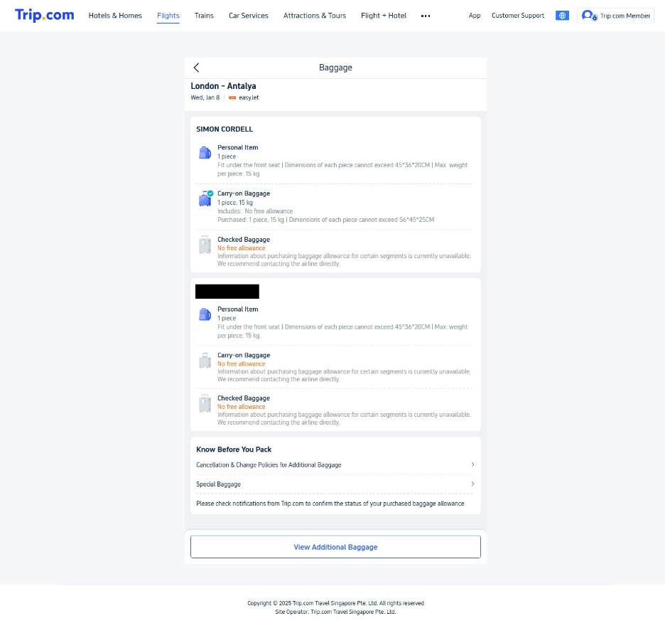
- When you click on the button titled at the bottom of the webpage that states “View Additional Baggage,” the next screenshot is where you get directed to.

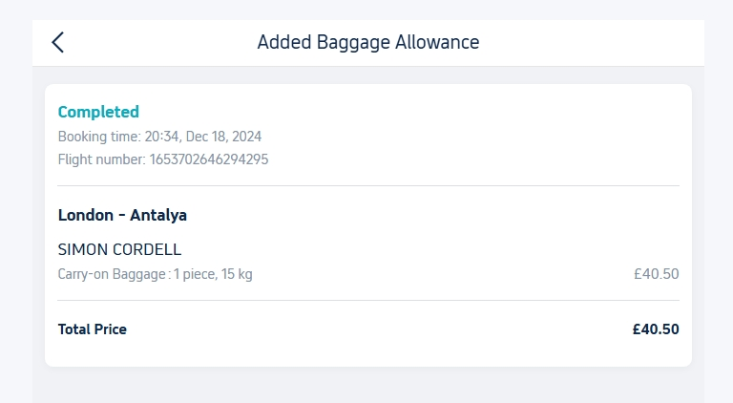
- The next screenshot below is taken from the original website layout that I used to book my orders.
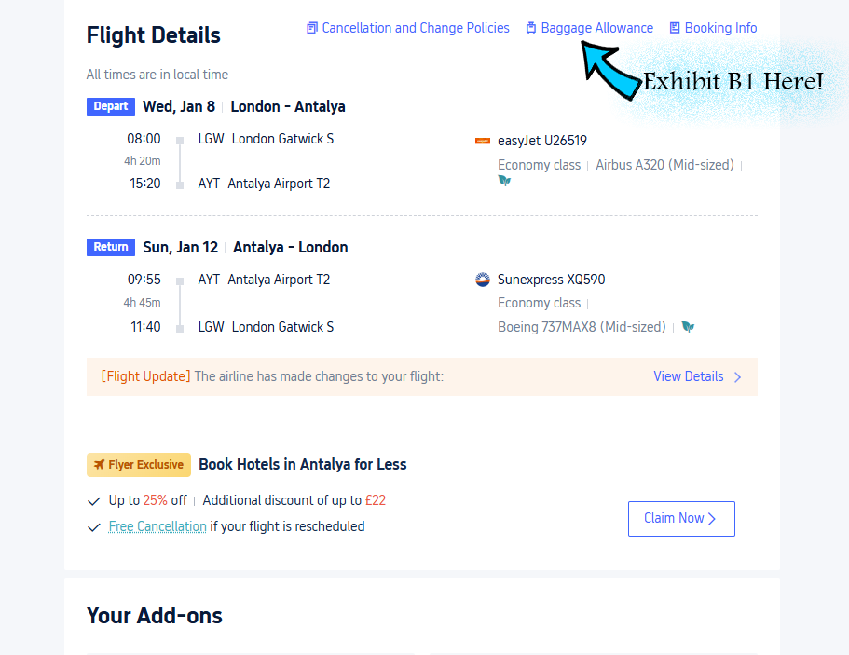

- Issues with Trip.com's Website Navigation and Baggage Information:
- Within the Trip.com website, the “Navigation Menu” is designed as an index for navigating through large quantities of content. Typically, navigation menus should ensure that titles and associated links provide consistent and transparent information. However, Trip.com’s website “Failed To Adhere To This Standard Protocol,” leading to confusion and misinformed decisions by the claimant.
- Specifically, the ‘Top Menu Link For’ “Baggage Allowance” directed users to a section labeled as “Free” baggage allowance. However, further down the webpage, a separate weblink redirected to a different page detailing “Paid Baggage Options.” This inconsistency created “Contradictory Pathways,” which are not typical of standard website navigation practices designed to ensure user clarity.
- Such discrepancies in links can cause consumers to make decisions based on “Incomplete or Misleading Information,” as was the case here.
- Across the entirety of Trip.com’s website, there was “No Direct Explanation or Link” provided regarding EasyJet’s policy for the ‘15kg Free Carry-On’ “Personal Item.” Instead, the baggage allowance information appeared vague and incomplete. Consumers could easily confuse the free 15kg carry-on allowance offered by EasyJet with Trip.com’s “15kg Paid Additional Baggage Allowance,” which lacked clear differentiation.
- As evidenced in “Exhibit B1,” the original weblink associated with the “Baggage Allowance” title directed users to a specific page. This page, as demonstrated in the exhibit, highlights the misleading design and division of information between “Free” and “Paid” baggage options.
- “Exhibit B1 Screenshot” further illustrates how the lack of clarity in web navigation contributed to the claimant’s misunderstanding and subsequent financial loss.

- Impact of Misleading Web Navigation:
- The separation and inconsistent labeling of baggage information links caused confusion for the claimant, resulting in “Misinformed Decisions” during the booking process.
- The “Failure To Provide Transparent Information” regarding EasyJet’s free baggage policy at the time of booking forced the claimant into unnecessary additional purchases and logistical challenges.
- Trip.com’s website design did not follow “Best Practices For Clarity And Consistency,” which are industry standards to prevent such consumer challenges.
- The original weblink directed you to the following screenshot below!

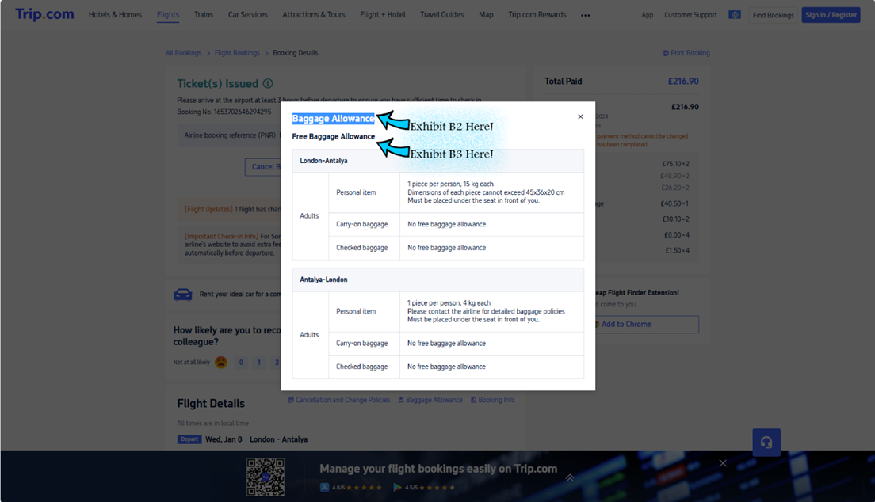

- Website Design Flaws and Consumer Confusion:
- “Exhibit B2 and Exhibit B3,” as displayed in the screenshots, appear directly above and below each other on Trip.com's website. This arrangement caused significant confusion due to their unclear and ambiguous presentation.
- Consumers using the Trip.com website were unable to clearly identify the purpose of “Exhibit B2” and “Exhibit B3,” as neither link provided sufficient explanation:
- Exhibit B2: led consumers to believe it represented “Paid Baggage Options.”
- Exhibit B3: appeared to represent “Free Baggage Allowance,” such as the 15kg carry-on baggage allowance offered by EasyJet.
- However, the lack of any explicit description or explanation distinguishing these links meant that customers could easily confuse “Paid Baggage Options With Free Baggage Allowances,” as was the case for the claimant.
- Specifically, the absence of guidance created the perception that the free 15kg allowance was part of the “Paid Baggage Section,” misleading consumers into unnecessary purchases.
- For the claimant to fully understand the intended purpose of these links, it was necessary to click on both links, located in “Separate Sections Of The Webpage,” without any clear instructions or contextual guidance. This design flaw deviates from standard user-friendly website practices, which aim to provide transparency and minimize confusion.

- Demonstrating the original second “Baggage Allowance Button” weblink!

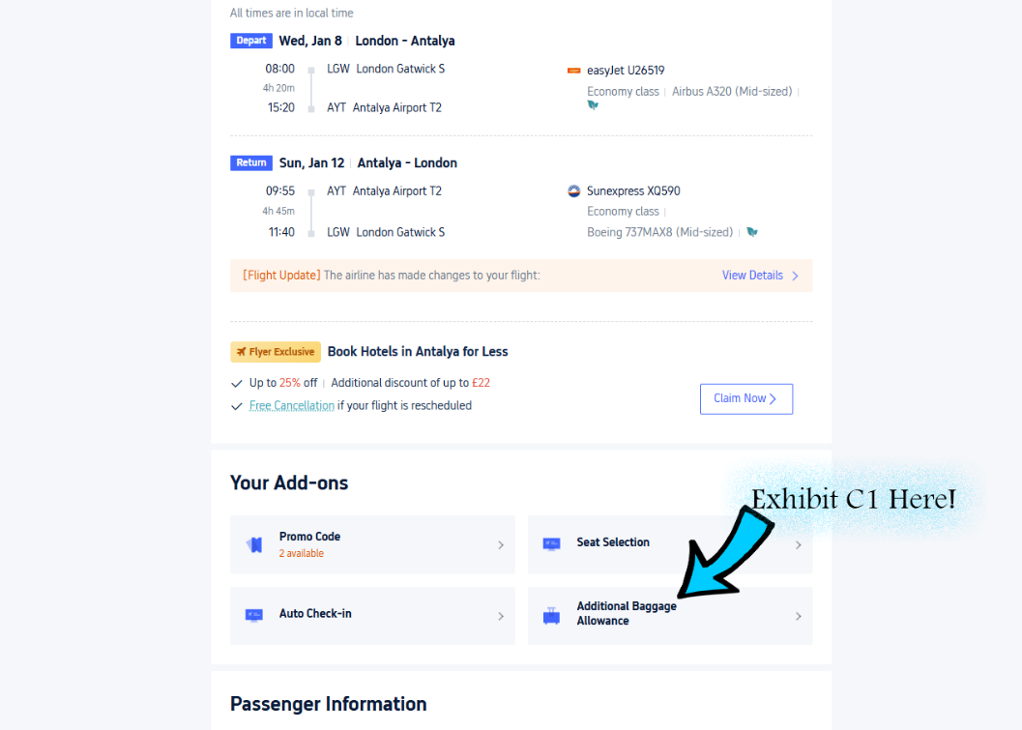

- Evidence of Website Modifications and Misleading Title Changes:
- As shown in “Exhibit C1,” the original title “Additional Baggage Allowance” has since been “Altered,” reflecting changes made to Trip.com’s website. This modification demonstrates an effort to address design flaws, though it lacks transparency regarding the initial discrepancies.

- Below, the original weblink button titled “Additional Baggage Allowance” is shown in the attached screenshot. This button previously redirected users to a page that created confusion regarding the distinction between “Free” and “Paid-For Baggage Options.” The lack of clear differentiation at the time of booking misled the claimant and contributed to the issues highlighted in this case.

- Below is what the original weblink button tiled as “Additional Baggage Allowance!” what directed you to the following screenshot below!

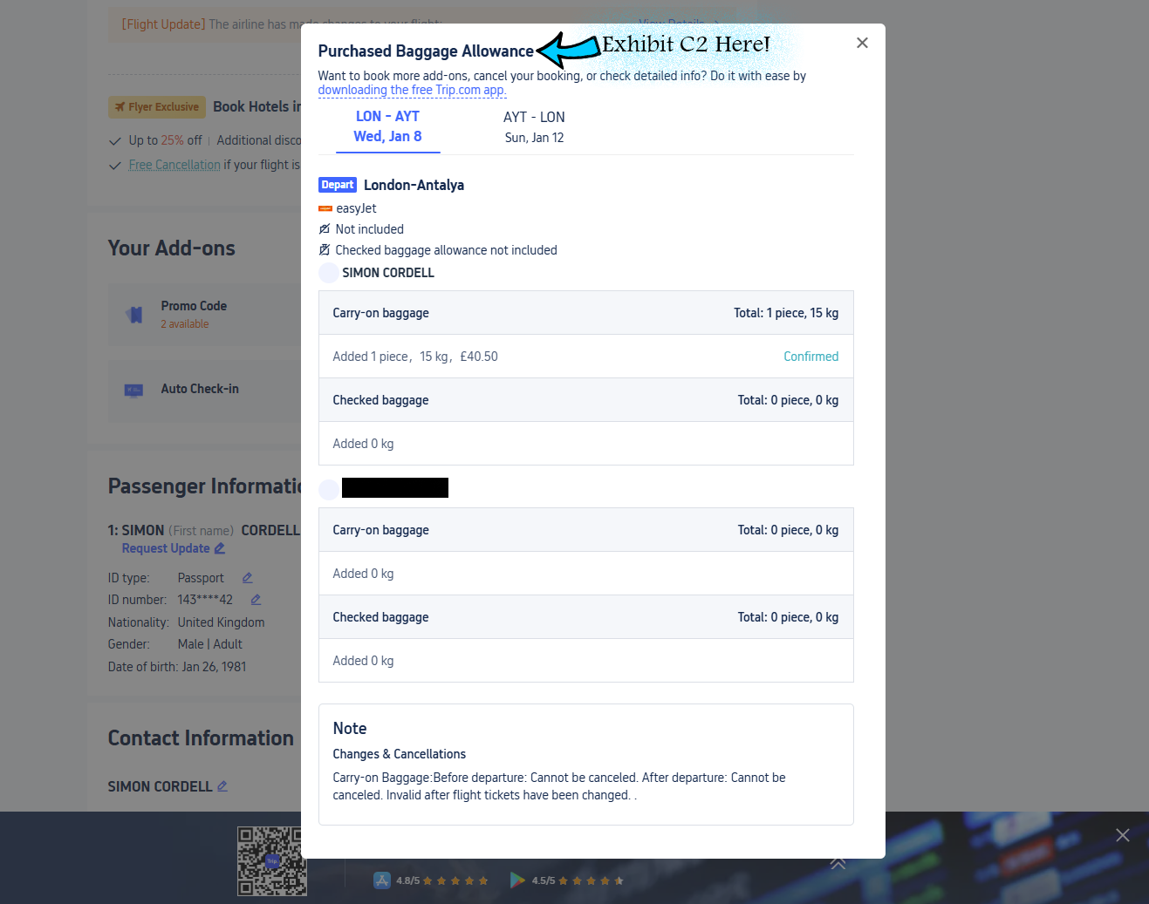

- Exhibited Video Link:
- Friday, April 18, 2025 3:30 PM - 431246967 35. was the 25th-Sent-Soon.mp4

- Transcribe Taken From The Exhibited Video:
- Saturday, April 19, 2025 10:21 AM - 18774 35. was the 25th-Sent-Soon video transcribe.docx

- Notes Taken From The Exhibited Video:
- Background: The claimant has presented evidence, supported by a recorded video and screenshots, which highlights significant flaws in Trip.com's website navigation and the misleading presentation of baggage information during the booking process. The claimant details their experience navigating Trip.com’s platform and subsequent issues, demonstrating the lack of clarity that led to confusion and financial losses.

- Key Points:
- Original Website Design:
  - The claimant accessed Trip.com’s website to manage their booking and verify their purchased options. Upon receiving the itinerary email, which was described as a "Sealed Document," they reasonably believed it contained complete and accurate information.
  - While navigating the site, two "Baggage Allowance" sections were identified:
  - One pertaining to “Free Baggage,” such as EasyJet's 15kg allowance.
  - The other pertaining to “Paid Baggage Options.”
  - Both sections were ambiguously titled and visually similar, causing confusion about what was free versus paid.

- Website Updates Post Complaint:
  - Following the claimant’s formal complaint, Trip.com updated the website design. The previously separate "Baggage Allowance" links now direct users to the same consolidated page.
  - This update lacks transparency, appearing to resolve the confusing layout while attempting to obscure the original design flaws.

- Consumer Impact:
  - The claimant mistakenly believed they had purchased a 15kg baggage allowance. Upon reviewing the itinerary, they discovered only “Free Baggage” information was listed, which conflicted with what had been paid for.
  - Extensive research and comparison with EasyJet’s policies confirmed the 15kg allowance was actually free, revealing how Trip.com’s website layout misled consumers into purchasing unnecessary baggage options.

- Evidence Presented:
  - The claimant has provided the following exhibits to substantiate their claims:
- Exhibit C1: Original email and itinerary reflecting ambiguous baggage details.
- Exhibit C2: Screenshots of the original "Baggage Allowance" sections, illustrating how free and paid baggage information were misrepresented.
- Exhibit C3: Updated website layout demonstrating consolidation of previously conflicting pages.

- Conclusion: Trip.com's misleading website design, combined with subsequent edits made after the claimant’s complaint, contributed to significant confusion and financial losses. These updates suggest an attempt to conceal the original flaws rather than addressing them transparently. The claimant contends that this constitutes a failure in consumer protection and calls for fair compensation.

- Itinerary: Evidence of Booking Access & Discrepancies in Account Review:
- Upon completing my purchase, I received an email from Trip.com containing a link to access my bookings page. This page provides an option to download my itinerary as a PDF, which I have attached below as supporting evidence.
- Failure by Trip.com to Access Booking Records: During a telephone conversation on the “22nd-Received-Tel-Call,” Trip.com staff informed me that they were unable to access my account due to “Security Challenges.” As a result, they claimed they could not review my booking confirmation page or itinerary.
- Pre-Action Submission of Exhibits & Lack of Acknowledgment: I previously provided “Screenshots Of Key Exhibits” in my formal claim letter, ensuring Trip.com had access to all relevant booking details. However, their failure to properly acknowledge these exhibits demonstrates a “Disregard For My Claim” and an attempt to avoid accountability.
- Re-exhibition of Key Documents: Given Trip.com’s refusal to recognize the original evidence provided, I have “Re-Exhibited Several Essential Files,” reinforcing my position and ensuring that the court has a complete record of the disputed booking details. These documents directly support my claim regarding compensation entitlements and Trip.com’s failure to uphold its customer service obligations.

- Exhibit: 21
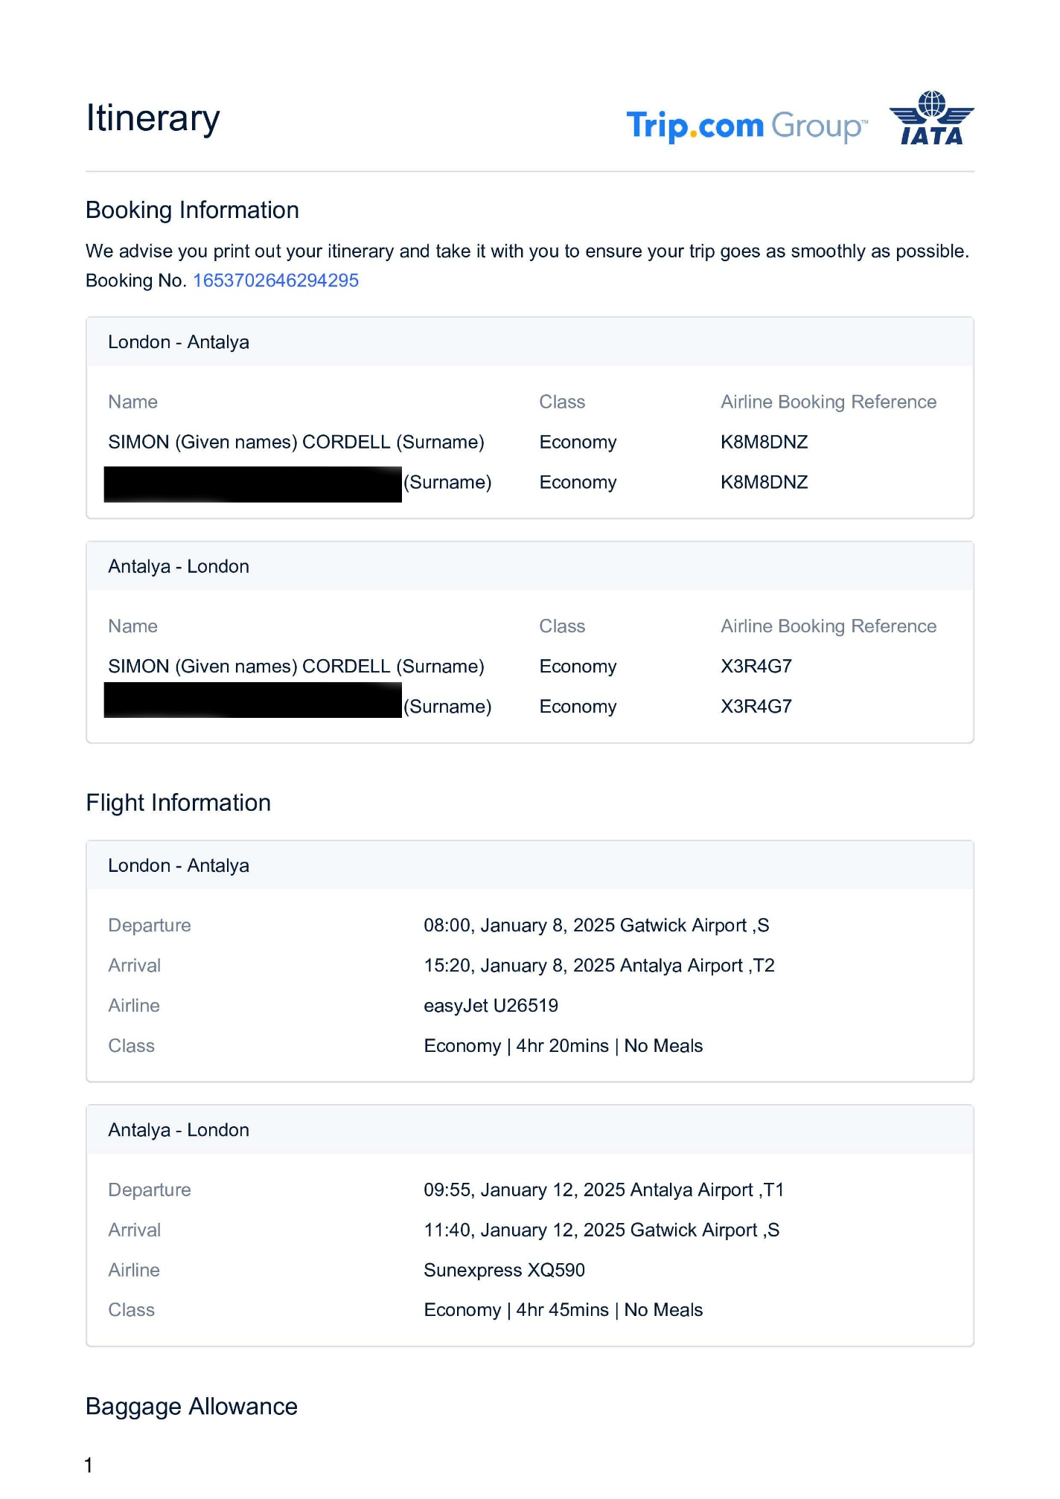

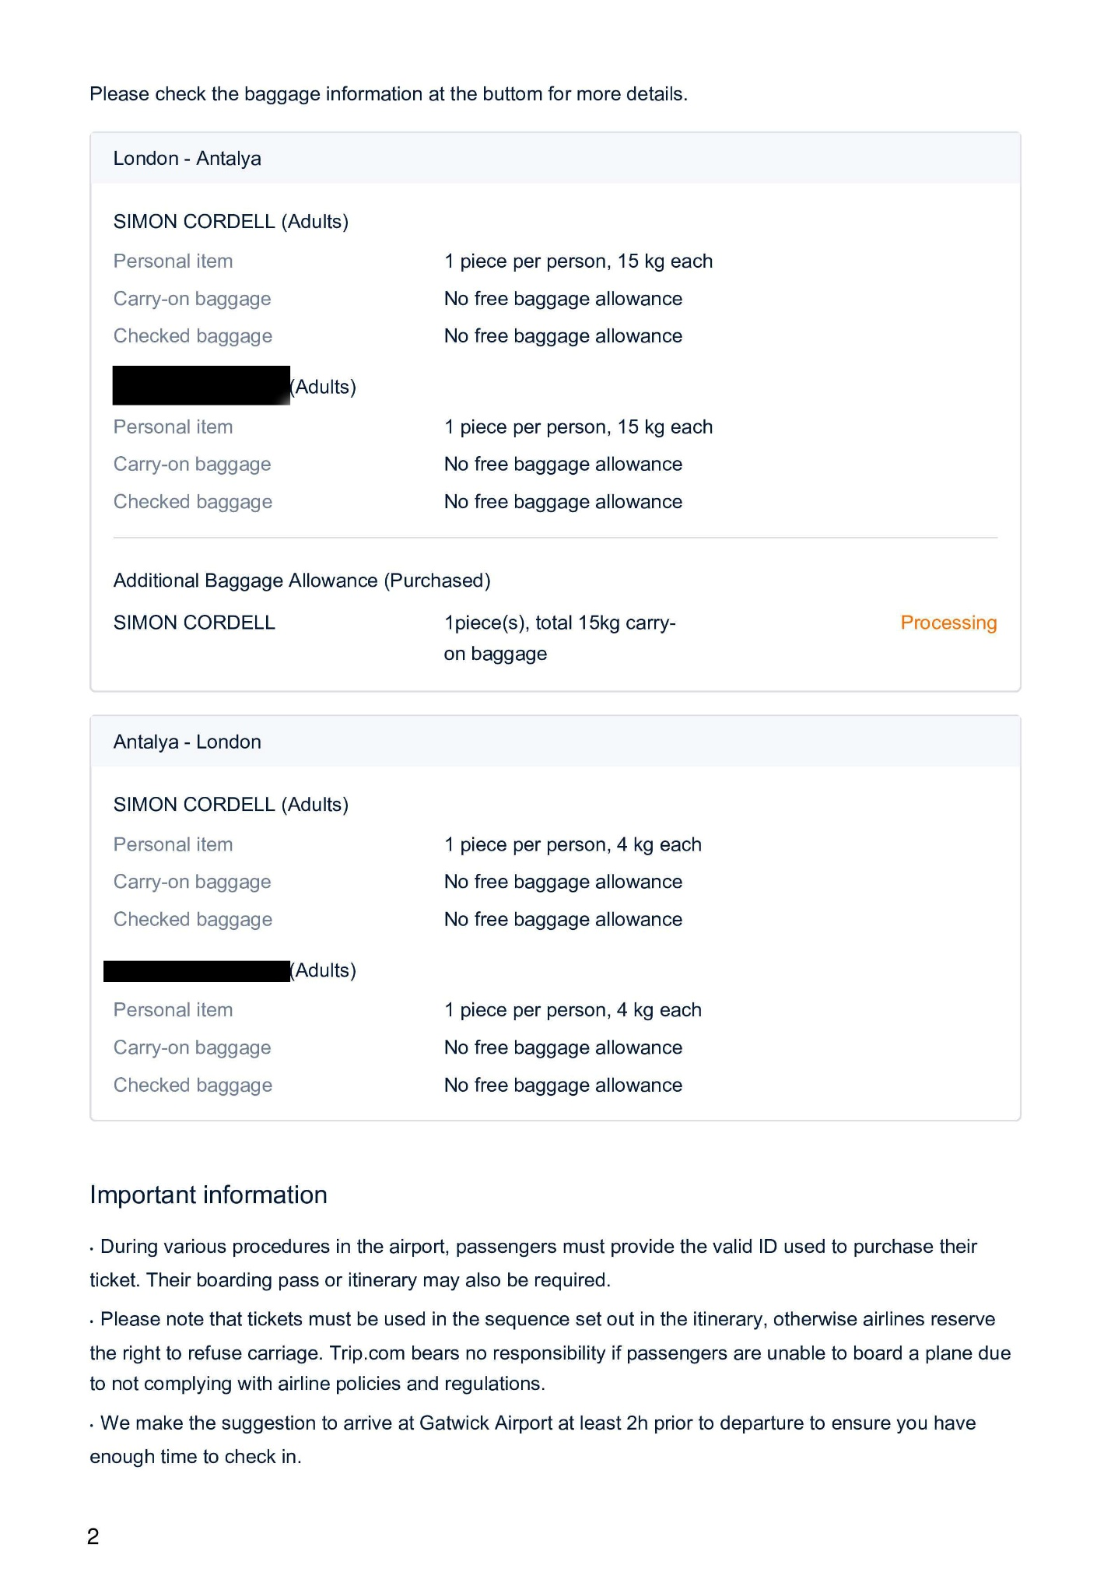
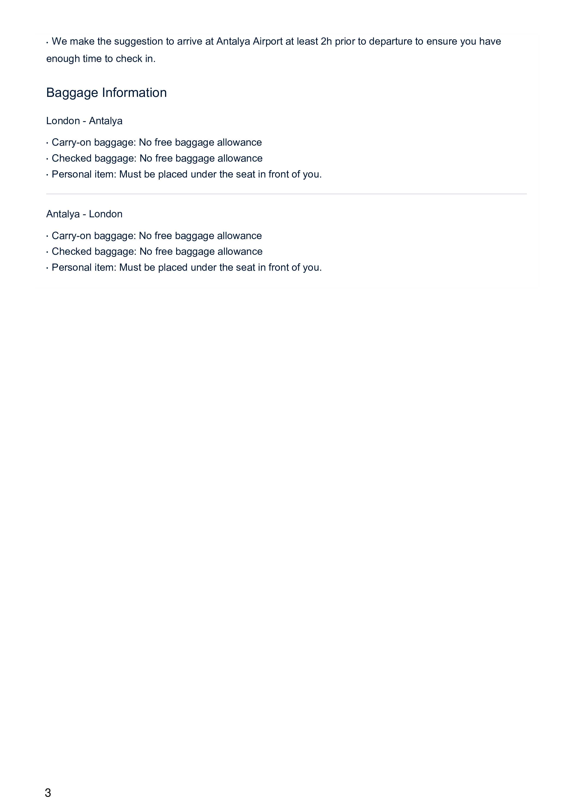
- Additional “Key Points” & Issues Identified in the Itinerary:
- The Itinerary Above Proves That:
  - The itinerary provided by Trip.com was marked as "Sealed" at the time of issuance on “Wednesday, 8th December 2024,” yet it remained incomplete and displayed the status of "Processing!". This status has persisted up until “Friday, 25th April 2025” as confirmed when the claimant logged into Trip.com’s website and downloaded the itinerary again. The failure to finalize and update this document over this extended period demonstrates negligence and a lack of transparency in handling the claimant’s booking.

- Incomplete Information on Baggage Allowance:
  - The itinerary fails to clearly differentiate between “Free Baggage Allowances” (Such As EasyJet’s 15kg Carry-On Allowance) and “Paid Baggage Options” purchased by the claimant. This ambiguity likely caused confusion during the booking and travel process.

- Contradictory Statements:
  - Despite mentioning “Processing!” alongside additional baggage purchased, the itinerary implies that the transaction remains unresolved, leading the claimant to question whether the paid baggage option was valid or accessible during travel.
  - The lack of updated confirmation contradicts the expectation of a “Sealed And Finalized Invoice” provided by Trip.com.

- Unclear Layout and Missing Explanations:
  - The itinerary lacks sufficient textual guidance for interpreting key sections, such as baggage information, flight details, and required documents.
  - The absence of clear headers and detailed explanations forces the user to manually decipher the content, contributing to unnecessary complexity.

- Failure to Reflect Airline Standards:
  - The itinerary provides no indication of EasyJet’s standard policy allowing free carry-on baggage as a personal item, which is a “Key Aspect Of Transparency” for travelers.

- Confusing Section Placement:
  - The placement of the baggage allowance information at the “Bottom Of The Itinerary” undermines its importance, as users must search through unrelated sections to find critical details.

- Misleading Information:
  - The itinerary suggests that no free baggage allowance exists, which contradicts EasyJet’s standard policy for personal items. This misrepresentation might lead consumers to purchase unnecessary baggage options under false pretenses.

- Lack of Clear Instructions for Airport Procedures:
  - Important information about checking in, required documents, and boarding instructions is buried in an “Unclear Format,” making it harder for travelers to prepare adequately for their flights.

- Invoice for Legal Fees, Analysis Costs & Correspondence Management:
- Prepared for: Simon Paul Cordell
- Case Reference: Booking No. 1653702646294295
- Subject: Compensation Claim against Trip.com
- Invoice Period: 12th January 2025 – Present

- Chronological Breakdown of Activities, Fees & Markers
- The time periods for Regular Hours, Overtime Hours, and Night Shift Hours based on a typical workday starting at 9:00 AM:
- Regular Hours:
  - Typically, these are the standard working hours during the day.
  - Start Time: 9:00 AM
  - End Time: 5:00 PM
- Overtime Hours:
  - These are hours worked beyond 5:00 PM up until 9:00 PM, assuming a normal 8-hour workday.
  - Start Time: 5:00 PM
  - End Time: 9:00 PM
- Night Shift Hours:
  - Night shift hours are generally recognised as any work done between 9:00 PM and 6:00 AM the following morning.
  - Start Time: 9:00 PM
  - End Time: 6:00 AM
- Correspondence Management:
- The implementation of this relatively new law introduced may cause a significant challenge for many companies unfamiliar with its details. The lack of clarity regarding final values and grand totals has necessitated for me to develop for this claim a robust system of documentation, including detailed receipts and explanatory texts. This initiative-taking approach has not only enabled me to align with the “Litigation Act (2014)” but also to understand its legal scope, potential for recovery of cost, and most of all its importance in achieving fairness and justice.

- Ensuring Fairness and Preventing Abuse:
- While the law demonstrates remarkable capacity for recovery, it also presents opportunities for misuse if left unchecked. The absence of strict caps on final values is of utmost importance due to the unique demands of each case and varying work durations that may arise. Placing a grand total cap would undermine the ability to account for these unique circumstances. Instead, we have ensured that compensation practices remain “Fair, Transparent, And Procedurally Correct” to prevent abuse and ensure compliance with litigation standards. This structured framework balances the law's flexibility with necessary safeguards against exploitation.

- The Role of Regular, Overtime, and Night Shift Hours:
- The legal right to claim “Regular Hours, Overtime Hours, And Night Shift Hours” is unquestionable. However, this flexibility can inadvertently result in compensation imbalances, particularly when calculating lengthy shifts. To prevent unfair totals, boundaries have been established to ensure equity, aligning with compliance under the “Litigation Act (2014)” and United Kingdom’s laws.

- Overtime Hours: Strict 4-Hour Limit:
- Overtime is carefully monitored and capped at “4 Hours Per Day,” ensuring compliance with necessary rest requirements under the “Working Time Regulations (1998).” This structure prioritizes worker safety while providing reasonable compensation for additional hours worked. Limiting overtime prevents excessive claims and ensures consistent standards across compensation practices.

- Night Shifts: Organized for Equity at a Lower Rate:
- To further enhance fairness and prevent inflated claims, “Night Shift Hours” are compensated at a rate of £30.88/hour, which is intentionally lower than the overtime rate. This approach acknowledges the distinct nature of night shift work while ensuring compensation remains equitable and procedurally correct. By organising night shifts with structured boundaries, we prevent the possibility of calculating night shifts at higher sums or combining them unfairly with extended overtime hours, which could inflate totals beyond what is reasonable under the law.

- Monitoring Compliance Under the Working Time Regulations (1998):
- While the UK has no specific law defining a "Maximum Overtime Hours Per Day," the “Working Time Regulations (1998)” provide critical safeguards to ensure fairness and prevent exploitation:
- 48-hour weekly limit: Averaged over a 17-week period unless an opt-out agreement is in place.
- Rest periods: Workers are entitled to “11 consecutive hours of rest within a 24-hour period.”
- These requirements indirectly limit the total working hours per day, ensuring compliance with health and safety standards and promoting fairness.

- Night Shift Rates and Procedural Compliance:
- To maintain compliance with the “Litigation Rules (2014),” night shift rates have been structured at £30.88/hour. This rate ensures compensation remains “Fair, Transparent, And Defensible,” aligning with legal and procedural standards.
- Night shift rates are deliberately set lower than overtime rates to prevent inflated calculations and ensure equity.
- This approach reflects the distinct workload and conditions of night shifts, ensuring fairness without compromising compliance.
- By adhering to these principles, the structured system of Regular Hours, Overtime Hours, and Night Shift Hours ensures all claims are calculated and compensated in a manner that is both equitable and compliant. Transparency and organised boundaries maintain the integrity of the law while preventing misuse.

- Refined Table of Correspondence with Times and Breakdown:
Refined Totals by Entry
- Initial Entries (1–6)
- Preliminary Review: £12,310.95
- 1st-Sent: £49.40
- 2nd-Received: £49.40
- 3rd-Sent: £74.10
- Post-3rd Sent: £123.50
- 4th-Sent: £74.10
- Subtotal (Entries 1–6): £12,681.45.

- Middle Entries (7–14)
- Post 5th-Received: £12.35
- 5th-Received: £24.70
- 6th-MP3 Recording: £24.70
- 7th-Received: £302.60
- Claim Preparation: £1,951.38
- 8th-MP3 Recording: £49.40
- 9th-Received: £49.40
- 10th-Sent: £49.40
- Subtotal (Entries 7–14): £2,464.93.

- Later Entries (15–22)
- 11th-Sent: £74.10
- 12th-Received: £160.55
- 13th-Received: £6.18
- 14th-Received: £12.36
- 15th-Sent: £765.70
- 16th-Received: £49.40
- 17th-Received: £49.40
- 18th-Sent: £86.45
- Subtotal (Entries 15–22): £1,252.54.

- Final Entries (23–38)
- 19th-Received: £61.75
- 20th-Received: £74.10
- 21st-Received: £74.10
- 22nd-Received: £61.75
- 23rd-Received: £98.80
- 24th-Received: £74.10
- 25th-Received: £98.80
- 26th-Received: £49.40
- 27th-Received: £209.96
- 28th-Received: £92.64
- 29th-Sent: £500.20
- 30th-Received: £500.20
- 31st-Received: £500.20
- 32nd-Received: £500.20
- 33rd-Received: £500.20
- 34th-Sent: £500.20
- Subtotal (Entries 23–38): £3,795.40.

- Grand Total:
Adding all subtotals: £12,681.45 + 2,464.93 + £1,252.54 + £3,795.40 = £20,194.32

- Refined Table of Correspondence with Times and Breakdown:
Nub Marker |  | Date & Time |  | Correspondence/Task | Time Spent | Regular Hours (£) | Overtime (£) | Night Shift (£) | Total (£)
1. Preliminary Review |  | 12 Jan – 12 Mar 2025 (daily hours vary) |  | Comprehensive analysis of website, correspondence, financial harm, and strategy formulation (minus 6 hospital hours). | 383 hours | £3,505.40 | £7,001.85 | £1,605.76 | £12,310.95
2. 1st-Sent |  | Monday, 24 Feb 2025 - 10:04 GMT |  | Drafting and sending the first email outlining issues, notifying Trip.com, EasyJet, and SunExpress. | 2 hours | £49.40 | £0 | £0 | £49.40
3. 2nd-Received |  | Monday, 24 Feb 2025 - 10:05, 10:04, 10:08 GMT |  | Reviewing EasyJet autoreply, SunExpress failure notice, and Trip.com acknowledgment emails. | 2 hours | £49.40 | £0 | £0 | £49.40
4. 3rd-Sent |  | Monday, 24 Mar 2025 - 15:01 GMT |  | Sending follow-up email requesting escalation and assignment of a resolute caseworker. | 3 hours | £49.40 | £37.05 | £0 | £74.10
5. Post-3rd Sent |  | Monday–Thursday, 24–27 Mar 2025 |  | Managing admin tasks, investigating reasons for delays, and monitoring Trip.com responses. | 4 hours | £49.40 | £74.10 | £0 | £123.50
6. 4th-Sent |  | Friday, 28 Mar 2025 - 11:59 GMT |  | Sending follow-up email emphasizing Trip.com’s policy breaches and urgency of resolution. | 3 hours | £49.40 | £37.05 | £0 | £74.10
7. Post 5th-Received |  | Wednesday, 02 Apr 2025 |  | I waited 5 days for a reply from Trip.com and kept checking emails while working on another insurance claim. | 0.5 hours | £12.35 | £0 | £0 | £12.35
8. 5th-Received |  | Wednesday, 02 Apr 2025 - 13:46 BST |  | Received an email from Trip.com with “Easter offers” instead of addressing prior inquiries; continued administrative work monitoring responses.  Trip.com has prior responded to me from this email. | 1 hour | £24.70 | £0 | £0 | £24.70
9. 6th-MP3 Recording |  | Wednesday, 02 Apr 2025 - 14:41 BST |  | Reviewed Trip.com complaint procedures; called Trip.com and navigated automated AI services to file a complaint with a live representative. | 1 hour | £24.70 | £0 | £0 | £24.70
10. 7th-Received |  | Wednesday, 02 Apr 2025 - 16:48 BST |  | Reviewed emails from Trip.com’s advisor; prepared a response, transcribed MP3 recording, and handled administrative tasks over multiple days. | 9 hours | £0 | £148.20 | £154.40 | £302.60
11. Claim Preparation |  | Wednesday, 02 Apr – Tuesday, 08 Apr 2025 |  | Guaranteed claim accuracy: significant stress from detailed preparation of financial breakdowns and Exhibited evidence over several days.  a. 02 April 2025: 16 hours  - Regular Hours (8): £24.70/hour × 8 = £197.60  - Overtime Hours (4): £37.05/hour × 4 = £148.20  - Night Shift Hours (4): £30.88/hour × 4 = £123.52 Total: £197.60 + £148.20 + £123.52 = £469.32  b. 03 April 2025: 16 hours  - Regular Hours (8): £24.70/hour × 8 = £197.60  - Overtime Hours (4): £37.05/hour × 4 = £148.20  - Night Shift Hours (4): £30.88/hour × 4 = £123.52 Total: £197.60 + £148.20 + £123.52 = £469.32  c. 04 April 2025: 0 hours  - Regular Hours (0): £24.70/hour × 0 = £0  - Overtime Hours (0): £37.05/hour × 0 = £0  - Night Shift Hours (0): £30.88/hour × 0 = £0  - Total: £0 + £0 + £0 + £0 = £0  d. 05 April 2025: 16 hours  - Regular Hours (8): £24.70/hour × 8 = £197.60  - Overtime Hours (4): £37.05/hour × 4 = £148.20  - Night Shift Hours (4): £30.88/hour × 4 = £123.52 Total: £197.60 + £148.20 + £123.52 = £469.32  e. 06 April 2025: 16 hours  - Regular Hours (8): £24.70/hour × 8 = £197.60  - Overtime Hours (4): £37.05/hour × 4 = £148.20  - Night Shift Hours (4): £30.88/hour × 4 = £123.52 Total: £197.60 + £148.20 + £123.52 = £469.32  f. 07 April 2025: 0 hours  - Regular Hours (0): £24.70/hour × 0 = £0  - Overtime Hours (0): £37.05/hour × 0 = £0  - Night Shift Hours (0): £30.88/hour × 0 = £0  - Total: £0 + £0 + £0 + £0 = £0  g. 08 April 2025: 2 hours  - Regular Hours (0): £24.70/hour × 0 = £0  - Overtime Hours (2): £37.05/hour × 2 = £74.10  - Night Shift Hours (0): £30.88/hour × 0 = £0  - Total: £0 + £74.10 + £0 = £74.10  Breakdown 1:  - Regular Hours (32): £24.70/hour × 32 = £790.40  - Overtime Hours (18): £37.05/hour × 18 = £666.90  - Night Shift Hours (16): £30.88/hour × 16 = £494.08  Total:  £790.40 + £666.90 + £494.08 = £1,951.38  Final Total Hours:  16 + 16 + 0 + 16 + 16 + 0 + 2 = 66 hours  Breakdown 2:  - 02 April 2025: £469.32  - 03 April 2025: £469.32  - 04 April 2025: £0.00  - 05 April 2025: £469.32  - 06 April 2025: £469.32  - 07 April 2025: £0.00  - 08 April 2025: £74.10  Total:  £469.32 + £469.32 + £0.00 + £469.32 + £469.32 + £0.00 + £74.10 = £1,951.38 | 66  hours | £790.40 | £666.90 | £494.08 | £1,951.38
12. 8th-MP3 Recording |  | Wednesday, 09 Apr 2025 - 23:44 BST |  | Task: Made a phone call to Trip.com to address weblink issues “Accepting Only Image Files;” transcribed the MP3 recording, filed it into exhibits, and sent a formal claim letter with receipts. | 2 hours | £49.40 | £0 | £0 | £49.40
13. 9th-Received |  | Thursday, 10 Apr 2025 - 00:19 BST |  | Analyzed Trip.com’s incomplete responses, drafted rebuttals, clarified strategic points. | 2 hours | £49.40 | £0 | £0 | £49.40
14. 10th-Sent |  | Thursday, 10 Apr 2025 - 21:07 BST |  | Sent updated evidence and documents for baggage inquiries, with attached receipts (£40 and £69.63). | 2 hours | £49.40 | £0 | £0 | £49.40
15. 11th-Sent |  | Thursday, 10 Apr 2025 - 23:17 BST |  | Resent corrected claim letter with additional documents to address issues caused by Trip.com stating they did not receive the files. This email includes an additional Microsoft word Docx Document of the claim along with a PDF file. | 3 hours | £49.40 | £37.05 | £0 | £74.10
16. 12th-Received |  | Friday, 11 Apr 2025 - 01:14 BST |  | Trip.com requested additional proof and clarification about baggage receipts, requiring further communication and clarification. This caused extra work to clarify the breakdown in communication regarding the receipt of official documents. | 5 hours | £49.40 | £111.15 | £0 | £160.55
17. 13th-Received |  | Friday, 11 Apr 2025 - 01:18 BST |  | Trip.com sent duplicate email requesting receipts; reviewed this correspondence and made clarifications. | 15 mins | £6.18 | £0 | £0 | £6.18
18. 14th-Received |  | Saturday, 12 Apr 2025 - 01:49 BST |  | Drafted a response to earlier emails, addressing Trip.com's claim of case closure within 24 hours; this caused significant “Stress” as to the additional effort. | 30 mins | £12.36 | £0 | £0 | £12.36
19. 15th-Sent |  | Monday, 14 Apr 2025 - 09:52 BST |  | Resent attachments and compiled prior correspondence; detailed effort over multiple days addressing Trip.com’s missing documents.  - 12 April: 13 hours  - 13 April: 13 hours  - 14 April: 0.87 hours  Total: = 13 + 13 + 0.87 = 26.87 hours  This Included:  - -10. 10th Sent-Claim-for-TripCom.pdf  - -10. 10th Sent-Claim-for-TripCom.docx  - All-Emails-TripCom-and-Co.docx | 26.87 hours | £345.80 | £148.20 | £123.52 | £765.70
20. 16th-Received |  | Monday, 14 Apr 2025 - 11:50 BST |  | Reviewed Trip.com’s response, indicating further delays in processing the claim. | 2 hours | £49.40 | £0 | £0 | £49.40
21. 17th-Received |  | Tuesday, 15 Apr 2025 - 08:44 BST |  | Acknowledged Trip.com’s misunderstanding of claim letter and partial acceptance of responsibility, requiring clarification of liability. Their partial acceptance of responsibility appears to divert focus away from their own accountability, what further complicated the resolution process for the claimant. | 2 hours | £49.40 | £0 | £0 | £49.40
22. 18th-Sent |  | Wednesday, 16 Apr 2025 - 12:33 BST |  | Drafted rebuttal to Trip.com's claims, reasserting evidence and clarification of reimbursement demands. | 3.5 hours | £86.45 | £0 | £0 | £86.45
23. 19th-Received |  | Wednesday, 16 Apr 2025 - 19:34 BST |  | Analyzed Trip.com's position contesting fees and requesting additional clarification. | 2.5 hours | £61.75 | £0 | £0 | £61.75
24. 20th-Received |  | Thursday, 17 Apr 2025 - 13:54 BST |  | Acknowledging Trip.com's response, which partially addressed the claimant’s concerns but still deflected full responsibility by attributing fault to the claimant, Trip.com failed to confirm whether the claim had been officially filed in order to avoid liability. As a result, the claimant was required to provide further evidence and clarification to ensure the claim was properly understood and addressed, causing additional delays and efforts. | 3 hours | £74.10 | £0 | £0 | £74.10
25. 21st-Received |  | Friday, 18 Apr 2025 - 18:46 BST |  | Acknowledging Trip.com's response, which demonstrated only a partial understanding of the claimant's correspondence, further clarification was necessary. This email compelled the claimant to expend additional time and effort to address and correct Trip.com's misinterpretation of the claim and its key points, thereby causing further “Unwanted Stress!” | 3 hours | £74.10 | £0 | £0 | £74.10
26. 22nd-Received |  | Friday, 18 Apr 2025 - 18:48 BST |  | Acknowledging Trip.com's “Telephone Call,” during which they appeared to reinterpret the claimant's statement in a way that minimized their liability. By reading between the lines, Trip.com seemingly diverted responsibility and shifted focus away from the clear points made in the original claim letter. This approach not only imposed additional obstacles on the claimant but also appeared to test the claimant's resolve through an impromptu call, thereby complicating the process further. Subsequently, I documented the recording and updated the claim files to accurately reflect the details discussed. | 2.5 hours | £61.75 | £0 | £0 | £61.75
27. 23rd-Received |  | Friday, 18 Apr 2025 - 18:52 BST |  | While preparing my response, I received multiple emails from Trip.com. By the 21st Email, it became clear that Trip.com intended to undermine my claim by misrepresenting the facts. This forced me to reorganize and refile all the exhibits to clarify my position more effectively. During this process, I also received the 22nd Telephone Call, which revealed Trip.com’s evasive tactics aimed at avoiding liability by distorting my claim. Subsequently, I received the 23rd Email and Two Additional Emails, some of which were related to the 22nd Telephone Call, all while I was still preparing my response. | 4 hours | £98.80 | £0 | £0 | £98.80
28. 24th-Received |  |  | Friday, 18 Apr 2025 - 23:58 BST | Acknowledged Trip.com's request for feedback on the claimant’s experience, balancing constructive feedback with formal complaint preparation. | 3 hours | £74.10 | £0.00 | £0.00 | £74.10
29. 25th-Received |  |  | Saturday, 19 Apr 2025 - 19:45 BST | While drafting my response to the 20th And 21st Emails, I received a telephone call from Trip.com’s Customer Services what is the 22nd Correspondence. I continued working on my response while receiving Two Additional Emails, and this process continued until I received the 25th Email were they “Accepted Liability as Trip.Com & Co.” Upon receiving this email, I changed my approach and redrafted new correspondence to address the missing sums, setting aside the previous draft. During this time, I also received three more emails while preparing the Second Document that needed to be sent. Additionally, I reviewed Trip.com’s offer for an out-of-court settlement and analyzing their strategic diversion approach. | 4 hours | £98.80 | £0.00 | £0.00 | £98.80
30. 26th-Received |  |  | Sunday, 20 Apr 2025 - 17:01 BST | I continued monitoring Trip.com's interpretation of claim evidence hosted on horrificcorruption.com to ensure proper representation of the facts.  Trip.com manager Ray made an attempted to call me and sent me an email to this effect as I was not available to chat. | 2 hours | £49.40 | £0.00 | £0.00 | £49.40
31. 27th-Received | Sunday, 20 Apr 2025 - 17:07 BST |  |  | While preparing my response I acknowledge another email from Trip.com manager Ray who sent me a follow-up email reminding me of his attempted telephone call, which prompted significant effort to refine my strategy and adapt to the evolving complexity of the case. | 9 hours | £0.00 | £148.20 | £61.76 | £209.96
32. 28th-Received | Sunday, 20 Apr 2025 - 23:03 BST |  |  | Acknowledging Trip.com's request for feedback on the claimant’s experience, which coincided with the claimant’s preparation of a formal complaint. This timing added further complexity to an already demanding process, requiring the claimant to balance providing constructive feedback with addressing unresolved issues. Trip.com's prioritisation of feedback over resolving the evidence - backed claims demonstrated inefficiency and contributed to unnecessary delays in the claimant’s pursuit of resolution. | 3 hours | £74.10 | £0.00 | £18.54 | £92.64
33. 29th-Sent | Monday, 21 Apr 2025 - 18:01 BST |  |  | The second document I made was sent rather than the first document as the 29th Email, and was filed Accordingly to “Trip.com’s Customer Service Guarantee,”  Turnaround Response Reflecting Strategic Focus and Accountability:  - Acknowledgment of Liability Acceptance:  - Trip.com had accepted liability for the core claims at this stage, and the claimant used this response to solidify their position and align the next steps accordingly.  - Request for Compensation of Stress and Legal Fees:  - The claimant explicitly detailed the request for compensation for stress and legal expenses as a litigant in person, including costs incurred from engaging clients and legal support. These requests were framed within the context of established legal principles.  - Request for Insurance Documentation:  - The claimant requested access to Trip.com's insurance documents as part of the evidence-gathering process, ensuring transparency and compliance with procedural requirements.  - Breakdown of Fees and Legal Compliance:  - The response provided a thorough explanation of fees, ensuring all claims adhered to relevant legal regulations and principles. This reinforced the claimant’s adherence to procedural integrity while holding Trip.com to the same standard.  - Reiteration of Total Losses and Warning of Legal Action:  - The claimant called for Trip.com to fully compensate for the documented losses and explicitly stated that failure to comply would result in the issuance of an N1 Claim Form. This underscored the seriousness of the matter while maintaining professionalism.  - Strategic Shift in Approach:  - This response represented a decisive pivot, balancing firm demands with legal precision to effectively advance the claim while adhering to core principles of fairness and accountability. | 17 hours | £197.60 | £148.20 | £154.40 | £500.20
34. 30th-Received | Tuesday, 22 Apr 2025 - 00:11 BST |  |  | Response Reflecting Trip.com’s Failures and Breaches:  Trip.com's response, stating they would "only be able to refund baggage charges incurred at the airport," represents a glaring disregard for their broader obligations and guarantees. By failing to address the full extent of their liability, they have violated.  Since the 30th Email, I have used the message originally intended for the 25th Email that I created before receiving their acceptance of liability but refusal to pay reasonable costs.  There unfair refusal has since prompted me to prepare a “Pre-Action Conduct Letter” and an “N1 Claim form,” as reviewing their correspondence revealed the need for further clarification regarding their failure to honor guarantees and thoroughly investigate my claims. These issues added complexity to the case preparation, highlighting Trip.com's failure to honor guarantees in correspondence and addressed incomplete claims. | 17 hours | £197.60 | £148.20 | £154.40 | £500.20
35. 31st-Received | Tuesday, 22 Apr 2025 - 00:53 BST |  |  | Clarified unresolved liability issues and finalized response to Trip.com's reimbursement proposal. | 17 hours | £197.60 | £148.20 | £154.40 | £500.20
36. 32nd-Received | Wednesday, 23 Apr 2025 - 00:59 BST |  |  | Prepared formal pre-action letter and N1 Claim Form ensuring accurate breakdowns and attached exhibits. | 17 hours | £197.60 | £148.20 | £154.40 | £500.20
37. 33rd-Received | Wednesday, 23 Apr 2025 - 23:25 BST |  |  | Finalized submission of correspondence and attached all evidence alongside the prepared N1 Claim Form. | 17 hours | £197.60 | £148.20 | £154.40 | £500.20
38. 34th-Sent | Sunday, 27 Apr 2025 |  |  | Submitted the completed court bundle, including the N1 Claim Form, evidence, and correspondence summary.  Claimant's Strategic Response:  - Formal Submission of Pre-Action Letter and N1 Claim Form:  - The claimant enclosed the “Pre-Action Conduct Letter” and the completed “N1 Claim Form,” officially escalating the matter and asserting legal grounds for compensation.  - Key Issues Raised: a. Acknowledgment of Liability:  - The claimant highlighted Trip.com's admission of liability for specific baggage fees while emphasizing their failure to compensate for additional losses incurred due to service failures.  b. Breach of Guarantees:  - Trip.com violated their own “Service Guarantee and Advance Compensation Policy,” which promise timely resolution and reimbursement for claims where fault is admitted.  c. Failure to Disclose Insurance Policies (CPR 31.12):  - The claimant reiterated their request for Trip.com to provide relevant insurance documentation, a key procedural requirement under the “Civil Procedure Rules.”  d. Substantial Financial and Emotional Impact:  - Direct financial losses included legal fees (£25,110.00), analysis fees (£12,327.50), and consequential expenses from disrupted travel.  - The claimant also addressed significant stress and disruption caused by Trip.com’s mishandling of the claim.  - Compensation Demands:  - The claimant formally requested full compensation for losses, including stress fees, legal expenses, and consequential damages.  - Trip.com was notified of the claimant's intent to escalate to court proceedings if their obligations remained unmet.  - Call for Procedural Compliance:  - The claimant urged Trip.com to confirm receipt of the submission, provide a clear timeline for action, and comply with the disclosure request to avoid legal escalation.  - Acceptance of Partial Payment “Without Prejudice”:  - While acknowledging the goodwill gesture for travel expenses, the claimant emphasized that partial | 17 hours | £197.60 | £148.20 | £154.40 | £500.20

- Now Adding All Of These Hours Together:
- 383 + 2 + 2 + 3 + 4 + 3 + 0.5 + 1 + 1 + 9 + 66 + 2 + 2 + 2 + 3 + 5 + 0.25 + 0.5 + 26.87 + 2 + 2 + 3.5 + 2.5 + 3 + 3 + 2.5 + 4 + 3 + 4 + 2 + 9 + 3 + 17 + 17 + 17 + 17 + 17 + 17 = 620.12 hours

- Total Hours: 620.12 hours
- - 383
- If we subtract 383 from the total hours calculated earlier (620.12 hours), the result is:
- 620.12 - 383 = 237.12 hours

- Legal Fees Grand Total, Without Expenses:
- Adding all subtotals: £12,681.45 + 2,464.93 + £1,252.54 + £3,795.40 = £20,194.32

- Additional Legal Fees and Costs
Category | Details | Total (£)
Solicitors’ Fees | Professional legal advice and consultations. | £20,194.32
New Period Solicitors’ Expenses | Travel, document preparation, etcetera. | £990.24

- Electricity Usage Tasks:
Task/Activity
Printer Usage
Computer Usage
Lighting (Office)
Printer Usage
Computer Usage
Lighting (Office)

- Revised Electricity Costs:
- Total Weekly Electricity Cost: £40.00
- Duration: From 12th March 2025 to 27th April 2025 = 47 days = 6 weeks + 5 days

- Step-by-Step Calculation:
- Cost for 6 Full Weeks: £40 × 6 = £240.00
- Cost for 5 Additional Days: £40 × (5 ÷ 7) = £40 × 0.714 = £28.57
- Total Electricity Cost for the Period: £240.00 + £28.57 = £268.57
- Final Total: £268.57

- Adjusted Usage Breakdown:
- Personal Usage:
  - £268.57 × 4% = £10.74
- Printer Usage at Work:
  - £268.57 × 5% = £13.43
- Computer Usage at Work:
  - £268.57 × 55% = £147.71
- Lighting and Utilities at Work:
  - £268.57 × 36% = £96.68

- Summary:
Category | Percentage (%) | Total (£)
Personal Usage | 4% | £10.74
Printer Usage at Work | 5% | £13.43
Computer Usage at Work | 55% | £147.71
Lighting and Utilities | 36% | £96.68
- Grand Total: £268.57

- Usage (kWh) Per Hour:
- Total Usage: 81 kWh (from the real-time data)
- Total Hours: 620.12 hours
- Usage per Hour: 81 ÷ 620.12 = 0.13 kWh/hour
- Trip.com Expense Breakdown: Electricity Table Costs
Section | Date & Time | Task | Work Hours | Usage (kWh) | Cost (£)
1 | 12 Jan – 12 Mar 2025 | Preliminary Review (Daily Hours Vary) | 383 hours | 383 × 0.13 = 49.79 | 383 × 0.433 = £165.84
2 | Monday, 24 Feb 2025 - 10:04 GMT | Drafting Initial Correspondence | 2 hours | 2 × 0.13 = 0.26 | 2 × 0.433 = £0.87
3 | Monday, 24 Feb 2025 - 10:05 GMT | Reviewing Follow-Up Emails | 1 hour | 0.13 | £0.43
4 | Monday, 24 Mar 2025 - 15:01 GMT | Preparing Comprehensive Claim Letter | 4 hours | 4 × 0.13 = 0.52 | 4 × 0.433 = £1.73
5 | Monday–Thursday, 24–27 Mar 2025 | Refining and Finalizing Claim Exhibits | 8 hours | 8 × 0.13 = 1.04 | 8 × 0.433 = £3.46
6 | Friday, 28 Mar 2025 - 11:59 GMT | Submission of Finalized Response to Trip.com | 2 hours | 0.26 | £0.87
7 | Wednesday, 02 Apr 2025 | Claim Preparation Initiation | 3 hours | 0.39 | £1.30
8 | Wednesday, 02 Apr 2025 - 13:46 BST | Reviewing and Compiling Updated Evidence | 2 hours | 0.26 | £0.87
9 | Wednesday, 02 Apr 2025 - 14:41 BST | MP3 Recording and Verification of Claim Details | 3 hours | 0.39 | £1.30
10 | Wednesday, 02 Apr 2025 - 16:48 BST | Submitting Drafted Claim Documents | 2 hours | 0.26 | £0.87
11 | Wednesday, 02 Apr – Tuesday, 08 Apr 2025 | Daily Claim Refinements | 14 hours | 14 × 0.13 = 1.82 | 14 × 0.433 = £6.06
12 | Wednesday, 09 Apr 2025 - 23:44 BST | MP3 Transcription and Filing of Evidence | 3 hours | 0.39 | £1.30
13 | Thursday, 10 Apr 2025 - 00:19 BST | Reviewing Incoming Correspondence | 2 hours | 0.26 | £0.87
14 | Thursday, 10 Apr 2025 - 21:07 BST | Reviewing and Compiling Additional Details | 2 hours | 0.26 | £0.87
15 | Thursday, 10 Apr 2025 - 23:17 BST | Finalizing Submission for Correspondence | 3 hours | 0.39 | £1.30
16–18 | Friday, 11 Apr – Saturday, 12 Apr 2025 | Reviewing & Responding to Multiple Emails | 4 hours | 0.52 | £1.73
19 | Monday, 14 Apr 2025 - 09:52 BST | Drafting "Pre-Action Reminder" | 3 hours | 0.39 | £1.30
20–22 | Monday, 14 Apr – Wednesday, 16 Apr 2025 | Analyzing Trip.com’s Responses | 6 hours | 0.78 | £2.60
23 | Friday, 18 Apr 2025 - 18:52 BST | Creating Detailed Pre-Action Reminder | 3 hours | 0.39 | £1.30
24–31 | Friday, 18 Apr – Sunday, 20 Apr 2025 | Reviewing Incoming Submissions & Exhibit Adjustments | 6 hours | 0.78 | £2.60
32 | Monday, 21 Apr 2025 - 18:01 BST | Preparing Chronological Summary for Submission | 3 hours | 0.39 | £1.30
33–37 | Tuesday, 22 Apr – Wednesday, 23 Apr 2025 | Final Correspondence, Review & Filing | 4 hours | 0.52 | £1.73
38 | Sunday, 27 Apr 2025 | Final Submission of N1 Claim Form | 3 hours | 0.39 | £1.30

- Adjusted Summary:
- Total Hours: 620.12 hours
- Total Usage: 81 kWh
- Total Cost (£): £268.57
- Trip.com Expense Breakdown: Stationary: Ink, Paper, and Pens Usage Costs

Item Number | Date & Time | Item | Cost per Unit (£) | Task | Item Used | Quantity | Total (£)
#01 | 12 Jan – 12 Mar 2025 | Paper (A4 sheets) | £0.01 per sheet | Preliminary Review (Daily Hours Vary) | Tick If Used  ☒ | 200 sheets | £2.00
 | 12 Jan – 12 Mar 2025 | Ink (Black Cartridge) | £20.00 per cartridge |  | Tick If Used  ☒ | 40% usage | £8.00
 | 12 Jan – 12 Mar 2025 | Ink (Color Cartridge) | £25.00 per cartridge |  | Tick If Used  ☒ | 40% usage | £10.00
 | 12 Jan – 12 Mar 2025 | Printer Maintenance | £10.00 (flat rate) |  | Tick If Used  ☒ | Equal distribution | £3.33
 | 12 Jan – 12 Mar 2025 | Pens & Markers | pen costs £1.50 Each |  | Tick If Used  ☒ | Weeks: 8  Pens: 12 | £18
 | 12 Jan – 12 Mar 2025 | Stationery: highlighters, sticky notes, and folders. | £2.50 per week |  | Tick If Used  ☒ | Weeks: 8 | £20
End of Items Total: £23.34 + £38 = £61.34
Item Number | Date & Time | Item | Cost per Unit (£) | Tasks | Item Used | Quantity | Total (£)
#02 | Monday, 24 Feb 2025 - 10:04 GMT 10:05 GMT  15:01 GMT | Paper (A4 sheets) | £0.01 per sheet | Drafting Initial Correspondence | Tick If Used  ☒ | 50 sheets | £0.50
 | Monday, 24 Feb 2025 - 10:04 GMT 10:05 GMT  15:01 GMT | Ink (Black Cartridge) | £20.00 per cartridge | Reviewing Follow-Up Emails | Tick If Used  ☐ | 0 cartridge | £0
 | Monday, 24 Feb 2025 - 10:04 GMT 10:05 GMT  15:01 GMT | Ink (Color Cartridge) | £25.00 per cartridge | Preparing Comprehensive Claim Letter | Tick If Used  ☒ | 1 cartridge | £25.00
 | Monday, 24 Feb 2025 - 10:04 GMT 10:05 GMT  15:01 GMT | Printer Maintenance | £10.00 (flat rate) |  | Tick If Used  ☐ | 0 unit | £0
 | Monday, 24 Feb 2025 - 10:04 GMT 10:05 GMT  15:01 GMT | Pens & Markers | pen costs £1.50 Each |  | Tick If Used  ☒ | Weeks: 1  Pens: 1 | £1.50
 | Monday, 24 Feb 2025 - 10:04 GMT 10:05 GMT  15:01 GMT | Stationery: highlighters, sticky notes, and folders. | £2.50 per week |  | Tick If Used  ☒ | Weeks: 1 | £2.50
End of Items Total: £29.50
Item Number | Date & Time | Item | Cost per Unit (£) | Task | Item Used | Quantity | Total (£)
#03 | Monday–Thursday, 24–27 Mar 2025 | Paper (A4 sheets) | £0.01 per sheet | Refining and Finalizing Claim Exhibits | Tick If Used  ☒ | 30 sheets | £0.30
 | Monday–Thursday, 24–27 Mar 2025 | Ink (Black Cartridge) | £20.00 per cartridge |  | Tick If Used  ☐ | 1 cartridge | £0
 | Monday–Thursday, 24–27 Mar 2025 | Ink (Color Cartridge) | £25.00 per cartridge |  | Tick If Used  ☐ | 1 cartridge | £0
 | Monday–Thursday, 24–27 Mar 2025 | Printer Maintenance | £10.00 (flat rate) |  | Tick If Used  ☒ | 1 unit | £10.00
 | Monday–Thursday, 24–27 Mar 2025 | Pens & Markers | pen costs £1.50 Each |  | Tick If Used  ☒ | Weeks: 1  Pens: 1 | £1.50
 | Monday–Thursday, 24–27 Mar 2025 | Stationery: highlighters, sticky notes, and folders. | £2.50 per week |  | Tick If Used  ☒ | Weeks: 1 | £2.50
End of Items Total: £14.30
Item Number | Date & Time | Item | Cost per Unit (£) | Task | Item Used | Quantity | Total (£)
#04 | Friday, 28 Mar 2025 - 11:59 GMT | Paper (A4 sheets) | £0.01 per sheet | Submission of Finalized Response to Trip.com | Tick If Used  ☒ | 100 sheets | £1.00
 | Friday, 28 Mar 2025 - 11:59 GMT | Ink (Black Cartridge) | £20.00 per cartridge |  | Tick If Used  ☒ | 1 cartridge | £20.00
 | Friday, 28 Mar 2025 - 11:59 GMT | Ink (Color Cartridge) | £25.00 per cartridge |  | Tick If Used  ☐ | 0 cartridge | £0
 | Friday, 28 Mar 2025 - 11:59 GMT | Printer Maintenance | £10.00 (flat rate) |  | Tick If Used  ☐ | 0 unit | £0
 | Friday, 28 Mar 2025 - 11:59 GMT | Pens & Markers | pen costs £1.50 Each |  | Tick If Used  ☒ | Weeks: 1  Pens: 1 | £1.50
 | Friday, 28 Mar 2025 - 11:59 GMT | Stationery: highlighters, sticky notes, and folders. | £2.50 per week |  | Tick If Used  ☒ | Weeks: 1 | £2.50
End of Items Total: £25.00
Item Number | Date & Time | Item | Cost per Unit (£) | Task | Item Used | Quantity | Total (£)
#05 | Wednesday, 02 Apr 2025  13:46 BST  14:41 BST  16:48 BST | Paper (A4 sheets) | £0.01 per sheet | Claim Preparation Initiation | Tick If Used  ☒ | 120 sheets | £1.20
 | Wednesday, 02 Apr 2025 - 16:48 BST | Ink (Black Cartridge) | £20.00 per cartridge | Reviewing and Compiling Updated Evidence | Tick If Used  ☐ | 0 cartridge | £0
 | Wednesday, 02 Apr 2025 - 16:48 BST | Ink (Color Cartridge) | £25.00 per cartridge | MP3 Recording and Verification of Claim Details | Tick If Used  ☒ | 1 cartridge | £25.00
 | Wednesday, 02 Apr 2025 - 16:48 BST | Printer Maintenance | £10.00 (flat rate) | Submitting Drafted Claim Documents | Tick If Used  ☒ | 1 unit | £10.00
 | Wednesday, 02 Apr 2025 - 16:48 BST | Pens & Markers | pen costs £1.50 Each |  | Tick If Used  ☒ | Weeks: 1  Pens: 1 | £1.50
 | Wednesday, 02 Apr 2025 - 16:48 BST | Stationery: highlighters, sticky notes, and folders. | £2.50 per week |  | Tick If Used  ☒ | Weeks: 1 | £2.50
End of Items Total: £40.20
Item Number | Date & Time | Item | Cost per Unit (£) | Task | Item Used | Quantity | Total (£)
#06 | Wednesday, 02 Apr – Tuesday, 08 Apr 2025 | Paper (A4 sheets) | £0.01 per sheet | Daily Claim Refinements | Tick If Used  ☒ | 50 sheets | £0.50
 | Wednesday, 02 Apr – Tuesday, 08 Apr 2025 | Ink (Black Cartridge) | £20.00 per cartridge |  | Tick If Used  ☐ | 0 cartridge | £0
 | Wednesday, 02 Apr – Tuesday, 08 Apr 2025 | Ink (Color Cartridge) | £25.00 per cartridge |  | Tick If Used  ☐ | 0 cartridge | £0
 | Wednesday, 02 Apr – Tuesday, 08 Apr 2025 | Printer Maintenance | £10.00 (flat rate) |  | Tick If Used  ☐ | 0 unit | £0
 | Wednesday, 02 Apr – Tuesday, 08 Apr 2025 | Pens & Markers | pen costs £1.50 Each |  | Tick If Used  ☒ | Weeks: 1  Pens: 1 | £1.50
 | Wednesday, 02 Apr – Tuesday, 08 Apr 2025 | Stationery: highlighters, sticky notes, and folders. | £2.50 per week |  | Tick If Used  ☒ | Weeks: 1 | £2.50
End of Items Total: £4.50
Item Number | Date & Time | Item | Cost per Unit (£) | Task | Item Used | Quantity | Total (£)
#07 | Wednesday, 09 Apr 2025 - 23:44 BST | Paper (A4 sheets) | £0.01 per sheet | MP3 Transcription and Filing of Evidence | Tick If Used  ☐ | 0 sheets | £0
 | Wednesday, 09 Apr 2025 - 23:44 BST | Ink (Black Cartridge) | £20.00 per cartridge |  | Tick If Used  ☐ | 0 cartridge | £0
 | Wednesday, 09 Apr 2025 - 23:44 BST | Ink (Color Cartridge) | £25.00 per cartridge |  | Tick If Used  ☐ | 0 cartridge | £0
 | Wednesday, 09 Apr 2025 - 23:44 BST | Printer Maintenance | £10.00 (flat rate) |  | Tick If Used  ☐ | 0 unit | £0
 | Wednesday, 09 Apr 2025 - 23:44 BST | Pens & Markers | pen costs £1.50 Each |  | Tick If Used  ☒ | Weeks: 1  Pens: 1 | £1.50
 | Wednesday, 09 Apr 2025 - 23:44 BST | Stationery: highlighters, sticky notes, and folders. | £2.50 per week |  | Tick If Used  ☒ | Weeks: 1 | £2.50
End of Items Total: £4.00
Item Number | Date & Time | Item | Cost per Unit (£) | Task | Item Used | Quantity | Total (£)
#08 | Thursday, 10 Apr 2025  00:19 BST  21:07 BST  23:17 BST | Paper (A4 sheets) | £0.01 per sheet | Reviewing Incoming Correspondence | Tick If Used  ☒ | 60 sheets | £0.60
 | Thursday, 10 Apr 2025 - 23:17 BST | Ink (Black Cartridge) | £20.00 per cartridge | Reviewing and Compiling Additional Details | Tick If Used  ☒ | 1 cartridge | £20.00
 | Thursday, 10 Apr 2025 - 23:17 BST | Ink (Color Cartridge) | £25.00 per cartridge | Finalizing Submission for Correspondence | Tick If Used  ☒ | 1 cartridge | £25.00
 | Thursday, 10 Apr 2025 - 23:17 BST | Printer Maintenance | £10.00 (flat rate) |  | Tick If Used  ☒ | 1 unit | £10.00
 | Thursday, 10 Apr 2025 - 23:17 BST | Pens & Markers | pen costs £1.50 Each |  | Tick If Used  ☒ | Weeks: 1  Pens: 1 | £1.50
 | Thursday, 10 Apr 2025 - 23:17 BST | Stationery: highlighters, sticky notes, and folders. | £2.50 per week |  | Tick If Used  ☒ | Weeks: 1 | £2.50
End of Items Total: £59.60
Item Number | Date & Time | Item | Cost per Unit (£) | Task | Item Used | Quantity | Total (£)
#09 | Friday, 11 Apr – Saturday, 12 Apr 2025 | Paper (A4 sheets) | £0.01 per sheet | Reviewing & Responding to Multiple Emails | Tick If Used  ☒ | 40 sheets | £0.40
 | Friday, 11 Apr – Saturday, 12 Apr 2025 | Ink (Black Cartridge) | £20.00 per cartridge |  | Tick If Used  ☐ | 0 cartridge | £0
 | Friday, 11 Apr – Saturday, 12 Apr 2025 | Ink (Color Cartridge) | £25.00 per cartridge |  | Tick If Used  ☐ | 0 cartridge | £0
 | Friday, 11 Apr – Saturday, 12 Apr 2025 | Printer Maintenance | £10.00 (flat rate) |  | Tick If Used  ☐ | 0 unit | £0
 | Friday, 11 Apr – Saturday, 12 Apr 2025 | Pens & Markers | pen costs £1.50 Each |  | Tick If Used  ☒ | Weeks: 1  Pens: 1 | £1.50
 | Friday, 11 Apr – Saturday, 12 Apr 2025 | Stationery: highlighters, sticky notes, and folders. | £2.50 per week |  | Tick If Used  ☒ | Weeks: 1 | £2.50
End of Items Total: £4.40
Item Number | Date & Time | Item | Cost per Unit (£) | Task | Item Used | Quantity | Total (£)
#10 | Monday, 14 Apr 2025 - 09:52 BST | Paper (A4 sheets) | £0.01 per sheet | Drafting "Pre-Action Reminder" | Tick If Used  ☒ | 60 sheets | £0.60
 | Monday, 14 Apr 2025 - 09:52 BST | Ink (Black Cartridge) | £20.00 per cartridge |  | Tick If Used  ☐ | 0 cartridge | £0
 | Monday, 14 Apr 2025 - 09:52 BST | Ink (Color Cartridge) | £25.00 per cartridge |  | Tick If Used  ☐ | 0 cartridge | £0
 | Monday, 14 Apr 2025 - 09:52 BST | Printer Maintenance | £10.00 (flat rate) |  | Tick If Used  ☒ | 1 unit | £10.00
 | Monday, 14 Apr 2025 - 09:52 BST | Pens & Markers | pen costs £1.50 Each |  | Tick If Used  ☒ | Weeks: 1  Pens: 1 | £1.50
 | Monday, 14 Apr 2025 - 09:52 BST | Stationery: highlighters, sticky notes, and folders. | £2.50 per week |  | Tick If Used  ☒ | Weeks: 1 | £2.50
End of Items Total: £14.60
Item Number | Date & Time | Item | Cost per Unit (£) | Task | Item Used | Quantity | Total (£)
#11 | Monday, 14 Apr – Wednesday, 16 Apr 2025 | Paper (A4 sheets) | £0.01 per sheet | Analyzing Trip.com’s Responses | Tick If Used  ☒ | 200 sheets | £2.00
 | Monday, 14 Apr – Wednesday, 16 Apr 2025 | Ink (Black Cartridge) | £20.00 per cartridge |  | Tick If Used  ☒ | 1 cartridge | £20.00
 | Monday, 14 Apr – Wednesday, 16 Apr 2025 | Ink (Color Cartridge) | £25.00 per cartridge |  | Tick If Used  ☒ | 1 cartridge | £25.00
 | Monday, 14 Apr – Wednesday, 16 Apr 2025 | Printer Maintenance | £10.00 (flat rate) |  | Tick If Used  ☒ | 1 unit | £10.00
 | Monday, 14 Apr – Wednesday, 16 Apr 2025 | Pens & Markers | pen costs £1.50 Each |  | Tick If Used  ☒ | Weeks: 1  Pens: 1 | £1.50
 | Monday, 14 Apr – Wednesday, 16 Apr 2025 | Stationery: highlighters, sticky notes, and folders. | £2.50 per week |  | Tick If Used  ☒ | Weeks: 1 | £2.50
End of Items Total: £61.00
Item Number | Date & Time | Item | Cost per Unit (£) | Task | Item Used | Quantity | Total (£)
#12 | Friday, 18 Apr 2025 - 18:52 BST | Paper (A4 sheets) | £0.01 per sheet | Creating Detailed Pre-Action Reminder | Tick If Used  ☒ | 60 sheets | £0.60
 | Friday, 18 Apr 2025 - 18:52 BST | Ink (Black Cartridge) | £20.00 per cartridge |  | Tick If Used  ☐ | 0 cartridge | £0
 | Friday, 18 Apr 2025 - 18:52 BST | Ink (Color Cartridge) | £25.00 per cartridge |  | Tick If Used  ☐ | 0 cartridge | £0
 | Friday, 18 Apr 2025 - 18:52 BST | Printer Maintenance | £10.00 (flat rate) |  | Tick If Used  ☒ | 1 unit | £10.00
 | Friday, 18 Apr 2025 - 18:52 BST | Pens & Markers | pen costs £1.50 Each |  | Tick If Used  ☒ | Weeks: 1  Pens: 1 | £1.50
 | Friday, 18 Apr 2025 - 18:52 BST | Stationery: highlighters, sticky notes, and folders. | £2.50 per week |  | Tick If Used  ☒ | Weeks: 1 | £2.50
End of Items Total: £14.60
Item Number | Date & Time | Item | Cost per Unit (£) | Task | Item Used | Quantity | Total (£)
#13 | Friday, 18 Apr – Sunday, 20 Apr 2025 | Paper (A4 sheets) | £0.01 per sheet | Reviewing Incoming Submissions & Exhibit Adjustments | Tick If Used  ☒ | 50 sheets | £0.50
 | Friday, 18 Apr – Sunday, 20 Apr 2025 | Ink (Black Cartridge) | £20.00 per cartridge |  | Tick If Used  ☒ | 1 cartridge | £20.00
 | Friday, 18 Apr – Sunday, 20 Apr 2025 | Ink (Color Cartridge) | £25.00 per cartridge |  | Tick If Used  ☒ | 3 cartridges | £75.00
 | Friday, 18 Apr – Sunday, 20 Apr 2025 | Printer Maintenance | £10.00 (flat rate) |  | Tick If Used  ☒ | 1 unit | £10.00
 | Friday, 18 Apr – Sunday, 20 Apr 2025 | Pens & Markers | pen costs £1.50 Each |  | Tick If Used  ☒ | Weeks: 1  Pens: 1 | £1.50
 | Friday, 18 Apr – Sunday, 20 Apr 2025 | Stationery: highlighters, sticky notes, and folders. | £2.50 per week |  | Tick If Used  ☒ | Weeks: 1 | £2.50
End of Items Total: £109.50
Item Number | Date & Time | Item | Cost per Unit (£) | Task | Item Used | Quantity | Total (£)
#14 | Monday, 21 Apr 2025 - 18:01 BST | Paper (A4 sheets) | £0.01 per sheet | Preparing Chronological Summary for Submission | Tick If Used  ☒ | 60 sheets | £0.60
 | Monday, 21 Apr 2025 - 18:01 BST | Ink (Black Cartridge) | £20.00 per cartridge |  | Tick If Used  ☐ | 0 cartridge | £0
 | Monday, 21 Apr 2025 - 18:01 BST | Ink (Color Cartridge) | £25.00 per cartridge |  | Tick If Used  ☐ | 0 cartridge | £0
 | Monday, 21 Apr 2025 - 18:01 BST | Printer Maintenance | £10.00 (flat rate) |  | Tick If Used  ☐ | 0 unit | £0
 | Monday, 21 Apr 2025 - 18:01 BST | Pens & Markers | pen costs £1.50 Each |  | Tick If Used  ☒ | Weeks: 1  Pens: 1 | £1.50
 | Monday, 21 Apr 2025 - 18:01 BST | Stationery: highlighters, sticky notes, and folders. | £2.50 per week |  | Tick If Used  ☒ | Weeks: 1 | £2.50
End of Items Total: £4.60
Item Number | Date & Time | Item | Cost per Unit (£) | Task | Item Used | Quantity | Total (£)
#15 | Tuesday, 22 Apr – Wednesday, 23 Apr 2025 | Paper (A4 sheets) | £0.01 per sheet | Final Correspondence, Review & Filing | Tick If Used  ☒ | 60 sheets | £0.60
 | Tuesday, 22 Apr – Wednesday, 23 Apr 2025 | Ink (Black Cartridge) | £20.00 per cartridge |  | Tick If Used  ☐ | 0 cartridge | £0
 | Tuesday, 22 Apr – Wednesday, 23 Apr 2025 | Ink (Color Cartridge) | £25.00 per cartridge |  | Tick If Used  ☐ | 0 cartridge | £0
 | Tuesday, 22 Apr – Wednesday, 23 Apr 2025 | Printer Maintenance | £10.00 (flat rate) |  | Tick If Used  ☒ | 1 unit | £10.00
 | Tuesday, 22 Apr – Wednesday, 23 Apr 2025 | Pens & Markers | pen costs £1.50 Each |  | Tick If Used  ☒ | Weeks: 1  Pens: 1 | £1.50
 | Tuesday, 22 Apr – Wednesday, 23 Apr 2025 | Stationery: highlighters, sticky notes, and folders. | £2.50 per week |  | Tick If Used  ☒ | Weeks: 1 | £2.50
End of Items Total: £14.60
Item Number | Date & Time | Item | Cost per Unit (£) | Task | Item Used | Quantity | Total (£)
#16 | Sunday, 27 Apr 2025 | Paper (A4 sheets) | £0.01 per sheet | Final Submission of N1 Claim Form | Tick If Used  ☒ | 60 sheets | £0.60
 | Sunday, 27 Apr 2025 | Ink (Black Cartridge) | £20.00 per cartridge |  | Tick If Used  ☒ | 1 cartridge | £20.00
 | Sunday, 27 Apr 2025 | Ink (Color Cartridge) | £25.00 per cartridge |  | Tick If Used  ☒ | 1 cartridge | £25.00
 | Sunday, 27 Apr 2025 | Printer Maintenance | £10.00 (flat rate) |  | Tick If Used  ☒ | 1 unit | £10.00
 | Sunday, 27 Apr 2025 | Pens & Markers | pen costs £1.50 Each |  | Tick If Used  ☒ | Weeks: 1  Pens: 1 | £1.50
 | Sunday, 27 Apr 2025 | Stationery: highlighters, sticky notes, and folders. | £2.50 per week |  | Tick If Used  ☒ | Weeks: 1 | £2.50
End of Items Total: £59.60

- Total Ink, Paper, and Pens Usage:
- # 01: £2.00 + £8.00 + £10.00 + £3.33 + £18.00 + £20.00 = £61.33
- # 02: £0.50 + £0 + £25.00 + £0 + £1.50 + £2.50 = £29.50
- # 03: £0.30 + £0 + £0 + £10.00 + £1.50 + £2.50 = £14.30
- # 04: £1.00 + £20.00 + £0 + £0 + £1.50 + £2.50 = £25.00
- # 05: £1.20 + £0 + £25.00 + £10.00 + £1.50 + £2.50 = £40.20
- # 06: £0.50 + £0 + £0 + £0 + £1.50 + £2.50 = £4.50
- # 07: £0 + £0 + £0 + £0 + £1.50 + £2.50 = £4.00
- # 08: £0.60 + £20.00 + £25.00 + £10.00 + £1.50 + £2.50 = £59.60
- # 09: £0.40 + £0 + £0 + £0 + £1.50 + £2.50 = £4.40
- # 10: £0.60 + £0 + £0 + £10.00 + £1.50 + £2.50 = £14.60
- # 11: £2.00 + £20.00 + £25.00 + £10.00 + £1.50 + £2.50 = £61.00
- # 12: £0.60 + £0 + £0 + £10.00 + £1.50 + £2.50 = £14.60
- # 13: £0.50 + £20.00 + £75.00 + £10.00 + £1.50 + £2.50 = £109.50
- # 14: £0.60 + £0 + £0 + £0 + £1.50 + £2.50 = £4.60
- # 15: £0.60 + £0 + £0 + £10.00 + £1.50 + £2.50 = £14.60
- # 16: £0.60 + £20.00 + £25.00 + £10.00 + £1.50 + £2.50 = £59.60
- Total: £61.33 + £29.50 + £14.30 + £25.00 + £40.20 + £4.50 + £4.00 + £59.60 + £4.40 + £14.60 + £61.00 + £14.60 + £109.50 + £4.60 + £14.60 + £59.60 = £560.83

- Trip.com Claim – Business Fees and Internet Usage Costs:

- Communication Costs:
Item | Cost per Unit (£)
Phone Calls | £0.10 per call
Internet Usage | £2.00 per GB
Postage (Letters) | £0.85 per letter

- Explanation of Business Fees:
- Virgin Media does not charge per GB because their service provides “Unlimited Data” for a fixed monthly fee of “£55 per month.” However, since this internet service is being used for “Business Purposes,” I apply a “Cost Rate Per GB” to calculate how much each liable party should pay for its usage.
- Even though Virgin does not bill this way, I treat internet usage as a “Measurable Business Expense,” similar to how companies charge for service consumption. Instead of simply stating "I paid £110," I break down how much of that cost was “Used By Each Claim” using the “Per-GB Model.”
- Additionally, I was “Trapped Into A Contract” with Virgin Media Voom 600, where the service was originally priced at “£55 Per Month.” Since then, Virgin has “Reduced The Price,” and I am disputing the “Additional Cost” under Virgin’s terms and conditions that I am still paying.
- Between “12th January 2025 and 10th March 2025,” I “Did Not Apply Business Fees” to my invoice as a “Goodwill Gesture.” Despite this, I have now been forced to do so due to “Trip.com’s Refusal” to cover my “Legal Fees And Additional Costs,” even though they have “Accepted Liability.”
- As of “10th March 2025,” the rate has been set at a “Fair Business Charge Of £4.00 Per GB” to ensure that my service “Generates A Return On Investment” while covering operational costs.
- “Cost Calculation for All Liable Parties”

- Step 1: Virgin Media Cost
- From 12th January 2025 To 10th March 2025, “Is 58 Days In Total!”
✔ January: 12th to 31st → 20 days.
✔ February: Full month → 28 days.
✔ March: 1st to 10th → 10 days.

- From 10th March 2025 To 4th May 2025, “Is 56 Days In Total!”
✔ March: 10th to 31st → 22 days.
✔ April: Full month → 30 days.
✔ May: 1st to 4th → 4 days.

- The Newest Calculations are for the 10th of March 2025 till 04th of May 2025:
- Monthly cost: £55
- Total cost for two months (56 days):
- £55×2 = £110.00

- Step 2: Data Usage at £4.00 per GB
- Since the actual usage is now adjusted to 40 GB, we calculate:
- 40 GB×£4.00 per GB = £160.00
- This ensures £50.00 profit while fully recovering Virgin’s cost.

- Step 3: Proportional Share Breakdown
- Each Liable Party Is Responsible For A Percentage Of Usage:
Party | Percentage Used | GB Used | Cost (£4 per GB)
Trip.com | 90% | 40 GB | £160.00
Thameslink | 10% | 4 GB | £16.00
Dentafly | 0% | 0 GB | £0.00

- Final Breakdown with Profit:
✔ Total amount being Recovered: = £160.00
✔ Virgin Media Cost Recovered: £110.00
✔ Profit Margin Included: £50.00 at £4.00 per GB

- Justification For Charges:
- “Trip.Com And Thameslink Are Paying Their Fair Share” based on actual business-related internet usage.
- “Virgin Media’s Cost Is Fully Recovered,” ensuring no personal financial burden.
- “A £50 Profit Margin Is Applied,” reflecting the administrative effort required to manage claims and handle business expenses.

- Trip.com’s Communication Costs Table (Phone Calls, Internet Usage, Postage-Letters.)

Item Number | Date & Time | Item | Cost per Unit (£) | Task | Item Used | Quantity | Total (£)
#01 | 12 January 2025 when we arrived back home.  till  12 Mar 2025 once I had completed my claim letter! | Phone Calls | £0.10 per call | Preliminary Review (Daily Usage) | Tick If Used  ☒ | 1 call | £0.10
 | 12 Jan – 12 Mar 2025 | Internet Usage | £2.00 per GB |  | Tick If Used  ☒ | 52.49 GB | £41.93
 | 12 Jan – 12 Mar 2025 | Postage (Letters) | £0.85 per letter |  | Tick If Used  ☒ | 0 letters | £0.00
End of Items Total: £42.03

- The communication costs for this period were “Split Proportionally” based on workload percentages for each claim:
- Trip.com: 40%
- Southern Rail: 30%
- Dentafly Clinic: 30%

- This method ensures fairness in distributing costs. The total sum of £105.08 was divided accordingly, considering how much time, effort, and data usage each claim required.
- For instance, internet usage was calculated by determining the “Daily Cost Of Virgin Media (£1.81 Per Day)” and multiplying it by the number of days in the claim period (58 days), resulting in “£104.98 For Data Usage.”
- Each claim was then assigned a “Proportional Share” of expenses based on workload percentages, ensuring an equitable split.

Item Number | Date & Time | Item | Cost per Unit (£) | Task | Item Used | Quantity | Total (£)
#02 | Monday, 24 Feb 2025 - 10:04 GMT 10:05 GMT  15:01 GMT | Internet Usage | £2.00 per GB | Researching Complaint Procedures | Tick If Used  ☒ | 1 Day  1.11GB | £2.22
 | Monday, 24 Feb 2025 - 10:04 GMT 10:05 GMT  15:01 GMT | Phone Calls | £0.10 per call | Drafting Initial Complaint Email | Tick If Used  ☒ | 0 call | £0.00
 | Monday, 24 Feb 2025 - 10:04 GMT 10:05 GMT  15:01 GMT | Postage (Letters) | £0.00 per letter | Preparing Comprehensive Complaint Letter | Tick If Used  ☒ | 0 letters | £0.00
End of Items Total: £6.00
- For Internet usage we evenly distribute 40GB over 36 days, we calculate:
- 40GB ÷ 36 days = 1.11GB per day
- So, the daily usage rate is approximately 1.11GB per day.
- Meaning that 1.11GB costs £4.44 at the £4.00 per GB rate.
#02 Formula:
1.11GB x 1 Days = 1.11GB
£2.00 × 1.11GB = £2.22

- 1st email sent this is already included in the first quote!
- 12th March 2025 stopped working on files.
Thursday, 24th of March

Item Number | Date & Time | Item | Cost per Unit (£) | Task | Item Used | Quantity | Total (£)
#03 | Monday–24th  March 2025  Till  Thursday – 27th Mar 2025 | Internet Usage | £4.00 per GB | Reviewing Automated Response | Tick If Used  ☐ | 4 Days  4.44GB | £17.76
 | Monday–Thursday, 24–27 Mar 2025 | Phone Calls | £0.10 per call | Attempting to Contact SunExpress | Tick If Used  ☒ | 0 call | £0.00
 | Monday–Thursday, 24–27 Mar 2025 | Postage (Letters) | £0.00 per letter | Reviewing Correspondence | Tick If Used  ☒ | 0 letters | £0.00
This is the new invoice Ratio of work split across the three claims for this duration.
Trip.com: 90%
Thameslink: 10%
Dentafly: 0%

End of Items Total: £10.24

#03 Formula:
1.11GB x 4 Days = 4.44GB
£4.00 × 4.44GB = £17.76

- From Tuesday the 25^{th of} March 2025 the new invoice starts.

Item Number | Date & Time | Item | Cost per Unit (£) | Task | Item Used | Quantity | Total (£)
#04 | Friday, 28  11:59 GMT  Saturday, 29th  Sunday, 30th  Monday 31st  Mar 2025  -  Tuesday, 01st | Internet Usage | £4.00 per GB | Sending Follow-Up Email | Tick If Used  ☒ | 1 Day  1.11GB | £4.44
 | Friday, 28  11:59 GMT  Saturday, 29th  Sunday, 30th  Monday 31st  Mar 2025  -  Tuesday, 01st | Phone Calls | £0.10 per call | Confirming Follow-Up Email Details | Tick If Used  ☐ | 0 call | £0.00
 | Friday, 28  11:59 GMT  Saturday, 29th  Sunday, 30th  Monday 31st  Mar 2025  -  Tuesday, 01st | Postage (Letters) | £0.00 per letter | Reviewing Case Files | Tick If Used  ☒ | 0 letters | £0.00
End of Items Total: £2.56

#04 Formula:
1.11GB x 1 Days = 1.11GB
£4.00 × 1.11GB = £4.44

- 04. 04th-Sent Date: Friday 28 March 2025 at 11:59 GMT Subject: Follow-up on Previous Correspondence From: Rewired To: service@trip.com.

Item Number | Date & Time | Item | Cost per Unit (£) | Task | Item Used | Quantity | Total (£)
#05 | Wednesday, 02nd Apr 2025  13:46 BST  14:41 BST  16:48 BST | Internet Usage | £4.00 per GB | Reviewing Advertisement Email | Tick If Used  ☒ | 5 Days  5.55GB | £22.20
 | Wednesday, 02nd Apr 2025  13:46 BST  14:41 BST  16:48 BST | Phone Calls | £0.10 per call |  | Tick If Used  ☒ | 2 calls | £0.20
 | Wednesday, 02nd Apr 2025  13:46 BST  14:41 BST  16:48 BST | Postage (Letters) | £0.00 per letter | No Postage Required | Tick If Used  ☒ | 0 letters | £0.00
End of Items Total: £13:00

#05 Formula:
1.11GB × 5 Days = 5.55GB
£4.00 × 5.55GB = £22.20

- 05. 05th-Received Date: Wednesday 2 April 2025 at 13:46 BST Email Received: Advertisement from Trip.com.
- 06. 06th-Made By Me, Making A Call: MP3, I made a telephone call and
- 07. 07th-Received Date: Wednesday 2 April 2025 at 16:48 BST Email Received: Request to Upload Proof for Order from Trip.com.

Item Number | Date & Time | Item | Cost per Unit (£) | Task | Item Used | Quantity | Total (£)
#06 | Thursday 03rd  Friday, 04th Saturday, 05th  Sunday, 06th  Monday 07th  Tuesday, 08th  Apr 2025 | Internet Usage | £4.00 per GB | Responding to Upload Proof Request | Tick If Used  ☒ | 6 Days  6.66GB | £26.64
 | Wednesday, 02  Thursday 03rd  Friday, 04th Saturday, 05th  Sunday, 06th  Monday 07th  Tuesday, 08th  Apr 2025 | Postage (Letters) | £0.00 per letter | No Postage Required | Tick If Used  ☒ | 0 letters | £0.00
End of Items Total: £15.36

#06 Formula:
1.11GB × 6 Days = 6.66GB
£4.00 × 6.66GB = £26.64

Item Number | Date & Time | Item | Cost per Unit (£) | Task | Item Used | Quantity | Total (£)
#07 | Wednesday, 09 Apr 2025 - 23:44 BST | Internet Usage | £4.00 per GB | Reviewing Advertisement Email | Tick If Used  ☒ | 1 Day  1.11GB | £4.44
 | Wednesday, 09 Apr 2025 - 23:44 BST | Phone Calls | £0.10 per call |  | Tick If Used  ☒ | 1 call | £0.10
 | Wednesday, 09  Apr 2025 - 23:44 BST | Postage (Letters) | £0.00 per letter | No Postage Required | Tick If Used  ☒ | 0 letters | £0.00
End of Items Total: £2.66

#07 Formula:
1.11GB x 1 Days = 1.11GB
£4.00 × 1.11GB = £4.44

- 08. 08th-Made MP3 09th April 2025 Time: 23:44 BST Telephone Call Made: Call to Trip.com Customer Support.

Item Number | Date & Time | Item | Cost per Unit (£) | Task | Item Used | Quantity | Total (£)
#08 | Thursday, 10 Apr 2025  00:19 BST  21:07 BST  23:17 BST | Internet Usage | £4.00 per GB | Contacting Trip.com Support | Tick If Used  ☒ | 1 Day  1.11GB | £4.44
 | Thursday, 10 Apr 2025  00:19 BST  21:07 BST  23:17 BST | Phone Calls | £0.10 per call | Searching Support Numbers | Tick If Used  ☒ | 1 call | £0.10
End of Items Total: £2.56

#08 Formula:
1.11GB x 1 Days = 1.11GB
£4.00 × 1.11GB = £4.44

- 09. 09th-Received Date: Thursday 10 April 2025 at 00:19 BST Email Received: Feedback Request from Trip.com regarding Booking No. 1653702646294295.
- 10. 10th-Sent Date: Thursday 10 April 2025 at 21:07 BST Email Sent: Response to Baggage Issue Inquiry – Booking No. 1653702646294295 From: Rewired To: en_flightservice@trip.com.
- 11. 11th-Received-Sent Date: Thursday 10 April 2025 at 23:17 BST Email Sent: Updated Claim Letter – Correct Version Attached From: Rewired To: en_flightservice@trip.com.

Item Number | Date & Time | Item | Cost per Unit (£) | Task | Item Used | Quantity | Total (£)
 | Friday, 11th Saturday, 12th  Sunday, 13th Apr 2025 | Internet Usage | £4.00 per GB | Reviewing & Responding to Multiple Emails | Tick If Used  ☒ | 2 Days  2.22GB | £8.88
#09 | Friday, 11th Saturday, 12th  Sunday, 13th Apr 2025 | Phone Calls | £0.10 per call |  | Tick If Used  ☒ | 0 call | £0.00
 | Friday, 11th Saturday, 12th  Sunday, 13th Apr 2025 | Postage (Letters) | £0.85 per letter |  | Tick If Used  ☒ | 0 letters | £0.00
End of Items Total: £5.12

#09 Formula:
1.11GB x 2 Days = 2.22GB
£4.00 × 2.22GB = £8.88

- 12. 12th-Received Date: Friday 11 April 2025 at 01:14 BST Email Received: Follow-Up from Trip.com regarding Baggage Issue.
- 13. 13th-Received Date: Friday 11 April 2025 at 01:18 BST: This email from Trip.com acknowledges a complaint about a baggage issue on flights between London and Antalya. They are apologizing for the inconvenience and requesting proof of the extra baggage fees paid, “£40.00 at Gatwick (Exhibit D) and £69.63 at Antalya (Exhibit J,)” to investigate the case further. However, they have overlooked the receipts that were already attached to the original claim letter, causing unnecessary delays. Their failure to carefully review the submission suggests a lack of thoroughness in handling the case. Essentially, they are requesting documentation that has already been provided, making it necessary to reassert that the claim was submitted correctly along with the necessary evidence.
- 14. 14th-Received Date: Saturday 12 April 2025 at 01:49 BST Email Received: Final Follow-Up from Trip.com, mentioning case closure if no response is received.

Item Number | Date & Time | Item | Cost per Unit (£) | Task | Item Used | Quantity | Total (£)
 | Monday, 14th  Apr 2025 - 09:52 BST | Internet Usage | £4.00 per GB | Drafting "Pre-Action Reminder" | Tick If Used  ☒ | 2 Days  2.22GB | £8.88
#10 | Monday, 14th  Apr 2025 - 09:52 BST | Phone Calls | £0.10 per call |  | Tick If Used  ☒ | 0 call | £0.00
 | Monday, 14th  Apr 2025 - 09:52 BST  15th | Postage (Letters) | £0.85 per letter |  | Tick If Used  ☒ | 0 letters | £0.00
End of Items Total: £5.12

#10 Formula:
1.11GB x 2 Days = 2.22GB
£4.00 × 2.22GB = £8.88

- 15. 15th-Sent Date: Monday 14 April 2025 at 09:52 BST Email Sent: Follow-Up on Claim Submission with Attachments Provided From: Rewired To: en_flightservice@trip.com.
- 16th-Received Monday, 14 April 2025 at 11:50 BST: Trip.com followed up, acknowledging receipt of attachments related to this claim and confirming that the documents would be reviewed to progress the case further.
- 17th-Received Tuesday, 15 April 2025 at 08:44 BST: I received a reminder from Trip.com requesting clarification and additional proof regarding this submitted claim. This email stressed the need for a timely response.

Item Number | Date & Time | Item | Cost per Unit (£) | Task | Item Used | Quantity | Total (£)
 | Tuesday, 15th  Wednesday, 16th  Thursday 17th Apr 2025 | Internet Usage | £4.00 per GB | Analyzing Trip.com’s Responses | Tick If Used  ☒ | 2 Days  2.22GB | £8.88
#11 | Monday, 14th  Tuesday, 15th  Wednesday, 16th  Thursday 17th Apr 2025 | Phone Calls | £0.10 per call |  | Tick If Used  ☒ | 0 call | £0.00
 | Monday, 14th  Tuesday, 15th  Wednesday, 16th  Thursday 17th Apr 2025  17th | Postage (Letters) | £0.85 per letter |  | Tick If Used  ☒ | 0 letters | £0.00
End of Items Total: £5.12

#11 Formula:
1.11GB x 2 Days = 2.22GB
£4.00 × 2.22GB = £8.88

- 18th-Sent Wednesday, 16 April 2025 at 12:33 BST Email Sent: Subject: Supplementary Documents for Case Review From: re_wired@ymail.com To: en_flightservice@trip.com Details: Submission of additional supporting documents, including updated receipts.
- 19th-Received Wednesday, 16 April 2025 at 19:34 BST Email Received: Subject: Confirmation of Receipt of Additional Documents From: en_flightservice@trip.com To: re_wired@ymail.com Details: Confirmation that the supplementary documents have been received, and review is ongoing.
- 20th-Received Thursday, 17 April 2025 at 13:54 BST: Trip.com responded with a clarification email, highlighting specific areas that needed further details or corrections to ensure full review of this case.

Item Number | Date & Time | Item | Cost per Unit (£) | Task | Item Used | Quantity | Total (£)
 | Friday, 18 Apr 2025 - 18:52 BST | Internet Usage | £4.00 per GB | Creating Detailed Pre-Action Reminder | Tick If Used  ☒ | 2 Days  2.22GB | £8.88
#12 | Friday, 18 Apr 2025 - 18:52 BST | Phone Calls | £0.10 per call |  | Tick If Used  ☒ | 0 call | £0.00
 | Friday, 18 Apr 2025 - 18:52 BST  19th | Postage (Letters) | £0.85 per letter |  | Tick If Used  ☒ | 0 letters | £0.00
End of Items Total: £5.12

#12 Formula:
1.11GB x 2 Days = 2.22GB
£4.00 × 2.22GB = £8.88

- 21st-Received Friday, 18 April 2025 at 18:46 BST Email Received: Case escalation notice from a senior team member at Trip.com who was assigned to oversee the resolution of the case, indicating progression in the review process.
- 22nd-Received Friday, 18 April 2025 at 18:52 BST: I received a “Telephone Call From Trip.Com,” during which the senior case manager discussed additional confirmation of myself for certain expenses, still.
- 23rd-Received Friday, 18 April 2025 at 18:52 BST: Another follow-up email from Trip.com reiterated the information shared during the phone call, stating that they do not accept liability. O with a member of staff, it became evident that the claims and accusations were being manipulated, and that the information provided was being misleading, diverting attention away from the true nature of the claims.
- 24th-Received Friday, 18 April 2025 at 23:58 BST: Trip.com confirmed receipt of the information I provided them, both via email and over the phone. I was unhappy with how the case was being manipulated during the phone call and requested an email confirming our conversation. However, the email sent to me does not reflect the details I explained nor address my request for a copy of the telephone call recording. Instead, it manipulates the facts in my claim letter to avoid liability. While thanking me for my cooperation and promising a decision soon, the email disregards the key points I raised and highlights Trip.com's attempt to shift responsibility unfairly.
- 25th-Received Saturday, 19 April 2025 at 19:45 BST: While drafting my response, which I posted on my disclosed website, I received an email from Trip.com's Customer Success Team. The email clarified their stance regarding liability for reimbursement of the claim but still failed to address the original payment for the lost baggage and the additional costs incurred.

Item Number | Date & Time | Item | Cost per Unit (£) | Task | Item Used | Quantity | Total (£)
 | Saturday, 19 Apr – Sunday, 20 Apr 2025 | Internet Usage | £4.00 per GB | Reviewing Incoming Submissions & Exhibit Adjustments | Tick If Used  ☒ | 2 Days  2.22GB | £8.88
#13 | Saturday, 19 Apr – Sunday, 20 Apr 2025 | Phone Calls | £0.10 per call |  | Tick If Used  ☒ | 0 call | £0.00
 | Saturday, 19 Apr – Sunday, 20 Apr 2025 | Postage (Letters) | £0.85 per letter |  | Tick If Used  ☒ | 0 letters | £0.00
End of Items Total: £5.12

#13 Formula:
1.11GB x 2 Days = 2.22GB
£4.00 × 2.22GB = £8.88

- 26th-Received Sunday, 20 April 2025 at 17:01 BST: I received an email informing me that a member of Trip.com staff had attempted to call me regarding the partial payment they agreed to provide. At that time, I was still preparing a detailed response to Trip.com, highlighting their price guarantee and formally requesting reimbursement for my additional losses.
- 27th-Received Sunday, 20 April 2025 at 17:07 BST: I received another Follow-up email in regard to the missed telephone call.
- 28th-Received Sunday, 20 April 2025 at 23:03 BST: Trip.com asked me by way of email to provide Feedback on my experience to which I am still responding.

Item Number | Date & Time | Item | Cost per Unit (£) | Task | Item Used | Quantity | Total (£)
 | Monday, 21 Apr 2025 - 18:01 BST | Internet Usage | £4.00 per GB |  | Tick If Used  ☒ | 1 Day  1.11GB | £4.44
#14 | Monday, 21 Apr 2025 - 18:01 BST | Phone Calls | £0.10 per call | Preparing Chronological Summary for Submission | Tick If Used  ☒ | 0 call | £0.00
 | Monday, 21 Apr 2025 - 18:01 BST | Postage (Letters) | £0.85 per letter |  | Tick If Used  ☒ | 0 letters | £0.00
End of Items Total: £2.56

#14 Formula:
1.11GB x 1 Days = 1.11GB
£4.00 × 1.11GB = £4.44

- 29th-Sent Monday, 21 April 2025 at 18:01 BST: I submitted a comprehensive response to Trip.com’s requests, addressing all points of clarification and providing additional evidence as required. In my response, I also emphasised the importance of Trip.com’s compliance with their own policies, including the “Customer Service Guarantee And Advance Compensation Policy.”

Item Number | Date & Time | Item | Cost per Unit (£) | Task | Item Used | Quantity | Total (£)
 | Tuesday, 22 Apr – Wednesday, 23 Apr 2025 | Internet Usage | £4.00 per GB |  | Tick If Used  ☒ | 2 Days  2.22GB | £8.88
#15 | Tuesday, 22 Apr – Wednesday, 23 Apr 2025 | Phone Calls | £0.10 per call | Final Correspondence, Review & Filing | Tick If Used  ☒ | 0 call | £0.00
 | Tuesday, 22 Apr – Wednesday, 23 Apr 2025 | Postage (Letters) | £0.85 per letter |  | Tick If Used  ☒ | 0 letters | £0.00
End of Items Total: £5.12

#15 Formula:
1.11GB x 2 Days = 2.22GB
£4.00 × 2.22GB = £8.88

- 30th-Received Tuesday, 22 April 2025 at 00:11 BST: Trip.com acknowledged receipt of my response regarding baggage fees and their “Customer Service Guarantee and Advance Compensation Policy,” but they refused to comply. Trip.com informed me that only the baggage fees paid at the airports (£40 at London Gatwick and £69.63 at Antalya) are refundable—not what was paid through their website—and that they will not refund my cost to Luton airport. They did not take any responsibility for the stress I faced, nor for the legal effort it took to get them to accept liability for the cause of the claim problems. Trip.com staff also asked me to confirm whether I would accept this as the only plausible refund offer.
- 31st-Received Wednesday, 23 April 2025 at 00:53 BST: Trip.com sent an email regarding my compensation claim. While acknowledging liability for the situation, the email failed to offer reimbursement for the complete losses I have incurred. Instead, it requested that I accept their current offer as it stands. Additionally, the email indicated that they are awaiting a reply from me to confirm my acceptance before proceeding further. In response, I have been diligently drafting my “Next Email,” including the “Pre-Action Conduct Letter” and “N1 Claim Form,” to address the need for “Recalculating The Complete Settlement” and ensuring that all consequential losses are fully accounted for, if the “Pre-Action Conduct Letter” is not adhered towards.

- 32nd-Received Wednesday, 23 April 2025 at 00:59 BST: I received a duplicate breakdown of the partially approved reimbursement, including amounts to be compensated.

- 33rd-Received Wednesday, 23 April 2025 at 23:25 BST: While I was drafting notes to be agreed upon for the reimbursement of compensation, pending Trip.com's compliance with their own terms and legal obligations for a fair resolution of the claim, Trip.com requested feedback from me again.

Item Number | Date & Time | Item | Cost per Unit (£) | Task | Item Used | Quantity | Total (£)
 | Sunday, 27 Apr 2025 | Internet Usage | £4.00 per GB |  | Tick If Used  ☒ | 4 Days  2.56GB | £10.24
#16 | Sunday, 27 Apr 2025 | Phone Calls | £0.10 per call | Final Submission of N1 Claim Form Multiple Emails | Tick If Used  ☒ | 0 call | £0.00
 | Sunday, 27 Apr 2025 | Postage (Letters) | £0.85 per letter |  | Tick If Used  ☒ | 0 letters | £0.00
End of Items Total: £5.12

#16 Formula:
1.11GB × 4 Days = 4.44GB
£4.00 × 4.44GB = £17.76

- Total Communication Costs:
Category | Total Quantity | Cost (£)
Phone Calls | 3 | £0.30
Internet Usage | 40GB | £160.54
Postage (Letters) | 0 letters | £0
- Grand Total: £160.84

- Totals Breakdown:
- #03 Formula:
- 1.11GB x 4 Days = 4.44GB
- £4.00 × 4.44GB = £17.76

- #04 Formula:
- 1.11GB x 1 Days = 1.11GB
- £4.00 × 1.11GB = £4.44

- #05 Formula:
- 1.11GB × 5 Days = 5.55GB
- £4.00 × 5.55GB = £22.20

- #06 Formula:
- 1.11GB × 6 Days = 6.66GB
- £4.00 × 6.66GB = £26.64

- #07 Formula:
- 1.11GB x 1 Days = 1.11GB
- £4.00 × 1.11GB = £4.44

- #08 Formula:
- 1.11GB x 1 Days = 1.11GB
- £4.00 × 1.11GB = £4.44

- #09 Formula:
- 1.11GB x 2 Days = 2.22GB
- £4.00 × 2.22GB = £8.88

- #10 Formula:
- 1.11GB x 2 Days = 2.22GB
- £4.00 × 2.22GB = £8.88

- #11 Formula:
- 1.11GB x 2 Days = 2.22GB
- £4.00 × 2.22GB = £8.88

- #12 Formula:
- 1.11GB x 2 Days = 2.22GB
- £4.00 × 2.22GB = £8.88

- #13 Formula:
- 1.11GB x 2 Days = 2.22GB
- £4.00 × 2.22GB = £8.88

- #14 Formula:
- 1.11GB x 1 Days = 1.11GB
- £4.00 × 1.11GB = £4.44

- #15 Formula:
- 1.11GB x 2 Days = 2.22GB
- £4.00 × 2.22GB = £8.88

- #16 Formula:
- 1.11GB × 4 Days = 4.44GB
- £4.00 × 4.44GB = £17.76

- Total Days:
- 36

- Total GB used:
- 4.44GB + 1.11GB + 5.55GB + 6.66GB + 1.11GB + 1.11GB + 2.22GB + 2.22GB + 2.22GB + 2.22GB + 2.22GB + 1.11GB + 2.22GB + 4.44GB = 40GB

- Total Amount:
- £17.76 + £4.44 + £22.20 + £26.64 + £4.44 + £4.44 + £8.88 + £8.88 + £8.88 + £8.88 + £8.88 + £4.44 + £8.88 + £17.76 + £00.30 for calls = £160.84

- Expenses Totals for New Period:
- Expenses: Electricity Costs £268.57
- Expenses: Stationary: Ink, Paper, and Pens Usage £560.83
- Expenses: Communication Costs £160.84
- Total: £268.57 + £560.83 + £160.84 = £990.24
+
- Legal Fees Grand Total, without Expenses: £20,194.32
- Legal Fees Grand Total, with Expenses: £20,194.32 + £990.24 = £21,184.56

- Based On The Provided Content And Our Calculations, We Have Outlined The Following Breakdown Of Costs:
- Legal Fees with Expenses : £21,184.56 – Matches your detailed calculations from earlier entries.
- Client Expenses: £621.75 – This figure is clearly detailed under the “Total Client Expenses” section of the webpage.
- Analysis Fees: £8,500.00 – Consistent with the listed amount for structured investigation costs.
- Stress Compensation: £5,000.00 – Documented at £50/day for 100 days, totaling £5,000.
- Grand Total: £21,184.56 + £621.75 + £8,500.00 + £5,000.00 = Final Total: £35,306.31

- Final Invoice Summary:
Category | Amount (£)
Legal Fees (620.12 hours @ £24.70/hour) | £20,194.32
Solicitors’ Expenses | £990.24
Analysis Fees | £8,500.00
Client Stress Fees (100 days @ £50/day) till the 21/04/2025. | £5,000.00
Price Guarantee “Pre-Approved Holiday Compensation”
Other Compensation (Flights, Taxi, Baggage, Food, Hotel, E.g.)  Exhibit Reference: A, F, G. “Trip.com Invoice of Purchases.” £216.90  Exhibit Reference: B. “Taxi Costs” £51.50  Exhibit Reference: C. “Omio Train Tickets” £53.40  Exhibit Reference: D. “EasyJet Baggage Charge” £40.00  Exhibit Reference: H. “Additionally Transportation” £46.00  Exhibit Reference: I. “Food & Drink Expenses” £23.00  Exhibit Reference: L. “Hotel Costs” £120.32  Exhibit Reference: J. “Antalya Airport Baggage Charge” £69.63 | £621.75
Grand Total | £35,306.31

- Our Notes:
- The “383 Hours” reflect time spent from “12th of January 2025 To 12th of March 2025,” as confirmed in “Email 15, Section 07.”
- All subsequent tasks (Emails 1–31) and their respective time allocations are calculated in addition to the 383 hours.
- From March 10^{th of} March 2025 till the 04th of May 2025, a total of “56 days”, have passed, during which “620.12 hours” were spent working as a litigant on the Trip.com official case files.
- The “MP3 Recordings” reflect the effort needed to document and extract actionable points from verbal correspondence.

- Legal Precedent for Recovering Costs in Public Interest Litigation:
- One compelling example of successfully claiming legal costs and expenses is “R (Unison) v Lord Chancellor [2017] UKSC 51.” In this landmark Supreme Court case, “Unison,” a trade union, challenged the introduction of “Employment Tribunal Fees,” arguing that they unlawfully restricted “Access To Justice.” The Supreme Court ruled in favor of Unison, declaring the fees “Unlawful” and striking down the legislation that introduced them.
- This ruling reinforced the principle that litigants forced to challenge “Unfair Policies” should not be burdened with financial barriers that prevent them from seeking justice. As the winning party, Unison was entitled to claim, “Legal Costs” and “Expenses Incurred” throughout the case, including “Solicitor And Barrister Fees,” expert analysis costs, and other associated expenses.
- The significance of this case lies in its clear recognition of how procedural failures by institutions can necessitate litigation. As such, the precedent “Supports Claims For Legal Costs” where claimants, acting “In Good Faith,” are forced to engage in complex legal action due to a defendant's refusal to resolve disputes fairly. This aligns directly with the “Civil Procedure Rules (CPR) 46.5,” which entitle litigants-in-person to claim “Reasonable Costs” associated with preparing and pursuing their case.

- Reimbursement Request & Next Steps:
- Given the “Lack Of Clarity” during booking and “Misalignment” between Trip.com’s itinerary details and EasyJet’s enforcement, I request a formal review of my claim for reimbursement. Specifically, I request compensation for the additional charges paid due to incorrect baggage classification:
- Direct Financial Losses Incurred:
- These costs are a direct consequence of Trip.com's misleading booking system and EasyJet’s failure to recognize the added carry-on baggage allowance at check-in.

- Original Website Fees:
- Additional Baggage:
- Seats:

- Airports Baggage Fees Paid, Due to Misrepresentation:
- £40.00 at Gatwick Airport: Forced to pay for checked baggage due to EasyJet staff incorrectly claiming no baggage was attached to the booking.
- £69.63 at Antalya Airport: Additional unexpected baggage cost upon return flight due to same misclassification issue.

- Additional Expenses Caused by the Missed Flight:
- £46.00 Train fare (Gatwick → Luton): Incurred to rebook after EasyJet refused boarding.
- £23.00 Food expenses (Luton Airport): Cost incurred while awaiting new travel arrangements.
- £120.32 Hotel accommodation: Required due to missed flight and forced rebooking.

- Stress, Disruption & Emotional Distress Compensation:
- Stress Fees: Beyond direct financial losses, Trip.com’s “Negligent Handling, Misleading Booking Process, And Repeated Refusal To Properly Investigate” have led to significant stress, inconvenience, and financial strain. £50.00 Daily inconvenience rate (starting from 20 March 2025): Ongoing personal disruption caused by handling the claim.

- Legal Fees and Expenses incurred: £25,110.00 Legal Fees: Costs related to advocacy, research, correspondence, and case preparation.

- Accountability for Misleading Consumer Practices:
- Trip.Com Knowingly Misrepresented Baggage Policies: through deceptive website layouts and visual elements, forcing unnecessary purchases.
- They Failed To Provide A Clear, Verifiable Booking Itinerary, resulting in contradictions with EasyJet staff and forcing additional payments.
- Their Responses Continuously Avoid Key Findings, causing unnecessary delays, which contributed to financial, emotional, and logistical distress.

I urge you to reconsider your decision and take responsibility for the misleading presentation of baggage details on your booking platform, which contributed to significant financial and logistical disruption. Kindly review my claim again and provide a fair resolution.
I look forward to your response.
Best regards, Mr. Simon Paul Cordell
P.S.
Here is a consolidated list of all the key issues that Trip.com has “Either Avoided Or Misrepresented” in their responses:
Checklist of Unresolved Issues in Trip.com’s Responses:
- Misleading Baggage Information During Booking:
- Issue: Trip.com’s website implied that carry-on baggage was included, but EasyJet staff later claimed, “No Baggage Was Associated With The Booking.”
- Impact: This led to last-minute confusion at the airport.
- Previously Mentioned In:
- Complaint Letter (Booking Process Section)
- Emails on 10 & 14 April 2025

- Contradictory Information from Airline Staff at the Airport:
- Issue: Different EasyJet staff members gave “Conflicting Instructions” on whether my bags was acceptable.
- Impact: Led to wasted time, extra costs, and ultimately missing my flight.
- Previously Mentioned In:
- Complaint Letter (Exhibit E – EasyJet Supervisor’s Response)
- Email on 28 March 2025

- Confusion Caused by Inconsistent Itinerary Details:
- Issue: Your itinerary “Did Not Reflect The Added Carry-On Baggage,” causing rejection by EasyJet staff.
- Impact: Forced unnecessary payments for checked baggage.
- Previously Mentioned In:
- Emails on 10 & 14 April 2025

- Unjustified Airport Charges for Baggage:
- Issue: You were charged “£40 at Gatwick” and “£69.63 at Antalya” due to misleading baggage policies.
- Impact: Financial loss caused by lack of clear booking information.
- Previously Mentioned In:
- Complaint Letter (Exhibits D & J)
- Emails with Trip.com (Karl & Jobert, 10–12 April 2025)

- Misrepresentation of Why the Flight Was Missed:
- Issue: Trip.com claims my flight was missed due to “Travel Document Issues,” ignoring that it was about the baggage dispute.
- Impact: Deflects responsibility for misleading baggage handling.
- Previously Mentioned In:
- Email on 17 April 2025
- Complaint Letter (Journey Details Section)

- Failure to Assign a Resolute Caseworker:
- Issue: Multiple requests for “A Resolute Caseworker” to oversee my complaint were ignored.
- Impact: No streamlined resolution or accountability.
- Previously Mentioned In:
- Email on 24 March 2025
- Follow-up on 28 March 2025

- Lack of Transparency in Baggage Policy Links:
- Issue: Trip.com “Did Not Provide Direct Airline Policy Links” before purchase, leading to assumptions about baggage inclusion.
- Impact: Created confusion about what was actually included.
- Previously Mentioned In:
  - Complaint Letter (Booking Experience Section)
  - Email on 10 April 2025

- Misleading Use of Images to Push Baggage Fees:
- Issue: Booking platforms—including Trip.com—use deceptive practices to misrepresent baggage policies.
Passengers are manipulated into believing they must “Pay For Any Suitcase,” even when airline policies allow certain personal and carry-on baggage at no extra cost. This practice results in “Unnecessary Spending” and confusion at check-in.

- How Manipulation is Achieved:
1. Misleading Visual Aids
- Booking platforms “Deliberately Depict Only Rucksacks” as acceptable personal items on flights.
- This “Excludes Suitcases” from visual representations, “Creating The False Impression” that passengers must pay extra to bring standard carry-on baggage.

- Lack of Clear Text-Based Descriptions:
- “No Clear Statements” explaining that “Small, Medium-Sized, And Large Suitcases” can qualify as personal or carry-on baggage under most airline policies.
- This omission “Leads Passengers To Assume They Cannot Bring A Suitcase Without Paying An Additional Fee.”

- The Reality: Airline Policies vs. Booking Site Representations:
- “99% Of Airlines Allow A Broad Range Of Personal Items,” including different sizes of suitcases, as long as they meet “Weight And Size Regulations.”
- “Trip.Com And Similar Platforms Misrepresent These Policies,” leading consumers to believe restrictions exist when they do not.

- Uniform Manipulation Across Travel Platforms:
- The “Systematic Use” of misleading visuals and ambiguous descriptions is “Consistent Across Multiple Booking Agents.”
- This creates “Widespread Confusion,” compelling passengers to “Purchase Baggage They Might Not Actually Need.”

- Contradictory Information on EasyJet’s Website & Video:
- “EasyJet’s Official Baggage Policy Does Not Require Passengers To Pay For Carry-On Suitcases” if they fit within the airline’s specified dimensions.
- However, “Trip.com’s Interface Displays Contradictory Baggage Requirements” that mislead customers into believing additional baggage fees are mandatory.
- A “Specific Video On EasyJet’s Website” intended to clarify baggage rules “Was Unavailable,” yet its content “Still Exists And Contradicts What Was Presented At Booking.”
- Extract from EasyJet Video: Exhibit A1 (referenced)
- Archived URL: horrific-corruption-files.webhop.me/PNC66/1. . PNC-Errors-and-Its-Other-Claims/05-01-25-till-25-01-25-File-Locked4Sharing/Teeth-14-01-25/02. Trip Com And Airlines-Claim-PartSent/00. Cabin-Bags-Explained-EasyJet-27-02-25/

- Conclusion:
Trip.com and other platforms “Intentionally Mislead Consumers By Manipulating Visuals And Policy Descriptions,” resulting in passengers “Wrongly Believing They Must Pay For A Suitcase.” The inconsistencies between “EasyJet’s Official Policy, Trip.com’s Booking Interface, And The Missing Yet Contradictory Video Evidence Further Reinforce The Deceptive Nature Of These Practices.”

10. Opaque Revenue Model for Baggage Fees:
- Issue: Trip.com “Prioritise Baggage Fees As A Separate Revenue Stream” rather than aligning with airline policies.
- Impact: Customers may “Unnecessarily” pay for luggage that should be included.
- Previously Mentioned In:
  - Complaint Letter (Baggage Revenue Analysis)
  - Email on 24 February 2025
11. Repetitive Excuses Instead of Proper Review:
- Issue: Trip.com continually uses “Generic Responses” about baggage policies instead of directly addressing your concerns.
- Impact: Prevents a “Proper Investigation” into misleading booking details.
- Previously Mentioned In:
  - All Follow-up Emails (Feb–Apr 2025)
  - Latest Email (17 April 2025)
12. Hidden Taxes and Fees:

For further details of the courts www.gov.uk/find-court-tribunal.
When corresponding with the Court, please address forms or letters to the Manager and always quote the claim number.
N1 Claim form (CPR Part 7) (06.22) © Crown Copyright 2022

