International Medical Claim.
- Türkiye, medical malpractice, and compensation claim.

Detailed Compensation Claim for Simon Paul Cordell
Name: Simon Paul Cordell
Address: 109 Burncroft Avenue, Enfield, London, EN3 7JQ
Email: Re_wired@ymail.com
Tel: +447864217519
Date:
Recipient: DentaFly Clinic Çağlayan Barınaklar Bulvari No:24 07230 Muratpaşa, Antalya Türkiye

Subject: Negligence Caused Harm To A Patient: Request for Compensation for Treatment Discrepancies and Additional Costs
Dear DentaFly Clinic,
I am writing to formally request compensation for the additional costs, inconveniences, and lack of transparency experienced during my recent treatment at your clinic in Antalya.
I initially received a quote of £1,325 for the treatment, which included “Two Straumann Neodent Implants And Abutments.” However, upon consultation, I was advised to upgrade to “Hiossen NH Hydrophilic Implants,” incurring an additional £375 which was invoiced at the cost of “£250 For The Implants And £125 For An Extra Crown.” Upon returning home, I reviewed the “Original Invoice” and “Pricing Information Provided On Your Website.” It became evident that the upgrade pricing charged was inconsistent with your advertised rates “£490 for Hiossen NH implants.” This raises concerns about the transparency of costs communicated during the consultation.
Moreover, I was assured during initial consultations that only “One Trip Would Be Required To Complete My Treatment.” However, during my stay, I was informed of the need for a follow-up visit, significantly increasing my travel expenses and time commitments. This critical information was not disclosed beforehand, leaving me unprepared for these unforeseen expenses.
Furthermore, while your promotional materials indicated complimentary accommodation for treatment costs exceeding £2,000, this benefit was not extended, despite my total expenses now exceeding this threshold.
Despite your clinic's commendable staff professionalism, excellent amenities, and High Standards of care, these issues detracted significantly from my overall experience. The lack of upfront clarity regarding treatment plans, costs, and requirements for additional visits has caused financial strain and stress.
To resolve this matter, I kindly request compensation for:
- The discrepancy in implant pricing (£250).
- Compensation for the
- Additional travel expenses incurred due to the follow-up visit.
- The absence of complimentary accommodation despite meeting the spending threshold.
1. Initial Quotation and Treatment Quality Misrepresentation
- I originally opted for the “Premium Straumann Neodent Implants,” as advised during consultations. I upgraded based on quality assurances and invested additional money to secure better options.
- At the second consultation, I was persuaded to switch to “Hiossen NH Hydrophilic Implants” at an additional cost of £250, which were described as superior. However, upon reviewing the invoice and pricing, I discovered these implants are marketed as a “Lower-Cost Option.”
- I am now surgically "Stuck" with these implants unless I endure further painful and expensive corrective procedures.

2. Undisclosed Need for Additional Visits
- I was assured prior to starting treatment that only one trip to Antalya would be necessary to complete the procedure. This was not honored.
- On the final day of my visit, I was informed about the need for further appointments, adding unexpected travel and accommodation costs, stress, and logistical challenges.

3. Implant and Crown Cost Discrepancies
- The upgraded implant cost charged £250 does not align with the pricing information in the clinic's advertisements, which lists Hiossen NH implants at £490 for new procedures.
- This suggests inconsistencies in how treatment costs were calculated and communicated.
- An additional crown was added to the treatment plan without prior agreement, adding £125 to the total expense.

4. Failure to Provide Complimentary Accommodation
- Promotional materials clearly stated that free accommodation was included for treatment plans exceeding £2,000.
- Despite my expenses surpassing this threshold due to the forced upgrades and extra procedures, the clinic did not extend this benefit.

5. Airport Transfer Issues
- The airport transfer arranged by the clinic was unavailable upon arrival, leaving me to arrange alternative transportation at my own expense “£30.”
- This was despite notifying the clinic of changes to my travel plans in advance.

6. Lack of Transparency and Communication
- Critical changes to the treatment plan and additional costs were only disclosed after payments were made or when it was too late for me to reconsider.
- The lack of clarity during consultations resulted in financial and emotional stress, significantly detracting from the overall experience.

7. Confusing Advertising and Documentation
- The clinic’s promotional materials, including the invoice and website, feature unclear pricing and brand representations, making it difficult for patients to understand what they are paying for.
- The section titled "Dental Implants: Which Brands We Are Working With" was misleading, as multiple brands were grouped together with unclear pricing distinctions.
- These discrepancies misrepresented the value and quality of the services provided.

8. Inadequate Resolution of Issues
- Despite raising concerns about the implant quality and pricing discrepancies, the clinic did not provide adequate explanations or solutions.
- The clinic’s stated mission and values, including fairness, transparency, and patient satisfaction, were not upheld in my case.

9. Emotional and Physical Impact
- The experience of undergoing surgery and ending up with implants makes me feel inferior and has caused significant emotional distress and regret.
- The prospect of undergoing corrective treatment to replace the implants adds to the stress and physical discomfort I have already endured.

10. Unfulfilled Expectations and Broken Trust
- I chose this clinic based on the superior quality of the implants compared to those my sister had received. After having my first consultation with the clinic and conducting thorough research on those implants, I was led to believe that I would receive top-quality care and materials.
- The series of miscommunications, cost discrepancies, and unmet promises has left you feeling misled and dissatisfied.
I trust that you will understand my concerns and take prompt action to address them. I look forward to your response and a resolution to this matter.
Thank you for your attention and understanding.
Sincerely, Mr. Simon Paul Cordell.

When dealing with international transactions and services, several laws, regulations, and standards come into play. Here is a detailed overview:

UK Consumer Protection Laws
Consumer Rights Act 2015:
- This act ensures that goods and services provided to consumers are of satisfactory quality, fit for purpose, and as described.
- It covers contracts for goods, digital content, and services, providing statutory rights and remedies if these rights are not met.
- Consumer Protection from Unfair Trading Regulations 2008:
- These regulations prohibit unfair commercial practices, including misleading actions and omissions, aggressive practices, and other unfair practices.

Alternative Dispute Resolution (ADR):
- ADR mechanisms are available for resolving disputes between consumers and traders without going to court. The UK has various ADR schemes that consumers can use.

International Consumer Protection
EU Consumer Protection Laws:
- Although the UK has left the EU, many EU consumer protection laws still apply to UK consumers when dealing with EU-based traders. This includes the right to clear information, cancellation rights, and protection against unfair contract terms.

International Money Transfer Regulations:
- These regulations ensure transparency, combat financial crimes, and protect consumers during international transactions. Key aspects include Anti-Money Laundering (AML) and Combating the Financing of Terrorism (CFT) regulations.

Turkish Dental Clinic Regulations and Standards
Medical Tourism Law:
- Enacted in 2018, this law governs medical and dental tourism in Türkiye. It ensures that foreign patients receive high-quality care and services.
- Requirements include obtaining a valid medical visa, registering with the Ministry of Health, and providing proof of health insurance.

Hygiene Standards:
- Dental clinics in Türkiye adhere to rigorous hygiene standards set by the Ministry of Health and the Turkish Dental Association (TDA). These standards ensure safe and professional care in a sterile environment.
- Infection control protocols include sterilization of instruments, use of disposable items, and maintaining a clean and hygienic clinic environment.

Licensing and Accreditation:
- All dental practitioners in Türkiye must be licensed and registered with the Turkish Dental Association. The Ministry of Health must also accredit dental clinics.

Consumer Protection Measures:
- The Ministry of Health has established consumer protection measures to ensure that dental tourists receive the best possible care. This includes the right to receive a detailed explanation of the treatment, a written estimate of the cost, and a guarantee of the quality of services.

Summary
- When dealing with dental treatment in Türkiye as a UK resident, you are protected by both UK and Turkish laws. The UK’s Consumer Rights Act 2015 and other consumer protection regulations ensure that you receive satisfactory services. In Türkiye, the Medical Tourism Law and hygiene standards ensure high-quality care. Additionally, international money transfer regulations protect your financial transactions.

Under Turkish law, compensation for medical malpractice typically covers medical expenses, lost wages, and emotional distress. The process involves several key steps:

- Proof of Negligence:
- Demonstrating that the healthcare provider deviated from standard care, resulting in harm.

- Medical Records:
- Collecting all relevant medical records and documents to support your case.

- Expert Testimony:
- Using medical experts to establish the standard of care and how it was breached.

- Economic and Non-Economic Damages:
- Calculating both tangible losses (like medical bills) and intangible ones (such as pain and suffering).

- Legal Representation:
- Consider hiring a lawyer experienced in Turkish medical malpractice to navigate the process.24

- The maximum compensation for medical malpractice in Türkiye varies widely depending on the case's specifics, including the severity of harm, economic losses, and non-economic damages like pain and suffering. There is no fixed cap, but courts assess compensation on a case-by-case basis.

Evaluation Of My Dentafly Booking, Pricing & Treatment Experience
As of a month prior to the date of this letter, my sister underwent dental treatment to repair damage to her teeth. This included work on her two front teeth and veneers for her other teeth, culminating in a complete “Hollywood Smile.” Upon her return, she shared her positive experience with me and recommended the dentist who performed her treatment at a fair price in Antalya, Türkiye.

However, after using Edge AI to evaluate the quality of her dental work, I became concerned. The results indicated that the quality of Implants she received was not up to my expectations. Consequently, I decided to consult a second dentist to explore my options further.

The First Dentafly Consultation
I reached out via the WhatsApp number provided by Dentafly, expressing my interest in the treatment I needed. The booking consultant requested pictures of my teeth, and based on my situation, they provided a detailed breakdown of the implants and crowns required for my treatment, along with flexible pricing options.

During my phone consultation, we came to an agreement on several key points, which I have summarized in the attached copy of the invoice that was subsequently sent to us. The details of this agreement are as follows:

- Exhibit: 1
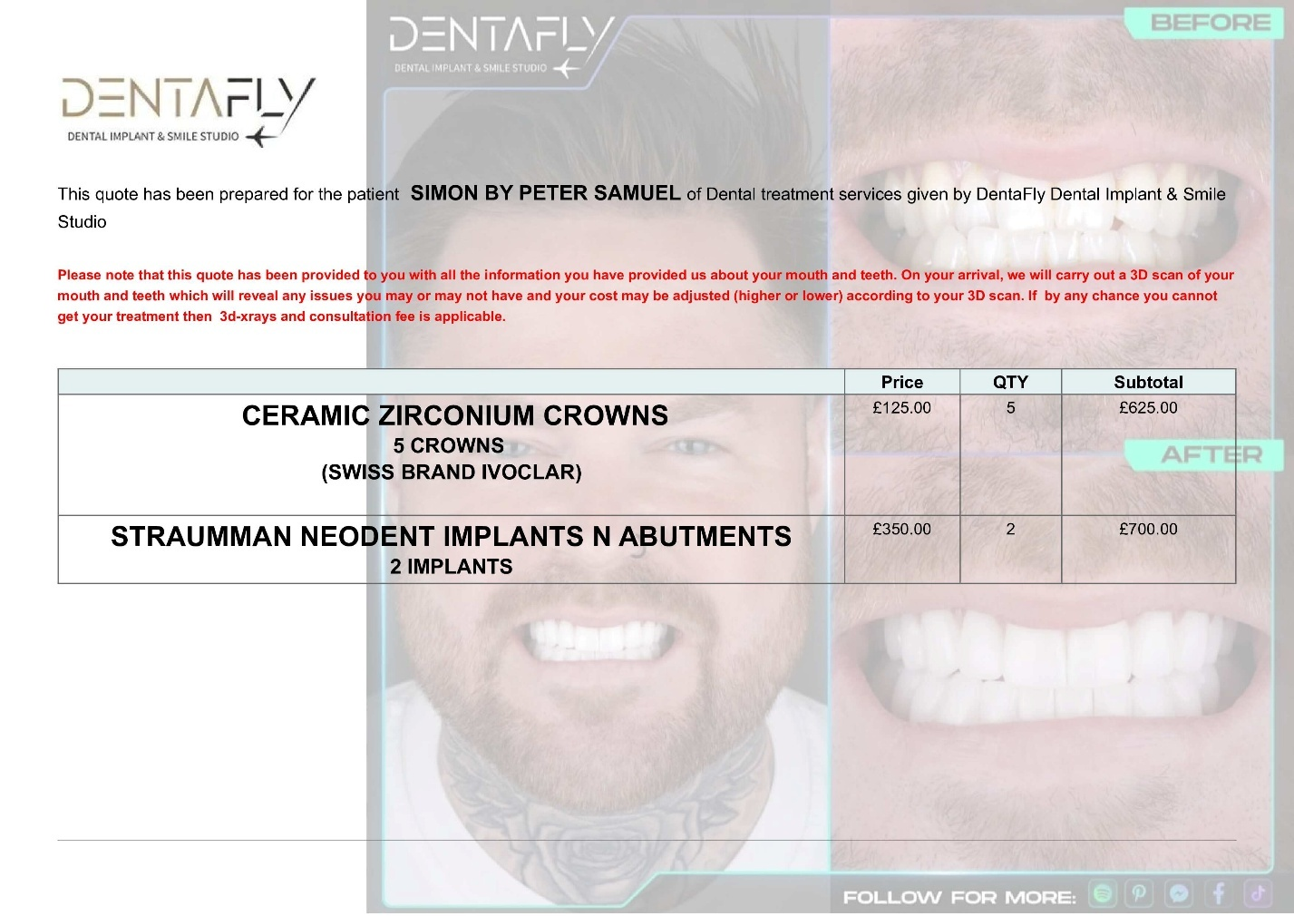
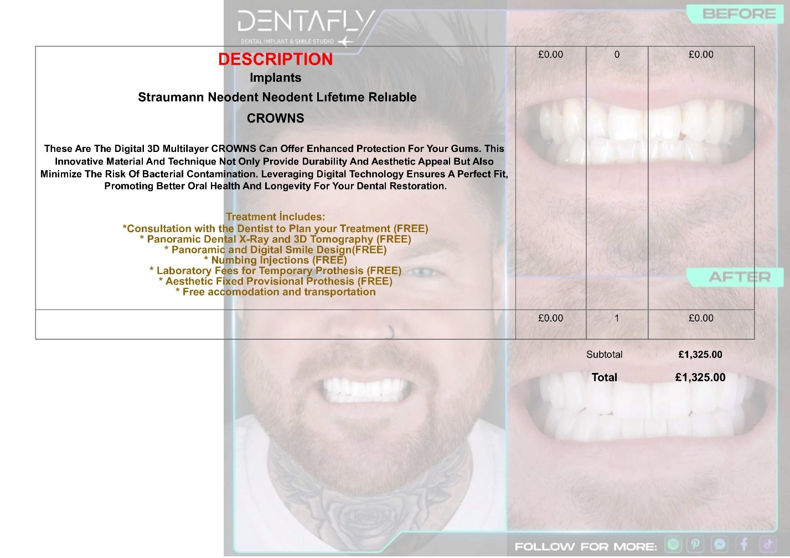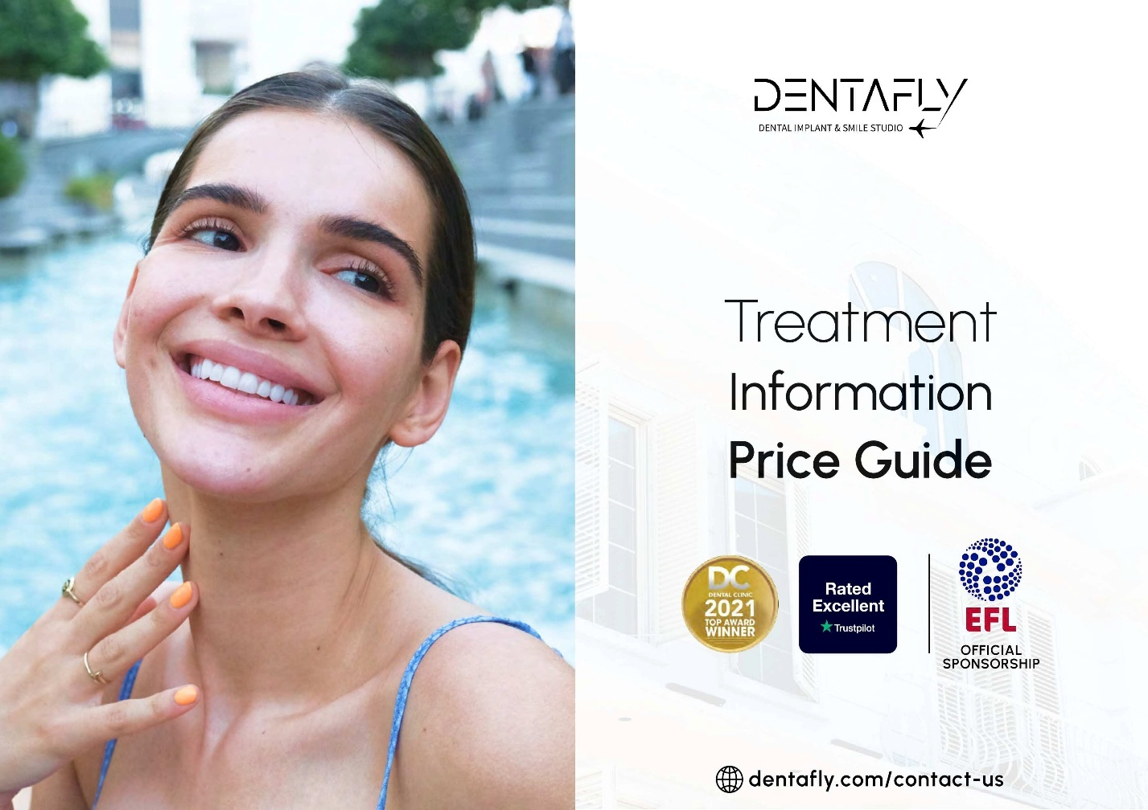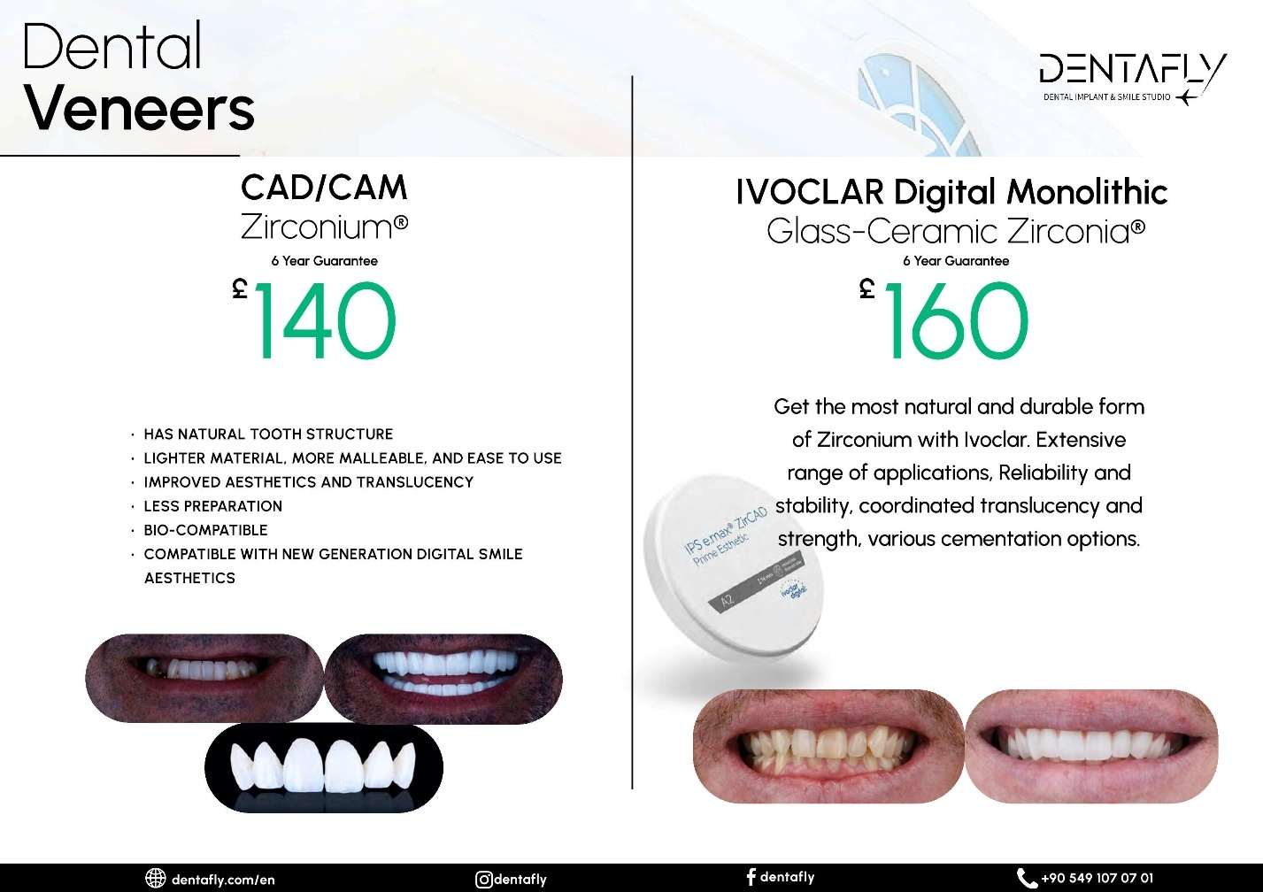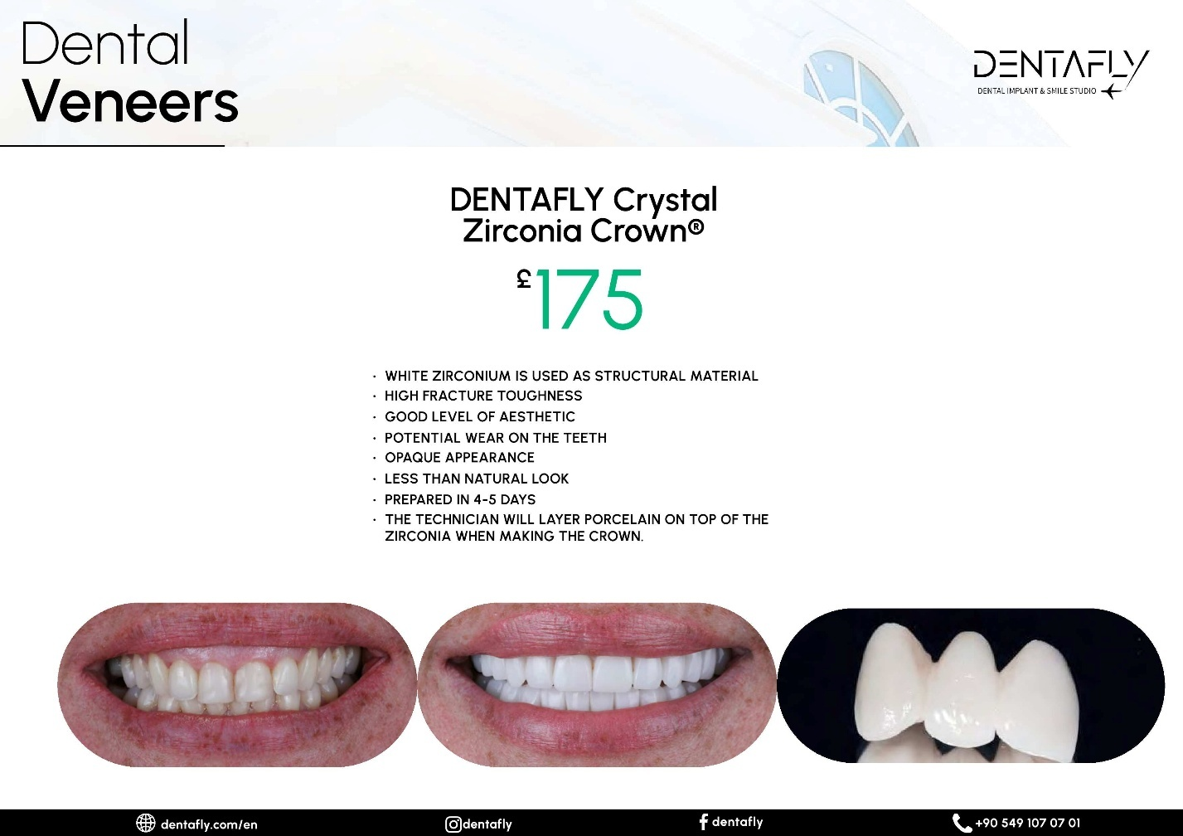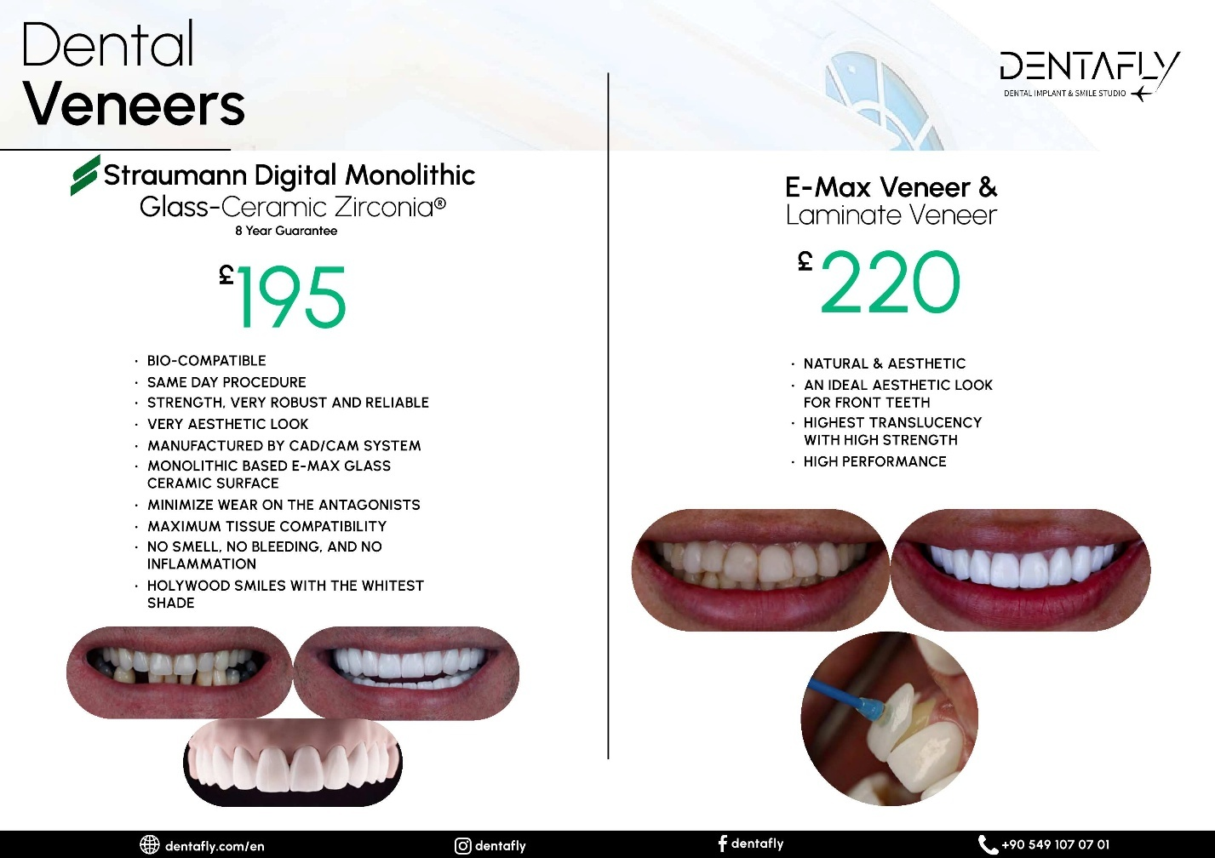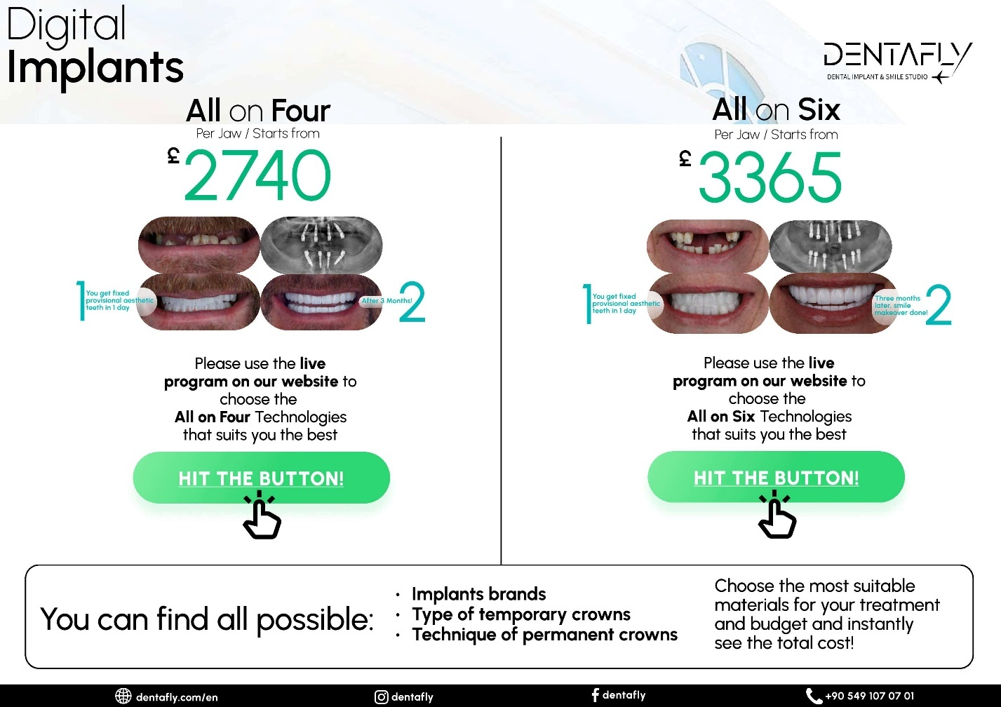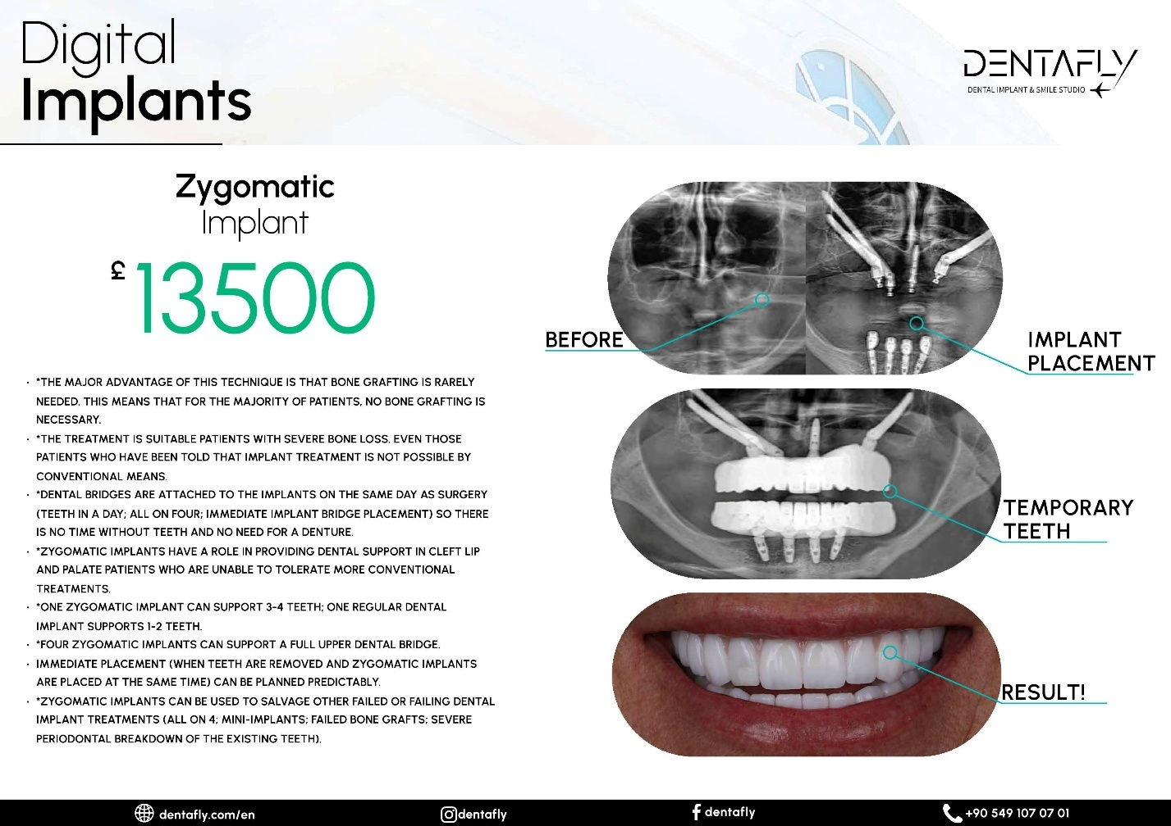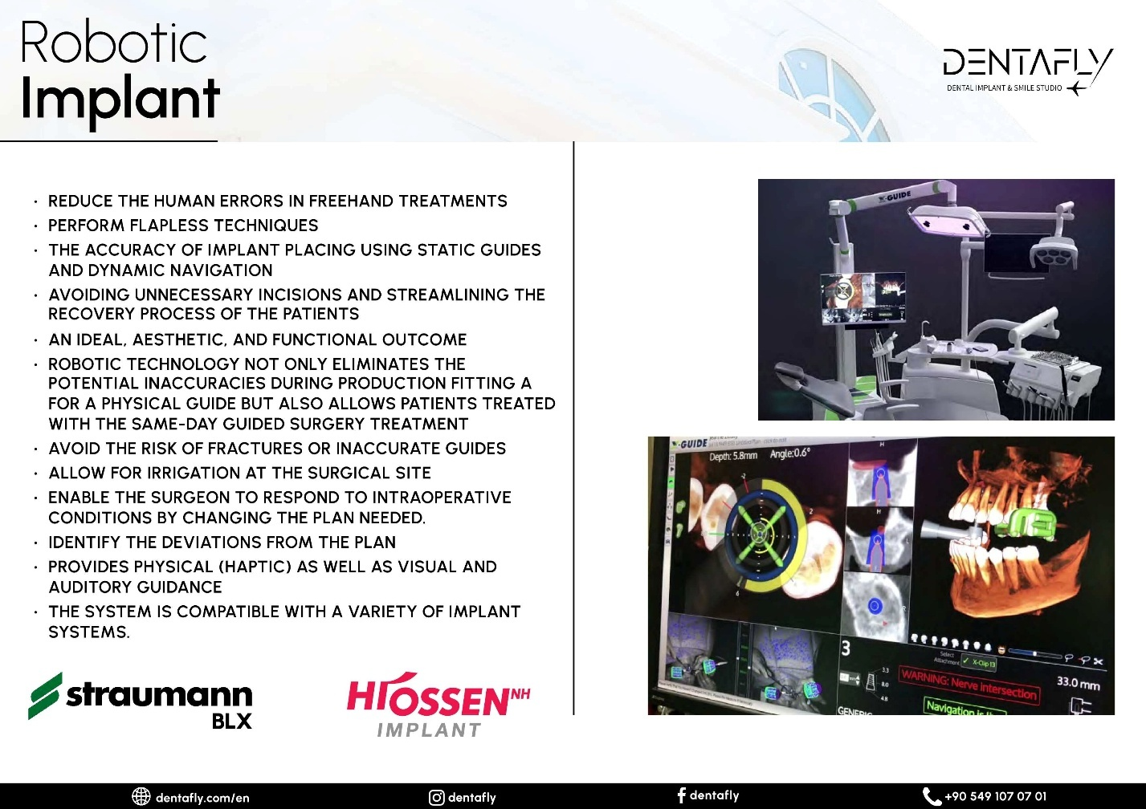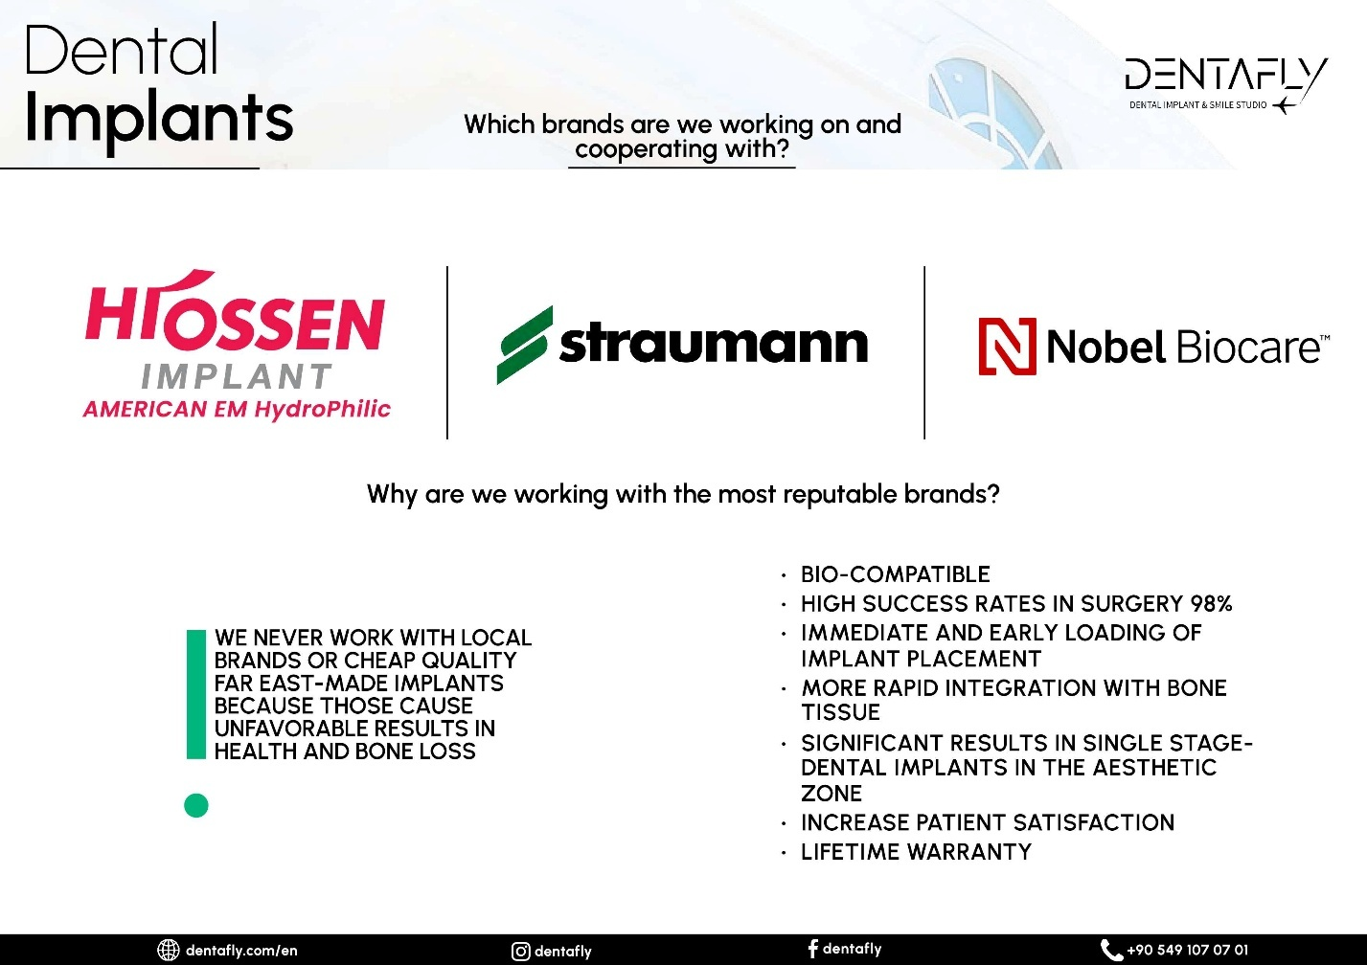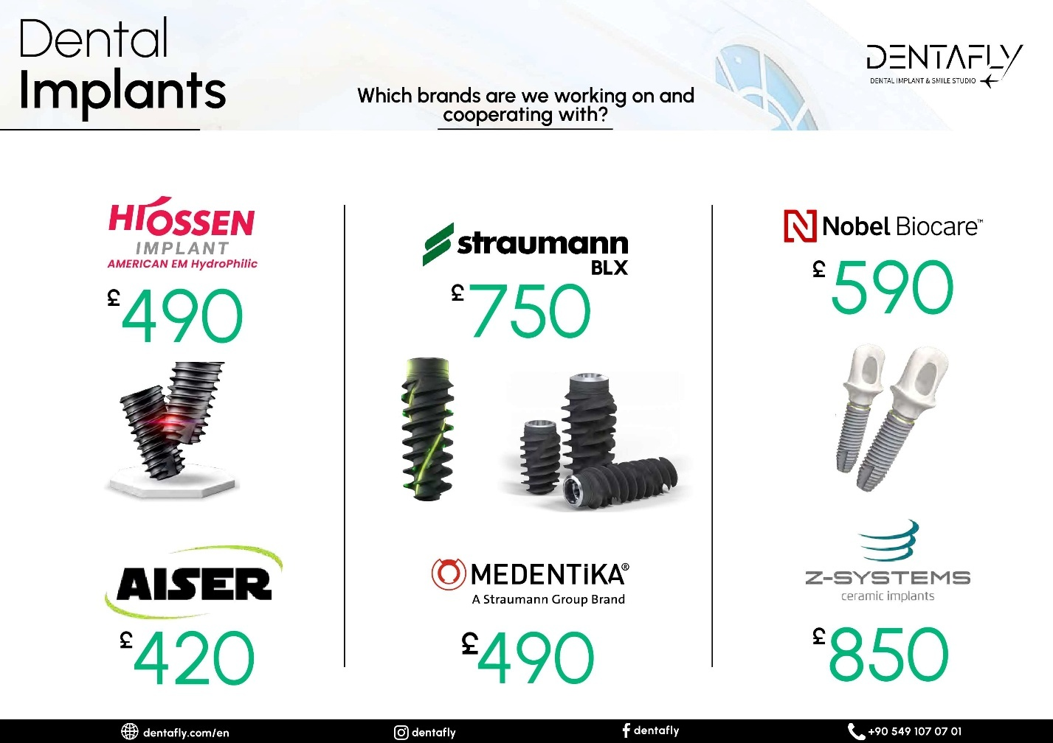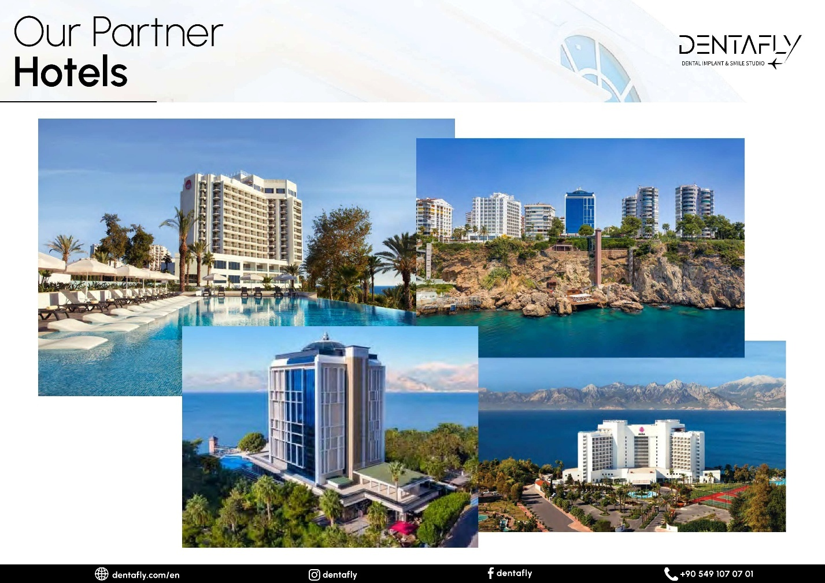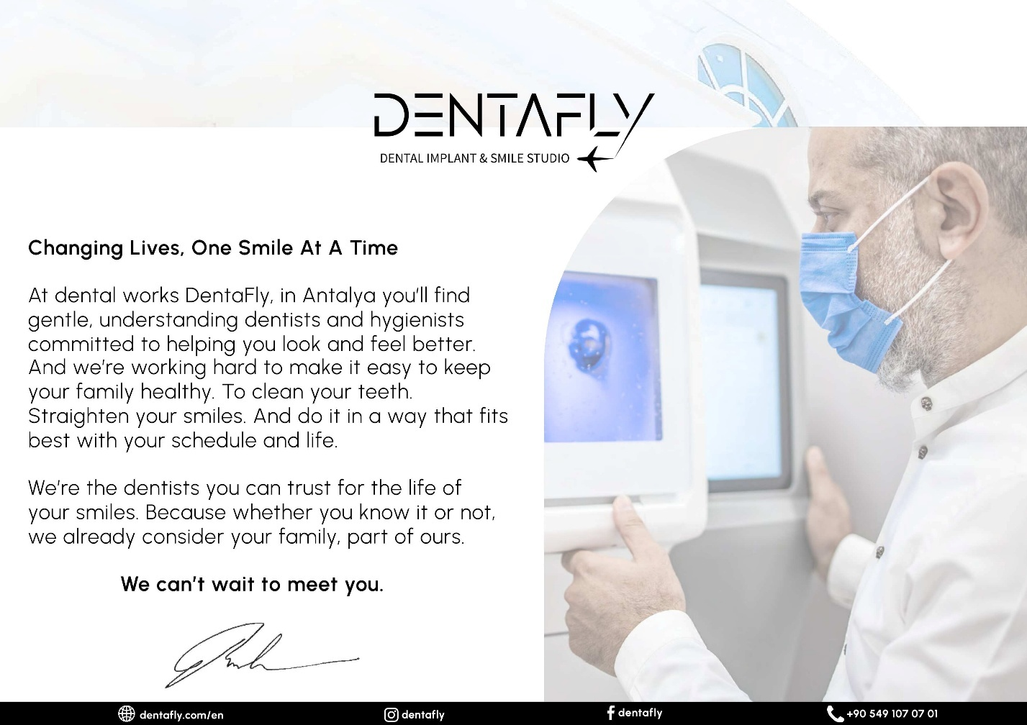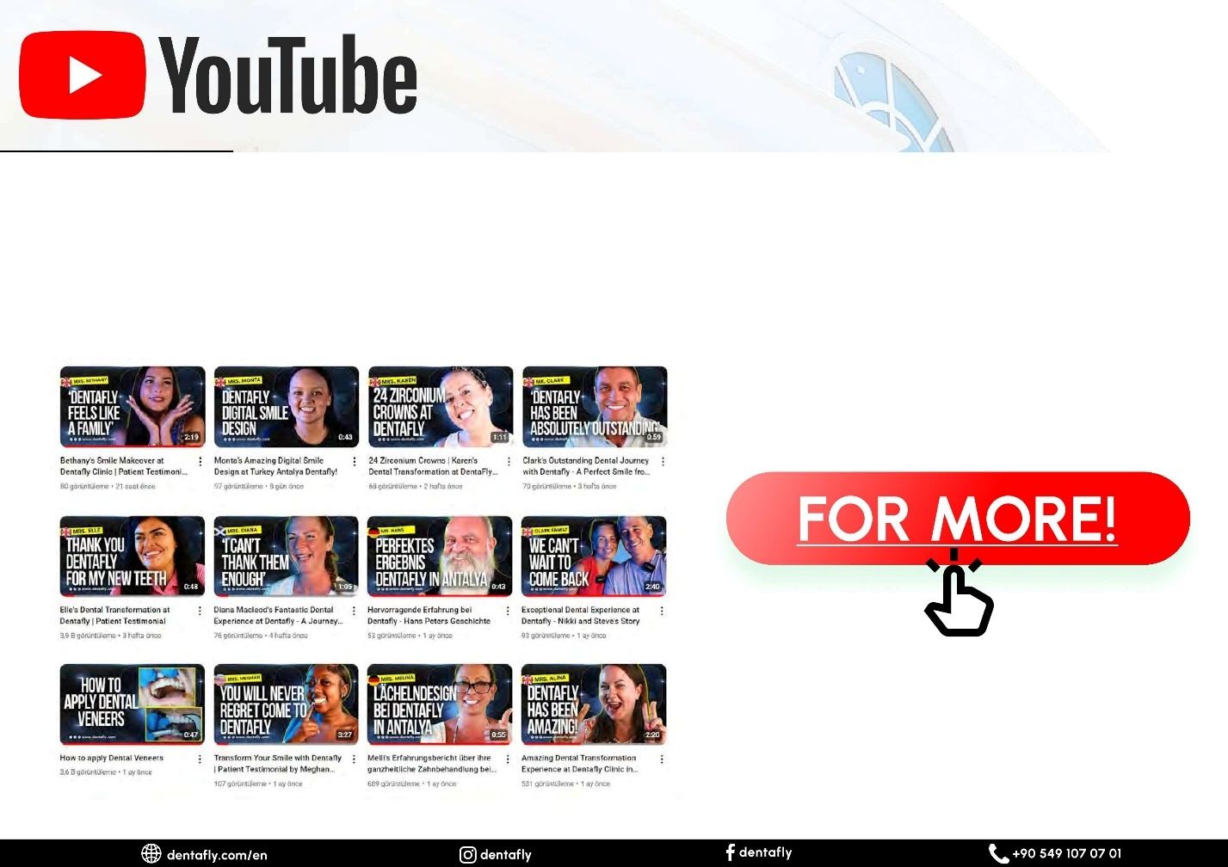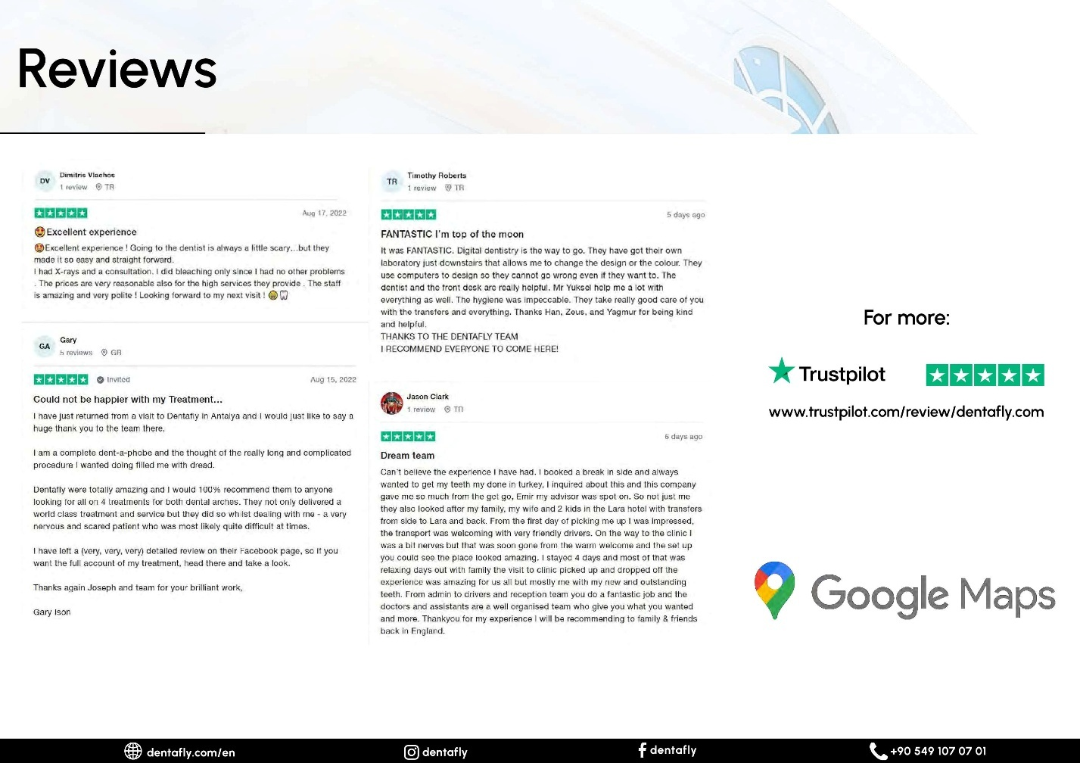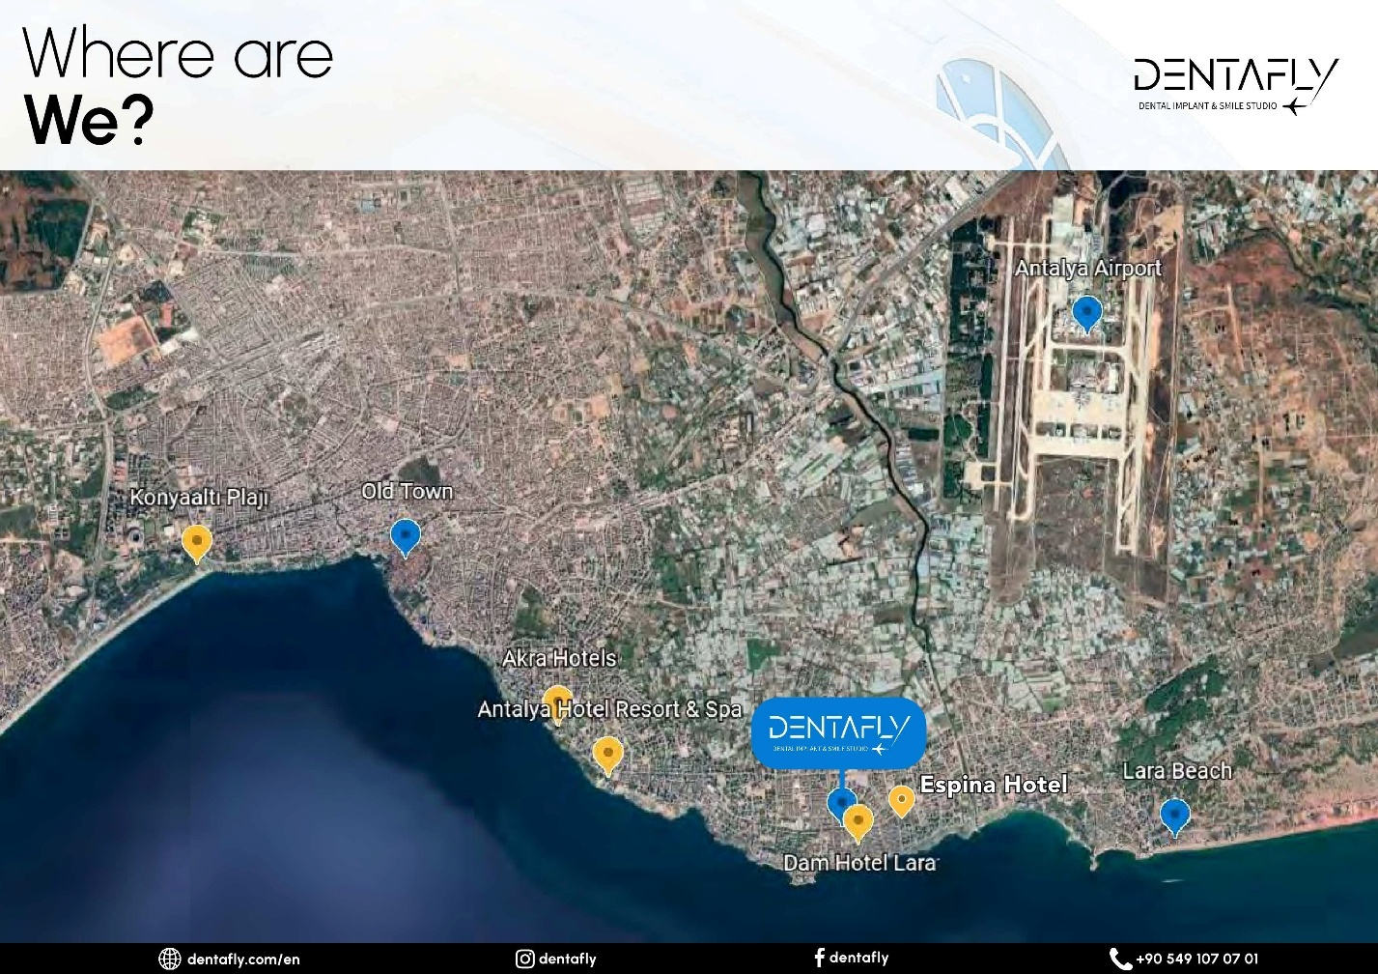

Pre-Travel Quotation:
Before my trip, I reached out via WhatsApp and sent pictures of my teeth. I received a quote for £1,325 for two implants (Straumann Neodent). However, upon arrival, and having a second consultation, the head dentist recommended Hiossen NH Hydrophilic Implants instead and quoted an additional £375 for upgrades and an extra crown. This pricing discrepancy left me feeling uneasy, as it did not align with the initial quotation I was given.

Airport and Transportation:
Upon arrival at Antalya Airport, I faced some confusion with the Dentafly cab service. After some initial miscommunication, I received help from airport scouts, priced at 1300 Turkish lira, which is roughly £30 pounds and then afterwards our transfer to the hotel went smoothly.

- Cab from Antalya Airport Türkiye to Hotel Receipt
- Exhibit: 2
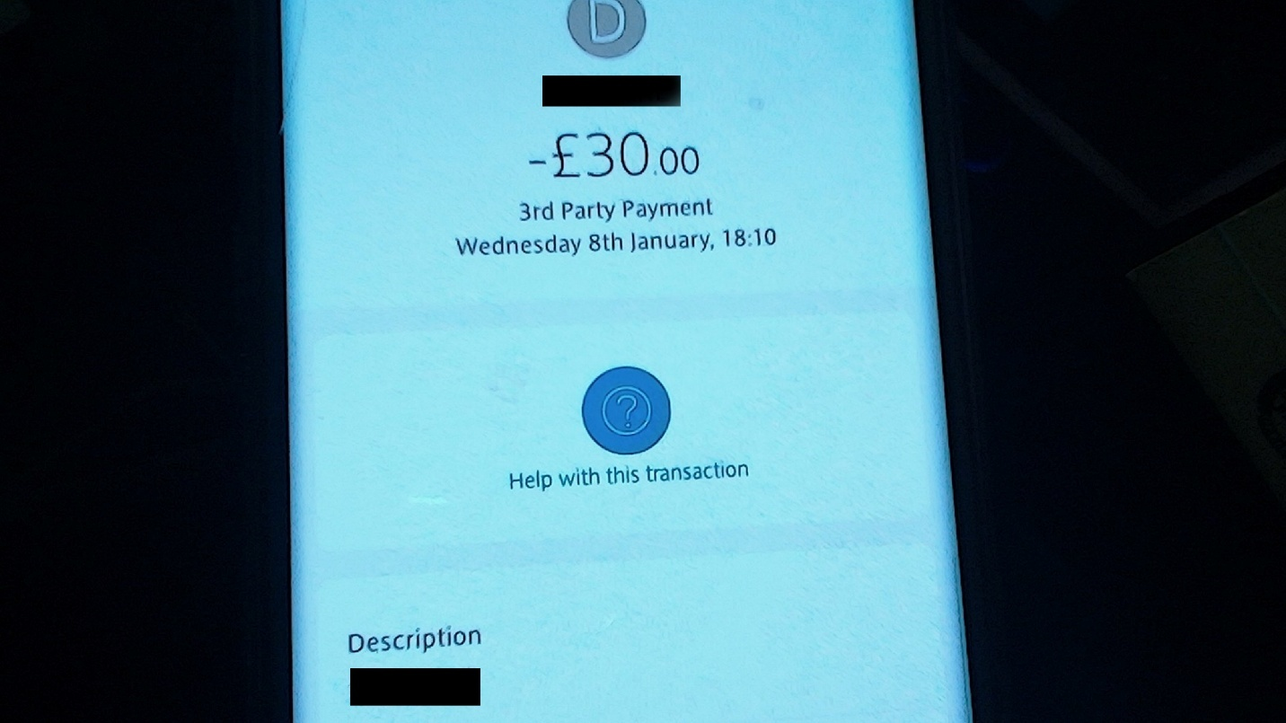
- Total £30.00 Pounds

Hotel Experience:
The accommodation for my stay was agreed to be at my own cost, as I did not meet the requirement of spending over £2000 at the DentaFly clinic for complimentary lodging. I chose a comfortable hotel with friendly staff that made my stay enjoyable. Its location was ideal, it was conveniently situated near a convenience store, the beach, and the dentist’s office.

Upon settling in, I texted DentaFly to inform them of my arrival. The next morning, I received confirmation that transportation would be arranged for me, and it indeed was. A spacious people carrier provided a comfortable ride, taking us a swift 10 minutes to reach the dentist's office located in the nearby town.

Denta Fly Clinic Impressions:
The Dentafly clinic itself was modern and welcoming. The staff exuded professionalism and made me feel at ease. The waiting area was cozy, and they offered complimentary refreshments, which was a nice touch.

During the Second Dentafly Consultation
The staff at DentaFly were not only professional but also approachable, which put me at ease from the moment I arrived. Upon entering the clinic, I was pleased to find a cozy bar area offering complimentary hot drinks and cold refreshments. While there were options for alcoholic beverages, I opted for their superb coffee, which turned out to be an excellent pick-me-up.

The check-in process was smooth, thanks to the attentive staff, and I was soon greeted by the head consultant. He took the time to thoroughly explain my recommended treatment plan, detailing the necessary procedures and outlining any potential “Additional Costs.” I greatly appreciated his transparency, as it was clear at the time as it seemed he understood my needs for straightforward information.

After the consultation, I left feeling confident about the proposed treatment plan and even decided to pay for it, despite initially believing we had reached an agreement during the first consultation. Being in capable hands alleviated my concerns, making the decision to proceed much easier. My priority was to receive top-notch medical care inclusive of materials at a fair price, and DentaFly Clinic reassured me of their commitment to quality, justifying the costs involved.

During the second consultation with DentaFly Clinic the head dentist advised me to consider “Hiossen NH Hydrophilic Implants” along with one additional crown, which we had not realized I needed. He quoted £375 for the extras: £125 for the crown, and £250 for the two implant upgrades.

Treatment Journey
Despite the initial confusion over pricing, I decided to proceed with the dental treatment. Overall, I felt confident in the clinic’s capabilities, and they demonstrated a powerful sense of community.

- This Is A Screenshot Of The Final Price Paid.
- Exhibit: 3
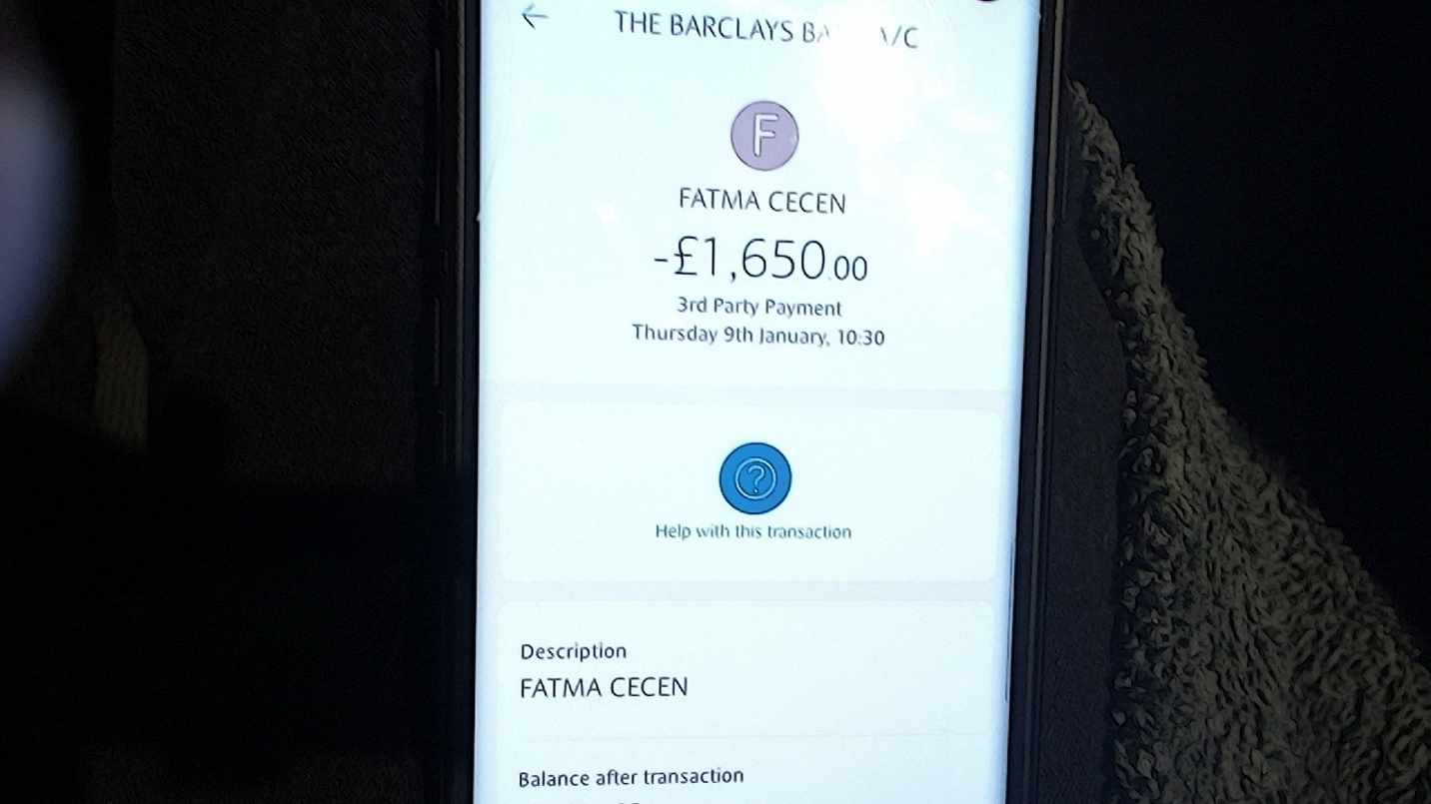
- Dentist-09-0125 - 1030 Total £1,650.00 Pounds

Once Back At Home
However, after returning home and reviewing the initial invoice, I noticed a section in the original invoice that is titled as "Dental Implants: Which brands we are working with." It stated that “Hiossen NH Hydrophilic Implants” were priced at £490, and “Straumann BLX Implants” at £750. This discrepancy indicates that I was charged more than what I expected, and I did not receive the higher-quality implants as suggested in their pricing.

- So, I had noticed that He had Charged Me to a lower graded implant than the Ones Pricing In Their 1st Invoice.
- Exhibit: 4
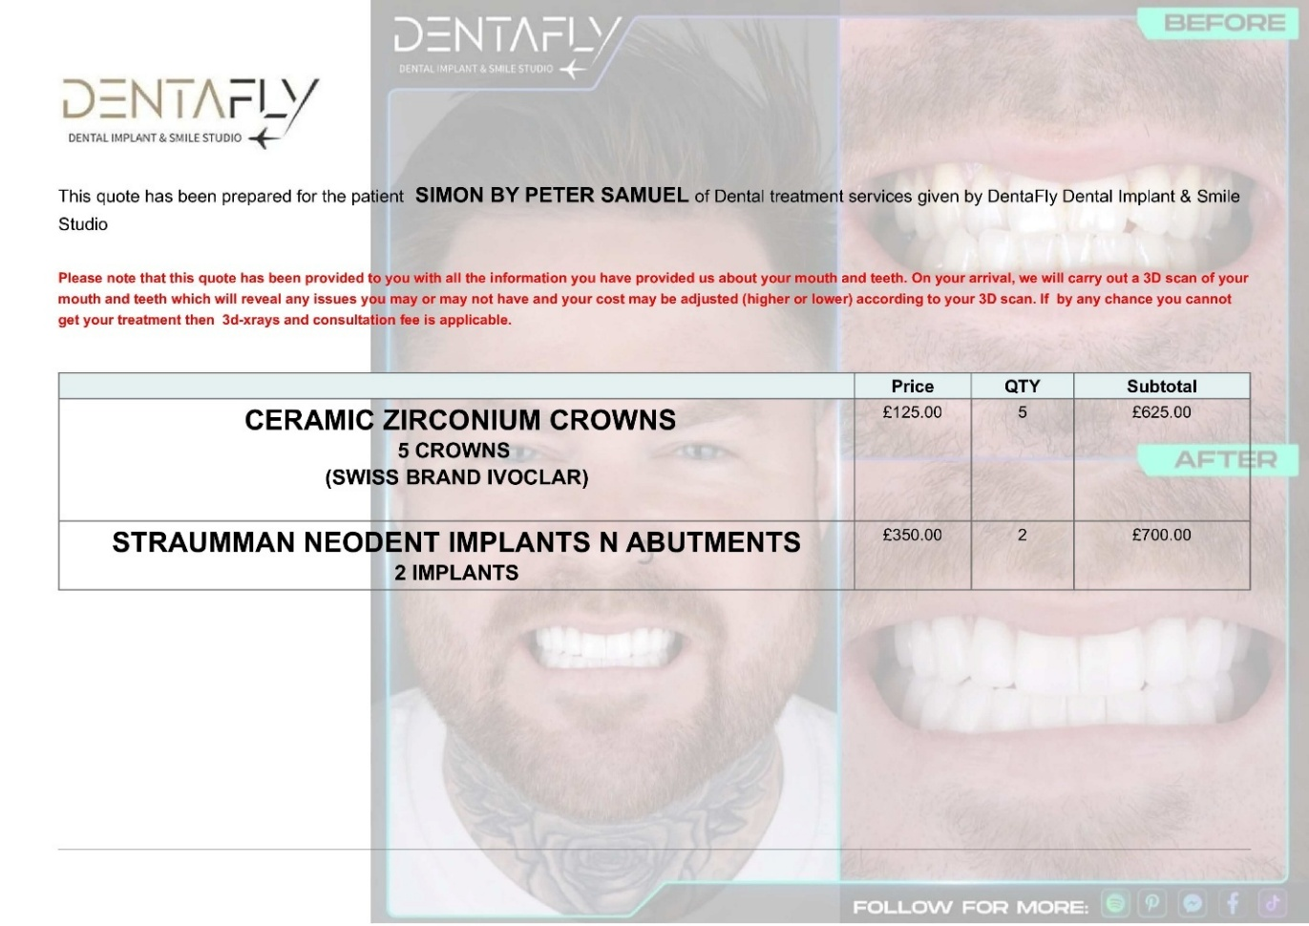

- The image provided below is also from the first invoice and serves as evidence of the pricing listed in their advertisements. It is important to note that there are six distinct brands featured, accompanied by only three images. This potentially leads to confusion, as each brand has its own unique pricing structure. Upon me reviewing their website, it becomes clear that these brands should each have their own corresponding images; however, this is not the case.

- Furthermore, the layout is compounded by the presence of only two divider lines, which implies that each section contains multiple advertisements rather than a single advertisement per brand. This setup undermines the clarity of the pricing information, as it suggests a mix of prices for two distinct products within the same section.

- Exhibit: 5
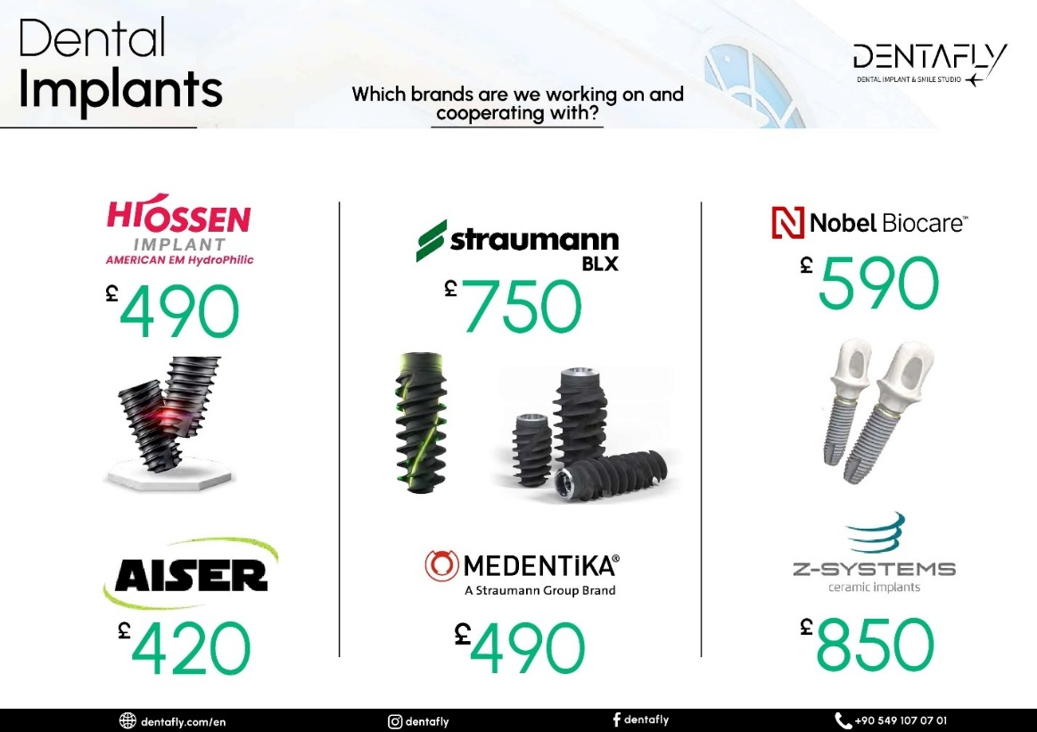

- Evidence that these brands should each have their own corresponding images, as they are their own brands, is as below!
- https://dentafly.com/treatments/antalya-implant-treatment/

- Exhibit: 6
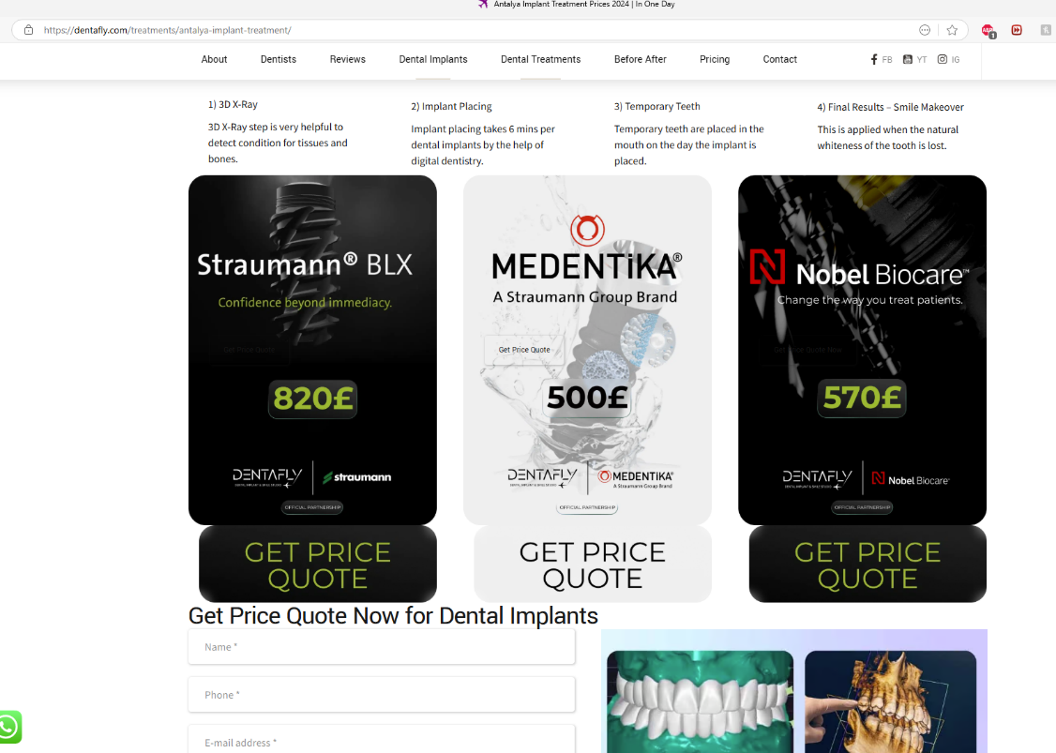

- This is their website link: https://dentafly.com

There website states:

- Dentafly, Vision
- As Dentafly, we aim to ensure the satisfaction of patients and their relatives with the health services we provide, and to set a model for Türkiye with its team. In digital dentistry, it is aimed to be a center where support is provided after treatment, with devices equipped with the latest technology in the world, with specialist physicians.

Dentafly, Mission
- As Dentafly, our mission is to provide quality standards in Oral and Dental Health service by using modern technology with physicians who are dedicated to their profession and value people.

Dentafly, Values
- Respect for Human,
- Environmental awareness,
- Commitment to Ethical Values,
- Working with a Team Spirit,
- Scientific Oriented Study,
- fairness,
- Focused on Patient and Employee Safety,
- Focus on Patient and Employee Satisfaction.

- This is who I had the second consultation with.
- Exhibit: 7
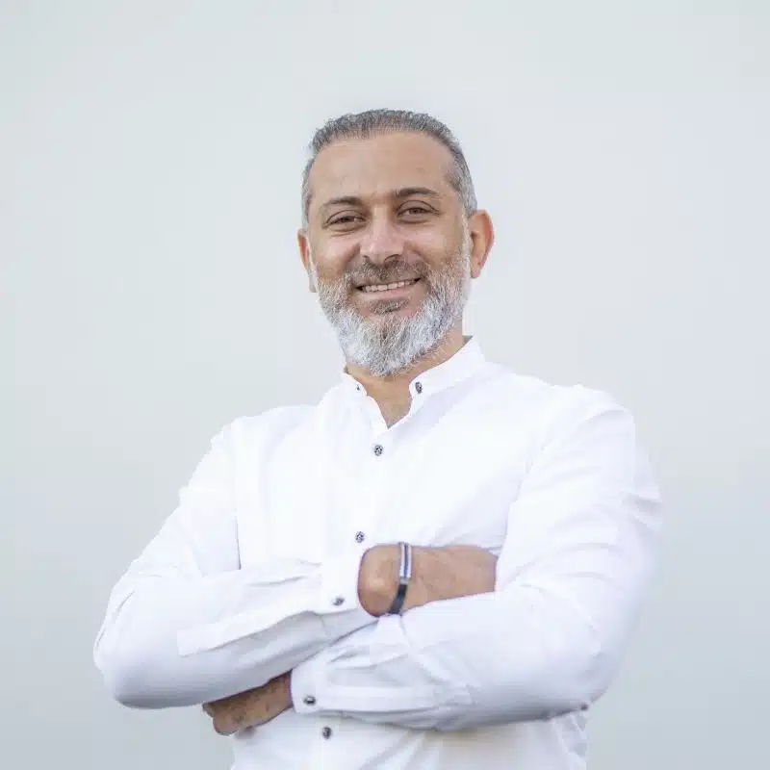
Free Consultation

Dt. Soner Arıkan, Founder / MSc. Dentistry
- He graduated from the Faculty of Dentistry at Gazi University in 2004. He has worked on Aesthetic and Cosmetic Dentistry, Cad Cam dental treatments, and smile designs. He has been a certified dentist for brands like Nobel Biocare Swedish Implant, Bego German Implant, I-System Screwless Implant, and Straumann Swiss Implant since 2006.

- He wrote on a piece of paper the name of the recommended implant upgrades and that is as follows: --
- Exhibit: 8
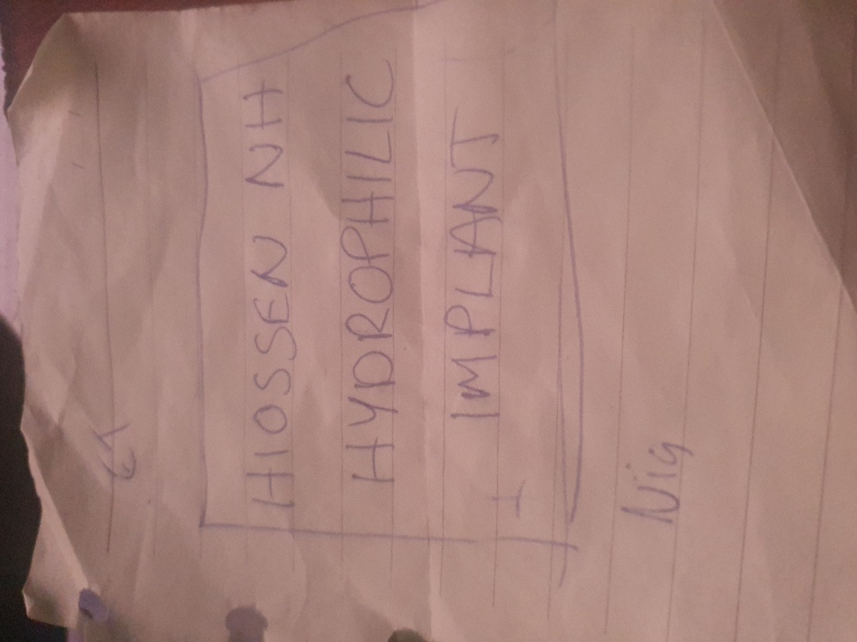
- Extracted from Website Menu: DENTAL-IMPLANTS
- https://dentafly.com/dental-implants/
- No Pricing on this webpage for implants or Crowns.

- Extracted from Website Menu: DENTAL-IMPLANTS/COSTS
- https://dentafly.com/dental-implants/costs/

- Here is a summary of the prices offered for dental implants and crowns on the Dentafly website:
- There are four sections that include price sheets attached to this webpage, and they are as follows: --
- Dental implant costs in Türkiye
- Dental Implant Cost Calculator Tool
- How Much Do Most Quality Dental Implants Cost in Türkiye?
- How much are full mouth dental implants?

- Dental Implant Costs in Türkiye
- Exhibit: 9
Brand Name | Türkiye Cost
Hiossen | £550
Straumann BLX | £890
Straumann Zygoma | £17000
Straumann Group Medentica | £490
Nobel | £750
Nobel Biocare | £590
Local Türkiye Brands | £150
Local Cheap Brands | £110
Chinese Brands | £90

Dental Implant Cost Calculator Tool, “Drop-Down-Menu!”
- Hiossen American EM: £490
- Straumann BLX: £850
- Nobel Biocare: £590
- Bego Implant: £490
- Aiser: £420
- Neodent: £420

- How Much Do Most Quality Dental Implants Cost in Türkiye?
- Exhibit: 10
Most Quality Dental Implant Brands | Cost
Hiossen | £550
Straumann BLX | £890
Straumann Group | £590
Nobel | £750
Nobel Biocare | £590

- How Much Are Full Mouth Dental Implants?
- Exhibit: 11
Full mouth dental implant prices | Cost
Hiossen | £6918
Straumann BLX | £10318
Neodent/Aiser | £6313
Bio HPP Toronto Straumann | £13080

- Extracted from Website Menu: ANTALYA-IMPLANT-TREATMENT
- https://dentafly.com/treatments/antalya-implant-treatment/

- Extracted from Website Menu: ZIRCONIUM-COSTS
- https://dentafly.com/treatments/digital-smile-design/zirconium-costs/

We Got Picked Up From The Hotel And Taken To Denta Fly But Not From The Airport To Our Hotel As Agreed
Dentafly, Airport Transfers
- Delay & Cancel Compensation Guarantee
- If your driver arrives late and this is confirmed by Trip.com, Trip.com will provide compensation based on the amount of time you waited for your driver.
- If you are unable to contact your driver upon arrival, please contact Trip.com's customer support by phone or service chat immediately. We will work to resolve the problem as soon as possible.
If in the end we are unable to provide the airport transfer service you booked, we will cancel your booking for free and provide additional compensation worth 100% of your booking total.

If The Bill Is Not Over £2000 Pounds, Then Free Accommodation Is Not Included!
- I would like to also share another part of my experience regarding the dental implant consultation process I underwent. During my initial consultation, I was assured that I would only need one visit to Türkiye to complete the implant procedure. However, during the second consultation, I was given a revised quote and asked to make a payment, which I promptly did, trusting that the work would be completed on the originally agreed-upon timeline.
- To my surprise, it was only on the last day of my visit that I learned this would not be the case. I was informed that I would need to return for additional appointments, a decision I was told was made based on the best medical treatment plan for my situation. While I understand the importance of prioritizing my health, I cannot help but feel that the lack of communication regarding this change throughout both consultations was concerning.
- Due to the unforeseen need for a follow-up visit, I now face additional travel expenses for which I had not budgeted.
- This situation has been made more complicated because, although I had hoped to qualify for complimentary accommodation based on spending over £2,000 with the clinic the original quote did not qualify but now with the additional costs arising from the second quote—along with the work required on my bottom teeth— the new treatment plan has brought my total bill with Dentafly to over that threshold.
- I was initially led to believe that meeting this spending requirement would ease my financial burden but yet have not felt that support and due to the unexpected expenses of attending the clinic for a second time I feel that Dentafly has turned this into a source of stress that I hope the click compensates me for.
- I would also like to state that the excellent service provided by the staff, who offered welcoming amenities such as a complimentary bar and impeccably clean waiting areas that boast a high-class ambiance, that I still felt uninformed at critical stages of the process. This lack of clarity only became apparent after I made my payment, and on the day before my departure.
- In summary, while I appreciate the High Standards of care and the pleasant environment, I believe more transparent communication throughout the issue I rase as concern during the process I incurred would have significantly enhanced my overall experience at the clinic.

A
What is better and cost more Neodent, dental implant or ET NH implant that otherwise are known as Hiossen NH Hydrophillic implants and what is the difference please?

Q
Both Neodent and Hiossen NH Hydrophilic implants are reputable options, but they have some differences in terms of cost and features.

Neodent Implants “What my sister had implanted.”
- Cost: Neodent implants are more affordable. For example, a Neodent dental implant can cost around £480.
- Features: Neodent implants are known for their versatility and stability. They are part of the Straumann Group and offer a range of solutions for different clinical needs.

Q
Straumann BLX implants

Hiossen NH Hydrophilic Implants
- Cost: Hiossen NH Hydrophilic implants tend to be more expensive. The exact cost can vary, but they are higher than Neodent implants.
- Features: Hiossen's ET NH (Nano-Hydroxyapatite) implants have a unique surface treatment that enhances osseointegration and bone healing. The super hydrophilic surface improves blood adhesion and cell differentiation, leading to faster and more predictable healing.

Key Differences
- Surface Treatment: Hiossen NH implants have a super hydrophilic surface that significantly improves osseointegration and bone healing, while Neodent implants focus on versatility and stability.
- Cost: Neodent implants are more affordable compared to Hiossen NH implants.
- Brand and Reputation: Neodent is part of the Straumann Group, known for its high-quality dental solutions. Hiossen is also a reputable brand, known for its advanced technology and high-end quality products.

A
The choice between Neodent and Hiossen NH Hydrophilic implants depends on your specific needs, budget, and the recommendation of your dental professional.

Q
What are the healing times of these implants I got told 3 months for one or 4 weeks for thew other is this true?

The healing times for dental implants can vary based on the type of implant and the individual's healing process. Here is a comparison of the healing times for Neodent and Hiossen NH Hydrophilic implants:

Neodent Implants
- Healing Time: Typically, Neodent implants require around 3-4 months for the healing process. This period allows for proper osseointegration, where the implant fuses with the bone.

Hiossen NH Hydrophilic Implants
- Healing Time: Hiossen NH Hydrophilic implants are designed to enhance osseointegration and bone healing. They can support functional loading after approximately 4 weeks3. The super hydrophilic surface improves blood adhesion and cell differentiation, leading to faster healing.

So, it is true that Hiossen NH Hydrophilic implants can have a shorter healing time compared to Neodent implants, which typically require a longer period for complete osseointegration.
If you have any more questions or need further assistance, feel free to ask!

Exhibit: 12
Email: Sent

Rewired
From: re_wired@ymail.com
To: Support@dentafly.com
Wed, 15 Jan at 12:28
Dear Dentafly Support Team,
I hope this message finds you well. My name is Mr. Simon Paul Cordell, and I recently had some dental work done at your clinic. I am writing to request the following:
- A copy of the receipt/invoice for the work for which I have just paid.
- A copy of the image of my face from the 3D scan.
- A quote for the following procedures:
  - The bottom front three teeth to be put into veneers.
  - The rest of the teeth to be cleaned when I arrive in around 4 weeks to have the temporary dentures taken out and crowns implanted.
Here are my details for your reference:
- Name: Mr. Simon Paul Cordell
- Address: 109 Burncroft Avenue, Enfield, London, EN3 7JQ
- Tel: +447864217519
- Email: Re_wired@ymail.com
Thank you for your assistance. I look forward to your prompt response.
Best regards, Simon Paul Cordell

Exhibit: 13
Email: Received

DentaFly Support
From: support@dentafly.com
To: re_wired@ymail.com
Wed, 15 Jan at 12:28
Hello.
We have received your email,
We will get back to you in 48 hours.
Hide original message
Thank you.

Exhibit: 14
Email: Sent

Rewired
From: re_wired@ymail.com
To: DentaFly Support
Fri 17 Jan at 11:56
Subject: Follow-Up on Previous Request
Dear Dentafly Support Team,
I hope this message finds you well. I am writing to follow up on my previous email sent on January 15th. As 48 hours have passed, I have not yet received a response.
To reiterate, I am requesting the following:
- A copy of the receipt/invoice for the work for which I have just paid.
- A copy of the image of my face from the 3D scan.
- A quote for the following procedures:
  - The bottom front three teeth to be put into veneers.
  - The rest of the teeth to be cleaned when I arrive in around 4 weeks to have the temporary dentures taken out and crowns implanted.
Here are my details for your reference:
- Name: Mr. Simon Paul Cordell
- Address: 109 Burncroft Avenue, Enfield, London, EN3 7JQ
- Tel: +447864217519
- Email: Re_wired@ymail.com
I would appreciate your prompt response to this matter.
Thank you for your assistance.
Best regards, Simon Paul Cordell

Exhibit: 15
Email: Received

DentaFly Support
From: support@dentafly.com
To: re_wired@ymail.com
Fri 17 Jan at 11:56
Hide original message.
Hello.
We have received your email,
We will get back to you in 48 hours
Thank you.

Exhibit: 16
Email: Received

DentaFly Support
From: support@dentafly.com
To: Rewired
Fri, 17 Jan at 21:09
Hello Paul,
It seems our previous email has not reached you.
We will provide you with your receipts and papers, but please let us know if you are experiencing any issues. If you are then please know that we are here for you and are more than ready to address any issues you could be experiencing promptly.
Please note that we can provide you with a picture of your panoramic X-ray, but a viable 3D scan is hard to send and would most probably not work on your computer or phone.
We look forward to hearing from you!
Warmest Regards,
Dentafly Support Team.

Exhibit: 17
Email: Sent

Rewired
From: re_wired@ymail.com
To: DentaFly Support
Sat, 18 Jan at 06:58
Subject: Follow-Up on Previous Request
Dear Dentafly Support Team,
Thank you for your response. I appreciate your willingness to provide the receipts and papers to me. I would like to confirm that I am indeed experiencing some issues and would appreciate your prompt assistance.
Regarding the panoramic X-ray, I would be grateful if you could send me pictures of the front and both sides of my face. I understand that a viable 3D scan might be difficult to send, but if there is any way to provide it to me in a format that could work on my computer or phone, I would appreciate it.
Additionally, I would like to request a quote for the following procedures:
- The bottom front three teeth to be put into veneers.
- The rest of the teeth to be cleaned when I arrive in around 4 weeks to have the temporary dentures taken out and crowns implanted.
It is important to resolve these matters as quickly as possible, as they are affecting my dental health and overall well-being. Therefore, I would greatly appreciate it if you could provide me with any given dates for the completion of the requested items in your next email. If not, please include them as the attached documents.
Thank you for your support and understanding.
Best regards, Simon Paul Cordell

Exhibit: 18
Email: Received

DentaFly Support
From: support@dentafly.com
To: re_wired@ymail.com
Sat, 18 Jan at 06:59
Hide original message.
Hello.
We have received your email,
We will get back to you in 48 hours
Thank you.

Exhibit: 19
Email: Sent

Rewired
From: re_wired@ymail.com
To: DentaFly Support
Mon, 20 Jan at 11:31
Subject: Urgent Follow-Up on Previous Requests
Dear Dentafly Support Team,
I hope this message finds you well. I am writing to follow up on my previous requests. Despite my repeated attempts to get the information I need, I have only received automated responses stating:
"Hello. We have received your email; we will get back to you in 48 hours. Thank you."
Additionally, I received an email stating:
"It seems our previous email has not reached you. We will provide you with your receipts and papers."
However, none of the requested documents have been provided. As of today, January 20, 2025, it has been six days since my initial request on January 15, 2025, at 12:28 PM.
I have received this same message three times now, and it is unreasonable to wait this long for a single client's requests to be addressed. Could you kindly send me the information I have asked for? I am still in need of the following:
- A copy of the receipt/invoice for the work for which I have just paid.
- A copy of the image of my face from the 3D scan.
- A quote for the following procedures:
  - The bottom front three teeth to be put into veneers.
  - The rest of the teeth to be cleaned when I arrive in around 4 weeks to have the temporary dentures taken out and crowns implanted.
Here are my details for your reference:
- Name: Mr. Simon Paul Cordell
- Address: 109 Burncroft Avenue, Enfield, London, EN3 7JQ
- Tel: +447864217519
- Email: Re_wired@ymail.com
I would appreciate your prompt response to this matter.
Thank you for your assistance. I look forward to your prompt response.
Best regards,
Simon Paul Cordell

Exhibit: 20
Email: Received

DentaFly Support
From: support@dentafly.com
To: re_wired@ymail.com
Mon, 20 Jan at 11:31
Hide original message.
Hello.
We have received your email,
We will get back to you in 48 hours
Thank you.

Exhibit: 21
Email: Received

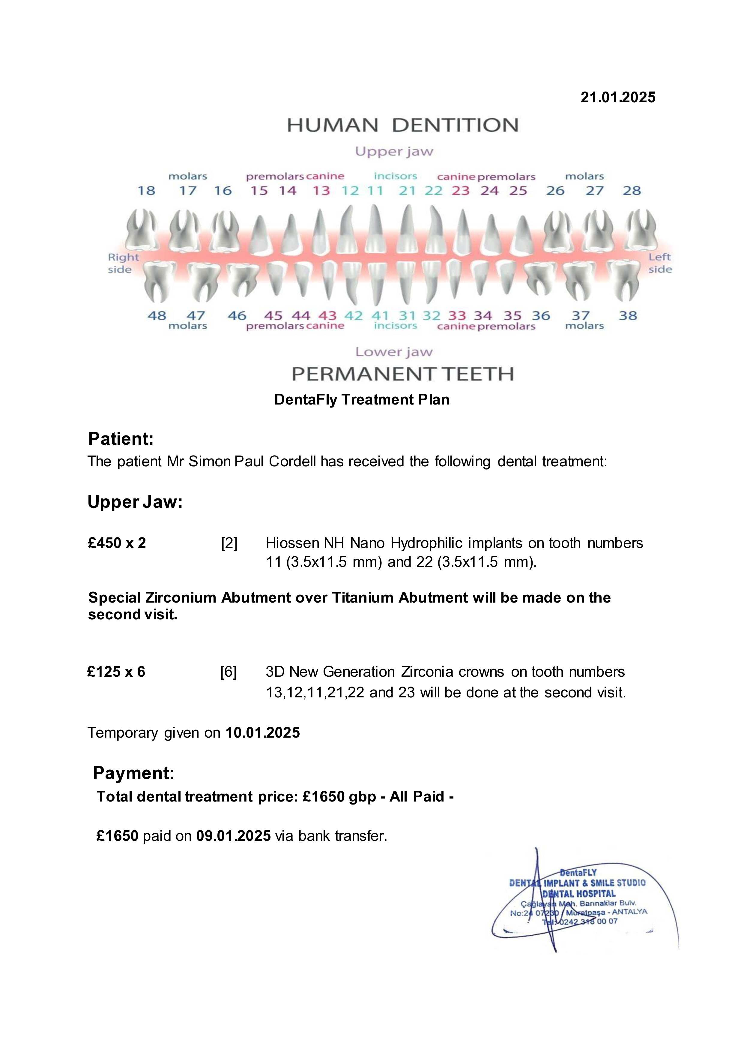
Initial Quote
- Ceramic Zirconium Crowns (Swiss Brand Ivoclar): £125 each, totaling £625 for 5 crowns.
- Straumann Neodent Implants and Abutments (2 Implants): £350 each, totaling £700.
Description
- Implants: Straumann Neodent, known for their reliability and lifetime guarantee and fast healing capabilities.
- Crowns: Digital 3D Multilayer Crowns, offering enhanced protection, durability, aesthetic appeal, and minimizing bacterial contamination.
Included Treatments (Free)
- Consultation with the dentist
- Panoramic Dental X-Ray and 3D Tomography
- Panoramic and Digital Smile Design
- Numbing Injections
- Laboratory Fees for Temporary Prosthesis
- Aesthetic Fixed Provisional Prosthesis
- Free accommodation and transportation if spent over £2000.
Total Cost in First Invoice
- Subtotal: £1,325
- Total: £1,325
Comparison with On-Site Second Invoice Recommendation
- Extra Fee: £375.
- Extra Crown: £125.
- Extra Charge For Implants: £125 for each X2 total £250.
- Discount Applied Of: £25.
- Refused To Discount The: £40 paid for cab from airport.
- Total extra to be paid: £350 not £375 as requested.
- Paid in full.
Total Cost with On-Site Recommendation
- Initial Quote: £1,325
- Additional Charges: £375 (extra crown x1 + implants £125 each X2 total £250)
- Total: £1,675 – £25 discount applied by staff. Final Total: £1,650 –

Pricing Paid and Brand from Invoice 1
- Straumann Implants: £350 each.

Pricing of Implant Advertisements in First Invoice
- Straumann BLX Implants: £750 each, totaling £1500 for 2 implants, in the first Invoiced advertisement price.
- Hiossen NH Hydrophilic Implants: £490 each, totaling £980 for 2 implants, in the first Invoiced advertisement price.

This is false advertising and leads you into believing you are getting the better brand selling, unless you find the confusions in their pricing in their website also.

Pricing from Website
- https://dentafly.com/dental-implants/costs/

- Dental Implant Costs in Türkiye

Brand Name | Türkiye Cost
Hiossen | £550
Straumann BLX | £890
Straumann Zygoma | £17000
Straumann Group Medentica | £490
Nobel | £750
Nobel Biocare | £590
Local Türkiye Brands | £150
Local Cheap Brands | £110
Chinese Brands | £90

- Misleading Advertising: The first invoice advertised Straumann BLX implants at £750, but the website piece states Straumann BLX implants at £890. I was invoiced for £350 for Straumann implants without the company specifying the type and the invoice only offering one type of Straumann implants, the BLX version. These discrepancies were misleading advertising, to me.

- Inconsistent Pricing: The website lists Hiossen implants at £550, and invoice at £490.

- Lack Of Transparency: The invoice did not clearly specify the type of Straumann implant I was receiving but did in images leading to confusion about the actual product and its cost.

- Pressure To Upgrade: I was told that Hiossen implants are better and were pressured to pay extra, despite the website listing a lower price for Hiossen implants.

- Inaccurate Information: The website lists different prices for various implant brands, and the invoice I received does not align with these prices, indicating a lack of accurate information provided to the customer.

Dental Implant Cost Calculator Tool
Taken from the drop-down menu to select from when paying is: -
- Hiossen NH Hydrophilic Implants: £490
- Straumann BLX Implants: £850
- Nobel Biocare: £590
- Neodent: £420

Unavailable Options:
- Straumann Zygoma £17000 and
- Straumann Group £490 within the category “Dental Implant Costs in Turkey” in the website page is not available in the drop-down menu.
- The Straumann Group implant option at £590 within the category “How Much Do Most Quality Dental Implants Cost in Turkey?” is advertised in the website but not available to select when paying, which can be seen as false advertising.

- Bait And Switch: The practice of advertising one price and then charging a higher price upon arrival can be considered a bait-and-switch tactic, which is unethical and potentially illegal.

How Much Do Most Quality Dental Implants Cost in Türkiye?

Most Quality Dental Implant Brands | Cost
Hiossen | £550
Straumann BLX | £890
Straumann Group | £590
Nobel | £750
Nobel Biocare | £590

- The table above has two prices for Straumann, £890 and £590 but both of them are higher than Hiossen at £550.

How Much Are Full Mouth Dental Implants?
Full Mouth Dental Implant Prices | Cost
Hiossen | £6918
Straumann BLX | £10318
Neodent/Aiser | £6313
Bio HPP Toronto Straumann | £13080

- Once again Straumann BLX is higher priced than Hiossen.
- Neodent/Aiser is also listed as its own implant as in the first invoiced advertisement, proving it to be a separate product from Hiossen.

Pricing from Invoice 2
- Incorrect Second Invoice:
- Hiossen NH Hydrophilic Implants: quoted £475 at second consultation… charge at £450 each in second invoice. 350 + 125 = 475 and is what I paid…. For the better implants but it seems as if
- The second invoice states £450 each but did not account for the £25 discount, leading to an under quote of £25. This discrepancy further highlights the lack of accuracy and transparency in the billing process.
- First Invoice Price for Hiossen implants is £490.
- Website Price for Hiossen implants is £550.

Other Key Points
- Initial Quote: £1,325 for Straumann Neodent implants and Ivoclar crowns.
- On-Site Recommendation: Hiossen NH Hydrophilic implants £475 each, and an extra crown, £125 each, totaling £1,675. Price paid £1,650, with £25 discount.
- Invoice 2 Pricing: Hiossen NH Hydrophilic implants at £450 each,

Concerns Identified
- Price Discrepancy: The initial quote for Straumann Neodent implants was £350 each, but the website lists Neodent implants at £420 each. This discrepancy might be confusing.
- Straumann BLX implants at £750 each and/or Straumann Group £590 even though Straumann Group £590 are not available to purchase.

- **Discrepancy in Pricing**:
  - Initial quote for Straumann Neodent implants was £350 each, but the website lists them at £420 each.
  - Pricing for Hiossen NH Hydrophilic implants varies between invoices (£490 in the first invoice, £475 in the second invoice, and questioned £450 in the second invoice).

- **Misleading Advertising**:
  - Initial invoice advertised Straumann BLX implants at £750, while website states £890.
  - Conflicting price listings for Hiossen implants (£490 in the first invoice vs. £550 on the website).
  - Price visibility confusion, leading clients to believe they are purchasing superior products without clear information.

- **Lack of Transparency**:
  - The invoice did not clearly specify the type of Straumann implants being provided.
  - Unclear communication regarding final costs and discounts applied.

- **Pressure to Upgrade**:
  - I felt pressured to pay more for Hiossen implants despite there being confusion regarding their pricing.

- **Inaccuracies in Information**:
  - Differences in prices listed on the website compared to the invoices, suggesting inaccurate or misleading information was provided.

- **Inconsistent Pricing**:
  - Various prices for the same implants across different invoices and the website led to confusion and distrust.

- **Bait and Switch**:
  - Practice of advertising one price and charging a higher price upon arrival could be interpreted as unethical and potentially illegal.

- **Additional Charges**:
  - Extra charges for an additional crown and two implants were misleading and not initially clear.

- **Downgrade in Quality**:
  - The recommendation to switch to a different brand of implants (Hiossen) was perceived as an upgrade grade from what was originally agreed (Straumann implants).

- **Discount Confusion**:
  - Confusion regarding the application of discounts, leading to discrepancies in expected versus actual billing.

- On-Site Recommendation: The recommendation to switch to Hiossen NH Hydrophilic implants and the additional crown increased the total cost significantly and downgraded the quality of the implants put into my body, when I agreed to pay for the best available.

- Advertising and Pricing: The website advertises different prices for various brands, which might not have been clear during your WhatsApp consultation.

I found trust pilot:
https://uk.trustpilot.com/review/dentafly.com

Then I clicked on the one star:
Dentafly Reviews | Read Customer Service Reviews of dentafly.com

And read the reviews….

