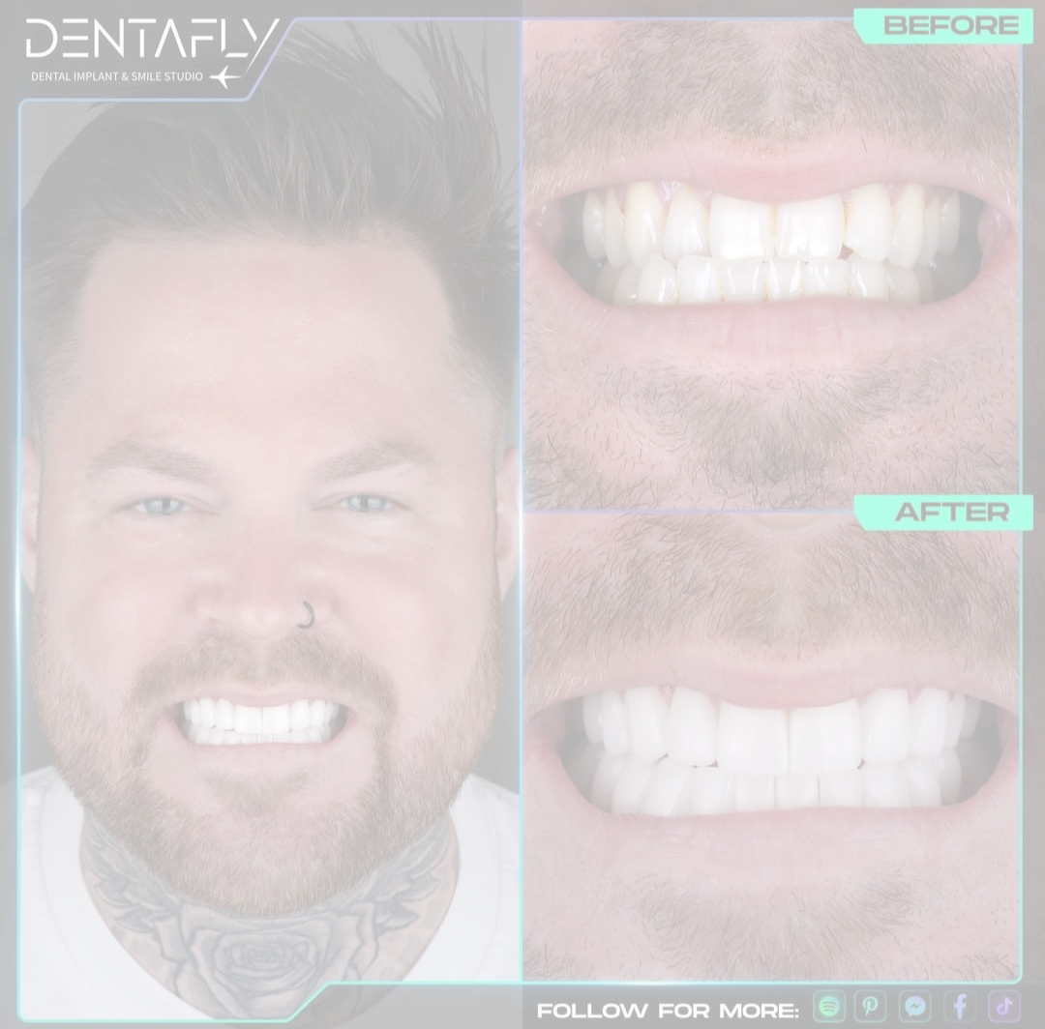

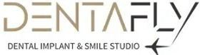

This quote has been prepared for the patient SIMON BY PETER SAMUEL of Dental treatment services given by DentaFly Dental Implant & Smile Studio

Please note that this quote has been provided to you with all the information you have provided us about your mouth and teeth. On your arrival, we will carry out a 3D scan of your mouth and teeth which will reveal any issues you may or may not have and your cost may be adjusted (higher or lower) according to your 3D scan. If by any chance you cannot get your treatment then 3d-xrays and consultation fee is applicable.

 | Price | QTY | Subtotal
CERAMIC ZIRCONIUM CROWNS  5 CROWNS (SWISS BRAND IVOCLAR) | £125.00 | 5 | £625.00
STRAUMMAN NEODENT IMPLANTS N ABUTMENTS  2 IMPLANTS | £350.00 | 2 | £700.00

DESCRIPTION  Implants  Straumann Neodent Neodent Lıfetıme Relıable CROWNS  These Are The Digital 3D Multilayer CROWNS Can Offer Enhanced Protection For Your Gums. This Innovative Material And Technique Not Only Provide Durability And Aesthetic Appeal But Also Minimize The Risk Of Bacterial Contamination. Leveraging Digital Technology Ensures A Perfect Fit, Promoting Better Oral Health And Longevity For Your Dental Restoration.  Treatment İncludes:  *Consultation with the Dentist to Plan your Treatment (FREE)  * Panoramic Dental X-Ray and 3D Tomography (FREE)  * Panoramic and Digital Smile Design(FREE)  * Numbing Injections (FREE)  * Laboratory Fees for Temporary Prothesis (FREE)  * Aesthetic Fixed Provisional Prothesis (FREE)  * Free accomodation and transportation | £0.00 | 0 | £0.00
 | £0.00 | 1 | £0.00
Subtotal £1,325.00
Total £1,325.00

.•..•-.·-·:··•··.
·····•;
·• ··•.·•:
- •. .

,f!

sij
S•

...
;::

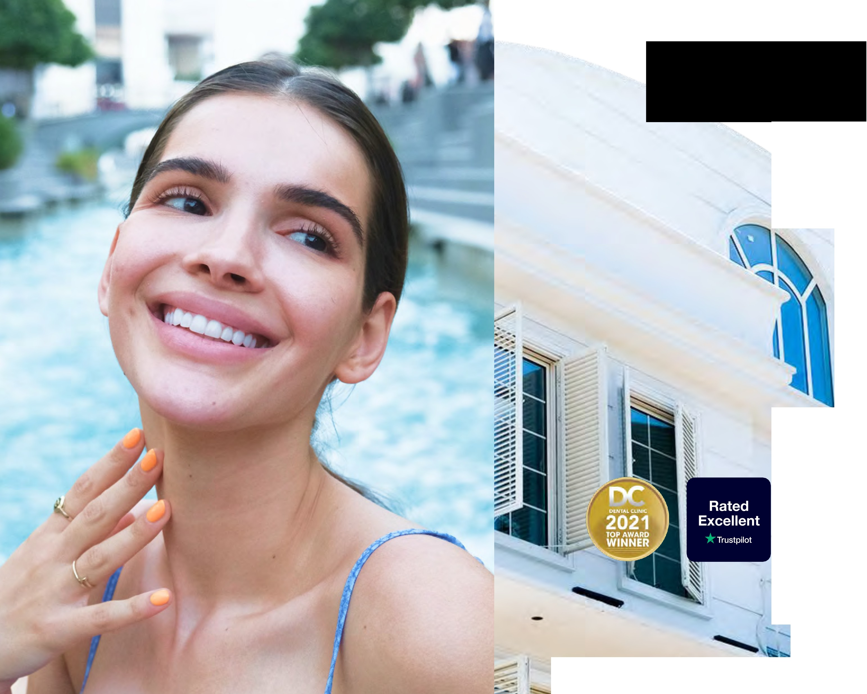
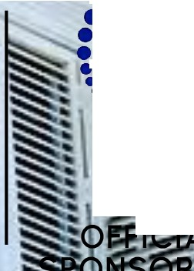
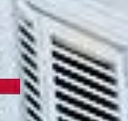
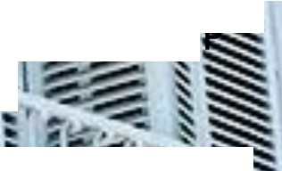
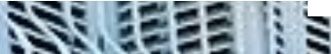
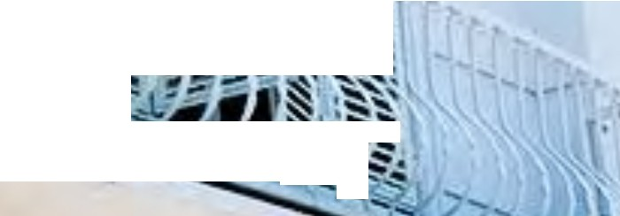
(® denfafly.com/co - .,= f'
'·

Denta

Veneers

CAD/CAM

Zirconium®
6 Year Guarantee
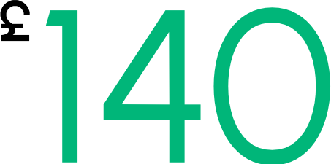

- HAS NATURAL TOOTH STRUCTURE
- LIGHTER MATERIAL, MORE MALLEABLE, AND EASE TO USE
- IMPROVED AESTHETICS AND TRANSLUCENCY
- LESS PREPARATION
- BIO-COMPATIBLE
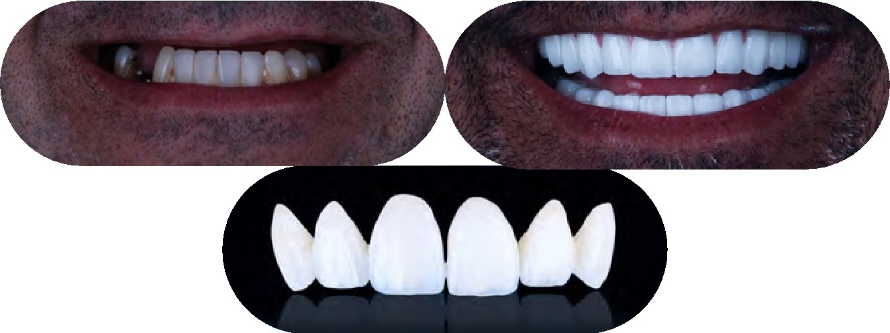

- COMPATIBLE WITH NEW GENERATION DIGITAL SMILE AESTHETICS



IVOCLAR Digital Monolithic


Glass-Ceramic Zirconia®
6 Year Guarantee


Get the most natural and durable form of Zirconium with lvoclar. Extensive range of applications, Reliability and
.,_-v stability, coordinated translucency and
1)-f.,r-
:,,,,,!
sf?., t\>f-'--f., strength, various cementation options.

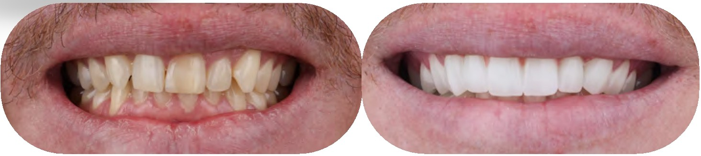

dentafly.com/en @)dentafly fly lllllt9o 549 107 07 01

Denta

Veneers



DENTAFLY Crystal Zirconia Crown®
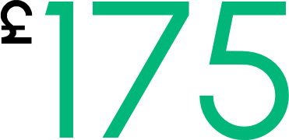

- WHITE ZIRCONIUM IS USED AS STRUCTURAL MATERIAL
- HIGH FRACTURE TOUGHNESS
- GOOD LEVEL OF AESTHETIC
- POTENTIAL WEAR ON THE TEETH
- OPAQUE APPEARANCE
- LESS THAN NATURAL LOOK
- PREPARED IN 4-5 DAYS
- THE TECHNICIAN WILL LAYER PORCELAIN ON TOP OF THE ZIRCONIA WHEN MAKING THE CROWN.

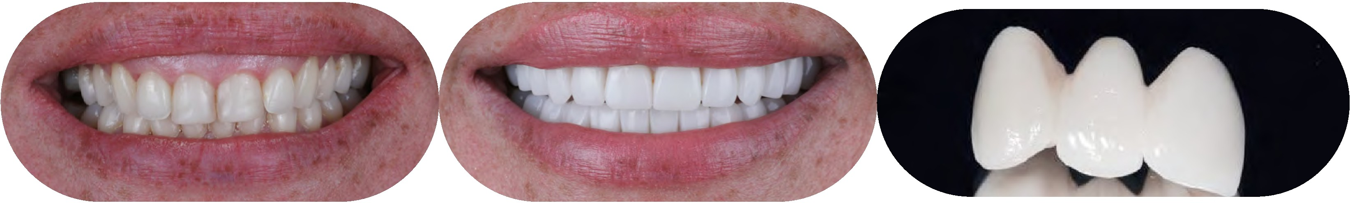

dentafly.com/en @)dentafly fly lllllt9o 549 107 07 01

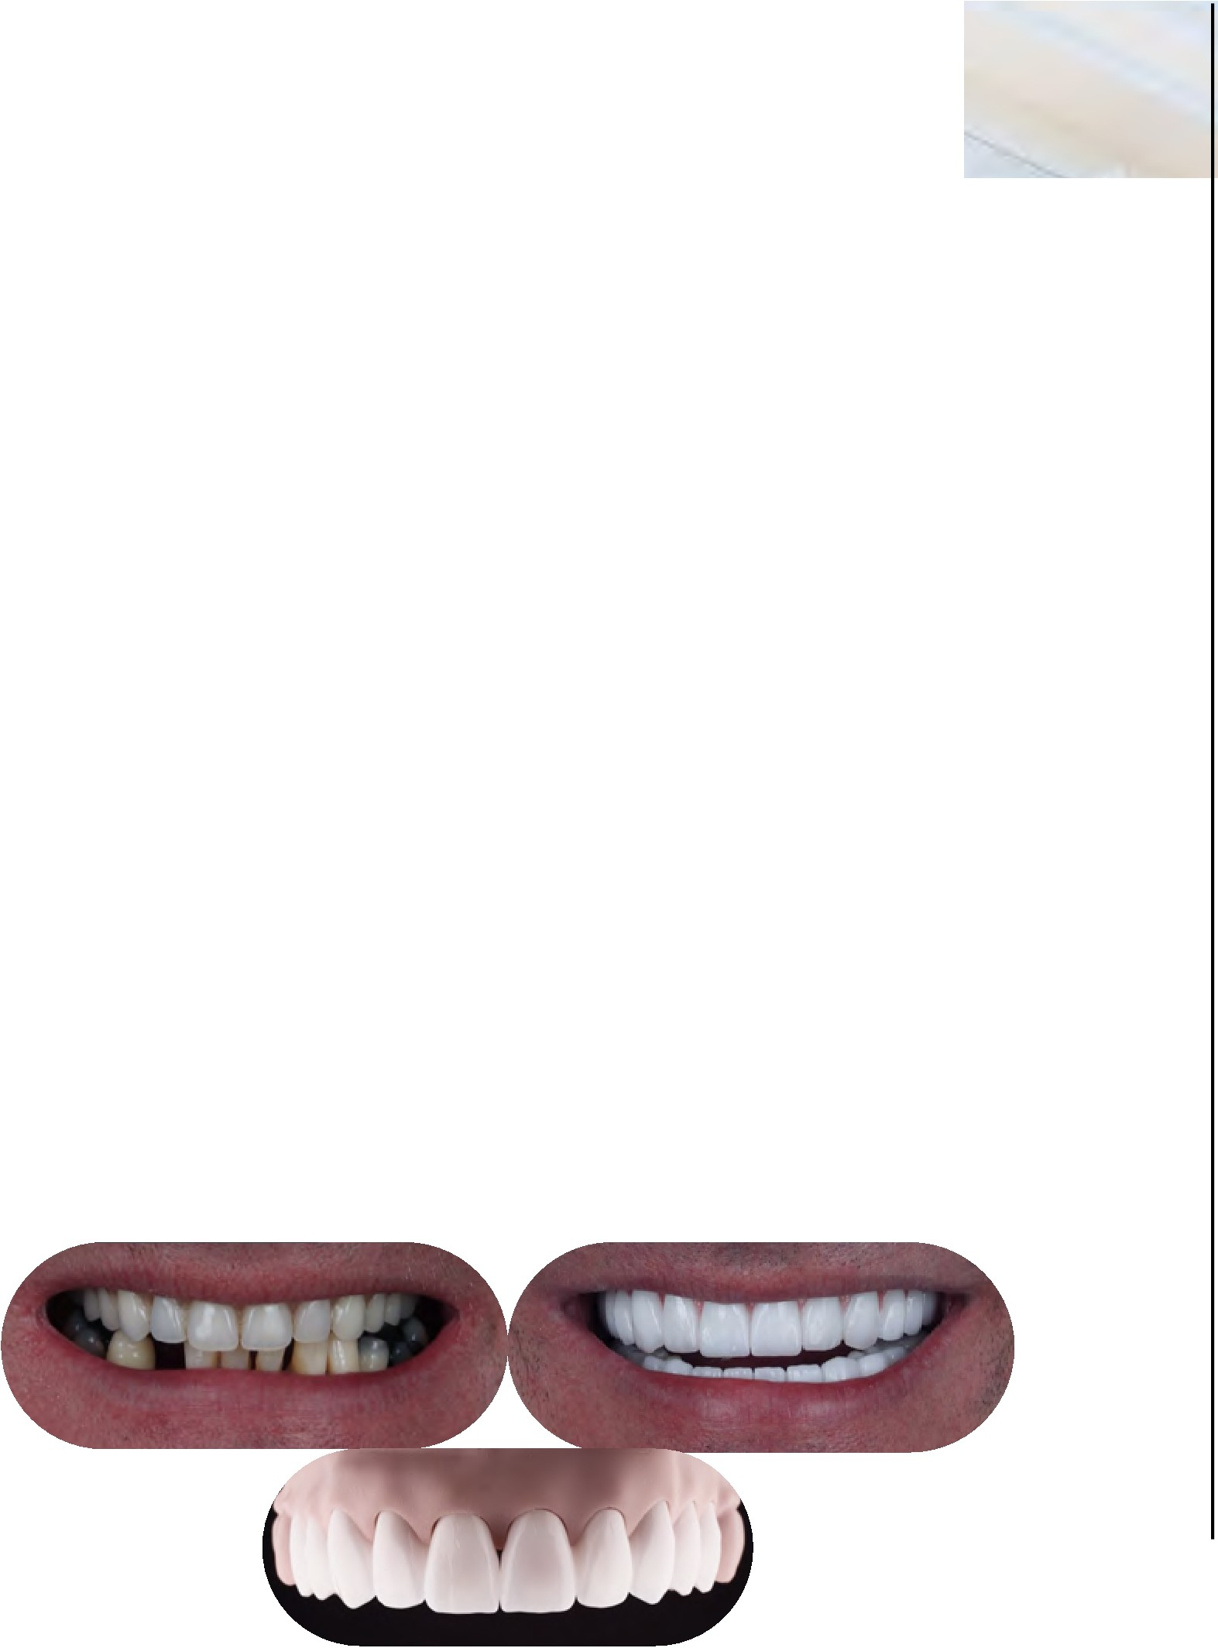
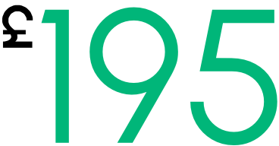
Denta
Veneers
,Straumann Digital Monolithic
Glass-Ceramic Zirconia®
8 Year Guarantee
- BIO-COMPATIBLE
- SAME DAY PROCEDURE
- STRENGTH. VERY ROBUST AND RELIABLE
- VERY AESTHETIC LOOK
- MANUFACTURED BY CAD/CAM SYSTEM
- MONOLITHIC BASED E-MAX GLASS CERAMIC SURFACE
- MINIMIZE WEAR ON THE ANTAGONISTS
- MAXIMUM TISSUE COMPATIBILITY
- NO SMELL. NO BLEEDING. AND NO INFLAMMATION
- HOLYWOOD SMILES WITH THE WHITEST SHADE

E-Max Veneer & Laminate Veneer
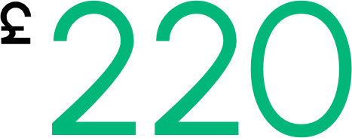

NATURAL & AESTHETIC
AN IDEAL AESTHETIC LOOK FOR FRONT TEETH HIGHEST TRANSLUCENCY
WITH HIGH STRENGTH
  - HIGH PERFORMANCE

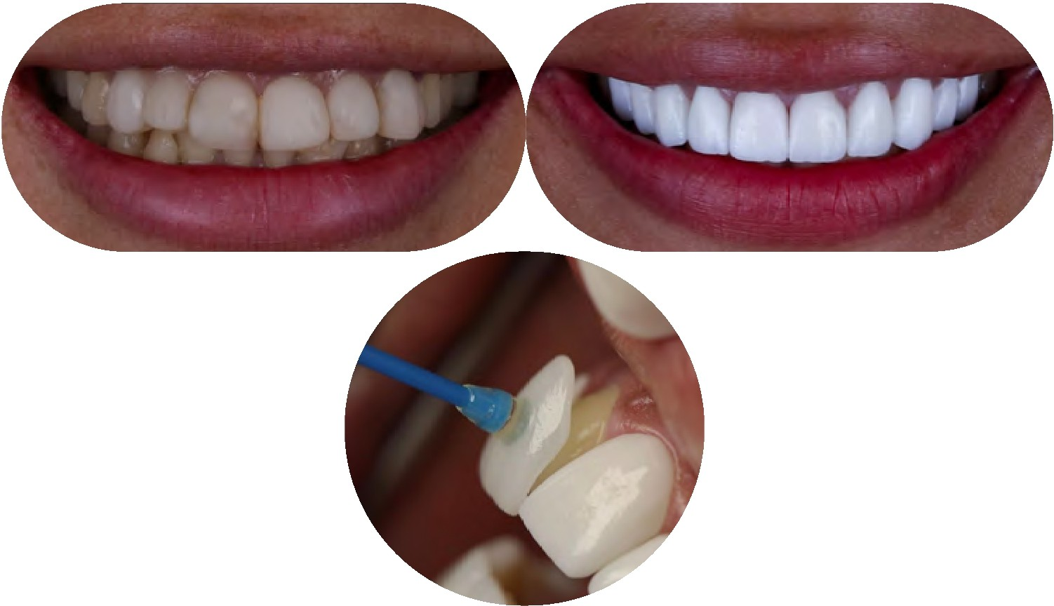

dentafly.com/en @ dentafly fly lllllt9o 549 107 07 01

Digital
Implants

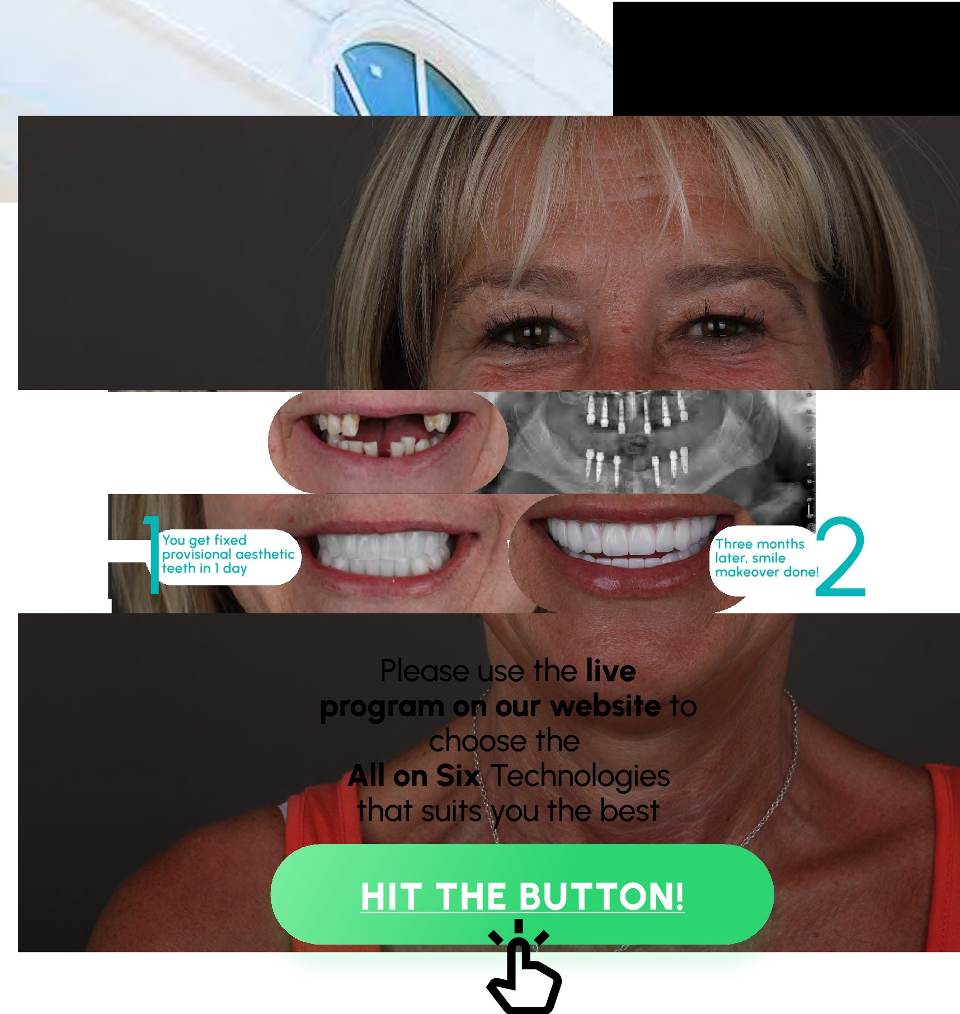
All on Four
Per Jaw / Starts from



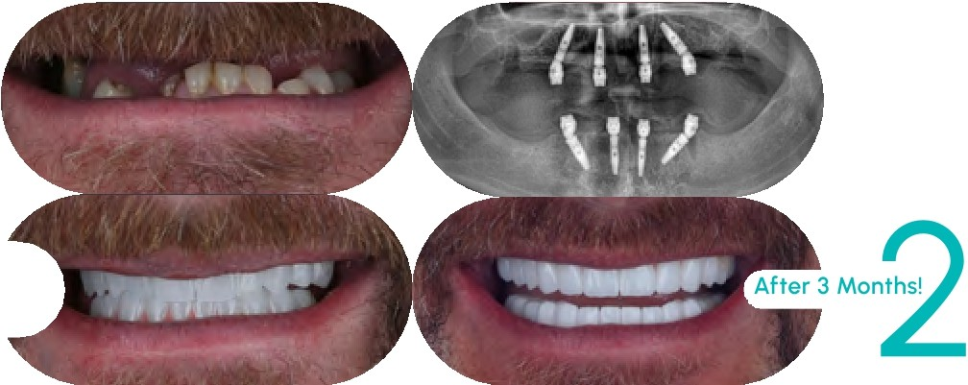
You get fixed provisional aesthetic teeth in I day
l

Please use the live program on our website to choose the
All on Four Technologies that suits you the best


You can find all possible:
- Implants brands
- Type of temporary crowns
- Technique of permanent crowns
Choose the most suitable materials for your treatment and budget and instantly see the total cost!

dentafly.com/en @ dentafly fly lllllt9o s49 107 07 01

Digita

Implants

Zygomatic
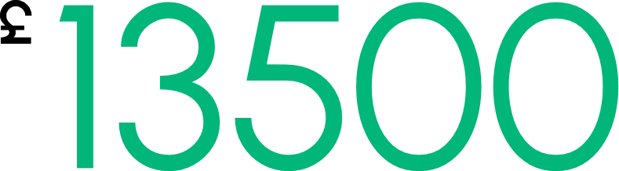
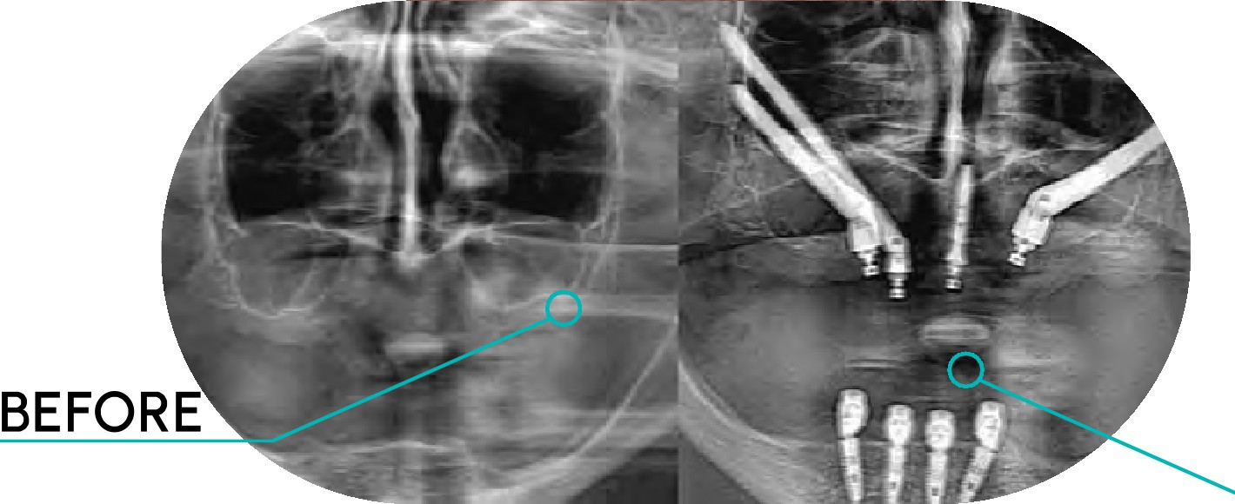
Implant

  - *THE MAJOR ADVANTAGE OF THIS TECHNIQUE IS THAT BONE GRAFTING IS RARELY NEEDED. THIS MEANS THAT FOR THE MAJORITY OF PATIENTS. NO BONE GRAFTING IS NECESSARY.
  - *THE TREATMENT IS SUITABLE PATIENTS WITH SEVERE BONE LOSS. EVEN THOSE PATIENTS WHO HAVE BEEN TOLD THAT IMPLANT TREATMENT IS NOT POSSIBLE BY CONVENTIONAL MEANS.
  - *DENTAL BRIDGES ARE ATTACHED TO THE IMPLANTS ON THE SAME DAY AS SURGERY
(TEETH IN A DAY: ALL ON FOUR: IMMEDIATE IMPLANT BRIDGE PLACEMENT) SO THERE IS NO TIME WITHOUT TEETH AND NO NEED FOR A DENTURE.
  - *ZYGOMATIC IMPLANTS HAVE A ROLE IN PROVIDING DENTAL SUPPORT IN CLEFT LIP AND PALATE PATIENTS WHO ARE UNABLE TO TOLERATE MORE CONVENTIONAL TREATMENTS.
  - *ONE ZYGOMATIC IMPLANT CAN SUPPORT 3-4 TEETH: ONE REGULAR DENTAL IMPLANT SUPPORTS 1-2 TEETH.
  - *FOUR ZYGOMATIC IMPLANTS CAN SUPPORT A FULL UPPER DENTAL BRIDGE.
  - IMMEDIATE PLACEMENT (WHEN TEETH ARE REMOVED AND ZYGOMATIC IMPLANTS ARE PLACED AT THE SAME TIME) CAN BE PLANNED PREDICTABLY.
  - *ZYGOMATIC IMPLANTS CAN BE USED TO SALVAGE OTHER FAILED OR FAILING DENTAL IMPLANT TREATMENTS (ALL ON 4: MINI-IMPLANTS: FAILED BONE GRAFTS: SEVERE PERIODONTAL BREAKDOWN OF THE EXISTING TEETH).
IMPLANT PLACEMENT

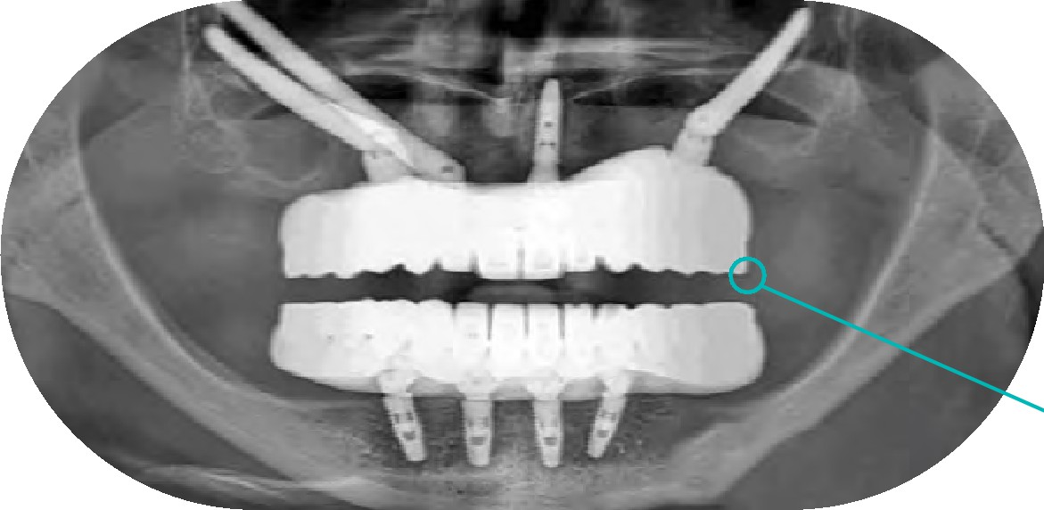
TEMPORARY
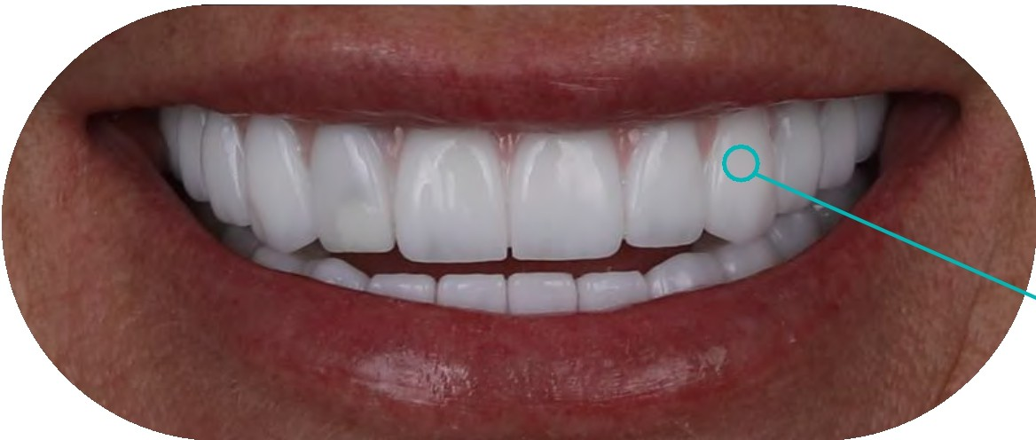
TEETH

RESULT!

dentafly.com/en @)dentafly fly lllllt9o 549 107 07 01

Robotic
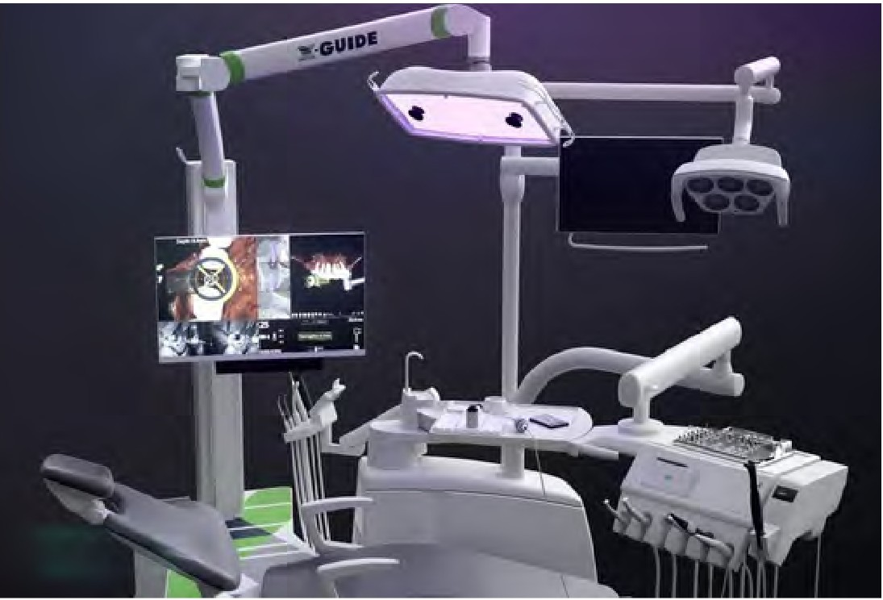
Implant

REDUCE THE HUMAN ERRORS IN FREEHAND TREATMENTS PERFORM FLAPLESS TECHNIQUES
THE ACCURACY OF IMPLANT PLACING USING STATIC GUIDES AND DYNAMIC NAVIGATION
AVOIDING UNNECESSARY INCISIONS AND STREAMLINING THE RECOVERY PROCESS OF THE PATIENTS
AN IDEAL AESTHETIC. AND FUNCTIONAL OUTCOME
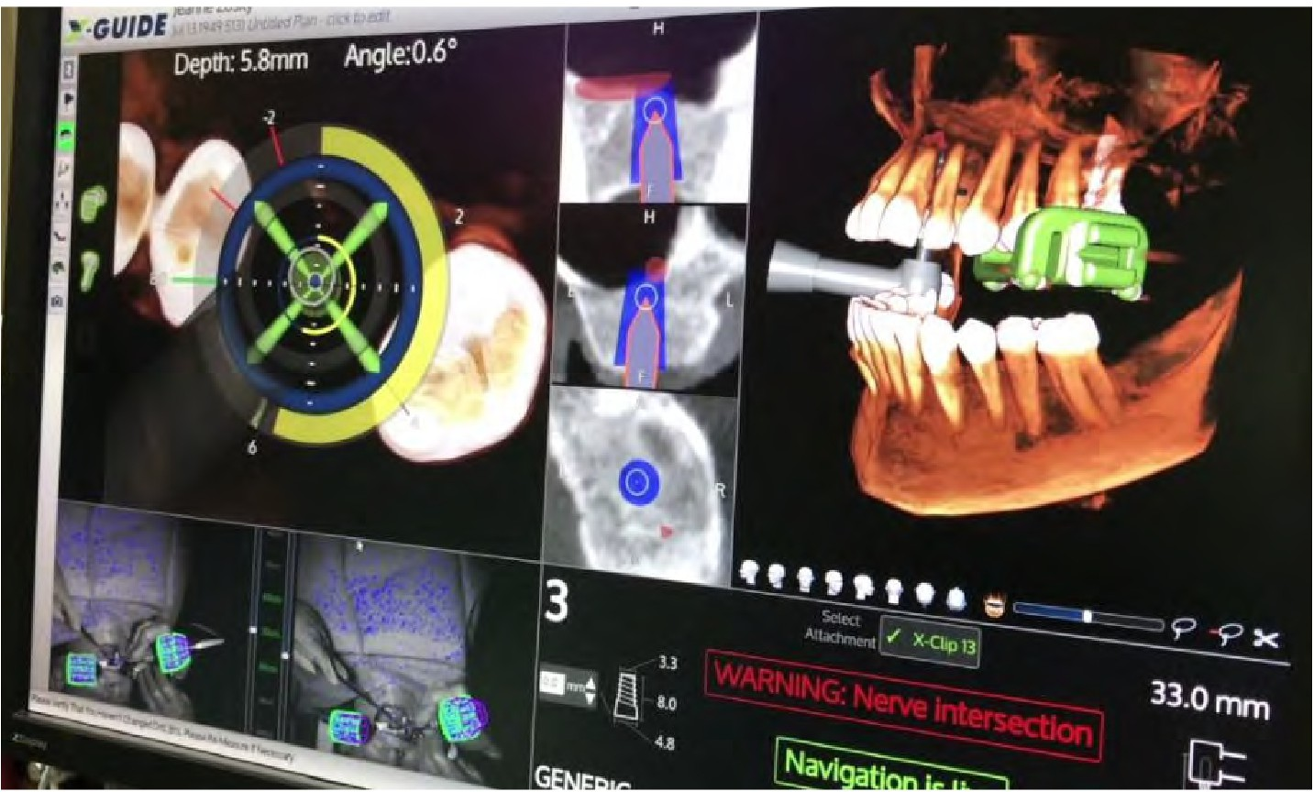
ROBOTIC TECHNOLOGY NOT ONLY ELIMINATES THE POTENTIAL INACCURACIES DURING PRODUCTION FITTING A FOR A PHYSICAL GUIDE BUT ALSO ALLOWS PATIENTS TREATED WITH THE SAME-DAY GUIDED SURGERY TREATMENT
AVOID THE RISK OF FRACTURES OR INACCURATE GUIDES ALLOW FOR IRRIGATION AT THE SURGICAL SITE
ENABLE THE SURGEON TO RESPOND TO INTRAOPERATIVE CONDITIONS BY CHANGING THE PLAN NEEDED.
IDENTIFY THE DEVIATIONS FROM THE PLAN
PROVIDES PHYSICAL (HAPTIC) AS WELL AS VISUAL AND AUDITORY GUIDANCE
THE SYSTEM IS COMPATIBLE WITH A VARIETY OF IMPLANT SYSTEMS.
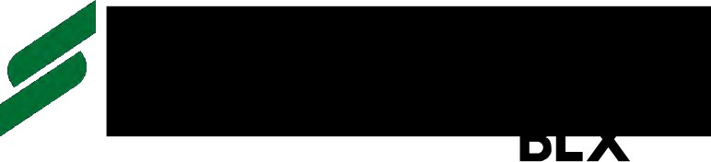
HIOssENNH
IMPLANT

dentafly.com/en @ dentafly fly lllllt9o 549 107 07 01

Denta
Implants

Which brands are we working on and cooperating with?

HIOSSEN
IMPLANT
AMERICAN EM HydroPhilic
Nobel Biocare™

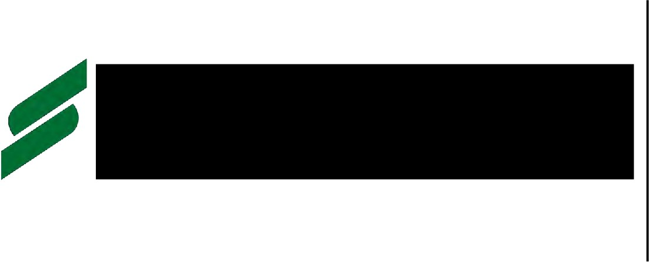
Why are we working with the most reputable brands?

WE NEVER WORK WITH LOCAL BRANDS OR CHEAP QUALITY FAR EAST-MADE IMPLANTS BECAUSE THOSE CAUSE UNFAVORABLE RESULTS IN HEALTH AND BONE LOSS

BIO-COMPATIBLE
HIGH SUCCESS RATES IN SURGERY 98% IMMEDIATE AND EARLY LOADING OF IMPLANT PLACEMENT
- MORE RAPID INTEGRATION WITH BONE TISSUE
- SIGNIFICANT RESULTS IN SINGLE STAGE­ DENTAL IMPLANTS IN THE AESTHETIC ZONE
- INCREASE PATIENT SATISFACTION
- LIFETIME WARRANTY

dentafly.com/en @ dentafly fly lllllt9o s49 107 07 01

Denta

Implants

Which brands are we working on and cooperating with?

HIOSSEN
IMPLANT
AMERICAN EM HydroPhilic

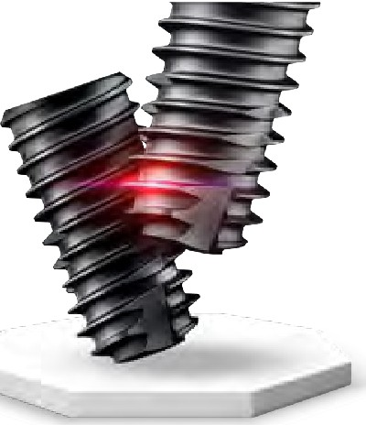

AIS11ER
£420

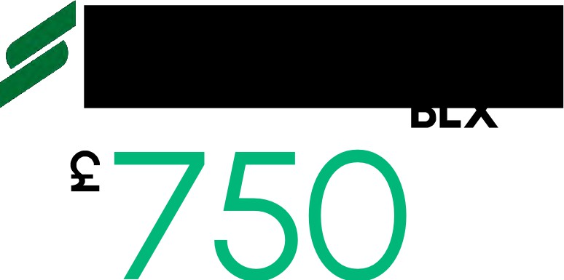
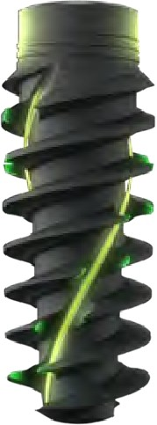
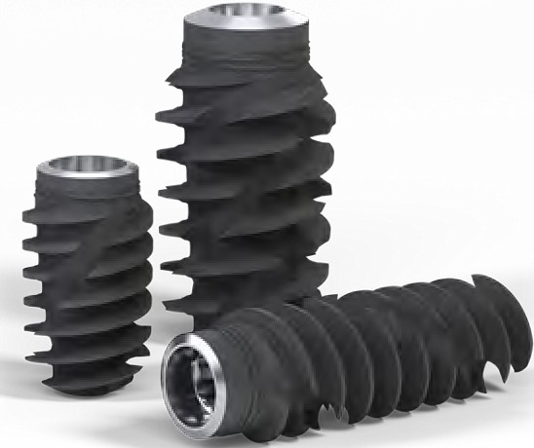

(Q) MEDENTiKA®
A Straumann Group Brand

Nobel Biocare'"


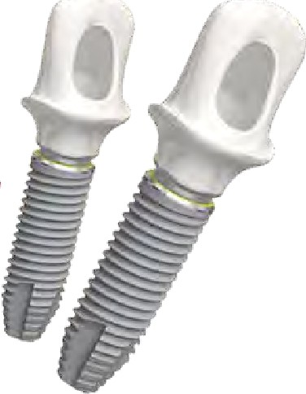


Z-SYSTEMS
ceramic implants


dentafly.com/en @ dentafly fly lllllt9o 549 107 07 01


Our Partner
Hotels
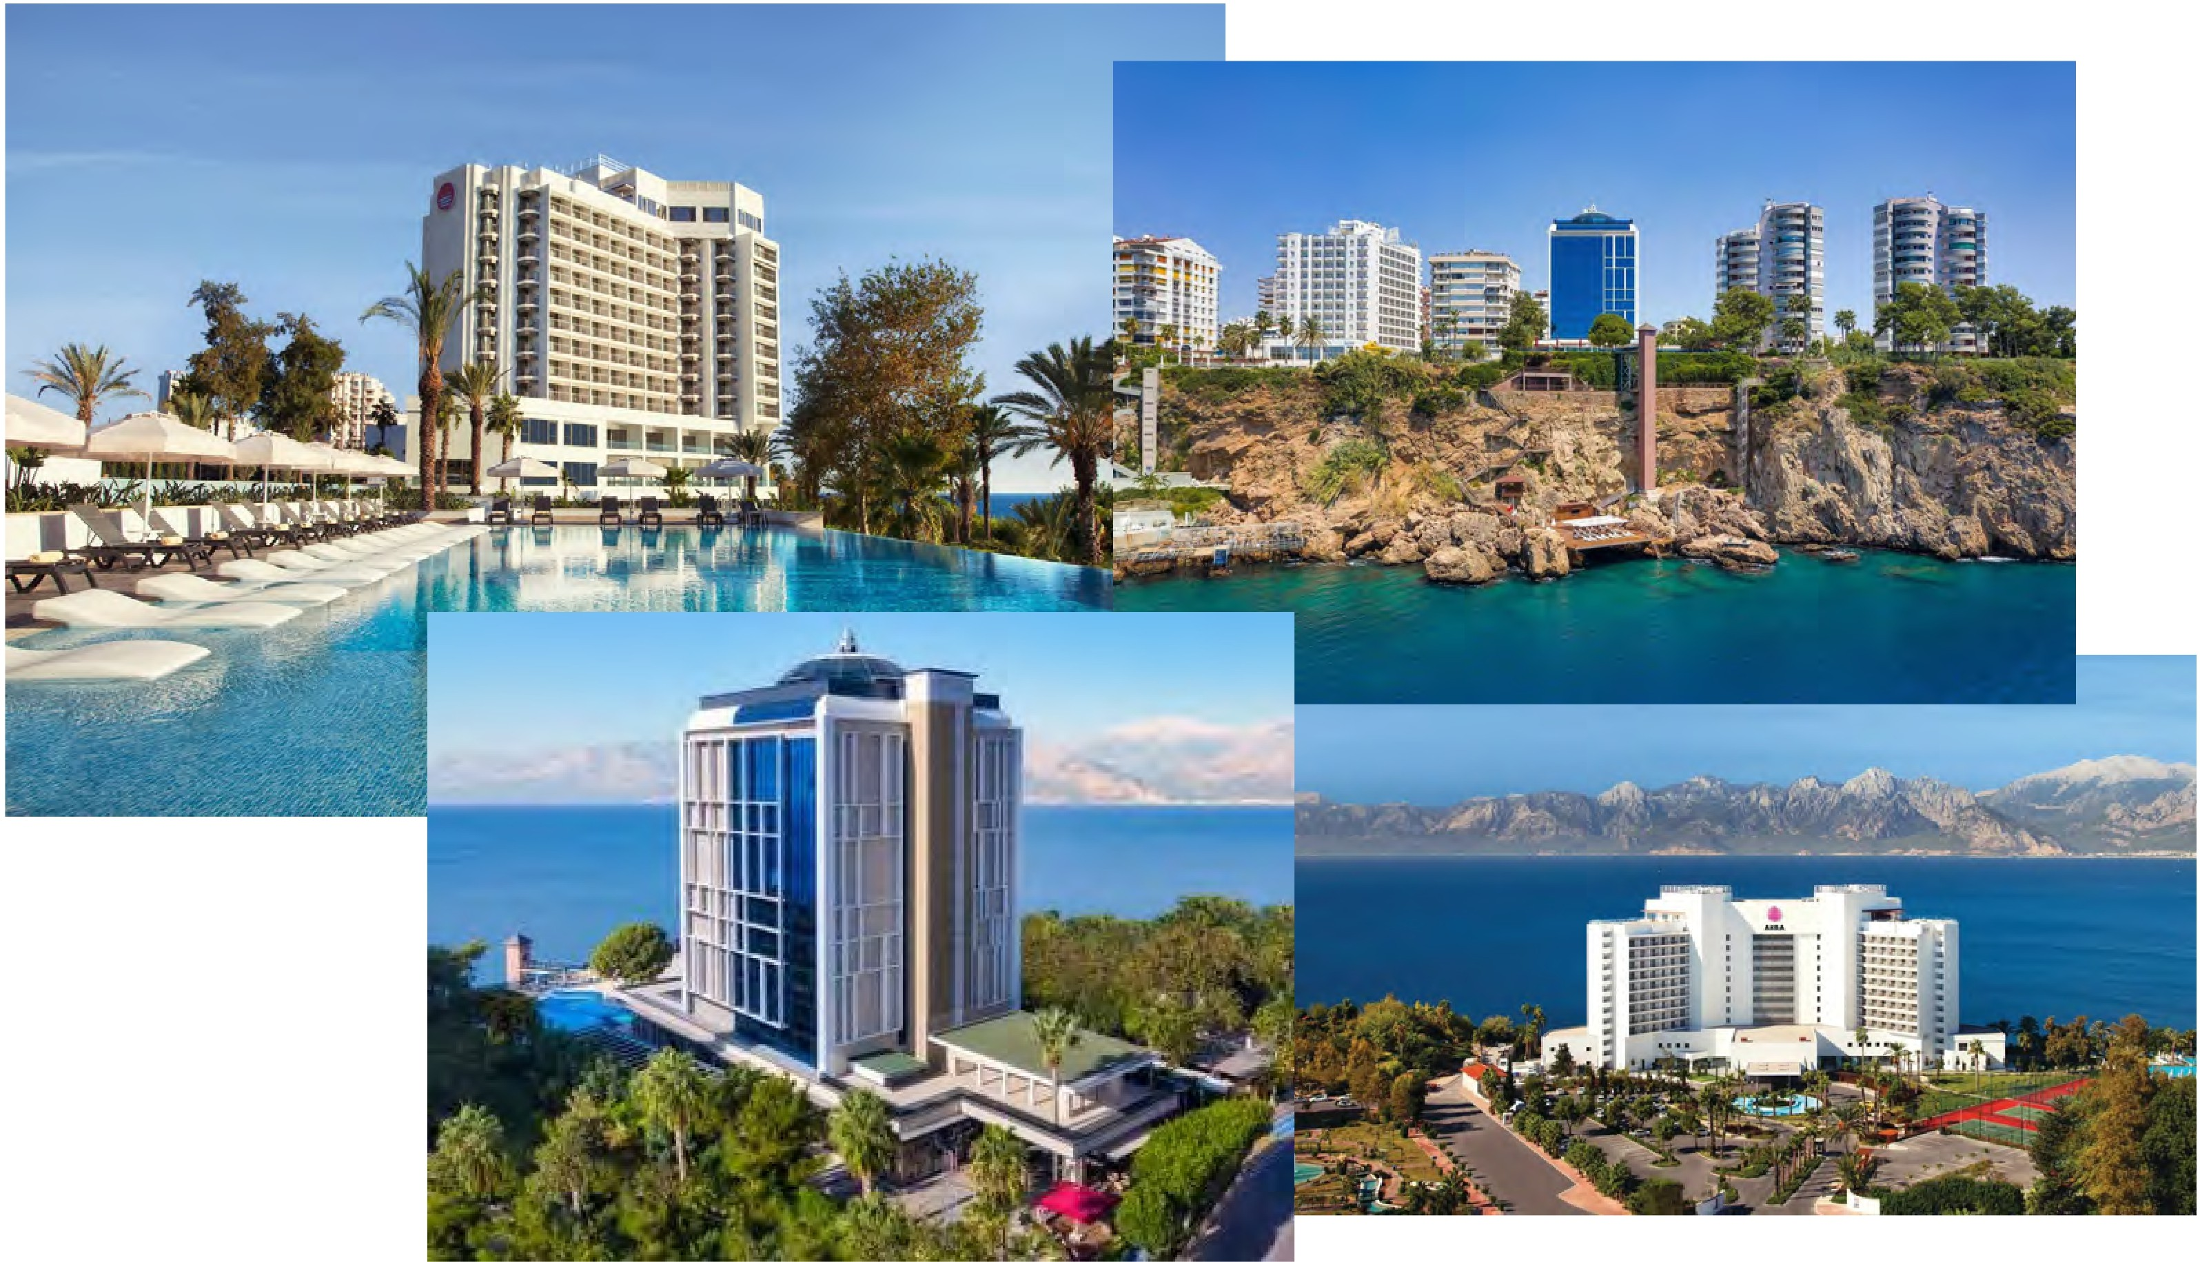

dentafly.com/en @ dentafly fly lllllt9o 549 107 07 01

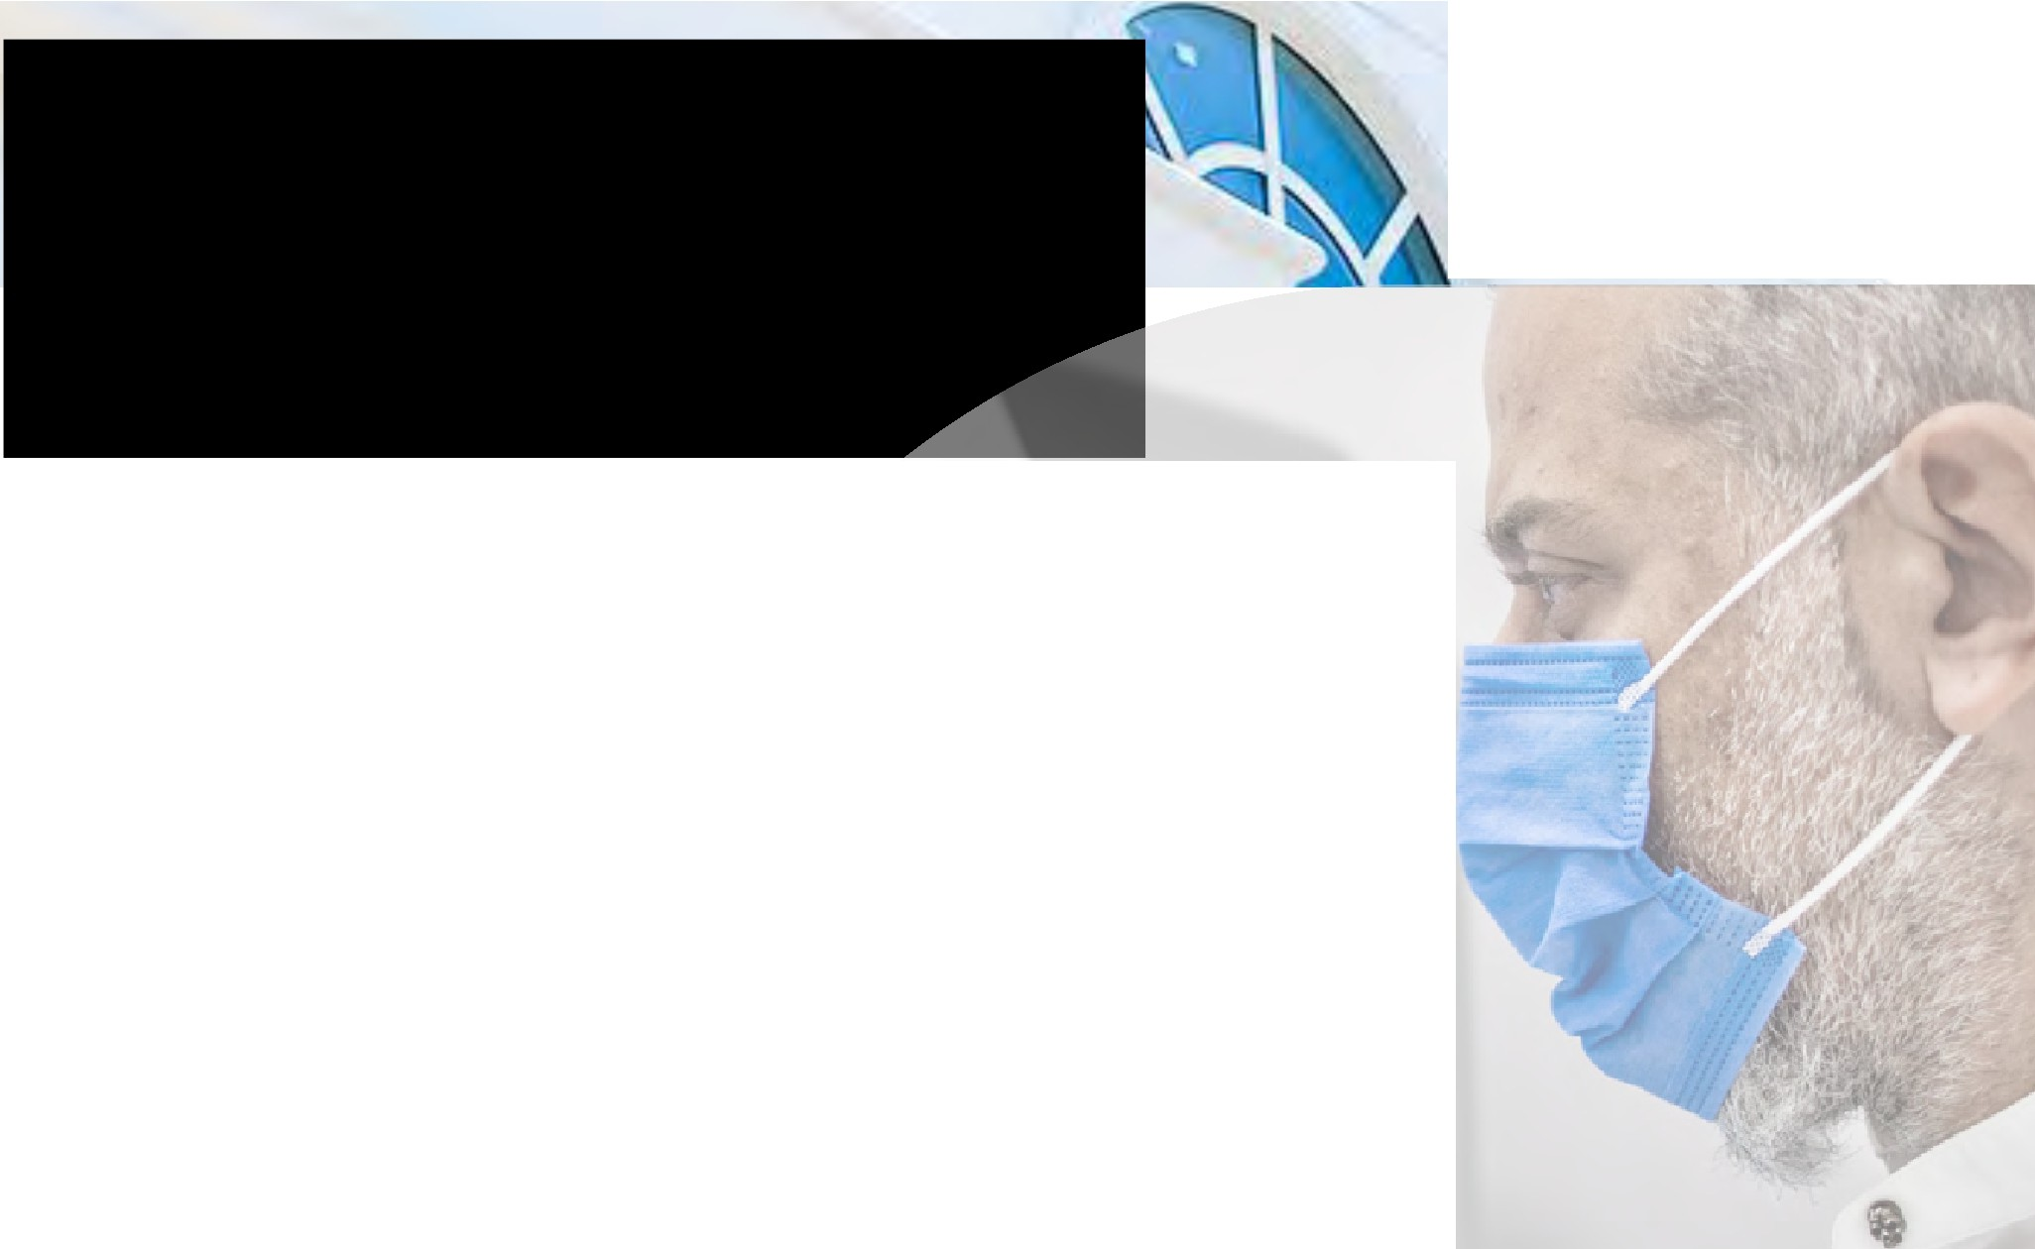
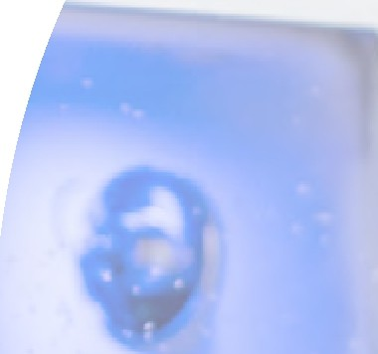
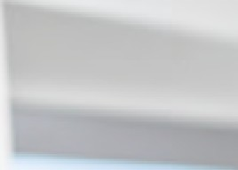
Changing Lives, One Smile At A Time

At dental works DentaFly, in Antalya you1II find gentle, understanding dentists and hygienists committed to helping you look and feel better. And we1re working hard to make it easy to keep your family healthy. To clean your teeth.
Straighten your smiles. And do it in a way that fits best with your schedule and life.

We1re the dentists you can trust for the life of your smiles. Because whether you know it or not, we already consider your family, part of ours.

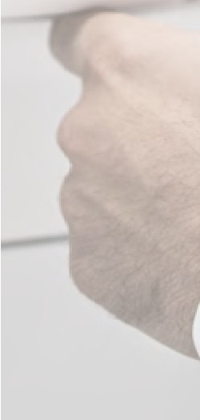
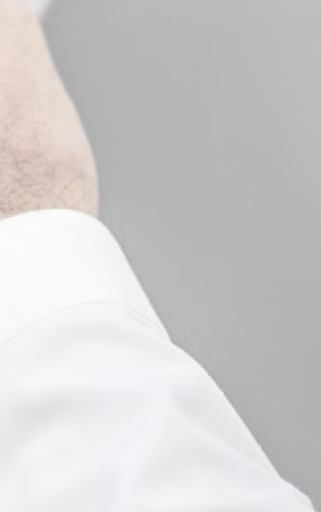

We can't wait to meet you.
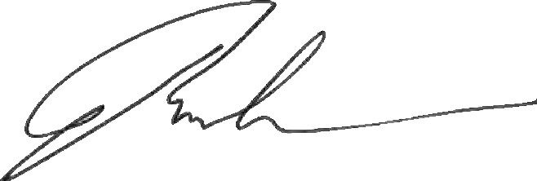
dentafly.com/en @ dentafly fly lllllt9o 549107 07 01


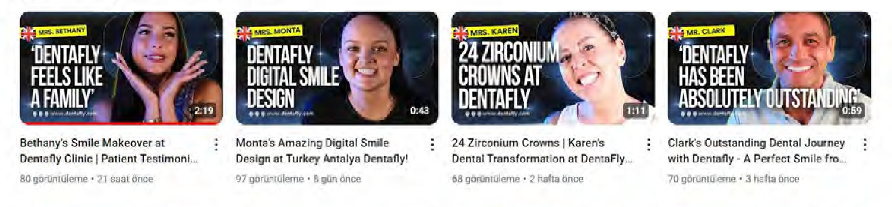
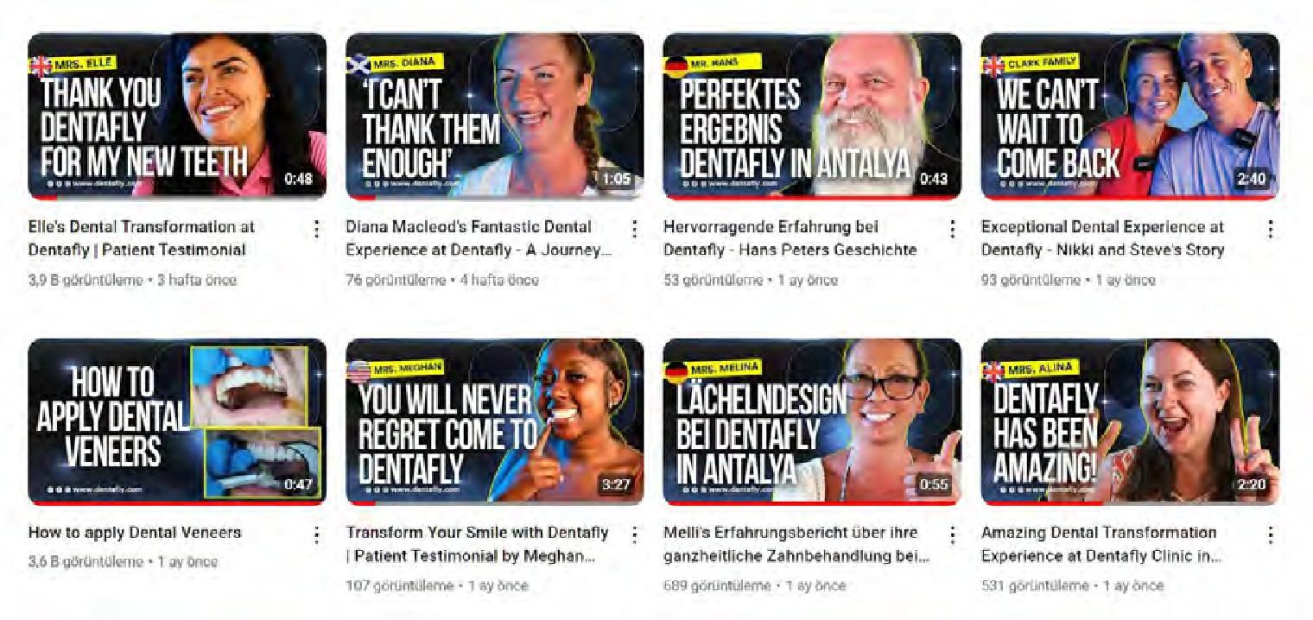



Reviews

Oimilri!I Vlochag
DV I • Vlow ® TR TR
Timolh Robent3
, rlilVIIIW @TR

r:1aa a Au 17, 2022
@Excellent experience
@E«8llen1-,,.p.er,..nc.. ! Going 10 Iii• duniisl is alwo.yo ii little $,;,ary,,,bul they m,i(le it so e.isy nd str ighl forward_
I had X-rays and a oonsllllation. I did bleaching only since I had no other problems The prices ;ire ver,ye,.,;.onahle ,i,!so l,:,r the high $eNi,e$ tney provid'e The stall
IS amazing and very polite Looking forv.ard to my nexl 'ttisit l ®Q

Gary
GA
5 reviews (:) GB
ODD
FANTASTIC I'm top of the moon
It was FANTASTIC. Digital d'entistry is the way to go. They have got their own laoorotory Ius1 downslairs that ollow me l:o chon e the design or the colour. lhey USQ computers to design so they cannot go wrong even it t ey want to. The dentist and the tront desk are really helpful. Mr Yuksel help me a lot with everything as well. The hygiene was impeccable. They take really good care of you with the transters and everything. Thanks Han, Zeus, and Yagmur tor being kind and helptul.
*
THANKS TO TH DENTAHY TEAM
I RECOMMEND E\I RYONE TO COME HEREt

For more:

l]Cll'JDCI O Invited Aug 15, 2022
Could not be happier with my Treatment...
I have just returned from a visit to Dentally in Antalya and I would just like to say a huge thank you to the team there.

I am a complete dent-a-phobe and the thought of the really long and complicated procedure I wanted doing filled me with dread.

Dentally were totally amazing and I would 100% recommend them to anyone looking for all on 4 treatments for both dental arches. They not only delivered a world class treatment and service but they did so whilst dealing with me - a very nervous and scared patient who was most likely quite difficult at times.

I have left a (very, very, very) detailed review on their Facebook page, so if you want the full account of my treatment, head there and take a look.

Thanks again Joseph and team for your brilliant work, Gary Ison

Jason Clark
1 review ® TA

r.:u:iaaa 6 days ago
Dream team
Can't believe the experience I have had. I booked a break in side and always wanted to get my teeth my done in turkey, I inquired about this and this company gave me so much from the get go, Emir my advisor was spot on. So not just me they also looked after my family, my wife and 2 kids in the Lara hotel with transfers from side to Lara and back. From the first day of picking me up I was impressed, the transport was welcoming with very friendly drivers. On the way to the clinic I was a bit nerves but that was soon gone from the warm welcome and the set up you could see the place looked amazing. I stayed 4 days and most of that was relaxing days out with family the visit to clinic picked up and dropped off the experience was amazing for us all but mostly me with my new and outstanding teeth. From admin to drivers and reception team you do a fantastic job and the doctors and assistants are a well organised team who give you what you wanted and more. Thankyou for my experience I will be recommending to family & friends back in England.
Trustpilot aaaaa
www.trustpilot.com/review /dentafly.com


Google Maps

dentafly.com/en @ dentafly fly lllllt9o 549107 07 01

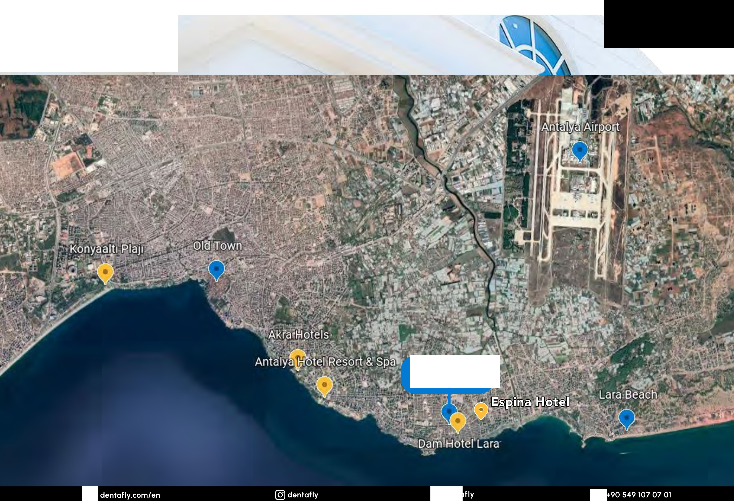
Where are
We?

