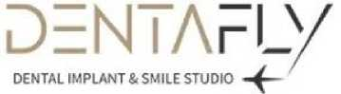

This quote has been prepared for the patient SIMON BY PETER SAMUEL of Dental treatment services given by DentaFly Dental Implant & Smile Studio
Please note that this quote has been provided to you with all the information you have provided us about your mouth and teeth. On your arrival, we will carry out a 3D scan of your mouth and teeth which will reveal any issues you may or may not have and your cost may be adjusted (higher or lower) according to your 3D scan. If by any chance you cannot get your treatment then 3d-xrays and consultation fee is applicable.
 | Price | QTY | Subtotal
CERAMIC ZIRCONIUM CROWNS  5 CROWNS  (SWISS BRAND IVOCLAR) | £125.00 | 5 | £625.00
STRAUMMAN NEODENT IMPLANTS N ABUTMENTS  2 IMPLANTS | £350.00 | 2 | £700.00

