21.01.202
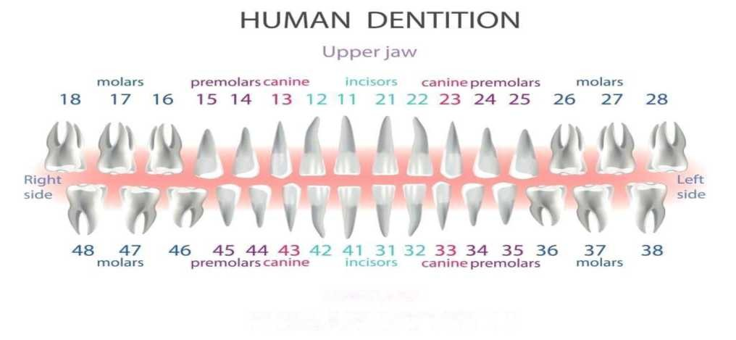
Lower jaw
PERMANENT TEETH
DentaFly Treatment Plan
Patient:
The patient Mr Simon Paul Cordell has received the following dental treatment:
Upper Jaw:
£450 x 2 [2] Hiossen NH Nano Hydrophilic implants on tooth numbers
11 (3.5x11.5 mm) and 22 (3.5x11.5 mm).
Special Zirconium Abutment over Titanium Abutment will be made on the second visit.
£125 x 6 [6] 3D New Generation Zirconia crowns on tooth numbers
13,12,11,21,22 and 23 will be done at the second visit.
Temporary given on 10.01.2025

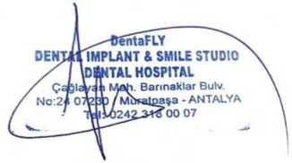
Payment:
Total dental treatment price: £1650 gbp - All Paid - £1650
paid on 09.01.2025 via bank transfer.

