- 01st Sent-Email
- 01st Sent Claim-Letter-4-Southern-Railway (1)
- 01. 01st Receipt
Subject: Compensation Claim Submission
From: Rewired (re_wired@ymail.com)
To: customerservices@gtrailway.com
Date: Wednesday 12 February 2025 at 20:21 GMT
Dear Thameslink Customer Service,
I hope this message finds you well. I am writing to inform you that I have attached a document detailing my compensation claim. I experienced significant delays on January 12, 2025, and I have outlined all relevant details and supporting documentation within the attached file.
Unfortunately, I encountered difficulties using your website to submit this claim. As a result, I am submitting my claim via email for your review and prompt attention.
Thank you for your understanding and assistance in this matter.
Kind regards,
Simon Paul Cordell 109 Burncroft Avenue, Enfield, London, EN3 7JQ Email: Re_wired@ymail.com Tel:
+447864217519


Claim-Letter-4-Southern-Railway .pdf 603.1kB

Detailed Compensation Claim for Simon Paul Cordell
Name: Simon Paul Cordell Address: 109 Burncroft Avenue, Enfield, London, EN3 7JQ Email: Re_wired@ymail.com Tel: +447864217519 Date: 09 February 2025.
Recipient's Name: Southern Railway Customer Service
- https://www.thetrainline.com/trains/great-britain/delay-repay
- https://www.thameslinkrailway.com/help-and-support/delay-repay
- https://www.thameslinkrailway.com/-/media/goahead/gtr-all-shared-pdfs-anddocuments/delay_repay_post_form.pdf
Subject: Claim for Compensation Due to Train Delays and Associated Issues
Dear Southern Railway Customer Service,
I am writing to formally file a claim for compensation due to significant disruptions to my travel on January 12, 2025. My planned journey from Gatwick to London Bridge was severely impacted by the cancellation of train services, which resulted in additional expenses and a loss of productivity.
Journey Details:
- Date: January 12, 2025
- Route: Train from Gatwick to London Bridge
- Scheduled Trains:
- 12:00 PM Southern train from Gatwick to East Grinstead o 12:32 PM Southern train from East Grinstead to London Bridge
- Ticket Price: £11.90 each x 2 = £23.80
Caption for Receipt: Purchase of Train Travel Tickets.
Upon arrival at Gatwick, I learned that the scheduled train services were cancelled, and a coach service was provided instead. The coach journey took approximately 45 minutes to reach an alternate train station before we could continue our journey, and I took a picture while on the train as below:
Caption for Receipt: Late Train Service Provided as An Alternative to Travel.
Alternative Transport:
- Coach Service: Provided as an alternative to train travel.
- Arrival Issues: Once at London Bridge, my attempts to contact the cab driver were unsuccessful, as the timing of our arrival did not allow for proper communication. I enlisted the assistance of my uncle, who was able to attempt to reach the cab company on our behalf. Unfortunately, we were informed that we could not recover our booking or fees for the taxi we missed.
- Missed Cab Booking: Cab price £51.50.
Caption for Receipt: Cab Booking Booked at The Same Time with Train Tickets.
Consequently, we took the Route 149 bus to Edmonton Green while managing multiple suitcases.
- Bus Fees: £1.75 x 2 = £3.50.
Caption for Receipt: TFL travel charge for bus fare on January 13, 2025.
Upon arriving in Edmonton Green, I opted for a cab as it was more affordable than attempting to recover the missed booking.
- Cab Fare: £13.00.
Caption for Receipt: Cab from Edmonton Green.
Impact: The delays not only caused distress but also led to fatigue, making it impossible for me to prepare dinner upon arriving home. As a result, I was forced to order food, an expense I wouldn't have incurred had I arrived on time.
- Dinner Bill: £25.00.
Caption for Receipt: Dinner Receipt.
More significantly, I lost an entire day of work that I had planned to dedicate to developing my business. This lack of productivity stems from unexpected delays caused by the train service's operational failures and were not a result of any fault on our part as customers. Based on my potential earnings from business development activities, I estimate the value of my lost time to be £80.
Caption for Receipt: Lost Downtime.
Compensation Request: It is crucial to note that the failure to board was not due to our actions as passengers, but rather the result of train cancellations and delays. Therefore, I am requesting compensation under the delay repay scheme, which compensates passengers for inconvenience and financial losses incurred due to service disruptions.
Specific Amounts Claimed:
- Train Tickets: £11.90 Each X2 £23.80 Each
- Missed Cab Booking: £51.50
- Bus Fees X2: £3.50
- Cab Fare: £13.00
- Dinner Bill: £25.00
- Lost Downtime: £80.00
▪ Total Amount Claimed: £196.80P

Justification for Full Recovery of Additional Costs and Tickets
I am writing to request a review and reversal of the decision regarding my compensation claim for the delay experienced with my day ticket on January 12, 2025. Given the significant disruption and the associated financial and emotional impact, I firmly believe that my case warrants full recovery of my ticket costs and additional expenses incurred.

Relevant Regulations and Standards
According to the Thameslink Delay Repay scheme and the National Rail Conditions of Travel, passengers holding day tickets are entitled to compensation if they experience delays. Specifically, the compensation guidelines for day ticket holders are as follows:
- 15-29 minutes: Entitled to at least 25% of the single fare paid, or if a return ticket was bought, at least 25% of the fare paid for the affected portion.
- 30-59 minutes: Entitled to at least 50% of the single fare paid, or if a return ticket was bought, at least 50% of the fare paid for the affected portion.
- 60-119 minutes: Entitled to 100% of the single fare paid, or if a return ticket was bought, at least 50% of the fare paid.
- 120+ minutes: Entitled to 100% of the cost of the fare paid, whether it was for a single or return ticket.
Given the above guidelines and the details of my journey, I firmly believe that my claim falls within the parameters of the compensation scheme. However, my situation involves exceptional circumstances that necessitate a departure from the standard compensation policy.
Exceptional Circumstances and Financial Impact
- Prolonged Delay and Missed Appointments:
  - The [E-Ticket Return] journey was purchased for [12:02 Gatwick Airport to London Bridge] and caused us a delay of time that was of over [1 hour to 1 hour
59 minutes] as the [Train was Cancelled] and this resulted in missed appointments and disrupted plans. This necessitated rescheduling and incurred additional costs, which would have been avoided had the train services operated as scheduled.
- Incurred Additional Costs:
  - I had to book alternative transport a Bus and Cab and manage additional transfers, leading to unexpected expenses. The extended travel time and inconvenience directly contributed to additional costs for food and alternative travel arrangements.
- Impact on Work and Productivity:
  - The delays caused me to lose an entire day of work that I had planned for business development. This lack of productivity has a significant financial impact, estimated at £80, which is crucial for my business operations.
- Compensation for Emotional Distress and Inconvenience:
  - The cumulative effect of the delays, missed appointments, and additional costs caused considerable distress and inconvenience. Compensation should reflect not only the financial losses but also the emotional impact of the disrupted journey.

Consumer Rights and Fair Treatment
According to the Consumer Rights Act 2015, services must be provided with reasonable care and skill. When service providers fail to meet this standard, consumers are entitled to remedies, including compensation for consequential losses. Furthermore, the Railways Act 1993 mandate’s that train operators must adhere to principles of fairness and transparency in their dealings with passengers.
Given these points, I kindly request a full recovery of my tickets and reimbursement for the additional costs incurred. The compensation should reflect the totality of the financial impact and inconvenience experienced, beyond the standard delay repay guidelines. This consideration is crucial for a fair resolution to the significant disruptions caused by the train service cancellations.
I have included all relevant documentation and imagery to support my claim. Thank you for your attention to this matter, and I look forward to your prompt response.
Sincerely, Simon Paul Cordell 109 Burncroft Avenue, Enfield, London, EN3 7JQ Re_wired@ymail.com +447864217519
Enclosures:
- Receipt: Purchase of TFL Train Travel Tickets:
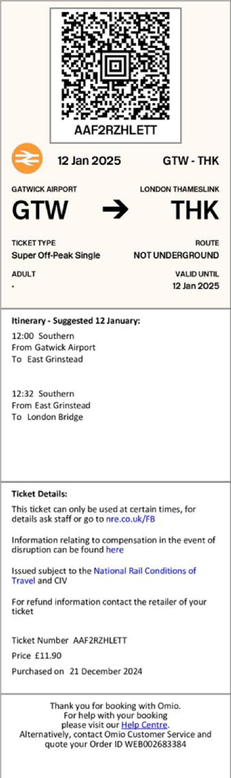
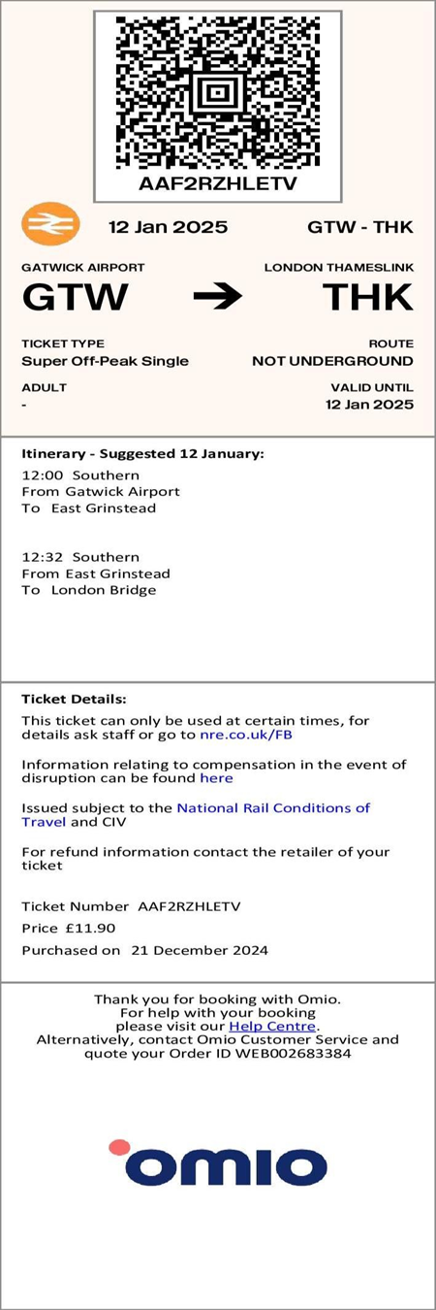

- Receipt: Late Train service provided as an alternative to travel:
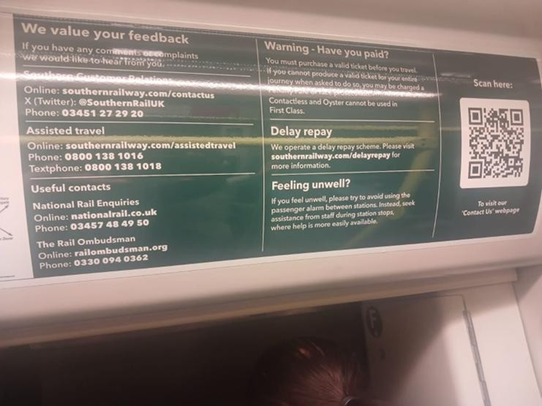

- Receipt: Cab Booking Booked at The Same Time with Train Tickets:
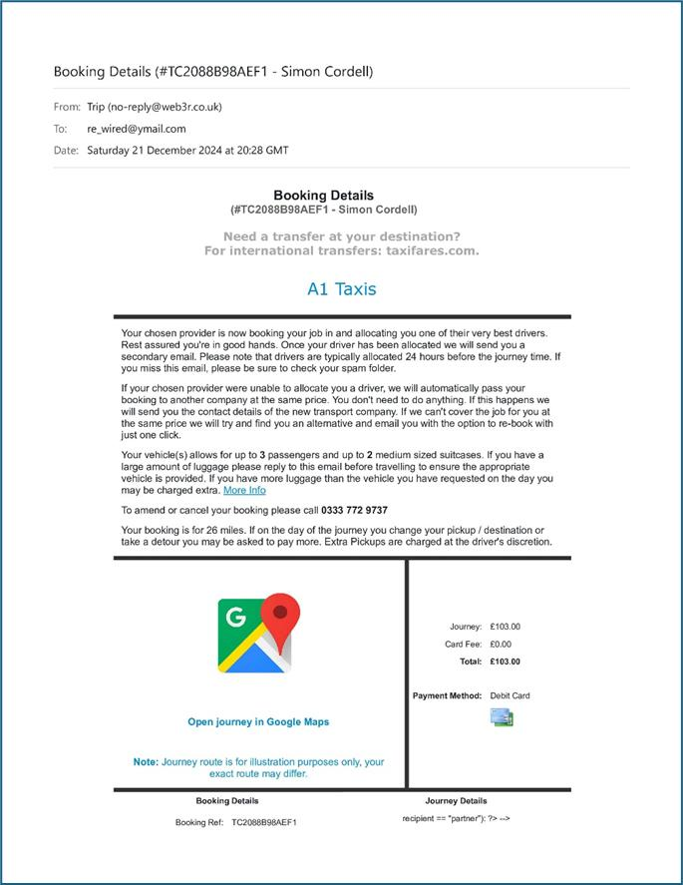
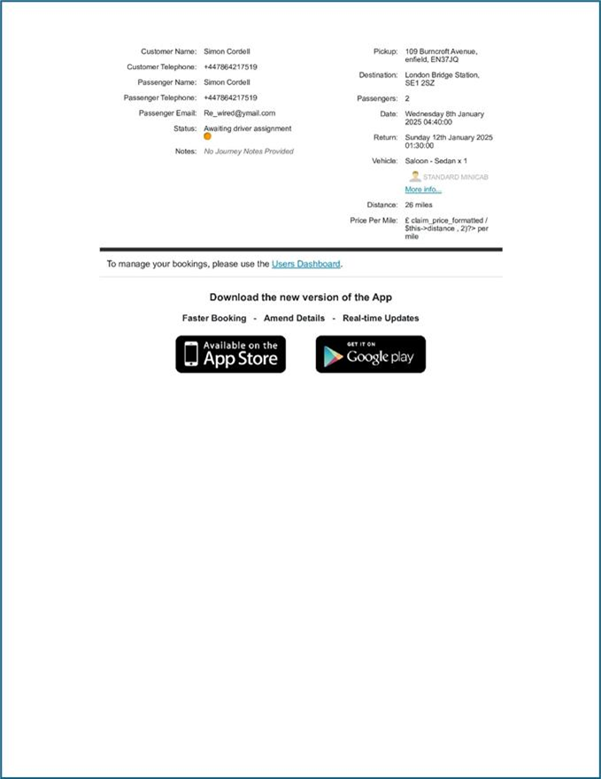

- Receipt: TFL travel charge for bus fare on January 13, 2025:
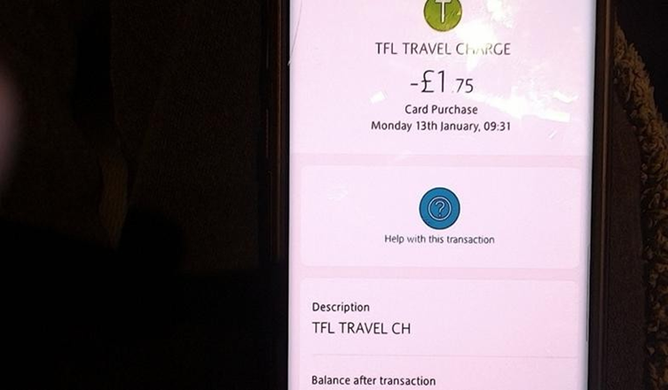

- Receipt: Cab from Edmonton Green:
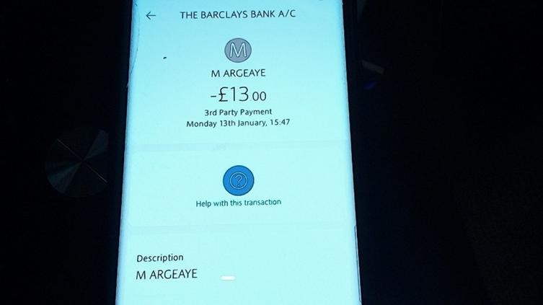

- Receipt: Dinner Receipt:
To be obtained!

- Receipt: Lost Downtime:
Web linked as: Horrific Corruption: Uncovering the Dark Truth's.

- Receipt: All Additional Relevant Documents:
None to be added!

Acknowledgement Email
From: No Reply - Customer Relations (noreply.customerrelations@gtrailway.com)
To:re_wired@ymail.com
Date: Wednesday 12 February 2025 at 20:25 GMT
Dear Customer
We appreciate you taking the time to contact us. Please accept this acknowledgement as confirmation that we've received your query.
We're receiving a high volume of contact at the moment. Our aim is to provide a full response within 10 working days and for more complex complaints it may take up to 20 working days. Please be assured we have your email and there is no need to chase us for a reply as we will get back to you as soon as we can. Please do not reply to this email.
You may find more information including our complaints handling procedure via the following links:
Great Northern: Great Northern Railway
Thameslink: Thameslink
Gatwick Express: Gatwick Express
Southern Railway: Southern Railway

Kind regards
Customer Relations

We are a member of the ADR scheme, an impartial service who can assist when complaints remain unresolved. You can find out more information here: Home - Rail Ombudsman

02. 02nd Received-Mail

20250213-725262
From: Thameslink Customer Relations (customerservices@thameslinkrailway.com)
To: re_wired@ymail.com
Date: Tuesday 18 February 2025 at 11:58 GMT
Dear Simon
Thank you for getting in touch regarding our journey on the 12th of January.
I have looked into your claim and since it is outside the 28 days we require customers to make a claim we are unable to offer delay repay compensation for this.
In regard to your additional costs that were incurred due to the 12:02 Gatwick service to London Bridge not running, compensation is not available if a service has been removed or changed as a result of planned engineering work. I’m sorry. This is because the journey claimed for is not valid if it is not scheduled. The valid journey would be the one involving the rail replacement, and as that ran as scheduled and was published in advance for customers to see, hence why we cannot offer you anything at this time. I know this isn’t what you wanted to hear.
To keep our services running as smoothly as possible, maintenance work is required regularly. So we can reduce the impact on passengers, works are usually scheduled during times where rail services are quieter, like weekends or overnight.
We make sure online journey planners are updated to show any changes as soon as possible. And we advise passengers to check in advance, before they travel. This includes information on buses replacing trains. In future, you can check using a journey planner like the one at National Rail Enquiries – www.nationalrail.co.uk. We also list any changes on our website at www.thameslinkrailway.com/travel-information/plan-your-journey/planned-engineering-work.
For all future travel, I recommend checking for planned works as they may affect your travel.
Thank you again for getting in touch, and I hope you have a wonderful day.
Kind regards
Izaak
Customer Relations Advisor

03. 03rd Received-Mail
Request for Assistance
From: Thameslink (customerexperience@send.concentrix.com)
To:re_wired@ymail.com
Date: Wednesday 19 February 2025 at 15:40 GMT

Please take a moment to answer a few questions about your recent experience with Thameslink. We'll use your feedback to improve the quality of service we offer and may contact you to learn more about your experience.
 Please share your feedback by 26/02/2025.
How likely is it that you would recommend Thameslink to a family member, colleague or friend?
 | 0 | 1 | 2 | 3 | 4 | 5 | 6 | 7 | 8 | 9 | 10
Not at all Likely |  |  |  |  |  |  |  |  |  |  | Extremely Likely
Questions? For troubleshooting, please check the FAQs here. To opt-out, click here. To read our privacy policy, click here.
Please do not reply to this message, this email is sent from an unmonitored account.

Copyright © Govia. All rights reserved worldwide. Thameslink Railway is a trading name of Govia Thameslink Railway Ltd. Registered in England under number: 07934306. Registered office: 3rd Floor, 41-51 Grey Street, Newcastle upon Tyne, NE1 6EE. Govia Thameslink Railway Ltd is a wholly owned subsidiary of Govia Ltd.

- 04. 04th Receipt
- 04. 04th-Sent
- 04. 04th Urgent-Request-for-Reconsideration-of-Compensation-Claim

Acknowledgement - Thameslink
From: No Reply - Customer Relations (noreply.customerrelations@gtrailway.com)
To:re_wired@ymail.com
Date: Saturday 22 February 2025 at 12:53 GMT
Dear Customer
We appreciate you taking the time to contact us. Please accept this acknowledgement as confirmation that we've received your query.
We're receiving a high volume of contact at the moment. Our aim is to provide a full response within 10 working days and for more complex complaints it may take up to 20 working days. Please be assured we have your email and there is no need to chase us for a reply as we will get back to you as soon as we can. Please do not reply to this email.
You may also find useful information at www.thameslinkrailway.com
If you have raised a complaint you can view our Complaints handling procedure here: Complaints handling procedure | Thameslink (thameslinkrailway.com)
Kind regards
Thameslink Customer Relations
We are a member of the ADR scheme, an impartial service who can assist when complaints remain unresolved. You can find out more information here: Home - Rail Ombudsman

Subject: Urgent: Request for Reconsideration of Compensation Claim
From: Rewired (re_wired@ymail.com)
To:customerservices@thameslinkrailway.com
Date: Saturday 22 February 2025 at 12:49 GMT
Dear Thameslink Customer Relations Team, I hope this email finds you well.
I am writing to request a reconsideration of my compensation claim, which was submitted on February 12, 2025. As explained in the attached PDF document, my initial claim was rejected due to being submitted outside the 28-day window and because the service was affected by planned engineering work. However, I would like to highlight exceptional circumstances and relevant UK laws and regulations that merit a review of my case.
Please find the attached document detailing the reasons for my request and supporting evidence. I kindly request that you review this information and consider my exceptional circumstances.
I would appreciate your prompt attention to this matter. Should you require any further information or clarification, please do not hesitate to contact me.
Thank you for your time and assistance.
Kind regards, Simon Paul Cordell
Address: 109 Burncroft Avenue, Enfield, London, EN3 7JQ
Email: Re_Wired@Ymail.com
Tel: +44786421751

Urgent-Request-for-Reconsideration-of-Compensation-Claim.pdf 161.9kB

Subject 1: Urgent: Request for Reconsideration of Compensation Claim.
Subject 2: Subject Access Request: For Complete Copies Of Company Specific Insurance Policies.
From: Simon Paul Cordell (re_wired@ymail.com)
To: Thameslink Customer Relations (customerservices@thameslinkrailway.com)
Date: 22 of February 2025.
Dear Thameslink Customer Relations Team,
I am writing to request a reconsideration of my compensation claim submitted on February 12, 2025. I understand that my claim was initially rejected due to being submitted outside the 28-day window and because the service was affected by planned engineering work. However, I would like to highlight exceptional circumstances and relevant UK laws and regulations that merit a review of my case.
On January 12, 2025, I experienced significant delays due to the cancellation of the 12:02 Gatwick service to London Bridge. This resulted in considerable additional expenses and inconvenience.
Exceptional Circumstances:
- Family Medical Emergency: During the period of the delays, my mother was in the hospital due to severe kidney failure, with her kidney function falling below 2%. This critical situation necessitated our presence at the hospital to provide emotional support and assist with her medical needs. Given the life-threatening nature of her condition, submitting the compensation claim within the 28-day window was not a priority.
Proof: Documentation and medical records are available at link to relevant documentation (part 2 covers this aspect). “https://horrific-corruptionfiles.webhop.me/PNC66/1.%20PNC-Errors-and-Its-Other-Claims/Letter-24-1124-Updated30-12-24/”

- Multiple Simultaneous Claims: While away on holiday, three significant negative events beyond my control occurred, including this compensation claim. Addressing all three complaints simultaneously has been extremely challenging and unfair. The mental and emotional toll of managing multiple claims has further delayed my ability to submit the claim within the required timeframe.
Proof: Documentation titled "01. Trip to Turkey to get My Teeth Fixed.docx,” provides evidence of the other concurrent issues and their impact on my ability to promptly file the compensation claim.

- Technical Issues with Claim Submission: The incident on January 12, 2025, led to an attempted claim submission on February 9, 2025. However, the website did not allow for the complete upload of the necessary files to support the claim. This technical issue, partly due to the website's outdated design, hindered the submission process and forced us to resort to email instead.
Proof: Email correspondence indicating our attempts to submit the claim via the website and the subsequent email submission to Thameslink Customer Relations [The Email We Had To Use] “Customerservices@Thameslinkrailway.Com.”

- Unforeseen Personal Circumstances: At the time, I was not expecting to engage in extensive litigation work concerning this matter. Additionally, I was involved in redecorating my flat, which rendered my computer console unusable and prevented me from submitting the claim promptly. The unexpected downtime and additional work further contributed to the delay in claim submission. o Proof: Documentation titled "17. Decorating-Updates-29-10-24-till-27-11-24" provides evidence of the ongoing redecoration work and the impact on my ability to access and use my computer for claim submission.
Relevant UK Laws and Regulations:
- Rail Passengers' Rights and Obligations Regulation (EC) No 1371/2007: This regulation enhances and strengthens the rights of rail passengers, particularly in the areas of information provision, compensation, and assistance. It applies to both international and domestic services in the UK. According to this regulation, passengers are entitled to compensation for delays, cancellations, and disruptions, regardless of the cause.

- Consumer Rights Act 2015: This act provides protection for consumers against unfair treatment and ensures that services are provided with reasonable care and skill. Under this act, passengers have the right to expect that train services will be provided as advertised and that any disruptions will be handled fairly and transparently.

- National Rail - Conditions of Travel: These conditions outline the rights and responsibilities of passengers and train operators. They include provisions for compensation in the event of delays, cancellations, and disruptions. Passengers are entitled to compensation if their journey is delayed by more than a certain amount of time, regardless of the cause.
Addressing Rejection Reasons:
1. Scheduled Service Changes Due to Planned Engineering Work:
  - Response: While it is understood that planned engineering work is necessary, the
Rail Passengers' Rights and Obligations Regulation (EC) No 1371/2007, Consumer Rights Act 2015, and National Rail Conditions of Travel stipulate that passengers are entitled to compensation for delays, cancellations, and disruptions, regardless of the cause. The regulation aims to protect passengers from undue financial burdens and ensure fair treatment, even during planned engineering works.

2. Advance Notice and Information Provided to Passengers:
  - Response: While advance notice of service changes is appreciated, the exceptional circumstances I faced, including a Family Medical Emergency and Technical Issues With The Claim Submission Process, prevented me from accessing and acting on this information promptly. The Consumer Rights Act 2015 requires that services be provided with reasonable care and skill, and any disruption should be handled fairly and transparently. The technical issues with your website further hindered my ability to submit the claim within the stipulated timeframe.
Subject Access Requests:
- A Complete Copy Of The: “Delay Repay Scheme Insurance Documents.”
- A Complete Copy Of The: “Public Liability Insurance.”
- A Complete Copy Of Any Other: “Insurance Policies That May Cover Aspects Of My Claim.”
I intend to file an “N1” claim form with the lower courts to request compensation if this matter cannot be addressed satisfactorily to recover my costs and losses internally within the company.
While I understand and agree that maintenance work is essential to keep train services running smoothly, and it is usually scheduled during quieter times like weekends or overnight, I believe that my exceptional circumstances warrant a reconsideration of my claim.
Thank you for your time and assistance.
Kind regards,
Simon Paul Cordell
Address: 109 Burncroft Avenue, Enfield, London, EN3 7JQ.
Email: Re_Wired@Ymail.Com.
Tel: +44786421751.
Weblink To My Website: https://horrificcorruption.com/.
Weblink To These Case Files : https://horrific-corruption-files.webhop.me/PNC66/1.%20PNCErrors-and-Its-Other-Claims/05-01-25-till-25-01-25-File-Locked4Sharing/Teeth-14-01-25/.

05. 05th Received

On Friday 28 February 2025 at 16:41:37 GMT, Ahmed Jama <ahmed.jama@gtrailway.com> wrote:
Dear Simon,
I am writing in response to your recent email in relation to your journey on 12 January 2025. I am sorry to hear that you experienced issues with your journey and are unhappy with the response received. I understand that you would like your claim to be reviewed outside of the 28-day timescale due to exceptional circumstances.
The 28-day time limit provided is for Delay Repay claims and any other requests are not subject to a 28-day timescale to submit a claim. I understand that you have requested reimbursement of train tickets, bus fares, cab fare, missed cab fare, dinner bill and loss of downtime. We are able to look into your request at any point and it is only the Delay Repay compensation scheme you need to submit an application for within 28 days.
Although a claim was not submitted within 28 days for the train tickets through Delay Repay, I’ll be happy to look into your claims for all costs. At this stage, I will investigate each aspect of your claim further and may need some additional information to ensure I have understood each part of your journey correctly.
Before I go further, I can see that you are making a Subject Access Request for insurance documents. Requests through a Subject Access Requests are provided for information we hold about individual customers. However, as we don’t have any insurance documents recorded against your personal records, there isn’t any information to supply.
You stated that you took a coach from Gatwick Airport station which had taken 45 minutes to reach an alternative station. Can you please confirm the train station you travelled to and the departure time of the train taken?
Kind Regards,
Ahmed Jama



Customer Relations Advisor Govia Thameslink Railway (GTR)
ThamesLink/
Email: ahmed.jama@gtrailway.com
Govia Thameslink Railway Limited Registered in England and Wales No. 07934306.
Registered office: 3rd Floor, 41-51 Grey Street, Newcastle upon Tyne, NE1 6EE This email is sent subject to our email disclaimer which can be accessed here

06. 06th Sent 01-03-25

From: Rewired <re_wired@ymail.com>
Sent: 01 March 2025 11:27
To: Ahmed Jama <ahmed.jama@gtrailway.com>
Subject: Re: 20250224-730595
Subject: Follow-Up on Compensation Claim for Journey on 12 January 2025 Dear Ahmed Jama,
Thank you for your detailed response to my email and for your willingness to review my compensation claim despite all the exceptional circumstances that delayed my submission.
I appreciate the clarification regarding the 28-day submission limit for the Delay Repay scheme and the distinction between this and other reimbursement claims. Based on your explanation, I understand that my compensation request for train tickets, bus fares, cab fare, missed cab fare, dinner bill, and loss of downtime can still be considered, even though my Delay Repay claim was not submitted within the 28-day window. Your email implies that Thameslink is willing to review and potentially compensate me for the various costs I incurred under your broader Customer Service and Goodwill Policies. and/or the specific Delay Repay Scheme.
To assist you in your investigation, please find the following details of my journey and the additional expenses incurred:
- Train Tickets: As prior Invoiced!
- Bus Fares: As prior Invoiced!
- Cab Fares: As prior Invoiced!
- Missed Cab Fare: As prior Invoiced!
- Dinner Bill: Misplaced!
- Loss of Downtime: As prior Invoiced!
Regarding the Subject Access Request for insurance documents, I appreciate your explanation that such documents are not recorded against my personal records. However, I kindly request information on Thameslink's compensation and liability policies, including the Delay Repay Scheme Insurance Documents and Public Liability Insurance. This information will greatly help in understanding the extent of coverage and support available for passenger's experiencing disruptions. Although I understand that Thameslink is a private company and not subject to the Freedom of Information Act (FOIA), I believe that transparency in these matters is important for passengers seeking compensation. I would greatly appreciate your cooperation in providing this information or guiding me on how I might access these documents through formal channels.
Additionally, in response to your query, I confirm that after taking a coach from Gatwick Airport station, I travelled to East Grinstead and was to take the train departing at 12:32 PM Southern train from East Grinstead to London Bridge, until the delays held us back.
Thank you for your continued assistance in this matter. I look forward to your prompt response and resolution of my compensation claim. Please feel free to contact me if you require any further information or clarification.
Kind regards,
Simon Paul Cordell
Address: 109 Burncroft Avenue, Enfield, London, EN3 7JQ Email: Re Wired@Ymail.com Tel: +447864217519

07. 07th Received
On Monday 3 March 2025 at 15:21:21 GMT, Ahmed Jama <ahmed.jama@gtrailway.com> wrote:
Dear Simon
Thank you for your email, you mention that delays held you back can you please clarify was this a delay to the 12:32pm train service from East Grinstead? As of yet i haven't been able to verify the route you were delayed on for over an hour and need confirmation on the part of the journey you had taken which was delayed.
Was it a coach to East Grinstead follow by the 12:32pm train that you had taken?
Kind Regards, Ahmed Jama
Customer Relations Advisor Govia Thameslink Railway (GTR)


Email:ahmed.jama@gtrailway.com
ThamesLink/
Govia Thameslink Railway Limited Registered in England and Wales No. 07934306.
Registered office: 3rd Floor, 41-51 Grey Street, Newcastle upon Tyne, NE1 6EE This email is sent subject to our email disclaimer which can be accessed here

08. 08th Sent-03-03-25
From: Rewired <re_wired@ymail.com> Sent: 03 March 2025 16:29 To: Ahmed Jama <ahmed.jama@gtrailway.com> Subject: Re: 20250224-730595
This Message Is from an External Sender
Report Suspicious
This message came from outside your organization. Subject: For Now₋Up on Compensation Claim for Journey on 12 January 2025.
Dear Ahmed Jama,
Thank you for your response and for looking into my claim further.
To clarify, the delay was due to the “12:00 PM Southern Rail Train from Gatwick Airport to East Grinstead Not Running.” This situation was initially acknowledged and explained by Izaak from your Customer Service Relations team. As Izaak mentioned:
• "In regard to your additional costs that were incurred due to the 12:02 Gatwick service to London Bridge not running, compensation is not available if a service has been removed or changed as a result of planned engineering work. This is because the journey claimed for is not valid if it is not scheduled. The valid journey would be the one involving the rail replacement, and as that ran as scheduled and was published in advance for customers to see, we cannot offer you anything at this time."
To my understanding we both arrived at “Gatwick Airport” expecting to take the train to “London Bridge,” which had one scheduled stop along the route as reflected in the receipt for my: “TFL Train Travel Tickets.” However, a replacement coach service was provided for the first part of the route. We took this coach from Gatwick Airport and arrived at another train station along the same route, most likely “East Grinstead.” where we were intended by train staff to quickly board the train waiting to leave that station to London Bridge and this is the train I took a picture of the delayed re pay scheme as prior evidenced. Unfortunately, as we are both unfamiliar with the local area “Being from North London.” we cannot 100% confirm the exact train station or service details beyond this point, without contacting yourselves!
I hope this additional information assists in verifying the details of our journey. Please do let me know if further clarification is needed.
Kind regards,
Simon Paul Cordell
Address: 109 Burncroft Avenue, Enfield, London, EN3 7JQ Email: Re Wired@Ymail.com Tel: +447864217519.

09. 09th Received
On Thursday 6 March 2025 at 14:26:25 GMT, Ahmed Jama <ahmed.jama@gtrailway.com> wrote:
Dear Simon
Thank you for your email and the additional information. I have had a look through the services scheduled to run on 12 January 2025. On this date engineering work was taking place between Gatwick Airport and East Croydon which had resulted in line closures.
Engineering work is an important part of running a reliable rail network. Where engineering work is scheduled, we make arrangements for alternative services to be available for customers to continue travelling. Arrangements can also include replacement bus services. Online journey planners are updated in advance so that customers can plan their journeys using the alternatives.
We do not operate a train service between Gatwick Airport and East Grinstead. There are services between Gatwick Airport and London Bridge and also from East Grinstead to London Bridge. Due to the engineering work taking place, some replacement bus services were in operation. This included replacement bus services between Gatwick Airport and East Grinstead to enable customers travelling to London to connect to the trains from East Grinstead.
The 12pm service you mention was a replacement bus service and your planned journey included this bus service. I can confirm there were no train cancellations as trains do not operate between Gatwick Airport and East Grinstead.
As your train itinerary included the 12pm service from Gatwick Airport to East Grinstead, the information about bus replacements was fully updated when you had purchased your ticket. As this service was always scheduled to be a replacement bus service and was part of the itinerary you were provided with. We are unable to provide any compensation as this was the planned route on the day. Please let me know if you have any questions.
Kind Regards, Ahmed Jama
Customer Relations Advisor Govia Thameslink Railway (GTR)


Email:ahmed.jama@gtrailway.com
ThamesLink/
Govia Thameslink Railway Limited Registered in England and Wales No. 07934306.
Registered office: 3rd Floor, 41-51 Grey Street, Newcastle upon Tyne, NE1 6EE This email is sent subject to our email disclaimer which can be accessed here

10. 10th-Sent-Email
10. 10th-Sent
10th Receipt
From: Simon Paul Cordell <re_wired@ymail.com>;
Received: Wed Mar 12 2025 23:26:54 GMT+0000 (Greenwich Mean Time)
To: Ahmed Jama <ahmed.jama@gtrailway.com>; Ahmed Jama <ahmed.jama@gtrailway.com>; Subject: Re: 20250224-730595
Subject: Response to Claim Ref: 20250224-730595 - Compensation and Legal Fees for 12th of January 2025. Dear Ahmed Jama,
I am writing to formally submit my compensation claim related to the disrupted service on Southern Railway. Please find the details of my claim below:
Compensation Claim:
- Total Financial Impact:
- Additional expenses incurred due to the disrupted service: £196.80
- Legal Fees:
- Legal Fees: £10,095.00
- Legal Expenses: £149.28
- Subtotal: £10,095.00 + £149.28 = £10,244.28
- Additional Compensation:
- For the undue stress, inconvenience, and disruption caused, impacting on the quality of my travel and overall experience.
- Future Costs:
- Any additional legal fees I incur while acting in litigation for this claim.
- Stress: This is documented in the claim file titled; “Days Worked Under Stress.”
- Total Requested:
- £10,441.08; This includes the legal fees, expenses for pursuing litigation.
Thank you for your attention to this matter. Please confirm receipt of this email and provide an update on the processing of my claim.
Kind regards,
Simon Paul Cordell


Date: 12/03/2025

Name: Simon Paul Cordell
Address: 109 Burncroft Avenue, Enfield, London, EN3 7JQ
Email: Re_wired@ymail.com
Tel: +447864217519

Subject: Response to Claim Ref: 20250224-730595 - Compensation and Legal Fees for 12th of January 2025.

Dear Ahmed Jama,

Thank you for your recent response. However, I must express my serious concerns about the handling of my case and the information provided by your team. It has become evident that the information shared with me was incomplete and misleading, impacting my ability to seek fair compensation and justice.

Misleading Information and Deliberate Attempts to Obfuscate
I have reviewed the traffic management records and train schedules for 12th of January 2025, and it is clear that the service on this date was significantly disrupted. Despite these disruptions, it seems that your team, including yourself, was well aware of the replacement coach services and the exact train timings but chose to withhold this critical information.

To clarify:
- Coach Service from Gatwick Airport to East Grinstead: I departed at 12:00 PM on a replacement coach service. The estimated travel time was around 30 minutes, meaning I arrived at East Grinstead at approximately 12:30 PM.

- Non-Existence of the 12:32 PM Train: Due to the disruptions, there was no 12:32 PM train from East Grinstead to London Bridge, contradicting the information provided on the Omio website. Instead, the next available train was at 1:12 PM.

- Scheduled Train Services: On the disrupted schedule, only 9 trains were running from East Grinstead to London Bridge, compared to the typical 32 trains per day under normal conditions. This discrepancy was never communicated to me.

Timeline and Impact of Delays
- 12:00 PM: Departure from Gatwick Airport on the replacement coach.
- 12:30 PM: Arrival at East Grinstead.
- 1:12 PM: Departure from East Grinstead to London Bridge, resulting in an arrival time of approximately 2:05 PM.
- 2:15 PM: Actual arrival at London Bridge due to additional delays.

Unacceptable Handling of the Claim
Given the above timeline and evidence, it is evident that the lack of transparency and the failure to update me on the actual train schedules led to significant delays and financial losses. Your team had access to this information but chose to provide misleading details, further delaying my journey and causing undue stress.

Neglect in Disclosing Insurance Policy’s
Additionally, your team has consistently avoided disclosing the insurance policy as requested. This lack of transparency further demonstrates neglect towards my claim and undermines my ability to seek proper resolution and compensation.

Relevant Laws, Regulations, and Standards
To support my claim, I would like to highlight the following laws, regulations, and standards:

- The Compensation “Claims Management Services” Regulations 2006:
- These regulations outline the requirements for claims management services, including the need for transparency and proper handling of claims. Your team’s failure to disclose critical information and the insurance policy violates these regulations.

- Consumer Rights Act 2015:
- This act protects consumers from unfair practices and ensures that they receive accurate information about services. The misleading information provided by your team breaches this act.

- Financial Conduct Authority “FCA” Regulations:
- The FCA regulates claims management companies to ensure high standards of conduct and consumer protection. Your team’s actions fall short of these standards.

Exceptional Circumstances 2:
The 4th Urgent Request for Reconsideration of Compensation Email: Dated: 22 of February 2025.
- Multiple Simultaneous Claims:
- While on holiday, three significant negative events beyond my control occurred simultaneously. Addressing all three claims—Trip.com & Airlines, Southern Rail & Thameslink, and Dentafly Clinic—has been extremely challenging and unfair. The mental and emotional toll of managing these claims has delayed my ability to submit within the required timeframe.

- Disclosure and Acceptance:
- In my prior email to Southern Rail, I explained the interconnected nature of these claims and their cumulative impact. This disclosure was accepted, granting credibility to my reasons and allowing the claim to proceed under those grounds.

- Proof:
- Documentation titled "01. Trip to Turkey to get My Teeth Fixed.docx,”" provides evidence of the concurrent issues and their impact on my ability to promptly file the claims.

- Details of Claims:
- Trip.com & Airlines Claim:
- Misleading baggage policies, additional charges, missed flights, and out-of-pocket expenses.
- Financial losses and undue stress.

- Southern Rail & Thameslink Claim:
- Service disruptions, delays, and additional travel costs.
- Delays, financial losses, and missed connections.

- Dentafly Clinic Claim:
- Dental treatment complications and related expenses.
- Health issues, financial burdens, and emotional stress.

- Interconnected Nature:
- These claims are intertwined, and the resolution of one impacts the others. It's essential to address them collectively for a fair compensation. The hours I have worked to manage these claims should be compensated accordingly.

- Extracted Snippet:
- “Multiple Simultaneous Claims: While away on holiday, three significant negative events beyond my control occurred, including this compensation claim. Addressing all three complaints simultaneously has been extremely challenging and unfair. The mental and emotional toll of managing multiple claims has further delayed my ability to submit the claim within the required timeframe. o Proof: Documentation titled "01. Trip to Turkey to get My Teeth Fixed.docx,” provides evidence of the other concurrent issues and their impact on my ability to promptly file the compensation claim.”

- New Disclosed Weblink:
- I am sharing a new web link that provides access to the claim files related to these ongoing proceedings. You can find these documents hosted on my dedicated webpage.

- The link is as follows:
https://horrific-corruption-files.webhop.me/PNC66/1.%20PNC-Errors-and-Its-Other-Claims/05-01-25-till-25-01-25-File-Locked4Sharing/Teeth-14-01-25/

- Purpose of the Disclosed Weblink
- This webpage contains important documentation that outlines the various claims I have filed. Each file has been organized and subject matter to facilitate easy navigation and review.

- Contents of the Page
- The files on this web link cover specific issues I encountered and the claims I have submitted in response. The organization of these documents is intended to provide clarity and a comprehensive overview of my situation.

- Access Instructions
- To view the documents, simply click on the link above. Please note that there may be access restrictions in place, and you might need the appropriate permissions to view some of the files.

- I encourage you to review these files for a better understanding of the claims I am pursuing. If you have any questions or require further assistance in accessing these documents, please do not hesitate to reach out.

Dates Equaling To Liability That We Are Accounting For
- Initial Booking and Departure: 18th December 2024 (booking date) - 8th January 2025 (departure date) = “Trip.com, EasyJet and Sunexpress”
- Travel Issues Encountered: 8th January 2025 - 9th January 2025 (during the journey from London to Antalya) = “Trip.com, EasyJet and Sunexpress”
- Missed Flight and Airport Ordeal: 9th January 2025 (missed flight at Gatwick Airport and subsequent issues) = “Trip.com, EasyJet and Sunexpress”
- Alternative Flight and Travel to Luton: 9th January 2025 - 10th January 2025 (travel from Gatwick to Luton and flight to Antalya) = “Trip.com, EasyJet and Sunexpress”
- Return Journey: 12th January 2025 (return flight from Antalya to Gatwick) = “Omio, Thameslink, and Southern Rail”

Days I Working Diligently Under Stress
From the moment we returned home on 12th January 2025, I began the arduous task of documenting our experience, analyzing the financial losses, and preparing our compensation claim. The following dates reflect the days spent working diligently under stress to address this matter:
- Documenting and Analyzing Events: January 12, 2025 - January 15, 2025
- Drafting the Compensation Claims: January 16, 2025 - January 18, 2025
- Communicating with Trip.com, EasyJet and Sunexpress + “Omio, Thameslink, and Southern Rail,” Gathering Evidence: till date.

Throughout this period, I meticulously reviewed receipts, email communications, and website information to compile a comprehensive claim, alongside other exceptional circumstances I faced. The emotional toll of revisiting the stressful experiences, coupled with the pressure to ensure a thorough and accurate presentation, added to the overall burden.

Compensation Claim

- Considering the recent circumstances, I therefore demand compensation for the following:

- Total Financial Impact:
  - Additional expenses incurred due to the disrupted service: £196.80

- Legal Fees:
  - Legal Fees: £10,095.00
  - Legal Expenses: £149.28
  - Subtotal: £10,095.00 + £149.28 = £10,244.28

- Additional Compensation:
  - For the undue stress, inconvenience, and disruption caused, impacting on the quality of my travel and overall experience.

- Future Costs:
  - Any additional legal fees I incur while acting in litigation for this claim.
  - Stress: This is documented in the claim file titled; “Days Worked Under Stress.”

- Total Requested:
  - £10,441.08: This includes the legal fees and expenses for pursuing litigation.

Detailed Breakdown of Work Hours and Calculations (Updated to 10th March 2025)
- Researching Legal Rights and Consumer Protection Laws:
- Extensive time spent researching consumer protection laws and regulations applicable to this case.
- Costs incurred for accessing legal resources and materials.

- Gathering and Organizing Evidence:
- Time invested in gathering, organizing, and presenting evidence to support my claim.
- Expenses related to printing and compiling documentation, including receipts and screenshots.

- Drafting and Submitting Correspondence:
- Time spent drafting formal complaints, correspondence, and resolution proposals.
- Costs for printing and administrative tasks.

Explanation of Hours Worked and Timeline
From 12th January 2025 to today, 12th March 2025, it's exactly 60 days and I have worked 7 days a week. Out of these 60 days, I took 6 hours off for hospital appointments. My working hours are as follows:

Simplified Total Hours Calculation:
- Daily Work Timeline:
  - For 14 days, working 14 hours/day = 196 hours.
  - For 16 days, working 15 hours/day = 240 hours.
  - For 13 days, working 17 hours/day = 221 hours.
  - For 20 days, working 14 hours/day = 280 hours.

- Summing Up Total Hours:
  - 196 + 240 + 221 + 280 = 937 hours.

- Subtracting Hospital Appointments:
  - 937 - 6 hours = 931 total hours worked.

Splitting 931 Hours Across Three Claims

- Trip.com & Airlines Claim
- Total Hours: 931 × (355 ÷ 861) ≈ 383 hours
- Night Shift Hours: 383 × (48 ÷ 355) ≈ 52 hours
- Overtime Hours: 383 × (175 ÷ 355) ≈ 189 hours
- Regular Hours: 383 × (132 ÷ 355) ≈ 142 hours

- Southern Rail & Thameslink Claim
- Total Hours: 931 × (290 ÷ 861) ≈ 313 hours
- Night Shift Hours: 313 × (38 ÷ 290) ≈ 41 hours
- Overtime Hours: 313 × (145 ÷ 290) ≈ 157 hours
- Regular Hours: 313 × (107 ÷ 290) ≈ 115 hours

- 3. Dentafly Clinic Claim
- Total Hours: 931 × (216 ÷ 861) ≈ 235 hours
- Night Shift Hours: 235 × (30 ÷ 216) ≈ 33 hours
- Overtime Hours: 235 × (110 ÷ 216) ≈ 120 hours
- Regular Hours: 235 × (76 ÷ 216) ≈ 82 hours

Summary of Updated Hours
Claim | Total Hours | Night Shift Hours | Overtime Hours | Regular Hours
Trip.com & Airlines | 383 | 52 | 189 | 142
Southern Rail & Thameslink | 313 | 41 | 157 | 115
Dentafly Clinic | 235 | 33 | 120 | 82

Breakdown of Work Hours
Comprehensive Work Timeline with Liabilities, Emails, and Detailed Hours

Liabilities: Dates Equaling To Liability That We Are Accounting For
Date | Event/Work Period | Notes
18-12-2024 – 08-01-2025 | Initial Booking and Departure: “Trip.com, EasyJet, and Sunexpress” | Booked and prepared for travel covered all necessary planning prior to departure.
08-01-2025 – 09-01-2025 | Travel Issues Encountered: “Trip.com, EasyJet, and Sunexpress” | Experienced delays and complications during the journey from London to Antalya.
09-01-2025 | Missed Flight and Airport Ordeal: “Trip.com, EasyJet, and Sunexpress” | Missed flight at Gatwick; dealt with airport issues.
09-01-2025 – 10-01-2025 | Alternative Flight and Travel to Luton: “Trip.com, EasyJet, and Sunexpress” | Arranged alternative transport from Gatwick to Luton; flew to Antalya.
12-01-2025 | Return Journey: “Omio, Thameslink, and Southern Rail” | Returned from Antalya to Gatwick; concluded travel events.

Work Timeline for 14 Days (9:00 AM – 11:00 PM / 14 Hours per Day)
Single Day on Its Own: 12th January 2025
Date | Day Count | Daily Tracking | Event/Work Period | Hours Worked | Type of Hours | Notes/Tasks Performed
12-01-2025 | N/A | 1 | Returned from Holiday | Late Flight Arrival | N/A | I settled back at home after returning from holiday and began writing everything down.

Work Timeline for 14 Days: 13th January 2025 – 26th January 2025 (9:00 AM – 11:00 PM / 14 Hours Per Day)
Date | Day Count | Daily Tracking | Event/Work Period | Hours Worked | Type of Hours | Notes/Tasks Performed
13-01-2025 | 14 Days, 1 of 14 | 2 | Initial Setup and Documentation | 9:00 AM – 11:00 PM = 14 Hours | Regular (8h) + Overtime (4h) + Night (2h) | Began documenting everything, structuring initial claims.
14-01-2025 | 14 Days, 2 of 14 | 3 | Drafting Correspondence | 9:00 AM – 11:00 PM = 14 Hours | Regular (8h) + Overtime (4h) + Night (2h) | Drafted correspondence for key claims.
15-01-2025 | 14 Days, 3 of 14 | 4 | Consolidating Evidence | 9:00 AM – 11:00 PM = 14 Hours | Regular (8h) + Overtime (4h) + Night (2h) | Organized receipts and supporting documents for claims.
16-01-2025 | 14 Days, 4 of 14 | 5 | Analyzing Financial Losses | 9:00 AM – 11:00 PM = 14 Hours | Regular (8h) + Overtime (4h) + Night (2h) | Prepared schedules and analyzed financial losses across claims.
17-01-2025 | 14 Days, 5 of 14 | 6 | Refining Documents | 9:00 AM – 11:00 PM = 14 Hours | Regular (8h) + Overtime (4h) | Continued refining drafts and categorizing supporting evidence for claims.
18-01-2025 | 14 Days, 6 of 14 | 7 | Reviewing Correspondence | 9:00 AM – 11:00 PM = 14 Hours | Regular (8h) + Overtime (4h) | Reviewed correspondence and finalized adjustments for initial drafts.
19-01-2025 | 14 Days, 7 of 14 | 8 | Structuring Claims | 9:00 AM – 11:00 PM = 14 Hours | Regular (8h) + Overtime (4h) | Focused on organizing Trip.com claims documentation.
20-01-2025 | 14 Days, 8 of 14 | 9 | Cross-Checking Financial Statements | 9:00 AM – 11:00 PM = 14 Hours | Regular (8h) + Overtime (4h) | Cross-checked financial statements and ensured accuracy across evidence.
21-01-2025 | 14 Days, 9 of 14 | 10 | Building Timelines | 9:00 AM – 11:00 PM = 14 Hours | Regular (8h) + Overtime (4h) | Prepared timelines for incidents involving Sunexpress and Omio claims.
22-01-2025 | 14 Days, 10 of 14 | 11 | Finalizing Documents | 9:00 AM – 11:00 PM = 14 Hours | Regular (8h) + Overtime (4h) | Finalized key documents and correspondence drafts.
23-01-2025 | 14 Days, 11 of 14 | 12 | Organizing Evidence | 9:00 AM – 11:00 PM = 14 Hours | Regular (8h) + Overtime (4h) | Organized receipts and detailed timelines for supporting claims.
24-01-2025 | 14 Days, 12 of 14 | 13 | Compliance Review | 9:00 AM – 11:00 PM = 14 Hours | Regular (8h) + Overtime (4h) | Conducted reviews and ensured compliance across submitted claims.
25-01-2025 | 14 Days, 13 of 14 | 14 | Finalizing Updates | 9:00 AM – 11:00 PM = 14 Hours | Regular (8h) + Overtime (4h) | Prepared final updates for claim stage completion.
26-01-2025 | 14 Days, 14 of 14 | 15 | Wrapping Up the Initial Stage | 9:00 AM – 11:00 PM = 14 Hours | Regular (8h) + Overtime (4h) | Ensured accuracy and completeness of initial stage claim submissions.

Work Timeline for 16 Days: (9:00 AM – 12:00 Midnight / 15 Hours per Day)
Date | Day Count | Daily Tracking | Event/Work Period | Hours Worked | Type of Hours | Notes/Tasks Performed
27-01-2025 | 16 Days, 1 of 16 | 15 | Updating Correspondence | 9:00 AM – 12:00 Midnight = 15 Hours | Regular (8h) + Overtime (4h) + Night (3h) | Focused on correspondence updates and managing timelines for EasyJet.
28-01-2025 | 16 Days, 2 of 16 | 16 | Following Up with Omio Claims | 9:00 AM – 12:00 Midnight = 15 Hours | Regular (8h) + Overtime (4h) + Night (3h) | Drafted follow-ups for Omio claims and cross-checked emails.
29-01-2025 | 16 Days, 3 of 16 | 17 | Reviewing Southern Rail Responses | 9:00 AM – 12:00 Midnight = 15 Hours | Regular (8h) + Overtime (4h) + Night (3h) | Reviewed responses for Southern Rail claims and began legal analysis.
30-01-2025 | 16 Days, 4 of 16 | 18 | Addressing Feedback | 9:00 AM – 12:00 Midnight = 15 Hours | Regular (8h) + Overtime (4h) + Night (3h) | Addressed feedback from EasyJet and Trip.com claims.
31-01-2025 | 16 Days, 5 of 16 | 19 | Preparing Claim Timelines | 9:00 AM – 12:00 Midnight = 15 Hours | Regular (8h) + Overtime (4h) + Night (3h) | Compiled detailed timelines for Trip.com, EasyJet, and Omio claims.
01-02-2025 | 16 Days, 6 of 16 | 20 | Organizing Evidence | 9:00 AM – 12:00 Midnight = 15 Hours | Regular (8h) + Overtime (4h) + Night (3h) | Categorized receipts, documents, and evidence related to each claim.
02-02-2025 | 16 Days, 7 of 16 | 21 | Refining Submissions | 9:00 AM – 12:00 Midnight = 15 Hours | Regular (8h) + Overtime (4h) + Night (3h) | Refined drafts and ensured completeness of claim submissions.
03-02-2025 | 16 Days, 8 of 16 | 22 | Reviewing Omio Responses | 9:00 AM – 12:00 Midnight = 15 Hours | Regular (8h) + Overtime (4h) + Night (3h) | Addressed follow-up correspondence for Omio claims.
04-02-2025 | 16 Days, 9 of 16 | 23 | Preparing Correspondence | 9:00 AM – 12:00 Midnight = 15 Hours | Regular (8h) + Overtime (4h) + Night (3h) | Prepared detailed replies for Trip.com and EasyJet-related inquiries.
05-02-2025 | 16 Days, 10 of 16 | 24 | Cross-Checking Financial Evidence | 9:00 AM – 12:00 Midnight = 15 Hours | Regular (8h) + Overtime (4h) + Night (3h) | Verified financial evidence for all three claims.
06-02-2025 | 16 Days, 11 of 16 | 25 | Refining Documented Losses | 9:00 AM – 12:00 Midnight = 15 Hours | Regular (8h) + Overtime (4h) + Night (3h) | Reassessed loss statements and ensured accuracy across submissions.
07-02-2025 | 16 Days, 12 of 16 | 26 | Reviewing Additional Omio Feedback | 9:00 AM – 12:00 Midnight = 15 Hours | Regular (8h) + Overtime (4h) + Night (3h) | Reviewed feedback from Omio, preparing responses and updates.
08-02-2025 | 16 Days, 13 of 16 | 27 | Preparing Email Submissions | 9:00 AM – 12:00 Midnight = 15 Hours | Regular (8h) + Overtime (4h) + Night (3h) | Worked on email submissions for updated claim details.
09-02-2025 | 16 Days, 14 of 16 | 28 | Attempting Email Submission | 9:00 AM – 12:00 Midnight = 15 Hours | Regular (8h) + Overtime (4h) + Night (3h) | Attempted To Send Claim Updates But Encountered Technical Difficulties Due To Document Uploads.
10-02-2025 | 16 Days, 15 of 16 | 29 | Exploring Alternative Submission Strategies | 9:00 AM – 12:00 Midnight = 15 Hours | Regular (8h) + Overtime (4h) + Night (3h) | Explored strategies to align evidence with submission guidelines without compromising documentation.
11-02-2025 | 16 Days, 16 of 16 | 30 | Finalizing Submission Drafts | 9:00 AM – 12:00 Midnight = 15 Hours | Regular (8h) + Overtime (4h) + Night (3h) | Finalized updates and ensured claim documents were ready for resubmission.

Work Timeline for 13 Days (9:00 AM – 2:00 AM / 17 Hours Per Day)
Date | Day Count | Daily Tracking | Event/Work Period | Hours Worked | Type of Hours | Notes/Tasks Performed
12-02-2025 | 13 Days, 1 of 13 | 31 | Sending Initial Emails | 9:00 AM – 2:00 AM = 17 Hours | Regular (8h) + Overtime (4h) + Night (5h) | Sent the First Email addressing compensation claims and prepared for follow-ups.
13-02-2025 | 13 Days, 2 of 13 | 32 | Drafting Responses | 9:00 AM – 2:00 AM = 17 Hours | Regular (8h) + Overtime (4h) + Night (5h) | Drafted responses to address feedback from service providers.
14-02-2025 | 13 Days, 3 of 13 | 33 | Organizing Evidence | 9:00 AM – 2:00 AM = 17 Hours | Regular (8h) + Overtime (4h) + Night (5h) | Categorized and reviewed evidence for Trip.com and EasyJet claims.
15-02-2025 | 13 Days, 4 of 13 | 34 | Reviewing Financial Impacts | 9:00 AM – 2:00 AM = 17 Hours | Regular (8h) + Overtime (4h) + Night (5h) | Cross-checked financial losses and confirmed calculation accuracy.
16-02-2025 | 13 Days, 5 of 13 | 35 | Refining Trip.com Submissions | 9:00 AM – 2:00 AM = 17 Hours | Regular (8h) + Overtime (4h) + Night (5h) | Worked on refining drafts for Trip.com submissions.
17-02-2025 | 13 Days, 6 of 13 | 36 | Addressing Omio Feedback | 9:00 AM – 2:00 AM = 17 Hours | Regular (8h) + Overtime (4h) + Night (5h) | Reviewed and addressed new feedback from Omio support.
18-02-2025 | 13 Days, 7 of 13 | 37 | Preparing for Thameslink Claims | 9:00 AM – 2:00 AM = 17 Hours | Regular (8h) + Overtime (4h) + Night (5h) | The Second Email  Sent detailed correspondence for Thameslink compensation claims.  The Third Email this was for Contacting customer service on the 18th of February 2025 and was a satisfaction survey
19-02-2025 | 13 Days, 8 of 13 | 38 | Refining Documentation | 9:00 AM – 2:00 AM = 17 Hours | Regular (8h) + Overtime (4h) + Night (5h) | Reassessed all documents for consistency and ensured completeness.
20-02-2025 | 13 Days, 9 of 13 | 39 | Consolidating Updates | 9:00 AM – 2:00 AM = 17 Hours | Regular (8h) + Overtime (4h) + Night (5h) | Consolidated updates and ensured all claims were aligned with recent feedback.
21-02-2025 | 13 Days, 10 of 13 | 40 | Preparing Submission Drafts | 9:00 AM – 2:00 AM = 17 Hours | Regular (8h) + Overtime (4h) + Night (5h) | Finalized drafts for submission across all three claims.
22-02-2025 | 13 Days, 11 of 13 | 41 | Sending the 4th Email | 9:00 AM – 2:00 AM = 17 Hours | Regular (8h) + Overtime (4h) + Night (5h) | Sent the Forth Email refining claims for Omio, Thameslink, and Southern Rail.
23-02-2025 | 13 Days, 12 of 13 | 42 | Following Up on Omio and Thameslink | 9:00 AM – 2:00 AM = 17 Hours | Regular (8h) + Overtime (4h) + Night (5h) | Worked on follow-ups for Omio and Thameslink claims.
24-02-2025 | 13 Days, 13 of 13 | 43 | Completing the 13-Day Period | 9:00 AM – 2:00 AM = 17 Hours | Regular (8h) + Overtime (4h) + Night (5h) | Reviewed and finalized claim updates to transition into the next stage.  I also Sent the 1st Email for “Trip.com EasyJet & SunExpress” related claims.

Work Timeline for 19 Days (9:00 AM – 11:00 PM / 14 Hours Per Day)
Date | Day Count | Daily Tracking | Event/Work Period | Hours Worked | Type of Hours | Notes/Tasks Performed
25-02-2025 | 16 Days, 1 of 16 | 44 | Reviewing Submissions | 9:00 AM – 11:00 PM = 14 Hours | Regular (8h) + Overtime (4h) + Night (2h) | Reassessed and refined all submissions to ensure they met standards.
26-02-2025 | 16 Days, 2 of 16 | 45 | Preparing Follow-Ups | 9:00 AM – 11:00 PM = 14 Hours | Regular (8h) + Overtime (4h) + Night (2h) | Worked on preparing follow-up correspondence for pending claims.
27-02-2025 | 16 Days, 3 of 16 | 46 | Consolidating Omio Documents | 9:00 AM – 11:00 PM = 14 Hours | Regular (8h) + Overtime (4h) + Night (2h) | Organized and consolidated documents for Omio claims.
28-02-2025 | 16 Days, 4 of 16 | 47 | Responding to Omio Updates | 9:00 AM – 11:00 PM = 14 Hours | Regular (8h) + Overtime (4h) + Night (2h) | Fifth Email from “Omio, Thameslink, and Southern Rail” which was another official correspondence that needed addressing
01-03-2025 | 16 Days, 5 of 16 | 48 | Reviewing Financial Adjustments | 9:00 AM – 11:00 PM = 14 Hours | Regular (8h) + Overtime (4h) + Night (2h) | The Sixth Email was sent by me to “Omio, Thameslink, and Southern Rail,”  I Cross-checked financial adjustments for all active claims.
02-03-2025 | 16 Days, 6 of 16 | 49 | Drafting Southern Rail Updates | 9:00 AM – 11:00 PM = 14 Hours | Regular (8h) + Overtime (4h) + Night (2h) | Prepared updated drafts for Southern Rail submissions.
03-03-2025 | 16 Days, 7 of 16 | 50 | Reviewing & Drafting Southern Rail | 9:00 AM – 11:00 PM = 14 Hours | Regular (8h) + Overtime (4h) + Night (2h) | The Seventh Email was received on the 3rd of March 2025,  This caused the Eight Email to be sent on the same day, which was the 03rd of March 2025.
04-03-2025 | 16 Days, 8 of 16 | 51 | Reviewing Feedback | 9:00 AM – 11:00 PM = 14 Hours | Regular (8h) + Overtime (4h) + Night (2h) | Reviewed feedback received from Trip.com and EasyJet claims.
05-03-2025 | 16 Days, 9 of 16 | 52 | Refining Financial Evidence | 9:00 AM – 11:00 PM = 14 Hours | Regular (8h) + Overtime (4h) + Night (2h) | Reassessed and refined financial evidence for pending claims.
06-03-2025 | 16 Days, 10 of 16 | 53 | Received the 9th Email | 9:00 AM – 11:00 PM = 14 Hours | Regular (8h) + Overtime (4h) + Night (2h) | Ninth Email, I received the Ninth Email, on the 6th of March 2025, but I was busy working on the claim files at the time and unfortunately didn’t notice it until it was too late to address it that evening. I decided to review its contents clearer in the morning.
07-03-2025 | 16 Days, 11 of 16 | 54 | Drafting Final Updates | 9:00 AM – 11:00 PM = 14 Hours | Regular (8h) + Overtime (4h) + Night (2h) | Friday  Drafted and finalized updates for all active claims.
08-03-2025 | 16 Days, 12 of 16 | 55 | Reviewing Southern Rail Feedback | 9:00 AM – 11:00 PM = 14 Hours | Regular (8h) + Overtime (4h) + Night (2h) | Saturday  Reviewed and addressed feedback received from Southern Rail.
09-03-2025 | 16 Days, 13 of 16 | 56 | Consolidating Final Evidence | 9:00 AM – 11:00 PM = 14 Hours | Regular (8h) + Overtime (4h) + Night (2h) | Sunday  Consolidated all evidence for submission to ensure completeness.
10-03-2025 | 16 Days, 14 of 16 | 57 | Preparing Final Correspondence | 9:00 AM – 11:00 PM = 14 Hours | Regular (8h) + Overtime (4h) + Night (2h) | Monday  Prepared final correspondence for submission to all service providers.
11-03-2025 | 16 Days, 15 of 16 | 58 | Wrapping Up the 19-Day Period | 9:00 AM – 11:00 PM = 14 Hours | Regular (8h) + Overtime (4h) + Night (2h) | Tuesday  Finalized all submissions, ensuring readiness for the next steps.
12-03-2025 | 16 Days, 15 of 16 | 58 | Wrapping Up the 19-Day Period | 9:00 AM – 11:00 PM = 14 Hours | Regular (8h) + Overtime (4h) + Night (2h) | Wednesday  Finalized all submissions, ensuring readiness for the next steps.

- I attempted to send the First email on the 9th of February 2025, this was unsuccessful due to their website not accepting the documents.
  - And I managed to send the First Email on the 12th of February 2025.
  - I continued overviewing the sent correspondence and addressed the issues in the “Trip.com, EasyJet and Sunexpress” claim files until the
  - The Second Email I received email 18th of February 2025, when I received an email from Thameslink.
  - The work continued on the “Omio, Thameslink, and Southern Rail” claim and I received the Third Email this was for Contacting customer service on the 18th of February 2025 and was a satisfaction survey.
  - The Fourth Email was sent on the 22nd of February 2025 to do with “Omio, Thameslink, and Southern Rail” claim.
  - I continued to focus my work on all three claims simultaneously as this would be beneficial to all involved due to three insurance claims being of a similar nature to one another.
  - The 24th of February 2025, I sent the first email to “Trip.com, EasyJet, & SunExpress”
  - On the 28th of February 2025, I received the Fifth Email from “Omio, Thameslink, and Southern Rail” which was another official correspondence that needed addressing
  - I completed this file by the 1st of March 2025 when the Sixth Email was sent by me to “Omio, Thameslink, and Southern Rail”
  - I then focused mostly on the “Trip.com claim and Co.”
  - The Seventh Email was received on the 3rd of March 2025,
  - This caused the Eight Email to be sent on the same day, which was the 03rd of March 2025.
  - I yet again continued working around the clock until the 6th of March 2025 was the day when I received the Ninth Email and had to do more work to reply.
  - I’m now working on the Tenth Email to be sent But all the while I have not stopped working on all 3 files.

Work Log: Structured and Ready for Claim
Date | Time | Activity | Details/Task Description | Supporting Evidence | Notes
2025-02-28 | 19:42:15 | Monitor Switch Detected | Focused monitor switched to Display 1 for reviewing files. | Log Entry: desk_rt.capture_component | Supporting Evidence Is Adequate  This activity was part of reviewing documents for the Omio and Southern Rail claims.
2025-02-28 | 19:46:51 | File Offer Detected | Found and relayed a file for claim preparation. | Log Entry: clipbrd.capture - Found 1 files | The file was related to financial evidence for EasyJet claims, emphasizing reimbursement for missed flights and additional charges.
2025-02-28 | 19:52:18 | File Offer Accepted | Received and accepted a file offer. | Log Entry: app.ctrl_clip_comp - File offer accepted | This file contained key documents for financial losses, linked to Trip.com claims regarding misleading baggage policies.
2025-02-28 | 21:14:01 | File Paste Operation | Completed file paste for claim documentation. | Log Entry: app.ft_sink_session - Pasting | Pasted documents included train schedules and disruption timelines for the Southern Rail and Thameslink claims.
2025-02-28 | 23:54:50 | File Paste Completed | Finalized file paste operation for the claim. | Log Entry: ole.files - Finished file paste operation | The operation successfully organized and compiled receipts, correspondence records, and itineraries for supporting evidence.
2025-02-28 | 23:12:41 | New Session Initiated | Accepted file offer and initiated session for claim work. | Log Entry: app.ft_sink_session - New session | The session was dedicated to addressing Omio claim updates, focusing on delays and additional travel costs.
2025-02-28 | 23:14:08 | Started File Paste Operation | Began pasting evidence documents for claims. | Log Entry: ole.files - Starting file paste operation | Evidence included train disruption schedules (e.g., missing 12:32 PM train on 12-01-2025) and financial loss breakdowns.
2025-02-28 | 23:14:15 | File Paste Completed | Completed pasting evidence files with no errors. | Log Entry: ole.files - Finished file paste operation | The completed paste included all essential documents for demonstrating service disruptions and their financial and emotional impacts.

Contextual Summary for “2025-02-28.”
The File “Sent” included:

- Receipts and Financial Statements: Highlighting costs incurred due to disrupted services across all three claims.
- Train Disruption Schedules: Demonstrating the lack of services, such as the non-existent 12:32 PM train on 12-01-2025.
- Correspondence Records: Documenting attempts to resolve issues and the inadequate responses received.
- Travel Itineraries: Showing discrepancies between promised and delivered services.
- Supporting Evidence for Compensation: Including extracted logs, legal references, and consumer rights violations.

The Work Included:
- Documented Communications:
- Email exchanges, chat logs, and official correspondences that illustrate the intent and actions of relevant parties. These documents directly correlate with the claims of misconduct/irregularities.

- Financial Records:
- Statements and transaction logs that provide quantitative backing to our assertions. They aid in tracing financial flows that are being disputed, thus reinforcing our argument regarding financial discrepancies.

- Analytical Reports:
- Summaries of findings and analyses that delve into the implications of the evidence presented. This should help contextualize the raw data and clarify how it aligns in this claim.

- Visual Evidence:
- Charts, images, and diagrams that visually represent the data, making complex information accessible and easily understandable. Such materials enhance the narrative we’re presenting.

Total Hours Calculation based on the revised figures:
- 196 hours (14 days at 14 hours/day)
- 240 hours (16 days at 15 hours/day)
- 221 hours (13 days at 17 hours/day)
- 266 hours (19 days at 14 hours/day)
- Minus 6 hours for hospital appointments

Total Hours Worked = 931 hours
These hours will next be divided into regular hours, night shifts, and overtime, and then split across the three claims.

Categorization of Hours

Regular Hours
- Hours worked under the standard 8-hour/day threshold: a) Regular Hours = 931 − (Night Shifts + Overtime)
- Total Night Shifts = 126 hours
- Total Overtime = 480 hours 931 − (126 + 480) = 325 Hours × £25/hour

Regular Hours Total: 325 × £25 = £8,125.00

Overtime Hours (Time-and-a-Half)
- Hours beyond 8 hours/day during extended workdays: a) 50% of total hours fall under overtime = 480 hours × £37.50/hour
- Overtime Hours Total: 480 × £37.50 = £18,000.00

Note for 50% Overtime
Overtime was calculated as 50% of total hours based on work consistently extending beyond 8 hours per day.
Time-tracking data is available to substantiate this breakdown, as detailed in the “Work Log: Structured and Ready for Claim!” section.

- Minimum Wage Calculation
Trip.com & Airlines Claim (383 hours)
- Regular Rate (£11/hour): Regular hours = 142 hours × £11/hour = £1,562.00
- Overtime Rate (£16.50/hour): Overtime hours = 189 hours × £16.50/hour = £3,118.50
- Night Shift Rate (£14.30/hour): Night shift hours = 52 hours × £14.30/hour = £743.60 Total Minimum Wage (Trip.com): £1,562.00 + £3,118.50 + £743.60 = £5,424.10

Southern Rail & Thameslink Claim (313 hours)
- Regular Rate (£11/hour): Regular hours = 115 hours × £11/hour = £1,265.00
- Overtime Rate (£16.50/hour): Overtime hours = 157 hours × £16.50/hour = £2,590.50
- Night Shift Rate (£14.30/hour): Night shift hours = 41 hours × £14.30/hour = £586.30 Total Minimum Wage (Southern Rail): £1,265.00 + £2,590.50 + £586.30 = £4,441.80

Dentafly Clinic Claim (235 hours)
- Regular Rate (£11/hour): Regular hours = 82 hours × £11/hour = £902.00
- Overtime Rate (£16.50/hour): Overtime hours = 120 hours × £16.50/hour = £1,980.00
- Night Shift Rate (£14.30/hour): Night shift hours = 33 hours × £14.30/hour = £471.90 Total Minimum Wage (Dentafly Clinic): £902.00 + £1,980.00 + £471.90 = £3,353.90

- Quarter Solicitor Fee
Trip.com & Airlines Claim (383 hours)
- Regular Rate (£25/hour): Regular hours = 142 hours × £25/hour = £3,550.00
- Overtime Rate (£37.50/hour): Overtime hours = 189 hours × £37.50/hour = £7,087.50
- Night Shift Rate (£32.50/hour): Night shift hours = 52 hours × £32.50/hour = £1,690.00 Total Solicitor Fees (Trip.com): £3,550.00 + £7,087.50 + £1,690.00 = £12,327.50

Southern Rail & Thameslink Claim (313 hours)
- Regular Rate (£25/hour): Regular hours = 115 hours × £25/hour = £2,875.00
- Overtime Rate (£37.50/hour): Overtime hours = 157 hours × £37.50/hour = £5,887.50
- Night Shift Rate (£32.50/hour): Night shift hours = 41 hours × £32.50/hour = £1,332.50 Total Solicitor Fees (Southern Rail): £2,875.00 + £5,887.50 + £1,332.50 = £10,095.00

Dentafly Clinic Claim (235 hours)
- Regular Rate (£25/hour): Regular hours = 82 hours × £25/hour = £2,050.00
- Overtime Rate (£37.50/hour): Overtime hours = 120 hours × £37.50/hour = £4,500.00
- Night Shift Rate (£32.50/hour): Night shift hours = 33 hours × £32.50/hour = £1,072.50 Total Solicitor Fees (Dentafly Clinic): £2,050.00 + £4,500.00 + £1,072.50 = £7,622.50

Summary Total as of so far!
Category | Trip.com (£) | Southern Rail (£) | Dentafly Clinic (£)
Minimum Wage Total | £5,424.10 | £4,441.80 | £3,353.90
Quarter Solicitor Fee | £12,327.50 | £10,095.00 | £7,622.50

Verification and Evidence
- Solicitor Fees in London, UK:
- Average Hourly Rate: Solicitors in London typically charge between £150 to £600 per hour depending on experience and specialization.
- Example Reference: The Law Society and other legal resources.
- https://www.lawsociety.org.uk/ and other legal resources.

- Minimum Wage in London, UK:
- Current Minimum Wage: As of April 2024, the minimum wage in London is £10.90 per hour for workers aged 23 and over.
- Example Reference: UK Government - Minimum Wage Rates
- https://www.gov.uk/national-minimum-wage-rates

Night Shift Hours (9 PM to 11 PM and beyond)
2 hours/day for each night worked across all scenarios: a) Night Shifts = 126 hours

Night Shift Time Blocks
- Night shifts were calculated based on documented work between 9 PM and 2 AM, where tasks included drafting correspondence and reviewing evidence.

Daily 24-Hour Work Schedule “For One Typical Day”
Hour | Activity
6:00 AM – 8:00 AM | Morning routine, reviewing correspondence/emails.
8:00 AM – 12:00 PM | Regular work hours: researching legal rights and compiling evidence.
12:00 PM – 1:00 PM | Lunch break and light review of documents.
1:00 PM – 5:00 PM | Continuation of regular work tasks (drafting claims, analysis).
5:00 PM – 6:00 PM | Break for one hour: Relaxation or light personal tasks.
6:00 PM – 9:00 PM | Evening work: organizing evidence, filing documents.
9:00 PM – 11:00 PM | Night shift hours: Detailed review of claims or legal follow-ups.
11:00 PM – 2:00 AM | Extended night shift (if applicable): Finalizing drafts or addressing urgent responses.

Updated Night Shift Hours
Date Range | Night Shift Hours | Time Range | Tasks Performed
12 Jan – 18 Jan | 2 hours/night | 9 PM–11 PM | Drafting initial correspondence and structuring claims.
19 Jan – 25 Jan | 4 hours/night | 9 PM–1 AM | Reviewing and organizing evidence for all claims.
26 Jan – 01 Feb | 3 hours/night | 9 PM–12 AM | Consolidating financial losses and preparing drafts.
02 Feb – 08 Feb | 5 hours/night | 9 PM–2 AM | Responding to correspondence and analyzing responses.
09 Feb – 22 Feb | 4 hours/night | 9 PM–1 AM | Continued correspondence, including legal follow-ups.
23 Feb – 06 Mar | 3 hours/night | 9 PM–12 AM | Preparing final documentation and cross-referencing data.
Total Night Shift Hours = 126 hours.

Total Night Shift Hours
- Night Shift Hours:
- 126 hours were calculated based on documented work between 9 PM and 2 AM. Tasks during this time included drafting correspondence, reviewing evidence, and preparing legal responses.

- Overtime Hours:
- 480 hours were calculated as 50% of total hours worked, representing consistent work beyond the standard 8-hour daily threshold. These hours were allocated to urgent tasks requiring immediate action and additional focus.

- Regular Hours:
- 325 hours were classified under regular work tasks completed during standard hours (9 AM–5 PM). These tasks primarily included organizing evidence, researching consumer rights, and drafting claims

Explanation of Hours Table
The figures provided in the updated summary table represent the current state of my compensation claims. These sums have been carefully calculated based on detailed documentation of expenses, work hours, and legal fees associated with each claim. Here's how the totals have been worked out so far:

Solicitor Fees and Additional Expenses

Solicitors’ Fees:
These are the charges for the legal services provided by a solicitor, covering their time, expertise, and the work they do on a case. This might include:
- Researching and gathering evidence.
- Drafting legal documents and correspondence.
- Providing legal advice and representation.

The expenses that can be claimed in compensation claims depend on the nature of the claim, whether it's related to travel disruptions, negligence, or other incidents. For claims such as these, the following categories of expenses are included:

- Client Out-of-Pocket Expenses:
- Direct costs incurred by the claimant due to the incident. Examples include alternative travel arrangements, meals, accommodation, and other necessary expenses.

- Solicitor’s Out-of-Pocket Expenses:
- Costs incurred by solicitors while acting in a legal capacity, such as travel expenses, postage, printing, or other necessary disbursements directly related to handling the claim.

- Legal Fees:
- Professional fees charged by solicitors for services rendered in managing the claim. This includes legal advice, drafting documents, and representing the client throughout the process.

- Lost Income:
- Compensation for any income lost due to the incident, such as missed workdays or a reduction in earnings resulting from the claimable event.

- Medical Costs:
- Expenses related to medical treatment or additional care resulting from injuries or negligence. This may also include rehabilitation, therapy, or specialist consultations.

Detail for Claim Submission: Legal Costs and Reimbursement as a Litigant in Person
As a litigant in person actively managing this claim, I am asserting my legal right to recover costs associated with the extensive work required to pursue fair resolution. This claim is in accordance with the principles outlined in “Rule 46.5 of the Civil Procedure Rules (CPR) in England and Wales,” which recognize the entitlement of litigants in person to reasonable costs.
The details of my claim include:

- Work Conducted:
  - Research into applicable laws, regulations, and consumer protection standards relevant to this case.
  - Preparation, organization, and submission of claim materials, including correspondence, evidence, and financial statements.
  - Responses to communications and addressing feedback from the involved parties.

- Hours Worked:
  - “931 Hours,” calculated based on diligent record-keeping and time tracking, with a breakdown provided for transparency.

- Compensation for Effort:
  - Standard hourly rate for litigants in person as prescribed under the CPR.
  - Adjustments for overtime hours incurred due to the complexities and delays in this matter.

- Supporting Evidence:
  - Comprehensive logs of hours worked, correspondence exchanged, and evidence compiled.
  - Proof of expenses incurred, such as fees for printing, administrative tasks, and disbursements directly related to this claim.

In light of these factors, I request that the court & accused as liable recognize and award the legal fees and costs outlined above as part of the claim settlement.

Summary Total as of so far!
Category | Trip.com (£) | Southern Rail (£) | Dentafly Clinic (£)
Minimum Wage Total | £5,424.10 | £4,441.80 | £3,353.90
Quarter Solicitor Fee | £12,327.50 | £10,095.00 | £7,622.50

Expense Sheet For “Trip.Com” Broken Down Into Three Compensation Claims

- Printing Costs Split by Claims
Item | Cost per Unit (£) | Trip.com (£) | Southern Rail (£) | Dentafly Clinic (£)
Paper (A4 sheets) | £0.01 per sheet | £2.00 (200 sheets) | £1.50 (150 sheets) | £1.50 (150 sheets)
Ink (Black Cartridge) | £20.00 per cartridge | £8.00 40% | £6.00 30% | £6.00 30%
Ink (Color Cartridge) | £25.00 per cartridge | £10.00 40% | £7.50 30% | £7.50 30%
Printer Maintenance | £10.00 (flat rate) | £3.33 | £3.33 | £3.33
Totals (£): |  | Trip.com: £23.34 | Southern Rail: £18.33 | Dentafly Clinic: £18.33

- Electricity Costs
Item | Usage (kWh) | Cost per kWh (£) | Total (£)
Printer Usage | 5 kWh | £0.34 per kWh | £1.70
Computer Usage | 10 kWh | £0.34 per kWh | £3.40
Lighting (Office) | 15 kWh | £0.34 per kWh | £5.10
Total Electricity Costs: £10.2

Revised Electricity Costs
Total Weekly Electricity Cost: £40.00
- Duration: From 12th January 2025 to 10th March 2025 = 58 days = 8 weeks + 2 days
- Cost for 8 full weeks: £40 × 8 = £320.00
- Cost for 2 additional days (2/7 of £40): £40 × (2 ÷ 7) = £11.43
- Total Electricity Cost for the Period: £320.00 + £11.43 = £331.43

Adjusted Usage Breakdown
- Personal Usage: 4%
- Printer Usage at Work: 5%
- Computer Usage at Work: 55% (reflecting higher reliance)
- Lighting and Utilities at Work: 36%

Allocation of Costs:
- Personal Usage: £331.43 × 4% = £13.26
- Printer Usage at Work: £331.43 × 5% = £16.57
- Computer Usage at Work: £331.43 × 55% = £182.29
- Lighting and Utilities at Work: £331.43 × 36% = £119.31

Splitting Across Three Claims
The electricity costs are distributed proportionally based on workload:
- Trip.com: 40%
- Southern Rail: 30%
- Dentafly Clinic: 30%

Category | Trip.com (£) | Southern Rail (£) | Dentafly Clinic (£)
Personal Usage | £ 13.26 × 40% = £5.30 | £ 13.26 × 30% = £3.98 | £ 13.26 × 30% = £3.98
Printer Usage at Work | £ 16.57 × 40% = £6.63 | £ 16.57 × 30% = £4.97 | £ 16.57 × 30% = £4.97
Computer Usage at Work | £ 182.29 × 40% = £72.92 | £ 182.29 × 30% = £54.69 | £ 182.29 × 30% = £54.69
Lighting/Utilities at Work | £ 119.31 × 40% = £47.72 | £119.31 × 30% = £35.79 | £ 119.31 × 30% = £35.79

Final Electricity Costs Per Claim
Claim | Total (£)
Trip.com | £5.30 (personal) + £6.63 (printer) + £72.92 (computer) + £47.72 (lighting/utilities) = £132.57
Southern Rail | £3.98 (personal) + £4.97 (printer) + £54.69 (computer) + £35.79 (lighting/utilities) = £99.43
Dentafly Clinic | £3.98 (personal) + £4.97 (printer) + £54.69 (computer) + £35.79 (lighting/utilities) = £99.43

Verification Notes
- Personal Usage: Reduced to 4% to account for minimal personal impact.
- Printer Usage at Work: Reduced to 5% for lower demand.
- Computer Usage at Work: Increased to 55% as the primary tool for claims preparation.
- Lighting and Utilities at Work: Adjusted to 36% to reflect office usage.

- Communication Costs
Item | Quantity | Cost per Unit (£) | Total (£)
Phone Calls | 1 call | £0.10 per call | £00.10
Internet Usage | 5 GB | £2.00 per GB | £104.98
Postage (Letters) | 5 letters | £0.85 per letter | £00.00
Total Communication Costs: £105.08

Step-by-Step Breakdown of Data Usage and Costs
Step 1: Total Days in the Period
From 12th January 2025 to 10th March 2025:
- 12th January to 31st January: 20 days
- Full February (2025, not a leap year): 28 days
- 1st March to 10th March: 10 days
Total Days: 20 + 28 + 10 = 58 days

Step 2: Virgin Media Monthly Cost
- My monthly Virgin Media bill is £55.00.
- Monthly costs are based on an average of 30.42 days per month.
- Daily cost of Virgin Media: £55.00 ÷ 30.42 = £1.81 per day

Step 3: Total Cost for 58 Days
- £1.81 per day × 58 days = £104.98

Step 4: Data Usage at £2.00 per GB
- At a rate of £2.00 per GB, the amount of data the three claims have used is: £104.98 ÷ £2.00 = 52.49 GB

Result
The Liable has used approximately 52.49 GB of data from 12th January to 10th March 2025, now charged at £2.00 per GB.

Table for Data Usage
Category | Calculation | Result
Total Days | 20 + 28 + 10 | 58 days
Daily Cost | £55 ÷ 30.42 | £1.81 per day
Cost for Period | £1.81 × 58 | £104.98
Data Usage | £104.98 ÷ £2.00 | 52.49 GB

Step 2: Proportional Split
Proportions are based on workload percentages:
- Trip.com: 40%
- Southern Rail: 30%
- Dentafly Clinic: 30%

Step 3: Final Distribution
Category | Trip.com (£) | Southern Rail (£) | Dentafly Clinic (£)
Phone Calls | £0.10 × 40% = £0.04 | £0.10 × 30% = £0.03 | £0.10 × 30% = £0.03
Internet Usage | £104.98 × 40% = £41.99 | £104.98 × 30% = £31.49 | £104.98 × 30% = £31.49
Postage (Letters) | £0.00 | £0.00 | £0.00
Totals (£):
- Trip.com: £0.04 (phone) + £41.99 (internet) = £42.03
- Southern Rail: £0.03 (phone) + £31.49 (internet) = £31.52
- Dentafly Clinic: £0.03 (phone) + £31.49 (internet) = £31.52

Final Communication Costs Per Claim
Claim | Total (£)
Trip.com | £42.03
Southern Rail | £31.52
Dentafly Clinic | £31.52

Verification Notes
- The total of £105.08 is split proportionately across the three claims.
- Categories include phone calls, internet usage, and postage, with exact calculations provided.
- Internet usage accounts for the majority of the costs and is divided according to the workload percentages.

- Legal Expenses, Grand Totals Sheet
Category | Trip.com (£) | Southern Rail (£) | Dentafly Clinic (£)
Printing Costs | £23.34 | £18.33 | £18.33
Electricity Costs | £132.57 | £99.43 | £99.43
Communication Costs | £42.03 | £31.52 | £31.52
Grand Total | £197.94 | £149.28 | £149.28

Verification Notes
- The totals include all claimable expenses across Printing, Electricity, Communication, Administrative Costs, and Legal Fees.
- No additional costs from Travel (Mileage, Public Transport, etc.) were included, as their totals were zeroed.
- Printing Costs:
- Based on actual usage of paper, ink, and printer maintenance. Receipts for cartridges and paper are attached.

- Electricity Costs:
- Calculated using the average kWh consumption of devices and the current electricity rate (£0.34 per kWh).

- Communication Costs:
- Includes phone bills, internet usage, and postage receipts.

- Administrative Costs:
- Time tracked for drafting and organizing evidence, calculated at £25/hour.

- Legal Fees:
- Based on solicitor invoices for consultation and document preparation.

Solicitor Fees and Additional Expenses: Verification and Evidence
- Printing Costs:
- Estimated Cost per Page: £0.10 (including paper, ink, and printer maintenance).
- Calculation: Total printing costs = Cost per page × Number of pages printed.

- Example Reference:
- Printing Cost Calculator: https://www.printingcostcalculator.com/.

Legal Fees and Expenses
- My Out-of-Pocket Expenses (£): These represent direct costs I personally incurred, including travel expenses, food and drink, baggage fees, and other related expenditures. Each item is backed by receipts and allocated to the respective case.

- Solicitor Out-of-Pocket Expenses (£): This includes additional costs incurred by a solicitor, such as printing, postage, and administrative expenses.

- Minimum Wage Hours Cost (£): This reflects the time I dedicated to working on each claim, valued at £11 per hour. This figure accounts for the minimum wage and the effort I invested in preparing, researching, and presenting the claim.

- Solicitor’s Fees (£): These are the legal fees charged by the solicitor, which can range from £100 to £600 or more per hour. Given the complex nature of this case and its two associated side claims, a solicitor at a lower rate may not possess the necessary qualifications to effectively handle this matter. The fees cover professional representation, including consultations, case preparation, and correspondence. Calculations include standard, overtime, and night shift rates.

Summary Total as of so far!
Category | Trip.com (£) | Southern Rail (£) | Dentafly Clinic (£)
Minimum Wage Total | £5,424.10 | £4,441.80 | £3,353.90
Quarter Solicitor Fee | £12,327.50 | £10,095.00 | £7,622.50
+
Legal Expenses, Grand Totals Sheet
Category | Trip.com (£) | Southern Rail (£) | Dentafly Clinic (£)
Printing Costs | £23.34 | £18.33 | £18.33
Electricity Costs | £132.57 | £99.43 | £99.43
Communication Costs | £42.03 | £31.52 | £31.52
Grand Total | £197.94 | £149.28 | £149.28

Summary Total As of So Far Including All Work Shifts, Legal Fees and Legal Expenses:
Trip.com (£)
Category | Amount (£)
Quarter Solicitor Fee | £12,327.50
Legal Expenses | £197.94
Grand Total | £12,525.44

Southern Rail (£)
Category | Amount (£)
Quarter Solicitor Fee | £10,095.00
Legal Expenses | £149.28
Grand Total | £10,244.28

Dentafly Clinic (£)
Category | Amount (£)
Quarter Solicitor Fee | £7,622.50
Legal Expenses | £149.28
Grand Total | £7,771.78

Calculations so Far at Minimum Wage for Each Company:
Category | Trip.com (£) | Southern Rail (£) | Dentafly Clinic (£)
Grand Total - Legal Expenses | £197.94 | £149.28 | £149.28
Minimum Wage Total | £5,424.10 | £4,441.80 | £3,353.90
Final Total | £5,622.04 | £4,591.08 | £3,503.18

Legal Fees and Expenses Verification of Totals
- The Total Compensation (£) is calculated as the sum of:
- Solicitor Fees (Regular Rate).
- Overtime Fees.
- Night Shift Fees.
- Legal-Fees Out-of-Pocket Expenses.

Additional Costs Specific to Claims
Next is the updated “Compensation Breakdown,” incorporating “Legal-Fees & Legal-Out-of-Pocket Expenses (£)” and including “Client Out-of-Pocket Expenses (£)” for the clarity of completeness:

Dentafly Clinic Claim as of so far with Medical Negligence Costs (£):
This includes costs incurred due to medical negligence, such as additional treatment or damages, and may include additional fees where applicable. These are accounted for separately from the total off:
- Total = £7,771.78

Teeth Turkey Claim – Updated Breakdown
Expense | Amount (£) | Exhibit
Initial Quote: | £1,325.00 “Not Paid” | A
Ceramic Zirconium Crowns: 5 Crowns @ £125 Each | £625.00 “Not Recovered”
Straumman Neodent Implants N Abutments: 2 Implants @ £350 Each | £700.00 “Recovering!”
Initial Quote Agreed to be Paid: | £1,325.00 “Not Paid”
Consultation Second Quote Paid: | £1,675.00 “Bank Transferred As Exhibited!”  “Partly Recovered”
Additional Charges Paid: | £375.00 “Paid, Partly Recovered” | AA
X1 Extra Crown (Not Requested For): | £125.00 “Not Recovered”
Implants (X2 @ £125 Each) (Requested For): | £250.00 “Recovering!”
Total Before Discount: | £1,675.00 “Paid, Partly Recovered” | C
Staff Discount: | -£25.00 “Not to be Included in Totals”
Final Total Paid: | £1,650.00 “Bank Transferred As Exhibited!”
Other Costs (Cab Fare, Food, Drink Expenses): | £30.00 “Recovering!” | B
Recovery of Costs for Lifetime Surgical Damage Caused by Lower Graded Implants: | £20,650.00 “Recovering!” | BB
Cost of Flights for Return: | “Negotiated With Discretion!”
Additional Hotel Costs (£2,000 Threshold): | “Negotiated With Discretion!”

Additional Costs and Totals
Category | Amount (£)
Client Recovered Receipts
Straumman Neodent Implants N Abutments: 2 Implants @ £350 Each | £700.00 “Recovering!” Not Included In Prior Workout Sums!
Implants (X2 @ £125 Each) (Requested For): | £250.00 “Recovering!”
Other Costs (Cab Fare, Food, Drink Expenses): | £30.00 “Recovering!”
Recovery of Costs for Lifetime Surgical Damage Caused by Lower Graded Implants: | £20,650.00 “Recovering!”
Cost of Flights for Return: | “Negotiated With Discretion!”
Additional Hotel Costs (£2,000 Threshold): | “Negotiated With Discretion!”
Client Recovered Out of pocket Total: | £21.630.00
All Receipts Together
Client Out-of-Pocket Expenses & Fee: | £21.630.00 “Hotel & Flights to be Negotiated, as Above!”
Solicitor Fees (Regular Rate!) and Legal Fees Out-of-Pocket Expenses: | £7,771.78 “Recovering!”
Minimum Wage Work Hours Cost “Not Included in Totals” | £3,080.00 “Not Included in Totals”
Total: | £29,401.78

£21,630.00 + £7,771.78 = £29,401.78

Grand Total After All, Compensation with Solicitor Fees: £29,401.78
Note: This grand total includes:
- The Medical Negligence Costs (£20,650.00).
- Additional expenses such as Legal Fees and Out-of-Pocket Expenses, except Work Hours Costs, which are noted separately.
- Costs marked "Recovering" or "Negotiated With Discretion" are pending confirmation or negotiation.
The new total for Dentafly Clinic is £29,401.78 and here is the revised information, based on Minimum Wage:

Minimum Wage and Claim Totals
- Calculations for Minimum Wage so Far:
- Trip.com: £197.94 + £5,424.10 = £5,622.04
- Southern Rail: £149.28 + £4,441.80 = £4,591.08
- Dentafly Clinic: £149.28 + £3,353.90 = £3,503.18

- Add with Client Out-of-Pocket Expenses & Fee:
For Dentafly Clinic, we add:
- Minimum Wage Work Hours Cost (Not Included in Totals): £3,503.18
- Client Out-of-Pocket Expenses & Fee: £21,630.00

- Calculation: £3,503.18 + £21,630.00 = £25,133.18

Total for Dentafly Clinic
The Total Minimum Wage (£) for Dentafly Clinic comes to:
- £25,133.18, which includes work hours cost, out-of-pocket expenses, and pending negotiation items like hotel and flights.

Additional Legal Travel Expenses Sheet, “This Section Has Already Been Implemented Into The Receipts!”
- Mileage Costs
Journey | Distance (Miles) | Rate (£ per Mile) | Total (£)
Home to Meeting (Round Trip) | 0 miles | £0.45/mile | £0.00
Home to Court (Round Trip) | 0 miles | £0.45/mile | £0.00
Total Mileage Costs: £0.00

- Public Transport Costs
Item | Quantity | Cost per Unit (£) | Total (£)
Train Tickets | 0 tickets | £0.00 | £0.00
Bus Tickets | 0 tickets | £0.00 | £0.00
Taxi Fares | 0 rides | £0.00 | £0.00
Total Public Transport Costs: £0.00

- Parking Fees
Location | Duration | Cost per Hour (£) | Total (£)
Meeting Venue Parking | 0 hours | £0.00 | £0.00
Court Parking | 0 hours | £0.00 | £0.00
Total Parking Fees: £0.00

- Fuel Costs
Vehicle Type | Fuel Consumed (Liters) | Cost per Liter (£) | Total (£)
Car/Van | 0 liters | £0.00 | £0.00
Total Fuel Costs: £0.00

- Miscellaneous Travel Costs
Item | Quantity | Cost (£) | Total (£)
Tolls (Bridges/Roads) | 0 trips | £0.00 | £0.00
Accommodation (If Overnight) | 0 nights | £0.00 | £0.00
Meals While Traveling | 0 meals | £0.00 | £0.00
Total Miscellaneous Travel Costs: £0.00

Grand Totals
Category | Dentafly Clinic (£)
Grand Total Minimum Wage (£): | £25,133.18
Grand Total with Legal Fees: | £29,401.78

My Notes:
- The totals now incorporate the updated Medical Negligence Costs (£20,650.00) for Dentafly Clinic.
- Adjustments have been made throughout to ensure all categories are accurate and transparent.
- This revised structure provides a comprehensive and precise summary for claim submission.
- I am claiming the total of £29,401.78

Trip.com & Airlines Claim: Total Compensation

- Total Compensation so far (Without Professional Website Analysis Fees):
Trip.com Totals so Far |  | Amount (£)
Quarter Solicitor Fee and -  Legal Expenses | £12,327.50
Minimum Wage and -  Client Legal Expenses | £5,622.04

Additional Fees

- Website Analysis Report Fees
Task | Estimated Hours | Hourly Rate (£) | Total (£)
Research and Analysis | 50 hours | £100/hour | £5,000.00
Report Preparation | 20 hours | £100/hour | £2,000.00
Consultation and Review | 10 hours | £150/hour | £1,500.00

Total Analysis Fees:
- £5,000.00 + £2,000.00 + £1,500.00 = £8,500.00

The Quarter Solicitor Fee and Legal Expenses Total is:
- £12,327.50 + £8,500.00 = £20,827.50

Updated Breakdown of Trip.com Total Compensation
Category | Amount (£) | Notes/Exhibit
Client Recovered Receipts
“Trip.com”-19-12-24-1020 “Not Included in Total!” | £216.90 “Not Included in Total!” | Exhibit: A
Taxicode - Book and Compare Taxi Prices | £51.50 “Recovering!” | Exhibit: B
OMIO - Train Tickets | £53.40 “Recovering!” | Exhibit: C
Additional Baggage Fee at Gatwick (EasyJet) | £40.00 “Recovering!” | Exhibit: D
EasyJet Supervisor Manager Computer Screenshot “Not Included in Total!” | — | Exhibit: E
“Trip.com” Invoice of Purchases | £216.90 “Recovering!” | Exhibit: F
Extracted Text of Quoted Invoice “Not Included in Total!” | — | Exhibit: G
Train Tickets from Gatwick to Luton | £46.00 “Recovering!” | Exhibit: H
Food and Drink Expenses at Luton Airport | £23.00 “Recovering!” | Exhibit: I
Additional Baggage Fee at Antalya Airport | £69.63 “Recovering!” | Exhibit: J
Receipt. “Not Included in Total!” | £51.50 “Not Included in Total!” | Exhibit: K
Hotel Due to Disruption | £120.32 “Recovering!” | Exhibit: L
“Sufferings” | *** | Exhibit: M
Additional Findings. “Website Analysis Report Fees!” | £8,500.00 “Recovering!” | Exhibit: N
Client Recovered Total | £9,120.75
All Receipts Together
Client Out-of-Pocket Expenses & Fee: | £9,120.75
Solicitor Fees (Regular Rate!) and Legal Fees Out-of-Pocket Expenses: | £12,327.50 | Exhibit: O
Minimum Wage Work Hours Cost “Not Included in Totals” | £5,622.04 “Not Included in Total!”
Total | £21,448.25

£51.50 + £53.40 + £40.00 + £216.90 + £46.00 + £23.00 + £69.63 + £120.32 + £8,500.00
Client Total is: £9,120.75

£9,120.75 + £12,327.50
The Grand Total is: £21,448.25

Additional Legal Travel Expenses Sheet, “This Section Has Already Been Implemented Into The Receipts!”
- Mileage Costs
Journey | Distance (Miles) | Rate (£ per Mile) | Total (£)
Home to Meeting (Round Trip) | 0 miles | £0.45/mile | £0.00
Home to Court (Round Trip) | 0 miles | £0.45/mile | £0.00
Total Mileage Costs: £0.00

- Public Transport Costs
Item | Quantity | Cost per Unit (£) | Total (£)
Train Tickets | 0 tickets | £0.00 | £0.00
Bus Tickets | 0 tickets | £0.00 | £0.00
Taxi Fares | 0 rides | £0.00 | £0.00
Total Public Transport Costs: £0.00

- Parking Fees
Location | Duration | Cost per Hour (£) | Total (£)
Meeting Venue Parking | 0 hours | £0.00 | £0.00
Court Parking | 0 hours | £0.00 | £0.00
Total Parking Fees: £0.00

- Fuel Costs
Vehicle Type | Fuel Consumed (Liters) | Cost per Liter (£) | Total (£)
Car/Van | 0 liters | £0.00 | £0.00
Total Fuel Costs: £0.00

- Miscellaneous Travel Costs
Item | Quantity | Cost (£) | Total (£)
Tolls (Bridges/Roads) | 0 trips | £0.00 | £0.00
Accommodation (If Overnight) | 0 nights | £0.00 | £0.00
Meals While Traveling | 0 meals | £0.00 | £0.00
Total Miscellaneous Travel Costs: £0.00

Minimum Wage and Claim Totals
- Calculations for Minimum Wage so Far:
- Trip.com: £197.94 + £5,424.10 = £5,622.04
- Southern Rail: £149.28 + £4,441.80 = £4,591.08
- Dentafly Clinic: £149.28 + £3,353.90 = £3,503.18

- Add with Client Out-of-Pocket Expenses & Fee:
For Dentafly Clinic, we add:
- Minimum Wage Work Hours Cost (Not Included in Totals): £5,622.04
- Client Out-of-Pocket Expenses & Fee: £9,120.75

- Calculation: £5,622.04 + £9,120.75 = £14,742.79

Total for Trip.com
The Total Minimum Wage (£) for Trip.com comes to:
- £21,448.25, which includes work hours cost, out-of-pocket expenses, and pending negotiation items like hotel and flights.

Validation:
- ClaimScore Real-Time Claim Validation:
- Provides data-driven backend analysis for claim validation.

- Consulting Fees Guide:
- Offers insights into determining consulting fees with pricing analysis.

- Average Consulting Rates By Industry:
- Provides industry benchmarks for consulting rates.

- ClaimScore Real-Time Claim Validation: https://www.claimscore.ai/solutions/real-time-claim-validation: Provides data-driven backend analysis for claim validation.
- Consulting Fees Guide: https://www.consultingsuccess.com/consulting-fees: Offers insights into determining consulting fees with pricing analysis.
- Average Consulting Rates By Industry: https://consultingmavericks.com/start/other/average-consulting-rates-by-industry/: Provides industry benchmarks for consulting rates.

My Notes:
- These resources can help verify the estimated fees and ensure they are fair and competitive.

Southern Railway Claim – Updated Breakdown

- Summary Total As of So Far Including All Work Shifts, Legal Fees and Legal Expenses:

Southern Rail (£)
Category | Amount (£)
Quarter Solicitor Fee | £10,095.00
Legal Expenses | £149.28
Grand Total | £10,244.28

Calculations so Far at Minimum Wage:
Category | Southern Rail (£)
Grand Total | £149.28
Minimum Wage Total | £4,441.80
Final Total | £4,591.08

Updated Breakdown of Trip.com Total Compensation
Category | Amount (£) | Notes/Exhibit
Client Recovered Receipts
Train Tickets | 23.80 (£11.90 × 2) “Recovering!” | Exhibit: A
Missed Cab Booking | 51.50 “Recovering!” | Exhibit: B
Bus Fees x2 | 3.50 “Recovering!” | Exhibit: C
Cab Fare | 13.00 “Recovering!” | Exhibit: D
Dinner Bill | 25.00 “Recovering!” | Exhibit: E
Lost Downtime | 80.00 “Recovering!” | Exhibit: F
Client Recovered Total | £196.80
All Receipts Together
Client Out-of-Pocket Expenses & Fee: | £196.80
Solicitor Fees (Regular Rate!) and Legal Fees Out-of-Pocket Expenses: | £10,244.28 | Exhibit: O
Minimum Wage Work Hours Cost “Not Included in Totals” | £4,638.60 “Not Included in Total!”
Grand Total | £10,441.08

£196.80 + £10,244.28 = £10,441.08

Additional Legal Travel Expenses Sheet, “This Section Has Already Been Implemented Into The Receipts!”
- Mileage Costs
Journey | Distance (Miles) | Rate (£ per Mile) | Total (£)
Home to Meeting (Round Trip) | 0 miles | £0.45/mile | £0.00
Home to Court (Round Trip) | 0 miles | £0.45/mile | £0.00
Total Mileage Costs: £0.00

- Public Transport Costs
Item | Quantity | Cost per Unit (£) | Total (£)
Train Tickets | 0 tickets | £0.00 | £0.00
Bus Tickets | 0 tickets | £0.00 | £0.00
Taxi Fares | 0 rides | £0.00 | £0.00
Total Public Transport Costs: £0.00

- Parking Fees
Location | Duration | Cost per Hour (£) | Total (£)
Meeting Venue Parking | 0 hours | £0.00 | £0.00
Court Parking | 0 hours | £0.00 | £0.00
Total Parking Fees: £0.00

- Fuel Costs
Vehicle Type | Fuel Consumed (Liters) | Cost per Liter (£) | Total (£)
Car/Van | 0 liters | £0.00 | £0.00
Total Fuel Costs: £0.00

- Miscellaneous Travel Costs
Item | Quantity | Cost (£) | Total (£)
Tolls (Bridges/Roads) | 0 trips | £0.00 | £0.00
Accommodation (If Overnight) | 0 nights | £0.00 | £0.00
Meals While Traveling | 0 meals | £0.00 | £0.00
Total Miscellaneous Travel Costs: £0.00

Minimum Wage and Claim Totals
- Calculations for Minimum Wage so Far:
- Trip.com: £197.94 + £5,424.10 = £5,622.04
- Southern Rail: £149.28 + £4,441.80 = £4,591.08
- Dentafly Clinic: £149.28 + £3,353.90 = £3,503.18

- Add with Client Out-of-Pocket Expenses & Fee:
For Dentafly Clinic, we add:
- Minimum Wage Work Hours Cost (Not Included in Totals): £4,591.08
- Client Out-of-Pocket Expenses & Fee: £196.80

- Calculation: £4,591.08 + £196.80= £4,787.88
Total for Trip.com
The Total Minimum Wage (£) for Trip.com comes to:
- £21,448.25, which includes work hours cost, out-of-pocket expenses, and pending negotiation items like hotel and flights.

Calculations for Minimum Wage so Far at Minimum Wage for Each Company:
Category | Southern Rail (£)
Minimum Wage Total with - Legal Expenses i.e. Ink, Electric | £4,591.08
Client Out-of-Pocket Expenses & Fee: | £196.80
Final Total | £4,787.88
£4,591.08 + £196.80 = £4,787.88

Overall Total (Updated)
Category | Amount (£)
Minimum Wage Total with – “Everything for Now!” | £4,787.88
The Quarter Solicitor Fee and Legal Expenses Total | £10,441.08

After-Tax Calculation “Southern Railway Claim!”

Minimum Wage Total with – "Everything for Now!"

- Total Income Before Tax: £4,787.88

- Personal Allowance (0% Tax):
  - £4,787.88 (untaxed)
  - Tax on this amount: £0

- Basic Rate (20%):
  - Taxable Income: £4,787.88 - £12,570 = £0 (since it's less than the personal allowance)
  - Tax on this amount: £0

Total Tax for Minimum Wage Total: £0
Total After Tax for Minimum Wage Total: £4,787.88

The Quarter Solicitor Fee and Legal Expenses Total

- Total Income Before Tax: £10,441.08

- Personal Allowance (0% Tax):
  - £10,441.08 (untaxed)
  - Tax on this amount: £0

- Basic Rate (20%):
  - Taxable Income: £10,441.08 - £12,570 = £0 (since it's less than the personal allowance)
  - Tax on this amount: £0

Total Tax for Quarter Solicitor Fee and Legal Expenses: £0
Total After Tax for Quarter Solicitor Fee and Legal Expenses: £10,441.08

Summary
Category | Amount (£) | Total Tax (£) | Total After Tax (£)
Minimum Wage Total with – "Everything for Now!" | £4,787.88 | £0 | £4,787.88
The Quarter Solicitor Fee and Legal Expenses Total | £10,441.08 | £0 | £10,441.08

Full Refund for Additional Costs:
- Reimbursement of all additional expenses incurred due to the errors, totaling £894.06, and £10,441.08 in legal fees.
- Confirmation of reimbursement for analysis fees, currently estimated but not finalized.

Summary of the Claim
Based on the detailed breakdown and the combined calculation, the compensation claim includes the following:
- Trip.com & Airlines Claim: Total Compensation = £21,448.25
- Southern Rail & Thameslink Claim: Total Compensation = £10,441.08
- Dentafly Clinic Claim: Total Compensation = £29,401.78

Request for Immediate Action
I expect an immediate resolution to this matter, including the full compensation for the financial impact, legal fees, and additional compensation as outlined above. Failure to address these issues promptly will result in further legal action.

Request for Resolution
To address the financial and emotional toll caused by Trip.com's errors, Southern Rail & Thameslink delays, and Dentafly Clinic's mishandling, I respectfully request the following resolutions

Immediate Action: Introduction of Additional Rates
As of today, 12th March 2025, I find myself compelled to introduce an additional rate alongside legal fees and expenses and this is due to the relentless stress and exhaustive efforts I have endured while pursuing this claim. This decision is necessary in light of the extensive amount of time spent working under pressure since 12th January 2025, the day we returned home.

From the very moment I arrived back, I have been forced to contribute time to these proceedings to recover justice and costs :
- Documenting our experiences and the disruptions encountered.
- Analyzing financial losses incurred due to service failures.
- Preparing our compensation claim with precision and thoroughness.

Days Worked Under Stress
The following timeline reflects the days spent working diligently under extreme stress to address this matter:

- 12th January 2025 onward: Commenced documenting events, preparing evidence, and drafting claims for submission.
- Significant focus placed on resolving claims involving “Omio, Thameslink, and Southern Rail,” as well as addressing their frequent and sometimes inadequate correspondences.

Introduction of Additional Rate
Although I have not included these additional fees within the “Total Grand Sum” for this claim against “Omio, Thameslink, and Southern Rail,” recent communication; “Marked with an Incomplete And Inconsistent Fair Response” I have further exacerbated the complexity of resolving this matter. As such, I am introducing a:

- Stress Compensation Fee: As an additional fee to account for the undue stress and emotional burden caused to me by the horrific circumstances and the constant bad reminder of the event that took place, and the fee will start from today.
Stress Compensation Fee

- Fair Fixed Stress Fee per Day:
  - The stress fee is determined at £50/day as outlined.

- Total Number of Days Worked:
  - You have worked for a total of 60 days (from 12th January 2025 to 12th March 2025, excluding breaks for hospital appointments).

- Stress Fee Calculation:
  - 60 days × £50/day = £3,000. “Not being charged at present!”

Rationale for the Additional Fees
This decision aligns with the “Consumer Rights Act 2015,” which protects individuals from unfair practices, and the “FCA Regulations,” which ensure that claims management companies meet “High Standards Of Conduct.” Considering:

- The lack of transparency provided by service providers.
- The ongoing burden of addressing misleading and incomplete information.
- The significant delays caused by these complications.

I reserve the right to continue applying these rates until the claim is resolved to my satisfaction. The extent of my efforts, coupled with the emotional and mental toll, justifies these additional fees.

Statement of Intent
This serves as a formal notice of my decision to implement these rates. I hope this encourages a swift and satisfactory resolution, avoiding the necessity for further escalation. I have made every effort to present my claims with honesty, accuracy, and evidence, and I trust that this matter will now be addressed with the urgency it deserves.

The Daily Compensation Rate and Stress Compensation Fees!
The worked out “Daily Compensation Rate!” and the “Stress Compensation Fees,” are as follows!

My Request At The Present Date
- Full Refund for Additional Costs:
  - Reimbursement of all additional expenses incurred due to the errors, totaling, Grand Total: £10,441.08 = “Omio, Thameslink, and Southern Rail.”

- Improved Transparency and Communication:
  - Implementation of detailed text-based explanations alongside visual guides for baggage policies and other booking elements to prevent future misunderstandings.
  - Clear, visible information regarding what additional payments include, with no hidden costs.

- Future Policy Changes:
  - A commitment to ensuring all customer interactions meet high standards of clarity and transparency, supported by improved training for customer service teams.

- Compensation for Emotional Distress:
  - Additional compensation for the undue stress, inconvenience, and disruption caused to myself and my travel partner, significantly impacting on the quality of our holiday.

- My Evidence Evaluation!
- Exhibited as: 1
- Receipts \ 6. Your Tickets LBG–GTW-Return

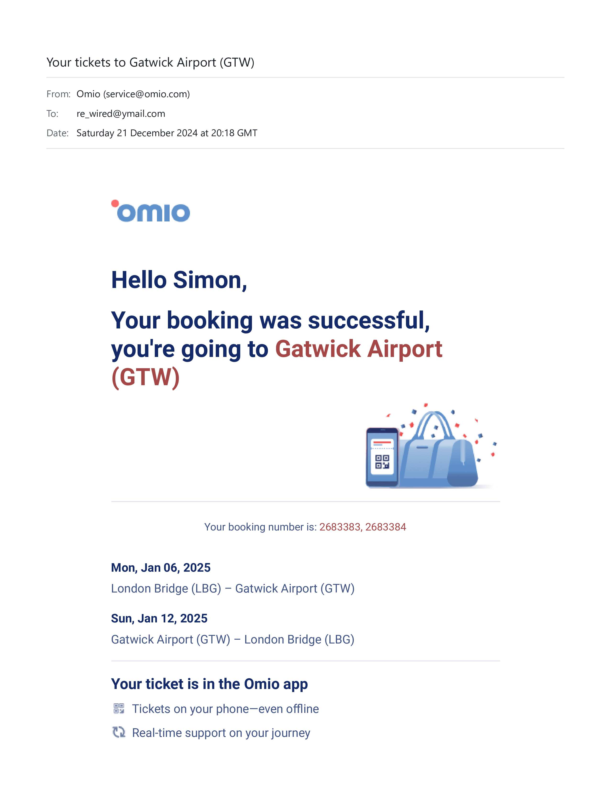
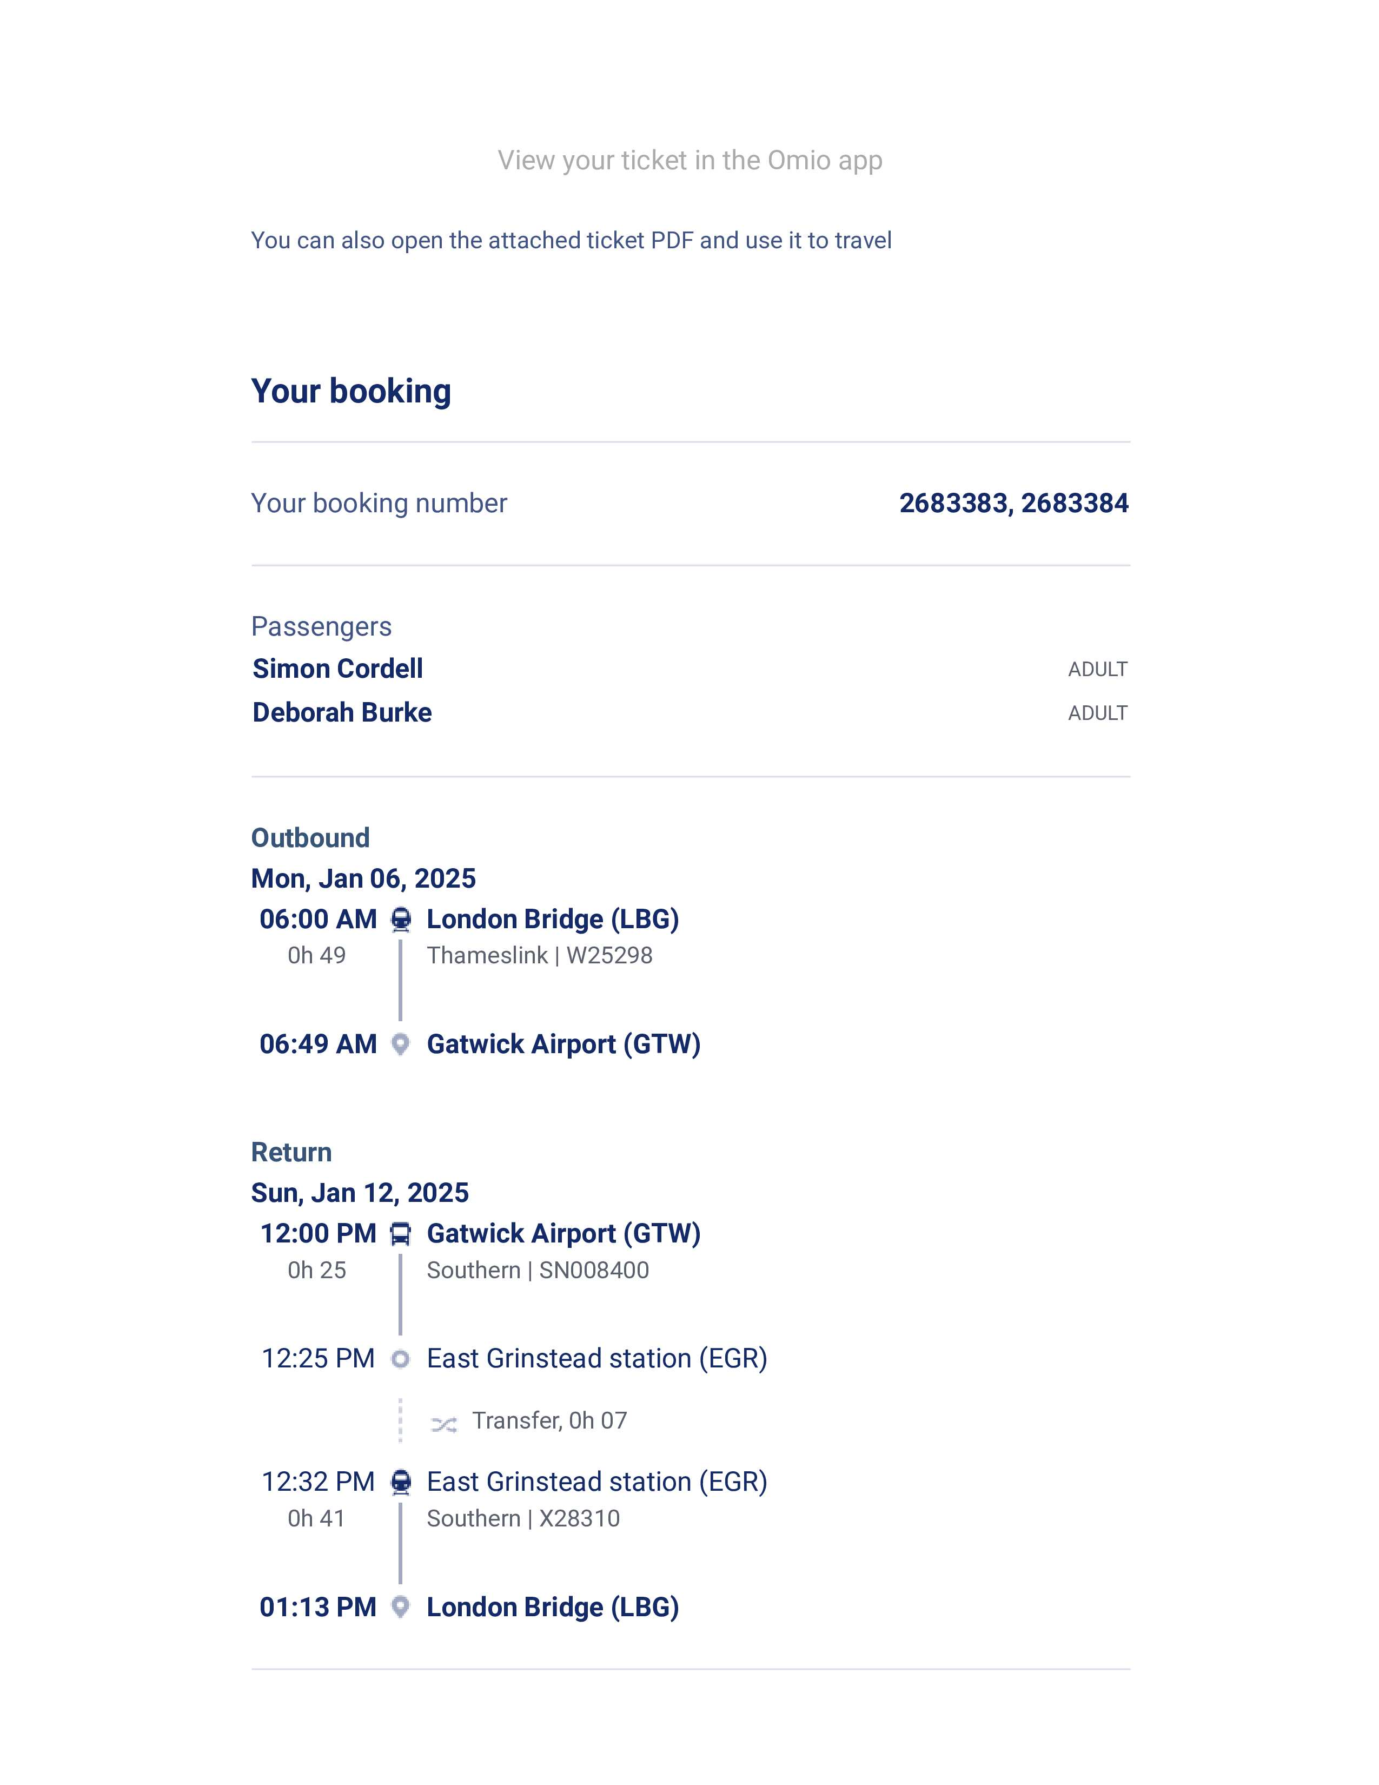

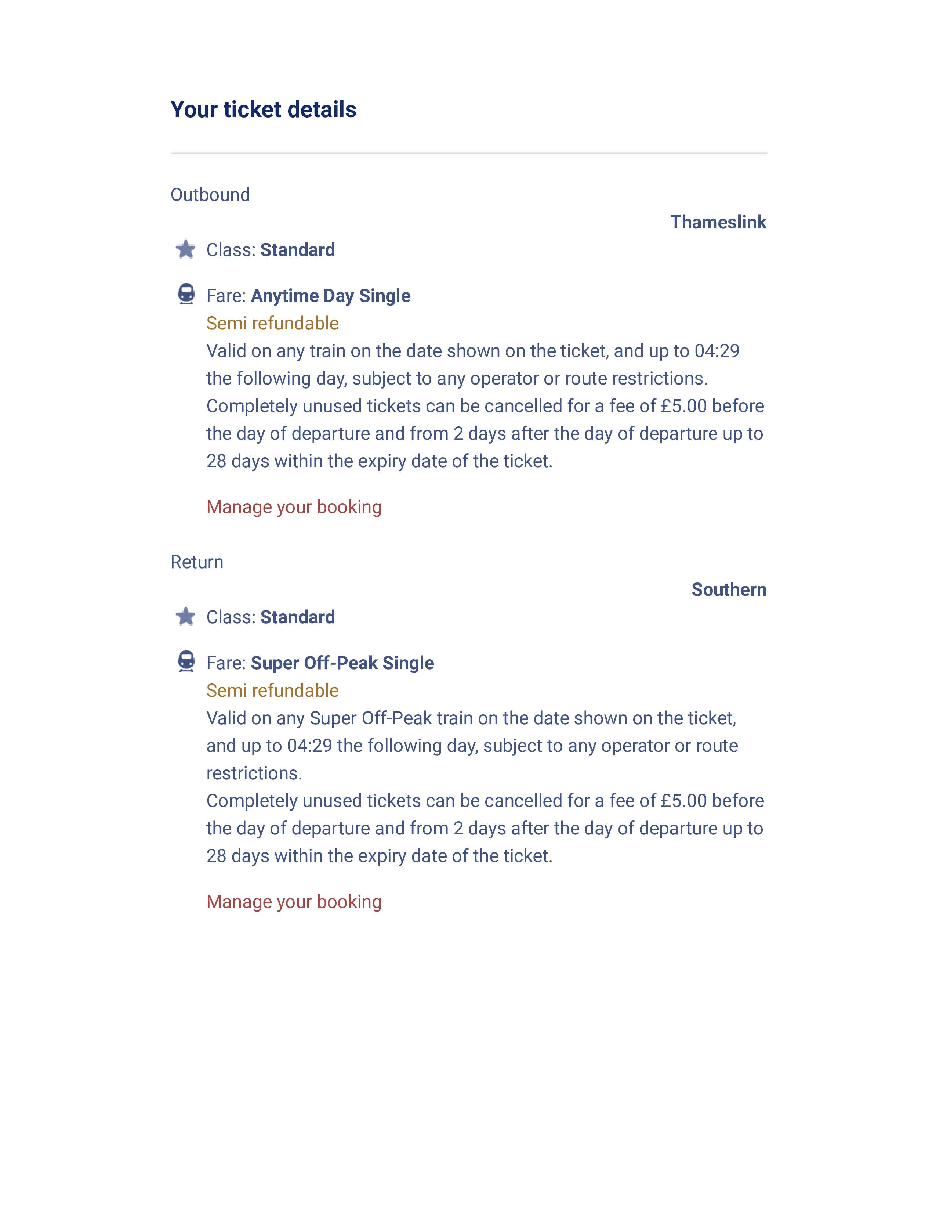
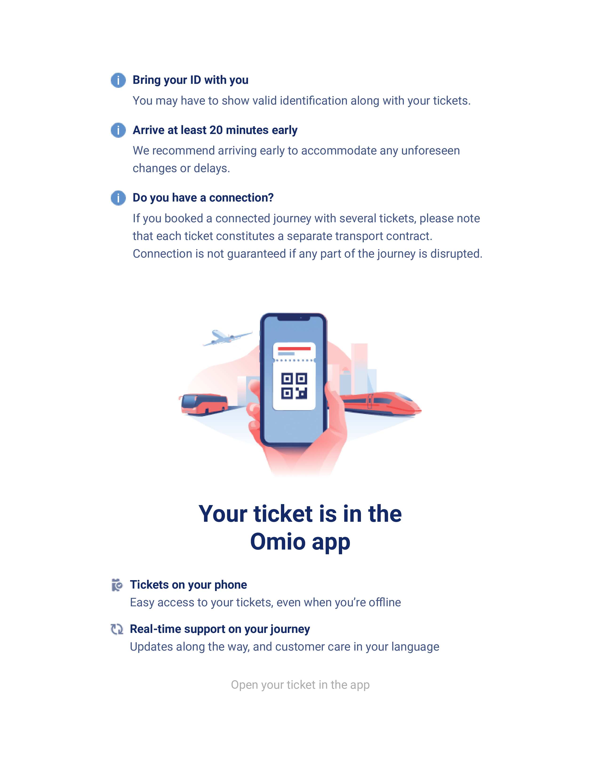

- This is the only email I received from Omio, there are six pages. I will first address each one of those pages content below and continue with the clickable option “View Your Ticket In The Omio App,” then address your issues afterwards.

- The First Page Of The Invoice:
- In the first page it states that my booking was successful, you're going to Gatwick Airport (GTW).
The message continues with two booking numbers and includes a confirmation that we have successfully received the requested items, and that the sale has been completed.

- Mon, Jan 06, 2025: London Bridge (LBG) – Gatwick Airport (GTW)
- Sun, Jan 12, 2025: Gatwick Airport (GTW) – London Bridge (LBG)

- There is a view your ticket in the Omio App Button, but we will be addressing this later.
- None of the website pages, invoices, or itineraries mentioned any warnings about potential delays or instances where train services would be replaced with coaches. Also, there wasn't any information about the additional train stop service at East Grinstead station (EGR) being linked to engineering work between Gatwick Airport and East Croydon, which resulted in line closures.

- The Second Page Of The Invoice:
- The second page of the invoice includes a section for passenger names, as well as a section for outbound and return travel details. When I purchased the tickets, I was presented with the option to input one outbound destination and one return destination, which was the only option available on the website. I must acknowledge that I have not had the opportunity to travel as frequently as I would like in recent times. Nevertheless, it is my understanding that it is standard practice for train service providers to make stops at multiple destinations before reaching the final destination and occasionally, the reasons for these stops may not even be disclosed to the public. In the absence of any textual warnings regarding delays, I believed that the additional stop added into the return journey was a part of the standard train service.
- Page two’s only possible clue towards warnings for delays was and is the follow: Transfer, 0h 07.
- Pricing: At the bottom end of the page is the total charged. £53.40 and still no warning of delays.

- The Third & Forth pages of the invoice:
Are tiled as:
- Your ticket details,
- Outbound Thameslink,
- Return Southern,
- Bring your ID with you,
- Arrive at least 20 minutes early,
- Do you have a connection?

- None of these “Omio” Webpage links, invoices, or itineraries contained warnings about delays or the substitution of train services with coach services. Additionally, there was no mention of the extra train stop service from East Grinstead station (EGR) being related to engineering work that was occurring between Gatwick Airport and East Croydon, which led to line closures. Nor was there advice to go to “Thameslink and Southern Rail Services” website to search for delay changes.

- The Five Page on the Invoice:
- Omio_Invoice_2683383_2683384.pdf
  - The invoice labeled "Omio_Invoice_2683383_2683384.pdf" does not indicate any alerts regarding potential service delays, nor does it mention any scenarios where train services would be substituted with bus services. Additionally, there is no mention of the East Grinstead station (EGR) stop being connected to engineering activities that led to closures between Gatwick Airport and East Croydon.

- The Clickable Option “View Your Ticket In The Omio App.”
- Screenshot:
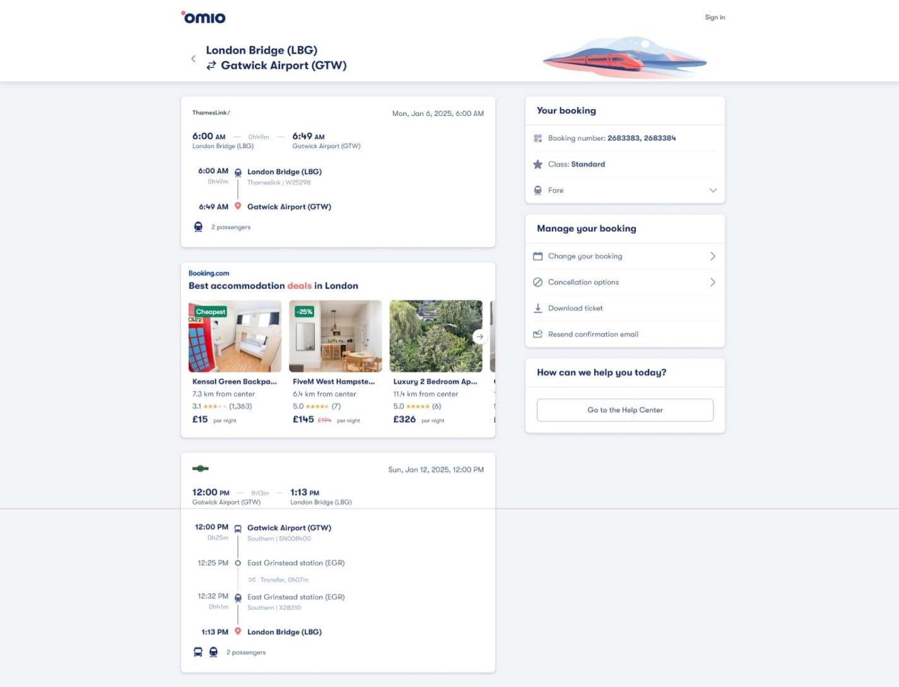

- After receiving the ninth confirmation email dated 07th of March 2025, I revisited the website to ensure I had not overlooked any information regarding the replacement train services. Upon review, I found that I had conducted a thorough search earlier, as I had discovered the "Download Tickets" dropdown button and this made me appreciate the user-friendly design of the site, which is easy to navigate and understand, while searching through and all thanks to its effective web development.

- However, I must emphasize that there was, and continues to be, no notification regarding train delays or clear instructions on where to locate such critical information. This absence of communication is concerning, and I believe it warrants attention.

- The “Download Tickets” Dropdown Button





- Due to not being informed in the omio website about our return ticket changes and not knowing that East Grinstead is not apart of the normal servise we took it as apart of it and this ment that we still booked our cab intime

- The Time On The Return Jorney States 12: 32
- The Cab Was Booked For 1:30
- We Arrived After 2:15 Pm

- Itinerary –
Suggested 12 January:
12:00 Southern
From Gatwick Airport
To East Grinstead
---
- 12:32 Southern
From East Grinstead
To London Bridge

On 12th of January 2025, due to the disruptions on the Southern Rail network, the train services from East Grinstead to London Bridge were affected. Here’s a comparison of the train frequency on that day versus a normal schedule:

12th of January 2025 “Disrupted Schedule!”
- Coach Service: Provided from Gatwick Airport to East Grinstead due to train disruptions.

- Train Service: From East Grinstead to London Bridge, trains were running at the following times:
  - 12:12 PM (1L35 service)
  - 1:12 PM
  - 2:12 PM
  - 3:12 PM
  - 4:12 PM
  - 5:12 PM
  - 6:12 PM
  - 7:12 PM
  - 8:12 PM

- Website linked here: https://www.realtimetrains.co.uk/service/gb-nr:X28328/2025-01-12/detailed

“Normal Schedule!”

Thameslink and Southern Rail Services from Gatwick Airport to London Bridge
Both Thameslink and Southern Rail provide services on the route from Gatwick Airport to London Bridge. Here are the accurate details:

Thameslink Services
Thameslink operates a significant number of trains on this route. On a typical day, there are approximately 86 Thameslink trains per day running from Gatwick Airport to London Bridge. This ensures frequent and reliable service for passengers.

Southern Rail Services
Southern Rail also provides services on this route. On a typical day, there are approximately 125 Southern Rail trains per day running from Gatwick Airport to London Bridge. This adds to the overall frequency and availability of trains on this route.

Combined Services
When considering all operators (including Thameslink, Southern Rail, and other train operators), there are usually about 211 trains per day running from Gatwick Airport to London Bridge. This total includes services provided by both Thameslink and Southern Rail, among others.

Key Points:
- Thameslink Frequency: Approximately 86 trains per day.
- Travel Time: The average journey duration from Gatwick Airport to London Bridge is around 36 minutes, with the fastest services taking just 29 minutes.

- Southern Rail Frequency: Approximately 125 trains per day.
- Travel Time: The average journey duration from Gatwick Airport to London Bridge is around 37 minutes, with the fastest services taking just 29 minutes.

- Total Trains (All Operators): Approximately 211 trains per day.

- Reliability: Both Thameslink and Southern Rail provide frequent and dependable services on this route.

For the most accurate and up-to-date information on train schedules, you can check the Thameslink website and the Southern Railway website.

- Thameslink website: https://www.thameslinkrailway.com/journey/gatwick-airport-to-london-bridge and the
- Southern Railway website: https://www.southernrailway.com/journey/gatwick-airport-to-london-bridge.

- Train Service: On a typical day, trains from East Grinstead to London Bridge run more frequently, with departures approximately every 30 minutes during peak times and every hour during off-peak times.
- Website linked here: https://www.southernrailway.com/journey/east-grinstead-to-london-victoria

The 12^{th of} January 2025 Summary
The disruptions significantly reduced the frequency of train services on 12th of January 2025, compared to the normal schedule.

- Disrupted Schedule: Approximately “9” trains per day.
- Normal Schedule: Approximately “211” trains per day.

Timeline
- 12:00 PM: Departure from Gatwick Airport on a coach service provided by Southern Rail due to the disruptions on the train network.
  - Estimated Coach Travel Time: The coach service from Gatwick Airport to East Grinstead typically takes around 30 minutes, depending on traffic conditions. This means we would have arrived at East Grinstead around 12:30 PM.

  - Due to the regular service not operating, this explains the “Non-Existence” of a 12:32 PM train from East Grinstead to London Bridge, even though there were no warnings about these delays on the Omio website or changes from the normal schedule to the disrupted schedule.

- 12:32 PM: Departure from East Grinstead on a Southern Rail train to London Bridge.
  - The train journey from East Grinstead to London Bridge typically takes around 53 minutes. Given this, we would have arrived at London Bridge at approximately 1:25 PM, if the trains had been running a normal service, but they were not.

Scenario
Based on the itinerary provided, let's analyze how it was possible for me to arrive at London Bridge Train Station at 2:15 PM instead of 1:25 PM.
Itinerary – Suggested 12 January 2025:

- 12:00 Southern: From Gatwick Airport to East Grinstead
- 12:32 Southern: From East Grinstead to London Bridge

We arrived at Gatwick Airport on 12th of January 2025, in time for the 12:00 PM Southern service to East Grinstead. We were told the train was not running and we would need to get on a replacement coach. The coach journey would take 30 to 40 minutes or longer.

Thameslink "Normal" Frequency: Approximately 86 trains per day.
Southern Rail "Normal" Frequency: Approximately 125 trains per day.

Both Thameslink and Southern Rail customers shared only 9 trains on 12th of January 2025.

The first train of the 9 was scheduled for 12:12 PM.
The first train running out of the nine was unattainable to us due to our ticket time being for 12:32 PM according to the normal schedule.
If we left Gatwick Airport to East Grinstead at 12:00 PM by coach, it would have taken at the best of times 30 minutes, so we would have missed the first of the nine replacement trains running at the time of 12:12 PM, as exhibited below:

- Train Service: From East Grinstead to London Bridge, trains were running at the following times:
- 12:12 PM (1L35 service) “We Would Have Missed This, Train!”
- 1:12 PM “We Would Have Just Arrived For This Train As I Remember!”
- 2:12 PM
- 3:12 PM
- 4:12 PM
- 5:12 PM
- 6:12 PM
- 7:12 PM
- 8:12 PM

For a start:
- Omio understood the delays when they sold us the tickets but gave us no warnings on the site at the time or after the purchase of tickets, nor did they advise us to check elsewhere.

Considerably Even Worse:
- You must have

Additional Considerations
- Disruptions and Delays: On days with disruptions, there might be adjustments in the schedule, and additional services might be put in place to accommodate passengers. This could explain why the train was present despite the disruptions.

- Coordination: Southern Rail likely coordinated the coach and train schedules to ensure that passengers could make their connections even with the disruptions.

I look forward to your prompt response and resolution of my compensation claim.

Kind Regards,
Simon Paul Cordell

Address: 109 Burncroft Avenue, Enfield, London, EN3 7JQ
Email: Re_Wired@Ymail.com
Tel: +44 7864 217519

- Waiver of Liability for Calculation Errors
- I, Simon, hereby declare that the calculations provided within this document are based on the information available at the time of preparation. While I have taken every reasonable effort to ensure accuracy, I acknowledge that mistakes can occur.

- Waiver of Liability:
- Release of Liability: I shall not be held liable for any discrepancies or errors in the calculations presented herein.
- Responsibility for Verification: It is the recipient's responsibility to verify the calculations independently. If any errors or discrepancies are identified, please notify me immediately for correction.

- Amendments and Feedback:
- Request for Reassessment: If you identify any errors or inaccuracies in the calculations, please resend the document with highlighted amendments to me at your earliest convenience.
- Collaborative Adjustment: Upon receiving your feedback, I will review and agree upon the necessary corrections, then we can provide an updated version promptly.

Thank you for your understanding and cooperation.

P.S.
I have included an index of the files associated to these claims here:

File Table
File Number | File Name | Size (bytes)
1 | 01. 01st Receipt.pdf | 111,052
2 | 01. 01st Sent Claim-Letter-4-Southern-Railway (1).pdf | 617,556
3 | 01. 01st Sent-Email.pdf | 67,742
4 | 02. 02nd Received-Mail.pdf | 81,035
5 | 03. 03rd Received-Mail.pdf | 279,146
6 | 04. 04th Receipt.pdf | 108,548
7 | 04. 04th Sent-Goes-With-Urgent-Request-pdf.pdf | 88,890
8 | 04. 04th Urgent-Request-for-Reconsideration-of-Compensation-Claim.docx | 21,281
9 | 04. 04th Urgent-Request-for-Reconsideration-of-Compensation-Claim.pdf | 165,755
10 | 05. 05th Received.pdf | 86,205
11 | 06. 06th Sent 01-03-25.pdf | 167,699
12 | 06. 06th Sent-Soon.docx | 16,576
13 | 06. 06th Sent-Soon.pdf | 81,285
14 | 07. 07th Received.pdf | 223,168
15 | 08. 08th Sent-03-03-25.pdf | 293,536
16 | 09. 09th Received.pdf | 249,785
17 | 10. 10th to-be-Sent-Fix.docx | 2,069,645
18 | 10. 10th to-be-Sent-Fix.htm | 1,614,079
19 | 10. 10th to-be-Sent-Fix.pdf | 1,802,878

Directory Names
Directory Number | Directory Name
1 | 01. 1st Claim-Letter-4-Southern-Railway _files
2 | 10. 10th to-be-Sent-Fix files
3 | 00. Receipts
4 | 01. 1st Teeth Invoice
5 | 02. Cabs-From-Home
6 | 03. Flights
7 | 04. Your Hotel
8 | 05. 02nd Teeth Invoice
9 | 06. Your Tickets-LBG–GTW-Return
10 | 07. 149 Bus-and-Cab-Home
11 | 08. 02nd Teeth Invoice
12 | 09. After-Booking-is-Clicked
13 | 10. After-Booking-is-Clicked2
14 | 11. Bank-Statements
15 | 12. Departing-to-Antalya
16 | 13. Itinerary
17 | 14. Icons
18 | 15. Slide-pic-Content Flex Farecard
19 | 16. Screenshot-Baggage-Click-and-Pay-
20 | 17. 02. Returning to London
21 | 18. Screenshot-Baggage-Allowance
22 | 19. Screenshot-Baggage-Allowance-Policies-Blue2
23 | 20. Screenshot-Baggage-Allowance-Policies1
24 | 21. DentaFly-com-treatments-Antalya-implant-treatment
25 | 22. Hiossen NH Hydrophilic Implants Doc Notes
26 | 23. Lamp Post
27 | 24. Screenshot Farecard Example2
28 | 25. Face-3dScan-Pics
29 | 26. Request for Receipt, 3D Scan Image, and Quote
30 | 27. Screenshot Seat-Selection-Paid-For!
31 | 28. Cab-from-Airport-to-Hotel
32 | 29. Exchanged-Money
33 | 30. Carry-on-Baggage-Allowance
34 | 31. Dt. Soner Arıkan
35 | 32. Trip-Com-Booking-Screenshots
36 | 33. Price-Detail-Dropdown
37 | 34. OMIO Receipt 21-12-24
38 | 35. Omio-Booked-Page
39 | 36. Train-Webpages
40 | 37. Work-Logs

11. 11th Received
Re: 20250224-730595
From: Ahmed Jama (ahmed.jama@gtrailway.com)
To: re_wired@ymail.com
Date: Thursday 13 March 2025 at 09:21 GMT
Dear Simon
Thank you for your email, I can see that you have included additional legal fees that you are requesting. I sent an email on 6 March explaining that we do not operate a train service on the route that you had advised we cancelled a train for and have not received any further responses from you.
Can you please confirm the response you would like me to provide? In your earlier email you stated that the cause of the delay was due to the "12:00 PM Southern Rail Train from Gatwick Airport to East Grinstead Not Running." As explained, we don't operate a train service for this route, and this was an advertised bus replacement service. Therefore, could you please clarify where we failed to provide the service you had booked a ticket for and I will be able to address your concerns further.
If you are unhappy with the responses provided you can raise a case with the Rail Ombudsman. I'll be happy to investigate any continued concerns or questions you have and provide a response.
If you are not satisfied with the way we have answered your complaint you have the right to take your complaint to the Rail Ombudsman. The Rail Ombudsman service is independent and free. If you contact them, please make sure that you tell them that you have this email, known as a Deadlock, to show that you have completed the complaints process with us.
The Ombudsman will investigate your complaint and make a decision based on the information given to them. If you agree with the Ombudsman's decision, we have to do what they say. This could be making an apology, explaining what went wrong, correcting the problem, or giving you a financial award.
If your complaint is about the way our service has been designed, rail industry policy, or if your complaint relates to an event that took place before the Rail Ombudsman service was established, the Ombudsman will review it and then put it in the hands of Transport Focus or London TravelWatch who may progress it on your behalf. These organisations are passenger watchdogs that work with the rail industry, government and others.
You can contact the Rail Ombudsman via the methods below:
Website: www.railombudsman.org
Telephone: 0330 094 0362
Textphone: 0330 094 0363
Email: info@railombudsman.org
Twitter: @RailOmbudsman
Post: FREEPOST - RAIL OMBUDSMAN
Kind Regards,
Ahmed Jama
Customer Relations Advisor Govia Thameslink Railway (GTR)
Email:ahmed.jama@gtrailway.com
Govia Thameslink Railway Limited Registered in England and Wales No. 07934306.
Registered office: 3rd Floor, 41-51 Grey Street, Newcastle upon Tyne, NE1 6EE This email is sent subject to our email disclaimer which can be accessed here

12. 12th-Sent
12. 12th-All-Emails

Re: 20250224-730595

From: Rewired (re_wired@ymail.com)
To: ahmed.jama@gtrailway.com
Date: Thursday 13 March 2025 at 16:25 GMT

Subject: Follow-Up on Compensation Claim for Journey on 12 January 2025

Dear Ahmed Jama,

Thank you for your detailed response. I would like to address several key points regarding my compensation claim and clarify the exceptional circumstances that have impacted this claim.

No Warnings or Updates on the Website
- Lack of Information:
  - The website did not provide any warnings about the replacement services, delayed services, or engineering work. At no point was the word "Coach," "Replacement Services," or "Delayed Services" mentioned when I booked my tickets. The tickets were purchased on 21st December 2024, just before Christmas. Despite this, the site was not updated, and no emails were sent to warn me about the delays or changes.
  - We booked our cab based on the provided itinerary, which does not account for the actual delays and replacement services.

Exceptional Circumstances
- Family Medical Emergency:
  - I was in the hospital with my mother on Christmas Day due to her severe kidney failure. This critical situation required my presence at the hospital, which significantly delayed my ability to focus on submitting the compensation claim.
  - The ongoing hospital visits and care for my mother continued through the New Year, further impacting my ability to manage this claim promptly.

Discrepancies in Service and Itinerary
- Incorrect Ticket Details:
  - The train ticket, not coach tickets sold to me, stated a departure time of 12:00 PM from Gatwick Airport train station.
  - The train ticket sold to me also stated a departure time of 12:32 PM from East Grinstead Train Station.
  - Despite arriving at Gatwick Airport on time, a coach service that was never mentioned about was provided.
  - The coach service provided arrived later than 12:32 PM at East Grinstead Train Station as stated in the sold tickets, to us.
  - Another issue is the first replacement train from East Grinstead Train Station that day was at 12:12 PM (1L35 service), and with us being at Gatwick Airport at 12:00pm we could never have got on this train
  - This means we could have only got on the second train from East Grinstead that day at the time of 1:12 PM.
  - The ticket's itinerary stating for us to be at Gatwick Airport for 12:00 PM and East Grinstead for 12:32 PM.

Impact on Planning
- Return Journey Timing:
  - The replacement coach service was never explained.
  - The planned train from East Grinstead to London Bridge at 12:32 PM was none existent and therefore made us late.
  - The next train from East Grinstead to London Bridge was at 1:12 PM, which is the train the coach managed to arrive for.

Accountability and Fairness
- Company Responsibility:
  - Govia Thameslink Railway Limited (GTR) operates train services under the brands Thameslink, Southern, Great Northern, and Gatwick Express. Therefore, GTR is responsible for addressing the service disruptions and the lack of adequate warnings.
  - It is not fair or reasonable to deny compensation based on these circumstances, given the exceptional conditions and the significant impact on my travel plans.

- Service Discrepancies:
  - If, as stated: “The 12 PM Service Was Always Scheduled As A Replacement Bus Service,” this would mean that I should never have been sold these train tickets with a train that was not running at 12:32.
  - The time of the missing 12:32 train not being accounted for in my itinerary or booking pages proves the train service never operated as scheduled, and compensation must be offered.

Given these points, I kindly request a reconsideration of my compensation claim, taking into account the detailed evidence and the exceptional circumstances that affected my ability to submit the claim promptly. The lack of adequate warnings and updates regarding the replacement services has caused considerable disruption and additional expenses.

Thank you for your understanding and assistance in this matter.

Kind regards,
Simon Paul Cordell 109 Burncroft Avenue, Enfield, London, EN3 7JQ Email: Re_Wired@Ymail.com Tel: +447864217519

All Emails PDF Goes here!

13. 13th-Received
Re: 20250224-730595

From: Ahmed Jama (ahmed.jama@gtrailway.com)
To: re_wired@ymail.com
Date: Thursday 13 March 2025 at 17:18 GMT

Dear Simon
Thank you for your email and the additional information. A number of the points you have raised relate to the information on the website you purchased the tickets from and lack of adequate warnings and updates regarding replacement services. Your ticket was purchased from a third-party retailer, therefore, any complaints relating to the information you were provided with will need to be addressed with the company your tickets were purchased from.
I am unable to address complaints relating to the information provided as this was through a company and website we do not manage.
I am sorry to hear of the medical emergency and can understand the concern this would have caused.
While requesting more information to assess your complaint, you were unable to confirm the train service you had taken and had mentioned the below. Therefore, we were unable to accurately assess the journey you had taken.
'Unfortunately, as we are both unfamiliar with the local area “Being from North London,” we cannot 100% confirm the exact train station or service details beyond this point, without contacting yourselves!'
You have also stated that you attempted to take the 12:12 1L35 service from East Grinstead, however, the ticket evidence you forwarded shows that you were not scheduled to take this train.
If you can confirm the time of the coach, you took from Gatwick airport and the time of the train you took from East Grinstead I can look into this for you. However, the complaint points relating to the information you were provided will need to be raised with the company you purchased the tickets from.
Kind Regards,
Ahmed Jama
Customer Relations Advisor
Govia Thameslink Railway (GTR)
Email:ahmed.jama@gtrailway.com
Govia Thameslink Railway Limited
Registered in England and Wales No. 07934306.
Registered office: 3rd Floor, 41-51 Grey Street, Newcastle upon Tyne, NE1 6EE This email is sent subject to our email disclaimer which can be accessed here

14. 14th-Sent

Re: 20250224-730595

From: Rewired Rewired (re_wired@ymail.com)
To: ahmed.jama@gtrailway.com
Date: Friday 14 March 2025 at 10:43 GMT

Subject: Reconsideration of Compensation Claim and Clarification of Responsibilities

Dear Ahmed Jama,

Thank you for your recent email. I am writing to address and correct several points regarding the liability of Govia Thameslink Railway (GTR) in my compensation claim.

- Liability and Third-Party Retailers:
· While my ticket was purchased through Omio, it is essential to recognize that GTR, as the service provider, retains ultimate responsibility for ensuring accurate and timely information dissemination. The “Consumer Rights Act 2015” mandates that services, including third-party sales, be provided with reasonable care and skill. GTR cannot deflect liability onto Omio when GTR itself is responsible for the accuracy of schedule updates and service changes communicated to retailers and passengers alike. The “Rail Passengers' Rights and Obligations Regulation (EC) No 1371/2007” further enforces this, requiring rail operators to provide comprehensive and accurate information to passengers, regardless of the sales channel.

- Delayed Response and Clarification Requests:
· Contrary to your claims, I have consistently communicated the challenges and confusion faced during my journey on 12th of January 2025. The itinerary clearly indicated travel from Gatwick Airport at 12:00 PM with an onward journey from East Grinstead to London Bridge at 12:32 PM. The confusion stems from the failure of GTR and Omio to update the scheduled services effectively and transparently, which directly resulted in the delays and additional expenses incurred.

- Responsibilities Under Relevant Regulations:
· Rail Passengers' Rights and Obligations Regulation (EC) No 1371/2007: This regulation provides comprehensive protection to rail passengers, including compensation for delays, cancellations, and disruptions, irrespective of the cause.
· National Rail Conditions of Travel: These conditions entitle passengers to compensation for delays exceeding a certain timeframe, regardless of the cause, and ensure transparency and fairness in dealings with passengers.
· Consumer Rights Act 2015: This act obligates service providers to deliver services with reasonable care and skill, ensuring that disruptions are handled fairly, and compensation is provided appropriately.

- Exceptional Circumstances:
· The exceptional circumstances surrounding my case, including a family medical emergency and technical issues with the claim submission process, warrant a departure from the standard compensation policy. These factors significantly hindered my ability to submit the claim within the 28-day window, necessitating a reconsideration of my compensation request.

- Clarification of Journey Details:
· As previously communicated, I was scheduled to take the 12:00 PM Southern train from Gatwick Airport to East Grinstead, followed by a 12:32 PM Southern train from to London Bridge. However, upon arrival at Gatwick Airport, I was informed that the scheduled train services were cancelled due to engineering works and were replaced by a coach service. This coach service took approximately 45 minutes to reach East Grinstead, where I then boarded the replacement train to continue my journey to London Bridge.

· The fact that the 12:32 PM Southern train from East Grinstead to London Bridge should never have been added or sold to passengers as it was never going to be running due to planned engineering works, raises serious questions about the accuracy and transparency of the information provided by GTR and Omio. If the 12:00 PM service was always scheduled as a replacement bus service, it is perplexing because a train that would never be running was sold to me.

· The delayed services at both parts of the journey meant that the delayed replacement services at East Grinstead contributed to missing nine trains, and the timing of the coach services meant that we would never have made it to the first scheduled service, but we did make it to the second. This should have been accurately communicated at the time of ticket purchase to prevent confusion and additional expenses.

- Request for Comprehensive Insurance Policy Information:
· I have requested a complete copy of the relevant insurance policies to assess the scope of coverage and validate my compensation claim. Your failure to address this request further perpetuates the impression of obfuscation and avoidance of liability by GTR.

I respectfully request that GTR reconsider my compensation claim, taking into account the exceptional circumstances and the legal obligations outlined above. I seek full recovery of my tickets and reimbursement for the additional costs incurred, as detailed in my initial claim.

Thank you for your attention to this matter. I look forward to your prompt and comprehensive response.

Sincerely,

Name: Simon Paul Cordell
Address: 109 Burncroft Avenue, Enfield, London, EN3 7JQ
Email: Re_wired@ymail.com
Tel: +447864217519

15. 15th-Sent
Subject: Follow-Up on Compensation Claim for Journey on 12 January 2025
Dear Ahmed Jama,
Regarding my previous communication, I noticed a minor text error and would like to provide the corrected statement for clarity:
"The delayed services at both parts of the journey meant that the delayed replacement services at East Grinstead contributed to missing "The first off," nine trains, and the timing of the coach services meant that we would never have made it to the first scheduled service."
Please let me know if you require any further information or clarification. I look forward to your prompt response and resolution of my compensation claim.
Kind regards,
Simon Paul Cordell
Address: 109 Burncroft Avenue, Enfield, London, EN3 7JQ
Email: Re_wired@ymail.com
Tel: +447864217519

16. 16th-Received

Re: 20250224-730595

From: Ahmed Jama (ahmed.jama@gtrailway.com)
To: re_wired@ymail.com
Date: Friday 14 March 2025 at 17:28 GMT

Dear Simon

Thank you for your email I haven't had a chance to review your email as of yet, however, I note that the corrected statement mentions missing nine trains, would you please be able to confirm the departure times of these services and the route so that I am able to look at the correct information. Kind Regards,
Ahmed Jama
Customer Relations Advisor
Govia Thameslink Railway (GTR)
Email:ahmed.jama@gtrailway.com

Govia Thameslink Railway Limited
Registered in England and Wales No. 07934306.
Registered office: 3rd Floor, 41-51 Grey Street, Newcastle upon Tyne, NE1 6EE This email is sent subject to our email disclaimer which can be accessed here

17. 17th-Sent

Re: 20250224-730595

From: Rewired (re_wired@ymail.com)
To: ahmed.jama@gtrailway.com
Date: Friday 14 March 2025 at 18:19 GMT

Subject: Follow-Up on Compensation Claim for Journey on 12 January 2025
Dear Ahmed Jama,
Thank you for your prompt response.
To clarify the details regarding the missed trains, please refer to the 10th email I sent to you, which contains a detailed summary of the journey, including departure times and the route taken. You can access the specific section through the following link:
1) 10th Sent Email https://horrific-corruption-files.webhop.me/PNC66/1.%20PNC-Errors-and-Its-Other-Claims/05-01-25-till-25-01-25File-Locked4Sharing/Teeth-14-01-25/04.%20Claim-4-Southern-Railway-Claim-Sent-Updated/10.%2010th-SentEmail.pdf
Within this email, you'll find the details under the section titled "The 'Download Tickets' Dropdown Button" and below the exhibited tickets.
For your convenience, I have summarized the key points here:
Due to not being informed on the Omio website about our return ticket changes and not knowing that East Grinstead is not part of the normal service, we took it as part of it and this meant that we still booked our cab in time. The time on the return journey states 12:32 PM; the cab was booked for 1:30 PM, but we arrived after 2:15 PM.

Itinerary:
1. Suggested 12 January:
· 12:00 PM Southern from Gatwick Airport to East Grinstead
· 12:32 PM Southern from East Grinstead to London Bridge

On 12 January 2025, due to disruptions on the Southern Rail network, the train services from East Grinstead to London Bridge were affected. Here’s a comparison of the train frequency on that day versus a normal schedule: 12th of January 2025, "Disrupted Schedule":

Coach Service: Provided from Gatwick Airport to East Grinstead due to train disruptions.
Train Service: From East Grinstead to London Bridge, trains were running at the following times:
- 12:12 PM (1L35 service) "We Would Have Missed This, Train!" - As it takes longer than 12 minutes to get to East Grinstead from Gatwick by coach.
- 1:12 PM "We Would Have Just Arrived For This Train As I Remember!"

My ticket to be at East Grinstead is 12:32 PM, and this train was cancelled but still sold to me. The comment from your team confirmed: "The 12 PM Service Was Always Scheduled As A Replacement Bus Service." For a detailed schedule, you can check RealTime Trains.

"Normal Schedule": Both Thameslink and Southern Rail provide frequent services from Gatwick Airport to London Bridge, with approximately 211 trains per day combined.
For more accurate information, check the Thameslink website and the Southern Railway website.

Summary:
Disrupted Schedule: Approximately 9 trains per day.
Normal Schedule: Approximately 211 trains per day.

Timeline:
- 12:00 PM: Departure from Gatwick Airport on a coach service provided by Southern Rail due to the disruptions.
· Estimated Coach Travel Time: 30 minutes, arriving at East Grinstead around 12:30 PM.
· The non-existence of a 12:32 PM train from East Grinstead to London Bridge was due to the lack of warnings on the Omio website.

- 12:32 PM: Scheduled departure from East Grinstead to London Bridge.
· Actual Arrival at London Bridge: 2:15 PM instead of 1:25 PM.

Given these repeated explanations, I hope this clarifies the details you requested. Please refer to the 10th email for further information and the attached documents that outline the sequence of events and incurred expenses.
I kindly request a prompt review and resolution of my compensation claim as the details have been exhaustively provided. Thank you for your attention to this matter.
Kind regards,

Simon Paul Cordell
Address: 109 Burncroft Avenue, Enfield, London, EN3 7JQ
Email: Re_wired@ymail.com
Tel: +447864217519

18. 18th-Sent

----- Forwarded message -----
From: Rewired Rewired <re_wired@ymail.com>
To: Ahmed Jama <ahmed.jama@gtrailway.com>
Sent: Friday 14 March 2025 at 10:43:43 GMT
Subject: Re: 20250224-730595
Subject: Reconsideration of Compensation Claim and Clarification of Responsibilities

Dear Ahmed Jama,

Thank you for your recent email. I am writing to address and correct several points regarding the liability of Govia Thameslink Railway (GTR) in my compensation claim.

- Liability and Third-Party Retailers:
· While my ticket was purchased through Omio, it is essential to recognize that GTR, as the service provider, retains ultimate responsibility for ensuring accurate and timely information dissemination. The “Consumer Rights Act 2015” mandates that services, including third-party sales, be provided with reasonable care and skill. GTR cannot deflect liability onto Omio when GTR itself is responsible for the accuracy of schedule updates and service changes communicated to retailers and passengers alike. The “Rail Passengers' Rights and Obligations Regulation (EC) No 1371/2007” further enforces this, requiring rail operators to provide comprehensive and accurate information to passengers, regardless of the sales channel.

- Delayed Response and Clarification Requests:
· Contrary to your claims, I have consistently communicated the challenges and confusion faced during my journey on 12th of January 2025. The itinerary clearly indicated travel from Gatwick Airport at 12:00 PM with an onward journey from East Grinstead to London Bridge at 12:32 PM. The confusion stems from the failure of GTR and Omio to update the scheduled services effectively and transparently, which directly resulted in the delays and additional expenses incurred.

- Responsibilities Under Relevant Regulations:
· Rail Passengers' Rights and Obligations Regulation (EC) No 1371/2007: This regulation provides comprehensive protection to rail passengers, including compensation for delays, cancellations, and disruptions, irrespective of the cause.
· National Rail Conditions of Travel: These conditions entitle passengers to compensation for delays exceeding a certain timeframe, regardless of the cause, and ensure transparency and fairness in dealings with passengers.
· Consumer Rights Act 2015: This act obligates service providers to deliver services with reasonable care and skill, ensuring that disruptions are handled fairly, and compensation is provided appropriately.

- Exceptional Circumstances:
· The exceptional circumstances surrounding my case, including a family medical emergency and technical issues with the claim submission process, warrant a departure from the standard compensation policy. These factors significantly hindered my ability to submit the claim within the 28-day window, necessitating a reconsideration of my compensation request.

- Clarification of Journey Details:
· As previously communicated, I was scheduled to take the 12:00 PM Southern train from Gatwick Airport to East Grinstead, followed by a 12:32 PM Southern train from to London Bridge.
However, upon arrival at Gatwick Airport, I was informed that the scheduled train services were
cancelled due to engineering works and were replaced by a coach service. This coach service took approximately 45 minutes to reach East Grinstead, where I then boarded the replacement train to continue my journey to London Bridge.

· The fact that the 12:32 PM Southern train from East Grinstead to London Bridge should never have been added or sold to passengers as it was never going to be running due to planned engineering works, raises serious questions about the accuracy and transparency of the information provided by GTR and Omio. If the 12:00 PM service was always scheduled as a replacement bus service, it is perplexing because a train that would never be running was sold to me.

· The delayed services at both parts of the journey meant that the delayed replacement services at East Grinstead contributed to missing nine trains, and the timing of the coach services meant that we would never have made it to the first scheduled service, but we did make it to the second. This should have been accurately communicated at the time of ticket purchase to prevent confusion and additional expenses.

6. Request for Comprehensive Insurance Policy Information:
· I have requested a complete copy of the relevant insurance policies to assess the scope of coverage and validate my compensation claim. Your failure to address this request further perpetuates the impression of obfuscation and avoidance of liability by GTR.

I respectfully request that GTR reconsider my compensation claim, taking into account the exceptional circumstances and the legal obligations outlined above. I seek full recovery of my tickets and reimbursement for the additional costs incurred, as detailed in my initial claim.

Thank you for your attention to this matter. I look forward to your prompt and comprehensive response.

Sincerely,

Name: Simon Paul Cordell
Address: 109 Burncroft Avenue, Enfield, London, EN3 7JQ
Email: Re_wired@ymail.com Tel: +447864217519

19. 19Th Sent

Re: 20250224-730595
From: Rewired (re_wired@ymail.com)
To:ahmed.jama@gtrailway.com
Date: Friday 14 March 2025 at 17:24 GMT
Subject: Follow-Up on Compensation Claim for Journey on 12 January 2025
Dear Ahmed Jama,
Regarding my previous communication, I noticed a minor text error and would like to provide the corrected statement for clarity:
"The delayed services at both parts of the journey meant that the delayed replacement services at East Grinstead contributed to missing "The first off," nine trains, and the timing of the coach services meant that we would never have made it to the first scheduled service."
Please let me know if you require any further information or clarification. I look forward to your prompt response and resolution of my compensation claim.
Kind regards,
Simon Paul Cordell
Address: 109 Burncroft Avenue, Enfield, London, EN3 7JQ
Email: Re_wired@ymail.com Tel: +447864217519

20. 20th-Received

Re: 20250224-730595
From: Ahmed Jama (ahmed.jama@gtrailway.com)
To: re_wired@ymail.com
Date: Friday 14 March 2025 at 17:28 GMT
Dear Simon
Thank you for your email I haven't had a chance to review your email as of yet, however, I note that the corrected statement mentions missing nine trains, would you please be able to confirm the departure times of these services and the route so that I am able to look at the correct information. Kind Regards,
Ahmed Jama
Customer Relations Advisor
Govia Thameslink Railway (GTR)
Email:ahmed.jama@gtrailway.com
Govia Thameslink Railway Limited
Registered in England and Wales No. 07934306.
Registered office: 3rd Floor, 41-51 Grey Street, Newcastle upon Tyne, NE1 6EE This email is sent subject to our email disclaimer which can be accessed here

21. 21st-Sent

Follow-Up on Previous Correspondence – Action Required! "Awaiting Your Response".
From: Rewired (re_wired@ymail.com)
To: ahmed.jama@gtrailway.com
Date: Monday 17 March 2025 at 15:25 GMT

Dear Amed,
I hope this message finds you well. I’m following up on the message I sent last Friday. Please let me know a convenient time to connect or if there are any matters you'd like to discuss.

22. 22nd-Sent

Fwd.: Follow-Up on Previous Correspondence – Action Required! "Awaiting Your Response".
From: Rewired (re_wired@ymail.com) To:ahmed.jama@gtrailway.com
Date: Wednesday 19 March 2025 at 09:17 GMT
----- Forwarded message -----

From: Rewired <re_wired@ymail.com>
To: ahmed.jama@gtrailway.com <ahmed.jama@gtrailway.com>
Sent: Monday 17 March 2025 at 15:25:42 GMT
Subject: Follow-Up on Previous Correspondence – Action Required! "Awaiting Your Response".
Dear Amed,
I hope this message finds you well. I’m following up on the message I sent last Friday. Please let me know a convenient time to connect or if there are any matters you'd like to discuss.

[EXTERNAL SENDER]
Subject: “Urgent Request for Response, Case Handler Assignment, and Insurance Policies!”

Dear Ombudsman and Ahmed,
I hope this message finds you well.

To Ahmed: I am writing to kindly request your prompt response to the matters discussed regarding my compensation claim for the disrupted journey on 12th of January 2025. Given the complexities involved, your timely input is essential to moving this matter forward.

To the Ombudsman: I would appreciate it if you could provide the name of a case handler to ensure that this claim is managed adequately and efficiently. Having a dedicated point of contact is crucial in achieving a fair and timely resolution.

To Both: I also respectfully request the following insurance-related documents, which are relevant to my understanding of the policies that may apply to this case:
  - A complete copy of the “Delay Repay Scheme Insurance Documents.”
  - A complete copy of the “Public Liability Insurance.”
  - Copies of any additional “Insurance Policies” that may pertain to my claim.

It is important to emphasize that this claim has caused significant inconvenience and financial impact, in addition to the time I’ve spent pursuing resolution. Resolving this matter promptly would demonstrate a commitment to fairness and customer satisfaction, which I trust are values upheld by your organisations.
I sincerely hope for your cooperation and a constructive outcome. Please feel free to contact me should you require any further information or clarification.
Thank you for your time and attention to this matter. I look forward to your responses.

Kind regards, Simon Paul Cordell

Address: 109 Burncroft Avenue, Enfield, London, EN3 7JQ
Email: re_wired@ymail.com
Tel: +447864217519

[Rail Ombudsman] Re: Re: Follow-Up on Previous Correspondence – Action Required! "Awaiting Your Response".
From:David (Support) (info@railombudsman.org)
To:re_wired@ymail.com
Date:Tuesday 25 March 2025 at 11:21 GMT
##- Please type your reply above this line -##
Your email (83785) has been responded to. To add additional comments, reply to this email.
Good Morning,

Thank you for contacting the Rail Ombudsman.

The Rail Ombudsman is an Alternative Dispute Resolution organisation, independent from the rail industry. We mediate unresolved complaints between consumers and Service Providers, as long as the consumer has been through the complaints handling procedure of the service provider, and a suitable resolution cannot be found.
Our scheme does allow Thameslink a reasonable amount of time to work with you and try to resolve the dispute. We allow the service provider 40 working days to resolve the complaint with you since you first raised it with them or require you to have been issued with a Deadlock Letter. A Deadlock Letter is any form of written communication from the service provider indicating you have exhausted the Service Providers complaints handling procedure and will reference the Rail Ombudsman by name.
To then raise an application with the Rail Ombudsman, please complete our form online via the following link so we can investigate your complaint:

I have also attached a link to our Consumer Guide which provides further information on what we do within our Scheme:
https://www.railombudsman.org/resource-area/consumerguide/

https://www.railombudsman.org/making-a-complaint/before-starting-a-complaint/
Please do not hesitate to contact us again if you require any further information.

Kind Regards,
Fionn
Contact Advisor.
Tel: 0330 094 0362 |
Premier House | 1-5 | Argyle Way | Stevenage | SG1 2AD
Telephone calls to and from the Ombudsman may be recorded for quality and training purposes.
Registered company name: Dispute Resolution Ombudsman Limited. Registered office: Richmond House, Walkern Road, Stevenage, Hertfordshire, England, SG1 3QP. Company Registration Number: 8945616. Registered in England & Wales.
DISCLAIMER: The information contained in this e-mail message is privileged and confidential and is only intended for the addressee. If you received this e-mail in error, you are hereby notified that any disclosure, reproduction, distribution or use of this message and any attachments is strictly prohibited. Please notify the sender immediately and delete the e-mail without copying or disclosing its contents to any other person. No legal consequences can be derived from the contents of this e-mail. Neither the sender nor Dispute Resolution
Ombudsman Limited accept liability for any damage resulting from the use and/or acceptance of the content of this e-mail message.
Please note that we have updated our Privacy Policy in accordance with the General Data
Protection Regulation 2018. A copy of this can be found here
Please consider the environment before printing this message.

Re:

Re:

Re:

Re:

Re:

Re:

