Statement of Evidence and Formal Complaint Regarding Police Interference, Council Misconduct, My Mother’s Passing, My Succession Rights, and the New Bail Date of 11 November 2026 — All Leading to My Unlawful Removal from My Home

To: Georgina Solan Resident Relationship Officer Housing & Regeneration Enfield Council Edmonton Centre 36–44 South Mall Edmonton Green N9 0TN Georgina.Solan@enfield.gov.uk
CC: DS Rob A. Johnston DC Alina Knox

Dear Georgina, DS Johnston, DC Knox, and Mr. Michel Carrol,
I am writing because the events of the past few months have left my home, my rights, and my stability in complete disarray. Each of you, other than my solicitor, has held different parts of the same official Information and confirmed communication with one another about my arrest due to Deon and because of my legal claim for succession of 23 Byron Terrace as well as my sister Deon’s housing situation. Because of these issues, I now need to bring everything together clearly, in one place, so nothing is misunderstood or overlooked any further.
Our mother passed away on 8 April 2026. I never got to see her again after she died. I was her eldest child, and 23 Byron Terrace has always been my home.
I lived there with her, and it was my main residence.
I applied for my legal right to succeed the tenancy on 11 May 2026, only days after losing her, because that home is the only stable place I have ever had. On the day of her funeral, 29 May 2026, I was unable to attend because of police bail conditions placed on me after the incident involving my sister Deon. I had to miss my own mother’s funeral. I had to miss saying goodbye. I had to miss returning to my home where she was placed after her funeral. All of this happened during the worst period of bereavement in my life due to police bail conditions.
Everything that happened on 9 May 2026 was not because of any of my own wrong doings. It was the result of a clear, deliberate plan by my sister Deon, and the police knew this on the day I was arrested because I told them the truth and provided them with evidence that included handing my mobile phone to the investigating officers so that could review my messages sent to me from my sister. The officers saw the threats. They saw the admissions. They saw the recordings but failed to act on the evidence in accordance with Government policies. After I was released, I sent the same evidence to them again by way of emails that I can prove they received!
The exhibited evidence included a video of Deon living in her temporary London & Quadrant flat on 04/04/2026, lying on the bed fixing her TV while I was helping her. This proves she was living there, not at my mother’s home.

Exhibit: 0A
- Deon in her flat London & Quadrant 04/04/2026, 10:26 - Deon: VID-20260404-WA0001.mp4 (file attached) https://everyoneloginto.me/Extra/Homes%20Folder%2028-04-26/Homes%20Folder%2028-04-26/09.%20WhatsApp%20Deon/WhatsApp%20(2)/VID-20260404-WA0001.mp4

There is also another fact I made them aware of and with that Exhibit being the audio recordings Deon sent me on the 03/05/2026, that was only two days before the alleged incident, this exhibited piece of evidence show her clearly premeditating the entire situation. In her own words Deon said: “Simon, I'm coming to the house tomorrow,” “I'm coming to stay there,” “You haven't got a choice,” “You need to kick your friends out of that house,” and “I'm coming to stay in the front room.” She made it clear she intended to force her way into the property and that if I didn’t allow it, she would call the police or escalate matters further. She said, “You're not letting me in my mum's house,” even though she was not living there.

Exhibit: 0B
<Dir> 09. WhatsApp Deon
<dir.> 09.1. WhatsApp Deon Part 2

The WhatsApp messages speak for themselves:
- On 2 May 2026, her boyfriend James wrote: “Mention my name again watch how I move I’m not a boy.” Minutes later he escalated: “You’re a crackhead… Silly cunt watch your getting we are all coming to get you… Go and section yourself before me and Deon come and get you.” These were not arguments caused by me or my actions, they are fake accusations of slander and “threats of violence.”
- On 3 May 2026, Deon was already building the false narrative she later used against me, while admitting she was going to use the police to do this before any altercations even arose.
- On 6 May 2026 she wrote: “I’m coming home. I’m moving into Mum’s house tomorrow,” despite living in her temporary accommodation.
- On 7 May 2026 she escalated again: “We’re coming there right now… You’re telling me I’m not coming there, yeah watch… Bro, the man is coming for you now.” She then sent a voice note saying: “I’m either going to call the police on you, yeah, or people are coming round to beat you up… You’ve got two options… I’m back in London now, Simon. Don’t fucking piss me off.” She threatened to send people to my mother’s home 23 Byron Terrace to get me beaten up. She threatened my past partners by name, saying she would “smash their faces in.” She said she was coming to stay in the front room and that I “had no choice.” She said she would call the police if I didn’t let her in, and if that didn’t work, she would escalate it further. She said I would “have no family, no friends, no nothing.”
- on the 8th of May All of this was said before she returned from holiday and the exact next day, she carried out what she had threatened. She arrived at my mother’s home with her boyfriend and caused the incident that led to my arrest.
- On the day I was arrested what was the 09/05/2026, the officers had my mobile phone in a clear police property bag. While I was in custody and in my cell, the police through the cell flap asked me to assist them in displaying the messages I had advised them off so I helped and I unlocked my phone by placing my hand out of the cell flap while the officer held it so, they as a team could view all the evidence themselves properly. This moment is visible on the custody cameras outside my cell, because:
- The Officers Stood at The Flap,
- Acknowledged Receiving the Phone,
- And Spoke to Me About the Evidence While Holding It.
- I Physically Put My Hand Out Through the Flap, Unlocked the Phone, scrolled to the Messages, Voice Notes, And Recordings, And Showed Them Exactly Where the Evidence Was.

The officers then took the phone away in a clear property bag while leaving me still in the cell and afterwards continued to look through the messages Because of this, the officers dealing with my case knew the truth immediately:
- The investigating officers all knew Deon was not living at my home or my Late Mother’s home at 23 Byron Terrace.
- They as officers of the law knew she had threatened me.
- They as police knew she had threatened my partners.
- They as officers on duty knew she had openly admitted she would use the police to set me up.
- They the local officers of the force knew she was homeless.
- They as fast dispatch officers all knew she was high risk.
- They as our Local Force Officers knew she had previously been assaulted in the Enfield area and was not allowed to live back in it but moved her in anyways.

The Metropolitan Police’s actions resulted in me being displaced from my own home, while my sister, the same person who had threatened me, admitted she wasn’t living there, and premeditated the incident while on holiday, was allowed to remain in the property.
The officers in the case saw everything. They saw the WhatsApp messages. They heard the voice notes. They saw the video of her living in her temporary London & Quadrant flat. They saw the threats from her boyfriend. They saw her planning it. They saw her admissions. They knew the full truth.
And all of this was because I personally unlocked my phone and handed it to them through the cell flap, while they held it in a clear police property bag. The very same officers who are supposed to protect all of us knew exactly what was happening to me / us and still decided on bail conditions that they knew would damage my life in a massive, negative way.
Despite all of this, the officers used police powers of bail to remove me from my own home at 23 Byron Terrace and then allowed Deon to stay there.
Once I was released from the police station on 09/05/2026, the officers involved in my criminal case went ahead and contacted Enfield Council about my home, “23 Byron Terrace” and my mother’s tenancy, even though I told them clearly not to do this. I explained to them directly that they must not interfere with my housing situation because I had already supplied them, right there and then, with clear evidence proving beyond any reasonable doubt that I was the lawful and rightful occupant of 23 Byron Terrace. I gave them my driving licence showing my address. I gave them letters addressed to me from Enfield Council at that same address. I told them they could check any police system and see my vehicles registered to 23 Byron Terrace, along with my insurance. My property is physically on the drive. And the police already knew this because my mother had updated their systems for years before she passed away, confirming that I lived there.
The Police Officer have from the start of the case held clear proof that Deon had premeditated the incident, but the officers still contacted the council and interfered with my housing situation. They did this while imposing bail conditions that were not correctly explained, not lawfully justified, and not proportionate. The officers acted outside their powers. “They as the Officers in this case stepped directly into civil territory, they had no lawful authority to interfere with!”

Under UK Law: the police cannot interfere with tenancy succession, housing allocation, civil occupancy, or council decision-making unless there is an immediate criminal risk — and there was none. Their actions breached the limits set out in the Police and Criminal Evidence Act 1984 (PACE), which requires officers to act proportionately and remain strictly within criminal jurisdiction. The case officers’ actions also breached the Local Government Act 1972, which prevents councils from acting on unverified or improper police contact in civil housing matters.
Because of the police contacting the council, the council acted on false assumptions, including the belief that I had claimed to already be on the tenancy. I never said this. I told them all truthfully that I was applying for succession following my mother’s passing. The police acted outside their powers, the council acted on incorrect information, and both actions combined to unlawfully remove me from my home.
This was explained in my police interview as well. Instead of recognising this, the police used what the council replied to their question with and then used the fact that I was not yet on the tenancy to justify removing me from the property, even though UK law protects individuals in my exact circumstances.
Under the Housing Act 1985, a person who lived with the deceased tenant as their main home has the right to remain in the property during succession review. Under the Equality Act 2010, the council must consider bereavement, vulnerability, and exceptional circumstances. Under the Care Act 2014, they must safeguard individuals experiencing trauma or instability. Under the Protection from Eviction Act 1977, no person can be removed from a property without due legal process. All these laws applied to me but have been wrongly breached. Given these laws, the police and council should not have acted in the manner they did by allowing for these bail conditions to be imposed against my person at such a time and with such weighty & compelling evidence.

Enfield Council’s Duty of Care to Both Household Members and Resulting Breaches
The London Borough of Enfield were placed in full receipt of my housing files, including the Court Order confirming my entitlement to succeed to a 2-bedroom tenancy the same kind as my Late mothers; “23 Byron Terrace.” They were therefore under a statutory obligation to assess my position correctly, “Protect My Legal Rights as The Lawful Occupant, And Ensure That No Action Taken by The Authority Would Unlawfully Displace Me from My Home.”

At The Same Time, The Enfield Council and Police & Co All Already Hold Extensive Collateral History Relating to My Sister, Deon Benjamin. Their own records document her as vulnerable female adult and of high-risk concerns, pertaining to issues of: homelessness, Assault, Mental Health Assessments with medical evidence, causing high risk notifications, and police on Alert reports that all confirm that Deon needs protection within a 5-mile radius from the place of her assault. Therefore, Deon is:
- Homeless And Under Relief Duty,
- Assessed As High Risk,
- Previously Assaulted Within the Borough,
- Registered As Vulnerable,
- Entitled Only to A One-Bedroom Property,
- Not Residing At 23 Byron Terrace,
- And Under Ongoing Involvement from Social Services, Police and Enfield Council alongside with:
- Mental Health Teams, And Multiple Caseworkers.

This information was already held across Council departments, neighbourhood support teams, and police systems.
Exhibit 0C: <Dir> 29. A Received Si Mum DB All Housing Files
Because of this, the Council were under a dual duty of care:

Duty Of Care by Government Services to Me (The Lawful Resident & Rightful Successor) Of My Late Mothers Home and as Council Stock.
- To Protect Me as the Lawful Occupant
- To Safeguard My Succession Rights
- To Prevent Unlawful Displacement
- To Ensure No Action Was Taken Based on Incorrect Assumptions
- To Protect My Home During the Succession Review
- To Act Proportionately and Lawfully Under the Housing Act 1985 And Protection from Eviction Act 1977

Duty of Care to Deon (Vulnerable, High-Risk Homeless Applicant)
- To Safeguard Her as A Vulnerable Individual
- To Prevent Placing Her into Situations That Increase Risk
- To Follow the Homelessness Reduction Act 2017
- To Ensure She Was Not Placed into A Property She Was Not Living In
- To Recognise Her Entitlement to A One-Bedroom Property and supply it
- To Coordinate with Her Caseworkers and Mental Health Teams

How the police and Council Breached BOTH Duties at the Same Time
Instead of fulfilling either duty, the Council acted in direct contradiction of both.
They and the police allowed Deon who is a person they knew not to be living at the property of 23 Byron Terrace and who had previously been assaulted in the Enfield area to enter and remain in the same vicinity and at the same time, they all continued to all remove me from my primary home against my free will, despite holding evidence that I met the threshold to remain in the property as the lawful occupant and until I am the legal successor.
This resulted in a serious breach of statutory obligations under the Homelessness Reduction Act 2017, which requires local authorities to safeguard vulnerable individuals and prohibits placing them into situations that increase risk.
By moving Deon into a property, she was not living in, and by displacing me the lawful resident the Metropolitan Police and the Enfield Council staff failed both duties to me and my sister simultaneously. This is made even worse by the fact that both the police and the council, including neighbourhood support teams, already held Deon’s collateral history on the Government systems “Databases!”
They as Government Staff created a situation where both me and Deon are put at risk. They failed to safeguard her as a vulnerable homeless applicant, and they failed to safeguard me as the lawful resident and applying successor. They failed both of us at the same time.

Police & Council Communication Failures (Chronological Order)
When our names were raised between police and council departments, especially after I submitted my Bail Variation Request on 08 June 2026, all these facts should have been addressed fairly and properly by Government staff, but they were not.
- On Fri 10 July 2026 at 16:37, I received an email from Georgina Solan stating: “However, we will review the matter and include your latest evidence. I will update you on the outcome.” Despite this assurance, I have received no update, no follow-up, and no request for further evidence, even though I made her fully aware of the scale and high value of my property inside 23 Byron Terrace and offered to provide additional documentation.
Exhibit 0D: 29. Received 10-07-26.pdf
From: Georgina Solan (georgina.solan@enfield.gov.uk)
To: re_wired@ymail.com
Date: Friday, 10 July 2026 at 16:37 BST
Last Quoted: “However, we will review the matter and include your latest evidence. I will update you on the outcome. Thank you for your cooperation. Kind regards Georgina Solan Resident Relationship Officer Housing & Regeneration Enfield Council”

- On 08 June 2026, I attended Wood Green Police Station to submit my bail variation, but I was told by officers on late after my arrival that they would not accept it at Wood Green Police Station. I then attended Edmonton Police Station the same day, where the officers accepted my Bail Variation Request and issued me a stamped receipt confirming submission. Despite this, I received no response from the OIC or any officer, even though they as police officers were fully aware of the request.
Exhibit 0E: Receipt Police.pdf

- Also, on the 09 June 2026 I submitted a Bail Variation Request through the Metropolitan Police online portal but again received no reply. In addition, I emailed my Bail Variation Request directly to the OIC, and I know it was received because the officer responded to acknowledge the email and stated he would “Get Back to Me.” No follow‑up ever occurred.
Exhibit 0F: 1FormSubmission-contact-us-about-something-elsecds-104510-26-0100-002.pdf
- Screenshot_21-5-2026_11343_www.met.police.uk.jpeg
- 07. Screenshot_21-5-2026_11343_www.met.police.uk.pdf
- Received 21-05-26.pdf

- Throughout June and July 2026, I notified both the police and the council that my belongings inside the property include generators, vehicles, trailers, cookers, sound systems, beds, fridges, freezers, tools, clothing, and extensive personal paperwork. The removal of these items requires proper time, planning, and safe access. I asked Housing to confirm the panel review of my succession documents submitted on 11 May, 08 July, and 10 July 2026, as well as the exhibited below, what is the 17 July 2026! Yet as of date of this email, I have still not received any fair communication from anyone about my mothers and my home and or belongings and without any fair response, I cannot organise my personal life, safeguard myself and family heritage, or prepare for the outcome of the succession as to the removal of property if needed.
Exhibit 0G: 14 Sent Items - Simon Cordell - Outlook.pdf
- Sent with 14: Doc1 Wood Green Police Sation Bail Variation and Case Disposal Request.pdf
- Sent with 14: Doc2 Procedural Case History.pdf
- Sent with 14: Doc3 What Happened with Sister Includes diary recordings before & afterwards.pdf
- Sent with 14: Doc4 Main the Truth and Nothing but the Truth 17-06-2026.pdf

These Attempts Are Formally Exhibited As:
- Bail Variation Request submitted at Edmonton Police Station — receipt dated
- 08/06/2026. Bail Variation Request submitted via Metropolitan Police website —
- 09/06/2026. Bail Variation Request emailed to OIC — acknowledged but never actioned, as:
Exhibit 0H:
- Sent 19-05-2026.pdf
- To DS Rob Johnston & Co Wood Green Police Sation Bail Variation Request!.pdf
- Sent Items - Simon Cordell - Outlook.pdf
- DS Replied Email - Simon Cordell - Outlook 28-05-26.pdf
- DS Replied Email - Simon Cordell - Outlook 28-05-26.pdf
- Emails & Correspondence Sent and Received Deon.pdf

Despite all of this, none of my requests were processed, and no officer contacted me. This failure directly contributed to the unlawful interference with my housing situation and the police’s incorrect assumptions about my legal rights to remain in 23 Byron Terrace all while my tenancy status is reviewed under succession law.
Under the Housing Act 1985, the legal process for succession is very clear. It begins when the successor notifies the Council of the tenant’s death and submits evidence of their entitlement. I did this on 11 May 2026 and provided further evidence on 18 May, 08 July, and 10 July 2026. Once the Council receive this information, they must carry out a formal review of the evidence, check their records, confirm eligibility, and then issue a formal written decision. This decision must be served correctly, on official Council letterhead, and must include the legal reasons, the outcome, and my Legal Right to a Section 202 appeal under the Housing Act 1996.
I have never received this formal decision. I have only received an email from Georgina, which does not meet the legal requirements for a lawful refusal and because no official decision has been served, I cannot begin the appeal stage, and the succession process has not ended. This means my succession claim is still legally active and open.
While a succession claim is active, the Council cannot lawfully take possession of the property, cannot clear the property, and cannot remove or dispose of any belongings. Any attempt to do so would breach the Housing Act 1985, the Protection from Eviction Act 1977, and the Torts (Interference with Goods) Act 1977, all of which protect lawful occupants and their property until the legal process is completed.

The Notice to Quit that the Council served was premature and procedurally incorrect. A Notice to Quit cannot be used to process succession, cannot be used to bypass the legal decision stage, and cannot be used to remove a successor before the formal decision and appeal rights have been served. The Council themselves stated they were ending my mother’s tenancy “To Process Succession In My Name,” then later claimed I never had the legal right As I already had a tenancy in my name” I proved them to be wrong in caselaw with ombudsman case presidents after months of debate for them to say my evidence of primary home was not strong enough so I reinserted it clearer and offered more if needed, yet I still await their reply and for any lawful documentation or evidence supporting their initial refusal . Without a formal decision letter, the Notice to Quit has no legal standing in law.
Because I have not received the official decision, because I have not been given my Section 202 Appeal Rights, and because the Council have not completed the succession process, they cannot lawfully repossess the property. They cannot take the house, cannot change the locks, cannot enter, and cannot remove or dispose of my belongings. My legal right to remain in occupation continues until the succession process is lawfully completed and all appeal rights have been exhausted.

This is especially critical because I am currently prevented from entering the property due to police bail conditions that have been extended to 11 November 2026 without proper communication or lawful justification. The Council are fully aware that my belongings remain inside the property and that I cannot access them. Any attempt to take possession or remove my belongings while I am legally barred from entering the home would be an unlawful interference with goods and an unlawful eviction under the Protection from Eviction Act 1977.

My succession claim remains active. The legal process has not ended. The Council have not served the required documents. They have not provided appeal rights. They as my local Enfield Council have not followed procedure. Therefore, they cannot lawfully take the house or my belongings!
- I therefore request conformation of these facts.

Instead of making the correct choices, the police and council acted in a way that removed me from my home, ignored the evidence I provided, ignored Deon’s risk history, ignored her threats, ignored her admissions, and ignored my legal right to succession. They after communication all as government staff allowed the person who premeditated the incident to stay in the property, after the police displaced the person who was grieving, who lived there, and who had done nothing wrong who is me.
I was taken to Wood Green Police Station and unfairly bailed at 00:38 by Sgt Rainbird. From that Moment, everything spiralled during my bereavement.
I was re-bailed to 19 June 2026 but was never properly told and was refused my bail status by Metropolitan Police civil servants in telephone calls to “Met CCC 999/101 Call Centre” that I recorded. I was told I would need to attend the police station, and this is what I was forced to do. Woodgreen police Station refused to tell me my bail conditions or return date and Edmonton police stations staff told me the date and failed to tell me the time to return.
I was then re-bailed again to 8 August 2026 without being informed. My solicitor repeatedly tried to contact the officers, but no one responded. I eventually had to contact my solicitor myself and give him the officers’ details because the police would not reply to them with the method they were using. Only then did my solicitor firm get a response from the officers who then informed them so they could make me learn that my bail had been extended again, this time all the way to November 2026. The first bail date has left me in limbo for months through my time of a bereavement and now for it to be extended as a second extension of bail considering my exhibited defence files and exceptional circumstances to do with the bail conditions it is unfair to still be suffering when the case was investigated by police.

During this time, DS Johnston contacted Enfield Council without my permission and against my explicit request. That contact resulted in my succession rights being wrongly interfered with. I was already grieving, already displaced, already prevented from attending my mother’s funeral, and already unable to return to my home. The communication between police and the council made everything worse. It took away the only thing I had left — my right to secure my mother’s home and protect my future.
I have been left without access to my home, without the ability to manage my mother’s estate, without the ability to grieve properly, and without any stability in my bail conditions, also the lack of communication, the procedural mistakes, and the interference with my succession claim have all negatively combined to put me in a position that no one should ever be in, especially not while dealing with the death of a parent.
I am asking all of you to acknowledge what has happened and to take immediate steps to put things right.
- My succession claim must be protected.
- My property at 23 Byron Terrace must be safeguarded.
- My rights as the eldest child must be respected.
- My solicitor must receive full disclosure of any communication between the police and the council.
And I must be allowed to move forward without further delays or interference.
I am asking for clarity, fairness, and action. I have lost my mother, my home, my stability, and months of my life because of decisions and communication that were not handled correctly. I need this corrected now.
On 07 August 2026, two days before my bail date of 09 August 2026, I contacted my solicitor because they still had not been able to reach the officers handling my case. I provided them with the officers’ email addresses myself. Later that same day, my solicitor telephoned me to confirm that the officers had finally responded — and that I had now been re-bailed again, this time until 11 November 2026. This was the first time I was informed of this extension.
Around the same period, I also received further unwanted telephone calls from my sister Deon and her boyfriend Jimmy on 01 August 2026 and 03 August 2026, which are evidenced in my WhatsApp records and stored in my documented timeline folder. These calls continued the pattern of harassment and pressure that had already been reported to the police and also show that my sister has told me herself to go back to my home and collect my stuff if the council are taking it away as she is not allowed it as her history already proved. What the officers done her with my bail conditions is horrific and devastating to my life.
As Exhibited in 0J:
03. Deon and Jimmy 01-08-26
http://everyoneloginto.me:90/15.%20DB%2023%20Byron%20My%20Home%20Folder%2028-04-26/04.%20Whats%20Happened/

Deon 01/08/2026:
Deon More Calls 01-08-26
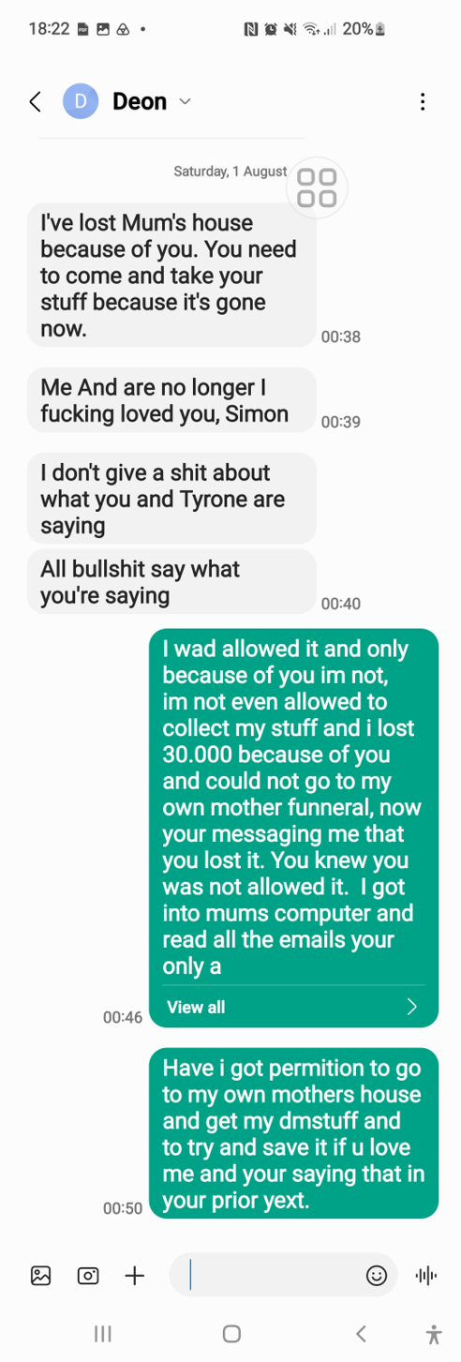
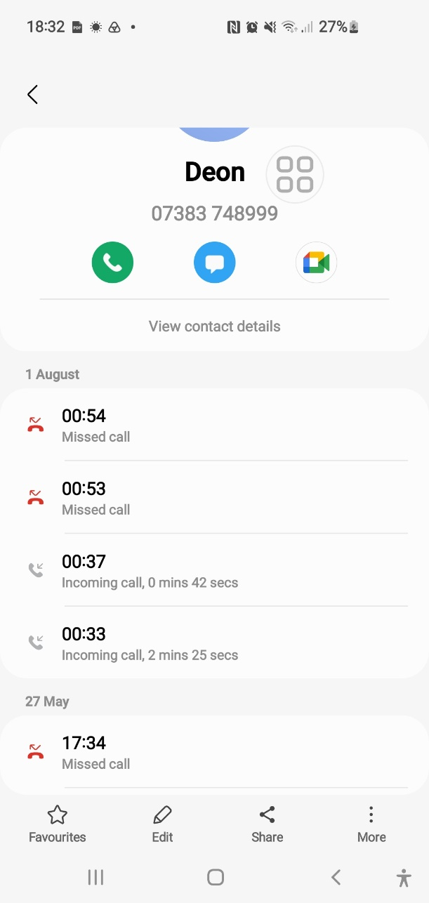

Jimmy 01/08/2026:
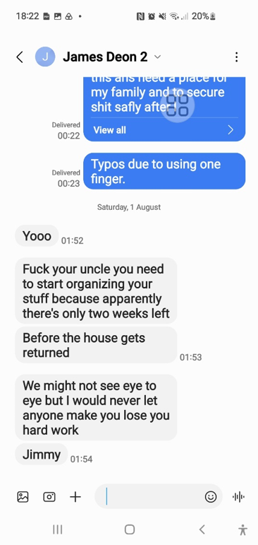

Formal Requests I formally request the following actions from Enfield Council, the Metropolitan Police Service, and all parties involved in my case:
- Immediate correction of all interference with my succession claim, including withdrawal of any statements or actions based on incorrect legal assumptions about my right to occupy 23 Byron Terrace.
- Full disclosure of all communication between the Metropolitan Police and Enfield Council, including emails, internal notes, telephone logs, and any information shared about my tenancy, my succession claim, or the incident involving my sister.
- Written confirmation of the current status of my succession review, including whether the panel has met, what evidence was considered, and why no formal decision letter has been served.
- Safeguarding of my property at 23 Byron Terrace, including written assurance that no belongings will be removed, disposed of, or destroyed while my succession claim remains legally active.
- Formal recognition of the failures toward BOTH me and my sister Deon, including the breaches of duty of care identified in the binder (turn0browsertab0).
- A full explanation for the extension of my bail to 11 November 2026, including why this was done without communication, why my solicitor was not informed, and why my bail variation requests were ignored.
- Immediate action to rectify the harm caused, including correction of procedural errors, restoration of my rights, and steps to prevent further damage.
- Appropriate rehoming of Deon, in accordance with her homelessness relief duty, risk history, and entitlement to a one-bedroom property — not placement in my mother’s home where she was not living.
- Confirmation that I am to be reinstated as the lawful occupant pending succession determination, in accordance with the Housing Act 1985.
- Inclusion of all emails sent and received relating to my case, including police correspondence, council correspondence, and internal communications.
- Inclusion of all bail verification records, including receipts, portal submissions, email acknowledgements, and station attendance logs.
- Inclusion of all receipts, including the stamped bail variation receipt from Edmonton Police Station and any other documents proving submission of requests.
- A formal request that Housing update me with ALL official correspondence relating to 23 Byron Terrace, Edmonton, London N9 7DG, sent directly to my email address: RE_WIRED@YAMIL.COM
- A requirement that ALL parties include me in ALL future emails relating to my home, my succession claim, my bail conditions, and any communication between police and council.

Summery Binder Folder all files combined.
- Binder.pdf

Kind regards, Simon Cordell Enfield, N9 7DG

https://www.bing.com/search?q=must%20the%20dection%20Include%20Section%20202%20Review%20Rights%20uk&qs=n&form=QBRE&sp=-1&ghc=2&lq=0&pq=must%20the%20dection%20include%20section%20202%20review%20rights%20uk&sc=12-53&sk=&cvid=64895AC32D1346999468EA718B376CF1

<Dir> 14. Formal Request to Begin 23 Byron Terrace Tenancy Succession dated 11-05-2026 at time 08_59Am

Exhibited File: 29. Received 10-07-26.pdf
From: Georgina Solan (georgina.solan@enfield.gov.uk)
To: re_wired@ymail.com
Date: Friday, 10 July 2026 at 16:37 BST
Last Quoted: “However, we will review the matter and include your latest evidence. I will update you on the outcome. Thank you for your cooperation. Kind regards Georgina Solan Resident Relationship Officer Housing & Regeneration Enfield Council”

<Dir> 15. DB 23 Byron My Home Folder 28-04-26
- Sent 19-05-2026.pdf
- To DS Rob Johnston & Co Wood Green Police Sation Bail Variation Request!.pdf
- Sent Items - Simon Cordell - Outlook.pdf
- 1FormSubmission-contact-us-about-something-elsecds-104510-26-0100-002.pdf
- Screenshot_21-5-2026_11343_www.met.police.uk.jpeg
- 07. Screenshot_21-5-2026_11343_www.met.police.uk.pdf
- Received 21-05-26.pdf
- DS Replied Email - Simon Cordell - Outlook 28-05-26.pdf
- DS Replied Email - Simon Cordell - Outlook 28-05-26.pdf
- Receipt Police.pdf
- Emails & Correspondence Sent and Received Deon.pdf
- Sent with 14: Doc1 Wood Green Police Sation Bail Variation and Case Disposal Request.pdf
- Sent with 14: Doc2 Procedural Case History.pdf
- Sent with 14: Doc3 What Happened with Sister Includes diary recordings before & afterwards.pdf
- Sent with 14: Doc4 Main the Truth and Nothing but the Truth 17-06-2026.pdf
- 14 Sent Items - Simon Cordell - Outlook.pdf
- Received.pdf
- Pc Knox phoned me and i worked it out.docx
- Pc Knox phoned me and i worked it out.pdf this is not correct in law anymore due to the Policing and Crime Act 2017 (PCA 2017) as this Act amended the Police and Criminal Evidence Act 1984 (PACE) and replaced the old bail system. No Time Limits in a sense or need to resign.
- Recording (6) - 7-7-26 Met ccc 101.m4a

Deon’s and Her Boyfriend Jimmys Newest Calls
<Dir> 02. Deon and Jimmy
<Dir> 03. Deon and Jimmy 01-08-26

